6.09 ALECTINIB
Capsule 150 mg,
Alecensa®, Roche Products Pty Ltd
- Purpose of Application
  - The minor submission sought an increase in the maximum number of repeats and a change to the restriction level from Authority Required (telephone) to Authority Required (STREAMLINED) for the current PBS listing of alectinib for treatment of non-small cell lung cancer (NSCLC).
- Requested listing
  - The requested changes to the current listings are added in italics and requested deletions are crossed out with strikethrough.

For more detail on PBAC’s view, see section 5 PBAC outcome.
Name, Restriction,  Manner of administration and form |  | Max.  Qty | №.of  Rpts | Dispensed Price for Max. Qty | Proprietary Name and Manufacturer
ALECTINIB  alectinib 150 mg capsule, 4 x 56 |  | 1 | 15 | $6804.12 | Alecensa | Roche Products Pty Ltd
Category /  Program | GENERAL – General Schedule (Code GE)
Prescriber type: | Medical Practitioners
PBS Indication: | Stage IIIB (locally advanced) or Stage IV (metastatic) non-small cell lung cancer (NSCLC)
Treatment phase: | Initial treatment
Restriction Level / Method: | Authority Required - Telephone  Streamlined
Clinical criteria: | The treatment must be as monotherapy,  AND  The condition must be non-squamous type non-small cell lung cancer (NSCLC) or not otherwise specified type NSCLC,  AND  Patient must have a WHO performance status of 2 or less.
Population criteria | Patient must have evidence of an anaplastic lymphoma kinase (ALK) gene rearrangement in tumour material, defined as 15% (or greater) positive cells by fluorescence in situ hybridisation (FISH) testing.
Administrative Advice | No increase in the maximum quantity or number of units may be authorised.  No increase in the maximum number of repeats may be authorised.  Special Pricing Arrangements apply.

Name, Restriction,  Manner of administration and form | Max.  Qty | №.of  Rpts | Dispensed Price for Max. Qty | Proprietary Name and Manufacturer
ALECTINIB  alectinib 150 mg capsule, 4 x 56 | 1 | 1 5 | $6804.12 | Alecensa | Roche Products Pty Ltd

Category /  Program | GENERAL – General Schedule (Code GE)
Prescriber type: | Medical Practitioners
PBS Indication: | Stage IIIB (locally advanced) or Stage IV (metastatic) non-small cell lung cancer (NSCLC)
Treatment phase: | Continuing treatment
Restriction Level / Method: | Authority Required - Telephone  Streamlined
Clinical criteria: | The treatment must be as monotherapy,  AND  Patient must have previously received PBS-subsidised treatment with this drug for this condition  AND  Patient must not develop disease progression while receiving PBS-subsidised treatment with this drug for this condition
Administrative Advice | No increase in the maximum quantity or number of units may be authorised.  No increase in the maximum number of repeats may be authorised.  Special Pricing Arrangements apply.
- Background
  - Alectinib was TGA registered on 14 March 2017 for the treatment of patients with anaplastic lymphoma kinase (ALK)-positive, locally advanced or metastatic non-small cell lung cancer (NSCLC).
  - In July 2017, the PBAC recommended the listing of alectinib for the TGA registered indication on a cost-minimisation basis with ceritinib. The PBAC considered ceritinib to be the appropriate comparator for the use of alectinib as later line therapy subsequent to progression in patients who have received crizotinib as the initial ALK inhibitor therapy. The PBAC considered that the restriction criteria for alectinib should be in close alignment with the current PBS listing of ceritinib, i.e. a telephone authority listing without any restrictions to the line of therapy. (Paragraph 7.3, 5.01 Alectinib Public Summary Document, July 2017 PBAC Meeting)
  - Alectinib has been listed on the PBS since 1 January 2018.
  - The original submission for alectinib proposed a maximum of one repeat.
For more detail on PBAC’s view, see section 5 PBAC outcome.

Consideration of the evidence

Sponsor hearing
  - There was no hearing for this item as this was a minor submission.

Consumer comments
  - The PBAC noted and welcomed the input from health care professionals (2) and individuals (3) via the Consumer Comments facility on the PBS website. The comments from individuals described the positive impacts of increased repeat prescriptions including less frequent medical appointments and less time off work for family carers. The comments from health care professionals also supported increasing repeats but indicated the maximum number of repeats should be less than 5 to align with frequency of necessary medical appointments.

Current situation
  - The minor submission was based on feedback from patients about the current PBS-listing. These patients described the burden associated with the current administrative procedures for accessing repeat prescriptions. In support of the request to change the maximum number of repeats, the submission presented a patient testimonial that detailed the financial burden and diminished quality of life associated with travelling to attend frequent medical appointments over several years for the sole purpose of obtaining prescriptions for continued treatment.
  - The submission also requested that the restriction level be changed from Authority Required (telephone) to Authority Required (STREAMLINED). It was argued that under current arrangements, the time involved to obtain authority via a telephone call for a continued treatment can consume a significant proportion of a medical appointment.
  - The submission claimed that appointments are typically scheduled at 3-4 month intervals for patients with a stable response. The submission referred to recent PBS listings of other oral kinase inhibitors such as dabrafenib and trametinib, vemurafenib and cobimetinib for BRAF V600 metastatic melanoma that are Authority Required (STREAMLINED) and have five repeats available to patients with stable or responding disease.

Estimated PBS usage & financial implications
  - The minor submission did not estimate financial implications to the PBS or changes in PBS usage.
  - The DUSC secretariat examined the utilisation of ALK inhibitors, including crizotinib, ceritinib and alectinib, for the period 1 July 2015 to 31 December 2018 based on the date of supply data.
  - Since first listing on 1 January 2018, the uptake of alectinib had been increasing as shown in Figure 1 below. The number of approved authorities for alectinib had grown over 2018, averaging 82 approvals per month (see Table 1 below).
  - DUSC examined the transition among the ALK inhibitor products since the first listing of crizotinib on 1 July 2015 with follow-up until 31 December 2018. The highest rate of change occurred in patients who commenced on crizotinib who transitioned to alectinib when alectinib was first listed (see Table 2 below).
  - Duration of ALK therapy including crizotinib, ceritinib and alectinib was tracked for patients initiating treatment in 2016 with follow-up until 31 December 2018. Over that period, mean, median and maximum days of ALK inhibitor treatment duration was 597, 718 and 1080 respectively. The data did not capture duration of treatment on alectinib alone, as follow-up time from the 1 January 2018 listing date was insufficient.
Figure 1: Market share summary of PBS-listed ALK inhibitors
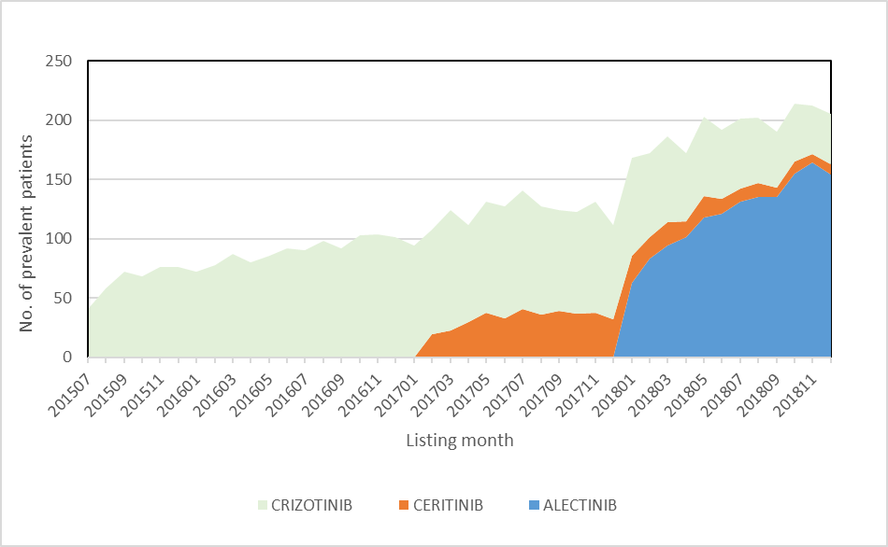
Source: Department of Human Services (DHS) Prescription database for the period 1 July 2015 to 31 December 2018 inclusive, based on the date that the prescription was supplied.

Table 1: Alectinib Authority approvals per month in 2018
Month | Jan | Feb | Mar | Apr | May | Jun | Jul | Aug | Sep | Oct | Nov | Dec
Number of Authority approvals | 70 | 49 | 75 | 68 | 84 | 77 | 85 | 89 | 80 | 104 | 106 | 91
Source: Department of Human Services (DHS) Prescription database for the period 1 July 2015 to 31 December 2018 inclusive, based on the date that the prescription was supplied.

Table 2: Drug sequence of PBS-listed ALK inhibitors for first initiators in 2016
Drug sequence | Patient count | Percent (%)
CRIZOTINIB | 155 | 32.6
ALECTINIB | 124 | 26.1
CRIZOTINIB -> ALECTINIB | 80 | 16.8
CRIZOTINIB -> CERITINIB | 41 | 8.6
CRIZOTINIB -> CERITINIB -> ALECTINIB | 38 | 8.0
CERITINIB | 23 | 4.8
CERITINIB -> ALECTINIB | 9 | 1.9
ALECTINIB -> CERITINIB | <6 | NR
ALECTINIB -> CRIZOTINIB | <6 | NR
CERITINIB -> CRIZOTINIB | <6 | NR
Source: Department of Human Services (DHS) Prescription database for the period 1 July 2015 to 31 December 2018 inclusive, based on the date that the prescription was supplied.
For more detail on PBAC’s view, see section 5 PBAC outcome.

PBAC Outcome
  - The PBAC did not recommend the requested changes to the PBS-listing of alectinib to lower the authority level from Authority Required (Telephone) to Authority Required (STREAMLINED) and to allow for an increased maximum number of repeats from one to five.
  - The PBAC noted that alectinib was recently listed on the PBS (on 1 January 2018), and longer-term utilisation data would be required prior to amending the current listing, to ensure use remains cost-effective in the current patient population.
  - The PBAC acknowledged that stable patients on continuing treatment are currently required to schedule some medical appointments only to obtain prescriptions for ongoing treatment, and considered that increasing maximum repeats to align with the monitoring regime in these patients could be beneficial. However, the PBAC considered that increasing the repeats from one to five could inappropriately extend the treatment duration in some patients, with the risk of continuing an ineffective treatment and/or unmanaged toxicity, and that the impact on the cost effectiveness of such extended treatment is unclear.
  - The PBAC noted the recent utilisation data for ALK-inhibitors across all lines of therapy showed a steady increase in uptake, particularly following the listing of alectinib. The PBAC also noted that there was a risk of leakage to other cancers with ALK gene rearrangement that were being identified through tumour whole genome mutation testing, where there was absence of robust evidence of effectiveness and cost-effectiveness. The PBAC advised that an Authority Required (STREAMLINED) listing would be inappropriate at this time until the ALK-inhibitor market had stabilised.
  - The PBAC noted that it would be willing to reconsider a future request for lowering the authority level and increasing repeats for continuing treatment when longer-term PBS utilisation data (at least 24 months) is available for alectinib. The PBAC advised that such a request would also need to be considered in the context of changes to other PBS-listed ALK-inhibitors for this condition including ceritinib and crizotinib.
  - The PBAC noted that this submission is not eligible for an Independent Review as the request is not for an entirely different disease or condition, an objectively different subtype of the same disease(s), or targeting a different population or disease stage.
Outcome:
Rejected

Context for Decision
The PBAC helps decide whether and, if so, how medicines should be subsidised in Australia. It considers submissions in this context. A PBAC decision not to recommend listing or not to recommend changing a listing does not represent a final PBAC view about the merits of the medicine. A company can resubmit to the PBAC or seek independent review of the PBAC decision.

Sponsor’s Comment
Roche is disappointed with the decision and is committed to ensuring optimal outcomes for patients with ALK-positive NSCLC. Roche put forward this application based on patient and clinical community feedback on the current PBS listing. Roche will work with the relevant stakeholders to progress a future change to the PBS listing.

