7.11 OBETICHOLIC ACID,
Tablet 5 mg, 10 mg,
Ocaliva®,
Emerge Health Pty Ltd

- Purpose of Application
  - This resubmission requested an Authority Required (STREAMLINED) listing for obeticholic acid (OCA) for the treatment of primary biliary cholangitis (PBC). The first submission was considered, but not recommended, by the PBAC in November 2018.
  - The requested basis for listing was cost-effectiveness of OCA in combination with ursodeoxycholic acid (OCA+UDCA) compared to UDCA plus placebo for UDCA inadequate responders, and OCA monotherapy compared to placebo for UDCA intolerant patients.
Table 1: Key components of the clinical issue addressed by the submission
Component | Description
Population | Patients diagnosed with PBC who are either  - UDCA-inadequate responders, defined as patients with an ALP ≥ 1.67 x ULN or total bilirubin > ULN but < 2 x ULN despite receiving UDCA treatment for ≥ 12 months (with a stable dose for 3 months); OR  - UDCA-intolerant, defined as patients who are intolerant to UDCA therapy due to severe side effects, most likely diarrhoea (3%) or very low-incident events including upper abdominal pain, decompensation of hepatic cirrhosis, calcification of gallstones, allergic reactions or urticaria with rates of ≤ 1 in 10,000 patients
Intervention | - For UDCA-inadequate responders: OCA 5-10 mg titration (as defined for the titration group in POISE; 5 mg for the first six months of treatment, followed by 10 mg for the subsequent months) + UDCA (13-15 mg per kilogram of body weight).  - For UDCA-intolerant patients: OCA 5-10 mg titration monotherapy.
Comparator | - For UDCA-inadequate responders: UDCA + placebo.  - For UDCA-intolerant patients: placebo
Outcomes | The primary composite endpoint was an ALP level of < 1.67 x ULN, with a reduction of ≥ 15% from baseline, and a total bilirubin level ≤ the ULN at 12 months.  Secondary efficacy end points included levels of ALP, GGT, alanine aminotransferase, aspartate aminotransferase, total and conjugated bilirubin, and albumin; prothrombin time; international normalized ratio; plasma bile acid levels.
Clinical claim | For patients with an inadequate response to UDCA, OCA titration dosing (5-10 mg) plus UDCA is superior to UDCA alone in reducing alkaline phosphatase and bilirubin levels and other important clinically relevant endpoints.  For patients intolerant to UDCA, OCA titration dosing (5-10 mg) is superior to placebo in reducing alkaline phosphatase and bilirubin levels and other important clinically relevant endpoints.  OCA titration dosing (5-10 mg) is inferior in terms of safety compared with placebo/best supportive care when used as combination therapy with UDCA for patients with prior inadequate response to UDCA and as monotherapy for patients who are intolerant to UDCA.
ALP = alkaline phosphatase; GGT = gamma glutamyl transferase; OCA = obeticholic acid; PBC = primary biliary cholangitis; UDCA = ursodeoxycholic acid; ULN = upper limit of normal
Source: Table 1.1.1, p32 of the resubmission.
- Requested listing
  - The requested listing with suggested additions in italics and suggested deletions in strikethrough is provided below.

Name, Restriction, Manner of administration and form |  | Max.  Qty | №.of  Rpts | DPMQ | Proprietary Name and Manufacturer
Obeticholic acid  Tablet, 5 mg |  | 30 | 5 | Published: $''''''''''''''''''''  Effective: $'''''''''''''''''''' | OCALIVA® | Manufacturer: Intercept Pharma  Australian sponsor: Emerge Health Pty Ltd
Category/Program: | Section 85 (General Schedule)
Prescriber type: | Dental Medical Practitioners Nurse practitioners Optometrists Midwives
Condition: | Primary biliary cholangitis
PBS indication: | Primary biliary cholangitis
Treatment phase: | Initial treatment
Restriction: | Authority Required (written)  Authority Required (streamlined)
Treatment criteria: | The patient must be treated by a gastroenterologist or hepatologist or in consultation with a gastroenterologist or hepatologist.
Clinical criteria: | The patient must not have severe liver disease, OR  The patient must not have immunodeficiency diseases,  AND  Treatment must be in combination with ursodeoxycholic acid (UDCA) in adults with an inadequate response to UDCA, AND  The patient must have an alkaline phosphatase (ALP) of greater than or equal to 1.67 times the upper limit of normal (ULN), AND/OR  The patient must have a total bilirubin greater than the ULN, but less than 2 times the ULN,  OR  Treatment must be as monotherapy in adults unable to tolerate UDCA, AND Patients must be intolerant to UDCA therapy due to severe side effects., most likely diarrhoea (3%) or very low-incident events including upper abdominal pain, decompensation of hepatic cirrhosis, calcification of gallstones, allergic reactions or urticaria with rates of ≤1 in 10,000 patients
Prescriber advice: | Severe side effects of UDCA therapy include diarrhoea, upper abdominal pain, decompensation of hepatic cirrhosis, calcification of gallstones, allergic reactions or urticarial.
Administrative Advice: | Not for use in the treatment of sclerosing cholangitis or cholelithiasis.  Special pricing arrangements apply
Source: Table 1.4.2, p54 of the resubmission

Category/Program: | Section 85 (General Schedule)
Prescriber type: | Dental Medical Practitioners Nurse practitioners Optometrists Midwives
Condition: | Primary biliary cholangitis
PBS Indication: | Primary biliary cholangitis
Treatment phase: | Continuing treatment
Restriction: | Authority Required (telephone)  Authority Required (streamlined)
Treatment criteria: | The patient must be treated by a gastroenterologist or hepatologist or in consultation with a gastroenterologist or hepatologist.
Clinical criteria: | The patient must have previously been issued with an authority prescription for this drug for this condition,  AND  The patient must have adequately tolerated 5 mg dose at 6 months assessment, AND OR  The patient must have achieved an adequate response to 5 mg at 12 months assessment as defined by the following criteria as an ALP < 1.67x ULN with ≥ 15% decrease from baseline in ALP and total bilirubin < ULN,  AND  Patient must continue to achieve an adequate response at yearly assessments,  AND  Patient must not have developed decompensated cirrhosis or hepatocellular cancer.
Administrative Advice: | Not for use in the treatment of sclerosing cholangitis or cholelithiasis.  Special pricing arrangements apply  Note  For prescribing by nurse practitioners as continuing therapy only, where the treatment of, and prescribing of medicine for, a patient has been initiated by a gastroenterologist or a hepatologist or in consultation with a gastroenterologist or hepatologist. Further information can be found in the Explanatory Notes for Nurse Practitioners.
Source: Table 1.4.2, p54 of the resubmission

Name, Restriction, Manner of administration and form |  | Max.  Qty | №.of  Rpts | DPMQ | Proprietary Name and Manufacturer
Obeticholic acid  Tablet, 10 mg |  | 30 | 5 | Published: $'''''''''''''''''''''''  Effective: $''''''''''''''''''''' | OCALIVA® | Manufacturer: Intercept Pharma  Australian sponsor: Emerge Health Pty Ltd
Category/Program: | Section 85 (General Schedule)
Prescriber type: | Dental Medical Practitioners Nurse practitioners Optometrists Midwives
Condition: | Primary biliary cholangitis
PBS Indication: | Primary biliary cholangitis
Treatment phase: | Continuing treatment
Restriction: | Authority Required (telephone)  Authority Required (streamlined)
Treatment criteria: | The patient must be treated by a gastroenterologist or hepatologist or in consultation with a gastroenterologist or hepatologist.
Clinical criteria: | The patient must have previously been issued with an authority prescription for this drug for this condition,  AND  The patient must have adequately tolerated 5 mg dose at 6 months assessment, OR  The patient must have adequately tolerated 10 mg dose at 12 months assessment, AND  The patient must have achieved an adequate response to 10 mg at 12 months assessment as defined by the following criteria as an ALP < 1.67x ULN with ≥ 15% decrease from baseline in ALP, and total bilirubin < ULN,  AND  Patient must continue to achieve an adequate response at yearly assessments,  AND  Patient must not have developed decompensated cirrhosis or hepatocellular cancer.
Administrative Advice | Not for use in the treatment of sclerosing cholangitis or cholelithiasis.  Special pricing arrangements apply  Note  For prescribing by nurse practitioners as continuing therapy only, where the treatment of, and prescribing of medicine for, a patient has been initiated by a gastroenterologist or a hepatologist or in consultation with a gastroenterologist or hepatologist. Further information can be found in the Explanatory Notes for Nurse Practitioners.
Source: Table 1.4.2, p54 of the resubmission

  - The ESC noted that the requested listing was updated in accordance with previous suggestions by the PBAC, including amending the proposed restriction to align with the POISE trial inclusion criteria and the addition of continuation criteria applied at 12 months (Section 2, obeticholic acid Public Summary Document (PSD), November 2018).
  - The proposed continuation criteria are not consistent with the economic model or the estimation of use in clinical practice and patients may continue long-term treatment on OCA. In the economic model, patients no longer receive OCA if they experience decompensated cirrhosis (DCC), hepatocellular cancer (HCC), are put on the waiting list for liver transplant, receive a liver transplant or experience PBC recurrence after liver transplant. The ESC reiterated its advice that it would be appropriate for the restriction to state that patients should not continue treatment if they experience DCC or HCC (paragraph 2.2, obeticholic acid PSD, November 2018).
  - The resubmission noted that the PBAC considered the proposed restriction required explicit instructions surrounding the need for dosage adjustment in patients who experience severe pruritus or moderate or severe hepatic impairment (paragraph 7.3, obeticholic acid PSD, November 2018). The resubmission argued that the restriction refers to the Product Information for more information on the dosage adjustment rather than including this information in the restriction.
  - The PBAC considered that initial supply of OCA should be an Authority Required (written) restriction and continuing supply an Authority Required (telephone) restriction to minimise leakage to patients who are UDCA tolerant and responders.
For more detail on PBAC’s view, see Section 7 PBAC outcome.
- Background

Registration status
  - OCA was TGA registered on 21 September 2018 for: ‘The treatment of primary biliary cholangitis (also known as primary biliary cirrhosis) in combination with ursodeoxycholic acid (UDCA) in adults with an inadequate response to UDCA or as monotherapy in adults unable to tolerate UDCA.’

Previous PBAC consideration
  - Table 2 summarises the outstanding matters of concern with respect to the November 2018 submission and how they have been addressed in the current resubmission.
Table 2: Summary of outstanding matters of concern
Component | Matter of concern  as identified in obeticholic acid PSD, November 2018 | How the resubmission addresses it
Restriction | The PBAC considered that the proposed PBS restriction should align with the inclusion and exclusion criteria of the POISE trial which excluded patients with severe liver disease and immunodeficiency diseases and required patients to have either an ALP ≥ 1.6 x ULN or total bilirubin > ULN but < 2 x ULN. The PBAC also considered that the proposed restriction required the inclusion of specific continuing and stopping criteria and explicit instructions surrounding the need for dosage adjustment in patients who experience severe pruritus or moderate or severe hepatic impairment (paragraphs 2.1 and 7.3).  The ESC advised that PBS subsidised treatment should cease if a patient experiences one of these [DCC, HCC, are put on the waiting list for liver transplant, receive a liver transplant, or experience PBC recurrence after liver transplant] events. The ESC considered it may also be appropriate to include a stopping or continuation rule for patients who do not demonstrate an adequate biochemical response to treatment with obeticholic acid, given that less than half of patients treated with OCA achieved the primary efficacy end point in the POISE Trial (paragraph 2.2). | Restriction changed to align with inclusion and exclusion criteria of the POISE trial. Continuation criteria proposed. Instructions regarding dosing not included, but referred to in the PI.
Clinical evidence
Risk of bias | The ESC and PBAC considered that unblinding due to the occurrence of pruritus [in the POISE trial] introduced a moderate potential for bias (paragraph 6.9). The overall risk of bias in the 747-201 (OCA monotherapy) and 747-202 (OCA combination) trials was also considered to be moderate as there were more withdrawals in the OCA treatment groups (mostly due to pruritus) than placebo (paragraph 6.11). | Not addressed
Clinical claim regarding efficacy for UDCA inadequate responders | The PBAC noted that the magnitude of the benefit was uncertain given the small sample sizes of the clinical trials and the short mean duration of follow-up (12 months) in the key trial, POISE, given that PBC is a chronic disease (paragraph 6.30 and 7.5). | No new data provided
Clinical claim regarding efficacy for UDCA-intolerant patients | The PBAC considered it was not possible to assess the efficacy or safety of OCA monotherapy against placebo in patients who were intolerant to UDCA due to insufficient data (paragraphs 6.17, 6.32 and 7.7). | No new data provided, but a sub-group analysis of the POISE trial presented.
Clinical claim regarding safety | The PBAC considered that the therapeutic claim of non-inferior safety for OCA plus UDCA compared to UDCA monotherapy in patients who were inadequate UDCA responders was not reasonable based on the incidence of adverse events in the POISE trial (paragraphs 6.31 and 7.6). | Clinical claim changed to inferior safety.
Economic evidence
Verification of transition probabilities | A number of the transition probabilities from the biochemical health states to the liver disease health states and between the liver disease health states were unable to be verified (paragraphs 6.39 and 7.9). | Some data sources changed. Many transition probabilities remain unable to be verified.
Time horizon | The 50 year time horizon of the model was long compared to the duration of follow-up in the POISE trial (12 months) (paragraphs 6.39 and 7.9). | Not addressed
Age of patients in the model | The mean age of patients entering the model was 47, which was based on the age of diagnosis of PBC, rather than 56, which was the mean age of patients in the POISE trial (paragraphs 6.39 and 7.9). | Mean age changed to 55.8 years in economic model.
Long-term efficacy with OCA | Patients treated with OCA remained in the same biochemical health state from Year 2 onwards. This lacked validity considering the progressive nature of the disease (paragraphs 6.39 and 7.9). | Not discussed by the resubmission, but assumption relaxed based on the Markov traces.
Transition probabilities with UDCA monotherapy | The assumption that patients treated with UDCA monotherapy or receiving no treatment are unable to improve (move to lower risk biochemical health states) was inconsistent with the POISE trial and Corpechot (2000), in which 9.6% and 3% of patients, respectively, experienced response with UDCA monotherapy (paragraph 6.39). | Not discussed by the resubmission, but assumption relaxed based on the Markov traces.
Source of transition probabilities for UDCA monotherapy | The submission estimated transition probabilities for UDCA monotherapy using model calibration using data from POISE, rather than directly applying the transition probabilities as was used for OCA +/- UDCA. While the transition probabilities were based on POISE data, the data were unable to be verified… The ESC considered that the application of new evidence into the model essentially resulted in the model being based on a naïve indirect comparison of results against the POISE trial which had not been clinically evaluated. The ESC considered that it would have been more appropriate to use data from the POISE trial (paragraph 6.39). | Not addressed
Utilities for health states | The utility values applied in the model were inconsistent and lacked face validity; for example, a higher utility was applied for patients with PBC re-emergence post liver transplant than for patients post-transplant without PBC re-emergence (paragraph 6.39). | Utilities changed
Disutilities for adverse events | The submission did not apply disutilities to adverse events. This was likely to favour OCA given that a higher proportion of patients receiving OCA experienced pruritus (paragraph 6.39). | Not addressed
Long-term costs | In the model OCA and UDCA treatment costs ceased once patients progressed to the liver disease health states. Given that the submission did not propose a stopping rule in the PBS restriction, treatment costs may be underestimated (paragraph 6.39). | Partially addressed by proposing a continuation criteria at 12 months.
Financial impact
Leakage | The PBAC was concerned that there was potential for OCA to be used in combination with UDCA in patients with an adequate response to UDCA in an effort to further improve biochemical markers, which are correlated with an increase in survival. The PBAC considered that a Risk Sharing Arrangement would be an appropriate method of mitigating the risk of leakage (paragraph 7.11). | Not addressed. No specific Risk Sharing Arrangement proposed.
PBAC recommendation
Recommendation | The PBAC did not recommend the listing of OCA as a second-line agent in the treatment of PBC. Although acknowledging the clinical need for effective PBC treatments, the PBAC considered that the magnitude of the clinical benefit was uncertain, the ICER was unacceptably high and uncertain and the estimated financial impact was high (paragraph 7.1). | -
ALP = alkaline phosphatase; DCC = decompensated cirrhosis; ESC = Economic Sub-Committee; HCC = hepatocellular cancer; ICER = incremental cost-effectiveness ratio; OCA = obeticholic acid; PBC = primary biliary cholangitis; PBAC = Pharmaceutical Benefits Advisory Committee; PBS = Pharmaceutical Benefits Scheme; PI = Product Information; PSD = Public Summary Document; UDCA = ursodeoxycholic acid; ULN = upper limit of normal
Source: Complied during the evaluation

For more detail on PBAC’s view, see Section 7 PBAC outcome.
- Population and disease
  - PBC was recently renamed from primary biliary cirrhosis. PBC is a rare, progressive, autoimmune, non-viral disease of the liver that gradually destroys the interlobular bile ducts. While the cause of the disease is unknown, a combination of multiple genetic factors and environmental factors are thought to trigger PBC.
  - The resubmission estimated there are approximately 1,275 PBC patients in Australia based on the prevalence of PBC at 51 per million population (Sood, 2004). However, Watson (1995) estimated a lower PBC prevalence rate at 19.1 per million population, resulting in 481 PBC patients in Australia based on current population estimates. The resubmission also provided estimates of prevalence in Victoria (1,012 from 2013) based on estimates from Australian specialists. This results in a prevalence rate of approximately 161 cases per million which equates to approximately 4,071 PBC patients in Australia, based on the current population size. The source of this latter estimate was unable to be verified. The DUSC estimated, based on the number of patients receiving UDCA, that there were approximately 8,200 PBC patients in Australia in 2017 (Table 2, p5, Obeticholic acid DUSC Advice, November 2018).
  - PBC is more prevalent in adults aged over 40 years, females and people of European descent.
  - For non-cirrhotic or compensated Child-Pugh Class A, the recommended starting dose is 5 mg once daily. Based on the assessment of tolerability after six months, the dose should be increased to 10 mg once daily to achieve optimal response (referred to as OCA 5-10 mg titration hereafter). The OCA dose is adjusted for patients with Child-Pugh Class B or C or patients with a prior decompensation event, or to manage pruritus to 5 mg up to twice weekly. Based on the assessment of tolerability this can be increased to 10 mg up to twice weekly.
For more detail on PBAC’s view, see Section 7 PBAC outcome.
- Comparator
  - The resubmission again proposed the following main comparators:
  - UDCA inadequate responders: UDCA monotherapy; and
  - UDCA intolerant patients: placebo or no treatment.
  - The PBAC had previously considered these to be the appropriate comparators (paragraph 7.4, obeticholic acid PSD, November 2018).
For more detail on PBAC’s view, see Section 7 PBAC outcome.
- Consideration of the evidence

Sponsor hearing
  - There was no hearing for this item.

Consumer comments
  - The PBAC noted and welcomed the input from individuals (31) and organisations (1) via the Consumer Comments facility on the PBS website. The comments described a range of benefits of treatment with obeticholic acid including providing a treatment option once UDCA ceases to work, improved symptom control and improved quality of life.
  - The PBAC noted the advice received from the PBC Foundation (UK) which advised that the use of obeticholic acid reduces symptom burden, improves quality of life, slows disease progression and improves biochemical markers.

Clinical trials
  - The ESC noted that the clinical evidence presented was unchanged from the previous submission.
  - Both submissions were based on:
  - The POISE trail, a head-to-head randomised trial (RCT) comparing:
    - OCA+UDCA versus UDCA+placebo in patients with an inadequate response to UDCA (OCA 5-10 mg titration: N = 65; OCA 10 mg: N = 67; placebo: N = 68) or
    - OCA versus placebo in patients with intolerance to UDCA (OCA 5-10 mg titration: N = 5; OCA 10 mg: N = 6; placebo: N = 5);
  - Two supplementary RCTs:
    - The 747-201 trial comparing OCA as monotherapy versus placebo (placebo: N = 24; OCA 10 mg: N = 20; OCA 50 mg: N = 16); and
    - The 747-202 trial comparing OCA+UDCA versus UDCA+placebo (placebo: N = 38; OCA 10 mg: N = 38; OCA 25 mg: N = 48; OCA 50 mg: N = 41); and
  - The open-label, long-term safety extension (LTSE) study of the POISE trial (POISE LTSE) (N = 193). All patients in the POISE LTSE received OCA at a dose of 5 mg (including those who have been taking OCA 10 mg in the double-blind phase) +/- UDCA for the first 3 months, after which time the dose could be increased.
  - Table 3 presents the details of the trials presented.
Table 3: Trials and associated reports presented in the submission
 | Protocol title/ Publication title | Publication citation
POISE | A Phase 3, double blind, placebo controlled trial and long term safety extension of obeticholic acid in patients with primary biliary cirrhosis (POISE) | Intercept Pharmaceuticals 2015
 | Nevens F, Andreone P, Mazzella G, Strasser SI, Bowlus C, Invernizzi P, et al. A placebo-controlled trial of obeticholic acid in primary biliary cholangitis | NEJM. 2016;375(7):631-43.
747-201 | Kowdley K, Luketic V, Chapman RW, et al. A randomized trial of obeticholic acid monotherapy in patients with primary biliary cholangitis. | Hepatology. 2018; 67 (5): 1890-1902.
747-202 | Hirschfield GM, Mason A, Luketic V, Lindor K, Gordon SC, Mayo M, et al. Efficacy of obeticholic acid in patients with primary biliary cirrhosis and inadequate response to ursodeoxycholic acid. | Gastroenterology. 2015; 148(4):751-61 e8.
Source: Table 2.2.2, p60 -63 of the previous submission

  - The key features of the direct randomised controlled trials are summarised in Table 4.
Table 4: Key features of the included evidence for OCA+UDCA versus UDCA+placebo for UDCA inadequate responders and OCA versus placebo for UDCA intolerant patients
 | N | Design/ Duration | Risk of bias | Patient population | Outcomes | Use in modelled evaluation
POISE | 217 | R, DB  12 months | Moderate | PBC | Serum ALP and total bilirubin levels, together as a composite endpoint in the OCA 10 mg group. | Used
747-201 | 60 | R, DB  12 weeks | Moderate | PBC | Serum ALP change from baseline to end of study | Not used
747-202 | 165 | R, DB  12 weeks | Moderate | PBC | Serum ALP change from baseline to end of study in each of the OCA groups | Not used
ALP = alkaline phosphatase; DB = double blind; OCA = obeticholic acid; PBC = primary biliary cholangitis/cirrhosis; R = randomised; UDCA = ursodeoxycholic acid.
Source: Figure 2.4.5 p99, Figure 2.4.6 p103, Figure 2.4.7 p105, and Table 2.4.32 p113-116 of the previous submission.

  - The ESC and PBAC had previously considered the unblinding due to the occurrence of pruritus introduced a moderate potential for bias (paragraph 6.9, obeticholic acid PSD, November 2018).

Comparative effectiveness
  - The resubmission presented different subgroup analyses compared to the previous submission. Whereas in November 2018 results were presented based on the dose of OCA received (i.e. OCA 10 mg or OCA 5-10 mg titration) only, the resubmission provided also subgroup results for patients who received OCA+UDCA (i.e. UDCA-inadequate responders) and OCA+placebo (i.e. UDCA-intolerant patients) (see Table 5).
Table 5: Percentage of subjects achieving composite endpoint (ALP < 1.67x ULN with ≥ 15% decrease from baseline in ALP, and total bilirubin < ULN) at month 12 by demographic and baseline subgroups in POISE
Population | Placebo |  | OCA 5-10mg titration |  |  | OCA 10 mg
 | N | n (%) | N | n (%) | p-value | N | n (%) | p-value
ITT population | 73 | 7 (10%) | 70 | 32 (46%) | < 0.0001 | 73 | 34 (47%) | < 0.0001
Treatment regimen
OCA+UDCA (i.e. UDCA-inadequate responders) | 68 | 7 (10%) | 65 | 30 (46%) | < 0.0001 | 67 | 33 (49%) | < 0.0001
OCA+placebo (i.e. UDCA-intolerant patients) | 5 | 0 | 5 | 2 (40%) | 0.0833 | 6 | 1 (17%) | 0.3173
ALP = alkaline phosphatase; BMI = body mass index; CMH = Cochran-Mantel-Haenszel; ITT = intention to treat; LS = least squares; OCA = obeticholic acid; SE = standard error; UDCA = ursodeoxycholic acid; ULN = upper limit(s) of normal
Endpoint: Responder was defined as a subject obtaining ALP < 1.67x ULN, total bilirubin ≤ ULN, and ALP decrease of ≥ 15% from baseline analysis; p-values based on LS mean (SE) difference between OCA treatment and placebo and were obtained using CMH general association test stratified by randomisation strata factor.
Bold indicates statistical significance.
Source: Table 2.5.2, p77 of the resubmission.

  - The PBAC previously considered that the magnitude of any benefit of OCA+UDCA 5-10 mg titration compared to UDCA alone was uncertain given the small sample sizes, the short mean duration of follow-up (12 months) and given that PBC is a chronic disease (paragraph 7.5, obeticholic acid PSD, November 2018).
  - Given that the sample sizes for patients receiving OCA monotherapy were small (OCA 5-10 mg titration: n = 5; OCA 10 mg: n = 6; placebo: n = 5), it was difficult to assess the effectiveness of OCA monotherapy based on the POISE trial alone.
  - Results of the POISE LTSE study demonstrated that response appeared to be maintained to three years in those patients who were responders at 12 months. Very few additional patients showed a response at Month 24.
  - The resubmission also represented the results from the 747-201 and 747-202 trials (see Table 7). The ESC noted that patients in trial 747-201 were either UDCA-naïve or had not been taking UDCA for greater than three months prior to screening (i.e. likely intolerant); however, as the proportion in each group was not reported it was not possible to identify whether the results were applicable to the proposed PBS population (i.e. UDCA intolerant).

Comparative harms
  - Table 6 presents a summary of patient-relevant harms, based on the POISE trial, 747-201 trial and 747-202 trial. This was unchanged from the previous submission.
Table 6: Summary of key adverse events in the randomised trials
Trial ID | Placebo  +/- UDCA,  n/N (%) | OCA 5-10 mg titration +/- UDCA,  n/N (%) | OCA 10mg  +/- UDCA,  n/N (%)
POISE Trial
Any TEAE | 66/73 (90%) | 65/70 (93%) | 69/73 (95%)
Total number of TEAEs | 452 | 471 | 467
A related TEAE of pruritus | 27/73 (37%) | 35/70 (50%) | 48/73 (66%)*
Any SAEs | 3/73 (4%) | 11/70 (16%)* | 8/73 (11%)
Total number of SAEs | 8 | 15 | 11
Any TEAE leading to Study Discontinuation | 2/73 (3%)ª | 5/70 (7%)^{b} | 8/73 (11%)^{c}
Study Discontinuation due to a TEAE of pruritus | 0/73 | 1/70 (1%) | 7/73 (10%)*
Deaths | 0/73 | 1/70 (1%) | 0/73
747-201 Trial (OCA monotherapy)
Subjects reporting at least 1 TEAE | 21/23 (91%) | - | 18/20 (90%)
Subjects with TEAE of pruritus or pruritus generalised | 8/23 (35%) | - | 14/20 (70%)
Subjects with related TEAE | 11/23 (48%) | - | 15/20 (75%)
Subjects with related TEAEs of pruritus or pruritus generalised | 7/23 (30%) | - | 14/20 (70%)
Subjects with SAE | 1/23 (4%) | - | 0/20
Subjects who withdrew due to a TEAE | 0/23 | - | 3/20 (15%)
Discontinuation due to pruritus | 0/23 | - | 3/20 (15%)
747-202 Trial (OCA combination)
Subjects reporting at least 1 TEAE | 32/38 (84%) | - | 34/38 (89%)
Subjects with TEAE of pruritus or pruritus generalised | 19/38 (50%) | - | 18/38 (47%)
Subjects with related TEAE | 22/38 (58%) | - | 28/38 (74%)
Subjects with related TEAEs of pruritus or pruritus generalised | 17/38 (45%) | - | 18/38 (47%)
Subjects with SAE | 1/38 (3%) | - | 0/38
Deaths | 0/38 | - | 0/38
Subjects who withdrew due to a TEAE | 1/38 (3%) | - | 6/38 (16%)
Discontinuation due to pruritus | 0/38 | - | 3/38 (8%)
OCA = obeticholic acid; SAE = serious adverse event; TEAE = treatment emergent adverse event; UDCA = ursodeoxycholic acid
a One subject additional experienced a TEAE of osteoarthritis that resulted in withdrawal of investigational product. The subject was discontinued from the study, which was determined by the Investigator to be withdrawal of consent.
b Four subjects in the titration group discontinued from the study due to a TEAE prior to being up titrated to OCA 10 mg.
c One Subject experienced a TEAE of fatigue, which was recorded as a discontinuation, however the subject remained in the study and investigational product was not changed.
* p ≤ 0.05 versus placebo group using a Chi-squared test, or Fisher’s Exact test where n ≤ 5 in either group
Source: Table 2.5.20, p162, Table 2.5.23, p167, Table 2.5.24, p167 of the previous submission.

Benefits/harms
  - A summary of the comparative benefits and harms for OCA 5-10 mg titration +/- UDCA or OCA 10mg +/- UDCA versus UDCA +/- placebo is presented in Table 7.
Table 7: Summary of comparative benefits and harms for OCA 10mg +/- UDCA and placebo +/-UDCA
Trial | OCA +/- UDCA,  n/N |  | PBO +/-UDCA,  n/N |  | RR  (95% CI) |  |  | Event rate/100 patients* |  |  |  | RD  (95% CI)
 |  |  |  |  |  |  |  | OCA +/- UDCA |  | PBO +/- UDCA
Benefits
Primary outcome
Composite endpoints: ALP < 1.67x ULN with ≥ 15% decrease from baseline in ALP, and total bilirubin < ULN
POISE: OCA 5-10 mg titration monotherapy  (i.e. UDCA-intolerant patients) | 2/5 |  | 0/5 |  | 5.0  (0.3, 83.7)** |  |  | 40.0 |  | 0.0 |  | 40.0  (-2.9, 82.9)**
POISE: OCA 10 mg monotherapy  (i.e. UDCA-intolerant patients) | 1/6 |  | 0/5 |  | 2.6  (0.1, 52.1)** |  |  | 16.7 |  | 0.0 |  | 16.7  (-13.2, 46.5)**
POISE: OCA 5-10 mg titration plus UDCA  (i.e. UDCA-inadequate responders) | 30/65 |  | 7/68 |  | 4.5  (2.1, 9.5) |  |  | 46.2 |  | 10.3 |  | 35.9  (21.8, 50.0)
POISE: OCA 10 mg plus UDCA  (i.e. UDCA-inadequate responders) | 33/67 |  | 7/68 |  | 4.8  (2.3, 10.1) |  |  | 49.3 |  | 10.3 |  | 39.0  (25.0, 52.9)
Primary outcome
Composite endpoint: Percentage change in serum ALP from baseline to the end of trial
 | OCA 10mg +/- UDCA |  |  |  |  | PBO +/- UDCA |  |  |  |  | Mean difference*:  OCA 10mg +/- UDCA vs. PBO +/- UDCA
 | N | Mean ∆ baseline, % |  | SD |  | N | Mean ∆ baseline, % |  | SD
747-201: OCA monotherapy | 20 | -44.5% |  | 24.4 |  | 23 | 0.4% |  | 15.3 |  | NR  (p < 0.0001)
747-202: OCA plus UDCA | 38 | -23.7% |  | 17.8 |  | 38 | -2.6% |  | 12.5 |  | NR  (p < 0.0001)
Harms
 | OCA +/- UDCA,  n/N |  | PBO +/- UDCA,  n/N |  | RR  (95% CI) |  |  | Event rate/100 patients* |  |  |  | RD  (95% CI)
 |  |  |  |  |  |  |  | OCA +/- UDCA |  | Placebo +/- UDCA
Pruritus
POISE: OCA 5-10 mg titration ± UDCA | 39/70 |  | 28/73 |  | 1.45  (1.02, 2.08) |  |  | 55.7 |  | 38.4 |  | 17.4  (1.2, 33.5)
POISE: OCA 10 mg ± UDCA | 50/73 |  | 28/73 |  | 1.79  (1.28, 2.48) |  |  | 68.5 |  | 38.4 |  | 30.1  (14.7, 45.6)
747-201: OCA monotherapy | 14/20 |  | 8/23 |  | 2.01  (1.07, 3.77) |  |  | 70.0 |  | 34.8 |  | 35.2  (7.2, 63.2)
747-202: OCA plus UDCA | 18/38 |  | 19/38 |  | 0.95  (0.60, 1.50) |  |  | 47.4 |  | 50.0 |  | -2.6  (-25.1, 19.8)
TEAEs
POISE: OCA 5-10 mg titration ± UDCA | 65/70 |  | 66/73 |  | 1.03  (0.93,0.80) |  |  | 92.9 |  | 90.4 |  | 2.5  (-6.6, 11.5)
POISE: OCA 10 mg ± UDCA | 69/73 |  | 66/73 |  | 1.04  (0.95, 1.15) |  |  | 94.5 |  | 90.4 |  | 4.1  (-4.4, 12.6)
747-201: OCA monotherapy | 18/20 |  | 21/23 |  | 0.99  (0.81,1.20) |  |  | 90 |  | 91.3 |  | -1.3  (-18.8, 16.2)
747-202: OCA plus UDCA | 34/38 |  | 32/38 |  | 1.06  (0.89,1.27) |  |  | 89 |  | 84 |  | 5.3  (-9.9, 20.4)
SAEs
POISE: OCA 5-10 mg titration ± UDCA | 11/70 |  | 3/73 |  | 3.82  (1.11,13.13) |  |  | 15.7 |  | 4.1 |  | 11.6  (1.9, 21.3)
POISE: OCA 10 mg ± UDCA | 8/73 |  | 3/73 |  | 2.67  (0.74, 9.66) |  |  | 11.0 |  | 4.2 |  | 6.8  (-1.6, 15.3)
747-201: OCA monotherapy | 0/20 |  | 1/23 |  | 0.38  (0.02, 8.86) |  |  | 0.0 |  | 0.04 |  | -0.04  (-0.13,0.04)
747-202: OCA plus UDCA | 0/38 |  | 1/38 |  | 0.33  (0.01, 7.93) |  |  | 0.0 |  | 0.03 |  | -0.03  (-0.08, 0.02)
ALP = alkaline phosphatase; CI = confidence interval; OCA = obeticholic acid; PBO = placebo; RD = risk difference; RR = risk ratio; SAE = serious adverse event; SD = standard deviation; TEAE = treatment emergent adverse event; UDCA = ursodeoxycholic acid; ULN = upper limit of normal
Bold indicates statistical significance.
* Maximum duration of follow-up: POISE = 12 months; 747-201 trial = 14 weeks; 747-202 trial = 14 weeks
** Added 0.5 patients.
Source: Complied during the evaluation based on Table 2.5.1, p129 of the submission, Table 2.5.20 of the submission, p162, Table 2.5.21, p164 of the submission.

  - On the basis of direct evidence presented by the submission (POISE trial), for every 100 patients treated with OCA 5-10 mg titration +/- UDCA in comparison to placebo +/- UDCA and over a maximum duration of follow-up of 12 months:
- Approximately 36 additional UDCA-inadequate responders would not experience PBC disease progression;
- Approximately 17 additional patients would experience pruritus; and
- Approximately 12 additional patients would experience at least one serious adverse event.

  - On the basis of direct evidence presented by the submission (POISE trial), for every 100 patients treated with OCA 10mg +/- UDCA in comparison to placebo +/- UDCA and over a maximum duration of follow-up of 12 months:
- Approximately 39 additional UDCA-inadequate responders would not experience PBC disease progression; and
- Approximately 30 additional patients would experience pruritus.

  - On the basis of direct evidence presented by the submission (747-201 trial), the comparison of OCA 10mg monotherapy and placebo resulted in a significant reduction in the percentage change in ALP from baseline to the end of the trial.
  - On the basis of direct evidence presented by the submission (747-202 trial), the comparison of OCA 10mg + UDCA and placebo + UDCA resulted in a significant reduction in the percentage change in ALP from baseline to the end of the trial.

Clinical claim
  - The resubmission described OCA 5-10 mg titration, used as combination therapy with UDCA, as superior in terms of effectiveness compared with UDCA alone for patients with prior inadequate response to UDCA.
  - The PBAC had previously considered that this claim was reasonable; however, the magnitude of the benefit remained uncertain given the small sample sizes of the clinical trials and the short mean duration of follow-up (12 months) in the key trial, POISE, given that PBC is a chronic disease (paragraph 7.5, obeticholic acid PSD, November 2018). The ESC considered that the uncertainty surrounding the magnitude of the clinical benefit remained.
  - The PBAC considered that the claim of superior effectiveness for OCA 5-10 mg titration + UDCA compared with UDCA monotherapy in patients who were UDCA-inadequate responders was again reasonable; however, the magnitude of the benefit remained uncertain.
  - The resubmission described OCA 5-10 mg titration as superior in terms of effectiveness compared with placebo when used as monotherapy for patients who are intolerant to UDCA.
  - The ESC considered that although the resubmission presented a subgroup analysis from the POISE trial (n = 16) and data from trial 747-201 (n = 43), the small sample sizes and issues surrounding the applicability of 747-201 to the proposed PBS population meant that it remained difficult to assess the efficacy of OCA monotherapy.
  - The PBAC considered that the claim of superior effectiveness for OCA 5-10 mg titration monotherapy compared with placebo in patients who were UDCA-intolerant was not adequately supported by the data.
  - The resubmission described OCA 5-10 mg titration as inferior in terms of safety compared with placebo/best supportive care when used as combination therapy with UDCA for patients with prior inadequate response to UDCA and as monotherapy for patients who are intolerant to UDCA.
  - The ESC considered that the claim of inferior safety was reasonable.
  - The PBAC considered that the claims of inferior safety for OCA 5-10 mg titration + UDCA and OCA 5-10 mg titration monotherapy compared with UDCA and placebo respectively were reasonable.

Economic analysis
  - The resubmission presented a stepped economic evaluation based on a direct randomised controlled trial (the POISE trial), other published studies, and implemented a modelled evaluation. The types of economic evaluation presented were cost-utility analysis and cost-effectiveness (per responder and per life year gained) analyses. This was unchanged from the previous submission.
  - The resubmission represented the following comparisons using both the requested published and effective prices:
  - OCA 5-10 mg titration + UDCA versus UDCA monotherapy for UDCA inadequate response patients.
  - OCA 5-10 mg titration monotherapy versus no treatment for UDCA intolerant patients.
  - Table 8 presents the key components of the economic evaluation.
Table 8: Summary of model structure and rationale
Component | Summary
Type of analysis | Cost-utility analysis (CUA) and cost-effectiveness analyses (CEA)
Outcomes | Quality adjusted life years (QALYS) and life years (LY) gained
Time horizon | Lifetime (50 years), POISE clinical trial 12 months duration plus the POISE LTSE study (5 years). Previously the PBAC considered that the 50 year time horizon of the model was long compared to the duration of follow-up in the POISE trial (12 months) (paragraphs 6.39 and 7.9, obeticholic acid PSD, November 2018). The ESC considered that a 50 year time horizon was inappropriate based on the progressive nature of the disease and contributed to the uncertainty of the results.
Methods used to generate results | A semi-Markov state-transition model which captures patient costs and outcomes over a lifetime horizon (up to 100 years of age/50 years dependent on starting age).
Health states | 10 health states (biochemical [first 3 states]; liver disease [last 7 states])  Biochemical States  - Low risk of PBC disease progression: ALP ≤ 200 U/L (i.e. 1.67 x ULN) and normal bilirubin (i.e. TB ≤ 20 µmol/L)  - Moderate risk of PBC disease progression: ALP > 200 U/L and normal bilirubin  - High risk of PBC disease progression leading to liver failure: abnormal bilirubin (i.e. TB > 20 µmol/L) and rising or CC.  Liver Disease States  - DCC  - HCC  - Pre-LT  - LT  - Post-LT  - PBC re-emergence  - Dead
Cycle length | 3 months
Population used in the model | Age: 55.8 years, based on the POISE trial. This was changed from 47.3 years in the previous submission; the ESC considered that this was appropriate.
Baseline health state distribution:
Low risk: 0%
Moderate risk: 76.85%
High risk: 23.15%
Based on the POISE trial.

This was unchanged from the previous submission. The ESC again noted that the distribution of patients in the health states at baseline was unable to be verified during the evaluation.
Transition probabilities | Low risk ↔ High risk  OCA monotherapy (UDCA intolerant) or OCA+UDCA (UDCA inadequate response): POISE. The transition probabilities between biochemical health states for OCA patients were based on a small sample size (N = 68). The same transition probabilities were used for OCA monotherapy as for OCA+/-UDCA, even though only 7% (n = 16) patients in the POISE trial received OCA monotherapy, which was uncertain. The resubmission no longer assumed that patients treated with OCA do not progress from the biochemical health state they are in at Year 2 for the rest of the patient’s lifetime, based on the Markov traces and economic model. The evaluation noted that the source of the new transition probabilities was unknown.  UDCA monotherapy (UDCA inadequate response): Model calibration using data from POISE. It was unclear whether POISE remains the data source in the resubmission for UDCA monotherapy, given the transition probabilities for UDCA monotherapy had changed. No explanation was given by the resubmission.  No treatment (UDCA intolerant): Corpechot (2000). The application of Corpechot (2000) effectively meant that the submission conducted a naïve comparison between the POISE trial and the trial reported by Corpechot (2000). The ESC noted that this remained unchanged.  Although not described in the resubmission, based on the Markov traces the evaluation identified that the resubmission no longer assumed that patients who were not receiving treatment or receiving UDCA monotherapy only were unable to improve (move to lower risk health states). The ESC noted that the basis of these transition probabilities were not provided.
Biochemical health states → Liver disease health states
Various published data sources and model calibration. Most transition probabilities were unable to be verified based on the information presented by the submission. Some were changed between the previous submission and the resubmission, with no explanation provided. Furthermore, there were inconsistencies between the data sources listed by the resubmission and those described in the economic model.
Discontinuations | OCA+/-UDCA or UDCA monotherapy: POISE, No treatment: Nil (assumed)  The resubmission assumed that 9.86% of patients discontinue OCA+/-UDCA after 3 months. This was unchanged from the previous submission. The resubmission has also applied a new assumption that 44.1% of patients discontinue OCA+/-UDCA at 12 months. This was not discussed by the resubmission. Together, this proportion sums to the proportion of patients not achieving the composite endpoint in the POISE trial (54%). The ESC considered that this was reasonable.
Utilities | Biochemical states  The low and moderate risk states were sourced from a quality of life study in chronic viral hepatitis and cholestatic liver disease patients. (Younossi, 2001). The utilities from Younossi (2001) were unable to be verified (i.e. located in the publication). The method to convert SF-36 data into utility values also remains unreported.  High risk was sourced from an economic evaluation of a hepatitis C treatment (Wright, 2006).  Liver disease states  Each of the liver disease states were sourced from the Wright (2006) economic evaluation, some of which cites Radcliffe (2002). Some utility values reported in Wright (2006) were not reported in Radcliffe (2002). The resubmission no longer applies a 15% decrease based on KOL opinion; this was reasonable.  The ESC again noted that a number of the utility values used in the model could not be verified.  Adverse events  The resubmission did not apply disutilities to adverse events. This was unchanged from the previous submission. The PBAC considered this was likely to favour OCA given that a higher proportion of patients receiving OCA experienced pruritus (paragraph 6.39, obeticholic acid PSD, November 2018). The ESC noted that this remained unchanged and considered it was unreasonable.
ALP = alkaline phosphatase; CC = compensated cirrhosis; DCC = decompensated cirrhosis; HCC = hepatocellular cancer; KOL = key opinion leader; LT = liver transplant; LTSE = long-term safety extension; OCA = obeticholic acid; PBAC = Pharmaceutical Benefits Advisory Committee; PBC = primary biliary cholangitis/cirrhosis; PSD = Public Summary Document; TB = total bilirubin; UDCA = ursodeoxycholic acid; ULN = upper limit of normal
Source: Compiled during the evaluation.

  - Table 9 summarises the key drivers of the model.
Table 9: Key drivers of the model
Description | Method/Value | Impact
Time horizon | Lifetime (50 years), based on the POISE clinical trial (12 months duration) and the POISE LTSE study (5 years). | High, favours OCA
Utilities in biochemical health states | Based on Younossi (2001) and Wright (2006) | Moderate, direction unclear
Transition probability between biochemical health states | POISE and Corpechot (2000). | Moderate, direction unclear
Discontinuation rate of OCA in the fourth cycle | Assumed that 9.86% of patients discontinue treatment after 3 months and 44.1% of patients discontinue treatment at 12 months. | Moderate, favours OCA
LTSE = long-term safety extension; OCA = obeticholic acid
Source: Compiled during the evaluation

  - Table 10 presents the results of the stepped economic evaluation.

Table 10: Results of the stepped economic evaluation (effective price for OCA)
Data | Costs |  |  | Health outcomes |  |  | ICER
 | OCA titration (+/- UDCA) | PBO  (+/- UDCA) | Increment | OCA titration (+/- UDCA) | PBO  (+/- UDCA) | Increment
Step 1 (UDCA inadequate responder individuals: OCA 5-10 mg titration+UDCA vs UDCA monotherapy): Trial-based analysis using 12-month POISE trial data (outcomes = POISE primary efficacy outcome: ALP < 1.67 x ULN, total bilirubin ≤ ULN, and ALP decrease of ≥ 15% from baseline), [ICER = $/responder gained] | $'''''''''''''''''' | $''''''''''''' | $''''''''''''''' | 50% | 10% | 40% | $'''''''''''''''
Step 2a (UDCA inadequate responder individuals: OCA 5-10 mg titration+UDCA vs UDCA monotherapy): Model-based analysis; costs related to AEs and disease management added; transformed POISE outcomes into biochemical and liver-related health states; model population specific to the inadequate responder population; added LYs as an outcome; extrapolated to 50 years; discounted costs and outcomes at 5% p.a., [ICER = $/LY gained] | $'''''''''''''''''' | $''''''''''''''''''' | $''''''''''''''''''' | 13.78 | 11.55 | 2.22 | $''''''''''''''''''
Step 2b (UDCA intolerant individuals: OCA 5-10 mg titration vs no treatment): Model-based analysis; Step 2a with model population specific to the UDCA intolerant population, [ICER = $/LY gained] | $''''''''''''''''' | $'''''''''''''''''''''' | $'''''''''''''''''' | 13.07 | 10.51 | 2.56 | $'''''''''''''''
Step 3a (UDCA inadequate responder individuals: OCA 5-10 mg titration+UDCA vs UDCA monotherapy): Model-based analysis; Step 2a with application of utilities to biochemical and liver-related health states to yield QALYs as an outcome, [ICER = $/QALY gained] | $''''''''''''''' | $'''''''''''''' | $''''''''''''''' | 10.69 | 7.80 | 2.89 | $'''''''''''''
Step 3b (UDCA intolerant individuals: OCA 5-10 mg titration vs no treatment): Model-based analysis; Step 3a with model population specific to the UDCA intolerant population, [ICER = $/QALY gained] | $''''''''''''''' | $'''''''''''''''''' | $''''''''''''''' | 9.82 | 6.52 | 3.30 | $'''''''''''''
November 2018 submission (effective prices)*
Step 3a (UDCA inadequate responder individuals: OCA 5-10 mg titration+UDCA vs UDCA monotherapy): Model-based analysis; [ICER = $/QALY gained] | $'''''''''''''''''''' | $''''''''''''''''' | $''''''''''''''''''' | 13.26 | 7.75 | 5.51 | $''''''''''''''''
Step 3b (UDCA intolerant individuals: OCA 5-10 mg titration vs no treatment): Model-based analysis; [ICER = $/QALY gained] | $'''''''''''''''''''' | $''''''''''''''''''' | $''''''''''''''''''' | 13.15 | 6.63 | 6.52 | $'''''''''''''''''
AE = adverse event; ALP = alkaline phosphatase; ICER = incremental cost-effectiveness ratio; LY = life year; OCA = obeticholic acid; PBO = placebo; QALY = quality-adjusted life year; UDCA = ursodeoxycholic acid; ULN = upper limit of normal
*Based on an OCA weighted effective price of $''''''''''''' ($''''''''''''''*53% + $9'''''''''*47%) (instead of $'''''''''''' applied by submission) based on sheet ‘Deterministic results’ in Attachment 11 of the previous submission
Source: 3.82 p123 and corrected during the evaluation based on sheet ‘Deterministic results’ in Attachment 9 of the resubmission.

The redacted table shows ICERs in the range of $45,000 - $75,000 to $105,000 - $200,000 per responder, life years or QALY gained.

  - When compared to the previous submission, both the incremental costs and incremental QALYs were approximately halved, resulting in ICERs that have remained largely the same. The reduction in incremental costs was driven by the new assumption that 44.14% of patients would discontinue OCA at 12 months.
  - The ESC considered that the small number of changes made to the model in the resubmission did not address the major issues described previously. Hence, the ESC reiterated that the model lacked transparency and clinical plausibility and was not sufficiently valid to inform decision making. The ESC again considered that results should be considered with caution for a number of reasons, including:
  - Many of the transition probabilities from the biochemical health states to the liver disease health states and between the liver disease health states were unable to be verified based on the information presented by the resubmission. Some were changed in the resubmission, with no explanation provided. The PSCR stated that the transition probabilities within the biochemical health states for the first twelve months of OCA treatment were based on results from the POISE trial, with transition probabilities for UDCA and OCA treated patients beyond 12 months derived from the literature, using PBC-specific data where possible (Lammers 2014, Harms 2015, Carbone 2016, Harms 2016). Transition probabilities for within the liver disease states for all patients were derived from the literature and/or analysis of data from the US Organ Procurement and Transplantation Network database. The PSCR stated that where necessary, a calibration process was undertaken to arrive at credible estimates. The ESC noted that the data sources provided in the PSCR were incomplete and not enough information was provided to verify a number of the model inputs. In addition, the information provided regarding the methodology of the calibration process was unclear, a number of sources were unable to be verified and a number of sources were changed in the resubmission with no explanation or reasoning.
  - The time horizon in the model (50 years) was long compared with the median age of patients in the POISE trial (56 years), the duration of follow-up in the POISE trial (12 months) and the progressive nature of the disease.
  - Some utility values were unable to be verified and the resubmission did not apply disutilities to adverse events. The ESC had previously considered that the lack of disutilities for adverse events was likely to favour OCA given that a higher proportion of patients receiving OCA experienced pruritus (paragraph 6.39, obeticholic acid PSD, November 2018).
  - In the model, the OCA and UDCA treatment costs cease once a patient progresses to the liver disease health states. As the proposed PBS restriction only includes a continuation rule at 12 months, with no requirement for reassessment of efficacy after that, treatment costs may have been underestimated.
  - Figures 1 and 2 present the Markov traces over time. The PBAC had previously considered that the assumptions that patients treated with OCA remained in the same biochemical health state from Year 2 onwards and that patients treated with UDCA monotherapy or placebo were unable to improve were unreasonable (paragraphs 6.39 and 7.9, obeticholic acid PSD, November 2019). Although the resubmission stated that these assumptions remained, the Markov traces indicated that these assumptions had been relaxed and patients treated with OCA could now progress after 2 years and patients receiving no treatment or UDCA monotherapy could improve in terms of biochemical health states.
Figure 1: Markov traces UDCA inadequate responders - LEFT PANEL: OCA+UDCA; RIGHT PANEL: UDCA monotherapy
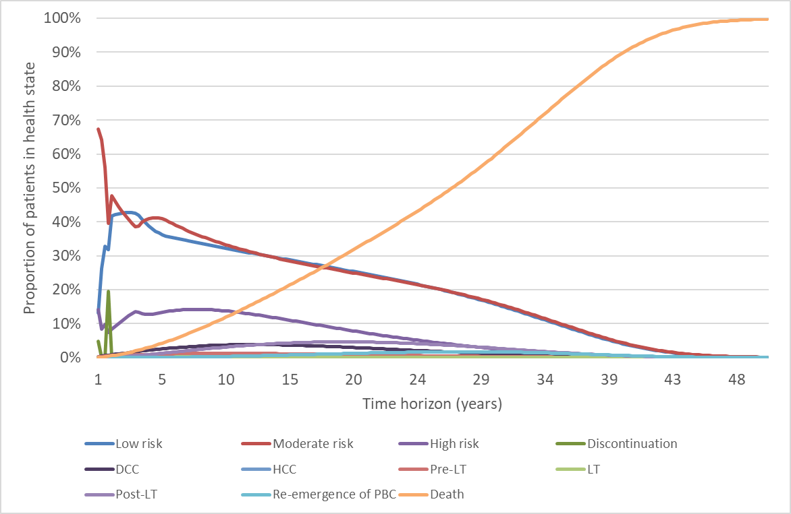
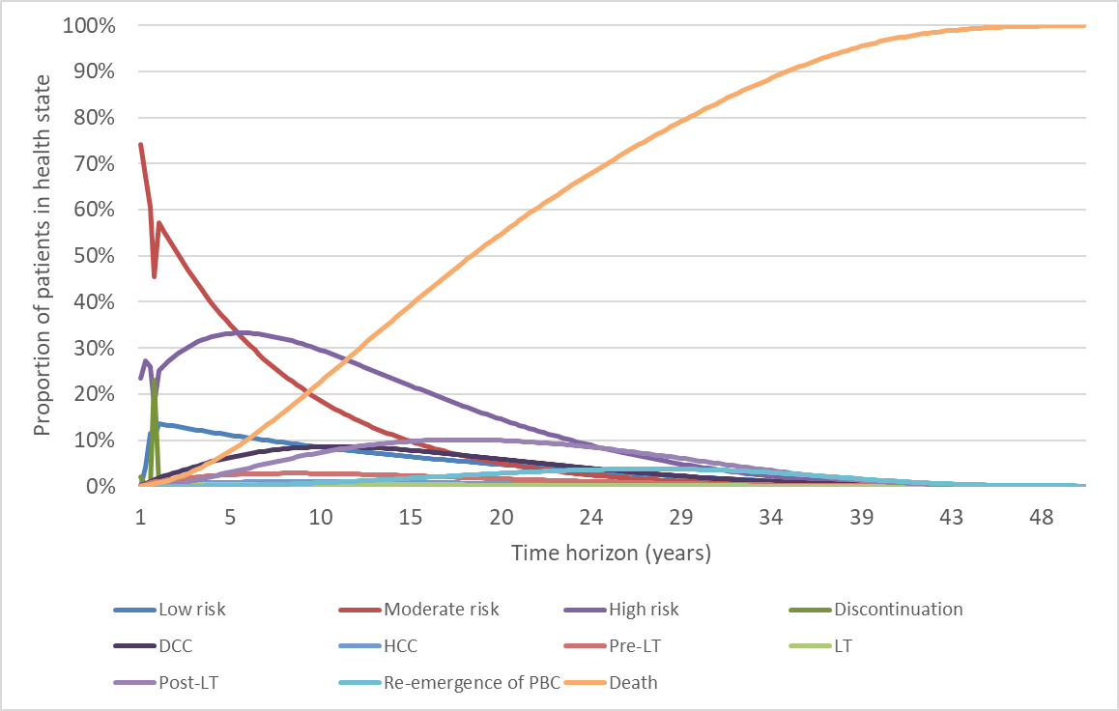DCC = decompensated cirrhosis; HCC = hepatocellular cancer; LT = liver transplant; OCA = obeticholic acid; PBC = primary biliary cholangitis/cirrhosis; UDCA = ursodeoxycholic acid.
Source: Compiled during evaluation using Attachment 9

Figure 2: Markov trace UDCA intolerant patients – LEFT PANEL: OCA monotherapy; RIGHT PANEL: no treatment

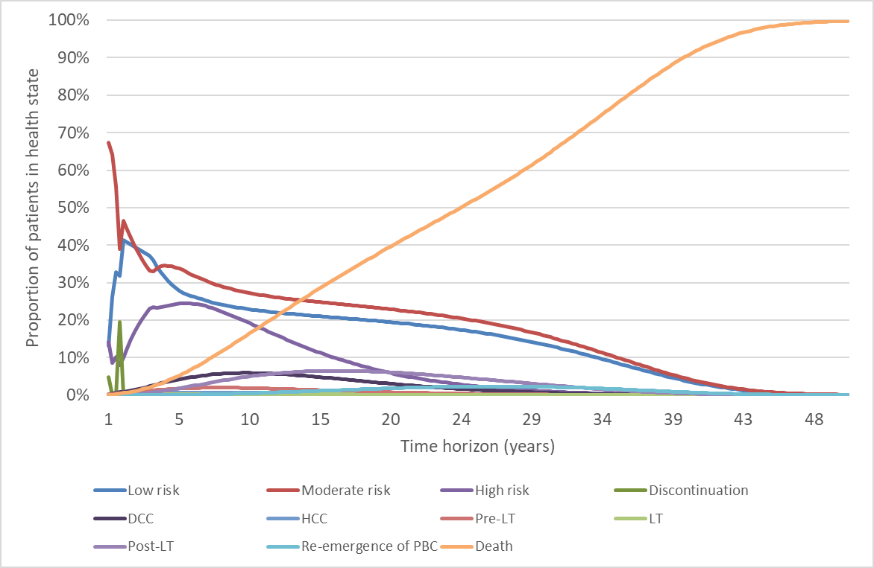
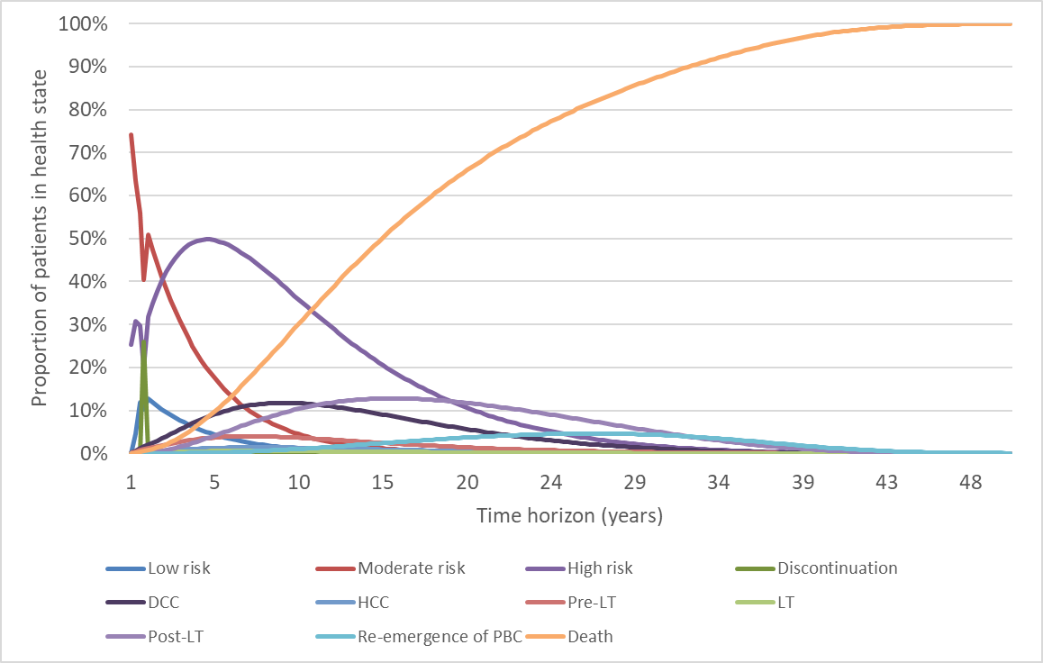
DCC = decompensated cirrhosis; HCC = hepatocellular cancer; LT = liver transplant; OCA = obeticholic acid; PBC = primary biliary cholangitis/cirrhosis; UDCA = ursodeoxycholic acid.
Source: Compiled during evaluation using Attachment 9

  - Figures 3 and 4 summarise the results of the sensitivity analyses.

Figure 3: UDCA inadequate responder population - effective price
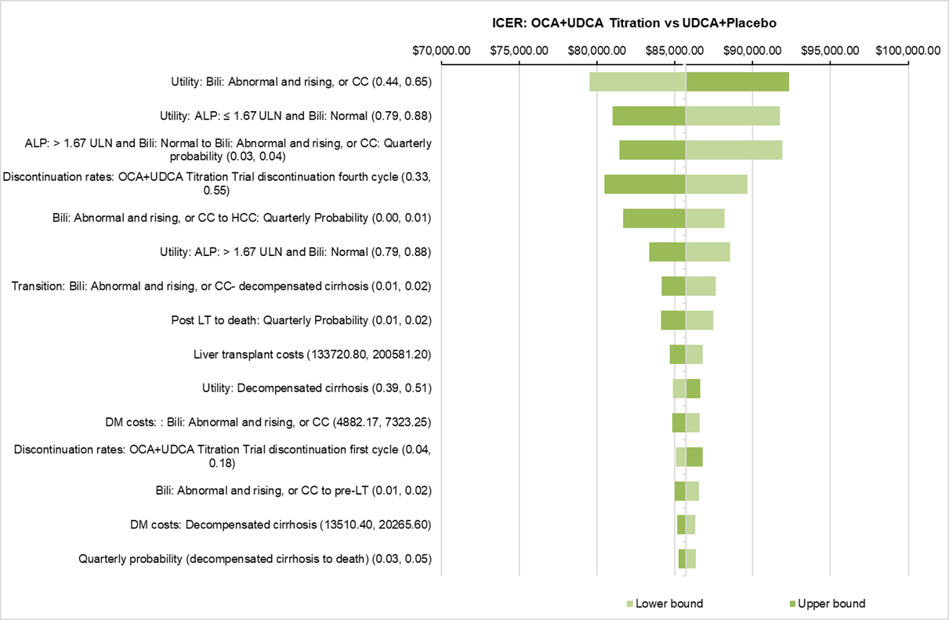
ALP = alkaline phosphatase; Bili = bilirubin; CC = compensated cirrhosis; DM = disease management; LT = liver transplant; OCA = obeticholic acid; UDCA = ursodeoxycholic acid; ULN = upper limit of normal
Source: Figure 3.9.2, p129 of the resubmission.
Figure 4: UDCA intolerant population - effective price

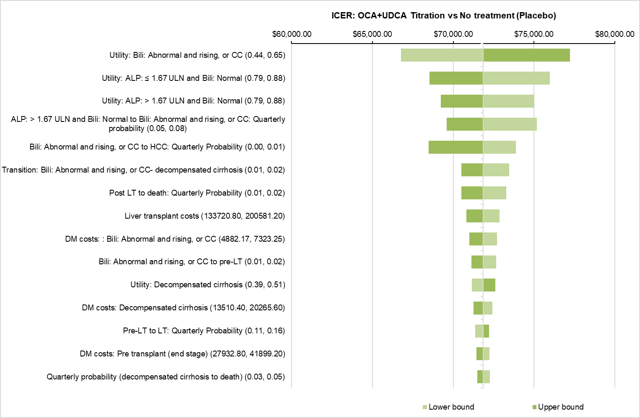
ALP = alkaline phosphatase; Bili = bilirubin; CC = compensated cirrhosis; DM = disease management; LT = liver transplant; OCA = obeticholic acid; UDCA = ursodeoxycholic acid; ULN = upper limit of normal
Source: Figure 3.9.4, p130 of the resubmission.

  - The model was sensitive to the utility values in the biochemical health states, transition probabilities between biochemical health states, and the discontinuation rate in the fourth cycle.
  - The ESC considered that due to the unreliability of the presented economic model only Step 1 of the analysis was meaningful. In addition, the ESC considered that it was unlikely that larger trials would become available due to the rare nature of the disease. Therefore, the ESC advised that it might be more appropriate to consider a submission based on a cost per responder analysis (i.e. using Step 1 only), noting the potential difficulties with interpreting an ICER based on this outcome.

Drug cost/patient/year
  - The drug cost per patient per year is presented in Table 11. The previous submission assumed that patients received 358.8 days of treatment and miscalculated the weighted cost of treatment in terms of the number of patients receiving 5 mg and 10 mg OCA. The price of OCA was updated in the resubmission to reflect an increase in dispensing fees. The resubmission also applied a discontinuation rate at three and 12 months, which was not previously included in the economic model or financial estimates.
Table 11: Drug cost per patient for OCA 5-10mg titration
 | Trial dose and duration | Model | Financial estimates
Mean dose of OCA | 6.2mg | NA | NA
Mean duration of OCA | 341.7 days | 365 days per year.  9.86% discontinue after 3 months and 44.1% discontinue at 12 months. | 365 days per year.  54% discontinue at 12 months.
Cost/patient/month of OCA (effective price) | $''''''''''''''''''''' | $''''''''''''''''''''''' | $''''''''''''''''''''''
Cost/patient/year (chronic) of OCA (effective price) | $'''''''''''''''''''''''''' | $''''''''''''''''''''''''''''' | $'''''''''''''''''''''''
NA: not applicable as the resubmission did not estimate the proportion using 5 mg versus 10 mg due to flat pricing; OCA = obeticholic acid; UDCA = ursodeoxycholic acid.
* Price per 30 tablet pack
** Calculated during evaluation using Attachment 9 assuming mean duration of 341.7 days.
*** Assuming patients continue treatment
Source: Table 52, p200 of CSR for POISE study (Attachment 2), sheet Clinical Inputs and sheet Treatment costs, Attachment 9, and Table 4.11 p131 of the resubmission.

Estimated PBS usage & financial implications
  - The resubmission was not considered by DUSC. The resubmission used a market share approach to estimate the financial impact of listing OCA on the PBS and RPBS for the treatment of PBC. The key data sources were UDCA PBS utilisation data from the DUSC advice to the November 2018 submission, a specialist survey, and the POISE trial. This approach differed from the previous submission that used an epidemiology approach.
  - Estimated uptake was significantly lower than assumed in the previous submission. The other key difference compared to the previous submission was the inclusion of an assumption that 54% of patients discontinue treatment at 12 months.
  - Table 12 presents the estimated use and financial implications.
Table 12: Estimated use and financial implications
 | Year 1  (2020) | Year 2  (2021) | Year 3  (2022) | Year 4  (2023) | Year 5  (2024) | Year 6  (2025)
Estimated extent of use
Number of patients treated | ''''''''' | ''''''''' | ''''''''' | '''''''''' | '''''''''''''' | '''''''''''''''
Correct number of patients treated ª | '''''''''' | ''''''''' | ''''''''' | '''''''''' | ''''''''' | '''''''''
Number of scripts dispensed | '''''''''''' | '''''''''''''' | ''''''''''''''' | '''''''''''''''' | '''''''''''''''' | ''''''''''''''''
Corrected number of scripts dispensed ^{a,b} | ''''''''''''''' | ''''''''''''''' | '''''''''''''' | '''''''''''' | ''''''''''''''' | '''''''''''''''
Estimated financial implications of OCA
Cost to PBS/RPBS | $''''''''''''''''''''''''''' | $'''''''''''''''''''''''' | $'''''''''''''''''''''''''''' | $'''''''''''''''''''''''''''' | $''''''''''''''''''''''''''' | $'''''''''''''''''''''''''''
Copayments | $''''''''''''''''''' | $''''''''''''''''''''' | $''''''''''''''''''''' | $'''''''''''''''''''''' | $''''''''''''''''''' | $''''''''''''''''''''
Cost to PBS/RPBS less copayments | $''''''''''''''''''''''''' | $''''''''''''''''''''''''''''' | $'''''''''''''''''''''''''' | $''''''''''''''''''''''''''' | $''''''''''''''''''''''''''' | $''''''''''''''''''''''''''
Corrected cost to PBS/RPBS less copayments ^{a,b} | $''''''''''''''''''''''''' | $'''''''''''''''''''''''' | $'''''''''''''''''''''''' | $''''''''''''''''''''''' | $'''''''''''''''''''''''''''' | $''''''''''''''''''''''''''''
Estimated financial implications for cholestyramine
Net cost to PBS/RPBS less copayments | $'''''''''''''''' | $''''''''''''''' | $''''''''''''''''''' | $'''''''''''''''''''''' | $''''''''''''''''' | $'''''''''''''''''''''
Corrected net cost to PBS/RPBS less copayments ^{a,b} | $'''''''''''''''''' | $'''''''''''''''' | $'''''''''''''''''' | $'''''''''''''''' | $'''''''''''''''' | $'''''''''''''''''
Net financial implications
Net cost to PBS/RPBS | $''''''''''''''''''''''''' | $'''''''''''''''''''''''''' | $''''''''''''''''''''''''' | $''''''''''''''''''''''''' | $'''''''''''''''''''''''' | $'''''''''''''''''''''''''''''
Net cost to MBS | $'''''''''''''''''' | $''''''''''''''''' | $''''''''''''''''' | $''''''''''''''''' | $'''''''''''''''' | $'''''''''''''''''
Net cost to PBS/RPBS/MBS | $''''''''''''''''''''''''' | $''''''''''''''''''''''''' | $''''''''''''''''''''''''' | $''''''''''''''''''''''''' | $'''''''''''''''''''''''' | $'''''''''''''''''''''''''
Corrected net cost to PBS/RPBS/MBS ^{a,b} | $''''''''''''''''''''''''''' | $'''''''''''''''''''''''''' | $'''''''''''''''''''''''''' | $'''''''''''''''''''''''''' | $''''''''''''''''''''''''' | $'''''''''''''''''''''''''
November 2018 submission net financial implications ^{c}
Number of patients treated | ''''''''' | '''''''''' | ''''''''' | '''''''' | '''''''''' | ''''''''''
Net cost to PBS/RPBS | $'''''''''''''''''''''' | $''''''''''''''''''''''''' | $''''''''''''''''''''''''' | $''''''''''''''''''''''''''' | $''''''''''''''''''''''''' | $''''''''''''''''''''''''''
Net cost to MBS | $''''''''''''''' | $'''''''''''''''' | $''''''''''''''''' | $''''''''''''''''' | $''''''''''''''' | $''''''''''''''''''
Net cost to PBS/RPBS/MBS | $'''''''''''''''''''''''' | $''''''''''''''''''''''''' | $'''''''''''''''''''''''' | $'''''''''''''''''''''''''' | $''''''''''''''''''''''''''' | $'''''''''''''''''''''''
MBS = Medicare Benefits Schedule; OCA = obeticholic acid; PBS = Pharmaceutical Benefits Scheme; RPBS = Repatriation Pharmaceutical Benefits Scheme
ª. Revised during the evaluation based on the full financial year for 2020 and only counting grandfathered patients once
^{b}. Corrected during evaluation to assume 12.17 scripts per year as estimated by the resubmission
^{c} Corrected during the November 2018 evaluation.
Source: Table 4.2.1 and Table 4.2.2, p136, Table 4.2.4, p137, Table 4.2.5, p138, Table 4.3.2 p141, Table 4.4.2, p144, Table 4.5.6, p146 of the resubmission

The redacted table shows that at year 6, the estimated number of patients was less than 10,000 and the net cost to the PBS would be $30 - $60 million per year.

  - Patient numbers for Year 1 (2020) were calculated based on an April 2020 listing. As a result, patient number and cost estimates were not for the full calendar year. This was not appropriate. The resubmission also added grandfathered patients (6 patients) to the number of patients starting treatment every month, rather than once. This overestimated the number of patients treated. The number of patients treated was recalculated during the evaluation.
  - The ESC considered that although the resubmission used PBS UDCA utilisation data, the number of patients treated may again be underestimated as:
  - The assumed annual growth rate of UDCA treated patients (2%) was low compared with DUSC data, which estimated that the growth in patients receiving UDCA was approximately 10% per annum.
  - The assumed proportion of patients receiving UDCA who were being treated for PBC was only 68%. However, this may be a considerable underestimate given that UDCA is only listed on the PBS as an Authority Required (STREAMLINED) item for the treatment of PBC. This estimate should be close to 100%, unless the resubmission assumed significant leakage of UDCA to the treatment of other patients (e.g. primary sclerosing cholangitis, drug-induced liver injury, cholestatic pregnancy). The ESC noted that the estimate of 68% was based on a survey of only five clinicians who treat approximately 2.1% of patients with PBC and receiving UDCA.
  - Estimated uptake rates (approximately 13% in year 1, decreasing to approximately 4% in year 6) were considerably lower than those assumed in November 2018 (20% in year 1 increasing to 75% in year 6), which the DUSC had previously considered to be underestimated. Although this was partially explained by uptake being estimated as a proportion of patients currently treated with UDCA, not those experiencing an inadequate response, the number of patients assumed to be commencing treatment was highly uncertain as it was based on the survey of five specialists. The ESC considered that the revised uptake rates were implausibly low.
  - The results were highly sensitive to the estimated uptake of OCA and the assumption that 54% of OCA patients discontinue treatment at 12 months.
  - The ESC considered that a Risk-Sharing Arrangement (RSA) would be required to mitigate the uncertainties surrounding the estimated financial implication of OCA, particularly the uptake rate and the risk of leakage to patients who were UDCA responders.

Quality Use of Medicines
  - The resubmission stated that they will “provide materials setting out the appropriate dosing with OCA as well as material on whatever entry and continuation criteria are determined by the PBAC. The Sponsor will employ a number of well qualified sales representatives supported by a medical team. They will visit all of the treating centres to educate treating physicians and nurse practitioners on the approved dosing schedules for OCA.”
For more detail on PBAC’s view, see Section 7 PBAC outcome.
- PBAC Outcome
  - The PBAC did not recommend the listing of obeticholic acid (OCA) as a second-line agent in the treatment of primary biliary cholangitis (PBC). Although again acknowledging the clinical need for effective PBC treatments, the PBAC considered that the magnitude of the clinical benefit remained uncertain, the economic model remained highly uncertain and resulted in an incremental cost-effectiveness ratio (ICER) that was unacceptably high at the requested price and the estimated financial impact was high.
  - The PBAC acknowledged the consumer comments, which were supportive of the PBS listing. In particular, the PBAC noted comments that described a reduced symptom burden and improved quality of life.
  - The PBAC again considered that the proposed clinical algorithms, in which OCA titration dosing (5-10 mg) was used in combination with ursodeoxycholic acid (UDCA) in patients who have an inadequate response to UDCA and as monotherapy in patients who are intolerant to UDCA, were appropriate.
  - The PBAC noted that the resubmission updated the requested PBS restriction in accordance with previous suggestions, including amending the restriction to align with the inclusion criteria of the key clinical trial (POISE) and the addition of continuation criteria applied at 12 months to identify patients who were intolerant or failed to respond to OCA. The PBAC considered that the restriction should also state that patients should not continue treatment if they experience decompensated cirrhosis (DCC) or hepatocellular cancer (HCC). In addition, the PBAC recommended that the restriction be an Authority Required (written) for initial treatment and Authority Required (telephone) for continuing treatment to reduce the risk of leakage and use in UCDA-tolerant patients.
  - The PBAC noted that although no new clinical evidence was provided in the resubmission, additional subgroup analyses of the key trial, POISE, were presented providing results for patients who received OCA+UDCA (i.e. UDCA-inadequate responders) and OCA+placebo (i.e. UDCA-intolerant patients).
  - The PBAC again considered that the clinical claim that OCA 5-10 mg titration + UDCA was superior in terms of effectiveness compared to UDCA monotherapy in patients who were UDCA-inadequate responders was reasonable. The PBAC considered that the magnitude of the clinical benefit remained uncertain given the relatively small sample size in POISE (n = 200) and as over 50% of patients failed to meet the primary end point at 12 months.
  - The PBAC noted that the population of PBC patients who are intolerant to UDCA appears to be very small (approximately 7% of all PBC patients). Although the resubmission presented a subgroup analysis of the POISE trial (n = 16) and supporting data from trial 747-201 (n = 43) for UCDA-intolerant patients, the small sample sizes and issues surrounding the applicability of trial 747-201 to the proposed PBS population meant it remained difficult to assess the efficacy of OCA monotherapy. The PBAC considered that the clinical claim that OCA 5-10 mg titration as monotherapy was superior in terms of effectiveness to placebo in patients who were UDCA-intolerant was not adequately supported by the data.
  - The PBAC noted that the resubmission updated the safety claim to describe OCA 5-10 mg titration + UDCA and OCA 5-10 mg titration monotherapy as inferior in terms of safety compared to UDCA and placebo respectively. The PBAC considered that this was reasonable.
  - The PBAC noted that some changes were made to the economic model presented in the resubmission, but that these did not address the major issues described during the November 2018 PBAC consideration. The PBAC again considered that the model lacked transparency and clinical plausibility and was insufficient to inform decision making. The PBAC considered that the ICERs remained unacceptably high at the requested price, especially considering the uncertainty surrounding the incremental clinical benefit.
  - The PBAC considered that due to the unreliability of the presented economic model only the trial based analysis (i.e. Step 1) was meaningful. The PBAC considered that other model inputs required more clarification and justification. The PBAC advised that if this was not possible it might be more appropriate to present a cost per responder analysis, noting the potential difficulties of interpreting an ICER based on this outcome.
  - The PBAC noted that the financial estimates had been updated, but considered that the number of patients treated may again be underestimated as:
  - The assumed growth rate of UDCA treated patients (2%) was low compared with DUSC utilisation data (10%);
  - Only 68% of patients who were receiving UDCA were assumed to have PBC; and
  - Uptake rates (13% in Year 1 and 4% in Year 6) were implausibly low.
  - The PBAC acknowledged that PBC is a rare disease and that this was reflected in the quantity of the clinical evidence, particularly concerning the population of patients who are intolerant to UDCA. As the uncertainty surrounding the incremental benefit of OCA was unlikely to be reduced by future high quality data, the PBAC considered that this could be mitigated through the requested price.
  - The PBAC advised that an RSA, in the form of subsidisation caps would be an appropriate method to manage the uncertainties surrounding uptake and the risk of leakage to patients who were UCDA responders.
  - The PBAC advised that a future resubmission should address the continuing issues with the economic model, changes to the estimated financial implications and the PBAC’s pricing concerns.
  - The PBAC noted that this submission is eligible for an Independent Review.
Outcome:
Rejected

- Context for Decision
The PBAC helps decide whether and, if so, how medicines should be subsidised in Australia. It considers submissions in this context. A PBAC decision not to recommend listing or not to recommend changing a listing does not represent a final PBAC view about the merits of the medicine. A company can resubmit to the PBAC or seek independent review of the PBAC decision.
- Sponsor’s Comment
Emerge Health is disappointed with the decision of the PBAC not to recommend listing of obeticholic acid given the unmet clinical need of patients with primary biliary cholangitis (PBC) who experience an inadequate response to ursodeoxycholic acid (UDCA) or who are intolerant to UDCA. Emerge Health will continue to work with the PBAC to ensure that patients with PBC are able to access obeticholic acid in Australia.

