7.08 ATEZOLIZUMAB,
Solution concentrate for IV infusion 1200mg in 20mL,
Tecentriq®,
Roche Products Pty Ltd
- Purpose of Application
  - The minor resubmission requested a Section 100 (Efficient Funding of Chemotherapy Program), Authority Required (STREAMLINED) listing for atezolizumab for the treatment of previously untreated patients with extensive stage (ES) small cell lung cancer (SCLC) and Eastern Cooperative Oncology Group (ECOG) 0-1. Atezolizumab is intended to be used in combination with carboplatin and etoposide (CE) initially, then as monotherapy for maintenance.
  - The minor resubmission sought to address the outstanding issues from the previous submission, which was considered at the July 2019 PBAC meeting.
- Requested listing
  - The minor resubmission replicated the proposed PBS restrictions for atezolizumab from the previous submission, accepting changes proposed by the Secretariat and the PBAC. Additions to the requested listing advised by the PBAC are added in italics and deletions are crossed out with strikethrough.
Name, Restriction,  Manner of administration and form |  | Max Amt | №.of  Rpts | Dispensed Price for Max Amt | Proprietary Name and Manufacturer
ATEZOLIZUMAB  Solution for IV infusion  1,200 mg in 20 mL vial |  | 1,200 mg | 3 | Public  Published: $7,561.36  Effective: $''''''''''''''''''''''  Private  Published: $7,705.79  Effective: $''''''''''''''''''''' | TECENTRIQ®  Roche Products Pty Ltd
Category / Program | Section 100 – Efficient funding of Chemotherapy  Private Hospital/Private Clinic Authority Required  Public Hospital Authority Required
Prescriber type: | Dental Medical Practitioners Nurse practitioners Optometrists  Midwives
Episodicity: | Previously untreated
Severity: | Extensive-stage primary
Condition: | Small cell carcinoma of lung [24247 draft, preferred SNOMED term]
PBS Indication: | Previously untreated Extensive-stage primary small cell carcinoma of lung
Treatment phase: | Initial treatment
Restriction: | Restricted benefit  Authority Required - In Writing  Authority Required – Telephone/Electronic/Emergency  Streamlined
Clinical criteria: | Patient must have extensive-stage small cell lung cancer,  AND  The condition must be previously untreated [8594],  AND  Patient must have a WHO performance status of 0 or 1 [10859],  AND  The treatment must be in combination with carboplatin and etoposide  Must be in combination with etoposide and a platinum-based antineoplastic
Administrative advice | No increase in the maximum quantity or number of units may be authorised [7606].  No increase in the maximum number of repeats may be authorised [7607].  Special Pricing Arrangements apply [7608].

 | Name, Restriction,  Manner of administration and form |  | Max Amt | №.of  Rpts | Dispensed Price for Max Amt
 | ATEZOLIZUMAB  Solution for IV infusion  1,200 mg in 20 mL vial |  | 1,200 mg | 4 | Public  Published: $7561.36  Effective: $''''''''''''''''''''  Private  Published: $7705.79  Effective: $'''''''''''''''''' | TECENTRIQ®  Roche Products Pty Ltd
Category /Program |  | Section 100 – Efficient funding of Chemotherapy  Private Hospital/Private Clinic Authority Required  Public Hospital Authority Required
Prescriber type: |  | Dental Medical Practitioners Nurse practitioners Optometrists  Midwives
Episodicity: |  | Previously untreated
Severity: |  | Extensive-stage primary
Condition: |  | Small cell carcinoma of lung
PBS Indication: |  | Previously untreated Extensive-stage primary small cell carcinoma of lung
Treatment phase: |  | Continuing treatment
Restriction: |  | Restricted benefit  Authority Required - In Writing  Authority Required – Telephone/Electronic/Emergency  Streamlined
Clinical criteria: |  | The treatment must be as monotherapy [7910],  AND  Patient must have previously been issued with an authority prescription for this drug for this condition [10972; 19469; 18901; 23815 draft],  Patient must have previously received PBS-subsidised treatment with this drug for this condition [20717]  AND  Patient must not have developed disease progression while being treated with this drug for this condition [23679]
Administrative advice |  | No increase in the maximum quantity or number of units may be authorised [7606].  No increase in the maximum number of repeats may be authorised [7607].  Special Pricing Arrangements apply [7608].

Name, Restriction,  Manner of administration and form |  | Max Amt | №.of  Rpts | Dispensed Price for Max Amt | Proprietary Name and Manufacturer
ATEZOLIZUMAB  Solution for IV infusion  1,200 mg in 20 mL vial |  | 1,200 mg | 4 | Public  Published: $7561.36  Effective: $''''''''''''''''''''  Private  Published: $7705.79  Effective: $''''''''''''''''''''' | TECENTRIQ®  Roche Products Pty Ltd
Category/Program: | Section 100 – Efficient Funding of Chemotherapy  Private Hospital/Private Clinic Authority Required  Public Hospital Authority Required
Episodicity: | Previously untreated
Severity: | Extensive-stage primary
Condition: | Small cell carcinoma of lung
PBS Indication: | Previously untreated Extensive-stage primary small cell carcinoma of lung
Treatment phase: | Grandfathering treatment
Restriction: | Restricted benefit  Authority Required - In Writing  Authority Required – Telephone/Electronic/Emergency  Streamlined
Clinical criteria: | Patient must have received treatment with this drug for this condition prior to the [PBS listing date] [new concept],  AND  Patient must not have developed disease progression while being treated with this drug for this condition [23679],  AND  The condition must have been untreated prior to initiation of non-PBS subsidised treatment with this drug for this condition [new concept],  AND  Patient must have had a WHO performance status of 0 or 1 prior to initiating non-PBS-subsidised treatment with this drug for this condition [22916]  Patient must have had a WHO performance status of 0 or 1 at the time non-PBS subsidised treatment with this drug for this condition was initiated [21831],  AND  The treatment must be in combination with etoposide and a platinum-based antineoplastic if the patient is yet to complete their first 4 cycles of treatment; or  The treatment must be as monotherapy if being administered as maintenance therapy [new concept]
Prescriber instructions | A patient may qualify for PBS-subsidised treatment under this restriction once only. For continuing PBS-subsidised treatment, a Grandfathered patient must qualify under the continuing treatment criteria. [24007]
Administrative advice | No increase in the maximum quantity or number of units may be authorised [7606].  No increase in the maximum number of repeats may be authorised [7607].  Special Pricing Arrangements apply [7608].

  - At the July 2019 PBAC meeting, the PBAC proposed that the clinical criterion ‘The treatment must be in combination with carboplatin and etoposide’ should also allow treatment in combination with cisplatin. Subsequent to the PBAC’s July 2019 consideration, atezolizumab has been TGA-registered, with the TGA indication specifying that use is in combination with carboplatin and etoposide (refer to Paragraph 3.1). The PBAC re-iterated its previous view that use in combination with either cisplatin or carboplatin (each in combination with etoposide) should be allowed under the initial restriction. As such, the PBAC considered that this clinical criterion should be changed to the treatment ‘must be in combination with etoposide and a platinum-based antineoplastic’. This criterion also applies to Grandfathering treatment for patients who are yet to complete their first 4 cycles of treatment.
For more detail on PBAC’s view, see section 6 PBAC outcome.
- Background
  - The July 2019 submission was made under the TGA/PBAC Parallel Process. Subsequent to the July 2019 PBAC meeting, atezolizumab has been TGA registered with the following indication: atezolizumab ‘in combination with carboplatin and etoposide, is indicated for the first-line treatment of patients with extensive-stage small cell lung cancer (ES-SCLC)’.

Previous PBAC considerations
  - At the July 2019 meeting, the PBAC did not recommend the PBS listing of atezolizumab. The PBAC considered there was uncertainty in the magnitude and durability of the benefit in overall survival (OS) and the impact on patient quality of life was unclear. The PBAC also considered the incremental cost effectiveness ratio (ICER) in this setting was uncertain and unacceptably high at the proposed price (paragraph 7.1, atezolizumab Public Summary Document (PSD), July 2019).
  - Table 1 provides a summary of the key issues raised by the PBAC at the July 2019 meeting that were addressed in the minor resubmission. Only economic and financial issues were addressed. In July 2019, the PBAC noted that the PSCR stated that no further formal OS analyses of IMpower 133 are planned. Thus, it was unlikely that uncertainties with the OS data would be resolved through any further data-cuts (paragraph 7.6, atezolizumab PSD, July 2019).
Table 1: Key issues identified by the PBAC in July 2019 and how they were addressed in the minor resubmission
Issue identified by PBAC in July 2019 | How issue was addressed in November 2019 resubmission
[paragraph 7.11] The PSCR and pre-PBAC response provided updated clinical data from the January 2019 cutoff. The PBAC considered that the economic model would need to be updated to reflect the most recent data-cut. | Updated (for OS results)
[paragraph 7.12] The base case of the economic model should: (i) assume the OS curves begin to converge at 24 months with convergence at 60 months; and (ii) use a time horizon of 5 years. This increased the ICER to $'''''''''''''''''''' per QALY. | Updated as requested.
[paragraph 7.13] In light of uncertainties with the economic model (i.e. additional uncertainties to those outlined in paragraph 7.12), along with the small OS benefit and unclear PFS benefit, the PBAC considered that an ICER less than $''''''''''''''' per QALY would be required for atezolizumab to be considered suitably cost-effective. | The changes outlined in the row above resulted in an ICER of $'''''''''''''''''''''' The resubmission proposed to lower the ICER through a combination of:  - reducing the effective price by '''''''% (AEMP reduced from $'''''''''''''''''''''' to $''''''''''''''''''''''; resulting DPMA reduced from $''''''''''''''''''''''' to $'''''''''''''''''''''''). This reduced the ICER to $''''''''''''''''' per QALY.  - an RSA with the subsidisation caps based on an average of ''' doses per patient. If the minor resubmission’s estimated rebates are achieved this would result in an ICER of $''''''''''''''' per QALY (also including the lower effective price).
[paragraph 7.15] The submission proposed an RSA based on a subsidisation cap and rebate arrangement to reduce uncertainty around the financial impact. The PBAC considered that an RSA with a 100% rebate above the subsidy caps would be required to account for the uncertain patient numbers and potential for leakage. | The resubmission reduced the proposed expenditure cap:  From: $''''''''''-$''''''''''' pa (July 2019 pre-PBAC response), 100% rebate for expenditure above the caps;  To: $'''''''''''-$'''''''''' pa, 100% rebate for expenditure above the caps.
AEMP = approved ex-manufacturer price; DPMA = dispensed price for maximum amount; ESC = Economics Sub-Committee; ICER = incremental cost effectiveness ratio; OS = overall survival; pa = per annum; PFS = progression free survival; PSCR = Pre-Sub-Committee Response; QALY = quality adjusted life year; RSA = Risk Sharing Arrangement.
Paragraph references refer to the atezolizumab PBAC Minutes, July 2019.
For more detail on PBAC’s view, see section 6 PBAC outcome.

Comparator
  - The proposed comparator, platinum based chemotherapy (cisplatin or carboplatin) + etoposide (+ placebo), was previously accepted by the PBAC (paragraph 7.4, atezolizumab PSD, July 2019).

Consideration of the evidence

Sponsor hearing
  - There was no hearing for this item as it was a minor submission.

Consumer comments
  - The PBAC noted and welcomed the input from one organisation via the Consumer Comments facility on the PBS website.
  - The Medical Oncology Group of Australia (MOGA) expressed its strong support for the atezolizumab in ES-SCLC minor resubmission, categorising it as one of the therapies of “high priority for PBS listing” on the basis of the IMpower 133 trial. The PBAC noted that the MOGA presented a European Society for Medical Oncology Magnitude of Clinical Benefit Scale (ESMO-MCBS) for atezolizumab + CE in ES-SCLC, which was limited to 3 (out of a maximum of 5, where 5 and 4 represent the grades with substantial improvement), based on a comparison with CE alone.

Clinical trials
  - In the July 2019 submission, the relative efficacy and safety of atezolizumab + CE (followed by atezolizumab monotherapy) compared with placebo + CE (or CE alone) was based on one head-to-head randomised trial (IMpower 133). No new clinical evidence was presented in the minor resubmission.
  - The July 2019 submission presented interim OS results (median follow up 13.9 months, data cut off 24 April 2018) of IMpower 133, while the July 2019 pre-sub-committee response (p1) and the pre-PBAC response provided additional OS data from a January 2019 cutoff, which reported a 13% improvement in 18 month OS in favour of atezolizumab + CE. The hazard ratio for OS, based on the January 2019 data-cut, was 0.755 (95% CI 0.601, 0.949), p=0.0154.
Figure 1: Overall survival in IMpower 133 (data cutoff January 2019)
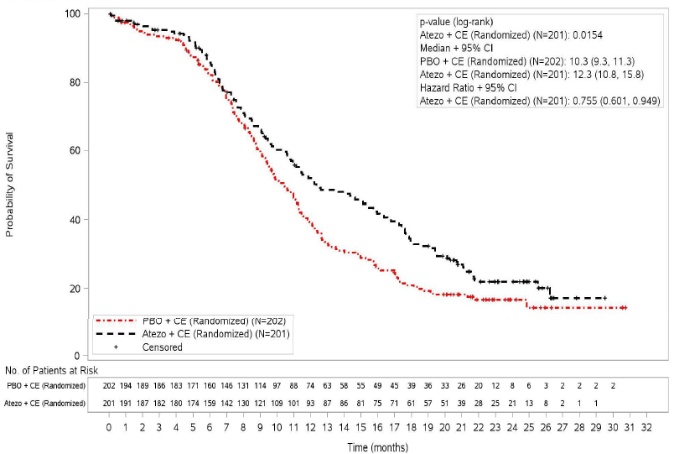
Source: Figure 2, p21 of updated CSR provided with the July 2019 pre-PBAC response.

Clinical claim
  - In July 2019, the PBAC considered that:
- the claim of superior comparative effectiveness of atezolizumab + CE compared with CE alone was reasonable with respect to OS, however the magnitude and durability of the benefit were uncertain;
- the revised claim of inferior comparative safety with manageable adverse events (AEs) of atezolizumab + CE compared with CE alone was reasonable (paragraphs 6.37-6.38, atezolizumab PSD, July 2019).
  - The PBAC reiterated its previous consideration that the claims of superior comparative effectiveness and inferior comparative safety of atezolizumab + CE compared with CE alone were reasonable.

Economic analysis
Updated base case of economic model
  - The minor resubmission presented an updated and respecified economic model, and stated that the changes were:
- The economic model was updated based on OS results from the most recent data-cut of the IMpower 133 trial (January 2019);
- OS curves were assumed to begin to converge at 24 months with convergence at 60 months;
- Time horizon of 5 years (as presented in the previous submission’s base case).
  - These three changes aligned with the changes requested by the PBAC in its July 2019 consideration.
  - The utility values in the economic model were also updated to reflect the most recent January 2019 data-cut of the IMpower 133 trial. This had a minimal impact on the ICER.
  - The minor resubmission stated that no structural changes, data transformations or interpretations were required to update the economic model. As a minor submission, the economic model was not independently evaluated.
  - The minor resubmission stated that with the changes outlined in Paragraph 5.8 (but at the price proposed in the previous submission), the incremental cost effectiveness ratio (ICER) would be $105,000 - $200,000 per quality adjusted life year (QALY). The resubmission stated that this is similar to the ICER noted by the PBAC of $105 - $200,000 per QALY when these changes were applied to the previous economic model, but based on the earlier April 2018 data-cut of IMpower 133. As such, updating the OS data increased the ICER by less than $15,000 per QALY (using the respecified base case).
Price proposal
  - The PBAC previously stated “that an ICER less than $45,000 - $75,000 per QALY … would be required for atezolizumab to be considered suitably cost-effective” (paragraph 7.13, atezolizumab PSD, July 2019). The minor resubmission noted this would require a significant price reduction and stated that a “significant straight price reduction would be unacceptable and proposed an alternative arrangement” comprising both a lower effective price and an “episode of care (EoC) cap”. These are discussed below.
  - Firstly, the minor resubmission proposed an effective approved ex-manufacturer price (AEMP) of $'''''''''''''''' per 1,200 mg vial, representing a '''''% reduction versus the price proposed in the previous submission (AEMP of $'''''''''''''''' per vial).
  - Secondly, the minor resubmission proposed an “episode of care (EoC) cap” (hereafter referred to as a Risk Sharing Arrangement (RSA)). The resubmission stated that the intention of the RSA was to rebate PBS expenditure for atezolizumab beyond '' doses per patient. As such, the subsidisation caps for the RSA were based on an average of ''' doses per patient (equivalent to '''''' months of treatment), which the minor resubmission stated was '''''% shorter than the average treatment duration estimated in the previous submission (of '''''' doses, or ''''''' months). The resubmission did not provide treatment duration information from the more recent (January 2019) data cutoff.
  - The minor resubmission assumed the RSA would reduce the average cost per patient from $'''''''''''''' (based on an average of '''''' doses) to a fixed cost per patient of $'''''''''''''' (based on '' doses per patient), with the difference ($'''''''''') assumed to be rebated to the Commonwealth. This level of rebate would only be achieved if utilisation of atezolizumab were at least at the level estimated by the minor resubmission. The PBAC noted that an alternative way to achieve the assumed level of price reduction would be through a further '''''% reduction to the effective price of atezolizumab. The pre-PBAC response stated that “such a significant straight price reduction would be unacceptable”.
  - Table 2 shows a summary of key results from the economic evaluation, reproduced from the minor resubmission.
Table 2: Summary of key results from the economic evaluation
Atezo+CE vs CE | Incremental cost | Incremental effectiveness | Incremental cost per QALY
Without RSA | $''''''''''''''' | ''''''''''' QALYs | $'''''''''''''''
With RSA ª | $'''''''''''''''' | ''''''''''' QALYs | $''''''''''''''''
Previous submission ^{b} | $'''''''''''''''' | ''''''''''' QALYs | $'''''''''''''''''
Atezo = atezolizumab; CE = carboplatin and etoposide; QALY = quality adjusted life year; RSA = Risk Sharing Arrangement.
Source: Table 3-1 Atezolizumab minor resubmission and Economic Evaluation_Jan19 cut_minor resubmission.xlsx, worksheet ‘Results tables’
ª Assuming the minor resubmission’s estimated rebates are achieved
^{b} Base case presented in previous submission (without convergence and with older OS data)
  - Without the proposed RSA (but with the reduced effective price), the ICER was estimated to be $75,000 - $105,000 per QALY. Including the proposed RSA (and assuming the minor resubmission’s estimated rebates are achieved) resulted in an ICER of $45,000 - $75,000 per QALY.
  - As the additional discount is proposed to be achieved through an RSA (rather than solely through a reduction to the effective price), the PBAC noted that the estimated ICER of $45,000/QALY – $75,000/QALY gained relies on the actual utilisation of atezolizumab being at least at the level estimated by the minor resubmission, so that the estimated rebates are achieved. The PBAC noted that for assessments of cost-effectiveness to rely on RSA rebates being realised, there would need to be a high level of confidence in the utilisation estimates underpinning the RSA in order to minimise the risk of the ICER not being achieved.
Extrapolation
  - In its July 2019 consideration, the PBAC “noted and agreed with the other issues regarding the economic model that were identified by the evaluation and the ESC, particularly the issues regarding: the choice of parametric function for OS extrapolation; and the proximity to death utilities presented. In light of these uncertainties, along with the small OS benefit and unclear PFS benefit, the PBAC considered that an ICER less than $45,000 - $75,000 per QALY (using the base case outlined above) would be required for atezolizumab to be considered suitably cost-effective.” (paragraph 7.13, atezolizumab PSD, July 2019).
  - As new longer-term data have been applied, the OS extrapolation is also affected. Figures 2 and 3 below show the OS and PFS data applied in the July 2019 and current economic models, respectively.
Figure 2: OS and PFS as applied in the previous economic model (April 2018 data-cut)
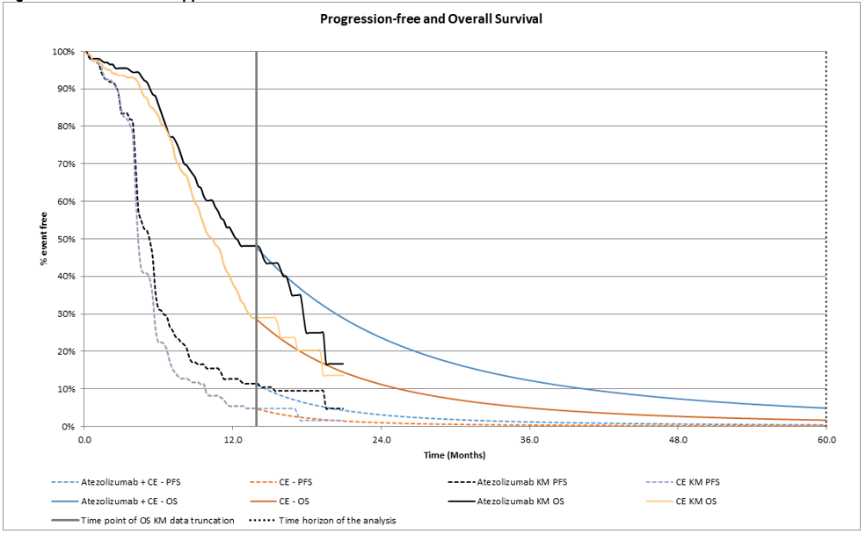
Source: Figure 2-1, p4 of the minor resubmission
Figure 3: OS and PFS as applied in the minor resubmission’s economic model (January 2019 data-cut and with convergence applied)
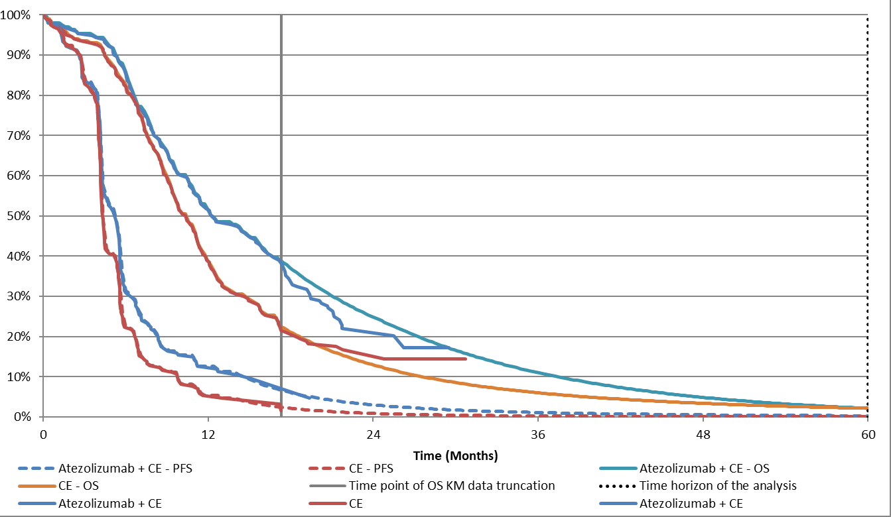
Source: Figure 2-2, p4 of the minor resubmission

Drug cost/patient: $''''''''''''' without RSA

$'''''''''''' with RSA (and with estimated rebates achieved)
  - In the minor resubmission, the proposed dispensed price for maximum amount (DPMA) of atezolizumab 1,200 mg vial was $''''''''''''''''' (based on 65.7% of prescriptions being dispensed in private hospitals and 34.3% in public hospitals) and it was estimated that patients would use an average of '''''' doses of atezolizumab. Without the proposed RSA, the average drug cost per patient was estimated to be $''''''''''''''. With the proposed RSA, the minor resubmission assumed that the cost of '''''' doses per patient would be rebated, resulting in a drug cost per patient of $''''''''''''' (i.e. based on '' doses per patient). The drug cost per patient for atezolizumab, with and without the RSA, is shown in Table 3.
Table 3: Drug cost per patient for atezolizumab
 | July 2019 major submission |  |  | November 2019 minor resubmission
 | Trial dose and duration | Model | Financial estimates | Without RSA | With RSA
Mean dose | 1,200mg | 1,200mg | 1,200mg | 1,200mg | 1,200mg
Mean duration | ''''''' months | '''''''' months | '''''''' months | ''''''''' months | ''''''' months
Mean number of dosesª | ''''''' | '''''''' | '''''''' | ''''''' | '''''''''
Cost/patient/dose | $'''''''''''''''''''' |  |  | $'''''''''''''''''''
Cost/patient | $'''''''''''''''' | $'''''''''''''''' | $''''''''''''''''' | $'''''''''''''''' | $'''''''''''''''
RSA = Risk Sharing Arrangement.
ª Assumed 1 dose every 3 weeks.
Source: Amended from Table 14, 6.02 atezolizumab minutes, July 2019 PBAC meeting; originally from Table 35, p141 IMpower CSR, p43 Section 3A and Table 4.2.8, p13 and Table 4.2.11, p15 Section 4 of the July 2019 submission.

Estimated PBS usage & financial implications
  - In July 2019, the PBAC “considered the changes to the financial estimates that were proposed by DUSC, and accepted by the pre-PBAC response, were reasonable including reducing the proportion of patients who progress from limited stage (LS)-SCLC to ES-SCLC and who have a ECOG 0-1 to '''''%; and reducing the estimated uptake rate in incident and prevalent patients to '''''% (due to contraindications)” (paragraph 7.14, atezolizumab PBAC Minutes, July 2019). As such, the total number of treated patients and scripts were unchanged from those estimated in the previous pre-PBAC response. The financial estimates were only updated for the lower effective price (and updates to dispensing fees).
  - Based on the updated price proposed in this minor resubmission, Table 4 presents the estimated total use and costs of atezolizumab in the first 6 years of listing.
Table 4: Estimated use and total cost of atezolizumab to the PBS/RPBS
 | Year 1 | Year 2 | Year 3 | Year 4 | Year 5 | Year 6
Estimated extent of use
Number of treated patients | '''''''''''' | '''''''''' | '''''''''' | ''''''''''''''' | ''''''''''''''' | ''''''''''''''
Number of scripts | ''''''''''''''' | ''''''''''''' | ''''''''''''' | ''''''''''''''' | ''''''''''''''' | '''''''''''''''
Estimated financial implications of atezolizumab (without proposed RSA)
Net cost to PBS/RPBSª | ''''''''''''''''''''''''' | $'''''''''''''''''''' | $'''''''''''''''''''' | $'''''''''''''''''''' | $''''''''''''''''''''''' | $'''''''''''''''''''''
MBS net cost ^{b} | $''''''''''''''''''''' | $''''''''''''''''''''' | $''''''''''''''''''''' | $'''''''''''''''''' | $'''''''''''''''''' | $'''''''''''''''''''''
Net cost to PBS/RPBS/MBS | $''''''''''''''''''''' | $''''''''''''''''''' | $''''''''''''''''''' | $'''''''''''''''''''''''' | $''''''''''''''''''' | $''''''''''''''''''''''
Net cost to PBS/RPBS - Previous submission ^{c} | $'''''''''''''''''''''''' | $''''''''''''''''''''''''''' | $'''''''''''''''''''''''' | $''''''''''''''''''''''''' | $'''''''''''''''''''''''''''' | $''''''''''''''''''''''''''''
DPMA = dispensed price for maximum amount; MBS = Medicare Benefits PBS = Pharmaceutical Benefits Scheme; RPBS = Repatriation Pharmaceutical Benefits Scheme.
Source: Section 4 Workbook_DUSC revisions_minor resubmission.xls, Table 4-1, p7 of the minor resubmission
Analysis assumes listing from 1 January 2020.
ª Costs represent DPMA minus copayment.
^{b} Based on MBS item 13915 ‘Administration of cytotoxic chemotherapy (1 hour or less duration)
^{c} As suggested by DUSC and accepted in the Pre-PBAC response. Per Table 16 of July 2019 Minutes, net cost to PBS/RPBS/MBS.

The redacted table shows that at Year 6, the estimated number of patients was less than 10,000.
  - The estimated net cost to the PBS/RPBS for atezolizumab was reduced to $10 – 20 million in Year 6 of PBS listing, with a total cost of more than $100 million in the first 6 years of listing (without the proposed RSA). This compares with more than $100 million in the first 6 years of listing in the July 2019 submission, including the changes suggested by DUSC and accepted in the July 2019 pre-PBAC response.
  - The minor resubmission proposed an RSA in which the expenditure cap was based on an average of ''' doses per patient (an average of '''''' doses per patient was estimated in the previous submission). The minor resubmission proposed that 100% of any expenditure above this subsidisation cap would be rebated to the Commonwealth. Table 5 shows the subsidisation caps for expenditure on atezolizumab, as proposed in the minor resubmission.

Table 5: Proposed subsidisation caps for expenditure on atezolizumab (based on an average of 7 doses per patient)
 | Year 1 | Year 2 | Year 3 | Year 4 | Year 5 | Year 6
Effective cost to PBS/RPBS – expenditure cap | $''''''''''''''''''''''' | $''''''''''''''''''''''''''''' | $''''''''''''''''''''''''''' | $''''''''''''''''''''''''''''' | $'''''''''''''''''''''''' | $'''''''''''''''''''''''''
PBS = Pharmaceutical Benefits Scheme; RPBS = Repatriation Pharmaceutical Benefits Scheme.
Source: Section 4 Workbook_DUSC revisions_minor resubmission.xls

  - The PBAC noted that the rebates leading to the reduced price per patient applied in the economic model would only be achieved if atezolizumab utilisation is at the level estimated in the minor resubmission.
  - Given that a high degree of confidence in the utilisation estimates is required in order to minimise the risk of the ICER not being achieved, the minor overview provided further information (in the table below) regarding the method used to estimate the number of treated patients.
Table 6: Summary of patient number estimates
 | Value | Year 1ª | Source and comment from July 2019 DUSC Advice
Lung cancer patients |  | 13,219 | AIHW 2014 with around 2% annual growth
% of lung cancer that is SCLC | 11.8% | 1,553 | AIHW 2011 report. Assumed a constant proportion over time. While DUSC considered the estimate was reasonable, DUSC also considered this was an area of uncertainty as SCLC is highly correlated with smoking and the rate of smoking is declining.
Incident patients
% of SCLC that is ES SCLC | 71% | 1,108 | Four Australian sources (including the Victorian Cancer Registry)
ECOG 0 -1 | '''''% | '''''''''' | Victorian Cancer Registry and Sydney South West Area Health Service, which reported 67% and 57% of SCLC patients had ECOG ≤1 respectively. While DUSC considered that ''''''% was reasonable, DUSC also considered this was an area of uncertainty as the submission used the '''''''''''''' estimate.
% treated | '''''% | ''''''' | Changed from 100% in the original submission based on DUSC advice
Prevalent patients
% of SCLC that is LS SCLC | '''''''% | '''''''' | (Inverse of ‘% of SCLC that is ES SCLC’ above)
% developing into ES SCLC | '''''''% | ''''''''' | -
ECOG 0-1 | '''''''% | ''''''''' | Changed from 100% in the original submission based on DUSC advice
% treated | '''''''% | '''''''' | Changed from 100% in the original submission based on DUSC advice
Grandfathered patients |  | '''''
Total patients |  | ''''''''''
Source: Table 16, atezolizumab PBAC Minutes July 2019
SCLC = small cell lung cancer, ES = extensive stage, ECOG = Eastern Cooperative Oncology Group performance status, LS = localised stage
ª Number of treated patients estimated at each step in Year 1 of the financial estimates.

  - The previous pre-PBAC response accepted the changes suggested by DUSC, which were to: reduce the proportion of patients who progress from LS-SCLC to ES-SCLC and who have an ECOG 0-1 from 100% to ''''''%; and reducing the estimated uptake rate in incident and prevalent patients from 100% to ''''''%.
  - However, there were two other assumptions that DUSC had considered were uncertain which were not addressed in the previous pre-PBAC response. These were that the estimates:
- assumed that the proportion of patients with SCLC will not change over time despite SCLC being highly correlated with smoking and the rate of smoking in Australia is in decline; and
- used the upper estimate to determine the proportion of patients with ES-SCLC who would be eligible for atezolizumab (pages 1 and 6, atezolizumab DUSC Advice, July 2019).
  - As a minor submission, the financial estimates have not been independently evaluated.
For more detail on PBAC’s view, see section 6 PBAC outcome.
- PBAC Outcome
  - The PBAC recommended the listing of atezolizumab, for use in combination with platinum-based chemotherapy plus etoposide, on the basis that it should be available only under special arrangements under section 100 – Efficient Funding of Chemotherapy. The PBAC recommended the listing be made available for previously untreated patients with ES-SCLC and an ECOG score 0–1. The PBAC’s recommendation for listing was based on, among other matters, its assessment that the cost-effectiveness of atezolizumab would be acceptable at the price applied in the economic model. The PBAC was satisfied that the minor resubmission’s proposal to achieve cost-effectiveness through RSA rebates, in addition to a proposed reduction in the effective price, was reasonable in this case as the Committee had a high degree of confidence in the financial estimates. The recommendation also reflected the high clinical need in this condition.
  - The PBAC was satisfied that atezolizumab + CE provides, for some patients, a significant improvement in efficacy over CE alone.
  - The PBAC re-iterated the high clinical need for effective treatments for ES-SCLC, noting the poor prognosis for patients and that there have been no new developments in the treatment of SCLC in 20 years.
  - The PBAC considered that the requested restriction was reasonable. The PBAC considered that use in combination with a platinum-based antineoplastic (cisplatin or carboplatin) and etoposide should be allowed under the initial and grandfathering restrictions.
  - The PBAC previously accepted the nominated comparator, platinum-based chemotherapy (cisplatin or carboplatin) + etoposide.
  - The minor resubmission did not present any new clinical evidence. The PBAC reiterated that the claim of superior comparative effectiveness of atezolizumab + CE compared with CE alone was reasonable with respect to OS. However, the PBAC considered that the magnitude and durability of the benefit was uncertain, especially given the short duration of follow-up in the trial (median follow-up of 22.9 months in the updated data-cut). The PBAC reiterated that the claim of inferior safety with manageable adverse events was reasonable.
  - The PBAC noted that the minor resubmission proposed a significant reduction in the price and the total financial impact compared with the previous submission. This comprised: a '''''% reduction to the proposed effective DPMA; and a RSA with expenditure thresholds set '''''% lower than that calculated based on the expected utilisation levels together with a rebate of 100% for expenditure above the thresholds. Combined, these two measures meant that:
- the price per patient per course was reduced from $'''''''''''' in the previous submission to $''''''''''''' in the resubmission (assuming the RSA results in '''''% of expenditure on atezolizumab being rebated); and
- the total financial impact of atezolizumab (net cost to PBS/RPBS) was reduced from more than $100 million over the first 6 years of listing in the previous pre-PBAC response to $60 - $100 million (as limited by the proposed RSA).
  - The PBAC noted the minor resubmission had amended the economic model by: using the updated OS results from the most recent data-cut; and assuming that the OS curves begin to converge at 24 months with convergence at 60 months. The PBAC considered that these changes adequately addressed its previous concerns. The PBAC considered the cost-effectiveness of atezolizumab was acceptable at the price applied in the economic model, which resulted in an ICER of $45,000 /QALY - $75,000/QALY.
  - The price applied in the economic model was lower than the requested effective DPMA on the basis that the difference would be rebated through the RSA (as outlined above). The PBAC noted that for assessments of cost-effectiveness to rely on RSA rebates being realised, there would need to be a high level of confidence in the utilisation estimates underpinning the RSA in order to minimise the risk of the ICER not being achieved.
  - The PBAC considered that the updated financial estimates provided in the previous pre-PBAC response (from July 2019) had adequately addressed the key uncertainties with the financial estimates. Further, the PBAC considered the population was well-defined and there were reliable sources for the majority of the assumptions applied in the financial estimates. Overall, the PBAC considered that the financial estimates were sufficiently reliable to form the basis for the RSA and were reasonably confident that an ICER of less than $45,000/QALY - $75,000/QALY would be achieved.
  - The PBAC advised that an RSA with a 100% rebate above the subsidy caps would be required to achieve cost-effectiveness. The PBAC considered that the RSA should be based on the updated estimates and the assumed average of ''' doses per patient, as proposed in the minor resubmission (as outlined in Table 5). The PBAC noted that if the use is lower than estimated in Table 4, then atezolizumab will not be acceptably cost-effective Thus, the PBAC considered that actual utilisation for this indication should be monitored to ensure that cost-effectiveness is reached, and that a method be agreed on to review utilisation and the risk share agreement, should expenditure not reach the levels expected in the submission.
  - The PBAC found that the criteria prescribed by the National Health (Pharmaceuticals and Vaccines – Cost Recovery) Regulations 2009 for Pricing Pathway A were not met. Specifically, the PBAC found that in the circumstances of its recommendation for atezolizumab:
- The treatment is not expected to provide a substantial and clinically relevant improvement in efficacy over alternative therapies. As outlined in Paragraph 6.6, the PBAC considered that the magnitude and durability of the benefit were uncertain;
- The treatment is expected to address a high and urgent unmet clinical need;
- It was not necessary to make a finding in relation to whether it would be in the public interest for the subsequent pricing application to be progressed under Pricing Pathway A because one or more of the preceding tests had failed.
  - Atezolizumab is not suitable for prescribing by nurse practitioners as antineoplastic agents are currently considered to be out of scope for prescribing by nurse practitioners.
  - The PBAC recommended that the Early Supply Rule should not apply to atezolizumab.
  - The PBAC did not recommend that atezolizumab should be treated as interchangeable on an individual patient basis with any other drugs.
Outcome:
Recommended

- Recommended listing
  - Add new item:
Name, Restriction,  Manner of administration and form | Max Amt |  | №.of  Rpts | Proprietary Name and Manufacturer
ATEZOLIZUMAB  Solution for IV infusion  1,200 mg in 20 mL vial | 1,200 mg |  | 3 | TECENTRIQ®  Roche Products Pty Ltd
Category / Program |  | Section 100 – Efficient funding of Chemotherapy  Private Hospital/Private Clinic Authority Required  Public Hospital Authority Required
Prescriber type: |  | Dental Medical Practitioners Nurse practitioners Optometrists  Midwives
Episodicity:
Severity: |  | Extensive-stage primary
Condition: |  | Small cell carcinoma of lung [24247 draft, preferred SNOMED term]
PBS Indication: |  | Extensive-stage primary small cell carcinoma of lung
Treatment phase: |  | Initial treatment
Restriction: |  | Restricted benefit  Authority Required - In Writing  Authority Required – Telephone/Electronic/Emergency  Streamlined
Clinical criteria: |  | The condition must be previously untreated [8594],  AND  Patient must have a WHO performance status of 0 or 1 [10859],  AND  The treatment must be in combination with etoposide and a platinum-based antineoplastic
Administrative advice |  | No increase in the maximum quantity or number of units may be authorised [7606].  No increase in the maximum number of repeats may be authorised [7607].  Special Pricing Arrangements apply [7608].

 | Name, Restriction,  Manner of administration and form | Max Amt |  | №.of  Rpts | Proprietary Name and Manufacturer
 | ATEZOLIZUMAB  Solution for IV infusion  1,200 mg in 20 mL vial | 1,200 mg |  | 4 | TECENTRIQ®  Roche Products Pty Ltd
Category /Program |  |  | Section 100 – Efficient funding of Chemotherapy  Private Hospital/Private Clinic Authority Required  Public Hospital Authority Required
Prescriber type: |  |  | Dental Medical Practitioners Nurse practitioners Optometrists  Midwives
Episodicity:
Severity: |  |  | Extensive-stage primary
Condition: |  |  | Small cell carcinoma of lung
PBS Indication: |  |  | Extensive-stage primary small cell carcinoma of lung
Treatment phase: |  |  | Continuing treatment
Restriction: |  |  | Restricted benefit  Authority Required - In Writing  Authority Required – Telephone/Electronic/Emergency  Streamlined
Clinical criteria: |  |  | The treatment must be as monotherapy [7910],  AND  Patient must have previously received PBS-subsidised treatment with this drug for this condition [20717]  AND  Patient must not have developed disease progression while being treated with this drug for this condition [23679]
Administrative advice |  |  | No increase in the maximum quantity or number of units may be authorised [7606].  No increase in the maximum number of repeats may be authorised [7607].  Special Pricing Arrangements apply [7608].

Name, Restriction,  Manner of administration and form | Max Amt |  | №.of  Rpts | Proprietary Name and Manufacturer
ATEZOLIZUMAB  Solution for IV infusion  1,200 mg in 20 mL vial | 1,200 mg |  | 4 | TECENTRIQ®  Roche Products Pty Ltd
Category/Program: |  | Section 100 – Efficient Funding of Chemotherapy  Private Hospital/Private Clinic Authority Required  Public Hospital Authority Required
Episodicity:
Severity: |  | Extensive-stage primary
Condition: |  | Small cell carcinoma of lung
PBS Indication: |  | Extensive-stage primary small cell carcinoma of lung
Treatment phase: |  | Grandfathering treatment
Restriction: |  | Restricted benefit  Authority Required - In Writing  Authority Required – Telephone/Electronic/Emergency  Streamlined
Clinical criteria: |  | Patient must have received treatment with this drug for this condition prior to the [PBS listing date] [new concept],  AND  Patient must not have developed disease progression while being treated with this drug for this condition [23679],  AND  The condition must have been untreated prior to initiation of non-PBS subsidised treatment with this drug for this condition [new concept],  AND  Patient must have had a WHO performance status of 0 or 1 at the time non-PBS subsidised treatment with this drug for this condition was initiated [21831],  AND  The treatment must be in combination with etoposide and a platinum-based antineoplastic if the patient is yet to complete their first 4 cycles of treatment; or  The treatment must be as monotherapy if being administered as maintenance therapy [new concept]
Prescriber instructions |  | A patient may qualify for PBS-subsidised treatment under this restriction once only. For continuing PBS-subsidised treatment, a Grandfathered patient must qualify under the continuing treatment criteria. [24007]
Administrative advice |  | No increase in the maximum quantity or number of units may be authorised [7606].  No increase in the maximum number of repeats may be authorised [7607].  Special Pricing Arrangements apply [7608].

This restriction may be subject to further review. Should there be any changes made to the restriction the Sponsor will be informed.

- Context for Decision
The PBAC helps decide whether and, if so, how medicines should be subsidised through the Pharmaceutical Benefits Scheme (PBS) in Australia. It considers applications regarding the listing of medicines on the PBS and provides advice about other matters relating to the operation of the PBS in this context. A PBAC decision in relation to PBS listings does not necessarily represent a final PBAC view about the merits of the medicine or the circumstances in which it should be made available through the PBS. The PBAC welcomes applications containing new information at any time.
- Sponsor’s Comment
The sponsor had no comment.

Cherny NI, Dafni U, Bogaerts J, et al: ESMO-Magnitude of Clinical Benefit Scale version 1.1. Annals of Oncology 28:2340-2366, 2017.

