6.10 DIMETHYL FUMARATE

Capsules 120mg and 240mg

Tecfidera®, Biogen Australia Pty Ltd
- Purpose of Application
  - The minor submission requested the current Authority Required (telephone) listing of dimethyl fumarate capsules be amended to an Authority Required (STREAMLINED) listing.
- Requested listing
The submission requested a change of restriction level for the existing listings. No other changes were requested.
Name, Restriction,  Manner of administration and form | Max.  Qty (units) | №.of  Rpts | Dispensed Price for Max. Qty | Proprietary Name and Manufacturer
DIMETHYL FUMARATE  Capsules, 120mg | 28 | 0 (initial and continuing) | $638.87 | Tecfidera | Biogen Australia Pty Ltd
DIMETHYL FUMARATE  Capsules, 240mg | 56 | 5 (continuing) | $1287.90 | Tecfidera
Authority Required (STREAMLINED)

For more detail on PBAC’s view, see section 5 PBAC outcome.

- Background
  - Dimethyl fumarate was TGA registered on 11 July 2013 for the treatment of patients with relapsing-remitting multiple sclerosis.
  - In July 2013, the PBAC recommended the listing of dimethyl fumarate on a cost-minimisation basis with ABCR therapies (intramuscular interferon beta-1a, subcutaneous interferon beta-1a, interferon beta-1b and glatiramer acetate) (Dimethyl fumarate Public Summary Document (PSD), July 2013 p6-7).
  - Dimethyl fumarate was listed on the PBS as an Authority Required (telephone) listing for RRMS on 1 December 2013. Dimethyl fumarate was listed in conjunction with a Deed of Agreement between Biogen and the Department, which included both a risk sharing arrangement (RSA) with a cap on expenditure for the 120 mg form, with rebates for any expenditure over the cap, and a special price arrangement (SPA). On 1 April 2019 the original Deed for dimethyl fumarate was replaced with a new Deed which ''''''''''''''''''' '''''''' ''''' '''''''' ''''''' '''''''' ''''''''''''''''''''' '''' '''''' '''''''''''''' '''''''''' '''''''''''''' ''''' ''''''''''''''''''' '''''''''.
  - A summary of PBS listed drugs for treatment of RRMS is provided in Table 1.
Table 1: PBS listed RRMS drugs as at 1 September 2019
Drug | Brands listed on PBS | Route of administration | Authority level | Schedule
Immunomodulators (ABCR therapy)
Glatiramer acetate | Copaxone | Injection | Streamlined | General
Interferon beta-1a | Rebif  Avonex | Injection | Streamlined | General
Interferon beta-1b | Betaferon | Injection | Streamlined | General
Newer therapies
Alemtuzumab | Lemtrada | Injection | Streamlined | S100 HSD
Cladribine | Mavenclad | Oral | Telephone | General
Dimethyl fumarate | Tecfidera | Oral | Telephone | General
Fingolimod | Gilenya | Oral | Telephone | General
Natalizumab | Tysabri | Injection | Streamlined | S100 HSD
Ocrelizumab | Ocrevus | Injection | Streamlined | S100 HSD
Peginterferon beta-1a | Plegridy | Injection/pen device | Streamlined | General
Teriflunomide | Aubagio  Teriflunomide Sandoz  Teriflagio | Oral | Telephone | General

  - In December 2014, the PBAC recommended lowering the restriction level for interferon beta-1a, interferon beta-1b, glatiramer and peginterferon beta-1a from Authority Required to Authority Required (STREAMLINED) as a result of the Post-Market Review of Authority Required PBS listings. At this time, the Committee noted that the oral therapies had only been listed in 2011 (fingolimod) and 2013 (dimethyl fumarate and teriflunomide) and as such did not recommend a change to the authority level for oral therapies as the market had not yet stabilised.
  - In July 2016, the PBAC recommended increasing the maximum quantity of dimethyl fumarate 120 mg capsules from one to two packs (28 capsules) to allow flexibility in dose titration for both initial and continuing dose titration periods (Dimethyl fumarate PSD, July 2016).
  - In November 2016, the PBAC did not recommend a change to the authority level of teriflunomide from Authority Required to Authority Required (STREAMLINED) as the Committee considered that the market for oral therapies for RRMS had not yet stabilised. The Committee noted that the October 2015 review of the utilisation of PBS listed medicines for RRMS by the Drug Utilisation Sub-Committee (DUSC) showed that the market for oral therapies was still growing (Teriflunomide PSD, November 2016 paragraph 6.2).
  - At the November 2019 PBAC meeting, the Committee also considered a major submission for siponimod (Mayzent®) requesting an Authority Required listing for treatment of patients with secondary progressive multiple sclerosis (agenda item 5.11).

Consideration of the evidence

Sponsor hearing
  - There was no hearing for this item as it was a minor submission.

Consumer comments
  - The PBAC noted that no consumer comments were received for this item.

Estimated PBS usage & financial implications
  - The submission argued that dimethyl fumarate has been listed for 6 years and that utilisation has stabilised.
  - The sponsor claimed that the change in authority level would not significantly affect utilisation rates or financial implications as the market for oral therapy for RRMS had stabilised. However, the minor submission did not present estimates of the financial impact of potential changes in utilisation rates resulting from the change in authority level.
  - An analysis of the utilisation of PBS listed medicines for multiple sclerosis was undertaken by the DUSC Secretariat. Patient and prescription numbers have stabilised for most MS therapies over the period 1 July 2017 to 30 June 2019 (Figure 1).
Figure 1: Number of patients by RRMS therapy (1 July 2015 – 30 June 2019)
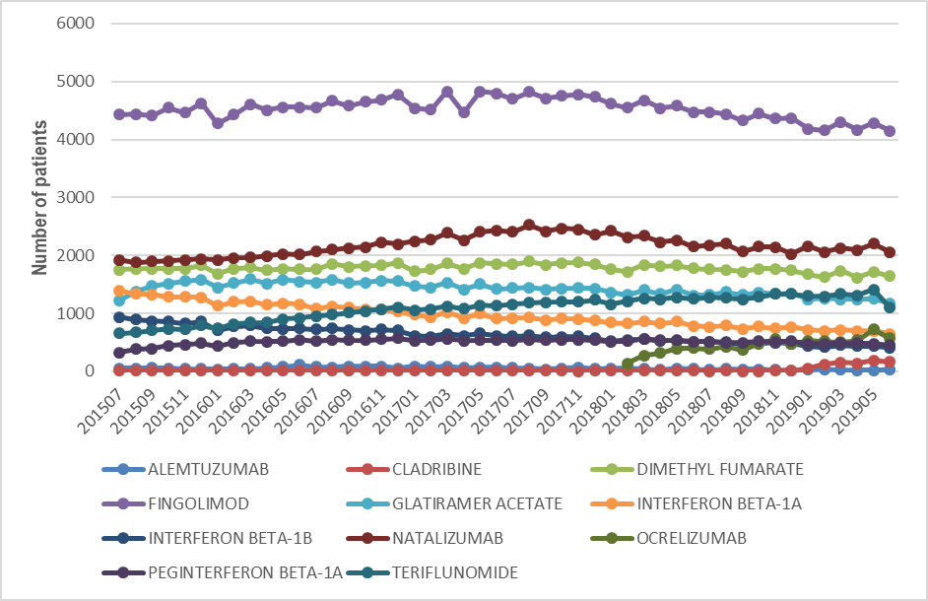Source: DHS Pharmacy Claims database

  - The most recent consensus statement regarding treatment of patients with RRMS is reported by Broadley et al 2015 in the Medical Journal of Australia. All of the medicines listed in Table 1 have the same place in therapy, with no preference given to any of the treatments, however ocrelizumab and cladribine were not registered at the time the consensus statement was published (2015).
  - Reducing the authority level for oral therapies may result in increased use of oral therapies in place of injectable therapies that are currently available as Authority Required (STREAMLINED), due to the reduced administrative burden. It is unlikely that this change will affect the total size of the market for RRMS therapy.
  - The AEMP for dimethyl fumarate 240mg (maintenance dose) is greater than that for glatiramer, interferon beta-1a, and interferon beta-1b. Patients switched from glatiramer, interferon beta-1b or interferon beta-1b to dimethyl fumarate would result in an increased cost to Government.
  - The AEMP for dimethyl fumarate 240mg (maintenance dose) is less than that for natalizumab. Patients switched from natalizumab to dimethyl fumarate would result in reduced cost to the Commonwealth.

For more detail on PBAC’s view, see section 5 PBAC outcome.
- PBAC Outcome
  - The PBAC recommended amending the listing of dimethyl fumarate to Authority Required (STREAMLINED) for the treatment of relapsing remitting multiple sclerosis (RRMS).
  - The PBAC also recommended amending the listings of fingolimod, teriflunomide and cladribine to Authority Required (STREAMLINED) for the treatment of RRMS.
  - The PBAC noted that patient and prescription numbers have stabilised for most MS therapies. The PBAC considered that the change of restriction level for oral therapies would not impact utilisation rates across all RRMS therapies.
  - The PBAC advised under Section 101 (3BA) of the National Health Act 1953 that dimethyl fumarate should not be treated as interchangeable with any other drugs.
The PBAC noted that current arrangements for eligible prescribers and the Early Supply Rule remained appropriate.
The PBAC noted that this submission is not eligible for an Independent Review as it received a positive recommendation.
Outcome:
Recommended
- Recommended listing
Amend existing listings 2896K, 2943X and 2966D (dimethyl fumarate) as follows:
Change restriction level from Authority Required (Telephone) to Authority Required (STREAMLINED).
Amend existing listings 11818B and 5262Y (fingolimod) as follows:
Change restriction level from Authority Required (Telephone) to Authority Required (STREAMLINED).
Amend existing listing 2898M (teriflunomide) as follows:
Change restriction level from Authority Required (Telephone) to Authority Required (STREAMLINED).
Amend existing listings 11603Q, 11611D and 11604R (cladribine) as follows:
Change restriction level from Authority Required (Telephone) to Authority Required (STREAMLINED).
- Context for Decision
The PBAC helps decide whether and, if so, how medicines should be subsidised through the Pharmaceutical Benefits Scheme (PBS) in Australia. It considers applications regarding the listing of medicines on the PBS and provides advice about other matters relating to the operation of the PBS in this context. A PBAC decision in relation to PBS listings does not necessarily represent a final PBAC view about the merits of the medicine or the circumstances in which it should be made available through the PBS. The PBAC welcomes applications containing new information at any time.
- Sponsor’s Comment
Biogen welcomes the PBAC positive recommendation for amending the listing of dimethyl fumarate to Authority Required (STREAMLINED) for the treatment of RRMS.

