7.05 OBETICHOLIC ACID,
Tablet 5 mg, 10 mg,
Ocaliva®,
Chiesi Australia Pty Ltd.

- Purpose of resubmission
  - The resubmission requested an Authority Required listing for obeticholic acid (OCA) for the treatment of primary biliary cholangitis (PBC). OCA has previously been considered, but not recommended, by the PBAC in November 2018 and March 2019.
  - The requested basis for listing was cost-effectiveness of OCA in combination with ursodeoxycholic acid (OCA+UDCA) compared to UDCA plus placebo for UDCA inadequate responders.
Table 1: Key components of the clinical issue addressed by the resubmission (as stated in the resubmission)
Component | Description
Population | Patients diagnosed with PBC who are either  - UDCA-inadequate responders, defined as patients with an alkaline phosphatase (ALP) > 1.67 x upper limit of normal (ULN) and/or total bilirubin > 1 x ULN despite receiving UDCA treatment for ≥ 12 months (with a stable dose for 3 months); OR  - UDCA-intolerant, defined as patients who are intolerant to UDCA therapy due to severe side effects, most likely diarrhoea (3%) or very low-incident events including upper abdominal pain, decompensation of hepatic cirrhosis, calcification of gallstones, allergic reactions or urticaria
Intervention | - For UDCA-inadequate responders: OCA 5-10 mg titration (as defined for the titration group in POISE; 5 mg for the first six months of treatment, followed by 10 mg for the subsequent months) + UDCA (13-15 mg per kilogram of body weight).  - For UDCA-intolerant patients: OCA 5-10 mg titration monotherapy
Comparator | - For UDCA-inadequate responders: UDCA monotherapy.  - For UDCA-intolerant patients: placebo
Outcomes | The primary composite endpoint was an ALP level of less than 1.67 times the upper limit of the normal range, with a reduction of at least 15% from baseline, and a total bilirubin level at or below the upper limit of the normal range at 12 months.  Secondary efficacy end points included levels of ALP, GGT, alanine aminotransferase, aspartate aminotransferase, total and conjugated bilirubin, and albumin; prothrombin time; international normalized ratio; plasma bile acid levels.
Clinical claim | For patients with an inadequate response to UDCA, OCA titration dosing (5-10mg) plus UDCA is superior to UDCA alone in reducing alkaline phosphatase and bilirubin levels and other important clinically relevant endpoints.  For patients intolerant to UDCA, OCA titration dosing (5-10mg) is superior to placebo in reducing alkaline phosphatase and bilirubin levels and other important clinically relevant endpoints.  OCA titration dosing (5-10mg) is inferior in terms of safety compared with placebo/best supportive care when used as combination therapy with UDCA for patients with prior inadequate response to UDCA and as monotherapy for patients who are intolerant to UDCA.
ALP = alkaline phosphatase; GGT = gamma glutamyl transferase; OCA = obeticholic acid; PBC = primary biliary cholangitis; UDCA = ursodeoxycholic acid; ULN = upper limit of normal.
Source: Table 10, p6 of the resubmission.
Blue shading indicates data previously seen by the PBAC.
- Background
Registration status
  - OCA was registered by the Therapeutic Goods Administration (TGA) on 21 September 2018 for ‘the treatment of primary biliary cholangitis (also known as primary biliary cirrhosis) in combination with ursodeoxycholic acid (UDCA) in adults with an inadequate response to UDCA or as monotherapy in adults unable to tolerate UDCA’.
Previous PBAC consideration
  - Table 2 summarises the outstanding matters of concern with respect to the March 2019 submission and how they have been addressed in the current resubmission.
Table 2: Summary of key matters of concern
Component | Matter of concern as identified in OCA PSD, July 2019 | How the resubmission addresses it
Restriction | The PBAC considered that the restriction should state that patients should not continue treatment if they experience decompensated cirrhosis (DCC) or hepatocellular cancer (HCC) (paragraph 7.4).  The PBAC recommended that the restriction be an Authority Required (written) for initial treatment and Authority Required (telephone) for continuing treatment to reduce the risk of leakage and use in UCDA-tolerant patients (paragraph 7.4). | Addressed.  Addressed.
Clinical Evidence
Clinical claim regarding efficacy for UDCA inadequate responders | The PBAC considered that the claim of superior effectiveness for OCA 5-10 mg titration + UDCA compared with UDCA monotherapy in patients who were UDCA-inadequate responders was again reasonable; however, the magnitude of the benefit remained uncertain (paragraph 6.21). | Not addressed. No new evidence provided.
Clinical claim regarding efficacy for UDCA-intolerant patients | The PBAC considered that the claim of superior effectiveness for OCA 5-10 mg titration monotherapy compared with placebo in patients who were UDCA-intolerant was not adequately supported by the data (paragraph 6.23). | Not addressed. No new evidence provided.
Economic evidence
Price of OCA | The PBAC acknowledged that PBC is a rare disease and that this was reflected in the quantity of the clinical evidence, particularly concerning the population of patients who are intolerant to UDCA. As the uncertainty surrounding the incremental benefit of OCA was unlikely to be reduced by future high quality data, the PBAC considered that this could be mitigated through the requested price (paragraph 7.12). | OCA effective AEMP was reduced by 7%. The pre-PBAC response offered an additional 13% price reduction to the July 2019 price (effective DPMQ = $'''''''''''''''''''') resulting in an effective DPMQ of $''''''''''''''''''''''.  The resubmission did not present an ICER for UDCA intolerant patients.
Verification of transition probabilities | The ESC considered that many of the transition probabilities from the biochemical health states to the liver disease health states and between the liver disease health states were unable to be verified based on the information presented by the resubmission. (paragraph 6.32) The PBAC again considered that the model lacked transparency and clinical plausibility and was insufficient to inform decision making (paragraph 7.9) | Some data sources changed. Many transition probabilities remained unable to be verified.
Time horizon | The time horizon in the model (50 years) was long compared with the median age of patients in the POISE trial (56 years), the duration of follow-up in the POISE trial (12 months) and the progressive nature of the disease (paragraphs 6.32 and 7.9). | The model time horizon was changed to 30 years.
Model input clarification and justification | The PBAC considered that other model inputs required more clarification and justification. The PBAC advised that if this was not possible it might be more appropriate to present a cost per responder analysis, noting the potential difficulties of interpreting an ICER based on this outcome (paragraph 7.10). | Some model inputs were clarified, many remained unable to be verified.  The resubmission also estimated a cost per responder (step 1 of the economic evaluation).
Utility values and disutilities for adverse events | Utility values were unable to be verified and the resubmission did not apply disutilities to adverse events (paragraph 6.32). | Utility values for HCC and DCC were unchanged and remained unable to be verified.  Disutilities were applied for adverse events (pruritus) for the first 12 months of treatment.
Long-term costs | In the model, the OCA and UDCA treatment costs cease once a patient progresses to the liver disease health states. As the proposed PBS restriction only includes a continuation rule at 12 months, with no requirement for reassessment of efficacy after that, treatment costs may have been underestimated (paragraph 6.32). | Restriction revised.
Financial impact
Estimated number of patients | The PBAC … considered that the number of patients treated may again be underestimated (paragraph 7.11). | Growth rate of UDCA treated patients was changed from 2% to 10%.  Patients who were receiving UDCA and were assumed to have PBC were increased from 68% to 100%.
RSA | The PBAC advised that an RSA, in the form of subsidisation caps would be an appropriate method to manage the uncertainties surrounding uptake and the risk of leakage to patients who were UCDA responders (paragraph 7.13). | RSA proposed in the form of financial caps.
AEMP = approved ex-manufacturer price; DCC = decompensated cirrhosis; ESC = Economic Sub-Committee; HCC = hepatocellular cancer; ICER = incremental cost-effectiveness ratio; OCA = obeticholic acid; PBAC = Pharmaceutical Benefits Advisory Committee; PBC: primary biliary cholangitis; PSCR = pre-Sub-Committee response; PSD = Public Summary Document; RSA = risk sharing arrangement; UDCA = ursodeoxycholic acid; ULN = upper limit of normal
Source: Complied during the evaluation

For more detail on PBAC’s view, see section 7 PBAC outcome.
- Requested listing
Name, Restriction, Manner of administration and form | Max.  Qty | №.of  Rpts | DPMQ | Proprietary Name and Manufacturer
Obeticholic acid  Tablet, 5mg | 1 pack  30 units | 5 | Published: $4,178.12 Effective: $''''''''''''''''''''' | OCALIVA® | Manufacturer: Intercept Pharma  Australian Sponsor: Chiesi Australia Pty Ltd

Category/Program | Section 85 (General Schedule)
Prescriber type: | Dental Medical Practitioners Nurse practitioners Optometrists Midwives
Condition: | Primary biliary cholangitis
PBS Indication: | Primary biliary cholangitis
Treatment phase: | Initial treatment
Restriction: | Restricted benefit  Authority Required - In Writing  Authority Required – Telephone, Electronic  Streamlined
Treatment criteria: | Patient must be treated by a gastroenterologist or hepatologist or in consultation with a gastroenterologist or hepatologist.
Clinical criteria: | Patient must not have severe liver disease,  ORAND  Patient must not have immunodeficiency diseases,  AND  Treatment must be in combination with ursodeoxycholic acid (UDCA) in adults with an inadequate response to UDCA,  AND  The patient must have an alkaline phosphatase (ALP) greater than or equal to 1.67 times the upper limit of normal (ULN),  AND/OR  Patient must have a total bilirubin > 1x ULN but < 2x the ULN,  OR  Treatment must be as monotherapy, in adults unable to tolerate UDCA, due to severe side effects.
Prescriber Instructions: | Severe side effects of UDCA therapy include diarrhoea, upper abdominal pain, decompensation of hepatic cirrhosis, calcification of gallstones, allergic reactions or urticaria.
Administrative Advice: | Not for use in the treatment of sclerosing cholangitis or cholelithiasis.  Special pricing arrangements apply
Source: p37-38 of the resubmission.

Category/Program | Section 85 (general schedule)
Prescriber type: | Dental Medical Practitioners Nurse practitioners Optometrists Midwives
Condition: | Primary biliary cholangitis
PBS Indication: | Primary biliary cholangitis
Treatment phase: | Continuing treatment
Restriction: | Restricted benefit  Authority Required - In Writing  Authority Required - Telephone, Electronic  Streamlined
Treatment criteria: | Patient must be treated by a gastroenterologist or hepatologist or in consultation with a gastroenterologist or hepatologist.
Clinical criteria: | Patient must have previously been issued with an authority prescription for this drug for this condition,  AND  Patient must have adequately tolerated 5 mg dose at 6 months assessment, OR  Patient must have achieved an adequate response to 5 mg as defined as an ALP < 1.67x ULN with ≥ 15% decrease from baseline in ALP and total bilirubin <1x ULN  AND  Patient must continue to achieve an adequate response at yearly assessments  ORAND  Not have compensated cirrhosis, decompensated cirrhosis or hepatocellular carcinoma.
Administrative Advice | Not for use in the treatment of sclerosing cholangitis or cholelithiasis.  Special pricing arrangements apply  Note  For prescribing by nurse practitioners as continuing therapy only, where the treatment of, and prescribing of medicine for, a patient has been initiated by a gastroenterologist or a hepatologist or in consultation with a gastroenterologist or hepatologist. Further information can be found in the Explanatory Notes for Nurse Practitioners.
Source: p38-39 of the resubmission.

Name, Restriction, Manner of administration and form | Max.  Qty | №.of  Rpts | DPMQ | Proprietary Name and Manufacturer
Obeticholic acid  Tablet, 10 mg | 1 pack  30 units | 5 | Published: $4,178.12 Effective: $''''''''''''''''''' | OCALIVA® | Manufacturer: Intercept Pharma  Australian Sponsor: Chiesi Australia Pty Ltd

Category/Program | Section 85 (general schedule)
Prescriber type: | Dental Medical Practitioners Nurse practitioners Optometrists Midwives
Condition: | Primary biliary cholangitis
PBS Indication: | Primary biliary cholangitis
Treatment phase: | Continuing treatment
Restriction: | Restricted benefit  Authority Required - In Writing  Authority Required - Telephone, Electronic  Streamlined
Treatment criteria: | Patient must be treated by a gastroenterologist or hepatologist or in consultation with a gastroenterologist or hepatologist.
Clinical criteria: | Patient must have previously been issued with an authority prescription for this drug for this condition,  AND  Patient must have adequately tolerated 5 mg dose at 6 months assessment, OR  Patient must have adequately tolerated 10 mg dose at 12 months,  AND  Patient must have achieved an adequate response to 10 mg at 12 months and each subsequent assessment as defined as an ALP < 1.67x ULN with ≥ 15% decrease from baseline in ALP, and total bilirubin < 1x ULN  AND  Patient must continue to achieve an adequate response at yearly assessments  OR AND  Not have compensated cirrhosis, decompensated cirrhosis or hepatocellular carcinoma.
Administrative Advice | Not for use in the treatment of sclerosing cholangitis or cholelithiasis.  Special pricing arrangements apply  For dosage titration from 5 mg to 10 mg, refer to the OCALIVA (obeticholic acid) Product Information for detailed instructions on implementation and patient monitoring after initial induction on the 10 mg dose.  Note  For prescribing by nurse practitioners as continuing therapy only, where the treatment of, and prescribing of medicine for, a patient has been initiated by a gastroenterologist or a hepatologist or in consultation with a gastroenterologist or hepatologist. Further information can be found in the Explanatory Notes for Nurse Practitioners.
Source: p39-40 of the resubmission.
  - The OCA effective dispensed price for maximum quantity (DPMQ) is lower compared to the previous submission ($'''''''''''''''' in 2020 versus $'''''''''''''''''' in 2019), reflecting a 7% reduction in the AEMP. The resubmission stated that “the 7% price reduction reflects the fact that it is estimated that 7% of PBC patients who would be eligible for obeticholic acid under the requested PBS restriction would be UDCA intolerant”. It appears that this reduction was arrived at by applying an AEMP of $''' for the 7% of UDCA-intolerant patients and an AEMP of $''''''''''''''''' (unchanged) for the remaining 93% of UDCA inadequate responder patients, resulting in the combined effective AEMP of $'''''''''''''''' and a DPMQ of $''''''''''''''''' (with updated dispensing fees). The Pre-Sub-Committee Response (PSCR) clarified that the 7% price reduction was offered to account for uncertainty in the clinical evidence and the economic model for both the UDCA-intolerant and UDCA-inadequate responder populations. The ESC considered that a 7% price reduction did not adequately meet the PBACs previous recommendations that the clinical and economic uncertainties be mitigated through the requested price. The pre-PBAC response offered an additional 13% price reduction, in addition to the 7% offered in the resubmission. This resulted in an effective DPMQ of $''''''''''''''''.
  - The requested listing was updated in accordance with previous suggestions by the PBAC (paragraph 7.4, obeticholic acid Public Summary Document (PSD), July 2019), including additional continuation criteria for decompensated cirrhosis (DCC) or hepatocellular cancer (HCC), and the addition of an Authority Required (written) restriction for initial therapy. The PBAC considered that, due to the addition of the continuation criteria that must be met in the proposed continuing restriction, an Authority Required (telephone/online) would be appropriate for both the initial and continuing restrictions.
  - The proposed restriction states that ‘Patient must continue to achieve an adequate response at yearly assessments.’ Adequate response was not further defined using a biochemical response marker, nor was whether response is to be compared to baseline or the previous yearly assessment.
  - The PBAC previously considered the proposed restriction required explicit instructions surrounding the need for dosage adjustment in patients who experience severe pruritus or moderate or severe hepatic impairment (paragraph 7.3, obeticholic acid PSD, November 2018). The resubmission argued that the restriction refers to the TGA Product Information for more information on the dosage adjustment rather than including this information in the restriction.
For more detail on PBAC’s view, see section 7 PBAC outcome.
- Population and disease
  - PBC was recently renamed from primary biliary cirrhosis. PBC is a rare, progressive, autoimmune, non-viral disease of the liver that gradually destroys the interlobular bile ducts. While the cause of the disease is unknown, a combination of multiple genetic factors and environmental factors are thought to trigger PBC.
  - PBC is more prevalent in adults aged over 40 years, females and people of European descent.
  - The resubmission estimated that there are approximately 1,275 PBC patients in Australia based on the prevalence of PBC at 51 per million population (Sood, 2004) Previously the DUSC estimated that there were approximately 8,200 PBC patients in Australia in 2017 based on the number of patients receiving UDCA (paragraph 4.2, obeticholic acid PSD, July 2019).
  - The clinical management algorithms were based on the 2017 European Association for the Study of the Liver (EASL) guidelines and were updated to reflect changes to the proposed PBS restrictions.
  - The resubmission proposed that OCA should be used in combination with UDCA for patients with an inadequate response to UDCA; or as monotherapy for patients who are intolerant to UDCA.
  - For non-cirrhotic or compensated Child-Pugh Class A PBC, the recommended starting dose is 5 mg once daily. Based on the assessment of tolerability after six months, the dose should be increased to 10 mg once daily to achieve optimal response. This is referred to as OCA 5-10 mg titration hereafter. The OCA dose is adjusted for patient with Child-Pugh Class B or C or Patients with a prior decompensation event, or to manage pruritus. The resubmission did not address dosage changes for patients with moderate (Child-Pugh Class B), severe (Child-Pugh Class C) hepatic impairment or prior decompensation event requiring an OCA dosage reduction. This is unchanged from the previous submission.
  - Figures 1 and 2 present the revised clinical management algorithms.

Figure 1: Updated proposed treatment algorithm for primary biliary cholangitis with OCA on the PBS for UDCA -Inadequate Response Patients.
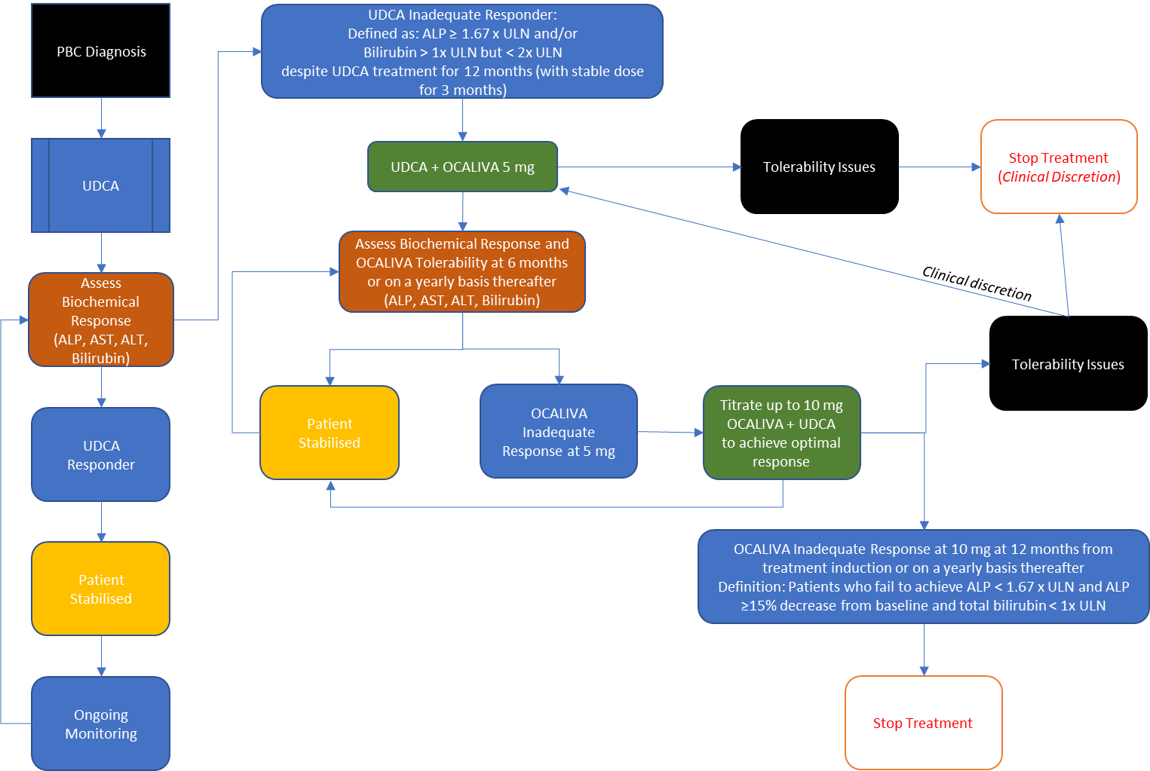
Source: Adapted and modified from EASL 2017 Figure 4, page 153.
ALP = alkaline phosphatase; ALT = alanine aminotransferase; AST = aspartate aminotransferase; OCA = obeticholic acid; PBC = primary biliary cholangitis; UDCA = ursodeoxycholic acid; ULN = upper limit of normal.
Updated as per feedback provided by the PBAC for the previous submission.

Figure 2: Updated proposed treatment algorithm for primary biliary cholangitis with OCA on the PBS for UDCA-Intolerant Patients
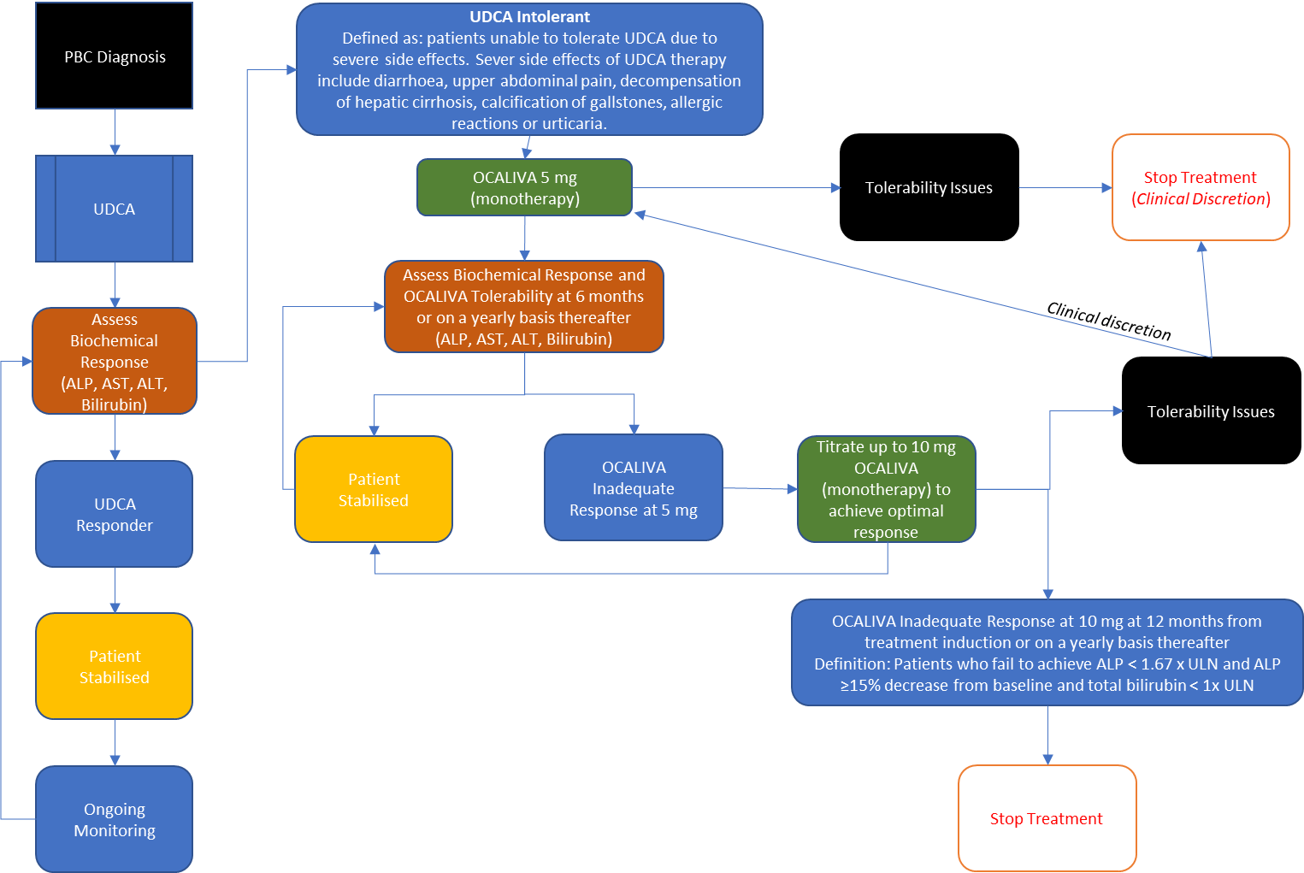
Source: Adapted and modified from EASL 2017 Figure 4, page 153.
ALP = alkaline phosphatase; ALT = alanine aminotransferase; AST = aspartate aminotransferase; OCA = obeticholic acid; PBC = primary biliary cholangitis; UDCA = ursodeoxycholic acid; ULN = upper limit of normal.
Updated as per feedback provided by the PBAC for the previous submission.

For more detail on PBAC’s view, see section 7 PBAC outcome.
- Comparator
  - The resubmission proposed the following main comparators:
• UDCA inadequate responders: UDCA monotherapy; and
• UDCA intolerant patients: placebo or no treatment
  - The PBAC had previously considered these to be the appropriate comparators (paragraph 7.4, obeticholic acid PSD, November 2018).
For more detail on PBAC’s view, see section 7 PBAC outcome.
- Consideration of the evidence

Sponsor hearing
  - There was no hearing for this item.

Consumer comments
  - The PBAC noted and welcomed the input from individuals (1) and health care professionals (1) via the Consumer Comments facility on the PBS website. The comments described the need for alternate PBC treatments.

Clinical studies/trials
  - The clinical evidence presented is unchanged from the previous submission.
  - The resubmission was based on:
- One head-to-head randomised trial (POISE) comparing:
- OCA + UDCA vs UDCA monotherapy in patients with an inadequate response to UDCA (OCA 5-10 mg titration: N=65; OCA 10 mg: N=67; placebo: N=68) or
- OCA vs placebo in patients with intolerance to UDCA (OCA 5-10 mg titration: N=5; OCA 10 mg: N=6; placebo: N=5).
- Two supplementary randomised controlled trials (RCTs) comparing:
      - OCA as a monotherapy vs placebo (747-201 trial, placebo: N=24; OCA 10 mg: N=20; OCA 50 mg: N=16)
      - OCA + UDCA vs UDCA + placebo (747-202 trial, placebo: N=38; OCA 10 mg: N= 38; OCA 25 mg: N=48; OCA 50 mg: N=41).
(3) One open-label extension study of the POISE trial (POISE LTSE) (N=193). All patients in the POISE LTSE received OCA at a dose of 5mg (including those who have been taking OCA 10 mg in the double-blind phase) +/- UDCA for the first 3 months, after which time dose could be increased.
  - Table 3 presents the details of the trials presented.
Table 3: Trials and associated reports presented in the resubmission
Trial | Protocol title/ Publication title | Publication citation
POISE | A Phase 3, double blind, placebo controlled trial and long term safety extension of obeticholic acid in patients with primary biliary cirrhosis (POISE) | Intercept Pharmaceuticals 2015
 | Nevens F, Andreone P, Mazzella G, Strasser SI, Bowlus C, Invernizzi P, et al. A placebo-controlled trial of obeticholic acid in primary biliary cholangitis | NEJM. 2016;375(7):631-43.
747-201 | Kowdley K, Luketic V, Chapman RW, et al. A randomized trial of obeticholic acid monotherapy in patients with primary biliary cholangitis. | Hepatology. 2018;67(5): 1890-1902
747-202 | Hirschfield GM, Mason A, Luketic V, Lindor K, Gordon SC, Mayo M, et al. Efficacy of obeticholic acid in patients with primary biliary cirrhosis and inadequate response to ursodeoxycholic acid. | Gastroenterology. 2015;148(4):751-61 e8
Source: Table 21, p54 -55 of the resubmission.
Blue shading indicates data previously seen by the PBAC.

  - The key features of the direct RCTs are summarised in Table 4.
Table 4: Key features of the included evidence
Trial | N | Design/ duration | Risk of bias | Patient population | Outcome(s) | Use in modelled evaluation
OCA + UDCA vs UDCA+ placebo for UDCA inadequate responders or OCA vs placebo for UDCA intolerant
POISE Trial | 217 | R, DB  12 months | Moderate | PBC | Serum ALP and total bilirubin levels, together as a composite endpoint in the OCA 10mg group. | Used
747-201 Trial | 60 | R, DB  12 weeks | Moderate | PBC | Serum ALP change from baseline to end of study | Not used
747-202 Trial | 165 | R, DB  12 weeks | Moderate | PBC | Serum ALP change from baseline to end of study in each of the OCA groups | Not used
ALP = alkaline phosphatase; DB = double blind; MC = multi-centre; OCA = obeticholic acid; PBC = primary biliary cholangitis; R = randomised; UDCA = ursodeoxycholic acid
Source: Figure 14 p68, Figure 15 p70, Figure 16 p71, and Table 26, p74-78 of the resubmission.
Blue shading indicates data previously seen by the PBAC.

Comparative effectiveness
  - Table 5 presents the key efficacy results of the POISE trial.
Table 5: Percentage of subjects achieving composite endpoint (ALP < 1.67x ULN with ≥ 15% decrease from baseline in ALP, and total bilirubin < ULN) by demographic and baseline subgroups in POISE
Population | Placebo |  | OCA 5-10mg Titration |  |  | OCA 10 mg
 | N | Month 12  n (%) | N | Month 12  n (%) | p-value | N | Month 12  n (%) | p-value
ITT population | 73 | 7 (10%) | 70 | 32 (46%) | <0.0001 | 73 | 34 (47%) | <0.0001
UDCA use
No UDCA use (i.e. UDCA-intolerant patients) | 5 | 0 | 5 | 2 (40%) | 0.0833 | 6 | 1 (17%) | 0.3173
UDCA use (i.e. UDCA-inadequate responders) | 68 | 7 (10%) | 65 | 30 (46%) | <0.0001 | 67 | 33 (49%) | <0.0001
ALP = alkaline phosphatase; CMH = Cochran-Mantel-Haenszel; ITT = intention to treat; LS = least squares; OCA = obeticholic acid; Se = standard error; UDCA = ursodeoxycholic acid; ULN = upper limit(s) of normal
Endpoint: Responder was defined as a subject obtaining ALP < 1.67x ULN, total bilirubin ≤ ULN, and ALP decrease of ≥ 15% from Baseline
Analysis: p-values based on LS mean (SE) difference between OCA treatment and placebo and were obtained using CMH General Association test stratified by randomisation strata factor.
Bold indicates statistical significance.
Source: Table 29, p89-90 of the resubmission.
Blue shading indicates data previously seen by the PBAC.

Comparative harms
  - Table 6 presents a summary of patient-relevant harms, based on the POISE trial, 747-201 trial and 747-202 trial.

Table 6: Summary of key adverse events in the randomised trials
Trial ID | Placebo  +/- UDCA  n/N (%) | OCA 5-10 mg titration +/- UDCA  n/N (%) | OCA 10mg  +/-UDCA  n/N (%)
POISE Trial
Any TEAE | 66/73 (90%) | 65/70 (93%) | 69/73 (95%)
Total number of TEAEs | 452 | 471 | 467
Any Related TEAE (at least “Possibly” related) | 38/73 (52%) | 42 /70 (60%) | 54/73 (74%)
A related TEAE of pruritus | 27/73 (37%) | 35 /70 (50%) | 48/73 (66%)*
Any SAEs | 3/73 (4%) | 11/70 (16%)* | 8/73 (11%)
Total number of SAEs | 8 | 15 | 11
TEAE by Severity:
Mild TEAEs | 29/73 (40%) | 16/70 (23%) | 19/73 (26%)
Moderate TEAEs | 28/73 (38%) | 27/70 (39%) | 29/73 (40%)
Severe TEAEs | 9/73 (12%) | 22/70 (31%)* | 21/73 (29%)*
Any TEAE leading to study discontinuation | 2/73 (3%)ª | 5/70 (7%)^{b} | 8/73 (11%)^{c}
Study Discontinuation due to a TEAE of pruritus | 0/73 (0%) | 1/70 (1%) | 7/73 (10%)*
Deaths | 0/73 (0%) | 1/70 (1%) | 0/73 (0%)
747-201 Trial (OCA monotherapy)
Subjects reporting at least 1 TEAE | 21/23 (91.3%) | - | 18/20 (90.0%)
Subjects with TEAE of pruritus or pruritus generalised | 8/23 (34.8%) | - | 14/20 (70.0%)
Subjects with related TEAE | 11/23 (47.8%) | - | 15/20 (75.0%)
Subjects with related TEAEs of pruritus or pruritus generalised | 7/23 (30.4%) | - | 14/20 (70.0%)
Subjects with SAE | 1/23 (4.3%) | - | 0/20 (0.0%)
Subjects with Mild TEAEs | 18/23 (78.3%) | - | 16/20 (80.0%)
Subjects with Moderate TEAEs | 8/23 (34.8%) | - | 9/20 (45.0%)
Subjects with Severe TEAEs | 5/23 (22.7%) | - | 7/20 (35.0%)
Subjects who withdrew due to a TEAE | 0/23 (0.0%) | - | 3/20 (15.0%)
Discontinuation due to pruritus | 0/23 (0.0%) | - | 3/20 (15.0%)
747-202 Trial (OCA combination)
Subjects reporting at least 1 TEAE | 32/38 (84%) | - | 34 /38 (89%)
Subjects with TEAE of pruritus or pruritus generalised | 19/38 (50%) | - | 18 /38 (47%)
Subjects with related TEAE | 22/38 (58%) | - | 28/38 (74%)
Subjects with related TEAEs of pruritus or pruritus generalised | 17/38 (45%) | - | 18/38 (47%)
Subjects with SAE | 1/38 (3%) | - | 0/38 (0%)
Deaths | 0/38 (0%) | - | 0/38 (0%)
Subjects with Mild TEAEs | 31/38 (82%) | - | 25/38 (66%)
Subjects with Moderate TEAEs | 15/38 (39%) | - | 17/38 (45%)
Subjects with Severe TEAEs | 3/38 (8%) | - | 6/38 (16%)
Subjects who withdrew due to a TEAE | 1/38 (3%) | - | 6/38 (16%)
Discontinuation due to pruritus | 0/38 (0%) | - | 3/38 (8%)
OCA = obeticholic acid; SAE = serious adverse event; TEAE = treatment emergent adverse event; UDCA = ursodeoxycholic acid.
a One subject additional experienced a TEAE of osteoarthritis that resulted in withdrawal of investigational product. The subject was discontinued from the study, which was determined by the Investigator to be withdrawal of consent.
b Four subjects in the titration group discontinued from the study due to a TEAE prior to being uptitrated to OCA 10 mg.
c One Subject experienced a TEAE of fatigue, which was recorded as a discontinuation on the AE eCRF, however the subject remained in the study and investigational product was not changed.
* P ≤ 0.05 vs placebo group using a Chi-squared test, or Fisher’s Exact test where n ≤ 5 in either group
Source: Table 33, p92-92 of the resubmission, and Table 2.5.23, p81, Table 2.5.24, p81 of Appendix 01-02 of the resubmission.
Blue shading indicates data previously seen by the PBAC.

Benefits/harms
  - A summary of the comparative benefits and harms for OCA 5-10 mg titration +/- UDCA or OCA 10mg +/- UDCA versus UDCA +/- placebo is presented in Table 7.
Table 7: Summary of comparative benefits and harms for OCA 10mg +/- UDCA and Placebo +/-UDCA
Trial | OCA +/-  UDCA  n/N |  | Placebo +/-UDCA  n/N |  | RR  (95% CI) |  | Event rate/100 patients* |  |  | RD  (95% CI)
 |  |  |  |  |  |  | OCA  (10 mg) +/- UDCA | PBO +/- UCDA
Benefits
Primary outcome
Composite endpoints: ALP < 1.67x ULN with ≥ 15% decrease from baseline in ALP, and total bilirubin < ULN
POISE (OCA 5-10mg titration), no UDCA use (i.e. UDCA-intolerant patients) | 2/5 |  | 0/5 |  | 5.0  (0.3, 83.7)** |  | 40.0 | 0.0 |  | 40.0  (-2.9, 82.9)**
POISE (OCA 10mg), no UDCA use (i.e. UDCA-intolerant patients) | 1/6 |  | 0/5 |  | 2.6  (0.1, 52.1)** |  | 16.7 | 0.0 |  | 16.7  (-13.2, 46.5)**
POISE (OCA 5-10mg titration), UDCA use (i.e. UDCA-inadequate responders) | 30/65 |  | 7/68 |  | 4.5  (2.1, 9.5) |  | 46.2 | 10.3 |  | 35.9  (21.8, 50.0)
POISE (OCA 10mg), UDCA use (i.e. UDCA-inadequate responders) | 33/67 |  | 7/68 |  | 4.8  (2.3, 10.1) |  | 49.3 | 10.3 |  | 39.0  (25.0, 52.9)
Primary outcome
Composite endpoint: Percentage change in serum ALP from baseline to the end of trial
 | OCA 10mg +/- UDCA |  |  |  |  | Placebo +/- UDCA |  |  |  | Mean difference*:  OCA 10mg +/- UDCA vs. PBO +/-UDCA  (95% CI)
 | N | Mean ∆ baseline (%) |  | SD |  | N | Mean ∆ baseline (%) |  | SD
747-201 trial (OCA monotherapy) | 20 | -44.5 |  | 24.4 |  | 23 | 0.4 |  | 15.3 | NR (p<0.0001)
747-202 trial (OCA combination) | 38 | -23.7 |  | 17.8 |  | 38 | -2.6 |  | 12.5 | NR (p<0.0001)
Harms
 | OCA +/- UDCA  n/N |  | Placebo +/- UDCA  n/N |  | RR  (95% CI) |  | Event rate/100 patients* |  |  | RD  (95% CI)
 |  |  |  |  |  |  | OCA +/- UDCA | Placebo +/- UDCA
Pruritus
POISE (OCA 5-10mg titration) | 39/70 |  | 28/73 |  | 1.45  (1.02, 2.08) |  | 55.7 | 38.4 |  | 17.4  (1.2, 33.5)
POISE (OCA 10mg) | 50/73 |  | 28/73 |  | 1.79  (1.28, 2.48) |  | 68.5 | 38.4 |  | 30.1  (14.7, 45.6)
747-201 trial(OCA monotherapy) | 14/20 |  | 8/23 |  | 2.01  (1.07, 3.77) |  | 70.0 | 34.8 |  | 35.2  (7.2, 63.2)
747-202 trial (OCA combination) | 18/38 |  | 19/38 |  | 0.95  (0.60, 1.50) |  | 47.4 | 50.0 |  | -2.6  (-25.1, 19.8)
TEAEs
POISE (OCA 5-10mg titration) | 65/70 |  | 66/73 |  | 1.03  (0.93,0.80) |  | 92.9 | 90.4 |  | 2.5  (-6.6, 11.5)
POISE (OCA 10mg) | 69/73 |  | 66/73 |  | 1.04  (0.95, 1.15) |  | 94.5 | 90.4 |  | 4.1  (-4.4, 12.6)
747-201 trial (OCA monotherapy) | 18/20 |  | 21/23 |  | 0.99  (0.81,1.20) |  | 90 | 91.3 |  | -1.3  (-18.8, 16.2)
747-202 trial (OCA combination) | 34/38 |  | 32/38 |  | 1.06  (0.89,1.27) |  | 89 | 84 |  | 5.3  (-9.9, 20.4)
SAEs
POISE (OCA 5-10mg titration) | 11/70 |  | 3/73 |  | 3.82  (1.11,13.13) |  | 15.7 | 4.1 |  | 11.6  (1.9, 21.3)
POISE (OCA 10mg) | 8/73 |  | 3/73 |  | 2.67  (0.74, 9.66) |  | 11.0 | 4.2 |  | 6.8  (-1.6, 15.3)
747-201 trial (OCA monotherapy) | 0/20 |  | 1/23 |  | 0.38  (0.02, 8.86) |  | 0.0 | 0.04 |  | -0.04  (-0.13,0.04)
747-202 trial (OCA combination) | 0/38 |  | 1/38 |  | 0.33  (0.01, 7.93) |  | 0.0 | 0.03 |  | -0.03  (-0.08, 0.02)
ALP = alkaline phosphatase; NR = not reported; OCA = obeticholic acid; RD = risk difference; RR = risk ratio; SAE = serious adverse event; SD = standard deviation; TEAE = treatment emergent adverse event; UDCA = ursodeoxycholic acid; ULN = upper limit of normal.
Bold indicates statistical significance.
*Maximum duration of follow-up: POISE = 12 months, 747-201 trial = 14 weeks; 747-202 trial = 14 weeks
** Added 0.5 patients.
Source: Complied during the evaluation based on Table 29 of the resubmission, p89-90, Table 33 of the resubmission, p92-93, and, Table 2.5.23, p81, Table 2.5.24, p81 of Appendix 01-02 the resubmission.
Blue shading indicates data previously seen by the PBAC.

  - On the basis of direct evidence presented by the resubmission (POISE trial), for every 100 patients treated with OCA 5-10 mg titration +/- UDCA in comparison to placebo +/- UDCA and over a maximum duration of follow-up of 12 months:
- Approximately 36 additional UDCA-inadequate responders would not experience PBC disease progression;
- Approximately 17 additional patients would experience pruritus; and
- Approximately 12 additional patients would experience at least one SAE.
  - On the basis of direct evidence presented by the resubmission (POISE trial), for every 100 patients treated with OCA 10 mg +/- UDCA in comparison to placebo +/- UDCA and over a maximum duration of follow-up of 12 months:
- Approximately 39 additional UDCA-inadequate responders would not experience PBC disease progression;
- Approximately 30 additional patients would experience pruritus.
  - On the basis of direct evidence presented by the resubmission (747-201 trial), the comparison of OCA 10mg monotherapy and placebo resulted in a significant reduction in the percentage change in ALP from baseline to the end of the trial.
  - On the basis of direct evidence presented by the resubmission (747-202 trial), the comparison of OCA 10mg + UDCA and placebo + UDCA resulted in a significant reduction in the percentage change in ALP from baseline to the end of the trial.

Clinical claim
  - The resubmission described OCA 5-10 mg titration dosing as superior in terms of effectiveness compared with best supportive care when used as combination therapy with UDCA for patients with prior inadequate response to UDCA. This claim is unchanged from the previous submission. The PBAC previously considered that the magnitude of the clinical benefit was uncertain given the relatively small sample size in the POISE trial (n = 200) and as over 50% of patients failed to meet the primary end point at 12 months (paragraph 7.6, obeticholic acid PSD, July 2019).
  - The resubmission described OCA 5-10 mg titration dosing as superior in terms of effectiveness compared with placebo when used as monotherapy for patients who are intolerant to UDCA. This claim is unchanged from the previous submission. The PBAC previously considered that the clinical claim was not adequately supported by the data (paragraph 7.8, obeticholic acid PSD, July 2019).
  - The resubmission described OCA 5-10 mg titration dosing as inferior in terms of safety compared with placebo/best supportive care when used as combination therapy with UDCA for patients with prior inadequate response to UDCA and as monotherapy for patients who are intolerant to UDCA. This claim is unchanged from the previous submission. The PBAC previously considered that this was reasonable (paragraph 7.7, obeticholic acid PSD, July 2019).

Economic analysis
  - The resubmission presented a stepped economic evaluation based on a direct RCT (the POISE trial), other published studies, and implemented a modelled evaluation. The types of economic evaluation presented were cost-utility and cost-effectiveness (per responder and per life year gained) analyses. The model used calibration to derive a number of transitions. This is unchanged from the previous submission.
  - The PBAC noted that the resubmission no longer presented an ICER for patients who are UDCA intolerant.
  - Table 8 presents the key components of the economic evaluation.

Table 8: Summary of model structure and rationale
Component | Summary
Type of analysis | Cost-utility analysis (CUA) and cost-effectiveness analysis (CEA)
Outcomes | Quality adjusted life years (QALYS) and life years (LY) gained
Time horizon | Lifetime (30 years), POISE clinical trial 12 months duration plus the POISE LTSE study (5 years). Previously the PBAC considered that the time horizon in the model (50 years) was long compared with the median age of patients in the POISE trial (56 years), the duration of follow-up in the POISE trial (12 months) and the progressive nature of the disease (paragraphs 6.32 and 7.9 obeticholic acid PSD, July 2019). The ICER was highly sensitive to the time horizon up to around 20 years (see Figure 6). The PSCR reiterated that a 30-year time horizon was appropriate as the age at diagnosis in POISE ranged from 29 to 86 years, with 81% of patients less than 65 years of age. The ESC considered that uncertainties remained with the application of the 30 year time horizon as the majority of the incremental benefits occurred in the extrapolated period.
Methods used to generate results | A semi-Markov state-transition model which captures patient’s costs and outcomes over the time horizon.
Health states | 10 health states (biochemical [first 3 states]; liver disease [last 7 states])  Biochemical States  - Low risk of PBC disease progression: ALP ≤ 200 U/L (i.e. 1.67 x ULN) and normal bilirubin (i.e. TB ≤ 20 µmol/L)  - Moderate risk of PBC disease progression: ALP > 200 U/L and normal bilirubin  - High risk of PBC disease progression leading to liver failure: Abnormal bilirubin (i.e. TB > 20 µmol/L) and rising or CC.  Liver Disease States  - DCC  - HCC  - Pre-LT  - LT  - Post-LT  - PBC re-emergence  - Dead
Cycle length | 3 months
Population used in the model | Age: 55.8 years, based on the POISE trial.
Baseline health state distribution:
Low risk: 0.46% (was 0% in July 2019)
Moderate risk: 91.20% (was 76.85% in July 2019)
High risk: 8.33% (was 23.15% in July 2019)
Based on the POISE trial.

The ESC noted that these values were changed from the previous submission; however, it was unclear why the new analysis of the POISE trial resulted in a different baseline health state distribution compared to the previous analysis. This was unable to be verified during the evaluation. The PBAC noted that the sensitivity analysis using 2019 baseline health state distribution indicated the ICER was not sensitive to this change (ICER = $'''''''''''''''''¹ using 2019 values, ICER = $'''''''''''''''¹ using 2020 values).
Transition probabilities | Low risk ↔ High risk  OCA + UDCA (UDCA inadequate response): POISE. The application of the POISE data is appropriate. The transition probabilities were the same as those used in the 2018 submission for months 0-3, 3-6 and 6-9 months. The probabilities for 9-12 months reflect the corrected values from the 2019 submission.  The transition probabilities between biochemical health states for OCA patients were based on a small sample size (N=68).
Biochemical health states → Liver disease health states
Various published data sources and model calibration. The ESC noted that although many of the transition probabilities were able to be verified based on the information presented by the resubmission, some remained unable to verified. Some were changed between the previous submission and the resubmission. These were tested in a sensitivity analysis and the ICER was not sensitive to changes in the individual transition probabilities from biochemical to liver disease health states.
Discontinuations | OCA+UDCA or UDCA monotherapy: POISE, No treatment: Nil (assumed)  The resubmission aimed to implement a stopping rule for 54% of patients at 12 months in the economic model. This is unchanged from the previous submission. The resubmission assumed that 9.86% of patients treated with OCA+/-UDCA discontinue after 3 months, and 44.1% of patients treated with OCA+/-UDCA discontinue treatment at 12 months. Together, this proportion sums to the proportion of patients not achieving the composite endpoint in the POISE trial (54%). When applied in the model the cycle 4 discontinuation rate was 39.47% meaning that the proportion of patients discontinued at 12 months is 49.3% rather than 54% as stated. (Sheet OCA+UDCA Titration Markov model of Ocaliva Economic Evaluation PBAC July 2020 FINAL.xlsm, cell BS7 and BS10, and cell X217). This is not appropriate. This was tested in a sensitivity analysis and the ICER was not sensitive to this change (ICER $'''''''''''''''¹ per QALY gained compared to base case $''''''''''''''''¹ per QALY gained).
Utilities | Biochemical states  The utility values for low and moderate risk states were sourced from a quality of life study in chronic viral hepatitis and cholestatic liver disease patients (Younossi et al, 2001). The utilities from Younossi et al (2001) were verified. Alternate utility values were available from the original EQ-5D data in Wright (2006) for low and moderate risk. This was tested in a sensitivity analysis and the ICER was sensitive to this change (ICER $'''''''''''''''''² per QALY gained compared to base case $'''''''''''''''''¹ per QALY gained).  The utility value for high risk (CC) was sourced from Wright (2006) economic evaluation. This utility value was verified.  Liver disease states  The utility values for DCC and HCC were sourced from Wright (2006) citing Ratcliffe (2002). The utility for the pre-transplant health states were assumed the same as DCC/HCC. The utilities for DCC and HCC were unable to be verified in Ratcliffe (2002). The PSCR stated that Wright (2006) applied the mean HRQoL score at transplant (0.45) for all hepatitis C patients to approximate the HRQoL for patients with DCC and HCC.  The utility values for liver transplant and post liver transplant were based on original data in Wright (2006). The utilities for liver transplant and post liver translate were verified in Wright (2006).  Adverse events  Disutilities for pruritus were sourced from Hawe (2016) which measured utility values for patients with chronic spontaneous/idiopathic urticaria. The resubmission applied the weighted average disutility (-0.03) over a one year period. This may not be reasonable given the ongoing use of OCA beyond one year. Sensitivity analysis conducted during the evaluation showed the ICER was sensitive to applying this disutility beyond the first year – increasing ICER to $''''''''''''''''² per QALY if discounted disutility of -0.015 (assumed) were applied after Year 1; and increasing ICER to $'''''''''''''''''''² per QALY gained if a discounted disutility of -0.03 (assumed) were applied after Year 1.
Costs | OCA, UDCA, adverse events, and disease management  The following costs were changed:  - The OCA effective DPMQ decreased (2019 = $''''''''''''''''''''' per pack, 2020 = $''''''''''''''''''' per pack). The ESC considered that the proposed 7% price reduction did not adequately mitigate the PBACs previous concerns regarding the clinical and economic uncertainties. The ESC considered that a price reduction in the magnitude of that projected by the proposed RSA (45% to 50%) may be required.  - The cost of OCA was adjusted to reflect that 21% of all patients were receiving a half dose (dose every other day). The assumption that patients would receive a half dose for 30 years with no impact on efficacy is uncertain. The PSCR stated that the LTSE reported that 21% of patients received half-dose OCA and that these patients were incorporated into the efficacy results at 3 years.  - Costs associated with adverse events (pruritus) were included (using a weighted average of medications for treatment of pruritus). Pruritus costs are applied for first 12 weeks, this may not be reasonable given the ongoing use of OCA.  - The ESC noted that some disease management costs were increased (DCC, HCC, pre-transplant, liver transplant, follow-up after liver transplant). This appears to be because of adjustment due to inflation, but it is not clear why other costs were not inflated too.
ALP = alkaline phosphatase; CC = compensated cirrhosis; CEA = cost effectiveness analysis; CUA = cost utility analysis; DCC = decompensated cirrhosis; ESC = Economic Sub-Committee; HCC = hepatocellular cancer; ICER = incremental cost effectiveness ratio; LT = liver transplant; LTSE = long term safety extension; Ly = life year; OCA = obeticholic acid; PBAC = Pharmaceutical Benefits Advisory Committee; PBC = primary biliary cholangitis; PSCR = pre-Sub-Committee response; PSD = Public Summary Document; QALY = quality adjusted life year; RSA = risk sharing arrangement; SF-36 = short form 36 questionnaire; TB = total bilirubin; UDCA = ursodeoxycholic acid; ULN = upper limit of normal
Source: Table 41 p125 of the resubmission and compiled during the evaluation.
Blue shading indicates data previously seen by the PBAC.
The redacted values correspond to the following ranges:
¹ $75,000 to <$95,000/QALY gained
² $95,000 to <$115,000/QALY gained

  - Table 9 summarises the key drivers of the model.
Table 9: Key drivers of the model
Description | Method/Value | Impact
Time horizon | Lifetime (30 years), POISE clinical trial 12 months duration and the POISE LTSE study (5 years). | High up to around 20 years, favours OCA
Patients receiving half dose (dose every other day) | Assumed that 21% of patients would receive a half dose (dose every other day) for the 30 year time horizon. | High, favours OCA
Utilities in biochemical health states | Based on Younossi (2001) and Wright (2006). | High, direction unclear
The application of disutility for pruritus beyond Year 1 | Assuming no application of disutility for pruritus beyond Year 1. | Moderate, favours OCA
Transition probability between biochemical health states (i.e. moderate to high risk) | POISE, various literature and calibration | High, favours OCA
LTSE = long-term safety extension; OCA = obeticholic acid
Source: Compiled during the evaluation

  - Table 10 presents the results of the stepped economic evaluation.

Table 10: Results of the stepped economic evaluation using the proposed effective price of OCA
Data | Costs |  |  | Health outcomes |  |  | ICER
 | OCA titration + UDCA | UDCA monotherapy | Increment | OCA titration + UDCA | UDCA monotherapy | Increment
Current resubmission
Step 1: (UDCA inadequate responder individuals: OCA titration + UDCA vs UDCA monotherapy): Trial-based analysis using the 12-month POISE trial data (outcomes = POISE primary efficacy outcome: ALP <1.67 x ULN, total bilirubin ≤ULN, and ALP decrease of ≥15% from Baseline), effective prices  [ICER = $/Responder Gained] | $''''''''''''''''' | $2,169 | '''''''''''''''''' | 47% | 10% | 37% | '''''''''''''''''¹
Step 2: (UDCA inadequate responder individuals: OCA titration + UDCA vs UDCA monotherapy): Model-based analysis; added costs related to adverse event and disease management; transformed POISE outcomes into biochemical and liver-related health states; made model population specific to the inadequate responder population; added life-years as an outcome; extrapolated to 30 years; discounted costs and outcomes at 5% p.a, effective prices  [ICER = $/Life-Year Gained] | ''''''''''''''''''''''' | $139,739 | ''''''''''''''''''''''' | 14.097 | 13.075 | 1.022 | ''''''''''''''''''''''²
Step 3: (UDCA inadequate responder individuals: OCA titration + UDCA vs UDCA monotherapy): Model-based analysis; Step 2 with application of utilities to biochemical and liver-related health states to yield quality-adjusted life-years as an outcome, effective prices  [ICER = $/Quality-Adjusted Life-Year Gained] | '''''''''''''''' | $139,739 | $''''''''''''''' | 10.878 | 8.846 | 2.033 | $''''''''''''¹
July 2019 resubmission
Step 1 (UDCA inadequate responder individuals: OCA titration + UDCA vs UDCA monotherapy): Trial-based analysis using the 12-month POISE trial data (outcomes = POISE primary efficacy outcome: ALP < 1.67 x ULN, total bilirubin ≤ ULN, and ALP decrease of ≥ 15% from baseline), effective prices  [ICER = $/responder gained] | $'''''''''''''''' | $1,645 | $''''''''''''''' | 50% | 10% | 40% | $'''''''''''''''''¹
Step 2a (UDCA inadequate responder individuals: OCA + UDCA vs UDCA monotherapy): Model-based analysis; added costs related to adverse event and disease management; transformed POISE outcomes into biochemical and liver-related health states; made model population specific to the inadequate responder population; added life-years as an outcome; extrapolated to 50 years; discounted costs and outcomes at 5% p.a, effective prices  [ICER = $/life year gained] | $''''''''''''''''''' | $111,027 | $''''''''''''''''''''' | 13.78 | 11.55 | 2.22 | $'''''''''''''''''''''³
Step 3a (UDCA inadequate responder individuals: OCA + UDCA vs UDCA monotherapy): Model-based analysis; Step 2a with application of utilities to biochemical and liver-related health states to yield quality-adjusted life-years as an outcome, effective prices  [ICER = $/quality-adjusted life year gained] | $''''''''''''''''' | $111,027 | $''''''''''''''''''' | 10.69 | 7.80 | 2.89 | $''''''''''''''''¹
ALP = alkaline phosphatase; ICER = Incremental cost-effectiveness ratio; OCA = obeticholic acid; UDCA = ursodeoxycholic acid; ULN = upper limit of normal.
Source: Table 61, p170 of the 2020 resubmission, and sheet ‘Deterministic results’ in Attachment 9 of the 2019 submission.
Blue shading indicates data previously seen by the PBAC.
The redacted values correspond to the following ranges:
¹ $75,000 to <$95,000/QALY gained
² $155,000 to <$255,000/QALY gained
³ $95,000 to <$115,000/QALY gained
  - The incremental costs, life years and QALYs were lower compared to the 2019 submission. This decreased the cost per responder and increased the cost per life years gained; however, the ESC noted that the ICER per QALY gained remained largely the same.
  - The reduction in life years was likely due to a combination of changes including time horizon and transition probabilities. The change in QALYs was likely due to the addition of disutilities associated with adverse events. The reduction in treatment costs were largely due to the assumption that 21% of patients would use a half dose (dose every other day) from Year 1 onwards (i.e. up to 30 years).
  - The ESC considered that the results should be considered with caution because:
- The time horizon in the model (30 years) was long compared to the median age of patients in the POISE trial (56 years), the duration of follow-up in the POISE trial (12 months) and the progressive nature of the disease.
- Many transition probabilities from the biochemical health states to the liver disease health states, and between the liver disease health states, were unable to be verified based on the information presented by the resubmission. The ICER was sensitive to the transition probabilities between biochemical health states (i.e. moderate to high risk), but not the transition probabilities from the biochemical health states to the liver disease health states. The ESC noted the ongoing inability to verify a number of model inputs and considered that inherent uncertainties in the model remained.
- Disutilities for pruritus were applied. However, these disutilities were only applied in the first year. Further, the cost of managing pruritus were only applied for 12 weeks (over a 30-year time horizon). This may not be reasonable given the ongoing use of OCA. This favours OCA. The ICER was sensitive to the application of disutility for pruritus beyond Year 1.
- The resubmission assumed that 21% of patients receive a half dose (dose every other day) after the first year of treatment. The assumption that patients would receive a half dose for 30 years with no impact on efficacy is uncertain.

  - Figure 3 presents the Markov traces over time.
Figure 3: Markov trace, OCA + UDCA, UDCA inadequate responders
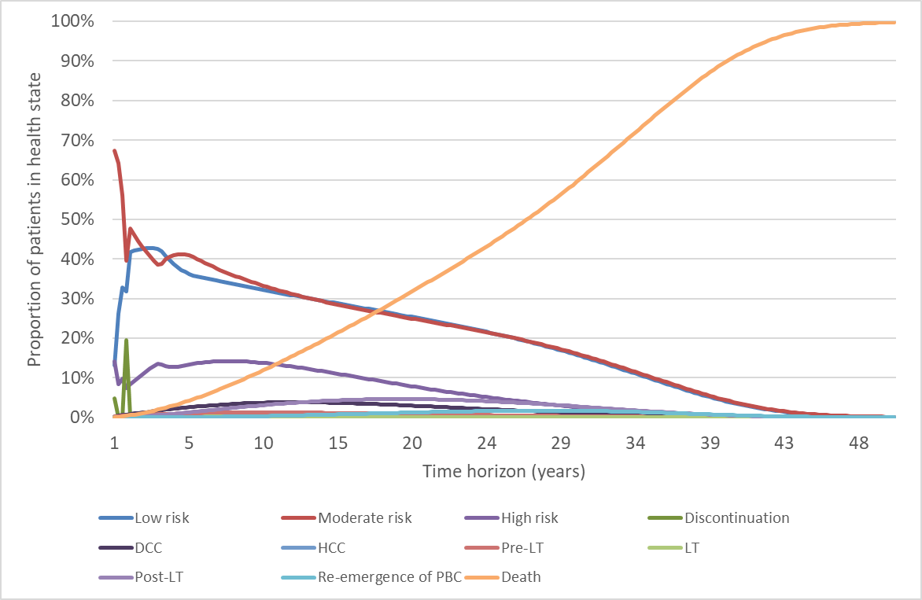
DCC = decompensated cirrhosis; HCC = hepatocellular cancer; LT = liver transplant; OCA = obeticholic acid; PBC = primary biliary cholangitis; UDCA = ursodeoxycholic acid.
Source: Compiled during evaluation using the economic model

  - Figure 4 summarises the results of the sensitivity analyses conducted in the resubmission.
Figure 4: UDCA Inadequate Responders Population—Effective Price
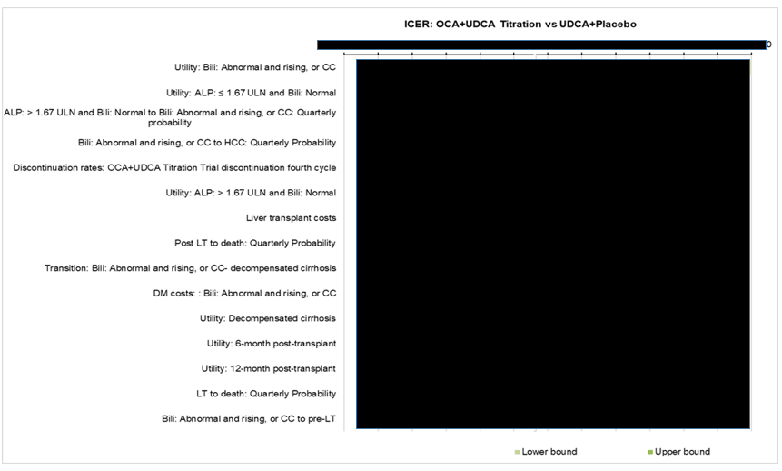
ALP = alkaline phosphatase; Bili = bilirubin; CC= compensated cirrhosis; HCC = hepatocellular cancer; ICER = incremental cost effectiveness ratio; LT = live transplant; OCA = obeticholic acid; UDCA = ursodeoxycholic acid; ULN = upper limit of normal
Source: Figure 33, p176 of the resubmission.
  - Figure 5 presents the ICER by the time horizon. The ICER was highly sensitive to the time horizon up to around 20 years.
Figure 5: ICER by time horizon, UDCA inadequate response patients (effective prices)
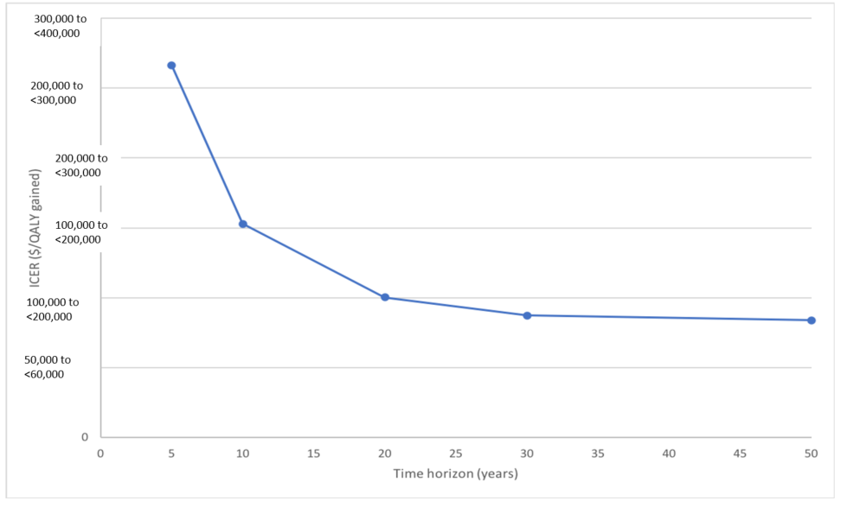
ICER = incremental cost-effectiveness ratio; QALY = quality adjusted life years; UDCA = ursodeoxycholic acid.
Source: compiled during the evaluation using the economic model
  - Table 11 summarizes the results of additional sensitivity analyses conducted during the evaluation.
Table 11: Results of sensitivity analyses conducting during evaluation
Analyses | Incremental cost | Incremental QALY | ICER
Base case | ''''''''''''''''' | 2.033 | ''''''''''''''''¹
Baseline health state distribution  - using 2019 values (see Table 8) | '''''''''''''''''''''' | 2.107 | '''''''''''''''''¹
Dose of OCA (base case assumed 21% on dose every other day)  - Patients on full dose | '''''''''''''''''''' | 2.033 | ''''''''''''''''''''' ²
Discount rate (base case 5% costs and outcomes)  - 0% costs and outcomes  - 3.5% costs and outcomes | '''''''''''''''''''''  '''''''''''''''''''''' | 4.285  2.496 | '''''''''''''''''''³  ''''''''''''''''''''¹
Time horizon (base case 30 years)  - 5 years  - 10 years  - 20 years  - 50 years | ''''''''''''''''''''''  ''''''''''''''''''''  '''''''''''''''''''''''  ''''''''''''''''''''''' | 0.262  0.682  1.498  2.235 | ''''''''''''''''''''''''⁴  ''''''''''''''''''''⁵  '''''''''''''''''''''²  '''''''''''''''''''''''
Mortality rate from DCC to death (base case used 12.9% at 1 year)  - 9% over 5 years (Fattovich 1997) | ''''''''''''''''''''''' | 1.868 | ''''''''''''''''''''
Discontinuation proportion in cycle (base case used 49.3%)  - Changed proportion in cycle 4 so that discontinuation adds to 54% at 12 months (instead of 49.3% currently) | '''''''''''''''''''' | 1.893 | ''''''''''''''''''¹
Utilities in mild and moderate health states (base case used 0.84 for mild and moderate from Younossi et al 2001)  - Mild (0.77) and moderate (0.66) biochemical health state utilities from Wright (2006) | '''''''''''''''''''' | 1.515 | '''''''''''''''''''''''''
Disutility for pruritus (base case -0.03 for 1 year)  - -0.03* in years 2-30  - -0.015* in years 2-30 | ''''''''''''''''''''  ''''''''''''''''''''' | 1.572  1.788 | ''''''''''''''''''''''²  '''''''''''''''''''''²
DCC = decompensated cirrhosis; DPMQ = dispensed price for maximum quantity; ICER = incremental cost effectiveness ratio; OCA = obeticholic acid; QALY = quality adjusted life year
*Ideally this value would be precisely calculated using the number of patients who are continuing in the model.
Source: compiled during the evaluation using the economic model
The redacted values correspond to the following ranges:
¹$75,000 to <$95,000/QALY gained
²$95,000 to <$115,000/QALY gained
³$75,000 to <$95,000/QALY gained
⁴$255,000 to <$355,000/QALY gained
⁵$135,000 to <$155,000/QALY gained

  - The model was sensitive to the time horizon, proportion of people on half dose (dose every other day), the application of disutility for pruritus beyond Year 1, utility values in the biochemical health states, transition probabilities between biochemical health states (i.e. moderate risk to high risk).

Drug cost/patient/year
  - The drug cost per patient per year is presented in Table 12.
Table 12: Drug cost per patient for OCA
 | OCA +/- UDCA  5-10 mg titration  Trial dose and duration | OCA +/- UDCA  5-10 mg titration  Model | OCA + UDCA  5-10 mg titration  Financial estimates
Mean dose of OCA | 6.2 mg | 21% of patients dose every other day from Year 2+ | NA*
Mean duration of OCA | 341.7 days | 365 days per year.  9.86% discontinue after 3 months and 44.1% discontinue at 12 months. | 365 days per year.  54% discontinue at 12 months.
Cost/patient/month of OCA (effective price) | $''''''''''''''''''''''** | $''''''''''''''''''''** | $''''''''''''''''''''''**
Cost/patient/year (chronic) of OCA (effective price) | $''''''''''''''''''''''''''*** | $''''''''''''''''''''''''''**** | $'''''''''''''''''''''''''****
NA = not applicable; OCA = obeticholic acid; UDCA = ursodeoxycholic acid.
* The resubmission did not estimate the proportion using 5 mg versus 10 mg due to flat pricing
** Price per 30 tablet pack
*** Calculated during evaluation using Ocaliva Economic Evaluation PBAC July 2020 FINALxlsm assuming mean duration of 341.7 days.
**** Assuming patients continue treatment
Source: Table 52, p200 of CSR for POISE study (Attachment 2), sheet Treatment costs of Ocaliva Economic Evaluation PBAC July 2020 FINAL.xlsm, and Table 55 p165 of the resubmission.

Estimated PBS usage & financial implications
  - This resubmission was not considered by DUSC.
  - The resubmission used a market share approach to estimate the financial impact of listing OCA on the PBS and RPBS for the treatment of PBC. The key data sources were UDCA PBS utilisation data from the DUSC advice to the November 2018 and March 2019 submission, a specialist survey, and the POISE trial. This approach was unchanged from the 2019 submission and changed from the 2018 submission which used an epidemiology approach.
  - Table 13 presents the key inputs for the financial estimates.
Table 13: Key inputs for financial estimates
Parameter | Value applied and source | Comment
Population of UDCA treated patients | Year 1: 11,968  Year 2: 13,164  Year 3: 14,481  Year 4: 15,929  Year 5: 17,522  Year 6: 19,274  Sourced from DUSC utilisation estimates. | -
Proportion of patients on UDCA who are being treated for PBC | 100%  ESC/PBAC advice stated as ‘estimate should be close to 100%’. (paragraph 6.42, obeticholic acid PSD, July 2019). | This addresses previous advice from the ESC (paragraph 6.42, obeticholic acid PSD, July 2019) that this estimate should be 100%. This reflects that UDCA is the only PBS listed treatment for PBC.
Annual growth rate of UDCA treated patients | 10%  DUSC data (PBAC PSD July 2019, item 6.42 and 7.11). | This addresses previous advice from the ESC and the PBAC (paragraph 6.42 and 7.11, obeticholic acid PSD, July 2019).
Uptake rate | 13% in Year 1 decreasing to 3.17% in Year 6. Based on expert opinion survey. | The ESC considered that the uptake rates were uncertain as it was based on the responses of 5 specialists treating ~2.1% of patients with PBC treated with UDCA.
Treatment utilisation | Fail continuation rule: 54% at 12 months  Continuing treatment (not failing continuation rule): 95% post 12 months  Adherence: 93.55% | Consistent with trial results.  Assumed. This is uncertain and the ESC considered that it is likely to be over-estimating the number of continuing patients.  The completion rate at 12 months was 90% for the OCA titration group and 88% for the OCA 10 mg group. The ESC considered that the adherence rate may be overestimated.  The resubmission did not assume that 21% of patients receive a half dose (dose every other day) after the first year of treatment, which was inconsistent with the economic model. The ESC noted that the PSCR provided revised financial estimates which included 21% of patients receiving half dose OCA.
Grandfathered patients | 6 per year | This is unchanged from the previous submission. The ESC noted that the addition of grandfathered patients every year (rather than once), has overestimated the number of patients treated
MBS item | MBS Item 119 (one extra specialist consultation to assess tolerability of OCA)  MBS Item 23 (2 GP consultations to manage pruritus) | This is uncertain as the assessment visit with a specialist will align with standard annual care so is unlikely to create any additional costs to the MBS.  It is unlikely for a GP to treat pruritus as patients will have regular consultation with specialists to assess tolerability.
DUSC = Drug Utilisation Sub-Committee; ESC = Economic Sub-Committee; GP = general practitioner; MBS: Medical Benefits Schedule; OCA = obeticholic acid; PBAC: Pharmaceutical Benefits Advisory Committee; PBC = primary biliary cholangitis; PSCR = pre-Sub-Committee response; PSD = product summary document; UDCA = ursodeoxycholic acid
Source: Table 70, p184-186 of the resubmission.

  - Table 14 presents the estimated use and financial implications. Updated financial implications applying the effective DPMQ offered in the pre-PBAC response have been added.
Table 14: Estimated use and financial implications
 | Year 1  (2021) | Year 2  (2022) | Year 3  (2023) | Year 4  (2024) | Year 5  (2025) | Year 6  (2026)
Estimated extent of use
Number of patients treated | ''''''''''''¹ | ''''''''''''¹ | '''''''''''''¹ | ''''''''''''¹ | '''''''''''''¹ | ''''''''''''¹
Number of scripts dispensedª | ''''''''''''''''''² | ''''''''''''''''² | ''''''''''''''''² | ''''''''''''''''² | '''''''''''''''''² | ''''''''''''''''''²
Estimated financial implications of OCA
Cost to PBS/RPBS less co-payments | $''''''''''''''''''''''''''''³ | $'''''''''''''''''''''''''''''³ | $'''''''''''''''''''''''''''³ | $''''''''''''''''''''''''''³ | $'''''''''''''''''''''''''''³ | $''''''''''''''''''''''''''⁴
Estimated financial implications for cholestyramine
Cost to PBS/RPBS less co-payments | $'''''''''''''''''''''⁵ | $''''''''''''''''''''''⁵ | $''''''''''''''''''''''⁵ | $'''''''''''''''''''⁵ | $''''''''''''''''''''⁵ | $'''''''''''''''''''''⁵
Net financial implications
Net cost to PBS/RPBS | $'''''''''''''''''''''''''''³ | $''''''''''''''''''''''''³ | $'''''''''''''''''''''''''³ | $''''''''''''''''''''''''''''³ | $'''''''''''''''''''''''''''''³ | $''''''''''''''''''''''''⁴
Net cost to MBS | $''''''''''''''''⁵ | $''''''''''''''''⁵ | $''''''''''''''''''⁵ | $'''''''''''''''⁵ | $''''''''''''''''⁵ | $'''''''''''''''''⁵
Net cost to PBS/RPBS/MBS | $'''''''''''''''''''''''³ | $'''''''''''''''''''''''''''''³ | $''''''''''''''''''''''''''³ | $'''''''''''''''''''''''''''''³ | $''''''''''''''''''''''''³ | $'''''''''''''''''''''''''''⁴
Pre-PBAC response
Net cost to PBS/RPBS | $''''''''''''''''''''''''''⁶ | $'''''''''''''''''''''''''''''⁶ | $''''''''''''''''''''''''⁶ | $'''''''''''''''''''''''''''³ | $'''''''''''''''''''''''''³ | $'''''''''''''''''''''''³
Net cost to PBS/RPBS/MBS | $''''''''''''''''''''''''''⁶ | $''''''''''''''''''''''''''''''' | $''''''''''''''''''''''''⁶ | $''''''''''''''''''''''''''''³ | $'''''''''''''''''''''''''³ | $''''''''''''''''''''''''''³
Previous resubmission July 2019
Net cost to PBS/RPBS | $''''''''''''''''''''''''''''⁷ | $''''''''''''''''''''''''''''⁶ | $''''''''''''''''''''''''''⁶ | $'''''''''''''''''''''''''''''³ | $'''''''''''''''''''''''''³ | $''''''''''''''''''''''''''³
Net cost to PBS/RPBS* | $'''''''''''''''''''''''''⁷ | $''''''''''''''''''''''''''⁷ | $'''''''''''''''''''''''''⁷ | $''''''''''''''''''''''''''⁷ | $''''''''''''''''''''''''''⁶ | $'''''''''''''''''''''''''''⁶
Submission, November 2018
Net cost to PBS/RPBS | $''''''''''''''''''''''''⁵ | $''''''''''''''''''''''''''''⁷ | $''''''''''''''''''''''''''⁷ | $'''''''''''''''''''''''''''⁷ | $'''''''''''''''''''''''''''''⁶ | $''''''''''''''''''''''''''''³
MBS = Medicare Benefits Schedule; OCA = obeticholic acid; PBS = Pharmaceutical Benefits Scheme; RPBS = Repatriation Pharmaceutical Benefits Scheme
Source: Utilisation and Cost Model OCALIVA, worksheet 5. Impact-net, 3a. Scripts proposed of the resubmission.3c. Impact-proposed (eff), 4c. Impact- affected (eff) from the resubmission.
*Revised during the evaluation based on the full financial year for 2021 and only counting grandfathered patients once.
The redacted values correspond to the following ranges:
¹500 to <5000
²10,000 to <20,000
³$30 million to <$40 million
⁴$40 million to <$50 million
⁵$0 to <$10 million
⁶$20 million to <$30 million
⁷$10 million to <$20 million
  - The net cost to the PBS/RPBS of listing OCA was estimated in the resubmission (in the pre-PBAC response) to be $40 to <$50 million ($30 to <$40 million) in Year 6, and a total of $200 to <$300 million ($100 to <$200 million) in the first 6 years of listing. This compared with a total cost of $100 to <$200 million (revised to $100 to <$200 million during the evaluation) and $100 to <$200 million over 6 years in the November 2018 and July 2019 submissions, respectively.
  - The ESC noted that although the resubmission addressed some of the issues raised by the PBAC during the July 2019 consideration, a number of issues, including the number of continuing patients, the adherence rate and grandfathered patients, all of which likely overestimated utilisation, remained. The ESC therefore considered that the financial estimates were overestimated. The ESC also noted that the uptake rates applied were highly uncertain as they were based on the survey responses of five specialists.

Quality Use of Medicines
  - The resubmission did not provide any information on the quality use of medicine. This is unreasonable given it is a relatively new medicine (registered on the TGA on 21 September 2018) with warnings regarding incorrect dosing from the United States (US) Food and Drug Administration (FDA) and PBC is a rare condition. This is unchanged from previous submission. No post marketing surveillance study was proposed. This was changed from previous submission which proposed a post-marketing survey.

Financial Management – Risk Sharing Arrangements
  - The resubmission proposed a RSA, in the form of financial caps (55% of the net cost to Commonwealth health budget presented in the resubmission over Years 1-3, and 50% in Year 4), beyond which ''''''''% rebates would be paid. The pre-PBAC response updated the caps based on the new effective DPMQ and applying a '''''% reduction from the estimated financial cost to the PBS to Years 1-5.
Table 15: Annual caps (at effective price) based on PBS/RPBS Commonwealth payments (contribution to service costs)
Year | Year 1 | Year 2 | Year 3 | Year 4 | Year 5
Annual cap | $''''''''''''''''''''''''''' | $'''''''''''''''''''''''' | $'''''''''''''''''''''''' | $''''''''''''''''''''''''''' | -
Pre-PBAC caps | $'''''''''''''''''''''''''''' | $''''''''''''''''''''''''' | $''''''''''''''''''''''''''' | $'''''''''''''''''''''''' | $'''''''''''''''''''''''''''''
PBS = Pharmaceutical Benefits Scheme; RPBS = Repatriation Pharmaceutical Benefits Scheme
Source: Table 26 of the resubmission, p200.

  - The resubmission claimed that the financial caps represent between '''''% and '''''% rebate on the financial estimates based on the PBAC recommended assumptions outlined in the July 2019 PBAC PSD. However, the estimated pre-RSA financial impact had more than doubled compared to the estimates presented in the 2019 evaluation. The ESC noted that this meant that the net effect of the proposed RSA resulted in similar financial expenditure as presented in the July 2019 submission.
  - The ESC noted that the sponsor considered that the proposed RSA projected a '''''% discount to the effective AEMP of OCA (from $0 to <$10 million to $0 to <$10 million). The ESC noted that achieving this discount relied on the financial estimates being exceeded and considered this was highly unlikely given the overestimation of the financial impact. The ESC considered that the clinical and economic uncertainties were not adequately addressed through the RSA, and the economic model should use the proposed price with no adjustment based on the RSA. The ESC considered a RSA was required to address the uncertainties associated with the financial estimates.
For more detail on PBAC’s view, see section 7 PBAC outcome.
- PBAC Outcome
  - The PBAC deferred making a recommendation regarding the listing of obeticholic acid (OCA) as a second-line treatment of primary biliary cholangitis (PBC). Although the PBAC again acknowledged that there was a clinical need for effective PBC treatments, the PBAC considered that a further price reduction would be required to address the uncertainties relating to the magnitude of the clinical benefit and the incremental cost-effectiveness ratio (ICER). The PBAC also considered the financial impact was overestimated.
  - The PBAC acknowledged the consumer comments, which were supportive of the PBS listing and the need for alternate PBC treatments.
  - The PBAC noted that no new clinical data were presented in the resubmission. The PBAC again considered the claim that OCA + ursodeoxycholic acid (UDCA) was superior in terms of effectiveness compared to UDCA monotherapy in patients who were UDCA-inadequate responders was reasonable; however, the magnitude of the clinical benefit remained uncertain given the relatively small sample size in the POISE trial (n = 200) and as over 50% of patients failed to meet the primary end point at 12 months. The PBAC considered the claim that OCA as monotherapy was superior in terms of effectiveness compared to placebo in UDCA-intolerant patients was uncertain due to the small sample size in the POISE trail (n = 16); however, likely reasonable in the context of the small number of patients expected to be treated with monotherapy. The PBAC considered the claim that OCA + UDCA and OCA monotherapy was inferior in terms in safety compared to UDCA and placebo respectively was reasonable.
  - The PBAC noted that the resubmission presented an updated economic model for the UDCA-inadequate responders (i.e. those receiving OCA + UDCA) that included:
  - a reduced time horizon (from 50 to 30 years). The PBAC considered that this was reasonable;
  - a 0.03 disutility for pruritus applied in the first year of treatment. The PBAC considered that a disutility of 0.03 should be applied in Year 1, with a disutility of 0.015 applied after Year 1 for the time horizon of the model. The PBAC considered it appropriate to apply a disutility in subsequent years as some patients would tolerate pruritus if their PBC improved with OCA treatment. A smaller disutility compared with Year 1 was considered reasonable as pruritus may have less of an effect on quality of life over time for some patients and some patients may have less pruritus if their disease state improved with OCA therapy;
  - an assumption that 21% of patients would receive a half dose of OCA from Year 1 onwards, with no change to the effectiveness of the treatment. The PBAC considered that the assumption that patients could receive a half dose of OCA with no impact of efficacy was highly uncertain and that it would be more appropriate to assume all patients receive the full dose of OCA; and
  - a 7% price reduction to the cost of OCA (with an additional 13% reduction offered in the pre-PBAC response).
  - The PBAC noted that the resubmission presented an updated economic model with additional documentation for the source data for the key inputs. The PBAC did note however, that a number of model inputs were unable to be verified during the evaluation and this added to the inherent uncertainty in the model results due to the limitations of the clinical data.
  - The PBAC considered that the ICER presented in the resubmission of $75,000 to <$95,000 per quality adjusted life year (QALY) (and in the pre-PBAC response of $35,000 to <$45,000 per QALY, which incorporated the RSA) remained too high and uncertain. This was particularly so given the uncertain magnitude of the clinical benefit and the unverified economic model inputs. The PBAC also considered that the calculated ICER should not be reliant on the RSA to be achieved, particularly given the likely overestimated financial assumptions. The PBAC considered that an appropriate ICER, using the model presented, would be less than $55,000 to <$75,000 per QALY and would incorporate the following three changes only (i) a 0.015 disutility for pruritus applied yearly from Year 2 for the 30 year time horizon of the model (a disutility of 0.03 should be applied in Year 1); (ii) the assumption that all patients received the full dose of OCA; and (iii) a suitable price reduction for OCA.
  - The PBAC considered OCA monotherapy would likely be acceptably cost-effective in the UDCA intolerant patients at the same reduced price as for the UDCA-inadequate responders.
  - The PBAC noted that the estimated financial impact of listing OCA on the PBS/RPBS had increased in the resubmission to $200 to <$300 million over the first six years (from $100 to <$200 million in July 2019). The PBAC considered this to be an overestimate of the likely cost due to the resubmission:
- applying a compounding 10% annual growth rate to the number of UDCA treated patients from 2017 onwards. This resulted in the 8,174 patients treated in 2017 increasing to 19,274 patients in 2026. The PBAC noted the average growth rate over the period 2013-2017 was 8% and in 2017 was 7%. The PBAC expected the diagnosis and incidence of PBC to be stable, and advised an annual growth rate of 7% should be applied in 2017 with it reducing by 0.5% each year such that the growth in 2026 is 2.5%.
- overestimating the number of continuing patients. The PBAC noted this was estimated in the resubmission to be 95% and considered it should be reduced to less than 90%.
- overestimating adherence to OCA. The PBAC noted this was estimated in the resubmission to be 93.55% and considered it should be 80%.
- including grandfathered patients after Year 1. The PBAC considered the grandfathered patients should be accounted for in Year 1 only.
  - Further, the PBAC noted the assumed uptake rates were based on responses of five specialists and considered these rates to be uncertain.
  - The PBAC noted that the resubmission proposed a RSA which included a ''''''''% rebate for use above set financial caps. The PBAC considered such a RSA was appropriate to account for the uncertainties associated with the potential for continued use in non-responders and the uncertain uptake. The PBAC noted the financial caps proposed in the pre-PBAC response were set at 45% below the financial estimates. The PBAC considered, due to the uncertain and overestimated financial impact, that the proposed reduction in the financial caps did not adequately address the financial risk or cost effectiveness of OCA. The PBAC advised the financial caps should be based on the financial estimates, with revisions to the (i) price of OCA as outlined in paragraph 7.6, and (ii) growth rate, number of continuing patients, adherence and number of grandfathered patients as outline in paragraph 7.8.
  - The PBAC advised that a revised price addressing the cost-effectiveness of OCA as outlined in paragraph 7.6, revised financial estimates as outlined in paragraph 7.8 and a revised RSA as outlined in paragraph 7.10 could be submitted in the form of a minor resubmission.
Outcome:
Deferred
- Context for Decision
The PBAC helps decide whether and, if so, how medicines should be subsidised through the Pharmaceutical Benefits Scheme (PBS) in Australia. It considers applications regarding the listing of medicines on the PBS and provides advice about other matters relating to the operation of the PBS in this context. A PBAC decision in relation to PBS listings does not necessarily represent a final PBAC view about the merits of the medicine or the circumstances in which it should be made available through the PBS. The PBAC welcomes applications containing new information at any time.
- Sponsor’s Comment
Chiesi Australia is committed to working with the PBAC to ensure that patients have access t for the treatment of primary biliary cholangitis in a timely manner.

