5.10 GEMTUZUMAB OZOGAMICIN,
Powder for injection 5 mg,
Mylotarg®,
Pfizer Australia Pty Ltd.
- Purpose of submission
  - The submission requested Section 100 Authority Required (Efficient Funding of Chemotherapy (EFC)) listing for gemtuzumab ozogamicin in combination with intensive chemotherapy (standard anthracycline and cytarabine) for the treatment of patients with previously untreated, de novo CD33-positive acute myeloid leukaemia, except acute promyelocytic leukaemia, who do not have a known unfavourable cytogenetic profile.
  - Any further reference to gemtuzumab refers to gemtuzumab ozogamicin.
  - Listing was requested on the basis of a cost-effectiveness analysis versus standard intensive chemotherapy (an anthracycline and cytarabine).
Table 1: Key components of the clinical issue addressed in the submission (as stated in the submission)
Component | Description
Population | Patients with previously untreated, de novo CD33-positive acute myeloid leukaemia, except acute promyelocytic leukaemia, who do not have known unfavourable cytogenetic profile (i.e. favourable, intermediate or unknown risk)
Intervention | 1-2 induction cycles: gemtuzumab 3 mg/m²/dose (maximum 5 mg) via intravenous infusion in combination with standard intensive chemotherapy on Day 1, 4 and 7 for one cycle only. If required, a second induction cycle may be administered with standard intensive chemotherapy alone.  2 consolidation cycles: gemtuzumab 3 mg/m²/dose (maximum 5 mg) via intravenous infusion in combination with standard intensive chemotherapy on Day 1 only. Each consolidation cycle is usually 4 days.
Comparator | Standard intensive chemotherapy for induction and consolidation therapy (an anthracycline and cytarabine)
Outcomes | Event-free survival, haematological response, relapse-free survival, overall survival and potential for functional cure
Clinical claim | Gemtuzumab in addition to standard intensive chemotherapy is superior in terms of efficacy and inferior in terms of safety compared to standard intensive chemotherapy.
Source: Table 1.1.1, p19 of the submission.
- Background

Registration status
  - Gemtuzumab was approved by the TGA on 9 April 2020 for the following indication:
“Combination therapy with standard anthracycline and cytarabine (AraC) for the treatment of patients age 15 years and above with previously untreated, de novo CD33-positive acute myeloid leukaemia (AML), except acute promyelocytic leukaemia (APL).“
  - The approved indication is agnostic to which anthracycline is used (i.e. daunorubicin or idarubicin), whereas the key trial data was based on gemtuzumab in combination with cytarabine and daunorubicin only. In a response to the TGA delegate, the sponsor indicated that the rationale for an anthracycline agnostic indication was to allow broader treatment options for clinicians. Daunorubicin is not PBS-funded in Australia and idarubicin is the more commonly used anthracycline.
  - The TGA delegate’s overview noted that the regulatory history of gemtuzumab is complex. In summary, gemtuzumab was evaluated by the TGA in 2006 at a higher dose and the decision was made not to approve its registration. A comparable application to the EMA was refused in 2008. Gemtuzumab had been approved by the FDA in 2000 under accelerated approval as monotherapy in patients >60 years of age who were unsuitable for chemotherapy. It was subsequently withdrawn from the market worldwide (except Japan) in 2010 when the confirmatory trial (SWOG S0106) submitted to the FDA failed to demonstrate therapeutic benefit. There was also an excess of early mortality noted in the gemtuzumab arm compared to chemotherapy alone in the same trial. The current reduced dosage and usage were approved by the FDA and EMA in 2017 and 2018 respectively. The risk management plan (RMP) evaluator noted a number of potential adverse effects of therapy and that the FDA Product Information includes a black boxed warning regarding incidence of veno-occlusive disease (VOD), also known as sinusoidal obstruction syndrome (SOS). The TGA approved Product Information includes special warnings and precautions for use including the risk of VOD. Gemtuzumab is also included in the Black Triangle Scheme for additional monitoring and identification of new safety information.
For more detail on PBAC’s view, see section 7 PBAC outcome.
- Requested listing
  - The submission claimed the administration of gemtuzumab would occur primarily in the public hospital inpatient setting. Therefore, the funding of gemtuzumab is expected to largely fall within the budget of public hospitals and not the Commonwealth Government. The ESC agreed that the majority of treatment would occur in the public hospital inpatient setting, noting that some consolidation therapy may be given in the outpatient setting.

Name, Restriction,  Manner of administration and form |  | Max.  Qty | №.of  Rpts | Dispensed Price for Max. Amt ª | Proprietary Name and Manufacturer
Induction therapy  Gemtuzumab Ozogamicin  5 mg injection, 1 vial |  | 3 vials | 0 | $'''''''''''''''''''''' (public)  $''''''''''''''''''''''''' (private) | Mylotarg®, Pfizer
Consolidation therapy  Gemtuzumab Ozogamicin  5 mg injection, 1 vial |  | 1 vial | 1 | $'''''''''''''''''''''' (public)  $''''''''''''''''''''' (private) | Mylotarg®, Pfizer
Category/Program: | Section 100 – Efficient Funding of Chemotherapy
PBS indication: | Previously untreated de novo Acute Myeloid Leukaemia (AML)
Restriction: | Authority Required – Telephone, Electronic
Treatment criteria: | This drug is not PBS-subsidised if it is prescribed to an in-patient in a public hospital setting.
Treatment phase: | Induction treatment
Clinical criteria: | The condition must be CD33 positive AML  AND  Patients must not have confirmed unfavourable cytogenetic risk  AND  Patient must have an ECOG performance status of 0-3  AND  The condition must not be acute promyelocytic leukaemia  AND  The treatment must be in combination with standard intensive remission induction chemotherapy for this condition.  A maximum of 1 induction cycle will be authorised under this restriction in a lifetime.  Standard intensive remission induction combination chemotherapy must include cytarabine and an anthracycline.  A patient who has progressive disease when treated with this drug is no longer eligible for PBS-subsidised treatment with this drug.
Treatment phase: | Consolidation treatment
Clinical criteria: | The treatment must be for consolidation treatment following induction treatment with gemtuzumab ozogamicin in combination with chemotherapy  AND  The treatment must be in combination with standard intensive remission consolidation chemotherapy for this condition  AND  Patients must not have confirmed unfavourable cytogenetic risk  AND  Patient must have achieved a complete remission.  A maximum of 2 consolidation cycles will be authorised under this restriction in a lifetime.  A patient who has progressive disease when treated with this drug is no longer eligible for PBS-subsidised treatment with this drug.  Standard intensive remission induction combination chemotherapy must include cytarabine and an anthracycline.
Definitions: | Progressive disease is defined as the presence of any of the following:  - Leukaemic cells in the CSF;  - Re-appearance of circulating blast cells in the peripheral blood, not attributable to overshoot following recovery from myeloablative therapy;  - Greater than 5% blasts in the marrow not attributable to bone marrow regeneration or another cause;  - Extramedullary leukaemia.  For patients experiencing a complete remission (CR) following induction, this is defined as fewer than 5% blasts in a normocellular marrow and an absolute neutrophil count (ANC) of more than 1.0 × 10⁹ cells/L with a platelet count of 100 × 10⁹/L or more in the peripheral blood in the absence of transfusion.
Source: Table 1.4.1, Table 1.4.2, Table 1.4.3, p32 of the submission
ª The DPMA for the induction therapy listing appears to be in error in the submission, based on an ex-manufacturer price of $''''''''''''''' per vial.
  - The maximum amount and number of repeats for induction therapy may not be appropriate given the administration of doses on separate days of the cycle. The number of vials per script was inconsistent with cost estimates in the economic model and financial estimates that were based on 1 vial per script.
  - The requested restriction is broader than the TGA indication as it allows use in the paediatric population (less than 15 years old). The primary source of evidence presented in the submission, the ALFA-0701 trial, was limited to patients between 50 and 70 years of age. In June 2020, the FDA extended the indication of gemtuzumab for newly diagnosed CD33-positive AML to include paediatric patients 1 month and older based on data from the AAML0531 trial (completed September 2020), a phase 3, randomised open-label study in newly diagnosed AML patients aged 0 to 29 years. Patients were randomised to 5-cycle combination chemotherapy alone (including asparaginase, cytarabine, daunorubicin, etoposide and mitozantrone) or with gemtuzumab, which was different to the treatment regimen used in the ALFA-0701 trial for adults. It may be appropriate to limit use of gemtuzumab in combination with standard intensive remission chemotherapy (cytarabine and anthracycline) to patients aged above 15 years only, consistent with the TGA indication.
  - The clinical criteria limit use of gemtuzumab to patients without confirmed unfavourable cytogenetic risk, which is narrower than the TGA indication that was not cytogenetic- or molecular-risk specific. The TGA indication allows patients who do not receive cytogenetic testing or those who are awaiting test results to receive treatment with gemtuzumab. The submission noted that there may be a clinical imperative to initiate treatment prior to confirmation of cytogenetic status, which may take up to 2 weeks. The Pre-Sub-Committee Response (PSCR) noted that there will be a proportion of patients (30% to 50%) awaiting test results who will initiate treatment. The ESC noted that the risk-benefit profile in these patients would be uncertain, but that the 21% of patients who were identified as having unfavourable cytogenetics in the key trial, ALFA-0701, would cease gemtuzumab treatment. The PBAC considered that it was reasonable for patients awaiting test results to commence treatment.
  - In addition, some patients may initiate gemtuzumab treatment and subsequently receive confirmation that they are FLT3 mutation positive and switch to treatment with midostaurin. The treatment regimen for midostaurin starts on Day 8 of therapy and is used in combination with the same backbone chemotherapy as gemtuzumab. There are no data on sequential use of these treatments. The ESC considered that the proposed restriction (and the midostaurin restriction) should allow the use of sequential midostaurin in this setting. Further, noting that the proposed criteria do not exclude use in combination with other therapies, including tyrosine kinase inhibitors (TKI) such as midostaurin, the PBAC considered that the proposed restriction should exclude use with other therapies.
  - It may be appropriate to define risk as both ‘cytogenetic and molecular’ in the clinical criterion as the panel of recommended tests and definitions of risk are rapidly evolving over time. The ESC, noting that the clinical trial did not define risk as both cytogenetic and molecular, considered that although a number of the cytogenetic and molecular risk factors correlate with regards to prognosis, some do not. Therefore, the inclusion of molecular risk in the restriction may exclude some patients who may benefit from accessing gemtuzumab.
  - The wording of the clinical criterion that the condition must be CD33 positive should include clarification that it should be prior to initiation of treatment. It was unclear whether the level of CD33 expression was a potential treatment effect modifier as few patients in the key trial had low CD33 expression (< 30%). A retrospective analysis of the subset of patients in the key trial with evaluable samples suggests a treatment benefit in patients with high CD33 expression (at least 70%) and no apparent benefit at lower levels (Olombel 2016).
  - The PBAC noted that the proposed restriction allows for patients with any ECOG performance status to be treated with gemtuzumab which is broader than the population in the key trial which required patients to have an ECOG performance status of 0 to 3 (the majority of patients had an ECOG of 0 or 1 and no patients had an ECOG of 3). The PBAC considered that the restriction should align with the trial.
  - The submission indicated that grandfathering provisions may be required as a compassionate access program commenced in October 2020. < 500 grandfathered patients are included in the estimated financial implications. It may be reasonable to require that these patients have a confirmed favourable or intermediate risk profile, prior to receiving consolidation therapy.
For more detail on PBAC’s view, see section 7 PBAC outcome.
- Population and disease
  - Acute myeloid leukaemia (AML) is a type of blood cancer, which develops when the body makes too many immature white blood cells known as myeloid blasts. These immature and abnormal blast cells are also known as leukaemia cells. They do not perform the usual infection-fighting function of white blood cells and also crowd out normal white blood cells, impairing their function. When the bone marrow is filled with leukaemia cells, there is less room for healthy red blood cells and platelets to be produced. Patients with AML typically experience fatigue, weakness or breathlessness, memory loss, bruising, bleeding and frequent infections.
  - AML is the most common type of acute leukaemia in adults. The disease becomes more common with age, mostly occurring after 65 years, and affects more males than females. AML is associated with rapid progression and poor prognosis, with a 5-year relative survival in all ages of 27.7% (AIHW Cancer data in Australia, 2016).
  - Diagnosis of AML is typically confirmed using blood tests, bone marrow examination (to determine cell morphology and degree of bone marrow infiltration with disease), immunophenotyping (to determine cell lineage, e.g. whether AML blasts are CD33 positive), cytogenetics profile and molecular genetics. The target population in the submission is patients with previously untreated, de novo CD33-positive AML, except acute promyelocytic leukaemia who do not have known unfavourable cytogenetic risk (i.e. those with favourable, intermediate or unknown risk).
  - The ESC considered that the clinical management algorithm was appropriate. The algorithm was broadly based on published Australian and international guidelines (eviQ – Acute Myeloid Leukaemia; European LeukemiaNet, ELN; National Comprehensive Cancer Network, NCCN; European Society for Medical Oncology, ESMO) and expert opinion. In treatment naïve de novo AML, standard of care is most commonly standard intensive induction chemotherapy cytarabine combined with an anthracycline (i.e. ‘7+3’ regimen) with or without cytogenetic targeted therapies, followed by high intensity consolidation therapy; e.g. intermediate or high dose cytarabine or allogeneic haematopoietic stem cell transplantation (HSCT).
  - Published international guidelines tend to stratify treatment options based on age as well as cytogenetic and molecular risk profiles (NCCN, October 2020; ESMO 2018). Both guidelines recommend gemtuzumab in adult CD33-positive patients with favourable or intermediate risk only. Gemtuzumab is not recommended in patients with unfavourable risk.
  - Expert opinion provided in the submission stated that gemtuzumab would likely be used in patients with favourable or intermediate cytogenetic risk, who were not going to progress to HSCT (Pfizer advisory board minutes, February 2020). Should patients be considered for HSCT after starting gemtuzumab (in combination with standard chemotherapy backbone), further treatment cycles would still be administered but with the omission of gemtuzumab.
  - The role of gemtuzumab in patients with unknown cytogenetic risk is unclear.
For more detail on PBAC’s view, see section 7 PBAC outcome.
- Comparator
  - The submission appropriately nominated standard of care as the main comparator. Standard of care was defined as intensive remission induction chemotherapy with an anthracycline and cytarabine. The main arguments provided in support of this nomination were that gemtuzumab is an add-on therapy to induction and consolidation chemotherapy regimens and will not substitute for existing treatments, which are indicated for use in different patient populations including azacitidine (AML with 20% to 30% marrow blasts and multi-lineage dysplasia) and fludarabine, cytarabine, granulocyte colony-stimulating factor and idarubicin (FLAG-Ida, for relapsed or refractory AML). The ESC considered standard of care to be the appropriate comparator.
  - The submission noted the availability of midostaurin, a TKI, listed on the PBS for the treatment of FLT3 internal tandem duplication (ITD) or tyrosine kinase domain (TKD) mutation positive AML only. The submission acknowledged that this subgroup of patients would be eligible for gemtuzumab under the proposed restriction. However, the submission claimed that patients with FLT3 mutations are likely to have unfavourable or adverse cytogenetic risk, and therefore would not be treated with gemtuzumab in practice. This claim was inadequately supported as more recent risk classifications include various combinations of FLT3 and NPM1 mutation status that are included across all risk categories. However, published guidelines and expert opinion provided in the submission agree that midostaurin is the treatment of choice in this subgroup of patients, therefore the ESC considered that midostaurin was not a relevant comparator in patients with confirmed FLT3 mutation results.
  - The submission did not explicitly consider treatment regimens used in consolidation therapy. Patients achieving complete remission post-induction therapy may be considered for HSCT or consolidation chemotherapy. In the pivotal trial, gemtuzumab was used in combination with intermediate dose cytarabine plus anthracycline. The eviQ guidelines recommend a range of treatment regimens for consolidation therapy including high dose cytarabine (HiDAC), intermediate dose cytarabine (IDAC) and standard dose cytarabine plus anthracycline, depending on patient age and tolerability.
For more detail on PBAC’s view, see section 7 PBAC outcome.
- Consideration of the evidence

Sponsor hearing
  - There was no hearing for this item.

Consumer comments
  - The PBAC noted and welcomed the input two organisations via the Consumer Comments facility on the PBS website.
  - The PBAC noted the advice received from the Leukaemia Foundation and Rare Cancers Australia describing the poor prognosis of patients with de novo positive AML. The PBAC specifically noted the advice that the availability of gemtuzumab would provide an alternate treatment option for patients.

Clinical trials
  - The submission was based on one head-to-head trial (ALFA-0701) comparing gemtuzumab with standard intensive remission chemotherapy (cytarabine and daunorubicin) versus standard intensive remission chemotherapy (cytarabine and daunorubicin alone), in induction and consolidation chemotherapy.
  - The submission also presented a supportive meta-analysis of individual patient data of five trials, including the pivotal trial (ALFA-0701), and four other trials (MRC AML15, SWOG S0106, NCRI AML16, GOELAMS AML 2006 IR) comparing gemtuzumab as add-on to induction chemotherapy versus chemotherapy alone. The submission noted the applicability of these results was limited as four of the included trials employed varying gemtuzumab dosage regimens that were inconsistent with the Product Information. These trials were also based on broader patient populations (including secondary AML and high-risk myelodysplastic syndrome), and used varying backbone chemotherapy regimens. A published systematic review (Li 2014) and network meta-analysis (Ashaye 2019) assessing gemtuzumab as add-on to standard induction chemotherapy were also identified in the submission. Another relevant systematic review was also identified during the evaluation (Kharfan-Dabaja 2013). All three reviews were considered as supportive analyses during the evaluation.
  - Details of the key trial and supportive studies presented in the submission are provided in the table below.

Table 2: Trials and associated reports presented in the submission
Trial ID | Protocol title/ Publication title | Publication citation
Key clinical trial
ALFA-0701 | Multicentre, randomized, phase 3 study of fractionated doses of the monoclonal antibody Gemtuzumab Ozogamicin (Mylotarg) in addition to Daunorubicin + Cytarabine for induction and consolidation therapy in patients with Acute Myeloid Leukaemia (AML) aged 50-70 years. (NCT00927498). | Clinical Study Report, 26 July 2016
 | Castaigne, Pautas, Terre et al. Effect of gemtuzumab ozogamicin on survival of adult patients with de-novo acute myeloid leukaemia (ALFA-0701): a randomised, open-label, phase 3 study. | Lancet 2012; 379(9825):1508-16
 | Fournier, Duployez, Ducourneau et al. Mutational profile and benefit of gemtuzumab in acute myeloid leukemia. | Blood 2020; 135(8):542-546
 | Lambert, Pautas, Terre et al. Gemtuzumab ozogamicin for de novo acute myeloid leukemia: final efficacy and safety updates from the open-label, phase II ALFA-0701 trial. | Haematologica 2019; 104(1):113-119
 | Olombel, Guerin, Guy et al. The level of blast CD33 expression positively impacts the effect of gemtuzumab ozogamicin in patients with acute myeloid leukemia. | Blood 2016; 124(17):2157-60
 | Renneville, Abdelali, Chevret et al. Clinical impact of gene mutations and lesions detected by SNP-array karyotyping in acute myeloid leukemia patients in the context of gemtuzumab ozogamicin treatment: Results of the ALFA-0701 trial. | Oncotarget 2014; 5(4):916-932
 | Othus, Wood, Stirewalt et al. Effect of measurable (“minimal”) residual disease (MRD) information on prediction of relapse and survival in adult acute myeloid leukemia. | Leukemia 2016; 30(10):2080-83
Systematic reviews and meta-analyses
Ashaye 2019 | Ashaye, Khankel, Xu et al. A comparative evaluation of gemtuzumab ozogamicin + daunorubicin-cytarabine and other treatments for newly diagnosed acute myeloid leukemia. | Future Oncology 2019; 15(6):663-81
IPD meta-analysis | Hills, Castaigne, Appelbaum et al. Addition of gemtuzumab ozogamicin to induction chemotherapy in adult patients with acute myeloid leukaemia: a meta-analysis of individual patient data from randomised controlled trials. | Lancet Oncology 2014; 15(9):986-96
 | Pfizer. Section 2.5.4.2. Individual patient data meta-analysis. Module 2.5 clinical overview gemtuzumab ozogamicin (Mylotarg) for the treatment of acute myeloid leukaemia. | Mylotarg Clinical Overview, 2016, attached in the submission
Kharfan-Dabaja 2013 | Kharfan-Dabaja, Hamadani, Reljic et al. Gemtuzumab ozogamicin for the treatment of newly diagnosed acute myeloid leukaemia: a systematic review and meta-analysis. | British Journal of Haematology 2013; 163:315-25
Li 2014 | Li, Su, Qin et al 2014. Effect of adding gemtuzumab ozogamicin to induction chemotherapy for newly diagnosed acute myeloid leukemia: a meta-analysis of prospective randomized phase III trials. | Annals of Oncology 2014; 25:455-61
Source: Table 2.2.2, p 45 and ‘Section 2 Literature Searches Report and Annotated Results’ Excel workbook, Attachment 1 of the submission
  - The key features of the ALFA-0701 trial are summarised in the table below.
Table 3: Features of the key trial included in the submission
Trial | N | Design/duration | Risk of bias | Patient population | Outcome(s) | Use in modelled evaluation
ALFA-0701 | 271 | Phase 3, multi-centre, open label, parallel-group RCT  1 August 2011 data cut: median follow-up duration 14.8 months;  30 April 2013 data cut: 47.6 months for gemtuzumab and 41.0 months in control arm | High | 50 to 70 years with previously untreated morphologically documented AML, normal cardiac function, ECOG PS 0 to 3. Excluded patients with acute promyelocytic leukaemia and secondary AML. | Primary: EFS  Secondary: CR/CRp, RFS, OS | CR/CRp, EFS, OS, time to HSCT, RMST for patients receiving subsequent therapies, post-HSCT cure rates, adverse events, age, gender, BSA, weight, treatment courses received in induction and consolidation.
Source: Section 2.3.1, p56; Table 3.4.1, p171 of the submission.
Abbreviations: AML, acute myeloid leukaemia; BSA, body surface area; CR/CRp, complete remission with or without incomplete platelet recovery; ECOG PS, Eastern Cooperative Oncology Group Performance Status; EFS, event-free survival; HSCT, haematopoietic stem cell transplant; OS, overall survival; RCT, randomised controlled trial; RFS, relapse-free survival; RMST, restricted mean survival time.
  - The open-label trial design for ALFA-0701 had the potential to introduce bias as knowledge of treatment assignment may affect disease management decisions as well as the reporting of subjective outcomes (e.g. response, relapse) that were not centrally-assessed during the trial.
  - During the initial study conduct, safety information was captured using a predefined checklist, rather than open-ended solicitation of all-causality treatment-emergent adverse events. Notable omissions were that Grade 1 or 2 events were not recorded, nor adverse events leading to dose reduction or temporary discontinuation. A retrospective safety data collection via review of individual patient records was conducted to capture this missing information.
  - The submission presented data from a post-hoc subgroup analysis of patients who had favourable/intermediate/unknown cytogenetic risk (as defined by the trial sponsor) (N=214). Baseline characteristics were broadly similar to the whole trial population except for risk distributions by ELN and NCCN definitions. Due to differences in risk classifications, there remained patients with poor/adverse risk based on ELN (9.3%) and NCCN (15.4%) definitions despite the exclusion of patients with unfavourable cytogenetic risk.
  - The submission acknowledged that the key trial population was not representative of the target PBS population in terms of patient characteristics (age), disease characteristics (CD33 positivity, cytogenetic risk distribution), treatment setting, treatment regimen (backbone chemotherapy regimen) and use of subsequent therapies. The ESC considered that that there was no plausible biological reason why patients aged 15 to 50 would not see similar outcomes to the trial patients. Overall the ESC considered that the differences between the trial population and the proposed PBS population were unlikely to substantially impact the treatment effects.
  - The submission claimed the cytogenetic risk distribution in the key trial is applicable to the proposed PBS population (3.3% favourable, 66.4% intermediate, 21.0% unfavourable, 9.2% unknown). There were notable differences between definitions of cytogenetic risk used in the key trial and more recent risk classifications, which include molecular aberrations. The submission presented data on cytogenetic risk distribution from two Australian studies. The Australasian Leukaemia & Lymphoma Group National Blood Cancer Registry (2019) reported a distribution of 13% favourable, 69% intermediate and 18% unfavourable risk and a retrospective analysis of de novo AML patients in Western Australia (Gangatharan 2013) reported a distribution of 19.7% favourable, 60.1% intermediate, 15.4% unfavourable and 4.8% unknown. Both studies used the Medical Research Council (MRC) 2010 risk classification. The likely proportion of patients with unfavourable risk in the PBS population is uncertain as cytogenetic and molecular testing is a rapidly emerging field and the panel of recommended tests and definitions of risk are evolving over time. The magnitude of treatment effect will be affected by the proportion of patients with adverse risk.
  - The submission did not adequately address potential differences in subsequent therapies (including salvage chemotherapy, conditioning regimens for HSCT and HSCT) used in the trial compared to Australian practice. It was unclear what combination regimens were used in the trial as salvage or non-curative therapies and whether they are applicable to practice. Local guidelines and expert opinion suggest FLAG-based regimens (fludarabine, cytarabine and filgrastim with or without idarubicin or amsacrine) as salvage therapies and low-dose cytarabine as a non-curative option.
  - In the trial, more patients in the control arm (39%) underwent HSCT compared to the gemtuzumab arm (23.7%), in all stages of the disease. The reasons for this difference were unclear. Data from a review of stem cell transplants in Australia and New Zealand in 2011 and 2013 suggest 20.7% of AML patients receive HSCT (Nivison-Smith 2016), with a growing number of HSCTs performed in 2013 compared to 2005 (25% increase), and a relatively greater increase in older patients age 60 years and above (87% increase). The applicability of HSCT rates from the trial to Australian practice was unclear, as data were limited to patients aged 50 to 70 years and it was conducted in the French setting and reported results in 2013. Rates of HSCT in the trial were also dependent on the trial protocol which limited HSCT to patients with Intermediate-2 or unfavourable cytogenetic risk. Differences in HSCT rates are likely to have a substantial impact on the effect of gemtuzumab treatment. Post-hoc analyses of overall survival suggest a treatment benefit in terms of overall survival in favour of gemtuzumab in patients without HSCT and no additional benefit in patients with HSCT. The PSCR stated that the primary goal of AML treatment is not typically to bridge patients to HSCT, unless they are at a high risk of relapse as patients who can achieve a complete response can maintain long term disease-free survival without HSCT. The PSCR states that because gemtuzumab prevents relapses, the total number of HSCTs for relapse patients was lower.
  - The submission did not consider the applicability of overall response rates (with or without platelet recovery) in the key trial, which reported results in 2013, to current practice, given the increasing use of minimal residual disease (MRD) status in monitoring. In practice, patients achieving complete remission but with persistently positive MRD after induction and/or consolidation therapy may be considered for alternative therapies including HSCT. The timing and use of active salvage therapies are likely to impact on the magnitude of benefit associated with gemtuzumab treatment.

Comparative effectiveness
  - Results of the ALFA-0701 trial were reported for the whole trial population, as well as post-hoc subgroup analyses of results based on risk, age, ECOG performance status, CD33 expression, and other disease characteristics. The subgroup of patients with favourable/intermediate/unknown cytogenetic risk (N=214) was used in the submission’s base case economic evaluation. There were multiple analysis sets available for key outcomes in the trial that were either investigator or independent review committee-assessed and based on the 1 August 2011 or 30 April 2013 data cut-offs. Where available, data presented are based on the independent review 2013 cut-off, as data based on this cut-off were used in the economic evaluation.

Event-free survival
  - The figure below presents the Kaplan-Meier plot of independent review committee assessed event-free survival (EFS), 30 April 2013 cut off in the modified ITT population.
Figure 1: Kaplan-Meier plot for event-free survival (mITT population, independent review, 30 April 2013 cut off)
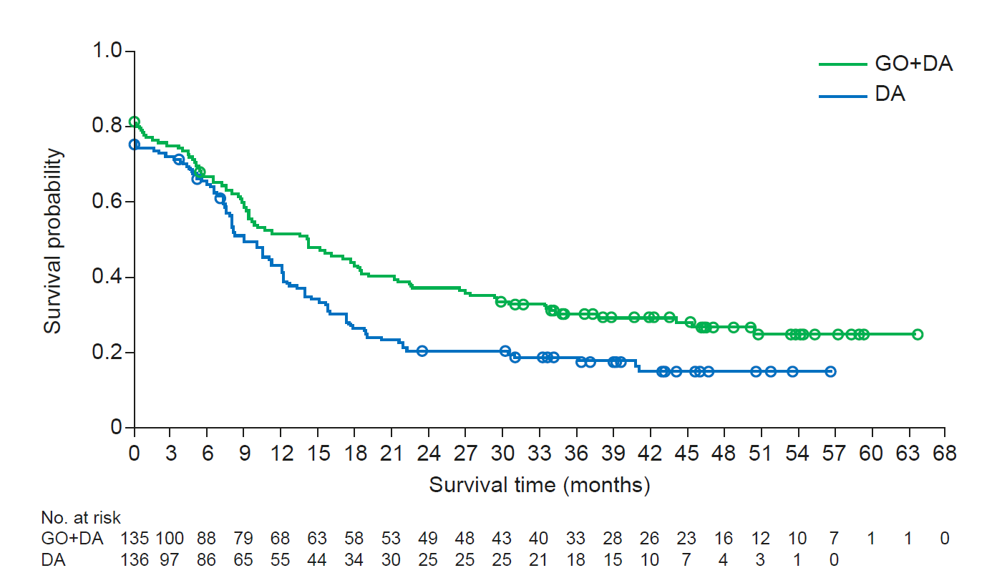
Source: Figure 2.5.3, p98 of the submission
  - The submission did not provide any discussion regarding baseline starting points for both treatment arms that begin at 0.8 or lower and were different between arms (with the number at risk representing the whole trial population). The PSCR claimed this was an artefact of the definition of EFS according to the independent review analysis, where the date of induction failure was set at the randomisation date (and there was meant to be a solid line alone the axis from 1.0 on Day 0).
  - The table below presents the results of independent review committee-assessed EFS, 30 April 2013 cut off in the modified ITT population.
Table 4: Event-free survival (EFS) results (mITT population, independent review, 30 April 2013 cut off)
 | GO+DA  (N=135) | DA  (N=136)
Number of events, n (%) | 97 (71.9) | 111 (81.6)
- Induction failure | 25 (18.5) | 34 (25.0)
- Relapse | 58 (43.0) | 60 (44.1)
- Death | 14 (10.4) | 17 (12.5)
Kaplan-Meier estimate of median EFS, months (95% CI) | 14.2 (9.1, 18.5) | 8.5 (7.5, 12.2)
Unstratified hazard ratio vs DA (95% CI) | 0.705 (0.536, 0.928), p = 0.0121
Stratified by ELN risk hazard ratio vs DA (95% CI) | 0.702 (0.528, 0.933), p = 0.0161
Source: Table 14.2.2.1, p 281 of the trial report
Abbreviations: CI, confidence interval; DA, daunorubicin and cytarabine; ELN, European LeukemiaNet 2010; GO, gemtuzumab ozogamicin
Note: p-values are not adjusted for multiplicity
  - EFS was statistically significantly longer in patients treated with gemtuzumab in combination with standard intensive chemotherapy versus standard intensive chemotherapy alone. Median follow-up duration for this analysis was not provided in the submission. These results were numerically less favourable for gemtuzumab than the primary analysis (investigator assessed, 1 August 2011 cut off) (HR = 0.562; 95% CI: 0.415, 0.762; median follow-up duration of 14.8 months).
  - Post-hoc subgroup analyses in patients with favourable/intermediate/unknown cytogenetic risk, including EFS as a proxy for relapse-free survival, haematological response rates and overall survival were used in the economic evaluation. The subgroup analyses provided in the submission were difficult to interpret due to poor documentation (e.g. subgroup sizes not always reported, overall survival results for the requested subgroup without known unfavourable risk not provided). These data were provided in the PSCR. Results from post-hoc subgroup analyses should be interpreted with caution given the lack of interaction testing and large number of analyses conducted without adjustment for multiplicity.
  - The table below presents results of a post-hoc analysis of independent review committee-assessed EFS (30 April 2013 cut off) by cytogenetic risk, including the requested patient population with favourable/intermediate/unknown cytogenetic risk.
Table 5: Post-hoc analysis of event-free survival by cytogenetic risk subgroups (independent review, 30 April 2013 cut off)
 | GO+DA | DA
Favourable/intermediate cytogenetic risk subgroup
Number of patients | 94 | 95
Number of events, n (%) | 65 (69.1) | 77 (81.1)
Kaplan-Meier estimate of median EFS, months (95% CI) | 17.7 (9.7, 27.0) | 11.3 (8.1, 14.0)
Hazard ratio vs DA (95% CI) | 0.655 (0.469, 0.914)
Unknown cytogenetic risk subgroup
Number of patients | 14 | 11
Number of events, n (%) | 7 (50.0) | 8 (72.7)
Kaplan-Meier estimate of median EFS, months (95% CI) | 33.5 (0.0, NE) | 8.2 (0.0, 15.9)
Hazard ratio vs DA (95% CI) | 0.531 (0.190, 1.487)
Unfavourable cytogenetic risk subgroup
Number of patients | 27 | 30
Number of events, n (%) | 25 (92.6) | 26 (86.7)
Kaplan-Meier estimate of median EFS, months (95% CI) | 4.0 (0.0, 6.5) | 1.4 (0.0, 9.1)
Hazard ratio vs DA (95% CI) | 1.009 (0.582, 1.750)
Favourable/intermediate/unknown cytogenetic risk subgroup
Number of patients | 108 | 106
Number of events, n (%) | 72 (66.7) | 85 (80.2)
Kaplan-Meier estimate of median EFS, months (95% CI) | 18.5 (10.8, 29.4) | 11.3 (8.0, 14.0)
Hazard ratio vs DA (95% CI) | 0.630 (0.459, 0.866)
Source: Table 14.2.2.9 provided in data request during the evaluation
Abbreviations: CI, confidence interval; ECOG, Eastern Cooperative Oncology Group performance status; ELN, European LeukemiaNet, HR, hazard ratio; NCCN, National Comprehensive Cancer Network; NE, not estimable
  - In patients with favourable/intermediate cytogenetic risk, EFS was statistically significantly longer in the gemtuzumab arm compared with the control arm. While the results were consistent with the whole trial population, the difference in treatment effect between arms appeared greater in these subgroups. There was no apparent treatment benefit in patients with unknown or unfavourable cytogenetic risk.
  - In the economic model, relative treatment effects for gemtuzumab were derived from EFS observed in a subset of patients in the subgroup without known unfavourable cytogenetic risk who achieved an overall response (complete remission with or without incomplete platelet recovery) (presented in the figure below). The ESC noted that the application of the subset results, rather than of the ITT results, was due to the model structure which stratified patients into those achieving an overall response and those who did not. Corresponding Kaplan-Meier curves for the whole subgroup were not provided in the submission.
Figure 2: Kaplan-Meier curve for event-free survival in the subgroup without unfavourable cytogenetic risk, who achieve an overall response (independent review, April 2013 cut-off)
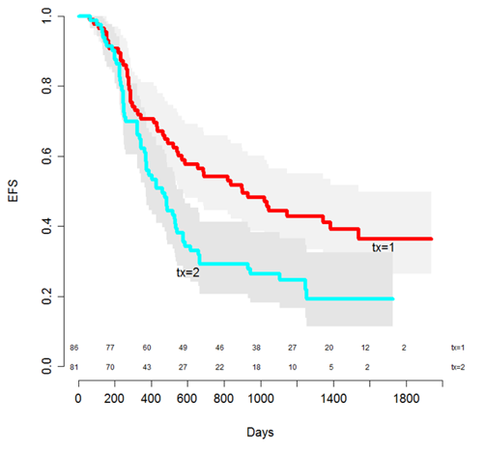
Source: Figure 3.4.1, p 173 of the submission
Abbreviations; EFS, event-free survival; tx=1, gemtuzumab; tx=2, control arm
  - It was difficult to interpret these results due to poor documentation in the submission. No treatment effect estimates or measures of uncertainty were provided in the submission for this subset of patients.
  - The ESC noted that EFS between arms was similar initially and then diverged from the 400-day mark, whereas treatment with gemtuzumab is for three to four months. The ESC considered that fit patients who achieved complete remission would likely receive a HSCT post induction and consolidation with gemtuzumab. The submission claimed the plateaus occurring between 3 and 4 years (1200 to 1600-day mark) represented patients who achieved a functional cure (i.e. approximately 40% in the gemtuzumab arm and 20% in the control arm). This claim was inadequately justified based on the limited data provided in the submission. The plateau appears to be based on a relatively small number of patients and limited follow-up based on the trial (median follow-up of 4 years in the gemtuzumab arm and 3.4 years in the control arm).

Response rates
  - Post-induction response rates (complete remission with or without incomplete platelet recovery, induction failure or “other”) by investigator assessment and independent review are summarised in the table below.
Table 6: Post-induction response rate by investigator assessment and independent review (mITT population)
 | GO+DA  (N=135) | DA  (N=136)
Investigator assessed
CR, n (%) | 95 (70.4) | 95 (69.9)
CRp, n (%) | 15 (11.1) | 5 (3.7)
Induction failure, n (%) | 17 (12.6) | 29 (21.3)
Other, n (%) ª | 8 (5.9) | 7 (5.1)
Overall response (CR or CRp), n (%) | 110 (81.5) | 100 (73.5)
95% CI, % | 73.9, 87.6 | 65.3, 80.7
Odds ratio vs DA (95% CI) | 1.58 (0.86, 2.96)
Independent review ^{b}
CR, n (%) | - | -
CRp, n (%) | - | -
Induction failure, n (%) | 25 (18.5) | 34 (25.0)
Other, n (%) ª | 10 (7.4) | 6 (4.4)
Overall response (CR or CRp), n (%) | 100 (74.1) | 96 (70.6)
95% CI, % | 65.8, 81.2 | 62.2, 78.1
Odds ratio vs DA (95% CI) | 1.19 (0.67, 2.10)
Source: Table 26, p 104 and Table 14.2.12.5, p 853 of the trial report
Abbreviations: CI, confidence interval; CR, complete response; CRp, complete response with incomplete platelet recovery; DA, daunorubicin and cytarabine; GO, gemtuzumab ozogamicin; HR, hazard ratio
Note: Overall response was defined as CR + CRp
ª Includes patients for whom there was insufficient data to determine response
^{b} No distinction was made between CR and CRp due to insufficient data in the original case report forms
  - The majority of patients in both arms achieved complete remission (CR) or complete remission with incomplete platelet recovery (CRp). The ESC noted that there was no statistically significant difference in overall response between treatment arms. A comparison of results between the investigator and independent review assessments suggested differences in response categorisation, with greater discordance within the gemtuzumab arm versus the control arm results.
  - Subgroup analysis results (favourable/intermediate/unknown cytogenetic risk) were consistent with the overall results, with no statistically significant differences in response rates between treatment arms. Patients in the favourable/intermediate risk, unknown risk and combined favourable/intermediate/unknown subgroups had numerically higher response rates in both treatment arms than in the unfavourable risk subgroup.

Overall survival
  - The figure below presents the Kaplan-Meier plot of overall survival, 30 April 2013 cut off in the modified ITT population.
Figure 3: Kaplan-Meier plot for overall survival (mITT population, 30 April 2013 cut off)
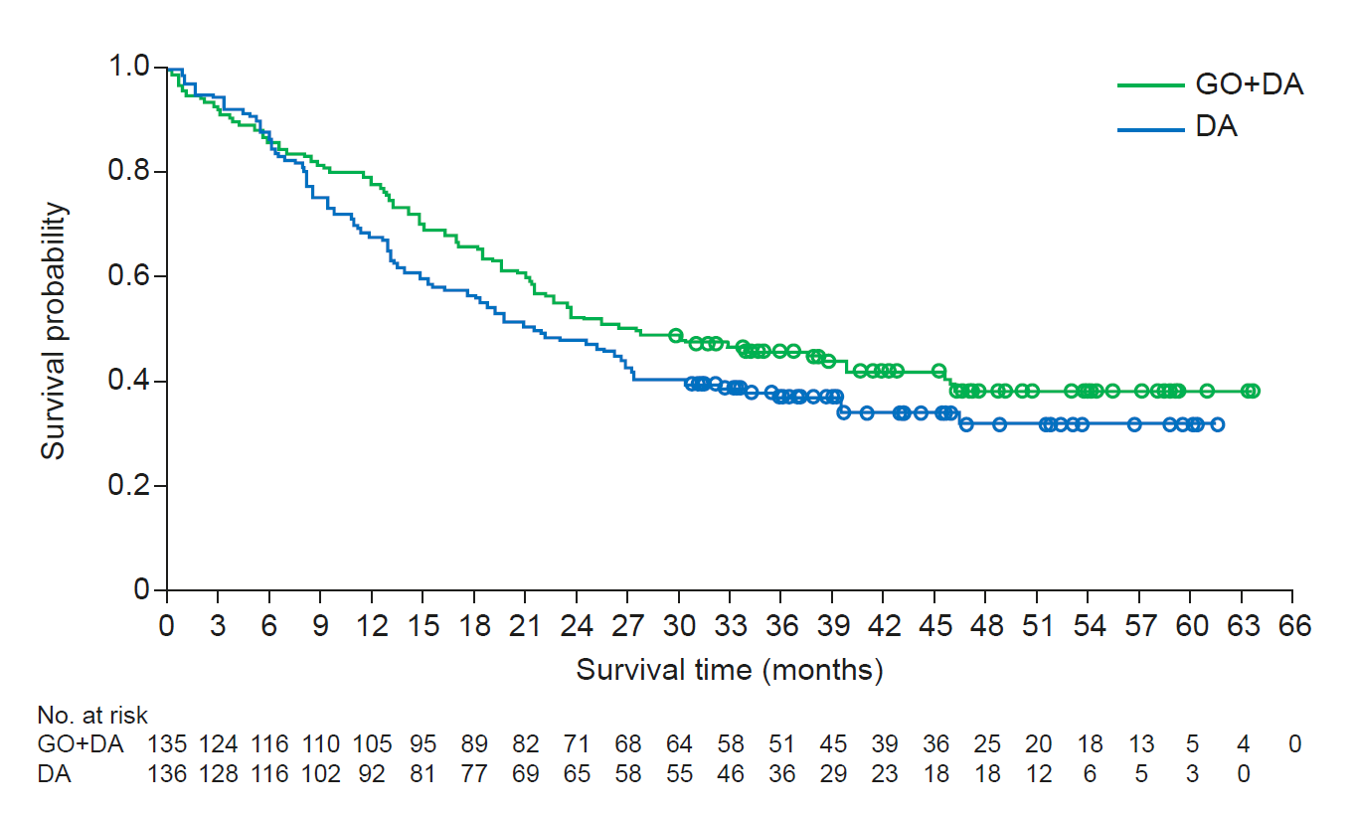
Source: Figure 2.5.6, p 102 of the submission
Abbreviations: GO, gemtuzumab; DA, daunorubicin and cytarabine
  - The table below presents the overall survival data, based on median follow-up duration of 47.6 months for gemtuzumab and 41.0 months in the control arm.
Table 7: Overall survival (OS) results (mITT population, 30 April 2013 cut off)
 | GO+DA  (N=135) | DA  (N=136)
Number of deaths, n (%) | 80 (59.3) | 88 (64.7)
Kaplan-Meier estimate of median OS, months (95% CI) | 27.5 (21.4, 45.6) | 21.8 (15.5, 27.4)
Unstratified hazard ratio vs DA (95% CI) | 0.807 (0.596, 1.093), p = 0.1646
Source: Table 14.2.5.1, p 559 of the trial report
Abbreviations: CI, confidence interval; DA, daunorubicin and cytarabine; ELN, European LeukemiaNet 2010; GO, gemtuzumab ozogamicin; NCCN, National Comprehensive Cancer Network v2013.2
Note: p-values are not adjusted for multiplicity
  - There was a numerical improvement in overall survival with gemtuzumab as add-on to standard intensive chemotherapy versus standard intensive chemotherapy alone, however, the ESC noted that the difference did not reach statistical significance. The submission claimed the lack of statistical significance was because the study was not powered to detect statistically significant differences for this outcome.
  - There was potential for confounding due to treatment crossover in the trial. Thirty patients (22.1%) in the control arm subsequently received gemtuzumab as a component of follow-up therapy. No crossover adjustment was performed in the submission. The submission conducted a feasibility assessment for adjusting the trial data, but found that the underlying assumptions of different adjustments methods would not hold, and therefore the results would not provide reliable and robust estimates of overall survival.
  - Overall survival may also be confounded due to the use of active salvage therapies including chemotherapy (75.6% received at least 1 follow-up therapy) and HSCT. More patients in the control arm (39.0%) underwent HSCT than in the gemtuzumab arm (23.7%). Post-hoc analyses of overall survival by HSCT status suggest a statistically significant benefit for overall survival in favour of gemtuzumab in the subgroup of patients without HSCT (HR = 0.680; 95% CI: 0.476, 0.972) and no additional benefit in patients with HSCT (HR = 0.970; 95% CI: 0.536, 1.754). These results should be interpreted with caution due to potential risk of bias, lack of adjustment for multiple tests and potential imbalances between treatment arms (patient characteristics were not provided in the submission).
  - Subgroup results for overall survival were broadly consistent with whole trial population results, with no statistically significant improvement in overall survival with gemtuzumab treatment. Results in the subgroup with favourable/intermediate cytogenetic risk were more favourable for gemtuzumab compared to the control arm. Results in patients with unfavourable risk were less favourable for gemtuzumab compared to the control arm. Overall survival results based on the requested PBS population with favourable/intermediate/unknown cytogenetic risk (unstratified by response) or unknown risk alone were not presented in the submission. This information was provided in the PSCR and is presented in the table below.
Table 8: Post-hoc analysis of overall survival in the cytogenetic risk subgroups (30 April 2013 cut off)
 | GO+DA | DA
Favourable/intermediate cytogenetic risk subgroup
Number of patients | 94 | 95
Number of deaths, n (%) | 51 (54.3) | 57 (60.0)
Median OS, months (95% CI) | 38.6 (24.4, NE) | 26.0 (18.9, 39.7)
Unstratified HR vs DA (95% CI) | 0.747 (0.511, 1.091), p = 0.1288
Unknown cytogenetic risk subgroup
Number of patients | 14 | 11
Number of deaths, n (%) | 5 (35.7) | 7 (63.6)
Median OS, months (95% CI) | NE (3.9, NE) | 8.5 (3.3, NE)
Unstratified HR vs DA (95% CI) | 0.378 (0.109, 1.310), p = 0.115
Unfavourable cytogenetic risk subgroup
Number of patients | 27 | 30
Number of deaths, n (%) | 24 (88.9) | 24 (80.0)
Median OS, months (95% CI) | 12.0 (4.2, 14.2) | 13.5 (9.4, 27.3)
Unstratified HR vs DA (95% CI) | 1.553 (0.878, 2.748), p = 0.1267
Favourable/intermediate/unknown cytogenetic risk subgroup
Number of patients | 108 | 106
Number of deaths, n (%) | 56 (51.9) | 64 (60.4)
Median OS, months (95% CI) | 39.9 (27.5, NE) | 25.6 (18.3, 39.4)
Unstratified HR vs DA (95% CI) | 0.697 (0.486, 0.999), p = 0.0480
Source: Table 3, p5 of the PSCR
Abbreviations: CI, confidence interval; DA = daunorubicin + cytarabine; GO, gemtuzumab ozogamicin; HR, hazard ratio; NE, not estimable; OS, overall survival

  - In the economic model, overall survival was modelled based on a subset of patients in the subgroup without known unfavourable cytogenetic risk (i.e. the favourable/intermediate/unknown cytogenetic risk subgroup presented above), who achieved an overall response (complete remission with or without incomplete platelet recovery, i.e. patients with a treatment benefit) and those who did not achieve an overall response (refractory, i.e. patients with no treatment benefit) (presented in the Figures 4 and 5 below). It was difficult to interpret these results due to poor documentation in the submission.
Figure 4: Kaplan-Meier curves for overall survival in the subgroup without unfavourable cytogenetic risk, who achieved an overall response (independent review, April 2013 cut-off).
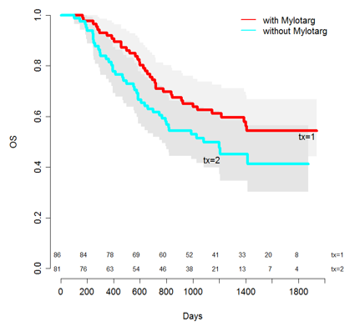
Source: Figure 3.4.2, p 174 of the submission
Abbreviations: OS, overall survival; tx=1, gemtuzumab; tx=2, control arm
  - Overall survival was initially similar between arms until the curves stated to diverge from the 200-day mark, which the ESC considered may be due to a post treatment effect, e.g. the effect of salvage treatments or HSCT. No treatment effect estimates were provided in the submission or the PSCR for the subsets of patients who achieved/did not achieve an overall response; however, the figure shows overlapping confidence intervals (grey areas), which suggest no statistically significant difference between treatment arms. Corresponding results for the whole subgroup (unstratified by response status) were not provided in the submission. A visual comparison with results from the whole trial population (Figure 3) suggest greater divergence between arms in this subset which favours gemtuzumab.
  - The submission claimed the plateau from approximately 3 to 4 years (1200 to 1400-day mark) represents patients who achieved a functional cure. This claim was inadequately justified based on the limited data provided in the submission. The plateau appears to be based on relatively few patients with follow-up extending beyond 3 years.
Figure 5: Kaplan-Meier curves for overall survival in the subgroup without unfavourable cytogenetic risk, who did not achieve an overall response (independent review, April 2013 cut-off).
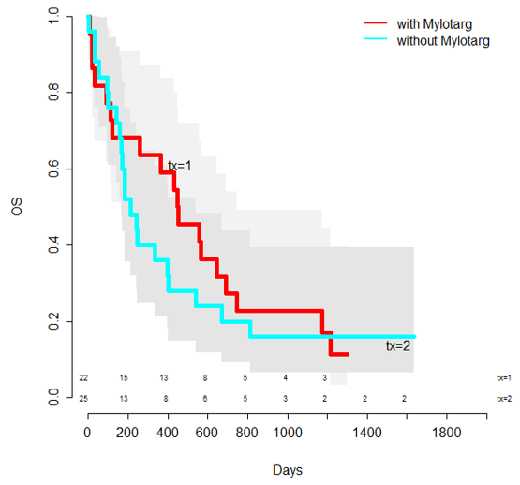
Figure 3.4.3, p 174 of the submission
Abbreviations: OS, overall survival; tx=1, gemtuzumab; tx=2, control arm
  - The submission claimed no difference in overall survival between treatment arms in patients without unfavourable cytogenetic risk, who did not achieve an overall response. The results were informed by relatively few patients in this subgroup and a very small number of patients informing the claimed plateau.

Comparative harms
  - Although the ALFA-0701 trial randomised patients 1:1 between the gemtuzumab and control arms, some patients randomised to the gemtuzumab arm did not receive gemtuzumab in each phase of treatment (induction, consolidation 1, consolidation 2). This resulted in an as-treated population that changed with each cycle. Further, there were thirty patients in the control arm who received gemtuzumab as follow-up therapy after relapse as part of the gemtuzumab compassionate use program. Therefore, any differences in frequency of adverse events between arms should be interpreted with caution.
  - Adverse event data were only available based on patient incidence.
  - During retrospective data collection, all source documents were reviewed to ascertain all events meeting the definition of a serious adverse events without regard to causality, unlike the adverse event reporting that was restricted to predefined categories. The total number of serious adverse events in this dataset was higher than reported based on pre-defined categories. The table below presents the incidence of serious and severe adverse events (of special interest) in the key trial.
Table 9: Incidence of treatment-emergent serious adverse events and severe adverse events in the ALFA-0701 trial (As Treated population)
 | Patients, n (%)
 | GO+DA  N=131 | DA  N=137
Any serious adverse event | 88 (67.2) | 76 (55.5)
Blood and lymphatic system disorders | 49 (37.4) | 19 (13.9)
- Thrombocytopaenia | 34 (26.0) | 6 (1.5)
- Febrile bone marrow aplasia | 12 (9.2) | 8 (5.8)
Hepatobiliary disorders | 17 (13.0) | 8 (5.8)
- Veno-occlusive disease (VOD) | 5 (3.8) | 0
- Hepatocellular injury | 4 (3.1) | 2 (1.5)
Infections and infestations | 54 (41.2) | 52 (38.0)
- Bronchopulmonary aspergillosis | 14 (10.7) | 10 (7.3)
- Septic shock | 12 (9.2) | 9 (6.6)
- Bacterial sepsis | 7 (5.3) | 0
Renal and urinary disorders | 10 (7.6) | 5 (3.6)
- Acute kidney injury | 6 (4.6) | 4 (2.9)
Retrospective data collection
Severe infections and infestations (≥Grade 3) | 102 (77.9) | 106 (77.4)
Haemorrhage, all grades | 118 (90.1) | 107 (78.1)
- Grade 3 | 23 (17.6) | 12 (8.8)
- Grade 4 | 4 (3.1) | 0
- Death | 3 (2.3) | 1 (0.7)
Veno-occlusive disease (VOD), all grades | 6 (4.6) | 2 (1.5)
- Grade 3 | 2 (1.5) | 1 (0.7)
- Grade 4 | 1 (0.8) | 1 (0.7)
- Death | 2 (1.5) | 0
Source: Table 14.3.1.2.1.1, p 865; Table 14.3.1.2.4.2, p 993; Table 35, p 122; Table 14.3.2.1.1, p 1116 of the trial report
Abbreviations: DA, daunorubicin and cytarabine; GO, gemtuzumab
  - The incidence of any serious adverse event was higher in the gemtuzumab arm compared with the control arm. The most common serious adverse events that were more frequent in the gemtuzumab arm were thrombocytopaenia, febrile bone marrow aplasia, bacterial sepsis, acute kidney injury, VOD and hepatocellular injury.
  - There were more treatment-related deaths in the gemtuzumab arm (n=7, 5.3%) compared with the control arm (n=5, 3.6%), most of them occurring during the induction phase. The most common fatal adverse events were haemorrhage, sepsis and VOD/liver toxicity.
  - Overall, the majority of patients in both treatment arms required at least one platelet transfusion and one red blood cell transfusion. Mean red blood cell transfusions were similar between treatments (15.3 versus 14.3 in gemtuzumab and control arms, respectively), while platelet infusions were higher in the gemtuzumab arm (25.8) than the control arm (12.6). This difference was observed across all phases of treatment.
  - The incidence of serious adverse events in the subgroup analysis of patients with favourable/intermediate cytogenetic risk appeared to be consistent with the analysis in the whole trial population. Safety outcomes in the unfavourable risk subgroup were difficult to interpret due to data sparseness. The incidence of serious adverse events in the nominated subgroup with favourable/intermediate/unknown cytogenetic risk was not provided in the submission. This information was provided in the PSCR: for the favourable/intermediate/unknown cytogenetic risk subgroup, serious adverse events were reported in 73/105 (69.5%) of patients in the gemtuzumab arm and 59/106 (55.7%) of patients in the control arm; for the unknown cytogenetic risk subgroup, serious adverse events were reported in 10/14 (71.4%) of patients in the gemtuzumab arm and 4/11 (36.4%) of patients in the control arm.

Benefits/harms
  - On the basis of direct evidence presented in the submission (ALFA-0701 whole trial population), after approximately 4 years, patients treated with gemtuzumab with standard intensive chemotherapy compared to standard intensive chemotherapy alone have:
- Longer EFS of approximately 5.7 months;
- No apparent difference in response rates; and
- No apparent difference in overall survival.
  - On the basis of direct evidence presented in the submission (ALFA-0701 whole trial population), over a median duration of follow-up of approximately 4 years, for every 100 patients treated with gemtuzumab with standard intensive chemotherapy compared to standard intensive chemotherapy alone:
- Approximately 12 additional patients would experience a serious adverse event that is life-threatening or requires hospitalisation;
- There will be a similar incidence of severe infections;
- Approximately 12 additional patients would experience any grade haemorrhage (blood loss) and 2 additional patients would die from haemorrhage; and
- Approximately 3 additional patients would experience any grade veno-occlusive disease (blocked veins in the liver that may lead to liver damage), and 2 additional patients would die from veno-occlusive disease.
  - On the basis of direct evidence presented by the submission (ALFA-0701) in the subgroup of patients with favourable, intermediate or unknown cytogenetic risk (the requested PBS population), patients treated with gemtuzumab with standard intensive chemotherapy compared to standard intensive chemotherapy alone have:
- Longer EFS of approximately 7.2 months; and
- No apparent difference in response rates.

Clinical claim
  - The submission described gemtuzumab as superior in terms of efficacy compared to standard of care. The ESC considered that the claim of superior efficacy may be reasonable in terms of EFS but may not be reasonable in terms of overall survival.
  - The ESC noted that data from the whole trial population suggest a numerical benefit in overall survival with gemtuzumab when used in addition to standard intensive chemotherapy; however, the difference was not statistically significant. While the lack of statistical significance may be due to lack of power, there was also potential for confounding due to treatment crossover and use of active salvage therapies, including differential rates of HSCT between arms.
  - There were concerns with the applicability of the magnitude of benefit observed in the key trial to the PBS population due to potential differences in age, CD33 expression levels, cytogenetic and molecular risk distribution, treatment regimens used as consolidation chemotherapy and use of subsequent therapies including HSCT. Data from the key trial were relatively old and may not adequately reflect changes in diagnostic work-up, assessment of response (e.g. molecular relapse based on MRD) and subsequent treatment decisions in current practice.
  - The submission claimed that the treatment benefit observed with gemtuzumab in the subset of patients achieving an overall response is likely to translate to ongoing survival benefit associated with functional cure. This claim was based on observed plateaus at the tail-end of the Kaplan-Meier data for EFS and overall survival. The robustness of these data was unclear as it was based on relatively small numbers of patients remaining at the end of the trial with a median follow-up of approximately 3 to 4 years. The PSCR claimed that the overall survival data were sufficiently mature; however, the ESC considered that it remained unclear whether the observed plateaus at the tail-end of the Kaplan-Meier data for EFS and overall survival were sufficiently robust representations of functional cure which would translate into ongoing survival benefits.
  - The PBAC considered that the claim of superior comparative effectiveness was reasonable in terms of EFS, but was not adequately supported by the data in terms of OS.
  - The submission described gemtuzumab as inferior in terms of safety compared to standard of care. The PBAC considered that this claim was adequately supported by the data.

Economic analysis
  - The submission presented a modelled economic evaluation of gemtuzumab in combination with standard intensive chemotherapy compared to standard intensive chemotherapy alone for the treatment of patients with previously untreated, de novo CD33-positive acute myeloid leukaemia (AML), except acute promyelocytic leukaemia (APL) who do not have an unfavourable cytogenetic profile (i.e. favourable, intermediate or unknown risk). The economic evaluation was based on data from the ALFA-0701 key trial as well as other modelled variables.
Table 10: Key components of the economic evaluation
Component | Summary
Treatments | Gemtuzumab in combination with standard intensive chemotherapy (daunorubicin and cytarabine) versus standard intensive chemotherapy alone (daunorubicin and cytarabine), for induction and consolidation therapy
Time horizon | 40 years in the model base case versus median follow-up of 4 years in the gemtuzumab arm and 3.4 years in the control arm in the trial
Outcomes | Life years, quality-adjusted life years
Methods used to generate results | Markov cohort expected value analysis
Health states | 6 main health states including sub-states described in brackets: induction phase, CR/CRp (complete remission, relapse), refractory, HSCT (procedure, CR without GVHD, CR with GVHD), functional cure, dead
Cycle length | 1 month
Allocation to health states | Pooled response rates from the ALFA-0701 trial used to determine treatment pathway (CR/CRp or refractory) in the induction phase.  Overall survival and relapse-free survival (using event-free survival in patients achieving overall response as a proxy) for CR/CRp patients based on individual treatment arm Kaplan-Meier curves from the ALFA-0701 trial for the median duration of follow-up (3-4 years), followed by parametric extrapolation. Overall survival for refractory patients based on Kaplan-Meier curves using pooled data from the ALFA-0701 trial, median duration of follow-up unreported, followed by parametric extrapolation.  Transition probabilities to HSCT were based on time to HSCT data from the ALFA-0701 trial (pooled for CR/CRp and refractory patients; individual arms for relapsed patients). Overall survival and relapse-free survival for CR/CRp sub-states based on underlying survival curves; overall survival for refractory patients based on underlying overall survival curve.  The submission assumed that patients are functionally cured after remaining in CR/CRp health states for 5 years in the model. Survival and relapse in the functionally cured health states were still determined by underlying overall survival and relapse-free survival curves (which had underlying cure fraction estimates). Transitions to the functionally cured health state occurred from CR/CRp sub-states at fixed time points in the model (after 5 years in the CR/CRp patients who do not relapse, with or without HSCT; after 5 years in post-HSCT states in relapsed or refractory patients). Overall survival in the functionally cured state was based on general population mortality adjusted for excess mortality due to AML.  In the model, 4.5% of incremental costs and 75.1% of incremental QALYs are generated in the extrapolated period.
Health state and event costs | First-line drug costs based on proportions receiving induction and consolidation treatment cycles in the ALFA-0701 trial. Additional gemtuzumab component costs for the first induction cost included for 10.5% of patients who receive treatment and are later confirmed with unfavourable risk.  Subsequent therapies (salvage, non-curative and best supportive care) costs based on local guidelines and UK expert opinion. The duration of treatment of salvage therapy was assumed to be 1.5 months. The durations of non-curative therapies and best supportive care were based on a restricted means survival time (RMST) analysis for newly relapsed (13.8 months) and refractory patients (10.98 months) in the ALFA-0701 trial. The duration of terminal care of 2 months was assumed with corresponding costs applied in the last 2 months of survival.  Administration costs based on AR-DRG items or MBS items applied using the following proportions: 100% public hospital inpatient cost for induction cycles; 80% public hospital inpatient costs, and 20% public and private hospital costs for consolidation cycles; 100% public hospital inpatient costs for salvage therapies; mixed settings (depending on treatment administered, but largely outpatient) for non-curative therapies.  Adverse event costs assumed captured in treatment administration costs. Additional costs for unplanned hospitalisations were based in incidence of adverse events in the ALFA-0701 trial and hospitalisation costs plus the cost of defibrotide for the treatment of VOD. Blood transfusions costs were included as a proxy for additional adverse events costs.  Additional adverse event costs were applied to the gemtuzumab arm (once-off) to 10.5% of patients assumed to have unfavourable risk.  Other disease management costs in the model include diagnostic and disease monitoring tests (MBS items), inpatient attendance costs in patient receiving non-curative therapy or best supportive care (4 hospitalisations), outpatient attendance, and antifungal and antibiotic prophylaxis.  HSCT costs and acute GVHD event costs were based on AR-DRG items. Post-HSCT costs were applied over 2 years based on assumed frequencies of hospitalisation and outpatient visits.
Health related quality of life | Based on multiple published sources:  Induction phase: 0.16 (midostaurin PSD, July 2018)  CR/CRp (consolidation 1 and 2): 0.57 (midostaurin PSD, July 2018)  CR/CRp (off treatment): 0.74 (NICE 2016 appraisal of azacitidine)  Relapse (salvage therapy): 0.16 (midostaurin PSD, July 2018)  Relapse (non-curative therapy): 5 years or less: 0.51 (midostaurin PSD, July 2018); after 5 years: 0.798 decreasing over time (age- and gender-adjusted EQ-5D UK general population utility)  Refractory (salvage therapy): 0.16 (midostaurin PSD, July 2018)  Refractory (non-curative therapy): 0.51 (midostaurin PSD, July 2018)  HSCT procedure: 0.613 (Forsythe 2018)  Post-HSCT CR/CRp without GVHD: 0.74 (NICE 2016 appraisal of azacitidine)  Post-HSCT CR/CRp with GVHD: 0.67 (Forsythe 2018)  Functionally cured: 0.821 decreasing over time (age- and gender-adjusted EQ-5D UK general population utility)  Adverse event disutility (all events except VOD): 0.0207 (NICE 2016 appraisal of azacitidine)  VOD disutility: 0.208 (defibrotide SMC submission, 2014)  The ESC noted that the submission provided little justification for the utility values applied in the model and that the utility values were sourced from a variety of studies, with little applicability to the proposed PBS population.
Discount rate | 5% for costs and outcomes, applied annually
Software | Excel
Source: Table 3.1.1, p 164 of the submission
Abbreviations: AR-DRG, Australian refined diagnosis related groups; CR/CRp, complete remission with or without incomplete platelet recovery; GVHD, graft versus host disease; HSCT, haematopoietic stem cell transplant; PSD, Public Summary Document; VOD, veno-occlusive disease
  - Overall, the evaluation of input data used in the economic model was challenging due to poor documentation of sources, methods and assumptions used to derive these inputs.
  - The structure of the economic model was based on a novel, semi-Markov cohort state-transition model. The model health states were identified and validated through a preference elicitation study undertaken by the sponsor to represent the clinical pathway and treatment experience of patients with AML (Castejón 2018). The design of the model structure was informed by the Castejón 2018 study, expert opinion and previous AML models in the published literature.
  - The figure and table below present the model structure, health states and transitions in the economic model.
Figure 7: Model structure diagram
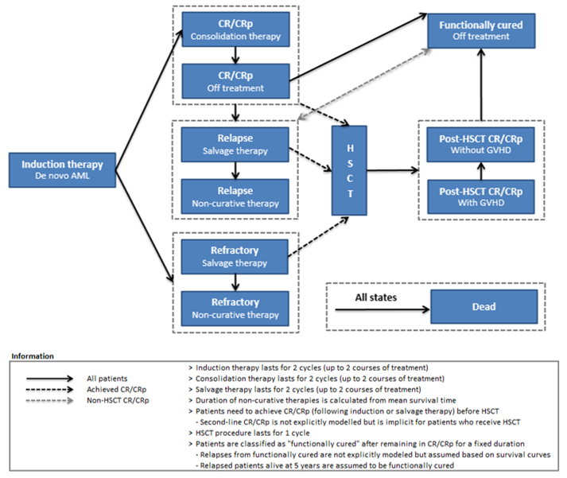
Source: Figure 3.2.1, p 157 of the submission
Abbreviations: AML, acute myeloid leukaemia; CR, complete remission; CRp, complete remission with incomplete platelet recovery; GVHS, graft versus host disease; HSCT, haematopoietic stem cell transplant
  - The model structure allowed for separate survival analyses to be undertaken based on induction success (i.e. CR/CRp treatment pathway) or induction failure (i.e. refractory pathway). This allowed differentiation between relapse and refractory patients as well as capturing the impact of downstream events (e.g. HSCT). The model structure was complex and difficult to evaluate given the difficulties in determining the actual flow of patients through the model. The use of multiple health states and sub-states increased the complexity of determining the attribution of costs and consequences to patients in the model. The ESC considered that the complex model structure resulted in a need to rely on transition probabilities informed by subgroups consisting of small patient numbers, unsubstantiated assumptions and unverifiable expert opinion, all of which made the outcomes highly uncertain.
  - The submission tried to limit the complexity of the state-transition model by (i) including relapse and HSCT as sub-states within the CR/CRp and CR/CRp, relapse and refractory health states respectively; and (ii) applying structural assumptions to the HSCT health state to avoid the need for spate states to capture patient ‘history’ and to ensure the internal validity of the model predictions.
  - Despite the use of a complex structure and simplifying assumptions, the submission claimed the internal validity of the model was maintained and produced outcomes that were similar to results from the key trial. While internal validity is important, the absence of an explicit structural link between relapse and HSCT and mortality rates significantly limits the flexibility of the model to fully reflect longer-term uncertainties. The lack of an explicit structural link between key states also results in the same independence assumption between clinical events that underpins the partitioned survival analysis approach. It was unclear whether the complex approach used in the submission provided any added advantage over simpler approaches. The PSCR stated that the model structure allowed the incorporation of transition probabilities for HSCT and functionally cured health states, to adjust survival for HSCT and non-HSCT patients and to allow for differentiation between overall survival in relapse and refractory patients. The ESC considered that any gains in clinical accuracy were offset by input uncertainty, particularly relating to the fact that although the clinical data did not demonstrate a survival benefit for gemtuzumab patients, benefits were applied in the model.
  - Overall, the appropriateness of the model structure and validity of individual transitions in the model was unclear. However, modelled outcomes were largely dependent on the ‘functional cure’ assumption and extrapolations beyond the trial duration. The validity of the functional cure assumption and cure fractions appeared more critical than the route by which patients achieve functional cure (i.e. whether pathways were explicitly or implicitly modelled).
  - The model trace is presented in the figure below, showing the proportion of patients who are in complete remission (with or without incomplete platelet recovery), relapsed or dead over the 40-year model time horizon.
Figure 8: Model trace: GO+DA versus DA alone
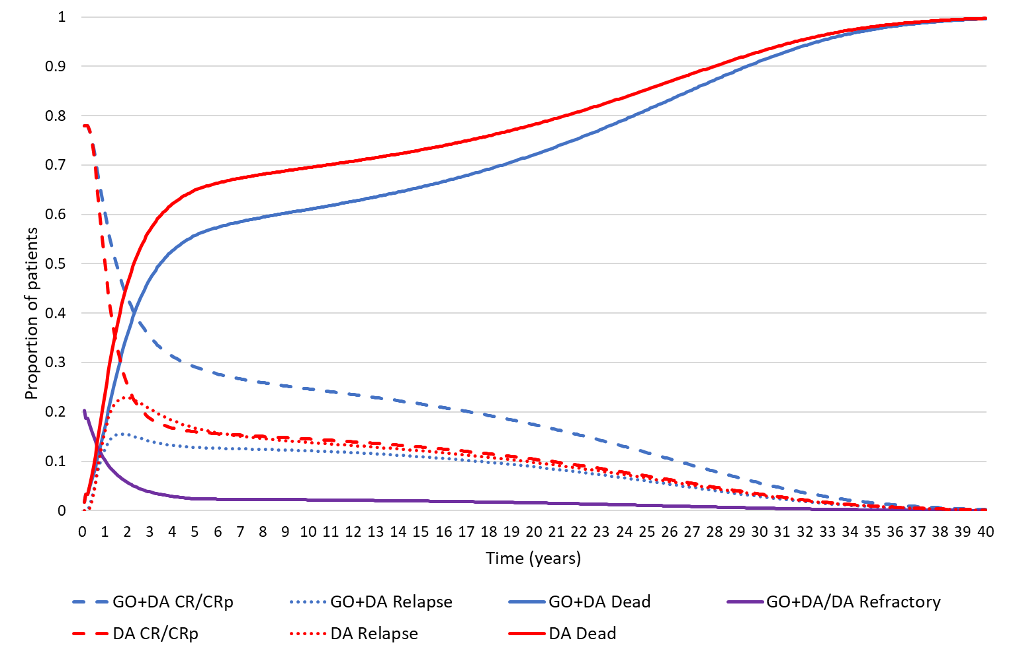
Source: constructed during the evaluation using the ‘201103_Mylotarg CEM_v7.2_Australia’ Excel workbook of the submission
Abbreviations: CR/CRp, complete remission with or without incomplete platelet recovery; DA, daunorubicin and cytarabine; GO, gemtuzumab
  - The model trace shows a separation of all curves from prior to 1 year, based on pre-determined response to induction therapy (CR/CRp or refractory). The proportion of patients who were refractory was the same between arms as this was based on a pooled overall survival curve. The maximum difference in relapse-free survival occurred at 1.92 years and the maximum difference in overall survival occurred at 2.17 years. There was an ongoing difference in relapse-free survival between arms that only converged towards the end of the 40-year time horizon. Similarly, the difference in overall survival curves was maintained in the extrapolated period beyond the trial, with the curves converging towards the end of the model. These differences were not adequately supported by the available data. The ESC considered the model traces to be highly uncertain, particularly for overall survival as the clinical trial data did not demonstrate a significantly difference for overall survival in the ITT population. The ESC noted that this uncertainty was then magnified over the 40 year extrapolation.
  - The ESC noted that the use of the log-normal mixture cure model for the overall survival curves resulted in mortality estimates for both treatment arms that were lower than general population estimates, and therefore considered that the log-normal mixture cure model was not clinically plausible. The pre-PBAC response stated that at no time did the mortality estimate in either treatment arm fall below that of the general population estimates. Although the submission adjusted overall survival estimates to account for Australian general population mortality (including an adjustment for excess mortality due to AML), the estimated cure fractions resulted in prolonged survival in patients achieving functional cure.
  - The extrapolated overall survival curves in both arms were driven by patients achieving functional cure. Figure 9 presents the model trace of patients who achieve functional cure from the CR/CRp health states (no HSCT, post-HSCT).
Figure 9. Model trace of patients who achieve functional cure from the CR/CRp health states (no HSCT and post-HSCT)
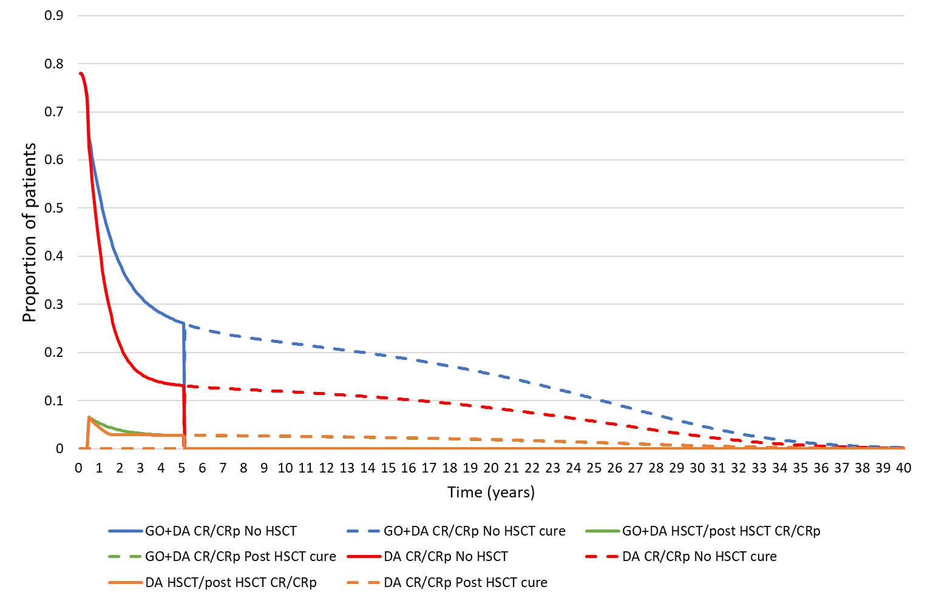
Source: constructed during the evaluation using the ‘201103_Mylotarg CEM_v7.2_Australia’ Excel workbook of the submission
Abbreviations: CR/CRp, complete remission with or without incomplete platelet recovery; DA, daunorubicin and cytarabine; GO, gemtuzumab; HSCT, haematopoietic stem cell transplant
  - Patients who achieve complete remission who do not relapse either remain in the CR/CRp health state, transition to HSCT or die. The model trace shows the proportion of patients transitioning to the functionally cured health state after 5 years in the CR/CRP health states. The graph shows the absolute proportions of patients achieving functional cure was driven by patients who do not relapse or undergo HSCT. The estimated cure fractions were driven by extrapolations based on plateaus at the tail-end of Kaplan-Meier overall survival curves in the trial. As previously noted, the ESC considered that it remained unclear whether the observed plateaus at the tail-end of the Kaplan-Meier data for EFS and overall survival were sufficiently robust representations of functional cure which would translate into ongoing survival benefits.
  - The table below presents the estimated cure functions informing long term survival extrapolations in the model.
Table 11: Estimated cure fractions used in the economic model
Survival curve | Estimated cure fractions from MCM log-normal function |  | Estimated cure fraction based on pooled data, Gompertz function | HSCT cure rate
 | GO+DA | DA
Relapse-free survival (CR/CRp) | 34.3% | 20.6% | - | -
Overall survival (CR/CRp) | 52.1% | 40.0% | - | 42.2%
Overall survival (refractory) | - | - | NE | 42.2%
Source: Adapted from Table 3.4.6, p 198 of the submission
Abbreviations: CR/CRp, complete remission with or without incomplete platelet recovery; HSCT, haematopoietic stem cell transplant; MCM, mixture cure model; NE, not estimable
  - There were substantial differences in estimated cure fractions between survival functions for both relapse-free and overall survival. The clinical plausibility of higher cure fractions estimated for overall survival compared to relapse-free survival was not discussed in the submission. The PSCR stated that the differences in the cure fractions between the groups was similar for both end points and that it was this difference in the probability of survival (as opposed to the absolute cure rates) that drove the QALY differences between the arms. The PSCR also stated that given that subsequent therapies (e.g. HSCT) have the potential to achieve functional cure, it was clinically plausible that relapsed patients became functionally cured. The ESC considered that the difference suggested that either there are a significant number of patients who become functionally cured following relapse (potentially due to subsequent therapies and/or HSCT) or the data may not be sufficiently mature to provide a robust estimate of the cure fraction for overall survival. The cure fractions estimated based on overall survival extrapolations in the trial appeared high compared to the estimated cure fraction due to HSCT.
  - While there was no cure fraction assumed for patients who are refractory, the submission assumed functional cure in patients who were still alive at 5 years (based on mortality rates applied at this time point). No justification was provided. The submission also assumed functional cure in refractory patients after HSCT. The pre-PBAC response stated that the model did not permit transition from refractory to functionally cured in the absence of HSCT, whereas relapsed patients receiving salvage therapy did have this pathway available. The pre-PBAC response stated that refractory patients who received HSCT and who were alive at 5 years were reasonably assumed to have achieved functional cure, and, in the absence of HSCT, only patients remaining in the CR/CRp state were considered functionally cured at 5 years.
  - The cure rate for HSCT was estimated to be 42.2% based on an analysis of post-hoc overall survival pooled from all HSCT data in the key trial. Data were pooled from both arms of the trial and for HSCTs from all health states. No details were provided on the methods of this analysis and it was unclear whether the cure rate was estimated via visual inspection or from a formal statistical analysis. There are likely differences in cure rates depending on when HSCT was received (before relapse, after relapse or refractory disease). The use of a fixed cure rate for all patients appears to be a simplifying assumption, however, the assumption further limits the flexibility of the model to appropriately reflect the impact of HSCT on survival outcomes. The PSCR stated that the cure fraction due to HSCT (42.2%) was based on the proportion of patients alive at 5 years post HSCT, which was estimated from the overall survival curve for all HSCT patients from the time of HSCT from the ALFA-0701 study.
  - Key drivers of the economic model are summarised in the table below.
Table 12: Key drivers of the model
Description | Method/Value | Impact
Time horizon | The time horizon used in the economic model was 40 years. The submission claimed that this was appropriate to capture the long-term costs and consequences associated with de novo AML. A lifetime horizon may be considered reasonable for this disease given the possibility of functional cure. However, the ESC considered that a modelled time horizon of 40 years appears optimistic as it exceeds the average life expectancy of the modelled population aged 62 years.  In a previous consideration of midostaurin for a similar population (newly diagnosed FLT-3 mutation positive AML patients who are eligible for standard intensive remission induction chemotherapy), the PBAC considered that 25 years was a reasonable time horizon in patients aged ≥ 60 years, and 40 years in patients < 60 years of age (para 6.32, midostaurin PSD, July 2018 PBAC meeting). The pre-PBAC response acknowledged that a 40 year time horizon was optimistic and provided a revised base case with a 25 year time horizon. | High, favours gemtuzumab
Extrapolation | Survival extrapolations in the economic model were based on post-hoc analyses of event-free survival (independent review committee analysis) and overall survival data in the key trial collected up to the April 2013 data cut-off. Overall survival analyses were further stratified by response status due to heterogeneity in survival outcomes between CR/CRp and refractory patients. The results of these analyses were difficult to interpret due to poor documentation in the submission. The ESC considered that the assumption of increased overall survival for patients in the gemtuzumab arm was highly uncertain as the clinical evidence did not suggest a statistically significant difference in overall survival in the ITT population of ALFA-0701. | High, favours gemtuzumab
Source: constructed during the evaluation
  - To capture the impacts of initiating treatment in patients who later are confirmed as having unfavourable cytogenetic risk, the submission increased the cohort size by 10.5% when calculating the costs of induction therapy. The submission claimed that patients who are subsequently identified as having unfavourable cytogenetic risk would not receive further treatment with gemtuzumab. Therefore, the assumption was made that these patients would have received their full induction course but would not proceed with consolidation courses. An additional cost of $'''''''''''' was calculated for the gemtuzumab component only based on the drug acquisition cost of gemtuzumab for the first induction course (10.5% x $''''''''''''). The likely proportion of patients with unfavourable cytogenetic risk in the requested PBS population was uncertain; however the PSCR estimated that 30% to 50% of patients would initiate treatment while waiting for cytogenetic test results and that 21% of those patients would have unfavourable cytogenetics and, therefore, cease treatment.
  - The results of the modelled economic evaluation are summarised below. The pre-PBAC response provided a revised base case which applied a 25 year time horizon, rather than a 40 year time horizon.
Table 13: Results of the economic evaluation
Component | GO+DA | DA | Increment
Costs | $''''''''''''''''''' | $265,942 | $'''''''''''''''
LYs | 6.68 | 5.49 | 1.19
QALYs | 4.77 | 3.86 | 0.91
Incremental cost per life year gained |  |  | $'''''''''''''''¹
Incremental cost per QALY gained |  |  | $'''''''''''''²
Pre-PBAC response revised base case – time horizon = 25 years
Costs | $''''''''''''''''''' | $265,942 | $'''''''''''''''
LYs | 6.43 | 5.29 | 1.14
QALYs | 4.61 | 3.73 | 0.87
Incremental cost per life year gained |  |  | $''''''''''''''''''¹
Incremental cost per QALY gained |  |  | $'''''''''''''²
Source: Table 3.8.6, p 236 of the submission
Abbreviations: DA, daunorubicin and cytarabine; GO, gemtuzumab; LYs, life years; QALYs, quality-adjusted life years
The redacted values correspond to the following ranges:
¹ $25,000 to < $35,000/QALY gained
² $35,000 to < $45,000/QALY gained
  - Based on the economic model, treatment with gemtuzumab was associated with an incremental cost effectiveness ratio (ICER) of $35,000 to < $45,000 per QALY gained compared to standard intensive remission chemotherapy.
  - The difference in cost between treatment arms was largely driven by increased drug costs in the gemtuzumab arm (primarily due to the gemtuzumab component in the induction 1, consolidation 1 and 2 courses), which was partially offset by substantial decreases in costs of subsequent therapies (primarily driven by hospitalisations, blood transfusions and prophylactic treatment costs) and HSCT procedures in relapsed patients. The ESC noted that HSCT was a key cost offset in the economic model, with the submission assuming, without justification, that a higher proportion of patients in the standard of care arm would receive a HSCT after relapse. The pre-PBAC response stated that the probability of HSCT after relapse was derived from patient-level data from ALFA-0701. There was a small increase in costs due to adverse events and red blood cell and platelet transfusions in the gemtuzumab arm versus its comparator arm during induction and consolidation therapies.
  - The difference in health outcomes was primarily driven by increased overall survival in the gemtuzumab arm, which was not demonstrated in the clinical trial evidence. The majority of this difference occurred in the functionally cured health state (primarily from non-HSCT patients achieving sustained remission after induction chemotherapy, partially offset by relapsed patients who underwent HSCT).
  - The results of key sensitivity analyses presented in the submission and conducted during the evaluation are summarised below.
Table 14: Results of sensitivity analyses
Analysis | Incremental cost | Incremental QALYs | ICER per QALY gained
Base case | $'''''''''''''' | 0.9094 | $'''''''''''''¹
Time horizon (base case 40 years)
10 years | $''''''''''''''''' | 0.5303 | $''''''''''''''''³
20 years | $''''''''''''''''' | 0.8103 | $''''''''''''''''''²
Treatment effect (base case: subgroup without known unfavourable risk, independent review – individual Kaplan-Meier curves of overall survival and event-free survival in CR/CRp patients; pooled Kaplan-Meier curve of overall survival in refractory patients; extrapolated using parametric distributions)
Subgroup without known unfavourable risk (investigator assessed) | $''''''''''''''' | 0.7802 | $'''''''''''''''''²
mITT population (independent review) | $'''''''''''''''''' | 0.6214 | $'''''''''''''''³
mITT population (investigator assessed) | $''''''''''''''''' | 0.4421 | $'''''''''''''''⁴
Survival extrapolation for RFS and OS in CR/CRp health states (base case: individually fitted MCM log-normal for RFS and OS, general population mortality with excess mortality HR: 1.34 applied after 5 years)
MCM log-normal for RFS and generalised gamma (combined fit) for OS | $''''''''''''''''' | 0.7609 | $''''''''''''''''''²
MCM Weibull for RFS and generalised gamma (combined fit) for OS | $''''''''''''''' | 0.7693 | $'''''''''''''''''²
MCM generalised gamma for RFS and generalised gamma (combined fit) for OS | $''''''''''''''''' | 0.7117 | $''''''''''''''''³
Survival extrapolation for OS in refractory patients (base case: pooled treatment arms, Gompertz extrapolation, general population mortality with excess mortality HR 1.34 applied after 5 years)
Individual treatment arms: GO+DA: exponential; DA: Gompertz | $'''''''''''''''' | 0.8289 | $''''''''''''''''''²
Individual treatment arms: GO+DA: Weibull; DA: log-logistic | $''''''''''''''' | 0.8260 | $''''''''''''''''''²
HSCT rates (base case: pooled rates in CR/CRp patients who do not relapse and refractory patients, individual arm rates in CR/CRp patients who relapse)
Pooled rates in CR/CRp patients who relapse (i.e. no difference in HSCT rates between arms) | $'''''''''''''''' | 0.9368 | $''''''''''''''''''²
No HSCT | $'''''''''''''''' | 0.9439 | $'''''''''''''''²
Gemtuzumab drug costs in patients who initiate treatment, who are later confirmed with unfavourable risk (base case: cost of gemtuzumab for 3 doses in induction course 1 multiplied by proportion with unfavourable risk, $3,797 added to GO+DA arm)
0% | $''''''''''''''''' | 0.9094 | $'''''''''''''''¹
30% | $'''''''''''''''''' | 0.9094 | $'''''''''''''''''²
Subsequent therapies (non-curative therapy and best supportive care) and disease management costs in relapsed or refractory patients (base case: duration of treatment based on pooled arms data from RMST analysis using ALFA-0701 trial data; 13.8 months and 10.98 months in relapsed and refractory patients.
Individual treatment arms for relapsed (GO+DA: 14.48 months, DA: 13.14 months) and refractory (GO+DA: 13.73 months, DA: 7.94 months) patients | $'''''''''''''''''' | 0.9094 | $''''''''''''''''²
HSCT procedure costs (base case: $140,535 weighted cost based on AR-DRGs for major complexity in patients age 16 years or less and minor complexity in patients age over 16 years)
Cost of procedure: $66,021.20 (based on AR-DRG for minor complexity, age above 16 years) | $''''''''''''''''' | 0.9094 | $''''''''''''''''²
Source: Table 3-30, p254 of the submission and additional analyses conducted during the evaluation using the ‘201103_Mylotarg CEM_v7.2_Australia’ Excel workbook of the submission
Abbreviations: CR, complete remission; CRp, complete remission with incomplete platelet recovery; HSCT, haematopoietic stem cell transplant; RFS, relapse-free survival; ICER, incremental cost-effectiveness ratio; MBS, Medicare Benefits Schedule; MCM, mixture cure model; OS, overall survival; QALY, quality adjusted life year; RMST, restricted means survival time; TTO, time trade off; VAS, visual analogue scale; VOD, veno-occlusive disease
The redacted values correspond to the following ranges:
¹ $35,000 to < $45,000/QALY gained
² $45,000 to < $55,000/QALY gained
³ $55,000 to < $75,000/QALY gained
⁴ $75,000 to < $95,000/QALY gained

  - The results were most sensitive to time horizon, treatment effect based on various datasets from the trial, survival extrapolation and functional cure assumptions in the CR/CRp health states and HSCT rates. The results were generally robust to changes in other parameters in the model.
  - The results were moderately sensitive to the use of Kaplan-Meier curves based on investigator-assessed and independent review analyses. This result was unexpected as available treatment effect estimates suggest more favourable results for gemtuzumab using the investigator-assessed results. The reasons for this were unclear and could not be adequately evaluated due to the complex nature of patient flow in the model. The pre-PBAC response stated that that the ICER does not decrease due to multiple inter-related reasons.
  - The ESC considered that the revisions required to the model structure and inputs were complex. The ESC considered that the unsubstantiated assumptions, such as the overall survival benefit applied in the model which was not demonstrated in the key clinical trial, the complex structure and the lack of transparency relating to various inputs (utilities, costs, etc.) meant the results of the economic evaluation were highly uncertain. The ESC considered that a future model should be based on the available evidence (i.e. EFS rather than overall survival) and should incorporate a more transparent and robust approach to costs and quality of life data to inform the model.

Drug/cost/patient/course
Table 15: Drug cost per patient per course for gemtuzumab component
 | ALFA-0701 | Economic model | Financial estimates
Gemtuzumab costs
Proportion receiving:  - Induction Day 1  - Induction Day 4  - Induction Day 7 | 98.5%  96.9%  95.4% | 100%  100%  100% | 100%  100%  100%
Induction vials/patient¹ | 2.91 | 3.00 | 3.00
Proportion receiving:  - Consolidation 1  - Consolidation 2 | 69.5%  48.9% | 74.0%  62.6% | 69.5%  48.9%
Consolidation vials/patient¹ | 1.18 | 1.37 | 1.20
Cost per 5 mg vial² | - | $'''''''''''''''''''''''''' | $'''''''''''''''''''''''''
Cost/patient/course | - | $'''''''''''''''''''''''' | $''''''''''''''''''''''
Source: Table 32, pp117 of the ALFA-0701 clinical study report; ‘Cost calcs’ worksheet of the ‘201103_Mylotarg CEM_v7.2_Australia’ Excel workbook; Table 4.1.1, pp234-236 of the submission.
¹ One 5 mg vial required per treatment.
² Weighted price based on assumed 21%/79% public/private split (based on idarubicin PBS dispensing data for January 2019 to December 2019).

  - In the economic model, the estimated total drug cost for induction and consolidation chemotherapy with gemtuzumab was $'''''''''''''' (based on $'''''''''''' for gemtuzumab, $9,124 for daunorubicin and $5,125 for cytarabine; using trial-based uptake rates of 100% induction 1, 14.5% induction 2, 74% consolidation 1 and 62.6% consolidation 2). The submission also included an additional cost of $'''''''''''' to the gemtuzumab arm of the model (10.5% x cost of 3 vials of gemtuzumab for induction therapy only) to capture the uncertainty of treating patients who are subsequently confirmed with unfavourable risk.
  - The estimated drug cost for induction and consolidation chemotherapy for standard of care was $14,255 (based on $9,151 for daunorubicin and $5,103 for cytarabine; using trial-based uptake rates of 100% induction 1, 14.5% induction 2, 70.8% consolidation 1 and 65% consolidation 2).

Estimated PBS usage & financial implications
  - This submission was not considered by DUSC.
  - The submission used an epidemiological approach to estimate the utilisation and financial impacts associated with the PBS listing of gemtuzumab for the treatment of patients with previously untreated de novo CD33-positive AML who do not have an unfavourable cytogenetic risk.
  - Key inputs used in the financial estimates are summarised in the table below.
Table 16: Key inputs for the financial estimates
Parameter | Value applied and source | Comment
AML incidence per 100,000 | Yr 1: 4.47; Yr 2: 4.49; Yr 3: 4.51; Yr 4: 4.53; Yr 5: 4.56; Yr 6: 4.58. AIHW Cancer Data in Australia (2018; 2020 supplement). Historical crude annual AML incidence (2007 to 2016; patients aged ≥15 years) were extrapolated using a log-linear function. Incidence rates were applied to the Australian population ≥15 years. | The method used to derive the incident population appeared to be reasonable. However, the submission did not exclude patients with APL who would not be eligible under the proposed restriction.
Proportion of patients with de novo AML | 70%. Krauss et al. (2018) reported that 10% of AML related to prior therapies and 20% due to antecedent haematological disorder. Juliusson et al. (2009) reported that 4% of patients had therapy-related AML and 24% secondary to previous haematologic disease. | -
Proportion of AML patients 'fit' or eligible for intensive chemotherapy | 62%. Based on an analysis of the Swedish Acute Leukemia Registry (2,767 patients diagnosed with non-APL AML leukemia January 1997 to September 2005; median age 72 years, range 16-97 years), by Juliusson et al. (2009). | Included patients across all WHO categories (I-IV). Seven percent of patients included in the study had a WHO performance status of IV and would not be eligible under the proposed restriction (ECOG performance status of 0-3).
Proportion of patients that have CD33-positive AML | 90%. Assumption based on O’Hear et al., 2015 (90%); Linenberger, 2005 (85-95%); Ehninger et al., 2014 (87.8%). | -
Proportion of patients with cytogenetics results available at induction | 50%. Based on expert opinion, 30%-50% of AML patients in Australia are estimated to have an unconfirmed cytogenetic status on Day 1 of induction. | -
Proportion of patients without unfavourable cytogenetics at induction | 78.9%. Based on ALFA-0701, 21.0% of patients had unfavourable cytogenetics (3.3% favourable, 66.4% intermediate, 9.2% unknown). | Changes in the methods used to characterise cytogenetic risk suggest that to the ALFA-0701 trial population may not be representative of the proposed PBS population.
Uptake rate (induction) | 70%. Expert opinion (Sept 2020) indicating that midostaurin is the treatment of choice for patients with FLT3-positive AML. The assumption of 70% represents the proportion of patients that do not have FLT3-positive AML (Daver et al., 2019). | May not be reasonable given that results of FLT3 may not be available at the time of induction. Given the timing of midostaurin during the induction cycle, some patients may initiate treatment with gemtuzumab prior to treatment with midostaurin.
Uptake rate (consolidation) | 69.5%. In the ALFA-0701 trial, 69.5% of patients who received Induction with gemtuzumab received at least one consolidation cycle. | The adjustment factor of 69.5% was also used to derive the number of vials used for consolidation treatment which may have resulted in underestimation of the number of consolidation treatments.
Proportion of public and private hospital treatment with gemtuzumab | Public: 80%; Private: 20%. Weighted average of caseloads for four haematologists in NSW (one), QLD (one), VIC (two). | The caseloads of the four surveyed haematologists, and the derived public/private split may not be representative of clinical practice in Australia. The PSCR stated that revised estimates (which included feedback from 4 additional haematologists) calculated the weighted average public versus private hospital split as 83%/17%.
Proportion of patients receiving induction with gemtuzumab as an inpatient | '''''''''%. The submission stated that this assumption was supported by sponsor-commissioned hospital pharmacist research. | -
Proportion of patients receiving consolidation with gemtuzumab as an inpatient | 80%. Midostaurin public summary documents (Nov 2017, July 2018). (Public: 64%, Private: 16%) | The PBAC considered that 80-90% of midostaurin patients were likely to receive consolidation treatment as an inpatient.
Number of gemtuzumab vials per induction cycle | 3 vials per patient per Induction cycle. Based on ALFA-0701, patients initiated and completed an average of 1 cycle of induction with gemtuzumab and received an average of 3 vials (1 vial on Day 1, 4 and 7). | The assumption that all patients will receive 3 vials is likely to (slightly) overestimate the number of vials, as not all patients will receive three doses. In the ALFA-0701 trial, 93.9% of patients received all 3 doses.
Gemtuzumab vials per consolidation treatment | 1.2 vials per patient. Based on ALFA-0701, 69.5% and 48.9% of patients received 1 vial of gemtuzumab in the first and second consolidation cycles, respectively (i.e. [69.5% x 1 vial] + [48.9% x 1 vial] = 1.2 vials). | The submission may have underestimated the number of vials as the 69.5% adjustment factor was already applied as the consolidation uptake rate.
Gemtuzumab drug price | $''''''''''''''''''''''''' (5 mg vial). Proposed price weighted for public/private hospital use (21%/79%) based on idarubicin PBS dispensing data (January 2019 to December 2019; Item number 4440Q and 7247K). | -
Source: Table 4.1.1, pp234-236 of the submission.
Abbreviations: AML, acute myeloid leukaemia; APL, acute promyelocytic leukemia AIHW, Australian Institute of Health and Welfare; CD, cluster of differentiation; ECOG, Eastern Cooperative Oncology Group; MDS, myelodysplastic syndrome; WHO, World Health Organization; Yr, Year.
  - The submission assumed no change in the use of standard intensive remission chemotherapy, which is also the backbone chemotherapy regimen for gemtuzumab. Therefore, only the cost of the gemtuzumab component was estimated. The table below presents the estimated net cost to the PBS/RPBS of listing gemtuzumab.
Table 17: Estimated cost to the PBS/RPBS of listing gemtuzumab
 | Year 1  (2022) | Year 2  (2023) | Year 3  (2024) | Year 4  (2025) | Year 5  (2026) | Year 6  (2027)
Patients without known unfavourable cytogenetic risk | '''''''''' ª | '''''''''' ª | '''''''''' ª | '''''''''' ª | '''''''''' ª | '''''''''' ª
Patients without cytogenetic results at induction | '''''''' ª | '''''''''' ª | '''''''''' ª | ''''''''' ª | '''''''''' ª | '''''''''' ª
Total eligible patients | ''''''''' ª | ''''''''' ª | ''''''''' ª | ''''''''' ª | '''''''''' ª | '''''''''' ª
Patients receiving gemtuzumab induction treatment
Uptake rate (70%) | ''''''''' ª | '''''''''' ª | ''''''''' ª | '''''''''' ª | '''''''''' ª | ''''''''' ª
Non-PBS  - Public admitted (80%)  PBS  - Private admitted (20%) | '''''''''' ª  ''''''^{1, a} | '''''''''' ª  ''''''' ª | ''''''''' ª  '''''' ª | '''''''''' ª  '''''' ª | ''''''''' ª  '''''' ª | '''''''' ª  '''''' ª
Induction scripts (3 per patient) | '''''''' ª | ''''''''' ª | '''''''''' ª | '''''''''' ª | '''''''''' ª | '''''''''' ª
Patients receiving gemtuzumab consolidation treatment
Induction patients | '''''''''' ª | '''''''' ª | '''''''''' ª | ''''''''' ª | ''''''''' ª | '''''''''' ª
Cytogenetics unfavourable³ | '''''' ª | '''''' ª | '''''' ª | '''''' ª | ''''''' ª | ''''''' ª
Total patients eligible for gemtuzumab consolidation | ''''''''' ª | '''''''''' ª | '''''''''' ª | ''''''''' ª | '''''''''' ª | '''''''''' ª
Uptake rate (69.5%) | ''''''''' ª | ''''''''' ª | '''''''''' ª | ''''''''' ª | '''''''''' ª | '''''''''' ª
Non-PBS  - Public admitted (64%)  PBS  - Public non-admitted (16%)  - Private admitted (16%)  - Private non-admitted (4%) | '''''' ª  '''''' ª  '''''' ª  ''' ª | '''''' ª  '''''' ª  ''''''' ª  '''' ª | ''''''' ª  ''''''' ª  ''''''' ª  '''' ª | '''''' ª  '''''' ª  '''''' ª  ''' ª | '''''''''' ª  ''''''' ª  ''''''' ª  '''' ª | '''''''''' ª  '''''' ª  ''''''' ª  ''' ª
Consolidation scripts (1.2 per patient) | '''''''^{2, a} | '''''' ª | '''''' ª | ''''''' ª | ''''''' ª | '''''' ª
Cost of gemtuzumab to the PBS/RPBS
Total PBS scripts | '''''''' ª | '''''''' ª | '''''''''' ª | '''''''''' ª | ''''''''' ª | '''''''''' ª
PBS/RPBS cost ($'''''''''''''''' per script) | $''''''''''''''''''''''''' ^{b} | $''''''''''''''''''''''' ^{b} | $'''''''''''''''''''''''''' ^{b} | $'''''''''''''''''''''''' ^{b} | $''''''''''''''''''''''' ^{b} | $''''''''''''''''''''''' ^{b}
Patient copayment ($26.81 per original script) | $'''''''''''''' ^{b} | $''''''''''''' ^{b} | $''''''''''''''' ^{b} | $'''''''''''' ^{b} | $'''''''''''''' ^{b} | $'''''''''''''' ^{b}
Net PBS/RPBS cost | $'''''''''''''''''''''''' ^{b} | $'''''''''''''''''''''' ^{b} | $''''''''''''''''''''''''' ^{b} | $'''''''''''''''''''''''''' ^{b} | $''''''''''''''''''''''' ^{b} | $''''''''''''''''''''''''' ^{b}
Source: Table 4.1.1, pp234-235; Table 4.2.4, pp240-241; Table 4.2.6, p242; Table 4.2.8, p243; Table 4.2.11, p245; Table 4.2.12, pp246-7 of the submission.
¹ Includes additional < 500 grandfathered patients in Year 1.
² Includes additional < 500 grandfathered patients in Year 1.
³ Patients with no cytogenetic results at induction who are subsequently found to have unfavourable cytogenetics (e.g. Year 1: < 500 x 70% x 21% = < 500).
The redacted values correspond to the following ranges:
ª < 500
^{b} $0 to < $10 million
  - The estimated net cost to the PBS/RPBS was $0 to < $10 million in Year 1 of listing, increasing to $0 to < $10 million in Year 6, and totalling $10 million to < $20 million over the first six years of listing.
  - As noted previously, the majority of costs associated with gemtuzumab are expected to be derived from use in the public hospital setting, as 80% of patients were estimated to receive induction treatment and 64% of patients were estimated to receive consolidation treatment as public hospital inpatients. The estimated cost to State Government budgets was $0 to < $10 million in Year 1, increasing to $0 to < $10 million in Year 6, and totalling $50 million to < $60 million over the first six years of listing.
  - The ESC considered the financial estimates to be uncertain due to the following reasons:
- The assumed split for gemtuzumab treatment between public and private hospitals was based on the caseloads of four haematologists (one in New South Wales, one in Queensland, two in Victoria), and may not be representative of the public/private distribution of patients in Australian clinical practice. A higher proportion of private hospital patients will increase the cost to the PBS and decrease the cost to State Government budgets. The PSCR stated that revised estimates, which included feedback from an additional four haematologists from Western Australia, South Australia and Tasmania, calculated the weighted average public versus private hospital split as 83%/17%, which would reduce the number of patients being treated in private hospitals and decrease the cost to the PBS by approximately $0 to < $10 million per year. The ESC noted that the public versus private hospital split was based on the caseload of four haematologists in the submission and eight haematologists in the PSCR. As the majority of AML is treated in the public sector, the ESC considered that the estimate was likely to be in the range of the actual public versus private split, but noted that the net cost to the PBS/RPBS was highly sensitive to the estimated proportions and that treatment practices could change in the future.
- The submission did not exclude patients with APL who would not be eligible for treatment with gemtuzumab under the proposed restriction.
- The applicability of the inputs from the ALFA-0701 trial, including the proportion of patients with known unfavourable cytogenetic profiles, and the proportion of patients receiving consolidation treatment were unclear.
- The assumed uptake rate of 69.5% applied to consolidation therapy was also used to derive the number of vials per patient for consolidation treatment and is likely to have resulted in underestimation of the costs associated with consolidation treatment.
- The proportion of patients with no cytogenetic results at induction and the proportion of patients considered fit for intensive chemotherapy were considered uncertain.
- The submission did not adequately justify the assumed uptake rate of 70% for gemtuzumab induction therapy in patients with no cytogenetic test results. It was unclear what proportion of patients have FLT3 mutation test results at the time of induction initiation, and some FLT3-positive patients may be treated with gemtuzumab (while awaiting results of FLT3 mutation testing). This would result in additional cost to government.
- There are likely to be additional costs to the PBS/MBS associated with gemtuzumab due to longer hospitalisations for treatment, higher numbers of unplanned hospital visits, higher rates of medical procedures (e.g. blood transfusions), and higher rates of adverse events compared to standard therapy.

Quality Use of Medicines
  - The submission noted the following activities to support the quality use of medicines:
- Initiation of a patient access program to enable local haematologists to gain experience with using gemtuzumab in combination with intensive chemotherapy (anthracycline and cytarabine), in the treatment of de novo AML patients.
- A commitment to developing a ‘Health Care Professional Therapeutic Management Guide’ focusing on the efficacy, safety, dosing and administration of gemtuzumab, targeted to haematologists, pharmacists and nurses.
- The planning of a presentation by a key international opinion leader discussing the treatment of de novo AML patients with gemtuzumab, to be held in 2021.
- Post-marketing surveillance using data from the ALLG National Blood Cancer Registry.
For more detail on PBAC’s view, see section 7 PBAC outcome.
- PBAC Outcome
  - The PBAC did not recommend gemtuzumab ozogamicin for the treatment of de novo CD33-positive acute myeloid leukaemia (AML), except acute promyelocytic leukaemia, who do not have a known cytogenetic profile. The PBAC considered, based on the clinical evidence presented, that the magnitude of the overall survival benefit over current standard of care in the proposed PBS population was difficult to determine. The PBAC noted that the economic model was complex and difficult to assess and considered the incremental cost effectiveness ratio highly uncertain.
  - The PBAC considered that the nominated primary comparator of standard of care, which consisted of intensive induction and consolidation chemotherapy with an anthracycline and cytarabine, was appropriate.
  - The PBAC noted that the submission was based on the results of one open-label randomised controlled trial, ALFA-0701, which compared gemtuzumab plus cytarabine and daunorubicin with cytarabine and daunorubicin.
  - The PBAC noted that the submission presented a number of post-hoc subgroup analyses by cytogenetic risk. The PBAC noted that the subgroup that included patients who had a favourable/intermediate/unknown cytogenetic risk (i.e. patients with an unfavourable risk were excluded) aligned with the proposed PBS population. The PBAC considered that the results of the post-hoc subgroup analyses should be interpreted with caution due to differences in the definitions of cytogenetic risk used in the key trial and more recent risk classifications, the lack of interaction testing and the large number of analyses conducted without adjustment for multiplicity.
  - In terms of event-free survival (EFS), the PBAC noted that gemtuzumab plus standard intensive chemotherapy compared with standard intensive chemotherapy alone was associated with a modest statistically significant benefit in the modified intention-to-treat (mITT) population, when assessed by independent review committee (5.7 months; HR = 0.705; 95% CI; 0.536, 0.928). The PBAC noted that the investigator assessed results were more favourable to gemtuzumab (HR = 0.562; 95% CI: 0.415, 0.762). The PBAC noted that the result in the favourable/intermediate/unknown cytogenetic risk subgroup was also statistically significant (7.2 months; HR = 0.630; 95% CI: 0.459, 0.866).
  - The PBAC noted that there was no statistically significant difference in overall response rate between the arms of ALFA-0701 when assessed either by the investigator (HR = 1.58; 95% CI: 0.86, 2.96) or by independent review (HR = 1.19; 95% CI: 0.67, 2.10).
  - The PBAC noted that the difference in overall survival, at a median follow up of 47.6 months in the gemtuzumab arm and 41.0 months in the control arm, was not statistically significant in the mITT population (HR = 0.807; 95% CI: 0.596, 1.093). The PBAC noted that in the favourable/intermediate/unknown cytogenetic risk subgroup the results were difficult to interpret (HR = 0.697; 95% CI: 0.486, 0.999).
  - The PBAC noted that overall survival was potentially confounded as 22.1% of patients in the control arm subsequently received gemtuzumab, and due to the use of salvage therapies and HSCT. The PBAC also noted that more patients in the control arm (39.0%) underwent HSCT compared to in the gemtuzumab arm (23.7%).
  - Although the submission stated that the goal of gemtuzumab treatment was to delay the time to relapse, the PBAC noted that no data were provided to support a long term survival benefit in the proposed population. The PBAC noted that the submission cited a study by Breems 2005 in claiming that increased length of remission is positively correlated with overall survival; however, Breems 2005 also identified three other clinically relevant parameters which correlated with overall survival (cytogenetic profile, age at relapse and prior stem cell transplantation). In addition, the submission claimed that treatment benefit in patients achieving an overall response was likely to translate into an ongoing survival benefit associated with functional cure. The submission assumed patients were functionally cured if they were alive five years after receiving treatment. The PBAC noted that this claim was based on the observed plateaus at the tail-end of the Kaplan-Meier data for EFS and overall survival. The PBAC considered that as the plateaus were informed by a relatively small number of patients with follow-up durations of less than four years, the likely proportion of patients achieving functional cure was unclear.
  - The PBAC considered that the claim that gemtuzumab plus standard intensive chemotherapy was superior in terms of efficacy compared to standard intensive chemotherapy alone was reasonable in terms of EFS in both the mITT and the favourable/intermediate/unknown cytogenetic risk subgroup. In terms of overall survival, the PBAC considered that the clinical claim of superior efficacy was not supported.
  - In terms of safety, the PBAC noted that the incidence of serious adverse events, including veno-occlusive disease, was higher in the gemtuzumab arm in both the as treated population and in the favourable/intermediate/unknown cytogenetic risk subgroup. The PBAC considered that the claim that gemtuzumab plus standard intensive chemotherapy was inferior in terms of safety compared to standard intensive chemotherapy alone was reasonable.
  - The PBAC noted that the submission presented a modelled economic evaluation of gemtuzumab in combination with standard intensive chemotherapy compared to standard intensive chemotherapy alone based on data from the ALFA-0701 trial as well as other modelled variables, expert option and assumptions.
  - The PBAC considered that the economic model structure was overly complex making it difficult to determine the flow of patients through the model. The PBAC identified a number of issues with the model which meant that the base case ICER of $35,000 to < $45,000/QALY gained was highly uncertain and likely optimistic, including that the:
  - model relied on transition probabilities which were informed by subgroups consisting of small patient numbers, unsubstantiated assumptions and unverifiable expert opinion which resulted in highly uncertain outcomes;
  - relative treatment effects for gemtuzumab in terms of EFS and overall survival were derived from a subset of patients in the favourable/intermediate/unknown cytogenetic risk subgroup who achieved an overall response (complete remission with or without incomplete platelet recovery). The PBAC noted that the submission did not adequately justify the use of the subgroup results over the ITT results or provide the relative and absolute treatment effects measures for the subgroups or their complements. In addition, the PBAC considered that the assumption of increased overall survival for patients in the gemtuzumab arm, which was a key driver of the model, was highly uncertain as the clinical evidence did not suggest a statistically significant difference in the mITT population of ALFA-0701 and the overall survival difference was difficult to interpret in the proposed PBS population;
  - relapse free survival and overall survival curves only converged towards the end of the 40 year time horizon. The PBAC considered that the differences, particularly the difference in overall survival, were not adequately supported by the clinical data;
  - time horizon applied in the model was 40 years, which was optimistic considering patients entered the model at 62 years. The PBAC noted that the pre-PBAC response accepted a time horizon of 25 years;
  - extrapolated overall survival curves in both arms were driven by patients achieving a functional cure. The PBAC considered that it was unclear whether the plateaus at the tail-end of the Kaplan-Meier data for EFS and overall survival were sufficiently robust representations of functional cure which would translate into ongoing survival benefits, particularly as there were substantial differences in the estimated cure fractions for relapse free survival and overall survival. The PBAC noted that higher cure factions were estimated for overall survival than for relapse free survival, which was not clinically plausible unless patients who relapsed became functionally cured due to subsequent therapies and/or HSCT, which is relatively rare in AML. In addition, the PBAC considered that the cure fractions based on overall survival (52.1% in the gemtuzumab arm and 40.0% in the comparator arm) were high compared to the estimated cure fraction due to HSCT (42.2%);
  - model assumed a higher proportion of patients in the standard of care arm would receive a HSCT after relapse. The PBAC noted that this was a key offset in the economic model and considered that the rate should be equal in both arms.
  - The PBAC noted that the estimated financial impact of listing gemtuzumab on the PBS was $10 million to < $20 million over the first six years. The PBAC considered that the majority of use would be in the public hospital setting, but that the estimated financial impact was highly dependent on the public hospital versus private hospital ratio of use, which was estimated to be 83% public hospital versus 17% private in the PSCR.
  - The PBAC considered that the utilisation and financial impact estimations were uncertain due to the reasons outlines in paragraph 6.95.
  - The PBAC considered a resubmission for gemtuzumab should address the issues with the economic model outlined in paragraph 7.12 and present updated utilisation and financial impact estimates as per paragraph 6.95.
  - The resubmission may be lodged at any future standard due date for PBAC submissions using the standard re-entry pathway.
  - The PBAC noted that this submission is eligible for an Independent Review.
Outcome:
Rejected

- Context for Decision
The PBAC helps decide whether and, if so, how medicines should be subsidised through the Pharmaceutical Benefits Scheme (PBS) in Australia. It considers applications regarding the listing of medicines on the PBS and provides advice about other matters relating to the operation of the PBS in this context. A PBAC decision in relation to PBS listings does not necessarily represent a final PBAC view about the merits of the medicine or the circumstances in which it should be made available through the PBS. The PBAC welcomes applications containing new information at any time.
- Sponsor’s Comment
The sponsor had no comment.

On p32 and elsewhere, the submission requested a Section 100 Highly Specialised Drugs Program listing. However, the requested restrictions in Tables 1.4.2-4 were for the Section 100 EFC Program. Sections 3 and 4 of the submission were presented on the basis of an EFC listing.
Breems D, Van Putten W, Huijgens P, et al. Prognostic index for adult patients with acute myeloid leukemia in first relapse. J Clin Oncol. 2005;22(9):1969-1978.

