5.10 SILTUXIMAB,  
Powder for injection 100 mg,  
Powder for injection 400 mg,  
Sylvant®,  
EUSA Pharma (UK) Ltd.

1. Purpose of submission
   1. The Category 1 submission requested a Section 100 (Highly Specialised Drugs Program) PBS listing for siltuximab for the treatment of patients with idiopathic multicentric Castleman’s disease (iMCD). The PBAC has not previously considered siltuximab for any indication.
   2. The ESC noted that the indication should be correctly referred to as Castleman disease, consistent with international treatment guidelines (van Rhee 2018).
   3. Listing was requested on the basis of a cost-effectiveness analysis versus placebo.

Table 1: Key components of the clinical issue addressed in the submission

|  |  |
| --- | --- |
| Component | Description |
| Population | Patients with idiopathic multicentric Castleman disease |
| Intervention | Siltuximab (11 mg/kg intravenous infusion every 3 weeks or every 6 weeks)* with or without corticosteroids in addition to other best supportive care measures |
| Comparator | Placebo with or without corticosteroids in addition to other best supportive care measures |
| Outcomes | Tumour response based on reduction in clinical symptoms and/or tumour size, disease progression, quality of life, overall survival |
| Clinical claim | Siltuximab is superior in terms of efficacy and similar in terms of safety compared to placebo |

Source: Table 1-2 of the submission

*\* This dosing is not PI approved but there were patients in the clinical study that did utilise the 6 weekly schedule, and it is expected that this will also be seen in clinical practice.*

1. Background

Registration status

* 1. Siltuximab was approved by the TGA on 31 August 2015 for the treatment of patients with multicentric Castleman disease (MCD) who are human immunodeficiency virus (HIV) negative and human herpes virus-8 (HHV-8) negative. Siltuximab was granted an orphan drug designation by the TGA for the same indication in August 2014.

1. Requested listing
   1. Suggestions and additions proposed by the Secretariat are added in italics and suggested deletions are crossed out with strikethrough.

|  |  |  |  |  |
| --- | --- | --- | --- | --- |
| **MEDICINAL PRODUCT**  **Form** | **PBS item code** | **~~Max Qty~~ *Max. Amount*** | **Dispensed price for maximum quantity** | **№.of Rpts** |
| SILTUXIMAB  Injection | NEW (Public)  NEW (Private) | ~~4 vials~~  *1200 mg* | *$''''''''''''''''''' (Public)*  *$''''''''''''''''''' (Private)* | ~~8~~  *4* |
| **Available brands** | | | | |
| Sylvant  (siltuximab 100 mg injection, 1 vial) | | | | |
| Sylvant  (siltuximab 400 mg injection, 1 vial) | | | | |
|  | | | | |
| **Category / Program:**  ~~Section 100 – Highly Specialised Drugs Program~~  *Section 100 – Efficient Funding of Chemotherapy Public/Private hospitals* | | | | |
| **Prescriber type:**  Medical Practitioners | | | | |
| **Restriction type:**  Authority Required (telephone/online PBS Authorities system) | | | | |
| **Episodicity:** Idiopathic | | | | |
| **Severity:** multicentric | | | | |
| **Condition:** Castleman disease | | | | |
| **Indication:** Idiopathic multicentric Castleman disease (iMCD) | | | | |
| **Treatment Phase:** Initial *treatment* | | | | |
| **Clinical criteria:** | | | | |
| ~~Patient must have been diagnosed as having Multicentric Castleman’s~~ | | | | |
| *The condition must have histopathologic lymph node features consistent with the iMCD spectrum specified below.* | | | | |
| ***AND*** | | | | |
| ***Clinical criteria:*** | | | | |
| *Patient must have enlarged lymph nodes (at least 1 cm in short-axis diameter) in at least 2 lymph node stations* | | | | |
| ***AND*** | | | | |
| ***Clinical criteria:*** | | | | |
| *Patient must have at least 1 finding as described in the laboratory iMCD criteria described below – state each number that applies to this patient in this authority application* | | | | |
| ***AND*** | | | | |
| ***Clinical criteria:*** | | | | |
| *Patient must have at least 2 findings as described in either of: (i) laboratory iMCD criteria, (ii) clinical iMCD criteria – state each number that applies to this patient in this authority application* | | | | |
| **AND** | | | | |
| **Clinical criteria:** | | | | |
| Patient must be negative for each of: (i) human herpes virus-8 infection, (ii) human immunodeficiency virus infection | | | | |
| **AND** | | | | |
| **~~Clinical criteria:~~** | | | | |
| ~~Patient should be assessed as appropriate for active treatment~~ | | | | |
| **~~Treatment criteria:~~** | | | | |
| ~~Patient must be treated by a qualified health care professional~~ | | | | |
| ***Prescribing Instructions:***  *Declare the presence of at least 1 of the following histopathologic lymph node features of the iMCD spectrum by stating in this authority application which letter(s) apply to the patient’s condition. Features along the iMCD spectrum are:*  *(a) Regressed/atrophic/atretic germinal centers, with/without expanded mantle zones composed of concentric rings of lymphocytes in an ‘onion skin’ like appearance;*  *(b) Follicular dendritic cell prominence*  *(c)Vascularity, with/without prominent endothelium in the interfollicular space, and, vessels penetrating into the germinal centers with a ‘lollipop’ like appearance*  *(d) sheet-like, polytypic plasmacytosis in the interfollicular space*  *(e)Hyperplastic germinal centres.*  *Note: Regressive germinal centers or plasmacytosis should be classified as at least grade 2-3.* | | | | |
| ***Prescribing Instructions:***  *Declare which iMCD criteria apply by stating in this application which corresponding numerical figure(s) apply to the patient:*  *Laboratory iMCD criteria are:*  *(1) Elevated CRP (>10 mg/L) or ESR (>15 mm/h)*  *(2) Anaemia (haemoglobin <12.5 g/dL for males, haemoglobin <11.5 g/dL for females)*  *(3) Thrombocytopenia (platelet count <150 k/mL) or thrombocytosis (platelet count >400 k/mL)*  *(4) Hypoalbuminemia (albumin <3.5 g/dL)*  *(5) Renal dysfunction (eGFR <60 mL/min/1.73m2 ) or proteinuria (total protein 150 mg/24 h or 10 mg/100 ml)*  *(6) Polyclonal hypergammaglobulinemia (total g globulin or immunoglobulin G >1700 mg/dL).*  *Clinical iMCD criteria are:*  *(7) Constitutional symptoms: night sweats, fever (>38°C), weight loss, or fatigue (with a score of at least 2 for this symptom using the Common Terminology Criteria for Adverse Events)*  *(8) Large spleen and/or liver*  *(9) Fluid accumulation: oedema, anasarca, ascites, or pleural effusion*  *(10) Eruptive cherry hemangiomatosis or violaceous papules*  *(11) Lymphocytic interstitial pneumonitis.* | | | | |
| ***Administrative advice:***  *Applications for authorisation under this restriction may be made in real time using the Online PBS Authorities system (see www.servicesaustralia.gov.au/HPOS) or by telephone by contacting Services Australia on 1800 888 333.* | | | | |
| ***Administrative advice:***  *Any queries concerning the arrangements to prescribe may be directed to Services Australia on 1800 700 270 (hours of operation 8 a.m. to 5 p.m. EST Monday to Friday).*  *Prescribing information (including Authority Application forms and other relevant documentation as applicable) is available on the Services Australia website at www.servicesaustralia.gov.au*  *Applications for authority to prescribe should be submitted online using the form upload facility in Health Professional Online Services (HPOS) at www.servicesaustralia.gov.au/hpos*  *Or mailed to:*  *Services Australia*  *Complex Drugs*  *Reply Paid 9826*  *HOBART TAS 7001* | | | | |

|  |
| --- |
| **Restriction type:**  Authority Required (immediate/real-time assessment by Services Australia) |
| **Indication:** Idiopathic multicentric Castleman disease (iMCD) |
| **Treatment Phase:** Continuing treatment |
| **Clinical criteria:** |
| ~~Patient must have had an initiation script for siltuximab~~  *Patient must have previously received PBS-subsidised treatment with this drug for this condition.* |
| **AND** |
| **Clinical criteria:** |
| ~~Patient must continue to gain clinical benefit to siltuximab treatment, within 6 months of initiating treatment.~~  *Patient must not have developed progressive disease while being treated with this drug for this condition.* |
| **~~Treatment criteria:~~** |
| ~~Patient must be treated by a qualified health care professional~~ |
| ***Administrative advice:***  *Applications for authorisation under this restriction may be made in real time using the Online PBS Authorities system (see www.servicesaustralia.gov.au/HPOS) or by telephone by contacting Services Australia on 1800 888 333.* |
| ***Administrative advice:***  *Applications for authorisation under this restriction may be made in real time using the Online PBS Authorities system (see www.servicesaustralia.gov.au/HPOS) or by telephone by contacting Services Australia on 1800 700 270 (hours of operation 8 a.m. to 5 p.m. EST Monday to Friday).* |

|  |
| --- |
| **Restriction type:**  Authority Required (immediate/real-time assessment by Services Australia) |
| **Indication:** Idiopathic multicentric Castleman disease (iMCD) |
| **Treatment Phase:** Transitioning from non-PBS to PBS-subsidised supply – ‘Grandfather’ arrangements |
| *As per Initial treatment criteria, plus treatment commenced prior to effective listing date and patient’s disease has not progressed.* |

* 1. The proposed effective ex-manufacturer price was $''''''''''''' per 100 mg vial and $''''''''''''''''' per 400 mg vial. The pre-PBAC response proposed a '''''% price reduction with the effective ex-manufacturer price reducing to $'''''''''''' per 100 mg vial and $''''''''''''''''' per 400 mg vial.
  2. A Section 100 (Highly Specialised Drugs (HSD) Program) listing was requested for siltuximab which would be consistent with current PBS listings for another IL-6 treatment given by intravenous infusion (tocilizumab) in other indications. Alternatively, as iMCD acts like a lymphoma and siltuximab is an infusible drug, inclusion in the Efficient Funding of Chemotherapy (EFC) was suggested by the Secretariat. The pre-PBAC response stated that the sponsor was amenable to an EFC listing. The PBAC was yet to form a view on the appropriateness of the proposed PBS program/category.
  3. The submission requested an Authority Required (Telephone) PBS listing for siltuximab. However, the PBAC considered an Authority Required (Written) listing appropriate for the initial treatment restriction due to the high treatment cost per prescription and uncertainty over whether the drug would be prescribed for conditions outside of the proposed indication. An Authority Required (telephone/online) listing would suffice for continuing therapy as the Initial treatment listing would have in theory identified the appropriate eligible patient population.
  4. The Pre‑Sub-Committee Response (PSCR) agreed with the Secretariat’s proposal to include detailed clinical criteria in the initial treatment restriction based on international consensus diagnostic criteria (Fajgenbaum 2017). The PBAC considered that basing the clinical criteria of the initial treatment restriction on the international consensus diagnostic criteria (Fajgenbaum 2017) was appropriate in confining PBS eligibility to the evidence base.
  5. The submission proposed the inclusion of a continuation criterion which limits ongoing treatment to patients with a ‘clinical benefit’ at six months. The term ‘clinical benefit’ was not clearly defined in the submission but appears to be related to patients achieving a treatment response based on imaging and/or clinical symptoms. However, expert advice from the sponsor’s advisory panel indicated a preference for ongoing therapy to be based on the absence of disease progression rather than treatment response (i.e. allowing patients with stable disease to remain on treatment). The PBAC agreed with the ESC that response criteria are clear in the international guidelines (Van Rhee 2018) and could be used to inform clinical benefit for ongoing supply. The PBAC also agreed with ESC that it was appropriate that ongoing supply be allowed in the absence of disease progression due to lack of alternative therapies for patients who stop treatment.
  6. The submission stated that after 12 months of therapy a large proportion of patients (66%) extend their treatment cycle from 3 weekly to 6 weekly. The ESC noted that the Product Information specifies siltuximab administration every 3 weeks, however consideration may need be given to the appropriate number of repeats allowed for continuing treatment if the non-approved dosing schedule of every 6 weeks is commonly observed in clinical practice. The PBAC noted that 4 repeats would provide either 15 weeks or 30 weeks of treatment depending on whether a 3 weekly or 6 weekly administration regimen was used.
  7. The sponsor did not request the listing be limited to any particular prescriber types, instead proposed that the ‘Patient must be treated by a qualified health care professional’. The PBAC considered that haematologists would be the most common prescriber type; however, to cater for other specialists, specifying the restriction to allow access to Consultant Physicians would be appropriate. It was noted that an EFC listing would imply treatment by an oncologist or haematologist, whereas a Section 100 HSD listing would imply that the drug is highly specialised in a way that makes a General Schedule listing unsuitable, but specification of a specialist type would be expected for a drug considered to be ‘highly specialised’.
  8. The submission noted that an unmet clinical need exists in paediatric patients and did not include any age limit in the proposed restriction, despite the TGA approved product information stating that safety and efficacy of siltuximab have not been established in paediatric patients. The PBAC considered that silence on age in the proposed restriction would be preferable so as to not discriminate based on age.
  9. The PSCR stated that the sponsor is amenable to removing the 400 mg vial from the requested PBS listing in order to reduce the risk of wastage.
  10. The submission noted that at the time of preparing the submission, there were 8 patients enrolled into the siltuximab Product Familiarisation Program (PFP). The pre-PBAC response noted that the enrolment had increased to 10 patients (after 6 months) and was now fully subscribed.

*For more detail on PBAC’s view, see section 7 PBAC outcome.*

1. Population and disease
   1. Castleman disease is a broad term used to describe a collection of rare, non-malignant, B-cell lymphoproliferative disorders with similar histopathological features that are characterised by the enlargement of one or more lymph node sites in the body.
   2. The primary classification of Castleman disease is based on whether the condition manifests in a single lymph node or lymph node region (unicentric disease) or manifests at multiple lymph nodes at different anatomical locations (multicentric disease). Unicentric disease is typically managed by surgical excision of the affected lymph nodes while the management of multicentric disease is more complex and may involve surgical excision as well as other treatments depending on the aetiology of the disease.
   3. The secondary classification of multicentric Castleman disease is based on whether the condition is associated with a viral infection (Human Herpes Virus-8 and/or Human Immunodeficiency Virus) which is primarily treated with rituximab-based regimens; or associated with polyneuropathy, organomegaly, endocrinopathy, monoclonal gammopathy, skin change syndrome (POEMS, a paraneoplastic syndrome) which is primarily treated with standard myeloma management; or remains idiopathic.
   4. Only a relatively small proportion of patients with multicentric disease remain idiopathic after undergoing a complex diagnostic workup to exclude other causes of MCD as well as a number of other diseases with similar presentations (Epstein-Barr virus–associated lymphoproliferative disorders, inflammation and adenopathy caused by other uncontrolled infections, systemic lupus erythematosus, rheumatoid arthritis, adult-onset Still disease, autoimmune lymphoproliferative syndrome, juvenile idiopathic arthritis, lymphoma, multiple myeloma, primary lymph node plasmacytoma and follicular dendritic cell sarcoma).
   5. Patients with idiopathic disease generally present with symptoms in the fourth or fifth decade of life. The severity of the disease is highly variable ranging from mild to severe symptoms such as fatigue, rash/skin discolouration, renal dysfunction, fever, night sweats, weight loss, oedema, pleural effusions, peripheral neuropathy and enlarged liver/spleen as well as life-threatening events such as cytokine storm. The disease is also associated with a number of laboratory abnormalities including anaemia, hypergammaglobulinaemia, thrombocytosis, thrombocytopenia, hypoalbuminaemia as well as increases in acute-phase proteins such as C-reactive protein (CRP), erythrocyte sedimentation rates (ESR), fibrinogen, and interleukin-6 protein (IL-6).
   6. The natural history of the disease is not well known with both chronic progressive and relapsing/remitting disease courses reported in the published literature. Recently, the literature has subdivided idiopathic cases into two groups based on presence or absence of a constellation of signs and symptoms referred to as TAFRO syndrome (thrombocytopenia, ascites, reticulin fibrosis, renal dysfunction, organomegaly). The ESC noted that the condition is very heterogeneous in presentation and severity and agreed with the evaluation, that patients with TAFRO syndrome typically have more severe symptoms and have a more aggressive disease course than non-TAFRO patients.
   7. Data from older published HIV negative MCD populations reported 5-year overall survival rates of 55% to 77%. The ESC noted the historical estimates and agreed with the evaluation that the current survival of patients with idiopathic disease is unclear due to changing diagnostic criteria and the introduction of standardised treatment algorithms.
   8. Siltuximab is a monoclonal antibody that binds to the IL-6 protein and prevents the formation of signalling molecules that mediate various pro-inflammatory responses. It is presumed that the therapeutic effects of siltuximab are due to the neutralisation of IL-6 bioactivity which may counteract the frequently elevated circulating serum IL-6 levels observed in patients with iMCD.
   9. The recommended dose of siltuximab in the TGA-approved product information is   
      11 mg/kg administered as a 1 hour intravenous infusion every 3 weeks until treatment failure or unacceptable toxicity. The submission acknowledged that the recommended dosing schedule is unlikely to be adhered to in clinical practice given the treatment burden associated with siltuximab administration. The submission noted that there are some clinical data to support longer dosing intervals (once every 6 weeks) in patients who have achieved a response with standard siltuximab treatment. Siltuximab should be administered by qualified healthcare professionals with appropriate resources to manage anaphylactic reactions.
   10. While the submission did not provide a clinical algorithm for the management of iMCD in current clinical practice it noted that, subject to treatment availability, the approach described by clinicians was similar to a recent peer reviewed international guideline (van Rhee 2018) (Figure 1). The ESC considered that, as presented in Figure 1, there are clear, peer reviewed international guidelines that support use of IL-6 inhibition in iMCD (van Rhee 2018).

Figure 1: Treatment algorithm for iMCD

Figure 1: Treatment algorithm for iMCD

Source: Figure 1-2, p14 of the submission

*For patients with mild symptomatology, a limited course of rituximab is an alternative option. Patients not responding to anti–IL-6 mAb therapy should be considered for rituximab-based therapy + steroids +/- immunomodulatory/ immunosuppressive agents.

♠ Immunomodulatory/immunosuppressive agents for second- or third-line therapy include thalidomide, cyclosporine A, sirolimus, anakinra, or bortezomib, but we recommend consulting with an expert at this stage.

* 1. The van Rhee 2018 clinical algorithm positions IL-6 inhibitors (siltuximab and tocilizumab) in combination with high dose corticosteroids as the preferred first-line treatment option in patients with severe iMCD (i.e. who have evidence of organ dysfunction such as renal failure, anasarca, severe anaemia, and pulmonary dysfunction resulting in poor performance status likely requiring critical care).
  2. The van Rhee 2018 clinical algorithm also positions IL-6 inhibitors (siltuximab and tocilizumab) with or without corticosteroids as the preferred first-line treatment option in patients with non-severe iMCD. Rituximab with or without corticosteroids is an alternative treatment option in patients with mild symptoms.
  3. The ESC advised that with no treatments on the PBS for iMCD current clinical practice in Australia included: watch and wait; use of corticosteroids; off-label rituximab (generally funded by hospital inpatient units); off-label tocilizumab; or chemotherapy, such as CHOP (cyclophosphamide, doxorubicin, vincristine, prednisolone) or R‑CHOP (rituximab- cyclophosphamide, doxorubicin, vincristine, prednisolone). The ESC agreed with the PSCR that rituximab is the most commonly used of these treatments, particularly in non-severe iMCD.

*For more detail on PBAC’s view, see section 7 PBAC outcome.*

1. Comparator
   1. The submission nominated placebo with or without corticosteroids in addition to other best supportive care measures as the main comparator. The main argument provided in support of this nomination was the lack of other registered treatment options and the limited evidence for the off-label use of other therapies.
   2. The submission argued against the consideration of rituximab or tocilizumab as the main comparator on the basis that the risk/benefit profile of these therapies is uncertain, that access is restricted by affordability and that use of these therapies in practice may reflect physician’s need to use any treatment that could plausibly work in iMCD patients.
   3. Expert advice from the sponsor’s advisory panel indicated that patients requiring active therapy would primarily be treated with rituximab in clinical practice. Additionally, siltuximab and tocilizumab belong to the same drug class and current treatment guidelines indicate that these therapies can be used interchangeably (van Rhee 2018). As a consequence, the evaluation considered both rituximab and tocilizumab could be considered as potential main comparators. The PSCR reiterated its previous arguments and stated that tocilizumab and siltuximab are not interchangeable, with tocilizumab recommended in the absence of siltuximab.
   4. The ESC agreed with the expert advice from the sponsor's advisory panel that patients requiring active therapy would primarily be treated with rituximab. While not PBS listed for this indication, the ESC considered rituximab +/- steroids would be the therapy likely replaced by siltuximab in Australian clinical practice and as such was an appropriate comparator. The ESC also noted that rituximab is often given in combination with chemotherapy such as CHOP for severe patients and therefore R-CHOP is also an appropriate comparator. The ESC noted that according to the van Rhee 2018 clinical algorithm rituximab could be considered a comparator in the non-severe group only.
   5. The ESC considered that tocilizumab was a less relevant comparator because it is rarely used in Australia due to cost and toxicity.
   6. The submission also argued that the comparative efficacy and safety of siltuximab, rituximab and tocilizumab cannot be established given the differences in the evidence base for each treatment. The key clinical study for siltuximab was a randomized controlled trial (MCD2001), the key clinical study for rituximab was a retrospective observational study in China (Dong 2018) in which all patients had rituximab with chemotherapy and the key clinical study for tocilizumab was a prospective observational study in Japan (Nishimoto 2005). While the key studies identified in the submission may not be directly comparable, there are non-randomised comparative data available for the treatments based on observational studies (Yu 2017, Yu 2020), a systematic review of case reports (Liu 2016) and the ACCELERATE disease registry (May 2019 to May 2020 and additional re-analysis in December 2020 based on unpublished data, provided with the submission). Of the available non-randomised data sources, the evaluation considered an analysis of the ACCELERATE disease registry using current diagnostic criteria may be the most informative for comparing different treatment options. There may also be additional non-randomised comparative data sources that were not identified during the evaluation.
   7. The ESC noted that the key clinical study for rituximab (Dong 2018) was conducted in two large centres in China and applied the international consensus diagnostic criteria suggested for inclusion in the proposed PBS restriction (Fajgenbaum 2017) (see paragraph 3.5) with pathology findings independently reviewed for diagnostic rigor. In addition, the ESC noted that all 27 patients included in the study received at least 2 doses or rituximab in combination with either cyclophosphamide, CHOP or COP (cyclophosphamide, vincristine, prednisolone). Acknowledging the limitations of this study, the ESC considered it potentially informative for any comparisons of rituximab and siltuximab.
   8. The pre-PBAC response reiterated that siltuximab is recommended as frontline therapy for all iMCD patients (non-severe and severe) and stated that use of other agents when siltuximab is not available is driven by the ethical need to treat. The pre-PBAC response noted that rituximab is only recommended in patients with limited symptomatology and for a limited course.

*For more detail on PBAC’s view, see section 7 PBAC outcome.*

1. Consideration of the evidence

Sponsor hearing

* 1. The sponsor requested a hearing for this item. The clinician discussed the natural history of the disease, the clinical trial evidence, how the drug would be used in practice and the approach taken to assessment of progressive disease. The PBAC considered that the hearing was informative as it provided a clinical perspective on treating this uncommon disease.

Consumer comments

* 1. The PBAC noted and welcomed the input from individuals (11), health care professionals (6) and organisations (1) via the Consumer Comments facility on the PBS website. The comments noted a high unmet need for PBS subsidised treatment and described a range of benefits of treatment with siltuximab including the ability to return to work, fewer side effects, and improved quality of life for patients receiving treatment. Comments from Myeloma Australia’s Medical and Scientific Advisory Group noted that siltuximab is recommended in international consensus guidelines for this indication.

Clinical studies

* 1. The submission was based on one head-to-head randomised trial comparing siltuximab to placebo in patients with HIV/HHV-8 negative MCD (MCD2001) with additional data from an untreated follow-up period (MCD2001 addendum) and an open-label extension study of patients previously enrolled in the key clinical trials for siltuximab (MCD2002). The submission also included two retrospective studies assessing siltuximab use in different patient cohorts as supportive data (Tonialini 2018, Min 2021).
  2. Details of the included studies are provided in the table below.

**Table 2: Studies and associated reports presented in the submission**

| **Trial ID** | **Protocol title/ Publication title** | **Publication citation** |
| --- | --- | --- |
| MCD2001 | Janssen Research & Development Protocol (2012). Protocol CNTO328MCD2001: Phase 2 Amendment 5 | Internal study report |
| Janssen Research & Development Clinical Study Report (2013). A Randomized, Double-blind, Placebo-controlled Study to Assess the Efficacy and Safety of CNTO 328 (Anti IL-6 Monoclonal Antibody) Plus Best Supportive Care Compared With Best Supportive Care in Subjects With Multicentric Castleman’s Disease | Internal study report |
| EUSA Pharma (2020). Additional Analyses MCD2001 – for Australia. | Internal study report |
| Casper, C et al. (2015). Analysis of Inflammatory and Anemia-Related Biomarkers in a Randomized, Double-Blind, Placebo-Controlled Study of Siltuximab (Anti-IL6 Monoclonal Antibody) in Patients with Multicentric Castleman Disease. | Clinical Cancer Research 21: 4294-4304 |
| Morra, DE et al. (2019). Predictors of response to anti-IL6 monoclonal antibody therapy (siltuximab) in idiopathic multicentric Castleman disease: secondary analyses of phase II clinical trial data. | British Journal of Haematology 184: 232-241 |
| van Rhee, F et al (2014). Siltuximab for multicentric Castleman's disease: A randomised, double-blind, placebo-controlled trial. | The Lancet Oncology 15: 966-974 |
| van Rhee, F et al. (2015). Patient-reported Outcomes for Multicentric Castleman's Disease in a Randomized, Placebo-controlled Study of Siltuximab. | Patient 8: 207-216 |
| van Rhee, F et al (2021). Newly diagnosed and previously treated multicentric Castleman disease respond equally to siltuximab. | British Journal of Haematology 192: e28-e31 |
| MCD2001 addendum | Janssen Research & Development Clinical Study Report (2017). Addendum to 48-week Clinical Study Report with  Follow-up Analyses Until End-of-study. | Internal study report |
| MCD2002 | Janssen Research & Development Interim Analysis (2013). Multicenter Study to Evaluate the Safety of Long-term Treatment with Siltuximab in Subjects with Multicentric Castleman’s Disease | Internal study report |
| Janssen Research & Development Clinical Study Report (2017). Multicenter Study to Evaluate the Safety of Long-term Treatment with Siltuximab in Subjects with Multicentric Castleman’s Disease | Internal study report |
| van Rhee, F et al. (2015). A phase 2, open-label, multicenter study of the long-term safety of siltuximab (an anti-interleukin-6 monoclonal antibody) in patients with multicentric Castleman disease. | Oncotarget 6: 30408-30419 |
| van Rhee, F et al (2020). Long-term safety of siltuximab in patients with idiopathic multicentric Castleman disease: a prespecified, open-label, extension analysis of two trials. | The Lancet Haematology 7: e209-e217 |
| Tonialini 2018 | Tonialini, L et al (2018). Siltuximab in relapsed/refractory multicentric Castleman disease: Experience of the Italian NPP program. | Hematological Oncology 36: 689-692 |
| Min 2021 | Min, GJ et al (2021). The clinical, laboratory, and radiologic improvement due to siltuximab treatment in idiopathic multicentric Castleman's disease. | The Korean Journal of Internal Medicine 36:424-432 |

Source: Table 2-5 of the submission

Note: Abstracts of studies with full publications are not presented

* 1. The key features of the included studies are summarised in the table below.

Table 3: Key features of the included evidence

| Trial | N | Design/ duration | Risk of bias | Patient population | Outcomes | Use in modelled evaluation |
| --- | --- | --- | --- | --- | --- | --- |
| MCD2001 | 79 | Double-blind, placebo controlled RCT  Median trial follow-up: 422 days with extension data up to approximately 6 yearsa | High | HIV/HHV-8 negative MCD | Tumour response, symptomatic response, treatment failure, biochemical parameters, quality of life, overall survival, adverse events | Individual data from MCD2001 and extensions used for patient characteristics, dosing patterns, response rates, treatment failure, overall survival and adverse events |
| Tonialini 2018 | 9 | Retrospective observational study (median duration 285 days) | High | Relapsed/  refractory iMCD | Treatment response, adverse events | Not used |
| Min 2021 | 15 | Retrospective observational study (median duration 9 months) | High | iMCD | Treatment response, adverse events | Not used |

Source: Section 2.3.1.2, Section 2.3.1.3, Table 2.7, Table 2.9, Section 2.4 of the submission

Abbreviations: HHV-8, Human Herpes Virus-8; HIV, human immunodeficiency virus; iMCD, idiopathic multicentric Castleman disease; MCD, multicentric Castleman disease; RCT, randomised controlled trial

a The extension analyses included patients who participated in a follow-up period without study treatment (N = 20; MCD2001 addendum) or who continued with siltuximab treatment in the long-term extension study (N = 41; MCD2002).

* 1. The submission noted that patients in the placebo arm of the MCD2001 trial were allowed to crossover to siltuximab during the main trial and extensions (conditional on the presence/absence of progressive disease) which the submission claimed may bias the estimates of overall survival towards the null. There were insufficient data available to adequately explore the impact of patient crossover on overall survival estimates. Overall, the claim that siltuximab use after progression would bias the results is based on the assumption that siltuximab is superior to other subsequent treatment options or provides an additional line of therapy before treatment options are exhausted. Neither of these assumptions was adequately supported in the submission.
  2. There were substantial differences in baseline characteristics between treatment arms of the MCD2001 trial including:
* Proportion of male patients (siltuximab: 56.6%; placebo: 84.6%).
* Proportion of patients with ECOG 2 score (siltuximab: 13.2%; placebo 0.0%).
* Median time since diagnosis (siltuximab: 0.60 years; placebo 1.11 years), mean time since diagnosis (siltuximab: 1.84 years, placebo: 2.84 years).
* Proportion of patients with > 6 symptoms (siltuximab: 41.5%; placebo 73.1%).
* Proportion of patients with prior therapy (siltuximab: 54.7%; placebo: 65.4%); proportion of patients with antineoplastics as component of prior regimen (siltuximab: 58.6%; placebo: 70.6%).
* Median C-reactive protein levels (siltuximab: 17.6 mg/L; placebo: 4.2 mg/L).
* Median erythrocyte sedimentation rate (siltuximab: 62.0 mm/hr; placebo: 23.5 mm/hr).
  1. Overall, patients in the placebo arm appeared to have a higher baseline disease burden or more slowly progressive disease while siltuximab patients had more markers of inflammatory disease and possibly more aggressive disease (i.e. suggestive of a disease flare). The submission did not adequately address the potential impact of these differences on clinical outcomes (particularly treatment failure and overall survival which are the main drivers of the economic model). The PSCR discussed the impact of baseline differences between treatment arms and argued that subgroup data presented in the submission did not identify any characteristics that were treatment effect modifiers for the primary outcome of treatment response. In addition, the PSCR claimed that data from published case reports and observational case series do not suggest that age (Liu 2016), symptom burden (Zhang 2016) or inflammatory markers (Zhang 2016) affect survival in HIV negative MCD populations. The ESC considered the subgroup analyses were not adequately powered to demonstrate differences in treatment response across populations and do not address the impact of patient characteristics on treatment failures and overall survival. Furthermore, in contrast to the studies identified by the PSCR the ESC noted a publication by Zhang (2018) included in the submission indicated that age, splenomegaly and serum albumin levels were independent prognostic factors for overall survival. Another publication by Yu (2020) included in the submission indicated that age, histopathological features and inflammatory consequences of iMCD (hepatomegaly and/or splenomegaly, haemoglobin <80 g/L, and pleural effusion) were independent prognostic factors for overall survival. The ESC considered that the impact of the baseline differences is difficult to predict considering the heterogeneity of the disease and the evidence base.
  2. Due to the limited documentation available to link patients between study reports (i.e. the response status of patients moving into MCD2001 addendum, MCD2002 or withdrawing consent for further follow-up) it was unclear whether there may be differential data capture between treatment arms over the course of the MCD2001 trial and extensions.
  3. The MCD2001 trial recruited patients between 2010-2012 with the diagnosis of multicentric Castleman disease based on detailed patient history, physical examination, assessment of laboratory abnormalities, pathological diagnosis, radiological imaging and with a histologically confirmed diagnosis by central pathology review using pre-specified criteria based on Cronin 2009 publication. However, new consensus diagnostic guidelines were developed after the trial was conducted in order to standardise the diagnosis of iMCD (Fajgenbaum 2017).
  4. A published re-analysis of the MCD2001 trial data indicates that approximately 40% of patients did not meet the current criteria for multicentric Castleman disease (17% did not meet the major histopathological criteria with a further 23% not meeting the minimum minor laboratory/symptom criteria) and it is unclear what proportion of the remaining patients would be classified with idiopathic disease (Fajgenbaum 2017). The re-analysis suggested an improvement in the proportion of patients with durable tumour and symptomatic response with siltuximab treatment in patients meeting the new criteria (43% compared to 34% in original trial report) but did not provide any information on treatment failure or overall survival.
  5. The eligibility criteria in the MCD2001 trial required patients to have both a measurable lesion and clinical symptoms attributable to Castleman disease. The trial report noted that presence of skin lesions alone was not sufficient in regards to tumour burden. The trial report also noted that laboratory abnormalities in the absence of clinical symptoms did not qualify as symptomatic disease.
  6. The definitions of treatment response and treatment failure used in the clinical trial were based on specific criteria assessed by an independent central committee. However, the trial-based criteria were not consistent with definitions used in current treatment guidelines and other published data sources. Additionally, the submission acknowledged that trial-based definitions were likely to be overly stringent compared to clinical practice.

Comparative effectiveness

* 1. The proportion of patients with a durable tumour and symptomatic response with siltuximab and placebo treatment in the MCD2001 trial (primary outcome) is summarised in the table below.

Table 4: Proportion of patients with a durable tumour and symptomatic response by independent review (primary outcome) with siltuximab and placebo treatment in the MCD2001 trial (median duration 422 days)

| **Outcome** | **Siltuximab**  **(N = 53)** | **Placebo**  **(N = 26)** | **Difference**  **(95% CI)** | **P-value** |
| --- | --- | --- | --- | --- |
| Patients with a durable tumour and symptomatic response (CR+PR) | 18 (34.0%) | 0 (0.0%) | 34.0% (11.1, 54.8) | 0.0012 |

Source: Table 2-27 of the submission

Abbreviations: CI, confidence interval, CR, complete response, PR, partial response

Note: Patients with a complete response defined as the complete disappearance of all measurable disease and resolution of baseline symptoms sustained for at least 18 weeks OR patients with a partial response defined as > 50% reduction in tumour size with stabilisation of symptoms for at least 18 weeks

* 1. Treatment with siltuximab was associated with a statistically significantly higher proportion of patients achieving a durable response compared to placebo over a median treatment duration of approximately 15 months (34.0% vs. 0%).
  2. The submission claimed that expert advice from the sponsor’s advisory panel indicated that the difference in the proportion of patients achieving a durable tumour and symptomatic response was clinically important.
  3. Kaplan-Meier estimates of the time to treatment failure with siltuximab and placebo treatment in the MCD2001 trial are presented in the figure below.

Figure 2: Time to treatment failure with siltuximab and placebo treatment in the MCD2001 trial (median duration 422 days)

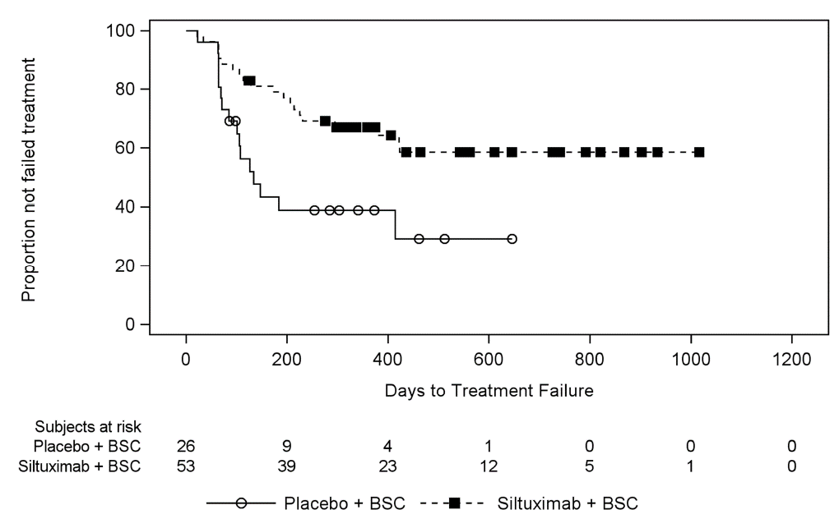

Source: Figure 2-7 of the submission

* 1. Treatment with siltuximab was associated with a statistically significant delay in the time to treatment failure compared to placebo (HR 0.418; 95% CI 0.214, 0.815).
  2. In the siltuximab arm, a total of 20 patients (38%) experienced treatment failure, with the most frequent causes being an increase in baseline symptoms (n = 12), initiation of subsequent therapy (n = 5), development of new severe symptoms (n = 3) and radiologic progression (n = 1). In the placebo arm, a total of 16 patients (62%) experienced treatment failure, with the most frequent causes being a sustained increase in baseline symptoms (n = 9), radiologic progression (n = 6), development of new severe symptoms (n = 1), worsening ECOG function (n = 1). It should be noted that patients could have more than one cause of treatment failure.
  3. The change in quality of life/symptom scores over time with siltuximab and placebo treatment in the MCD2001 trial is summarised in the table below.

Table 5: Change in quality of life/symptom scores over time with siltuximab and placebo treatment in the MCD2001 trial

| **Outcome** | **Baseline**  **Mean (SE)** | **Cycle 6**  **LS Mean (SE)** | **Cycle 12**  **LS Mean (SE)** | **Cycle 18**  **LS Mean (SE)** | **P-value** |
| --- | --- | --- | --- | --- | --- |
| **Multicentric Castleman Disease Symptom Scale (0-10 scale, with higher scores indicating more severe symptoms)** | | | | | |
| Siltuximab (N = 53) | 2.48 (0.21) | 1.81 (0.20) | 1.68 (0.22) | 1.81 (0.26) | 0.3379 |
| Placebo (N = 26) | 2.91 (0.30) | 2.25 (0.31) | 2.73 (0.35) | 3.35 (0.47) |
| **FACIT-F scale (0-52 scale, with higher scores indicating less fatigue)** | | | | | |
| Siltuximab (N = 53) | 31.99 (1.45) | 38.56 (1.35) | 37.71 (1.44) | 38.59 (1.69) | 0.0364 |
| Placebo (N = 26) | 31.06 (2.07) | 31.65 (2.07) | 35.24 (2.32) | 26.89 (3.16) |
| **SF-36 Mental Component Score (0-100 scale, with higher scores indicating better quality of life)** | | | | | |
| Siltuximab (N = 53) | 39.34 (1.55) | 44.46 (1.56) | 45.68 (1.69) | 47.72 (1.90) | 0.0002 |
| Placebo (N = 26) | 43.25 (2.18) | 41.87 (2.38) | 42.22 (2.69) | 41.26 (3.56) |
| **SF-36 Physical Component Score (0-100 scale, with higher scores indicating better quality of life)** | | | | | |
| Siltuximab (N = 53) | 42.60 (1.36) | 46.15 (1.34) | 45.46 (1.39) | 46.02 (1.52) | 0.2115 |
| Placebo (N = 26) | 41.57 (1.93) | 41.92 (1.99) | 43.88 (2.16) | 39.81 (2.71) |

Source: Figure 2-17, Figure 2-21, Figure 2-31, Figure 2-32, of the submission; Attachment 3-33, Attachment 3-38, Attachment 3-43, Attachment 3-47 of the MCD2001 trial report

Abbreviations: LS, least squares; SE, standard error

* 1. Treatment with siltuximab was associated with statistically significant improvements in fatigue and the SF-36 mental component scores over time compared to placebo. Other quality of life/symptoms scores generally favoured siltuximab but the differences did not reach statistical significance.
  2. The submission claimed that patients switching from placebo to siltuximab in the MCD2001 trial and extensions would bias the estimates of overall survival against siltuximab.
  3. The submission stated that standard approaches to addressing treatment switching such as inverse probability of censoring weighting, rank preserving structural failure time models, or ‘two-stage’ methods were not feasible given the limited sample size and small number of events during the follow-up period.
  4. Due to the data limitations, the submission argued that it was necessary to adopt the less robust approach of censoring at the time of cross-over. The submission acknowledged that this approach is susceptible to selection bias as it requires the strong assumption that there are no inherent differences between switching and non-switching patients that may affect prognosis. The PSCR acknowledged that using censoring to adjust for cross-over has limitations but did not provide any results from alternative statistical methods.
  5. Kaplan-Meier estimates of overall survival with siltuximab and placebo treatment in the MCD2001 trial and extensions are summarised in the figure below (13 crossed over during the trial with an additional 5 patients crossing over during the extensions).

Figure 3: Overall survival from MCD2001 trial and extensions with adjustments for treatment switching

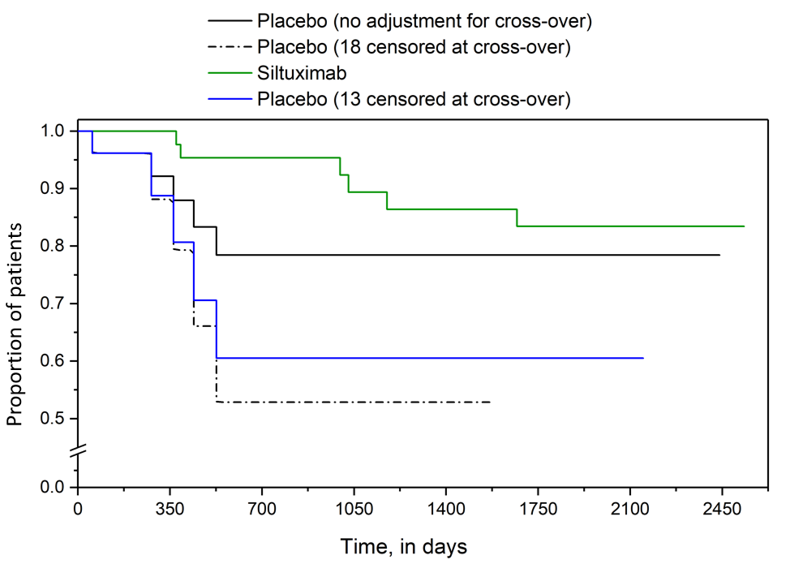

Source: Figure 3-4 of the submission

* 1. During the MCD2001 trial and extensions, 6 patients (11%) died in the siltuximab arm due to disease progression (n = 3), multiple organ failure and urinary sepsis (n = 1), renal failure (n = 1) and unknown cause (n = 1). In the placebo arm, 5 patients (19%) died due to progressive disease (n = 3), adverse event (n = 1) and development of myelodysplastic syndrome (n = 1).
  2. Adjustment for treatment switching had a major impact on overall survival results with the original unadjusted estimates indicating no difference between treatment arms (HR 0.58; 95% CI 0.18, 1.90) while the revised values indicated a substantial improvement in survival with siltuximab compared to placebo (13 censored HR 0.25; 95% CI: 0.08 to 0.83; 18 censored 0.13; 95% CI 0.03, 0.50)[1].
  3. There were insufficient data presented in the submission to adequately compare switching and non-switching patients (such as the characteristics of switching and non-switching patients with progression, characteristics of switching and non-switching patients with stabilised disease, as well as the proportion of patients using subsequent line therapies, including siltuximab, in both groups). Due to the design of the MCD2001 trial and extensions it is likely that there are inherent differences between these two groups as treatment switching was conditional based on the presence/absence of disease progression. The PSCR reported on baseline characteristics that differed between switching (n=18) and non-switching (n=8) patients: gender (89% male in switching versus 75% in non-switching patients); time since diagnosis (mean 3.44 years versus 1.47 years); corticosteroid use at baseline (44.4% versus 26.2%); and prior therapies (mean 1.9 versus 0.5). The ESC agreed with the evaluation that there was insufficient data to adequately compare switching and non-switching patients.
  4. The pre-PBAC response maintained that censoring at crossover was the only viable method to adjust overall survival estimates in MCD2001 due the small number of participants. However, the pre-PBAC response also acknowledged the improvement in survival in the crossover analysis which censored 13 patients was more conservative than the analysis that censored 18 patients (see paragraph 6.27). The crossover analysis which censored 13 patients reflected those who crossed over during the MCD2001 trial, whereas the analysis which censored 18 patients included an additional 5 patients who switched to siltuximab after the 48-week treatment phase of MCD2001. The pre-PBAC response presented a comparison of the 13 patients that crossed over from placebo to siltuximab compared to those who did not (Table 6).

Table 6: Characteristics of placebo patients who did or did not crossover during MCD2001

| **Characteristic** | **Crossed over during MCD2001 (N=13)** | **Not crossed over during MCD2001 (N=13)** |
| --- | --- | --- |
| Baseline age, mean (range) | 45.4 (27 to 66) | 50.0 (29 to 78) |
| Males, % | 92.3% | 76.9% |
| Mean number of prior systemic treatments | 1.7 (0 to 6) | 1.3 (0 to 5) |
| % with 1+ prior treatments | 69.2% | 61.5% |
| Mean number of MCD symptoms (range) | 6.9 (1 to 10) | 7.7 (2 to 19) |
| Mean number of years from diagnosis (range) | 2.65 (0.33 to 8.24) | 3.02 (0.11 to 16.58) |
| Steroids at randomization | 46.2% | 15.4% |
| White race, % | 53.8% | 38.5% |

Source: pre-PBAC response page 2 (Submission Tables 2.13, 3.9).

*\* Note that the results presented in Table 6 are derived from ad-hoc/ post-hoc analyses conducted by the applicant specifically for the purposes of informing the PBAC consideration. These analyses were not part of the pre-specified statistical plan for Study MCD2001. Interpretation of the results and their application should therefore be limited to seeking to understand the basis for the PBAC outcome and should not be used for any other purpose.*

Comparative harms

* 1. An overall summary of the adverse events reported in the MCD2001 trial is summarised in the table below.

Table 7: Overall summary of adverse events in the MCD2001 trial

| **Adverse event** | **Siltuximab (N = 53)** | | **Placebo (N = 26)** | |
| --- | --- | --- | --- | --- |
| **Incidence** | **Events per**  **patient yeara** | **Incidence** | **Events per**  **patient yeara** |
| Any adverse event | 53 (100%) | 15.39 (948 events) | 25 (96.2%) | 17.85 (273 events) |
| Treatment-related adverse event | 42 (79.2%) | NR | 10 (38.5%) | NR |
| Severe adverse event | 25 (47.2%) | 1.14 (70 events) | 14 (53.8%) | 1.77 (27 events) |
| Serious adverse event | 12 (22.6%) | 0.36 (22 events) | 5 (19.2%) | 0.65 (10 events) |
| Adverse events leading to dose suspension | 15 (28.3%) | 0.47 (29 events) | 5 (19.2%) | 0.52 (8 events) |
| Adverse events leading to discontinuation | 12 (22.6%) | 0.37 (23 events) | 10 (38.5%) | 1.11 (17 events) |
| Adverse events leading to death | 0 (0.0%) | 0.00 (0 events) | 1 (3.8%) | 0.13 (2 events) |

Source: Table 2-42 of the submission; Table 44 of the MCD2001 trial report

Abbreviations: NR, not reported

a Based on total number of events and total patient exposure time to siltuximab (61.58 patient years) or placebo (15.29 patient years)

* 1. The most frequently reported adverse events (> 20% of patients) in the siltuximab treatment arm were pruritus, upper respiratory tract infection, maculo-papular rash, fatigue, peripheral oedema, malaise, dyspnoea, peripheral sensory neuropathy, diarrhoea, increased weight and localised oedema. Severe adverse events reported in more than one patient included fatigue, localised oedema, weight gain, hyperhidrosis, night sweats, thrombocytopenia, hyperuricaemia, neutropenia, hypertension and hyperkalaemia.
  2. The most frequently reported adverse events (> 20% of patients) in the placebo treatment arm were fatigue, dyspnoea, peripheral oedema and cough. Severe adverse events reported in more than one patient included anaemia.
  3. The PBAC noted that treatment with siltuximab was associated with a higher incidence of treatment-related events compared to placebo (mainly skin disorders, gastrointestinal disorders, blood disorders and other general disorders such as fatigue and oedema). Treatment with siltuximab was also associated with a higher incidence of haematological (decreased platelets) and biochemical (elevated cholesterol levels) abnormalities compared to placebo.
  4. The PBAC noted that the overall incidence of severe events, serious adverse events and adverse events leading to discontinuations were similar or lower with siltuximab treatment compared to placebo.
  5. Longer-term data from the MCD2002 extension study indicated that the number of subjects reporting adverse events generally decreased with the number of years of siltuximab treatment.
  6. Important identified risks with siltuximab include thrombocytopenia, neutropenia, infusion-related reactions and serious hypersensitivity, hyperlipidaemia, hypertension and renal impairment. Important potential risks include elevated hepatic transaminases and bilirubin, serious infections, elevated haemoglobin levels including polycythaemia, malignancy, gastrointestinal perforation, cardiovascular events and immunogenicity.

Benefits/harms

* 1. On the basis of direct evidence presented in the submission, for every 100 patients treated with siltuximab in comparison with placebo over a median treatment duration of approximately 15 months:
* Approximately 34 additional patients would achieve a durable tumour and symptomatic response (50-100% reduction in tumour size with no worsening of symptoms for at least 18 weeks).
* Approximately 41 additional patients would experience treatment-related adverse events such as pruritis, maculo-papular rash, diarrhoea, thrombocytopenia, fatigue, neutropenia, peripheral oedema and upper respiratory tract infection. Adverse event estimates were based on unadjusted proportions which did not account for differences in treatment exposure.

Clinical claim

* 1. The submission described siltuximab as superior in terms of efficacy and similar in terms of safety compared to placebo. The evaluation considered this claim was reasonable in terms of efficacy but not in terms of safety.
  2. The PBAC agreed with the ESC that the claim of superior efficacy compared to placebo was reasonable for the primary outcome of durable tumour and symptomatic response.
  3. The PBAC agreed with the ESC that the submission’s safety claim was not reasonable and considered that the safety of siltuximab was inferior to placebo. The PBAC noted that treatment with siltuximab was associated with a higher incidence of treatment-related events and a higher incidence of haematological and biochemical abnormalities compared to placebo.

Economic analysis

* 1. The submission presented a modelled economic evaluation of siltuximab versus placebo for the treatment of patients with iMCD. The comparison was based on individual patient data from the MCD2001 trial, MCD2001 addendum and MCD2002 extension studies and other modelled inputs. The type of economic evaluation presented was a cost-utility analysis.

Table 8: Key components of the economic evaluation

| Component | Summary |
| --- | --- |
| Treatments | Siltuximab versus placebo |
| Time horizon | 50 years in the model base case versus the MCD2001 trial duration (median 1.2 years) and integrated analysis of individual patient data from the MCD2001 trial, MCD2001 addendum and MCD2002 study (data cut-off of 1.4 years for placebo and 4.5 years for siltuximab) |
| Outcomes | Life years and QALYs |
| Methods used to generate results | Markov cohort state-transition model |
| Health states | Stable disease, response, treatment failure and dead |
| Cycle length | 21 days, no half-cycle correction |
| Transition probabilities and extrapolation | Transitions to response from stable disease were based on MCD2001 trial data only (last event at approximately 2 years in siltuximab arm). There were no responders in the placebo arm.  Probabilities of treatment failure were based on time to treatment failure in MCD2001 (all patients for placebo and by subgroups based on response status in siltuximab arm), extrapolated from 1.2 years using a lognormal function for siltuximab and from 1.1 years using a generalised gamma function for placebo.  Overall survival was modelled using separate analyses for stage 1 and stage 2 of the model. In stage 1, transitions to death from response, stable disease and treatment failure health states were informed directly from an integrated analysis of individual patient data from the MCD2001 trial, MCD2001 addendum and MCD2002 study with censoring for 18 patients in the placebo arm at time of crossover to siltuximab (data cut-off: 4.5 years for siltuximab and 1.4 years for placebo). In stage 2, probabilities of death were dependent on underlying overall survival curves based on the integrated analysis of MCD2001, MCD2001 addendum and MCD2002 study (with censoring), extrapolated using separate exponential functions for siltuximab and placebo. Probabilities of death from individual health states were estimated assuming a higher risk of death in patients with treatment failure versus stable disease or response (HR 1.75, based on Dong 2018). In all health states, the probability of death was further adjusted with the addition of general population mortality.  55% of the incremental costs, 79% of incremental life years; and 74% of incremental QALYs are accrued in the extrapolated period (beyond 5 years). |
| Health related quality of life | Baseline utility (stable disease): '''''''''''''''''  On-treatment utility gain: ''''''''''''''''  Response utility gain: '''''''''''''''''  Treatment failure utility decrement: '''''''''''''''''  Adverse event utility decrement: '''  Based on an unpublished analysis of EQ-5D-5L estimates from the ACCELERATE registry of patients with Castleman disease. The estimates were derived from subgroups of patients who had treatment-specific assessments (n='''''), response-specific assessments (n='''''') and hospitalisation specific assessments (n=''''). |
| Costs | Siltuximab drug costs (based on proposed prices of siltuximab for the 100 mg and 400 mg vial, individual body weights of all patients in MCD2001, including wastage scenario). Additional treatment-related costs were estimated including administration, monitoring and patient education costs.  Cost of subsequent therapies estimated based on utilisation of anti-cancer therapies in MCD2001, mapped to treatment regimens used for non-Hodgkin’s lymphoma, average number of treatment cycles per regimen (Dong 2018) and average number of subsequent lines of therapy (source not provided). Other included costs were BSC drug costs, disease management costs, adverse events costs, hospitalisation costs and end of life care. |

Source: Table 3.1 of the submission

Abbreviations: QALY, quality adjusted life year

* 1. Overall, the evaluation of input data used in the economic model was challenging due to poor documentation of sources, methods and assumptions used to derive these inputs.
  2. The base case presented in the submission included treatment discontinuation in all patients with stable disease in the siltuximab arm, from approximately 2 years in the model. After this timepoint, patients with stable disease in the siltuximab arm no longer accrued siltuximab treatment costs; the probability of treatment failure was assumed to be the same as placebo from the start of the model; and the probability of death mirrored that of placebo from 2 years and beyond. During the evaluation, it was considered that the inclusion of this assumption in the base case analysis was an error as it was only described as a sensitivity analysis. This was corrected during the evaluation with the base case assuming patients in the stable disease state receive ongoing siltuximab treatment. The PSCR considered it would be more appropriate to assume 42% of stable disease patients continued therapy beyond two years. The ESC considered the approach taken by the evaluation more appropriate as in clinical practice patients whose disease is being maintained and not progressing are unlikely to cease treatment. Furthermore, the submission assumed a long term benefit of siltuximab which was not plausible if siltuximab was no longer being taken.
  3. The figure below represents the model structure used in the economic evaluation. The red crosses represent transitions that did not occur during stage 1 of the model for siltuximab (diagram on the left) and placebo (diagram on the right).

Figure 4: Model structure used in the economic evaluation

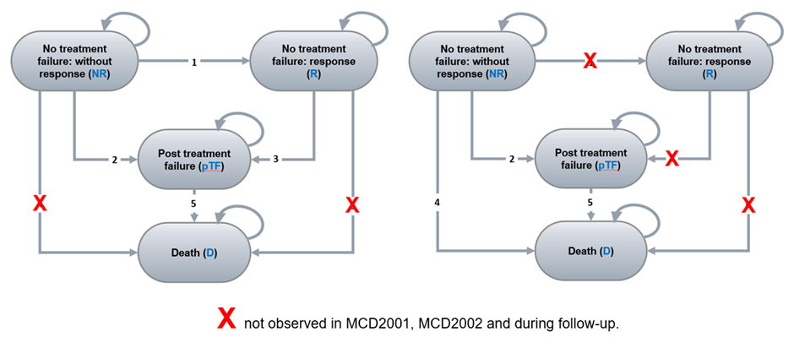

Source: Figure 3.3 of the submission

Note: The red crosses represent transitions that did not occur during stage 1 of the model for siltuximab (diagram on the left) and placebo (diagram on the right).

* 1. The non-response state described in the submission was referred to as stable disease during the evaluation for consistency with clinical trial data, treatment guidelines and published literature.
  2. All patients start in the stable disease state, representing patients who have neither shown a response or disease progression. In every cycle, patients can either remain in stable disease, transition to response, treatment failure or die. Patients with response can either remain in response, transition to treatment failure or die. Patients with treatment failure can either remain in treatment failure or die.
  3. In the siltuximab arm, patients in the stable disease and response health states are assumed to receive ongoing siltuximab treatment. Patients in the siltuximab arm who experience treatment failure are assumed to permanently discontinue siltuximab treatment. In both arms, all patients in the treatment failure health state are assumed to receive subsequent therapies.
  4. Key drivers of the model are summarised in the table below.

Table 9: Key drivers of the model

| Description | Method/Value | Impact |
| --- | --- | --- |
| Modelled overall survival | The inputs used to inform overall survival appear to be based on an integrated analysis of individual patient data from the MCD2001 trial, MCD2001 addendum and MCD2002 study (with censoring for 18 placebo patients at time of crossover to siltuximab) that was not provided in the submission and could not be reconciled with survival data presented in the clinical section of the submission. There was insufficient data available to adequately explore the impact of patient crossover on overall survival estimates. Overall, the claim that siltuximab use in the placebo arm after progression would bias the results is based on the assumption that siltuximab is superior to other subsequent treatment options or provides an additional line of therapy before treatment options are exhausted. Neither of these assumptions was adequately supported in the submission. | High, favours siltuximab |
| Transition probabilities and survival extrapolation | The derivation of transition probabilities in the model was complex given the use of multiple sources and adjustments including:   * The use of individual patient transitions in stage 1 for each health state; * The use of extrapolated survival curves in stage 2 with extrapolation points that differed by treatment arm and health state; * The application of a mortality adjustment based on published data (HR 1.75 based on Dong 2018) to distribute the overall probability of death to individual health states in stage 2; and * The application of a competing risks adjustment throughout the model duration to ensure that all transition probabilities from the same health state sum to 1. | High, favours siltuximab |
| Siltuximab dosing frequency | The submission assumed that the proportion of patients switching from 3-weekly to 6-weekly administrations of siltuximab in the MCD2001 trial was applicable to the PBS population. The submission inappropriately assumed that some patients with stable disease were able to switch to 6-weekly dosing, which was inconsistent with the protocol for the extension study (only patients with response were eligible). The submission did not adequately justify the use of trial-based estimates only, given the availability of data from the ACCELERATE patient registry. The ESC considered that the proportion of patients who will continue with 3 weekly versus 6 weekly dosing intervals to be highly uncertain. | High, favours siltuximab |
| Siltuximab use after treatment failure | The submission assumed that siltuximab was not used as a subsequent therapy following treatment failure. This assumption may not be reasonable as the submission acknowledged that the definition of treatment failure in the trial was overly stringent and may not be applicable to clinical practice. In practice, some patients are likely to receive ongoing treatment with siltuximab beyond treatment failure. | High, favours siltuximab |
| Baseline utility values | Utility values were based on an unpublished analysis of EQ-5D-5L estimates from the ACCELERATE registry of patients with Castleman disease (N=24). Trial-based estimates that were based on a larger population (MCD2001, N=79) were also available. Overall, the utility estimates could not be adequately assessed during the evaluation due to limited documentation of the dataset including a lack of patient characteristics, inclusion/exclusion criteria and handling of missing data. | High, favours siltuximab |

Source: constructed during the evaluation

* 1. Figure 5 is a plot of transition probabilities of death in the siltuximab arm.

Figure 5: Probability of death in the siltuximab arm (stage 1 from 0 to 4.5 years; stage 2 beyond 4.5 years)

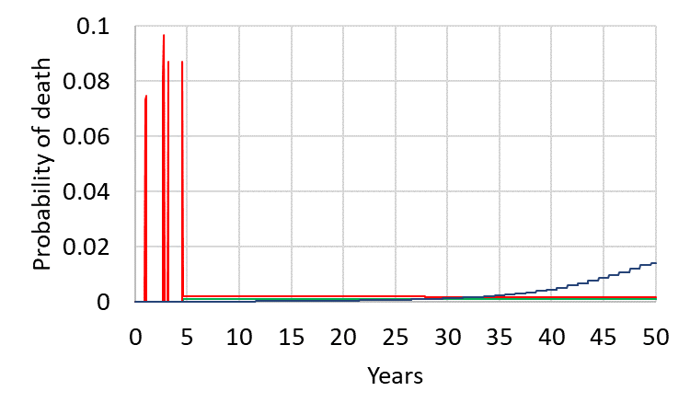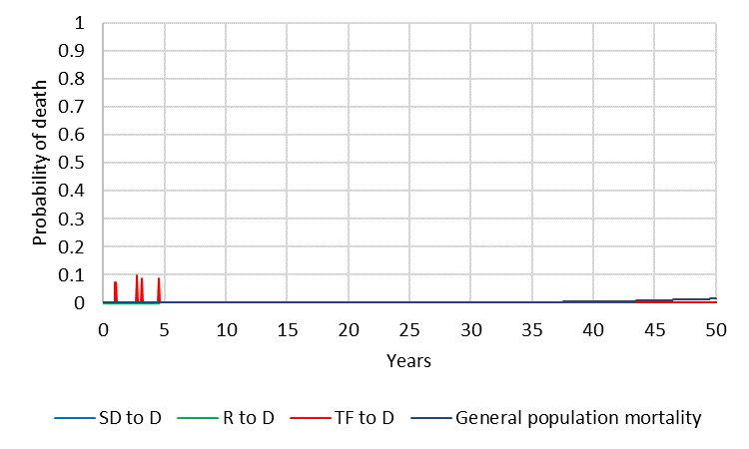

Source: constructed during the evaluation using the Siltuximab SYLVANT – Section 3 – CEA – (Final)’ Excel workbook of the submission

Note: Inset graph represents the transitions probabilities with Y-axis scale between 0 and 0.1

Abbreviation: D, death; R, response; SD, stable disease; TF, treatment failure

* 1. In stage 1 of the base case analysis (from 0 to 4.5 years), deaths in the siltuximab arm only occurred for patients in the treatment failure health state (represented by the peaks). There were no deaths in patients with stable disease or response. In stage 2 (from 4.5 years onwards), the hazards of death were based on overall survival distributed across the stable disease, response and treatment failure states with the mortality adjustment.
  2. Modelled hazards of death from 0 to 4.5 years were inconsistent due to data sparseness. Beyond 4.5 years in the model, the submission assumed constant hazards of death (based on the exponential function) which were less than general population mortality from 34 years in patients with treatment failure and from 29 years in patients with stable disease or response. The evaluation considered the modelled hazards appeared clinically implausible and required the inclusion of background mortality to ensure the modelled hazards meet face validity.
  3. Figure 6 is a plot of transition probabilities of death in the placebo arm.

Figure 6: Probability of death in the placebo arm (stage 1 from 0 to 1.4 years; stage 2 beyond 1.4 years)

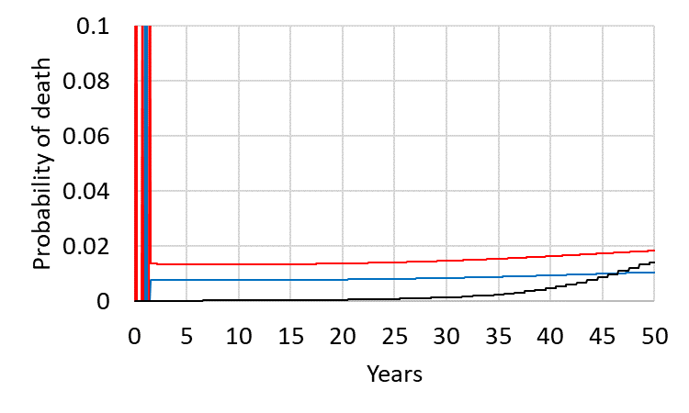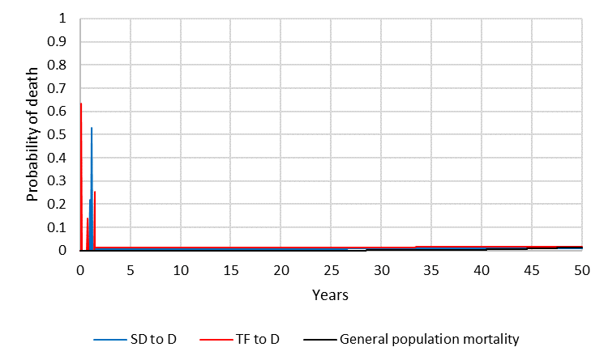

Source: constructed during the evaluation using the Siltuximab SYLVANT – Section 3 – CEA – (Final)’ Excel workbook of the submission

Note: Inset graph represents the transitions probabilities with Y-axis scale between 0 and 0.1

Abbreviation: D, death; SD, stable disease; TF, treatment failure

* 1. In stage 1 of the base case analysis (from 0 to 1.4 years), deaths in the placebo arm occurred for patients in stable disease and treatment failure health states (represented by the peaks). In stage 2 (from 1.4 years onwards), the hazards of death were based on overall survival distributed across the stable disease and treatment failure states with the mortality adjustment and addition of background mortality.
  2. Beyond 47 years in the model, deaths from the stable disease state were primarily due to general population mortality.
  3. The following overall survival curves were constructed during the evaluation, comparing modelled overall survival to the Kaplan-Meier overall survival data extrapolated using the exponential function with and without the background mortality adjustment.

Figure 7: Comparison of overall survival curves

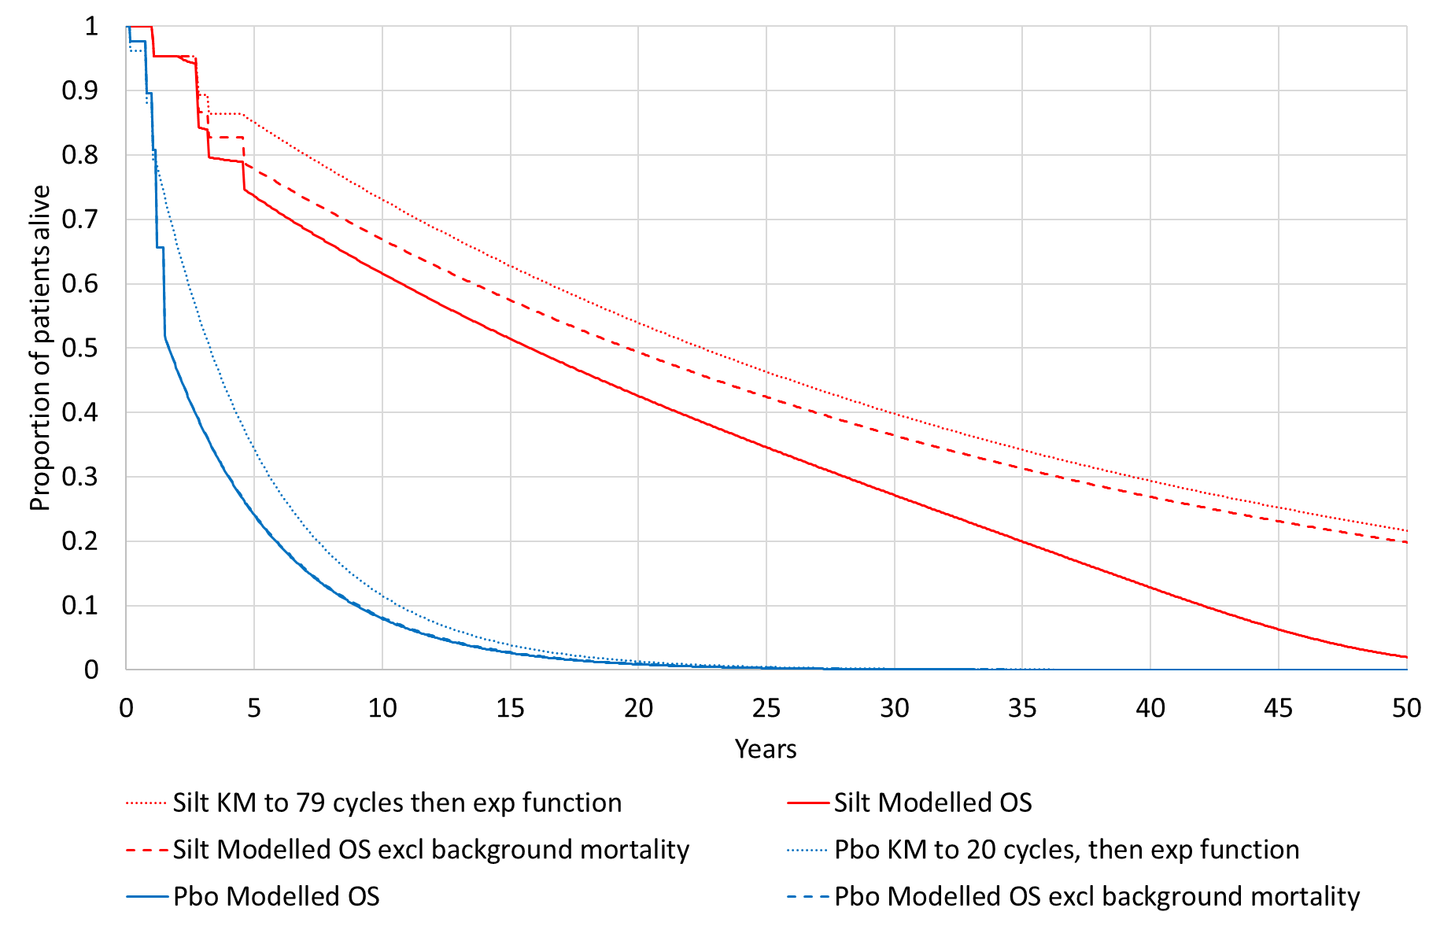

Source: constructed during the evaluation using the Siltuximab SYLVANT – Section 3 – CEA – (Final)’ Excel workbook of the submission

Abbreviations: exp, exponential; KM, Kaplan-Meier; OS, overall survival; Pbo, placebo; Silt, siltuximab

* 1. Modelled overall survival for both treatment arms in the model appeared different to the Kaplan-Meier curves of overall survival extrapolated using the exponential function. Some of the difference was due to the inclusion of background mortality adjustments in the siltuximab arm, although overall survival in the placebo arm appeared to be similar with or without background mortality adjustments.
  2. The reasons for the discrepancies were unclear due to the complex approach used to derive the transition probabilities for deaths from different health states during stage 1 of the model, and distribution of deaths across the health states from underlying overall survival curves during stage 2 of the model. The PSCR stated that adjustment for competing risks resulted in some deviation in the model compared with the Kaplan-Meier estimates. The ESC considered the extrapolation of overall survival data in the model highly uncertain given trial duration compared to the period of extrapolation. In addition, the ESC noted the small sample size of available trial data and was concerned that the corrections and adjustments required for the overall survival estimates were underpinned by limited data.
  3. Figure 8 presents the model trace over time in the response, stable disease, treatment failure and dead health states.

Figure 8: Markov trace of patients remaining alive in the response, stable disease, treatment failure and dead health states

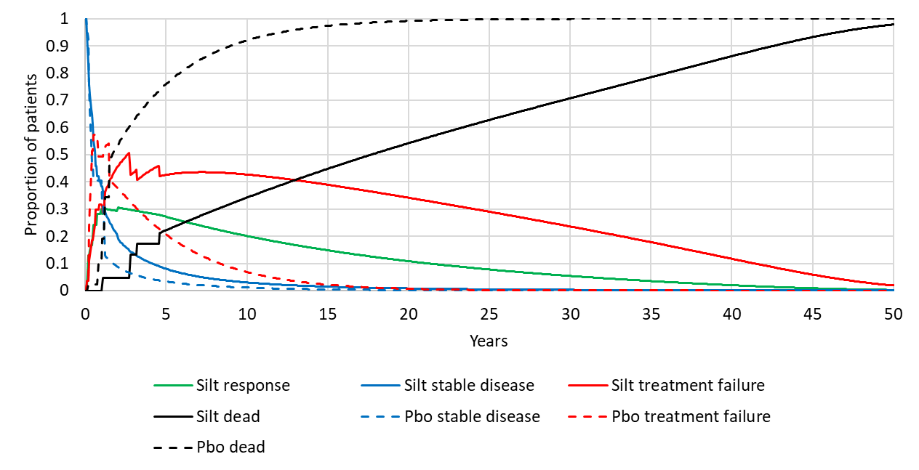

Source: constructed during the evaluation using the Siltuximab SYLVANT – Section 3 – CEA – (Final)’ Excel workbook of the submission

* 1. The Markov traces show inconsistent patterns in the proportion of patients in each health state in the first 5 years of the model. This was reflective of data sparseness that resulted in substantial variation in per cycle transition probabilities.
  2. The Markov traces suggest the survival gain associated with siltuximab was due to the difference in the proportion of patients in the response and treatment failure health states, and a relatively small difference due to patients with stable disease. The majority of the survival benefit was due to patients remaining in the treatment failure health state over time (total undiscounted survival gain: 16.59 years; survival gain in treatment failure state: 10.61 years). This was due to the approach used in the model to determine modelled survival that was based on underlying overall survival curves (with mortality adjustments to distribute the risk of death to each health state), with no explicit links to treatment or disease status. The attribution of the majority of the survival benefit to patients after treatment failure appeared clinically implausible given these patients were no longer receiving siltuximab treatment. The PSCR described this as ‘an artefact of the modelling approach’. However, the ESC agreed with the evaluation that this clinically implausible benefit calls the validity of the model into question given that many patients in the placebo arm died while in this state (and likely at a younger age given most deaths occurred early in the model, see Figure 6).
  3. The submission performed external validation of overall survival estimates in the model with published estimates based on observational studies of HIV negative MCD populations, presented in the figure below.

Figure 9: Comparison of modelled overall survival and survival estimates in published studies

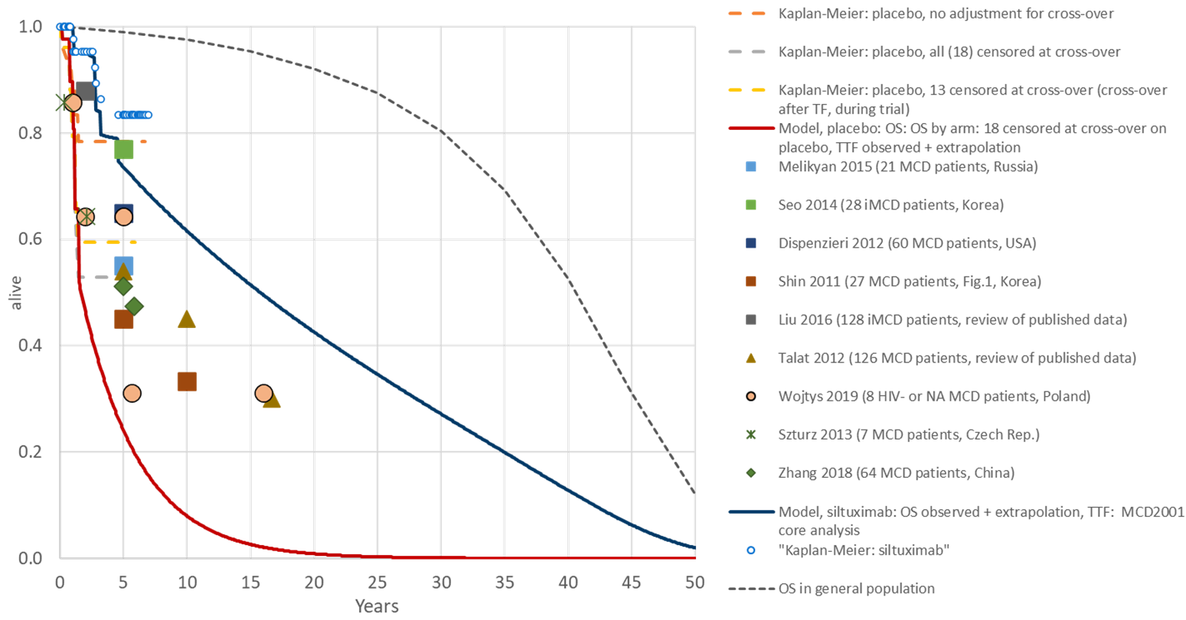

Source: Figure 3-51 (p299) of the submission

Abbreviations: MCD, multicentric Castleman disease; OS, overall survival; TTF, time to treatment failure

* 1. The submission claimed that modelled overall survival in the placebo arm based on overall survival with censoring for 18 patients in the placebo arm at time of crossover was supported by the comparison with published survival estimates. The modelled survival estimates for placebo were considerably worse compared to all published estimates provided in the submission, which suggests poor external validity. The PSCR stated that a number of the studies included in the comparison involved small patient numbers (Wojtys 2019, Talat 2012). In addition, the PSCR argued that various treatments (siltuximab/tocilizumab and rituximab) were used in these studies and hence the modelled placebo overall survival curve would be expected to be below the external sources. The ESC restated that despite not being PBS listed for iMCD agents such as rituximab are commonly used in Australian clinical practice for this condition. The ESC noted that the main driver of the economic model was a large survival gain reflective of a high mortality rate in the placebo group which lacked face validity and was modelled on data from a very small sample. The ESC considered that differences between 5-year overall survival rates of 55% to 77% reported for the published HIV negative MCD populations (see paragraph 4.7) and that evident for the modelled placebo group (approximately 25%) further highlighted face validity concerns. The ESC considered that the survival rate in the placebo population should, as a minimum, be consistent with that reported in the published cohort studies of iMCD as per Figure 9. The ESC considered this would be more likely to reflect the mix of interventions used in clinical practice.
  2. Using the corrected base case analysis prepared during the evaluation, treatment with siltuximab was associated with a cost per QALY gained of $75,000 to < $95,000 compared to placebo for the treatment of patients with iMCD (Table 10)[2]. The evaluation considered the cost-effectiveness estimate was uncertain due to concerns with the robustness and generalisability of the survival data and extrapolation methods that generated clinically implausible survival estimates, with the majority of survival benefit accrued in patients with treatment failure. Comparisons of modelled survival with trial data and external data sources were suggestive of poor internal and external validity.

Table 10: Results of the economic evaluation*

| Component | Siltuximab | Placebo | Increment |
| --- | --- | --- | --- |
| Costsa | $''''''''''''''''' | $90,073 | $''''''''''''''''''''' |
| LYsa | 11.19 | 3.16 | 8.03 |
| QALYsa | 7.51 | 2.01 | 5.51 |
| **Incremental cost per life year gaineda** | | | **$'''''''''''''1** |
| **Incremental cost per QALY gaineda** | | | **$''''''''''''''2** |

Source: Table 3.41 of the submission

Abbreviations: QALY, quality adjusted life year

a Estimates were calculated during the evaluation without siltuximab treatment discontinuation at 2 years among patients with stable disease.

* *Note that the results presented in Table 10 are derived from post-hoc analyses conducted by the applicant specifically for the purposes of informing the PBAC consideration. These analyses were not part of the pre-specified statistical plan for Study MCD2001 and MCD2002. Interpretation of the results and their application should therefore be limited to seeking to understand the basis for the PBAC outcome and should not be used for any other purpose.*

*The redacted values correspond to the following ranges:*

*1* *$55,000 to < $75,000*

*2 $75,000 to < $95,000*

* 1. The results of key sensitivity analyses conducted during the evaluation using the corrected base case is presented in the table below. The ESC considered that the ICERs reported for the sensitivity analyses were also unreliable given the issues raised with the economic model.

**Table 11: Results of sensitivity analyses**

| **Analysis** | **Incremental costa** | **Incremental QALYsa** | **ICER per QALY gaineda** |
| --- | --- | --- | --- |
| **Base case** | **$'''''''''''''''** | **5.51** | **$''''''''''''''1** |
| **Siltuximab treatment discontinuation in stable disease health state (base case excluded)** | | | |
| Included after 2 years (base case of the submission) | $'''''''''''''''''' | 5.11 | $''''''''''''''''1 |
| **Time horizon (base case 50 years)** | | | |
| 5 years | $''''''''''''''''''' | 1.41 | $'''''''''''''''''''''2 |
| 10 years | $'''''''''''''''''' | 2.82 | $''''''''''''''''''''3 |
| 20 years | $''''''''''''''''' | 4.54 | $''''''''''''''''''''4 |
| 40 years | $''''''''''''''''''''' | 5.46 | $'''''''''''''''''1 |
| **Response rates (base case siltuximab 34%, placebo 0%)** | | | |
| Siltuximab 0% | $''''''''''''''''''''' | 4.61 | $''''''''''''''''''5 |
| Siltuximab 20% | $''''''''''''''''''' | 5.19 | $'''''''''''''''1 |
| Siltuximab 50% | $''''''''''''''''''''' | 5.81 | $'''''''''''''''''4 |
| Siltuximab 80% | $''''''''''''''''''' | 6.23 | $'''''''''''''''''4 |
| Siltuximab 100% | $'''''''''''''''''''' | 6.44 | $''''''''''''''''''''4 |
| **Overall survival source data (base case with censoring for 18 placebo patients at time of crossover to siltuximab)** | | | |
| No crossover adjustment | $'''''''''''''''''' | 2.45 | $''''''''''''''''''''2 |
| With censoring for 13 placebo patients at time of crossover | $''''''''''''''''''' | 4.72 | $'''''''''''''''''''4 |
| **Baseline utility (base case 0.721)** | | | |
| Vernon 2016 EQ-5D model 1 (MCD2001): 0.561 | $''''''''''''''''''''' | 4.22 | $'''''''''''''''''''3 |
| Vernon 2016 EQ-5D model 2 (MCD2001): 0.544 | $'''''''''''''''''' | 4.09 | $''''''''''''''''''3 |
| **Siltuximab administration frequency (base case 3-weekly until 14.7% of stable disease and 33.3% of response patients switch to 6-weekly dosing after 2 years)** | | | |
| Recommended treatment frequency only (every 3 weeks) | $'''''''''''''''''''' | 5.51 | $''''''''''''''''''4 |
| Average treatment frequency based on all patients in the trial (every 3.5 weeks) | $'''''''''''''''''' | 5.51 | $''''''''''''''''4 |
| **Cost of subsequent therapies (base case no siltuximab treatment costs)** | | | |
| 30% of patients in siltuximab arm continue 3-weekly siltuximab treatment for 1 year after treatment failure | $'''''''''''''''''' | 5.51 | $'''''''''''''''''''''3 |
| 20% of patients in siltuximab arm continue 3-weekly siltuximab treatment for 1 year after treatment failure | $'''''''''''''''''' | 5.51 | $''''''''''''''''''3 |
| 10% of patients in siltuximab arm continue 3-weekly siltuximab treatment for 1 year after treatment failure | $'''''''''''''''''''''' | 5.51 | $''''''''''''''''''''4 |

Source: Section 3.12.1 and ‘Siltuximab SYLVANT – Section 3 – CEA – (Final)’ Excel workbook of the submission

a Estimates were calculated during the evaluation using the corrected base case.

*The redacted values correspond to the following ranges:*

*1* *$75,000 to < $95,000*

*2 $155,000 to < $255,000*

*3 $115,000 to < $135,000*

*4 $95,000 to < $115,000*

*5 $55,000 to < $75,000*

* 1. The results were most sensitive to censoring for cross-over, time horizon, cost of subsequent therapies (assumed use of siltuximab) and baseline utility values.
  2. Overall survival data used in the model could not be adequately assessed during the evaluation as the sources were not provided in the submission. The appropriateness of using the censored datasets was unclear as there were insufficient data available to adequately explore the impact of patient crossover on overall survival estimates.
  3. The results from a number of sensitivity analyses associated with the on-treatment health states (stable disease and response) were counterintuitive, with improvements in the treatment effect of siltuximab associated with an increasing ICER per QALY gained. This was observed based on sensitivity analyses of alternative response rates and alternative extrapolation functions for time to treatment failure for the siltuximab arm. The cost-effectiveness of siltuximab was largely driven by incremental survival benefit versus placebo after treatment failure. The incremental time spent in the treatment failure health state was in favour of siltuximab given the ongoing survival benefit without ongoing siltuximab treatment costs. The ESC agreed with the evaluation that the counterintuitive results reported in the sensitivity analysis cast doubt on the reliability of the model for decision making.
  4. The ESC noted the model was sensitive to the time horizon. The ESC considered that, given the limited period of trial data and the small sample size upon which the extrapolations of benefit are based, a 50 year time horizon introduced an unacceptable level of uncertainty. The ESC advised that a 10 to 15 year time horizon may be more appropriate given the data available.
  5. The PSCR argued that use of EQ-5D utility values from the ACCELERATE registry dataset was appropriate as the trial used SF-36 which can introduce bias due to conversion methodologies. The ESC considered the base case utility values favoured siltuximab and agreed with the evaluation that it was instead appropriate to use trial-based utility values.
  6. The ESC noted the ICER increased if the treatment frequency recommended in the Product Information (every 3 weeks) was applied. The ESC considered the base case likely underestimated long term adherence to siltuximab due to the assumption that more than 40% of patients will switch to 6 weekly dosing after 2 years.
  7. While the results appeared less sensitive to other variables used in the model, the impact of these alternative scenarios could not be fully assessed due to the impact of time spent in the treatment failure health state.
  8. The ESC considered that the use of more conservative assumptions may improve the reliability of the model for decision making. This may include: a more conservative adjustment for treatment switching and extrapolation resulting in a survival curve for the placebo arm more closely aligned with published studies (see paragraph 6.62); a shorter time horizon of 10 to 15 years; use of trial based utility values; and revised treatment assumptions to reflect anticipated utilisation throughout the time horizon (see paragraph 6.70).
  9. The pre-PBAC response provided a respecified economic model to address key concerns raised by ESC. The respecified model reported treatment with siltuximab was associated with a cost per QALY gained of $95,000 to < $115,000 compared to placebo for the treatment of patients with iMCD. The following table describes the revisions to the model made in the pre-PBAC response.

**Table 12: Model revisions in the respecified model provided with pre-PBAC response**

| **Row** | **Variable** | **Base case** | **Revised** |
| --- | --- | --- | --- |
| 1 | Stable disease treatment discontinuation | All patients with stable disease discontinued at 2 years. | Patients with stable disease assume the same persistence pattern as patients who respond. |
| 2 | Utility values | Based on an unpublished analysis of EQ-5D-5L data from the ACCELERATE registry.  Baseline: '''''''''''''''  Siltuximab treatment increment: '''''''''''''''  Response increment: '''''''''''''  Treatment failure decrement: ''''''''''''''' | Based on EQ-5D estimates in the CADTH 2015 siltuximab submission.  Baseline: 0.7034  Siltuximab treatment increment: 0.0819  Response increment: 0.0352  Treatment failure decrement: 0.1801 |
| 3 | Siltuximab drug wastage | Wastage calculation using trial-based individual body weights and assuming most efficient vial combination | Wastage calculation using trial-based body weight, normal distribution function and assuming most efficient vial combination |
| 4 | Siltuximab dosing frequency | 3-weekly until 14.7% of stable disease and 33.3% of response patients switch to 6-weekly dosing after 2 years | Average dosing frequency in the trial and extension study (includes 21.2% switching from 3-weekly to 6-weekly). Fixed adjustment to drug, administration and monitoring costs. |
| 5 | Time horizon | 50 years | 15 years |
| 6 | Placebo overall survival source data | Censored for 18 patients at time of crossover to siltuximab | Censored for 13 patients at time of crossover to siltuximab |
| 7 | Transition probabilities and survival extrapolation | Complex derivation based on individual patient transitions (stage 1) and exponential survival functions (stage 2) with competing risks adjustments. | Use of modelled exponential survival curves (i.e. stage 2 approach) only. |
| 8 | Extrapolation timepoint | Based on last event in Kaplan-Meier curves for OS and TTF | Based on last observation in Kaplan-Meier curves for OS and TTF |
| 9 | Mortality adjustment (refers to mortality by health state) | In stage 2 of the model, overall probability of death was distributed assuming a 1.75 factorial increase in the hazard rate of death in patients with treatment failure compared to those without treatment failure (HR: 1.75; Dong 2018) | Removed mortality adjustment |
| 10 | Siltuximab drug acquisition costs | AEMP per vial of 100 mg, $'''''''''''''''''; 400 mg, $''''''''''''''''''') | ''''''% price reduction (100 mg, $''''''''''''''''''; 400 mg, $''''''''''''''''''') |

Source: Constructed during the preparation of the PBAC Minutes based on Table PCR-3 of the pre-PBAC response and Siltuximab SYLVANT - Section 3 - CEA - (PCR - 30 June 2021) Excel Workbook of the pre-PBAC response

* 1. The PBAC noted that, consistent with the ESC advice, the respecified model assumed the same persistence patterns for patients with stable disease as those who respond (see Row 1, Table 11) and amended the time horizon to 15 years (see Row 5, Table 11). The Committee noted the respecified model also included a revision which was slightly more conservative than the base case with respect to dosing frequency (see Row 4, Table 11) and the placebo overall survival source (see Row 6, Table 11).
  2. The PBAC noted the revised survival estimates for the placebo arm were better aligned with those reported in published cohort studies (as suggested by ESC). However, it was also noted that more conservative assumptions around placebo arm survival rates were counterbalanced with more optimistic estimates of survival with siltuximab.
  3. The PBAC noted that, inconsistent with ESC advice suggesting use of trial-based utility values, the respecified model included revised utilities from the CADTH 2015 siltuximab submission (see Row 2, Table 11). The PBAC noted the pre-PBAC response argument that the CADTH modelling utilities were used ‘because the Vernon estimates do not identify the utility associated with response alone (required for the model)’. The PBAC noted the utility estimates provided could not be reconciled with published estimates in the Vernon study.
  4. The PBAC noted the respecified model removed the mortality adjustment (see Row 9, Table 11). The PBAC considered the approach taken in the base case in the submission was more plausible than that used in the respecified model with respect to mortality adjustment.

Drug cost/patient/year

Table 13: Drug cost per patient for siltuximab

|  | Economic model | | Financial estimates | |
| --- | --- | --- | --- | --- |
| 3-weekly | 6-weekly | 3-weekly | 6-weekly |
| Average dose | 844.3 mg a | | 844.3 mg a | |
| 100 mg vials | 2.57 b | | 2.57 b | |
| 400 mg vials | 1.47 b | | 1.47 b | |
| Cost per dose | $'''''''''''''''''''''' c | | - | |
| Cost per 100 mg script | - | | $'''''''''''''''''''''' d | |
| Cost per 400 mg script | - | | $''''''''''''''''''''''' e | |
| 100 mg scripts per year | - | - | 11.02 f | 5.51 g |
| 400 mg scripts per year | - | - | 6.31 h | 3.16 i |
| Cost/patient/year | $'''''''''''''''''''''' | $''''''''''''''' | $''''''''''''''''' | $'''''''''''''''' |
| Proportion of patients switching from 3-weekly to 6-weekly dosing | 21.2% of patients in the MCD2001 and MCD2002 studies switch at around 2 years, with no further switching beyond this timepoint j | | 66% of patients regardless of response switch in the first year, with no further switching beyond this timepoint | |
| Adherence | 3-weekly dosing interval of 21.4 days (stable disease) or 22.1 days (response). 6-weekly dosing interval of 42.3 days (stable) or 42.7 days (response) | | 100% adherence assumed | |
| Discontinuations | 1.89% discontinue after 3 weeks and a further 3.23% discontinue after 1.8 years (due to adverse events). 100% treatment discontinuation after treatment failure. | | ''''''% discontinuation at the end of the first year | |

Source: constructed during the evaluation

a Based on individual body weight of all patients in the MCD2001 trial (N=79)

b Number of full vials require for each patient assuming wastage occurs in 100 mg vials only

c Calculated based on proposed ex-manufacturer price for 100 mg ($'''''''''''''''') and 400 mg ($''''''''''''''''''''') vials, assuming fees and mark-ups for 1 script of 2.57 x 100 mg vials and 1.47 x 400 mg vials, assuming 90% public and 10% private hospital use

d Based on the proposed DPMQ for siltuximab in public hospital ($''''''''''''''''''''') and private hospital setting ($'''''''''''''''''''''') inflated for a maximum quantity of 4.04 vials. Assumed distribution of 90% public and 10% private hospital use.

e Based on the proposed DPMQ for siltuximab in public hospital ($'''''''''''''''''''''''') and private hospital setting ($''''''''''''''''''''''''') inflated for a maximum quantity of 4.04 vials. Assumed distribution of 90% public and 10% private hospital use.

f Based on 17.33 administrations x 2.57 vials per administration / 4.04 vials per script

g Based on 17.33 administrations x 1.47 vials per administration / 4.04 vials per script x 50%

h Based on 17.33 administrations x 1.47 vials per administration / 4.04 vials per script

I Based on 17.33 administrations x 2.57 vials per administration / 4.04 vials per script x 50%

j Implemented as 33% of patients with response and 14.7% of patients with stable disease (of those remaining alive without treatment failure) switch at around 2 years, with no further switching beyond this timepoint

* 1. The estimated drug costs per patient per year for siltuximab used in the economic and financial estimates were calculated assuming the most efficient vial combinations. Wastage was also assumed to only occur with the 100 mg vials as total vials required were calculated using the 400 mg vial first, with the remaining dose provided via 100 mg vials. It was unclear how the most efficient vial combination would be obtained under the Section 100 HSD Program, with fixed quantities and repeats for each script. There is potential for greater wastage than estimated in the submission, should combinations other than the most efficient combination of vials be provided. As outlined in paragraph 3.10, the sponsor is amenable to removing the 400 mg vial from the requested PBS listing to reduce the risk of wastage.
  2. The estimates used for dosing frequency, adherence and discontinuations were inconsistent between the economic model and financial estimates.
  3. The PBAC noted the pre-PBAC response proposed a '''''% price reduction with the effective ex-manufacturer price reducing to $'''''''''''' per 100 mg vial and $'''''''''''''''''' per 400 mg vial.

Estimated PBS usage & financial implications

* 1. DUSC considered this submission. The submission used an epidemiological approach to estimate the utilisation and financial impact of siltuximab. Key inputs are summarised in the table below.

Table 14: Key inputs for financial estimates

| Parameter | Value applied and source | Comment |
| --- | --- | --- |
| Incidence of HIV- MCD | Estimated annual incidence of 0.000570% based on a published analysis of commercial insurance claims data from the United States (Munshi 2015).  MCD patients identified based on a claim for lymphadenopathy with a lymph node biopsy within 2 years of index date who received cytotoxic therapy and who had no exclusionary diagnosis of rheumatoid arthritis, lupus, cancer (including lymphoma, Hodgkin’s disease and non-Hodgkin’s lymphoma) and HIV | The diagnosis of MCD is based on a complex diagnostic workup which is unlikely to be adequately captured using claims data. Consensus diagnostic guidelines for the diagnosis of MCD (Fajgenbaum 2017) were published after this analysis was conducted.  The publication noted that the incidence may be overestimated as there were no biopsy or laboratory data available to confirm diagnosis and patients may have had other conditions with similar clinical presentation or diagnosis patterns.  Conversely, the publication noted that the incidence may be underestimated as it was based on coding claims which may not be consistently applied to all patients, excluded patients with co-morbidities that may occur in clinical practice, and included a population with at least 3 year coverage using commercial insurance which may not be reflective of the broader population. |
| Prevalence of HIV- MCD | Calculated based on the published incidence of HIV- MCD (0.000570%) x assumed duration of disease (4 years) which equates to an annual prevalence of 0.0023% | The assumed duration of disease was poorly supported. Data from older published HIV- MCD populations reported 5-year overall survival rates of 55% to 77%. However, the current survival of patients is unclear due to changing diagnostic criteria and the introduction of standardised treatment algorithms. |
| Proportion of HIV- MCD with iMCD | Estimate proportion of 23.9% based on a published retrospective review of all biopsy proven cases of Castleman’s disease from one French hospital over a 20-year period (Oksenhendler 2017)  Unicentric CD: 57  HIV+ MCD: 140  HHV8+ MCD: 29  iMCD: 27 | The submission incorrectly calculated the proportion of HIV- MCD patients based on the total population of CD patients without HIV rather than MCD patients without HIV  The calculation should have been number of iMCD cases (27) divided by all HIV- MCD cases (29+27). Which equates to 48.2% of the HIV- MCD population.  The PSCR agreed with the evaluation that the proportion should be 48.2%, and also noted that the revised diagnostic guidelines would reduce the estimate by 35%. |
| Siltuximab uptake rate | - Uptake in incident population: Increasing from ''''''% in Year 1 to ''''''% in Year 6  - Uptake in prevalent population: Increasing from ''''''% in Year 1 to ''''''% in Year 6  - Uptake in grandfathered population: ''''''''% in Year 1 | The submission did not adequately justify the low uptake rates in the prevalent population given the claimed high clinical need and the recommendation of siltuximab as the preferred therapy in treatment guidelines. |
| Eligible population adjustment | The eligible population from the prevalent pool was adjusted by removing patients who initiated siltuximab therapy in any previous year. | This approach does not account for deaths and discontinuations in the incident population over time. Consequently, the adjustment results in an implausible estimate of no prevalent patients without prior siltuximab exposure in Year 6 despite there being incident patients in each year who do not use siltuximab. |
| Patient persistence | Year 1 to Year 2: ''''''%  Year 2 to Year 3: ''''''%  Year 3 to Year 4: '''''''%  Year 4 to Year 5: '''''''''%  Year 5 to Year 6: ''''''''''%  Persistence estimate from Year 1 to Year 2 based on feedback from a clinical expert:  - At '''' months, '''''% of patients change to a '''-weekly schedule,  - by '''''' months, ''''''% of patients change to a '''-weekly schedule,  - ''''''% of patients stop treatment at ''''' months, and  - '''''''% of patients will continue ''' weekly treatment indefinitely.  Persistence estimates beyond two years were based on sponsor’s assumptions.  The submission has calculated persistence estimates for each year applying different weights to patients using 3-weekly dosing (1), patients using 6-weekly dosing (0.5) and patients discontinuing therapy (0) | The inclusion of dosing frequency into treatment persistence estimates is not a standard methodological approach and makes it difficult to appropriately assess patient numbers in the budget impact model (as patients using less frequent dosing still remain on therapy).  The proportion of patients using longer (6-weekly) dosing intervals by the end of Year 1 was inconsistent between the budget impact estimates (66%) and economic model (21.2%).  The proportion of patients discontinuing therapy by the end of Year 1 was inconsistent between the budget impact model ('''''%) and economic model (''''''%, includes treatment failures and discontinuation due to adverse events). |
| Siltuximab infusions per year | Assumption of 17.33 infusions per year. Based on patients being 100% adherent to siltuximab using 3-weekly dosing | This assumption was inadequately justified in the submission. Adherence should have been separately estimated for patients using 3-weekly and 6-weekly dosing and is unlikely to be 100% in clinical practice |
| Siltuximab vials dispensed per infusion | 2.57 x 100 mg vials and 1.47 x 400 mg vials dispensed per infusion. Based on economic model using individual patient weights from the MCD2001 trial and assuming the most efficient use of 100 and 400 mg vials to minimise wastage | The prescribing of drugs listed under the requested Section 100 HSD program is not limited to the most efficient combination.  Trial-based weights may not be representative of body weights in the Australian setting due to the higher proportion of Asian subjects in the trial (48%) compared to the Australian population (approximately 10%). |
| Estimated siltuximab scripts per year | 11.02 x 100 mg scripts calculated based on 17.33 administrations x 2.57 vials per administration / 4.04 vials per script  6.31 x 400 mg scripts calculated based on 17.33 administrations x 1.47 vials per administration / 4.04 vials per script | The simplified approach does not adequately account for patients requiring multiple scripts at each administration (each dose strength will need a separate script), uses a maximum quantity that exceeds the requested listing and inappropriately assumes that vials from a single script can be used over multiple administrations. This approach affects both the expected mark-ups and co-payments attributable to siltuximab treatment |

Source: Table 4-3 of the submission

* 1. The table below presents the estimated use and financial implications of siltuximab over 6 years of listing.

Table 15: Estimated utilisation and cost of siltuximab

|  | **Year 1**  **(2021)** | **Year 2**  **(2022)** | **Year 3**  **(2023)** | **Year 4**  **(2024)** | **Year 5**  **(2025)** | **Year 6**  **(2026)** |
| --- | --- | --- | --- | --- | --- | --- |
| Patients with iMCD | '''''''''1 | '''''''''1 | '''''''''1 | '''''''''1 | ''''''''''1 | ''''''''''1 |
| Incident patients initiating siltuximab treatment | ''''''1 | ''''''1 | '''''''1 | ''''''1 | ''''''1 | ''''''1 |
| Prevalent patients initiating siltuximab treatment | '''1 | '''''1 | '''''''1 | ''''1 | ''''1 | '''1 |
| Grandfathered patients using siltuximab treatment | ''''1 | - | - | - | - | - |
| Annual initiators | '''''''1 | ''''''1 | '''''1 | ''''''1 | '''''1 | '''''''1 |
| Patients continuing treatment from previous year(s) | - | '''''''1 | '''''''1 | '''''1 | '''''''1 | ''''''1 |
| Total patients treated with siltuximab | '''''''1 | '''''1 | ''''''1 | '''''a, 1 | '''''''a, 1 | ''''''1 |
| Siltuximab infusions per year | ''''''''''2 | ''''''''2 | '''''''''''''2 | '''''''''''''''2 | ''''''''''''''2 | '''''''''''''2 |
| 100 mg siltuximab scripts | ''''''''''1 | ''''''''''1 | '''''''''2 | ''''''''''2 | ''''''''''2 | '''''''''2 |
| Cost of 100 mg scripts | $'''''''''''''''''''''3 | $''''''''''''''''''''''''3 | $''''''''''''''''''''''''3 | $'''''''''''''''''''''''3 | $'''''''''''''''''''''3 | $'''''''''''''''''''''''''3 |
| 400 mg siltuximab scripts | '''''''''1 | ''''''''''1 | ''''''''''1 | ''''''''1 | ''''''''''1 | ''''''''''2 |
| Cost of 400 mg scripts | $''''''''''''''''''''''''3 | $''''''''''''''''''''''3 | $''''''''''''''''''''''3 | $''''''''''''''''''''''3 | $''''''''''''''''''''''3 | $''''''''''''''''''''''3 |
| Total cost | $''''''''''''''''''''''3 | $'''''''''''''''''''''''''3 | $''''''''''''''''''''''''3 | $''''''''''''''''''''''''3 | $'''''''''''''''''''''''''3 | $''''''''''''''''''''''3 |
| Patient co-payment | -$'''''''''''''''3 | -$'''''''''''''3 | -$'''''''''''''''3 | -$'''''''''''''''3 | -$'''''''''''''''''3 | -$'''''''''''''''''3 |
| **Net cost to PBS** | **$'''''''''''''''''''**3 | **$'''''''''''''''''''''**3 | **$'''''''''''''''''''**3 | **$''''''''''''''''''**3 | **$''''''''''''''''''**3 | **$''''''''''''''''''**3 |
| Cost of infusionb | $''''''''''''''''''3 | $''''''''''''''''''3 | $'''''''''''''''3 | $''''''''''''''''''''3 | $'''''''''''''''''''3 | $'''''''''''''''''''''3 |
| **Net cost to government** | **$'''''''''''''''''''**3 | **$'''''''''''''''''''**3 | **$'''''''''''''''''''**3 | **$'''''''''''''''''**3 | **$'''''''''''''''''''''**3 | **$'''''''''''''''''''''**3 |

Source: Table 4-5 of the submission; ‘Siltuximab SYLVANT - Section 4 - Base Case - (Final)’ Excel workbook

a Rounding was applied to the utilisation estimates which resulted in small discrepancies in the estimated patient numbers.

b Cost of infusion based on MBS item 13950 (parenteral administration of one or more antineoplastic agents).

*The redacted values correspond to the following ranges:*

*1* *< 500*

*2 500 to < 5,000*

*3 $0 to < $10 million*

* 1. The net cost of listing siltuximab on the PBS/RPBS was estimated to be up to $0 to < $10 million in the sixth year of listing, with a cumulative total cost of $40 million to < $50 million over six years. The submission also estimated increased MBS costs of $0 to < $10 million over six years due to treatment administration. These estimates should be considered highly uncertain given the major issues associated with estimating eligible population size and treatment persistence (see Table 14). For example, correcting the estimate of the proportion of patients with iMCD (48.2% versus 23.9%, see Table 14) resulted in a cumulative total cost of $80 million to < $90 million over six years.
  2. DUSC considered the estimates presented in the submission to be underestimated. The main issues were:
* The eligible patient population was based on poorly supported incidence estimates, inappropriate assumptions regarding disease duration, a miscalculated proportion of patients with iMCD, implausible calculations for the size of the prevalent pool of patients without siltuximab exposure and inadequately justified uptake rates. DUSC commented that the uptake rates in each population were unclear and the prevalent population was likely underestimated.
* The approach taken to estimate the iMCD population was overly complicated and that a prevalence-based approach would have been simpler and preferable. DUSC noted that the inclusion of incidence and prevalence of iMCD overestimates the patient population.
* It was unclear whether the population used in the submission would be similar to the Australian population, particularly since contemporary diagnostic criteria were not used. DUSC commented that for this reason the submission’s estimate of the iMCD population, using the revised proportion of iMCD patients (48.2%), was likely an overestimation.
  1. The PBAC noted a sensitivity analysis using a prevalence-based approach provided by the DUSC Secretariat (Table 16). The key considerations were:
* Applying the sponsor’s prevalence estimate for multicentric Castleman disease to the general population.
* The proportion of patients with idiopathic disease was corrected as per the evaluation.
* The treatment uptake assumptions were increased by 10% per year above the submission’s estimates.

**Table 16. Sensitivity analysis 1. Prevalence-based estimates corrected for the proportion of patients with idiopathic disease and with increased uptake assumptions**

|  | **2021** | **2022** | **2023** | **2024** | **2025** | **2026** | **Step**  **Source** |
| --- | --- | --- | --- | --- | --- | --- | --- |
| General Australian population | 22,978,553 | 23,358,925 | 23,735,025 | 24,100,201 | 24,458,671 | 24,816,134 | [1] ABS - 3222.0 Series B |
| Prevalence MCD | 0.0023% | 0.0023% | 0.0023% | 0.0023% | 0.0023% | 0.0023% | [2] Munshi et al. 2015 |
| Number of prevalent MCD patients | 529 | 537 | 546 | 554 | 563 | 571 | [3] = [1] x [2] Calculation |
| Proportion of patients with idiopathic MCD | 48.2% | 48.2% | 48.2% | 48.2% | 48.2% | 48.2% | [4] Oksenhendler et al. 2018 and Commentary p142 |
| Number of idiopathic MCD prevalent patients | 255 | 259 | 263 | 267 | 271 | 275 | [5] = [3] x [4] Calculation |
| Siltuximab uptake rate | ''''''% | ''''''% | ''''''% | ''''''% | '''''% | '''''% | [6] Assumption. based on DUSC advice that uptake is underestimated |
| Number of treated patients | ''''''1 | '''''1 | '''''''1 | ''''''1 | '''''''1 | '''''1 | [7] = [5] x [6] Calculation |

Source: Prepared by DUSC Secretariat.

*The redacted values correspond to the following ranges:*

*1* *< 500*

Quality Use of Medicines

* 1. The submission stated the sponsor’s intent to conduct quality use of medicines activities to support the listing of siltuximab for the treatment of iMCD.

Financial Management – Risk Sharing Arrangements

* 1. No Special Pricing Arrangement or Risk Sharing Arrangement was proposed in the submission. The pre-PBAC response stated that the Sponsor is amenable to a Risk Share Arrangement to provide funding certainty and enable access to optimal treatment for iMCD to patients in Australia.

*For more detail on PBAC’s view, see section 7 PBAC outcome.*

1. PBAC Outcome
   1. The PBAC did not recommend siltuximab for treatment of idiopathic Multicentric Castleman disease (iMCD). The PBAC noted that iMCD is a rare disease and considered there was a high clinical need for effective treatments for these patients. The PBAC considered that the claim of superior efficacy compared to placebo was reasonable, however the submission’s safety claim was not reasonable. The PBAC considered that the safety of siltuximab was inferior to placebo. The PBAC considered that the submission had underestimated the incremental cost-effectiveness ratio (ICER) due to reliance on optimistic assumptions and inputs in the economic model. The PBAC noted that a revised economic model addressing some of the concerns raised was submitted with the pre-PBAC response. However, the PBAC considered the ICER remained high and uncertain at the proposed price. Furthermore, the PBAC considered the proposed number of patients to be treated with siltuximab was uncertain.
   2. The PBAC noted the input from individuals, health care professionals and organisations and acknowledged there was a high unmet need for PBS subsidised treatment for this condition.
   3. The submission nominated placebo as the main comparator. The PBAC noted the ESC advice that rituximab was an appropriate comparator, particularly in patients with non-severe iMCD (see paragraph 5.4). The PBAC also noted rituximab was neither TGA registered nor PBS subsidised for iMCD and agreed with the submission that its use in this condition was supported by a limited evidence base. The PBAC noted the defined treatment course for rituximab in iMCD and considered that it would likely be displaced rather than replaced by siltuximab. Overall, in this rare disease, the PBAC considered placebo to be an acceptable comparator.
   4. The PBAC noted that the primary clinical evidence supporting the clinical claim was a randomised controlled trial (MCD2001, N=79) in which 53 patients were randomised to the siltuximab arm and 26 to the placebo arm. The PBAC noted that treatment with siltuximab was associated with a statistically significantly higher proportion of patients achieving a durable tumour and symptomatic response compared to placebo over a median treatment duration of approximately 15 months (34.0% vs. 0%). The PBAC also noted the proportion of patients achieving this response increased if restricted to those meeting the current criteria for Multicentric Castleman disease (see paragraph 6.11). The PBAC considered that quality of life/symptoms scores generally favoured siltuximab but noted not all differences reached statistical significance.
   5. Regarding overall survival, the submission claimed that patients switching from placebo to siltuximab in the MCD2001 trial and extensions would bias results against siltuximab and censored patients at the time of cross-over. The PBAC noted that the original unadjusted estimates suggested a non-significant difference between siltuximab and placebo on this endpoint (HR 0.58; 95% CI 0.18, 1.90), but after censoring for treatment switching, there was a substantial improvement in the hazard ratio (13 censored HR 0.25; 95% CI: 0.08 to 0.83; 18 censored 0.13; 95% CI 0.03, 0.50)[3]. The PBAC considered that censoring to adjust for crossover has limitations, including the potential for selection bias, however the Committee also noted there are limitations for other methods in the context of trials with small sample sizes (see paragraph 6.23). The PBAC noted the crossover analysis which censored the 13 patients who crossed over during the MCD2001 trial (see paragraph 6.29) was supported by a comparison of patient characteristics of those who did and did not switch (Table 6). While the resulting HR reported a more conservative estimate than the analysis that censored 18 patients, the PBAC considered there remained substantial uncertainty regarding the magnitude of the gain in overall survival.
   6. The PBAC considered the claim of superior efficacy compared to placebo was reasonable for the primary outcome of durable tumour and symptomatic response.
   7. The PBAC noted that treatment with siltuximab was associated with a higher incidence of treatment-related events and a higher incidence of haematological and biochemical abnormalities compared to placebo. The PBAC considered that the safety of siltuximab was inferior to placebo.
   8. The PBAC considered the ICER estimated in the submission was uncertain due to concerns with the robustness of the survival data and extrapolation methods that generated clinically implausible survival estimates, with the majority of the survival benefit accrued in patients with treatment failure. In addition, the PBAC agreed with the ESC that comparisons of modelled survival with trial data and external data sources were suggestive of poor internal and external validity.
   9. The PBAC considered that the reliability of the model was improved by using more conservative assumptions in the respecified model provided with the pre-PBAC response. However, the PBAC noted that the respecified model had used unpublished EQ-5D values from the CADTH model rather than the published values from Vernon 2016 (see paragraph 6.76). The PBAC considered that the selection of utility values in the respecified model was inadequately justified. In addition, in terms of the mortality adjustment, the PBAC considered the approach taken in the base case in the submission was more plausible than that used in the respecified model (see paragraph 6.77). The PBAC considered the revised ICER of $95,000 to < $115,000 /QALY based on the price proposed in the pre-PBAC response remained high and uncertain.
   10. Notwithstanding the remaining uncertainties with the economic model, but noting the high unmet clinical need, the PBAC foreshadowed that use of the respecified model would be appropriate in a resubmission if (i) the utility values were adequately justified (see paragraph 7.9), (ii) the mortality adjustment was removed (i.e. return to base case setting, where HR=1.75; from Dong 2018), and (iii) the ICER was in the range $75,000-$85,000/QALY.
   11. The PBAC noted the advice from the DUSC that the approach taken to estimate the iMCD population was overly complicated and that using a prevalence-based approach would be preferable (see paragraph 6.84). The PBAC noted the sensitivity analysis using a prevalence-based approach provided in Table 16 which also increased the treatment uptake assumptions (see paragraph 6.85). The PBAC considered the sensitivity analysis addressed concerns raised by DUSC regarding the proposed number of patients to be treated with siltuximab and should be used in any resubmission.
   12. The PBAC considered the outstanding issues may be addressed in a simple resubmission for siltuximab if the following changes were made, without any additional amendments to the economic evaluation or financial implications:

* Use of the pre-PBAC response respecified economic model as outlined in paragraph 7.10.
* Revision of the financial estimates to use the prevalence-based approach outlined in paragraph 7.11 and recalculation of the financial implications using the revised siltuximab price.
  1. The PBAC considered an early re-entry pathway would be acceptable if the resubmission addressed each of the points in the above paragraph with no further adjustment. The resubmission must be lodged by week 7 of the current PBAC cycle or the next cycle. If any of these terms are not acceptable to the sponsor, a standard re-entry pathway is available which would afford re-evaluation of a substantially revised model.
  2. The PBAC noted that this submission is eligible for an Independent Review.

**Outcome:**

Not recommended

1. Context for Decision

The PBAC helps decide whether and, if so, how medicines should be subsidised through the Pharmaceutical Benefits Scheme (PBS) in Australia. It considers applications regarding the listing of medicines on the PBS and provides advice about other matters relating to the operation of the PBS in this context. A PBAC decision in relation to PBS listings does not necessarily represent a final PBAC view about the merits of the medicine or the circumstances in which it should be made available through the PBS. The PBAC welcomes applications containing new information at any time.

1. Sponsor’s Comment

The Sponsor will work with the PBAC to ensure this treatment, in a high clinical need disease, continues to be made available to patients.

1. *Note that the results presented in Paragraph 6.27 and 7.5/Figure 3.4 are derived from post-hoc analyses conducted by the applicant specifically for the purposes of informing the PBAC consideration. These analyses were not part of the pre-specified statistical plan for Study* MCD2001 and MCD2002*.  Interpretation of the results and their application should therefore be limited to seeking to understand the basis for the PBAC outcome and should not be used for any other purpose.*
2. *Note that the results presented in Paragraph 6.63 are derived from post-hoc analyses conducted by the applicant specifically for the purposes of informing the PBAC consideration. These analyses were not part of the pre-specified statistical plan for Study MCD2001 and MCD2002. Interpretation of the results and their application should therefore be limited to seeking to understand the basis for the PBAC outcome and should not be used for any other purpose.*
3. *Note that the results presented in Paragraph 6.27 and 7.5/Figure 3.4 are derived from post-hoc analyses conducted by the applicant specifically for the purposes of informing the PBAC consideration. These analyses were not part of the pre-specified statistical plan for Study MCD2001 and MCD2002. Interpretation of the results and their application should therefore be limited to seeking to understand the basis for the PBAC outcome and should not be used for any other purpose.*