6.01 ABEMACICLIB,   
Tablet 50 mg, Tablet 100 mg, Tablet 150 mg,   
VerzenioTM,  
Eli Lilly Australia Pty Ltd.

1. Purpose of submission
   1. The Category 2 submission requested an Authority Required listing of abemaciclib in combination with endocrine therapy (ET) for the treatment of patients with hormone receptor positive (HR+) and human epidermal growth factor receptor 2 negative (HER2-), lymph node positive, invasive, resected, early breast cancer at high risk of recurrence.
   2. Listing was requested on the basis of a cost-effectiveness analysis versus ET alone. The key components of the submission are shown in Table 1.

Table **: Key components of the clinical issue addressed by the submission (as stated in the submission)**

| Component | Description |
| --- | --- |
| Population | Adult patients with HR positive, HER2 negative, lymph node positive, invasive, resected, early-stage breast cancer at high risk of recurrencea |
| Intervention | Endocrine therapy (as per physician’s direction) + abemaciclib (150 mg, twice daily, orally, until progression) |
| Comparator | Endocrine therapy (as per physician’s direction) |
| Outcomes | Invasive disease-free survival, distant recurrence-free survival, overall survival, health-related quality of life (HRQoL) |
| Clinical claim | In the target population described above:  • Abemaciclib + ET provides superior effectiveness to ET alone; and  • Abemaciclib + ET provides manageable safety to ET alone |

Source: Table 1-1, p31 of the submission.

ET = endocrine therapy; HER2 = human-epidermal growth factor receptor 2; HR = hormone receptor; HRQoL, health related quality of life; mg = milligram.

a Defined in the submission as 1. Having 4 or more positive lymph nodes OR 2. Having 1−3 positive lymph nodes AND a. Tumour size of greater than 5cm OR b. Histological grade ≥3.

1. Background

Registration status

* 1. Abemaciclib was not TGA registered at the time of PBAC consideration. The submission was made under the TGA/PBAC Parallel Process. The TGA Delegate’s Overview was available and abemaciclib was considered by the Advisory Committee on Medicine (ACM) on 4 February 2022.
  2. The proposed TGA indication for abemaciclib is:

VERZENIO in combination with endocrine therapy is indicated for the adjuvant treatment of patients with hormone receptor (HR)-positive, human epidermal growth factor receptor 2 (HER2)-negative, node-positive early breast cancer at high risk of recurrence.

In pre- or peri-menopausal women, aromatase inhibitor endocrine therapy should be combined with a luteinising hormone-releasing hormone (LHRH) agonist.

* 1. The Delegate deferred approval of registration of abemaciclib for the proposed indication, subject to ACM advice on:

1. Whether a Ki-67 score is needed to determine the population likely to receive benefit from abemaciclib in early breast cancer;
2. Whether the 2.5–3.5% difference in invasive disease-free survival (IDFS) represents a meaningful clinical benefit in this setting;
3. Whether IDFS is likely to translate to overall survival (OS) benefit, given the interim OS analysis does not yet demonstrate a benefit; and
4. Whether the benefit risk profile supports registration in Cohort 1 population or whether it should be limited to those patients whose high risk status includes tumours with the proliferation marker Ki-67 index at ≥20%.
   1. The ACM advised that there were insufficient data to make a recommendation on the overall risk benefit balance and expressed interest in the provision of the next release of OS data. The ACM also advised that there was a patient benefit regardless of Ki-67 and high Ki-67 alone is not predictive of IDFS benefit, and that it cannot be concluded that treatment should be limited to high Ki-67 patients.

Previous PBAC consideration

* 1. This is the first consideration of abemaciclib by the PBAC for this indication. Abemaciclib is currently listed on the PBS for the treatment of HR+ HER2- locally advanced or metastatic breast cancer.

*For more detail on PBAC’s view, see section 7 PBAC outcome.*

1. Requested listing
   1. The submission requested initial, continuing and grandfather restrictions for abemaciclib. The Secretariat noted that there are no specific response criteria for continuing treatment with abemaciclib; therefore, it may be appropriate to combine the initial, continuing and grandfather restrictions into a single treatment phase for administrative simplicity. A single treatment phase is consistent with PBS listings for ET (letrozole, anastrozole, exemestane, tamoxifen) for adjuvant treatment of HR+ breast cancer. The listing proposed by the Secretariat is shown below.

|  |  |  |  |  |  |
| --- | --- | --- | --- | --- | --- |
| **MEDICINAL PRODUCT**  **medicinal product pack** | **PBS item code** | **Max. qty packs** | **Max. qty units** | **Rpts** | **Available brands** |
| ABEMACICLIB | | | | | |
| abemaciclib 150 mg tablet, 56 | 11868P | 1 | 56 | 5 | Verzenio |
| abemaciclib 100 mg tablet, 56 | 11871T | 1 | 56 | 5 | Verzenio |
| abemaciclib 50 mg tablet, 56 | 11876C | 1 | 56 | 5 | Verzenio |
|  | | | | | |
| **Restriction Summary / Treatment of Concept: [New 1]** | | | | | |
| **Category / Program:** GENERAL – General Schedule (Code GE) | | | | | |
| **Prescriber type:**  Medical Practitioners | | | | | |
| **Restriction type:**  Authority Required (telephone/online PBS Authorities system) | | | | | |
|  | | | | | |
| **Administrative advice:**  Applications for authorisation under this restriction may be made in real time using the Online PBS Authorities system (see www.servicesaustralia.gov.au/HPOS) or by telephone by contacting Services Australia on 1800 888 333. | | | | | |
| **Administrative advice:** No increase in the maximum quantity or number of units may be authorised. | | | | | |
| **Administrative advice:** No increase in the maximum number of repeats may be authorised. | | | | | |
| **Administrative advice:** Special Pricing Arrangements apply. | | | | | |
|  | | | | | |
| **Episodicity:** Adjuvant treatment of | | | | | |
| **Severity:** early stage | | | | | |
| **Condition:** breast cancer | | | | | |
| **Indication:** Adjuvant treatment of early stage breast cancer | | | | | |
|  | | | | | |
| **Clinical criteria:** | | | | | |
| The treatment must be adjuvant to surgical resection | | | | | |
| **AND** | | | | | |
| **Clinical criteria:** | | | | | |
| The condition must be each of: (i) negative for human epidermal growth factor receptor 2 (HER2) overexpression, (ii) hormone receptor positive, (iii) early stage disease (i.e. the most recent medical imaging indicates an absence of disease metastasis) | | | | | |
| **AND** | | | | | |
| **Clinical criteria:** | | | | | |
| The condition must be considered to be of high risk of recurrence at treatment initiation with this drug, with high risk being any of: (a) cancer cells in at least 4 positive axillary lymph nodes, (b) cancer cells in 1 to 3 positive axillary lymph nodes plus at least one of: (i) tumour size of greater than 5 cm, (ii) tumour histological grading of at least 3 | | | | | |
| **AND** | | | | | |
| **Clinical criteria:** | | | | | |
| The treatment must not be a PBS-subsidised benefit beyond whichever comes first: (i) week 104 of treatment in accordance with the Product Information, (ii) disease recurrence/progression | | | | | |
|  | | | | | |
| **Treatment criteria:** | | | | | |
| Patient must be undergoing concurrent treatment with endocrine therapy | | | | | |
|  | | | | | |
| **Prescribing Instructions:**  Retain all pathology imaging and investigative test results in the patient’s medical records. Do not submit copies of these as part of the authority application. | | | | | |

* 1. The submission proposed a grandfathering clause to include 500 patients that will be enrolled to an early patient familiarisation program. As described in paragraph 3.1, the requested initial, continuing and grandfather restrictions could be combined into a single treatment phase.
  2. A special pricing arrangement (SPA) was proposed in the submission.
  3. The restriction was relatively consistent with the predominant subgroup of the key monarchE trial (Cohort 1), which constituted 90.8% of the intention-to-treat (ITT) population.
  4. Eligible patients in the monarchE trial were required to satisfy specific criteria with respect to lymph node involvement, translating into a high risk of recurrence. The submission proposed restriction criteria consistent with the trial population (patients at high risk of recurrence based on having 4 or more positive lymph nodes or having 1 to 3 positive lymph nodes in addition to a tumour ≥5 cm or a histological grade ≥3) but did not define a cell proliferation rate (Ki‑67 index) threshold. The PBAC agreed with the ESC that the methodology for Ki-67 scoring may not be sufficiently validated in Australia to allow inclusion in the restriction criteria, either (1) as a required eligibility criterion, or (2) to expand eligibility to patients with 1 to 3 positive lymph nodes who do not qualify for abemaciclib according to tumour size or histological grade.
  5. The ESC considered that the proposed restriction was appropriately narrower than the proposed TGA indication (HR+, HER2-, node-positive early breast cancer at high risk of recurrence [paragraph 2.2]). The PBAC agreed with the ESC that a definition of high risk is required, as per the requested restriction, or there may be significant use outside the restriction in lower risk patients who are unlikely to benefit.

*For more detail on PBAC’s view, see section 7 PBAC outcome.*

1. Population and disease
   1. The population proposed to be eligible for abemaciclib are those with HR+, HER2-, lymph node positive, invasive, early stage breast cancer (stages 1−3), at high risk of recurrence. In Australia, breast cancer is the most common type of cancer in women and the second most common cause of cancer-related death in women[1]. The majority of breast cancer cases are diagnosed at an early stage (95%),and HR+ HER2- breast cancer remains the most common subtype, accounting for 70% of cases[2].
   2. Approximately 30% of all patients diagnosed in the early stages of breast cancer experience recurrence at some time point[3]. The submission proposed listing of abemaciclib in those classified as being at high risk of recurrence based on having 4 or more positive lymph nodes, or having 1 to 3 positive lymph nodes in addition to a tumour >5 cm or a histological grade of ≥3. |
   3. Abemaciclib is a cyclin D-dependent kinases 4 and 6 (CDK4/6) inhibitor.
   4. The proposed use of abemaciclib is in combination with ET. ET remains the standard of care for breast cancer in the adjuvant setting. Patients may have had neoadjuvant or adjuvant radiotherapy and/or chemotherapy prior to abemaciclib and ET. The clinical management of HR+, HER2- early breast cancer in Australia, with the positioning of abemaciclib, is shown in Figure 1.

Figure : Summary of Australian clinical management algorithm for HR+, HER2- EBC

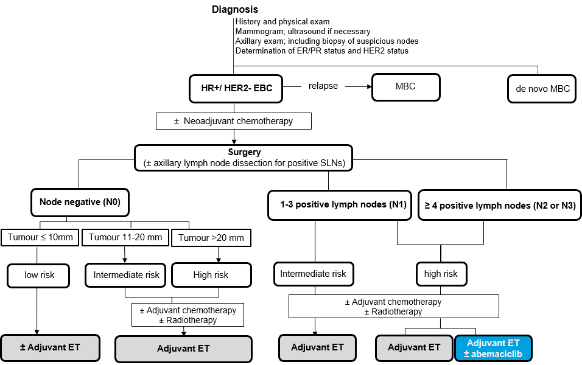

Source: Figure 1-4, p40 of the submission.

ER = Estrogen Receptor; HR+ = hormone receptor positive; HER2- = human epidermal growth factor receptor 2 negative; EBC = early breast cancer; MBC = advanced or metastatic breast cancer; ET = Endocrine therapy (i.e. aromatase inhibitor letrozole, anastrozole or exemestane or SERM = selective estrogen receptor modulator (tamoxifen); PR = Progesterone Receptor; N= lymph node; SLN = sentinel lymph nodes.

Note: The proposed intervention (Adjuvant ET ± abemaciclib) comprises abemaciclib, continuously for 2 years and ET, also taken continuously for at least 5 years in accordance with Australian guidelines.

* 1. There is currently no evidence regarding the effectiveness of CDK4/6 inhibitors following disease recurrence after a prior CDK4/6 inhibitor. Use of abemaciclib in combination with ET in early breast cancer may alter the effectiveness of subsequent use of CDK4/6 inhibitors after progression to metastatic breast cancer. PBS-listed abemaciclib or ribociclib plus fulvestrant at this later stage would potentially be replaced by abemaciclib in early breast cancer, reducing treatment options at later cancer stages.

*For more detail on PBAC’s view, see section 7 PBAC outcome.*

1. Comparator
   1. The submission nominated ET alone as the comparator. ET may be either an aromatase inhibitor (e.g. letrozole, anastrozole or exemestane) or an established selective estrogen receptor modulator (SERM) or tamoxifen. The submission argued that ET is the appropriate comparator as it is standard of care for adjuvant treatment of HR+, HER2- early breast cancer, and that PBAC has previously accepted ET as the comparator for trastuzumab emtansine (T-DM1) for patients with HER2+, HR+ early breast cancer. The ESC agreed with the evaluation that ET is the appropriate comparator.

*For more detail on PBAC’s view, see section 7 PBAC outcome.*

1. Consideration of the evidence

Sponsor hearing

* 1. The sponsor requested a hearing for this item. The clinician stated that results for IDFS and distant relapse free survival (DRFS) become more statistically significant over time across the 3 data cuts, and argued that the benefit from abemaciclib does not diminish over time. The clinician acknowledged that OS data from the monarchE trial is currently immature and noted that patients who develop metastatic disease may receive a CDK4/6 inhibitor as part of their first line metastatic treatment, and are likely still alive, and therefore it may be several years before a difference between arms in OS is seen. With respect to side effects, the clinician acknowledged that there would be increased follow up for abemaciclib patients in early breast cancer during the initial 3−6 month treatment period, compared to ET alone, to ensure an optimum dose with a manageable side effect profile. The clinician noted that many monarchE patients had undergone intensive treatment with chemotherapy, surgery, and radiotherapy, and therefore had time before treatment with abemaciclib to ensure recovery (up to 16 months, see paragraph 6.9 below), and noted that an additional 3 months of ET was allowed before randomisation. The PBAC considered that the hearing was informative as it provided a clinical perspective on the meaningfulness of the results reported in monarchE.

Consumer comments

* 1. The PBAC noted and welcomed the input from an individual and organisations (2) via the Consumer Comments facility on the PBS website.
  2. The PBAC noted the advice received from the Breast Cancer Network Australia (BCNA). The BCNA noted that the use of abemaciclib in combination with ET is associated with increased IDFS, as shown in the pivotal monarchE trial, and considered the incidence and severity of side effects in both arms of the trial were acceptable. The BCNA noted that a number of Australian patients participated in the trial and included testimonials from these patients in the submission. The BCNA emphasised the potential wider benefits of reducing long term costs and healthcare burden by reducing progressive disease and the need for further treatment. The BCNA also recognised the psycho-social role of treatments that reduce fear of cancer recurrence in patients, which can have wide reaching impacts on wellbeing and quality of life. The PBAC noted that the advice from the BCNA was supportive of the evidence provided in the submission.
  3. The Medical Oncology Group of Australia (MOGA) also expressed its strong support for the use of abemaciclib in early breast cancer at high risk of recurrence, categorising it as one of the therapies of “highest priority for PBS listing” on the basis of the monarchE trial. The PBAC noted that the MOGA presented a European Society for Medical Oncology Magnitude of Clinical Benefit Scale (ESMO-MCBS) grade for abemaciclib (in combination with ET) as the highest grade ‘A’, categorising it as a treatment with substantial benefit in the curative setting.[4]
  4. One individual who has used abemaciclib provided insight into their experience with early breast cancer and treatment with this medicine. The individual reported that the capsule was convenient, but considered that side effects with abemaciclib may be an issue for patients.

Clinical trials

* 1. The submission was based on one head-to-head randomised trial comparing abemaciclib in combination with ET to ET alone (n=5637) (monarchE). The clinical claim and economic analysis were based on the ITT population (all participants randomised), although the proposed PBS restriction was aligned with a subgroup (Cohort 1, representing 91% of the ITT population). Cohort 2 was not considered relevant to the Australian setting as there is no standardised methodology to quantify Ki-67 levels in a reproducible way (paragraph 3.5).
  2. Details of the trial presented in the submission are provided in Table 2.

**Table 2: Trials and associated reports presented in the submission**

| Trial ID | Protocol title/ Publication title | Publication citation |
| --- | --- | --- |
| **Direct randomised trials** | | |
| monarchE /  I3Y-MC-JPBL  (NCT03155997)  (JPRN0JapicCTI-173668)  EUCTR2016-004362-26-DE)  CTRI/2017/10/010017) | **Clinical Study Report**  A Randomised, Open-Label, Phase 3 Study of Abemaciclib combined with standard adjuvant endocrine therapy versus standard adjuvant endocrine therapy alone in patients with high risk, node positive, early stage, hormone receptor positive, human epidermal receptor 2 negative, breast cancer. | CSR approval date: 30-Nov-2020;  CSR approval date: 28-Jun-2021 |
| Protocol I3Y-MC-JPCF. Amendment (e) | Approval date: 18-Sept-2020 |
| Statistical Analysis Plan I3Y-MC-JPC, version 5. | Approval date: 05-Jun-2020 |
| Statistical Analysis Plan I3Y-MC-JPC, PRO version 2 | Approval date: 06-May-2020 |
| Statistical Analysis Plan I3Y-MC-JPC, Addendum for OS Analyses | Approval date: 15-Dec-2020 |
| **Publications**  Rastogi, P., Toi, M. et al. MonarchE: a randomized, open-label, phase 3 study of ABE combined with standard adjuvant endocrine therapy versus standard adjuvant endocrine therapy alone in patients with high risk, node positive, early stage, HR+, HER2-breast cancer. | Cancer Research 2018; 78 (4). |
| Johnston, S., Harbeck, N. et al. 2MO ABE in high-risk early breast cancer. | Annals of Oncology 2020; 31:S1242‐S1243. |
| Johnston, S. R. D., Harbeck, N. et al. ABE Combined with Endocrine Therapy for the Adjuvant Treatment of HR+, HER2-, Node-Positive, High-Risk, Early Breast Cancer (monarchE). | Journal of clinical oncology 2020 |
| Johnston, S. R. D., Harbeck, N. et al. ABE in high-risk early breast cancer. | Annals of Oncology 2020; 31:S1143‐S1144 |
| Jiang, Z., Nakayama, T. et al. LBA 1 Baseline characteristics of patients from Asia enrolled in monarchE, evaluating ABE in high-risk early breast cancer. | Annals of oncology 2020; 31:S1241. |
| Harbeck N., Rastogi P., et al. Adjuvant abemaciclib combined with endocrine therapy for high-risk early breast cancer: updated efficacy and Ki-67 analysis from the monarchE study | 2021 (in press) |
| Harbeck N., Rastogi P., et al. Adjuvant abemaciclib combined with endocrine therapy for high-risk early breast cancer: updated efficacy and Ki-67 analysis from the monarchE study | 2021 (in press – supplementary data) |
| Harbeck N., Rastogi P., et al. Letter to the Editor for "Adjuvant Abemaciclib Combined With Endocrine Therapy for High-Risk Early Breast Cancer: Updated Efficacy and Ki-67 Analysis From the monarchE Study" | 2021 (in press) |

Source: Table 2-4, p55 of the submission.

ABE = abemaciclib; CSR = clinical study report; HER2- = human epidermal growth factor receptor 2 negative; HR+ = hormone receptor positive; OS = overall survival.

* 1. The key features of the monarchE direct randomised trial are summarised in Table 3. The trial had an overall low risk of bias, although there was no attempt made to blind participants to treatment allocation.

**Table 3: Key features of the included evidence**

| Trial | N | Design/ duration | Risk of bias | Patient population | Outcomes | Use in modelled evaluation |
| --- | --- | --- | --- | --- | --- | --- |
| Abemaciclib in combination with endocrine therapy versus endocrine therapy alone | | | | | | |
| monarchE | 5637 | R, OL  27 months | Low | HR+, HER2- resected EBC, ALN+ with high risk of recurrence  **ITT**: both cohort 1 and cohort 2. | IDFS, DRFS, OS, HR-QoL and safety | IDFS used |
|  | 5120 |  |  | **Cohort 1**: high risk of recurrence: ≥4 ALNs; or 1-3 ALNs and tumour ≥5cm or grade ≥3 disease. | IDFS, DRFS, OS | Not used |
|  | 517 |  |  | **Cohort 2**: 1-3 ALNs and high Ki-67 index (≥20%), not meeting eligibility for cohort 1 due to tumour <5cm and grade <3 disease. | IDFS, DRFS, OS | Not used |

Source: Table 2-5, p60, and Table 2-19, p76 of the submission

ALN = axillary lymph node; DRFS = distant relapse free survival; EBC = early breast cancer; HER2- = human epidermal growth factor receptor 2 negative; HR+ = hormone receptor positive; HR-QoL = health-related quality of life; IDFS = invasive disease-free survival; OL = open label; OS = overall survival; R = randomised.

* 1. The ESC noted that patients were eligible to enrol in the monarchE study for up to 16 months following surgery. This extended time to enrolment may have led to a bias in patient recruitment. The PBAC agreed with the evaluation that data regarding actual time to enrolment of patients in both arms of the study would aid in assessing this further, noting that the time to randomisation from surgery is unclear, as is the time from imaging to randomisation. The pre-PBAC response stated that a 16 month maximum timeframe between surgery and enrolment allowed patients time to recover from adjuvant chemotherapy, radiotherapy, or both and that the median time between surgery and randomisation in monarchE is aligned with routine medical practice and is well-balanced between treatment arms (7.8 months in abemaciclib + ET versus 7.9 months in ET alone arm)[5].

Comparative effectiveness

* 1. Abemaciclib in combination with ET resulted in a 30% reduction in hazard of IDFS compared to ET alone in the ITT population, after a median of 27 months (Table 4 and Figure 2); the absolute difference in IDFS rates at 27 months was 3.5%. There was also a 32% reduction in hazard of DRFS associated with abemaciclib in combination with ET (Table 4 and Figure 3).
  2. The absolute difference in IDFS rates was 2.7% at 24 months (percent alive without invasive disease: 92.7% vs 90.0%), and 5.4% at 36 months (88.8% vs 83.4%) (Table 6).
  3. OS data were immature from the most recent data cutoff (April 2021) (Table 4 and Figure 4), as only around 3% of events had occurred. No difference in OS was observed at this data cutoff. The validity of IDFS as a surrogate for OS is unknown, as the evidence provided on the strength of IDFS surrogacy was in HER2+ patients rather than HER2- patients and based on drugs that have a different mechanism of action. The ESC noted that if patients receive a CDK4/6 inhibitor in the adjuvant setting but then not in the metastatic setting, this may reduce any potential OS benefit from adjuvant treatment.
  4. The ITT population included both Cohort 1 (relevant to the target population) and Cohort 2 (irrelevant to the target population). Cohort 1 constituted the majority of participants in the trial and had a larger absolute and relative response to abemaciclib than Cohort 2. The ITT results are therefore conservative for estimating the benefit of abemaciclib in Cohort 1.

**Table 4: Results of the whole trial population (ITT), then the relevant subgroup (Cohort 1) and the complement subgroup (Cohort 2), at AFU1 (April 2021, median 27 months)**

|  |  |  |  |  |
| --- | --- | --- | --- | --- |
|  | ABE + ET  n with event/N (%) | ET  n with event/N (%) | Absolute difference | HR (95% CI) |
| Invasive disease-free survival (IDFS) | | | | |
| ITT population | 232/2808 (8.3%) | 333/2829 (11.8%) | 3.5% | **0.70 (0.59, 0.82)** |
| Cohort 1 | 218/2555 (8.5%) | 318/2565 (12.4%) | 3.9% | **0.69 (0.57, 0.81)** |
| Cohort 2 | 14/253 (5.5%) | 15/264 (5.7%) | 0.2% | 0.99 (0.48, 2.05) |
| Test for treatment effect variation | - | - | - | 0.70 (0.33, 1.47) |
| **Distant relapse-free survival (DRFS)** | | | | |
| ITT population | 191/2808 (6.8%) | 278/2829 (9.8%) | 3.0% | **0.68 (0.57, 0.83)** |
| Cohort 1 | 179/2555 (7.0%) | 266/2565 (10.4%) | 3.4% | **0.67 (0.55, 0.81)** |
| Cohort 2 | 12/253 (4.7%) | 12/264 (4.5%) | -0.2% | 1.04 (0.47, 2.32) |
| Test for treatment effect variation | - | - | - | 0.64 (0.28, 1.46) |
| Overall survival (OS) | | | | |
| ITT population | 96/2808 (3.4%) | 90/2829 (3.2%) | -0.2% | 1.09 (0.82, 1.46) |
| Cohort 1 | 90/2555 (3.5%) | 88/2565 (3.4%) | -0.1% | 1.04 (0.78, 1.40) |
| Cohort 2 | 6/253 (2.4%) | 2/264 (0.8%) | -1.6% | Not estimable |
| Test for treatment effect variation | - | - | - | - |

Source: Table 2-21, p81 of the submission; Table 2-56, p130 of the submission, and Table 2-57, p133 of the submission.

ABE = abemaciclib; AFU1 = additional follow up 1; CI = confidence interval; ET = endocrine therapy; HR = hazard ratio; ITT = intention to treat; n = number of participants with event; N = total participants in group.

**Bold** indicates statistically significant results. Treatment effect variation calculated during the evaluation by using the ratio of HRs for Cohort 1 vs Cohort 2.

Figure : Kaplan-Meier curve for IDFS at AFU1 (ITT population, April 2021, median follow-up 27 months)

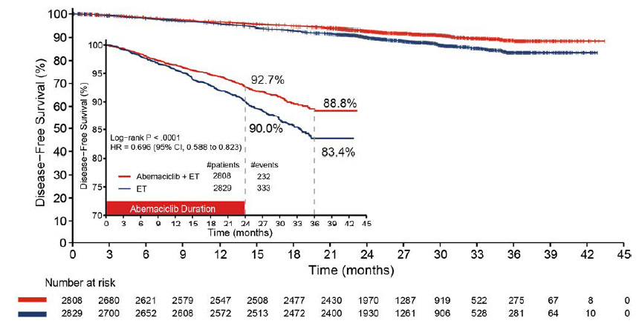

Source: Figure 2-6, p82 of the submission

Note: p-value is nominal. Inset shows a truncated y-axis (70% to 100%) without any censoring ticks to show separation of curves more clearly.

# = number of; CI = confidence interval; ET = endocrine therapy; HR = hazard ratio; IDFS = invasive disease-free survival; ITT = intent-to-treat

Figure : Kaplan-Meier curve for DRFS at AFU1 (ITT population, April 2021, median follow-up 27 months)

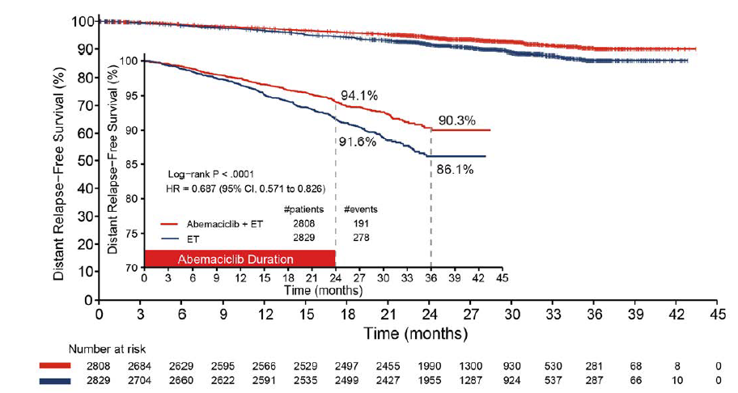

Source: Figure 2-12, p93 of the submission

Note: p-value is nominal. Inset shows a truncated y-axis (70% to 100%) without any censoring ticks to show separation of curves more clearly.

# = number of; CI = confidence interval; DRFS = distant relapse-free survival; ET = endocrine therapy; HR = hazard ratio; ITT = intent-to-treat; OS = overall survival

Figure : Kaplan-Meier curve for overall survival (ITT population, April 2021, median follow-up 27 months)

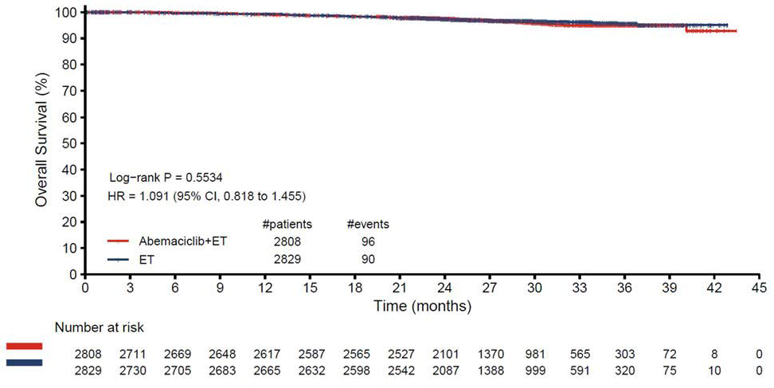

Source: Figure 2-15, p96 of the submission

# = number of; CI = confidence interval; ET = endocrine therapy; HR = hazard ratio.

* 1. The impact of treatment on patients’ health status was assessed using the EuroQol 5D 5-level version (EQ-5D-5L) on Day 1 and Visits 6, 9, 15, 21 and 27. Changes from baseline in both the abemaciclib in combination with ET arm and the ET alone arm were smaller than the specified minimal clinically important difference (MCID) of 0.5 of the baseline standard deviation (i.e. 0.085). The proportion of patients who experienced a clinically meaningful increase or decrease in perceived health problems, from either treatment option, was not presented in the submission. As abemaciclib is an additional treatment and there is an increase in observed adverse events (Table 5), some impact on health-related quality of life would be expected.

Comparative harms

* 1. Table 5 presents a summary of adverse events, based on the monarchE trial. The rate of Grade ≥3 treatment emergent adverse events was 33% higher in the patient group who received the addition of abemaciclib, compared to ET alone, and 19% of patients discontinued abemaciclib due to adverse events. The ESC noted that 18.5% of patients discontinued abemaciclib due to toxicity.

**Table 5:** Summary of key adverse events in the monarchE randomised trial by analysis data cut-off, safety population

| Trial ID | Arm A  ABE + ET  n with event/N (%) | Arm B  ET  n with event/N (%) | RD % (95%CI) | RR (95% CI) |
| --- | --- | --- | --- | --- |
| Patients with ≥1 TEAE | 2745/2791 (98.4%) | 2486/2800 (88.8%) | **9.57 (8.30, 10.82)** | **1.11 (1.09, 1.12)** |
| Patients with ≥1 CTCAE Grade ≥3 TEAE | 1388/2791 (49.7%) | 456/2800 (16.3%) | **33.44 (31.14, 35.75)** | **3.05 (2.79, 3.35)** |
| Patients with ≥1 TE-SAE | 424/2791 (15.2%) | 219/2800 (7.8%) | **7.37 (5.71, 9.03)** | **1.94 (1.66, 2.27)** |
| Patients who discontinued abemaciclib due to AE | 515/2791 (18.5%) | NA | NA | NA |
| Patients who discontinued all study treatment due to AE | 181/2791 (6.5%) | 30/2800 (1.1%) | **5.41 (4.42, 6.40)** | **6.05 (4.13, 8.88)** |
| Patients who died due to AE on study therapy or ≤30 days of discontinuation from study treatment | 15/2791 (0.5%) | 10/2800 (0.4%) | 0.18 (-0.17, 0.53) | 1.50 (0.68, 3.34) |
| Grade ≥3 diarrhoea | 219/2791 (7.8%) | 6/2800 (0.2%) | **7.63 (6.62, 8.64)** | **36.62 (16.30, 82.26)** |
| Grade ≥3 neutropenia | 546/2791 (19.6%) | 23/2800 (0.8%) | **18.74 (17.23, 20.24)** | **23.82 (15.74, 36.03)** |
| Grade ≥3 leukopenia | 317/2791 (11.4%) | 11/2800 (0.4%) | **10.96 (9.77, 12.16)** | **28.91 (15.89, 52.62)** |
| Grade ≥3 lymphopenia | 151/2791 (5.4%) | 13/2800 (0.5%) | **4.95 (4.07, 5.82)** | **11.65 (6.63, 20.48)** |

Source: Table 2-44, p114 of the submission and Table 2-46, p115 of the submission. Note: RD and RR calculated during the evaluation. Bold indicates a statistically significant result.

ABE = abemaciclib; AE = adverse event; AFU1 = additional follow-up 1 (April 2021); CI = confidence interval; CTCAE = Common Terminology Criteria for adverse Events; ET = endocrine therapy; n = number of participants reporting data; N = total participants in group; NA = not applicable; RD = risk difference; RR = relative risk; TEAE = treatment emergent adverse events; TE-SAE = treatment-emergent serious adverse event.

Benefits/harms

* 1. A summary of the comparative benefits and harms for abemaciclib in combination with ET versus ET alone is presented in Table 6.

**Table 6: Summary of comparative benefits and harms for ABE + ET versus ET alone**

|  |  |  |  |  |
| --- | --- | --- | --- | --- |
| Invasive disease-free survival (IDFS; median duration of follow up 27 months) | | | | |
| Event | ABE + ET | ET | Absolute Difference | HR (95% CI) |
| Invasive disease or death, n (%) | 232/2808 (8.3%) | 333/2829 (11.8%) | -3.5% | 0.70 (0.59, 0.82) |
| Median IDFS, months (95% CI) | NA | NA | NA |  |
| % alive without invasive disease at 24 months (95% CI) | 92.7%  (91.6%, 93.6%) | 90.0%  (88.8%, 91.1%) | 2.7%  (1.1%, 4.2%) |  |
| % alive without invasive disease at 36 months (95% CI) | 88.8%  (87.0%, 90.3%) | 83.4%  (81.3%, 85.3%) | 5.4%  (2.8%, 8.0%) |  |
| **Distant relapse-free survival (DRFS; median duration of follow up 27 months)** | | | | |
| Distant relapse or death, n (%) | 191/2808 (6.8%) | 278/2829 (9.8%) | -3.0% | 0.69 (0.57, 0.83) |
| Median DRFS, months (95% CI) | NA | NA | NA |  |
| % Alive without distant relapse at 24 months 95% CI) | 94.1%  (93.2%, 95.0%) | 91.6%  (90.5%, 92.6%) | 2.5%  (1.1%, 3.9%) |  |
| % Alive without distant relapse at 36 months (95% CI) | 90.3%  (88.6%, 91.8%) | 86.1%  (84.2%, 87.9%) | 4.2%  (1.8%, 6.7%) |  |
| Overall survival (OS; median duration of follow up 27 months) | | | | |
| Deaths, n/N (%) | 96/2808 (3.4%) | 90/2829 (3.2%) | 0.2% | 1.09 (0.82, 1.46) |
| Median OS, months (95% CI) | NA | NA | NA |  |
| % Alive at 24 months (95% CI) | 97.6%  (96.9%, 98.1%) | 97.4%  (96.7%, 97.9%) | 0.2%  (-0.6%, 1.1%) |  |
| % Alive at 36 months (95% CI) | 95.2%  (94.0%, 96.2%) | 95.6%  (94.3%, 96.6%) | -0.4%  (-1.9%, 1.2%) |  |

|  |  |  |  |  |  |  |
| --- | --- | --- | --- | --- | --- | --- |
| Harms | | | | | | |
|  | ABE + ET  n/N | ET  n/N | RR  (95% CI) | Event rate/100 patients* | | RD  (95% CI) |
| ABE + ET | ET |
| Grade ≥3 TEAE | 1388/2791 | 456/2800 | 3.05 (2.79, 3.35) | 49.7 | 16.3 | 33.44 (31.14, 35.75) |
| TE-SAE | 424/2791 | 219/2800 | 1.94 (1.66, 2.27) | 15.2 | 7.8 | 7.37 (5.71, 9.03) |
| Grade ≥3 diarrhoea | 219/2791 | 6/2800 | 36.62 (16.30, 82.26) | 7.8 | 0.2 | 7.63 (6.62, 8.64) |
| Grade ≥3 neutropenia | 546/2791 | 23/2800 | 23.82 (15.74, 36.03) | 19.6 | 0.8 | 18.74 (17.23, 20.24) |

Source: Table 2-28, p92 of the submission, Table JPCF.5.2, p36 of the monarchE CSR AFU1 (April 2021), Table JPCF.8.5, p154 of the monarchE CSR AFU1 (April 2021)

ABE = abemaciclib; CI = confidence interval; DRFS = distant relapse-free survival; ET = endocrine therapy; HR = hazard ratio; IDFS = invasive disease-free survival; NA = not available (not reached); RD = risk difference; RR = risk ratio; TEAE = treatment emergent adverse event; TE-SAE = treatment emergent serious adverse event

* median 27 months duration of follow-up

* 1. On the basis of direct evidence presented by the submission, for every 100 patients with HR+/HER2- early breast cancer with a high risk of recurrence, treated with abemaciclib in combination with ET instead of ET alone and for a median follow-up duration of 27 months:
* Approximately 4 additional patients would not experience invasive disease or death (IDFS).
* No difference in OS.
* Approximately 33 additional patients would experience a grade ≥3 treatment-emergent AE, primarily related to reduced white blood cell levels (including approximately 19 additional cases of neutropenia (too few neutrophils, a type of white blood cell), 11 additional cases of leukopenia (low white blood cell count), and 5 additional cases of lymphopenia (too few lymphocytes, a type of white blood cell)). Reduced white blood cell levels leads to an increase in the risk of infection.
* Approximately 8 additional patients would experience grade ≥3 diarrhoea.
* Approximately 7 additional patients would experience a treatment-emergent serious adverse event.
* Approximately 5 additional patients would discontinue all study treatment due to adverse events.

Clinical claim

* 1. The submission described abemaciclib in combination with ET as superior in terms of effectiveness compared with ET alone and with a manageable safety profile.
  2. The therapeutic conclusion presented in the submission was supported by a statistically significant difference in the hazard of invasive disease or death between patients receiving abemaciclib in combination with ET versus those receiving ET alone. However, OS data were immature (only around 3% of events had occurred). The appropriateness of IDFS as a surrogate for OS in patients with HER2- disease remains uncertain, particularly as the IDFS benefit appeared modest. Although statistically significant, the absolute difference in IDFS favouring the use of abemaciclib was only 3.5% at the April 2021 data cut-off. The ESC considered there was uncertainty whether the IDFS benefit would be maintained with longer follow-up and whether it would translate into a clinically meaningful OS benefit.
  3. The Pre-Sub-Committee Response (PSCR) noted that the ITT population included both Cohort 1 (relevant to the target population) and Cohort 2 (irrelevant to the requested population). Cohort 1 constituted most participants (91%) in the trial and had a larger absolute and relative response to abemaciclib than Cohort 2. The PSCR argued that the ITT results are therefore conservative for estimating the benefit of abemaciclib in Cohort 1. Notwithstanding, the ESC considered that it remains unclear whether the difference observed in IDFS would translate into clinically meaningful OS benefit.
  4. The pre-PBAC response stated that the increasing magnitude of numerical effect size over time in the annualised hazard ratios (HR 0.795 [Year 0-1] to HR 0.596 [Year 2+]), in addition to the absolute improvement in IDFS rate at 3 years, confirms the evolution of treatment benefit in the entire observation period, including the benefit beyond the 2-year study treatment period. The PBAC noted that the annualised HRs indicated that the magnitude of effect of abemaciclib in reducing the risk of recurrence increases over the time intervals discussed in the pre-PBAC response.
  5. The PBAC noted that the immature OS results meant there would be several years until final reporting, and considered that in the meantime, there was an unclear relationship between IDFS and OS. While there was a relative risk reduction in IDFS of 30%, the PBAC questioned whether the absolute difference in IDFS of 3.5% is clinically meaningful, and noted a similar pattern for DRFS. The PBAC noted that abemaciclib is associated with a smaller absolute risk reduction compared to agents seen previously, such as trastuzumab emtansine for HER2+ early breast cancer. The PBAC concluded that the extent of benefit may be meaningful, as the difference occurs at the highest risk point, which is 2-3 years post diagnosis. Overall, the PBAC considered that the claim of superior comparative effectiveness was uncertain but supportable.
  6. The evaluation noted that abemaciclib in combination with ET appeared to be associated with inferior safety compared to ET alone. A large percentage of patients (49.7%) receiving abemaciclib had at least one severe adverse event (Grade ≥3), which was over three times the rate of those in the ET arm. In particular, grade ≥3 neutropaenia occurred in 19.6% of patients receiving abemaciclib compared with 0.8% in the ET arm. Further, grade ≥3 diarrhoea occurred in 7.8% of patients in the abemaciclib arm compared with 0.2% in the ET arm. Adverse events caused a large percentage (18.5%) of those in the abemaciclib arm to discontinue treatment. Most of these patients continued to receive ET, however 6.5% of patients in the abemaciclib arm discontinued both abemaciclib and ET. The PBAC agreed with the ESC that while abemaciclib was associated with inferior safety, with a high proportion of patients discontinuing treatment, there were no new safety signals and the safety profile of abemaciclib is manageable with monitoring and dose modifications.

Economic analysis

* 1. The submission presented a modelled economic evaluation based on the monarchE randomised controlled trial with the addition of health states in the model that drew on a separate economic evaluation that was based on the MONARCH-2 and MONARCH-3 trials (and associated network meta-analyses). The type of economic evaluation presented was a cost-utility analysis. The submission did not present a stepped economic evaluation, which the evaluation considered was not reasonable as the analysis was highly dependent on modelled assumptions, including extrapolation of IDFS and generation of outcomes in metastatic recurrence. The key components of the economic evaluation comparing abemaciclib in combination with ET with ET alone are summarised in Table 7.

Table **: Summary of model structure, key inputs and rationale**

| Component | Summary |
| --- | --- |
| Treatments | Abemaciclib + ET vs ET |
| Time horizon | 40 years in the model base case versus 27 months median follow-up in the monarchE trial. The PBAC previously considered that a 20 year time horizon may be more reasonable, given the average age at diagnosis of early breast cancer in Australia is 61.4 years (para 6.36, Trastuzumab emtansine PSD, Nov 2019 PBAC meeting). Due to the uncertain extrapolation of IDFS in the base case of the economic model and the average age at diagnosis in Australia, the ESC agreed with the evaluation that a 20 year time horizon would be more reasonable. |
| Outcomes | QALYs |
| Methods used to generate results | Cohort expected value analysis (Markov model) |
| Health states | Five health states: Invasive disease free survival; Non-metastatic recurrence (including three sub-states: second primary neoplasm [a], locoregional recurrence and contralateral recurrence); Remission; Metastatic recurrence (including two sub-states: endocrine-resistant and endocrine-sensitive) [a]; and Dead [a]. The rationale for separating the non-metastatic recurrence health state was not clear. The ESC agreed that the two metastatic recurrence sub-states in the economic model added unwarranted complexity and was not justified. |
| Cycle length | 28 days |
| Transition probabilities | IDFS, recurrence type, OS without metastatic recurrence and TTD were sourced from monarchE. The probability of recurrence in remission was based on Hamilton (2015).  As metastatic recurrence was modelled as an absorbing health state, one-off costs and QALYs were applied on transition, based on LYs (by progression status) generated in analyses of abemaciclib in the metastatic setting for each first-line metastatic treatment option included. These were weighted by the distribution of use with and without abemaciclib in the adjuvant setting.  The ESC advised that the one-off costs and QALYs applied on transition to the metastatic recurrence sub-states was not justified due to transitivity issues. |
| Extrapolation method | Observed KM data were used in the model with extrapolation of monarchE KM IDFS, OS without distant recurrence and TTD for ET (with or without adjuvant abemaciclib) data. The IDFS and OS without distant recurrence data were not mature and are not likely to provide a reliable basis for extrapolation. Parametric model selection was based on an assessment of proportional hazards and goodness of fit statistics.   * IDFS: a jointly fitted Weibull distribution was used from month 32. * OS without metastatic recurrence: a jointly fitted exponential distribution was used from month 34.7. * ET TTD: independently fitted models were used after all of the observed KM TTD. Hazards spline models with two knots (abemaciclib + ET) and one knot (ET) were used.   All extrapolations were adjusted for background mortality, and IDFS and OS without metastatic recurrence were further adjusted for a waning of the abemaciclib treatment effect (over Year 8−38). Due to crossing of the log-cumulative hazards plots, joint models assuming a treatment effect beyond the observed period, may not be reasonable. While a waning of this treatment effect was modelled, no evidence was provided to support the duration of treatment effect due to abemaciclib treatment beyond the observed data. Due to crossing of the log-cumulative hazard plots, the ESC advised that the jointly fitted approach for IDFS was not well-supported. While the submission modelled a waning in treatment effect, no evidence was provided in the submission or the PSCR to support the duration of treatment effect due to abemaciclib treatment beyond the observed data, nor the year at which waning was applied. The ESC noted that the ICER was sensitive to changes in the assumed duration of abemaciclib treatment effect beyond the observed period and to the year at which waning commenced. |
| Health related quality of life | Derived from monarchE (IDFS and remission: 0.783), MONARCH-2 (ER-MBC PFS and ES-MBC PFS2: 0.748), MONARCH-3 (ER-MBC PFS1: 0.724) and published literature (Lidgren 2007a and Lloyd 2006b). It was noted by the ESC that not all utility data were transformed for Australian preference weights. |

Source: Table 3−1, p146 of the submission.

ER-MBC = endocrine-resistant metastatic breast cancer; ES-MBC = endocrine-sensitive metastatic breast cancer; ET = endocrine therapy; IDFS = invasive disease-free survival; KM = Kaplan-Meier; LY = life years; OS = overall survival; PFS = progression-free survival; PBAC = Pharmaceutical Benefits Advisory Committee; PSD = public summary document; QALY = quality-adjusted life year; TTD = time to treatment discontinuation

a Lidgren M, Wilking N, Jonsson B, Rehnberg C. Health related quality of life in different states of breast cancer. Qual Life Res. 2007 Aug;16(6):1073-81.

b Lloyd A, Nafees B, Narewska J, Dewilde S, Watkins J. Health state utilities for metastatic breast cancer. Br J Cancer. 2006 Sep 18;95(6):683-90.

* 1. A comparison of the economic evaluation from the trastuzumab emtansine PBAC submission (November 2019 PBAC meeting) for early breast cancer and the present submission for abemaciclib shows that there are key differences in time horizon (40 vs 20 years accepted by PBAC), increased complexity of modelled health states post-progression, and the duration of extrapolated treatment effect (38 years vs 10 years).
  2. The evaluation considered that the time horizon in the base case of 40 years was not likely to be reasonable given that the average age at diagnosis of early breast cancer in Australia is 61.4 years (paragraph 6.36, Trastuzumab emtansine Public Summary Document [PSD], November 2019 PBAC meeting) and noted that a 20-year time horizon was more reasonable in the early breast cancer setting. Reducing the time horizon to 20 years increased the ICER to $35,000 to < $45,000/QALY. The PSCR stated that a time horizon of 20 years would not be appropriate as 29.0% and 18.8% of patients in the abemaciclib and ET arms remain in IDFS, respectively, at this time point. The ESC considered that the extrapolation of IDFS is likely to be associated with a high degree of uncertainty and agreed with the evaluation that a 20-year time horizon would be more appropriate than 40 years.
  3. The OS benefit of abemaciclib was modelled indirectly through IDFS. Improvement in IDFS with abemaciclib was assumed to reduce the number of recurrences, in particular metastatic recurrences, and therefore death due to metastatic recurrence. The submission modelled both an improvement in IDFS with abemaciclib based on the results from the monarchE trial, and a lower proportion of recurrences that were metastatic (71.6% with abemaciclib + ET versus 74% with ET alone) based on monarchE trial data on the first tumour recurrence occurrence. Modelling a difference between arms may not be reasonable, as the submission has not supported that the differences are statistically significant. Assuming a lower proportion of invasive disease events that are metastatic favoured abemaciclib.
  4. A summary of the key drivers of the model is shown in Table 8.

Table **: Key drivers of the model**

| Description | Method/Value | Impact  Base case ICER: $　|　1 (revised) |
| --- | --- | --- |
| Duration of treatment effect | The treatment effect based on the jointly-fitted parametric model extrapolations was assumed to continue beyond the trial period (maximum 42 months) until Year 8. A waning of the treatment effect was implemented until the extrapolated comparator IDFS hazard rate equalled background mortality (at Year 38). This approach is not well justified. No evidence was presented to support an ongoing benefit of abemaciclib beyond the observed period. The ESC noted that there was no evidence provided in the submission or PSCR to support the duration of treatment effect due to abemaciclib treatment beyond the observed data. The ESC noted that the ICER is sensitive to changes in this assumption and the year at which waning is assumed to commence. | High, favours abemaciclib. Assuming that the treatment effect wanes over the period from the end of the observed data to Year 7 increases the ICER to $||||2. Assuming no effect beyond the observed period increases the ICER to $||||3. |
| Time horizon | 40 years in the base case. The PBAC had previously considered that a 20-year time horizon was more appropriate in the adjuvant treatment of HER2+ early breast cancer, given the median age at diagnosis (paragraph 6.36, Trastuzumab emtansine, PSD November 2019 PBAC meeting). Due to the uncertain extrapolation of IDFS in the base case of the economic model and the average age at diagnosis in Australia, the ESC advised that a 20-year time horizon would be more reasonable. | High, favours abemaciclib. Reducing the time horizon to 20 years increases the ICER to $||||4. |
| Extrapolation of IDFS | Jointly-fitted Weibull extrapolation from month 32. The IDFS data contained a small number of events (approximately 10% events at the latest follow-up) and may not provide a reliable basis for extrapolation. | High, favours abemaciclib. Using the log-logistic model increased the ICER to $||||5 |
| Calibration of outcomes in ES-MBC | LYs in the external ES-MBC model were calibrated to reduce the time in PFS2/PPS such that the relative gain in OS for first-line metastatic CDK4/6 inhibitors + NSAI was 27.5% of the gain in PFS (based on PALOMA-1 (Finn 2015)). The basis for the applied surrogacy relationship was not clear. ESC has previously considered that PFS has not been shown to be a good surrogate for OS (para 6.26, Palbociclib PSD, November 2017 PBAC Meeting). As CDK4/6 inhibitors are not modelled after adjuvant abemaciclib, calibration that reduces OS of CDK4/6 inhibitors in the metastatic setting favours abemaciclib. The ESC agreed with the evaluation that the validity of IDFS as a surrogate for OS remains unknown for the proposed patient population. | Moderate, favours abemaciclib. When estimates without calibration were used, the ICER increased to $||||1.  This was noted to have a high impact in the multivariate analyses where assumptions regarding the treatment effect of abemaciclib were also reduced (Table 13). |
| Proportion of recurrences that are non-metastatic | A constant proportion was assumed, though varied by model arm (ABE + ET: 28%; ET: 26%). The submission has not supported that the differences are statistically significant, and so the approach may not be reasonable. | Moderate, favours abemaciclib. When the same proportion is applied across both model arms, the ICER increased to $||||1. |

Source: Constructed during the evaluation.

ABE = abemaciclib; CDK4/6 = cyclin-dependent kinases 4 and 6; ER-MBC = endocrine-resistant metastatic breast cancer; ESC = Economics Sub Committee; ES-MBC = endocrine-sensitive metastatic breast cancer; ET = endocrine therapy; HER2 = human epidermal growth factor receptor-2; ICER = incremental cost-effectiveness ratio; IDFS = invasive disease-free survival; LY = life years; NSAI = non-steroidal aromatase inhibitor; OS = overall survival; PBAC = Pharmaceutical Benefits Advisory Committee; PFS = progression-free survival; PPS = post-progression survival; PSD = public summary document.

Note: The base case was revised during the evaluation to correct the per cycle probability of recurrence in the Remission health state, to apply the probability of death in IDFS to the proportion in IDFS rather than invasive disease events, and to apply only one hospitalisation cost per cycle in abemaciclib monitoring. The metastatic health state fixed pay-offs (costs and QALYs) were also revised to apply a discount rate of | |% × (28/365.25) per cycle, the ES-MBC PPS QALYs and costs were revised based on PPS LYs, rather than PFS1 LYs, and to correct for calculation errors in the ER-MBC PPS and ES-MBC PFS2 weighted treatment costs per cycle.

*The redacted values correspond to the following ranges:*

*1 $15,000 to < $25,000*

*2 $75,000 to < $95,000*

*3 $355,000 to < $455,000*

*4 $35,000 to < $45,000*

*5 $25,000 to < $35,000*

* 1. Observed IDFS data from monarchE were used until month 32, after which data were extrapolated using jointly fitted parametric models. At the time of the latest data cut, 10.0% of patients in the trial had experienced an IDFS event. Given the low number of events, the IDFS data were not likely to provide a reliable basis for extrapolation. While the models appeared to fit the observed data reasonably well, the projected estimates varied substantially between the different parametric models (Figure 5). The incremental cost-effectiveness ratio (ICER) was sensitive to the parametric model used for IDFS extrapolation. Using the log-logistic model, which projected estimates in the ET arm that were similar to external studies for both IDFS at 5 years (Smith 2017)[6], and metastatic recurrence at 5−20 years (Pan 2017)[7], increased the (revised) ICER from $15,000 to < $25,000 to $25,000 to < $35,000. The PSCR stated that the difference in IDFS projections occur later in the modelled time horizon and the proposed shortening of the model time horizon would reduce the impacts of selecting the log-logistic distribution for the purposes of IDFS extrapolation. The ESC considered that shortening the time horizon would be necessary as described above (paragraph 6.26), independent of the parametric model used for extrapolation, but agreed it would also reduce overestimation of the long-term incidence of metastatic recurrence in the ET model arm.

Figure : Parametric functions used for IDFS extrapolation

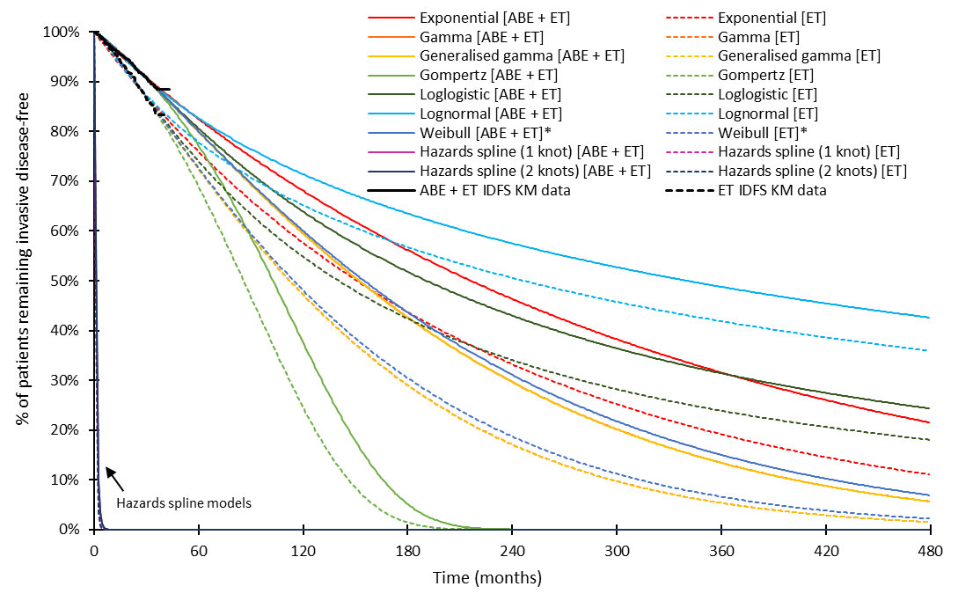

Source: Constructed during the evaluation from the ‘A6.1_Abemaciclib Section 3 workbook.xlsm’ workbook included in the submission.

ABE = abemaciclib; ET = endocrine therapy; IDFS = invasive disease-free survival; KM = Kaplan-Meier.

* Denotes parametric model chosen in the base case analysis.

* 1. As a jointly fitted approach was adopted, the parametric extrapolations included an ongoing treatment effect of abemaciclib + ET over ET alone. This treatment effect was modelled to last for at least eight years, after which, the effect of abemaciclib waned until the extrapolated comparator arm IDFS hazard rate equalled background mortality (Year 38). The assumption of an ongoing treatment effect of abemaciclib beyond the observed period is not reasonable. That waning would not begin until eight years was based on the benefit of anastrozole over tamoxifen (Cuzick 2006)[8] which has unlikely applicability to the duration of the abemaciclib treatment effect. A comparison of the modelled curves with differing assumptions regarding treatment waning is presented in Figure 6. The ICER was highly sensitive to changes in the duration of the treatment effect. Assuming a waning of the effect from the end of the observed data to Year 7 increased the ICER to $75,000 to < $95,000, while assuming no effect beyond the observed period increased the ICER to $355,000 to < $455,000. The PSCR stated that the duration of effect reported for anastrozole and tamoxifen reported in the Arimidex, Tamoxifen, Alone or in Combination (ATAC) trial supports the assumed ongoing treatment effect of abemaciclib in the base case of the economic model. However, the applicability of the ATAC trial to the monarchE trial population and the duration of treatment effect of abemaciclib are unknown. The ESC agreed with the evaluation that there was no evidence provided in the submission or PSCR to support the duration of treatment effect due to abemaciclib treatment beyond the observed data. The ESC noted that the ICER is sensitive to changes in this assumption and that given the lack of data, the ESC advised that waning the treatment effect from 2 to 7 years would be more appropriate than 8 to 38 years. The pre-PBAC response maintained that the piecewise analysis presented in the submission and smoothed hazard rates of IDFS confirm that the treatment effect of abemaciclib was maintained at 3 years and is evidence that treatment effect would be maintained long-term.

Figure : Effect of assumptions regarding treatment waning on modelled IDFS

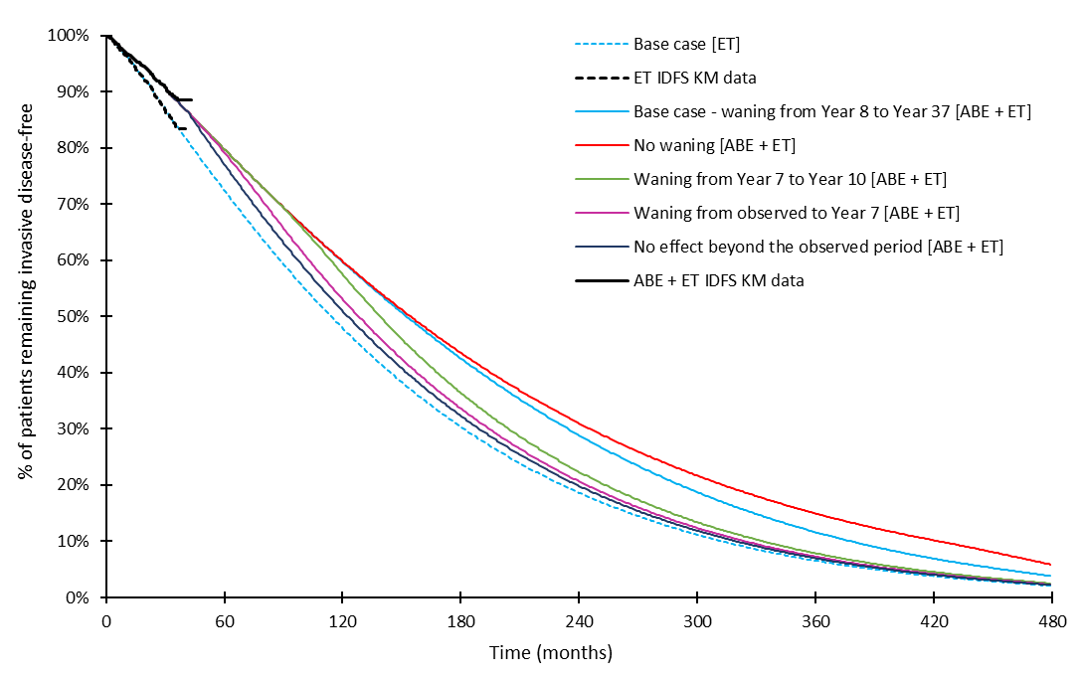

Source: Constructed during the evaluation from the ‘A6.1_Abemaciclib Section 3 workbook.xlsm’ workbook included in the submission.

ABE = abemaciclib; ET = endocrine therapy; IDFS = invasive disease-free survival; KM = Kaplan-Meier.

* 1. The submission separated metastatic recurrence into two substates based on whether patients were resistant to ET (those who developed metastatic recurrence while on, or within 12 months of completion of, adjuvant ET) or who were sensitive to ET. While the definition of endocrine-resistance was consistent with previous submission to the PBAC (Figure 1, Ribociclib PSD, July 2020 PBAC Meeting), this approach would alter the relative proportion of patients who would be classed as endocrine-resistant and endocrine-sensitive with abemaciclib treatment, due to improved IDFS. This was not supported by monarchE trial data as follow-up was less than 72 months and, by definition, did not observe any endocrine-sensitive recurrences. This may bias in favour of abemaciclib, as patients in the model who are endocrine-sensitive are assumed to be associated with fewer costs and more quality-adjusted life years (QALYs) after adjuvant abemaciclib + ET, than if they were modelled as endocrine-resistant. No evidence was presented to establish whether the use of abemaciclib would affect the endocrine sensitivity of a metastatic recurrence. The ESC agreed with the evaluation that the two metastatic recurrence sub-states in the economic model added unwarranted complexity and their inclusion was not well justified.
  2. Due to limited follow-up in the monarchE trial, the submission applied fixed payoffs that represented the expected costs and QALYs in metastatic disease on transition into the health state. These were based on estimates of life years (LYs) gained from analyses that explored the cost-effectiveness of abemaciclib in the metastatic setting based on the MONARCH-2 and MONARCH-3 trials (and associated network meta-analyses). There may be transitivity issues due to the differences in the types of therapy received and patient characteristics between monarchE and the metastatic studies. The effect of these transitivity issues on the results of the analysis is unclear. As abemaciclib in the metastatic setting was listed on the basis of non-inferiority claims to ribociclib, the economic analyses based on these trials have not previously been presented to the PBAC. The PSCR acknowledged there is heterogeneity between the monarchE, MONARCH-2 and MONARCH-3 trials and stated that the economic model was not sensitive to changes in these inputs. The ESC advised that the two metastatic recurrent substates in the economic model added unwarranted complexity and that the one-off costs and QALYs applied on transition to the metastatic recurrence sub-states was not justified due to transitivity issues. The ESC also noted that the analysis was not based on the most recent data cut.
  3. Costs and outcomes attributed to metastatic recurrences were assumed to vary by the treatment received in the adjuvant setting, as the submission assumed that patients in the abemaciclib + ET arm would not receive a CDK4/6 inhibitor after metastatic recurrence. The modelled ICERs for the mix of treatments received in the metastatic setting were calculated during the evaluation (Table 9). In endocrine-sensitive recurrences, this represented a comparison of CDK4/6 inhibitor + non-steroidal aromatase inhibitor (NSAI) use in 85% of patients in the first-line metastatic setting after adjuvant ET to NSAI use in 86% of patients after adjuvant abemaciclib + ET. The derived ICER observed ($155,000 to < $255,000) was higher than what the PBAC has previously considered cost-effective ($15,000−$45,000, paragraph 6.10 Palbociclib PSD, March 2018 PBAC Meeting). Therefore, the applied cost-effectiveness of metastatic treatment was not likely to reflect the accepted cost-effectiveness of CDK4/6 inhibitor treatments in this setting.

Table **:** Incremental cost effectiveness of modelled metastatic treatment, with and without adjuvant abemaciclib

|  |  |  |  |
| --- | --- | --- | --- |
|  | **ET** | **ABE + ET** | **Increment** |
| **Endocrine-resistant metastatic recurrence**  Depicts first-line metastatic treatment of predominantly CDK4/6 inhibitor + fulvestrant after adjuvant ET compared to a mix single-agent therapies (exemestane, capecitabine and fulvestrant) after adjuvant ABE + ET. | | | |
| Costs ($) | | | | | | |
| QALYs | 2.417 | 1.960 | 0.457 |
| **ICER per additional QALY gained ($)** |  |  | **|**1 |
| **Endocrine-sensitive metastatic recurrence**  Depicts first-line metastatic treatment of predominantly CDK4/6 inhibitor + NSAI after adjuvant ET compared to predominantly NSAI alone after adjuvant ABE + ET. | | | |
| Costs ($) | | | | | | |
| QALYs | 3.238 | 3.031 | 0.207 |
| **ICER per additional QALY gained ($)** |  |  | **|**2 |

Source: Constructed during the evaluation from the ‘A6.1_Abemaciclib Section 3 workbook.xlsm’ workbook included in the submission.

ABE = abemaciclib; CDK4/6 = cyclin-dependent kinases 4 and 6; ET= endocrine therapy; ICER = incremental cost-effectiveness ratio; NSAI = non-steroidal aromatase inhibitor; PFS = progression-free survival; QALY = quality-adjusted life year.

Note: Estimates were revised during the evaluation to apply a discount rate of | |% × (28/365.25) per cycle. QALYs and costs in endocrine-sensitive recurrences were also revised based on post-progression life years, rather than life years estimated in PFS1.

*The redacted values correspond to the following ranges:*

*1* *$75,000 to < $95,000*

*2 $155,000 to < $255,000*

* 1. One of the drivers of the cost-effectiveness of CDK4/6 inhibitors in the metastatic endocrine-sensitive setting was the calibration of OS data after progression on first-line metastatic treatment. The submission reduced the time spent after progression such that the relative gain in OS for CDK4/6 inhibitor + NSAI versus NSAI was 27.5% of the gain in progression-free survival (PFS). The basis for this was the palbociclib PALOMA-1 trial.[9] Using estimates without calibration reduced the ICER for the mix of treatments in endocrine-sensitive recurrences from $155,000 to < $255,000to $55,000 to < $75,000. The ESC agreed with the evaluation that the validity of IDFS as a surrogate for OS remains unknown for the proposed patient population. The results of the economic analysis are presented in Table 10. Estimates were revised to correct for errors identified during the evaluation. The revised ICER was observed to be lower than that presented in the submission driven by the correction for discounting made to the metastatic health state fixed costs and QALYs, where a | |% rate had been applied per cycle, rather than per year. The PSCR presented an updated economic model and ICER of $25,000 to < $35,000 (originally $35,000 to < $45,000). However, the updated model did not include a number of the commentary’s revisions and correction of errors. The PSCR did not agree with the commentary’s changes to discounting or IDFS probability of death applied to the proportion of patients in IDFS; in contrast, the submission applied the IDFS probability of death to the proportion of patients with events. The ESC agreed with the correction of errors made in the commentary.

Table **: Results of the economic evaluation**

|  | ABE + ET | ET | Increment |
| --- | --- | --- | --- |
| Costs ($) | | | | | | |
| Revised ($) | | | | | | |
| QALYs | 9.170 | 8.482 | 0.687 |
| Revised | 9.044 | 8.446 | 0.598 |
| **Incremental cost per additional QALY gained ($)** |  |  | **|**1 |
| **Revised ($)** |  |  | **|**2 |

Source: Table 3−60, p226 of the submission and the ‘A6.1_Abemaciclib Section 3 workbook.xlsm’ workbook.

ABE = abemaciclib; ET= endocrine therapy; IDFS = invasive disease-free survival; PFS = progression-free survival; PPS = post-progression survival; QALY = quality-adjusted life year.

Note: Analyses were revised during the evaluation to correct the per cycle probability of recurrence in the Remission health state, to apply the probability of death in IDFS to the proportion in IDFS rather than invasive disease events, and to apply only one hospitalisation cost per cycle in abemaciclib monitoring. The metastatic health state fixed pay-offs (costs and QALYs) were also revised to apply a discount rate of | |% × (28/365.25) per cycle, the endocrine-sensitive PPS QALYs and costs were revised based on PPS life years, rather than PFS1 life years, and to correct for calculation errors in the endocrine-resistant PPS and endocrine-sensitive PFS2 weighted treatment costs per cycle.

*The redacted values correspond to the following ranges:*

*1 $35,000 to < $45,000*

*2 $15,000 to < $25,000*

* 1. Traces for the model results are presented in Figure 7. Time spent in IDFS is the key driver of the clinical benefits modelled.

Figure : Model traces over the time horizon

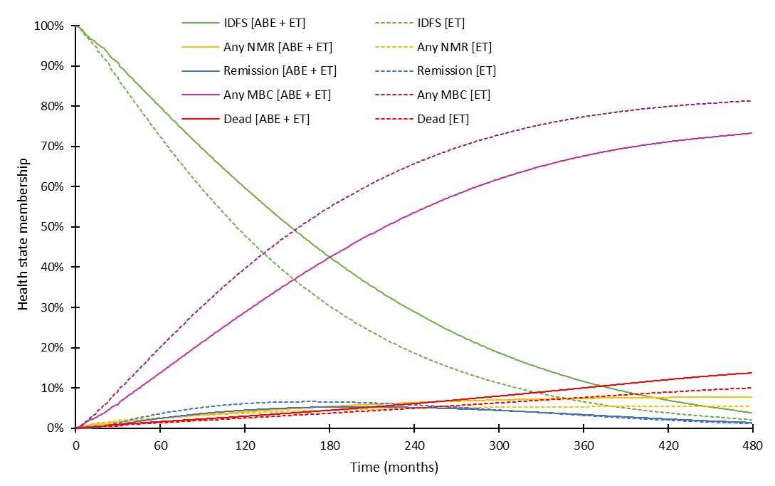

Source: Constructed during the evaluation from the ‘A6.1_Abemaciclib Section 3 workbook.xlsm’ workbook included in the submission.

ABE = abemaciclib; ET = endocrine therapy; IDFS = invasive disease-free survival; NMR = non-metastatic recurrence; MBC = metastatic breast cancer.

Note: Analyses were revised during the evaluation to correct the per cycle probability of recurrence in the Remission health state, and to apply the probability of death in IDFS to the proportion in IDFS rather than invasive disease events.

* 1. At the 40-year time horizon, the model predicted that 73.3% of patients treated with adjuvant abemaciclib + ET and 81.4% of patients treated with adjuvant ET alone would have experienced a metastatic recurrence. This is higher than what is reported for breast cancer patients diagnosed in early stages of disease overall (approximately 30%) (paragraph 4.2). Whether this is reflective of patients targeted for high risk of recurrence is unknown. The projections of metastatic recurrence at 20 years may be more appropriate given the lack of data to inform projections longer term. The rates for metastatic recurrence at the 40-year time horizon also reflected an 8.1% difference in metastatic recurrence between model arms, which was higher than the absolute difference in DRFS observed at the latest data cut of the monarchE trial (3.0%, Table 4). This difference was driven by assumptions regarding the duration of the abemaciclib treatment effect, which the evaluation considered were not reasonable. Further, the Weibull model selected for IDFS extrapolation in the base case may overestimate the incidence of metastatic recurrence in the ET arm (65.7% at 20 years), compared to published estimates (52% at 20 years, Pan 2017)[10] and the estimates used in the financial analysis.[11] The log-logistic model provided estimates that were more consistent with these data (52.3% at 20 years).
  2. Disaggregated costs and QALYs are presented in Table 11 for the revised base case. The LYs and QALYs gained were predominantly accrued in the IDFS health state, with a reduction in QALYs related to non-metastatic and metastatic recurrences. This is consistent with the claim that abemaciclib improves IDFS and leads to a reduction in metastatic recurrences. However, due to the approach used to wane the treatment effect of abemaciclib beyond the observed period, the LYs and QALYs gained with abemaciclib treatment are likely to be overestimated. As shown in Figure 8, the majority of the LYs gained with abemaciclib treatment were accrued in the extrapolated period, particularly beyond 15 years.
  3. The disaggregated costs were driven by the cost of adjuvant abemaciclib treatment and monitoring, with cost-offsets due to a reduction in the treatment of metastatic recurrence. As the modelled reduction in metastatic recurrences may be overestimated, so too may be the modelled cost-offsets related to metastatic recurrence. Further, a number of the costs applied in metastatic recurrence were likely to be overestimated (such as the cost of fulvestrant, electrocardiogram [ECG] and oncologist visits), which would likely further overestimate the cost-offsets modelled.
  4. Differences in costs and outcomes were observed in the post-progression health states in metastatic recurrence (PPS in endocrine-resistant, and PFS2 and PPS in endocrine-sensitive). As first-line treatment with CDK4/6 inhibitors is the current standard of care, it is reasonable for the submission to consider the effects of treatment with and without CDK4/6 inhibitor in the first-line metastatic setting. However, there is no evidence to support whether there would be differences in costs and QALYs in subsequent lines once patients have received a CDK4/6 inhibitor either in the adjuvant or metastatic setting.

Table **: Disaggregated costs and outcomes**

|  |  |  |  |  |
| --- | --- | --- | --- | --- |
|  | **ABE + ET** | **ET** | **Increment** | % |
| **Costs** | | | | |
| Drug-related costs (pre-metastatic recurrence) ($) | | | | |
| Adjuvant drug acquisition and monitoring |  |  |  |  |
| ABE | | |  | | | 295% |
| ET | | | | | −| | −1% |
| Adjuvant treatment-specific monitoring costs | | | | | | | 9% |
| Total drug-related costs in NMR | | | | | −| | −0% |
| Disease management costs (pre-metastatic recurrence) ($) | | | | |
| Invasive disease-free survival | | | | | | | 1% |
| Non-metastatic recurrence | | | | | −| | −3% |
| Remission | | | | | −| | −0% |
| Metastatic recurrence (endocrine-resistant) ($) |  |  |  |  |
| PFS | | | | | −| | −74% |
| PPS | | | | | −| | −16% |
| Metastatic recurrence (endocrine-sensitive) ($) |  |  |  |  |
| PFS1 | | | | | −| | −115% |
| PFS2 | | | | | | | 5% |
| PPS | | | | | | | 1% |
| Terminal care ($) | | | | | −| | −2% |
| Adverse events ($) | | | | | | | 1% |
| **Total costs ($)** | **|** | **|** | **|** | **100%** |
| **QALYS** |  |  |  |  |
| Invasive disease-free survival | 7.426 | 6.357 | 1.069 | 179% |
| Non-metastatic recurrence | 0.068 | 0.081 | −0.013 | −2% |
| Remission | 0.455 | 0.562 | −0.107 | −18% |
| Metastatic recurrence (endocrine-resistant) |  |  |  |  |
| PFS | 0.121 | 0.289 | −0.168 | −28% |
| PPS | 0.158 | 0.207 | −0.049 | −8% |
| Metastatic recurrence (endocrine-sensitive) |  |  |  |  |
| PFS1 | 0.313 | 0.546 | −0.233 | −39% |
| PFS2 | 0.265 | 0.170 | 0.096 | 16% |
| PPS | 0.238 | 0.234 | 0.004 | 1% |
| Adverse events | −0.001 | −0.000 | −0.000 | −0% |
| **Total QALYs** | **9.044** | **8.446** | **0.598** | **100%** |

Source: Table 3−58, p224 of the submission and the ‘A6.1_Abemaciclib Section 3 workbook.xlsm’ workbook.

ABE = abemaciclib; ET= endocrine therapy; IDFS = invasive disease-free survival; NMR = non-metastatic recurrence; PFS = progression-free survival; PPS = post-progression survival; QALY = quality-adjusted life year.

Note: Analyses were revised during the evaluation to correct the per cycle probability of recurrence in the Remission health state, to apply the probability of death in IDFS to the proportion in IDFS rather than invasive disease events, and to apply only one hospitalisation cost per cycle in abemaciclib monitoring. The metastatic health state fixed pay-offs (costs and QALYs) were also revised to apply a discount rate of | |% × (28/365.25) per cycle, the endocrine-sensitive PPS QALYs and costs were revised based on PPS life years, rather than PFS1 life years, and to correct for calculation errors in the endocrine-resistant PPS and endocrine-sensitive PFS2 weighted treatment costs per cycle.

Figure : Cumulative life years gained over the time horizon of the model (undiscounted)

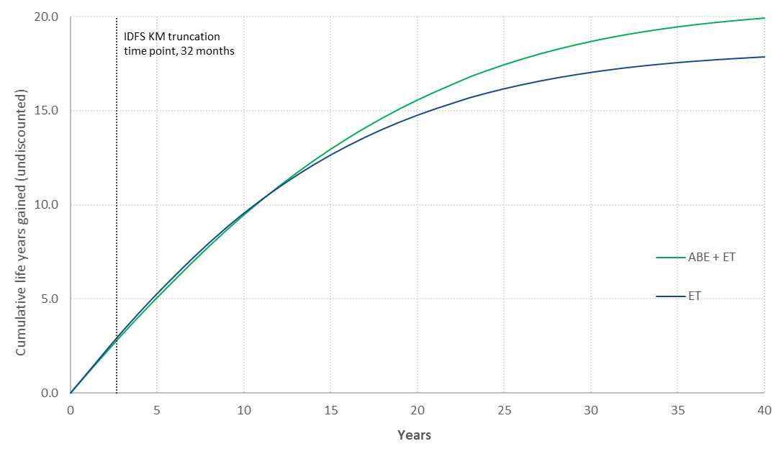

Source: Constructed during the evaluation from the ‘A6.1_Abemaciclib Section 3 workbook.xlsm’ workbook included in the submission.

ABE = abemaciclib; ET= endocrine therapy; IDFS = invasive disease free survival; KM = Kaplan-Meier.

* 1. The number of recurrence events and resulting number of recurrences avoided by abemaciclib treatment in combination with ET compared with ET alone for the trial duration and the submission’s time horizon of the economic evaluation are presented in Table 12 (undiscounted). The revised base case ICER largely relies on avoiding metastatic recurrence in 8% of patients over a 40-year time horizon. Over the 40-year time horizon the model estimated that each patient treated with abemaciclib gained 2.087 life years (208.7 per 100 patients, undiscounted). Thus, there were 38.0 (208.7/5.5) life years gained per recurrence avoided or 25.8 (208.7/8.1) life years gained per metastatic recurrence avoided. The ESC considered these estimates to be implausibly high.

Table **:** Recurrence events (undiscounted), commentary revised base case

|  |  |  |  |
| --- | --- | --- | --- |
| **Recurrence event** | **ABE + ET** | **ET** | **Incremental outcome (per 100 patients)** |
| LYG | 19.933 | 17.846 | 2.087 (208.7 per 100 patients) |
| **monarchE, April 2021 data cut** |  |  |  |
| Non-metastatic recurrence | 2.1% | 2.8% | −0.7 |
| Metastatic recurrence | 5.6% | 8.7% | −3.1 |
| Any recurrence | 7.7% | 11.4% | −3.7 |
| **Model time horizon (40 years)** |  |  |  |
| Non-metastatic recurrence | 24.1% | 23.4% | 0.7 |
| Metastatic recurrence | 73.3% | 81.4% | −8.1 |
| From IDFS | 60.6% | 66.7% | −6.1 |
| From Remission (following non-metastatic recurrence) | 12.7% | 14.7% | −1.9 |
| Any recurrence a | 84.7% | 90.2% | −5.5 |

Source: Table JPCF.8.6, p156 of the April 2021 monarchE CSR and the ‘A6.1_Abemaciclib Section 3 workbook.xlsm’ workbook included in the submission.

ABE = abemaciclib; ET = endocrine therapy; IDFS = invasive disease free survival; LYG = life years gained.

a Any recurrence is not the sum of non-metastatic and metastatic recurrences, as patients who experience a non-metastatic recurrence could later develop a metastatic recurrence.

* 1. The results of key sensitivity analyses are summarised in Table 13. The analyses were observed to be sensitive to changes in estimates that affect the proportion of patients that transition to the metastatic recurrence health states, including IDFS parametric model selection, duration of the treatment effect and proportion of invasive disease events that were non-metastatic (where the same estimate has been applied across both model arms).
  2. The submission presented an analysis where some use of a CDK4/6 inhibitor could occur on metastatic recurrence following adjuvant abemaciclib treatment. The ICER was sensitive to this change, however this analysis assumed that outcomes with metastatic CDK4/6 inhibitors were independent of the treatment received in the adjuvant setting. Thus, modelled effect of CDK4/6 inhibitors following adjuvant abemaciclib may be an overestimate. There is currently no evidence to support the use of a CDK4/6 inhibitor following disease recurrence on a prior CDK4/6 inhibitor.
  3. The submission did not present multivariate analyses. These were conducted during the evaluation, varying, in a stepped manner, plausible alternate estimates that affect the proportion of patients that transition to the metastatic recurrence health states (Table 13). The ICER was observed to substantially increase with these combined changes.
  4. Additional steps were performed modifying key drivers of costs in the metastatic recurrence health states (such as the cost applied of ECG and oncologist visits) and the use of the estimates in endocrine-sensitive recurrences without calibration. In the univariate analyses, these were observed to have low-to-moderate effects on the ICER, however with the reduction in the modelled difference in metastatic recurrence (through analyses #2, #3 and #4), the effect of these changes on the ICER was more substantial.

Table **:** Key sensitivity analyses

|  | **Inc. cost ($)** | **Inc. QALYs** | **ICER ($)** | **%** |
| --- | --- | --- | --- | --- |
| **Base case (evaluator corrected)** | **|** | **0.598** | **|　1** |  |
| Time horizon (base case: 40 years) |  |  |  |  |
| * 20 years **(#1)** | | | 0.350 | |　2 | 90% |
| IDFS extrapolation (base case: Weibull) |  |  |  |  |
| * Exponential | | | 0.634 | |　1 | 21% |
| * Log-logistic **(#3)** | | | 0.502 | |　3 | 62% |
| Treatment waning (base case: from Year 8 to Year 38) |  |  |  |  |
| * Year 7 to Year 10 | | | 0.344 | |　2 | 92% |
| * From end of observed period (month 42) to Year 7 **(#2)** | | | 0.166 | |　4 | 321% |
| * No effect beyond the observed period (month 42) | | | 0.040 | |　5 | 1717% |
| Age at model entry (base case: 52.1 years), 61.4 years | | | 0.496 | |　3 | 31% |
| Proportion of NMR (base case: ABE + ET: 28%, ET: 26%) |  |  |  |  |
| * 27% both arms (average across all patients in monarchE) **(#4)** | | | 0.565 | |　1 | 9% |
| Costs |  |  |  |  |
| * ECG costs (base case: $421.20), $32.55 a **(#5)** | | | 0.598 | |　1 | 9% |
| * Fulvestrant cost (base case: $345.77), $261.10 b **(#5)** | | | 0.598 | |　1 | 2% |
| * Oncologist cost in public setting (base case: $447), $82.55 c **(#5)** | | | 0.598 | |　1 | 7% |
| CDK4/6 inhibitor market share in the first-line metastatic setting (base case: None after adjuvant abemaciclib), some CDK4/6 inhibitor use after adjuvant abemaciclib | | | 0.547 | |　3 | 43% |
| Endocrine resistance status in metastatic recurrence |  |  |  |  |
| * All endocrine-sensitive | | | 0.582 | |　1 | 1% |
| * All endocrine-resistant | | | 0.550 | |　1 | 19% |
| Use uncalibrated endocrine-sensitive PFS2 and PPS LY estimates d **(#6)** | | | 0.464 | |　1 | 15% |
| **Multivariate analyses** |  |  |  |  |
| #1 AND #2 | | | 0.130 | |　6 | 504% |
| #1, #2 AND #3 | | | 0.146 | |　6 | 548% |
| #1, #2, #3 AND #4 | | | 0.128 | |　7 | 656% |
| #1, #2, #3, #4 AND #5 | | | 0.128 | |　8 | 716% |
| #1, #2, #3, #4, #5 AND #6 | | | 0.045 | |　5 | 2169% |

Source: Adapted from Table 3−61, p229 of the submission and the ‘A6.1_Abemaciclib Section 3 workbook.xlsm’ workbook.

ABE = abemaciclib; ECG = electrocardiogram; ET = endocrine therapy; ICER = incremental cost-effectiveness ratio; IDFS = invasive disease-free survival; Inc. = incremental; LY = life years; NMR = non-metastatic recurrence; PFS = progression-free survival; PPS = post-progression survival; QALY = quality-adjusted life year.

a Based on MBS item 11704

b Current dispensed price for the maximum quantity

c The submission source the cost from the direct cost component of the Tier 2 2042 Medical Oncology (Consultation), however pharmacy costs contributed to the bulk of this cost. The direct ward medical component cost was $82.55.

d From the ‘Monarch 3 Global CEM_v1_30Sept21v2.xlsm’ workbook.

*The redacted values correspond to the following ranges:*

*1* *$15,000 to < $25,000*

*2 $35,000 to < $45,000*

*3 $25,000 to < $35,000*

*4 $75,000 to < $95,000*

*5 $355,000 to < $455,000*

*6 $115,000 to < $135,000*

*7 $135,000 to < $155,000*

*8 $155,000 to < $255,000*

* 1. Given the uncertainties identified during the evaluation regarding the modelling of the treatment benefit of abemaciclib in the base case, the estimated LYs gained per recurrence or metastatic recurrence avoided have been presented for the key sensitivity analyses (Table 14). The LYs gained per metastatic recurrence avoided was sensitive to the model time horizon and the treatment effect waning. When the time horizon is 20 years and treatment effect wanes from the end of the observed period (month 42) to year 7, the LYs assumed to be gained per metastatic recurrence avoided reduces from 25.8 years (revised commentary base case) to 6.1 years.

Table **:** Life years gained per recurrence avoided in key sensitivity analyses

|  |  |  |  |  |  |
| --- | --- | --- | --- | --- | --- |
|  | **LYG** | **Difference in any recurrence** | **Difference in metastatic recurrence** | **LYG per recurrence avoided** | **LYG per metastatic recurrence avoided** |
| Revised base case | 2.087 | −0.055 | −0.081 | 38.0 | 25.8 |
| Time horizon (base case: 40 years)   * 20 years **(#1)** | 0.825 | −0.115 | −0.122 | 7.2 | 6.8 |
| Treatment waning (base case: from Year 8 to Year 38)   * From end of observed period (month 42) to Year 7 **(#2)** | 0.462 | −0.012 | −0.039 | 38.5 | 11.7 |
| IDFS extrapolation (base case: Weibull)   * Log-logistic distribution **(#3)** | 1.827 | −0.068 | −0.085 | 27.1 | 21.6 |
| Proportion of NMR (base case: ABE + ET: 28%, ET: 26%)   * The same proportion across both arms **(#4)** | 1.978 | −0.055 | −0.072 | 36.0 | 27.6 |
| Costs (base case: ECG $421.20; fulvestrant $345.77; oncologist visits $447)   * ECG ($32.55), fulvestrant ($261.10) and oncologist visits ($82.55) **(#5)** | 2.087 | −0.055 | −0.081 | 38.0 | 25.8 |
| Uncalibrated endocrine-sensitive PFS2 and PPS LY estimates **(#6)** | 1.678 | −0.055 | −0.081 | 30.5 | 20.8 |
| Multivariate analysis |  |  |  |  |  |
| #1 AND #2 | 0.289 | −0.026 | −0.047 | 11.0 | 6.1 |
| #1, #2 AND #3 | 0.334 | −0.038 | −0.052 | 8.8 | 6.4 |
| #1, #2, #3 AND #4 | 0.294 | −0.038 | −0.044 | 7.7 | 6.8 |
| #1, #2, #3, #4 AND #5 | 0.294 | −0.038 | −0.044 | 7.7 | 6.8 |
| #1, #2, #3, #4, #5 AND #6 | 0.080 | −0.038 | −0.044 | 2.1 | 1.8 |
| #2, #3, #4, #5 AND #6 | 0.350 | −0.027 | −0.039 | 13.1 | 8.9 |

Source: Constructed during the evaluation from the ‘A6.1_Abemaciclib Section 3 workbook.xlsm’ workbook included in the submission.

ABE = abemaciclib; ECG = electrocardiogram; ICER = incremental cost-effectiveness ratio; IDFS = invasive disease-free survival; LY = life years; LYG = life years gained; NMR = non-metastatic recurrence; PFS = progression-free survival; PPS = post-progression survival.

* 1. The PBAC recommended the revised base case according to the evaluation and ESC advice (ICER of $15,000 to < $25,000per QALY), noting the ICER rose with realistic parameters for key drivers of the model (Table 13).

Drug cost/patient/course

* 1. The per patient cost of abemaciclib + ET and ET alone used in the monarchE trial, the economic model, and the financial analysis, are presented in Table 15. Patients can receive up to two years of abemaciclib treatment. The average duration of treatment modelled was 19.4 months (equivalent to 21.1 28-day cycles). At the proposed effective DPMQ per pack of abemaciclib ($| |), the total average treatment course cost was estimated to be $| |. This was lower than the treatment cost per course applied in the financial estimates ($| |) where all patients were assumed to receive the maximum amount of abemaciclib (two years treatment, assuming 100% compliance).
  2. Patients in the model were assumed to receive up to five years of ET, with or without abemaciclib use. The average duration of ET treatment modelled with adjuvant abemaciclib in the abemaciclib in combination with ET arm was 45.6 months (equivalent to 49.5 28-day cycles). The average cost per cycle of ET was estimated to be $| |, and so the treatment course cost of ET with abemaciclib was estimated to be $| |. The total costs per course of adjuvant abemaciclib + ET was therefore $| |.
  3. The average duration of ET modelled without abemaciclib was 48.8 months (equivalent to 53.1 28-day cycles). The treatment course cost of ET was therefore estimated to be $| |.

Table **: Medicine costs per patient for ABE + ET and ET alone**

|  | ABE + ET  monarchE | ABE + ET  Model | ABE + ET  Financial estimates | ET  monarchE | ET  Model | ET  Financial estimates |
| --- | --- | --- | --- | --- | --- | --- |
| Mean duration  (28-day cycles) | ABE: 20.6 a  ET: 22.6 b | ABE: 21.1  ET: 49.5 | ABE: 26.1  ET: NE | 23.2 c | 53.1 | NE |
| Cost/patient/ 28-day cycle ($) | ABE: 　|  ET: 　| | ABE: 　|  ET: 　| | ABE: 　|  ET: NE | | | | | NE |
| Cost/patient/course ($) | ABE: 　|  ET: 　|  ABE+ET: ||| | ABE: 　|  ET: 　|  ABE+ET: ||| | ABE: 　|  ET: NE  ABE+ET: NE | | | | | NE |

Source: Constructed during the evaluation from Section 3.8.1, p221 of the submission and Table JPCF.4.3, p26 of the monarchE April 2021 CSR.

ABE = abemaciclib; ET = endocrine therapy; NE = not estimated.

a Mean duration of treatment was 82.32 weeks at the April 2021 data cut.

b Mean duration of treatment was 90.56 weeks at the April 2021 data cut.

c Mean duration of treatment was 92.68 weeks at the April 2021 data cut.

Estimated PBS usage & financial implications

* 1. This submission was considered by DUSC.
  2. The submission took an epidemiological approach to estimate the extent of use and the financial implications associated with the requested PBS listing of abemaciclib. The key inputs in the financial analysis and their data sources are summarised in Table 16.

Table : **Key inputs for financial estimates**

| Parameter | Value applied and source | Evaluation comment |
| --- | --- | --- |
| Incidence of breast cancer | 21,159 in Year 1 of listing, increasing to 24,955 in Year 6  BreastScreen Australia monitoring report (AIHW 2020), assuming a linear projection | Appropriate data source |
| Excluding inflammatory breast cancer | 98% (i.e. 2% inflammatory breast cancer)  National Breast Cancer Centre 2007 | The proposed PBS listing did not exclude inflammatory breast cancer. This, however, would have a negligible impact on the net PBS/RPBS costs. |
| % incident breast cancer cases of Stage 1-3 | 95.3%  NCCI data on distribution of cancer stage (2018) | Appropriate data source |
| % HR+/HER2- | 70%  Everolimus PSD, March 2013 PBAC meeting | Reasonable estimate |
| % node-positive early breast cancer | 24.6%  US SEER Registries Research Data | Information on the commissioned SEER analysis was provided with the PSCR. |
| % meeting high risk criteria | 48.8%  US SEER Registries Research Data |
| Uptake rate abemaciclib | |　% in Year 1, increasing to 　|　% in Years 3-6  Previous PBAC advice on the uptake of trastuzumab emtansine (PSD, November 2019 PBAC meeting) | The uptake of trastuzumab emtansine might not be applicable to abemaciclib given the differential approach (epidemiological vs. modified market share) taken by the two financial analyses, as well as the safety profile of abemaciclib. |
| Treatment duration | 2 years  Median treatment duration in the clinical trial | Represents the maximum treatment duration as specified in the proposed listing. |
| Compliance | 100%  Assumption | The mean compliance was 99.3% in the abemaciclib arm of Trial monarchE. |
| Utilisation across abemaciclib dose forms (150mg vs. 100mg vs. 50mg) | 53%:36%:11%  PBS script data July 2020 - July 2021, for abemaciclib PBS items relating to locally advanced or metastatic HR+/HER2- breast cancer | The change in the distribution of various abemaciclib doses would not affect the results given the proposed flat pricing. |
| Abemaciclib (150mg, 100mg, or 50mg, 56 tablets) | $|||| (flat pricing)  Requested effective price | Appropriate |
| Patient co-payment | PBS: $29.46 (99.6%)  RPBS: $6.60 (0.4%)  Medicare data on trastuzumab for early HER2+ breast cancer in 2021 | Reasonable |

Source: Information provided in Section 4.1, pp232-235 of the submission.

AIHW = Australian Institute of Health and Welfare; HER2+ = human epidermal growth factor receptor 2 positive; HER2- = human epidermal growth factor receptor 2 negative; HR+ = hormone receptor positive; NCCI = National Cancer Control Indicators, PBAC = Pharmaceutical Benefits Advisory Committee; PBS = Pharmaceutical Benefits Scheme; PSCR = pre-Sub-Committee response; PSD = public summary document; RPBS = Repatriation Pharmaceutical Benefits Scheme; SEER = Surveillance, Epidemiology and End Results.

* 1. The estimated use and financial impacts of listing abemaciclib are summarised in Table 17.

Table **: Estimated use and financial implications**

|  | Year 1 | Year 2 | Year 3 | Year 4 | Year 5 | Year 6 |
| --- | --- | --- | --- | --- | --- | --- |
| Estimated extent of use | | | | | | |
| Number of patients treateda | |　1 | |　1 | |　1 | |　1 | |　1 | |　1 |
| Number of scripts dispensedb | ||||2|| | ||||5|| | |　7 | ||||7|| | ||||7|| | ||||7|| |
| Estimated financial implications of abemaciclib | | | | | | |
| Cost to PBS/RPBS less copayments ($) | |3 | |6 | |6 | |8 | |8 | |8 |
| **Estimated financial implications for other medicines** | | | | | | |
| Cost to PBS/RPBS less copayments ($) | |4 | |4 | |4 | |4 | |4 | |4 |
| Net financial implications | | | | | | |
| Net cost to PBS/RPBS ($) | |3 | |6 | |6 | |8 | |8 | |8 |
| Net cost to MBS ($) | |4 | |4 | |4 | |4 | |4 | |4 |
| Net cost to PBS/RPBS/MBS ($) | |3 | |6 | |6 | |8 | |8 | |8 |

Source: Table 4-2, p236, Table 4-3, p237 and Table 4-4, p238 of the submission; “A7.1_Cost and utilisation model abemaciclib EBC” Excel workbook.

a From Year 2, the number of treated patients includes patients who initiate abemaciclib therapy in the previous year and continue on their second year of treatment.

b 13.04 (=365.25/28) scripts per year per treated patient

*The redacted values correspond to the following ranges:*

*1 500 to < 5,000*

*2 10,000 to < 20,000*

*3 $20 million to < $30 million*

*4 $0 to < $10 million*

*5 30,000 to < 40,000*

*6 $60 million to < $70 million*

*7 40,000 to < 50,000*

*8 $70 million to < $80 million*

* 1. The total cost to the PBS/RPBS of listing abemaciclib was estimated to be $70 million to < $80 million in Year 6, and a total of $300 million to < $400 million in the first 6 years of listing.
  2. The evaluation considered that the main areas of uncertainty in estimating the number of the patients likely to initiate abemaciclib therapy were:
  + The proportion of lymph node positive patients (24.6%) and the proportion of patients with early breast cancer at high risk of recurrence (48.8%). The submission stated that both estimates were obtained from a commissioned analysis from the Surveillance, Epidemiology, and End Results (SEER) Program, and the full report was provided with the PSCR.
  + The uptake of abemaciclib (| |% in Year 1, increasing to | |% in Years 3-6). This was estimated on the basis of previous PBAC advice on the uptake of T-DM1 as adjuvant therapy of patients with HER2+ early breast cancer with residual disease following HER2-targeted neoadjuvant therapy that included trastuzumab and taxane-based chemotherapy (Trastuzumab emtansine PSD, November 2019 PBAC meeting). The applicability of the assumed uptake of T-DM1 to the abemaciclib submission is uncertain, as the T-DM1 financial analysis took a modified market share approach and the uptake rate assumed in the analysis was effectively a substitution rate of adjuvant T-DM1 in patients who would otherwise receive adjuvant intravenous or subcutaneous trastuzumab. In contrast, the abemaciclib financial analysis took an epidemiological approach and the estimated uptake of abemaciclib was related to all eligible patients with HR+/HER2- early breast cancer with high risk of recurrence. Further, the inferior safety profile of abemaciclib plus ET, in comparison with ET alone, might affect the uptake of abemaciclib in clinical practice. The pre-PBAC response argued that the target patient population would likely adopt a treatment with a positive efficacy and safety profile to improve the likelihood of a cure, and maintained the uptake rates assumed in the submission.
  1. The financial analysis assumed that all patients would receive the maximum treatment duration as specified in the requested PBS restriction (i.e. 2 years), with 100% compliance. The evaluation considered that this has resulted in an overestimate of the net financial implications to the PBS/RPBS with the proposed listing of abemaciclib. If the average treatment duration modelled in the economic evaluation (19.4 months) is applied, the net PBS/RPBS cost over the first 6 years of listing would reduce by 17.2% from the submission’s estimate (from $300 million to < $400 million to $300 million to < $400 million). The pre-PBAC response maintained support for an abemaciclib treatment duration of 2 years and stated that this assumption was based on data reported at the most recent data cut (median treatment duration = 102.71 weeks; April 2021). The pre-PBAC response stated that treatment compliance of 100% was also reasonable, based on data reported for the overall safety population (April 2021 data cutoff).
  2. No additional costs for the management of AEs were taken into account in the financial estimates. The safety results from the pivotal trial, monarchE, indicated that abemaciclib in combination with ET was associated with an increased risk of diarrhoea AEs, both of any grade and of Grade 3-5, compared with ET alone. Loperamide is the most commonly used treatment for diarrhoea. The submission argued that, as the PBS patient co-payment exceeds the retail price of loperamide, patients are more likely to buy loperamide as an over-the-counter medication if required. In addition, the sponsor has a scheme which supplies loperamide to clinicians for patients at no cost. Patients with Grade ≥3 diarrhoea might need more intensive treatment than loperamide. Apart from diarrhoea, the incidence of Grade ≥ 3 neutropenia, leukopenia and lymphopenia was also higher in patients receiving abemaciclib + ET than those in the comparator ET arm of Trial monarchE (Table 5). The removal of costs associated with management of these AEs, e.g. filgrastim and full blood count, would result in an underestimate of the net PBS/RPBS costs and the MBS costs due to the listing of abemaciclib.
  3. The DUSC agreed with the evaluation that the financial estimates presented in the submission were overestimated. The DUSC considered that:
* An uptake rate of | |% in Year 1 increasing to | |–| |% by Year 6 would be more appropriate than the submission estimate of | |% in Year 1 increasing to | |% in Years 3-6, as | |% of patients using abemaciclib by Year 3 would be unlikely in an older/frailer patient population;
* The duration of therapy should be reduced from 24 months due to toxicity and average treatment duration modelled in the economic evaluation was 19.4 months.
* Compliance should be reduced from 100% to reflect use in real world populations as opposed to the monarchE trial population.
* The costs associated with managing AEs associated with the treatment of abemaciclib should be added to the net cost to the PBS/RPBS and MBS.
  1. The DUSC advised that changes to the inputs and structure of the model used to derive the utilisation and financial estimates should be considered. These included a reduction to the uptake and compliance rates and the duration of therapy discussed in paragraph 6.58, and a review of the costs used for metastatic recurrence and AEs.

Quality Use of Medicines

* 1. The submission outlined a number of educational activities to promote the safe and effective use of medicines in the treatment of early breast cancer with a high risk of recurrence, and the appropriate use of abemaciclib in combination with ET in accordance with the registered indication and the proposed PBS listing.
  2. The submission indicated that there are no additional safety concerns that require risk minimisation activities for abemaciclib in Australia other than those already discussed in the European Union Risk Management Plan. Routine risk minimisation measures via appropriate wording in the Australian Product Information and the Consumer Medicines Information were considered sufficient by the submission. The effectiveness of routine risk minimisation activities is determined from routine pharmacovigilance where AE reports are reviewed on an ongoing basis.
  3. The DUSC considered that there was uncertainty around the potential for harm due to a lack of longer-term data and noted that there may be substantial risks associated with abemaciclib treatment.

*For more detail on PBAC’s view, see section 7 PBAC outcome.*

1. PBAC Outcome
   1. The PBAC did not recommend abemaciclib in combination with endocrine therapy (ET) for the treatment of patients with hormone receptor positive (HR+) and human epidermal growth factor receptor 2 negative (HER2-), lymph node positive, invasive, resected, early breast cancer at high risk of recurrence. The PBAC considered it was likely that abemaciclib in combination with ET provided clinical benefit over the comparator but the magnitude of benefit past the observed period was uncertain. The PBAC considered that the cost-effectiveness model was not a good basis for decision making particularly due to the uncertain extrapolation of clinical benefit associated with abemaciclib over the comparator.
   2. The PBAC noted that the TGA Delegate deferred approval of registration of abemaciclib for the proposed TGA indication, subject to ACM advice. The ACM advised that there were insufficient data to make a recommendation on the overall risk benefit balance and expressed interest in the provision of the next release of OS data.
   3. The PBAC noted the consumer comments highlighting the psycho-social benefits associated with effective new therapies for patients diagnosed with early breast cancer and the quality of life benefits gained by reducing the burden associated with the fear of cancer recurrence. The PBAC noted the comments provided in the sponsor hearing highlighting the importance of managing side effects through early dosing adjustments.
   4. The PBAC noted that there is a high clinical need for reducing the risk of recurrence for patients diagnosed with early breast cancer and noted that abemaciclib treatment can be administered during the peak risk of recurrence after a primary diagnosis of breast cancer (first 2–4 years). The PBAC noted that recurrences are often distant metastases and are incurable.
   5. The PBAC considered that abemaciclib treatment in early breast cancer may lead to partial replacement of treatment with CDK4/6 inhibitors in combination with fulvestrant in later stages of disease, potentially leading to a reduction in future treatment options.
   6. The PBAC agreed with the suggestions and additions to the restriction proposed by the Secretariat. The PBAC considered that containing the use of abemaciclib to patients at highest risk of recurrence would be important to maintain a risk benefit balance and prevent use in lower risk patients who are unlikely to benefit. The PBAC noted the requested grandfather restriction for a large number of patients (500) that will be enrolled in a patient familiarisation program.
   7. The PBAC considered the nominated comparator of single agent ET alone, as standard of care, was appropriate.
   8. The PBAC was satisfied that abemaciclib in combination with ET was both statistically and clinically superior to the nominated comparator in improving IDFS and DRFS. While acknowledging that the IDFS benefit appeared modest and was smaller compared to agents seen previously, the PBAC considered a 3.5% absolute difference may be clinically meaningful in the adjuvant setting where the goal is cure. The PBAC considered that IDFS being employed as a surrogate for OS was uncertain but generally plausible. However, the PBAC noted the relationship between IDFS and OS is uncertain for abemaciclib, given the OS data were immature and no difference in OS was observed at the most recent data cutoff. The PBAC considered that longer-term OS data would be informative. The PBAC noted that patients in the monarchE trial who develop metastatic disease may receive a CDK4/6 inhibitor as part of their first line metastatic treatment, which may extend their life following progression to metastatic disease. Overall, the PBAC considered that a claim of superior efficacy was uncertain but supportable.
   9. The PBAC considered that a claim of inferior but manageable safety was reasonable. The PBAC noted the relatively high percentage of patients who discontinued abemaciclib due to an AE (18.5%) and grade ≥3 treatment emergent adverse events were 33% higher in abemaciclib patients compared with ET alone. However, the PBAC considered that there was unlikely to be new QUM issues given abemaciclib is an existing therapy with a known safety profile and agreed with the submission that the adverse events associated with adjuvant abemaciclib could be monitored and managed with dose modifications.
   10. The PBAC noted the base case ICER presented in the submission was revised during the evaluation (revised ICER = $15,000 to < $25,000 per QALY) and agreed with these corrections. The PBAC considered this ICER to be highly uncertain, with the economic model sensitive to the duration of treatment effect, time horizon, extrapolation of IDFS, calibration of outcomes in endocrine-sensitive metastatic breast cancer, and the proportion of recurrences that are non-metastatic.
   11. The PBAC noted that the ICER was sensitive to a number of model inputs and assumptions. The submission assumed that a treatment effect of abemaciclib on IDFS would continue beyond the observed data (treatment duration was a maximum of two years). The PBAC considered that the presented assumption for treatment effect duration (until Year 8, with a waning of this effect modelled until Year 38) was highly optimistic and not well justified. The PBAC noted the ICER is highly sensitive to changes in this assumption and the year at which waning is assumed to commence, and assuming no treatment effect beyond the observed period resulted in an ICER of $355,000 to < $455,000 per QALY. The PBAC advised that a more conservative assumption regarding treatment effect duration should be considered. The PBAC agreed with the ESC that a time horizon of 40 years was not reasonable due to the average age of diagnosis (61.4 years) and the uncertain extrapolation of IDFS. Thus, it advised that a 20-year time horizon was more reasonable. The PBAC noted that at the time of the latest data cut, a small percentage of patients (10.0%) had experienced an IDFS event. It considered that due to the low number of observed events, the extrapolation (a jointly-fitted Weibull parametric model) was highly uncertain and did not address a reduction in risk profile relative to time since diagnosis.
   12. The economic model applied one-off costs and QALYs on transition to metastatic disease health states. These were based on estimates from cost-effectiveness analyses of abemaciclib in the metastatic setting and on the MONARCH-2 and MONARCH-3 clinical trials. The PBAC considered that transitivity issues were likely to exist between the monarchE trial and the metastatic MONARCH-2 and MONARCH-3 trials, and that this introduced further uncertainty. The PBAC also noted that the economic model assumed abemaciclib patients do not receive a CDK4/6 inhibitor after metastatic recurrence and applied costs and outcomes to the ET alone patients that do reflect the accepted cost-effectiveness of CDK4/6 inhibitor treatments. It advised that the assumption that CDK4/6 inhibitor treatment in this setting would not be cost-effective was not appropriate and favoured the abemaciclib arm in the economic model. The PBAC also considered that some CDK4/6 inhibitor use would be likely post adjuvant abemaciclib treatment.
   13. Overall, the PBAC considered the model was not a reliable basis for decision making. The PBAC noted that abemaciclib treatment in the revised economic model avoided metastatic recurrence in 8% of patients compared with a difference of 3% observed in the trial, and that over the 40-year time horizon there were 25.8 life years gained per metastatic recurrence avoided and 38.0 life years gained per recurrence avoided. The PBAC considered these estimates to be implausibly high.
   14. The PBAC considered the financial estimates presented in the submission were overestimated. The PBAC noted the points raised by DUSC and advised that a reduction to the assumed uptake and compliance rates and duration of therapy should be considered. The PBAC agreed with DUSC that a review of the costs used for metastatic recurrence and AEs should also be considered. The PBAC noted there was significant risk in use outside the proposed restriction to patients with lower risk of recurrence than seen in the monarchE trial.
   15. The PBAC considered a resubmission for abemaciclib should address the following issues:

* The uncertainty regarding the difference in IDFS and the implications of this on OS;
* Revise the economic model to address the issues noted in paragraphs 7.10–7.13 and Section 6; and
* Present revised financial estimates consistent with the DUSC advice.
  1. The resubmission may be lodged at any future standard due date for PBAC submissions using the standard re-entry pathway.
  2. The PBAC noted that this submission is eligible for an Independent Review.

**Outcome:**

Not recommended

1. Context for Decision

The PBAC helps decide whether and, if so, how medicines should be subsidised through the Pharmaceutical Benefits Scheme (PBS) in Australia. It considers applications regarding the listing of medicines on the PBS and provides advice about other matters relating to the operation of the PBS in this context. A PBAC decision in relation to PBS listings does not necessarily represent a final PBAC view about the merits of the medicine or the circumstances in which it should be made available through the PBS. The PBAC welcomes applications containing new information at any time.

1. Sponsor’s Comment

The sponsor had no comment.

1. AIHW. Cancer in Australia. 2019 [cited 2021 2 December]; Available from: https://www.aihw.gov.au/getmedia/8c9fcf52-0055-41a0-96d9-f81b0feb98cf/aihw-can-123.pdf.aspx?inline=true.
2. American Cancer Society. Breast Cancer Facts & Figures 2019-2000. 2019 [cited 15 February 2021; Available from: https://www.cancer.org/cancer/breast-cancer/understanding-a-breast-cancer-diagnosis/breast-cancer-survival-rates.html.
3. Gerber, B., M. Freund, and T. Reimer, Recurrent breast cancer: treatment strategies for maintaining and prolonging good quality of life. Dtsch Arztebl Int, 2010. 107(6): p. 85-91.

   O'Shaughnessy, J., Extending survival with chemotherapy in metastatic breast cancer. Oncologist, 2005. 10 Suppl 3: p. 20-9.
4. Cherny NI, Dafni U, Bogaerts J, et al: ESMO-Magnitude of Clinical Benefit Scale version 1.1. Annals of Oncology 28:2340-2366, 2017.
5. *Note that the results presented in Paragraph 6.9 are derived from post-hoc analyses conducted by the applicant during the evaluation/ by the ESC/ PBAC specifically for the purposes of informing the PBAC consideration. These analyses were not part of the pre-specified statistical plan for the monarchE study. Interpretation of the results and their application should be limited to seeking to understand the basis for the PBAC outcome and should not be used for any other purpose.*
6. Smith I, Yardley D, Burris H, De Boer R, Amadori D, McIntyre K, et al. Comparative Efficacy and Safety of Adjuvant Letrozole Versus Anastrozole in Postmenopausal Patients With Hormone Receptor-Positive, Node-Positive Early Breast Cancer: Final Results of the Randomized Phase III Femara Versus Anastrozole Clinical Evaluation (FACE) Trial. J Clin Oncol. 2017 Apr 1;35(10):1041-8.
7. Pan H, Gray R, Braybrooke J, Davies C, Taylor C, McGale P, et al. 20-Year Risks of Breast-Cancer Recurrence after Stopping Endocrine Therapy at 5 Years. N Engl J Med. 2017 Nov 9;377(19):1836-46.
8. Cuzick J, Sasieni P, Howell A. Should aromatase inhibitors be used as initial adjuvant treatment or sequenced after tamoxifen? Br J Cancer. 2006 Feb 27;94(4):460-4.
9. Finn RS, Crown JP, Lang I, Boer K, Bondarenko IM, Kulyk SO, et al. The cyclin-dependent kinase 4/6 inhibitor palbociclib in combination with letrozole versus letrozole alone as first-line treatment of oestrogen receptor-positive, HER2-negative, advanced breast cancer (PALOMA-1/TRIO-18): a randomised phase 2 study. Lancet Oncol. 2015 Jan;16(1):25-35.
10. Pan H, Gray R, Braybrooke J, Davies C, Taylor C, McGale P, et al. 20-Year Risks of Breast-Cancer Recurrence after Stopping Endocrine Therapy at 5 Years. N Engl J Med. 2017 Nov 9;377(19):1836-46.
11. The financial analysis assumed that 48.8% of patients with node-positive early breast cancer would be considered high risk. If the risk of recurrence in early breast cancer generally is 30%, then the maximum recurrence rate in the high-risk group would be approximately 60%.