7.04 CEMIPLIMAB,
Solution for IV infusion 350 mg in 7 mL,
LIBTAYO®,
Sanofi-aventis Australia Pty Ltd.
- Purpose of submission
  - The standard re-entry resubmission requested a Section 100 (Efficient Funding of Chemotherapy) listing for cemiplimab for the treatment of patients with metastatic or locally advanced cutaneous squamous cell carcinoma (mCSCC or laCSCC) who are not candidates for curative surgery or curative radiation. This was unchanged from the previous submission considered by the PBAC in November 2020.
  - Listing was requested on the basis of a cost-utility analysis versus best supportive care (BSC) with or without chemotherapy (CT). The key components of the clinical issues addressed by the resubmission are presented below. The key components of the clinical issue addressed by the resubmission are unchanged from the previous submission.
Table 1: Key components of the clinical issue addressed by the resubmission
Component | Description
Population | Patients with mCSCC or laCSCC who are not candidates for curative surgery or curative radiation
Intervention | Cemiplimab (LIBTAYO®) 350 mg injection given as an IV infusion over 30 minutes Q3W
Comparator | BSC ± CT
Outcomes | ORR, DOR, PFS, OS and CRR
Clinical claim | In patients with mCSCC or laCSCC who are not candidates for curative surgery or curative radiation:  - Cemiplimab is superior in terms of effectiveness (improved OS and PFS) compared with BSC ± CT  - Cemiplimab is non-inferior in terms of safety compared with BSC ± CT
Source: Table 1.1.1, p15 of the resubmission
BSC= best supportive care; CRR = complete response rate; CT=chemotherapy; DOR = duration of response; IV= intravenous; laCSCC = locally advanced cutaneous squamous cell carcinoma; mCSCC = metastatic cutaneous squamous cell carcinoma; ORR = objective response rate; OS = overall survival; PFS = progression free survival; Q3W = every three weeks
- Background

Registration status
  - Cemiplimab received provisional approval by the TGA on 2nd of July 2020 for the following indication:
Treatment of adult patients with metastatic or locally advanced cutaneous squamous cell carcinoma (mCSCC or laCSCC) who are not candidates for curative surgery or curative radiation. This indication was approved based on objective response rate (ORR) and duration of response from single arm clinical studies.
  - When considering the original submission in November 2020, the PBAC noted that the sponsor is required to submit further clinical data to confirm the clinical benefit of the medicine. This includes interim data from a single-arm study in the same population [study 1540 group 6], which will investigate whether programmed death ligand-1 (PD-L1) expression is predictive of efficacy. These results are due by 31 Mar 2023. In addition, the final study report for Groups 1-3 in the study 1540 is due by 31 Oct 2022 (para 2.1, cemiplimab public summary document (PSD), November 2020 PBAC meeting).

Previous PBAC consideration
  - This is the second submission to PBAC for cemiplimab for the treatment of mCSCC or laCSCC who are not candidates for curative surgery or curative radiation. The first submission was considered by the PBAC in November 2020 and the key matters of concern raised by the PBAC are summarised below.
Table 2: Summary of key matters of concern
Component | Matter of concern (cemiplimab PSD, November 2020 PBAC meeting) | How the resubmission addresses it
Proposed restriction | The proposed restrictions were broader than the inclusion criteria in the key studies (1423 and 1540) in terms of PS and immunocompetence (para 3.3) | Remain unchanged. The PSCR proposed excluding patients with a PS of ≥2.
 | The ESC considered that the restriction should clarify if the decision regarding the eligibility for curative radiation or surgery could be made by an individual physician or required the consensus of a multidisciplinary team; the ESC considered that the risk of use outside the intended PBS population was high given the lack of clarity in terms of eligibility for curative radiation or surgery criteria (para 3.5) | The resubmission included additional criteria in the restriction. The revised proposed restriction has sought to include the use of a multidisciplinary team for the decision whether a patient is eligible for radiation therapy.
Clinical effectiveness | Cemiplimab results were limited by the single arm design of Study 1423 and Study 1540 and small sample sizes, OS data immature; a larger dataset would be required to confirm that PD-L1 expression is not predictive of efficacy (para 7.4) | Remain outstanding, despite the provision of updated data from Study 1540.
 | The evidence for the comparator group was prone to significant bias; it was heterogeneous in its construction and not necessarily generalisable to the Australian population. The magnitude of the improvement in effectiveness of cemiplimab vs BSC ± CT could not be determined (para 7.5) | Remain outstanding, despite the addition of three new chemotherapy studies for the comparator group
Clinical safety | Comparative safety was unclear as none of the BSC studies reported AEs and limited data were available from chemotherapy studies (para 7.6) | Remain outstanding
Source of evidence | A larger data set would be required to evaluate the clinical parameters of comparative effectiveness and safety (para 7.8) | Remain outstanding
Economic evaluation | The economic model was unreliable due to the uncertainties in the clinical data of cemiplimab and concerns regarding the validity of the indirect comparisons. Convergence of the cemiplimab and BSC ± CT curves at 10 years would be required given the significant uncertainty associated with the clinical data (para 7.9) | Uncertainties regarding the clinical data of cemiplimab and the indirect comparison remain outstanding. The resubmission implemented linear convergences of PFS and OS for cemiplimab from 42 months and 52 months respectively, to reach convergence with BSC ± CT at 10 years.
Financial estimates | The number of patients treated was likely underestimated as the data source used to determine the proportion of patients with advanced CSCC did not include laCSCC, patients progressing from earlier stages of disease were not fully considered in the estimates, and uptake rates would likely be higher.  For patients with a PS of 2 or more, BSC rather than cemiplimab was the appropriate approach to management, but these patients were not excluded from the financial estimates | The data source and the inclusion of patients with PS≥2 were unchanged from the previous submission.  The resubmission included the estimates of patients who progress to advanced stage from earlier stages. However, the same data source of Venables 2019, which did not include laCSCC and may not be applicable to Australian population, was used.  The resubmission increased the uptake rate in the first two years from 60% and 75% in the previous submission to 70% and 80% respectively.
Source: Compiled during the evaluation.
AEs= adverse events, PS = performance status; PSD = public summary document; PFS = progression free survival; OS= overall survival; PD-L1 = programmed death ligand 1; BSC ± CT = best supportive care with or without chemotherapy.

  - The ESC noted that a number of key matters of concern were raised with the November 2020 submission and that many of these remain outstanding in the resubmission.
For more detail on PBAC’s view, see section 7 PBAC outcome.
- Requested listing
  - Suggestions and additions proposed by the Secretariat are added in italics and suggested deletions are crossed out with strikethrough.
MEDICINAL PRODUCT  Medicinal Product Pack | PBS item code | Max.  Amount | №.of Rpts | Dispensed Price for  Max. Amt
CEMIPLIMAB  cemiplimab 350 mg/7 mL, 10 mL vial | NEW (Public)  NEW (Private) | 350 mg | 2 | Published Price  $|| (Public hospital)  $|| (Private hospital)  Effective Price  $|| (Public hospital)  $|| (Private hospital)
Available brands
Libtayo
cemiplimab 350 mg/7 mL, 10 mL vial

Category / Program: Section 100 – Efficient Funding of Chemotherapy Public/Private hospitals
Prescriber type: Medical Practitioners
Restriction Type: Authority Required – Streamlined [new/existing code]
Administrative Advice: No increase in the maximum number of repeats may be authorised.
Administrative Advice: Special Pricing Arrangements apply.
Administrative Advice:
Patient should be treated with the recommended dose of cemiplimab according to the TGA-approved Product Information.
Condition: Cutaneous squamous cell carcinoma (CSCC) Metastatic or locally advanced cutaneous squamous cell carcinoma (CSCC)
Indication: : Cutaneous squamous cell carcinoma (CSCC) Metastatic or locally advanced cutaneous squamous cell carcinoma (CSCC)
Treatment Phase: Initial treatment – 3-weekly treatment regimen
Clinical criteria:
The condition must be histologically confirmed as cutaneous squamous cell carcinoma
AND
Clinical criteria:
The condition must be metastatic;OR
The condition must be locally advanced and not be amenable to curative treatment with surgery or radiation
The condition must not be amenable to curative treatment with surgery
AND
Clinical criteria:
The condition must not be amenable to curative treatment with radiation therapy as assessed by either (i) a radiation oncologist (ii) a multidisciplinary oncology team
AND
Clinical criteria:
Patient must have a WHO performance status of 0 or 1.
AND
Clinical criteria:
Patient must not receive more than 9 weeks of treatment under this restriction.
AND
Clinical criteria:
The treatment must be the sole PBS-subsidised therapy for this condition.
Prescribing Instruction
The condition must not be amendable to curative treatment with surgery defined as:
- Curative resection is unlikely, such as where CSCC has recurred in the same location after two or more surgical procedures; OR
- Anticipated substantial morbidity or deformity from surgery or requiring complicated reconstructive surgery (e.g. removal of all or part of a facial structure, such as nose, ear, eyelid, eye; or requirement for limb amputation or free tissue transfer); OR
- Medical contraindication to surgery; OR
The condition must not be amendable to curative treatment with radiation defined as:
- Limitations due to location of tumour; OR
- Limitations due to cumulative prior radiotherapy dose; OR
- Judgment of radiation oncologist that such tumour was unlikely to respond to therapy; OR
- Radiation therapy was deemed to be contraindicated based on an individualised benefit: risk assessment performed by a multidisciplinary team.
NOTE:
In the first few months after start of immunotherapy, some patients can have a transient tumour flare with subsequent disease response. When progression is suspected, this should be confirmed through a confirmatory scan, taken at least 4 weeks later.

MEDICINAL PRODUCT  Medicinal Product Pack | PBS item code | Max.  Amount | №.of Rpts | Dispensed Price for  Max. Amt
CEMIPLIMAB  cemiplimab 350 mg/7 mL, 10 mL vial | NEW (Public)  NEW (Private) | 350 mg | 7 | Published Price  $|| (Public hospital)  $|| (Private hospital)  Effective Price  $|| (Public hospital)  $|| (Private hospital)
Available brands
Libtayo
cemiplimab 350 mg/7 mL, 10 mL vial

Category / Program: Section 100 – Efficient Funding of Chemotherapy Public/Private hospitals
Prescriber type: Medical Practitioners
Restriction Type: Authority Required – Streamlined [new/existing code]
Administrative Advice: No increase in the maximum number of repeats may be authorised.
Administrative Advice: Special Pricing Arrangements apply.
Administrative Advice:
Patient should be treated with the recommended dose of cemiplimab according to the TGA-approved Product Information.
Condition: Cutaneous squamous cell carcinoma (CSCC) Metastatic or locally advanced cutaneous squamous cell carcinoma (CSCC)
Indication: Cutaneous squamous cell carcinoma (CSCC) Metastatic or locally advanced cutaneous squamous cell carcinoma (CSCC)
Treatment phase: Continuing
Clinical criteria:
The condition must be histologically confirmed as cutaneous squamous cell carcinoma.
AND
The condition must be metastatic.
OR
The condition must be locally advanced and not be amendable to curative treatment with surgery or radiation.
AND
Clinical criteria:
The treatment must be the sole PBS-subsidised therapy for this condition.
AND
Clinical criteria:
Patient must have previously received PBS-subsidised therapy with this drug for this condition.
AND
Clinical criteria:
Patient must not develop disease progression while receiving PBS-subsidised treatment with this drug for this condition.
Clinical criteria:
Patient must not exceed 96 weeks of therapy under this restriction
The treatment must not exceed a lifetime maximum of 96 weeks of therapy.
NOTE:
In the first few months after start of immunotherapy, some patients can have a transient tumour flare with subsequent disease response. When progression is suspected, this should be confirmed through a confirmatory scan, taken at least 4 weeks later.

Category / Program: Section 100 – Efficient Funding of Chemotherapy Public/Private hospitals
Prescriber type: Medical Practitioners
Restriction Type: Authority Required – Streamlined [new/existing code]
Administrative Advice: No increase in the maximum number of repeats may be authorised.
Administrative Advice: Special Pricing Arrangements apply.
Administrative Advice:
Patient should be treated with the recommended dose of cemiplimab according to the TGA-approved Product Information.
Condition: Cutaneous squamous cell carcinoma (CSCC) Metastatic or locally advanced cutaneous squamous cell carcinoma (CSCC)
Indication: Cutaneous squamous cell carcinoma (CSCC) Metastatic or locally advanced cutaneous squamous cell carcinoma (CSCC)
Treatment Phase: Grandfathered Transitioning from non-PBS to PBS-subsidised supply - Grandfather arrangements
Clinical criteria:
Patient must have received non-PBS subsidised therapy with this drug for this condition prior to [insert date of listing]
AND
Clinical criteria:
The condition must have been histologically confirmed as cutaneous squamous cell carcinoma
AND
The condition must be metastatic.
OR
The condition must be locally advanced and not be amendable to curative treatment with surgery or radiation.
AND
Clinical criteria:
The condition must have not been amenable to curative treatment with surgery
AND
Clinical criteria:
The condition must have not been amenable to curative treatment with radiation therapy as assessed by either (i) a radiation oncologist (ii) a multidisciplinary oncology team.
AND
Clinical criteria:
Patient must have had a WHO performance status of 0 or 1 prior to initiation of non-PBS-subsidised treatment with this drug for this condition.
AND
Clinical criteria:
Patient must not receive more than 24 weeks of treatment under this restriction.
AND
Clinical criteria:
The treatment must be the sole PBS-subsidised therapy for this condition.
AND
Administrative advice: Patients may qualify for PBS-subsidised treatment under this restriction once only. For continuing PBS-subsidised treatment, a 'Grandfathered' patient must qualify under the 'Continuing treatment' criteria. This grandfather restriction will cease to operate from 12 months after the date specified in the clinical criteria.

  - Prior to the November 2020 PBAC meeting, the sponsor offered a ||| |||% price reduction on the proposed effective approved ex-manufacturer price (AEMP) of $| |. The PBAC considered that the proposed price reduction did not address the uncertainties in the clinical data or the concerns with the economic model (paragraph 7.09, Cemiplimab PSD, November 2020 PBAC meeting).
  - The resubmission proposed a Special Pricing Arrangement (SPA), with an effective AEMP of $| | per vial and a published AEMP of $| |per vial. This represents a | |% reduction in the effective AEMP proposed in the previous submission (excluding the | |% reduction proposed in the Pre-PBAC response).
  - The resubmission requested an Authority Required (Streamlined) listing. However, as this would be the first listing for this indication the PBAC considered an Authority Required (Telephone/online PBS Authorities system) listing appropriate to assist with ensuring compliance with ECOG performance status (PS) requirements (see paragraph 3.7) and the proposed 24 month lifetime maximum of duration of therapy.
  - The number of repeats permitted for initial treatment in the resubmission was reduced to two (from four in the previous submission), to better align with the median time for response (complete or partial response) observed in Study 1423 and Study 1540.
  - The ESC previously noted that the proposed restrictions were consistent with the TGA indication but were broader than the population included in the key studies (1423 and 1540) in terms of PS and immunocompromised patients (paragraph 3.3, Cemiplimab PSD, November 2020 PBAC meeting). The key studies did not enrol patients with PS≥2 or patients who were immunocompromised. The resubmission did not revise the restrictions in terms of ECOG PS and immunocompetence. The resubmission noted that patients with PS>1 are frequently excluded from clinical trials, and that PS restrictions are not applied for other PBS subsidised PD-(L) 1 medicines, but did not offer a substantive argument to remain silent on PS in the restriction for the current indication. The resubmission stated that a consensus statement from an Australian advisory board was that the use of cemiplimab in immunocompromised patients should be made on an individual benefit-risk assessment.
  - The Pre-Sub-Committee Response (PSCR) stated that Hober et al provides valuable information regarding ECOG PS ≥2 as a treatment effect modifier versus ECOG PS 0-1 (see paragraph 6.31). As such, the PSCR argued the proposed restriction be revised to exclude patients with an ECOG PS ≥2. The PBAC agreed with the PSCR that the restriction should exclude patients with an ECOG PS ≥2 noting the reduced efficacy of cemiplimab in these patients.
  - The PSCR argued that immune status was not identified as a treatment effect modifier in Hober et al (see paragraph 6.30) and proposed the restriction allow immunocompromised patients to receive treatment with cemiplimab. The ESC reiterated that PBS subsidisation of cemiplimab for immunocompromised patients may be more appropriate once evidence from current trials recruiting such patients are available (para 3.3, cemiplimab PSD, November 2020 PBAC meeting).
  - The ESC previously considered that the restriction should clarify if the decision regarding whether a patient is a candidate for curative radiation or curative surgery should be provided by an individual physician or a multidisciplinary team (para 3.5, cemiplimab PSD, November 2020 PBAC meeting). The proposed restriction in the resubmission has sought to include the use of a multidisciplinary team for the decision whether a patient is eligible for radiation therapy.
  - The resubmission included a “definition” section in the proposed listing to define eligibility for cemiplimab. The definition section of the listing is complex and may be difficult to navigate. The listing should be careful not to preclude the use of palliative radiation or palliative surgery. The ESC agreed with the evaluation that the definition section of the listing is complex and considered it could be replaced with a clinical criterion that states ‘The condition must not be amenable to curative treatment with surgery or radiation as determined by a multidisciplinary team’. The PBAC agreed with the ESC that the definition section of the listing was complex and that it could be replaced by the clinical criteria proposed by its Sub Committee. However, the PBAC considered that reference to a multidisciplinary team as part of this criterion was not required. In addition, the PBAC considered the criterion stating the condition must be histologically confirmed could be removed from the restriction as this is already stated in the condition and indication.
For more detail on PBAC’s view, see section 7 PBAC outcome.
- Population and disease
  - The population and disease described in the resubmission were unchanged from the previous submission. CSCC accounts for approximately 20-30% of non-melanoma skin cancer. In less than 5% of patients with CSCC, the condition can progress to an advanced stage, either by not being eligible for curative surgery or radiation treatment (laCSCC) or by having metastatic disease (mCSCC). Advanced stage CSCC is associated with reduced overall survival and with large and wide spread lesions that can interfere with essential functions and may have a disfiguring effect, which cumulatively reduces the patients’ quality of life (QoL). The ESC considered the QoL impacts of the lesions to be the key patient outcome, noting the comments in the NICE evaluation of cemiplimab: ‘The skin lesions may grow quite large, and the disease can spread to different parts of the body. Because of the link with ultraviolet exposure, the lesions often develop on parts of the body that are visible. The patient experts explained that advanced CSCC can be extremely debilitating because it can result in unpleasant foul-smelling wounds that need daily dressings. Depending on the location and extent of the disease it can also cause pain. Living with advanced unresectable CSCC is challenging and, because of the visibility of the disease, it often results in people avoiding social interaction. The patient experts also noted that caring for a person with CSCC can be physically and emotionally draining. The committee concluded that living with advanced unresectable CSCC is physically and emotionally challenging for both patients and carers.’ The ESC considered that the debilitating aspect of advanced unresectable CSCC should be considered in decision-making.
  - The population proposed for treatment with cemiplimab is patients with mCSCC or laCSCC who are not candidates for curative surgery or curative radiation. The PBAC considered there to be a high unmet clinical need in this population (paragraph 7.2, Cemiplimab PSD, November 2020 PBAC meeting). The ESC considered the proposed place in therapy was reasonable.
  - Cemiplimab is a fully recombinant human immunoglobulin G4 monoclonal antibody that targets the programmed death 1 (PD-1) receptor and is part of the pharmacologic class of PD-1 blocking antibodies. Cemiplimab blocks the interaction of PD-1 with its ligands PD-L1 and PD-L2 which potentiates T-cell responses, including anti-tumour responses.
  - The recommended dose of cemiplimab is 350 mg administered as an intravenous infusion over 30 minutes every three weeks (Q3W) until symptomatic disease progression or unacceptable toxicity.
For more detail on PBAC’s view, see section 7 PBAC outcome.
- Comparator
  - The resubmission nominated BSC ± CT, as the main comparator. This was unchanged from the previous submission. The PBAC considered the nominated comparator of BSC ± CT was reasonable due to the lack of a standard of care in this setting (para 7.3, cemiplimab PSD, November 2020 PBAC meeting).
For more detail on PBAC’s view, see section 7 PBAC outcome.
- Consideration of the evidence

Sponsor hearing
  - The sponsor requested a hearing for this item. The clinicians presented clinical case studies and discussed the natural history of the disease, in particular highlighting the impact on QoL due to the social isolation and depression often experienced by patients as a result of the development of large foul-smelling lesions on parts of the body that are visible. The clinicians also drew attention to the fact that the lesions are often painful. The clinicians described how the drug would be used in practice and indicated treatment was often associated with minimal adverse events. The PBAC considered that the hearing was informative as it provided a clinical perspective on treating CSCC.

Consumer comments
  - The PBAC noted and welcomed the input from individuals (33), health care professionals (21) and organisations (8) via the Consumer Comments facility on the PBS website. The comments from individuals who have used this medicine described a range of benefits of treatment with cemiplimab including reductions in tumour size and associated pain. These individuals also described skin reactions (e.g. rash or dry itchy skin) and fatigue associated with cemiplimab as generally mild in nature. Comments were also received from individuals with CSCC who would like access or interested individuals with a family member with the condition. Comments from Skin Cancer Tasmania, Australian Skin Cancer Foundation, Rare Cancers Australia, the Melanoma and Skin Cancer Advocacy Network and Melanoma Patients Australia also described a high unmet need for such treatments due to the potential for a poor prognosis, disease recurrence and poor QoL due to the disfiguring complications of the disease. The comments from health care professionals described the response rates observed, the impact on QoL of reduction in tumour size and the generally manageable adverse effect profile of cemiplimab.
  - The PBAC noted the advice received from the Australian College of Dermatologists clarifying the likely use of cemiplimab in clinical practice and suggesting that use may reduce the need for hospitalisations and other less expensive therapies if disease recurrence was reduced.
  - The Medical Oncology Group of Australia (MOGA) also expressed its strong support for the cemiplimab submission, categorising it as one of the therapies of “highest priority for PBS listing” on the basis of the Study 1540 trial. The PBAC noted that the MOGA presented a European Society for Medical Oncology Magnitude of Clinical Benefit Scale (ESMO-MCBS) for cemiplimab, which was limited to 3 (out of a maximum of 5, where 5 and 4 represent the grades with substantial improvement), based on no comparison in the trial and a comparison with chemotherapy on the PBS.

Clinical studies
  - The resubmission was based on an unadjusted naïve indirect comparison between the key studies that represent the use of cemiplimab in laCSCC and/or mCSCC (study 1423 and study 1540) and a total of ten retrospective cohort studies that represent current clinical management of laCSCC and mCSCC:
- Sun et al and Amaral et al representing BSC;
- Jarkowski et al, Chapalain et al, Ogata et al, Cowey et al, Tam et al and Galbiati et al representing chemotherapy;
- Two studies were included in a sensitivity analysis (Zhu and Chang) and descriptive analysis (Hillen et al).
  - The relevant studies of cemiplimab and BSC remain unchanged from the previous submission, with updated data (data cut-off date October 2020) from study 1540 being presented in the resubmission. Three additional chemotherapy studies (Cowey et al, Tam et al and Galbiati et al) were included in the resubmission.
  - An additional observational study of cemiplimab in 240 patients with laCSCC and mCSCC was identified during the evaluation (Hober et al).
  - Details of the studies presented in the resubmission are provided in the table below.

Table 3: Studies and associated reports presented in the resubmission
Study ID | Protocol title/ Publication title | Publication citation
Cemiplimab studies
Study 1423 | A First-in-Human Study of Repeat Dosing with REGN2810, a Monoclonal, Fully Human Antibody to Programmed Death – 1 (PD-1), as Single Therapy and in Combination with Other Anti-Cancer Therapies, in Patients with Advanced Malignancies. Data cut-off for CSCC 2 October 2017 | April 2019
 | Migden MR, Rischin D, et al. PD-1 blockade with cemiplimab in advanced cutaneous squamous-cell carcinoma. | New England Journal of Medicine 2018 37(4): 341-351.
Study 1540 | A Phase 2 Study of REGN2810, a fully human monoclonal antibody to Programmed Death-1 (PD-1), in patients with advanced cutaneous squamous cell carcinoma. Data cut-off for Groups 1 and 3 was 20 September 2018 and for Group 2 was 10 October 2018.  Safety and Efficacy cut-off date updated in the resubmission to 11 October 2020. No new CSR can be located in the dossier, however updated tables and figures have been provided. | October 2019
 | Migden MR, Rischin D, et al.. PD-1 blockade with cemiplimab in advanced cutaneous squamous cell carcinoma. | New England Journal of Medicine 2018 37(4): 341-351
 | Migden MR, Khushalani NI, et al. Cemiplimab in locally advanced cutaneous squamous cell carcinoma: results from an open-label, phase 2, single-arm trial. | Lancet Oncology 2020 Feb;21(2):294-305
Best supportive care studies
Sun et al (2019) | Sun L, Chin RI, et al. Association of disease recurrence with survival outcomes in patients with cutaneous squamous cell carcinoma of the head and neck treated with multimodality therapy. | JAMA Dermatology 2019; 155(4):442-447.
Amaral et al (2019) | Amaral T, Osewold M, et al. Advanced cutaneous squamous cell carcinoma: real world data of patient profiles and treatment patterns. | Journal of the European Academy of Dermatology and Venereology 2019; 33(S8):44-51.
Zhu and Chang (2015) | Zhu GA and Chang ALS. Overall and progression-free survival of stage 4 cutaneous squamous cell carcinoma at a single large referral centre | Journal of the American Academy of Dermatology 2015; 73(1):165-166.
Hillen et al (2018) | Hillen U, Leiter U, et al. Advanced cutaneous squamous cell carcinoma: A retrospective analysis of patient profiles and treatment patterns—Results of a non-interventional study of the DeCOG | European Journal of Cancer 2018; 96:34-43.
Chemotherapy studies
Jarkowski et al (2016) | Jarkowski A, Hare R, et al. Systemic therapy in advanced cutaneous squamous cell Carcinoma (CSCC): The Roswell Park experience and a review of the literature. | American Journal of Clinical Oncology: Cancer Clinical Studies 2016; 39(6):545-548.
Chapalain et al (2019) | Chapalain M, Baroudjian B, et al. Stage IV cutaneous squamous cell carcinoma: treatment outcomes in a series of 42 patients. | Journal of the European Academy of Dermatology and Venereology 2019 Oct 6.
Ogata et al (2020) | Ogata D, Namikawa K, et al. Systemic treatment of patients with advanced cutaneous squamous cell carcinoma: response rates and outcomes of the regimes used. | European Journal of Cancer 2020; 127:108-117.
Hillen et al (2018) | Hillen U, Leiter U, et al. Advanced cutaneous squamous cell carcinoma: A retrospective analysis of patient profiles and treatment patterns—Results of a non-interventional study of the DeCOG | European Journal of Cancer 2018; 96:34-43.
Cowey et al (2020) | Cowey et al. Clinical outcomes among unresectable, locally advanced, and metastatic cutaneous squamous cell carcinoma patients treated with systemic therapy.  Treatment patterns and outcomes among patients with advanced cutaneous squamous cell carcinoma (CSCC) in a US community oncology setting. | Cancer Medicine 2020; 9 (20):7381-7387  Journal of Clinical and Aesthetic Dermatology 2020; 12 (5 SUPPL):S19
Galbiati et al (2019) | Galbiati et al. Activity of platinum and cetuximab in cutaneous squamous cell cancer not amenable to curative treatment. | Drugs in Context 2019; 8
Tam et al (2021a) | Tam et al. Cytotoxic and targeted systemic therapy in patients with advanced cutaneous squamous cell carcinoma in the head and neck. | Head and Neck 2021;43: 1592-1603
Source: Table 2.2-1, pp59-60, Table 2.2-4, p62 and Table 2.2-7, p66 of the resubmission.
Note: shaded cells remain unchanged from the November 2020 submission.
  - The key features of the included evidence are summarised in the table below.
Table 4: Key features of the included evidence – indirect comparison
Studies | N | Design/ duration | Risk of bias* | Patient population | Outcomes | Use in modelled evaluation
Cemiplimab studies
Study 1423 | 26 | Phase I single arm, 31.7 months | High | laCSCC/ mCSCC, not candidate for curative surgery or radiation therapy | Safety, tolerability, ORR, DOR, OS, PFS | Base case and SA
Study 1540 | 193 | Phase II single arm, 18.5 months | High | laCSCC/ mCSCC, not candidate for curative surgery or radiation therapy | ORR, DOR, OS, PFS and safety | Base case and SA
BSC studies
Sun et al | 72 | Retrospective study, NR | High | CSCC with loco-regional or distant recurrence after surgery and postoperative RT | OS | OS: base case, SA
Amaral et al | 195 | Retrospective study, 21 months | High | Stage III or IV CSCC, not candidate for curative surgery | OS | OS: base case, SA
Zhu and Chang | 36 | Retrospective study, 22 months | High | Stage IV CSCC | PFS, OS | OS: SA
Hillen et al | 190 | Retrospective study, NR | High | laCSCC/ mCSCC, not candidate for curative surgery or radiation therapy | OS | Not used
Chemotherapy studies
Jarkowski et al | 25 | Retrospective study, 42.8 months | High | laCSCC, not candidate for curative surgery; and mCSCC | ORR, PFS, OS | PFS: Base case  OS: base case and SA
Chapalain et al | 42 | Retrospective study, 18.6 months | High | Stage IV CSCC | ORR, PFS, OS and safety | PFS and OS: Base case and SA
Ogata et al | 130 | Retrospective study, NR | High | Advanced CSCC, not candidate for surgery or radiotherapy | ORR, PFS, OS and safety | PFS: Base case and SA  OS: Base case
Cowey et al | 82 | Retrospective study, NR | High | Unresectable, locally advanced, and mCSCC | OS | OS: Base case and SA
Galbiati et al | 12 | Retrospective study, NR | High | CSCC not amenable to curative treatment | PFS, OS, and safety | PFS: Base case  OS: not used
Tam et al | 129 | Retrospective study, NR | High | Advanced CSCC in the head and neck | OS | OS: base case (M1 subgroup only)
Source: Section 2.3 and 2.4 of the resubmission
CSCC= cutaneous squamous cell carcinoma; DOR= duration of response; laCSCC = locally advanced cutaneous squamous cell carcinoma; mCSCC = metastatic cutaneous squamous cell carcinoma, NR= not reported; ORR= objective response rate; OS= overall survival; PFS= progression free survival; RT= radiation therapy; SA = sensitivity analysis.
*Risk of bias for the naive indirect comparison using ROBINS-I tool
Note: shaded cells have been considered by the PBAC in November 2020.
  - Hober et al is a single arm, retrospective study of cemiplimab based on patients enrolled in an early access scheme (n=240). Patients had laCSCC or mCSCC that was not amenable to surgery. The study reported objective response rates, progression free survival, overall survival, and safety. Median follow up was 12.6 months. This study was published after the resubmission had been provided. The comparison of this study with BSC ± CT studies is associated with a high risk of bias. The PSCR noted the following differences in patient characteristics in Hober et al and the largest comparator study (Ogata et al): mean age of patients (77.1 years in Hober et al versus 67); and the proportion of patients who had received prior chemotherapy (49% in Hober et al versus 0% in Ogata et al). The PSCR argued that as a comparison of Hober et al versus BSC and CT studies is not adjusted for prior lines of systemic therapies this creates a bias against cemiplimab.
  - The resubmission included additional data for Study 1540 based on an updated data cut-off (DCO) of October 2020 (previously October 2019). This has increased mean duration of study follow up by about 3 months, from 15.53 (SD 11.0) months to 18.49 (SD 14.1) months.
  - Same as the previous submission, the evidence of cemiplimab effectiveness and safety was based on unadjusted indirect comparisons (without a common reference arm): cemiplimab versus BSC studies only, cemiplimab versus chemotherapy studies only and, cemiplimab versus pooled data from BSC ± CT studies. Similar to the previous submission the resubmission also presented population-adjusted comparisons using both a simulated treatment comparison (STC) and matching adjusted indirect comparison (MAIC) approach. Indirect comparisons presented in the resubmission were updated from the previous submission with the incorporation of data from the three newly identified chemotherapy studies, and the updated data from Study 1540. In all analyses, pooled estimates from Study 1423 and Study 1540 were included. The following indirect comparisons are presented in the resubmission.
Table 5: Indirect comparisons of cemiplimab versus BSC ± CT or CT alone presented in the resubmission
Endpoint | Comparator | Method of indirect comparison
 |  | Unadjusted | MAIC | STC
Overall survival | BSC | ü | ü | ü
 | BSC ± CT | ü | ü | ü
Progression free survival | BSC | û | û | û
 | BSC ± CT | û | û | û
 | CT | ü | ü | ü
Safety | BSC | û | û | û
 | BSC ± CT | û | û | û
 | CT | ü | û | û
Source: generated during the evaluation based on analyses performed in Section 2.6
MAIC = matching adjusted indirect comparison; STC = simulated treatment comparison; BSC = best supportive care; CT = chemotherapy.
  - No meta-analysis was presented in the resubmission. There were important transitivity concerns with the studies being indirectly compared, which affected the estimated incremental differences between the two treatment modalities.
  - The PBAC previously noted the transitivity concerns outlined in paragraph 6.11, cemiplimab PSD (November 2020 PBAC meeting) relating to differences across studies in terms of patients demographic and disease characteristics, in terms of PS, the inclusion/exclusion of immunosuppressed patients, the percentage of patients with mCSCC disease, the duration of follow up, and the definition of overall survival (OS). The PBAC previously agreed with the ESC that the evidence used to inform the comparator group was prone to significant bias, noting that it was heterogeneous in its construction and not necessarily generalisable to the Australian population. At that time, the PBAC also agreed with the ESC that the magnitude of the improvement in effectiveness from using cemiplimab compared to BSC ± CT could not be reliably determined from the data presented as it does not allow a valid indirect comparison to be undertaken (para 7.5, cemiplimab PSD November 2020 PBAC meeting). The PSCR stated that there are no other sponsor initiated clinical trials of cemiplimab that may address the issues relating to study design, sample size and transitivity issues.
  - The ESC agreed with the evaluation that these concerns remain outstanding in the resubmission, as the inclusion of the three additional chemotherapy studies could not address these issues. Tam et al enrolled patients from as early as 1995, while Cowey et al and Galbiati et al enrolled patients from 2008 and 2010, respectively. Health care systems, clinical practice and technology have likely evolved from 1995. Treatments in these studies were according to clinician choice. It is unclear whether the interventions used in the three studies were similar to the Australian setting.
  - A key transitivity issue relates to differences in study design. Study 1540 and Study 1423 were prospective clinical trials with rigorous eligibility criteria that is likely to have reduced enrolment of patients with substantial comorbidities, higher PS or presence of immunosuppression. Study 1540 reported approximately a 40% screening failure rate. In contrast, the observational studies included patients with few eligibility criteria. In addition to other transitivity issues already raised, it is likely that some of the treatment effect observed in the unadjusted indirect comparison is a consequence of patient selection, rather than the comparative effect of cemiplimab.
  - In an attempt to address transitivity concerns, the resubmission presented population-adjusted comparisons using both a STC and MAIC approach. However, as noted by the resubmission, the population-adjusted comparisons were limited by the published information available, and by the missing information including duration of treatment and duration of follow-up. In addition, as noted above, there were differences in how the OS duration was defined among different studies. The ESC previously considered that the impact of these factors on the observed treatment effect of cemiplimab compared with BSC ± CT cannot be estimated, and thus, the extent of clinical benefit of cemiplimab for treatment of advanced CSCC is difficult to determine from these population-adjusted comparisons (para 6.28, cemiplimab PSD, November 2020 PBAC meeting). The ESC considered the transitivity concerns with the indirect comparisons remain.

Comparative effectiveness
  - There were no new data from Study 1423. Updated data from Study 1540 at data cut off Oct 2020 were presented in the resubmission. Updated results for response rates, duration of response, progression free survival (PFS) and OS are summarised below.
Table 6. Results of cemiplimab studies
Proportion of patients, n (%) | Study 1423  N= 26 | Study 1540 | Study 1540 | Pooled data  N= 219
 |  | N= 193 | N= 193
 |  | Oct 2019 DCO | Oct 2020 DCO
Best overall tumour response
CR ª | 0 | 31 (16.1) | 33 (17.1) | 33 (15.1)
PR ª | 13 (50.0) | 58 (30.1) | 58 (30.1) | 71 (32.4)
Response
ORR (CR + PR) | 13 (50.0) | 89 (46.1) | 91 (47.2) | 104 (47.5)
95% CI ^{b} | 29.9, 70.1 | (38.9, 53.4) | (39.9, 54.4) | -
Durable DCR ^{c} | 17 (65.4) | 117 (60.6) | 117 (60.6) | 134 (61.2)
95% CI ^{b} | (44.3, 82.8) | (53.3, 67.6) | (53.3, 67.6) | -
Duration of response
N | 13 | 89 | 91 | 104
Number of events, n (%) ^{d} | 2 (15.4) | 22 (24.7) | 24 (26.4) | 26 (25.0)
Median (95% CI), months | 20.3 (NE, NE) | NR (28.8, NE) | NR (31.0, NE) | -
Observed DOR, n (%) ^{e}
≥6 months | 11 (84.6) | 81 (91.0) | 83 (91.2) | 94 (90.4)
≥12 months | 9 (69.2) | 65 (73.0) | 65 (71.4) | 74 (71.2)
≥24 months | 0 | 22 (24.7) | 45 (49.5) | 45 (43.3)
PFS
Number of events, n (%) | 12 (46.2) | 97 (50.3) | 101 (52.3) | 113 (51.6)
Months, median (95% CI) | 22.0 (5.4, 31.4) | 18.4 (10.3, 24.3) | 18.5 (10.3, 31.3) | 21.68 (13.6, 31.38)
Estimated event free probability, % (95% CI)
6 months | 71.8 (49.7, 85.5) | 66.4 (58.9, 72.8) | 66.7 (59.2, 73.1) | -
12 months | 67.3 (45.0, 82.2) | 55.3 (47.6, 62.4) | 55.8 (48.1, 62.8) | 57.2 (50.7, 64.5)
24 months | 25.2 (1.8, 62.4) | 44.2 (36.1, 52.1) | 46.9 (39.2, 54.3) | 46.9 (40.1, 54.8)
OS
Number of events, n (%) | 9 (34.6) | 52 (26.9) | 61 (31.6) | 70 (32.0)
Months, median (95% CI) | NR (16.2, NE) | NR (NE, NE) | NR (NE, NE) | NE
Estimated probability of survival, % (95% CI)
6 months | 88.0 (67.1, 96.0) | 88.9 (83.5, 92.6) | 88.9 (83.5, 92.6) | -
12 months | 83.3 (61.3, 93.4) | 82.8 (76.6, 87.6) | 82.8 (76.6, 87.6) | 82.9 (77.9, 88.2)
24 months | 60.2 (37.2, 77.0) | 73.3 (66.1, 79.2) | 73.1 (66.0, 78.9) | 71.6 (65.7, 78.1)
48 months | NE (NE, NE) | - | - | -
Source: Table 2.5-8. p105, Table 2.5-11, p108, Table 2.5-13, p110, Table 2.5-14, p112, Table2.6-12, p151, Table 2.6-18, p165 of the resubmission.
CI = confidence interval; CR = complete response; DCR = disease control rate, DOR = duration of response; NE = not evaluable; ORR = objective response rate; OS = overall survival; PD = progressive disease; PR = partial response; PFS= progression free survival
a CR/PR must be confirmed by repeated assessments no less than 4 weeks apart.
b Clopper-Pearson exact confidence interval.
c Durable DCR: proportion of patients with CR, PR, or SD for at least 105 days without PD
d Events include progressive disease or deaths. Percentages are based on number of patients with confirmed CR or PR.
e Percentages are based on number of patients with confirmed CR or PR. The numerator includes the number of patients whose observed duration of response reached at least the specified time. Patients who did not have the opportunity to reach the specified timepoint were included in the denominator only.
Note: shaded cells have been considered by the PBAC in November 2020.
  - The estimates for PFS in the data from the updated data cut off (October 2020) in Study 1540 included an additional four events. Median PFS increased substantially for Group 3 from 15 months to 21.7 months. This marked increase was largely due to a minor change in the shape of the Kaplan-Meier curve around 50% progression free survival.
  - Similar to the data presented in the previous submission, median OS had not been reached at the updated data cut off (October 2020) in study 1540. Concern regarding immature OS data for cemiplimab remain outstanding.
  - Overall, the estimates of tumour response, PFS and OS for cemiplimab remain largely unchanged from the November 2020 submission, despite a greater duration of follow up for Study 1540.
  - The resubmission presented updated QoL data from Study 1540, measured using the European Organization for Research and Treatment of Cancer Quality of Life Questionnaire Core 30 (EORTC QLQ-C30). Mixed effect repeated measures models were used to estimate least squares mean change from baseline at Cycle 3 (24-27 weeks), and Cycle 12 (96-108 weeks), however were not updated from the previous submission, and relied upon the October 2019 data cut off. A clinically meaningful change was defined as an average increase in 10 points for global health status and functional scales, or a reduction in 10 points for symptom scales. Based on 43 respondents in Cycle 12, a clinically meaningful improvement was observed for global health status pain, insomnia, appetite loss and constipation. There were no observed clinically meaningful worsening of function or symptoms at Cycle 3 or Cycle 12. The PBAC considered the potential QoL benefits associated with a response to cemiplimab were not clearly captured by available data.
  - The indirect comparisons presented in the resubmission relied on pooled cemiplimab data from Study 1423 and Study 1540. The base case comparisons were against pooled BSC studies for overall survival, pooled CT studies for progression-free survival and pooled BSC ± CT studies for overall survival. The results of the indirect comparisons are summarised below.
Table 7: Results of the indirect comparisons of pooled cemiplimab vs pooled BSC, pooled CT or pooled BSC±CT
Proportion of patients, n (%) | Pooled cemiplimab data | Pooled comparator data | Cemiplimab vs BSC, HR (95% CI)
 |  |  | Oct 2020 DCO | Oct 2019 DCOª
Overall survival: Cemiplimab vs BSC^{b}
Number included in analysis | 219 | 70 | - | -
Median (95% CI), months | NE | 13.08 (7.33, 24.08) | 0.31 (0.21, 0.46) | 0.30 (0.20, 0.45)
≥12 months (95% CI) | 82.9 (77.9, 88.2) | 55 (43.9, 68.8)
≥24 months (95% CI) | 71.6 (65.7, 78.1) | 38.3 (27.3, 53.7)
Overall survival: Cemiplimab vs BSC±CT^{c}
Number included in analysis | 219 | 369
Median (95% CI), months | NE | 14.83 (13.00, 16.93) | 0.32 (0.25, 0.42) | 0.33 (0.25, 0.44)
≥12 months (95% CI) | 82.9 (77.9, 88.2) | 59.2 (54.3, 64.6)
≥24 months (95% CI) | 71.6 (65.7, 78.1) | 32.7 (28.0, 38.3)
Progression-free survival: Cemiplimab vs CT^{d}
Number included in analysis | 219 | 208 | - | -
Median (95% CI), months | 21.68 (13.60, 31.38) | 5.26 (4.41, 6.51) | 0.51 (0.40, 0.65) | 0.53 (0.41, 0.68)
≥12 months (95% CI) | 57.2 (50.7, 64.5) | 28.5 (22.9, 35.5)
≥24 months (95% CI) | 46.9 (40.1, 54.8) | 18.3 (13.5, 24.6)
Source: Table 2.6-, p138, Table 2.6-6, p138, Table 2.6-11, p150, Table 2.6-12, p151, Table 2.6-17, p164, Table 2.6-18, p165 of the resubmission.
BSC = best supportive care; CI = confidence interval; CT = chemotherapy; DCO = data cut-off
Note: All analyses include both Study 1423 and Study 1540.
a The comparison for the October 2019 data cut-off column represents the estimates from the November 2020 submission. The pooled cemiplimab and comparator estimates for the November 2020 submission are not presented.
b BSC studies: Sun et al (unresectable, immunocompetent) and Amaral et al (unresectable)
c Sun et al (unresectable, immunocompetent), Amaral et al (unresectable), Jarkowski et al, Chapalain et al, Ogata et al, Cowey et al and Tam et al (M1 subgroup)
d CT studies: Jarkowski et al, Chapalain et al, Ogata et al and Galbiati et al
Note: shaded cells have been considered by the PBAC in November 2020.
  - The confidence intervals generated by the unadjusted indirect comparison are difficult to interpret. The method used pools data together from different studies without accounting for between trial heterogeneity, then compares pooled cemiplimab with pooled comparator data as though they were data from the same trial. The confidence intervals are narrower than had they accounted for the variance at each step of pooling. In addition, the confidence intervals do not capture uncertainty associated with the transitivity of the included studies.
  - The resubmission presented updated Kaplan-Meier curves representing the pooled data used in the base case unadjusted indirect comparisons.

Figure 1: Overall survival Kaplan-Meier curves for pooled cemiplimab studies and pooled BSC studies
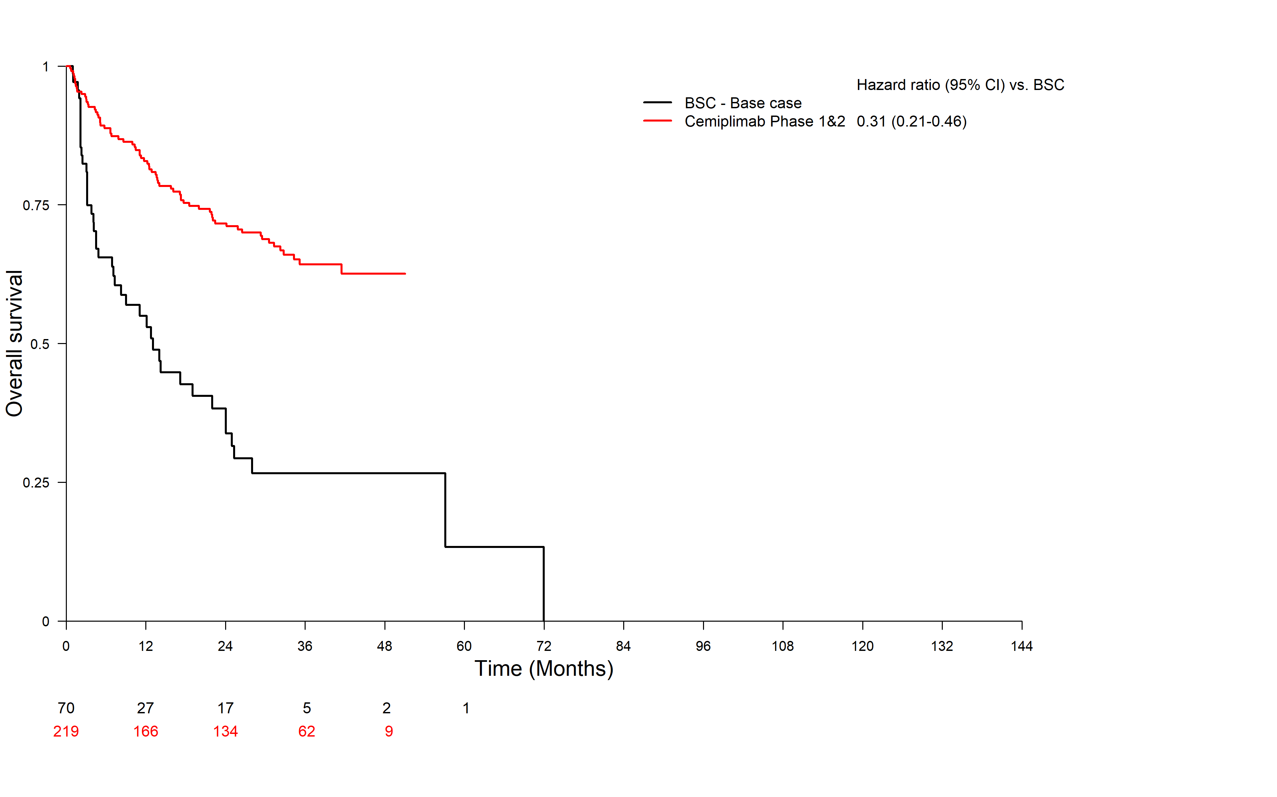
Source: Appendix 17 to the resubmission
BSC = best supportive care; CI = confidence interval

Figure 2: Overall survival Kaplan-Meier curves for pooled cemiplimab studies and pooled BSC±CT studies
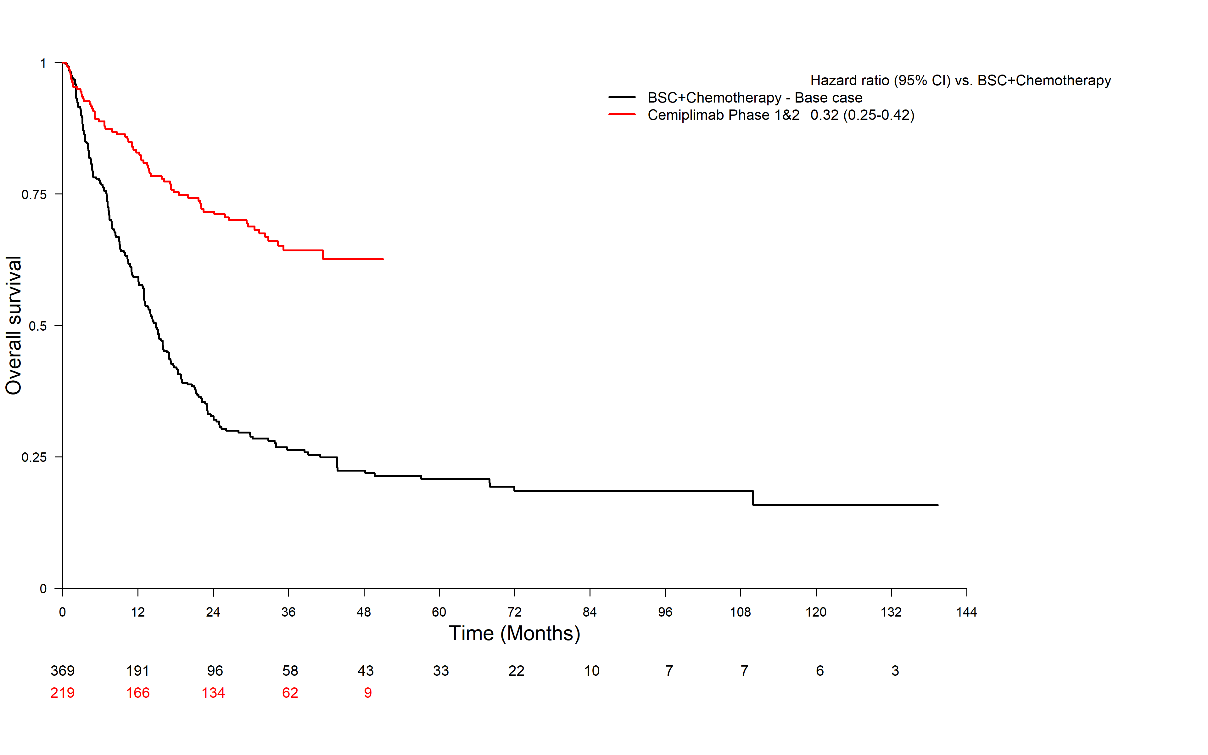
Source: Appendix 17 to the resubmission
CI = confidence interval; BSC = best supportive care; CT = chemotherapy

Figure 3: Progression-free survival Kaplan-Meier curves for pooled cemiplimab studies and pooled CT studies
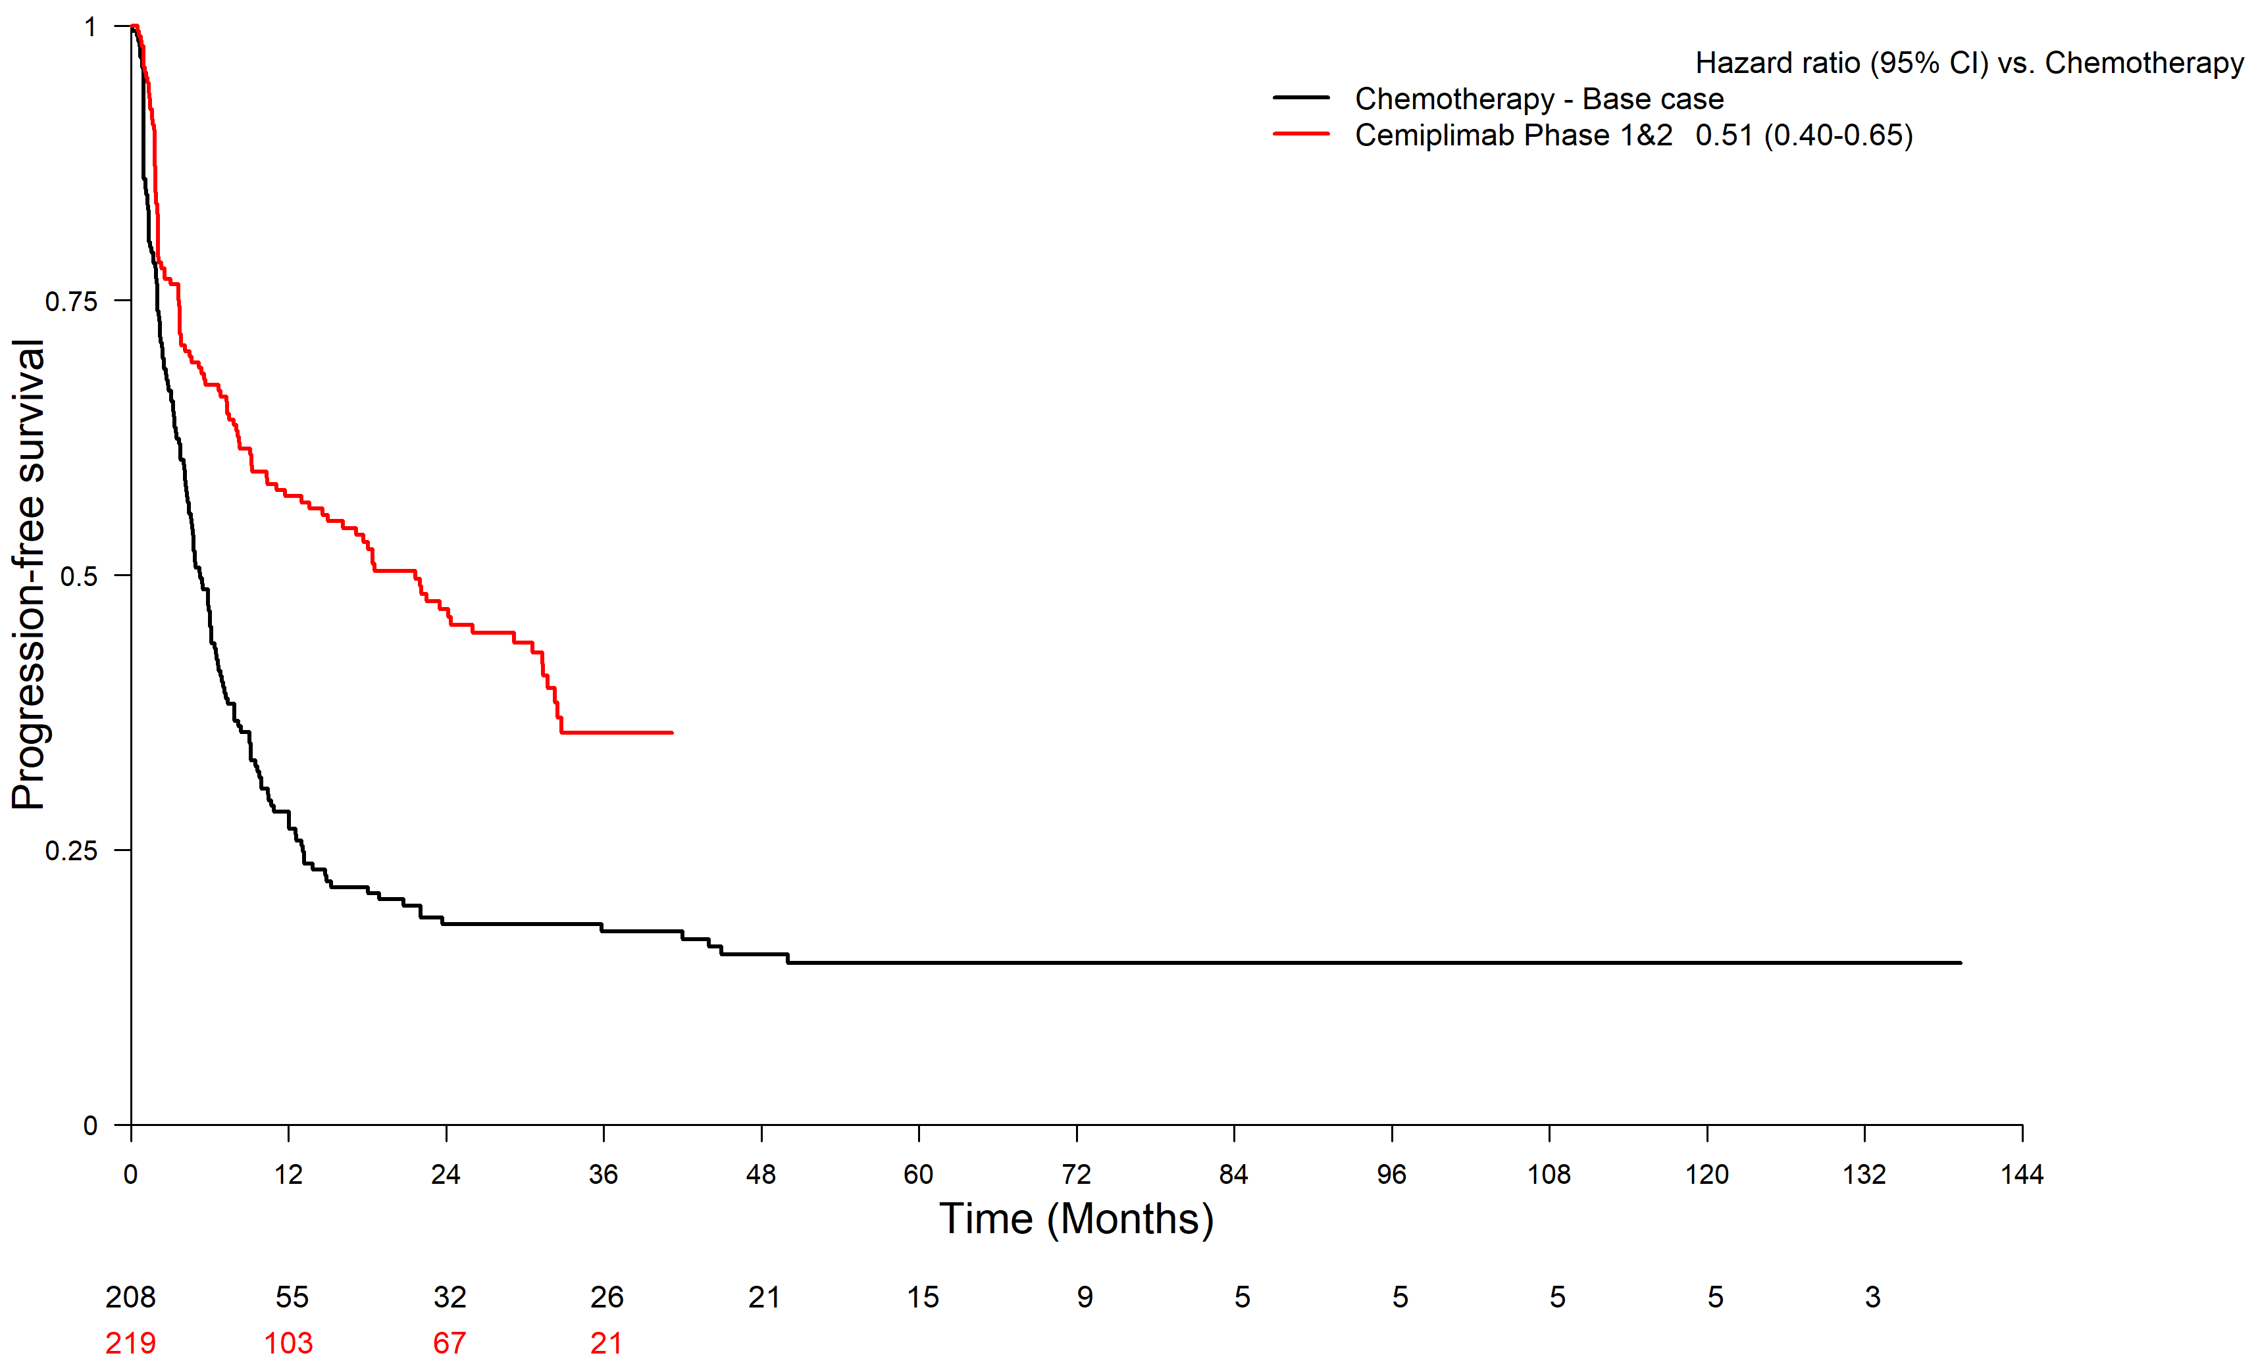
Source: Appendix 17 to the resubmission.
CI = confidence interval; CT = chemotherapy
  - The ESC noted the inclusion of updated Study 1540 data and three additional chemotherapy studies has had a minor effect on the indirect comparison results and Kaplan-Meier curves compared with the previous submission.
  - A comparison of the observational cemiplimab study identified during the evaluation (Hober et al) and the cemiplimab studies (Study 1540 and Study 1423) or the BSC ± CT studies emulating the resubmission's approach was not possible during the evaluation. While no indirect hazard ratios were produced, the evaluation superimposed the Kaplan-Meier curves for PFS and OS from Hober et al onto the pooled cemiplimab study curves and the pooled BSC ± CT curves (base case).
Figure 4: Comparison of Kaplan-Meier curve for OS for cemiplimab studies, BSC ± CT studies and Hober et al
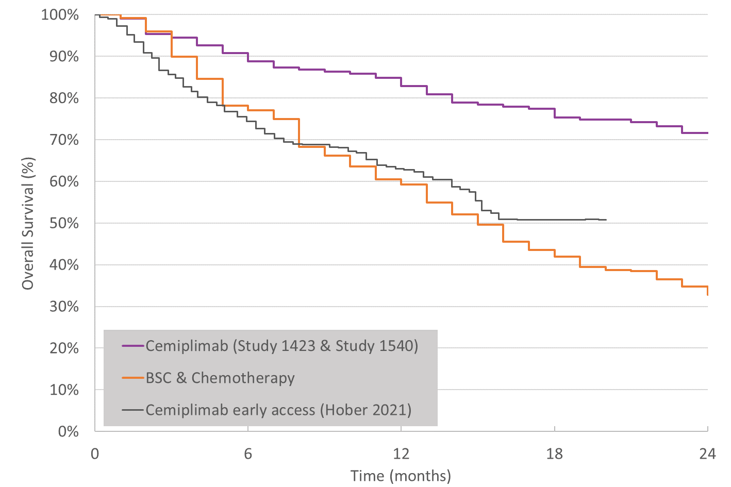
Source: Pooled Study 1423 and Study 1540, Pooled BSC ± CT studies (base case) – generated using the resubmission's data from the economic model. Hober et al curve digitised from the publication.

Figure 5: Comparison of Kaplan-Meier curve for PFS for cemiplimab studies, CT studies and Hober et al
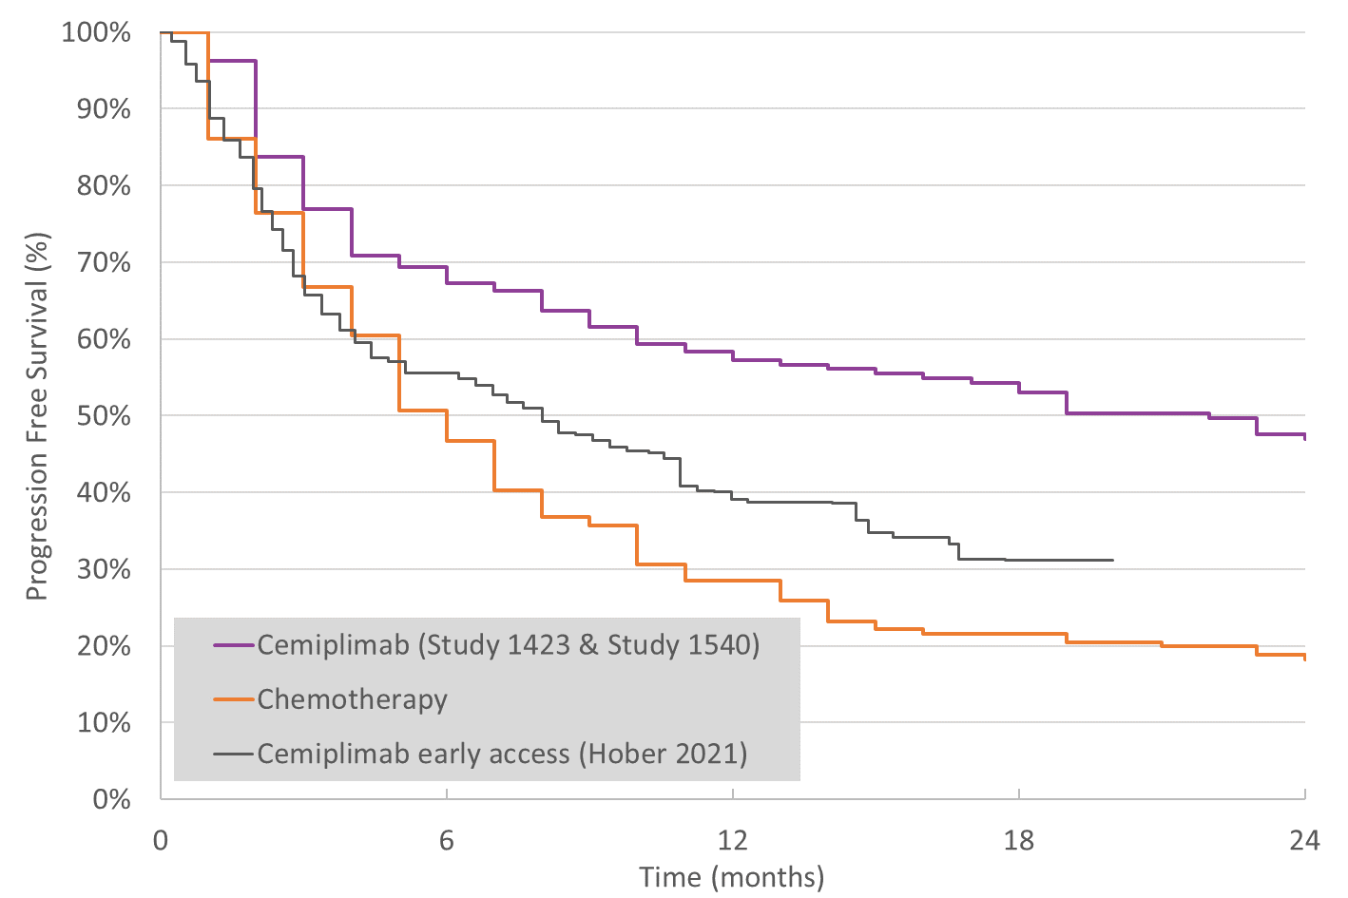
Source: Pooled Study 1423 and Study 1540, Pooled BSC ± CT studies (base case) – generated using the resubmission's data from the economic model. Hober et al curve digitised from the publication.
  - The tumour response rates in Hober et al (ORR = 50.4%) are similar to those reported in Study 1540 (ORR = 47.2%). However, PFS and OS appeared to be markedly lower in the observational study compared with Study 1540. PFS at 12 months was reported to be 39% (95% CI 33%, 46%) in Hober et al compared with 55.8% (95% CI 48.1, 62.8) in Study 1540. OS at 12 months was reported to be 63% (95% CI 57%, 70%) in Hober et al compared with 82.8% (95% CI 76.6%, 87.6%) in Study 1540.
  - The estimate of OS in Hober et al may be affected by the older average age in the study (77.1 years) compared with Study 1540 (71.1 years). The average age across the BSC ± CT observational studies varies, although may be younger than 77.1 years.
  - The PSCR provided Kaplan-Meier curves of PFS and OS for subgroups by immune status from Hober et al and stated that it was not a treatment effect modifier.
  - The PSCR also provided Kaplan-Meier curves of PFS and OS for subgroups by ECOG PS in Hober et al (Figure 6).
Figure 6 Kaplan-Meier curves of PFS (A) and OS (B) for patients with an ECOG PS score of 0-1 versus ≥2 in Hober et al
- PFS B) OS

Source: Figure 1, PSCR
  - The PSCR argued 1-year PFS is greater for patients with ECOG PS 0-1 (43.5%) compared with ECOG PS ≥2 (25.1%) (Figure 6A). The PSCR also argued the 1-year OS for patients with ECOG PS 0-1 (73%) was better than that of patients with ECOG PS ≥2 (36%) (Figure 6B). Overall, the PSCR argued that the lower PFS and OS in the total population included in Hober et al compared with Study 1540 and Study 1423 were due to the inclusion of patients with an ECOG PS ≥2. The ESC acknowledged that the differences in ECOG PS of patients in the Hober et al and the Study 1540 and Study 1423 trials would likely impact on the PFS and OS results observed. However, the ESC noted a comparison of the OS data from the Hober et al ECOG PS 0-1 subgroup with the pooled Study 1540 and Study 1423 data and considered that the patients with a ECOG PS 0-1 in Hober et al were still dissimilar to the pooled trials with the probability of OS lower in the observational study (Figure 7).
Figure 7 Kaplan-Meier curves of OS for patients with an ECOG PS score of 0-1 versus ≥ 2 and for pooled Study 1540 and Study 1423 ITT populations

Source: Constructed during the development of the ESC Advice
  - The PSCR also presented a comparison of Kaplan-Meier curves for PFS and OS of cemiplimab with and without Hober et al versus the BSC ± CT (Figure 8).
Figure 8 Kaplan-Meier curves of PFS (A) and OS (B) for cemiplimab versus BSC CT studies
A:PFS
B:OS

Source: Figure 3, PSCR

Comparative harms
  - The safety data presented in the resubmission for Study 1423 was unchanged. Following the October 2020 data cut off for Study 1540, the mean duration of treatment exposure increased by approximately 0.61 months. The safety profile of cemiplimab was largely unchanged from the previous submission. Changes to the safety profile include two additional serious treatment emergent adverse events (both in the laCSCC study arm), and one additional patient with a Grade 3-5 treatment emergent adverse event of special interest.
  - Of the three newly identified chemotherapy studies, only Galbiati et al (n=12) reported safety outcomes. Overall, the changes to the indirect comparison for safety of cemiplimab vs chemotherapy from the November 2020 submission to the current resubmission were negligible.
  - The results of indirect comparison of adverse events for cemiplimab versus chemotherapy are presented below. Of note, BSC studies did not report safety.
Table 8: Results of indirect comparison of adverse events for cemiplimab versus chemotherapy
 | Pooled cemiplimab  N = 219 | Pooled chemotherapy  N = 184 | RR (95% CI) | RD (95% CI)
Any AE | 218 (99.5) | 151 (82.1) | 1.21 (1.13, 1.3) | 0.17 (0.12, 0.23)
Grade 3-4 AE~ | 105 (47.9)~ | 47 (25.5) | 1.88 (1.41, 2.49) | 0.22 (0.13, 0.32)
- Anaemia | 8 (3.6) | 2/130 (1.5) | 2.37 (0.51, 11.01) | 0.02 (-0.01, 0.05)
- Diarrhoea | 2 (0.9) | 3/42 (7.1) | 0.26 (0.01, 5.07) | -0.07 (-0.15, 0.01)
- Failure to thrive | 1/26 (3.8) | 5/130 (4.6) | 1.18 (0.15, 9.41) | 0.01 (-0.07, 0.08)
- Hyperkalaemia | 0 | 1/130 (0.8) | 0.3 (0.01, 8.77) | -0.01 (-0.02, 0.01)
- Hyponatraemia | 4 (1.8) | 2/130 (1.5) | 1.19 (0.22, 6.39) | 0 (-0.02, 0.03)
- Nausea | 0 | 1/130 (0.8) | 0.30 (0.01, 8.77) | -0.01 (-0.02, 0.01)
- Neutrophil count decreased | 1 (0.5) | 14/130 (10.8) | 0.04 (0.01, 0.32) | -0.1 (-0.16, -0.05)
- Neutropenia | 0 | 1/12 (8.3) | 0.03 (0, 0.77) | -0.08 (-0.24, 0.07)
- Pneumonitis | 5/193 (2.6)~ | 2 (1.2) | 2.67 (0.55, 13.07) | 0.02 (-0.01, 0.05)
- Skin infection | 5 (2.3) | 3/130 (2.3) | 0.99 (0.24, 4.07) | 0 (-0.03, 0.03)
- Skin rash | 1 (0.5) | 3/12 (25.0) | 0.02 (0, 0.16) | -0.25 (-0.49, 0)
- Thrombocytopenia | 0/193 | 1/42 (2.4) | 0.11 (0, 3.18) | -0.02 (-0.07, 0.02)
- White blood cell count decreased | 1 (0.5) | 2/130 (9.2) | 0.05 (0.01, 0.38) | -0.09 (-0.14, -0.04)
Source: Table 2.6-23, p180 of the resubmission
AE = adverse event; CI = confidence interval; OR = odds ratio; RD = risk difference; RR = relative risk
~Only AEs of grade 3 or 4 (based on the individual patient data) were considered to better match with the chemotherapy studies
Note that estimates are based only on the studies that reported on the category of adverse event, such that most safety events are not captured across the total pooled chemotherapy population. The number of patients at risk is reported in individual cells.
  - In November 2020 the ESC noted that the net difference in the safety profile and the impact of cemiplimab on QoL compared to the currently used chemotherapy regimens cannot be estimated, in the context of low number of events, and different (and/or missing) information about treatment duration between cemiplimab and chemotherapy. The fact that the BSC ± CT pooled safety data were derived mainly from two studies (Chapalain et al and Ogata et al), it is very difficult to interpret the safety data presented from this comparison, as different populations were included in each analysis. The immaturity of the presented cemiplimab data, such that the risk of late-onset immune adverse events, could not be reliably estimated. In addition, chemotherapy will have a higher rate of adverse events than BSC, therefore the comparison of cemiplimab with chemotherapy leads to an under-estimate of the incremental difference in harms associated with cemiplimab vs BSC ± CT (para 6.32, cemiplimab PSD, November 2020 PBAC meeting). The ESC considered these concerns remain outstanding. In addition, the ESC noted the higher rate of grade 3-4 adverse events evident with cemiplimab versus pooled chemotherapy (Relative risk 1.88, 95% CI 1.41, 2.49) and considered that cemiplimab may have an inferior safety profile. The pre-PBAC response stated that the comparisons were limited and were not adjusted for treatment duration as only two of the comparator studies (Chapalain et al 2019 and Ogata et al 2020) reported any adverse events but did not report drug exposure duration. As such, the pre-PBAC response argued the comparison is likely to be biased against cemiplimab as its duration is likely to be longer compared to chemotherapy. Furthermore, the pre-PBAC response argued that the letter of support from MOGA indicated that cemiplimab was less toxic than chemotherapy.
  - The ESC previously noted that the requested fixed-dosing regimen (350 mg intravenously Q3W) was only tested in a minority of patients. The ESC previously considered that the fixed-dosing regimen would result in a higher cemiplimab dose than weight-based dosing for some patients and as such may increase the risk of adverse events in those patients. Hence, the ESC previously considered that the adverse event data reported in the submission may not be truly reflective of the risk of events in clinical practice (para 6.32, cemiplimab PSD, November 2020 PBAC meeting). This issue remained outstanding.
  - While the estimate of comparative safety remains uncertain, the safety profiles of PD-(L)1 inhibitors are reasonably established. Immune related adverse events were common, with 15% of patients in Study 1540 assessed (by investigator) to have a Grade 3-5 immune related treatment emergent adverse event. Overall, 7.8% of patients ceased treatment due to an immune related adverse event. An outstanding safety concern relates to the use of cemiplimab in immunocompromised patients, which may comprise a substantial proportion of the target population.

Benefits/harms
  - Because of the unadjusted indirect nature of comparison (without a common reference arm), and the different (and unreported) duration of treatment in the chemotherapy studies, an assessment of the comparative benefits/harms would be misleading. Overall, same as the previous submission, the unadjusted indirect comparison presented in the resubmission did not allow for a quantitative comparison of the benefits and harms of cemiplimab and BSC ± CT. Accordingly, a benefits/harms table has not been presented.

Clinical claim
  - As for the previous submission, the resubmission described cemiplimab as superior in terms of effectiveness compared to BSC and chemotherapy and non-inferior in terms of safety compared to platinum-based and non-platinum-based chemotherapy. The PBAC previously considered that the clinical claim was not adequately supported by the data (para 7.8, cemiplimab PSD, November 2020 PBAC meeting).
  - In November 2020, the PBAC noted the transitivity concerns and agreed with the ESC that the evidence used to inform the comparator group was prone to significant bias noting that it was heterogeneous in its construction and not necessarily generalisable to the Australian population. At that time, the PBAC agreed with the ESC that the magnitude of the improvement in effectiveness from using cemiplimab compared to BSC ± CT could not be reliably determined from the data presented as it does not allow a valid indirect comparison to be undertaken (para 7.5, cemiplimab PSD, November 2020 PBAC meeting).
  - The PBAC previously considered that the safety of cemiplimab compared to BSC ± CT was unclear as none of the BSC studies reported adverse events and limited data were available for a comparison with chemotherapy (para 7.6, cemiplimab PSD, November 2020 PBAC meeting).
  - The updated data from Study 1540 and the inclusion of the three additional chemotherapy studies in the resubmission did not address the major concerns raised by the PBAC in November 2020. The ESC considered the Hober et al study may better reflect the effectiveness of cemiplimab in clinical practice and considered the claim of superior effectiveness remained highly uncertain due to the outstanding concerns regarding transitivity with the comparator studies.
  - The PBAC agreed with the ESC that the claim of superior comparative effectiveness was uncertain but considered it reasonable in the context of a condition with high clinical need and a lack of alternative treatment options.
  - The PBAC considered that the claim of non-inferior comparative safety was not adequately supported by the data but advised that cemiplimab had an acceptable safety profile.

Economic analysis
  - The resubmission presented a modelled economic evaluation, based on an unadjusted indirect comparison of cemiplimab studies (Study 1540 and Study 1423) with the pooled analysis of relevant (sub)groups from studies Sun et al 2019, Amaral et al 2019, Jarkowski et al 2016, Chapalain et al 2019, Ogata et al 2020, Galbiati et al. 2019, Cowey et al. 2020 and Tam et al. 2020. Consistent with the November 2020 submission, a cost-utility analysis was presented.
  - The key components of the economic evaluation are summarised below. Compared to the November 2020 submission, updated data were used for allocation to health states and health related QoL components of the model and changes were evident for the extrapolation method.
Table 9: Key components of the economic evaluation
Component | Summary
Treatments | BSC±CT.
Time horizon | 10 years (compared to a median follow-up of 18.5–31.7 months in cemiplimab studies and duration of follow-up of 18.6–42.8 months in BSC ± CT studies ª).
Outcomes | Life-years gained (LYG) and quality-adjusted life-years (QALYs) gained
Methods used to generate results | Partitioned survival (area under the curve) analysis.
Health states | Three: Progression-free survival (PFS), Progressive disease (PD), and Death.
Cycle length | One month.
Allocation to health states | Health state allocation over time was determined by PFS and OS curves from the cemiplimab pooled analysis and comparator studies until the extrapolation time point ^{b}. In the base case analysis, three additional studies were included (Galbiati et al. 2019, Cowey et al. 2020 and Tam et al. 2020) for the comparator and updated data from Study 1540 were included for cemiplimab. However, the concerns related to transitivity across these studies and the applicability of these studies to the proposed Australian context remain outstanding in the resubmission.
Extrapolation method | In the BSC±CT arm, parametric distributions fitted to the observed KM curves were used to extrapolate PFS and OS to the end of time horizon of the model. In the cemiplimab arm, parametric distributions were used to extrapolate PFS and OS until the last observation of PFS and OS in the studies, which were 42 months (33% unprogressed) and 52 months (55% alive) respectively, and then linear convergence was applied so that both PFS and OS from the cemiplimab converge with BSC±CT arms at 10 years. This has been updated from the previous submission by implementing a convergence of survival curves, as advised by PBAC (Paragraph 7.9, cemiplimab PSD, November 2020 PBAC meeting). However, the ESC considered the application of linear convergence was not an appropriate approach to estimating the treatment effect of cemiplimab.
Health related quality of life | EORTC QLQ-C30 data from Study 1540, mapped to EQ-5D values, using the Longworth 2014 algorithm.  PFS health state utility: 0.768  Progressive disease health state utility: 0.707  Adverse event-related and age-related utility decrements were also included in the economic model.
Source: Table 3.1.-2, p265 of the submission.
BSC ± CT = best supportive care with or without chemotherapy; EORTC QLQ-C30 = European Organisation for Research and Treatment of Cancer Quality of Life Questionnaire – Core 30 items; EQ-5D = EuroQol - 5 dimensions; HRQoL = health-related quality of life; HTA = Health Technology Assessment; LYs = life years; OS = overall survival; PFS = progression-free survival; PSD = Public Summary Document; QALYs = quality-adjusted life years; DCO = data cut-off.
ª The median follow-up in Study Sun et al 2019 and in Study Ogata et al 2020 was not reported.
^{b} 19 months for cemiplimab PFS, 5 months for BSC ± CT PFS, 42 months for cemiplimab OS, and 15 months for BSC ± CT OS.
  - The PBAC previously considered that the economic model was unreliable due to the uncertainties in the supporting clinical data from Study 1423 and Study 1540 and concerns regarding the validity of the indirect comparison with BSC ± CT (Para 7.9, cemiplimab PSD, November 2020 PBAC meeting). The PBAC considered that ‘the economic model should incorporate more conservative efficacy estimates and extrapolation methods, including convergence of the survival curves at 10 years’ (Paragraph 7.11, cemiplimab PSD, November 2020 PBAC meeting). The resubmission provided greater follow-up in Study 1540 (data cut-off point October 2020) for cemiplimab, additional data from studies Galbiati et al. 2019, Cowey et al. 2020 and Tam et al. 2020 for the comparator arm, and implemented convergence of the cemiplimab and BSC ± CT curves at 10 years. However, the uncertainties around the cemiplimab and BSC ± CT data and unadjusted indirect comparisons were retained in the model. In addition, concerns related to the applicability of clinical evidence to target Australian population remain outstanding.
  - The revised model implemented linear convergence of PFS and OS for cemiplimab from 42 months and 52 months, respectively to reach convergence with BSC ± CT at 10 years. This was achieved by assuming that the proportion of patients in the pre-progression health state and the progressed health state declined linearly each month from the last observed data points until full convergence with BSC ± CT curves was reached at 10 years. This is not reasonable and is not an application of a conservative approach to convergence. This approach resulted in higher estimates of PFS and OS with cemiplimab between approximately 40–90 months, compared with analysis excluding the linear convergence. The comparison of modelled survival curves (current and previous submissions) and updated Kaplan-Meier curves for PFS and OS are presented below. The PSCR argued that extrapolating OS using an exponential function from 42 months resulted in survival estimates that are below the observed KM curve for the next 9 months [Figure 9]. Further, the PSCR argued that when this is combined with a linearly declining survival curve for the remainder of the time horizon, it is likely that OS for cemiplimab is underestimated and hence reduced rather than amplified the uncertainty of the estimated health gains. The ESC disagreed with the PSCR and considered that the approach favoured cemiplimab as the fitted curve for BSC lies considerably below the observed curve with the corresponding cemiplimab curve above the previously modelled curve even with convergence and despite little additional data. The ESC considered the use of an exponential function for cemiplimab and log-normal for BSC ± CT reasonable but noted that as the cemiplimab data remained immature other functional forms would also be reasonable. The ESC considered the effect of the parametric function on the ICER to be relatively modest due to the convergence overriding the extrapolation in the later part of the curve. The ESC considered application of linear convergence was not an appropriate approach to estimating the treatment effect of cemiplimab. Instead, the ESC considered that convergence should be applied as a weighted average of the extrapolated value for the two arms.
Figure 9: Comparison of modelled survival curves and updated Kaplan-Meier curves
- Progression free survival
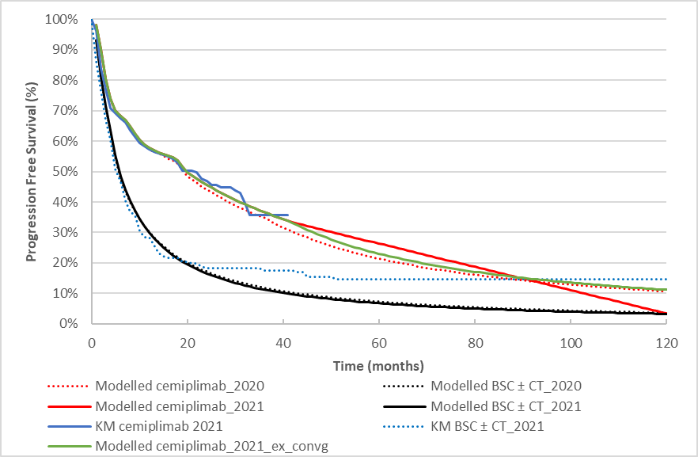
- Overall survival
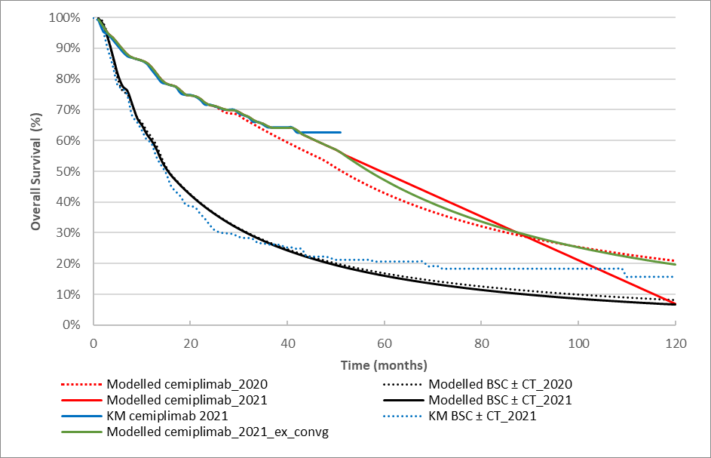
Source: Constructed during the evaluation
BSC ± CT = best supportive care with or without chemotherapy; ex_convg = excluding convergence; KM = Kaplan-Meier; PFS = progression free survival

  - In addition to the updated clinical data from Study 1540 and three chemotherapy studies, costs associated with health resources were also updated in the resubmission. Compared to the previous submission, the resubmission proposed a | |% reduction in the effective AEMP price of cemiplimab ($| | per vial vs $| | per vial in November 2020).
  - The approach used to estimate health state utilities in the resubmission was unchanged from the previous submission. However, the analysis was updated to include the additional follow-up data from Study 1540 (October 2020 data cut off). The results were largely unchanged with the inclusion of the updated data. In November 2020, the ESC considered that the use of a relatively high utility value for progressive disease favoured cemiplimab (Paragraph 6.42, cemiplimab PSD, November 2020 PBAC meeting). The ESC considered the concerns raised in November 2020 remained. In addition, the ESC noted that the use of Australian QLU-C10D utilities weights would avoid the need to map to EQ-5D values and considered that such an approach would have been more appropriate.
  - The key drivers of the model are summarised below. The key drivers of the model were largely unchanged from the previous submission.
Table 10: Key drivers of the model
Description | Method/Value | Impact  (Base case ICER: $|¹/QALY)
Comparative treatment effect | The economic model was based on an unadjusted indirect comparison of cemiplimab with BSC ± CT, which contained major transitivity issues. | High, favours cemiplimab  If the observed PFS and OS from Hober et al 2021 were used, the ICER would be expected to be substantially higher.
Extrapolation | Independent parametric distributions of PFS and OS in both arms; and linear convergence for both PFS and OS | High, favours cemiplimab  Alternative approach to convergence - assuming dependent extrapolation using Hazard ratioª for cemiplimab vs. BSC ± CT of PFS and OS from 42 and 52 months respectively to the end of 10 year time horizon, the ICER increased to $||||²/QALY
Utilities | The study-based health state utilities used in the economic model, particularly the progressive disease state utility (0.707), could have been overestimated, due to the short follow-up period in Study 1540 (18.5 months) and the uncertainty regarding the representativeness of the responders who provided the HRQoL data in Study 1540. | Moderate, favours cemiplimab  When the lower health state utility values derived from the NICE TA473 submission for patients with recurrent or metastatic SCCHN were applied to the economic model, the ICER increased to $||||²/QALY.
Source: Table compiled during the evaluation based on Section 3.9 of the submission and the sensitivity analyses performed during the evaluation.
BSC ± CT = best supportive care with or without chemotherapy; HRQoL = health-related quality of life; ICER = incremental cost-effectiveness ratio; NICE = National Institute for Health and Care; OS = overall survival; PFS = progression free survival; QALY = quality-adjusted life year; SCCHN = squamous cell cancer of head and neck
ªA hazard ratio of 1.92 for PFS and 1.99 for OS after the last observed data point, such that the intervention and comparator curves converge at 10 years, as used in the previous evaluation.
The redacted values correspond to the following ranges:
¹ $45,000 to < $55,000/QALY gained
² $55,000 to < $75,000/QALY gained

  - The model was predominantly driven by the estimated incremental health benefit of cemiplimab compared with BSC ± CT (2.44 LYs gained (undiscounted)), either within the study observation period (derived from the unadjusted indirect comparison) or extrapolated long term benefit. The incremental health benefit of cemiplimab compared with BSC ± CT was subject to high level of uncertainty and cannot be reliably estimated. As noted above, the indirect comparison was unreliable due to the single arm design, small sample size and immature data of cemiplimab studies, and the substantial transitivity concerns across the studies included in the indirect comparison. Cemiplimab PFS extrapolation commences with 33% patients remaining progression free and OS extrapolation commences with 55% alive. The extrapolation based on immature data for cemiplimab – particularly in terms of OS, amplified the uncertainty associated with the estimated health gains.
  - The results of stepped economic evaluation are summarised below.
Table 11: Results of the stepped economic evaluation
Step and component | Cemiplimab | BSC ± CT | Increment
Step 1: study-based costs and outcomes (time horizon 41 months)
Costs ($) | | | | | |
LYs | 2.47 | 1.58 | 0.89
Incremental cost/extra LY gained |  |  | |¹
Step 2: study evidence extrapolated to 10 years
Costs ($) | | | | | |
LYs | 4.24 | 2.21 | 2.03
Incremental cost/extra LY gained |  |  | |²
Step 3: study evidence extrapolated to 10 years including all resource use
Costs ($) | | | | | |
LYs | 4.24 | 2.21 | 2.03
Incremental cost/extra LY gained |  |  | |²
Step 4: study evidence extrapolated to 10 years including all resource use and LYs transformed to QALYs
Costs ($) | | | | | |
QALYs | 3.13 | 1.62 | 1.51
Incremental cost/extra QALY gained |  |  | |³
Submission considered in November 2020
Cost ($) | | | | | |
LYs | 4.17 | 2.27 | 1.90
QALYs | 3.07 | 1.66 | 1.41
Incremental cost/extra QALY gained |  |  | |¹
Source: Table 3.8.1, p321 of the submission, and Table 14, cemiplimab PSD, November 2020 PBAC meeting.
BSC ± CT = best supportive care with or without chemotherapy; ICER = incremental cost-effectiveness ratio; LYs = life years; QALYs = quality-adjusted life years
Shaded cells are the results considered by the PBAC in November 2020.
The redacted values correspond to the following ranges:
¹$55,000 to < $75,000
²$25,000 to < $35,000
³$45,000 to < $55,000

  - Compared with the previous submission, the ICER decreased to $45,000 to < $55,000 /quality-adjusted life year (QALY) in the resubmission from $55,000 to < $75,000 /QALY in the previous submission. This was not only driven by the reduction in the price of cemiplimab, but also the higher estimate of the PFS (1.56 LYs gained (undiscounted) in the previous submission versus 1.71 LYs gained (undiscounted) in the current submission) and OS (2.30 versus 2.44 LYs gained (undiscounted)) benefit of cemiplimab (see Figure 9 above).
  - The modelled PFS and OS gains have primarily been influenced by two changes in the resubmissions model. The model has adopted a linear convergence of both the OS and PFS cemiplimab curves to BSC ± CT at 10 years. This will result in a reduction in incremental OS and PFS. However, due to the greater follow up observed in Study 1540, the point at which the convergence starts has been extended, resulting in additional gains in incremental OS and PFS compared with the previous submission. The net effect results in an overall gain in modelled life years.
  - The results of key sensitivity analyses are summarised below. The PSCR included the economic model updated with data from Hober et al which enabled additional analyses. Substantial revisions were required to the model to incorporate the Hober et al data; the revised model was not evaluated.
Table 12: Sensitivity analyses
Analyses | Incremental cost ($) | Incremental QALY | ICER ($)
Base case | | | 1.51 | |¹
Cemiplimab trial data Phase I/II pooled laCSCC | | | 2.00 | |²
Cemiplimab trial data Phase I/II pooled mCSCC | | | 1.20 | |³
Cemiplimab trial data Phase I/II pooled with Hober et al ECOG PS 0-1ª | | | 1.28 | |³
Cemiplimab trial data Phase I/II pooled with Hober et al^{b} | | | 1.06 | |³
Economic evaluation based on matching adjusted indirect comparison | | | 1.32 | |¹
Economic evaluation based on simulated treatment comparison | | | 1.47 | |¹
Assuming all patients in the cemiplimab arm receive one additional cycle of cemiplimab | | | 1.51 | |¹
Assume dependent extrapolation using Hazard ratio for cemiplimab vs. BSC ± CT which allowed the survival curves of the two treatment arms converge at Year 10 ^{c, d} | | | 1.19 | |³
Independent Gompertz for BSC±CT for both OS and PFS ^{c} | | | 1.43 | |¹
Excluding linear convergence ^{c} | | | 1.55 | |²
Use of health state utilities from cetuximab for SCCHN (NICE TA473) for both PFS and progressive disease health states | | | 1.26 | |³
Discount rate: 0% | | | 1.80 | |²
Discount rate: 3.5% | | | 1.59 | |¹
Multivariate analysis 1^{b}
Applying convergence as a weighted average of the extrapolated value for the two arms^{e} (A) | | | 1.29 | |¹
A + Cemiplimab trial data Phase I/II pooled with Hober et al ECOG 0-1 (B) | | | 1.09 | |³
B +Use of health state utilities from cetuximab for SCCHN (NICE TA473) for both PFS and progressive disease states | | | 0.90 | |⁴
Multivariate analysis 2^{b}
Applying convergence as a weighted average of the extrapolated value for the two arms^{e}(A) | | | 1.29 | |¹
A +Cemiplimab trial data Phase I/II pooled with Hober et al (B) | | | 0.89 | |⁴
B +Use of health state utilities from cetuximab for SCCHN (NICE TA473) for both PFS and progressive disease states | | | 0.74 | |⁴
Source Table 3.9-1, pp324-325 of the submission
BSC ± CT = best supportive care with or without chemotherapy; ICER = incremental cost-effectiveness ratio; laCSCC = locally advanced cutaneous squamous cell cancer; mCSCC = metastatic cutaneous squamous cell cancer; SCCNH = squamous cell cancer of the head and neck; NICE = National Institute for Health and Care; OS = overall survival; PFS = progression-free survival; QALY = quality-adjusted life year
ª Sensitivity analyses reported on in PSCR
^{b} Sensitivity analyses undertaken during the development of the ESC Advice
^{c} Sensitivity analyses which were not presented in the submission. But the submission’s economic model were built to allow such analyses to be performed during the evaluation.
^{d} A hazard ratio of 1.92 for PFS and 1.99 for OS after the last observed data point.
^{e} A new worksheet named “Convergence” was created to calculate weights from the months 52 (OS) and 42 (PFS) based on values in cells ‘Paramteres!C67’ and ‘Parematers!C71’. Formulas in ‘Arm1!AH’ and ‘Arm1!BN’ were changed to apply the weighted average.
The redacted values correspond to the following ranges:
¹$45,000 to < $55,000
²$35,000 to < $45,000
³$55,000 to < $75,000
⁴$75,000 to <$95,000

  - The evidentiary basis of the economic model was an unadjusted indirect comparison of cemiplimab studies and BSC ± CT studies, with major transitivity concerns. Sensitivity analyses are unable to test the impact of transitivity concerns in the model. The ESC considered although transitivity concerns remained that the Hober et al study may better reflect the effectiveness of cemiplimab in clinical practice and should be incorporated in the economic model. The ESC noted that the inclusion of OS and PFS data from the Hober et al study substantially reduced the QALYs gained from 1.51 to 1.28 (15% reduction) when the data for the ECOG 0-1 subgroup were combined with the cemiplimab Phase I/II data, and to 1.06 (30% reduction) when the full dataset were combined with the cemiplimab Phase I/II data. The corresponding ICER increased from $45,000 to < $55,000 to $55,000 to < $75,000 and $55,000 to < $75,000/QALY, respectively. The ESC considered this range did not fully reflect the uncertainty with respect to the incremental QALYs and ICERs, noting the substantive issues raised regarding transitivity of the cemiplimab and comparator studies, differences in outcome definitions across the studies and applicability of the cemiplimab Phase I/II studies to the PBS population (paragraphs 6.10-6.13). In this regard, the ESC considered a modelled analysis using only the Hober et al data would be informative. However, the model provided with the PSCR did not allow this comparison as it included the survival data for Hober et al combined with the phase I/II studies only and not separately.
  - The submission applied a linear convergence of PFS and OS for cemiplimab with BSC ± CT after the last observed data point. The ESC considered the approach of using linear convergence was not appropriate and does not address the uncertainty associated with the modelled benefit. The ESC noted the ICER only changed marginally when the linear convergence was excluded in the model ($35,000 to < $45,000/QALY). The ESC considered that convergence should be applied as a weighted average of the extrapolated value for the two arms and noted that use of this approach increased the ICER from a base case of $45,000 to < $55,000/QALY to $45,000 to < $55,000/QALY.
  - The health state utilities, particularly the utility for the progressive disease health state, may have been overestimated in the economic evaluation. The ESC noted that when the lower health state utility values derived from the NICE TA473 submission for patients with recurrent or metastatic SCCHN were applied to the economic model, the ICER was also impacted, increasing to $55,000 to < $75,000 /QALY.
  - The ESC considered that the following amendments may improve the reliability of the economic analysis:
- Applying convergence as a weighted average of the extrapolated value for the two arms; and
- Use of cemiplimab trial data Phase I/II pooled with the Hober et al ECOG 0-1 subgroup.
The ESC noted the application of these amendments increased the base case ICER to $55,000 to < $75,000 /QALY with a further increase if all patients from the Hober et al study were included ($75,000 to < $95,000/QALY). The ESC noted that if amendments to the model extended to the use of the health state utility values from the NICE TA473 submission the ICER increased to $75,000 to < $95,000/QALY using the ECOG 0-1 subgroup or to $75,000 to < $95,000if all patients in the Hober et al study were included. The ESC considered that these ICERs should be interpreted in the context of the uncertain magnitude of clinical benefit generated from an indirect comparison of single arm studies, and in particular the relatively large modelled OS gain given that the benefit of treatment might not be best captured through OS (see paragraph 4.1). The ESC advised that this uncertainty could at least partly be addressed through use of a relatively low ICER threshold, noting that additional clinical evidence which would reduce this uncertainty is unlikely to become available. The pre-PBAC response requested that the PBAC provide advice on the ICER threshold for the above-mentioned respecified base case (ICER: $55,000 to < $75,000 /QALY) to enable the sponsor to make a price offer for cemiplimab that is aligned with that advice, if it is reasonably able to do so, noting that no further applications for the listing of cemiplimab for the treatment of CSCC would be made in the absence of new clinical evidence.

Drug cost/patient/course
  - The per patient drug costs for cemiplimab and chemotherapy are presented in the table below. The drug cost for cemiplimab was estimated to be $| |, using the modelled treatment duration of 13.1 months in the economic evaluation. As discussed above, this cost is a likely underestimate, due to the shorter planned treatment duration in cemiplimab studies than that proposed in the PBS restriction. The drug cost for chemotherapy would be $| |, based on the PFS curve for BSC ± CT with a maximum of six treatment cycles for both cisplatin+5-FU and paclitaxel. This drug cost for chemotherapy would apply to 30% of patients in the comparator BSC ± CT arm. Costs associated with other interventions which form BSC ± CT, i.e. palliative radiation and palliative surgery, are not included in the table below. The PBAC considered a mean treatment duration of 13.1 months in CSCC patients with an ECOG PS 0-1 was reasonable.
Table 13: Drug cost per patient for proposed and comparator drugs
 | Cemiplimab |  |  | Chemotherapyª
 | Study dose and duration | Model | Financial estimates | Study dose and duration | Model | Financial estimates
Mean dose | Study 1423 and Groups 1 & 2 of Study 1540: 3mg/kg Q2W  Group 3 of Study 1540: 350mg Q3W | 350mg Q3W | 350mg Q3W | NR | Cis: 146mg Q3W  5-FU: 7,797mg Q3W  Pac: 156mg every week for 3 weeks in a 4-week treatment cycle | N/A^{e}
Mean duration | 3mg/kg Q2W: 7.8-13.1 months^{b}  350mg Q3W: 10.8 months^{b} | 13.1 months^{c} | 13.4 months^{c} | NR | Cis+5-FU: 3.4 months^{d}  Pac: 4.2 months^{d} | N/A^{e}
Cost/patient/month | – | $||||^{g} | $||||^{g} | – | Cis+5-FU: $||||^{g}  Pac: $||||^{g} | N/A^{e}
Cost/patient/course | – | $|||| | $|||| | – | $1,619^{h} | N/A^{e}
Source: Table compiled during the evaluation based on Table 2.4-7, p88, information provided in Section 3.6.1, pp293-310 of the submission, the “Libtayo (cemiplimab) Economic Evaluation” workbook, the “Libtayo (cemiplimab) Predicted Use” workbook. Italicised values have been calculated.
5-FU = 5-fluorouracil; BSC ± CT = best supportive care with or without chemotherapy; Cis = cisplatin; NR = not reported; Pac = paclitaxel; Q2W = every 2 weeks; Q3W = every 3 weeks; N/A = not applicable.
ª Cisplatin + 5-FU as a proxy for platinum-based chemotherapy and paclitaxel as a proxy for non-platinum-based chemotherapy.
^{b} The planned treatment duration was 48 weeks in Study 1423, 96 weeks in Groups 1 and 2 of Study 1540, and 54 weeks in Group 3 of Study 1540.
^{c} The cemiplimab treatment durations used in the economic model and in the financial analysis were both derived from a pooled analysis of time-on-treatment in Study 1423 and Study 1540, with a small difference due to the differential time interval in which the drug cost is accrued (1 month vs. 3 week).
^{d} In the economic evaluation, the estimated treatment duration was based on the progression-free survival curve with a maximum of six treatment cycles for both cisplatin+5-FU and paclitaxel.
^{e} In the financial analysis, offset from chemotherapies was not considered in the resubmission as DUSC advised that chemotherapies were likely to be displaced to a later line, rather than replaced.
^{g} In the economic evaluation, it was assumed that 47% of the cemiplimab/chemotherapy scripts would be dispensed in a public hospital setting and 53% dispensed in a private hospital setting (based on National Hospitals Cost Data Collection data on chemotherapy services). In the financial analysis a public/private split of 29%/71% was used (based on Services Australia data on services processed for nivolumab and pembrolizumab for Stage III/IV unresectable melanoma)
^{h} Weighted average, assuming 56.9% of the patients receive cisplatin+5-FU and 43.1% receive paclitaxel.

Estimated PBS usage & financial implications
  - This resubmission was not considered by DUSC. The November 2020 submission was considered by DUSC. As in the previous submission, the resubmission took an epidemiological approach to estimate the financial impact of the proposed listing of cemiplimab.
  - DUSC considered the estimates presented in the November 2020 submission to be underestimated. The main issues were related to the estimated proportion of laCSCC and mCSCC, not considering patients progressing from earlier stages of disease, using a mixed prevalence and incidence approach rather than a prevalence approach in all six years of estimates, the inclusion of grandfathered patients as an addition to prevalent patients in calculating the number of patients likely to receive cemiplimab in the first year of listing, the underestimated uptake of cemiplimab and the substitution of chemotherapy (para 6.56, cemiplimab PSD, November 2020 PBAC meeting).
  - DUSC previously requested sensitivity analyses to estimate impact of: (i) using a prevalence approach rather than a mixed prevalence and incidence approach and removing grandfathered patients; (ii) removing substitution of chemotherapy as the Committee considered that palliative chemotherapy is likely to be displaced to later line rather than replaced, and (iii) changing the proportion of patients with metastatic disease from 1.67% to 3.7% (para 6.56, cemiplimab PSD, November 2020 PBAC meeting).
  - The resubmission did not use the prevalence approach recommended by DUSC using the same argument as that put forward in November 2020, that the mixed prevalence and incidence approach was appropriate to account for patients who survive for longer than 1 year. The resubmission did not include the grandfathered patients in addition to the prevalent population in Year 1, which was reasonable and consistent with DUSC advice.
  - As previously, the submission estimated proportion of patients with mCSCC and laCSCC in incident patients (1.4%) and prevalent patients (1.67%) from published U.K. study (Venables 2019). This is a likely underestimate. DUSC previously questioned the applicability of Venables et al 2019 to the Australian population, as it is a source from the UK with different solar radiation exposure risk. DUSC considered that the incidence of late stage disease may be higher in Australia than the UK, and noted that other studies reported incidences of (1.2 -3.7%), including 3.7% from a NZ study (Brougham 2012) (Page 5, 5.03 cemiplimab DUSC Advice, November 2020).
  - The previous submission assumed that cemiplimab would replace platinum-based chemotherapy (cisplatin + 5-FU) in 17% of patients and replace non-platinum-based chemotherapy (paclitaxel) in 13% of patients. DUSC noted that palliative chemotherapy is likely to be displaced rather than replaced and the cost savings from replaced chemotherapy were likely overestimated (Page 7, 5.03 Cemiplimab DUSC Advice, November 2020). Following the DUSC’s advice, substitution of chemotherapy was removed from the resubmission’s base case financial analysis.
  - Given the paucity of data on incidence of disease progression from an earlier stage of disease to a later stage, the resubmission estimated the incidence of patients who progress from earlier stages using the difference between the prevalent population and the incidence population in the prior year. The estimated incidence and prevalence of CSCC was based on the time trend analysis of outdated National Cancer Control Initiative (NCCI) national surveys (1985–2002), and may not reflect the current disease epidemiology.
  - The resubmission assumed that the uptake of cemiplimab would be 70% of the prevalent population in Year 1 of listing. In Year 2, 80% of incident patients were expected to commence treatment with cemiplimab, increasing to 90% in Years 3-6. The uptake rates used in the resubmission for years 1 and 2 were higher than the ones used in the previous submission (60% and 75%).
  - The key inputs in the financial analysis are summarised in the table below.

Table 14: Key inputs for financial estimates
Parameter | Value and source |  |  | Comments
Epidemiology
Australian population | 26,727,025 in Year 1 to 28,765,734 in Year 6  ABS Population projections, Series B. |  |  | This was unchanged from the previous submission and is appropriate.
Incidence rate and prevalence rate of CSCC in Australia | Prevalence: 0.70% in Year 1 ª  Incidence: 0.69% in Year 2 to 0.70% in Year 6 ª  2002 NCCI national survey; Staples 2006. |  |  | DUSC previously considered that these data are now 18 years old and may over- or under- estimate the prevalence and incidence of CSCC, but may represent best available evidence.
Proportion of patients with laCSCC or mCSCC | 1.4% in incident patients ª  1.67% in prevalent patients ª  Venables 2019 |  |  | This is a likely underestimate. DUSC previously considered that the incidence of late stage disease may be higher in Australia than the UK, and noted that other studies reported incidences of (1.2 -3.7%), including 3.7% from a NZ study (Brougham 2012).
Incidence of laCSCC or mCSCC who progress from early stages | 3.34% of the difference between the prevalent and incident mCSCC and laCSCC patients Submission’s assumption (assumed that the proportion of patients with laCSCC or mCSCC that progressed from early stages was twice the prevalence of laCSCC or mCSCC) |  |  | This is uncertain. DUSC previously considered using a prevalence approach in all six years of estimates would simplify the estimates and include patients progressing from earlier stages of disease.
Proportion of patients with mCSCC or laCSCC who are not candidates for curative surgery or curative radiation | 45%  Ronconi 2020, IQVIA Research. |  |  | DUSC noted the sponsor’s involvement with the research letter and the research by IQVIA, but considered this estimate may be reasonable.
Utilisation of cemiplimab
Cemiplimab uptake rates | 70% in Year 1, 80% in Year 2 and 90% in Years 3-6  Submission’s assumption |  |  | The resubmission increased the uptake rates in the first two years compared with the previous submission (60% and 75% in Year 1 and Year 2 in the previous submission).
Mean treatment duration for cemiplimab | 57.97 weeks  Modelled time-on-treatment on the basis of the data from Study 1423 and Study 1540. Consistent with the economic evaluation. |  |  | DUSC considered the treatment duration of cemiplimab is likely overestimated as the PBS population is likely to be older and frailer than the patients are in the clinical study.
Source: Table 4.1.1, p329-330, and information provided in Section 4.1, pp326-352 of the submission
ABS = Australian Bureau of Statistics; CSCC = cutaneous squamous cell carcinoma; laCSCC = locally advanced cutaneous squamous cell carcinoma; mCSCC = metastatic cutaneous squamous cell carcinoma; NCCI = National Cancer Control Initiative.
ª The number of patients likely to receive cemiplimab was estimated on the basis of prevalent patients in Year 1 of listing and on the basis of incident patients from Year 2 to Year 6
  - The estimated use and financial implications of cemiplimab are summarised below.
Table 15: Estimated use and financial implications
 | Year 1 | Year 2 | Year 3 | Year 4 | Year 5 | Year 6
Estimated extent of use
Number of patients treated | | ¹ | | ¹ | | ¹ | | ¹ | | ¹ | | ¹
Number of scripts dispensedª | | ² | | ² | | ³ | | ³ | | ³ | | ³
Estimated financial implications of cemiplimab
Cost to PBS/RPBS less copayments ($) | | ⁴ | | ⁵ | | ⁵ | | ⁵ | | ⁶ | | ⁶
Estimated financial implications for other medicines
Cost to PBS/RPBS less copayments | $0 | $0 | $0 | $0 | $0 | $0
Net financial implications ^{b,c}
Net cost to PBS/RPBS^{b} ($) | | ⁴ | | ⁵ | | ⁵ | | ⁵ | | ⁶ | | ⁶
Net cost to MBS ^{c} ($) | | ⁷ | | ⁷ | | ⁷ | | ⁷ | | ⁷ | | ⁷
Net cost to PBS/RPBS/MBS ^{b,c} ($) | | ⁴ | | ⁵ | | ⁵ | | ⁶ | | ⁶ | | ⁶
Submission considered in November 2020
Number of patients treated | | ¹ | | ¹ | | ¹ | | ¹ | | ¹ | | ¹
Net cost to PBS/RPBS/MBS ($) | | ⁸ | | ⁶ | | ⁶ | | ⁹ | | ⁹ | | ⁹
Source: Table 4.2-3, p354, Table 4.2-4, p355, Table 4.2-9, p357, and Table 4.4-3, p359 of the resubmission, and Table 18, cemiplimab PSD, November 2020 PBAC meeting.
ª Mean treatment duration of 57.97 weeks as in the economic model, requiring 19.32 prescriptions in total, including 2.93 initial prescriptions (1st year), 9.79 continuing prescriptions in the 1st year and 6.60 continuing prescriptions in the 2nd year.
^{b} Table 4.3-1, p358 in the resubmission incorrectly included the costs offsets associated with chemotherapy substitution to the PBS/RPBS. Chemotherapy substitution was removed in the resubmission base case, based on DUSC advice that the chemotherapy will be displaced to later line and not replaced in patients receiving cemiplimab.
^{c} Table 4.4-2, p359 in the resubmission included the MBS costs associated with chemotherapy administration, palliative surgery and palliative radiation. Estimated costs to MBS were revised by removing costs offsets associated with these services.
The redacted values correspond to the following ranges:
¹ 500 to < 5,000
²10,000 to < 20,000
³20,000 to < 30,000
⁴$40 million to < $50 million
⁵$60 million to < $70 million
⁶$70 million to < $80 million
⁷$0 to < $10 million
⁸$50 million to < $60 million
⁹$80 million to < $90 million
  - The total cost to the PBS/RPBS of listing cemiplimab was estimated to be $70 million to < $80 million in Year 6, and a total of $300 million to < $400 million in the first 6 years of listing.
  - The costs of cemiplimab to the PBS/RPBS for treatment of patients with mCSCC or laCSCC who are not candidates for curative surgery or curative radiation in Australian clinical practice were uncertain and could be greater than the above estimates. The uncertainty and likely underestimation were primarily because the resubmission: 1) estimated the incidence and prevalence of CSCC based on the time trend analysis of outdated NCCI national surveys (1985–2002); and 2) used epidemiological data from the Venables et al 2019 study, which only considered mCSCC and did not include laCSCC. The ESC agreed with the PSCR that despite the age of the NCCI national surveys DUSC had advised that they appeared to represent the best available evidence for the prevalence and incidence of CSCC (Table 14). With respect to the use of the Venables et al 2019 study the ESC noted the high impact of using other plausible data sources (Table 16).
Table 16. Uncertainty analyses – net implications for the PBS/RPBS
 | Year 1 ($) | Year 2 ($) | Year 3 ($) | Year 4 ($) | Year 5 ($) | Year 6 ($)
Base case | | ¹ | |² | |² | |² | | ³ | | ³
% laCSCC and mCSCC in incident patients (base case: 1.4%, from Venables 2019) (affecting number of patients commencing treatment in Years 2-6)
Robsahm 2015 (2.1%) | | ¹ | |⁴ | |⁵ | |⁶ | | ⁶ | | ⁶
Brougham 2012 (1.9%) | | ¹ | |³ | |⁴ | |⁵ | | ⁵ | | ⁵
Brougham 2012 (3.7%) | | ¹ | |⁶ | |⁶ | |⁶ | | ⁶ | | ⁶
Weighted average (1.59%) | | ¹ | |² | |³ | |³ | | ⁴ | | ⁴
Source: Table 4.5.1, pp359-360 of the submission, revised during the evaluation by removing the PBS/RPBS cost of chemotherapy
The redacted values correspond to the following ranges:
¹$40 million to < $50 million
²$60 million to < $70 million
³$70 million to < $80 million
⁴$80 million to < $90 million
⁵$90 million to < $100 million
⁶$100 million to < $200 million

  - The ESC noted that 26% of patients in Hober et al had an ECOG PS ≥2 and that these patients were not excluded from the financial estimates. The ESC considered these patients should be excluded from the financial estimates given the proposed listing for patients with an ECOG PS of 0 or 1. The ESC further considered the risk of use in patients with an ECOG PS ≥2 was high and that this risk should be managed with a risk sharing arrangement given the results of Hober et al suggest cemiplimab is less effective in these patients.
  - The pre-PBAC response argued that Hober et al likely overestimates the population with an ECOG PS ≥2 as it was an early access scheme and enrolled patients outside of the cemiplimab clinical trials. The pre-PBAC response argued that the use of the average of the comparator studies that had no eligibility criterion relating to ECOG PS status and reported the ECOG PS status of patients at baseline would be more appropriate. The pre-PBAC response stated that the average proportion of patients in relevant comparator studies with an ECOG PS ≥2 was 16.7%.
  - The PBAC considered the exclusion of patients with an ECOG PS ≥2 from the financial estimates appropriate and accepted the estimate of 16.7% included in the pre-PBAC response.

Quality Use of Medicines
  - The submission outlined a number of activities to promote the safe and effective use of cemiplimab in clinical practice, including the development of clinician and patient support materials, and the implementation of a comprehensive pharmacovigilance system.

Financial Management – Risk Sharing Arrangements
  - A risk sharing arrangement was proposed in the resubmission to address residual uncertainty in the financial estimates. Additional detail beyond such an agreement being based on financial caps and agreed patient estimates was not provided. The ESC considered a risk sharing arrangement would be required to manage the risk of use of cemiplimab in patients with a poor performance status. The pre-PBAC response stated the sponsor was willing to accept a risk sharing arrangement based on the estimates presented in the submission adjusted to exclude no more than 16.7% of patients with an ECOG PS ≥2.
For more detail on PBAC’s view, see section 7 PBAC outcome.
- PBAC Outcome
  - The PBAC recommended the Authority Required (telephone/online PBS Authorities system) listing of cemiplimab for the treatment of patients with metastatic or locally advanced cutaneous squamous cell carcinoma (mCSCC or la CSCC), on the basis that it should be available only under special arrangements under Section 100 – Efficient Funding of Chemotherapy.
  - The PBAC was satisfied that cemiplimab provides, for some patients, improvement in efficacy over best supportive care ± chemotherapy (BSC ± CT). The PBAC considered that, while the magnitude of difference in effectiveness of cemiplimab remains uncertain, there is a high unmet clinical need in this population with potential for quality of life (QoL) benefits not encompassed in the available data. The PBAC’s recommendation for listing was based on, among other matters, its assessment that the subsequent uncertainty in the incremental cost-effectiveness ratio (ICER) could be addressed through a lower ICER threshold and resulting price reduction. The PBAC considered the exclusion of patients with an ECOG performance status (PS) of 2 or more appropriate and considered the financial estimates should be amended accordingly. In addition, the PBAC considered a risk sharing arrangement appropriate to manage the risk of use beyond the restriction.
  - The PBAC noted the consumer comments from individuals, health care professionals and organisations which highlighted the high unmet clinical need for treatment due to the symptom burden from locally advanced disease and poor QoL associated with the disfiguring complications of the disease. In addition, the PBAC noted the Medical Oncology Group of Australia’s strong support for the submission.
  - The PBAC reaffirmed its November 2020 advice that the nominated comparator of BSC ± CT was reasonable due to the lack of a standard of care in this setting.
  - The resubmission presented updated follow-up data for Study 1540 (n = 193), a
phase II single arm study, and three additional chemotherapy studies. The PBAC noted the updated survival data for Study 1540 remained immature and considered the transitivity concerns across the studies included in the indirect comparison raised by the Committee in November 2020 were not addressed by the inclusion of the additional chemotherapy studies. As such, the PBAC considered the magnitude of improvement in effectiveness of cemiplimab compared to BSC ± CT in terms of overall survival (OS) and progression free survival (PFS) remained highly uncertain based on the evidence presented in the resubmission. The PBAC noted there are no randomised trials of cemiplimab in the setting of the proposed restriction to address the issues relating to study design and transitivity concerns.
  - The PBAC noted the observational study (Hober et al) of 240 patients with laCSCC and mCSCC who received cemiplimab identified during the evaluation. PFS and OS appeared markedly lower in the observational study compared to Study 1540 (see paragraph 6.28). The PBAC acknowledged the differences in ECOG PS of patients in the Hober et al and the Study 1540 and Study 1423 trials and considered that the efficacy of cemiplimab in terms of these outcomes was reduced in patients with an ECOG PS ≥2 (see paragraph 6.32). The PBAC agreed with the Pre-Sub-Committee response that PBS subsidisation of cemiplimab should exclude patients with an ECOG PS ≥2.
  - The PBAC noted the tumour response rates in Hober et al (objective response rate (ORR) = 50.4%) were similar to those reported in Study 1540 (ORR = 47.2%). CSCC is a disfiguring disease and the PBAC considered that the ORR reported in both the clinical trial and real-world settings were likely to translate into meaningful QoL gains for some patients. The PBAC considered the potential QoL benefits associated with a response to cemiplimab were not clearly captured by available data. Overall, the PBAC considered that the claim of superior comparative effectiveness was uncertain but reasonable in the context of a condition with high clinical need and a lack of alternative treatment options. The uncertainty related to the size of the benefit in terms of the patient-relevant endpoints, namely quality-of-life, progression-free and overall survival.
  - The PBAC considered that the claim of non-inferior comparative safety was not adequately supported by the data as none of the BSC trials reported adverse events and limited data were available for a comparison with chemotherapy. However, the PBAC considered the toxicity profile would likely be similar to other PD-(L) 1 inhibitors and advised that cemiplimab had an acceptable safety profile that could be managed in clinical practice although the currently-available safety database is smaller than for some other PD-(L) 1 inhibitors.
  - The PBAC recalled that in November 2020 it had considered the economic model unreliable due to the uncertainties in the supporting clinical data from Study 1423 and Study 1540 and concerns regarding the unanchored indirect comparison with BSC ± CT. In this resubmission, the PBAC agreed with the ESC that, although transitivity concerns remained, the Hober et al study may better reflect the effectiveness of cemiplimab in clinical practice and should be incorporated in the economic model. As per paragraph 7.6, the PBAC considered the use of the Hober et al ECOG PS 0-1 subgroup appropriate and noted that these data were pooled with cemiplimab Phase I/II trial data in the economic model (see paragraph 6.59). In addition, the PBAC considered applying convergence as a weighted average of the extrapolated value an appropriate approach to estimating the treatment effect of cemiplimab (see paragraph 6.50). The PBAC noted that the application of these amendments increased the base case ICER from $45,000 to < $55,000 /QALY to $55,000 to < $75,000 /QALY. The PBAC considered the resulting ICER of the respecified base case to be highly uncertain given the uncertain magnitude of clinical benefit generated from an unanchored indirect comparison of single arm studies, and in particular the relatively large modelled OS gain reported (see Table 12). However, the PBAC noted patient and health care professional input highlighted the debilitating nature of advanced unresectable CSCC and considered that the impact of these complications may not have been fully captured in the economic model. On balance, the PBAC considered that applying an ICER threshold in the order of $45,000 to < $55,000 /QALY to the respecified base case with a resulting price reduction was appropriate to address the uncertainty identified in this area of high unmet clinical need.
  - The PBAC noted the resubmission provided revised financial estimates which included the incidence of laCSCC or mCSCC who progress from early stages, an increased uptake rate and removed substitution of chemotherapy. As per paragraph 6.78, the PBAC considered the exclusion of patients with an ECOG PS ≥2 from the financial estimates appropriate and considered the proportion excluded should be 16.7% (based on the average proportion of patients in relevant comparator studies with an ECOG PS ≥2). The PBAC noted that the financial estimates would need to be updated to reflect the exclusion of patients with an ECOG PS ≥2 and the price reduction outlined in paragraph 7.9. The PBAC considered it would be reasonable to accept the resulting estimates as an appropriate basis for a risk sharing arrangement.
  - The PBAC considered the use in patients with an ECOG PS of 2 was likely and that this risk should be managed with a risk sharing arrangement given the results of Hober et al suggest cemiplimab is less effective in these patients. The PBAC advised that a risk sharing arrangement with a 100% rebate for utilisation above the agreed estimates outlined in paragraph 7.10 would be necessary to minimise the high risk of cemiplimab use outside the proposed restriction.
  - The PBAC recommended that cemiplimab should not be treated as interchangeable with any drugs.
  - The restriction is considered to be simple.
  - The PBAC advised that cemiplimab is not suitable for prescribing by nurse practitioners.
  - The PBAC recommended that the Early Supply Rule should not apply.
  - The PBAC found that the criteria prescribed by the National Health (Pharmaceuticals and Vaccines – Cost Recovery) Regulations 2009 for Pricing Pathway A were not met. Specifically the PBAC found that in the circumstances of its recommendation for cemiplimab:
  - The treatment is not expected to provide a substantial and clinically relevant improvement in efficacy over alternative therapies, as the magnitude of improvement was uncertain (see paragraph 7.7);
  - The treatment is expected to address a high and urgent unmet clinical need.
  - It was not necessary to make a finding in relation to whether it would be in the public interest for the subsequent pricing application to be progressed under Pricing Pathway A because one or more of the preceding tests had failed.
  - The PBAC noted that this submission is not eligible for an Independent Review as it received a positive recommendation.
Outcome:
Recommended
- Recommended listing
  - Add new medicinal product as follows:

MEDICINAL PRODUCT  Form |  | PBS item code | Max.  Amount | №.of  Rpts | Manufacturer
CEMIPLIMAB  Injection |  | NEW (Public)  NEW (Private) | 350 mg | 2 | Sanofi-Aventis Australia Pty Ltd
Available brands
Libtayo
(cemiplimab 350 mg/7 mL, 10 mL vial)
Restriction Summary [new] / Treatment of Concept: [new]
Concept ID  (for internal Dept. use) | Category / Program: Section 100 – Efficient Funding of Chemotherapy Public/Private hospitals
 | Prescriber type: Medical Practitioners
 | Restriction Type: Authority Required (telephone/online PBS Authorities system)
 | Episodicity: [blank]
 | Severity: Metastatic or locally advanced
 | Condition: cutaneous squamous cell carcinoma (CSCC)
 | Indication: Metastatic or locally advanced cutaneous squamous cell carcinoma (CSCC)
 | Treatment Phase: Initial treatment covering the first 3 treatment cycles
 | Clinical criteria:
 | The condition must be unsuitable for each of: (i) curative surgical resection, (ii) curative radiotherapy
 | AND
 | Clinical criteria:
 | Patient must have a WHO performance status of 0 or 1.
 | AND
 | Clinical criteria:
 | The treatment must be the sole PBS-subsidised therapy for this condition.
CAUTION:
In the first few months after starting immunotherapy, a transient tumour flare may occur that may be mistaken as disease progression despite an overall positive response to treatment.
 | Administrative Advice: No increase in the maximum number of repeats may be authorised.
 | Administrative Advice: Special Pricing Arrangements apply.

MEDICINAL PRODUCT  Form |  | PBS item code | Max.  Amount | №.of  Rpts | Manufacturer
CEMIPLIMAB  Injection |  | NEW (Public)  NEW (Private) | 350 mg | 7 | Sanofi-Aventis Australia Pty Ltd
Available brands
Libtayo
(cemiplimab 350 mg/7 mL, 10 mL vial)
Restriction Summary / Treatment of Concept: [New 2]
Concept ID  (for internal Dept. use) | Category / Program: Section 100 – Efficient Funding of Chemotherapy Public/Private hospitals
 | Prescriber type: Medical Practitioners
 | Restriction Type: Authority Required (telephone/online PBS Authorities system)
 | (NOTEs and Cautions common across both restrictions):
CAUTION:
In the first few months after starting immunotherapy, a transient tumour flare may occur that may be mistaken as disease progression despite an overall positive response to treatment.
 | Administrative Advice: No increase in the maximum number of repeats may be authorised.
 | Administrative Advice: Special Pricing Arrangements apply.
 | Indication: Metastatic or locally advanced cutaneous squamous cell carcinoma (CSCC)
 | Treatment phase: Continuing treatment
 | Clinical criteria:
 | Patient must have previously received PBS-subsidised therapy with this drug for this condition.
 | AND
 | Clinical criteria:
 | The treatment must be the sole PBS-subsidised therapy for this condition.
 | Treatment criteria:
 | Patient must not be undergoing treatment with this drug as a PBS-benefit where the treatment duration extends beyond the following, whichever comes first: (i) disease progression despite treatment with this drug, (ii) 24 months from treatment initiation; annotate any remaining repeat prescriptions with the words ‘cancelled’ where this occurs
Restriction Summary / Treatment of Concept: [New 3]
 | Indication: Metastatic or locally advanced cutaneous squamous cell carcinoma (CSCC)
 | Treatment Phase: Transitioning from non-PBS to PBS-subsidised supply – ‘Grandfather’ arrangements
 | Clinical criteria:
 | Patient must have received non-PBS subsidised therapy with this drug for this condition prior to [insert date of listing]
 | AND
 | Clinical criteria:
 | The condition must be unsuitable for each of: (i) curative surgical resection, (ii) curative radiotherapy
 | AND
 | Clinical criteria:
 | Patient must have had a WHO performance status of 0 or 1 prior to initiation of non-PBS-subsidised treatment with this drug for this condition.
 | AND
 | Clinical criteria:
 | The treatment must be the sole PBS-subsidised therapy for this condition.
 | Treatment criteria:
 | Patient must not be undergoing treatment with this drug as a PBS-benefit where the treatment duration extends beyond the following, whichever comes first: (i) disease progression despite treatment with this drug, (ii) 24 months from treatment initiation; annotate any remaining repeat prescriptions with the words ‘cancelled’ where this occurs
Administrative advice:
Patients may qualify for PBS-subsidised treatment under this restriction once only. For continuing PBS-subsidised treatment, a 'Grandfathered' patient must qualify under the 'Continuing treatment' criteria.
Administrative advice:
This grandfather restriction will cease to operate from 12 months after the date specified in the clinical criteria.

- Context for Decision
The PBAC helps decide whether and, if so, how medicines should be subsidised through the Pharmaceutical Benefits Scheme (PBS) in Australia. It considers applications regarding the listing of medicines on the PBS and provides advice about other matters relating to the operation of the PBS in this context. A PBAC decision in relation to PBS listings does not necessarily represent a final PBAC view about the merits of the medicine or the circumstances in which it should be made available through the PBS. The PBAC welcomes applications containing new information at any time.
- Sponsor’s Comment
Sanofi welcomes the PBAC’s positive recommendation to list cemiplimab (LIBTAYO®) on the PBS for the treatment of patients with mCSCC or laCSCC, offering these patients an effective treatment option for a condition with high clinical need and a lack of alternative treatment options.

Cemiplimab-rwlc for Unresectable Locally Recurrent and/or Metastatic CSCCv. Available from: https://clinicaltrials.gov/ct2/show/NCT04242173
3 Committee discussion | Cemiplimab for treating metastatic or locally advanced cutaneous squamous cell carcinoma | Guidance | NICE
Cherny NI, Dafni U, Bogaerts J, et al: ESMO-Magnitude of Clinical Benefit Scale version 1.1. Annals of Oncology 28:2340-2366, 2017
Hober C, Fredeau L, Pham-Ledard A, Boubaya M, Herms F, Celerier P, et al. Cemiplimab for Locally Advanced and Metastatic Cutaneous Squamous-Cell Carcinomas: Real-Life Experience from the French CAREPI Study Group. Cancers (Basel). 2021;13(14).
Hober C, Fredeau L, Pham-Ledard A, Boubaya M, Herms F, Celerier P, et al. Cemiplimab for Locally Advanced and Metastatic Cutaneous Squamous-Cell Carcinomas: Real-Life Experience from the French CAREPI Study Group. Cancers (Basel). 2021;13(14).

