5.09 ENFORTUMAB VEDOTIN,
Powder for I.V. infusion 20 mg,
Powder for I.V. infusion 30 mg,
Padcev®,
Astellas Pharma Australia Pty Ltd.
- Purpose of submission
  - The Category 1 submission requested a Section 100 (Efficient Funding of Chemotherapy) listing for enfortumab vedotin for the treatment of patients with locally advanced (Stage III) or metastatic (Stage IV) urothelial cancer who have progressed on or after a platinum-containing chemotherapy regimen and either a programmed cell death-1 (PD-1) inhibitor or a programmed cell death ligand-1 (PD-L1) inhibitor.
  - Listing was requested on the basis of a cost-utility analysis of enfortumab vedotin versus docetaxel or paclitaxel. The key components of the clinical issue addressed by the submission are summarised below.
Table 1: Key components of the clinical issue addressed by the submission
Component | Description
Population | Patients with locally advanced (Stage III) or metastatic (Stage IV) urothelial cancer and WHO performance status of 0 or 1 who have progressed on or after treatment with a platinum-containing chemotherapy regimen and either a programmed cell death-1 (PD-1) inhibitor or a programmed cell death ligand-1 (PD-L1) inhibitor
Intervention | Enfortumab vedotin 1.25 mg/kg (to a maximum of 125 mg) on Days 1, 8 and 15 of each 28-day treatment cycle until disease progression or unacceptable toxicity
Comparator | Docetaxel 75 mg/m² on Day 1 of each 21-day treatment cycle or paclitaxel 175 mg/m² on Day 1 of each 21-day treatment cycle until disease progression or unacceptable toxicity
Outcomes | Overall survival, progression-free survival, quality-adjusted survival, overall response rates, safety
Clinical claim | In patients with locally advanced (Stage III) or metastatic (Stage IV) urothelial cancer and WHO performance status of 0 or 1 who have progressed on or after treatment with a platinum-containing chemotherapy regimen and either a PD-1 inhibitor or a PD-L1 inhibitor, enfortumab vedotin has superior clinical efficacy and non-inferior safety compared with docetaxel or paclitaxel.
Source: Table 1.1-1, pp 2-3 of the submission (modification underlined made to clinical claim to correct an obvious typographical error in the submission).
- Background

Registration status
  - TGA status at time of PBAC consideration: not registered.
  - The submission was made under the TGA/PBAC Parallel Process. The submission noted that enfortumab vedotin is being evaluated as part of Project ORBIS, which is a collaboration between the TGA, U.S. Food and Drug Administration (FDA) and Health Canada, and a letter was received from TGA on 29 October 2021 stating that the evaluation phase had been completed. The TGA Delegates Overview dated 5 January 2022 was provided by the sponsor and the ESC noted that the delegate sought advice on the submission at the February ACM meeting. The pre-PBAC response noted the ACM discussed the safety profile associated with enfortumab vedotin at its February meeting, and suggested that a boxed warning would be appropriate along with an education campaign targeted towards patients and clinicians to further raise awareness of the significant and severe off-target toxicity, particularly skin reactions and neuropathy. The PBAC noted the minutes from the February meeting stated the ACM considered enfortumab vedotin to have an overall positive benefit-risk profile for the indication outlined in the paragraph below.
  - The proposed TGA indication is for the treatment of adult patients with locally advanced or metastatic (la/m) urothelial cancer (UC) who have received a programmed death receptor-1 (PD-1) or programmed death ligand 1 (PD-L1) inhibitor and who:
- have received a platinum-containing chemotherapy in the neoadjuvant/adjuvant, la/m setting or
- are not eligible for cisplatin-containing chemotherapy.
For more detail on PBAC’s view, see section 7 PBAC outcome.
- Requested listing
  - Suggestions and additions proposed by the Secretariat are added in italics and suggested deletions are crossed out with strikethrough.
MEDICINAL PRODUCT  Form |  | PBS item code | Max.  Amount | №.of Rpts | Dispensed price for maximum amount
ENFORTUMAB VEDOTIN  20 mg powder for injection, 1 vial  30 mg powder for injection, 1 vial |  | NEW | 125 mg | 9 | Public Hospital:  $6,209.67 (published)  $| (effective)  Private Hospital:  $6,336.43 (published)  $| (effective)
Available brands
Padcev
(enfortumab vedotin 20 mg powder for injection, 1 vial)
Padcev
(enfortumab vedotin 30 mg powder for injection, 1 vial)
Restriction Summary [new] / Treatment of Concept: [new]
 | Category / Program: Section 100 – Efficient Funding of Chemotherapy Public/Private hospitals
 | Prescriber type: Dental Medical Practitioners Nurse practitioners Optometrists Midwives
 | Restriction Type: Authority Required – Streamlined
 | Administrative Advice: No increase in the maximum quantity or number of units may be authorised.
 | Administrative Advice: No increase in the maximum number of repeats may be authorised.
 | Administrative Advice: Special Pricing Arrangements apply.
Administrative Advice:
Patient should be treated with the recommended dose of enfortumab vedotin according to the TGA-approved Product Information.
 | Severity: Locally advanced (Stage III) or metastatic (Stage IV)
 | Condition: Urothelial cancer
 | Indication: Locally advanced (Stage III) or metastatic (Stage IV) urothelial cancer
 | Treatment Phase: Initial treatment
 | Clinical criteria:
 | The condition must have progressed on or after prior platinum-containing chemotherapy; OR
 | The condition must have progressed on or within 12 months of completion of adjuvant platinum-containing chemotherapy following cystectomy for localised muscle-invasive urothelial cancer; OR
 | The condition must have progressed on or within 12 months of completion of neoadjuvant platinum-containing chemotherapy prior to cystectomy for localised muscle-invasive urothelial cancer,
 | AND
 | Clinical criteria:
 | The condition must have progressed on or after either a programmed death protein 1 (PD-1) or programmed death ligand 1 (PD-L1) inhibitor; OR
 | Patient must have developed intolerance to a programmed death protein 1 (PD-1) or programmed death ligand 1 (PD-L1) inhibitor necessitating permanent treatment withdrawal,
 | AND
 | Clinical criteria
 | Patient must have a WHO performance status of 0 or 1 at the time of initiation of PBS-subsidised treatment with this drug for this condition.
 | AND
 | Clinical criteria:
 | The treatment must be the sole PBS-subsidised therapy for this condition.

Category / Program: Section 100 – Efficient Funding of Chemotherapy Public/Private hospitals
Prescriber type: Dental Medical Practitioners Nurse practitioners Optometrists Midwives
Restriction Type: Authority Required – Streamlined
Administrative Advice: No increase in the maximum quantity or number of units may be authorised.
Administrative Advice: No increase in the maximum number of repeats may be authorised.
Administrative Advice: Special Pricing Arrangements apply.
Administrative Advice:
Patient should be treated with the recommended dose of enfortumab vedotin according to the TGA-approved Product Information.
Severity: Locally advanced (Stage III) or metastatic (Stage IV)
Condition: Urothelial cancer
Indication: Locally advanced (Stage III) or metastatic (Stage IV) urothelial cancer
Treatment Phase: Continuing treatment
Clinical criteria:
Patient must have previously received PBS-subsidised treatment with this drug for this condition,
AND
Clinical criteria:
Patient must not have developed disease progression progressive disease while being treated with this drug for this condition,
AND
Clinical criteria
The treatment must be the sole PBS-subsidised therapy for this condition.

Category / Program: Section 100 – Efficient Funding of Chemotherapy Public/Private hospitals
Prescriber type: Dental Medical Practitioners Nurse practitioners Optometrists Midwives
Restriction Type: Authority Required – Streamlined
Administrative Advice: No increase in the maximum quantity or number of units may be authorised.
Administrative Advice: No increase in the maximum number of repeats may be authorised.
Administrative Advice: Special Pricing Arrangements apply.
Administrative Advice:
Patient should be treated with the recommended dose of enfortumab vedotin according to the TGA-approved Product Information.
Severity: Locally advanced (Stage III) or metastatic (Stage IV)
Condition: Urothelial cancer
Indication: Locally advanced (Stage III) or metastatic (Stage IV) urothelial cancer
Treatment Phase: Grandfather treatment (initial treatment of a patient commenced on non-PBS-subsidised treatment)
Clinical criteria:
Patient must have received treatment with this drug for this condition prior to [listing date],
AND
Clinical criteria:
Patient must have been treated with platinum-containing chemotherapy prior to initiation of non-PBS-subsidised treatment with this drug for this condition; OR
AND
Clinical criteria:
Patient must have been treated with a programmed death protein 1 (PD-1) or programmed death ligand 1 (PD-L1) inhibitor prior to initiation of non-PBS-subsidised treatment with this drug for this condition,
AND
Clinical criteria:
Patient must have had a WHO performance status of 0 or 1 at the time of initiation of non-PBS-subsidised treatment with this drug for this condition,
AND
Clinical criteria:
Patient must not have developed disease progression while being treated with this drug for this condition,
AND
Clinical criteria:
The treatment must be the sole PBS-subsidised therapy for this condition.
Prescribing instructions
A patient may qualify for PBS-subsidised treatment under this restriction once only. For continuing PBS-subsidised treatment, a Grandfathered patient must qualify under the 'Continuing treatment' criteria.
Administrative advice: This grandfather restriction will cease to operate from 12 months after the date specified in the clinical criteria.

  - The submission proposed a special pricing arrangement (SPA) and stated that the effective price was to offer a | |% rebate on government expenditure on enfortumab vedotin. The proposed ex-manufacturer prices of a 30mg vial are $1,413.09 (published) and $| | (effective).
  - The PBAC considered the requested Authority Required (Streamlined) listing was appropriate as the risk of use outside of the proposed population was low given the toxicity profile of enfortumab vedotin.
  - The proposed restrictions were consistent with the selection criteria in the key trial EV-301, and narrower than the draft TGA indication, as the proposed PBS listing does not permit use in patients who have not previously been treated with platinum-containing chemotherapy. The PBAC considered the requirement for patients to have a WHO performance status (PS) of 0 or 1 at the time of initiating treatment was appropriate and noted it was consistent with the EV-301 trial.
  - The PBAC noted that, as progression following prior PD-(L)1 inhibitor treatment is a requirement in the proposed listing, patients who have received pembrolizumab must have already satisfied the restrictions surrounding prior platinum-containing chemotherapy. For patients who receive prior avelumab, by definition they must not have progressed on platinum-containing chemotherapy. An inclusion criteria of the EV-301 trial was a requirement for patients to have received prior platinum-containing (cisplatin or carboplatin) chemotherapy in the metastatic or locally advanced, adjuvant or neoadjuvant setting. As such, the PBAC considered it appropriate that a clinical criterion stating ‘Patient must have received platinum-based chemotherapy’, replace the following clinical criteria in the initial treatment restriction and it’s equivalent in the grandfathering restriction:
Clinical criteria:
The condition must have progressed on or after prior platinum-containing chemotherapy; OR
The condition must have progressed on or within 12 months of completion of adjuvant platinum-containing chemotherapy following cystectomy for localised muscle-invasive urothelial cancer; OR
The condition must have progressed on or within 12 months of completion of neoadjuvant platinum-containing chemotherapy prior to cystectomy for localised muscle-invasive urothelial cancer,

  - The PBAC considered the inclusion of a grandfathering restriction was appropriate.
For more detail on PBAC’s view, see section 7 PBAC outcome.
- Population and disease
  - Urothelial cancer (formerly transitional cell cancer) originates in the urothelial cells, which line the bladder, urethra, ureters and renal pelvis. Urothelial cancer is the predominant histologic type of bladder cancer in Western countries, accounting for approximately 90% of all bladder cancers. Approximately 25% of patients with bladder cancer present with or develop metastatic disease.
  - Systemic chemotherapy is the standard of care for the initial treatment of patients with inoperable locally advanced or metastatic urothelial malignancies (la/mUC). Median survival after initiation of a platinum-containing chemotherapy regimen in the absence of maintenance treatment is approximately 15 months. In March 2021, the PBAC recommended the PBS listing of avelumab, a PD-L1 inhibitor, as a maintenance treatment for patients who did not have progression of disease after administration of a course of first-line platinum-containing chemotherapy for la/mUC. Median survival after initiation of maintenance therapy with avelumab following a platinum-containing chemotherapy regimen is approximately 21 months. The ESC considered the overall survival of the comparator best supportive care (BSC) arm of the JAVELIN Bladder 100 (avelumab) trial was likely underestimated due to a lower proportion of patients receiving subsequent treatment with a PD-1/PD-L1 inhibitor than would be expected in the Australian setting; 61% of patients in the BSC arm who had disease progression received a PD-1/PD-L1 inhibitor, compared to an anticipated 80% in Australian clinical practice. As such, the ESC considered the overall survival results were uncertain and favoured avelumab (para 6.13 and 6.16, avelumab Public Summary Document (PSD), March 2021 PBAC meeting).
  - Pembrolizumab, a PD-1 inhibitor, is TGA-registered and PBS-listed for use in patients with la/mUC who have progressed during or after platinum-containing therapy. Median survival after initiation of treatment with pembrolizumab is approximately 10 months.
  - Following progression with PD-(L)1 inhibitors, the general approach to management involves the administration of single-agent chemotherapy, e.g., docetaxel or paclitaxel.
  - The submission proposed enfortumab vedotin as an alternative to single agent docetaxel or paclitaxel for the la/mUC patients who have progressed on or after a platinum-containing chemotherapy regimen and either a PD-1 inhibitor or a PD-L1 inhibitor. The PBAC agreed with the ESC that the proposed place in therapy was reasonable.
  - Enfortumab vedotin is a Nectin-4 directed antibody-drug conjugate comprising a fully human IgG1_{k} antibody conjugated to the microtubule-disrupting agent monomethyl auristatin E (MMAE) via a protease-cleavable linker. Enfortumab vedotin is thought to induce antitumour activity by binding to Nectin-4 protein on the surface of cancer cells, leading to internalisation, proteolytic cleavage of the linker and intracellular release of MMAE, which subsequently disrupts tubulin polymerisation and leads to mitotic arrest and apoptosis of the tumour cell. The underlying aim of therapy with enfortumab vedotin is to target delivery of the cytotoxic agent to cancer cells and to minimise exposure to normal tissue.
  - The recommended dose of enfortumab vedotin is 1.25 mg/kg, up to a maximum of 125 mg for patients weighing ≥100 kg. It is administered as an intravenous (IV) infusion on Days 1, 8 and 15 of a 28-day cycle until disease progression or unacceptable toxicity.
For more detail on PBAC’s view, see section 7 PBAC outcome.
- Comparator
  - The submission nominated docetaxel or paclitaxel, administered as single agents, as the main comparators. The ESC considered the nominated comparators were appropriate. The submission acknowledged that for some patients, these treatments may be displaced to a later line, not replaced.
For more detail on PBAC’s view, see section 7 PBAC outcome.
- Consideration of the evidence

Sponsor hearing
  - There was no hearing for this item.

Consumer comments
  - The PBAC noted and welcomed the input from individuals (1) and organisations (3) via the Consumer Comments facility on the PBS website. The comments described the lack of treatment options currently available for patients with this indication. Comments from Rare Cancers Australia and BEAT Bladder Cancer Australia described the benefits of treatment with enfortumab vedotin including the potential for extended survival.
  - The Medical Oncology Group of Australia (MOGA) also expressed its strong support for the enfortumab vedotin submission, categorising it as one of the therapies of “highest priority for PBS listing” on the basis of the EV-301 trial. The PBAC noted that the MOGA presented a European Society for Medical Oncology Magnitude of Clinical Benefit Scale (ESMO-MCBS) for enfortumab vedotin, which was limited to 4 (out of a maximum of 5, where 5 and 4 represent the grades with substantial improvement)[1], based on a comparison with chemotherapy.

Clinical trials
  - The submission was based on one head-to-head Phase III, multicentre, randomised, controlled, open-label trial comparing enfortumab vedotin with chemotherapy (investigator’s choice of docetaxel, paclitaxel or vinflunine; the selection was nominated before randomisation) in patients with la/mUC who had previously been treated with a platinum-containing regimen and a PD-(L)1inhibitor (n=608) (EV-301). Vinflunine is not PBS subsidised, however the PBAC has previously considered a trial in urothelial cancer (KN045), which resulted in similar PFS and OS regardless of whether vinflunine was included in the analysis with docetaxel and paclitaxel (paragraph 7.12, pembrolizumab, PSD, July 2018 PBAC meeting).
  - Details of the trial presented in the submission are provided in the table below
Table 2: Trials and associated reports presented in the submission
Trial ID | Protocol title/ Publication title | Publication citation
EV-301  NCT03474107 | EV-301 primary analysis clinical study report (CSR). An open-label, randomized Phase 3 study to evaluate enfortumab vedotin vs chemotherapy in subjects with previously treated locally advanced or metastatic urothelial cancer | 25 Jan 2021.
 | Patient reported outcomes (PRO) Analysis of Data Collected in the EV-301 Study. | 25 Jan 2021.
 | Powles T, Rosenberg JE, et al. Primary results of EV-301: A Phase III trial of enfortumab vedotin versus chemotherapy in patients with previously treated locally advanced or metastatic urothelial carcinoma. | Journal of Clinical Oncology. 2021;39(Suppl. 6):393.
 | Powles T, Rosenberg JE, et al. Primary results of EV-301: A Phase III trial of enfortumab vedotin versus chemotherapy in patients with previously treated locally advanced or metastatic urothelial carcinoma. | Journal of Clinical Oncology. 2021;39(Suppl. 6):393.
Source: Table 2.2-1, pp 20-21 of the submission
  - The key features of the direct randomised trial EV-301 are summarised in the table below.
Table 3: Key features of the included evidence
Trial | N | Design/ duration | Risk of bias | Patient population | Outcome(s) | Use in modelled evaluation
Enfortumab vedotin vs. chemotherapy
EV-301 | 608 | R, OL, MC  11 mths | Low* | Patients with la/mUC who had previously been treated with a platinum-containing regimen and a PD-(L)1 inhibitor | OS, PFS, QoL and AEs | Used
Source: Sections 2.3-2.4, pp22-32 of the submission.
AEs = adverse events; la/mUC = locally advanced or metastatic urothelial cancer; MC = multi-centre; OL = open label; OS = overall survival; PD-(L)1 =programmed cell death (ligand)1; PFS = progression-free survival; QoL = quality of life; R = randomised.
*Given the open label design, the assessment of QoL and PFS may be subject to risk of bias.

Comparative effectiveness
  - OS and PFS results from EV-301 are presented below.
Table 4: OS and PFS results from the EV-301 trial (ITT population, interim data cut-off 15 July 2020)
 | Enfortumab vedotin arm  N = 301 | Chemotherapy arm  N = 307
Overall survival
Deaths – n (%) | 134 (44.5) | 167 (54.4)
Overall survival rate
At 6 months - % (95% CI) | 77.9 (72.74, 82.25) | 69.5 (63.85, 74.38)
At 12 months - % (95% CI) | 51.5 (44.63, 58.03) | 39.2 (32.60, 45.64)
Duration of overall survival (months)
Median (95% CI) | 12.88 (10.58, 15.21) | 8.97 (8.05, 10.74)
Difference | 3.92
HR (95% CI) | 0.70 (0.56, 0.89)
Progression free survival
PFS events – n (%) | 201 (66.8) | 231 (75.2)
Radiographic progression – n (%) | 172 (57.1) | 195 (63.5)
Death without documented progression – n (%) | 29 (9.6) | 36 (11.7)
Censored, n (%) | 100 (33.2) | 76 (24.8)
PFS Rate - % (95% CI)
At 6 months | 44.0 (37.96, 49.84) | 28.2 (22.85, 33.76)
At 12 months | 21.7 (16.26, 27.71) | 8.3 (4.61, 13.36)
Duration of PFS (months)
Median (95% CI) | 5.55 (5.32, 5.82) | 3.71 (3.52, 3.94)
Difference | 1.84
HR (95% CI) | 0.62 (0.51, 0.75)
Source: Table 2.5-1, p34 and Table 2.5-2, p37 of the submission
CI = confidence interval; HR = hazard ratio; n = number with outcome; N = total number in sample; PFS = progression free survival.
Figure 1: Kaplan-Meier plot of OS by treatment group in the EV-301 trial (ITT population, interim data cut-off)
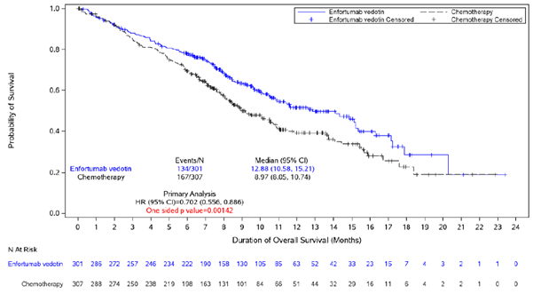
Source: Figure 2-4, p34 of the submission.
Figure 2: Kaplan-Meier plot of PFS by treatment group in the EV-301 trial (ITT population, interim data cut-off)
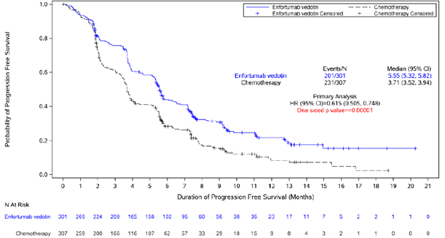
Source: Figure 2-7, p37 of the submission.
  - Following the EV-301 protocol, an interim analysis was performed when approximately 285 OS events (65% of the total planned events) had occurred in the trial. At the interim data cut-off of 15 July 2020 (median follow-up 11.1 months), a statistically significant OS benefit was observed in the enfortumab vedotin arm compared to the chemotherapy arm. The independent data monitoring committee (IDMC) recommended early termination of EV-301 based on this significant difference.
  - Treatment with enfortumab vedotin reduced the risk of death (HR 0.70, 95% CI [0.56, 0.89]) compared with chemotherapy and median OS extended by about 4 months. However, at this interim analysis, the data remain immature; approximately 55% of patients in the enfortumab vedotin arm and 45% of patients in the chemotherapy arm were still alive. Heavy censoring was also noted from 6 months onward and the number of patients at risk rapidly drops from this time point. The ESC considered the OS benefit to be modest.
  - Treatment with enfortumab vedotin also reduced the risk of progression or death (HR 0.62 95% CI [0.51, 0.75]) compared with chemotherapy, with a median PFS benefit just under 2 months.
  - Exploratory subgroup analyses suggested consistent benefit of enfortumab vedotin vs chemotherapy across the three chemotherapy regimens (docetaxel, paclitaxel and vinflunine).
  - The PBAC noted that patients in the enfortumab vedotin arm had approximately twice the overall response rate recorded (117/288 (40.6%)), compared to the chemotherapy arm (53/296 (17.9%)) in the interim analysis of the ITT population.
  - No statistically significant differences in the mean change from baseline to Week 12 in EORTC QLQ-C30 data between enfortumab vedotin and chemotherapy arms were identified, though there was a trend favouring enfortumab vedotin, with patients in the chemotherapy arm reporting more negative effects on physical functioning, global health and role functioning. Given the low compliance rate (the number of subjects who completed the questionnaires divided by the total number of subjects who are expected to complete the questionnaires), and the open label design of the trial, health related quality of life (QoL) data are subject to bias. The Pre-Sub-Committee Response (PSCR) stated that compliance with the completion of questionnaires was consistently numerically lower in the chemotherapy arm. The PSCR argued that if there was a bias toward people in better health states completing the questionnaires then the direction of the bias would be against enfortumab vedotin.
  - The PSCR presented updated OS data (under embargo) for enfortumab vedotin compared to all chemotherapy patients (n=307) and those on taxanes (n=229) in the EV-301 trial. The ESC noted that at the interim analysis (data cut-off 15 July 2020; median follow-up 11.1 months) the EV-301 trial was terminated. The study database was subsequently locked for the primary efficacy analysis, and the protocol was amended to allow subjects in the chemotherapy arm to switch to receive treatment with enfortumab vedotin. With this in mind, the ESC considered these data suggest the treatment effect in the original submission was accurate and reduced the uncertainty associated with the initial data presented.
Figure 3: Kaplan Meier plots of OS for the updated cut of data (data cut-off: 30 July 2021) for the EV-301 trial (ITT analysis)
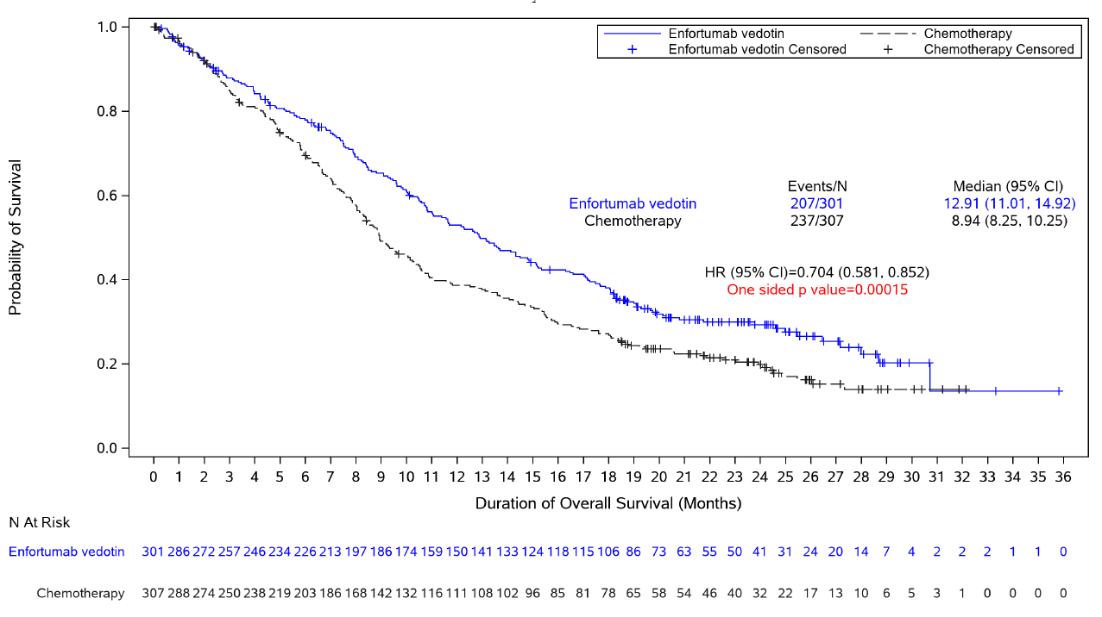
Source: Figure 1, p1 of the PSCR

Figure 4 Kaplan Meier plots of OS for the updated cut of data (data cut-off: 30 July 2021) for the EV-301 trial (enfortumab vedotin versus the taxanes)
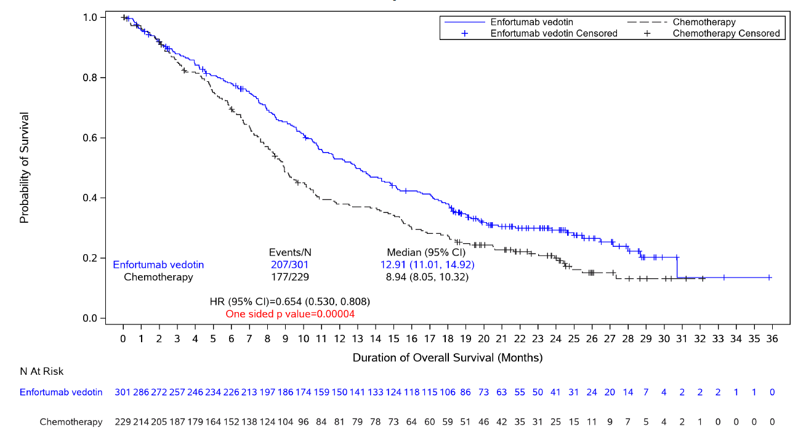
Source: Figure 2, p2 of the PSCR

Comparative harms
  - An overall summary of the incidence of treatment-emergent adverse events (TEAEs) is presented below.
Table 5: Key safety results from EV-301, interim data cut-off
EV-301 | Enfortumab vedotin  N=296  n with event/N (%) | Chemotherapy  N=291  n with event/N (%)
TEAEs | 290 (98.0) | 288 (99.0)
Serious TEAEs | 138 (46.6) | 128 (44.0)
TEAEs leading to withdrawal of treatment | 51 (17.2) | 51 (17.5)
Grade ≥ 3 TEAEs | 210 (70.9) | 193 (66.3)
TEAEs leading to dose reduction of study drug | 101 (34.1) | 81 (27.8)
TEAEs leading to dose interruption of study drug | 180 (60.8) | 85 (29.2)
TEAEs leading to death | 21 (7.1) | 16 (5.5)
TEAEs leading to death, excluding disease progression | 11 (3.7) | 11 (3.8)
Source: Table 2.5-5, p46 of the submission.
CI = confidence interval; n = number of participants reporting data; N = total participants in group; RD = risk difference; RR = relative risk
  - The most commonly observed TEAEs in patients treated with enfortumab vedotin were alopecia (47.0%) and decreased appetite (40.9%). In the chemotherapy arm, the most commonly observed TEAEs were alopecia (37.8%) and anaemia (29.9%). Enfortumab vedotin treatment was associated with less than half as many Grade ≥3 AEs related to neutropenia/anaemia compared to chemotherapy (14% vs 33% respectively) and fewer cases of febrile neutropenia (0.7% vs 5.5%), but enfortumab vedotin had equal or higher rates of all other Grade ≥ 3 AEs, including maculopapular rash (7.4% vs 0%) and hyperglycaemia (3.7% vs 0%).
  - The incidence of serious adverse events (SAEs) was similar across the treatment arms. The most common SAEs in the enfortumab vedotin arm were acute kidney injury (6.4% vs 2.4% in the chemotherapy arm), malignant neoplasm progression (4.1% vs 2.4% in the chemotherapy arm) and pneumonia (4.1% vs 2.4% in the chemotherapy arm). The most common SAE in the chemotherapy arm was febrile neutropenia (5.5% vs 1.4% in the enfortumab vedotin arm).
  - The PSCR acknowledged numerical differences in the rates of Grade ≥ 3 and serious TEAEs. The PSCR noted that enfortumab vedotin has a different mode of action and thus argued it has a different toxicity profile to the taxanes. The PSCR stated there was insufficient evidence to suggest that taxanes have a superior toxicity profile compared to enfortumab vedotin (and vice versa) and noted the rate of TEAEs leading to withdrawal were similar in the two arms of the EV-301 trial.
  - There were more treatment-related deaths associated with enfortumab vedotin treatment compared with the chemotherapy arm (7/296, 2.4% in the enfortumab vedotin arm vs 3/291, 1% in the chemotherapy arm). The ESC noted there were also more treatment-emergent adverse event leading to death enfortumab vedotin treatment compared with the chemotherapy arm (21/296, 7.1% in the enfortumab vedotin arm vs 16/291, 5.5% in the chemotherapy arm).
  - In addition to the differences in safety profiles discussed above, the TGA delegate’s overview (January 2022) noted toxicity concerns, and highlighted AEs of special interest (any grade) which occurred more frequently in the enfortumab vedotin arm compared to chemotherapy in EV-301; these included Stevens-Johnson Syndrome and Severe Cutaneous Adverse Reactions (26% vs 9.3%), hyperglycaemia (11.8% vs 2.7%), peripheral neuropathy (50.3% vs 34.4%), ocular toxicity which resulted in dry eye (24% vs 5.8%) and blurred vision (6.1% vs 2.4%). The overview concluded that for patients who are seeking additional treatment, and who are well enough and prepared for the potential toxicities, enfortumab vedotin may offer nearly 4 months of survival benefit, and presents an acceptable benefit/risk/uncertainty profile. The ESC noted that the FDA label includes a black box warning for severe and fatal cutaneous adverse reactions, including Stevens-Johnson syndrome and toxic epidermal necrolysis (TEN). The ESC noted the EMA paused its consideration of enfortumab vedotin in metastatic urothelial cancer due to concerns over severe skin reactions in a French compassionate access program. The pre-PBAC response stated that analysis of data from the French compassionate access program revealed that the severe cutaneous adverse events reported through the program were consistent in severity and outcomes with those reported from both the clinical study setting and the post-marketing experience. The pre-PBAC response stated that, subsequent to this additional information being brought to the attention of the Committee for Medicinal Products for Human Use (CHMP), on 24 February 2022, the CHMP re-adopted its first positive opinion. The pre-PBAC response also noted that guidance on the recommended management of skin reactions that arise with enfortumab vedotin had recently been published.

Benefits/harms
  - A summary of the comparative benefits and harms for enfortumab vedotin versus chemotherapy is presented in the table below.
Table 6: Summary of comparative benefits and harms for enfortumab vedotin and chemotherapy
Benefits
Progression free survival (median duration of follow up 11.1 months)
Event |  |  | EV |  | Chemotherapy |  | Absolute Difference |  | HR (95% CI)
Progressed, n (%) |  |  | 201/301 (66.8%) |  | 231/307 (75.2%) |  | - |  | 0.615 (0.505, 0.748)
Median PFS, months (95% CI) |  |  | 5.55 (5.32, 5.82) |  | 3.71 (3.52, 3.94) |  | 1.84 |  | -
% not progressed at 6 months (95% CI) |  |  | 44.0 (37.96, 49.84) |  | 28.2 (22.85, 33.76) |  | 15.8% |  | -
% not progressed at 12 months (95% CI) |  |  | 21.7 (16.26, 27.71) |  | 8.3 (4.61, 13.36) |  | 13.4% |  | -
Overall survival (median duration of follow up 11.1 months)
Deaths, n/N (%) |  |  | 134/301 (44.5%) |  | 167/307 (54.4%) |  | - |  | 0.70 (0.56, 0.89)
Median OS, months (95% CI) |  |  | 12.88 (10.58, 15.21) |  | 8.97 (8.05, 10.74) |  | 3.91 |  | -
% Alive at 6 months (95% CI) |  |  | 77.9 (72.74, 82.25) |  | 69.5 (63.85, 74.38) |  | 8.4% |  | -
% Alive at 12 months (95% CI) |  |  | 51.5 (44.63, 58.03) |  | 39.2 (32.60, 45.64) |  | 12.3% |  | -
Harms
 | EV  n/N | Chemotherapy  n/N |  | RR  (95% CI) |  | Event rate/100 patients* |  |  |  | RD  (95% CI)
 |  |  |  |  |  | EV |  | Chemotherapy
Serious TEAEs | 138/296 | 128/291 |  | 1.06 (0.89, 1.27)** |  | 47 |  | 44 |  | 0.03 (-0.05, 0.11)**
Grade ≥ 3 TEAEs | 210/296 | 193/291 |  | 1.07 (0.96, 1.19)** |  | 71 |  | 66 |  | 0.05 (-0.03, 0.12)**
Source: Table 2.5-1, p34, Table 2.5-2, p37 and Table 2.5-5, p46 of the submission
EV = enfortumab vedotin; OS = overall survival; PFS = progression free survival; HR = hazard ratio; RD = risk difference; RR = risk ratio.
* Median duration of follow-up 11.1 months.
**Figures were calculated during evaluation using Stata 15.1 csi Command.
  - On the basis of the key trial EV-301, for every 100 patients treated with enfortumab vedotin in comparison chemotherapy:
- Approximately 13 additional patients will remain progression-free at 12 months;
- Approximately 12 additional patients will remain alive at 12 months;
- Approximately 3 additional patients would experience a serious TEAE over a median duration of follow-up of 11 months;
- Approximately 5 additional patients would experience a Grade ≥3 TEAEs over a median duration of follow-up of 11 months.

Clinical claim
  - The submission described enfortumab vedotin as superior in terms of effectiveness compared with chemotherapy (docetaxel, paclitaxel or vinflunine) and non-inferior in terms of safety compared to chemotherapy.
  - The evaluation considered the claim of superior efficacy appeared reasonable, with a statistically significant OS benefit observed in the key trial EV-301. The ESC considered that while the submission OS data were immature and had heavy censoring the PSCR provided updated OS data to support this claim.
  - The claim of non-inferior safety is not well supported by the evidence. The submission primarily presented TEAEs, which were generally similar between the enfortumab vedotin and chemotherapy arms, however there were numerically more grade ≥ 3 TEAEs in the enfortumab vedotin arm compared to chemotherapy (70.9% vs 66.3% respectively). Chemotherapy was associated with more Grade ≥3 TEAEs related to neutropenia/anaemia than enfortumab vedotin treatment. Enfortumab vedotin had equal or higher rates of all other Grade ≥ 3 AEs compared to chemotherapy, such as maculopapular rash (7.4% vs 0%) and hyperglycaemia (3.7% vs 0%). Enfortumab vedotin was also associated with numerically more SAEs than chemotherapy (46.6% vs 44%). Apart from the ‘febrile neutropenia’ SAE, enfortumab vedotin had approximately equal (<1% difference) or higher rates of all other SAEs. Additionally, more than twice as many patients in the enfortumab vedotin arm required dose interruptions due to AEs compared to the chemotherapy arm (60.8% vs 29.2%). The TGA delegate’s overview (January 2022) also highlighted a range of AEs of special interest which occurred more frequently in the enfortumab vedotin arm than chemotherapy. The PSCR argued that the high rate of dose reductions observed with enfortumab vedotin could be partially attributed to the more frequent dosing schedule and the longer time on treatment. In addition, the PSCR argued the differences may also be attributed to the protocol differences between treatment arms for when doses should be withheld in the EV-301 trial. The ESC acknowledged the differences in the adverse event profiles of EV-301 trial treatment arms made assessment of the non-inferiority claim difficult but considered that enfortumab vedotin had an acceptable safety profile.
  - The PBAC considered that the claim of superior comparative effectiveness was reasonable.
  - The PBAC considered that the claim of non-inferior comparative safety was not well supported by the data but agreed with the ESC that enfortumab vedotin had an acceptable safety profile.

Economic analysis
  - The submission presented a stepped modelled economic evaluation based on the direct randomised trial (EV-301). The type of economic evaluation presented was a cost-utility analysis. The key components of the economic evaluation are presented below.
Table 7: Summary of model structure, key inputs and rationale
Component | Summary
Treatments | Enfortumab vedotin vs docetaxel or paclitaxel. The base-case excluded vinflunine-related data in the comparator arm.
Time horizon | 10 years in the model base-case versus less than two years in trial
Outcomes | Life years and quality adjusted life years.
Methods used to generate results | Partitioned survival model (i.e. area under the curve)
Health states | Three. Progression-free, post-progression and dead.
Cycle length | One month with half cycle correction
Allocation to health states and extrapolation method | For enfortumab vedotin arm, health state allocation is determined by PFS and OS curves directly from EV-301 to 15 months followed by extrapolation of the curves using parametric functions.  For chemotherapy arm, health state allocation is determined by PFS and OS curves generated by applying the HR from EV-301 to the enfortumab PFS and OS curves and extrapolations.  Time on treatment curves for both enfortumab vedotin and chemotherapy are derived from EV-301 and extrapolated using parametric functions of best fit.  Observed PFS and OS data from the comparator arm of EV-301 were not directly used in the model. Applying a HR to inform the comparator arm PFS and OS data introduced uncertainty. The PBAC Guidelines indicate that “where extrapolation is undertaken, use observed time-to-event data in preference to modelled data up to the time point at which the observed data become unreliable as a result of small numbers of patients remaining event-free.” (Section 3A.4.3 Extrapolation, PBAC Guidelines version 5.0).  In addition, the assumption of a continued treatment effect of enfortumab vedotin by applying the HRs for OS and PFS over the time horizon of the model was not justified.  68.8% of QALYs (and 30.7% of costs) occur in the extrapolated period (beyond 15 months).
Health related quality of life | EV-301 trial-based.  The derivation of utilities in the post-progression state is not well described, and it is unlikely that the post-progression utilities measured in EV-301 will represent the average utility of that health state.
Source: Table 3.1-1, p54 of the submission.
HR = hazard ratio; Lys = life years; OS = overall survival; PFS = progression free survival; QALYs = quality adjusted life years.
  - Health state membership for enfortumab vedotin was determined by observed Kaplan-Meier estimates for PFS and OS in EV-301 up to 15 months. The PFS and OS curves are then extrapolated to the model time horizon of 10 years. PFS and OS curves for the comparator (docetaxel and paclitaxel) arm were generated using the estimated hazard ratio from EV-301, applied over the entire model time horizon. The ESC noted the time horizon is longer than has previously been accepted by PBAC for urothelial cancer. The PBAC previously considered that a 7.5 year time horizon was appropriate in its consideration of avelumab for maintenance following first-line treatment of urothelial cancer (paragraph 7.10, avelumab, PSD, March 2021 PBAC meeting). The PBAC previously considered that a 5 year time horizon was appropriate in its consideration of pembrolizumab for second-line treatment of urothelial cancer (paragraph 7.15, pembrolizumab, PSD, July 2018 PBAC meeting). The PBAC agreed with the ESC that a 5 year time horizon would be more appropriate for enfortumab vedotin.
  - The methods of assigning health state membership in the economic analysis are summarised below.
Table 8: Method of assigning health state membership in the economic analysis
Health state | Method of assigning membership | Source | Base-case | Re-specified base-case
Enfortumab vedotin
Progression free | Observed PFS curve for 15 months | EV-301 | KM curve to 15 months | As per base-case
 | Extrapolation to 10 years | Parametric functionª of best fit based on AIC, BIC and visual inspection | Log-logistic | As per base-case
Post-progression | Area between OS curve and PFS curve | Calculated | NA | NA
Dead | Observed OS curve for 15 months | EV-301 | KM curve to 15 months | As per base-case
 | Extrapolation to 10 years | Parametric functionª fit to EV-301, selected by comparing with longer follow up from EV-201 | Exponential | Weibull
Time on treatment^{b} | Observed time on treatment curve for 15 months | EV-301 | KM curve to 15 months | As per base-case
 | Extrapolation to 10 years | Parametric functionª of best fit based on AIC, BIC and visual inspection | Log-normal | As per base-case
Chemotherapy
Progression free | Modelled PFS curve to 10 years based on HR of enfortumab vedotin vs docetaxel and paclitaxel^{c} | EV-301 subgroup analysis | HR = 0.543 | HR = 0.615  (based on ITT)
Post-progression | Area between OS curve and PFS curve | Calculated | NA | NA
Dead | Modelled OS curve to 10 years based on HR of enfortumab vedotin vs docetaxel and paclitaxel^{c} | EV-301 subgroup analysis | HR = 0.649 | HR = 0.702 (based on ITT)
Time on treatment^{b} | Observed time on treatment curve for 15 months for docetaxel and paclitaxel subgroup | EV-301 | KM curve to 15 months | Altered to include time on treatment for vinflunine (based on ITT)
 | Extrapolation to 10 years | Parametric functionª of best fit based on AIC, BIC and visual inspection | Log-normal | As per base-case
Source: Table constructed during the evaluation based on Section 3.4 of the submission.
ªParametric function fit to KM data using R statistical package “flexsurv”.
^{b}Time on treatment is not a health state, and is only used to apply treatment costs.
^{c}Vinflunine patients are removed from the estimate of the HR derived from a comparison of enfortumab vs chemotherapy in EV-301
AIC = Akaike information criterion; BIC = Bayesian information criterion; HR = hazard ratio; ITT = intention to treat; PFS = progression-free survival; OS = overall survival.
Shaded cells represent values changed in the re-specification of the base-case.
  - Observed Kaplan-Meier OS and PFS data for the chemotherapy arm were not used in the economic model. The PBAC Guidelines indicate that, where extrapolation is undertaken, use observed time-to-event data in preference to modelled data up to the time point at which the observed data become unreliable as a result of small numbers of patients remaining event-free. Therefore the observed PFS and OS for the comparator arm should have been used up to around 15 months and then applying parametric models to extrapolate for the remaining of the time horizon. The PSCR acknowledged a difference in approach to modelling the comparator arm through to approximately 15 months. However, the PSCR stated the modelled curves were reasonably similar to the observed Kaplan-Meier curves, and therefore the results are likely to be similar to an approach that had been based on observed survival curves. The ESC noted that, while the model structure was not designed to make this adjustment, the impact of the use of Kaplan-Meier curve data for chemotherapy up to 15 months could be estimated (see Table 11).
  - In addition, applying the HRs for PFS and OS over the time horizon of the model has effectively assumed a continued treatment effect of enfortumab vedotin over docetaxel and paclitaxel. The ongoing treatment effect was not justified. A more reasonable approach would be to nominate a time in the model after which a mechanism is applied to cause the overall survival curves to converge by an appropriate time.
  - The submission removed PFS, OS and time on treatment (ToT) data pertaining to vinflunine for the comparator arm from the EV-301 trial in the base-case of the model, on the basis that vinflunine is not PBS listed or TGA registered for the treatment of urothelial cancer or any other cancer. Given that the selection of chemotherapy (docetaxel, paclitaxel or vinflunine) was a choice of investigators, the comparison of patients treated with enfortumab vedotin and the subgroup of patients receiving docetaxel and paclitaxel was then non-randomised. The PSCR presented the baseline characteristics of patients in the enfortumab vedotin, chemotherapy and docetaxel/paclitaxel subgroups and argued that the baseline characteristics of these groups were generally comparable. Using the information provided in the PSCR to determine characteristics for the vinflunine arm the ESC considered there are several characteristics that differed across the taxanes and vinflunine subgroups, including sex, region, smoking history, histology, number of prior therapies, and some variation of type of PD-(L)1 therapy used. The ESC noted there are key differences in the comparative treatment effect of enfortumab across some of these subgroups. While the PBAC acknowledged that vinflunine is unlikely to be used in clinical practice in Australia, the Committee considered exclusion of vinflunine data may impact the validity of the estimate of the HR.
  - The submission chose exponential distribution to extrapolate OS curve of enfortumab vedotin from 15 months to 10 years. The comparison of the KM OS curve and extrapolated curves using a selection of parametric functions is presented below. All parametric functions presented appear to fit the early KM curve well. After approximately 15 to 20 months, parametric functions diverged considerably with several functions providing estimates that are substantially greater than the remaining (and likely unstable) observed data. The ESC noted a Weibull distribution results in best statistical fit for the model and appeared to be a good visual fit.
Figure 5: Parametric models fit to OS data for the enfortumab vedotin arm of EV-301
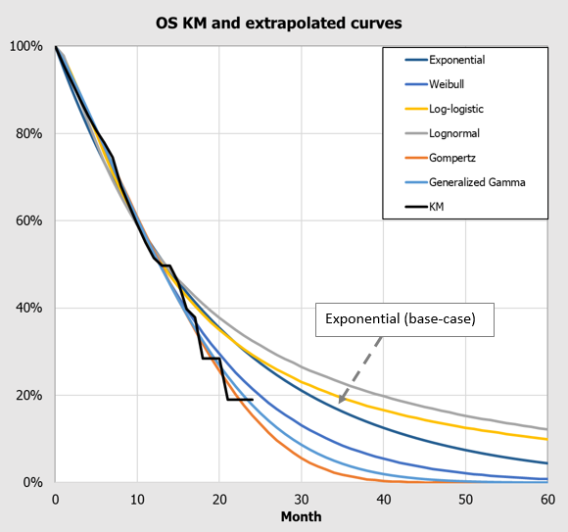
Source: Figure 3-4, p68 of the submission
  - The submission argued that the choice of exponential function for OS extrapolation was supported by the OS curve from a non-randomised study of enfortumab vedotin (EV-201). During the evaluation, KM data from EV-201 were digitally extracted, and a comparison of KM OS curve from EV-201 with OS curve from EV-301 and extrapolated curves using exponential and Weibull models is presented below. The evaluation considered that, visually, the Weibull parametric function appears to be the better fit for the observed data from EV-201 up to about 25 months of follow up and for all observed data from EV-301. Therefore extrapolation of OS using Weibull model was used in a respecified base-case analysis during the evaluation.
Figure 6: Comparison of KM estimates from EV-201, EV-301 and the exponential parametric function (base-case) and the Weibull parametric function (best fit)
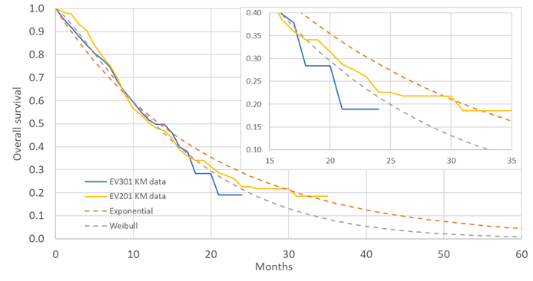
Source: generated during the evaluation from KM data and parametric functions provided in the submission’s economic model. KM data from EV-201 digitally extracted from Figure 3-6, p71 of the submission.
  - The PSCR noted that with the availability of longer-term data from EV-301, OS predicted by the model can be compared to actual OS over a longer time horizon (Figure 7). The PSCR argued that the exponential distribution applied in the submission’s model provided a good fit to the EV-301 longer-term data for the enfortumab vedotin arm whereas the Weibull distribution underestimates the proportion of patients alive, particularly beyond 15 months. The ESC noted that no estimates of statistical fit were provided, the parameters for the exponential function were not updated based on the longer-term data, and a comparison of the modelled and trial data was not provided for the chemotherapy arm. The ESC therefore considered that the exponential extrapolation had not been adequately supported and that the Weibull extrapolation should be used in the base case analysis. The pre-PBAC response provided a statistical analysis comparing the fit of the exponential and Weibull functions to the updated survival data from the EV-301 trial. The statistical analysis presented the sum of squared difference between predicted and observed updated survival for the exponential and Weibull functions and the pre-PBAC response argued that the exponential function has a better fit compared to the Weibull function. The PBAC considered that sum of squared difference between predicted and observed is a non-standard approach for survival data, with other methods such as AIC or BIC preferred.
Figure 7: Overlay of the KM OS plot for enfortumab vedotin from the primary analysis, the updated analysis and the exponential and Weibull functions fit to the primary OS data
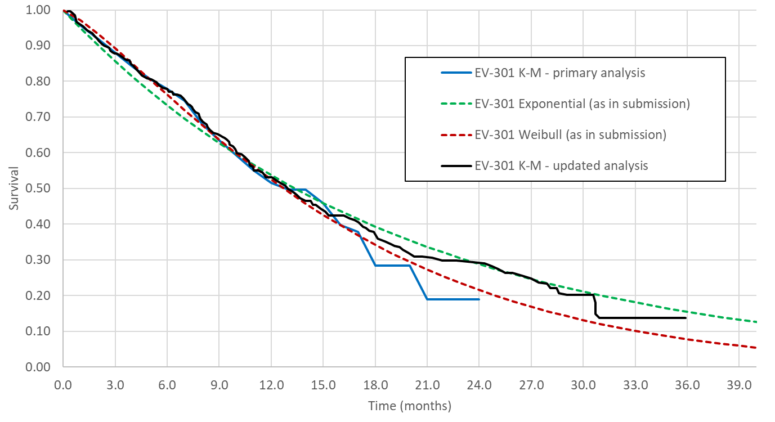
Source: Figure 3, p3 of the PSCR
  - The submission applied a HR 0.649 for OS (enfortumab vedotin vs. docetaxel or paclitaxel) in modelling the OS curve of the comparator arm. The source of the HR is not provided in the submission. Although no subgroup analysis can be identified in the CSR that excludes only vinflunine, the proposed HR for docetaxel or paclitaxel appears inconsistent with HRs reported in the CSR for other subgroups (HR 0.706, 0.705 and 0.770 when comparing with docetaxel only, paclitaxel only and vinflunine only respectively). As noted earlier, the choice of chemotherapy was not a stratification factor in EV-301, patient baseline characteristics may differ systematically across these subgroups and the results can only be interpreted as observational and exploratory. The PSCR stated that the HRs reported for the ITT population in the CSR for the primary analysis (data cut-off: July 15, 2020) and the HRs applied in the model for the enfortumab vedotin versus taxanes group were based on Cox models that adjusted for ECOG PS, region, and liver metastasis. The PSCR) stated the HRs reported in the CSR for enfortumab vedotin versus subgroups treated with docetaxel and paclitaxel were based on unadjusted Cox models. The ESC considered the inconsistency of the HR with the study results is likely due to the method of generating the HR, the difference in baseline patient characteristics across the control therapies and imbalances of patients assigned to the different control therapies (with the potential for better performing patients being excluded with the removal of vinflunine). The PBAC agreed with the ESC and considered the HR observed from the ITT population is likely to be more reasonable than the HR from the subgroup. The PBAC noted that during the evaluation, the HR from ITT population was used in the respecified base-case analysis.
  - Due to the maturity of the PFS and ToT data, the model is not sensitive to the parametric functions for extrapolation or the HRs to model the PFS for the chemotherapy arm in the submission’s base-case. In the respecified analysis, the model becomes slightly more sensitive to this parameter as the QALY gain due to incremental PFS accounts for a higher proportion of overall gain in the model.
  - Utilities were derived from the results of EQ-5D-5L questionnaires administered to patients in the EV-301 trial. EQ-5D-5L results were mapped to EQ-5D-3L scores, and translated to utilities using UK preference weights. The submission stated that UK preference weights were used due to the absence of appropriate Australian weights. The ESC considered that use of Australian EQ-5D-3L utility weights would be more appropriate. The ESC noted that individual patient data of EQ-5D would be required to test the impact of using Australian preference weights.
  - The EV-301 study reported a trend toward a higher utility estimates in patients treated with enfortumab vedotin compared with chemotherapy in the progression free health state, and the submission applied treatment specific utility values for this health state. A single utility value was applied in the post progression health state. As noted earlier, given the low compliance rate for the EQ-5D in EV-301, and the open label design of the trial, the results of EQ-5D data were subject to bias. The PSCR argued that the direction of the bias would be against enfortumab vedotin (see paragraph 6.13).
  - The utility values used in the submission (0.74 for progression free in enfortumab vedotin arm, 0.71 for progression free in chemotherapy arm, and 0.61 for progressed disease in both arms) are higher than those applied in a cost-utility analysis of atezolizumab for second-line treatment of metastatic bladder cancer derived from Imvigor 211, a study of atezolizumab in metastatic bladder cancer. However, they are consistent with the values deemed acceptable in the NICE single technology assessment of nivolumab for the treatment of la/mUC following failure after platinum chemotherapy. The ESC noted the differential utilities by treatment arm for the progression free health state. Noting the different adverse event profiles of the two treatment arms the ESC considered that the use of a higher utility value for the progression free state for patients treated with enfortumab vedotin was not adequately supported and it may be more appropriate to use non-treatment specific utilities for the progression free health state (in addition to the use of non-treatment specific utilities for progressed disease). The pre-PBAC response accepted that any respecified base case analysis could assume non-treatment specific utilities for patients in equivalent health states regardless of treatment arm.
  - The key drivers of the model are summarised below.
Table 9: Key drivers of the model
Description | Method/Value | Impact  Base-case ICER $||¹/QALY
Extrapolation | Exponential distribution was used for OS extrapolation in the base-case of the model | High, favours enfortumab vedotin.  Use of Weibull distribution increased the ICER to $||||²/QALY gained.
OS HR used to generate OS curve for the chemotherapy arm | The submission used OS HR from the subgroup of patients receiving docetaxel or paclitaxel in the comparator arm (i.e. excluding patients who have received vinflunine) | Moderate, favours enfortumab vedotin. Use of OS HR from the ITT population increased the ICER to $||||³/QALY gainedª.
a The ICER calculated includes the application of the ITT HR for both OS and PFS, and increasing ToT for the chemotherapy arm to match that of the mean treatment duration of docetaxel, paclitaxel and vinflunine. Changes to PFS and ToT do not have a marked impact on the model.
Source: Compiled during evaluation based on Section 3.9 of the submission.
HR = hazard ratio; ICER = incremental cost effectiveness ratio; ITT = intention to treat; OS = overall survival; QALY = quality of adjusted life year.
The redacted values correspond to the following ranges
¹ $95,000 to < $115,000
² $135,000 to < $155,000
³ $115,000 to < $135,000
  - The results of the stepped economic evaluation are summarised below.
Table 10: Results of the stepped economic evaluation
 | Submission base-case |  |  | Respecified base-case
 | EV arm | DP arm | Increment | EV arm | DP arm | Increment
Step 1: trial-based costs and outcomes (15 months)
Costs | $| | $| | $| | $| | $| | $|
Life-years | 0.880 | 0.748 | 0.132 | 0.880 | 0.773 | 0.106
QALYs | 0.612 | 0.498 | 0.113 | 0.612 | 0.513 | 0.099
Incremental cost/life year | $|¹ |  |  | $|⁴
Incremental cost/QALY | $|¹ |  |  | $|⁴
Step 2: 10 year time horizon
Total costs | $| | $| | $| | $| | $| | $|
Life years | 1.538 | 1.036 | 0.502 | 1.316 | 1.002 | 0.314
QALYs | 1.040 | 0.677 | 0.363 | 0.901 | 0.656 | 0.245
Incremental cost/life year | $|² |  |  | $|⁵
Incremental cost/QALY | $|³ |  |  | $|¹
Source: Tables 3.7-1 and 3.7-2, p88-89 of the submission. Respecified base-case generated during the evaluation. .
LYS = life year saved; QALY = quality adjusted life year
Estimates for the DP arm are different from the submission due to an error identified in the economic analysis.
Note: Costs > $100 are rounded to whole dollars. Costs and outcomes are discounted at | |% per annum
Respecified base-case uses a Weibull parametric function for the extrapolation of the OS curve for enfortumab (base case = exponential), applies the ITT HR for OS and PFS (base case = subgroup HR for docetaxel and paclitaxel), and time on treatment for the chemotherapy arm is based on ITT (base case = subgroup of docetaxel and paclitaxel).
The redacted values correspond to the following ranges
¹ $155,000 to < $255,000
² $75,000 to < $95,000
³ $95,000 to < $115,000
⁴ $255,000 to < $355,000
⁵ $115,000 to < $135,000
  - The extrapolation of health outcomes to the model time horizon of 10 years had the most impact on the results of the economic evaluation. Comparing the exponential model used to extrapolate OS in the submission’s base-case, the use of a Weibull extrapolation reduced the life years accrued in the enfortumab vedotin arm from 1.54 to 1.32. As the comparator arm is generated by applying a HR, changing the OS extrapolation for enfortumab vedotin also reduces the life years accrued in the comparator arm from 1.04 to 0.94 (step not shown in table above). Applying the ITT HR from EV-301 to the respecified (Weibull) extrapolation, the life years accrued in the comparator arm result in a smaller drop from 1.04 in the base-case to 1.00 in the respecified base-case. Therefore, the combination of using a more reasonable Weibull extrapolation and the ITT HR results in a minor reduction in the QALYs generated in the comparator arm (approx. 3%) compared with more substantial reduction in the enfortumab vedotin arm (approx. 13%).
  - In the respecified base-case, approximately one-third of the incremental life years (undiscounted) are accrued prior to the 15 month Kaplan-Meier truncation point. By 5 years, almost all of the incremental differences between the arms have been accrued. The accumulated life years over time by treatment arm are illustrated below.
Figure 8: Accumulated life year gains (undiscounted) over time in the model, by treatment arm (respecified base-case)
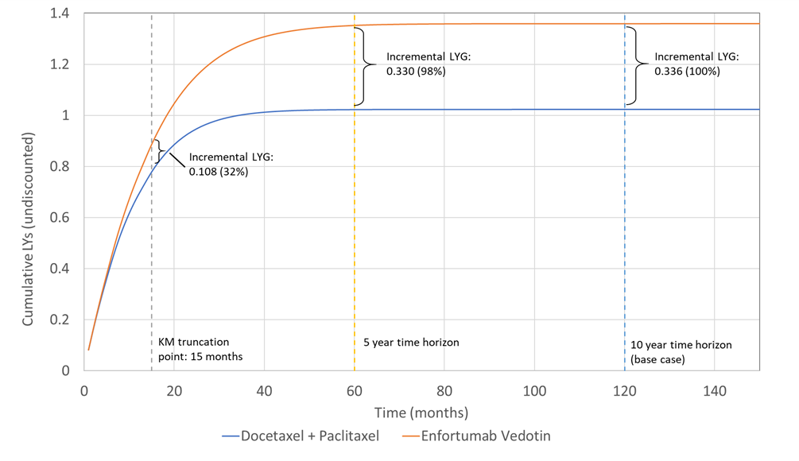
Source: generated during the evaluation
KM = Kaplan-Meier; LY = life year; LYG = life years gained.
  - The results of key sensitivity analyses are presented below.
Table 11: Results of key sensitivity analyses for the submission base-case
Variables altered in sensitivity analysis | Incremental costs ($) | Incremental QALYs | ICER ($)
Base-case results | | | 0.363 | |
Respecified base-case results  Weibull parametric function for OS, ITT HR for OS and PFS, ITT data for ToT in the comparator arm | | | 0.245 | |
Time horizon (base-case = 10 years)
5 years | | | 0.332 | |
20 years | | | 0.365 | |
Selection of parametric function for OS (base-case = exponential)
Weibull | | | 0.281 | |
Gompertz | | | 0.219 | |
Log-normal | | | 0.505 | |
Log-logistic | | | 0.476 | |
Generalised gamma | | | 0.240 | |
Source of data for comparator arm (base-case = docetaxel & paclitaxel patients in EV-301)
Docetaxel, paclitaxel & vinflunine patients in EV-301ª | | | 0.368 | |
Actual impact of using the ITT data for ToT, PFS and OS^{b} | | | 0.316 | |
OS HR for chemotherapy vs enfortumab vedotin (base-case = point estimate [1.541])
Lower 95% CL around point estimate [1.194] | | | 0.197 | |
Upper 95% CL around point estimate [1.989] | | | 0.495 | |
Source of utilities (base-case = treatment-specific utilities while progression-free; not treatment-specific utilities post-progression)
Treatment-specific utilities for both health states | | | 0.373 | |
Non-treatment-specific utilities for both health states | | | 0.351 | |
Use of observed Kaplan-Meier data for chemotherapy arm (base-case = not used)^{c}
Observed data for chemotherapy up to 15 months | | | 0.344 | |
Variations to respecified base case requested by ESC (respecified base case = Weibull parametric function for OS, ITT HR for OS and PFS, ITT data for ToT in the comparator arm, 10 year time horizon)^{c}
Respecified base-case results + 5 year time horizon | | | 0.241 | |
Respecified base-case results + KM curve for chemotherapy up to 15 months | | | 0.241 | |
Respecified base-case results + KM curve for chemotherapy up to 15 months + 5 year time horizon | | | 0.237 | |
Respecified base-case results + non-treatment specific utilities for both health states | | | 0.227 | |
Respecified base-case results + non-treatment specific utilities for both health states + 5 year time horizon | | | 0.224 | |
Respecified base-case results + KM curve for chemotherapy up to 15 months + non-treatment specific utilities for both health states | | | 0.223 | |
Respecified base-case results + KM curve for chemotherapy up to 15 months + non-treatment specific utilities for both health states + 5 years | | | 0.220 | |
Source: Table 3.8-1, pp90-91 and generated during the evaluation based on the Section 3 workbook.
ªThe sensitivity analysis presented claims to use docetaxel, paclitaxel and vinflunine as the source of data, however the model only incorporates a longer time on treatment as was observed in the EV-301 for the whole population. It does not include ITT hazard ratios to simulate the comparator curves.
^{b}The sensitivity analysis performed during the evaluation has used the EV-301 ITT based hazard ratio to generate the survival curves for docetaxel and paclitaxel, as well as implementing the longer time on treatment for the docetaxel + paclitaxel arm. This is a multivariate analysis.
^{c} Sensitivity analyses undertaken during the development of the ESC Advice.
The redacted values correspond to the following ranges
¹ $95,000 to < $115,000
² $155,000 to < $255,000
³ $115,000 to < $135,000
⁴ $135,000 to < $155,000
⁵ $75,000 to < $95,000
  - The model is most sensitive to parametric models used for OS extrapolation, and the 95% confidence interval of OS HR used to generate the OS curve of chemotherapy arm.
  - The ESC noted the respecified base-case proposed by the evaluation increased the base-case ICER from $95,000 to < $115,000/QALY to $155,000 to < $255,000/QALY. The ESC considered the use of the Weibull extrapolation and the ITT HR in the respecified base-case appropriate as outlined in paragraphs 6.36 and 6.37. However, the ESC for clinical plausibility considered that any respecified base-case should further incorporate a 5 year time horizon although noted this only had a minimal impact on the respecified base-case ICER $155,000 to < $255,000/QALY). Given the different adverse event profiles of the two treatment arms the ESC considered that it may be reasonable to use non-treatment specific utilities for both the progression free and progressed health states. The PBAC noted the ESC respecified base-case increased the ICER to $155,000 to < $255,000/QALY.
  - The ESC noted that approximating the impact of incorporating the KM curve for chemotherapy up to 15 months in the respecified base-case increased the ICER to $155,000 to < $255,000/QALY. While the ESC considered it preferrable to use time-to-event-data the Committee noted the model structure was not designed to make this adjustment and hence it could not reliably be included in a re-specified base-case.

Drug cost/patient/course
Table 12: Drug cost per patient per month and per course for enfortumab vedotin (based on proposed effective price) and chemotherapy
 | Trial dose and duration | Model^{b} | Financial estimates | Comparator  Trial dose and duration | Comparator  Model^{b} | Comparator  Financial estimates
Mean dose (per month) | 220 mgª | 234.5mg | 289.5mg | Paclitaxel: 431.9mg  Docetaxel: 184.6mg^{g} | Paclitaxel: 441.1mg  Docetaxel: 192.3mg | NR
Mean duration | 5.4 months | 6.97 months^{c} | 7.47 months^{d} | 3.96 months^{f} | 4.06 months^{c} | NR
Cost/patient/month | - | $| | $ | ^{h} | - | $242 | NR
Cost/patient/course | - | $| | $ | ^{h} | - | $982 | NR
NR = not reported. Cycle length = 1 month
Source: Table 11, p79 of the CSR, Table 12.2.1, pp228-31 of the CSR, Section 3 workbook, sheet 3a of the utilisation-and-cost-model. Italicised values have been calculated.
ª Dose intensity (2.98mg/kg/cycle) x average weight (73.9 kg)
^{b}Mean dose dispensed accounting for efficient vial combination across the distribution of patient weights in EV-301.
^{c}Mean treatment duration accounting for half-cycle correction – estimated using mean treatment duration across docetaxel, paclitaxel and vinflunine (respecified base-case).
^{d}Mean treatment duration without half-cycle correction
^{e}Docetaxel and Paclitaxel 21 day cycles have been converted to monthly doses (/21x365.25/12)
^{f}Combined mean duration of treatment across docetaxel, paclitaxel and vinflunine
^{g}Monthly doses for paclitaxel and docetaxel in the study are estimated by multiplying dose intensity (161.06mg and 68.84mg, respectively) by the average body surface area (1.85m²), dividing by 21 days, multiplying by 365.25/12.
^{h}Cost per course is derived by dividing cost to R/PBS in Year 1 by the number of patients treated. Cost per month further divides this by treatment duration.
  - The monthly doses for the financial section and the economic model are not comparable. The sequence in which relative dose intensity is applied results in a difference in the mean dose. The financial estimates account for relative dose intensity by reducing the number of scripts required, whereas the economic evaluation more appropriately applies a reduced dose.

Estimated PBS usage & financial implications
  - This submission was considered by DUSC.
  - The submission took an epidemiological approach to estimating the number of patients treated with enfortumab vedotin. The key inputs for financial estimates are summarised below.
Table 13: Key inputs for financial estimates
Data | Value | Source | Comment
Eligible population
Projected Australian Population | Year 1: 26,727,025  Year 6: 28,765,734 | ABS population data | Appropriate
Incidence rate of urothelial cancer | 13.32 per 100,000 person-years | GLOBOCAN estimate of number of patients in Australia with bladder cancer in 2020 | The incidence rate is applied directly to the Australian population.
Proportion of patients with la/m disease | 25% | Bellmunt (2021) ¹ | The reference provided in the submission is a website (UpTo Date). The author of the article does not cite any source for the estimate of the proportion of patients who present with or will develop locally advanced or metastatic disease. The estimate cannot be verified.
Proportion who receive 1L platinum based chemotherapy | 90% | Clinical advice | This estimate cannot be verified.
Proportion eligible for avelumab | 75% | Based on an estimate of the proportion of patients remaining progression free 4 months after starting platinum based therapy² | This is reasonable.
Proportion not treated with avelumab | Year 1: 60%  Year 2: 25%  Year 3-6: 10% | Clinician advice | The submission assumes that avelumab will be used increasingly over the years following listing. After 2 years, avelumab is anticipated to be used in 90% of those eligible. This estimate cannot be verified.
Proportion treated with pembrolizumab | 75% | Clinician advice | This estimate is applied only to those not treated with avelumab.
Treatment utilisation
Uptake of enfortumab vedotin | Dependent on pathway  (higher for shorter pathways)  Year 3: 80% (post-avelumab)  Year 3: 60% (post-pembrolizumab) | Clinician advice | Estimates of uptake are uncertain
Grandfathered patients | Year 1: 90 | Sponsor | Grandfathered patients only enter in year 1. This may be reasonable. However, no reduction in duration of therapy has been estimated for this population.
Average treatment duration | 7.47 months | EV-301 (extrapolated time on treatment curve presented in Section 3) | This is appropriate
Compliance / relative dose intensity | 79.35% | EV-301 | This is appropriate, however the sequence in which this is applied is likely incorrect.
Vial distribution | 1.1 x 20mg  2.5 x 30mg | Based on efficient vials for the target dose (1.25mg/kg) for the distribution of patients (by weight) in EV-301 | This is based on the target dose, and not the dose as adjusted by mean relative dose intensity.
Source: Tables 4-1, 4-2, 4-3, 4-4, 4-5, 4-6, 4-7, 4-9, pp95-107, text in Section 4 and Financial estimates – enfortumab vedotin (PADCEV) – la-mUC – March 2022 PBAC meeting.xlsx.
1L = first line; la/m = locally advanced or metastatic; UC = urothelial cancer.
ªBeneficiary types: General O ($41.30) = general ordinary; General SN ($6.60) = general safety net; Concess O = ($6.60) concessional ordinary; Concess F ($0) = concessional free; RPBS O ($6.60) = RPBS ordinary; RPBS SN ($0) = RPBS safety net.
  - The submission estimated the proportion of eligible patients for three different pathways.
- Eligible for avelumab and treated with avelumab (maintenance)
- Eligible for avelumab, not treated with avelumab and treated with pembrolizumab (after progression)
- Not eligible for avelumab and treated with pembrolizumab
  - The purpose for separating the population by pathway is that a different proportion of patients will receive enfortumab depending on the pathway. This approach is reasonable.
  - The submission anticipated that 90 patients would receive enfortumab vedotin via a grandfathering restriction for patients enrolled in an early access scheme. Grandfathered patients are assumed in the submission to receive the same duration of treatment as incident patients. This is unlikely to be accurate. As grandfathered patients make up only 30% of the estimated number of patients in year 1, and zero patients from year 2 onwards, the impact of this assumption is likely to be minimal.
  - The submission assumed that the treatment uptake rate of enfortumab vedotin would double over the first three years. Given that there are no current market competitors for enfortumab vedotin, the uptake rate may be more rapid than this. The submission further assumed that, once steady (from year 3 onwards), the uptake rate of enfortumab vedotin is estimated to be 80% following avelumab and 60% following pembrolizumab. It may be reasonable that the estimated uptake rate is lower when enfortumab vedotin is used in a third-line setting (post pembrolizumab) compared with a second-line setting (post avelumab).
  - To estimate the number of scripts dispensed, the submission converted the number of treated patients to treated patient-years. This is done by multiplying incident patients by average duration of treatment (7.47 months). Treatment duration is derived from the economic model in which the observed ToT curve is fitted with a parametric function from 15 months onwards, and modelled over 10 years.
  - The number of scripts dispensed was estimated by applying the relative dose intensity observed in EV-301 (79.35%). The reduced number of scripts is then applied to the number of vials dispensed based on efficient usage of vials for the 100% target dose. This approach is inappropriate. Reductions in relative dose intensity that are a consequence of dose reductions will not impact the number of scripts, but will reduce the number of vials. The sequence in which the relative dose intensity is applied markedly underestimates the number of scripts, and slightly underestimates the number of vials that will be dispensed. The pre-PBAC response agreed with DUSC that the approach taken may slightly underestimate the financial implications to the PBS/RPBS.
  - No cost offsets were included in the submission. It is stated that there is a high likelihood that the listing of enfortumab vedotin will result in taxanes (docetaxel or paclitaxel) being displaced to a later line of therapy rather than replaced. The submission claims that this may be increasingly true where enfortumab vedotin becomes used in the second-line setting after avelumab.
  - The estimated use and financial implications of enfortumab vedotin are summarised below.
Table 14: Estimated use and financial implications (effective price)
 | Year 1 | Year 2 | Year 3 | Year 4 | Year 5 | Year 6
Estimated extent of use
Number of patients treated | | | | | | | | | | | |
Number of scripts dispensedª | | | | | | | | | | | |
Estimated financial implications of enfortumab vedotin
Cost to PBS/RPBS less copayments^{b} ($) | | | | | | | | | | | |
Estimated financial implications for other medicines
Cost to PBS/RPBS less copayments | | | | | | | | | | | |
Net financial implications
Net cost to PBS/RPBS^{b} ($) | | | | | | | | | | | |
Net cost to MBS ($) | | | | | | | | | | | |
Net cost to PBS/RPBS/MBS^{b} ($) | | | | | | | | | | | |
Source: Table 4-6, p102, Table 4-8, p104 of the submission.
ª Average treatment duration per patient 7.47 months, 0.75 dose per week (Calculated as 3 doses per 4 weeks – day 1, 8 and 15 of a 28 day cycle), and 79.35% dose intensity (which has been applied to the number of scripts).
^{b}Figures have been corrected to reflect the cost of an average dose of 96.5mg (based on the dispensed efficient vial dose calculated using the distribution of patient weights in EV-301). The submission figures used the cost of 130mg (maximum dispensed amount).
The redacted values correspond to the following ranges:
¹ <500
² 5,000 to < 10,000
³ $10 million to <$20 million
⁴ $0 to <$10 million
⁵ 500 to <5,000
⁶ 10,000 to <20,000
⁷ $20 million to <$30 million
  - The total cost to the PBS/RPBS of listing enfortumab vedotin was estimated to be $20 million to < $30 million in Year 6, and a total of $100 million to < $200 million in the first 6 years of listing.
  - DUSC considered that overall the financial estimates presented in the submission are reasonable. The main issues are:
- The submission has applied relative dose intensity to the financial model at a step that reduces the number of scripts rather than applying it to the dose dispensed. This underestimates the number of scripts (unless dose intensity is entirely driven by delays in treatment). It may slightly underestimate the financial implications to the R/PBS because the average dispensed amount per patient (adjusted for efficient usage of vials) is slightly lower than had dose intensity been applied directly to the dose dispensed for each patient prior to the calculation of efficient usage of vials. DUSC agreed with the evaluation that the 5% underestimate in costs may be larger if dose intensity is primarily a result of dose reductions rather than dose delays. The pre-PBAC response noted 34.1% of patients treated with enfortumab vedotin had TEAEs resulting in a dose reduction and 60.8% of patients had TEAEs resulting in dose interruptions. As such, the pre-PBAC response) argued that the financial estimates will only have been slightly underestimated.
- DUSC noted an uncited UpToDate article was used to establish the proportion of urothelial cancer patients with locally advanced or metastatic cancer which was not appropriate and may lead to an underestimated eligible pool. The pre-PBAC response accepted that there is uncertainty in relation to the proportion of patients with urothelial cancer who develop locally advanced or metastatic disease but noted that there do not appear to be better estimates of this proportion.
- DUSC noted that the estimated current number of patients using pembrolizumab per month using PBS statistics was similar to the number of patients proposed in the submission. DUSC noted, however that the number of patients who would use avelumab increase the total number of locally advanced and metastatic patients by < 500 in the first year. DUSC considered this an area of uncertainty as the number of patients treated with avelumab could not be verified. DUSC considered sales and compassionate data from the sponsor of avelumab may help inform the estimates. The pre-PBAC response stated that the sponsor has no further intelligence on the use of avelumab.
- DUSC considered that early termination of the trial EV-301 would likely result in a shorter duration of therapy than would occur in practice.

Quality Use of Medicines
  - The sponsor did not identify any quality of use medicines issues.
  - DUSC considered planned education for prescribers would be important, noting that the FDA currently has a black box warning for enfortumab vedotin due to the incidence of Stevens-Johnson syndrome/ toxic epidermal necrolysis.

Financial Management – Risk Sharing Arrangements
  - The submission did not propose a risk sharing arrangement but expressed a willingness to enter into such an arrangement should the PBAC consider this necessary to provide the Government with greater financial certainty.
For more detail on PBAC’s view, see section 7 PBAC outcome.
- PBAC Outcome
  - The PBAC did not recommend enfortumab vedotin for the treatment of patients with locally advanced (Stage III) or metastatic (Stage IV) urothelial cancer who have progressed on or after a platinum-containing chemotherapy regimen and either a programmed cell death-1 (PD-1) inhibitor or a programmed cell death ligand-1 (PD-L1) inhibitor. The PBAC considered data from the key trial EV-301 supported a moderate overall survival (OS) benefit. In addition, the PBAC considered the evidence presented suggested that enfortumab vedotin had significant potential adverse events but overall an acceptable safety profile. However, the PBAC considered the incremental cost-effectiveness ratio (ICER) proposed in the submission was uncertain and the respecified ICERs were high at the proposed price.
  - The PBAC noted the input from an individual and organisations which highlighted the clinical need for treatment options for patients with this indication. In addition, the PBAC noted the Medical Oncology Group of Australia’s strong support for the submission. The PBAC considered there was a moderate clinical need for more effective therapies for metastatic urothelial cancer as current PBS listed therapies were moderately effective.
  - The PBAC considered the nominated comparators of docetaxel or paclitaxel, administered as single agents, to be appropriate.
  - The PBAC noted that the clinical claim was based on data from the key trial EV-301. The PBAC noted that at the interim data cut-off, treatment with enfortumab vedotin reduced the risk of death (hazard ratio (HR) 0.70, 95% CI [0.56, 0.89]) compared with chemotherapy, and median OS was extended by approximately 4 months. The PBAC agreed with the ESC that while the OS data presented in the submission were immature, the updated OS data provided in the Pre-Sub-Committee Response (PSCR) suggested the treatment effect in the original submission was accurate and reduced the uncertainty associated with the initial data presented. At the interim data cut-off, the PBAC noted that treatment with enfortumab vedotin reduced the risk of progression or death (HR 0.62 95% CI [0.51, 0.75]) and increased the overall response rate (40.6% vs 17.9%) compared to chemotherapy. Although there was a trend favouring enfortumab vedotin, the PBAC noted that no statistically significant differences in EORTC QLQ-C30 scores between enfortumab vedotin and chemotherapy arms were identified (see paragraph 6.13). The PBAC considered the claim of superior comparative effectiveness was reasonable with a moderate OS benefit observed.
  - The PBAC noted that although treatment emergent adverse events (TEAEs) were generally similar between arms, enfortumab vedotin was associated with numerically more Grade ≥ 3 TEAEs and serious TEAEs than chemotherapy. There were also more treatment-related deaths associated with enfortumab vedotin compared with the chemotherapy arm (7/296, 2.4% vs 3/291, 1% respectively). In addition, the PBAC noted the adverse events of special interest which occurred more frequently in the enfortumab vedotin arm compared to chemotherapy including Stevens-Johnson syndrome and Severe Cutaneous Adverse Reactions (26% vs 9.3%) along with peripheral neuropathy (50.3% vs 34.4%). The Committee noted the ACM suggested a boxed warning for severe skin toxicities that included fatalities. Acknowledging the differences in the adverse event profiles of the EV-301 treatment arms, the PBAC considered that the claim of non-inferior comparative safety was not well supported by the data presented in the submission. However, the PBAC agreed with the ESC that enfortumab vedotin had significant potential adverse events but overall an acceptable safety profile.
  - The submission presented a cost-utility analysis with a 10 year time horizon and a resulting base-case ICER of $95,000 to < $115,000 /quality-adjusted life year (QALY). The PBAC agreed with the ESC that for clinical plausibility the model time horizon should be reduced to 5 years and noted this had a minimal impact on the ICER (increased to $115,000 to < $135,000/QALY). The PBAC considered that applying the HR observed from the subgroup analysis (as had been undertaken in the submission) was associated with a high level of uncertainty. The PBAC agreed with the ESC that exclusion of vinflunine data to create the taxane subgroup used in the model may impact the validity of the estimate of the HR and hence considered the use of intention-to-treat (ITT) HR results in the model more appropriate. The PBAC noted that use of ITT data for OS and PFS (along with time on treatment) increased the base-case ICER to $115,000 to < $135,000/QALY gained. The PBAC also noted the pre-PBAC response accepted that the use of non-treatment specific utilities for patients in equivalent health states regardless of treatment arm may be appropriate. The PBAC noted the ESC proposed a respecified base-case that incorporated a 5 year time horizon, ITT HRs data for OS and PFS (along with time on treatment), non-treatment specific utilities for both the progression free and progressed health states and applied a Weibull extrapolation for OS. The PBAC noted this increased the ICER to $155,000 to < $255,000/QALY. The PBAC considered the ICER proposed in the submission was uncertain and the respecified ICERs were high at the proposed price.
  - The PBAC noted the PSCR and pre-PBAC response arguments that the exponential distribution provided a better fit to the EV-301 longer-term OS data for the enfortumab vedotin arm compared to the use of the Weibull extrapolation. The PBAC considered that this remained an area of uncertainty and advised that it would be appropriate in a resubmission for (i) changes as per the ESC respecified base-case scenario including use of the Weibull function for OS extrapolation unless the use of an exponential distribution can be adequately justified, which may include provision of additional information, including the Clinical Study Report, for the analysis using the July 2021 data cut-off for the EV-301 trial, and (ii) if the ICER was in the order of $55,000 to < $75,000/QALY.
  - The PBAC noted the advice from DUSC that the approach taken to the application of relative dosing intensity in the financial estimates likely underestimated costs by around 5%. The PBAC considered that this should be corrected in any resubmission. In addition, the PBAC noted DUSC advice that, while the estimated number of patients predicted to use pembrolizumab was consistent with current utilisation data, the predicted number of patients treated with avelumab was a source of uncertainty. Despite this uncertainty, DUSC considered that overall the financial estimates presented in the submission were reasonable. The PBAC considered it would be appropriate for a resubmission to address any residual uncertainty regarding the number of patients treated with enfortumab vedotin by data triangulation. The PBAC considered this would involve verifying the submission’s estimate of patient numbers against those derived from using current pembrolizumab utilisation data for this indication and an assumption that 80% of such patients would subsequently receive enfortumab vedotin.
  - The PBAC considered a risk sharing arrangement would not be required as the Committee considered the risk of use outside of the proposed population was low.
  - The PBAC considered the outstanding issues could be resolved in a simple resubmission for enfortumab vedotin using the early re-entry pathway. If the sponsor accepts this pathway, the following changes may address these outstanding issues without requiring further re-evaluation:
- If available, provision of the Clinical Study Report regarding the updated analysis with data cut-off of July 2021 for the EV-301 trial.
- Use of the ESC respecified base-case as outlined in paragraph 7.7.
- Revision of the financial estimates as outlined in paragraph 7.8 and recalculation of the financial implications using the revised enfortumab vedotin price.
  - The early re-entry resubmission must be lodged by week 7 of the current PBAC cycle or the next cycle. If the issues cannot be addressed by the sponsor in a simple resubmission and the early re-entry timing is not acceptable, a standard re-entry pathway is available.
  - The PBAC noted that this submission is eligible for an Independent Review.
Outcome:
Not recommended
- Context for Decision
The PBAC helps decide whether and, if so, how medicines should be subsidised through the Pharmaceutical Benefits Scheme (PBS) in Australia. It considers applications regarding the listing of medicines on the PBS and provides advice about other matters relating to the operation of the PBS in this context. A PBAC decision in relation to PBS listings does not necessarily represent a final PBAC view about the merits of the medicine or the circumstances in which it should be made available through the PBS. The PBAC welcomes applications containing new information at any time.
- Sponsor’s Comment
Astellas Pharma Australia thanks the PBAC for it's assessment of ENFORTUMAB VEDOTIN (Padcev®). We will work with the PBAC on an accelerated pathway for a Padcev® PBS listing for patients with locally advanced (Stage III) or metastatic (Stage IV) urothelial cancer, who meet the criteria's outlined in our submission.

Powles T, et al. Avelumab Maintenance Therapy for Advanced or Metastatic Urothelial Carcinoma. New England Journal of Medicine. 2020;383(13):1218-30.
Bellmunt J, et al. Pembrolizumab (pembro) versus investigator’s choice of paclitaxel, docetaxel, or vinflunine in recurrent, advanced urothelial cancer (UC): 5-year follow-up from the phase 3 KEYNOTE-045 trial. Journal of Clinical Oncology. 2021;39(15_suppl):4532-.
Cherny NI, Dafni U, Bogaerts J, et al: ESMO-Magnitude of Clinical Benefit Scale version 1.1. Annals of Oncology 28:2340-2366, 2017]
label (fda.gov)
Astellas, Seagen. Sponsor Notification to Health Authorities (enfortumab vedotin). 28 January 2022.
Lacouture ME, Patel AB, Rosenberg JE & O’Donnell PH. Management of dermatologic events associated with the nectin-4-directed antibody-drug conjugate enfortumab vedotin. Oncologist 2022;27:e223–e232, https://academic.oup.com/oncolo/advance-article/doi/10.1093/oncolo/oyac001/6537593
Viney R, Norman R, King MT, Cronin P, Street DJ, Knox S, et al. Time trade-off derived EQ-5D weights for Australia. Value Health. 2011;14(6):928-36.
Parmar A, Richardson M, Coyte PC, Cheng S, Sander B, Chan KKW. A cost-utility analysis of atezolizumab in the second-line treatment of patients with metastatic bladder cancer. Curr Oncol. 2020;27(4):e386-e94.

