7.06 IXAZOMIB,
Capsule 2.3 mg, Capsule 3 mg, Capsule 4 mg,
Ninlaro®,
Takeda Pharmaceuticals Australia Pty Ltd.
- Purpose of submission
  - The standard re-entry resubmission requested a Section 100 (Highly Specialised Drug), Authority Required (telephone) listing for ixazomib in combination with lenalidomide and dexamethasone (ILd) for the treatment of relapsed and/or refractory multiple myeloma (RRMM) after at least two prior therapies.
  - Listing was requested on the basis of a cost utility analysis versus lenalidomide in combination with dexamethasone (Ld), and the cost-minimisation analysis (CMA) versus carfilzomib in combination with dexamethasone (Cd) which was presented in the November 2020 submission. The resubmission did not re-present the CMA comparing ILd and Cd in the proposed PBS population.
  - The key components of the clinical issues addressed by the submission are provided in Table 1.
Table 1: Key components of the clinical issue addressed by the submission (as stated in the submission)
Component | November 2020 PBAC consideration | March 2022 PBAC consideration.
Population | Patients with histologically-confirmed multiple myeloma who have received at least one prior therapy | Patients with histologically-confirmed multiple myeloma who have received at least two prior therapies.
Intervention | Ixazomib (NINLARO®) in combination with lenalidomide and dexamethasone (ILd) | Ixazomib (NINLARO®) in combination with lenalidomide and dexamethasone (ILd)
Comparator | Main comparator: Carfilzomib in combination with dexamethasone (Cd)  Secondary comparator: Lenalidomide in combination with dexamethasone (Ld)  Secondary near market comparator: Daratumumab in combination with bortezomib and dexamethasone (DBd) | Main comparator: Lenalidomide in combination with dexamethasone (Ld)  Secondary comparator: Carfilzomib in combination with dexamethasone (Cd)
Outcomes | PFS, OS, ORR, Safety/tolerability | PFS, OS, ORR, Safety/tolerability
Clinical claim | In patients with RRMM, ILd is superior in terms of effectiveness, and non-inferior in terms of safety to Ld  In patients with RRMM, ILd is at least non-inferior in terms of effectiveness and safety to Cd.  In patients with RRMM, ILd is non-inferior in terms of effectiveness and safety to DBd. | In patients with RRMM, ILd is superior in terms of effectiveness, and non-inferior in terms of safety to Ld.  On balance, in patients with RRMM, ILd is at least non-inferior in terms of effectiveness and safety to Cd.
Source: Table 1-1, p17 of the resubmission.
Cd = carfilzomib + dexamethasone; DBd = daratumumab + bortezomib + dexamethasone; ILd = ixazomib + lenalidomide + dexamethasone; ORR = overall response rate; OS = overall survival; PFS = progression-free survival; RRMM = relapsed and/or refractory multiple myeloma.
Underlined text refers to changes relative to the initial submission; blue shaded text refers to information previously included in the initial submission of ixazomib to the PBAC.
- Background

Registration status
  - Ixazomib in combination with lenalidomide and dexamethasone (ILd) was TGA registered on 15 November 2016 for the treatment of patients with multiple myeloma (MM) who have received at least one prior therapy.

Previous PBAC consideration
  - A summary of the matters of concern raised by the PBAC with respect to the November 2020 submission, and how they have been addressed in the March 2022 resubmission is provided in Table 2.
  - As distinct from the November 2020 submission, the March 2022 resubmission requested listing of ILd after at least two prior therapies rather than after at least one prior therapy. The resubmission argued its decision to change the requested line of therapy was due to the listing of daratumumab in combination with bortezomib and dexamethasone (DBd) in second line only. In addition, the resubmission proposed Ld as its main comparator and Cd as its secondary comparator. The submission provided updated survival data from the pivotal TMM-1 trial (ILd vs Ld).
Table 2: Summary of key differences between submissions
Component | Matter of concern | How the resubmission addresses it
Clinical place in therapy | If DBd is listed on the PBS and restricted to the second-line setting it will likely displace the other RRMM treatments to the third-line setting. (para 7.4, November 2020 PSD) | Addressed.  The new requested restriction for ILd is for after at least two prior therapies (refer Table 1).
Naïve indirect treatment comparison with Cd | Due to a number of eligibility criteria differences and transitivity issues between the TMM-1 (ILd vs Ld) and ENDEAVOUR (Cd vs Bd) with no comparison between the comparator arms (Ld for TOURMALINE and Bd for ENDEAVOR), the PBAC considered that the results of the naïve ITC were difficult to interpret (para 7.6 and 7.7, November 2020 PSD) | Addressed.  The main comparator is now Ld. However, the resubmission did not address the issues with respect to proposed secondary comparator Cd.
Immature OS | The data from the TMM-1 were too immature to assess efficacy in terms of OS (para 7.8, November 2020 PSD) | Addressed.  Updated OS for TMM-1 (85-month follow-up) is presented. No statistically significant difference was found in the ITT analysis.
Clinical claim: efficacy | PBAC considered the claim that ILd was non-inferior compared to Cd in terms of efficacy was not supported by the available data due to the nature of the naïve ITC, the differences across the trial patient populations, the more favourable PFS results for Cd (vs Bd) compared with ILd (vs Ld) and the more certain OS results for Cd (para 7.9, November 2020 PSD) | The new primary comparator is Ld with a direct comparison based on TMM-1.  Although this addressed previous PBAC concerns with respect to the naïve ITC, the clinical claim of non-inferior efficacy with respect to Cd remained unsupported.  The resubmission did not present any evidence supporting the claim against Cd, hence all issues identified in the initial submission remained unaddressed.
Clinical claim: safety | Neutropenia and thrombocytopenia were the most commonly reported Grade ≥ 3 adverse events (AEs) for ILd and anaemia and hypertension were the most commonly reported Grade ≥ 3 AEs for Cd. The PBAC considered that the naïve ITC did not support the claim that ILd was non-inferior to Cd in terms of safety (para 7.10, November 2020 PSD) | The new primary comparator is Ld with a direct comparison based on TMM-1.  Although this addressed previous PBAC concerns with respect to the naïve ITC, the non-inferiority safety claim remained unaddressed.
Economic analysis | CMA between ILd vs Cd not appropriate as the claim of non-inferiority efficacy and safety not supported (para 7.11, November 2020 PSD) | The resubmission presented a CUA of ILd vs Ld based on the direct randomised comparison from TMM-1. This is appropriate, however no CMA was presented for the secondary comparator, Cd.
Financial analysis | Estimated net financial impact of listing ixazomib on the PBS was underestimated as (i) ILd would displace, rather than replace, a proportion of Cd use; (ii) the duration of use of Cd was potentially overestimated; and (iii) the substitution for Ld was potentially underestimated (para 7.12, November 2020 PSD) | Partially addressed.  The resubmission did not consider the potential impact of displacement of other treatments, including Cd, to further lines in therapy. The PBAC has previously stated that ILd would potentially replace/displace Cd in the third-line setting (paragraph 6.4, ixazomib PSD, November 2020).
Source: Compiled during evaluation from ixazomib PSD, November 2020 PBAC Meetings
Bd = bortezomib + dexamethasone; DBd = daratumumab + bortezomib + dexamethasone; Cd = carfilzomib + dexamethasone; CUA = cost utility analysis; ILd = ixazomib + lenalidomide + dexamethasone; ITC = indirect treatment comparison; Ld = lenalidomide + dexamethasone; PICO = population, intervention, comparator and outcomes table; PSD = public summary document; RRMM = relapsed and/or refractory multiple myeloma.

For more detail on PBAC’s view, see section 7 PBAC outcome.
- Requested listing
  - The proposed restriction is presented below. Secretariat and PBAC additions are in italics and deletions in strikethrough.

MEDICINAL PRODUCT, medicinal product pack | Max Qty  (packs) | Max Qty  (units) | No. of repeats | DPMQ | Available brands
IXAZOMIB
ixazomib 4 mg capsule, 3 | 1 | 3 | 2 | $|  [$SPA TBD] | Ninlaro
ixazomib 3 mg capsule, 3 | 1 | 3 | 2
ixazomib 2.3 mg capsule, 3 | 1 | 3 | 2

Category/Program: Section 100 (Highly Specialised Drugs Program - Public/Private)
Prescriber type: Medical Practitioners
Restriction type / Method: Authority Required – immediate/real-time assessment by Services Australia (telephone/online)
Episodicity: N/A Relapsed and/or refractory
Condition: Multiple myeloma
PBS Indication: Relapsed and/or refractory multiple myeloma
Treatment phase: Initial treatment
Clinical criteria:
The condition must be confirmed by a histological diagnosis,
AND
Clinical criteria:
The treatment must be in combination with lenalidomide and dexamethasone,
AND
Clinical criteria:
Patient must have progressive disease after at least two prior therapies,
AND
Clinical criteria:
Patient must not have previously received this drug for this condition
Prescriber Instructions:
Progressive disease is defined as at least 1 of the following:
(a) at least a 25% increase and an absolute increase of at least 5 g per L in serum M protein (monoclonal protein); or
(b) at least a 25% increase in 24-hour urinary light chain M protein excretion, and an absolute increase of at least 200 mg per 24 hours; or
(c) in oligo-secretory and non-secretory myeloma patients only, at least a 50% increase of the difference between involved free light chain and uninvolved free light chain; or
(d) at least a 25% relative increase and at least a 10% absolute increase in plasma cells in a bone marrow aspirate or on biopsy; or
(e) an increase in the size or number of lytic bone lesions (not including compression fractures); or
(f) at least a 25% increase in the size of an existing or the development of a new soft tissue plasmacytoma (determined by clinical examination or diagnostic imaging); or
(g) development of hypercalcaemia (corrected serum calcium greater than 2.65 mmol per L not attributable to any other cause).
Prescriber Instructions
Oligo-secretory and non-secretory patients are defined as having active disease with less than 10 g per L serum M protein.
Prescribing Instructions:
Provide details of the histological diagnosis of multiple myeloma, prior treatments including name(s) of drug(s) and date of most recent treatment cycle; the basis of the diagnosis of progressive disease or failure to respond; and which disease activity parameters will be used to assess response once only through the Authority application for lenalidomide.
Administrative Advice:
Applications for authorisation under this restriction may be made in real time using the Online PBS Authorities system (see www.servicesaustralia.gov.au/HPOS) or by telephone by contacting Services Australia on 1800 700 270 (hours of operation 8 a.m. to 5 p.m. EST Monday to Friday).
Administrative Advice: No increase in the maximum quantity or number of units may be authorised.
Administrative Advice: No increase in the maximum number of repeats may be authorised.
Administrative Advice: Special Pricing Arrangements apply

Category/Program: Section 100 (Highly Specialised Drugs Program - Public/Private)
Prescriber type: Medical Practitioners
Restriction type / Method: Authority Required – immediate/real-time assessment by Services Australia (telephone/online)
Episodicity: N/A Relapsed and/or refractory
Condition: Multiple myeloma
PBS Indication: Relapsed and/or refractory multiple myeloma
Treatment phase: Continuing treatment
Clinical criteria:
Patient must have previously received PBS-subsidised treatment with this drug for this condition,
AND
Clinical criteria:
The treatment must be in combination with lenalidomide and dexamethasone,
AND
Clinical criteria:
Patient must not have developed disease progression while receiving treatment with this drug for this condition,
AND
Clinical criteria:
Patient must not be receiving concomitant PBS-subsidised treatment with each of: (i) carfilzomib, (ii) bortezomib, (iii) pomalidomide, or (iv) thalidomide, (v) elotuzumab
Prescriber Instructions:
Progressive disease is defined as at least 1 of the following:
(a) at least a 25% increase and an absolute increase of at least 5 g per L in serum M protein (monoclonal protein); or
(b) at least a 25% increase in 24-hour urinary light chain M protein excretion, and an absolute increase of at least 200 mg per 24 hours; or
(c) in oligo-secretory and non-secretory myeloma patients only, at least a 50%
increase of the difference between involved free light chain and uninvolved free light chain; or
(d) at least a 25% relative increase and at least a 10% absolute increase in plasma cells in a bone marrow aspirate or on biopsy; or
(e) an increase in the size or number of lytic bone lesions (not including compression fractures); or
(f) at least a 25% increase in the size of an existing or the development of a new soft tissue plasmacytoma (determined by clinical examination or diagnostic imaging); or
(g) development of hypercalcaemia (corrected serum calcium greater than 2.65 mmol per L not attributable to any other cause).
Prescriber Instructions:
Oligo-secretory and non-secretory patients are defined as having active disease with less than 10 g per L serum M protein.
Prescriber instructions:
Determine if disease progression has occurred according to the definition in the relevant lenalidomide restriction and the nominated disease activity parameters.
Administrative Advice:
Applications for authorisation under this restriction may be made in real time using the Online PBS Authorities system (see www.servicesaustralia.gov.au/HPOS) or by telephone by contacting the Services Australia on 1800 700 270 (hours of operation 8 a.m. to 5 p.m. EST Monday to Friday)
Administrative Advice: No increase in the maximum quantity or number of units may be authorised.
Administrative Advice: No increase in the maximum number of repeats may be authorised.
Administrative Advice: Special Pricing Arrangements apply

Category/Program: Section 100 (Highly Specialised Drugs Program - Public/Private)
Prescriber type: Medical Practitioners
Restriction type / Method: Authority Required – immediate/real-time assessment by Services Australia (telephone/online)
Episodicity: N/A Relapsed and/or refractory
Condition: Multiple myeloma
PBS Indication: Relapsed and/or refractory multiple myeloma
Treatment phase: Transitioning from non-PBS to PBS-subsidised treatment – ‘Grandfathering’ treatment
Clinical criteria:
Patient must have previously received treatment with this drug for this condition PBS indication prior to [the date of PBS listing],
AND
Clinical criteria:
Patient must have a documented histological diagnosis
AND
Clinical criteria:
The treatment must be in combination with lenalidomide and dexamethasone,
AND
Clinical criteria:
Patient must have had documented progressive disease after at least one prior therapy prior to commencing non-PBS subsidised treatment with this drug for this condition.
AND
Clinical criteria:
Patient must not have developed disease progression while receiving treatment with this drug for this condition,
AND
Clinical criteria:
Patient must not be receiving concomitant PBS-subsidised treatment with each of: (i) carfilzomib, (ii) bortezomib, (iii) pomalidomide, or (iv) thalidomide, (v) elotuzumab
Prescriber Instructions:
Progressive disease is defined as at least 1 of the following:
(a) at least a 25% increase and an absolute increase of at least 5 g per L in serum M protein (monoclonal protein); or
(b) at least a 25% increase in 24-hour urinary light chain M protein excretion, and an absolute increase of at least 200 mg per 24 hours; or
(c) in oligo-secretory and non-secretory myeloma patients only, at least a 50%
increase of the difference between involved free light chain and uninvolved free light chain; or
(d) at least a 25% relative increase and at least a 10% absolute increase in plasma cells in a bone marrow aspirate or on biopsy; or
(e) an increase in the size or number of lytic bone lesions (not including compression fractures); or
(f) at least a 25% increase in the size of an existing or the development of a new soft tissue plasmacytoma (determined by clinical examination or diagnostic imaging); or
(g) development of hypercalcaemia (corrected serum calcium greater than 2.65 mmol per L not attributable to any other cause).
Prescribing Instructions:
Provide details of the histological diagnosis of multiple myeloma, prior treatments including name(s) of drug(s) and date of most recent treatment cycle prior to having commenced non-PBS subsidised treatment; the basis of the diagnosis of progressive disease or failure to respond; and which disease activity parameters will be used to assess response once only through the Authority application for lenalidomide.
Administrative Advice:
Applications for authorisation under this restriction may be made in real time using the Online PBS Authorities system (see www.servicesaustralia.gov.au/HPOS) or by telephone by contacting the Services Australia on 1800 700 270 (hours of operation 8 a.m. to 5 p.m. EST Monday to Friday)
Administrative Advice: No increase in the maximum quantity or number of units may be authorised.
Administrative Advice: No increase in the maximum number of repeats may be authorised.
Administrative Advice: Special Pricing Arrangements apply

  - The same dispensed price for maximum quantity (DPMQ) was proposed for the listing of the three presentations of ixazomib. It should be noted that 25% of patients who received ILd required at least one dose reduction, of which 7% required at least two dose reductions.
  - The resubmission noted that an SPA applies to both carfilzomib and lenalidomide and requested a similar arrangement for ixazomib. No effective price was proposed at the time of the resubmission given that effective prices of the comparators were unknown to the sponsor.
  - The resubmission proposed listing for patients with histologically-confirmed multiple myeloma who have received at least two prior therapies. The ESC noted that the proposed restriction was narrower than the TGA indication where the use is for RRMM patients who had received at least one prior therapy, and considered that this more accurately reflected how ILd would be used in clinical practice. The proposed restriction also reflected the clinical evidence (efficacy) presented, the economic model and the estimation of use in clinical practice.
  - The proposed Section 100 (Highly Specialised Drugs Program) restriction for ixazomib aligned with the current restrictions for lenalidomide. The PBAC considered that this was appropriate.
For more detail on PBAC’s view, see section 7 PBAC outcome.
- Population and disease
  - MM is a haematological malignancy characterised by a clonal population of plasma cells in the bone marrow derived from post-germinal-centre B cells. Classification of symptomatic MM is defined by the presence of myeloma-defining events including the presence of myeloma related organ or tissue dysfunction, such as hypercalcaemia, renal insufficiency, anaemia and bone disease (also known as CRAB features). Although long term disease control is possible, MM is an incurable, progressive disease particularly challenging for patients who are considered biologically frail or difficult to treat.
  - The clinical management algorithm presented in the resubmission (Figure 1) was primarily based on recommendations by the Myeloma Australia Medical Scientific Advisory Group (MSAG) MM clinical practice guidelines, which were updated in October 2019. The clinical algorithm appeared reasonable and reflected the Australian treatment context.
Figure 1: Proposed clinical management algorithm for RRMM in Australia.
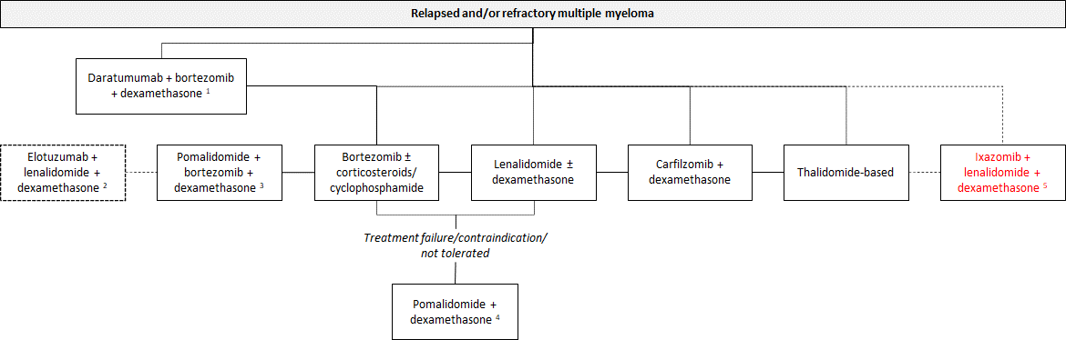
Source: Figure 1-11, p35 of the resubmission.
RRMM = relapsed and/or refractory multiple myeloma
1. For patients who have progressive disease after one prior treatment only (i.e. 2L only).
2. Recommended at the July 2021 PBAC meeting for patients who have experienced disease progression with at least one prior treatment. Not PBS listed at time of resubmission.
3. Prior treatment must include lenalidomide, as monotherapy, or as part of a combination
4. Experienced treatment failure with lenalidomide and bortezomib, unless contraindicated or not tolerated. Pomalidomide must be used in combination with dexamethasone.
5 The regimen and place in therapy requested in this resubmission, ixazomib in combination with lenalidomide and dexamethasone for RRMM patients who have received at least two prior therapies, is highlighted in red.

  - Ixazomib is an oral, selective and reversible proteasome inhibitor. The combination of ixazomib and lenalidomide demonstrated synergistic cytotoxic effects in MM cell lines. Ixazomib is the only oral proteasome inhibitor available in Australian clinical practice. The pre-Sub-Committee response (PSCR; p1) noted that ILd is the only all-oral three drug combination for RRMM that contains both a proteasome inhibitor and immunomodulating agent.
For more detail on PBAC’s view, see section 7 PBAC outcome.
- Comparator
  - The resubmission nominated Ld as the main comparator, Cd as a secondary comparator and ELd as a near market comparator. This differed to the November 2020 submission in which Cd was nominated as the main comparator, Ld was a secondary comparator and DBd was a near market comparator.
  - The resubmission noted the November 2020 PBAC PSDs which stated that given lenalidomide was the backbone of ILd, a patient considered eligible for ILd would likely also be considered eligible for Ld. Cd would be mostly displaced by ILd, whereas Ld would be replaced; thus, Ld may be the most relevant comparator (paragraphs 5.2 and 5.3, Ixazomib, November 2020). The ESC considered that the nomination of Ld as the main comparator was reasonable.
  - No further clinical data were presented in the resubmission to support the November 2020 non-inferiority claims in terms of efficacy and safety between ILd and Cd; hence, the issues previously identified remained and the claims remained unsupported by the evidence.
  - Ld was included as a comparator in the economic model, while Ld and Cd were included as comparators in the financial estimates.
  - Although the resubmission took the advice of ESC from October 2020 and nominated ELd as a near market comparator(paragraph 5.5, ixazomib Public Summary Document [PSD], November 2020), the resubmission stated that the target patient population of ELd would differ to the ILd population in clinical practice due to differences in the route of administration (oral versus intravenous), mechanism of action and the tolerability of ILd, particularly in patients with limiting fitness or frailty. ELd was recommended by the PBAC in July 2021, but it was not listed on the PBS at the time of the resubmission.
  - DBd was identified as a near-market comparator in the November 2020 submission. However, the listing of DBd in second line setting only and the revised proposed restriction for ixazomib placing it after DBd in the treatment algorithm for RRMM meant that DBd was no longer considered a relevant comparator.
  - Noting the advice provided by the ESC in October 2020 which stated that ILd would most likely be used in the third-line setting, making Pd another relevant comparator (paragraph 5.5, ixazomib PSD, November 2020), the resubmission stated that the target population for ILd would not significantly overlap with the target populations for Pd or PBd. The arguments provided were that in patients who are refractory or who have experienced significant prior toxicity with lenalidomide, combination treatment with Pd and PBd are preferred, whereas patients considered for ILd should be sensitive to lenalidomide. This was consistent with the recommendations from the MSAG guideline (MSAG 2019) which state that pomalidomide should be used in patients who have failed lenalidomide and bortezomib (MSAG 2019, Fig 4.).
For more detail on PBAC’s view, see section 7 PBAC outcome.
- Consideration of the evidence

Sponsor hearing
  - There was no hearing for this item.

Consumer comments
  - The PBAC noted and welcomed the input from individuals (10) and organisations (3) via the Consumer Comments facility on the PBS website. The comments from individuals described the impact of multiple myeloma, the desire for access to additional treatments and the benefits associated with ILd as it is an oral triplet regimen.
  - The PBAC noted the comments from Myeloma Australia’s Medical and Scientific Advisory Group (MSAG), which supported the proposed listing of ILd on the basis of the safety and efficacy results from the TMM-1 trial. MSAG also noted that ILd, as a triple oral therapy, would minimise hospital attendance requirements for RRMM patients. The PBAC noted the comments from Myeloma Australia, which strongly supported the proposed listing and highlighted the importance of providing patients with the best possible opportunity to achieve and stay in remission and that the all oral combination is highly valued by MM patients. The PBAC noted the comments from the Leukemia Foundation in support of the proposed listing.

Clinical trial
  - The resubmission was based on one head-to-head trial comparing ILd to Ld (n=722), TMM-1. This trial was also presented in the November 2020 submission; however, the data presented in the resubmission included a longer median duration follow-up (85 months compared to 23 months presented in the November 2020 submission) and the results of the final analysis.
  - Details of TMM-1 are provided in the table below.
Table 3: TMM-1 and associated reports presented in the resubmission
Trial ID | Protocol title/ Publication title | Publication citation
TOURMALINE MM-1  NCT01564537 | TOURMALINE MM-1 Interim 1 CSR. A Phase 3, Randomised, Double-Blind, Multicenter Study Comparing Oral MLN9708 Plus Lenalidomide and Dexamethasone Versus Placebo Plus Lenalidomide and Dexamethasone in Adult Patients With Relapsed and/or Refractory Multiple Myeloma. Clinical Study Report C16010. Data cut-off date 30 October 2014  TOURMALINE MM-1 Interim 1 TFLs. Tables and figures referred to but not included in the text. Clinical Study Report C16010 | May 2015
 | TOURMALINE MM-1 Interim 2 CSR. A Phase 3, Randomised, Double-Blind, Multicenter Study Comparing Oral MLN9708 Plus Lenalidomide and Dexamethasone Versus Placebo Plus Lenalidomide and Dexamethasone in Adult Patients With Relapsed and/or Refractory Multiple Myeloma. Clinical Study Report C16010. Clinical Study Report C16010 Addendum 1. Data cut-off date 12 July 2015.  TOURMALINE MM-1 Interim 2 TFLs. Tables and figures referred to but not included in the text. | January 2016
 | TOURMALINE MM-1 FA CSR April 2021. A Phase 3, Randomized, Double-Blind, Multicenter Study Comparing Oral MLN9708 Plus Lenalidomide and Dexamethasone Versus Placebo Plus Lenalidomide and Dexamethasone in Adult Patients With Relapsed and/or Refractory Multiple Myeloma. | Clinical Study Report C16010. Data cut-off date 28 September 2020
 | TOURMALINE MM-1 Final Analysis Addendum | CSR, TFLs April 2021
 | Richardson, P.G., Kumar, S.K., Masszi, T., Grzasko, N., Bahlis, N.J., Hansson, M., Pour, L., Sandhu, I., Ganly, P., Baker, B.W. and Jackson, S.R., (2021). "Final Overall Survival Analysis of the TOURMALINE MM-1 Phase III Trial of Ixazomib, Lenalidomide, and Dexamethasone in Patients With Relapsed or Refractory Multiple Myeloma.". | Journal of Clinical Oncology 39(22): 2430-2442
Source: Table 2-4, p.49 of the resubmission.
Blue refers to the TMM-1 reports presented in the November 2020 submission from which some of the data was also presented in this resubmission.

  - The key features of TMM-1 are summarised in the table below.
Table 4: Key features of the included evidence
Trial | N | Design/ duration | Risk of bias | Patient population | Outcomes | Used in modelled evaluation
ILd vs Ld
TOURMALINE | 722 | Phase III, R, DB, MC  ITT  OS (FA)ª, median follow-up 85 months.  PFS (IA1)^{b}, median follow-up 15 months.  PFS (IA2)^{c} median follow-up 23 months | Low | Patients with RRMM who had received 1-3 prior lines of therapy. | Primary: PFS  Key secondary: OS  Other secondary: ORR^{c}, QoLª, Safetyª | PFS^{b}, OSª and safetyª
Source: Compiled during evaluation from Main body of the resubmission.
DB = double blind; FA = final analysis; IA = interim analysis; ILd = ixazomib + lenalidomide + dexamethasone; ITT = intention to treat; Ld = lenalidomide + dexamethasone; MC = multi-centre; ORR = overall response rate; OS = overall survival; PFS = progression-free survival; R = randomised; RRMM = relapsed and/or refractory multiple myeloma; QoL = quality of life; TTP = time to progression
a= FA data cut-off 28 September 2020, median follow-up 85 months;
b = IA1 data cut-off 30 October 2014, median follow-up 15 months;
c = IA2 data cut-off 12 July 2015, median follow-up 23 months.

  - The overall risk of bias for TMM-1 was considered to be low.
  - The resubmission presented the updated results from TMM-1 (final analysis) for OS in the ITT population and the subgroup analysis of 2-3 prior therapies. This was reasonable and reflected the proposed PBS restriction.

Comparative effectiveness
  - The resubmission presented the updated OS results for the ITT population, prior lines of treatment for the subgroup (1 prior vs 2-3 prior lines), and adjusted OS for subsequent treatments (2-3 prior lines of therapy subgroup). The adjusted OS was used in the economic model.
  - The summary of survival outcomes in TMM-1 is presented in Table 5, with the corresponding OS Kaplan-Meier (KM) plots reported in Figure 2.
Table 5: Summary of survival outcomes in TMM-1, ITT analysis.
 | ILd | Ld | Absolute difference | HR (95% CI);  p-value
Progression-free survival (15 months follow-up - IA1)
Progressed, n/N (%) | 129/360 (35.8) | 157/362 (43.4) | 7.6 | 0.74 (0.59, 0.94);  p = 0.012
Median PFS, months (95% CI) | 20.6 (17.02, NE) | 14.7 (12.9, 17.58) | 5.9
PFS (23 months follow-up – IA2)^{b}
Progressed, n/N (%) | 177/360 (49.2) | 195/362 (53.9) | 4.7 | 0.82 (0.67, 1.00);  p = NA
Median PFS, months | 20.0 | 15.9 | 4.1
Overall survival (15 months follow-up)ª
Deaths, n/N (%) | 51/360 (14.2) | 56/362 (15.5) | - | 0.90 (0.62, 1.32);  p=0.582
OS (23 months follow-up)^{b}
Deaths, n/N (%) | 81/360 (22.5) | 90/362 (24.9) | - | 0.87 (0.64, 1.75);  p = 0.359
Median OS, months (95% CI) | NE (NE, NE) | NE (30.92, NE) | -
OS (85 months follow-up)^{c}
Deaths, n/N (%) | 240/360 (67) | 244/362 (67) | 0 | 0.94 (0.78, 1.13); p=0.495
Median OS, months (95% CI) | 53.6 (49.25, 62.95) | 51.6 (44.78, 59.14) | 2.0
Source: Table 2-10, p56 of the resubmission. Table 14.3.1.1A, p 753 of TMM-1 IA1 TFL May 2015; Table 2.2.b, p25 of TMM-1 IA2 CSR 2016. Figure 14.3.2.6D, p6319 of TMM-1 IA2 TFLs Jan 2016.
Values in bold indicate statistical significance. Blue shaded text refers to information previously included in the initial submission of ixazomib to the PBAC.
CI = confidence interval; ILd = ixazomib + lenalidomide + dexamethasone; HR = hazard ratio; ITT= intent to treat; Ld = lenalidomide + dexamethasone; NA = not available; NE = not estimable; OS = overall survival; PFS = progression free survival
a. TMM-1 data cut-off for IA1 was 30th October 2014, median follow-up was 14.8 months for ILd vs 14.6 months for the Ld arm;
b. TMM-1 data cut-off1 was 12th July 2015, median follow-up was 23.3 months for ILd vs 22.9 months for the Ld arm;
c. TMM-1 data cut-off was 28 September 2020, median follow-up was 85.0 months for ILd vs 85.1 months for Ld arm.

  - The progression free survival (PFS) results have been previously presented to the PBAC. The resubmission stated that since the median PFS was reached at TMM-1 (IA1, data cut-off 30 Oct 2014) there were no PFS data collected in the final analysis. The median PFS in TMM-1 was significantly longer in the ILd arm (20.6 months) compared to the Ld arm (14.7 months; HR = 0.74, 95% CI: 0.59, 0.94). 64% of patients were censored in the ILd arm and 57% in the Ld arm, predominantly due to absence of documented death or progressive disease (54% ILd vs 44% Ld). The OS results presented in the resubmission showed that median OS was reached at the 85 months follow-up; however, the results showed no statistically significant difference between the arms, ILd and Ld. The Pre-Sub-Committee Response (PSCR) noted that PFS was the primary outcome of the TMM-1 trial.
Figure 2: Kaplan-Meier analysis of OS in TMM-1, ITT
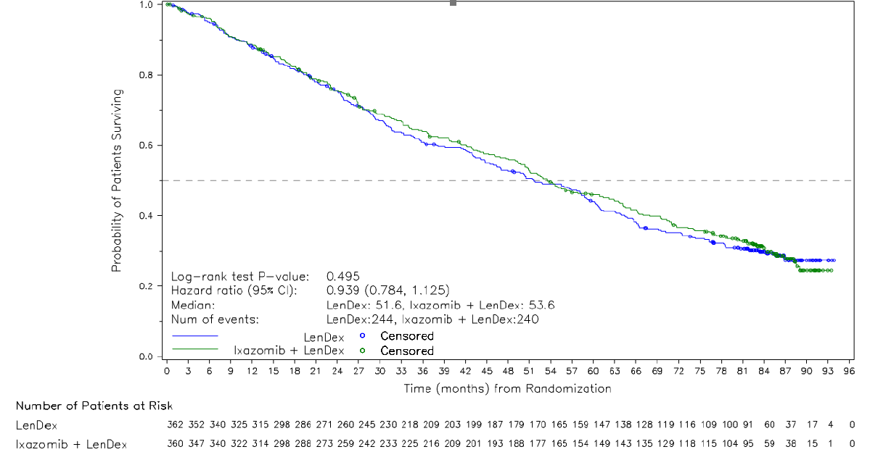
Source: Figure 2-2, p 55 of the resubmission
CI = confidence interval; ITT = intention to treat; LenDex = lenalidomide + dexamethasone; OS = overall survival

Subgroup analysis
  - The resubmission presented subgroup analyses for PFS, overall rate of response (ORR) and OS from the TMM-1 based on 2-3 prior lines of therapy (i.e. the proposed PBS population) versus 1 prior line of therapy. The treatment arms in the 2-3 prior lines of treatment subgroup were well balanced (N=149 for ILd; N=148 for Ld). However, the resubmission did not present a test for interaction between subgroups. The TMM-1 used the number of prior therapies as a (pre-specified) stratification factor at randomisation. This aligns with the proposed population in the requested PBS listing.
  - The resubmission presented the PFS results for the subgroups of interest based on the IA1 data-cut (15 months follow-up), and PFS and ORR results based on the IA2 data-cut (23 months follow-up) as no data were collected for these outcomes at the time of the final analysis (Table 6).

Table 6: PFS and ORR Results of subgroup analysis with whole trial population results and complements.
Population | ILd | Ld | Absolute difference | HR (95% CI);  p-value
PFS (15 months follow-up)
1 prior line therapy (complement of subgroup)
Progressed, n/N (%) | 73/212 (34) | 84/213 (39) | - | 0.88 (0.65, 1.20);  p = 0.419
Median PFS, months (95% CI) | 20.6 (16.82; NE) | 16.6 (13.24; NE) | 4
2-3 prior lines of therapy
Progressed, n/N (%) | 41/148 (28) | 61/1498 (41) | - | 0.58 (0.40, 0.84);  p = 0.003
Median PFS, months (95% CI) | NE (16.59; NE) | 12.9 (10.12; 15.64) | NE
PFS (23 months follow-up, IA2)ª
1 prior line of therapy
Progressed, n/N (%) | 100/212 (47) | 106/213 (50) | 3 | 0.99 (0.76, 1.29);  p = NA
Median PFS, months (95% CI) | 18.7 (15.67, 25.82) | 17.6 (14.72, 22.44) | 1.1
2-3 prior lines of therapy
Progressed, n/N (%) | 58/148 (39) | 74/149 (50) | 11 | 0.62 (0.45, 0.86);  p = NA
Median PFS, months (95% CI) | 22.0 (18.43, 29.44) | 13.0 (10.15, 18.27) | 9.0
ORR (23 months follow-up) |  |  |  | OR (95% CI);  p-value
1 prior line therapy (complement of subgroup)
Overall response, n/N | 164/212 | 166/213 | - | 0.97 (0.61, 1.53);  p = 0.886
% (95% CI) | 77.4 (71.1, 82.8) | 77.9 (71.8, 83.3) | -
2-3 prior lines of therapy
Overall response, n/N | 119/148 | 99/149 | - | 2.09 (1.23, 3.56);  p = 0.006
% (95% CI) | 80.4 (73.1, 86.5) | 66.4 (58.4, 74.0) | -
Source: Table 2-15, p64 of the resubmission. Figure 14.3.2.6A, p4455 of TOURMALINE MM-1 IA1 TFL May 2015; Table 14.3.1.14, p1530 and Figure 14.3.2.6D, p6319 of TMM-1 IA2 TFLs Jan 2016.
Values in bold indicate statistical significance.
CI = confidence interval; HR = hazard ratio; NA = not available; NE = not estimable; OR = odds ratio; ORR = overall rate of response; PFS = progression free survival.
TOURMALINE data cut-off for IA1 was 30th October 2014 median follow-up 15 months; IA2 (data cut-off 12 July 2015), 23 month follow-up.
a. The AI2 PFS analysis was based on non-inferential analysis (as the IA1 was significant at IA1) requested by the Food and Drug Administration (United States of America) and noted in the protocol.

  - The median PFS was significantly longer in the ILd arm compared to Ld in the 2-3 prior lines subgroup. The PFS showed no statistical significance between the two arms in the 1 prior line subgroup.
  - The ORR (at 23 months follow-up) was significantly higher for ILd compared to Ld in the 2-3 prior lines of therapy subgroup (80.4% vs 66.4%; odds ratio = 2.09, 95% CI: 1.23, 3.56). No data was presented by response type or duration of response.
  - The resubmission presented the subgroup analysis by number of prior therapies for OS based on the final analysis data-cut (median follow-up of 85 months) (Table 7) with its corresponding KM (Figure 3).
Table 7: Analysis of OS in TMM-1 (FA) by prior therapies, by subgroup (85 months follow up)
 | ILd | Ld | Absolute difference | HR (95% CI);  p-value
OS (1 prior therapy)
Deaths, n/N (%) | 136/212 (64) | 140/213 (66) | 2 | 1.02 (0.80, 1.29);  p = 0.899
Median OS, months (95% CI) | 54.3 (42.81, 66.30) | 58.3 (50.30, 65.74) | 4
OS (2-3 prior therapies)
Deaths, n/N (%) | 104/148 (70) | 104/149 (70) | 0 | 0.85 (0.64, 1.11);  p = 0.232
Median OS, months (95% CI) | 53.0 (49.25, 63.54) | 43.0 (30.85, 52.67) | 10
Source: Table 2-16, p65 of the resubmission.
CI = confidence interval; FA = final analysis; HR = hazard ratio; ILd = ixazomib + lenalidomide + dexamethasone; ITT = intent to treat; Ld = lenalidomide + dexamethasone; OS = overall survival.
  - OS was similar between the ILd and Ld arms among patients who had 1 prior therapy (HR = 1.02; 95% CI: 0.80, 1.29). Although median OS in the ILd arm was prolonged among patients who had 2-3 prior therapies (53.0 months vs 43.0 months, respectively), the results were not statistically significant (HR: 0.85; 95% CI: 0.64, 1.11).
  - The KM estimates for OS by subgroup (Figure 3) shows a separation of the curves (ILd and Ld) for the 2-3 prior lines of therapy subgroup for most of the follow-up period, with the curves coming together at around 85 months although there were very few patients remaining at risk.

Figure 3: Kaplan-Meier plots of OS by number of prior therapies in TMM-1, by subgroup, ITT analysis.
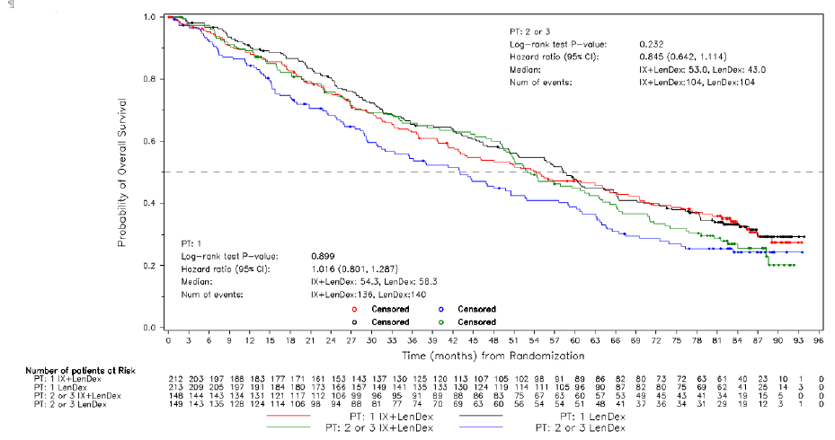
Source: TOURMALINE MM-1 FA CSR April 2021 Figure 2.g p33
ITT= intent to treat; IX+LenDex= ixazomib + lenalidomide + dexamethasone; LenDex= lenalidomide + dexamethasone; OS = overall survival; PT = prior therapy.

OS adjustment for subsequent treatments received in the 2-3 prior lines of therapy subgroup
  - TMM-1 allowed patients in both treatment arms to receive multiple active novel MM therapies following disease progression. The resubmission stated that for patients in the 2-3 prior therapies subgroup, 70.9% (105/148) in the ILd arm and 62.4% (93/149) in the Ld arm received at least one subsequent therapy after progression. The resubmission also stated that some of the subsequent therapies used in TTM-1 were not reflective of the Australian clinical pathway (i.e. therapies were not available or reimbursed via the PBS, or were not considered suitable for patients at or beyond the fourth-line setting based on local management guidelines). Based on these arguments the OS in the 2 to 3 prior lines of treatment subgroup was adjusted for subsequent treatment received. Rather than adjusting for subsequent treatments in all patients who received active MM therapy after disease progression, the resubmission adjusted OS for a proportion of the patients who received subsequent treatments which the resubmission defined as not available in Australia.
  - The resubmission stated the following therapies are not available in Australia in post ILd settings: daratumumab-based, elotuzumab-based, isatuximab-based, ixazomib-based, plitidepsin-based, cetuximab-based, pembrolizumab-based, nivolumab-based or 3 drug combination that are bortezomib or pomalidomide-based. This list was not based on treatments available in Australia, but rather those available in the UK (not including those therapies funded through the Cancer Fund), with the PSCR noting that the OS HR analysis presented was originally undertaken to support a reimbursement application for ixazomib to the UK National Institute for Health and Care Excellence (NICE). This was inappropriate, with the ESC noting that many of the subsequent therapies which were adjusted for, are currently available in Australia in the setting of interest, as follows:
- Pomalidomide in combination with bortezomib and dexamethasone (PBd) is listed for patients with MM who have received prior treatment with lenalidomide-containing regimen (paragraph 7.1, pomalidomide PSD, November 2019).
- Lenalidomide monotherapy or lenalidomide in combination with dexamethasone is listed for MM patients who must have progressive disease after at least one prior therapy and be ineligible for a primary stem cell transplant (paragraph 12, lenalidomide PSD, November 2008; and paragraph 7.4, lenalidomide PSD, November 2017). The PSCR stated that as ILd will likely replace, rather than displace, Ld in clinical practice it was consistent with the proposed clinical algorithm that subsequent lenalidomide-based therapies be censored in the adjusted OS analysis. The ESC agreed with this statement.
- Carfilzomib in combination with dexamethasone is PBS listed for RRMM patients after at least one prior therapy (paragraph 4, carfilzomib PSD, March 2018).
- Elotuzumab (as ELd) was recommended by the PBAC in RRMM after at least one prior therapy at the July 2021 PBAC meeting (paragraph 7.1, elotuzumab PSD, July 2021).
- Despite not being used as subsequent therapy beyond second line, daratumumab based therapy is listed as a second line treatment option for all patients that progress after first line treatment in Australia, which may differ from the patient population in TMM-1.
  - The resubmission stated that 59/148 (40%) patients in the ILd arm and 52/149 (35%) patients in the Ld arm required adjustment for receiving therapies in TMM-1 that are not likely to be used in the Australian setting (Table 8). The ESC noted that 36 of the 111 patients whose results were adjusted potentially received treatments which were available in Australia (see paragraph 6.22).
Table 8: Patients adjusted for in the subsequent treatment analyses.
 | All subsequent lines
 | ILd | Ld
Daratumumab-based | 11 | 10
Daratumumab + lenalidomide-based | 1 | 0
Carfilzomib-based | 18 | 13
Elotuzumab-based | 2 | 4
Isatuximab-based | 1 | 0
Lenalidomide-based | 14 | 8
Ixazomib-based | 3 | 5
Plitidepsin-based | 2 | 1
Cetuximab-based | 1 | 0
Pembrolizumab-based | 2 | 1
Stem cell transplant | 0 | 5
Bortezomib + lenalidomide + dexamethasone | 2 | 1
Pomalidomide + bortezomib + dexamethasone | 2 | 3
Nivolumab-based | 0 | 1
Total | 59 | 52
Source: Table 2-18, pp68-69 of the resubmission.
ILd = ixazomib + lenalidomide +dexamethasone; Ld = lenalidomide + dexamethasone

  - Overall, the resubmission’s rationale for adjustment for subsequent treatments was considered inappropriate for the following reasons:
- The resubmission did not provide baseline characteristics of patients who received and did not receive subsequent treatments, nor did it provide the characteristics of participants before subsequent therapy;
- The resubmission presented a KM curve reflecting the adjusted OS compared to the unadjusted OS (2-3 prior lines of therapy) treatment effect, however no “at-risk” table with relevant information regarding censored patients was included;
- The subsequent treatment analysis presented in the resubmission used to support the rationale for adjustment was based on access to therapies in the UK and not Australian practice. The ESC considered that this was inappropriate;
- The ESC noted that approximately one third of the patients (36/111) for whom subsequent treatment was adjusted, were likely to have received these treatments as they are PBS listed in the patient population of interest (carfilzomib-based (i.e. Cd) and pomalidomide based (i.e. PBd). Therefore, the number of patients for whom treatment was adjusted was most likely overestimated in both, ILd and Ld arms. The ESC noted that this likely led to an overestimation of the OS HR (favouring ILd) which was used in the economic analysis.
  - The resubmission used a two-stage (TSE) method to adjust OS which was later re-censored, resulting in a HR of 0.713 (95% CI: 0.535, 0.952). This value was applied in the base case analysis in the economic model.
  - The results of the adjustment for subsequent treatments for OS using different methods are presented in Table 9.
Table 9: Unadjusted and adjusted OS hazard ratios for ILd vs Ld in TMM-1, in the 2-3 prior therapies subgroup
 | OS hazard ratio (95% CI) | p value
Unadjusted | 0.845 (0.642, 1.114) | 0.2316
Naïve – censor at switch | 0.712 (0.507, 0.999) | 0.0484
Naïve – per protocolª | 0.699 (0.493, 0.990) | 0.0428
TSE (no re-censoring + adjust for baseline characteristics^{b}) | 0.785 (0.596, 1.035) | 0.0857
TSE (re-censored^{c} + adjust for baseline characteristics^{b}) | 0.713 (0.535, 0.952) | 0.0216
IPCW (stabilised weights + adjust for baseline characteristics^{b}) | 0.674 (0.465, 0.979) | 0.0383
Source: Table 2-19, p71 of the resubmission. Values in bold are statistically significant.
CI = confidence interval; IPCW = inverse probability of censoring weighting; ILd = ixazomib + lenalidomide + dexamethasone; Ld = lenalidomide + dexamethasone; OS = overall survival; TSE = two-stage estimator
Note: p-values from stratified log-rank tests for analyses which do not adjust for baseline characteristics. For analyses which adjust for baseline characteristics, p-values are those associated with the coefficient from a Cox regression model including treatment arm and baseline characteristics as covariates.
a. Excludes all patients who switched from the analysis
b. Adjusts for high-risk, age>65, ISS stage at screening, and history of bone lesions.
c Counterfactual survival times are re-censored for all patients at the minimum of the administrative censoring time of the study (28th September 2020; C_{i}) and C_{iψ2}, where _{ψ2} is the adjustment factor associated with group 2 membership. This represents the earliest possible censoring time.

  - The results indicated that the OS HR improved compared to the unadjusted and became statistically significant with all methods except for the TSE without re-censoring. The resubmission stated that the results of the naïve analysis showed that receiving subsequent treatments was associated with improved clinical outcomes, but since more patients were adjusted for in the ILd arm 59 vs 52 in Ld arm, the result was subject to selection bias.
  - The resubmission stated that the TSE (with re-censoring) method was the most appropriate method to adjust OS. Additional methods were also tested (TSE with/without re-censoring, naïve analyses, IPCW and rank preserving structural failure time models (RPSFTM)). The resubmission stated that the inverse probability of censoring weights (IPCW) method produced clinically implausible OS as clinical experts suggested that OS should be reduced when adjusting for the effects of efficacious subsequent therapies, while it showed an improvement of OS in both treatment arms. The resubmission also stated that with respect to the IPCW method, the model predicting switching had poor explanatory power. Despite producing a lower HR compared with the TSE method, the IPCW method was associated with a higher ICER (see Table 15).
  - Overall, the ESC considered that although the choice of the TSE method of adjustment was technically appropriate, the adjustment for switching of OS data required the assumption surrounding the subsequent therapies not available in Australia to hold, but that this was incorrectly specified in the resubmission. Therefore, the number of patients adjusted for receiving subsequent treatment was overestimated. In addition, the ESC questioned the clinical rationale for an improved OS HR when very similar proportions of patients from both arms of the trial were excluded. The ESC considered that the change in OS HR was most likely a data or methodological artefact. The ESC advised that the OS HR unadjusted for subsequent treatments should be applied in the economic model.

Comparative harms
  - Summary of adverse events (AEs) from TMM-1 (data cut-off: 28 September 2020, media follow-up 85.0 months for ILd and 85.1 months for Ld) is presented in Table 10.
Table 10: Summary of key adverse events in the TMM-1 (FA), safety population
n (%) | ILd  n=361 | Ld  n=359 | RD (95% CI) | RR (95% CI)
Any AE | 359 (99) | 357 (99) | 0 (-0.01, 0.01) | 1.00 (0.99, 1.01)
Grade 3 or higher AE | 289 (80) | 266 (74) | 0.06 (0, 0.12) | 1.08 (1, 1.17)
Treatment-related AEª | 339 (94) | 333 (93) | 0.01 (-0.02, 0.05) | 1.01 (0.97, 1.05)
Treatment-related Grade 3 or higher AE | 240 (66) | 203 (57) | 0.1 (0.03, 0.17) | 1.18 (1.05, 1.33)
Any SAE | 205 (57) | 201 (56) | 0.01 (-0.06, 0.08) | 1.01 (0.89, 1.15)
Treatment-related SAEª | 115 (32) | 108 (30) | 0.02 (-0.05, 0.09) | 1.06 (0.85, 1.32)
AE resulting in dose modification of 1 or more of the 3 agents in the drug regimen^{b} | 290 (80) | 265 (74) | 0.07 (0, 0.13) | 1.09 (1.01, 1.18)
AE resulting in dose reduction of any drug | 218 (60) | 195 (54) | 0.06 (-0.01, 0.13) | 1.11 (0.98, 1.26)
AE resulting in discontinuation of any drug | 140 (39) | 116 (32) | 0.06 (-0.01, 0.13) | 1.2 (0.98, 1.46)
AE resulting in discontinuation of the full drug regimen | 91 (25) | 78 (22) | 0.03 (-0.03, 0.1) | 1.16 (0.89, 1.51)
On study death^{c} | 21 (6) | 30 (8) | -0.03 (-0.06, 0.01) | 0.7 (0.41, 1.2)
Source: Table 2-11, p60 of the resubmission.
AE = adverse events; CI = confidence interval; FA = final analysis; ILd = ixazomib + lenalidomide + dexamethasone; Ld = lenalidomide + dexamethasone; RD = risk difference; RR = relative risk, SAE = serious adverse event.
a. AE assessed by the investigator as that was related to any drug in the drug combination (placebo, ixazomib, lenalidomide, or dexamethasone) was treatment-related.
b. Dose modification included dose reduced, increased, delayed, and discontinued permanently.
c. On study deaths were defined as deaths that occurred after the first dose through 30 days after the last dose of any agent in the study drug regimen.

  - The overall rates of any AEs, serious adverse events (SAEs) and treatment related AEs (TRAEs) were similar across both arms of TMM-1. The rates of Grade ≥ 3 AE and TRAEs were slightly higher in the ILd arm (80% and 74%) compared to the Ld arm (66% and 57% respectively). The aggregated TRAEs Grade 3 or higher and AE resulting in dose modification of 1 or more of the agents in the drug regimen were higher in the ILd arm compared to the Ld arm.
  - Grade ≥ 3 thrombocytopenia occurred more frequently in the ILd arm compared to the Ld arm (9% vs 4%). Other differences in Grade ≥ 3 AEs included diarrhoea (10% ILd vs 3% Ld) and hypokalaemia (5% ILd vs 2% Ld). The rates of SAEs were similar across both arms (32% vs 30%, respectively).
  - The safety analysis was based on the full safety population in TMM-1 (Table 10). The resubmission did not present safety results for the 2-3 prior lines of therapy subgroup.
  - The resubmission presented an extended assessment of comparative harms based on the periodic benefit-risk evaluation report (PBRER) of 19 November 2020. Thrombotic microangiopathy and accidental overdosage were identified as safety concerns. The PBAC noted that these concerns were described in the TGA approved product information, with thrombotic microangiopathy reported as a clinically significant adverse drug reaction based on post-marketing data, and accidental overdose reported to have been associated with SAEs.

Benefits/harms
  - A summary of the comparative harms for ILd versus Ld is presented in the Table 11.
Table 11: Summary of comparative benefits and harms for ILd and Ld from TMM-1
Benefits
Progression free survival (median duration of follow up 15 months) ITT, whole population
Event | ILd | Ld | Absolute Difference | HR (95% CI);  p-value
Progressed, n/N (%) | 129/360 (35.8) | 157/362 (43.4) | 7.6 | 0.74 (0.59, 0.94);  p = 0.012
Median PFS, months (95% CI) | 20.6 (17.02, NE) | 14.7 (12.9, 17.58) | 5.9
PFS (23 months follow-up – IA2)
Progressed, n (%) | 177/360 (49.2) | 195/362 (53.9) | 4.7 | 0.82 (0.67, 1.00);  p = NA
Median PFS, months | 20.0 | 15.9 | 4.1
Progression free survival (median duration of follow up 15 months) 2-3 prior lines of therapy
Progressed, n/N (%) | 41/148 (28) | 61/149 (41) | 13 | 0.58 (0.40, 0.84);  p = 0.003
Median PFS, months (95% CI) | NE (16.59; NE) | 12.9 (10.12; 15.64) | NE
PFS (median duration of follow-up 23 months) 2-3 prior lines of therapy
Progressed, n/N (%) | 58/148 (39) | 74/149 (50) | 11 | 0.62 (NA, NA);  p = NA
Median PFS, months (95% CI) | 22.0 (18.43, 29.44) | 13.0 (10.15, 18.27) | 9.0
Overall survival (median duration of follow up 85 months), ITT, whole population
Deaths, n/N (%) | 240/360 (67) | 244/362 (67) | 0 | 0.94 (0.78, 1.13)  p = 0.495
Median OS, months (95% CI) | 53.6 (49.25, 62.95) | 51.6 (44.78, 59.14) | 2.0
Overall survival (median duration of follow up 85 months), 2-3 prior lines of therapy
Deaths, n/N (%) | 104/148 (70) | 104/149 (70) | 0 | 0.85 (0.64, 1.11)  p = 0.232
Median OS, months (95% CI) | 53.0 (49.25, 63.54) | 43.0 (30.85, 52.67) | 10
Harms
TMM-1 | ILd,  n/N | Ld,  n/N | RR  (95% CI) | Event rate/100 patients* |  | RD  (95% CI)
 |  |  |  | ILd | Ld
Adverse event I
Thrombocytopenia | 34/361 | 15/359 | 2.25 (1.25, 4.06) | 9.42 | 4.18 | 0.05 (0.02, 0.09)
Adverse event II
Diarrhoea | 36/361 | 11/359 | 3.25 (1.68, 6.28) | 9.97 | 3.06 | 0.07 (0.03, 0.1)
Adverse event III
Hypokalaemia | 18/361 | 7/359 | 2.56 (1.08, 6.05) | 5.0 | 1.9 | 0.03 (0.00, 0.06)
Source: Table 2-10, p56, Table 2-15, p64, Table 2-16 p65, of the resubmission. Figure 14.3.2.6A, p4455 of TOURMALINE MM-1 IA1 TFL May 2015; Section 3.2.1, Attachment 13 of the resubmission; Table 2.a, p 85, CSR TMM-1 FA.
Values in bold indicate statistical significance. blue shaded text refers to information previously included in the initial submission of ixazomib to the PBAC.
AE = adverse event; CI = confidence interval; FA = final analysis; HR = hazard ratio; ILd = ixazomib + lenalidomide + dexamethasone; ITT = intention to treat; Ld = lenalidomide + dexamethasone; NA = not available; NE = not estimable; OS = overall survival; PFS = progression free survival; RD = risk difference; RR = risk ratio.

  - On the basis of direct comparison presented by the resubmission, for every 100 patients treated with ILd in comparison with Ld:
Whole population ITT
- Approximately 7 additional patients will remain progression-free over a median duration of follow-up of 15 months;
- Approximately 4 additional patients will remain progression-free over a median duration of follow-up of 23 months;
- There would be no difference in overall survival after 85 months;
- Approximately 5 additional patients would experience thrombocytopenia over a median duration of follow-up of 85 months;
- Approximately 7 additional patients would experience diarrhoea over a median duration of follow-up of 85 months; and
- Approximately 3 additional patients would experience hypokalaemia over a median duration of follow-up of 85 months.
Subgroup population that had received 2-3 prior therapies
- Approximately 13 additional patients will remain progression-free over a median duration of follow-up of 15-months follow-up;
- Approximately 11 additional patients will remain progression-free over a median duration of follow-up of 23-months follow-up; and
- There would be no difference in overall survival after 85 months.

Clinical claim
Main Comparator: Ld
  - The resubmission claimed that ILd has superior effectiveness to Ld in RRMM patients who have received at least two prior therapies based on second- and third-line subgroup analysis of TMM-1. The ESC considered that the claim of superior effectiveness was uncertain, noting that although the results from TMM-1 (2-3 lines of therapies subgroup) showed statistically significant improvement in PFS for ILd compared to Ld, the unadjusted data for OS did not show statistical significance. The ESC considered that the process of adjustment of OS data was not appropriate for the Australian clinical setting.
  - Overall, the PBAC considered that the claim of superior comparative effectiveness was not adequately supported by the data. Although ILd resulted in a statistically significant improvement in PFS for the ITT population and for patients who had received 2-3 prior lines of therapy, the ITT and subgroup unadjusted results for OS were not statistically significant and the adjustment of the OS data as presented was not appropriate.
  - The resubmission claimed that ILd had non-inferior safety compared to Ld. The ESC noted that data from TMM-1 showed that ILd was associated with more toxicity events than Ld, including Grade ≥ 3 thrombocytopenia and diarrhoea. In addition, the new safety concerns related to thrombotic microangiopathy and a safety signal of accidental overdose presented in the extended assessment of comparative harms may also suggest that ILd has inferior safety compared to Ld.
  - The PBAC noted that ILd was associated with similar rates of any adverse event, serious adverse events and adverse events resulting in discontinuation from the trial as Ld. The PBAC did note that ILd resulted in a higher incidence of Grade ≥ 3 adverse events, including thrombocytopenia, diarrhoea and hypokalaemia; however, considered these were generally manageable. Overall, the PBAC considered that the safety of ILd was similar to that of Ld.
Secondary comparator: Cd
  - The resubmission claimed that ILd was non-inferior in terms of effectiveness and safety compared to Cd. However, the resubmission did not present new clinical evidence to support this claim. The resubmission stated that the results for the TSE adjustment of OS show a comparable reduction in the risk of death for ILd versus Ld (HR: 0.713; 95% CI: 0.535, 0.952 ; p=0.0216) and for carfilzomib plus dexamethasone versus its primary comparator, bortezomib plus dexamethasone (HR: 0.761; 0.663, 0.915; p=0.029) and concluded that these data support the clinical claims versus Cd.
  - The November 2020 submission relied on a naïve indirect treatment comparison (ITC) between ILd and Cd that assumed Ld was equivalent to Bd (ILd vs Ld and Cd vs Bd) based on the ITT population in patients who had received at least one prior therapy. The resubmission did not present an ITC between ILd and Cd for the subgroup of 2-3 prior lines of therapy. The PBAC has previously considered that, due to the nature of the naïve ITC and differences between the key trials, the results of the naïve ITC were difficult to interpret and did not adequately demonstrate non-inferiority between ILd and the nominated comparator, Cd, in terms of efficacy or safety (paragraph 7.1, ixazomib PSD, November 2020). No new data was presented by the resubmission to support the non-inferiority clinical claim of ILd against Cd, hence, the PBAC considered that the issues previously identified remained and that the claim was unsupported by the evidence.

Economic analysis
  - The resubmission presented a cost-effectiveness analysis (CEA) and a cost-utility analysis (CUA). Health benefits were reported as life years (LYs) gained and quality adjusted life years (QALYs) gained. The key points from the economic evaluation are summarised in Table 12.
Table 12: Summary of model structure, key inputs and rationale
Component | Summary
Treatments | ILd vs Ld
Time horizon | 20 years in the model base case versus 85 months in TMM-1. The PSCR presented a respecified base case in which the time horizon was 15 years.
Outcomes | LYs and QALYs gained
Methods used to generate results | Cohort-based partitioned survival model
Health states | Three health states are included in the model: pre-progression, post-progression and death
Cycle length | 1 week
Allocation to health states | The KM estimates were derived from TMM-1 (2-3 prior lines of therapy subgroup was used for OS, PFS and ToT outcomes)
Treatment effect adjustment | Adjustment of OS HR for patients who had received 2-3 prior therapies for post-progression treatments using two-stage method with re-censoring. The treatments were incorrectly specified (did not reflect Australian clinical practice) and the TSE method is subject to bias especially in relation to re-censoring.
Extrapolation method | Parametric model fitted to each treatment arm with Generalised Gamma selected in base case for OS, and Weibull for PFS and ToTª based on goodness of fit; parametric model fitted to entire dataset with treatment group included as a covariate and assuming proportional hazards.  No convergence of OS and PFS was implemented, however PFS was restricted to OS if PFS> OS.  Extrapolation point for PFS and ToT = 20 months; OS extrapolation curve was applied from 0 months. The PSCR presented a respecified base case in which the generalised gamma curve was applied to OS from 50 months.
Health related quality of life | Utility values from TMM-1 based on EQ-5D converted using UK weights.  Progression-free state was a weighted mean of VGR = 0.692, PR = 0.699 and SD = 0.665; Progressed = 0.667.  Decrement related to AEs (Grade 3 or 4), hospitalizations and end of life (0-3 months pre-death) were also included.  Although it is unclear, it appears that the utility data represents the ITT population and not the subgroup of interest (i.e. those who had received 2-3 prior lines of therapy).
AE costs | The estimated AEs cost per cycle for ILd was $|||| and for Ld $||||. This was not consistent with the claim of non-inferiority. The source of the AE rates could not be verified.
Post progression therapy cost (subsequent therapy) | Subsequent therapies were costed as per PBS schedule, median duration based on literature, therapies not available on PBS were costed as thalidomide with dexamethasone ($||||).
Ixazomib cost | Resubmission used an indicative AEMP for ixazomib of $||||.
Source: Compiled during evaluation.
AE = adverse event; ILd = ixazomib + lenalidomide + dexamethasone; Ld = lenalidomide + dexamethasone; LYG = life years gained; ToT = time on treatment OS = overall survival; PFS = progression free survival; PR = partial response; SD = stable disease; QALY = quality adjusted life years; VGR = very good response.
a. ToT was used to estimate the cost of treatment.

  - The proportion of patients receiving subsequent therapies was based on the therapies received by the subgroup of patients in TMM-1 that had received 2-3 prior lines of therapies which was then adjusted for treatment switching. The economic model relied on subgroup data which may have increased uncertainty compared with a model based on ITT population. Since the adjustment for treatment switching was conducted inappropriately (based on therapies available in the UK), the ESC considered that this proportion is likely incorrect and may lead to an underestimation of the cost for post-progression therapies favouring ILd (i.e. Cd post-progression was excluded in the estimations) – see paragraphs 6.19 to 6.22.
  - The resubmission’s model considered a time horizon of 20 years. The extrapolation of OS was applied over a 34-year period and the analysis was then truncated at 20 years. The PBAC has previously considered that a 15-year time horizon was reasonable for patients treated in the second-line setting (paragraph 7.12, daratumumab PSD, November 2019). As the resubmission is seeking listing for the third line and beyond, the chosen time horizon was inappropriate. The impact of applying a shorter time horizon is presented in Table 15. The PSCR and pre-PBAC response presented respecified base cases in which the time horizon was 15 years.
  - For OS, the model used the adjusted parametric curve throughout the entire time horizon based on the latest data cut-off (85-months). The PBAC previously considered the use of fitted survival curves for the entire duration of the time horizon was inappropriate (paragraph 7.9, lenalidomide PSD, March 2018). Direct time-to-event data from the KM curves should have been applied until the median follow-up was reached or where observed data becomes unreliable due to small numbers of patients remaining event-free (noting that the whole observation period should be used to extrapolate). Extrapolation to the specified time horizon (i.e. 20 years) using parametric distributions should have been used from this point. The impact on the ICER of adjusting the point of extrapolation is presented in Table 15. The PSCR presented a respecified base case in which the generalised gamma distribution was applied to the OS curves from 50 months (median survival in the 2-3 prior therapy subgroup was 53 months). The PSCR noted that applying the extrapolated curve from the median follow up (85 months) resulted in an ill-fitting curve, higher censoring of data and the possibility of overestimated survival (see Figure 4). The ESC noted that the application from 50 months favoured ILd, with the extrapolated generalised gamma curve positioned above the KM curve for the ILd arm and below the KM curve for the Ld arm. The pre-PBAC response provided a revised base case in which extrapolation was applied from 53 months.
Figure 4: Extrapolation of the Kaplan-Meier curves for OS in the 2-3 prior therapies subgroup using the generalised gamma function from 85 months (left) and 50 months (right)
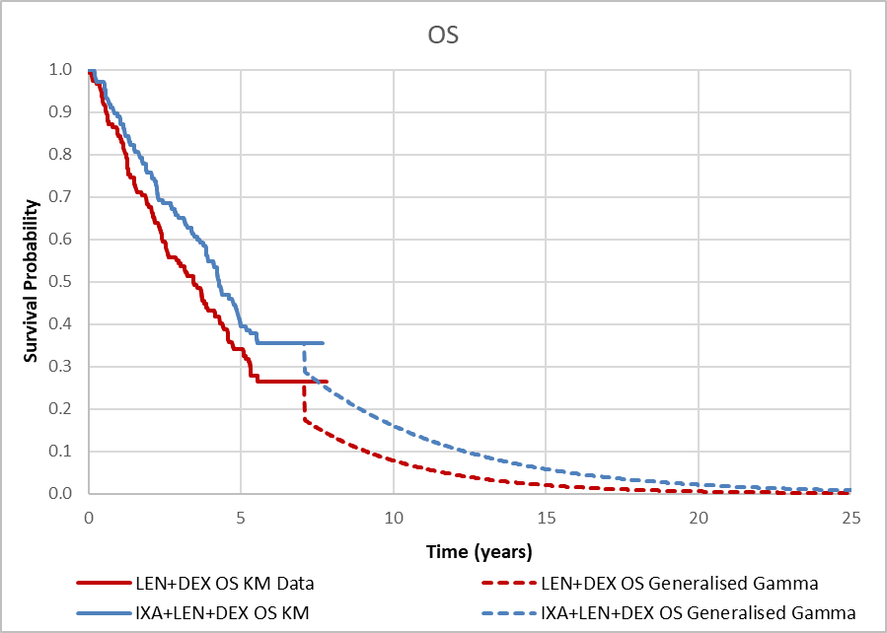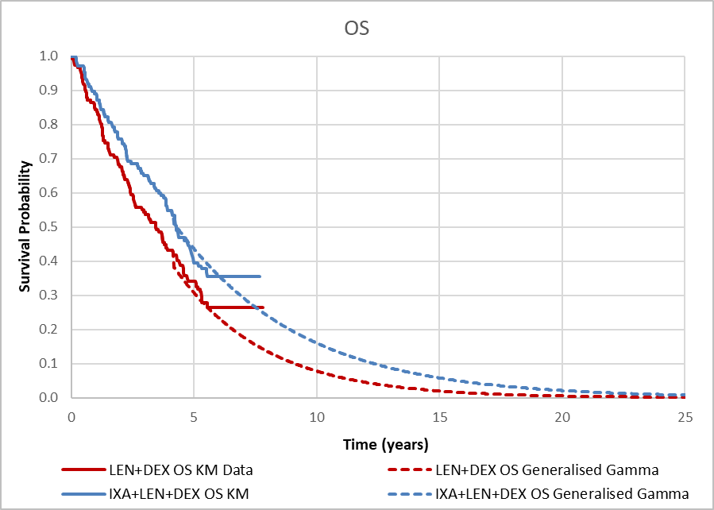
Source: Figures 1 and 2, pp 4-5 of the PSCR
DEX = dexamethasone; IXA = ixazomib; KM = Kaplan-Meier; LEN = lenalidomide; OS = overall survival

  - The resubmission stated that the generalised gamma distribution provided a good fit to the KM data and was chosen for the base case due to violation of the proportional hazard assumption and clinical plausibility of long-term extrapolation. The results of the model show that at 20 years there were approximately 2% of patients still alive in ILd arm (see Figure 5). The ESC considered that the resubmission did not justify the clinical plausibility of the generalised gamma function and with reference to previous PBAC advice that a 15 year time horizon may be the most appropriate, noted that the Gompertz distribution may be the most clinically plausible option as it predicted no patients alive after 15 years. The pre-PBAC response noted that in TMM-1 at a median follow up of 85 months (7.1 years), 4% of ILd patients remained on study treatment and 31% were alive. The pre-PBAC response stated that it was not implausible that a small proportion of patients would remain alive after 15 years as predicted by the generalised gamma distribution.
Figure 5: Extrapolation functions and the Kaplan-Meier curve for OS in ILd arm of the 2-3 prior therapies subgroup
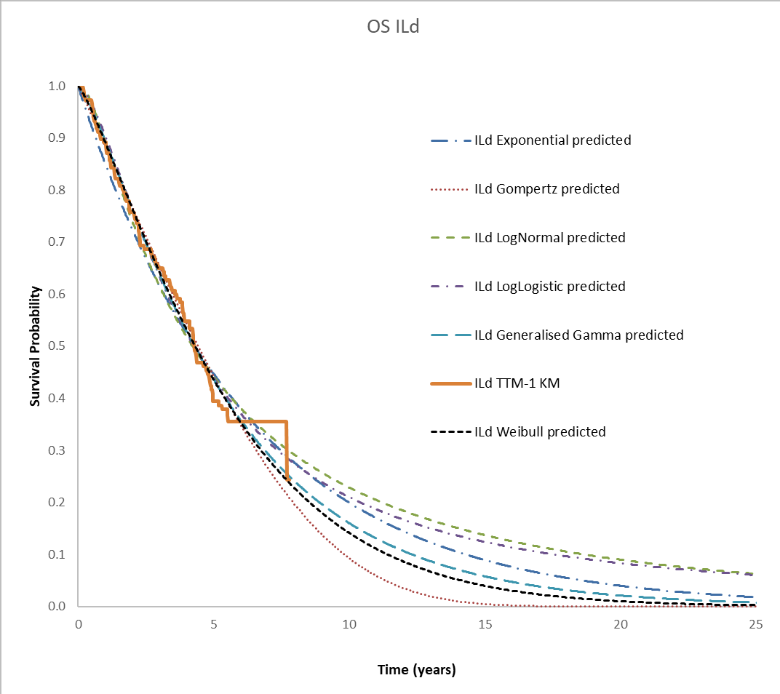
Source: Compiled during evaluation using Workbook Section 3 CE Model
ILd = ixazomib + lenalidomide + dexamethasone; KM = Kaplan-Meier; OS = overall survival.
Note: The KM cut-off (months) worksheet Main Settings, Cell [E32-F32] was changed to zero; the OS for ILd was taken from Worksheet Comp1, column: BE; The PFS for ILd was taken from Worksheet Comp2, column: BE.

  - For PFS and ToT the model used the KM data until 20-months and then applied Weibull parametric curves (median follow-up time was 23.3 months for ILd and 22.9 months for Ld). The resubmission stated that Gompertz and exponential parametric curves were also considered. The use of 20 months of KM data was reasonable for PFS. The ESC noted that the ToT extrapolations were underestimated compared to the KM curves for both the ILd and Ld arms (Figure 6). The ESC considered that extrapolation of the ToT curves might not have been necessary and may have added more uncertainty to the results – see Figure 6. The pre-PBAC response acknowledged that the extrapolation of the ToT curves may not have improved the reliability of the model and stated that the removal of any extrapolation of the ToT KM data was reasonable in the base case.
Figure 6: Extrapolation of Kaplan-Meier curves for ToT in the 2-3 prior therapies subgroup using Weibull function
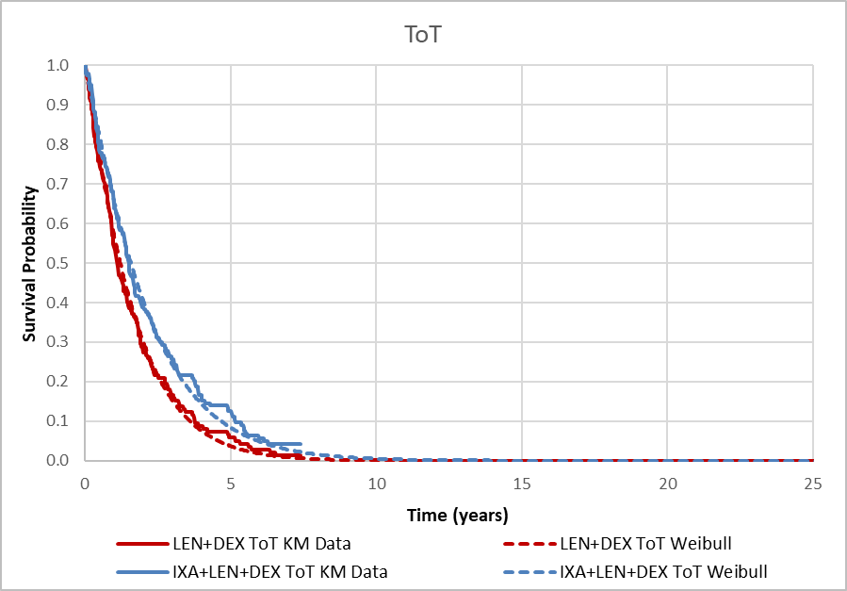
Source: Figure 3-4, p100 of the resubmission.
IXA+LEN+DEX = ixazomib + lenalidomide + dexamethasone; KM = Kaplan-Meier; LEN+DEX = lenalidomide + dexamethasone; ToT = time on treatment

  - There were applicability issues related to age and the cytogenetic risk profile of patients in the economic model (sourced from TMM-1) and the Australian population. The ESC noted that patients from TMM-1 in the subgroup of patients who had received 2-3 prior therapies had a median age of 65 years, whereas patients in Australia are first diagnosed with MM at a median age of 70 years (MSAG, 2019). The latter implies that patients are more than 5 years older in Australia at diagnosis relative to the modelled population who have already received 2-3 prior therapies. The resubmission stated that this was unlikely to have a significant effect. This may not be reasonable.
  - Summary of the key drivers of the model are presented in Table 13.
Table 13: Key drivers of the model
Description | Method/Value | Impact  Base case: $||³/QALY gained
Time horizon | Model adopted a 20-year time horizon, compared with a median follow-up of 85 months from the updated final analysis | Moderate to high, favours ILd  15 years: ICER = $||||³/QALY  10 years: ICER = $||||⁴/QALY
Survival adjustment | Unadjusted OS (from TMM-1 for 2-3 prior lines of therapy subgroup) | High, favours ILd.  ICER = $||||⁴/QALY
 | OS adjustment using IPWC method (base case: TSE method) | High, favours ILd.  ICER = $||||⁴/QALY
Cost of therapy | Cost of lenalidomide (subject to RSA) Model uses the published DPMQ lenalidomide prices. The SA applied 25%, 50% and 75% discount rate | High, favours Ld.  25%: ICER = $||||³/QALY  50%: ICER = $||||²/QALY  75%: ICER = $||||¹/QALY
OS point of extrapolation | The submission used extrapolated OS curve data for the entire time horizon in the base-case analysis. The SA applied the extrapolated data from the median follow-up (85 months) and the median OS (50 months) | Low, favours ILd  50 months: ICER = $||||³/QALY  85-months: ICER = $||||/QALY
Extrapolation function: OS | Model adopted Generalised gamma as base case, Weibull and Gompertz distributions were also considered a good fit. | Moderate to high, favours ILd  Weibull: ICER = $||||³/QALY  Gompertz: ICER = $||||⁴/QALY
Source: Table 3-22, p 114 of the resubmission. Calculated during evaluation.
ICER = incremental cost-effectiveness ratio; ILd = ixazomib + lenalidomide + dexamethasone; IPWC = Inverse probability of censoring weights; KM = Kaplan Meier; Ld = lenalidomide + dexamethasone; OS = overall survival; PFS = progression free survival; ToT = time on treatment.

The redacted values correspond to the following ranges:$45,000 to < $55,000
$55,000 to < $75,000
$75,000 to < $95,000
$95,000 to < $115,000

  - Results of the base case economic analysis are presented in Table 14. These results were based on the published price of the comparator. Results of the respecified base case presented in the PSCR which reduced the time horizon to 15 years (from 20 years) and which applied the generalised gamma distribution to the OS curve from 50 months (rather than applying the extrapolated curve for the entire time horizon) are also presented below. The pre-PBAC response provided a further respecified base case in which the time horizon was 15 years, there was no extrapolation of the ToT KM curves, the generalised gamma distribution was applied to the OS curve from 53 months follow-up and the unadjusted OS hazard ratio of 0.845 was applied.
Table 14: Results of the economic evaluation
 | ILd | Ld | Increment
Costs | $| | $| | $|
Life years | 4.65 | 3.65 | 1.01
QALYs | 3.05 | 2.39 | 0.66
Incremental cost per life year gained |  |  | $|
Incremental cost per QALY gained |  |  | $|^{a,1}
PSCR respecified base case
Costs |  |  | $|
QALYs |  |  | 0.62
Incremental cost per QALY gained |  |  | $|^{a,1}
Pre-PBAC respecified base case
Costs |  |  | $|
QALYs |  |  | 0.54
Incremental cost per QALY gained |  |  | $|^{a,2}
Source: Table 3-21, p113 of the resubmission.
AEMP = approved ex-manufacturer price; CUA = cost utility analysis; ILd = ixazomib + lenalidomide + dexamethasone; Ld = lenalidomide + dexamethasone; QALY = quality adjusted life years.
a. The resubmission used an indicative AEMP for ixazomib $| | in the CUA estimates.

The redacted values correspond to the following ranges:
¹$75,000 to < $95,000
²$115,000 to < $135,000

  - Traces of the model results for the scenario included in the resubmission are presented in Figure 7.
Figure 7: Markov traces for ILd and Ld in each health state
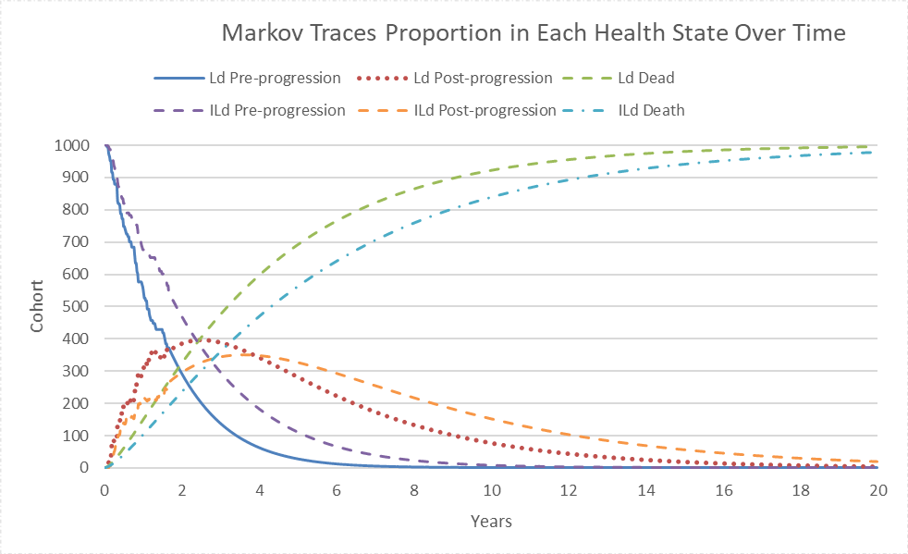
Source: prepared during evaluation.
ILd = ixazomib + lenalidomide + dexamethasone; Ld = lenalidomide + dexamethasone.

  - The results of key univariate and multivariate sensitivity analyses are summarised in Table 15.
Table 15: Sensitivity analyses
Description | Incremental cost | Incremental QALY | ICER | Change in ICER (%)
Base case | $ | | 0.66 | $ | ¹ | -
Univariate sensitivity analysis
Discount rate (base case = 5%)
3.5% | $ | | 0.72 | $ | ¹ | -4%
0% | $ | | 0.91 | $ | ¹ | -13%
Time horizon (base case = 20 years)
10 years | $ | | 0.53 | $ | ² | 24%
15 years | $ | | 0.63 | $ | ¹ | 5%
OS HR (base case = 0.713; adjusted using the two-stage method)
HR = 0.845 (unadjusted) | $ | | 0.57 | $ | ² | 24%
HR = 0.674 (IPCW method) | $ | | 0.59 | $ | ² | 11%
OS extrapolation (base case = generalised gamma applied from 0 months)
Weibull extrapolation | $ | | 0.62 | $ | ¹ | 6%
Gompertz extrapolation | $ | | 0.54 | $ | ² | 25%
Generalised gamma applied from 85 months (median time to follow-up)ª | $ | | 0.60 | $ | ² | 9%
Generalised gamma applied from 50 months (median OS 53.0 for ILd, 43.0 for Ld at 85 months of follow-up)^{b} | $ | | 0.66 | $ | ¹ | 1%
Multivariate sensitivity analysis
Unadjusted OS HR, generalised gamma applied from 85 months | $ | | 0.40 | $ | ⁴ | 79%
Unadjusted OS HR, generalised Gamma applied from 85 months, time horizon 15 years | $ | | 0.38 | $ | ⁴ | 88%
Unadjusted OS HR, generalised gamma applied from 85 months, time horizon 10 years | $ | | 0.34 | $ | ⁴ | 111%
Unadjusted OS HR, Gompertz applied from 85 months, time horizon 20 years | $ | | 0.38 | $ | ⁴ | 91%
Unadjusted OS HR, Gompertz applied from 85 months, time horizon 15 years | $ | | 0.37 | $ | ⁴ | 93%
Unadjusted OS HR, Weibull applied from 85 months, time horizon 20 years | $ | | 0.40 | $ | ⁴ | 80%
Unadjusted OS HR, Weibull applied from 85 months, time horizon 15 years | $ | | 0.38 | $ | ⁴ | 88%
PSCR multivariate sensitivity analysis
Unadjusted OS HR, generalised gamma applied from 50 months, time horizon 15 years^{d} | $ | | 0.60 | $ | ² | 18%
ESC multivariate sensitivity analysis
Unadjusted OS HR, Gompertz applied from 60 months, time horizon 15 years and remove extrapolation from ToT curves^{f} | $ | | 0.44 | $ | ³ | 70%
Source: Table 3-22, p 114 of the resubmission.
ICER = incremental cost-effectiveness ratio; ILd = ixazomib + lenalidomide + dexamethasone; IPWC = Inverse probability of censoring weights; Ld = lenalidomide + dexamethasone; OS = overall survival; PBS = Pharmaceutical Benefits Scheme; PFS = progression free survival; ToT = time on treatment.
a. Median time to follow-up of 85 month, the OS values were adjusted for ILd in worksheet ‘Comp2’, cells BE9:BE378 to reflect the ILd KM data in Cells AS9:AS378.; for Ld in worksheet ‘Comp1’, cells BE9:BE378 to reflect the Ld KM data in Cells AS9:AS378;
b. For 50 months (median OS) similarly the cells ranged BR 9:BE226 were adjusted for both treatment arms;
c. Only including the AEs rates for diarrhoea and thrombocytopenia (as per the Economic model), the AEs cost per cycle was $| | for ILd and $| | for Ld (compared to base case $| | (ILd) and $| | (Ld)).
d. Corresponding settings changed on Main Settings sheet as follows (E10=15 years; E24=Unadjusted OS; E32=50; E39=FA – Unadjusted)
f. The value of ToT time of KM data cut-off is set to 89 months (worksheet Main settings, cell E21); and in worksheet Comp1 and Comp2. Cells U397:U1783 and X397: X1783 are set to Zero (manually removing the link to the extrapolation curve)
The redacted values correspond to the following ranges:
¹$75,000 to < $95,000
²$95,000 to < $115,000
³$135,000 to < $155,000
⁴$155,000 to < $255,000

  - The model was sensitive to the use of the unadjusted OS HR which ICER increased to $95,000 to < $115,000 per QALY. The ESC noted that the multivariate sensitivity analysis presented in the PSCR which applied the unadjusted OS HR resulted in and ICER of $95,000 to < $115,00 per QALY. The ESC considered that a more appropriate base case would (i) apply a 15-year time horizon; (ii) apply the unadjusted OS HR; (iii) extrapolate OS from 60 months using the Gompertz function; and (iv) remove extrapolation from the ToT curves. This resulted in an ICER of $135,00 to < $155,000per QALY.

Ixazomib cost/patient/course
  - A summary of the drug cost per patient for ILd and Ld is provided in Table 16. Based on the CUA, the cost/patient/course for a patient treated with ILd was estimated to be $| |, with the corresponding indicative AEMP for ixazomib being $| | (cost per cycle) at 26 cycles of treatment. However, the financial estimates assumed only 14 cycles (12.9 months) of treatment using a published DPMQ for ixazomib of $| |.
Table 16: Drug cost per patient for proposed and comparator drugs
 | ILd  Trial dose and duration  (ITT pop) | ILd  CUA  (2-3 prior lines subgroup) | ILd  Financial estimates  (2-3 prior lines subgroup) | Ld  Trial dose and duration  (ITT pop) | Ld  CUA  (2-3 prior lines subgroup) | Ld  Financial estimates  (2-3 prior lines subgroup)
Mean RDIª | Ixa: 92.2%  Len: 82.1%  Dex: 80.5% | Ixa: 92.2%  Len: 82.1%  Dex: 80.5% | Ixa: 100.0%  Len: 84.7%  Dex: NA ^{b} | Len: 86.5%  Dex: 83.3% | Len: 86.5%  Dex: 83.3% | Len: 84.7%  Dex: NA^{b}
Duration^{c}, months, (cycles) | Mean  Ixa: 23.1 (25.1)  Len: 24.5 (26.6)  Dex: 23.4 (25.4) | Mean  ILd: 24.34 (26.4)^{d} | Median PFS  ILd: 12.9 (14) | Mean  Len: 22.2 (24.1)  Dex: 21.2 (23.0) | Mean  Ld: 19.13 (20.8)^{d} | Median PFS  Ld: 12.9 (14)
Cost/patient/  cycle^{e} | ILd: $ |  Ixa: $ |  Len: $ |  Dex: $|| | ILd: $ | ^{f}  Ixa: $ |  Len: $ |  Dex: $ | | IL(d): $||  Ixa: $ |  Len: $||^{i} | Ld: $ |  Len: $||  Dex: $|| | Ld: $ | ^{f}  Len: $||  Dex: $|| | L(d): $|||^{i}
Cost/patient/  course | $ | ^{g} | $|^{g}  $|^{h} | $ | (Ixa published DPMQ)^{g}  $ | (Ixa indicative AEMP) | $ | ^{g} | $|^{g}  $|^{h} | $ | ^{g}
Source: Table 2-8, 53 of the resubmissions; Section 3 workbook.
AEMP = approved ex-manufacturer price; Dex = dexamethasone; DPMQ = dispensed price per maximum quantity; ILd = ixazomib + lenalidomide + dexamethasone; Ixa = ixazomib; ITT = intention to treat; Ld = lenalidomide + dexamethasone; Len = lenalidomide; NA = not applicable; RDI = relative dose intensity
a. The resubmission applied a mean RDI from the TMM-1 trial ILd and Ld based on the ITT population.
b. The submission did not include dexamethasone in the financial estimates, as dexamethasone is a concomitant treatment in both ILd and Ld and the submission did not expect the addition of ixazomib to the PBS to increase the total number of patients treated.
c. The mean duration of therapy from TMM-1 reflects the ITT population, with no data available for subgroup (prior 2-3 lines of therapy).
d. Sourced from the predicted time on treatment for ILd and Ld based on TMM-1 (2-3 prior lines of therapy), respectively (Section 3 workbook, worksheet Results, cells D36 and D46)
e. Cost per patient per cycle was sourced from the Section 3 and Section 4 of the resubmission.
f. The cost was sourced from Section 3 Workbook, Worksheet Costs (with cost per cycle in cells G8 and G9).
g. Cost calculated by multiplying to mean cycle duration.
h. Cost sourced from Section 3 workbook, ILd: worksheet Comp2, cell CE3, Ld: worksheet Comp1, cell CC3.
i. Corresponds to an average cost for lenalidomide considering all strength. This mean cost was calculated for the purpose of this table only.

Estimated PBS usage & financial implications
  - This submission was not considered by DUSC.
  - The resubmission utilised a combined epidemiological/market share approach to estimate the utilisation and financial impact of listing ILd for patients who have undergone at least two prior therapies. This seemed reasonable, given the assumption of superiority to Ld and non-inferiority to Cd. An overview of the data sources and assumptions used to populate the financial estimates is provided in Table 17.
  - The duration of treatment used for both the ILd and Ld arms was 12.90 months. This reflected the median PFS reported in TOURMALINE 1 (TMM-1) (IA1) from the Ld arm in the subgroup of interest (2-3 prior therapies). This underestimated the cost of ILd as the duration of treatment of ILd was assumed to be longer in TMM-1 given that although the median PFS for ILd was not estimable the lower bound 95% CI was 16.59 months. Furthermore, the median PFS in a later analysis from TMM-1 (IA2) reported a median PFS for ILd of 21.98 months and for Ld of 12.98 months. These results were used in the economic model. A sensitivity analysis using duration of treatment of 21.98 months (median PFS (23 months follow-up)) for ILd arm as per TMM-1 was conducted by the evaluation.
Table 17: Key inputs for financial estimates
Parameter | Value applied and source | Comment
Prevalent population | Medicare data – 10% sample.  The number of patients in RRMM (all lines) for year 2021 was 6,286. | The Year 1 estimate was presented for 2022. The estimates up to Year 6 were projected, however how the projections were calculated was unclear. The increase of patients per year ranged from 6.5% to 15.4%.  Given that DBd is available in 2nd line, this will impact the number of patients that would progress to 3rd line of treatment. However, this impact is unknown given that DBd was listed on PBS in January 2021 (p128 of the resubmission).
Eligible patients | Medicare data – 10% sample: based on the projected proportion of eligible patients in 3+ line (33.96%), proportion of those patients receiving lenalidomide and proportion receiving lenalidomide with dexamethasone. | The source could not be verified during evaluation.
Uptake rate | ||||% in Year 1 (based on Medicare data – 10% sample: ||||% of lenalidomide in 3+ lines corresponded to patients aged 70) increasing to ||||% in Year 6 (assumption). | May be reasonable; however, due to the listing of lenalidomide in the newly diagnosed MM setting the use of lenalidomide-based regimens in later lines is not certain.
Grandfathered patients | |||| patients from Takeda Australia Named Patients Program | This is reasonable.  There were no new patients in the program since 2019.
Duration | 12.9 months for initiating patients (based on the median PFS in Ld arm in subgroup of prior 2 to 3 treatment lines).  21.3 months in grandfathered patients. This corresponds to the remaining treatment estimated based on the treatment duration from TMM-1 for patients who have remained on treatment for at least 48 months, which was 69.3 months. | This is not consistent with data applied in the economic evaluation of median PFS of 21.98 months (23 months follow-up) for ILd and 12.98 months for Ld. Using duration of treatment from the Ld arm may lead to an underestimation from Year 2 to Year 6 underestimating the use of ILd (refer SA conducted during evaluation, Table 19).  It was also noted that Grandfathered patients remained on treatment for longer compared to patients initiating treatment (all patients in the program that have received at least 2 years of treatment were estimated to receive 21.3 additional months of treatment).
Patients electing lenalidomide-based therapy | Year 1, ||||% to Year 6, ||||%. | The resubmission estimated that the use of Ld will decline over time, thus the substitution of Ld by ILd will also decline.
Substitution rate/ electing treatment | Assumption of ixazomib being added to the Ld regimen and equal duration of treatment for ILd and Ld.  Assuming replacement of Cd.  Market share substitution rate:  Carfilzomib  Yr 1: ||||% to Yr 6: ||||%  Lenalidomide  Yr 1: ||||% to Yr 6: ||||% | The assumption that ||||-||||% of carfilzomib scripts would be affected by ixazomib was not justified.  The assumption that the number of ILd cycles would equal the number of Ld cycles was inconsistent with the difference in duration of treatment between ILd and Ld in TMM-1.
Ixazomib price | $|||| | Published requested price of ixazomib
Lenalidomide price | Lenalidomide:  5mg: 5783J, 9642L $4,495.22  10mg: 5784K, 9643M $4,704.42  15mg: 5785L, 9644N $5,486.60  25mg: 5786M, 9645P $5,928.74 | Used published DPMQ prices for lenalidomide
Carfilzomib cost | Published DPMA:  60mg: $1,268.94; 30 mg: $634.47; 10 mg: $211.49 . The resubmission assumed the same growth rate of carfilzomib scripts for twice weekly and once weekly injections, based on the PBS Statistics (PBS item reports) | The use of carfilzomib once weekly may be underestimated and hence, the use of carfilzomib twice weekly is likely overestimated by the resubmission. As the assumed substitution of ILd for Cd is low this may not have a major impact on the estimates
MBS item | $112.40 MBS item number 13950, used for infusion services for carfilzomib. | Appropriate
Source: Compiled during evaluation
DBd = daratumumab + bortezomib + dexamethasone; DPMA = dispensed price per maximum amount; DPMQ = dispensed price per maximum quantity; ILd = ixazomib + lenalidomide + dexamethasone; Ld = lenalidomide + dexamethasone; MBS = Medicare Benefits Schedule

  - A summary of financial implications of the proposed listing of ILd for the treatment of RRMM of patients who have received at least 2 prior therapies is presented in Table 18.
  - The resubmission estimated a net cost to the PBS/RPBS of listing ILd of $20 million to < $30 million in Year 1, increasing to $30 million to < $40 million in Year 6, amounting to $100 million to < $200,000 million over six years (published prices). Cost offsets were included for reduced use of lenalidomide and carfilzomib under current PBS item codes, for patients assumed to be treated with ILd. The resubmission did not consider the potential impact of displacement of other treatments, including Cd, to a further line in therapy.

Table 18: Estimated use and financial implications
 | Year 1 | Year 2 | Year 3 | Year 4 | Year 5 | Year 6
Estimated extent of use
Number of patients treated | | ¹ | | ¹ | | ¹ | | ¹ | | ¹ | | ¹
Number of ixazomib scripts dispensedª | | ² | | ² | | ² | | ² | | ² | | ²
Number of lenalidomide scripts dispensed | | ² | | ² | | ² | | ² | | ² | | ²
Estimated financial implications of ixazomib
PBS/RPBS cost Ixazomib | $ | ⁵ | $ | ⁶ | $ | ⁶ | $ | ⁶ | $ | ⁶ | $ | ⁶
Less co-payment | $ | ³ | $ | ³ | $ | ³ | $ | ³ | $ | ³ | $ | ³
Cost to PBS/RPBS less co-payment of ixazomib | $ | ⁵ | $ | ⁵ | $ | ⁶ | $ | ⁶ | $ | ⁶ | $ | ⁶
Estimated financial implications for lenalidomide (as part of ILd)
PBS/RPBS cost Lenalidomide (as part of ILd) | $ | ⁴ | $ | ⁴ | $ | ⁵ | $ | ⁵ | $ | ⁵ | $ | ⁵
Co-payments | $ | ³ | $ | ³ | $ | ³ | $ | ³ | $ | ³ | $ | ³
Cost to PBS/RPBS for lenalidomide (as part of ILd, less co-payments) | $ | ⁴ | $ | ⁴ | $ | ⁵ | $ | ⁵ | $ | ⁵ | $ | ⁵
Estimated financial implications for ILd
PBS/RPBS cost ixazomib plus lenalidomide (as part of ILd) | $ | ⁶ | $ | ⁶ | $ | ⁷ | $ | ⁷ | $ | ⁸ | $ | ⁸
Estimated financial implications for medicines with reduced use: Ld and Cd (not including dexamethasone)
Cost offsets to PBS/RPBS less co-payments | $ | ⁴ | $ | ⁴ | $ | ⁵ | $ | ⁵ | $ | ⁵ | $ | ⁵
Net financial implications
Net cost to PBS/RPBS | $ | ⁵ | $ | ⁶ | $ | ⁶ | $ | ⁶ | $ | ⁶ | $ | ⁶
Net cost to MBS | -$ | ³ | -$ | ³ | -$ | ³ | -$ | ³ | -$ | ³ | -$ | ³
Net cost to PBS/RPBS/MBS | $ | ⁵ | $ | ⁶ | $ | ⁶ | $ | ⁶ | $ | ⁶ | $ | ⁶
Previous submission November 2020
Net cost to PBS/RPBS | $ | ³ | $ | ³ | $ | ³ | $ | ³ | $ | ³ | -$ | ³
Source: Table 4-4, p126 of the resubmission; and Utilisation and cost model – ‘2b. Patients – prevalent’.
PBS = Pharmaceutical Benefits Scheme; RPBS = Repatriation Pharmaceutical Benefits Scheme
a. Assuming 13 per year as estimated by the submission.

The redacted values correspond to the following ranges:
¹< 500
²500 to < 5,000
³$0 to < $10 million
⁴$10 million to < $20 million
⁵$20 million to < $30 million
⁵$30 million to < $40 million
⁶$40 million to < $50 million
⁷$50 million to < $60 million
⁸$60 million to < $70 million

  - The resubmissions estimates differed significantly from the November 2020 submission, in which the net cost to PBS/RPBS of listing ILd was estimated to be $0 to < 10 million over six years (Table 18).
  - In November 2020, the PBAC considered the net financial impact of listing ILd was underestimated (paragraph 7.12, ixazomib PSD, November 2020). The November 2020 submission had assumed a higher substitution rate for Cd compared to Ld, and similar to the resubmission, did not incorporate displacement to Cd, but rather included replacement. The resubmission provided two sensitivity analyses based on the following assumptions relating to the proportion of patients electing to receive lenalidomide-based therapy: (i) that there will be no change to the proportion (i.e. it will remain constant at | |%); and (ii) that there will be a steeper decline. The results are summarised in Table 19.
Table 19: Sensitivity analyses results (Net Impact PBS/RPBS)
 | 2022 | 2023 | 2024 | 2025 | 2026 | 2027
ILd patients electing treatment (based on patients treated with lenalidomide in 3L+)
Base case (%) | || || | || || | || || | || || | || || | || ||
Net cost to PBS/RPBS | $|| ||¹ | $|| ||² | $|| ||² | $|| ||² | $|| ||² | $|| ||²
SA 1: Status Quo (%) | || || | || || | || || | || || | || || | || ||
Net cost to PBS/RPBS | $|| ||¹ | $|| ||² | $|| ||² | $|| ||³ | $|| ||³ | $|| ||⁴
SA 2: Accelerated decline (%) | || || | || || | || || | || || | || || | || ||
Net cost to PBS/RPBS | $|| ||¹ | $|| ||¹ | $|| ||¹ | $|| ||¹ | $|| ||¹ | $|| ||¹
Source: Table 4-20, p146 of the resubmission. Source: Adapted from Section 4 Excel file during evaluation
PBS = Pharmaceutical Benefits Scheme; RPBS = Repatriation Pharmaceutical Benefits Scheme; SA = sensitivity analysis.

The redacted values correspond to the following ranges:
¹$20 million to < $30 million
²$30 million to < $40 million
³$40 million to < $50 million
⁴$50 million to < $60 million

Quality Use of Medicines
  - The resubmission did not present a quality use of medicines section. However, a planned strategy for the safe and effective use of ixazomib would be important with respect to the new safety concerns, specifically regarding accidental overdose. Thus, health care professional education on the mechanism of action, identification and management of adverse effect symptoms, dose modifications in light of laboratory results are considered necessary at the prescribing and dispensing stage. Further patient information, outlining the administration schedule of ILd with clear instructions would also be important in ensuring patient compliance and avoiding dosing misadventures.
For more detail on PBAC’s view, see section 7 PBAC outcome.
- PBAC Outcome
  - The PBAC did not recommend ixazomib, in combination with lenalidomide and dexamethasone (ILd), for the treatment of relapsed and/or refractory multiple myeloma (RRMM) after at least two prior therapies. The PBAC considered that although ILd appeared to have a benefit in terms of progression free survival (PFS) over the nominated comparator, lenalidomide plus dexamethasone (Ld), the impact on overall survival (OS) was uncertain. In addition, the PBAC considered that the incremental cost effectiveness ratio was uncertain, as it relied on a gain in OS, and was unacceptably high.
  - The PBAC noted that the comments from consumers and from Myeloma Australia, Myeloma Australia’s Medical and Scientific Group (MSAG) and The Leukaemia Foundation were all in support of the requested listing for ILd, describing the ongoing need for additional treatment options for RRMM patients.
  - The PBAC noted that as ixazomib was an oral capsule, ILd was an entirely oral triple therapy which may have advantages for rural and remote patients.
  - The PBAC noted that the proposed PBS restriction limited the use of ILd to patients who had received at least two prior lines of treatment, and that this was narrower than the registered indication, and the PBS listings for other RRMM treatments which require only one prior line of treatment. The PBAC acknowledged the proposed PBS restriction reflected ILd’s likely use in practice given that daratumumab plus bortezomib and dexamethasone (DBd) is listed on the PBS as a second-line therapy only and will likely displace the other RRMM treatments to the third and later line setting; however, considered a restriction that was consistent with the other RRMM treatments and which requires only one prior line of treatment would be appropriate.
  - The PBAC noted that the multiple treatment options for RRMM, and the changing treatment algorithm, complicated the selection of a main comparator(s). The PBAC recalled the November 2020 submission nominated Cd as the primary comparator and Ld a secondary comparator and, at that time, the Committee considered Ld and Cd were relevant comparators. The PBAC noted that the resubmission nominated Ld as the primary comparator and Cd as a secondary comparator. The resubmission did not present any new clinical evidence to support the clinical claim that ILd was non-inferior in terms of effectiveness and safety compared to Cd, and the PBAC therefore maintained its previous view that this claim was not supported. The resubmission therefore relied solely on the comparison of ILd and Ld. The PBAC considered that Ld was a relevant comparator; however, noted Cd remained an important comparator with it having been previously accepted as the comparator for ELd. Noting international guidelines indicate a preference for triple combination therapies, the PBAC considered that PBS listed triple therapies, such as ELd which was nominated as a near market comparator, may increasingly become relevant comparators.
  - The PBAC noted that the resubmission presented data from the TOURMALINE MM-1 (TMM-1) trial (N = 722) that compared ILd with Ld. The resubmission presented updated OS data from the intention to treat (ITT) population and a subgroup analysis for patients who had received 2-3 prior lines of therapy which reflected the proposed PBS population.
  - For the ITT population the PBAC noted that median PFS was statistically significantly longer in the ILd arm compared to the Ld arm (HR = 0.74; 95% CI: 0.59, 0.94). The OS results did not demonstrate a statistically significant difference at 23 months follow-up (HR = 0.87; 95% CI: 0.64, 1.75) or at 85 months follow-up (HR = 0.94; 95% CI: 0.78, 1.13).
  - The PBAC noted the point estimate for the hazard ratio for PFS suggested ILd was more effective in the subgroup of patients who had received 2-3 prior lines of therapy (HR = 0.58; 95% CI: 0.40, 0.84) compared with those who had received 1 prior line of therapy (HR = 0.88; 95% CI: 0.65, 1.20). However, the PBAC noted that a test for interaction was not presented in the resubmission and the biological plausibility of a larger relative effect in patients with more lines of prior treatment was not addressed in the resubmission. The PBAC noted the hazard ratio for OS was also more favourable for the patients with 2-3 prior lines of therapy but it did not demonstrate statistical significance (HR = 0.85; 95% CI: 0.64, 1.11).
  - The PBAC noted that the resubmission presented OS results for the subgroup of patients who had received 2-3 prior lines of therapy adjusted for subsequent treatments received. The PBAC noted that the resubmission applied a two-stage method with recensoring to adjust the OS results for subsequent treatments which were defined as not available in Australia. However, many of the subsequent therapies were incorrectly specified as not being available in Australia and thus, the adjustment was inappropriately applied and most likely overestimated the survival benefit (HR = 0.71; 95% CI: 0.54, 0.95).
  - Overall, in terms of efficacy, the PBAC considered that the claim that ILd was superior to Ld was not supported. The PBAC noted that ILd resulted in a statistically significant improvement in PFS for the ITT population and for patients who had received 2-3 prior lines of therapy, but that the ITT and subgroup unadjusted OS results were not statistically significant and the adjustment of the OS data as presented was not appropriate.
  - The PBAC noted that ILd was associated with similar rates of any adverse event, serious adverse events and adverse events resulting in discontinuation from the trial as Ld. The PBAC did note that ILd resulted in a higher incidence of Grade ≥ 3 adverse events, including thrombocytopenia, diarrhoea and hypokalaemia; however, considered these were generally manageable. Overall, the PBAC considered that the safety of ILd was similar to that of Ld.
  - The PBAC noted that the resubmission presented a cost utility analysis comparing ILd and Ld based on the results from TMM-1 for the 2-3 prior lines of therapy subgroup and the incremental cost effectiveness ratio (ICER) was $75,000 to < $95,000 per quality adjusted life year (QALY). The PBAC noted the use of subgroup data increased the uncertainty compared with a model based on the ITT population. The PBAC noted the following issues with the base case economic model:
  - The time horizon applied was 20 years. The PBAC recalled that it had previously accepted a time horizon of 15 years in the second-line MM setting when considering daratumumab and therefore considered that 20 years was too long for a listing in the third and later line settings. The PBAC noted that the time horizon was reduced to 15 years in the PSCR and pre-PBAC respecified base cases.
  - The model applied the adjusted OS hazard ratio. The PBAC noted that the unadjusted hazard ratio was applied in the respecified base cases.
  - For OS, the fitted function was used for the entire time horizon rather than using the observed Kaplan Meier data followed by extrapolation with the fitted function. The PSCR presented a respecified base case in which the generalised gamma distribution was applied to the OS Kaplan Meier curves from 50 months, despite median survival in the 2-3 prior therapy subgroup being 53 months and median follow up being 85 months. The PBAC noted the ESC considered that the application of the curve from 50 months favoured ILd and noted that the revised base case in the pre-PBAC response applied extrapolation from 53 months.
  - The generalised gamma distribution was applied to the OS curves. The PBAC noted that the ESC considered that the Gompertz distribution, which predicted no patients alive after 15 years, was the more clinically plausible option.
  - The unnecessary extrapolation of the time on treatment (ToT) curves may have added additional uncertainty to the results. The PBAC noted that the extrapolation of the ToT curves was removed from the respecified base case presented in the pre-PBAC response consistent with advice from ESC.
  - The PBAC noted that a respecified base case was presented in the pre-PBAC response which applied a 15 year time horizon, did not extrapolate the ToT curves, applied the unadjusted OS hazard ratio and extrapolated the OS Kaplan Meier curves from 53 months follow-up using a generalised gamma distribution . The PBAC noted that this differed from the ESC multivariate analysis in which the OS curves were extrapolated from 60 months using a Gompertz distribution. The pre-PBAC response stated that the generalised gamma distribution was reasonable as it was not implausible that a small proportion of patients would remain alive after 15 years. The respecified base case in the pre-PBAC response resulted in an ICER of $115,000 to < $135,000 per QALY based on the published lenalidomide price. The ICER for the ESC multivariate sensitivity analysis was $135,000 to < $155,000 per QALY. The PBAC considered that these ICERs were unacceptably high, and this conclusion was unchanged when the effective lenalidomide price was applied in the economic model.
  - The PBAC considered that the financial estimates were underestimated as the resubmission (i) applied an equal duration of treatment for ILd and Ld despite ILd treatment resulting in a statistically longer PFS; and (ii) did not consider the potential impact of displacement of other treatments.
  - The PBAC considered a resubmission for ILd should address the uncertainties relating to the comparator, and the efficacy clinical claim. The PBAC noted that the clinical algorithm in RRMM is rapidly evolving and that international guidelines indicate a preference for triple therapies.
  - The resubmission may be lodged at any future standard due date for PBAC submissions using the standard re-entry pathway.
  - The PBAC noted that this submission is eligible for an Independent Review.
Outcome:
Not recommended
- Context for Decision
The PBAC helps decide whether and, if so, how medicines should be subsidised through the Pharmaceutical Benefits Scheme (PBS) in Australia. It considers applications regarding the listing of medicines on the PBS and provides advice about other matters relating to the operation of the PBS in this context. A PBAC decision in relation to PBS listings does not necessarily represent a final PBAC view about the merits of the medicine or the circumstances in which it should be made available through the PBS. The PBAC welcomes applications containing new information at any time.
- Sponsor’s Comment
| |The sponsor had no comment.

