5.19 SOTORASIB
Tablet 120 mg
Lumakras®
Amgen Australia Pty Ltd
- Purpose of submission
        - The Category 1 submission requested modification of Medicare Benefits Schedule (MBS) item 73337 to include Kirsten rat sarcoma viral oncogene homologue (KRAS) G12C variant gene testing and Pharmaceutical Benefits Scheme (PBS) Section 85 Authority Required listing of sotorasib for the treatment of patients with non-squamous or not otherwise specified (NOS) Stage IIIB (locally advanced) or Stage IV (metastatic) non-small cell lung cancer (NSCLC) who harbour the KRAS G12C variant and who have progressed on prior therapy.
        - The submission was based on a cost-utility analysis comparing sotorasib with docetaxel in a population of previously treated patients with KRAS G12C variant advanced NSCLC. The key components of the clinical issue addressed by the submission are summarised below.
Table 1 Key components of the clinical issue addressed by the submission
Component | Description
Population | Test: Patients diagnosed with NSCLC shown to have non-squamous histology or histology NOS (i.e., same population eligible for pathogenic EGFR variant testing).  Medicine: Patients with locally advanced or metastatic NSCLC shown to have non-squamous histology or histology NOS and the KRAS G12C variant, of performance status 0-2, and who have progressed on prior therapy.
Intervention | KRAS variant test to determine G12C status and, if positive, the intervention after progression on prior therapy is sotorasib (oral, 960mg daily). If negative, the intervention after progression on prior therapy is docetaxel chemotherapy (75 mg/m² IV infusion every 3 weeks).
Comparator | Test: No testing, i.e., MBS item 73337 in its current format, which has no explicit inclusion of KRAS G12C variant testing in NSCLC, and no reference to sotorasib.  Medicine: Docetaxel (75 mg/m² IV infusion every 3 weeks).
Outcomes | Test: Concordance between the evidentiary standard and other KRAS G12C variant testing methods likely to be used in Australia, prognostic effect of the KRAS G12C variant.  Medicine: OS, PFS, ORR, DoR, quality of life and AEs associated with treatment.
Clinical claim | Test: KRAS G12C variant testing methods used in Australia are likely to be concordant.  Medicine: In patients with locally advanced or metastatic KRAS G12C variant positive NSCLC, sotorasib is superior to docetaxel in terms of both efficacy and safety.
Source: Table 1.1, p20 of the submission.
AE = adverse event; DoR = duration of response; EGFR = epidermal growth factor receptor; IV = intravenous; KRAS = Kirsten rat sarcoma viral oncogene homologue; NOS = not otherwise specified; NSCLC = non-small cell lung cancer; ORR = objective response rate; OS = overall survival; PFS = progression-free survival.
- Background

Registration status
        - TGA status at time of PBAC consideration: not registered. The submission was made under the TGA/PBAC Parallel Process. Sotorasib was evaluated through the TGA’s provisional pathway via Project Orbis. The TGA Delegate’s Overview and Advisory Committee on Medicines (ACM) minutes were received during the evaluation.
        - The TGA Delegate considered sotorasib to have an overall positive benefit-risk profile for the following provisional indication:
“For the treatment of adult patients with KRAS G12C mutated locally advanced or metastatic non-small cell lung cancer (NSCLC) who have received at least one prior systemic therapy for advanced disease. The decision to approve this indication has been made on the basis of objective response rate (ORR) and duration of response (DoR). Continued approval of this indication depends on verification and description of benefit in confirmatory trials”.
        - The ACM noted that the randomised data from CodeBreak 200, which will be available shortly, will be important to confirm the clinical benefit of sotorasib and to understand the efficacy and safety within organ impaired patients (liver, renal). CodeBreak 200 is an ongoing Phase III randomised controlled trial comparing sotorasib with docetaxel in the proposed target population (previously treated locally advanced (and unresectable) or metastatic KRAS G12C variant NSCLC). To be eligible, patients must have received and progressed (or experienced disease recurrence) on or after at least a platinum-based doublet chemotherapy and a checkpoint inhibitor, given in one line or across different lines (p52 of the CodeBreak 200 Protocol, Attachment 3 to the main submission). The pre-subcommittee response (PSCR) indicated the CodeBreak 200 study is ongoing with expected primary completion and data ready for submission in Q4 2022 - Q1 2023.
        - The ACM also stated that although accelerated approval was granted by the FDA in May 2021 for the proposed indication, evaluators have concluded that the dose of sotorasib has not been optimised, leading to a post-marketing requirement of a dose finding study (240 mg versus 960 mg) to investigate whether a lower dose will have a similar clinical effect. The submission noted that the sponsor has committed to the conduct of the post-marketing study requested by the FDA. The submission also noted the sponsor’s expectation was that if the same health outcomes were delivered, “the cost of sotorasib per patient should be the same irrespective of the daily dose”.
        - While the ACM acknowledged that sotorasib can cause serious toxicities, on balance, the safety profile of the 960 mg dose appeared acceptable. The ACM was of the view that the data also indicated that the 960 mg dose appeared generally tolerable.
        - An amended Delegate’s Overview was provided with the PSCR with the Delegate “not in a position to approve sotorasib for the proposed indication as outstanding issues relating to Manufacturing and Quality Control remain unresolved”. The pre-PBAC response stated the ACM further considered sotorasib in February 2022 and considered that additional studies of impurities/degradants are unlikely to influence the positive overall benefit-risk assessment, and the presence of the impurities/degradants in the drug product should not preclude provisional registration of sotorasib.

Previous PBAC consideration
        - The PBAC has not previously considered sotorasib.
- Requested listing
        - Suggestions and additions proposed by the Secretariat are added in italics and suggested deletions are crossed out with strikethrough.
Proposed PBS Listing
Name, Restriction,  Manner of administration and form |  | Max.  Qty | №.of  Rpts | Dispensed Price for Max. Qty | Proprietary Name and Manufacturer
Sotorasib  Tablets, 120mg |  | 240 | 3 | Published $||||  Effective $|||| | Lumakras® | Amgen
Category / Program: | GENERAL – General Schedule (Code GE)
Prescriber type: | Medical Practitioners
Severity: | Stage IIIB (locally advanced) or Stage IV (metastatic)
Condition: | Non-small cell lung cancer (NSCLC)
PBS Indication: | Stage IIIB (locally advanced) or Stage IV (metastatic) non-small cell lung cancer (NSCLC)
Treatment phase: | Initial
Restriction Level / Method: | Authority Required – Telephone/Electronic/Emergency
Clinical criteria: | The treatment must be as monotherapy,  AND  Patient must have a WHO performance status of 2 or less;  Patient must have (had) a WHO performance status of no greater 2 at treatment initiation with this drug  AND  The condition must be non-squamous type non-small cell lung cancer (NSCLC) or not otherwise specified (NOS) type NSCLC,  AND  The condition must have progressed on or after prior therapy for this condition;  The treatment must be occurring in a patient where disease progression occurred following another drug therapy, prior to treatment initiation with this drug  AND  Patient must have evidence of a KRAS G12C pathogenic variant in tumour material.  The condition must be confirmed to have a Kirsten rat sarcoma (KRAS) G12C pathogenic variant in tumour material prior to treatment initiation with this drug; retain pathological evidence on the patient’s medical records  AND  The treatment must not be subsidised in a patient where the condition has further progressed despite treatment with this drug
Administrative advice | No increase in the maximum quantity or number of units may be authorised. No increase in the maximum number of repeats may be authorised.

Category / Program: | GENERAL – General Schedule (Code GE)
Prescriber type: | Medical Practitioners
Severity: | Stage IIIB (locally advanced) or Stage IV (metastatic)
Condition: | Non-small cell lung cancer (NSCLC)
PBS Indication: | Stage IIIB (locally advanced) or Stage IV (metastatic) non-small cell lung cancer (NSCLC)
Treatment phase: | Grandfathered
Restriction Level / Method: | Authority Required – Telephone/Electronic/Emergency
Clinical criteria: | Patient must have received non-PBS subsidised treatment with this drug for this PBS indication prior to [insert listing date];  AND  The treatment must be as monotherapy,  AND  Patient must have a WHO performance status of 2 or less;  AND  The condition must be non-squamous type non-small cell lung cancer (NSCLC) or not otherwise specified (NOS) type NSCLC,  AND  The condition must have progressed on or after prior therapy for this condition;  AND  Patient must have evidence of a KRAS G12C pathogenic variant in tumour material.
Administrative advice | No increase in the maximum quantity or number of units may be authorised. No increase in the maximum number of repeats may be authorised.

Category / Program: | GENERAL – General Schedule (Code GE)
Prescriber type: | Medical Practitioners
Severity: | Stage IIIB (locally advanced) or Stage IV (metastatic)
Condition: | Non-small cell lung cancer (NSCLC)
PBS Indication: | Stage IIIB (locally advanced) or Stage IV (metastatic) non-small cell lung cancer (NSCLC)
Treatment phase: | Continuing
Restriction Level / Method: | Streamlined
Clinical criteria: | The treatment must be as monotherapy,  AND  Patient must have previously received PBS-subsidised treatment with this drug for this condition,  AND  Patient must not have developed disease progression while receiving PBS-subsidised treatment with this drug for this condition.
Administrative advice | No increase in the maximum quantity or number of units may be authorised. No increase in the maximum number of repeats may be authorised.

        - The submission proposed a Special Pricing Arrangement (SPA) with a published dispensed price for maximum quantity (DPMQ) of $| | and an effective DPMQ of | |.
        - The submission requested a grandfather restriction for patients on the Sponsor’s planned shared cost access program at the time of PBS listing. An estimate of <500 patients was assumed in the financial estimates although the sponsor “will be able to better advise the number of grandfathered patients closer to listing”.
        - The proposed listing for sotorasib did not restrict eligibility by ECOG performance status (PS). However, there were no patients in CodeBreak 100 with an ECOG PS of >1. The PSCR stated that although patients with PS 2 were not enrolled in CodeBreak100, these patients could be good candidates for treatment with sotorasib based on its efficacy and favourable adverse event and tolerability profile and its easier administration relative to the current non-targeted, IV cytotoxic standard of care therapy. The PSCR stated patients with PS 2 may therefore have specific unmet needs that could be met by sotorasib and noted PS 2 NSCLC patients are able to access other targeted therapies (despite trials which limited enrolment to PS 0-1). The PBAC agreed with the ESCs that the proposed criteria limiting access to patients with a PS of ≤2 was reasonable.
        - The evaluation considered it may be appropriate for the proposed restriction to specify that prior therapy for advanced disease should include an anti PD-(L) agent and platinum-based doublet chemotherapy (except where contraindicated), given either as one line of therapy or across different lines. This is consistent with the proposed clinical management algorithm and the CodeBreak 100 study. The PSCR stated that the sponsor does not consider it is necessary or appropriate to precisely match the PBS criteria to the trial entry criteria. The PSCR stated the likely TGA indication does not include a specific prior therapy requirement and sotorasib was effective across prior therapy subgroups in CodeBreak100. The PSCR stated such a change would lead to an unnecessarily complex listing and the proposed simple restriction wording is appropriate and preferable. The ESCs disagreed with the PSCR and considered that it would be appropriate for initial treatment to be limited to patients who have had prior therapy with a PD1/PD-L1 inhibitor and a platinum-based doublet chemotherapy to ensure use of sotorasib in the appropriate line of therapy. The PBAC considered the clinical criteria “The treatment must be occurring in a patient where disease progression occurred following another drug therapy, prior to treatment initiation with this drug” was clinically appropriate and it was not necessary to specify which prior therapies.
        - The requested restrictions were for patients with either locally advanced (Stage IIIB) or metastatic (Stage IV) NSCLC. However, there was limited evidence for sotorasib’s efficacy in patients with locally advanced disease from the CodeBreak 100 and SELECT-1 studies (~96% of patients were metastatic at baseline). The PBAC agreed with the ESCs that the requested restriction for patients with either locally advanced (Stage IIIB) or metastatic (Stage IV) NSCLC was reasonable.
        - The PBAC noted that reference to ‘pathogenic’ in the requested initial restriction was not required and could be removed.
For more detail on PBAC’s view, see section 7 PBAC outcome.
- Population and disease
        - NSCLC comprises a histologically heterogeneous group of tumours, which include adenocarcinoma, the most common histologic subtype, squamous cell carcinoma and large cell carcinoma. In 2011, approximately 19% of NSCLC patients were diagnosed at an early stage (stage I or II), 11% with locally advanced stage III disease and 42% with metastatic (stage IV) disease (29% could not be staged). In Australia between 2013 and 2017, lung cancer was associated with a 5-year survival rate of 20%, which is poorer than for the other frequently diagnosed cancers including prostate, breast cancer, bowel cancer and melanoma.
        - The submission stated the clinical outcomes and quality of life (QoL) in patients with NSCLC tumours containing the KRAS G12C variant remain very poor, particularly after progression on first-line therapy.
        - It is proposed that at diagnosis, patients with non-squamous NSCLC (adenocarcinoma, adenosquamous carcinoma, and large cell carcinoma) or not otherwise specified (NOS) histology will be eligible for KRAS variant testing conducted concurrently with pathogenic EGFR variant testing. Pathogenic KRAS variants are present in 30–37% of non-squamous NSCLC cases. Those with the KRAS G12C variant (present in 12.5–14.5% of non-squamous NSCLC cases) will be eligible for treatment with sotorasib after the failure of first-line treatment for advanced (stage IIIB/IV) disease. The ESCs advised the clinical place proposed for sotorasib is reasonable.
        - Sotorasib is a small molecule that specifically and irreversibly inhibits the KRAS G12C protein. The recommended dose of sotorasib in the draft Product Information (PI) is 960 mg taken orally once daily (as eight 120 mg tablets) until disease progression or unacceptable toxicity.
- Comparator
        - The submission nominated docetaxel as the main comparator for sotorasib.
For more detail on PBAC’s view, see section 7 PBAC outcome.
- Consideration of the evidence

Sponsor hearing
        - The sponsor requested a hearing for this item. The clinician discussed the clinical need for additional therapeutic options for the second-line treatment of patients with KRAS G12C variant NSCLC where the current standard of care is docetaxel which has limited efficacy and significant toxicity. The clinician noted the manageable toxicity profile of sotorasib and the convenience of an oral treatment for patients.

Consumer comments
        - The PBAC noted and welcomed the input from a consumer group (1), a health care professional (1) and an organisation (1) via the Consumer Comments facility on the PBS website. The comments described a range of benefits of treatment with sotorasib including an additional choice of therapy, an oral treatment regimen, longer overall survival, and quality of life benefits because sotorasib is better tolerated than chemotherapy by most patients.
        - The Medical Oncology Group of Australia (MOGA) also expressed its strong support for the sotorasib submission, categorising it as one of the therapies of “high priority for PBS listing” on the basis of the CodeBreak100 trial. The PBAC noted that the MOGA presented a European Society for Medical Oncology Magnitude of Clinical Benefit Scale (ESMO-MCBS) for sotorasib, which was limited to 3 (out of a maximum of 5, where 5 and 4 represent the grades with substantial improvement), based on a comparison with no treatment.

Overview of the evidence base
        - The approach taken in the submission was to present linked evidence that KRAS G12C variant testing plus treatment with sotorasib produced superior clinical outcomes to no KRAS variant testing plus docetaxel.
Table 2 Summary of the linked evidence approach
 | Type of evidence supplied | Extent of evidence supplied
Accuracy and performance of the test (analytical validity) | Concordance with clinical utility standard  Concordance between two NGS programs  Diagnostic yield studies | ☒ k=1 n=81  ☒ k=1 n=230  ☒ k=8 n=2,247
Prognostic evidence | Comparison of outcomes in patients receiving usual care conditioned on the presence or absence of biomarker positive status | ☒ k=13 n=9,419
Change in patient management | Evidence to show that biomarker determination guides decisions about treatment with the medicine | ☐ k=0 n=0
Treatment effectiveness
Predictive effect  (treatment effect variation) | Comparison of outcomes in patients with and without the biomarker who receive the medicine or its comparator | ☐ k=0 n=0
Treatment effect (enriched) | Single randomised controlled trial of medicine vs usual care in patients that are test positive in both arms | ☐ k=0 n=0
Naïve indirect comparison  (unanchored MAIC) | KRAS G12C positive patients from a single-arm sotorasib study (CodeBreak 100) and SoC patients from a single arm of a randomised trial in patients with advanced NSCLC who had a pathogenic KRAS variant in the second-line setting (SELECT-1) | Sotorasib  ☒ k=1 n=126  Docetaxel  ☒ k=1 n=256
k = number of studies, KRAS = Kirsten rat sarcoma viral oncogene homologue; n = number of patients; NGS = next generation sequencing; NSCLC = non-small cell lung cancer; MAIC = matching adjusted indirect comparison; SoC = standard of care
Source: Constructed during the evaluation.
        - The submission presented evidence to address most parts of the analytic framework, as outlined in the table below. However, the evidence presented to show concordance between the clinical utility standard and NGS, the most commonly used method in Australia, was limited to one small study. Similarly, the evidence presented for clinical effectiveness of sotorasib was limited to an unanchored comparison between one single-arm study using sotorasib and a single arm treated with the comparator, docetaxel, from a randomised trial.
Table 3 Data availability to inform comparisons
Proposed test vs no test | NGS diagnostic yield: 1 comparative (NGS vs NGS) study and 7 non-comparative studies
Proposed test vs alternative test | NGS vs therascreen KRAS PCR test (clinical utility standard): 1 comparative study
 | Proposed medicine (sotorasib) | Comparator medicine (docetaxel)
Biomarker test positive  (KRAS G12C variant) | CodeBreak 100 single-arm study | Docetaxel arm from the SELECT-1 study
Biomarker test negative  (KRAS non-G12C and KRAS wild type) | No evidence presented | Docetaxel arm from the SELECT-1 study  (also included patients with KRAS non-G12C variants)
KRAS = Kirsten rat sarcoma viral oncogene homologue; NGS = next generation sequencing; PCR = polymerase chain reaction
Source: Sections 2B and 2D of the submission, as well as additional data identified during the evaluation

Comparative effectiveness (based on linked evidence)
        - The submission was based on an indirect comparison without a common reference between a Phase II single-arm study of sotorasib in pre-treated patients with KRAS G12C variant advanced NSCLC (CodeBreak 100; ≥1 prior treatment lines; N=126) and a docetaxel arm from a randomised trial in patients with KRAS-mutated advanced NSCLC (SELECT-1; all KRAS variants and second treatment line; N=256). Details of the sotorasib and docetaxel studies are provided in the table below.
Table 4 Trials and associated reports presented in the submission
Trial ID | Protocol title/ Publication title | Publication citation
Single-arm sotorasib study
CodeBreak 100 (NCT04303780) | CSR 2020. A Phase 1/2, Open-label Study Evaluating the Safety, Tolerability, Pharmacokinetics, Pharmacodynamics, and Efficacy of AMG 510 Monotherapy in Subjects With Advanced Solid Tumors With KRAS p.G12C Mutation and AMG 510 Combination Therapy in Subjects With Advanced NSCLC With KRAS p.G12C Mutation (CodeBreak 100). | 10 November 2020.
 | Hong D.S, Fakih M.G, Strickler J.H, et al. 2020. KRAS G12C inhibition with sotorasib in advanced solid tumors. | New England Journal of Medicine 2020; 383 (13): 1207-17.
 | Skoulidis F, Li B.T, Dy G.K, et al. Sotorasib for lung cancers with KRAS P.G12C mutation. | New England Journal of Medicine 2021; 384 (25) 2371-81.
Single arm docetaxel
SELECT-1 (NCT01933932) | Jänne P.A, van den Heuvel M, Barlesi F, et al. Selumetinib Plus Docetaxel Compared With Docetaxel Alone and Progression-Free Survival in Patients With KRAS-Mutant Advanced Non-Small Cell Lung Cancer: the SELECT-1 Randomized Clinical Trial. | Journal of the American Medical Association (JAMA) 2017; 317 (18), 1844-53.
 | National Clinical Trials. AZD6244 in Combination With Docetaxel Versus Docetaxel Alone in KRAS Mutation Positive NSCLC Patients. https://clinicaltrials.gov/ct2/show/ NCT01933932.
 | Jänne P.A, Mann H, et al. Study Design and Rationale for a Randomized, Placebo-Controlled, Double-Blind Study to Assess the Efficacy and Safety of Selumetinib in Combination With Docetaxel as Second-Line Treatment in Patients With KRAS-Mutant Advanced Non-Small Cell Lung Cancer (SELECT-1). | Clinical lung cancer 2016; 17, e1-4.
Source: Table 2.41, p93 of the submission.
        - The key features of the included evidence are summarised below.
Table 5 Key features of the included evidence – indirect comparison
Trial | N | Design/Duration of follow up | Patient population | Outcome(s) | Used in modelled evaluation
Sotorasib
CodeBreak 100  (DCO March 2021) | 126ª | Single-arm, MC  15.3 monthsª | KRAS G12C variant advanced NSCLC after failure of 1-3 prior lines of therapy | ORR, DoR, PFS, OS | OS, PFS, TTD
Docetaxel
SELECT-1  (DCO June 2016) | 256^{b} | R^{b}, MC, DB  12.2 months | KRAS pathogenic variant advanced NSCLC after failure of 1 prior line of therapy (unselected for variant type) | ORR, DoR, PFS, OS | OS, PFS, TTD
Source: Table ES4, p7 of the Executive Summary of the submission.
ªPhase II portion, NSCLC cohort
^{b}Only the single docetaxel arm from SELECT-1 was used for the indirect comparisons.
DB=double blind; DCO = data cut-off; DoR=duration of response; KRAS = Kirsten rat sarcoma viral oncogene homologue; MC=multi-centre; NSCLC=non-small cell lung cancer; ORR=objective response rate; OS=overall survival; PFS=progression-free survival; R=randomised; TTD=time to treatment discontinuation.
        - There were differences between the CodeBreak 100 and SELECT-1 studies in terms of the proportion of patients who: i) had received more than 1 prior line of therapy (51% vs. 0%), ii) had prior therapy with an anti PD-(L)1 agent (91.3% versus 0.0%), iii) an ECOG or World Health Organisation (WHO) PS of 0 (30.2% vs. 41.0%), iv) had the specific KRAS G12C variant (100% vs. 42.7%), and v) were former smokers (81.0% vs. 68%). The PBAC noted late responses to immunotherapies can occur which may confound the comparison given the high proportion of patients in the sotorasib trial that received prior immunotherapy compared to no patients in the docetaxel trial. Additionally, the PBAC noted the OS for patients with KRAS G12C NSCLC treated in the second-line setting in a real-world study was higher than observed in the SELECT-1 study (paragraph 6.39) and considered the results of the SELECT-1 study may not reflect outcomes in clinical practice.
        - A lack of reporting for some baseline disease characteristics such as the presence and number of metastatic sites (brain, liver, or bone) and time since diagnosis limited the ability to compare across the studies.
        - A summary of objective response rate (following blinded independent central review (BICR)) is presented below.
Table 6 CodeBreak 100: ORR as per RECIST v1.1 (BICR)
Patients (N=124)ª  ORR n (%)  [95% CI] | BOR  n (%) |  |  |  | KM estimate of duration of objective response  % (95% CI)
 | CR | PR | SD | PD | 3 months | 6 months | 9 months
46 (37.1)  [28.8, 46.6] | 4 (3.2) | 42 (33.9) | 54 (43.5) | 20 (16.1) | 90.5  (76.7, 96.3) | 70.8  (54.3, 82.2) | 57.3  (40.4, 70.1)
Source: Modified from Table 2.57, p115 of the submission.
Data cutoff March 2021
ªOf 126 patients, 124 patients had measurable disease at baseline and were evaluated for response.
BICR=blinded independent central review; BOR=best objective response; CI=confidence interval; CR=complete response; KM=Kaplan-Meier; ORR=objective response rate; PD=progressive disease; PR=partial response; RECIST=Response Evaluation Criteria in Solid Tumours; SD=stable disease
        - Among the 124 patients who were evaluated for a response, 46 patients experienced an objective response (ORR 37.1%; 95% CI: 28.6, 46.2). Of responders, 4 patients (3.2%) had a complete response (CR), 42 patients (33.9%) had a partial response (PR), and 54 patients (43.5%) had stable disease (SD). The disease control rate (CR+PR+SD) was 80.6% (95% CI: 72.6%, 87.2%).
        - Among patients with an objective response, the Kaplan–Meier estimate of duration of objective response was 90.5% (95% CI: 76.7%, 96.3%) at 3 months, 70.8% (95% CI: 54.3%, 82.2%) at 6 months, and 57.3% (95% CI: 40.4%, 71.0%) at 9 months. The median duration of response was 11.1 months (95% CI: 6.9, not reached).
        - A summary of the progression free survival (PFS) and overall survival (OS) results is presented below.
Table 7 CodeBreak 100: PFS and OS results (all KRAS G12C variant NSCLC)
Patients, | Number of events  n (%) | Median | KM estimates, % (95% CI)
N |  | (95% CI) | 6 months | 9 months | 12 months
PFS
124 | 87 (70.2) | 6.8 months  (5.1, 8.2) | 52.2  (42.6, 60.9) | 37.5  (28.4, 46.5) | 27.4  (19.2, 36.1)
OS
126 | 64 (50.8) | 12.5 months  (10.0, not reached) | 75.5  (66.8, 82.2) | 63.5  (54.3, 71.4) | 51.3  (41.9, 59.9)
Source: Data provided from the sponsor during the evaluation upon request.
Data cutoff March 2021
KM=Kaplan-Meier; PFS = progression free survival; OS=overall survival
Figure 1 CodeBreak 100 - KM curve of PFS by central independent review (data cutoff March 2021)
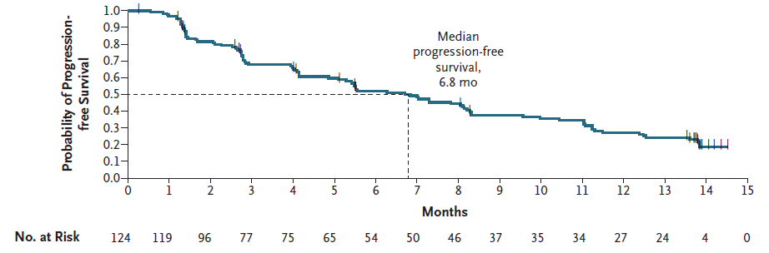
Source: Figure 2.21, p117 of the submission
KM=Kaplan-Meier; PFS=progression-free survival
Figure 2 CodeBreak 100 - KM curve of OS (data cutoff March 2021)
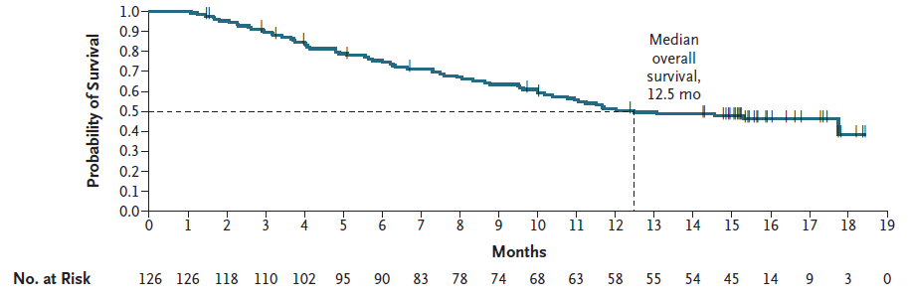
Source: Figure 2.22, p118 of the submission
Median follow-up time of 15.3 months
KM=Kaplan-Meier; OS=overall survival
        - The submission also presented patient-reported outcomes (PROs) from CodeBreak 100. It was unclear what the participation rate was at each cycle of data collection. Overall, PRO measures suggested maintenance or improvement (from baseline) of global health status/quality of life (QoL), physical functioning, and the severity of key lung cancer-related symptoms, including cough, dyspnoea, and chest pain.
        - ORR, PFS and OS results for the docetaxel arm from SELECT-1 are summarised below. Data by KRAS variant type were limited.
Table 8 SELECT-1: Summary of ORR, docetaxel arm, data cutoff June 2016
 |  | ORR, n/N (%) |  | BOR, n (%)
Study ID | All KRAS variants | KRAS G12C or G12V variant | KRAS variants other than G12C or G12V | CR | PR
SELECT-1 | 35/256 (13.7) | 18/149 (12.0) | 16/101 (16.0) | 0 (0.0) | 35 (13.7)
Source: Table 2.59, p117 of the submission
BOR = best objective response; KRAS = Kirsten rat sarcoma viral oncogene homologue; NSCLC = non-small cell lung cancer; ORR = objective response rate
        - ORR was 13.7% for all patients receiving docetaxel regardless of KRAS variant type. The median DoR was 4.5 months (range 2.3 to 7.3 months; 95% CI: 2.8, 5.6) for patients in the placebo plus docetaxel arm of SELECT-1. 37% had stable disease for 6 weeks or more.
Table 9 SELECT-1: Summary of investigator-assessed PFS, docetaxel arm, data cutoff June 2016
Population | No. of events (%)ª | Median PFS duration | IQR
All KRAS variants | 218/243 (89.7) | 2.8 months | 1.4-5.5 months
KRAS G12C variant | 96/104 (92.0%) | NR | NR
Source: Table 2.60, p117 of the submission
ªPatients with available PFS and Next Generation Sequencing data from efigure 6, Supplementary content, Jänne et al. (2017)
KRAS = Kirsten rat sarcoma viral oncogene homologue; IQR = interquartile range; NR = not reported; PFS = progression-free survival
        - Median PFS was 2.8 months (range 1.4 to 5.5 months) for all patients receiving docetaxel regardless of KRAS variant type (218 events). The proportion of events in the KRAS G12C variant subgroup was 92% (96 events).
Table 10 SELECT-1: Summary of OS, docetaxel arm, data cutoff June 2016
Population | Events, n/N (%) | Median OS duration | IQR
All KRAS variants | 170/256 (66) | 7.9 months | 3.8-20.1
KRAS variant (codon 12/13) | 163/244 (67) | NR | NR
KRAS G12C variant | NR | NR | NR
Source: Table 2.61, p118 of the submission
KRAS = Kirsten rat sarcoma viral oncogene homologue; IQR = interquartile range; NR = not reported (for OS); OS = overall survival
        - The median OS was 7.9 months (range 3.8 months to 20.1 months) for all patients receiving docetaxel regardless of KRAS variant type. The proportion of events was similar between all KRAS variant patients and patients with a KRAS variant on codon 12 or 13 (66% and 67%, respectively). There were no OS results presented specifically for the KRAS G12C variant subgroup.
        - A comparison of baseline characteristics between CodeBreak 100 and the docetaxel arm of SELECT-1 is presented below.
Table 11 Comparison of baseline patient characteristics between CodeBreak 100 and the docetaxel arm of SELECT-1
Characteristic | CodeBreak 100  N=126 | SELECT-1 (docetaxel arm)  N=256
Sex, n (%)
Male | 63 (50.0) | 145 (57.0)
Race, n (%)
Caucasian | 103 (81.7) | 243 (95.0)
Other | 23 (18.3) | 13 (5.0)
Age, years
Mean (SD) | 62.9 (9.3) | 60.9 (8.1)
Smoking status, n (%)
Never | 6 (4.8) | 21 (8.0)
Current | 15 (11.9) | 62 (24.0)
Former | 102 (81.0) | 173 (68.0)
Missing data | 3 (2.4) | 0 (0.0)
Performance status, n (%)ª
0 | 38 (30.2) | 104 (41.0)
1 | 87 (69.8) | 152 (59.0)
Prior lines of therapy, n (%)
1 | 54 (42.9) | 256 (100.0)
2 | 44 (34.9) | 0
3 | 28 (22.2) | 0
Prior therapy with immune checkpoint inhibitors
Anti-PD-1 or anti-PD-L1 agent | 116 (91.3) | 0 (0.0%)^{b}
Platinum-based chemotherapy AND an anti PD-1 or PD-L1 agent | 102 (81.0%) | 0 (0.0%)
Codon 12 KRAS variant(s)^{c,d} | G12C 126 (100%) | G12C 104 (42.7%)  G12D 47 (19.3%)  G12V 39 (16.0%)  G12A 14 (5.8%).
Histology type, n (%)
Non-squamous | 125 (99.2) | 242 (95.0)
Disease stage
Locally advanced (Stage IIIB) | 5 (4.0) | 10 (4.0)
Metastatic (Stage IV) | 121 (96.0) | 246 (96.0)
Source: Table 251, p106 and Section 2D.4 of the submission and Jänne (2017)).
ªECOG for CodeBreak 100 and WHO for SELECT-1.
^{b}The SELECT-1 protocol does not indicate that prior therapies included immune checkpoint inhibitors and SELECT-1 was conducted before approval of anti PD-1/PD-L1 monotherapy agents (p106 of the submission).
^{c}For SELECT-1: Proportions estimated from 243 patients presented in the subgroup analysis (Source: eFigure 6: Progression-Free Survival ^{d}94% of patients in SELECT-1 had a KRAS variant in codon 12 or 13 (6% had a KRAS variant on Codon 61). Further details on Codon 13 variants were not provided (Analysis by KRAS mutation Subgroup, Supplemental content, Jänne (2017)).
^{e}Data were only provided for Stage IV. The proportion of locally advanced was assumed as in the NSCLC cohort, eligible patients were required to have locally advanced or metastatic disease.
ECOG = European Cooperative Oncology Group; KRAS = Kirsten rat sarcoma viral oncogene homologue; MEK = mitogen-activated protein kinase; NR = not reported; NSCLC = non-small cell lung cancer; WHO = World Health Organization
        - The submission presented three unanchored matching adjusted indirect comparisons (MAICs) in addition to an unadjusted indirect comparison of the single treatment arms for sotorasib and docetaxel. Models 1 and 3 were considered in the submission to be the “main” analyses whereas Model 2 was considered as a sensitivity analysis. The covariates used in the three MAIC models are summarised below.
        - The arguments presented in the submission to justify choice of the “main” models were:
        - Model 1 included all variables (ECOG, age, metastatic at baseline, and smoking status) identified as “very important” or “somewhat important” for which data were available from the SELECT-1 trial, with the exception of PD-L1 expression and number of prior lines of therapy. These two variables were excluded on the basis that they lead to a significant reduction in the effective sample size. Model 1 represents a balance between retaining more than 86% of the enrolled subjects in CodeBreak 100 (effective sample size, ESS (~109)) whilst adjusting for the covariates considered “very important”.
        - Model 3 adjusted for the same variables as Model 1 but restricted the analysis only to second-line patients from CodeBreak 100. The submission argued that Model 3 was a “better match” with the SELECT-1 trial (100% of patients in SELECT-1 were second-line patients) and the likely Australian population who would be eligible for sotorasib. However, the application of weights to Model 3 led to a substantial reduction in the ESS (~44).
        - Based on the larger ESS in Model 1 and the suitability to the proposed Australian population in Model 3, these two models were considered in the submission to be the “most applicable” for the cost-effectiveness analysis.
        - Model 2 included four additional variables (PD-L1, gender, histology and race) but included all lines of therapy and was therefore presented as a sensitivity analysis.
Table 12 Variables used in the unanchored MAICs
Covariates | Model 1  Variable included YES/NO | Model 2  (“Sensitivity analysis”)  Variable included YES/NO | Model 3  Variable included YES/NO
ECOG (% PS 1 [vs PS 0]) | YES | YES | YES
Age (mean) | YES | YES | YES
Metastatic disease at baselineª | YES | YES | YES
Smoking status (% ever smoker) | YES | YES | YES
PD-L1 expression level (<5%, >5%)^{b} | NO | YES | NO
Gender (% female) | NO | YES | NO
Histology (% non-squamous) | NO | YES | NO
Race (% white) | NO | YES | NO
Number of prior lines of therapy | NO | NO | YES
Adjusted effective sample size (ESS) – sotorasib arm  Original sample size N=126 | ~109  (~87% original sample size) | ~53  (~42% of original sample size) | ~44  (~35% of original sample size)
Source: Tables 2.75 (p133), 2.77 (p135), 2.79 (p136), and 2.81 (p137) of the submission
ª Metastatic disease at baseline was not reported for patients in the SELECT-1 publication by Jänne et al. (2017), although extent of disease (locally vs metastatic) was. The submission used this variable as a “proxy” for the MAIC analyses.
^{b} The physician interviews mentioned the following PD-L1 expression groups relevant to treatment decision: <1%, 1-49%, >=50%; however, as this was not available in Jänne (2017), the reported categories of <5% and >5% were used.
CEA=cost-effectiveness analysis; ECOG=Eastern Cooperative Oncology Group; PD-L1=programmed death-ligand-1; MAICs=matching adjusted indirect comparisons.
*For a weighted estimate, the ESS is the number of independent non-weighted individuals that would be required to give an estimate with the same precision as the weighted sample estimate. A small ESS, relative to the original sample size, is an indication that the weights are highly variable due to a lack of population overlap, and that the estimate may be unstable.
        - Post matching baseline characteristics for the three unanchored MAIC models (Models 1 and 3 considered main in the submission and Model 2 considered as a sensitivity analysis) are summarised below.
Table 13 MAIC Model 1: Post matching baseline characteristics
Covariates | SELECT-1  Docetaxel arm  (All KRAS variants)  N=256 | CodeBreak 100  Sotorasib  (KRAS G12C variant)  N=126
 |  | Pre-matching | Post-matching
ECOG PS 1, % | 59.0 | 70.0 | 59.0
Mean age, years | 60.6 | 62.9 | 60.9
Metastatic at baseline, % | 96.0 | 97.0 | 96.0
Smoking status (ever smoker”), % | 92.0 | 93.0 | 92.0
Source: Table 2.76, p135 of the submission
ª Current and former smokers were combined together to estimate the % ever smoker
ECOG = Eastern Cooperative Oncology Group; KRAS = Kirsten rat sarcoma viral oncogene homologue; MAIC = matching adjusted indirect comparison; N = original sample size; PD-L1 = programmed death-ligand-1; PS = performance status.
Table 14 MAIC Model 3: Post matching baseline characteristics
Covariatesª | SELECT-1  Docetaxel arm  (All KRAS variants)  N=256 | CodeBreak 100  Sotorasib  (KRAS G12C variant)  N=126  Subgroup of second-line patients
 |  | Pre-matching | Post-matching
ECOG PS 1, % | 59.0 | 74.0 | 59.0
Mean age, years | 60.6 | 62.4 | 60.9
Metastatic at baseline, % | 96.0 | 94.0^{c} | 96.0
Smoking status (ever smoker^{b}), % | 92.0 | 96.0^{b} | 92.0
Source: Table 2.78, p136 of the submission.
ªSince SELECT-1 only included patients with one prior line of therapy, in Model 3, the robustness of the results of the base case was tested by using the same variables as in Model 1 but restricting the analysis to patients in CodeBreak 100 who had received only one prior therapy.
^{b}Current and former smokers were combined together to estimate the % ever smoker (3 patients with missing smoking status excluded).
^{c}Noted as 94% in the MAIC technical report (Table 13, p37, Attachment 9 to the main submission), as 97% in Table 2.78 (p136) of the main submission, and 96% (Stage IV, Table 2.49, p103 of the main submission)).
ECOG = Eastern Cooperative Oncology Group; KRAS = Kirsten rat sarcoma viral oncogene homologue; MAIC = matching adjusted indirect comparison; N = original sample size; PD-L1 = programmed death-ligand-1; PS = performance status
Table 15 MAIC Model 2: Post matching baseline characteristics
Covariates | SELECT-1 | CodeBreak 100  N=126
 | As reported  N=256 | Pre-matching | Post-matching
ECOG (% PS 1 vs PS 0) | 59.0 | 69.0 | 59.0
Age (% mean) | 60.9 | 61.8 | 60.9
Metastatic at baseline (%) | 96.0 | 97.0 | 96.0
Smoking status (% ever smokerª) | 92.0 | 95.0ª | 92.0
PD-L1 expression level (<5% vs ≥5%) | 58.0 | 48.0 | 58.0
Gender (% female) | 43.0 | 48.0 | 43.0
Histology (% non-squamous) | 95.0 | 99.0 | 95.0
Race (% white) | 95.0 | 81.0 | 95.0
Source: Table 2.80, p137 of the submission
ª Current and former smoker were combined together to estimate the % ever smoker, after removing patients (n=3) with missing smoking status
ECOG = Eastern Cooperative Oncology Group; MAIC = matching adjusted indirect comparison; N = original sample size; PD-L1 = programmed death-ligand-1; PS = performance status
        - Aside from differences between the studies, in terms of prior therapy with an anti PD-(L)1 agent and the inclusion of other KRAS variants, there were several baseline potentially clinically relevant disease-related characteristics that were not adjusted (due to the lack of data from both studies and/or the difficulty of additional matching whilst maintaining a reasonable ESS). These included the presence of brain, liver, or bone metastases, number of metastatic sites, other co-occurring mutations or alterations, and time since diagnosis.
        - For the unanchored MAIC Model 1, there did not appear to be large differences between CodeBreak 100 and the SELECT-1 docetaxel arm for three of the four baseline covariates used for matching: mean age (years) 63 vs. 61; metastatic (Stage IV) disease: 97% vs. 96%; and “ever” smoker: 93% vs. 92%. These apparent “differences” are likely a result of random variation and unlikely to have any prognostic relevance.
        - For the unanchored MAIC Model 3, the covariates used for matching were similar to that for Model 1 (and therefore similar limitations apply), except that for Model 3, adjustment was restricted to the subgroup of patients who had received only one prior line of therapy (second line) from CodeBreak 100.
        - The submission noted that Model 3 has the advantage of being a “better match” with the SELECT-1 trial (all were second-line patients). The majority of patients in CodeBreak 100 received prior treatment with anti PD-1/PD-L1 agents (91%) or an anti PD-1 or PD-L in combination with platinum-based chemotherapy (81%). On the other hand, SELECT-1 was conducted before anti PD-1 agents were approved, and therefore none of the patients had received prior treatment with an anti-PD1 agent before entry into the trial. The submission argued that there was limited evidence that the use of anti-PD-1 therapies in prior lines can enhance tumour response on subsequent chemotherapy (including docetaxel) and that “so far no significant difference has been found in terms of PFS or OS”. The outcomes from the MAICs were PFS and OS only and did not include ORR. Furthermore, there is established RCT-based evidence that pembrolizumab (an anti PD-1 agent which is available on the PBS for use as front-line therapy in advanced NSCLC) resulted in clinically meaningful OS gains over platinum-based chemotherapy in advanced NSCLC (without sensitizing EGFR variants or ALK alterations), when administered either as monotherapy (in patients with PD-L1–positive NSCLC), or in combination with chemotherapy (regardless of tumour PD-L1 expression) in the front-line setting. In this context, the use of anti-PD-1 therapies in CodeBreak 100 may have favoured sotorasib in the MAICs. This asymmetry in prior therapy also gives rise to an applicability issue. Unlike the docetaxel arm of SELECT-1, the majority of patients in Australian clinical practice who would be eligible for sotorasib, would be receiving second-line therapy and would have already received prior anti-PD1 ± chemotherapy. In this context, the OS profile of docetaxel treated patients in SELECT-1 may be inferior compared to that of SoC in current Australian clinical practice. This may favour sotorasib.
        - The application of Model 3 weights to this dataset resulted in a very small ESS (~44) which represented only 35% of the original sample size of CodeBreak 100 (N=126). A small ESS is unlikely to be sufficient to reliably compare sotorasib and docetaxel. The MAIC technical report noted that a small ESS indicates the weights are highly variable due to a lack of population overlap, and that the estimate may be unstable.
        - For the unanchored MAIC Model 2, the application of weights resulted in a small ESS (~53) making the results unreliable and indicating that there was limited overlap between the CodeBreak 100 and SELECT-1 treatment arms.
        - Results of the unanchored MAIC models and those of the corresponding unadjusted analyses (no matching) are summarised below. The ESC noted the sotorasib OS for Model 1 was longer than the unadjusted sotorasib OS (15.3 months vs 12.5 months) but the related PFS was shorter (6.3 months vs 7.0 months). The ESC considered this raised concern regarding the plausibility of the adjusted analyses and provided further support for the unadjusted analysis as being the most relevant.
Table 16 Results of indirect comparisons
Endpoint | SELECT-1  Docetaxel arm  (All KRAS variants)  N=256  Median (95% CI) | CodeBreak 100  Sotorasib  (KRAS G12C variant)  Median (95% CI) | Sotorasib vs. docetaxel  HR  (95% CI)
Overall survival (OS)
Unadjusted (non-matching) | 8.1 monthsª (6.8, 9.5) | N=126  12.5 months (10.4, NE) | 0.65  (0.49, 0.87)
Adjusted Model 1 | 8.1 months (6.8, 9.5) | ESS=108.9  15.3 months (10.8, NE) | 0.61  (0.45, 0.83)
Adjusted Model 3 | 8.1 months (6.8, 9.5) | ESS=43.8  17.7 months (9.5, NE) | 0.54  (0.34, 0.86)
Adjusted Model 2 | 8.1 months (6.8, 9.5) | ESS=53.3  17.7 months (9.9, NE) | 0.55  (0.37, 0.82)
Progression-free survival (investigator assessed PFS)
Unadjusted (non-matching) | 2.8 monthsª (2.6, 3.6) | N=126  7.0 months (5.5, 8.3) | 0.43  (0.34, 0.56)
Adjusted Model 1 | 2.8 months (2.6, 3.6) | ESS=108.9  6.3 months (5.5, 8.3) | 0.44  (0.34, 0.57)
Adjusted Model 3 | 2.8 months (2.6, 3.6) | ESS=43.8  7.9 months (5.5, 8.3) | 0.43  (0.30, 0.62)
Adjusted Model 2 | 2.8 months (2.6, 3.6) | ESS=53.3  8.1 months (5.5, 11.5) | 0.40  (0.28, 0.58)
Source: Tables, 2.77, 2.79, p135 of the submission
ªFor the docetaxel arm of SELECT-1, patient-level data were not available, and KM curves were digitized. For OS, the reconstructed data had a median value of 8.1 months vs. 7.9 months as reported in Jänne (2017). For PFS, the reconstructed data had a median value of 2.8 months, in line with the reported value of 2.8 months in Jänne (2017).
HRs rounded to two decimal places
CI = confidence interval; ESS = effective sample size; HR = hazard ratio; KRAS = Kirsten rat sarcoma viral oncogene homologue; N = original sample size; NE = not estimable (not reached).
        - The median OS duration for docetaxel from the reconstructed data was 8.1 months (similar to 7.9 months reported in the SELECT-1 publication, Jänne (2017)). For sotorasib, the data were insufficiently mature to characterise the upper limit of the 95% confidence interval. The median PFS duration for docetaxel from the reconstructed data was identical (2.8 months) to that reported in Jänne (2017).
        - The unadjusted (no matching) indirect comparisons indicated that compared to docetaxel, i) sotorasib was associated with a 35% reduction in the hazard of death which was statistically significant (median OS: 12.5 months vs. 8.1 months; HR=0.65 (95% CI: 0.49, 0.87)), and ii) a 57% reduction in the hazard of progression or death which was also statistically significant (median PFS: 7.0 months vs. 2.8 months; HR=0.43 (95% CI: 0.34, 0.56)).
        - The reductions in hazard of death for the unanchored MAIC Models 1, 2, and 3 were 39% (HR=0.61; 95%: 0.45, 0.83), 45% (HR=0.55; 95%: 0.37, 0.82), and 46% (HR=0.54; 95%: 0.34, 0.86), respectively.
        - The reductions in hazard of progression or death for the unanchored MAIC Models 1, 2, and 3 were 56% (HR=0.44; 95%: 0.34, 0.57), 60% (HR=0.40; 95%: 0.28, 0.58), and 57% (HR=0.43; 95%: 0.30, 0.62), respectively.
        - The OS and PFS curves for sotorasib and docetaxel for the unanchored MAICs are presented below. The unadjusted curves have been included for comparative purposes.
Figure 3 Unadjusted (non-matching) and MAIC-adjusted OS curves for sotorasib (comparator docetaxel)

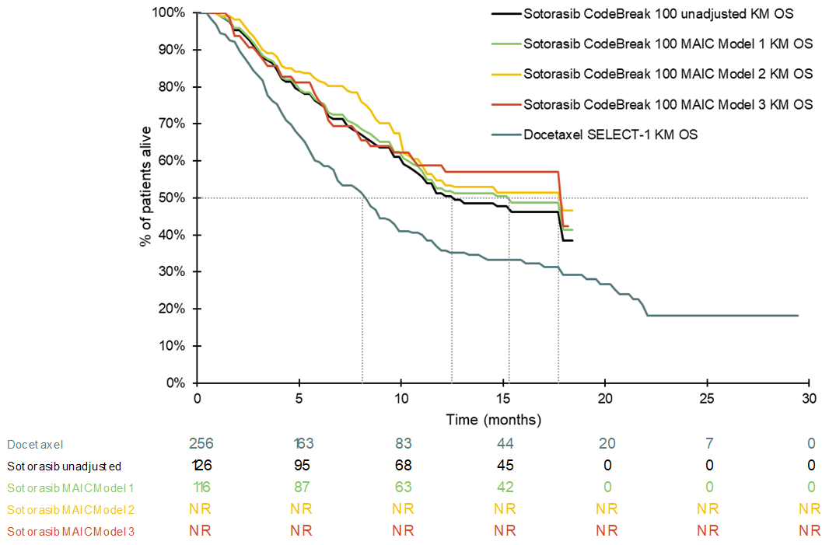
Source: Constructed during the evaluation from the ‘OS’ worksheet in the ‘Sotorasib_NSCLC_CEA_Final.xlsm’ workbook included in the submission.
KM = Kaplan-Meier; MAIC = matching-adjusted indirect comparison; OS = overall survival; NR = not reported.
Figure 4 Unadjusted (non-matching) and MAIC-adjusted PFS curves for sotorasib (comparator docetaxel)

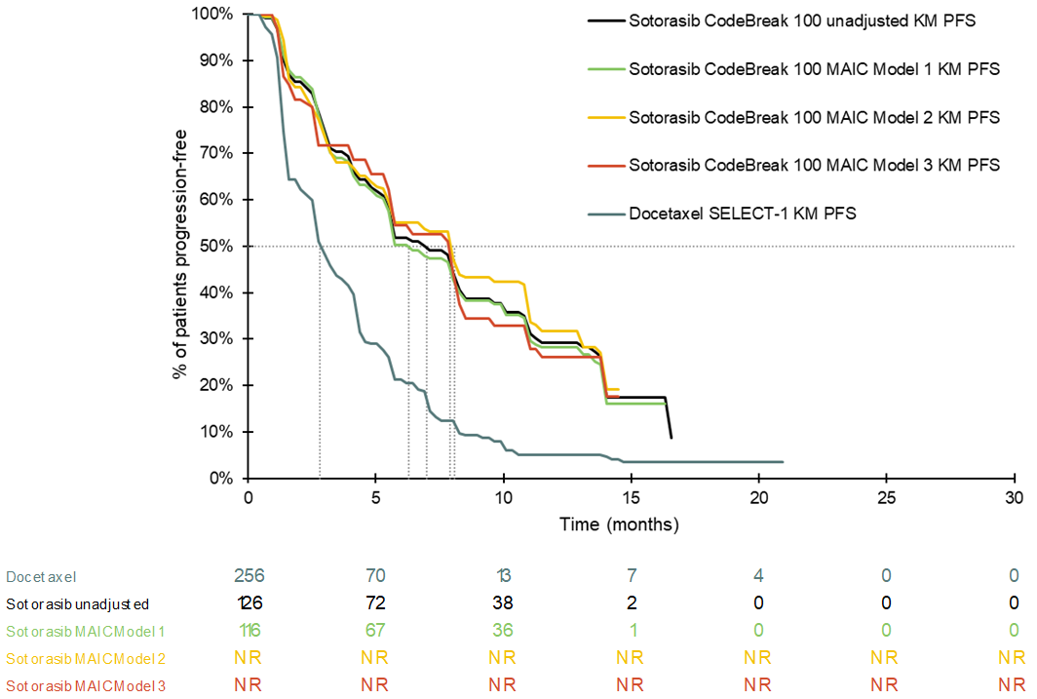
Source: Constructed during the evaluation from the ‘PFS’ worksheet in the ‘Sotorasib_NSCLC_CEA_Final.xlsm’ workbook included in the submission.
KM = Kaplan-Meier; MAIC = matching-adjusted indirect comparison; PFS = progression-free survival.
        - For several of the covariates used for matching in the unanchored MAICs, differences between the CodeBreak 100 and SELECT-1 studies appeared too small to have a clinically meaningful impact on the indirect results. Where a covariate is irrelevant to response, and/or is already balanced across the two studies being compared (except for random variation), matching for this covariate introduces “noise” into the indirect analysis. The ESCs noted matching on balanced confounding variables is likely to result in a loss of statistical efficiency by reducing the sample size and thus increasing variance but considered that this would not be expected to introduce bias across the comparisons.
        - There were differences between the patients in CodeBreak 100 and those in SELECT-1 that could not be adjusted for, either because of substantial disparity between the studies (such as the types of prior therapies including immune checkpoint inhibitors ± chemotherapy), or the lack of available data. Failure to adjust for potential effect modifiers leads to an unknown amount of bias in the unanchored estimate. The matching algorithm can only account for patient characteristics that are within the bounds of the dataset. Post-matching characteristics for variables not chosen for matching were not provided in the submission. The residual bias due to unaccounted-for covariates, and the extent of this bias, remains unknown. Furthermore, due to the interdependence of variables, and different weights applied to each patient, matching of specific characteristics is likely to affect the distribution of other characteristics. Without providing the supporting data, the PSCR stated baseline characteristics post-matching were well balanced, with perfect matching for the four covariates included in the MAIC Model 1 and a difference of less than 5 percentage points for all other characteristics that were able to be compared. The ESCs considered that conducting an unanchored MAIC across all confounders was not possible in this circumstance given the extent of data available for matching and the small sample sizes.
        - Where there is poor overlap between the populations, unanchored MAICs cannot adjust for several factors while maintaining a sufficiently large ESS. Model 1 had a relatively larger ESS (however with limited adjustment) compared to the small and unreliable ESSs for Models 2 and 3. Taken together, results from the three unanchored models were inconclusive.
        - The ESCs noted the point estimates of the HR for PFS and OS were more favourable with the MAIC models compared to the unadjusted analyses but the confidence intervals across all analyses overlapped (Figure 5). Overall, the ESCs considered the MAICs were statistically reasonable but given the uncertainty associated with the models, the ESCs considered the unadjusted indirect comparison provided the most reasonable point estimates of the incremental effectiveness of sotorasib.
Figure 5 Forest plot of hazard ratios and 95% confidence intervals for PFS and OS
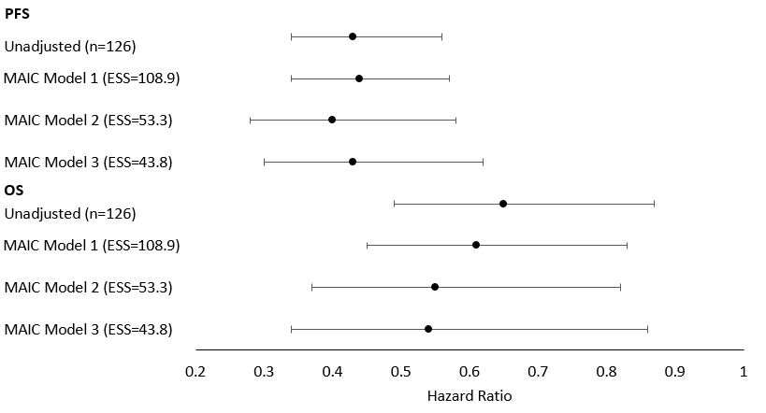
ESS=effective sample size; MAIC = matching-adjusted indirect comparison; OS=overall survival; PFS = progression-free survival
Source: constructed using data in Table 16.
        - The docetaxel arm from SELECT-1 also appeared to have limited applicability to standard of care (SoC) in Australian clinical practice:
        - The majority of patients who would be eligible for sotorasib in Australian clinical practice, would be second-line patients (with no other actionable biomarkers) who would have progressed on pembrolizumab (± chemotherapy). As previously discussed, none of the docetaxel-treated patients in SELECT-1 had received prior immunotherapy. Given the established evidence that prior use of pembrolizumab ± chemotherapy, in the first-line advanced NSCLC setting, has resulted in clinically meaningful OS gains over platinum-based chemotherapy alone, the OS profile of docetaxel arm in SELECT-1 may likely be inferior to that of current SoC in Australian clinical practice.
        - Noting the need for caution when making cross study comparisons, real world outcome data for SoC, in second-line patients with KRAS G12C variant advanced NSCLC (sourced from the FDA review report for sotorasib), indicated a higher median OS (approximately 10 months) compared to that observed for the docetaxel arm in SELECT-1 (approximately 8 months). Details on patient characteristics and prior therapies received for the real-world studies (for example prior use of immunotherapy) were not provided.

Comparative harms
        - No formal indirect statistical analyses were conducted for assessing comparative safety. A descriptive comparison of AEs, between CodeBreak 100 and the docetaxel arm of SELECT-1, is presented in the table below.
Table 17 Comparison of patient-reported treatment-related AEs for sotorasib and docetaxel
 | CodeBreak 100 (Phase II NSCLC)  Sotorasib (N=126)  Data cutoff March 2021 |  | SELECT-1  Docetaxel arm (N=254)  Data cut-off June 2016
 | Any grade, n (%) | Grade ≥3, n (%) | Any grade, n (%) | Grade ≥3, n (%)
AEs | 88 (69.8) | 26 (20.6) | NR | NR
Diarrhoea | 40 (31.7) | 5 (4.0) | 64 (25.0) | 6 (2.0)
Nausea | 24 (19.0) | 0 | 29 (11.0) | 0
Increased ALT | 19 (15.1) | 8 (6.3) | NR | NR
Increased AST | 19 (15.1) | 7 (5.6) | NR | NR
Fatigue | 14 (11.1) | 0 | 43 (17.0) | 4 (2.0)
Vomiting | 10 (7.9) | 0 | 17 (7.0) | 1 (1.0)
Decreased appetite | 5 (4.0) | 0 | 28 (11.0) | 2 (1.0)
Oedema peripheral | 5 (4.0) | 0 | 13 (5.0) | 0
Arthralgia | 3 (2.4) | 0 | NR | NR
Asthenia | 3 (2.4) | 0 | 24 (9.0) | 2 (1.0)
Drug-induced liver injury | 3 (2.4) | 2 (1.6) | NR | NR
Dyspnoea | 2 (1.6) | 1 (0.8) | 4 (2.0) | 0
Neutropenia | 1 (0.8) | 1 (0.8) | 8 (3.0) | 4 (2.0)
Anaemia | 1 (0.8) | 0 | 8 (3.0) | 0
Rash | 1 (0.8) | 0 | 23 (9.0) | 1 (1.0)
Source: Table 2.71, p128 of the submission and eTable 1, Supplemental content from Jänne (2017)
Italicised: NR outcomes in Table 2.71 of the submission were replaced by 0 events during the evaluation as per eTable 1 of the Jänne (2017) publication.
AE=adverse events; ALT=alanine amino transferase; AST=aspartate aminotransferase; NR=not reported
        - There were higher frequencies in the sotorasib arm versus the docetaxel arm (any grade) for diarrhoea (31.7% versus 25.0%) and nausea (19.0% versus 11.0%) whereas frequencies were lower in the sotorasib arm for fatigue (11.1% versus 17.0%), decreased appetite (4.0% versus 11.0%), asthenia (2.4% versus 9.0%), and rash (0.8% versus 9.0%). The ESCs noted some important AEs related to liver function and liver injury could not be compared across the treatment arms and therefore considered the comparison was unreliable for decision-making.
        - The superiority claim in terms of safety was based on a descriptive analysis of AEs between CodeBreak 100 and the docetaxel arm from SELECT-1. The PSCR strongly defended the claim of superior safety as this is a key advantage for a targeted therapy like sotorasib over cytotoxic chemotherapy. The sponsor acknowledged that it is difficult to see this when comparing adverse event reporting across different trials; however, stated it is the hands-on patient experience where the differences, and advantages with sotorasib become apparent.
        - The ESCs considered the safety comparison presented in the submission, based on a descriptive comparison of AE across single arms, was unreliable to support a claim of superior safety. The ESCs considered a more reasonable interpretation of the safety data is that sotorasib and docetaxel have different safety profiles.

Benefits and harms
        - The results of the unanchored indirect comparison were associated with a high risk of bias and the MAIC adjustments were unreliable. There were important known differences between the studies that could not be adjusted, and the impact of unknown confounders remained unclear. All these limitations lead to a high level of uncertainty associated with the magnitude of any incremental effectiveness of sotorasib over docetaxel. Interpretation of the safety data was problematic given the indirect and descriptive nature of the comparison. Accordingly, a benefits/harms quantification table has not been presented.

Interpretation of clinical evidence
        - The therapeutic conclusion presented in the submission was as follows:
        - Test: KRAS G12C variant testing methods used in Australia are likely to be concordant.
        - Medicine: In patients with locally advanced or metastatic KRAS G12C variant positive NSCLC, sotorasib is superior to docetaxel in terms of both efficacy and safety.
        - The evaluation considered the data from the individual studies indicated sotorasib may be superior to docetaxel in terms of PFS and OS. However, the evidence was inadequate to support a robust quantification of the magnitude of benefit. The ESCs considered the results of the unanchored indirect comparison was associated with a high risk of bias and the MAIC adjustments were unreliable:
        - The clinical relevance of the covariates used for adjustment was uncertain.
        - The application of weights resulted in substantial reductions in the ESS, particularly for MAIC Models 2 and 3. This was likely due to a lack of overlap between the CodeBreak 100 and SELECT-1 populations being compared.
        - A difference between the studies was prior therapy which differed between the CodeBreak 100 (91% received an anti PD-(L)1 agent or its combination with platinum-based chemotherapy (81%)) and SELECT-1 (primarily platinum-based chemotherapy) studies. The ESCs considered the impact of this difference in prior therapy, on the effectiveness of subsequent treatments (with either sotorasib or docetaxel), remained uncertain.
        - Post-matching characteristics for variables not chosen for matching were not provided and therefore, the impact of the matching on other baseline variables not included in the MAICs was unclear. Due to the interdependence of variables, and different weights applied to each patient, matching of specific characteristics is likely to affect the distribution of other characteristics.
        - Several prognostic/effect modifier variables were not included in the analyses, primarily due to the lack of data for both studies and/or the difficulty of additional matching whilst maintaining a reasonable ESS. The residual bias due to unaccounted covariates, and the extent of this bias, remains unknown.
        - The ESCs considered that, on balance, the claim of superior effectiveness was reasonable, but the magnitude of incremental effectiveness was uncertain. The ESCs noted the upcoming CodeBreak 200 study (sotorasib versus docetaxel in the same proposed population of patients with previously treated locally advanced or metastatic KRAS G12C variant NSCLC) should provide more certainty about the incremental effectiveness of sotorasib.
        - The ESCs considered the claim of superior safety was not adequately supported by the evidence presented in the submission. The ESCs considered interpretation of the descriptive comparison of AEs across single treatment arms was unreliable; however, it did not appear to suggest superiority. Overall, a claim of a different safety profile for sotorasib, compared with that for docetaxel, would better describe the data.
        - The PBAC considered that the claim of superior comparative effectiveness was reasonable, but the magnitude of the benefit was uncertain.
        - The PBAC considered that the claim of superior comparative safety was not adequately supported by the data and agreed with the ESCs that a claim that sotorasib had a different safety profile to docetaxel was reasonable.

Rationale for codependency
        - Several molecular and genetic characteristics in advanced NSCLC have been identified which have transformed treatment options. However, no targeted therapy has previously been developed for pathogenic KRAS variants, which have been recognised as oncogenic drivers for approximately 40 years. The KRAS G12C variant is the most common KRAS variant in NSCLC (prevalence of approximately 13%).
        - Sotorasib is a small molecule that specifically and irreversibly inhibits the KRAS G12C protein. Sotorasib covalently binds to a pocket of the switch II region that is present only in the inactive GDP-bound conformation, trapping KRAS G12C in the inactive state and inhibiting KRAS oncogenic signalling.
        - Escape mechanisms that re-activate or bypass the inhibited RAF/MEK/ERK/MAPK pathway occur quickly after a KRAS G12C inhibitor is introduced to the tumour environment. Various adaptive changes occur, such as 1) reducing the availability of the inactive form, 2) activation of feedback mechanisms to reactivate RAS signalling via NRAS and HRAS, and 3) the use of EGFR and aurora kinase downstream signalling cascades.
        - It has also been suggested that cancers may vary in their dependence on RAS signalling, and that these intrinsic differences could account for some of the variable responses seen in patients.
        - These intrinsic and adaptive changes may help to explain why the majority of NSCLC patients with the KRAS G12C variant tend to respond partially to treatment with a KRAS G12C inhibitor rather than showing a complete radiographic response. In the CodeBreak 100 trial, 77.4% of patients had either a partial response or stable disease and only 3% had a complete response.

Economic analysis
        - The submission presented a modelled economic evaluation, based on an unanchored MAIC of single-arm studies comparing sotorasib and docetaxel in a population of patients with KRAS G12C NSCLC (i.e. treatment-only). The model however did allow a test-treatment structure to be explored. This approach was justified on the basis of high diagnostic performance of KRAS variant testing, and that as KRAS variant testing is currently conducted in the proposed population, no increase in utilisation is expected with PBS listing of sotorasib. Therefore, the testing component of the codependent technology would not impact the cost-effectiveness of sotorasib.
        - The assumption that testing is associated with no additional cost may not be reasonable. PASC noted that most testing of KRAS in Australia is done using NGS with gene panels, though noted that some smaller laboratories may still be using single gene testing (1669 Ratified PICO). A survey of 25 laboratories included in the submission that represent approximately 85−87% of testing in NSCLC suggests that current pathogenic EGFR variant testing is being performed on NGS panels that would also likely include KRAS G12C. It is unclear how the remaining 13−15% of tests are being conducted. The laboratories not included in the survey are likely to be smaller and may not test EGFR using NGS. Further, the wording of the proposed MBS item allows for single gene testing of either EGFR or KRAS over a transition period. PASC noted that this could create an incentive for laboratories to charge twice when both EGFR and KRAS were tested (1669 Ratified PICO). The assumption of perfect test performance may also not be reasonable. While the test most commonly used in practice (NGS) was observed to be highly concordant with the PCR-based tests used in the clinical studies, detection of KRAS G12C would still be expected to vary according to sample quality. However, the ICER was insensitive to changes in testing-related parameters.
        - Table 18 summarises the key components of the economic evaluation.
Table 18 Summary of model structure and rationale
Component | Summary
Comparison modelled | Sotorasib vs docetaxel. As this is a codependent application, it may be more appropriate that the comparison presented reflect both the testing and treatment components (noting that the model did allow this comparison to be explored in sensitivity analyses).
Time horizon | 10 years in the model base case (vs 15.3 month follow-up at the latest CodeBreak 100 data cut). The nominated time horizon was longer than what the PBAC have previously accepted in the context of previously treated NSCLC (5 years; paragraph 5.7, Osimertinib PSD, November 2018 PBAC meeting))
Outcomes | Quality-adjusted life-years, life-years gained. These were reasonable.
Discount rate | 1.5% per annum, based on the current 10-year Australian government bond rate. This was not consistent with the current MSAC and PBAC Guidelines. The submission cited a CADTH review (Paulden 2016)ª and local opinion piece (Devlin & Scuffham 2020)^{b} that concluded that a discount rate of 5% per annum is inappropriately high in HTA and that the real cost of borrowing should be used to determine an appropriate discount rate. The results presented in the herein were respecified using a 5% per annum discount rate, with a 1.5% discount rate presented as a sensitivity analysis.
Methods used to generate results | Partitioned survival analysis.
Health states | Three health states: progression-free, progressed disease, dead based on PFS and OS curves from the CodeBreak 100 and SELECT-1 studies. These were reasonable.
Cycle length | 1 week. This was reasonable.
Allocation to health states | Health state allocation over time was determined by PFS and OS curves from the sotorasib CodeBreak 100 study (adjusted for matching using MAIC Model 1) and the docetaxel arm of the SELECT-1 trial. The incremental benefit of sotorasib based on the single-arm studies (adjusted for matching or not) was associated with a high level of uncertainty.
Extrapolation method | Standard parametric distributions were fitted to the sotorasib KM data from CodeBreak 100 and the docetaxel KM data from SELECT-1 jointly (i.e. with treatment group included as a covariate). Log-normal distributions were chosen in the base case analysis for both OS and PFS based on AIC/BIC, and that the QQ plot did not provide evidence against the use of an AFT model. Given the single-arm nature of the underlying data, the use of the jointly fitted models may not be reasonable. This approach means that the docetaxel extrapolations vary slightly depending on the sotorasib data used (i.e. adjusted or not), which may not be reasonable, nor is the assumption of an ongoing treatment effect (as the location parameter does not change over time).  77.6% of LYs gained occur in the extrapolated period.
Health related quality of life | Utility depends on time to death; decrements associated with mode of administration and adverse events. The PBAC have previously indicated a preference for utilities by progression status instead of by time-to-death in NSCLC (paragraph 6.38, 7.09 pembrolizumab PSD, July 2019 PBAC meeting).
Test parameters | The base case model structure did not incorporate a testing component, though did allow a test-treat structure to be explored. In this analysis, test performance was assumed to be 100%. This may not be reasonable. Detection of the KRAS G12C variant would still be expected to vary according to sample quality. Thus, false negative results (due to poor quality or inadequate DNA) will occur.  Prevalence of KRAS G12C was estimated to be 13%. This was reasonable.
False positives/negatives | The implication of a false negative result would be to have the cost of testing applied, but to receive no treatment with sotorasib. This was reasonable, however under the base case assumption that KRAS variant testing is not associated with an additional cost, there is no effect of false negatives on the ICER.  False positives were generally modelled as true negative patients, where only the cost of pre-progression treatment (and associated costs) varied. The utility decrement applied for mode of administration was unchanged, which is not appropriate. These patients incurred the cost of sotorasib for one month before switching to docetaxel. This approach was not justified. Changes in a treatment plan after one month may be too soon– 6 to 8 weeks may be more reasonable, given that the median time to objective response in CodeBreak 100 was 1.4 months.
Source: Adapted during the evaluation from Table 3.1, p148 of the submission.
AIC = Akaike Information Criterion; BIC = Bayesian information criterion; ICER = incremental cost effectiveness ratio; KM = Kaplan-Meier; KRAS = Kirsten rat sarcoma viral oncogene homologue; NGS = next generation sequencing; NSCLC = non-small cell lung cancer; OS = overall survival; PFS = progression-free survival
ª Paulden M, Galvanni V, Chakraborty S, Kudinga B, McCabe C. Discounting and the Evaluation of Health Care Programs. Canadian Agency for Drugs and Technologies in Health,; 2016 [cited 2021 9 Dec]; Available from: https://www.cadth.ca/sites/default/files/pdf/CP0008_Economic_Evaluation_Guidelines_Discount_Rate_Report.pdf.
^{b} Devlin N, Scuffham P. Health today versus health tomorrow: does Australia really care less about its future health than other countries do? Aust Health Rev. 2020 Jun;44(3):337-9.
        - A partitioned survival approach, using PFS and OS curves, was used to determine health state allocation. These were derived from the CodeBreak 100 and SELECT-1 studies for sotorasib and docetaxel, respectively. For sotorasib, the PFS and OS data used in the base case analysis were adjusted for matching using MAIC Model 1. This model was chosen in the base case as outcomes were adjusted for variables identified as very important by expert opinion. The alternate adjusted analyses resulted in small ESS, and so are associated with a high degree of uncertainty.
        - In the base case analysis, the submission used the OS KM data until median follow-up (15.3 months for sotorasib and 12.2 months for docetaxel). The truncation time points chosen may not be reasonable. The PBAC Guidelines state a preference for the use of observed time-to-event data over modelled data up to the point at which the observed data become unreliable – and so more of the docetaxel data could have reliably been used (up to around 20 months) and less of the sotorasib data should have been used – particularly in the matching-adjusted analyses, which are associated with reduced effective sample sizes. A truncation time point similar to the median survival observed in the unadjusted analyses (i.e. 12.5 months) may be more reasonable. The ICER was sensitive to changes in the truncation time points for both sotorasib and docetaxel.
        - Beyond these truncation time points, OS data were extrapolated using jointly-fitted parametric functions (where only the ‘location’ parameter differed across treatment arms). Given the single-arm nature of the underlying data, the use of the jointly fitted models may not be reasonable. A log-normal model was chosen in the base case analysis based on Akaike information criterion and Bayesian information criterion. Parametric models that produce extrapolations more consistent with the expectation that all patients in this later-line setting would have died by years 5−6 would have been more reasonable, given that a 7.5-year time horizon has previously been accepted by the PBAC in the first-line setting (Table 12, pembrolizumab PSD, July 2019 PBAC meeting). The ICER is sensitive to the model chosen for OS extrapolation. The PSCR stated the base case jointly fitted (restricted) lognormal model (with a 10-year time horizon) was determined to provide clinically valid projections of overall survival following docetaxel and was well-aligned with clinical expectation at the 5-year (4.4%) and 10-year (1.1%) landmarks. The ESCs considered a time horizon of 10 years was too long in the context of a second-line treatment and a shorter time horizon would be more appropriate.
        - A comparison of the KM and modelled survival data used in the analysis are presented in Figure 6. The truncation time point chosen for sotorasib OS appeared to shift the modelled OS curve right, which may introduce bias in favour of sotorasib. Extrapolation from the unadjusted median survival time (depicted in grey) appears more consistent with the observed data. Modelled OS for docetaxel appears to underestimate survival from months 13–22.
Figure 6 Kaplan-Meier and modelled curves for PFS and OS
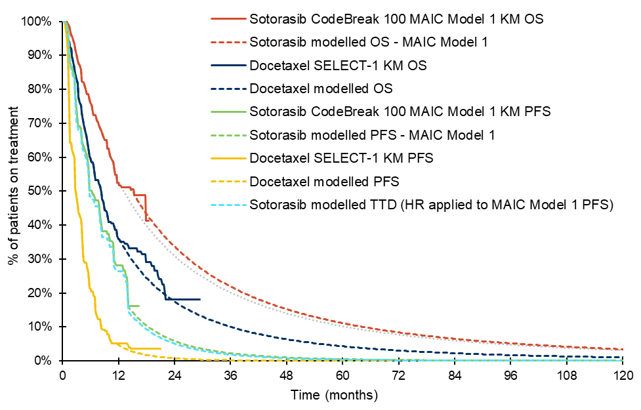
Note: The grey dotted line depicts sotorasib OS extrapolation applying a truncation time point of 12.5 months, which was the median OS in CodeBreak 100.
Source: Constructed during the evaluation from the ‘Sotorasib_NSCLC_CEA_Final.xlsm’ workbook included in the submission.
KM = Kaplan-Meier; MAIC = matching-adjusted indirect comparison; PFS = progression-free survival; OS = overall survival.
        - For PFS, the submission stated that the KM data were used until the time of median follow-up. These were estimated to be 6 and 3 weeks shorter than median follow-up for OS for sotorasib and docetaxel, respectively. The approach used to select the PFS truncation time points was not clear as median follow-up for PFS was reported in both the CodeBreak 100 study (13.8 months) and SELECT-1 (4.2 months). While the median follow-up reported in CodeBreak 100 was similar to the applied truncation time point (13.8 vs 14.0 months), the ICER was sensitive to reducing the truncation time point.
        - The ESC considered that the combined effect of the selection of sotorasib results from the MAICs, the truncation points, and the methods of extrapolation was to increase its overall estimate of effectiveness. The combined effect of the selection of truncation points and the methods of extrapolation was to decrease the overall estimate of effectiveness of docetaxel. Combined together, the overall incremental effectiveness of sotorasib was overestimated and the ICER was underestimated.
        - As utilities were generated by time-to-death, rather than progression status, the effect of changes in PFS was mediated through sotorasib treatment costs, as a HR was applied to the PFS curve to determine the duration of sotorasib treatment. The HR applied to generate the modelled TTD curve was 1.049 (95% CI: 0.956, 1.151), and was based on a comparison of PFS and TTD from the latest data cut of the CodeBreak 100 study. As the HR was not statistically significant, it may not be reasonable to apply a difference. Further, as this HR was based on unadjusted data from CodeBreak 100, the submission has not considered the applicability of the HR to the adjusted data. As these may represent patients with an improved prognosis, patients may be better able to tolerate treatment while progression-free. The ICER increased by 5% when no difference is assumed between the PFS and TTD curves, which is consistent with the approach used to determine docetaxel treatment duration (i.e. treatment while progression-free). The PSCR stated the time-to-death approach for capturing utilities was selected for the base case on clinical expertise, as it has been deemed as more appropriate. The PSCR stated that by transferring utility from “pre-progression” and “post-progression” of the sotorasib arm to the comparator arm, the value of sotorasib would be underestimated. The PSCR considered the time-to-death approach better reflects the current health condition of an individual patient. The ESCs did not accept this variation in approach and preferred a consistent approach across modelled economic evaluation in generating QALY estimates.
        - The key drivers of the model are presented in Table 19.
Table 19 Key drivers of the model
Description | Method/Value | Impact  (Revised base case ICER: $||||¹)
Sotorasib OS and PFS data | MAIC Model 1. Due to differences between patients enrolled in the CodeBreak 100 and SELECT-1 studies, a MAIC was performed. MAIC Model 1 was chosen in the base case as outcomes were adjusted for variables identified as very important by expert opinion. The alternate adjusted analyses resulted in small ESS, and so are associated with a high degree of uncertainty. | High – favours sotorasib. It may be preferable that the most conservative approach, i.e. the unadjusted analyses, be used in the base case analysis. This led to an increase in the ICER to $||||¹.
OS extrapolation | A log-normal parametric model fitted jointly to the sotorasib and docetaxel data. A joint approach for parametric model extrapolation of single-arm studies may not be reasonable.  The truncation time points were 15.3 months for sotorasib and 12.2 months for docetaxel. In line with the PBAC Guidelines more of the docetaxel data could have reliably been used (up to around 20 months) and less of the sotorasib data should have been used (around median survival in the unadjusted analyses, 12.5 months). | High – favours sotorasib. Alternate independently fitted parametric functions increase the ICER up to $||||² (using Weibull).  Changes in the sotorasib truncation time point (from 15.3 to 12.5 months) increased the ICER to $||||¹; and changes in the docetaxel truncation time point (from 12.2 to 20 months) increased the ICER to $||||¹.
Time horizon | 10 years. This is longer than median follow-up in the CodeBreak 100 study (15.3 months). Further, this is longer than the time horizon previously accepted for the combination of immunotherapy and platinum-doublet chemotherapy in the first-line setting, 7.5 years (Table 12, pembrolizumab PSD, July 2019 PBAC meeting). | Moderate − favours sotorasib. Decreasing the time horizon to 6 years increased the ICER to $||||¹; however, this effect was reduced when alternate parametric functions (such as Weibull) were applied.
Utilities | Time-to-death approach. The use of utilities by progression status may be a more reasonable approach (para 6.38, 7.09 pembrolizumab PSD, July 2019 PBAC meeting). | Moderate − favours sotorasib. The use of utilities by progression status increased the ICER to $||||¹.
Sotorasib PFS truncation | 14.0 months. The rationale for this truncation time point was not clear. While similar to median follow-up for PFS (13.8 months), the ICER is sensitive to this change, due to the small number of patients remaining and number of events towards the tail end of the KM PFS data. | Moderate − favours sotorasib. Reducing the PFS truncation time point to 13.8 months increases the ICER to $||||¹.
Pegfilgrastim costs | Applied with each cycle of docetaxel treatment, in all patients. While this use was consistent with use in the SELECT-1 trial, the rationale for this was due to the investigational treatment in that study, which was associated with a high incidence of febrile neutropenia. This is unlikely to occur in clinical practice in all patients treated with docetaxel monotherapy. | Low, favours sotorasib. The ICER increased to $||||¹ when pegfilgrastim costs are excluded.
Source: Compiled during the evaluation based on Section 3 of the submission.
ESS = effective sample size; ICER = incremental cost-effectiveness ratio; KM = Kaplan-Meier; MAIC = matching-adjusted indirect comparison; PFS = progression-free survival; OS = overall survival.
The redacted values correspond to the following ranges:
¹$95,000 to < $115,000
²$115,000 to < $135,000
        - The results of the stepped economic evaluation are presented in Table 20. Steps 1 and 2 were conducted prior to the introduction of extrapolation (or other transformations) into the model, however the submission’s analyses at these steps included truncation (and so parametric modelling) of PFS and docetaxel OS estimates. Further, the sotorasib TTD data were derived in Step 1 from the application of a HR to the PFS data, rather than using the observed unadjusted TTD data from CodeBreak 100. The discount rate applied in Step 4 was not consistent with the rate in the current PBAC and MSAC Guidelines. Table 20 incorporates revisions for these issues, where relevant.
Table 20 Results of the stepped economic evaluation (using Guidelines recommended annual discount rate)
 | Sotorasib | Docetaxel | Increment
Step 0 – Trial-based analysis
Using unadjusted sotorasib OS and TTD data from CodeBreak 100 and docetaxel OS and TTD data from SELECT-1.
Time horizon: 18.4 months (max. OS follow-up in CodeBreak 100, noting that max. follow-up for TTD was 17.8 months)
Cost ($) | | | | | |
LYs | 1.012 | 0.819 | 0.193
ICER per additional LY gained ($) |  |  | |¹
Step 1 – Quasi-trial-based analysis ª
Using unadjusted sotorasib data from CodeBreak 100 and docetaxel data from SELECT-1.
Time horizon: 15.3 months (median duration of follow-up in CodeBreak 100)
Cost ($) | | | | | |
LYs | 0.902 | 0.740 | 0.162
ICER per additional LY gained ($) |  |  | |²
Step 2 – MAIC-adjusted quasi-trial-based analysis (using MAIC Model 1) ^{b}
Cost ($) | | | | | |
LYs | 0.918 | 0.740 | 0.178
ICER per additional LY gained ($) |  |  | |²
Step 3 – Extrapolation to 10 years
Cost ($) | | | | | |
LYs | 2.108 | 1.270 | 0.837
ICER per additional LY gained ($) |  |  | |³
Step 4 – Application of discounting ^{c}
Cost ($) | | | | | |
LYs | 1.887 | 1.172 | 0.715
ICER per additional LY gained ($) |  |  | |⁴
Step 5 – Transformation of outcomes into QALYs ^{c}
Cost ($) | | | | | |
QALYs | 1.439 | 0.876 | 0.563
ICER per additional QALY gained ($) |  |  | |⁵
Step 6 – Inclusion of the costs and utility decrements associated with AEs and disease management ^{c}
Cost ($) | | | | | |
QALYs | 1.439 | 0.867 | 0.572
ICER per additional QALY gained ($) |  |  | |⁵
Note: Estimates in italics text were revised during the evaluation (see notes below for revisions performed at the respective steps).
Source: Adapted during the evaluation from analyses presented in Table 3.29, p179 of the submission.
ICER = incremental cost-effectiveness ratio; LY = life year; MAIC = matching-adjusted indirect comparison; OS = overall survival; QALY = quality-adjusted life year; TTD = time-to-treatment discontinuation.
ª Analyses were revised such that only the observed KM data were used to the time horizon. Analyses were also revised to derive sotorasib TTD on the unadjusted KM TTD estimates (rather than use a HR applied to the PFS curve).
^{b} Analyses were revised such that only the MAIC-adjusted KM data were used to the time horizon.
^{c} Analyses were revised to apply the 5% per annum discount rate in the current PBAC and MSAC guidelines.
The redacted values correspond to the following ranges:
¹$155,000 to < $255,000
²$255,000 to < $355,000
³$55,000 to < $75,000
⁴$75,000 to < $95,000
⁵$95,000 to < $115,000
        - Trial-based (Step 0) and quasi-trial-based (Step 1) analyses were presented using the unadjusted sotorasib data from CodeBreak 100. Step 0 uses the maximum data available from the CodeBreak 100 study (up to 18.4 months), noting that the maximum follow-up for TTD was 17.8 months. PFS data were not used. Step 1 therefore was the first step generated using the submission’s partitioned survival approach.
        - The step that contributed most to the final ICER was extrapolation to the 10-year time horizon. The extrapolation time points and the parametric models chosen were identified as major drivers for the cost-effectiveness of sotorasib, and may not be reasonable. The transformation of outcomes into QALYs was also a major contributor to the final ICER. This was due to the majority of the incremental QALYs gained (96%) being accrued in those with >6 months to live. In contrast, life-years were more evenly accrued by progression status (see Table 22).
        - The introduction of the adjusted sotorasib results (at Step 2) had only a small effect on the ICER. However, this was introduced prior to extrapolation and other transformations. Table 21 presents a comparison of the final ICERs generated using the alternate sotorasib data sets included in the submission. Lower ICERs were observed using MAIC Models 2 and 3, however these analyses should be interpreted with caution as they were associated with large reductions in the ESS, and so were associated with substantial uncertainty. Across the analyses, docetaxel costs and outcomes were observed to vary, due to the joint approach to fitting and extrapolating the sotorasib and docetaxel data, which may not be appropriate.
Table 21 Comparison of revised results using the alternate sotorasib data sets
 | Sotorasib | Docetaxel | Increment
Unadjusted ª
Cost ($) | | | | | |
QALYs | 1.357 | 0.862 | 0.494
ICER per additional QALY gained ($) |  |  | |¹
MAIC Model 1 (base case)
Cost ($) | | | | | |
QALYs | 1.439 | 0.867 | 0.572
ICER per additional QALY gained ($) |  |  | |¹
MAIC Model 2
Cost | | | | | |
QALYs | 1.546 | 0.859 | 0.688
ICER per additional QALY gained ($) |  |  | |²
MAIC Model 3
Cost | | | | | |
QALYs | 1.636 | 0.876 | 0.760
ICER per additional QALY gained ($) |  |  | |³
Note: Estimates were revised during the evaluation to apply a 5% per annum discount rate.
Source: Constructed during the evaluation from the ‘Sotorasib_NSCLC_CEA_Final.xlsm’ workbook included in the submission.
ICER = incremental cost-effectiveness ratio; MAIC = matching-adjusted indirect comparison; QALY = quality-adjusted life year.
ª The unadjusted analyses use the CodeBreak 100 unadjusted TTD curve, with independent parametric model extrapolation applied.
The redacted values correspond to the following ranges:
¹$95,000 to < $115,000
²75,000 to < $95,000
³$55,000 to < $75,000
        - The main driver of the incremental cost was that of sotorasib treatment, which was driven by the HR applied to the sotorasib PFS data and the PFS truncation time point chosen (Table 22). The main drivers of cost offsets were those related to pegfilgrastim use with each dose of docetaxel and terminal care costs. Prophylactic use of pegfilgrastim with docetaxel is not recommended in clinical practice guidelines and is only PBS subsidised for chemotherapy-induced neutropenia with the intention of cure or substantial remission. The PBAC considered it is unlikely that patients in the proposed setting would use pegfilgrastim in this way, and so the cost offsets are likely to be an overestimate.
        - A comparison of the incremental outcomes gained shows that when the time-to-death approach is used, 96% of the incremental QALYs gained were accrued in patients with >6 months until death (associated with the highest utility value). In contrast, by progression status, 56% of the incremental life years gained are in those that are progression-free.
Table 22 Disaggregated costs and outcomes, base case analysis (MAIC Model 1)
 | Sotorasib | Docetaxel | Increment | %
Costs
KRAS G12C variant testing costs ($) | | | | | | | 0%
Drug acquisition costs ($) | | | | | | | 107%
Concomitant and premedication costs ($) | | | | | −| | −4%
Drug administration costs ($) | | | | | −| | −2%
PF disease management ($) | | | | | | | 1%
PD disease management ($) | | | | | | | 0%
Terminal care costs ($) | | | | | −| | −3%
AE management costs ($) | | | | | | | 1%
Total discounted costs ($) | | | | | | | 100%
Life years
Progression-free LYs | 0.748 | 0.348 | 0.401 | 56%
Progressed disease LYs | 1.138 | 0.824 | 0.314 | 44%
Total LYs | 1.887 | 1.172 | 0.715 | 100%
QALYs
>6 months until death | 1.174 | 0.623 | 0.551 | 96%
3−6 months until death | 0.136 | 0.123 | 0.013 | 2%
1−3 months until death | 0.094 | 0.094 | 0.001 | 0%
≤1 month until death | 0.035 | 0.036 | −0.002 | −0%
Decrement due to AEs | −0.000 | 0.000 | −0.000 | −0%
Decrement due to mode of admin | 0.000 | −0.009 | 0.009 | 2%
Total QALYs | 1.439 | 0.867 | 0.572 | 100%
Note: Estimates were revised during the evaluation to apply a 5% per annum discount rate.
Source: Adapted during the evaluation from analyses presented in Table 3.30, p179 of the submission.
AE = adverse event; LY = life year; MAIC = matching-adjusted indirect comparison; KRAS = Kirsten rat sarcoma viral oncogene homologue; PD = progressive disease; PF =progression free; QALY = quality-adjusted life year.
        - The results of the key sensitivity analyses are presented in Table 23.
Table 23 Results of key sensitivity analyses
 | Inc. cost ($) | Inc. QALYs | ICER ($) | %
Base case | | | 0.572 | |¹
Discount rate (base case: 5% per annum), 1.5% per annum (submission base case) | | | 0.635 | |² | −6%
Time horizon (base case: 10 years)
5 years | | | 0.459 | |³ | 21%
6 years (#6) | | | 0.495 | |¹ | 13%
Unadjusted sotorasib data (base case: MAIC Model 1) (#8) | | | 0.494 | |¹ | 16%
OS truncation time point (base case: sotorasib: 15.3 months, docetaxel: 12.2 months)
Sotorasib, 12.5 months (#3) | | | 0.503 | |¹ | 14%
Docetaxel, 20 months (#4) | | | 0.488 | |¹ | 18%
OS parametric model selection (base case: joint log-normal)
Unrestricted exponential | | | 0.534 | |¹ | 8%
Unrestricted Weibull (#7) | | | 0.411 | |⁴ | 41%
Sotorasib PFS truncation time point, 13.8 months (#5)  (base case: 14.0 months) | | | 0.572 | |¹ | 9%
Utilities by progression status, AUS preferences (#2)  (base case: time-to-death, CodeBreak 100 US preferences) | | | 0.526 | |¹ | 9%
Pegfilgrastim costs excluded (#1)  (base case: included with each docetaxel cycle) | | | 0.572 | |¹ | 4%
Multivariate analyses
#1 AND #2 | | | 0.526 | |¹ | 13%
#1, #2, #3 AND #4 | | | 0.392 | |⁴ | 52%
#1, #2, #3, #4 AND #5 | | | 0.396 | |⁵ | 64%
#1, #2, #3, #4, #5 AND #7 | | | 0.273 | |⁵ | 141%
#1, #2, #3, #4, #5, #6 AND #7 | | | 0.269 | |⁵ | 142%
#1, #2, #3, #4, #5, #6, #7 AND #8 | | | 0.221 | |⁶ | 196%
Note: Analyses were revised to apply a 5% per annum discount rate.
Source: Adapted during the evaluation from analyses presented in Table 3.48, p193 of the submission.
HR = hazard ratio; ICER = incremental cost-effectiveness ratio; OS = overall survival; PFS = progression-free survival; QALY = quality-adjusted life year.
The redacted values correspond to the following ranges:
¹$95,000 to <$115,000
²$75,000 to <$95,000
³$115,000 to < $135,000
⁴$135,000 to < $155,000
⁵$155,000 to < $255,000
⁶$255,000 to < $355,000
        - The ICER was most sensitive to inputs related to extrapolation (including truncation time points, OS extrapolation function used and time horizon) and the application of utilities by progression status, rather than time-to-death.
        - The ESCs considered that, given the reliance on an unanchored indirect comparison, there was considerable uncertainty around the magnitude of incremental effectiveness of sotorasib over docetaxel. The ESCs considered the MAICs were statistically reasonable but the uncertainty regarding the extent of incremental effectiveness remained. The ESCs noted the unadjusted indirect comparison produced the more conservative results and considered it was reasonable to use these results in a respecified base case.
        - The ESCs advised the PBAC that consideration should be based on a respecified base case assuming (i) a 5% per annum discount rate (ii) unadjusted sotorasib effectiveness results (iii) OS truncation time points of 12.5 months for sotorasib and 20 months for docetaxel (iv) sotorasib PFS truncation time point of 13.8 months (v) 6 year time horizon (vi) unrestricted Weibull extrapolation for OS (vii) Australian utility values by progression status and (viii) exclusion of pegfilgrastim costs with docetaxel.
        - The ESCs noted the ICER for this respecified base case was $255,000 to < $355,000 /QALY. The ESCs noted the ICER based on the same assumptions but using the results from MAIC Model 1 was $155,000 to < $255,000 /QALY and using the results from MAIC Model 3 was $115,000 to < $135,000/QALY.
Table 24 Respecified base case
 | Incr. cost ($) | Incr. QALYs | ICER ($) | % change*
Respecified base case  Includes 5% per annum discount rate, unadjusted sotorasib effectiveness results, OS truncation time points of 12.5 months for sotorasib and 20 months for docetaxel, sotorasib PFS truncation time point of 13.8 months, 6-year time horizon, unrestricted Weibull extrapolation for OS, Australian utility values by progression status and exclusion of pegfilgrastim costs with docetaxel  #1, #2, #3, #4, #5, #7, #6 AND #8 in Table 23) | ||| | 0.221 | ||| | -
As above using MAIC Model 1 sotorasib data | ||| | 0.269 | ||| | −18%
As above using MAIC Model 3 sotorasib data | ||| | 0.478 | ||| | −54%
* compared to respecified base case
MAIC = matched adjusted indirect comparison; OS = overall survival; PFS = progression-free survival; QALY = quality adjusted life year.

Figure 7 Kaplan-Meier and modelled curves for PFS and OS, respecified base case
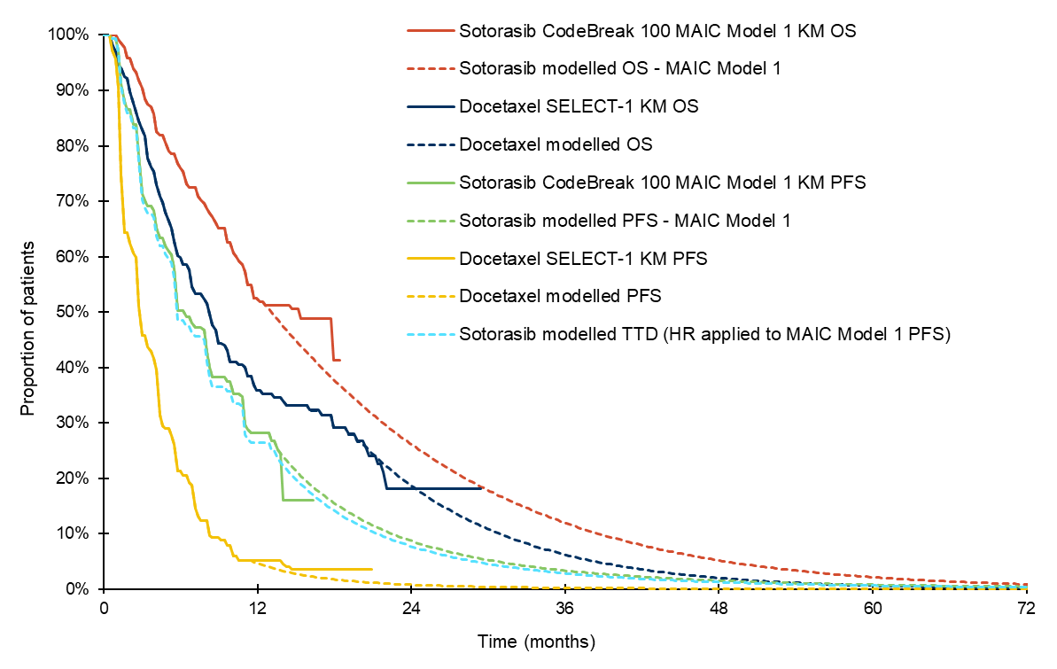HR = hazard ratio; KM = Kaplan-Meier; MAIC = matching-adjusted indirect comparison; PFS = progression-free survival; OS = overall survival.

Figure 8 Kaplan-Meier and modelled curves for PFS and OS, respecified base case using MAIC Model 1
HR = hazard ratio; KM = Kaplan-Meier; MAIC = matching-adjusted indirect comparison; PFS = progression-free survival; OS = overall survival
Figure 9 Kaplan-Meier and modelled curves for PFS and OS, respecified base case using MAIC Model 3
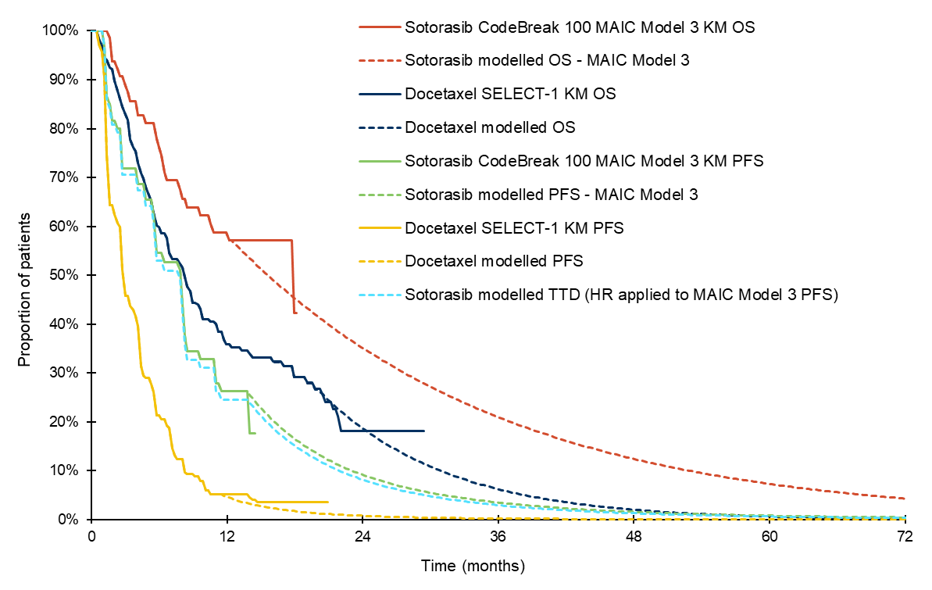HR = hazard ratio; KM = Kaplan-Meier; MAIC = matching-adjusted indirect comparison; PFS = progression-free survival; OS = overall survival
        - The pre-PBAC response considered the ESCs advice combined the main issues into an extremely conservative respecified base case. The response suggested that the sponsor may be able to consider a managed entry as an option for sotorasib if it were to be an arrangement based on a less extreme base case.

Drug cost/patient/course: $||||||||
        - The per patient cost of sotorasib and docetaxel used in the model, and as used in financial analysis, are presented in Table 25. The cost of sotorasib per patient applied in the economic analysis was $| |. This was based on the proposed effective DPMQ of $| | and an average of 8.02 packs per patient. The number of packs was calculated assuming an average treatment duration of 38.7 weeks and an average relative dose intensity of 88.97%. This differed slightly to the estimates applied in the financial estimates, due to rounding of the treatment duration and a higher relative dose intensity applied (89.2%).
        - The modelled cost of docetaxel treatment was $751.80. This was based on an average cost per administration of $122.08. To account for wastage, the cost of 160 mg was estimated from the weighted public and private DPMAs, divided by the maximum amount (250 mg). This cost was then multiplied by 160 to derive a cost per 160 mg vial, and a relative dose intensity of 90.3% was then applied. It is unclear whether the application of the relative dose intensity would lead to a reduction in costs (or just increase the amount wasted). One 160 mg vial would be used to administer an average dose of 123 mg (136 mg × 90.3%), and so the average (weighted) dispensed price for a 160 mg vial is $162.54. This was noted to be the cost of docetaxel applied in the financial estimates. Each patient was assumed to receive on average 6.2 cycles of docetaxel treatment.
Table 25 Medicine costs per patient for sotorasib and docetaxel
 | Sotorasib use |  |  | Docetaxel use
 | CodeBreak 100 | Model | Financial estimates | SELECT-1 | Model | Financial estimates
Mean dose | 854 mg (88.97% RDI) | 854 mg (88.97% RDI) | 856 mg (89.2% RDI) | NR | 136 mg ª | 136 mg ª
Mean duration | 31.6 weeks (truncated)  [6.56 packs]^{b} | 38.7 weeks  [8.02 packs]^{b} | 39.1 weeks ^{c}  [8.15 packs]^{b} | 4 cycles (median) | 6.2 cycles | 5.54 cycles ^{d}
Cost/patient/pack ($) | | | | | | | $122.08 | $122.08 ^{e} | $162.34 ^{f}
Cost/patient/course ($) | | | || | | | | $488.30 | $751.80 ^{g} | $900.08
Source: Constructed during the evaluation from the ‘Sotorasib_NSCLC_CEA_Final.xlsm’ workbook included in the submission.
RDI = relative dose intensity
ª Docetaxel dose (75 mg/m²) × average body surface are in CodeBreak 100 (1.81m²)
^{b} No. weeks divided by the number of weeks a (30 day) pack would last × RDI
^{c} 9 months
^{d} 4.25 months, converted to weeks × no. treatment cycles per week (1/3) × RDI (90.3%)
^{e} Estimated cost per mg based on the weighted DPMA ($211.23) divided by the maximum amount (205 mg) × 160mg (to account for wastage) × RDI (90.3%)
^{f} Weighted price for one 160 mg vial
^{g} undiscounted

Estimated PBS & financial implications
        - This submission was considered by DUSC. An epidemiological approach was used to estimate the financial impact of listing sotorasib for the later-line treatment of patients with KRAS G12C variant NSCLC. The key data sources and parameter values used in the financial estimates are summarised in Table 26.
Table 26 Data sources and parameter values applied in the utilisation and financial estimates
Data | Value applied and source | Comment
Eligible population
Lung cancer incidence, 2020 | 13,258; projected incidence in 2020 reported by the AIHW | The submission’s estimates could not be verified, and may not be current, as the AIHW currently project incidence in lung cancer to 2021.
Lung cancer incidence growth rate | 2%; assumption that was consistent with growth rates used in the AIHW projections (2016−2020) | The growth rates applied in the AIHW projections varied from 1.7%−2.4% per year. Extrapolation of the AIHW 2017−2021 data using a linear function may be a more reasonable approach.
Proportion of lung cancer that is NSCLC | 86.6%; based on Mitchell (2013)ª | This is reasonable and consistent with previous PBAC decision making (Table 10, entrectinib PSD, March 2020 PBAC Meeting).
Proportion of NSCLC that has non-squamous histology | 74.2%; based on paragraph 6.46, nivolumab PSD, March 2016 PBAC meeting
Proportion of that have KRAS G12C variant | 13.0%; based on Cui (2020)^{b} | This is reasonable and is consistent with the estimate used in the economic analysis.
Stage IIIB/IV at diagnosis | 65.5%; based on Mitchell (2013)ª | The approach and estimates used to derive the population with advanced disease were consistent with previous PBAC decision making (Table 10, entrectinib PSD, March 2020 PBAC meeting).
Proportion of Stage IIIA who progress within a year | 11.8% are Stage IIIA at diagnosis (Mitchell 2013ª)  60% progress within a year (Table 17, pembrolizumab PSD, November 2018 PBAC meeting)
ECOG performance 0−2 at diagnosis | 80.1%; based on Mitchell (2013)ª | The DUSC considered this estimate to be reasonable, however, noted that a number of changes in treatment practice could have occurred since the survey was conducted.
Proportion eligible for ≥2 lines of therapy | 50%; assumption, based on previous MSAC (MSAC Application 1161 PSD, November 2012) and PBAC (gefitinib PSD, November 2012 PBAC meeting) considerations, and Cui (2020)^{b} (approx. 45%). A higher estimate allowed for an increase in uptake with sotorasib | The estimate reported in Cui (2020)^{b} was reported for all patients with KRAS variants – not just those with a performance status of 0−2 or of those who received a first-line therapy.
Number of grandfathered patients | 100 in Year 1; assumption | Use in grandfathered patients was assumed to be half that of incident cases.
Treatment utilisation
Sotorasib uptake rate | 100%; assumption | This is reasonable.
Sotorasib scripts dispensed per incident patient | 8.15; based on the average time on treatment estimated in the economic analysis (9 months), assuming 89.2% compliance | The estimate of compliance could not be verified and was slightly higher than applied in Section 3 (88.97%).
Docetaxel scripts per incident patient | 5.54; based on the extrapolated SELECT-1 PFS curve, assuming 90.3% compliance | The assumption that patients would remain on treatment while progression-free may overestimate docetaxel use. A median of 4 cycles was reported in SELECT-1.
Pegfilgrastim scripts per incident patient | 5.54; assuming one script per docetaxel infusion | The submission has assumed that pegfilgrastim use would occur with each treatment cycle of docetaxel in all patients. The PBAC considered this was not consistent with the eviQ recommendations for docetaxel monotherapy or with clinical practice.
Source: Adapted during the evaluation from Table 4.1 pp197−198 of the submission.
DPMQ = dispensed price for the maximum quantity; ECOG = Eastern Clinical Oncology Group; KRAS = Kirsten rat sarcoma viral oncogene homologue; NSCLC = non-small cell lung cancer.
ª Mitchell PL, Thursfield VJ, Ball DL, Richardson GE, Irving LB, Torn-Broers Y, et al. Lung cancer in Victoria: are we making progress? Med J Aust. 2013 Nov 18;199(10):674-9.
^{b} Cui W, Franchini F, Alexander M, Officer A, Wong H-L, Ijzerman M, et al. Real world outcomes in KRAS G12C mutation positive non-small cell lung cancer. Lung Cancer. 2020 2020/08/01/;146:310-7.
        - The DUSC noted the epidemiological approach and key inputs were similar to those used in the entrectinib NSCLC submission previously presented to the PBAC (Table 10, entrectinib PSD, March 2020 PBAC Meeting).
        - The submission assumed that as KRAS variant testing will occur with pathogenic EGFR variant testing, no increase in the utilisation or cost of item 73337 would occur due to the listing of sotorasib. PASC noted that some smaller laboratories may still be using single gene testing (1669 Ratified PICO) and the proposed item does allow for single gene testing of either EGFR or KRAS. Therefore, the submission assumed that listing sotorasib would be associated with a net cost saving to the MBS, due to a reduction in docetaxel chemotherapy administration (MBS item 13950). The PSCR (p2) acknowledged that there may be a small increase in MBS costs from a small number of low throughput laboratories still using single gene testing which is difficult to quantify and may diminish over time as more laboratories move to next generation sequencing (NGS).
        - The estimated use and financial implications of KRAS G12C variant testing and sotorasib treatment is presented in Table 27.
Table 27 Estimated use and financial implications
 | 2022 | 2023 | 2024 | 2025 | 2026 | 2027
Estimated extent of use and cost of sotorasib treatment
Number of patients that receive sotorasib | ||¹ | ||¹ | ||¹ | ||¹ | ||¹ | ||¹
Grandfathered patients | ||¹
Number of sotorasib scripts ª | ||² | ||² | ||² | ||² | ||² | ||²
Cost to the PBS/RPBS, less copayments ($) | ||³ | ||³ | ||³ | ||³ | ||³ | ||³
Changes in use and cost of other medicines
Reduction in cost to the PBS/RPBS, less copayments for docetaxel ^{b} ($) | |⁴ | |⁴ | |⁴ | |⁴ | |⁴ | |⁴
Reduction in cost to the PBS/RPBS, less copayments for dexamethasone ^{c} ($) | |⁴ | |⁴ | |⁴ | |⁴ | |⁴ | |⁴
Reduction in cost to the PBS/RPBS, less copayments for pegfilgrastim ^{b} ($) | |⁴ | |⁴ | |⁴ | |⁴ | |⁴ | |⁴
Total reduction in cost to the PBS/RPBS, less copayments ($) | |⁴ | |⁴ | |⁴ | |⁴ | |⁴ | |⁴
Net cost to the PBS/RPBS ($) | | ³ | | ³ | | ³ | | ³ | | ³ | | ³
Estimated extent of use and cost of KRAS G12C variant testing
Change in use of MBS item 73337 | 0 | 0 | 0 | 0 | 0 | 0
Cost of KRAS G12C variant testing to the MBS | $0 | $0 | $0 | $0 | $0 | $0
Changes in use of chemotherapy administration services
Reduction in docetaxel infusions ^{d} | |² | |² | |² | |² | |² | |²
Reduction in cost to the MBS due to affected services ($) | |⁴ | |⁴ | |⁴ | |⁴ | |⁴ | |⁴
Net cost to the MBS (-$) | | ⁴ | | ⁴ | | ⁴ | | ⁴ | | ⁴ | | ⁴
Net financial implications
Net cost to government ($) | |³ | |³ | |³ | |³ | |³ | |³
Source: Table 4.12, p204; and Table 4.15, p206 of the submission.
KRAS = Kirsten rat sarcoma viral oncogene homologue.
ª | | per incident patient and | | per grandfathered patient
^{b} Based on 5.54 scripts per incident patient and 2.77 scripts per grandfathered patient
^{c} Based on 1.11 scripts per incident patient and 0.55 scripts per grandfathered patient
^{d} The number of docetaxel infusions varied slightly to the number of docetaxel scripts due to rounding of the number of infusions per patient.
The redacted values correspond to the following ranges:
¹ < 500
² 500 to < 5,000
³ $20 million to < $30 million
⁴ $0 to < $10 million

        - The net cost to the PBS/RPBS was estimated to be $20 million to < $30 million in Year 6 and a total of $100 million to < $200 million in the first 6 years of listing. The net cost saving to the MBS was estimated to be a net cost saving in Year 6 and a total of net cost saving in the first 6 years of listing. The overall net cost to government was estimated to be $20 million to < $30 million in Year 6 and a total of $100 million to < $200 million in the first 6 years of listing.
        - The submission expected that a reduction in docetaxel use would occur in every patient that receives sotorasib treatment. The evaluation considered this may not be reasonable, as i) the population that receive sotorasib may reflect use in patients that would otherwise not have received docetaxel; and ii) the submission did not consider that docetaxel may be displaced rather than replaced in a proportion of patients.
        - The DUSC considered the net cost to the PBS/ RPBS and MBS was likely to be an underestimate. The DUSC considered the main issues were:
- The analyses were sensitive to the proportion of patients eligible for ≥2 lines of treatment. The estimate used in the base case (50%) may be an underestimate as it was based on evidence where all patients had KRAS variants, rather than just those with a performance status of 0−2 or of those who received a first-line therapy.
- The submission assumed that patients treated with sotorasib would have otherwise been treated with docetaxel. The DUSC considered this assumption was not reasonable as some patients may not be fit enough to be treated with docetaxel. The pre-PBAC response stated this may be a reasonable comment as sotorasib does have a superior safety profile to docetaxel. The pre-PBAC response stated the docetaxel cost offsets are relatively small and making this change would not have a large impact on the financial estimates.
- The submission did not include high risk Stage I and II patients that may recur and would become eligible for sotorasib in its financial estimates. The pre-PBAC response stated the sponsor sought the advice of the DUSC Secretariat at a pre-submission meeting on whether or not to consider disease recurrence in Stage I/II patients and were advised to assume progression in 60% of the stage IIIA population as was done in the submission.
- The MBS costs associated with single gene testing conducted at low throughput laboratories should be accounted for in the financial estimates. The pre-PBAC response stated the sponsor does not have an estimate for the number of laboratories or tests processed by laboratories still doing single gene testing. The pre-PBAC response stated if these costs were to be included, it would need to rely on a nominal assumption and would likely be small.

Quality use of medicines
        - The following were presented in the submission to support the quality use of medicines:
- targeted therapy with sotorasib is the most appropriate medication choice for patients whose tumours harbour the KRAS G12C variant;
- in the refractory setting, patients with advanced NSCLC are often already fatigued, anorexic and in pain. Therefore, a treatment that does not worsen these symptoms, and that mitigates the risk of chemotherapy-related toxicity (such as febrile neutropenia) is preferable; and
- oral administration of sotorasib at home is preferable to hospital administration of chemotherapy, particularly given the current situation with COVID-19 which can potentially delay access to treatment for some patients.
6.89 The DUSC identified the following additional quality use of medicines issues:
- There could potentially be a dose reduction from 960 mg to 240 mg, depending on the outcomes of post-marketing studies. The pre-PBAC response stated the sponsor does not envisage any major issues with a future potential changeover in dose, particularly none related to the effective and safe use of sotorasib.
- The adherence to oral therapy and potential for error, noting patients are required to take 8 × 120 mg tablets daily. The pre-PBAC response stated that information available from the CodeBreak100 trial and the expanded access program indicate that dose errors appear to be extremely rare. Amongst the 126 NSCLC patients in CodeBreak 100 treated with 8 x 120 mg tablets, only 2 patients (1.6%) experienced a dosing administration error. Data available from 137 patients in the expanded access program showed that only 1/137 (0.7%) patients have reported a dosing error.
        - The PBAC noted an additional quality use of medicine concern related to the use of proton pump inhibitors (PPIs) and other acid-reducing agents. The PBAC noted coadministration of sotorasib and PPIs may significantly reduce the absorption, and hence reduce the efficacy, of sotorasib. The PBAC noted the Product Information stated that coadministration of PPIs and H2-receptor antagonists with sotorasib is not recommended and if treatment with an acid-reducing agent is required, sotorasib should be taken 4 hours before or 10 hours after administration of a local antacid.

Financial management – risk sharing arrangements
        - No risk sharing arrangement was proposed in the submission. However, the sponsor indicated that they would be willing to agree to a financial cap arrangement for sotorasib that appropriately shares financial risk with government to reduce uncertainty associated with the prevalence of KRAS G12C in the Australian setting, the proportion of patients who receive a second-line therapy, and the duration of sotorasib therapy.
For more detail on PBAC’s view, see section 7 PBAC outcome.
- PBAC Outcome
        - The PBAC decided not to recommend sotorasib for the treatment of non-squamous or not otherwise specified (NOS) Stage IIIB (locally advanced) or Stage IV (metastatic) non-small cell lung cancer (NSCLC) who harbour the KRAS G12C variant and who have progressed on prior therapy. The PBAC considered it was likely that sotorasib provided some clinical benefit over docetaxel but the magnitude of the benefit was highly uncertain. The PBAC considered the incremental cost-effectiveness ratio (ICER) was uncertain and unacceptably high at the proposed price.
        - The PBAC noted the consumer comments were supportive of making sotorasib available as a treatment option. The PBAC acknowledged there was a moderate clinical need for additional therapies for NSCLC, given the availability of other treatment options.
        - The PBAC considered the clinical positioning of sotorasib as a second-line treatment was reasonable and the nominated comparator of docetaxel was appropriate.
        - The PBAC noted the clinical evidence for sotorasib was from the CodeBreak 100 study, a single-arm study of patients with KRAS G12C variant advanced NSCLC (n=126) who had received 1 to 3 prior lines of therapy. The PBAC noted the objective response rate (ORR) was 37%, which was notably less than observed for other targeted therapies in NSCLC, median PFS was 6.8 months and median OS was 12.5 months. The PBAC noted that this moderate performance was reflected in a score of 3 out 5 for sotorasib on the European Society for Medical Oncology Magnitude of Clinical Benefit Scale.
        - The PBAC noted the clinical claim in the submission was that sotorasib was superior to docetaxel in terms of effectiveness and safety. The PBAC noted the submission supported the clinical claim regarding effectiveness with unanchored indirect comparisons of patients treated with sotorasib in the CodeBreak 100 study and patients treated with docetaxel in the SELECT-1 study. The PBAC noted there were a number of differences between the patients included in CodeBreak 100 and SELECT-1 that may impact on the transitivity of the indirect comparisons (see paragraph 6.8).
        - The PBAC noted the unadjusted indirect comparison of sotorasib and docetaxel resulted in a hazard ratio (HR) for PFS of 0.43 (95% CI: 0.34, 0.56) and for OS of 0.65 (95% CI: 0.49, 0.87). The PBAC noted the estimated incremental PFS and OS gains for sotorasib were approximately 4.2 and 4.4 months, respectively. However, the PBAC considered the results of the indirect comparison were unreliable and may be subject to bias due to differences in patient populations. The PBAC considered the claim that sotorasib is more effective docetaxel was reasonable, but the magnitude of benefit was highly uncertain.
        - The PBAC noted that the submission also presented three matching adjusted indirect comparisons (MAICs). The PBAC noted there were a number of differences between the patients in CodeBreak 100 and those in SELECT-1 that could not be adjusted for in the MAICs and therefore they remained prone to bias. In the context of the main source of uncertainty being the unanchored nature of the comparison, the PBAC did not accept the resulting less conservative estimates from these MAICs over the results of the unadjusted indirect comparison.
        - The PBAC considered the descriptive comparison of AEs between the single arms of CodeBreak 100 and SELECT-1 did not support a claim that sotorasib is safer than docetaxel. The PBAC considered that, in the absence of direct evidence, a more a reasonable conclusion would be that sotorasib has a different toxicity profile to docetaxel.
        - The PBAC noted the incremental cost effectiveness ratio (ICER) for sotorasib was highly uncertain but likely to be between $95,000 to < $115,000/ QALY (if accepting only the need to rely on the results of the unadjusted indirect comparison) and $255,000 to < $355,000/ QALY (if accepting all aspects of the base case respecified by the ESCs, see paragraphs 6.76 and 6.77), which the PBAC considered was unacceptably high.
        - The PBAC considered that, overall, the estimated number of patients likely to be treated with sotorasib was reasonable. The PBAC considered the net cost of listing sotorasib on the PBS was likely underestimated as the estimated cost offsets for docetaxel and pegfilgrastim were unlikely to be fully realised.
        - The PBAC considered a resubmission for sotorasib should address the following issues:
- the relatively moderate improvement in cancer outcomes in the context of the residual unmet clinical need;
- the reduced confidence in the comparative PFS and OS estimates based on the unanchored indirect comparison compared to the forthcoming direct randomised trial (CodeBreak 200);
- the unacceptably high ICER in the context of the over-optimistic approach to the modelled economic evaluation as described by the ESCs; and
- the over-estimated cost offsets for docetaxel and pegfilgrastim.
        - The resubmission may be lodged at any future standard due date for PBAC submissions using the standard re-entry pathway.
        - The PBAC noted that this submission is eligible for an Independent Review.
Outcome:
Not recommended
- Context for Decision
The PBAC helps decide whether and, if so, how medicines should be subsidised through the Pharmaceutical Benefits Scheme (PBS) in Australia. It considers applications regarding the listing of medicines on the PBS and provides advice about other matters relating to the operation of the PBS in this context. A PBAC decision in relation to PBS listings does not necessarily represent a final PBAC view about the merits of the medicine or the circumstances in which it should be made available through the PBS. The PBAC welcomes applications containing new information at any time.
- Sponsor’s Comment
LUMAKRAS® (sotorasib) recently received provisional TGA approval for the treatment of adult patients with KRAS G12C-mutated locally advanced or metastatic non-small cell lung cancer (NSCLC) who have received at least one prior systemic therapy for advanced disease. Amgen will continue to work with the PBAC to secure reimbursement of sotorasib for eligible Australian lung cancer patients.

A collaborative review project co-ordinated by the United States FDA. For this submission, the regulators taking part were FDA (USA), TGA (Australia), Health Canada, MHRA (UK) and ANVIA (Brazil).
Cherny NI, Dafni U, Bogaerts J, et al: ESMO-Magnitude of Clinical Benefit Scale version 1.1. Annals of Oncology 28:2340-2366, 2017
In SELECT-1, the proportion of patients with a Codon 12 KRAS variant other than G12C (for example G12D, G12V, and G12A) was around 41%.
Wang et al. The landscape of immune checkpoint inhibitor plus chemotherapy versus immunotherapy for advanced non-small-cell lung cancer: A systematic review and meta-analysis. J Cell Physiol. 2020;235(5):4913-4927.
Mok TSK, Wu Y-L, Kudaba I, Kowalski DM, Cho BC, Turna HZ, et al. The Lancet. 2019 2019/05/04/;393(10183):1819-30; Reck M, Rodríguez–Abreu D, Robinson AG, Hui R, Csőszi T, Fülöp A, et al. Journal of Clinical Oncology. 2019;37(7):537-46.
Gadgeel S, Rodríguez-Abreu D, Speranza G, Esteban E, Felip E, Dómine M, et al. Journal of clinical. 2020 May 10;38(14):1505-17; Gandhi L, Rodríguez-Abreu D, Gadgeel S, Esteban E, Felip E, De Angelis F, et al. The New England journal of medicine. 2018 May 31;378(22):2078-92.
Han, Simeng. 2014. Statistical Methods for Aggregation of Indirect Information. Doctoral dissertation, Harvard University. http://nrs.harvard.edu/urn-3:HUL.InstRepos:12274529.
Page 31, NDA/BLA Multi-disciplinary Review and Evaluation {NDA 214665}; LUMAKRAS™ (sotorasib). https://www.accessdata.fda.gov/drugsatfda_docs/nda/2021/214665Orig1s000MultidisciplineR.pdf
38.7 weeks × 7 days per week, divided by the number of days one pack lasts (30), × by the relative dose intensity (88.97%)
Weighted 32.8% public and 67.2% private based on PBS item statistics for docetaxel (PBS items 10148D and 10158P), June 2020−May 2021.

