5.14 TEPOTINIB
Tablet 225 mg (as hydrochloride monohydrate),
Tepmetko®,
Merck Healthcare Pty Ltd.
- Purpose of submission
        - The Category 1 submission requested MBS listing for tumour tissue testing for the purpose of detecting MET proto-oncogene, receptor tyrosine kinase (MET) gene alteration that causes skipping of exon 14 (METex14sk) status. A line-agnostic PBS listing was sought for tepotinib as a targeted therapy for advanced non-small-cell lung cancer (aNSCLC) patients who have evidence of METex14sk alterations in tumour materials.
        - The submission was based on cost minimisation of METex14sk testing and tepotinib treatment for patients with METex14sk, compared with no METex14sk testing and patients treated with pembrolizumab and/or chemotherapy. The key components of the clinical issue addressed by the submission are summarised below.
Table 1: Key components of the clinical issue addressed by the submission
Component | Description
Population | Test: Adults (18 years or older) with histologically and cytologically confirmed locally advanced or metastatic NSCLC, shown to have squamous and non-squamous histology or histology not otherwise specified.  Medicine: Adults (18 years or older) with histologically and cytologically confirmed locally advanced or metastatic NSCLC, shown to have squamous and non-squamous histology or histology not otherwise specified, with a METex14sk alteration, who are either treatment naïve or pre-treated with no more than 2 lines of prior therapy.
Intervention | Test: Genetic testing for METex14sk. Testing may utilise RNA/DNA on tumour tissue using commercially available platforms or laboratory accredited in-house tests (e.g., PCR or NGS).  Medicine: Tepotinib orally administered in those with METex14sk alternations until disease progression. The recommended dose of tepotinib is 450mg (two 225mg tablets) orally once daily with food.
Comparator | Test: No testing for METex14sk.  Medicine: Immunotherapy (pembrolizumab) and/or platinum doublet chemotherapy  or  Immunotherapy or mono-chemotherapy (e.g., pemetrexed or docetaxel) after failure of first line treatment
Outcomes | Test: Analytical performance of METex14sk testing compared to evidentiary standard; comparative prognosis of patients with advanced NSCLC between those whose tumours do and do not have METex14sk; and treatment effect modification of METex14sk on response to tepotinib in patients with advanced NSCLC  Medicine: Safety and tolerability of tepotinib; objective response rate; progression free survival; overall survival, and health related quality of life.
Clinical claim | In adult patients with advanced NSCLC harbouring METex14sk alterations, tepotinib is non-inferior to pembrolizumab with chemotherapy, and superior to chemotherapy alone.
NGS=next generation sequencing; NSCLC=non-small cell lung cancer; PCR=polymerase chain reaction; MET= MET proto-oncogene, receptor tyrosine kinase; METex14sk=MET exon 14 skipping alteration.
Source: Table 1-1, pp24-25 of the submission.
        - The submission proposed testing for METex14sk on diagnosis of locally advanced or metastatic NSCLC patients who have squamous (SQ) and non-squamous (NSQ) histology or histology not otherwise specified (NOS), and with documented absence of activating mutations of the epidermal growth factor receptor (EGFR) gene. However, the MBS item descriptor proposed by the submission was for all NSCLCs, regardless of disease stage. The Pre-Sub-Committee Response (PSCR) provided a revised MBS item descriptor that restricted testing to patients with locally advanced or metastatic NSCLC and a documented absence of activating mutation of the EGFR gene, anaplastic lymphoma kinase (ALK) gene rearrangement or a c-ROS proto-oncogene 1 (ROS1) gene arrangement.
- Requested listing
        - Suggestions and additions proposed by the Secretariat are added in italics and suggested deletions are crossed out with strikethrough.
Proposed PBS listing
Name, Restriction,  Manner of administration and form | Max.  Qty | №.of  Rpts | Dispensed Price for Max. Qty | Proprietary Name and Manufacturer
Tepotinib, 225mg tablet , 60 | 1 pack  60 units | 5 | $10,700.43 | Tepmetko® | Merck Healthcare Pty Ltd
Category/program: | GENERAL – General Schedule (Code GE)
Prescriber type: | Medical Practitioners
Restriction type: | Authority Required – STREAMLINED
Administrative advice | No increase in the maximum quantity or number of units may be authorised.  No increase in the maximum number of repeats may be authorised.
Condition: | Non-small cell lung cancer (NSCLC)
PBS Indication: | Stage IIIB (locally advanced) or Stage IV (metastatic) non-small cell lung cancer (NSCLC)
Treatment phase: | Initial treatment
Clinical criteria: | The treatment must be as monotherapy The treatment must be the sole PBS-subsidised therapy for this condition  AND  Patient must have a WHO performance status of 2 or less  AND  Patient must have evidence of MET proto-oncogene, receptor tyrosine kinase (MET) exon 14 skipping alterations in tumour material

Category/program: | GENERAL – General Schedule (Code GE)
Prescriber type: | Medical Practitioners
Restriction type: | Authority Required – STREAMLINED
Administrative advice | No increase in the maximum quantity or number of units may be authorised.  No increase in the maximum number of repeats may be authorised.
Condition: | Non-small cell lung cancer (NSCLC)
PBS Indication: | Stage IIIB (locally advanced) or Stage IV (metastatic) non-small cell lung cancer (NSCLC)
Treatment phase: | Continuing treatment
Clinical criteria: | Patient must have previously received PBS-subsidised treatment with this drug for this condition,  AND  Patient must not develop disease progression while receiving PBS-subsidised treatment with this drug for this condition  AND  The treatment must be the sole PBS-subsidised therapy for this condition.
Treatment criteria: | Patient must have previously received PBS-subsidised treatment with this drug for this condition

Category/program: | GENERAL – General Schedule (Code GE)
Prescriber type: | Medical Practitioners
Restriction type: | Authority Required – STREAMLINED
Administrative advice | No increase in the maximum quantity or number of units may be authorised.  No increase in the maximum number of repeats may be authorised.
Condition: | Non-small cell lung cancer (NSCLC)
PBS Indication: | Stage IIIB (locally advanced) or Stage IV (metastatic) non-small cell lung cancer (NSCLC)
Treatment phase: | Grandfathering
Clinical criteria: | Patient must have previously received non-PBS subsidised treatment with this drug for this condition prior to [date of PBS listing]  AND  The treatment must be as monotherapy. The treatment must be the sole PBS-subsidised therapy for this condition.  AND  Patient must have a WHO performance status of 2 or less prior to initiation of non-PBS subsidised treatment with this drug for this condition  AND  Patient must have evidence of MET proto-oncogene, receptor tyrosine kinase (MET) exon 14 skipping alterations in tumour material
Administrative advice: | A patient may only qualify for PBS-subsidised treatment under this restriction once
Administrative advice: | Following completion of the initial PBS-subsidised course, further applications for treatment will be assessed under the continuing treatment restriction.
        - The submission proposed that the effective price of tepotinib will be based on the effective price of pembrolizumab, on a cost-minimisation basis.
        - The key VISION trial for tepotinib restricted patients to an Eastern Cooperative Oncology Group Performance Status (ECOG PS) of 0 or 1. This is equivalent to a World Health Organisation performance status (WHO PS) of 0 or 1, and is lower than the proposed restriction of WHO PS of 2 or less. The ESC considered the proposed restriction was clinically reasonable.
        - The requested restrictions were for Stage IIIB and Stage IV NSCLC patients. The ESCs noted the evidence of the clinical effect of tepotinib in patients with Stage IIIB disease was limited, as only three patients (2%) in the key VISION study had Stage IIIB disease. However, the ESCs considered the requested restriction was reasonable as some Stage IIIB patients that are not suitable for chemoradiation treatment are more appropriately treated as Stage IV patients.
        - The ESCs noted the requested restriction did not limit to a specific NSCLC histology and that this was inconsistent with the ratified PICO confirmation which was limited to non-squamous or not otherwise specified. The ESCs considered the requested restriction was reasonable, despite only a small proportion of patients in the VISION study having a squamous histology (7%). However, the ESCs also noted that patients with squamous NSCLC are not currently routinely tested for other existing biomarkers listed in the MBS.
        - The ESCs noted the proposed restriction criteria is line agnostic and that this is not consistent with the ratified PICO confirmation which specified tepotinib was appropriate in patients who were either treatment naïve or pre-treated with no more than 2 lines of prior therapy, consistent with the patients included in the VISION study. However, the ESCs considered that the proposed line agnostic restriction was clinically reasonable.
For more detail on PBAC’s view, see section 7 PBAC outcome.
- Background

Registration status
        - TGA status at time of PBAC consideration: not registered. The submission was made under the TGA/PBAC parallel process. At the time of PBAC consideration the TGA Delegate’s Overview was available.
        - The TGA Delegate was supportive of provisional registration for the following indication:
“For the treatment of adult patients with locally advanced or metastatic non-small cell lung cancer (NSCLC) harbouring mesenchymal-epithelial transition (MET)
exon 14 skipping alterations. The decision to approve this indication has been made on the basis of overall response rate (ORR) and duration of response (DOR). Continued approval of this indication depends on verification and description of benefit in confirmatory trials.”
        - The PBAC noted the confirmatory data for full registration of tepotinib would consist of data from 130 treatment naïve and 143 previously treated patients, after responders have been followed up for at least 12 months and 6 months, respectively.

Previous PBAC consideration
        - The PBAC has not previously considered tepotinib.
For more detail on PBAC’s view, see section 7 PBAC outcome.
- Population and disease
        - Lung cancer is the fifth most common cancer in Australia, however, it causes more deaths than any other cancer. Lung cancer affects predominantly older Australians, with a median age at diagnosis of 72 years. The prognosis of advanced lung cancer is poor.
        - The submission sought listing for use in all histological subtypes of NSCLC, which accounts for approximately 85% of all lung cancer cases. Histologically, non-squamous cell carcinoma (NSQ) and not otherwise specified (NOS) make up approximately three quarters of this population (74.2%, Nivolumab DUSC June 2020 report), with the remainder classified as squamous (SQ) (25.8%).
        - The submission requested tepotinib as a line agnostic listing, but predicted that tepotinib would be predominantly used as a first-line treatment. The submission also stated that ESMO guidelines recommend targeted therapy as the preferred first-line therapy for eligible patients. The evaluation noted this is true of treatments targeting activating epidermal growth factor receptor (EGFR) mutations, anaplastic lymphoma kinase (ALK) gene rearrangements, c-ROS proto-oncogene 1 (ROS1) gene rearrangements, BRAF mutations and PD-L1 expression, with level III/B evidence; however treatment with capmatinib/tepotinib targeting METex14 mutations was not formally recommended as a first-line treatment.
For more detail on PBAC’s view, see section 7 PBAC outcome.
- Comparator
        - The submission nominated pembrolizumab in combination with chemotherapy as the main comparator. The evaluation considered pembrolizumab monotherapy is likely to be a more appropriate comparator for a high proportion of patients.
        - The proposed target METex14sk population is likely to be older and frailer than baseline NSCLC patients and clinicians may be more likely to prescribe pembrolizumab monotherapy more frequently than anticipated by the submission. This is further reinforced by recent retrospective meta-analyses which suggest there may be little difference in efficacy between pembrolizumab + chemotherapy and pembrolizumab monotherapy,, however the safety profile favours monotherapy.
        - The submission stated that of the 22% of patients with PD-L1 tumour proportion score (TPS) ≥50%, 70% would use pembrolizumab monotherapy and 30% would use pembrolizumab in combination with chemotherapy. The evaluation noted the submission did not present any comparative efficacy and safety data for tepotinib and pembrolizumab monotherapy.
        - The ESCs considered patients eligible for treatment with pembrolizumab are increasingly likely to be treated with it in combination with chemotherapy and, overall, the comparator nominated by the submission was appropriate.
        - Although the submission nominated two secondary comparators: atezolizumab in combination with bevacizumab and chemotherapy (ABCP), and chemotherapy for patients ineligible for immunotherapy (either from receiving durvalumab in Stage III NSCLC, or if contraindicated by having an auto-immune disease or frailty), no comparative evidence was provided for tepotinib and ABCP.
        - The submission stated that as tepotinib offers at least the same efficacy as pembrolizumab with chemotherapy, at no additional cost per patient, then by extension, tepotinib can be considered cost effective vs secondary comparators. The evaluation considered this statement may not be reasonable:
        - The PBAC previously considered the naïve indirect comparison between pembrolizumab+platinum+pemetrexed and ABCP (KN189 and IMpower 150) largely uninformative (Paragraph 7.9, Pembrolizumab Public Summary Document (PSD), July 2019 PBAC meeting). Therefore, no inference for the comparative efficacy and safety between tepotinib and ABCP can be made.
        - Patients with Stage IIIB NSCLC are ineligible for pembrolizumab. Currently in Australia, patients with Stage III NSCLC typically receive platinum-based chemo-radiotherapy, and in patients who do not progress after this regimen, durvalumab (another PD-L1 inhibitor) is PBS-listed. The efficacy and safety of pembrolizumab has not been established in the Stage IIIB population, and therefore, the comparative efficacy and safety between tepotinib and chemo-radiotherapy and durvalumab cannot be assumed.
        - In addition, it is likely that, to some extent, immunotherapy may be displaced to a later line (e.g. atezolizumab or nivolumab monotherapy), if patients are treated with tepotinib as a first-line therapy and fit enough to receive a later line treatment after progression.
        - Finally, the submission’s nomination of comparator assumes that pembrolizumab ± chemotherapy will be comparably efficacious in the target METex14sk population. This may not be the case, as reflected in the current NCCN guidelines. METex14sk is a primary oncogenic driver, and understanding of its responsiveness to standard therapies is lacking. The largest study to date (N=337) which examined the effect of METamp and METex14sk on treatment outcomes suggested immune checkpoint inhibitor therapy, primarily administered as monotherapy, may be effective in METamp tumours compared to chemotherapy (median OS 19 vs 8 months, p <0.0001), but potentially ineffective in METex14sk tumours (median OS 16 vs 10 months, p = 0.147). It also found that tumour PD-L1 scores did not predict magnitude of ICI benefit, but the gene copy number (GCN) of the METamp mutations did, with the GCN ≥10 subgroup demonstrating greatest ICI efficacy over chemotherapy (median OS 36 vs 4 months, p <0.0001). The study found approximately 1/3 of METex14sk tumours harboured co-occurring METamp. These findings are hypothesis-generating only, but highlight the possible differential treatment responsiveness of ICI therapy in these newly delineated tumour mutations (METamp and METex14sk). If the target population do respond differently to ICI ± chemotherapy compared to the general EGFR/ALK/ROS1-negative Stage IV NSCLC population, then any conclusions based on the submission’s match-adjusted indirect treatment comparison (MAITC) would be invalid. It may be more important to differentiate patients who harbour METex14sk and METamp mutations, rather than METex14sk and PD-L1 TPS, when determining which patients will benefit from ICI and/or tepotinib therapy.
For more detail on PBAC’s view, see section 7 PBAC outcome.
- Consideration of the evidence

Sponsor hearing
        - The sponsor requested a hearing for this item. The clinician considered tepotinib provided an important additional treatment option for a small population of patients with NSCLC. The clinician acknowledged the lack of a randomised controlled trial but stated clinical experience with other targeted therapies and driver mutations can be extrapolated to tepotinib and METex14sk alteration.

Consumer comments
        - The PBAC noted and welcomed the input from health care professionals (2) and organisations (2) via the Consumer Comments facility on the PBS website. The comments described a range of benefits of treatment with tepotinib including disease control in later lines of therapy, maintenance of qualify of life, ease of administration and manageable side effects.
        - The PBAC noted the advice received from the Lung Foundation of Australia that patients with METex14sk alterations currently have limited treatment options and listing tepotinib on the PBS will provide clinicians and patients with an additional treatment choice.
        - The Medical Oncology Group of Australia (MOGA) also expressed its strong support for the tepotinib submission, categorising it as one of the therapies of “highest priority for PBS listing” on the basis of the VISION trial. The PBAC noted that the MOGA presented a European Society for Medical Oncology Magnitude of Clinical Benefit Scale (ESMO-MCBS) for tepotinib, which was limited to 3 (out of a maximum of 5, where 5 and 4 represent the grades with substantial improvement)^{[1]}, based on a comparison with no treatment, in an area of unmet need.

Overview of the evidence base
        - The approach taken in the submission is to present evidence that has been linked to support the claim that targeting of METex14sk with tepotinib will be non-inferior to pembrolizumab + chemotherapy in the treatment of aNSCLC.
Table 2: Summary of the linked evidence approach
 | Type of evidence supplied | Extent of evidence supplied
Accuracy and performance of the test (analytical validity) | One case-control study (level III-3) and two comparative studies (level III-2) | ☒ k=3 n=387
Prognostic evidence | Comparison of outcomes in patients receiving usual care conditioned on the presence or absence of biomarker positive status | ☒ k=6 n=78
Change in patient management | No evidence provided. | ☐ k=0 n=0
Treatment effectiveness | Efficacy data from the first-line treatment subgroup in the key VISION trial, which enrolled patients with METex14sk, were indirectly compared to the pembrolizumab + chemotherapy arm of KN189, which enrolled patients who were negative for EGFR and ALK; it is unknown how many, if any, harboured a METex14sk mutation. | ☒ k=2 n=65+410
Predictive effect  (treatment effect variation) | No studies.
Treatment effect (enriched) | No single randomised controlled trial of tepotinib vs usual care in patients that are test positive in both arms was provided. | ☐ k=0 n=0
ALK = anaplastic lymphoma kinase; EGFR = epidermal growth factor receptor; k = number of studies; KN189 = Keynote 189; METex14sk = MET proto-oncogene, receptor tyrosine kinase gene alteration that causes skipping of exon 14; k=number of studies, n=number of patients.
Source: Constructed during the evaluation.
        - The submission did not provide any data on the efficacy of pembrolizumab in METex14sk positive or negative populations, however it proposed the prevalence of METex14sk for EGFR-negative non-squamous NSCLC was 4.4%, which means approximately 95.6% of the KN189 population did not harbour the METex14sk mutation.
Table 3: Data availability to inform comparisons
Proposed test vs alternative test | DNA-NGS vs Hybrid DNA/RNA NGS: 1 case-control study  Sanger sequencing vs Hybrid DNA/RNA NGS: 1 case-control and 1 comparative study  qRT-PCR vs Hybrid DNA/RNA NGS: 1 case-control and 1 comparative study  ArcherDX RNA NGS vs Hybrid DNA/RNA NGS: 1 case-control study  DNA-NGS vs RNA-NGS: 1 comparative study
 | Tepotinib | Pembrolizumab + chemotherapy
Biomarker test positive | VISION trial | NA
Biomarker test negative | NA | NA
Unselected | NA | Keynote189 ITT population, where approximately 4.4% may have had METex14sk, based on the prevalence reported in the submission¹.
- Huang 2020 and Reungwetwattana 2017 reported METex14sk alterations in approximately 3% of non-squamous NSCLC
METex14sk = MET proto-oncogene, receptor tyrosine kinase gene alteration that causes skipping of exon 14; NA = Not applicable.
Source: Constructed during the evaluation.

Comparative effectiveness (based on linked evidence)
        - The submission was based on an indirect comparison of tepotinib and pembrolizumab + chemotherapy via two studies:
        - VISION: A phase II single-arm study of tepotinib in advanced (locally advanced or metastatic) NSCLC with METex14sk.
        - KN189: A double-blind, randomised, controlled, phase III trial comparing pemetrexed and a platinum-based drug plus either pembrolizumab or placebo in treatment-naïve patients with metastatic non-squamous NSCLC without sensitising EGFR or ALK mutations. This trial was considered by PBAC in July 2019 when making the recommendation for pembrolizumab + chemotherapy for metastatic NSCLC.
        - VISION enrolled patients based on defined MET alterations identified in tumour tissue and/or in circulating DNA (ctDNA) derived from plasma, and then subdivided into three cohorts.
        - Cohort A: Efficacy assessment was based on data from Cohort A, at the 01 July 2020 data cut-off date; the data presented referred to patients who had received their first dose of tepotinib before 02 October 2019, which ensured at least 9 months of follow-up data from the start of treatment. The cohort consisted of 147 patients, 95 who tested positive from the plasma ctDNA, and 84 from tumour tissue.
        - Cohort B: enrolled patients with NSCLC harbouring MET amplification (METamp). This cohort was halted following the pre-planned interim analysis. This cohort was not included for evaluation as this represented a different target population.
        - Cohort C: confirmatory part for tepotinib for METex14sk, it began enrolling on 1 January 2020 and efficacy data remains immature for efficacy evaluation, with its final report expected in April 2023.
Safety data were pooled from Cohorts A and C. Evaluating safety data from Cohort C whilst it is immature may underestimate adverse events, which may require time on treatment to emerge.
        - Details of the trials presented in the submission are provided in the table below.
Table 4: Trials and associated reports presented in the submission
Trial ID | Protocol title / Publication title | Publication date
Tepotinib
VISION/ NCT02864992 | Tepotinib Phase II in NSCLC Harboring MET Alterations (VISION)  Paik PK, Felip E, Veillon R, et al. Phase II trial of the c-Met inhibitor tepotinib in advanced lung adenocarcinoma with MET exon 14 skipping mutations (Paik et al., 2017)  Paik PK, Felip E, Veillon R, et al. Tepotinib in non-small cell lung cancer with MET exon 14 skipping mutations (Paik et al., 2020) | 13 September 2016  Journal of Clinical Oncology 2017; 35, no. 15_suppl  N Engl J Med 2020; 383: 931-943
 | Tepotinib Phase II in NSCLC harboring MET alterations r(CSR: MS200095-0022) (Merck KGaA, 2016) | 06 September 2016
Pembrolizumab + platinum chemotherapy
Keynote 189/NCT02578680 | Study of Pemetrexed+Platinum Chemotherapy With or Without Pembrolizumab (MK-3475) in Participants With First Line Metastatic Nonsquamous Non-small Cell Lung Cancer (MK-3475-189/KEYNOTE-189)  Gandhi L, Rodríguez-Abreu D, Gadgeel S, et al. Pembrolizumab plus Chemotherapy in Metastatic Non–Small-Cell Lung Cancer. (Gandhi et al., 2018a) | 15 January 2016  N Engl J Med 2018; 378:2078-2092
 | Study of Pemetrexed+Platinum Chemotherapy With or Without Pembrolizumab (MK-3475) in Participants With First Line Metastatic Nonsquamous Non-small Cell Lung Cancer (MK-3475-189/KEYNOTE-189) (updated analysis)  Gadgeel S, Rodríguez-Abreu D, Speranza G, et al. Updated Analysis From KEYNOTE-189: Pembrolizumab or Placebo Plus Pemetrexed and Platinum for Previously Untreated Metastatic Nonsquamous Non-Small-Cell Lung Cancer. (Gadgeel et al., 2020) | 9 March 2020  J Clin Oncol 2020 May 10;38(14):1505-1517.
 | Final analysis of the phase III KEYNOTE-042 study: pembrolizumab (Pembro) versus platinum-based chemotherapy (Chemo) as first-line therapy for patients (Pts) with PD-L1-positive locally advanced/metastatic NSCLC  Mok TSK, Wu Y‐L, Kudaba I, et al. (T.S.K Mok et al., 2019) | 31 August 2019  Annals of oncology 2019, 30, ii38
Source: Table 2-16, pp 72-73 of the submission.
        - The key features of the included evidence are summarised below.
Table 5: Key features of the included evidence – indirect comparison
Trial | N | Design/ duration | Patient population | Outcome(s) | Use in modelled evaluation
Tepotinib
VISION | 147 | Single arm, OL  Median 11.2 months | Stage IIIB or Stage IV NSCLC patients with METex14sk | ORR, PFS,OS | TTD used to model the treatment duration
Pembrolizumab + chemotherapy vs placebo + chemotherapy
KN189 | 616 | R, DB  Median 23.1 months | Untreated NSQ Stage IV NSCLC, EGFR and ALK negative | PFS, OS | Not used
OL= open label; R = randomised; DB = double blind; NSQ = non-squamous; NSCLC = non-small cell lung cancer; METex14sk = MET proto-oncogene, receptor tyrosine kinase exon 14 skipping alterations; EGFR = epidermal growth factor receptor; ALK = anaplastic lymphoma kinase; ECOG = Eastern Cooperative Oncology Group; ORR = overall/objective response rate; PFS = progression free survival; OS = overall survival; TTD = time to treatment discontinuation.
Source: Section 2.3-2.4, pp74-93 of the submission.
        - The submission presented a match-adjusted indirect treatment comparison (MAITC) between the key VISION study and the KN189 trial. The MAITC adjusted the prognostic factors of age, gender and histology (squamous and non-squamous) as these baseline characteristic across VISION and KN189 were not balanced (HR adjustment summarised in the table below). It is reasonable to adjust baseline characteristics for which the distributions are not balanced across the studies and that are known prognostic factors (however, the ESC noted no confidence intervals were provided for the adjustments). However, the adjustment did/could not include all prognostic factors, some of which may be unknown. In particular, METex14sk status could not be adjusted in the MAITC. All patients in VISION were METex14sk positive, while patients in KN189 had unknown METex14sk status. It is also noted that there were almost twice as many patients in KN189 with brain metastases compared to VISION (17.8% vs 9.6%). The presence of brain metastases increases the risk of death and significantly impairs the quality of life by a factor of 4, and patients with brain metastases have recently been reported to have a median OS of 12 months. The submission did not adjust the presence of brain metastases in the MAITC, which was not reasonable and biased the result in favour of tepotinib. The PSCR stated an analysis of 46,030 patients in the SEER database demonstrated an OS HR for metastatic lung adenocarcinoma patients with brain metastases versus patients without brain metastases of 1.18 (95% CI: 1.15, 1.21, p < 0.001) using multivariate Cox regression analysis. The PSCR provided a revised MAITC to include brain metastases as a prognostic factor and concluded the change to the KM curve was marginal.
Table 6: Keynote-189 prognostic adjustment
Prognostic adjustment | Hazard ratio
Male vs female | 0.982
Squamous vs non-squamous | 1.012
Median age 74.5 vs 65 | 1.164
Total prognostic factor | 1.157
Source: Table 2-45, p 114 of the submission.
        - The submission further adjusted the efficacy data of pembrolizumab + chemotherapy in KN189, based on a claim that the TPS ≥50% subgroup of KN189, which demonstrated the greatest benefit of pembrolizumab therapy compared to placebo, was overrepresented, and not representative of the ‘real world’. The submission identified a publication (Dietel et al., 2018) which retrospectively analysed PD-L1 status of 2,368 patients from 45 centres in 18 countries around the world. This study found that the TPS prevalence in all NSCLC cases was lower than in KN189, and used this to increase the TPS <1% group to 47.97%, and TPS 1-49% to 29.65%, as described in Table 7 below in what the submission defined as the ‘real world’ pooled TPS.
        - The publication of Dietel et al. (2019) also provided PD-L1 distributions in NSCLC cases who tested negative for both EGFR mutation and ALK alteration, which is a more accurate representation of the proposed target population. In addition, Kron et al. (2020) assessed the PD-L1 positivity in 337 tumour specimens that had METex14 mutations and found these tumours had a higher PD-L1 expression than the general population, with about a third of patients having PD-L1 TPS ≥50%. These distributions are summarised below. As the submission sought to match the population of KN189 to the target METex14sk population, these higher rates of PD-L1 positivity provide a more accurate representation. The evaluation considered the submission’s adjustment of the efficacy of pembrolizumab + chemotherapy may have underestimated the benefit of pembrolizumab + chemotherapy, and biased the result of the indirect comparison in favour of tepotinib. The PSCR agreed with the evaluation that the PD-L1 distributions in Dietel 2019 in patients negative for EGFR pathogenic variants and ALK alteration were more relevant and provided revised KM curves. The PSCR stated the METex14 cohort in the Kron paper only included 59 patients which is a small sample size to conclude that the proportion of patients with PD-L1 TPS ≥50% is greater in METex14 patients than the general population.
Table 7: Comparison of PD-L1 distribution from KN189, submission’s adjustment, and literature reported estimates
Source | PD-L1 TPS <1% | PD-L1 TPS 1-49% | PD-L1 TPS ≥50%
KN189 | 31.0% | 31.2% | 32.2%
Estimate based on all Stage IIIB/IV NSCLC tumours, Dietel et al., 2018 (submission assumption) | 47.97% | 29.65% | 22.38%
Estimate based on tumours which tested negative for both EGFR mutation and ALK alteration, Dietel et al., 2019 | 46.5% | 26.9% | 26.6%
PD-L1 positivity recorded in patients with METex14sk mutations, Kron et al. 2020. | 27.8% | 36.1% | 36.1%
KN189 = Keynote 189; PD-L1 = programmed death ligand 1; TPS = tumour proportion score; NSCLC= non-small cell lung cancer; EGFR = epidermal growth factor receptor; ALK = anaplastic lymphoma kinase; METex14sk = MET proto-oncogene, receptor tyrosine kinase exon 14 skipping alterations.
Source: Constructed during the evaluation, based on data from Table 1, p 1507 of Gadgeel et. al. 2020, Table 1, p 177 of Dietel et al. 2019, Figure 4, p 579 of Kron et al. 2020, and data from the submission’s excel spreadsheet “20210603 KM Curve Comparison Dashboard v3.xlsm”
        - The key results of tepotinib, in terms of objective response rate (ORR), progression-free survival (PFS) and overall survival (OS) are summarised below. The PBAC noted the ORR for previously untreated patients (n=65) was 45% (95%CI: 32%, 57.5%).
Table 8: Key results of tepotinib from VISION, Cohort A (ITT-02 Oct 2019), by biopsy technique
 | L+ | T+ | Combinedª
 | N = 95 | N = 84 | N = 146
Primary outcome - ORR
ORR (confirmed CR/PR), n (%) | 45 (47.4) | 39 (46.4) | 66 (45.2)
95% CI (exact)^{b} | 37.0, 57.9 | 35.5, 57.6 | 37.0, 53.6
OS
Median OS time (months) | 16.3 | 20.4 | 17.6
95% CI^{c} | 10.9, 21.0 | 15.3, 29.7 | 15.0, 21.0
Number of subjects who died | 53 (55.8) | 39 (46.4) | 75 (51.4)
PFS
Median PFS time (months) | 8.5 | 11.0 | 8.9
95% CI^{c} | 6.7, 10.9 | 8.2, 13.7 | 8.2, 11.0
Number of subjects with an event of progression or death, n (%) | 64 (67.4) | 45 (53.6) | 86 (58.9)
ITT-02 Oct 2019=Intention-to-Treat analysis set restricted to subjects who received a first dose of tepotinib before 02 October 2019, L+=liquid biopsy positive, T+=tumour tissue biopsy positive; ORR=objective response rate, CR=complete response, PR=partial response, CI = confidence interval.
ª There were 33 patients who had both L+ and T+
^{b}. 95% exact CI using the Clopper-Pearson method.
^{c} 95% CI for the median using the Brookmeyer and Crowley method.
Source: Table 2-33, p94, Table 2-38, p 101 of the submission, and Table 132 Clinical Study Report.

Figure 1: Kaplan-Meier Curve Showing PFS, Cohort A (ITT-02 Oct 2019)

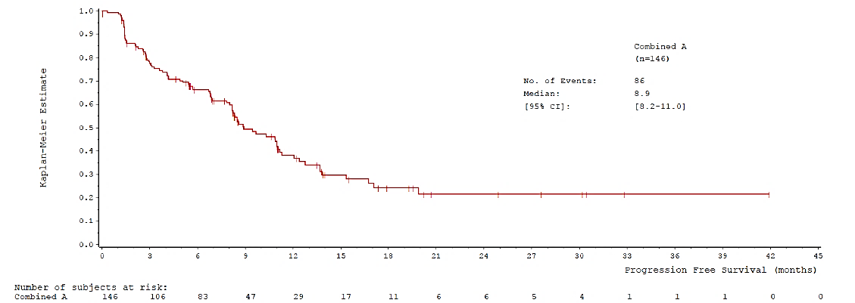

Figure 2: Kaplan-Meier Curve Showing Overall Survival, Cohort A (ITT-02 Oct 2019)

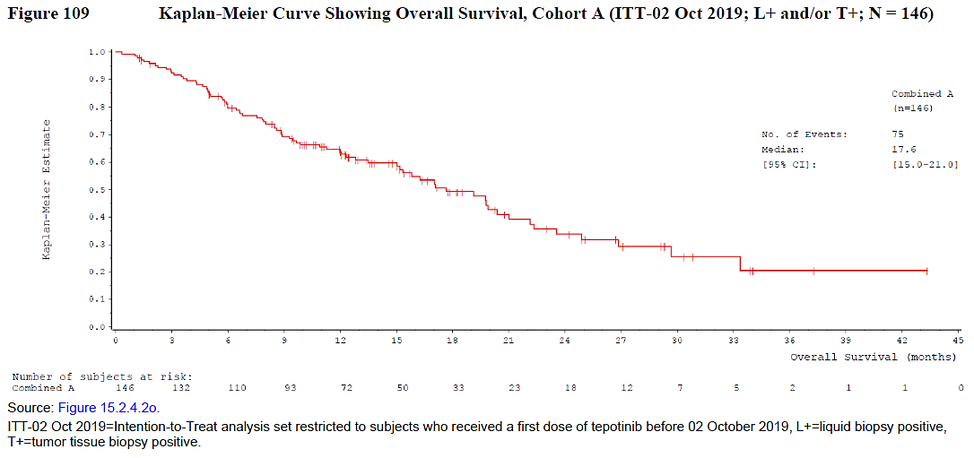
        - The pre-PBAC response provided updated clinical data from the VISION study which was presented at the World Conference on Lung Cancer in September 2021. The PBAC noted the updated analysis combined data for Cohort A (n=152) and Cohort C (n=123). The PBAC noted the ORR for patients with a tissue biopsy was 51.1% (compared to 46% in Table 8), median OS was 22.3 months (compared to 20.4 months in Table 8) and median PFS was 12.4 months (compared to 11.0 months in Table 8).
        - The PFS and OS results of pembrolizumab from KN189 are summarised below. All results are based on the updated cut-off data of September 21, 2018.
Figure 3: Kaplan-Meier analysis of progression-free survival, KN189, September 2018 data cut
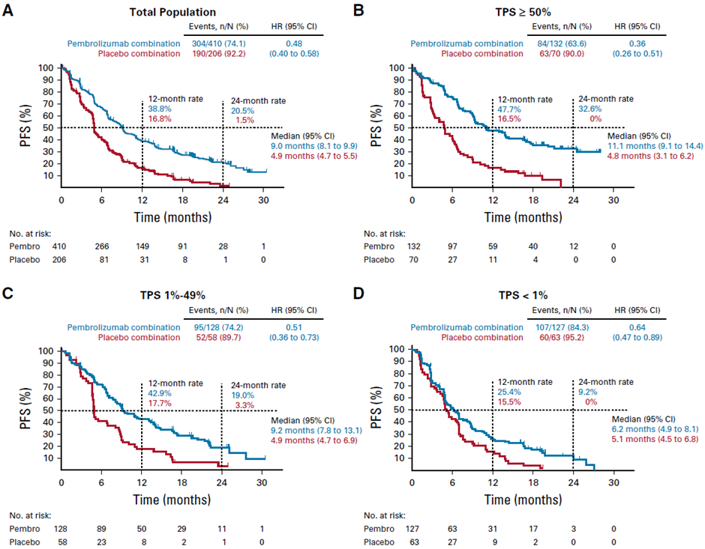
HR = hazard ratio; pembro = pembrolizumab; TPS = tumour proportion score
Source: Figure 3, p 1510 of Gadgeel et. al. 2020
Figure 4: Kaplan-Meier analysis of overall survival, KN189, September 2018 data cut
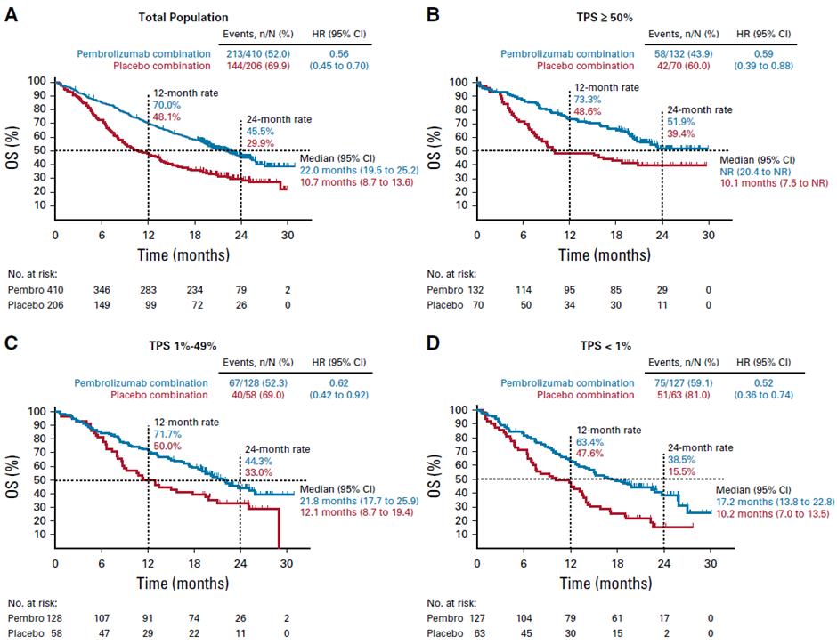
HR = hazard ratio; NR = not reached; pembro = pembrolizumab; TPS = tumour proportion score
Source: Figure 2, p 1509 of Gadgeel et. al. 2020
        - The PFS Kaplan-Meier curves from KN189 adjusted TPS <50% and ‘real world’ pooled TPS (defined in paragraph 6.12) are compared to the VISION 1L cohort in the figure below. The ESC noted the number of patients at risk was not provided in the submission for a number of analyses and considered it would have been informative to include this information in Figures 5 to 8.
Figure 5: PFS KM curves for VISION 1L and Keynote 189 TPS <50 and TPS agnostic populations
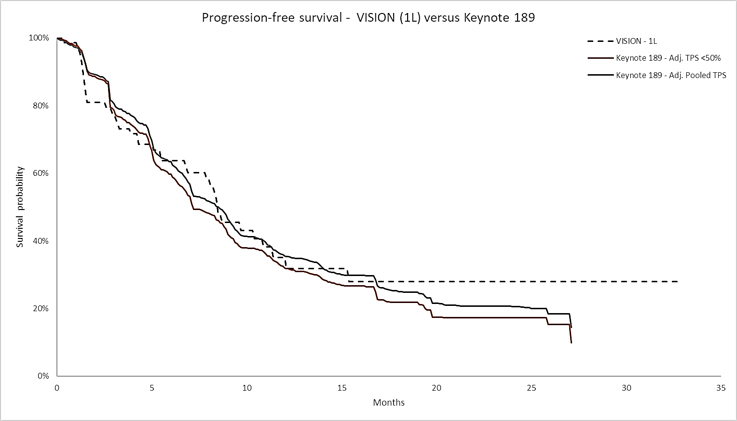
1L = first-line treatment subgroup; TPS = programmed death ligand-1 tumour proportion score.
Source: Figure 2-26, p 117 of the submission.
        - The OS Kaplan-Meier curves adjusted using ‘real-world pooled’ PD-L1 prevalence for pembrolizumab + chemotherapy, both unadjusted and adjusted for prognostic factors, along with the OS curve for tepotinib observed from a subgroup of patients treated with first-line tepotinib in VISION, are presented below. The sample size of patients treated with 1st line tepotinib in VISION study is small (65 patients), any results from such subgroup are likely to be subject to high uncertainty. The TPS ≥50% subgroup demonstrated the greatest efficacy of pembrolizumab, in terms of both PFS and OS (Figure 1 and Figure 2) and this subgroup was not represented in the matching adjusted indirect comparison with tepotinib presented in the submission.
Figure 6: OS Vision 1L vs Keynote 189 results pooled based on real-world TPS prevalence unadjusted for prognostic factors
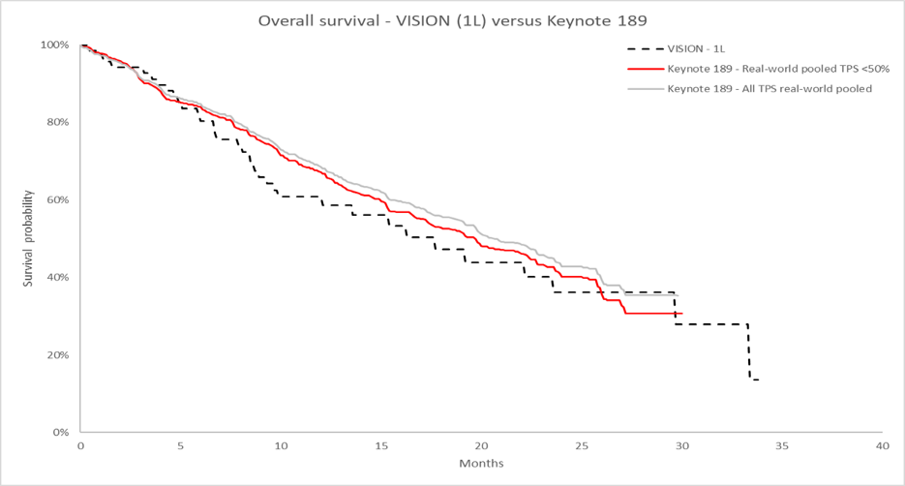
1L = first-line treatment subgroup; OS = overall survival; TPS = programmed death ligand-1 tumour proportion score
Source: Figure 2-24, p 116 of the submission
Figure 7: OS in VISION 1L vs Keynote 189 results pooled based on real-world TPS prevalence and adjusted for prognostic factors
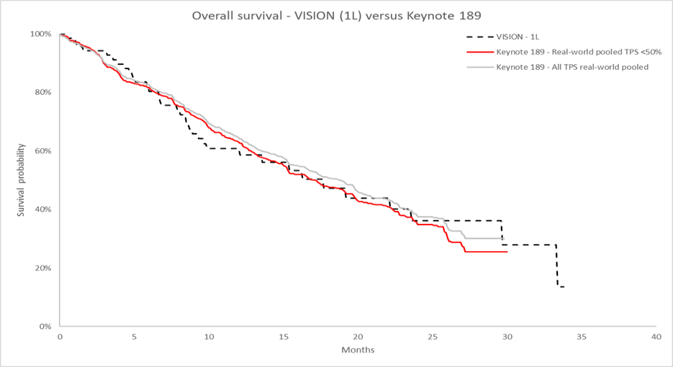
1L = first-line treatment subgroup; OS = overall survival; TPS = programmed death ligand-1 tumour proportion score.
Source: Figure 2-25, p 117 of the submission.
        - These graphs show that even after prognostic factors and the TPS prevalence were adjusted for, the OS curve of pembrolizumab + chemotherapy for all patients was above the OS curve for tepotinib in the 1st line population in VISION. As noted above, the OS benefit of pembrolizumab + chemotherapy may have been underestimated, given that the prevalence of PD-L1 expression in the proposed PBS population may be higher than the submission’s estimate. In addition, the estimated incremental benefit of tepotinib versus pembrolizumab + chemotherapy may have been biased in favour of tepotinib given that the adjusted indirect comparison did not consider the imbalanced distribution of brain metastasis across the two studies. Finally, the adjustment did not account for METex14sk status and, as it is likely that approximately 97% of patients in KN189 were not METex14sk positive, any treatment effect modification from pembrolizumab + chemotherapy or by level of PD-L1 expression (see previous paragraph) would not have been captured in the adjustment or in the overall survival results.
        - The submission did not present the OS curve of patients with TPS ≥50% in KN189 (either adjusted or not adjusted for prognostic factors), in comparison with the PD-L1 prevalence adjusted OS curve for all patients in KN189 and that from first-line patients in VISION. However, a comparison adjusted for prognostic factors was constructed during the evaluation (see Figure below). The evaluation noted pembrolizumab + chemotherapy provided a superior survival curve to tepotinib in the patients with PD-L1 TPS ≥50%. Patients with PD L1 TPS ≥50% had not reached their median OS after 24 months of follow-up in the base case, and when the OS was adjusted for prognostic factors, they had a median OS of approximately 25 months. In contrast, patients treated with 1st line tepotinib in VISION had a median OS 16.3 months. The PSCR stated that as immunotherapy does not work well in METex14sk altered tumours and PD-L1 TPS level is not predictive of immunotherapy efficacy in these patients, it may not be reasonable to compare the tepotinib KM curves to the PD-L1 TPS ≥50% KM curves from KN189.
Figure 8: Kaplan Meier curve of overall survival, comparing VISION (1L) to Keynote 189 adjusted for prognostic factors, TPS ≥50% subgroup
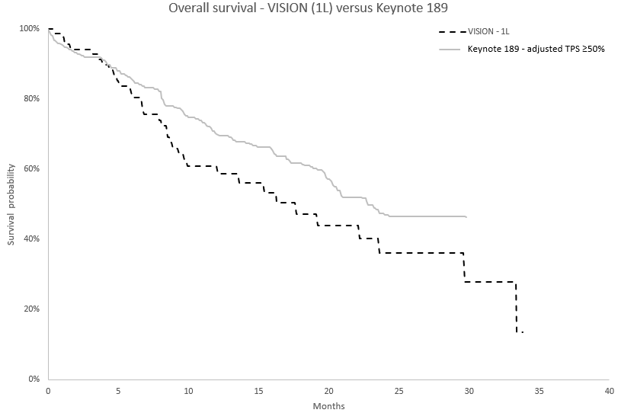
1L = first-line treatment subgroup; TPS = programmed death ligand-1 tumour proportion score.
Source: Constructed during the evaluation using the file ‘20210603 KM Curve Comparison Dashboard v3.xlsm’.

Comparative harms
        - The submission pooled safety data from Cohorts A + C from the VISION study. The median duration of exposure to tepotinib was 5.13 months in the combined analysis set. Cohort C was immature, and the median duration of exposure was less than half that of Cohort A, which was 11.62 months. This means the pooled safety data may underestimate the true adverse event rates that would be experienced by the target population. Separate safety data for Cohort A alone could not be located in the submission. The treatment-emergent adverse events (TEAEs) are presented below.
Table 9: Treatment-emergent adverse events of tepotinib, VISION Cohorts A + C, Safety Analysis Set
Combinedª
N = 255
Number of subjects with: | n (%)
Any TEAE | 246 (96.5)
Any study treatment-related TEAE | 220 (86.3)
Any serious TEAE | 115 (45.1)
Any study treatment-related serious TEAE | 31 (12.2)
Any TEAE by worst NCI-CTCAE severity
Grade ≥ 3 | 135 (52.9)
Grade ≥ 4 | 41 (16.1)
Study treatment-related TEAE by worst NCI-CTCAE severity grade
Grade ≥ 3 | 64 (25.1)
Grade ≥ 4 | 9 (3.5)
Any TEAE leading to death | 30 (11.8)
Any study treatment-related TEAE leading to death | 2 (0.8)
Any TEAE leading to temporary discontinuation of study treatment | 112 (43.9)
Any study treatment-related TEAE leading to  temporary discontinuation of study treatment | 90 (35.3)
Any TEAE leading to permanent discontinuation of study treatment | 52 (20.4)
Any study treatment-related TEAE leading to  permanent discontinuation of study treatment | 27 (10.6)
Any TEAE leading to dose reduction of study treatment | 76 (29.8)
Any study treatment-related TEAE leading to dose reduction of study treatment | 71 (27.8)
TEAE=treatment-emergent adverse event; NCI-CTCAE=National Cancer Institute-Common Terminology Criteria for Adverse Events, NCI-CTCAE Version 4.03.
Note: Treatment-emergent AEs were defined as events that started within the day of the first dose of study treatment until 30 days after the last dose of treatment, or started prior to the first dose but worsened during the treatment period.
Source: Table 2-41, p 108 of the submission.
        - The most common TEAE for tepotinib was peripheral oedema (54.1%), followed by nausea (20%), diarrhoea (19.6%), increased creatinine (17.6%) and hypoalbuminaemia (14.5%). The most common TEAE of Grade ≥ 3 severity, was peripheral oedema, reported in 20 patients (7.8%). Other frequently reported TEAEs of Grade ≥ 3 severity were hypoalbuminaemia (14 patients; 5.5%), pleural effusion (13 patients; 5.1%), disease progression (12 patients; 4.7%), and pneumonia (11 patients; 4.3%). Treatment-emergent AEs of Grade ≥ 4 severity were reported in 41 patients (16.1%). Of these, 30 patients (11.8%) had a TEAE which led to death.
        - The submission performed a comparison of VISION Cohort A + C (n=255) and the KN189 safety population (n=405), presented below. As previously discussed, the inclusion of Cohort C may bias the safety profile in favour of tepotinib, as this cohort is immature, with a median exposure which was less than half that of Cohort A.
Table 10: Naive comparison of adverse events in VISION Cohort A+C and Keynote 189
Adverse event, n (%) | VISION Cohort A+C | Keynote 189^{c} | p-value ª | RR (95% CI) | RD (95% CI)
N | 255 | 405
Any grade AE | 246 (96.5) | 404 (99.8) | <0.001 | 0.967 (0.944, 0.991) | -3.3% (-5.6, -1.0)
Led to discontinuation of any treatment component | 52 (20.4) | 136 (33.6) | <0.001 | 0.607 (0.46, 0.802) | -13.2% (-19.9, -6.4)
AE leading to death | 30 (11.8)^{b} | 29 (7.2) | 0.044 | 1.643 (1.011, 2.671) | 4.6% (-0.1, 9.3)
Grade ≥ 3 AE | 135 (52.9) | 291 (71.9) | <0.001 | 0.737 (0.646, 0.84) | -18.9% (-26.4, -11.4)
Grade ≥ 3 AEs of interest
Peripheral oedema | 20 (7.8) | 2 (0.5) | <0.001 | 15.882 (3.744, 67.378) | 7.3% (4.0, 10.7)
Dyspnoea | 7 (2.7) | 17 (4.2) | 0.332 | 0.654 (0.275, 1.555) | -1.5% (-4.3, 1.3)
Decreased appetite | 3 (1.2) | 5 (1.2) | 0.947 | 0.953 (0.23, 3.953) | -0.1% (-1.8, 1.6)
Vomiting | 3 (1.2) | 16 (4.0) | 0.038 | 0.298 (0.088, 1.012) | -2.8% (-5.1, -0.5)
Asthenia | 3 (1.2) | 27 (6.7) | <0.001 | 0.176 (0.054, 0.576) | -5.5% (-8.3, -2.7)
Nausea | 2 (0.8) | 14 (3.5) | 0.030 | 0.227 (0.052, 0.99) | -2.7% (-4.8, -0.6)
Back pain | 2 (0.8) | 6 (1.5) | 0.425 | 0.529 (0.108, 2.603) | -0.7% (-2.3, 0.9)
Diarrhoea | 1 (0.4) | 21 (5.2) | <0.001 | 0.076 (0.01, 0.559) | -4.8% (-7.1, -2.5)
Fatigue | 1 (0.4) | 28 (6.9) | <0.001 | 0.057 (0.008, 0.414) | -6.5% (-9.1, -3.9)
Cough | 1 (0.4) | 0 (0.0) | 0.207 | 3.176 (0.107, 94.346) | 0.4% (-0.4, 1.2)
Constipation | 0 (0.0) | 4 (1.0) | 0.111 | 0.199 (0.011, 3.74) | -1.0% (-2.0, 0.0)
Neutropenia | 1 (0.4) | 65 (16.0) | <0.001 | 0.024 (0.003, 0.175) | -15.7% (-19.3, -12.0)
Anaemia | 7 (2.7) | 74 (18.3) | <0.001 | 0.15 (0.07, 0.321) | -15.5% (-19.8, -11.3)
Thrombocytopenia | 0 (0.0) | 34 (8.4) | <0.001 | 0.023 (0.001, 0.379) | -8.4% (-11.1, -5.7)
Immune-mediated adverse events | 0 (0.0) | 44 (10.9) | <0.001 | 0.018 (0.001, 0.292) | -10.9% (-13.9, -7.8)
AE = adverse event; CI = confidence interval; RR = risk ratio; RD = risk difference.
ª Pearson’s Chi-squared test.
^{b} Reasons for deaths were mostly disease progression, with two related to tepotinib treatment.
^{c} Gadgeel, 2020
Bold = statistically significant differences.
Source: Table 2-48, p 119 of the submission.
        - Apart from peripheral oedema, most Grade ≥ 3 AEs were more frequently reported in the pembrolizumab + chemotherapy arm of KN189. In particular, anaemia, and neutropaenia were substantially more common in the KN189 cohort. Immune-related AEs occurred in about 11% of patients treated with pembrolizumab + chemotherapy.
        - The evaluation noted that, for patients with TPS ≥50% treated with pembrolizumab monotherapy, the relative safety profile would be more favourable than for patients treated with the combination therapy.

Interpretation of clinical evidence
        - The submission claimed that tepotinib is non-inferior to pembrolizumab + chemotherapy in terms both efficacy and safety, and tepotinib is superior to chemotherapy in terms of both efficacy and safety. The submission did not nominate a non-inferiority margin to make this claim.
        - The evaluation considered the claim of non-inferiority of tepotinib to pembrolizumab + chemotherapy in terms of efficacy was not adequately supported. The MAITC may have been biased in favour of tepotinib by not adjusting the distribution of brain metastasis across VISION and KN189, and by using PD-L1 TPS prevalence data observed from all Stage IIIB/IV NSCLC patients in Dietel et al., 2018. Studies suggest that PD-L1 TPS ≥50% prevalence may be higher among those Stage IIIB/IV NSCLC patients who do not have EGFR mutation or ALK alterations, and among those who have METex14 mutations. Underestimating the prevalence of PD-L1 TPS ≥50% in the MAITC may underestimate the overall benefit of pembrolizumab.
        - For patients with PD-L1 TPS ≥50%, tepotinib may be an inferior treatment to pembrolizumab + chemotherapy in terms of OS benefit, although the isolated effect in patients with METex14sk is unknown.
        - The evaluation considered the claim of non-inferiority of tepotinib to pembrolizumab + chemotherapy in terms of safety appears reasonable.
        - The evaluation considered the claim of superiority of tepotinib to chemotherapy is not adequately supported. Non-inferiority of tepotinib to pembrolizumab + chemotherapy and superiority of pembrolizumab + chemotherapy to chemotherapy alone may imply that tepotinib is superior to chemotherapy alone in those who are eligible for pembrolizumab + chemotherapy treatment.
        - The submission stated that METex14sk is a negative OS prognostic factor, and therefore the indirect comparison presented a conservative estimate of the relative benefit of tepotinib to pembrolizumab + chemotherapy. This statement has not been substantiated by evidence; a meta-analysis performed during the evaluation of 6 relevant studies, which adjusted for prognostic factors, failed to demonstrate a statistically significant negative prognostic value for OS in METex14sk patients. The overall pooled result for all included studies was not statistically significant, but there was a trend suggesting that those with METex14sk alterations have worse prognosis than those without variants (HR = 1.38, 95%CI 0.81, 2.34). When the two studies were pooled that only included patients with advanced disease, no prognostic effect of METex14sk was observed (HR = 1.02, 95%CI 0.67, 1.54). The PBAC noted that patients with a METex14sk alteration were older, and older patients with NSCLC tended to have worse prognosis and be less likely to respond to immunotherapy. The PBAC considered the prognosis of patients with a METex14sk alteration may be marginally worse but that may be accounted for by the adverse prognostic factors (such as age) associated with METex14sk alterations.
        - The submission’s claims about clinical efficacy are predicated on the assumption that the combination of pembrolizumab + chemotherapy is equally effective in treating tumours with a METex14sk mutation as in the general EGFR/ALK-negative population used in KN189. Available data suggest this is unlikely to be the case, as discussed in Section 5 above.
        - The ESCs considered the claims that tepotinib is non-inferior to pembrolizumab with chemotherapy, and superior to chemotherapy alone in terms of efficacy was uncertain. The ESCs noted the additional analyses provided in the PSCR but considered they were also likely to be associated with significant uncertainty. On the balance of the evidence provided, the ESCs were of a view that there were no major signals to suggest tepotinib had an inferior safety profile to either pembrolizumab with chemotherapy or chemotherapy alone, so a claim of non-inferiority in terms of safety may, on balance, be reasonable.
        - The PBAC considered that, overall, the claim that tepotinib is non-inferior to pembrolizumab in terms of effectiveness and safety was reasonable and the claim that tepotinib is superior in terms of effectiveness and safety compared to chemotherapy was reasonable.

Claim of codependence
        - NSCLC is genomically diverse and offers the potential to define molecular subsets of patients treated with personalised therapies. Most adenocarcinoma can be classified based on molecular testing for predictive biomarkers in oncogenic drivers such as EGFR, ROS1, ALK, BRAF, and MET.
        - Oncogenic MET gene alterations identified in NSCLC affect the splice sites of exon 14 of the MET gene (METex14). METex14sk alterations appear to be mutually exclusive with other established driver mutations in NSCLC such as EGFR, KRAS, ALK or ROS1. METex14sk alterations are regarded as a primary oncogenic driver in NSCLC, and are sufficient to promote carcinogenesis and tumour progression.
        - The submission stated that tepotinib is an orally administered, highly selective, ATP-competitive, Type 1b tyrosine kinase inhibitor (TKI) that is highly specific for the c-MET receptor with fewer off target effects as compared with a type 1a TKI. It further stated that identification of patients suitable for tepotinib requires a test currently not covered by the MBS. As such tepotinib was appraised as a codependent submission by MSAC/PBAC addressing both the test and the drug.
        - The PBAC noted the ESCs considered that it was difficult to distinguish between the prognostic value (clinical validity) and predictive value (clinical utility) of METex14sk alterations based on the available evidence.

Economic analysis
        - The submission presented a cost-minimisation approach (CMA) for tepotinib compared with pembrolizumab in combination with chemotherapy, based on the claimed non-inferiority of tepotinib to pembrolizumab in combination with chemotherapy. The equi-effective doses assumed in the base case CMA were:
        - Tepotinib 392.78 mg orally administered once daily over 13.35 months; and
        - Pembrolizumab administered intravenously at 200 mg every 3 weeks (Q3W) in combination with pemetrexed administered intravenously at 865.0 mg Q3W for 11.38 months and 129.75 mg cisplatin or 477.1 mg carboplatin administered intravenously Q3W for 2.58 months.
        - The comparator therapies considered in the base case of the CMA were pembrolizumab + cisplatin/carboplatin + pemetrexed. The evaluation considered the assumption that 100% patients would receive pembrolizumab combination therapy favoured tepotinib, as patients with NSCLC expressing PD-L1 (TPS ≥1%) are TGA-indicated for pembrolizumab monotherapy (pembrolizumab PI), at a lower treatment cost than pembrolizumab + platinum doublet. As noted in paragraph 5.2, the ESCs considered most patients eligible for pembrolizumab would be treated in combination with chemotherapy.
        - No equi-effective doses for patients with Stage IV squamous NSCLC have been proposed in the submission. The comparator treatment regimen for this population would be pembrolizumab + platinum + (nab-)paclitaxel (instead of pemetrexed). The treatment duration for paclitaxel would be shorter than pemetrexed, as the maximum treatment duration for paclitaxel is four cycles (i.e. no maintenance therapy). Therefore, pembrolizumab + chemotherapy in squamous NSCLC patients is likely to be less than the comparator drug cost as estimated in the CMA (for non-squamous NSCLC). The PSCR provided an updated CMA that assumed 25.8% of patients have squamous NSCLC and would be treated with pembrolizumab + platinum + paclitaxel.
        - Cost of subsequent PD-(L)1 inhibitor use after first-line tepotinib was not considered in the CMA. Among 146 patients in VISION cohort A, 44 (30.1%) patients received subsequent anti-cancer therapy and 23 (15.8%) were treated with pembrolizumab, nivolumab or atezolizumab. Of note, the study data of 15.8% was a likely underestimate of the extent of use of later-line PD-(L)1 inhibitor following first-line tepotinib in clinical practice, as 41.1% of subjects in VISION Cohort A were free of disease progression/death event at the data cut-off (July 2020). The OS results reported in VISION, which were compared against the OS results from the pembrolizumab combination therapy trial KN189 in the indirect comparison, have incorporated survival benefits from later-line PD-(L)1 inhibitor use following tepotinib. It appeared unreasonable for a CMA to remove the cost of subsequent immunotherapy whilst the clinical benefits of such later-line use has been taken into account in the clinical non-inferiority basis of the CMA. The ESCs considered inclusion of the cost of second line treatments in the tepotinib arm but not the pembrolizumab arm biased against tepotinib.
        - The equi-effective doses of tepotinib and pembrolizumab + carboplatin/cisplatin + pemetrexed were based on the key clinical trials and Product Information (PI) for each respective medicine. The PI-recommended daily dose of tepotinib is 450 mg. The relative dose intensity (RDI) (87.3%) in Cohort A intention-to-treat (ITT) population of the VISION study was used to estimate the daily dose of tepotinib, which was 392.78 mg (= 450 mg x 87.3%). In KN189, pemetrexed, cisplatin and carboplatin were dosed 500 mg/m², 75 mg/m², and area under the plasma concentration/time curve (AUC) of 5, respectively, Q3W, on the same day as pembrolizumab. Using the patient baseline characteristics of the study population (e.g. mean body surface area (BSA) of 1.73 m²), the estimated average doses were 865.0 mg for pemetrexed, 129.8 mg for cisplatin and 477.1 mg for carboplatin. The relative use of carboplatin and cisplatin (66.5% vs. 33.5%) for treatment of NSCLC was estimated based on the PBS utilisation data of these two agents (for all cancer indications) in the 2020 calendar year.
        - The submission extrapolated trial-based time to treatment discontinuation (TTD) and PFS data to determine the mean treatment duration of tepotinib. Six parametric distributions, exponential, Weibull, Gompertz, log-normal, log-logistic and generalised gamma, were fitted to the TTD and PFS curves in the first-line population (data cut-off: July 2020; patients treated with tepotinib before 2nd October 2019) in the VISION study. The submission stated that an exponential parametric distribution was chosen for tepotinib TTD and PFS, since it had the best visual fit to the trial data and reflected the clinical association between TTD and PFS, e.g. TTD curve lies below the PFS curve all the time, with no crossover. The submission’s justification for the chosen exponential distribution was not convincing:
        - By visual inspection, the log-normal and log-logistic distributions fitted the trial TTD data better than the exponential model;
        - The draft tepotinib PI recommends that tepotinib therapy should continue as long as clinical benefit is observed, without stipulating treatment discontinuation upon disease progression per Response Evaluation Criteria in Solid Tumours (RECIST). In the VISION study, the trial-based TTD was above the PFS Kaplan-Meier curve in earlier time points, suggesting that some study subjects continued treatment beyond RECIST progression (Figure 9). Blumenthal et al (2019) studied a total 18 randomised trials of patients with metastatic NSCLC and found median TTD (13.4 and 14.1 months) exceeding median PFS (11.4 and 11.3 months) in NSCLC oncogene-targeted subgroups (EGFR+ and ALK+, respectively). The authors indicated that some NSCLC patients were able to safely continue treatment well beyond RECIST progression might have been reflective of the underlying biology of oncogene-addicted lung cancer, where continued suppression of the driver mutation may be needed despite the emergence of alternate resistance mechanism. Therefore, a crossover of modelled TTD and modelled PFS curves reflected what occurred in the VISION study and, possibly, in clinical practice as well. The exclusion of parametric models solely on this basis was not fully justified in the submission.
Figure 9: PFS and TTD Kaplan Meier curves from VISION (first-line) and fitted exponential parametric models
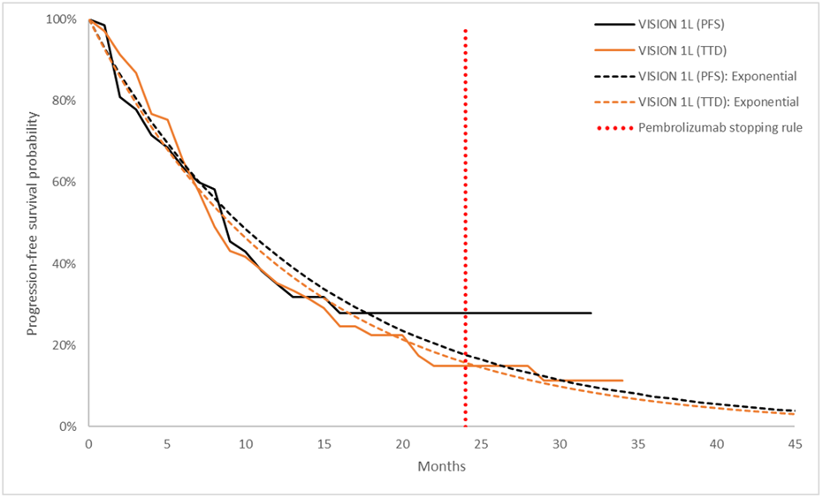
PFS = progression-free survival; TTD = time to treatment discontinuation
Source: Figure 3-2, p133 of the submission
        - The proportion of patients remaining on tepotinib therapy each month was determined from the exponential distribution for TTD from Month 0 to Month 60, resulting in a mean treatment duration of 13.35 months. It is unknown why the submission chose to use the parametric distribution for TTD for the entire time horizon, not the trial-based data up to the time point when the trial estimates became unstable and extrapolating the TTD curve using a parametric function thereafter. The PSCR provided a revised CMA with the extrapolation for TTD from the time at which 20% of patients remained at risk. From the visual inspection, the log-normal provided the best fit to the trial-based TTD data; and it also had the lowest Akaike information criteria and Bayesian information criteria statistics for VISION TTD among all parametric functions.
        - The TTD curve of pembrolizumab + chemotherapy in KN189 was not reported. In the base case analysis, the TTD curve of pembrolizumab combination therapy was assumed to be identical to that of tepotinib until 24 months; thereafter, the proportion of patients receiving pembrolizumab therapy dropped to 0%, corresponding to the maximum treatment duration of pembrolizumab (35 x 3-week cycles). The maximum treatment duration for pemetrexed and platinum was set to be 35 cycles and 4 cycles, respectively. The resulting mean treatment durations were 11.38 months (equivalent to 16.5 cycles) for pembrolizumab and pemetrexed, and 2.58 months for carboplatin/cisplatin. The assumption of a similar TTD for tepotinib and pembrolizumab + platinum doublet therapy before the maximum treatment duration for pembrolizumab is reached would be appropriate, only if the claimed non-inferiority, in terms of both PFS and safety, is accepted.
        - Although dose reduction is not recommended for pembrolizumab therapy, temporary interruption of therapy is allowed to manage immune-mediated adverse reactions, per pembrolizumab PI, and was not uncommon in pembrolizumab trials. Pembrolizumab dose interruptions were not considered in the CMA. The RDI of tepotinib, calculated by the actual dose received divided by the standard calculated dose during a set period, has taken into account dose interruptions. This resulted in a cost-minimising price in favour of tepotinib. A sensitivity analysis was performed during the evaluation by reducing the treatment duration of pembrolizumab by 0.5 cycle from the base case (16 cycles vs. 16.5 cycles). The ESC considered it was reasonable to include dose interruptions for pembrolizumab in the CMA; however, considered a reduction of 0.5 cycles may be an underestimate.
        - The submission estimated the number of patients needed to be tested per positive case, by estimating the METex14sk prevalence in squamous NSCLC (1.6%) and METex14sk prevalence in EGFR wild-type non-squamous NSCLC (4.6%). The weighted average number of NSCLC patients needed to be tested to identify one patient with METex14sk was estimated to be 32.2 patients. The calculations of METex14sk prevalence provided in the submission and in the PSCR are summarised in Table 11. The PBAC noted the number needed to be tested for squamous NSCLC is 62.5 (assuming a prevalence of 1.6%) and for non-squamous NSCLC is 20.5 (assuming a prevalence of 4.6% as proposed in the PSCR).
Table 11: Prevalence of METex14sk alteration in NSCLC
 | All NSCLC | SQ NSCLC (25.8%) | NSQ NSCLC (74.2%) | NNT
All patients | 3.1% | 1.6% | 3.6% | 32.3
Removing patients with EGFR pathogenic variants¹ | - | 1.6% | 4.6% | 32.2
Removing patients with ALK or ROS1 gene rearrangements in PSCR² | - | 1.6% | 4.9% | 31.3
ALK = anaplastic lymphoma kinase; EGFR = epidermal growth factor receptor; NSCLC=non-small cell lung cancer; NSQ=non-squamous; NNT= number needed to test; ROS1 = ROS proto-oncogene 1; PSCR=pre-subcommittee response; SQ=squamous
- Assuming 17.9% EGFR pathogenic variants
- Assuming 3% ALK gene rearrangements, 1.2% ROS1 gene rearrangements
        - The evaluation noted the calculation of METex14sk prevalence by NSCLC histology, could not be verified during evaluation.
        - The MBS item descriptor proposed by the submission was for all NSCLC patients, regardless of disease stage. In contrast, first-line tepotinib would be given to those with locally advanced and metastatic disease according to the requested PBS listing. Therefore, the CMA should also consider the cost for testing of patients with Stage I-IIIA NSCLC who do not progress into Stage IIIB/IV (ineligible for tepotinib therapy). In addition, retesting was not considered in the CMA. A sensitivity analysis was performed during the evaluation, by increasing the number of tested patients to around 50 for every METex14sk patient to account for retesting and inconsistent MBS listing for METex14sk testing and PBS restriction for tepotinib in terms disease stage. The PSCR amended the MBS item descriptor to test patients diagnosed with locally advanced or metastatic NSCLC.
        - The submission’s CMA is summarised below. As the effective price of pembrolizumab is confidential, the CMA was based on the published price of pembrolizumab prior to its statutory price reduction in April 2021. The calculated ex-manufacturer price for tepotinib was $10,543.32 per pack of 225 mg x 60 tablets.
Table 12: Results of cost-minimisation approach presented in the submission
 | Tepotinib | Pembrolizumab + pemetrexed + cisplatin/carboplatin
 |  | Pembrolizumab | Pemetrexed | Carboplatin | Cisplatin
Ex-manufacturer price per unit | $175.72 per 225 mg tabletª  ($10,543.32 per pack) | $4,025.00 per 100mg vial^{g} | $45.98 per 500mg vial | $13.43 per 150mg vial | $19.28 per 100 mg vial  $10.41 per 50 mg vial
Dose per administration | 392.8 mg | 200 mg | 865.0 mg | 477.1 mg | 129.8 mg
Units per dose | 1.75 x 225 mg tablets | 2 x 100 mg vials | 2 x 500 mg vials | 4 x 150 mg vials | 1 x 100 mg vial + 1 x 50 mg vial
Drug cost per dose | $306.76 | $8,050.00 | $91.96 | $53.72 | $29.69
Doses per month | 30.4^{b} | 1.4^{c} | 1.4^{c} | 1.4^{c} | 1.4^{c}
Drug cost per month | $9,336.88 | $11,667.71 | $133.29 | $77.86 | $43.03
Treatment duration | 13.4 months | 11.4 months | 11.4 months | 2.6 months | 2.6 months
Drug cost | $124,671.06 | $132,554.37 | $1,514.25 | $170.58^{d}
Total drug acquisition cost | $124,671.06 | $134,239.20
Administration cost | $0.00 | $1,599.37e
Cost for METex14sk test | $11,127.50^{f} | $0.00
Total treatment cost | $135,798.56 | $135,798.56
METex14sk = MET proto-oncogene, receptor tyrosine kinase exon 14 skipping alterations
ª The calculated ex-manufacturer price for tepotinib was $10,543.32 per pack of 225mg x 60 tablets. Per tablet cost of $175.72 = $10,543.32/60.
^{b} The dose frequency for tepotinib is once daily. Number of doses per month (30.4) = 365.25/12.
^{c} The dose frequency for pembrolizumab, pemetrexed, cisplatin and carboplatin is once every 21 days. Number of doses per month (1.4) = 365.25/21/12.
^{d} Weighted by assuming 66.5% patients on carboplatin and 33.5% on cisplatin.
^{e} $1,599.37 = $94.70 x 1.4 x 11.4, where $94.70 is the 85% Benefit of MBS fee for chemotherapy administration (item 13950), 1.4 is the number of doses per month and 11.4 is the treatment duration in months.
^{f} $11,127.50 = $337.75 x 32.9, where $337.75 is the 85% Benefit of MBS Schedule fee for METex14sk testing and 32.9 is the number of patients needed to be tested to identify one mutation positive case.
^{g} The cost-minimisation approach used the published ex-manufacturer price of pembrolizumab prior to its statutory price reduction in April 2021.
Source: Table compiled during the evaluation, based on Table 3-13, p145 of the submission and the “20210607 Tepotinib Section 3 Workbook CMA V2.1 (FINAL)” Excel workbook
        - The submission’s base case CMA used 85% of the MBS fees for METex14sk testing and chemotherapy administration, not the 100% MBS Schedule fees. In addition, the drug costs for pemetrexed and carboplatin were not calculated on the basis of the most efficient vial combination. If both errors were corrected, the ex-manufacturer price for tepotinib would decrease slightly from $10,543.32 per 225 mg x 60 tablets to $10,386.73. The PSCR acknowledged the corrections applied to the CMA.
        - The results of key sensitivity analyses performed during the evaluation are presented below.
Table 13: Results of sensitivity analyses performed during the evaluation
Variable | Assumption in sensitivity analysis | Total cost per patient | Ex-manufacturer price per tepotinib 225 mg x 60 tablets
 |  |  | $ | % change
Base case |  | $135,910.47ª | $10,386.73ª | –
Parametric function used for tepotinib TTD (base case: exponential) | Log-normal | $135,501.12 | $9,671.56 | -6.9%
 | Log-logistic | $132,224.88 | $10,158.18 | -2.2%
 | Generalised gamma | $135,635.08 | $10,075.12 | -3.0%
 | Gompertz | $135,422.01 | $10,209.71 | -1.7%
 | Weibull | $137,890.46 | $10,882.09 | 4.8%
Dose of tepotinib (base case: 392.8 mg) | 450 mg per administration | $135,910.47 | $9,066.00 | -12.7%
Restriction of METex14sk testing and tepotinib in terms of NSCLC histology (base case: both non-squamous and squamous) | Non-squamous only ^{b} | $135,910.47 | $10,732.04 | 3.3%
Proportion of patients receiving pembrolizumab monotherapy in the comparator arm (base case: 0%) | 22.4% of all patients (i.e. all patients with PD-L1 TPS ≥50% treated with pembrolizumab monotherapy | $135,569.87 | $10,357.92 | -0.3%
The treatment duration of pembrolizumab (base case: 11.38 months) | Reducing by 0.5 cycle, i.e. 11.04 months (arbitrary assumption) | $131,885.47 | $10,046.34 | -3.3%
Pembrolizumab price (base case: $4,025.00 per 100mg vial) | Current PBS-listed price, i.e. $3,823.75 per 100 mg vial | $129,282.75 | $9,826.23 | -5.4%
Number of patients undergoing METex14sk test per treated patient (base case: 32.9 patients) | 50 patients | $135,910.47 | $9,813.65 | -5.5%
Subsequent nivolumab use (base case: not included) | 15.8% of patients receiving 3rd-line nivolumab^{c} | $135,910.47 | $9,835.29 | -5.3%
Log-normal distribution for TTD and reducing the pembrolizumab treatment duration of 0.5 cycle from the modelled TTD |  | $131,476.12 | $9,353.55 | -9.9%
Log-normal distribution for TTD, reducing the pembrolizumab treatment duration of 0.5 cycle from the modelled TTD and assuming 50 tested patients per treated patient |  | $131,476.12 | $8,818.15 | -15.1%
Log-normal distribution for TTD, reducing the pembrolizumab treatment duration of 0.5 cycle from the modelled TTD, assuming 50 tested patients per treated patient, and including 15.8% patients treated with nivolumab in the 3rd-line setting |  | $131,476.12 | $8,302.96 | -20.1%
METex14sk = MET proto-oncogene, receptor tyrosine kinase exon 14 skipping alterations; NSCLC = non-small cell lung cancer; TTD = time to treatment discontinuation
ª Revised base case results based on: i) 100% MBS Schedule fees for METex14sk testing and chemotherapy administration; and ii) the most efficient vial combination for pemetrexed and carboplatin
^{b} Assuming 22.67 (=1/4.41%) patients with non-squamous NSCLC needed to be tested to identify one patient eligible for tepotinib.
^{c} The dose regimen of nivolumab is 480mg Q4W for 4.14 cycles (i.e. 3.8 months), as per financial analysis. The published price for nivolumab was used in the sensitivity analysis.
Source: Sensitivity analyses performed during the evaluation
        - The price of tepotinib estimated from the CMA was most sensitive to the average dose of tepotinib and the parametric distribution for TTD. The log-normal model had the best fit to the VISION trial TTD data based on visual inspection and goodness of fit statistics. When the log-normal function was used, the per pack price for tepotinib would decrease to $9,671.56 (compared with the submission’s proposed price of $10,543.32). The price would decrease further to $8,302.96 by reducing the treatment duration of pembrolizumab by 0.5 cycle from the log-normal modelled TTD to take into account dose interruptions, assuming 50 patients would be tested for METex14sk per patient treated with tepotinib, and including the cost of third-line nivolumab use in 15.8% of patients.
        - The PSCR provided an updated CMA incorporating the following changes:
- 25.8% of patients have squamous NSCLC and are treated with pembrolizumab + platinum + paclitaxel;
- Removing ALK+ (3%) and ROS1+ (1.2%) positive patients from the non-squamous testing pool (number needed to test changed from 32.9 to 32.1) (the ESC noted this change was appropriate with the amended MBS descriptor provided with the PSCR);
- Applying the prevalence of PD-L1 TPS expression in the EGFR- and ALK-negative cohort from Dietel et al. 2019 and assuming 70% of pembrolizumab monotherapy use in the PD-L1 TPS ≥50% population; and
- Initiating extrapolation from the time at which 20% of patients remained at risk in the VISION 1L OS KM data (12.0 months) (resulting in an average treatment duration 12.87 months for tepotinib, 11.1 months for pembrolizumab and 2.66 months for chemotherapy).
The revised CMA resulted in an AEMP for tepotinib of $10,453.49 per pack (compared to $10,386.73 in the submission). The ESCs noted correcting a number of errors in the CMA resulted in an AEMP of $10,489.64.
        - The ESCs considered the following CMA assumptions would be reasonable:
- 25.8% of patients have squamous NSCLC and are treated with pembrolizumab + platinum + paclitaxel (as proposed in the PSCR);
- Removing ALK+ (3%) and ROS1+ (1.2%) positive patients from the non-squamous testing pool (as proposed in the PSCR);
- Initiating extrapolation from the time at which 20% of patients remained at risk in the VISION 1L OS KM data (as proposed in the PSCR) and applying a lognormal extrapolation (as discussed in paragraph 6.45);
- Reducing treatment duration of pembrolizumab by 0.5 cycle to account for dose interruption (assuming 50% of patients reduce treatment duration by one cycle); and
- A 15% retest rate as proposed in the evaluation.
The revised CMA resulted in an AEMP of $9,277.31 per pack.
        - The PBAC noted the pre-PBAC response did not accept the 15% retest rate in the CMA proposed by the ESC. The PBAC agreed with the pre-PBAC response that a retest rate of 7%, consistent with that observed for EGFR testing, was reasonable.
        - The PBAC noted initiating extrapolation from the time at which 20% of patients remained at risk in the VISION 1L OS KM data and applying a lognormal extrapolation (as proposed by the ESC) resulted in an average treatment duration of 13.98 months for tepotinib, 11.2 months (16.23 cycles) for pembrolizumab and pemetrexed and 2.66 months (3.86 cycles) for chemotherapy.
        - The PBAC noted the difference in chemotherapy cost in the CMA between squamous and non-squamous patients was negligible and considered it would be reasonable for the CMA to apply treatment costs for non-squamous NSCLC only.
        - The pre-PBAC response stated that if panel testing is implemented for NSCLC, the marginal cost of testing for METex14sk alteration would be negligible and requested the PBAC take this into account for tepotinib. The PBAC considered the value of the test is unrelated to whether it is provided via a single gene test (as proposed in the submission) or subsequently via a gene panel, so there would not need to be a re-visiting of the CMA in the event that METex14sk alteration testing is incorporated into a panel in the future.

Drug cost/patient/course
        - As presented in Table 3 above, at the proposed ex-manufacturer price for tepotinib of $10,543.32 per pack of 225 mg x 60 tablets, the treatment cost with tepotinib, at an average of 392.8 mg per administration, over an average of 13.4 months, was $124,671/patient. To identify one eligible patient for treatment, 32.9 patients need to be tested for METex14sk at a total cost of $11,128 (using the 85% MBS fee for the testing). The total cost to treat one METex14sk patient with tepotinib was $135,799, same as the cost of treatment with pembrolizumab in combination with chemotherapy. The total cost per tepotinib patient would be $135,910, including a testing cost of $13,091 (using the 100% MBS Schedule fee) and a drug cost of $122,819 (based on revised cost minimising price of $10,386.73 per pack and using the most efficient vial combination for pemetrexed and carboplatin).

Estimated PBS & financial implications
        - This submission was considered by the DUSC. The submission took an epidemiological approach to estimating the financial impacts of the listing of the proposed codependent technologies, i.e. testing for METex14sk and treatment with tepotinib for those patients with METex14sk. The key data sources used in the financial analysis are summarised below.

Table 14: Data sources used to calculate the financial impacts of reimbursement of METex14sk testing and tepotinib
Data | Value (data source) | Data source | Comment
Eligible population
Incidence of lung cancer in Australia | 13,689 in Yr 1, increasing to 14,953 in Yr 6 | AIHW 2020
% NSCLC | 86.6% | Victorian Cancer Registry data reported by Mitchell et al (2013)
Distribution of disease stage at diagnosis | Stage I-IIIA: 34.5%  Stage IIIB: 14.0%  Stage IV: 51.5%
% patients tested for EGFR mutations | 90% | Pennell et al 2019 | The submission incorrectly assumed that patients with squamous NSCLC would also be tested for EGFR mutations and have a 17.9% positive rate.
Prevalence of activating EGFR mutations | 17.9% | DUSC report on erlotinib and gefitinib (2017)
Prevalence of METex14sk | 5% | Ratified PICO Confirmation document (Application 1660), literature | 5% was higher than the prevalence reported in most of the studies (ranging from 3% to 4%).
% patients ineligible for immunotherapy due to autoimmune diseases | 13.5% | Large American study by Khan et al 2016 | Reasonable data source
Split of PD-L1 TPS < 50% vs. PD-L1 TPS ≥50% | 77.8% vs. 22.2% | Dietel et al 2019 (in all aNSCLCs) | The proportion of patients with PD-L1 TPS ≥50% in METex14sk+ NSCLC patients could be higher than the estimate in aNSCLC patients reported in this study.
% patients with PD-L1 TPS ≥ 50% NSCLC receiving pembrolizumab + chemotherapy | 30% | July 2019 submission of pembrolizumab combination therapy, based on Flatlron real-world database | The ESC considered that only a small proportion of patients in the PD-L1 TPS ≥50% population with a high disease burden would be treated with pembrolizumab + chemotherapy instead of pembrolizumab monotherapy.
% patients diagnosed with earlier stages of disease who progress to unresectable Stage III | 30% | DUSC report on erlotinib and gefitinib (2017) | The DUSC report provided the estimate of the proportion of patients with Stage I-IIIA NSCLC progressed to Stage IIIB-IV in first year of diagnosis, not from Stage I-II to unresectable III.
Uptake of durvalumab | 90% | November 2019 durvalumab resubmission | A proportion of patients with unresectable stage III NSCLC would be ineligible for chemoradiation and, thus, ineligible for durvalumab. This was not considered in the financial analysis.
% patients experiencing disease progression after durvalumab | 75%
% patients having disease progression after 1st-line pembrolizumab combination therapy | 57.9% | Disease progression rate from tepotinib reported in VISION | Reasonable if the non-inferior effectiveness of tepotinib relative to pembrolizumab + chemotherapy is accepted.
Grandfathering patients | 50 in Year 1 | Assumption | No justification provided
Treatment utilisation
Uptake of tepotinib in patients who otherwise receive pembrolizumab ± chemotherapy | 40% in Yr 1, 50% in Yr 2, 70% in Yr 3 and 90% in Yrs 4-6 | Assumption | Given the more convenient administration route of tepotinib versus pembrolizumab and chemotherapy (oral vs. IV infusion), the uptake of tepotinib could be high in the eligible population if the submission’s claim of non-inferiority versus pembrolizumab ± chemotherapy and superiority versus chemotherapy alone has been proven.
Uptake of tepotinib in patients who otherwise receive chemotherapy | 90%-95%
Treatment duration of tepotinib | 13.35 months | Modelled TTD based on the VISION study
Compliance of tepotinib therapy | 87.28% | VISION study
Progression to 2nd- and 3rd-line after tepotinib use | 57.9% to 2nd-line,  33.6% to 3rd-line | VISION study, assumption | Due to the lack clinical data, the submission assumed identical progression rate from 1st-line to 2nd-line and from 2nd-line to 3rd-line. This assumption was not well justified.
Treatment duration of pembrolizumab and pemetrexed (in combination with pembrolizumab) | 11.38 months | Modelled TTD based on the VISION study, applying a 24-month stopping rule | Pembrolizumab dose interruptions were not considered in the submission. This favoured tepotinib.
Treatment duration of pemetrexed as platinum doublet chemotherapy | 6 x 3-week cycles | Wu et al 2014 | Could have been underestimated, as the Wu 2014 study protocol specified subjects to receive pemetrexed for a maximum of 6 cycles, not as a maintenance therapy.
Treatment duration of cisplatin | 4 x 3-week cycles | eviQ | Reasonable
Treatment duration of 3rd-line nivolumab | 3.8 months | Checkmate 153 | Checkmate 153 reported the duration of retreatment with nivolumab following prior nivolumab treatment failure. This may not reflect 3rd-line nivolumab use following 1st-line tepotinib and 2nd-line chemotherapy.
Treatment duration of 3rd-line docetaxel | 2.1 months | Assumption
Source: Table 4-1, p149, Table 4-3, p150, Table 4-4, pp150-151, and information provided in Sections 4.2-4.5, p150-165 of the submission
AEMP = approved ex-manufacturer price; AIHW = Australian Institute of Health and Welfare; aNSCLC = advanced non-small cell lung cancer; DPMA = dispensed price for maximum amount; DUSC = Drug Utilisation Sub-Committee; EGFR = epidermal growth factor receptor; EFC = Efficient Funding of Chemotherapy; ESC = Economic Sub-Committee; IV = intravenous; MBS = Medicare Benefits Schedule; METex14sk = MET proto-oncogene, receptor tyrosine kinase exon 14 skipping alterations; NSCLC = non-small cell lung cancer; PBS = Pharmaceutical Benefits Scheme; PD-L1 = programmed cell death ligand-1; PICO = Population, Intervention, Comparator, and Outcome; RPBS = Reparation Pharmaceutical Benefits Scheme; TPS = tumour proportion score; TTD = time to treatment discontinuation
        - The submission underestimated the number of patients eligible for METex14sk testing by only considering those NSCLC patients who are diagnosed at Stage IIIB and IV. The proposed MBS listing for METex14sk testing in the submission did not specify the disease stage of NSCLC. Patients with Stages I-IIIA disease would also be eligible for METex14sk testing according to the requested MBS listing. The PBAC noted that, although the eligibility criteria for METex14sk testing was limited to locally advanced or metastatic NSCLC in the PSCR, the size of the eligible patients for testing remained underestimated, as those diagnosed with Stages I-IIIA but subsequently progressing into a later stage were not included in the submission’s estimates.
        - The submission further underestimated the number of patients eligible for METex14sk testing, by applying the EGFR testing uptake rate and the proportion of patients who are EGFR positive among those tested, to all NSCLC patients, irrespective of histology. Only patients with non-squamous NSCLC will undergo an EGFR test; and those tested negative will be eligible for METex14sk testing. Patients with squamous NSCLC do not require an EGFR test to determine their eligibility to METex14sk testing, per requested MBS descriptor.
        - Uptake of testing was assumed to be 100%. Cost of retesting for METex14sk was not considered in the financial analysis.
        - The submission categorised patients who are eligible for tepotinib therapy into six subgroups, according to the line of therapy, their PD-L1 expression, disease stage, prior treatment, eligible/ineligible for immunotherapy. Therapies which would be replaced by tepotinib differed across these subgroups (Table 15).
Table 15: Description of the patient populations eligible for tepotinib included in the financial analysis
 | Population description | Replaced therapy in the financial analysis
Incident 1 | 1L: Patients diagnosed with Stage IV NSCLC with PD-L1 <50% and 30% of patients diagnosed with Stage IV NSCLC with PD-L1 TPS ≥50, eligible for immunotherapy | Pembrolizumab + cisplatin + pemetrexed
Incident 2 | 1L: 70% of patients diagnosed with Stage IV NSCLC with PD-L1 TPS ≥50, eligible for immunotherapy | Pembrolizumab monotherapy*
Incident 3 | 1L: Patients who progressed from Stage I-II and received durvalumab in Stage III and subsequently progressed to Stage IV | Cisplatin + pemetrexed*
Incident 4 | 1L: Patients diagnosed with Stage IV NSCLC who are ineligible for immunotherapy due to autoimmune disease | Cisplatin + pemetrexed*
Incident 5 | 1L: Patients diagnosed with Stage III who received durvalumab and subsequently progressed to Stage IV | Cisplatin + pemetrexed*
Incident 6 | 2L: Patients diagnosed with Stage IV NSCLC who received pembrolizumab + platinum chemotherapy in 1L setting and progressed to 2L | Pemetrexed single-agent chemotherapy*
Source: Table 4-6, p152 of the submission
1L = first-line; 2L = second-line; NSCLC = non-small cell lung cancer; PD-L1 = programmed cell death ligand 1; TPS = tumour proportion score
* At a lower cost per patient than tepotinib
        - Overall, the eligible population for tepotinib therapy estimated in the financial analysis did not match the proposed PBS restriction. The financial analysis assumed that tepotinib would be used in patients with Stage IV NSCLC only (at initial diagnosis or having progressed into this disease stage from earlier stages) whilst the requested PBS listing for tepotinib was for treatment of Stage IIIB and Stage IV NSCLC (resulting in an underestimation of patient numbers).
        - The submission did not exclude NSCLC patients with poor performance status (3 or above) who would be ineligible for tepotinib per the proposed PBS listing which may have overestimated the extent of use.
        - The estimated number of tested population for determination of the MBS cost of METex14sk testing was not used to calculate the number of patients likely to receive tepotinib. The size of both populations was estimated independently from the incident NSCLC patients in each listing year, using different assumptions: patients with locally advanced or metastatic NSCLC at initial diagnosis for eligible testing population versus patients diagnosed with metastatic NSCLC or those diagnosed with earlier stages who subsequently progress to metastatic disease for the population eligible for tepotinib therapy.
        - The submission assumed that the uptake of tepotinib would vary across Incident populations dependent on their relevant comparators to tepotinib. In Incident 1 and 2 (comparator: pembrolizumab ± chemotherapy), the uptake rate was expected to be 40% in Year 1 of listing, increasing to 90% by Year 4. For Incident 3, 4, 5, where platinum doublet was the comparator, and for incident 6, where single-agent chemotherapy was the comparator, the uptake of tepotinib was assumed to remain 90% and 95%, respectively, from Years 1-6. Given the more convenient administration route of tepotinib in comparison with pembrolizumab (oral vs. IV infusion), the submission’s assumption of high uptake rate of tepotinib might be reasonable.
        - As in the CMA, the treatment duration of 13.35 months for tepotinib therapy and a compliance rate of 87.28% from the VISION study were used to estimate the extent of tepotinib use as a first line therapy (Incident 1-5 populations). This resulted in one patient requiring 11.84 (=13.35x87.28%/12x365.25/30) packs for the entire tepotinib course therapy for first-line treatment of METex14sk+ aNSCLC. As noted above, the selection of the parameter distribution (exponential) to model the TTD of tepotinib was not adequately justified. In patients who have failed first-line pembrolizumab therapy and receive second-line tepotinib (Incident 6 population), the submission assumed a 100% compliance rate, resulting in 13.57 (=13.35/12x365.25/30) tepotinib packs per treatment course. The submission effectively assumed a longer treatment duration of tepotinib in a later-line setting than in a first-line setting. This was not reasonable, given the expected decreasing PFS along the course of aNSCLC disease. The PBAC considered it would be appropriate to assume patients treated with tepotinib receive the same number of packs, regardless of the treatment setting.
        - The submission assumed that, in Year 1 of listing, an additional 50 patients receiving tepotinib via patient access program would be eligible for PBS funded treatment through the Grandfathering listing. The basis of this estimate was not provided by the submission. It was assumed that grandfathered patients would receive 6 months of treatment on average through compassionate program, leaving the remaining 7.35 months of treatment reimbursed via PBS. This resulted in 6.52 packs per patient, by taking into account 87.28% compliance rate of tepotinib therapy. The assumption of a shorter PBS-subsidised treatment in the grandfathered patients than the general initiating incident patients was appropriate.
        - The estimated use and financial implications of METex14sk testing and treatment with tepotinib are summarised below.
Table 16: Estimated use and financial implications
 | Year 1 | Year 2 | Year 3 | Year 4 | Year 5 | Year 6
Estimated extent of use of METex14sk testing
Number of patients testedª | ''''''''''''¹ | ''''''''''''¹ | '''''''''''''''¹ | ''''''''''''¹ | ''''''''''''''¹ | '''''''''''''''¹
Estimated extent of use of tepotinib
Number of patients likely to be treated with tepotinib^{b,c} | ''''''''' ^{i, 2} | '''''''''' ^{i, 2} | ''''''''' ^{i, 2} | ''''''''' ^{i, 2} | '''''''''' ^{i, 2} | ''''''''' ^{i, 2}
Number of scripts dispensed^{b,c,d,e} | '''''''''''''³ | ''''''''''''''³ | ''''''''''''''³ | ''''''''''''''³ | '''''''''''''³ | '''''''''''''³
Estimated financial implications of the METex14sk testing to the MBS
Cost to the MBS | '''''''''''''''''''''''''''''⁴ | ''''''''''''''''''''''''''⁴ | '''''''''''''''''''''''''''⁴ | ''''''''''''''''''''''''''⁴ | ''''''''''''''''''''''''''⁴ | ''''''''''''''''''''''''''⁴
Estimated financial implications of tepotinib to the PBS/RPBS
Cost to PBS/RPBS less copayments^{b,c,e,f} ($) | ''''''''''''''''''''''''''''⁵ | ''''''''''''''''''''''''''''⁶ | '''''''''''''''''''''''''''⁶ | '''''''''''''''''''''''''''⁵ | '''''''''''''''''''''''''''⁶ | '''''''''''''''''''''''''''⁶
Estimated financial implications for pembrolizumab ± chemotherapy (based on published price of pembrolizumab
Cost to PBS/RPBS less copayments^{b,c,e,g} ($) | -'''''''''''''''''''''''''''''''⁷ | -'''''''''''''''''''''''''''⁷ | -''''''''''''''''''''''''''''''⁸ | -''''''''''''''''''''''''''⁸ | -''''''''''''''''''''''''''''''⁸ | -'''''''''''''''''''''''''''''⁸
Estimated financial implications to the MBS relating to drug administration
Cost to the MBS^{,c,e,h} ($) | -''''''''''''''''''''''''⁴ | -''''''''''''''''''''''⁴ | -''''''''''''''''''''''''⁴ | -'''''''''''''''''''''''⁴ | -'''''''''''''''''''''⁴ | -'''''''''''''''''''''''⁴
Net financial implications
Net cost to PBS/RPBS ^{b,c,e,f,g} ($) | ''''''''''''''''''''''''''''⁹ | ''''''''''''''''''''''''''''⁸ | ''''''''''''''''''''''''''''⁸ | ''''''''''''''''''''''''''⁸ | '''''''''''''''''''''''''''''⁸ | ''''''''''''''''''''''''''''''⁸
Net cost to MBS ^{b,c,e,h} ($) | ''''''''''''''''''''''''⁴ | ''''''''''''''''''''''''''''⁴ | '''''''''''''''''''''''''''⁴ | '''''''''''''''''''''''''''⁴ | '''''''''''''''''''''''''⁴ | '''''''''''''''''''''''''''''⁴
Net cost to PBS/RPBS/MBS^{b,c,e,f,g,h} ($) | ''''''''''''''''''''''''''⁹ | '''''''''''''''''''''''''''''''⁹ | ''''''''''''''''''''''''''''⁸ | ''''''''''''''''''''''''''''⁸ | ''''''''''''''''''''''''''⁸ | '''''''''''''''''''''''''''⁸
ª The number of patients eligible for METex14sk testing was NOT used to determine the number of patients eligible for tepotinib, given the different assumptions used to calculate the tested populations and the treated population.
^{b} There was a referencing error contained in submission’s calculation of the Incident 5 eligible population. The uptake of durvalumab (90%) should be used in the formula of Cells S45:X45,‘Inputs’ spreadsheet, “20210606 Section 4 Workbook Tepotinib NSCLC v10 (FINAL)” Excel workbook, not the prevalence of EGFR wild-type (82.1%). This was revised during the evaluation.
^{c} The submission assumed that, in Year 1 of listing, there were no patients who received 1L pembrolizumab for metastatic NSCLC in the previous year and subsequently experienced disease progression. This assumption was revised by assuming an estimate of 13,437 lung cancer cases in the year before Year 1 of tepotinib listing and uptake of 100% 1L pembrolizumab therapy in the metastatic setting in patients who are eligible for immunotherapy (as tepotinib was not listed in that year)
^{d} 11.84 scripts/patient for Incident 1-5 patients, 13.57 scripts/patient for Incident 6 patients and 6.52 scripts/patient (just in Year 1) for grandfathered patients.
^{e} Incident 3 treated patients (n=22) was not included in calculating the number of tepotinib scripts dispensed in Year 1. This was revised during the evaluation.
^{f} Revised by: 1) recalculating the dispensed price for tepotinib as a Section 85 item, using the updated fees and mark-ups; 2) applying patient co-payments to both the original tepotinib scripts and repeats; 3) calculating the dispensed price for tepotinib based on current mark-ups and fees.
^{g} Revised by 1) correcting the number of scripts per administration of cisplatin (1 script, not 4 scripts, per infusion); 2) recalculating the dispensed prices for pembrolizumab, cisplatin, pemetrexed, nivolumab and docetaxel on the basis of the most efficient vial combination for the required chemotherapy doses and the updated Efficient Funding of Chemotherapy (EFC) fees/mark-ups; and 3) applying patient co-payments to the original scripts only for chemotherapies and immunotherapies, according to the EFC program.
^{h} Correcting the calculation of the number of pemetrexed administrations in Incident 6; and including changes in administration of third-line nivolumab and docetaxel.
^{i} Based on the revised estimates of the number of patients likely to receive tepotinib, 40% of the total treated patients over the first 6 years of listing is from Incident 1, followed by Incident 5 (21%) and Incident 6 (16%). The other three Incident populations account for 6% - 9% of the total treated patients each.
Source: Table 4-5, pp151-152 of the submission; Table 4-8, pp153-154 of the submission, Table 4-10, p156 of the submission; Table 4-12, p157 of the submission Table 4-15, p158, Table 4-16, p158 and Table 4-22, p161 Table 4-26, p164,
The redacted values correspond to the following ranges:
¹ 5,000 to < 10,000
² <500
³ 500 to < 5,000
⁴ $0 to < $10 million
⁵ $50 million to < $60 million
⁶ $40 million to < $50 million
⁷ $10 million to < $20 million
⁸ $20 million to < $30 million
⁹ $30 million to < $40 million
        - The PBS/RPBS financial implications were based on the assumption that tepotinib would be prescribed to patients with metastatic disease only, which was inconsistent with the proposed PBS restriction of locally advanced or metastatic METex14sk+ NSCLC. Treatment duration for tepotinib and pembrolizumab was based on the modelled TTD as in the CMA; and the selection of exponential distribution was inadequately justified. No dose interruptions during pembrolizumab therapy was considered. This has resulted in an overestimate of cost offsets.
        - Sensitivity analyses indicated that treatment duration and compliance of tepotinib therapy had a big impact on the PBS/RPBS implications. The financial implications to the PBS/RPBS were also sensitive to the change in the proportion of patients who were ineligible for immunotherapy, the treatment duration of pembrolizumab and the incidence of NSCLC.
        - The DUSC noted the following main issues regarding the financial estimates provided in the submission:
- The split between the Incident 1 and 2 subgroups where the comparator is pembrolizumab ± chemotherapy, is unclear. If the target population for tepotinib treatment are older and frailer with a PD-L1 TPS ≥50% most patients would be indicated for pembrolizumab monotherapy. Therefore, the proportion in the Incident 2 subgroup could be underestimated.
- The validity of the METex14sk test and its associated costs remains unclear, particularly the number of false positives and its effect on the estimated population size.
- There is a discrepancy between the number of patients eligible for the METex14sk test and the testing rate used to determine the number of patients eligible for tepotinib treatment. The discrepancy between the two figures would likely result in the number of patients eligible for tepotinib to be overestimated.
- During the first few years of listing, the prevalent pool of patients would likely account for majority of tepotinib uptake. Therefore treatment duration during the first few years would likely be reflective of prevalent patients rather than incident patients.
        - The PBAC noted there were significant uncertainties associated with the cost offsets in the submission but considered that, as it was likely tepotinib would displace (rather than replace) other therapies, any offsets would be unlikely to be realised.

Financial management – risk sharing arrangements
        - No risk sharing arrangement (RSA) was proposed in the submission. The PBAC considered an RSA would be required to manage the financial uncertainty associated with a number of the CMA inputs and assumptions, including the treatment duration.
For more detail on PBAC’s view, see section 7 PBAC outcome.
- PBAC Outcome
        - The PBAC deferred making a recommendation to list tepotinib for the treatment of locally advanced or metastatic IV non-small cell lung cancer patients who have evidence of a MET proto-oncogene, receptor tyrosine kinase (MET) gene alteration that causes skipping of exon 14 (METex14sk). The PBAC was of a mind to recommend tepotinib pending MSAC advice on the funding of the codependent METex14sk testing. The PBAC considered that, despite the uncertainties associated with the indirect comparisons presented in the submission, on balance, it was likely tepotinib provided similar health outcomes to pembrolizumab in combination with chemotherapy in the proposed population. The PBAC considered that tepotinib would be acceptably cost effective if it were cost-minimised against pembrolizumab in combination with chemotherapy, taking into account the number of patients needed to be tested to identify one patient with a METex14sk alteration. The PBAC considered a risk sharing arrangement would be appropriate to manage the uncertainty associated with a number of the CMA inputs and assumptions, including the treatment duration.
        - The PBAC noted the relatively small population of patients with NSCLC and METex14sk alterations and the clinical need for additional therapies for NSCLC, which was supported by the consumer comments received.
        - The PBAC considered it would be appropriate for tepotinib to be listed on the PBS as a line agnostic treatment for patients with Stage IIIB and Stage IV NSCLC with a WHO performance status of 0 to 2, as requested in the submission. The PBAC considered it was reasonable for the listing to be silent on histology should the MSAC support testing in patients with squamous and non-squamous NSCLC. The PBAC considered it would be appropriate to include a grandfather restriction and this should remain in place for 12 months.
        - The PBAC noted the submission nominated pembrolizumab in combination with chemotherapy as the main comparator and considered this was reasonable. The PBAC noted that, to a lesser extent, tepotinib may also substitute for pembrolizumab monotherapy or chemotherapy alone. The PBAC noted that while tepotinib would replace pembrolizumab in combination with chemotherapy in the first line setting, it is likely immunotherapy would be displaced to second line treatment. However, the PBAC noted the current PBS restrictions for immunotherapies would preclude their use second line to tepotinib; therefore, flow on changes will be required should tepotinib be recommended for listing.
        - The PBAC noted the clinical evidence for tepotinib was from the VISION study, a single arm study of patients with advanced NSCLC with MET alterations. The pivotal evidence in the submission was from Cohort A (n=146) which enrolled patients with METex14sk alteration. The PBAC noted the ORR (the primary outcome in the study) was 45%, median PFS was 8.9 months and median OS was 17.6 months for the combined liquid and tissue biopsy group. The PBAC noted the ORR was 46%, median PFS 11.0 months and median OS 20.4 months in the tissue biopsy group which together suggest the results from the overall sample may be conservative for the Australian treated population as testing will be based on tissue biopsy.
        - The PBAC noted the clinical claim in the submission was that tepotinib was non-inferior to pembrolizumab in combination with chemotherapy in terms of effectiveness and safety. The PBAC noted the clinical claim was based on an unanchored indirect comparison of the subgroup of previously untreated patients in Cohort A of the VISION study (n=65) and patients treated with pembrolizumab in combination with chemotherapy in the KN189 study (n=410). The efficacy results for pembrolizumab were adjusted to account for differences in baseline characteristics in gender (52% male in VISION vs 62% in KN189), age (median 74 in VISION vs 65 in KN189) and histology (7% squamous in VISION vs 0% in KN189). The results were further adjusted to account for the over-representation of patients with PD-L1 TPS ≥50% in the pembrolizumab trials compared to the Australian NSCLC population (32% vs 22%). The PBAC noted the results provided in the submission were not adjusted for differences in brain metastases (9.6% in VISION vs 17.8% in KN189), smoking rates (52% in VISION vs 88% in KN189), PD-L1 expression in the tepotinib study, METex14sk status in the pembrolizumab study and other potential, unknown factors. However, the PBAC considered an unanchored indirect treatment comparison was inherently uncertain and respecifying the analysis to include additional adjustments would not substantially improve confidence in the results of the comparison.
        - The PBAC considered that, overall, tepotinib was likely to be non-inferior to pembrolizumab in combination with chemotherapy in terms of efficacy and safety in the requested patient population. The PBAC noted patients with METex14sk alterations tended to be older, and in general, older patients are less responsive to immunotherapy. The PBAC considered tepotinib would provide a useful additional treatment option for people with a METex14sk alteration.
        - The PBAC considered it was reasonable to base the average treatment duration for the CMA on the tepotinib TTD curves (as proposed in the submission) applying a log-normal extrapolation from when 20% of patients were at risk (as proposed by the ESC). The PBAC considered the equi-effective doses were tepotinib 392.8 mg administered once daily for 13.98 months and pembrolizumab 200 mg Q3W for 15.74 cycles in combination with pemetrexed 865 mg Q3W for 16.23 cycles, 129.75 mg cisplatin Q3W or 477.1 mg carboplatin Q3W for 3.8 cycles. The PBAC noted these equi-effective doses incorporated a dose intensity of 87.3% for tepotinib and a reduction in the number of cycles by 0.5 for pembrolizumab to account for dose reductions and treatment interruptions, respectively.
        - The PBAC advised the CMA should also include (i) a retest rate of 7% and; (ii) a prevalence of METex14sk alterations of 1.6% in SQ NSCLC and 4.9% in NSQ NSCLC after accounting for patients with EGFR pathogenic variations, ALK and ROS1 gene rearrangements. The PBAC noted these parameters are dependent on the MSAC outcome regarding the appropriate population and positioning in the algorithm to test for METex14sk alteration.
        - The PBAC advised the financial estimates provided with the submission need to be revised to:
- Account for patients with ROS1 and ALK gene rearrangements when determining the number of patients eligible for testing;
- Account for a rate of retesting of 7%;
- Account for patients diagnosed with earlier disease progressing to Stage IIIB and Stage IV NSCLC that would become eligible for testing;
- Apply a prevalence of METex14sk alteration to the squamous (1.6%) and non-squamous (4.9%) tested population (separately) to calculate the number of patients eligible for tepotinib;
- Account for patients diagnosed with Stage IIIB NSCLC that would be eligible for tepotinib;
- Assume an average treatment duration of 13.98 months for tepotinib (consistent with the economic analysis outlined in paragraph 7.8).
        - The PBAC considered it would be appropriate for tepotinib to be subject to an RSA with expenditure caps based on the revised financial estimates (as outlined in paragraph 7.10) to manage the financial uncertainty associated with a number of the CMA inputs and assumptions, including the treatment duration of tepotinib which, unlike pembrolizumab, would not be capped.
Outcome:
Deferred
- Context for Decision
The PBAC helps decide whether and, if so, how medicines should be subsidised through the Pharmaceutical Benefits Scheme (PBS) in Australia. It considers applications regarding the listing of medicines on the PBS and provides advice about other matters relating to the operation of the PBS in this context. A PBAC decision in relation to PBS listings does not necessarily represent a final PBAC view about the merits of the medicine or the circumstances in which it should be made available through the PBS. The PBAC welcomes applications containing new information at any time.
- Sponsor’s Comment
Merck looks forward to working with the Department to provide access to Tepotinib for lung cancer patients with the METex14sk alteration.

Addendum to the November 2021 Public Summary Document:
- Background
        - At its November 2021 meeting, the PBAC deferred making a recommendation to list tepotinib for the treatment of locally advanced or metastatic IV non-small cell lung cancer (NSCLC) patients who have evidence of a MET proto-oncogene, receptor tyrosine kinase (MET) gene alteration that causes skipping of exon 14 (METex14sk). The PBAC was of a mind to recommend tepotinib pending MSAC advice on the funding of the codependent METex14sk testing.
        - The MSAC advice on METex14sk testing was provided following its meeting on 25 – 26 November 2021. The MSAC’s advice to the Minister was as follows:
After considering the strength of the available evidence in relation to comparative safety, clinical effectiveness and cost-effectiveness, MSAC supported the creation of a new MBS item for METex14sk testing in patients with advanced NSCLC, to determine eligibility for tepotinib. MSAC advised that patients diagnosed with locally advanced or metastatic NSCLC (stage IIIB or IV) with non-squamous (NSQ) or not-otherwise-specified (NOS) histology should be eligible for this test. MSAC preferred not to support testing in patients with squamous (SQ) histology due to insufficient evidence supporting the clinical effectiveness of tepotinib in patients with SQ histology, consistency with testing for other biomarkers (EGFR, ALK and ROS1) and other targeted therapies in NSCLC, and the low prevalence of the METex14sk biomarker amongst patients with SQ histology. MSAC advised that the absence of these other NSCLC biomarkers need not be a pre-requisite for METex14sk testing. MSAC advised that the test should not be pathologist-determinable.
        - Overall, MSAC advised PBAC that it preferred to remain consistent across testing for all tyrosine kinase inhibitors (TKIs), ALK, ROS1 and MET inhibitor NSCLC treatments, with respect to disease stage and histology. MSAC noted that PBAC was silent with respect to histology for tepotinib access, and advised that it preferred METex14sk testing be only for patients with NSQ/NOS histology. However, should PBAC still decide to include SQ histology, MSAC advised that the MBS item for METex14sk testing should be consistent on this aspect.
        - The sponsor provided a pre-PBAC response to address any outstanding issues for PBAC consideration following receipt of the minutes from MSAC consideration. The pre-PBAC response provided information to address MSAC’s concerns regarding there being insufficient evidence to support the clinical effectiveness of tepotinib in patients with SQ histology. The pre-PBAC response stated that, whilst a numerically lower overall response rate was observed within the SQ population in the pivotal study, the confidence intervals between the groups overlap almost entirely, and counters the suggestion of uncertainty of effect in these patients versus those with other histology.
        - The sponsor provided revised financial estimates with the pre-PBAC response to address the issues raised in paragraph 7.10. The revised financials amended relevant inputs for consistency with the revised CMA (i.e., cost of tepotinib, duration of treatment), changed the prevalence of METex15sk alterations to 3.84% (from 5% in the previous submission) and assumed 65.5% of incident patients had Stage IIIB or Stage IV disease (rather than assuming 51.5% of incident patients having Stage IV disease at diagnosis in the previous submisison).
Table 17: Revised estimated use and financial implications
 | Year 1 | Year 2 | Year 3 | Year 4 | Year 5 | Year 6
Estimated extent of use of tepotinib
Number of patients likely to be treated with tepotinib | | ¹ | | ¹ | | ¹ | | ¹ | | ¹ | | ¹
Number of scripts dispensed | | ² | | ² | | ² | | ² | | ² | | ²
Estimated financial implications of the METex14sk testing to the MBS
Cost to the MBS | $ | ³ | $ | ³ | $ | ³ | $ | ³ | $ | ³ | $ | ³
Estimated financial implications of tepotinib to the PBS/RPBS
Cost to PBS/RPBS less copayments | $ | ⁴ | $ | ⁴ | $ | ⁴ | $ | ⁵ | $ | ⁴ | $ | ⁵
Estimated financial implications for pembrolizumab ± chemotherapy (based on published price of pembrolizumab)
Cost to PBS/RPBS less copayments | -$ | ⁶ | -$ | ⁶ | -$ | ⁷ | -$ | ⁷ | -$ | ⁷ | -$ | ⁷
Estimated financial implications to the MBS relating to drug administration
Cost to the MBS | -$ | ³ | -$ | ³ | -$ | ³ | -$ | ³ | -$ | ³ | -$ | ³
Net financial implications
Net cost to PBS/RPBS | $ | ⁸ | $ | ⁷ | $ | ⁷ | $ | ⁷ | $ | ⁷ | $ | ⁷
Net cost to MBS | $ | ³ | $ | ³ | $ | ³ | $ | ³ | $ | ³ | $ | ³
Net cost to PBS/RPBS/MBS | $ | ⁸ | $ | ⁷ | $ | ⁷ | $ | ⁷ | $ | ⁷ | $ | ⁷
Source: Section 4 spreadsheet provided with pre-PBAC response
The redacted values correspond to the following ranges
¹ < 500
² 500 to < 5000
³ $0 to < $10 million
⁴ $40 million to < $50 million
⁵ $50 million to < $60 million
⁶ $10 million to < $20 million
⁷ $20 million to < $30 million
⁸ $30 million to < $40 million
- PBAC Outcome
        - The PBAC recommended the listing of tepotinib for the treatment of patients with locally advanced (Stage IIIB) or metastatic (Stage IV) non-small cell lung cancer (NSCLC) who have evidence of a MET proto-oncogene, receptor tyrosine kinase (MET) gene alteration that causes skipping of exon 14 (METex14sk).
        - The PBAC noted MSAC supported the creation of a new MBS item for METex14sk testing in patients with locally advanced or metastatic NSCLC and had advised that testing did not need to be dependent on an absence of other biomarkers (i.e., EGFR, ALK, ROS1). The PBAC noted MSAC preferred to limit testing to patients with non-squamous (NSQ) or not otherwise specific (NOS) histology for consistency with testing for other biomarkers.
        - The PBAC noted the frequency of METex14sk alterations in patients with NSQ histology was 3.6% and in patients with squamous (SQ) histology was 1.6% (Table 11). The PBAC noted 10% of patients in Cohort A and C of the VISION study had SQ histology and, although based on very small patient numbers, one third of patients responded to treatment. The PBAC considered that it would be appropriate for tepotinib to be available for all patients with a METex14sk alteration, regardless of histology.
        - The PBAC recalled it had previously advised the CMA should apply a prevalence of METex14sk alterations of 1.6% in SQ NSCLC and 4.9% in NSQ NSCLC after accounting for patients with EGFR pathogenic variations, ALK and ROS1 gene rearrangements (paragraph 7.9). However, the MSAC had recommended testing for METex14sk alteration not be dependent on the absence of these biomarkers. The PBAC considered that in clinical practice, it was likely testing for METex14sk alterations would occur after testing for EGFR pathogenic variations. The PBAC advised the CMA should include an overall prevalence of METex14sk alterations of 1.6% in SQ NSCLC and 4.6% in NSQ NSCLC after accounting for patients with EGFR pathogenic variations.
        - The PBAC considered the financial estimates provided in pre-PBAC response were reasonable but noted the following amendments would be required:
- Amend the prevalence of METex14sk alterations to 1.6% in SQ NSCLC and 4.6% in NSQ NSCLC (as discussed in paragraph 10.4); and
- Account for any relevant changes as outlined in paragraph 8.1.
        - As outlined in paragraph 7.11, the PBAC considered an RSA with expenditure caps based on the financial estimates (as revised in paragraph 10.5) would be appropriate with a rebate above the expenditure caps. The PBAC acknowledged the limited risk of use outside the recommended patient population but considered a number of uncertainties remained included the treatment duration and the extent of clinical benefit in patients with squamous histology. The PBAC advised a rebate of less than | |% may be appropriate but any rebate would need to require the sponsor to rebate the majority of the cost of use above the expenditure cap.
        - The PBAC recalled that flow-on changes to the immunotherapy listings would be required to ensure patients treated with tepotinib can access second line treatment (as discussed in paragraph 7.4) and advised the following changes to the relevant items:
- amend first line immunotherapy listings: “Patient must not have previously been treated for this condition in the metastatic setting” to “Patient must not have previously been treated for this condition in the metastatic setting OR The condition must have progressed after treatment with tepotinib”.
- amend second line immunotherapy listings: “The condition must have progressed on or after prior platinum based chemotherapy” to “The condition must have progressed on or after prior platinum based chemotherapy OR The condition must have progressed after treatment with tepotinib”.
        - The PBAC noted that its recommendation was on a cost-minimisation basis and advised that, because tepotinib is not expected to provide a substantial and clinically relevant improvement in efficacy, or reduction of toxicity, over pembrolizumab in combination with chemotherapy, or not expected to address a high and urgent unmet clinical need given the presence of an alternative therapy, the criteria prescribed by the National Health (Pharmaceuticals and Vaccines – Cost Recovery) Regulations 2009 for Pricing Pathway A were not met.
        - The PBAC advised that tepotinib is not suitable for prescribing by nurse practitioners.
        - The PBAC recommended that tepotinib should not be treated as interchangeable with any other drugs.
        - The PBAC noted that this submission is not eligible for an Independent Review as it received a positive recommendation.
Outcome:
Recommended
- Recommended listing
        - Add new item:
Name, Restriction,  Manner of administration and form | Max.  Qty | №.of  Rpts | Proprietary Name and Manufacturer
Tepotinib, 225 mg tablet , 60 | 1 pack  60 units | 5 | Tepmetko®  Merck Healthcare Pty Ltd
Category/program: | GENERAL – General Schedule (Code GE)
Prescriber type: | Medical Practitioners
Restriction type: | Authority Required – STREAMLINED
Administrative advice | No increase in the maximum quantity or number of units may be authorised.  No increase in the maximum number of repeats may be authorised.
Condition: | Non-small cell lung cancer (NSCLC)
PBS Indication: | Stage IIIB (locally advanced) or Stage IV (metastatic) non-small cell lung cancer (NSCLC)
Treatment phase: | Initial treatment
Clinical criteria: | The treatment must be the sole PBS-subsidised therapy for this condition  AND  Patient must have a WHO performance status of 2 or less  AND  Patient must have evidence of MET exon 14 skipping alterations in tumour material

Category/program: | GENERAL – General Schedule (Code GE)
Prescriber type: | Medical Practitioners
Restriction type: | Authority Required – STREAMLINED
Administrative advice | No increase in the maximum quantity or number of units may be authorised.  No increase in the maximum number of repeats may be authorised.
Condition: | Non-small cell lung cancer (NSCLC)
PBS Indication: | Stage IIIB (locally advanced) or Stage IV (metastatic) non-small cell lung cancer (NSCLC)
Treatment phase: | Continuing treatment
Clinical criteria: | Patient must have previously received PBS-subsidised treatment with this drug for this condition,  AND  Patient must not develop disease progression while receiving PBS-subsidised treatment with this drug for this condition  AND  The treatment must be the sole PBS-subsidised therapy for this condition.
Treatment criteria: | Patient must have previously received PBS-subsidised treatment with this drug for this condition

Category/program: | GENERAL – General Schedule (Code GE)
Prescriber type: | Medical Practitioners
Restriction type: | Authority Required – STREAMLINED
Administrative advice | No increase in the maximum quantity or number of units may be authorised.  No increase in the maximum number of repeats may be authorised.
Condition: | Non-small cell lung cancer (NSCLC)
PBS Indication: | Stage IIIB (locally advanced) or Stage IV (metastatic) non-small cell lung cancer (NSCLC)
Treatment phase: | Grandfathering
Clinical criteria: | Patient must have previously received non-PBS subsidised treatment with this drug for this condition prior to [date of PBS listing]  AND  The treatment must be the sole PBS-subsidised therapy for this condition.  AND  Patient must have a WHO performance status of 2 or less prior to initiation of non-PBS subsidised treatment with this drug for this condition  AND  Patient must have evidence of MET exon 14 skipping alterations in tumour material
Administrative advice: | A patient may only qualify for PBS-subsidised treatment under this restriction once
Administrative advice: | Following completion of the initial PBS-subsidised course, further applications for treatment will be assessed under the continuing treatment restriction.
This restriction may be subject to further review. Should there be any changes made to the restriction the Sponsor will be informed.
- Context for Decision
The PBAC helps decide whether and, if so, how medicines should be subsidised through the Pharmaceutical Benefits Scheme (PBS) in Australia. It considers applications regarding the listing of medicines on the PBS and provides advice about other matters relating to the operation of the PBS in this context. A PBAC decision in relation to PBS listings does not necessarily represent a final PBAC view about the merits of the medicine or the circumstances in which it should be made available through the PBS. The PBAC welcomes applications containing new information at any time.
- Sponsor’s Comment
Merck looks forward to working with the Department of Health to ensure PBS listing for Tepotinib for the treatment of advanced non-small-cell lung cancer (aNSCLC) patients who have evidence of METex14sk alterations in tumour materials.

https://www.aihw.gov.au/reports/cancer/cancer-data-in-australia/contents/cancer-summary-data-visualisation
https://www.cancercouncil.com.au/lung-cancer
https://www.cancer.org.au/cancer-information/types-of-cancer/lung-cancer
Planchard, D et al. Metastatic non-small cell lung cancer: ESMO Clinical Practice Guidelines for diagnosis, treatment and follow-up. Annals of Oncology. 2019; 30(5): iv192 – iv237. Updated version published by ESMO: https://www.esmo.org/guidelines/lung-and-chest-tumours/clinical-practice-living-guidelines-metastatic-non-small-cell-lung-cancer (relevant section is Table 4, p 51).
Kim, R et al. First-line Pembrolizumab Versus Pembrolizumab Plus Chemotherapy Versus Chemotherapy Alone in Non–small-cell Lung Cancer: A Systematic Review and Network Meta-analysis. Clinical Lung Cancer. 2019; 20(5): 331-338.
Isono, T et al. A retrospective analysis of pembrolizumab plus chemotherapy versus pembrolizumab monotherapy for advanced or recurrent non-small cell lung cancer. Thorac Cancer. 2021 May;12(9):1387-1397.
National Comprehensive Cancer Network Guidelines, Version 5.2021, p. MS-19.
Kron, A et al. Genetic Heterogeneity of MET-Aberrant NSCLC and Its Impact on the Outcome of Immunotherapy. Journal of Thoracic Oncology. 2021; 16(4): 572-582.
Ali, A et al. Survival of patients with non-small-cell lung cancer after a diagnosis of brain metastases. Current Oncology. 2013 Aug; 20(4): e300-e306.
Jing, L J et al. Estimating Survival in Patients with Non-Small-Cell Lung Cancer and Brain Metastases: A Verification of the Graded Prognostic Assessment for Lung Cancer Using Molecular Markers (Lung-molGPA). OncoTargets and Therapy. 2021 Feb; 14: 1623-1631.
Campos-Balea, Begoña, Javier de Castro Carpeño, Bartomeu Massutí, David Vicente-Baz, Diego Pérez Parente, Pedro Ruiz-Gracia, Leonardo Crama, and Manuel Cobo Dols. 2020. “Prognostic Factors for Survival in Patients with Metastatic Lung Adenocarcinoma: An Analysis of the SEER Database.” Thoracic Cancer. https://doi.org/10.1111/1759-7714.13681.
Dietel M et al. Real-world prevalence of PD-L1 expression in locally advanced or metastatic non-small cell lung cancer (NSCLC): The global, multicentre EXPRESS study. Tumour biology and pathology. 2018 April; 13(4): S74-S75.
Dietel M et al. Real-world prevalence of programmed death ligand 1 expression in locally advanced or metastatic non-small-cell lung cancer: The global, multicenter EXPRESS study. Lung Cancer. 2019 Aug; 134: 174-179.
Kron A. et al. Genetic Heterogeneity of MET-Aberrant NSCLC and Its Impact on the Outcome of Immunotherapy. Journal of Thoracic Oncology. 2021 Apr; 16(4): 572-582.
Blumenthal GM, Gong Y, et al. Analysis of time-to-treatment discontinuation of targeted therapy, immunotherapy, and chemotherapy in clinical trials of patients with non-small-cell lung cancer. Annals of oncology: official journal of the European Society for Medical Oncology. 2019;30(5):830-8.
in calculating the drug costs in the comparator pembrolizumab ± platinum doublet arm, the treatment frequency for some chemotherapy agents were erroneously assumed to be Q6W, instead of Q3W (Cells G62, I62, N62:Q62 in ‘Cost per dose’ spreadsheet, “20210922 Tepotinib Section 3 Workbook CMA_PSCR_Final.xlsm” workbook). Additionally, Cell F70, ‘Cost per dose’ spreadsheet (referred to in the formula of Cells AR10:AR370, ‘Trace’ spreadsheet): the per cycle cost for pemetrexed failed to include the cost of 100 mg vials.

