6.07 OLAPARIB

Tablet 100 mg, Tablet 150 mg

Lynparza®

AstraZeneca Pty Ltd

- Purpose of submission
        - A Category 1 integrated codependent submission requesting MBS listing of homologous recombination deficiency (HRD) testing and General Schedule Authority PBS listing of olaparib for use in combination with bevacizumab for maintenance therapy in patients with newly diagnosed advanced epithelial ovarian, fallopian tube or primary peritoneal cancer that is both HRD positive and breast cancer gene (BRCA) wild type (wt). Population referred to as HRD positive BRCAwt herein.
        - Listing was requested on the basis of a cost-effectiveness analysis versus placebo plus bevacizumab. Watch and wait (i.e. placebo) was presented as a supplementary comparator, comprising 10% of the base case scenario.
Table 1 Key components of the clinical issue addressed by the submission
Component | Description
Test population | Patient with newly diagnosed, advanced (FIGO stage III-IV) high-grade epithelial ovarian, fallopian tube or primary peritoneal cancer.
Treatment population | Patient with newly diagnosed, advanced (FIGO stage III-IV) high-grade epithelial ovarian, fallopian tube or primary peritoneal cancer who are in response (complete or partial) to first-line platinum-based chemotherapy and found to have HRD positive and BRCA pathogenic variant negative status.
Intervention | Test of tumour tissue to determine HRD status (i.e. both BRCA status and genomic instability status).  The proposed test is the SOPHiA Genetics HRD assay.  If HRD positive BRCAwt, patient can receive olaparib (300 mg twice daily, up to 24 months) + bevacizumab (15 mg/kg every 3 weeks for up to 22 cycles/15 months).  If HRD negative BRCAwt, patient can receive bevacizumab (15 mg/kg every 3 weeks for up to 22 cycles/15 months). OR watch and wait (i.e. placebo).  If BRCAm, patient can receive olaparib monotherapy (300 mg twice daily, up to 24 months).
Comparator | Test of tumour tissue to determine BRCA status only. BRCA testing via NGS is the reference standard for BRCA testing with HRD tests. The Myriad myChoice CDx test was the clinical utility standard nominated in the submission^. The Myriad myChoice HRD Plus test was used in the PAOLA-1 trial  Bevacizumab monotherapy as maintenance following platinum-based chemotherapy is the predominant comparator for this population and this submission. Watch and wait (i.e. placebo) as a supplementary comparator.
Outcomes | PFS, PFS2, OS, quality of life, safety and tolerability for olaparib plus bevacizumab vs bevacizumab monotherapy
Clinical claim | In patients with advanced (FIGO stage III-IV) high-grade epithelial ovarian, fallopian tube or primary peritoneal cancer who are in response (complete or partial) to first-line platinum-based positive chemotherapy, HRD testing to determine HRD+ BRCAwt and eligibility to access olaparib in combination with bevacizumab is more effective than bevacizumab alone at improving PFS; and no worse in terms of safety.
BRCA = breast cancer gene; BRCAm = breast cancer gene mutation; BRCAwt = breast cancer gene wild type; FIGO = International Federation of Gynaecology and Obstetrics; HRD = homologous recombination deficiency; NGS = next-generation sequencing; OS = overall survival; PFS = progression free survival; PFS2 = time from randomisation to second progression or death
^ The clinical utility standard, as per the definition in the MSAC Guidelines, should be the Myriad myChoice HRD plus test – the test used in the PAOLA-1 trial (based on the protocol and CSR).
Source: Table 1.2, p23 of the submission
        - The submission proposed that testing of tumours to identify HRD (BRCA and genomic instability (GI)) status should occur at diagnosis as part of routine diagnostic work-up for women with advanced (FIGO stage III-IV) high-grade epithelial ovarian, fallopian tube or primary peritoneal cancer. Tumour tissue for HRD testing would be collected during diagnostic biopsy or cytoreductive surgery. While the submission noted that testing at diagnosis rather than after response to first-line platinum-based chemotherapy avoids treatment delay and ensures the most efficient testing sequence of tumour tissue testing, this also leads to unnecessary testing and increases the total cost of testing as patients who do not respond to platinum-based chemotherapy would not have been eligible for maintenance therapy with olaparib irrespective of HRD or BRCA status. PASC has nominated alternative populations for testing and the economic and financial estimates were explored in sensitivity analyses.
- Background

Registration status
        - Olaparib was TGA registered on 10 March 2021 for the following indication:
Olaparib in combination with bevacizumab is indicated for the maintenance treatment of adult patients with advanced epithelial ovarian, fallopian tube or primary peritoneal cancer who are in complete or partial response to first-line platinum-based chemotherapy and whose cancer is associated with homologous recombination deficiency (HRD)-positive status defined by either:
- a deleterious or suspected deleterious BRCA mutation (germline or somatic), and/or
- genomic instability.
HRD status should be determined by an experienced laboratory using a validated test method.
        - The proposed HRD test is not registered in Australia, although there are Australian laboratories that offer BRCA pathogenic variant tests on a commercial basis.

Previous PBAC consideration
        - The requested listing of olaparib plus bevacizumab for the treatment of high grade epithelial ovarian cancer (HGEOC) has not been previously considered by the PBAC.
        - In February 2017 olaparib was first listed on the PBS (Items 11034R and 11050N) as maintenance treatment for patients with platinum sensitive, relapsed high grade ovarian, fallopian tube or primary peritoneal cancer who have a germline BRCA1/2 gene mutation (codependent MSAC/PBAC Application 1380). The detection of germline BRCA1/2 gene mutations (MBS Item 73295) in patients with platinum sensitive, relapsed high grade serous ovarian cancer (HGSOC) or HGEOC was listed on the MBS to determine eligibility for PBS treatment with olaparib.
        - The PBS listing of olaparib for the treatment of germline breast cancer gene mutation (BRCAm) platinum-sensitive recurrent HGSOC or HGEOC was extended to include somatic BRCA mutated patients and testing of tumour tissue to detect BRCA (germline and somatic) mutation was MBS listed (item 73301) in August 2020.
        - In November 2020 olaparib was PBS listed for patients newly diagnosed with BRCAm advanced HGEOC.
        - MSAC has not previously considered HRD testing to allow access to treatment for ovarian cancer or for any other indication.
For more detail on PBAC’s view, see section 7 PBAC outcome.
- Requested listing
        - Suggestions and additions proposed by the Secretariat are added in italics and suggested deletions are crossed out with strikethrough.
Proposed PBS listing | Form & strength | Maximum quantity (packs) | Maximum quantity (units) | No. of repeats | DPMQ- Public | DPMQ - Effective | Proprietary name and manufacturer
Olaparib  Initial treatment | Tablets,  150 mg,  100 mg | 2 | 112 | 2 | $6,630.72 | $|| | LYNPARZA®  AstraZeneca Pty Ltd
Olaparib  Continuing treatment | Tablets,  150 mg,  100 mg | 2 | 112 | 5 | $6,630.72 | $|| | LYNPARZA®  AstraZeneca Pty Ltd
Category / Program | Section 85 – General Schedule
Prescriber type | Medical Practitioners
Condition | High grade stage III/IV epithelial ovarian, fallopian tube or primary peritoneal cancer
PBS Indication | High grade stage III/IV epithelial ovarian, fallopian tube or primary peritoneal cancer
Treatment phase | Initial treatment – first line treatment
Restriction | Authority Required – Telephone  Authority Required – Electronic
Clinical criteria | The condition must be associated with homologous recombination deficiency (HRD) positive status defined by genomic instability  AND  The condition must not be associated with a class 4 or 5 BRCA1 or BRCA2 gene mutation pathological variant  AND  Patient must be in partial or complete response to the immediately preceding platinum-based chemotherapy regimen prior to commencing treatment with this drug for this condition,  AND  Treatment must commence in combination with bevacizumab  AND  Patient must not have previously received PBS-subsidised treatment with this drug for this condition
Prescriber Instructions | A response (complete or partial) to the platinum-based chemotherapy regimen is to be assessed using either Gynaecologic Cancer InterGroup (GCIC) or Response Evaluation in Solid Tumours (RECIST) guidelines.  Evidence of genomic instability derived through a validated HRD assay.
Prescriber Instructions | Evidence of a BRCA1 or BRCA2 gene mutation must be derived through [TBC, further detail required see below], germline or somatic mutation testing.  Evidence of genomic instability must be derived through a validated HRD assay where HRD positive status is defined as a Genomic Instability Score (GIS) exceeding 42 using the Myriad myChoice HRD Plus assay or an assay and score threshold that has been validated against this standard.
Administrative Advice | Applications for authorisation under this restriction may be made in real time using the Online PBS Authorities system (see www.servicesaustralia.gov.au/HPOS) or by telephone by contacting Services Australia on 1800 888 333.
Administrative Advice | Special Pricing Arrangements apply
Treatment phase | Continuing treatment – first line treatment
Clinical criteria | Patient must have received previous PBS-subsidised treatment with this drug as first line maintenance therapy for this condition  AND  Patient must not have developed disease progression while receiving treatment with this drug for this condition  AND  Treatment with olaparib must not exceed a total of 24 months of combined non-PBS subsidised and PBS-subsidised treatment for patients who are in complete response.
Administrative Advice | Applications for authorisation under this restriction may be made in real time using the Online PBS Authorities system (see www.servicesaustralia.gov.au/HPOS) or by telephone by contacting Services Australia on 1800 888 333.
Administrative Advice | Special Pricing Arrangements apply
        - The requested DPMQ (published and effective) included the 5% five-year anniversary statutory price reduction applied to the ex-manufacturer price of olaparib from 1 April 2022. The sponsor proposed a special pricing arrangement (SPA). The requested effective price for olaparib represents a | |% rebate on the published DPMQ and is consistent with the existing SPA for olaparib.
        - The recommended dose of olaparib is 300 mg (two 150 mg tablets) taken orally, twice daily, equivalent to a total daily dose of 600 mg. Each pack contains 56 tablets, with a supply quantity of two packs corresponding to 28 days of treatment at the recommended daily dose. A 100 mg tablet is also available should dose reductions be required.
        - To use more contemporary language, it is recommended that the second clinical criterion be modified to “The condition must not be associated with a class 4 or 5 BRCA1 or BRCA2 pathogenic variant”.
        - The proposed PBS listing includes a maximum quantity of two 56 tablet packs (28 days of treatment) and 6 repeats for continuing treatment, allowing for approximately seven months of treatment per script. The current olaparib PBS-listing for ovarian cancer allows a maximum quantity (packs) of two, maximum quantity (units) of 112 and two repeats (initial listing) or five repeats (continuing treatment). The number of repeats should be kept consistent with the current listing of olaparib for first line maintenance treatment of BRCAm ovarian cancer.
        - The requested stopping rule that treatment with olaparib not exceed a total of 24 months of combined non-PBS subsidised and PBS-subsidised for patients in complete response is in line with PAOLA-1 where the maximum duration of study treatment was 24 months and with the Australian PI which states: “Patients with a complete response (no radiological evidence of disease) at 2 years should stop treatment. Patients with evidence of disease at 2 years, who in the opinion of the treating physician can derive further benefit from continuous Lynparza treatment, can be treated beyond 2 years”.
        - While the requested PBS-listing was aligned with the registered TGA indication, the submission requested that the clinical criteria for initial treatment not explicitly prohibit patients who have not used bevacizumab concurrently with their first-line platinum-based chemotherapy, despite the inclusion criteria for PAOLA-1 stating that patients must have received a minimum of three cycles of bevacizumab in combination with the last three cycles of chemotherapy. It was unclear whether the use of bevacizumab alongside platinum-based chemotherapy in first line treatment would affect the efficacy of any maintenance therapy. All patients enrolled in PAOLA-1 received prior treatment with bevacizumab alongside platinum-based chemotherapy.
        - While the current submission is not seeking listing of olaparib plus bevacizumab in BRCAm patients (i.e. the other subgroup in the HRD positive population), the exclusion of these patients from treatment may not be adequately justified given that post-hoc analysis of results from PAOLA-1 showed that in the HRD positive subgroup, BRCA status was not a treatment effect modifier (interaction modifier p = 0.5173). The pre-PBAC response stated that the rationale for exclusion of the HRD+ BRCAm subgroup was that patients identified as BRCAm positive will continue to be treated with the current standard of care, namely olaparib monotherapy. However, in contrast it was also stated that a minority of BRCAm patients would be treated with olaparib+bevacizumab instead of olaparib monotherapy.
        - The ESCs noted that NCCN guidelines allow for the use of olaparib either with or without bevacizumab in BRCAm patients. However, the ESCs considered that Australian clinicians are unlikely to treat BRCAm patients in the first line setting with bevacizumab in combination with olaparib because the additional benefit of bevacizumab is likely to be small and given bevacizumab is now unrestricted it can be given in later lines. The PBAC considered that the decision of whether to use concomitant bevacizumab or not should be determined by clinical factors, separate to BRCA/HRD status and that it would be appropriate to amend the PBS listings for first line PARPi in the BRCAm population to allow combination use with bevacizumab (noting that niraparib was recommended in March 2022 but was not yet PBS listed at the time of the PBAC’s July 2022 meeting).
        - Additionally, the PBAC noted that there is evidence of benefit for treatment with a PARPi alone in HRD+ BRCAwt tumours (from the PRIMA and VELIA trials), which suggested that there is likely to be little benefit from the addition of bevacizumab to a PARPi. The PBAC therefore considered that it was not clinically appropriate for the PBS listing for HRD+ ovarian cancer to mandate use of bevacizumab with PARPi and the decision of whether to use concomitant bevacizumab or not for HRD+ patients should be determined by clinical factors, as in the BRCAm population.
        - The proposed HRD test includes a gene signature of genomic instability, which generates scores on a scale rather than providing a dichotomous detection (or not) of a pathogenic variation. In order to dichotomise a gene signature score to a positive result or a negative result, a threshold also needs to be defined. The PBAC expressed a preference for stating the specific threshold of genomic instability within the PBS restriction criteria that would demonstrate HRD positivity for the purposes of eligibility for olaparib and requested MSAC advice regarding the threshold that should be used to define HRD positivity for determining PARPi eligibility with reference to the clinical utility standard. The PBAC noted that stating the threshold would allow a clear definition of HRD positive status, but considered that the restriction should also allow alternative assays to be used once they have established their ability to identify the same patients as eligible for the proposed therapy or not.
        - The submission stated that the sponsor is intending to provide compassionate access to first line olaparib plus bevacizumab maintenance treatment for patients who meet the proposed PBS criteria and assumed that < 500 patients will be grandfathered onto the PBS once olaparib plus bevacizumab is recommended. It was unclear how the HRD status of these grandfathered patients would be determined (given that there is currently no approved HRD test in Australia) and whether it would satisfy the instruction of “Evidence of genomic instability derived through a validated HRD assay.” No separate PBS criteria was proposed by the submission for grandfathered patients.
For more detail on PBAC’s view, see section 7 PBAC outcome.
- Population and disease
        - The majority (84%) of ovarian cancers are classified as epithelial cancers. Epithelial tumours are grouped by histology into five main sub-types with HGSOC by far the most common (82%). HGSOC has a high prevalence of HRD with approximately 50% of epithelial ovarian carcinomas estimated to exhibit defective DNA repair by HRD (Konstantinopoulos 2015). Germline BRCA1 and BRCA2 pathogenic variants are the most well-known HRD aetiology, others include somatic BRCA1 or BRCA2 pathogenic variants and germline and somatic pathogenic variants in other genes related to HRD (Bonadio 2018).
        - The target population is the subgroup of patients with HGEOC whose tumours are HRD positive BRCAwt. The proposed HRD test, which determines both BRCA and HRD status, allows identification of these patients.
        - HRD is a phenotype that is characterised by the inability of a cell to effectively repair DNA double-strand breaks using the homologous recombination repair (HRR) pathway. Alterations in these genes (including BRCA) have been deemed “causes” of HRD (e.g. genetic events and epigenetic events). This can result in an impaired HRR pathway, which can be assessed by probing the genome for evidence of genomic instability (e.g. chromosomal instability and other genomic signatures). Loss-of-function genes involved in this pathway can sensitise tumours to poly(adenosine diphosphate [ADP]-ribose) polymerase (PARP) inhibitors and platinum-based chemotherapy, which target the destruction of cancer cells by working in concert with HRD through synthetic lethality. A key current challenge is that there is no standardized method to define, measure, and report HR status using diagnostics in the clinical setting (Stewart 2022).
        - HRD positive status was defined in the submission as having either tumour BRCA1/2 mutation(s) (BRCAm) or positive GIS Status (≥42 using the Myriad myChoice HRD plus assay). Given this relationship, GIS positivity implies HRD positivity and they are therefore used interchangeably at times. The terminology ‘HRD positive’ has been used herein to allow consistency as it has previously been used by the PBAC (e.g. niraparib public summary document (PSD), PBAC Meeting March 2021). However, the term ‘GIS threshold’ has been used herein rather than ‘HRD threshold’ when describing specific threshold criteria, as GIS threshold is a more accurate description what is being measured i.e. the genomic instability.
        - The submission proposed that testing of tumours to identify HRD (BRCA and GI) status should occur once per primary tumour diagnosis, as part of routine diagnostic work-up for women with advanced (FIGO stage III-IV) high-grade epithelial ovarian, fallopian tube or primary peritoneal cancer. Tumour tissue for HRD testing would be collected during diagnostic biopsy or cytoreductive surgery.
        - Olaparib is an orally active inhibitor of human poly (ADP-ribose) polymerase (PARP) enzymes, PARP-1, PARP-2, and PARP-3. When olaparib is bound to the active site of DNA-associated PARP it prevents the dissociation of PARP and traps it on the DNA, thus blocking repair and leading to tumour cell death.
        - The submission requested use of olaparib in combination with bevacizumab as maintenance therapy after response to first line platinum-based chemotherapy (with or without bevacizumab) in patients who are HRD positive and BRCAwt. Patients who are HRD positive BRCAm are eligible for olaparib monotherapy treatment under the existing PBS listing. Patients who test HRD negative would not be eligible to receive olaparib and are likely to receive bevacizumab monotherapy. The ESCs considered that a significant proportion of these patients would not receive bevacizumab and that ‘watch and wait’ was a relevant comparator for these patients.
        - The submission noted that testing at diagnosis rather than after response to first-line platinum-based chemotherapy avoids treatment delay and ensures the most efficient testing sequence of tumour tissue testing. However, this also leads to unnecessary testing and increases the total cost of testing as patients who do not respond to platinum-based chemotherapy would not have been eligible for maintenance therapy with olaparib irrespective of HRD or BRCA status. The ESCs considered that most patients (around 70-80% based on clinical experience), will respond to platinum-based chemotherapy, and supported offering the test to all patients at diagnosis rather than after response to first-line platinum-based chemotherapy.
For more detail on PBAC’s view, see section 7 PBAC outcome.
- Comparator
        - The submission appropriately nominated bevacizumab as the main comparator for the proposed drug regimen. Routine surveillance ‘watch and wait’ (i.e. placebo) was nominated as a supplementary comparator (in approximately 10% of the population). The PBAC agreed with the ESCs that ‘watch and wait’ is a relevant comparator for a significant proportion of patients, particularly now that bevacizumab is unrestricted and may therefore be used in later lines.
        - During its consideration of niraparib for the treatment of newly diagnosed HGEOC in patients who are in response to platinum-based chemotherapy, the PBAC (paragraph 5.1, p7, niraparib PSD, July 2021 PBAC meeting) accepted that the appropriate comparator for niraparib monotherapy in non-BRCAm patients is either bevacizumab or no active treatment (standard medical management, SMM). For non-BRCAm patients, bevacizumab maintenance therapy, following front-line bevacizumab plus chemotherapy, is the only active maintenance treatment available, but there may also be some non-BRCAm patients eligible for, but not treated with bevacizumab due to risk/benefit considerations (paragraph 7.4, niraparib PSD, July 2021 PBAC meeting).
        - Currently tumour BRCA testing is MBS funded under MBS item 73301 upon diagnosis of advanced ovarian cancer. This test was nominated by the submission as the main comparator to the proposed test as the submission proposed that the HRD test will replace the existing tumour BRCA test, given that the HRD test will provide both BRCA and GI status.
- Overview of the evidence base
        - The submission presented a linked evidence approach to support the contention that patients with HGEOC whose tumours are HRD positive BRCAwt who respond to first line chemotherapy (with or without concurrent bevacizumab) will derive benefit from maintenance treatment with olaparib plus bevacizumab.
        - A randomised controlled trial of olaparib plus bevacizumab versus bevacizumab (PAOLA-1) was presented in the submission in which all randomised patients were stratified based on tumour BRCA status, with GI/HRD status determined post randomisation using archive samples and the Myriad myChoice HRD Plus assay. A direct evidence approach could not be used as the method used to test HRD status (and BRCA status) in the clinical trial was different to the proposed test to be used in Australia (which will be carried out at the | | using a test by SOPHiA Genetics, referred to as the SOPHiA assay herein). Instead, the evidence presented included:
        - Validation of the SOPHiA assay against the Myriad myChoice CDx assay in detection of BRCA and GI as well as detection of HRD status. The Myriad myChoice CDx assay used for this validation is a different test to the Myriad myChoice HRD Plus assay used in PAOLA-1.
        - Accuracy and performance of Myriad CDx and Myriad myChoice HRD plus assays compared to NGS and the Foundation Medicine T5 panel in detection of BRCA and GI as well as detection of HRD status.
        - Longitudinal performance of Myriad CDx and Myriad myChoice HRD plus assays, considering the response of PARP inhibitors in HRD positive BRCAwt patients compared to HRD negative patients.
Table 2 Summary of the linked evidence approach
 | Type of evidence supplied | Extent of evidence supplied
Accuracy and performance of the test (cross-sectional accuracy) | The || || validation study aimed to evaluate concordance between Myriad myChoice CDx and the || || test based on the SOPHiA assay. PAOLA-1 (n=806) used Myriad myChoice HRD plus with a threshold of ≥42 to determine HRD positivity. Similarly, the FDA 2019 study investigated Myriad myChoice CDx for determining HRD status in patients with advanced ovarian cancer. Both studies compared to NGS testing. One additional study (the Myriad myChoice® CDx PLUS Technical Specifications) identified during evaluation compared Myriad myChoice CDx with Myriad myChoice HRD plus  Hodson 2018 evaluated Myriad tumour BRCA assay for aiding in the determination of HRD status in patients with HGEOC and compared to the Foundation Medicine T5 panel. | k=ª n=1,246  and  SOPHiA validation:  k=1 n=78
Prognostic evidence (longitudinal accuracy) | Longitudinal accuracy was assessed in the four trials (PAOLA-1, Coleman 2017, Coleman 2019, Gonzalez-Martin 2019) for the purpose of investigating clinical response to a PARP inhibitor (i.e. PFS, OS).  Three studies used the Myriad myChoice® assay and one study used the Foundation Medicine assay to identify patients with HRD tumours. | k=4 ª n=3,243
Change in patient management | Not explicitly assessed.  The SOPHiA assay to be used at the || || is being validated vs Myriad myChoice® using the GIS threshold in PAOLA-1 (42). Patients designated as HRD positive BRCAwt would be eligible for olaparib + bevacizumab treatment. | k=0 n=0
Predictive effect (treatment effect variation) | Based on PAOLA-1 using primary endpoint PFS (investigator assessed).  Analysis of PAOLA-1 subgroups conducted (based on HRD and BRCA status, including HRD positive BRCAwt). | k=1 n=806
ª PAOLA-1 included for both accuracy and performance and for prognostic evidence
n=number of patients; BRCAwt = breast cancer gene wild type; k=number of studies; HGEOC = high grade epithelial ovarian cancer; HRD = homologous recombination deficiency; NGS = next-generation sequencing; | | = | | || || | | | |; PFS = progression free survival.
Source: Constructed during evaluation.
        - The data available to inform the comparisons of PARP inhibitor efficacy in biomarker positive and negative patients are summarised in Table 3.
Table 3 Data availability to inform comparisons
 | Olaparib + bevacizumab | Bevacizumab
Biomarker test positive | PAOLA-1 | PAOLA-1
Biomarker test negative | PAOLA-1 | PAOLA-1
BRCA = breast cancer gene; HRD = homologous recombination deficiency; NGS = next-generation sequencing; | | = || || | | | | | |
Source: Constructed during evaluation
        - The figure below provides a pictorial representation of the evidentiary chain of evidence available for the codependent submission.
Figure 1 Illustration of the evidentiary chain of the codependent submission
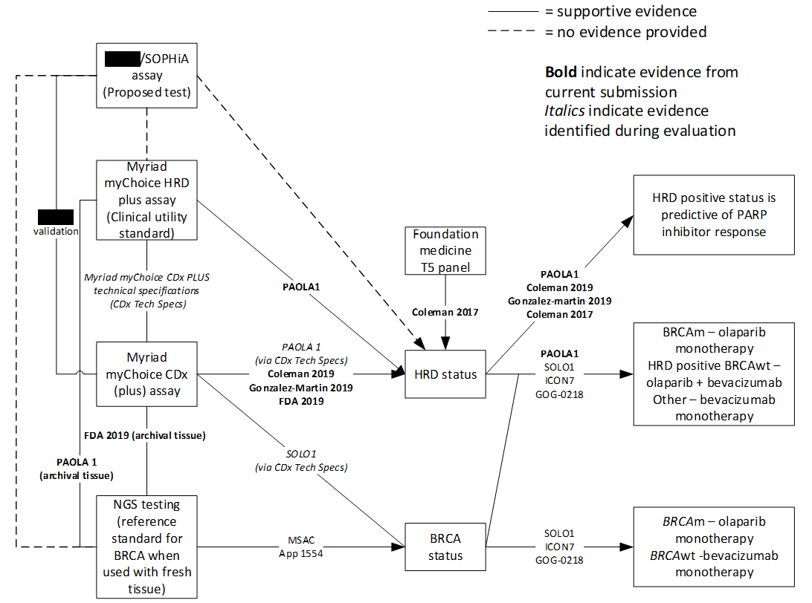
Source: constructed during evaluation
BRCA = Breast Cancer Gene; BRCAm = BRCA mutation; BRCAwt = BRCA wild type; HRD = homologous repair deficiency; NGS = Next Generation Sequencing; | | = | | | | | | | |

Sponsor hearing
        - The sponsor requested a hearing for this item. The three speakers discussed the submission from the perspective of an expert pathologist, scientist and medical oncologist. It was noted that treatment guidelines recommend HRD testing to determine whether maintenance treatment with a PARPi is appropriate, and that HRD testing is considered effective in identifying patients who will benefit from treatment. It was stated that patients with HRD negative tumours are unlikely to benefit from PARPi, and this is expected to be 50% of patients. The PBAC considered that the hearing was informative as it provided useful context regarding the proposed test and PBS listing from three relevant perspectives.

Consumer comments
        - The PBAC noted and welcomed input from one patient support organisation (Ovarian Cancer Australia) in support of the olaparib submission. The comments noted that ovarian cancer is the sixth most common cause of death from cancer in females, and the deadliest gynaecological cancer. Many patients experience anxiety and depression related to the fear of recurrence. The comments noted that a number of patients were self-funding olaparib, with a high financial burden or were unable to access treatment due to the high cost.
        - The PBAC noted and welcomed input from 3 consumers via the Consumer Comments facility on the PBS website which supported the proposed listing of olaparib. The individuals expressed that treatment in the first line setting may delay or prevent recurrence and has potential to prolong life.
        - The Medical Oncology Group of Australia (MOGA) expressed its strong support for the olaparib submission, categorising it as one of the therapies of “highest priority for PBS listing” on the basis of the PAOLA-1 trial. The PBAC noted that the MOGA presented a European Society for Medical Oncology Magnitude of Clinical Benefit Scale (ESMO-MCBS) for olaparib plus bevacizumab, of 4 (out of a maximum of 5, where 5 and 4 represent the grades with substantial improvement), based on a comparison with bevacizumab alone. The PBAC noted that MOGA upgraded the ESMO-MCBS score to 4 on the basis of a long term PFS difference >10% at 2 years and a plateau of the PFS curve in the treatment arm.

Clinical trials
        - The submission was based on one head-to-head trial comparing olaparib plus bevacizumab to placebo plus bevacizumab (n=806), PAOLA-1.
        - PAOLA-1 is a phase 3 randomised controlled trial (RCT) that was conducted to evaluate maintenance treatment of olaparib plus bevacizumab compared to placebo plus bevacizumab, in patients with newly diagnosed HGEOC who responded to treatment with chemotherapy plus bevacizumab, regardless of tumour BRCAm status. The submission claimed that the risk of bias for the PAOLA-1 trial is considered low. This was reasonable when considering the ITT population, however the use of what were effectively post hoc HRD subgroups (as they were determined post randomisation nearly three years after enrolment began) introduced a high risk of selection bias.
        - Details of the trials, including key publications presented in the submission are provided in the table below.
Table 4 Trials and associated reports presented in the submission
Trial ID | Protocol title/ Publication title | Publication citation
Direct randomised trial
PAOLA-1  NCT02477644 | Harter P, Mouret-Reynier MA, Pignata S, Cropet C, Gonzalez-Martin A, Bogner G, et al. Efficacy of maintenance olaparib plus bevacizumab according to clinical risk in patients with newly diagnosed, advanced ovarian cancer in the phase III PAOLA-1/ENGOT-ov25 trial. | Gynecologic Oncology. 2022;164(2):254-64.
 | Ray-Coquard I, Pautier P, Pignata S, Perol D, Gonzalez-Martin A, Berger R, et al. Olaparib plus Bevacizumab as First-Line Maintenance in Ovarian Cancer. | New England Journal of Medicine. 019;381(25):2416-28.
 | Randomized, Double-Blind, Phase III Trial of Olaparib vs. Placebo in Patients with Advanced FIGO Stage IIIB – IV High Grade Serous or Endometrioid Ovarian, Fallopian Tube, or Peritoneal Cancer treated with standard First Line Treatment,  Combining Platinum-Taxane Chemotherapy and Bevacizumab Concurrent with Chemotherapy and in Maintenance (PAOLA-1) | Clinical Study Report 30 October 2019
 | Randomized, Double-Blind, Phase III Trial of Olaparib vs. Placebo in Patients with Advanced FIGO Stage IIIB – IV High Grade Serous or Endometrioid Ovarian, Fallopian Tube, or Peritoneal Cancer Treated with Standard First Line Treatment,  Combining Platinum-Taxane Chemotherapy and Bevacizumab Concurrent with Chemotherapy and in Maintenance (PAOLA-1) Final PFS2 Analysis and Safety Update | Clinical Study Report 27 November 2020
Source: Table 2.58, p137 of the submission
        - The key features of the direct randomised trial are summarised in the table below.
Table 5 Key features of the included evidence
Trial | N | Design/ duration | Patient population | Outcomes | Use in modelled evaluation
PAOLA-1 | 806 | R, DB, MC  Maximum duration of study treatment: 2 years | Patients with newly diagnosed advanced (FIGO stage IIIB-IV) high-grade serous or endometrioid ovarian, fallopian tube or peritoneal cancer who were in response following first-line treatment with platinum-taxane chemotherapy plus bevacizumab and for whom bevacizumab maintenance was planned. | Primary: PFS  Secondary: PFS2, OS, safety, HRQoL | PFS  HRQoL (PFS health state only)
DB = double blind; FIGO = International Federation of Gynaecology and Obstetrics; ; HRQoL = health-related quality of life; MC = multi-centre; OS = overall survival; PFS = progression-free survival; PFS2 = time to second progression or death; R = randomised.
Source: Constructed during evaluation using Figure 2C.3.1, p117 of the submission.

Comparative effectiveness
        - The sixth protocol amendment of PAOLA-1 dated 03 October 2018 (more than three years after the trial was initiated and after the last patient has been recruited) was made to expand the ‘pre-planned’ subgroup analysis of efficacy to include HRD status, which was determined post randomisation. The CSR noted that the subgroup analyses of PFS were just exploratory outcomes and no statistical adjustments were made to account for the inclusion of subgroups. Including the stratification factors, 28 subgroups were considered, with 10 subgroups relating to BRCA and HRD status based on the Myriad myChoice HRD plus testing. A finding of significance from such an approach may not be methodologically appropriate and the results from HRD subgroups likely carried a high risk of bias. All subgroup results from PAOLA-1 should be interpreted with caution. The ESCs considered it reasonable to accept there was a clinical benefit associated with addition of olaparib in HRD+ BRCAwt patients based on PAOLA-1, however the magnitude of benefit for the proposed PBS population remained uncertain due to reliance on exploratory subgroup analyses.
        - Results from two data cuts were presented: one set of results from data cut-off 1 (DCO1) with a median follow up for PFS of 22.7 in the olaparib plus bevacizumab arm and 24.0 months in the placebo plus bevacizumab arm, and one set of results from data cut-off 2 (DCO2) with a median follow up for PFS of 35.5 (OS of 38.5) in the olaparib plus bevacizumab arm and 36.5 months (OS of 38.2 months) in the placebo plus bevacizumab arms. A summary of the trial results for PFS, conditional on biomarker status is provided in the table below.
Table 6 PFS results for retrospectively HRD-stratified population treated with either olaparib plus bevacizumab or placebo plus bevacizumab
 | Ola + beva  N=537 | Pbo + beva  N=269 | HR for disease progression or death (95% CI)
Data cut-off 1
FAS
Median PFS | 22.1 months | 16.6 months | 0.59 (0.49, 0.72)
Events, n/N (%) | 280/537 (52.1) | 194/269 (72.1)
HRD positive BRCAwt (subgroup of interest)
Median PFS | 28.1 months | 16.6 months | 0.43 (0.28, 0.66)
Events, n/N (%) | 43/97 (44.3) | 40/55 (72.7)
HRD positive tumoursª
Median PFS | 37.2 months | 17.7 months | 0.33 (0.25, 0.45)
Events, n/N (%) | 87/255 (34.1) | 92/132 (69.7)
HRD negative tumours
Median PFS | 16.6 months | 16.2 months | 1.00 (0.75, 1.35)
Events, n/N (%) | 145/192 (75.5) | 66/85 (77.6)
Tumour BRCAm
Median PFS | 37.2 months | 18.8 months | 0.28 (0.19, 0.42)
Events, n/N (%) | 44/158 (27.8) | 52/77 (67.5)
Tumour BRCAwt
Median PFS | 18.2 months | 16.4 months | 0.77 (0.62, 0.96)
Events, n/N (%) | 223/346 (64.5) | 130/174 (74.7)
HRD unknown
Median PFS | NR | NR | 0.71 (0.46, 1.10)
Events, n/N (%) | NR/90 | NR/52
Data cut-off 2
All HRD tested population^{b}
Median PFS (95% CI) | 23.1 months (22.0,27.4) | 16.7 months (15.8,18.8) | 0.62 (0.51,0.75)
Events, n/N (%) | 276/447 (61.7) | 172/217 (79.3)
HRD positive BRCAwt (subgroup of interest)
Median PFS | 30.0 months | 16.6 months | 0.44 (0.29, 0.66)
Events, n/N (%) | 51/97 (52.6) | 45/55 (81.8)
HRD positive
Median PFS | 42.6 months | 17.6 months | 0.38 (0.29, 0.50)
Events, n/N (%) | 115/255 (45.1) | 100/132 (75.8)
Beva = bevacizumab; BRCAm = breast cancer gene mutation; BRCAwt = breast cancer gene wild type; FAS = full analysis set; HR = hazard ratio; HRD = homologous recombination deficiency; Ola = olaparib; Pbo = placebo; PFS = progression-free survival.
ª Includes patients with tumour BRCAm.
^{b} All HRD tested patients constituted 82% of the overall PAOLA-1 population.
Bold text indicates statistically significant differences between treatment groups.
Source: Tables 2.70, 2.83 and 2.84, p162 and 164 of the submission, Table 38, p142 of the CSR, Table 2, p12 1658 ratified PICO.
        - In all randomised patients, olaparib plus bevacizumab demonstrated a statistically significant improvement in investigator assessed PFS compared with placebo plus bevacizumab, with a 41% reduction in risk of disease progression or death (stratified HR: 0.59; 95% CI 0.49-0.72; p<0.0001). In comparison, in the HRD positive BRCAwt subgroup patients randomised to olaparib plus bevacizumab had a 57% reduction in risk of disease progression or death (HR 0.43; 95% CI 0.28,0.66) compared to patients randomised to placebo plus bevacizumab. Similar results were seen for patients with HRD positive BRCAm tumours (PFS HR = 0.33; 95% CI 0.25,0.45). The submission noted that this indicated that the treatment effect in the overall HRD positive population was not driven by the tumour BRCAm population alone.
        - The ESCs noted that the PFS HR for the HRD positive subgroup (including BRCAm) was similar to that for the BRCAm subgroup (0.33; 95% CI 0.25, 0.45 vs 0.28; 95% CI 0.19, 0.42), while the PFS HR for the proposed PBS population (HRD positive BRCAwt subgroup) was less favourable (PFS HR 0.43; 95% CI 0.28, 0.66). The ESCs considered that patients in the HRD positive BRCAwt subgroup clearly benefit from treatment with olaparib, however the subgroup analyses suggested that the benefit for patients with HRD positive BRCAwt tumours may be less than the benefit for patients with BRCAm tumours.
        - In contrast, treatment with olaparib plus bevacizumab did not result in any benefit in terms of PFS in patients with HRD negative tumours (HR 1.00; 95% CI 0.75, 1.35) compared with bevacizumab alone. The submission stated that this demonstrates that HRD status is predictive of response to olaparib treatment when used in combination with bevacizumab for patients with HGEOC. Tests for interaction by HRD status, and for the HRD positive BRCAwt subpopulation were not provided by the submission to support this claim and as such it was not clear if HRD status or if being HRD positive BRCAwt was an effect modifier in PAOLA-1 despite the difference in the magnitude of PFS HR reported. No results for the complement subgroup to the HRD positive BRCAwt subgroup were provided.
        - Not all studies of PARP inhibitors supported the claim that HRD positivity was strongly correlated with improved PFS with treatment with PARP inhibitors, with PAOLA-1 reporting the largest difference between HRD positive BRCAwt (PFS HR = 0.43) and HRD negative patients (PFS HR = 1.00). Gonzalez-Martin 2019 (HRD positive BRCAwt PFS HR = 0.50; HRD negative HR = 0.68) and Coleman 2017 (HRD positive BRCAwt PFS HR = 0.44; HRD negative HR = 0.58) all reported smaller differences between patients treated with a PARP inhibitor and placebo. Both Gonzalez-Martin 2019 and Coleman 2017 reported a statistically significant improvement in PFS for the HRD negative populations.
        - Additionally, no evidence on the longitudinal accuracy using OS, which was likely more clinically relevant, was provided. OS results were not statistically significantly different between patients treated with olaparib plus bevacizumab compared to bevacizumab monotherapy in PAOLA-1 (OS HR = 0.84, 95% CI 0.46, 1.52 for HRD+ BRCAwt patients) though the data is immature.
        - Kaplan Meier plots of PFS for the FAS and various subgroup populations are provided in the figures below.
Figure 2 KM plot of investigator assessed PFS, FAS (DCO1)
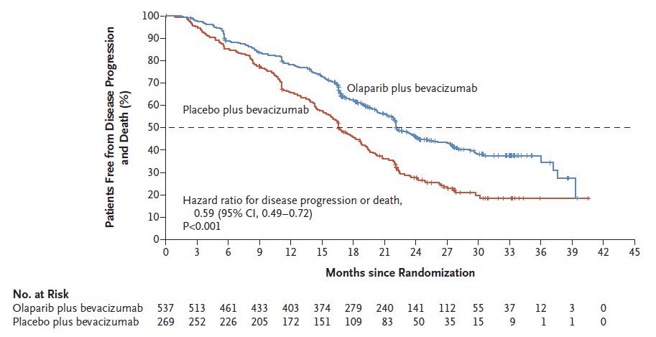
DCO1 = data cut-off 1; FAS = full analysis set; KM = Kaplan-Meier; PFS = progression-free survival
Source: Figure 2.13, p163 of the submission

Figure 3 KM estimates of PFS among patients with HRD positive BRCAwt tumours (DCO1)
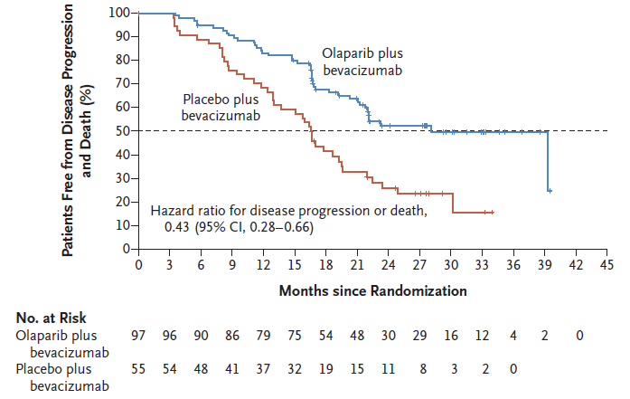
BRCAwt = breast cancer gene wild type; DCO1 = data cut-off 1; HRD = homologous recombination deficiency; KM = Kaplan-Meier; PFS = progression-free survival
Source: Figure 2.20, p184 of the submission

Figure 4 KM estimates of PFS among patients with HRD positive tumours, including patients with tumour BRCAm (DCO1)
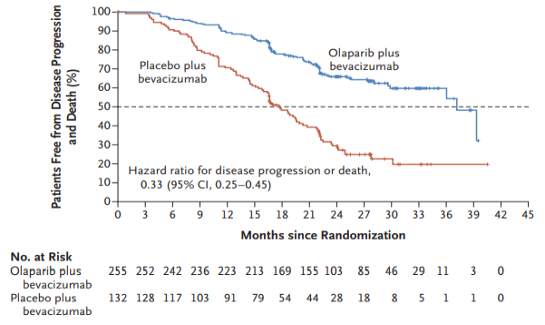
BRCAm = breast cancer gene mutation; DCO1 = data cut-off 1; HRD = homologous recombination deficiency; KM = Kaplan-Meier; PFS = progression-free survival
Source: Figure 2.21, p184 of the submission

Figure 5 KM estimates of PFS among patients with HRD negative tumours (DCO1)
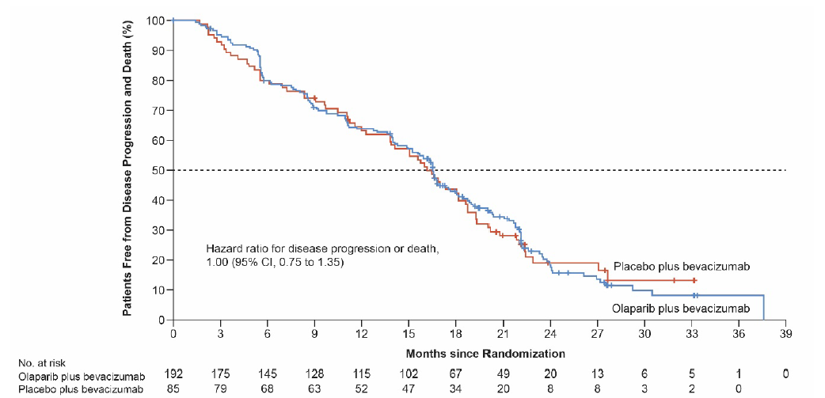
DCO1 = data cut-off 1; HRD = homologous recombination deficiency; KM = Kaplan-Meier; PFS = progression-free survival
Source: Figure 2.22, p185 of the submission
        - The submission did not explicitly justify why a listing for the entire HRD positive subpopulation was not sought, and it may be unreasonable for patients with BRCAm to be denied the opportunity to use olaparib plus bevacizumab given that PAOLA-1 has demonstrated that it was efficacious and there could be additional benefits from the addition of bevacizumab to olaparib for some patients. Based on the MAIC of PAOLA-1 and SOLO1 presented by the submission, the landmark probability for PFS at 24 months for olaparib + bevacizumab was 82% compared to 73% for olaparib alone, though the adjusted PFS HR (0.71, 95% CI 0.45, 1.09) was not statistically significantly different.
        - The MAIC used results from BRCAm patients as classified with NGS as reported in Ray-Coquard 2019, and a MAIC using the results from BRCAm patients classified with Myriad myChoice may have led to different estimates, as olaparib plus bevacizumab appeared to be nominally more effective when using Myriad myChoice (HR = 0.28) than Ray-Coquard 2019. However, this highlights the lack of robustness of the data with regards to subgroup manipulation.
        - At the final time to second progression (PFS2) analysis (at DCO2), PFS2 data maturity had reached 52.6% (424 PFS2 events/806 patients). A summary of the results for PFS2 is provided in the table below.
Table 7 PAOLA-1 PFS2 results (DCO2) ª
 | Ola + beva | Pbo + beva | HR^{b} (95% CI)
FAS
Median PFS2 (95% CI) | 36.5 months (32.2,42.6) | 32.6 months (28.3,35.1) | 0.78 (0.64, 0.95)
Events, n/N (%) | 260/537 (48.4) | 164/269 (61.0)
HRD positive BRCAwt
Median PFS2 (95% CI) | 50.3 months (NR) | 30.1 months (NR) | 0.60 (0.38,0.96)^{c}
Events, n/N (%) | 41/97 (42.3) | 33/55 (60.0)
HRD positive
Median PFS2 (95% CI) | 50.3 months (50.3, nr) | 35.4 months (31.2,44.3) | 0.56 (0.41,0.77)
Events, n/N (%) | 65/255 (37.8) | 70/132 (53.0)
Beva = bevacizumab; BRCAwt = breast cancer gene wild type; DCO2 = second data cut-off; FAS = full analysis set; HR =hazard ratio; HRD = homologous recombination deficiency; nr = not reached; NR = not reported; Ola = olaparib; Pbo = placebo; PFS2 = time from randomisation to second progression or death
ª Table 2.88, p189 of the submission referred to the source “PAOLA-1 CSR Addendum 1”. This reference was incomplete. Additional information was provided by the sponsor during the evaluation that allowed for verification of this data.
^{b} Estimated from a stratified Cox Proportional Hazards model stratified by first-line treatment outcome and tumour BRCA status.
^{c} While it was unclear from the submission why these results were not significant, the PAOLA-1 protocol (p19) stated that “a multiple testing procedure will be applied following a hierarchical testing strategy, PFS is tested first, PFS2 will be tested only if the null hypothesis for PFS is rejected, and then OS will be tested only if statistical significance is shown for PFS and PFS2."
Source: Table 2.88, p189 of the submission, Table 26, p117 PAOLA-1 CSR and Table 5, p35 PAOLA-1 CSR Addendum 1.
        - A summary of the trial results for OS, conditional on biomarker status is provided in the table below.
Table 8 PAOLA-1 OS according to tumour variant (DCO2) ª
 | Ola + beva | Pbo + beva^{c} | HR^{b} (95% CI)
FAS
Median OS | NR | 45.8 (43.2, NR) | 0.93 (0.74,1.18)
Events, n/N (%) | 195/537 (36.3) | 108/269 (40.1) | p=0.5631
ITT HRD tested population
Median OS | NR | 45.8 (43.2, NR) | 0.91 (0.70,1.19)
Events, n/N (%) | 156/447 (34.9) | 86/217 (39.6) | p=0.4833
HRD positive BRCAwt
Median OS | NR | 45.8 | 0.84 (0.46,1.52)
Events, n/N (%) | 30/97 (30.9) | 19/55 (34.5)
HRD positive
Median OS | NR | NR | 0.70 (0.47,1.04)
Events, n/N (%) | 61/255 (23.9) | 42/132 (31.8)
Beva = bevacizumab; BRCAwt = breast cancer gene wild type; DCO2 = second data cut-off; FAS = full analysis set; HR = hazard ratio; HRD = homologous recombination deficiency; NR = not reached; Ola = olaparib; Pbo = placebo; OS = overall survival.
ª Table 2.90, p191 of the submission referred to the source “PAOLA-1 CSR Addendum 1”. This reference was incomplete. Additional information (dated 27 April 2022) was provided by the sponsor during the evaluation that allowed for verification of this data.
^{b} Estimated from a stratified Cox Proportional Hazards model stratified by first-line treatment outcome and tumour BRCA status.
^{c} It was unclear how median OS could have been reached in the bevacizumab plus placebo arm already given that fewer than 50% of patients have died, and the reported median OS in the bevacizumab plus placebo arm was likely unreliable.
Source: Tables 2.73 and 2.90, p167 and 191 of the submission
        - The submission claimed that although OS results were not found to be statistically significantly different between the treatment arms (ITT OS HR = 0.93, 95% CI 0.74; 1.18, HRD positive BRCAwt OS HR = 0.84, 95% CI 0.46, 1.52), the OS DCO2 data was not yet mature (37.6% maturity). A final OS analysis is planned for when data reaches 60% maturity or after a 3-year duration of treatment from main PFS analysis, whichever occurs first. Subsequent communication with the sponsor (dated 23 February 2022) indicated that this update would be available in July 2022.
        - The economic evaluation assumed a substantial survival benefit for patients treated with olaparib plus bevacizumab compared to bevacizumab alone which may be overestimated (see paragraph 6.61-6.63). The ESCs considered that the large difference in survival assumed in economic model between groups was unsupported by evidence to date. The ESCs considered that even with more mature data the results for OS may remain statistically non-significant due to small numbers in the HRD+BRCAwt subgroup. The ESCs also noted that subsequent second line PARPi use may reduce the OS benefit demonstrated for PAOLA-1 so the final analysis may not be particularly informative for OS.
        - Kaplan Meier plots of OS for the FAS and HRD positive populations are provided in the figures below.
Figure 6 PAOLA-1 KM plot of OS, FAS (DC02)
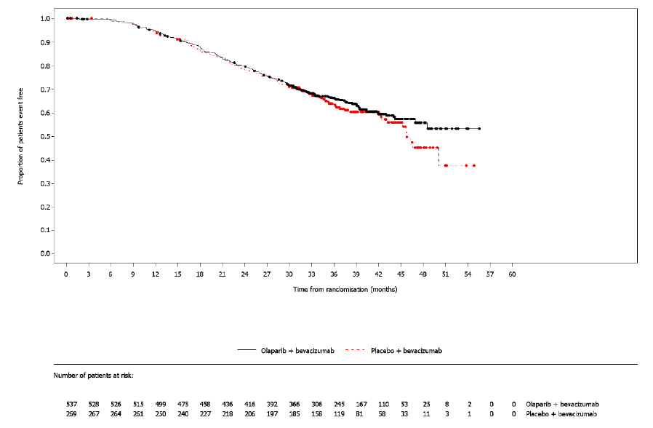
DCO2 = data cut-off 2; FAS = full analysis set; KM = Kaplan-Meier; OS = overall survival
Source: Figure 2.16, p167 of the submission

Figure 7 PAOLA-1 KM plot of OS, patients whose tumours are HRD positive BRCAwt (DCO2) with confidence intervals
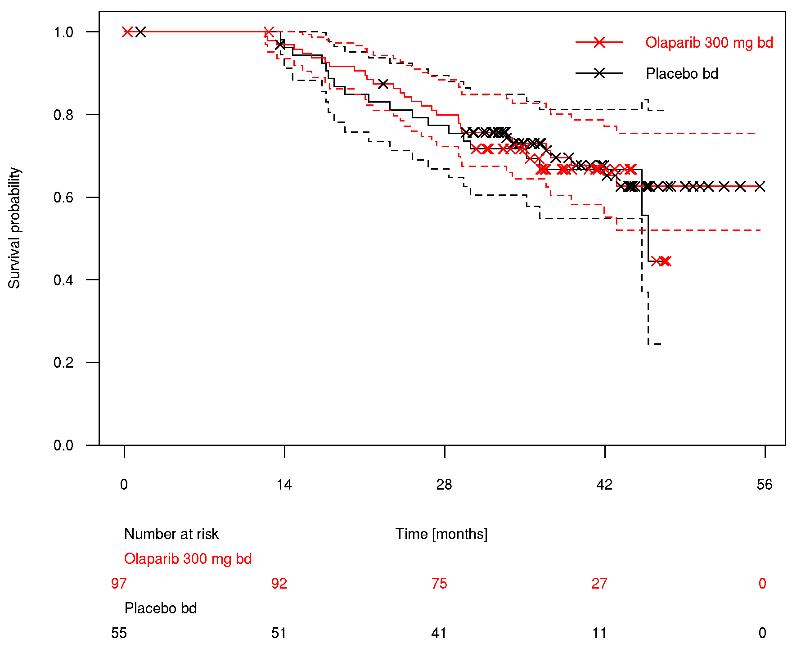
BRCAwt = breast cancer gene wild type; DCO2 = data cut-off 2; FAS = full analysis set; HRD = homologous recombination deficiency; KM = Kaplan-Meier; OS = overall survival
Source: p5, Appendix 3.2 to the submission

Figure 8 PAOLA-1 KM plot of OS in HRD positive population (DCO2)
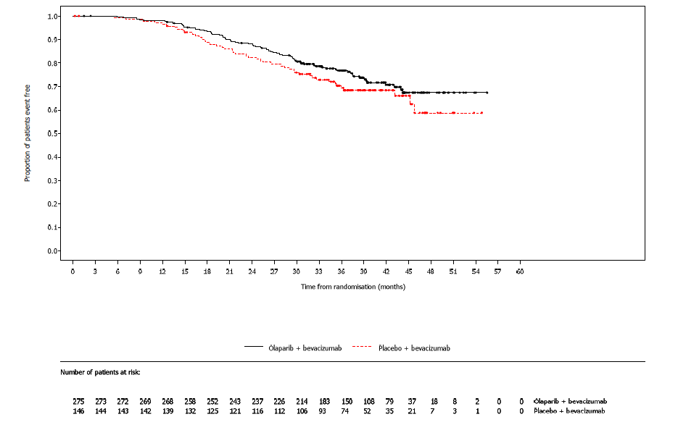
DCO2 = data cut-off 2; FAS = full analysis set; HRD = homologous recombination deficiency; KM = Kaplan-Meier; OS = overall survival
Source: Subsequent correspondence with sponsor (Figure 4, p4)
        - As shown in Figure 7, in the HRD positive BRCAwt subgroup, the confidence intervals around the OS Kaplan-Meier curves were wide for both treatment arms (likely due to small sample sizes) and there was almost complete overlap of the confidence intervals between the two treatments. The OS curve for bevacizumab plus placebo experienced a steep drop at around 45 months, with fewer than 10 patients at risk (11 patients were at risk at 42 months and a few additional patients were subsequently censored before the drop). This resulted in the reported median OS of 45.8 months in the HRD positive BRCAwt subgroup despite only 19/55 patients having died and a median follow up of 38.2 months. As such, the tail end of the OS Kaplan-Meier curve is unreliable for extrapolation in the economic evaluation and the reported median OS for the bevacizumab plus placebo treatment arm is likely to change with the later data cut.
        - The Pre-Sub Committee Response (PSCR) stated that the KM curve for OS for the complement of the requested population was not available.
        - Health-related quality of life (HRQoL) data was collected in PAOLA-1, however, no subgroup analyses were performed for the requested subpopulation. The model used the utility value derived from the ITT population in PAOLA-1 for the PFS health state but not for the progressed disease health state.

Comparative harms
        - The submission did not present any safety data specifically for patients whose HGEOC tumours were HRD positive BRCAwt. The PBAC agreed with the ESCs that it was reasonable to assume that the safety results for the overall population were applicable to the subgroup of interest (HRD positive BRCAwt).
        - The submission reported that most of the AEs reported in PAOLA-1 were non-serious and occurred within the first 28 days of treatment (439 [82.1%] patients in the olaparib plus bevacizumab arm and 186 [69.7%] patients in the placebo plus bevacizumab arm). In the olaparib plus bevacizumab arm, 97.9% (523/534) of patients reported any AE during the combination phase compared to 99.3% (531/535) in the overall study duration. Most AEs reported in the placebo plus bevacizumab arm occurred during the combination phase (95.5%, 255/267) when compared with the overall study duration (95.9%, 256/267).
        - The table below presents an overview of the number of patients who experienced at least one AE during PAOLA-1.
Table 9 PAOLA-1 number (%) of patients who had at least one AE in any category, SAS (overall study duration)
AE category, n (%) | Ola + beva  N=535 | Pbo + beva  N=267 | RR (95% CI) | RD (95%CI)
Any AE | 531 (99.3) | 256 (95.9) | 1.04 (1.01,1.07) | 3.4 (1.3, 6.5)
Any AE of CTCAE Grade ≥3 | 311 (58.1) | 137 (51.3) | 1.13 (0.99,1.31) | 6.8 (-0.5, 14.1)
Any AE with outcome = death | 1 (0.2) | 4 (1.5) | 0.12 (0.02,0.83) | -1.3 (-3.6, -0.2)
Any severe AE (including events with outcome = death) | 168 (31.4) | 84 (31.5) | 1.00 (0.81,1.24) | -0.1 (-2.0, 6.6)
Any AE leading to discontinuation of study treatment | 112 (20.9) | 15 (5.6) | 3.73 (2.25,6.25) | 15.3 (10.7, 19.7)
Any AE leading to dose reduction of study treatment | 223 (41.1) | 21 (7.9) | 5.30 (3.51,8.11) | 33.8 (28.3, 38.9)
Any AE leading to interruption of study treatment | 290 (54.2) | 65 (24.3) | 2.23 (1.79,3.23) | 29.9 (23.0, 36.3)
AE = adverse event; Beva =bevacizumab; CI = confidence interval; CTCAE =Common Terminology Criteria for Adverse Events; Ola = olaparib; Pbo = placebo; RD = risk difference; RR = relative risk; SAS = safety analysis set
The values reported below are from the most recent CSR, from data cut-off 2 (DCO2). This differed to the submission, which reported AEs from data cut-off 1 (DCO1). Values in bold indicate statistically significant differences
Source: Table 2.75, p173 of the submission and calculated during evaluation using StatsDirect v3
        - Overall, among patients in the safety population, there were generally more severe (Common Terminology Criteria for Adverse Events (CTCAE) grade ≥3) events reported in the olaparib plus bevacizumab arm compared with the placebo plus bevacizumab arm. Significantly more cases of anaemia, lymphopenia and fatigue were observed in the olaparib plus bevacizumab treatment arm compared to patients receiving placebo plus bevacizumab. Hypertension (grade ≥3) was higher for patients in the placebo plus bevacizumab arm compared to the olaparib plus bevacizumab arm. The dose intensity of bevacizumab was similar in both arms (mean 91.2% in olaparib plus bevacizumab arm, 90.5% in bevacizumab only arm) therefore it was unclear why there would be a statistically significant difference in both all grade and grades 3/4 hypertension events that favoured olaparib plus bevacizumab. Notably, there was no difference in the incidence of hypertension considered to be caused by the treatments received.
Table 10 PAOLA-1 severe AEs of Grade ≥3 by system class, SAS (overall study duration)
AE by system organ class & preferred term, n (%) | Ola + beva  N=535 | Pbo + beva  N=267 | RR (95% CI) | RD (95%CI)
Any AEs of CTCAE grade ≥3 | 311 (58.1) | 137 (51.3) | 1.13 (0.99, 1.31) | 6.8 (-0.5, 14.1)
Blood and lymphatic system disorders | 141 (26.4) | 12 (4.5) | 5.86 (3.36, 10.35) | 21.9 (17.2, 26.3)
Anaemia | 94 (17.6) | 1 (0.4) | 46.91 (8.4, 267.3) | 17.2 (14.0, 20.7)
Lymphopenia | 37 (6.9) | 3 (1.1) | 6.16 (2.05, 18.73) | 5.8 (3.1, 8.4)
Vascular disorders | 108 (20.2) | 82 (30.7) | 0.66 (0.51, 0.84) | -10.5 (-17.2, -4.2)
Hypertension | 100 (18.7) | 82 (30.7) | 0.61 (0.47, 0.78) | -12.0 (-18.6, -5.7)
General disorders and administration site conditions | 34 (6.4) | 8 (3.0) | 2.12 (1.02, 4.46) | 3.4 (0.1, 6.2)
Fatigue | 28 (5.2) | 4 (1.5) | 3.49 (1.30, 9.49) | 3.7 (1.1, 6.2)
AE = adverse event; Beva = bevacizumab; CI = confidence interval; CTCAE = Common Terminology Criteria for Adverse Events; Ola = olaparib; Pbo = placebo; RD = risk difference; RR = relative risk; SAS = safety analysis set
Values in bold indicate statistically significant differences
Source: Table 24 p65-66 PAOLA-1 CSR DCO2 and, calculated during evaluation using StatsDirect v3
        - There was a statistically significantly higher (RR=1.38, 95% CI 1.26, 1.53) proportion of patients in the olaparib plus bevacizumab arm experiencing AEs (of any grade) potentially related to treatment compared to patients in the placebo plus bevacizumab arm (471/535 (88.0%) vs 170/267 (63.7%), respectively) in the safety analysis set (SAS) population.
        - Safety data provided for the ITT population largely indicated that the safety outcomes for the two treatment arms were not statistically significantly different for the cumulative measures such as any AE or any AE of Grade ≥3; however more patients in the olaparib plus bevacizumab arm experienced AEs leading to discontinuation, dose reduction or interruption of study treatment. Additionally, patients receiving olaparib plus bevacizumab experienced higher rates of a number of individual AEs both for any grade and ≥Grade 3 (nausea, fatigue, anaemia and lymphopenia), while hypertension was the only AE found to occur more in patients receiving bevacizumab monotherapy (both any grade and Grade ≥3).
        - Appropriately, the model incorporated frequencies of treatment-related AEs of Grade 3 or higher that occurred in greater than 1% of the study population based on data from the ITT PAOLA-1 population. However, inappropriately, the unexplained increase in grade 3/4 hypertension in the bevacizumab monotherapy arm was also modelled.
        - No safety data for olaparib plus bevacizumab versus watch and wait (placebo) were presented in the submission. When the PBAC evaluated the safety of olaparib monotherapy versus placebo (paragraph 7.15, p 42, olaparib PSD, November 2019 PBAC Meeting) it noted that olaparib has an inferior safety profile compared with placebo, particularly clinically-relevant anaemia of grade 3 or greater severity, which occurred in 21.2% of patients receiving olaparib and 1.5% of patients in the placebo arm. The PBAC considered that the safety profile of olaparib appears manageable but includes clinically important AEs, particularly as it is used as maintenance treatment.

Benefits/ harms
        - A summary of the comparative benefits and harms for olaparib plus bevacizumab versus placebo plus bevacizumab is presented in the table below.
Table 11 Summary of comparative benefits and harms for the HRD+BRCAwt subgroup in PAOLA-1
Event | Olaparib + bevacizumab  n/N | Placebo + bevacizumab  n/N | Absolute Difference | HR (95% CI)
Progression free survival for HRD+BRCAwt subgroup (median duration of follow up 36.4 months for olaparib + bevacizumab, 38.7 months for bevacizumab)
Progressed, n/N (%) | 51/97 (52.6) | 45/55 (81.8) | 29.2% | 0.44 (0.29, 0.66)
Median PFS months (95% CI) | 30.0 (NR) | 16.6 (NR) | 13.4 months (NR) | P=NR
Progression free at 12 months (%) | 83.2 | 68.5 | +14.7
Progression free at 24 months (%) | 53.5 | 27.8 | +25.7
Progression free at 36 months (%) | 47.6 | 20.4 | +27.2
Progression free at 48 months (%) | 42.0 | NR | NA
Overall survival for HRD+BRCAwt subgroup (median duration of follow up 39.5 months for olaparib + bevacizumab, 38.3 months for bevacizumab)
Deaths, n/N (%) | 30/97 (30.9%) | 19/55 (34.5%) | 3.6% | 0.84 (0.46, 1.52)
Median OS, months (95% CI) | nr | 45.8 (NR) ª | NA | P=NR
Alive at 12 months (%) | 100.0 | 100.0 | 0
Alive at 24 months (%) | 86.3 | 81.1 | +5.2
Alive at 36 months (%) | 73.0 | 69.3 | +3.7
Alive at 48 months (%) | 62.7 | NR | NA
Harms (Safety analysis set)
 | Olaparib + bevacizumab  n/N | Placebo + bevacizumab  n/N | RR  (95% CI) | Event rate/100 patients |  | RD  (95% CI)
 |  |  |  | Olaparib + bevacizumab | Placebo + bevacizumab
Any casually related AE
Nausea | 269/535 | 46/267 | 2.80 (2.15, 3.68) | 50.3 | 18.0 | 32.3
Vomiting | 89/535 | 13/267 | 3.42 (1.97,5.98) | 16.6 | 4.9 | 11.8
Fatigue | 252/535 | 68/267 | 1.84 (1.48,2.32) | 47.1 | 25.5 | 21.6
Anaemia | 194/535 | 15/267 | 6.45 (3.95,10.7) | 36.3 | 5.6 | 30.6
Lymphopenia | 75/535 | 13/267 | 2.88 (1.65,5.08) | 14.0 | 4.9 | 9.2
Leukopenia | 72/535 | 15 /267 | 2.40 (1.42,4.09) | 13.5 | 5.6 | 7.8
AE = adverse event; BRCAwt = breast cancer gene wild type; CTCAE = Common Terminology Criteria for Adverse Events; DCO1 = data cut off 1; FAS = full analysis set; HR = hazard ratio; HRD = homologous recombination deficiency; NA = not applicable; NR =not reported; nr = not reached; NS = not significant; PFS = progression free survival; OS = overall survival; RD = risk difference; RR = relative risk
ª It was unclear how median OS could have been reached in the bevacizumab plus placebo arm given that fewer than 50% of patients had died, and the reported median OS in the bevacizumab plus placebo arm was likely unreliable.
Source: Tables 2.83, 2.84, 2.9, pages 181, 182, 189 of the submission, Tables 2500.1 and 2501.2.1 PAOLA CSR DCO2 (data provided by sponsor during evaluation).
        - On the basis of direct evidence presented by the submission, for every 100 patients with HRD positive BRCAwt HGEOC treated with olaparib plus bevacizumab in comparison with olaparib plus bevacizumab:
- Approximately 29 fewer patients will experience progression or death after approximately 36 months, however, there would be no demonstrated difference in overall survival after 38 months.
- Approximately 32 additional patients would experience nausea.
- Approximately 12 additional patients would experience vomiting.
- Approximately 22 additional patients would experience fatigue.
- Approximately 31 additional patients would have anaemia.
- Approximately 9 additional patients would have lymphopenia.
- Approximately 8 additional patients would have leukopenia.

Clinical claim
        - The submission described olaparib in combination with bevacizumab as superior in terms of effectiveness compared to bevacizumab alone in patients with HRD positive BRCAwt advanced (FIGO stage III-IV) high-grade epithelial ovarian, fallopian tube or primary peritoneal cancer who are in response (complete or partial) to first-line platinum-based positive chemotherapy. While the PFS results demonstrated that olaparib plus bevacizumab was statistically significantly superior to placebo plus bevacizumab in the requested patient population, the magnitude of this benefit may not be reliable as it is based on exploratory subgroup analyses. Moreover, to date PAOLA-1 has not demonstrated a statistically significant OS benefit for olaparib plus bevacizumab. The ESCs considered that PAOLA-1 demonstrated a PFS benefit from the addition of olaparib to bevacizumab, however the magnitude of benefit for the proposed PBS population remained uncertain due to reliance on exploratory subgroup analyses.
        - The submission described olaparib plus bevacizumab as non-inferior in terms of safety compared to bevacizumab alone but the submission also stated that compared to maintenance bevacizumab, the combination of olaparib plus bevacizumab has inferior but manageable safety (with respect to event rates). The ESCs considered that the clinical claim that patients treated with olaparib plus bevacizumab are no worse in terms of safety than patients treated with bevacizumab alone was not reasonable and the addition of an active treatment (olaparib) to bevacizumab would lead to an increase in adverse events. The ESCs considered a claim of inferior but manageable safety would better reflect the evidence provided.
        - The PBAC considered that the claim of superior comparative effectiveness was adequately supported by the PFS data. The PBAC considered that this benefit was likely to be driven by olaparib, and it was unclear to what extent bevacizumab contributed to the efficacy in the combination. Further, the PBAC noted that there is no evidence of a significant improvement in OS based on current data, however the OS data are immature.
        - The PBAC considered that the combination of olaparib and bevacizumab had inferior safety in comparison with bevacizumab monotherapy.

Claim of codependence
        - While the codependency between HRD status and PARP inhibitors has not previously been accepted by MSAC and PBAC, they have both accepted that variation in the size of the treatment effect of PARP inhibitors is predicted by BRCA1/2 status as one HRD biomarker. This application raises a related codependency issue for MSAC and PBAC consideration: whether variation in the size of the treatment effect of the combination of olaparib and bevacizumab is predicted by the proposed combination of BRCA1/2 status and genomic instability. If so, the further issue is whether this predictive value is sufficiently differentiated from the predictive value of BRCA1/2 status alone or by the predictive value of genomic instability alone.
        - While the submission did not explicitly state that there is a biological plausibility for the use of PARP inhibitors for the treatment of HRD positive tumours the submission appears to make the underlying claim that, when using the combined HRD test, GI positive status has greater predictive value than BRCA status, because olaparib plus bevacizumab therapy has effectiveness in patients with GI positive BRCAwt tumours that is similar to effectiveness in BRCAm patients. Based on the results of Gonzalez-Martin 2019 (niraparib) and Coleman 2017 (rucaparib), a class effect in ovarian cancer is not strongly supported. Results for the HRD positive BRCAm, HRD positive BRCAwt and HRD negative subpopulations all indicate that PARP inhibitor use resulted in improved PFS, although the magnitude of benefit varied. The ESCs considered it is unclear to what extent the variation in pivotal trial results for PARP inhibitors (olaparib, niraparib and rucaparib) may be explained by differences in patient populations (due to different HRD testing protocols or thresholds), as compared with pharmacologic differences between the individual PARP inhibitors.

Economic analysis
        - The submission presented a modelled economic evaluation, based on subgroup results from PAOLA-1. The basis of the economic evaluation was a cost effectiveness analysis (CEA) that compared the proposed scenario where all patients undergo HRD (BRCA and GI) testing vs the comparator/current scenario where patients receive BRCA testing only, with patients receiving either olaparib plus bevacizumab or bevacizumab monotherapy (or placebo instead of bevacizumab monotherapy in the supplementary analysis). The base case economic evaluation assumed that HRD testing (BRCA and GI in parallel) occurs upfront at diagnosis of advanced HGEOC.
        - An ICER based on the ITT population was not presented in the submission. As the subgroup results in PAOLA-1 were exploratory, it may not be appropriate to use subgroup results to inform the base case economic evaluation. In addition, HRs varied somewhat depending on the BRCA and GI testing methods and thresholds applied in determining BRCA and HRD status. The ESCs considered that the lack of strong evidence for concordance between Myriad, Sophia and NGS testing for BRCAm introduced substantial uncertainty into the modelled outcomes.
        - A time horizon of 20 years was nominated, extrapolated from a trial with median follow up of only 38 months, which introduced significant uncertainty with the extrapolated results. The PBAC previously noted that 20 years may be too long for the non-BRCAm population in the consideration of niraparib for the maintenance treatment of patients with FIGO Stage III-IV high grade epithelial ovarian cancer who are in response to platinum-based chemotherapy (paragraph 7.15, p43, niraparib PSD, July 2021 PBAC Meeting). The PSCR maintained that a 20-year time horizon was appropriate because this duration was needed to capture benefits for cured patients, and was supported on the basis that long term survival is likely to increase with introduction of PARPs. The PSCR also stated this would be consistent with the PBAC recommendation for olaparib monotherapy based on SOLO-1 (PBAC July 2020 meeting).
        - The table below summarises the key components of the economic evaluation.
Table 12 Summary of model structure, key inputs and rationale
Component | Description | Justification/comments
Type(s) of analysis | Cost-effectiveness analysis, cost-utility analysis. | Appropriate.
Outcomes | Progression-free years gained, life-years gained, quality-adjusted life-years gained. | Appropriate.
Time horizon | 20 years in the model base case vs a median follow-up duration of 38 months in PAOLA-1. | PBAC has previously noted 20 years may be too long in BRCAwt ovarian cancer patients (paragraph 7.15, p43, niraparib PSD, July 2021 PBAC Meeting)
Method used to generate results | Partitioned survival analysis. | Reasonable.
Health states | Cured, PFS for uncured patients, progressed disease, death.  Patients who enter the cured health state do not experience disease progression over the time horizon of the model and are subject to all-cause mortality only. | The model did not include a health state for PFS2 (which was included in the olaparib in BRCAm model), which may have favoured olaparib plus bevacizumab due to underestimating progressed disease utility.  Both olaparib monotherapy (July 2020) and niraparib monotherapy (July 2021) PBAC submissions for HGEOC included a ‘cured’ health state.
Cycle length | Monthly. | Reasonable.
Implications of false positive and false negative results | False negatives and false positives were considered in the structure of the testing component of the model for most patient populations. | The model did not consider the implications of false positives for the populations P5 (patients with BRCAm tumours who have HRD test) and C1 (patients with BRCAm tumours who have BRCA test only). This led to the aggregate results being inaccurate though the incremental results are correct, assuming P5 and C1 cancel each other out as stated by the submission.
Transition probabilities | Cure fraction was estimated using parametric mixture cure models fitted directly to PFS data from PAOLA-1. Kaplan-Meier estimates for PFS and OS for uncured patients were based on data from PAOLA-1.  For cured patients, the death rate is solely based on age-specific mortality based on Australian life tables. | The submission noted that the inclusion of a cure fraction was consistent with the model presented for olaparib monotherapy for the treatment of advanced HGEOC (July 2020 PBAC Meeting).  The choice of parametric function resulted in a cure fraction for patients who received olaparib plus bevacizumab that appears overly optimistic (38.57%, compared to a cure fraction for the comparator of 6.63%). The submission applied the same extrapolation function to both arms, which ignored the best statistical fitting model (Weibull) for bevacizumab and favoured olaparib plus bevacizumab.
Health related quality of life | The following utilities were used in the model: progression-free = 0.765; progressed = 0.544; cured = 0.765.  The progression-free utility value was derived from PAOLA-1 ITT population. The post-progression utility value was derived from an average of four published literature values (Havrilesky 2009, NICE TA 91, Greving 2009/Grann 1999 and Byrne 2018). Utility values for cured patients were assumed to be the same as the progression-free health state. | While the submission claimed that it was not possible to use EQ-5D data collected in PAOLA-1 to inform the utility score after progression due to the limited number of observations, it may have been more appropriate to consistently use utilities from PAOLA-1 rather than values from other publications (see paragraphs 6.65 and 6.67).
Adverse events | AEs of Grade 3 or higher from the PAOLA-1 that occurred in greater than 1% of the study population were incorporated into the model. The incidence of adverse events was based on the ITT PAOLA-1 population as it was considered by the submission (p 251) to be unlikely that the incidence of AEs would differ between the subgroups. | No disutility was applied for any adverse events, and the incidence of adverse events was used only to inform costs.  The methods used to derive the unit costs were reasonable.
AE = adverse event; BRCAm = breast cancer gene mutation; BRCAwt = breast cancer gene wild type; EQ-5D = EuroQol five dimensions; HGEOC = high grade epithelial ovarian cancer; HRD = homologous recombination deficiency; ITT = intention to treat; OS = overall survival; PFS = progression free survival; PFS2 = time from randomisation to second progression or death; for description of P1-5 and C1-2 see Table 13.
Source: Table 3.2, p209 of the submission
        - The model structure presented in the submission comprised a testing phase, relating to the determination of patient tumour HRD and BRCA status, and a maintenance treatment phase, as shown below. A total of seven patient groups were considered as shown below.
Figure 9 Structure of testing component of the model
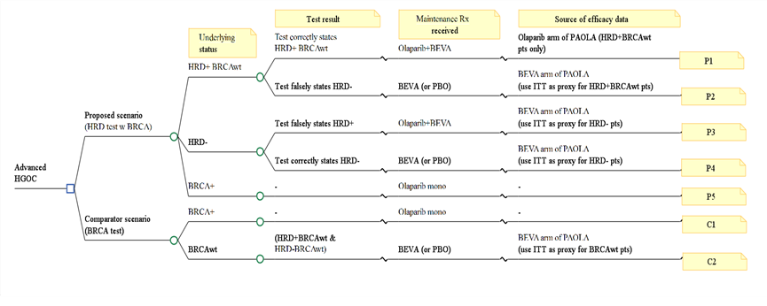
BRCA = breast cancer gene; HRD = homologous recombination deficiency; BEVA = bevacizumab; PBO = placebo; ITT = intention to treat;
for description of P1-5 and C1-2 see Table 13.
Note: HRD unknown are assumed to be combined with HRD negative.
Source: Figure 3.1, p217 of the submission.
        - Details of the seven different patient groups presented in the model structure are shown in the following table.
Table 13 Patient populations represented in the submission model structure
Branch | Patient group in branch | Test result true/false | Maintenance treatment received (efficacy data source) | Maintenance treatment that should be received
P1 | HRD positive BRCAwt | Test correctly | Ola + beva (Ola + beva, PAOLA-1 HRD + BRCAwt) | Ola + beva
P2 | HRD positive BRCAwt | Test falsely (test HRD negative) | Beva mono (or placebo)  (Beva mono, PAOLA-1 ITT) | Ola + beva
P3 | HRD negative | Test falsely (test HRD positive) | Ola + beva (Beva mono, PAOLA-1 BRCAwt)ª | Beva (or placebo)
P4 | HRD negative | Test correctly | Beva mono (or placebo)  (Beva mono, PAOLA-1 BRCAwt) ª | Beva (or placebo)
P5 | BRCAm | NR | Ola mono (NR) | NR
C1 | BRCAm | NR | Ola mono (NR) | NR
C2 | BRCAwt | HRD positive BRCAwt, HRD negative BRCAwt | Bevacizumab (or placebo) (Beva mono, PAOLA-1 BRCAwt) ª | Beva (or placebo)
Beva = bevacizumab; BRCA = breast cancer gene; HRD = homologous recombination deficiency; mono = monotherapy; NR = not reported; Ola = olaparib; wt = wild type
Test results for P5 and C1 were not reported.
P1-5 represent the proposed scenarios.
C1 and 2 represent the comparator arms.
ª calculated by applying a 0.96 adjustment factor to the ITT results used in P2, based on claim that median PFS in bevacizumab arm for all BRCAwt patients was 16.0 months and in ITT patients was 16.6 months
Source: Section 3A.2.2, p217 of the submission.
        - The submission stated that as per the MSAC Guidelines, the codependent technology (test treatment) model should consider the costs/outcomes for all subgroups of patients, however this was not the case for the P5 and C1 subgroups (scenarios where patients have BRCAm) in which no false results were considered.
        - Due to patients requiring testing for both HRD and BRCA status in order to be eligible for olaparib plus bevacizumab, false positive or false negative BRCA and HRD results would lead to numerous different potential scenarios with implications for patients as shown in the following table.
Table 14 Scenarios of treatment received for actual status by test result
 | Actual status
Test result | HRD -BRCAwt | HRD-BRCAm* | HRD+ BRCAwt | HRD+ BRCAm
False + HRD | Should receive beva mono.  Receives ola + beva.  (Category 4, as described below) | Should receive ola mono.  If BRCA true + receives ola mono, if BRCA false – receives beva mono (Category 5, as described below). | NA | NA
False - HRD | NA | NA | Should receive ola + beva.  Receives beva mono.  (Category 6, as described below) | Should receive ola mono.  Receives beva mono.  (Category 5, as described below).
False-+ BRCA | Should receive beva mono.  Receives ola mono.  (Category 2, as described below) | NA | Should receive ola + beva. Receives ola mono.  (Category 1, as described below) | NA
False - BRCA | NA | Should receive ola mono. Receives beva mono.  (Category 5, as described below) | NA | Should receive ola mono.  Receives ola + beva.  (Category 3, as described below)
Beva = bevacizumab; BRCA = breast cancer gene; HRD = homologous recombination deficiency; m = mutation; mono = monotherapy; ola = olaparib; wt = wild type
* The submission defined any patients who were BRCAm as automatically being HRD positive. However, Telli 2016 defined the GIS threshold of 42 so that 5% of these patients would be HRD negative.
        - In the above matrix, patients who have been designated as receiving bevacizumab monotherapy could alternatively adopt a ‘watch and wait’ approach (as proposed by the submission would occur for 10% of patients). In which case, there could be additional benefits foregone with treatment. False positive or false negative BRCA and HRD results that occur in clinical practice will have the following consequences for patients:
- HRD positive BRCAwt patients who incorrectly receive olaparib monotherapy instead of olaparib + bevacizumab do not receive the additive/synergistic benefits of bevacizumab, potentially leading to additional health benefits foregone.
- HRD negative BRCAwt patients who incorrectly receive olaparib monotherapy instead of bevacizumab monotherapy are unnecessarily exposed to olaparib, resulting in additional cost (for olaparib) and higher rate of AEs. The efficacy of olaparib monotherapy in BRCAwt has not been established.
- Patients who incorrectly receive olaparib + bevacizumab instead of olaparib monotherapy are unnecessarily exposed to bevacizumab, incurring the additional cost of bevacizumab and potentially resulting in additional AEs due to bevacizumab.
- Patients who incorrectly receive olaparib + bevacizumab instead of bevacizumab are unnecessarily exposed to olaparib, resulting in additional cost and likely leading to a higher rate of AEs.
- Patients who incorrectly receive bevacizumab monotherapy instead of olaparib monotherapy would have the benefit of olaparib treatment foregone, while being exposed to bevacizumab unnecessarily.
- Patients who incorrectly receive bevacizumab monotherapy instead of olaparib + bevacizumab would have the benefit of olaparib foregone.
        - Sensitivity and specificity in the base case of the economic model were assumed to be 100% for the BRCA component of the HRD test and 95% for the GIS component of the HRD test. The ESCs considered this may not be reasonable as no diagnostic accuracy studies comparing the proposed HRD test (the SOPHiA assay) with NGS for BRCA testing were presented. A false positive for BRCAm would lead to a patient being treated with olaparib monotherapy when they should have been treated with bevacizumab.
        - The PAOLA-1 study provided efficacy data for both olaparib plus bevacizumab and bevacizumab in all patient subgroups of the model. The economic evaluation used mixture cure models (MCMs) to estimate the cure fraction and to model PFS for uncured patients. MCMs are statistical survival models that can differentiate between the PFS of “cured” (long-term survivors) and “uncured” (not long-term survivors) patients and can identify the size of these two groups based on the PFS patient-level data. The submission stated that the use of MCMs in the economic model is appropriate because there is clinical evidence of the existence of a cure fraction within this patient population (however no specific details were provided) and on the basis that most patients in PAOLA-1 have no evidence of disease at baseline (having achieved complete response to a combination of surgery and platinum chemotherapy). Progression represents a recurrence of disease for these patients.
        - The cured fraction patients are assumed, from cycle one, to never progress and have the same life expectancy as the general population with the risk of death informed by Australian life tables. Uncured patients (the complement to cure fraction) could experience disease progression and die (based on modified PAOLA-1 PFS curve and OS curves from the HRD positive BRCAwt subgroup, extrapolated to the full time horizon from 38 months onwards – see Figure 10). No justification for why PFS data (rather than OS) was used to estimate the cure fraction was provided, particularly as the cure fraction directly affects OS which is the more objective outcome. The July 2020 resubmission for olaparib monotherapy also used PFS data to estimate the cure fraction.
Figure 10 Modelled PFS for uncured HRD+BRCAwt patients
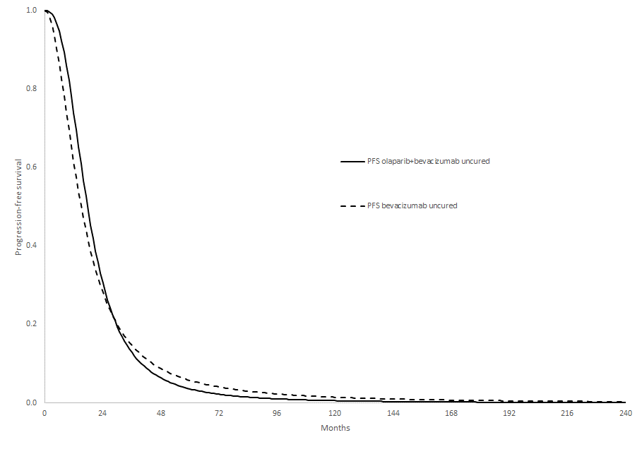
BRCAwt = breast cancer gene wild type; PFS = progression free survival; HRD = homologous recombination deficiency.
Source: Figure 3.8, p240 of the submission
        - The maintenance treatment phase is represented by a partitioned survival model with four health states; cured, progression-free survival following first-line treatment (uncured patients only), progressive disease (uncured patients only) and dead. For both olaparib plus bevacizumab and bevacizumab monotherapy (and placebo in the supplementary analysis), life years, QALYs and resource utilisation were estimated based on the time spent in each health state. Time on treatment (ToT) with olaparib in branch P1 was taken from the actual ToT curve in PAOLA-1 in the HRD positive BRCAwt subgroup, but in branch P3 it was taken from the PFS curve in the BRCAwt subgroup to reflect patients discontinuing due to lack of efficacy as this was a false positive subgroup. ToT curves for olaparib from PAOLA-1 were mature and appear reasonable, with treatment ceased at 24 months. The cost of bevacizumab was applied as a lump sum in cycle one based on the mean number of doses in the respective treatment arms in PAOLA-1. The estimation of olaparib plus bevacizumab and bevacizumab monotherapy doses in the economic evaluation differed to that of the financial estimates, which used median doses instead of mean doses.
        - The submission stated that relative goodness of fit of the parametric models was assessed based on the Akaike Information Criterion (AIC) and visual inspection of the model projections against the Kaplan-Meier plot. The loglogistic extrapolation was nominated as the base case for both treatment arms. However, the Weibull function had the best statistical fit for the bevacizumab monotherapy arm and also has external validity (the estimated cure fraction of 17.4% was more consistent with the 18.0% cure fraction used for the placebo arm in the olaparib July 2020 submission - see Table 15). The loglogistic function estimated only a cure fraction of 6.6%. The PSCR maintained that the submission’s approach to extrapolation was reasonable, and stated that the sponsor anticipates that more mature PFS data from data cut-off 3 (DCO3, expected Q3, 2022) will validate the modelled PFS curves.
        - Overall, the submission chose very optimistic extrapolation functions in the model base case with regards to the increment between the cure fractions of the two treatment arms, which may not be adequately supported and were inconsistent with cure fractions estimated for olaparib monotherapy in the BRCAm model using data from SOLO1 considered by PBAC in July 2020. A comparison of the cure fractions estimated in this submission and the July 2020 resubmission for olaparib monotherapy in BRCAm patients as well as the median PFS data from the pivotal trials is presented in the table below.
Table 15 Comparison of cure fractions and median PFS estimated for PAOLA-1 and SOLO1
Parameter | PAOLA-1 (HRD positive BRCAwt) |  | SOLO1 (BRCAm)
 | Olaparib + bevacizumab | Bevacizumab monotherapy | Olaparib monotherapy | Placebo
Median PFS (95%CI) | 30.0 months (NR) | 16.6 months (NR) | 56.0 months (41.9, nr) | 13.8 months (11.1, 18.2)
PFS HR (95%CI) | 0.44 (0.29, 0.66) |  | 0.33 (0.25, 0.43)
Median follow up | 3.2 years | 3.2 years | 4.8 years | 5.0 years
Cure fraction | 38.6% | 6.6% | 25.45% | 18.0%
Incremental cure fraction | 32.0% |  | 7.45%
BRCA = breast cancer gene; CI = confidence interval; HR = hazard ratio; HRD = homologous recombination deficiency; m = mutation; NR = not reported; nr = not reached; PFS = progression free survival; wt = wild type
Source: Constructed during evaluation using information from table 2.84, p183 of the submission, p239 of the submission, Banerjee 2021, and Table 3.4.5, July 2020 olaparib commentary.
        - MCM was estimated using the PFS curve in both models however the median PFS was inconsistent with the estimated cure fractions. Olaparib plus bevacizumab in PAOLA-1 had a shorter median PFS than olaparib monotherapy in SOLO1 but a higher cure fraction, and bevacizumab monotherapy in PAOLA-1 had a longer median PFS than placebo in SOLO1 but a lower cure fraction. The PFS HR was also inconsistent with the incremental difference in cure fractions, as the July 2020 olaparib monotherapy in BRCAm model had a more favourable PFS HR than this submission (0.33 compared to 0.44) but a much lower incremental cure fraction (7.45% compared to 32%).
        - The submission did not provide any clinical evidence to support the substantially more favourable cure fractions for olaparib plus bevacizumab compared to bevacizumab monotherapy in HRD positive BRCAwt patients, or for the difference between the incremental cure fraction proposed for olaparib monotherapy compared to placebo in BRCAm patients. The PBAC considered the cure fractions in the submission appeared substantially overestimated and favoured olaparib plus bevacizumab. The choice of the MCM PFS extrapolation function and the associated cure fractions had a substantial impact on the resultant ICER.
        - The modelled PFS curve including both cured and uncured patients in each branch of the model (Figure 11) and the modelled OS curve (Figure 12) in the base case are presented below.
Figure 11 Modelled PFS curves (combined cured and uncured patients)
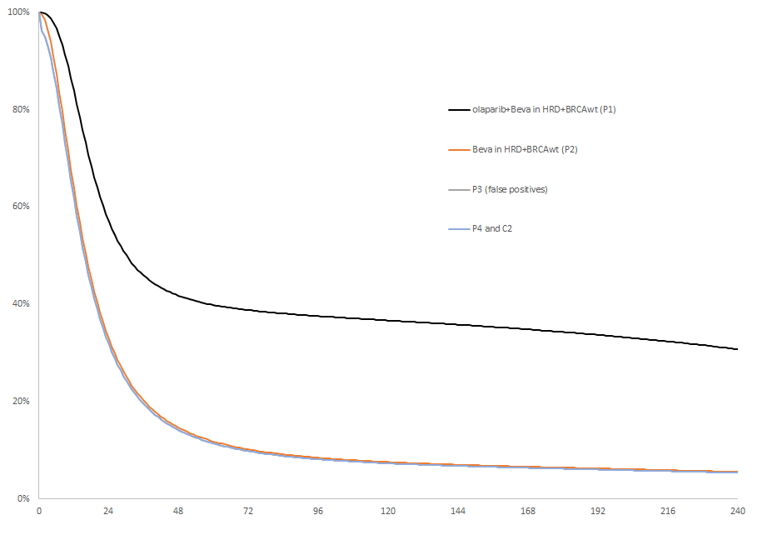
Beva = bevacizumab; BRCAwt = breast cancer gene wild type; HRD = homologous recombination deficiency; PFS = progression free survival; for description of P1-5 and C1-2 see Table 13.
Source: Figure 3.9, p241 of the submission

Figure 12 Modelled OS curves by branch (20 year time horizon)
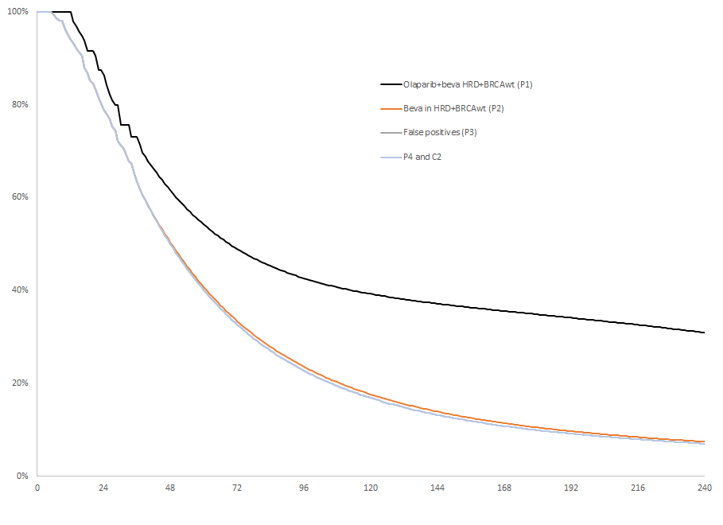
Beva = bevacizumab; BRCAwt = breast cancer gene wild type; HRD = homologous recombination deficiency; OS = overall survival; for description of P1-5 and C1-2 see Table 13.
Source: Figure 3.14, p246 of the submission
        - Compared to the OS KM curve among HRD positive BRCAwt patients in PAOLA-1 (Figure 7), which did not show any clear separation, the model estimated a much more substantial OS benefit with maintenance treatment with olaparib plus bevacizumab compared to bevacizumab alone. The extrapolation of OS in the bevacizumab arm was also unreasonably influenced by a sudden dip at the tail end of the curve at 45 months where the number of patients at risk was low (<10 patients) which led to a clear underestimate of the OS in patients treated with bevacizumab monotherapy compared to the available KM curve (see Figure 7)
        - The frequencies of treatment-related AEs were extracted from the PAOLA-1 Clinical Study Report using the figures for AEs Grade 3 or higher that occurred in greater than 1% of the ITT PAOLA-1 population. AE data for the olaparib plus bevacizumab arm was used for populations P1 and P3, and AE data for the bevacizumab monotherapy arm was used for populations P2, P3, P4 and C2. This included an unexpectedly high (18.7%) rate of hypertension in the olaparib plus bevacizumab arm, however this was not a main driver of the model (ICER increased by 0.36% when costs for hypertension were removed in sensitivity analysis). The methods used to derive their costs were reasonable and the unit costs from these sources were correct.
        - Utility weights for patients in the PFS health state were derived directly from the PAOLA-1 study using individual patient data from the EQ-5D-5L instrument. The submission argued that it was not possible to use EQ-5D data from PAOLA-1 to inform the post-progression utility score due to the limited number of observations beyond the date of progression. The post-progression utility score was taken from the published literature, derived from an average of published estimates considered by the submission to be from a viable range. The commentary noted that the number of observations from PAOLA-1 (870) was far greater than the sample size reported in the published literature used to derive this utility. The post-progression utility in PAOLA-1 (0.720) was much higher than the utility used in the base case (0.544). Further, the utility of patients experiencing a (first) progression in the model was actually lower than the utility of the second progression in the model considered by the PBAC in July 2020 for olaparib monotherapy in BRCAm ovarian cancer (0.557). Use of the lower post-progression utility favoured olaparib plus bevacizumab. The PSCR argued that the PAOLA-1 EQ-5D did not capture the true utility decrement associated with progressive disease until death and overestimated post-progression utility compared to Australian clinical practice. The PSCR also noted that literature-based utilities were used for the post-progression health states in the olaparib monotherapy SOLO1 model.
        - In branches P3, P4 and C2, parametric models were based on data from all patients in the bevacizumab monotherapy population (i.e. the ITT bevacizumab monotherapy population in PAOLA-1), an ‘adjustment factor’ of 0.96 was applied to the PFS and cure fractions based on the ratio of median PFS in the ITT population (16.6 months) and in the BRCAwt population (16.0 months). This may not have been reasonable, as PAOLA-1 was not necessarily powered to detect differences in efficacy of patients treated with bevacizumab monotherapy between subgroups.
        - A summary of the key drivers of the model is provided in the table below. The ESCs considered that the results of the model were uncertain given the use of exploratory subgroup analyses from PAOLA-1, and also noted that the key drivers of the model favoured olaparib + bevacizumab.
Table 16 Key drivers of the model
Description | Method/Value | Impact
Cure fraction (olaparib + bevacizumab) | The economic evaluation used mixture cure models to estimate the cure fraction and to model PFS for uncured patients.  Base case (branch P1): 38.57% | High, favours olaparib + bevacizumab.  Changing the cure fraction for branch P1 to 25.45% (as used in the olaparib July 2020 submission) increased the ICER by 62%.
Cure fraction (bevacizumab monotherapy) | The economic evaluation used mixture cure models to estimate the cure fraction and to model PFS for uncured patients.  Base case for (P2, P3, P4 and C2): 6.63% | High, favours olaparib + bevacizumab.  Changing the cure fraction for branches P2, P3, P4 and C2 to 15% increased the ICER by 30.5%.
Extrapolation function | The extrapolation function was chosen based on the Akaike Information Criterion (AIC) and visual inspection of the model projections against the Kaplan-Meier plot.  The submission applied the same distribution across both treatment arms. | High, favours olaparib + bevacizumab.  When the model used to extrapolate PFS for bevacizumab arm (base case = log logistic) was changed to Weibull (with olaparib plus bevacizumab remaining as log logistic) the ICER increased by 31%.
Time horizon | Base case: 20 years | High, favours olaparib + bevacizumab.  Changing the time horizon to 15 years increased the ICER by 27.3%.
Utility values for the progressed disease health state | Utility weights for patients in the PFS health state were derived directly from PAOLA-1. Utility for the progressed disease health state was derived from an average of published estimates considered by the submission to be in a viable range. | Moderate, favours olaparib + bevacizumab.  When only utility values from PAOLA-1 were used the ICER increased by 13.1%.
ICER = incremental cost effectiveness ratio; PFS = progression-free survival
Source: Table 3.39, p280 of the submission
        - The proposed MBS unit cost for the HRD test in the proposed scenario was assumed to be $2,500. The ESCs also noted that the total cost of HRD testing was a significant proportion of the overall cost (7% of modelled costs) due to the relatively high unit cost and the proposed replacement of the existing (less expensive) BRCA1/2 test.
        - The cost of the BRCA test used in the submission was $1,200 (MBS item 73301). While the current fee for MBS item 73301 is $1,200, MSAC previously advised that the fee for MBS items to test for pathogenic variants in only the BRCA1 and BRCA2 genes should be reduced from $1,200 to $1,000 (p1, Application No. 1618 MSAC PSD, MSAC meeting November 2021) as reflected in the new MBS item 73304 for prostate cancer.
        - The PBAC noted that the model included testing costs in the proposed scenario of $3,125 per patient tested, which equates to more than $| | per patient treated with olaparib plus bevacizumab (23.5% HRD+ BRCAwt patients), the incremental cost for HRD testing was $1,625 per patient tested, or $| | per patient treated with olaparib plus bevacizumab. No costs or consequences of failed or inconclusive tests (e.g. cost of retesting, re-sampling, and/or risk of using suboptimal treatment) were considered in the economic evaluation, which likely favoured olaparib.
        - The base case ICERs for the trial-based analysis and the modelled analysis are presented below.
Table 17 Results of the economic evaluation (main analysis: olaparib + bevacizumab versus bevacizumab monotherapy)
Component | Olaparib+bevacizumab (proposed scenario) | Bevacizumab  (current scenario) | Increment
Trial-based ICER (38 months)
Discounted cost | $| | $17,271 | $|
Progression-free years gained | 2.29 ª | 1.64 ^{b} | 0.65
Incremental cost per progression-free year gained |  |  | $|¹
Modelled cost per QALY versus bevacizumab (20 years)
Discounted costs | $| ^{c} | $32,046 ^{c} | $|
Discounted LY gained | 4.10 ^{c} | 3.59 ^{c} | 0.52
Discounted QALYs | 2.80 ^{c} | 2.34 ^{c} | 0.46
Incremental cost per LY gained |  |  | $|²
Incremental cost per QALY gained |  |  | $|³
BRCA = breast cancer gene; HRD = homologous recombination deficiency; m = mutation; ICER = incremental cost-effectiveness ratio; LY = life year, QALY = quality adjusted life year; wt = wild type
ª based on PFS results from HRD positive BRCAwt in PAOLA-1
^{b} based on PFS results from intention-to-treat population in PAOLA-1
^{c} The submission did not include any drug or management costs or outcomes for patients who were BRCAm and treated with olaparib monotherapy. As such, the absolute costs, LY gained and QALY in each scenario were not reflective of the entire cohort. However the incremental results and resultant ICERs are accurate.
Source: Tables 3.33, 3.34 and 3.35, p273-274 of the submission.
The redacted values correspond to the following ranges:
¹ $135,000 to < $155,000
² $35,000 to < $45,000
³ $45,000 to < $55,000
        - A substantial OS difference was modelled (a 3.74 LYG difference over the 20 year time horizon) despite OS not being statistically significant in PAOLA-1 for the ITT (OS HR = 0.91, 95%CI 0.70, 1.1) or the HRD positive BRCAwt populations (OS HR = 0.84, 95%CI 0.46, 1.52). This was almost entirely driven by the assumed cure fractions.
        - Based on the sensitivity analyses conducted by the submission and during the evaluation, the model was most sensitive to changes in the cure fraction (both for olaparib plus bevacizumab and bevacizumab monotherapy as well as the incremental difference), extrapolation function (which directly affects the cure fraction), utility values for the progressed disease health state, proportion of patients who were HRD positive BRCAwt and time horizon. Results of the key univariate sensitivity analyses are summarised in the table below.
Table 18 Results of key sensitivity analyses of economic model
Variable or assumption | Incremental costs | Incremental effectiveness (QALYs) | ICER versus bevacizumab | % change from base case
Base case | $ | | 0.4616 | $ | ¹ | NA
Time horizon (base case = 20 years)  - 15 years  - 25 years | $ |  $ | | 0.3621  0.5311 | $ | ²  $ | ³ | +27.32  -12.83%
Prevalence of HRD+ (base case = 50%)  - 40%, 25.3% BRCAm  - 60%, 25.3% BRCAm | $ |  $ | | 0.2747  0.6485 | $ | ²  $ | ¹ | +12.55%  -5.23%
Cure fraction for branch P1 (base case = 38.57%)  - 30%  - 25.45% (as for July 2020 olaparib)  - 20% | $ |  $ |  $ | | 0.3500  0.2928  0.2262 | $ | ²  $ | ⁴  $ | ⁵ | +33.67%  +60.86%  +109.88%
Cure fraction for branches P2 (base case 6.63%), P3, P4 and C2 (base case = 0.96 × P2)  - 5%  - 10%  - 15% | $ |  $ |  $ | | 0.4777  0.4188  0.3583 | $ | ¹  $ | ²  $ | ² | -3.57%  +10.82%  +30.50%
Model used to extrapolate PFS for bevacizumab arm (base case = log logistic), while fixing P1 cure fraction at 20%  - Log normal  - Generalised gamma  - Weibull | $ |  $ |  $ | | 0.2505  0.1202  0.1217 | $ | ⁴  $ | ⁶  $ | ⁶ | +89.02%  +300.14  +295.20
HRD test sensitivity and specificity (base case 95% sensitivity and 95% specificity)  - Lowest estimate of diagnostic accuracy (86% for sensitivity and 94% for specificity)  - Highest estimate of diagnostic accuracy (98.5% for sensitivity and 97.4% for specificity) | $ |  $ | | 0.4191  0.4781 | $ | ¹  $ | ¹ | +2.91%  -3.96%
Using median DoT (22 months) instead of mean DoT (17.1 months) | $ | | 0.4616 | $ | ² | +25.61%
Utility value for post-progression health state from PAOLA-1 (0.72) (base case = 0.544) | $ | | 0.4081 | $ | ² | +13.11%
BRCA test cost $1,000 (base case = $1,200) | $ | | 0.4616 | $ | ¹ | +1.08%
Use the KM PFS curve instead of the DoT curve to determine the proportion of patients remaining on treatment with olaparib (up to 25 months) | $ | | 0.4616 | $ | ² | +17.15%
Use Weibull function for the MCM PFS extrapolation for olaparib monotherapy in BRCAm patients (leaving the olaparib plus bevacizumab extrapolation as loglogistic) | $ | | 0.3570 | $ | ² | +30.96%
All bevacizumab patients have the ITT efficacy (no adjustment for subgroups) | $ | | 0.4485 | $ | ¹ | +3.05
HRD = homologous recombination deficiency; ICER = incremental cost effectiveness ratio; PFS = progression-free survival; QALY = quality adjusted life year; MCM = mixture cure models; OS = overall survival
Source: Table 3.39, p280 of the submission
The redacted values correspond to the following ranges:
¹ $45,000 to < $55,000
² $55,000 to < $75,000
³ $35,000 to < $45,000
⁴ $75,000 to < $95,000
⁵ $95,000 to < $115,000
⁶ $155,000 to < $255,000

        - While the HRD test sensitivity and specificity was investigated in sensitivity analyses, it was not possible to conduct a sensitivity analysis to investigate changing the BRCA test sensitivity and specificity as there was no false positive arm built into the model. BRCA test sensitivity and specificity were assumed to be 100% in the model.
        - Given the key drivers identified above as well as the MSAC-recommended changes in the fee for BRCA testing, several multivariate sensitivity analyses were conducted during the evaluation and for ESC, these are summarised in the table below.
Table 19 Multivariate sensitivity analyses conducted during evaluation and additional ESCs and PBAC analyses
Assumptions varied | Incremental costs | Incremental QALYs | ICER  versus bevacizumab | % change from base case
Base case | $ | | 0.4616 | $ | ¹ | NA
Assume Weibull extrapolation for bevacizumab monotherapy PFS and time horizon 15 years and BRCA testing $1,000. | $ | | 0.2880 | $ | ² | +64%
Assume cure fraction 25.45% for olaparib plus bevacizumab ª and Weibull extrapolation for bevacizumab monotherapy PFS and BRCA testing $1,000. | $ | | 0.1882 | $ | ³ | +156%
Assume cure fraction 25.45% for olaparib plus bevacizumab ª and 10.0% for bevacizumab monotherapy, BRCA testing $1,000. | $ | | 0.2500 | $ | ⁴ | +91%
Assume cure fraction 25.45% for olaparib plus bevacizumabª and 18.0% for bevacizumab monotherapy^{b}, BRCA testing $1,000. | $ | | 0.1525 | $ | ⁵ | +218%
Additional ESCs analysis
ESCs respecified base case: assume Weibull extrapolation for bevacizumab monotherapy PFS, time horizon 15 years and using progressed disease utility from PAOLA-1 (0.720) and BRCA testing $1,000. | $ | | 0.2434 | $ | ⁴ | +94%
BRCA = breast cancer gene; ICER = incremental cost effectiveness ratio; PFS = progression free survival; QALY = quality adjusted life year
ª Same as assumed for olaparib monotherapy in July 2020 resubmission for BRCAm ovarian cancer
^{b} Same as assumed for placebo in July 2020 resubmission for BRCAm ovarian cancer
Source: Constructed during evaluation using Economic Evaluation.xls
The redacted values correspond to the following ranges:
¹ $45,000 to < $55,000
² $75,000 to < $95,000
³ $115,000 to < $135,000
⁴ $95,000 to < $115,000
⁵ $155,000 to < $255,000

        - As shown in Table 13, patients designated as receiving bevacizumab monotherapy could alternatively adopt a ‘watch and wait’ approach (as proposed by the submission would occur for 10% of patients). The submission presented this as a supplementary analysis rather than an ICER based on a weighted comparator. This analysis was based on the PFS and OS hazard ratios from the GOG-218 and ICON7 trials, which were used to estimate the relative efficacy of placebo compared to bevacizumab monotherapy. ‘Watch and wait’ was a nominated comparator in BRCAwt patients in the consideration of niraparib for HGEOC, and up to 72.6% of all BRCAwt were assumed to be treated with ‘watch and wait’ in the financial estimates (Table 22, niraparib PBAC PSD March 2022). However, it was unclear what proportion of HRD+ BRCAwt patients in the comparator population would choose to ‘watch and wait’, especially if concomitant use of bevacizumab is not required. This analysis (with varying rates of placebo use) was conducted during the evaluation.
Table 20 Weighted ICER for main analysis (olaparib + bevacizumab vs bevacizumab) and supplementary analysis (olaparib + bevacizumab vs placebo)
Assumption of comparator | Incremental cost | Incremental QALY | ICER ($/QALY) | % change from base case
100% bevacizumab (main analysis) | $ | | 0.4616 | $|||¹ | -
100% placebo (supplementary analysis) | $ | | 0.5345 | $|||² | -
Base case = 90% bevacizumab + 10% placebo | $ | | 0.4689 | $||¹ | -
80% bevacizumab + 20% placebo | $ | | 0.4762 | $|||¹ | +1.1%
70% bevacizumab + 30% placebo | $ | | 0.4835 | $|||¹ | +2.1%
50% bevacizumab + 50% placebo | $ | | 0.4980 | $|||¹ | +4.1%
ICER = incremental cost effectiveness ratio; QALY = quality adjusted life year
Source: Source: Constructed during evaluation using Economic Evaluation.xls
The redacted values correspond to the following ranges:
¹ $45,000 to < $55,000
² $55,000 to < $75,000
        - As shown in Table 20, use of the supplementary analysis (100% placebo comparator) resulted in a moderate increase (+9.8%) in the ICER compared to the main analysis (bevacizumab comparator) due to the increase in incremental drug costs and QALYs incurred with the use of the placebo comparator. The ICER assuming a comparator of 90% bevacizumab and 10% placebo was $45,000 to < $55,000.
        - Additional economic analyses were conducted for alternate BRCA and HRD testing populations proposed by PASC where testing approach was varied. These resulted in only small changes to the base case ICER (+0.4% to +1.9%).
        - The PSCR considered that the commentary’s multivariate analysis was not appropriate with respect to assumptions for PFS extrapolation (see paragraph 6.60), time horizon (see paragraph 6.75), and utility values (see paragraph 6.68).
        - The ESCs considered that the economic model relied on uncertain evidence with respect to whether or not the proposed test will identify an equivalent group of patients to determine eligibility for PBS treatment with olaparib as were included in PAOLA-1. The ESCs considered that additional evidence would be required to address this concern, including evidence that the proposed test will identify the appropriate population who will benefit from the proposed PBS listing as requested by the submission. The PBAC noted that MSAC advice was required regarding the equivalence or validation of the SOPHiA assay (the assay in the submission proposed for MBS listing) versus the Myriad MyChoice Plus HRD assay (the clinical utility standard assay used in PAOLA-1).
        - The ESCs considered that the base case ICER proposed by the submission was underestimated. Using more conservative inputs (15-year time horizon, Weibull extrapolation for bevacizumab monotherapy PFS, using post-progression utility from PAOLA-1, and changing BRCA testing cost to $1,000 to reflect proposed MSAC change) increased the ICER by 94%, from a base case of $45,000 to < $55,000/QALY to $95,000 to < $115,000/QALY. The ESCs agreed with the commentary that the model and resulting ICER remained optimistic with these settings, as the assumed cure fraction for olaparib plus bevacizumab was still assumed to be 38%, around one and a half times that of the assumed cure fraction for olaparib monotherapy in BRCAm patients in July 2020.
        - The ESCs noted that the submission requested an effective price that was equal to the current effective price for olaparib, which appears inconsistent with the proposed circumstances of use, in which the cost increased testing fees must also be considered.
        - The ESCs noted that in July 2020, the PBAC recommended the listing of olaparib as first line maintenance monotherapy for BRCAm patients. The PBAC’s recommendation for listing was based on, among other matters, its assessment that the cost-effectiveness of olaparib would be acceptable if the ICER was less than $58,000/QALY for the revised economic model scenario as described in the PBAC PSD (July 2020 PBAC PSD, paragraphs 7.1 and 7.17).

Olaparib cost/patient/course: $|||||||| (mean 17.1 months) /$|||||||| (median 22 months)
        - There were inconsistencies between the duration of treatment and consequently the number of doses used in the economic evaluation (mean 17.1 months, 18.55 packs) and the financial estimates (median 22 months, 23.9 packs). For consistency the financial estimates were updated to reflect the mean number of doses for olaparib and bevacizumab from the economic model during the evaluation. Treatment cost for olaparib is calculated at an effective price of $| | per 112 tablets (28 days of treatment).
        - A comparison table was constructed during evaluation and is presented below.
Table 21 Drug cost per patient for olaparib and bevacizumab
 | Olaparib + bevacizumab  PAOLA-1 HRD + BRCAwt | Olaparib + bevacizumab economic evaluation | Olaparib + bevacizumab financial estimates | Bevacizumab PAOLA-1 HRD + BRCAwt | Bevacizumab economic evaluation | Bevacizumab financial estimates
Olaparib
Mean dose | 600 mg/day | 600 mg/day | 600 mg/day | NA | NA | NA
DoT (months) | Mean: 16.96  Median 22.08 | 17.08 months | 22 months | NA | NA | NA
Cost | NA | $| | $| | NA | NA | NA
Bevacizumab
DoT (months) | Mean 10.3  Median: 11.04 | - | - | Mean: 9.6  Median: 10.2 | - | -
Number of doses | Mean: 14.3 | 14.3 | 15.93ª | Mean: 14.3 | 13.1^{b} | 15.35^{c}
Cost | NA | $14,709 | NR | NA | $13,474 | NR
BRCAwt = breast cancer gene wild type; DoT = duration of treatment; HRD = homologous recombination deficiency; NA = not applicable
ª11.0 months assumed in submission’s calculations
^{b} ITT mean infusions used
^{c} 10.6 months assumed in submission’s calculations
Calculation for converting treatment months into the number of packs required is: # months x (365.25/12) / 28.
Source: Table 3.20, p258 of the submission, PAOLA-1 CSR DCO2 Table 2828.1, financial estimates spreadsheet

Estimated PBS & financial implications
        - The submission was considered by DUSC. The main concern raised by DUSC was the inconsistency between the estimated duration of olaparib treatment in the economic evaluation (17.1 months – based on mean of PAOLA-1) and the financial estimates (22 months – based on median of PAOLA-1). Using the mean duration of treatment (consistent with economic evaluation) rather than median duration of treatment decreased the financial estimates by 13%, which DUSC considered would be appropriate (see paragraph 6.92). The PBAC considered that the estimates were appropriate after adjustment of the treatment duration to reflect mean rather than median (see paragraph 6.92).
        - The submission used an epidemiological approach to estimate the number of patients who would be eligible for the proposed HRD test, likely uptake of the test and the estimated number of patients with HRD positive BRCAwt tumours. Patients then need to be treated with and have a response to first-line platinum-based chemotherapy in order to be eligible for olaparib plus bevacizumab maintenance treatment.
        - An overview of the sources used to inform the financial impact of listing pembrolizumab is presented in the table below.
Table 22 Data sources and parameter values applied in the utilisation and financial estimates
Data | Value | Source | Comment
Eligible population
Ovarian cancer incidence projections in Australia | Yr 1: 1,733  Yr 2: 1,765  Yr 3: 1,798  Yr 4: 1,831  Yr 5: 1,865  Yr 6: 1,900 | AIHW Cancer Incidence Report (2011 to 2020) (ovarian cancer only) | Ovarian cancer incidence projections were extrapolated out to 2028 by applying the calculated annual change in incidence from 2011 to 2020 (1.855% each year). Not all patients would be suitable for treatment with bevacizumab either during initiation or as part of the maintenance alongside olaparib. The submission did not make an explicit adjustment for these patients which is consistent with PBAC’s recommendation regarding the proposed restriction.
Incidence of epithelial tumours | 84.0% | AIHW & National Breast and Ovarian Cancer Centre 2010. Ovarian cancer in Australia: an overview, 2010. Cancer series no. 52. Cat. no. CAN 48. Canberra: AIHW. | Inclusion recommended by the PBAC (paragraph 6.44, p29, Olaparib PSD, July 2020 PBAC Meeting).
Incidence of advanced FIGO stage III-IV ovarian cancer | 81.8% | AOCS publication (Lindermann et al 2018), as referenced in paragraph 6.68, p35, niraparib PSD, July 2021 PBAC Meeting. | This figure was higher than the 70% used in the July 2020 olaparib submission although this may be appropriate given the different patient populations.
Rate of tumour testing at diagnosis | ||% | Clinical opinion provided in submission that || ||% of patients unable to provide sufficient tissue for testing. | Appropriate. Previously accepted by the PBAC (paragraph 6.47, p29, olaparib PSD, July 2020 PBAC Meeting).
Prevalence of the HRD positive BRCAwt | 25% | A prevalence of 25.3% of BRCAm (gBRCA = 20.3%, sBRCA =5%) was previously accepted by the PBAC (paragraph 6.46, p28, Olaparib PSD, July 2020 PBAC Meeting).  Approximately 50% of HGEOC tumours are HRD+: Bell 2011 and Moschetta 2016. Consequently the prevalence of HRD+BRCAwt was estimated to be 24.7%. Figure rounded to 25% for the financial estimates. | A prevalence of 24.7% was used in section 3 of submission. It was not explained why this figure was not used for the financial estimates rather than rounding it up, although the impact was small (resulting in ~2 fewer treated patients per year).
Proportion of ovarian cancer patients treated with platinum-based therapy in 1L setting | 90% | The AstraZeneca AOCS1 data indicates that approximately 92% of patients with advanced ovarian cancer are treated with a platinum-based chemotherapy regimen in Australia. | The figure of 92% from the AZ AOCS1 data could not be independently verified. It was not explained why this figure was approximated to 90%, rather than using 92%. This figure was lower than the 97% used in the July 2020 olaparib submission.
Response to 1L platinum-based therapy | 80% | AZ AOCS2 report 2019, PAOLA1 (80.1%). | This figure was lower than the 85% used in the July 2020 olaparib submission, although this may be appropriate given the different patient populations.
Grandfathered patients | Yr 1: ||||¹ | Sponsor assumption.  AstraZeneca intends to provide HRD testing and olaparib treatment to eligible patients via a compassionate access program for a period of 14 months. | No explanation for this figure was provided in the submission. Figure cannot be independently verified.
Olaparib + bevacizumab
Olaparib uptake rate | Yr 1: ||%  Yr 2: ||%  Yr 3: ||%  Yr 4: ||%  Yr 5: ||%  Yr 6: ||% | Uptake rate sponsor assumption. | The PBAC previously considered that the olaparib uptake should be lower in Year 1 of PBS listing to account for patients commencing treatment throughout the year, although a specific rate was not detailed (paragraph 6.50, Olaparib PSD, July 2020 PBAC Meeting).
Number of olaparib doses | Yr 1 13.04  Yr 2 10.87 | Based on 22 months treatment, with no treatment breaks. | These figures were inconsistent compared to the olaparib treatment duration used in the model (17.08 months). This was due to the model using the mean for DoT and the financial estimates using the median DoT.
Number of bevacizumab doses (given with olaparib) | 15.93 | Based on an average treatment duration of 11 months from PAOLA-1. | This was different to the bevacizumab treatment duration used in the model (14.3 doses) as median duration used instead of mean.
Cost of bevacizumab (DPMA) | Weighted average 7.5 mg/kg $721.42; 15 mg/kg $1,335.75 | Based on weighted DPMA across 100 mg and 400 mg vial (PBS item numbers 12479T, 12508H), across public and private hospitals. | Reasonable.
Current scenario
Bevacizumab uptake rate | 90% | The source of this figure was not provided in the submission.
Number of bevacizumab doses | 15.35 doses | A treatment duration of 10.6 months corresponding to 15.35 doses was assumed based on PAOLA-1. | This was different to the bevacizumab treatment duration used in the model (13.1 doses). This inconsistency was not explained in the submission.
Cost of bevacizumab (DPMA) | Weighted average 7.5 mg/kg $721.42 | Based on weighted DPMA across 100 mg and 400 mg vial (PBS item numbers 12479T, 12508H), across public and private hospitals. | Reasonable. Note that no 15 mg/kg use was assumed in financial estimates but 50% of patients in the economic model were assumed to use 15 mg/kg.
Other costs
Cost of HRD testing | $2,500 | Requested fee
Cost of tumour BRCA1/2 mutation testing | $1,200 | MBS item 73301 | MSAC advised that this cost should be $1,000. Included in the updated base case.
Cost of IV administration for bevacizumab | $112.40 | MBS item 13950 | Reasonable.
AOCS = Australian Ovarian Cancer Study, AIHW = Australian Institute of Health and Welfare; BRCAwt = breast cancer gene wild type; DoT = duration of treatment; DPMA = dispensed price maximum amount; HRD = homologous recombination deficiency; gBRCA = germline breast cancer gene; HGEOC = high grade epithelial ovarian cancer; PSD = public summary document; sBRCA = somatic breast cancer gene
Source: Table 4.1, p288 of the submission.
The redacted values correspond to the following ranges:
¹ < 500

        - The submission stated that the cost of relevant MBS items was used as in the MBS schedule and included the cost of BRCA testing of $1,200. As MSAC has previously stated that the cost of BRCA testing should be reduced to $1,000, financial estimates assuming an MBS fee of $1,000 for BRCA testing was included during the evaluation. The commentary noted that both the proposed HRD test (MBS fee $2,500) and BRCA test (MBS fee $1,200/$1,000) exceed the threshold for the greatest permissible gap (GPG) as of 1 November 2021, meaning that the fee rebated will be MBS item fee minus $87.90. The financial estimates have been updated to reflect the GPG rebate.
        - The estimated use and financial implications for listing olaparib plus bevacizumab on the PBS for the treatment of patients with HRD positive BRCAwt HGEOC are summarised in the table below. The estimates were recalculated during the evaluation, applying mean (rather than median) treatment durations for olaparib and bevacizumab.
Table 23 Estimated number patients accessing HRD testing and with HRD positive BRCAwt status over six years (using mean number of doses in PAOLA-1 for treatment durations of olaparib and bevacizumab)
 | 2023 | 2024 | 2025 | 2026 | 2027 | 2028
Estimated financial implications of olaparib + bevacizumab to PBS
Incidence ovarian cancer | 1,733 | 1,765 | 1,798 | 1,831 | 1,865 | 1,900
Proportion tested positive for HRD+BRCAwtª | | ¹ | | ¹ | | ¹ | | ¹ | | ¹ | | ¹
Patients treated with olaparib + bevacizumab | | ¹ | | ¹ | | ¹ | | ¹ | | ¹ | | ¹
Grandfathered patients treated with olaparib + bevacizumab | | ¹ | | ¹ | | ¹ | | ¹ | | ¹ | | ¹
Total patients treated with olaparib + bevacizumab | | ¹ | | ¹ | | ¹ | | ¹ | | ¹ | | ¹
Total olaparib prescriptions | | ² | | ² | | ² | | ² | | ² | | ²
Total bevacizumab prescriptions (given with olaparib) | | ² | | ² | | ² | | ² | | ² | | ²
Change in bevacizumab monotherapy prescriptions | - | ² | - | ² | - | ² | - | ² | - | ² | - | ²
Net cost to PBS/RPBS for olaparib | $||³ | $||³ | $||³ | $||³ | $||³ | $ | ³
Net cost to PBS/RPBS for bevacizumab | $||⁴ | $||⁴ | $||⁴ | $||⁴ | $||⁴ | $ | ⁴
Cost reductions (bevacizumab) | -$||⁴ | -$||⁴ | -$||⁴ | -$||⁴ | -$||⁴ | -$||⁴
Total net cost to PBS /RPBS for olaparib + bevacizumab | $||³ | $||³ | $||³ | $||³ | $||³ | $||³
Estimated financial implications of HRD and BRCA tests to the MBS
Total test numbers | | ² | | ² | | ² | | ² | | ² | | ²
Cost of testing HRD test to MBS | $||⁴ | $||⁴ | $||⁴ | $||⁴ | $||⁴ | $ | ⁴
Net cost of testing BRCA test to MBS ($1,000 BRCA test fee) | -$||⁴ | -$||⁴ | -$||⁴ | -$||⁴ | -$||⁴ | -$||⁴
Net cost of tests to MBS | $||⁴ | $||⁴ | $||⁴ | $||⁴ | $||⁴ | $ | ⁴
Net bevacizumab administration cost | $||⁴ | $||⁴ | $||⁴ | $||⁴ | $||⁴ | $ | ⁴
Net financial implications
Net cost to PBS | $||³ | $||³ | $||³ | $||³ | $||³ | $ | ³
Net cost to MBS ($1,000 BRCA test fee) | $||⁴ | $||⁴ | $||⁴ | $||⁴ | $||⁴ | $ | ⁴
Net cost health budget ($1,000 BRCA test fee) | $||³ | $||³ | $||⁵ | $||⁵ | $||⁵ | $||⁵
BRCAwt = breast cancer gene wild type; HRD = homologous recombination deficiency.
ª Based on submission’s assumption of 50% HRD positive and 25% HRD positive BRCA wild type
Source: Table 4.4 and 4.6, p292, 295 of the submission, Olaparib (PAOLA1) UCM_final.xlsx
The redacted values correspond to the following ranges:
¹ < 500
² 500 to < 5,000
³ $10 million to < $20 million
⁴ $0 to < $10 million
⁵ $20 million to < $30 million
        - The total cost to the PBS/RPBS of listing olaparib was estimated to be $10 million to < $20 million in year 1 and $10 million to < $20 million in Year 6, and a total of $100 million to < $200 million in the first 6 years of listing. The net additional cost to the MBS of HRD testing was $0 to < $10 million in year 1, increasing to $0 to < $10 million in year 6.
        - The estimated number of patients who are expected to be HRD positive BRCAwt (< 500 in year 1 and < 500 in year 6) is less than the number of patients estimated to test BRCAm (< 500 in year 1 and < 500 in year 6) in the olaparib submission in July 2020. Slightly fewer patients would be expected to test HRD positive BRCAwt (estimated 25% of HGEOC) compared to BRCAm (estimated to be 26.3% of HGEOC).
        - The submission estimated that < 500 grandfathered patients would be treated with PBS listed olaparib plus bevacizumab in the first year of listing, with no grandfathered patients assumed in subsequent years. The submission stated that the sponsor intends to provide HRD testing and olaparib treatment to eligible patients via a compassionate access program for a period of | | | |. It was unclear how the HRD status of these grandfathered patients would be determined (given that there is currently no approved HRD test in Australia) and whether it would satisfy the instruction of “Evidence of genomic instability derived through a validated HRD assay.”
        - There were several issues with the estimation of bevacizumab usage and offset in the submission.
- It was unclear why the ‘continuing’ patient count (with ‘continuing’ patients assumed to be 80% of all eligible patients) was used instead of 'incident' patients (for whom a 90% uptake rate from eligible patients assumed) for the estimation of bevacizumab when used with olaparib. This appears to be an error (as these numbers are the same as the 'proportion no longer treated with bevacizumab' instead of being the proportion initiating treatment) and likely underestimated the patient numbers and subsequently cost of bevacizumab when used with olaparib from year 2 onwards; and
- The submission’s approach to estimating the number of patients no longer treated with bevacizumab monotherapy in year 1 led to an implausible estimate as the uptake rate of olaparib plus bevacizumab (65%) was actually lower than bevacizumab monotherapy (80%) in year one. Thereby there were < 500 patients initiating treatment with olaparib plus bevacizumab but < 500 patients who ceased treatment with bevacizumab monotherapy.
        - There were also several issues with the MBS usage estimated in the submission which were corrected during the evaluation.
        - The PBAC noted that the estimated number of patients eligible for treatment under the proposed listing was dependent upon the assumed proportions of the population anticipated to be HRD positive and BRCAwt. The PBAC requested that MSAC provide advice regarding the following for patients eligible to be treated with olaparib for 1L ovarian cancer:
        - The proportion of patients with BRCA pathogenic or likely pathogenic variants (assumed to be 25.3% by the submission, and so eligible for treatment under the existing olaparib monotherapy listing).
        - The proportion of patients with HRD positive tumours (assumed to be 50% by the submission), and thus the increment in the population eligible for olaparib of 24.7%.

Quality use of medicines
        - AstraZeneca led a symposium at the Australia New Zealand Gynaecological Oncology Group’s (ANZGOG) Annual Scientific Meeting (23-26 March 2022) to provide information and education on tumour BRCA and HRD testing in ovarian cancer, explore developing/establishing a HRD assay in Australia and tumour acquisition for BRCA testing, examine selection of appropriate sample for tumour BRCA testing, discuss the optimal timing for a biopsy and provide discussion and case study.
        - AstraZeneca’s Biomarker and Gene Mutation Patient Advocacy Exchange held a virtual meeting (May 2021) aimed at patient advocacy groups (PAGs) who are involved in educating and supporting patients with cancer. The meeting explored biomarkers across multiple tumour types, including breast, ovarian, lung, gastrointestinal, haematological and genitourinary cancers.
        - DUSC noted that there was a high rate of dose interruption (54%), dose reduction (41%) and discontinuation (20%) in the olaparib plus bevacizumab group in the PAOLA-1 trial. However, DUSC commented that clinicians treating gynaecological malignancies are now relatively familiar with olaparib and its QUM issues.

Financial management – risk sharing arrangements
        - A Deed of Agreement between the Commonwealth of Australia and AstraZeneca Pty Ltd in relation to sharing the costs of Commonwealth subsidy for the supply of olaparib, was executed | | | | | | | | and updated | | | | | | to include the first line olaparib monotherapy listing.
        - No specific risk sharing arrangement for this submission was proposed. However, the submission stated that AstraZeneca is willing to work with the PBAC and Department of Health to determine appropriate terms for PBS listing of olaparib for eligible patients with HRD positive BRCAwt advanced ovarian cancer that recognises the value of this treatment and shares the risk of uncertainty between the Sponsor and the Department.
- PBAC Outcome
        - The PBAC did not recommend olaparib for use in combination with bevacizumab for maintenance therapy in patients with newly diagnosed HRD positive BRCAwt advanced epithelial ovarian, fallopian tube or primary peritoneal cancer. The PBAC considered that a clinical claim of superior efficacy was supported for olaparib plus bevacizumab in the HRD positive group, compared with bevacizumab alone based on PFS benefit, although the OS benefit was uncertain due to immature data. The PBAC considered that olaparib plus bevacizumab was inferior compared with bevacizumab alone in terms of safety, but would be manageable in practice. The PBAC considered that revisions to the inputs for the economic model were required so that they were consistent with those previously accepted by the PBAC for olaparib monotherapy in the BRCAm group and with these revisions the ICER would increase substantially and hence a price reduction would be required for the proposed listing to be considered acceptably cost-effective.
        - The PBAC noted that the proposed clinical place for PARP inhibitors in patients without BRCAm was reliant on access to an approved HRD test. The PBAC considered that the submission had relied on uncertain evidence with respect to whether or not the proposed test will identify an equivalent group of patients as in the PAOLA-1 trial to determine eligibility for PBS treatment with olaparib. In particular, the PBAC requested that MSAC provide advice on:
        - The equivalence or validation of the SOPHiA assay (the assay in the submission proposed for MBS listing) versus the Myriad MyChoice Plus HRD assay (the clinical utility standard assay used in PAOLA-1).
        - The threshold that should be used to define HRD positivity for determining PARPi eligibility with reference to the clinical utility standard.
        - The proportions of the population anticipated to be HRD positive and breast cancer gene wild type (BRCAwt), which are relevant for the financial estimates. To validate the financial estimates, it will be necessary to confirm the following for patients eligible to be treated with olaparib for 1L ovarian cancer:
        - The proportion of patients with BRCA pathogenic or likely pathogenic variants (assumed to be 25.3% by the submission, and so eligible for treatment under the existing olaparib monotherapy listing).
        - The proportion of patients with HRD positive tumours (assumed to be 50% by the submission), and thus the increment in the population eligible for olaparib of 24.7%.
        - The PBAC noted that the submission proposed exclusion of the HRD+ BRCAm subgroup from treatment with olaparib plus bevacizumab on the basis that patients identified as BRCAm positive will continue to be treated with the current standard of care (olaparib monotherapy). However, results from PAOLA-1 showed that in the HRD positive subgroup, BRCA status was not a treatment effect modifier (interaction modifier p = 0.5173) and the combination was effective in BRCAm patients (see paragraph 7.7). Additionally, the PBAC noted that there is evidence of benefit for treatment with a PARPi alone in HRD+ tumours (from the PRIMA and VELIA trials) and the PBAC considered it was unclear to what extent bevacizumab would add benefit when combined with PARPi. The PBAC noted that bevacizumab now has an unrestricted PBS listed and therefore less use of bevacizumab in first line is expected, and instead there is increasing use in later line upon relapse. The PBAC considered it was not clinically appropriate to mandate use of bevacizumab with PARPi in patients with HRD+ tumours and the decision of whether or not to use bevacizumab should be determined by clinical factors, separate to BRCA/HRD status. Given the population included in the pivotal evidence (PAOLA-1) the PBAC considered it was not appropriate to have different requirements regarding concomitant bevacizumab for the BRCAm and HRD+ populations. The PBAC advised that it would be appropriate for the PBS listings for first line PARPi in the BRCAm population to allow combination use with bevacizumab. The PBAC foreshadowed that a similar flexibility regarding concomitant use of bevacizumab with PARPi should apply if it recommends PBS listing for the HRD+ BRCAm subgroup in the future.
        - The PBAC noted the input from individuals, and organisations and acknowledged that the Medical Oncology Group of Australia (MOGA) had expressed its strong support for the olaparib submission, categorising it as one of the therapies of “highest priority for PBS listing” on the basis of the PAOLA-1 trial. The PBAC noted that HRD testing was recommended to guide prescribing of PARPi in other countries as reflected by clinical guidelines in Europe, the United Kingdom and the United States.
        - The PBAC considered that the nomination of bevacizumab as the main comparator was appropriate but that standard medical management (‘watch and wait’ or placebo) was also a relevant comparator as not all patients would receive bevacizumab as first line treatment. The PBAC noted that ‘watch and wait’ was presented as a supplementary comparator, but that changing the assumed proportions of use of these potential comparators had minimal impact on the ICER (see paragraph 6.79).
        - The PBAC noted that the primary clinical evidence supporting the clinical claim was a randomised, double-blind, multicentre phase 3 study (PAOLA-1) of olaparib plus bevacizumab (n=537) compared to placebo plus bevacizumab (n=269) in patients with newly diagnosed advanced (FIGO stage IIIB-IV) high-grade serous or endometrioid ovarian, fallopian tube or peritoneal cancer in response to platinum-based chemotherapy. The PBAC noted that the submission relied on results from exploratory subgroup analyses of PFS for patients with HRD+ and BRCAwt tumours, and no statistical adjustments were made in assessing subgroup analyses.
        - The PBAC noted from data cut off (DCO) 1 that the PFS HR for the HRD positive subgroup (including BRCAm) was similar to that for the BRCAm subgroup (0.33; 95% CI 0.25, 0.45 vs 0.28; 95% CI 0.19, 0.42), while the PFS HR for the proposed PBS population (HRD positive BRCAwt subgroup) was less favourable (PFS HR 0.43; 95% CI 0.28, 0.66). In contrast, treatment with olaparib plus bevacizumab did not result in any benefit in terms of PFS in patients with HRD negative tumours (HR 1.00; 95% CI 0.75, 1.35) compared with bevacizumab alone.
        - The PBAC considered that the PFS results in the HRD positive subgroup and HRD positive BRCAwt subgroup in PAOLA-1 supported a claim of superior efficacy for olaparib plus bevacizumab compared to bevacizumab alone (PFS HR of 0.38; 95% CI 0.29, 0.50 and 0.44; 95% CI 0.29, 0.66, respectively at median follow up of 38.5 months, DCO2), though there was no statistically significant difference in OS (HR of 0.70, 95% CI 0.47, 1.04 and 0.84; 95% CI 0.46, 1.52, respectively). The PBAC noted the next OS data cut is expected to be available in Q3 2022, however cross-over to second line PARPi treatment may impact the interpretation of updated OS data. The PBAC also noted that mature data from the SOLO1 study (olaparib monotherapy in the first line setting) and SOLO2 study (olaparib monotherapy in second line relapse/refractory setting) provide reassurance that the observed PFS benefit in PAOLA-1 will likely translate into an overall survival benefit in the long term.
        - The PBAC noted that more patients in the olaparib plus bevacizumab arm experienced AEs leading to discontinuation, dose reduction or interruption of study treatment than patients treated with bevacizumab alone (see Table 9). Additionally, patients receiving olaparib plus bevacizumab experienced higher rates of a number of individual AEs both for any grade and ≥Grade 3 (nausea, fatigue, anaemia and lymphopenia), while hypertension was the only AE found to occur more in patients receiving bevacizumab monotherapy (both any grade and Grade ≥3). The PBAC considered that the combination of olaparib and bevacizumab had inferior safety in comparison with bevacizumab monotherapy.
        - The PBAC noted that the submission presented a cost-effectiveness analysis, based on subgroup results from PAOLA-1 for the HRD+ BRCAwt population. The economic evaluation compared the proposed scenario where all patients undergo HRD (BRCA and GI) testing vs the comparator/current scenario where patients receive BRCA testing only, with patients receiving either olaparib plus bevacizumab or bevacizumab monotherapy (or placebo instead of bevacizumab monotherapy in the supplementary analysis).
        - The PBAC noted the ESCs considered that the base case ICER proposed by the submission was underestimated, and that revisions to the time horizon, extrapolation for bevacizumab monotherapy PFS, post-progression utility and the assumed cure fraction for olaparib plus bevacizumab should be considered. The PBAC noted use of a 15-year time horizon, Weibull extrapolation for bevacizumab monotherapy PFS, the post-progression utility from PAOLA-1, and changing BRCA testing cost to $1,000 to reflect proposed MSAC change increased the ICER from a base case of $45,000 to < $55,000/QALY to $95,000 to < $115,000/QALY. The PBAC further noted that a number of the model inputs appeared inconsistent with those previously accepted for the olaparib BRCAm model.
        - Regarding the time horizon, the submission nominated 20 years which required extrapolation from a trial with median follow up of only 38 months, which the PBAC considered introduced significant uncertainty with the extrapolated results. The PBAC previously noted that 20 years may be too long for the non-BRCAm population in the consideration of niraparib for the maintenance treatment (paragraph 7.15, p43, niraparib PSD, July 2021 PBAC Meeting), however a time horizon of 20 years was accepted in the consideration of olaparib in first line treatment for BRCAm patients. The PBAC considered that the time horizon of 20 years was reasonable for the HRD+ population, recalling that this was consistent with the time horizon previously accepted for the BRCAm population.
        - The economic evaluation used mixture cure models to estimate the cure fraction and to model PFS for uncured patients. The PBAC noted that the chosen cure fractions were inconsistent those estimated for olaparib monotherapy in the BRCAm model using data from SOLO1 considered by PBAC in July 2020 which had a more favourable PFS HR than this submission (0.33 compared to 0.44) but a much lower incremental cure fraction (7.5% compared to 32.0%). The choice of the MCM PFS extrapolation function and the associated cure fractions had a substantial impact on the resultant ICER. The PBAC considered the cure fraction for olaparib plus bevacizumab (38.6%) appeared substantially and implausibly overestimated for patients with stage III-IV disease and favoured olaparib plus bevacizumab. The PBAC considered that a substantially reduced cure fraction consistent with that applied in the BRCAm model using data from SOLO1 considered by PBAC in July 2020 (25.45%) would be more appropriate. The PBAC noted the loglogistic extrapolation of bevacizumab monotherapy PFS resulted in a cure fraction that seemed underestimated and inconsistent with that previously accepted based on the placebo arm of SOLO-1 (see paragraph 6.60). The PBAC considered that the submission’s use of loglogistic extrapolation for bevacizumab monotherapy PFS added uncertainty to the analysis. The PBAC noted that the sponsor anticipates that more mature PFS data from DCO3 will be available Q3, 2022. The PBAC considered that these data could be used to better support the modelled PFS curves in a resubmission.
        - Overall, compared to the OS KM curve among HRD positive BRCAwt patients in PAOLA-1 (Figure 7), which did not show any clear separation, the model estimated a much more substantial OS benefit with maintenance treatment with olaparib plus bevacizumab compared to bevacizumab alone. Although the PBAC considered it is likely that the observed PFS benefit in PAOLA-1 will translate into an overall survival benefit in the long term the magnitude of the benefit appeared overestimated in the economic evaluation.
        - Regarding the post-progression utility, the PBAC noted data from the literature were used in preference to data from PAOLA-1 and that the value used (0.544) was lower than that used in the model for olaparib BRCAm model (0.557). The PBAC considered the post-progression utility should be consistent with the value previously accepted (0.557).
        - The PBAC considered that given the uncertainty regarding the magnitude of benefit for the HRD positive population due to reliance on an exploratory subgroup analysis, uncertain extrapolations, uncertainty regarding whether the proposed test will identify an equivalent group of patients as in the PAOLA-1 trial and because the proposed HRD positive BRCAwt population are likely to have a reduced PFS benefit compared with the BRCAm population, the PBAC considered that an ICER of less than $50,000/QALY would be considered appropriately cost-effective.
        - With regard to utilisation estimates, the PBAC considered that the estimates were appropriate after adjustment of the duration treatment to reflect mean rather than median. Using the mean duration of treatment (consistent with economic evaluation) rather than median duration of treatment decreased the financial estimates by 13%, which the PBAC considered would be appropriate (see paragraph 6.92). The PBAC noted that MSAC advice was also required in relation to the financial estimates (see paragraph 7.2).
        - The PBAC considered the outstanding issues could be resolved in a simple resubmission for olaparib using the early re-entry pathway. If the sponsor accepts this pathway, the following changes may address these outstanding issues without requiring further re-evaluation:
- Revise the inputs for the economic model as follows. The PBAC noted that the early re-entry pathway would not be appropriate if the model structure is revised.
  - Use of cure fractions consistent with those accepted for the olaparib BRCAm model, thus assuming a cure fraction of no more than 25.45% for olaparib plus bevacizumab (paragraph 7.13).
  - Use of loglogistic PFS extrapolations consistent with those accepted for the olaparib BRCAm model. However, noting the uncertainty in these PFS extrapolations, particularly for the bevacizumab monotherapy arm, the PBAC considered that a resubmission should be supported by more mature PFS data from DCO3 to validate these modelled PFS curves (paragraph 7.13).
  - Use of a post-progression utility value (0.557) consistent with that accepted for the olaparib BRCAm model (paragraph 7.15).
  - A BRCA testing cost of $1,000 (paragraph 6.71); and
  - A price reduction to result in an ICER of less than $50,000/QALY gained (paragraph 7.16).
- Recalculation of the financial implications using the revised olaparib price and mean treatment duration.
        - The early re-entry resubmission must be lodged by week 7 of the current PBAC cycle or the next cycle. If the issues cannot be addressed by the sponsor in a simple resubmission and the early re-entry timing is not acceptable, a standard re-entry pathway is available. The PBAC considered that a resubmission via the standard re-entry pathway should include revisions to the economic model such that assumptions of benefit are more conservative and similar to those accepted in the BRCAm population.
        - The PBAC noted that this submission is eligible for an Independent Review.
Outcome:
Not recommended
- Context for Decision
The PBAC helps decide whether and, if so, how medicines should be subsidised through the Pharmaceutical Benefits Scheme (PBS) in Australia. It considers applications regarding the listing of medicines on the PBS and provides advice about other matters relating to the operation of the PBS in this context. A PBAC decision in relation to PBS listings does not necessarily represent a final PBAC view about the merits of the medicine or the circumstances in which it should be made available through the PBS. The PBAC welcomes applications containing new information at any time.
- Sponsor’s Comment
The sponsor had no comment.

Cost per patient estimated as test fee multiplied by 1.25 to account for only 80% of patients respond to first line platinum chemotherapy with or without bevacizumab.
Cost per patient estimated as test fee multiplied by 1.25 to account for only 80% of patients respond to first line platinum chemotherapy with or without bevacizumab: $1,625 = $3,125-$1,500.
Miller RE, Leary A, Scott CL, Serra V, Lord CJ, Bowtell D, Chang DK, Garsed DW, Jonkers J, Ledermann JA, Nik-Zainal S, Ray-Coquard I, Shah SP, Matias-Guiu X, Swisher EM, Yates LR. ESMO recommendations on predictive biomarker testing for homologous recombination deficiency and PARP inhibitor benefit in ovarian cancer. Ann Oncol. 2020 Dec;31(12):1606-1622. doi: 10.1016/j.annonc.2020.08.2102. Epub 2020 Sep 28. PMID: 33004253.
NICE Technology appraisal guidance [TA693], Published: 28 April 2021. Olaparib plus bevacizumab for maintenance treatment of advanced ovarian, fallopian tube or primary peritoneal cancer. https://www.nice.org.uk/guidance/ta693
National Comprehensive Cancer Network (NCCN). NCCN clinical practice guidelines – ovarian cancer including fallopian tube cancer and primary peritoneal cancer Version 1. 2021.

