An addendum to this Public Summary Document has been included at the end of the document.

5.16 VOSORITIDE,
Powder for injection 0.4 mg with diluent,
Powder for injection 0.56 mg with diluent,
Powder for injection 1.2 mg with diluent,
Voxzogo®,
BioMarin Pharmaceutical Australia Pty Ltd
- Purpose of submission
  - The submission requested the Authority Required (Telephone) listing of vosoritide for the treatment of patients with achondroplasia whose epiphyses are not closed.
  - Listing was requested on the basis of a cost-effectiveness analysis versus placebo (best supportive care (BSC)).
Table 1: Key components of the clinical issue addressed by the submission
Component | Description
Population | Patients with achondroplasia whose epiphyses are not closed
Intervention | Vosoritide: daily subcutaneous (SC) administration with the recommended dose based on the patient's weight and the vosoritide concentration. The usual dose is 15 µg/kg body weight or 30 µg/kg in children less than 2 years of age
Comparator | Best supportive care (BSC)
Outcomes | Efficacy:  - Annual growth velocity  - Z-score  - Upper to lower segment body ratio  Safety:  - Adverse events
Clinical claim | Vosoritide is superior with respect to efficacy. Vosoritide is well tolerated relative to best supportive care, indicating non-inferior safety. Whilst a claim of non-inferior safety may not be appropriate in the context of a comparison versus placebo, the differences observed were related to the mode of administration (injection site reactions, injection site swelling), with events generally mild in severity, transient in nature and manageable.
Source: Table 13, p17 of the submission.
Abbreviations: µg/kg = microgram per kilogram.
- Background

Registration status
  - TGA status at time of PBAC consideration: not registered.
  - The submission was made under the TGA/PBAC Parallel Process. At the time of evaluation for PBAC consideration, no TGA documents were available.
  - The sponsor has obtained orphan drug designation for vosoritide and lodged an application to the TGA for registration of vosoritide in patients with achondroplasia in October 2021 via the comparable overseas regulators A (COR-A) pathway. The TGA Delegate’s Overview dated 29 June 2022 was provided by the sponsor. The proposed TGA indication for vosoritide is: “for the treatment of achondroplasia in patients 2 years of age and older whose epiphyses are not closed. The diagnosis of achondroplasia should be confirmed by appropriate genetic testing”.
  - Treatment age differs across EMA and FDA approvals. The EMA approved use for patients 2 years of age and older while the FDA approved use in those 5 years of age and older. The proposed TGA indication is for use in patients 2 years and above with the submission stating expert advice has been submitted to the TGA stating further benefits of vosoritide under age 2 years. The TGA Delegate’s Overview stated that because early treatment is likely to maximize patient benefit, it appears reasonable to include patients from the age 2 years in the authorised indication.
For more detail on PBAC’s view, see section 7 PBAC outcome.
- Requested listing
  - Suggestions and additions proposed by the Secretariat are added in italics and suggested deletions are crossed out with strikethrough.

MEDICINAL PRODUCT  medicinal product pack | PBS item code | Max. qty packs | Max. qty units | №.of  Rpts | Dispensed Price for Max. Qty | Available brands
VOSORITIDE
Vosoritide powder for injection 0.4 mg with diluent, 10 units | NEW | 3 | 30 | 5 | Published:  $||||  Effective:  $|||| | Voxzogo
Vosoritide powder for injection 0.56 mg with diluent, 10 units | NEW | 3 | 30 | 5 |  | Voxzogo
Vosoritide powder for injection 1.2 mg with diluent, 10 units | NEW | 3 | 30 | 5 |  | Voxzogo
Category / Program: GENERAL – General Schedule (Code GE)
Prescriber type: Medical Practitioners
Restriction type: Authority Required (telephone/online PBS Authorities system)
Administrative advice: Special Pricing Arrangements apply.
Administrative advice: No increase in the maximum quantity or number of units may be authorised.
Administrative advice: No increase in the maximum number of repeats may be authorised.
Episodicity: Chronic
Severity: [blank]
Condition: Achondroplasia
Indication: Patients with Aachondroplasia
Treatment Phase: Initial
Clinical criteria:
The pPatient must have a diagnosis of achondroplasia, confirmed by appropriate genetic testing
AND
Clinical criteria:
The pPatient must not have evidence of growth plate closure either: i) confirmed through bilateral lower extremity X-rays (proximal tibia, distal femur); ii) OR demonstrated by an annual decreased growth velocity of (ie, annual growth velocity less than 1.5 cm/year) as assessed over a period of at least 6 months.
Treatment criteria:
Must be treated by a medical specialist, experienced in the management of achondroplasia
Administrative Advice:
Applications for authorisation under this restriction may be made in real time using the Online PBS Authorities system (see www.servicesaustralia.gov.au/HPOS) or by telephone by contacting Services Australia on 1800 888 333.
Category / Program: GENERAL – General Schedule (Code GE)
Prescriber type: Medical Practitioners Nurse practitioners
Restriction type: Authority Required (telephone/online PBS Authorities system)
Indication: Patients with Aachondroplasia
Treatment Phase: Continuation
Clinical criteria:
The patient must have received PBS subsidised vosoritide treatment for this condition
AND
Clinical criteria:
The pPatient must not have evidence of growth plate closure either: i) confirmed through bilateral lower extremity X-rays (proximal tibia, distal femur); ii) OR demonstrated by an annual decreased growth velocity of (ie, annual growth velocity less than 1.5 cm/year).
Treatment criteria:
Must be treated by a medical specialist, experienced in the management of achondroplasia; OR
Must be treated by a nurse practitioner experienced in the treatment of achondroplasia in consultation with a medical specialist experienced in the management of achondroplasia
Administrative Advice:
Applications for authorisation under this restriction may be made in real time using the Online PBS Authorities system (see www.servicesaustralia.gov.au/HPOS) or by telephone by contacting Services Australia on 1800 888 333.
Category / Program: GENERAL – General Schedule (Code GE)
Prescriber type: Medical Practitioners Nurse practitioners
Restriction type: Authority Required (telephone/online PBS Authorities system)
Episodicity: Chronic
Severity: [blank]
Condition: Achondroplasia
Indication: Patients with Aachondroplasia
Treatment Phase: Grandfather (transition from non-PBS subsidised treatment)
Clinical criteria:
Patient must have a diagnosis of achondroplasia, confirmed by appropriate genetic testing
AND
Clinical criteria:
The patient must have received non-PBS subsidised vosoritide treatment for this condition prior to [listing date to be inserted]
AND
Clinical criteria:
The pPatient must not have evidence of growth plate closure either: i) confirmed through bilateral lower extremity X-rays (proximal tibia, distal femur); ii) OR demonstrated by an annual decreased growth velocity of (ie, annual growth velocity less than 1.5 cm/year) as assessed over a period of at least 6 months.
Treatment criteria:
Must be treated by a medical specialist, experienced in the management of achondroplasia;
Must be treated by a nurse practitioner experienced in the treatment of achondroplasia in consultation with a medical specialist experienced in the management of achondroplasia
Administrative Advice:
Applications for authorisation under this restriction may be made in real time using the Online PBS Authorities system (see www.servicesaustralia.gov.au/HPOS) or by telephone by contacting Services Australia on 1800 888 333.
Administrative advice: Patients may qualify for PBS-subsidised treatment under this restriction once only. For continuing PBS-subsidised treatment, a 'Grandfathered' patient must qualify under the 'Continuing treatment' criteria.
Administrative advice: This grandfather restriction will cease to operate from 12 months after the date specified in the clinical criteria.

  - The submission proposed the same DPMQ for vosoritide (published $|||| |||| and effective $| |) across all three strengths.
  - The submission proposed a Special Pricing Arrangement (SPA) for vosoritide, presented as effective AEMP and effective DPMQ.
  - The requested PBS restriction is not consistent with the (proposed) TGA indication, the clinical evidence presented, or the population included in the economic model. The main difference is that the proposed PBS restriction does not include age criteria. The proposed TGA indication is for patients 2 years of age and older. The clinical evidence provided included a clinical trial in patients aged ≥5 years (Study 111-301) and another clinical trial in patients 0 to <5 years (Study 111-206). Results available for patients aged 6 months to <5 years (Study 111-206) were limited to eight sentinel intervention patients only. In the economic model patients commenced treatment at 4 years of age, while the financial estimates included patients from age 0 to 17 years. The Pre-Sub-Committee Response (PSCR) stated the proposed PBS initiation restriction for vosoritide is age agnostic because expert clinicians have recommended treatment with vosoritide to commence as soon as possible after confirmation of a diagnosis of achondroplasia, to maximise the opportunity for growth. The PSCR provided updated data from the randomised treatment arms for children 0-5 years from Study 111-206 and argued that an age agnostic restriction was appropriate. The ESC considered that evidence for use in patients less than 5 years was minimal with more detail about the updated data from Study 111-206 required to allow its evaluation. The pre-PBAC response argued the results from Study 111-206 had since been published in a poster (Savarirayan, 2022), providing evidence of efficacy and safety of vosoritide in children aged 0 to 5 years old (n=75) (see paragraph 6.15). The PBAC considered that, while evidence for use in patients less than 5 years was limited, an age agnostic restriction was appropriate.
  - An authority required restriction is sought based on the need for medical specialist oversight. The evaluation considered this reasonable. The ESC considered it is unclear to what extent nurse practitioners are currently involved in the care of patients with achondroplasia. The PBAC considered that while paediatricians were likely to be the most common prescribers, inclusion of nurse practitioners in continuing and grandfathered restriction treatment criteria was appropriate.
  - The ESC noted that patients must not have evidence of growth plate closure to remain eligible for ongoing PBS subsidised treatment. Growth plate closure in the restriction could be assessed by either bilateral lower extremity X-rays or demonstrated by decreased growth velocity. The ESC considered that the option for growth plate closure assessment by either method would likely reduce the requirement for 6-monthly X-rays. However, as both of these requirements were to be met for removal of patients from treatment in Study 111-301 and Study 111-206 the ESC considered that there would be potentially earlier treatment cessation in the PBS population. The ESC also considered that the continuing treatment restriction did not include a marker for successful treatment continuation. The PBAC agreed with the ESC that the option for growth plate closure assessment by either method was appropriate and would reduce the requirement for 6-monthly X-rays.
  - The submission also stated that the diagnosis of achondroplasia is based on the assessment of key clinical and radiographic features, with confirmation achieved via molecular genetic testing, and access to such genetic testing is straightforward with testing readily available to the small number of patients via tertiary hospital laboratories and funded by the state public hospital system at no cost to the patient. This is reasonable and a co-dependent application is not required. While the submission provided a description of the genetic analysis of the fibroblast growth factor receptor 3 (FGFR3) gene that is routinely performed, the PSCR argued that a full description of the genetic analysis as a prescribing instruction is unlikely to be useful in the restriction. The PSCR argued that the use of the words ‘The condition must have been confirmed by genetic testing’ was consistent with other genetic conditions with the PBS listings of evolocumab and alirocumab provided as examples.
  - The proposed TGA Product Information (PI) states patients should be monitored every 3-6 months to check body weight and growth with the dose adjusted according to the patient’s body weight. The vials are single use only with the maximum quantity and repeats providing 6 months of treatment. As the maximum quantity and repeats enables dosing for all weights (as per Table 1 of the proposed PI) the PBAC considered the addition of administrative advice that no increase in the maximum quantity or repeats allowed was appropriate.
  - The submission proposed a grandfathering restriction to allow for patients that have received non-PBS funded vosoritide as part of participation in a clinical trial to transition to receiving PBS reimbursed treatment. The submission stated that 54 Australian patients are currently participating in a clinical trial with a proportion expected to transition to PBS funded treatment. The PBAC considered a grandfathering restriction appropriate. The PBAC advised that the grandfathering restriction should include the requirement for achondroplasia to be confirmed by appropriate genetic testing, allow a patient to qualify under such a restriction once only and should cease to operate 12 months post listing.
For more detail on PBAC’s view, see section 7 PBAC outcome.
- Population and disease
  - Achondroplasia is a genetic condition that impairs bone growth and is the most common cause of dwarfism. It is a primary skeletal dysplasia caused by heterozygous, gain-of-function mutations in the FGFR3 gene that lead to impaired endochondral ossification. People with achondroplasia are at risk of experiencing severe complications throughout their lifespan, with a nearly 50 times higher increased risk of death in children less than five years of age compared to the general population (Hoover-Fong 2021; Hecht 1987). Given the adult height of an average person with achondroplasia is well less than the height of a 5th percentile female (~153 cm), the design of ordinary public and private spaces does not cater for persons with achondroplasia, which in turn impacts their ability to perform activities of daily living resulting in lifelong impairments to quality of life (QoL).
  - Expert groups have published guidance documents pertaining to the diagnosis and management of achondroplasia. Such documents provide guiding principles on the management of patients with achondroplasia in different stages of their life rather than treatments available. Vosoritide is the only treatment that addresses the biological mechanism of achondroplasia.
  - A treatment algorithm was not provided for vosoritide as there are currently no treatment options available to patients. The submission gave a simple description of vosoritide treatment process: “On suspicion of achondroplasia, in utero or at birth, assessment takes place by neonate specialist or paediatrician. The median age of diagnosis of achondroplasia is 17 days of age (Tofts 2021). Diagnosis is based on clinical characteristics, radiographs and confirmed with genetic testing. Once diagnosed, patients will receive BSC. Patients would commence treatment upon diagnosis in addition to receiving BSC.”
  - Vosoritide is a biological analogue of C type natriuretic peptide (CNP) that was developed to have a longer half-life than its endogenous form in order to prolong pharmacologic activity. CNP is a potent stimulator of endochondral ossification through downregulation of the intracellular signalling pathway of the FGFR3 receptor. Recommended daily subcutaneous (SC) administration dose was based on the patient's weight and the vosoritide concentration.
  - The ESC noted that a number other treatments for achondroplasia were currently being investigated in clinical trials.
For more detail on PBAC’s view, see section 7 PBAC outcome.
- Comparator
  - The submission nominated BSC as the comparator. The main arguments provided in support of this nomination were: that there is currently no cure for achondroplasia and no treatment option that addresses the biological mechanism of the disease for achondroplasia; and that current management of achondroplasia in Australia is BSC consisting of monitoring, prevention, and management of complications using a multidisciplinary approach.
  - BSC is an appropriate comparator given there are no other treatments available, and that current management is BSC focusing on the prevention and management of complications.
  - Some surgical treatments are attempted in other countries but not Australia (for example limb lengthening surgery is not standard practice in Australia and is considered ineffective and unacceptable). Use of growth hormone in achondroplasia is controversial with the long-term effects unclear (Savarirayan 2022). Growth hormone is not registered for use in patients with achondroplasia in Australia, nor is it reimbursed on the PBS for this indication. If recommended, vosoritide would be the first treatment available for patients with achondroplasia.
For more detail on PBAC’s view, see section 7 PBAC outcome.
- Consideration of the evidence

Sponsor hearing
  - The sponsor requested a hearing for this item. The clinician discussed the clinical significance of the change from baseline in annual growth velocity (AGV). The implications of the increase in final height in terms of accessing environment and a reduced requirement for assistive devices along with the potential for a decrease in fatigue due to the ability to walk and run more efficiently was also discussed by the clinician. The clinician suggested it was conceivable that the earlier long-term treatment is started the greater the possibility of a positive effect on the lifetime incidence of medical comorbidities of achondroplasia such as spinal stenosis, sleep apnoea and foramen magnum stenosis. The clinician indicated that off target effects (such as premature closure of the growth plates) had not been identified and that treatment effects were anticipated to be durable. The PBAC considered that the hearing was informative as it provided a clinical perspective on treating this uncommon disease.

Consumer comments
  - The PBAC noted and welcomed the input from individuals (99) and health care professionals (5) via the Consumer Comments facility on the PBS website. The PBAC noted that of the 104 consumer comments received, 34 from individuals were identical and 6 did not have any information typed in. The PBAC also noted that there were 5 videos uploaded with the submission with 4 featuring children taking vosoritide and one clinician speaking about the drug.
  - The comments from individuals who would like access to the medicine to treat their own health condition described the experience of living with achondroplasia. Experiences included difficulties in reaching objects, with manoeuvring and with coordination. The individuals also described suffering from joint and back pain along with other comorbidities and the medical treatment required to address these issues. Anticipated benefits of the potential height gains of treatment with vosoritide included: being able to participate in a wider range of activities at school; improvement in daily activities, chores, and routines; accessibility and independence in a wider range of home, educational, work, and public environments; and being able to drive and ride on transport without assistance. The comments from parents or partners of an individual with achondroplasia described benefits of treatment with vosoritide including increased independence in self-care activities and improved endurance allowing their child to keep up with peers at school. Concerns regarding the high cost of vosoritide if not subsidised on the PBS was raised by both parents and other interested individuals who provided feedback via the Consumer Comments facility.
  - The comments from health care professionals working in the area described a range of benefits of treatment with vosoritide resulting from the observed height gains including improved access to the environment, increased functionality and exercise tolerance along with the potential for reduced pain and medical complications. The health care professionals indicated vosoritide appears well tolerated and noted improvements in quality of life with treatment. A health care professional suggested that the costs of vosoritide treatment (which has an endpoint) should be considered versus the costs of supporting individuals with this condition through the medical system for the rest of their lives.

Clinical trials
  - Details of the trials presented in the submission are provided in the table below. The submission was based on two pivotal vosoritide studies (Study 111-301 and Study 111-206), which are placebo-controlled randomised trials comparing vosoritide to placebo and two corresponding open-label extension studies (Study 111-302 and Study 111-208).
Table 2: Trials and associated reports presented in the submission
Trial ID | Protocol title/ Publication title | Publication citation
111-301 (NCT03197766) /  111-302 | A Phase 3 Randomised, Double-Blind, Placebo-Controlled, Multicenter Study to Evaluate the Efficacy and Safety of BMN 111 in Children with Achondroplasia | Date not provided.
 | A Phase 3, Open-Label Long-Term Extension Study to Evaluate the Safety and Efficacy of BMN 111 in Children with Achondroplasia Interim CSR | Date not provided.
 | A Phase 3, Open-Label Long-Term Extension Study to Evaluate the Safety and Efficacy of BMN 111 in Children with Achondroplasia Interim CSR 2 | Date not provided.
 | Savarirayan, R., et al. Once-daily, subcutaneous vosoritide therapy in children with achondroplasia: a randomised, double-blind, phase 3, placebo-controlled, multicentre trial. | Lancet. 2020 Sep 5;396(10252):684-692.
 | Savarirayan, R., et al. Safe and persistent growth-promoting effects of vosoritide in children with achondroplasia: 2-year results from an open-label, phase 3 extension study. | Genet Med. 2021 Dec;23(12):2443-2447.
 | Polgreen, L., et al. A randomized controlled trial of vosoritide in children with achondroplasia. Hormone Research in Paediatrics 93(SUPPL 1): 169-170. | Conference abstract, 2020, Hormone Research in Paediatrics 93(SUPPL 1): 169-170
 | Savarirayan, R., et al. (2020). "A Randomized Controlled Trial of Vosoritide in Children with Achondroplasia." Journal of Bone and Mineral Research 35(SUPPL 1): 18. | Conference abstract,2020, Journal of Bone and Mineral Research 35(SUPPL 1): 18.
111-206 (NCT03583697) / 111-208 | A Phase 2 Randomised, Double-Blind, Placebo-Controlled Clinical Trial to Evaluate the Safety and Efficacy of BMN 111 in Infants and Young Children with Achondroplasia, Age 0 to < 60 Months (Study 111-206) and A Phase 2 Open-Label Long-Term Extension Study to Evaluate the Safety and Efficacy of BMN 111 in Children with Achondroplasia (Study 111-208). | Date not provided.
111-202/ 111-205 (Included as supportive evidence with efficacy presented as supportive evidence) | A Phase 2, Open-label, Sequential Cohort Dose-escalation Study of BMN 111 in Children with Achondroplasia | Date not provided.
 | A Phase 2, Open-Label, Extension Study to Evaluate the Long-Term Safety, Tolerability, and Efficacy of BMN 111 in Children with Achondroplasia | Date not provided.
 | A Phase 2, Open-Label, Extension Study to Evaluate the Long-Term Safety, Tolerability, and Efficacy of BMN 111 in Children with Achondroplasia (Interim Clinical Study Report Erratum No. 2) | Date not provided.
 | Savarirayan, R., et al. C-type natriuretic peptide analogue therapy in children with achondroplasia. | N Engl J Med. 2019 Jul 4;381(1):25-35.
 | Irving, M., et al. Vosoritide (BMN 111) in children with achondroplasia: Results from a phase 2, open-label, sequential cohort, dose-escalation study | Conference abstract, Journal of Bone and Mineral Research 30, 2015
 | Irving, M., et al. Vosoritide for children with achondroplasia: A 30 month update from an ongoing phase 2 clinical trial. | Conference abstract, Hormone Research in Paediatrics 90: 76., 2018
Source: Table 27, p51 of the submission.
  - Study 111-301 (duration of 52 weeks, with extension Study 111-302, follow up until final adult height, currently 104 weeks) includes children aged 5 to <18 years of age (N=121). Study 111-206 includes children aged 0 to <5 years of age (N=8 sentinel intervention patients only are reported based on data cut-off point for interim report). Data collection for Study 111-206 patients aged 6 months to < 5 years was completed (duration of 52 weeks follow up) in February 2022 but at time of submission only an interim report was available focussed on eight sentinel intervention patients. Extension Study 111-208 is ongoing, and completion is expected in 2026. The PSCR noted that, since submission, data had become available from the randomised treatment arms for children 0-5 years from Study 111-206. The ESC considered that more detail about the updated data from Study 111-206 was required to allow it to be evaluated. The pre-PBAC response noted the results from Study 111-206 had since been published in a poster (Savarirayan, 2022).
  - The key features of the direct randomised trials, extension studies and supportive evidence are summarised in Table 3.
Table 3: Key features of the included evidence
 | Design/duration (study status) | Patient population (Age range) | N | Risk of bias | Comparator | Outcomes | Used in modelled evaluation
Pivotal evidence
111-301 | Phase 3, DB, RCT, PC, MN  52 weeks  (completed) | 5 to <18 years | 121 | Low | Placebo | Change from baseline in:  - AGV  - height Z-score  - upper to lower body segment ratio  - body proportion ratios of the extremities  - Changes in HRQoL  Change in functional dependence | Yes
111-302 | Phase 3, OLE, SGA, MN  Until final adult height  (Ongoing; completion expected Dec 2024) |  | 119ª |  | NA |  | No
111-206 | Phase 2, DB, RCT, PC, MN  52 weeks  (data collection for 6 months to 60 months completed Feb 2022^{b}) | 0 to < 60 months | 75  (results available for 8 sentinel patients in submission) | Low | Placebo | Change from baseline in:  - height Z-score  - AGV  - upper to lower body segment ratio | No
111-208 | Phase 2, OLE, SGA, MN  Until final adult height  (Ongoing; completion expected Dec 2026) |  |  |  | NA |  | No
Supportive evidence
111-202 | Phase 2, OL, sequential dose-escalation  104 weeks  (completed) | 5 to < 14 years | 35 |  | NA | Change from baseline in:  - AGV  - height Z-score  - body proportion | No
111-205 | Phase 2, OLE  Until final adult  (Ongoing; completion expected Oct 2022) | As per study 111-202 | 30^{c} |  | NA | Change from baseline in:  - AGV  - height Z-score  - upper to lower body segment ratio | No
Source: Table 29, p56 of the submission, and amended during the evaluation.
AGV = annual growth velocity; DB = double-blind; HRQoL = health related quality of life; MN = multinational; NA = not applicable; OL = open-label; OLE = open-label extension; PC = placebo-controlled; RCT = randomised controlled trial; SC = subcutaneous; SGA = single group assignment; VOS = vosoritide
ª Currently 2 dropped from the planned 121 participants
^{b} Full results not available at time of submission, interim report on 8 sentinel patients only
^{c} Continuing treatment at data cut off (planned 35, same with 111-202)

  - The risk of bias for the two randomised clinical trials (111-301 and study 111-206) is considered low. Although study 111-206 is considered low risk of bias, the results of only eight sentinel intervention patients were available at the time of submission. The interim data are limited in that it cannot provide study group comparison. The primary outcome of AGV is objective which minimises potential sources of detection and performance bias. Outcomes of annual height velocity and height standard deviation change were previously considered by the PBAC for mecasermin for children and adolescents with growth failure with primary insulin-like growth factor-1 deficiency (mecasermin public summary document (PSD), November 2021).
  - AGV is an objective outcome that is assessed routinely in clinical practice. The minimal clinically important difference (MCID) in AGV in patients with achondroplasia is not established. In the November 2021 consideration of mecasermin the submission also did not indicate what difference in height velocity was considered to be clinically meaningful. For mecasermin, changes in annual growth velocity of 1.79cm (80 µg/kg twice daily) and 2.58cm (120 µg/kg twice daily) were reported (Table 4, mecasermin PSD November 2021). The PSCR stated that the mean adult heights of persons with achondroplasia of approximately 120 cm in women and 130 cm in men are well below reach standards for urban design which are based on the height of a 5th percentile female (~153 cm). The PSCR argued that the relevance of increasing AGV in persons with achondroplasia is to close the gap between adult height of patients with achondroplasia and these reach standards, which would provide significant functional gains. The PSCR also noted expert advice that longer extremities improve functional mobility and reduce fatigue on walking. Additionally, the PSCR argued that increased height and limb length improves the ability to complete simple tasks of daily living associated with self-care and independence, that are challenging for persons with achondroplasia, which is expected to improve a person’s QoL.
  - For study 111-301, the mean (SD) age at baseline was 9.06 (2.47) years in the placebo group, and 8.35 (2.43) years in the vosoritide group. The submission stated that children with achondroplasia typically exhibit a stable and predictable growth pattern that is well characterised and described in the literature (Hoover-Fong 2008; Horton 1978; del Pino 2013) and thus favourable differences in change from baseline in AGV in vosoritide treated subjects relative to an untreated control group observed in a clinical trial, can be attributed to treatment effect of vosoritide.

Comparative effectiveness
  - Results from the pivotal Study 111-301 pertaining to patients aged 5 to <18 years old with respect to the primary outcome (change from baseline in AGV) and the key secondary outcome (change from baseline in height Z-score) are presented in Table 4 and Figure 1. Study 111-301 shows that vosoritide resulted in a statistically significant improvement in AGV vs. placebo (difference in least squares mean change from baseline: 1.57 cm/year [95% CI: 1.22, 1.93, p<0.0001]) and height Z-score (difference in least squares mean change from baseline: +0.28 [95% CI: 0.17, 0.39; p<0.0001]). The clinical significance of a 1.57 cm difference (vosoritide vs placebo) in change in AGV is not clear as MCID for this outcome is not established. The clinical relevance of a 1.57 cm increase in AGV will likely differ depending on child age with higher growth velocity expected at younger ages based on Australian achondroplasia growth charts. The submission did not comment on relevance of AGV outcome at different ages although did provide evidence that achondroplasia growth charts show more even annual growth compared to similar age ranges in the general population. The
PSCR argued that if the observed benefit of vosoritide of 1.57 cm per year were to be maintained until growth plate closure, patients commencing vosoritide early in life could gain an incremental 25 cm in height (~1.57*16) with treatment relative to BSC when final adult height has been reached. To contextualise, the PSCR stated this additional height benefit would allow the average statured person with achondroplasia to approximate the height of reach standards (120+25=145 cm females; male 130+25=155 cm), which would have a favourable impact on a person’s QoL. The ESC acknowledged the statistically significant improvement in AGV reported for patients receiving vosoritide. However, the ESC considered the clinical significance of the reported change remained uncertain as the AGV would likely differ depending on child age. In addition, the ESC noted that in the scenario presented in the PSCR a patient would need to commence treatment at 1 year of age to achieve the reported height benefit (assuming the observed benefit were to be maintained until growth plate closure at 17 years of age).
  - Secondary outcomes in Study 111-301 showed no evidence of a difference between treatment groups in change in upper to lower body segment ratio from baseline to 52 weeks. The submission stated that there was no worsening in upper to lower body segment ratio, which is clinically important as it indicates that the observed increase in growth is occurring proportionally in both the spine and the lower limbs. The ESC noted that although there was no worsening of upper to lower body ratio, there was also no improvement in upper to lower body segment ratio during the 52 week study.
  - Patient-reported outcomes including PedsQL, Quality of Life in Short Stature Youth (QoLISSY) and WeeFIM (Pediatric Functional Independence Measure) were evaluated in Study 111-301 and showed no difference between study groups. The submission claimed that the study was not powered to detect differences in these outcomes. Changes in PedsQL were all below five points, and any differences below five are widely considered to be not clinically important (Varni, J. W., et al. 2003). It is unclear over what time frame patient reported outcomes would be expected to change. It is possible that QoL impacts associated with increased height would take longer than 52 weeks to accrue for disease specific measures. Patients are receiving daily SC injections in both treatment arms and there may be some disutility while receiving treatment. The ESC noted in qualitative interviews (n=36) with children/adolescents with achondroplasia and/or their caregivers that pain, short stature, impacts on physical functioning and impacts on well-being (e.g. negative attention/comments) were identified as key bothersome aspects of the condition.
  - The OLE longer term study (111-302) showed that up to 104 weeks follow up the AGV outcome is continued in Figure 1. The observed mean change in vosoritide / vosoritide group at 52 weeks was 1.41 cm/year which was the same at 104 weeks (1.41 cm/year), suggesting the treatment effect with vosoritide is consistent in the subsequent year.
  - Results from the eight sentinel intervention subjects from Study 111-206 are generally supportive of a positive treatment effect of vosoritide in younger patients (0 to < 5 years) relative to baseline with respect to AGV and height Z scores. In study 111-206, given the small sample size and lack of controlled comparison, the results presented do not inform the magnitude of effect of vosoritide versus placebo, because the change in AGV might be due to natural change by age. As per paragraph 6.6, the PSCR provided additional data from the randomised treatment arms for children 0-5 years from Study 111-206 (Table 4). The ESC noted the difference in least squares change from baseline in AGV was 0.92 cm/year (95% CI: 0.24, 1.59) for patients aged 0 to <5 years in Study 111-206. This compares to 1.57 cm/year [95% CI: 1.22, 1.93, p<0.0001] from Study 111-301 for patients aged 5 to <18 years. Noting the study was not powered for efficacy comparisons the ESC considered that the size of AGV effect appears smaller for younger children. The ESC noted that the difference in least squares mean change from baseline in z score was similar from both trials but with larger confidence intervals due to smaller sample size for study 111-206 (Study 111-206 z-score 0.30, 95% CI: 0.07, 0.54; Study 111-301 z-score 0.28, 95% CI: 0.17, 0.39). The pre-PBAC response stated that a positive treatment effect was observed in height Z scores across all cohorts in Study 111-206 (Figure 2), with the increased variability at youngest age group (Cohort 3 = <6 months) reflecting rapidly changing growth pattern in young children with achondroplasia.
Table 4: Results of key outcomes in Study 111-301 and Study 111-206
Trial ID | Time point | Treatment arm | Sample size | Change from baseline:  Mean (SD) | Change from baseline:  LS mean (95% CI) | VOS vs. PBO: Difference in LS mean change from baseline: (95% CI; p-value)
Change from baseline in AGV
111-301  (5 to <18 years) | Week 52 | VOS | 60 | 1.35 (1.71) | 1.71 (1.40, 2.01) | 1.57 (1.22, 1.93; p<0.0001)
 |  | PBO | 61 | -0.12 (1.74) | 0.13 (-0.18, 0.45)
111-206  (0 to <5 years) | Week 52 | Cohort 1 (sentinel)  24 to < 60 months | 4 | 0.57 (0.91) | NA | NA
 | Week 26ª | Cohort 2 (sentinel)  6 to < 24 months | 4 | -0.26 (0.89) | NA | NA
 | Week 52^{b} | VOS | 43 | -3.20 (0.94) | -2.41 (-2.88, -1.94) | 0.92 (0.24, 1.59; p = 0.0075)
 |  | PBO | 32 | -2.26 (1.12) | -3.32 (-3.81, -2.84)
Change from baseline in height Z-score
111-301  (5 to <18 years) | Week 52 | VOS | - | 0.24 (0.32) | 0.27 (0.18, 0.36) | 0.28 (0.17, 0.39; p<0.0001)
 |  | PBO | - | 0 (0.28) | -0.01 (-0.1, 0.09)
111-206 (0 to <5 years) | Week 52 | Cohort 1 (sentinel)  24 to < 60 months | 4 | 0.34 (0.27) | NA | NA
 | Week 26ª | Cohort 2 (sentinel)  6 to < 24 months | 4 | 0.76 (0.81) | NA | NA
 | Week 52^{b} | VOS | 43 | -0.03 (0.11) | 0.01 (-0.15, 0.17) | 0.30 (0.07, 0.54; p = 0.0110)
 |  | PBO | 32 | -0.24 (0.11) | -0.30 (-0.47, -0.13)
Source: Table 38, 41, pp87,91 of the submission. Compiled duration evaluation.
AGV, annual growth velocity; CI, confidence interval; LS, least square; NA, not applicable; NR, not reported; PBO, placebo; SD, standard deviation; VOS, vosoritide.
ªAt the time of interim report, the cohort 2 only had 26 weeks follow up.
^{b}Provided in attachment to PSCR titled VOXZOGO 206 Study top line results 21/3/22.
Figure 1: AGV over time in 6-month intervals starting in the baseline observation study (111-901) and continuing through the randomised placebo-controlled study for 52 weeks and then into the extension study for a total of 104 weeks (study 111-301/302)
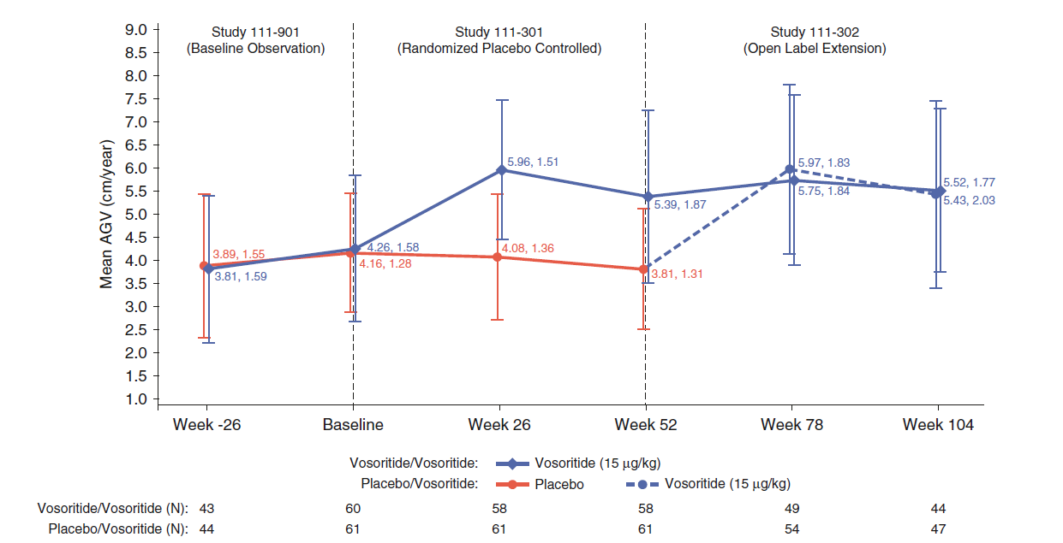

Note: Values are displayed as means and SD. Source: Savarirayan (2021)

Figure 2: Change in height z-score in Study 111-206 by cohort
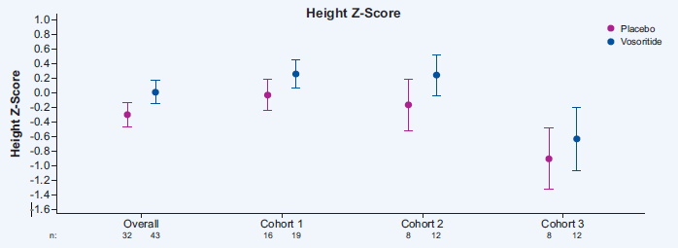
Source: Figure 1 pre-PBAC response (p1)
Cohort 1= Ages 24 to <60 months; n=35, 4 sentinels 31 randomised; Cohort 2 = Ages 6 to <24 months; n =20, 4 sentinels 16 randomised; Cohort 3 = Ages 0 to <6 months; n = 20, 3 sentinels 17 randomised.

Comparative harms
  - Comparative safety data are only available in Study 111-301 and are summarised in Table 5. The majority of AEs reported in study 111-301 were Grade 1 (mild) or Grade 2 in both groups (96.7% and 39.3% in the placebo group, respectively, 96.7% and 31.7% in the vosoritide group, respectively). Grade 3 AEs were reported less frequently, with 4.92% and 5% of subjects in the placebo and vosoritide groups, respectively. No Grade 4 AEs or deaths were reported.
  - The most common AEs (>20% in either treatment group) were injection site reaction (73.33% for vosoritide versus 47.54% for placebo), injection site erythema (68.33% versus 65.57%), and injection site swelling (38.33% versus 9.84%), nasopharyngitis (26.67% versus 29.51%), vomiting (26.67% versus 19.67%), headache (23.33% versus 26.23%), and pyrexia (16.67% versus 21.31%). Based on post hoc analyses of the odds ratio (OR), relative risk (RR) and risk difference (RD) and a p-value of less than 0.05 in each case, statistically significantly more patients in the vosoritide group than in the placebo arm reported: injection site reaction (73.33% vs. 47.54%; OR=3.03 [95% CI: 1.42, 6.5]); and injection site swelling (38.33% vs. 9.84%; OR=5.7 [95% CI: 2.12, 15.34]). Both study groups received daily SC injections so there is a lack of ability to determine magnitude of impact of injection related AEs compared to the absence of daily injections (as would be seen with BSC). The PSCR argued that all of these injection site events were transient, non-serious and the majority of events resolved without intervention and that no subjects discontinued from treatment due to injection site-related events. The ESC considered additional information on the impact of vosoritide on other complications that may impact on QoL such as pain, otitis media and sleep apnoea may be informative.
  - There were no drug-related SAEs or Grade 3 or higher drug-related AEs for 5-18 years old according to study 111-301 and 111-302. For 0 to <5 years old, no drug-related SAEs or death were reported for subjects in treatment Cohorts 1 and 2 (study 111-206).
Table 5: Summary of key adverse events in the Study 111-301
TEAEs | VOS (N=60) | Placebo (N=61) | OR [95% CI] | RR [95% CI] | RD [95% CI]
 | n with event/N (%) | n with event/N (%) | OR / RR < 1 favours VOS |  | RD < 1 favours VOS
All cause TEAEs
Any TEAE | 59/60 (98.33%) | 60/61 (98.36%) | 0.98 [0.06, 16.09] | 1.00 [0.95, 1.05] | 0.00 [-0.05, 0.05]
Any SAE | 3/60 (5.00%) | 4/61 (6.56%) | 0.75 [0.16, 3.50] | 0.76 [0.18, 3.26] | -0.02 [-0.1, 0.07]
Grade 3 AE | 3/60 (5.00%) | 3/61 (4.92%) | 1.02 [0.20, 5.25] | 1.02 [0.21, 4.84] | 0.00 [-0.08, 0.08]
Death | 0/60 (0.00%) | 0/61 (0.00%) | Not estimable | Not estimable | 0.00 [0.00, 0.00]
AEs leading to dose reduction | 0/60 (0.00%) | 0/61 (0.00%) | Not estimable | Not estimable | 0.00 [0.00, 0.00]
AEs leading to dose interruption | 10/60 (16.67%) | 10/61 (16.39%) | 1.02 [0.39, 2.66] | 1.02 [0.46, 2.26] | 0.00 [-0.13, 0.14]
AEs leading to study drug or study discontinuation | 1/60 (1.67%) | 0/61 (0.00%) | Not estimable | Not estimable | 0.02 [-0.02, 0.05]
SAEs leading to dose reduction | 0/60 (0.00%) | 0/61 (0.00%) | Not estimable | Not estimable | 0.00 [0.00, 0.00]
SAEs leading to dose interruption | 2/60 (3.33%) | 2/61 (3.28%) | 1.02 [0.14, 7.47] | 1.02 [0.15, 6.99] | 0.00 [-0.06, 0.06]
SAEs leading to study drug or study discontinuation | 0/60 (0.00%) | 0/61 (0.00%) | Not estimable | Not estimable | 0.00 [0.00, 0.00]
Drug-related TEAEs
Any drug-related TEAE | 53/60 (88.33%) | 51/61 (83.61%) | 1.48 [0.52, 4.20] | 1.06 [0.91, 1.22] | 0.05 [-0.08, 0.17]
Any drug-related SAE | 0/60 (0.00%) | 0/61 (0.00%) | Not estimable | Not estimable | 0.00 [0.00, 0.00]
Subjects with any EOI
Injection site reaction | 51/60 (85.00%) | 50/61 (81.97%) | 1.25 [0.48, 3.27] | 1.04 [0.88, 1.22] | 0.03 [-0.10, 0.16]
Most frequently reported TEAEs
Injection site reaction | 44/60 (73.33%) | 29/61 (47.54%) | 3.03 [1.42, 6.50] | 1.54 [1.14, 2.09] | 0.26 [0.08, 0.43]
Injection site erythema | 41/60 (68.33%) | 40/61 (65.57%) | 1.13 [0.53, 2.42] | 1.04 [0.81, 1.34] | 0.03 [-0.14, 0.20]
Injection site swelling | 23/60 (38.33%) | 6/61 (9.84%) | 5.70 [2.12, 15.34] | 3.90 [1.71, 8.89] | 0.28 [0.13, 0.44]
Source: Table 51 and Table 52, pp107, 110 of the submission, and amended during evaluation.
AE, adverse event; CI, confidence interval; EOI, event of interest; OR, odds ratio; RD, risk difference; RR, risk ratio; SAE, serious adverse event; TEAE, treatment emergent adverse event; VOS, vosoritide
Note: The ratio of ‘Injection site reaction’ is different between table 52 (111-301 CSR table 11.2.1.1) and table 53 (111-301 CSR table 11.2.3.2.1). The original CSR also had different values.
  - Comparative safety data between treatment and placebo were not available for children aged 6 month to < 5 years old. The PSCR provided an overview of the adverse events in Study 111-206, including children aged 0 to 5 years. The PSCR stated there were no SAEs related to treatment and low incidence of discontinuation due to an AE (3.1% with vosoritide) over 52 weeks. One vosoritide subject died, due to respiratory arrest, however the PSCR stated this event was not considered related to study treatment (the patient had a pre-existing respiratory condition). The ESC considered that more detail on the updated data from Study 111-206 was required to allow it to be evaluated. The pre-PBAC response noted the results from Study 111-206 had since been published in a poster (Savarirayan, 2022).
  - In addition, the small sample size might limit the ability to observe serious adverse events, especially for the under 5 years old age group.

Benefits/harms
  - A summary of the comparative benefits and harms for vosoritide versus placebo is presented in Table 6.
Table 6: Summary of comparative benefits and harms for vosoritide and PBO
Continuous outcome I: change from baseline AGV
 | Vosoritide |  |  |  |  |  |  |  | PBO |  |  |  |  | Difference in LS mean change from baseline:  Vosoritide vs. PBO  (95% CI)
 | N |  |  | LS Mean ∆ baseline AGV |  |  | 95%CI |  | N | LS Mean ∆ baseline AGV |  | 95%CI
Trial 111-301 | 60 |  |  | 1.71 |  |  | (1.40, 2.01) |  | 61 | 0.13 |  | (-0.18, 0.45) |  | 1.57 (1.22, 1.93)
Continuous outcome II: change from baseline height Z score
Trial 111-301 | 60 |  |  | 0.27 |  |  | (0.18, 0.36) |  | 61 | -0.01 |  | (-0.1, 0.09) |  | 0.28 (0.17, 0.39)
Harms
 |  | Vosoritide  n/N |  |  | PBO  n/N |  |  | RR  (95% CI) |  |  | Event rate/100 patients |  |  |  | RD  (95% CI)
 |  |  |  |  |  |  |  |  |  |  | Vosoritide |  | PBO
Adverse event I: Injection site reaction
Trial 111-301 |  |  | 44/60 |  |  | 29/61 |  | 1.54 (1.14, 2.09) |  |  | 73.3 |  | 47.5 |  | 0.26 (0.08, 0.43)
Adverse event II: Injection site swelling
Trial 111-301 |  |  | 23/60 |  |  | 6/61 |  | 3.90 (1.71, 8.89) |  |  | 38.3 |  | 9.8 |  | 0.28 (0.13, 0.44)
Adverse event III: Injection site erythema
Trial 111-301 |  | 41/60 |  |  |  | 40/61 |  | 1.04 (0.81, 1.34) |  |  | 68.3 |  | 65.6 |  | 0.03 (-0.14, 0.20)
Adverse event IV: Nasopharyngitis
Trial 111-301 |  | 16/60 |  |  |  | 18/61 |  | 0.90 (0.51, 1.60) |  |  | 26.7 |  | 29.5 |  | -0.03 (-0.19, 0.13)
Adverse event V: Vomiting
Trial 111-301 |  | 16/60 |  |  |  | 12/61 |  | 1.36 (0.70, 2.62) |  |  | 26.7 |  | 19.7 |  | 0.07 (-0.08, 0.22)
Adverse event VI: Headache
Trial 111-301 |  | 14/60 |  |  |  | 16/61 |  | 0.89 (0.48, 1.66) |  |  | 23.3 |  | 26.2 |  | -0.03 (-0.18, 0.12)
Adverse event VII: Pyrexia
Trial 111-301 |  | 10/60 |  |  |  | 13/61 |  | 0.78 (0.37, 1.64) |  |  | 16.7 |  | 21.3 |  | -0.05 (-0.19, 0.09)
Source: Table 38, 41,52; pp87,91, 110 of the submission.
CI = confidence interval; LS = least square = SD = standard deviation; VOS = vosoritide; PBO = placebo; RD = risk difference; RR = risk ratio.
Duration of follow up: trial 111-301 = 52 weeks.
  - On the basis of direct evidence presented by the submission:
- An average 1.57 cm increase in Annual Growth Velocity (AGV) from baseline to 52 weeks follow-up was achieved for vosoritide compared to placebo for children aged 5-17 (inclusive). The submission did not indicate what difference in AGV was considered clinically meaningful including across different ages when AGV are expected to differ.
  - On the basis of the direct evidence presented by the submission for the main clinical trial (study 111-302), for every 100 patients treated with vosoritide in comparison with placebo (also daily SC injections):
- Approximately 26 additional patients will have an injection site reaction
- Approximately 29 additional patients will have an injection site swelling

Clinical claim
  - The submission described vosoritide as superior in terms of effectiveness compared with placebo. The claim is appropriate and well-supported in 5 to < 18 year old children, but not well-supported in children under 5 years old. The key issues were:
  - Data from the one trial to provide data on children under 5 years of age (Study 111-206) included only eight sentinel intervention patients with no controlled comparison. The PSCR provided additional data from the randomised treatment arms for children 0-5 years from Study 111-206 (see paragraph 6.15). The ESC considered that evidence for use in patients less than 5 years was minimal with more detail about the updated data from Study 111-206 required to allow it to be evaluated. The pre-PBAC response noted the results from Study 111-206 had since been published in a poster (Savarirayan, 2022).
  - The ESC acknowledged the statistically significant improvement in AGV reported for patients receiving vosoritide compared with placebo. However, the ESC considered the clinical significance of the magnitude of change in this outcome was not well supported, nor it’s translation into other health benefits.
  - The submission described vosoritide as non-inferior in terms of safety compared to BSC. This claim is not supported. The key issues were:
  - Both study groups in Study 111-301 received daily SC injections so there is a lack of ability to determine magnitude of impact of injection related AEs compared to the absence of daily injections (as would be seen with BSC). Even compared with daily injection of placebo, statistically significantly more patients in the vosoritide group than in the placebo arm reported: injection site reaction (OR=3.03 [95% CI: 1.42, 6.5]); and injection site swelling (OR=5.7 [95% CI: 2.12, 15.34]). The PSCR argued that all of these injection site events were transient and non-serious with no subjects discontinuing treatment due to injection site-related events. The ESC agreed with the evaluation that a claim of non-inferior safety was not supported given injection site reactions were higher with vosoritide compared to placebo injection.
  - The safety comparative data between treatment and placebo were not available for children aged 6 month to < 5 years old. The PSCR provided an overview of the adverse events in Study 111-206, including children aged 0 to 5 years. As outlined in paragraph 6.24, the ESC considered that more detail about the updated data from Study 111-206 was required to allow it to be evaluated. The pre-PBAC response noted the results from Study 111-206 had since been published in a poster (Savarirayan, 2022).
  - The small sample size might limit the ability to observe serious adverse events, especially for children under 5 years old.
  - The PBAC considered that on the basis of improved height outcomes the claim of superior comparative effectiveness was reasonable in 5 to < 18 year old children and uncertain but likely reasonable in children under 5 years old.
  - The PBAC considered that the claim of non-inferior comparative safety was not adequately supported by the data.

Economic analysis
  - The submission presented a stepped economic evaluation including a modelled cost-utility analysis (CUA) comparing vosoritide with BSC based on a direct randomised trial (study 111-301). This is appropriate given the claim of superior efficacy of vosoritide against placebo.
  - The submission presented a cohort simulation model that included two health states (alive and dead) capturing patient mortality and complications via risks applied each cycle. Health-related QoL was incorporated in the model via the application of continuous health specific utility values (based on patient’s height relative to the age- and sex-matched general population) to patients remaining alive each cycle and utility decrements to patients experiencing complication events. The ESC considered the model structure is appropriate, however, there are uncertainties with the extrapolation of relative height (z-scores), translation of relative height into QoL, mortality and complications.
  - The key components of the economic evaluation are described in Table 7.
Table 7: Key components of the economic evaluation
Component | Description
Type of analysis | Cost-utility analysis (CUA)
Outcomes | QALYs and LYs gained
Time horizon | Lifetime (100 years)
Methods used to generate results | Cohort simulation; where characteristics of the patient cohort are updated each cycle, from which QoL, mortality risks and complication risks are derived
Health states | Two health states (alive and dead)
Cycle length | 1 year
Transition probabilities | Mortality risks applied in the BSC arm are derived via the application of achondroplasia standardised mortality ratios (Hetch 1987; Wynn 2007; Hashmi 2018; Simmons 2014) to Australian lifetables. Mortality risks applied in the vosoritide arm are derived via the application of a treatment effect based on relative patient height.  Complication risks applied in the BSC arm are derived from the LIAISE study. Complication risks applied in the vosoritide arm are derived via the application of a treatment effect based on relative patient height.  HRQoL is incorporated in the model via the application of a utility value to patients remaining alive each cycle. Rather than being attached to specific health states, utility values are applied as a continuous variable in the model, based on patient’s height relative to the age- and sex-matched general population (i.e., Z-score).
Software package | Microsoft Excel
Source: Table 62, p154 of the submission.
Abbreviations: BSC = best supportive care; HRQoL = health related quality of life; LIAISE = Lifetime Impact of Achondroplasia Study in Europe; LYs = Life years; QoL = quality of life; QALYs = Quality adjusted life years.

  - The model utilised achondroplasia specific growth charts to estimate height in the BSC arm of the model, while general population growth charts were used for estimating height Z-scores in the model. Height Z-scores were subsequently used for estimating the clinical benefits of vosoritide compared to BSC with respect to QoL, mortality and complications. The submission used the Sydney Children's Hospitals Network (SCHN) published growth charts for children with achondroplasia, and World Health Organisation (WHO) and Centre for Disease Control and Prevention (CDC) growth charts for general population. The evaluation considered this was appropriate.
  - Mortality risks in the BSC arm of the model were derived based on published natural history data in achondroplasia, while in the vosoritide arm of the model mortality risks were estimated relative to BSC risks based on a surrogate treatment effect estimated as a function of relative patient heights (Z-scores). Standardised mortality ratios (SMR’s) applied in the model base case are presented in Table 8. The ESC agreed with the evaluation that the use of height as a surrogate to estimate the impact of treatment with vosoritide on patient risk of mortality was not supported by the evidence presented in the submission. The pivotal trial (study 111-301) did not have an appropriate follow up period or study power to determine mortality risk. Further evidence to support the link between height and mortality was not provided.
Table 8: Standardised mortality ratios (SMR’s) applied in the model base case
Age | Vosoritide arm | BSC arm
4 | 2.000 | 2.000
5 | 1.851 | 2.000
6 | 1.757 | 2.000
7 | 1.685 | 2.000
8 | 1.641 | 2.000
9 | 1.602 | 2.000
10 | 1.576 | 2.000
11 | 1.544 | 2.000
12 | 1.501 | 2.000
13 | 1.463 | 2.000
14 | 1.437 | 2.000
15 | 1.426 | 2.000
16 | 1.430 | 2.000
17 | 1.439 | 2.000
18+ | 1.423 | 2.000
Source: Table 88, p186 of the submission.
Abbreviations: BSC = best supportive care; SMR’s = standardised mortality ratios.

  - Complication risks in the BSC arm of the model were based on natural history data from the Lifetime Impact of Achondroplasia Study in Europe (LIAISE) study, and in the vosoritide arm of the model these are estimated relative to BSC risks (via the application of a treatment effect based on relative patient height observed in study 111-301). LIAISE is a retrospective observational study examining the clinical characteristics, clinical measures and QoL over the lifetime of patients with achondroplasia across six European countries. Cumulative risk of complications applied in the model base case is presented in Table 9. The ESC agreed with the evaluation that the use of height as a surrogate to estimate the impact of treatment with vosoritide on patient risk of complications was not supported by the evidence presented in the submission. The pivotal trial (study 111-301) did not have an appropriate follow up period or study power to determine long-term complication risk. Further evidence to support the link between height and complications was not provided.
Table 9: Cumulative risk of complications in the model base case
 | Vosoritide | BSC | Difference | RR ª
Foramen magnum stenosis | 9.4% | 11.6% | -2.2% | 0.810
Hydrocephalus | 2.8% | 3.9% | -1.0% | 0.730
Sleep apnoea | 17.6% | 22.5% | -4.8% | 0.785
Spinal stenosis | 24.6% | 37.6% | -13.0% | 0.653
Kyphosis | 1.0% | 1.4% | -0.4% | 0.746
Leg bowing | 15.3% | 20.0% | -4.7% | 0.764
Cardiovascular disease | 9.3% | 14.1% | -4.8% | 0.657
Otitis media | 9.2% | 11.3% | -2.1% | 0.812
Dental malocclusion | 9.0% | 12.4% | -3.4% | 0.730
Source: Table 87, p185 of the submission.
Abbreviations: BSC = best supportive care; RR = relative risk.
Note: a. This is an implied relative risk over the duration of the model. Implied RR’s are not consistent across complications as the incidence of events differ based on age, as does the applied treatment effect (i.e., Z-score ratio). Therefore, complications most often occurring in adults are most impacted by the applied treatment effect as the Z-score ratio is highest in patients aged 18 and above.

  - The treatment effect in terms of gains in annual height velocity are achieved within childhood (up to age 17-18 years). The economic evaluation continues to apply mortality benefits after the treatment effect ceases. This may be reasonable but is uncertain with a lack of evidence presented to support this approach. The PSCR stated that achondroplasia is known to cause complications, including death, throughout a patient’s lifetime but acknowledged the extent of mortality benefit is uncertain. The ESC agreed with the evaluation that there was a lack of evidence to support the application of mortality benefits in the model but noted sensitivity analyses showed that the impact of this uncertainty on the cost-effectiveness is minimal (change in the ICER of less than 3% when mortality benefits are removed (see Table 15)). The pre-PBAC response acknowledged the data supporting an effect for vosoritide on risk of complications and mortality is still emerging. As such, the pre-PBAC response argued that the model takes a conservative approach to the estimation and valuation of this treatment effect, reflected in the insensitivity of the model results to these treatment effects.
  - There is an ongoing QoL benefit applied throughout the economic evaluation time horizon based on the gains in height achieved during childhood. The evaluation considered this may be reasonable but is uncertain. The PSCR argued short stature can impair quality of life and that treatment with vosoritide may enable patients to reach a final adult height that is up to 25 cm greater than would otherwise have been achieved. The PSCR stated that patients treated with vosoritide will live their remaining life expectancy with an improved final height and so it is reasonable for this improved quality of life to be accounted for over the patient’s remaining life expectancy. The ESC noted evidence from Study 111-301 indicated no difference in QoL measures between treatment arms (see paragraph 6.13). In addition, the ESC noted the submission’s argument that significant functional gains would be provided by closing the gap between adult height of patients with achondroplasia and urban design reach standards (153 cm) (see paragraph 4.1). However, the ESC noted that according to clinical benefits modelled (see Figure 3), only those who started treatment at < 1 year of age would likely reach this threshold of 153 cm. As such, the ESC considered the magnitude of QoL benefits associated with closing the gap with urban design reach standards was uncertain. The pre-PBAC response argued it was not necessary to reach a threshold of 153 cm to achieve improvements in quality of life. The pre-PBAC response argued that Christensen (2007) showed that declines in quality of life as a function of height in the general population begin to appear from a Z-score of approximately -2 (see Figure 4). This corresponds to approximately 150 cm to 160 cm in the Australian adult population (for women and men respectively). The pre-PBAC response stated that a continuous decline in quality of life from this point shows that the closer to 153 cm, the smaller the quality of life impairment.
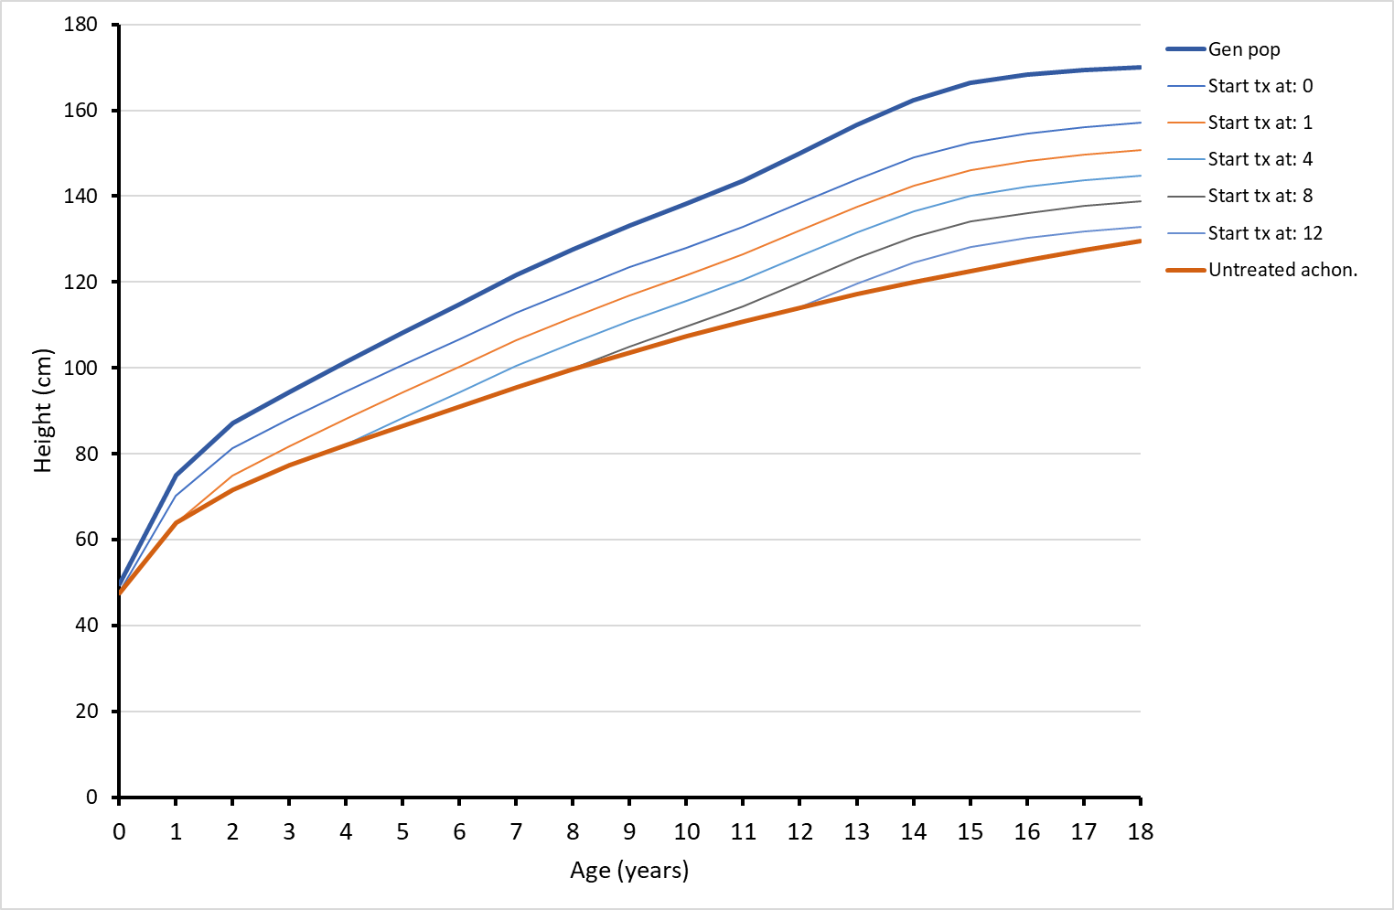
Figure 3: Modelled patient height, by age at initiation of vosoritide
Source: Figure 44, p170 of the submission.
Abbreviations: cm = centimetre; Gen pop = general population; tx = treatment.

  - The economic model applied a baseline height of 82.1 cm, and baseline age of 4 years to the modelled cohort. Baseline height was based on data from the Sydney Children’s Hospital Network, while baseline age was assumed based on the average age of patients initiating treatment with vosoritide in budget impact estimates presented in the submission. The model population age and height were different to the clinical evidence presented (study 111-301). The average baseline age and height in study 111-301 were 8.71 years (8.35 years in the vosoritide arm and 9.06 years in the placebo arm) and 101.6 cm (100.20 cm in the vosoritide arm and 102.94 cm in the placebo arm), respectively. The assumed average age of patients initiating treatment in the financial estimates presented is uncertain, given that it relied on uncertain underlying assumptions to estimate the number of patients initiating treatment. The ESC noted that baseline age of the economic model (4 years) is inconsistent with the PI and proposed TGA population, while the financial estimates included patients from age 0 to 17 years. The PBAC noted the impact of varying baseline age on the ICER was tested in the sensitivity analyses.
  - The model estimated vosoritide treatment effect to provide 72% of the growth velocity deficit experienced by the achondroplasia population, and this 72% was applied to vosoritide treated patients in each year of the model until growth plate closure. This may not be reasonable given that trial 111-301 follow-up duration was limited to 12 months only, with the supportive evidence from the ongoing long-term extension study 111-205 providing evidence of positive effects on growth for up to 5 years. The PSCR argued that the 5-year data are useful in establishing the longer-term treatment effect since the natural history of achondroplasia rates of growth are well understood (as demonstrated by achondroplasia growth charts). Therefore, the PSCR argued that growth velocity observed in the longer-term data can be reliably compared to what would be expected in an age/sex matched population. The ESC considered that it is uncertain if the treatment effect of 72% applied in the economic model will be sustained across childhood, particularly beyond the first 5 years of treatment until growth plate closure.
  - The estimated utilities applied in the model were uncertain for the reasons discussed below:
- Health related QoL was incorporated in the model via the application of a height-specific utility value to patients remaining alive each cycle. The model extrapolated utility data obtained from Christensen (2007) using a quadratic polynomial function to allow for the estimation of utility values associated with Z-scores beyond the ranges reported in Christensen (2007) (see Figure 4).
- Utility values were obtained from a study (Christensen 2007) conducted in the general UK population, and not in achondroplasia population or short stature population.
- Height Z-score of the great majority of patients with achondroplasia was below -3.0, while Christensen (2007) did not distinguish between patients with Z-scores below -3.
- Given that Christensen (2007) did not report utility data or people with Z-scores below -3, extrapolation was performed by the submission to allow estimation of utility values beyond those reported in the study. Extrapolation has increased the uncertainty of the estimates applied to economic model and testing in sensitivity analysis was limited to two other functions (cubic and linear). The ICER is highly sensitive to this assumption.
- The utility values were applied in the model to children aged 4 years onwards, while Christensen 2007 study was based on a survey of adults (aged ≥18 years) with the EQ-5D and not children.
Overall, the lack of data from prospective longitudinal follow-up studies makes inferences about cause and consequences difficult. The lack of data in a similar population to achondroplasia also impacts the generalisability of utility values given that the condition is characterised not just by short stature but also significant clinical morbidity which likely interact. The PSCR argued that while uncertain, it was reasonable to assume utility continues to be correlated with height below z-scores of
-3. The PSCR argued that this is supported by mapped SF-36 data from Yonko 2021, whereby a mean EQ-5D utility values of 0.57 is estimated for achondroplasia patients in the US compared to 0.84 in the general population. The ESC agreed with the PSCR that the single utility estimate for the achondroplasia population in Yonko 2021 could not be directly used in the economic model because it doesn’t capture a change in utility associated with a change in height. However, the ESC considered it is not sufficient to rely on mapping of a single utility estimate to support the assumption that utility will continue to correlate with height below z-score of -3 as used in the economic model. The ESC considered that the estimated utilities beyond those reported in Christensen are highly uncertain and noted that the ICER was highly sensitive to the extrapolation of these utility data (see Table 15).
Figure 4: Illustration of height-based utility values applied in sensitivity analyses
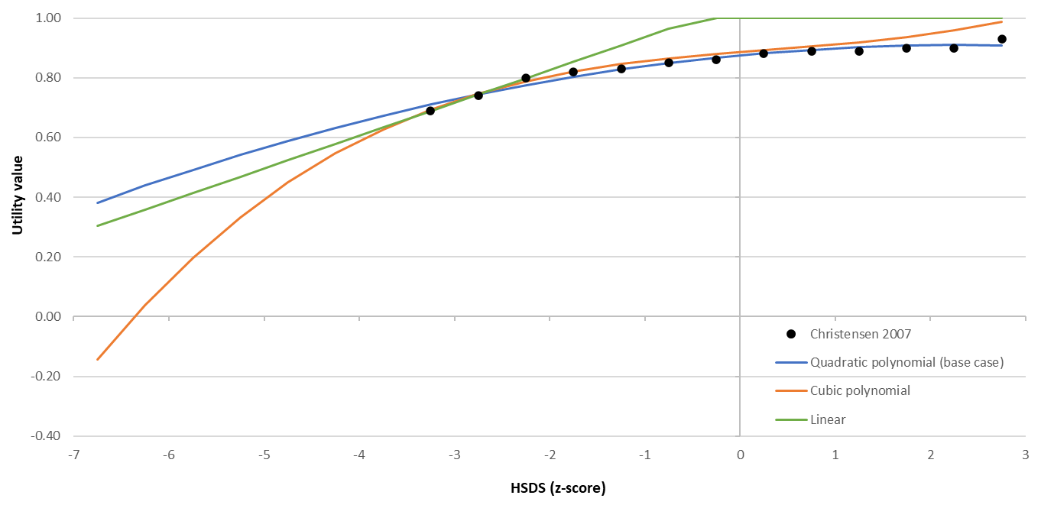
Source: Figure 58, p209 of the submission.
Abbreviations: HSDS = height standard deviation scores.
Note: The linear extrapolation is capped at a maximum utility of 1.0.

  - The base case economic model assumed 100% persistence to vosoritide, until growth plate closure. This is not consistent with the clinical evidence presented. Study 111-301 was limited to 12-month follow-up (with 57.77 months extension in study 111-205) with discontinuation rate of 3.3% reported in the treatment arm of the study.
  - The survival model traces over time for vosoritide and BSC arms, relative to the age- and sex-matched general population are presented in Figure 5. The submission stated that over the lifetime model these survival curves translate to an estimated life expectancy of 76 years in the vosoritide arm and 72.5 years in the BSC arm, compared to 79.3 years for the age- and sex-matched general population. This was not consistent with the data presented in Figure 5 and it would be more appropriate to compare life expectancy with the average for the achondroplasia population rather than the age- and sex- matched general population. The model validation statistics show that median survival in the treatment arm of the model is observed approximately at age 83 years. The PBAC agreed with the ESC that this may not be reasonable given that achondroplasia has an average life expectancy of 72.8 years (10 years less than average of the general population). The modelled survival gain for the treatment arm is uncertain. As described above (see paragraph 6.32), the submission assumed that vosoritide treatment will lead to the estimated survival gain through improved height.
Figure 5: Survival modelled in the base case (including general population for reference)
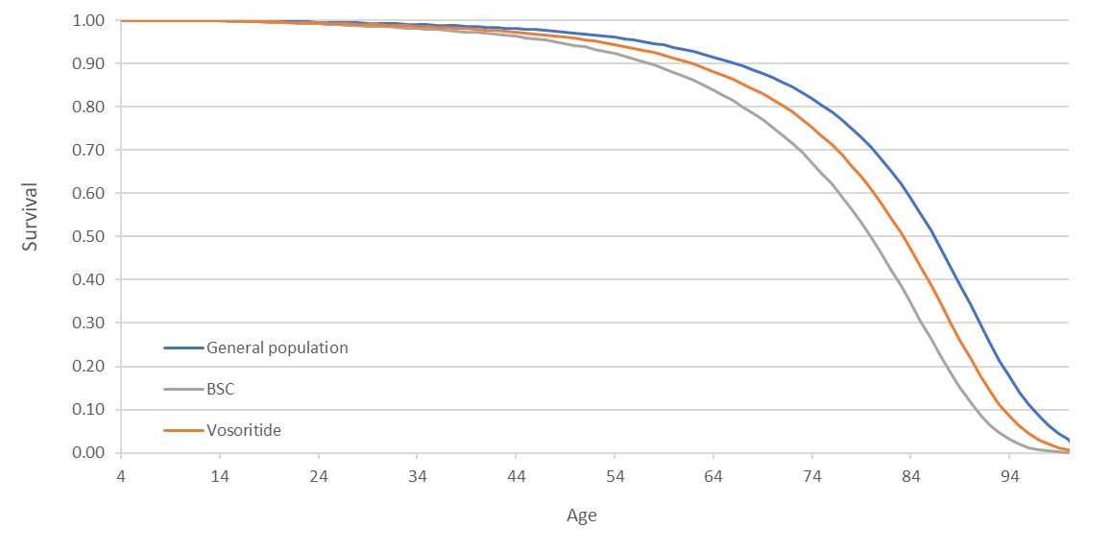Source: Figure 52, p199 of the submission.
Median survival
General population = ~86 years
BSC = ~80 years
Vosoritide = ~83 years
Abbreviations: BSC = best supportive care.

  - The standing height over time of patients in the vosoritide and BSC arms in the model base case (including general population for reference) is presented in Figure 6. The submission stated that patients in the vosoritide arm grow at a greater rate than patients in the BSC arm until growth plate closure, after which time patient height remains constant for the remainder of the model. This was appropriate and consistent with the clinical evidence presented in the submission, where patients in the vosoritide arm of Study 111-301 grew at a greater rate than patients in the placebo arm.
Figure 6: Patient height modelled in the base case (including general population for reference)
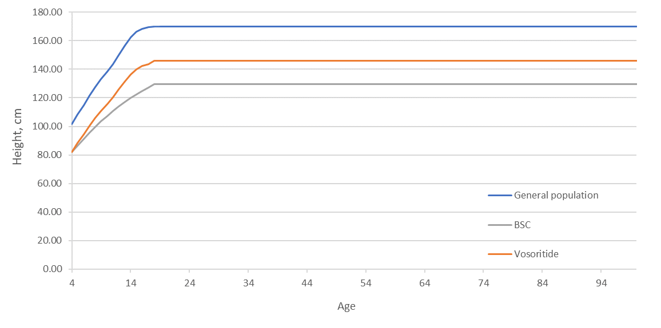Source: Figure 53, p200 of the submission.
Abbreviations: BSC = best supportive care.

  - The modelled height Z-scores for vosoritide and BSC in the model base case are presented in Figure 7. The submission stated that the initial Z-score variability observed in the model is a result of the differing patterns of growth velocity experienced by patients with achondroplasia compared to the general population. Z-scores subsequently plateau upon patients reaching adult height.
  - The submission stated that a pubertal acceleration in growth velocity from approximately 10 to 14 years of age in the general population is not observed in the achondroplasia population, which means the height Z-score of the achondroplasia population drops dramatically over this period before improving again post puberty. The evaluation considered this was reasonable.
Figure 7: Height Z-score modelled in the base case
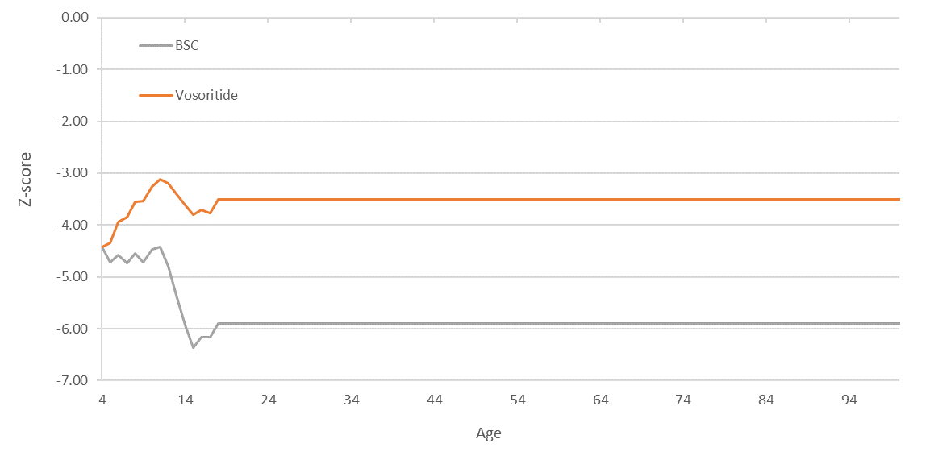
Source: Figure 54, p200 of the submission.
Abbreviations: BSC = best supportive care.

  - The cumulative undiscounted costs and QALYs for both arms from the model base case are presented in Figure 8 and Figure 9, respectively.

Figure 8: Undiscounted cumulative costs in the model base case
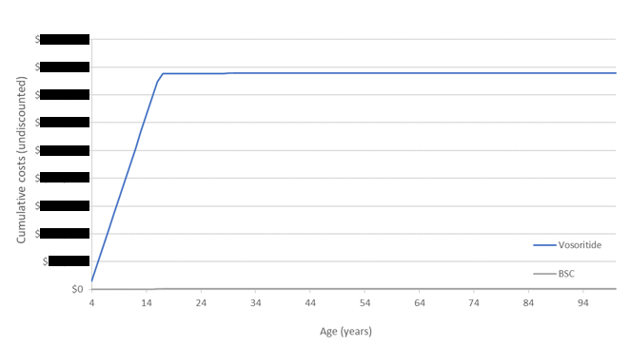
Source: Figure 55, p201 of the submission. Abbreviations: BSC = best supportive care.

Figure 9: Undiscounted cumulative QALYs in the model base case
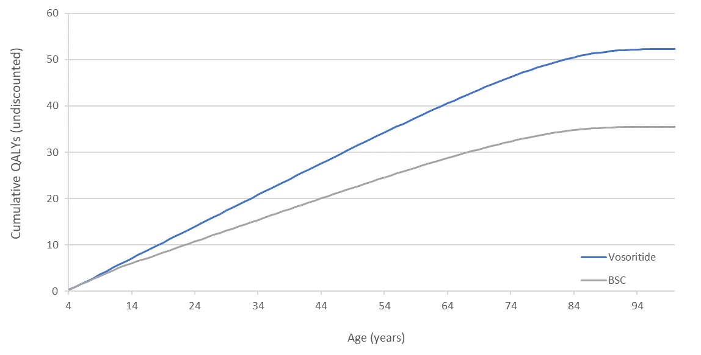
Source: Figure 56, p201 of the submission.
Abbreviations: BSC = best supportive care.

  - The disaggregated summary of discounted health outcomes for the comparison of vosoritide with BSC are presented in Table 10. The ESC noted that the model resulted in an incremental benefit of 3.346 QALYs which was driven by the height based QALYs (99.8% of the total incremental outcome).
Table 10: Disaggregated summary of health outcomes included in the economic evaluation (discounted)
Outcome | Outcome for vosoritide | Outcome for BSC | Incremental outcome | % of total incremental outcome
Height-based QALYs | 13.551 | 10.212 | 3.340 | 99.8%
Complication based QALYs | -0.025 | -0.031 | 0.006 | 0.2%
Total QALYs | 13.527 | 10.181 | 3.346 | 100%
Total LYs | 19.789 | 19.652 | 0.137 | N/A
Source: Table 101, p204 of the submission.
Abbreviations: BSC = best supportive care; LY = life year; N/A = not applicable; QALY = quality adjusted life year.

  - The disaggregated costs for comparison of vosoritide with BSC are presented in Table 11. The model resulted in an incremental cost of $| | (discounted) which was driven by the cost of vosoritide treatment.
Table 11: Disaggregated summary of cost impacts (discounted and undiscounted)
 | Vosoritide | BSC | Incremental
Undiscounted
Drug costs | $|||||| | $0 | $||||||
Complication costs ª | $13,214 | $18,343 | -$5,129
Total costs | $|||||| | $18,343 | $||||||
Discounted
Drug costs | $|||||| | $0 | $||||||
Complication costs | $6,784 | $8,477 | -$1,693
Total costs | $|||||| | $8,477 | $||||||
Source: Table 101, p204 of the submission.
Abbreviations: BSC = best supportive care; LYs = life years; QALYs = quality adjusted life years.
^{a.} Complication applied in the model were: Decompression surgery (applied as foramen magnum stenosis); Shunt insertion (applied as hydrocephalus); Sleep apnoea; Spinal corrective surgery (applied as spinal stenosis); Kyphosis; Leg bowing; Cardiovascular disease; Tympanostomy (applied as otitis media); and Dental overcrowding (applied as dental malocclusion).

  - A summary of the key drivers of the model is presented in Table 12. The model results were most sensitive to the time horizon, extrapolation of utility data, and reduction in treatment effect (% of height restoration of general population).
Table 12: Key drivers of the model
Description | Method/Value | Impact  Base case: $|¹/QALY gained.
Time horizon | lifetime | High, favours vosoritide. Use of 10-year and 20-year time horizon increased the ICER to $||||||² and $||||||² per QALY gained, respectively.
Utility data extrapolation | Height based utility values extrapolated from Christensen 2007 | High, ICER highly sensitive to utility values. A 20% decrease in utility values resulted in an ICER of $||||||² with a 20% increase resulting in an ICER of $||||||³.
Treatment effect (% of height restoration of general population) | 72% restoration of general population height | High, favours vosoritide. Use of 56% and 20% restoration of general population increased the ICER to $||||||² and $||||||² per QALY gained, respectively.
Source: Table 104, p206, and Table 107, p210 of the submission.
Abbreviations: BSC = best supportive care; ICER = incremental cost effectiveness ratio; QALY = quality adjusted life years.
The redacted values correspond to the following ranges:
¹ $855,000 to < $955,000
² > $1,055,000
³ $655,000 to < $755,000

  - The results of the stepped economic evaluation and base case analysis are presented in Table 13 and Table 14.
Table 13: Results of the stepped economic evaluation
Step | Analysis | Incremental cost | Incremental outcome | ICER
1 | Trial-based analysis (12-months)  Costs: Drug costs  Outcomes: Incremental growth (cm) | $| | 1.57 cm | $||||¹ per cm height
2 | Extrapolation of costs and outcomes (lifetime)  Costs: Drug costs  Outcomes: Incremental growth (cm) | $| | 16.42 cm | $||||¹ per cm height
3 | Translation of outcomes to QALYs  Costs: Drug costs  Outcomes: QALYs | $| | 3.245 QALYs | $||² per QALY
4 | Incorporation of disease related mortality  Costs: Drug costs  Outcomes: QALYs and LYs | $| | 3.340 QALYs | $||² per QALY
5 | Incorporation of disease related complications  Costs: Drug and healthcare costs  Outcomes: QALYs and LYs | $| | 3.346 QALYs | $||² per QALY
Source: Table 100, p203 of the submission.
Abbreviations: cm = centimetre; ICER = incremental cost-effectiveness ratio; LYs = life years; QALY = quality adjusted life year.
The redacted values correspond to the following ranges:
¹ $155,000 to < $255,000
² $855,000 to < $955,000

Table 14: Results of the base case economic evaluation
Component | Vosoritide | BSC | Increment
Costs | $| | $8,477 | $ |
QALYs | 13.527 | 10.181 | 3.346
Incremental cost/extra QALY gained |  |  | $ | ¹
Source: Table 102, p204 of the submission.
Abbreviations: BSC = best supportive care; ICER = incremental cost-effectiveness ratio; QALY = quality adjusted life year.
The redacted values correspond to the following ranges:
¹ $855,000 to < $955,000

  - Sensitivity analyses for height-based utility values based on actual values could not be performed during the evaluation because the utility formulas used in the model were directly applied to model traces and not to input parameters. However, an alternative approach was explored during evaluation; where a 20% (either increase or decrease) was multiplied to the resulting utility values in the model traces despite that relative treatment effect was already incorporated. A new model that allowed different utility values to be tested in sensitivity analysis was provided in the PSCR. The sensitivity analysis applying 20% variability to the height-based utility values was updated using the new model provided in the PSCR (see Table 15).
  - The results of key univariate and multivariate sensitivity analyses presented in the submission and performed during the evaluation are summarised in Table 15.
Table 15: Sensitivity analyses
Analyses |  | Incremental cost | Incremental QALY | ICER |  | % change from base case
Base case |  | $|| | 3.3459 | $||¹ |  | -
Time horizon (base case lifetime)
1 yearª |  | $|| | 0.02 | $||||² |  | 2141%
5 yearsª |  | $|| | 0.25 | $||||² |  | 615%
10 years |  | $|| | 0.70 | $||||² |  | 396%
20 years |  | $|| | 1.77 | $||||² |  | 189%
Discount rate (base case 5%)
0% |  | $|| | 16.81 | $||||³ |  | -73%
1.5%ª |  | $|| | 9.15 | $||||⁴ |  | -55%
3.5% |  | $|| | 4.85 | $||||⁵ |  | -25%
Utility data extrapolation (base case quadratic polynomial function)
Cubic extrapolation |  | $|| | 7.63 | $||||⁴ |  | -56%
Linear extrapolation |  | $|| | 4.11 | $||||⁶ |  | -19%
Height-based utility values (base case obtained from Christensen 2007)
20% variability (increase)^{b} |  | $|| | 3.88 | $||||⁶ |  | -14%
20% variability (decrease)^{b} |  | $|| | 2.59 | $||||² |  | 29%
Treatment effect: height (base case 72% restoration of GP height)
56% restoration of GP height |  | $|| | 2.69 | $||||² |  | 124%
30% restoration of GP heightª |  | $|| | 1.52 | $||||² |  | 221%
20% restoration of GP heightª |  | $|| | 1.03 | $||||² |  | 325%
Additional 1.93 cm/year relative to BSC |  | $|| | 4.49 | $||||⁵ |  | -25%
Start age (base case: start age 4 years)
2 years |  | $|| | 3.6794 | $||||¹ |  | 0.4%
5 years |  | $|| | 2.8511 | $||||¹ |  | 3.8%
8 years |  | $|| | 2.2261 | $||||¹ |  | 3.5%
Multivariate sensitivity analyses
Treatment effect: mortality and complications (Base case: based on relative Z-scores)
None (both mortality and complications)ª | $|| |  | 3.25 |  | $||||¹ |  | 3%
Start age + treatment effect on mortality and complications + time horizon
(Base case: start age 4 years + treatment effect (mortality and complications based on relative Z-score) + lifetime time horizon)
2 years start age + no treatment effect on mortality or complications + 5-year time horizonª |  | $|| | 0.27 | $||||² |  | 568%
5 years start age + no treatment effect on mortality or complications + 5-year time horizonª |  | $|| | 0.2 | $||||² |  | 793%
8 years start age + no treatment effect on mortality or complications + 5-year time horizonª |  | $|| | 0.15 | $||||² |  | 1008%
Source: Table 104, p206, Table 106, p208, and Table 107, p210 of the submission.
Abbreviations: BSC = best supportive care; cm = centimetre; GP = general population; ICER = incremental cost effectiveness ratio; QALY = quality adjusted life years.
ª Sensitivity analyses conducted during the evaluation.
^{b} Sensitivity analysis updated using the new model provided in the PSCR (see paragraph 6.49).
The redacted values correspond to the following ranges:
¹ $855,000 to < $955,000
² > $1,055,000
³ $155,000 to < $255,000
⁴ $355,000 to < $455,000
⁵ $555,000 to < $655,000
⁶ $655,000 to < $755,000
  - The submission stated that decreasing the discount rate to 1.5% as recommended in the Medicines Australia submission would reduce the ICER to $355,000 to < $455,000 and into a range which the PBAC can consider acceptable for a rare condition like achondroplasia. The ICER decreased to $155,000 to < $255,000/QALY and $555,000 to < $655,000/QALY when the discount rates of 0% and 3.5% were applied respectively.
  - The ESC noted the ICER was sensitive to QoL estimation. The ICER increased to > $1,055,000 when a 20% decrease in the height-based utility values are used. The ICER decreased to $355,000 to < $455,000/QALY with cubic extrapolation of utility values, and $655,000 to < $755,000/QALY when linear extrapolation was applied. As outlined in paragraph 6.35 and paragraph 6.38 the ESC considered the height based QoL benefits applied in the model highly uncertain.

Drug cost/patient/year
  - The drug cost per patient per year is presented in Table 16 based on the proposed effective price. The estimated the cost of treatment with vosoritide per patient per year to be approximately $| | (at 98.8% compliance rate). The vosoritide cost per day is approximately $| |.
Table 16: Drug cost per patient for proposed and comparator drugs (proposed effective price)
 |  | Vosoritide  Trial dose and duration | Vosoritide  Model | Vosoritide  Financial estimates
A | Mean dose (daily) ª | 15 µg/kg (for >2 years) | 15 µg/kg (for >2 years) | 30 µg/kg (for <2 years; off-label use^{d})  15 µg/kg (for >2 years)
B | Cost/script (DPMQ) | $ | | $ | | $|
C | Doses per year (full compliance) | 365.25 | 365.25 | 365.25
D | Annual compliance | 98.8% | 98.8% | 98.8%
E | Doses per year (compliance adjusted) ^{b} | 360.7 | 360.7 | 360.7
F | Doses per script | 30 | 30 | 30
G | Scripts per year ^{c} | 12.02 | 12.02 | 12.02
H | Cost/patient/month | $ | | $ | | $|
I | Cost/patient/year | $ | | $ | | $|
Source: Compiled during evaluation based on data from the submission and Table 93, p193 of the submission.
Abbreviations: BSC = best supportive care; DPMQ = dispensed price per maximum quantity; N/A = not applicable; µg = microgram.
Notes:
a. Weight band dosing is recommended for vosoritide based on a usual dose of 30 µg/kg for patients aged less than two years old and 15 µg/kg for patients aged two and above.
b. C*D.
c. E/F
d. The proposed TGA indication for vosoritide is for the treatment of achondroplasia in patients 2 years of age and older whose epiphyses are not closed.

Estimated PBS usage & financial implications
  - This submission was considered by DUSC.
  - The submission used an epidemiological approach to estimate the financial implications associated with the proposed listing of vosoritide, for the treatment of patients with achondroplasia, prior to growth plate closure. The evaluation considered this was appropriate, given that no medicines are currently listed on the PBS for use in achondroplasia.
  - The key inputs used by the submission to inform the financial estimates are summarised in Table 17.
Table 17: Data sources and parameter values applied in the utilisation and financial estimates
Data | Value | Source | Comment
Eligible population
Approach taken (epidemiological approach) | Year 1:  - Grandfathered patients aged 0-16 years, plus  - Achondroplasia prevalence among patients aged 0-16 years (total prevalence patients minus patients currently enrolled in clinical trials).  Years 2-6:  - Birth prevalence of achondroplasia (patients aged 0-4 years) | N/A | Achondroplasia prevalence among people aged less than 18 is used to estimate the total eligible patient population. The budget impact model assumes patients aged 17 and above will neither initiate nor continue treatment with vosoritide. The evaluation considered this was reasonable.
Births in Australia | Yr 1: 353,462  Yr 2: 358,304  Yr 3: 362,706  Yr 4: 366,687  Yr 5: 370,252  Yr 6: 373,433 | ABS | The evaluation considered this was appropriate.
Prevalence of achondroplasia, per 100,000 | Yr 1: 5.2 per 100,000  Yr 2: 5.3 per 100,000  Yr 3: 5.3 per 100,000  Yr 4: 5.3 per 100,000  Yr 5: 5.3 per 100,000  Yr 6: 5.3 per 100,000 | Tofts 2021 | In Year 1, the submission applied a prevalence of 5.2 per 100,000; which corresponds to childhood prevalence as reported in the study; for all patients including patients at age 0. The birth prevalence rate of 5.3 per 100,000 would have been more appropriate for those patients at age 0.
Eligible patients, n | Yr 1: 299  Yr 2: 19  Yr 3: 19  Yr 4: 19  Yr 5: 20  Yr 6: 20 | Calculated by the submission | The evaluation considered this was appropriate.
Treatment utilisation
Uptake rate | Yr 1: (total uptake)  ||||||% for grandfathered patients ª  ||||||% for prevalent patients ^{b}  Yr 2: ||||||% (total uptake)  Yr 3: ||||||% (total uptake)  Yr 4: ||||||% (total uptake)  Yr 5: ||||||% (total uptake)  Yr 6: ||||||% (total uptake) | Submission assumption | The assumptions used to estimate the uptake rates were not appropriately justified by the submission. DUSC considered the uptake rates uncertain and maybe underestimated.
Total patients initiating treatment | Yr 1: ||| |||¹ (grandfathered + prevalent patients)  Yr 2: ||| |||¹  Yr 3: ||| |||¹  Yr 4: ||| |||¹  Yr 5: ||| |||¹  Yr 6: ||| |||¹ | Calculated by the submission ^{c} | The evaluation considered this was appropriate. The submission subtracted the ||||||¹ patients expected to be eligible for grandfathering from the total projected prevalent achondroplasia population to avoid double counting.
Number treated (initiating and continuing) ^{d} | Yr 1: ||| ||| (grandfathered + prevalent patients)  Yr 2: ||| |||¹  Yr 3: ||| |||¹  Yr 4: ||| |||¹  Yr 5: ||| |||¹  Yr 6: ||| |||¹ | Calculated by the submission | The evaluation considered this was appropriate.
Utilisation of vosoritide vial volumes, by age | 0.4 mg: 0-10 years  0.56 mg: 11-15 years  1.2 mg: >16 years | Calculated by the submission based on median weight and dose. | The evaluation considered this was appropriate.
Scripts dispensed | Yr 1: ||| |||²  Yr 2: ||| |||²  Yr 3: ||| |||²  Yr 4: ||| |||²  Yr 5: ||| |||²  Yr 6: ||| |||² | Calculated by the submission ^{e} | The evaluation considered this was appropriate
Costs
Vosoritide | Published pricing:  All strengths:  $|||| |||| (AEMP)  $|||| |||| (DPMQ)  Effective pricing/SPA  All strengths:  $||| ||| (AEMP)  $||| ||| (DPMQ) | Requested price | This is consistent with the prices presented in the economic evaluation. Both economic analyses and financials used the effective pricing.
Patient co-payments
Beneficiary type distribution | General ordinary: 7.0%  General safety net: 1.3%  Concessional ordinary: 65.6%  Concessional free service: 22.6%  RPBS ordinary: 2.5%  RPBS safety net: 1.2%
Patient co-payments, % | 96.63% (PBS services)  3.37% (RPBS services) | PBS/RPBS 2021 | The evaluation considered this seemed reasonable.
Patient co-payments, $ | $7.73 (PBS services)  $4.49 (RPBS services) | PBS/RPBS 2021 | The evaluation considered this seemed reasonable.
Source: Table 111, p214, Table 113, p216, Table 114, p217, Table 115, p217, Table 117, p218, Table 121, p220, Table 123, p221, and Table 124, p221 of the submission.
Abbreviations: ABS = Australian Bureau of statistics; AEMP = approved ex-manufacturer price; DPMQ = dispensed price for maximum quantity; N/A = not applicable; PBS = Pharmaceutical Benefits Scheme; RPBS = Repatriation Pharmaceutical Benefits Scheme; SPA = special pricing arrangement.
Notes:
a. The submission assumed ||| |||% of patients in clinical trials will transition to PBS setting. The submission noted that weighted average uptake (||| |||%) is not equal to ||| |||% due to rounding.
b. Age based uptake rates among the prevalent pool were based on the submission assumptions (||| |||% for patients aged 0-4; ||| |||% for patients aged 5-8; ||| |||% for patients aged 9-12; and ||| |||% for patients aged 13 to 16 years).
c. Prevalence * uptake rate. Patient uptake estimates are rounded to the nearest whole patient. The submission noted that this approach was considered reasonable due to the low patient numbers at each age.
d. Financial estimates assume 97.1% of patients on treatment will remain on treatment the following year, until growth plate closure (assumed to occur at 17 years of age).
e. Calculated as a function of patients on treatment, multiplied by scripts per patient per year.
The redacted values correspond to the following ranges:
¹ < 500
² 500 to < 5000
  - The submission used prevalence of achondroplasia among people aged less than 18 (5.2 per 100,00) and birth prevalence of achondroplasia (5.3 per 100,000) to estimate the total eligible patient population. In Year 1, the submission applied a prevalence of 5.2 per 100,000 that corresponds to childhood prevalence as reported in the study, for all patients including those who at age 0. Achondroplasia birth prevalence rate of 5.3 per 100,000 would have been more applicable for those patients at age 0. However, this will likely have a minor impact on the total estimated number of patients with achondroplasia; the submission estimated 18 patients with achondroplasia when achondroplasia childhood prevalence (5.2 per 100,000) was used, while this estimate would be 19 patients if achondroplasia birth prevalence (5.3 per 100,00) is applied.
  - Consistent with the economic model, the budget impact model assumed patients aged 17 and above will neither initiate nor continue treatment with vosoritide. The evaluation considered this was reasonable.
  - The submission estimated a total of < 500 patients currently enrolled and receiving vosoritide in a clinical trial setting. The submission stated that it is expected that a proportion of these patients (n=44) will remain on treatment and be eligible to transition to PBS subsidised therapy upon PBS listing of vosoritide. The evaluation considered this seemed reasonable, and the submission subtracted the 44 patients expected to eligible for grandfathering from the total projected prevalent achondroplasia population to avoid double counting.
  - Among prevalent untreated patients in Year 1, base case financial estimates assumed vosoritide uptake of | |% in patients aged 0 to 4, | |% in patients aged 5 to 8, | |% in patients aged 9 to 12, and | |% in patients aged 13 to 16. Among patients eligible for grandfathering, the submission assumed | |% of those patients will transition to PBS subsidised therapy upon the listing of vosoritide, resulting in an estimated < 500 grandfathered patients in Year 1. The assumption of | |% vosoritide uptake among patients aged 0 to 4 seemed reasonable, given that it was based on expert advice that patients with a family history of achondroplasia (i.e., a parent with achondroplasia) are less likely to uptake treatment and | |% of achondroplasia is inherited. However, neither the clinical evidence presented or the economic analyses included patients aged between 0 and 2 years (aside from eight sentinel intervention patients from Study 111-206). It is accepted that uptake will likely decline with patient age (reflecting less time available to benefit), however, the assumptions behind uptake rates among patients; in particular children >5 years, were not justified and are likely uncertain.
  - For the subsequent years (Year 2 to Year 6), the submission assumed a total vosoritide uptake of | |% (| |% aged 0, | |% aged 1, and | |% aged 2). These rates are uncertain. Results from sensitivity analyses conducted during evaluation showed that the financial estimates were sensitive to the total vosoritide uptake for the subsequent years.
  - For grandfathered patients, the submission assumed |||| ||||% of patients in clinical trials will transition to PBS setting. The submission justified that a proportion of patients will opt for PBS subsidised treatment due to the added burden associated with remaining in the clinical trials (e.g., additional follow up measures at each visit), however, did not provide justification for the assumption used to estimate those patients will be transitioning to the PBS setting. The submission tested the impact of alternative uptake rates on financial estimates in sensitivity analysis.
  - The submission estimated a total of < 500 patients (in Year 1) will initiate treatment with vosoritide by combining grandfathered patients and prevalent patients. This is reasonable, given that the submission subtracted the < 500 patients expected to eligible for grandfathering from the total projected prevalent achondroplasia population aged 0 to 16 in 2023 (n = < 500) in the first place.
  - The estimated number of patients initiating treatment included patients with achondroplasia aged between 0 and 16 years. This is inconsistent with the proposed Product Information (where proposed population are patients aged >2 years), the clinical evidence presented (where study 111-301 included patients aged >5 years and eight sentinel intervention patients were aged <5 years in Study 111-206) and the economic analyses (where patients aged >4 years included in the analyses). The pre-PBAC response argued the results from Study 111-206 had since been published in a poster (Savarirayan, 2022), providing evidence of efficacy and safety of vosoritide in children aged 0 to 5 years old (n=< 500) (see paragraph 6.15).
  - The base case financial estimates assumed 97.1% of patients on treatment will remain on treatment the following year, until growth plate closure (assumed to occur at 17 years of age). The persistence rate of 97.1% was obtained from the study 111-205 with median of 57.77 months of treatment. This is reasonable but is inconsistent with the persistence rate applied in the economic model, where the submission applied 100% persistence. Persistence beyond 57.77 months of treatment is unknown.
  - The estimated use and financial implications of vosoritide are presented in Table 18.
Table 18: Estimated use and financial implications
 | Year 1 | Year 2 | Year 3 | Year 4 | Year 5 | Year 6
Estimated extent of use
Number of patients treated | ||||¹ | ||||¹ | ||||¹ | ||||¹ | ||||¹ | ||||¹
Number of scripts dispensed ª | ||||² | ||||² | ||||² | ||||² | ||||² | ||||²
Estimated financial implications of vosoritide
Cost to PBS/RPBS less co-payments | $||||³ | $||||³ | $||||⁵ | $||||⁵ | $||||⁵ | $||||⁵
Co-payments ^{b} | $||||⁴ | $||||⁴ | $||||⁴ | $||||⁴ | $||||⁴ | $||||⁴
Net financial implications
Net cost to PBS/RPBS | $||||³ | $||||³ | $||||⁵ | $||||⁵ | $||||⁵ | $||||⁵
Source: Table 126, p222 of the submission.
Abbreviations: DPMQ = dispensed price for maximum quantity; PBS = Pharmaceutical Benefits Scheme; RPBS = Repatriation Pharmaceutical Benefits Scheme.
Notes: The submission noted that rounding errors may apply.
a. Assuming 12.02 per year as estimated by the submission.
b. A weighted average co-payment of $7.62 is estimated based on 96.63%/3.37% PBS/RPBS split and average co-payments of $7.73 and $4.49 for PBS and RPBS scripts respectively.
The redacted values correspond to the following ranges:
¹ < 500
² 500 to < 5000
³ $30 million to < $40 million
³ $0 to < $10 million
⁵ $40 million to < $50 million

  - At Year 1, the estimated number of patients was 126 and the net cost to the PBS would be $30 million to < $40 million. At Year 6, the estimated number of patients was 162 and the net cost to the PBS would be $40 million to < $50 million. The results of the sensitivity analyses presented by the submission and conducted during evaluation are presented in Table 19.
Table 19: Results of sensitivity analyses as presented by the submission – Net Cost to PBS/RPBS
 | Year 1 | Year 2 | Year 3 | Year 4 | Year 5 | Year 6
Base case | $||||||¹ | $||||||¹ | $||||||⁶ | $||||||⁶ | $||||||⁶ | $||||||⁶
Sensitivity analyses
Vosoritide uptake among incident patients (base case: | %)
40% ª | $||||||¹ | $||||||¹ | $||||||¹ | $||||||¹ | $||||||¹ | $||||||¹
0% ^{b} | $||||||¹ | $||||||¹ | $||||||¹ | $||||||¹ | $||||||¹ | $||||||²
25% ^{b} | $||||||¹ | $||||||¹ | $||||||¹ | $||||||¹ | $||||||¹ | $||||||¹
Annual persistence (base case: 97.1%)
90% | $||||||¹ | $||||||¹ | $||||||¹ | $||||||¹ | $||||||¹ | $||||||¹
50% ^{b} | $||||||¹ | $||||||² | $||||||³ | $||||||³ | $||||||³ | $||||||³
Birth prevalence (base case: 5.3 per 100,000)
3.3 per 100,000 ^{c} | $||||||¹ | $||||||¹ | $||||||¹ | $||||||¹ | $||||||¹ | $||||||¹
Vosoritide uptake among untreated prevalent patients (base case: | % in ages 0-4, | % in ages 5-8, | % in ages 9-12 and | % in ages 13-16)
Decrease 50% ^{b} | $||||||² | $||||||² | $||||||² | $||||||² | $||||||¹ | $||||||¹
Decrease 75% ^{b} | $||||||³ | $||||||³ | $||||||³ | $||||||² | $||||||² | $||||||¹
Increase 50% ^{b} | $||||||⁴ | $||||||⁴ | $||||||⁴ | $||||||⁴ | $||||||⁵ | $||||||⁵
Increase 75% ^{b} | $||||||⁵ | $||||||⁵ | $||||||⁵ | $||||||⁵ | $||||||⁵ | $||||||⁵
Source: Table 131, p227 of the submission.
Abbreviations: MBS = Medicare Benefits Schedule; PBS = Pharmaceutical Benefits Scheme; RPBS = Repatriation Pharmaceutical Benefits Scheme.
Notes:
a. 25% aged 0, 10% aged 1 and 5% aged 2.
b. Sensitivity analyses conducted during the evaluation
c. Based on the estimated worldwide achondroplasia birth prevalence reported in Foreman (2020).
The redacted values correspond to the following ranges:
¹ $30 million to < $40 million
² $20 million to < $30 million
³ $10 million to < $20 million
⁴ $50 million to < $60 million
⁵ $60 million to < $70 million
⁶ $40 million to < $50 million
  - DUSC considered the estimates presented in the submission to be overestimated. The main issues are:
- The clinical trials presented in the submission mainly included patients aged over 5 years (study 111-301) and study 111-206 with results available for patients aged 6 months to less than 5 years for eight sentinel intervention patients only. The number of patients is overestimated given 17% of patients are 0-1 years of age for which there is limited clinical evidence. The pre-PBAC response noted the results from Study 111-206 had since been published in a poster (Savarirayan, 2022) (see paragraph 6.64). In addition, the pre-PBAC response argued inclusion of patients 0-1 years of age is appropriate for the requested age agnostic listing. Furthermore the pre-PBAC response noted, the exclusion of patients aged less than two years of age is estimated to reduce the financial impact from $30 million to < $40 million to $20 million to < $30 million in Year 1, and from $40 million to < $50 million to $40 million to < $50 million in Year 6.
- Uptake rates are uncertain and may be underestimated, especially for grandfathered patients without a clear indication to not continue therapy, and for untreated patients for which there is no alternative treatment.
- Assuming a compliance level of 98.8% is a likely overestimate for this chronic treatment.

Quality Use of Medicines
  - The submission did not present a quality use of medicines section. Patients are already under regular specialist oversight. The proposal to utilise nurse practitioners to prescribe this medicine to continuing and grandfathered patients may pose quality use of medicine issues with regards to training which has not been discussed. DUSC considered the lack of any planned training for prescribers or carers administering vosoritide to be a concern given that the proposed vials for administration have different concentrations. DUSC considered that a training program should be devised and implemented if the medication was recommended by PBAC. The pre-PBAC response stated the sponsor would provide educational material for doctors and nurses and a comprehensive patient support program to support quality use of vosoritide, including components such as demonstration injection kits, written and online dosage and administration instructional guides, and a smartphone app to support caregivers to administer injections safely and effectively.

Financial Management – Risk Sharing Arrangements
  - The submission indicated that given the uncertainty associated with estimated uptake of vosoritide as demonstrated by the sensitivity analyses, the sponsor is amenable to discussing appropriate risk-sharing arrangements to manage any relevant uncertainties and ensure vosoritide can be included on the PBS in a cost-effective manner.
For more detail on PBAC’s view, see section 7 PBAC outcome.
- PBAC Outcome
  - The PBAC did not recommended vosoritide for the treatment of patients with achondroplasia whose epiphyses are not closed. The PBAC recognised that there are no treatments on the PBS available specifically for this condition, and it considered that the addition of vosoritide offered high added therapeutic value. The PBAC considered that the claim of superior efficacy compared to placebo was well-supported in 5 to <18 year old children and uncertain but likely reasonable in children under 5 years old. The PBAC considered that the safety of vosoritide was inferior to placebo. The PBAC considered the incremental cost effectiveness ratio (ICER) in this setting was unacceptably high at the proposed price, even in the context of relatively rare diseases. The PBAC considered that a price reduction would be required to achieve a cost-effective listing.
  - The PBAC noted the input from individuals and health care professionals highlighting the impact of an increase in final height in terms of accessing environment, improved functionality and exercise tolerance along with the potential for reduced pain and medical complications. The PBAC acknowledged there are currently no treatment options available to patients.
  - The PBAC considered best supportive care (BSC) is an appropriate comparator given there are no other treatments available.
  - The submission was based on two placebo-controlled randomised trials of one year duration (Studies 111-301 [n=121] and 111-206 [n=75]), and one open-label extension study (Study 111-302 [n=119]). Studies 111-301 and 111-302 provided data on children aged 5 to <18 years with Study 111-206 undertaken in children 0 to < 5 years. The PBAC considered that data for Study 111-206 were limited, noting it included only eight sentinel intervention subjects in the initial submission, with updated data from the randomised treatment arms provided in the Pre-Sub-Committee (unpublished) and pre-PBAC response (published in a poster).
  - Change from baseline in annual growth velocity (AGV) was the primary outcome of Study 111-301 pertaining to patients aged 5 to <18 years with change from baseline in height Z-score the key secondary outcome. The PBAC noted that vosoritide resulted in a statistically significant improvement in AGV vs. placebo (difference in least squares mean change from baseline: 1.57 cm/year [95% CI: 1.22, 1.93) and height Z-score (difference in least squares mean +0.28 [95% CI: 0.17, 0.39]). The PBAC considered that the AGV of 1.41 cm at 104 weeks follow up reported in the Study 111-301 extension study (Study 111-302) suggested a similar treatment effect with vosoritide in the second year in the 5 to <18 year age group. Acknowledging the limited available data for Study 111-206, the PBAC noted the difference in least squares change from baseline in AGV was 0.92 cm/year (95% CI: 0.24, 1.59) for patients aged 0 to <5 years. The PBAC also noted that the difference in least squares mean change from baseline in z score was +0.30 (95% CI: 0.07, 0.54) for Study 111-206. Overall, the PBAC considered that on the basis of improved height outcomes, the claim of superior comparative effectiveness was reasonable in 5 to <18 year old children and uncertain but likely reasonable in children under 5 years old. However, the PBAC agreed with the ESC that the translation of the height benefits observed with vosoritide into other health benefits (such as improved quality of life (QoL)) was not well supported by the evidence provided in the submission.
  - The PBAC noted that both vosoritide and placebo groups in study 111-301 and 111-206 received daily subcutaneous injections and hence the magnitude of impact of injection related adverse events compared to the absence of daily injections (as would be seen with BSC) was unable to be determined. In addition, the PBAC noted injection site reactions were higher with vosoritide compared to placebo injection and considered the claim of non-inferior safety was not supported.
  - The submission presented a cost-utility analysis comparing vosoritide with BSC based on Study 111-301. The PBAC agreed with the ESC that there were uncertainties with the extrapolation of relative height (z-scores), translation of relative height into mortality, complications and QoL. The PBAC noted that Study 111-301 did not have an appropriate follow up period or study power to determine mortality or complications risk. The PBAC considered that while a positive impact of vosoritide on the lifetime incidence of the medical comorbidities of achondroplasia was conceivable, evidence to support a link between height and mortality or complications was not provided. The PBAC noted the base case ICER was not sensitive to assumptions regarding mortality or complications. With respect to QoL, the PBAC noted the utility values applied to patient height were obtained from Christensen (2007) which was conducted in the general UK population (aged ≥18 years), and not in the achondroplasia population or short stature population. In addition, Christensen (2007) did not stratify patients with height Z-scores below -3, with extrapolation performed to allow estimation of height-specific utility values beyond those reported. As such, the PBAC considered that the estimated utilities were highly uncertain and noted that the ICER was highly sensitive to the extrapolation of these utility data. The PBAC also noted the ICER was highly sensitive to the time horizon. Overall, the PBAC considered the ICER was unacceptably high and uncertain at the proposed price, even in the context of relatively rare diseases. The PBAC considered a price reduction would be required to achieve a cost-effective ICER and to help mitigate remaining uncertainty associated with the translation and extrapolation of the height benefits observed with vosoritide over the lifetime horizon. The PBAC considered that using the base case model presented in the submission, an ICER in the order of $200,000 per QALY gained would adequately address the uncertainties noted and be consistent with previous PBAC decisions for rare diseases in which no other treatment options were available.
  - The PBAC noted DUSC considered the financial estimates presented in the submission to be overestimated given patients 0-1 years of age were included. The pre-PBAC response argued that inclusion of patients 0-1 years of age was appropriate for the requested age agnostic listing. The PBAC considered that, while evidence for use in patients less than 5 years was limited, an age agnostic restriction and hence inclusion of patients 0-1 years of age in the financials was appropriate.
  - The PBAC considered the outstanding issues could be easily resolved in a simple resubmission for vosoritide. The PBAC also considered vosoritide addresses a high and urgent unmet clinical need and was expected to provide a substantial and clinically relevant improvement in efficacy, over any alternative therapies. Therefore, the PBAC considered an early resolution pathway would be acceptable. If the sponsor accepts this pathway, the following changes may address these outstanding issues without requiring further re-evaluation:
- a price reduction to achieve an ICER in the order of $200,000 per QALY gained using the base case model included in the submission as outlined in paragraph 7.7.
- the financial estimates updated with the price reduction outlined in paragraph 7.7.
  - The early resolution resubmission must be lodged by week 7 of the current PBAC cycle or the next cycle. If the issues cannot be addressed by the sponsor in a simple resubmission and the early resolution timing is not acceptable, a standard re-entry pathway is available.
  - The PBAC noted that this submission is eligible for an Independent Review.
Outcome:
Not recommended

- Context for Decision
The PBAC helps decide whether and, if so, how medicines should be subsidised through the Pharmaceutical Benefits Scheme (PBS) in Australia. It considers applications regarding the listing of medicines on the PBS and provides advice about other matters relating to the operation of the PBS in this context. A PBAC decision in relation to PBS listings does not necessarily represent a final PBAC view about the merits of the medicine or the circumstances in which it should be made available through the PBS. The PBAC welcomes applications containing new information at any time.
- Sponsor’s Comment
BioMarin is disappointed with the PBAC’s decision not to recommend vosoritide for the treatment of patients with achondroplasia, however, is encouraged to be working with PBAC on an early resolution resubmission to ensure patients can gain access to this important treatment without unnecessary delays.

Addendum to the July 2022 PBAC PSD:

7.03 VOSORITIDE,
Powder for injection 0.4 mg with diluent,
Powder for injection 0.56 mg with diluent,
Powder for injection 1.2 mg with diluent,
Voxzogo®,
BioMarin Pharmaceutical Australia Pty Ltd
- Background
  - The submission requested the Authority Required (Telephone) listing of vosoritide for the treatment of patients with achondroplasia whose epiphyses are not closed.
  - At the July 2022 PBAC meeting, vosoritide was not recommended. The resubmission for vosoritide was made under the early resolution pathway and sought to address the PBAC’s concerns from its July 2022 meeting.
- Consideration of the evidence
  - In July 2022 the PBAC considered the outstanding issues could be resolved in a simple resubmission and that the following changes may address these outstanding issues without requiring further re-evaluation:
- a price reduction to achieve an ICER in the order of $200,000 per QALY gained using the base case model included in the submission as outlined in paragraph 7.7; and
- the financial estimates updated with the price reduction outlined in paragraph 7.7.
  - Table 20 summarises the inputs made by the resubmission to address outstanding matters raised in the PBAC PSD.

Table 20 Summary of inputs made by the resubmission to address outstanding matters raised in the PBAC PSD
 | Resubmission changes | PBAC PSD
Effective price per 0.4 mg, 0.56 mg or 1.2 mg vial | $| | | |% lower than proposed in July 2022 submission
TGA approval | Registered on 6 July 2022
Restriction criteria | Incorporated edits suggested by the Secretariat | Consistent with PBAC PSD (paragraphs 3.1 and 3.4 to 3.9).
Comparative effectiveness | Provided additional data from Study 111-206 (children < 5 years)
Economic evaluation
- Effective price per vial  (ex-man) | $| | A change to the discount rate was not consistent with the PBAC PSD.
- Discount rate | 3%
Financial estimates
- Effective price per vial  (ex-man) | $| | Financial estimates updated with the revised price, consistent with the PBAC PSD (paragraph 7.9).

Comparative effectiveness
  - The resubmission noted that since the PBAC consideration in July 2022, the CSR for Study 111-206 had become available. In relation to relevant clinical data beyond height improvement, the resubmission presented MRI data for children <5 years from Study 111-206 for facial volume, sinus volume and foramen magnum area (Table 21).
  - The resubmission stated that based on comparison of MRI parameters at Week 52, positive numerical changes were observed with vosoritide treatment compared to placebo, most notably in Cohort 3 (aged < 6 months), including marked positive percentage change from baseline in facial volume, sinus volume and the area of foramen magnum. The resubmission stated that the changes observed in the youngest cohort (aged < 6 months) versus those aged ≥6 months was consistent with the growth of the foramen magnum being negligible beyond 6 months of age in children with achondroplasia (Hecht 1989), and highlighted the importance of commencing treatment as early as possible.
  - The resubmission stated that whilst the dataset was small and the data were variable, the observed MRI finding from Study 111-206 indicate that vosoritide treatment may have the potential to impact on craniofacial and foramen magnum growth, meaning it is possible that early onset treatment with vosoritide could in turn reduce the risk of sudden death, sleep disordered breathing and need for decompression surgery. The resubmission stated that longer-term follow up from Study 111-208 together with the ongoing study comparing current standard of care versus vosoritide treatment in infants age less than 1 year with achondroplasia at risk of requiring surgical decompression of the foramen magnum (Study 111-209) will continue to assess whether these observed MRI changes translate to decreased death and complications.
Table 21 Change in select MRI parameters from baseline to Week 52 by Cohort – Safety population
Variable | Cohort 1 (Age ≥ 24 to < 60 months) |  |  |  | Cohort 2 (Age ≥ 6 to < 24 months) |  |  |  | Cohort 3 (Age < 6 months)
 | Vosoritide (N=19) |  | Placebo (N=16) |  | Vosoritide (N=12) |  | Placebo (N=8) |  | Vosoritide (N=12) |  | Placebo (N=8)
 | Mean (SD) | n | Mean (SD) | n | Mean (SD) | n | Mean (SD) | n | Mean (SD) | n | Mean (SD) | n
Volume of face (cm³)
Baseline | 582.41 (88.15) | 16 | 573.83 (91.02) | 13 | 451.48 (61.43) | 12 | 450.79 (71.20) | 8 | 340.37 (38.68) | 11 | 357.53 (51.16) | 8
Change at Wk 52 | 34.95 (39.15) | 14 | 61.45 (23.21) | 8 | 89.58 (42.33) | 7 | 68.80 (24.63) | 7 | 144.38 (24.11) | 9 | 111.17 (33.09) | 6
% Change at Wk 52 | 6.32 (7.82) | 14 | 11.85 (4.96) | 8 | 20.56 (10.48) | 7 | 15.08 (5.66) | 7 | 43.49 (10.33) | 9 | 33.74 (12.66) | 6
Volume of sinus (cm³)
Baseline | 9.48 (4.20) | 19 | 8.90 (3.91) | 16 | 4.35 (3.46) | 12 | 5.38 (4.48) | 8 | 2.33 (1.62) | 12 | 2.78 (2.20) | 8
Change at Wk 52 | 12.75 (5.51) | 17 | 11.09 (3.09) | 11 | 1.11 (3.73) | 8 | 0.08 (3.43) | 7 | 1.86 (2.39) | 10 | -1.01 (3.40) | 6
% Change at Wk 52 | 52.01 (82.95) | 17 | 100.9 (177.15) | 11 | 44.91 (78.80) | 8 | 80.91 (160.39) | 7 | 128.81 (128.18) | 10 | 48.49 (191.74) | 6
Area of foramen magnum (cm³)
Baseline | 0.139 (0.021) | 19 | 0.136 (0.022) | 12 | 0.140 (0.032) | 12 | 0.130 (0.031) | 8 | 0.091 (0.033) | 12 | 0.094 (0.026) | 8
Change at Wk 52 | -0.012 (0.034) | 17 | 0.000 (0.022) | 12 | -0.001 (0.022) | 8 | 0.006 (0.018) | 7 | 0.006 (0.018) | 10 | 0.018 (0.018) | 6
% Change at Wk 52 | -7.26 (21.86) | 17 | 0.93 (16.07) | 12 | 0.76 (14.82) | 8 | 4.00 (11.99) | 7 | 43.89 (74.44) | 10 | 24. 74 (26.07) | 6
SD, standard deviation.
Source: Table 3, p8 of the resubmission

Economic analysis
  - The resubmission proposed a | |% price reduction (ex-man $|||| |||| per 0.4 mg, 0.56 mg or 1.2 mg vial compared to $| | per 0.4 mg, 0.56 mg or 1.2 mg vial in the original submission). The revised price resulted in an ICER of $255,000 to < $355,000 per QALY gained when a 3% discount rate was applied. In July 2022, the PBAC considered a price reduction to achieve an ICER in the order of $200,000 per QALY gained using the base case model (which incorporated a 5% discount rate) may address the outstanding issues. The results of the economic model are presented in Table 22, including the ICERs corresponding to alternative discount rates.
Table 22 Results of the economic model for the early resolution resubmission
Scenario | Incremental cost | Incremental QALYs | ICER
July 2022 PBAC meeting  Price = $||||||; Discount rate = 5% | $|||||| | 3.3459 | $||||||¹
Revised price  Price = $||||||; Discount rate = 5% | $|||||| | 3.3459 | $||||||²
Early resolution resubmission base case  Price = $||||||; Discount rate = 3% | $|||||| | 5.5931 | $||||||³
Impact of alternative discount ratesª  Price = $||||||; Discount rate = 4.5%  Price = $||||||; Discount rate = 4.0%  Price = $||||||; Discount rate = 3.5% | $||||||  $||||||  $|||||| | 3.7568  4.2515  4.8532 | $||||||²  $||||||²  $||||||³
Starting age reduced to 0 in the model^{b}  Price = $||||||; Discount rate = 3%  Price = $||||||; Discount rate = 3.5%  Price = $||||||; Discount rate = 5% | $||||||  $||||||  $|||||| | 8.8219  7.6642  5.3418 | $||||||⁴  $||||||³  $||||||³
- Calculated for the September 2022 Intracycle consideration of this item. Inputs as for the Early resolution resubmission base case (Price = $| |) with discount rates as shown.
- Calculated for the September 2022 Intracycle consideration of this item. Inputs as for the Early resolution resubmission base case (Price = $| |) with starting age reduced to 0 in the model and discount rates as shown.
Source: Table 4, p10 of the resubmission

The redacted values correspond to the following ranges:
¹$855,000 to < $955,000
²$355,000 to < $455,000
³$255,000 to < $355,000
⁴$155,000 to < $255,000

Estimated PBS usage & financial implications
  - The resubmission presented the budget impact model considered at the July 2022 PBAC meeting updated with the revised price proposed in the early resolution resubmission (see Table 23). The changes to the financial estimates are consistent with the changes requested in the PBAC PSD.
Table 23 Estimated use and financial implications
 | Year 1 | Year 2 | Year 3 | Year 4 | Year 5 | Year 6
Estimated extent of use
Total patients on treatment | ||||||¹ | ||||||¹ | ||||||¹ | ||||||¹ | ||||||¹ | ||||||¹
Number of scripts dispensed | ||||||² | ||||||² | ||||||² | ||||||² | ||||||² | ||||||²
Net financial implications
Net cost PBS / RPBS | $||||||³ | $||||||³ | $||||||⁴ | $||||||⁴ | $||||||⁴ | $||||||⁴
Previous submission
Net cost PBS / RPBS | $||||||⁵ | $||||||⁵ | $||||||⁶ | $||||||⁶ | $||||||⁶ | $||||||⁶
Source: Table 6, p12 of the resubmission

The redacted values correspond to the following ranges:
¹< 500
²500 to < 5,000
³$10 million to < $20 million
⁴$20 million to < $30 million
⁵$30 million to < $40 million
⁶$40 million to < $50 million
- PBAC Outcome
  - The PBAC deferred making a recommendation for vosoritide for the treatment of patients with achondroplasia whose epiphyses are not closed to allow for further consultation with the sponsor regarding a cost-effective price for vosoritide. In deciding to defer making a recommendation, the PBAC affirmed its view that there was a high clinical need for effective treatments for achondroplasia, however the Committee considered that a further price reduction was required to achieve an incremental cost effectiveness ratio (ICER) within a cost-effective range.
  - The PBAC noted the resubmission presented a revised restriction that addressed the listing related issues raised at the July 2022 meeting.
  - The PBAC noted the additional data from Study 111-206 for children aged 0 to < 5 years of age provided in the resubmission and the Clinical Study Report. The PBAC considered the change in selected MRI parameters reported indicated a potential positive effect of vosoritide outside of linear growth in the youngest participants and highlighted the likely importance of early treatment. However, the PBAC noted the data reported were based on the full analysis set which combined both randomised and non-randomised data.
  - The PBAC noted the resubmission proposed a revised price which resulted in an ICER of $255,000 to < $355,000 per QALY gained when a 3% discount rate was applied or $355,000 to < $455,000 per QALY gained when a 5% discount rate was applied. The PBAC recalled that in July 2022 it had considered that using the base case model presented in the submission, an ICER in the order of $200,000 per QALY gained would adequately address the uncertainties noted and be consistent with previous PBAC decisions for rare diseases in which no other treatment options were available (see paragraph 7.7). The PBAC considered the ICER proposed in the resubmission remained above what the Committee considered cost-effective, even with a 3% discount rate. As such, the PBAC considered a further reduction from the price proposed in the resubmission was required to achieve cost-effectiveness.
  - The PBAC noted that the financial estimates presented were updated with the price reduction proposed in the resubmission.
Outcome: Deferred
- Context for Decision
The PBAC helps decide whether and, if so, how medicines should be subsidised through the Pharmaceutical Benefits Scheme (PBS) in Australia. It considers applications regarding the listing of medicines on the PBS and provides advice about other matters relating to the operation of the PBS in this context. A PBAC decision in relation to PBS listings does not necessarily represent a final PBAC view about the merits of the medicine or the circumstances in which it should be made available through the PBS. The PBAC welcomes applications containing new information at any time.
- Sponsor’s Comment
BioMarin remains encouraged to be working with the PBAC to ensure patients can gain rapid access to this important treatment for patients with a high clinical need without unnecessary delays.

Wrobel W, Pach E, Ben-Skowronek I. Advantages and Disadvantages of Different Treatment Methods in Achondroplasia: A Review. Int J Mol Sci. 2021 May 25;22(11):5573. doi: 10.3390/ijms22115573. PMID: 34070375; PMCID: PMC8197470.
Aldhouse NVJ, Kitchen H, Johnson C, Marshall C, et al. Key measurement concepts and appropriate clinical outcome assessments in pediatric achondroplasia clinical trials. Orphanet J Rare Dis. 2022 May 7;17(1):182. doi: 10.1186/s13023-022-02333-6. PMID: 35525989; PMCID: PMC9077640.
Christensen TL et al. An evaluation of the relationship between adult height and health-related quality of life in the general UK population. Clinical Endocrinology. 2007; 67: 407–412.
Richard M. Pauli. Achondroplasia, a comprehensive clinical review. Orphanet Journal of Rare Diseases. 2019; 14:1. https://doi.org/10.1186/s13023-018-0972-6

