An addendum to this Public Summary Document (PSD) has been included at the end of the document.

6.01 DAROLUTAMIDE,
Tablet 300 mg,
Nubeqa®,
Bayer Australia Ltd.
- Purpose of submission
  - The Category 2 submission requested Authority Required (telephone) listing for darolutamide for the treatment of patients with metastatic hormone-sensitive prostate cancer (mHSPC).
  - Listing of darolutamide in addition to androgen deprivation therapy (ADT) and docetaxel was requested on the basis of a cost-effectiveness analysis versus placebo in addition to ADT and docetaxel.
  - The submission noted that combining darolutamide with ADT and docetaxel gives a multimodal approach to the treatment of mHSPC: docetaxel targets the androgen-insensitive component of the tumour and thus addressing tumour heterogeneity; the androgen receptor (AR) axis is targeted centrally with ADT; and by adding darolutamide the AR axis is optimised. International guidelines have not yet provided clear guidance on triple therapy versus double therapy.
  - Table 1 summarises the components of the overall clinical claim addressed by the submission.
Table 1: Key components of the clinical issue addressed by the submission (as stated in the submission)
Component | Description
Population | Patients with metastatic hormone sensitive prostate cancer (mHSPC) and suitable for treatment with docetaxel.
Intervention | Darolutamide 2 x 300 mg, twice daily (i.e., total dose of 1,200 mg/day), with background ADT and docetaxel (up to 6 cycles at beginning of treatment; 75 mg/kg).
Comparator | Placebo in combination with background androgen deprivation therapy (ADT) and docetaxel in patients suitable for treatment with docetaxel.
Outcomes | Primary outcome: overall survival (OS).  Secondary outcomes: time to metastatic castration-resistant prostate cancer (mCRPC), time to pain progression, symptomatic skeletal event-free survival, time to first symptomatic skeletal event, time to initiation of subsequent systemic antineoplastic therapy, time to worsening of disease-related physical symptoms, time to initiation of opioid use for ≥7 consecutive days, adverse events (AEs), quality of life (QoL).
Clinical claim | Darolutamide + ADT and docetaxel is associated with a superior efficacy compared to placebo + ADT and docetaxel, based on overall survival and secondary endpoints.  Darolutamide has an acceptable safety profile in mHSPC with no major safety signals, characterised by AEs that are mostly predictable and reversible.
Source: Table 1 of the submission.
- Background
  - This was the first submission for darolutamide for mHSPC. Darolutamide is already PBS-listed for patients with non-metastatic castration resistant prostate cancer (m0CRPC).
  - The PBAC previously considered submissions for apalutamide for mHSPC at the November 2021 and the July 2022 PBAC meetings. The requested listing was for patients with i) low volume (LV) disease or ii) high volume (HV) disease who are unsuitable for chemotherapy; however, the PBAC made a recommendation to list apalutamide for mHSPC irrespective of disease volume.

Registration status
  - The submission was made under the Therapeutic Goods Administration (TGA)/PBAC Parallel Process. At the time of PBAC consideration, no TGA documents were available. The proposed TGA indication is for the treatment of mHSPC in combination with ADT and docetaxel.
  - The TGA application was submitted as part of Project Orbis, an initiative of the Food and Drug Administration (FDA) for international collaboration among regulatory agencies to review new cancer treatments. Other countries evaluating darolutamide for this indication via Project Orbis include Brazil, Canada, Israel, Singapore, Switzerland, UK and USA.
For more detail on PBAC’s view, see section 7 PBAC outcome.
- Requested listing
  - Suggestions and additions proposed by the Secretariat are added in italics and suggested deletions are crossed out with strikethrough.
MEDICINAL PRODUCT  medicinal product pack | Dispensed Price for Max. Qty | Max. qty packs | Max. qty units | №. of  Rpts | Available brands
DAROLUTAMIDE  Darolutamide 300 mg oral tablet, 112 | Published: $3,536.86  Effective: $ | | 1 | 112 | 5 | NUBEQA®
Category / Program: General Schedule
Prescriber type: Medical Practitioners
Restriction type: Authority Required – immediate/real time assessment (telephone)
Administrative advice: No increase in the maximum quantity or number of units may be authorised
Administrative advice: No increase in the maximum number of repeats may be authorised
Administrative advice: Special Pricing Arrangements apply
Administrative advice:
Applications for authorisation under this restriction may be made in real time using the Online PBS Authorities system (see www.servicesaustralia.gov.au/HPOS) or by telephone by contacting Services Australia on 1800 888 333.
Administrative advice:
Where the term ‘novel hormonal drug’ appears in this restriction, it refers to: (i) abiraterone, (ii) apalutamide, (iii) darolutamide, (iv) enzalutamide.
Severity: Metastatic castration sensitive
Condition: Metastatic hormone sensitive carcinoma of the prostate Carcinoma of the prostate
Indication: Metastatic hormone sensitive carcinoma of the prostate Metastatic castration sensitive carcinoma of the prostate
Treatment Phase: Initial treatment
Clinical criteria:
Patient must have metastatic disease
AND
Clinical criteria:
Treatment must be/have been initiated within 3 months of treatment initiation with androgen deprivation therapy
AND
Clinical criteria:
Treatment with docetaxel must be initiated within six weeks of darolutamide
AND
Clinical criteria:
Patient must have an ECOG performance score of 0 or 1
AND
Clinical criteria:
Patient must only receive subsidy for one novel hormonal drug per lifetime for prostate cancer (regardless of whether a drug was subsidised under a metastatic/non-metastatic indication); or
Patient must only receive subsidy for a subsequent novel hormonal drug where there has been a severe intolerance to another novel hormonal drug leading to permanent treatment cessation.
AND
Clinical criteria:
Patients who have progressive disease while on this drug are no longer eligible for PBS-subsidised treatment with this drug
Patient must not receive PBS-subsidised treatment with this drug if progressive disease develops while on this drug
AND
Clinical Treatment criteria:
Treatment Patient must be used in combination with undergoing concurrent androgen deprivation therapy
Prescribing Instructions:
The recommended course of docetaxel is 6 cycles (75mg/kg)

  - The submission requested General Schedule Authority Required (Telephone) listing of darolutamide 300 mg tables for initial and continuing treatment of patients with mHSPC in combination with ADT and docetaxel.
  - The submission proposed a special pricing arrangement, resulting in an effective approved ex-manufacturer price (AEMP) of $| | (DPMQ of $| |). The pre-PBAC response offered a reduced price for the proposed listing (AEMP: $| |). Darolutamide is currently listed on the PBS for m0CRPC, with an AEMP of $| |.
  - The Economics Sub Committee (ESC) noted that in the key clinical trial, ARASENS, patients must have commenced treatment with darolutamide within 12 weeks of commencing ADT. The ESC and PBAC considered that a similar clinical criterion should be added to the proposed restriction to align the restriction with the trial.
  - The submission requested an initial and continuing restriction. No grandfathering provision was specifically requested in the submission. Nevertheless, the submission noted that a planned darolutamide Patient Access Program will be launched after TGA registration of the product and prior to receiving PBS listing, with the same eligibility criteria as the proposed PBS restriction. The PBAC considered that the initial, continuing and any potential grandfather restriction could be combined into a single restriction.
  - In previous considerations, the PBAC advised that treatment with a novel hormonal agent (NHA) should cease upon disease progression and that subsidy of sequential use of a NHA in the prostate cancer setting would not be appropriate given their pharmacological similarity and the likelihood of cross-resistance. A corresponding criterion has been added to the proposed listing (identical to that in place for darolutamide in m0CRPC).
  - The PBAC considered that the restriction should remain silent in terms of requiring concomitant treatment with docetaxel to maximise clinician choice of therapy.
For more detail on PBAC’s view, see section 7 PBAC outcome.
- Population and disease
  - mHSPC is a stage of advanced prostate cancer when the cancer has spread past the prostate, but the tumour is sensitive/responds to ADT. Metastatic prostate cancer is incurable, the goal of treatment in this population is to delay progression from mHSPC to metastatic castration-resistant prostate cancer (mCRPC) and prolong survival.
  - The submission’s proposed population included ‘de-novo’ patients who presented with distant metastases at the time of initial diagnosis, and ‘relapsed’ patients who were diagnosed with localised prostate cancer (and may or may not have received hormonal therapy) and then relapse. These patients can develop biochemical recurrence, indicating failure to initial therapy, or progress to metastatic disease while their tumours remain sensitive/respond to ADT. In darolutamide’s clinical trial (ARASENS) patients who received LHRH agonist/antagonist more than 12 weeks before randomisation were excluded.
  - The submission indicated that approximately 70% of all patients with mHSPC have metastasis at initial diagnosis (“de novo”). This was consistent with Australian data from the Electronic CRPC Australia Database (ePAD), where 67% of patients with mHSPC had de novo metastases. In ARASENS, the main clinical trial presented in the submission, the vast majority of patients with mHSPC were classified as de novo mHSPC (86%). The European Society for Medical Oncology (ESMO) 2020 guidelines highlighted that most clinical trials largely included men with de novo mHSPC and caution should be used when extrapolating the results to men without metastasis at initial prostate diagnosis who relapsed to mHSPC after previous treatment.
  - As opposed to recent submissions for apalutamide, considered at the Nov 2021 and July 2022 PBAC meetings, the submission and ARASENS trial did not stratify patients by disease volume. In previous trials disease volume was found to be an effect modifier for docetaxel, particularly in CHAARTED where the benefit for docetaxel was more convincingly demonstrated for men with HV disease, and this was later confirmed in a combined analysis of the CHAARTED and GETUG-AFU15 trials (Gravis 2018). By contrast, in the subgroup of men with LV disease, CHAARTED did not find any significant difference in OS between ADT + docetaxel versus ADT alone.
  - ADT lowers serum testosterone to castrate levels and is an integral part of the initial treatment of men with mHSPC. Recent evidence also supports the use of docetaxel (a chemotherapeutic agent) and NHAs (abiraterone, enzalutamide and apalutamide) in combination with ADT as dual therapy for this population. Evidence is also emerging for triple therapy of ADT + docetaxel and NHA, but with mixed results. The ENZAMET trial showed no additional benefit for enzalutamide added to docetaxel and ADT, whereas PEACE-1 for abiraterone and ARASENS for darolutamide were able to demonstrate benefit of adding NHA to docetaxel + ADT. However, there were key differences across the trials that may have contributed to these results (see paragraphs 6.25 and 6.26 below).
  - There is currently a lack of guidance on the choice between dual or triple therapy for mHSPC, and the preferred regimen may depend on patient and clinician preferences, including their considerations of disease extent, patient frailty, additional toxicities associated with docetaxel and access to subsequent therapies given patients are only able to access NHAs once in their lifetime on the PBS. The ESC considered that most patients with mHSPC would receive dual therapy, with triple therapy used in young, fit patients or those with very high volume, poor prognostic disease.
  - Patient preferences for NHAs over docetaxel have been consistently observed in prostate cancer. The PBS listings of enzalutamide and abiraterone for mCRPC were restricted to patients who failed treatment with docetaxel OR were unsuitable for docetaxel on the basis of predicted intolerance. Despite the restrictions, data provided by the DUSC Secretariat indicated that in 2020, 69% of use of abiraterone and enzalutamide was in patients who had not received a prior supply of docetaxel. This prompted the PBAC to review the PBS listings of enzalutamide and abiraterone, ultimately recommending the listings be amended to allow use of enzalutamide and abiraterone prior to docetaxel.
  - The proposed intervention was darolutamide, at a recommended dose of 600 mg (two 300 mg tablets) twice daily, in combination with ADT and docetaxel (up to 6 cycles; 75 mg/kg dose as tolerated). Referred to herein as ‘darolutamide’ for simplicity. Treatment is to continue until disease progression.
  - The main difference between the current and proposed clinical algorithms was that in the proposed algorithm, darolutamide would be added to docetaxel and ADT in patients able to tolerate docetaxel. Following the recent apalutamide PBAC recommendation, apalutamide should also be an additional option for all patients with mHSPC, irrespective of disease volume and patient suitability for docetaxel.
  - The submission also omitted olaparib from the clinical algorithm, claiming its utilisation in mCRPC was unknown. This justification was insufficient, as olaparib is a therapeutic option for mCRPC patients with BRCA1/2 pathogenic variants which represents approximately 10% of patients with mCRPC.
For more detail on PBAC’s view, see section 7 PBAC outcome.
- Comparator
  - The submission nominated placebo in combination with ADT and docetaxel (6 cycles; 75mg/kg dose) as the main comparator (herein referred to as ‘placebo’ for simplicity).
  - The submission also identified abiraterone and enzalutamide as additional relevant comparators given both have trial evidence in triple therapy for mHSPC but argued these should not be considered comparators in this submission as they are not PBS-listed for this indication. The submission, however, appropriately presented indirect treatment comparisons (ITC) of darolutamide and these treatments. The TGA registered indications of abiraterone and enzalutamide are sufficiently broad to permit use in triple therapy for mHSPC, although neither are PBS-listed for this indication.
  - The submission also argued that apalutamide was not a relevant comparator because apalutamide sought PBS-listing in mHSPC patients unsuitable for docetaxel and, therefore, the proposed clinical place in therapy differed to darolutamide. The Pre-Sub-Committee Response (PSCR) stated that although apalutamide was recommended for a broad patient population in the mHSPC setting, in clinical practice, the use of darolutamide and apalutamide would be in different and not readily comparable mHSPC patient populations. Following the recent PBAC recommendation to list apalutamide on the PBS for all patients with mHSPC regardless of disease volume or suitability for docetaxel, the ESC considered that apalutamide was also a relevant comparator.
  - An assessment of the differences between ARASENS and TITAN (apalutamide’s trial) was presented in Appendix A of the submission. The submission considered that TITAN was not exchangeable with ARASENS and therefore an ITC was inappropriate. The evaluation considered this was reasonable, noting a Butcher ITC comparing apalutamide dual therapy with darolutamide triple therapy would not be appropriate given the lack of a common comparator. ARASENS and TITAN had enrolled patients of comparable baseline characteristics, but there were important differences in treatments received. Although, TITAN did not include background docetaxel in combination with ADT, and patient outcomes would not be interchangeable with those in ARASENS, the ESC considered that an unanchored indirect treatment comparison would be informative.
  - There is a paucity of data for darolutamide and apalutamide to inform both double and triple therapy settings; while darolutamide has demonstrated benefit in triple therapy, data are lacking for dual therapy. Conversely, apalutamide has demonstrated benefit in dual therapy, but data are lacking for use in triple therapy. A phase III trial is under way for darolutamide dual therapy in mHSPC versus ADT alone (ARANOTE) but is not expected to complete until September 2025. A search of the clinical trial registries was not able to identify any trials (including forthcoming) of apalutamide in triple therapy for mHSPC.
- Consideration of the evidence

Sponsor hearing
  - The sponsor provided a hearing for this item. The clinician described the clinical place of darolutamide within the treatment landscape, stating it will used in patients with high grade disease that would be best served by triple therapy. It was noted that these patients often present with de novo metastatic disease and high volume disease. The clinician considered that the results from the ARASENS trial were clinically relevant and supported the proposed PBS listing of darolutamide for mHSPC. The clinician also stated that radiographic progression is the most commonly used measure for assessing treatment effectiveness. The PBAC considered that the hearing was informative as it provided a clinical perspective on the proposed use of darolutamide in Australian clinical practice.

Consumer comments
  - The PBAC noted and welcomed the input from individuals (21), health care professionals (2), consumer group organisations (3) and medical organisations (1) via the Consumer Comments facility on the PBS website. The comments described a range of benefits of treatment with the combination of darolutamide with chemotherapy and androgen deprivation therapy, including improved efficacy in terms of delaying disease progression and increasing overall survival. Other common themes included the importance of effective treatments to maintain quality of life, the uncertainty and fear associated with disease progression, concerns about cancer-related pain, side effects of alternative treatments, and the cost of darolutamide treatment without PBS listing.
  - The PBAC noted that input was received from the Prostate Cancer Foundation of Australia, Prostate Heidelberg and the Geelong Prostate Support Group which supported the proposed listing. The Medical Oncology Group of Australia (MOGA) also expressed its strong support for the darolutamide submission, categorising it as one of the therapies of “highest priority for PBS listing” on the basis of the ARASENS trial. The PBAC noted that the MOGA presented a European Society for Medical Oncology Magnitude of Clinical Benefit Scale (ESMO-MCBS) for darolutamide with ADT and docetaxel, which was limited to 4 (out of a maximum of 5, where 5 and 4 represent the grades with substantial improvement), based on a comparison with ADT and docetaxel + placebo.

Clinical trials
  - The submission was based on one head-to-head randomised trial (ARASENS), comparing darolutamide + ADT and docetaxel (i.e., ‘darolutamide’) to placebo + ADT and docetaxel (i.e. ‘placebo’) in patients with mHSPC.
  - Details of the trial presented in the submission are provided in Table 2.

Table 2: Trials and associated reports presented in the submission
Trial ID | Protocol title/ Publication title | Publication citation
ARASENS | A randomized, double-blind, placebo-controlled Phase III Study of darolutamide (ODM–201) versus placebo in addition to standard androgen deprivation therapy and docetaxel in patients with metastatic hormone sensitive prostate cancer. | CSR, February 2022
 | Smith, M. R., et al. Darolutamide and Survival in Metastatic, Hormone Sensitive Prostate Cancer. The New England journal of medicine. | NEJM 2022; 386(12): 1132-1142
 | Smith, M. R., et al. (2022). "Overall survival with darolutamide versus placebo in combination with androgen-deprivation therapy and docetaxel for metastatic hormone sensitive prostate cancer in the phase 3 ARASENS trial. (Conference abstract) | Journal of Clinical Oncology 2022; 40(6 SUPPL).
Source: Table 9; Table 10 of the submission
  - The key features of ARASENS are summarised in Table 3.
Table 3: Key features of the included evidence
Trial | N | Design/ duration | Risk of bias | Treatments | Patient population | Outcomes | Use in modelled evaluation
Darolutamide (+ ADT/docetaxel) versus placebo (+ ADT/docetaxel)
ARASENS | 1,305 | P3, R, MC, PC, DB  60 months. | Some concerns | Darolutamide 600 mg BID versus placebo.  All patients received ADT and 6-cycles of docetaxel (75 mg/m² every 21 days) | mHSPC | 1°: OS  2°: time to mCRPC, pain progression, SSE, subsequent antineoplastic therapy, symptom worsening, initiation of opioid use | Yes
Source: Table 11 of the submission.
ADT=androgen deprivation therapy, BID=twice daily, DB=double blind, MC=multicentre, mCRPC=castration resistant prostate cancer, mHSPC=metastatic hormone-sensitive prostate cancer, OS=overall survival, P3=phase 3, PC=placebo-controlled, R=randomised, SSE=symptomatic skeletal event.
  - The submission considered the risk of bias in ARASENS was low. However, there were some concerns raised during the evaluation due to a high number of important protocol deviations (>70%), including unblinding to determine the best subsequent therapy and imprecise reporting regarding disease progression. The definition of disease progression was inconsistent across the submission with time to mCRPC being defined as the composite of radiographic progression, clinical progression and prostate-specific antigen (PSA) progression in some places and only including PSA and radiographic progression in others. The PSCR stated that the definition of mCRPC being based on either radiographic or biochemical progression was consistent with the definition of CRPC in the recent EAU guidelines, 2022 which define CRPC as castrate serum testosterone < 50 ng/dl or 1.7 nmol/L + either:
  - Biochemical progression – three consecutive rises in PSA at ≥ 1 week apart resulting in two 50% increases over the nadir, and a PSA > 2 ng/mL OR
  - Radiological progression – the appearance of new lesions (either ≥ 2 new bone lesions on bone scan or a soft tissue lesion using RECIST). Symptomatic progression alone must be questioned and subject to further investigation. It is not sufficient to diagnose CRPC.
Clinical progression was not defined in the submission, and it was unclear as to how it was measured.
  - The ESC considered that while the above definition of mCRPC was correct, it is most relevant to clinical trial eligibility criteria and trial outcomes, and it is not used in clinical practice to guide treatment decisions. The ESC noted that in the ARASENS trial, treatment was not stopped for PSA progression alone, with patients continuing to receive darolutamide or placebo until symptomatic disease progression, a change in antineoplastic therapy, unacceptable toxic effects, patient or physician decision, death or non-adherence.
  - Overall, patients baseline characteristics were comparable to other trials in mHSPC, although ARASENS did not classify patients by disease volume and therefore could not be directly compared to trials that reported outcomes in patients with low-volume and high-volume disease separately. Approximately 86% of patients in ARASENS had de novo metastases.
  - Only the first event to mCRPC (PSA or radiographic progression) was counted, if multiple events occurred at the same time radiographic progression was reported over PSA progression. This is an important outcome given time to mCRPC is used in the economic model as progression-free survival (PFS). The apalutamide PBAC submissions for treatment in mHSPC only considered radiographic (r)PFS in their PFS analysis and economic model (Table 1, Table 7, apalutamide PSD, November 2021).
  - The six docetaxel cycles were completed by 571 of 652 patients (87.6%) in the darolutamide group and in 556 of 650 patients (85.5%) in the placebo group. Approximately 2% of patients did not receive any docetaxel, effectively receiving dual therapy (darolutamide + ADT).
  - There was no cross-over to receive darolutamide in patients assigned to the placebo group. Both treatment groups were treated with NHAs as subsequent treatment after disease progression. At the time of the data cut-off (25 Oct 2021), 45.9% of the patients in the darolutamide arm and 19.1% of the patients in the placebo arm were still on treatment with the study drug. Subsequent treatment was given to 27.5% and 57.2% of patients in each treatment group, respectively.
  - Study treatment discontinuation was lower in the darolutamide group than in those taking placebo (54.1% versus 80.4%, respectively). The most frequently reported primary reason for permanent treatment discontinuation was progressive disease (clinical progression), reported in 19.5% of patients treated with darolutamide and 41.6% of those given placebo.
  - The submission presented two indirect treatment comparisons (ITCs) of darolutamide versus abiraterone or enzalutamide, with placebo as common reference (all in combination with ADT and docetaxel). The ITCs were conducted using the Bucher method and were based on three RCTs in mHSPC: ARASENS (darolutamide), PEACE-1 (abiraterone), and ENZAMET (enzalutamide). Table 4 summarises the key features of the trials included in the ITCs.
Table 4: Key features of the included trials in the indirect comparisons
Trial | N | Design/duration | Risk of bias | Patient population | Outcomes | Use in modelled evaluation
Abiraterone (+ ADT and docetaxel) versus standard of care (ADT and docetaxel)
PEACE-1 | 710 ª | P3, R, MC, OL  5 yrs (60 months) | Some concerns | de novo mHSPC | 1°: OS, rPFS  2°: mCRPC-free survival | Not used
Enzalutamide (+ ADT and docetaxel) versus standard of care (ADT and docetaxel)
ENZAMET | 503 ª | P3, R, MC, OL  4 yrs (48 months) | Some concerns | mHSPC | 1°: OS  2°: PSA-PFS, clinical progression | Not used
Source: Table 8 of ITC Appendix A of the submission. Davis 2019; Fizazi 2022.
ADT=androgen deprivation therapy, DB=double blind, MC=multicentre, mCRPC=castration resistant prostate cancer, mHSPC=metastatic hormone-sensitive prostate cancer, OL=open label, OS=overall survival, P3=phase 3, PFS=progression-free survival, PSA=prostate-specific antigen, R=randomised, rPFS=radiographic progression-free survival
ª Subgroup analysis of patients who received docetaxel in addition to ADT as background therapy. PEACE-1 ITT=1172, ENZAMET ITT=1125.
  - Overall, populations and baseline characteristics were similar across the trials. However, there were important differences between ARASENS and other trials with respect to trial design, treatment regimens, proportions of de-novo versus relapsed mHSPC, prior antineoplastic treatments, definitions of disease progression, and power to detect overall survival (OS) differences (see paragraphs 6.25 and 6.26 below).

Comparative effectiveness
  - Table 5, Figure 1 and Figure 2 present the results of OS and time to mCRPC in ARASENS. The median follow-up for OS was 43.7 months in the darolutamide group and 42.4 months in the placebo group.
Table 5: Summary of survival outcomes in ARASENS
 | Darolutamide | Placebo | Absolute difference | HR (95% CI)
Overall survival
Deaths, n/N (%) | 229/651 (35.2) | 304/654 (46.5) | - | 0.675 (0.568, 0.801)
Median OS, months (95% CI) | NE | 48.9 (44.4, NE) | NE
% alive at 12 months (95% CI) | 94.9 (93.2, 96.6) | 90.3 (88.0, 92.5) | 4.6%
% alive at 24 months (95% CI) | 83.1 (80.2, 86.0) | 76.8 (73.5, 80.1) | 6.3%
% alive at 36 months (95% CI) | 72.3 (68.8, 75.8) | 63.8 (60.1, 67.6) | 8.5%
% alive at 48 months (95% CI) | 62.7 (58.7, 66.7) | 50.4 (46.3, 54.6) | 12.3%
Time to mCRPC
Progressed, n (%) | 225/651 (34.6) | 391/654 (59.8) | - | 0.357 (0.302, 0.421)
Median time to mCRPC, months (95% CI) | NE | 19.1 (16.5, 21.8) | NE
Bold typography indicates statistically significant results.
Source: Table 19 of the submission.
CI=confidence interval, HR=hazard ratio, mCRPC=metastatic castration-resistant prostate cancer, NE=not estimable, OS=overall survival
ª The median follow-up for OS was 43.7 months in the darolutamide group and 42.4 months in the placebo group.
Figure 1: Kaplan-Meier curve for OS in ARASENS
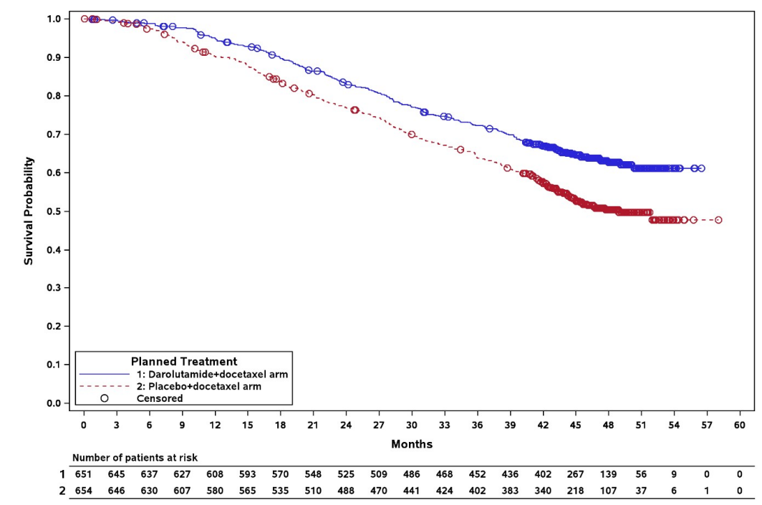
Source: Figure 7, p79 of the submission.
OS=overall survival
Figure 2: Kaplan-Meier curve for time to mCRPC in ARASENS
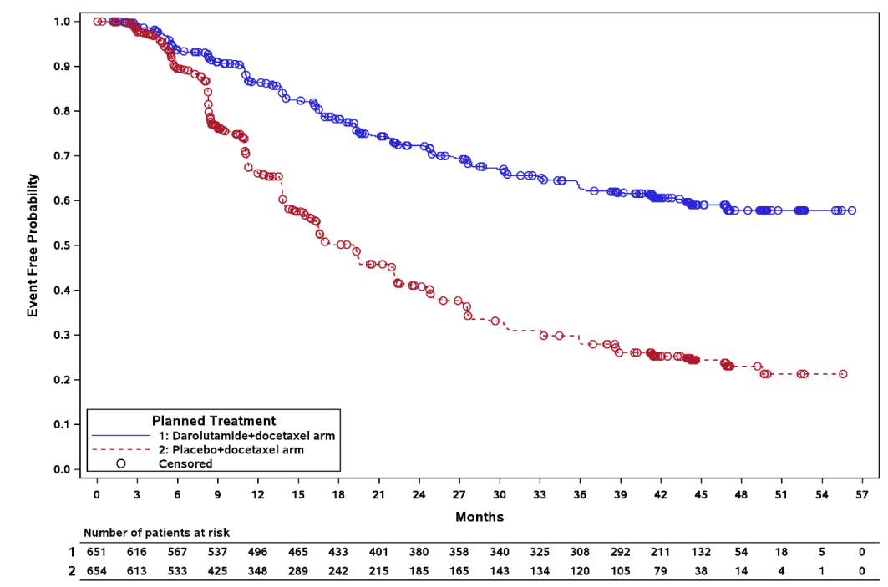
Source: Figure 8 of the submission.
mCRPC=metastatic castration-resistant prostate cancer
  - Results showed statistically significant longer OS for darolutamide compared to placebo, with a 32.5% reduction in the risk of death (HR=0.675; 95% CI: 0.568, 0.801). Median OS was not reached in the darolutamide arm and was 48.9 months in the placebo arm. These results were not adjusted for subsequent treatments. The most common subsequent treatments in the placebo arm were abiraterone and enzalutamide, given to 35.5% and 20.8% of patients, respectively. The corresponding proportions in the darolutamide arm were 17.2% and 7.4%.
  - Time to mCRPC was used in the economic model as PFS. This differed to how progression was measured and modelled in the apalutamide submissions for mHSPC, where progression was only based on radiographic(r)PFS (apalutamide PSDs at the November 2021 and July 2022 PBAC meetings). This also differed to how progression was measured in the PEACE-1 and ENZAMET trials for abiraterone and enzalutamide, thus raising potential issue of comparability across trials.
  - The majority of patients in the ARASENS trial were deemed to have progressed based on PSA rather than radiographic evidence (66.6% versus 33.4%), and PSA progression was lower in the darolutamide than in the placebo arm (53.8% versus 73.9%). The clinical study report also reported the exploratory endpoint of time to PSA progression, but not time to radiographic progression. The median time to PSA progression was not reached in the darolutamide arm and was 22.4 months (95% CI: 22.1, 27.6) in the placebo arm. The time to PSA progression hazard ratio (HR) was lower (HR=0.255; 95% CI: 0.208; 0.313) than the overall time to mCRPC HR in Table 5 (HR=0.357; 95% CI: 0.302, 0.421). Therefore, adding PSA to radiographic progression reduced the HR between darolutamide and placebo for the composite outcome of time to mCRPC. In the modelled economic evaluation this translated into a larger proportion of patients in the placebo arm progressing early to mCRPC, likely favouring darolutamide.
  - A summary of other secondary outcomes is presented in Table 6.

Table 6: Summary of secondary outcomes in ARASENS
Time to event outcomes | Darolutamide (N=651) | Placebo (N=654) | HR (95% CI)
Time to pain progression
Patients with event, n (%) | 222 (34.1) | 248 (37.9) | 0.792  (0.660, 0.950)
Median time to event, months (95% CI) | NE (30.5, NE) | 27.5 (22.0, 36.1)
Symptomatic skeletal event-free survival
Patients with event, n (%) | 257 (39.5) | 329 (50.3) | 0.609  (0.516, 0.718)
Median time to event, months (95% CI) | 51.2 (47.2, NE) | 39.7 (36.0, 42.3)
Time to first symptomatic skeletal event
Patients with event, n (%) | 95 (14.6) | 108 (16.5) | 0.712  (0.539, 0.940)
Median time to event, months (95% CI) | NE | NE
Time to initiation of subsequent systemic antineoplastic therapy
Patients with event, n (%) | 219 (33.6) | 395 (60.4) | 0.388  (0.328, 0.458)
Median time to event, months (95% CI) | NE | 25.3 (23.1, 28.8)
Time to worsening of disease-related physical symptoms
Patients with event, n (%) | 351 (53.9) | 308 (47.1) | 1.043  (0.894, 1.217)
Median time to event, months (95% CI) | 19.3 (13.8, 24.8) | 19.4 (15.4, 27.6)
Time to initiation of opioid use for ≥7 consecutive days
Patients with event, n (%) | 92 (14.1) | 117 (17.9) | 0.688  (0.523, 0.906)*
Median time to event, months (95% CI) | NE | NE
Bold typography indicates statistically significant results.
Source: Table 20-Table 26 of the submission.
CI=confidence interval, HR=hazard ratio, NE=not estimable.
* Not tested formally for statistical significance
  - Time to initiation of subsequent systemic antineoplastic therapy was used in the economic model to estimate the cost of mCRPC treatments. More patients in the placebo group received subsequent antineoplastic treatments than in the darolutamide group (57.2% versus 27.5%), and more received >1 regimen (23.4% versus 10.9%). Of those treated with darolutamide, 24.6% had subsequent abiraterone or enzalutamide, which they would be precluded from accessing on the PBS.
  - Quality of life outcomes were reported as change from baseline using symptom and pain questionnaires NCCN-FACT-FPSI-17 and BPI-SF. There were no significant differences between treatment groups for symptom burden or pain scores. These outcomes did not inform the economic model.

Comparative harms
  - Table 7 summarises key adverse events (AEs) in ARASENS.
Table 7: Summary of key adverse events in the trials
 | Darolutamide  N=652, n (%) | Placebo  N=650, n (%) | ORª (95% CI) | RDª (95% CI)
Any AE | 649 (99.5) | 643 (98.9) | 2.36 (0.61, 9.15) | 0.01 (-0.00, 0.02)
Grade 3 or 4 AE | 431 (66.1) | 413 (63.5) | 1.12 (0.89, 1.41) | 0.03 (-0.03, 0.08)
Grade 5 AE | 27 (4.1) | 26 (4.0) | 1.04 (0.60, 1.80) | 0.00 (-0.02, 0.02)
SAE | 292 (44.8) | 275 (42.3) | 1.11 (0.89, 1.38) | 0.02 (-0.03, 0.08)
Leading to discontinuation of study drug | 88 (13.5) | 69 (10.6) | 1.31 (0.94, 1.84) | 0.03 (-0.01, 0.06)
Leading to discontinuation of docetaxel | 52 (8.0) | 67 (10.3) | 0.75 (0.52, 1.10) | -0.02 (-0.05, 0.01)
Any study drug-related AEs | 340 (52.1) | 308 (47.4) | 1.21 (0.97, 1.50) | 0.05 (-0.01, 0.10)
Grade 3 or 4 AE | 62 (9.5) | 38 (5.8) | 1.69 (1.11, 2.57) | 0.04 (0.01, 0.07)
Grade 5 AE | 0 | 3 (0.5) | 0.14 (0.01, 2.75) | -0.00 (-0.01, 0.00)
SAE | 29 (4.4) | 23 (3.5) | 1.27 (0.73, 2.22) | 0.01 (-0.01, 0.03)
Leading to discontinuation | 25 (3.8) | 13 (2.0) | 1.95 (0.99, 3.85) | 0.02 (0.00, 0.04)
Key study drug related Grade 3 AEs | 53 (8.1) | 31 (4.8) | 1.77 (1.12, 2.79) | 0.03 (0.01, 0.06)
ALT increased | 11 (1.7) | 3 (0.5) | 3.70 (1.03, 13.33) | 0.01 (0.00, 0.02)
AST increased | 10 (1.5) | 2 (0.3) | 5.05 (1.10, 23.12) | 0.01 (0.00, 0.02)
Hypertension | 6 (0.9) | 2 (0.3) | 3.01 (0.61, 14.96) | 0.01 (-0.00, 0.01)
Weight increased | 3 (0.5) | 0 | 7.01 (0.36, 136.00) | 0.00 (-0.00, 0.01)
Febrile neutropenia | 2 (0.3) | 5 (0.8) | 0.40 (0.08, 2.05) | -0.00 (-0.01, 0.00)
Pulmonary embolism | 2 (0.3) | 3 (0.5) | 0.66 (0.11, 3.98) | -0.00 (-0.01, 0.01)
Key study drug related Grade 4 AEs | 9 (1.4) | 7 (1.1) | 1.29 (0.48, 3.47) | 0.00 (-0.01, 0.01)
Neutrophil count decreased | 4 (0.6) | 1 (0.2) | 4.01 (0.45, 35.94) | 0.00 (-0.00, 0.01)
Source: Table 28; Table 29 of the submission.
AE=adverse event, ALT=alanine aminotransferase, AST=aspartate aminotransferase, CI=confidence interval, OR=odds ratio, RD=risk difference, SAE=serious adverse event
ªNote that results for OR and RD presented in Table 7 are derived from post-hoc analyses. Interpretation of the results and their application should therefore be limited to seeking to understand the basis for the PBAC outcome and should not be used for any other purpose.
  - There were no significant differences for overall AEs or AEs leading to discontinuation of study drug or docetaxel. However, patients in the darolutamide arm experienced significantly higher number of Grade 3 or 4 AEs compared to placebo (mainly Grade 3 AEs), particularly increases in hepatic enzymes alanine aminotransferase (ALT) and aspartate aminotransferase (AST). There was a trend towards increased Grade 4 AEs in the darolutamide group, but the difference did not reach statistical significance.

Indirect treatment comparisons
  - The submission considered ARASENS, ENZAMET and PEACE-1 exchangeable enough to warrant an ITC based on OS and safety results, but it was noted results should be interpreted with caution given the differences in docetaxel use between trials. Considering the different definitions for progressive disease used across the trials, it was reasonable not to include PFS in the ITC.
  - There were some key differences between the trials:
- ARASENS was a double-blind RCT, whereas PEACE-1 and ENZAMET were open-label trials;
- The proportion of patients with de-novo metastases varied across the trials: 86% in ARASENS, 100% in PEACE-1 and 61% in ENZAMET. International guidelines have indicated that patients who develop metastatic disease following localised prostate cancer (relapsed group) have better prognosis than those with de-novo metastatic disease,.
- Prior docetaxel or ADT was not permitted in ARASENS and PEACE-1, but in ENZAMET up to two cycles of docetaxel were permitted before randomisation, as well as prior ADT as long as treatment duration was up to 24 months and the treatment had been completed at least 12 months before randomisation;
- In ENZAMET, patients treated with docetaxel were part of a subgroup analysis that may be underpowered to detect an OS difference. The ENZAMET publication acknowledged the authors “anticipated that the smaller number of deaths would limit the reliability of subgroup analyses of overall survival”.
- PEACE-1 did not report how many patients did not complete the six cycles of docetaxel, in ARASENS approximately 86% of patients completed 6 cycles of docetaxel, and in ENZAMET this proportion was approximately 70%.
  - Table 8 presents OS results in the trials included and the ITC.
Table 8: Results of OS in the indirect comparisons
ARASENS (follow-up = 60 months)
 | Darolutamide | Placebo | Absolute difference | HR (95% CI)
Events, n/N (%) | 229/651 (35.2) | 304/654 (46.5) | 11.3% | 0.675 (0.568, 0.801)
Median OS, months (95% CI) | NE | 48.9 (44.4, NE) | NE
ENZAMET 2019 (follow-up = 48 months)
 | Enzalutamide | NSAA | Absolute difference | HR (95% CI)
Events, n/N (%) | 52/254 (20.5) | 55/249 (22.1) | 1.6% | 0.90 (0.62, 1.31)
Median OS, months (95% CI) | NE | NE | NE
ENZAMET 2022 (follow-up = 68 months)
Events, n/N (%) | 108/253 (42.7) | 123/250 (49.2) | 6.5% | 0.82 (0.63, 1.06)
Median OS, months (95% CI) | NR | NR | NE
PEACE-1 (follow-up = 5 years)
 | Abiraterone | SoCª | Absolute difference | HR (95% CI)
Events, n/N (%) | 121/355 (34.1) | 151/355 (42.5) | 8.4% | 0.75 (0.59,0.95)
Median OS, months (95% CI) | NE | 4.43 (2.47, NE) | NE
Indirect comparison darolutamide versus comparators |  |  |  | HR (95% CI)
ARASENS versus ENZAMET 2019 |  |  |  | 0.756 (0.501, 1.139)
ARASENS versus ENZAMET 2022 |  |  |  | 0.829 (0.608, 1.131)
ARASENS versus PEACE-1 |  |  |  | 0.907 (0.677, 1.215)
Source: Table 15; Table 21 of the submission
ADT=androgen deprivation therapy, CI=confidence interval, HR=hazard ratio, NE=not estimable, NR=not reported, NSAA=non-steroidal anti-androgen, OS=overall survival, SoC=standard of care.
ª SoC was ADT + docetaxel, PEACE-1 did not provide a matching-placebo pill.
  - There were no significant differences in OS between darolutamide, enzalutamide or abiraterone in patients receiving background therapy of ADT + docetaxel.
  - Overall, the safety profiles of the three NHAs were similar. The ITC of darolutamide versus enzalutamide showed more Grade 3 or 4 AEs with enzalutamide; however, study drug-related Grade 3 and 4 AEs were not assessed, and darolutamide treatment resulted in significantly higher Grade 3 and 4 AEs compared to placebo. The ITC of darolutamide versus abiraterone showed more AEs leading to discontinuation with abiraterone. There was only one discontinuation event due to AEs in the SoC group of PEACE-1 and the confidence interval was very large (4.82, 260.97), which may impact the ITC.

Benefits/harms
  - A summary of the comparative benefits and harms for darolutamide versus placebo is presented in Table 9.
Table 9: Summary of comparative benefits and harms for darolutamide and placebo
Benefits
 | Darolutamide | Placebo | Absolute Difference | HR (95% CI)
Overall survival
Deaths, n/N (%) | 229/651 (35.2) | 304/654 (46.5) | - | 0.675 (0.568, 0.801)
Median OS, months (95% CI) | NE | 48.9 (44.4, NE) | NE
% alive at 12 months (95% CI) | 94.9 (93.2, 96.6) | 90.3 (88.0, 92.5) | 4.6%
% alive at 24 months (95% CI) | 83.1 (80.2, 86.0) | 76.8 (73.5, 80.1) | 6.3%
% alive at 36 months (95% CI) | 72.3 (68.8, 75.8) | 63.8 (60.1, 67.6) | 8.5%
% alive at 48 months (95% CI) | 62.7 (58.7, 66.7) | 50.4 (46.3, 54.6) | 12.3%
Time to mCRPC
Progressed, n (%) after a median follow up of 43 months | 225/651 (34.6) | 391/654 (59.8) | - | 0.357 (0.302, 0.421)
Median time to mCRPC, months (95% CI) | NE | 19.1 (16.5, 21.8) | NE
Harms
Key study drug related AEs | Darolutamide | Placebo | ORª (95% CI) | RDª (95% CI)
Grade 3-4 AEs, n/N (%) | 62/524 (9.5) | 38/527 (5.8) | 1.69 (1.11, 2.57) | 0.04 (0.01, 0.07)
Grade 3 ALT increase, n/N (%) | 11/524 (1.7) | 3/527 (0.5) | 3.70 (1.03, 13.33) | 0.01 (0.00, 0.02)
Grade 3 AST increase, n/N (%) | 10/524 (1.5) | 2/527 (0.3) | 5.05 (1.10, 23.12) | 0.01 (0.00, 0.02)
Bold typography indicates statistically significant results.
Source: Table 19; Table 29 of the submission.
AE=adverse event, ALT=alanine aminotransferase, AST=aspartate aminotransferase, CI=confidence interval, HR=hazard ratio, mCRPC=metastatic castration-resistant prostate cancer, NE=not estimable, OR=odds ratio, OS=overall survival, RD=risk difference.
ªNote that results for OR and RD presented in Table 9 are derived from post-hoc analyses. Interpretation of the results and their application should therefore be limited to seeking to understand the basis for the PBAC outcome and should not be used for any other purpose.
  - On the basis of direct evidence from ARASENS presented by the submission, for every 100 patients treated with darolutamide in comparison with placebo:
- Approximately 12 additional patients will remain alive after 48 months.
- Approximately 4 additional patients will develop Grade 3 or 4 AEs related to darolutamide, and 1 additional patient will develop Grade 3 ALT or AST increases.

Clinical claim
  - The submission described darolutamide as superior in terms of effectiveness compared with placebo and “comparable” in terms of safety compared to placebo.
  - The ESC considered that the effectiveness claim was adequately supported by the evidence presented in the submission which demonstrated a significantly higher OS in the darolutamide arm compared to placebo, and superior efficacy for other secondary outcomes.
  - The ESC considered that the safety claim was not adequately supported by the evidence presented in the submission, given darolutamide had more drug-related Grade 3 or 4 AEs than placebo. The ESC considered that darolutamide was inferior compared to placebo in terms of safety.
  - The PBAC considered that darolutamide was superior in terms of effectiveness and inferior in terms of safety compared to placebo.

Economic analysis
  - The submission presented a stepped economic evaluation (cost-utility analysis) based on the ARASENS trial, using a partitioned survival model to estimate costs and outcomes for darolutamide versus placebo in mHSPC.
  - Table 10 summarises the key components of the economic evaluation.
Table 10: Summary of model structure, key inputs and rationale
Component | Summary
Treatments | Darolutamide + ADT + docetaxel versus ADT+ docetaxel.
Time horizon | 15 years in the model base case versus 3.6 years trial based. Median OS follow-up in ARASENS was 43.7 and 42.4 months in darolutamide and placebo arms, respectively.
Outcomes | Quality-adjusted life years, life years.
Methods used to generate results | Partitioned survival model. The model relies on KM data from ARASENS to inform transitions over 3 health states.
Health states | Progression-free survival (mHSPC), progressed disease (mCRPC) and death.
Cycle length | Monthly.
Allocation to health states | PFS and OS curves for the darolutamide and placebo arms of the model are based on the ARASENS trial and parametric curve fitting.
Extrapolation method | Parametric model fitted to each treatment arm. Extrapolation methods used 43.7 months of KM data for:  OS: log-logistic for placebo arm. OS HR (0.675) applied to placebo curve to estimate darolutamide arm. Independent extrapolations were not presented for comparison to the proportional hazards approach favoured by the submission, nor evidence that this proportional hazard approach was appropriate (e.g., log-hazard plot).  PFS (time to mCRPC): independent log-normal  ToT: generalised gamma. Applied to darolutamide arm.  TST: log-normal  Convergence was not assumed to occur within the modelled time horizon.
Health related quality of life | Health state utilities were literature based PFS utilities: NICE TA712, PD: Wu 2007 (Darolutamide PSD, July 2021)  PFS (mHSPC) on docetaxel=0.80; PFS (mHSPC) post docetaxel=0.82, PD=0.635  These estimates resulted in a large utility decrement when patients entered PD (-0.185) and greatly contributed to the QALY benefit associated with extended PFS.
Costs | The model included costs for darolutamide, background ADT and docetaxel (6 cycles), management of AEs, subsequent treatment post progression and end of life costs. The model assumed patients treated with apalutamide for mHSPC did not receive abiraterone or enzalutamide for mCRPC.  The submission did not include any costs of follow-up medical visits or imaging or PSA testing. Errors and inconsistencies were detected with health care resource use and costing, particularly drug costing; however, as these were not drivers of the model, they had little impact on the model ICER.
Compiled during the evaluation.
Source: Table 33 of the submission.
ADT=androgen deprivation therapy, AE=adverse event, HR=hazard ratio, ICER=incremental cost-effectiveness ratio, KM=Kaplan Meier, mCRPC=metastatic castration-resistant prostate cancer, mHSPC=metastatic hormone-sensitive prostate cancer, OS=overall survival, PD=progressed disease, PFS=progression-free survival, PSA=prostate-specific antigen, QALY=quality-adjusted life year, ToT=time on treatment, TST=time to initiation of subsequent treatment.
  - A summary of the KM data and modelled extrapolations are presented in Figure 3, with all extrapolations presented by the submission in Figure 4.
Figure 3: KM data included in the model, and base case modelled extrapolationsª
KM data used in the economic evaluation | Summary of extrapolations as modelled
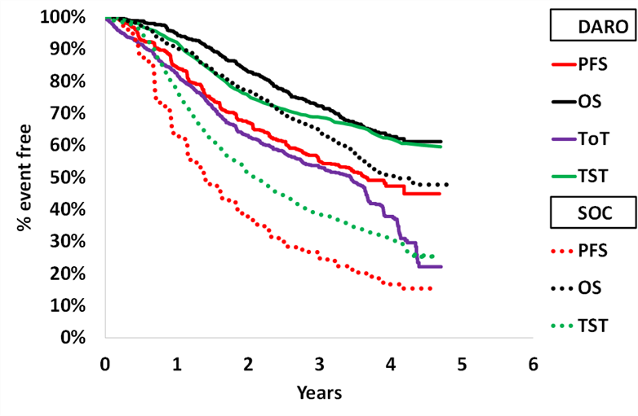 | 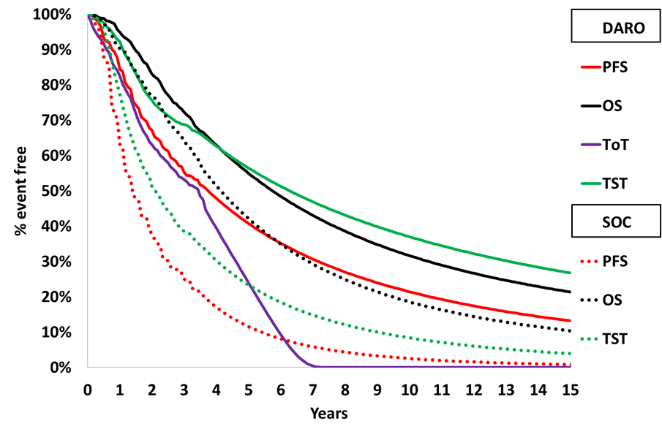
Source: compiled during the evaluation from Excel workbook ‘Attachment 14 - Darolutamide_mHSPC_Section3model_Jul2022_PBAC_Submission.xlsx’
ADT=androgen deprivation therapy, DARO=darolutamide, KM=Kaplan Meier, mHSPC=metastatic hormone sensitive prostate cancer, OS=overall survival, PFS=progression-free survival, SOC=standard of care, ToT=time on treatment, TST=time to subsequent antineoplastic treatment
ToT was only presented for darolutamide as ADT was assumed to occur for every cycle and docetaxel in mHSPC was applied as a one-off cost at the beginning of the model.
ªNote that the results presented in Figure 3 are derived during the evaluation specifically for the purposes of informing the PBAC consideration. Interpretation of the results and their application should therefore be limited to seeking to understand the basis for the PBAC outcome and should not be used for any other purpose.
  - Individual patient data (IPD) from ARASENS was used to fit parametric survival curves (exponential, Weibull, log-logistic, log-normal, Gompertz and generalised gamma) to PFS, ToT, TST, and OS. The submission selected the parametric functions for the base case using a combination of goodness of fit statistics (the Akaike information criterion [AIC] and Bayesian information criterion [BIC]), visual inspection and clinical plausibility (see Figure 4).
  - ARASENS did not report rPFS, and time to mCRPC in ARASENS was used as PFS and this data was applied to each arm of the model. This differed from the apalutamide submissions in mHSPC, which used rPFS in the economic model. The submission noted that PFS in the model was defined as the time from randomisation to confirmed evidence of metastasis or death from any cause, whichever occurred first. However, the definition of time to mCRPC in ARASENS was wider, including PSA progression or radiographically confirmed metastases, whichever occurred first. PFS extrapolations were calculated independently, and log-normal extrapolations chosen for both arms in the base case. Although the incremental cost-effectiveness ratio (ICER) was not very sensitive to the choice of PFS extrapolation, as previously discussed, the definition for progression was particularly broad, and the data for rPFS was not provided for comparison. The ESC considered that PSA progression was not a clinically meaningful endpoint and the broader definition of PFS applied in the model significantly favour darolutamide as it would result in a larger PFS benefit and a shorter time on treatment compared to if rPFS was used. The use of PSA progression also meant that the results of the model are less comparable to other models previously considered by the PBAC. The ESC advised that the use of rPFS rather than time to mCRPC in the model would be preferable. If this data were not available, the ESC advised that time to initiation of subsequent treatment (TTST) could be used, noting that patients in the ARASENS trial were unblinded to determine best subsequent therapy and that this outcome may be biased against the placebo arm.
  - OS extrapolations were fitted for the SOC arm and then hazard ratio of 0.675 applied to estimate the darolutamide arm. The proportional hazards approach was described as “conservative” by the submission, but was not substantiated, as independent extrapolations were not presented for comparison, and the submission did not include testing of the proportional hazards assumptions. The PSCR provided a cumulative log-hazard plot that indicated that the assumption of proportional hazards was supported over the trial period. Given the median OS in the darolutamide arm of ARASENS was not met, uncertainty remains regarding the accuracy of the applied HR. A sensitivity analysis applying the lower and upper confidence intervals (CIs) of the OS HR in ARASENS (0.568, 0.801) resulted in an ICER ranging from $35,000 to < $45,000 to $45,000 to < $55,000 per quality-adjusted life year (QALY) gained on a 15-year time horizon. Log-logistic was chosen as the base case OS extrapolation, under which ~10% patients in the SOC arm and >20% in the darolutamide arm remained alive at 15 years. The ESC has previously indicated that more conservative survival estimates may be more appropriate given the median age of men with mHSPC in Australia (74 years compared to a median of 67 years in ARASENS) and competing causes of mortality (paragraph 6.31, apalutamide PSD, November 2021).
  - Time on treatment (ToT) KM was applied to the darolutamide arm to allow appropriate costing of darolutamide treatment. The generalised gamma function was chosen to fit time on darolutamide because it showed the lowest AIC/BIC statistics but resulted in the shortest extrapolated ToT and the extrapolations were informed by significant censoring towards the end of trial follow up. The ESC considered that time on darolutamide was underestimated in the model, as time in PFS and ToT were similar up to 3.5 years, beyond which the model predicted sustained PFS even after treatment cessation (Figure 3), which was not supported by available clinical data. If ToT was modelled equal to PFS the ICER increased to $55,000 to < $75,000 per QALY gained compared to $35,000 to < $45,000 in the base case.
  - TTST was based on the time to subsequent antineoplastic treatment curves in both arms. KM data was applied to all alive patients (mHSPC and mCRPC). There was a significant delay between disease progression and commencement of subsequent treatment in the KM data, which may not be clinically reasonable, and other models modelled subsequent treatment at disease progression. However, the TTST curve was converted to a per cycle probability in the model which was applied to all alive patients, meaning the TTST curve could exceed OS, see Figure 3, and likely resulted in a reduced time to subsequent treatment than seen in the KM data. Independent log-normal extrapolations were chosen for both arms in the base case, which had the lowest AIC/BIC in the darolutamide arm, though the submission claimed this was the best fit for the SOC arm. The ICER was not sensitive to the choice of TTST extrapolation.
Figure 4: Summary of extrapolationsª
PFS | OS
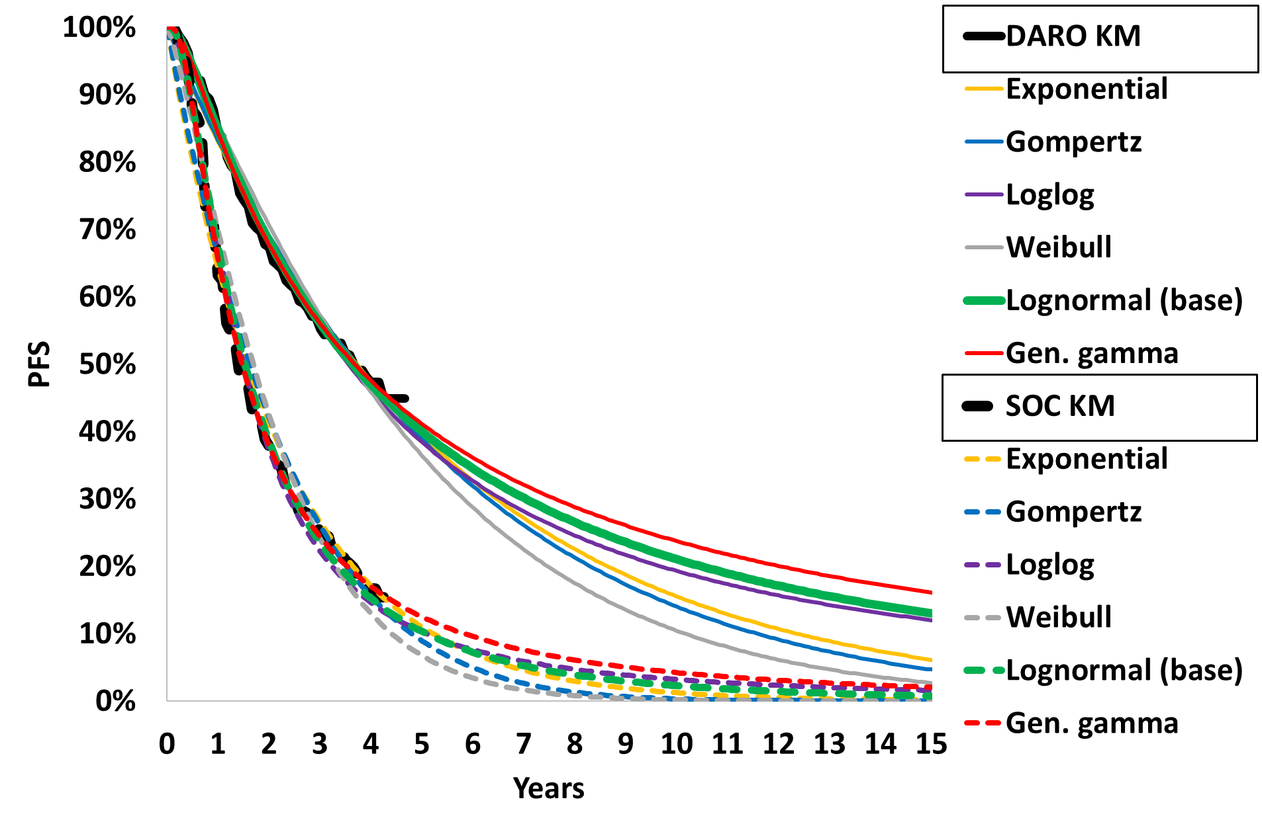 | 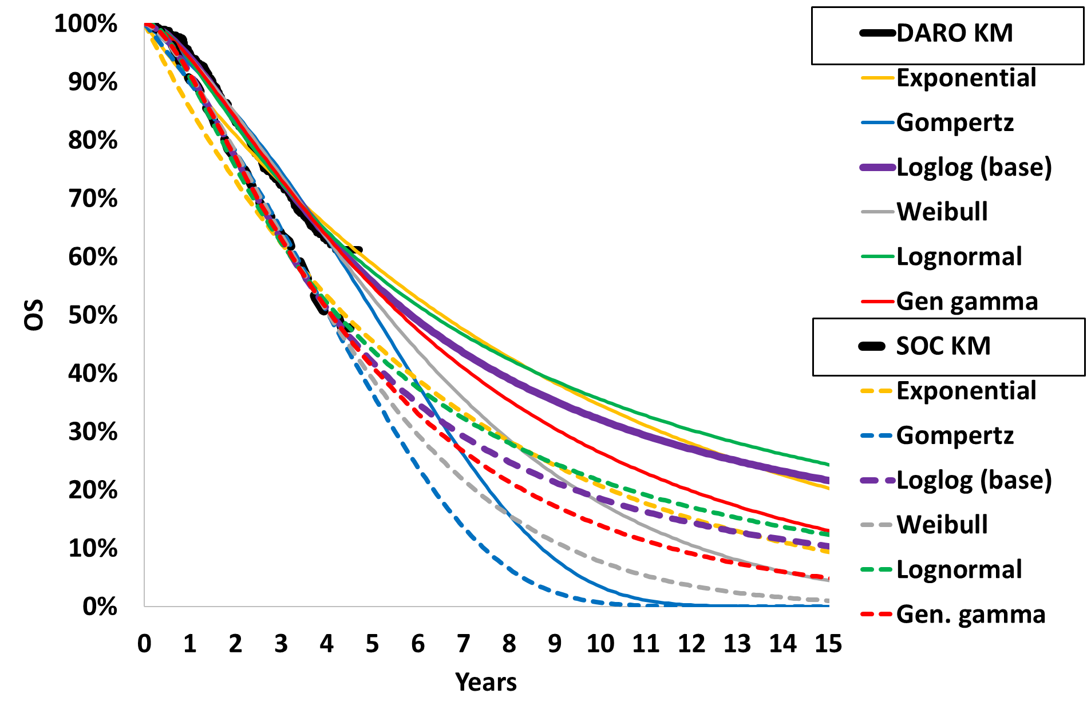
ToT | TST
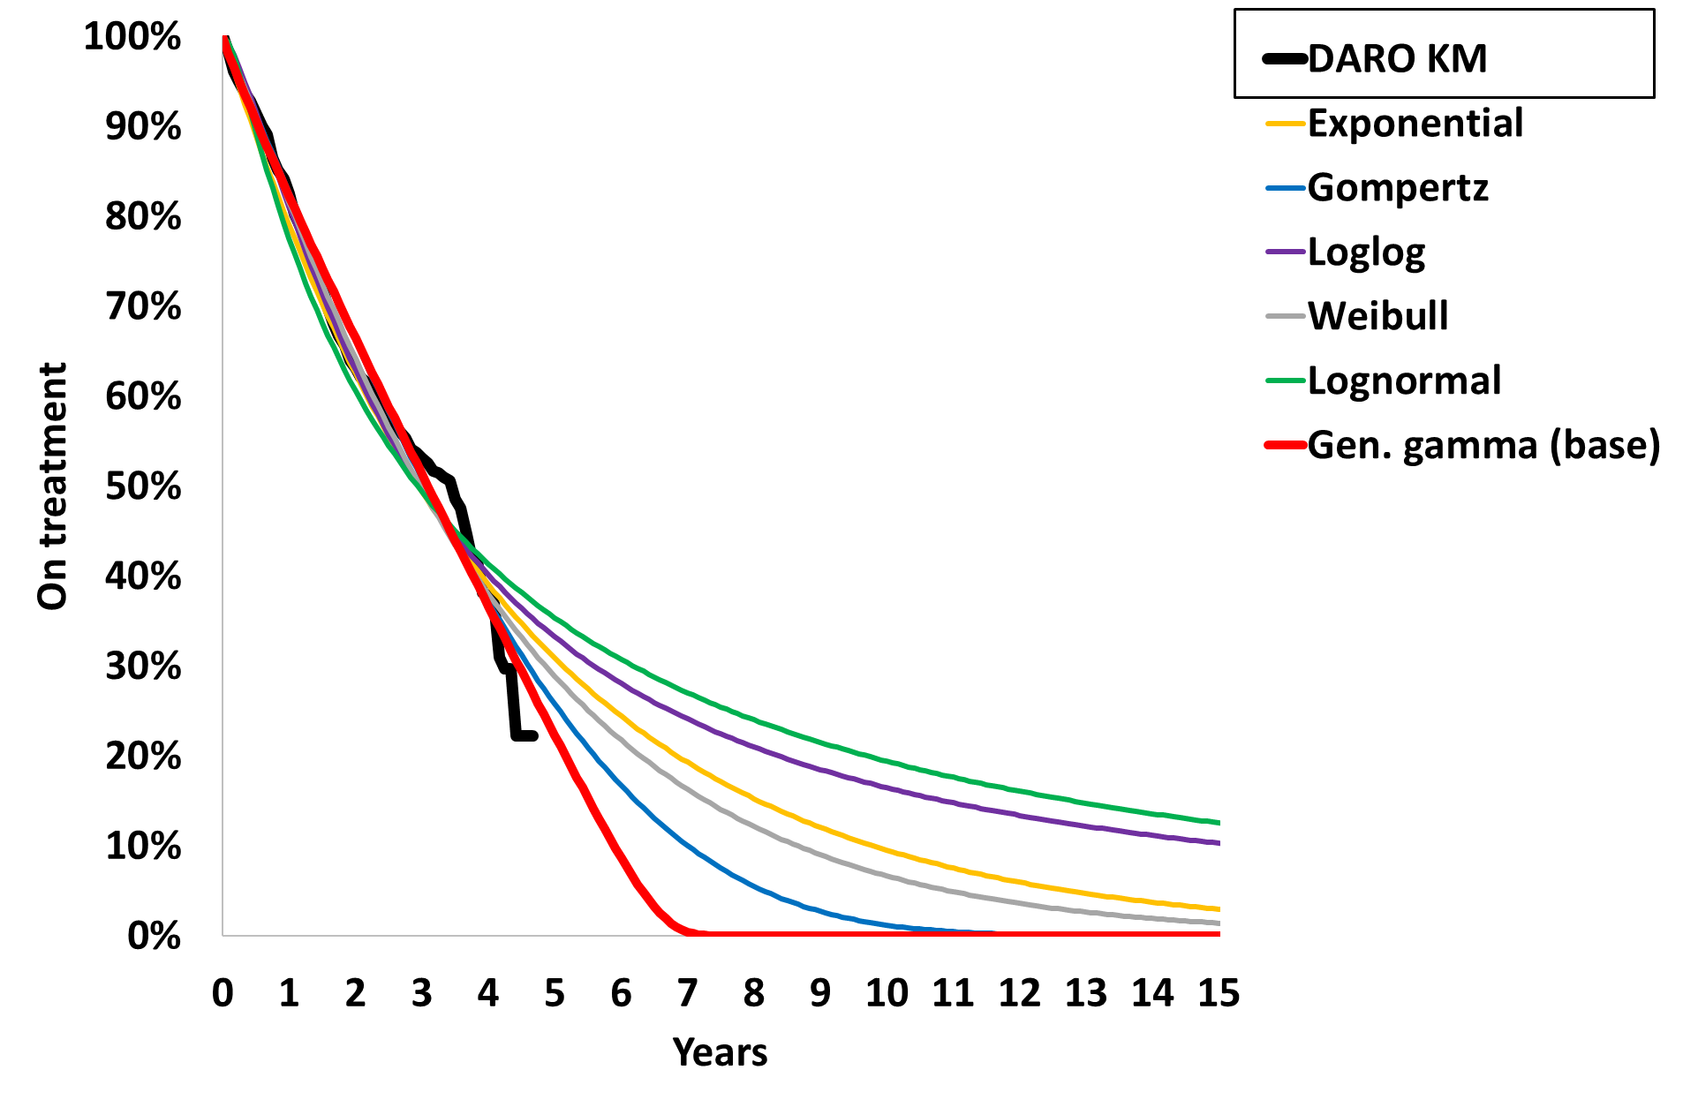 | 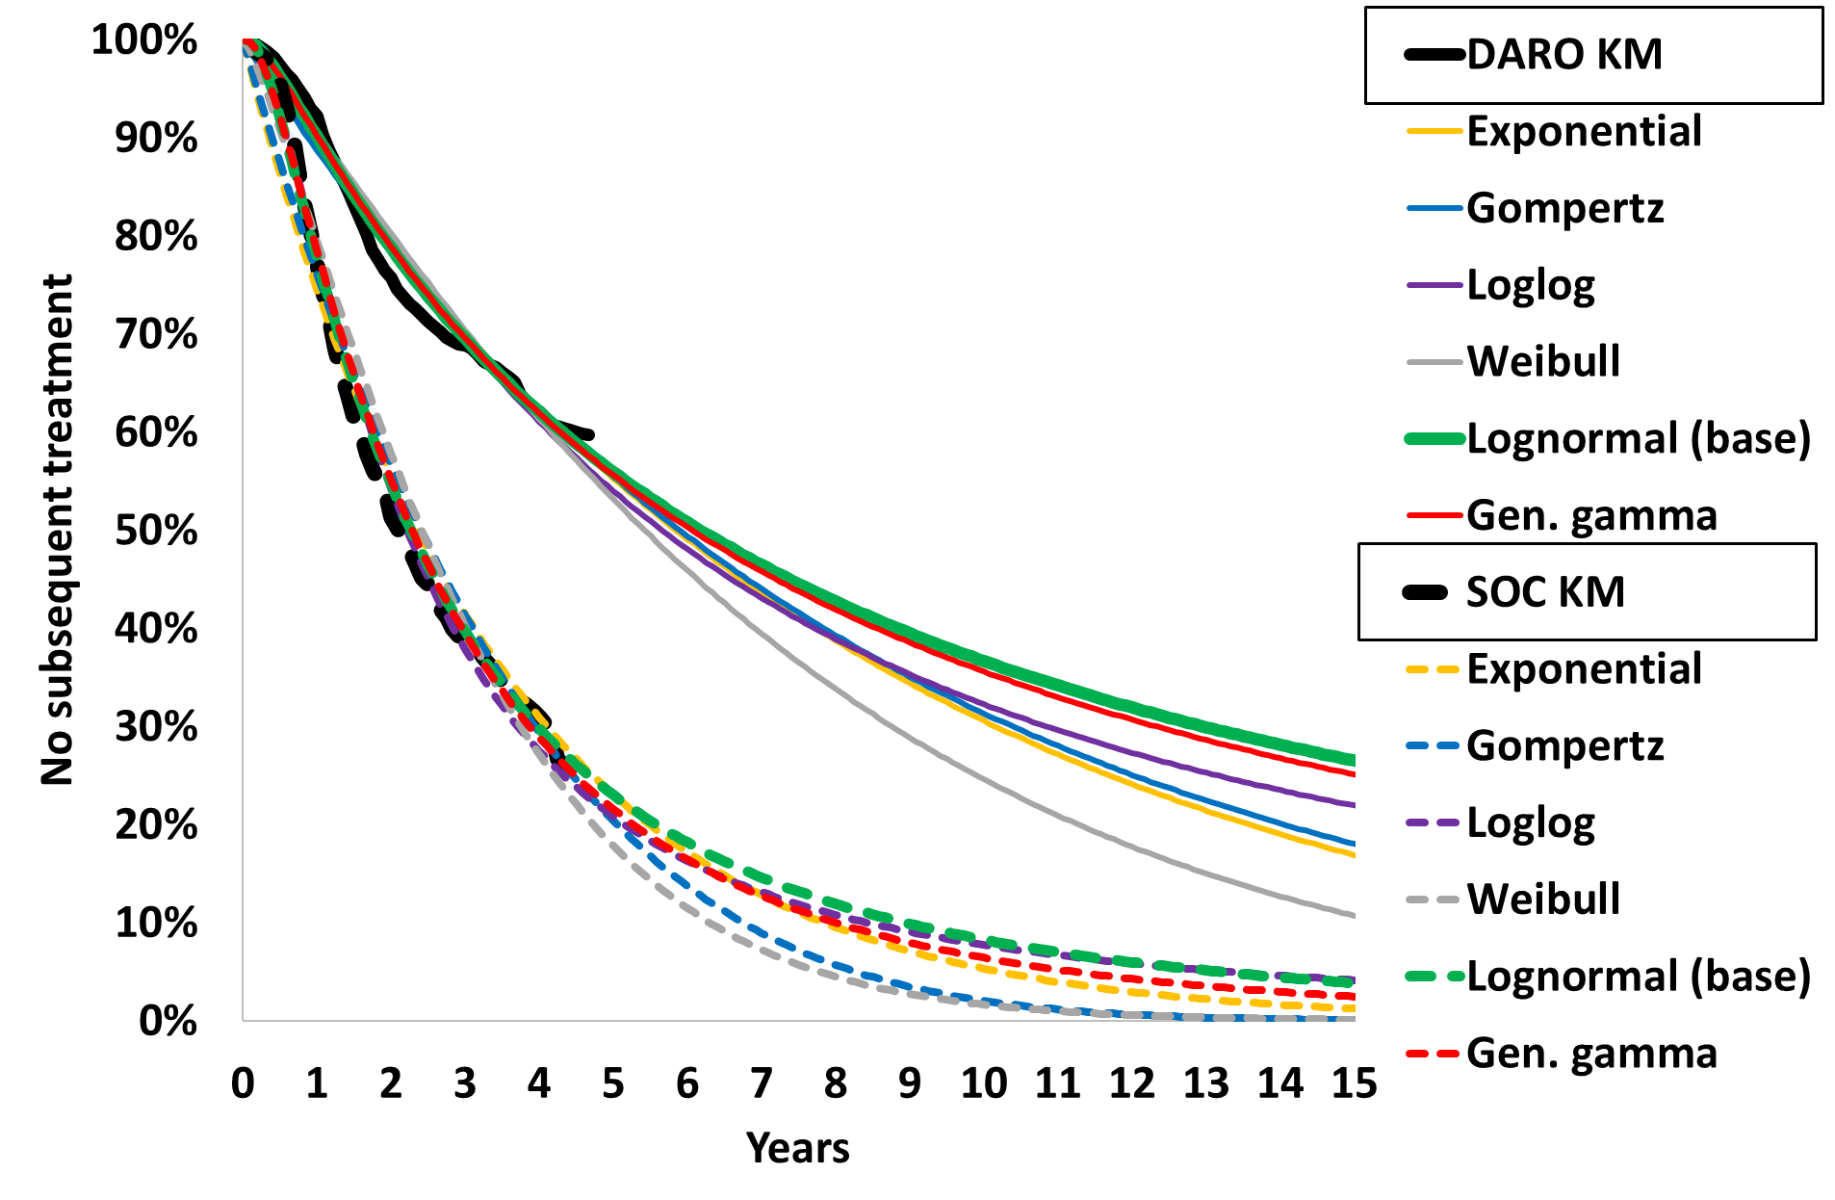
Source: compiled during the evaluation from the Excel workbook: ‘Attachment 14 - Darolutamide_mHSPC_Section3model_Jul2022_PBAC_Submission.xlsx’
DARO=darolutamide, OS=overall survival, PFS=progression free survival, SOC=standard of care, ToT=time on treatment, TST=Time to subsequent treatment
ªNote that the results presented in Figure 4 are derived during the evaluation specifically for the purposes of informing the PBAC consideration. Interpretation of the results and their application should therefore be limited to seeking to understand the basis for the PBAC outcome and should not be used for any other purpose
  - The model applied utility values from different sources for the progression free (on docetaxel = 0.80; post-docetaxel = 0.82, from NICE TA712) and PD (0.635, from Wu, 2007) health states, resulting in an increment of 0.185. The ICER was sensitive to the utilities, and if alternate PFS utilities from Hall, 2017 were used (on docetaxel = 0.64; post-docetaxel = 0.71, incremental difference = 0.075), the ICER increased to $55,000 to < $75,000 per QALY gained. The model also applied docetaxel disutility inconsistently across the treatment arms (up to 12 months in PFS in the darolutamide arm versus 4.1 months in PFS in the SOC arm), although this did not greatly alter the results. The PSCR stated that the PFS health state utility was based on the most applicable trial with the best available data (the ENZAMET trial). The ESC noted that the PSCR did not justify the large difference in utility between the PFS and PD health states.
  - Key drivers of the model are presented in the following table.
Table 11: Key drivers of the model
Description | Method/Value | Impact  Base case: $|¹ per QALY gained.
Time horizon | 15 years extrapolated from 43.7 months trial data | High, favoured darolutamide.  If time horizon was 10 years or 5 years, ICER increased to $||||² and $||||³ per QALY gained respectively.  The PSCR stated that the application of a 15-year time horizon was appropriate given the baseline age in the model cohort, derived from ARASENS and confirmed by registry data, was 66.8 years. Given the uncertainty around OS and the lack of information in ARASENS regarding disease volume, the ESC considered that a 5- to 10-year time horizon should be applied.
OS extrapolation | Treatment effect continued to from 43.7 months KM data to 15 years. SOC extrapolation log-logistic, HR of 0.675 applied to the darolutamide arm. | High, favoured darolutamide.  If more conservative extrapolation used (Weibull) ICER increased to $||||² per QALY gained.  If 95% CI of HR used, ICER ranged from $||||¹ to $||||² per QALY gained.  If no treatment effect (i.e., HR=1) assumed beyond 60 months (i.e. convergence from 60 months), the ICER increased to $||||² per QALY gained.
Time on darolutamide | Based on KM data with high rates of censoring near end of the data, extrapolated with generalised gamma beyond 43.7 months to 15 years (nearly all patients finished darolutamide by Year 7). The model assumed ongoing PFS benefit despite cessation of darolutamide. | High, favoured darolutamide.  If ToT matched PFS (similar up to 3.5 years), ICER increased to $||||² per QALY gained.
Health state utilities | PFS and PD utilities were taken from different HTA sources (NICE TA712, darolutamide PSD, July 2021), resulting in a large disutility upon entry to PD (0.82 to 0.635). | High, favoured darolutamide.  If PFS utilities were reduced, the ICER increased to $||||² per QALY gained.
Source: compiled during the evaluation
CI=confidence interval, HR=hazard ratio, HTA=health technology assessment, ICER=incremental cost-effectiveness ratio, KM=Kaplan Meier, OS=overall survival, PD=progressed disease, PFS=progression free survival, QALY=quality-adjusted life year, SOC=standard of care ToT=time on treatment
The redacted values correspond to the following ranges:
¹ $35,000 to < $45,000
² $55,000 to < $75,000
³ $115,000 to < $135,000
  - Table 12 summarises the results of the economic evaluation.
Table 12: Results of the stepped economic evaluation
Step and component | Darolutamide | Placebo | Increment
Step 1: trial-based costs and outcomes (follow-up 43.7 months/3.6 years)
Costs | $| | $26,483 | $|
LY | 2.847 | 2.665 | 0.181
QALY | 2.241 | 1.999 | 0.242
Incremental cost/extra LY gained |  |  | $|¹
Incremental cost/extra QALY gained |  |  | $|¹
Step 2: time horizon extended to 15 years
Costs | $| | $43,825 | $|
LY | 5.692 | 4.581 | 1.111
QALY | 4.420 | 3.293 | 1.128
Incremental cost/extra LY gained |  |  | $|²
Incremental cost/extra QALY gained |  |  | $|³
Source: Excel workbook: ‘Attachment 14 - Darolutamide_mHSPC_Section3model_Jul2022_PBAC_Submission.xlsx’
LY=life year, QALY=quality-adjusted life year
The redacted values correspond to the following ranges:
¹ $155,000 to < $255,000
² $45,000 to < $55,000
³ $35,000 to < $45,000
  - The results of key univariate and multivariate sensitivity analyses are summarised in Table 13. The ICER was most sensitive to time horizon, OS extrapolation and convergence, PFS utility and time on darolutamide.
Table 13: Sensitivity analyses
Analyses | Incremental cost ($) | Incremental QALY | ICER ($)
Base case | | | 1.128 | | ¹
Discount rate (base case 5% costs and outcomes)
0% costs and outcomes | | | 1.624 | | ²
3.5% costs and outcomes* | | | 1.251 | | ¹
Time horizon (base case 15 years)
5 years | | | 0.389 | | ³
7.5 years | | | 0.637 | | ⁴
10 years* | | | 0.841 | | ⁵
Extrapolation OS (base case log-logistic extrapolation)
Weibull | | | 0.973 | | ⁶
OS HR (base case 0.675)
0.568 (low 95% CI) | | | 1.275 | | ¹
0.801 (high 95% CI) | | | 0.974 | | ⁶
OS convergence (base case no convergence, HR=0.675)
HR=1 from 60 months | | | 0.888 | | ⁵
HR=1 from 44 months | | | 0.774 | | ⁵
Extrapolation ToT DARO (base case KM followed by gamma extrapolation
ToT equal to PFS | | | 1.128 | | ⁵
PFS utilities (on docetaxel 0.8, post-docetaxel 0.82)
Hall 2017 on docetaxel 0.64, post-docetaxel 0.71 | | | 0.845 | | ⁵
PD utility (base case 0.635)
0.699* | | | 1.049 | | ⁶
0.572* | | | 1.205 | | ¹
Subsequent therapy costs (base case one off costs in DARO arm $2,297, SOC arm $12,355ª)
Increase 50%* | | | 1.128 | | ¹
Decrease 50%* | | | 1.128 | | ⁶
Multivariate analyses
MA1: Time horizon 10 years, OS convergence from 60 months | | | 0.736 | | ⁵
MA2: MA1 and PFS=ToT | | | 0.736 | | ⁷
MA3: MA2 and PFS utilities reduced as per Hall 2017 | | | 0.499 | | ⁸
MA4: Time horizon 5 years, OS convergence from 44 months | | | 0.372 | | ³
MA5: MA4 and PFS=ToT | | | 0.372 | | ⁸
Source: Table 62 of the submission and compiled during the evaluation
DARO=darolutamide arm, HR=hazard ratio, ICER=incremental cost-effectiveness ratio, MA=multivariate analysis, NHA=novel hormonal agent, OS=overall survival, PD=progressed disease, PFS=progression free survival, QALY=quality-adjusted life year, SOC=standard of care arm, ToT=time on treatment
* Sensitivity analyses presented in Table 62 of the submission that could not be reproduced and therefore were recalculated during the evaluation
ª Subsequent treatment in the DARO arm included docetaxel and cabazitaxel, and in the SOC arm included NHAs as well as docetaxel and cabazitaxel, based on DUSC data request
The redacted values correspond to the following ranges:
¹ $35,000 to < $45,000
² $25,000 to < $35,000
³ $115,000 to < $135,000
⁴ $75,000 to < $95,000
⁵ $55,000 to < $75,000
⁶ $45,000 to < $55,000
⁷ $95,000 to < $115,000
⁸ $135,000 to < $155,000
  - The ESC considered that a more reasonable economic model would:
  - apply rPFS, rather than time to mCRPC as PFS, noting that if rPFS data were not available, then TTST could be used (see paragraph 6.40);
  - model ToT to equal PFS;
  - reduce the time horizon to 10 years
  - apply convergence to the OS curves from 60 months;
  - reduce the utility difference between PFS and PD.
  - The pre-PBAC response offered a 20% price reduction (AEMP of $||| |||, compared to $| | in the submission) and provided revised base cases which incorporated some, but not all, of the ESC’s recommendations, as shown in Table 14. The PBAC noted the TTST data from the economic model was used directly and hence, TTST for the darolutamide arm appeared too long when compared with OS (see Figure 3), possibly because death had not been appropriately accounted for as a competing risk for receiving subsequent treatment.
Table 14: Revised model results based on alternative scenarios presented in pre-PBAC response (ICER/QALY)
Model assumptions | Revised base case | Revised base case with convergence
 | Time horizon: 10 years | Time horizon: 15 years
 | Extrap: No convergence | Extrap: Convergence from 60 months to 15 years
 | AEMP: $| | AEMP: $|
Pre-PBAC response base case  - Revised time horizon or Extrapolation assumption (see column heading)  - Apply TTST as PFS  - Did not model ToT as equal PFS  - Did not reduce utility difference | $| | $|
Source: Table 1, pre-PBAC response.
AEMP=approved ex-manufacturer price, extrap=extrapolation, ICER=incremental cost-effectiveness ratio, PFS=progression free survival, QALY=quality-adjusted life year, ToT=time on treatment, TTST=time to initiation of subsequent treatment.

Darolutamide cost/patient/course: $|||| |||| (15-year time horizon).
Table 15: Darolutamide cost per patient
Darolutamide | Trial dose and duration | Model  (15-year time horizon) | Financial estimates
Mean dose | 1,176.712 mg/day | 1,200 mg/day | 1,200 mg/day
Mean duration | 31.853 (SD 16.758) months | 38.474 months | Dose (1,200 mg/day), dose intensity (97%), cost per script ($||||) and duration (ARASENS time on treatment KM data) assumptions consistent with the model.
Cost/patient/month | - | $|
Cost/patient/course | - | $|
Source: compiled during the evaluation from Excel workbooks: ‘Attachment 14 - Darolutamide_mHSPC_Section3model_Jul2022_PBAC_ Submission.xlsx’ and ‘Darolutamide mHSPC Section4model July2022.xlsx’.
KM=Kaplan Meier, SD=standard deviation

Estimated PBS usage & financial implications
  - This submission was not considered by DUSC. The submission adopted an epidemiological approach, with estimates based on AIHW projected prostate cancer incidence data combined with data from ePAD and the Victorian Prostate Cancer Outcomes Registry (PCOR-Vic) as reported by Azad 2021 (Table 16). This was different to the approach adopted in the apalutamide submissions which was based on the PBS 10% sample.
  - The submission commissioned an analysis of the 10% PBS sample for validation of the estimates, applying two approaches to the 10% PBS sample: the first identified patients who initiated docetaxel 6 or 12 months after ADT, and the second identified patients who initiated ADT 6 or 12 months prior to docetaxel. The submission argued that neither methodology accurately captured the number of mHSPC patients and noted that patient numbers in the base case model were reasonable if not potentially underestimated. A sensitivity analysis conducted during the evaluation using 10% PBS sample data (both methods) resulted in significantly higher number of eligible patients than the submission’s model, indicating patient numbers were likely underestimated.
  - No grandfathered patients were included in the financial model. However, the submission had indicated that a planned darolutamide Patient Access Program would be launched after TGA registration of the product and prior to receiving PBS listing.

Table 16: Key inputs for financial estimates
Data | Value | Source | Comment
Eligible population
Incidence of prostate cancer | Year 1: 17,656  Year 2: 17,429  Year 3: 17,202  Year 4: 16,975  Year 5: 16,748  Year 6: 16,521 | AIHW Cancer Data in Australia 2021 | Estimates calculated using linear extrapolation of data. These data were not presented in the excel model, the values were hard copied.
Incident patients mHSPC | Year 1: 1,845  Year 2: 1,821  Year 3: 1,797  Year 4: 1,774  Year 5: 1,750  Year 6: 1,726 | Applying 7% metastasis at diagnosis (PCOR-ANZ) and ePAD split for de-novo/relapsed of 67%/33% | 7% was previously considered in the apalutamide PSD (para. 6.50, November 2021)
Total initiating ADT + docetaxel (eligible patients) | Year 1: ||||¹  Year 2: ||||¹  Year 3: ||||¹  Year 4: ||||¹  Year 5: ||||¹  Year 6: ||||¹ | Based on uptake of ADT + docetaxel (Azad 2021 updated) and calculated by applying an average 2.5% increase per year.  Year 1: 43.1%  Year 2: 45.5%  Year 3: 48.0%  Year 4: 50.5%  Year 5: 52.9%  Year 6: 55.4% | Treatments given within 12 months of diagnosis. Azad 2021 noted the registry captures newly diagnosed patients and therefore this study was biased towards de novo, as opposed to relapsed metastatic patients. These numbers are uncertain.
Treatment utilisation
Uptake rate of darolutamide + ADT + docetaxel | Year 1: ||||%  Year 2: ||||%  Year 3: ||||%  Year 4: ||||%  Year 5: ||||%  Year 6: ||||% | Multiplying projected uptake of ADT + docetaxel (as above) by assumed darolutamide uptake:  Year 1: ||||%  Year 2: ||||%  Year 3: ||||%  Year 4: ||||%  Year 5: ||||%  Year 6: ||||% | Uptake rates of darolutamide were very uncertain. The ESC noted that they may be significantly lower if apalutamide is listed on the PBS for mHSPC, or they may be higher if all patients suitable to docetaxel (step above) decide to have triple therapy.
Patients initiating darolutamide | Year 1: ||||²  Year 2: ||||²  Year 3: ||||¹  Year 4: ||||¹  Year 5: ||||¹  Year 6: ||||¹ | Calculated by applying uptake of darolutamide + ADT + docetaxel to Incident patients with mHSPC. | See above.
Total patients on treatment with darolutamide | Year 1: ||||²  Year 2: ||||¹  Year 3: ||||¹  Year 4: ||||¹  Year 5: ||||¹  Year 6: ||||¹ | Time to treatment discontinuation KM data from ARASENS, % on treatment:  Year 1: 100%  Year 2: 82.5%  Year 3: 63.1%  Year 4: 53.1%  Year 5: 39.4%  Year 6: 23.9% | Patient numbers were not rounded in the calculations; therefore, some of the sums appear to be incorrect and it impacts number of scripts and costs further on.
Scripts dispensed | Year 1: ||||¹  Year 2: ||||³  Year 3: ||||⁴  Year 4: ||||⁵  Year 5: ||||⁵  Year 6: ||||⁵ | Compliance 97% (ARASENS), 1 script every 28 days. | -
Reduction in numbers of patients initiating subsequent treatments for mCRPC | Year 1: ||||²  Year 2: ||||²  Year 3: ||||²  Year 4: ||||²  Year 5: ||||² | Time to subsequent treatment data from ARASENS (and as extrapolated in the economic model) was used to estimate the reduction in numbers of patients starting subsequent treatment due to darolutamide. | -
Subsequent treatments: assumed proportional use and numbers of scripts per patient | Drug NHA No NHA Scripts  Enza 58.1% 0% 11.4  ABI 10.8% 0% 8.0  DOC 54.1% 48.9% 10.0  CAB 5.7% 2.6% 6.6  Based on DUSC data (April-June 2018, N=795) provided to the sponsor. Patients treated with darolutamide were not permitted any further NHAs (No NHA column).  The submission used data from 776 patients in this cohort (out of 795) to calculate these proportions, excluding 19 patients treated with ‘other’ treatments. | Post darolutamide, uptake of docetaxel or CAB were based on 51.5% that used ENZA or ABI as first line treatment for mCRPC who were considered unsuitable of intolerant to chemotherapy. If only those treated with NHA were included, that % would be 44.8%. Therefore, approx. 55% would be suitable to receive further docetaxel. | -
Costs
DPMQ Darolutamide | $||||, reduced to $|||| in the pre-PBAC response | Requested price | -
DPMQ Abiraterone | $|||| | Assumed effective price | -
DPMQ Enzalutamide | $|||| | Assumed effective price | -
Patient co-payment | PBS: $11.27  RPBS: $1.36 | PBS/RPBS split: 98.23%/1.77%  Based on darolutamide utilisation in m0CRPC (PBS item 12684N) | -
Source: Table 72; Table 73; Table 75 of the submission; excel workbook ‘section4 model’ (attachment 12 of the submission)
ABI=abiraterone, ADT=androgen deprivation treatment, AIHW=Australian institute of Health and Welfare, CAB=cabazitaxel, DOC=docetaxel, DPMQ=dispensed price for maximum quantity, ENZA=enzalutamide, KM=Kaplan-Meier, m0CRPC=non-metastatic castrate-resistant prostate cancer, mCRPC=metastatic castration-resistant prostate cancer, mHSPC=metastatic hormone-sensitive prostate cancer, NHA=novel hormonal agent, PCOR-ANZ = Prostate Cancer Outcomes Registry – Australia and New Zealand.
The redacted values correspond to the following ranges:
¹ 500 to < 5,000
² < 500
³ 5,000 to < 10,000
⁴ 10,000 to < 20,000
⁵ 20,000 to < 30,000
  - Table 17 summarises the estimated net financial implications to the PBS/RPBS for the proposed listing of darolutamide over the first six years (i.e., 2023 to 2028).
Table 17: Estimated use and financial implications
 | Year 1 | Year 2 | Year 3 | Year 4 | Year 5 | Year 6 | Total
Estimated number of patients
Incident patients with mHSPC | ||¹ | ||¹ | ||¹ | ||¹ | ||¹ | | ¹ | | ⁷
Patients taking ADT + docetaxel and eligible for DARO | ||¹ | ||¹ | ||¹ | ||¹ | ||¹ | | ¹ | | ⁵
Total patients treated with DARO | ||² | ||¹ | ||¹ | ||¹ | ||¹ | | ¹ | | ⁵
Estimated use and net cost of darolutamide to PBS/RPBS
DARO scripts | ||¹ | ||⁵ | ||⁷ | ||⁹ | ||⁹ | | ⁹ | | ¹³
Cost PBS/RPBS ($) | ||³ | ||⁶ | ||⁸ | ||¹⁰ | ||¹¹ | ||¹² | | ¹⁴
Net cost* PBS/RPBS ($) | ||³ | ||⁶ | ||⁸ | ||¹⁰ | ||¹¹ | ||¹² | | ¹⁴
Estimated changes in use and financial impact of currently listed treatments
Patients initiating mCRPC treatment | ||² | ||² | ||² | ||² | ||² | | ² | | ¹
Net impact on mCRPC treatment scripts
ABI | -||² | -||² | -||² | -||² | -||² | -||² | - | ¹
ENZA | -||² | -||¹ | -||¹ | -||¹ | -||¹ | -||¹ | - | ⁷
Docetaxel | -||² | -||² | -||¹ | -||¹ | -||¹ | -||¹ | - | ⁵
Cabazitaxel | -||² | -||² | -||² | -||² | -||² | -||² | - | ¹
Total | -||¹ | -||¹ | -||¹ | -||¹ | -||⁵ | -||⁵ | - | ⁹
Cost PBS/RPBS ($) | ||⁴ | ||⁴ | ||⁴ | ||⁴ | ||⁴ | | ⁴ | | ⁴
Net cost* PBS/RPBS ($) | ||⁴ | ||⁴ | ||⁴ | ||⁴ | ||⁴ | | ⁴ | | ⁴
Net financial implications to government
Total cost PBS/RPBS ($) | ||³ | ||⁶ | ||⁸ | ||¹⁰ | ||¹⁰ | ||¹¹ | | ¹⁴
Total net cost* PBS/RPBS ($) | ||³ | ||⁶ | ||⁸ | ||¹⁰ | ||¹⁰ | ||¹¹ | | ¹⁴
Net financial implications using updated DPMQ proposed in the pre-PBAC response
Total net cost* PBS/RPBS ($) | ||³ | ||³ | ||⁶ | ||⁸ | ||⁸ | ||¹⁰ | | ¹⁴
Source: Table 72; Table 73; Table 75; Table 78 of the submission; Excel workbook ‘Darolutamide mHSPC Section4model July2022.xlsx’ (attachment 12 of the submission)
ABI=abiraterone, ADT=androgen deprivation therapy, DARO=darolutamide, DPMQ=dispensed price for maximum quantity, ENZA=enzalutamide, mCRPC=metastatic castrate-resistant prostate cancer, mHSPC=metastatic hormone-sensitive prostate cancer.
* Cost minus patient co-payments
The redacted values correspond to the following ranges:
¹ 500 to < 5,000
² < 500
³ $0 to < $10 million
⁴ net cost saving
⁵ 5,000 to < 10,000
⁶ $20 million to < $30 million
⁷ 10,000 to < 20,000
⁸ $20 million to < $30 million
⁹ 20,000 to < 30,000
¹⁰ $30 million to < $40 million
¹¹ $40 million to < $50 million
¹² $50 million to < $60 million
¹³ 100,000 to < 200,000
¹⁴ $100 million to < $200 million
  - The net total cost to the PBS/RPBS of listing of darolutamide was estimated to be $40 million to < $50 million in Year 6, and a total of $100 million to < $200 million over the first 6 years of listing. Using the updated price proposed in the pre-PBAC response resulted in a net cost in Year 6 of $30 million to < $40 million and a total of $100 million to < $200 million over the first 6 years.
  - Overall, the ESC considered that the submission’s financial estimates were uncertain as:
- The incident population was calculated by applying the percentage of patients treated with ADT and docetaxel in Azad 2021 to AIHW prostate cancer data. However, the AIHW inputs were hard coded in the Excel workbook and the AIHW data could not be verified. Also, if apalutamide is not listed on the PBS, then there is potential for a higher proportion of mHSPC patients to access darolutamide beyond those treated with docetaxel in Azad 2021. This would increase the estimated number of treated patients and financial estimates. There is also potential for further growth to the market beyond the projected growth for docetaxel due to the reported OS benefit from triple therapy versus ADT + docetaxel in ARASENS.
- The uptake of darolutamide was estimated at | |% in Year 1 and increased to | |% by Year 4 onwards. Given patients identified to uptake darolutamide are those already taking docetaxel, the assumed uptake rates are likely underestimated given the OS benefit demonstrated in ARASENS. Alternatively, the listing of apalutamide for mHSPC would significantly affect the market share of darolutamide, given general patient preferences for non-chemotherapeutic agents in prostate cancer.
- The number of patients initiating darolutamide treatment was calculated using data from the PCOR-Vic (Azad 2021) in patients receiving docetaxel within 12 months. The use of 10% PBS sample data doubled the submission’s estimates. Therefore, there is potential for the number of eligible patients in the submission to be underestimated. Assuming a higher uptake for darolutamide and using the 10% PBS data (identifying eligible patients as those initiating docetaxel 6 months following ADT) increased the net financial cost to $400 million to < $500 million over 6 years from a base case of $100 million to < $200 million.
- The estimated utilisation and number of scripts for subsequent docetaxel in mCRPC was uncertain. The submission’s estimates of docetaxel uptake were likely overestimated (see Table 16), particularly as 100% of the intended population have just failed docetaxel in mHSPC. The submission also omitted subsequent treatment with olaparib for a proportion of patients with BRCA 1/2 gene variants (approximately 10% of the mCRPC population). As docetaxel and olaparib are subsequent treatment options for those treated with ADT + docetaxel and darolutamide + ADT + docetaxel, changes in these cost offsets are unlikely to significantly impact the overall financial estimates for the proposed darolutamide listing.

Financial Management – Risk Sharing Arrangements
  - The submission stated that a risk-sharing arrangement was not required considering the requested restriction aligns closely with the inclusion criteria applied in the ARASENS trial and therefore minimises uncertainty of leakage.
For more detail on PBAC’s view, see section 7 PBAC outcome.
- PBAC Outcome
  - The PBAC deferred its decision on whether to recommend darolutamide for the treatment of mHSPC. The PBAC was of a mind to recommend darolutamide, pending advice from the TGA Delegate and, in the circumstance where apalutamide is not PBS listed for mHSPC, revised financials estimates and parameters for a risk sharing arrangement (RSA) are provided. The PBAC noted the submission’s proposed listing was for darolutamide in combination with docetaxel and ADT, i.e. triple therapy only. However, the PBAC considered that, in order to increase clinical choice, the PBS restriction for darolutamide should mirror that previously recommended for apalutamide and allow use as dual therapy in combination with ADT or as triple therapy in combination with docetaxel and ADT. The PBAC considered that darolutamide, in combination with docetaxel and ADT, provides a moderate clinical benefit for patients with mHSPC compared with docetaxel + ADT. The PBAC advised that changes should be made to the economic model and that for darolutamide to be considered cost effective, the price should be reduced such that the ICER is no more than $45,000 per QALY gained. The PBAC considered that uncertainties in the utilisation estimates could be managed by a RSA.
  - The PBAC noted the comments from consumers, prostate cancer support organisations and the Medical Oncology Group of Australia, all of which supported the listing of darolutamide on the PBS for the treatment of mHSPC.
  - The PBAC noted the submission’s proposed listing was for darolutamide (a NHA) in combination with docetaxel and ADT, i.e. triple therapy. The PBAC recalled its July 2022 recommendation to list apalutamide (an alternative NHA) on the PBS was for use in combination with ADT, i.e. dual therapy; however, use with docetaxel (triple therapy) was not precluded. The PBAC considered the choice between dual or triple therapy for mHSPC, and the preferred regimen will depend on patient and clinician preferences, including their assessment of disease extent, patient frailty, additional toxicities associated with docetaxel and access to subsequent therapies given patients are only able to access NHAs once in their lifetime on the PBS. The PBAC also acknowledged that for darolutamide the key clinical evidence currently available was for triple therapy, whereas for apalutamide the key clinical evidence currently available was for dual therapy. However, based on darolutamide and apalutamide having the same mechanism of action, the agents being considered non-inferior in the m0CRPC and the absence of a clinically meaningful difference in efficacy between the agents, the PBAC considered that, in order to increase clinical choice, the PBS restriction for darolutamide should mirror that for apalutamide and allow use as dual or triple therapy.
  - The PBAC considered that the nominated comparator, placebo in combination with ADT and docetaxel, was appropriate. The PBAC noted that the submission stated that apalutamide was not a relevant comparator because its proposed clinical place in therapy differed to that for darolutamide with it being restricted to use as triple therapy. As the PBAC considered that the PBS restrictions for darolutamide and apalutamide should be the same (see paragraph 7.3), it considered that apalutamide was also a relevant comparator. However, the PBAC noted that apalutamide was not yet listed on the PBS for mHSPC and that a clinical comparison of darolutamide and apalutamide was challenging due to differences between the trials (see paragraph 5.4).
  - In terms of the restriction, the PBAC considered that the initial and continuing restrictions could be combined into a single restriction. In addition, the PBAC considered that (i) a clinical criterion should be added to the proposed restriction stating that darolutamide must be initiated within 3 months of initiation of ADT to align with the key trial, ARASENS, and (ii) that the clinical criterion requiring that treatment with docetaxel should be initiated within 6 weeks of darolutamide should be removed (see paragraph 7.3).
  - The PBAC noted that the submission was based on one head-to-head randomised trial, ARASENS, that compared darolutamide in combination with ADT and docetaxel with placebo in combination with ADT and docetaxel (N = 1,305). Median follow up was 43.7 months in the darolutamide arm and 42.4 months in the placebo arm.
  - The ARASENS trial demonstrated significant improvements for darolutamide compared with placebo for the primary outcome of overall survival (OS, HR = 0.675; 95% CI: 0.568, 0.801) and secondary outcomes including: time to mCRPC, time to pain progression, symptomatic skeletal event-free survival, time to first symptomatic skeletal event, and time to initiation of subsequent systemic antineoplastic therapy (see Table 5 and Table 6). The PBAC considered that the claim that darolutamide was superior to placebo in terms of effectiveness was supported.
  - Although there were no significant differences in overall adverse events (AEs) or AEs leading to discontinuation of study drug or docetaxel in the ARASENS trial, the PBAC noted that darolutamide was associated with a significantly higher number of Grade 3 or 4 AEs compared to placebo. Overall, the PBAC considered that darolutamide was inferior compared to placebo in terms of safety.
  - The submission presented a cost-utility analysis based on the ARASENS trial, using a partitioned survival model to estimate costs and outcomes for darolutamide versus placebo in patients treated with background ADT + docetaxel in mHSPC. Health state transitions and survival benefits were sourced from time to mCRPC and OS data from ARASENS, with extrapolations to 15 years. The base case ICER reported by the submission was $35,000 to < $45,000 per QALY gained; however, the PBAC noted the concerns raised by ESC regarding the model:
  - The submission modelled a 15-year time horizon in the base case. The PBAC advised that the time horizon should be no longer than 10 years, consistent with the time horizon previously recommended by the PBAC for mHSPC (paragraph 7.7, apalutamide PSD, July 2022).
  - OS was extrapolated in the model by fitting a parametric function to the ARASENS placebo arm Kaplan Meier data and then applying the OS hazard ratio of 0.675 from ARASENS to estimate OS in the darolutamide arm. Thus, the extent of benefit observed in the trial was assumed to be maintained for the entire modelled time horizon. The PBAC advised OS should converge from 5 to 15 years as per the pre-PBAC response.
  - Time to mCRPC was used in the economic model to represent PFS. The PBAC agreed with the ESC in considering that the use of time to mCRPC, which was based on a broad definition including PSA progression, favoured darolutamide in the modelled economic evaluation. The PBAC noted that radiographic PFS was not reported as an outcome in ARASENS and therefore could not be used in the economic model. Based on ESC’s advice (see paragraph 6.48), the pre-PBAC response included a revised analysis in which time to initiation of subsequent treatment (TTST) was used to inform PFS. The PBAC considered the analysis as presented was not reliable as the subsequent treatment data from the economic model was used directly and TTST for the darolutamide arm appeared too long when compared with OS (see Figure 3), possibly because death had not been appropriately accounted for as a competing risk for receiving subsequent treatment. Further, this change on its own reduced the ICER from $35,000 to < $45,000 to $35,000 to < $45,000 per QALY gained and hence, did not appear to be addressing the issue of the outcome of mCRPC favouring darolutamide.
  - Darolutamide ToT may have been underestimated in the model as time in PFS and ToT were similar up to 3.5 years, beyond which the model predicted a sustained PFS effect even after treatment cessation. The PBAC considered that ToT was potentially underestimated and that this was a key uncertainty with the economic model. The PBAC considered this uncertainty could be at least partly addressed through having a RSA with the treatment duration from the economic model informing the financial expenditure caps.
  - The model applied utility values from different sources for the progression free health state (utility post-docetaxel = 0.82, sourced from NICE TA712) and the progressed disease health state (utility = 0.635, sourced from Wu, 2007) which resulted in a difference of 0.185. The PBAC noted that if the utility value for PFS post-docetaxel from Hall, 2017 was used (0.71) then the incremental difference was 0.075, which the PBAC considered was likely conservative. The PBAC acknowledged it was difficult to determine an accurate utility decrement for progression; however, considered that a difference in the order of 0.10 to 0.12 to be reasonable, noting it was consistent with that applied in the apalutamide mHSPC models (see Table 9, apalutamide PSD, July 2022). The PBAC noted applying a utility value of 0.699 for progressive disease as per the sensitivity analysis in Table 13 resulted in a difference of 0.121.
  - Based on the above, the PBAC considered that the model should be amended as follows: (i) time horizon reduced to 10 years; (ii) apply convergence to OS from 5 to 15 years as per the pre-PBAC response; and (iii) apply a utility value of 0.699 for progressed disease. The PBAC noted with the revised price proposed for darolutamide in the pre-PBAC response, that the ICER for this scenario was $55,000 to < $75,000 per QALY gained. The PBAC considered that darolutamide would be cost-effective if the ICER was no more than $45,000 per QALY gained and noted a further price reduction would be required to achieve this.
  - The PBAC considered for the purpose of Section 101(3B) of the National Health Act 1953, that darolutamide was an alternative therapy to apalutamide, and that darolutamide does not provide a significant improvement in efficacy and/or reduction of toxicity over apalutamide. The PBAC advised the price of darolutamide should therefore be no higher than the price of apalutamide, based on the daily cost at recommended doses (darolutamide 1,200 mg (600 mg twice daily) is equi-effective to apalutamide 240 mg (120 mg twice daily)), should apalutamide be PBS listed for mHSPC.
  - The PBAC noted the estimated utilisation of darolutamide in the submission was for triple therapy use only and considered that utilisation would increase with the PBAC proposed restriction changes, which permitted darolutamide to be used in both dual and triple therapy (see paragraph 7.5). The PBAC advised that if apalutamide was listed on the PBS at the time of listing darolutamide, then darolutamide should join the apalutamide RSA. If apalutamide is not listed, the sponsor should provide revised financial estimates together with a RSA for consideration by the PBAC. The PBAC noted the estimates would need to account for the revised restriction, and the RSA should aim to mitigate the risks that (i) patients would remain on darolutamide for longer than estimated in the economic model based on the ARASENS trial and (ii) the use of dual therapy as an alternative to docetaxel.
Outcome:
Deferred
- Context for Decision
The PBAC helps decide whether and, if so, how medicines should be subsidised through the Pharmaceutical Benefits Scheme (PBS) in Australia. It considers applications regarding the listing of medicines on the PBS and provides advice about other matters relating to the operation of the PBS in this context. A PBAC decision in relation to PBS listings does not necessarily represent a final PBAC view about the merits of the medicine or the circumstances in which it should be made available through the PBS. The PBAC welcomes applications containing new information at any time.
- Sponsor’s Comment
Bayer will continue to work with the PBAC and the Department of Health on the listing of Darolutamide.

Addendum to the November 2022 PBAC PSD:

4.01 DAROLUTAMIDE
Tablet 300 mg,
Nubeqa®
Bayer Australia Ltd
- Purpose of Submission
  - At the November 2022 PBAC meeting, the PBAC deferred its decision on whether to recommend darolutamide for the treatment of metastatic hormone sensitive prostate cancer (mHSPC), pending the TGA’s Delegate’s Overview and, in the circumstance where apalutamide was not listed on the PBS for the same indication, revised financial estimates and parameters for a risk sharing arrangement (RSA).
  - The proposal from the sponsor aimed to address the outstanding issues from the November 2022 deferral (see Table 18).
Table 18: Outstanding issues from the November 2022 deferral of darolutamide for mHSPC
Matter outstanding from November 2022 PSD | Is this addressed in May 2023 submission?
Advice from the TGA Delegate was outstanding (paragraph 7.1) | Addressed.  The Delegate’s overview was provided and darolutamide was registered on 17 March 2023 for mHSPC.
Requested restriction should mirror that previously recommended for apalutamide to allow use of darolutamide as both double and triple therapy (paragraphs 7.1 and 7.3). | Addressed
The economic model should:  1. reduce the time horizon from 15 years to no longer than 10 years;  2. OS should converge from years 5 to 15;  3. apply a utility value of 0.699 for progressed disease.  The PBAC noted that a price reduction would be required to achieve an ICER was of no more than $45,000 per QALY (paragraph 7.10). | Addressed.  The changes were made as requested to the economic model and the effective ex-manufacturer price of darolutamide was reduced to $||||, which resulted in an ICER of $||||¹ per QALY.
Revised utilisation and financial impact estimates should be provided which accounted for the revised restriction (paragraph 7.12). | Addressed.  The submission provided revised financial impact estimates that accounted for patients receiving dual and triple therapy.
A RSA should be provided that mitigated the risks that patients would remain on darolutamide for longer than in the economic model and the use of dual therapy as an alternative to docetaxel (paragraph 7.12). | Addressed.
ICER = incremental cost effectiveness ratio; mHSPC = metastatic hormone sensitive prostate cancer; OS = overall survival; PSD = Public Summary Document; QALY = quality-adjusted life year; RSA = risk sharing arrangement; TGA = Therapeutic Goods Administration
The redacted value corresponds to the following range:
¹$35,000 to < $45,000
- Background

Registration status
  - Darolutamide was TGA registered on 17 March 2023 for metastatic hormone sensitive prostate cancer. The Delegate’s Overview was received on 10 February 2023.
- Requested listing
  - The submission requested the following restriction, which aligns with the previously recommended restriction for apalutamide and allow use as a dual therapy in combination with ADT or as a triple therapy in combination with docetaxel and ADT.
  - The Secretariat noted that in November 2022, the PBAC recommended that darolutamide must be initiated within 3 months of commencing ADT to align with the ARASENS trial. The PBAC was asked to confirm whether patients must have commenced treatment within 3 months or within 6 months, to align with the restriction recommended for apalutamide.
MEDICINAL PRODUCT  medicinal product pack | DPMQ | Max. qty packs | Max. qty units | №. of  Rpts | Available brands
DAROLUTAMIDE  Darolutamide 300 mg oral tablet, 112 | Published: $3,536.92  Effective: $ | | 1 | 112 | 5 | NUBEQA®
Category / Program: General Schedule
Prescriber type: Medical Practitioners
Restriction type: Authority Required – immediate/real time assessment (telephone/electronic)
Administrative advice: No increase in the maximum quantity or number of units may be authorised
Administrative advice: No increase in the maximum number of repeats may be authorised
Administrative advice: Special Pricing Arrangements apply
Administrative advice:
Applications for authorisation under this restriction may be made in real time using the Online PBS Authorities system (see www.servicesaustralia.gov.au/HPOS) or by telephone by contacting Services Australia on 1800 888 333.
Administrative advice:
Where the term ‘novel hormonal drug’ appears in this restriction, it refers to: (i) abiraterone, (ii) apalutamide, (iii) darolutamide, (iv) enzalutamide.
Severity: Metastatic castration sensitive
Condition: Carcinoma of the prostate
Indication: Metastatic castration sensitive carcinoma of the prostate
Clinical criteria:
Treatment must be/have been initiated within 3 months of treatment initiation with androgen deprivation therapy
AND
Clinical criteria:
Patient must only receive subsidy for one novel hormonal drug per lifetime for prostate cancer (regardless of whether a drug was subsidised under a metastatic/non-metastatic indication); or
Patient must only receive subsidy for a subsequent novel hormonal drug where there has been a severe intolerance to another novel hormonal drug leading to permanent treatment cessation.
AND
Clinical criteria:
Patient must not receive PBS-subsidised treatment with this drug if progressive disease develops while on this drug
AND
Treatment criteria:
Patient must be undergoing concurrent androgen deprivation therapy
- Comparator
  - The PBAC previously considered that the nominated comparator, placebo in combination with ADT and docetaxel, was appropriate (paragraph 7.4, darolutamide PSD, November 2022).

Consideration of the evidence

Clinical claim
  - In November 2022, the PBAC considered that darolutamide was superior in terms of effectiveness and inferior in terms of safety compared to placebo (paragraph 6.35, darolutamide PSD, November 2022).
  - The proposal provided no additional clinical data.

Economic analysis
  - The economic model was amended as requested by the PBAC in November 2022 so that (i) the time horizon was reduced to 10 years; (ii) convergence was applied to the overall survival (OS) arms from Years 5 to 15; and (iii) a utility value of 0.699 was used for progressed disease.
  - To achieve an ICER of $35,000 to < $45,000 per QALY, an effective ex-manufacturer price of $| | was proposed.

Estimated PBS usage and financial implications
  - In November 2022, the PBAC requested that the sponsor provide revised utilisation and financial impact estimates that aligned with the revised restriction.
  - The proposal used an epidemiological approach to define the total eligible mHSPC patient population. The proposal described 3 eligible populations:
  - Population 1: Patients receiving triple therapy, i.e. darolutamide + ADT + docetaxel. This is the same population as described in the November 2022 submission;
  - Population 2A: Patients receiving dual therapy, i.e. darolutamide + ADT who would otherwise be considered ineligible for docetaxel; and
  - Population 2B: Patients receiving dual therapy, i.e. darolutamide + ADT who would otherwise be considered eligible for docetaxel.
  - Figure 5 and Table 19 present the epidemiological approach for the revised utilisation estimates.
Figure 5: Epidemiological base approach for the revised utilisation estimates
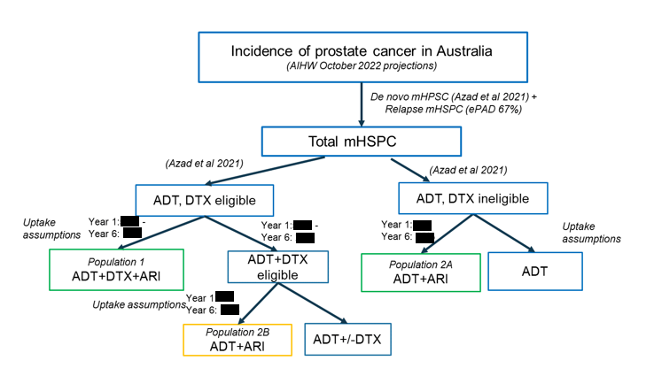
Source: Figure 1 of the darolutamide deferral response
ADT = androgen deprivation therapy; AIHW = Australian Institute of Health and Welfare; ARI = androgen receptor inhibitor/novel hormonal agent; DTX = docetaxel; mHSPC = metastatic hormone sensitive prostate cancer
Table 19: Summary of the utilisation and financial impact assumptions
Data | November 2022 value and method/source | May 2023 value and method/source | Comment
Eligible population
Incidence of prostate cancer | Year 1: 17,656  Year 2: 17,429  Year 3: 17,202  Year 4: 16,975  Year 5: 16,748  Year 6: 16,521  AIHW Cancer Data in Australia 2021 | Year 1: 24,778  Year 2: 25,321  Year 3: 25,852  Year 4: 26,397  Year 5: 26,902  Year 6: 27,404  Updated. AIHW Cancer Data in Australia 2022 | Estimates calculated using linear extrapolation of data. Updated AIHW data results in an incident population that is 31% larger than in the November 2022 submission.  The 2022 release of Cancer data included a change of methodology for calculating prostate cancer incidence projections, which increased the estimated number of prostate cancers. This change resulted in the number of incident patients with mHSPC being more consistent with those for estimated for apalutamide.
Incident patients with mHSPC | Year 1: 1,845  Year 2: 1,821  Year 3: 1,797  Year 4: 1,774  Year 5: 1,750  Year 6: 1,726  Applied 7% metastasis at diagnosis (PCOR-ANZ) and ePAD split for de-novo/relapsed of 67%/33% | Year 1: 2,589  Year 2: 2,645  Year 3: 2,701  Year 4: 2,758  Year 5: 2,811  Year 6: 2,863  Unchanged. | -
Pop 1: Triple therapy eligible patients | Year 1: ||||¹  Year 2: ||||¹  Year 3: ||||¹  Year 4: ||||¹  Year 5: ||||¹  Year 6: ||||¹  Based on uptake of ADT + docetaxel (Azad 2021 updated) and calculated by applying an average 2.5% increase per year.  Year 1: 43.1%; Year 2: 45.5%; Year 3: 48.0%; Year 4: 50.5%; Year 5: 52.9%; Year 6: 55.4% | Year 1: ||||¹  Year 2: ||||¹  Year 3: ||||¹  Year 4: ||||¹  Year 5: ||||¹  Year 6: ||||¹  Unchanged. | The PBAC noted with listings for both dual and triple therapy it may not be appropriate to assume the proportion eligible for triple therapy increases over time.
Pop 2A: Dual therapy docetaxel ineligible patients | - | Year 1: ||||¹  Year 2: ||||¹  Year 3: ||||¹  Year 4: ||||¹  Year 5: ||||¹  Year 6: ||||¹  Based on remaining proportion of uptake of ADT + docetaxel (i.e. 1 – Pop 1 rate)  Year 1: 56.9%; Year 2: 54.5%; Year 3: 52.0%; Year 4: 49.5%; Year 5: 47.1%; Year 6: 44.6% | The PBAC noted with listings for both dual and triple therapy it may not be appropriate to assume the proportion eligible for dual therapy decreases over time.
Pop 2B: Dual therapy - docetaxel eligible patients | - | Year 1: ||||¹  Year 2: ||||²  Year 3: ||||²  Year 4: ||||²  Year 5: ||||²  Year 6: ||||²  Based on Pop 1. patients eligible for triple therapy – those receiving triple therapy | -
Treatment utilisation
Pop 1: Triple therapy uptake rate | Year 1: ||||%  Year 2: ||||%  Year 3: ||||%  Year 4: ||||%  Year 5: ||||%  Year 6: ||||% | Year 1: ||||%  Year 2: ||||%  Year 3: ||||%  Year 4: ||||%  Year 5: ||||%  Year 6: ||||% | Uptake rates revised to be higher in Years 1 and 2.
Pop 2A and 2B: Dual therapy uptake rate | - | Year 1: ||||%  Year 2: ||||%  Year 3: ||||%  Year 4: ||||%  Year 5: ||||%  Year 6: ||||% | Based on apalutamide uptake in the LV population in the pre-PBAC response.
Pop 1: Patients initiating triple therapy | Year 1: ||||²  Year 2: ||||²  Year 3: ||||¹  Year 4: ||||¹  Year 5: ||||¹  Year 6: ||||¹ | Year 1: ||||¹  Year 2: ||||¹  Year 3: ||||¹  Year 4: ||||¹  Year 5: ||||¹  Year 6: ||||¹ | Increase compared to November 2022 is due to the increase in the total incident population and increased uptake rates.
Pop 2A: Patients initiating dual therapy; docetaxel ineligible | - | Year 1: ||||¹  Year 2: ||||¹  Year 3: ||||¹  Year 4: ||||¹  Year 5: ||||¹  Year 6: ||||¹ | This is a new incident mHSPC pool of patients; therefore, there are no prevalent patients associated with this population to avoid double counting.
Pop 2B: Patients initiating dual therapy; docetaxel eligible | - | Year 1: ||||²  Year 2: ||||²  Year 3: ||||²  Year 4: ||||²  Year 5: ||||²  Year 6: ||||² | Assumed to be similar to the HV apalutamide population.
Total incident patients on treatment with darolutamide | Year 1: ||||²  Year 2: ||||¹  Year 3: ||||¹  Year 4: ||||¹  Year 5: ||||¹  Year 6: ||||¹  Time to treatment discontinuation KM data from ARASENS, % on treatment:  Year 1: 100%; Year 2: 82.5%; Year 3: 63.1%; Year 4: 53.1%; Year 5: 39.4%; Year 6: 23.9% | Year 1: ||||¹  Year 2: ||||¹  Year 3: ||||¹  Year 4: ||||³  Year 5: ||||³  Year 6: ||||³  Unchanged. | -
Scripts dispensed | Year 1: ||||¹  Year 2: ||||³  Year 3: ||||⁴  Year 4: ||||⁵  Year 5: ||||⁵  Year 6: ||||⁵  Compliance = 97% (ARASENS), 1 script every 28 days. | Year 1: ||||⁴  Year 2: ||||⁶  Year 3: ||||⁷  Year 4: ||||⁸  Year 5: ||||⁹  Year 6: ||||¹⁰  Unchanged. | -
Reduction in numbers of patients initiating subsequent treatments for mCRPC | Year 1: ||||²  Year 2: ||||²  Year 3: ||||²  Year 4: ||||²  Year 5: ||||²  Year 6: ||||²  Time to subsequent treatment data from ARASENS (and as extrapolated in the economic model) was used to estimate the reduction in numbers of patients starting subsequent treatment due to darolutamide. | Year 1: ||||²  Year 2: ||||²  Year 3: ||||¹  Year 4: ||||¹  Year 5: ||||¹  Year 6: ||||¹  Unchanged. | -
Subsequent treatments: assumed proportional use and numbers of scripts per patient | Drug NHA No NHA Scripts  Enza 58.1% 0% 11.4  ABI 10.8% 0% 8.0  DOC 54.1% 48.9% 10.0  CAB 5.7% 2.6% 6.6  Based on DUSC data (April-June 2018, N=795) provided to the sponsor. Patients treated with darolutamide were not permitted any further NHAs. | Unchanged | -
Costs
DPMQ Darolutamide | $||||, reduced to $|||| in the pre-PBAC response | $|||| | -
DPMQ Abiraterone | $|||| | Unchanged | -
DPMQ Enzalutamide | $|||| | Unchanged | -
Patient co-payment | PBS: $11.27  RPBS: $1.36  PBS/RPBS split: 98.23%/1.77%  Based on darolutamide utilisation in m0CRPC (PBS item 12684N) | PBS: $10.11  RPBS: $3.81  PBS/RPBS split: unchanged  Based on updated darolutamide usage in m0CRPC (PBS item 12684N) to include 2022 calendar year. | Updated co-payments did not incorporate the reduction in the general co-payment on 1 Jan 2023 to $30.
Source: Table 3 of the darolutamide deferral response
ABI = abiraterone; ADT = androgen deprivation therapy; AIHW = Australian Institute of Health and Welfare; CAB = cabazitaxel; DOC = docetaxel; DPMQ = dispensed price for maximum quantity; DUSC = Drug Utilisation Sub-Committee; Enza = enzalutamide; ESC = Economic Sub-Committee; HV = high volume; KM = Kaplan Meier; LV = low volume; mCRPC = metastatic castration resistant prostate cancer; m0CRPC = non-metastatic castration resistant prostate cancer; mHSPC = metastatic hormone sensitive prostate cancer; NHA= novel hormonal agent; PBAC = Pharmaceutical Benefits Advisory Committee; PBS = Pharmaceutical Benefits Scheme; RPBS = Repatriation Pharmaceutical Benefits Scheme

The redacted values correspond to the following ranges:
¹500 to < 5,000
²< 500
³5,000 to < 10,000
⁴10,000 to < 20,000
⁵20,000 to < 30,000
⁶40,000 to < 50,000
⁷50,000 to < 60,000
⁸70,000 to < 80,000
⁹90,000 to < 100,000
¹⁰100,000 to < 200,000
  - Table 20 summarises the estimated net financial implications of listing darolutamide on the PBS/RPBS.
Table 20: Estimated use and financial implications
 | Year 1 | Year 2 | Year 3 | Year 4 | Year 5 | Year 6
Estimated number of patients
Incident patients with mHSPC | | ¹ | | ¹ | | ¹ | | ¹ | | ¹ | | ¹
Pop 1: Patients receiving triple therapy | | ¹ | | ¹ | | ¹ | | ¹ | | ¹ | | ¹
Pop 2A: Patients receiving dual therapy (docetaxel ineligible) | | ¹ | | ¹ | | ¹ | | ¹ | | ¹ | | ¹
Pop 2B: Patients receiving dual therapy (docetaxel eligible) | | ² | | ² | | ² | | ² | | ² | | ²
Total initiating patients | | ¹ | | ¹ | | ¹ | | ¹ | | ¹ | | ¹
Continuing patients | | ² | | ¹ | | ¹ | | ¹ | | ¹ | | ³
Total DARO patients | | ¹ | | ¹ | | ¹ | | ³ | | ³ | | ³
Estimated use and net cost of darolutamide to PBS/RPBS
DARO scripts | | ⁴ | | ⁵ | | ⁶ | | ⁷ | | ⁸ | | ⁹
Cost PBS/RPBS ($) | | ¹⁰ | | ¹¹ | | ¹² | | ¹³ | | ¹⁴ | | ¹⁴
Patient co-payments ($) | | ¹⁵ | | ¹⁵ | | ¹⁵ | | ¹⁵ | | ¹⁵ | | ¹⁵
Net cost to PBS/RPBS ($) | | ¹⁰ | | ¹¹ | | ¹² | | ¹³ | | ¹⁴ | | ¹⁴
Estimated changes in use and financial impact of currently listed treatments
Patients initiating mCRPC treatment | | ² | | ² | | ¹ | | ¹ | | ² | | ¹
Net impact on mCRPC treatment scripts
ABI | | ² | | ¹ | | ¹ | | ¹ | | ¹ | | ¹
ENZA | | ¹ | | ³ | | ³ | | ³ | | ⁴ | | ⁴
Docetaxel | | ¹ | | ¹ | | ¹ | | ¹ | | ¹ | | ¹
Cabazitaxel | | ² | | ² | | ² | | ² | | ² | | ¹
Cost PBS/RPBS ($) | | ¹⁵ | | ¹⁵ | | ¹⁶ | | ¹⁶ | | ¹⁶ | | ¹⁶
Net financial implications to government
Total cost PBS/RPBS ($) | | ¹⁶ | | ¹⁷ | | ¹⁸ | | ¹² | | ¹³ | | ¹⁹
November 2022 submission
Darolutamide use
Total patients treated with DARO | | ² | | ¹ | | ¹ | | ¹ | | ¹ | | ¹
DARO scripts | | ¹ | | ³ | | ⁴ | | ²⁰ | | ²⁰ | | ²⁰
Net cost PBS/RPBS ($) | | ¹⁵ | | ¹⁶ | | ¹⁰ | | ¹⁷ | | ¹¹ | | ¹⁸
Changed use of other treatments
Patients initiating mCRPC treatment | | ² | | ² | | ² | | ² | | ² | | ²
Net cost PBS/RPBS ($) | | ²¹ | | ²¹ | | ²¹ | | ²¹ | | ²¹ | | ²¹
Net financial implication to government
Total net cost PBS/RPBS ($) | | ¹⁵ | | ¹⁶ | | ¹⁰ | | ¹⁷ | | ¹⁷ | | ¹¹
Net financial implication to government using DPMQ proposed in pre-PBAC response
Total net cost PBS/RPBS ($) | | ¹⁵ | | ¹⁵ | | ¹⁶ | | ¹⁰ | | ¹⁰ | | ¹⁷
Source: Tables 5, 7, 9 and 10 of the darolutamide deferral response and Table 17 of the November 2022 darolutamide PSD
ABI = abiraterone; DARO = darolutamide; ENZA = enzalutamide; mCRPC = metastatic castration resistant prostate cancer; mHSPC = metastatic hormone sensitive prostate cancer; PBS = Pharmaceutical Benefits Scheme; RPBS = Repatriation Pharmaceutical Benefits Scheme
The redacted values correspond to the following ranges:
¹500 to < 5,000
²< 500
³5,000 to < 10,000
⁴10,000 to < 20,000
⁵40,000 to < 50,000
⁶50,000 to < 60,000
⁷70,000 to < 80,000
⁸90,000 to < 100,000
⁹100,000 to < 200,000
¹⁰$20 million to < $30 million
¹¹$40 million to < $50 million
¹²$60 million to < $70 million
¹³$80 million to < $90 million
¹⁴$100 million to < $200 million
¹⁵$0 to < $10 million
¹⁶$10 million to < $20 million
¹⁷$30 million to < $40 million
¹⁸$50 million to < $60 million
¹⁹$90 million to < $100 million
²⁰20,000 to < 30,000
²¹net cost saving
  - The proposal estimated that the addition of darolutamide to the PBS/RPBS would cost $10 million to < $20 million in Year 1, $90 million to < $100 million in Year 6 and total $300 million to < $400 million over the first 6 years of listing.

Financial Management – Risk Sharing Arrangements
  - In November 2022 the PBAC requested that an RSA should be proposed that mitigated the risks associated with (i) the concerns that patients would remain on darolutamide for longer than estimated in the economic model, which was based on the ARASENS trail; and (ii) the use of dual therapy as an alternative to docetaxel (i.e. Population 2B in the above financial estimates).
  - The proposal noted that the use of a NHA + ADT in patients in Population 2B was not supported by the ARASENS trial evidence (which supports darolutamide + ADT + docetaxel) or the TITAN trial (which supports the use of apalutamide + ADT in patients unsuitable for docetaxel). The proposal noted that this population accounted for 12% of the estimated total population defined by the proposed PBS restriction.
  - The RSA therefore proposed expenditure caps based upon the net drug cost for Population 1 and Population 2A, excluding Population 2B. A | |% rebate for use beyond the expenditure caps was proposed.
Table 21: Proposed RSA expenditure caps
 | Year 1 | Year 2 | Year 3 | Year 4 | Year 5 | Year 6
Total net cost to PBS/RPBS (Pop 1, 2A and 2B) ($) | | ¹ | | ² | | ³ | | ⁴ | | ⁵ | | ⁵
Net cost to PBS/RPBS of Pop 2B ($) | | ⁶ | | ⁶ | | ⁶ | | ⁷ | | ⁷ | | ⁷
Proposed RSA expenditure caps ($) | | ⁷ | | ⁸ | | ⁹ | ||¹⁰ | | ⁴ | | ⁵
Source: Table 12 of the darolutamide deferral response
PBS = Pharmaceutical Benefits Scheme; RPBS = Repatriation Pharmaceutical Benefits Scheme; RSA = risk sharing arrangement

The redacted values correspond to the following ranges:
¹$20 million to < $30 million
²$40 million to < $50 million
³$60 million to < $70 million
⁴$80 million to < $90 million
⁵$100 million to < $200 million
⁶$0 to < $10 million
⁷$10 million to < $20 million
⁸$30 million to < $40 million
⁹$50 million to < $60 million
¹⁰$70 million to < $80 million
- PBAC Outcome
  - The PBAC recommended darolutamide for the treatment of metastatic hormone sensitive prostate cancer (mHSPC). The PBAC noted that the advice from the TGA Delegate had been provided. The PBAC also noted that the proposal had accepted the November 2022 recommended changes to the economic model, provided revised financial estimates and parameters for a risk sharing arrangement (RSA) and proposed a restriction that mirrored that previously recommended by the PBAC for apalutamide which allowed darolutamide to be used as dual therapy in combination with androgen deprivation therapy (ADT) or as triple therapy in combination with ADT and docetaxel.
  - The PBAC considered that the single proposed restriction for darolutamide, that aligned with that previously recommended for apalutamide and enzalutamide and catered for initial, continuing and grandfather patients, was appropriate. The PBAC noted that the restriction allowed for the use of darolutamide as dual or triple therapy and considered that this would appropriately increase clinical choice. As noted above in paragraph 7.3, the PBAC considered the choice between dual or triple therapy for mHSPC, and the preferred regimen will depend on patient and clinician preferences, including their assessment of disease extent, patient frailty, additional toxicities associated with docetaxel and access to subsequent therapies given patients are only able to access NHAs once in their lifetime on the PBS. The PBAC acknowledged that for darolutamide the key clinical evidence currently available was for triple therapy, whereas for apalutamide the key clinical evidence currently available was for dual therapy. However, as darolutamide and apalutamide have the same mechanism of action and are considered non-inferior in the m0CRPC setting, there was not likely to be a clinically meaningful difference in efficacy between the agents if used as a part of dual or triple therapy.
  - The PBAC considered that darolutamide should be initiated within 6 months of commencing ADT, which aligned with the recommended restriction for apalutamide. The PBAC noted that this should allow patients sufficient time to access the required specialists.
  - The PBAC recalled that in November 2022 it had considered that the economic model should be amended to incorporate a time horizon of 10 years (reduced from 15 years), convergence of the overall survival curves from 5 to 15 years and a utility value of 0.699 for progressed disease (as compared to 0.635 in the base case). The PBAC had considered that darolutamide would be cost effective if the ICER for this scenario was no more than $45,000 per QALY (see paragraph 7.10).
  - The PBAC noted that the proposal amended the model as requested and proposed an effective ex-manufacturer price for darolutamide of $| | that resulted in a cost effective ICER of $35,000 to < $45,000 per QALY.
  - The PBAC considered for the purpose of Section 101(3B) of the National Health Act 1953, that darolutamide was an alternative therapy to apalutamide and enzalutamide, and that darolutamide does not provide a significant improvement in efficacy and/or reduction of toxicity over apalutamide or enzalutamide. The PBAC advised that the price of darolutamide should therefore be not higher than the price of apalutamide or enzalutamide, based on the daily cost at recommended doses (darolutamide 1,200 mg daily is equi-effective to enzalutamide 160 mg daily and apalutamide 240 mg daily), should apalutamide or enzalutamide be PBS listed for mHSPC.
  - In terms of the utilisation and financial impact estimates, the PBAC noted that the proposal provided revised estimates that aligned with the revised restriction. The PBAC noted that, whereas the November 2022 estimates for darolutamide as triple therapy included only a proportion of mHSPC patients who were eligible for docetaxel, the revised estimates included all mHSPC patients who would be eligible for dual or triple therapy, regardless of their docetaxel eligibility.
  - The PBAC recalled that in July 2022, in consideration of apalutamide, it had noted that there was no evidence that the use of a NHA + ADT was cost effective in patients who were eligible to receive docetaxel, and that an aim of the RSA recommended for apalutamide was to mitigate the risk of non-cost effective NHA + ADT use in these patients (paragraphs 7.12 and 7.14, apalutamide PSD, July 2022 PBAC meeting).
  - The PBAC considered that as the key clinical evidence that informed the economic model provided for darolutamide was based on its use as triple therapy, it could now be assured that the use of a NHA + ADT + docetaxel was cost effective in those patients who were docetaxel eligible. The PBAC noted that there was still no assurance that the use of dual therapy, i.e. a NHA + ADT, where the NHA is being used as an alternative to docetaxel, was cost effective.
  - Noting that it had previously accepted the financial estimates for apalutamide for the use of a NHA + ADT +/- docetaxel in all patients except those with high volume disease who were docetaxel eligible, the PBAC considered that the apalutamide assumptions and inputs should form the basis of any future utilisation estimates and RSAs in this setting. As noted above (paragraph 13.8), the recommended utilisation estimates for apalutamide excluded patients with high volume disease who were docetaxel eligible due to uncertain cost effectiveness. The PBAC considered that the RSA recommended for apalutamide should be amended to include docetaxel eligible patients who received triple therapy, as the darolutamide submission has proven the cost effectiveness of this combination in these patients. The PBAC considered it would be reasonable to assume 50% of docetaxel eligible patients would be eligible to receive triple therapy, and that the assumed uptake should be as presented in the November 2022 submission (| |% in Year 1 increasing to | |% in Years 4 to 6). The PBAC considered the uptake of triple therapy would be lower initially due to the anticipated listing of apalutamide in this setting and the available evidence for its use as dual therapy (see paragraph 15.2).
  - The PBAC advised that darolutamide is not suitable for prescribing by nurse practitioners.
  - The PBAC advised that darolutamide should not be exempt from the Early Supply Rule.
  - The PBAC found that the criteria prescribed by the National Health (Pharmaceuticals and Vaccines – Cost Recovery) Regulations 2022 for Pricing Pathway A were not met. Specifically, the PBAC found that in the circumstances of its recommendation for darolutamide + ADT +/- docetaxel:
    - The treatment is expected to provide a moderate clinical benefit for patients with mHSPC compared to ADT alone;
    - The treatment is not expected to address a high and urgent unmet clinical need as it, and other NHAs, are available on the PBS for patients with prostate cancer in a later line setting;
    - It was not necessary to make a finding in relation to whether it would be in the public interest for the subsequent pricing application to be progressed under Pricing Pathway A because one or more of the preceding tests had failed.
  - The PBAC noted that this submission is not eligible for an Independent Review as it received a positive recommendation.
Outcome:
Recommended
- Recommended listing
  - Add new item:

MEDICINAL PRODUCT  medicinal product pack |  |  | PBS item code | Max. qty packs | Max. qty units | №. of  Rpts | Available brands
DAROLUTAMIDE
darolutamide 300 mg oral tablet, 112 |  |  | NEW  ^{MP} | 1 | 112 | 5 | Nubeqa
 |  | Category / Program: General Schedule (Code GE)
 |  | Prescriber type: Medical Practitioners
 |  | Restriction type: Authority Required – immediate/real time assessment (telephone/electronic)
 |  | Administrative advice: No increase in the maximum quantity or number of units may be authorised
 |  | Administrative advice: No increase in the maximum number of repeats may be authorised
 |  | Administrative advice: Special Pricing Arrangements apply
Administrative advice:
Applications for authorisation under this restriction may be made in real time using the Online PBS Authorities system (see www.servicesaustralia.gov.au/HPOS) or by telephone by contacting Services Australia on 1800 888 333.
 |  | Severity: Metastatic, castration sensitive
 |  | Condition: carcinoma of the prostate
 |  | Indication: Metastatic, castration sensitive carcinoma of the prostate
 |  | Clinical criteria:
 |  | Treatment must be/have been initiated within 6 months of treatment initiation with androgen deprivation therapy
 |  | AND
 |  | Clinical criteria:
 |  | Patient must only receive subsidy for one novel hormonal drug per lifetime for prostate cancer (regardless of whether a drug was subsidised under a metastatic/non-metastatic indication); or
 |  | Patient must only receive subsidy for a subsequent novel hormonal drug where there has been a severe intolerance to another novel hormonal drug leading to permanent treatment cessation.
 |  | AND
 |  | Clinical criteria:
 |  | Patient must not receive PBS-subsidised treatment with this drug if progressive disease develops while on this drug
 |  | AND
 |  | Treatment criteria:
 |  | Patient must be undergoing concurrent treatment with androgen deprivation therapy
Administrative advice:
Where the term ‘novel hormonal drug’ appears in this restriction, it refers to: (i) abiraterone, (ii) apalutamide, (iii) darolutamide, (iv) enzalutamide.

This restriction may be subject to further review. Should there be any changes made to the restriction the sponsor will be informed.
- Context for Decision
The PBAC helps decide whether and, if so, how medicines should be subsidised through the Pharmaceutical Benefits Scheme (PBS) in Australia. It considers applications regarding the listing of medicines on the PBS and provides advice about other matters relating to the operation of the PBS in this context. A PBAC decision in relation to PBS listings does not necessarily represent a final PBAC view about the merits of the medicine or the circumstances in which it should be made available through the PBS. The PBAC welcomes applications containing new information at any time.
- Sponsor’s Comment
Bayer welcomes the PBAC’s decision to recommend darolutamide (Nubeqa®) for reimbursement on the PBS for metastatic hormone sensitive prostate cancer (mHSPC) patients. Bayer will continue to work with the Department of Health to ensure a timely PBS listing.

July 2022 PBAC Meeting: https://www.pbs.gov.au/industry/listing/elements/pbac-meetings/pbac-outcomes/2022-07/pbac-web-outcomes-07-2022.pdf
Parker C, Castro E, Fizazi K, Heidenreich A, Ost P, Procopio G, Tombal B, Gillessen S; ESMO Guidelines Committee. ESMO Clinical Practice Guidelines for diagnosis, treatment and follow-up. Ann Oncol. 2020 Sep;31(9):1119-1134
Apalutamide (mHSPC) PSD, November 2021, available from: https://www.pbs.gov.au/industry/listing/elements/pbac-meetings/psd/2021-11/files/apalutamide-mHSPC-psd-nov-2021.pdf, accessed 3 August 2022.
PBAC agenda July 2022, available from: https://www.pbs.gov.au/industry/listing/elements/pbac-meetings/agenda/pdf/2022/PBAC-meeting-agenda-July-2022-July.pdf, accessed 3 August 2022.
High volume (HV) disease defined as: visceral metastases or at least 4 bone metastases including at least one outside the vertebral column or pelvis, whereas Low volume (LV) were defined as no visceral metastases and less than 4 bone metastases.
Gravis G, Boher JM, Chen YH, et al. Burden of Metastatic Castrate Naive Prostate Cancer Patients, to Identify Men More Likely to Benefit from Early Docetaxel: Further Analyses of CHAARTED and GETUG-AFU15 Studies. Eur Urol. 2018;73(6):847-855. doi:10.1016/j.eururo.2018.02.001
Darolutamide in Addition to ADT Versus ADT in Metastatic Hormone-sensitive Prostate Cancer (ARANOTE), clinicaltrials.gov, available from: https://clinicaltrials.gov/ct2/show/NCT04736199, accessed 02/8/2022.
Cherny NI, Dafni U, Bogaerts J, et al: ESMO-Magnitude of Clinical Benefit Scale version 1.1. Annals of Oncology 28:2340-2366, 2017
Cornford P. et al. European Association of Urology (EAU)-European Association of Nuclear Medicine (EANM)-European Society for Radiotherapy & Oncology (ESTRO)-European Society of Urogenital Radiology (ESUR)- International Society of Geriatric Oncology (SIOG). Guidelines on Prostate Cancer. Part II-2020 Update: Treatment of Relapsing and Metastatic Prostate Cancer. Eur Urol. 2021 Feb;79(2):263-282
Lowrance WT, Breau RH, Chou R et al: Advanced Prostate Cancer: AUA/ASTRO/SUO Guideline PART I. J Urol 2021; 205: 14/22

