OOS Dulaglutide,
Injection 1.5 mg in 0.5 mL single dose pre-filled pen (s19A),
Trulicity (Netherlands),
Medsurge Healthcare Pty Ltd
- Background
  - Dulaglutide is a GLP-1 analogue used in the treatment of type 2 diabetes, it is available on the PBS for use in combination with metformin and/or sulfonylurea or with insulin.
  - Eli Lilly Australia Pty Ltd (Lilly), the sponsor of the only PBS listed dulaglutide product, Trulicity®, has notified the TGA of a shortage of its brand caused by increased consumer demand due to the shortage of semaglutide. Lilly anticipates limited availability of Trulicity into the foreseeable future and beyond 31 December 2022.
  - Medicare prescription data from 2021 is set out in the table below.
Table 1: Patient category share of prescriptions for dulaglutide (11364D) from 1 January 2021 to 31 December 2021.
 | PBS |  |  |  | RPBS
 | General – Ordinary | General – Safety Net | Concessional-Ordinary | Concessional – Free Safety Net | RPBS – Ordinary | RPBS – Safety Net | Total
Services | 199,349 | 20,114 | 245,213 | 154,271 | 5,610 | 5,077 | 629,634
Benefit | $18,534,597 | $2,551,364 | $30,947,505 | $20,457,742 | $703,953 | $670,582 | $73,865,742
Source: Medicare statistics website (http://medicarestatistics.humanservices.gov.au/statistics/pbs_item.jsp)
  - The chart below shows the year-to-date PBS prescription volumes for dulaglutide injections, the figures for the month of September showed a decline in prescriptions of approximately 41% from the prior month.

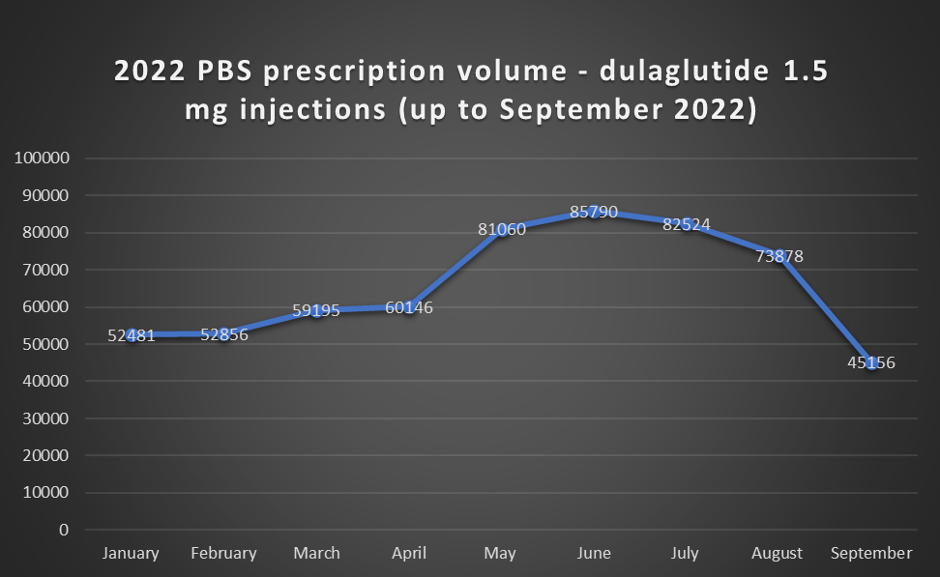
- Requested Listing
  - The s19A approved product is the same form, strength and pack size as the current listing. Medsurge Healthcare has requested a higher AEMP for the s19A product ($| |) compared to the existing listing $| | (effective price, the published price is $111.44). The details of the request are set out in table 2.
Table 2: Details of requested s19A listing
Product in shortage | AEMP (Current listing) | s19A product | s19A expiry | Requested AEMP
Dulaglutide Injection 1.5 mg in 0.5 mL single dose pre-filled pen (Injection), Trulicity | $111.44 published price  ($ | effective price) | TRULICITY dulaglutide 1.5 mg/0.5 mL solution for injection  prefilled pen (Netherlands) | 28 February 2023 | $|

  - Medsurge has advised that it can supply < 500 units per month. Due to the limited supply volume, the estimated financial impact is expected to be low.
  - The submission requested the following new listing. Additions are in italics and deletions are in strikethrough.
MEDICINAL PRODUCT  medicinal product pack |  | PBS item code | Max. qty packs | Max. qty units | №.of  Rpts | Available brands
DULAGLUTIDE
dulaglutide 1.5 mg/0.5 mL injection, 4 x 0.5 mL pen devices |  | 11364D | 1 | 4 | 5 | Trulicity
dulaglutide 1.5 mg/0.5 mL injection, 4 x 0.5 mL pen devices |  | NEW | 1 | 4 | 5 | Trulicity (Netherlands)
Concept ID  (for internal Dept. use) | Category / Program: GENERAL – General Schedule (Code GE)
 | Prescriber type: Medical Practitioners Nurse Practitioners
 | Restriction type: Streamlined
- PBAC advice
  - The PBAC recommended the temporary listing of the s19A product dulaglutide 1.5 mg/0.5 mL solution for injection prefilled pen (Netherlands), TRULICITY on the PBS at the same ex-manufacturer price (effective price) as the PBS-listed dulaglutide which are currently in shortage.
  - The PBAC did not support listing at the requested price as it considered that the s19A listing should not come at an increased cost.
  - The PBAC considered the requested price for the s19A product (AEMP $|||| ||||) represented a steep markup over the effective price of the listed product and that the low supply volumes would not meaningfully assist with the current shortages.
  - The PBAC considered that there is a clinical need to maintain supply of dulaglutide on the PBS. The PBAC considered that the temporary listing should apply for the duration of the subsection 19A(1) approval.
  - The PBAC noted that the limited availability of TRULICITY has been caused by an unexpected increase in consumer demand, which has arisen due to the shortages of semaglutide. The PBAC noted reports that the shortage of semaglutide has been driven by off-label prescribing for obesity management. The PBAC also noted that there is uncertainty as to a timeframe for when the shortages for both drugs will be resolved.
  - The PBAC also noted there were no mechanisms available to ensure existing patients would have prioritised access to the s19A product if listed on the PBS, and there would be a risk that the limited supplies could be diverted to patients with lesser clinical needs.
  - The PBAC advised under section 101(4AACD) of the Act that the temporary listing for dulaglutide 1.5 mg/0.5 mL solution for injection prefilled pen (Netherlands), TRULICITY should be treated as equivalent to the currently listed brand of dulaglutide, Injection 1.5 mg in 0.5 mL single dose pre-filled pen (Injection), TRULICITY for the purpose of substitution at the pharmacy level.
Outcome:
Recommended
- Context for Decision
The PBAC helps decide whether and, if so, how medicines should be subsidised through the Pharmaceutical Benefits Scheme (PBS) in Australia. It considers applications regarding the listing of medicines on the PBS and provides advice about other matters relating to the operation of the PBS in this context. A PBAC decision in relation to PBS listings does not necessarily represent a final PBAC view about the merits of the medicine or the circumstances in which it should be made available through the PBS. The PBAC welcomes applications containing new information at any time.
- Sponsor’s Comment
Since the worldwide shortage of diabetes medicine, Ozempic® (semaglutide) started earlier this year, there has been a flow-on effect in creating a shortage of Trulicity® (dulaglutide). Medsurge sought a section 19a (S19A) approval from the Therapeutics Goods Administration (TGA) to source overseas-registered dulaglutide products. Medsurge was granted a temporary S19A approval and has worked diligently to fill a critical need for patients with type 2 diabetes.
Australian local supply of TRULICITY dulaglutide (rch) 1.5 mg/0.5 mL solution for injection prefilled pen AUST R: 217965, supplied by Novo Nordisk is subsidised on the Pharmaceutical Benefits Scheme (PBS) for treatment of type 2 diabetes.
Sourcing overseas medicines under an S19A requires the local sponsor to apply to the Pharmaceutical Benefits Advisory Committee (PBAC) to approve a temporary variation in cost to the original Pharmaceutical Benefits Scheme pricing. Unfortunately, PBAC recommended that PBS listing be granted at the current local supply price.
Medsurge sources the dulaglutide products from various overseas supply partners, not directly from the manufacturer, which is considerably more expensive. Medsurge does not have control over the pricing set by the overseas partners. In addition, the rising cost of shipping, air freight, duties, currency conversion and small batch quantities add to the increased expense of sourcing critical medicines from overseas wholesalers. Therefore, Medsurge are unable to supply overseas products at the expected local market prices.
Medsurge continues to engage with TGA, PBAC and other health professional organisations to find a favourable solution for all stakeholders, whilst still sourcing sufficient S19A supply to fulfil the current demand until the shortage is resolved.
Medsurge acknowledges the importance of access to Trulicity® for patients living with diabetes and other chronic health conditions and we are taking this shortage very seriously.

