5.06 MOBOCERTINIB,
Capsule 40 mg,
Exkivity®,
Takeda Pharmaceuticals Australia Pty Ltd.
- Purpose of submission
  - The Category 1 submission requested a General Schedule Authority Required listing for mobocertinib for the treatment of adults with epidermal growth factor receptor exon 20 insertion (EGFR ex20ins) positive locally advanced or metastatic (Stage IIIB/IV) non-small cell lung cancer (NSCLC) who have received platinum-based chemotherapy (PBC).
  - Listing was requested on the basis of a cost-utility analysis versus standard of care (SOC). SOC was assumed to comprise of standard EGFR tyrosine kinase inhibitors (TKIs) that target classical EGFR variants (in exon 19 and 21 for example), immune checkpoint inhibitors (ICIs), and chemotherapy. The key components addressed by the submission are presented in Table 1.
Table 1: Key components of the clinical issue addressed by the submission
Component | Description
Population | Patients diagnosed with EGFR ex20ins mutation-positive locally advanced (Stage IIIB) or metastatic (Stage IV) NSCLC whose disease has progressed on or after PBC
Intervention | Mobocertinib 160 mg (4 × 40 mg capsules) once daily.
Comparator | SOC, defined in the submission as a mix of EGFR TKIs, ICIs and chemotherapy
Outcomes | PFS, OS and safety.
Clinical claim | In patients with EGFR ex20ins-positive, Stage IIIB/IV NSCLC whose disease has progressed on or after PBC, mobocertinib is more effective than current SOC at improving PFS and extending OS with a non-inferior and acceptable safety profile
Source: Table 1-1, p31 and Section 2.8 of the submission.
EGFR = epidermal growth factor receptor; ex20ins = exon 20 insertion; ICIs = immune checkpoint inhibitors; NSCLC = non-small cell lung cancer; OS = overall survival; PBC = platinum-based chemotherapy; PFS = progression-free survival; SOC = standard of care; TKIs = tyrosine kinase inhibitors.
- Background

Registration status
  - Mobocertinib was listed on the Australian Register of Therapeutic Goods (ARTG) with provisional registration on the 19 July 2022. The approved indication is as follows:
“EXKIVITY has provisional approval in Australia for the treatment of adult patients with epidermal growth factor receptor (EGFR) exon 20 insertion mutation-positive locally advanced or metastatic non-small cell lung cancer (NSCLC), who have received prior platinum-based chemotherapy. The decision to approve this indication has been made on the basis of overall response rate (ORR) and duration of response (DOR). Continued approval of this indication depends on verification and description of benefit in confirmatory trials.”
  - Conditions of the provisional approval include the provision of all clinical study reports (CSRs) for the key Study 101 (interim and final) and other post-marketing safety studies. The submission noted that data from an ongoing randomised trial comparing mobocertinib versus PBC, in treatment naïve patients with EGFR ex20ins advanced NSCLC (NCT04129502), will be submitted to the TGA as part of an application to register mobocertinib on the ARTG for use in the first-line treatment setting.
- Requested listing
  - The requested listing for mobocertinib is provided below. Secretariat suggestions and additions proposed are shown in italics and deletions are in strikethrough. The submission proposed separate listings for mobocertinib for initial and continuing therapy, and for use in grandfathered patients; the proposed restriction for grandfathered patients is not presented below (discussed in paragraph 3.3).
MEDICINAL PRODUCT  medicinal product pack | Dispensed Price for Max. Qty | Max. qty packs | Max. qty units | №.of  Rpts | Available brands
MOBOCERTINIB
Mobocertinib 40 mg capsules, 112 | Published price  $13,489.99ª  Effective price  $|ª | 1 | 112 | 5 | Exkivity
ª Using the updated PBS fees, the dispensed price for mobocertinib would be $13,490.05 (published) and $| | (effective).

Category / Program: GENERAL – General Schedule (Code GE)
Prescriber type: Medical Practitioners
Restriction type:
Authority Required (telephone/online application avenues)
Administrative Advice: No increase in the maximum quantity or number of units may be authorised.
Administrative Advice: No increase in the maximum number of repeats may be authorised.
Condition: Stage IIIB (locally advanced) or IV (metastatic) non-small cell lung cancer (NSCLC).
Indication: Stage IIIB (locally advanced) or IV (metastatic) epidermal growth factor receptor (EGFR) exon 20 insertion positive non-small cell lung cancer (NSCLC) previously treated with platinum-based chemotherapy.
Treatment Phase: Initial PBS-subsidised treatment
Clinical criteria
The treatment must be the sole PBS-subsidised therapy for this condition
AND
Clinical criteria
Patient must have/have had a WHO performance status of 0 or 1 prior to initiation of treatment with this drug for this condition an ECOG performance status of 1 or less
AND
Clinical criteria
Patient must not have previously received this drug for this condition; OR
Patient must be each of: (i) currently receiving non-PBS subsidised supply for this drug for this PBS indication, (ii) untreated with this drug at the time that non-PBS subsidised supply was commenced, (iii) free of disease progression since commencing non-PBS subsidised supply
AND
Clinical criteria
The condition must be non-squamous type non-small cell lung cancer (NSCLC) or not otherwise specified type NSCLC
AND
Clinical criteria
The condition must have progressed on or after platinum-based chemotherapy Patient must have had progressive disease following platinum-based chemotherapy
AND
Clinical criteria
Patient must have evidence in tumour material of an activating epidermal growth factor receptor (EGFR) exon 20 insertion mutation
Administrative Advice: A patient may only qualify for PBS-subsidised treatment under this restriction once.
Following completion of the initial PBS-subsidised course, further applications for treatment will be assessed under the continuing treatment restriction.
Administrative Advice: Special Pricing Arrangements apply.
Administrative Advice: Applications for authorisation under this restriction may be made in real time using the Online PBS Authorities system (see www.servicesaustralia.gov.au/HPOS) or by telephone by contacting Services Australia on 1800 888 333.

Category / Program: GENERAL – General Schedule (Code GE)
Prescriber type: Medical Practitioners
Restriction type:
Authority Required (telephone/online application avenues)
Administrative Advice: No increase in the maximum quantity or number of units may be authorised.
Administrative Advice: No increase in the maximum number of repeats may be authorised.
Condition: Stage IIIB (locally advanced) or IV (metastatic) non-small cell lung cancer (NSCLC).
Indication: Stage IIIB (locally advanced) or IV (metastatic) epidermal growth factor receptor (EGFR) exon 20 insertion positive non-small cell lung cancer (NSCLC) previously treated with platinum-based chemotherapy.
Treatment Phase: Continuing
Clinical criteria
The treatment must be the sole PBS-subsidised therapy for this condition
AND
Clinical criteria
Patient must have previously received PBS-subsidised treatment this drug for this condition
AND
Clinical criteria
Patient must not have developed disease progression while receiving treatment with this drug for this condition
Administrative Advice: Special Pricing Arrangements apply.
Administrative Advice: Applications for authorisation under this restriction may be made in real time using the Online PBS Authorities system (see www.servicesaustralia.gov.au/HPOS) or by telephone by contacting Services Australia on 1800 888 333.

  - The submission proposed a Special Pricing Arrangement (SPA) with published and effective dispensed prices for maximum quantity (DPMQs).
  - The submission requested a Grandfather restriction for patients on the Sponsor’s compassionate access program. The submission stated that < 500 patients would require transitioning to PBS funded treatment should mobocertinib be listed. The Secretariat’s suggested changes accommodate such transitioning in the initial treatment phase restriction.
  - The requested restriction was for patients with either locally advanced (Stage IIIB) or metastatic (Stage IV) NSCLC. There was limited evidence for efficacy in patients with locally advanced disease in the key study, Study 101 (one patient (0.9%)). The PBAC noted that the staging system for NSCLC has been updated according to the American Joint Committee on Cancer (AJCC) Cancer Staging 8th edition (January 2018) to include a IIIC stage that has partial overlap with the prior IIIB stage. This is relevant to the requested indication for mobocertinib in Stage IIIB (locally advanced) or IV (metastatic) patients. The PBAC acknowledged that the updated AJCC staging system affects PBS listings for NSCLC in general, and noted that the updated system should be used for each new consideration in NSCLC.
  - The submission requested that the restrictions for mobocertinib specify: i) that mobocertinib is used as monotherapy (consistent with the evidence), ii) that patients must have the EGFR ex20ins mutation for eligibility (consistent with the evidence), and iii) that the word “mutation”, rather than “variant”, is used in the requested restriction, in order to be consistent with the current PBS listings of other EGFR TKIs. Nomenclature guidelines are available from the Human Genome Variation Society; while the recommendation from the Society is to use the term ”variant”, the PBAC noted that “mutation” is consistent with current PBS listings of other EGFR TKIs.
  - The submission proposed that patients be eligible for mobocertinib (an EGFR TKI agent) regardless of whether they have received prior treatment with other EGFR TKIs. The submission stated that this is consistent with the current PBS restrictions in NSCLC for osimertinib , afatinib, erlotinib, and gefitinib. However, the evaluation noted that current listings for these agents do not allow sequential use of EGFR TKIs except for intolerance/toxicity, with the exception of osimertinib. The submission noted that other EGFR TKIs are “widely recognised as being ineffective in EGFR ex20ins positive NSCLC”. The submission stated that Study 101 included patients who had been previously treated with other EGFR TKIs, and that a post-hoc subgroup analysis showed there was no statistically significant difference in objective response rate (ORR) between patients with or without a history of prior EGFR TKI use. The evaluation noted that the subgroup analysis was based on small patient numbers and the results were not reliable (prior TKI use: N=29, ORR=21%; no prior TKI use: N=85, ORR=31%).
  - The submission noted that EGFR gene mutation testing in NSCLC, to determine eligibility for various EGFR TKIs listed on the PBS (Medicare Benefits Schedule (MBS) Item number 73337), is performed as part of standard clinical practice in Australia, and that this item is agnostic to the specific EGFR TKI. The submission anticipated that i) a PBS listing for mobocertinib would have no impact on the number of EGFR tests performed in clinical practice, or on the cost to the MBS, ii) no tests beyond those already administered in routine clinical practice are required to determine eligibility for treatment with mobocertinib, and iii) next-generation sequencing (NGS) is currently being assessed by the Medicare Services Advisory Committee (MSAC Assessment 1721)), which if reimbursed, may supersede MBS Item 73337. In the pooled prior platinum (PPP) treated cohort of the key mobocertinib study (Study 101), 48% of patients were tested with Sanger sequencing or NGS, and 22% were tested using polymerase chain reaction methods. The testing methods for the remaining patients were not specified.
  - The prevalence of EGFR ex20ins variants in NSCLC varies depending on the genotyping technique. According to the literature, EGFR ex20ins accounts for 1–10% of EGFR variants identified in NSCLC. Because EGFR ex20ins are highly molecularly heterogeneous, the ability to identify the range of variants is dependent on the test methods used and PCR detection methods are considered to have a “miss” rate of more than 50%. Thus, PCR methods may not be optimal for the detection of EGFR ex20ins variants, and NGS testing remains important in this regard7.
  - The submission requested access be limited to non-squamous or not otherwise specified NSCLC subtypes. The PBAC agreed with the ESC that it may be appropriate to remove the reference to histology in the criteria to allow patients with squamous cell NSCLC to access treatment, due to the very small number of these patients in the community and their inclusion within the trial used as evidence in the submission. However, the PBAC noted that MBS item 73337 refers specifically to testing for EGFR status in non-squamous or ‘not otherwise specified’ histology and patients with squamous histology do not currently have access to testing.
  - The ESC considered that it may not be reasonable to require patients to have a WHO performance status of 0 or 1 prior to initiation of treatment with mobocertinib as it may be appropriate for some patients who have a status of ≥2 to receive treatment. The PBAC considered it would be appropriate for patients to have WHO performance status of 2 or less, consistent with the current listings for EGFR TKIs.
For more detail on PBAC’s view, see section 7 PBAC outcome.
- Population and disease
  - Lung cancer is the fourth most often diagnosed cancer for both men and women in Australia, representing approximately 9% of all new cancer diagnoses, and the leading cause of cancer mortality. The Australian Institute of Health and Welfare (AIHW) estimated that approximately 13,810 patients were diagnosed with lung cancer in 2021, while around 8,693 patients died from the disease.
  - The most common (termed “classical”) EGFR variants in NSCLC are deletions in exon 19 or the L858R point mutation in exon 21 which together account for 85-90% of EGFR variants in NSCLC. The remainder include ex20ins variants (1%-10% of identified EGFR mutations) and other point mutations at exon 18 (3-5% of identified EGFR mutations), exon 21 (2-3% of identified EGFR mutations), and exon 20 (1% of identified EGFR mutations).
  - The submission noted that as EGFR ex20ins variant NSCLC is associated with poor survival improvements following treatment with currently available EGFR TKIs and other agents, there are limited treatment options for this disease in the refractory setting.
  - The submission proposed that after failure of PBC, patients with advanced EGFR ex20ins NSCLC be eligible for mobocertinib. The submission noted that upon disease progression on or following first-line therapy, National Comprehensive Cancer Network (NCCN) guidelines recommend either mobocertinib or amivantamab (FDA approved but not available in Australia) for these patients.
  - Mobocertinib (formerly known as TAK-788) is a selective irreversible TKI for EGFR with a higher binding affinity to EGFR ex20ins variants at lower concentrations compared to wild-type EGFR. This differentiates it from available classical first-generation (gefitinib and erlotinib) and second-generation (afatinib) EGFR TKIs to which ex20ins variants are typically insensitive.
For more detail on PBAC’s view, see section 7 PBAC outcome.
- Comparator
  - The submission nominated SOC comprising of standard EGFR TKIs targeting classical EGFR variants, ICIs, and chemotherapy, as the main comparator. The main arguments provided in the submission were as follows:
- Standard EGFR TKIs (including gefitinib, erlotinib, afatinib and osimertinib) are currently used in Australian clinical practice for the proposed indication. This has been advised by the Sponsor’s Australian Medical Advisory Board (March 2022), although the extent to which they are used varies between clinicians. The Product Information (PI) for standard EGFR TKIs do not specify the particular sensitising EGFR mutation except for osimertinib (requirement of a EGFR T790M acquired resistance mutation).
- ICIs are TGA approved for use as monotherapy in the second-line treatment setting for metastatic NSCLC, noting that patients with EGFR mutant disease should have received targeted therapies before receiving these agents. Advice from the Sponsor’s Medical Advisory Board showed that these agents are currently being used after PBC although the extent to which they are used varies between clinicians.
- Chemotherapy agents currently used in Australian clinical practice in the second-line treatment setting for advanced NSCLC include docetaxel, gemcitabine, pemetrexed, carboplatin and paclitaxel.
  - However, the evaluation and/or the ESC noted/considered the following:
- EGFR ex20ins variants do not confer sensitivity to EGFR TKIs in general, either in vitro or in vivo. Although the registered indications for erlotinib, gefitinib, and afatinib do not explicitly exclude their use in EGFR ex20ins-positive tumours, such treatments would not generally be used in these patients (Delegate’s Overview for mobocertinib; PM-2021-02546-1-4). Evidence in the literature does not support EGFR TKI therapy as an effective treatment option for EGFR ex20ins positive patients,,. The use of EGFR TKIs for EGFR ex20ins patients is not recommended in the NCCN guidelines for NSCLC and it is highly unlikely that they are used routinely in this context in Australia. TKIs are known to have no benefit in ex20ins NSCLC and it is unlikely they would be used in clinical practice.
- There is limited evidence for the efficacy of ICI monotherapy in refractory EGFR ex20ins positive NSCLC. Data from clinical trials have shown that the overall survival (OS) benefit associated with pembrolizumab after PBC and EGFR TKIs is poor, and far less, in EGFR mutant patients compared to the EGFR wild type patients,. Similarly, there is no benefit associated with nivolumab or atezolizumab following PBC in advanced EGFR variant-positive NSCLC,. First-line treatment of patients with EGFR ex20ins variant is expected to be the same as for patients with metastatic NSCLC without an oncogenic driver mutation and a majority of patients would receive platinum-based chemotherapy plus ICI, which would limit the extent of use of ICI in the second line setting.
- Agents currently used in Australian clinical practice in the second-line treatment setting for advanced NSCLC include docetaxel, gemcitabine, pemetrexed, carboplatin and paclitaxel. Defining chemotherapy as comparator/s was appropriate and would likely be taxane-based in the Australian context.
  - The TGA Delegate’s Overview for mobocertinib noted that for EGFR ex20ins-positive NSCLC which has progressed following PBC, treatment options in Australia reflect those cited in the US FDA multidisciplinary review and evaluation document for mobocertinib. The FDA evaluation document noted that from a review of immunotherapy use in the EGFR ex20ins NSCLC refractory population, “immuno-oncology monotherapy is not an appropriate standard of care therapy for the treatment of these patients”. Furthermore, “docetaxel is the cornerstone of second-line treatment in advanced NSCLC and has been the control arm in most randomized Phase 3 studies in this setting” (p146, NDA Multi-disciplinary Review and Evaluation NDA 215,310; mobocertinib).
  - The Pre-Sub-Committee (PSCR) and Pre-PBAC Responses maintained that SOC comprising a basket of EGFR TKIs, ICI monotherapy and chemotherapy is the appropriate comparator, citing evidence that both EGFR TKIs and ICI monotherapies are used in the target population. This included the retrospective studies 5002 (USA) and 5008 (Germany) that were presented as SOC evidence in the submission, and an Australian retrospective observational cohort study (n=82 EGFR ex20ins) in which 23 patients received conventional EGFR TKIs (ORR 13%), and 23 had ICI monotherapy (ORR 4%) (Leal et al., 2021). The ESC considered that the USA- and Germany-based retrospective studies have limited applicability, in terms of treatments administered, to current clinical practice in Australia. Furthermore, Leal et al. (2021) did not provide treatment data by line of therapy and thus the implicit assumption that these therapies are used in the refractory setting is not reasonable.
  - In summary, the evaluation, the ESC, and the PBAC were in agreement that defining the comparator as SOC, comprising all three drug classes (standard EGFR TKIs, ICIs, and chemotherapy) was not appropriate, and that chemotherapy should be defined as the comparator.
For more detail on PBAC’s view, see section 7 PBAC outcome.
- Consideration of the evidence

Sponsor hearing
  - The Sponsor requested a hearing for this item. The clinician described their participation as an investigator in the international mobocertinib clinical trials and how their patients have benefited from the compassionate access program for mobocertinib. The clinician stated that the sub-group of NSCLC patients harbouring an EGFR ex20ins has unmet clinical need as there is no targeted therapy currently available.

Consumer comments
  - The PBAC noted and welcomed the input from organisations (3) via the Consumer Comments facility on the PBS website. The organisations comprised Rare Cancers Australia, Lung Foundation Australia, and the Medical Oncology Group of Australia (MOGA). The PBAC noted that this advice was supportive of the evidence provided in the submission.
  - Rare Cancers Australia stated that the NSCLC EGFR exon20ins patient population are faced with an extremely poor prognosis, and commented that those diagnosed with NSCLC need better treatment options that provide significant improvements in survival. The organisation stated that the fear of progression, which this advanced stage population lives with, has severe mental-health and functioning impacts. The organisation described the rare and particularly aggressive nature of the disease, and highlighted that available evidence for mobocertinib suggests that treatment can significantly extend progression-free survival (PFS).
  - Lung Foundation Australia noted that mobocertinib is the first and only oral therapy specifically designed to target EGFR exon20ins mutations, providing a new and effective treatment for cancer patients with this specific mutation. The organisation noted that EGFR exon20ins mutation is uncommon and often underdiagnosed with a worse prognosis and survival outcomes compared to other EGFR mutations, which may be due to a lack of targeted therapies. The organisation stated that mobocertinib offers the opportunity to improve outcomes for [EGFR exon20ins mutation] lung cancer patients who have no other treatment options available.
  - The Medical Oncology Group of Australia (MOGA) also expressed its strong support for the mobocertinib submission, categorising it as one of the therapies of “high priority for PBS listing” on the basis of the 101 trial. The PBAC noted that the MOGA presented a European Society for Medical Oncology Magnitude of Clinical Benefit Scale (ESMO-MCBS) for mobocertinib, which was limited to 3 (out of a maximum of 5, where 5 and 4 represent the grades with substantial improvement), based on a comparison with SOC.

Clinical studies
  - The submission was based on two indirect comparisons, using the inverse probability treatment weighting (IPTW) approach, between a Phase I/II single arm study of mobocertinib Study 101 (PPP cohort of selected patients with EGFR ex20ins variant advanced NSCLC, N=114, data cutoff November 2021) and two retrospective cohort studies representing SOC. Only data for the relevant PPP cohort of Study 101 are presented hereafter. The two retrospective cohort studies included:
- Study 5008 (German chart review, 12 thoracic oncology centres across Germany): subgroup of platinum pre-treated patients with EGFR ex20ins variant advanced NSCLC (observation period 2013−2019, N=43);
- Study 5002 (US Flatiron health registry): subgroup of platinum pre-treated patients with EGFR ex20ins variant advanced NSCLC (observation period 2011−2020, N=50).
  - The evaluation noted that Study 101 is a prospective study whereas Study 5008 and Study 5002 are retrospective studies. Unlike Study 101, in which scheduled assessments were conducted (as per protocol), data collection in the comparator studies (baseline data and the assessment of outcomes) was unlikely to have been uniform or scheduled in a systematic manner. Furthermore, if EGFR TKIs and ICI monotherapy have little impact on disease progression in patients with an EGFR ex20ins pathogenic variant, the evaluation noted that health outcomes may be poorer in the observational studies than if all patients had received single agent chemotherapy. The ESC acknowledged that the IPTW indirect comparisons with the retrospective Studies 5008 and 5002 were performed in the context of the limited evidence available.
  - Details of the studies presented in the submission are provided in Table 2.
Table 2: Studies and associated reports presented in the submission
Trial ID | Protocol title/ Publication title | Publication citation
Proposed medicine: mobocertinib
Study 101 (NCT02716116) | Clinical Study Report. AP32788-15-101. A Phase 1/2 Study of the Safety, Pharmacokinetics, and Anti-Tumor Activity of the Oral EGFR/HER2 Inhibitor TAK-788 (AP32788) in Non-Small Cell Lung Cancer. | 15 January 2021.
 | Clinical Study Report Addendum 2. AP32788-15-101. A Phase 1/2 Study of the Safety, Pharmacokinetics, and Anti-Tumor Activity of the Oral EGFR/HER2 Inhibitor TAK-788 (AP32788) in Non-Small Cell Lung Cancer. | 19 April 2022.
 | Clinical Study Report Addendum 1. AP32788-15-101. A Phase 1/2 Study of the Safety, Pharmacokinetics, and Anti-Tumor Activity of the Oral EGFR/HER2 Inhibitor TAK-788 (AP32788) in Non-Small Cell Lung Cancer. | 03 May 2021
 | Zhou C, Ramalingam S, et al. Treatment Outcomes and Safety of Mobocertinib in Platinum-Pretreated Patients with EGFR Exon 20 Insertion-Positive Metastatic Non-Small Cell Lung Cancer: A Phase 1/2 Open-label Non-randomized Clinical Trial. | JAMA Oncology 2021; 7(12): 1772-1781
Proposed comparator: SOC
Study 5008  (Germany) | Final report of the study. Multicenter real-world analysis of non-small cell lung cancer patients with EGFR or HER2 exon 20 insertion mutations. TAK-788-5008. Retrospective analysis. Final study report | 14 January 2021.
 | Study protocol. Multicenter Real World Analysis of Non-Small Cell Lung Cancer Patients with EGFR and HER2 Exon 20 Insertion Mutations. | 04 February 2019, Version 1.0.
Study 5002  (US Flatiron) | Clinical Study Report. TAK-788-5002. Retrospective Observational Study of Non-Small Cell Lung Cancer (NSCLC) Patients with EGFR Exon 20 Insertion Mutations: Real World Data Generation of Natural History. | 19 January 2019, Version 1.0.
 | Study Protocol. Retrospective Observational Study of Non-Small Cell Lung Cancer (NSCLC) Patients with EGFR Exon 20 Insertion Mutations: Real World Data Generation of Natural History. | 14 July 2020, version 1.1
 | Statistical Analysis Plan. TAK-788-5002. Retrospective Observational Study of Non-Small Cell Lung Cancer (NSCLC) Patients with EGFR Exon 20 Insertion Mutations: Real World Data Generation of Natural History. | 15 July 2020, version 1.0.
Indirect comparison between mobocertinib and SOC
Study 101 vs. retrospective analysis 5008 (Germany) | Technical report. IPTW of Mobocertinib vs. Standard of Care (SOC) in Advanced NSCLC Patients with EGFR EXON 20 Insertions. TAK-788-5010. Technical report of the IPTW of mobocertinib vs. SOC (Germany) using data from Study 101 at the 01 November 2020 cutoff | 21 December 2021, Version 1.0.
 | Comparison of Mobocertinib vs Usual care (GCR) using TAK-788-5008 data. Updated results of the IPTW of mobocertinib vs. SOC (Germany) using data from Study 101 at the 01 November 2021 cutoff | 15 February 2022.
 | Statistical Analysis Plan. IPTW of Mobocertinib vs. Standard of Care (SOC) in Advanced NSCLC Patients with EGFR EXON 20 Insertions. TAK-788-5010. | 24 August 2021, Version 2.0.
Study 101 vs. retrospective analysis 5002 (US Flatiron) | Study Report. Comparative Effectiveness of Mobocertinib and Standard of Care in Patients with NSCLC with EGFR Exon 20 Insertion Mutations: An Indirect Comparison. | 09 November 2021.
 | Comparison of Mobocertinib vs Usual care (Fl) using TAK-788-5002 data.  Updated results of the IPTW of mobocertinib vs. SOC (US Flatiron) using data from Study 101. Updated results of the IPTW of mobocertinib vs. SOC (US Flatiron) using data from Study 101 at the 01 November 2021 cutoff. | 15 February 2022
Source: Table 2-5, pp71-76 of the submission.
EGFR = epidermal growth factor receptor; Ex20ins = exon 20 insertion; IPTW = inverse probability treatment weighting; SOC = standard of care; TAK-788 = mobocertinib

  - The key features of the included evidence are summarised in Table 3.
Table 3: Key features of the included evidence – indirect comparison
Study | N | Design/Duration of follow up | Risk of bias | Patient population | Outcome(s) | Used in modelled evaluation
Mobocertinib
Study 101  (DCO November 2021) | PPP cohort  114ª | Single-arm,  25.8 monthsª | High | Patients with EGFR ex20ins variant advanced NSCLC, ≥ 1 prior treatment lines | PFS, OS, cORR, DOR | OS, PFS, TTD
SOC
Study 5008 | 43^{b} | Retrospective cohort study | High | Patients with EGFR ex20ins variant advanced NSCLC, ≥ 1 prior treatment lines | PFS, OS | OS, PFS, TTD
Study 5002 | 50^{c} | Retrospective cohort study | High | Patients with EGFR ex20ins variant advanced NSCLC, ≥ 1 prior treatment lines | PFS, OS, ORR | OS, PFS, TTD^{d}
Source: Compiled during the evaluation based on Sections 2.3-2.5 of the submission.
DCO = data cut-off; DOR = duration of response; EGFR = epidermal growth factor receptor; ex20ins = exon 20 insertion; NSCLC = non-small cell lung cancer; cORR = confirmed objective response rate by Response Evaluation Criteria in Solid Tumours (RECIST v1.1); OS = overall survival; PFS = progression-free survival; PPP = pooled prior platinum; SOC = standard of care; TTD = time to treatment discontinuation.
ªSelected from three parts of Study 101 based on the following criteria: platinum pre-treated patients with EGFR ex20ins variant NSCLC who received the recommended mobocertinib dose of 160 mg once daily. Median treatment duration of 7.4 months.
^{b}German chart review; observation period 2013−2019.
^{c}US Flatiron registry data; observation period 2011−2020.
^{d} Study 5002 was only used in the sensitivity analysis.
  - The retrospective cohort populations were ‘trimmed’ based on inclusion/exclusion criteria from Study 101 to improve overlap with the PPP population. Broadly, patients were selected from the comparator studies if i) they had initiated a line of therapy after they had a confirmed diagnosis of advanced NSCLC, and ii) their tumours harboured an EGFR ex20ins variant. Patients were excluded from the indirect comparison analysis if they had an Eastern Cooperative Oncology Group (ECOG) performance status of ≥2, and had received 3 or more regimens of systemic anticancer chemotherapies for advanced NSCLC before the index therapy date (therapy following PBC). Patients who had experienced prior response to treatment with an EGFR TKI before the index therapy date were excluded in Study 5002. The evaluation noted that it is unclear from the submission whether this exclusion criterion was also applied to Study 5008.
  - Study 5008 was selected to represent the main SOC study in the base case of the economic evaluation based on “better applicability” to the Australian healthcare setting in terms of the treatments included in the SOC arm. Table 4 shows the composition of index therapies for comparator studies 5008 and 5002. The submission stated that for the two comparator studies, there was more use of ICI monotherapy in Study 5002 compared with Study 5008 (40% vs 9%), while there was less use of EGFR TKIs (20% vs 37%) or chemotherapy in combination with a monoclonal antibody (8% vs 16%), respectively. The submission considered the distribution of SOC treatments in Study 5008 to be more applicable to the Australian setting as immunotherapies are not commonly used in the second-line in this population.
Table 4: Index therapyª received by patients in studies 5008 and 5002
 | Study 5008  (base case in submission)  N = 43  n (%) | Study 5002  N = 50  n (%)
ICI monotherapy | 4 (9.3) | 20 (40.0)
EGFR TKI | 16 (37.2) | 10 (20.0)
Non-PB chemotherapy | 8 (18.6) | 7 (14.0)
Non-PB chemotherapy + MAb | 7 (16.3) | 4 (8.0)
Other^{b} | 8 (18.6) | 9 (18.0)
Total | 43 (100.0) | 50 (100.0)
Source: Modified from Tables 2-21 p110 and 2-43 p163 of the submission.
EGFR = epidermal growth factor receptor; ICI = immune checkpoint inhibitor; MAb = monoclonal antibody; PB = platinum based; TKI = tyrosine kinase inhibitor.
ª Index line of therapy defined as the therapy initiated immediately after PBC.
^{b} Comprised PBC + non-PBC ± ICI or MAb.

  - The evaluation noted that, compared to mobocertinib Study 101, patients in Studies 5008 and 5002 may have had a poorer prognosis and were less fit, as follows:
- In contrast to Study 101, the Study 5008 cohort selected for the indirect comparison did not exclude patients with a ≤3-month life expectancy or those with suboptimal laboratory values for hepatic, haematology, and bone marrow functions. The submission stated that as the selected SOC patients with an ECOG performance status of ≥2 were excluded, this is unlikely to have resulted in selection bias; however, the evaluation noted that for Study 5008, there were missing ECOG data for 42% of patients (21/50). Similar to Study 5008, a minimum life expectancy of >3 months could not be applied to Study 5002.
- Baseline characteristics of patients included in the Study 5008 were collected at diagnosis of NSCLC or study entry, and thus might represent patient status in the first-line setting and not at the start of the patient’s index therapy (i.e., the relevant line of therapy following PBC). For the majority of patients (93%) in Study 5008, an average of 11.3 months had elapsed between start of the first-line treatment recorded in the study (and hence collection of the baseline data) and the index line of therapy (therapy following PBC). Some changes may have occurred in these patients over this period of time such as worsening in ECOG performance status and disease stage, and increased incidence in brain metastasis.
  - The evaluation considered that there was insufficient information on the retrospective selection approach for Studies 5008 and 5002 taken in terms of i) the number of patients excluded from the comparator studies based on each specific exclusion criterion from Study 101, and their overall prognostic profile compared to that of the included patients, and ii) the full list of eligibility criteria that could not be applied due to lack of information about the ‘real world’ data. The risk of selection bias in establishing the ‘SOC’ cohorts was considered high.
  - The selected patient cohorts from the comparator studies had small sample sizes (N=43 in Study 5008 and N=50 in Study 5002). This limited the number of variables that could have been adjusted for in the IPTW analyses and also the reliability of the results.
  - For Study 101 versus Study 5008, before weighting, there were more Asian patients (59.6% vs. 7%), patients with no history of smoking (71.1% vs. 41.8%), and patients with more than 1 prior line of therapy (58.8% vs. 7.0%). The mean time since diagnosis of advanced NSCLC disease was also longer in the mobocertinib cohort (15.7 months vs. 11.8 months).
  - For Study 101 versus Study 5002, before weighting, there were more Asian patients (59.6% vs. 8%), patients with no history of smoking (71.1% vs. 58.0%), and patients with more than 1 prior line of therapy (58.8% vs. 4.0%). The mean time since diagnosis of advanced NSCLC disease was also longer in the mobocertinib cohort (15.7 vs. 11.8 months).
  - Adjustment using IPTW method reduced imbalances between Study 101 and Study 5008/Study 5002 in most factors included in the weight estimations. The submission did not present a discussion on the IPTW inflated sample sizes of the “pseudo population” in Study 5008 (from 43 to 114.2) and Study 5002 (from 50 to 107.6). Weighting creates a pseudo-population containing ‘replications’ of individuals and thus the sample size becomes artificially inflated. As a result, correlation is induced within the comparator cohort and there is a resulting lack of independence. It is unclear from the submission whether the IPTW weights were stabilised to account for extreme weighting and the inflated sample size.
  - Patient characteristics that were adjusted for in the IPTW are summarised in Table 5.
Table 5: Patient characteristics in Study 5008 and Study 5002 adjusted for in the IPTW analyses
Prognostic | Mobocertinib vs. Study 5008 (Germany) | Mobocertinib vs. Study 5002  (US Flatiron database)
Included (adjusted in the IPTW analyses)
Mean age
Gender (female)
Smoking status (no smoking)
Brain metastases (no brain metastases)
Mean time since advanced diagnosis
ECOG performance status = 1 |  | X (due to missing data)
Source: Table 2-35, p148 of the submission
ECOG = Eastern Cooperative Oncology Group; IPTW = inverse probability treatment weighting; US = United States.

  - There were large differences in patient characteristics between Study 101 and the selected cohorts from Studies 5008 and 5002 that were not adjusted for in the IPTW analysis. These included (non-exhaustive) (i) number of prior lines of therapy (approximately half of patients received mobocertinib as a third-line or later-line treatment whereas >90% of patients selected from Study 5008 and Study 5002 were at the second-treatment line setting), and (ii) Asian patients (60% of mobocertinib treated patients versus 7-8% in the comparator cohorts).
  - Exploratory analyses conducted on the PPP cohort from Study 101, to examine the relationship between baseline characteristics and the outcomes of OS, PFS and ORR, indicated that survival benefit with mobocertinib was:
- Worse in non-Asian patients compared with Asian patients (hazard ratio (HR)=2.04; p=0.025).
- Better in patients who had received two prior lines of therapy compared to one prior line of therapy (HR=0.46; p=0.036). This was considered probably due to fitter patients being more likely to be offered additional therapy.
  - There is a high risk of residual confounding due to other unobserved/unmeasured patient/disease characteristics across the mobocertinib and comparator data sets. There was no information from Studies 5008 and 5002 on prior use of chemoradiotherapy and surgery (± adjuvant chemotherapy) in early-stage disease, which was considered to be an important prognostic factor. As stated, data on ECOG performance status were missing in 42% of patients in Study 5002. The residual bias due to covariates which were not accounted for, and the extent of this bias, remains unknown. However, the PSCR stated that adjustments for the known confounders had only a small impact on the comparative survival benefits and it is reasonable to expect that the unknown confounders would likely have a smaller impact.
  - The evaluation considered that the arguments presented in the submission for the choice of Study 5008 over Study 5002 were not reasonable. Overall, EGFR TKIs and ICI monotherapy made up approximately 50%-60% of the treatments received in Studies 5008 and 5002 (Table 4); the extent of use of these agents in the refractory setting in Australian clinical practice is expected to be quite limited (paragraph 5.2). Therefore, both studies have limited applicability in terms of SOC treatments to current Australian clinical practice. While the ESC had substantial reservations about the applicability of both the comparator studies, given that neither study provided a pure effect of chemotherapy-based treatments for a group of patients with a similar treatment history to Study 101, it considered that a comparison of mobocertinib with pooled results from Studies 5008 and 5002 may be more reasonable than a comparison with either study alone. The Pre-PBAC response acknowledged the ESC’s view and provided an IPTW analysis using pooled efficacy data from Studies 5008 and 5002 (paragraph 6.33).

Comparative effectiveness
Response rates in Studies 101, 5008 and 5002
  - Results for response rates in Study 101 are summarised in Table 6.
Table 6: Summary of cORR and best overall confirmed response by IRC and investigator assessments – Study 101 PPP cohort
Endpoint | IRC (N = 114) | Investigator (N=114)
Best overall confirmed response, n (%)ª
CR | 1 (0.87) | 1 (0.87)
PR | 31 (27.2) | 39 (34.2)
SD | 57 (50.0) | 49 (43.0)
PD | 14 (12.3) | 14 (12.3)
NE | 11 (9.6) | 11 (9.6)
cORR^{b}, n (%) [95% CI]^{d} | 32 (28.1) [20.1, 37.3] | 40 (35.1) [26.4, 44.6]
cDCR^{c}, n (%) [95% CI]^{d} | 89 (78.1) [69.4, 85.3] | 90 (78.9) [70.3, 86.0]
Source: Table 2-28, p130 of the submission
cDCR = confirmed disease control rate; cORR = confirmed objective response rate; CR = complete response; IRC = independent review committee; NE = not evaluable; PPP = pooled prior platinum; PD = progressive disease; PR = partial response; QD = once daily; RECIST = Response Evaluation Criteria in Solid Tumours; SD = stable disease.
Data cutoff: 01 November 2021; Median follow-up 25.8 months.
ª Assessed using RECIST v1.1; counts only include patients with confirmed response. A best overall response of SD must have been observed at least 6 weeks after first study drug administration.
^{b} cORR is defined as the proportion of the patients who are confirmed to have achieved CR or PR after the initiation of study drug. Confirmed responses are those that persist on repeat imaging 4 weeks (allowing a minus 3-day time window) or more after initial response.
^{c} Disease control rate (DCR) is defined as the proportion of patients who are confirmed to have achieved CR or PR or have a best overall response as SD for 6 weeks (allowing a minus 3-day time window) or more after initiation of the study drug using RECIST v1.1.
^{d} Exact Clopper-Pearson CIs of the percentage.

  - For Study 101, with a median follow-up time of 25.8 months at the November 2021 data cutoff, confirmed ORR (cORR) as assessed by an independent review committee (IRC) was 28.1%. The median time to first response by IRC assessment was 1.87 months. Only one patient (0.9%) achieved a complete response (CR), 31 patients (27.2%) achieved a partial response (PR), and 57 patients (50.0%) maintained stable disease (SD) (observed ≥6 weeks after first study drug administration). The remaining 21.9% of patients either had progressive disease (12.3%) or were not evaluable (9.6%).
  - In Study 5002, for study-aligned patients and prior platinum study-aligned patients who received any treatment type in the second-line or greater setting, confirmed real-world ORR (crwORR) was 11% and 14%, respectively. For Study 5008, the submission noted that no patient achieved a response.
Mobocertinib (Study 101) versus SOC (Study 5008)
  - Results of the unadjusted and IPTW-based indirect comparisons between Study 101 and Study 5008 are presented in Table 7. Kaplan-Meier (KM) plots for OS and PFS (investigator-based) are presented in Figure 1 and Figure 2, respectively. Interpretation of the indirect comparison results should consider that i) no multiplicity adjustments were seemingly made for the computation of confidence intervals (CIs) and p-values, ii) no imputation was apparently planned for missing data, and iii) these analyses do not represent formal statistical hypotheses testing and are essentially exploratory.
Table 7: Summary of the indirect comparison results – Study 101 PPP cohort versus Study 5008 cohort
 | OS | PFS-INV | PFS-IRC
Median duration mobocertinib in Study 101 (N=114), months (95% CI) | 20.17 (14.88, 25.26) | 7.33 (5.55, 8.83) | 7.29 (5.52, 9.23)
Unadjusted median duration in Study 5008 (N=43), months (95% CI) | 11.27 ( 8.87, 14.45) | 3.02 (2.04, 4.37)
Adjusted IPTW median duration Study 5008 (95% CI) | 9.76 (4.30, 13.70) | 2.60 (1.54, 5.55)
Unadjusted HR mobocertinib vs. Study 5008, (95% CI) [Log-rank p-value] | 0.50 (0.32, 0.76)  [0.0009] | 0.34 (0.22, 0.51) [<0.0001] | 0.32 (0.22, 0.49) [<0.0001]
Adjusted IPTW HR of mobocertinib vs. Study 5008 (95% CI) [Log-rank p-value] | 0.42 (0.26, 0.69)  [0.0025] | 0.28 (0.18, 0.43) [<0.0001] | 0.27 (0.17, 0.43) [<0.0001]
Source: Table 8, Attachment 2.11 accompanying the submission.
CI = confidence interval; HR = hazard ratio; INV = investigator; IPTW = inverse probability treatment weighting; IRC = independent review committee; OS = overall survival; PFS = progression-free survival
Notes: Mobocertinib data were based on the November 2021 data cutoff for Study 101. Median duration of follow-up 25.8 months. The median duration of follow was not provided for Study 5008.
Bolded font represent statistically significant results.

Figure 1: KM plot of OS for mobocertinib (observed) vs. Study 5008 (observed and weighted)
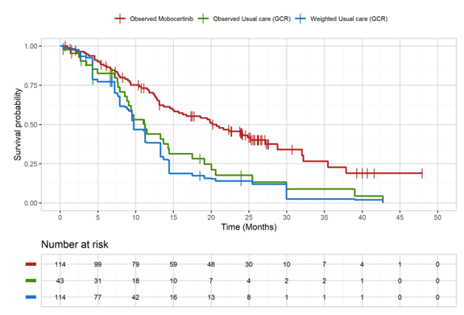
Source: Figure 2-15, p152 of the submission.
KM = Kaplan-Meier; OS = overall survival

Figure 2: KM plot of PFS-INV for mobocertinib (observed) vs. Study 5008 (observed and weighted)
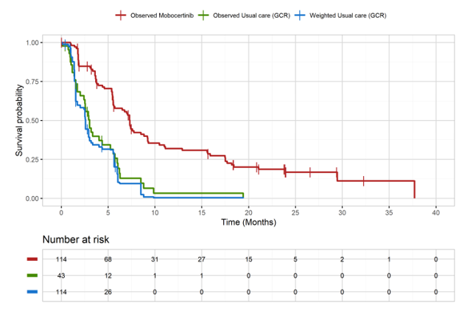
Source: Figure 2-16, p153 of the submission.
KM = Kaplan-Meier; PFS-INV = progression free survival as assessed by investigator

  - Based on a median duration of follow-up of 25.8 months in Study 101, the median duration of OS was 20.2 months (95% CI: 14.9, 25.3) in the Study 101 PPP cohort (events observed in 57.9% [66/114]) compared to 11.3 months (95% CI: 8.9, 14.5) in Study 5008 (events observed in 74.4% [32/43]). Before IPTW adjustment, the HR was 0.50 representing a statistically significant 50% reduction in the hazard of death associated with mobocertinib compared to treatments received in Study 5008. After adjustment, the median OS decreased to 9.8 months in the Study 5008 cohort which corresponded to a statistically significant 58% reduction in the hazard of death associated with mobocertinib (HR=0.42; 95% CI: 0.26, 0.69).
  - The median duration of PFS in the mobocertinib cohort was similar between investigator- and IRC-based assessments (approximately 7.3 months). Given the retrospective design of Study 5008, there were no IRC-based or investigator-based assessments for PFS. Adjustment resulted in a slight decrease in the median PFS duration in Study 5008 from 3.02 months to 2.60 months. The reduction in hazard of progression or death associated with mobocertinib was approximately 70%, which was statistically significant, and similar across unadjusted and adjusted analyses.
Mobocertinib (Study 101) versus SOC (Study 5002)
  - Results of the IPTW-based indirect comparison between Study 101 and Study 5002 are presented in Table 8. KM plots for OS and PFS (investigator-based) are presented in Figure 3 and Figure 4, respectively.
  - The evaluation noted that some of the results presented in the submission’s main body could not be verified from the submission’s cited source As the PFS results appeared consistent across all sections of the source document, they were considered to be more accurate and are summarised in Table 8.
Table 8: Summary of the indirect comparison results – Mobocertinib versus Study 5002
 | OS | PFS-INV | PFS-IRC
Median duration mobocertinib, months (95% CI) | 20.17 (14.88, 25.26) | 7.33 (5.55, 8.83) | 7.29 (5.52, 9.23)
Unadjusted median duration Study 5002, months (95% CI) | 11.47 (7.89, 16.56) | 3.25 (2.30, 5.91)
IPTW adjusted median duration Study 5002 (95% CI) | 12.42 (7.10, 16.56) | 3.25 (2.17, 7.33)
Unadjusted HR mobocertinib vs. Study 5008, (95% CI) [Log-rank p-value] | 0.58 (0.38, 0.88)  [0.0120] | 0.57 (0.37, 0.89) [0.0099] | 0.58 (0.36, 0.93)^{b} [0.0187]
IPTW adjusted HR of mobocertinib vs. Study 5002 (95% CI) [Log-rank p-value] | 0.56 (0.37, 0.84)ª [0.0095] | 0.58 (0.37, 0.91) [0.0207] | 0.59 (0.37, 0.95)^{b} [0.0326]
Source: Table 8, Attachment 2.14 accompanying the submission.
CI = confidence interval; HR = hazard ratio; INV = investigator; IRC = independent review committee; IPTW = inverse probability treatment weighting; OS = overall survival; PFS = progression-free survival.
ªAdjusted OS HR presented in the submission (Table 2-39, p157) was 0.5994 (95% CI: 0.3833, 0.9374).
^{b}Unadjusted and adjusted PFS-IRC HRs presented in the submission (Table 2-39, p158) were 0.7005 (95% CI: 0.4158, 1.1801) and 0.7134 (95% CI: 0.4167, 1.2212), respectively.
Notes: Mobocertinib data were based on the November 2021 data cutoff for Study 101. Median duration of follow-up was 25.8 months. Data on median duration of follow-up in Study 5002 was not provided.
Bolded font represents statistically significant results

Figure 3: KM plot of OS for mobocertinib (observed) vs. Study 5002 (observed and weighted)
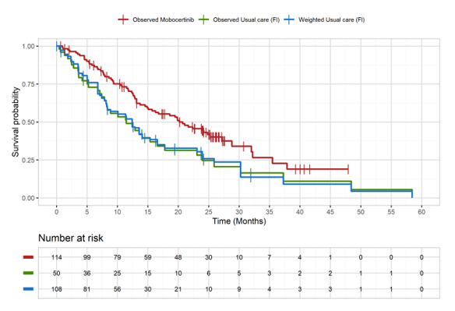
Source: Figure 2-18, p156 of the submission.
KM = Kaplan-Meier; OS = overall survival

Figure 4: KM plot of PFS-INV for mobocertinib (observed) vs. Study 5002 (observed and weighted)
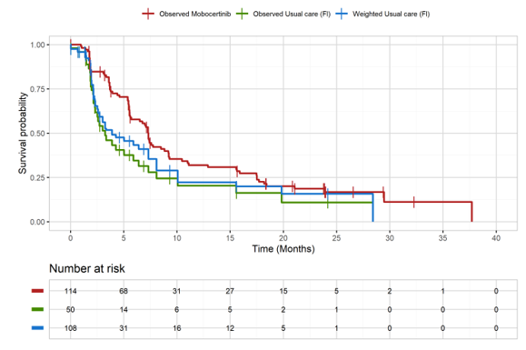
Source: Figure 2-19, p156 of the submission.
KM = Kaplan-Meier; PFS-INV = progression free survival as assessed by investigator

  - Based on a median duration of follow-up of 25.8 months in Study 101, the median duration of OS was 20.2 months (95% CI: 14.9, 25.3) in the mobocertinib group compared with 11.5 months (95% CI: 7.9, 16.6) in Study 5002. Before weight adjustment, the HR was 0.58 corresponding to a statistically significant 42% reduction in the hazard of death associated with mobocertinib compared to SOC treatments received in Study 5002. After adjustment, the reduction in hazard of death associated with mobocertinib was similar to the unadjusted hazard reduction (44%) which was also statistically significant. Noteworthy is that after weighting, the median OS in Study 5002 increased by approximately 1 month to 12.4 months.
  - PFS results in the mobocertinib group were similar between investigator and independent review assessments (median duration of approximately 7.3 months). There were no IRC-based or investigator-based assessments for PFS given the retrospective nature of Study 5002. The unadjusted and adjusted median PFS durations (as assessed by investigator) were similar (3.3 months). The reduction in hazard of progression or death associated with mobocertinib compared with Study 5002 (40%) was statistically significant, and similar across unadjusted and adjusted analyses, regardless of whether PFS was investigator-based or IRC-based (with respect to mobocertinib). However, the PFS HR results should be interpreted with caution, as the proportional hazards (PH) assumption appears to have been violated for PFS as assessed by investigator (p=0.03) and IRC (p<0.01), based on Log-cumulative hazards plots as a function of time and global tests for Schoenfeld residuals.
Mobocertinib (Study 101) versus SOC (pooled Studies 5008 and 5002)
  - The Pre-PBAC response provided an IPTW analysis using pooled efficacy data from Studies 5008 and 5002. The response stated that due to differences in the baseline characteristics collected in each dataset, the analysis adjusts for a different set of variables (age, sex, smoking status, brain metastasis at baseline and time from advanced diagnosis and histology) compared to the two separate 5008 and 5002 analyses. Compared to the median OS of 20.2 months (95% CI: 14.88, 25.26) for patients treated with mobocertinib in Study 101, the median OS in the pooled SOC group was 11.4 months (95% CI: 8.9, 14.1) before weighting and 11.4 months (95% CI: 8.0, 13.6) after weighting, reflecting an improvement in OS of 8.8 months (Table 9 and Figure 5). This compares to adjusted IPTW median OS of 9.76 months (95% CI: 4.30, 13.70) in Study 5008 (Table 7) and 12.42 months (95% CI: 7.10, 16.56) in Study 5002 (Table 8). As would be expected, pooling the results has the effect of narrowing the confidence intervals. This update in the Pre-PBAC response was not independently evaluated.
Table 9: Comparison of survival data for mobocertinib vs pooled SOC (Study 5002 and Study 5008)
Outcome | Mobocertinib | Pooled SOC before weighting | Pooled SOC after weighting
Median OS (95% CI) | 20.2 (14.9, 25.3) | 11.4 (8.9, 14.1) | 11.4 (8.0, 13.6)
Median PFS-INV (95% CI) | 7.3 (5.6, 8.8) | 3.0 (2.5, 4.3) | 2.9 (2.2, 4.4)
Median PFS-IRC (95% CI) | 7.3 (5.5, 9.2) | 3.0 (2.5, 4.3) | 2.9 (2.2, 4.4)
Source: Table 1, Pre-PBAC Response.
C I= confidence interval; INV = investigator; IRC = independent review committee; IPTW = inverse probability treatment weighting; OS=overall survival; PFS = progression-free survival; SOC = standard of care.

Figure 5: KM plot of OS for mobocertinib (observed) vs. pooled Studies 5008 and 5002 (observed and weighted)
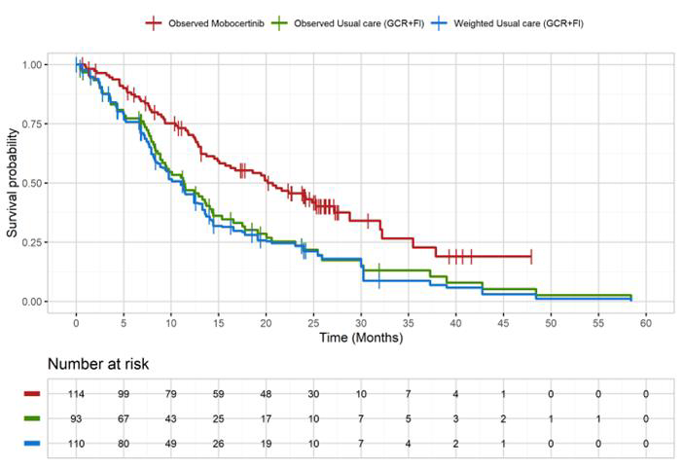
Source: Figure 1, Pre-PBAC Response.
KM = Kaplan-Meier; OS = overall survival

Mobocertinib harms
  - No indirect comparisons were conducted for assessing comparative safety. Table 10 summarises overall adverse events (AEs) from the Study 101 PPP cohort.

Table 10: Summary of overall AEs (any grade or Grade ≥3) – Study 101 PPP cohort (N=114)
AE, n (%) | Any grade | Grade ≥3
Any TEAEª | 114 (100) | 86 (75)
Drug-related | 113 (99) | 59 (52)
Leading to treatment discontinuation | 21 (18) | NA^{c}
Leading to dose reduction | 31 (27) | NA^{c}
Any TESAE | 60 (53) | 55 (48)
Drug-related | 22 (19) | 20 (18)
Leading to treatment discontinuation | 11 (10) | NA^{c}
Leading to dose reduction | 3 (3) | NA^{c}
Deaths^{b} | 15 (13)
Source: Table 2-33, pp138 of the submission
AE = adverse event; NA = not available/applicable; PPP = pooled prior platinum; TEAE = treatment-emergent adverse event; TESAE = treatment-emergent serious adverse event.
Data cutoff: 01 November 2021.
ª TEAEs are all AEs with an onset date on or after the first dose date and within 30 days of last dose of study drug. AEs were graded according to the National Clinical Institute Common Terminology Criteria for Adverse Events (NCI CTCAE) v5.0. Patients were counted only once in their most severe category. Medical Dictionary for Regulatory Activities (MedDRA) Dictionary (Version 24.0) was used for coding AEs.
^{b} Death within 30 days of last dose.
^{c} Not evaluated by AE grade.

  - Treated patients were followed for treatment emergent AEs (TEAEs) up to 30 days after last dose of study drug. The median time on treatment at the November 2021 data cutoff was 7.38 months.
  - The most frequently reported TEAEs of any grade (>30% of patients) included diarrhoea (93%), rash (47%), decreased appetite (45%), vomiting (43%), nausea (40%), paronychia (39%), blood creatinine increased (35%), anaemia (34%), and dry skin (33%).
  - The majority of patients (75%) experienced a ≥Grade 3 TEAE with 52% of events considered to be drug-related. The most common Grade ≥3 TEAE events occurring in ≥5% of the study population included diarrhoea (24%); electrocardiogram (ECG) QT prolonged (8%); hypertension (7%); anaemia (6%); and nausea, amylase increased, and dyspnoea (5% each).
  - A total of 60 patients (53%) reported treatment-emergent serious AEs (TESAEs). TESAEs that were of Grade ≥3 occurred in almost half of the patients (48%). Of these, approximately 20% were considered to be drug-related. TESAEs of any grade leading to treatment discontinuation occurred in 10 patients (11%).
  - There were a total of 15 on-study deaths (13% of patients) with 14 deaths considered to be related to underlying disease. One of the 15 deaths was caused by cardiac failure deemed related to mobocertinib.
  - The safety profile of mobocertinib appeared to be similar to that of other EGFR inhibitors which is typically characterised by gastrointestinal (GI)-related and cutaneous-related AEs.
  - It was noted in the TGA Delegate’s Overview for mobocertinib (PM-2021-02546-1-4) that based on a larger safety dataset for Study 101 (N=256; data cutoff May 2020), serious AEs occurred in 41% of patients in the pooled safety population.
  - Interpretation of the safety data from Study 101 should be made in the context of the open label design and stringent exclusion criteria of Study 101 (such as patients with a history of interstitial lung disease (ILD), drug-related or radiation-related pneumonitis that required steroid treatment, or active cardiovascular disease/prolonged QTc interval). The safety data from Study 101 are likely to underestimate the safety of mobocertinib in clinical practice.
  - The FDA Product labelling includes a boxed warning for QTc prolongation and Torsades de Pointes, and warnings for ILD/pneumonitis, cardiac toxicity, and diarrhoea. The TGA Product Information also includes special warnings and precautions for use for these events.

Benefits/harms
  - The results of the unanchored IPTW-based indirect comparisons were associated with a high risk of bias and there were important observed differences between the studies that could not be adjusted for, and the impact of unknown confounders remained unclear. These and several other limitations, including the applicability of Studies 5008 and 5002 to current Australian clinical practice, lead to a high level of uncertainty regarding the magnitude of any incremental benefit associated with mobocertinib over SOC. There were no formal comparisons made for safety, noting that a claim of non-inferior safety was made in the submission. Accordingly, a benefits/harms table has not been presented.

Clinical claim
  - The submission described mobocertinib as superior in terms of effectiveness compared with SOC and non-inferior in terms of safety, with a manageable safety profile, compared to SOC.
  - The evaluation considered the effectiveness claim to be uncertain. The evidence indicated that mobocertinib may be superior, in terms of PFS and OS, to SOC. However, the evidence was inadequate to support a robust quantification of the magnitude of incremental benefit. Results of the IPTW-based indirect comparisons were associated with a high risk of bias and were unreliable:
- The study design differed between Study 101 (prospective) and Studies 5008 and 5002 (retrospective). There were also large imbalances for some characteristics between Study 101 and the retrospective cohort studies that could not be adjusted for (such as Asian race and number of prior lines of therapy). In addition, there was a high risk of residual confounding due to other unobserved/unmeasured patient and study characteristics across the mobocertinib and retrospective cohort data sets. For Study 5008, baseline characteristics were collected at study initiation rather than at the index line following failure on PBC. At index line, the health status of patients would most likely have deteriorated.
- The retrospective cohort studies had small sample sizes (N = 43-50) which potentially limited the number of variables that could have been adjusted for and the precision of the IPTW-based indirect estimates of treatment effect. The effective sample sizes were substantially reduced from the original sample sizes, especially for Study 5008. The PSCR noted that the relevant patient population comprises less than 100 incident patients annually with a life expectancy of less than 12 months, and that the IPTW analyses reflect what is possible with the available evidence and are likely to provide estimates of treatment effect that are reasonable for the size of the patient population and the level of clinical need.
- EGFR TKIs and ICI monotherapy made up 50%-60% of the treatments received in Studies 5008 and 5002. The extent of use of these agents in Australian clinical practice, for the proposed indication, is expected to be limited. As a result, the magnitude of the indirect estimates of treatment benefit may also have limited applicability.
  - No formal indirect comparisons of safety were presented. The nature of the evidence does not allow for a claim of non-inferiority to be made. Overall, a different safety profile for mobocertinib compared to chemotherapy or immunotherapy would be expected. The safety profile of mobocertinib is in keeping with toxicities observed with other EGFR TKIs, most commonly GI and skin toxicities. Less common (but serious and potentially fatal) toxicities that may be associated with mobocertinib, include QT prolongation and Torsades de Pointes, ILD/pneumonitis and cardiac failure.
  - The ESC agreed with the evaluation that it is difficult to interpret the magnitude of benefit of mobocertinib, and that the imbalances in the IPTW may create significant bias in the results whereby the true effect of this bias is unknown. With respect to the submission’s clinical claim, the ESC considered that it is unclear but likely that mobocertinib is more effective than current SOC at improving PFS and extending OS, and similarly it is unclear but likely that mobocertinib has an acceptable safety profile that is similar to other TKIs. With respect to the therapy expected to be replaced by mobocertinib, the ESC considered that mobocertinib is likely, although not confirmed, to be better overall than conventional chemotherapy in this setting.
  - The PBAC agreed with the evaluation and the ESC, that the submission’s claim of superior effectiveness was very uncertain, due to a high risk of bias and small sample sizes, and that inflating the populations (using IPTW methodology) had risk of exacerbating the potential biases. While the PBAC acknowledged that mobocertinib may be better than conventional chemotherapy in this setting, it did not consider that the submission had adequately demonstrated this in terms of the evidence presented against SOC, where the majority of SOC treatments comprised EGFR TKIs and ICI monotherapy, not chemotherapy. The PBAC noted the submission did not present a safety comparison of mobocertinib against SOC, and considered that mobocertinib may have a “different” safety profile that is not non-inferior to SOC.

Economic analysis
  - The submission presented a stepped economic evaluation comparing mobocertinib versus SOC for the treatment of patients with locally advanced or metastatic (Stage IIIB-IV) NSCLC with EGFR ex20ins mutations who have previously received platinum-based chemotherapy (PBC) based on an indirect comparison of retrospective cohort studies. A cost-effectiveness analysis and a cost-utility analysis were presented measuring outcomes in terms of life years (LYs) gained and quality-adjusted life years (QALYs) gained, respectively. The key components of the economic evaluation and justifications for the approach provided by the submission are presented in Table 11.
Table 11: Summary of model structure, key inputs and rationale
Component | Description
Type of analysis | Cost-utility analysis
Outcomes | Life years gained, quality-adjusted life years gained
Time horizon | 5 years
Methods used to generate results | Three health state partitioned survival model
Health states | Progression-free; Progressed disease; Dead
Cycle length | 28 days - reflects the duration of treatment per pack of mobocertinib dispensed.
Health state allocation | Mobocertinib arm: PFS (IRC) and OS from Study 101 (PPP cohort).  SOC arm: IPTW-adjusted PFS and OS from Study 5008 (Germany) in the base case; IPTW-adjusted PFS and OS data from the Study 5002 (USA) is used in sensitivity analysis.
Extrapolation method | KM data are used up until trial follow-up (36 months) and extrapolated out to the modelled time horizon.  The selection of parametric curve in the base case was based on the visual fit to the KM curves as well as clinical validity of the extrapolations.  For all extrapolations, the Weibull parametric function is used in the base case.  Convergence – curves are forced to converge from 36 months to 5-year time horizon.
Utilities | Utilities derived from Part 3ª of Study 101 (EXCLAIM) were applied across both arms of the model.  Utility decrements are applied for Grade ≥3 AEs in each treatment arm.
Source: Compiled during the evaluation based on Table 3-1, p179 of the submission
AE = adverse event; EGFR = epidermal growth factor receptor; ex20ins = exon 20 insertion; HRQoL = health-related quality of life; IRC = independent review committee; OS = overall survival; PFS = progression free survival; PPP = pooled prior-platinum; SOC = standard of care; IPTW=inverse probability treatment weighting USA = United States of America
ª Study 101 included three parts: Part 1 (dose escalation cohort, N=73), Part 2 (expansion cohort, N=136) and Part 3 (extension cohort, N=96). The PPP cohort of Study 101 (N=114) were mainly from Part 3 (n=86), followed by Part 2 (n=22) and Part 1 (n=6).

  - A half cycle correction (HCC) was applied to all costs and outcomes. The submission assumed a half-cycle correction for the time-to-treatment discontinuation (TTD) curve at the start of the cycle which reduced the proportion of patients treated in cycle 1 by 50%. The evaluation considered this to be inappropriate; as all patients initiate the treatment at the start of the cycle, HCC may not be required in this context. The evaluation noted that correcting this calculation had only a minimal impact on the incremental cost-effectiveness ratio (ICER).
  - The model inputs in the mobocertinib arm were largely derived from Study 101. Due to single arm nature of the study, the submission identified two retrospective cohort studies (Study 5008 [base case] and Study 5002 [sensitivity analysis]) as relevant sources of input for comparator arm.
  - The submission argued that the comparator treatments represented in the SOC studies broadly reflect Australian clinical practice. The SOC studies reported substantial use of immunotherapies and EGFR TKIs. The evaluation and ESC agreed that the use of these therapies is likely to be limited. As discussed (paragraphs 5.1 and 5.2), chemotherapy would represent the main comparator for the current submission. Consequently, the applicability of Studies 5002 and 5008 is unclear and the costs of EGFR TKIs and immunotherapies are not applicable. While the submission adjusted the treatment distribution in both the studies to reflect the clinical practice in Australia, immunotherapies/EGFR TKIs accounted for about 70% of the included treatments in both the studies. The evaluation considered treatment distributions (adjusted and unadjusted) from both the studies are unlikely to reflect Australian clinical practice. The evaluation considered that limiting the cost of SOC to chemotherapy regimens, which is more likely to be the treatment used in the absence of mobocertinib, may be a reasonable approach. As immunotherapies and targeted therapies are substantially more costly than single agent chemotherapy, applying the costs of these treatments will overestimate the cost of the SOC arm.
  - Independent parametric survival models were fitted to available KM data for mobocertinib and SOC arms for PFS, OS and TTD curves. The selection of parametric functions was not well justified in the submission, and was stated to be assessed on visual fit and clinical validity. The submission stated that goodness-of-fit statistics were not provided as they were not directly comparable across alternative sets of endpoints and/or cohorts. It is unclear how endpoints or cohorts differ for individual KM curves used in the model. Goodness-of-fit statistics are particularly relevant for the mature KM data for the SOC arm in the model.
  - Although the approach adopted in the submission for the selection of parametric functions for extrapolation was both poorly described and poorly justified, the model is not sensitive to the choice of parametric functions used for extrapolation because:
- the observed data are reasonably mature; and,
- the model uses a convergence function from 36 months, which partly replaces the parametric function for PFS and entirely replaces the parametric function for OS and for TTD.
  - In the base case analysis, the submission used the observed (weighted) KM data up until 36 months (39 cycles) in both the arms for OS and PFS. For PFS, as the truncation point (39 cycles) is beyond the available observed data, the operational point of truncation in the model is at the end of the observed data. This is 34 cycles (approximately 31 months) in the mobocertinib arm, and 21 cycles (approximately 19 months) in the SOC arm. There are a large number of cycles towards the end of the KM curves in which the estimated PFS remains unchanged in both arms. Therefore, using all of the observed data (as the model has done) may not be reliable. Using an earlier truncation point of 24 cycles for mobocertinib results in a loss of approximately 3.7% progression free life years (undiscounted). In the SOC arm, this has no impact on the model as the proportion remaining in the progression-free state is close to zero from approximately 10 months onward.
  - A comparison of the trial-based (IPTW-adjusted for the SOC arm) and the modelled survival curves (Figure 6) indicated that the most of the observed trial data have been used to inform the modelled curves, and extrapolation and point of truncation have only a minor impact on the survival outcomes.
Figure 6: Comparison of modelled and trial based PFS and OS estimates
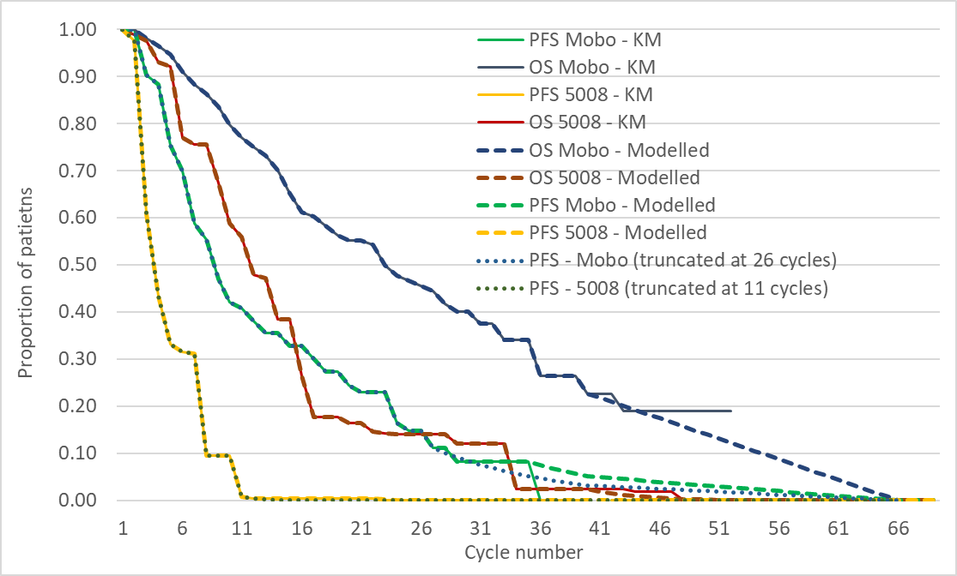
Source: Figure constructed during the evaluation, based on ‘Section 3 CE Model Workbook – Takeda Australia – Mobocertinib’ included in the submission.
Mobo = mobocertinib; OS = overall survival; PFS = progression free survival
  - The economic model uses a mechanism to converge the PFS, OS and TTD curves of the mobocertinib arm with the SOC arm. The base case starts the convergence after 39 cycles (3 years), and reduces PFS, OS and TTD using a linear function to meet the estimate for the SOC arm at 5 years. In the absence of the convergence mechanism, progression-free life years are 1.4% lower than with the convergence mechanism in place. The impact of converging the mobocertinib overall survival curve with that of SOC at 5 years results in <0.01% remaining alive at 5 years. In the absence of the convergence, almost 7% of patients in the mobocertinib arm remain alive at 5 years. The decision to converge the overall survival curves is therefore a conservative one, and may underestimate the survival in the mobocertinib arm (Figure 7).
Figure 7: Comparison of modelled overall survival with and without convergence
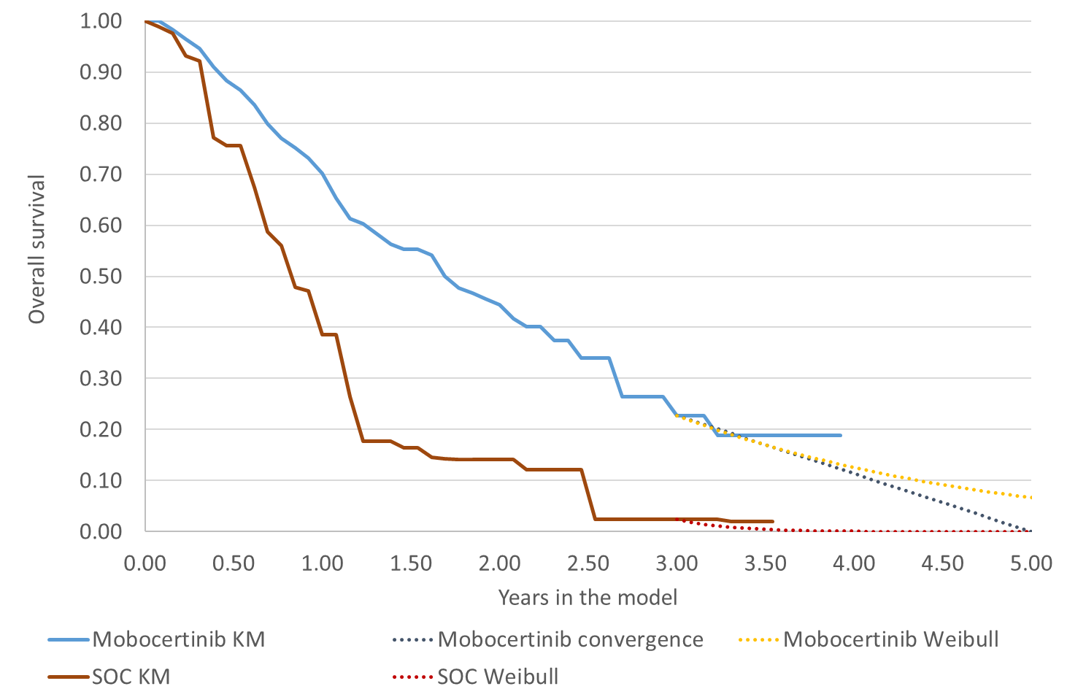
Source: Constructed during the evaluation based on the ‘Section 3 CE Model Workbook – Takeda Australia – Mobocertinib’
KM = Kaplan-Meier; SOC = standard of care

  - Utility values used in the model base case were sourced from EQ-5D-5L questionnaires completed in Study 101. The same utilities were applied to the mobocertinib and the SOC arms of the model. The utility analyses conducted to inform the economic model were restricted to patients from Part 3 (EXCLAIM cohort) of Study 101 who had provided a utility score at baseline (N=81). No health related-quality of life (HRQoL) data were collected in Part 1 and Part 2 of the study. Therefore, utility estimates were derived from 71% of the study population. The submission has not discussed whether this is likely to impact the estimates of utilities. The submission did not provide demographic and treatment characteristics of patients excluded from the analyses.
  - It is unclear from the submission if Australian weights were used to generate utilities from the EQ-5D estimates. While the main body of the submission mentions the application of a set of weights developed for the US, the economics workbook provided with the submission states that EQ-5D-5L data were mapped to Australian utility index scores.
  - A mean per cycle utility decrement of 0.0370, derived from the statistical analysis of HRQoL data from Study 101, was used as the average decrement per Grade ≥3 adverse event. The estimate was then applied to the incidence of Grade ≥3 AEs each cycle. The submission did not report the compliance rate of responders answering EQ-5D in the trial. If the compliance rate for EQ-5D was low in the study, utility values used in the study may have been biased. If this reason for non-compliance is AEs, then the adjustment made to the health state utility values may not be reasonable.
  - The submission modelled the SOC treatment costs in the base case based on the treatments received in the included retrospective cohort studies (Study 5008 in base case). Two minor adjustments were made to the retrospective cohort based treatment distributions. First, treatment regimens not used in Australian clinical practice were removed and the remaining treatments were weighted to ensure the total equals 100%. The submission identified the treatment regimens that are not in use in Australian clinical practice based on their inclusion on eviQ. Second, the distribution of EGFR TKIs was adjusted based on PBS utilisation data of currently available EGFR TKIs for the year 2020/21.
  - A summary of the key drivers of the model is given in Table 12.
Table 12: Key drivers of the model
Description | Method/Value | Impact  Base case: $||¹/ QALY gained
Choice of comparator treatment | Basket of treatments incorporating a large proportion of EGFR TKIs and immunotherapies. | Moderate, favours mobocertinib  Limiting the cost of SOC to only chemotherapy regimens used in the model base case increased ICER to $||||²/ QALY gained.
Choice of Study to inform survival outcome in comparator arm | Survival outcomes in the base case comparator arm were informed by Study 5008 (after weighting). | Moderate, favours mobocertinib  Choosing Study 5002 instead of Study 5008 significantly increased ICER to $||||³/ QALY gained.
Source: Compiled during the evaluation based on Section 3 of the submission
EGFR = epidermal growth factor receptor; ICER = incremental cost-effectiveness ratio; QALY = quality-adjusted life year; SOC = standard of care.
The redacted values correspond to the following ranges:
¹ $75,000 to < $95,000
² $115,000 to < $135,000
³ $95,000 to < $115,000

  - The results of the stepped economic evaluation presented in the submission are summarised in Table 13.
Table 13: Results of the stepped economic evaluation – model base case
Step and component | Mobocertinib | Standard of care | Increment
Step 1: trial-based costs (including administration costs) and outcomes
Costs ($) | | | $23,167 | |
LYG | 1.750 | 0.999 | 0.751
Incremental cost/LYG gained ($) |  |  | |¹
Step 2: time horizon extended to 5 years
Costs ($) | | | $23,167 | |
LYG | 2.014 | 1.006 | 1.008
Incremental cost/LYG gained ($) |  |  | |²
Step 3: Convergence applied
Costs ($) | | | $23,167 | |
LYG | 1.976 | 1.006 | 0.970
Incremental cost/extra LYG gained ($) |  |  | |¹
Step 4: discounting (5%) included
Costs ($) | | | $22,685 | |
LYG | 1.844 | 0.969 | 0.874
Incremental cost/extra LYG gained ($) |  |  | |¹
Step 5: utility weights applied
Costs ($) | | | $22,685 | |
QALYs | 1.515 | 0.782 | 0.733
Incremental cost/ QALY gained ($) |  |  | |¹
Step 6: incorporation of costs and utility decrements associated with AEs, disease management and subsequent treatment
Costs ($) | | | $74,075 | |
QALYs | 1.512 | 0.781 | 0.731
Incremental cost/ QALY gained (base case) ($) |  |  | |³
Source: Compiled during the evaluation based on the ‘Section 3 CE Model Workbook – Takeda Australia – Mobocertinib’
LYG = life year gained; QALY = quality-adjusted life year.
The redacted values correspond to the following ranges:
¹ $55,000 to < $75,000
² $45,000 to < $55,000
³ $75,000 to < $95,000

  - The steps that had the most impact on the model estimates were the extension of time horizon (Step 2) and addition of costs associated with AEs, subsequent treatments and disease management (Step 6). As depicted in Figure 8, 20% of the incremental LYs gained were accrued in the extrapolation period. However, the model is not sensitive to varying the extrapolation approach, and a 5 year time horizon is likely reasonable.
Figure 8: Cumulative life years gained over the time horizon of the model (discounted)
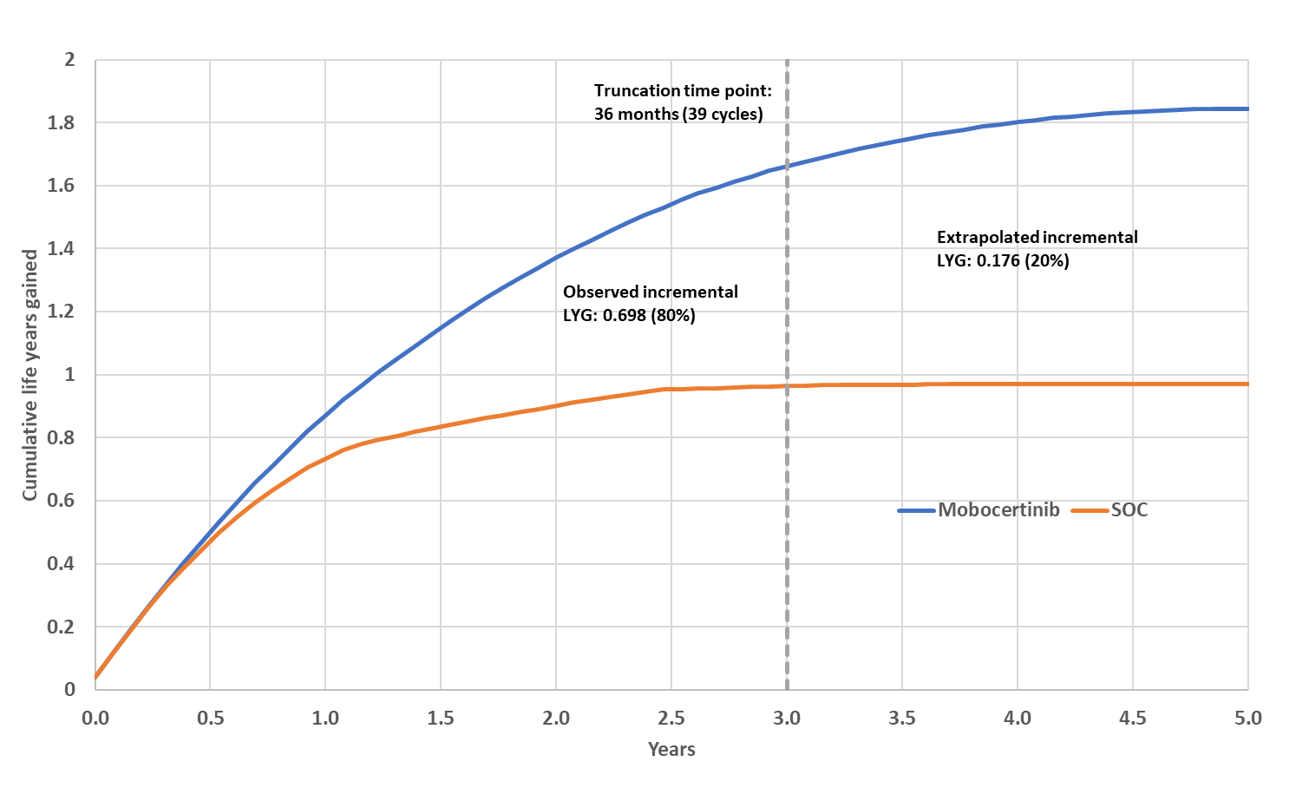
Source: Constructed during the evaluation, based on the ‘Section 3 CE Model Workbook – Takeda Australia – Mobocertinib’
LYG = life years gained.

  - The submission identified baseline imbalances between the study populations of Study 101 (mobocertinib) and the two retrospective cohort studies (SOC). To address these differences, the submission conducted an indirect treatment comparison (ITC) of mobocertinib versus SOC using IPTW methodology (refer to Table 7 for results). The submission has only provided weighted OS and PFS survival data in the model, and therefore the effect of weighting on the model results cannot be quantified. As there are considerable concerns relating to the transitivity of the key studies, the validity of the weighting, and the exclusion of patients from the SOC studies prior to weighting, the weighted KM curves are uncertain and may overestimate the incremental PFS and OS attributed to mobocertinib.
  - In response to these concerns, the PSCR provided IPTW-adjusted and unadjusted KM curves for PFS, OS and TTD in studies 5002 and 5008, and stated that the adjusted and unadjusted curves are highly similar. The PSCR also provided a summary of the ICERs using the unadjusted KM data for both Study 5002 and 5008. The PSCR stated that the lack of sensitivity of the model to the choice of comparator dataset and the IPTW adjustments is a direct consequence of the much greater survival gain with mobocertinib versus the SOC data. The ESC noted the economic analyses presented in the PSCR continued to include the cost of EGFR TKIs and ICI in the SOC arm. These analyses were not independently evaluated and have not been presented herein.

  - The submission modelled costs and survival outcomes in the comparator arm based on Study 5008. The evaluation considered arguments presented in the submission, to support use of Study 5008 in the base case (rather than Study 5002), as representative of SOC in Australian clinical practice, may not be reasonable.
  - A comparison of survival outcomes suggest that Study 5002 has better survival outcomes compared to Study 5008 (Figure 9). The ICER is higher (less favourable) when the costs and survival outcomes are based on Study 5002 (Table 15). The evaluation considered that, in the absence of any compelling justification to use one particular observational study as the SOC arm in the model, the choice of Study 5008 in the base case favours mobocertinib. The PSCR maintained that the choice of Study 5008 to inform the economic model was based on a distribution of SOC treatments that was more applicable to the Australian setting than Study 5002. The PSCR noted that an analysis in which both 5008 and 5002 SOC arms are pooled (equal weighting) yielded an ICER of $95,000 to < $115,000 / QALY. As for the separate analyses for Studies 5008 and 5002 presented in the PSCR (paragraph 6.67), the ESC noted the analyses for the pooled 5008 and 5002 studies continued to include the cost of EGFR TKIs and ICI in the SOC cost. These analyses were not independently evaluated.
  - As described above, the evaluation identified several issues with the approaches and assumptions in the model. Therefore, a respecified base case (Table 14) was proposed that addresses those issues. The respecified base case altered the submission's base case in the following ways:
- does not include half-cycle correction in the calculation of treatment costs;
- limits the cost of treatment in the SOC arm to chemotherapies only;
- limits subsequent treatment to only single agent chemotherapies in both arms.
Table 14: Results of the stepped economic evaluation – respecified base case
Step and component | Proposed medicine | Comparator | Increment
Step 1: trial-based costs (including administration costs) and outcomes
Costs ($) | | | $2,137 | |
LYG | 1.750 | 0.999 | 0.751
Incremental cost/LYG gained ($) |  |  | |¹
Submission base case |  |  | |²
Step 2: time horizon extended to 5 years
Costs ($) | | | $2,137 | |
LYG | 2.014 | 1.006 | 1.008
Incremental cost/LYG gained ($) |  |  | |³
Submission base case |  |  | |⁴
Step 3: Convergence applied
Costs ($) | | | $2,137 | |
LYG | 1.976 | 1.006 | 0.970
Incremental cost/extra LYG gained ($) |  |  | |³
Submission base case |  |  | |²
Step 4: discounting (5%) included
Costs ($) | | | $2,097 | |
LYG | 1.844 | 0.969 | 0.874
Incremental cost/extra LYG gained ($) |  |  | |³
Submission base case |  |  | |²
Step 5: utility weights applied
Costs ($) | | | $2,097 | |
QALYs | 1.515 | 0.782 | 0.733
Incremental cost/ QALY gained ($) |  |  | |¹
Submission base case |  |  | |²
Step 6: incorporation of costs and utility decrements associated with AEs, disease management and subsequent treatment
Costs ($) | | | $42,386 | |
QALYs | 1.512 | 0.781 | 0.731
Incremental cost/ QALY gained (base case) ($) |  |  | |⁵
Submission base case |  |  | |³
Source: Compiled during the evaluation based on the ‘Section 3 CE Model Workbook – Takeda Australia – Mobocertinib’
LYG = life year gained; QALY = quality-adjusted life year.
The redacted values correspond to the following ranges:
¹ $95,000 to < $115,000
² $55,000 to < $75,000
³ $75,000 to < $95,000
⁴ $45,000 to < $55,000
⁵ $115,000 to < $135,000

  - Limiting the cost of treatment in the comparator arm and subsequent treatments in both arms to chemotherapies and removing half-cycle correction in estimating treatment costs (respecified base-case) results in an ICER of $115,000 to < $135,000/QALY gained.
  - A comparison of respecified results using Study 5008 and Study 5002 is presented in Table 15. This indicates modelling treatment costs and survival outcomes based on Study 5002 results in a higher (less favourable) ICER estimate. Figure 9 presents the survival outcomes (trial based (after IPTW) and modelled) for Study 5008 and Study 5002. It is evident that survival outcomes are better with Study 5002. This resulted in a significantly lower incremental QALY gain driving the ICER estimate, despite a small reduction in incremental cost.
Table 15: Comparison of respecified results using Study 5008, Study 5002 (IPTW-adjusted)
 | Study 5008 | Study 5002
Incremental cost ($) | | | |
Incremental QALYs gained | 0.731 | 0.494
Incremental cost per QALY gained ($) | |¹ | |²
Source: Compiled during the evaluation based on the ‘Section 3 CE Model Workbook – Takeda Australia – Mobocertinib’
QALY = quality-adjusted life year.
The redacted values correspond to the following ranges:
¹ $115,000 to < $135,000
² $155,000 to < $255,000

Figure 9: Comparison of survival curves for Study 5008 and Study 5002
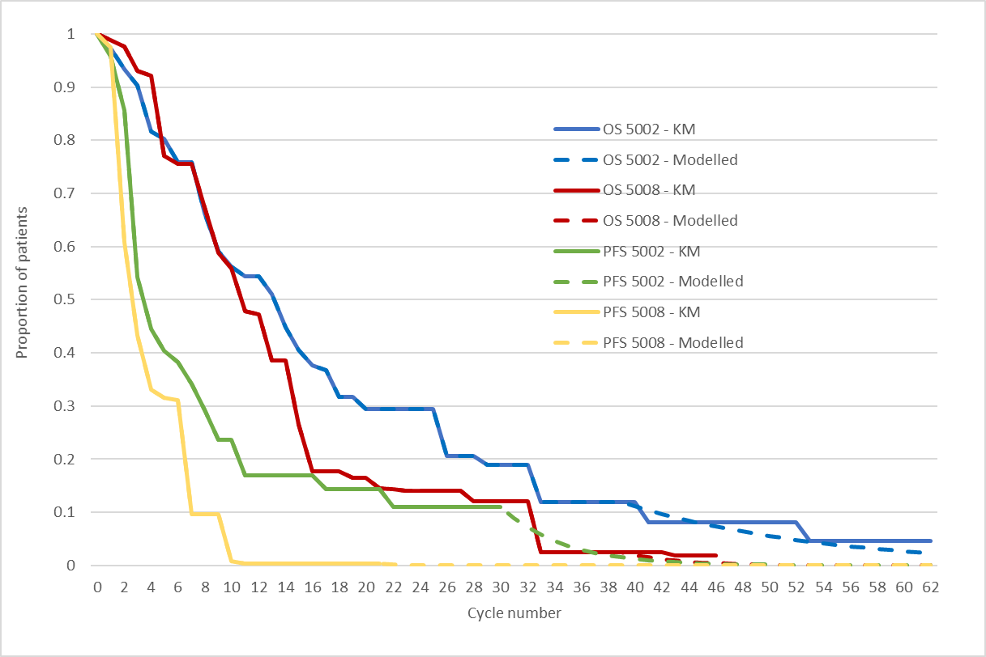
Source: Figure constructed during the evaluation, based on ‘Section 3 CE Model Workbook – Takeda Australia – Mobocertinib’ included in the submission.
KM = Kaplan-Meier; OS = overall survival; PFS = progression free survival

  - The Pre-PBAC Response proposed a respecified base case for the economic model. The base case specification was updated as follows: (i) utilisation of pooled data from Study 5002 and 5008 to inform the model inputs; (ii) adjustment of SOC to align with Australian clinical practice, as informed by the Sponsor’s clinical Advisory Board; (iii) removal of half cycle correction from the treatment costs; (iv) limiting 3L treatment to chemotherapies only. The revised model resulted in an ICER of $115,000 to < $135,000/QALY gained at the price proposed in the submission (effective ex-manufacture price [EMP] of $| |). The Sponsor proposed a reduction to the effective EMP for mobocertinib to $| |; the reduced effective price corresponds to an ICER in the Sponsor’s revised model of $75,000 to < $95,000/QALY. The PBAC considered that the resulting ICER of $75,000 to < $95,000 did not align with the respecified base case proposed by the evaluation and remained unacceptably high.
  - The results of key sensitivity analyses using the submission base case are summarised in Table 16. The results were most sensitive to choice of comparator treatments in SOC arm, distribution of second line (2L) treatments in SOC arm, and adjustments made to health state resource costs. The evaluation noted that the choice of treatments used in 2L setting for the proposed population is highly uncertain and tested the impact of altering the source and choice of treatments in SOC arms. Choosing Study 5002 instead of Study 5008 significantly increased ICER by 22% ($95,000 to < $115,000/QALY gained compared to $75,000 to < $95,000/QALY gained in the base case). Limiting the 2L treatments in SOC to only chemotherapy used in the model increased the ICER by 26% ($115,000 to < $135,000/QALY gained compared to $75,000 to < $95,000/QALY gained in the base case). The choice of subsequent treatments had only a moderate impact on ICER. Limiting the choice of treatment to single agent chemotherapy in 3L setting reduced the ICER by 5%.

Table 16: Sensitivity analyses (using submission base case)
Analyses | Incremental cost ($) | Incremental QALY | ICER ($) | %change from base case ICER
Base case | | | 0.731 | ||¹
Source of comparator treatments (base case: Study 5008)  - Study 5002 – after IPTW | | | 0.494 | | ² | 22%
Treatment in SOC arm (base case: All treatment classes based on Study 101)  - Only chemotherapy (based on Study 101) | | | 0.731 | | ³ | 26%
Subsequent treatment (base case: All classes of treatments)  - Only single agent chemotherapy | | | 0.731 | | ¹ | -5%
Health state resource costs (base case: Rate of hospitalisation and outpatient visits adjusted in both health states)  - Without adjusting rate of hospitalisation and outpatient visits in progressed disease state | | | 0.731 | | ² | 45%
Discount rate (base case: 5%)
- 0% | | | 0.810 | | ¹ | -0.7%
- 3.5% | | | 0.753 | | ¹ | -0.2%
Multivariate analysis
2 + 3 + 4 | | | 0.731 | | ³ | 27%
1 + 2 + 3 + 4 | | | 0.494 | | ⁴ | 89%
Source: Analyses conducted during the evaluation based on Table 3-32, p227 of the submission and the ‘Section 3 CE Model Workbook – Takeda Australia – Mobocertinib’.
AE = adverse event; ICER = incremental cost-effectiveness ratio; IPTW = inverse probability treatment weighing; QALY = quality adjusted life year; SOC = standard of care
The redacted values correspond to the following ranges:
¹ $75,000 to < $95,000
² $95,000 to < $115,000
³ $115,000 to < $135,000
⁴ $155,000 to < $255,000

  - The PBAC recalled it had previously recommended targeted therapies for NSCLC in the second line setting, with ICERs of $45,000 to $75,000 per QALY gained (paragraphs 7.12 and 7.13, osimertinib Public Summary Document [PSD], July 2018 PBAC meeting; paragraph 6.6, crizotinib PSD, July 2018 PBAC meeting).

Drug cost/patient/course
  - A comparison of the drug costs of mobocertinib and SOC treatment estimated based on the trial data, the economic evaluation and the financial analysis is presented in Table 17.
Table 17: Drug cost per patient for mobocertinib and standard of care
 | Mobocertinib |  |  | Standard of care
 | Proposed drug  Trial dose and duration | Proposed drug  Model | Proposed drug  Financial estimates | Comparator  Trial dose and duration | Comparator  Model | Comparator  Financial estimates
Mean dose | 160 mg/day | 160 mg/day | 160 mg/day | NR | NR | NR
Dose intensity | 91.81%ª | 93%^{h} | 93%^{h} | 93%^{h} | 93%^{h} | 93%^{h}
Mean duration (28-day cycles) | 7.995 (median)^{b} | 12.84^{c} | 12.79^{d} | 3.26 (median)^{e} | 4.40^{c} | 4.40^{d}
Cost/patient/cycle | $| | $| | $| | $5,184 | $5,184^{j} | $4,695^{g,j}  ($4,982)^{i}
Cost/patient/ /course | $| | $| | $| | $16,894 | $22,841 | $20,656 ^{f}  ($21,922)^{i}
Source: Compiled based on ‘Section 3 CE Model Workbook – Takeda Australia – Mobocertinib’ and ‘Section 4 UCM Workbook – Takeda – Australia – Mobocertinib.xlsx’
NR=not reported in the submission
ª Mean relative dose intensity in the pooled prior platinum cohort in Study 101 (N=114), sourced from Section 4.3.1 of ‘2.3 AP32788-15-101 CSR Addendum 2’
^{b} The submission provided median duration (7.8 months) only. Sourced from Section 4.3.1 of ‘2.3 AP32788-15-101 CSR Addendum 2’
^{c} Sourced from ‘Section 3 CE Model Workbook – Takeda Australia – Mobocertinib’
^{d} Sourced from ‘Section 4 UCM Workbook – Takeda – Australia – Mobocertinib.xlsx’
^{e} Submission assumed median PFS (3 months) to be the median duration of treatment. Sourced from Table 6 of ‘2.6 TAK-788-5008 report’
^{f} Calculated by changing number of patients on treatment in one of the years to ‘1’ and other years to ‘0’. Cost after correcting the calculation and referencing errors identified during the evaluation.
^{g} Calculated by dividing cost/patient/course with mean duration.
^{h} The economic evaluation and the financial analysis used the mean relative dose intensity for mobocertinib in Part 3 of Study 101 (N=96). The submission assumed the same relative dose intensity for the comparator treatments.
^{i} Revised results after correcting the submission’s referencing errors and the errors in estimating the patient split for the PBS items associated with combination therapies and the PBS items for both initial and continuing treatment phases.
^{j} Cost/patient/cycle in the financial analysis is different from that in the economic model due to differences in the estimated distribution of treatments included. Proportion of immunotherapies was 25.2% and 28.6%, proportion of chemotherapies was 29% and 26% in financial estimates and economic model, respectively.

Estimated PBS usage & financial implications
  - This submission was considered by DUSC.
  - The submission used an epidemiological approach to estimate the number of patients eligible for treatment with mobocertinib. A summary of the data sources and parameter values used to estimate the utilisation and financial implications associated with the listing of mobocertinib is provided in the Table 18.
Table 18: Key inputs for financial estimates
Data | Value and data source | Comment from evaluation
Eligible population
Incidence of Lung cancer | 14,413 in Year 1 of listing (2023), increasing to 16,038 in Year 6 (2028); AIHW - Cancer report 2021ª (for incidence data in 2021: 13,810) and Osimertinib PSD, July 2020 PBAC meeting (for an annual growth rate of 2.16%) | Reasonable data sources
Proportion of lung cancer reported as NSCLC | 85.0%; Vinod (2010)^{b} | Reasonable. The PBAC previously accepted a proportion of 86.6% in the entrectinib submission (Entrectinib PSD, March 2020 PBAC Meeting).
Proportion with Stage IIIB-IV disease | 73.60%; NCCI (2011)^{c} | Uncertain. The PBAC noted the NCCI estimate included Stage IIIA disease, which is not within the proposed PBS restriction for mobocertinib (Stage IIIB/IV). In addition, patients diagnosed with early stage NSCLC who subsequently progress into Stage IIIB/IV disease were not included in the financial estimates.
Patients with successful biopsy and biomarker testing | 90%; MSAC Application 1173, August 2012 | Reasonable
Patients with EGFR mutations | 17.90%; DUSC review on erlotinib and gefitinib (2017) | Reasonable
Proportion of EGFR-positive NSCLC patients with Ex20ins | 8%; Burnett (2021)^{d} | Uncertain. The proportion of EGFR ex20ins in EGFR variants in NSCLC varied in the literature, depending on the genotyping technique.
Proportion with ECOG performance status of 0-1 | 88%; Study 5008 | Uncertain. ECOG performance status reported in Study 5008 was recorded at start of first-line therapy for advanced NSCLC, not at start of the index therapy (the relevant line of therapy following PBC).
Proportion who elect first-line PBC | 89.38%; expert opinion from the Sponsor’s clinical advisory board | A total of eight Australian oncologists were on the advisory board. It was unknown whether the opinions from these clinicians would represent Australian clinical practice.
Proportion who progress following first-line PBC | 70%; expert opinion from the advisory board
Prevalent cases | 71; based on incidence cases in Year 1 (64) and average life expectancy from Studies 5008 and 5002 (1.116 years) | The estimation of the size of this population has not been well justified in the submission.
Utilisation
Uptake of mobocertinib | ||||% in Years 1 and 2, increasing to ||||% in Year 3 and onward | This is an area of uncertainty. However, a high uptake rate of mobocertinib is expected if the risk-benefit balance of mobocertinib is favourable in clinical practice.
Treatment duration of mobocertinib | Mean duration (cycles) in each treatment year:  1st treatment year: 7.94 cycles  2nd treatment year: 2.93 cycles  3rd treatment year: 1.29 cycles  4th treatment year: 0.43 cycles  5th treatment year: 0.15 cycles  6th treatment year: 0.05 cycles  Based on modelled TTD (Study 101)
Distribution of standard of care treatments in current clinical practice | Immunotherapies: 25.2%  EGFR TKIs: 45.7%  Chemotherapies: 29.0%  Study 5008 data, adjusted for Australian context | Given the assumed limited use of immunotherapies and EGFR TKIs in the current refractory setting for the proposed population, the cost offsets to PBS/RPBS are likely to have been overestimated.
Treatment duration for standard of care | Mean duration (cycles) in each treatment year:  1st treatment year: 3.71 cycles  2nd treatment year: 0.70 cycles  3rd treatment year onward: 0 cycle  Based on modelled TTD (Study 5008)
Relative dose intensity | 93% - for both mobocertinib and standard of care
Medical services
Parenteral administration of antineoplastic agents | 100% Schedule fee: $112.40 (80% rebate used in the financial analysis); MBS item 13950
Source: Compiled based on Table 4-1, p232 of the submission.
AIHW = Australian Institute of Health and Welfare; DUSC = Drug Utilisation Sub-Committee; ECOG = Eastern Cooperative Oncology Group; EGFR = epidermal growth factor receptor; Exon20ins = exon 20 insertions; MBS = Medicare Benefits Schedule; MSAC = Medical Services Advisory Committee; NCCI = National Cancer Control Indicators; NSCLC = non-small cell lung cancer; PBC = platinum-based chemotherapy; PBS = Pharmaceutical Benefits Schedule; PSD = public summary document; RPBS = Repatriation Pharmaceutical Benefits Scheme; TKI = tyrosine kinase inhibitor; TTD = Time to treatment discontinuation.
ª Australian Institute of Health and Welfare (AIHW) 2022 Cancer Data in Australia; Canberra: AIHW. https://www.aihw.gov.au/reports/cancer/cancer-data-in-australia/.
^{b} Vinod SK, Sidhom MA, et al. Why do some lung cancer patients receive no anticancer treatment? J Thorac Oncol. 2010;5:1025-32
^{c} https://ncci.canceraustralia.gov.au/diagnosis/distribution-cancer-stage/distribution-cancer-stage
^{d} Burnett H, Emich H, et al. Epidemiological and clinical burden of EGFR Exon 20 insertion in advanced non-small cell lung cancer: A systematic literature review. PLoS One. 2021;16(3):e0247620
  - The estimated use and financial impacts of listing mobocertinib are summarised in Table 19.

Table 19: Estimated use and financial implications (using the proposed effective price for mobocertinib and published prices for the comparator agents)
 | 2022 | 2023 | 2024 | 2025 | 2026 | 2027
Estimated extent of use
Number of patients initiating mobocertinib treatment | | ¹ | | ¹ | | ¹ | | ¹ | | ¹ | | ¹
Total treated patients | | ¹ | | ¹ | | ¹ | | ¹ | | ¹ | | ¹
Number of scripts dispensedª | | ² | | ² | | ² | | ² | | ² | | ²
Estimated financial implications of mobocertinib
Cost to PBS/RPBS less copayments ($) | | ³ | | ³ | | ³ | | ³ | | ³ | | ³
Estimated financial implications for other medicines
Cost to PBS/RPBS less copayments^{b} ($) | | ⁴ | | ⁴ | | ⁴ | | ⁴ | | ⁴ | | ⁴
Net financial implications
Net cost to PBS/RPBS^{b} ($) | | ³ | | ³ | | ³ | | ³ | | ³ | | ³
Net cost to MBS^{b} ($) | | ⁴ | | ⁴ | | ⁴ | | ⁴ | | ⁴ | | ⁴
Net cost to PBS/RPBS/MBS^{b} ($) | | ³ | | ³ | | ³ | | ³ | | ³ | | ³
Source: Table 4-9, p 242, Table 4-16, p248, Table 4-24, p256, Table 4-25, p256, Table 4-29, p259, and Table 4-30, p259 of the submission.
ª For incident patients, the number of scripts was estimated to be 7.38 in the first year of treatment, 2.73 in the second year, 1.21 in the third year, 0.40 in the fourth year, 0.14 in the fifth year and 0.05 in the sixth year. This has taken into account the treatment duration in each treatment year and the relative dose intensity (93%).
^{b} Revised results after correcting the submission’s referencing errors, errors in estimating the patient split for the PBS items associated with combination therapies, and the PBS items for both initial and continuing treatment phases.
The redacted values correspond to the following ranges:
¹ < 500
² 500 to < 5,000
³ $0 to < $10 million
⁴ net cost saving

  - The net cost to the PBS/RPBS of listing mobocertinib was estimated to be $0 to < $10 million in Year 6, and a total of $20 million to < $30 million in the first 6 years of listing.
  - The evaluation and DUSC considered that the estimated cost of mobocertinib presented in the submission was uncertain. The main sources of uncertainty in estimating the costs of mobocertinib to the PBS/RPBS included:
  - The proportion of patients with Stage IIIB/IV NSCLC. The evaluation and the DUSC noted that the financial analysis only included incident patients with Stage IIIB/IV disease at initial diagnosis; however, there will be some patients who are diagnosed with early stage NSCLC but subsequently progress to Stage IIIB/IV. These patients are also eligible for mobocertinib but not considered in the financial estimates. The PBAC considered inclusion of all Stage III patients was likely to overestimate patient numbers.
  - The prevalence of EGFR ex20ins. The evaluation noted that the proportion of EGFR ex20ins in EGFR variants identified in NSCLC ranged from 1% to 10% in the literature. The true frequency of EGFR ex20ins mutations in NSCLC remains unknown, and the prevalence of these mutations vary depending on the genotyping technique. The DUSC commented that financial estimates are sensitive to the estimate of the proportion of patients with ex20in EGFR disease and the assumption of 8% is at the higher end of values reported in the literature.
  - The number of the prevalent patients. The evaluation noted that the financial analysis included an additional < 500 prevalent cases to commence treatment with mobocertinib in Year 1. This was estimated by multiplying the number of incident patients likely to be treated with mobocertinib in Year 1 by the mean life expectancy of 1.116 years from Studies 5008 and 5002. The inclusion of prevalent NSCLC patients in the financial analysis is appropriate. However, the use of the incident cases in the first year of listing (not in the years before listing) and the survival after second-line SOC (not after first-line PBC) to determine the number of prevalent patients eligible for mobocertinib was not justified in the submission.
  - Immunotherapies and EGFR TKIs make up approximately 99.4% of the cost offsets to the PBS/RPBS. Given the assumed limited use of these therapies in the current refractory setting for the proposed population, the evaluation and the DUSC noted that estimated cost offsets to PBS/RPBS are likely to have been overestimated.

Quality Use of Medicines
  - The Sponsor proposed that educational materials will be developed and made available for treating clinicians and patients should mobocertinib be approved for funding on the PBS for the proposed indication.
  - The DUSC noted that there is a lack of long-term safety data available for mobocertinib, and noted that while there was a clinical claim of a non-inferior safety profile, there was no formal comparison of safety presented. The DUSC also noted there are rare but significant adverse events associated with mobocertinib such as cardiac failure, pneumonitis, QTc prolongation and arrythmias.

Financial Management – Risk Sharing Arrangements
  - The submission did not propose any risk-sharing arrangement. The submission stated that the proposed PBS listing for mobocertinib can be achieved without the need for explicit financial caps. However, if required, the Sponsor is willing to discuss the use of an appropriate financial cap if it is deemed necessary.
For more detail on PBAC’s view, see section 7 PBAC outcome.
- PBAC Outcome
  - The PBAC did not recommend the listing of mobocertinib for the treatment of adults with epidermal growth factor receptor exon 20 insertion (EGFR ex20ins) positive locally advanced or metastatic (Stage IIIB/IV) non-small cell lung cancer (NSCLC) who have received platinum-based chemotherapy (PBC). The PBAC considered the nominated comparator of Standard of Care (SOC), comprising EGFR tyrosine kinase inhibitors (TKIs), immune checkpoint inhibitor (ICI) monotherapy, and chemotherapy, was inappropriate as EGFR TKIs and ICI monotherapy are generally not used in these patients. The PBAC considered that the evidence presented is associated with a very high degree of uncertainty that did not permit either a comparison of mobocertinib with the appropriate comparator (chemotherapy), or a comparison of safety.
  - The PBAC noted the consumer input supported the high clinical need for additional effective treatment options for this population, given that patients have a very poor prognosis and there is currently no listed therapy that targets the EGFR exon20ins mutation.
  - The PBAC considered the proposed place for mobocertinib in clinical practice to be appropriate, given the provisional TGA approval in patients who have received prior platinum-based chemotherapy and the patient population in the pivotal mobocertinib trial, Study 101.
  - The submission nominated SOC as the main comparator, comprising standard EGFR TKIs, ICI monotherapy, and chemotherapy. The PBAC noted that evidence in the literature and treatment guidelines does not support EGFR TKI therapy in this patient population, and the PBAC agreed with the evaluation and the ESC that it is highly unlikely that TKIs are used routinely in this context in Australia. Similarly, the PBAC noted there is limited evidence of the benefit of ICI monotherapy in refractory EGFR ex20ins positive NSCLC, and most patients would be treated with ICIs in the first line setting and not receive them second line. The PBAC noted that chemotherapy agents such as taxanes are the most likely treatments used in Australia second line, and that these agents are therefore the appropriate comparator for refractory EGFR ex20ins positive NSCLC.
  - The clinical evidence supporting the clinical claim was the prospective mobocertinib Study 101 indirectly compared with the retrospective SOC Study 5008 (German chart review) and Study 5002 (US Flatiron health registry). The SOC cohorts comprised subgroups of platinum pre-treated patients with EGFR ex20ins-variant advanced NSCLC. As a result of the consideration of the comparator (paragraph above), the PBAC considered that the retrospective SOC studies have limited applicability, in terms of treatments administered (EGFR TKIs, ICI monotherapy, and non-PB chemotherapy), to current clinical practice in Australia.
  - The PBAC considered that the submission’s claim of superior effectiveness was very uncertain, due to a high risk of bias and small sample sizes, and that inflating the populations (using the adjusted IPTW methodology) had risk of exacerbating the potential biases. While the PBAC acknowledged that mobocertinib may be better than conventional chemotherapy in this setting, it did not consider that the submission had adequately demonstrated this in terms of the evidence presented against SOC, where the majority of SOC treatments in Studies 5008 and 5002 comprised EGFR TKIs and ICI monotherapy, not chemotherapy. The PBAC considered the magnitude of a potential incremental benefit of mobocertinib compared with SOC was uncertain and may be overestimated by the submission due to the inclusion of SOC treatments (EGFR TKIs and ICI monotherapy) that are not effective in the 2L setting and are not used in Australian clinical practice. The PBAC considered that the median OS for mobocertinib of 20.17 months, compared to 9.76 months for SOC Study 5008 (adjusted IPTW HR = 0.42, p = 0.0025; Table 7) was implausible, given the relatively low cORR of 28% for mobocertinib (Table 6).
  - The PBAC noted the submission did not present a safety comparison of mobocertinib against SOC, and considered that mobocertinib may have a “different” safety profile that is not non-inferior to SOC.
  - The PBAC agreed with the ESC that the applicability of comparator treatments from Studies 5008 and 5002 to Australian clinical practice is highly uncertain and that limiting the cost of SOC to chemotherapy regimens, which are more likely to be the treatment in the absence of mobocertinib, may be a more reasonable approach. As immunotherapies and targeted therapies are substantially more costly than single agent chemotherapy, applying the costs of these treatments has overestimated the cost of the SOC arm. The PBAC also considered that modelling survival outcomes based on Study 5008 alone was not adequately justified, and that there were no clear justifications for the choice of one comparator study over the other.
  - Overall, the PBAC had low confidence in the modelled benefits of mobocertinib and considered that the ICER was uncertain and unacceptably high at the proposed price. The PBAC noted it had previously recommended other targeted therapies for the second line treatment of NSCLC with ICERs of $45,000 to $75,000 per QALY gained.
  - The PBAC agreed with the DUSC consideration of the financial estimates and advised any resubmission should address the issues outlined in 6.81 and 6.82.
  - The PBAC considered a resubmission for mobocertinib for EGFR ex20ins NSCLC in the second line setting should address the following issues:
- Address any relevant restriction issues discussed Section 3.
- Include a clinical analysis that measures an incremental benefit for mobocertinib compared with chemotherapy-based treatments (taxanes);
- Include an economic analysis based on the above clinical comparison that only includes the cost of chemotherapy-based treatments for the SOC arm; and
- Provide revised financial implications, and exclude the use of EGFR TKIs and ICI monotherapy financial offsets.
The resubmission may be lodged at any future standard due date for PBAC submissions using the standard re-entry pathway.
  - The PBAC noted that this submission is eligible for an Independent Review.
Outcome:
Not recommended

- Context for Decision
The PBAC helps decide whether and, if so, how medicines should be subsidised through the Pharmaceutical Benefits Scheme (PBS) in Australia. It considers applications regarding the listing of medicines on the PBS and provides advice about other matters relating to the operation of the PBS in this context. A PBAC decision in relation to PBS listings does not necessarily represent a final PBAC view about the merits of the medicine or the circumstances in which it should be made available through the PBS. The PBAC welcomes applications containing new information at any time.
- Sponsor’s Comment
The sponsor had no comment.

www.hgvs.org
Patient must not have received previous PBS-subsidised treatment with another epidermal growth factor receptor (EGFR) tyrosine kinase inhibitor (TKI); OR Patient must have developed intolerance to another epidermal growth factor receptor (EGFR) tyrosine kinase inhibitor (TKI) of a severity necessitating permanent treatment withdrawal.
A test of tumour tissue from a patient diagnosed with NSCLC, shown to have non-squamous histology or histology not otherwise specified, requested by, or on behalf of, a specialist or consultant physician, to determine: a) if the requirements relating to EGFR gene status for access to an EGFR tyrosine kinase inhibitor under the PBS are fulfilled; or b) If the requirements relating to EGFR status for access to pembrolizumab under the PBS are fulfilled.
“Small gene panel testing for non-small cell lung carcinoma.”
Wang F, et al (2020). EGFR exon 20 insertion mutations in non-small cell lung cancer. Translational Cancer Research. 9(4):p2982
Bauml J et al (2021). FP07. 12 underdiagnosis of EGFR exon 20 insertion mutation variants: Estimates from NGS-based real-world datasets. Journal of Thoracic Oncology. 16(3):S208-S9.
Hou J et al (2022). EGFR exon 20 insertion mutations in advanced non-small-cell lung cancer: current status and perspectives. Biomarker Research. 10(1):pp1-12.
Australian Institute of Health and Welfare. Cancer in Australia 2021. Cancer series no. 133. Cat. no CAN 144. Canberra: AIHW.
Wang F et al (2020). EGFR exon 20 insertion mutations in non-small cell lung cancer. Translational Cancer Research. 9(4):p2982.
National Comprehensive Cancer Network (USA). NCCN clinical practice guidelines in oncology. Non-small cell lung cancer. Version 6.2021
Use of osimertinib in the refractory setting requires that the patient must have evidence of an EGFR T790M mutation (a point mutation in exon 20 but not an insertion mutation). The additional current PBS listing for osimertinib, that is not restricted to the T790M advanced NSCLC patient population, is only for use as a first-line EGFR TKI therapy.
Leal JL et al (2021). EGFR Exon 20 Insertion Mutations: Clinicopathological Characteristics and Treatment Outcomes in Advanced Non–Small Cell Lung Cancer. Clinical Lung Cancer. 22(6):e859-e69.
Vyse S et al (2019). Targeting EGFR exon 20 insertion mutations in non-small cell lung cancer. Signal transduction and targeted therapy. 2019;4(1):pp1-10.
Yasuda H et al (2012). EGFR exon 20 insertion mutations in non-small-cell lung cancer: preclinical data and clinical implications. The lancet oncology. 13(1):e23-e31.
Borghaei H et al (2015). Nivolumab versus docetaxel in advanced nonsquamous non–small-cell lung cancer. New England Journal of Medicine. 373(17):pp1627-39
Herbst RS et al (2016). Pembrolizumab versus docetaxel for previously treated, PD-L1-positive, advanced non-small-cell lung cancer (KEYNOTE-010): a randomised controlled trial. The Lancet. 387(10027):pp1540-50.
Rittmeyer A et al (2017). Atezolizumab versus docetaxel in patients with previously treated non-small-cell lung cancer (OAK): a phase 3, open-label, multicentre randomised controlled trial. The Lancet. 389(10066):pp255-65
Borghaei H et al (2015). Nivolumab versus docetaxel in advanced nonsquamous non–small-cell lung cancer. New England Journal of Medicine. 373(17):pp1627-39
Cherny NI, Dafni U, Bogaerts J, et al: ESMO-Magnitude of Clinical Benefit Scale version 1.1. Annals of Oncology 28:2340-2366, 2017.
EGFR ex20ins Positive patients who were Previously treated with Platinum

