An addendum to this public summary document has been included at the end of the document

7.13 OLAPARIB,
Tablet 100 mg,
Tablet 150 mg,
Lynparza®,
AstraZeneca Pty Ltd
- Purpose
  - The early re-entry resubmission sought to list olaparib with a General Schedule Authority Required listing for maintenance therapy in patients with newly diagnosed advanced epithelial ovarian, fallopian tube or primary peritoneal cancer that is both homologous recombination deficiency (HRD) positive and breast cancer gene (BRCA) wild type (BRCAwt).
  - The resubmission was based on the PBAC advice from the July 2022 meeting. The previous submission was an integrated co-dependent submission and as the MSAC did not support public funding of HRD testing at its July 2022 Meeting, the PBAC can either decide not to recommend or defer its decision. The resubmission partially addressed the issues raised by the PBAC; see Table 6.
  - Table 1 presents the key components of the clinical issue addressed by the resubmission.
Table 1: Key components of the clinical issue addressed by the submission (as stated in the submission)
Component | Description
Test population | Patient with newly diagnosed, advanced (FIGO stage III-IV) high-grade epithelial ovarian, fallopian tube or primary peritoneal cancer.
Treatment population | Patient with newly diagnosed, advanced (FIGO stage III-IV) high-grade epithelial ovarian, fallopian tube or primary peritoneal cancer who are in response (complete or partial) to first-line platinum-based chemotherapy and found to have HRD positive and BRCA pathogenic variant negative status.
Intervention | Test of tumour tissue to determine HRD status (i.e. both BRCA status and genomic instability status).  The proposed test is the SOPHiA Genetics HRD assay.  If HRD positive BRCAwt patient can receive olaparib (300mg twice daily, up to 24 months) + bevacizumab (15mg/kg every 3 weeks for up to 22 cycles/15 months).  If HRD negative BRCAwt, patient can receive bevacizumab (15mg/kg every 3 weeks for up to 22 cycles/15 months). OR watch and wait (i.e. placebo).  If BRCAm, patient can receive olaparib monotherapy (300mg twice daily, up to 24 months)
Comparator | Test of tumour tissue to determine BRCA status only. BRCA testing via NGS is the reference standard for BRCA testing with HRD tests. The Myriad myChoice CDx test was the clinical utility standard nominated in the submission^. The Myriad myChoice HRD Plus test was used in the PAOLA-1 trial.  Bevacizumab monotherapy as maintenance following platinum-based chemotherapy is the predominant comparator for this population and this submission. Watch and wait (i.e. placebo) as a supplementary comparator.
Outcomes | PFS, PFS2, OS, quality of life, safety and tolerability for olaparib plus bevacizumab vs bevacizumab monotherapy
Clinical claim | In patients with advanced (FIGO stage III-IV) high-grade epithelial ovarian, fallopian tube or primary peritoneal cancer who are in response (complete or partial) to first-line platinum-based positive chemotherapy, HRD testing to determine HRD + BRCAwt and eligibility to access olaparib in combination with bevacizumab is more effective than bevacizumab alone at improving PFS; and no worse in terms of safety.
BRCA = breast cancer gene; BRCAm = breast cancer gene mutation; BRCAwt = breast cancer gene wild type; FIGO = International Federation of Gynaecology and Obstetrics; HRD = homologous recombination deficiency; NGS = next-generation sequencing; OS = overall survival; PFS = progression free survival; PFS2 = time from randomisation to second progression or death
^ The clinical utility standard, as per the definition in the MSAC Guidelines, should be the Myriad myChoice HRD plus test – the test used in the PAOLA-1 trial (based on the protocol and CSR).
Source: Table 1.2, p23 of the previous submission.
- Background

Registration status
  - Olaparib was TGA registered on 10 March 2021 for the following indication:
Olaparib in combination with bevacizumab is indicated for the maintenance treatment of adult patients with advanced epithelial ovarian, fallopian tube or primary peritoneal cancer who are in complete or partial response to first-line platinum-based chemotherapy and whose cancer is associated with homologous recombination deficiency (HRD)-positive status defined by either:
  - a deleterious or suspected deleterious BRCA mutation (germline or somatic), and/or
  - genomic instability
HRD status should be determined by an experienced laboratory using a validated test method.

Previous PBAC consideration
  - An integrated co-dependent submission requesting MBS listing of HRD testing and PBS listing of olaparib for use in combination with bevacizumab for maintenance therapy in patients with newly diagnosed advanced epithelial ovarian, fallopian tube or primary peritoneal cancer that is both HRD positive and BRCAwt was previously considered by the PBAC and MSAC in July 2022.
  - In July 2022 the PBAC did not recommend olaparib for use in combination with bevacizumab for maintenance therapy in patients with newly diagnosed HRD positive BRCAwt advanced epithelial ovarian, fallopian tube or primary peritoneal cancer. “The PBAC considered that a clinical claim of superior efficacy was supported for olaparib plus bevacizumab in the HRD positive group, compared with bevacizumab alone based on PFS benefit, although the OS benefit was uncertain due to immature data. The PBAC considered that olaparib plus bevacizumab was inferior compared with bevacizumab alone in terms of safety, but would be manageable in practice. The PBAC considered that revisions to the inputs for the economic model were required so that they were consistent with those previously accepted by the PBAC for olaparib monotherapy in the BRCAm group and with these revisions the ICER would increase substantially and hence a price reduction would be required for the proposed listing to be considered acceptably cost-effective” (paragraph 7.1 olaparib Public Summary Document (PSD), July 2022 PBAC meeting). The PBAC also sought advice from MSAC regarding the HRD testing component (paragraph 7.2 olaparib PSD, July 2022 PBAC meeting).
  - The PBAC considered if the sponsor accepted the early re-entry pathway, the following changes may address these outstanding issues without requiring further re-evaluation:
- Revise the inputs for the economic model as follows:
  - Use of cure fractions consistent with those accepted for the olaparib BRCAm model, thus assuming a cure fraction of no more than 25.45% for olaparib plus bevacizumab (paragraph 7.13, olaparib PSD, July 2022 PBAC meeting).
  - Use of loglogistic PFS extrapolations consistent with those accepted for the olaparib BRCAm model. However, noting the uncertainty in these PFS extrapolations, particularly for the bevacizumab monotherapy arm, the PBAC considered that a resubmission should be supported by more mature PFS data from DCO3 to validate these modelled PFS curves (paragraph 7.13, olaparib PSD, July 2022 PBAC meeting).
  - Use of a post-progression utility value (0.557) consistent with that accepted for the olaparib BRCAm model (paragraph 7.15, olaparib PSD, July 2022 PBAC meeting).
  - A BRCA testing cost of $1,000 (paragraph 6.71, olaparib PSD, July 2022 PBAC meeting); and
  - A price reduction to result in an ICER of less than $50,000/QALY gained (paragraph 7.16, olaparib PSD, July 2022 PBAC meeting).
- Recalculation of the financial implications using the revised olaparib price and mean treatment duration.
  - Table 2 summarises the key matters from the previous PBAC consideration and how the resubmission addressed those concerns.
Table 2: Summary of key matters to be addressed
Matter of concern | Response | Addressed?
Economic model
Cure fraction  The PBAC considered the cure fraction used for olaparib plus bevacizumab in the previous submission (38.6%) appeared substantially and implausibly overestimated. The PBAC noted that the chosen cure fractions were inconsistent with those estimated for olaparib monotherapy in the BRCAm model using data from SOLO1 (paragraph 7.13, olaparib PSD, July 2022 PBAC meeting).  The PBAC considered it appropriate to use cure fractions consistent with those accepted for the olaparib BRCAm model (no more than 25.45% for olaparib plus bevacizumab (paragraph 7.18, olaparib PSD, July 2022 PBAC meeting). | The resubmission applied a cure fraction of 30%, based on comparative rates from the PAOLA-1 trial DCO3 data. The resubmission (p16) stated that a cure fraction of 30% for olaparib plus bevacizumab more accurately reflected the PAOLA-1 DCO3 data.  The cure fraction used for bevacizumab monotherapy remained at 6.6%, as in the previous submission. | Not addressed as per PBAC advice.  Proposed cure fraction for olaparib plus bevacizumab (25.45%) was not used.
PFS extrapolations  The PBAC considered that the submission’s use of loglogistic extrapolation for bevacizumab monotherapy PFS added uncertainty to the analysis (paragraph 7.13, olaparib PSD, July 2022 PBAC meeting).  PAOLA-1 DCO2 data was presented in the previous submission. The PBAC considered that a resubmission should be supported by more mature PFS data from DCO3 (expected to be available in Q3 2022) to validate the modelled PFS curves (paragraphs 7.8 and 7.18, olaparib PSD, July 2022 PBAC meeting). | The resubmission presented DCO3 data. However DC03 data was not used directly in economic modelling.  The submission maintained the use of loglogistic extrapolations in both arms.  The resubmission applied KM data up to the end of study follow-up. The previous submission used the extrapolation functions for the whole model duration. This change was not requested by the PBAC. | PBAC advice required.
Post-progression utility  The model presented in the previous submission used a post-progression utility value of 0.544 (average literature value). The PBAC proposed that this be revised to a post-progression utility value of 0.557, consistent with olaparib BRCAm model (paragraph 7.18, olaparib PSD, July 2022 PBAC meeting). | The resubmission model used a post-progression utility value of 0.557. | Addressed
BRCA testing cost  The PBAC proposed use of a BRCA testing cost of $1,000 instead of $1,200 used in the previous submission (paragraph 7.18, olaparib PSD, July 2022 PBAC meeting). | BRCA testing cost $1,000 used in resubmission for both economic model and financial estimates. | Addressed
Olaparib price  A lower price was requested to align with a maximum ICER of $50,000/QALY using inputs recommended by the PBAC as described below (paragraph 7.18, olaparib PSD, July 2022 PBAC meeting).  Price submitted (July 2022):  AEMP published (per pack): $3,234.75  AEMP effective (per pack): $||  DPMQ published $6,630.72  DPMQ effective $|| | The resubmission included a revised price (||% reduction on the effective AEMP per pack compared to the previous submission).  AEMP published (per pack): $3,234.75  AEMP effective (per pack): $||  DPMQ published $6,630.78  DPMQ effective $|| | Not addressed.  The ICER remained >$50,000/QALY in the base case with the proposed price
Other costs  The PBAC did not recommend changes to other costs in the model. | The resubmission stated that unit costs were updated to reflect August 2022 MBS and AR-DRG costs.  The cost of palliative care was increased from $16,301 to $17,051. | N/A
Financial estimates
The mean treatment duration should be used and estimates recalculated to apply the mean (rather than median) treatment durations (paragraphs 7.17 and 7.18, olaparib PSD, July 2022 PBAC meeting). | Mean treatment duration of 17.1 months applied (revised from a median of 22 months). Patient numbers, numbers of packs, cost to PBS/RPBS, $30 patient co-payment and revised olaparib price used (Section 4) | Partially addressed. Bevacizumab duration still based on median.
Co-payment reduced from $42.50 to $30 based on Australian Labor Party Election promise. This change was not requested by the PBAC. | Revised net cost to PBS/RPBS in financial estimates. | N/A
Source: Table 1, pp 3-4 of the resubmission.
PBAC = Pharmaceuticals Benefits Advisory Committee; PFS = Progression Free Survival; NA = not applicable; OS = Overall Survival; DCO2 = data cut off 2; DCO3 = data cut off 3; QALY = Quality Adjusted Life Years
For more detail on PBAC’s view, see section 5 PBAC outcome.
- Requested listing
  - The proposed restriction is shown below.
Proposed PBS listing | Form & strength | Maximum quantity (packs) | Maximum quantity (units) | No. of repeats | DPMQ- Public | DPMQ - Effective | Proprietary name and manufacturer
Olaparib  Initial treatment | Tablets,  150 mg,  100 mg | 2 | 112 | 2 | $6,630.72 | $|| | LYNPARZA®  AstraZeneca Pty Ltd
Olaparib  Continuing treatment | Tablets,  150 mg,  100 mg | 2 | 112 | 5 | $6,630.72 | $|| | LYNPARZA®  AstraZeneca Pty Ltd
Category / Program | Section 85 – General Schedule
Prescriber type | Medical Practitioners
Condition | High grade stage III/IV epithelial ovarian, fallopian tube or primary peritoneal cancer
PBS Indication | High grade stage III/IV epithelial ovarian, fallopian tube or primary peritoneal cancer
Administrative Advice | Special Pricing Arrangements apply
Administrative Advice | Applications for authorisation under this restriction may be made in real time using the Online PBS Authorities system (see www.servicesaustralia.gov.au/HPOS) or by telephone by contacting Services Australia on 1800 888 333.
Restriction | Authority Required – Telephone  Authority Required – Electronic
Treatment phase | Initial treatment – first line treatment
Clinical criteria | The condition must be associated with homologous recombination deficiency (HRD) positive status defined by genomic instability  AND  The condition must not be associated with a class 4 or 5 BRCA1 or BRCA2 pathogenic variant  AND  Patient must be in partial or complete response to the immediately preceding platinum-based chemotherapy regimen prior to commencing treatment with this drug for this condition,  AND  Patient must not have previously received PBS-subsidised treatment with this drug for this condition
Prescriber Instructions | Evidence of no germline or somatic class 4 or 5 pathogenic BRCA1 or BRCA2 gene mutation must be derived through [TBC, further detail required],  Evidence of genomic instability must be derived through a validated HRD assay where HRD positive status is defined as a Genomic Instability Score (GIS) exceeding 42 using the Myriad myChoice HRD Plus assay or an assay and score threshold that has been validated against this standard.
Treatment phase | Continuing treatment – first line treatment
Clinical criteria | Patient must have received previous PBS-subsidised treatment with this drug as first line maintenance therapy for this condition  AND  Patient must not have developed disease progression while receiving treatment with this drug for this condition  AND  Treatment with olaparib must not exceed a total of 24 months of combined non-PBS subsidised and PBS-subsidised treatment for patients who are in complete response.
Treatment phase | Grandfather – treatment
Clinical criteria | Patient must have received non- PBS-subsidised treatment with this drug as first line maintenance therapy for this condition prior to [Date of PBS listing]  AND  Patient must not have developed disease progression while receiving treatment with this drug for this condition  AND  Treatment with olaparib must not exceed a total of 24 months of combined non-PBS subsidised and PBS-subsidised treatment for patients who are in complete response.
  - The proposed effective dispensed price (DPMQ) in the resubmission ($|| ||) was lower than the previous submission ($| |).
  - The resubmission accepted the following changes to the previously considered PBS restriction:
  - The removal of the requirement that olaparib treatment must commence in combination with bevacizumab; and
  - For the prescriber instructions, the removal of the proposed wording and inclusion of “Evidence of genomic instability must be derived through a validated HRD assay where HRD positive status is defined as a Genomic Instability Score (GIS) exceeding 42 using the Myriad myChoice HRD Plus assay or an assay and score threshold that has been validated against this standard.”
  - In the previous submission, no separate PBS criteria was proposed for grandfathered patients and it was unclear how the HRD status of these grandfathered patients would be determined (paragraph 3.12, olaparib PSD, July 2022 PBAC meeting). The resubmission proposed a restriction for grandfathered patients, however the proposed restriction did not specify HRD or BRCA status nor response to previous platinum-based chemotherapy.
  - At its July 2022 meeting the PBAC considered, given the population included in the pivotal evidence (PAOLA-1), it was not appropriate to have different requirements regarding concomitant bevacizumab for the BRCAm and HRD+ populations. The PBAC advised that it would be appropriate for the PBS listings for first line PARPi in the BRCAm population (currently niraparib – PBS item codes: 13092C, 13079J, 13089X, 13112D; olaparib – PBS item codes: 12170M, 12157W, 12169L, 12161C) to allow combination use with bevacizumab by removing the existing Clinical criterion of: ‘The treatment must be the sole PBS-subsidised therapy for this condition’. At the time of November 2022 PBAC meeting, this recommendation was yet to be implemented. The PBAC foreshadowed that a similar flexibility regarding concomitant use of bevacizumab with PARPi should apply if it recommends PBS listing for the HRD+ BRCAm subgroup in the future.
For more detail on PBAC’s view, see section 5 PBAC outcome.
- Consideration of the evidence

Sponsor hearing
  - There was no hearing for this item.

Consumer comments
  - The PBAC noted and welcomed input from Ovarian Cancer Australia in support of the olaparib resubmission. The PBAC recalled input from Ovarian Cancer Australia at the July 2022 PBAC meeting noted that ovarian cancer is the sixth most common cause of death from cancer in females, and the deadliest gynaecological cancer. Many patients experience anxiety and depression related to the fear of recurrence. The comments also noted that a number of patients were self-funding olaparib, with a high financial burden or were unable to access treatment due to the high cost (para 6.6, olaparib PSD, July 2022 PBAC meeting). Ovarian Cancer Australian provided additional comments emphasizing the importance of minimising delay to listing for patients who require first line maintenance treatment. Statements from patients with ovarian cancer reported that they are fearful and frustrated that a treatment shown to be effective may not be available or accessible to them in time to prevent or delay recurrence.
  - The PBAC also noted input from Pink Hope in support of the olaparib resubmission. The PBAC noted the high clinical need for patients without BRCAm with many young women and their families impacted by ovarian cancer and affected by the side-effects from treatments and the fear of recurrence. Comments noted that patients consider that olaparib will improve survival rates and give patients important additional time with their families. The comments also noted that there is currently an additional barrier to patient access as HRD testing is not currently funded in Australia.
  - The Medical Oncology Group of Australia (MOGA) also expressed its strong support for the olaparib submission, categorising it as one of the therapies of “high priority for PBS listing” on the basis of the PAOLA-1 trial. The PBAC noted that the MOGA presented a European Society for Medical Oncology Magnitude of Clinical Benefit Scale (ESMO-MCBS) for olaparib, which was limited to 3 (out of a maximum of 5, where 5 and 4 represent the grades with substantial improvement), based on a comparison with placebo.
  - The PBAC noted that there were no additional Consumer Comments from individuals or healthcare providers in relation to the resubmission but recalled that input from 3 individuals was received in relation to the July 2022 submission. These comments supported the proposed listing of olaparib and stated that treatment in the first line setting may delay or prevent recurrence and has potential to prolong life (paragraph 6.7, olaparib PSD, July 2022 PBAC meeting).

Clinical trials
  - The resubmission was based on one head-to-head trial comparing olaparib plus bevacizumab to placebo plus bevacizumab (n=806), PAOLA-1.
  - PAOLA-1 is a phase 3 randomised controlled trial (RCT) that was conducted to evaluate maintenance treatment of olaparib plus bevacizumab compared to placebo plus bevacizumab, in patients with newly diagnosed HGEOC who responded to treatment with chemotherapy plus bevacizumab, regardless of tumour BRCAm status. The resubmission provided outcomes for an updated data cut (DCO3) for HRD positive BRCAwt patients in PAOLA-1 for OS and PFS.
  - Details of the trials, including key publications presented in the resubmission are provided in the table below.
Table 3 Trials and associated reports presented in the resubmission
Trial ID | Protocol title/ Publication title | Publication citation
Direct randomised trial
 | Harter P, Mouret-Reynier MA, Pignata S, Cropet C, Gonzalez-Martin A, Bogner G, et al. Efficacy of maintenance olaparib plus bevacizumab according to clinical risk in patients with newly diagnosed, advanced ovarian cancer in the phase III PAOLA-1/ENGOT-ov25 trial. | Gynecologic Oncology. 2022;164(2):254-64.
 | Ray-Coquard I, Pautier P, Pignata S, Perol D, Gonzalez-Martin A, Berger R, et al. Olaparib plus Bevacizumab as First-Line Maintenance in Ovarian Cancer. | New England Journal of Medicine. 019;381(25):2416-28.
PAOLA-1  NCT02477644 | Randomized, Double-Blind, Phase III Trial of Olaparib vs. Placebo in Patients with Advanced FIGO Stage IIIB – IV High Grade Serous or Endometrioid Ovarian, Fallopian Tube, or Peritoneal Cancer treated with standard First Line Treatment,  Combining Platinum-Taxane Chemotherapy and Bevacizumab Concurrent with Chemotherapy and in Maintenance (PAOLA-1) | Clinical Study Report 30 October 2019
 | Randomized, Double-Blind, Phase III Trial of Olaparib vs. Placebo in Patients with Advanced FIGO Stage IIIB – IV High Grade Serous or Endometrioid Ovarian, Fallopian Tube, or Peritoneal Cancer Treated with Standard First Line Treatment,  Combining Platinum-Taxane Chemotherapy and Bevacizumab Concurrent with Chemotherapy and in Maintenance (PAOLA-1) Final PFS2 Analysis and Safety Update | Clinical Study Report 27 November 2020
Source: Table 2.58, p137 of the submission

Comparative effectiveness
  - A comparison of OS in the previous submission (DCO1 and DCO2) and the resubmission (DCO3) is presented in Table 4 and the corresponding Kaplan-Meier curves in Figure 1. Neither the mean nor median duration of follow-up in DCO3 was reported by the resubmission.
Table 4: Comparison of OS in DCO2 and DCO3 in PAOLA-1
 | DCO2 |  |  | DCO3
 | ola + beva | pbo + beva | HR (95% CI) | ola + beva | pbo + beva | HR (95% CI)
HRD positive BRCAwt
Median OS | NR | 45.8 | 0.84  (0.46,1.52) | NR | 52.0 | 0.71  (0.45,1.13)
Events, n/N (%) | 30/97 (30.9) | 19/55 (34.5) |  | 44 (45.4%) | 32 (58.2%)
HRD positive
Median OS | NR | NR | 0.70  (0.47,1.04) | 75.2 | 57.3 | 0.62  (0.45,0.85)
Events, n/N (%) | 61/255 (23.9) | 42/132 (31.8) |  | 93 (36.5%) | 69 (52.3%)
Source: Table 5, p 14 of the resubmission.
beva = bevacizumab, HR = hazard ratio ola = olaparib, OS = overall survival, pbo = placebo
Note that the results presented in Table 4 are derived from post-hoc analyses of a subgroup of the PAOLA-1 population across endpoints conducted specifically for the purposes of informing the PBAC consideration. These analyses were not part of the pre-specified statistical plan for PAOLA-1. Interpretation of the results and their application should therefore be limited to seeking to understand the basis for the PBAC outcome and should not be used for any other purpose.
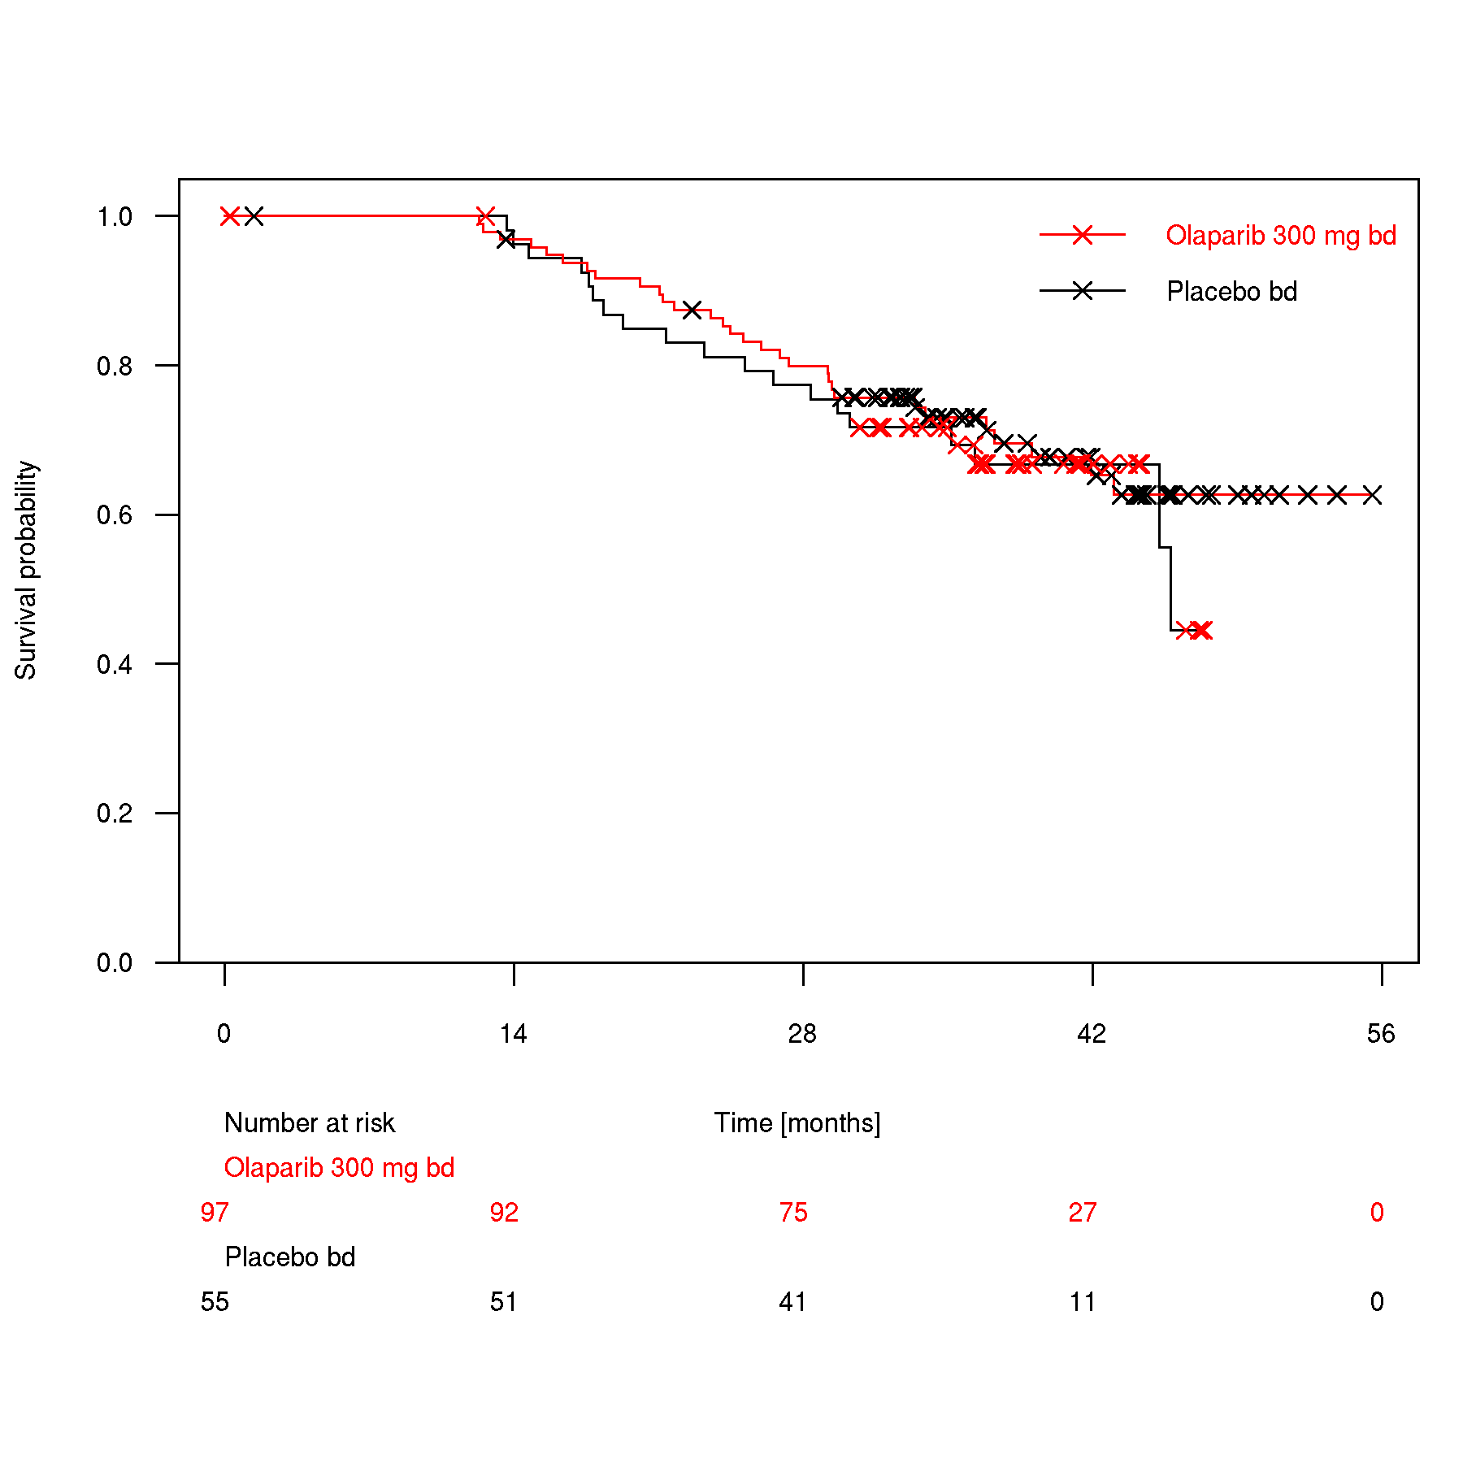
Figure 1: Comparison of OS Kaplan-Meier curves from HRD positive BRCAwt patients in PAOLA-1 DCO3 (left) and DCO2 (right)
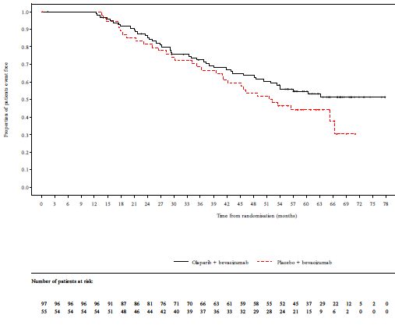
Source: Figures 1 and 2, p13 of the resubmission

  - The resubmission noted that OS data from DCO3 included over 40% of patients randomised to the bevacizumab arm who subsequently received treatment with a second line PARPi, which would be expected to bias OS results against olaparib. The resubmission claimed that if a formal treatment switching analysis were undertaken, it is likely to demonstrate statistical significance on that basis. However, no such analysis was presented to support this assertion.
  - The resubmission also provided an updated data cut (DC03) for HRD positive BRCAwt patients in PAOLA-1 for PFS (Table 5) and the Kaplan-Meier curves for DC03 (Figure 2). PFS was not assessed at DCO2 therefore no Kaplan-Meier curves were presented for DCO2.
Table 5: Comparison of PFS in DCO1, DCO2 and DCO3 in PAOLA-1
 | DCO1 |  |  | DCO2 |  |  | DC03
 | ola + beva | pbo + beva | HR  (95% CI) | ola + beva | pbo + beva | HR  (95% CI) | ola + beva | pbo + beva | HR  (95% CI)
HRD positive BRCAwt
Median PFS | 28.1 | 16.6 | 0.43  (0.28,0.66) | 30.0 | 16.6 | 0.44*  (0.29, 0.66) | 30.0 | 16.6 | 0.45*  (0.31,0.67)
Events, n/N (%) | 43/97 (44.3) | 40/55 (72.7) |  | 51/97 (52.6) | 45/55 (81.8) |  | 58/97 (59.8) | 46/55 (83.6)
Source: Table 6, p 14 of the resubmission and Table 6, 6.07 olaparib PSD July 2022.
beva = bevacizumab, HR = hazard ratio ola = olaparib, pbo = placebo, PFS = progression free survival
* The hazard ratio was not formally estimated at DCO2 or DCO3, but point estimate and 95% profile likelihood CIs were estimated from Cox proportional hazards models with treatment, subgroup and treatment-by-subgroup interaction terms fitted as covariates. The Efron method was used for handling ties.
Note that the results presented in Table 5 are derived from post-hoc analyses of a subgroup of the PAOLA-1 population across endpoints conducted specifically for the purposes of informing the PBAC consideration. These analyses were not part of the pre-specified statistical plan for PAOLA-1. Interpretation of the results and their application should therefore be limited to seeking to understand the basis for the PBAC outcome and should not be used for any other purpose.

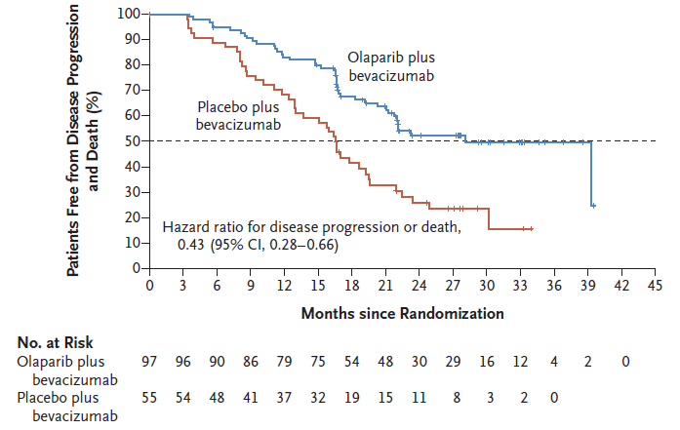
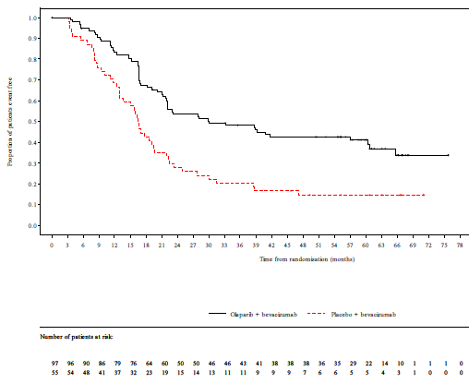
Figure 2: PFS Kaplan-Meier curves from PAOLA-1 DCO3 (left) and DCO1 (right)

Source: Figure 3, p15 of the resubmission and Figure 3, 6.07 olaparib PSD July 2022

  - The submission stated that DCO3 data-cut demonstrates a continuing PFS benefit and a continued divergence of the OS curves despite >40% cross-over to subsequent PARPi in the placebo arm.

Comparative harms
  - The resubmission did not present any additional safety data. The PBAC previously considered that the combination of olaparib and bevacizumab had inferior safety in comparison with bevacizumab monotherapy (para 7.9 olaparib PSD, July 2022 PBAC meeting).

Revised economic analysis
  - The base case incremental cost-effectiveness ratio in the resubmission was $55,000 to < $75,000 per QALY.
Table 6: Comparison of economic evaluation between resubmission and July 2022
Increment | July 2022 submission | November 2022 resubmission
Cost | $| | $|
LY (discounted) | 0.52 | 0.40
QALY (discounted) | 0.46 | 0.36
Cost effectiveness ratio ($/QALY) | $|¹ | $|²
Source: Table 9 of the resubmission and Table 17, 6.07 olaparib PSD July 2022
The redacted values correspond to the following ranges:
¹ $45,000 to < $55,000
² $55,000 to < $75,000
  - The difference in incremental cost was due to the reduced olaparib price, and the difference in life years and QALYs was primarily due to the reduction in the assumed cure fraction for olaparib (changed from 38.6% to 30%). The change in the utility value applied in the post-progression health state (changed from 0.544 to 0.577) and change in the BRCA testing cost (from $1200 to $1000) both had a minimal impact on the ICER.
Cure fractions
  - While the PBAC requested a cure fraction of no more than 25.45%, the model used a cure fraction of 30% for olaparib plus bevacizumab. The resubmission claimed that the PAOLA-1 trial DCO3 data were more accurately reflected by a cure fraction of 30%. The resubmission stated that caution should be applied when comparing the cure fractions between PAOLA-1 and SOLO1, given the trials enrolled slightly different patient populations, administered different treatment regimens and the trials had different durations of data maturity. The resubmission reported that the mixture cure modelling conducted on the DCO2 data cut showed that the average of “clinically plausible” cure fractions for olaparib plus bevacizumab in BRCAm patients was 31.2% (Attachment 6 of the resubmission). The derivation of this value could not be verified. Cure fractions reported in Attachment 6 ranged from 0% (exponential) to 41.2% (Gompertz), with five of the seven extrapolation functions reporting a cure fraction lower than 21%. Analyses in Attachment 6 also appeared to relate to the BRCAm population rather than the population proposed in the submission (HRD+ BRCAwt). The resubmission did not present cure fractions based on the DC03 data cut and instead the value of 30% was chosen based on visual inspection only, and it was unclear if different parametric functions were tested (see Figure 4).
  - Although the PBAC considered it appropriate to use cure fractions consistent with those accepted for the olaparib BRCAm model (paragraph 7.18, olaparib PSD, July 2022 PBAC meeting), there were no changes regarding the cure fraction used for the comparator arm (6.6%). This compared to a value of 18.0% used for the comparator (placebo) in the olaparib BRCAm model (paragraph 6.60, olaparib PSD, July 2022 PBAC meeting). This resulted in an incremental difference in cure fraction of 23.4% (30.0% - 6.6%) in the resubmission, which was a decrease from 32.0% in the previous submission but remains substantively greater than the 7.45% in the olaparib monotherapy BRCAm model based on SOLO-1 (Table 15, olaparib PSD July 2022 PBAC meeting).
  - The pre-PBAC response presented estimated cure fractions from PAOLA-1 DCO2 and DCO3 and cure fractions based on 5 and 7 year follow-up from SOLO-1, as shown in Table 7. The PBAC considered that the estimated cure fraction for the placebo arm from DCO3 (12.3% for HRD+ BRCAwt) may have been affected by the substantial cross-over to PARPi treatment.
Table 7 Updated cure fraction data for PAOLA and SOLO-1 studies
 | PAOLA-1 |  |  |  | SOLO-1
 | Early re-entry  HRD+BRCAwt  DCO2 | HRD+  BRCAwt  DCO3 | HRD+  DCO3 | BRCAm  DCO3 | Submitted | 5 year follow-up | 7 Year follow-up
Olaparib arm | 30% | 34.0%  range 25.7% - 36.5% | 36.7%  range 33.9% - 41.0% | 38.3%  range 34.2% - 44.7% | 25.45% | 33.7%  range 20.6% - 45% | 28.2%  range 16.6% - 37.9%
Control arm | 6.6% | 12.3%  range 11.1% - 14.7% | 16.8%  range 15.1 - 19.2% | 20.2%  range 18.1% - 22.6% | 18.0% | 17.1%  range 14.5% - 19.3% | 15.6%  range 12.2% - 17.4%
Note that the results presented in Table 7 are derived from post-hoc analyses of a subgroup of the PAOLA-1 population across endpoints conducted specifically for the purposes of informing the PBAC consideration. These analyses were not part of the pre-specified statistical plan for PAOLA-1. Interpretation of the results and their application should therefore be limited to seeking to understand the basis for the PBAC outcome and should not be used for any other purpose.
Extrapolations
  - The loglogistic extrapolation remains the resubmission’s nominated functional form for PFS as the base case for both treatment arms in the resubmission. The resubmission stated that modelled extrapolation of PFS for the bevacizumab arm fit the DCO3 data well, however, the Weibull function had the best statistical fit for the bevacizumab monotherapy arm and has external validity (the estimated cure fraction of 17.4% was more consistent with the 18.0% cure fraction used for the placebo arm in the olaparib July 2020 submission) (paragraph 6.60, 6.07 olaparib PSD, July 2022 PBAC meeting).
  - The resubmission noted that the PBAC Guidelines request trial-based time-to-event data be used until a certain point with parametric extrapolation thereafter. This was not done in the previous model but it was implemented in the resubmission for the calculation of PFS for olaparib plus bevacizumab (branch P1) because without changing the point of truncation, the modelled PFS curve for olaparib+bevacizumab sits substantially below the DCO3 trial data. The submission stated that the point of truncation chosen in the model was the end of the trial follow-up (49 months for olaparib arm, 39 months for other arms). The PBAC guidelines request that time-to-event data be used up to the time point at which the observed data become unreliable due to the small number of patients remaining event-free. At the end of trial follow-up there were no patients at risk, therefore the truncation point chosen appears to be inappropriate. The application of KM data up to the end of the trial follow-up increased the proportion of patients who remain progression-free (but uncured) in the olaparib + bevacizumab arm but did the opposite for the bevacizumab only arm after 20 months, favouring olaparib + bevacizumab (Figure 3).

Figure 3: Comparison of proportion of PFS (uncured) patients with and without truncation in the model for olaparib + bevacizumab (left) and bevacizumab only (right)
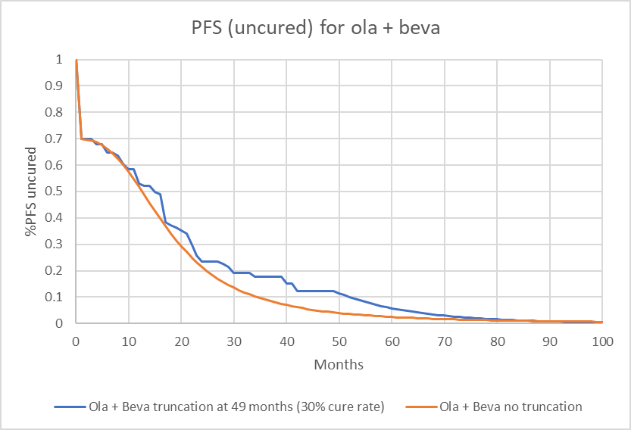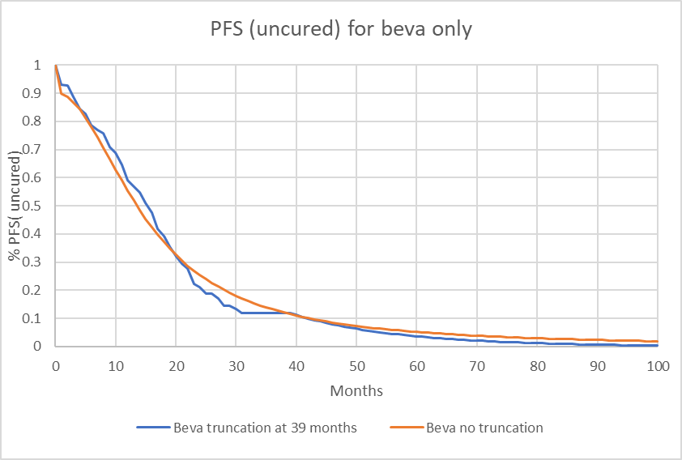
Source: Constructed during evaluation using Attachment 3 LYNPARZA (olaparib) HRDBRCAwt CEM.xlsx
  - The modelled PFS and OS curves applied in the resubmission, along with data from DCO3 are shown in Figure 4 and Figure 5, respectively.
Figure 4 PFS using loglogistic for both arms with cure fraction of 30% for olaparib+bevacizumab and 6.6% for bevacizumab monotherapy
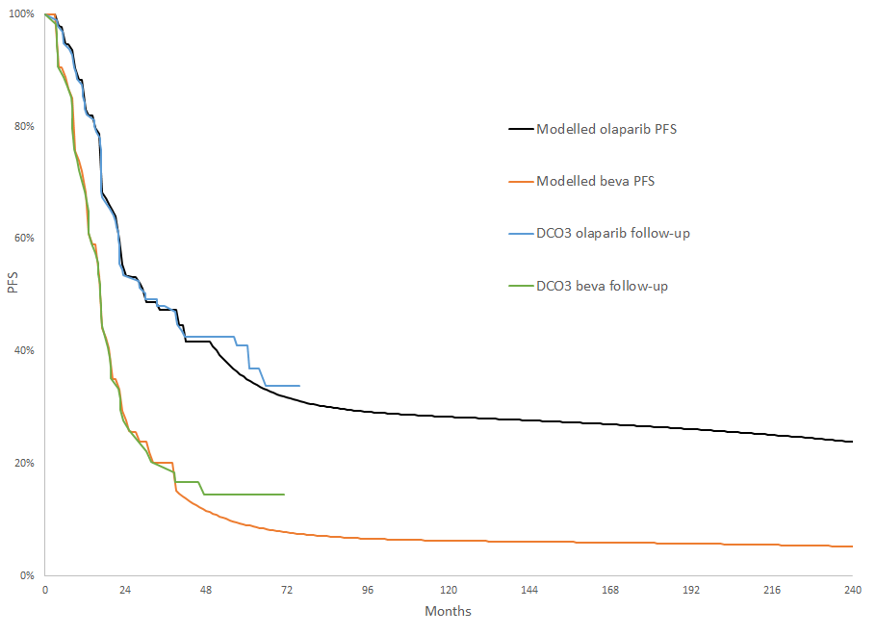
Source: Figure 8 of the resubmission
Figure 5 Comparison of modelled OS and validation using DCO3 OS data (cure fractions are 30% for olaparib+bevacizumab and 6.6% for bevacizumab monotherapy)
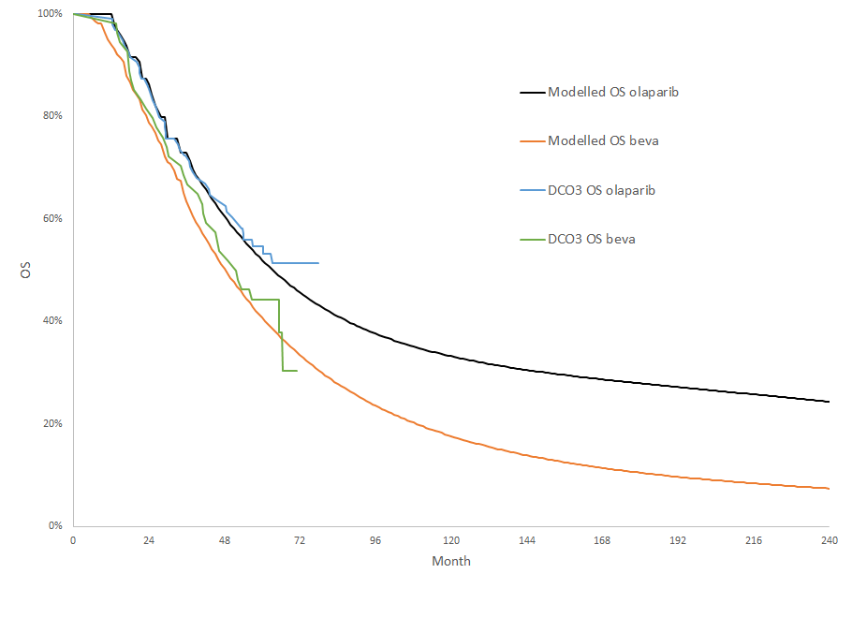
Source: Figure 9 of the resubmission
Changes in costs
  - Additionally, the cost of palliative care was increased from $16,301 to $17,051 in the updated model due to the inclusion of an additional year of data for the Health Price Index that was used to inflate the palliative care cost (Kardamanidis 2007) to 2022 prices. The cost of MBS items, other medical items (e.g. secondary debulking surgery) and dispensing fees for chemotherapy were also updated in line with current item costs. Cost for treatment of adverse events appears to have been updated to National Hospital Cost Data Collection (NHCDC) Round 23 to Round 24 data though the reference in the attached model still refers to Round 23. These changes were not requested by the PBAC but had a very minimal impact on the ICER (<$100 change to the ICER).
  - Though the PBAC requested a price reduction to result in an ICER of less than $50,000/QALY gained (paragraph 7.16, olaparib PSD, July 2022 PBAC meeting), the submission argued that the strength of the OS data from DCO3 should alleviate any of the PBAC’s concern and permit an ICER threshold consistent with SOLO-1, given the OS gains demonstrated. An effective DPMQ of $| | was required to achieve an ICER of $50,000/QALY (as considered appropriately cost-effective by the PBAC) based on the resubmission’s assumptions and inputs. This represented a further | |% reduction in the price proposed in the resubmission (effective DPMQ of $| |).

Sensitivity analyses
  - Key sensitivity analyses are shown in Table 8. The model was sensitive to changes in the cure fraction in either arm. When the cure fraction for olaparib + bevacizumab was changed from 30% to 25.45%, the ICER increased by 16.8% to $55,000 to < $75,000 per QALY. Using the Weibull function for the extrapolation of bevacizumab monotherapy PFS (which increased the cure fraction to 17.4%) increased the ICER by 45.5% to $75,000 to < $95,000 per QALY. Removal of the PFS point of truncation from the model only had a small impact on the model, resulting in a 4.8% increase in the ICER ($55,000 to < $75,000 per QALY).
Table 8: Results of key sensitivity analyses
Variable or assumption | Incremental costs | Incremental effectiveness (QALYs) | ICER versus bevacizumab | % change from base case
Resubmission Base Case | $ | | 0.36 | $ | ¹ | N/A
ola+beva arm cure fraction (base case = 30%)  - 25.45% (PBAC advice) | $ | | 0.31 | $ | ¹ | +16.8%
beva arm cure fraction (base case = 6.6%)  - 18.0% (see para 4.17) ª | $ | | 0.25 | $ | ² | +49.8%
Beva arm cure fraction (base case = 6.6%)  - 17.43% by applying Weibull (see para 4.19) | $ | | 0.25 | $ | ² | +45.5%
PFS point of truncation (base case = 49 months for beva arm (P1) and 39 months for all other branches)  - No KM data used (para 4.20)  - 1 month for all branches  - 35.5 months for P1 and 36.5 for all other branches (median follow-up DCO2; July 2022 PSD, paragraph 6.14) | $ |  $ |  $ | | 0.35  0.35  0.36 | $ | ¹  $ | ¹  $ | ¹ | +4.8%  +4.2%  +0.9%
Multivariate analysis  - ola+beva arm cure fraction (25.45%) and No KM data used for PFS (as for July 2022 model) | $ | | 0.29 | $ | ¹ | +26.1%
Source: Attachment 3 LYNPARZA (olaparib) HRDBRCAwt CEM.
ola = olaparib, beva = bevacizumab
a The inputs on Mixture cure Modelling sheet are P2=18.00%; P3-P4 and C2=17.35% (P2 x 0.9639)
The redacted values correspond to the following ranges:
¹ $55,000 to < $75,000
² $75,000 to < $95,000

Revised financial estimates
  - The estimated olaparib cost/patient per course for the financial estimates was $|| ||, based on 17.1 months treatment duration (18.58 scripts).
  - The resubmission presented revised financial implications using the reduced olaparib price and mean treatment duration.
  - There were several issues with the financial estimates presented in the resubmission:
- While the mean duration of treatment for olaparib was used, the median duration for concomitant bevacizumab (from DCO2) was used in the resubmission instead of the mean duration and the values differed to data presented in the previous submission which was based on the PAOLA-1 CSR DCO2 Table 2828.1 (see Table 9).
- The resubmission assumed that grandfathered patients would use only an additional 7.97 bevacizumab scripts if olaparib was listed but assumed an offset of 15.35 scripts of bevacizumab for each grandfathered patient.
- Estimation of concomitant bevacizumab use along with olaparib was inconsistently applied in the resubmission’s financial estimates, leading to a slight underestimate of concomitant bevacizumab use with olaparib.
- While the co-payment for general-ordinary services were updated, the co-payment for general-safety net, RPBS – ordinary and concessional – ordinary services were not updated in the resubmission.
- None of the issues in the calculation of the financial estimates identified during the evaluation of the previous submission (paragraphs 6.96 and 6.97, 6.07 olaparib PSD, July 2022 PBAC meeting) were addressed in the resubmission.
Table 9: Comparison of treatment duration assumed in resubmission with data provided in previous submission
 | Estimates from resubmission’s economic model |  | Used in resubmission’s financial estimates ª |  | Table 2828.1, DCO2 (presented with previous submission)
 | Ola + Beva | Ola + Beva | Ola + Beva | Ola + Beva | Ola + Beva | Ola + Beva
Olaparib (months) | 17.079 | - | 17.1 | - | Mean 16.9426  Median: 21.552 | -
Bevacizumab (months) | 9.865 ^{b} | 9.037^{c} | 11.0 | 10.6 | Mean 10.319  Median 11.039 | Mean 9.598  Median 10.218
Beva = bevacizumab, Ola = olaparib
a Resubmission claims mean values were used
b Economic model assumed 14.3 infusions of bevacizumab based on number of bevacizumab doses post randomisation (i.e. maintenance only) in PAOLA-1 among HRD + BRCAwt patients. Back calculated assuming 30.44 days in a month as in financial model
c Economic model assumed 13.1 infusions of bevacizumab based on number of bevacizumab doses post randomisation (i.e. maintenance only) in PAOLA-1 among HRD + BRCAwt patients. Back calculated assuming 30.44 days in a month as in financial model.
Source: Attachment 4 to the resubmission and PAOLA-1 CSR DCO2 Table 2828.1 (Other Attachment_Section4 to previous submission)
  - Correcting the issues above, the financial estimates were revised as shown in Table 10. The pre-PBAC response acknowledged these adjustments were appropriate and the revisions did not substantially change the financial implications.
Table 10: Estimated use and financial implications
 | Year 1 | Year 2 | Year 3 | Year 4 | Year 5 | Year 6
Revised estimated extent of use
Number of patients treated | | ^{a,1} | | ¹ | | ¹ | | ¹ | | ¹ | | ¹
Number of scripts dispensed | | ² | | ² | | ² | | ² | | ² | | ²
Revised estimated financial implications
Cost to PBS/RPBS | ||³ | ||³ | ||³ | ||³ | ||³ | ||³
Cost to MBS | ||⁴ | ||⁴ | ||⁴ | ||⁴ | ||⁴ | ||⁴
Net cost to health budget | ||³ | ||³ | ||³ | ||³ | ||³ | ||³
Previous submission (July 2022)
Net cost to PBS/RPBS | ||³ | ||³ | ||³ | ||³ | ||³ | ||³
a Assuming mean treatment duration of 17.1 months (median duration of 22.1 months used in previous submission).
b Includes<500 grandfathered patients in Year 1 of listing.
Source: Tables 6 and 7, pp 27 and 28 of the resubmission, spreadsheet 4a, Attachment 4 – LYNPARZA (olaparib) Section 4 financial estimates revised final.
The redacted values correspond to the following ranges:
¹ < 500
² 5,000 to < 10,000
³ $10 million to < $20 million
⁴ $0 to < $10 million
  - After these corrections, the estimated a net cost to the PBS/RPBS for listing olaparib + bevacizumab was $10 million to < $20 million in Year 1 of listing, increasing to $10 million to < $20 million in Year 6 of listing, with a total net cost to the PBS/RPBS of $90 million to < $100 million over the first 6 years of listing.

Financial Management – Risk Sharing Arrangements
  - The resubmission stated the sponsor is willing to work with the PBAC and Department of Health to determine appropriate terms for PBS listing of olaparib for eligible patients with HRD+BRCAwt advanced ovarian cancer that recognises the value of this treatment and shares the risk of uncertainty between the Sponsor and the Department.

HRD testing
  - At its July 2022 meeting the MSAC did not support public funding of HRD testing for access to olaparib and advised that further information is needed to elucidate how to confidently identify ovarian tumour tissue as being homologous recombination deficient. The resubmission noted that the sponsor is working with the MSAC to address remaining issues regarding HRD testing, the proposed HRD test is expected to be TGA-notified prior to the MSAC and PBAC meetings in the second half of 2022 and the | | | | | | | | | | anticipates receipt of NATA accreditation to conduct HRD testing in the second half of 2022. The pre-PBAC response noted that a resubmission was submitted to MSAC on 5th October 2022 and that HRD testing data is currently being reviewed by TGA and NATA, with NATA accreditation now expected towards the end of 2022.
  - At its July 2022 meeting the PBAC sought advice from MSAC regarding the HRD testing component (paragraph 7.2, olaparib PSD, July 2022 PBAC meeting). In particular, the PBAC requested that MSAC provide advice on:
        - The equivalence or validation of the SOPHiA assay (the assay in the submission proposed for MBS listing) versus the Myriad MyChoice Plus HRD assay (the clinical utility standard assay used in PAOLA-1). MSAC considered that the tests were not fully concordant.
        - The threshold that should be used to define HRD positivity for determining PARPi eligibility with reference to the clinical utility standard. MSAC advised that the concept of the clinical utility standard (in this case assay, algorithm, and threshold) remains relevant as a basis for judging whether to allow other test options to be used within the scope of a broad MBS item descriptor. However, in the context of this application, more fundamental concerns regarding the different definitions of genomic instability (in this case assay, algorithm, and threshold) in the context of different definitions of HRD status needed clearer resolution as a prerequisite to accepting this concept for this purpose.
        - The proportions of the population anticipated to be HRD positive and BRCAwt, which are relevant for the financial estimates. To validate the financial estimates, it will be necessary to confirm the following for patients eligible to be treated with olaparib for 1L ovarian cancer:
        - The proportion of patients with BRCA pathogenic or likely pathogenic variants (assumed to be 25.3% by the submission, and so eligible for treatment under the existing olaparib monotherapy listing).
        - The proportion of patients with HRD positive tumours (assumed to be 50% by the submission), and thus the increment in the population eligible for olaparib of 24.7%.
MSAC advised that approximately 25% of people with advanced ovarian cancer would be HRD-positive BRCAwt in addition to the 25% of this population who would be BRCAm. These estimates are broadly consistent with the results of the validation study, although the prevalence of HRD-positive may vary with choice of assay and threshold of genomic instability.

For more detail on PBAC’s view, see section 5 PBAC outcome.

- PBAC Outcome
  - The PBAC deferred its decision on whether to recommend olaparib for use in combination with bevacizumab for maintenance therapy in patients with newly diagnosed HRD positive BRCA wild type advanced epithelial ovarian, fallopian tube or primary peritoneal cancer. The PBAC was of a mind to recommend olaparib pending MSAC consideration of HRD testing. The PBAC noted that MSAC did not support public funding of HRD testing for access to olaparib during its consideration in July 2022 and that a resubmission for MBS funding had been lodged by the sponsor.
  - The PBAC considered that the resubmission had addressed the substantive outstanding issues identified at the July 2022 PBAC meeting via revised inputs for the economic model including: use of loglogistic PFS extrapolations, use of a post-progression utility value of 0.557 and a BRCA testing cost of $1,000. In addition, recalculation of the financial implications was provided as requested. The PBAC noted that although the cure fraction for olaparib + bevacizumab had been reduced to 30% (rather than 25.45% as advised), the cure fractions used in the resubmission were supported by more mature data from the PAOLA-1 and SOLO-1 trials. The PBAC noted that the resubmission did not reduce the price to give an ICER of $50,000/QALY gained. The PBAC maintained that an ICER of no more than $50,000/QALY was appropriate and that a reduction in price would be required to ensure cost-effectiveness given the remaining uncertainty in the modelled benefit of olaparib in the proposed population.
  - The PBAC noted that the proposed clinical place for PARP inhibitors in patients without BRCAm was reliant on access to an approved HRD test and noted that uncertainties remained with respect to the proposed HRD testing which would require MSAC advice (see paragraph 4.32).
  - The PBAC noted that the resubmission accepted the recommended changes to the previously considered PBS restriction in terms of the removal of the requirement that olaparib treatment must commence in combination with bevacizumab and amendment of the description for requirements for HRD testing. The PBAC considered that these changes were appropriate, noting that further changes to the wording of HRD testing requirements may be required, pending MSAC advice. The resubmission also proposed a restriction for transitioning to PBS-funded treatment (grandfather arrangements), however the proposed restriction did not specify HRD or BRCA status nor response to previous platinum-based chemotherapy. The PBAC considered that the grandfather restriction should be amended to reflect the clinical criteria in the initial treatment listing to ensure the same population is eligible for treatment under these arrangements.
  - The resubmission provided outcomes from an updated data cut (DCO3) of PAOLA-1 (the pivotal trial), noting that for this data cut more than 40% of HRD+ BRCAwt patients in the placebo arm had received subsequent treatment with a PARPi. The PBAC noted that the OS HR improved from 0.84 (95% CI: 0.46, 1.52) in DCO2 to 0.71 (95% CI: 0.45, 1.13) in DCO3 for the HRD+ BRCAwt population, while the PFS HR was largely unchanged between DCO2 and DCO3. The PBAC noted that at DCO3 the OS HR for the ITT population was not statistically significant and subgroup analyses (i.e. HRD+ BRCAwt) were exploratory in nature, with no alpha assigned. The submission claimed that if a formal treatment switching analysis were undertaken, it is likely to demonstrate statistical significance.
  - The resubmission did not present any additional safety data. The PBAC previously considered that the combination of olaparib and bevacizumab had inferior safety in comparison with bevacizumab monotherapy (para 7.9, olaparib PSD, July 2022 PBAC meeting).
  - While the PBAC recalled it had requested a cure fraction of no more than 25.45%, the model in the resubmission used a cure fraction of 30% for olaparib plus bevacizumab, claiming that the PAOLA-1 trial DCO3 data were more accurately reflected by a cure fraction of 30%. The PBAC noted that results from the 7 year follow-up of SOLO-1 indicated that PFS at 5 years was 42% with olaparib in patients with high risk disease and 56% for patients with low-risk disease (DiSilvestro 2022). The PBAC considered that this longer-term follow-up data suggested that it was plausible that the true cure fraction for olaparib in patients with BRCAm was better than the 25.45% estimated in the July 2020 submission. The PBAC maintained that a lower cure fraction would be expected for the HRD+ BRCAm population but considered that the cure fraction estimate of 30% appeared reasonable based on the additional data presented for DCO3 and the longer follow-up from the SOLO-1 trial.
  - The PBAC noted the cure fraction used for the comparator arm (6.6%) in the resubmission model was lower than the value used for the comparator (placebo) in the olaparib BRCAm model based on SOLO-1 data (18.0%). However, the PBAC noted that the estimated cure fraction for placebo estimated from DCO3 of PAOLA-1 was 12.3% and the PBAC considered that this may have been affected by the substantial cross-over to PARPi treatment. Therefore, the PBAC considered that the cure fraction of 6.6% for the comparator arm was acceptable, but noted that this was a source of uncertainty in the modelled outcomes.
  - The PBAC noted that with the resubmission’s revisions to the cure fraction, utility values, BRCA testing cost and olaparib price the resulting ICER was increased to $55,000 to < $75,000 per QALY gained. The PBAC recalled its advice that “given the uncertainty regarding the magnitude of benefit for the HRD positive population due to reliance on an exploratory subgroup analysis, uncertain extrapolations, uncertainty regarding whether the proposed test will identify an equivalent group of patients as in the PAOLA-1 trial and because the proposed HRD positive BRCAwt population are likely to have a reduced PFS benefit compared with the BRCAm population, the PBAC considered that an ICER of less than $50,000/QALY would be considered appropriately cost-effective” (para 7.16, olaparib PSD, July 2022 PBAC meeting). A further reduction of | |% in the proposed effective DPMQ would be required to achieve an ICER of $50,000/QALY using the revised inputs. The PBAC maintained that this reduction in price would be required to ensure cost-effectiveness given the remaining uncertainty in the modelled benefit of olaparib in the proposed population.
  - The resubmission presented revised financial implications using the resubmission’s proposed olaparib price and mean treatment duration. The PBAC considered that, after corrections as per paragraph 4.27, the revised financial estimates were reasonable, but would need to be updated to reflect the olaparib price PBAC considered acceptably cost-effective.
  - The PBAC noted that risk sharing arrangements are currently in place for olaparib and niraparib in the BRCAm population. If recommended, the PBAC considered that it may be appropriate for the existing olaparib and niraparib caps to be increased to account for the broader population including HRD positive BRCAwt population.
Outcome:
Deferred
- Context for Decision
The PBAC helps decide whether and, if so, how medicines should be subsidised through the Pharmaceutical Benefits Scheme (PBS) in Australia. It considers applications regarding the listing of medicines on the PBS and provides advice about other matters relating to the operation of the PBS in this context. A PBAC decision in relation to PBS listings does not necessarily represent a final PBAC view about the merits of the medicine or the circumstances in which it should be made available through the PBS. The PBAC welcomes applications containing new information at any time.
- Sponsor’s Comment
The sponsor had no comment.

Addendum to the November 2022 PBAC Public Summary Document:

4.06 OLAPARIB,
Tablet 100 mg,
Tablet 150 mg,
Lynparza®,
AstraZeneca Pty Ltd
- Background
  - In November 2022, the PBAC deferred its decision on whether to recommend olaparib for use in combination with bevacizumab for maintenance therapy in patients with newly diagnosed HRD positive BRCA wild type advanced epithelial ovarian, fallopian tube or primary peritoneal cancer. The PBAC was of a mind to recommend olaparib pending MSAC consideration of HRD testing (see paragraph 5.1).
  - In March 2023, the Medical Services Advisory Committee (MSAC) supported the creation of a new Medicare Benefits Schedule (MBS) item to test tumour tissue for genomic instability (GI) to determine homologous recombination deficiency (HRD) status (including BRCA1/2 status) to define eligibility for treatment with a poly-ADP ribose polymerase (PARP) inhibitor for patients with advanced (FIGO stage III-IV), high grade serous or other non-mucinous high grade ovarian, fallopian tube or primary peritoneal carcinoma (see Table 11). The sponsor had proposed a fee of $2,500 for the proposed MBS item for HRD testing, however the MSAC considered that a fee of $3,000 would be appropriate due to the complexity of the test. The sponsor stated that NATA accreditation has been granted to the Peter MacCallum Cancer Centre for the SOPHIA HRD assay.
Table 11: MSAC’s supported item descriptor (applies to MSAC Application 1658.1)
Category 6 – Pathology Services Group P7 - Genetics
MBS item XXXXX
A test of tumour tissue from a patient with advanced (FIGO III–IV), high-grade serous or other high-grade ovarian, fallopian tube or primary peritoneal carcinoma, requested by a specialist or consultant physician, to determine eligibility with respect to homologous recombination deficiency (HRD) status, including BRCA1/2 status, for access to PARP inhibitor therapy under the Pharmaceutical Benefits Scheme (PBS).
Evidence of homologous recombination deficiency must be derived through a test that has been validated against the Myriad MyChoice® HRD assay.
Applicable once per primary tumour diagnosis. Not applicable to a service to which 73295 or 73301 applies.
Fee: $3,000.00 Benefit: 75% = $2,250.00 85% = $2,906.80
Practice note: Validation against the Myriad MyChoice® HRD assay should use a score of 42 or greater as the threshold for HRD (genomic instability) positivity.
85% benefit reflects the 1 November 2022 Greatest Permissible Gap (GPG) of $93.20. All out-of-hospital Medicare services that have an MBS fee of $621.50 or more will attract a benefit that is greater than 85% of the MBS fee – being the schedule fee less the GPG amount. The GPG amount is indexed annually on 1 November in line with the Consumer Price Index (CPI) (June quarter).

  - The sponsor provided additional information for PBAC consideration after receipt of the MSAC Public Summary Document for Application No. 1658.1. A summary of the additional information and issues addressed is provided in Table 12.
Table 12: Issues to be addressed
Matter of Concern |  | Information from sponsor (June 2023)
1 | The PBAC maintained that an ICER of no more than $50,000/QALY was appropriate and that a reduction in price would be required to ensure cost-effectiveness given the remaining uncertainty in the modelled benefit of olaparib in the proposed population (paragraph 5.2, November 2022 PSD). | The sponsor proposed a reduced effective price for olaparib:  Effective AEMP: $|||| per pack (56 tablets).  Effective DPMQ: $|||| (112 tablets)  The corresponding ICER is:  - $|¹/QALY (HRD test $2,500)  - $|¹/QALY (HRD test cost $3,000)  - $|¹/QALY to $|¹/QALY (HRD test cost $3,000, and revised palliative care costs).  The proposed price was ||||
2 | The PBAC noted that further changes to the wording of HRD testing requirements may be required in the proposed PBS restriction, pending MSAC advice (paragraph 5.4, November 2022 PSD). | The proposed restriction was updated after receipt of the MSAC PSD.
3 | The PBAC noted that revised financial implications would be required to reflect the olaparib price PBAC considered acceptably cost-effective (paragraph 5.4, November 2022 PSD). | The sponsor provided revised estimates, see Table 14.
The redacted values correspond to the following ranges:
¹ $45,000 to < $55,000
  - The results of the revised economic evaluation are provided in Table 13.
Table 13: Results of the revised economic evaluation
Scenario | Olaparib DPMQ  (112 tabs) | Cost of palliative care | Incr. cost ($) | Inc. LY | Inc. QALY | ICER ($/QALY)
(A) July 2022 submission | $|||| | $16,301 (Kardamanidis 2007 inflated to 2021 dollars) | $|||| | 0.52 | 0.46 | $|||| ¹
(B) November 2022 resubmission | $|||| | $17,051 (Kardamanidis 2007 inflated to 2022 dollars) | $|||| | 0.40 | 0.36 | $|||| ²
(C) Economic model corresponding to November 2022 PBAC recommendation (same model inputs as row B, and further price reduction of ||||% on dispensed price) | $||||  (AEMP=$|||| per pack) | $17,051 | $|||| | 0.40 | 0.36 | ≤$|||| ¹
July 2023 scenarios
(D) Apply resubmission price to November 2022 model (same model inputs as row B, with proposed price) | $|||| (AEMP=$|||| per pack) | $17,051 | $||||ª | 0.40 | 0.36 | $|||| ¹
(E) Increase test cost to $3,000 (reflects MSAC advice) | $|||| | $17,051 | $|||| | 0.40 | 0.36 | $|||| ¹
(F) Increase test cost to $3,000 and revise palliative care costs to Reeve 2018 | $|||| | $27,107  (Reeve 2018^{b}; Secretariat unable to verify costs) | $|||| | 0.40 | 0.36 | $|||| ¹
(G) Increase test cost to $3,000 and revise palliative care costs to Reeve 2018 (inflation-adjusted) | $|||| | $40,283  (Reeve 2018, inflation-adjusted). | $|||| | 0.40 | 0.36 | $|||| ¹
- corrected by Secretariat, resubmission incorrectly reported cost of $||
- https://bmcpalliatcare.biomedcentral.com/articles/10.1186/s12904-017-0213-0#Sec18
Abbreviations: DPMQ, dispensed price maximum quantity; ICER, incremental cost-effectiveness ratio; LY, life-year; QALY, quality-adjusted life-year
The redacted values correspond to the following ranges:
¹ $45,000 to < $55,000
² $55,000 to < $75,000
  - The estimated use and financial implications are provided in Table 14.

Table 14: Estimated use and financial implications
 | Year 1 | Year 2 | Year 3 | Year 4 | Year 5 | Year 6
Revised estimated extent of use
Number of patients treated | || ^{a1} | | ¹ | | ¹ | | ¹ | | ¹ | | ¹
Number of scripts dispensed | | ² | | ² | | ² | | ² | | ² | | ²
Revised estimated financial implications (DPMQ=$||||)
Net Cost to PBS/RPBS | | ³ | | ³ | | ³ | | ³ | | ³ | | ³
Cost to MBS | | ⁴ | | ⁴ | | ⁴ | | ⁴ | | ⁴ | | ⁴
Net cost to health budget | | ³ | | ³ | | ³ | | ³ | | ³ | | ³
Previous resubmission (November 2022)
Net cost to PBS/RPBS | | ³ | | ³ | | ³ | | ³ | | ³ | | ³
Previous submission (July 2022)
Net cost to PBS/RPBS | | ³ | | ³ | | ³ | | ³ | | ³ | | ³
- Includes < 500 grandfathered patients in Year 1 of listing.
Source: Sponsor document, Table 4.
The redacted values correspond to the following ranges:
¹ < 500
² 500 to < 5,000
³ $10 million to < $20 million
⁴ $0 to < $10 million
For more detail on PBAC’s view, see section 9 PBAC outcome.
- PBAC Outcome
  - The PBAC recommended olaparib for use in combination with bevacizumab for maintenance therapy in patients with newly diagnosed homologous recombination deficiency (HRD) positive BRCA wild type advanced epithelial ovarian, fallopian tube or primary peritoneal cancer. The PBAC noted that it had deferred its decision on whether to recommend the proposed listing at the November 2022 PBAC meeting, pending MSAC consideration of HRD testing. The PBAC noted that the MSAC had recommended HRD testing for determination of eligibility for PARPi for this indication at its March 2023 meeting. The PBAC considered that the outstanding issues were satisfactorily resolved by the revised economic evaluation which included a price reduction to account for remaining uncertainty in the modelled benefit of olaparib, as requested by the PBAC in November 2022. The PBAC noted the revised financial estimates appropriately incorporated the reduced olaparib price.
  - The PBAC was satisfied that olaparib in combination with bevacizumab provides, for some patients, a significant improvement in efficacy over bevacizumab alone, based on the results of the PAOLA-1 study. The PBAC’s recommendation for listing was based on, among other matters, its assessment, that the cost-effectiveness of olaparib would be acceptable at the proposed price.
  - The PBAC noted the MSAC advice that confirmed support for the proposed MBS item that would enable determination of HRD status for access to PARP inhibitor therapy under the PBS. The PBAC noted that MSAC’s supported item descriptor (see Table 11), includes a practice note stating that “Validation against the Myriad MyChoice® HRD assay should use a score of 42 or greater as the threshold for HRD (genomic instability) positivity”.
  - The PBAC considered there was a high clinical need for olaparib in the proposed population of patients with HRD positive BRCAwt tumours. The PBAC recalled the input from individuals and organisations received previously in support of the proposed listing. The comments had noted that many young women and their families are impacted by ovarian cancer and that effective treatment may delay or prevent recurrence and has potential to prolong life. The PBAC noted that the Medical Oncology Group of Australia (MOGA) had expressed its strong support for olaparib, categorising it as a “high priority for PBS listing” on the basis of the PAOLA-1 trial.
  - Consistent with its November 2022 advice, the PBAC considered that a clinical claim of superior efficacy was supported for olaparib with bevacizumab in the HRD positive group, compared with bevacizumab alone. The PBAC considered that olaparib with bevacizumab was inferior compared with bevacizumab alone in terms of safety.
  - The PBAC noted that in comparison with the evaluation considered in November 2022, the sponsor’s revised economic evaluation included increased HRD testing costs consistent with MSAC advice, and increased palliative care costs due to inclusion of a more recent estimate derived from an Australian study of health care costs at the end of life published by Reeve et al (2018). The PBAC noted that the sponsor’s proposed base case was approximately $45,000 to < $55,000/QALY and the likely range of the ICER was between approximately $45,000 to < $55,000 to $45,000 to < $55,000 per QALY (Table 13). The PBAC considered the cost effectiveness of olaparib to be acceptable when the revised price of $| | was applied (effective AEMP per pack of 56 tablets, with the same price applying for olaparib 150 mg tablets and 100 mg tablets).
  - With regard to the proposed restriction, the PBAC provided the following advice:
- The PBAC noted that testing of tumour tissue to determine HRD status (i.e. both BRCA status and genomic instability status) would be enabled by the MBS item that was supported by the MSAC at its March 2023 meeting.
- The PBAC’s preference was for a combined first line listing for the maintenance population, including the population currently eligible for olaparib under the existing first line item codes for BRCAm patients and the new population of HRD positive BRCAwt patients. The PBAC considered a combined restriction would be preferred because this would be simpler for prescribers, especially if there was a time lag between reporting of HRD and BRCA status by test providers. The PBAC considered that separate restrictions would be acceptable if defined in a way that is easily understood by prescribers.
- A weighted price will be required to implement a combined restriction, given that the recommended price for HRD positive BRCAwt patients is different to that for BRCAm patients which reflects the clinical efficacy observed in the different patient subgroups.
- Ongoing PBS supply of olaparib would be appropriate for patients commencing treatment before the effective date of the PBS listing, for patients fulfilling the eligibility criteria before commencing olaparib. A separate grandfather restriction is not required for these patients, as the restriction would be worded so as to not inadvertently exclude such situations. The sponsor has estimated < 500 grandfathered patients in Year 1 of listing.
  - The PBAC noted the revised financial estimates using the proposed olaparib price (Table 14) and considered these were reasonable. The PBAC noted the findings of the DUSC analysis reviewing the utilisation of olaparib for ovarian, fallopian tube and primary peritoneal cancer that was considered at the July 2023 PBAC meeting. The DUSC analysis suggested a shorter treatment duration for olaparib in the PBS population compared with the key clinical trial (SOLO1) in the first-line BCRAm population. The PBAC did not recommend any changes to the sponsor’s financial estimates at this time.
  - The PBAC noted that risk sharing arrangements are currently in place for olaparib and niraparib in the BRCAm population. Where a combined listing is implemented, the PBAC considered it was appropriate for the existing olaparib and niraparib caps to be increased to account for the broader population including HRD positive BRCAwt population.
  - The PBAC noted that editorial changes have been proposed for the new restrictions based on more recent terminology. The PBAC noted that flow-on restriction changes should be applied to the olaparib second-line restrictions, to ensure consistent use of terminology across first-line and second-line restrictions. This includes use of 1) italics for BRCA1 and BRCA2; 2) inclusion of the term “maintenance therapy” in the description of the treatment phase (for initial and continuing) and deletion of the clinical criterion “The treatment must be maintenance therapy” from initial and continuing restrictions because it is captured in the description of the treatment phase; 3) delete the words “The condition must be associated with a class 4 or 5 BRCA1 or BRCA2 gene mutation” and replace with “The condition must be associated with BRCA1 or BRCA2 positive status” so that it will be the same as shown in Section 10 below; and 4) modification of the prescribing instruction in relation to BRCA1 or BRCA2 positive status so that it will be the same as shown in Section 8 below.
  - The PBAC found that the criteria prescribed by the National Health (Pharmaceuticals and Vaccines – Cost Recovery) Regulations 2022 for Pricing Pathway A were met. Specifically the PBAC found that in the circumstances of its recommendation for olaparib:
  - The treatment is expected to provide a substantial and clinically relevant improvement in efficacy, over alternative therapies, on the basis of the PAOLA-1 trial;
  - The treatment is expected to address a high and urgent unmet clinical need because of the risks of progression and mortality associated with the condition and the limited treatment options available for these patients;
  - It would be in the public interest for the subsequent pricing application to be progressed under Pricing Pathway A on the basis of the preceding findings.
  - The PBAC noted that this submission is not eligible for an Independent Review as it received a positive recommendation.
Outcome:
Recommended
- Recommended listing
  - The recommended listing is shown below, reflecting the combined first-line maintenance population, including the population currently eligible for olaparib under the existing item codes for BRCAm patients and the newly recommended population of HRD positive BRCAwt patients.
  - Amend the existing PBS listings relating to first-line use in ovarian cancer to include the new HRD+ BRCAwt population whilst retaining the existing BRCAm population. Amend items: 12170M, 12157W, 12169L, 12161C (current item codes for olaparib as first-line ovarian cancer treatment for BRCAm population).
  - Flow-on changes to items: 11522K, 11528R, 11503K, 11539H (current item codes for olaparib as second-line ovarian cancer treatment for BRCAm population), for consistent use of terminology as outlined in paragraph 9.10.
MEDICINAL PRODUCT  medicinal product pack |  | PBS item code | Max. qty packs | Max. qty units | №.of Rpts | Available brands
OLAPARIB
olaparib 150 mg tablet, 56 |  | 12157W (initial)  12161C (continuing) | 2 | 112 | 2 (initial)  5 (continuing) | Lynparza
olaparib 100 mg tablet, 56 |  | 12170M (initial)  12169L (continuing) | 2 | 112 | 2 (initial)  5 continuing) | Lynparza
Category / Program: GENERAL – General Schedule (Code GE)
Prescriber type: Medical Practitioners
Restriction type: Authority Required - Telephone / Electronic
Administrative Advice |  | This drug belongs to the poly ADP ribose polymerase (PARP) inhibitor drug class. The restriction refers to the following PARP inhibitors: olaparib, niraparib  Applications for authorisation under this restriction may be made in real time using the Online PBS Authorities system (see www.servicesaustralia.gov.au/HPOS) or by telephone by contacting Services Australia on 1800 888 333.  Special Pricing Arrangements apply.
PBS Indication |  | High grade stage III/IV epithelial ovarian, fallopian tube or primary peritoneal cancer
Treatment phase (edit): Initial treatment – first-line maintenance therapy
Edit Restriction Summary / Treatment of Concept:
Clinical criteria |  | Patient must be in partial or complete response to the first-line platinum-based chemotherapy regimen prior to commencing treatment with this drug for this condition,  AND  The condition must be associated with homologous recombination deficiency (HRD)-positive status, defined by at least one of: (i) BRCA1 or BRCA2 positive status, (ii) Evidence of genomic instability above threshold for HRD-positivity demonstrated on a validated test  AND  Patient must not have previously received PBS-subsidised treatment with this drug for this condition.
Treatment criteria: |  | Patient must be undergoing treatment with this drug class for the first time; OR  Patient must be undergoing treatment with this drug class on a subsequent occasion, but only because there was an intolerance/contraindication to another drug in the same class that required permanent treatment withdrawal
Prescribing Instructions |  | A response (complete or partial) to the platinum-based chemotherapy regimen is to be assessed using either Gynaecologic Cancer InterGroup (GCIG) or Response Evaluation Criteria in Solid Tumours (RECIST) guidelines.  Evidence of HRD-positive status must be derived through a test validated against the Myriad MyChoice HRD assay, which defines HRD positivity as a genomic instability score (GIS) of 42 or greater.  BRCA1 or BRCA2 positive status is defined as presence in the BRCA1 and/or BRCA2 genes of (i) a pathogenic or likely pathogenic germline gene variant (class 4 or 5) and/or (ii) a somatic gene variant of strong or potential clinical significance (tier I-II).
Treatment phase (edit): Continuing treatment – first-line maintenance therapy
Edit Restriction Summary / Treatment of Concept:: Authority Required
Clinical criteria |  | Patient must have received previous PBS-subsidised treatment with this drug as first-line maintenance therapy for this condition  AND  Patient must not have developed disease progression while receiving treatment with this drug for this condition  AND  Treatment with olaparib must not exceed a total of 24 months of combined non-PBS subsidised and PBS-subsidised treatment for patients who are in complete response.

This restriction may be subject to further review. Should there be any changes made to the restriction the sponsor will be informed.

- Context for Decision
The PBAC helps decide whether and, if so, how medicines should be subsidised through the Pharmaceutical Benefits Scheme (PBS) in Australia. It considers applications regarding the listing of medicines on the PBS and provides advice about other matters relating to the operation of the PBS in this context. A PBAC decision in relation to PBS listings does not necessarily represent a final PBAC view about the merits of the medicine or the circumstances in which it should be made available through the PBS. The PBAC welcomes applications containing new information at any time.
- Sponsor’s Comment
The sponsor had no comment.

Cherny NI, Dafni U, Bogaerts J, et al: ESMO-Magnitude of Clinical Benefit Scale version 1.1. Annals of Oncology 28:2340-2366, 2017
Application No. 1658 Public Summary Document: http://www.msac.gov.au/internet/msac/publishing.nsf/Content/8D409C551135EC2BCA25866F000919DE/$File/1658%20Final%20PSD_Jul2022_redacted.pdf
DiSilvestro P, et al. Overall Survival With Maintenance Olaparib at a 7-Year Follow-Up in Patients With Newly Diagnosed Advanced Ovarian Cancer and a BRCA Mutation: The SOLO1/GOG 3004 Trial. J Clin Oncol. 2022 Sep 9:JCO2201549. Epub ahead of print.

