6.06 PEMBROLIZUMAB,
Solution concentrate for I.V. infusion 100 mg in 4 mL,
Keytruda®,
Merck Sharp & Dohme (Australia) Pty Ltd.
- Purpose of submission
  - The Category 2 submission requested Section 100, Authority Required listing for pembrolizumab for the treatment of persistent, recurrent, or metastatic (Stage IVB) squamous cell carcinoma, adenocarcinoma and adenosquamous carcinoma of the cervix in patients whose tumours express PD-L1 combined positive score equal to or greater than 1. A streamlined codependent submission was also submitted to MSAC for PD-L1 IHC testing for access to pembrolizumab for patients with cervical cancer.
  - Listing was requested based on a cost-effectiveness analysis versus chemotherapy (taxane plus platinum compound) +/- bevacizumab.
Table 1: Key components of the clinical issue addressed by the submission (as stated in the submission)
Component | Description
Population | Patients with persistent, recurrent or metastatic (Stage IVB) squamous cell carcinoma, adenocarcinoma and adenosquamous carcinoma of the cervix whose tumours express PD-L1 with a combined positive score (CPS) ≥1.
Intervention | Pembrolizumab 200 mg IV Q3W for up to 35 cycles + paclitaxel 175 mg/m² Q3W + cisplatin 50 mg/m² Q3W or carboplatin AUC 5 Q3W ± bevacizumab 15 mg/kg Q3W for up to 35 cycles.  OR  Pembrolizumab 400 mg IV Q6W for up to 18 cycles + paclitaxel 175 mg/m² Q3W + cisplatin 50 mg/m² Q3W or carboplatin AUC 5 Q3W ± bevacizumab 15 mg/kg Q3W for up to 35 cycles.
Comparator | Paclitaxel 175 mg/m² Q3W + cisplatin 50 mg/m² Q3W or carboplatin AUC 5 Q3W ± bevacizumab 15 mg/kg Q3W
Outcomes | Progression free survival (PFS), overall survival (OS), objective response rate (ORR), health-related quality of life, and safety.
Clinical claim | In patients with persistent, recurrent or metastatic (Stage IVB) cervical cancer, pembrolizumab plus chemotherapy with or without bevacizumab is more effective than standard chemotherapy with or without bevacizumab at improving survival, progression free survival, and quality of life in a PD-L1 CPS ≥1 population with an inferior safety profile.
Source: Table 1.1-1, p5 of the submission.
IV = intravenous; Q3W = every 3 weeks
- Background

Registration status
  - TGA registration for pembrolizumab was approved 19th August 2022 for the following indication: KEYTRUDA® (pembrolizumab) in combination with platinum chemotherapy and paclitaxel, with or without bevacizumab is indicated for the treatment of patients with persistent, recurrent, or metastatic cervical cancer whose tumours express PD-L1 [Combined Positive Score (CPS) greater than or equal to 1] as determined by a validated test.
  - The TGA dossier was submitted through Project Orbis and was considered in collaboration with the US FDA, Health Canada, SwissMedic and Brazilian National Health Surveillance Agency. It has subsequently been approved by the US FDA, the EMA, SwissMedic and Health Canada for this indication. Both the US FDA and the EMA recommended that the indication should specify use in patients with cervical cancer whose tumours express PD-L1 with a CPS ≥1.

Previous PBAC consideration
  - The PBAC has not previously considered the indication of cervical cancer for pembrolizumab.
For more detail on PBAC’s view, see section 7 PBAC outcome.
- Requested listing
MEDICINAL PRODUCT  Form | Dispensed Price Max Amt | Max. Amount (units) | №.of Rpts
PEMBROLIZUMAB | $7,881.87 published price (private)  $7,733.78 published price (public)  $| effective price (private)  $| effective price (public) | 200mg | 6
 | $15,636.43 published price (private)  $15,381.28 published price (public)  $| effective price (private)  $| effective price (public) | 400mg | 3
Available brands
Keytruda, pembrolizumab 100mg injection, 1 vial
Category / Program: Section 100 – Efficient Funding of Chemotherapy Public/Private hospitals
Prescriber type: Medical Practitioners
Restriction type: Authority Required (STREAMLINED) [new code]
Administrative Advice: Applications for authorisation under this restriction may be made in real time using the Online PBS Authorities system (see www.servicesaustralia.gov.au/HPOS) or by telephone by contacting Services Australia on 1800 888 333.
Administrative advice: No increase in the maximum number of repeats may be authorised.
Administrative advice: Special Pricing Arrangements apply.
Severity: Advanced
Condition: Carcinoma of the cervix of the following types: (i) squamous cell carcinoma, (ii) adenosquamous carcinoma, (iii) adenocarcinoma
Indication: Advanced carcinoma of the cervix of the following types: (i) squamous cell carcinoma, (ii) adenosquamous carcinoma, (iii) adenocarcinoma
Treatment Phase: Initial Treatment
Clinical criteria:
Advanced carcinoma of the cervix is defined as persistent carcinoma, recurrent carcinoma or metastatic carcinoma of the cervix
AND
Clinical criteria:
The condition must be unsuitable for curative treatment such as: (i) surgical resection, and/or (ii) radiation
AND
Clinical criteria:
The condition must express programmed cell death ligand 1 (PD-L1) with a combined positive score (CPS) ≥1 in the tumour sample
Treatment criteria:
Patient must be undergoing treatment with this drug for the first time
AND
Patient must be undergoing treatment with this drug for metastatic disease (Stage IV disease) that is untreated with drug therapy; or
Patient must be undergoing treatment with this drug for persistent or recurrent disease that is untreated with drug therapy
AND
Treatment criteria:
Patient must be undergoing concomitant treatment with chemotherapy, at least at treatment initiation with this drug, containing a minimum of: (i) a platinum agent, plus (ii) paclitaxel, with or without (iii) bevacizumab
AND
Treatment criteria:
Patient must have WHO performance status no higher than 1 at treatment initiation with this drug
Administrative Advice:
In the first few months after start of immunotherapy, some patients can have a transient tumour flare with subsequent disease response. When progression is suspected, this should be confirmed through a confirmatory scan, taken at least 4 weeks later.
Treatment Phase: Continuing Treatment
Clinical criteria:
The condition must not have progressed
Treatment criteria:
Patient must be undergoing continuing treatment with this drug, with PBS-subsidised treatment having commenced through one of: (i) the ‘Initial treatment’ phase listing, (ii) ‘Grandfather arrangements’ listing; do not commence PBS-subsidised treatment through this treatment phase
AND
Treatment criteria:
Patient must not be undergoing continuing treatment through the PBS such that the total duration of treatment (as measured from the first dose of this drug, regardless if it was PBS-subsidised/non-PBS subsidised) goes beyond whichever comes first out of the following: (i) 24 months, (ii) 35 doses (based on a 3-weekly dose regimen), (iii) disease progression
Treatment Phase: Transitioning from non-PBS to PBS-subsidised supply – ‘Grandfather’ arrangements
Clinical criteria:
Patient must be currently receiving treatment with this drug for this PBS indication, with treatment having commenced prior to [PBS listing date]
AND
Clinical criteria:
Patient must have met all other PBS eligibility criteria that a non-‘Grandfather’ patient would ordinarily be required to meet, meaning that at the time non-PBS supply was commenced, the patient: (i) had a WHO performance status no greater than 1, (ii) was unsuitable for curative treatment, (iii) was untreated with this drug, (iv) for metastatic disease (Stage IV disease), the metastatic disease had yet to be treated with drug therapy, (vi) for persistent or recurrent disease, the persistent or recurrent disease had yet to be treated with drug therapy, (vi) was treated concomitantly with chemotherapy containing at least each of a platinum agent plus paclitaxel with or without bevacizumab.
AND
Clinical criteria:
The condition must not have progressed
Treatment criteria:
Patient must not be undergoing continuing treatment through the PBS such that the total duration of treatment (as measured from the first dose of this drug, regardless if it was PBS-subsidised/non-PBS subsidised) goes beyond whichever comes first out of the following: (i) 24 months, (ii) 35 doses (based on a 3-weekly dose regimen), (iii) disease progression
Administrative advice:
Patients may qualify for PBS-subsidised treatment under this restriction once only. For continuing PBS-subsidised treatment, a 'Grandfathered' patient must qualify under the 'Continuing treatment' criteria.
Administrative advice:
This grandfather restriction will cease to operate from 12 months after the date specified in the clinical criteria.

  - The proposed effective AEMP for pembrolizumab was $||| ||| per 100 mg vial, this was revised to $| | per 100 mg vial in the pre-PBAC response.
  - The PBAC considered that it would be appropriate for the restriction to remain silent on PD-L1 status given the limitations of testing (see paragraph 4.3), and as the clinical evidence demonstrated benefit in the full all-comers population, irrespective of PD-L1 status.
For more detail on PBAC’s view, see section 7 PBAC outcome.
- Population and disease
  - The submission stated that the target population is patients with persistent, recurrent or metastatic (Stage IVB) cervical cancer who are not amenable to curative treatment and have not previously received systemic therapy for metastatic disease, whose tumours express PD-L1 with CPS of greater or equal to 1. The submission stated that based on Australian data from 2017, 839 patients were diagnosed with cervical cancer. The submission also described the differences in cancer rates and risk of death from cervical cancer between Indigenous and non-indigenous Australian women. The submission stated that approximately 15% of patients are classified as having metastatic disease (Stage IVB) at initial diagnosis, with up to 50% presenting with persistent or recurrent disease, depending on their initial stage of diagnosis.
  - The submission noted that the sponsor is confident that PD-L1 testing can be used to accurately identify patients at the requested cut point. However, the submission also noted that the proportion and likely number of cervical cancer patients who are CPS <1 in Australia is small (11%, 24 patients per annum).
  - In its consideration of PD-L1 testing for HNSCC, MSAC advised against relying on a CPS threshold of ≥1. MSAC considered there were several practical considerations that limited its confidence in PD-L1 CPS assessment in clinical practice. In its Position Statement on PD-L1 immunohistochemistry testing to determine eligibility for treatment with PD-(L)1 checkpoint inhibitors, MSAC stated that it will not in future support the use of PD-L1 IHC testing as being essential for the purpose of helping to make decisions affecting the eligibility of patients for treatment involving PD-L1 or PD-1 checkpoint inhibitors. The primary concern was evidence of the poor real-world analytical performance of PD-L1 IHC testing that limits its confidence in relying on the results of this PD-L1 assessment. Overall, MSAC considered PD-L1 to be a poor biomarker, noting there is a likelihood that patients who might benefit from PD-(L)1 checkpoint inhibitor treatment would be excluded by the test result and a likelihood that claimed sizes of improvements in cancer outcomes would not be realised.
  - Pembrolizumab is a high affinity antibody against PD-1, which is an immune-checkpoint receptor that limits the activity of T lymphocytes in peripheral tissues. The chemotherapy agents in this submission referred to are paclitaxel and a platinum compound (cisplatin or carboplatin). Bevacizumab is a recombinant humanised monoclonal antibody that binds human vascular endothelial growth factor (VEGF).
For more detail on PBAC’s view, see section 7 PBAC outcome.
- Comparator
  - The submission appropriately nominated the current standard of care (SOC) used in Australia as the main comparator, i.e. a combination of chemotherapy agents including paclitaxel and a platinum-based compound, with or without bevacizumab.
For more detail on PBAC’s view, see section 7 PBAC outcome.
- Consideration of the evidence

Sponsor hearing
  - The sponsor requested a hearing for this item. The clinician noted that cervical cancer is becoming less common in Australia due to screening, however women with advanced cervical cancer tend to be from Indigenous and/or disadvantaged backgrounds or remote locations and therefore less likely to have participated in screening programs. The clinician noted that cervical cancer is a devastating disease when it presents as metastatic, with short overall survival times of 12-18 months, and with very significant morbidity experienced by patients. The clinician noted that the results of KN826 showed that pembrolizumab resulted in marked improvements in OS and that there is evidence that the involvement of Human papillomavirus (HPV) in cervical cancer seems to make immunotherapy particularly effective in this cancer type, especially as first line treatment. The clinician noted that benefits appear to be maintained regardless of the platinum treatment used, the use of bevacizumab, or previous chemoradiation. In addition, response appears to be maintained regardless of squamous or non-squamous histology and the presence of PD-L1 positivity. The clinician noted that response to pembrolizumab can mean that patients can be well and return to caring for families, work and being part of their community. The clinician noted the toxicity does not appear to be substantially increased with the addition of pembrolizumab, with quality of life (QoL) benefits demonstrated for patients treated with pembrolizumab in KN826.

Consumer comments
  - The PBAC noted and welcomed the input from health care professionals (4) and organisations (3) via the Consumer Comments facility on the PBS website. Input from health professionals noted that while metastatic cervical cancers are rare, survival rates for this group are low, and treatment options are limited. Comments outlined that metastatic cervical cancer often affects young women and individuals with low socioeconomic backgrounds and Indigenous communities are disproportionately affected by cervical cancer. One comment stated that it is difficult for patients in regional areas to access treatment with immunotherapies as they would need to travel to major centres. Input received outlined that pembrolizumab has the potential to improve control of disease, extend life expectancy, and minimise morbidity with manageable toxicity. Health professionals noted that some patients may experience a long-term response to treatment.
  - The PBAC noted the input received from National Aboriginal Community Controlled Health Organisation (NACCHO) in support of the pembrolizumab submission. The PBAC noted NACCHO’s comments highlighted the inequities associated with cervical cancer in Australia with Indigenous women being more than 2.5 times more likely than non-Indigenous women to be diagnosed with cervical cancer, often with a late diagnosis, and mortality rates estimated to be 4 times higher than non-Indigenous women. NACCHO stated that affordable access to effective medication for all will be essential to redressing the inequities associated with cervical cancer and specific investment will be required to overcome existing inequities and achieve the WHO elimination targets by 2030 for all women in Australia.
  - The PBAC also noted the input received from Rare Cancers Australia in support of the pembrolizumab submission. These comments also outlined inequities regarding the impact of cervical cancer on Indigenous women and those living in remote areas and the high burden of cervical cancer in terms of impacts on dignity, fertility and the psychosocial impacts of reproductive cancers.
  - The Medical Oncology Group of Australia (MOGA) also expressed its strong support for the pembrolizumab submission, categorising it as one of the therapies of “highest priority for PBS listing” on the basis of the KN826 trial. The PBAC noted that the MOGA presented a European Society for Medical Oncology Magnitude of Clinical Benefit Scale (ESMO-MCBS) for pembrolizumab, which was limited to 4 (out of a maximum of 5, where 5 and 4 represent the grades with substantial improvement), based on a comparison with chemotherapy alone (with or without bevacizumab).

Clinical trials
  - The submission was based on one head-to-head trial comparing pembrolizumab + SOC with SOC alone.
  - Details of the trial presented in the submission are provided in Table 2.
Table 2: Trial and associated reports presented in the submission
Trial ID | Protocol title/ Publication title | Publication citation
KEYNOTE 826  NCT03635567 | A Phase 3 Randomized, Double-Blind, Placebo-Controlled Trial of Pembrolizumab (MK-3475) Plus Chemotherapy Versus Chemotherapy Plus Placebo for the First-Line Treatment of Persistent, Recurrent, or Metastatic Cervical Cancer (KEYNOTE 826). | August 2021
 | Colombo, N., Dubot, C., Lorusso, D., Caceres, M., Hasegawa, K., Shapira-Frommer, R., Tewari, K., Salman, P., Hoyos Usta, E., Yañez, E., Gümüş, M., Olivera Hurtado de Mendoza, M., Samouëlian, V., Castonguay, V., Arkhipov, A., Toker, S., Li, K., Keefe, S. and Monk, B. Pembrolizumab for Persistent, Recurrent, or Metastatic Cervical Cancer. | NEJM 2021; 385(20):1856-1867.
Source: Table 2.2-1, p32-33 of the submission.
  - The key features of the randomised trial are summarised in Table 3.
Table 3: Key features of the included evidence
Trial | N | Design/ duration | Risk of bias | Patient population | Outcome(s) | Use in modelled evaluation
Pembrolizumab + SOC vs. SOC
Colombo 2021, KEYNOTE 826 | 617 | R, DB, MC/  35 treatment cycles pembrolizumab  Median follow-up: 17.2 months | Low | At least 18 years of age with persistent, recurrent, or metastatic cervical cancer. | OS, PFS, response rate, health -related quality of life | OS, PFS, QoL
Source: Table 2.3-2 and associated text, p25-26 of the submission, Table 14.2-3 KN826 CSR.
DB = double blind; MC = multi-centre; OL = open label; OS = overall survival; PFS = progression-free survival; QoL = quality of life; R = randomised.
  - The ESC noted that the statistical analysis plan for the trial appropriately accounted for the multiplicity of testing, with superiority demonstrated in the CPS ≥1 population before superiority in the all-comers population could be tested.

Comparative effectiveness
  - The overall survival and progression free survival results are shown below, including the Kaplan Meier (KM) curves, for the ITT population and the proposed subgroup CPS ≥1. As the CPS≥1 subgroup was 89% of the total trial population, the results of these two analyses were similar. The results for the complement (CPS <1) are also shown, although the small numbers in this subgroup make the results difficult to interpret. The statistical test for interaction was not significant. KM curves were not provided for the complement group. The ESC noted that the trial was not powered to detect a benefit in patients with CPS <1 and considered that there was insufficient information to conclude that there was no benefit in this small subgroup, also noting the limitations of testing to reliably and accurately identify patients with CPS <1.
  - The Pre-Sub Committee Response (PSCR) agreed with the commentary that the overall estimate of effect that is likely to be seen in practice may be most like the ITT outcome. The ESC and PBAC also agreed.
Table 4: Summary of survival outcomes in KEYNOTE 826
Outcome | Pembrolizumab + SOC | SOC
Overall survival (OS) – CPS ≥1 subgroup
Deaths (n/N %) | 118/273 (43.2%) | 154/275 (56.0%)
Median months (95% CI) | NR (19.8, NR) | 16.3 (14.5, 19.4)
HR (95% CI) | 0.64 (0.50, 0.81)
OS rate (%) at 12 months (95% CI) | 75.3 (69.7, 80.0) | 63.1 (57.0, 68.5)
Risk difference (95% CI), NNT | 12.2 (4.5, 19.9), 8
OS – ITT population
Deaths (n/N %) | 138/308 (44.8 %) | 174/309 (56.3 %)
Median months (95% CI) | 24.4 (19.2, NR) | 16.5 (14.5,19.4)
HR (95% CI) | 0.67 (0.54,0.84)
OS rate (%) at 12 months (95% CI) | 74.8 (69.5, 79.3) | 63.6 (57.9, 68.7)
Risk difference (95% CI), NNT | 11.2 (3.9. 18.4), 9
OS – CPS <1 subgroup
Deaths (n/N %) | 20/35 (57.1%) |  | 20/34 (58.8%)
Median months (95% CI) | 19.0 (12.6, 21.4) |  | 18.9 (11.7, 21.3)
HR (95% CI) | 1.00 (0.53, 1.89)
OS rate (%) at 12 months (95% CI) | 70.6 (52.3, 83.0) |  | 67.6 (49.2, 80.6)
Risk difference (95% CI), NNT | 1.7 (-21.6, 24.9), 59.5
Progression-free survival (PFS) - CPS ≥1 subgroup
Events (n %) | 157/273 (57.1%) | 198/275 (72.0%)
Median months PFS (95% CI) | 10.4 (9.7, 12.3) | 8.2 (6.3, 8.5)
HR (95% CI) | 0.62 (0.50, 0.77)
PFS rate (%) at 12 months (95% CI) | 81.5 (76.2, 85.7) | 67.1 (61.0, 72.4)
PFS – ITT population
Events (n %) | 180/308 (58.4%) | 226/309 (73.1%)
Median months PFS (95% CI) | 10.4 (9.1,12.1) | 8.2 (6.4, 8.4)
HR (95% CI) | 0.65 (0.53, 0.79)
PFS rate (%) at 12 months (95% CI) | 44.7 (38.8, 50.4) | 33.5 (28.0, 39.1)
PFS – CPS <1 subgroup
Median months PFS (95% CI) | 8.1 (6.1, 12.6) | 8.2 (6.2,10.4)
HR (95% CI) | 0.94 (0.52,1.70)
PFS rate (%) at 12 months (95% CI) | 37.9 (21.0, 54.7) | 28.2 (13.5, 44.8)
Source: Table 2.5-2, p42; Table 2.5-3, p44; Table 2.6-2, p60; Table 2.6-3, p62; Table 2.6-12, p71 of the submission; Table 14.2-37, p555; Table 14.2-38, p557 of the KN826 CSR.
CI = confidence interval; CPS = combined positive score; HR = hazard ratio; ITT = intention-to-treat; NNT = number needed to treat; NR = not reached; SOC = standard of care; bold = statistically significant

Figure 1: CPS ≥1 population - Kaplan Meier estimates of OS and PFS from KN826
A: OS – CPS ≥1 population | B: PFS – CPS ≥1 population
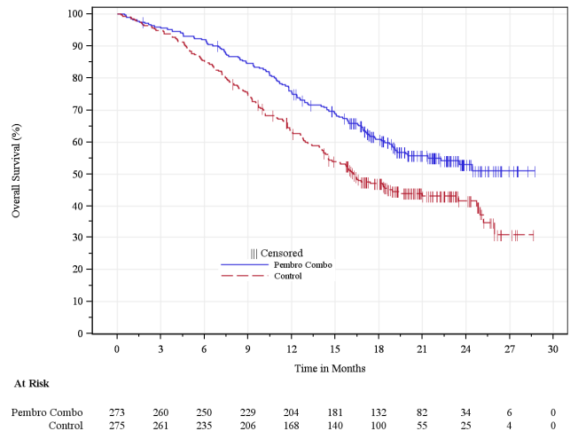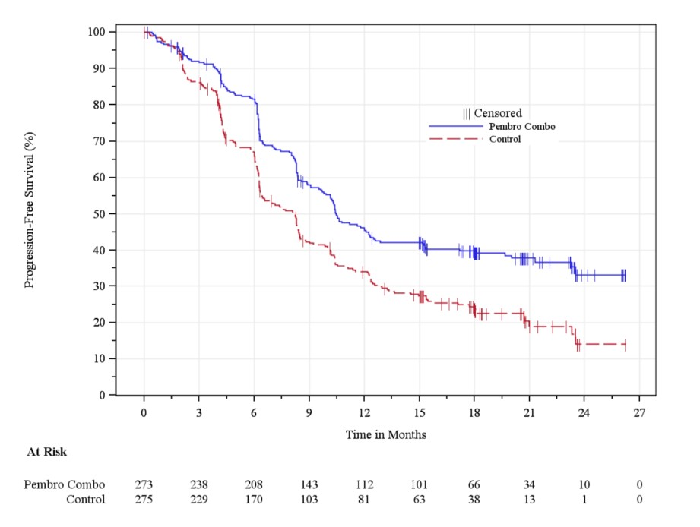
Source: Figure 2.6-1, p61; Figure 11-1, p72 of the KN826 CSR.
CPS = combined positive score; OS = overall survival; PFS = progression-free survival
Figure 2: ITT population - Kaplan Meier estimates of PFS and OS from KN826
A: OS – ITT population | B: PFS - ITT population
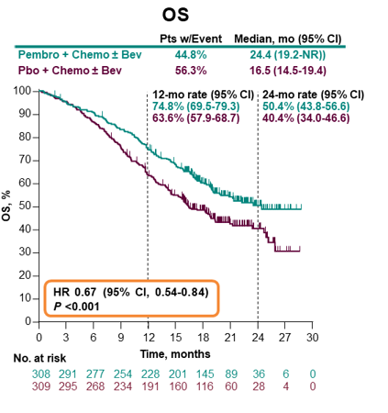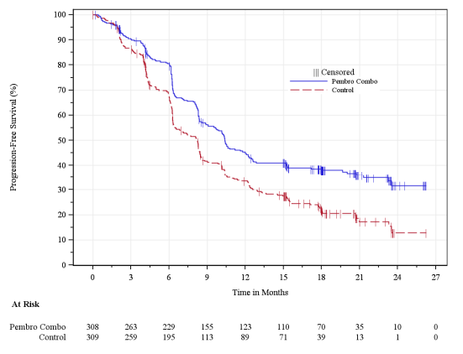
Source: Figure 2.5-1, p42; Figure 2.5-3, p45 of the submission.
ITT = intention-to-treat; OS = overall survival; PFS = progression-free survival
  - The results for the QoL data collected in the trial and transformed for use in the economic model are shown below.
Table 5. Analysis of change from baseline in EQ-5D-5L VAS score to Week 30 for the ITT and CPS ≥1 populations
 | PEM + SOC |  | SOC
 | Nª | Mean (SD) | Nª | Mean (SD)
ITT population
Baseline | 281 | 70.46 (21.30) | 285 | 71.88 (20.17)
Week 30 | 200 | 74.59 (19.39) | 168 | 74.68 (18.92)
Change from baseline to Week 30 | Nª | LS Mean (95% CI)^{b} | Nª | LS Mean (95% CI)^{b}
 | 290 | 0.28 (-2.20, 2.75) | 297 | -1.52 (-4.09, 1.06)
Pairwise comparison | Difference in LS means (95% CI)
PEM + SOC vs. SOC | 1.79 (-1.55, 5.13)
CPS ≥1 population
 | N | Mean (SD) | N | Mean (SD)
Baseline | 248 | 70.84 (20.82) | 254 | 71.81 (20.10)
Week 30 | 181 | 74.56 (19.27) | 145 | 75.25 (17.51)
Change from baseline to Week 30 | Nª | LS Mean (95% CI)^{b} | Nª | LS Mean (95% CI)^{b}
 | 256 | 0.38 (-2.20, 2.95) | 364 | -1.31 (-4.30, 1.40)
Pairwise comparison | Difference in LS means (95% CI)
PEM + SOC vs. SOC | 1.69 (-1.80, 5.18)
Source: Table 2.5-11, p51; Table 2.6-10, p69-70 of the submission.
LS = least squares; PEM+SOC = pembrolizumab plus standard of care; SD = standard deviation; SOC = standard of care
ª For baseline and Week 30, N is the number of subjects in each treatment group with non-missing assessments at the specific time point; for change from baseline, N is the number of subjects in the analysis population in each treatment group.
^{b} Based on a cLDA model with the PRO scores as the response variable with covariates for treatment by study visit interaction, stratification factors metastatic at diagnosis (FIGO [2009] Stage IVB) (yes or no), bevacizumab use (yes or no) and PD-L1 status (CPS<1, CPS 1 to <10, CPS>=10)

Comparative harms
  - The adverse events of Grade 3-5 severity reported in KN826 for the CPS ≥1 and ITT populations are shown in Table 6. The type and frequencies of Grade 3 to 5 adverse events were generally similar across the treatment arms, and the submission stated that there were no trends noted in the PEM+SOC group that suggested any new safety concerns. The most frequently reported Grade 3 to 5 AEs across the arms were anaemia, decreased neutrophil count, neutropenia, and hypertension.
Table 6: Summary of Grade 3-5 AEs in the CPS ≥1 population and the ITT populationª (incidence ≥5% in any treatment group)
Adverse events | CPS ≥1 population |  |  | ITT population
 | PEM + SOC (N=272) | SOC (N=275) | PEM + SOC (N=307) |  | SOC (N=309)
With one or more grade 3-5 adverse events | NR | NR | 251 (81.8) |  | 232 (75.1)
With grade 3-5 drug-related adverse events | NR | NR | 210 (68.4) |  | 198 (64.1)
Anaemia | 62 (22.8%) | 55 (20.0%) | 93 (24.1) |  | 83 (26.9)
Neutrophil count decreased | 37 (13.6%) | 22 (8.0%) | 40 (17.0) |  | 26 (8.4)
Neutropenia | 35 (12.9%) | 27 (9.8%) | 38 (14.6) |  | 30 (9.7)
Hypertension | 17 (6.3%) | 22 (8.0%) | 29 (12.2) |  | 33 (10.7)
Urinary tract infection | NR | NR | 27 (9.5) |  | 25 (8.1)
Thrombocytopenia | 17 (6.3%) | 10 (3.6%) | 23 (9.2) |  | 14 (4.5)
Febrile neutropenia | 19 (7.0%) | 11 (4.0%) | 22 (7.8) |  | 14 (4.5)
Platelet count decreased | 21 (7.7%) | 12 (4.4%) | 21 (7.8) |  | 14 (4.5)
White blood cell count decreased | 19 (7.0%) | 10 (3.6%) | 21 (7.3) |  | 13 (4.2)
Source: Table 2.5-17, p56; Table 3.6-7, p129 of the submission.
CPS = combined positive score; ITT = intention-to-treat; NR = not reported; PEM+SOC = pembrolizumab plus standard of care; SOC = standard of care
ª Every patient is counted a single time for each applicable row and column. A specific adverse event appears only if its incidence in one or more of the columns meets the incidence criterion in the report title, after rounding. Non-serious adverse events up to 30 days of last dose and serious adverse events up to 90 days of last dose are included.

Benefits/harms
  - On the basis of direct evidence presented by the submission and as shown in Table 4 and Table 5 above, for every 100 patients treated with pembrolizumab + SOC in comparison with SOC alone:
- Approximately 8 additional patients will be alive after 12 months.
- Patients will experience similar adverse events, although 4 additional patients may have Grade 3-5 drug related adverse events.

Clinical claim
  - The submission described pembrolizumab + SOC as superior in terms of effectiveness compared to SOC. The ESC agreed with the Commentary that this claim was adequately supported.
  - The submission described pembrolizumab + SOC as inferior in terms of safety compared to SOC. The ESC agreed with the Commentary that this claim was adequately supported.
  - The PBAC considered that the claim of superior comparative effectiveness was reasonable.
  - The PBAC considered that the claim of inferior comparative safety was reasonable, while noting that QoL appeared to be maintained for patients treated with pembrolizumab.

Economic analysis
  - The submission presented an economic evaluation based on the KN826 trial, comparing pembrolizumab + SOC to SOC using a cost-utility analysis based on a partitioned survival model with three health states. The table below outlines the model structure and key inputs.
Table 7: Summary of model structure, key inputs and rationale
Component | Description
Type of analysis | Cost-utility analysis
Outcomes | Quality adjusted life year (QALYs) and life years (LYs)
Time horizon | 15 years
Methods used to generate results | Partitioned survival model
Health states | Three health states:  - Progression-free  - Progressed disease  - Death
Cycle length | 1 week, no half cycle correction
Allocation to health states | Based on parametric survival models fitted to PFS and OS data reported in the KN826 trial. A piecewise model was used for the base case.
Utility values | EQ-5D-5L data from KN826 mapped to an EQ-5D-3L value set (van Hout 2012) with Australian tariffs based on Viney (2011) applied.
Costs | Drug and administration cost, disease monitoring, adverse event cost, subsequent treatment cost and terminal care cost.
Source: Table 3.1-1, p81 of the submission.
PFS = progression-free survival; OS = overall survival
  - Extrapolation in the submission’s base case used a piecewise model (see Table 10). Results based on a one-piece model were presented as sensitivity analyses (see Table 11) while results for the ITT population, which used a piecewise model with alternate extrapolation parameters, were presented as an additional base case (see Table 10). The different extrapolation parameters applied in the model versions are summarised in the table below.
Table 8: Extrapolation parameters applied in the economic model
 | PFS |  | OS
 | PEM+SOC | SOC | PEM+SOC | SOC
Base case: CPS ≥1 population (piecewise model) | Log-logistic fitted from 37 weeks | Log-logistic fitted from 37 weeks | Generalised gamma fitted from 40 weeks | Generalised gamma fitted from 40 weeks
ITT population  (piecewise model) | Log-logistic fitted from 37 weeks | Log-logistic fitted from 37 weeks | Log-logistic fitted from 40 weeks | Generalised gamma fitted from 40 weeks
One-piece model  (CPS ≥1 population) | Log-logistic | Generalised gamma | Log-logistic | Generalised gamma
ITT population  (one-piece, PSCR & pre-PBAC response) | Log-logistic | Generalised gamma | Log-logistic | Generalised gamma
Source: Section 3.4.3.1, p98-120 of the submission.
CPS = combined positive score; OS = overall survival; PEM+SOC = pembrolizumab plus standard of care; PFS = progression-free survival; SOC = standard of care
  - Figure 3 and Figure 4 illustrate extrapolations of PFS and OS in the base case CPS ≥1 piecewise model, while Figure 5 illustrates extrapolations in the one-piece model. Figure 6 and Figure 7 provide extrapolations for the piecewise model used for the ITT population. As outlined in Table 8, the submission applied the same extrapolation parameters for the CPS ≥1 and ITT populations for PFS in the piecewise model, with different parameters used for OS in the piecewise model and the one-piece model. Figure 8 provides extrapolations of the ITT population using the one-piece model.
Figure 3: Extrapolation of PFS at 37-week cut-off for the PEM + SOC and SOC groups in the CPS ≥1 population of KN826 – piecewise model
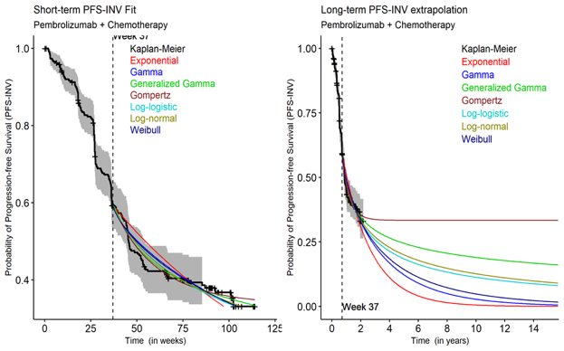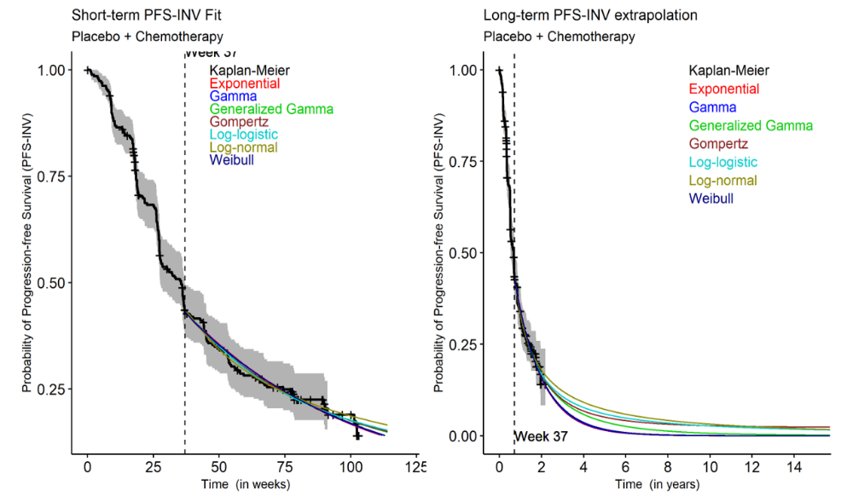
Source: Figure 3.4-6, p105; Figure 3.4-7, p105 of the submission.
CPS = combined positive score; INV = investigator; PEM+SOC = pembrolizumab plus standard of care; PFS = progression-free survival; SOC = standard of care

Figure 4: Extrapolation of OS after the 40-week cut-off for the PEM + SOC and SOC groups in the CPS ≥1 population of KN826 – piecewise model
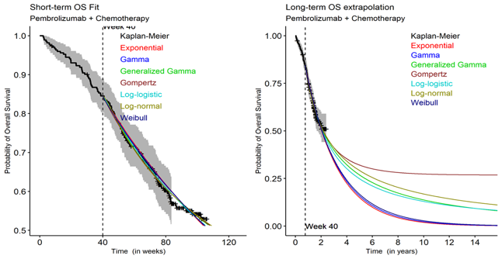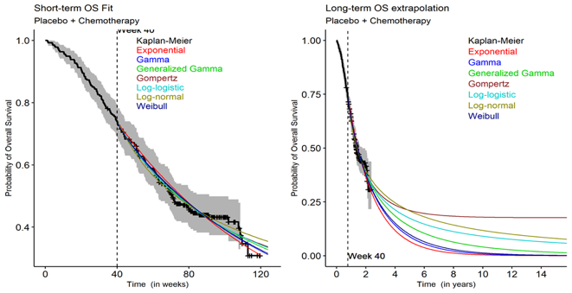
Source: Figure 3.4-19, p116; Figure 3.4-20, p116 of the submission.
CPS = combined positive score; OS = overall survival; PEM+SOC = pembrolizumab plus standard of care; SOC = standard of care

Figure 5: Extrapolation of PFS and OS in the CPS ≥1 population of KN826 – one-piece model (long term)
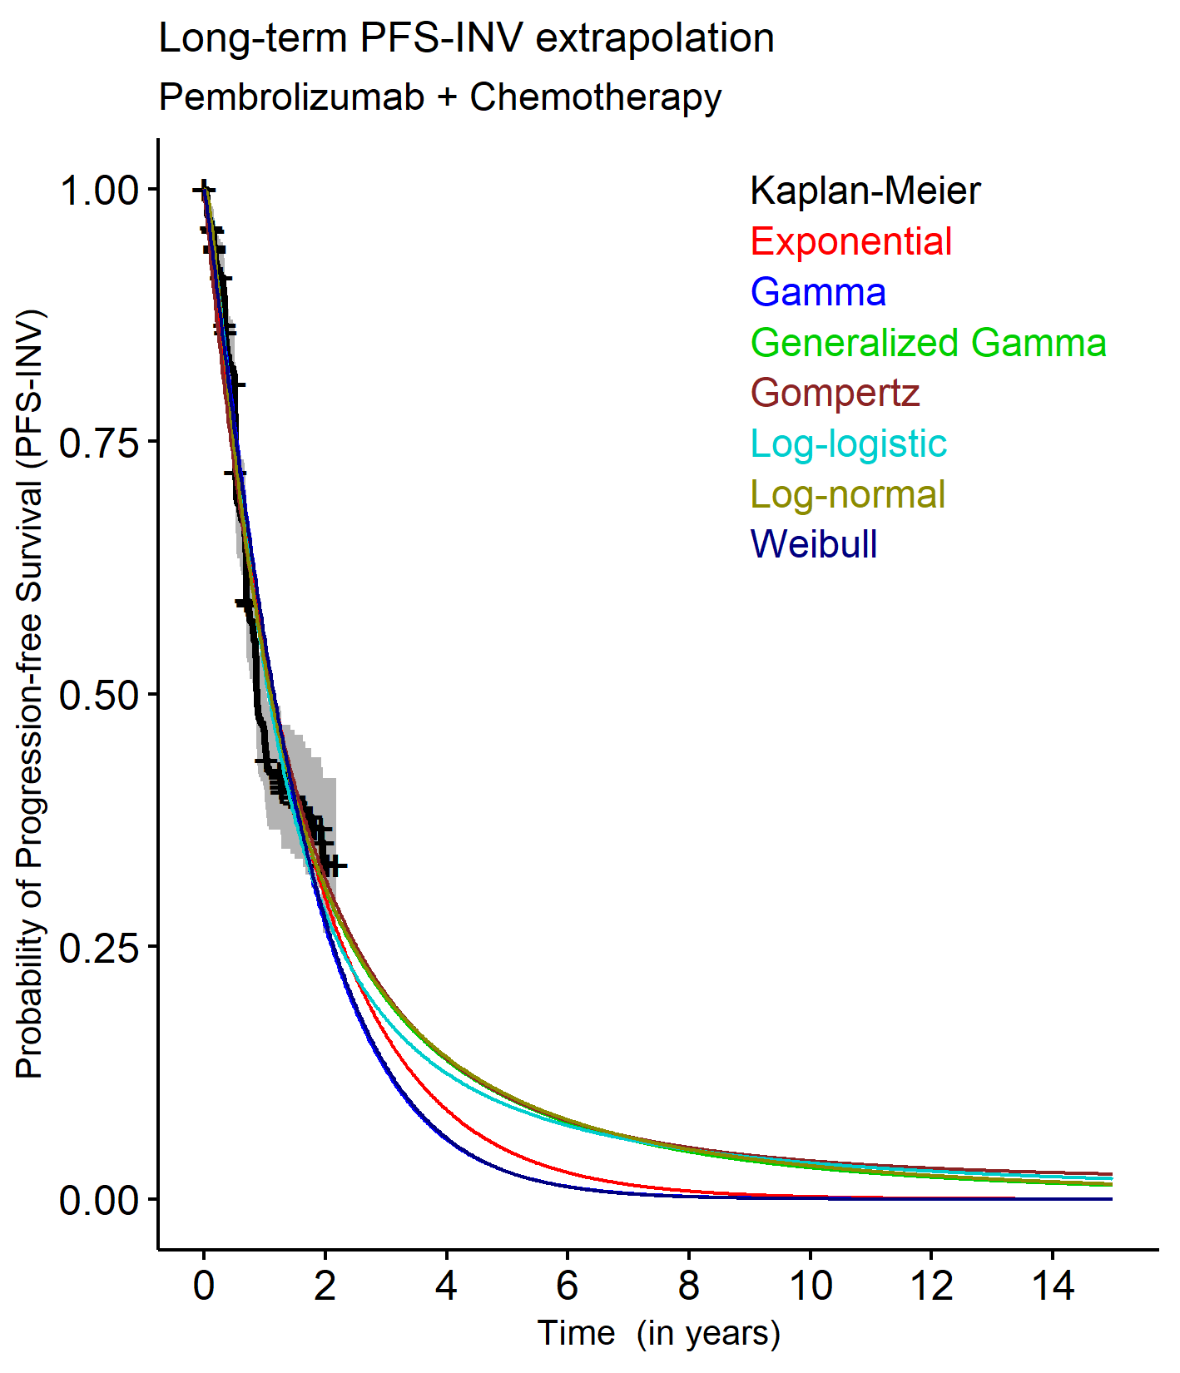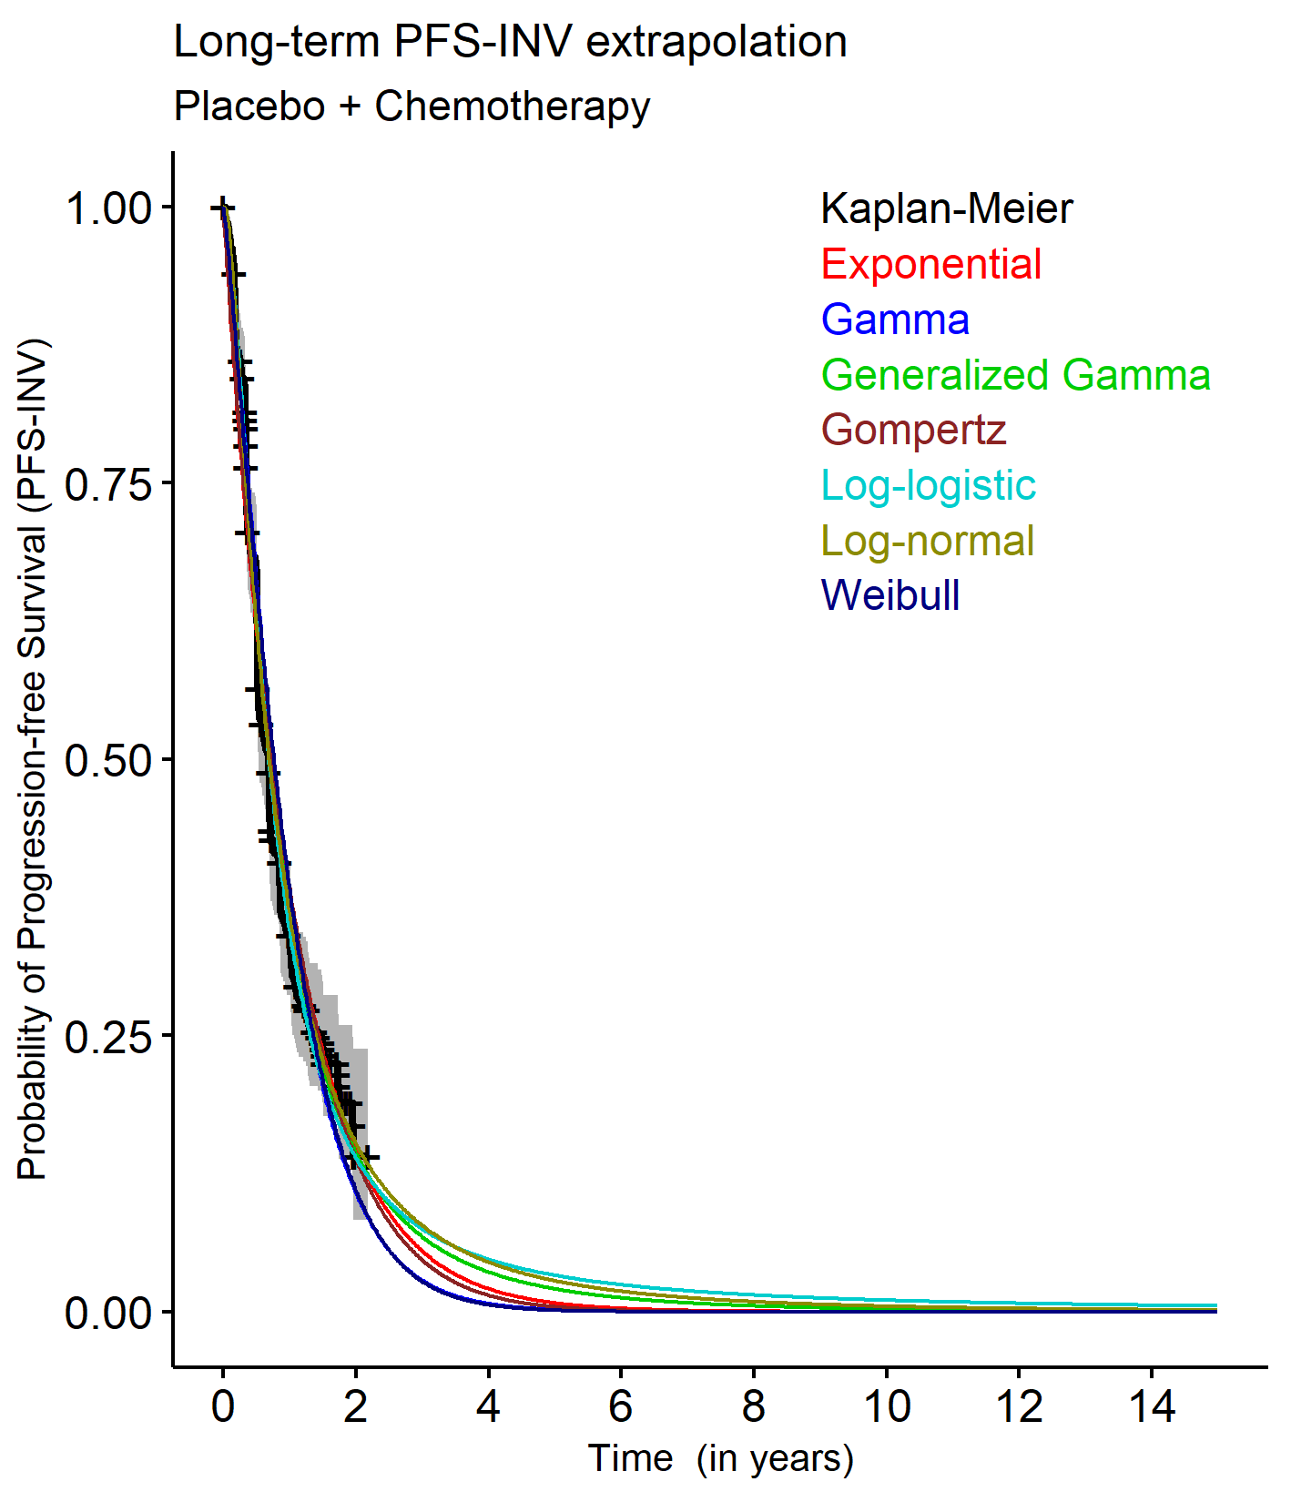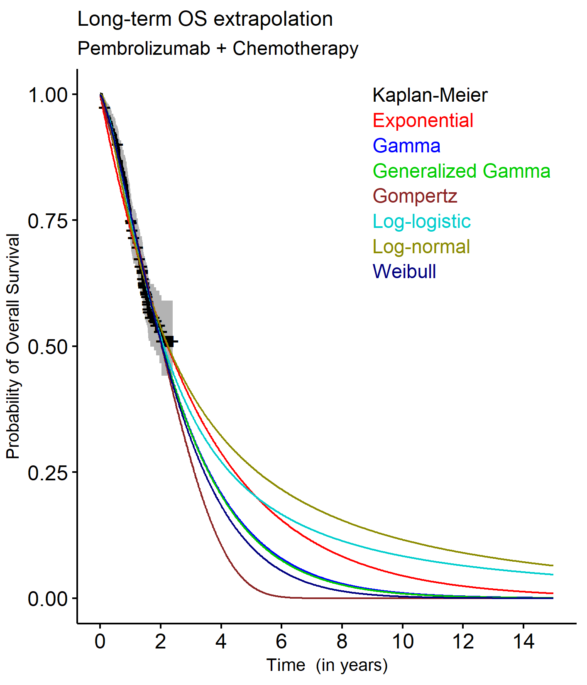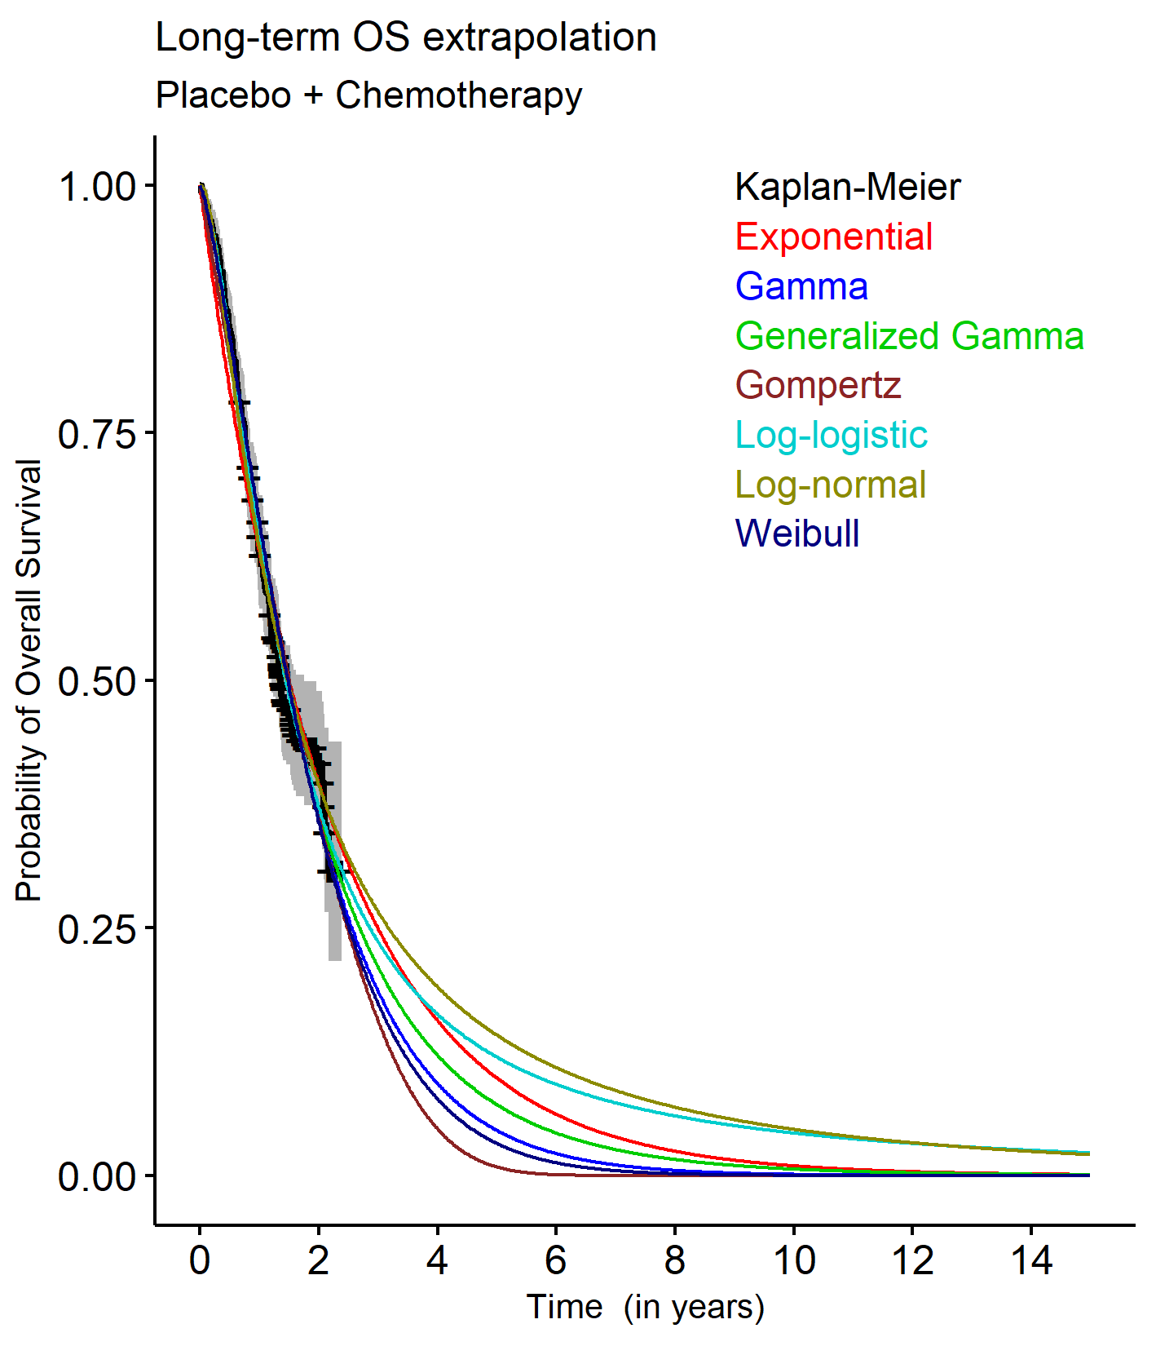
Source: p 927, 989, 1189, 1251 Attachment 8 of the submission.
CPS = combined positive score; INV = investigator; OS = overall survival; PFS = progression-free survival

Figure 6: Extrapolation of PFS at 37-week cut-off for the PEM + SOC and SOC groups in the ITT population of KN826 – piecewise model
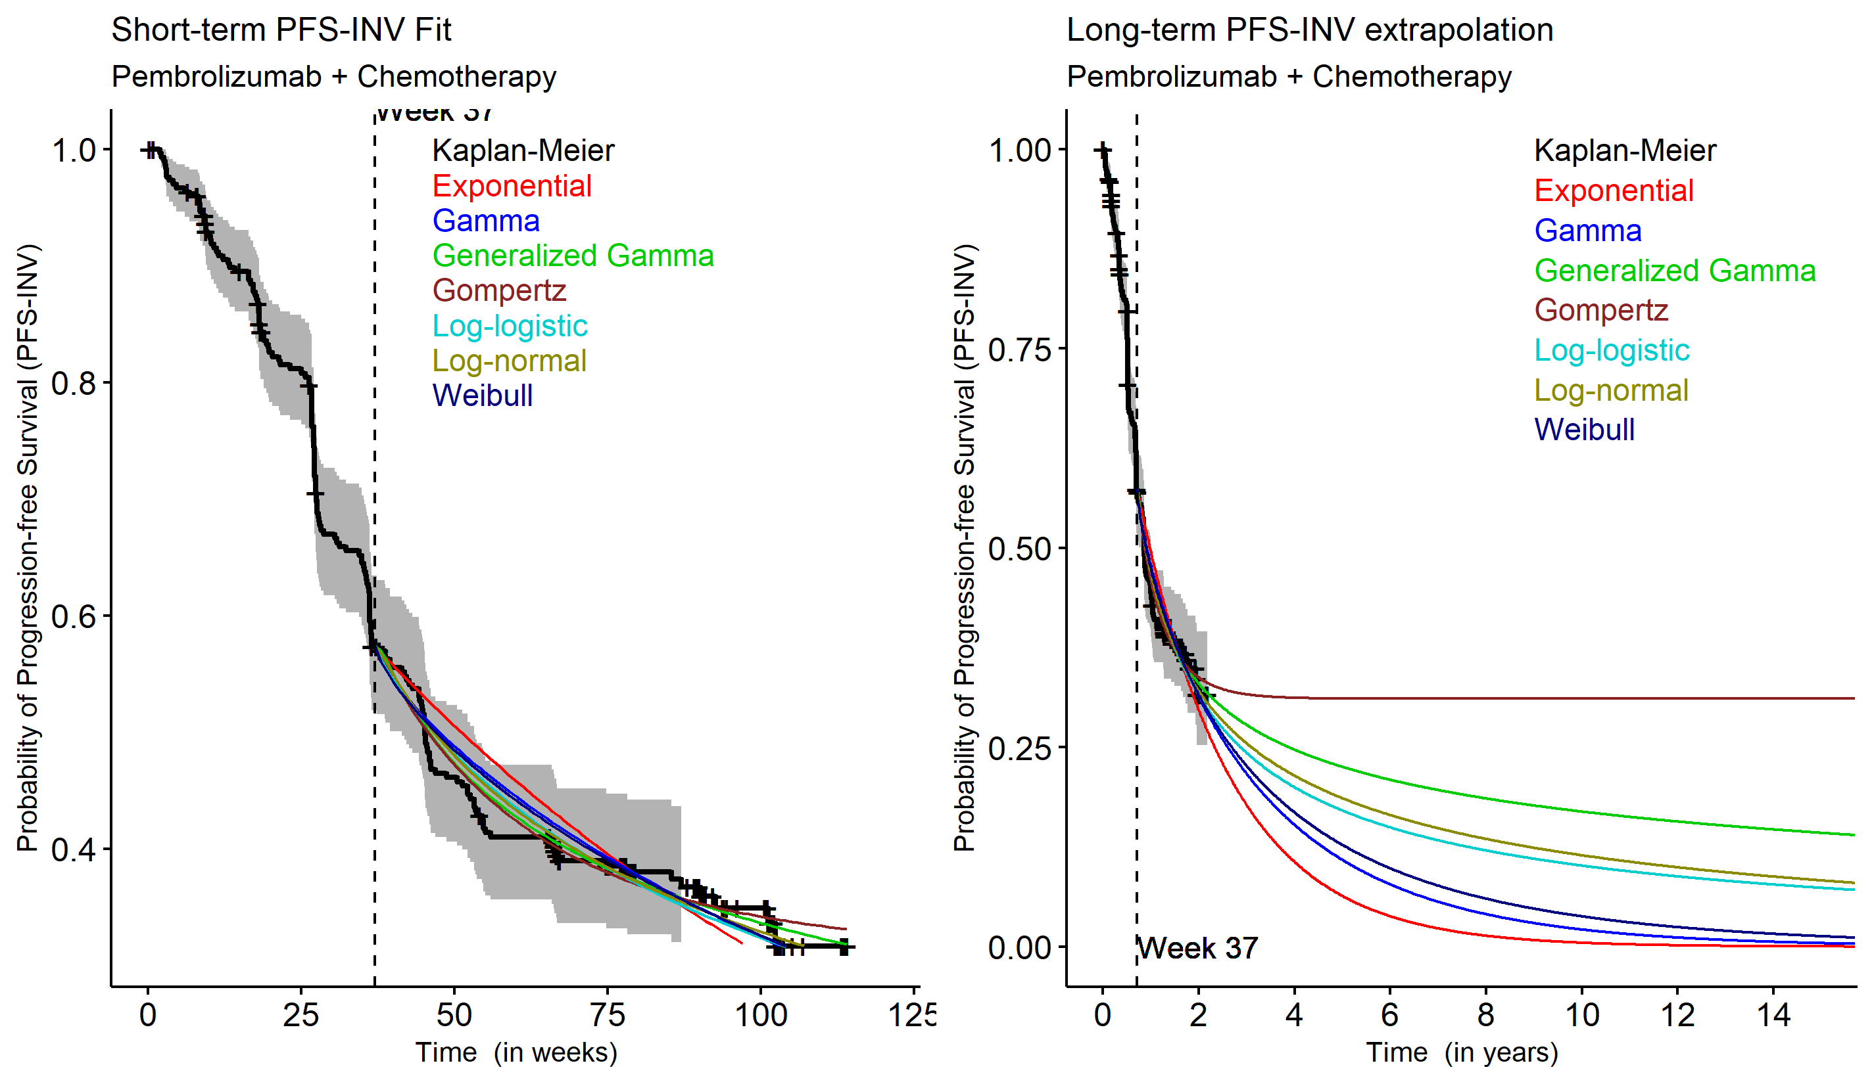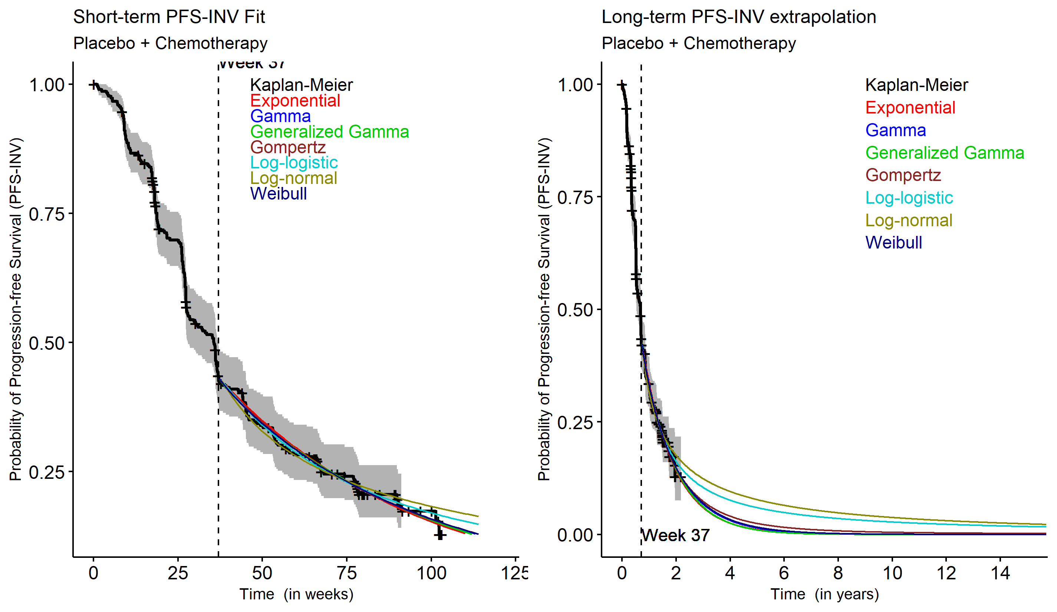
Source: Section 3.2.5, p693; Section 3.3.5, p755 of Attachment 7 of the submission.
INV = investigator; ITT = intention-to-treat; PEM+SOC = pembrolizumab plus standard of care; PFS = progression-free survival

Figure 7: Extrapolation of OS after the 40-week cut-off for the PEM + SOC group in the ITT population of KN826 – piecewise model
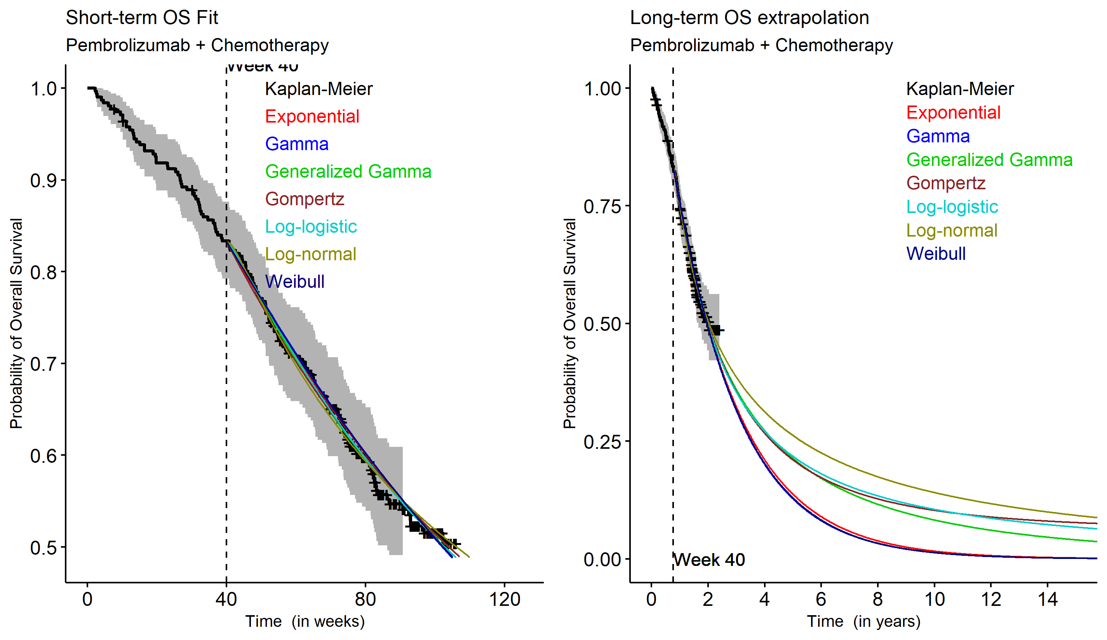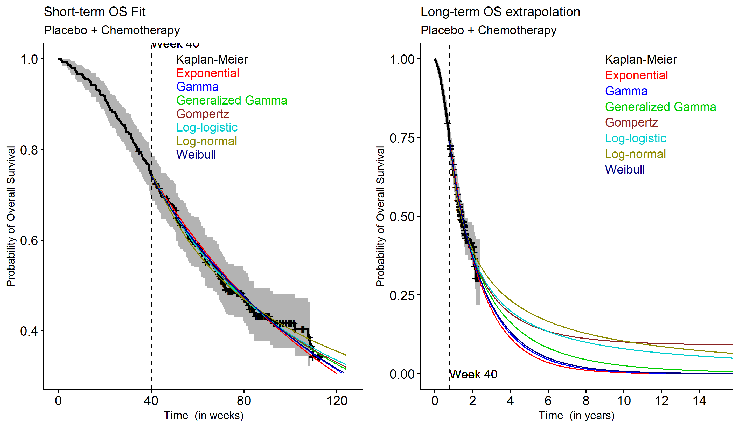
Source: Section 1.2.5, p431; Section 1.3.5, p493 of Attachment 7 of the submission.
ITT = intention-to-treat; OS = overall survival; PEM+SOC = pembrolizumab plus standard of care

Figure 8: Extrapolation of PFS and OS in the ITT population of KN826 – one-piece model (long term)
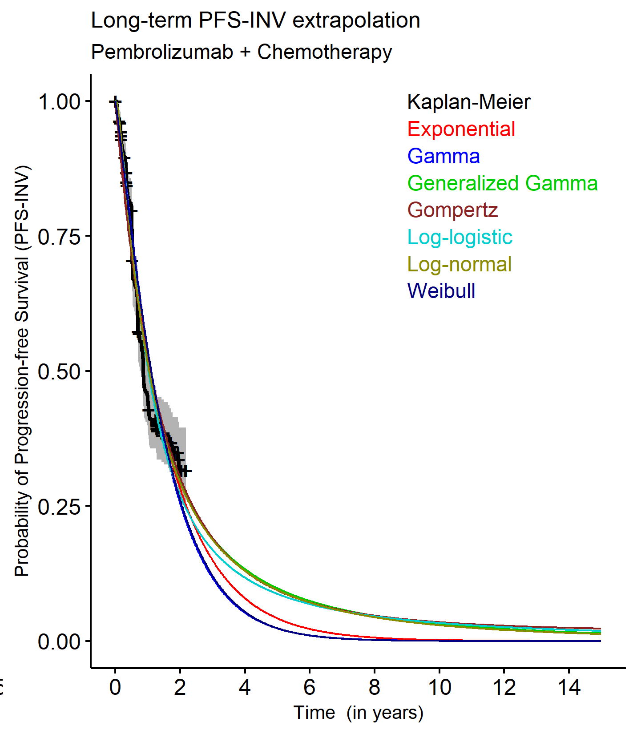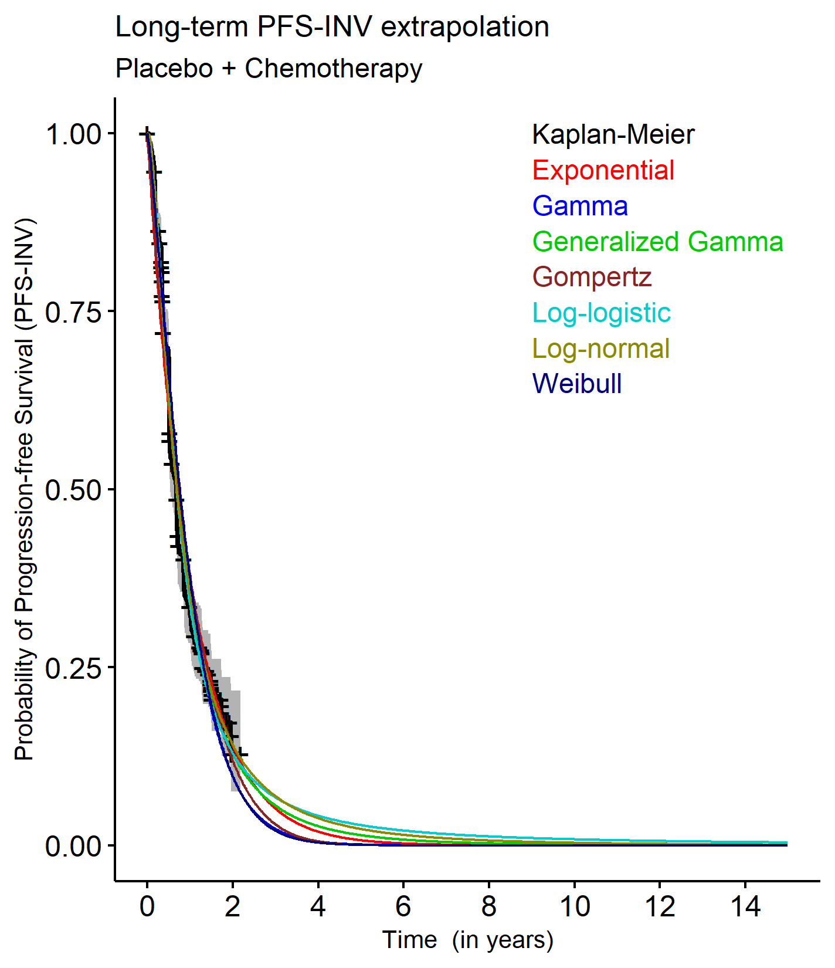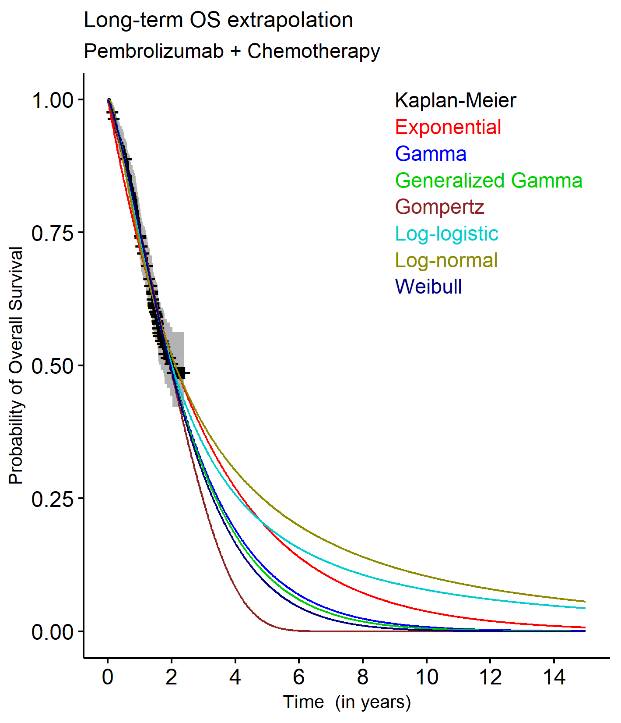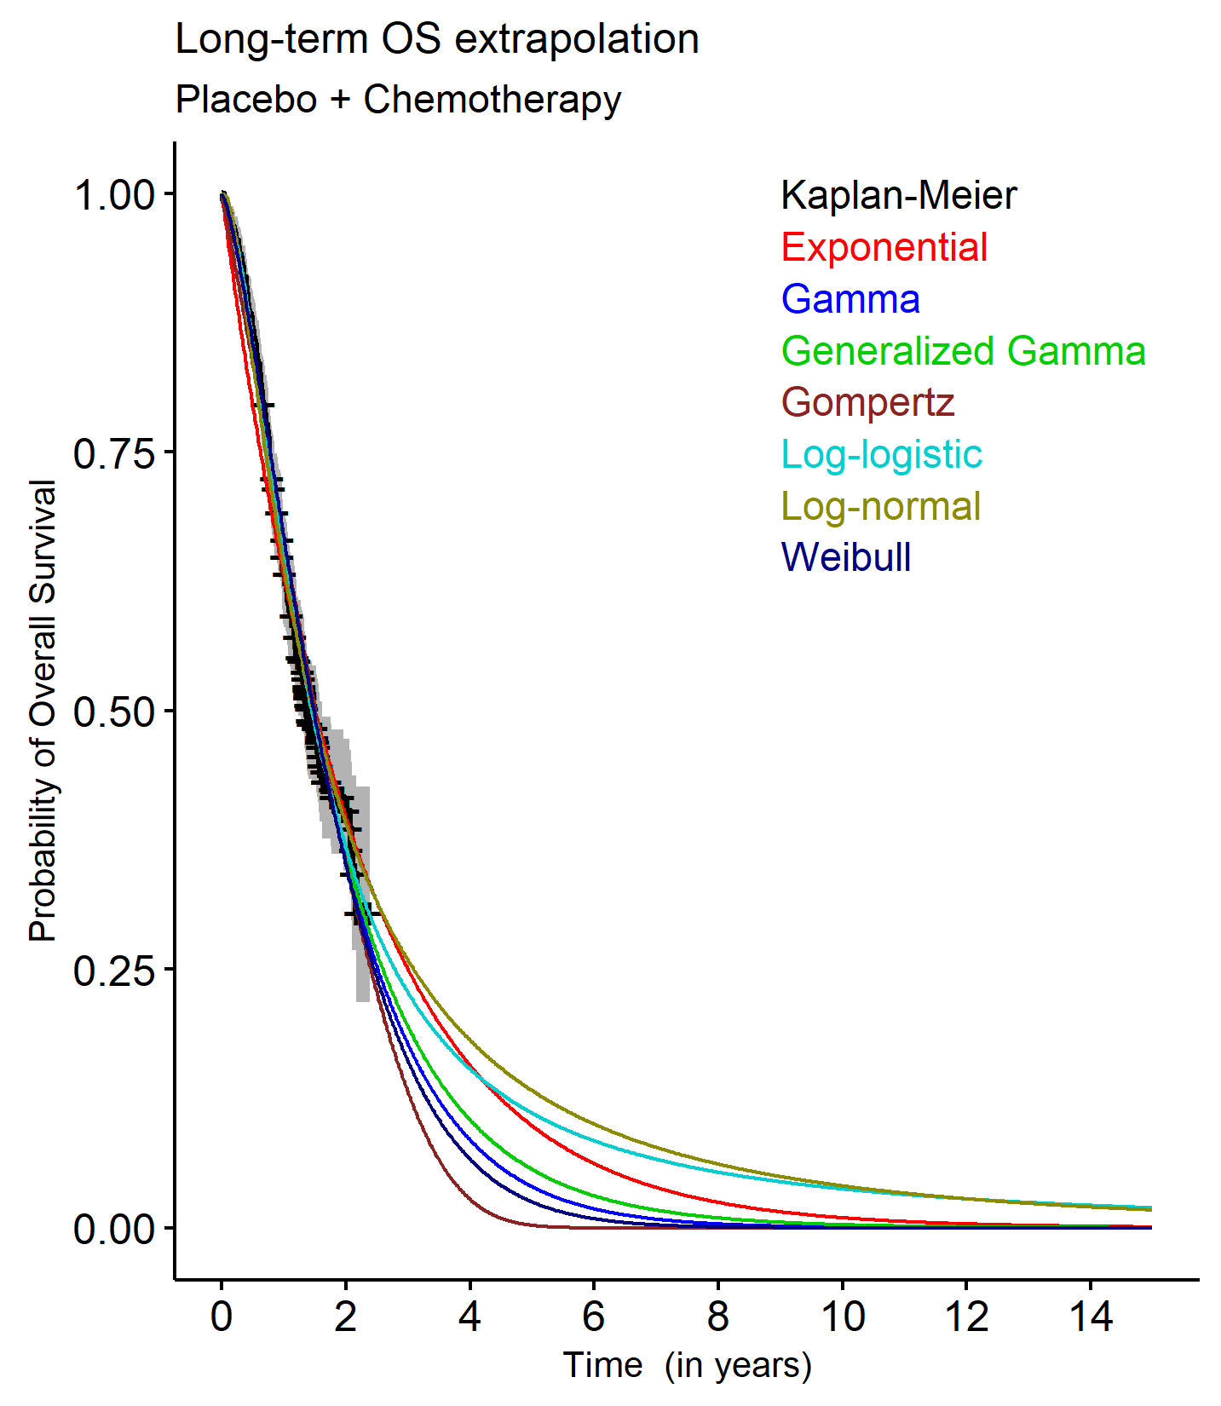
Source: p403, 465, 664, 727 Attachment 7 of the submission.
INV=investigator; ITT = intention-to-treat; OS = overall survival; PFS = progression-free survival

  - In its consideration of pembrolizumab for oesophageal adenocarcinoma (OAC) in November 2021, the PBAC agreed with the ESC that the use of a two-piece extrapolation method resulted in additional weight being attached to the tail of the Kaplan Meier data (where patient numbers are low and the data is less reliable) and that a one-piece extrapolation method fitted to the full Kaplan Meier curve was more reliable (paragraph 7.11, Nov 2021 pembrolizumab OAC Public Summary Document [PSD]). Assessment of the Kaplan Meier data (see Figure 1 and Figure 2) shows that the number of patients at risk dropped considerably beyond 18 months, reducing the reliability of the data beyond this point.
  - The submission argued that for PFS, one-piece models did not provide a good visual fit to the data, particularly for PEM + SOC. The ESC considered that poor visual fit for PEM + SOC for PFS was not sufficient basis for choosing the piecewise extrapolation method, noting its limitations as discussed in paragraph 6.22. However, the ESC noted that the submission also stated that suitability was considered based on clinical plausibility of long-term extrapolations (with reference long-term outcomes from the GOG-240 trial), and assessment of the underlying hazard functions and statistical fit to the observed data (AIC and BIC) for both the one-piece and piecewise extrapolations. The ESC noted that the consideration of the extrapolation cut points was applied using the Chow test to determine break points, with a number of different cut points considered for PFS and OS. The ESC considered that the use of piecewise models was not sufficiently justified and may not provide more reliable estimates of survival outcomes than one-piece models due to reliance on the tail of the KM data. The ESC noted that the submission presented detailed assessment of the extrapolation functions for the CPS≥1 population for both the piecewise and one-piece model, but the same was not provided for the ITT population, which is likely to be more relevant.
  - The model demonstrated sensitivity to use of the one-piece model (see Table 11). The PSCR stated that the sponsor remained of the view that a piecewise approach to the economic modelling is the most appropriate as it represents the most accurate estimate of long-term benefits seen with immunotherapy. However, the PSCR also acknowledged that alternative extrapolation methods such as a one-piece approach using KM until median follow up (75 weeks) with log-logistic functions applied to PFS and OS for the PEM+SOC arm and generalised gamma applied to PFS and OS for the SOC arm, may present a reasonable scenario for consideration. The ESC noted that this approach was more favourable to pembrolizumab + SOC for the ITT population.
  - The ESC noted that the one-piece model was also sensitive to the extrapolation functions chosen and use of the generalised gamma functions for the SOC arm was not well-justified for either the ITT population or the CPS ≥1 population. The ESC noted that log-logistic functions had the best fit for PFS and OS for the SOC arm based on AIC, and use of generalised gamma functions for SOC favoured PEM+SOC. The pre-PBAC response argued that application of a scenario using the log-logistic function for extrapolations in both arms (see Table 11) resulted in clinically implausible results and the gen-gamma function demonstrated a better fit for both PFS and OS for SOC at 2 years when compared to the GOG240 results.
  - Another key component of the model was the 15-year time horizon selected by the submission, on the basis that a shorter time horizon would fail to capture the outcomes for patients with long-term response to immunotherapy treatment, and long-term survival rates support the need to treat immunotherapies differently. Given that published data indicates median survival with metastatic cervical cancer is only 8 to 13 months, and the 5-year survival rate is 16.5%, it may not be reasonable to assume longer survival will be observed for all patients. While not an immunotherapy, a 7-year time horizon was used for bevacizumab (Table 6, bevacizumab PSD November 2015). The model is sensitive to the time horizon, with the ICER for the CPS ≥1 population increasing to $75,000 to < $95,000/QALY when the model duration is reduced to 10 years (see Table 11). The PSCR argued that 15 years was a reasonable time horizon given the average age of women with cervical cancer in Australia is 47 years and based on the improvement in survival with pembrolizumab. The ESC noted that in KN826 complete response was achieved in 23% of patients treated with PEM+SOC with a median duration of response of 18 months. The ESC considered that a time horizon of 10 years was more reasonable, even accounting for the proportion of patients who may have a prolonged response to immunotherapy.
  - While the total number of patients contributing data was available (520 patients for the CPS ≥1 population), the ESC noted that the submission provided no information regarding the time point for the EQ-5D-5L data used for the model’s utility values. The submission noted that mapping trial-based EQ-5D-5L data to progression status may miss utility data after further deterioration in the patient’s condition, and therefore overestimate the utility for the progressed health state. To assess this, a time-to-death approach was also presented as sensitivity analysis, where utilities were applied based on the distribution of patients across different categorisations of time-to-death (see Table 11).
  - A summary of the key drivers of the economic model is provided in the table below.
Table 9: Key drivers of the model
Description | Method/Value | Impact (CPS ≥ 1)  Base case: $|¹/QALY gained
Extrapolation | The submission selected a piecewise model for use in the base case. | High, favours pembrolizumab for the CPS ≥1 population.  Using a one-piece model increases the ICER to $||||²/QALY or higher, depending on the extrapolation function chosen.
Time horizon | 15 years. | High, favours pembrolizumab. Shortening the model to 10 years increases the ICER to $||||²/ QALY.
Source: Section 3.2.2.2, p92; Section 3.4.3.1, p98-120 of the submission.
The redacted values correspond to the following ranges:
¹ $55,000 to < $75,000
² $75,000 to < $95,000

  - Model results are provided for the submission’s base case (CPS ≥1 population) and the ITT population.
Table 10: Results of the economic evaluation
Component | PEM + SOC | SOC | Increment
CPS ≥1 population (base case)
Costs | $| | $25,153 | $|
LY | 3.388 | 2.200 | 1.188
Incremental cost/extra LY gained |  |  | $|¹
QALY | 2.444 | 1.566 | 0.878
Incremental cost/extra QALY gained (base case) |  |  | $|²
ITT population
Costs | $| | $25,075 | $|
LY | 3.045 | 2.087 | 0.958
Incremental cost/extra LY gained |  |  | $|¹
QALY | 2.205 | 1.490 | 0.715
Incremental cost/extra QALY gained (ITT population) |  |  | $|²
Source: Table 3.8-11, p141; Table 3.9-3, p145 of the submission.
CPS = combined positive score; ITT = intention-to-treat; LY = life year; PEM + SOC = pembrolizumab plus standard of care; QALY = quality adjusted life year; SOC = standard of care.
The redacted values correspond to the following ranges:
¹ $55,000 to < $75,000
² $75,000 to < $95,000
  - The incremental cost in the model is largely comprised of drug cost, with the cost of pembrolizumab accounting for 93% of the incremental cost.
  - The QALY gain in the CPS ≥1 base case model (0.878) is greater than that for the ITT population model (0.715), resulting in a lower ICER for the CPS ≥1 population. Given the hazard ratios for PFS and OS are similar between the CPS ≥1 and ITT populations (see Table 4), the model results are also impacted by the different extrapolation functions applied in the CPS ≥1 and ITT models.
  - The ESC noted that the QALY gain in the base case model (0.878) was higher than other published cost-effectiveness analyses of pembrolizumab in cervical cancer. For example, Nedzesky (2022) estimated an incremental gain of 0.63 QALYs for PEM+SOC for a lifetime model in patients with PD-L1 positive cervical cancer based on the KN826 trial. In addition, the ESC noted that the majority of incremental LY and QALYs accrued in the pre-progression health state (98%), meaning the model is highly sensitive to the utility values and when they are collected.
  - As well as differences between the CPS ≥1 population and the ITT population model results, there were also differences when a one-piece model was used instead of the piecewise model selected by the submission. Consideration of these and other sensitivity analyses are summarised in Table 11.
Table 11: Sensitivity analyses
Analyses |  | Incremental cost ($) | Incremental QALY | ICER ($) | % change ICER
CPS ≥1 population
Base case ª |  | | | 0.878 | | ¹ | -
Time horizon (base case: 15 years)
12.5 years |  | | | 0.807 | | ² | +8%
17.5 years |  | | | 0.932 | | ¹ | -6%
10 years |  | | | 0.711 | | ² | +22%
7 years |  | | | 0.555 | | ³ | +56%
Discount rate (base case: 5%)
1.5% costs and benefits |  | | | 1.085 | | ¹ | -17%
3.5% costs and benefits |  | | | 0.959 | | ¹ | -7%
OS and PFS extrapolation (base case: PEM+SOC and SOC: log-logistic from 37 weeks for PFS; generalised gamma from 40 weeks for OS)
PEM+SOC: PFS and OS log-logistic |  | | | 0.973 | | ¹ | -10%
SOC: PFS log-logistic; OS gen gamma
PEM+SOC: one-piece PFS+OS log-logistic |  | | | 0.795 | | ² | +9%
SOC: one-piece PFS+OS gen gamma
PEM+SOC: one-piece PFS+OS log-logistic |  | | | 0.872 | | ¹ | +0.5%
SOC: one-piece PFS log-normal; OS gen gamma
Utility values (base case: progression based: progression free 0.741; progressed 0.672)
Time-to-death based |  | | | 0.915 | | ¹ | -4%
OS and PFS extrapolation + duration (base case: PEM+SOC and SOC: log-logistic PFS from 37 weeks and generalised gamma OS from 40 weeks; 15 years)
10 years | PEM+SOC: log-logistic PFS and OS; one-piece ^{c} | | | 0.679 | | ⁴ | +28%
 | SOC: gen gamma PFS and OS; one-piece ^{c}
ITT population
Base case ª – ITT population (piecewise, PFS log-logistic for both arms; OS log-logistic for PEM+SOC; generalised gamma for SOC) |  | | | 0.715 | | ² | +19%
10 year time horizon |  | | | 0.575 | | ⁴ | +24% ^{b}
Extrapolation as per CPS ≥1 base case (both arms - PFS log-logistic and OS gen gamma) |  | | | 0.636 | | ⁴ | +12% ^{b}
PSCR ITT population: One-piece KM to median follow up ^{c}:  PEM+SOC: PFS+OS log-logistic;  SOC: PFS+OS gen gamma |  | | | 0.770 | | ² | -8% ^{b}
PSCR ITT population: One-piece KM to median follow up ^{c}:  PEM+SOC: PFS+OS log-logistic;  SOC: PFS+OS gen gamma using 10-year time horizon |  | | | 0.660 | | ⁴ | +7% ^{b}
One-piece KM to median follow up ^{c}: log-logistic PFS and OS both arms |  | | | 0.544 | | ³ | +30%
One-piece KM to median follow up ^{c}: log-logistic PFS and OS both arms, 10-year time horizon |  | | | 0.482 | | ³ | +47%
Source: Table 3.9-1, p142-143 of the submission; Excel workbook ‘Section 3 Workbook’.
AE = adverse event; CPS = combined positive score; IRC = independent review committee; IV = intravenous; NR = not reported; OS = overall survival; PEM+SOC = pembrolizumab plus standard of care; PFS = progression-free survival; SOC = standard of care
ª Using the ‘KM+PSM cut-off 37 weeks; specifiable KM’ for PFS and ‘KM+PSM cut-off 40 weeks; specifiable KM’ for OS modelling methods in the Section 3 Workbook (drop-down selection in cells J71, M71, J82 and M82).
^{b} Relative to the ITT population base case
^{c} Using the ‘KM+PSM from time zero; specifiable KM’ modelling method in the Section 3 Workbook (drop-down selection in cells J71, M71, J82 and M82).
The redacted values correspond to the following ranges:
¹ $55,000 to < $75,000
² $75,000 to < $95,000
³ $115,000 to < $135,000
⁴ $95,000 to < $115,000
  - The model demonstrated sensitivity to the time horizon. When the model duration was reduced to 10 years, the ICER increased to $75,000 to < $95,000/QALY for the CPS ≥1 population and $95,000 to < $115,000/QALY for the ITT population.
  - The model was also sensitive to the extrapolation parameters applied. When one-piece extrapolations were applied (log-logistic for PEM + SOC for PFS and OS; generalised gamma for PFS and OS for SOC), the ICER for the CPS ≥1 population increased to $75,000 to < $95,000/QALY. However, when one-piece extrapolations were applied the ICER for the ITT population decreased from $75,000 to < $95,000 to $75,000 to < $95,000. When this change was combined with the shortening of model time horizon, the ICER was $95,000 to < $115,000/QALY for the CPS ≥1 population and $95,000 to < $115,000 for the ITT population.
  - The pre-PBAC response revised the base case of the model such that outcomes for the ITT population were used, with one-piece extrapolation functions applied (PEM+SOC: log-logistic; SOC: generalised-gamma). The pre-PBAC response reduced the proposed effective AEMP price of pembrolizumab to $| | per 100 ml vial to give an ICER of $55,000 to < $75,000 per QALY for this revised base case. The PBAC noted that when the time horizon was reduced to 10 years the ICER increased to $75,000 to < $95,000/QALY.
  - Overall, the ESC considered that the choice of extrapolation approach and extrapolation functions added considerable uncertainty to the modelled outcomes due to the immaturity of the trial data.

Drug cost/patient/course
  - As the submission’s financial estimates did not include costs for SOC, only dosage and cost relevant to pembrolizumab is provided in Table 12.
Table 12: Drug cost per patient for pembrolizumab
 | Pembrolizumab
 | Trial dose and duration | Model | Financial estimates
Dose and administration | 200 mg Q3W | 200 mg Q3Wª | 200 mg Q3Wª
Mean treatment duration | 13.2 months (CPS ≥1 population)  11.8 months (ITT population) | 11.8 months^{b}  (ITT and CPS ≥1 population) | 1 year  (17.48 administrations^{c})
Drug cost applied (DPMA, 200 mg) | - | $| | $|
Public/private hospital use | - | 21% public; 79% private | 21% public; 79% private
Cost/patient/course | - | $|  $|| (undiscounted) | $|
Cost/patient/month | - | $| | $|
Source: Table 3.6-3, p126; Table 27, p57 of Att. 6 – MK3475_prot826_Base_Eff_CPS1_v1.0 and Table 2.5-13 of the submission; Excel workbook ‘Section 3 Workbook’; Excel workbook ‘Section 4 Workbook’.
CPS = combined positive score; Q3W = every 3 weeks;
ª While the requested listing included a 400 mg Q6W dose, the trial did not include this dose, and it was not used in the economic model or financial estimates. The alternative dosing schedule would have minimal impact on the overall cost of pembrolizumab.
^{b} Average treatment duration calculated using the ‘PF – PartSM – Pembro arm’ worksheet of the Excel workbook ‘Section 3 Workbook’. This represents mean time on treatment, which includes missed doses (whereas duration of treatment represents the time from the first dose to the last).
^{c} The submission stated that 17.48 treatment administrations per year were applied (19.17 average administrations × 91.2% dose intensity) to account for the costs associated with the patient at the appropriate time point since a Deed of Agreement will be required if the submission is positively recommended. The value actually applied in the Excel workbook to calculate estimated costs over the first 6 years of listing was 17.33 administrations per year (see ‘Estimated PBS usage & financial implications’ for further detail), although the ‘Overview’ worksheet of the Section 4 Workbook used 17.48 administrations to calculate cost for one year.
d Duration of therapy was reported for the ITT population
  - The treatment duration in KN826 was longer for the CPS ≥1 population (13.6 months) than that estimated by the model, though the submission stated that the modelled time on treatment was based on the proportion of patients on treatment in each cycle based on ToT from the trial. For the ITT population the time on treatment in the model and financial estimates was similar to the treatment duration from the trial.

Estimated PBS usage & financial implications
  - This submission was not considered by DUSC. The submission applied an epidemiological approach to the financial estimates, outlined in Table 13.
Table 13: Key inputs for financial estimates
Parameter | Value applied and source | Comment
Incidence and prevalence: eligible patients | Incidence: The submission identified two groups of incident patients, i) those metastatic at diagnosis and ii) those recurrent from earlier stages.  - Metastatic at diagnosis: The submission used the US-based SEER database to estimate the proportion of patients with early, advanced and metastatic disease. Local clinician input indicated that 16%ª of cervical cancer patients were Stage IVB (metastatic), which corresponded to the SEER database.  - Recurrent from earlier stages (Stage I to IVA): Recurrence rates were based on clinician input, UpToDate data and Lim 2012, which was a retrospective review of Western Australia cervical cancer patients. Using clinician input and UpToDate, a 10% recurrence rate was applied to patients with localised disease (Stage I). Using clinician input, UpToDate and Lim 2012, a recurrence rate of 30% was applied to patients with regional disease (Stage II – IVA). | The PBAC considered the estimate of 16% metastatic at diagnosis appeared too high and data from the US may not be applicable to the Australian setting where screening programs are reducing rates of de novo metastatic disease.
 | Prevalence: The prevalent population was based on the metastatic population that were diagnosed in the previous year and were still alive. AIHW data (2021) indicated these patients have a 1-year survival rate of 88.6%. | May be overestimated (~75-80% may be more reasonable). The ESC noted that the 1-year survival in the SOC arm of KN826 was lower (64%), though it was unclear why survival in the trial was poorer.
Uptake rate | Year 1 to Year 6: 90%; sponsor assumption. | The ESC noted that some prevalent patients would be ineligible due to prior treatment with chemotherapy and therefore uptake for prevalent patients may be lower (~70-80%).
Grandfathered patients | < 500, after accessing pembrolizumab through the sponsor’s cost-share program. These patients were removed from the prevalent pool to avoid double-counting. | Approach is reasonable.
Dose/duration | Pembrolizumab 200 mg Q3W. Treatment duration was based  on KN826 where patients were treated until disease progression or until a patient had received 35 trial administrations of pembrolizumab. Section 4 Excel workbook used 100% compliance, 0.33 doses/period arriving at 17.33 scripts per treatment. | Duration and script numbers may vary depending on the CPS ≥1 or ITT population.
SOC | The cost of SOC chemotherapy was not included as part of the financial estimates. | Approach is reasonable.
Other agents | The submission indicated that as pembrolizumab will be used adjunctively to platinum-based chemotherapy and paclitaxel, with or without bevacizumab, there was no estimated change in the use of other PBS medicines. | Approach is reasonable.
MBS item | MBS items: 13950 (drug administration), 72814 (PD-L1 test) | Appropriate.
Source: Section 4.2.1, p147-149; Section 4.2.2, p149-152; Section 4.2.3, p152-153; Section 4.2.4, p153-154; Table 4.6-2, p158 of the submission.
AIHW = Australian Institute of Health and Welfare; Q3W = every 3 weeks; SOC = standard of care
ª The submission (Table 4.2-2 and Section 4.2.2, p150) cited approximately 15% of the incident population as metastatic at diagnosis, but the Section 4 Excel workbook used 16%.

  - The estimated patient numbers, prescription numbers and costs for the PBS/RPBS listing of pembrolizumab for cervical cancer are provided below. The pre-PBAC response provided updated financial estimates reflecting a scenario where PBS access is not limited to patients with PD-L1 CPS ≥1 with the revised price for pembrolizumab.
Table 14: Estimated use and financial implications
 | Year 1 | Year 2 | Year 3 | Year 4 | Year 5 | Year 6
Estimated financial implications of pembrolizumab for first-line treatment of cervical cancer (CPS ≥1)
Estimated extent of use
Number of patients treated | | ^{a1} | | ¹ | | ¹ | | ¹ | | ¹ | | ¹
Number of scripts dispensed^{b} | | ² | | ³ | | ³ | | ³ | | ³ | | ³
Net cost to PBS/RPBS ($) | ||||⁴ | | ⁴ | | ⁴ | | ⁴ | | ⁴ | | ⁴
Net cost to MBS ($) | | ⁵ | | ⁵ | | ⁵ | | ⁵ | | ⁵ | | ⁵
Net cost to Government ($) | | ⁶ | | ⁴ | | ⁴ | | ⁴ | | ⁴ | | ⁴
Estimated financial implications of pembrolizumab for first-line treatment of cervical cancer (all-comers)
Estimated extent of use
Number of patients treated | | ^{a1} | | ¹ | | ¹ | | ¹ | | ¹ | | ¹
Number of scripts dispensed^{b} | | ² | | ³ | | ³ | | ³ | | ³ | | ³
Net cost to PBS/RPBS ($) | | ⁶ | | ⁴ | | ⁴ | | ⁴ | | ⁴ | | ⁴
Net cost to MBS ($) | | ⁵ | | ⁵ | | ⁵ | | ⁵ | | ⁵ | | ⁵
Net cost to Government ($) | | ⁶ | | ⁴ | | ⁴ | | ⁴ | | ⁴ | | ⁴
Source: Table 4.2-6, p152-153; Table 4.2-8, p154 of the submission; worksheet ‘5. Impact – net’ and worksheet ‘7. Net changes – MBS’ of the Excel workbook ‘Section 4 Workbook’.
ª Includes < 500 grandfathered patients.
^{b} Section 4 Excel workbook used 100% compliance, 0.33 doses/period to calculate 17.33 scripts per treatment which was used to estimate script numbers (see worksheet ‘3a. Scripts – proposed’ E117 to Q120).
The redacted values correspond to the following ranges:
¹ < 500
² 5,000 to < 10,000
³ 500 to < 5,000
⁴ $10 million to < $20 million
⁵ $0 to < $10 million
⁶ $20 million to < $30 million
  - The total cost to Government of listing pembrolizumab for the first-line treatment of cervical cancer was estimated to be $10 million to < $20 million in Year 6, and a total of $90 million to < $100 million in the first 6 years of listing (based on CPS≥1 and the pembrolizumab price proposed in the submission). This increased slightly in the pre-PBAC response to $10 million to < $20 million in year 6, and a total of $90 million to < $100 million in the first 6 years of listing, accounting for the expanded patient population (all-comers) and reduced pembrolizumab price.
  - The estimated patient numbers rely on the assumptions made by the submission to determine eligible patients, and additional assumptions used to determine treated patients (i.e. ECOG 0-1, CPS ≥1, uptake rate). Many of the assumptions applied were based on local clinician input, for which the submission provided no information on the form of the input or the number of clinicians providing input.
  - The PBAC noted that patient numbers for bevacizumab for the treatment of cervical cancer (from PBS data, prior to implementation of the unrestricted listing) were generally consistent with the estimated pembrolizumab patient numbers, accounting for a number of patients who would not be suitable for treatment with bevacizumab. However, the PBAC noted that the pembrolizumab estimates did not show a decline in usage as could be expected given the success of screening and vaccination program. In addition, the PBAC considered that, overall, the estimated extent of use may be overestimated due to:
- Overestimated rates of advanced or metastatic disease at screening, noting that the vast majority of patients are early stage at screening, and rates of advanced/metastatic disease are likely to be declining.
- Overestimated recurrence rates for early-stage disease.
- Prevalence in year 1 may be overestimated based on 1-year survival in the SOC arm of KN826.
- Uptake for prevalent patients may be overestimated.

Quality Use of Medicines
  - The submission indicated that the sponsor will develop materials to provide the latest information to physicians, nurses, pharmacists and patients about how to identify and manage potential treatment-related AEs, in particular immune-related AEs. The submission indicated these materials will be developed through input from planned clinician and oncology nurse advisory boards. The submission also indicated the sponsor has a number of education activities planned that will be supported by the sponsor’s medical team and representatives.

Financial Management – Risk Sharing Arrangements
  - The submission stated that the sponsor is willing to enter into a risk-sharing arrangement (RSA) with the Commonwealth for sharing the cost of subsidy for supply of pembrolizumab for the treatment of persistent, recurrent or metastatic cervical cancer. The submission stated that the sponsor agrees to reimburse the Commonwealth with | |% of the treatment costs of pembrolizumab, should use exceed the subsidisation cap in that year.
For more detail on PBAC’s view, see section 7 PBAC outcome.
- PBAC Outcome
  - The PBAC recommended the listing of pembrolizumab for the treatment of patients with persistent, recurrent, or metastatic (Stage IVB) cervical cancer. The PBAC noted that although rates of cervical cancer are declining, there remains a high clinical need for effective treatment in this patient population, particularly for communities disproportionately affected by cervical cancer. The PBAC was satisfied that pembrolizumab in combination with chemotherapy provides a meaningful improvement in overall survival, compared with standard chemotherapy alone. Although the submission proposed treatment in patients with PD-L1 CPS ≥1, the PBAC noted that the survival benefit was demonstrated in the full trial population and therefore recommended listing without restriction based on PD-L1 status. The PBAC considered that pembrolizumab would be cost-effective with a price reduction.
  - The PBAC noted that Australia is moving toward elimination of cervical cancer through screening and vaccination programs, however rates of participation in screening are currently 55.7% and participation is lower for Indigenous Australians. The PBAC noted that individuals with low socioeconomic backgrounds, Aboriginal and Torres Strait Islander communities and those in remote locations are disproportionately affected by cervical cancer with higher incidence rates, more advanced disease at diagnosis and poorer outcomes. The PBAC noted that although rates of cervical cancer are declining, there remains a high clinical need for effective treatment for patients with advanced cervical cancer where current treatments have limited efficacy and outcomes are poor.
  - Although the sponsor requested listing in patients with PD-L1 CPS ≥1, consistent with the TGA indication for pembrolizumab, the PBAC considered that it would be appropriate for the restriction to remain silent on PD-L1 CPS status as few patients are likely to have CPS <1 (11%) and noting the limitations of PD-L1 testing to reliably and accurately identify these patients. Importantly, the clinical evidence demonstrated benefit in the full ITT population, irrespective of PD-L1 CPS status.
  - The PBAC noted that the clinical algorithm for cervical cancer is changing, with a number of immunotherapies under investigation for the second line treatment of advanced cervical cancer. The PBAC considered that the clinical place nominated for pembrolizumab as first line treatment for persistent, recurrent, or metastatic cervical cancer was appropriate and consistent with international guidelines.
  - The submission nominated the current standard of care (SOC) used in Australia as the main comparator, i.e., a combination of chemotherapy agents including paclitaxel and a platinum-based compound, with or without bevacizumab. The PBAC considered that this was appropriate and represented SOC in Australia.
  - The PBAC noted that the clinical evidence was based on one head-to-head trial comparing pembrolizumab + SOC and SOC alone (KN826) with 17.2 months median follow-up. The PBAC noted that results were presented for both the ITT population and the PD-L1 CPS ≥1 population, with the CPS ≥1 subgroup contributing 89% of the total. The PBAC noted that KN826 showed statistically significant longer OS for pembrolizumab + SOC compared to SOC alone, with a 33% reduction in the risk of death (HR=0.67; 95% CI: 0.54, 0.84) in the ITT population, and an absolute difference in median OS of 7.9 months. The PBAC noted that survival outcomes in the PD-L1 CPS ≥1 population were similar to the ITT population, with KM curves also showing a similar profile, reflecting the predominance of patients with CPS ≥1. Given the small number of patients with CPS <1 the PBAC considered that there was insufficient information to conclude that there was no benefit in this small subgroup, also noting the limitations of testing to reliably and accurately identify patients with CPS <1. The PBAC considered that the claim of superior effectiveness for pembrolizumab + SOC compared to SOC was adequately supported for both the ITT population (all-comers) and the PD-L1 CPS ≥1 population.
  - The PBAC noted that the type and frequency of Grade 3 to 5 adverse events was generally similar across the treatment arms with no trends noted in the PEM+SOC group that suggested any new safety concerns. Although there was a slightly higher number of events for the PEM+SOC group, the PBAC considered that this was to be expected where adding a therapy to SOC. The PBAC considered the clinical claim of inferior safety compared with SOC alone was reasonable but also noted that in KN826 QoL was maintained for patients treated with PEM+SOC.
  - The PBAC noted the submission presented an economic evaluation based on the KN826 trial, comparing pembrolizumab + SOC to SOC using a cost-utility analysis. Economic analyses were presented based on outcomes for both the ITT and CPS ≥1 populations. The PBAC considered that clinical outcomes seen in practice are most likely to reflect the outcomes for the ITT population and considered these were most appropriate for use in the base case economic analysis.
  - The PBAC noted the ESC’s advice that the use of piecewise models was not sufficiently justified and may not provide more reliable estimates of survival outcomes than one-piece models due to reliance on the tail of the KM data (where patient numbers are low and the data is less reliable. The PBAC noted that use of a piecewise model to extrapolate the clinical trial data was a source of uncertainty in the submission’s model. Noting that there were few patients at risk beyond 18 months, especially for PFS, the PBAC considered that use of one-piece extrapolations were preferable in this context. The PBAC considered that use of the log-logistic function for the PEM+SOC arm and the generalised-gamma function for the SOC arm appeared clinically reasonable and was supported by longer term outcomes from the GOG-240 trial in similar patients.
  - The PBAC noted that use of a 15-year time horizon based on only 17.2 months median follow-up also increased uncertainty in the modelled outcomes. The PBAC noted that the pre-PBAC response argued that a shorter time horizon would fail to capture the outcomes for patients with long-term response to immunotherapy treatment, and the PSCR argued that 15 years was a reasonable time horizon given the average age of women with cervical cancer in Australia is 47 years. The PBAC noted that survival rates for advanced cervical cancer are poor, with median survival around 8 to 13 months and 5-year survival at around 16.5%. As such, the PBAC agreed with the ESC that a time horizon of 10 years was more reasonable, even accounting for the proportion of patients who may have a prolonged response to immunotherapy.
  - The pre-PBAC response revised the base case of the model such that outcomes for the ITT population were used, with one-piece extrapolation functions applied (PEM+SOC: log-logistic; SOC: generalised-gamma). The pre-PBAC response also reduced the proposed price of pembrolizumab to $| | per 100 ml vial to give an ICER of $55,000 to < $75,000 per QALY. The PBAC noted that when the time horizon was reduced to 10 years the ICER increased to $75,000 to < $95,000/QALY. The PBAC was satisfied that, for treatment of advanced cervical cancer, pembrolizumab would be acceptably cost-effective at a price that resulted in an ICER of $55,000 to < $75,000 /QALY using outcomes for the ITT population, one-piece extrapolation functions (PEM+SOC: log-logistic; SOC: generalised-gamma) and a time horizon of 10 years.
  - The PBAC considered that, overall, the estimated extent of use may be slightly overestimated due to overestimated rates for advanced or metastatic disease at screening, overestimated recurrence rates and overestimated prevalence in year 1 of the estimates. In addition, the PBAC noted that the pembrolizumab estimates did not show a decline in usage as could be expected given the success of screening and vaccination programs. However, the PBAC noted that patient numbers for bevacizumab (based on PBS data, prior to implementation of the unrestricted listing) were generally consistent with the estimated pembrolizumab patient numbers, accounting for a number of patients who would not be suitable for treatment with bevacizumab. As such, the PBAC considered that the estimated extent of use revised in the pre-PBAC response is likely to be reasonable.
  - The submission stated that the sponsor is willing to enter into an RSA with the Commonwealth, agreeing to reimburse the Commonwealth with | |% of the treatment costs of pembrolizumab, should use exceed the subsidisation cap in that year. The PBAC considered the proposed RSA acceptable in the context of limited risk of use outside the proposed restrictions and noting that with declining rates of cervical cancer, usage is unlikely to be higher than estimated. The PBAC considered that the revised financial estimates in the pre-PBAC response would be a reasonable basis for the caps, with application of a reduced price for pembrolizumab (as per paragraphs 7.11 and 7.12).
  - The PBAC found that the criteria prescribed by the National Health (Pharmaceuticals and Vaccines – Cost Recovery) Regulations 2022 for Pricing Pathway A were met. Specifically the PBAC found that in the circumstances of its recommendation for pembrolizumab:
  - The treatment is expected to provide a substantial and clinically relevant improvement in efficacy over SOC in terms of overall survival;
  - The treatment is expected to address a high and urgent unmet clinical need;
  - It would be in the public interest for the subsequent pricing application to be progressed under Pricing Pathway A on the basis of the preceding findings.
  - The PBAC noted that this submission is not eligible for an Independent Review as it is a positive recommendation.
Outcome:
Recommended

- Recommended listing
Add new indication as follows:
MEDICINAL PRODUCT  Form |  |  | PBS item code | Max. Amount | №.of Rpts
Pembrolizumab  Injection |  |  | NEW (Public)  NEW (Private) | 400 mg | 6
Available brands
Keytruda
(pembrolizumab 100 mg/4 mL injections, 4 mL vial)
Restriction Summary [new]
Concept ID (for internal Dept. use) |  | Category / Program: Section 100 – Efficient Funding of Chemotherapy Public/Private hospitals
 |  | Prescriber type: Medical Practitioners
Restriction type:
Authority Required (Streamlined)
 |  | Administrative Advice: No increase in the maximum quantity or number of units may be authorised.
 |  | Administrative Advice: No increase in the maximum number of repeats may be authorised.
 |  | Administrative Advice: Special Pricing Arrangements apply.
Administrative Advice:
Patient should be treated with the recommended dose of pembrolizumab according to the TGA-approved Product Information.
 |  | Severity: Advanced
 |  | Condition: Carcinoma of the cervix
 |  | Indication: Advanced carcinoma of the cervix
 |  | Treatment Phase: Initial treatment
 |  | Clinical criteria
 |  | The condition must be at least one of (i) persistent carcinoma,(ii) recurrent carcinoma (iii) metastatic carcinoma of the cervix
 |  | AND
 |  | Clinical criteria
 |  | The condition must be unsuitable for curative treatment with either of (i) surgical resection, (ii) radiation
 |  | AND
 |  | Clinical criteria:
 |  | Patient must have WHO performance status no higher than 1
 |  | AND
 |  | Clinical criteria:
 |  | Patient must not have received prior treatment for this PBS indication
 |  | Treatment criteria: Patient must be undergoing concomitant treatment with chemotherapy, containing a minimum of : (i) a platinum-based chemotherapy agent, plus (ii) paclitaxel
 |  | AND
 |  | Treatment criteria:
 |  | Patient must be undergoing treatment with this drug administered once every 3 weeks – prescribe up to 6 repeat prescriptions; OR
 |  | Patient must be undergoing treatment with this drug administered once every 6 weeks - prescribe up to 3 repeat prescriptions
 |  | Treatment Phase: Continuing Treatment
 |  | Clinical criteria:
 |  | Patient must have previously received PBS-subsidised treatment with this drug for this condition.
 |  | And
 |  | Clinical criteria:
 |  | The condition must not have progressed while receiving PBS-subsidised treatment with this drug for this condition.
 |  | AND
 |  | Treatment criteria:
 |  | The treatment must not exceed a total of (i) 24 months, (ii) 35 doses (based on a 3-weekly dose regimen), (iii) 17 doses (based on a 6-weekly dose regimen) whichever comes first from the first dose of this drug regardless if it was PBS /non-PBS subsidised
 |  | AND
 |  | Treatment criteria:
 |  | Patient must be undergoing treatment with this drug administered once every 3 weeks – prescribe up to 6 repeat prescriptions; OR
 |  | Patient must be undergoing treatment with this drug administered once every 6 weeks - prescribe up to 3 repeat prescriptions
 |  | Treatment Phase: Transitioning from non-PBS to PBS-subsidised supply – ‘Grandfather’ arrangements
 |  | Clinical criteria
 |  | Patient must be currently receiving treatment with this drug for this PBS indication, with treatment having commenced prior to [PBS listing date]
 |  | AND
 |  | Clinical criteria
Patient must have met all other PBS eligibility criteria that a non-‘Grandfather’ patient would ordinarily be required to meet, meaning that at the time non-PBS supply was commenced, the patient:
(i) had either one of (1) persistent carcinoma,(2) recurrent carcinoma (3) metastatic carcinoma of the cervix
(ii) a WHO performance status no higher than 1,
(ii) was unsuitable for curative treatment with at either of (i) surgical resection, (ii) radiation,
(iii) haven’t received prior treatment for this PBS indication
(iv) was treated concomitantly with platinum-based chemotherapy agent, plus (ii) paclitaxel.
 |  | AND
 |  | Clinical criteria: The condition must not have progressed while receiving non-PBS-subsidised treatment with this drug for this condition.
 |  | AND
Treatment criteria:
The treatment must not exceed a total of (i) 24 months, (ii) 35 doses (based on a 3-weekly dose regimen), (iii) 17 doses (based on a 6-weekly dose regimen) whichever comes first from the first dose of this drug regardless if it was PBS /non-PBS subsidised
 |  | Treatment criteria:
 |  | Patient must be undergoing treatment with this drug administered once every 3 weeks – prescribe up to 6 repeat prescriptions; OR
 |  | Patient must be undergoing treatment with this drug administered once every 6 weeks - prescribe up to 3 repeat prescriptions
Administrative advice:
Patients may qualify for PBS-subsidised treatment under this restriction once only. For continuing PBS-subsidised treatment, a 'Grandfathered' patient must qualify under the 'Continuing treatment' criteria.
Administrative advice:
This grandfather restriction will cease to operate from 12 months after the date specified in the clinical criteria.

This restriction may be subject to further review. Should there be any changes made to the restriction the Sponsor will be informed.

- Context for Decision
The PBAC helps decide whether and, if so, how medicines should be subsidised through the Pharmaceutical Benefits Scheme (PBS) in Australia. It considers applications regarding the listing of medicines on the PBS and provides advice about other matters relating to the operation of the PBS in this context. A PBAC decision in relation to PBS listings does not necessarily represent a final PBAC view about the merits of the medicine or the circumstances in which it should be made available through the PBS. The PBAC welcomes applications containing new information at any time.
- Sponsor’s Comment
The sponsor had no comment.

Cherny NI, Dafni U, Bogaerts J, et al: ESMO-Magnitude of Clinical Benefit Scale version 1.1. Annals of Oncology 28:2340-2366, 2017]
Tewari et al 2017 - the pivotal trial for bevacizumab in advanced cervical cancer including a patient population similar to KN826 (aCC patients who are not amenable to curative treatment with surgery and/or radiation therapy), similar treatments (such as bevacizumab, cisplatin and paclitaxel) used in KN826, and reporting longer-term outcomes (including PFS and OS at four years).
Ferlay J, Steliarova-Foucher E, Lortet-Tieulent J, Rosso S et al. Cancer incidence and mortality patterns in Europe: estimates for 40 countries in 2012. Eur J Cancer 2013; 49:1374–1403.
Li H, Wu X, Cheng X. Advances in diagnosis and treatment of metastatic cervical cancer. J Gynecol Oncol 2016; 27:e43.
J Nedzesky, D Veenstra (2022) EE44 Cost-Effectiveness of Pembrolizumab in First-Line Treatment of PD-L1 Positive Persistent, Recurrent, or Metastatic Cervical Cancer, Value in Health, Volume 25, Issue 7, Supplement, 2022, Page S343, ISSN 1098-3015, https://doi.org/10.1016/j.jval.2022.04.297.

