6.15 PEMBROLIZUMAB,

Solution concentrate for I.V. infusion 100 mg in 4 mL,
Keytruda®,
Merck Sharp & Dohme (Australia) Pty Ltd
- Purpose of Submission
  - The Category 3 submission requested the PBAC consider the following for pembrolizumab (Keytruda®) for locally advanced (Stage III) or metastatic (Stage IV) urothelial cancer:
- To increase the subsidisation caps from $|################ |M to $| ################## |M for Year 4 and $|############# |M to $|################## |M for Year 5 to reflect the increasing trend in actual scripts for Year 1,2 and 3 since listing on 1 March 2019.
- To lower the current subsidisation cap rebate level of |################## |% to |################## |% consistent with the pembrolizumab colorectal cancer Deed of Agreement which was negotiated in 2021.
- Should avelumab join the current Risk Sharing Arrangement subsidisation caps for pembrolizumab for urothelial carcinoma, that they be amended to cover all cost-effective patients for maintenance treatment and second-line (2L) treatment of Stage III or IV urothelial cancer.
- Requested listing
  - The submission proposed no changes to the existing listing.
- Background

Previous PBAC consideration
  - Pembrolizumab was previously considered for the treatment of Stage III or Stage IV urothelial cancer by the PBAC in November 2017 and was recommended at its July 2018 PBAC meeting.
  - In November 2021, the PBAC considered a DUSC predicted vs actual analysis on the utilisation of pembrolizumab for locally advanced or metastatic urothelial carcinoma since pembrolizumab was listed on 1 March 2019 (para 3.7 refers).
  - A summary of the November 2017, July 2018 consideration and current proposal is provided in the table below.

Table 1: Summary of the November 2017, July 2018 PBAC consideration and current proposal
 | November 2017 | July 2018 | Current proposal
PBS listed restriction | The PBAC considered that there was a risk that pembrolizumab would be used outside the requested restriction (into first-line treatment for cisplatin-ineligible patients) (para 7.11, pembrolizumab PSD, Nov 2017) | The PBAC considered that use outside the proposed restriction into the first line setting may be less likely as there was emerging data suggesting decreased survival when PD-1 inhibitors are used first line in PD-L1-low expressing urothelial cancer ,, (para 7.5, pembrolizumab PSD, July 2018). | Remains unchanged.
Number of patients estimated | The PBAC considered patient numbers were likely underestimated (para 7.11, pembrolizumab PSD, Nov 2017). | Remained unchanged from November 2017. The resubmission maintained the epidemiological approach used in the November 2017 submission to estimate the eligible population each year (para 6.4, pembrolizumab PSD, July 2018). | Request to vary patient and script numbers to reflect the additional utilisation of pembrolizumab as seen in the first three years of listing.
Risk-sharing arrangements | The PBAC was unclear as to how the RSA would fully address the uncertainties related to treatment duration, particularly given that the magnitude of the proposed rebate was not specified for expenditure over the caps (para 7.13, pembrolizumab PSD, Nov 2017). | The PBAC noted that the RSA would assist in addressing the financial implications of treatment beyond 35 cycles (para 7.5, pembrolizumab PSD, July 2018)  The PBAC recommended that, consistent with its recommendation for pembrolizumab for the treatment of non-small cell lung cancer, the rebate for treatment costs above the annual caps be 100% in order to retain the ICER/QALY estimates. (para 7.17, pembrolizumab PSD, July 2018). | Request to vary current RSA to reflect additional utilisation of pembrolizumab as seen in the first three years of listing and reduce the rebate level from ||||% to ||||%.
Abbreviations: PSD = Public Summary Document; RSA = Risk Sharing Agreement
Source: Pembrolizumab PSD, November 2019 PBAC meeting, Pembrolizumab PSD, July 2018 PBAC meeting; Main submission body
  - At the November 2017 meeting, the PBAC considered the financial impact of pembrolizumab was highly uncertain because 1) the patient numbers were likely underestimated; 2) there was a risk of use outside the requested restriction into first-line treatment for cisplatin-ineligible patients and 3) the duration of pembrolizumab use may be longer than estimated. Some patients in KN045 were treated beyond progression, and some were allowed to access an additional 12 months of treatment if they progressed after 24 months of pembrolizumab. Further, evidence of progression is less likely to be monitored as intensively in regular clinical practice compared with the trial (para 7.11, pembrolizumab Public Summary Document (PSD), November 2017).
  - In July 2018, the PBAC considered that use outside the proposed restriction into the first line setting may be less likely as there was emerging data suggesting decreased survival when PD-1 inhibitors are used first line in PD-L1-low expressing urothelial cancer ,,. The PBAC also noted that the risk sharing arrangement (RSA) would assist in addressing the financial implications of treatment beyond 35 cycles (para 7.5, pembrolizumab PSD, July 2018 PBAC meeting).
  - In July 2018, the PBAC noted that a ||| |||% rebate for use beyond week 79 was included in the calculation of the cost per patient for both the economic and financial analyses, thus contributing to both the ICER/QALY and budget estimates. The PBAC also noted the sponsor’s proposed RSA included a |################# |% rebate of any treatment costs above the annual caps, which is aligned with an RSA for pembrolizumab for treatment of classic Hodgkin’s lymphoma. At that time the PBAC recommended that, consistent with its recommendation for pembrolizumab for the treatment of non-small cell lung cancer, the rebate for treatment costs above the annual caps be 100% in order to retain the ICER/QALY estimates (para 7.17, pembrolizumab PSD, July 2018 PBAC meeting).
  - In November 2021 DUSC provided the PBAC with an analysis of utilisation of pembrolizumab for locally advanced or metastatic urothelial cancer. The analysis (para 2.3-2.6, DUSC review of pembrolizumab for urothelial cancer, November 2021) indicated that:
    - patient numbers were greater than the submission estimates (27% greater number in Year 1, 76% greater in Year 2).
    - the number of patients who were platinum therapy-ineligible (did not receive prior platinum-based chemotherapy) was approximately 8%.
    - the median time on treatment was 101-110 days, suggesting that the duration of pembrolizumab treatment assumed in the submission estimates (mean 9.6 administrations, i.e. more than 12 months of treatment) was overestimated.
    - the actual number of prescriptions were 20-25% less in Years 1 (part year 1 March to 31 December 2019) and 3 (part year, 1 January to 31 July 2021). In Year 2 (1 January to 31 December 2020) there was a 76% higher patient number than predicted however this resulted in only a 9% greater prescription count.

Current RSA and expenditure
  - The submission presented the annual actual spend from March 2019 to February 2022 (years 1 to 3 of the deed) and forecast annual spend from March 2022 to February 2024 (years 4-5 of the deed). The current agreed caps from March 2019 to February 2024 are also provided in
  - Table 2 below. Note the periods presented below do not align with the DUSC predicted vs actual analysis.
Table 2: Pembrolizumab urothelial cancer subsidisation caps
 | Year 1  Mar 2019 to Feb 2020 | Year 2  Mar 2020 to Feb 2021 | Year 3  Mar 2021 to Feb 2022 | Year 4  Mar 2022 to Feb 2023 | Year 5  Mar 2023 to Feb 2024
Current caps  (Mar 2019) ($) | | | | | | | | | |
 | Actual
Script numbers | |¹ | |¹ | |¹
Actual Commonwealth Payment ($) | | | | | |
Difference ($) | -|  (-23.7%) | ||(+24.6%) | ||(+27.9%)
Source: Main submission body (pg 9); Deed of Agreement financial workbook
The redacted values correspond to the following ranges:
¹ 500 to < 5,000
3.9 The submission noted that in the third year of listing (March 2021 to February 2022), the total Commonwealth expenditure for pembrolizumab for the treatment of urothelial cancer was 27.9% above the cap, resulting in a $|################ |M rebate payable to the government.
For more detail on PBAC’s view, see section 5 PBAC outcome.
- Consideration of the evidence

Sponsor hearing
  - There was no hearing for this item.

Consumer comments
  - The PBAC noted that no consumer comments were received for this item.

Estimated PBS utilisation and financial implications

Use outside PBS restrictions
  - In November 2021, the PBAC noted that prior to recommending pembrolizumab there was concern of leakage into first-line use and for treatment beyond progression. The PBAC noted that the DUSC utilisation data indicated that leakage into the first-line setting appeared to be less than ten percent and treatment duration was shorter than expected (para 3.1, DUSC analysis of pembrolizumab for urothelial carcinoma, PBAC November 2021). The PBAC considered that the shorter duration likely reflects the older, frailer population seen in practice compared to the trial data (para 4.21, avelumab PSD, March 2022 PBAC meeting). The submission argued that this indicates that the higher than expected utilisation of pembrolizumab on the PBS is not due to use outside the requested restriction or longer treatment duration, rather it is most likely related to the changes in the Australian guidelines and treatment practices related to the COVID-19 pandemic (see below). The DUSC predicted vs actual analysis indicated that up to July 2021 approximately 8% of patients treated with pembrolizumab for urothelial carcinoma had not received prior platinum-based therapy, reflecting usage outside the current PBS restrictions.

External factors affecting uptake
  - The submission claimed that the increase in patient numbers was attributable to the COVID-19 pandemic as there was a change in recommendations for treating Stage IV urothelial cancer patients as an expert consensus paper published in May 2020 suggested medical practitioners consider single agent immunotherapy in preference to chemotherapy given the lower risk of toxicity for COVID patients. Regarding the November 2021 DUSC analysis, the PBAC noted and agreed with the sponsor that increased use during the pandemic was likely driven by changes in clinical guidance recommending immunotherapy with longer durations between treatment than chemotherapy (para 3.2, DUSC analysis of pembrolizumab for urothelial cancer, PBAC November 2021).
  - The submission argued that this change resulted in a higher-than-expected number of patients starting pembrolizumab. In the second line (2L), when there is the choice of using either pembrolizumab or 2L chemotherapy, immunotherapy would likely be preferable in the context of the COVID-19 pandemic. However, regardless of COVID considerations immunotherapy may be the preferred standard-of-care 2L choice for most clinicians (as reflected in guidelines) and the July 2018 submission assumed a 90% treatment uptake rate in 2L patients. Current international guidelines,also suggest pembrolizumab can be used in first line (1L) for platinum ineligible patients (per KEYNOTE-052 trial which is outside the current PBS restrictions).
  - The submission argued that the rise of multiple SARS-CoV-2 virus variants is likely to cause periodic outbreaks and the change in urothelial cancer treatment is now embedded in practice and should be accounted for in year 4 and 5 of the Deed. It is unclear whether impacts of the pandemic have resulted in an overall, ongoing increased use of pembrolizumab.

Long term data from KN045
  - The submission provided updated long-term data from KN045 with 27.7 months median follow up (compared with 19 months in the July 2018 submission). The submission argued that these data demonstrate that pembrolizumab produces a robust OS benefit which is sustained after more than 2 years of follow up with no change in the hazard ratio compared to what was approved in July 2018. At 24 months, almost twice as many patients were alive in the pembrolizumab arm compared to SOC.
  - The submission concluded that pembrolizumab continues to be cost-effective in all 2L patients and therefore, there is no need for financial caps to manage the cost effectiveness of pembrolizumab. Patients included in the KN045 trial were previously treated with platinum-based chemotherapy. The additional evidence presented reflects the same population and is consistent with the evidence that PBAC previously accepted as demonstrating “better OS, higher and more durable response rates and improved health related quality of life (HRQoL) for the pembrolizumab arm compared with the standard of care (SOC) arm” (para 7.9, pembrolizumab PSD, July 2018 PBAC meeting).
Table 3: Comparison of pembrolizumab overall survival data by length of follow up
 | July-18 submission |  | Fradet et al, 2019
 | Pembrolizumab | SoC | Pembrolizumab | SoC
Median Follow up (mths) | 19 |  | 27.7
OS HR (95% CI) | 0.70 (0.57, 0.85) |  | 0.70 (0.57–0.85)
Median overall survival (mths, 95% CI) | 10.3 (8.0, 11.8) | 7.4 (6.1, 8.3) | 10.1 (8.0, 12.3) | 7.3 (6.1, 8.1)
% alive at 12 months | 44.4 | 29.8 | 44.2 | 29.8
% alive at 24 months | NA | NA | 26.9 | 14.3
Abbreviations: SoC = standard of care; mths = months; OS = overall survival; HR = hazard ratio; CI = confidence interval; NA = not applicable

Revised financial estimates
  - The sponsor presented new script numbers and proposed revised subsidisation caps for March 2022 to February 2024 using actual patient and scripts numbers from the first three years of listing. The sponsor calculated the new subsidisation caps by forecasting the expected total dispensed scripts for March 2022 to February 2024 multiplied by the effective cost per script.
  - The forecast script numbers were calculated based on PBS script data from May 2020 to December 2021, excluding data from January 2022 to April 2022. The sponsor used the Microsoft Excel FORECAST.ETS function to project the estimate of monthly scripts. Using this function may be reasonable as it applies exponential smoothing to existing values in estimating the forecast values and handles seasonality present in PBS data, however the projections assume linear growth in utilisation which may not be reasonable.
Figure 1: PBS scripts actual and forecast of pembrolizumab for urothelial cancer (items 11632F and 11646Y)
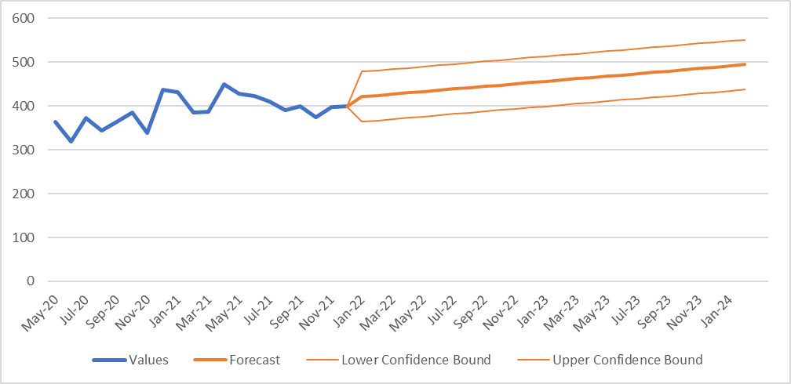
Source: Keytruda UC deed new caps workbook – Uro forecast worksheet
  - The sponsor claimed that it was reasonable to exclude data from January 2022 because there was a reduction in script numbers due to the Omicron wave. The sponsor argued that the reduction in pembrolizumab scripts is likely due to the extreme pressure on all parts of the public hospital system as evidenced by the suspension of elective surgery, delays in accessing emergency treatment and hospital admission in NSW and the treatment of nearly 2,000 more patients in VIC than in the previous quarter. The submission also claimed that increased absenteeism at the Department of Health due to illness and COVID lockdown rules may have also slowed down the processing of PBS scripts and as such, it would be appropriate to exclude PBS data from January 2022 to April 2022 as it is not reflective of the preceding trends. The PBAC considered it was inconsistent to include PBS data from May 2020 to December 2021 which include periods affected by the pandemic but to then exclude PBS data from January 2022 through to April 2022.
  - Figure 1 shows there has been declining month-on-month growth in the utilisation of pembrolizumab for urothelial carcinoma. The sponsor’s forecast of increasing monthly scripts from January 2022 appears unlikely based on the current utilisation trend. Further, actual data from January to June 2022 shows fewer scripts than forecast by the model for this period.
  - Figure 2 shows revised forecasts including script data from January 2022 to April 2022. Consistent with the sponsor’s methodology the revised forecast also applies the Microsoft Excel FORECAST.ETS function to project the estimate of monthly scripts.
Figure 2: PBS scripts actual (including scripts from January 2022 through to April 2022) and revised forecast of pembrolizumab for urothelial cancer (items 11632F and 11646Y)
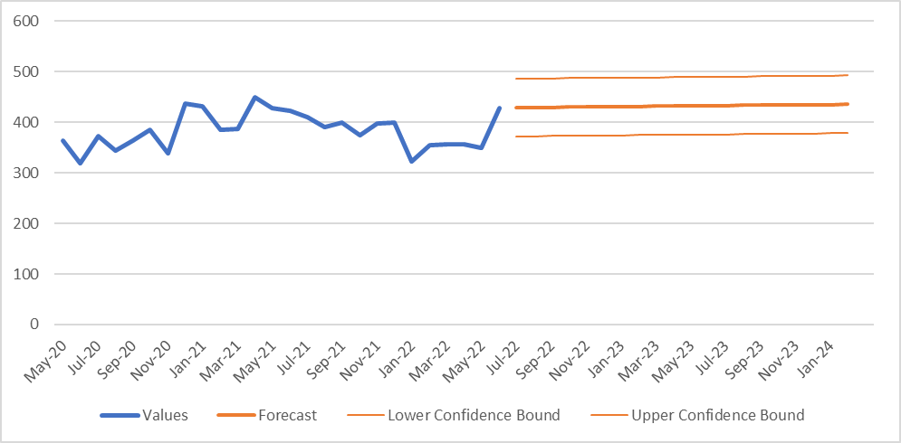
Source: constructed for the overview based on PBS script data for items 11632F and 11646Y
  - The sponsor argued that the flattening of the curve in Year 3 (March 2021 to February 2022) appeared to be related to the avelumab access program that has been running and advertising since TGA approved on 3 March 2021 which could have decreased the number of eligible patients for pembrolizumab. The sponsor estimated that upon listing of avelumab and following cessation of the program, the number of patients for pembrolizumab would continue upwards in Year 4 and Year 5 reflecting the trend in the first two years of pembrolizumab listing.
  - The sponsor calculated the gross cost per PBS script by dividing 2021 PBS expenditure by 2021 PBS scripts to give a gross cost per script of $7,997,31. The rebate percentage was then applied (| |%) to determine the effective cost per script ($| |). The sponsor multiplied the effective cost per script by the forecasted scripts number for Year 4 (5,000 to < 10,000) and Year 5 (5,000 to < 10,000) which resulted in the new subsidisation caps forecasted at $| |M in Year 4 and $| |M in Year 5. As such, the revised estimates did not apply the current effective price for pembrolizumab in this indication.
  - Table 4 below shows the sponsor’s revised cap forecasts, based on PBS data from May 2020 to December 2021. Revised cap forecasts including data to June 2022 for PBS items 11632F and 11636Y are also shown. The Pre-PBAC response accepted that the revised forecast is a reasonable projection using the most up to date data and considered these estimates an appropriate basis for the expenditure caps for Deed Year 4 and 5.
Table 4: Actual and forecast scripts and costs for forward years
 | DY1  Mar19-Feb20 | DY2  Mar20-Feb21 | DY3  Mar21-Feb22 | DY4  Mar22-Feb23 | DY5  Mar23-Feb24
 | Actuals |  |  | Forecast
Scripts numbers (sponsor) | | ¹ | | ¹ | | ¹ | | ² | | ²
Script numbers (revised estimates) ª |  |  |  | | ¹ | | ²
Current caps ($) | | | | | | | | | |
Actual spend and sponsor’s revised forecast based on actual data from May 2020 to December 2021 ($) | | | | | | | | | |
Variance from cap | -24% | +25% | +28% | +44% | +53%
Revised forecast ª ($) |  |  |  | | | |
% increase |  |  |  | 33% | 39%
Source: Keytruda UC deed new caps workbook – Uro forecast worksheet
a forecast based on actual data from May 2020 to June 2022
The redacted values correspond to the following ranges:
¹ 500 to < 5,000
² 5,000 to < 10,000
Figure 3: Graph of actuals and forecast of PBS expenditure caps for KEYTRUDA for urothelial cancer
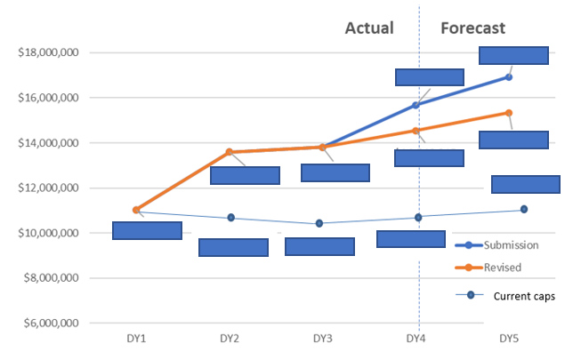
Note: PBS expenditure in DY2 and DY3 reflect actual Commonwealth Payment, DY1 reflects the subsidisation cap for year 1, which was not reached.
Source: Keytruda UC deed new caps workbook – Uro forecast worksheet, and revised values calculated for the overview

Listing of avelumab
  - In March 2021, the PBAC recommended the listing of avelumab, for the maintenance treatment of Stage III or Stage IV urothelial carcinoma in patients whose disease has not progressed following first-line platinum-based chemotherapy (para 7.1, avelumab March 2021 PBAC meeting). The PBAC recommended that avelumab be included within the current RSA for 2L pembrolizumab to address any residual uncertainty regarding the uptake rate and the costs associated with the different treatment durations of these two therapies. The PBAC considered an increase in the patient numbers informing the current financial caps was not required as this was adequately accounted for with the assumed uptake rate for 2L pembrolizumab (para 7.13, avelumab PSD, March 2021 PBAC meeting).
  - In March 2022, the PBAC considered a listing proposal for avelumab that included a revised price, changes to the economic model including a ‘financial stopping rule’ and options for implementing the stopping rule. The PBAC advised that there is a low risk of sequential use of avelumab maintenance therapy followed by pembrolizumab given such use is not clinically indicated. As such, the PBAC advised that, provided the vial price and annual expenditure of each drug reflects cost-effectiveness, then a combined cap may not be required (para 5.6, avelumab PSD, March 2022 PBAC meeting).
  - From 1 October 2022, avelumab was listed on the PBS for the maintenance treatment of Stage III or Stage IV urothelial carcinoma. Given avelumab was recommended as first-line maintenance treatment for urothelial cancer and the restrictions for pembrolizumab prevent sequential use following avelumab, it is expected that the listing of avelumab will reduce the uptake rate of pembrolizumab in the second-line setting. The Pre-PBAC response noted that the avelumab patient access program has been available since TGA approved on 3 March 2021 and therefore the pembrolizumab script volumes used as the basis of the submission’s forecast already reflect the use of avelumab in practice.

Revising subsidisation cap rebate level from |||| ||||% to |||| ||||%
  - The sponsor requested that the PBAC consider recommending that the subsidisation cap rebate level of | |% be revised to | |% consistent with the Deed for pembrolizumab for colorectal cancer. The sponsor noted that the 2022-2027 Strategic Agreement between Medicines Australia and the Commonwealth is committed to developing an RSA Policy. The submission noted that the PBAC previously recommended a 100% rebate due to uncertainties (leakage into first-line/cisplatin-ineligible patients and treatment beyond progression). The sponsor argued that these concerns have not been realised and therefore the request of lowering the rebate level to | |% would be reasonable and consistent with the colorectal cancer Deed.
For more detail on PBAC’s view, see section 5 PBAC outcome.

PBAC Outcome
  - The PBAC did not advise that its previous recommendation regarding the risk sharing arrangement (RSA) subsidisation caps and rebate level for pembrolizumab for locally advanced (Stage III) or metastatic (Stage IV) urothelial cancer be amended. The PBAC considered there was insufficient basis to amend its previous advice with regards to subsidisation caps and rebate level. The PBAC noted the 1 October 2022 listing of avelumab as first-line (1L) maintenance treatment for urothelial cancer is likely to continue to reduce the uptake rate of second-line (2L) pembrolizumab steadily because restrictions for pembrolizumab prevent sequential use following treatment with avelumab.
  - The PBAC noted that the submission requested a change to the existing Deed for pembrolizumab in urothelial cancer, to increase the subsidisation caps for Year 4 and Year 5 to reflect the higher than forecasted utilisation since PBS listing on 1 March 2019. The PBAC noted that script numbers in year 1 were lower than forecasted and the cap was not met, however script numbers were 25% higher than forecasted in year 2 and 28% higher in year 3 of listing, resulting in usage above the agreed expenditure caps. The PBAC recalled that the RSA with financial caps was established to address the highly uncertain financial impact of pembrolizumab because 1) the patient numbers were likely underestimated; 2) there was a risk of use outside the requested restriction into 1L treatment of cisplatin-ineligible patients and 3) the duration of pembrolizumab use may be longer than estimated. The PBAC noted that the higher than forecasted utilisation was due to higher-than-expected patient numbers, rather than longer duration of pembrolizumab use.
  - The PBAC noted that the submission provided updated long-term data from KN045 and concluded that pembrolizumab continues to be cost-effective in all 2L patients and therefore there is no need for financial caps to manage the cost effectiveness of pembrolizumab. The PBAC noted that the updated results were consistent with those presented in the November 2018 submission but considered that the updated data did not address the issues noted above, which were the basis for establishing financial caps.
  - The PBAC noted that the submission argued that the increase in patient numbers was attributable to the COVID-19 pandemic due to a change in recommendations for treating Stage IV urothelial cancer patients with single agent immunotherapy in preference to chemotherapy, given the lower risk of toxicity and less frequent dosing. The PBAC noted that the submission argued that this change in urothelial cancer treatment is now embedded in practice and should be accounted for in year 4 and 5 of the Deed. However, the PBAC considered that regardless of COVID considerations immunotherapy would be the preferred 2L choice for most patients and recalled the July 2018 submission assumed a |################## |% treatment uptake rate in 2L patients. The PBAC considered it is unclear whether impacts of the pandemic have resulted in an overall, ongoing increased use of pembrolizumab in urothelial cancer and that this was insufficient basis for increasing the expenditure caps at this time.
  - The PBAC noted that from 1 October 2022, avelumab was listed on the PBS for the maintenance treatment of Stage III or Stage IV urothelial carcinoma. Given avelumab was recommended as first-line maintenance treatment for urothelial cancer, and the restrictions for pembrolizumab prevent sequential use following avelumab, the PBAC considered it is very likely that the listing of avelumab will reduce the uptake rate of pembrolizumab in the second-line setting.
  - The PBAC noted that the submission provided revised forecasts of pembrolizumab script numbers for years 4 and 5 of the Deed based on PBS data from May 2020 to December 2021, excluding data from January 2022 to April 2022 because there was a reduction in script numbers due to Omicron wave. The PBAC noted it was inconsistent to include PBS data from May 2020 to December 2021 which includes periods affected by the pandemic but to exclude PBS data from January 2022 through to April 2022. The PBAC considered the forecasts based on PBS data from May 2020 to June 2022 appeared to be more reasonable, however the PBAC considered that increasing monthly scripts from January 2022 onwards appears unlikely based on the current utilisation trend, noting there has been declining month-on-month growth in the utilisation of pembrolizumab. Further, the forecasts assume that the number of patients for pembrolizumab would continue upwards in year 4 and 5, reflecting the trend in the first two years of pembrolizumab listing, despite availability of 1L avelumab on the PBS since October 2022. The PBAC noted that the pre-PBAC response argued an avelumab patient access program has been available since March 2021 and therefore the pembrolizumab script volumes used as the basis of the submission’s forecast already reflect the use of avelumab in practice. However, the PBAC considered that pembrolizumab script numbers are unlikely to have a reached a steady state since avelumab became available as 1L treatment for urothelial cancer. Therefore, the PBAC considered that forecast pembrolizumab script numbers for years 4 and 5 of the Deed are uncertain and likely to be overestimated in the submission, however it is too early to reliably predict pembrolizumab utilisation.
  - The PBAC noted that the submission requested that the PBAC consider recommending revision of the subsidisation cap rebate level from |############## |% to |########### |%, consistent with the pembrolizumab for colorectal cancer Deed. The PBAC recalled that it previously recommended a 100% rebate in order to retain the ICER/QALY estimates where there may be leakage into 1L/cisplatin-ineligible patients or treatment beyond progression. The PBAC considered the submission did not provide a sufficient basis for reducing the rebate level from |############## |% to |############### |%.
  - The PBAC noted that this submission is not eligible for an Independent Review as it was not seeking a change to the listing that includes a new indication, objectively different subtype of disease or new population.
Outcome:
Not recommended

Context for Decision
The PBAC helps decide whether and, if so, how medicines should be subsidised through the Pharmaceutical Benefits Scheme (PBS) in Australia. It considers applications regarding the listing of medicines on the PBS and provides advice about other matters relating to the operation of the PBS in this context. A PBAC decision in relation to PBS listings does not necessarily represent a final PBAC view about the merits of the medicine or the circumstances in which it should be made available through the PBS. The PBAC welcomes applications containing new information at any time.

Sponsor’s Comment
MSD is disappointed that PBAC has not recommended an amendment to the estimated utilisation for urothelial cancer given the independent DUSC review in Oct 2021 showed that the patient numbers were underestimated, with minimal leakage and shorter than anticipated time on treatment. MSD is of the view that the listing of avelumab is unlikely to significantly reduce the uptake rate of pembrolizumab, therefore presenting an ongoing risk to MSD. MSD will continue to assess what available options exist to support an appropriate amendment to the estimated utilisation of pembrolizumab.

US Food and Drug Administration (2018). Keytruda (pembrolizumab) or Tecentriq (atezolizumab): FDA Alerts Health Care Professionals and Investigators: FDA Statement - Decreased Survival in Some Patients in Clinical Trials Associated with Monotherapy. https://www.fda.gov/Safety/MedWatch/SafetyInformation/SafetyAlertsforHumanMedicalProducts/ucm608253.htm
Gourd E (2018). EMA restricts use of anti-PD-1 drugs for bladder cancer. Lancet Oncology 19, 7:e341, DOI: https://doi.org/10.1016/S1470-2045(18)30433-9
European Medicines Agency (2018). EMA restricts use of Keytruda and Tecentriq in bladder cancer. http://www.ema.europa.eu/docs/en_GB/document_library/Press_release/2018/05/WC500249798.pdf
US Food and Drug Administration (2018). Keytruda (pembrolizumab) or Tecentriq (atezolizumab): FDA Alerts Health Care Professionals and Investigators: FDA Statement - Decreased Survival in Some Patients in Clinical Trials Associated with Monotherapy. https://www.fda.gov/Safety/MedWatch/SafetyInformation/SafetyAlertsforHumanMedicalProducts/ucm608253.htm
Gourd E (2018). EMA restricts use of anti-PD-1 drugs for bladder cancer. Lancet Oncology 19, 7:e341, DOI: https://doi.org/10.1016/S1470-2045(18)30433-9
European Medicines Agency (2018). EMA restricts use of Keytruda and Tecentriq in bladder cancer. http://www.ema.europa.eu/docs/en_GB/document_library/Press_release/2018/05/WC500249798.pdf
https://ascopubs.org/doi/full/10.1200/op.20.00229
https://www.annalsofoncology.org/article/S0923-7534(21)04827-4/fulltext
https://jnccn.org/view/journals/jnccn/20/8/article-p866.xml
https://www.annalsofoncology.org/article/S0923-7534(19)31210-4/pdf
https://www.bhi.nsw.gov.au/__data/assets/pdf_file/0009/730197/BHI_HQ48_JAN-MAR-2022_REPORT.pdf
https://www.abc.net.au/news/2022-04-30/victorias-hospital-and-ambulance-system-under-record-pressure/101028042
https://www.pbs.gov.au/general/medicines-industry-strategic-agreement-files/MA-Strategic-Agreement-Signed.pdf

