5.09 SELUMETINIB,  
Capsule 10 mg, Capsule 25 mg,  
Koselugo®,  
Alexion Pharmaceuticals Australasia Pty. Ltd.

1. Purpose of submission
   1. The Category 1 submission requested both a Section 100 (Highly Specialised Drugs Program) and Section 100 (Highly Specialised Drugs Program – Community Access) Authority Required listing for selumetinib for the treatment of symptomatic, inoperable plexiform neurofibroma(s) (PN) in paediatric patients with neurofibromatosis (NF1).
   2. Listing was requested on the basis of a cost-utility analysis versus supportive care.

Table : **Key components of the clinical issue addressed by the submission (as stated in the submission)**

| Component | Description |
| --- | --- |
| Population | Children aged ≥2 years and diagnosed ≤18 years with NF1 and symptomatica, inoperableb PN |
| Intervention | Selumetinib 25mg/m2 BSA orally twice daily until unacceptable tolerability or disease progression |
| Comparator | Supportive care (no active treatment) |
| Outcomes | ORR assessed by centralised volumetric MRI of the target PN, DoR, PFS, clinical outcomes including pain, motor dysfunction, airway dysfunction |
| Clinical claim | In children with NF1 and symptomatic, inoperable PN, treatment with selumetinib is more effective than supportive care in reducing PN volume, reducing pain, improving functional assessment scores and improving HRQoL.  Selumetinib has an acceptable safety and tolerability profile for chronic treatment in children. |

Source: Table 1.1, p17 of the submission.

BSA = body surface area, DoR = duration of response, HRQoL = health-related quality of life, MRI = magnetic resonance imaging, NF1 = neurofibromatosis type 1, ORR = objective response rate, PFS = progression-free survival, PN = plexiform neurofibroma(s).

a Definition of symptomatic: PN has to cause significant morbidity, such as (but not limited to) head and neck PN that can compromise the airway or great vessels, paraspinal PN that can cause myelopathy, brachial or lumbar plexus PN that can cause nerve compression and loss of function, PN that can result in major deformity (e.g., orbital PN) or significant disfiguring, PN of the extremity that can cause limb hypertrophy or loss of function, and painful PN.

b Definition of inoperable: Adequate tumour resection cannot be done safely or without causing unacceptable morbidity.

1. Background

Registration status

* 1. Selumetinib was TGA registered on 2 December 2021 for the treatment of paediatric patients aged 2 years and above, with neurofibromatosis type 1 (NF1) who have symptomatic, inoperable plexiform neurofibromas (PN).

1. Requested listing

|  |  |  |  |  |  |
| --- | --- | --- | --- | --- | --- |
| **MEDICINAL PRODUCT**  **medicinal product pack** | **DPMQ** | **Max. qty packs** | **Max. qty units** | **№.of**  **Rpts** | **Available brands** |
| SELUMETINIB | | | | | |
| selumetinib 10 mg capsule, 60 | Published: $||  Effective: $|||| (public)  $　|　 (private) | 4 | 240 | 5 | Koselugo |
| selumetinib 25 mg capsule, 60 | Published: $||  Effective: $|||| (public)  $　|　 (private) | 2 | 120 | 5 | Koselugo |
| **Category / Program:** Section 100 – Highly Specialised Drugs Program | | | | | |
| **Prescriber type:** Medical Practitioners | | | | | |
| **Restriction type:** Authority Required (telephone/online PBS Authorities system) | | | | | |
|  | | | | | |
| **Episodicity:** Chronic treatment | | | | | |
| **Severity:** Symptomatic, inoperable plexiform neurofibroma(s) (PN) | | | | | |
| **Condition:** Neurofibromatosis type 1 (NF1) | | | | | |
| **Indication:** Treatment of symptomatic, inoperable PN in patients with NF1 | | | | | |
|  | | | | | |
| **Treatment Phase:** Initial | | | | | |
|  | | | | | |
| **Clinical criteria:** | | | | | |
| The PN must cause or risk causing significant symptoms/morbidity, disability, disfigurement or impairment of normal body function | | | | | |
| **AND** | | | | | |
| **Clinical criteria:** | | | | | |
| Complete PN resection cannot be done safely or without causing unacceptable morbidity | | | | | |
|  | | | | | |
| **Treatment criteria:** | | | | | |
| Patient must be under the care of a specialist paediatrician | | | | | |
|  | | | | | |
| **Population criteria:** | | | | | |
| Patients with NF1 ≥ 2 years of age and diagnosed ≤18 years of age with symptomatic, inoperable PN | | | | | |
|  | | | | | |
| **Prescribing Instructions:** For the purposes of administering this restriction, PN-related morbidity is defined as symptomatic if it can cause significant morbidity, such as (but not limited to) head and neck PN that can compromise the airway or great vessels, paraspinal PN that can cause myelopathy, brachial or lumbar plexus PN that can cause nerve compression and loss of function, PN that can result in major deformity (e.g., orbital PN) or significant disfiguring, PN of the extremity that can cause limb hypertrophy or loss of function, and painful PN. | | | | | |
| **Administrative Advice:** Special Pricing Arrangements apply | | | | | |
|  | | | | | |
| **Treatment Phase:** Continuing | | | | | |
|  | | | | | |
| **Clinical criteria:** | | | | | |
| Patient must have previously received PBS-subsidised treatment with this drug for this condition | | | | | |
| **AND** | | | | | |
| **Clinical criteria:** | | | | | |
| Patient must not have developed disease progression while being treated with this drug for this condition | | | | | |
| **AND** | | | | | |
| **Clinical criteria:** | | | | | |
| Patient must not have developed unacceptable toxicity to this drug | | | | | |
| **AND** | | | | | |
| **Clinical criteria:** | | | | | |
| Treatment must have commenced between the ages of 2 to 18 years, inclusive. | | | | | |
|  | | | | | |
| **Treatment criteria:** | | | | | |
| Patient must be under the care of a specialist clinician | | | | | |
|  | | | | | |
| **Treatment Phase:** Transitioning from non-PBS to PBS-subsidised supply – ‘Grandfather’ arrangements | | | | | |
|  | | | | | |
| **Clinical criteria:** | | | | | |
| Patient must have previously received treatment with this drug for this condition prior to PBS listing | | | | | |
| **AND** | | | | | |
| **Clinical criteria:** | | | | | |
| Patient must not have developed disease progression while being treated with this drug for this condition | | | | | |
| **AND** | | | | | |
| **Clinical criteria:** | | | | | |
| Patient must not have developed unacceptable toxicity to this drug | | | | | |
| **AND** | | | | | |
| **Clinical criteria:** | | | | | |
| Treatment must have commenced between the ages of 2 to 18 years, inclusive | | | | | |
|  | | | | | |
| **Treatment criteria:** | | | | | |
| Patient must be under the care of a specialist clinician | | | | | |
|  | | | | | |
| **Administrative criteria:**  Patients may qualify for PBS-subsidised treatment under this restriction once only.  For continuing PBS-subsidised treatment, a 'Grandfathered' patient must qualify under the 'Continuing treatment' criteria.  This grandfather restriction will cease to operate from 12 months after the date specified in the clinical criteria. | | | | | |

* 1. The proposed restriction allowed treatment with selumetinib in patients diagnosed with symptomatic and inoperable PN between the ages of 2 and 18. The evaluation noted this would allow patients aged over 18 years of age to initiate treatment, as diagnosis may not always coincide with treatment initiation (i.e. treatment initiation may commence well after the initial diagnosis if a ‘wait-and-watch’ approach is taken). The Pre-Sub-Committee Response (PSCR) proposed a revised criterion to only allow treatment initiation in children aged between 2 and 18 years of age.
  2. Patients who commenced treatment with selumetinib prior to the age of 18 years would be allowed to continue treatment indefinitely if it was tolerated or there was no disease progression. There is a lack of data informing efficacy and safety of selumetinib in patients aged > 18 years, given that patients in the key trial (SPRINT) were aged ≤ 18 years at enrolment. This was also not consistent with the economic evaluation, where disease progression and treatment were assumed to occur up to the age of 24. The pre-PBAC response stated that a meta-analysis by Sharawat et al (2022)[1] demonstrated that selumetinib was as efficacious in the paediatric and adult populations. In addition, the pre-PBAC response noted that 20% of patients (10/50) in the SPRINT trial turned 18 whilst receiving selumetinib and demonstrated comparable efficacy and safety outcomes compared to the overall SPRINT trial population.
  3. The requested initial restriction criteria were not consistent with the inclusion criteria of the SPRINT trial as it did not specify: i) a minimum body surface area (BSA) of 0.55 m2, ii) the ability to swallow a whole capsule, or iii) a Karnofsky or Lansky Performance Score of ≥70%. It was noted that if the restriction was to incorporate the Karnofsky performance scaling system or the Lansky play-performance scaling system by reference, then the source, location or version of these scales needs to be clearly specified in the listing such that PBS eligibility is clearly defined for any reader.
  4. The requested continuing supply restriction did not specify the criteria for assessing disease progression. Disease progression in the SPRINT trial was defined as ≥ 20% increase in PN volume using volumetric magnetic imaging resonance (MRI). Of note, volumetric MRI is not listed on the MBS for this indication.
  5. The Secretariat noted that it would be unusual to designate a drug listing as both a Highly Specialised Drugs Program (HSDP) and a HSDP – Community Access program listing. It was also noted that whilst the proposed indication requires specialist management, the treatment itself is a solid, ready-prepared oral dose form and would not be considered to require administration in an institution with ready access to specialised medical equipment and emergency medical care. Therefore, designation of the drug as a Highly Specialised Drug Program listing may not be adequately supported.

*For more detail on PBAC’s view, see section 7 PBAC outcome.*

1. Population and disease
   1. NF1 is a rare autosomal-dominant hereditary disorder caused by mutations in the NF1 tumour suppressor gene, with a prevalence rate of 1 in 3,000 people. Approximately 30% of patients with NF1 develop PN. PN are non-malignant peripheral nerve sheath tumours which may develop anywhere in the body.
   2. PN associated with NF1 can cause significant morbidities, including pain, disfigurement, motor function deficits and, in the most severe cases, can be life-threatening due to compression of vital structures (e.g., great vessel compression, spinal cord compression and airway obstruction). PN associated with NF1 has a substantial burden on the quality of life of patients, their families and carers.
   3. Most patients are diagnosed as children. The rate of PN growth is much higher during early childhood and slows with age. According to the National Cancer Institute Natural History study (NCI NH study), a ≥ 20% increase in PN volume was observed in patients aged 0 to 12 years; whereas, a growth rate of ≥ 20% was rarely observed in adults. PN growth by age group from the NH study is presented in Figure 1.

Figure . **Change in PN growth from NCI Natural History study individual patient profiles, over five years by age group**

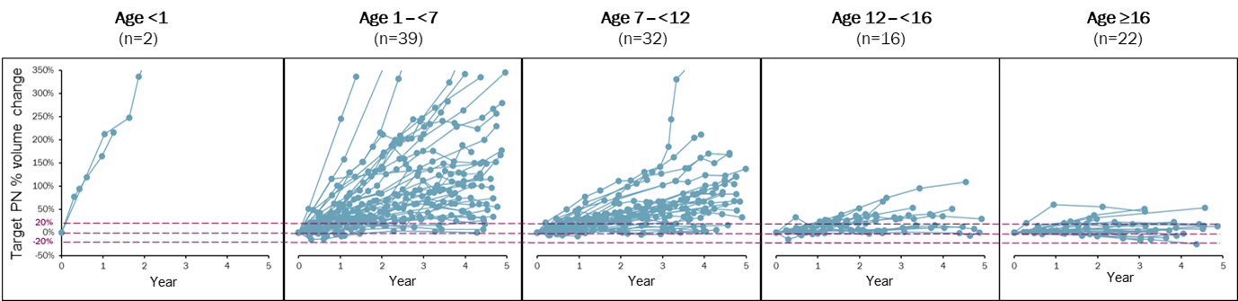

Source: Figure 1.3, p22 of the submission.

NCI = National Cancer Institute, PN = plexiform neurofibroma(s),

* 1. The submission defined PN-related morbidity as ‘symptomatic’ if it can cause significant morbidity, such as (but not limited to):
* head and neck PN that can compromise the airway or great vessels;
* paraspinal PN that can cause myelopathy;
* brachial or lumbar plexus PN that can cause nerve compression and loss of function;
* PN that can result in major deformity (e.g., orbital PN) or significant disfiguring;
* PN of the extremity that can cause limb hypertrophy or loss of function; and
* painful PN.
  1. The submission defined PN as ‘inoperable’ if it cannot be completely resected without risk of substantial morbidity due to encasement of, or close proximity to, vital structures, invasiveness or high vascularity.
  2. Currently, there are no approved pharmacological treatments for symptomatic, inoperable PN in paediatric patients with NF1. Treatment options are limited to symptomatic and supportive treatment, such as pain medication, debulking surgery or interventions (e.g., tracheostomy to alleviate severe airway morbidities). The ESC noted trametinib (a MEK inhibitor) is used off-label to treat NF1 PN in Australia and there is an ongoing local clinical trial[2]. The ESC also noted a number of other MEK inhibitors such as binimetinib and mirdametinib are currently being trialled among paediatric and adult patients with NF1 PN and other NF1 related tumours.
  3. The submission proposed selumetinib as an alternative to the supportive care available to patients with NF1 PN in Australia. Additionally, concomitant symptomatic and supportive management (e.g., pain medication) may be required with selumetinib. The submission’s proposed place in therapy for selumetinib is presented in Figure 2.

Figure : Proposed clinical management algorithm

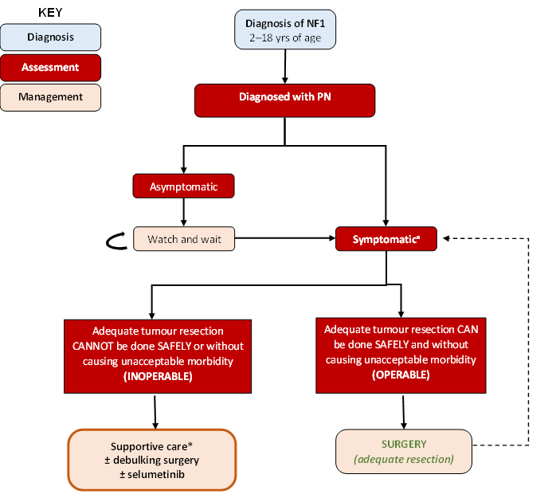

Source: Figure 1.7, p37 of the submission.

NF1 = neurofibromatosis type 1, PN = plexiform neurofibroma(s).

* Supportive care is inclusive of, but not limited to, complex PN care, pain management, physical therapy, management of airway obstruction (e.g., tracheostomy), management of bladder and bowel morbidities (e.g., incontinence products, laxatives and diuretics), management of vision loss.

a Defined as PN has to cause significant morbidity, such as (but not limited to) head and neck PN that can compromise the airway or great vessels, paraspinal PN that can cause myelopathy, brachial or lumbar plexus PN that can cause nerve compression and loss of function, PN that can result in major deformity (e.g., orbital PN) or significant disfiguring, PN of the extremity that can cause limb hypertrophy or loss of function, and painful PN.

* 1. Selumetinib is a selective inhibitor of mitogen-activated protein kinase kinases 1 and 2 (MEK 1 and 2). MEK 1 and 2 are key components of the cellular growth signalling cascade which is overactive in NF1 due to mutations in the NF1 tumour suppressor gene. Inhibition of MEK prevents PN growth and promotes PN shrinkage by reducing cell proliferation and preventing abnormal cell survival.

*For more detail on PBAC’s view, see section 7 PBAC outcome.*

1. Comparator
   1. The submission nominated supportive care as the main comparator. The submission defined supportive care as “inclusive of, but not limited to, complex PN care, pain management, physical therapy, management of airway obstruction (e.g., tracheostomy), management of bladder and bowel morbidities (e.g., incontinence products, laxatives and diuretics), management of vision loss”.
   2. The main arguments provided in support of this nomination were:

* Currently, there are no approved pharmacological treatments for symptomatic, inoperable PN in paediatric patients with NF1.
* Traditional antineoplastic agents, such as chemotherapy or radiotherapy are inappropriate due to the risk of malignant transformation.
* Debulking surgery (i.e., partial resection) was not considered as an appropriate stand-alone comparator, given that selumetinib may be initiated prior to or after debulking surgery.
  1. The ESC considered supportive care to be an appropriate comparator.
  2. During the Therapeutic Goods Administration (TGA) evaluation, the Advisory Committee on Medicines (ACM) commented that paediatric patients may have difficulty taking selumetinib twice daily on an empty stomach and this may lead to compliance issues. The capsule was considered to be relatively large for paediatric use (14 mm) and presented a potential choking hazard in young patients. According to the PI of selumetinib, the capsule should not be chewed, dissolved, or opened. The ACM also commented that an alternative dose form would be a useful option for very young children2. The ESC noted trametinib is provided in the TiNT study as a solution for children under 6 years of age or those that cannot take tablets.

*For more detail on PBAC’s view, see section 7 PBAC outcome.*

1. Consideration of the evidence

Sponsor hearing

* 1. The sponsor requested a hearing for this item. The clinician discussed the natural history of the disease, described the quality of life issues associated with the disease, and explained how selumetinib would be used in practice. The clinician also discussed the difficulties associated with surgery as a treatment for PN in patients with NF1. The clinician noted that even a small reduction in tumour volume can have a significant impact on quality of life due to the location of tumours. The PBAC considered that the hearing was informative as it provided a clinical perspective on treating this uncommon disease.

Consumer comments

* 1. The PBAC noted and welcomed the input from individuals (29) and organisations (1) via the Consumer Comments facility on the PBS website. The comments from individuals discussed the physical and psychological burden of the disease and the high unmet clinical need for effective treatments for PN in patients with NF1. Contributors described the limited surgical options available for some tumours due to their location, the need for repeated surgeries and the ongoing complications associated with tumours that have been surgically debulked. Both surgery and chemotherapy were considered to have a high treatment burden and access to these treatments and to clinical trials was also problematic, whilst the cost of access to selumetinib was considered prohibitive. The comments emphasised the effects of PN associated with NF1 on physical health with multiple impairments and difficulties managing the pain associated with the condition and its treatment, in addition to the psychological and social impacts on quality of life due to disfigurement, and the inability to engage in school and work. There was strong support for this listing as a more effective treatment, associated with fewer disadvantages than surgery or chemotherapy.
  2. The PBAC noted the advice received from The Children’s Tumour Foundation which described the quality of life challenges faced by NF1 patients with PN. In addition, the advice described the unmet clinical need for effective, non-surgical treatments for this condition. The PBAC noted that this advice was supportive of the evidence provided in the submission.

Clinical trials/studies

* 1. The submission stated that there were no direct head-to-head trials comparing selumetinib with supportive care for the treatment of paediatric patients with NF1 PN. Therefore, the submission presented an indirect treatment comparison (ITC) of selumetinib and supportive care based on:
* the SPRINT (Phase I and II) trial, which informed the efficacy and safety of selumetinib; and
* the National Cancer Institute Natural History (NCI NH) Study and the 01-C-0222 trial, which informed the efficacy of supportive care.
  1. Details of the studies presented in the submission are provided in Table 2.

Table : **Trials/studies and associated reports presented in the submission**

| Trial ID | Protocol title/ Publication title | Publication citation |
| --- | --- | --- |
| SPRINT  (NCT01362803) | A Phase I/II Study of the Mitogen Activated Protein Kinase (MEK) 1 Inhibitor Selumetinib (AZD6244; HYD Sulfate) in Children with Neurofibromatosis Type 1 (NF1) and Inoperable Plexiform Neurofibromas. | August 2019 |
| A Phase I/II Study of the Mitogen Activated Protein Kinase (MEK) 1 Inhibitor Selumetinib (AZD6244; HYD Sulfate) in Children with Neurofibromatosis Type 1 (NF1) and Inoperable Plexiform Neurofibromas (SPRINT). Long Term Efficacy and Safety Update. | April 2022 |
| Gross A, Wolters P et al. Selumetinib in children with inoperable plexiform neurofibromas. | *New England Journal of Medicine* 2020; 382, 1430-1442 |
| Glassberg B, Gross A et al. Selumetinib in children with clinically asymptomatic inoperable NF1 related plexiform neurofibromas. | *Pediatric Blood and Cancer* 2020; 67. |
| Gross A, Wolters P et al. Sprint: Phase II study of the MEK 1/2 inhibitor selumetinib (AZD6244, ARRY-142886) in children with neurofibromatosis type 1 (NF1) and inoperable plexiform neurofibromas. | *Neuro-Oncology* 2018; 20, i143-i144. |
| Gross A, Baldwin A et al. Phase II Study of the MEK 1/2 inhibitor selumetinib (AZD6244, ARRY-142886) in children with neurofibromatosis type 1 (NF1) and inoperable plexiform neurofibromas. | *Journal of Clinical Oncology* 2016; 34. |
| Gross A, Glassberg B et al. Selumetinib in Children with Neurofibromatosis Type 1 and Asymptomatic Inoperable Plexiform Neurofibroma at Risk for Developing Tumor-Related Morbidity. | *Neuro-Oncology* 2022. |
| Gross A, Wolters P et al. SPRINT: Phase II study of the MEK 1/2 inhibitor selumetinib (AZD6244, ARRY-142886) in children with neurofibromatosis type 1 (NF1) and inoperable plexiform neurofibromas. | *Journal of Clinical Oncology* 2018; 36. |
| Jackson S, Baker E et al. The effect of selumetinib on spinal neurofibromas in patients with NF1. | *Neuro-Oncology* 2018; 20, vi237 |
| Jackson S, Baker E et al. The MEK inhibitor selumetinib reduces spinal neurofibroma burden in patients with NF1 and plexiform neurofibromas | *Neuro-Oncology Advances* 2020; 2, vdaa095 |
| Dombi E, Baldwin A et al. Activity of selumetinib in neurofibromatosis type 1-related plexiform neurofibromas. | *New England Journal of Medicine* 2016; 375, 2550-2560. |
| Fisher M, Marcus L et al. Selumetinib (AZD6244) hydrogen sulfate, a MEK1/2 inhibitor, in children with neurofibromatosis type 1 (NF1) and inoperable plexiform neurofibromas (PNS): A Phase I study. | *Neuro-Oncology* 2014; 16, i129 |
| Widemann B, Marcus L et al. Phase I study of the MEK1/2 inhibitor selumetinib (AZD6244) hydrogen sulfate in children and young adults with neurofibromatosis type 1 (NF1) and inoperable plexiform neurofibromas (PNs). | *Journal of Clinical Oncology* 2014; 32. |
| NH study  (NCT00924196) | Akshintala S, Baldwin A et al. Longitudinal evaluation of peripheral nerve sheath tumours in neurofibromatosis type 1: growth analysis of plexiform neurofibromas and distinct nodular lesions. | *Neuro-Oncology* 2020; 22, 1368-1378. |
| Akshintala S, Dombi E et al. Predictors of plexiform neurofibroma growth in patients with neurofibromatosis 1 (NF1). | *Pediatric Blood and Cancer* 2014; 61, S32-S33. |
| Dagalakis U, Lodish M et al. Puberty and plexiform neurofibroma tumour growth in patients with neurofibromatosis type 1. | *Journal of Pediatrics* 2014; 164, 620-624. |
| Gross A, Singh G et al. Association of plexiform neurofibroma volume changes and development of clinical morbidities in neurofibromatosis 1. | *Neuro-Oncology* 2018; 20, 1643-1651. |
| Hou Y, Allen T et al. Predictors of cognitive development in children with neurofibromatosis type 1 and plexiform neurofibromas. | *Developmental Medicine and Child Neurology* 2020; 62, 977-984. |
| Kim A, Gillespie A et al. Characteristics of children enrolled in treatment trials for NF1-related plexiform neurofibromas. | *Neurology* 2009; 79, 1273-1279 |
| Loucas C, Wolters P et al. Verbal learning and memory in youth with neurofibromatosis type 1 and plexiform neurofibromas: Relationships with disease severity. | *European Journal of Paediatric Neurology* 2022; 38, 7-12. |
| Meany H, Dombi et al. 18-fluorodeoxyglucose-positron emission tomography (FDG-PET) evaluation of nodular lesions in patients with neurofibromatosis type 1 and plexiform neurofibromas or malignant peripheral nerve sheath tumours (MPNST). | *Pediatric Blood and Cancer* 2013; 60, 59-64. |
| Ngyuen R, Dombi E et al. Characterization of spinal findings in children and adults with neurofibromatosis type 1 enrolled in a natural history study using magnetic resonance imaging. | *Journal of Neuro-Oncology* 2015; 121, 209-215. |
| Widemann B. Natural history of peripheral nerve sheath tumours in NF1: Identification and characterization of malignant precursor lesions. | Clinical Cancer Research 2018; 24. |
| Wolters P, Burns K et al. Pain interference in youth with neurofibromatosis type 1 and plexiform neurofibromas and relation to disease severity, social-emotional functioning, and quality of life. | *American Journal of Medical Genetics* 2015; Part A, 167, 2103-2113. |
| 01- C0222 trial  (NCT00021541) | Widemann B, Dombi E et al. Phase 2 randomized, flexible crossover, double-blinded, placebo-controlled trial of the farnesyltransferase inhibitor tipifarnib in children and young adults with neurofibromatosis type 1 and progressive plexiform neurofibromas. | *Neuro-Oncology* 2014; 16, 707-718. |

Source: Table 2.11, pp68-71 of the submission.

MEK = mitogen-activated protein kinase, NF1 = neurofibromatosis type 1, PN = plexiform neurofibroma(s).

* 1. The key features of the included evidence are summarised in Table 3.

**Table 3: Key features of the included evidence**

| Trial | N | Design/duration | Risk of bias | Patient population | Outcome(s) | Use in modelled evaluation |
| --- | --- | --- | --- | --- | --- | --- |
| Selumetinib | | | | | | |
| SPRINT | 50 | OL, MC  Median follow-up of 4 years a | Low to Moderate b | Children aged ≥2 years and ≤18 years with NF1 and symptomatic and inoperable PN | ORR, DoR, TTP, PFS, TTR, effect on pain; quality of life; physical functioning; BMD; functional impairments specific to PN location; and disfigurement, safety and tolerability | PFS, TTD |
| **Supportive Care** | | | | | | |
| NH Study | 250 | OB  Median follow-up of 6.6 years | Low to Moderate b | Patients (children, adolescents, and adults) with a confirmed diagnosis of NF1 or a confirmed NF1 mutation. | PFS, PN growth rate | PFS |
| 01-C-0222 trial (Phase A) | 60 | R, DB  NR | Low | Children and young adults (aged 3 to 25 years) with NF1 and unresectable, progressive PN. | TTP, PFS | Not used |

Source: Table 2.24, p94, Table 2.26, pp98-106 and Section 3 of the submission.

BMD = bone mineral density, DB = double blind, DoR = duration of response, HRQoL = health-related quality of life, MC = multi-centre, NF1 = neurofibromatosis type 1, NH = Natural History, NR = not reported, OB = observational, OL = open label, ORR = objective response rate, OS = overall survival, PFS = progression-free survival, PN = plexiform neurofibroma(s), PRO = patient-reported outcomes, R = randomised, TTP = time to progression, TTR = time to response.

a Data cut-off March 2021, maximum duration of follow-up 5.6 years

b Risk of bias in non-randomized studies of interventions (ROBINS-I) was used to estimate the risk of bias.

* 1. All three studies were sponsored and conducted by the National Cancer Institute (NCI) Paediatric Oncology Branch (POB).
  2. The SPRINT trial was an open-label, single-arm, multi-centre study of selumetinib in children (aged ≥2 years and ≤18 years, with the ability to swallow whole capsules) with NF1 and symptomatic and inoperable PN. Pre-specified analyses included comparisons with the NH study and the placebo arm of the 01-C-0222 trial (Phase A).
  3. The NCI NH study was a longitudinal, observational, natural history study of patients (children, adolescents, and adults) with a confirmed diagnosis of NF1 or a confirmed NF1 mutation. Comparative analyses with the SPRINT trial were performed using an age-matched cohort (N=92) aligned with the maximum follow-up of the SPRINT trial (5.6 years).
  4. The 01-C-0222 trial (tipifarnib=31, placebo=29) was a Phase II, randomised, crossover, double-blinded, placebo-controlled study of tipifarnib (an experimental treatment) in children and young adults (aged 3 to 25 years) with NF1 and unresectable, progressive PN.
  5. The eligibility criteria were largely similar across the studies. However, the ESC noted thatthere were key differences that may affect transitivity. Specifically, compared with the SPRINT trial:
* patients were younger in the age-matched cohort of the NH study (10.2 years versus 7.8 years) and the 01-C-0222 trial (10.2 years versus 8.2 years). Older age was found to be a predictor of a better outcome[3]; this could favour selumetinib.
* a lower proportion of patients had progressive PN in the age-matched cohort of the NH study (42.0% versus 33.3%). All patients in the 01-C-0222 trial had progressive PN, given the eligibility criteria. The potential impact on trial comparison was not clear.
* the median PN volume was lower in the age-matched cohort of the NH study (487.5 mL versus 301.5 mL) and the 01-C-0222 trial (487.5 mL versus 316.0 mL). The potential impact on trial comparison was not clear.
* a lower proportion of patients had PN located in the head/neck in the age-matched cohort of NH study (24.0% versus 14.1%). Tumours of the head, neck, and face were most likely to progress following resection compared with tumours of the extremities, this could favour SC.
* a lower proportion of patients had received prior treatment for PN in the 01-C-0222 trial (62.0% versus 13.8%). The potential impact on trial comparison was not clear.
  1. The submission presented propensity score analyses to adjust for differences in age, target PN volume, and target PN location.

Comparative effectiveness

**SPRINT trial**

Objective Response Rate (ORR)

* 1. ORR (assessed by NCI POB central review), the primary efficacy outcome, was defined as the percentage of patients with complete response or confirmed partial response (PR). PR was defined as PN volume decrease ≥20% compared to baseline with a confirmed PR defined as a PR on consecutive restaging examinations at least 3 months apart. Table 4 summarises the results of ORR in the SPRINT trial.

Table : **Summary of ORR in SPRINT trial**

| **Outcome** | **SPRINT**  **Selumetinib 25 mg/m2 BID**  **n/N (%)** |
| --- | --- |
| Confirmed ORR, (95% CI) | 34/50 (68.0%), (53.3, 80.5) |
| **Best objective response** | |
| Complete response | 0 |
| Confirmed partial response a | 34/50 (68%) |
| Unconfirmed partial response b | 3/50 (6%) |
| Stable disease c | 11/50 (22%) |
| Progression | 0 |
| Not evaluable | 2/50 (4%) |
| **Confirmed ORR by PN status at enrolment** | |
| Progressive PN, (95% CI) d | 13/21 (61.9%), (38.4, 81.9) |
| Non-progressive PN, (95% CI) e | 10/15 (66.7%), (38.4, 88.2) |
| Unknown, (95% CI) f | 11/14 (78.6%), (49.2, 95.3) |

Source: Table 2.28, p111 and Table 2.29, p111 of the submission.

BID = twice daily, CI = confidence interval, n = number of participants with event, N = total participants in group, ORR = objective response rate, PN = plexiform neurofibroma(s).

a Partial Response (PR) was defined as PN volume decrease ≥20% compared to baseline. A confirmed partial response was defined as a partial response on consecutive restaging examinations at least 3 months apart

b Partial response was achieved but either no confirmation assessment was performed, or a confirmation assessment was performed but the response was not confirmed.

c Insufficient volume change from baseline to qualify for either partial response or progressive disease.

d Progressive disease in the 18 months prior to enrolment.

e Not meeting criteria for progressive disease prior to enrolment.

f Determination of progressive/non-progressive PN was not possible based on the prior image available.

* 1. An ORR of 68.0% (95% CI: 53.3, 80.5) was observed at the latest data cut-off (March 2021).

PN Growth Rate

* 1. Percentage change from baseline in target PN volume over time is presented in Figure 3 and a waterfall plot of best percent change from baseline in target PN volume is presented in Figure 4.

Figure . Percent change from baseline in target PN volume over time in SPRINT trial

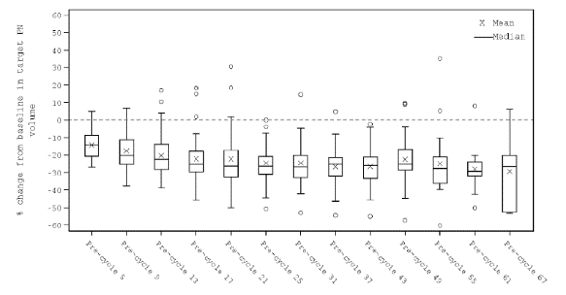

Source: Figure 2.8, p112 of the submission.

Figure . Waterfall plot best percent change from baseline in target PN volume NCI POB analysis in SPRINT trial

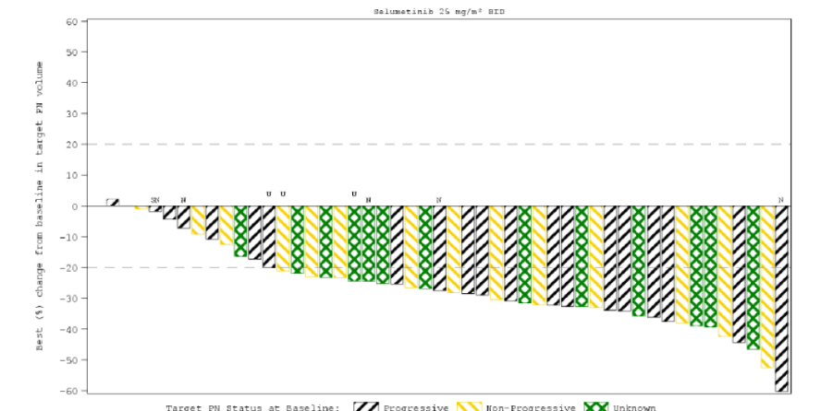

Source: Figure 2.9, p113 of the submission.

* 1. In the SPRINT trial, a median reduction of ≥ 20% in target PN volume from baseline was observed at all timepoints, except for pre-cycle 5. In 46 out of 48 (95.8%) patients, there was a reduction from baseline in target PN volume, with the largest change being -60.3% at pre-Cycle 55. Out of these 48 patients, 37 (77.1%) had a maximum reduction from baseline of ≥ 20% in target PN volume and 5 (10.4%) patients had a maximum reduction from baseline of ≥ 40%. It is important to note that the SPRINT trial did not find any correlation between changes in functional or patient-reported outcome assessments and percentage change in tumour volume. The PSCR noted that clinically the volume of the target PN does not necessarily correlate with severity of symptoms and given the heterogeneity of the size and location of PN and the associated morbidities, it would be difficult to define a quantitative relationship between change in PN volume and each clinical outcome.

Progression-Free Survival (PFS)

* 1. PFS was defined as the time from study treatment initiation to the pre-cycle (a cycle was defined as 28 days of treatment) documented progression or death. Progression was defined as ≥ 20% increase in PN volume (as per Response Evaluation in Neurofibromatosis and Schwannomatosis (REiNS) criteria). A Kaplan-Meier plot of PFS by NCI POB central analysis is presented in Figure 5.

Figure . Kaplan-Meier Plot of PFS, NCI POB central analysis in SPRINT trial

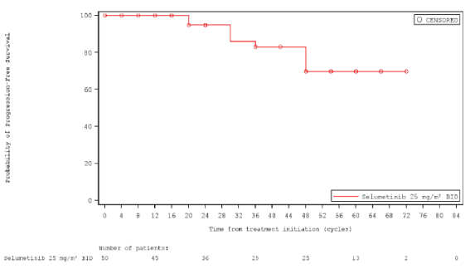

Source: Figure 2.11, p115 of the submission.

BID = Twice daily, MRI = magnetic imaging resonance, NCI = National Cancer Institute, POB = Paediatric Oncology Branch, PR = Partial response.

Progression-free survival was defined as the time from study treatment initiation until the pre-cycle of objective disease progression or death (by any cause in the absence of progression). Patients not known to have progressed at the time of analysis were censored at the last evaluable on-treatment pre-cycle volumetric MRI assessment. The values at the base of the figure indicate number of patients at risk. Dots represent censored observations. A cycle was defined as 28 days.

* 1. The median PFS was not reached. The proportion of patients who were progression free at Cycle 16 was 100% (95% CI: NE, NE), Cycle 24 was 94.8% (95% CI: 81.0, 98.7), Cycle 36 was 83.0% (95% CI: 65.9, 92.0) and Cycle 48 was 69.7% (95% CI: 50.8, 82.5).

Patient Reported Outcomes (PROs) and Functional Outcomes

* 1. A range of clinical outcome assessments (PROs and functional outcomes) were used to assess the clinical benefit of selumetinib treatment and are presented in Figure 6.

Figure . Overview of clinical outcome assessments conducted in SPRINT

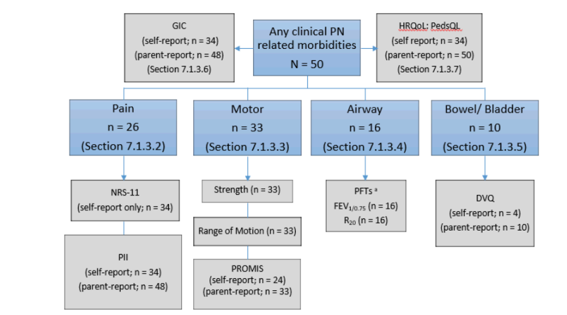

Source: Figure 2.12, p116 of the submission.

DVQ = Dysfunctional voiding questionnaire, FEV1/0.75 = Forced expiratory volume in 1 second/0.75 seconds, GIC = Global Impression of Change, HRQoL = Health-related quality of life, n = number of participants reporting data, N = total participants in group, NRS-11 = Numerical rating scale-11, PedsQL = Paediatric Quality of Life Inventory, PFT = Pulmonary function test, PII = Pain interference index, PN = Plexiform neurofibroma(s), PROMIS = Patient-reported outcomes measurement information system, R = Resistance.

* 1. With the exception of the Pain Interference Index (PII) and measurements of visual acuity, the PROs used by the submission have not been validated in PN, and, as such, no validated thresholds for clinically meaningful change exist in this population. Furthermore, PROs and functional outcomes were not used in the economic model. The PSCR stated that it was not feasible to validate the PROs in patients with PN given the nature of the disease and the heterogeneity of NF1 PN.
  2. Clinically meaningful improvements were seen in the following PROs and functional outcomes:
* Pain: NRS-11 pain intensity scale at pre-Cycle 25 (adjusted mean change from baseline: -2.17, 95% CI: -3.17, -1.17) and pre-Cycle 49 (adjusted mean change from baseline: -2.43, 95% CI: -3.47, -1.40).
* Pain interference: child-reported interference of pain in daily functioning scores at pre-Cycle 37 (the adjusted mean change from baseline was -0.79, 95% CI: -1.15, -0.43).
* Motor function:
  + At each time point for strength and range of motion, most patients showed no change or improvement; very few patients showed a deterioration.
  + Self-reported patient-reported outcomes measurement information system (PROMIS) scores at pre-Cycle 25 (the adjusted mean change from baseline was 3.59, 95% CI: -0.13, 7.31) and pre-Cycle 49 (the adjusted mean change from baseline was 3.86, 95% CI: -0.86, 8.59).
  + Self-reported upper extremity function scores at pre-Cycle 37 (the adjusted mean change from baseline was 6.53, 95% CI: 2.70, 10.35).
  + Parent-reported mobility score reported at pre-Cycle 25 through pre-Cycle 49.
  1. Notably, the clinically meaningful improvement in PROs and functional outcomes were not consistently observed throughout the trial but intermittently at some cycles. No clinically meaningful improvement was observed in airway function, bowel/bladder function, vision function or disfigurement.
  2. Health-related Quality of life (HRQoL) was measured using the PedsQL 4.0 Generic Core Scales. Mean change in self-reported and parent-reported HRQoL from baseline is presented in Figure 7 and Figure 8.

Figure . Mean Change from Baseline of PedsQL Self-report Scores Over Time – Transformed Scores

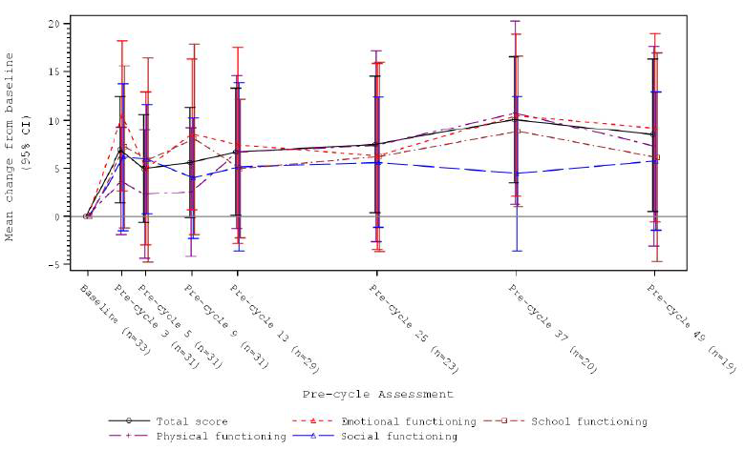

Source: Figure 2.20, p128

PedsQL = Paediatric Quality of Life Inventory

Patients aged 8 to 18 years at enrolment expected to complete self-report measures of the PedsQL (N = 34).

Figure . Mean Change from Baseline of PedsQL Parent-report Scores Over Time – Transformed Scores

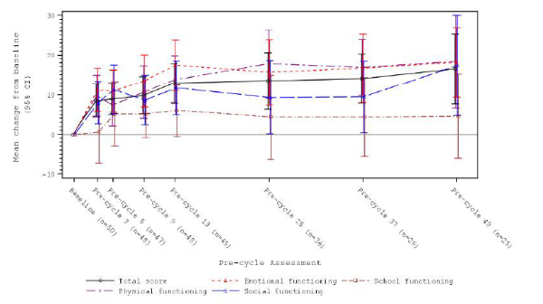

Source: Figure 2.21, p128

PedsQL = Paediatric Quality of Life Inventory

Parents or legal guardians of children aged 2 to 18 years at enrolment expected to complete the parent proxy

measures of the PedsQL (N = 50).

* 1. An improvement was observed in self- and parent-reported HRQoL over time based on mean change from baseline in PedsQL total score and domain scores. For self-reported PedsQL total scores, clinically meaningful improvements from baseline were observed at pre-Cycles 37 and 49. For parent-reported PedsQL total scores, clinically meaningful improvements from baseline were observed at pre-Cycles 13, 25, 37 and 49. However, HRQoL data from the SPRINT trial were not used to derive utilities in the economic model.

**NH Study**

* 1. Percentage change in target PN volume in NH study for age-matched cohort (aligned to maximum duration of follow up in SPRINT) is presented in Figure 9.

Figure . Percentage change in target PN volume in NH study, aligned to maximum follow-up (5.6 years) duration in SPRINT (age-matched cohort)

Figure 9. Percentage change in target PN volume in NH study, aligned to maximum follow-up (5.6 years) duration in SPRINT (age-matched cohort)

Source: Figure 2.23, p139 of the submission.

NH = Natural History, PN = plexiform neurofibroma(s)

* 1. The majority of patients in the NH study had PN that grew continuously over time or remained stable in size. The target PN growth rates of 73.4% (95% CI: -40.0, 1,426.0) and 78.4% (95% CI: -40.0, 1,429.0) were observed in the full analysis set (FAS) population and age-matched cohort, respectively. The target PN growth rates per year were similar across both the age-matched cohort and the age-matched cohort aligned to maximum follow-up in SPRINT, 15.1% (95% CI: -3.7, 126.2) and 16.0% (95% CI: -3.2, 136.2), respectively.
  2. Median PFS in the NH age-matched cohort was 1.3 years (95% CI: 1.1, 1.6). The proportion of patients without progression after 5 years was 23.1% (95% CI: 15.4, 31.7) in the FAS and 18.2% (95% CI: 10.8, 27.1) in the age-matched cohort of the NH study.
  3. HRQoL data was collected in the NH study using the Impact of Pediatric Illness Scale and Skindex. Comparison of HRQoL data was not presented in the submission because data in the SPRINT trial and NH study were collected at different intervals using different instruments (PedsQL 4.0 Generic Core Scales in SPRINT trial and Impact of Pediatric Illness Scale and Skindex in the NH study).

**01-C-0222 trial**

* 1. Kaplan-Meier plots of PFS in the 01-C-0222 trial is presented in Figure 10.

Figure . PFS in the 01-C-0222 trial

Figure 10. PFS in the 01-C-0222 trial

Source: Figure 2.27, p143 of the submission.

PFS = progression-free survival

* 1. The median time-to-progression in Phase A was 19.2 month for tipifarnib (n=31) and 10.6 months for placebo (n=29). No meaningful decrease in PN volumes was observed in either arm of the 01-C-0222 trial.

**Indirect treatment comparisons**

* 1. The submission presented the following unanchored indirect treatment comparisons to inform the efficacy of selumetinib compared to supportive care:
* A comparison of PFS between SPRINT and the age-matched cohort of children with symptomatic, inoperable NF1 PN from the NH study.
* A comparison of PFS between SPRINT and patients with NF1 and unresectable, progressive PN from the placebo arm of the 01-C-0222 trial.
  1. The submission also presented propensity score analyses between SPRINT and the age-matched cohort of NH study for PFS. Four different methods were performed to investigate the risk of bias for the comparison of the SPRINT and NH study populations:
* Matched 1:1 (without replacement) with a robust variance.
* Weighted using stabilised Inverse Probability of Treatment Weighting (IPTW).
* Weighted using IPTW, with a robust variance.
* Matched 1:2 (with replacement) with a robust variance.
  1. The evaluation considered that the methods used for propensity score analysis were appropriate.
  2. The submission identified one systematic review and meta-analysis of the efficacy and safety of selumetinib treatment of symptomatic, inoperable PN in patients with NF1 (Sharawat et al., 2022) during the literature search. A total of six uncontrolled trials with 134 patients (including 26 adults) were included in the analysis with 77.9% of patients had a partial response, 71.2% had a confirmed partial response, and PFS was observed in 93.1% of patients at the time of data cut-off. An independent search found one other systematic review and meta-analysis for selumetinib in paediatric patients with NF 1 (Hwang J et al., 2022). The findings of the meta-analysis were largely consistent with that of the SPRINT trial.
  3. Target PN growth rate in SPRINT and NH study are summarised in Table 5 and Figure 11.

Table **. Target PN Growth Rate, SPRINT and NH study**

|  |  |  |
| --- | --- | --- |
| **Trial** | **Time period, years**  **Median (min, max)** | **PN volume % change/year**  **Median (min, max)** |
| SPRINT | 4.0 (0.3, 5.6) | -5.1 (-27.3, 19.0) |
| NH study (age-matched) | 6.8 (1.0, 17.7) | 15.1 (-3.7, 126.2) |
| NH study (age-matched and aligned to maximum follow-up duration of SPRINT trial) | 4.8 (1.0, 5.6) | 16.0 (-3.2, 136.2) |

Source: Table 2.48, p152 of the submission.

NH = Natural History, PN = plexiform neurofibroma(s), min = minimum, max = maximum.

Figure . Percentage Change in Target PN Volume, NH Study (Age-matched) and SPRINT, Individual Patient Data Aligned to the Maximum Follow-up Duration of SPRINT

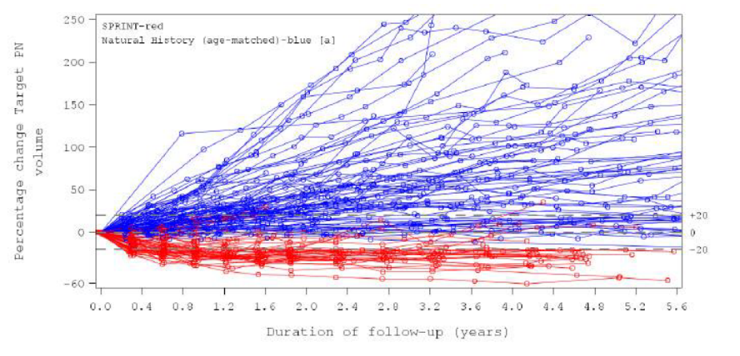

Source: Table 2.28, p152 of the submission.

NH = Natural History, PN = plexiform neurofibroma(s), min = minimum, max = maximum.

Red indicates SPRINT trial and Blue indicates NH study (age-matched)

* 1. Median percentage change in PN volume per year with selumetinib was -5% compared to 15.1% in the age-matched cohort and 16.0% in age-matched and aligned to maximum follow-up duration of the SPRINT trial. Selumetinib demonstrated efficacy in reversing or stabilising PN volume growth when compared with the NH study age-matched cohort.
  2. Kaplan-Meier curves for PFS in SPRINT and the NH study are presented in Figure 12.

Figure **. Kaplan Meier analysis of PFS, NH age-matched cohort and SPRINT, aligned to maximum follow-up duration of SPRINT**

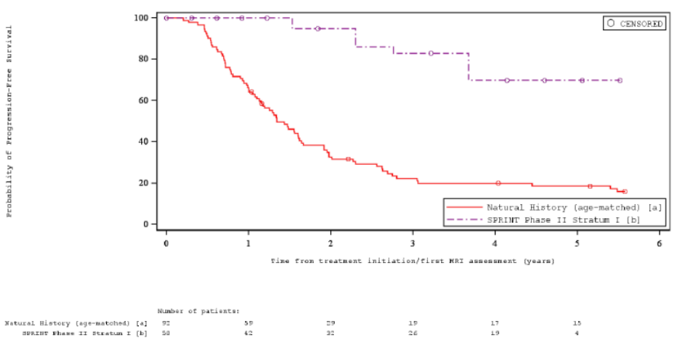

Source: Table 2.29, p153 of the submission.

* 1. Median PFS was not reached in the SPRINT trial, compared to 1.3 years (95% CI: 1.1, 1.6) in the NH age matched cohort. The proportion of patients without progression after 5 years was 69.7% (95% CI: 50.8, 82.5) in the SPRINT trial compared with 18.2% (95% CI: 10.8, 27.1) in the NH study.
  2. The results of the propensity score matching analyses for PFS is summarised in
  3. Table 6.

Table . HR for PFS from the unanchored indirect treatment comparison and from the propensity score analyses

|  |  |
| --- | --- |
| **Analysis** | **Hazard Ratio d (95% CI)** |
| Cox model: Unadjusted comparison | 0.07 (0.02, 0.24) |
| Cox model: Matched patients 1:1 (robust variance estimator) a,b | 0.08 (0.02, 0.29) |
| Cox model: Weighted by stabilised IPTW | 0.09 (0.03, 0.27) |
| Cox model: Weighted by IPTW (robust variance estimator) | 0.09 (0.03, 0.29) |
| Cox model: Matched patients 1:2 (robust variance estimator) b,c | 0.09 (0.03, 0.24) |

Source: Table 2.50, p155 of the submission.

CI = Confidence interval, IPTW = inverse probability of treatment weighting, HR = hazard ratio, NH = Natural History, PFS = Progression-free survival.

a Greedy Matching algorithm is used without replacement.

b The difference in the logit of the propensity score for a match must be ≤0.2 times the pooled estimate of the common standard deviation of the logits of the propensity scores.

c Each treated patient is matched up to 2 controls. Matching is performed with replacement.

d HRs were obtained using Cox regression with study as the only covariate.

* 1. The additional propensity score analyses for PFS between SPRINT and the age-matched cohort of the NH study showed that selumetinib is effective in reducing the risk of progression, when compared to supportive care.
  2. An unanchored indirect comparison was conducted against 01-C-0222 trial using the SPRINT data (n=21 patients with progressive PN at enrolment) from first data cut-off (June 2018). Kaplan-Meier curves for PFS in SPRINT and the 01-C-0222 trial are presented in Figure 13.

Figure **. Kaplan Meier analysis of PFS, 01-C-0222 trial placebo arm and SPRINT (Progressive PN)**

Figure 13. Kaplan Meier analysis of PFS, 01-C-0222 trial placebo arm and SPRINT (Progressive PN) 

Source: Table 2.31, p160 of the submission.

* 1. The proportion of patients without progression at 2 years for patients with progressive PN was 94.7% (95% CI: 80.6, 98.7) in the SPRINT trial compared to 20.6% (95% CI: 7.7, 37.8) in the placebo arm of the 01-C-0222 trial.

Comparative harms

* 1. A summary of key adverse events (AEs) in the SPRINT trial is presented in Table 7.

Table : **Summary of key adverse events in SPRINT trial**

| SPRINT trial | Selumetinib  n with event/N (%) |
| --- | --- |
| Any AE | 49/50 (98%) |
| Any severe AE (Grade ≥3)   * Diarrhoea * Vomiting * Blood CPK increased * Weight increased * Paronychia * Dermatitis acneiform * Pyrexia * Fracture * Syncope * Hypoxia | 34/50 (68%)  8/50 (16%)  4/50 (8%)  3/50 (6%)  4/50 (8%)  4/50 (8%)  3/50 (6%)  4/50 (8%)  3/50 (6%)  3/50 (6%)  4/50 (8%) |
| Any serious AE | 15/50 (30%) |
| Death | 0 |
| Any AE leading to discontinuation | 6/50 (12%) |
| Any AE leading to dose reduction | 16/50 (32%) |
| Any AE leading to dose interruption | 43/50 (86%) |

Source: Table 2.38, p133 and Table 2.40, p136 of the submission.

AE = adverse event, n = number of participants reporting data, N = total participants in group.

* 1. In the SPRINT trial, 34 (68%) patients experienced any severe adverse events (AEs) (Grade ≥ 3), 15 (30%) patients had serious AEs and 6 (12%) patients had an AE leading to discontinuation. The most frequently reported severe AEs (grade ≥ 3) were diarrhoea (16%), hypoxia (8%), paronychia (8%), pyrexia (8%), vomiting (8%), and increased weight (8%).
  2. The ESC noted 26/50 (52%) of patients discontinued treatment, with reasons for discontinuation including adverse event (6 patients), disease progression (6 patients), investigator discretion (6 patients), patient not willing to continue (3 patients), complicating illness (2 patients), treatment period completed (1 patient), non-compliance with protocol (1 patient) and other (1 patient)[4].

Benefits/harms

* 1. The indirect comparison presented in the submission did not allow for a quantitative comparison of the benefits and harms of selumetinib and supportive care. Accordingly, a benefits/harms table has not been presented.

Clinical claim

* 1. The submission described selumetinib as superior in terms of effectiveness compared to supportive care. The ESC and PBAC considered that this claim was adequately supported; however, noted the following uncertainties remained:
* The clinical evidence for selumetinib was based on the SPRINT trial, a single-arm, open-label study with a small sample size (N=50). The PSCR stated that clinical trials in paediatric patients were limited by the rare nature and high heterogeneity of NF1 PN.
* The comparison with supportive care was based on two unanchored indirect comparisons: the SPRINT trial versus the NH study and the SPRINT trial versus the placebo arm of the 01-C-0222 trial and there were transitivity issues between the studies relating to age, PN location, proportion of patients with progressive PN and PN volume.
* Progression was defined as ≥ 20% increase in PN volume; however, the SPRINT trial did not find direct correlation between change in neurofibroma size and PROs or functional responses.
* Most of the PROs presented in the submission (except for Pain Interference Index and visual acuity), have not been validated in patients with PN and no validated clinically meaningful thresholds exist for this population.
* There was a lack of clinical evidence assessing the effectiveness of selumetinib in patients > 18 years old.
  1. The submission described selumetinib as non-inferior in terms of safety compared to supportive care. The ESC considered that this claim was not adequately supported as:
* No evidence was presented comparing safety between selumetinib and supportive care. The pre-PBAC response stated that there were no safety outcomes available that would allow an indirect comparison.
* In the SPRINT trial, a total of 34 (68%) patients had any severe Grade ≥3 AEs and 15 (30%) patients had serious AEs.
  1. The pre-PBAC response reiterated that the safety profile of selumetinib was predictable and that overall, selumetinib is well tolerated. The pre-PBAC response stated that debulking surgery is often associated with the risk of complications, including delayed wound healing, pain, permanent neurological deficits, disfigurement, and functional deficits. In addition, the pre-PBAC response stated that many patients require long-term, complex pain management regimens with are associated with significant risk of side effects.
  2. The PBAC considered that the claim of non-inferior comparative safety was not adequately supported by the data.

Economic analysis

* 1. The submission presented a cost-utility analysis (CUA) of selumetinib compared to supportive care based on the claim of superior efficacy. Key components of the economic evaluation are presented in Table 8.

Table : **Summary of model structure, key inputs and rationale**

| Component | Summary |
| --- | --- |
| Treatments | Selumetinib vs Supportive Care |
| Time horizon | 100 years in the model base case versus maximum follow up of 6 years in trial. The PSCR and pre-PBAC response presented revised base cases in which the time horizon was reduced to 75 years. |
| Outcomes | QALYs |
| Methods used to generate results | Partitioned survival model (i.e., area under the curve) |
| Health states | Non-progressive, progressive disease, or death |
| Cycle length | 12 months |
| Allocation to health states | PFS KM were derived from the SPRINT trial for selumetinib and the NH study for supportive care and were extrapolated using parametric survival models.  Treatment discontinuation was implemented via parametric extrapolation of patient-level TTD from the SPRINT trial.  OS for both selumetinib and supportive care was estimated using general population mortality from the ABS adjusted based on the SMR for patients with NF1 reported in Duong et al. 2011. |
| Extrapolation method | Parametric model fitted to treatment arm with exponential distribution selected in base case for PFS (selumetinib), lognormal distribution selected in base case for PFS (supportive care), and Weibull distribution selected in base case for TTD based on goodness of fit and visual inspection. The pre-PBAC response presented revised base cases in which the lognormal distribution was applied to the selumetinib PFS arm.  85% of the incremental QALYs (discounted) and 5% of incremental costs (discounted) occurred in the extrapolated period. |
| Health related quality of life | TTO study conducted by the submission.  Selumetinib arm:  Patients off-treatment with selumetinib = 0.51 (progressed health state); Patients on-treatment with selumetinib =0.74 (progression-free health state)  Supportive care arm:  Progression-free = 0.625; Progressed = 0.51 |
| Discount rate | 5% applied to all costs; 5% applied to benefits until a patient turns 18, 3% applied between the ages of 18 and 24, and 1.5% applied for patients over the age of 24. The pre-PBAC response presented a revised base case in which a 5% discount rate was applied to benefits up until the age of 24 and a 3.5% rate was applied thereafter. |

Source: Table 3.2, p176 of the submission and ‘Selumetinib Section 3 workbook’ Excel workbook.

ABS = Australian Bureau of Statistics, KM = Kaplan-Meier, NF1 = neurofibromatosis type 1, NH = Natural History study, OS = overall survival, PFS = progression-free survival, PN = plexiform neurofibroma(s), QALY = Quality-adjusted life-years, SMR = standardised mortality ratio, TTD = treatment-to-discontinuation, TTO = time trade off.

* 1. The submission used a partitioned survival model to assess the cost effectiveness of selumetinib for the treatment of patients with NF1 PN. The model consisted of three health states:
* Non-progressed disease (on-treatment and off-treatment); the separation of the non-progressed state into on-treatment and off-treatment may not be appropriate especially with the assignment of different utilities to the two sub-states*.*
* Progressed disease (defined as ≥ 20% increase in PN tumour size from baseline or, if a patient had a partial response then defined as an increase of at least 20% from the best response measured by volumetric MRI analysis); and
* Death.
  1. The maximum duration of follow-up for selumetinib in the SPRINT trial was 72 months (6 years). Parametric distributions with best relative fit according to Akaike's Information Criteria (AIC) and Bayesian Information Criteria (BIC) and visual inspection were used to extrapolate the Kaplan-Meier function curves (PFS and time to treatment discontinuation (TTD)) from the maximum follow-up time over a time horizon of 100 years.
  2. The ESC considered that the application of a 100-year time horizon was too long for the population with NF1 PN and introduced considerable uncertainty to the model. The ESC noted that paediatric patients with NF1 and symptomatic PN, have a higher mortality rate compared to NF1 patients with no PN or asymptomatic PN (3.2% vs 0.5%)[5]. The results of sensitivity analyses indicated that the model was sensitive to a reduction in the time horizon, with incremental cost per QALY gained plateauing around 70 years. The PSCR and pre-PBAC response presented revised base cases in which the time horizon was reduced to 75 years.
  3. A uniform discount rate of 5% was applied to the costs, whereas a differential discount rate was applied to benefits. The submission stated that the requested listing is for a paediatric population with the majority of patients stopping treatment by the age of 18. Thus, the submission applied a 5% discount on benefits until a patient turns 18 based on the assumption that the benefits are accrued at the same time as costs. For patients between the ages of 18 to 24, the submission applied a discount rate of 3% based on the assumption that the majority of patients are off-treatment, but a minority of patients may continue to experience progressive disease. A 1.5% benefit discount rate was applied up until the specified lifetime horizon based on the assumption that no patients progress or accrue costs of treatment. This approach would maximise the estimated benefits from selumetinib by applying a reduced discount rate for the extrapolated period until the end of the specified time horizon. The PSCR stated that the tiered differential discount rate applied to the health benefits was appropriate as treatment with selumetinib demonstrated a clinically meaningful improvement in QoL, due to a reduction in tumour size, which was expected to persist and result in future benefits, allowing patients to be more productive and reducing the cost of managing morbidities in adulthood. In addition, the clinical benefits observed at the age of 18 were assumed to continue until the end of the time horizon. The ESC noted that as tumour growth rates are expected to slow over time, the comparative effectiveness claimed while on treatment may not continue for the duration of the time horizon.
  4. According to the PBAC guidelines (Version 5.0), both costs and health outcomes should be discounted at a rate of 5% per year for all costs and health outcomes that occur or extend beyond one year in the base case. Although the PSCR noted that the PBAC guidelines allow submissions to use other discounting methodologies such as a different uniform rate, differential rates and time-varying rates, the ESC noted that the guidelines state that these should be presented as supplementary analyses.
  5. The PSCR further noted that the PBAC had previously accepted a reduced 3.5% discount on costs and outcomes for a meningococcal B vaccine. Whilst acknowledging that the indication and utilisation of selumetinib was different to a vaccine, the PSCR stated that there were similarities that should be factored into the economic evaluation – like a vaccine, the cost of treatment with selumetinib is upfront in the earlier years of life, with benefits expected to continue into later years of life. The ESC, whilst acknowledging the use of a 3.5% discount rate in the meningococcal B vaccine submission, considered that a 5% discount rate, applied to costs and outcomes in the base case analysis, more appropriately captured the time preference of the more immediate (certain) health gains against future (much less certain) health gains of selumetinib, as there was a very high degree of uncertainty associated with the future consequences of selumetinib use, particularly given the increased mortality associated with NF1 PN.
  6. The pre-PBAC response presented a revised base case in which a 5% discount rate was applied to benefits up to the age of 24, beyond which a 3.5% rate was applied. The pre-PBAC response stated that the application of a 5% rate on immediate health benefits whilst the patient was on treatment was appropriate. The pre-PBAC response stated that as (i) tumour growth rates slow, and (ii) there is an overall improvement in the management of existing morbidities as patients age, the application of a 3.5% rate to benefits for patients off treatment was appropriate.
  7. The submission did not use the PedsQL data from the SPRINT trial to estimate utilities in the economic model. The submission stated that PedsQL data mapped to EQ-5D-Y using an algorithm developed by Khan et al. (2014) did not adequately reflect the targeted patient population as a different population was used to develop the mapping algorithm.
  8. The ESC noted that the submission conducted a time trade off (TTO) study amongst general public in the United Kingdom (UK) to estimate utilities for patients with NF1 and symptomatic, inoperable PN for use in the economic model. As the utility values were not based on the experience of patients or their carers, they may not reflect accurate utility values for patients with NF1 PN.
  9. Based on the TTO, the submission applied an estimated utility of 0.74 for patients in the progression-free health state and of 0.51 for patients in the progressed state to the selumetinib arm. For the supportive care arm, the submission assumed a utility of 0.625 in the progression-free state and 0.51 in the progressive disease state. Assigning progression-free patients in the selumetinib arm higher utility scores favoured selumetinib. The submission did not provide any justification or source for the utilities used for progression-free health state in the supportive care arm. The ESC considered that the utility values in the progression-free health state should be consistent between the selumetinib and best supportive care arms. The pre-PBAC response stated that the application of a uniform progression free utility value was not appropriate as it implied that patients on standard care experience the same rate of PN growth (or reduction) and quality of life as selumetinib patients.
  10. The total accrued utility over the first 30 years of the model is presented in Figure 14.

Figure . Age-adjusted utility values for the first 30 years of the model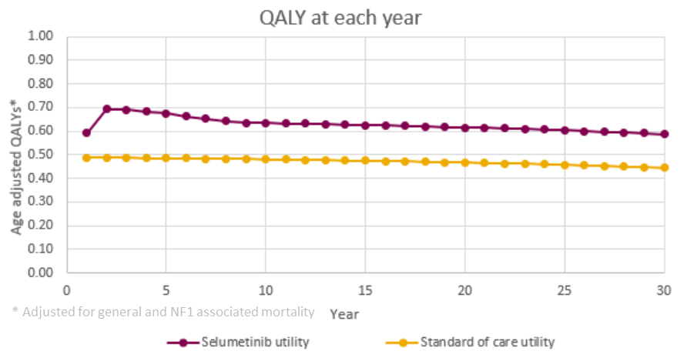

Source: Figure 3.13, p203 of the submission.

* 1. As the submission assumed that the effect of selumetinib on HRQoL would continue for life, the utility for all surviving patients was adjusted to include age-related disutility using a regression equation developed by Ara and Brazier (2010).
  2. The economic model included costs associated with drug acquisition (selumetinib), concomitant pain medication, disease monitoring, and management of adverse events.
  3. The model applied an average MRI cost (weighted across a number of MBS codes) and assumed two MRIs would be used for routine disease monitoring in the selumetinib arm. The evaluation of target PN was conducted using volumetric MRI in the SPRINT trial. It is uncertain if MRI would be used routinely in clinical practice outside of a clinical trial and if the MBS codes used appropriately represent volumetric MRI.
  4. The submission might have underestimated the costs associated with the additional tests required to monitor toxicity with the use of selumetinib. The TGA Product Information (PI) for selumetinib recommends testing of serum creatine phosphokinase (CPK) prior to obtaining selumetinib, periodically during treatment, and as clinically indicated. The TGA PI further recommends an ophthalmological evaluation prior to treatment and at any time a patient reports new visual disturbances.
  5. Traces of trial versus the model results (PFS and TTD) are presented in Figure 15. The ESC noted 52% of patients discontinued treatment (see paragraph 6.46). The ESC considered there was a high degree of uncertainty around the long-term use of selumetinib as reflected in the clinical trial data and the modelling.

Figure : Kaplan Meier curves from the SPRINT trial with extrapolations

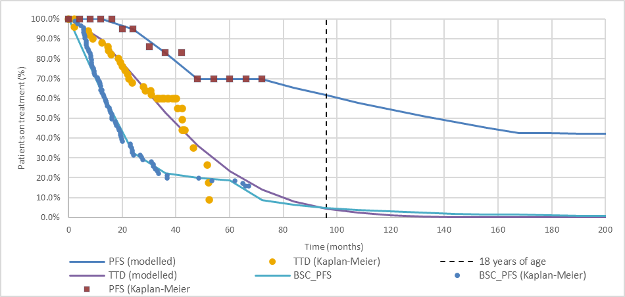

Source: ‘Selumetinib Section 3 workbook’ Excel workbook.

KM = Kaplan-Meier

* 1. The submission used exponential parametric distribution to extrapolate the KM PFS curve for the selumetinib arm, lognormal parametric distribution to extrapolate the KM PFS curve for the supportive care arm, and Weibull parametric distribution to extrapolate the KM TTD curve beyond the duration of the trial. The use of different parametric distributions to extrapolate KM PFS curves for the selumetinib (exponential) and supportive care (lognormal) arms may not be appropriate.
  2. The parametric models used in the model for PFS may not be appropriate and favoured selumetinib. The models were chosen based on visual inspection only, with no consideration of AIC and BIC scores. The application of the exponential distribution to the PFS Kaplan Meier curve from the SPRINT trial favoured selumetinib compared to if the lognormal curve, which had the lowest AIC and BIC scores, was applied (see Figure 16). Additionally, the time point at which extrapolation occurs (i.e., maximum follow up) may not be appropriate. The PSCR and pre-PBAC response presented revised base cases in which the lognormal distribution was applied to the selumetinib PFS arm.

Figure 16: Parametric survival models for PFS in the selumetinib arm

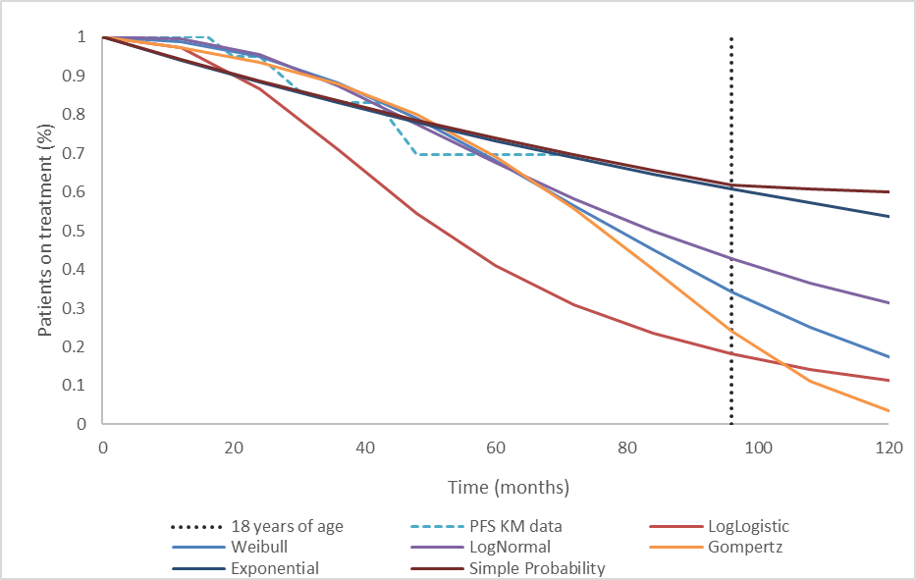

Source: Figure 3.8, p191 of the submission.

KM = Kaplan-Meier, PFS = progression-free survival.

* 1. The submission stated the selection of the most appropriate distribution for the TTD curve was informed by goodness-of-fit statistics, visual inspection of the extrapolated curves against SPRINT trial data and expected clinical outcome. The submission stated the AIC and BIC statistics were similar across the six distributions explored indicating similar statistical fit. The base case model implemented a Weibull distribution as it had the lowest AIC and BIC statistics and resulted in the most plausible predictions of treatment duration given the assumption that the rate of treatment continuation into adulthood would be low. The evaluation considered the use of a Weibull distribution to model TTD might have underestimated the use of selumetinib as well as the costs of managing adverse events. The ESC considered that while the Weibull distribution may be reasonable, the model is very sensitive to the extrapolation assumptions with the use of a loglogistic function (the next best fit according to AIC and BIC statistics) increasing the ICER to $135,000 to < $155,000 per QALY. The ESC noted the Weibull and loglogistic function both visually fit the earlier data reasonably well (Figure 17).

Figure 17: Parametric survival models for TTD in the selumetinib arm

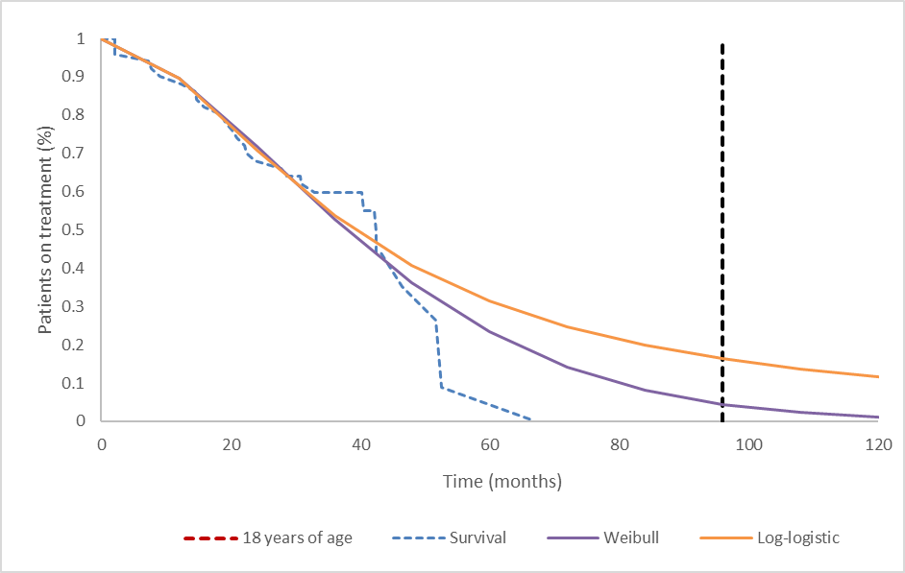

Source: Selumetinib Section 3 workbook.xls provided with the submission

* 1. There was also substantial uncertainty in PFS over the long-term due to the immaturity of PFS data in the SPRINT trial.
  2. A summary of the key drivers of the model is presented in Table 9.

Table : **Key drivers of the model**

| Description | Method/Value | Impact  Base case: $|1/QALY gained. |
| --- | --- | --- |
| Discount rate | 5% for costs, with a differential rate for outcomes:  5% applied until 18 years  3% applied from 18 to 24 years  1.5% from age 24 years | High, favours selumetinib.  Applying a uniform discount rate of 5% (as per PBAC guidelines) to costs and outcomes increased the ICER by 95% to $||||||2/QALY. |
| Time horizon | 100 years in the model base case versus maximum follow up of 6 years in trial. | Moderate, favours selumetinib.  Reducing the time horizon to 50 years increased the ICER by 18% to $||||||3/QALY. |
| Extrapolation | Exponential distribution applied to PFS in the selumetinib arm;  Lognormal distribution applied to PFS in the supportive care arm;  Weibull distribution applied to TTD. | High, favours selumetinib.  Application of the lognormal parametric distribution (best relative fit according to AIC and BIC scores) to PFS in the selumetinib arm, instead of exponential distribution, increased the ICER by 9%.  Application of the loglogistic parametric distribution to TTD, instead of Weibull distribution, increased the ICER by 51%. |
| SMR | Assumed to be 2.02 based on Duong et al., 2011. | Moderate, favours selumetinib.  Assuming an SMR of 3.22 based on Uusitalo et al., 2015, increased the ICER by 22% to $||||||3/QALY. |

Source: Table 3.2, p176 of the submission, Table 3.31, pp221-222 and Table 3.32, p222-223 of the submission.

ICER = incremental cost-effectiveness ratio, PFS = progression-free survival, SMR = standardised mortality ratio, TTD = time to treatment discontinuation, TTO = time trade off.

*The redacted values correspond to the following ranges:*

*1 $95,000 to < $115,000*

*2 $155,000 to < $255,000*

*3 $115,000 to < $135,000*

* 1. The results of the modelled economic evaluation are summarised in Table 10.
  2. The Pre-PBAC response presented a revised base case which applied:
  + a 75 year time horizon (as compared to 100 years in the submission);
  + the lognormal distribution to PFS in the selumetinib arm as this had the lowest AIC/BIC scores (as compared to the exponential distribution in the submission);
  + an updated average MBS MRI fee to reflect July 2022 costs; and
  + a 5% discount rate to benefits up to the age of 24, beyond which a 3.5% rate was applied.

Table : **Results of the stepped economic evaluation**

| Step and component | Selumetinib | Supportive care | Increment |
| --- | --- | --- | --- |
| **Step 1: trial-based costs and outcomes** | | | |
| Costs | $| | $0 | $　| |
| QALY | 4.06 | 3.07 | 0.99 |
| Incremental cost/extra QALY gained | | | $　|　1 |
| Step 2: time horizon extended to 100 years | | | |
| Costs | $| | $0 | $　| |
| QALY | 38.42 | 29.47 | 8.95 |
| Incremental cost/extra QALY gained | | | $　|　2 |
| Step 3: discounting (5% for costs and differential discounting for outcomes) included | | | |
| Costs | $| | $0 | $　| |
| QALY | 23.77 | 18.23 | 5.54 |
| Incremental cost/extra QALY gained | | | $　|　3 |
| Step 4: incorporation of medical resource costs | | | |
| Costs | $| | $10,860 | $　| |
| QALY | 23.77 | 18.23 | 5.54 |
| **Incremental cost/extra QALY gained (base case)** | | | **$　|**3 |
| Pre-PBAC revised base case | | | |
| Costs | $| | $10,845 | $　| |
| QALY | 14.87 | 11.59 | 3.29 |
| **Incremental cost/extra QALY gained (base case)** | | | **$　|**4 |

Source: Table 3.27, p219 of the submission, p2 of the pre-PBAC response.

QALY = quality-adjusted life years

*The redacted values correspond to the following ranges:*

*1 $555,000 to < $655,000*

*2 $55,000 to < $75,000*

*3 $95,000 to < $115,000*

*4 $155,000 to < $255,000*

* 1. For patients treated with selumetinib and followed-up for 100 years, the economic evaluation estimated the following:
* Cost of selumetinib was $| | (undiscounted).
* Approximately 38.42 QALYs gained (undiscounted), resulting in an improvement of approximately 8.95 QALYs over supportive care.
  1. Based on the economic model presented in the submission, treatment with selumetinib was associated with an incremental cost per QALY gained of $95,000 to < $115,000 compared to supportive care, for the treatment of patients with NF1 PN. The revised base case in the pre-PBAC response resulted in an incremental cost per QALY gained of $155,000 to < $255,000.
  2. The results of key sensitivity analyses are summarised in Table 11.

Table 11: Sensitivity analyses

| Analyses | Incremental cost ($) | Incremental QALY | ICER ($) | % change to ICER |
| --- | --- | --- | --- | --- |
| **Base case** | **|** | **5.54** | **|**1 | **-** |
| Discount rate (base case 5% for costs and differential rate for outcomes) | | | | |
| 0% costs and outcomes | | | 8.95 | |　2 | -31% |
| 3.5% costs and outcomes | | | 3.69 | |　3 | 55% |
| 5% costs and outcomes | | | 2.84 | |　4 | 95% |
| Time horizon (base case 100 years) | | | | |
| 50 years | | | 4.70 | |　5 | 18% |
| 80 years | | | 5.54 | |　1 | 0.1% |
| Extrapolation of PFS – selumetinib (base case exponential) | | | | |
| Gompertz | | | 4.22 | |　5 | 31% |
| Loglogistic | | | 4.64 | |　5 | 20% |
| Lognormal | | | 5.08 | |　1 | 9% |
| Weibull | | | 4.70 | |　5 | 18% |
| Extrapolation of TTD (base case Weibull) | | | | |
| Exponential | | | 5.54 | |　3 | 41% |
| Gompertz | | | 5.54 | |　6 | -13% |
| Loglogistic | | | 5.54 | |　3 | 51% |
| Lognormal | | | 5.54 | |　4 | 60% |
| Utility – PFS (base case 0.74 for selumetinib (on-treatment) and 0.625 for supportive care arm) | | | | |
| Assuming same progression-free utility values for both arms (0.74) | | | 5.38 | |　1 | 3% |
| SMR (base case 2.02) | | | | |
| 3.22 | | | 4.55 | |　5 | 21.83% |
| **Multivariate sensitivity analyses** | | | | |
| Assuming uniform discount rate (5%) and varying time horizon | | | | |
| 50 years | | | 2.73 | |　4 | 103% |
| 80 years | | | 2.84 | |　4 | 95% |
| Assuming uniform discount rate (5%), 50 year time horizon, extrapolation of PFS for selumetinib (lognormal), same progression-free utility values for both arms (0.74) | | | | |
|  | | | 2.40 | |　4 | 131% |
| Assuming uniform discount rate (5%), 50 year time horizon, extrapolation of PFS for selumetinib (lognormal) and TTD (loglogistic), same progression-free utility values for both arms (0.74) | | | | |
|  | | | 2.40 | |　7 | 247% |

Source: Table 3.31, pp221-222 and Table 3.32, p222-223 of the submission.

AIC = Akaike's Information Criteria, BIC = Bayesian Information Criteria, ICER = Incremental cost-effective ratio, PFS = progression-free survival, TTD = time to discontinuation, QALY = quality adjusted life year.

*The redacted values correspond to the following ranges:*

*1 $95,000 to < $115,000*

*2 $55,000 to < $75,000*

*3 $135,000 to < $155,000*

*4 $155,000 to < $255,000*

*5 $115,000 to < $135,000*

*6 $75,000 to < $95,000*

*7 $255,000 to < $355,000*

* 1. The results of sensitivity analyses indicate that the model was most sensitive to discount rate. Applying a uniform discount rate of 5% (as per PBAC guidelines) to outcomes instead of differential discounting increased the ICER by 95% to $155,000 to < $255,000 per QALY gained*.*
  2. The ESC considered that the economic model provided in the submission was optimistic and suggested that a revised base case should apply:
  + a constant discount rate of 5% to costs and outcomes. The pre-PBAC response stated that the revised base case applied a 5% discount rate to health benefits whilst a patient was on treatment (i.e. up to the age of 24 years). The pre-PBAC response claimed that the application of the revised 3.5% rate to benefits for patients off treatment (i.e. patients over the age of 24 years) was appropriate as these patients had improved quality of life and it reduced the uncertainties in the economic model,
  + a time horizon of 50 years. The pre-PBAC response stated that there was no justification for a 50 year time horizon and that Evans et al (2011)[6] demonstrated a median survival of 71.5 years, based on estimates from 1,023 NF1 patients;
  + lognormal extrapolation for PFS in the selumetinib arm (this was accepted in the pre-PBAC response); and
  + uniform utility values to the progression free health state for both the selumetinib and standard care arms. The pre-PBAC response stated that the application of a uniform progression free utility value was not appropriate as it implied that patients on standard care experience the same rate of PN growth (or reduction) and quality of life as selumetinib patients.
  1. The ESC noted the ICER for this scenario was $155,000 to < $255,000 per QALY and advised that a price reduction would be required to ensure the cost effectiveness of selumetinib. The ESC noted the ICER was sensitive to assumptions regarding time to treatment discontinuation with the ICER increasing to $255,000 to < $355,000 per QALY using an alternative extrapolation assumption.

Drug cost/patient/year

Table : **Drug cost per patient**

| **Body surface area (m2) a** | **Dose (mg)** | **Cost/dose ($)** | **Cost/day ($)** | **Cost/annum ($)** |
| --- | --- | --- | --- | --- |
| 0.55-0.69 | 20 then 10 | | | | | | |
| 0.70-0.89 | 20 | | | | | | |
| 0.90-1.09 | 25 | | | | | | |
| 1.10-1.29 | 30 | | | | | | |
| 1.30-1.49 | 35 | | | | | | |
| 1.50-1.69 | 40 | | | | | | |
| 1.70-1.89 | 45 | | | | | | |
| 1.90-1.94 | 50 | | | | | | |

Source: ‘Selumetinib Section 3 Workbook’

a Dosage was based on body surface area and was assumed to increase with age until 18 years.

* 1. The cost of selumetinib per patient per year was based on the patients BSA. In the economic model, the submission assumed that BSA will change as patients age and grow. A linear regression algorithm was used to predict the BSA of patients until the age of 18 years, after which the BSA was assumed to stabilise. In the financial analysis, the submission estimated the annual cost based on a mean age of 10.3 years and a mean BSA of 1.127m2; however, as the BSA was not adjusted for age this may have underestimated the financial impact of listing selumetinib.

Estimated PBS usage & financial implications

* 1. This submission was considered by DUSC.
  2. The submission applied an epidemiological approach to estimate the use of selumetinib for the treatment of patients aged ≥2 years and diagnosed ≤18 years of age with NF1 and symptomatic, inoperable PN. The estimated use and financial implications of listing selumetinib are summarised in Table 13.

Table : **Key inputs for financial estimates**

| Parameter | Value applied and source | Comment |
| --- | --- | --- |
| Australian population aged ≥2 years to ≤18 years | Year 1: 5,680,375; ABS projection (2023) | - |
| Prevalence of NF1 | 1 in 3,000; The Royal Children’s Hospital Melbourne | - |
| Incidence of NF1 | 103 to 104 new patients per year; Projections from AIHW Mothers and babies 2019 | Incident patients were removed in the revised estimates presented in the pre-PBAC response. |
| Proportion of patients with PN | 30%; Survey of seven Australian clinicians experienced in treating PN and validated at Australian Clinical Advisory Board | The DUSC noted there was no information provided in the submission regarding the range of responses provided or how the responses were analysed. |
| Proportion of patient with symptomatic NF1 PN | 74%; Survey of seven Australian clinicians experienced in treating PN and validated at Australian Clinical Advisory Board |  |
| Proportion of patients with symptomatic, inoperable NF1 PN | 90%; Survey of seven Australian clinicians experienced in treating PN and validated at Australian Clinical Advisory Board |  |
| Patients actively managed | 75%; Survey of seven Australian clinicians experienced in treating PN and validated at Australian Clinical Advisory Board | This assumption was removed in the revised estimates presented in the pre-PBAC response. |
| Selumetinib share | 80%; Survey of seven Australian clinicians experienced in treating PN and validated at Australian Clinical Advisory Board | This is uncertain given the off-label use of trametinib for treating NF1 PN in Australia and the ongoing recruitment of patients in the TiNT trial. |
| Prevalent population uptake rate | Estimation based on proxy analysis of vismodegib listed on the PBS.  40% in Year 1 to 95% in Year 6. | The DUSC considered other factors that may affect uptake of selumetinib include the ability to swallow capsules as well as the off-label use of trametinib for the treatment of NF1 PN. |
| Time on treatment (Weibull) | Derived from the Weibull extrapolation of time on treatment.  100% in Year 1 to 23.3% in Year 6 from TTD KM curve. | This approach to estimating time on treatment may not be reasonable as applying discontinuation from the Weibull extrapolation is not necessary with a prevalence-based approach. Patients will be represented in each forward year within the prevalence estimate and compliance is already applied for the number of scripts they receive in each year. |
| Compliance rate | 85%; submission assumption | - |
| Average dose | 30 mg BID; Based on the mean BSA reported in the SPRINT trial and dosed at 25 mg/m2 | Consistent with the SPRINT trial, the dose for a BSA of 1.127m2 was 30 mg twice daily ($|||||| per patient per year). However, this dose was not adjusted to account for the increase in BSA with age. |
| MRI scans | $380.80; 100%, MBS item code: 63301  Average MBS benefit: 80% | Updated to reflect July 2022 costs in pre-PBAC response |
| Public/Private weighting | The submission assumed 100% public weighting, | This may not be appropriate given that the submission requested listing for use in both public and private setting. |

Source: Table 4.2, pp225-226 of the submission.

ABS = Australian Bureau of Statistics, AIHW = Australian Institute of Health and Welfare, BID = twice a day, BSA = body surface area, MBS = Medicare Benefits Scheme, MRI = magnetic imaging resonance, NF1 = neurofibromatosis type 1, PN = plexiform neurofibroma(s).

* 1. The addition of the number of incident patients to the number of prevalent patients will overestimate the treated population (as incident patients would already be captured in the prevalence estimate). The DUSC considered that a prevalence only based epidemiological approach would be appropriate and this approach would also capture any potential grandfathered patients (noting the submission requested a restriction to allow patients currently receiving selumetinib to transition to PBS-subsidised treatment). Revised estimates presented in the pre-PBAC response removed the incident patients.
  2. The evaluation considered the main sources of uncertainty relating to the estimated use of selumetinib were:
* The estimated uptake rate may not be accurate given the off-label use of trametinib for treating NF1 PN in Australia and the ongoing recruitment of patients in TiNT trial.
* Vismodegib, a PBS drug listed for different indication and population, was used as a proxy to predict the uptake rate for selumetinib.
* Use of compliance rate to estimate scripts would be double counting given that compliance is reflected in the number of patients on treatment.
  1. The submission may have underestimated the additional tests required for monitoring toxicity with the use of selumetinib. TGA PI for selumetinib recommends the use of serum creatine phosphokinase (CPK) prior to obtaining selumetinib, periodically during treatment, and as clinically indicated. The TGA PI further recommends an ophthalmological evaluation prior to treatment and at any time a patient reports new visual disturbances. Furthermore, the number of MRIs are required to replace volumetric MRIs is uncertain.
  2. The estimated net financial implications of listing selumetinib are summarised in Table 14.

Table : **Estimated use and financial implications**

|  | Year 1 | Year 2 | Year 3 | Year 4 | Year 5 | Year 6 |
| --- | --- | --- | --- | --- | --- | --- |
| Estimated extent of use | | | | | | |
| Number of patients treated | |||1 | |||1 | |||1 | |||1 | |||1 | |||1 |
| Number of scripts dispenseda | |||2 | |||2 | |||2 | |||2 | |||2 | |||2 |
| Estimated financial implications of selumetinib | | | | | | |
| **Cost to PBS/RPBS less copayments ($)** | **|||**3 | **|||**6 | **|||**6 | **|||**6 | **|||**5 | **|||**5 |
| Net financial implications | | | | | | |
| Net cost to MBS ($) | |||4 | |||4 | |||4 | |||4 | |||4 | |||4 |
| Net cost to PBS/RPBS/MBS ($) | |||3 | |||6 | |||6 | |||6 | |||5 | |||5 |
| **Pre-PBAC revised estimates** | | | | | | |
| Number of patients treated | |||1 | |||1 | |||1 | |||1 | |||1 | |||1 |
| Net cost to PBS/RPBS less copayments ($) | |||5 | |||6 | |||6 | |||6 | |||5 | |||5 |
| Net cost to PBS/RPBS/MBS ($) | |||5 | |||6 | |||6 | |||5 | |||5 | |||5 |

Source: Source: Table 4.8, p233, Table 4.20, p239, and Table 4.23, p240 of the submission and Table 1, p3 of the pre-PBAC response.

a Assuming 10.35 scripts per year as estimated by the submission.

*The redacted values correspond to the following ranges:*

*1 < 500*

*2 500 to < 5,000*

*3 $10 million to < $20 million*

*4 $0 to < $10 million*

*5 $20 million to < $30 million*

*6 $30 million to < $40 million*

* 1. The net cost to the PBS/RPBS of listing selumetinib was estimated in the submission to be $20 million to < $30 million in Year 6 and total of $100 million to < $200 million over the first 6 years. The net cost to the PBS/RPBS of listing selumetinib was estimated in the pre-PBAC response to be $20 million to < $30 million in Year 6 and total $100 million to < $200 million over the first 6 years.
  2. The DUSC considered that the estimates presented in the submission were uncertain and likely underestimated as:
* the approach used to estimate the dose and number of prescriptions supplied was imprecise as the trial based mean BSA was applied to the whole population.
* there was uncertainty in the estimates of:
* the proportion of patients with PN. The financial estimates were most sensitive to this parameter.
* the proportion of patients with symptomatic, inoperable PN.
* the off-label use of trametinib in this population.
* there were no stopping, relapse or restart rules in the proposed restriction.
* there was potential for use outside the restriction into the adult population, particularly in young adults.

Quality Use of Medicines

* 1. The submission stated that implementation of TGA approved label wording and consumer medicine information will ensure quality use of medicines.
  2. The submission stated that a post-marketing safety study has been planned to characterise the long-term safety profile of selumetinib among paediatric patients; however, no Australian patients were expected to be enrolled.
  3. The DUSC considered there was potential for underdosing and wastage due to challenges associated with taking large capsules in a paediatric population.

Financial Management – Risk Sharing Arrangements

* 1. The sponsor acknowledged the uncertainty in patient estimates and indicated willingness to enter into a Risk Sharing Arrangement (RSA).

*For more detail on PBAC’s view, see section 7 PBAC outcome.*

1. PBAC Outcome
   1. The PBAC did not recommend selumetinib for the treatment of symptomatic, inoperable plexiform neurofibroma(s) (PN) in paediatric patients with neurofibromatosis (NF1). Although the PBAC considered that selumetinib provided a high clinical benefit for patients with PN associated with NF1 compared to supportive care, the PBAC noted that there were significant issues with the proposed restriction, the economic model and the utilisation estimates. The PBAC also noted that there were quality use of medicine issues relating to the size of the capsule and the proposed use in young children (who were the most likely to benefit from treatment).
   2. The PBAC acknowledged the consumer comments relating to this submission which described the quality of life challenges associated with the disease and highlighted the high unmet clinical need for effective treatments. The PBAC noted the significant impact PN associated with NF1 can have on children including pain and disfigurement. The PBAC noted the comments related to the importance of access to a treatment other than surgery and the high cost of selumetinib.
   3. The PBAC considered that the proposed place in therapy of selumetinib as an alternative to supportive care in paediatric patients with inoperable PN was reasonable.
   4. The PBAC considered that the nominated comparator, supportive care, was appropriate.
   5. The PBAC noted that to demonstrate effectiveness the submission presented unanchored indirect treatment comparisons between selumetinib and supportive care based on the SPRINT trial (selumetinib), the National Cancer Institute Natural History (NCI NH) study and the placebo arm of the 01-C-0222 trial. The PBAC noted that although the eligibility criteria across the studies were similar, there were key differences in the patient populations that may have affected the transitivity (see paragraph 6.11).
   6. The PBAC noted that the SPRINT trial (median follow up of 4 years) reported that 46 of 48 patients (95.8%) experienced a reduction in PN volume and 34 of 50 patients (68.0%) had a confirmed partial response (which was defined as PN volume decrease of ≥ 20% compared to baseline on consecutive examinations at least 3 months apart). The PBAC noted that median progression free survival (which was defined as PN volume increase of ≥ 20% compared to baseline) was not reached in the SPRINT trial. The PBAC noted that patients in the SPRINT trial also reported clinically meaningful improvements in a number of functional and patient-reported outcomes.
   7. In terms of the indirect treatment comparisons, the PBAC noted that:
   * selumetinib was associated with a -5.1% (95% CI: -27.3, 19.0) PN volume change (decrease) per year in the SPRINT trial compared to a 15.1% (95% CI: -3.7, 126.2) volume change (increase) per year for supportive care in the NH study;
   * the probability of remaining without progression after 5 years was 69.7% (95% CI: 50.8, 82.5) in the SPRINT trial compared to 18.2% (95% CI: 10.8, 27.1) in the NH study; and
   * the probability of remaining without progression after 2 years was 94.7% (95% CI: 80.6, 98.7) in the SPRINT trial compared to 20.6% (95% CI: 7.7, 37.8) in the placebo arm of the 01-C-0222 trial.
   1. Overall, the PBAC was moderately certain that selumetinib demonstrated superior efficacy compared to supportive care but noted a number of uncertainties remained due to the reasons outlined in paragraph 6.48.
   2. The PBAC noted that the submission did not provide any comparative safety data for selumetinib versus supportive care. The PBAC noted that 68% of patients in the SPRINT trial experienced a severe adverse event (Grade ≥ 3) and 52% of patients had discontinued treatment at the median follow up of 4 years.
   3. Overall, the PBAC considered the claim that selumetinib was non-inferior in terms of safety compared to supportive care could not be supported given the lack of comparative data.
   4. The PBAC considered there were a number of issues with the economic model that reduced its reliability for decision-making, including:
   * time horizon (paragraph 6.55).
   * application of the differential discount rate (paragraphs 6.56 to 6.59).
   * costs of monitoring for selumetinib toxicity and the costs associated with AEs due to selumetinib were omitted (paragraph 6.67).
   * source of utilities and application of differential utilities for the progression free health state (paragraphs 6.60 to 6.62).
   * extrapolation function applied to selumetinib for PFS (paragraph 6.70).
   * extrapolation function for time to treatment discontinuation (paragraph 6.71).
   * standard mortality ratio applied (Table 9).
   1. Notwithstanding the concerns regarding the economic model outlined above, the PBAC considered the ESC revised base case (as outlined in paragraph 6.80) addressed the minimum changes required to improve the reliability of the model. The PBAC noted the ICER using the revised base case was $155,000 to < $255,000 per QALY gained to $255,000 to < $355,000 per QALY gained, depending on the extrapolation function applied for time to treatment discontinuation. The PBAC considered that, based on the economic model respecified by the ESC, it was moderately confident selumetinib was likely to be cost effective at an ICER of less than $75,000 to < $95,000 per QALY gained.
   2. The PBAC noted that the cost of selumetinib per patient per year was high and varied considerably from approximately $| | per year to approximately $| | per year depending on the patient’s body surface area (BSA). The PBAC noted the benefit of treatment with selumetinib was likely to be greatest in younger patients as PN growth rate is highest in these patients; however, the cost per patient was higher for older patients in whom benefit is less certain. The PBAC considered that a fixed cost per patient per year would be preferrable for selumetinib as it would reduce the cost effectiveness concerns relating to use in older patients (including adults) and any changes in the average BSA over time.
   3. The PBAC noted the following issues regarding the estimated number of patients who would be treated with selumetinib and the financial impact of listing selumetinib would need to be addressed in a resubmission:
   * the uncertainty regarding the proportion of patients with symptomatic, inoperable PN;
   * the assumed maximum uptake rate of 95% is likely overestimated as a proportion of younger, eligible children would be unable to swallow capsules;
   * any impact of the suggested changes to the proposed restrictions outlined in paragraphs 7.16 and 7.17;
   * the imprecise approach used to estimate the dose and number of prescriptions supplied as the trial based mean BSA was applied to the whole population; and
   * the inappropriate application of treatment duration to a prevalent patient population by using the extrapolated TTD survival curve (as discussed in Table 13).
   1. The PBAC considered that a risk sharing arrangement would be required given the potential for use in adults patients in which the efficacy and cost-effectiveness of treatment was uncertain. The PBAC considered that an RSA with expenditure caps based on the estimated financial impact of listing selumetinib as revised in paragraph 7.14 and a rebate of 100% for use exceeding the caps, would likely be appropriate.
   2. In terms of the proposed restriction, the PBAC considered that the initial supply restriction should align more closely with the SPRINT trial and specify that patients have: (i) the ability to swallow a whole capsule, and (ii) a Karnofsky or Lansky Performance score of ≥ 70%. The source/version of such scoring systems should be clearly stated in the listing.
   3. The PBAC noted that the proposed restrictions did not include a clear definition of disease progression. The PBAC noted that in the SPRINT trial progression was based on volumetric MRI assessments which is not part of routine MRI reporting. The PBAC considered that any future restriction required the addition of a definition for progression and a clear stopping rule.
   4. The PBAC considered that it would likely be reasonable for patients who were less than 18 years at commencement of selumetinib treatment to continue to receive selumetinib as an adult. The PBAC requested that a resubmission should present any available data for adult patients.
   5. The PBAC noted that selumetinib was only available as a capsule which was considered by the TGA to be relatively large and which could not be chewed, dissolved or opened. The PBAC considered that this posed quality use of medicine issues, particularly considering that treatment would likely be initiated in young children in whom PN growth is the most rapid. The PBAC noted the average age of patients enrolled in the SPRINT trial was 10.3 years and the youngest was 3.5 years.
   6. The PBAC considered selumetinib addresses a high and urgent unmet clinical need and was expected to provide a substantial and clinically relevant improvement in efficacy over any alternative therapies. The PBAC noted that a significant price reduction will be required for selumetinib to be cost-effective (as outlined in paragraph 7.12), but if the sponsor is able to proceed on this basis then a facilitated resolution pathway may be acceptable for a resubmission (as defined in the Procedure Guidance for listing medicines on the Pharmaceutical Benefits Scheme). As part of this pathway, prior to a resubmission for selumetinib being made, the PBAC would like to offer the sponsor a solution-focussed workshop with one or more members of the PBAC, to explore feasible options to address the following issues:
   * The high and variable cost per patient per year, as outlined in paragraph 7.13;
   * The restriction issues, as outlined in paragraphs 7.16 and 7.17, in particular concerning the definition of progressed disease;
   * The quality use of medicine issues associated with the large capsule size, as outlined in paragraph 7.19; and.
   * The estimated number of patients who would be treated with selumetinib and the financial impact of listing selumetinib, as outlined in paragraph 7.14.

The workshop agenda would be based on the issues for resolution outlined above. It should be noted that any advice provided by members of the PBAC, the sponsor or the department in a workshop is in no way binding on the PBAC, the department, sponsor, evaluation groups or sub-committees of the PBAC. If this option is not acceptable to the sponsor a standard re-entry pathway is available.

* 1. The PBAC noted that this submission is eligible for an Independent Review.

**Outcome:**

Not recommended

1. Context for Decision

The PBAC helps decide whether and, if so, how medicines should be subsidised through the Pharmaceutical Benefits Scheme (PBS) in Australia. It considers applications regarding the listing of medicines on the PBS and provides advice about other matters relating to the operation of the PBS in this context. A PBAC decision in relation to PBS listings does not necessarily represent a final PBAC view about the merits of the medicine or the circumstances in which it should be made available through the PBS. The PBAC welcomes applications containing new information at any time.

1. Sponsor’s Comment

Alexion welcomes the PBAC’s acknowledgment that selumetinib provides a high clinical benefit for paediatric patients with rare plexiform neurofibroma(s) (PN) with neurofibromatosis type 1 (NF1). We look forward to continuing to work with the PBAC and the Department to secure access to selumetinib for children with this rare condition, where there are no alternative therapies available

1. Sharawat IK, et al. Efficacy and safety profile of selumetinib in symptomatic inoperable plexiform neurofibromas: A systematic review and meta-analysis. Journal of Neurosurgical Sciences. 2022. DOI: 10.23736/S0390-5616.21.05528-4
2. Trametinib in Neurofibromatosis Type 1 associated tumours (TiNT) (ACTRN12620001229965). <https://www.anzctr.org.au/Trial/Registration/TrialReview.aspx?id=379244>
3. Needle M, Cnaan A, et al., (1997), ‘Prognostic signs in the surgical management of plexiform neurofibroma: the Children’s Hospital of Philadelphia experience, 1974-1994’. Journal of Pediatrics, 131(5):678–682.
4. Table 7, page 40, SPRINT CSR 2002.
5. Prada C, Rangwala F et al., (2012), ‘Pediatric Plexiform Neurofibromas: Impact on Morbidity and Mortality in

   Neurofibromatosis Type 1’, The Journal of Paediatrics, 160.
6. Evans DGR, et al. Mortality in neurofibromatosis 1: in north west England: an assessment of actuarial survival in a region of the UK since 1989. European Journal of Human Genetics. 2011;19:1187-1191.