11.01 ACALABRUTINIB
Capsule 100 mg,
Calquence®,
AstraZeneca Pty Ltd
- Purpose of Submission
  - The Category 3 submission requested the PBAC consider the following for acalabrutinib (Calquence®) relapsed/refractory chronic lymphocytic leukaemia/small lymphocytic lymphoma (rrCLL/SLL):
- To increase the Deed of Agreement (the Deed) expenditure Cap 2 from the 2022 levels by $| |million (+19.4%) in 2023 and every subsequent year of an ongoing renewed Deed due to the increase in the incident number of patients - < 500 (from the Drug Utilisation Sub-Committee (DUSC) review 2020) to 500 to < 5,000 patients per year.
- To increase the Deed expenditure Cap 2 from 2022 levels by $| |million (27% of $| |million) in 2023 and every subsequent year of an ongoing renewed Deed to account for sequential use of venetoclax following a rrCLL bruton tyrosine kinase inhibitor (BTKi) regimen.
- To increase the Deed expenditure Cap 2 from 2022 levels by $| | in 2023 and every subsequent year of an ongoing renewed Deed due to the changes to the general patient co-payment levels from 1 January 2023.
- Requested listing
  - The submission proposed no changes to the existing listing.
- Background

Previous PBAC consideration
  - Acalabrutinib was recommended for listing by the PBAC in March 2020. In March 2020, the PBAC considered that it would be appropriate for acalabrutinib to join the current RSA for rrCLL/SLL.
  - Acalabrutinib was listed on the PBS for the treatment of rrCLL/SLL on 1 September 2020.
  - In October 2020, a 24-month predicted versus actual analysis on the utilisation of ibrutinib for CLL/SLL was considered by the DUSC and the PBAC.

Concurrent PBAC consideration
  - At its March 2023 meeting, the PBAC considered submissions for zanubrutinib for the treatment of rrCLL/SLL and treatment naïve CLL/SLL (items 6.09 and 6.10 refer).

Current RSA and expenditure
  - There is a shared cap arrangement for ibrutinib, venetoclax and acalabrutinib (rrCLL/SLL):
- Ibrutinib deed commenced 1 December 2017
- Venetoclax joined on 1 March 2019
- Acalabrutinib deed commenced in the Year 3 of this arrangement on 1 September 2020
  - The current acalabrutinib Deed Term was from 1 September 2020 until 30 November 2022. As new terms have not been negotiated, the Deed continues to operate on the existing terms applying the Subsidisation Caps for the final year (until such time as a new deed is entered into, or the deed is terminated).
  - The RSA for rrCLL/SLL is intended to provide budget certainty in a market of substantial Commonwealth expenditure. Importantly, it was also the means for achieving a cost-effective price for ibrutinib, to which both venetoclax and acalabrutinib were cost-minimised. The cost-effective price recommended for ibrutinib was achieved via an artificial reduction in financial estimates in order to reduce the expenditure caps (see Background, Addendum to the November 2016 minutes, p16 of the ibrutinib PSD, November 2016 PBAC meeting). Thus, the expenditure caps must be exceeded in order for this price to be realised. See Committee-In-Confidence section below for details of the Commonwealth expenditure.
  - The cap invoice amounts for acalabrutinib have been as follows:
- Year 3: $ |
- Year 4: $ |
- Year 5: $ |

Committee-In-Confidence information
|||||| |||||| |||||| |||||| |||||| |||||| |||||| |||||| |||||| |||||| |||||| |||||| |||||| |||||| |||||| |||||| |||||| |||||| | | | | | | | | | | | | | | | | | | | | | | | | ||| ||| | | | | | | | | | | | | | |
|||| |||| |||| |||| | |||| |||| |||| |||| |||| |||| | |||| |||| |||| |||| |||| |||| | |||| |||| |||| |||| | |||| |||| |||| |||| |||| |||| |||| |||| | |||||||| |||||||| |||||||| ||||||||
|||| |||| |||| |||| | |||| |||| | |||| |||| | |||| |||| | |||| |||| |||| |||| | |||||||| |||||||| |||||||| ||||||||
|||| |||| |||| |||| | |||| |||| | |||| |||| | |||| |||| | |||||||| |||||||| |||||||| |||||||| |||||||| | |||||||| |||||||| |||||||| |||||||| |||||||| |||||||| ||||||||
 |  |  |  | |||||||| |||||||| |||||||| |||||||| ||||||||
|||| |||| |||| |||| |||| |||| | |||| |||| | |||| |||| | |||| |||| | |||||||| |||||||| |||||||| |||||||| |||||||| | |||||||| |||||||| |||||||| |||||||| |||||||| |||||||| ||||||||
 |  |  |  | |||||||| |||||||| |||||||| |||||||| ||||||||
 |  |  |  | |||||||| |||||||| |||||||| |||||||| ||||||||
|||| |||| |||| |||| |||| |||| | |||| |||| | |||| |||| | |||| |||| | |||||||| |||||||| |||||||| |||||||| |||||||| | |||||||| |||||||| |||||||| |||||||| |||||||| |||||||| ||||||||
 |  |  |  | |||||||| |||||||| |||||||| ||||||||
 |  |  |  | |||||||| |||||||| |||||||| |||||||| ||||||||
|||| |||| |||| |||| |||| |||| | |||| |||| | |||| |||| | |||| |||| | |||||||| |||||||| |||||||| |||||||| |||||||| | |||||||| |||||||| |||||||| |||||||| |||||||| |||||||| ||||||||
 |  |  |  | |||||||| ||||||||
 |  |  |  | |||||||| |||||||| |||||||| |||||||| ||||||||

|||| || |||||| |||| |||||| |||||| |||| |||||||| |||||| |||| ||| |||| || |||||| || |||||| |||| |||||||| || | |||| || |||||| |||||| |||| || |||||| |||||||||||| |||||||||| |||||| |||||||||||| |||||||| |||||||||||||| |||||||||||||| |||||||||||| |||||||||| |||||| |||||||||| |||||||| |||||||||||||| |||||||||||| |||||||||| |||||||||||||| |||||||||||||| |||||||||||| |||||||||| |||||| |||||||||| |||||||| |||||||||||||| |||||||||||| |||||||||| |||||||||||||| |||||||||||||| |||||||||||| |||||||||| |||||| |||||||||| |||||||| |||||||||||||| |||||||||||| |||||||||| |||||||||||||| |||||||||||||| |||||||||||| |||||||||| |||||| |||||||||| |||||||| |||||||||||||| |||||||||||| |||||||||| |||||||||||||| |||||||||||||| |||||||||||| |||||||||| |||||| |||||||||| |||||||| |||||||||||||| |||||||||||| |||||||||| |||||||||||||| |||||||||||| |||||||||| |||| |||||||||| |||||| |||||||||| |||| |||||||||||||| |||||||||| |||||||| |||||||||||||| |||||||||||||| |||||||||||| |||||||||| |||||| |||||||||| |||||||| |||||||||||||| |||||||||||| |||||||||| |||||||||||||| |||||||||||||| |||||||||||| |||||||||| |||||| |||||||||| |||||||| |||||||||||||| |||||||||||| |||||||||| |||||||||||||| |||||||||||||| |||||||||||| |||||||||| |||||| |||||||||| |||||||| |||||||||||||| |||||||||||| |||||||||| |||||||||||||| |||||||||||||| |||||||||||| |||||||||| |||||| |||||||||| |||||||| |||||||||||||| |||||||||||| |||||||||| |||||||||||||| |||||||||||||| |||||||||||| |||||||||| |||||| |||||||||| |||||||| |||||||||||||| |||||||||||| |||||||||| |||||||||||||| |||||||||||||| |||||||||||| |||||||||| |||||| |||||||||| |||||||| |||||||||||||| |||||||||||| |||||||||| |||||||||||||| |||||||||||||| |||||||||||| |||||||||| |||||| |||||||||| |||||||| |||||||||||||| |||||||||||| |||||||||| |||||||||||||| |||||||||||||| |||||||||||| |||||||||| |||||| |||||||||| |||||||| |||||||||||||| |||||||||||| |||||||||| |||||||||||||| |||||||||||||| |||||||||||| |||||||||| |||||| |||||||||| |||||||| |||||||||||||| |||||||||||| |||||||||| |||||||||||||| |||||||||||||| |||||||||||| |||||||||| |||||| |||||||||| |||||||| |||||||||||||| |||||||||||| |||||||||| |||||||||||||| |||||||||||||| |||||||||||| |||||||||| |||||| |||||||||| |||||||| |||||||||||||| |||||||||||| |||||||||| |||||||||||||| |||||||||||||| |||||||||||| |||||||||| |||||| |||||||||| |||||||| |||||||||||||| |||||||||||| |||||||||| |||||||||||||| |||||||||||||| |||||||||||| |||||||||| |||||| |||||||||| |||||||| |||||||||||||| |||||||||||| |||||||||| |||||||||||||| |||||||||||||| |||||||||||| |||||||||| |||||| |||||||||| |||||||| |||||||||||||| |||||||||||| |||||||||| |||||||||||||| |||||||||||||| |||||||||||| |||||||||| |||||| |||||||||| |||||||| |||||||||||||| |||||||||||| |||||||||| |||||||||||||| |||||||||||||| |||||||||||| |||||||||| |||||| |||||||||| |||||||| |||||||||||||| |||||||||||| |||||||||| |||||||||||||| |||||||||||||| |||||||||||| |||||||| |||||||||||||| |||||||||||||| |||||||||||||||||||||||||||||| |||||||| |||||||||||||| |||||||||||||| |||||||||||| |||||||||| |||||| |||||||||| |||||||| |||||||||||||| |||||||||||| |||||||||| |||||||||||||| |||||||||||||| |||||||||||| |||||||||| |||||| |||||||||| |||||||| |||||||||||||| |||||||||||| |||||||||| |||||||||||||| |||||||||||||| |||||||||||| |||||||||| |||||| |||||||||| |||||||| |||||||||||||| |||||||||||| |||||||||| |||||||||||||| |||||||||||||| |||||||||||| |||||||||| |||||| |||||||||| |||||||| |||||||||||||| |||||||||||| |||||||||| |||||||||||||| |||||||||||||| |||||||||||| |||||||||| |||||| |||||||||| |||||||| |||||||||||||| |||||||||||| |||||||||| |||||||||||||| |||||||||||||| |||||||||||| |||||||||| |||||| |||||||||| |||||||| |||||||||||||| |||||||||||| |||||||||| |||||||||||||| |||||||||||||| |||||||||||| |||||||||| |||||| |||||||||| |||||||| |||||||||||||| |||||||||||| |||||||||| |||||||||||||| |||||||||||||| |||||||||||| |||||||||| |||||| |||||||||| |||||||| |||||||||||||| |||||||||||| |||||||||| |||||||||||||| |||||||||||||| |||||||||||| |||||||||| |||||| |||||||||| |||||||| |||||||||||||| |||||||||||| |||||||||| | | | |

End Committee-In-Confidence information

Consideration of the evidence

Sponsor hearing
  - There was no hearing for this item.

Consumer comments
  - The PBAC noted that no consumer comments were received for this item.

Estimated PBS usage and financial implications

Increase in incidence
  - The submission stated that the age-standardised incidence rate of CLL has increased from an average of 5.8 per 100,000 during 2007 to 2014, to 6.925 per 100,000 during the period 2015 to 2022. This 19.4% increase was not included in the incidence estimates to determine the number of patients and hence net expenditure caps within the rrCLL/SLL RSA when it was established.
  - The submission proposed a renewed Deed should increase the number of incident patients by +19.4%.
  - The submission stated that a 10% PBS sample supplied by Model Solutions was used for its analyses. No information was provided on the data extraction or analysis methods, only dashboard outputs were provided in the submission. As such the PBS data presented could not be directly verified.
  - The 2020 DUSC review found by the end of June 2020 there were approximately 40 incident patients per month, or around < 500patients per year.
  - The submission proposed the expenditure Cap 2 should be increased to reflect the increased incidence by increasing the number of predicted incident patients for a renewed Deed to 500 to < 5,000, i.e. a difference of < 500patients.
  - The submission’s base estimate for 2020 (< 500patients) was based on an assumption of 40 patients per month to June 2020 from the 2020 DUSC review and extrapolated to 12 months. The actual number of patients treated with ibrutinib in 2020 from the 100% PBS data was lower (< 500) due to a loss of some of its market share to acalabrutinib when it listed in September 2020 and also to venetoclax (Figure 1).
Figure 1: Incident by month by drug
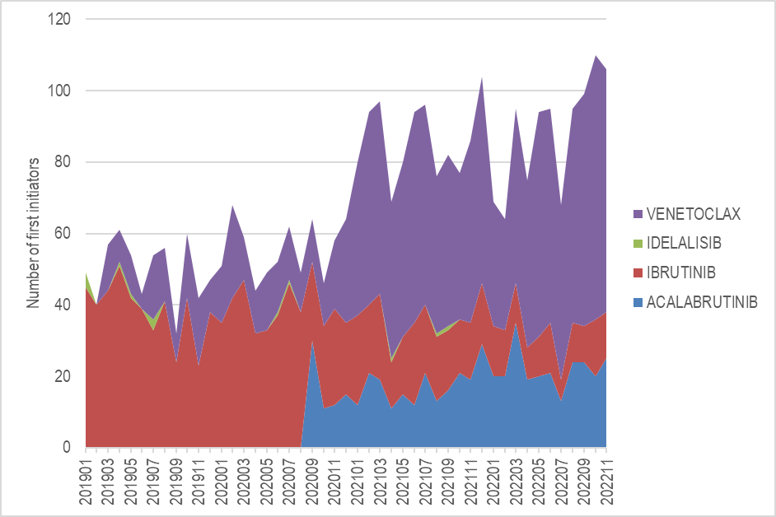Source: Data extracted from the PBS database maintained by Department of Health and Aged Care, processed by Services Australia
  - The submission stated that assuming a duration of treatment assumption for the ibrutinib Deed of 32 months (the duration of treatment assumption was not shared with AstraZeneca at the time of joining the current arrangements) and a monthly net Commonwealth expenditure for ibrutinib of $| |, this gives a cost per course of $| | per patient. For an additional < 500 patients this would increase the expenditure Cap 2 by $| |million in a renewed rrCLL/SLL market RSA and associated Deeds.
  - The entry of acalabrutinib to the market in September 2020 resulted in additional initiating patients rather than substituting into the existing market, likely from grandfathered patients. If the intent of the deed was for venetoclax and acalabrutinib to substitute into the existing ibrutinib market without allowance for growth, then a 2020 incident count from the 100% PBS data for all R/R listings would not be an appropriate basis to forecast a new deed as the additional agents have increased the number of initiators above the levels for ibrutinib only.
  - While the Australian Institute of Health and Welfare (AIHW) data showed an increase in the incidence of CLL over time, this had not translated to a substantial increase in the number of patients initiating on relapsed/refractory PBS listings. As shown in Figure 2, the overall R/R market was stabilising from December 2020 to December 2022.
Figure 2: rrCLL/SLL Market Net Sales
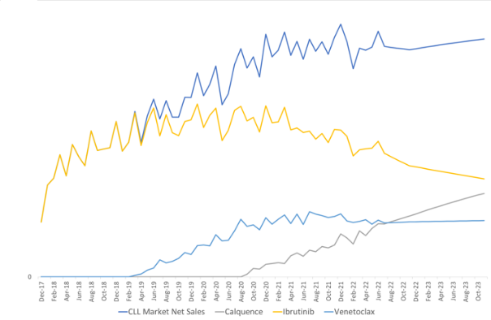
Source: Submission main body p14
Abbreviations: rrCLL/SLL: relapsed/refractory chronic lymphocytic leukaemia/small lymphocytic lymphoma
  - A similar trend was seen from an analysis of the 100% PBS data. Comparing the last 12 months to 30 November 2022 versus the same period to 30 November 2021, the number of first initiators to R/R PBS listings had declined by 7% (Figure 3).
Figure 3: Number of first initiators to relapsed/refractory listing
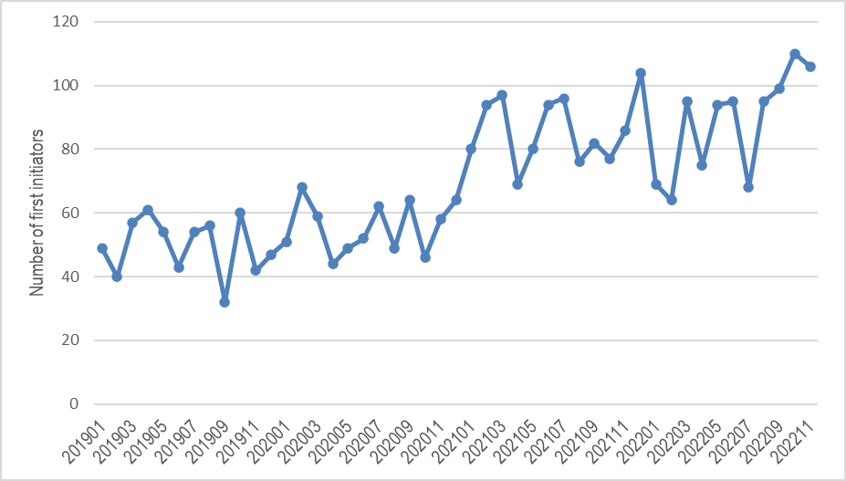Source: Data extracted from the PBS database maintained by Department of Health and Aged Care, processed by Services Australia.
Note: Includes all R/R listings for ibrutinib, idelalisib, venetoclax and acalabrutinib
  - The submission’s suggestion to apply the 19.4% growth rate in CLL incidence from 2015 to 2022 to the number of initiating R/R patients was inappropriate as the AIHW incidence figures did not directly relate to R/R patients.

Sequential use of venetoclax
  - The submission stated that the proportion of sequential use (after a rrCLL BTKi regimen) of venetoclax regimens of 27% reflects additional patients undergoing treatment which were not included in the original RSA.
  - The submission estimated that the net sales of venetoclax regimens were $|||||| |||||| million in 2021 and were expected to reach $| | million by the end of 2022.
  - The submission proposed that the RSA expenditure Cap 2 should be increased from 2022 levels by $| |million (27% of $| |million) in any ongoing renewed RSA.
  - There was limited detail provided in the submission on the analysis of sequential use. An analysis of the 100% PBS data for first initiators on a R/R listing from 1 January 2020 to 31 December 2021 with follow-up to 30 November 2022 identified a smaller proportion of cases of sequential use (8.1%) and the proportion of cases for venetoclax supply after a BTKi appears to be very small (<5%). See Table 2.
  - In its consideration of venetoclax for rrCLL, the PBAC had ‘advised that the sequential use of venetoclax plus rituximab and ibrutinib was likely and may be clinically appropriate given the different mechanism of action and the emerging evidence of clinical benefit with sequential therapy’. The PBAC had also ‘considered the financial implications of this sequential use could be high, but were also highly uncertain’. The PBAC had noted the venetoclax ‘Pre-PBAC Response had requested that sequential use of venetoclax and ibrutinib be excluded from their restriction criteria unless a modified RSA was negotiated to account for the expected additional cost’. However, the PBAC ‘considered that the cost-effectiveness of sequential use was uncertain’ (paragraphs 7.2 and 7.3, venetoclax PSD, November 2018 PBAC meeting).
Table 2: Drug transitions for patients first initiating between 1 January 2020 to 31 December 2021 with follow-up to 30 November 2022
Drug name | Number of initiators | Proportion
VENETOCLAX | 779 | 45.8%
IBRUTINIB | 531 | 31.2%
ACALABRUTINIB | 254 | 14.9%
IBRUTINIB -> ACALABRUTINIB | 45 | 2.6%
IBRUTINIB -> VENETOCLAX | 44 | 2.6%
ACALABRUTINIB -> VENETOCLAX | 19 | 1.1%
VENETOCLAX -> ACALABRUTINIB | 12 | 0.7%
Other sequential use | 17 | 1.0%
Total | 1701 | 100.0%
Total proportion for sequential use |  | 8.1%
Source: Data extracted from the PBS database maintained by Department of Health and Aged Care, processed by Services Australia.

Decrease in general patient co-payment
  - Changes to the general patient co-payment level (decreasing from $42.50 to $30.00) became effective from 1 January 2023.
  - The submission stated that although only approximately one third of rrCLL/SLL patients pay the general patient co-payment, these changes reduce the average patient co-payment in rrCLL/SLL and increase the total Commonwealth expenditure on rrCLL/SLL treatments included in the RSA.
  - The submission estimated that the additional breach for all treatments in the rrCLL/SLL RSA (ibrutinib, acalabrutinib, venetoclax) to be $| | in 2023.
  - The submission proposed that Expenditure Cap 2 should be increased by $|||||| |||||| from the 2022 base in 2023 and subsequent years in a renewed Deed to account for the change in patient co-payment.
  - This was not a significant driver of the request and was considered to be a matter of departmental policy that was better managed through the negotiation processes with the department.

PBAC Outcome
  - The PBAC did not recommend amending the subsidisation caps for the current Risk Share Arrangement (RSA) for acalabrutinib (Calquence®) in relapsed/refractory chronic lymphocytic leukaemia/small lymphocytic lymphoma (rrCLL/SLL).
  - The PBAC noted the current acalabrutinib Deed Term was from 1 September 2020 until 30 November 2022. As new terms had not been negotiated, the PBAC noted that the Deed continued to operate on the existing terms applying the subsidisation caps for the final year until such time as a new deed was entered into or the deed was terminated.
  - The PBAC noted the combination of the three requests to amend the subsidisation caps would increase expenditure Cap 2 by a total of $| |million for each year in a renewed rrCLL/SLL market RSA.
  - The PBAC noted the first request to increase the expenditure Cap 2 from the 2022 levels by $| |million (+19.4%) in 2023 and every subsequent year of an ongoing renewed RSA due to the increase in the incident number of patients. The PBAC considered the request to apply a 19.4% growth rate in CLL incidence from 2015 to 2022 to the number of initiating R/R patients was inappropriate as the Australian Institute of Health and Welfare incidence figures do not directly relate to R/R patients. The PBS advised that it would have been more appropriate for the number of initiating patients in the R/R population to be based on the available PBS data. The PBAC noted that the analysis of the 100% PBS data comparing the last 12 months to 30 November 2022 versus the same period to 30 November 2021 demonstrated that the number of first initiators to R/R PBS listings had declined by 7%.
  - The PBAC noted the second request to increase the expenditure Cap 2 from 2022 levels by $| |million (27% of $| |million) in 2023 and every subsequent year of an ongoing renewed RSA to account for sequential use of venetoclax following rrCLL BTKi regimen. The PBAC considered that the claim of 27% sequential use was not substantiated. The PBAC noted that for drug transitions in patients first initiating between 1 January 2020 to 31 December 2021 with follow-up to 30 November 2022 there was only 8.1% sequential use in total, of which 3.7% was use of venetoclax post a BTKi. The PBAC considered that updates to the subsidisation cap due to sequential use may be clinically reasonable, though considered it too early to see a significant difference in patient numbers in sequential treatments. The PBAC noted that a 3.4% increase to the expenditure Cap 2 in line with evidence of sequential venetoclax may be appropriate.
  - The PBAC noted the third request to increase the expenditure Cap 2 from 2022 levels by $ | in 2023 and every subsequent year of an ongoing renewed Deed due to the changes to the general patient co-payment levels from 1 January 2023. The PBAC noted this request was not specific to rrCLL/SLL and noted it is a policy matter for the department.
  - The PBAC noted that this submission was not eligible for an Independent Review as it was not seeking a change to the listing that includes a new indication, objectively different subtype of disease or new population.
Outcome:
Not recommended

Context for Decision
The PBAC helps decide whether and, if so, how medicines should be subsidised through the Pharmaceutical Benefits Scheme (PBS) in Australia. It considers applications regarding the listing of medicines on the PBS and provides advice about other matters relating to the operation of the PBS in this context. A PBAC decision in relation to PBS listings does not necessarily represent a final PBAC view about the merits of the medicine or the circumstances in which it should be made available through the PBS. The PBAC welcomes applications containing new information at any time.

Sponsor’s Comment
The sponsor had no comment.

