6.05 DURVALUMAB,  
Solution concentrate for I.V. infusion 120 mg in 2.4 mL vial,  
Solution concentrate for I.V. infusion 500 mg in 10 mL vial,  
Imfinzi®,  
AstraZeneca Pty Ltd.

1. Purpose of submission
   1. The Category 1 submission requested a Section 100 listing for durvalumab in combination with gemcitabine and cisplatin (GemCis) in 3-weekly cycles for up to 8 cycles, followed by durvalumab monotherapy every 4 weeks until disease progression for the first-line treatment of patients with advanced biliary tract cancer (BTC).
   2. Listing was requested on the basis of a cost-effectiveness analysis versus placebo + GemCis. The key components of the clinical issues addressed in the submission are summarised in Table 1.

Table **: Key components of the clinical issue addressed by the submission (as stated in the submission)**

| Component | Description |
| --- | --- |
| Population | Patients with advanced BTC (i.e. patients with previously untreated, unresectable locally advanced, or metastatic disease, and patients with recurrent disease after curative surgery or after completion of adjuvant therapy). |
| Intervention | Durvalumab 1,500 mg in combination with GemCis every 3 weeks up to 8 cyclesa followed by durvalumab 1,500 mg every 4 weeks until disease progression. |
| Comparator | Placebo in combination with GemCis every 3 weeks up to 8 cycles followed by placebo every 4 weeks until disease progression. |
| Outcomes | OS, PFS, ORR, DoR, HRQoL and safety. |
| Clinical claim | Durvalumab in combination with GemCis is superior in term of efficacy and non-inferior in terms of safety overall when compared to placebo in combination with GemCis. |

Source: Table 1.1, p21 of the submission.  
BTC = biliary tract cancer; DoR = duration of response; GemCis = gemcitabine plus cisplatin; HRQoL = health related quality of life; ORR = objective response rate; OS = overall survival; PFS = progression free survival.

a Durvalumab was administered once per cycle with GemCis on day 1, and GemCis administered again on day 8 of each 3-week cycle.

1. Background

Registration status

* 1. **TGA status at time of PBAC consideration**:not registered*.* Thesubmission was made under the TGA/PBAC parallel process. In March 2022 the TGA granted durvalumab orphan drug designation for the treatment of advanced BTC. At the time of PBAC consideration, the Round 1 TGA Clinical Evaluator’s Report (CER) and the Delegate’s Overview were available. The TGA Delegate was supportive of approving durvalumab in combination with gemcitabine and cisplatin for the treatment of patients with locally advanced or metastatic biliary tract cancer (BTC).
  2. Durvalumab is currently TGA approved for the treatment of malignant pleural mesothelioma, non-small cell lung cancer (NSCLC) and extensive stage small cell lung cancer (ES-SCLC).

Previous PBAC consideration

* 1. This is the first time the PBAC has considered a drug for the treatment of advanced BTC.
  2. The PBAC have previously considered durvalumab for the following indications:
* Stage III unresectable NSCLC: PBAC meetings November 2018 (not recommended), July 2019 (not recommended), and November 2019 (recommended).
* ES-SCLC: PBAC meeting November 2020 (recommended, but not currently PBS listed).
* Urothelial cancer: PBAC meeting July 2019 (not recommended).

1. Requested listing
   1. Suggestions and additions proposed by the Secretariat are added in italics and suggested deletions are crossed out with strikethrough.

|  |  |  |  |
| --- | --- | --- | --- |
| MEDICINAL PRODUCT  Form | Dispensed Price Max Amt | Max. Amount | №.of Rpts |
| Durvalumab  500 mg/10 mL solution for infusion  120 mg/2.4 mL solution for infusion | Published price  $12,012.07 (public hospital)  $12,220.65 (private hospital)  Effective price  $|||| (public hospital) $|||| (private hospital) | 1,500 mg | 7 (initial treatment)  5 (continuing treatment) |

|  |
| --- |
| **Available brands** |
| Imfinzi®  Durvalumab 500 and 120 mg injection, 1 vial |
| **Category / Program:** Section 100 – Efficient Funding of Chemotherapy Public/Private hospitals |
| **Prescriber type:**  Medical Practitioner |
| **Restriction type:**  Authority Required (STREAMLINED |
|  |
| **Administrative Advice:** No increase in the maximum amount or number of units may be authorised |
| **Administrative Advice:** No increase in the maximum number of repeats may be authorise |
| **Administrative Advice:** Special Pricing Arrangements apply |

|  |
| --- |
| **Severity:** Locally advanced, metastatic or recurrent |
| **Condition:** Biliary tract cancer |
| **Indication:** Locally advanced, metastatic or recurrent Biliary tract cancer |
|  |
| **Treatment Phase:** Initial treatment |
|  |
| **Patient population:** |
| Patient must be initiating treatment and have either of the following: (i) locally advanced biliary tract cancer that is untreated with systemic anti-cancer therapy *in the unresectable setting*, (ii) metastatic biliary tract cancer that is untreated with systemic anti-cancer therapy *in the metastatic setting* ~~, (iii) recurrent biliary tract cancer after~~~~surgery with curative intent/adjuvant therapy~~; OR |
| Patient must be transitioning from existing non-PBS to PBS subsidised supply of this drug and have either of the following at the time this drug was initiated: (i) locally advanced biliary tract cancer that is untreated with systemic anti-cancer therapy *in the unresectable setting*, (ii) metastatic biliary tract cancer that is untreated with systemic anti-cancer therapy *in the metastatic setting*, ~~(iii) recurrent biliary tract cancer after~~~~surgery with curative intent/adjuvant therapy~~ |
| **Clinical criteria:** |
| Patient must have/have had a WHO performance status score of no greater than 1 at treatment initiation with this drug |
| **AND** |
| **Clinical criteria:** |
| The treatment must be/have been initiated with both: (i) gemcitabine, (ii) cisplatin |
| **AND** |
| **Clinical criteria:** |
| The treatment must be prescribed with up to a certain number of repeat prescriptions dependent on either of which: (i) up to 7 repeats for initial treatment to complete 8 cycles, (ii) remainder repeats to complete 8 cycles for patients transitioning from non-PBS to PBS-subsidised supply provided the disease has not progressed |

|  |
| --- |
| **Category / Program:** Section 100 – Efficient Funding of Chemotherapy Public/Private hospitals |
| **Prescriber type:**  Medical Practitioners |
| **Restriction type:**  Authority Required (STREAMLINED) |
|  |
| **Administrative Advice:** No increase in the maximum amount or number of units may be authorised. |
| **Administrative Advice:** No increase in the maximum number of repeats may be authorised. |
| **Administrative Advice:** Special Pricing Arrangements apply. |

|  |
| --- |
| **Severity:** Locally advanced, metastatic or recurrent |
| **Condition:** Biliary tract cancer |
| **Indication:** Locally advanced, metastatic or recurrent Biliary tract cancer |
|  |
| **Treatment Phase:** Continuing treatment |
|  |
| **Clinical criteria:** |
| Patient must have previously received PBS-subsidised treatment with this drug for this condition |
| **AND** |
| Patient must not have developed disease progression while being treated with his drug for this condition |
| **AND** |
| The treatment must be the sole PBS-subsidised systemic anti-cancer therapy for this condition |

* 1. Durvalumab will be supplied as 3 x 500 mg vials to achieve a dose of 1,500 mg per administration. The listing proposed 1 prescription + 7 repeats for initial treatment, which covers the span of 8 cycles (24 weeks), and 1 prescription + 5 repeats for continuing treatment, which covers an additional 24 weeks of monotherapy.
  2. Durvalumab may also be supplied in 120 mg vials for patients who weigh ≤30 kg , in whom the protocol for TOPAZ-1 required an adjusted durvalumab dose of 20 mg/kg every 3 weeks for combination with chemotherapy, and 20 mg/kg every 4 weeks for monotherapy.
  3. The proposed restriction is largely consistent with the population and eligibility criteria of TOPAZ-1, however the following differences were identified:
* The proposed restriction does not specify patients must have unresectable locally advanced disease, which could result in use of durvalumab + GemCis outside the proposed PBS listing, in the (neo)adjuvant setting. The ESC considered the risk of use in the (neo)adjuvant treatment setting was low and it was unnecessary to refer to ‘unresectable locally advanced’ disease in the restriction.
* In TOPAZ-1, following the initial 8 cycles of durvalumab + GemCis, patients continued durvalumab monotherapy beyond disease progression if they were deemed to be receiving a clinical benefit. The proposed restriction states that patients are not eligible for continuing therapy in the presence of progressive disease. The restriction is in line with the draft TGA product information which stated that duration of therapy should be limited to disease progression or unacceptable toxicity. The ESC considered the use of durvalumab beyond progression was likely to be limited as there are second line chemotherapy options available. The ESC noted limiting the use of durvalumab to patients not having developed disease progression was consistent with other immunotherapy listings.
  1. The ESC considered the clinical criteria ‘Patient must have locally advanced or metastatic disease that is untreated with systemic therapy’ could be amended to ‘Patient must have locally advanced or metastatic disease that is untreated with systemic therapy in the unresectable/ metastatic setting’. The ESC noted that with thisamendment, the clinical criteria ‘Patient must have recurrent disease after curative surgery or after adjuvant therapy’ is not necessary and could be removed.
  2. The submission requested an effective price (EMP of $|||| |||| per 500 mg in 10 mL vial) via a special pricing arrangement (SPA). The pre-PBAC response reduced the EMP to $| | per 500 mg in 10 mL vial.
  3. The submission requested a grandfathering restriction be applied to durvalumab for advanced BTC but did not provide any details regarding existing or planned grandfathering or early access program for patients, and the financials did not consider grandfathering patients. The pre-subcommittee response (PSCR) updated the financials to include < 500 grandfathered patients.
  4. DUSC noted that patients with ampullary carcinoma were excluded from the pivotal trial (TOPAZ-1). DUSC considered that the restriction should specify the exclusion of this patient population due to the potential uncertainty in its management in practice (treatment with either small bowel, pancreatic or biliary regimens).

*For more detail on PBAC’s view, see section 7 PBAC outcome.*

1. Population and disease
   1. The target population was defined as having unresectable locally advanced, recurrent or metastatic BTC. BTCs arise from the biliary tree and gallbladder, comprised of three categories, depending on the location of malignancy:

* Cholangiocarcinoma (CCA): arise from the epithelial cells of the intrahepatic or extrahepatic bile ducts (IHCC and EHCC). These account for approximately 3% of all gastrointestinal malignancies, noting that incidence varies with geography. Projections from the Australian Institute of Health and Welfare (AIHW)[1] show that in 2022 there would be 425 new cases of EHCC (crude rate: 1.6 per 100,000) and 2,905 new cases of liver cancer, of which the submission suggested that approximately 436 (15%) will be IHCC.
* Gallbladder cancer (GBC): comprised of almost 90% adenocarcinomas of the gallbladder. The AIHW projected 413 new cases of GBC in 2022 (crude rate: 1.6 per 100,000).
* Ampullary carcinoma: arises from the ampulla of Vater, has distinct pathophysiology and treatments, and was excluded from the target population.
  1. BTC is a rare aggressive cancer that is often diagnosed late due to the anatomical location of the tumour and the paucity or non-specificity of symptoms. Symptoms generally arise as a result of direct tissue compression (e.g. biliary obstruction) which may lead to jaundice and pruritis, which can mimic or are due to cholelithiasis, leadingto patients generally presenting with advanced disease.[2] The majority of patients develop resistance to treatment with GemCis after a few months with an OS of less than one year. Curative surgery is an option when diagnosed at an early stage, however disease recurrence rates post-surgery are high (60% to 70%); hence, the majority of patients are ultimately managed with systemic therapy regardless of whether they present with advanced disease or develop recurrence after surgery.
  2. Patients with BTC have a poor prognosis, which is worse for the target population of unresectable locally advanced, recurrent or metastatic disease. Surveillance, Epidemiology, and End Results (SEER) registry data collected in the U.S. from 2011 to 2017 show that the 5-year survival rate of different types of BTC ranges between 2% to 16%, varying based on cancer type and stage. For metastatic gallbladder cancer, IHCC and EHCC, the 5-year survival rate was 2%.[3],[4]
  3. Durvalumab is a monoclonal antibody (mAb) of the IgG1 kappa subclass that specifically binds to the programmed cell death ligand‑1 (PDL‑1) receptor, which delivers inhibitory signals to T lymphocytes. Programmed death-ligand 1 (PD‑L1) is expressed on the surface of tumour cells. By binding to the PD‑1 receptor expressed on cytotoxic T‑cells, tumour cells can evade detection and destruction by the body’s innate immune system, thereby repressing the anti‑tumour T‑cell response. Durvalumab prevents PD‑L1 from interacting with the PD‑1 receptor, thus reversing PD‑L1’s immunosuppressive effects and enhancing the cytotoxic activity of anti‑tumour T‑cells.
  4. The National Comprehensive Cancer Network (NCCN) guidelines for hepatobiliary tract cancers list GemCis, as well as durvalumab + GemCis, as the preferred treatment options for patients with advanced BTC following the results of TOPAZ-1. The European Society for Medical Oncology (ESMO) clinical practice guidelines for BTC recommends GemCis as standard of care but also recommend that the combination of GemCis with durvalumab should be considered in first-line BTC. UpToDate (September 2022 update) stated durvalumab + GemCis is an alternative to GemCis but is not necessarily preferred in all patients. It noted the short-term benefits of durvalumab + GemCis over GemCis alone are modest but long-term benefits may be clinically meaningful for some patients.
  5. The standard first-line treatment for the Australian target population is GemCis, given until disease progression or unacceptable toxicity (typically up to 8 cycles).[5]

1. Comparator
   1. The nominated comparator was 3-weekly placebo + GemCis on day 1 and 8, for up to 8 cycles, followed by placebo every 4 weeks until disease progression. This was appropriate and consistent with current Australian clinical practice.
2. Consideration of the evidence

Sponsor hearing

* 1. There was no hearing for this item.

Consumer comments

* 1. The PBAC noted and welcomed the input from individuals (4), health care professionals (2) and organisations (5) via the Consumer Comments facility on the PBS website. The comments from individuals described durvalumab as an effective treatment resulting in benefits such as a reduction in tumour size, increased life expectancy and improved quality of life. The comments noted side effects were mostly mild and included fatigue, nausea, diarrhoea and skin rash. The comments noted the cost burden associated with paying for treatment with durvalumab. The health professionals noted the poor prognosis of BTC and the need for additional treatment options.
  2. The PBAC noted the Cholangiocarcinoma Foundation Australia, Rare Cancers Australia, Australasian Gastro Intestinal Trials Group Community Advisory Panel and PanCare Foundation were all strongly supportive of making durvalumab available for patients with BTC. The comments noted durvalumab improves survival and has an acceptable toxicity profile. The comments noted the importance of hope for patients with BTC. Australasian Gastro Intestinal Trials Group Community Advisory Panel supported listing on the basis of access to an effective treatment for a cancer with low survival rates and discussed the current inequity of access to trials dependent on the willingness of clinician's participation and consumers ability to advocate for themselves for inclusion. PanCare presented the issues raised by their members affected by biliary cancer and their concern for more effective and sustainable treatment options. They highlighted the financial and treatment burden and the severity of the side-effects of chemotherapy that patients are prepared to undergo to gain additional survival benefits and argue that immunotherapy offers the potential for better quantity and quality of life.
  3. The Medical Oncology Group of Australia (MOGA) also expressed its strong support for the durvalumab submission, categorising it as one of the therapies of “highest priority for PBS listing” on the basis of the TOPAZ-1 trial. The PBAC noted that the MOGA presented a European Society for Medical Oncology Magnitude of Clinical Benefit Scale (ESMO-MCBS) for durvalumab, which was limited to 4 (out of a maximum of 5, where 5 and 4 represent the grades with substantial improvement)[6], based on a comparison with GemCis.

Clinical trials

* 1. The submission was based on one direct trial comparing durvalumab + GemCis to placebo + GemCis (N=685), TOPAZ-1. Subgroup data were presented, noting that the study was not powered to detect differences across the subgroups. The PBAC noted 914 patients were screened and 685 patients were randomised to TOPAZ-1 with 23% of screened patients (214/914) not meeting inclusion criteria.
  2. Details of the trial presented in the submission are provided in Table 2.

Table : TOPAZ-1 and associated reports presented in the submission

| Trial ID | Protocol title/ Publication title | Publication citation |
| --- | --- | --- |
| TOPAZ-1  (NCT03875235) | A Phase III Randomised, Double-Blind, Placebo-Controlled, Multi-Regional, International Study of Durvalumab in Combination with Gemcitabine plus Cisplatin versus Placebo in Combination with Gemcitabine plus Cisplatin for Patients with First-Line Advanced Biliary Tract Cancers (TOPAZ-1) | Clinical Study Report, Feb 2022 |
| Oh et al. (2022) Durvalumab plus Gemcitabine and Cisplatin in Advanced Biliary Tract Cancer. | *NEJM Evid* 2022; 1 (8) |
| Oh et al. A phase 3 randomised, double-blind, placebo-controlled study of durvalumab in combination with gemcitabine plus cisplatin (GemCis) in patients (pts) with advanced biliary tract cancer (BTC): TOPAZ-1 | *Journal of Clinical Oncology* 2022; 40 (4 Suppl). |
| Oh et al. A phase 3, randomised, double-blind, placebo-controlled, international study of durvalumab in combination with gemcitabine plus cisplatin for patients with advanced biliary tract cancers: TOPAZ-1. | *Hepatology International* 2020; 14: S296-297. |
| Oh et al. A phase III, randomised, double-blind, placebo-controlled, international study of durvalumab in combination with gemcitabine plus cisplatin for patients with advanced biliary tract cancers: TOPAZ-1. | *Annals of Oncology* 2019; 30: v319 |
| Antonuzzo et al, 2022. Immune-mediated adverse event incidence, timing and association with ef­ficacy in the Phase 3 TOPAZ-1 study of durvalumab or placebo plus gemcitabine and cisplatin in advanced biliary tract cancer. | *Annals of Oncology* 2022; 33 (Supplement 7): S566-S567. |
| He et al, 2022. Outcomes by primary tumour location in patients with advanced biliary tract cancer treated with durvalumab or placebo plus gemcitabine and cisplatin in the Phase 3 TOPAZ-1 study. | *Annals of Oncology* 2022; 33 (Supplement 4): S378. |
| Oh et al, 2022. Updated overall survival from the Phase 3 TOPAZ-1 study of durvalumab or placebo plus gemcitabine and cisplatin in patients with advanced biliary tract cancer. | *Annals of Oncology* 2022; 33 (Supplement 7): S565-S566. |
| Burris et al. (2022) Patient-reported outcomes for the Phase 3 TOPAZ-1 study of durvalumab plus gemcitabine and cisplatin in advanced biliary tract cancer. | *Journal of Clinical Oncology* 2022 40:16_suppl, 4070 |
| Vogel et al. (2022) Regional subgroup analysis of the Phase 3 TOPAZ-1 study of durvalumab plus gemcitabine and cisplatin in advanced biliary tract cancer. | *Journal of Clinical Oncology* 2022 40:16_suppl, 4075 |
| Okusaka et al. (2022) Outcomes by disease status in patients with advanced biliary tract cancer treated with durvalumab plus gemcitabine and cisplatin or placebo plus gemcitabine and cisplatin in the Phase 3 TOPAZ-1 study. | *Annals of Oncology* 2022; 33 (Supplement 4): S242. |
| He et al. (2022) Outcomes by primary tumour location in patients with advanced biliary tract cancer treated with durvalumab or placebo plus gemcitabine and cisplatin in the Phase 3 TOPAZ-1 study | Oral presentation at 2022 ESMO World Congress on Gastrointestinal Cancer |

Source: Table 2.5, pp 44-45 of the submission.

* 1. The key features of TOPAZ-1 are summarised in Table 3. The risk of bias was determined to be low, and baseline characteristics were balanced between treatment arms.

**Table 3: Key features of the included evidence**

| Trial | N | Design/ duration | Risk of bias | Patient population | Outcomes | Use in modelled evaluation |
| --- | --- | --- | --- | --- | --- | --- |
| Durvalumab + GemCis vs placebo + GemCis | | | | | | |
| TOPAZ-1 | 685 | R, MC, DB  23.4 mthsa | Low | First-line advanced biliary tract cancers | Primary: OS  Secondary: PFS, ORR, DoR, PRO, safety | PFS, OS, Safety, PRO, TTD |

Source: Table 2.17, pp 64-66 of the submission.

DB = double blind; DoR = duration of response; GemCis = gemcitabine + cisplatin; MC = multi-centre; mths = months; ORR = objective response rate; OS = overall survival; PFS = progression-free survival; PRO = patient-reported outcomes (includes global health status and health-related quality of life measures); R = randomised; TTD = time to treatment discontinuation.

a At the additional 6.5-month follow-up after interim analysis 2.

* 1. The PBAC noted the median age of patients in the study was 64 years, 49% had a performance status of 0 and all patients had adequate liver function (as defined by inclusion criteria which required bilirubin ≤ 2.5 x upper limit of normal and ALT/ AST ≤ 2.5 x upper limit of normal). The PBAC considered the population of patients in TOPAZ-1 is likely to be fitter than the PBS population.

Comparative effectiveness

* 1. The efficacy from TOPAZ-1 was presented based on analyses at two data cuts; the planned interim analysis 2 (IA-2; August 2021) which reported all outcomes, and an unplanned overall survival (OS) and safety update, performed with an additional 6.5 months of follow-up (February 2022). The additional 6.5-month follow-up provided maturity to the OS results, but as it was not prespecified, p-values were not calculated and statistical significance not tested*.*
  2. The proportional hazards assumption was violated for the primary outcome of OS and secondary outcome of PFS, as tested for by the log(-log(S)) versus log(time), Cox-Snell and Schoenfeld residuals presented in the submission. Therefore, the corresponding hazard ratios (HR), confidence intervals (CI) and p-values are potentially misleading and should be interpreted with caution. The submission provided landmark analyses at different time points which may represent the best way of interpreting PFS and OS efficacy data from TOPAZ-1*.*
  3. The OS results from both data-cuts, and the Kaplan-Meier plot of the most recent data-cut (February 2022), are presented in Table 4 and Figure 1, respectively.

Table : **Overall survival, TOPAZ-1 FAS at IA-2 and additional 6.5-month follow-up**

|  | **IA-2 (11 August 2021)** | | **Additional 6.5-month follow-up (25 February 2022)** | |
| --- | --- | --- | --- | --- |
| **Durvalumab + GemCis (N=341)** | **Placebo + GemCis**  **(N=344)** | **Durvalumab + GemCis (N=341)** | **Placebo + GemCis**  **(N=344)** |
| Primary outcome: overall survival | | | | |
| Median duration of follow-up (months) | 16.8 | 15.9 | 23.4 | 22.4 |
| Deaths, n (%) | 198 (58.1) | 226 (65.7) | 248 (72.7) | 279 (81.1) |
| Censored patients n (%) | 143 (41.9) | 118 (34.6) | 93 (27.3) | 65 (18.9) |
| Median OS (months) (95% CI) | 12.8 (11.1, 14.0) | 11.5 (10.1, 12.5) | 12.9 (11.6, 14.1) | 11.3 (10.1, 12.5) |
| Hazard ratio (95% CI)  2-sided p-valuea | **0.80 (0.66, 0.97)**  **0.021** | | 0.76 (0.64, 0.91)  *NR* | |
| Survival rate at 12 months (%) (95% CI) | 54.1 (48.4, 59.4) | 48.0 (42.4, 53.4) | 54.3 (48.8, 59.4) | 47.1 (41.7, 52.3) |
| Survival rate at 18 months (%) (95% CI) | 35.1 (29.1, 41.2) | 25.6 (19.9, 31.7) | 34.8 (29.6, 40.0) | 24.1 (19.6, 28.9) |
| Survival rate at 24 months (%) (95% CI) | 24.9 (17.9, 32.5) | 10.4 (4.7, 18.8) | 23.6 (18.7, 28.9) | 11.5 (7.6, 16.2) |

Source: Table 2.19, p 70-71 of the submission.

CI = confidence interval; FAS = full analyses set, defined as all randomised patients and analysed on an intention-to-treat basis; GemCis = gemcitabine + cisplatin; IA = interim analysis; N = number of patients in treatment group; n = number of patients in a category; NR = not reported; OS = overall survival.

a The analysis was performed using a stratified log-rank test, tested at the 0.03 significance level.

Bold indicates statistically significant differences. Hazard ratio and 95% confidence interval at the 6.5-month follow-up are nominal only.

Figure : Kaplan-Meier plot of overall survival, TOPAZ-1 FAS, additional 6.5-month follow-up (data cut-off 25 Feb 2022)

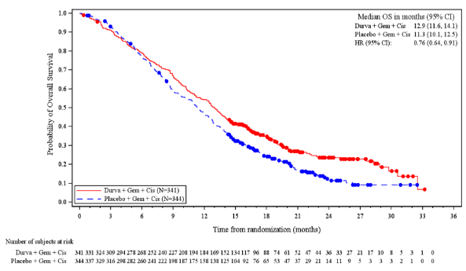Source: Figure 2.9, p72 of the submission.

CI = confidence interval, Cis = cisplatin; CSR = clinical study report; Durva = durvalumab; FAS = full analyses set; Gem = gemcitabine; HR = hazard ratio; OS = overall survival.

FAS was defined as all randomised patients and analysed on an intention-to-treat basis

Hazard ratio and 95% confidence interval are nominal only.

* 1. At 18 months, 34.8% of patients were alive in the durvalumab + GemCis compared to 24.1% in the placebo + GemCis arm. At 24 months, approximately twice as many patients were alive in the durvalumab + GemCis arm compared to the placebo + GemCis arm (23.6% vs 11.5% respectively).
  2. PFS was tested at IA-2, at which time data were mature and showed a statistically significant benefit of durvalumab + GemCis over placebo + GemCis. PFS, objective response rate (ORR) and duration of response (DoR) are presented in Table 5, Figure 2 and Figure 3.

Table : **PFS, ORR and DoR, TOPAZ-1 FAS at** IA-2 (data cut-off 11 Aug 2021)

|  | Durvalumab + GemCis (N=341) | Placebo + GemCis (N=341) |
| --- | --- | --- |
| Progression-free survival | | |
| Total events, n (%) | 276 (80.9) | 297(86.3) |
| Censored patients n (%) | 65 (19.1) | 47 (13.7) |
| Median PFS (months) (95% CI) | 7.2 (6.7, 7.4) | 5.7 (5.6, 6.7) |
| Hazard ratio (95% CI)  2-sided p-value | **0.75 (0.63, 0.89)**  **0.001** | |
| PFS rate at 6.5-months (%) (95% CI) | 58.3 (52.8, 63.4) | 47.2 (41.6, 52.5) |
| PFS rate at 9 months (%) (95% CI) | 34.8 (29.6, 40.0) | 24.6 (20.0, 29.5) |
| PFS rate at 12 months (%) (95% CI) | 16.0 (12.0, 20.6) | 6.6 (4.1, 9.9) |
| **Objective response ratea** | | |
| Patients with a response, n, (%)b   * Complete response (CR) * Partial response (PR) | 91 (26.7) 7 (2.1)  84 (24.6) | 64 (18.7)  2 (0.6)  62 (18.1) |
| Odds ratio (95% CI)c  2-sided p-value | **1.60 (1.11, 2.31)**  **0.011** | |
| Duration of response | | |
| Number of responders who subsequently progressed or died, n (%) | 60 (65.9) | 51 (79.7) |
| Duration of response from onset of response (months)d,e  Median (95% CI)  25th percentile, 75th percentile | 6.4 (5.9, 8.1)  4.6, 17.2 | 6.2 (4.4, 7.3)  3.8, 9.0 |

Source: Table 2.20 p74, Table 2.21, pp 91-92 and Table 2.24, p 97 of the submission.

CI = confidence interval; CR = complete response; DoR = duration of response; FAS = full analyses set, defined as all randomised patients and analysed on an intention-to-treat basis; GemCis = gemcitabine + cisplatin; HR = hazard ratio; n = number of participants reporting data; ORR = objective response rate; PFS = progression free survival; PR = partial response.

a The analysis was performed using a stratified Cochran-Mantel-Haenszel test with factors for disease status and tumour location (per interactive voice response system).

b Responses included confirmed complete or partial response per Investigator according to RECIST 1.1. Does not include patients who discontinued randomised treatment without progression or received a subsequent anti-cancer therapy and then responded.

c An odds ratio > 1 favours D + Gem/Cis.

d Duration of response is the time from the first documentation of CR/PR until the date of progression, death, or the last evaluable RECIST assessment.

e Calculated using the Kaplan-Meier technique.

Bold indicates statistically significant differences.

Figure : Kaplan-Meier plot of progression free survival, TOPAZ-1 FAS, **IA-2 (**data cut-off **11 Aug 2021)**

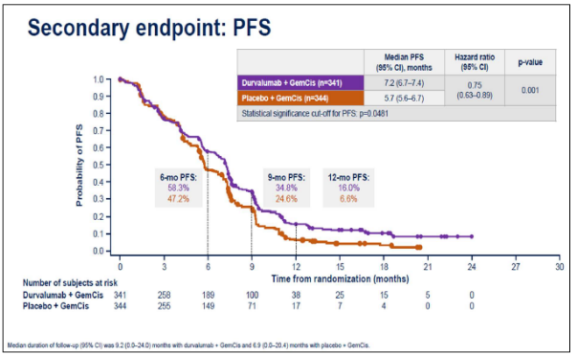Source: Figure 2.11, p75 of the submission.   
CI = confidence interval; GemCis = gemcitabine + cisplatin; HR = hazard ratio; IA = interim analysis; PFS = progression free survival.

Figure : Kaplan-Meier plot of duration of response, TOPAZ-1 patients with an objective response, IA-2 (data cut-off 11 Aug 2021)

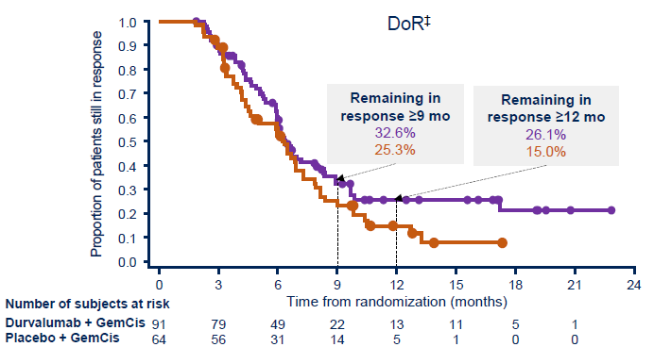  
Source: Figure 2.17, p 82 of the submission.  
DoR = duration of response; FAS = full analysis set; GemCis = gemcitabine + cisplatin; IA = interim analysis; mo = months.  
‡ Analysis of DoR was based on patients in the full analysis set who had an objective response (RECIST 1.1, per investigator) and measurable disease at baseline.

* 1. The submission stated that the results from the IA-2 analysis showed a statistically significant, clinically meaningful, and sustained improvement in PFS.The landmark analyses show improved PFS rates in the durvalumab + GemCis arm compared to placebo + GemCis, with a consistent difference of approximately ten percentage points at 6.5 months, 9 months and 12 months.
  2. The ORR and DoR also favoured the durvalumab + GemCis arm, with an enduring DoR up to and beyond 12 months observed in approximately 26% to 33% of patients (Figure 3), noting the low number of patients at risk in either arm beyond 15 months*.*
  3. Health related quality of life (HRQoL) measurements were similar between treatment arms, with a trend for improved quality of life scores in the durvalumab + GemCis arm, as measured by the European Organisation for Research and Treatment of Cancer 30-Item Cancer Quality of Life Questionnaire (EORTC QLQ-C30) and 21-Item Cholangiocarcinoma and Gallbladder Cancer Quality of Life Questionnaire (QLQ-BIL21) (Figure **4**). A mean change of ≥10 points from baseline in the EORTC QLQ-C30, which represents clinically meaningful difference, was not achieved for either arm in TOPAZ-1. Overall, all instruments used to measure HRQoL showed that durvalumab + GemCis is not associated with a detriment in QoL compared to placebo + GemCis. The impact of treatment and disease state on health state utility was assessed using the EuroQoL 5-dimension, 5 level health state utility index (EQ-5D-5L); the change from baseline in ED-5D-5L and EQ-VAS score was similar over time for durvalumab + GemCis and placebo + GemCis treatment arms.

Figure 4: Adjusted mean change from baseline scores (95% CI) averaged over all visits for (A) GHS/QoL and (B) EORTC QLQ-C30 symptom scales

Figure 4: Adjusted mean change from baseline scores (95% CI) averaged over all visits for (A) GHS/QoL and (B) EORTC QLQ-C30 symptom scales

Source: Figure 2, Burris 2022, presented at ASCO

* 1. The ESC considered the OS benefit for durvalumab was modest but noted the poor prognosis and clinical need for effective treatments for this condition.

**Subgroup analyses**

* 1. In BTC there are currently no predictive biomarkers to select which patients may preferentially benefit from durvalumab treatment.[7] Pre-specified subgroup analyses show consistent effects across subgroups (including PD-L1 tumour area positivity score <1% and ≥1%) with no significant differences (Figure 5 and Figure 6).

Figure : Forest plot of progression-free survival by subgroups, TOPAZ-1 FAS, IA-2 (data cut-off11 Aug 2021)

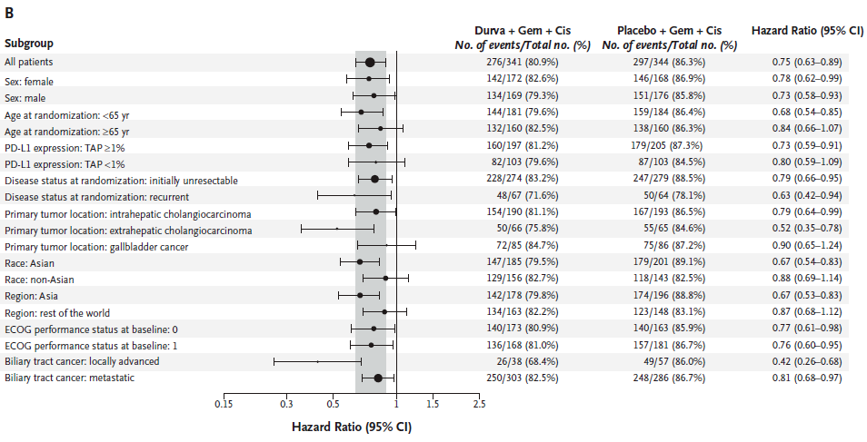  
Source: Figure 2.12, p76 of the submission.  
CI = confidence interval; Cis = cisplatin; eCRF = electronic case report form; ECOG = Eastern Cooperative Oncology Group; FAS = full analyses set, defined as all randomised patients and analysed on an intention-to-treat basis; Gem = gemcitabine; IVRS = interactive voice response system; PD-L1 = programmed cell death ligand-1; PS = performance status; TAP = tumour area positivity; yr = year.  
The overall analysis was performed using a stratified Cox proportional hazards model, adjusting for disease status (initially unresectable or recurrent) and primary tumour location (intrahepatic cholangiocarcinoma, extrahepatic cholangiocarcinoma or gallbladder cancer) from IVRS. Profile likelihood methods were used to calculate CIs. Estimates for all subgroup categories were from an unstratified Cox model with treatment as the only covariate. Stratification subgroups are from the eCRF.

Figure : Forest plot of overall survival by subgroups, TOPAZ-1 FAS, IA-2 (data cut-off 11 Aug 2021)

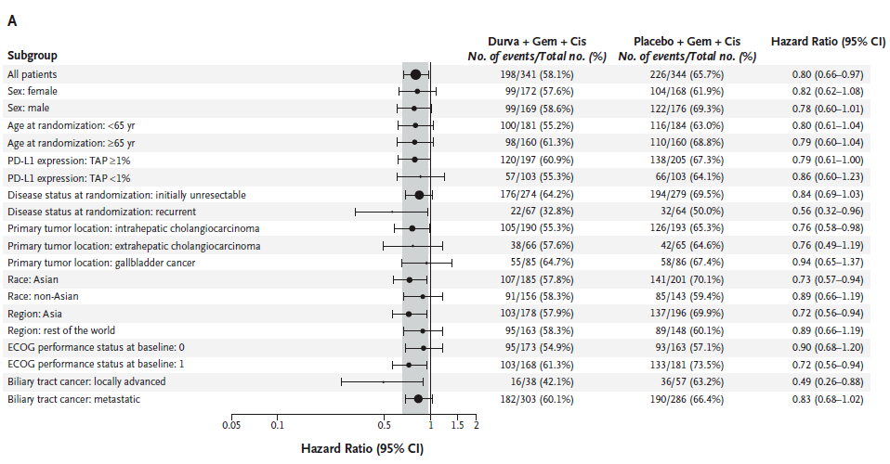Source: Figure 2.10, p73 of the submission.

CI = confidence interval; Cis = cisplatin; eCRF = electronic case report form; ECOG = Eastern Cooperative Oncology Group; FAS = full analyses set, defined as all randomised patients and analysed on an intention-to-treat basis; Gem = gemcitabine; IVRS = interactive voice response system; PD-L1 = programmed cell death ligand-1; PS = performance status; TAP = tumour area positivity; yr = year.   
The overall analysis was performed using a stratified Cox proportional hazards model, adjusting for disease status (initially unresectable or recurrent) and primary tumour location (intrahepatic cholangiocarcinoma, extrahepatic cholangiocarcinoma or gallbladder cancer) from IVRS. Profile likelihood methods were used to calculate CIs. Estimates for all subgroup categories were from an unstratified Cox model with treatment as the only covariate. Stratification subgroups are from the eCRF.

Comparative harms

* 1. The safety analysis set of TOPAZ-1 comprised all patients who received at least one dose of study treatment; updated safety data from the additional 6.5-month follow-up (data cut-off 25 February 2022) are presented. Generally, the durvalumab + GemCis arm demonstrated a similar safety profile to the placebo + GemCis arm, as described in Table 6.

Table : Overview of adverse events and deaths, TOPAZ-1 safety analysis set, 6.5-month follow-up (data cut-off 25 Feb 2022)

|  |  |  |  |  |
| --- | --- | --- | --- | --- |
|  | Number (%) of patientsa | | |  |
| D + GemCis  (N = 338) | Placebo + GemCis  (N = 342) | RR (95% CI)e | RD (95% CI)e |
| Median duration of exposure (months) (min, max)b | 7.33 (0.1, 31.0) | 5.77 (0.2, 26.6) |  |  |
| Any AE | 336 (99.4) | 338 (98.8) | 1.01 (0.99, 1.02) | 0.01 (-0.01, 0.02) |
| Possibly related to any study medicationc | 314 (92.9) | 308 (90.1) | 1.03 (0.99, 1.08) | 0.03 (-0.02, 0.07) |
| Any AE of maximum CTCAE Grade 3 or 4 | 250 (74.0) | 257 (75.1) | 0.98 (0.90, 1.07) | -0.01 (-0.08, 0.05) |
| Possibly related to any study medicationc, d | 206 (60.9) | 217 (63.5) | 0.96 (0.85, 1.08) | -0.03 (-0.10, 0.05) |
| Any AE with outcome of death | 13 (3.8) | 14 (4.1) | 0.94 (0.45, 1.97) | -0.00 (-0.03, 0.03) |
| Possibly related to any study medicationc | 2 (0.6) | 1 (0.3) | 2.02 (0.18, 22.2) | 0.00 (-0.01, 0.01) |
| Any SAE (including AEs with outcome of death) | 161 (47.6) | 151 (44.2) | 1.08 (0.92, 1.27) | 0.03 (-0.04, 0.11) |
| Possibly related to any study medicationc | 52 (15.4) | 59 (17.3) | 0.89 (0.63, 1.25) | -0.02 (-0.07, 0.04) |
| Any AE leading to discontinuation of study treatment | | |  |  |
| Any | 43 (12.7) | 52 (15.2) | 0.84 (0.58, 1.22) | -0.02 (-0.08, 0.03) |
| Durvalumab or placebo | 20 (5.9) | 18 (5.3) | 1.12 (0.61, 2.09) | 0.01 (-0.03, 0.04) |
| Gem and/or Cis | 42 (12.4) | 47 (13.7) | 0.90 (0.61, 1.33) | -0.01 (-0.06, 0.04) |
| Possibly related to any study medicationc | 30 (8.9) | 39 (11.4) | 0.78 (0.50, 1.22) | -0.03 (-0.07, 0.02) |
| Any AE leading to dose interruption/delay or reduction | | |  |  |
| Any | 225 (66.6) | 244 (71.3) | 0.93 (0.84, 1.03) | -0.05 (-0.12, 0.02) |
| Durvalumab or placebo | 127 (37.6) | 120 (35.1) | 1.07 (0.88, 1.31) | 0.03 (-0.05, 0.10) |
| Gem and/or Cis | 213 (63.0) | 239 (69.9) | 0.90 (0.81, 1.00) | -0.07 (-0.14, 0.00) |

Source: Data extracted from Table 5, p32 and Table 6 pp33-34 Attachment 3 of the submission.

AE = adverse event; CI = confidence interval; Cis = cisplatin; CSR = clinical study report; CTCAE = Common Terminology Criteria for Adverse Events; D = durvalumab; Gem = gemcitabine; GemCis = gemcitabine + cisplatin; IA-2 = interim analysis 2; MedDRA = Medical Dictionary for Regulatory Activities; N = number of patients in treatment group; n = number of patients in a category; RD = risk difference; RR = relative risk; SAE = serious adverse event; SMQ = Standardised MedDRA Query

a Patients with multiple events in the same category were counted only once in that category. Patients with events in more than one category were counted in each of those categories.

b Figures of actual treatment duration provided, defined as the total treatment duration minus the total duration of delays.

c As assessed by the Investigator.

d The maximum CTCAE grade per patient/event is considered (ie, does not include patients with subsequent Grade 5 events).

e Calculated during the evaluation, in Review Manager 5.4.1.

A RR >1 represents more events in the durvalumab + GemCis arm compared to placebo + GemCis arm. This analysis was not powered to detect statistical differences in the occurrence of safety events; apparent differences shown in relative measures of effect are exploratory only.

* 1. The incidence of the most common any-grade AEs by organ class were generally balanced, except for nausea where ≥5% events were reported in the durvalumab + GemCis arm compared to the placebo arm (40.5% versus 34.8%, respectively). The TGA CER noted a small but higher proportion of patients who died from nervous system disorders in the durvalumab + GemCis arm (1.2%) compared to placebo + GemCis (0.3%).
  2. Adverse events of special interest (AESI) were defined as AEs with a likely inflammatory or immune-mediated pathophysiological basis resulting from the mechanism of action of durvalumab and were greater in the durvalumab arm; when restricted to Grade 3 or 4 events, there were relatively more events in the durvalumab + GemCis arm, with low absolute numbers, as presented in Table 7.

Table : Adverse events of special interest in any category, TOPAZ-1 safety analysis set, 6.5-month follow-up (data cut-off 25 Feb 2022)

| **AE category** | **Durva (N=338)** | **Placebo (N=342)** | **RR**  **(95% CI)e** | **RD**  **(95% CI)e** |
| --- | --- | --- | --- | --- |
| Any AE   * Possibly relateda | 147 (43.5)  104 (30.8) | 111 (32.5)  71 (20.8) | 1.3 (1.1, 1.6)  1.5 (1.1, 1.9) | 0.11 (0.04, 0.18)  0.10 (0.03, 0.17) |
| Any AE of CTCAE Grade 3 or 4b   * Possibly relateda | 13 (3.8)  8 (2.4) | 10 (2.9)  5 (1.5) | 1.3 (0.6, 3.0)  1.6 (0.5, 4.9) | 0.01 (-0.02, 0.04)  0.01 (-0.01, 0.03) |
| Any SAE (including death)   * Possibly relateda | 13 (3.8)  9 (2.7) | 10 (2.9)  7 (2.0) | 1.3 (0.6, 3.0)  1.3 (0.5, 3.5) | 0.01 (-0.02, 0.04)  0.01 (-0.02, 0.03) |
| Any AE with outcome of death   * Possibly relateda | 0  0 | 1 (0.3)d  1 (0.3) | 0.3 (0.0, 8.2)  0.3 (0.0, 8.2) | -0.00 (-0.01, 0.01)  -0.00 (-0.01, 0.01) |
| Received systemic corticosteroids | 28 (8.3) | 8 (2.3) | 3.5 (1.6, 7.7) | 0.06 (0.03, 0.09) |
| Received high dose steroids | 13 (3.8) | 6 (1.8) | 2.2 (0.8, 5.7) | 0.02 (-0.00, 0.05) |
| Received endocrine therapy | 24 (7.1) | 5 (1.5) | 4.9 (1.9, 12.6) | 0.06 (0.03, 0.09) |
| Any AE leading to discontinuation of study treatmentc | 3 (0.9) | 4 (1.2) | 0.8 (0.2, 3.4) | -0.00 (-0.02, 0.01) |
| Event outcome resolved | 109 (32.2) | 89 (26.0) | 1.2 (1.0, 1.6) | 0.06 (-0.01, 0.13) |
| Event outcome not resolved | 38 (11.2) | 21 (6.1) | 1.8 (1.1, 3.1) | 0.05 (0.01, 0.09) |

Source: Extracted from Table 14.3.2.11.1, p 409 of Attachment 4 of the submission.

AE = adverse event; AEPI = adverse event of possible interest; AESI = adverse event of special interest; CI = confidence interval; CSR = clinical study report; CTCAE = Common Terminology Criteria for Adverse Events; Durva = durvalumab + GemCis; GemCis = gemcitabine + cisplatin; MedDRA = Medical Dictionary for Regulatory Activities; Placebo = placebo + GemCis; RD = risk difference; RR = relative risk; SAE = serious adverse event  
a Possibly related to any of the study treatments, as assessed by the Investigator. Missing responses are counted as related.

b All CTCAE grades per patient, not just the maximum, were considered when identifying whether there was a Grade 3 or 4 event (i.e., includes patients with subsequent Grade 5 events).

c Adverse events with Action taken = Drug permanently discontinued for at least one treatment.

d This event was causally related polymyositis.

e Calculated during the evaluation, in Review Manager 5.4.1.

A RR >1 represents more events in the durvalumab + GemCis arm compared to placebo + GemCis arm. This analysis was not powered to detect statistical differences in the occurrence of safety events; apparent differences shown in relative measures of effect are exploratory only.

Patients with multiple events in the same category were counted only once in that category. Patients with events in more than one category were counted in each of those categories. Includes AEs with an onset date on or after the date of first dose or pre-treatment AEs that increased in severity on or after the date of first dose up to and including 90 days following the date of last dose of study medication or up to and including the date of initiation of the first subsequent therapy (whichever occurred first).

Benefits/harms

* 1. A summary of the comparative benefits and harms for durvalumab + GemCis versus placebo + GemCis from TOPAZ-1 is presented in Table 8.

Table : Comparative benefits and harms for durvalumab + GemCis versus placebo + GemCis, TOPAZ-1

|  |  |  |  |  |
| --- | --- | --- | --- | --- |
| **Progression free survival at IA-2 (data cut-off 11 Aug 2021)** | | | | |
| Event | Durvalumab + GemCis (341) | Placebo + GemCis  (344) | Absolute Differencea | HR (95% CI) |
| Progressed, n (%) | 276 (80.9) | 297(86.3) |  | **0.75 (0.63, 0.89)**  **0.001** |
| Median PFS, months (95% CI) | 7.2 (6.7, 7.4) | 5.7 (5.6, 6.7) | 1.5 |
| % not progressed at 6.5-months (95% CI) | 58.3 (52.8, 63.4) | 47.2 (41.6, 52.5) | 11.1 |
| % not progressed at 9 months (95% CI) | 34.8 (29.6, 40.0) | 24.6 (20.0, 29.5) | 10.2 |
| % not progressed at 12 months (%) (95% CI) | 16.0 (12.0, 20.6) | 6.6 (4.1, 9.9) | 9.4 |
| **Overall survival at additional 6.5-month follow-up (data cut-off 25 Feb 2022)** | | | | |
| Deaths, n (%) | 248 (72.7) | 279 (81.1) |  | 0.76 (0.64, 0.91)  *NR* |
| Median OS, months (95% CI) | 12.9 (11.6, 14.1) | 11.3 (10.1, 12.5) | 1.5 |
| Alive at 12 months (%) (95% CI) | 54.3 (48.8, 59.4) | 47.1 (41.7, 52.3) | 7.2 |
| Alive at 18 months (%) (95% CI) | 34.8 (29.6, 40.0) | 24.1 (19.6, 28.9) | 10.7 |
| Alive at 24 months (%) (95% CI) | 23.6 (18.7, 28.9) | 11.5 (7.6, 16.2) | 12.1 |

|  |  |  |  |  |  |  |
| --- | --- | --- | --- | --- | --- | --- |
| Harms at additional 6.5-month follow-up (data cut-off 25 Feb 2022) | | | | | | |
|  | Durvalumab + GemCis  n/N | Placebo + GemCis  n/N | RRa  (95% CI) | Event rate/100 patients | | RDa  (95% CI) |
| Durvalumab + GemCis | Placebo + GemCis |
| Any SAE (including AEs with outcome of death) | | | | | | |
| TOPAZ-1 | 161/338 | 151/342 | 1.08 (0.92, 1.27) | 47.6 | 44.2 | 0.03 (-0.04, 0.11) |
| **Any AESI – possibly treatment related** | | | | | | |
| TOPAZ-1 | 104/338 | 71/342 | 1.48 (1.14, 1.93) | 30.8 | 20.8 | 0.10 (0.03, 0.17) |
| **Received systemic corticosteroids** | | | | | | |
| TOPAZ-1 | 28/338 | 8/342 | 3.5 (1.6, 7.7) | 8.3 | 2.3 | 0.06 (0.03, 0.09) |
| **Received endocrine therapy** | | | | | | |
| TOPAZ-1 | 24/338 | 5/342 | 4.9 (1.9, 12.6) | 7.1 | 1.5 | 0.06 (0.03, 0.09) |

Source: Data extracted from Table 2.30 p97, Table 2.31 p98 and Table 5, p32 and Table 6 pp33-34 Attachment 3 of the submission and Table 14.3.2.11.1, p409, of Attachment 4 of the submission.

AESI = adverse event of special interest; CI = confidence interval; CTCAE = Common Terminology Criteria for Adverse Events; GemCis = gemcitabine + cisplatin; HR = hazard ratio; NR = not reported; OS = overall survival; PFS = progression free survival; RD = risk difference; RR = relative risk; SAE = serious adverse event.

a Calculated during the evaluation.

Bold indicates a statistically significant difference.

* 1. On the basis of direct evidence presented by the submission, for every 100 patients treated with durvalumab + GemCis in comparison with placebo + GemCis:
* Approximately 9 additional patients will remain progression-free after 12 months.
* Approximately 12 additional patients will remain alive after 24 months.
  1. On the basis of direct evidence presented by the submission, for every 100 patients treated with durvalumab + GemCis in comparison with placebo + GemCis, after a median treatment duration of 7.3 months:
* Approximately 10 more patients will have an inflammatory or immune-mediated adverse effect requiring more frequent monitoring and/or interventions (e.g., hypothyroid events and rash), almost all of which will be low grade.
* Approximately 6 more patients will require systemic corticosteroids.
* Approximately 6 more patients will require systemic endocrine therapy (e.g. thyroid hormone replacement).

Clinical claim

* 1. The submission described durvalumab + GemCis as superior in terms of effectiveness (with a claim of clinically meaningful improvement in OS, PFS and ORR), and that it did not add substantial toxicity, when compared to placebo + GemCis in the treatment of advanced BTC. A claim of no detriment to HRQoL was also made. The evaluation considered the data presented supports the claim with respect to a difference in efficacy outcomes, however:
* The OS benefit was moderate; and
* The small clinical benefit may not be realised in Australian clinical practice due to the following applicability issues:
  + Ethnicity: more than half of the patients in TOPAZ-1 were from Asian countries (54.6% Asian vs 45.4% Non-Asian). Although there was a trend for improved efficacy in the Asian subgroup compared to the non-Asian subgroup, it did not reach statistical significance. In the 2021 census, the proportion of the population identifying as Asian was approximately 17.4%.[8] The TGA CER stated that generalising the efficacy and safety data from TOPAZ-1 to the Australian population may not be appropriate.
  + Subsequent anti-cancer therapies: approximately 9% of patients in the durvalumab + GemCis arm received post-discontinuation anti-cancer therapies in TOPAZ-1 that included treatments that are not available in the Australian setting (immunotherapies and tyrosine kinase inhibitors).
  + Use beyond progression: the trial design of TOPAZ-1 allowed treatment beyond progression if clinical benefit was observed. Given that the proposed PBS restriction is for use in patients without disease progression, the survival advantage for durvalumab observed in TOPAZ-1 may therefore exceed what might be expected in clinical practice in Australia.
  1. The PBAC agreed with the ESC that, overall, the claim that durvalumab + GemCis is superior to placebo + GemCis in terms of effectiveness was adequately supported*.* However,the PBAC considered the trial population in TOPAZ-1 is likely to be fitter than the PBS population, in terms of age, performance score and liver function.
  2. The ESC considered the submission's claim that durvalumab + GemCis does not add substantial toxicity, compared to GemCis, may be reasonable. AEs, SAEs, deaths and treatment discontinuations were similar between treatment arms. Whilst there were more immune mediated AEs, these were almost all low-grade, and few patients required additional corticosteroids or endocrine therapy. The claim of no detriment to HRQoL was reasonable. The PBAC considered the clinical claim regarding safety was reasonable.

Economic analysis

* 1. The submission presented a stepped economic evaluation based on the direct randomised trial (TOPAZ-1). The types of economic evaluation presented were a cost-effectiveness (cost-per-life-year-gained) and a cost-utility analysis (cost-per-quality adjusted life year [QALY]-gained). This was appropriate and consistent with the clinical claim of superior effectiveness of durvalumab + GemCis over placebo + GemCis. A summary of the key components of the economic evaluation is presented in Table 9.

Table **:** Key components of the economic evaluation

| Component | Description | Justification/comments |
| --- | --- | --- |
| Types of analysis | Cost effectiveness analysis and cost utility analysis | This was reasonable. |
| Outcomes | Life years (LYs) and quality adjusted life years (QALYs) | This was reasonable.  TOPAZ-1 collected EQ-5D-5L that was valued using the Canadian value set to transform LYs to QALYs. Sensitivity analyses were presented using other utility estimates. |
| Method used to generate results | Partitioned survival model | This was reasonable. |
| Health states | Progression free survival (PFS), progressive disease (PD) and dead | This was reasonable. |
| Cycle length | 1 week | This was reasonable. |
| Time horizon | 10 years in the base case versus median follow-up of 23.4 months in TOPAZ-1. | This may not be reasonable, and favoured durvalumab; see discussion paragraph 6.31. |
| Health state transition | Kaplan-Meier estimates for PFS, OS and time to treatment discontinuation (TTD) were derived directly from TOPAZ-1. | This was reasonable. |

Source: Table 3.1 pp114-115, p162 of the submission.

EQ-5D-5L = EuroQoL 5-dimension, 5‑level; LYs = life years; OS = overall survival; PD = progressive disease; PFS = progression free survival; QALYs = quality adjusted life years; TTD = time to treatment discontinuation.

a The 33 months correspond to the latest direct Kaplan-Meier data point available from TOPAZ-1.

* 1. Key model input parameters came from either TOPAZ-1 or Australian costing sources, which was appropriate. HRQoL was measured alongside the trial using the EQ-5D-5L instrument.
  2. The submission presented a partitioned survival model with three health states: (1) PFS, (2) PD, and (3) dead. Time-to-treatment discontinuation (TTD) was used in the model to calculate the cost of the intervention and that of its comparators.
  3. A 10-year time horizon was proposed for the base case, based on consistency with other economic models identified in the published literature search of HTA agency websites. All comparative economic models presented by the submission targeted patients with advanced hepatocellular carcinoma (HCC), which is a different patient population, with an estimated 3-year survival of 15%. The ESC previously considered a time horizon of 5 or 7.5 years was reasonable in the context of HCC, despite the possibility of a small percentage of patients having a durable response (paragraph 6.3 and 6.38, atezolizumab and bevacizumab Public Summary Document [PSD], July 2020 meeting). The ESC noted the model was sensitive to varying the time horizon (Figure 7). The ESC considered a 5 year time horizon was reasonable, consistent with consideration of other conditions with a poor prognosis. The ESC noted using a time horizon of 5 years increased the ICER from $115,000 to < $135,000/QALY to $135,000 to < $155,000/ QALY.

Figure : ICER over time (using the base case economic model)

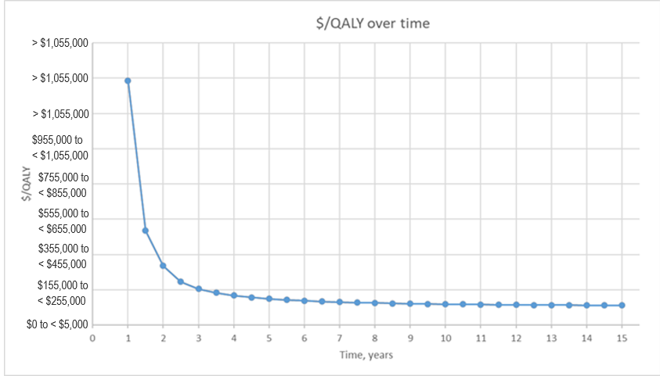

Source: Compiled during the evaluation using Attachment 13_Imfinzi (Durvalumab)_BTC_CEA_

ICER = incremental cost effectiveness ratio; QALYs = quality adjusted life years.

* 1. The proportional hazards assumption was violated for OS and PFS, resulting in the use of independent parametric survival curves (exponential, Weibull, Gompertz, lognormal, log-logistic, generalised gamma and gamma) for the extrapolation of those outcomes within each treatment group. Extrapolated curves were fitted to the observed KM data. The goodness of fit statistics, Akaike Information Criteria (AIC) and Bayesian Information Criteria (BIC), were used to assess the best fit for the parametric functions. Clinical plausibility was also used to justify the choice of parametric function, and sensitivity analyses were conducted.
  2. For PFS and TTD, the model used the data from the IA-2 data cut (11 August 2021), and for OS it used the updated data cut (25 Feb 2022). TTD was longer than PFS in the durvalumab + GemCis arm, which represented the continuation of treatment through disease progression which was permitted in TOPAZ-1.
  3. The best fit parametric function was not used to inform most of the base case scenarios, apart from the PFS and TTD curves in the durvalumab + GemCis arm. The best fit and base case parametric functions are described in Table 10. The PSCR noted the AIC and BIC statistics for the log-logistic, gamma and Weibull for durvalumab + GemCis and the log-logistic and gamma for placebo + GemCis differed only marginally. The PSCR stated these small differences in the goodness of fit statistics suggest that any of the parametric distributions are unlikely to be statistically meaningfully different from each other. Consequently, the PSCR stated greater importance should be placed on selecting parametric distributions that are clinically plausible and most closely reflect the survival of patients with advanced BTC who receive first-line treatment in clinical practice.

Table : Comparison of the parametric functions based on goodness of fit statistics, and the models used in the submission’s base case.

|  |  |  |  |  |
| --- | --- | --- | --- | --- |
|  | **Durvalumab + GemCis** | | **Placebo + GemCis** | |
|  | **Best fita** | **Base case** | **Best fita** | **Base case** |
| Overall survival | Gamma or Weibull | Log-logistic | Gamma | Log-logistic |
| Progression-free survival | Gamma | Gamma | Weibull or generalised gamma | Gamma |
| Time to discontinuation | Gamma | Gamma | Weibull | Gamma |

Source: Compiled during the evaluation, using data from Table 3.6, pp 143-144 and Table 3.7, pp 150-151, Table 3.8, pp 157-158 and Table 3.9, p 161 of the submission.

GemCis = gemcitabine plus cisplatin.   
a Based on Akaike Information Criteria and Bayesian Information Criteria.

* 1. The submission stated that based on visual inspection, all parametric models provided a good fit to the observed Kaplan-Meier data for both durvalumab + GemCis and placebo + GemCis. Visual inspection showed similarity between the Weibull and gamma functions used for PFS and TTD in the placebo + GemCis arm. However, there were differences between the best-fit gamma and base-case log-logistic functions used for OS, as shown in Figure 8. The evaluation considered the submission had not adequately justified its departure from the model fit statistics when selecting the log-logistic function for the model’s OS base case, which sensitivity analyses show was a main driver of the economic model*.* The ESC noted the external validation provided in the submission and the PSCR but considered overall there was limited trial data to determine what proportion of patients, if any, would have relatively long survival with durvalumab (and hence result in a flattening of the OS KM plot).

Figure : Kaplan-Meier estimates for base-case OS compared to independent survival models identified as best fit (AIC/BIC)

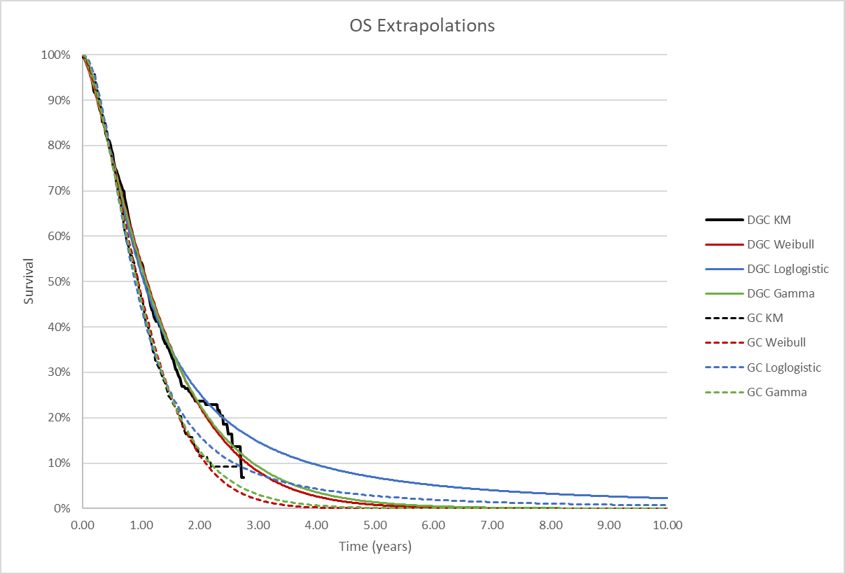Source: Compiled during the evaluation using Figure 3.21 and Figure 3.22 p 153 of the Submission; Attachment 13_Imfinzi (Durvalumab)_BTC_CEA _worksheet ‘Data_curves’.

AIC = Akaike Information Criteria; BIC = Bayesian Information Criteria; DGC = durvalumab + gemcitabine + cisplatin; GC = placebo + gemcitabine + cisplatin; KM = Kaplan-Meier; OS = overall survival.

* 1. The PSCR provided a plot of OS hazard for durvalumab + GemCis over time from the TOPAZ study overlaid with plots for the different extrapolation approaches (Figure 9). The PSCR stated the panel plots demonstrate that the gamma and Weibull are unable to capture the change in hazard over time in the earlier follow-up period, while the log-logistic does capture this change, therefore supporting the choice of log-logistic as a better fit to extrapolate OS for durvalumab + GemCis*.*

**Figure 9**: **TOPAZ-1 modelled durvalumab + GemCis panel plot\***

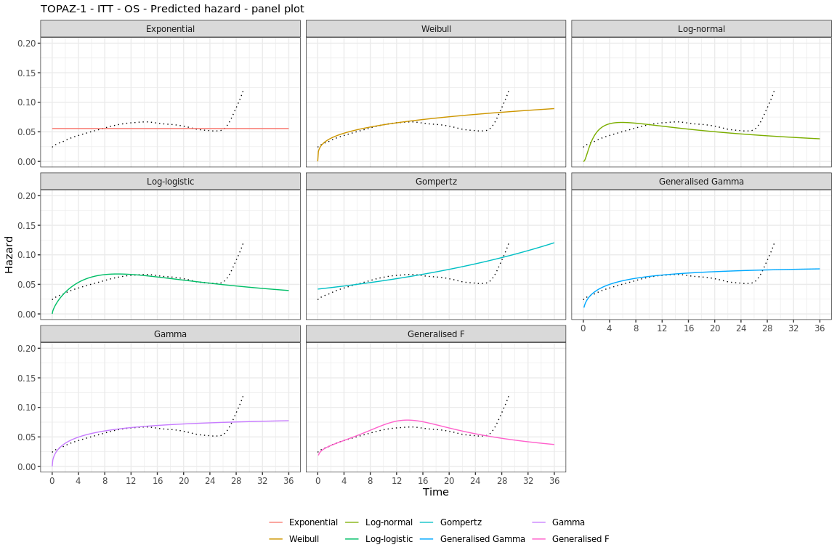

Source: Figure 3, PSCR

* *Note that the results presented in Figure 9 are derived from ad-hoc analyses conducted by the applicant during the evaluation specifically for the purposes of informing the PBAC consideration. Interpretation of the results and their application should therefore be limited to seeking to understand the basis for the PBAC outcome and should not be used for any other purpose (e.g. from ~24 months onwards, should be interpreted cautiously due to the very low numbers of patients at risk (<10%)).*

* 1. The ESC considered that, based on the totality of evidence (i.e., AIC/ BIC, visual inspection, external validation and panel plots), the extrapolation functions applied to OS for durvalumab + GemCis and placebo + GemCis in the base case economic model were appropriate.
  2. Utilities for the modelled health states, PFS and PD, were derived from a post-hoc analysis of the EQ-5D-5L data from TOPAZ-1, using mixed effects repeated measures (MMRM) models, which included univariate and multivariate analyses with covariates for treatment, treatment status (i.e., on off treatment) and progression status (PFS and PD) fitted to the observed EQ-5D-5L data. The EQ-5D score for PD from TOPAZ-1 was reflective of patients’ health-related quality of life (HRQoL) on their first visit since progression.
  3. The submission’s base case used utility values from a post-hoc analysis from TOPAZ-1 using the Canadian value set. The submission stated that the Canadian population is not markedly different from the Australian population, hence the use of these values in the base case was appropriate. The PSCR stated the use of a Canadian value set was the most appropriate of the available options given that it enabled the direct use of the EQ-5D-5L data from TOPAZ-1. The ESC noted an Australian value set for EQ-5D-5L is now available[9] and considered it would be informative to see the impact on the ICER of using this value set (rather than the Canadian value set) has on the ICER.Disutilities for all grade ≥3 adverse events were applied in the first cycle for both treatment arms. The model was not sensitive to inclusion of disutilities for TEAEs.
  4. Subsequent anti-cancer treatments were determined by data from TOPAZ-1, using a representative combination of medicines and dosing regimens; primarily folinic acid combinations or platinum-based therapy, consistent with Australian eviQ guidelines. The submission considered subsequent therapies used as second, third and further lines (up to seven) and excluded ~10-11% of second-line and ~17-19% of third-line (or more) patients that were given other treatments (i.e. immunotherapies, targeted therapies).Patients in TOPAZ-1 who received subsequent immunotherapies, which are not PBS-listed in Australia, were redistributed proportionately to the other subsequent therapy regimens. This was reasonable, but the evaluation noted it may result in a disconnect between the trial evidence for outcomes and costs.
  5. There were only small differences between the modelled analysis and trial estimates; according to the traces, approximately 84% of the patients in the durvalumab + GemCis arm would have progressed by the first 12 months, while in the GemCis arm 94% of the patients progressed by the first 12 months, which was similar to the difference in PFS in TOPAZ-1. After 24 months, 77% of patients in the durvalumab + GemCis arm were dead, while in the GemCis arm 89% were dead, which was similar to TOPAZ-1 (76.4% and 88.5%, respectively). At the end of the time horizon, no patients in the GemCis were alive, and 2.1% in the durvalumab + GemCis arm were alive in the PD health state. The ESC noted there would be 6.8% and 3.3% of patients alive in the durvalumab + GemCis arm at the end of the time horizon, if the time horizon was reduced to 5 years and 7.5 years, respectively.
  6. A summary of the key drivers of the model is provided in Table 11.

Table : **Key drivers of the model**

| Description | Method/Value | Impact  Base case: $|1/QALY gained |
| --- | --- | --- |
| Parametric function used for OS extrapolation | TOPAZ-1 with loglogistic parametric distribution to extrapolate OS (for both arms) | High, favours durvalumab + GemCis.  Use of gamma parametric function for both arms increased ICER to $||||||2/QALY gained. |
| Utilities | TOPAZ-1 Canadian value set for model health states. | Moderate, favours durvalumab + GemCis.  Use of the TOPAZ-1 UK cross-walk analysis increased the ICER to $||||||1/QALY gained. |
| Time horizon | Base case 10 years | Moderate, favours durvalumab + GemCis.  Reducing time horizon to 7.5 years increased the ICER to $||||||1/QALY gained. The ESC noted reducing the time horizon to 5 years increased the ICER to $||||||3/ QALY. |

Source: compiled during the evaluation using the information from the economic model of the submission.

GemCis = gemcitabine + cisplatin; HCC = hepatocellular carcinoma; ICER = incremental cost-effectiveness ratio; OS = overall survival; PBAC = Pharmaceutical Benefits Advisory Committee; QALY = quality adjusted life years.

*The redacted values correspond to the following ranges:*

*1 $115,000 to < $135,000*

*2* *$155,000 to < $255,000*

*3 $135,000 to < $155,000*

* 1. The results of the stepped economic evaluation are presented in Table 12. The submission presented a base case incremental cost effectiveness ratio (ICER) of $115,000 to < $135,000/QALY gained (Step 4). The model was most sensitive to Step 2, the extrapolation of health outcomes from the trial-based outcomes of 19 months (the latest time point for which PFS and OS data were available for both durvalumab + GemCis and placebo + GemCis arms.) to 10 years*.*

Table : Results of the stepped economic evaluation

|  |  |  |  |  |  |  |  |
| --- | --- | --- | --- | --- | --- | --- | --- |
| **Steps** | **Cost** | | | **Outcomes** | | | **ICER** |
| **Durvalumab + GemCis** | **PBO + GemCis** | **Incremental** | **Durvalumab + GemCis** | **PBO+ GemCis** | **Incremental** |
| Step 1: TOPAZ-1 (time horizon 19 months; costs of interventions and IV infusion costs) | | | | | | | |
|  | $|| | $5,216 | $|| | 1.009 | 0.941 | 0.068 | $||||1/LYGa |
| Step 2: Step 1 + clinical trial extrapolated to 10 years | | | | | | | |
|  | $|| | $5,216 | $|| | 1.568 | 1.174 | 0.394 | $||||2/LYG |
| Step 3: clinical trial extrapolated to 10 years including all resource useb | | | | | | | |
|  | $|| | $66,995 | $|| | 1.568 | 1.174 | 0.394 | $||||2/LYG |
| Step 4: trial extrapolated to 10 years including all resource use and transformed QALYs (base case) | | | | | | | |
|  | $|| | $66,995 | $|| | 1.259 | 0.947 | 0.312 | $||||3/QALY |

Source: Table 3.23, p182 of the submission.

GemCis = gemcitabine + cisplatin; ICER = incremental cost effectiveness ratio; LYG = life years gained; PBO = placebo; QALY = quality adjusted life years.

a ICER in model for Step 1 was calculated as $455,000 to < $555,000/LYG during the evaluation.

b Includes costs for disease management, subsequent anti-cancer treatments, management of AEs, and terminal care costs.

*The redacted values correspond to the following ranges:*

*1 $455,000 to < $555,000*

*2* *$75,000 to < $95,000*

*3 $115,000 to < $135,000*

* 1. The disaggregated base case cost estimates and health outcomes are presented in Table 13.
* The cost of durvalumab was the main driver of incremental costs accounting for 98.6% of the total costs. The use of TTD in the model captures the costs of continuing treatment beyond progression.
* Approximately 2% of patients were estimated to be alive in the durvalumab + GemCis arm after 10 years, reflecting a cost-offset in the end-of-life care costs (4.3%).
* The difference in health states was driven by the additional time spent in the PD health state for patients treated with durvalumab + GemCis compared to placebo + GemCis (69% of the incremental QALY gain). The total incremental QALY gain for durvalumab + GemCis was 0.312.
* Given the applicability issues described in paragraph 3.4, the survival advantage for durvalumab + GemCis observed in TOPAZ-1 may capture use beyond progression and may therefore exceed what might be expected in clinical practice in Australia (given the proposed PBS restriction excludes use in patients with PD).

Table **: Health care resource items: disaggregated summary of cost impacts and health outcome impacts**

|  |  |  |  |  |
| --- | --- | --- | --- | --- |
|  | **Durvalumab + GemCis** | **Placebo + GemCis** | **Incremental** | **% of total incremental** |
| **Disaggregated summary of cost impacts** | | | | |
| Intervention medicines | $　| | $3,675 | $　| | 98.6% |
| Subsequent treatments | $　| | $2,107 | -$　| | -0.6% |
| Administration costs | $　| | $2,384 | $　| | 1.3% |
| Disease management | $　| | $5,578 | $　| | 5.3% |
| Adverse events | $　| | $3,734 | -$　| | -0.2% |
| End of life care | $　| | $49,517 | -$　| | -4.3% |
| Total | $　| | $66,995 | $　| | 100.0% |
| Disaggregated summary of health outcome impacts | | | | |
| **QALYs (discounted)** | | | | |
| PFS | 0.551 | 0.456 | 0.095 | 31% |
| PD | 0.709 | 0.492 | 0.216 | 69% |
| TEAEs | 0.000 | 0.000 | 0.000 | 0% |
| Total QALYs (discounted) | 1.259 | 0.947 | 0.312 | 100% |
| LYs (discounted) | | | | |
| PFS | 0.643 | 0.532 | 0.111 | 28% |
| PD | 0.925 | 0.643 | 0.282 | 72% |
| Total LYs (discounted) | 1.568 | 1.174 | 0.394 | 100% |

Source: Table 3.24 and Table 3.25, p 183 of the submission.

GemCis = gemcitabine + cisplatin; LYs = life years; PFS = progression free survival; PD = progressive disease; QALYs = quality adjusted life years; TEAEs = treatment emergent adverse events.

* 1. Univariate and multivariate sensitivity analyses are presented in Table 14. The ESC noted the model was sensitive to the:
* Utilities values: The submission conducted sensitivity analyses using utility values from other value sets derived from TOPAZ-1: (i) UK cross walk analysis (5L to 3L); (ii) US crosswalk analysis; and (iii) UK Devlin analysis. The submission argued that since health state utilities based on UK and US value sets were derived indirectly, these are used in sensitivity analyses.
* Time horizon: Reducing the time horizon to 7.5 years increased the ICER to $115,000 to < $135,000/QALY and reducing it to 5 years increased the ICER to $135,000 to < $155,000/QALY.
* Costs of end-of-life care: The impact of the terminal care costs in the ICER is driven by the difference in the surviving proportions at the end of the model time horizon. Removing the costs of terminal care increased the ICER to $115,000 to < $135,000/QALY*.*
* Removal of post-progression use durvalumab: if it is assumed that durvalumab is ceased at disease progression, consistent with the proposed PBS listing, the ICER was $95,000 to < $115,000/QALY.This sensitivity analysis assumed no change in clinical efficacy despite less cumulative durvalumab.

Table **: Results of key univariate and multivariate sensitivity analyses**

|  | **Incremental costs** | **Incremental QALYs** | **ICER**  **($/QALY)** | **Change (%) to base case ICER** |
| --- | --- | --- | --- | --- |
| Base case | $|| | 0.312 | $|| 1 |  |
| **Univariate analyses** |  |  |  |  |
| **Discount rate (base case: 5% costs and outcomes)** | | | |  |
| Costs/outcomes: 3.5% | $|| | 0.326 | $|| 2 | -3% |
| Costs/outcomes: 0% | $|| | 0.364 | $|| 2 | -11% |
| **Time horizon** |  |  |  |  |
| 5 years ***(#1)*** | $|| | 0.238 | $|| 3 | 25% |
| 7.5 years ***(#2)*** | $|| | 0.286 | $|| 1 | 8% |
| **Point of extrapolation (base case: 24 months for both treatment arms)** | | | | |
| 21 months for placebo + GemCis treatment arm | $|| | 0.287 | $|| 1 | 8% |
| **Health state utilities (base case: TOPAZ-1 Canadian value set; PFS 0.857 and PD 0.766)** | | | |  |
| UK crosswalk analysis (PFS 0.795; PD 0.682) ***(#3)*** | $|| | 0.281 | $|| 1 | 11% |
| **Terminal care costs (base case: *$51,376)*** |  |  |  |  |
| Exclude terminal care cost ***(#4)*** | $|| | 0.312 | $|| 1 | 4% |
| **Treatment discontinued at disease progression** | | | | |
| Treatment duration: PFS ≥ TTD | $|| | 0.312 | $|| 2 | -10% |
| **Multivariate analyses** |  |  |  |  |
| #1 + #3 | $|| | 0.216 | $|| 4 | 38% |
| #1 + #3 + #4 | $|| | 0.216 | $|| 4 | 49% |
| #1 + #3 | $|| | 0.258 | $|| 3 | 19% |
| #2 + #3 + #4 | $|| | 0.258 | $|| 3 | 25% |

Source: Compiled during the evaluation, including data extracted from Table 3.26 pp185-187 of the submission;

D = durvalumab; GemCis = gemcitabine + cisplatin; ICER = incremental cost-effectiveness ratio; OS = overall survival; PD = progressive disease; PFS = progression free survival; PSD = Public Summary Document; QALYs = quality adjusted life years; TTD = time to treatment discontinuation; UK = United Kingdom.

*The redacted values correspond to the following ranges:*

*1 $115,000 to < $135,000*

*2* *$95,000 to < $115,000*

*3 $135,000 to < $155,000*

*4* *$155,000 to < $255,000*

* 1. The ESC noted a multivariate sensitivity analysis that (i) reduced the time horizon to 5 years (ii) applied utility values from TOPAZ-1 using the UK crosswalk analysis and (iii) removed the costs of terminal care increased the ICER from $115,000 to < $135,000/ QALY to $155,000 to < $255,000/ QALY. The ESC noted using the same assumptions with a 7.5 year time horizon resulted in an ICER of $135,000 to < $155,000/ QALY. The ESC considered noted the impact of using the Australian value set on this multivariate analysis should also be examined.
  2. The pre-PBAC response proposed a revised base case analysis that (i) included a reduced vial cost for durvalumab (see paragraph 3.6) and (ii) reduced the cost per patient by assuming treatment to progression. The pre-PBAC response stated the revised base case ICER was $75,000 to < $95,000 per QALY gained.
  3. The PBAC recalled its consideration of atezolizumab for ES-SCLC, a condition with clinical need for effective treatments and a moderate clinical benefit observed in the clinical trials. The PBAC noted the 18 month overall survival estimates were similar (atezolizumab + chemotherapy 34% vs placebo + chemotherapy 21%; durvalumab + GemCis 35% vs placebo + GemCis 24%) (Table 5, atezolizumab PSD, July 2019 PBAC meeting).

Drug cost/patient/year

* 1. A summary of the drug cost per patient of durvalumab + GemCis and placebo + GemCis is presented in Table 15. The cost per patient per month for durvalumab + GemCis estimated from the economic model was lower than that estimated from the financial estimates. This is because the cost/patient/month in the financial estimates section did not include the concomitant use of GemCis, hence underestimating the total annual cost of treatment.

Table **: Effective drug cost per patient for proposed and comparator drugs**

|  | Durvalumab + GemCis | | | Placebo + GemCis | | |
| --- | --- | --- | --- | --- | --- | --- |
|  | Trial dose and duration | Model | Financial estimates* | Trial dose and duration | Model | Financial estimates* |
| Mean dose intensity (%) | D: 100  G: 100  C: 100 | D: 100  G: 100  C: 100 | D: 100  G: 100  C: 100 | PBO: 100  G: 95.2  C: 95.8 | D: 100  G: 100  C: 100 | Not included |
| Mean duration (months) | DGC: 4.40a  D: 3.59a  Total: 7.99a | 8.82b | 9.05c | 4.18a | 4.56b | Not included |
| Cost/patient/month | DGC: $||||  D: $|| | $||e | $||d | $787 | $806e | Not included |
| Cost/patient/course | $　| | $|||f | $|| | $3,289 | $3,675 | Not included |

Source: Data extracted from Table 2.11, p 60 and Table 2.12, p 61 of the submission; Table 14.3.1.1.2, p45-46 of Attachment 4 ‘CSR section tables listings figures addendum’ for the 6.5-month follow-up’; Spreadsheet ‘Durvalumab + Gemcitabine’ of the CEA model; Spreadsheet ‘Gemcitabine + Cisplatin’ of the CEA model.

C: cisplatin; D: durvalumab; G = gemcitabine; GemCis = gemcitabine + cisplatin.

Effective AEMP of durvalumab $|| ||; costs of durvalumab and GemCis per administration were estimated as a weighted average of the public and private hospital dispensed effective price for maximum amounts (DPMAs) (public hospital: 42%; private hospital: 58%). The weighted average cost per administration was $|| || for durvalumab (effective price) and $544.56 for GemCis.; Treatment is delivered every 3 weeks (21 days) when in combination with GemCis and every 4 weeks in monotherapy.

*The financial estimated did not consider the use of GemCis in its calculations.

a From 6.5-month updated analysis; Table 5, p32 of Attachment 3. Table 14.3.1.1.1 pp42 of Attachment 4; Calculation applied to duration of treatment of durvalumab monotherapy as 7.99 – 4.40 = 3.59 months. Treatment duration of the comparator was based on duration of Gemcitabine (4.18 months) slightly lower compared to cisplatin (4.08 months)

b Based on extrapolated TTD from economic model.

c Calculation applied based on duration of treatment of 39.23 weeks (39.23*12/52 = 9.05 months).

d Calculation applied based on total cost to PBS/RPBS in Year 1 $|| || / *500 to < 5,000* patients / 9.05 months = $|| ||. Cost does not include GemCis.

e Calculation applied: Cost per patient per course / mean duration.

f The total cost/patient/course without GemCis is $|| ||.

* 1. The PBAC noted the revised modelled cost per patient for durvalumab incorporating the changes made in the pre-PBAC response (see paragraph 6.47) was $| |.

Estimated PBS usage & financial implications

* 1. This submission was considered by DUSC.
  2. The submission used an epidemiological approach to estimate the use of durvalumab + GemCis as a first line therapy for patients with advanced BTC. The key inputs are presented in Table 16.

Table **: Key inputs for financial estimates**

| Data | Value | Source | Comment |
| --- | --- | --- | --- |
| Eligible population | | | |
| GBC: All age-specific incidence (crude) rate per 100,000 | Years 1-4: 1.6  Years 5-6: 1.7 | AIHW 2022, Cancer data in Australia |  |
| EHCC: All age-specific incidence (crude) rate per 100,000 | Year 1-2: 1.7  Year 3-4: 1.8  Year 5 6: 1.9 | AIHW 2022, Cancer data in Australia |  |
| Liver cancer: All age-specific incidence (crude) rate per 100,000 | Year 1: 11.5  Year 2: 11.8  Year 3: 12.1  Year 4: 12.3  Year 5: 12.6  Year 6: 12.9 | AIHW 2022, Cancer data in Australia |  |
| Patients (%) with IHCC | 15% of liver cancer  Estimated Incidence rate of 1.3 per 100,000 | Literature review  Advisory board | Increased to 22% in PSCR (and maintained in pre-PBAC response) |
| Patients (%) diagnosed with advanced BTC (locally advanced, metastatic, recurrent) | ||||||% | Literature review  Advisory board | DUSC considered this assumption to be overestimated. DUSC noted the figures in each source and commented that it is likely to be 80%, including patients with upfront unresectable and relapse disease |
| Patients (%) with WHO PS 0-1 | ||||||% | Treatment guidelines (Brungs et al., 2017, Cancer Treatments Online eviQ, 2022, NCCN, 2022, Valle et al., 2010).  Advisory board | DUSC considered this assumption to be overestimated. DUSC commented that these patients are often older and frailer and noted Brungs et al. 2017 only included patients who received chemotherapy and did not include patients receiving best supportive care. |
| **Treatment utilisation** | | | |
| Uptake rate | ||||||% | Submission assumption  Advisory board | DUSC considered this assumption to be overestimated. DUSC commented that the high uptake rate assumes the majority of patients are eligible for cisplatin. However, DUSC noted the potential for patients to use cisplatin for a short period in order to initiate durvalumab treatment. |
| Average duration of treatment and scripts dispensed | 39.23 weeks  11.71 scripts per person | Based on the extrapolated TTD from TOPAZ-1   * Initiating treatment: 22.82 weeks, 7.61 scripts * Continuing treatment: 16.41 weeks, 4.10 scripts | The PSCR updated script numbers:  Initiating treatment: 20.74 weeks, 6.91 scripts  Continuing treatment; 18.49 weeks, 4.62 scripts  The pre-PBAC response revised to 35.7 weeks (6.7 initial scripts, 3.9 continuing scripts) |
| **Costs** | | | |
| Durvalumab | EMP: $||||||    Revised to $|||||| in pre-PBAC response | The submission is requesting two vials sizes of durvalumab to be listed:   * 500 mg/10 mL; 10 mL * 120 mg/2.4 mL; 2.4 mL | Submission assumed patients would only receive the 500 mg/mL and patients’ weight was >30 kg*.* |

Source: Table 4.1 pp191-192, pp196-197 of the submission.

AIHW = Australian Institute of Health and Welfare; BTC = biliary tract cancer; EMP = ex-manufacturer price; GemCis = gemcitabine plus cisplatin; IHCC = intrahepatic cholangiocarcinoma; NCCN = National Comprehensive Cancer Network; PBS = Pharmaceutical Benefit Scheme; PI = product information; PS = performance status; TGA = Therapeutic Goods Administration; TTD = Time to treatment discontinuation; WHO = World Health Organisation.

* 1. The evaluation considered the number of patients with intrahepatic cholangiocarcinoma may be underestimated, as it relied on the assumption that they comprise 15% of hepatocellular carcinomas. A study (Rutherford 2021) was identified during the evaluation that provided a comparison of liver cancer by histological subgroup for seven countries (including Australia). Of liver cancer cases diagnosed in Australia between 1995 to 2014, 22% were IHCC (Rutherford et al 2021, Table 3 p2026). Increasing the proportion of liver cancer cases corresponding to IHCC to 22%, the eligible patient population in Year 1 from 977 to 1,134 patients.
  2. The number of scripts per patient (11.7) may be overestimated, as they assumed treatment beyond progression, which is not reflective of the proposed PBS listing. The pre-PBAC response revised to 10.6 scripts assuming treatment to progression.
  3. The financial estimates excluded the use of GemCis, which implies that the utilisation of GemCis (current practice) or in combination with durvalumab (proposed listing) is the same. This will have marginal impact in the incremental cost to the government.
  4. The submission’s estimated number of scripts and estimated net cost to the PBS/RPBS are provided in Table 17 and Table 18.

Table : Estimation of number of treated patients and scripts

|  |  |  | Year 1 | Year 2 | Year 3 | Year 4 | Year 5 | Year 6 |
| --- | --- | --- | --- | --- | --- | --- | --- | --- |
| A | Australian pop. | A | |||||| 1 | |||||| 1 | |||||| 1 | |||||| 1 | |||||| 1 | |||||| 1 |
| B | GBC, incidence per 100,000a | B | 1.6 | 1.6 | 1.6 | 1.6 | 1.7 | 1.7 |
| C | GBC patients, incident cases | C= (A x B) /100,000 | |||| 2 | |||| 2 | |||| 2 | |||| 2 | |||| 2 | |||| 2 |
| D | EHCC, incidence per 100,000a | D | 1.7 | 1.7 | 1.8 | 1.8 | 1.9 | 1.9 |
| E | EHCC patients, incident cases | E= (A x D) /100,000 | |||| 2 | |||| 2 | |||| 2 | |||| 3 | |||| 3 | |||| 3 |
| F | Liver cancer, incidence per 100,000a | F | 11.5 | 11.8 | 12.1 | 12.3 | 12.6 | 12.9 |
| G | Liver cancer patients, incident cases | G= (A x F) /100,000 | |||| 3 | |||| 3 | |||| 3 | |||| 3 | |||| 3 | |||| 3 |
| H | Patients (%) with IHCC out of all liver cancer | H | 15% | 15% | 15% | 15% | 15% | 15% |
| I | IHCC patients, incident cases | I= G x H | |||| 2 | |||| 2 | |||| 3 | |||| 3 | |||| 3 | |||| 3 |
| J | BTC patients, incident cases | J=  C + E + I | |||| 3 | |||| 3 | |||| 3 | |||| 3 | |||| 3 | |||| 3 |
| K | Patients (%) with locally advanced/ metastatic/ recurrent BTC | K | ||||% | ||||% | ||||% | ||||% | ||||% | ||||% |
| L | Patients (n) with advanced BTC | L= J x K | |||| 3 | |||| 3 | |||| 3 | |||| 3 | |||| 3 | |||| 3 |
| M | Advanced BTC with WHO PS 0-1, patients (%) | M | ||||% | ||||% | ||||% | ||||% | ||||% | ||||% |
| N | Patients with advanced BTC with WHO PS 0-1, total (n) | N= L x M | |||| 3 | |||| 3 | |||| 3 | |||| 3 | |||| 3 | |||| 3 |
| P | Patients with advanced BTC with WHO PS 0-1 initiating GemCis, total (n) | P= N x 100% | |||| 3 | |||| 3 | |||| 3 | |||| 3 | |||| 3 | |||| 3 |
| Q | Uptake | Q | ||||% | ||||% | ||||% | ||||% | ||||% | ||||% |
| R | Patients initiating D + GemCis, total (n) | R= P x Q | |||| 3 | |||| 3 | |||| 3 | |||| 3 | |||| 3 | |||| 3 |

Source: Table 4.2 p193, Table 4.3 p194, Table 4.4 p194, Table 4.5 p195, Table 4.6 p195, Table 4.7 p 196, of the submission.

BTC = biliary tract cancer; D = durvalumab; EHCC = extrahepatic cholangiocarcinoma; GemCis = gemcitabine + cisplatin; GBC = gallbladder cancer; IHCC = intrahepatic cholangiocarcinoma; PBS = Pharmaceutical Benefits Scheme; PS = performance status; RPBS = Repatriation Pharmaceutical Benefits Scheme; WHO = World Health Organization.

a Reported as all age-specific incidence (crude) rate per 100,000.

*The redacted values correspond to the following ranges:*

*1 > 10,000,000*

*2 < 500*

*3* *500 to < 5,000*

Table : Estimated financial impact of durvalumab listing based on effective prices

|  |  |  |  |  |  |  |
| --- | --- | --- | --- | --- | --- | --- |
|  | **Year 1**  **2023** | **Year 2**  **2024** | **Year 3**  **2025** | **Year 4**  **2026** | **Year 5**  **2027** | **Year 6**  **2028** |
| **Estimated extent of use** | | | | | | |
| Patients initiating | ||| 1 | |||| 1 | |||| 1 | |||| 1 | |||| 1 | || 1 |
| Scripts dispenseda | ||| 2 | |||| 2 | |||| 2 | |||| 2 | |||| 2 | || 2 |
| **Net financial implications** | | | | | | |
| Cost to PBS/RPBS (less copayments) ($) | ||| 3 | |||| 3 | |||| 3 | |||| 3 | |||| 4 | || 4 |
| Cost to MBS ($) | ||| 5 | |||| 5 | |||| 5 | |||| 5 | |||| 5 | || 5 |
| **Total cost to Government ($)** | **||** 3 | **||||** 3 | **||||** 3 | **||||** 4 | **||||** 4 | **||||** 4 |

Source: Table 4.13 p 199 and Table 4.14 p 200, of the submission.

PBS = Pharmaceutical Benefits Scheme; RPBS = Repatriation Pharmaceutical Benefits Scheme.

a Assumed 11.7 scripts dispensed per patient (which does not account for wastage).

*The redacted values correspond to the following ranges:*

*1 500 to < 5,000*

*2 10,000 to < 20,000*

*3 $30 million to < $40 million*

*4 $40 million to < $50 million*

*5* *$0 to < $10 million*

* 1. The total cost to the PBS/RPBS of listing durvalumab in the submission was estimated to be $30 million to < $40 million in Year 1, and total of $200 million to < $300 million over the first 6 years of listing.
  2. DUSC noted the PSCR proposed the following changes to its utilisation estimates:
  + Updated the proportion of patients with liver cancer that have IHCC from 15% to 22% (as discussed in paragraph 6.53).
  + Patient co-payments were updated to reflect changes effective from 01 January 2023 (i.e., general scripts reduced from $42.50 to $30.00 and concessional scripts increased from $6.80 to $7.30).
  + Updated script numbers: 6.91 scripts during 20.74 weeks at initiation and 4.62 scripts during 18.49 weeks at continuation.
  + Addition of approximately < 500 grandfathered patients.
  1. DUSC noted the financial estimates were most sensitive to the (i) proportion of patients with liver cancer that have IHCC (ii) proportion of patients with WHO PS 0 – 1 at initiation and (iii) treatment uptake of durvalumab.
  2. The pre-PBAC response made the following additional changes:
  + Reduced the number of grandfathered patients from < 500 to < 500 to account for reduced treatment duration.
  + Updated the duration of treatment for durvalumab to PFS data from the TOPAZ-1 trial extrapolated to reflect PBS restrictions which does not allow for use beyond progression and as updated in economic model. Based on this, the duration of treatment with D + GemCis is 35.7 weeks. The average number of scripts dispensed for the initial treatment phase is 6.7, and for the continuing treatment phase is 3.9.
  1. Based on the changes made in the PSCR and the pre-PBAC response, the estimated number of patients treated increased from 500 to < 5,000 to 500 to < 5,000 in Year 1 (including < 500 grandfathered patients) and 500 to < 5,000 to 500 to < 5,000 in Year 6 with a total cost to the PBS/RPBS of $30 million to < $40 million in Year 1 and $200 million to < $300 million over the first 6 years of listing.

Quality Use of Medicines

* 1. To support the quality use of medicines (QUM), the submission stated as part of the launch of durvalumab the sponsor will provide:
  + A clinician education/training meeting on TOPAZ-1.
  + Monitoring: Report any clinician adverse events that will be highlighted in discussions and other scientific exchange meetings to our pharmacovigilance team.
  + Training the internal field-facing team on TOPAZ-1.

*For more detail on PBAC’s view, see section 7 PBAC outcome.*

1. PBAC Outcome
   1. The PBAC did not recommend the listing of durvalumab for the treatment of advanced biliary tract cancer (BTC). The PBAC considered that durvalumab in combination with chemotherapy provided a moderate added benefit in progression free survival (PFS) and overall survival (OS). The PBAC considered the base case incremental cost effectiveness ratio (ICER) was high and underestimated. The PBAC considered the utilisation of durvalumab was overestimated.
   2. The PBAC considered there is a moderate to high clinical need for more effective treatments in this patient population who generally have a poor prognosis. The PBAC noted this was supported by the consumer comments received for this submission.
   3. The PBAC considered the listing incorporating the ESC and Secretariat’s proposed changes outlined in paragraph 3.1 was appropriate and agreed with DUSC that patients with ampullary cancer should be excluded.
   4. The PBAC considered the nominated comparator of placebo + GemCis was reasonable.
   5. The submission was based on one direct trial comparing durvalumab + GemCis to placebo + GemCis (TOPAZ-1; N=685) in patients with previously untreated advanced BTC. The PBAC noted a modest improvement in OS for patients treated with durvalumab + GemCis compared to placebo + GemCis (HR 0.76; median incremental gain of 1.6 months, 23.6% alive vs 11.5% alive at 24 months). The PBAC noted a small improvement in PFS (HR 0.76, median incremental gain of 1.5 months, 16.0% not progressed vs 6.6% not progressed at 12 months). Overall, the PBAC considered the claim that durvalumab + GemCis is superior in terms of effectiveness to placebo + GemCis was reasonable. The PBAC noted the weak endorsement of durvalumab + GemCis in international treatment guidelines (as discussed in paragraph 4.5).
   6. The PBAC noted the proportion of patients with adverse events was similar between treatment arms in TOPAZ-1 but there was some increase in immune-related AEs in the durvalumab + GemCis treatment arm. The PBAC noted durvalumab + GemCis is associated with more immune-related AEs compared to placebo + GemCis, but considered overall the toxicity of durvalumab + GemCis is manageable.
   7. The submission presented a cost utility analysis using a stepped economic evaluation based on the TOPAZ-1 trial. The PBAC noted the base case ICER presented in the submission was $115,000 to < $135,000/QALY, which included the use of durvalumab beyond progression consistent with the trial. The PBAC noted the economic model was sensitive to the time horizon with a change from 10 years to 5 years increasing the ICER to $135,000 to < $155,000/QALY. The PBAC noted the pre-PBAC response provided a revised economic model with a reduced vial price and assuming no treatment beyond progression which resulted in an ICER of $95,000 to < $115,000/ QALY but the economic model maintained a time horizon of 10 years. The PBAC considered a time horizon of 10 years for this condition was not justified and a time horizon of 5 years would be more appropriate.
   8. The PBAC noted the pre-PBAC response provided revised financial estimates which (i) assumed 22% of patients with liver cancer have IHCC (ii) updated patient co-payments (iii) included the cost for < 500 grandfathered patients (as a proxy for accounting for the estimated < 500 grandfathered patients receiving less treatment to account for treatment already received) (iv) reduced vial price for durvalumab and (v) assumed no treatment beyond progression. The PBAC considered the utilisation of durvalumab in the pre-PBAC response was likely to be overestimated with optimistic assumptions regarding uptake (| |% each year), proportion of patients with PS 0 – 1 (| |%) and proportion of patients with liver cancer assumed to have IHCC (22%). The PBAC noted the sensitivity analyses conducted by DUSC for each of these assumptions resulted in a substantial reduction in the overall costs.
   9. The PBAC considered the outstanding issues could be easily resolved in a simple resubmission for durvalumab using the early re-entry pathway. If the sponsor accepts this pathway, the following changes may address these outstanding issues without requiring further re-evaluation:
   * Provide revised restriction criteria as outlined in paragraph 7.3;
   * Provide an economic model with a reduced time horizon as per paragraph 7.7 and a revised price that results in an ICER of less than $75,000 per QALY; and
   * Provide revised financial estimates incorporating a revised price and addressing the issues outlined in 7.8.

The early re-entry resubmission must be lodged by week 7 of the current PBAC cycle or the next cycle. If the issues cannot be addressed by the sponsor in a simple resubmission and the early re-entry timing is not acceptable, a standard re-entry pathway is available.

* 1. The PBAC noted that this submission is eligible for an Independent Review.

**Outcome:**

Not recommended

1. Context for Decision

The PBAC helps decide whether and, if so, how medicines should be subsidised through the Pharmaceutical Benefits Scheme (PBS) in Australia. It considers applications regarding the listing of medicines on the PBS and provides advice about other matters relating to the operation of the PBS in this context. A PBAC decision in relation to PBS listings does not necessarily represent a final PBAC view about the merits of the medicine or the circumstances in which it should be made available through the PBS. The PBAC welcomes applications containing new information at any time.

1. Sponsor’s Comment

The sponsor had no comment.

1. Australian Institute of Health and Welfare, (2022), Cancer summary data visualization, Australian Government. URL: <https://www.aihw.gov.au/reports/cancer/cancer-data-in-australia/contents/cancer-summary-data-visualisation>
2. Valle JW, Kelley RK, Nervi B, Oh DY, Zhu AX. Biliary tract cancer. Lancet. 2021 Jan 30;397(10272):428-444. doi: 10.1016/S0140-6736(21)00153-7. PMID: 33516341.
3. American Cancer Society (2022), Survival Rates for Gallbladder Cancer. URL: <https://www.cancer.org/cancer/gallbladder-cancer/detection-diagnosis-staging/survival-rates.html>
4. American Cancer Society (2022), Survival Rates for Bile Duct Cancer. URL: <https://www.cancer.org/cancer/bile-duct-cancer/detection-diagnosis-staging/survival-by-stage.html>
5. EviQ Guidelines, (2022), Biliary and gallbladder advanced cisplatin and gemcitabine, Australian Government, URL: <https://www.eviq.org.au/medical-oncology/upper-gastrointestinal/pancreas-and-biliary/1200-biliary-and-gallbladder-advanced-cisplatin-an#treatment-schedule>
6. Cherny NI, Dafni U, Bogaerts J, et al: ESMO-Magnitude of Clinical Benefit Scale version 1.1. Annals of Oncology 28:2340-2366, 2017
7. Stuart, KE (2022), Systemic therapy for advanced cholangiocarcinoma, UpToDate, Wolters Kluwer N.V.
8. Australian Bureau of Statistics, 2021, Cultural diversity: Census. URL: <https://www.abs.gov.au/statistics/people/people-and-communities/cultural-diversity-census/latest-release>
9. Norman, R; Mulhern B; Lancsar E et al. The use of a discrete choice experiment including both duration and dead for the development of an EQ-5D-5L value set for Australia. PharmacoEconomics 2023 Jan 31. doi: 10.1007/s40273-023-01243-0. Online ahead of print.