6.08 PEMBROLIZUMAB,
Solution concentrate for I.V. infusion 100 mg in 4 mL vial,
Keytruda®,
Merck Sharp & Dohme (Australia) Pty Ltd.
- Purpose of submission
  - The Category 1 submission requested a Section 100 (Efficient Funding of Chemotherapy) Authority Required (STREAMLINED) listing for the treatment of early stage triple negative breast cancer in patients who have not received prior systemic therapy.
  - Listing was requested on the basis of cost-utility analysis versus chemotherapy.
Table 1: Key components of the clinical issue addressed by the submission
Component | Description
Population | High risk early-stage triple negative breast cancer (TNBC) patients who have not had prior systemic therapy administered for newly diagnosed, locally advanced, centrally confirmed TNBC.
Intervention | Neoadjuvant: Pembrolizumab (200 mg IV) every 3 weeks in combination with paclitaxel + carboplatin for 4 cycles then pembrolizumab + doxorubicin/epirubicin + cyclophosphamide for 4 cycles, for a total of 8 cycles (24 weeks) followed by:  Adjuvant: Pembrolizumab (200 mg IV) every 3 weeks as a single agent for up to 9 cycles (27 weeks)
Comparator | Standard chemotherapy guided by physician for the neoadjuvant phase, and placebo in the adjuvant phase
Outcomes | Pathological complete response (pCR), event-free survival (EFS), overall survival (OS), safety, quality of life (QoL)
Clinical claim | In patients with high-risk early-stage triple negative breast cancer, who have not had prior systemic therapy administered, pembrolizumab in combination with chemotherapy as neoadjuvant therapy, followed by pembrolizumab monotherapy post-surgery is superior to chemotherapy alone in terms of efficacy and inferior in terms of safety.
Source: Table 1.1-1, p4 of the submission.
- Background

Registration status
  - Pembrolizumab was approved by the TGA on 2 September 2022 for the treatment of patients with high-risk early-stage triple-negative breast cancer (TNBC) in combination with chemotherapy as neoadjuvant treatment, and then continued as monotherapy as adjuvant treatment after surgery.
For more detail on PBAC’s view, see section 7 PBAC outcome.
- Requested listing
MEDICINAL PRODUCT  Form |  | Dispensed Price Max Amt | Max. Amount | №.of Rpts
Pembrolizumab 100mg injection, 1 vial (neoadjuvant) |  | $7,881.87 private published price  $7,733.78 public published price | 200mg | 7
Pembrolizumab 100mg injection, 1 vial (adjuvant) |  | $|| private effective price  $|| public effective price | 200mg | 8
Available brands
Keytruda
pembrolizumab, 100mg injection, 1 vial
Condition: | Triple negative breast cancer
PBS Indication: | early stage triple negative breast cancer
Restriction:  Section 100 (Efficient funding of chemotherapy) | Authority Required – (STREAMLINED)
Treatment criteria (initiation/neoadjuvant) | The condition must be hormone receptor (oestrogen and progesterone receptor) negative  AND  The condition must be human epidermal growth factor receptor 2 (HER2) negative  AND  Patient must be preparing for surgery (neoadjuvant)  AND  The condition must not have previously been treated  AND  Patient must have a Eastern Cooperative Oncology Group (ECOG) performance status score of 1 or less  AND  The treatment must be in combination with chemotherapy  AND  The patient must not receive more than 24 weeks of PBS-subsidised therapy during this phase of therapy  AND  The treatment must not be used in a patient with a left ventricular ejection fraction (LVEF) of less than 50%
Treatment criteria (continuation/adjuvant) | Patient must have undergone surgery (adjuvant)  AND  Patient must have an Eastern Cooperative Oncology Group (ECOG) performance status score of 1 or less  AND  The treatment must be the sole PBS-subsidised therapy for this condition  AND  Patient must have previously been issued with an authority prescription for this drug for neoadjuvant treatment  AND  Patient must not receive more than 27 weeks of PBS subsidised therapy during this phase of therapy  AND  The treatment must not be used in a patient with a left ventricular ejection fraction (LVEF) of less than 50%  AND  The treatment must not exceed a total of 17 doses or up to 12 months of combined initial and continuing treatment for this condition, whichever comes first
Treatment criteria (grandfathering) | Patient must have received non-PBS subsidised treatment with this drug for this condition prior to [listing date]  AND  Patient must have received pembrolizumab combined with chemotherapy for this condition  AND  Patient must not have received prior PBS funded treatment with a programmed cell death-1 (PD-1) inhibitor or a programmed cell death ligand-1 (PD-L1) inhibitor or any prior tyrosine kinase inhibitor for this condition  AND  Patient must not have developed disease progression while receiving PBS-subsidised treatment with this drug for this condition  AND  Patient must have had a Eastern Cooperative Oncology Group (ECOG) performance status score of 1 or less prior to initiation of non-PBS-subsidised treatment with this drug for this condition  AND  The treatment must not exceed a total of 17 doses or up to 12 months of combined initial and continuing treatment for this condition whichever comes first  A patient may qualify for PBS-subsidised treatment under this restriction once only. For continuing PBS-subsidised treatment, a Grandfathered patient must qualify under the Continuing treatment criteria.  This grandfather restriction will cease to operate from 12 months after the date specified in the clinical criteria.
Administrative Advice | No increase in the maximum quantity or number of units may be authorised.  No increase in the maximum number of repeats may be authorised
Source: pp12-14 of the submission
  - The requested effective ex-manufacturer price (EMP) in the eTNBC setting was higher than the requested price in the mTNBC setting: $| | for one 100 mg vial in eTNBC compared to $| | for one 100 mg vial in mTNBC. The pre-PBAC response revised the requested EMP to $| | per 100 mg vial in eTNBC.
  - The requested restriction was narrower than the TGA indication due to the requested restriction requiring Eastern Cooperative Oncology Group (ECOG) status of 0 or 1.
  - The restriction did not specify ‘high risk’ (T1c, N1-N2; T2-T4d, N0-N2) early disease, which was specified in the TGA indication and also as part of the enrolment criteria of KN-522. As such, the requested restriction was broader than both the TGA indication and the pivotal trial and the efficacy and cost effectiveness of treatment in the non ‘high risk’ eTNBC population was unknown. The ESC considered it was reasonable to omit risk status from the restriction as this would be needlessly complex and unlikely to significantly affect prescribing practice.
  - The clinical criteria that pembrolizumab must not be used in patients with a left ventricular ejection fraction (LVEF) of less than 50% was consistent with the inclusion criteria of the KN-522 trial, but not with existing listings of pembrolizumab nor the proposed listing in metastatic (m)TNBC. It was unclear whether standard assessment and monitoring of TNBC patients in Australia would include an echocardiogram or other procedures for monitoring of LVEF. The ESC considered that LVEF would often, though not necessarily, be monitored for patients receiving anthracycline chemotherapy in this patient group, but would not be routinely performed for the indication of pembrolizumab alone. Accordingly, the ESC suggested removing this criterion from the proposed restriction clinical criteria.
  - It was unclear if patients who experience locoregional recurrence or distant metastasis during pembrolizumab neoadjuvant treatment would remain eligible for surgery and/or should be eligible for adjuvant treatment with pembrolizumab (in the absence of the mTNBC listing for pembrolizumab being recommended by the PBAC) as there is no proposed stopping rule except for maximum duration of treatment.
  - The ESC noted that the proposed restrictions (“The treatment must be the sole PBS-subsidised therapy for this condition”) would preclude combination treatment with capecitabine in the adjuvant setting for patients without pCR. The ESC noted that some clinicians may wish to treat patients without pCR with capecitabine in addition to pembrolizumab, however there was no evidence available to support combination use.
For more detail on PBAC’s view, see section 7 PBAC outcome.
- Population and disease
  - TNBC is defined by a lack of progesterone receptors (PgR) and oestrogen receptors (ER), as well as the absence of human epidermal growth factor receptor 2 (HER2) overexpression or amplification. According to an analysis of the Surveillance, Epidemiology, and End Results (SEER) database in the US, the five-year survival rate for someone with localised triple-negative breast cancer, is 91 percent. For cancer that has spread into nearby lymph nodes or nearby areas, the five-year survival rate is 65 percent. For cancer that has spread further into the body, such as into the bones, lungs or liver, survival is 11 percent (Cancer Centre 2022). Patients with TNBC experience distant recurrence more frequently (approximately 34% vs approximately 20%) and earlier (mean time to distant recurrence 2.6 years vs 5.0 years) compared with patients with other types of breast cancer (Dent R, 2007).
  - Pembrolizumab is proposed as a neo-adjuvant therapy in combination with chemotherapy and subsequently as adjuvant monotherapy (with or without radiotherapy).
  - Pembrolizumab is a programmed cell death receptor 1 (PD-1) inhibitor. PD-1 is an immune-checkpoint receptor that limits the activity of T lymphocytes in peripheral tissues. By inhibiting the PD-1 receptor from binding to its ligands, pembrolizumab reactivates tumour-specific cytotoxic T lymphocytes in the tumour microenvironment and reactivates anti-tumour immunity.
For more detail on PBAC’s view, see section 7 PBAC outcome.
- Comparator
  - The submission nominated standard chemotherapy guided by physician as the comparator for the neoadjuvant phase, and placebo as the comparator in the adjuvant phase.
  - The submission considered that patients considered eligible for neoadjuvant therapy prior to surgery can be given various chemotherapy regimens and noted that hormone therapies and HER2 therapies are not an option for TNBC patients.
  - The submission noted that currently in Australia, eviQ guidelines recommend an anthracycline with cyclophosphamide for 4 cycles, followed by a taxane for 4 cycles. However, a dose dense regimen consisting of carboplatin 3 weekly with paclitaxel weekly for 4 cycles, followed by doxorubicin plus cyclophosphamide 3 weekly for 4 cycles has been endorsed since July 2016, and this regimen matches the neoadjuvant regimen in the KN-522 trial. The submission also considered that use of carboplatin has been shown in several studies to improve the pathological complete response (pCR) rate.
  - The submission noted that in the neoadjuvant setting, most patients who achieve a pCR after surgery do not receive any systemic therapy, just radiotherapy for consolidation. However, patients with some residual cancer burden (RCB 1-3) can receive capecitabine in the adjuvant setting. The Pre-Sub-Committee Response (PSCR) stated that capecitabine is associated with toxicities/adverse events necessitating treatment discontinuation but is used due to the lack of alternative treatments. The ESC noted that there is evidence of survival benefit for adjuvant capecitabine and that AEs associated with capecitabine are manageable and may be no worse than those associated with pembrolizumab. The ESC considered that in Australia the majority of patients without pCR would currently receive capecitabine and clinicians may still choose to treat patients with capecitabine in the adjuvant setting where their response to neoadjuvant pembrolizumab has been incomplete. Capecitabine was not included in the pivotal KN-522 trial. Exclusion of capecitabine from the comparator for the 40% of patients without pCR in the KN-522 trial may have led to an overestimate of the incremental benefit associated with pembrolizumab.
  - While not PBS listed or TGA-approved in this indication, olaparib has been FDA approved as an adjuvant treatment for people with an inherited BRCA mutation who have been diagnosed with early-stage HER2-negative breast cancer and are at high risk for recurrence. Olaparib was also considered at the March 2023 PBAC meeting for patients with HER2 negative high risk early breast cancer with BRCA1/2 pathogenic variants who have been previously treated with neoadjuvant or adjuvant chemotherapy. The ESC considered that there would be some overlap in these populations and olaparib may be a near market comparator.
For more detail on PBAC’s view, see section 7 PBAC outcome.
- Consideration of the evidence

Sponsor hearing
  - The sponsor requested a hearing for this item. The clinician noted that eTNBC typically affects young women, and has a poor prognosis, with relapse often occurring within 5 years of primary treatment. The clinician noted that systemic response in TNBC is often poor because there are no targets on the cancer cell, unlike hormone or HER2 driven breast cancer. The clinician stated that pCR is reliably correlated with prognosis and that the best long-term outcomes are achieved by maximising response in the neoadjuvant treatment stage and minimising residual disease after surgery. The clinician noted that in study KN-522, even where pCR was not achieved, residual disease burden appears to be reduced for patients treated with pembrolizumab compared with chemotherapy alone, and EFS was improved with pembrolizumab treatment regardless of pCR. The clinician considered that EFS was a good surrogate for survival as patients who relapse usually do so within 5 years. The clinician noted that immunotherapies are now used in a wide number of cancers and clinicians are well-placed to monitor and manage adverse events.

Consumer comments
  - The PBAC noted and welcomed the input from individuals (12), health care professionals (12) and organisations (5) via the Consumer Comments facility on the PBS website.
  - The PBAC noted there was strong support from health care providers for the submission, noting decreased mortality and morbidity rates for patients treated with pembrolizumab based on EFS and pCR outcomes in KN-522. The comments noted that there are limited data on combination treatment of pembrolizumab and capecitabine, or pembrolizumab and olaparib. This provides a challenge to clinicians in determining optimal adjuvant treatment for patients who do not achieve a pCR. The comments also noted that side effects are largely manageable and complicated immune-related side effects that substantially impact patients are uncommon. However, there is risk of long term immune mediated toxicities including permanent endocrinopathies, which is more relevant in the early breast cancer setting where treatment is with curative intent. Comments also noted that pembrolizumab is standard of care for eTNBC in other countries and there is a high clinical need for patients with TNBC.
  - The comments from patients noted that pembrolizumab trials demonstrated a clear overall survival benefit in the eTNBC setting. Consumers who have had the medication noted the good quality of life they had on it and others noted the psychosocial benefits of giving hope and reducing fear by knowing there was an additional form of treatment that could reduce their risk of disease progression. Comments described the unmet treatment need for patients with TNBC, noting the high cost to patients of self-funding pembrolizumab treatment.
  - Comments from consumer groups Pink Hope and Breast Cancer Network Australia (BCNA) provided their support for the pembrolizumab submission. Comments described TNBC patients as typically young, meaning they often have young families and work responsibilities that are impacted substantially by their diagnosis. The comments also described the need for new, effective targeted treatments for TNBC and the importance of subsidised access to treatment, given its high cost. The comments noted that a pCR allows patients to hope and plan for the future and is a significant outcome. Patients reported a willingness to risk AEs if there is potential to prevent recurrence of disease and are well-placed to consider potential side-effects with their treatment team.
  - Comments from Peter MacCallum Cancer Centre and Medical Oncology Group of Australia (MOGA) supported the pembrolizumab submission, noting that clinical trials have shown that it reduced the risk of relapse, with improved EFS at 3 years, while being well-tolerated in addition to chemotherapy. MOGA also commented that relevant safety concerns include haematological toxicity (which may require transfusion and white cell growth factors, including possible hospital admission for treatment of sepsis) and immune-related adverse events including inflammation of organs and endocrine glands (some of which may lead to a need for long lasting medication). These patients will require careful management and long term follow up, however MOGA noted that there is significant experience using pembrolizumab in Australia. MOGA commented the KN-522 trial did not address alternative comparators capecitabine and olaparib and decisions about the best approach for individual patients will need to take into account potential toxicities of either medication in the adjuvant setting.
  - The Medical Oncology Group of Australia (MOGA) expressed its strong support for the pembrolizumab submission, categorising it as one of the therapies of “highest priority for PBS listing” on the basis of the KN-522 trial. The PBAC noted that the MOGA presented a European Society for Medical Oncology Magnitude of Clinical Benefit Scale (ESMO-MCBS) for pembrolizumab which was a Grade A. This is the highest grade on a scale from A to C, where A and B represent the grades with substantial improvement for new approaches to adjuvant therapy or new potentially curative therapies.

Clinical trials
  - The submission was based on one placebo-controlled trial (KN-522) which randomised participants in a 2:1 ratio into one of the two treatments:
- Neoadjuvant: Pembrolizumab (200 mg intravenously (IV)) every 3 weeks in combination with paclitaxel + carboplatin for 4 cycles then pembrolizumab + doxorubicin/epirubicin + cyclophosphamide for 4 cycles, for a total of 8 cycles (24 weeks).
Followed by adjuvant: Pembrolizumab (200 mg IV) every 3 weeks as a single agent for up to 9 cycles (27 weeks).
or
- Neoadjuvant: Placebo every 3 weeks in combination with paclitaxel + carboplatin for 4 cycles then placebo + doxorubicin/epirubicin + cyclophosphamide for 4 cycles, for a total of 8 cycles (24 weeks).
Followed by adjuvant: placebo every 3 weeks for up to 9 cycles (27 weeks).
  - The submission presented results for interim analysis 4 (IA4), with a data cut-off of 23 March 2021. The KN-522 CSR noted that results had previously been reported in interim analysis 1 (IA1: data cutoff 24 September 2018) and interim analysis 2 (IA2: data cutoff 24 April 2019).
  - Details of KN-552 are provided in Table 2.
Table 2: Trials and key associated reports presented in the submission
Trial ID | Protocol title/ Publication title | Publication citation
KN-522 | A Randomised, Double-Blind, Phase III Study to evaluate Pembrolizumab plus chemotherapy vs Placebo plus chemotherapy as neoadjuvant therapy and Pembrolizumab vs placebo as adjuvant therapy for triple negative breast cancer (KEYNOTE-522) Clinical Study Report (CSR) – Interim analysis 4 | 26 July 2021
 | Schmid P, Cortes J, Dent R, Pusztai L, McArthur H, Kümmel S, Bergh J, Denkert C, Park YH, Hui R, Harbeck N, Takahashi M, Untch M, Fasching PA, Cardoso F, Andersen J, Patt D, Danso M, Ferreira M, Mouret-Reynier MA, Im SA, Ahn JH, Gion M, Baron-Hay S, Boileau JF, Ding Y, Tryfonidis K, Aktan G, Karantza V, O'Shaughnessy J; KEYNOTE-522 Investigators. Event-free Survival with Pembrolizumab in Early Triple-Negative Breast Cancer. | NEJM 2022; 386(6):556-567.
 | Schmid P, Cortes J, Pusztai L, McArthur H, Kümmel S, Bergh J, Denkert C, Park YH, Hui R, Harbeck N, Takahashi M, Foukakis T, Fasching PA, Cardoso F, Untch M, Jia L, Karantza V, Zhao J, Aktan G, Dent R, O'Shaughnessy J; KEYNOTE-522 Investigators. Pembrolizumab for Early Triple-Negative Breast Cancer. N Engl J Med. | NEJM 2020; 382(9):810-821.
Source: Table 2.2-2, pp18-19 of the submission.
  - The key features of the KN-552 trial are summarised in Table 3.
Table 3: Key features of the included evidence
Trial | N | Design/ duration | Risk of bias | Patient population | Outcome(s) | Use in modelled evaluation
Pembrolizumab plus chemotherapy versus placebo plus chemotherapy
KN-522 | 225 | MC, R, DB  27 weeks max treatment duration | Low | Early TNBC (adjuvant and neoadjuvant setting) | pCR, EFS | EFS
Source: pp19-20 of the submission.
DB = double blind; MC = multi-centre; EFS = event-free survival; R = randomised.

Comparative effectiveness
  - Table 4 presents the results of the rate of pCR, as defined by absence of tumour in the breast or lymph nodes (i.e. in the TNM staging system, yp T0/Tis ypN0 where yp indicates pathological data following systemic or radiation therapy be it prior to surgery or as a primary treatment, T0 indicating no evidence of primary tumour, Tis indicating carcinoma in situ and N0 indicating no regional nodal metastasis) in the pembrolizumab + chemotherapy and placebo + chemotherapy ITT populations.
  - The submission stated that the primary endpoint of pCR was met at the first pre-specified interim analysis (IA1) and continued to show a significant improvement in the pembrolizumab treatment group in IA2, which is further supported through a supportive analysis (estimation) in IA4. The median follow-up in the ITT population at IA4 (data cut-off, 23 March 2021) was 37.8 months (range 2.7 to 48.0 months).
  - Both treatment arms reported pCRs above 50%. A higher proportion of patients randomised to pembrolizumab plus chemotherapy reported pCR compared to the proportion of patients randomised to placebo + chemotherapy at IA4, with an absolute difference of 7.5% in the ITT population.
Table 4: Results of pCR (ypT0/Tis ypN0), ITT KN-522 IA4
Treatment | Pembro + chemo | Placebo + chemo | Difference in % (95%CI)
n/N | 494/784 | 217/390
pCR rate (95% CI) | 63.0 (59.5, 66.4) | 55.6 (50.6, 60.6) | 7.5 (1.6, 13.4)
Source: Table 2.5-4, p41 of the submission
Chemo = chemotherapy; CI = confidence interval; IA = interim analysis; NR = not reported; pCR = pathological complete response; pembro = pembrolizumab
  - The PBAC noted that 75% (588/783) of treated patients in the pembrolizumab arm went on to receive adjuvant pembrolizumab treatment.
  - Table 5 presents the event free survival (EFS) results of KN-522 at IA4. Treatment with pembrolizumab plus chemotherapy was associated with a 7.75 percentage point reduction in the risk of events at 36 months compared with placebo plus chemotherapy (HR 0.63 (95% CI: 0.48, 0.82; p = 0.0003093, EFS rate at 36 months 84.5% vs 76.8%). Median EFS in both treatment groups had not yet been reached at the time of data cut off.
Table 5: Event free survival in KN-522 (ITT) at IA4
 | Pembro + chemo  N=784 | Placebo + chemo  N=390 | HR (95% CI)
Patients with event n (%) | 123 (15.7) | 93 (23.8) | -
Patients censored n(%) | 661 (84.3) | 297 (76.2)
Median EFS months (95% CI) | NR | NR | 0.63 (0.48, 0.82)  p=0.0003093
EFS rates at different time points
EFS Rate at 12 Months (%) (95% CI) | 93.3 (91.4, 94.9) | 92.5 (89.4, 94.7) | -
EFS Rate at 18 Months (%) (95% CI) | 90.0 (87.7, 91.9) | 85.8 (81.9, 88.9) | -
EFS Rate at 24 Months (%) (95% CI) | 87.8 (85.3, 89.9) | 81.0 (76.8, 84.6) | -
EFS Rate at 36 Months (%) (95% CI) | 84.5 (81.7, 86.9) | 76.8 (72.2, 80.7) | -
Source: Table 2.5-8, p44 and Table 2.5-7, p43 of the submission.
Chemo = chemotherapy; CI = confidence interval; EFS = event free survival; HR = hazard ratio; ITT = intention to treat; NR = not reported; pembro = pembrolizumab
  - While the analysis showed a statistically significant improvement in EFS, generally, the EFS data were immature (with only 15.7% of pembrolizumab plus chemotherapy and only 23.8% of placebo plus chemotherapy patients having an event).
  - Figure 1 presents the Kaplan Meier (KM) curves for EFS at IA4.
Figure 1: KM estimates for EFS, ITT
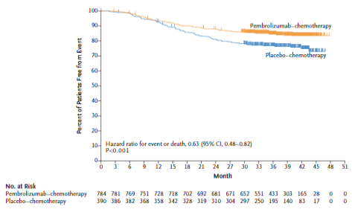
Source: Figure 2.5-1, p45 of the submission.
  - The KM curves show a separation after around 12 months favouring treatment with pembrolizumab plus chemotherapy, but also highlight the immaturity of the EFS data.
  - The submission presented details of a European Society of Medical Oncologists (ESMO) presentation (Fasching 2022), which the submission claimed demonstrated the association of EFS with OS, supporting its use as a surrogate endpoint.
  - Fasching (2022) included an analysis of individual and trial level associations in 45 studies for a total of 7,522 patients with eTNBC. For individual level associations, 3-year EFS significantly predicted 5-year OS. The EFS coefficient of 1.13, p <0.01 (R² was 0.82 (95% CI 0.68, 0.91)). The correlation between 5-year EFS and 5-year OS was similarly high (EFS coefficient = 1.02, R² = 0.80 (95% CI 0.65, 0.89)). Only 26.7% of the total population in the individual-level analyses were from randomised controlled trials (RCTs) with single arm studies accounting for 4.4% and real-world evidence studies accounting for 66.9%. Trial-level association analysis based only on the RCTs reported lower levels of correlation between EFS and OS (EFS coefficient = 1.03, R² = 0.80 (95% CI 0.45,0.83)). However, Fasching (2022) included studies which had a much more variable definition of EFS, many of which differed substantially to the EFS definition in KN-522.
  - A publication by Gyawali (2021), had a nearly identical methodology to the trial level analyses in Fasching (2022) but included all early breast cancer types (including TNBC). Gyawali (2021) found that the estimated linear association between the log of the hazard ratio (HR) EFS and log HR OS indicated a positive slope (b = 0.58 [95% CI: -0.32-1.48]) and the coefficient of determination confirmed a moderate trial-level association between log HRs for OS and EFS (R² 0.76 [95% CI 0.34,1.00]. Gyawali (2021) concluded that treatment effects in EFS are only moderately correlated with treatment effects in OS in early breast cancer in the neoadjuvant setting, but the association was not significant and that there may be insufficient evidence to unequivocally support EFS for use as a surrogate endpoint. The definitions of EFS in the TNBC studies included in Gyawali (2021) were generally more aligned with KN-522 and therefore may be more relevant to the submission than Fasching (2022). Consequently, it was unclear to what extent the EFS results supported a claim of improved overall survival and to what extent EFS results could be relied on for modelling overall survival.
  - The PSCR argued that EFS is a validated surrogate endpoint for efficacy in the neoadjuvant setting with the FDA accepting that pCR and EFS are valid and appropriate breast cancer surrogates for OS. The sponsor considered the conclusions from Gyawali (2021) and Fasching (2022) publications as being complementary. The moderate trial level association observed by Gyawali in the early (all) breast cancer setting, is further confirmed in TNBC for both the patient-level and more importantly, trial-level association between EFS and OS. The ESC considered that regardless, the events in the trial included in the definition of EFS (i.e. progressive disease leading to unresectability, recurrence, new primary disease or death) were clinically significant and as such, it would be appropriate to consider EFS as a measure of efficacy.
  - Table 6 presents the OS results from KN-522 at IA4.
Table 6: Overall survival in KN-522 (ITT)
 | Pembro + chemo  N=784 | Placebo + chemo  N=390 | HR (95% CI)
Patients with event n (%) | 80 (10.2) | 55 (14.1) | -
Patients censored n(%) | 704 (89.8) | 335 (85.9) | -
Median OS months (95% CI) | NR | NR | 0.72 (0.51, 1.02), p=0.032128
OS rate at
12 months (95% CI) | 97.2 (95.8, 98.1) | 97.2 (95.8, 98.1) | -
18 months (95% CI) | 95.0 (93.2, 96.3) | 93.8 (91.0, 95.8) | -
24 months (95% CI) | 92.3 (90.2, 94.0) | 91.0 (87.7, 93.5) | -
36 months (95% CI) | 89.7 (87.3, 91.7) | 86.9 (83.0, 89.9) | -
42 months (95% CI) | 89.2 (86.7, 91.3) | 84.1 (79.5, 87.7) | -
Source: Table 2.5-10, p47 of the submission and Table 11-4, p115 of the Kn-522 CSR
CI = confidence interval; HR = hazard ratio; ITT = intention to treat; NR = not reported
  - The submission considered that the analysis showed improvement in OS that favoured the pembrolizumab + chemotherapy arm over the placebo + chemotherapy arm at month 42. However, the submission acknowledged that due to the relative early time of the analysis with respect to the OS endpoint (approximately 45% [135 of the 297] events needed for the final analysis), the observed one-sided p-value did not cross the multiplicity-adjusted, one-sided prespecified p-value boundary at IA4. Therefore, the success criterion for the secondary OS hypothesis was not met.
  - The overall survival data is not mature enough for any clear conclusions to be drawn, except that at IA4 the difference in OS was not statistically significant between treatment arms. The PSCR noted the final analysis is not expected until late 2025 and at that point OS will be confounded by treatment cross-over.
  - Figure 2 presents the OS KM curves for KN-522.
Figure 2: KM estimates for OS, ITT
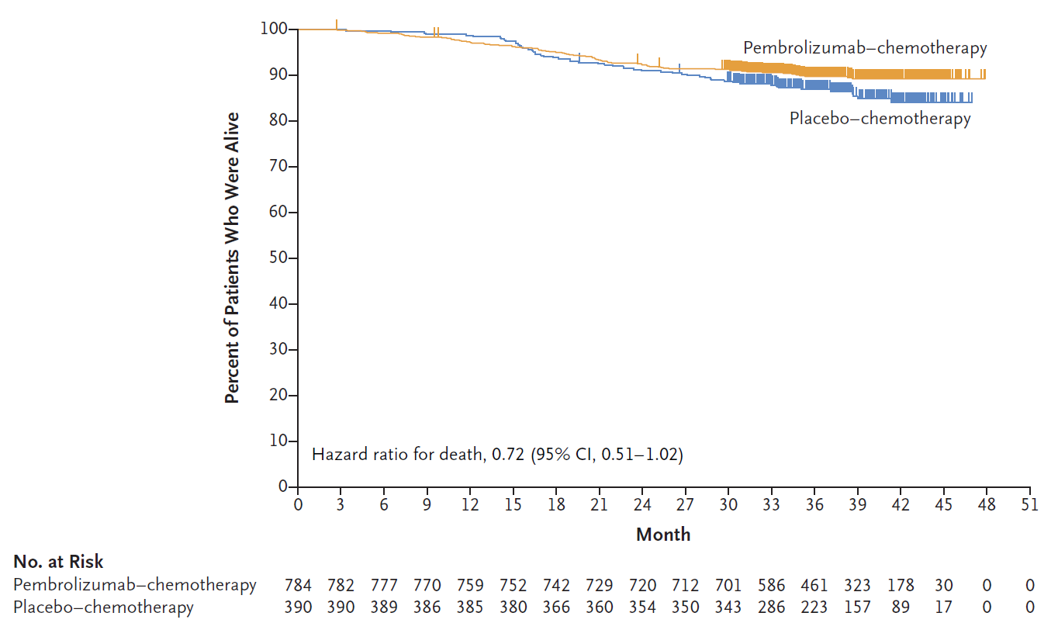
Source: Figure 2.5-3, p48 of the submission.
  - The KN-522 trial reported health related quality of life (HRQoL) results measured with the EuroQoL 5 dimensions 5 levels (EQ-5D-5L) visual analogue scale (VAS), the European Organisation for the Research and Treatment of Cancer Quality of Life Questionnaire (EORTC QLQ-C30) and the European Organisation for the Research and Treatment of Cancer Breast Cancer questionnaire (EORTC QLQ-BR23). No statistically significant differences between treatment arms were reported in any of the measures at any time point.
  - With regards to the EQ-5D-5L VAS, in the neoadjuvant phase, both treatment arms reported a worsening in terms of QoL based on the VAS of about 5-10 points with pembrolizumab + chemotherapy being slightly worse than placebo + chemotherapy (between group difference of -1.61 (95% CI -3.87 to 0.64)) but the difference was not statistically significant. Comparatively, in the adjuvant phase, both treatment arms reported a small improvement in VAS score, with the placebo arm demonstrating a small, but non-statistically significant improvement compared to pembrolizumab monotherapy (between group difference -0.59 (95% CI -2.40 to 1.23)).
  - For the economic evaluation utilities were based on KN-522 EQ-5D results classified by whether the patient had disease progression.

Comparative harms
  - Table 7 presents a summary of key adverse events (AEs) in KN-522 in the “all subjects as treated” (ASaT) population, defined as all patients who had at least one dose of treatment.
Table 7: Summary of key adverse events in KN-522 in ASaT population (neoadjuvant and adjuvant phases)
 | Pembrolizumab + chemo |  | Placebo + chemo |  | RR (95% CI) | RD (95% CI)
 | N | (%) | N | (%)
Subjects in Population | 783 |  | 389
with one or more adverse events | 777 | (99.2) | 389 | (100.0) | 0.99 (0.99, 1) | -0.01 (-0.01, 0)
With no adverse events | 6 | (0.8) | 0 | (0.0) | NA | 0.01 (0, 0.01)
with drug-related adverse events | 774 | (98.9) | 388 | (99.7) | 0.99 (0.98, 1) | -0.01 (-0.02, 0)
with toxicity grade 3 to 5 adverse events | 645 | (82.4) | 306 | (78.7) | 1.05 (0.99, 1.11) | 0.04 (-0.01, 0.09)
with toxicity grade 3 to 5 drug-related adverse events | 604 | (77.1) | 285 | (73.3) | 1.05 (0.98, 1.13) | 0.04 (-0.01, 0.09)
with serious drug-related adverse events | 267 | (34.1) | 78 | (20.1) | 1.7 (1.36, 2.12) | 0.14 (0.09, 0.19)
who died due to a drug-related adverse event | 4 | (0.5) | 1 | (0.3) | 1.99 (0.22, 17.72) | 0 (0, 0.01)
discontinued any drug due to a drug-related adverse event | 217 | (27.7) | 55 | (14.1) | 1.96 (1.5, 2.57) | 0.14 (0.09, 0.18)
discontinued pembrolizumab/ placebo | 140 | (17.9) | 26 | (6.7) | 2.68 (1.79, 3.99) | 0.11 (0.08, 0.15)
discontinued any chemotherapy | 227 | (29.0) | 58 | (14.9) | 1.94 (1.5, 2.53) | 0.14 (0.09, 0.19)
discontinued any drug due to a serious drug-related adverse event | 84 | (10.7) | 11 | (2.8) | 3.79 (2.05, 7.03) | 0.08 (0.05, 0.11)
discontinued pembrolizumab/ placebo | 72 | (9.2) | 10 | (2.6) | 3.58 (1.87, 6.85) | 0.07 (0.04, 0.09)
discontinued any chemotherapy | 82 | (10.5) | 11 | (2.8) | 3.7 (2, 6.87) | 0.08 (0.05, 0.1)
Source: Table 2.5-13, p59 of the submission.
ASaT = all subject as treated, defined as all patients who had at least one dose of treatment; Chemo = chemotherapy
  - There was a higher rate of toxicity grade 3 to 5 adverse events in the pembrolizumab + chemotherapy arm (82.4% versus 78.7%) as well as a higher rate of serious drug related adverse events (34.1% versus 20.1%), and a higher proportion of patients discontinued pembrolizumab than placebo (17.9% versus 6.7%) indicating a generally inferior safety profile compared to placebo.
  - Deaths due to AEs during the combined phases occurred in seven patients (0.9%) in the pembrolizumab + chemotherapy arm and one patient (0.3%) in the placebo + chemotherapy arm. There were four deaths in the pembrolizumab + chemotherapy arm which were considered drug related. Deaths due to AE in three patients were considered related to pembrolizumab (pneumonitis in one patient in the neoadjuvant phase, pulmonary embolism in one patient in the adjuvant phase, and autoimmune encephalitis in one patient in the adjuvant phase).
  - Table 8 presents the incidence of selected adverse events of special interest in KN-522.
Table 8: Selected adverse events of special interest in KN-522
 | Pembrolizumab + chemo |  | Placebo + chemo |  | RR (95% CI) | RD (95% CI)
 | N | (%) | N | (%)
Subjects in Population | 783 |  | 389
Any grade AEOSI | 341 | (43.6) | 85 | (21.9) | 1.99 (1.63, 2.45) | 0.217 (0.162, 0.269)
Grade 3-5 AEOSI | 117 | (14.9) | 8 | (2.1) | 7.27 (3.66, 14.56) | 0.129 (0.100, 0.158)
Serious AEOSI | 83 | (10.6) | 5 | (1.3) | 8.25 (3.49, 19.68) | 0.093 (0.069, 0.118)
AEOSI led to death | 2 | (0.3) | 0 | (0) | 2.49 (0.26, NE) | 0.003 (-0.007, 0.009)
AEOSI led to discontinuation | 85 | (10.9) | 10 | (2.6) | 4.22 (2.25, 7.98) | 0.083 (0.055, 0.110)
Types of adverse events
Infusion reactions | 141 | (18.0) | 45 | (11.6) | 1.56 (1.14, 2.13) | 0.064 (0.021, 0.105)
Hypothyroidism | 118 | (15.1) | 22 | (5.7) | 2.66 (1.73, 4.13) | 0.094 (0.059, 0.128)
Severe skin reaction | 45 | (5.7) | 4 | (1.0) | 5.59 (2.12, 14.87) | 0.047 (0.027, 0.067)
Hyperthyroidism | 41 | (5.2) | 7 | (1.8) | 2.91 (1.35, 6.32) | 0.034 (0.012, 0.055)
Adrenal insufficiency | 20 | (2.6) | 0 | (0) | 20.4 (2.61, NE) | 0.026 (0.016, 0.039)
Hypophysitis | 15 | (1.9) | 1 | (0.3) | 7.45 (1.27, 44.13) | 0.017 (0.004, 0.029)
Source: Table 12-14, p183 and Table 12-15, pp186-189, IA4 CSR
AEOSI = adverse events of special interest; chemo = chemotherapy; NE = not estimable RD = risk difference, RR = relative risk
RD and RR calculated using statsdirect during evaluation

Benefits/harms
  - A summary of the comparative benefits and harms for pembrolizumab + chemotherapy versus placebo + chemotherapy is presented in Table 9.
Table 9: Summary of comparative benefits and harms for pembrolizumab plus chemotherapy and placebo plus chemotherapy
Trial |  | Pembro + chemo | Placebo + chemo | Event rate/100 patients* |  | Difference in %  (95% CI)
 |  |  |  | Pembro + chemo | Placebo + chemo
Benefits
pCR rate
IA4 | n/N | 494/784 | 217/390 | 63.0 | 55.6 | 7.5 (1.6, 13.4)
 | pCR rate (95% CI) | 63.0 (59.5, 66.4) | 55.6 (50.6, 60.6)
Event free survival (median follow-up of 37.8 months)
Event | Pembro + chemo | Placebo + chemo | Absolute Difference | HR (95% CI)
Event, n (%) | 123 (15.7) | 93 (23.8) | - | 0.63 (0.48, 0.82)  p=0.0003093
Median PFS, months (95% CI) | NR | NR
EFS rate at:
12 Months (%) (95% CI) | 93.3 (91.4, 94.9) | 92.5 (89.4, 94.7) | 0.8%
18 Months (%) (95% CI) | 90.0 (87.7, 91.9) | 85.8 (81.9, 88.9) | 4.2%
24 Months (%) (95% CI) | 87.8 (85.3, 89.9) | 81.0 (76.8, 84.6) | 6.8%
36 Months (%) (95% CI) | 84.5 (81.7, 86.9) | 76.8 (72.2, 80.7) | 7.7%
Harms
 | Pembro + chemo | Placebo + chemo | RR  (95% CI) | Event rate/100 patients* |  | RD  (95% CI)
 |  |  |  | Pembro + chemo | Placebo + chemo
Adverse events (IA4: ASaT)
Serious drug-related AE | 267/783 | 78/389 | 1.7 (1.36, 2.12) | 34.1 | 20.1 | 0.14 (0.09, 0.19)
Discontinued any drug due to a drug-related AE | 217/783 | 55/389 | 1.96 (1.5, 2.57) | 27.7 | 14.1 | 0.14 (0.09, 0.18)
Infusion reactions | 141/783 | 45/389 | 1.56 (1.14, 2.13) | 18.0 | 11.6 | 0.064 (0.021, 0.105)
Hypothyroidism | 118/783 | 22/389 | 2.66 (1.73, 4.13) | 15.1 | 5.7 | 0.094 (0.059, 0.128)
Severe skin reaction | 45/783 | 4/389 | 5.59 (2.12, 14.87) | 5.7 | 1.0 | 0.047 (0.027, 0.067)
Hyperthyroidism | 41/783 | 7/389 | 2.91 (1.35, 6.32) | 5.2 | 1.8 | 0.034 (0.012, 0.055)
Adrenal insufficiency | 20/783 | 0/389 | 20.4 (2.61, NE) | 2.6 | 0 | 0.026 (0.016, 0.039)
Hypophysitis | 15/783 | 1/389 | 7.45 (1.27, 44.13) | 1.9 | 0.3 | 0.017 (0.004, 0.029)
Source: Table 2.5-4, p41 of the submission and Figure 1, p816 of Schmidt 2020, Table 2.5-10, p47 of the submission and Table 11-4, p115 of the Kn-522 CSR, Table 2.5-8, p44, Table 2.5-7, p43, and Table 2.5-13, p59 of the submission
AE = adverse even; ASaT = all subject as treated, defined as all patients who had at least one dose of treatment; Chemo = chemotherapy; CI = confidence interval; IA = interim analysis; NR = not reported; pCR = pathological complete response; pembro = pembrolizumab; HR = hazard ratio; PBO = placebo; RD = risk difference; RR = risk ratio
* median follow-up of 37.8 months in IA4; median follow up was 15.5 months in IA2
  - On the basis of direct KN-522 trial evidence presented by the submission, for every 100 patients treated with pembrolizumab + chemotherapy in comparison with placebo + chemotherapy:
Approximately 8 additional patients would have pathological complete response;
Approximately 8 additional patients will remain event-free after 36 months, however, there would be no difference in overall survival.
  - On the basis of direct KN-522 trial evidence presented by the submission, for every 100 patients treated with pembrolizumab + chemotherapy in comparison with placebo + chemotherapy over a median duration of follow-up of 37.8 months:
Approximately 14 additional patients would have a serious drug-related adverse event;
Approximately 14 additional patients would discontinue any drug due to a drug related adverse event;
Approximately 6 additional patients would experience an infusion reaction;
Approximately 9 additional patients would experience hypothyroidism;
Approximately 5 additional patients would experience a severe skin reaction;
Approximately 3 additional patients would experience hyperthyroidism;
Approximately 3 additional patients would experience adrenal insufficiency; and
Approximately 2 additional patients would experience hypophysitis.

Clinical claim
  - The submission’s clinical claim was that pembrolizumab + chemotherapy has superior efficacy and inferior but manageable safety profile compared to placebo + chemotherapy in high-risk early stage TNBC patients.
  - Overall, the commentary concluded that EFS and pCR results showed that patients may benefit from pembrolizumab + chemotherapy in the adjuvant and neoadjuvant settings. However, OS data from KN-522 was immature and not statistically significantly different between treatment arms. Furthermore, the equivocal validation of EFS as surrogate for OS posed challenges to estimating the magnitude of benefit associated with pembrolizumab and determining whether such benefit was clinically meaningful. The absence of capecitabine in the KN-522 trial may have led to an overestimate of the incremental benefit compared to what may be expected in the Australian setting. The ESC considered that there was a clinically significant benefit from treatment with pembrolizumab + chemotherapy in the neoadjuvant setting in terms of pCR and EFS, however the benefit of adjuvant treatment with pembrolizumab over SoC including capecitabine, for patients with residual disease, remains uncertain. In addition, the ESC considered that there remained significant uncertainty regarding long term benefit in terms of overall survival.
  - For overall safety, the submission considered that pembrolizumab + chemotherapy was well tolerated. This is supported by a median duration of exposure that was equal in both arms (i.e., both arms reached median duration of 17 cycles). However, more adverse events were observed for pembrolizumab. The submission stated adverse events were manageable and consistent with the safety profile for pembrolizumab in other settings. While some adverse events may be manageable there was a higher number of fatal adverse events in the pembrolizumab arm. The ESC agreed with the submission that inferior safety for pembrolizumab + chemotherapy was supported by the KN-522 evidence.
  - The PBAC considered that the claim of superior comparative effectiveness was reasonable, with a clinically significant benefit based on improved EFS. The PBAC noted that KN-522 showed that patients benefited from pembrolizumab in the neoadjuvant setting, however it was unclear whether there was any benefit from adjuvant pembrolizumab, especially for patients with a pCR. The PBAC considered that there remained uncertainty regarding the magnitude of OS benefit as the data are immature.
  - The PBAC considered that the claim of inferior comparative safety was reasonable. The PBAC noted that most AEs are manageable in clinical practice, however there is a potential for life-threatening toxicities, and long-term immune mediated toxicities, which is a significant concern given that TNBC patients are generally younger and treatment in the eTNBC stage is given with curative intent.

Economic analysis
  - The submission presented a stepped cost-utility analysis. A summary of the economic evaluation is presented in Table 10.
Table 10: Summary of model structure, key inputs and rationale
Component | Summary
Treatments | Pembrolizumab plus chemotherapy in the neoadjuvant setting and pembrolizumab monotherapy in the adjuvant setting versus chemotherapy in the neoadjuvant setting.
Time horizon | 30 years in the model base case vs. approximately 164 weeks (37.8 months) in the trial.
Outcomes | Life years gained, Quality-adjusted life years
Methods used to generate results | Markov cohort – expected value analysis
Health states | - Event-free survival (EFS)  - Locoregional recurrence (LR)  - Distant metastasis (DM)  - Death
Cycle length | 1 week, half cycle corrected
Transition probabilities | Informed by KN-522 trial transitions, extrapolated from the trial follow-up period and including background mortality.
Extrapolation method | EFS was extrapolated from KN-522 KM data at median follow-up of 164.3 and 163.4 weeks for pembrolizumab plus chemotherapy and chemotherapy, respectively, using generalised gamma curves in both arms.
Health related quality of life | Utilities were based on EQ-5D responses in KN-522. Event free on treatment: 0.775, Event free off treatment: 0.785, locoregional recurrence: 0.693, distant metastasis: 0.552, Grade 3+ AE decrement: -0.039
Table 3.1-1, p87 the submission.
EQ-5D = EuroQoL 5 dimensions.
  - Figure 3 presents the health state transition diagram in the Markov model
Figure 3: Health state transition diagram in the Markov model
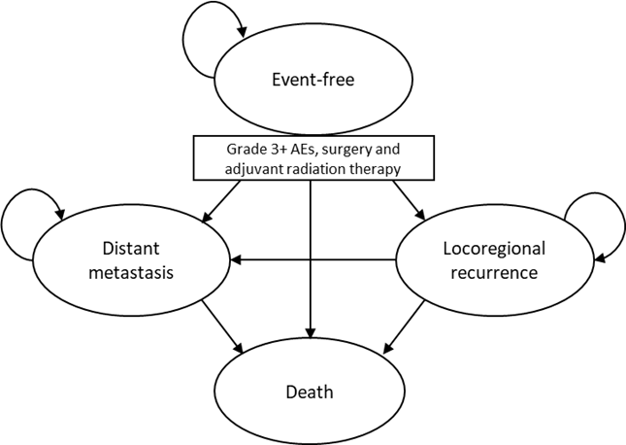
Source: Figure 3.2-2 (p97) of the submission
  - Transition probabilities from the event-free (EF) state were determined by the EFS KM curve from KM-522 based on the probability of EFS events over time, with a mix of observed and extrapolated results. The probability of transitioning from EF to local recurrence (LR), distant metastasis (DM) or death were analysed using the Gray’s method (J.P. and Gray R.J., 1999) considering competing risks. Transitions from the EFS state, as modelled by the EFS extrapolations, were a key driver of the model.
  - The time to death from local recurrence (LR) and distant metastasis (DM) were also determined by patients who experienced LR and DM in KN-522. The model was not sensitive to changes in the transition from LR and DM to death.
  - Figure 4 presents the extrapolations tested in the submission. The submission stated that the curves were modelled independently based on the distinct nature of the different treatments and the PSCR noted that log-cumulative hazard plots showed that the proportional hazard assumption was violated and therefore it was reasonable to model them independently. The base case used generalised gamma extrapolations in both arms. The submission stated that for the pembrolizumab + chemotherapy arm this provided the best Akaike information criterion (AIC) and Bayesian information criterion (BIC) statistics, and in the chemotherapy arm it had the best AIC and second-best BIC (to the log-normal). As illustrated in Figure 4, there was a large degree of uncertainty regarding the long term EFS extrapolation and a substantial amount of variation in incremental EFS depending on the function chosen. The generalised gamma function was among the most optimistic extrapolations for both treatment arms. The ESC questioned whether it was reasonable to expect that 60% of patients with TNBC diagnosed at ~51 years would be alive at 81 years, or similarly, 40% of TNBC patients treated with chemotherapy.
Figure 4: Event-free survival one-piece parametric survival curves for pembrolizumab vs. chemotherapy (0 axis, 30-year time horizon)
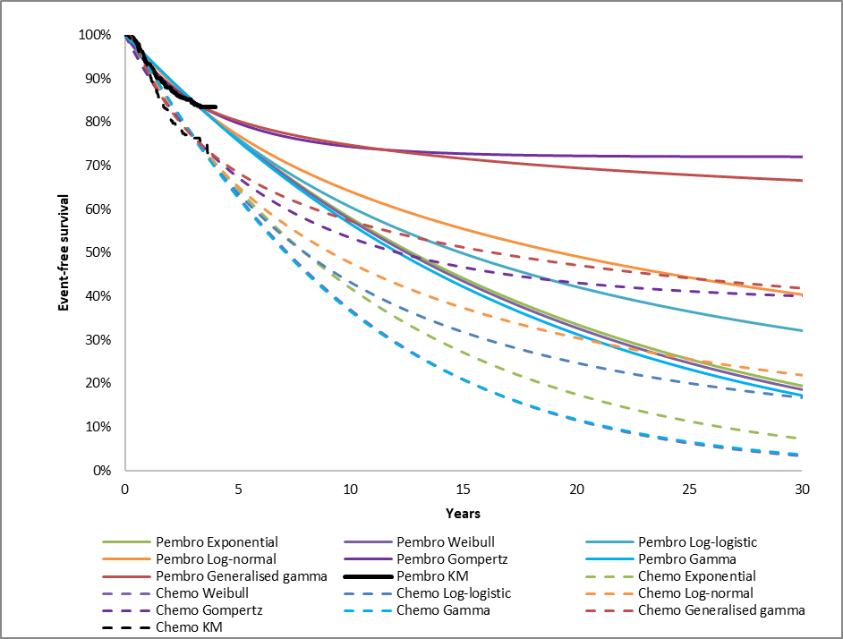
Source: ‘EFS extrapolation’ worksheet of ‘eTNBC Section 3 workbook.xlsx’
Chemo = chemotherapy; KM = Kaplan Meier; pembro = pembrolizumab
  - OS was estimated as the sum of time spent in the EF, LR and DM states. The submission compared the resulting OS curves with two external studies as shown in Figure 5:
- Walsh (2019), a retrospective study of patients diagnosed with TNBC between January 2000 and December 2015, with a median follow-up of 30 months. The study was conducted in Ireland where, the submission considered, neoadjuvant therapy is consistent with current standard of care in Australia; and
- Sikov (2019) (CALGB 40603), a randomised, open-label phase II trial conducted in the United States of 443 patients with stage II or III TNBC designed to examine the impact of adding carboplatin and/or bevacizumab to conventional neoadjuvant chemotherapy.
It was unclear whether treatment options and outcomes in these studies in Ireland and the US would be reflective of the Australian setting.
  - The OS KM for the chemotherapy arm in KN-522 sat above the OS reported in the external literature, which raises questions as to the value of this external validation. Nonetheless, this validation suggested that the OS in both arms of the economic model may be overestimated, which was consistent with the fact that more optimistic extrapolations were chosen for both treatment arms (see Figure 4).
Figure 5: Overall survival external validation
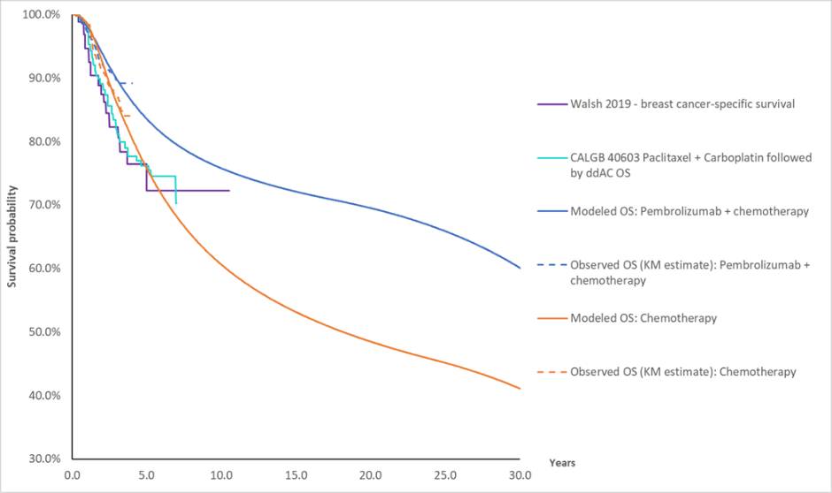
Source: Figure 3.7-11, p142 of the submission.
  - The economic evaluation used a 30-year time-horizon. The submission justified this time horizon based on: the curative intent of pembrolizumab, the claimed effectiveness of pembrolizumab based on KN-522 median follow-up of over 3 years, the listing of sacituzumab govitecan extending OS for TNBC patients, the younger median age of TNBC patients (49 years in KN-522, 55 years in Naher (2018)) compared to HER+2 breast cancer patients (58.5 years, Table 11 of trastuzumab emtansine November 2019 Public Summary Document (PSD)) and overall early breast cancer (61.4 years, para. 7.11 abemaciclib March 2022 PSD), and that longer time horizons have been adopted by other HTA agencies (51 years for CADTH). The commentary noted that the CADTH model estimated a smaller incremental quality adjusted life year (QALY) gain compared to the submission’s model despite having a longer time horizon.
  - The ESC noted that patients with TNBC are often diagnosed at a young age and considered that the patient age from KN-522 is likely to be applicable to the Australian setting. In its consideration of trastuzumab emtansine (T-DM1) in early HER2+ breast cancer the PBAC considered that greater confidence in establishing cost-effectiveness would be derived by limiting the time horizon to 20 years (paragraph 6.36, trastuzumab emtansine PSD, November 2019 PBAC meeting). The PBAC noted that the use of a 30-year time horizon introduced additional uncertainty into the modelled outcomes but considered that this time horizon was reasonable, as patients with eTNBC are typically younger.
  - The ESC considered that the utility values from the KN-522 trial appeared reasonable and were relatively consistent with values used in other eBC submissions.
  - The submission claimed that subsequent therapy costs for LR and DM were derived from usage in KN-522. This could not be verified as subsequent usage of anticancer medications in KN-522 was not presented. The PSCR noted that this data could not be provided as publication of this data could pose a risk to the integrity of the ongoing study. The ESC noted that subsequent therapy utilisation therefore remained unverified.
  - The terminal care cost assumed in DM patients who die in the model ($31,638.76, based on Reeve (2017)) may be overestimated. In its consideration of sacituzumab govitecan at the March 2022 PBAC meeting, the PBAC noted that the majority of costs in Reeve may be associated with management of co-morbidities and should not be applied in a disease specific economic analysis (paragraph 6.54, sacituzumab govitecan PSD, March 2022 PBAC meeting). The pre-PBAC response by the sponsors of sacituzumab govitecan proposed much lower terminal care costs of $6,050, which the PBAC considered to be more appropriate (paragraph 6.56, sacituzumab govitecan PSD, March 2022 PBAC meeting). The ESC noted that the impact of terminal care costs is likely to be dependent on the time horizon applied.
  - The submission calculated the proportion of patients on adjuvant treatment at each point in time as the difference between the proportion of patients on any treatment (based on time to end of treatment course curve) and the proportion of patients who had surgery (based on time to end of surgery curve). This led to a relatively small discrepancy between the trial and modelled ToT. As noted in the PSCR the mean ToT for the 71.3% (558/783) of patients who received adjuvant pembrolizumab was 22.9 weeks. While this led to mean ToT of 22.9*71.3%= 16.3 weeks for the ITT population in the pembrolizumab arm, the model estimated mean ToT was 16.6 weeks.
  - The submission also noted that sacituzumab govitecan for R/R mTNBC was listed on the PBS in 2022 based on superiority to SoC chemotherapy, but no patients in KN-522 were treated with sacituzumab govitecan. The submission stated adjustments for sacituzumab govitecan were made to OS in the base-case by increasing the mean OS in the DM health state by 7.96 weeks in both treatment arms. Removing this adjustment increased the ICER by 6.2%.
  - Table 11 presents a summary of the key drivers of the model.
Table 11: Key drivers of the model
Description | Method/Value | Impact  Base case: $||¹/QALY gained.
Assumption of treatment waning in EFS | The submission base case did not assume treatment waning | High, favours pembrolizumab  Applying treatment waning at 8 years increased the ICER by 20%.  Applying treatment waning at 5 years increased the ICER by 102.7%
Time horizon | The base case ICER applied a 30-year time horizon | High, favours pembrolizumab  Applying a 20-year time horizon, increased the ICER by 39.1%
EFS extrapolation | The base case used generalised gamma extrapolations in both arms. The switch from KM estimates to extrapolated estimates was at 164.3 and 163.4 weeks for pembrolizumab + chemotherapy and chemotherapy, respectively | Moderate, favours pembrolizumab  Use of next best fitting curves (Log normal in both arms) increased the ICER by 12.4%
Capecitabine use | The base case did not adjust costs and outcomes for capecitabine use | Moderate, favours pembrolizumab  Including capecitabine use increased the ICER by 12.6%
Source: Table 3.9-1, p148-151 of the submission.
EFS = event free survival; ICER = incremental cost-effectiveness ratio; QALY = quality adjusted life-year
The redacted values correspond to the following ranges:
¹ $35,000 to < $45,000
  - Table 12 presents the results of the stepped economic evaluation.
Table 12: Stepped base-case analysis results (discounted)
Step | Cost | Incremental cost | Effectiveness | Incremental effectiveness | ICER
Step 1 – within trial analysis (cost/LY gained)
Pembrolizumab | $|| | $ | | 2.74 | 0.02 | $||¹
Chemotherapy | $9,879 |  | 2.72
Step 2 – 30-year time horizon (cost/LY gained)
Pembrolizumab | $|| | $ | | 12.65 | 2.09 | $||²
Chemotherapy | $15,912 |  | 10.56
Step 3 – include disease management costs (cost/LY gained)
Pembrolizumab | $|| | $ | | 12.65 | 2.09 | $||²
Chemotherapy | $28,529 |  | 10.56
Step 4 – include AE costs (cost/LY gained)
Pembrolizumab | $|| | $ | | 12.65 | 2.09 | $||²
Chemotherapy | $29,347 |  | 10.56
Step 5 – include terminal care costs (cost/LY gained)
Pembrolizumab | $|| | $ | | 12.65 | 2.09 | $||³
Chemotherapy | $40,954 |  | 10.56
Step 6 – transform LYs into QALYs (cost/QALY)
Pembrolizumab | $|| | $ | | 9.33 | 1.57 | $||²
Chemotherapy | $40,954 |  | 7.76
Source: Table 3.8-2 (p145) of the submission
AE = adverse event; LY = life years; QALY = quality assurance life year
The redacted values correspond to the following ranges:
¹ > $1,055,000
² $35,000 to < $45,000
³ $25,000 to < $35,000
  - Table 13 presents a summary of disaggregated and aggregated model results.
Table 13: Disaggregated and aggregated base-case results (discounted)
Item description | Pembrolizumab | Chemotherapy | Incremental | % of incremental
Treatment costs
Drug acquisition costs (neoadjuvant) | $ | | $2,979 | $ | | 66.5%
Drug acquisition costs (adjuvant) | $ | | $0 | $ | | 50.6%
Metastatic treatment costs | $ | | $11,154 | -$ | | -5.5%
Disease management costs
EFS | $ | | $1,909 | $ | | 0.4%
LR | $ | | $1,754 | -$ | | -1.1%
DM | $ | | $6,749 | -$ | | -4.8%
Terminal care costs | $ | | $11,607 | -$ | | -7.0%
Adverse event costs | $ | | $818 | $ | | 0.3%
QALYs
EFS | 9.64 | 7.75 | 1.89 | 120.2%
LR | 0.07 | 0.13 | -0.06 | -3.6%
DM | 0.13 | 0.26 | -0.13 | -8.3%
Age-related decrement | -0.51 | -0.38 | -0.13 | -8.3%
Total | 9.33 | 7.76 | 1.57 | 100.0%
LYs (discounted)
EFS | 12.30 | 9.89 | 2.41 | 115.3%
LR | 0.10 | 0.18 | -0.08 | -3.8%
DM | 0.24 | 0.48 | -0.24 | -11.5%
Total | 12.65 | 10.56 | 2.09 | 100%
Source: Tables 3.8-3 and 3.8-4 (p146-7) of the submission and the ‘Pairwise base case’ worksheet of the ‘eTNBC Section 3 workbook.xlsx’
DM = distant metastasis; EFS = event free survival; ICER = incremental cost effectiveness ratio; LY = Life year; LR = local recurrence; LYG = life year gained; QALY = Quality adjusted life year.
  - A comparison of EFS rates in the KN-522 trial and in the model is presented in Table 14. The observed and modelled EFS and OS KM estimates are presented in Figure 6.
Figure 6: Observed and modelled event-free survival and overall survival for pembrolizumab vs. chemotherapy
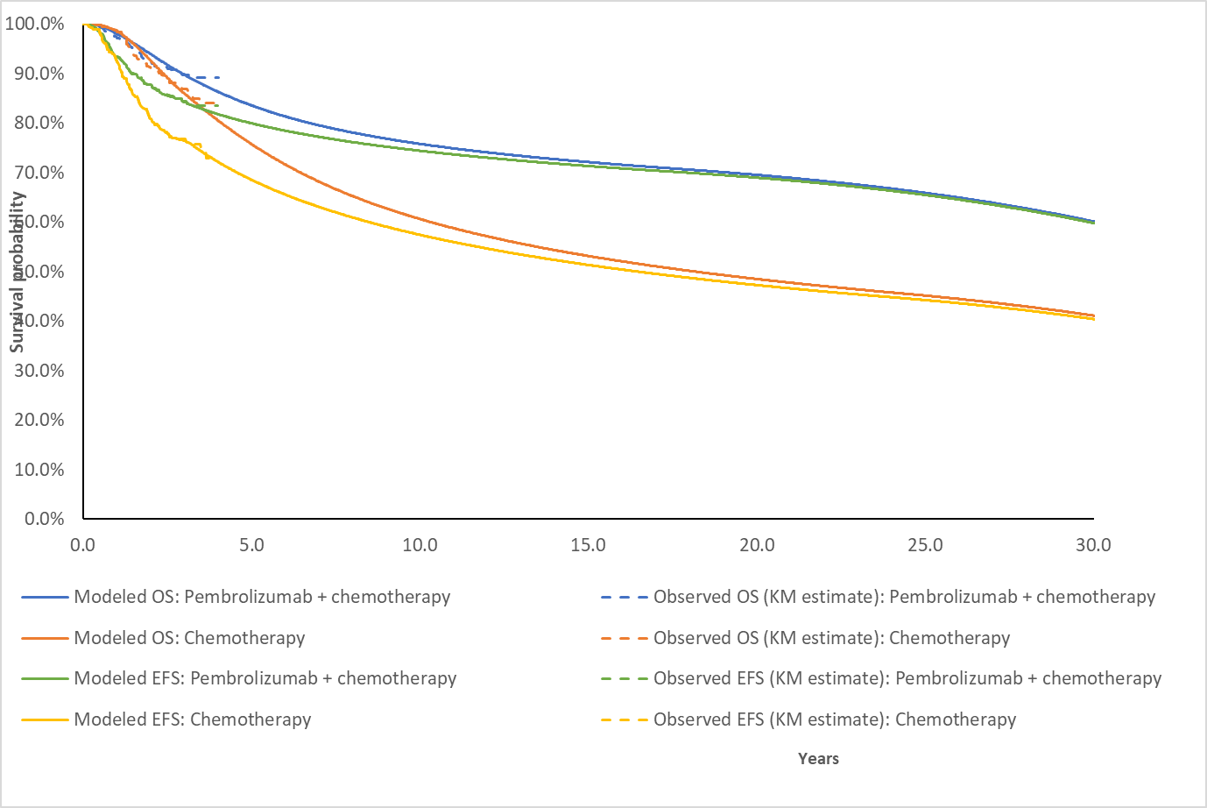
Source: ‘EFS extrapolation’ worksheet of ‘eTNBC Section 3 workbook.xlsx’
Chemo = chemotherapy; KM = Kaplan Meier; Pembro = pembrolizumab
Table 14: Event free survival in KN-522 and in the model
Recurrence event | Pembro plus chemo | Chemo | Incremental outcome
KN-522 |  |  | Increment
EFS
At 12 months (%) | 93.3 | 92.5 | 0.8
At 18 months (%) | 90.0 | 85.8 | 4.2
At 24 months (%) | 87.8 | 81.0 | 6.8
At 36 months (%) | 84.5 | 76.8 | 7.7
Model (time horizon 30 years)
EFS
At 24 months (%) | 87.8 | 81.0 | 6.8
At 36 months (%) | 84.5 | 76.8 | 7.7
At 48 months (%) | 82.0 | 72.4 | 9.6
At 5 years (%) | 80.2 | 68.8 | 11.4
At 10 years (%) | 74.6 | 57.6 | 17.0
At 20 years (%) | 69.4 | 47.4 | 22.0
At 30 years (%) | 66.5 | 42.0 | 24.5
Source: Table 2.5-7, p43 of the submission and columns AV and AW of the ‘EFS Summary sheet of ‘eTNBC Section 3 workbook.xlsx’
EFS = event free survival.
  - The model generated a greater increment in EFS (and consequently OS) as the time progresses and estimated treatment effects in OS and EFS at any given point beyond 5 years were substantially greater than any increment in the KM data. By the end of the 30-year time horizon, the model estimated an increment of 24.5% of EFS events as compared with 7.7% at the last landmark EFS estimate of KN-522 (36 months).
  - The model settings allowed for varying assumptions of treatment waning, which assumed the EFS hazard rate of the pembrolizumab arm would be equal to the EFS hazard of the chemotherapy arm after a specified time-point. The submission assumed no treatment waning effect in the base case and argued that this was justified based on the mechanism of action for immunotherapies such as pembrolizumab, especially in the early stage setting with curative intent. The model was highly sensitive to this assumption. The PSCR noted that for each subsequent data cut throughout KN-522, the OS HR consistently moved in a direction that favours pembrolizumab + chemotherapy (1.09 at IA2, 0.80 at IA3, and 0.72 at IA4), with the curves continuing to separate. The PSCR argued that the application of treatment waning was therefore not appropriate. The ESC noted that the trial data was immature and limited to a median follow up of 37.8 months. The ESC considered that it was not clinically plausible that the increment in EFS would continue to increase throughout the full time horizon of the model and hence application of treatment waning would be appropriate. The ESC noted that the model structure did not allow for the impact of curve convergence to be tested. The pre-PBAC response argued that it is clinically implausible that treatment benefit ceases completely at 5 years and is not supported by the available data and maintained that the long-term treatment benefit of pembrolizumab modelled from KN-522 is unlikely to diminish significantly over time. The PBAC noted that with application of treatment waning in the model, the incremental EFS and OS benefit from treatment was assumed to be maintained, rather than continuing to increase, which it considered to be reasonable. The PBAC noted that the majority of patients who relapse would be expected to do so within 5 years and therefore this was an appropriate timepoint at which to apply treatment waning.
  - Figure 7 shows the impact on modelled OS of applying treatment waning for pembrolizumab at different timepoints.
Figure 7: Overall survival using treatment waning assumptions at various timepoints
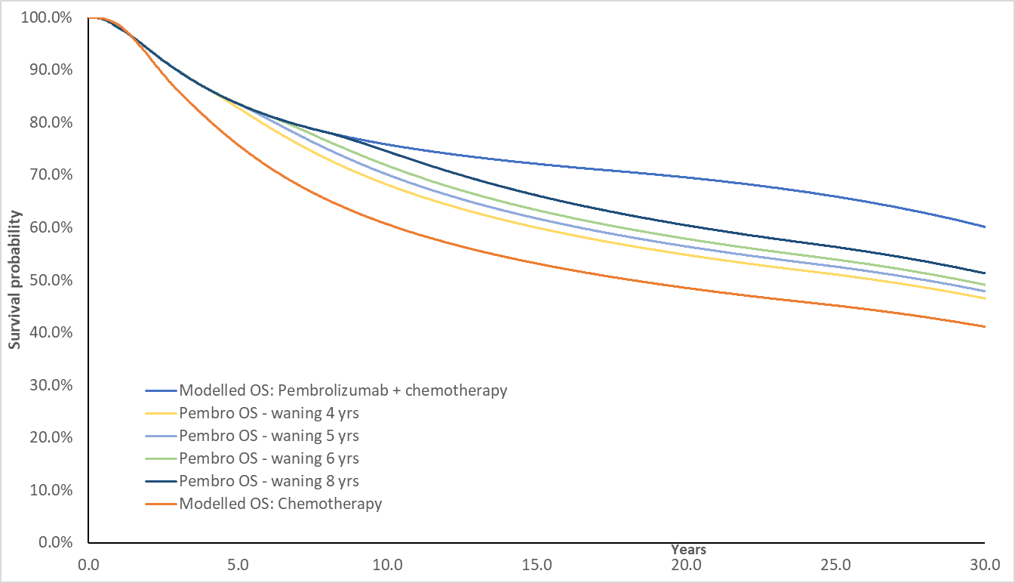
Source: ‘EFS extrapolation’ worksheet of ‘eTNBC Section 3 workbook.xlsx’
Chemo = chemotherapy; KM = Kaplan Meier; Pembro = pembrolizumab; OS = overall survival
  - The submission acknowledged that there was a proportion of capecitabine use as adjuvant therapy for early stage TNBC in Australia despite its toxicity profile, given the absence of alternative effective treatments, though capecitabine was not used in KN-522. In a sensitivity analysis, the submission assumed 44.5% of patients would receive capecitabine based on the proportion of chemotherapy arm patients who did not achieve pCR after the neoadjuvant phase in KN-522.
  - A HR of 0.886 from a meta-analysis by van Mackelenbergh (2022) was applied to the chemotherapy arm for the proportion of patients (44.5%) assumed in the adjuvant phase of the trial to have used capecitabine. Van Mackelenbergh (2022) was a meta-analysis of patient level data from 13 trials (n=15,993) to examine the effect of capecitabine on disease free survival (DFS) in early breast cancer. In the subgroup of TNBC patients (n=3,854), the DFS HR for capecitabine compared to the control arms (primarily chemotherapy) from the meta-analysis in TNBC patients was 0.886 (95%CI 0.789, 0.994). The DFS definition in van Mackelenbergh (2022) was not completely aligned with EFS in KN-522 and it may not have been appropriate to apply the DFS HR to the EFS curve in KN-522. The ESC agreed with the Commentary that the base-case likely underestimated the EFS and OS in the chemotherapy arm by not accounting for the benefit of adjuvant capecitabine for patients with residual disease. The ESC considered that it would be appropriate for the model to include adjustment to account for capecitabine use in these patients, but also noted that it was uncertain whether the adjustment applied in the sensitivity analysis appropriately captured the benefit for capecitabine.
  - The results of key univariate and multivariate sensitivity analyses are summarised in Table 15.
Table 15: Sensitivity analysis results
Description | Incremental cost ($) | Incremental QALYs | ICER ($) | %Δ
Base-case | || | 1.57 | ||||||¹ | -
Time horizon (30 years in base case)
20-year | || | 1.114 | ||||² | 39.1%
Discounting (5% in BC)
0% discounting per year for costs and outcomes | || | 3.40 | ||||³ | -57.0%
3% discounting per year for costs and outcomes | || | 2.10 | ||||¹ | -26.7%
Starting age (49 in base case)
55 based on Naher (2018) | || | 1.48 | ||||⁴ | 6.1%
Adjustment of costs and outcomes to account for DM use of Sacituzumab govitecan (included in base case)
Turn off sacituzumab govitecan adjustment (both outcomes and costs) | || | 1.58 | ||||⁴ | 6.2%
Adjustment for adjuvant capecitabine (not included in base case)
Adjustment for adjuvant capecitabine (HR of 0.886 and proportion of adjuvant capecitabine use of 44.5%) | || | 1.41 | ||||⁴ | 12.6%
EFS extrapolation (generalised gamma in both arms in base case)
Next best fitting one-piece curves (log-normal for both pembrolizumab and chemotherapy) | || | 1.44 | ||||⁴ | 12.4%
Disease management costs (based on Verry 2012 in base case)
Schilling (2019) for both LR and DM disease management costs ($48.91 per week) | || | 1.57 | ||||⁴ | 4.8%
Terminal care costs ($31,638.76 in base case)
Assume $6,050 terminal cost as in sacituzumab govitecan | || | 1.57 | ||||⁴ | 5.7%
Treatment effect waning (not applied in base case)
Applied after 8 years | || | 1.16 | ||||² | 20.0%
Applied after 6 years | || | 0.97 | ||||⁵ | 75.6%
Applied after 5 years | || | 0.85 | ||||⁵ | 102.7%
Applied after 4 years | || | 0.71 | ||||⁶ | 147.8%
Multivariate sensitivity analyses
20 year time horizon, adjustment for adjuvant capecitabine, SG terminal care costs, treatment waning after 5 years | || | 0.61 | ||||⁷ | 188.4%
Pre-PBAC response revised base case
25 year time horizon, adjustment for adjuvant capecitabine, SG terminal care costs, treatment waning after 8 years | || | 0.95 | ||||⁵ | 83.8%
As above, with price revised from $|||||| to $|||||| per 100 mg vial EMP. | || | 0.95 | ||||¹ | -
PBAC revised analysis
30 year time horizon, adjustment for adjuvant capecitabine, SG terminal care costs, treatment waning after 5 years, price revised from $|||||| to $|||||| per 100 mg vial EMP. | || | 0.75 | ||||² | 30.2%
Source: Table 3.9-1, p148-151 of the submission
AE = adverse event; BC = base case; DM = distant metastasis; EFS = event free survival; EMP = ex-manufacturer price; HR = hazard ratio; LR = local recurrence; OS = overall survival; Q3W = every three weeks; QALY = quality adjusted life-year.
*This value is adjusted to reflect time spent in PFS and PD for metastatic breast cancer
ª This was done by multiplying values in column BT of ‘Pembro Trace’ by 1.1
^{b} Changing the DM cost and median LY (as a proxy for mean) to that reported from the mTNBC model. (cells F112:G113 in ‘DM Treatment cost and efficacy” in the eTNBC model.) Source of OS in DM treatment in the model base case was unclear.
The redacted values correspond to the following ranges:
¹ $35,000 to < $45,000
² $55,000 to < $75,000
³ $15,000 to < $25,000
⁴ $45,000 to < $55,000
⁵ $75,000 to < $95,000
⁶ 95,000 to < $115,000
⁷ $115,000 to < $135,000
  - Overall the largest drivers of the model were the variables which contributed to the long-term modelling of EFS in the treatment arms, including time horizon, EFS extrapolation and treatment waning assumptions. Employing the model’s treatment effect waning options increased the incremental cost effectiveness ratio (ICER) substantially.
  - The scenario analysis which incorporated the use of capecitabine in the chemotherapy arm to better reflect treatment in the Australian setting increased the ICER by nearly 13%, though as discussed in paragraph 6.65 there were uncertainties associated with this analysis.
  - The submission also presented a scenario analysis in which pembrolizumab was available for both eTNBC and mTNBC. However, the inputs assumed for this analysis were unlikely to have been reasonable (e.g. only ‘PD-L1 negative’ patients were assumed to be treated with pembrolizumab in the mTNBC setting, and PD-L1 treatments including both pembrolizumab and atezolizumab were assumed in the chemotherapy arm when PD-L1 testing was assumed despite no immunotherapies being currently available on the PBS for mTNBC) and therefore the results were unlikely to be informative.
  - A sensitivity analysis using the base case results of the mTNBC economic model inputted into the DM management costs and outcomes in the eTNBC model (without making any structural changes) resulted in an overall ICER of $45,000 to < $55,000 per QALY, a 12.7% increase from the base case of eTNBC only. This could be interpreted as a comparison of the combination of the proposed treatment algorithm across the two submissions (pembrolizumab + chemotherapy neoadjuvant and pembrolizumab as adjuvant in eTNBC and pembrolizumab + chemotherapy in mTNBC for those who relapse) with the current treatment algorithm (chemotherapy neoadjuvant with no neoadjuvant treatment in eTNBC and chemotherapy in mTNBC for those who relapse). However, this result should be interpreted with caution as this includes all the uncertainties associated with the eTNBC model in addition to the uncertainties within the mTNBC model and it was unclear if the analysis appropriately accounts for all the interactions of the combination listing (e.g. the mTNBC result would include both recurrent and de novo mTNBC patients whereas only recurrent patients should be included in the eTNBC analysis). Moreover, KN-355, the pivotal trial used to inform the mTNBC submission, specifically excluded patients who had previously received PD-(L)1 treatment and may not be an appropriate evidence source for this analysis.
  - A multivariate analysis was conducted applying the inputs ESC considered likely to be reasonable, specifically:
- Changed time horizon to 20 years (see paragraphs 6.50 and 6.51);
- Inclusion of costs and benefits for adjuvant capecitabine (see paragraph 6.65);
- Applied a terminal care cost in mTNBC consistent with PBAC’s previous consideration of sacituzumab govitecan (paragraph 6.54); and
- Applied treatment waning from 5 years (see paragraph 6.61).
This analysis increased the ICER by 188%, from $35,000 to < $45,000 to $115,000 to < $135,000 per QALY.
  - The pre-PBAC response provided a revised base case applying the following inputs:
- Changed time horizon to 25 years;
- Inclusion of costs and benefits for adjuvant capecitabine;
- Applied a terminal care cost in mTNBC consistent with PBAC’s previous consideration of sacituzumab govitecan; and
- Applied treatment waning from 8 years.
This analysis increased the ICER by 84%, from $35,000 to < $45,000 to $75,000 to < $95,000 per QALY. The pre-PBAC response proposed a revised price ($| |) that resulted in an ICER of $35,000 to < $45,000/QALY.

Drug cost/patient/course
Table 16: Drug cost per patient for proposed and comparator drugs
 | Pembrolizumab plus chemotherapy
 | Trial dose and duration | Model | Financial estimates  (PSCR revised)
Neoadjuvant
Pembrolizumab
Cost per admin | $|ª |  | $|
Number of admin | 7.1 | 7.436^{b} | 7.44 ^{h}
Total pembrolizumab acquisition cost | $ | | $ | | $|
Chemotherapy ^{c} | NC ^{f} | $2,901.84^{d} | Not included
Total neo-adjuvant costs | NC ^{f} | $ | | $|
Adjuvant
Pembrolizumab
Proportion of neoadjuvant patients treated in the adjuvant setting | 71.3% | NA | 75% ^{i}
Time on treatment (weeks) | 22.9 | NA | 22.9
Time on treatment (adjusted for proportion receiving adjuvant treatment) | 16.3 | 16.6 | 17.2
Cost per admin | $|^{e} |  | $|
Number of admin | 5.92 ^{g} | 5.525 ^{b} | 5.72
Cost/patient/course | $ | | $ | | $|
Combined
Combined neo-adjuvant and adjuvant drug cost | NC ^{f} | $ | | $|
Pembrolizumab total cost | $ | | $ | | $|
Source: neoadj_trt_costs and adj_trt_costs worksheets of ‘eTNBC Section 3 Workbook.xlsx’
AUC = area under the curve; NC = not calculated Q3W = every three weeks
ª Based on 95% relative dose intensity in neoadjuvant setting
^{b} Back calculated based on calculated total pembrolizumab cost divided by cost per administration
^{c} Including Carboplatin AUC 5, Q3W, carboplatin AUC 1.5, weekly, paclitaxel, cyclophosphamide, doxorubicin, epirubicin. Drug costs per administration and number of administrations could not be disaggregated in the economic model.
^{d} Calculated by setting values C30:C53 in neoadj_trt_costs worksheet to 0, and taking output of cell CP12 in pembro_trace sheet
^{e} Based on 99.8% relative dose intensity in adjuvant setting
^{f} Because of the number of chemotherapy regimens, the diversity in dosing schedules, and the relatively low impact of their costs, for brevity and clarity, the individual chemotherapy costs are not presented.
^{g} The mean number of administrations from the trial in the adjuvant phase (8.3), adjusted to account for only 71.3% of neoadjuvant patients receiving adjuvant treatment.
^{h} Revised to 22.31 weeks in PSCR
^{i} 75% based on PSCR revised financial estimates
  - The submission’s economic model estimated a total undiscounted cost of pembrolizumab of $| | per patient, per course. Without half cycle correction applied, this was $| |. This was based on a weighted DPMQ of $| | and with a dose intensity of 95% applied in the neoadjuvant setting and 99.8% in the adjuvant setting and 7.4 neoadjuvant administrations and 5.5 adjuvant administrations. The sponsor’s revised price (weighted DPMQ of $| |) reduced the modelled drug cost per patient per course to $| | ($| | as neoadjuvant treatment and $| | as adjuvant treatment).
  - The submission’s financial estimates assumed a dose intensity of 100% and assumed the maximum number of administrations (9) were received in the adjuvant setting. The PSCR revised the proportion of neoadjuvant patients receiving adjuvant pembrolizumab from 100% to 75% and revised the time on treatment for these patients to 22.9 weeks to align with use in KN-522 and the economic model.
  - The modelled cost for chemotherapy was $2,901.84 in combination with pembrolizumab and $2,965.30 without pembrolizumab. Chemotherapy costs were not included in the financial estimates.

Estimated PBS usage & financial implications
  - This submission was considered by DUSC. The submission took an epidemiological approach to estimating use. This was reasonable.
  - Table 17 presents the key inputs relied on in the financial estimates.
Table 17: Data sources and parameter values applied in the utilisation and financial estimates
Data | Value | Source | Comment
Eligible population
Incidence of breast cancer, projected to 2028 | Yr 1: 21,118  Yr 2: 21,602  Yr 3: 22,087  Yr 4: 22,571  Yr 5: 23,055  Yr 6: 23,540 | AIHW 2022 | This was reasonable.
% TNBC | 15% | TNBC accounts for approximately 10-20% of all breast cancers (Cancer Council Australia). | The submission noted that midpoint estimate of 15% of all breast cancers was selected for the atezolizumab metastatic TNBC PBAC submission in March 2021, which was considered by DUSC to be reasonable.
% Patients with Stage II or III TNBC at diagnosis | 46.8% | AIHW data for all breast cancer | The submission assumed that the relative proportions of Stage II or III TNBC will be similar to the total incident breast cancer population. DUSC considered this may be underestimated with higher rates of Stage III TNBC at diagnosis reported worldwide however noted that there is likely no better source of data for the Australian population.
% ECOG 0 or 1 | 78% | Atezolizumab PSD Mar 2021 in | DUSC considered this may be an underestimate for the early TNBC population and 95% (as per the PSCR) was reasonable.
Prevalent patients | A 1-year survival rate of 98% | Calculated based on Stage II-III patients who were diagnosed in the previous year but were still alive and had not progressed to inoperable disease. One year survival based on AIHW. A linear extrapolation was then applied but only for the first year of listing. | DUSC noted that the KN-522 study had rates of 96.7% in the pembrolizumab arm and 97.4% in the control arm. DUSC considered the 98% extrapolated using AIHW data was therefore reasonable. Prevalent patients (who were not grandfathered) were included as patients in year one.
Treatment utilisation
Uptake | 85% (incident and prevalent)  100% (grandfathered) | Assumption | DUSC considered the assumption of 85% uptake may be overestimated given immature OS data and side effect profile. Clinicians may be more reluctant to continue pembrolizumab in the continuation/adjuvant phase if there is residual cancer burden especially considering the ample evidence for capecitabine following surgery for this indication.
Administrations per patient | 16.47 cycles in prevalent and incident patients, half the treatment duration in grandfathered patients | Based on mean ToT in neo adjuvant phase and maximum dose (9 admins) in adjuvant phase | The PSCR updated the number of cycles to be 15.07 cycles based on extrapolation of the KN-522 study. DUSC considered this to be reasonable.
% patients who received pembrolizumab in adjuvant setting | 100% | Assumption | This was inconsistent with the trial and the economic evaluation which estimated adjuvant treatment based on KN-522 KM data. The PSCR updated this assumption to 75% which is in line with the KN-522 study where 69.8% of patients received adjuvant treatment in the experimental arm and 80.5% in the control arm.  DUSC considered that it is possible that 75% may also be overestimated with some clinicians switching to capecitabine which has mature data in the adjuvant setting relative to pembrolizumab.
Costs
Administration costs | $114.20 | MBS 13950 | This cost is applied every three weeks. This was reasonable.
Source: pp154-163 of the submission.
AIHW = Australian Institute for Health and Wellbeing; DPMA = dispensed price per maximum amount; ECOG = Eastern Cooperative Oncology Group; TNBC = triple negative breast cancer; mBC = metastatic breast cancer; MBS = Medicare Benefits Schedule; PBS = Pharmaceutical Benefits Scheme; PSD = public summary document; RPBS = Repatriation Pharmaceutical Benefits Scheme; ToT = time on treatment
  - Table 18 presents the estimated use and financial implications.
Table 18: Estimated use and financial implications
 | Year 1 |  | Year 2 | Year 3 |  |  | Year 4 |  | Year 5 |  | Year 6
Estimated extent of use
Number of patients treated | |||¹ |  | ||¹ | ||¹ |  |  | ||¹ |  | ||¹ |  | ||¹
Number of scripts dispensed ª | |||² |  | ||³ | ||³ |  |  | ||³ |  | ||³ |  | ||³
Estimated financial implications of pembrolizumab
Cost to PBS/RPBS less copayments ($) | |||⁴ |  | ||⁵ | ||⁵ |  |  | ||⁵ |  | ||⁵ |  | ||⁵
Net financial implications
Net cost to PBS/RPBS ($) | |||⁴ |  | ||⁵ | ||⁵ |  |  | ||⁵ |  | ||⁵ |  | ||⁵
Net cost to MBS ($) | ||||||||||⁶ |  | ||||||||⁶ | ||||||⁶ |  |  | |||||||| ⁶ |  | |||||||| ⁶ |  | |||||||| ⁶
Net cost to PBS/RPBS/MBS ($) | ||⁴ |  | |||⁵ | |||⁵ |  |  | |||⁵ |  | |||⁵ |  | ||⁵
PSCR updated estimates
Estimated extent of use
Total treated incident patients | |||¹ |  | ||¹ | ||¹ |  |  | | ¹ |  |  | ||¹ | ||¹
Total treated prevalent patients | |||¹
GF patients | |||⁷
TOTAL treated patients  neo-adjuvant  adjuvant | ||||¹  ||||¹ |  | ||||¹  ||||¹ | ||||¹  ||||¹ |  |  | ||||||¹  ||||¹ |  |  | ||||¹  ||||¹ | ||||¹  ||||¹
Number of scripts dispensed | ||||² |  | ||³ | ||³ |  |  | | ³ |  |  | ||||³ | ||³
Estimated financial implications of pembrolizumab
Cost to PBS/RPBS less copayments ($) | |||⁵ |  | ||⁵ | ||⁵ |  |  | | ⁵ |  |  | ||⁵ | ||⁵
Net financial implications – revised pre-PBAC price
Cost to PBS/RPBS less copayments ($) | |||⁵ |  | ||⁸ | ||⁹ |  |  | | ⁹ |  |  | ||⁹ | ||⁹
Source: Table 4.2-2, p156, Table 4.2-4, p159, and Table 4.6-3, p164 of the submission, Table 3, PSCR
ª Assuming 16.47 administrations per patient for incident and prevalent patients. The submission assumed that grandfathered patients only receive half of the time on treatment.
^{b} This was calculated by changing duration of treatment in ‘2d. Patients DTG’ sheet to correspond time on treatment in the neo adjuvant and adjuvant settings (22.31 weeks and 16.58 weeks, respectively, corresponding to 12.96 doses). The duration of treatment for the Grandfathered patients was also updated to reflect half of the new total treatment duration.
The redacted values correspond to the following ranges:
¹ 500 to < 5,000
²30,000 to < 40,000
³ 10,000 to < 20,000
⁴ $200 million to < $300 million
⁵ $100 million to < $200 million
⁶ $0 to < $10 million
⁷ < 500
⁸ $50 million to < $60 million
⁹ $60 million to < $70 million
  - The submission estimated a total cost to government of $200 million to < $300 million in Year 1, decreasing to $100 million to < $200 million in Year 2, increasing to $100 million to < $200 million in Year 6 for a total of $700 million to < $800 million over the first six years of listing. This was reduced to a total of $400 million to < $500 million over the first six years of listing with the changes applied in the PSCR and the revised pembrolizumab price from the pre-PBAC response.
  - The submission’s assumption that 100% of patients would be treated with pembrolizumab in the adjuvant setting likely led to an overestimate of costs to the PBS/RPBS. The PSCR provided revised estimates assuming 75% of patients who initiate neo-adjuvant pembrolizumab go on to receive adjuvant pembrolizumab. The submission assumed 78% of patients would have ECOG 0 or 1. DUSC considered this may be an underestimate for the early TNBC population and 95% (as updated in the PSCR) was reasonable.
  - The submission included < 500 grandfather patients under the assumption that they would have accessed a sponsor access program or have been self-funded. This was subtracted from the prevalent pool, which was reasonable. But this was subtracted from all prevalent patients rather than just patients with ECOG status of 0-1, which slightly overestimated the number of prevalent patients. The submission also assumed that the grandfather patients would receive half the treatment duration as incident and prevalent patients.
  - The submission also presented financial estimates which considered the listing of pembrolizumab in both eTNBC and mTNBC settings. The usage of pembrolizumab in the eTNBC setting was appropriately unaffected by the combination of listings though slight differences in cost existed due to a different assumption of the ratio of PBS to RPBS scripts.
  - DUSC noted that eTNBC typically occurs in younger patients and clinicians may be motivated towards using combination therapies e.g. pembrolizumab + olaparib/ pembrolizumab + capecitabine as seen overseas in an effort to reduce risk of metastatic disease. DUSC considered the assumption that 75% of patients receive pembrolizumab in the adjuvant setting may be overestimated with patients who have not achieved pCR switching to capecitabine which has mature data in the adjuvant setting relative to pembrolizumab. The pre-PBAC response maintained that the assumption that 75% of patients receive adjuvant pembrolizumab was reasonable, as it is likely that clinicians will add capecitabine to pembrolizumab for patients without pCR, rather than replacing adjuvant pembrolizumab.

Quality Use of Medicines
  - The submission stated that the sponsor is committed to achieving the best possible outcomes for patients with TNBC and that quality use of medicines (QUM) is a critical determinant of this.
  - The submission outlined the following QUM activities:
- The sponsor will develop materials to provide the latest information to physicians, nurses, pharmacists and patients about how to identify and manage potential treatment-related adverse events in particular immune-related adverse events.
- The sponsor has a number of education activities planned, including face to face workshop sessions aligned to major oncology clinician and nurse conferences.
- The sponsor provides an 1800 medical information service to respond to questions from patients, carers and health care professionals.

Financial Management – Risk Sharing Arrangements
  - The submission stated that, if required, to manage any residual uncertainty, the sponsor is willing to discuss and agree on the parameters of any risk sharing arrangement with the Department of Health.
For more detail on PBAC’s view, see section 7 PBAC outcome.
- PBAC Outcome
  - The PBAC did not recommend the listing of pembrolizumab, for the treatment of early stage triple negative breast cancer. The PBAC noted there is a high clinical need for effective treatment in this patient population, who are typically young and have a poor prognosis. The PBAC considered that pembrolizumab in combination with chemotherapy provides a meaningful improvement in event free survival, compared with standard chemotherapy alone, however overall survival data were immature. The PBAC advised that inputs to the economic model should be revised to reflect the uncertainty in overall survival, and a price reduction would be required for pembrolizumab to be considered cost effective in the early stage treatment setting.
  - The PBAC noted that there is limited data on combination treatment of pembrolizumab and capecitabine, or pembrolizumab and olaparib. This provides a challenge to clinicians in determining optimal adjuvant treatment for patients, who do not achieve a pCR. The PBAC considered that the majority of patients without pCR would currently receive capecitabine and clinicians may still choose to treat patients with capecitabine in the adjuvant setting where their response to neoadjuvant pembrolizumab has been incomplete. The PBAC considered it would be appropriate for the listing to remain silent regarding capecitabine use, to allow use in combination with adjuvant pembrolizumab where clinically appropriate, noting that there is some safety data for this combination from other settings. The PBAC considered that, if listed, olaparib would be the preferred agent for patients with BRCAm, and patients would likely start neoadjuvant pembrolizumab then switch to adjuvant olaparib as BRCA status is often discovered towards the end of neoadjuvant chemotherapy treatment. The PBAC considered that combination use of pembrolizumab and olaparib (for patients with BRCAm) would not be appropriate as this combination is unlikely to be cost-effective and there is a lack of safety and efficacy data to support it. Therefore, the restrictions should prevent combination use of olaparib and pembrolizumab.
  - The PBAC considered that it would be appropriate for the indication to specify Stage 2-3 eTNBC to limit use to the high-risk population and considered it was not necessary to include criteria specifying HER2 and HR status in the restriction as TNBC in the indication was sufficient to define the patient population. The PBAC considered that a single restriction combining neoadjuvant and adjuvant treatment would be preferable, with a limit on the total treatment duration aligned with the KN-522 trial and a requirement for patients to discontinue treatment where disease recurrence is evident. The PBAC considered that the restrictions should specify that treatment initiation is in combination with chemotherapy.
  - The submission noted that patients with some residual cancer burden (RCB 1-3) can currently receive capecitabine, however, capecitabine was not included in the pivotal KN-522 trial. The PBAC considered that capecitabine was a relevant comparator for patients without pCR, but noted a formal indirect treatment comparison may not have been informative given the applicability issues with the current available evidence.
  - The submission was based on one placebo-controlled trial (KN-522, n=225) where patients were randomised 2:1 to pembrolizumab + chemotherapy or placebo + chemotherapy as neoadjuvant treatment, followed by pembrolizumab or placebo as adjuvant treatment. The PBAC noted that the primary outcomes for KN-522 were pCR and EFS, with OS being a secondary endpoint. The PBAC noted that the structure of the trial did not allow for assessment of the effect of adjuvant pembrolizumab, especially for patients achieving a pCR and only 75% of patients in the pembrolizumab arm went on the receive adjuvant pembrolizumab. The PBAC also considered that it is likely that the benefit of pembrolizumab treatment in KN-522 would be overestimated due to exclusion of capecitabine as a comparator for patients without pCR.
  - The PBAC noted that a higher proportion of patients randomised to pembrolizumab + chemotherapy reported pCR compared to patients randomised to placebo + chemotherapy at IA4, (63.0% versus 55.6%, respectively, with an absolute difference of 7.5% in the ITT population). Treatment with pembrolizumab + chemotherapy was associated with a 7.7 percentage point reduction in the risk of events at 36 months compared with placebo + chemotherapy (HR 0.63 (95% CI: 0.48, 0.82; p = 0.0003093, EFS rate at 36 months 84.5% vs 76.8%). Median EFS in both treatment groups had not been reached at the time of data cut off. The PBAC considered that the claim of superior comparative effectiveness was reasonable, with a clinically significant benefit based on improved EFS. The PBAC noted that KN-522 showed that patients benefited from pembrolizumab in the neoadjuvant setting, however it was unclear whether there was any benefit from adjuvant pembrolizumab, especially for patients with a pCR. The PBAC considered that there remained uncertainty regarding the magnitude of OS benefit as the data are immature.
  - The PBAC noted that there was a higher rate grade 3 to 5 adverse events in the pembrolizumab + chemotherapy arm (82.4% versus 78.7%) as well as a higher rate of serious drug related adverse events (34.1% versus 20.1%), and a higher proportion of patients discontinued pembrolizumab than placebo (17.9% versus 6.7%). In addition, deaths due to AEs occurred in seven patients (0.9%) in the pembrolizumab + chemotherapy arm and one patient (0.3%) in the placebo + chemotherapy arm. The PBAC considered that the claim of inferior comparative safety was reasonable. The PBAC considered that most AEs are manageable in clinical practice, however there is a potential for life-threatening toxicities, and long-term immune mediated toxicities, which is a significant concern given that TNBC patients are generally younger and treatment in the eTNBC stage is given with curative intent.
  - The PBAC noted that the submission presented a cost-utility analysis based on the outcomes of the KN-522 trial, with outcomes extrapolated to 30 years in the base case. The PBAC noted that the model generated a greater increment in EFS (and consequently OS) over time. By the end of the 30-year time horizon, the model estimated an increment of 24.5% EFS events compared with 7.7% at the longest follow-up from KN-522 (36 months). The PBAC considered it was not clinically plausible for the EFS increment to continue to increase beyond 5 years as the vast majority of TNBC relapse occurs within the first 5 years. The PBAC noted that the pre-PBAC response proposed applying treatment waning from 8 years, which resulted in a 9.35% OS benefit after 30 years. The PBAC considered that this remained optimistic, particularly in the context of immature OS data, and considered it would be appropriate to apply treatment waning from 5 years to reflect the clinical course of eTNBC. The PBAC noted that the use of a 30-year time horizon, where the trial median follow-up was just over 3 years and OS data were immature, introduced additional uncertainty into the modelled outcomes. However, the PBAC considered that a 30-year time horizon was reasonable, in the context of more conservative treatment waning and given the aim of treatment is cure, in patients with eTNBC who are typically relatively young.
  - As adjuvant capecitabine was considered an appropriate comparator to pembrolizumab for patients with residual disease, the PBAC considered that it would be appropriate for the model to include adjustment to account for capecitabine use in these patients, as applied in the pre-PBAC revised base case. Although it was uncertain whether the adjustment applied in the sensitivity analysis appropriately captured the benefit for capecitabine, the PBAC considered that the approach appeared reasonable. The PBAC also considered that revision of the terminal care costs to $6,050, in the pre-PBAC revised base case was appropriate and consistent with terminal care costs in the sacituzumab govitecan submission.
  - The PBAC noted that with these revisions the ICER increased to $55,000 to < $75,000 per QALY. The PBAC considered that an ICER of up to $35,000/QALY gained would account for the uncertainty regarding the modelled outcomes (as discussed in paragraph 7.8).
  - The PBAC noted that the submission estimated a total cost of $400 million to < $500 million over the first six years of listing with the changes applied in the PSCR and the revised pembrolizumab price from the pre-PBAC response. The PBAC considered that the budget impact was high and may be overestimated. The PBAC considered that newly diagnosed eTNBC patients would begin treatment immediately or be enrolled on an access program, therefore inclusion of a prevalent pool of patients (other than Grandfather patients) overestimated the number of patients in year 1. The PBAC considered that the PSCR’s amendment to the proportion of patients with ECOG 0-1 to 95% was reasonable for the eTNBC setting. The PBAC also considered the amendment of uptake in the adjuvant setting from 100% of patients treated in the neo-adjuvant setting to 75% was reasonable and was consistent with the KN-522 trial. However, the PBAC noted that if olaparib is listed for patients with BRCAm early breast cancer the utilisation of adjuvant pembrolizumab would be expected to decrease to around 60% of neo-adjuvant patients as olaparib would be the preferred adjuvant treatment for the 15% of patients with BRCAm. The PBAC considered that the changes to the treatment duration applied in the PSCR to reflect the extrapolated time on treatment from KN-522 were also reasonable. The PBAC considered that listing of pembrolizumab in eTNBC should result in offsets for pembrolizumab utilisation in the locally advanced metastatic TNBC setting from patients without disease progression and patients who progress but are not eligible for retreatment with pembrolizumab.
  - The PBAC considered the outstanding issues could be easily resolved in a simple resubmission for pembrolizumab using the early re-entry pathway. If the sponsor accepts this pathway, the following changes may address these outstanding issues without requiring further re-evaluation.
- Revision of inputs to the economic evaluation:
- Time horizon of 30 years (see paragraph 7.8)
- Application of treatment waning from 5 years (see paragraph 7.8)
- Inclusion of adjustment of costs and outcomes to include adjuvant capecitabine as in the pre-PBAC revised based case (see paragraph 7.9)
- Revision of terminal care costs to $6,050 as in the pre-PBAC revised base case (see paragraph 7.9)
The PBAC considered that with the above revisions to the economic model pembrolizumab would be acceptably cost-effective at a price that gives an ICER of less than $35,000 per QALY.
- Revision of inputs to the financial estimates (see paragraph 7.11):
- Removal of the prevalent population from the patient numbers
- 75% uptake in the adjuvant setting, or 60% uptake if olaparib is PBS listed for early breast cancer
- The PBAC considered that an RSA across early and metastatic settings would be required, with appropriate offsets in mTNBC to account for cured patients and early relapsers:
- Assuming 8% cured
- At least 16% patients who have relapsed following eTNBC treatment with pembrolizumab (not eligible for retreatment with pembrolizumab)
  - The PBAC noted that this submission is eligible for an Independent Review.
Outcome:
Not recommended

- Context for Decision
The PBAC helps decide whether and, if so, how medicines should be subsidised through the Pharmaceutical Benefits Scheme (PBS) in Australia. It considers applications regarding the listing of medicines on the PBS and provides advice about other matters relating to the operation of the PBS in this context. A PBAC decision in relation to PBS listings does not necessarily represent a final PBAC view about the merits of the medicine or the circumstances in which it should be made available through the PBS. The PBAC welcomes applications containing new information at any time.
- Sponsor’s Comment
MSD welcomes that the PBAC has acknowledged that there is a high clinical need for effective treatment in this patient population. Treatments for early stage, aggressive cancers such as triple negative breast cancer will have challenges regarding timing and maturity of survival outcomes. MSD is committed to working with the PBAC to expedite availability of pembrolizumab, so patients can get access to treatment without needing to await final overall survival data.

Cherny NI, Dafni U, Bogaerts J, et al: ESMO-Magnitude of Clinical Benefit Scale version 1.1. Annals of Oncology 28:2340-2366, 2017
Source: Table 2.5-3 of submission
Gyawali, B., D’andrea, E., Franklin, J.M., Kesselheim, A.S. A correlation analysis to assess event-free survival as a trial-level surrogate for overall survival in early breast cancer. EClinicalMedicine 32 (2021) 100730. Available at: https://www.thelancet.com/action/showPdf?pii=S2589-5370%2821%2900010-9
Gion, M., Pérez-García, J.M., Llombardt-Cussac, A., et al. Surrogate endpoints for early-stage breast cancer: a review of the state of the art, controversies, and future prospects. Ther Adv Med Oncol 2021, Vol. 13: 1– 30.
Naher S, Tognela A, Moylan E, Adams DH, Kiely BE. Patterns of care and outcomes among triple-negative early breast cancer patients in South Western Sydney. Intern Med J. 2018 May;48(5):567-572.

