6.07 PEMBROLIZUMAB,
Solution concentrate for I.V. infusion 100 mg in 4 mL vial,
Keytruda®,
Merck Sharp & Dohme (Australia) Pty Ltd.
- Purpose of submission
  - The Category 1 submission requested Section 100 (Efficient Funding of Chemotherapy) Authority Required (STREAMLINED) listing for pembrolizumab for the treatment of locally recurrent unresectable or metastatic triple negative breast cancer (mTNBC).
  - Listing was requested on the basis of a cost-utility analysis versus placebo.
  - Key components of the clinical issue addressed by the submission are presented in Table 1.
Table 1: Key components of the clinical issue addressed by the submission
Component | Description
Population | Patients with locally recurrent unresectable or metastatic triple negative breast cancer (mTNBC) whose tumours express PD-L1 (CPS≥10) as determined by validated CPS testing and who have not received prior chemotherapy for metastatic disease.
Intervention | Pembrolizumab (200 mg every 3 weeks or 400 mg every 6 weeks) in combination with chemotherapy.
Comparator | Current standard chemotherapy regimens for mTNBC.
Outcomes | Progression free survival, overall survival, objective response rate, duration of response, disease control rate, safety and quality of life.
Clinical claim | In patients with locally recurrent unresectable or metastatic TNBC who have not had prior systemic therapy administered and whose tumours express CPS ≥10, pembrolizumab in combination with chemotherapy (paclitaxel or nab-paclitaxel OR gemcitabine + carboplatin) is superior to chemotherapy alone in terms of efficacy and inferior in terms of safety.
Source: Table 1.1-1, p3 of the submission.
CPS = combined positive score; PD-L1 = programmed death ligand 1; TNBC = triple negative breast cancer
- Background

Registration status
  - Pembrolizumab was approved by the TGA on 2 September 2022 for the following indication:
‘In combination with chemotherapy…for the treatment of patients with locally recurrent unresectable or metastatic TNBC whose tumours express PD-L1 (CPS ≥10) as determined by a validated test and who have not received prior chemotherapy for metastatic disease.’
- Requested listing
MEDICINAL PRODUCT  Form | Dispensed Price Max Amt | Max. Amount | №.of Rpts
Pembrolizumab | $15,636.53 private published price  $15,381.28 public published price  $|| private effective price  $ | public effective price | 400 mg | 6
Available brands
Keytruda
pembrolizumab, 100mg injection, 1 vial

Condition: | Triple negative breast cancer
PBS Indication: | recurrent, unresectable or metastatic triple negative breast cancer
Restriction:  Section 100 (Efficient funding of chemotherapy) | Authority Required – (STREAMLINED)
Treatment criteria (initial) | The condition must be hormone receptor (oestrogen and progesterone receptor) negative  AND  The condition must be human epidermal growth factor receptor 2 (HER2) negative  AND  The condition must be inoperable  AND  The condition must not have previously been treated in the metastatic setting  AND  Patient must have a Eastern Cooperative Oncology Group (ECOG) performance status score of 1 or less  AND  The treatment must be in combination with chemotherapy  AND  The condition must express programmed cell death ligand 1 (PD-L1) with a combined positive score (CPS) ≥ 10 as determined by a validated test
Treatment criteria (continuing) | Patient must have previously received PBS-subsidised treatment with this drug for this condition  AND  Patient must not have developed disease progression while being treated with this drug for this condition  AND  The treatment must not exceed a total of 24 months of combined initial and continuing treatment for this condition.
Treatment criteria (grandfathering) | Patient must have received non-PBS treatment with this drug for this condition in the recurrent/ metastatic setting prior to [date of PBS listing],  AND  The patient must not have received prior PBS-subsidised treatment with a programmed cell death-1 (PD-1) inhibitor for this condition in the metastatic setting.  AND  The treatment must not exceed a total of 24 months of combined initial and continuing treatment for this condition.  A patient may qualify for PBS-subsidised treatment under this restriction once only. For continuing PBS-subsidised treatment, a Grandfathered patient must qualify under the Continuing treatment criteria.  This grandfather restriction will cease to operate from 12 months after the date specified in the clinical criteria.
Administrative Advice | No increase in the maximum quantity or number of units may be authorised.  No increase in the maximum number of repeats may be authorised
Source: pp11-13 of the submission.
  - The requested effective ex-manufacturer price (EMP) was $|||| |||| for one 100 mg vial, this was reduced to $| | per vial in the Pre-PBAC response.
  - The requested restriction was generally consistent with the TGA indication. The restriction also included the clinical criteria that patients must have Eastern Cooperative Oncology Group (ECOG) performance score of 1 or less, consistent with the pivotal trial inclusion criteria. There was no maximum duration of treatment specified in the TGA approved product information, but the maximum duration of treatment in the restriction (2 years) was consistent with the KN-355 trial.
  - The submission proposed no restriction on retreatment of patients who have completed treatment with pembrolizumab in the high-risk early triple negative breast cancer (eTNBC) setting (concurrently submitted for the March 2023 PBAC meeting). The submission considered that these patients should still be eligible for treatment in the metastatic setting if they had not progressed on treatment in the early setting. The Pre-Sub-Committee Response (PSCR) proposed limiting retreatment to patients who have progressed more than 12 months after completion of their eTNBC treatment. The pivotal trial for mTNBC, KN-355, explicitly excluded patients who have had prior therapy with an anti- programmed cell death-1 (PD-1), anti-programmed death ligand 1 (PD-L1), or anti- programmed death ligand 2 (PD-L2) agent, therefore, the efficacy of pembrolizumab for mTNBC in patients who progressed following eTNBC treatment with pembrolizumab was unknown. The ESC considered it would be appropriate to restrict pembrolizumab to patients who have not previously received any PD-(L)1 inhibitors, based on the evidence presented.
  - The submission considered that the codependence of the PD-L1 test and PD-(L)1 inhibitors in mTNBC has previously been ratified by the MSAC in Application 1570 considered at the April 2020 MSAC meeting. The submission noted that the MSAC had been inclined to approve PD-L1 testing for access to atezolizumab (as first line therapy for patients with mTNBC). The submission considered that although MSAC application 1570 used a different scoring method (immune cell scoring; ICS), the combined positive score (CPS) approach proposed in this submission has previously been accepted by the MSAC in their approval of PD-L1 testing for squamous cell carcinoma of the head and neck (Application 1522.1). In September 2022, the MSAC released a position statement on PD-L1 testing which outlines MSAC’s views on the place of PD-L1 IHC testing to help determine eligibility for PD-(L)1 checkpoint inhibitors.
  - The sponsor proposed a ‘Grandfather’ listing (transitioning from non-PBS to PBS-subsidised supply) for around < 500 patients accessing pembrolizumab via a patient familiarisation program or self-funded treatment (< 500 in the financial estimates). The PBAC considered that the restrictions should be revised such that a separate grandfather listing is not required to enable these patients to access PBS-subsidised therapy.
  - The PBAC considered the clinical criteria “The condition must be inoperable” was not required as the indication is defined as unresectable or metastatic. The PBAC considered the clinical criteria “The condition must be hormone receptor (oestrogen and progesterone receptor) negative” and “The condition must be human epidermal growth factor receptor 2 (HER2) negative” was not required as the indication is defined as triple negative.
For more detail on PBAC’s view, see section 7 PBAC outcome.
- Population and disease
  - TNBC is defined by a lack of progesterone receptors (PgR) and oestrogen receptors (ER), as well as the absence of human epidermal growth factor receptor 2 (HER2) overexpression or amplification (Dent R, 2007). TNBC accounts for approximately 10-15% of all breast cancers (Howard FM and Olopade OI, 2021; Bauer KR, 2007). Patients with TNBC experience distant recurrence more frequently (approximately 34% vs approximately 20%) and earlier (mean time to distant recurrence 2.6 years vs 5.0 years) compared with patients with other types of breast cancer (Dent R, 2007).
  - Pembrolizumab is a programmed cell death receptor 1 (PD-1) inhibitor. PD-1 is an immune-checkpoint receptor that limits the activity of T lymphocytes in peripheral tissues. By inhibiting the PD-1 receptor from binding to its ligands, pembrolizumab reactivates tumour-specific cytotoxic T lymphocytes in the tumour microenvironment and reactivates anti-tumour immunity.
For more detail on PBAC’s view, see section 7 PBAC outcome.
- Comparator
  - The submission nominated current standard chemotherapy regimens as the main comparator. The submission specified that in Australia, current standard of care usually consists of the clinician’s choice of chemotherapy regimen with either a taxane (e.g., paclitaxel or nab-paclitaxel or docetaxel) or carboplatin or doxorubicin as monotherapy or combinations of carboplatin + gemcitabine, doxorubicin + cyclophosphamide, or epirubicin + cyclophosphamide. The submission’s nomination of these specific treatments was based on Australian eviQ guidelines.
  - The submission also considered that the comparators in the pivotal trial (KN-355) were representative of the majority of the comparators that are currently used in Australia. The submission stated that this was in line with the atezolizumab submission to the March 2021 PBAC meeting, where the PBAC noted that the METIS market research reported that carboplatin was used in 43% of patients and that taxanes were used in approximately one third of patients (paragraphs 5.3 and 5.4, atezolizumab Public Summary Document [PSD], March 2021 PBAC meeting). The ESC considered that the nominated main comparator was appropriate and consistent with current clinical practice in Australia.
  - The submission considered that in patients who fail first-line treatment, the use of sacituzumab govitecan can be considered if the patient has failed at least two prior systemic treatments, and at least one of those in the metastatic or unresectable setting. This suggests that sacituzumab govitecan would not be a relevant comparator, as it would not be replaced by pembrolizumab.
  - The submission did not consider atezolizumab to be a near market comparator, since it only has provisional approval from the TGA and the sponsor has withdrawn their application for this indication from the FDA in August 2021, and from the EMA in July 2021.
  - Two poly (ADP-ribose) polymerase (PARP) inhibitors, olaparib and talazoparib have been approved by the FDA in the US as monotherapy for the treatment of metastatic TNBC harbouring a germline BRCA 1 or 2 mutation. It is likely that there would be overlap between the submission’s requested population and the population for which these therapies have been approved internationally. The evaluation considered these therapies could potentially be considered near market comparators for some patients.
For more detail on PBAC’s view, see section 7 PBAC outcome.
- Consideration of the evidence

Sponsor hearing
  - The sponsor requested a hearing for this item. The clinician discussed the overall survival benefit for pembrolizumab for patients with TNBC, especially those who have relapsed following treatment with chemotherapy. The clinician also noted treatment is usually well-tolerated that side effects are manageable with close monitoring. The clinician noted that PD-L1 testing results were typically available within 1 week, meaning that treatment delays due to testing requirements are minimal. The clinician encouraged the sponsor to establish a registry to collect Australian real-world data for TNBC patients treated with pembrolizumab to gather further information about outcomes for Australian patients.

Consumer comments
  - The PBAC noted and welcomed the input from individuals (35), health care professionals (7) and organisations (4) via the Consumer Comments facility on the PBS website. The comments from patients noted that pembrolizumab trials demonstrated a clear overall survival benefit in the mTNBC setting. Consumers who have had the medication noted the good quality of life they had on it and others noted the psychosocial benefits of giving hope and reducing fear by knowing there was an additional form of treatment that could reduce their risks of disease progression. The comments also noted immune-mediated toxicities associated with pembrolizumab, which require monitoring, and patients expressed a willingness to continue treatment despite toxicities, in order to improve survival outcomes. Both patients and health professionals noted that side effects were manageable, particularly if detected early. Comments described the unmet treatment need for patients with TNBC, noting the high cost to patients of self-funding pembrolizumab treatment.
  - Comments from consumer groups Pink Hope and Breast Cancer Network Australia (BCNA) provided their support for the pembrolizumab submission. Comments described TNBC patients as typically young, meaning they often have young families and work responsibilities that are impacted substantially by their diagnosis. The comments also described the need for new, effective targeted treatments for TNBC and the importance of subsidised access to treatment, given its high cost. The comments also noted that additional survival is highly valued by patients with mTNBC and patients are well-placed to consider potential side-effects with their treatment team.
  - Comments from Peter MacCallum Cancer Centre and Medical Oncology Group of Australia (MOGA) supported the pembrolizumab submission, noting that clinical trials have shown that it improves survival in the advanced setting for patients whose tumour express PD-L1, while being well-tolerated in addition to chemotherapy. MOGA also commented that relevant safety concerns include haematological toxicity (which may require transfusion and white cell growth factors, including possible hospital admission for treatment of sepsis) and immune-related adverse events including inflammation of organs and endocrine glands (some of which may lead to a need for long lasting medication). These patients will require careful management and long term follow up, however MOGA noted that there is significant experience using pembrolizumab in Australia.
  - The MOGA also expressed its strong support for the pembrolizumab submission, categorising it as one of the therapies of “highest priority for PBS listing” on the basis of the KN-355 trial. The PBAC noted that the MOGA presented a European Society for Medical Oncology Magnitude of Clinical Benefit Scale (ESMO-MCBS) for pembrolizumab, which was limited to 4 (out of a maximum of 5, where 5 and 4 represent the grades with substantial improvement).

Clinical trials
  - The submission was based on one randomised double-blind trial (KN-355; N= 847) where patients with advanced TNBC were randomised 2:1 to pembrolizumab + chemotherapy (n=566) or placebo + chemotherapy (n=281). Chemotherapy was clinician’s choice of paclitaxel/nab-paclitaxel monotherapy or carboplatin + gemcitabine. The CPS ≥10 subgroup included 220 and 103 patients for pembrolizumab + chemotherapy and placebo + chemotherapy, respectively. Overall survival (OS) and progression-free survival (PFS) were primary outcomes. Patients, irrespective of CPS, were recruited with outcomes evaluated in stepwise fashion (CPS ≥10, CPS ≥1 and all-comers). The PBAC noted that the KN-355 trial comprised 30% de novo mTNBC patients, 67% recurrent mTNBC patients and 3% locally recurrent inoperable TNBC patients.
  - The KN-355 trial was originally designed with PFS and OS in all patients as well as in those expressing PD-L1 positive tumours at CPS ≥ 1 as co-primary endpoints. Based on emerging data external to the trial, the protocol underwent its final amendment (Amendment 5) on the 4th of October 2019 to add PFS and OS in subjects with PD-L1 positive tumours (CPS ≥10) as two additional primary endpoints. This amendment also changed the multiplicity strategy such that CPS ≥10 was the subgroup which would be first tested in stepwise fashion, essentially giving priority to this subgroup. This last amendment was completed prior to the final analysis (15th June 2021) but was after the first interim analysis (IA1). The PSCR noted that revisions to the statistical analysis plan are statistically justified by eliminating the alpha spent in IA1. The ESC considered that the multiplicity strategy presented in the submission was difficult to interpret, but that error spending appeared to have been applied appropriately. The ESC considered that the protocol change, although it occurred almost 2 years prior to the final analysis, may have introduced bias in terms of the statistical analysis.
  - In addition, given that KN-355 was originally stratified by the proportion of CPS ≥1 as opposed to CPS ≥10, the commentary considered the CPS ≥10 subgroup could be considered potentially inadequately randomised and may carry a higher risk of bias. The PSCR noted that a similar strategy was implemented in KN119-05 (also in patients with mTNBC) with regards to the addition of CPS ≥10, and the sponsor conducted an evaluation of the potential for imbalance in the CPS ≥10 population. This evaluation concluded that the impact of not having CPS ≥10 would be minimal, and it is unlikely that there would be large imbalances in baseline factors between the treatment groups. The ESC considered that this is unlikely to be a substantial source of bias.
  - The statistical analysis plan included consideration of efficacy bars (expressed as a one-sided p-value which must be met, along with an estimated hazard ratio denoting the boundary). If an efficacy bar was crossed for OS, in all patients or patients with CPS ≥1 or CPS ≥10, the study would be declared to have met its primary objective. The ESC considered that the use of approximate values for the efficacy bars (i.e., ‘CPS ≥ 10 OS HR = ~0.72’) increased uncertainty regarding their application in the statistical analysis plan.
  - Details of KN-355 presented in the submission are provided in Table 2.
Table 2: Trials and associated reports presented in the submission
Trial ID | Protocol title/ Publication title | Publication citation
(NCT 02819518) | A Randomised, Double-Blind, Phase III Study of Pembrolizumab (MK-3475) plus chemotherapy for first line treatment for previously untreated locally recurrent in inoperable or metastatic triple negative breast cancer (KEYNOTE-355). Clinical Study Report (CSR) | 13 Sept 2021
KN355 | Cortes J, Cescon DW, Rugo HS, et al. Pembrolizumab plus chemotherapy versus placebo plus chemotherapy for previously untreated locally recurrent inoperable or metastatic triple negative breast cancer (KEYNOTE-355): a randomised, placebo-controlled, double-blind, phase 3 clinical trial. | Lancet 2020; 396:1817-28.
 | Cortes J, Rugo HS, Cescon DW, et al. Pembrolizumab plus Chemotherapy in Advanced Triple-Negative Breast Cancer. | NEJM 2022; 387:217-26.
 | Rugo HS, Cortes J, Cescon DW, et al. KEYNOTE-355: Final Results from a Randomised, Double-blind, Phase 3 Study of Pembrolizumab + Chemotherapy versus Placebo + Chemotherapy for Metastatic Triple Negative Breast Cancer. | ESMO 2021 [conference presentation]
 | Cortes J, Cescon DW, Rugo HS, et al. Efficacy of Pembrolizumab + Chemotherapy vs. Placebo + Chemotherapy by PD-L1 Combined Positive Score 1-9, 10-19, and ≥ 20 for Previously Untreated, Locally Recurrent Inoperable or Metastatic Triple Negative Breast Cancer: KEYNOTE-355 Subgroup Analysis. | San Antonio Breast Cancer Symposium, December 7-10, 2021. [conference presentation]
Source: Table 2.2-2, p17 of the submission.
  - The key features of KN-355 are summarised in Table 3.
Table 3: Key features of KN-355
Trial | N | Design/duration | Risk of bias | Patient population | Outcome(s) | Use in modelled evaluation
Pembrolizumab plus chemo versus placebo plus chemo
KN-355 | 847 | R, DB  17.0 monthsª | Low^{b} | Advanced, metastatic TNBC, first line | OS, PFS | used
Source: pp19-40 of the submission.
DB = double blind; MC = multi-centre; OL = open label; OS = overall survival; PFS = progression-free survival; R = randomised, TNBC = triple negative breast cancer.
ª Median follow-up for all patients defined as the time from randomisation to the date of death or the database cut-off date if the subject is still alive. In the economic evaluation follow-up of 44.0-44.4 months defined as, the median time since randomisation at the data cut-off date
^{b} Low for CPS ≥ 1 and all patient population. Possibly higher in CPS ≥ 10 subgroup due to amendment which prioritised CPS ≥ 10 subgroup occurring after first interim analysis and randomisation was not stratified by CPS ≥ 10.

Comparative effectiveness
  - A summary of primary efficacy endpoints in KN-355 is presented in Table 4.
Table 4: Summary of primary efficacy endpoints in KN-355
 | CPS ≥ 10 |  | CPS ≥ 1 |  | ITT
 | Pembro + chemo  N = 220 | Placebo + chemo  N = 103 | Pembro + chemo  N = 425 | Placebo + chemo  N = 211 | Pembro + chemo  N = 566 | Placebo + chemo  N = 281
PFS (IA2)
Median, months (95% CI) | 9.7  (7.6, 11.3) | 5.6  (5.3, 7.5) | 7.6  (6.6, 8.0) | 5.6  (5.4, 7.4) | 7.5  (6.3, 7.7) | 5.6  (5.4, 7.2)
HR (95% CI)  p-value | 0.65 (0.49, 0.86)  0.0012 |  | 0.74 (0.61, 0.90)  0.0014 |  | 0.82 (0.69, 0.97)  0.0112 (nominal)
Rate (%) at 12 months (95% CI) | 39 (32, 46) | 23 (15, 32) | 32 (27, 37) | 19 (14, 26) | 29.3 (25, 34) | 21 (16, 26)
PFS (FA) (nominal)ª
Events (%) | 144 (65.5) | 81 (78.6) | 299 (70.4) | 166 (78.7) | 406 (71.7) | 217 (77.2)
Median, months (95% CI) | 9.7 (7.6, 11.3) | 5.6 (5.3, 7.5) | 7.6 (6.6, 8.0) | 5.6 (5.4, 7.4) | 7.5 (6.3, 7.7) | 5.6 (5.4, 7.2)
HR (95% CI)  p-value | 0.66 (0.50, 0.88)  0.0018 |  | 0.75 (0.62, 0.91)  0.0016 |  | 0.82 (0.70, 0.98)  0.0120
Rate (%) at 12 months (95% CI) | 39.1  (32.0, 46.1) | 23.0  (14.7, 32.3) | 31.7  (26.8, 36.6) | 19.4  (13.8, 25.9) | 29.3  (25.2, 33.5) | 20.8  (15.6, 26.4)
OS (Final Analysis)
Events (%) | 155 (70.5) | 84 (81.6) | 336 (79.1) | 177 (83.9) | 460 (81.3) | 238 (84.7)
Median, months (95% CI) | 23.0  (19.0, 26.3) | 16.1  (12.6, 18.8) | 17.6  (15.5, 19.5) | 16.0  (12.8, 17.4) | 17.2  (15.3, 19.0) | 15.5  (13.9, 17.2)
HR (95% CI) p-value | 0.73 (0.55, 0.95)  0.0093 |  | 0.86 (0.72, 1.04)  0.0563 |  | 0.89 (0.76, 1.05)  0.0797 (nominal)
Rate (%) at 6 months (95% CI) | 89 (84, 92) | 88 (80, 93) | 87 (83, 90) | 89 (84, 93) | 86 (83, 89) | 88 (93, 91)
Rate (%) at 12 months (95% CI) | 71 (64, 76) | 64 (54, 73) | 64 (60, 69) | 63 (56, 70) | 65 (60, 68) | 62 (56, 68)
Rate (%) at 18 months (95% CI) | 58 (51, 65) | 45 (35, 54) | 48 (44, 53) | 41 (35, 48) | 48 (44, 52) | 42 (36, 48)
Rate (%) at 24 months (95% CI) | 48 (41, 55) | 34 (25, 43) | 38 (33, 42) | 30 (24, 36) | 36 (32, 40) | 30 (25, 36)
Source: Table 2.5-3, pp43-44 and Table 2.5-4, p48 of the submission.
CI = confidence interval; CPS = combined positive score; FA = final analysis HR = hazard ratio; IA2 = interim analysis 2; ITT = intention to treat; OS = overall survival; PFS = progression free survival
ª At IA2, KEYNOTE-355 met the success criterion for the primary hypothesis of PFS in participants with PD-L1 positive tumours (CPS ≥10). As per the Statistical Analysis Plan, the analyses performed at IA2 were the final pre-specified analyses for PFS and the PFS results at the final analysis were only provided with nominal p-values
Text in bold indicate statistically significant differences
  - The submission stated that KN-355 met its primary endpoint of OS in the CPS ≥10 subgroup since the prespecified p-value boundary of 0.01311 was met.
  - The OS results for the CPS ≥10 subgroup demonstrated a 27% reduction in the risk of death in patients randomised to pembrolizumab + chemotherapy compared to patients randomised to placebo + chemotherapy. The median OS in patients with CPS ≥10 who were randomised to pembrolizumab + chemotherapy was almost seven months longer than for those patients randomised to placebo + chemotherapy (median OS pembrolizumab + chemotherapy: 23.0 months; placebo + chemotherapy: 16.1 months).
  - The OS p-value (0.0093) was close to the pre-specified p-value boundary of 0.01311 and the point estimate of OS HR for CPS ≥10 in KN-355 (OS HR = 0.73) was close to the approximated minimally clinically important difference (MCID) (MCID OS HR ~ 0.72). Based purely on these statistical considerations, the trial met its primary endpoint of OS at CPS ≥10. However, given that this was contingent on an important protocol change after the first interim results were completed, there was still a risk of bias despite the change in the multiplicity strategy.
  - In the CPS ≥1 subgroup and the ITT population, the upper 95% CI of the OS HR exceeded 1, and the (nominal) p-values for both groups exceeded 0.05. Therefore, it was likely that, without the protocol amendment to change the ordering of statistical testing of primary outcome such that the CPS ≥10 subgroup was first tested, the OS results from KN-355 would not have been statistically significant.
  - Figure 1 presents the Kaplan Meier curves for OS in patients with CPS ≥10 in KN-355.
Figure 1: Kaplan Meier curves for OS in patients with CPS ≥ 10, final analysis KN-355
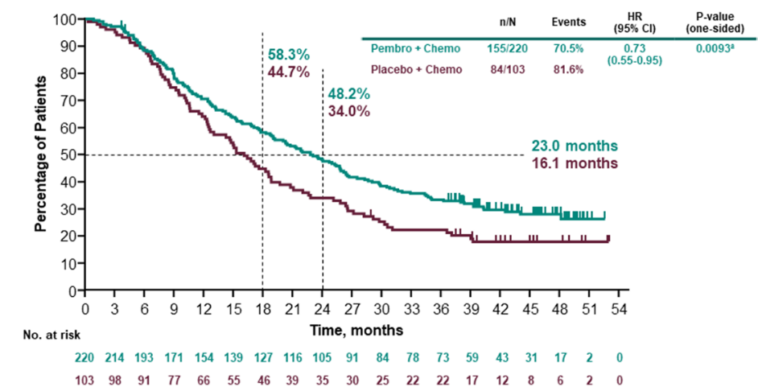
Source: Figure 2.5.1, 45 of the submission
chemo = chemotherapy; CI = confidence interval; CPS = combined positive score; HR = hazard ratio; OS = overall survival; pembro = pembrolizumab
  - Figure 2 presents the Kaplan Meier curves for OS in the ITT population in KN-355.
Figure 2: Kaplan-Meier estimates of OS for pembrolizumab + chemotherapy vs placebo + chemotherapy (all comers) (KN355)
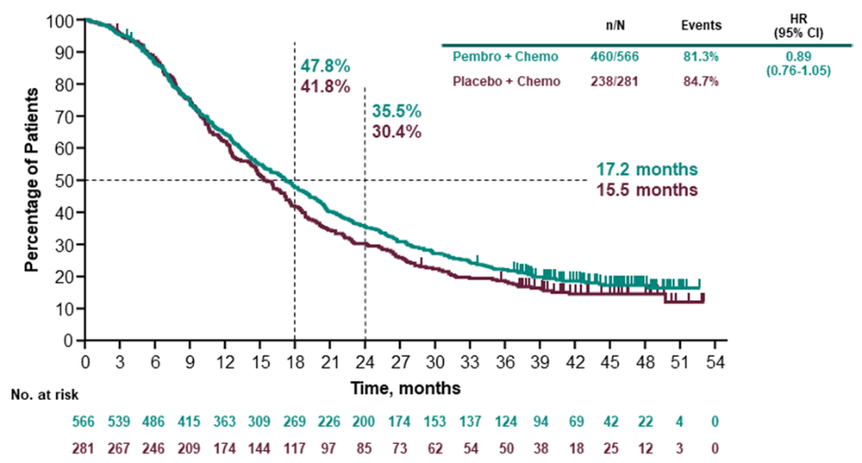
Source: Figure 2.5-3, p46 of the submission.
chemo = chemotherapy; CI = confidence interval; HR = hazard ratio; OS = overall survival; pembro = pembrolizumab
  - The KM curves for PFS in patients with CPS ≥10 from the final analysis are presented in Figure 3.
Figure 3: Kaplan-Meier estimates for PFS in patients with CPS ≥ 10, final analysis KN-355
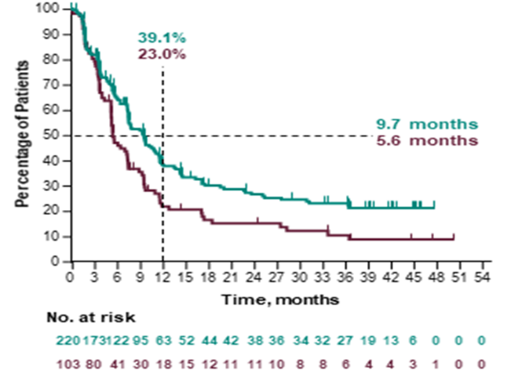
Source: Figure 2.5-5, p49 of the submission
CPS = combined positive score; PFS = progression free survival
  - Figure 4 presents the Kaplan-Meier estimates of PFS in the ITT population from the final analysis of KN 355.
Figure 4: Kaplan-Meier estimates of PFS in the ITT population at final analysis of KN 355
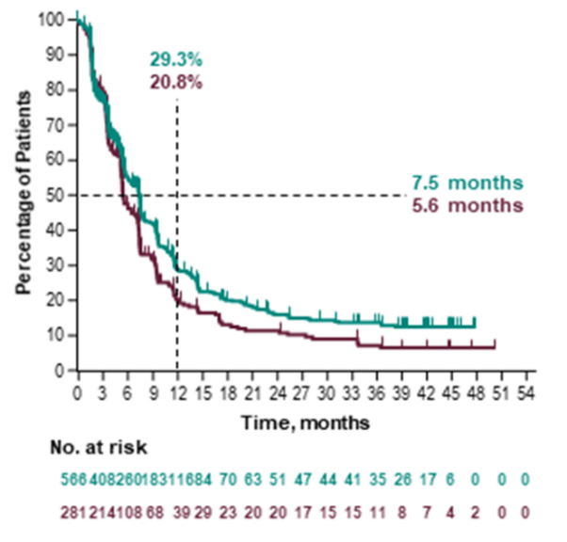
Source: Figure 2.5-6, p50 of the submission.
ITT = intention to treat; PFS = progression free survival
  - Table 5 presents the overall survival by subgroups in KN-355.
Table 5: Analysis of overall survival subgroups (intention to treat population)
 | Pembrolizumab + Chemotherapy |  |  | Placebo + Chemotherapy |  |  | Pembrolizumab + Chemotherapy vs. Placebo + Chemotherapy
Overall Survival | N^{b} | Participants  with Event n (%) | Median  Time^{c} in Months  [95 %-CI] | N^{b} | Participants  with Event n (%) | Median  Time^{c} in Months [95 %-CI] | Hazard Ratio  [95 %-CI]^{d} | p-Value for  Interaction Test^{e}
PD-L1 CPS 1 Cut-off
CPS ≥1 | 425 | 336 (79.1) | 17.6 [15.5; 19.5] | 211 | 177 (83.9) | 16.0 [12.8; 17.4] | 0.86 [0.72; 1.04] | 0.523
CPS <1 | 141 | 124 (87.9) | 16.2 [13.8; 20.1] | 70 | 61 (87.1) | 14.7 [9.8; 19.8] | 0.97 [0.72; 1.32]
PD-L1 CPS 10 Cut-off
CPS ≥10 | 220 | 155 (70.5) | 23.0 [19.0; 26.3] | 103 | 84 (81.6) | 16.1 [12.6; 18.8] | 0.71 [0.54; 0.93] | 0.022
CPS <10 | 346 | 305 (88.2) | 14.7 [13.3; 17.0] | 178 | 154 (86.5) | 15.2 [12.6; 17.4] | 1.04 [0.85; 1.26]
PD-L1 CPS 20 cut-off
CPS ≥20 | 140 | 99 (70.7) | 24.0 [19.0; 28.3] | 64 | 51 (79.7) | 15.6 [12.3; 20.8] | 0.72 [0.51; 1.01] | 0.133
CPS <20 | 426 | 361 (84.7) | 15.9 [13.9; 17.7] | 217 | 187 (86.2) | 15.5 [12.6; 17.6] | 0.96 [0.80; 1.14]
Source: Table 2.6.1, p75 of the submission.
CI = confidence interval; CPS = combined positive score
ª Database Cut-off Date: 15JUN2021
^{b} Number of participants: intention-to-treat population
^{c} From product-limit (Kaplan-Meier) method for censored data
^{d} Based on Cox regression model with treatment as a covariate using Wald confidence interval
^{e} Based on Cox model with treatment and subgroup as covariates, and treatment-by-subgroup interaction (p-value of likelihood ratio test for interaction term)
  - The subgroup analysis reported OS in the CPS ≥20 subgroup as not statistically significant (OS HR 0.72, 95%CI 0.51, 1.01). The submission considered that there is a treatment effect modification for CPS ≥10 compared to CPS <10, but there was no significant interaction for CPS ≥1 compared to CPS <1, or for CPS ≥20 compared to CPS <20. The submission concluded that this was strong evidence that the PD-L1 test is required to obtain a statistically significant overall survival benefit with pembrolizumab in TNBC, and that the most appropriate cut point is CPS ≥10. The commentary considered this was reasonable, but it was unclear whether these results indicated opportunistic subgroup selection, or if the CPS ≥20 group lacked statistical significance due to small sample size.
  - The Kaplan-Meier curves for the CPS <10 subgroup were provided in the PSCR and are show in Figure 5.
Figure 5: Kaplan-Meier estimates of OS (left) and PFS (right) in the CPS<10 population
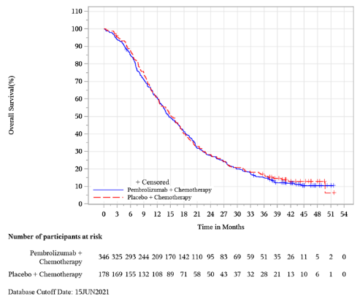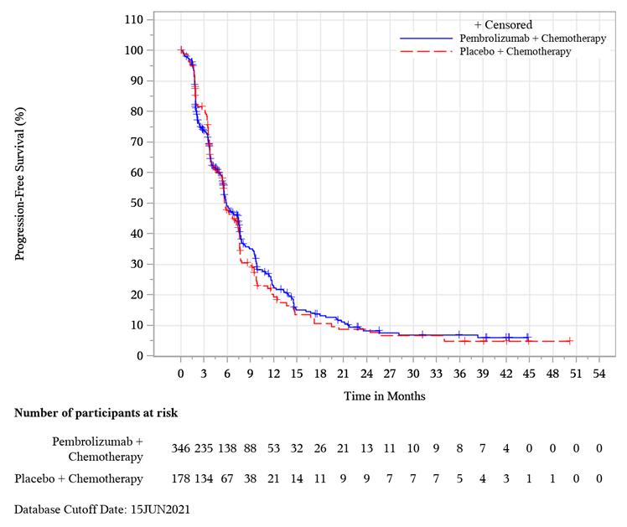
Source: PSCR Attachment 2
CPS = combined positive score; OS = overall survival; PFS = progression free survival
  - Given the statistically significant test for treatment effect modification between the CPS ≥10 and CPS <10 subgroups and the lack of a statistically significant difference in treatment effect for pembrolizumab in the CPS <10 subgroup, the ESC agreed with the commentary that the submission’s request for treatment in the CPS ≥ 10 subgroup may be reasonable, noting there remained a potential for bias in terms of the statistical analysis.
  - The submission also presented results of the health-related quality of life (HRQoL) results from KN-355, as measured with the EuroQoL 5 dimensions 5 levels (EQ-5D-5L) visual analogue scale (VAS), the European Organisation for the Research and Treatment of Cancer Quality of Life Questionnaire (EORTC QLQ-C30) and the European Organisation for the Research and Treatment of Cancer Breast Cancer questionnaire (EORTC QLQ-BR23). The submission noted that patients in both the pembrolizumab + chemotherapy and placebo + chemotherapy treatment arms exhibited stable EQ-5D VAS and utility scores at Week 15. There was no significant difference between the two arms of the study in the total patient reported outcome (PRO) full analysis set (defined as all randomised participants who received at least 1 dose of study intervention and had completed at least 1 PRO assessment) population or the CPS ≥1 or CPS ≥10 subgroups.
  - The lack of a clear harmonisation of various PD-L1 tests, and the absence of clear consensus on their accuracy may have an impact on how well patients who benefit from pembrolizumab treatment in mTNBC are identified in the Australian setting, and consequently how effective pembrolizumab treatment is.
  - The MSAC has also previously noted the possibility that pathologists may be inclined overestimate CPS scores close to the threshold for treatment eligibility so that patients can access more treatment options (p5, MSAC application 1522.1, PSD, November 2021 MSAC meeting). Given that patients with CPS <10 who were treated with pembrolizumab did not report any difference in OS compared to patients treated with placebo (see Table 4) this may lead to a lower efficacy of pembrolizumab in the Australian setting than in KN-355.

Comparative harms
  - Table 6 presents a summary of key adverse events from KN-355 in the “all subjects as treated” (ASaT) population, defined as all patients who received at least 1 dose of study intervention.
  - The submission considered that although there was a trend towards a numerically higher percentage of patients experiencing drug-related adverse events (AEs) with pembrolizumab + chemotherapy, this may be due to the longer duration of drug exposure observed in this group.
Table 6: Summary of Adverse events in KN-355 (ASaT population)
` | Pembrolizumab + Chemotherapy |  | Placebo + Chemotherapy |  | RD (95% CI)
 | N | (%) | N | (%)
Subjects in Population - | 562 |  | 281
with one or more adverse events | 554 | (98.6) | 276 | (98.2) | 0 (-0.01, 0.02)
with no adverse event | 8 | (1.4) | 5 | (1.8) | 0 (-0.02, 0.01)
with drug-related adverse events | 541 | (96.3) | 267 | (95.0) | 0.01 (-0.02, 0.04)
with toxicity grade 3 to 5 adverse events | 438 | (77.9) | 207 | (73.7) | 0.04 (-0.02, 0.1)
with toxicity grade 3 to 5 drug-related adverse events | 383 | (68.1) | 188 | (66.9) | 0.01 (-0.05, 0.08)
with serious drug-related adverse events | 100 | (17.8) | 34 | (12.1) | 0.06 (0.01, 0.11)
who died due to a drug-related adverse event | 2 | (0.4) | 0 | (0.0) | 0 (0, 0.01)
discontinued any drug due to a drug-related adverse event | 103 | (18.3) | 31 | (11.0) | 0.07 (0.02, 0.12)
discontinued pembrolizumab/ placebo | 51 | (9.1) | 9 | (3.2) | 0.06 (0.03, 0.09)
discontinued any chemotherapy | 104 | (18.5) | 37 | (13.2) | 0.05 (0, 0.1)
discontinued any drug due to a serious drug-related adverse event | 36 | (6.4) | 3 | (1.1) | 0.05 (0.03, 0.08)
discontinued pembrolizumab/ placebo | 32 | (5.7) | 2 | (0.7) | 0.05 (0.03, 0.07)
discontinued any chemotherapy | 22 | (3.9) | 1 | (0.4) | 0.04 (0.02, 0.05)
Adverse events of special interest in >10 patients in any treatment arm
Hypothyroidism | 89 | 15.8 | 9 | 3.2 | 0.126 (0.088, 0.163)
Hyperthyroidism | 24 | 4.3 | 3 | 1.1 | 0.032 (0.009, 0.054)
Pneumonitis | 14 | 2.5 | 0 | 0 | 0.025 (0.011, 0.041)
Colitis | 10 | 1.8 | 4 | 1.4 | 0.04 (-0.02, 0.021)
Severe skin reactions | 10 | 1.8 | 1 | 0.4 | 0.014 (-0.003, 0.030)
Source: Table 2.5-10, p62 of the submission and Table 12-10, KN-355 CSR.
ASaT = All subjects as treated
The ASaT population included patients who received at least 1 dose of study intervention.
Risk difference calculated using stats direct during evaluation
  - Overall, there was a higher proportion of patients in the pembrolizumab arm with serious AEs and events that led to discontinuation compared to in the chemotherapy arm. There was a substantially higher rate of immune-mediated AEs of any grade in the pembrolizumab + chemotherapy arm (26.5% vs 6.4%). These included hypothyroidism (15.8% vs 3.2%) and hyperthyroidism (4.3% vs 1.1%) and pneumonitis (2.5% vs 0%) compared to the placebo + chemotherapy arm.

Benefits/harms
  - A summary of the comparative benefits and harms for pembrolizumab plus chemotherapy versus chemotherapy is presented in Table 7.
Table 7: Summary of comparative benefits and harms for pembrolizumab plus chemotherapy versus chemotherapy
Benefits (CPS ≥10)
 | Pembro + chemo | Chemo | Absolute difference | HR (95% CI)
Progression free survival (FA) (median follow up of 23.2 months in the pembro arm and 16.1 in the chemo arm)
Progressed, n/N (%) | 144/220 (65.5) | 81/103 (78.6) |  | 0.66 (0.50, 0.88)
Median PFS, months (95% CI) | 9.7 (7.6, 11.3) | 5.6 (5.3, 7.5) | 4.1
% not progressed at 12 months (95% CI) | 39.1 (32.0, 46.1) | 23.0 (14.7, 32.3) | 16%
Overall survival (median follow up of 23.2 months in the pembro arm and 16.1 in the chemo arm)
Deaths, n/N (%) | 155/255 (70.5) | 84/103 (81.6) |  | 0.73 (0.55, 0.95)  P=0.0093
Median OS, months (95% CI) | 23.0 (19.0, 26.3) | 16.1 (12.6, 18.8) | 6.9
Rate (%) at 6 months (95% CI) | 89 (84, 92) | 88 (80, 93) | 1%
Rate (%) at 12 months (95% CI) | 71 (64, 76) | 64 (54, 73) | 7%
Rate (%) at 18 months (95% CI) | 58 (51, 65) | 45 (35, 54) | 13%
Rate (%) at 24 months (95% CI) | 48 (41, 55) | 34 (25, 43) | 14%
Harms (ASaT)
 | Pembro + chemo | Chemo | Event rate/100 patientsª |  | RD  (95% CI)
 |  |  | Pembro + chemo | Chemo
Serious drug-related adverse events | 100 (17.8) | 34 (12.1) | 17.8 | 12.1 | 0.06 (0.01, 0.11)
with toxicity grade 3 to 5 adverse events | 438 (77.9) | 207 (73.7) | 77.9 | 73.7 | 0.04 (-0.02, 0.1))
Hypothyroidism | 89 (15.8) | 9 (3.2) | 15.8 | 3.2 | 0.126 (0.088, 0.163)
Hyperthyroidism | 24 (4.3) | 3 (1.1) | 4.3 | 1.1 | 0.032 (0.009, 0.054)
Pneumonitis | 14 (2.5) | 0 (0) | 2.5 | 0 | 0.025 (0.011, 0.041)
Source: Table 2.5-3, pp43-44, Table 2.5-4, p48, and Table 2.5-10, p62 of the submission as well as Table 11-1,p87 and Table 11-4, p107 of the KN-355 CSR
ASaT = All subjects as treated; Chemo = chemotherapy; CI = confidence interval; FA = final analysis; IA2 = interim analysis 2; HR = hazard ratio; Pembro = pembrolizumab; RD = risk difference; RR = risk ratio
ª Median follow up of 23.2 months in the pembro arm and 16.1 in the chemo arm
  - On the basis of the KN-355 trial (final analysis) evidence presented in the submission, for every 100 patients treated with pembrolizumab plus chemotherapy in comparison with chemotherapy:
- Approximately 16 additional patients will remain progression-free after 12 months
- Approximately 7 additional patients will remain alive after 12 months; and
- Approximately 14 additional patients will remain alive after 2 years
  - On the basis of the KN-355 trial (final analysis) evidence presented by the submission, for every 100 patients treated with pembrolizumab plus chemotherapy in comparison with chemotherapy over a median duration of follow-up of 16.1 months in the chemotherapy arm and 23.2 months in the pembrolizumab arm:
- Approximately 6 additional patients would experience serious adverse events
- Approximately 4 additional patients would experience toxicity grade 3 to 5 adverse events
- Approximately 13 additional patients would experience hypothyroidism
- Approximately 3 additional patients would experience hyperthyroidism; and
- Approximately 3 additional patients would experience pneumonitis.

Clinical claim
  - The submission concluded that:
- pembrolizumab + chemotherapy has superior efficacy and an inferior, but manageable safety profile compared with chemotherapy alone in mTNBC patients whose tumours express PD-L1 at a cut-point of CPS ≥10.
- In patients with PD-L1 CPS <10, as well as in the ITT population, there was no benefit of adding pembrolizumab to chemotherapy in terms of efficacy and is potentially harmful; as well as having inferior safety compared with chemotherapy alone.
  - Overall, based on the KN-355 trial, the ESC considered the clinical claim of superior efficacy for patients with CPS ≥10 was supported by the evidence presented. The ESC considered that the magnitude and clinical significance of the OS benefit remained somewhat uncertain given the protocol change in KN-355 and the proximity of the result to the proposed efficacy bar. Additionally, the concordance of PD-L1 testing in Australia to the PD-L1 testing used in KN-355 and therefore the applicability of the results from KN-355 to the Australian setting was uncertain.
  - The ESC agreed with the commentary that the submission’s safety claim of inferiority was reasonable.
  - The ESC agreed with the commentary that the submission’s claim that in patients with CPS <10, there is no benefit to adding pembrolizumab and even potential harm was reasonable. Subgroup analyses of OS by CPS status appear to support this claim, though uncertainty remains regarding the appropriateness of the amendment to the KN-355 outcome hierarchy after the first interim analysis and the higher risk of bias in the results of the CPS ≥ 10 subgroup.
  - The PBAC considered that the claim of superior comparative effectiveness in patients with PD-L1 CPS ≥10 was reasonable.
  - The PBAC considered that the claim of inferior comparative safety was reasonable.

Economic analysis
  - The submission presented a cost utility analysis.
  - Table 8 presents key components of the economic evaluation.
Table 8: Key components of the economic evaluation
Component | Summary
Treatments | Pembrolizumab + chemotherapy vs. chemotherapy
Time horizon | 15 years in the model base-case  Sensitivity analysis considers a time horizon of 12 and 17 years
Outcomes | QALY and LY
Methods used to generate results | Partitioned survival analysis
Health states | Progression free (PF), Progressive disease (PD) and death
Cycle length | 1 week, with half-cycle correction
Allocation to health states | Determined by PF and Overall Survival (OS) curves from KN355
Extrapolation method | PFS and OS beyond the trial period was extrapolated using log normal extrapolation for the pembrolizumab OS arm and log-logistic extrapolations for chemotherapy PFS and OS curves. The submission claimed that proportional hazard assumption was not supported due to the overlapping log-cumulative Hazard and Schoenfeld residual plots and therefore extrapolation of OS was conducted independently for pembrolizumab and chemotherapy. The selection of OS and PFS extrapolation method was based on goodness of fit and clinical plausibility
Health related quality of life | EQ-5D scores from KN355 were used to derive utility estimates based on an Australian scoring algorithm  PF health state utility: 0.790 for both arms  PD health state utility: 0.703 for both arms  AE disutility: -0.023
Discount rate | 5% per annum for cost and effectiveness. Inappropriately applied from cycle 1 onwards.
Software | Microsoft Excel
Source: Table 3.1-1, p82 of the submission.
AE = adverse event; LYG = life-year gained; PF = progression free; PD = progressive disease; QALY = Quality-adjusted life year
  - Although eligible patients require PD-L1 with a CPS ≥10 as determined by a validated test, a test-treat model structure (where false positives and false negatives are explicitly modelled) was not adopted for this economic evaluation as it was a streamlined co-dependent submission. Acknowledging the complexities of a test-treat model, the commentary considered such a model would be more informative in assessing the uncertainties regarding PD-L1 testing in the Australian context, and how they might affect modelled long-term treatment effect of pembrolizumab. The lack of consideration for false (positive and negative) results likely favoured treatment with pembrolizumab + chemotherapy.
  - The submission selected a 15-year time horizon as the base case. The submission claimed that nearly 30% of patients were still alive at 44 months of follow-up as per final analysis of KN-355. The submission also noted the average age of TNBC is lower than that of other breast cancers. Patients enter the model at the age of 53 based on the mean age in the CPS ≥ 10 subgroup of KN355. The submission stated that there was little risk of an extended time horizon encroaching an unrealistic age, as would be the case for other indications.
  - The submission acknowledged that the time horizon nominated was longer than the 10-year time horizon adopted in the atezolizumab 1L mTNBC submission as per its March 2020 and March 2021 PSDs. However, the economic evaluation in this submission, based on the final analysis of KN-355, was informed by significantly more mature data (median follow-up of ~44 months) than the Impassion130 data that formed the evidence base for atezolizumab (median follow-up of 18.8 months). The submission concluded that, therefore, long-term estimates in this economic evaluation are considerably more robust, associated with significantly less uncertainty, justifying a time horizon reflective of the disease course as well as the statistically significant overall survival benefit observed in pembrolizumab.
  - The ESC previously considered that it may not be clinically plausible to assume ongoing benefit and survival for some patients up to 10 years, as TNBC is an aggressive disease and median survival is typically only 15-16 months (paragraph 6.28, atezolizumab PSD, March 2021 PBAC meeting). The ESC noted that the OS data were relatively mature and provided a reasonable level of confidence in the outcomes to 4 years, a proxy for a trial-based analysis. The ESC also considered that a small proportion of patients may experience prolonged response to pembrolizumab, however beyond the 45 months of trial follow-up OS remained uncertain and the ESC considered 30% survival at <4 years did not necessarily justify the use of a 15-year time horizon in this population. As such, the ESC considered that a time horizon of 10 years would be more appropriate. The pre-PBAC response maintained that a time horizon longer than 10 years was justified, based on the extent of follow-up and maturity of the data and statistically significant OS benefit from the KN-355 trial.
  - Figure 6 presents the OS extrapolations modelled by the submission extrapolated out to 10 years.
Figure 6: Overall survival extrapolations
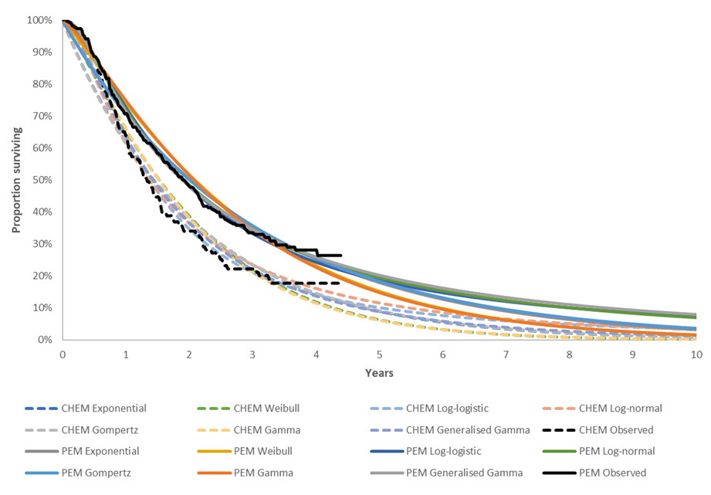
Source: Figure 3.4.3, p101 of the submission, Eff_PemChemo and Eff_Chemo sheets, mTNBC section 3 Workbook.
CHEM = chemotherapy; PEM = pembrolizumab
  - For OS the submission selected the log normal curve for pembrolizumab and the log-logistic curve for chemotherapy as it had the lowest Akaike information criteria (AIC) and Bayesian information criteria (BIC) scores, as well as visual fit and plausibility. The AIC and BIC scores were quite similar for all extrapolations, as was visual fit. As such, all the extrapolation functions were arguably plausible. The log normal curve for pembrolizumab was the second most optimistic extrapolation based on long term survival, behind generalised gamma. The gamma function estimated the lowest long-term survival for pembrolizumab. However, there are some combinations of extrapolations which lead to crossover of OS curves, which may not be plausible. Assuming a gamma extrapolation for both pembrolizumab plus chemotherapy and chemotherapy increased the ICER by 16.8%.
  - The economic evaluation used KM survival estimates (for OS, PFS, and time on treatment (ToT)) up to 44.4 months in the chemotherapy arm and 44.0 months in the pembrolizumab + chemotherapy arm. At 44.0 months approximately 10% of patients in the chemotherapy arm remained ‘at risk’ (see Figure 1). The ESC noted that where 10% of the cohort remain at risk may be considered the minimum required to accept reliability of the KM curves. The point of truncation had an unpredictable impact on the economic model. Using KM data up to 36 months increased the ICER by 5.4%, but using KM data up to 40 months decreased the ICER by 2.9%. Given this variation in effect on the ICER, the ESC considered that using the minimum percentage of the cohort remaining at risk as the base case may not be reasonable. The ESC noted that 36 months appears to be a reasonable point of truncation as it is the end of a period where there have been few censored events, and there was a high number of patients being censored after 36 months.
  - The submission also compared the modelled OS curves to the available external data. The submission identified three relevant real-world studies in mTNBC (Aly 2019, Deluche 2020, Skinner 2021). Figure 7 presents a graphical comparison of the modelled survival and survival in these studies.
Figure 7: External validation of modelled OS
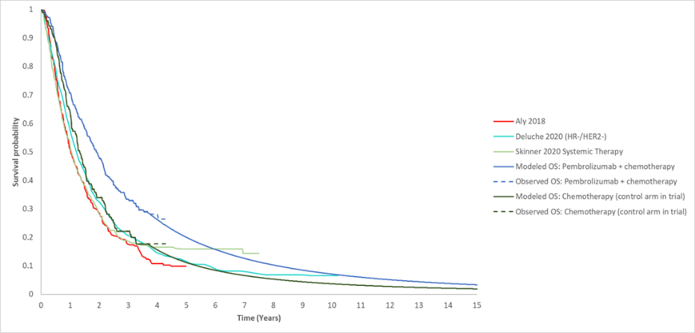
Source: Figure 3.7-3, p120 of the submission.
HER2 = Human epidermal growth factor receptor; HR = hormone receptor; OS = overall survival
  - Given the substantially higher age of the Aly (2018) study (patients needed to be at least 66 years of age to be enrolled in the study), and the fact that the majority of patients did not receive chemotherapy, it was unlikely that this was a relevant point of external validation.
  - The OS curve from both Deluche 2020 and Skinner 2020 sat above the modelled chemotherapy OS curve and crossed or approximately reached the extrapolated OS curve for pembrolizumab + chemotherapy. To the extent that these external populations were applicable, this suggested that long-term survival in the chemotherapy arm of the model may have been underestimated, and that it may be more reasonable to model convergence of OS. The PSCR stated that these slight differences are attributable to variance in the patient population included in the studies:
- In Deluche et al. (2020), 34.6% of patients received targeted therapy in the 1L metastatic setting, which will increase survival as compared with chemotherapy.
- The applicability of Skinner et al. (2021) for long term extrapolation validation is limited as OS for the systematic therapy subgroup is lower than OS from the chemotherapy arm of KN355 for the first four years.
  - The model provided a ‘treatment waning’ option which would set the rate of change in OS in the pembrolizumab plus chemotherapy arm to be equal to the chemotherapy arm after a specific time point. The model was reasonably sensitive to this change, though given that the majority of patients in both arms had died by year 2, setting waning at year 4 or 5 had limited impact. There was no operability to force convergence of the OS curves, however the ESC noted that the Markov trace showed PFS and OS curves begin to converge after the switch to parametric extrapolation, due to a ceiling effect (i.e. most patients have died). Complete convergence does not occur over the 15 year time horizon for the base case or the treatment waning scenarios.
  - The pre-PBAC response maintained that the application of treatment waning and convergence in the metastatic setting would underestimate the treatment benefit and was inappropriate given the maturity of the survival data.
  - Modelled OS including waning assumptions at 3 and 4 years is shown in Figure 8.
Figure 8: Observed and modelled OS curves including treatment waning assumptions
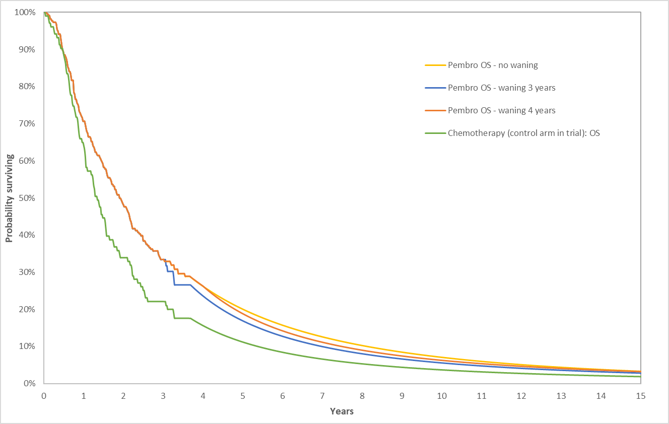
Source: Compiled for ESC from mTNBC Section 3 Workbook.
OS = overall survival
  - The model was not sensitive to the choice of extrapolation function for PFS or ToT.
  - The use of trial-based EQ-5D data (from KN-355) to inform the economic model was internally valid. However, the ESC considered that the value for progressive disease (0.703) appeared higher than would be expected and was inconsistent with the values used for other relevant breast cancer submissions:
- In the atezolizumab 2021 resubmission for metastatic mTNBC, the progressed disease (PD) health state utility value was 0.583 (paragraph 6.36, atezolizumab PSD, March 2021 PBAC meeting).
- The PBAC had previously noted that this was generally consistent with the utility value that was previously considered reasonable by the PBAC for advanced breast cancer (0.555 for progressive disease, paragraph 6.50, pertuzumab and trastuzumab PSD, November 2014 PBAC meeting).
- In addition, utilities used for the LR and DM health states in the eTNBC submission (based on KN-522) were 0.693 and 0.552, respectively.
Using the utilities from the atezolizumab resubmission (PF = 0.693, PD = 0.583) increased the ICER by 16.8%. Using the utility for DM from the KN-522 trial (0.552) decreased the ICER by 4%. The PBAC noted the utility value for PD in the economic model was higher than applied in other economic models and the model was sensitive to the utility value applied. However, on balance, the PBAC considered the use of trial-based utilities was a reasonable approach in the base case.
  - The following second line (2L), third line (3L) and fourth line and beyond (4L+) treatment options were included in the model:
- 2L: Capecitabine, cyclophosphamide + doxorubicin, gemcitabine + carboplatin, eribulin, paclitaxel
- 3L: Capecitabine, eribulin, capecitabine + vinorelbine, cyclophosphamide + doxorubicin, paclitaxel, sacituzumab govitecan
- 4L+: Vinorelbine, capecitabine, eribulin, carboplatin, nab-paclitaxel
  - The use of subsequent therapies in the model was not consistent with the use of subsequent therapies in KN-355. For example, 10/562 (2.3%) and 22/281 (9.6%) of patients in the pembrolizumab and placebo arms in KN-355 received subsequent immunotherapy treatments which were not included in the model. This likely favoured placebo + chemotherapy.
  - Further, subsequent sacituzumab govitecan use in KN-355 was low (5/562, 0.9% and 3/281, 1.1% in the pembrolizumab and placebo arm, respectively) which may not be consistent with the PBS population. The submission conducted a sensitivity analysis to address this issue, which resulted in a 12% reduction in the ICER, however this analysis does not appear to be reliable as incremental QALYs and LYs increased, despite the assumption that more patients were treated with sacituzumab govitecan in the chemotherapy arm than in the pembrolizumab + chemotherapy arm. The ESC considered that over time a similar proportion of patients in each arm would be expected to receive sacituzumab govitecan, as established metastatic breast cancer remained incurable regardless of initial treatment. The change in incremental cost and benefit is therefore expected to be minimal.
  - The economic evaluation incorrectly applied discounting in year 1. Applying discounting from year 2 had a small impact on the ICER, increasing the ICER by <2%.
  - Table 9 presents a summary of the key drivers of the model.
Table 9: Key drivers of the model
Description | Method/Value | Impact  Base case: $ | ¹/QALY gained.
Time horizon | A base case of 15-years was assumed by the submission | Moderate to high, favours pembrolizumab Assuming a 4-year time horizon (as a proxy for ‘trial based’ increased ICER by 90.6%. Assuming a 10 year time horizon increased ICER by 9.3%
OS Extrapolation | For overall survival the submission selected the log normal curve for pembrolizumab and the log-logistic curve for chemotherapy | High, favours pembrolizumab  Use of Gamma OS extrapolation in both treatment arms increased the ICER by 16.8%
Utilities | Model health state utilities taken from KN-355. | High, favours pembrolizumab  Use of corresponding utilities from the atezolizumab mTNBC PSD increased the ICER by 16.8%  Using the utility for DM from the KN-522 trial (0.552) decreased the ICER by 4%.
Switch to extrapolation | The economic evaluation used KM survival estimates (for OS, PFS, and ToT) up to 44.4 months in the chemotherapy arm and 44.0 months in the pembrolizumab + chemotherapy arm | Moderate, favours pembrolizumab  Extrapolation from 36 months increased the ICER by 5.4%.
Treatment waning | No treatment waning considered in the base case economic model | Moderate to high, favours pembrolizumab. Assuming treatment waning at 3 years and 4 years increased ICER by 24.0% and 9.0%, respectively.
Source: Table 3.9-1, pp125-126 of the submission.
ICER = incremental cost effectiveness ratio; KM = Kaplan Meier; mTNBC = metastatic triple negative breast cancer; OS = overall survival; PFS = progression free survival; PSD = Public Summary Document; QALY = Quality-adjusted life year; ToT = Time on treatment
The redacted values correspond to the following ranges:
¹ $55,000 to < $75,000
  - Table 10 presents the results of the economic evaluation.
Table 10: Results of the economic evaluation (discounted)
Component | Pembrolizumab + chemo | Chemo | Increment
Costs | $| | $55,139 | $ |
LYs | 2.75 | 2.04 | 0.71
Cost/LYG |  |  | $||¹/LYG
QALYs | 2.10 | 1.52 | 0.57
Incremental cost/extra QALY gained |  |  | $ | ¹
Source: Table 3.8-4, p123 and Table 3.8-5, p124 of the submission.
LY= Life year; LYG = Life years gained; QALYs = Quality-adjusted life year.
The redacted values correspond to the following ranges:
¹ $55,000 to < $75,000
  - The results of key univariate and multivariate sensitivity analyses are summarised in Table 11.
Table 11: Key sensitivity analyses of economic model
Analyses | Incremental cost |  | Incremental QALY | ICER |  | %Δ
Base case | $ | |  | 0.57 | $|||| ¹ |  | -
Time horizon (15 years in base case)
4 years (Proxy for trial based) | $ | |  | 0.35 | $|| ² |  | 90.6%
10 years | $ | |  | 0.52 | $|| ³ |  | 9.33%
Discount rate (5% in base case)
3.5% | $ | |  | 0.61 | $|| ¹ |  | -5.33%
0% | $ | |  | 0.73 | $|| ¹ |  | -17.56%
No discounting in year 1 | $ | |  | 0.57 | $|| ³ |  | 1.28%
Utilities (PF: 0.79, PD: 0.703, AE: -0.023 in base case)
Use atezolizumab PSD utilities (PF = 0.693, PD = 0.583) | $ | |  | 0.49 | $|| ³ |  | 16.77%
Assume PD = 0.552 based on eTNBC submission | $ | |  | 0.60 | $|| ¹ |  | -4.0%
Treatment waning (none in base case)
Assume waning at 4 years | $ | |  | 0.53 | $|| ³ |  | 9.0%
Assume waning at 3 years | $ | |  | 0.46 | $|| ³ |  | 24.0%
Cost of terminal care (Reeve 2018; $31,638.76 in base case)
$6,050 from para. 6.56 of SG PSD Nov 2021 | $ | |  | 0.57 | $|| ³ |  | 2.49%
OS extrapolation approach (log normal curve for pembrolizumab/ log-logistic curve for chemotherapy in base case)
Second best fitting pembrolizumab curve (log-logistic) | $ | |  | 0.60 | $|| ¹ |  | -4.78%
Second best fitting chemotherapy curve (log-normal) | $ | |  | 0.59 | $|| ¹ |  | -3.18%
Gamma applied to both arms | $ | |  | 0.50 | $|| ³ |  | 16.8%
PFS extrapolation approach (log-logistic in both arms in base case)
Gamma (best statistical fit) applied to pembrolizumab arm | $ | |  | 0.54 | $|| ³ |  | 6.44%
KM cut-off (44.0 months for pembrolizumab arm/ 44.4 months for chemotherapy arm in BC)
36 months in both arms | $ | |  | 0.55 | $|| ³ |  | 5.40%
40 months for both arms | $ | |  | 0.59 | $|| ¹ |  | -2.86%
Multivariate analyses
10 year time horizon, no discounting in year 1, treatment waning from 4 years, SG terminal care costs, utility for PD 0.552 | $ | |  | 0.51 | $|||| ³ | 16.5%
10 year time horizon, no discounting in year 1, treatment waning from 4 years, SG terminal care costs, utility for PD 0.552, KM cut-off 36 months for both arms | $ | |  | 0.49 | $|||| ³ | 22.7%
Pre-PBAC response analyses
12-year time horizon, SG terminal care costs; no discounting applied in year 1 as per ESC considerations, | $ | |  | 0.55 | $|||| ³ | 8.5%
12-year time horizon, SG terminal care costs; no discounting applied in year, pre-PBAC AEMP $|||||| | $ | |  | 0.55 | $|||| ¹ | -
PBAC analyses
10-year time horizon, SG terminal care costs; no discounting applied in year, pre-PBAC AEMP $|||||| | $ | |  | 0.52 | $|||| ³ | 5.4%
Source: Table 3.9-1, pp125-126 of the submission
AE, adverse event; CEM, cost-effectiveness model; CPS, combined positive score; KM, Kaplan-Meier; mTNBC, metastatic triple negative breast cancer; OS, overall survival; PEM, pembrolizumab; PD, progressed disease; PF = progression free; PFS = progression-free survival; PSD = public summary document QALY, quality-adjusted life-year; SG, sacituzumab govitecan
The redacted values correspond to the following ranges:
¹ $55,000 to < $75,000
² $135,000 to < $155,000
³ $75,000 to < $95,000
  - Overall, the ESC considered the ICER presented in the submission was likely underestimated as:
- The time horizon was too long for the mTNBC population;
- No treatment waning was assumed in the base case, and the point of truncation was uncertain;
- The terminal care cost applied was likely overestimated; and
- Discounting was inappropriately applied to the first year of the model.
The ESC noted that multivariate analysis addressing these issues increased the ICER from $55,000 to < $75,000 to $75,000 to < $95,000/QALY gained (22.7%). The ESC noted that uncertainties regarding PD-L1 testing, and how they might affect modelled long-term treatment effect of pembrolizumab and the lack of consideration for false (positive and negative) results also likely favoured treatment with pembrolizumab + chemotherapy.
  - The Pre-PBAC response presented an alternative multivariate analysis including a 12-year time horizon, terminal care costs of $6,050 and removal of discounting in year 1. This resulted in an ICER of $75,000 to < $95,000/QALY and the pre-PBAC response proposed a reduction in the pembrolizumab price (per 100 mg vial) from $| | to $| | to maintain the ICER at $55,000 to < $75,000/QALY. The PBAC considered a 10-year time horizon was appropriate for the mTNBC population and would adequately address the uncertainties with regard to extrapolation in terms of treatment waning and the point of KM data truncation. The PBAC noted applying a 10-year time horizon to the alternative multivariate analysis provided in the pre-PBAC response resulted in an ICER of $75,000 to < $95,000/QALY.

Drug cost/patient/course
Table 12: Drug cost per patient for proposed and comparator drugs
 | Pembro  Trial dose and duration | Pembro  Model | Pembro  Financial estimates | Chemo  Trial dose and duration | Chemo  Model | Chemo  Financial estimates
Pembrolizumab
Cost per cycle | $ | ª | $|| | $|| ^{c} | - | - | -
Number of cycles per course | 12.0 | 15.18 ^{b} | 10.94 ^{d} | - | - | -
Cost per course | $ | | $|| | $|| | - | - | -
Chemotherapy regimens
Paclitaxel |  |  | Not included |  |  | Not included
Cost per administration | $12.19 | $12.19 |  | $9.25 | $9.25
Number of administrations | 20.9 | 35.95 |  | 19.8 | 32.78
Total drug acquisition cost | $254.77 | $438.01 |  | $183.15 | $303.28
Nab-paclitaxel
Cost per administration | $206.16 | $206.16 |  | $278.48 | $278.48
Number of administrations | 25.5 | 35.95 |  | 22.6 | 32.78
Total drug acquisition cost | $5,256.83 | $7,410.63 |  | $6,293.64 | $9,127.92
Gemcitabine
Cost per administration | $73,60 | $73,60 |  | $76.98 | $76.98
Number of administrations | 16.4 | 31.94 |  | 16,6 | 29.14
Total drug acquisition cost | $1,207.04 | $2,350.94 |  | $1,277.86 | $2,243.07
Carboplatin
Cost per administration | $97.58 | $97.58 |  | $10.62 | $100.62
Number of administrations | 15.8 | 31.94 |  | 16.5 | 29.14
Total drug acquisition cost | $1,541.76 | $2,976.91 |  | $1,660.23 | $2,960.87
Source: Constructed during the evaluation from information on pp30-137 of the submission
ª With dose intensity of 90.8% applied to DPMA of 200 mg of $||||
^{b} 15.18 doses given every three weeks, equivalent to 45.54 weeks of treatment
^{c} Back calculated from total cost of 7 × 200mg administrations and 3.94 × 400 mg administrations
^{d} The submission assumed a total of 44.62 weeks of pembrolizumab treatment, which was assumed to be of 7 × 200 mg every three weeks and 3.94 × 400 mg every six weeks. This was revised in the PSCR to 15.18 cycles per course to align with the economic evaluation.
  - The total cost of pembrolizumab was $|||| |||| per patient per course based on 15.18 cycles (as estimated in the economic evaluation) and a DPMA of 200 mg of $| | with a relative dose intensity of 90.8% applied. Using the revised pre-PBAC DPMA of $| |, the cost per patient per course was reduced to $| |.
  - The modelled cost of chemotherapy treatment when used concomitantly with pembrolizumab was $| |, compared to the cost of $14,635 for chemotherapy alone.
  - Durations of treatment for chemotherapy components were longer in the economic model than in the trial due to time on treatment extrapolation in the model.
  - The financial estimates did not apply a dose intensity of 90.8% to pembrolizumab use and assumed 200 mg Q3W regimens would correspond with initiating scripts, and 400 mg Q6W regimens would correspond with continuing scripts. This led to differences in estimated costs. There was also a slight discrepancy in the duration of pembrolizumab treatment assumed (45.54 weeks in the economics, 44.62 weeks in the financial estimates) which was addressed in the PSCR (see paragraph 6.77)

Estimated PBS usage & financial implications
  - This submission was considered by DUSC. The submission took an epidemiological approach.
  - Table 13 presents key inputs of the financial estimates.
Table 13: Data sources and parameter values applied in the utilisation and financial estimates
Data | Value | Source | Comment
Eligible population
Incidence of breast cancer, projected to 2028 | Yr 1: 21,118  Yr 2: 21,602  Yr 3: 22,087  Yr 4: 22,571  Yr 5: 23,055  Yr 6: 23,540 | AIHW. The 2022 report includes actual data up to 2018, projected data to 2022 then extrapolated to 2028. | DUSC considered this to be reasonable.
% TNBC | 15% | TNBC accounts for approximately 10-20% of all breast cancers (Cancer Council Australia). | The submission noted that midpoint estimate of 15% of all breast cancers was selected for the atezolizumab metastatic TNBC PBAC submission in March 2021, which was considered by DUSC to be reasonable.
% De Novo patients | 29.7% | KN-355 | The submission considered that this estimate is similar to the proportion that was used by atezolizumab (25%) which DUSC had considered reasonable (Table 16, pg. 33, atezolizumab PSD, Mar 2021).
% Patients with Stage II or III TNBC at diagnosis | 46.8% | AIHW data for all breast cancer | The submission assumed that the relative proportions of Stage II or III TNBC will be similar to the total incident breast cancer population.
% Recurrent from earlier stages over previous 10 years | 20% | DUSC advice as per atezolizumab PBAC PSD, Mar 2021 | DUSC considered that this input could approach 34% as seen in Dent et al. 2007 however DUSC noted that the recurrence rate was not calculated only in survivors and was thus likely to represent an upper estimate. The PBAC considered that 20% was more consistent with other data sources.
10-year survival rate in Stage II/III | 44% | Lin (2012) as per the atezolizumab PSD, Mar 2021. | DUSC considered this to be reasonable.
% ECOG 0 or 1 | 78% | Atezolizumab PSD Mar 2021 | DUSC considered this to be reasonable.
% Electing PD-L1 test | 95% | Assumption | DUSC considered this to be reasonable.
% CPS ≥ 10 | 38.9% | KN-355 | DUSC noted that 38.9% of patients in the pembrolizumab arm of KN-355 had a CPS ≥10. DUSC considered it would be more appropriate to use the total population value of 38.1% which included placebo patients.
Prevalent patients | 93,938 | The prevalence was calculated by multiplying the incident rate in each of the previous 5 years (2018 to 2022) by the estimated relative survival rate in each of those years (AIHW National Cancer Control Indicators ), i.e., for 2018, the 5-year survival rate across all stages was 91.3%. For 2019 and 2020, the 3-year survival (94.5%) was applied across all stages, and for 2021 and 2022, the 1-year survival (98%) was applied across all the stages. | DUSC considered it more appropriate to use data from Dent et al. 2007ª which would more accurately reflect the lower survival rate seen in TNBC patients and higher distant recurrence. The PBAC considered that patients would not wait for treatment and therefore there would not be a prevalent pool of mTNBC patients.
Grandfathered patients | ||||||¹ patients, subtracted from prevalent pool. | Assumption | The submission considered that there will be patients who will have received pembrolizumab for this indication via a sponsor access program or self-funded treatment.
Treatment utilisation
Uptake | 95% (incident and prevalent)  100% (grandfathered) | Assumption | The assumption of 100% uptake for grandfathered patients was reasonable.
Administrations per patient | Q3W: 7 cycles  Q6W: 3.94 cycles | The mean time of treatment with pembrolizumab was 44.62 weeks (21 weeks initial and 23.62 weeks continuing), which equates to 7 cycles of the Q3W plus 3.94 cycles of the Q6W regimen | This approach was inconsistent with the economic evaluation, which applied relative dose intensity of 90.08% to pembrolizumab use. DUSC considered the updates to time on therapy from the PSCR based on 45.54 weeks to be reasonable. The PBAC considered that a half-length treatment duration for grandfathered patients was reasonable.
Vials per administration | Q3W: 2  Q6W: 4 | Based on Australian dosage of 400mg Q6Q and 200mg Q2W and 100mg vial size as described in TGA product information.
Costs
PD-L1 testing cost | $74.50 | MBS 72814 | The submission noted that this item is a place holder and the streamlined co-dependent submission has been submitted in order to amend the existing MBS item to include testing for TNBC.
Source: pp129-140 of the submission, Item 6.07 pembrolizumab mTNBC DUSC advice.
AIHW = Australian Institute for Health and Wellbeing; CPS = combined positive score; DPMA = dispensed price per maximum amount; ECOG = Eastern Cooperative Oncology Group; TNBC = triple negative breast cancer; mBC = metastatic breast cancer; MBS = Medicare Benefits Schedule; PBS = Pharmaceutical Benefits Scheme; PSD = public summary document; RPBS = Repatriation Pharmaceutical Benefits Scheme; Q3W = every 3 weeks; Q6W = every 6 weeks; TGA = Therapeutic Goods Administration
The redacted values correspond to the following ranges:
¹ < 500
  - Table 14 presents the estimated use and financial implications of listing pembrolizumab as revised in the PSCR.
Table 14: Estimated use and financial implications from revised PSCR worksheet
 | Year 1 |  | Year 2 | Year 3 | Year 4 | Year 5 | Year 6
Estimated extent of use
Number of patients treated | || ¹ |  | || ¹ | || ¹ | || ¹ | || ¹ | || ¹
Number of scripts dispensed ª | || ² |  | || ³ | || ³ | || ³ | || ³ | || ³
Estimated financial implications of pembrolizumab
Cost to PBS/RPBS less copayments | || ⁴ |  | || ⁵ | || ⁵ | || ⁵ | || ⁵ | || ⁵
Net financial implications
Net cost to PBS/RPBS | || ⁴ |  | || ⁵ | || ⁵ | || ⁵ | || ⁵ | || ⁵
Net cost to MBS | || ⁶ |  | || ⁶ | || ⁶ | || ⁶ | || ⁶ | || ⁶
Net cost to PBS/RPBS/MBS | || ⁴ |  | || ⁵ | || ⁵ | || ⁵ | |||⁷ | |||⁷
Revised costs – DUSC ^{b}
Total treated patients | || ¹ |  | || ¹ | || ¹ | || ¹ | || ¹ | || ¹
Net cost to PBS/RPBS | || ⁸ |  | || ⁷ | |||⁷ | || ⁷ | |||⁴ | || ⁴
Revised costs – pre-PBAC response ^{c}
Total treated patients | || ¹ |  | || ¹ | || ¹ | || ¹ | || ¹ | || ¹
Net cost to PBS/RPBS | || ⁴ |  | || ⁵ | || ⁷ | || ⁷ | || ⁷ | $|| ⁷
Source: Table 1 p5 of PSCR.
ª Assuming 7 cycles initial plus 3.94 cycles continuing per year, and half of the treatment duration for grandfathered patients as estimated by the submission. PSCR increased treatment duration from 44.62 weeks to 45.54 weeks in response to the commentary
^{b} reduced the survival rate applied to the 5 year prevalent patients (from 91% to 98% to 72% to 97%) and increased the proportion of recurrent eTNBC patients from 20% (in the submission) to 34%.
^{c} The pre-PBAC response changed the proportion of recurrent eTNBC patients to 27% (rather than the 34% applied by DUSC) and reduced the cost of pembrolizumab from $|||| AEMP to $||||.
The redacted values correspond to the following ranges:
¹ 500 to < 5,000
² 10,000 to < 20,000
³ 5,000 to < 10,000
⁴ $40 million to < $50 million
⁵ $20 million to < $30 million
⁶ $0 to < $10 million
⁷ $30 million to < $40 million
⁸ $60 million to < $70 million
  - The total cost to the PBS/RPBS of listing pembrolizumab in the pre-PBAC response was estimated to be $40 million to < $50 million in Year 1. This was substantially higher than in Years 2-6 due to the inclusion of grandfathered and prevalent patients in Year 1. In Year 2, the cost was estimated to be $20 million to < $30 million, increasing to $30 million to < $40 million in Year 6. The total cost to the PBS/RPBS in the first 6 years of listing was estimated to be $200 million to < $300 million.
  - The submission estimated < 500 grandfathered patients based on current access programs. These grandfathered patients were subtracted from the prevalent pool. The submission also assumed that the grandfather patients would receive half the treatment duration as incident and prevalent patients as they would have commenced treatment prior to the time of listing. The PBAC considered that it was not reasonable to assume a prevalent pool in addition to grandfather patients, as patients diagnosed with mTNBC would not wait for treatment and therefore would not be eligible for treatment with pembrolizumab.
  - DUSC considered the incident patient count to be inappropriately calculated as a distant recurrence rate attributed to all breast cancer (20%) was used in determining the incident patient count (recurrent from earlier stages). DUSC considered it more appropriate to use data from Dent et al. 2007 which would more accurately reflect the lower survival rate seen in TNBC patients and higher distant recurrence (34%). The pre-PBAC response argued that this reference is 15 years old, and changes to surgical techniques, imaging, and clinical practice are likely to have altered the recurrence rates. The PBAC noted that in the CREATE-X trial (in patients with HER2-negative residual invasive breast cancer after neoadjuvant chemotherapy) for patients treated with capecitabine 5-year disease-free survival was 74.1%. The PBAC noted that this (i.e., 26% recurrence) represents the highest risk group and considered that 20% recurrence rate across all TNBC stages was reasonable.
  - The approach to estimating pembrolizumab use was inconsistent with that of the economic evaluation in that no adjustment was made for the relative dose intensity of (90.8%) in the financial estimates.
  - The submission claimed that the average number of pembrolizumab administrations per year was determined from the economic evaluation. The mean time of treatment with pembrolizumab was 44.62 weeks (21 weeks initial and 23.62 weeks continuing), which equates to 7 cycles of the Q3W plus 3.94 cycles of the Q6W regimen. This was different to the duration of treatment in the economic model (15.18 cycles, 45.54 weeks). The revised financial estimates provided with the PSCR amended the treatment duration to 45.54 weeks to be consistent with the economic evaluation.
  - The financial estimates did not account for possible changes in use and costs of chemotherapy. This would not be expected to have a substantial impact on the financial estimates.

Quality Use of Medicines
  - The submission outlined the following QUM activities:
- The sponsor will develop materials to provide information to physicians, nurses, pharmacists and patients about how to identify and manage potential treatment-related adverse events in particular immune-related adverse events.
- The sponsor has a number of education activities planned including face to face workshop sessions aligned to major oncology clinician and nurse conferences.
- The sponsor provides an 1800 medical information service to respond to questions from patients, carers and health care professionals including development of comprehensive materials related to pembrolizumab.

Financial Management – Risk Sharing Arrangements
  - The submission stated that, if required, to manage any residual uncertainty, the sponsor is willing to discuss and agree on the parameters of any risk sharing arrangement with the Department of Health.
For more detail on PBAC’s view, see section 7 PBAC outcome.
- PBAC Outcome
  - The PBAC recommended the listing of pembrolizumab for the treatment of patients with locally recurrent unresectable or metastatic triple negative breast cancer whose tumours express PD-L1 (CPS ≥10). The PBAC noted there is a high clinical need for effective treatment in this patient population, who are typically young and have a poor prognosis. The PBAC is satisfied that pembrolizumab in combination with chemotherapy provides a meaningful improvement in overall survival, compared with standard chemotherapy alone. The PBAC considered that pembrolizumab would be cost-effective at the reduced price proposed in the pre-PBAC response.
  - The PBAC noted that the submission’s proposed clinical place was in patients whose tumours express PD-L1 and have a combined positive score of at least 10 (CPS ≥10). The PBAC considered there was uncertainty regarding the analytical performance of PD-L1 testing and the appropriate CPS cut off for determining eligibility for treatment. However, the PBAC considered that the proposed clinical place was appropriate, noting that PD-L1 testing is widely available and the proposed CPS cut off is consistent with the TGA indication and the KN-355 trial data, where there was no OS benefit shown in the subgroup with CPS <10.
  - The PBAC considered that the proposed restriction criteria were generally appropriate (with amendments as noted in Section 3) and consistent with the pivotal trial. However, the PSCR proposed allowing retreatment with pembrolizumab for patients who have progressed more than 12 months after completion of their eTNBC treatment. The PBAC noted that there was no data presented to support the sequential use of PD-1 inhibitors and the KN-355 trial explicitly excluded patients who had prior therapy with PD-1 agents. The PBAC considered it would be appropriate to limit pembrolizumab subsidy to one course per lifetime until additional data is presented to support the cost-effectiveness of sequential use of PD-1 inhibitors.
  - The submission nominated the comparator as clinician’s choice of chemotherapy regimen with either a taxane (paclitaxel or nab-paclitaxel or docetaxel) or carboplatin or doxorubicin as monotherapy or combinations of carboplatin + gemcitabine, doxorubicin + cyclophosphamide, or epirubicin + cyclophosphamide. The PBAC considered that the nominated main comparator was appropriate and consistent with current clinical practice in Australia.
  - The PBAC noted that submission was based on one randomised double-blind trial (KN-355; N= 847) where patients were randomised 2:1 to pembrolizumab + chemotherapy or placebo + chemotherapy. The PBAC noted that the trial protocol was amended to add PFS and OS in subjects with PD-L1 positive tumours (CPS ≥10) as two additional primary endpoints, with outcomes evaluated in the CPS ≥10 group first, in stepwise fashion. The PBAC noted the ESCs advice that this may have introduced bias in terms of the statistical analysis.
  - The primary efficacy outcomes were met for KN-355, and treatment with pembrolizumab + chemotherapy in the CPS ≥10 subgroup resulted in a 27% reduction in the risk of death compared with placebo + chemotherapy (HR 0.73, 95% CI: 0.55, 0.95; p = 0.0093). The PBAC considered that the median incremental survival benefit of almost 7 months in this population was clinically meaningful. The PBAC noted that there appeared to be no benefit from pembrolizumab in patients with CPS <10 (OS HR 1.04, 95% CI: 0.85, 1.26) and potential harm, given toxicities. The PBAC considered that the clinical claim of superior efficacy in the CPS ≥10 subgroup was adequately supported based on the data presented, despite some uncertainty due to the protocol amendment and the limitations of PD-L1 testing.
  - The PBAC noted that there was a higher proportion of patients in the pembrolizumab + chemotherapy arm with serious AEs and events that led to discontinuation compared to the placebo + chemotherapy arm. There was a substantially higher rate of immune-mediated AEs in the pembrolizumab + chemotherapy arm (26.5% vs 6.4%) including hypothyroidism, hyperthyroidism and pneumonitis, compared to the placebo + chemotherapy arm. The PBAC considered that the claim of inferior comparative safety was reasonable.
  - The PBAC noted that the submission presented a cost-utility analysis based on the outcomes of the KN-355 trial, with outcomes extrapolated to 15 years in the base case. The PBAC noted that the pre-PBAC response presented a revised analysis that addressed the terminal care costs, corrected discounting in year 1, reduced the time horizon from 15 to 12 years and reduced the price for pembrolizumab to maintain an ICER of $55,000 to < $75,000/QALY.
  - The PBAC noted that the main remaining areas of uncertainty in the model were the time horizon and method of extrapolation of OS beyond the trial period. The PBAC noted that the pre-PBAC response maintained that a time horizon longer than 10 years was justified, based on the extent of follow-up and maturity of the data and statistically significant OS benefit from the KN-355 trial. The pre-PBAC response also maintained that the application of treatment waning and convergence in the metastatic setting would underestimate the treatment benefit and was inappropriate given the maturity of the survival data.
  - The PBAC considered a 10-year horizon would be more appropriate for the mTNBC population also noting uncertainties with regard to extrapolation in terms of treatment waning and the point of KM data truncation. The PBAC noted the ICER was not sensitive to the reduced 10-year time horizon with the ICER for the revised analysis provided in the pre-PBAC response increasing to $75,000 to < $95,000/QALY. On this basis the PBAC was satisfied that pembrolizumab was cost-effective for the treatment of mTNBC at the price proposed in the pre-PBAC response.
  - The PBAC noted that the submission took an epidemiological approach to estimating the utilisation and financial implications of listing pembrolizumab for mTNBC. The PBAC considered that the financial estimates appear to be overestimated and should be revised as follows:
- Prevalent patients (except grandfather patients) should be removed from the patient estimates (see paragraph 6.74).
- The proportion of patients PD-L1 CPS ≥10 should be revised from 38.9% to 38.1%, in line with the KN-355 trial.
- A dose intensity of 90.08% should be applied, in line with the KN-355 trial and consistent with the economic model.
- The rate of recurrence from earlier stages over the previous 10 years should be maintained at 20% as per the submission (see paragraph 6.75).
  - The submission stated that, if required, to manage any residual uncertainty, the sponsor is willing to discuss and agree on the parameters of any risk sharing arrangement with the Department of Health. The PBAC considered that given the high financial impact of listing pembrolizumab and the uncertainties associated with the analytical performance of PD-L1 testing and its impact on cost-effectiveness, a RSA with | |% rebate of expenditure above the financial caps would be required. The PBAC considered that if pembrolizumab was recommended for eTNBC in the future, caps would need to be combined and the estimates informing financial caps would need to be revised to account for reduced use in the mTNBC setting.
  - The PBAC found that the criteria prescribed by the National Health (Pharmaceuticals and Vaccines – Cost Recovery) Regulations 2022 for Pricing Pathway A were met. Specifically the PBAC found that in the circumstances of its recommendation for pembrolizumab:
  - The treatment is expected to provide a substantial and clinically relevant improvement in efficacy, over chemotherapy alone, on the basis of the KN-355 trial;
  - The treatment is expected to address a high and urgent unmet clinical need;
  - It would be in the public interest for the subsequent pricing application to be progressed under Pricing Pathway A on the basis of the preceding findings.
  - The PBAC noted that this submission is not eligible for an Independent Review as it is a positive recommendation.
Outcome:
Recommended
- Recommended listing
8.1 Add indication as follows:

Category / Program: Section 100 – Efficient Funding of Chemotherapy Public/Private hospitals

MEDICINAL PRODUCT  Form |  | PBS item code | Max. Amount | №.of Rpts
pembrolizumab  Injection |  | NEW (Public)  NEW (Private)  _{MP} | 400 mg | 6
Available brands
Keytruda
(pembrolizumab 100 mg/4 ml injection, 4 ml vial)
Restriction Summary [new 1] / Treatment of Concept: [new 1.1]: Authority Required (STREAMLINED)

 | Severity: Recurrent, unresectable or metastatic
 | Condition: triple negative breast cancer
 | Indication: Recurrent, unresectable or metastatic triple negative breast cancer
 | Treatment Phase: [blank]
 | Clinical criteria:
 | The condition must have been (up until this drug therapy) untreated in the unresectable/metastatic disease stage
 | AND
 | Clinical criteria:
 | The condition must have been (up until this drug therapy) untreated with programmed cell death-1/ligand 1-1 (PD-1/PD-L1) inhibitor therapy in breast cancer
 | AND
 | Clinical criteria:
 | Patient must have a World Health Organisation (WHO) Eastern Cooperative Oncology Group (ECOG) performance status score of no higher than 1 prior to treatment initiation
 | AND
 | Clinical criteria:
 | The treatment must be in combination with chemotherapy
 | AND
 | Clinical criteria:
 | The condition must have both: (i) programmed cell death ligand 1 (PD-L1) expression confirmed by a validated test, (ii) a Combined Positive Score (CPS) of at least 10 at treatment initiation
 | Treatment criteria:
 | Patient must be undergoing initial treatment with this drug – this is the first prescription for this drug; or
 | Patient must be undergoing continuing treatment with this drug – both the following are true: (i) the condition has not progressed on active treatment with this drug, (ii) this prescription does not extend PBS subsidy beyond 24 cumulative months from the first administered dose
 | AND
 | Treatment criteria:
 | Patient must be undergoing treatment with this drug administered once every 3 weeks - prescribe up to 6 repeat prescriptions; or
 | Patient must be undergoing treatment with this drug administered once every 6 weeks - prescribe up to 3 repeat prescriptions.
 | Administrative Advice: No increase in the maximum amount or number of units may be authorised.
 | Administrative Advice: No increase in the maximum number of repeats may be authorised
Administrative Advice:
A Combined Positive Score is determined by:
The number of PD⁠-⁠L1–stained cells (tumour cells, lymphocytes, macrophages) divided by the number of all viable tumour cells (i.e. the total number of: PD⁠-⁠L1–positive tumour cells plus PD⁠-⁠L1–negative tumour cells).

Although the result of the CPS calculation can exceed 100, the maximum score is defined as CPS 100.

A minimum of 100 viable tumor cells in the PD⁠-⁠L1–stained slide is required for the specimen to be considered adequate for PD⁠-⁠L1 evaluation.

This restriction may be subject to further review. Should there be any changes made to the restriction the sponsor will be informed.

- Context for Decision
The PBAC helps decide whether and, if so, how medicines should be subsidised through the Pharmaceutical Benefits Scheme (PBS) in Australia. It considers applications regarding the listing of medicines on the PBS and provides advice about other matters relating to the operation of the PBS in this context. A PBAC decision in relation to PBS listings does not necessarily represent a final PBAC view about the merits of the medicine or the circumstances in which it should be made available through the PBS. The PBAC welcomes applications containing new information at any time.
- Sponsor’s Comment
MSD welcomes the positive recommendation made by the PBAC and the acknowledged codependency between PD-L1 expression at CPS ≥10 and treatment benefit from pembrolizumab.
MSD will work closely with the Department of Health and Aged Care to ensure that pembrolizumab is made available to Australian metastatic triple negative breast cancer patients whose tumours express PD-L1 (CPS ≥10) as soon as possible.

http://www.msac.gov.au/internet/msac/publishing.nsf/Content/Additional-Resources
Cherny NI, Dafni U, Bogaerts J, et al: ESMO-Magnitude of Clinical Benefit Scale version 1.1. Annals of Oncology 28:2340-2366, 2017]
Masuda N, Lee SJ, Ohtani S, et al: Adjuvant capecitabine for breast cancer after preoperative chemotherapy. N Engl J Med 376:2147-2159, 2017 Crossref, Medline,

