5.05 DAUNORUBICIN WITH CYTARABINE,
Powder for I.V. infusion containing daunorubicin 44 mg and cytarabine 100 mg,
Vyxeos®,
Jazz Pharmaceuticals ANZ Pty Ltd.
ACUTE MYELOID LEUKAEMIA
- Purpose of submission
  - The Category 1 submission requested a Section 100 (Efficient Funding of Chemotherapy Program) listing for liposomal daunorubicin and cytarabine for the treatment of therapy-related acute myeloid leukaemia (t-AML) or acute myeloid leukaemia with myelodysplasia-related changes (AML-MRC).
  - Listing was requested on the basis of a cost-effectiveness analysis versus idarubicin and cytarabine.
Table 1: Key components of the clinical issue addressed in the submission
Component | Description
Population | Adults with newly diagnosed therapy-related acute myeloid leukaemia or acute myeloid leukaemia with myelodysplasia-related changes.
Intervention | First induction: liposomal daunorubicin 44 mg/m² and cytarabine 100 mg/m² via intravenous infusion on Days 1, 3 and 5.  Second induction, as required: liposomal daunorubicin 44 mg/m² and cytarabine 100 mg/m² via intravenous infusion on Days 1 and 3.  Up to 2 consolidation cycles, as required: liposomal daunorubicin 29 mg/m² and cytarabine 65 mg/m² via intravenous infusion on Days 1 and 3.
Comparator | First induction: idarubicin 12 mg/m² via intravenous infusion on Days 1 to 3 + cytarabine 100 mg/m² via continuous intravenous infusion on Days 1 to 7 (7+3 regimen).  Second induction, as required: idarubicin 12 mg/m² on Days 1 and 2 + cytarabine 100 mg/m² via on Days 1 to 5 (5+2 regimen).  Up to 2 consolidation cycles, as required: idarubicin 12 mg/m² via intravenous infusion on Days 1 and 2 + cytarabine 100 mg/m² via continuous intravenous infusion on Days 1 to 5 (5+2 regimen).
Outcomes | Higher rates of complete remission, event-free survival and bridging to haematopoietic stem cell transplantation leading to improved overall survival
Clinical claim | Liposomal daunorubicin + cytarabine is superior in terms of efficacy and non-inferior in terms of safety compared to idarubicin + cytarabine.
Source: Table 1-1, p4 of the submission
- Background

Registration status
  - Liposomal daunorubicin and cytarabine was approved by the TGA on 3 June 2022 for the treatment of adults with newly diagnosed, therapy-related acute myeloid leukaemia (t AML) or AML with myelodysplasia-related changes (AML-MRC).
  - The sponsor initially proposed an additional indication for the treatment of paediatric and young patients aged 1 to 21 years old with relapsed or refractory acute myeloid leukaemia (AML). However, the paediatric indication was withdrawn during the evaluation phase of the TGA application. Data relating to this indication were not considered by the TGA delegate.
For more detail on PBAC’s view, see section 7 PBAC outcome.
- Requested listing
MEDICINAL PRODUCT  Form | Dispensed Price Max Amt | Max. Amount | №. of Rpts
Induction therapy
Daunorubicin and cytarabine liposomal | Published: $24,732.07 (public)  $25,118.73 (private)  Effective: $| (public)  $| (private) | 132 mg/300 mg  (3 vials) | 4
Consolidation therapy
Daunorubicin and cytarabine liposomal | Published: $16,517.07 (public)  $16,788.72 (private)  Effective: $| (public)  $| (private) | 88 mg/200 mg  (2 vials) | 3
Available brands
Vyxeos
(Powder for I.V. infusion containing daunorubicin 44 mg and cytarabine 100 mg)
Category / Program: Section 100 – Efficient Funding of Chemotherapy
Prescriber type: Medical Practitioners
Restriction type: Authority Required (telephone/online PBS Authorities system)
Indication: Acute myeloid leukaemia
CRITERIA FOR INDUCTION LISTING
Treatment Phase: Induction
Clinical criteria:
Patient must not have received prior chemotherapy as induction therapy for this condition
AND
Clinical criteria:
The condition must be either (i) newly-diagnosed therapy-related acute myeloid leukaemia (AML), or (ii) newly-diagnosed AML with myelodysplasia-related changes (MRC) (prior myelodysplastic syndromes (MDS) or MDS-related cytogenetic or molecular abnormality)
AND
Clinical criteria:
Patient must not be suitable for treatment with midostaurin
AND
Clinical criteria:
Patient must have a World Health Organization (WHO) performance status of 2 or less
Treatment criteria:
The treatment must not exceed two cycles of induction therapy under this restriction
Population criteria:
Patient must be at least 18 years of age
Prescribing Instructions: This product is not PBS-subsidised if it is administered to an inpatient in a public hospital setting
Administrative Advice: No increase in the maximum number of repeats may be authorised
Administrative Advice: Special Pricing Arrangements apply
CRITERIA FOR CONSOLIDATION LISTING
Treatment Phase: Consolidation
Clinical criteria:
The treatment must be for consolidation treatment following induction treatment with this product
AND
Clinical criteria:
The condition must be either (i) newly-diagnosed therapy-related acute myeloid leukaemia (AML), or (ii) newly-diagnosed AML with myelodysplasia-related changes (MRC) (prior myelodysplastic syndromes (MDS) or MDS-related cytogenetic or molecular abnormality)
AND
Clinical criteria:
Patient must have had either (i) a complete response, or (ii) complete response with incomplete platelet or neutrophil recovery, to induction treatment
Treatment criteria:
The treatment must not exceed two cycles of consolidation therapy under this restriction
Population criteria:
Patient must be at least 18 years of age
Prescribing Instructions: This product is not PBS-subsidised if it is administered to an inpatient in a public hospital setting
Administrative Advice: No increase in the maximum number of repeats may be authorised
Administrative Advice: Special Pricing Arrangements apply

  - The submission claimed that as the majority of patients will initiate treatment in the public hospital inpatient setting, the funding of liposomal daunorubicin and cytarabine is expected to largely fall within the budget of public hospitals and not the Australian Government. However, the submission argued that it is important for the treatment to be PBS-listed as some patients may be treated in the private hospital setting. The ESC agreed, noting that with the exception of Queensland, the majority of AML induction and consolidation therapy is provided in the public hospital setting. In Queensland, much of this treatment is provided in the private hospital setting. In addition, the submission claimed that treatment administration of liposomal daunorubicin and cytarabine involves shorter and less frequent infusions which increases the potential for administration of consolidation therapy in the outpatient setting.
  - The submission proposed a special pricing arrangement for induction and consolidation, with an effective approved ex-manufacturer price (AEMP) of $| | per vial and a published AEMP of $8,215 per vial.
  - The requested PBS restrictions were narrower than the TGA indication, which does not restrict treatment on the basis of prior chemotherapy, suitability for midostaurin treatment or WHO performance status.
  - DUSC noted that the proposed restriction aligns with the current World Health Organization (WHO) classification scheme for AML which is currently under review and may need to be updated in the future to account for any change in the classification scheme.
  - The requested maximum amounts provide sufficient quantities for induction and consolidation for a patient with a body surface area (BSA) up to 2.2 m² which was consistent with listings under the Efficient Funding of Chemotherapy (EFC) program.
  - The requested restriction does not exclude patients who are FLT3 mutation positive but instead stipulates patients must be unsuitable for treatment with midostaurin. The approach was inconsistent with guideline recommendations of separate pathways and treatment options depending on FLT3 mutation status. It was also unclear what defining characteristics would prevent treatment with midostaurin, in FLT3 positive patients otherwise suitable for intensive induction. DUSC noted the subjective nature of the phrase ‘not suitable for treatment with midostaurin’ and considered that there was a possibility that midostaurin could be used in addition to liposomal daunorubicin and cytarabine. The ESC considered that it would be more appropriate to replace the clinical criterion of ‘unsuitable for treatment with midostaurin’ with the exclusion of patients who are FLT3 mutation positive. This approach is better aligned with the increasing prioritisation of genetic aberrations in determining treatment options and also consistent with cytogenetic and molecular risk criteria included in other listings for newly diagnosed AML patients who are eligible for intensive induction chemotherapy (midostaurin, gemtuzumab).
  - The proposed restriction was agnostic to cytogenetic risk. This was inconsistent with the key trial that excluded patients with favourable cytogenetic risk. The evaluators suggested that it may be appropriate to include cytogenetic risk criteria based on patients with intermediate or poor risk only, as per the key trial.
  - Data from the key trial indicated no difference in treatment benefit with liposomal daunorubicin and cytarabine versus daunorubicin and cytarabine in patients who had prior exposure to hypomethylating agents (HMAs e.g. azacitidine or decitabine). The evaluators suggested that it may be appropriate to exclude these patients in the restriction, consistent with the place in therapy of liposomal daunorubicin and cytarabine in the NCCN guidelines.
  - The proposed restriction was agnostic to TP53 mutation status. A post hoc subgroup analysis suggested poor outcomes in patients with poor cytogenetic risk who have TP53 mutation in both arms of the key trial, with no apparent benefit in patients treated with liposomal daunorubicin and cytarabine versus daunorubicin and cytarabine. The authors of the published analysis noted that the use of standard intensive induction (7+3 daunorubicin and cytarabine) in these patients is not recommended by the NCCN guidelines due to poor outcomes, therefore it is not unexpected that the liposomal formulation also had limited benefit in patients with TP53 mutations (Cortes 2022). The evaluators suggested that it may be appropriate to exclude patients with TP53 mutations, consistent with guideline recommendations.
  - The Pre-Sub-Committee Response (PSCR) noted that although the effect of liposomal daunorubicin and cytarabine did not demonstrate a statistically significant benefit in patients previously treated with HMAs, given the multiplicity of subgroup analyses performed there was a risk of spurious statistical associations arising due to chance alone. Therefore, the PSCR stated that it would be premature to exclude subgroups of patients (e.g. those with prior HMA exposure or TP53 mutation) in the absence of demonstration that these factors are modifiers of treatment effect. The ESC considered that the restriction should remain agnostic as to TP53 mutation and prior HMA exposure to allow clinician choice.
  - It may be reasonable to include prescribing instructions regarding the non-interchangeability of liposomal daunorubicin and cytarabine with non-liposomal daunorubicin or cytarabine. It may also be appropriate to note that the liposomal formulation should not be used in combination with other chemotherapy agents given the lack of data and conventional use of non-liposomal products as backbone therapy.
For more detail on PBAC’s view, see section 7 PBAC outcome.
- Population and disease
  - AML is a type of cancer that affects the blood and bone marrow. It is characterised by the rapid growth of abnormal white blood cells, also known as myeloid blasts, that interfere with the production of normal blood cells. AML can cause symptoms such as fatigue, fever, easy bruising or bleeding and an increased risk of infections. AML is a relatively rare form of cancer in Australia, with slightly more males affected than females. The incidence of AML tends to increase with age, with the majority of cases occurring in people over the age of 60 years.
  - The diagnosis of AML is complex and typically confirmed using blood tests, bone marrow examination, immunophenotyping, cytogenetics and molecular testing. The disease is conventionally classified as either de novo AML (spontaneous mutation) or secondary AML due to predisposing features (e.g. therapy-related, prior myelodysplastic syndrome or myelodysplasia-related abnormalities). However, the classification of AML subtypes is rapidly changing, with international guidelines recommending that genetic characteristics be prioritised over clinical history because of increasing evidence of the impact of genetic aberrations on disease outcome (European Leukemia Net; Dohner 2022).
  - The submission is targeted at patients with two rare, high-risk subtypes of AML that are associated with poor survival outcomes:
t-AML which may develop in patients after previous exposure to DNA damaging agents such as cytotoxic chemotherapy or radiation therapy.
AML-MRC in patients who have a history of myelodysplasia syndrome (MDS) or myelodysplastic/myeloproliferative neoplasms such as chronic myelomonocytic leukaemia (CMMoL), or MDS-related cytogenetic or molecular abnormalities.
  - The proposed intervention consists of a liposomal fixed dose combination of daunorubicin and cytarabine. Standard formulations of daunorubicin and cytarabine are commonly used as chemotherapy for the treatment of various types of cancer including AML. The liposomal formulation is not interchangeable with standard formulations of daunorubicin and cytarabine due to differences in dose and dosing schedule. Additional monitoring and use of supportive treatments may also be required with liposomal daunorubicin and cytarabine due to its prolonged half-life, leading to prolonged recovery of neutrophils and platelets after treatment.
  - The target population for liposomal daunorubicin and cytarabine is for the treatment of adults with newly diagnosed t-AML or AML-MRC in the following patient groups:
Patients without FLT3 mutation who are suitable for intensive chemotherapy.
Patients who are FLT3 mutation positive who are suitable for intensive chemotherapy but are unsuitable for treatment with midostaurin.
  - The clinical management of AML is rapidly changing, with updated international guidelines prioritising cytogenetic and molecular aberrations over more classic features (e.g. de novo, therapy-related, prior MDS) for treatment decisions. In patients who are eligible for intensive induction therapy, the latest guidelines (NCCN v2.2023) recommend a wide variety of treatment regimens stratified by FLT3 mutation status, cytogenetic risk, presence of secondary clinical features and TP53/del17p mutation status.
  - The NCCN guidelines recommend liposomal daunorubicin and cytarabine as induction therapy for patients who are FLT3 mutation negative, with poor cytogenetic risk and secondary features (t-AML, AML-MRC, antecedent MDS/CMMoL). The guidelines also noted that liposomal daunorubicin and cytarabine is not recommended in AML-MRC patients with prior exposure to hypomethylating agents (e.g. decitabine, azacitidine). Overall, the recommended place in therapy for liposomal daunorubicin and cytarabine for induction appears narrower than that proposed in the restriction.
  - The algorithm did not reflect treatment pathways beyond induction therapy, particularly in patients considered unsuitable for haematopoietic stem cell transplant (HSCT). The choice of second induction and consolidation therapies is multifactorial, typically based on the first induction received, treatment response and other patient-related factors (age, fitness, toxicity). International guidelines (NCCN, ELN, ESMO) recommend the use of high dose cytarabine (HiDAC), intermediate dose cytarabine (IDAC), standard cytarabine and an anthracycline (idarubicin or daunorubicin) or liposomal daunorubicin and cytarabine if given in first induction. Australian-specific data are limited, however, the Australasian Leukaemia and Lymphoma Group National Blood Cancer Registry (ALLG NBCR) dataset and expert opinion provided with the submission (KOL survey) indicated that HiDAC/IDAC are the most commonly used consolidation therapies in Australia. The KOL survey also indicated that fludarabine, cytarabine, idarubicin, granulocyte colony-stimulating factor (FLAG-Ida) is most commonly used for second induction, although it was unclear whether treatment was for residual or relapsed/refractory disease.
For more detail on PBAC’s view, see section 7 PBAC outcome.
- Comparator
  - The submission nominated idarubicin and cytarabine (7+3 regimen) as the main comparator for induction chemotherapy, as the therapy most likely to be replaced in the Australian setting. The PSCR stated that idarubicin is used more commonly as it is PBS-listed and has a substantially lower price than daunorubicin in Australia. The ESC considered that the nomination of idarubicin and cytarabine (7+3 regimen) as the main comparator in the induction setting was appropriate.
  - The submission nominated idarubicin and cytarabine (5+2 regimen) as the main comparator for second induction and consolidation chemotherapy. As noted above, the limited Australian data available suggest that HiDAC/IDAC are the most commonly used consolidation therapies in Australia and FLAG-Ida is most commonly used for second induction. The PSCR stated that although FLAD-Ida and HiDAC/IDAC can be used for second induction therapy, there are no trials comparing liposomal daunorubicin and cytarabine with these regimens. The ESC considered that the nomination of idarubicin and cytarabine (5+2 regimen) in the second induction and consolidation settings was inadequately justified given the range of treatment options available. Further, the ESC advised that clinicians would not re-use idarubicin and cytarabine at lower doses if patients had failed on these agents in the first induction setting.
  - The submission acknowledged that the clinical evidence in the submission was based on a direct comparison of liposomal daunorubicin and cytarabine against daunorubicin and cytarabine. However, daunorubicin is not PBS-listed and is used less commonly than idarubicin in Australia. The submission claimed that daunorubicin is a reasonable proxy for idarubicin when used in combination with cytarabine.
For more detail on PBAC’s view, see section 7 PBAC outcome.
- Consideration of the evidence

Sponsor hearing
  - The sponsor requested a hearing for this item. The clinician discussed the natural history of the disease, the poor prognosis for patients with t-AML or AML-MRC and how the drug would be used in practice. The clinician focussed on the comparison between idarubicin and daunorubicin, noting that the Australasian Leukaemia and Lymphoma Group Acute Leukaemia Working Party AML guidelines utilise idarubicin and daunorubicin interchangeably and that daunorubicin is used internationally. The PBAC considered that the hearing was informative as it provided a clinical perspective on treating this uncommon disease.

Consumer comments
  - The PBAC noted and welcomed the input from health care professionals (13) and organisations (2) via the Consumer Comments facility on the PBS website. The comments described a range of benefits of treatment with liposomal daunorubicin and cytarabine including the improved response rate and overall survival, particularly in patients who subsequently underwent a HSCT. The comments also described the shorter administration time associated with liposomal daunorubicin and cytarabine. The comments did note the short expiration once compounded which meant this treatment could not be administered in rural settings.
  - The PBAC noted the advice received from Rare Cancers Australia and the Leukaemia Foundation, both which supported the submission and noted the unmet need for alternative and effective AML treatments.

Clinical trials
  - The submission was based on a head-to-head trial comparing liposomal daunorubicin and cytarabine with daunorubicin and cytarabine (as a proxy for idarubicin and cytarabine) for the treatment of newly diagnosed t-AML or AML-MRC in patients aged 60-75 years (Study 301).
  - No head-to-head trials were identified comparing liposomal daunorubicin and cytarabine with the nominated comparator, idarubicin and cytarabine. The submission also claimed an indirect comparison of liposomal daunorubicin and cytarabine versus idarubicin and cytarabine was not possible as there were no head-to-head trials of idarubicin and cytarabine against daunorubicin and cytarabine (7+3 induction regimens).
  - The submission argued that daunorubicin is a reasonable proxy for idarubicin based on the assumption that daunorubicin and idarubicin are equi-effective at the daunorubicin dose used in the trial (60 mg/m²) and recommended dose of idarubicin (12 mg/m²) when used in combination with cytarabine as a 7+3 induction regimen. As supportive evidence, the submission presented a comprehensive review of trials comparing daunorubicin- and idarubicin-containing regimens for the treatment of AML, not restricted by dose or dosing schedule.
  - Details of the key trial presented in the submission are in Table 2 below.
Table 2: Trials and associated reports presented in the submission
Trial ID | Protocol title/ Publication title | Publication citation
Study 301  NCT01696084 | Study CLTR0310-301. Phase III, Multicenter, Randomized, Trial of CPX-351 (Cytarabine: Daunorubicin) Liposome Injection versus Cytarabine and Daunorubicin in Patients 60 -75 years of Age with Untreated High Risk (Secondary) AML. | Clinical Study Report, February 2017
 | Study CLTR0310-301 Addendum 1. Phase III, Multicenter, Randomized, Trial of CPX-351 (Cytarabine: Daunorubicin) Liposome Injection versus Cytarabine and Daunorubicin in Patients 60 -75 years of Age with Untreated High Risk (Secondary) AML. | Clinical Study Report Addendum 1, April 2020
 | Kim M, Williams S, Daunorubicin and Cytarabine Liposome in Newly Diagnosed Therapy-Related Acute Myeloid Leukemia (AML) or AML with Myelodysplasia-Related Changes | Ann Pharmacother 2018; 52:8 (792-800)
 | Kolitz JE, Strickland SA, Cortes JE, et al, Consolidation outcomes in CPX-351 versus cytarabine/daunorubicin-treated older patients with high-risk/secondary acute myeloid leukemia | Leuk Lymphoma, 2020, 61:3 (631-640)
 | Lancet JE, Uy GL, Cortes JE, et al, CPX-351 (cytarabine and daunorubicin) liposome for injection versus conventional cytarabine plus daunorubicin in older patients with newly diagnosed secondary acute myeloid leukemia | J Clin Oncol (2018) 36:26 (2684-2692)
 | Lancet JE, Uy GL, Newell LF, et al, CPX-351 versus 7+3 cytarabine and daunorubicin chemotherapy in older adults with newly diagnosed high-risk or secondary acute myeloid leukaemia: 5-year results of a randomised, open-label, multicentre, phase 3 trial | Lancet Haematol, 2021, 8:7 (e481-e491)
 | Lin TL, Rizzieri DA, Ryan DH, et al, Older adults with newly diagnosed high-risk/secondary AML who achieved remission with CPX-351: Phase 3 post hoc analyses | Blood Adv, 2021, 5:6 (1719-1728)
 | Villa KF, Ryan RJ, Chiarella M, Louie AC, Healthcare resource utilization in a phase 3 study of CPX-351 in patients with newly diagnosed high-risk/secondary acute myeloid leukemia | J Med Econ, 2020, 23:7 (714-720)
Source: Table 2.1, p35 of the submission
  - The key features of Study 301 are summarised in Table 3.
Table 3: Key features of the included evidence
Trial | N | Design/ duration | Risk of bias | Patient population | Outcomes | Use in modelled evaluation
Study 301 | 309 | Phase 3, MC (US/Canada), OL, parallel-arm RCT  3-year primary analysis and up to 5 years follow-up | High | Patients aged 60 to 75 years with newly diagnosed t-AML or AML-MRC, excluding patients with APL or favourable cytogenetics | Response rates, EFS, HSCT rates, OS | EFS, HSCT rates, OS
Source: Table 2.2, p36 and Table 2.3, p37 of the submission
AML-MRC = acute myeloid leukaemia with myelodysplasia-related changes; APL = acute promyelocytic leukaemia; EFS = event-free survival; HSCT = haematopoietic stem cell transplant; MC = multi-centre; OL = open label; OS = overall survival; RCT = randomised controlled trial; t-AML = therapy-related acute myeloid leukaemia
  - The open-label trial design has the potential to introduce bias as knowledge of treatment assignment may affect disease management decisions. For example, decisions for sending patients for HSCT and initiation of post-remission consolidation therapy were made by local investigators prior to an independent review of response.
  - There was differential treatment discontinuation between treatment arms, primarily due to a greater proportion of patients with persistent disease in the comparator arm who did not complete both consolidation courses. The difference was partially offset by more patients in the intervention arm discontinuing treatment early as they went on to receive HSCT compared to those in the comparator arm. These differences may have affected the primary endpoint of overall survival based on intent-to-treat (ITT) analysis, although a reduction in persistent disease is related to improved treatment response. A formal sensitivity analysis censoring patients at the start of HSCT was performed so that survival potentially attributable to HSCT could be isolated from treatment-related effects.
  - The submission identified two key sources of data on Australian patients with t-AML or AML-MRC from the ALLG NBCR 2020 Report and a sponsor-commissioned survey of haematologists in Australia (KOL 2021 survey).
  - Patient demographics in the trial were broadly similar to data from the Australian registry and survey, with some differences in terms of age and gender distribution.
  - The distribution of patients based on cytogenetic risk and AML subtype were similar between the trial and Australian sources. The proportion of patients with FLT3 mutation was higher in the trial (14%) compared to the Australian registry cohort (9%) but lower than suggested in the survey (31%). The PBAC previously considered a FLT3 mutation positive rate of 34% in the broader newly diagnosed AML population (paragraph 6.45, midostaurin Public Summary Document (PSD), July 2018 PBAC meeting).
  - There were important differences between the key trial and the Australian setting in terms of treatment regimens used for induction and consolidation, the most commonly used anthracycline (daunorubicin versus idarubicin), the dose of cytarabine, the proportion of patients receiving second induction and consolidation courses and rates of HSCT. A comparison of treatment practices and outcomes is presented in Table 4 below.
Table 4: Comparison between the trial setting and Australian setting
 | Study 301 | ALLG NBCR 2020 | KOL 2021 survey
Treatment regimens (based on control arm for Study 301)
Induction treatment regimen (without FLT3 mutation) | 100% 7+3  (cytarabine, daunorubicin) | Not reported ª | 75% 7+3 (cytarabine, idarubicin),  16% (cytarabine, daunorubicin),  9% other
Induction treatment regimen (with FLT3 mutation) | 100% 7+3  (cytarabine, daunorubicin) | Not reported ª | 82% 7+3 (cytarabine, anthracycline) + midostaurin,  8% 7+3 (cytarabine, mitoxantrone),  10% other
Re-induction treatment regimen (without FLT3 mutation) | 100% 5+2  (cytarabine, daunorubicin) | Not reported | 41% FLAG-Ida,  20% 7+3 (cytarabine, idarubicin),  39% other
Re-induction treatment regimen (with FLT3 mutation) | 100% 5+2  (cytarabine, daunorubicin) | Not reported | 41% 7+3 + midostaurin,  35% FLAG-Ida,  25% other
Consolidation regimen (without FLT3 mutation) | 100% 5+2  (cytarabine, daunorubicin) | Not reported ^{b} | 64% HiDAC,  16% 5+2 (cytarabine, idarubicin),  20% other
Consolidation regimen (with FLT3 mutation) | 100% 5+2  (cytarabine, daunorubicin) | Not reported ^{b} | 60% HiDAC + midostaurin,  22% 5+2 midostaurin,  10% 7+3+midostaurin,  8% other
Salvage therapy | Regimens not reported ^{c} | Not reported | 75% FLAG-Ida,  7% IDAC,  4% IDAC + idarubicin,  4% MEC
Cytarabine daily dose, mg/m² |  |  | Median (range)
- Induction | 100 | Not reported | 100 (100, 200)
- Re-induction | 100 | Not reported | 600 (100, 3,000)
- Consolidation 1 | 100 | Not reported | 1,500 (100, 6,000)
- Consolidation 2 | 100 | Not reported | 1,500 (100, 6,000)
Treatment courses received
- Induction | All patients: 100% | 100% | -
- Re-induction | LDC: 31.4%, DC: 33.8% | 11.8% | 28%
- 1 consolidation | LDC: 32.0%, DC: 21.2% | 40% | 13%
- 2 consolidations | LDC: 15.0%, DC: 7.9% | 3.5% | 34%
- More than 2 consolidations | - | - | 35%
- Subsequent lines of therapy | LDC: 77%, DC: 70% | Not reported | Salvage: 38-42% ^{d}  Non-intensive: 32-38% ^{d}  BSC: 35-44% ^{d}
Upfront HSCT | LDC: 34%, DC: 25% | 7.1% | -
Outcomes
Treatment response
- CR/CRi | LDC: 47.7%, DC: 33.3% | 53.2% | -
- CR | LDC: 37.3%, DC: 25.6% | 35.4% | -
EFS, median months | LDC: 2.53, DC: 1.31 | 3.45 | -
OS, median months | LDC: 9.56, DC: 5.95 | 9.46 | -
OS landmarked from HSCT, median months | LDC: NR, DC: 10.25 | 11.07 | -
Source: Sections 2.3-2.5, pp36-49 of the submission; pp46-47, ALLG NBCR 2020 report and the KOL 2021 survey of the submission
ALLG NBCR = Australasian Leukaemia and Lymphoma Group National Blood Cancer Registry; AML-MRC = acute myeloid leukaemia with myelodysplasia-related changes; BSC = best supportive care; DC = daunorubicin and cytarabine; EFS = event free survival; FLAG-Ida = fludarabine + cytarabine + colony-stimulating factor + idarubicin; HiDAC = high dose cytarabine; HSCT = hematopoietic stem cell transplant; IDAC = intermediate dose cytarabine; KOL = key opinion leader; LDC = liposomal daunorubicin and cytarabine; MEC = mitoxantrone + etoposide + intermediate dose cytarabine; NR = not reached; OS = overall survival; t-AML = therapy-related acute myeloid leukaemia
ª The report noted the dominant anthracycline used in backbone chemotherapy was idarubicin
^{b} The report noted that intermediate dose cytarabine (IDAC) was used as consolidation in 44% of patients
^{c} The most common therapies received were pyrimidine analogues (cytarabine, decitabine, azacitidine) and purine analogues (fludarabine, cladribine, clofarabine)
^{d} Depending on response to induction/consolidation and whether patients underwent HSCT
Note: Estimates from the KOL survey were calculated as the average of responses to each question
  - The ALLG NBCR report included a comparison of patient characteristics and outcomes from the key trial based on a matching population aged 60-75 years treated with intensive chemotherapy for secondary AML or t-AML from an Australian blood cancer registry. The authors noted the matched registry cohort had better response rates and overall survival compared to the control arm of Study 301, and that overall survival outcomes were more comparable to the liposomal daunorubicin and cytarabine arm of the trial despite lower rates of HSCT (7%). The authors suggested the relatively favourable outcomes in the registry cohort could be due to differences in the type of backbone chemotherapy received, imbalances in the molecular characteristics of the treatment populations or differences in supportive care practices. However, the authors noted that the registry database has low population coverage, comprising approximately 30% of AML cases reported by the Australian Institute of Health and Welfare (AIHW). The authors also noted other limitations including potential data gaps within the registry due to lack of onsite and/or central monitoring.

Comparative effectiveness
Liposomal daunorubicin and cytarabine versus daunorubicin and cytarabine
  - The following results for response rates, event-free survival, duration of remission and HSCT rates were based on the primary analysis period, over a median follow-up duration of 1.7 years (31 December 2015 data cut). These endpoints were not assessed beyond the primary analysis data cut.
  - Table 5 below presents the proportion of patients achieving response in Study 301.
Table 5: Proportion of patients with a response in Study 301 (ITT population, primary analysis)
Patients, n (%) | Liposomal daunorubicin and cytarabine  N=153 | Daunorubicin and cytarabine  N=156 | Odds ratio  (95% CI)
CR + CRi | 73 (47.7) | 52 (33.3) | 1.77 (1.11, 2.81)
- CR | 57 (37.3) | 40 (25.6) | 1.69 (1.03, 2.78)
- CRi | 16 (10.5) | 12 (7.7) | 1.20 (0.53, 2.77)
No response | 80 (52.3) | 104 (66.7) | -
Source: Table 2.9, p47 of the submission
CI = confidence interval; CR = complete remission; CRi = complete response with incomplete peripheral blood counts; ITT = intent-to-treat
Bolded results were statistically significant
  - A statistically significantly greater proportion of patients treated with liposomal daunorubicin and cytarabine achieved a complete remission with or without incomplete peripheral blood counts compared to patients on daunorubicin and cytarabine. The difference was primarily due to more patients achieving complete remission.
  - Median remission duration was 6.9 months in the liposomal daunorubicin and cytarabine arm and 6.1 months in the daunorubicin and cytarabine arm. However, the results did not achieve statistical significance (HR = 0.70; 95% CI: 0.42, 1.17) with complete convergence of the Kaplan-Meier curves after 12 months.
  - Figure 1 below presents the Kaplan-Meier plot of event-free survival in Study 301.
Figure 1: Kaplan-Meier plot for event-free survival (ITT population, primary analysis)
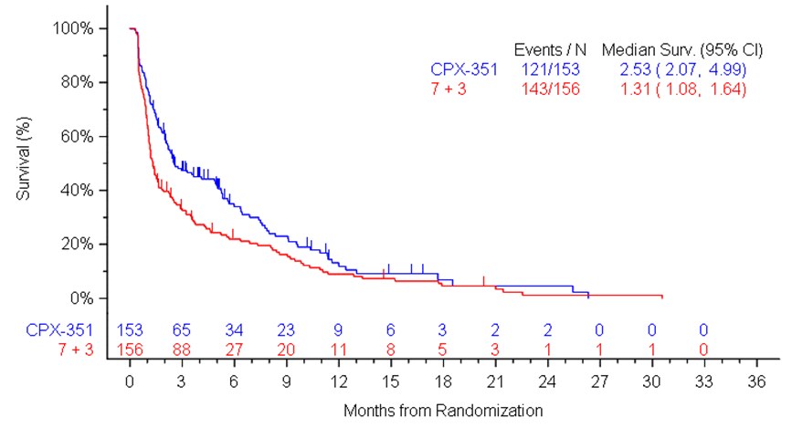
Source: Figure 2-6, p68 of the submission
7+3 = cytarabine + daunorubicin; CI = confidence interval; CPX-351 = liposomal cytarabine + daunorubicin; ITT = intent-to-treat; Surv = survival
  - Liposomal daunorubicin and cytarabine was associated with statistically significantly prolonged event-free survival compared to daunorubicin and cytarabine (HR = 0.74; 95% CI: 0.58, 0.99). Event-free survival was defined as time to failure of induction (persistent disease), relapse after complete remission with or without incomplete count recovery or death, whichever came first. At the end of the primary analysis period, most patients in the intervention arm (121/153, 79%) and comparator arm (143/156, 92%) had experienced an event. Results based on a sensitivity analysis that censored patients at the time of HSCT were consistent with the primary analysis (HR = 0.74, 95% CI: 0.56, 0.97).
  - The economic model used data from an ad hoc analysis of event-free survival based on 5-year follow-up data. The analysis included additional follow up for 13 patients who were censored at the 3-year primary data cut off. It was difficult to reconcile event-free survival estimates from the ad hoc analysis with the primary analysis as no formal analysis was conducted for treatment effects (i.e. no median survival estimates or hazard ratio). Visual inspection of the survival curves indicated full convergence between treatment arms after 36 months in the ad hoc analysis compared to after 12 months in the primary analysis.
  - Table 6 below presents the proportion of patients receiving HSCT in Study 301.
Table 6: Proportion of patients receiving HSCT in Study 301 (ITT population, primary analysis)
Patients, n (%) | Liposomal daunorubicin and cytarabine  N=153 | Daunorubicin and cytarabine  N=156 | Odds ratio (95% CI)
Proportion with HSCT | 52 (34.0) | 39 (25.0) | 1.54 (0.92, 2.56)
Source: Table 2.10, p69 of the submission
CI = confidence interval; HSCT = haematopoietic stem cell transplant; ITT = intent-to-treat

  - Although not statistically significantly, the submission noted that the point estimate suggested that a greater proportion of patients treated with liposomal daunorubicin and cytarabine underwent HSCT compared to patients on daunorubicin and cytarabine. This was consistent across subgroups by age and AML subtype.
  - The submission claimed the higher response rate achieved with liposomal daunorubicin and cytarabine translated to a higher proportion of patients receiving HSCT compared to those treated with daunorubicin and cytarabine. More patients with response to liposomal daunorubicin and cytarabine treatment received HSCT compared to patients on daunorubicin and cytarabine (55% versus 46%, respectively); however, a substantial proportion of patients in both arms who achieved a response did not receive HSCT. The proportion of patients with no response to study treatments who received HSCT was similar between arms (15% liposomal daunorubicin and cytarabine versus 14% daunorubicin and cytarabine).
  - Post hoc exploratory analyses were conducted on the subgroup of patients who underwent HSCT to investigate potential differences between arms in terms of pre- and post-transplant characteristics (Uy 2022 letter to the editor). The results suggest a higher proportion of patients in the liposomal daunorubicin and cytarabine arm were in complete remission before and after HSCT compared to those in the daunorubicin and cytarabine group.
  - Overall, it is plausible that higher response rates led to increased HSCT rates in the liposomal daunorubicin and cytarabine arm. However, the Uy 2022 study authors noted the lack of formal testing of measurable residual disease (MRD) in the trial. The authors noted the known relationship between MRD positivity before HSCT and risk of relapse, and that MRD status likely influences the choice of conditioning regimen or decision to perform HSCT. The impact of MRD status on HSCT rates in the trial was unknown. The PSCR noted that Study 301 was initiated in 2012 and completed by 2015. Further, the PSCR stated that the methodologies and thresholds for MRD negativity have only recently been standardised for AML.
  - Figure 2 below presents the Kaplan-Meier plot of overall survival in Study 301 (primary endpoint). The analysis was performed using the final data cut (25 October 2019) over a median follow-up duration of 5 years.
Figure 2: Kaplan-Meier plot for overall survival (ITT population, final analysis)
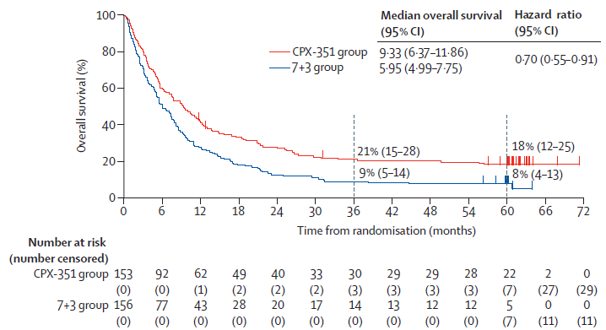

Source: Figure 2, Lancet 2021 publication
Note: 3-year and 5-year Kaplan-Meier estimated survival rates are shown with 95% CI
7+3 = cytarabine + daunorubicin; CI = confidence interval; CPX-351 = liposomal cytarabine + daunorubicin; ITT = intent-to-treat
  - Liposomal daunorubicin and cytarabine (9.33 months) was associated with statistically significantly improved overall survival compared to daunorubicin and cytarabine (5.95 months) over a median follow-up duration of 5 years (HR = 0.70; 95% CI: 0.55, 0.91). At the end of the final analysis period, most patients in the intervention arm (124/153, 81%) and comparator arm (145/156, 93%) had died. The results were consistent with the primary analysis over a median follow-up of 1.7 years, with median overall survival of 9.56 months versus 5.95 months for liposomal daunorubicin and cytarabine versus daunorubicin and cytarabine (HR = 0.69; 95% CI: 0.52, 0.90).
  - The submission claimed the plateaus at the tail-end of the overall survival plots, from around 3 years, represented patients who achieved durable remission. This claim was inadequately justified as remission status was not captured beyond the primary analysis period of the trial (median 1.7 years follow-up).
  - Overall survival estimates were potentially confounded by differences in the proportion of patients who received HSCT in each arm. A formal sensitivity analysis censoring patients at the start of HSCT was conducted over the primary analysis period, with results suggesting that patients on liposomal daunorubicin and cytarabine had numerically greater median overall survival of 7.8 months versus 5.6 months in patients on daunorubicin and cytarabine; however, the results were not statistically significant (HR = 0.81; 95% CI: 0.60, 1.09) with survival curves converging by approximately 26 months.
  - The submission claimed the difference in overall survival was driven by the greater proportion of patients receiving HSCT in the liposomal daunorubicin and cytarabine arm. The submission also claimed the majority of patients who were alive beyond 3 years in the trial were patients who had received HSCT, which is potentially curative. This claim was supported by an ad hoc analysis provided in the submission, indicating that at 3 years, 90% of patients in the liposomal daunorubicin and cytarabine arm and 64% of patients in the daunorubicin and cytarabine arm had undergone HSCT.
  - A Kaplan-Meier plot for overall survival landmarked at date of HSCT is presented in Figure 3 below.
Figure 3: Kaplan-Meier plot for overall survival landmarked at date of HSCT (ITT population, final data cut)
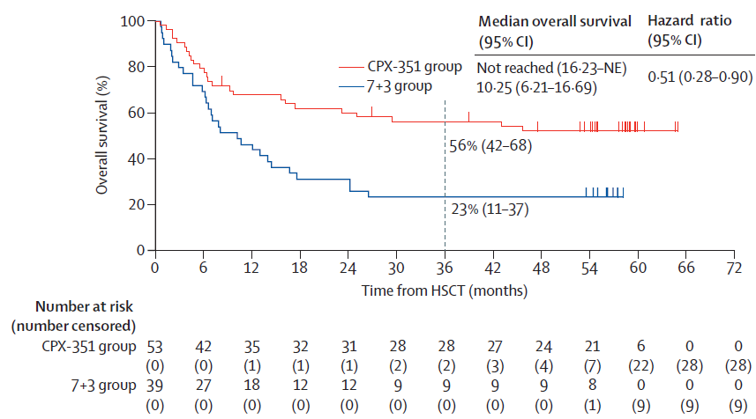
Source: Figure 4, Lancet 2021 trial publication
7+3 = cytarabine + daunorubicin; CI = confidence interval; CPX-351 = liposomal cytarabine + daunorubicin; HSCT = haematopoietic stem cell transplant; ITT = intent-to-treat; NE = not estimable
  - There was statistically significantly improved overall survival after HSCT for patients in the liposomal daunorubicin and cytarabine arm compared to daunorubicin and cytarabine. There were limited long-term survival data post-HSCT, with the publication noting that only 3-year survival estimates were reported as follow-up time after HSCT was less than 5 years.
  - The trial report for the final data cut (5-year follow-up) included exploratory pre- and post-transplant analyses to attain a better understanding of which aspects or features of liposomal daunorubicin and cytarabine may lead to improved outcomes following HSCT. Additional analyses on transplant outcomes were also published in a research letter to the editor (Uy 2022). The results showed a higher proportion of patients in the liposomal daunorubicin and cytarabine arm were in complete remission before and after transplant compared to the daunorubicin and cytarabine arm. However, the Uy 2022 study authors noted that there were limitations with data capture that was not prospectively planned, with higher rates of missing data in the comparator arm. Additionally, there was a lack of MRD testing results during the trial. Overall, the reasons for improved post-HSCT outcomes remained uncertain.
Daunorubicin and cytarabine versus idarubicin and cytarabine
  - The submission presented the results of a literature review to support the use of daunorubicin and cytarabine as a proxy for the nominated comparator idarubicin and cytarabine. The search identified 17 randomised trials comparing daunorubicin with idarubicin (all with concomitant cytarabine) as well as systematic reviews, meta-analyses and meta-regressions. The pre-PBAC response also noted that in consideration of other AML therapies (midostaurin PSD, July 2018 PBAC meeting and gemtuzumab ozogamicin PSD, March 2021 and November 2021 PBAC meetings), the PBAC had considered daunorubicin and idarubicin to be interchangeable.
  - Table 7 summarises the interventions used for induction of remission in the randomised trials, and the cumulative dose ratios of the reported induction courses of treatment for daunorubicin and idarubicin, used in combination with cytarabine. The ESC noted that no specific claim was made with regards to the relative efficacy of daunorubicin and idarubicin for second induction or consolidation.

Table 7: Induction regimen doses in trials comparing daunorubicin and idarubicin
Trial ID | Anthracycline |  | Cytarabine  (same in both arms) | Ratio of DAUNO:IDA cumulative doses
 | Daunorubicin | Idarubicin
Eridani 1989 | Age < 60 years:  45 mg/m² IV D1-3  Age > 60 years:  45 mg/m² IV D1 | Age < 60 years:  10 mg/m² IV D1-3  Age > 60 years:  20 mg/m² orally D1-3 | 200 mg/m² IV D1-5 | 4.5 in patients aged < 60 years;  N/A in patients aged > 60 years ª
Mandelli 1991 | 45 mg/m² IV D1-3 | 12 mg/m² IV D1-3 | 100 mg/m² CIV D1-7 | 3.75
Berman 1991 | 50 mg/m² IV D1-3 | 12 mg/m² IV D1-3 | 25 mg/m² IV bolus then 200 mg/m² CIV for 5 days | 4.17
Wiernik 1992 | 45 mg/m² IV D1-3 | 13 mg/m² IV D1-3 | 100 mg/m² CIV D1-7 | 3.46
Vogler 1992 | 45 mg/m² IV D1-3 | 12 mg/m² IV D1-3 | 100 mg/m² CIV D1-7 | 3.75
Rubio 1993 | 45 mg/m² IV D1-3 | 10 mg/m² IV D1-3 | 100 mg/m² CIV D1-7 | 4.5
Masaoka 1996 | 40 mg/m² IV D1-3 | 12 mg/m² D1-3 | 80 mg/m² IV bd D1-7 | 3.33
Reiffers 1996 | 50 mg/m² IV D1-3 | 8 mg/m² IV D1-5 | 100 mg/m² CIV D1-7 | 3.75
Creutzig 2001 ^{b} | 30 mg/m² IV bd D3-5 | 12 mg/m²/day IV D3-5 | 100 mg/m² CIV D1-2 then IV bd D3-8 | 5.0
Rowe 2004 | 45 mg/m² IV D1-3 | 12 mg/m² IV D1-3 | 100 mg/m² CIV D1-7 | 3.75
Gardin 2007 | 45 mg/m² IV D1-4 | 9 mg/m² IV D1-4 | 200 mg/m² CIV D1-7 | 5.0
Mandelli 2009 ^{c} | 50 mg/m² IV D1, 3, 5 | 10 mg/m² IV D1, 3, 5 | 25 mg/m² IV bolus then 100 mg/m² CIV for 10 days | 5.0
Pautas 2010 | 80 mg/m² IV D1-3 | 12 mg/m² IV D1-3 | 200 mg/m² CIV D1-7 | 6.67
 |  | 12 mg/m² IV on D1-4 |  | 5.0
Ohtake 2011 | 50 mg/m² IV D1-5 | 12 mg/m² IV D1-3 | 100 mg/m² CIV D1-7 | 6.94
Jia 2011 | 25 mg/m² IV D1-3 | 8 mg/m² IV D1-3 | 150 mg/m² IV D1-7 | 3.125
Récher 2014 | 60 mg/m² IV D1-3 | 8 mg/m² IV D1-5 | 200 mg/m² IV D1-7 | 4.5
Lee 2017 | 90 mg/m² IV D1-3 | 12 mg/m² IV D1-3 | 200 mg/m² D1- 7 | 7.5
Source: Table 3, Attachment 1 of the submission.
Bd = twice daily; CIV = continuous intravenous infusion; CYT = cytarabine; D = day; DAUNO = daunorubicin; IDA = idarubicin; IV = intravenous
ª Patients aged > 60 years received oral idarubicin, and one day only of daunorubicin
^{b} In Creutzig 2001, both treatment arms also received etoposide 150 mg/m² IV on Days 6-8
^{c} In Mandelli 2009, both treatment arms also received etoposide 100 mg/m² IV on Days 1 to 5
  - The dose equivalence of daunorubicin and idarubicin, when given in combination with cytarabine for induction therapy, is uncertain given substantial variations in doses and dose regimens used in the included trials, yielding cumulative dose ratios of daunorubicin: idarubicin of 3:1 to almost 8:1. None of the trials directly compared the 7+3 regimens containing daunorubicin or idarubicin in combination with cytarabine, using the equi-effective doses proposed in the submission (daunorubicin 60 mg/m² daily and idarubicin 12 mg/m² daily for 3 days). Comparative efficacy based on complete remission rates and survival varied across the trials, which is expected given substantial differences in terms of trial populations and treatment regimens (induction, second induction, consolidation). The PSCR stated that as the two anthracycline plus cytarabine regimens endorsed by eviQ protocols are (i) 7+3 idarubicin (idarubicin 12 mg/m² daily for 3 days), and (ii) 7+3 daunorubicin (daunorubicin 60 mg/m² daily for 3 days), these two regimens have similar effectiveness when administered as recommended and that the ratio of recommended doses for daunorubicin and idarubicin is 5:1. The ESC considered that the therapeutic equivalence of daunorubicin and idarubicin was not supported by the data presented. The pre-PBAC response noted that the Australasian Leukaemia and Lymphoma Group Acute Leukaemia Working Party AML treatment guidelines consider idarubicin and daunorubicin to be interchangeable.
  - Multiple systematic reviews comparing idarubicin- and daunorubicin-containing regimens for induction therapy were identified; however, the results were difficult to compare as there was no consistent pattern of inclusion or exclusion of trials. The Li 2015 review had the most comprehensive selection of trials (16 of 17 identified trials in the submission), with results indicating that idarubicin is superior to daunorubicin. The submission argued that most of the systematic reviews did not account for differences in dose and dosing schedules, and focussed on two reviews (Adige 2019, Teuffel 2013) that suggested potential equipotency between daunorubicin and idarubicin at dose ratios of at least 5:1 or higher. However, the Li 2015 review also presented multiple subgroup analyses by dose, with results indicating no relationship between dose and treatment effect sizes. The PSCR stated that Li 2015 demonstrated a strong trend towards non-inferiority at dose ratios of 5:1 or higher, and that it was the inclusion of trials with lower ratios into the meta-analysis that meant the overall treatment effect favoured idarubicin. The PSCR presented a cumulative meta-analysis using the same set of studies, suggesting the sequential addition of studies with lower daunorubicin to idarubicin dose ratios resulted in a shift of outcomes from no statistically significant difference towards statistically significant differences in favour of idarubicin (see Figure 4). The ESC considered that the validity of the analysis was uncertain due to limited documentation, noting that varying conclusions from subgroup analyses in Li 2015 suggested no relationship between dose and treatment effect size.
Figure 4: Forest plot of cumulative meta-analysis of idarubicin versus daunorubicin studies reported by Li 2015
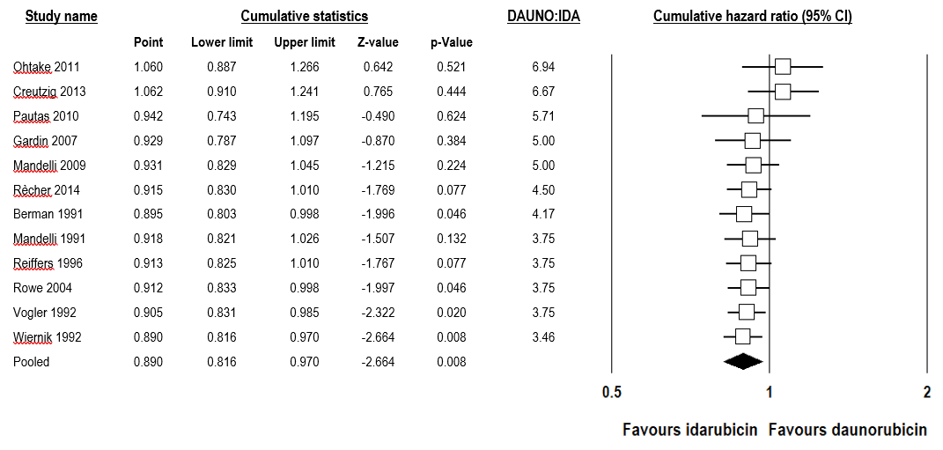
Source: Figure 3, p3 of the PSCR
CI = confidence interval; DAUNO = daunorubicin; IDA = idarubicin

  - The evidence base included trials conducted up to more than 30 years ago, with the most recent trial conducted approximately 10 years ago. The data are unlikely to reflect the comparative efficacy and safety of current daunorubicin- and idarubicin-containing regimens due to changing treatment algorithms and disease management protocols over this time period. For example, the role of disease cytogenic and molecular profiles such as FLT3 mutation as a treatment effect modifier was only considered in one of the more recent trials.
  - Overall, the ESC considered that the submission’s claim of equi-effectiveness between daunorubicin and idarubicin at the proposed doses was inadequately supported by the available evidence for induction therapy, with no evidence presented that compared the use of these treatments for consolidation. The pre-PBAC response maintained that it was reasonable to conclude that daunorubicin 60 mg/m² for 3 days and idarubicin 12 mg/m² for 3 days were approximately equi-effective.

Comparative harms
  - Safety data from Study 301 were reported for the primary analysis period only (31 December 2015 data cut off, median 1.7 years follow-up), with no adverse event data except for deaths and medical observations post-HSCT collected during the extended 5-year follow-up period. Study 301 was open label with no blinding of investigators and patients, which may have biased the reporting of adverse events.
  - Concomitant medications and supportive care were allowed in the trial for premedication and treatment of nausea and vomiting, hypersensitivity/infusion-related reactions, infection prophylaxis, growth factor support and transfusion support.
  - Table 8 below presents the incidence of treatment-emergent adverse events in the trial.
Table 8: Summary of incidence of treatment-emergent adverse events (safety population, primary analysis)
Patients with events, n (%) | Liposomal daunorubicin and cytarabine  N=153 | Daunorubicin and cytarabine  N=151
Any AE | 153 (100) | 151 (100)
Treatment discontinuation due to AE | 3 (2.0) | 2 (1.3)
Grade ≥ 3 AE | 141 (92.2) | 137 (90.7)
Serious AE | 90 (58.8) | 65 (43.0)
Deaths ª | 106 (69.3) | 128 (84.8)
- Progressive leukaemia | 65 (61.3) | 67 (52.3)
- Non-progressive disease, cancer-related organ failure | 0 | 5 (3.9)
- Adverse event | 15 (14.2) | 19 (14.8)
- Unknown | 10 (9.4) | 22 (17.2)
Adverse events of special interest
Infection | 142 (92.8) | 140 (92.7)
Bleeding | 114 (74.5) | 90 (59.6)
Cardiac | 75 (49.0) | 72 (47.7)
Source: Table 2.11, p51; Table 16, p75; Table 14.3.1.1, p208; Table 14.3.3.2, p401 of the Study 301 trial report
AE = adverse event
ª An additional 3 deaths were observed after the end of the follow-up phase, 1 in the liposomal daunorubicin and cytarabine group and 2 in the daunorubicin and cytarabine group
  - All patients in the trial experienced at least one adverse event, with similar types of events occurring in both arms. The most frequently reported adverse events by preferred term, occurring in at least 40% of patients in either treatment group, were febrile neutropenia, diarrhoea, nausea, peripheral oedema, constipation and decreased appetite.
  - The incidence of serious adverse events was higher in the liposomal daunorubicin and cytarabine arm compared with the daunorubicin and cytarabine arm. A greater proportion of patients in the liposomal daunorubicin and cytarabine arm experienced serious events of febrile neutropenia, respiratory failure, sepsis and pneumonia. Progressive or relapsed disease was the leading cause of death for both arms of the trial.
  - More patients in the liposomal daunorubicin and cytarabine arm experienced bleeding-related adverse events. The most notable differences between liposomal daunorubicin and cytarabine versus daunorubicin and cytarabine groups were for epistaxis (35.9% vs 17.9%, respectively), mouth haemorrhage (10.5% vs 5.3%, respectively) and blood blister (9.2% vs 3.3%, respectively).
  - The median time to neutrophil and platelet recovery was assessed in patients who achieved response after initial induction chemotherapy. The results indicated longer recovery times with liposomal daunorubicin and cytarabine (35-37 days) compared to daunorubicin and cytarabine (29 days). This was consistent with warnings in the Product Information regarding prolonged time to recovery of neutrophils and platelets requiring additional monitoring and use of prophylactic anti-infectives and supportive measures to manage myelosuppressive complications (e.g. colony-stimulating factors, transfusions).
  - The submission noted that the longer treatment duration for liposomal daunorubicin and cytarabine could have potentially resulted in the reporting of a greater number of adverse events in this group compared to the daunorubicin and cytarabine group. However, the trial report noted that rates of adverse events (i.e. number of events over follow-up duration) were not calculated.
  - The submission conducted an ad hoc analysis of safety data to determine adverse events rates (see Table 9).
Table 9: Incidence rate of adverse events in Study 301 (safety population, ad hoc analysis)
 | Liposomal daunorubicin and cytarabine  N=153 |  | Daunorubicin and cytarabine  N=151
 | Mean rate per patient-year (SD) | Median rate per patient-year (range) | Mean rate per patient-year (SD) | Median rate per patient-year (range)
Any AE | 85.3 (46.9) | 75.7 (10, 244) | 92.6 (43.6) | 87.2 (11, 248)
Grade ≥ 3 AE | 17.1 (15.7) | 12.2 (0, 80) | 19.2 (18.5) | 13.5 (0, 117)
Serious AE | 4.9 (5.9) | 3.2 (0, 37) | 4.4 (6.8) | 0.0 (0, 31)
Source: Table 2.12, p51 of the submission
AE = adverse events; SD = standard deviation
  - The submission stated that when corrected for treatment exposure, the median rate of any adverse event was lower in the liposomal daunorubicin and cytarabine arm compared to daunorubicin and cytarabine. The submission claimed the analysis supported the clinical clam of non-inferior safety between treatment groups.
  - The rates of adverse events could not be validated during the evaluation due to limited documentation in the submission. Additional documentation was provided by the sponsor during the evaluation, indicating the median rate of adverse events was derived using the incidence of adverse events normalised over the length of the safety reporting period (i.e. time from first administration of study drug through to 30 days after the end of the treatment phase) (poster publication, Medeiros 2017). The source analysis used to calculate the mean rate per patient-year was not provided.
  - The submission did not address the higher median rate of serious adverse events for liposomal daunorubicin and cytarabine compared to daunorubicin and cytarabine. The authors of the poster publication noted that the higher rates could be partly due to the greater proportion of patients in the liposomal daunorubicin and cytarabine arm who received consolidation in the outpatient setting. The authors further noted that a move from an outpatient to inpatient setting was documented as a serious adverse event; therefore, subsequent management of an adverse event in an inpatient setting may have contributed to the higher proportion of patients reporting a serious adverse event.
  - The interpretation of adverse event rates from the ad hoc analysis was hindered due to limited documentation. Moreover, the rates appeared to be calculated using the incidence of events (i.e. patients with new events only). Event rates over time (calculated using total number of events over total exposure time) would be more informative as individual patients may experience multiple events of the same type, particularly given patients in the liposomal daunorubicin and cytarabine received more subsequent cycles of study treatment.

Benefits/harms
  - On the basis of direct evidence presented in the submission (Study 301), for every 100 patients treated with liposomal daunorubicin and cytarabine compared to daunorubicin and cytarabine:
  - Approximately 12 additional patients would remain alive after 36 months.
  - On the basis of direct evidence presented in the submission (Study 301), for every 100 patients treated with liposomal daunorubicin and cytarabine compared to daunorubicin and cytarabine, over a median duration of follow up of 1.7 years:
Approximately 14 additional patients would achieve complete remission with or without incomplete recovery of blood counts, but with no apparent difference in duration of remission.
Approximately 9 additional patients would undergo HSCT.
Approximately 16 additional patients would experience a serious adverse event that is life-threatening or requires hospitalisation.
Approximately 15 additional patients would experience bleeding events.
There would be a similar incidence of infections and cardiac events.

Clinical claim
  - The submission described liposomal daunorubicin and cytarabine as superior in terms of efficacy compared to daunorubicin and cytarabine, as a proxy for idarubicin and cytarabine. The ESC noted that the data supported superior efficacy when comparing liposomal daunorubicin and cytarabine versus daunorubicin and cytarabine. However, the ESC considered that the claim that daunorubicin and cytarabine was a reasonable proxy for idarubicin and cytarabine was not supported.
  - The ESC considered that the therapeutic equivalence of daunorubicin and cytarabine remained uncertain due to evidence gaps (no direct comparison at proposed equi-effective doses, no comparison of consolidation regimens), contrasting conclusions regarding equi-potency from published systematic reviews and limited applicability of the evidence base that was relatively old (trials conducted up to more than 30 years ago).
  - The ESC noted that there was added uncertainty associated with the magnitude of benefit associated with liposomal daunorubicin and cytarabine in the Australian setting given the following concerns:
- Registry data indicated a higher proportion of patients with t-AML or AML-MRC were classified as having poor risk compared to the trial. Cytogenetic risk did not appear to be a treatment effect modifier; however, the absolute magnitude of benefit is likely to be lower due to poorer overall survival in those with adverse risk. The PSCR noted that all t-AML and AML-MCR patients have a poor prognosis, independent of karyotype.
- Expert opinion indicated that more aggressive regimens such as FLAG-Ida and HiDAC/IDAC are used as second induction and consolidation courses, and a higher proportion of Australian patients receive 2 or more consolidation courses (69%) compared to patients in the control arm of the trial (15%). The ESC considered that idarubicin and cytarabine (5+2 regimen) was not a suitable comparator in the second induction or consolidation settings.
- The trial was conducted in the US and Canada and reported in-trial HSCT rates that were considerably higher (34% liposomal daunorubicin and cytarabine; 25% daunorubicin and cytarabine) than observed in the Australian registry cohort (7%). Although relatively old, published data from 2013 indicated that HSCT rates in Australian and New Zealand patients with AML (21%) were lower compared to the US (29%). The ESC agreed that Australia has a more rigorous patient selection process for HSCT than the US and Canada which results in less HSCTs, but better HSCT outcomes.
- The impact of MRD status on HSCT rates in the trial was unknown as no formal testing was planned. The PSCR noted that Study 301 was initiated in 2012 and completed by 2015. Further, the PSCR stated that the methodologies and thresholds for MRD negativity have only recently been standardised for AML.
  - The submission described liposomal daunorubicin an cytarabine as non-inferior in terms of safety compared to daunorubicin and cytarabine, as a proxy for idarubicin and cytarabine. The ESC considered that this claim was inadequately supported, with data from the key trial indicating that liposomal daunorubicin and cytarabine treatment was associated with a longer treatment duration and consequently increased incidence of adverse events compared to daunorubicin and cytarabine. The data also indicated prolonged time to neutrophil and platelet recovery following treatment with liposomal daunorubicin and cytarabine due to the long plasma half-life of the drug, which was associated with increased use of supportive therapies.
  - The submission stated there was insufficient data to permit an analysis of comparative safety between daunorubicin and idarubicin at the proposed equi-effective doses.
  - The PBAC considered that the claim of superior comparative effectiveness was reasonable.
  - The PBAC considered that the claim of non-inferior comparative safety was not adequately supported by the data.

Economic analysis
  - The submission presented a modelled economic evaluation comparing treatment with liposomal daunorubicin and cytarabine versus idarubicin and cytarabine, in patients with newly diagnosed t-AML and AML-MRC. The model was based on the liposomal daunorubicin and cytarabine and daunorubicin and cytarabine arms of Study 301, using the results and circumstances of use for the daunorubicin and cytarabine arm as a proxy for treatment with idarubicin and cytarabine. The economic evaluation was presented as a stepped cost-effectiveness/cost-utility analysis.
Table 10: Key components of the economic evaluation
Component | Summary
Treatments | Liposomal daunorubicin and cytarabine (LDC) vs idarubicin and cytarabine (IC).
Time horizon | 25 years in the model base case versus a median follow-up of 5 years in Study 301. Average age of patients at model entry was 67.7 years.
Outcomes | Quality-adjusted life years; life years.
Methods used to generate results | Partitioned survival analysis
Health states | Event-free survival; post-event survival; dead.
Cycle length | 1 month
Allocation to health states | LDC arm: Kaplan-Meier estimates of event-free survival and overall survival for the liposomal daunorubicin and cytarabine arm of Study 301, extrapolated using parametric functions.  IC arm: Kaplan-Meier estimates of event-free survival and overall survival for the daunorubicin and cytarabine arm of Study 301 (as a proxy for treatment with idarubicin and cytarabine), extrapolated using parametric functions.  Background population mortality and additional disease-related mortality (assumed to be 50% of background population mortality) applied from the point at which extrapolation occurred.
Extrapolation method | Event-free survival: Dependent parametric model fitted to each treatment arm based on the assumption of proportional hazards. Generalised gamma function selected for the base case based on goodness of fit statistics and visual inspection. Parametric function applied from the point at which 15% of patients remain at risk (10 months in the LDC arm and 8 months in the IC arm).  Overall survival: Dependent parametric model fitted to each treatment arm based on the assumption of proportional hazards. Gompertz function selected for the base case based on goodness of fit statistics and visual inspection. Parametric function applied from the point at which 15% of patients remain at risk (60 months in the LDC arm and 21 months in the IC arm).
Health related quality of life | Health state utility during the initial 3 years of the model for event-free survival (0.55) and post-event health states (0.52) based on a published time-trade off study (Matza et al., 2019).  Health state utility in event-free survival and post-event survival states beyond 3 years (0.80) based on the mean Australian EQ-5D-3L utility value for persons aged 65-74 years (0.82) reported by Clemens et al. (2014), with a small downward adjustment.
Costs | LDC cost based on proposed effective AEMP. Treatment regimen based on LDC regimen in Study 301.  IC cost based on published AEMPs for idarubicin and cytarabine. Treatment regimen based on IC regimen included in eviQ protocol.  Proportions of patients receiving first/second induction, first/second consolidation, and HSCT based on LDC and DC arms of Study 301. Proportions of patients receiving induction/consolidation treatment in an inpatient versus outpatient setting based on LDC and DC arms of Study 301.
Source: Section 3.3, pp67-68; Section 3.4, pp69-81; Section 3.5, pp82-84; Section 3.6, pp85-88 of the submission; Section 3 economic model Excel workbook
AEMP = approved ex-manufacturer price; DC = daunorubicin and cytarabine; HSCT = haematopoietic stem cell transplant; IC = idarubicin and cytarabine; LDC = liposomal daunorubicin and cytarabine
  - A partitioned survival design, using extrapolated event-free survival and overall survival data, was used to distribute patients between model health states.
  - Event-free survival and overall survival estimates were derived from Kaplan-Meier survival data for the liposomal daunorubicin and cytarabine and daunorubicin and cytarabine arms in Study 301. The results for the daunorubicin and cytarabine arm of Study 301 were used as a proxy for treatment with idarubicin and cytarabine.
  - Dependent parametric models fitted to the Kaplan-Meier plot of event-free survival for the liposomal daunorubicin and cytarabine and daunorubicin and cytarabine arms of Study 301 are presented in Figure 5 and Figure 6, respectively.
Figure 5: Parametric models fitted to the Kaplan-Meier plot of event-free survival for the liposomal daunorubicin and cytarabine arm
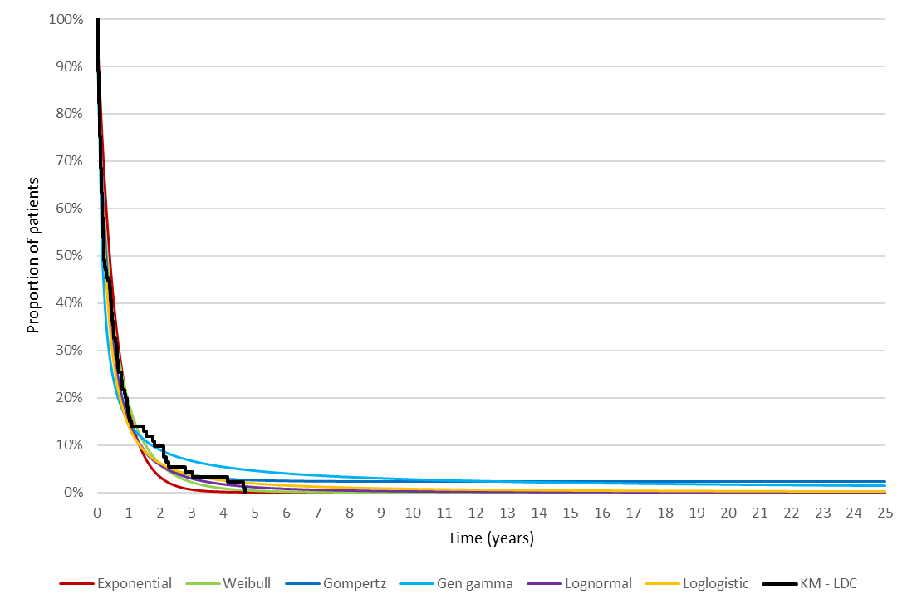
Source: Constructed during the evaluation using the Section 3 economic model Excel workbook
Gen gamma = generalised gamma; KM = Kaplan-Meier; LDC = liposomal daunorubicin and cytarabine
Figure 6: Parametric models fitted to the Kaplan-Meier plot of event-free survival for the daunorubicin and cytarabine arm
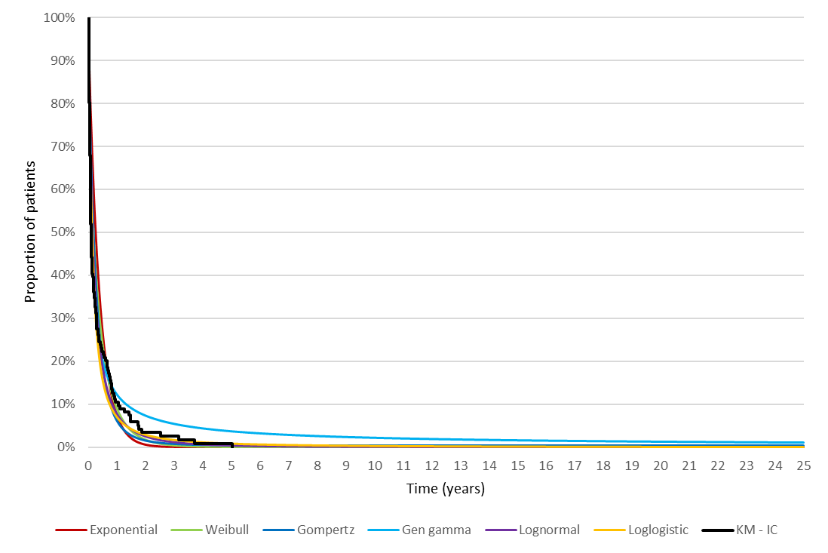

Source: Constructed during the evaluation using the Section 3 economic model Excel workbook
Gen gamma = generalised gamma; IC = idarubicin and cytarabine; KM = Kaplan-Meier
  - Based on the Akaike information criterion (AIC) and Bayesian information criterion (BIC), the generalised gamma function demonstrated the best statistical fit. Based on visual inspection, the generalised gamma function appeared to overestimate the event-free survival compared to the Kaplan-Meier data. However, sensitivity analyses indicated that the choice of function used to extrapolate event-free survival had minimal impact on the modelled results.
  - Dependent parametric models fitted to the Kaplan-Meier plot of overall survival for the liposomal daunorubicin and cytarabine and daunorubicin and cytarabine arms of Study 301 are presented in Figure 7 and Figure 8, respectively.
Figure 7: Parametric models fitted to the Kaplan-Meier plot of overall survival for the liposomal daunorubicin and cytarabine arm
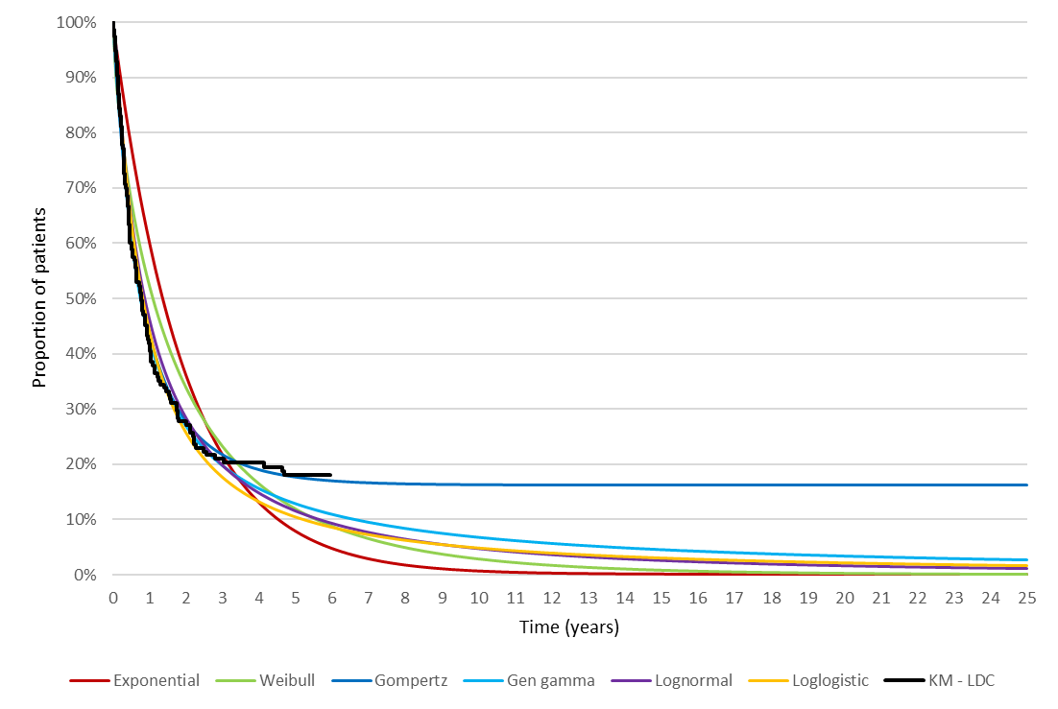
Source: Constructed during the evaluation using the Section 3 economic model Excel workbook
Gen gamma = generalised gamma; KM = Kaplan-Meier; LDC = liposomal daunorubicin and cytarabine
Figure 8: Parametric models fitted to the Kaplan-Meier plot of overall survival for the daunorubicin and cytarabine arm
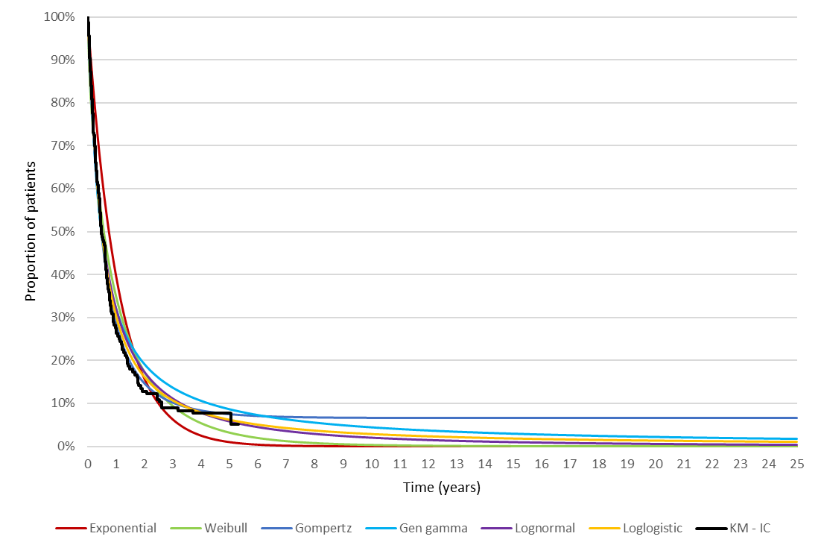
Source: Constructed during the evaluation using the Section 3 economic model Excel workbook
Gen gamma = generalised gamma; IC = idarubicin and cytarabine; KM = Kaplan-Meier
  - Based on the AIC and BIC, the Gompertz function demonstrated the best statistical fit, and was selected for the extrapolation of overall survival in the model. The selected Gompertz function lacked face validity, at it resulted in indefinite survival for patients beyond approximately 9 years. The submission noted that extrapolation of overall survival using a Gompertz function resulted in the appearance of indefinite survival but argued that the application of background population mortality (based on Australian life tables) and an additional disease-related mortality factor (50% of background population mortality) applied consistently across both arms resulted in plausible survival estimates. The ESC considered it was uncertain whether the resulting overall survival curve adequately reflected the long-term survival outcomes for patients with t-AML or AML-ARC. Mortality rates among patients with t-AML or AML-MRC may be higher than estimated in the submission due to comorbidities associated with prior chemotherapy treatments, the potential for disease recurrence, and issues associated with HSCT (e.g., graft versus host disease). The PSCR stated that the majority of patients who survived beyond 3 years in Study 301 were those who had received HSCT, which is curative in some patients. Further, the PSCR stated that the inclusion of background mortality and an assumption of 50% excess mortality in patients with a history of HSCT ensured life expectancy was not overestimated. The ESC noted that the current extrapolation approach resulted in overall survival estimates that were not clinically plausible over the modelled time horizon and hence, relied on adjustment with an inflated population mortality rate. The ESC noted that the ICER was moderately sensitive to the additional disease-related mortality factor (50%), especially in the context of only 18% of patients in the liposomal daunorubicin and cytarabine arm being alive at 5 years (see Figure 2). The ESC considered the life years modelled for the additional 10% of patients alive at 5 years to be uncertain, and that applying convergence to the overall curves from approximately 10 years would be appropriate to reflect the lack of evidence in long term outcomes. The pre-PBAC response stated that convergence of the survival outcomes beyond 5 years was applied in the submission, with the curves converging by approximately 28 years.
  - Due to the partitioned survival design of the model, which incorporated event-free survival and overall survival results from Study 301, the modelled outcomes reflect the treatments administered in Study 301. The ESC noted that there were concerns regarding the applicability of Study 301 to the PBS population due to potential differences in the chemotherapy treatments used for second induction and consolidation, the proportions of patients receiving second induction and consolidation courses, and HSCT rates. These differences may affect survival outcomes associated with treatment among patients in the PBS population.
  - The submission stated that utilities in the model were sourced from published literature, as health-related quality of life was not measured in Study 301. During the initial 3 years of the model, patients in the event-free survival health state were assumed to have a utility of 0.55 and patients in the post-event survival health state were assumed to have a utility of 0.52, based on health state utilities reported in a published time-trade off study of patients with AML (Matza et al., 2019). The assumed utilities did not appear to be appropriate as the model health states did not align with the descriptions included in the vignettes (the pre-event survival utility was based on a vignette which described a patient with active AML, typically a newly diagnosed patient, prior to receiving treatment; the post-event survival utility was based on a vignette which described a patient who is not considered a good candidate for chemotherapy and transplants, receiving best supportive care). The ESC noted that the utility values applied were broadly consistent with those applied in the gemtuzumab ozogamicin submission (Table 8, gemtuzumab ozogamicin PSD, November 2021 PBAC meeting) but were lower than the values applied in the venetoclax submission (Table 11, venetoclax PSD, March 2021).
  - The assumed health state utility for patients surviving beyond 3 years in the model (0.80) was based on the mean Australian EQ-5D-3L utility value for persons aged 65-74 years (0.82) reported by Clemens et al. (2014), with a small downward adjustment. The quality of life among patients surviving beyond 3 years may be worse than assumed in the submission, given comorbidity associated with t-AML/AML-MRC and prior chemotherapy treatments, the risk of disease recurrence, and issues associated with HSCT (e.g., graft versus host disease).
  - The model included drug costs, hospitalisation costs and costs associated with undergoing HSCT. No costs were included for subsequent lines of therapy. This was inconsistent with trial data suggesting that most patients received salvage therapies in the trial, with more patients in the intervention arm (77%) receiving salvage therapy versus the comparator arm (70%). No costs were included for pre- and post-transplant costs associated with HSCT, which was inconsistent with HSCT-related information from the trial. No costs were included for disease monitoring, disease management or use of supportive treatments. The omission of these costs was inconsistent with trial data indicating more tests for monitoring and greater use of prophylactic anti-infectives, blood transfusions and granulocyte-colony stimulating factors (G-CSF) in the liposomal daunorubicin and cytarabine arm of the trial. Exclusion of these costs favoured the liposomal daunorubicin and cytarabine arm and was not adequately justified in the submission. The PSCR noted the sensitivity analysis conducted during the evaluation that increased the costs associated with HSCT by 50%. The PSCR noted that this increased the ICER by 6% and could be considered indicative of examining the impact of increasing costs associated with subsequent lines of therapy, disease monitoring, disease management, supportive treatments and pre- and post-transplant costs. The ESC noted that the sensitivity analysis did not capture the potential impact of non-HSCT-related costs and advised that costs associated with subsequent therapies, disease monitoring and management, supportive treatments and adverse events should be included in the base case analysis. The ESC noted that exclusion of these costs was inconsistent with health resource utilisation data from the trial that indicated greater resource use in the liposomal daunorubicin and cytarabine arm.
  - The submission argued that the inclusion of adverse event costs was not necessary as the clinical evidence suggests similar safety between treatments in the trial when adjusted for duration of treatment exposure. The ESC considered that this argument was inadequately justified as the data indicated that liposomal daunorubicin and cytarabine treatment was associated with a longer treatment duration, and consequently an increased incidence of adverse events compared to daunorubicin and cytarabine. The data also indicated prolonged time to neutrophil and platelet recovery following treatment, due to the long plasma half-life of the drug, which the ESC considered would prolong hospitalisation by approximately 6-8 days and the associated costs should be included in the model.
  - The key drivers of the model are summarised in Table 11.
Table 11: Key drivers of the model
Description | Method/Value | Impact
Time horizon | The model base case incorporated a 25-year time horizon, versus a median follow-up of 5 years in Study 301. There was a large amount of uncertainty associated with the extrapolation of the survival data from 5 years to 25 years. | Moderate, favours LDC
Extrapolation | A Gompertz function was used to extrapolate overall survival in the model, with adjustment for background population mortality and additional mortality associated with the disease. The modelled overall survival may not adequately reflect survival outcomes among patients with t-AML and AML-MRC, due to comorbidities associated with prior chemotherapy treatments, the potential for disease recurrence, and issues associated with HSCT (e.g., graft versus host disease). | Moderate, favours LDC
Utilities | Utilities for the pre- and post-event health states during the initial 3 years of the model (0.55 for patients in the pre-event survival state; 0.52 for patients in the post-event survival state) were sourced from Matza et al. (2019). The model health states did not match the health state descriptions included in Matza et al. (2019).  The assumed health state utility for patients surviving beyond 3 years in the model (0.80) was based on the mean Australian EQ-5D-3L utility value for persons aged 65-74 years of 0.82 reported by Clemens et al. (2014), with a small downward adjustment. The quality of life among patients surviving greater than 3 years may be worse than assumed in the submission, given comorbidity associated with t-AML/AML-MRC and prior chemotherapy treatments, the risk of disease recurrence, and issues associated with HSCT (e.g., graft versus host disease). | Moderate, favours LDC
Costs | The model included drug costs, hospitalisation costs, and HSCT costs only. Costs associated with subsequent lines of therapy, disease monitoring, disease management, supportive treatments, adverse events, and pre- and post-transplant costs associated with HSCT were not included in the model. | Moderate, favours LDC
Source: Constructed during the evaluation based on Section 3, pp57-95 of the submission
AML-MRC = acute myeloid leukaemia with myelodysplasia-related changes; HSCT = haematopoietic stem cell transplant; LDC = liposomal daunorubicin and cytarabine; t-AML = therapy-related acute myeloid leukaemia
  - Model traces for the liposomal daunorubicin and cytarabine and idarubicin and cytarabine arms are presented in Figure 9.
Figure 9: Model traces for the liposomal daunorubicin and cytarabine and idarubicin and cytarabine arms 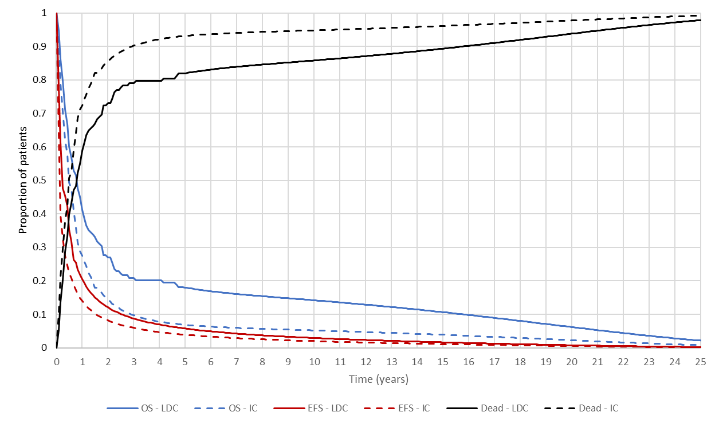
Source: Constructed during the evaluation using the Section 3 economic model Excel workbook
EFS = event-free survival; IC = idarubicin and cytarabine; LDC = liposomal daunorubicin and cytarabine; OS = overall survival
  - The model traces indicate that:
At 5 years, approximately 18% of patients in the liposomal daunorubicin and cytarabine arm versus 7% of patients in the daunorubicin and cytarabine arm are alive, with approximately 6% versus 4% of patients remaining event-free, respectively. The reported 5-year overall survival rates for Study 301 were 18% for the liposomal daunorubicin and cytarabine arm and 8% for the daunorubicin and cytarabine arm.
At 15 years, approximately 11% of patients in the liposomal daunorubicin and cytarabine arm versus 4% of patients in the daunorubicin and cytarabine arm are alive, with approximately 2% versus 1% of patients remaining event-free, respectively.
At 25 years, approximately 2% of patients in the liposomal daunorubicin and cytarabine arm versus 0% of patients in the daunorubicin and cytarabine arm are alive, with 0% of patients in either arm remaining event-free.
  - The submission claimed that the modelled median overall survival in the idarubicin and cytarabine arm of the model (6 months) is similar to the median survival reported by Ong et al. (2018), in a study of Australian patients included in the Victorian Cancer Registry with t-AML (n=73) and secondary AML (non-proliferative neoplasm or myelodysplastic syndrome as the primary malignancy; n=365) between 2003 and 2014. No data were presented to validate the longer-term modelled outcomes for patients with t-AML and AML-MRD.
  - The results of the stepped economic evaluation are presented in Table 12.
Table 12: Results of the stepped economic evaluation
Step and component | Liposomal daunorubicin and cytarabine | Idarubicin and cytarabine | Increment
Step 1: Trial-based analysis over 5 years including drug acquisition costs (undiscounted)
Costs | $| | $2,499 | $|
Life years | 1.620 | 1.013 | 0.607
Incremental cost/extra life year gained |  |  | $|¹
Step 2: Modelled analysis over 25 years including all costs (discounted) ª
Costs | $| | $96,591 | $|
Life years | 2.683 | 1.407 | 1.276
Incremental cost/extra life year gained |  |  | $|²
Step 3: Modelled analysis over 25 years including all costs and utility weights (discounted)
Costs | $| | $96,591 | $|
Life years | 2.683 | 1.407 | 1.276
QALYs | 1.837 | 0.904 | 0.933
Incremental cost/extra QALY gained |  |  | $|³
Source: Table 3-10, p91 of the submission
HSCT = haemopoietic stem cell transplant; QALY = quality-adjusted life year
ª Costs include drug acquisition costs, drug administration costs, hospitalisation costs and HSCT costs.
The redacted values correspond to the following ranges:
¹ $95,000 to < $115,000
² $55,000 to < $75,000
³ $75,000 to < $95,000

  - Based on the economic model, treatment with liposomal cytarabine and daunorubicin was associated with an incremental cost per QALY gained of $55,000 to < $95,000 compared to cytarabine and idarubicin.
  - The ESC noted that the difference in total cost between treatment arms was primarily driven by the higher drug costs for patients treated with liposomal cytarabine and daunorubicin (drug cost per course of $| | for liposomal daunorubicin and cytarabine versus $2,499 for cytarabine and idarubicin). The difference in health outcomes between treatment arms was primarily driven by the higher number of post-event life years accrued by patients in the liposomal cytarabine and daunorubicin arm.
  - In the model, 63% of incremental QALYs and 0% of costs (drug costs, HSCT costs, hospitalisation costs), were accrued in the extrapolated period beyond 5 years.
  - For every patient treated with liposomal cytarabine and daunorubicin versus cytarabine and idarubicin and followed up for 25 years, the economic evaluation (without discounting) estimated that there would be:
- Additional drug costs of $60,077, additional HSCT costs of $10,534, and additional hospitalisation costs of $12,326.
- An additional 1.88 years of life lived and an additional 1.41 quality-adjusted life years.
- No difference in the occurrence of adverse events.
  - The results of sensitivity analyses presented in the submission and conducted during the evaluation are summarised in Table 13.
Table 13: Sensitivity analyses
Analysis | Incremental cost ($) | Incremental QALY | ICER($) | % change
Base case | | | 0.933 | |³ | -
Discount rate (base case: 5% costs and outcomes)
0% costs and outcomes | | | 1.412 | |² | -34%
3.5% costs and outcomes | | | 1.045 | |³ | -11%
Time horizon (base case: 25 years)
5 years | | | 0.344 | |⁴ | 171%
10 years | | | 0.627 | |⁵ | 49%
15 years | | | 0.804 | |¹ | 16%
20 years | | | 0.898 | |³ | 4%
Parametric function for OS extrapolation (base case: Gompertz)
Weibull | | | 0.673 | |⁵ | 39%
Generalised gamma | | | 0.690 | |⁵ | 35%
Point of OS extrapolation (base case: 15% of patients at risk; 60 months for LDC, 21 months for IC)
10% at risk (LDC: 61 months; IC: 31 months) | | | 0.924 | |³ | 1%
20% at risk (LDC: 31 months; IC 17 months) | | | 0.786 | |¹ | 19%
Excess mortality (base case: 50% applied at point of EFS and OS extrapolation)
0% | | | 0.990 | |³ | -6%
100% | | | 0.888 | |³ | 5%
200% | | | 0.8235 | |¹ | 13%
300% | | | 0.779 | |¹ | 20%
Applied to LDC and IC at 60 months for OS and 10 months for EFS | | | 0.901 | |³ | 4%
Health state utilities (base case: event-free 0.55; post-event 0.52; alive beyond 3 years 0.80)
Event-free utility: 0.6 | | | 0.943 | |³ | -1%
Post-event utility: 0.47 | | | 0.926 | |³ | 1%
Post-event utility: 0.57 | | | 0.940 | |³ | -1%
Alive beyond 3 years: 0.70 | | | 0.839 | |¹ | 11%
Alive beyond 3 years: 0.75 | | | 0.886 | |³ | 5%
HSCT costs (base case: included)
HSCT costs removed | | | 0.933 | |³ | -13%
HSCT costs increased by 50% | | | 0.933 | |³ | 6%
Hospitalisation costs (base case: total cost LDC $74,813.95; total cost IC $62,487.61)
Increased by 50% | | | 0.933 | |¹ | 7%
Proportion receiving HSCT (base case: LDC 34%; IC 25%)ª
LDC 39% IC 25% | | | 0.933 | |¹ | 7%
Source: Table 3-10, p91 of the submission
EFS = event free survival; HSCT = haematopoietic stem cell transplant; IC = idarubicin and cytarabine; ICER = incremental cost effectiveness ratio; LDC = liposomal daunorubicin and cytarabine; OS = overall survival; QALY = quality-adjusted life year
ª Due to the partitioned survival design of the model, changes to the proportions receiving of patients receiving first/second consolidation and HSCT only affected the modelled costs
The redacted values correspond to the following ranges:
¹ $95,000 to < $115,000
² $55,000 to < $75,000
³ $75,000 to < $95,000
⁴ $155,000 to < $255,000
⁵ $115,000 to < $135,000

  - The modelled results were most sensitive to the time horizon, the choice of parametric extrapolation for overall survival, the point of extrapolation for the overall survival curve, and the disease mortality factor applied to surviving patients. Due to the partitioned survival design, changes to the proportion of patients receiving treatment (i.e., first/second consolidation, HSCT) affected the modelled costs only. Additionally, as the drug, hospitalisation and HSCT costs were assumed to be fixed and occur in the initial year, changes to survival durations in the model did not affect the modelled costs.

Drug cost/patient/course
  - Table 14 presents a comparison of the drug cost per patient per course included in the economic model and financial estimates.
Table 14: Drug cost per patient for proposed and comparator drugs
 | Liposomal daunorubicin and cytarabine |  |  | Idarubicin and cytarabine
 | Study 301 | Economic model | Financial estimates | Study 301 ª | Economic model | Financial estimates
Cost per dose | - | Induction: $ | ^{b}  Consolidation: $ | ^{b} | Induction: $ | ^{c}  Consolidation:  $ | ^{c} | - | Idarubicin: $265.74 ^{d}  Cytarabine: $137.25 ^{e} | Idarubicin: $286.23 ^{f}  Cytarabine: $156.91 ^{g}
Induction 1 (3 doses of liposomal daunorubicin 44 mg/m² and cytarabine 100 mg/m² OR 7+3 regimen cytarabine 100 mg/m² and idarubicin 12 mg/m²)
Cost per cycle ^{h} | - | $| | $| | - | $1,757.94 | $1,957.05
Proportion treated | 100% | 100% | 100% | 100% | 100% | 100%
Dose intensity | 94.8% ^{i} | 100% | 100% | 93.4% ^{i} | 100% | 100%
Adjusted cost ^{j} | - | $| | $| | - | $1,757.94 | $1,957.05
Induction 2 (2 doses of liposomal daunorubicin 44 mg/m² and cytarabine 100 mg/m² OR 5+2 regimen cytarabine 100 mg/m² and idarubicin 12 mg/m²)
Cost per cycle ^{h} | - | $| | $| | - | $1,217.71 | $1,357.00
Proportion treated | 31.4% | 31.4% | 22.9% ^{k} | 32.7% | 32.7% | 32.7%
Dose intensity | 97.4% ^{i} | 100% | 100% | 94.7% ^{i} | 100% | 100%
Adjusted cost ^{j} | - | $| | $| | - | $398.10 | $443.63
Consolidation 1 (2 doses of liposomal daunorubicin 29 mg/m² and cytarabine 65 mg/m² OR 5+2 regimen cytarabine 100 mg/m² and idarubicin 12 mg/m²)
Cost per cycle ^{h} | - | $| | $| | - | $1,217.71 | $1,357.00
Proportion treated | 32.0% | 32.0% | 27.4% ^{l} | 20.5% | 20.5% | 20.5%
Dose intensity | 99.3% ^{i} | 100% | 100% | 99.3% ^{i} | 100% | 100%
Adjusted cost ^{j} | - | $| | $| | - | $249.79 | $278.36
Consolidation 2 (2 doses of liposomal daunorubicin 29 mg/m² and cytarabine 65 mg/m² OR 5+2 regimen cytarabine 100 mg/m² and idarubicin 12 mg/m²)
Cost per cycle ^{h} | - | $| | $| | - | $1,217.71 | $1,357.00
Proportion treated | 15.0% | 15.0% | 12.6% ^{m} | 7.7% | 7.7% | 7.7%
Dose intensity | 98.7% ^{i} | 100% | 100% | 98.7% ^{i} | 100% | 100%
Adjusted cost ^{j} | - | $| | $| | - | $93.67 | $104.38
Total cost | - | $ | | $ | | - | $2,499.49 | $2,783.43
Source: Constructed during the evaluation based on the Section 3 economic model Excel workbook, the Section 4 financial implications Excel workbook.
AEMP = approved ex-manufacturer price
ª Patients in Study 301 received treatment with daunorubicin 100 mg/m² whereas the economic and financial estimates assumed treatment with idarubicin 12 mg/m²
^{b} Based on the proposed effective AEMP per vial of $| |, assuming an average of 2.44 vials per treatment for a 44 mg/m²/100 mg/m² dose and 1.97 vials for a 29 mg/m²/65 mg/m² dose, and a 46.79%:53.21% public/private hospital split
^{c} Based on the proposed effective AEMP per vial of $| |, assuming an average of 2.44 vials per treatment for a 44 mg/m²/100 mg/m² dose and 1.97 vials for a 29 mg/m²/65 mg/m² dose, and 100% private hospital use
^{d} Based on the published AEMP of $29.91 per 5 mg vial, assuming an average of 5.19 vials per treatment and a 46.79%:53.21% public/private hospital split
^{e} Based on the published AEMP of $56.99 per pack of 5 x 100 mg vials, assuming an average of 2.44 vials per treatment and a 46.79%:53.21% public/private hospital split
^{f} Based on the published AEMP of $29.91 per 5 mg vial, assuming an average of 5.19 vials per treatment and 100% private hospital use
^{g} Based on the published AEMP of $56.99 per pack of 5 x 100 mg vials, assuming an average of 2.44 vials per treatment and 100% private hospital use
^{h} Based on cost per dose and number of doses per cycle
^{i} Excluding patients who had doses held, reduced or interrupted in each treatment cycle in the liposomal daunorubicin and cytarabine and daunorubicin and cytarabine (as proxy for idarubicin and cytarabine) arms Study 301
^{j} Based on cost per cycle adjusted for proportion of patients treated and dose intensity
^{k} Based on number of patients treated with induction 2 in Year 1 divided by patients treated with induction 1 (40/175 = 22.9%)
^{l} Based on number of patients treated with consolidation 1 in Year 1 divided by patients treated with induction 1 (48/175 = 27.4%)
^{m} Based on number of patients treated with consolidation 2 in Year 1 divided by patients treated with induction 1 (22/175 = 12.6%)

Estimated PBS usage & financial implications
  - This submission was considered by DUSC. The submission used an epidemiological approach to estimate the utilisation and financial impact associated with the PBS/RPBS listing of liposomal daunorubicin.
Table 15: Key inputs to estimate the utilisation of liposomal daunorubicin and cytarabine
Parameter | Value applied and source | Comment
Incident patients with AML | Average age-specific incidence of AML reported in AIHW Cancer Data in Australia (2022). Fixed incidence over 6 years, applied to Australian population ≥18 years. | Overall, DUSC considered that the approach was appropriate as incidence of AML has remained relatively constant historically. However, DUSC noted there was uncertainty and possible underestimation for future estimations due to:  - The ageing Australian population, as t-AML and AML-MRC are more common amongst the elderly and absolute numbers will likely increase.  - The new WHO classifications (only available in Beta form) are yet to be finalised and it may result in a change in classification of patients as to whether they have t-AML or not.
Patients with t-AML/AML-MRC | 33.76% based on an Australian registry cohort of patients with t-AML (5.4%) and AML-MRC (28.3%) (ALLG NBCR 2020 report). | The authors of the ALLG NBCR report noted that the registry database has low population coverage, comprising approximately 30% of AML cases reported by the Australian Institute of Health and Welfare (AIHW). The data may not accurately reflect the size of the t-AML/AML MRC population in the Australian setting. Further, DUSC noted that the register may not capture the entire patient population as it is based on voluntary data primarily from large referral centres. DUSC considered that the population using this data may be an underestimate.
Proportion of patients suitable for intensive therapy | 50%. Based on the average of responses received in the KOL 2021 survey. | Responses to the survey varied substantially, with proportions ranging from 5% to 100% of patients suitable for intensive chemotherapy. The applicability of these estimates was uncertain, with no consensus on criteria for suitability for intensive therapy in clinical guidelines and no specific criteria in the proposed restriction. The PBAC has previously considered higher proportions of patients who are fit for intensive therapy in other AML populations (62% in gemtuzumab November 2021, 65% in venetoclax July 2021 and 61% in azacitidine July 2022 submissions).  Noting the survey variability, DUSC considered that the proportion of patients suitable for intensive therapy uncertain and possibly underestimated. DUSC noted that as the population ages the number of patients is likely to increase over time. However, its use in older patients may be limited by their suitability for intensive therapy.
Uptake rates | Induction 1: 82.5%, Induction 2: 59.4%, Consolidation 1: 70.9%, Consolidation 2: 68.6%. KOL 2021 survey. Calculated average uptake based on responses for expected use of LDC in the first year of listing, assumed to apply to all subsequent years. | The use of calculated average estimates appeared misleading due to differences in the way the respondents addressed the question. For example, most respondents provided the same proportions across all treatment cycles while the estimates used in the submission suggest variations in uptake by treatment cycle. Uptake rates should be applied to eligible population estimates as use in subsequent cycles will be affected by other factors, such as treatment response, already captured in the trial data. DUSC considered that the different uptake rates assumed for each treatment cycle were uncertain given use in subsequent cycles is effected by issues such as treatment response and toxicity.  DUSC noted that there was no increase in first induction uptake across years which could lead to an underestimate of uptake. DUSC noted that in the Australian setting a high proportion of patients used a single induction before preceding to consolidation and that the estimate given for second induction was overestimated in the Australian setting. DUSC noted that the population suitable for midostaurin was not explicitly excluded from the estimates of eligible population leading to an overestimate of the eligible patient population.
Proportion of patients treated with LDC induction and consolidation therapy | Induction 1: 100%, Induction 2: 31.4%, Consolidation 1: 32%, Consolidation 2: 15%. Based on circumstances of use in the LDC arm of Study 301. | The proportions of patients initiating induction and/or consolidation therapy in Study 301 may not reflect the use of LDC in the Australian setting. DUSC considered that the use of these estimates in conjunction with uptake rates per treatment cycle was inappropriate and possibly yielded lower treated patient estimates than observed in the trial for re-induction (22.9%), consolidation 1 (27.4%) and consolidation 2 (12.6%). Further, DUSC considered that the number of patients receiving consolidation therapy could be an underestimate due to an incorrect proportion of uptake applied to those receiving second induction in the Australian setting.
Source: ‘Vyxeos - t-AML & AML-MRC - financials - UCM-Release-3-Workbook-v1081 – updated.xlsx’ Excel workbook of the submission
Abbreviations: AIHW, Australian Institute of Health and Welfare; ALLG NBCR, Australian Leukaemia and Lymphoma Group National Blood Cancer Registry; LDC, liposomal daunorubicin and cytarabine
  - The size of the eligible population was overestimated as the submission did not exclude patients suitable for treatment with midostaurin. This was inconsistent with the proposed restriction. The submission acknowledged that midostaurin is the preferred treatment option for FLT3 mutation positive patients, which may constitute 9-31% of patients with t-AML and AML-MRC based on data provided in the submission. The PSCR stated that the questions asked in the clinician survey prompted clinicians to consider patients who might be suitable for treatment with midostaurin, thus, the uptake figures were in the context of midostaurin being available.
  - The approach used in the submission was not based on the standard workbook and did not present discrete script numbers. These were instead based on average drug costs per treatment cycle derived from the economic model applied to patient numbers, with separate estimates for patient copayments. Errors were also identified during the evaluation in the calculations of patient copayments for liposomal daunorubicin and cytarabine as well as cost offsets due to substituted use of idarubicin and cytarabine. These errors were not corrected during the evaluation due to the minimal impact on the financial estimates.
  - The submission assumed that 53.2% of use of liposomal daunorubicin and cytarabine would be in private hospital settings, based on PBS utilisation estimates for cytarabine in 2022. This estimate was used to determine the net cost to the PBS/RPBS associated with the listing of liposomal daunorubicin and cytarabine. The approach used was inappropriate for the following reasons:
Drug costs in public settings were calculated using the proposed AEMP per vial and a preparation fee ($87.07) as per the PBS schedule. The calculated costs may not represent drug costs incurred by public hospitals in the inpatient setting, which is not PBS-subsidised.
The submission assumed that PBS/RPBS costs would only be applicable to treatments administered in private hospital settings. This assumption was incorrect as chemotherapies administered in public hospital outpatient settings are also PBS-subsidised.
The private/public hospital split based on PBS use of idarubicin in the 2022 calendar year was substantially different (93% private and 7% public hospital). When considering gemtuzumab for newly diagnosed AML, the PBAC considered that the public/private hospital split for inpatient settings was uncertain, but the majority of use would be in public hospitals (paragraph 6.102, gemtuzumab ozogamicin PSD, November 2021 PBAC meeting).
DUSC considered the assumption of use in both public (particularly during consolidation) and private hospitals was likely to be an underestimate as use in outpatients is uncertain due to the prolonged time to recovery of neutrophils and platelets than with the comparator.
  - The net cost to the PBS/RPBS should have been estimated with the exclusion of patients receiving treatment in public hospital inpatient settings, with different distributions at each treatment cycle. Estimates presented in the submission were uninformative as the fundamental approach was based on use across all settings, separated into PBS/RPBS costs as the final step after patient copayment, with no discrete estimates provided for scripts per patient. It was noted that if recommended, the presentation of the financial estimates would be unworkable for the purposes of listing.
  - The submission estimated PBS/RPBS cost offsets assuming 100% substituted use of idarubicin and cytarabine regimens. This may be reasonable for the first induction cycle but may not reflect substituted therapies used in second induction (FLAG-Ida) or consolidation (HiDAC/IDAC). However, the impact is likely minimal as the costs of alternative therapies were relatively low compared to liposomal daunorubicin and cytarabine for second induction and consolidation (up to $| |). Approximate costs per cycle published on eviQ was $3,550 for FLAG-Ida, $1,400 for IDAC and up to $4,390 for HiDAC. The PCSR noted that although FLAG-Ida can be used for second induction in patients not achieving complete remission and that IDAC/HiDAC can be used for consolidation, there was no evidence demonstrating superior effectiveness of these regimens over the 5+2 regimen used in the comparator arm of Study 301 (and which is the least costly for second induction and consolidation). DUSC considered that 100% offset use of idarubicin for the second induction and consolidation may not be reasonable given Australian practice.
  - The submission did not account for additional costs to the PBS/RPBS/MBS associated with longer treatment durations with liposomal daunorubicin and cytarabine including greater use of supportive therapies (e.g. anti-infectives, G-CSF), pre-HSCT medications and treatments used to manage post-HSCT complications (e.g. GvHD). This was inconsistent with observations in the trial that indicated increased health resource utilisation in the liposomal daunorubicin and cytarabine arm versus the control arm of Study 301. DUSC noted that exclusion of these costs favoured the liposomal daunorubicin and cytarabine arm and was not adequately justified in the submission. Further, DUSC considered that the prolonged time to recovery of neutrophils and platelets compared to the comparator and a possible greater proportion of patients accessing HSCT would require additional supportive care as compared to current therapy and noted that these costs were not accounted for in the financial estimates.
  - The estimated use and financial impact of liposomal daunorubicin and cytarabine over the first 6 years of listing is summarised in Table 16.
Table 16: Estimated use and financial implications
 | Year 1 | Year 2 | Year 3 | Year 4 | Year 5 | Year 6
Estimated extent of use
Eligible patients | | ¹ | | ¹ | | ¹ | | ¹ | | ¹ | | ¹
Treated patients (82.5%) | | ¹ | | ¹ | | ¹ | | ¹ | | ¹ | | ¹
- Induction 1 (100%) | | ¹ | | ¹ | | ¹ | | ¹ | | ¹ | | ¹
- Induction 2 (22.4%) ª | | ¹ | | ¹ | | ¹ | | ¹ | | ¹ | | ¹
- Consolidation 1 (27.3%) ª | | ¹ | | ¹ | | ¹ | | ¹ | | ¹ | | ¹
- Consolidation 2 (12.6%) ª | | ¹ | | ¹ | | ¹ | | ¹ | | ¹ | | ¹
Number of scripts dispensed | NE | NE | NE | NE | NE | NE
Estimated financial implications of liposomal daunorubicin and cytarabine
Cost in public hospitals ($) | | ² | | ² | | ² | | ² | | ² | | ²
Cost in private hospitals ($) | | ² | | ² | | ² | | ² | | ² | | ²
Total expenditure across public and private hospitals ($) | | ³ | | ³ | | ³ | | ³ | | ³ | | ³
Total weighted copayment ^{b} | | ⁴ | | ⁴ | | ⁴ | | ⁴ | | ⁴ | | ⁴
Expenditure less copayment ($) | | ³ | | ³ | | ³ | | ³ | | ³ | | ³
Net PBS/RPBS cost (53.2%) ($) | | ² | | ² | | ² | | ² | | ² | | ²
PBS/RPBS cost offset less copayment for substituted use of IC ^{c} | | ⁴ | | ⁴ | | ⁴ | | ⁴ | | ⁴ | | ⁴
Net financial implications to PBS/RPBS/MBS
Net cost to PBS/RPBS ($) | | ² | | ² | | ² | | ² | | ² | | ²
MBS costs for administration of LDC in outpatient settings ($) | | ² | | ² | | ² | | ² | | ² | | ²
MBS cost offsets for administration of IC in outpatient settings | | ⁴ | | ⁴ | | ⁴ | | ⁴ | | ⁴ | | ⁴
Net PBS/RPBS/MBS cost ($) | | ² | | ² | | ² | | ² | | ² | | ²
Source: ‘Calculations & results’ spreadsheet of the ‘Vyxeos - t-AML & AML-MRC - financials - UCM-Release-3-Workbook-v1081 – updated.xlsx’ of the submission
Abbreviations: IC, idarubicin and cytarabine; LDC, liposomal daunorubicin and cytarabine; NE, not estimated
ª The proportion of patients treated with subsequent cycles of therapy was estimated in the submission based on circumstances of use in Study 301 (31.4% induction 2, 31.9% consolidation 1, 15.0% consolidation 2) and uptake rates from the KOL survey (59.4% induction 2, 70.9% consolidation 1, 68.6% consolidation 2)
^{b} Based on one copayment per patient receiving induction and consolidation. This was calculated in error in the submission as weightings for private/public hospital split were applied twice. This was not corrected during the evaluation due to minimal impact on the financial estimates.
^{c} Estimates of patients treated with consolidation courses appear to be incorrectly calculated in the submission, as the proportions were applied to subsets of patients receiving a preceding course of therapy rather than all patients (e.g. consolidation 2 patients derived by multiplying 20.5% to patients who received induction 2). This error was not corrected during the evaluation due to minimal impact on the financial estimates.
The redacted values correspond to the following ranges:
¹ < 500
² $0 to < $10 million
³ $10 million to < $20 million
⁴ net cost saving

  - The estimated net PBS/RPBS/MBS cost was $0 to < $10 million in Year 1, increasing to $0 to < $10 million in Year 6, a total of $30 million to < $40 million over 6 years. These estimates should not be considered reliable due to concerns with the alternative approach used to determine the cost of liposomal daunorubicin and cytarabine to the PBS/RPBS.

Financial Management – Risk Sharing Arrangements
  - The submission stated that because the estimated net PBS expenditure was low and there was a low risk of use beyond the requested eligible population, a risk-sharing arrangement was not proposed.
For more detail on PBAC’s view, see section 7 PBAC outcome.
- PBAC Outcome
  - The PBAC did not recommend liposomal daunorubicin and cytarabine for the treatment of therapy-related acute myeloid leukaemia (t-AML) or acute myeloid leukaemia with myelodysplasia-related changes (AML-MRC). The PBAC considered that liposomal daunorubicin and cytarabine had improved efficacy over the nominated comparator, idarubicin and cytarabine, in terms of overall survival (OS); however, considered that the incremental cost effectiveness ratio was high and uncertain. The PBAC also considered that the estimated utilisation and financial impact estimates were uncertain. The PBAC nominated the early re-entry pathway for this item.
  - The primary reason for this outcome was due to the economic evaluation.
  - The PBAC acknowledged the advice received via the consumer comments facility which noted the unmet need for alternate AML treatments and was supportive of the submission.
  - The PBAC considered that the nomination of idarubicin and cytarabine (7+3 regimen) as the comparator for first induction chemotherapy was appropriate. However, the PBAC considered that the nomination of idarubicin and cytarabine (5+2 regimen) as the comparator for second induction and consolidation chemotherapy was not reasonable. The PBAC noted that in Australia second induction was uncommon, but if done, it was usually with FLAG ± idarubicin, and that HiDAC or IDAC were the most commonly used consolidation therapies in Australia.
  - The PBAC noted that the submission was based on one randomised controlled trial, Study 301, that compared liposomal daunorubicin and cytarabine with daunorubicin and cytarabine. The PBAC noted that the submission considered that daunorubicin was a reasonable proxy for idarubicin and that daunorubicin and idarubicin were approximately equi-effective at the recommended 7+3 regimen doses: 60 mg/m² of daunorubicin for 3 days = 12 mg/m² of idarubicin for 3 days.
  - The PBAC noted that the submission presented a number of randomised trials, systematic reviews, meta-analyses and meta-regressions comparing various doses of daunorubicin with idarubicin (both with cytarabine) in the induction setting to support its claim of equivalent efficacy. The PBAC noted that a number of guidelines and protocols considered daunorubicin and idarubicin to be interchangeable when used in the 7+3 regimen and recalled that it had previously considered daunorubicin and idarubicin to be interchangeable (midostaurin PSD, July 2018 and gemtuzumab ozogamicin PSD, March 2021 and November 2021). Overall, the PBAC accepted that daunorubicin was an acceptable proxy for idarubicin when given at the recommended dose for the 7+3 regimen in the induction setting.
  - The PBAC noted that liposomal daunorubicin and cytarabine resulted in a statistically significant improvement in patients achieving a complete remission with or without incomplete peripheral blood counts (OR = 1.77; 95% CI: 1.11, 2.81), event free survival (HR = 0.74, 95% CI: 0.58, 0.99) and OS (HR = 0.70, 95% CI: 0.55, 0.91) compared to daunorubicin and cytarabine. In terms of effectiveness, the PBAC considered that liposomal daunorubicin and cytarabine was superior compared to daunorubicin/idarubicin plus cytarabine in the first induction setting.
  - The PBAC noted that liposomal daunorubicin and cytarabine was associated with a longer plasma half-life compared to daunorubicin and cytarabine which prolonged the time to neutrophil and platelet recovery following treatment and which increased the incidence of bleeding-related adverse events and myelosuppressive complications. Further, the PBAC noted that liposomal daunorubicin and cytarabine was associated with more serious adverse events (59% versus 43%) compared to daunorubicin and cytarabine. Overall, the PBAC considered that the claim that liposomal daunorubicin and cytarabine was non-inferior in terms of safety compared to daunorubicin/ idarubicin and cytarabine was not supported in the first induction setting.
  - The PBAC considered that the claim that liposomal daunorubicin and cytarabine was superior in terms of efficacy and non-inferior in terms of safety compared to daunorubicin/idarubicin and cytarabine (5+2 regimen) in the second induction and consolidation therapy settings was not supported as the 5+2 regimen was not standard clinical practice in Australia. The PBAC noted only a proportion of the trial population received consolidation therapy (32% in the liposomal daunorubicin and cytarabine arm and 21% in the daunorubicin and cytarabine arm), and the HSCT, rather than the consolidation therapy, tends to be the key determinant for OS.
  - The PBAC noted that the submission presented a cost utility analysis comparing liposomal daunorubicin and cytarabine with daunorubicin/idarubicin and cytarabine, based on the results of Study 301. The PBAC considered that the base case ICER of $75,000 to < $95,000 per quality adjusted life year (QALY) was high and uncertain.
  - The PBAC, noting that the time horizon of 25 years was long compared to the follow up in Study 301 of 5 years, considered that the approach applied in the submission which resulted in liposomal daunorubicin and cytarabine having a survival advantage at 25 years was highly uncertain given the lack of long-term evidence and the average age of patients entering the model (67.7 years). The PBAC, noting that long term survival of HSCT recipients alive at 2 to 5 years post-transplant is generally good, considered that the OS curves should converge within the 25 year model time horizon.
  - Further, the PBAC noted that the costs associated with subsequent treatments, disease monitoring and management, supportive therapy, adverse events and pre- and post-HSCT costs were not included in the base case evaluation. For the purposes of an early re-entry submission, the PBAC accepted the argument in the pre-Sub-Committee response that the sensitivity analysis in which the costs associated with HSCT were increased by 50% could be considered indicative of increasing the costs associated with liposomal daunorubicin and cytarabine treatment.
  - The PBAC considered that liposomal daunorubicin and cytarabine could be considered cost effective if the base case was respecified to include the changes outlined in paragraphs 7.12 and 7.13 and the price of liposomal daunorubicin and cytarabine was reduced to result in an ICER of no more than $60,000 per QALY to account for other uncertainties such as the concerns regarding the applicability of the second induction and consolidation therapy received in Study 301 to Australian clinical practice, the high utility applied to patients who survived beyond 3 years (0.80) and the residual uncertainty associated with the fact that the trial patients in the comparator arm received daunorubicin whereas Australian patients receive idarubicin.
  - In terms of the utilisation and financial impact estimates, the PBAC agreed with DUSC and considered that they were uncertain, particularly in terms of uptake rates (underestimated for first induction and overestimated for second induction), the potential inclusion of midostaurin suitable patients in the estimates and use in the private and public hospital settings (underestimated in both). Further, the PBAC considered that use in the private and public hospital settings should align with that previously accepted for gemtuzumab (i.e. 17% and 83% respectively, paragraph 6.102, gemtuzumab ozogamicin, November 2021).
  - The PBAC considered that any future restriction should include a criterion that prevents treatment in patients with favourable risk cytogenetics, exclude patients who are FLT3 mutation positive and be age agnostic.
  - The PBAC considered the outstanding issues could be easily resolved in a simple resubmission for liposomal daunorubicin and cytarabine using the early re-entry pathway. If the sponsor accepts this pathway, the following changes may address these outstanding issues without requiring further re-evaluation:
  - Present a revised economic model as per paragraph 7.13;
  - Present revised financial impact estimates as per paragraph 7.14 and using the standard approach and workbook; and
  - Present a revised restriction as per paragraph 7.15.
  - The PBAC noted that this submission is eligible for an Independent Review.

Outcome:
Not recommended

- Context for Decision
The PBAC helps decide whether and, if so, how medicines should be subsidised through the Pharmaceutical Benefits Scheme (PBS) in Australia. It considers applications regarding the listing of medicines on the PBS and provides advice about other matters relating to the operation of the PBS in this context. A PBAC decision in relation to PBS listings does not necessarily represent a final PBAC view about the merits of the medicine or the circumstances in which it should be made available through the PBS. The PBAC welcomes applications containing new information at any time.
- Sponsor’s Comment
The sponsor had no comment.

