5.08 OLIPUDASE ALFA,
Powder for I.V. infusion 20 mg,
Xenpozyme®,
Sanofi-Aventis Australia Pty Ltd
- Purpose of submission
  - The Category 1 submission requested Section 100 (Highly Specialised Drugs Program), Authority Required listing for olipudase alfa for the treatment of acid sphingomyelinase (ASMD) type A/B or type B.
  - Listing was requested on the basis of a cost-utility analysis versus best supportive care (BSC) (Table 1).
Table 1: Key components of the clinical issue addressed by the submission (as stated in the submission)
Component | Description
Population | Adult and paediatric patients with ASMD type A/B or type B
Intervention | Olipudase alfa IV infusion Q2W:  - Starting dose: 0.1 mg/kg for adults and 0.03 mg/kg for paediatric patients  - Maintenance dose: 3 mg/kg for both adults and paediatric patients
Comparator | Placebo, representing best supportive care
Outcomes | Spleen volume, DLco, liver volume, platelet count
Clinical claim | In patients with ASMD, olipudase alfa is more effective than best supportive care at improving measures of spleen volume, DLco (in adults only), liver volume, platelet counts and growth (in children only), with a non-inferior safety profile.
Source: Source: Table 1.1.1, p1; Section 2(a).8.2, p66 and Section 2(b).8.2, p93 of the submission.
ASMD = acid sphingomyelinase deficiency, IV = intravenous, Q2W = every two weeks, DLco = diffusing capacity of the lung for carbon monoxide.
Italics added during the evaluation.
- Background

Registration status
  - The Delegate’s Overview was provided with the submission. The Delegate intended to approve olipudase alfa pending the outcome of consideration by the Advisory Committee on Medicines (ACM) for the following indication: ‘XENPOZYME® (olipudase alfa), is indicated as an enzyme replacement therapy for the treatment of non-central nervous system (CNS) manifestations of acid sphingomyelinase deficiency (ASMD) in paediatric and adult patients with type A/B or type B’.
  - The ACM considered olipudase alfa to have an overall positive risk-benefit profile for the indication: ‘XENPOZYME® is indicated as an enzyme replacement therapy for the treatment of non-central nervous system (CNS) manifestations of acid sphingomyelinase deficiency (ASMD) (also known as Niemann-Pick Disease) in paediatric and adult patients with Type B and intermediate form’ (ACM Meeting Outcomes document 30/31 March 2023). The ACM noted that ‘ASMD type A/B’ is alternatively referred to as ‘ASMD intermediate form.’
  - The submission requested PBS listing of two vial strengths: 4 mg and 20 mg; however, a positive Delegate’s Overview was available for the 20 mg vial only. At the time of evaluation, the 4 mg vial strength had not been submitted to the TGA for approval. While the Pre-Sub-Committee Response (PSCR) clarified that an application seeking registration for the 4 mg vial will be lodged with the TGA immediately after the TGA approval of the 20 mg vial, the PBAC can only consider the vial strength associated with a positive Delegate’s Overview (20 mg).
For more detail on PBAC’s view, see section 7 PBAC outcome.
- Requested listing
  - The Secretariat-suggested wording for the restriction is shown below. The Secretariat rephrased the adult and paediatric manifestations of the requested restrictions to allow a single restriction. Also, the Secretariat noted that the requested clinical criteria for continuing therapy did not have defined continuation rules with respect to improvements in specific clinical parameters, and therefore proposed that the listing could be simplified by combining initial and continuing treatment into one treatment phase. The proposed restriction allows grandfathered patients to move to PBS-subsidised treatment.
Category / Program: Section 100 – Highly Specialised Drugs Program (Public/Private hospital codes)
MEDICINAL PRODUCT  medicinal product pack | PBS item code | Max. qty packs | Max. qty units | №.of  Rpts | Available brands
OLIPUDASE ALFA
olipudase alfa powder for injection 20 mg, 1 | New 2 (Public)  New 2.1 (Private)  _{MP} | 12 | 12 | 11 | Xenpozyme
Authority Required

Episodicity: [blank]
Severity: [blank]
Condition: Sphingomyelin/cholesterol lipidosis (also known as Niemann-Pick disease, or, acid sphingomyelinase deficiency)
Indication: Sphingomyelin/cholesterol lipidosis (also known as Niemann-Pick disease, or, acid sphingomyelinase deficiency)
Clinical criteria:
The condition must be type B disease; or
The condition must be type A/B disease (i.e. disease that is neither type A disease, nor type B disease, but has disease manifestations intermediate to types A and B)
AND
Clinical criteria:
The condition must have, prior to initiating treatment with this drug, evidence of acid sphingomyelinase deficiency (ASMD) in any of: (i) peripheral leukocytes, (ii) cultured fibroblasts, (iii) lymphocytes; or
The condition must have, prior to initiating treatment with this drug, evidence of bi allelic variants in the sphingomyelin phosphodiesterase 1 (SMPD1) gene that are either: (i) pathogenic, (ii) likely pathogenic; or
The condition must have, prior to initiating treatment with this drug, evidence of both: (i) ASMD, (ii) pathogenic/likely pathogenic SMPD1 gene variants
AND
Clinical criteria:
The condition must have at least one of the following clinical findings prior to initiating treatment with this drug: (i) a spleen volume at least 6 multiples of normal where the patient is aged at least 18 years, (ii) a spleen volume at least 5 multiples of normal where the patient is aged less than 18 years, (iii) symptomatic organomegaly, (iv) interstitial lung disease, (v) increased liver enzymes greater than 2 times the upper limit of normal, (vi) hypersplenism, (vii) growth delay, where the patient is a child
Treatment criteria:
Must be treated by a specialist physician with expertise in the management of inherited metabolic disorders; or
Must be treated by a medical practitioner who has been directed by a specialist physician of the type above to prescribe treatment with this drug
Prescribing instructions:
By prescribing this PBS benefit, the prescriber declares that reasonable steps have been taken to exclude each of the following differential diagnoses:
(i) lysosomal acid lipase deficiency (Wolman disease),
(ii) ASMD type A,
(iii) Niemann-Pick disease type C,
(iv) Chanarin Dorfman syndrome,
(v) galactosemia,
(vi) fructose intolerance,
(vii) specific disorders of amino acid metabolism,
(viii) Gaucher disease
Administrative Advice:
The stated maximum quantity of this listing is based on providing sufficient drug for one dose in an 80 kg patient stabilised on a dose of 3 mg/kg.

Refer to the product information for guidance on the appropriate dose on a given occasion. At the start of treatment, due to dose escalation, the dose is not uniform.

Once the appropriate dose has been determined, the strengths and number of units prescribed per dispensing will need to be either lower (for smaller patients and/or dosing at a lower mg/kg dose than 3 mg/kg) or higher (for a patient larger than 80 kg, an increase in maximum quantity may need to be sought) compared to the stated values of this PBS listing. The quantity per dispensing is to be sufficient to provide a treatment duration of no greater than 28 days at dosing intervals specified by the approved Product Information.

The first prescription is to be for the dose at week zero only. Prescribe nil repeats.
The second new prescription is to cover the doses due at weeks 2 and 4. Prescribe 1 repeat only to cover week 4’s dose.
The third new prescription is to cover the doses due at weeks 6 and 8. Prescribe 1 repeat only to cover week 8’s dose.
The fourth new prescription is to be for the dose at week 10 only. Prescribe nil repeats.
The fifth new prescription is to be for the dose at week 12 only. Prescribe nil repeats.
The sixth and subsequent new prescription is to cover doses from week 14 onwards. Prescribe up to 11 repeats.

As examples, for a 20 kg patient with a BMI below 30, the first 6 prescriptions would prescribe the following quantities and repeat prescriptions:

Prescription one: 1 x 20 mg vial, zero repeats
Prescription two: 1 x 20 mg vials, 1 repeat
Prescription three: 1 x 20 mg vials, 1 repeat
Prescription four: 1 x 20 mg vial, zero repeats
Prescription five: 2 x 20 mg vials, zero repeats
Prescription six: 3 x 20 mg vials, 11 repeats

For a 40 kg patient with a BMI below 30, the first 6 prescriptions would prescribe the following quantities and repeat prescriptions:

Prescription one: 1 x 20 mg vial, zero repeats
Prescription two: 1 x 20 mg vials, 1 repeat
Prescription three: 2 x 20 mg vial, 1 repeat
Prescription four: 2 x 20 mg vials, zero repeats
Prescription five: 4 x 20 mg vials, zero repeats
Prescription six: 6 x 20 mg vials, 11 repeats

For a 60 kg patient with a BMI below 30, the first 6 prescriptions would prescribe the following quantities and repeat prescriptions:

Prescription one: 1 x 20 mg vials, zero repeats
Prescription two: 1 x 20 mg vials, 1 repeat
Prescription three: 2 x 20 mg vial, 1 repeat
Prescription four: 3 x 20 mg vials, zero repeats
Prescription five: 6 x 20 mg vials, zero repeats
Prescription six: 9 x 20 mg vials, 11 repeats
Administrative Advice:
Applications for authorisation under this restriction may be made in real time using the Online PBS Authorities system (see www.servicesaustralia.gov.au/HPOS) or by telephone by contacting Services Australia on 1800 888 333.
Administrative Advice: No increase in the maximum number of repeats may be authorised.
Administrative Advice: Special Pricing Arrangements apply.

  - The Secretariat proposed that, as ASMD Type A is not part of the requested indication for TGA approval or PBS recommendation, it should be noted for exclusion in the restriction (see paragraph 4.11 below), along with other differential diagnoses of similar presentation to ASMD type A/B and B.
  - Noting that ASMD type A/B includes patients with disease manifestations intermediate to types A and B, the Secretariat modified the clinical criteria to accurately reflect the included ASMD disease types [‘The condition must be type B disease; or the condition must be type A/B disease (i.e. disease that is neither type A disease, nor type B disease, but has disease manifestations intermediate to types A and B)].’ The Secretariat noted that this wording is consistent with the TGA indication recommended by the ACM (‘patients with Type B and intermediate form,’ paragraph 2.2).
  - The TGA indication recommended by the ACM precludes olipudase alfa for the treatment of CNS manifestations of ASMD (‘XENPOZYME® is indicated as an enzyme replacement therapy for the treatment of non-CNS manifestations of ASMD …’), given that olipudase alfa does not cross the blood-brain barrier and has no effect on neurological symptoms of ASMD. While the PBS indication does not specifically refer to non-CNS manifestations, the clinical manifestations listed in the restriction proposed by the Secretariat, of which at least one must be present, are non-CNS manifestations and are consistent with the TGA indication recommended by the ACM.
  - The ESC noted the Secretariat’s suggestion that there could be simplification of the listing by combining initial and continuing treatment into one treatment phase listing (paragraph 3.1); however, the ESC expressed concern regarding continued use beyond benefit or with adverse events, given that olipudase alfa would be the only agent available.
  - The ESC noted the sponsor’s request in the PSCR to add “recurrent bleeding episodes” to the list of clinical findings in the restriction, one of which is required prior to initiating treatment with olipudase alfa. The ESC noted that the sponsor did not include a rationale in the PSCR for making the change and bleeding episodes are not part of the inclusion criteria for the olipudase alfa trials, although bleeding problems are a symptom of ASMD. The PSCR also requested to modify the criteria for “increased liver enzymes” by removing the requirement for the increase to be “greater than 2 times the upper limit of normal”; a rationale for making the change was not included.
  - The dose regimen of olipudase alfa involves a dose escalation phase followed by a maintenance phase. The starting dose of olipudase alfa is 0.03 mg/kg in paediatric patients and 0.1 mg/kg in adult patients every two weeks; the dose is escalated in increments over 14 weeks for adults and 16 weeks for paediatric patients to minimise infusion-associated reactions from pro-inflammatory breakdown products and/or transient liver enzyme elevations. The maintenance dose is olipudase alfa 3.0 mg/kg for both paediatric and adult patients every two weeks. Adult patients in the dose escalation phase will receive olipudase alfa as hospital outpatients, while paediatric patients in the escalation phase will receive it as day patients in an in-hospital setting (admitted for a day). In the maintenance phase, the Sponsor stated 50% of both adult and paediatric patients will receive olipudase alfa as outpatients and 50% will receive it as part of the sponsor’s home-based infusion program. Of note, with respect to paediatric patients in the dose escalation phase, the PBS does not fund in-patient medicines.
For more detail on PBAC’s view, see section 7 PBAC outcome.
- Population and disease
  - Acid sphingomyelinase, historically known as Niemann-Pick disease type A and type B, is an ultra-rare lysosomal storage disorder (LSD) resulting from deficiency of the lysosomal enzyme acid sphingomyelinase (ASM) due to bi-allelic mutations in the sphingomyelin phosphodiesterase 1 (SMPD1) gene.
  - Currently, three types of ASMD are recognised and distinguished by differences in the implicated alleles, age of onset, presence or absence of CNS manifestations and prognosis.
- ASMD type A (also referred to as infantile neurovisceral ASMD) is associated with a severe phenotype, with onset of hepatosplenomegaly, lung and neurological disease and death usually before the age of 3 years. ASMD type A is not part of the requested indication for TGA approval or PBS listing.
- ASMD type B (also referred to as chronic visceral ASMD) is usually diagnosed in early childhood with hepatosplenomegaly as the presenting feature. It presents a slower progression and is also characterised by thrombocytopaenia, hyperlipidaemia, interstitial lung disease, retinal stigmata and impaired growth. CNS manifestations are not prominent. Patients with ASMD type B frequently survive into adulthood (even later adulthood).
- ASMD type A/B (also referred to as chronic neurovisceral ASMD or ASMD intermediate form) includes patients with disease manifestations intermediate to types A and B, but does not refer individually to ASMD type A or type B.
  - The diagnosis of ASMD must be confirmed by biochemical and/or molecular genetic testing (SMPD1) to distinguish ASMD from diseases with similar manifestations, such as Gaucher disease.
  - Based on a recent study, the incidence and prevalence of ASMD in Australia was 0.27 per 100,000 live births and 0.30 per 100,000 live births, respectively.
  - The submission conducted a survey of < 500 Australian clinicians who treat patients with ASMD. Based on the survey, < 500 patients were identified (< 500 adults and < 500 paediatric patient). Out of the < 500 adults, < 500 were assumed to be eligible for treatment with olipudase alfa. The ESC noted that all patients were diagnosed with ASMD type B and the median age at diagnosis was 11 years (range: 3, 43), and that adult patients had been living for between 18 and 55 years with the condition. The ESC commented on the difficulty of assessing the reliability of this survey to reflect the ASMD disease landscape in Australia.
  - Whilst the prognosis for ASMD type B and type A/B is better than for type A, they are still associated with significant premature death. Based on McGovern et al. (2013), the median age at death of patients with ASMD type B was 15.5 years (range: 1, 72). According to Cassiman et al. (2017), the median age at death was 23.5 years for ASMD type B and 8.5 years for ASMD type A/B³.
  - Based on data from a natural history study (SPHINGO-100) and mortality data from the US general population (2017), a standardised mortality rate (SMR) of 12.50 (95% CI: 4.33, 20.67) was estimated for ASMD type B. The SMR for the paediatric population was higher compared to the adult population (36.23 compared to 6.88).
  - The population targeted in the submission was paediatric and adult patients with ASMD type A/B or type B. Of note, limited evidence was provided for patients diagnosed with ASMD type A/B throughout the submission. The submission did not differentiate between ASMD type A/B or type B and no subgroup analyses were presented to assess the comparative treatment effect of olipudase alfa on ASMD type A/B or type B.
  - Currently, there is no TGA-approved disease-modifying treatment for patients with ASMD. Treatment options are limited to disease monitoring and symptom management. The ACM has recently recommended olipudase alfa for registration for the treatment of ASMD type B and intermediate form (paragraph 2.2).
  - Olipudase alfa is an enzyme replacement therapy (ERT) designed to replace ASM, the enzyme deficient in patients with ASMD type A/B or type B (hereafter referred to as ASMD). By supplementing the deficient functional enzyme, olipudase alfa can reduce sphingomyelin accumulation and retain the enzymatic activity and lysosomal targeting of the native protein.
  - Treatment with olipudase alfa is likely to have an effect on the visceral symptoms of ASMD, which mainly occur in ASMD type B. Considering that olipudase alfa does not cross the brain blood barrier, it is not indicated for the treatment of patients with ASMD type A, and it has no effect on the neurological symptoms of ASMD, which mainly occur in ASMD type A and ASMD type A/B.
For more detail on PBAC’s view, see section 7 PBAC outcome.
- Comparator
  - The submission nominated placebo representing BSC, defined as the management of symptoms and treatment of complications, as the main comparator. The main arguments provided in support of this nomination were:
- Currently, there is no treatment that modifies the natural course or alters the progression of ASMD.
- Splenectomy, liver transplantation, and allogenic stem cell transplantation are not considered disease-modifying treatments for ASMD and are avoided in most cases because the benefit does not outweigh the risk, or the patient has severe co-morbidities that precludes them.
  - The ESC agreed with the evaluation that the submission’s nomination of BSC as the main comparator was appropriate.
For more detail on PBAC’s view, see section 7 PBAC outcome.
- Consideration of the evidence

Sponsor hearing
  - The sponsor requested a hearing for this item. Two clinicians presented clinical case studies and discussed the natural history of ASMD. One clinician described how olipudase alfa has been used in clinical practice and the highly positive effects on a patient, and in contrast, a patient interview described the negative effects of the untreated disease on everyday life. The PBAC considered that the hearing was informative as it provided a clinical perspective on treating this uncommon disease.

Consumer comments
  - The PBAC noted and welcomed the input from individuals (3) and health care professionals (3) via the Consumer Comments facility on the PBS website.
  - The health care professionals commented on the favourable clinical trial results with respect to improvements in lung function, organ size and blood counts. Olipudase alfa treatment was reported to result in general quality of life improvements with respect to energy and well-being, with an expectation that treatment early in the disease course would allow a nearly normal life, largely free of disease manifestations. Overall, the treatment was described as transformative. However, one healthcare professional commented that fortnightly infusions for life represented a significant burden of care for the patient.
  - The individuals who commented comprised an ASMD patient, a parent/partner of an ASMD patient, and one other interested individual. The comments noted the declining quality of life for the patient requiring oxygen, and the anticipated improvement upon treatment with olipudase alfa and the manageable side effects. The comments also described the social, financial and mental impact of living with ASMD without effective treatment, where planning for the future for themselves and their family is marred by the expectation of premature death.

Clinical trials/studies
  - The submission was based on the following evidence:
- ASCEND (DF12712; N=36) is an ongoing phase II/III, multicentre, randomised, double-blinded, placebo-controlled trial of olipudase alfa in adult patients with ASMD.
- ASCEND-peds (DFI13803; N=20) is a completed phase I/II, multicentre, open-label, single arm trial of olipudase alfa in paediatric patients with ASMD.
- SPHINGO-100 (N=59; paediatric cohort=30 and adult cohort=29) is a completed prospective natural history study of patients with ASMD. An unanchored and partially adjusted comparison of patients from ASCEND-peds and paediatric patients from SPHINGO-100 was conducted to assess the comparative effectiveness of olipudase alfa versus BSC in paediatric patients.
- DFI13412 (N=5) is a completed Phase 1b single arm dose escalation trial of tolerability and safety of recombinant human acid sphingomyelinase (i.e., olipudase alfa) in adult patients with ASMD. The results for study DFI13412 are not presented separately, rather they are presented as part of study LTS13632 (below).
- LTS13632 (N=25) is a single arm ongoing long-term study, which comprises an adult group (n=5) and a paediatric group (n=20). The adult group includes the five patients from Phase 1b study DFI13412 and the paediatric group includes the 20 patients from ASCEND-peds.
  - Details of the included evidence presented in the submission are provided in Table 2.
Table 2: Included evidence and associated reports presented in the submission
Trial ID | Protocol title/ Publication title | Publication citation
ASCEND  (NCT02004691) | A Phase 2/3, multicentre, randomized, double blinded, placebo controlled, repeat dose study to evaluate the efficacy, safety, pharmacodynamics, and pharmacokinetics of olipudase alfa in patients with acid sphingomyelinase deficiency. | September 2021
 | Wasserstein et al. A randomized, placebo controlled clinical trial evaluating olipudase alfa enzyme replacement therapy for chronic acid sphingomyelinase deficiency (ASMD) in adults: One year results. | Genetics in Medicine 2022; 24(7):1425-1436.
ASCEND-Peds  (NCT02292654) | A Phase 1/2, multicentre, open label, ascending dose study to evaluate the safety, tolerability, pharmacokinetics, pharmacodynamics and exploratory efficacy of olipudase alfa in paediatric patients aged <18 years with acid sphingomyelinase deficiency. | August 2020
 | Diaz et al. One year results of a clinical trial of olipudase alfa enzyme replacement therapy in paediatric patients with acid sphingomyelinase deficiency. | Genetics in Medicine 2021; 23(8):1543-1550
DFI13412  (NCT01722526) | An open label, multicentre, ascending dose study of the tolerability and safety of recombinant human acid sphingomyelinase (rhASM) in patients with acid sphingomyelinase deficiency (ASMD). | November 2014
 | Wasserstein et al. Successful within patient dose escalation of olipudase alfa in acid sphingomyelinase deficiency. | Molecular Genetics and Metabolism 2015;116(1-2):88-97.
 | Garside et al. Changes in PCSK 9 and apolipoprotein B100 in Niemann–Pick disease after enzyme replacement therapy with olipudase alfa. | Orphanet Journal of Rare Diseases 2021; 16(107).
LTS13632  (NCT02004704) | A Long Term Study to Assess the Ongoing Safety and Efficacy of Olipudase Alfa in Patients With Acid Sphingomyelinase Deficiency. | September 2021
 | Wasserstein et al. Olipudase alfa for treatment of acid sphingomyelinase deficiency (ASMD): safety and efficacy in adults treated for 30 months. | Journal of Inherited Metabolic Disease 2018; 41(5):829 -838.
 | Thurberg et al. Long term efficacy of olipudase alfa in adults with acid sphingomyelinase deficiency (ASMD): Further clearance of hepatic sphingomyelin is associated with additional improvements in pro and anti-atherogenic lipid profiles after 42 months of treatment. | Molecular Genetics and Metabolism 2020;  131(1-2):245-252.
 | Thurberg et al. Clearance of Hepatic Sphingomyelin by Olipudase Alfa Is Associated With Improvement in Lipid Profiles in Acid Sphingomyelinase Deficiency. | The American journal of surgical pathology 2016; 40(9):1232-1242
SPHINGO-100 | A prospective, cross sectional survey study to collect natural history data in patients with Niemann Pick B disease. | December 2015
 | McGovern et al. A prospective, cross sectional survey study of the natural history of Niemann Pick disease type B. | Paediatrics 2008; 122(2):e341-9.
 | McGovern et al. Prospective study of the natural history of chronic acid sphingomyelinase deficiency in children and adults: eleven years of observation. | Orphanet Journal of Rare Diseases 2021; 16(212).
 | Kapetanakis et al. Analysis of overall survival in patients with acid sphingomyelinase deficiency type B using the standardized mortality ratio method. | Molecular Genetics and Metabolism 2022; 135: S64
 | Fournier et al. Clinical relevance of spleen volume and platelet count with bleeding events in patients with acid sphingomyelinase deficiency (ASMD) | HemaSphere 2022; 6:398-399.
Source: Table 2.2.1, pp28-29 and Table 2.2.2, p30 of the submission.
PCSK 9 = Proprotein convertase subtilisin/kexin type 9.
  - The key features of the included evidence are summarised in Table 3.
Table 3: Key features of the included evidence
Trial | N | Design/ duration | Risk of bias | Patient population | Outcomes | Use in modelled evaluation
Olipudase alfa studies
ASCEND | 36 | R, DB, MC | Low | Adult patients with ASMD type B | Spleen volume, DLco, liver volume, platelet count, safety, SRS, fatigue, pain and dyspnea severity and HRQoL | Spleen volume and DLco
ASCEND-peds | 20 | SA, OL, MC | Unclear | Paediatric patients with ASMD type A/B or type B | Spleen volume, DLco, liver volume, platelet count, growth, safety | Spleen volume and DLco
DFI13412 | 5 | SA, OL | Unclear | Adult patients with ASMD type A/B or type B | Spleen volume, DLco, liver volume, platelet count, safety | Spleen volume and DLco
LTS13632 | 25ª | SA, OL | Unclear | Adult and paediatric patients with ASMD type A/B or type B | Spleen volume, DLco, liver volume, platelet count, growth, safety | Spleen volume and DLco
BSC studies
SPHINGO-100 | 59  adult =30; paediatric =29 | Prospective, 11-year longitudinal NH study | Unclear | Adult and paediatric patients with ASMD type A/B or type B | Spleen volume, DLco, liver volume, platelet count, growth | Spleen volume, DLco
Source: Section 2 of the submission.
ASMD = acid sphingomyelinase deficiency, DB = double blind, DLco = diffusing capacity of the lung for carbon monoxide, HRQoL = health-related quality of life, NH = natural history, MC = multi-centre, OL = open label, R = randomised, SA = single arm; SRS = Splenomegaly Related Symptom.
ª LTS13632 (N=25) comprises of 5 adult patients from DFI12412 and 20 paediatric patients from ASCEND-peds.
  - In the ASCEND trial, patients were randomised 1:1 to olipudase alfa or BSC (placebo) for the first 52 weeks, referred to as the primary analysis period. After completing the primary analysis period, patients entered the extended treatment period, where those who were randomised to olipudase alfa continued treatment and patients who were randomised to the BSC group crossed over to receive olipudase alfa. All patients regardless of treatment assignment underwent dose escalation (true or mock) in the same manner in both the primary analysis period and the extended treatment period.
  - In the ASCEND trial, patients in the olipudase alfa arm had a lower proportion of females (50% compared to 72%) and higher age of diagnosis (21.4 years compared to 14.6 years) than the BSC arm, respectively. The evaluation considered that the impact of these differences on trial outcomes is not clear.
  - Based on the 2023 survey of < 500 Australian clinicians, which assessed < 500 adult patients with confirmed ASMD, the median age at diagnosis was 11 years (range: 3, 43). The median age at diagnosis in the ASCEND trial was 6.4 (range: 1, 58) and 2.15 years (range: 0, 11.1) in the ASCEND-peds trial. There was insufficient data to assess the impact of differences in patient demographics, disease characteristics and management of ASMD on the outcomes.
  - In the ASCEND trial, percentage change in spleen volume and predicted DLco were the primary efficacy outcomes. The secondary efficacy outcomes included percentage change in liver volume and platelet count, and change in fatigue, pain, dyspnoea, and Splenomegaly Related Symptom (SRS) score. Table 4 summarises the efficacy outcomes presented by the submission.
Table 4: Summary of efficacy outcomes presented by the submission as reported in the ASCEND trial
Outcome | Definition | Method of measurement | Pre-specified analysis | Comments
Primary efficacy outcomes
Change in spleen volume | The % change in spleen volume (in MN) from baseline to 52 weeks. | Measured by abdominal MRI. | Pre-specified responder for spleen volume was defined as a patient who achieved a reduction ≥30% in spleen volume at Week 52. | This was based on therapeutic goals for spleen reduction in Gaucher disease and may not reflect actual clinical benefits for patients with ASMD.
Change in percent predicted DLco | The change in percent predicted DLco from baseline to 52 weeks. | Lung volume, air flow, and gas exchange assessed using PFTs. | Pre-specified responder for DLco was defined as a patient who achieved an absolute change from baseline value on percent predicted DLco of ≥15% at Week 52. | This was based on therapeutic goals for spleen reduction in ILD and may not reflect actual clinical benefits for patients with ASMD
Secondary efficacy outcomes
Change in liver volume | The % change in liver volume (in MN) from baseline to Week 52 | Measured by abdominal MRI. | Not specified | Liver failure is the second common cause of death in patients with ASMD of type B.
Change in platelet counts | The % change in platelet counts from baseline to Week 52 | Samples of hematology were collected, processed, coded, and evaluated by a central laboratory. | Not specified | -
Change from baseline in fatigue, pain, and dyspnoea severity | Week 52 change from baseline in fatigue severity, pain severity and dyspnoea severity | Measured by item 3 of the BFI scale, BFI-SF scale and FACIT dyspnoea tool, respectively. | Not specified | The clinical relevance of these scores is unknown.
Change in SRS | Change in SRS from baseline to Week 52 | The SRS rates 5 items aiming to measure the impact of splenomegaly on patient quality of life (abdominal pain, abdominal discomfort, early satiety, abdominal body image, and ability to bend down) on a scale of 0 (absent) to10 (worst imaginable). | The primary and secondary SRS responder thresholds were -12.5 and -18 derived using anchor and distribution-based methods. | The validity of SRS has not been previously established in ASMD
Source: Section 2.(a).4.3. and Section 2(a).5.1 of the submission.
ASMD = acid sphingomyelinase deficiency, BFI = Brief Fatigue Inventory, BPI = Brief Pain Inventory – Short Form, DLco = diffusing capacity of the lung for carbon monoxide, FACIT = Functional Assessment of Chronic Illness Therapy, ILD = interstitial lung disease, mITT = modified intend to treat, MN = multiples of normal, MRI = magnetic resonance imaging, PFT = pulmonary function tests, SRS = splenomegaly related score.
  - Other studies included in the submission (olipudase alfa single arm trials ASCEND-peds, DFI13412, LTS13632; natural history study SPHINGO-100) reported outcomes such as percentage change in spleen volume, liver volume, platelet counts, predicted DLco, growth (height Z-score), and safety.
  - According to a recently published consensus clinical guidelines for ASMD (type A, type B and type A/B), the effectiveness of treatment with olipudase alfa should be monitored with the measurement of growth (in children), the volume of liver and spleen, lung function, haematological markers, plasma lipid profile and disease biomarkers. Furthermore, the European Medical Agency considered the improvement in DLco and reduction in spleen volume as clinically relevant7.

Comparative effectiveness
ADULT POPULATION

ASCEND randomised trial (olipudase alfa versus BSC)
  - Table 5 summarises the percentage change in spleen volume, DLco (percent predicted), liver volume and platelet count from baseline to Week 52 in the ASCEND trial for the adult population.
Table 5: Results of efficacy outcomes in ASCEND trial for adult population
Outcomes | Olipudase alfa  (N =18) | BSC  (N =18) | Difference, LS mean  (95% CI)
Primary efficacy outcomes
Mean spleen volume, MN
Baseline, mean (SD) | 11.7 (4.9) | 11.2 (3.8) | -
% change from baseline to Week 26, LS mean (SE) | -30.8 (2.2) | -2.4 (2.2) | -28.5 (-34.9, -22.1)
% change from baseline to Week 52, LS mean (SE) | -39.5 (2.4) | 0.5 (2.5) | -39.9 (-47.1, -32.8)
Mean percent predicted DLco
Baseline, mean (SD) | 49.4 (11.0) | 48.5 (10.8) | -
% change from baseline to Week 26, LS mean (SE) | 15.5 (2.9) | 1.4 (2.9) | 14.1 (5.9, 22.4)
% change from baseline to Week 52, LS mean (SE) | 22.0 (3.3) | 3.0 (3.4) | 19.0 (9.3, 28.7)
Secondary efficacy outcomes
Mean liver volume, MN
Baseline, mean (SD) | 1.4 (0.6) | 1.6 (0.5) | -
% change from baseline to Week 26, LS mean (SE) | -21.3 (2.0) | -1.3 (2.1) | -20.0 (-26.0, -14.0)
% change from baseline to Week 52, LS mean (SE) | -28.1 (2.5) | -1.5 (2.5) | -26.6 (-33.9, -19.3)
Mean platelet counts, 10⁹/L
Baseline, mean (SD) | 107.2 (26.9) | 115.6 (36.3) | -
% change from baseline to Week 26, LS mean (SE) | 10.8 (3.2) | -5.7 (3.4) | 16.5 (7.0, 26.0)
% change from baseline to Week 52, LS mean (SE) | 16.8 (4.0) | 2.5 (4.2) | 14.3 (2.6, 26.1)
Source: Table 2.2.15, p49, Table 2.2.17, p51, Table 2.2.19, p53, and Table 2.2.20, p54 of the submission.
BSC = best supportive care, CI = confidence interval, DLco = diffusing capacity of the lung for carbon monoxide, LS = least squares, MN = multiples of normal, N = total participants in group, SD = standard deviation, SE = standard error
Bold indicates statistical significance.
  - Patients treated with olipudase demonstrated clinical improvements from baseline to Week 52, showing:
- a decrease in spleen and liver volume (multiples of normal; MN);
- an increase in the percent predicted DLco and platelet count.
  - Table 6 presents a summary of responder analysis for change in spleen volume and percent predicted DLco at Week 52.
Table 6: Responder analysis for change in spleen volume and percent predicted DLco at Week 52
Outcomes | Olipudase alfa  n (%)  (N=18) | BSC  n (%)  (N =18) | Comparison  OR (95% CI)
Spleen volumeª | 17 (94.4) | 0 (0) | 1,232.8 (13.3, 114,771.6)
Percent predicted DLco^{b} | 5 (27.8) | 0 (0) | 14.4 (0.8, 271.1)
Source: Table 2.2.16, p50, Table 2.2.17, p51, Table 2.2.18, p52 of the submission.
BSC = best supportive care, CI = confidence interval, DLco = diffusing capacity of the lung for carbon monoxide, MN = multiples of normal, n = participants in a group, N = total participants in group, OR = odds ratio.
ª responder was defined as having a reduction ≥30% in spleen volume.
^{b} A responder was defined as having an absolute change from baseline value on percent predicted DLco of ≥15%.
  - For spleen volume, 94% patients in the olipudase alfa arm were responders compared to none in the BSC arm. For percent predicted DLco, 28% patients in the olipudase alfa arm were responders compared to none in the BSC arm.
  - At Week 52, the LS mean change in SRS score was -7.7 with olipudase alfa compared to -9.3 with BSC (i.e., no meaningful difference between trial arms). Furthermore, no difference was observed in fatigue and pain severity between the two treatment arms. The ASCEND trial collected HRQoL data at baseline, Week 26 and Week 52 using the EQ-5D-5L and the SF-6D; however, the submission did not present the HRQoL results and did not utilise HRQoL data for adult patients from the ASCEND trial (for more details refer to paragraph 6.77).
  - In the extended treatment period, similar trends were observed for patients who continued treatment with olipudase alfa (primary olipudase alfa/extended olipudase alfa) and patients in the BSC arm who crossed over to olipudase alfa (primary BSC/extended olipudase alfa).
  - For the primary efficacy outcomes, Figure 1 and Figure 2 presents the mean spleen volume and percent predicted DLco, respectively, in the primary analysis period to Week 52 (olipudase alfa versus placebo) and extended treatment period from Week 53 (all patients receiving olipudase alfa) in the ASCEND trial for adult population.
Figure 1: Mean spleen volume in the primary analysis period and extended treatment period in the ASCEND trial for adult population
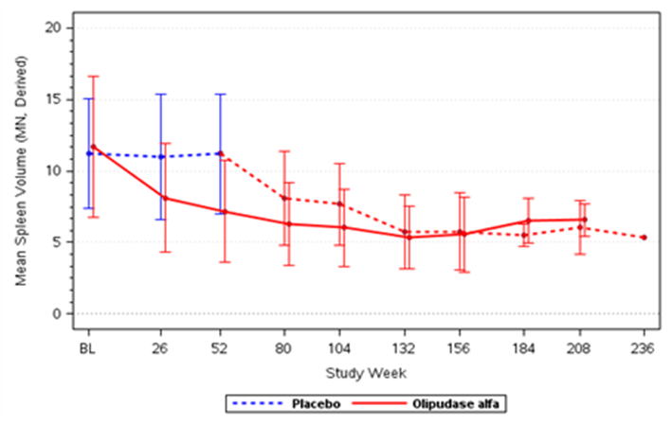
Source: Figure 2.2.6, p49 of the submission.
MN = multiple of normal
Figure 2: Percent predicted DLco in the primary analysis period and extended treatment period in the ASCEND trial for adult population
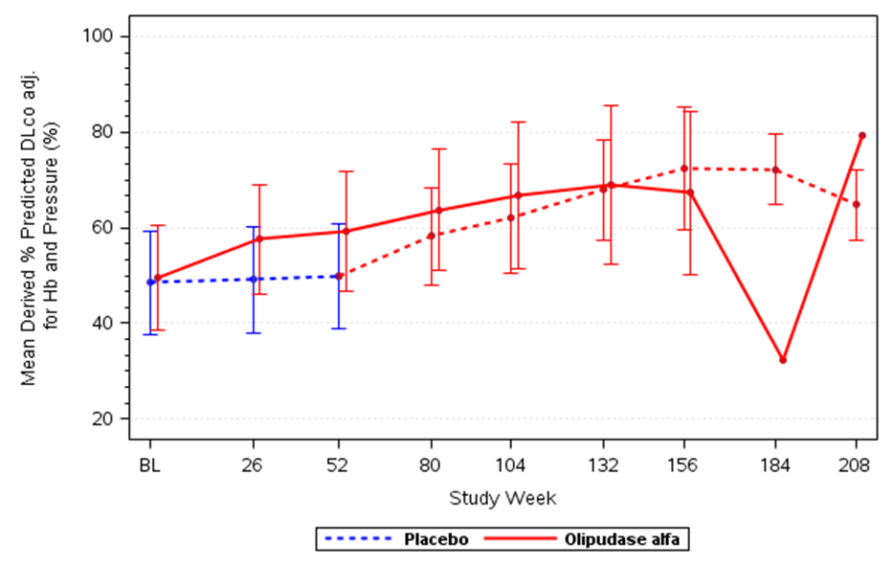
Source: Figure 2.2.8, p51 of the submission.
Adj = adjusted, DLco = diffusing capacity of the lung for carbon monoxide, Hb = haemoglobin
Note: The submission stated that the decline at Week 184 in the olipudase alfa arm was due to the unavailability of data for one patient who missed six consecutive infusions between Week 174 to 184.
  - In the extended treatment period, the BSC/olipudase alfa arm achieved 35.9% reduction in spleen size from Week 53. For the olipudase alfa/olipudase alfa arm, a further reduction was seen at Week 104 (47%; n=14) week 132 (52%; n=13) and was stable at Week 156 (50%; n=6). In the extended treatment period, the BSC/olipudase alfa arm achieved 28.04% improvement in percent predicted DLco from Week 53. For olipudase alfa/olipudase alfa arm, a further improvement was seen at Week 104 (28%; n=10) and at Week 156 (33%; n=6). Furthermore, there was an improvement in mean liver volume and thrombocytopenia in both groups from baseline during the extended treatment period. Limited data is available for the extended treatment period of the ASCEND trial given that only four patients received olipudase alfa for more than 208 weeks.
PAEDIATRIC POPULATION

ASCEND-peds single arm study (olipudase alfa)
  - Table 7 summarises the results of efficacy outcomes in ASCEND-peds.
Table 7: Results of efficacy outcomes in ASCEND-peds
Outcomes | Adolescent  (N =4) | Child  (N =9) | Infant/early child  (N =7) | Overall  (N=20)
Mean spleen volume, MN
Baseline, mean (SD) | 16.6 (9.1) | 19.3 (11.4) | 19.9 (4.9) | 19.0 (8.8)
% change from baseline to Week 26, LS mean (SE) | -37.0 (3.9) | -39.9 (1.5) | -42.1 (3.7) | -40.0 (1.5)
% change from baseline to Week 52, LS mean (SE) | -46.9 (1.6) | -46.0 (3.6) | -54.6 (2.8) | -49.2 (2.0)
Mean liver volume, MN
Baseline, mean (SD) | 2.3 (0.6) | 2.7 (0.8) | 2.8 (0.8) | 2.7 (0.7)
% change from baseline to Week 26, LS mean (SE) | -29.8 (4.3) | -32.5 (1.9) | -34.9 (2.8) | -32.7 (1.4)
% change from baseline to Week 52 (SE) | -41.3 (2.9) | -36.7 (2.7) | -45.1 (2.0) | -40.6 (2.7)
Mean platelet counts, 10⁹/L
Baseline, mean (SD) | 98.9 (9.3) | 148.8 (87.5) | 145.7 (28.0) | 137.7 (62.3)
% change from baseline to Week 52, LS mean (SE) | 45.0 (26.3) | 30.7 (12.0) | 31.8 (8.1) | 34.0 (7.6)
Mean % predicted DLcoª
Baseline, mean (SD) | 53.4 (23.4) | 55.5 (10.1) | - | 54.8 (14.2)
% change from baseline to Week 26, LS mean (SE) | 14.9 (6.2) | 22.1 (4.2) | - | 19.4 (3.7)
% change from baseline to Week 52, LS mean (SE) | 28.0 (9.9) | 35.4 (8.2) | - | 32.9 (8.3)
Source: Table 2.2.36, p80, Table 2.2.37, p81, Table 2.2.38, p82, Table 2.2.39, p83 of the submission.
BSC = best supportive care, CI = confidence interval, DLco = diffusing capacity of the lung for carbon monoxide, LS = least squares, MN = multiples of normal, N = total participants in group, SD = standard deviation, SE = standard error.
A DLco was evaluated in 9 paediatric patients aged ≥ 5 years who were able to perform the test.
  - Treatment with olipudase alfa resulted in improvements in mean percent change in spleen volume, liver volume, platelet counts, and DLco (percent predicted) from baseline to week 52. Furthermore, height Z-scores improved in 15 patients (79%) and remained the same in four (21%), with an overall improvement of 0.6 in mean height Z-scores at week 52. However, the causality of this reduction to treatment cannot be established in the absence of a control group.
  - Figure 3 and Figure 4 presents the plots of spleen volume and liver volume, respectively, for individual patients over time in the ASCEND-peds trial.
Figure 3: Plot of spleen volume for individual patients over time in the ASCEND-peds trial
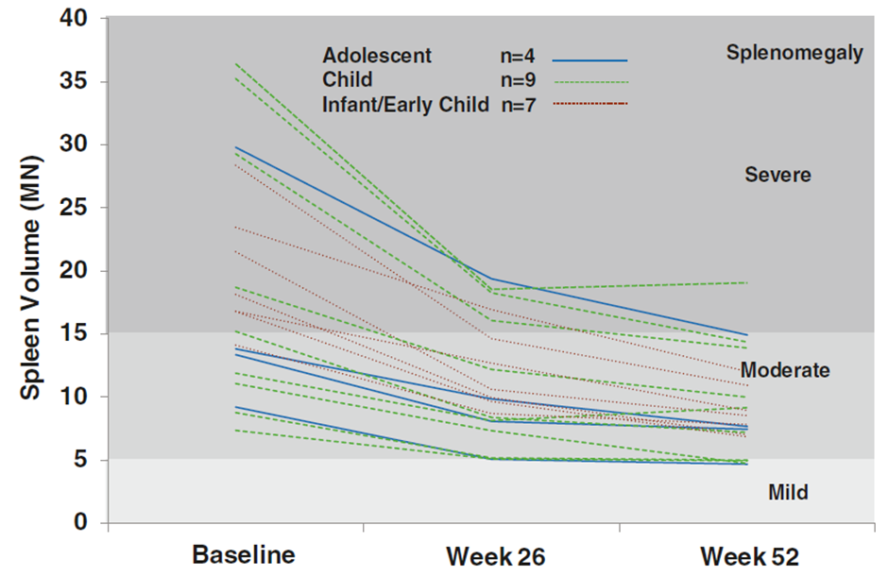
Source: Figure 2.2.14, p81 of the submission.
MN = multiple of normal, n = number of participants.
Figure 4: Plot of liver volume for individual patients over time in the ASCEND-peds trial
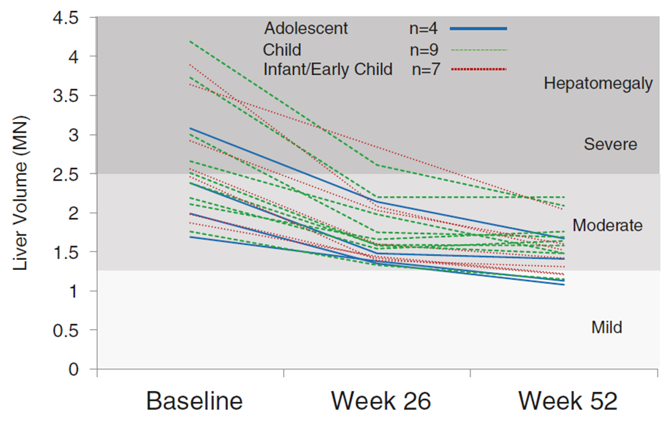
Source: Figure 2.2.15, p82 of the submission.
Adj = adjusted, DLco = diffusing capacity of the lung for carbon monoxide, Hb = haemoglobin

SPHINGO-100 single arm study (ASMD natural history)
  - SPHINGO-100 enrolled 30 paediatric patients (≥6 and <18 years) and 29 adult patients (≥18 years) with a diagnosis of ASMD type B (including type A/B). The median age of the paediatric group of SPHINGO-100 at baseline was 12 years (range: 7, 17). In SPHINGO-100, common clinical characteristics that tended to worsen gradually with time were splenomegaly, hepatomegaly, interstitial lung disease (ILD), DLco and dyslipidaemia. The results for paediatric patients are presented below:
- Approximately 50% of the paediatric patients had an increase in spleen volume (range: 2%, 15%), while the remaining patients had no change or decrease in spleen volume (range: 0%, 19%) between the baseline and first year visit.
- Mean liver volume in the paediatric group did not change significantly over time.
- Platelet counts decreased from baseline to the final visit (ranging from 4.5 to 11 years) in paediatric patients, with a mean change from baseline of − 41%.
- The median percent decrease in DLco from baseline to the final visit was 13% (range: −55, 141), indicating an increased impairment of diffusion capacity.

Comparison of ASCEND-peds and SPHINGO-100
  - The submission presented an unanchored and partially adjusted comparison of patients from the ASCEND-peds and paediatric patients from the natural history, SPHINGO-100, to assess the comparative effectiveness of olipudase alfa versus BSC in paediatric patients.
  - Across ASCEND-peds and SPHINGO-100, no statistically significant differences were observed in most of the demographic baseline characteristics except for mean age (9.9 years in ASCEND-peds compared to 12.9 in SPHINGO-100) and sphingomyelin in plasma (394.6 mg/L in ASCEND-peds compared to 551.3 mg/L in SPHINGO 100). The evaluation considered that the impact of these differences on trial outcomes is not clear.
  - To maximise comparability between the two studies, the submission included only paediatric patients from SPHINGO-100 and excluded patients aged <5 years from ASCEND-peds. Furthermore, the inclusion and exclusion criteria from ASCEND-peds, (in terms of spleen volume, height Z-score, platelet count, alanine aminotransferase [ALT] and aspartate aminotransferase [AST] or bilirubin), were applied to SPHINGO-100. This was appropriate; however, data from only 15 patients from ASCEND-peds was compared to 14 patients from SPHINGO-100 after implementing selection criteria to maximise the comparability.
  - Table 8 presents a comparison of ASCEND-peds (treated with olipudase alfa) and SHPINGO-100 (treated with BSC) in the paediatric population.
Table 8: Summary of efficacy parameters for comparative paediatric analysis of ASCEND-peds and SPHINGO-100
Outcomes | ASCEND-peds  Olipudase alfa  (n=15) | SPHINGO-100  BSC  (n=14) | Difference, LS mean  (95% CI)
Spleen volume, MN | n=15 | n=9
Baseline, mean (SD) | 18.7 (9.8) | 17.4 (5.6) | -
% change from baseline to 1 year, LS mean (95% CI) | -47.7 (-53.3, -42.1) | -1.5 (-6.6, 3.7) | -46.3 (-54.1, -38.5)
Liver volume, MN | n=15 | n=8
Baseline, mean (SD) | 2.6 (0.7) | 2.4 (0.7) | -
% change from baseline to 1 year, LS mean (95% CI) | -39.5 (-44.3, -34.8) | 8.7 (-6.9, 24.3) | -48.22 (-64.19,-32.24)
Platelet counts, 10⁹/L | n=15 | n=13
Baseline, mean (SD) | 138.2 (71.6) | 168.15 (59.0) | -
% change from baseline to 1 year, LS mean (95% CI) | 34.8 (18.4, 51.2) | -11.0 (-29.8, 7.9) | 45.8 (19.4, 72.1)
% predicted DLco | n=9 | n=8
Baseline, mean (SD) | 54.8 (14.2) | 51.7 (25.7) | -
% change from baseline to 1 year, LS mean (95% CI) | 27.8 (7.8, 47.8) | 27.9 (-8.8, 64.5) | -0.06 (-42.44, 42.33)
Height z-score | n=14 | n=13
Baseline, mean (SD) | -2.19 (0.870) | -2.90 (0.917) | -
% change from baseline to 1 year, LS mean (95% CI) | 0.61 (0.21, 1.01) | -0.03 (-0.22, 0.17) | 0.64 (0.23, 1.05)
Source: Table 2.2.44, pp90-91 of the submission.
BSC = best supportive care, CI = confidence interval, DLco = diffusing capacity of the lung for carbon monoxide, LS = least squares, MN = multiples of normal, N = total participants in group, SD = standard deviation, SE = standard error
Italics corrected during evaluation.
Bold indicates statistical significance.
  - Statistically significant improvement (albeit from an unanchored comparison) was observed in paediatric patients in ASCEND-peds in terms of spleen volume, liver volume, and platelet count compared to SPHINGO-100. Patients in ASCEND-peds also achieved greater improvements in height with a mean Z-score of 0.61 from baseline to 1 year compared to no improvement in height with a mean Z-score of -0.03 in the BSC group.
  - No statistically significant difference (albeit from an unanchored comparison) was observed for DLco (percent predicted) between the two groups. Of note, only nine patients (60%) in ASCEND-peds and eight patients (57%) in SPHINGO-100 had DLco values at baseline and week 52.
  - The results of the comparison between ASCEND-peds and SPHINGO-100 were difficult to interpret, given that the submission did not conduct a comparison using a full matching approach to account for all apparent sources of heterogeneity, such as age and sphingomyelin in plasma, between trials. Of note, full matching may not be feasible given the small sample size.
ADULT AND PAEDIATRIC POPULATIONS

LTS13632 long-term extension single arm study with patients from DFI13412 and ASCEND-peds studies (olipudase alfa)
  - Figure 5 presents the mean spleen volume over time in adult and paediatric patients.
Figure 5: Mean spleen volume over time in adult and paediatric patients in LTS13632
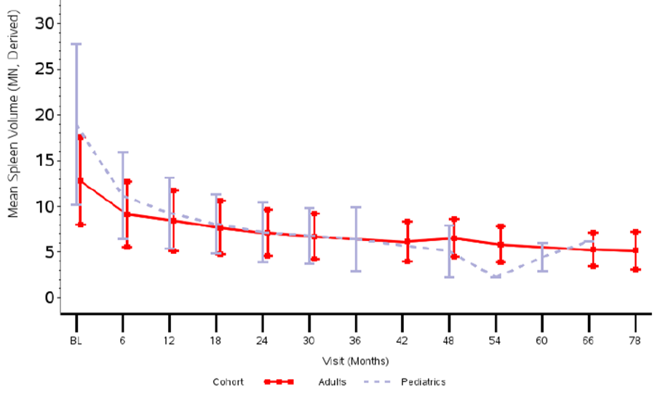
Source: Figure 2.2.21, p100 of the submission.
MN = multiple of normal
  - Mean spleen volume at baseline was 12.8 MN (moderate splenomegaly) in adults and 19.0 MN (severe splenomegaly) in paediatric patients. Mean spleen volume in both groups were trending downwards to mild splenomegaly (spleen volume <5 MN).
  - Figure 6 presents the percent predicted DLco over time in adult and paediatric patients.
Figure 6: Percent predicted DLco over time in adult and paediatric patients in LTS13632.
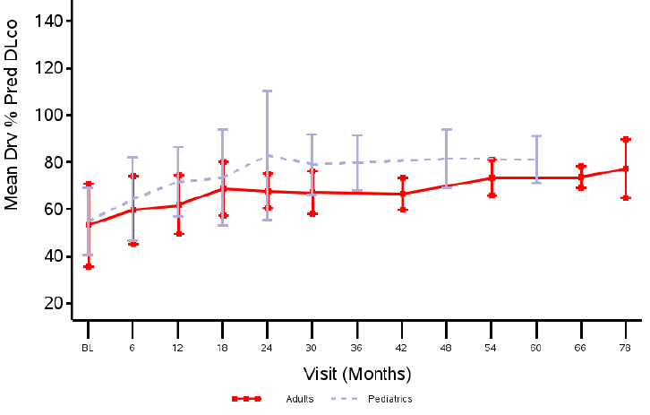
Source: Figure 2.2.22, p101 of the submission.
DLco = diffusing capacity of the lung for carbon monoxide, Drv = derived, Pred = predicted.
  - Mean percent predicted DLco at baseline was 53% (moderate severity) in adults and 55% (moderate severity) in paediatric patients. The mean percent predicted DLco was approximately 80% (normal range) for adults at Month 78 and paediatric patients at Month 58.
  - Figure 7 presents the mean liver volume over time in adult and paediatric patients.
Figure 7: Mean liver volume over time in adult and paediatric patients in LTS13632
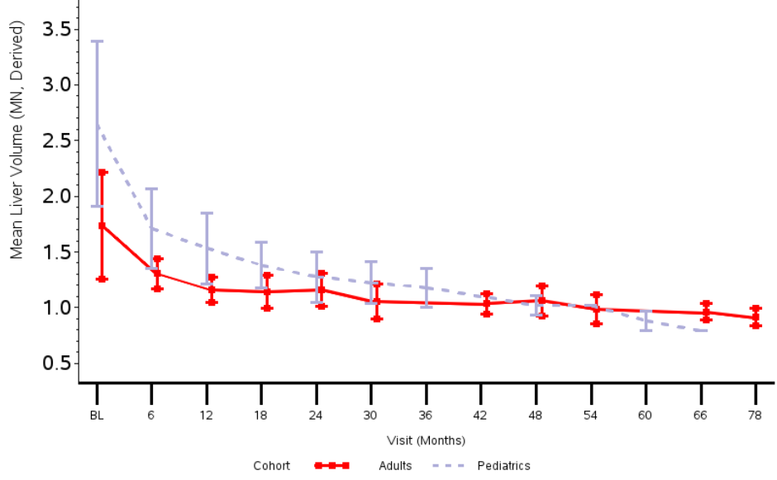
Source: Figure 2.2.23, p102 of the submission.
MN = multiple of normal
  - At baseline, the mean liver volume was 1.7 MN (moderate hepatomegaly) in the adults and 2.7 MN (severe hepatomegaly) in the paediatric patients. The mean liver volume reduced to within normal ranges by Month 48 for both adult and paediatric patients.
  - Figure 8 presents the mean platelet counts over time in adult and paediatric patients.
Figure 8: Summary plot of platelet counts over time in adult and paediatric patients in LTS13632
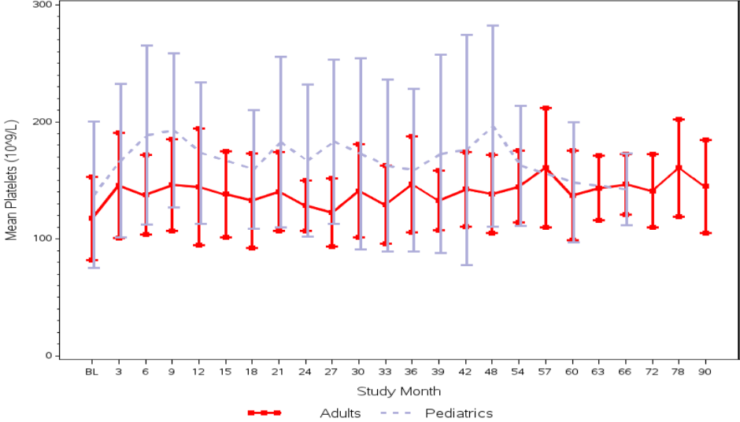
Source: Figure 2.2.24, p103 of the submission.
  - At baseline, the mean platelet count was 117.6 x 10⁹/L (moderate thrombocytopenia) in adults and 137.7 x 10⁹/L (mild thrombocytopenia) in the paediatric patients. The platelet counts improved over time in both the adult and paediatric patient groups: mean % improvement was 26.8% by Month 54 (p=0.0505) and 38.5% by Month 78 for five adult patients (p=0.0093); mean % improvement from baseline was 28.7% by Month 24 (p=0.0009) in 14 paediatric patients, which corresponded to normalised platelet counts.
  - Figure 9 presents the change in height Z-scores over time for paediatric patients.
Figure 9: Height Z score in the paediatric group of LTS13632
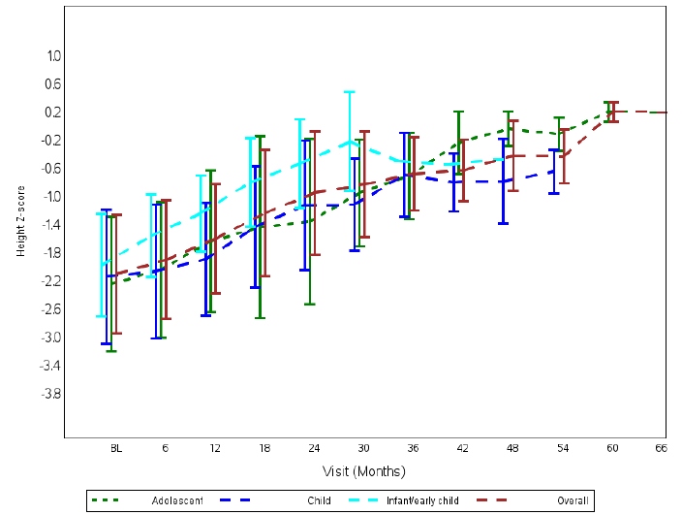
Source: Figure 2.2.25, p103 of the submission.
  - At baseline, the mean height Z-score was 2.1, indicating that the cohort were on average more than two standard deviations shorter than the mean height of the general population of the same age. The overall score improved by 1.2 by Month 24 and by 2.3 in five patients by Month 48, indicating continued improvement in growth.

Comparative harms
ADULT POPULATION

ASCEND randomised trial (olipudase alfa versus BSC)
  - Table 9 presents summary of the key adverse events during the primary treatment period of the ASCEND trial.
Table 9: Summary of key adverse events during the primary treatment period of the ASCEND trial
 | Olipudase alfa  n/N (%) | BSC  n/N (%) | RD (95% CI) | RR (95% CI) | OR (95% CI)
Any TEAE | 18/18 (100%) | 18/18 (100%) | 0.00 (-0.10, 0.10) | 1.00 (0.90, 1.11) | NE
Mild | 18/18 (100%) | 18/18 (100%) | 0.00 (-0.10, 0.10) | 1.00 (0.90, 1.11) | NE
Moderate | 13/18 (72.2%) | 13/18 (72.2%) | 0.00 (-0.29, 0.29) | 1.00 (0.67, 1.50) | 1.00 (0.23, 4.30)
Severe | 1/18 (5.6%) | 6/18 (33.3%) | -0.28 (-0.52, -0.04) | 0.17 (0.02, 1.25) | 0.12 (0.01, 1.11)
Any serious TEAEs | 3/18 (16.7%) | 4/18 (22.2%) | -0.06 (-0.31, 0.20) | 0.75 (0.20, 2.88) | 0.70 (0.13, 3.70)
Any TEAEs potentially related to study drug | 12/18 (66.7%) | 6/18 (33.3%) | 0.33 (0.03, 0.64) | 2.00 (0.96, 4.15) | 4.00 (1.00, 15.99)
Any protocol-defined infusion associated reaction
Headache | 5/18 (27.8%) | 2/18 (11.1%) | 0.17 (-0.09, 0.42) | 2.50 (0.56, 11.25) | 3.08 (0.51, 18.53)
Nausea | 2/18 (11.1%) | 1/18 (5.6%) | 0.06 (-0.12, 0.24) | 2.00 (0.20, 20.15) | 2.12 (0.18, 25.78)
Arthralgia | 1/18 (5.6%) | 0 | 0.06 (0.09, 0.20) | 3.00 (0.13, 68.97) | 3.17 (0.12, 83.17)
Urticaria | 1/18 (5.6%) | 0 | 0.06 (0.09, 0.20) | 3.00 (0.13, 68.97) | 3.17 (0.12, 83.17)
Pyrexia | 1/18 (5.6%) | 0 | 0.06 (0.09, 0.20) | 3.00 (0.13, 68.97) | 3.17 (0.12, 83.17)
Vomiting | 1/18 (5.6%) | 1/18 (5.6%) | 0.00 (0.15, 0.15) | 1.00 (0.07, 14.79) | 1.00 (0.06, 17.33)
Source: Table 2.2.21, pp57-58 of the submission.
BSC = best supportive care, CI = confidence interval, n = number of participants reporting data, N = total participants in group, NE = not estimable, OR = odds ratio, RD = risk difference, RR = relative risk, TEAE = treatment emergent adverse event.
  - In the primary treatment period of the ASCEND trial, all patients experienced at least one treatment emergent adverse event (TEAE). A greater proportion of patients experienced TEAEs potentially related to treatment in the olipudase alfa arm (66.7%) compared with BSC arm (33.3%). Furthermore, a greater proportion of patients experienced infusion-associated reactions to treatment in the olipudase alfa arm (44.4%) compared with BSC arm (27.8%).
  - For the extended treatment analysis, all patients (n=35; 100%) experienced at least one TEAE. A total of 12 (34.3%) patients had at least one serious AE. There were no TEAEs that led to treatment discontinuation or death.
PAEDIATRIC POPULATION

ASCEND-peds single arm study (olipudase alfa)
  - Table 10 presents a summary of the key adverse events in the ASCEND-peds trial.
Table 10: Summary of key adverse events in the ASCEND-peds study
 | Adolescent  (N=4) | Child  (N=9) | Infant/Early Child  (N=7) | Overall  (N=20)
 | n (%) | n (%) | n (%) | n (%)
Any TEAE | 4 (100%) | 9 (100%) | 7 (100%) | 20 (100%)
Mild | 4 (100%) | 9 (100%) | 7 (100%) | 20 (100%)
Moderate | 3 (75.0%) | 8 (88.9%) | 5 (71.4%) | 16 (80.0%)
Severe | 1 (25.0%) | 1 (11.1%) | 1 (14.3%) | 3 (15.0%)
Any serious TEAEs | 0 | 1 (11.1%) | 4 (57.1%) | 5 (25.0%)
Any TEAEs potentially related to study drug | 2 (50.0%) | 6 (66.7%) | 5 (71.4%) | 13 (65.0%)
Any serious TEAEs potentially related to study drug | 0 | 0 | 3 (42.9%) | 3 (15.0%)
Any protocol-defined infusion associated reaction
Pyrexia | 0 | 4 (44.4%) | 3 (42.9%) | 7 (35.0%)
Vomiting | 0 | 3 (33.3) | 3 (42.9) | 6 (30.0)
Urticaria | 0 | 2 (22.2) | 2 (28.6) | 4 (20.0)
Headache | 0 | 3 (33.3) | 1 (14.3) | 4 (20.0)
C-reactive protein increased | 0 | 2 (22.2) | 2 (28.6) | 4 (20.0)
Nausea | 0 | 3 (33.3) | 1 (14.3) | 4 (20.0)
Source: Table 2.2.40, p85 of the submission.
n = number of participants reporting data, N = total participants in group, TEAE = treatment emergent adverse event.
  - In the ASCEND-peds trial, all patients experienced at least one TEAE. A total of 13 (65.0%) patients experienced TEAEs and a total of 3 (42.9%; all in the infant/early child cohort) patients experienced serious TEAEs potentially related to treatment with olipudase alfa. Furthermore, 11 (55.0%) patients experienced infusion-associated reactions (IARs) to treatment.
  - The submission stated that a comparison of safety of olipudase alfa versus BSC was not possible given SPHINGO-100 did not collect AEs over the same time. Of note, five deaths were reported in the paediatric cohort of SPHINGO-100, with pneumonia as the most common cause of death followed by liver-related deaths. All deaths except one were attributed to ASMD.
ADULT AND PAEDIATRIC POPULATIONS

LTS13632 long-term extension single arm study with patients from DFI13412 and ASCEND-peds studies (olipudase alfa)
  - Table 11 presents a summary of the key adverse events in the LTS13632 study.
Table 11: Summary of key adverse events in the LTS13632 study
 | Patients from DFI13412  (Adults) (N=5) | Patients from ASCEND peds (Paediatric) (N=20) | All Patients  LTS13632  (N=25)
 | n (%) | n (%) | n (%)
Any TEAE | 5 (100%) | 20 (100%) | 25 (100%)
Mild | 5 (100%) | 20 (100%) | 25 (100%)
Moderate | 2 (40%) | 17 (85%) | 19 (76%)
Severe | 1 (20%) | 7 (35%) | 8 (32%)
Any serious TEAEs | 1 (20%) | 9 (45%) | 10 (40%)
Any TEAEs potentially related to study drug | 4 (80%) | 15 (75%) | 19 (76%)
Any serious TEAEs potentially related to study drug | 0 | 4 (20%) | 4 (16%)
Any TEAE leading to dose reduction | 1 (20%) | 7 (35%) | 8 (32%)
Any TEAE leading to treatment interruption | 1 (20%) | 5 (25%) | 6 (24%)
Any protocol-defined infusion associated reaction
Headache | 3 (60%) | 4 (20%) | 7 (28%)
Nausea | 3 (60%) | 4 (20%) | 7 (28%)
Arthralgia | 3 (60%) | 0 | 3 (12%)
Urticaria | 2 (40%) | 7 (35%) | 9 (36%)
Pyrexia | 2 (40%) | 8 (40%) | 10 (40%)
Vomiting | 0 | 6 (30%) | 6 (24%)
Source: Table 2.2.49, p104 of the submission.
n = number of participants reporting data, N = total participants in group, TEAE = treatment emergent adverse event.
  - In the LTS13632 study, all patients experienced at least one treatment emergent adverse event (TEAE). A total of 19 (76.0%) patients experienced TEAEs and a total of 4 (16.0%) patients experienced serious TEAEs potentially related to treatment with olipudase alfa. Furthermore, 17 (68.0%) patients experienced infusion-associated reactions to treatment.
  - According to the TGA Delegate’s Overview, among a pooled safety set of 60 patients (40 adults and 20 children) from the multiple dose studies, the ESC noted that paediatric patients appeared to have a higher burden of adverse events compared to adults:
- SAEs (16.12 per 100 patient-years vs. 12.18 per 100 patient-years);
- Severe TEAEs (11.47 per 100 patient-years vs. 5.93 per 100 patient-years);
- TEAEs leading to dose reduction (12.86 per 100 patient-years vs. 3.31 per 100 patient-years).
  - Furthermore, IARs were common in both adult (53.8%) and paediatric patients (60.0%). In adults, IARs occurred more often during dose escalation, whereas in paediatric patients they occurred both during and after dose escalation. Three paediatric patients had serious infusion associated reactions (anaphylaxis, urticaria and hypersensitivity). Hypersensitivity infusion associated reactions were twice as common in children compared to adults (40.0% and 17.9%, respectively). There was an association between treatment emergent antidrug antibody (ADA) positivity and infusion associated reactions (both hypersensitivity and non-hypersensitivity related). Hypersensitivity IARs occurred more frequently in ADA positive patients compared with ADA negative patients (38.5% compared to 7.7%). Nine of out 60 patients developed neutralising ADAs that inhibits catalytic activity.
  - The Food and Drug Administration (FDA) has included a boxed warning for hypersensitivity reactions (including anaphylaxis) with administration of olipudase alfa.
  - The submission stated that while systemic hypersensitivity reactions and transient elevation in transaminases have been observed during the treatment with olipudase, the benefit-risk profile of olipudase alfa remains favourable.

Benefits/harms
  - A summary of the comparative benefits and harms for olipudase alfa versus BSC in the adult population is presented in Table 12.
Table 12: Summary of comparative benefits and harms for olipudase alfa and BSC
Benefits: Percentage change from baseline at week 52
Adult Population (ASCEND trial) | Olipudase alfa |  |  |  |  | BSC |  |  |  |  | LS Mean difference:  Olipudase alfa vs. BSC  (95% CI)
 | N | % change,  LS mean |  | SE |  | N | % change,  LS mean |  | SE
Spleen volume (MN) | 18 | -39.5 |  | 2.4 |  | 18 | 0.5 |  | 2.5 |  | -39.9 (-47.1, -32.8)
% predicted DLco | 18 | 22.0 |  | 3.3 |  | 18 | 3.0 |  | 3.4 |  | 19.0 (9.3, 28.7)
Liver volume (MN) | 18 | -28.1 |  | 2.5 |  | 18 | -1.5 |  | 2.5 |  | -26.6 (-33.9, -19.3)
Platelet counts, 10⁹/L | 18 | 16.8 |  | 4.0 |  | 18 | 2.5 |  | 4.2 |  | 14.3 (2.6, 26.1)
Harms
Adult Population  (ASCEND trial) | Olipudase alfa n/N |  | BSC  n/N |  | RR  (95% CI) |  |  | Event rate/100 patients |  |  |  | RD  (95% CI)
 |  |  |  |  |  |  |  | Olipudase alfa |  | BSC
Any serious TEAEs | 3/18  (16.7%) |  | 4/18  (22.2%) |  | 0.75 (0.20, 2.88) |  |  | 17 |  | 22 |  | -0.06 (-0.31, 0.20)
Any TEAEs potentially related to study drug | 12/18  (66.7%) |  | 6/18  (33.3%) |  | 2.00 (0.96, 4.15) |  |  | 67 |  | 33 |  | 0.33 (0.03, 0.64)
TEAEs considered infusion associated reactions | 8/18  (44.4%) |  | 5/18  (27.8%) |  | 1.60 (0.65; 3.96) |  |  | 44 |  | 28 |  | 0.17 (-0.14; 0.48)
BSC = best supportive care, CI = confidence interval, DLco = diffusing capacity of the lung for carbon monoxide, LS = least squares, MN = multiples of normal, n = number of participants reporting data, N = total participants in group, RD = risk difference, RR = relative risk, SE = standard error, TEAE = treatment emergent adverse event.
  - On the basis of direct evidence presented by the submission for the adult population, the comparison of olipudase alfa and BSC resulted in:
- Approximately 39.9% reduction in spleen volume (MN). The submission stated that a reduction of ≥30% is clinically significant. However, this threshold was based on patients with Gaucher disease and may not be applicable to ASMD patients.
- Approximately 19.0% improvement in percent predicted DLco (MN). The submission stated that a reduction of ≥15% is clinically significant. However, this threshold was based on patients with interstitial lung disease (ILD) and may not be applicable to ASMD patients.
  - On the basis of direct evidence presented by the submission, for every 100 adult patients treated with olipudase alfa in comparison with BSC over a median duration of treatment of 54 weeks:
- Approximately 33 additional patients would have TEAEs potentially related to olipudase alfa.
- Approximately 17 additional patients would have infusion-associated reactions.
  - The partially adjusted, unanchored comparison presented for the paediatric population in the submission did not allow for a quantitative comparison of the benefits and harms of olipudase alfa and BSC. Accordingly, a benefits/harms table has not been presented for the paediatric population.

Clinical claim
  - The submission described olipudase alfa as superior in terms of effectiveness compared to BSC. This claim was adequately supported by evidence, but the following issues need to be considered:
  - The PBAC agreed with the ESC and the evaluation, that olipudase alfa has superior effectiveness compared to BSC in terms of the change spleen volume and DLco, which are both clinically relevant to ASMD; however, it is uncertain whether it would translate into an overall survival (OS) benefit over the long-term. With reference to this, the PSCR stated the following:
  - It was necessary to use surrogate outcomes for ASMD given that it is an ultra-rare disease and patients receiving ERT in a clinical trial setting are expected to survive the duration of study period;
  - Patients from the SPHINGO-100 study with severe splenomegaly (≥15 MN) were at a higher risk of death than those without (<15 MN) with a hazard ratio of 10.0 (95% CI: 1.0, 97.2), and splenomegaly is associated with more severe multi-organ disease (McGovern et al. 2008). Splenomegaly correlates with liver fibrosis (Jones et al. 2020), with liver disease being one the of primary causes of death in patients with ASMD (Cassiman et al. 2016, p210).
  - Patients from the SPHINGO-100 study with DLco <40% (i.e., severe decrease) or a DLco 40-80% (mild to moderate decrease) had a 3.1 times and 2.4 times, respectively, higher risk of a respiratory event compared with patients with a DLco ≥80% (normal) (Mengel et al. 2022, post hoc analysis), noting that respiratory failure, including pneumonia, is another leading cause of death in ASMD (Cassiman et al. 2016, p210).
- In the adult population, there was no difference in the health-related quality of life (HRQoL), based on EQ-5D and SF-36, between the two arms in the ASCEND trial. The PSCR stated that the generic questionnaires, which are not specific, sensitive, nor validated for ASMD, do not fully assess the impact or severity of ASMD and that other significant impacts of ASMD such as deterioration in pulmonary function, bleeding and bruising, sleep disturbances and the impact of respiratory infections were not adequately accounted for. Further, the pre-PBAC response noted that anecdotal evidence from consumers and clinicians (see Consumer comments, paragraphs 6.2 to 6.4) indicate that it is reasonable to assume that patients treated with olipudase alfa experience improved QoL.
- In the paediatric population, the claim of superiority was based on an unanchored and partially adjusted comparison of the results of ASCEND-Peds trial and SPHINGO-100 natural history study. The PSCR noted that paediatric patients were selected from SPHINGO-100 to derive a relevant subgroup for the comparison (paragraph 6.28).
- The clinical evidence beyond one year was based on (i) a long-term study of olipudase alfa in adults and paediatric patients (LTS13632); and (ii) the extended treatment period of the ASCEND trial, neither of which provided comparative evidence versus BSC. The PSCR noted that ASCEND trial patients in the BSC arm were switched to olipudase alfa after 1 year because it was deemed unethical to withhold an effective treatment from patients with a disease that is known to be associated with a reduced life expectancy. Limited evidence was available for olipudase alfa in the extended treatment period of the ASCEND trial as only four patients received treatment for more than 208 weeks (4 years). The PSCR noted that the long-term data showed that the treatment effect of olipudase alfa was maintained or improved [for adults] up to the last follow-up point of the LTS13632 study at 6.5 years.
  - The ESC noted the following information from McGovern et al. (2017):
… mortality data for NPD [Niemann-Pick Disease] B are too heterogeneous and limited to allow for the construction of survival curves. Available evidence suggests that survival among patients with NPD B varies significantly, consistent with their phenotypic heterogeneity. Although many patients do not survive into adulthood, some have reached their fifth or sixth decade of life.
  - The submission described olipudase alfa as non-inferior in terms of safety compared to BSC. The PBAC agreed with the evaluation and the ESC that this claim was not adequately supported because:
- In the ASCEND randomised trial in the adult population, a greater proportion of patients in olipudase alfa arm compared with BSC arm experienced treatment emergent adverse events (TEAEs) potentially related to study drug (66.7% versus 33.3%) and infusion related reactions (44.4% versus 27.8%). While the PSCR stated that there were no statistically significant differences between olipudase alfa and BSC for any TEAEs, the ESC agreed with the evaluation that the “events potentially related to study drug” is the relevant measure and noted there is an FDA boxed warning for hypersensitivity reactions with olipudase alfa (paragraph 6.53).
- In the paediatric population, no randomised data was available for comparison of olipudase alfa with BSC.
  - The PBAC considered that the claim of superior comparative effectiveness of olipudase alfa compared to BSC was reasonable in terms of the change in spleen volume and DLco. The PBAC acknowledged the difficulty in obtaining high-level evidence-based data due to: (i) the lack of randomised trial data with reasonable patient numbers, (ii) the lack of long-term data due to ethical concerns, and (iii) the lack of specific, sensitive, validated HRQoL questionnaires for ASMD. The PBAC acknowledged that the therapeutic area necessitated the use of surrogate outcomes (splenomegaly and lung diffusion testing) in small trials involving both randomised and single arm data. Nevertheless, the PBAC considered that extending the superior findings for spleen volume and DLco to a survival benefit was uncertain.

Economic analysis
  - The submission presented two separate cost-utility analyses comparing olipudase alfa and BSC for the treatment of ASMD type A/B or type B in (i) adult and (ii) paediatric populations. A summary of the model structure in the submission’s economic evaluation is presented in Table 13.
Table 13: Summary of model structure, key inputs and rationale
Component | Summary
Treatments | Olipudase alfa versus BSC
Time horizon | Lifetime in the model base case versus two years in the ASCEND and ASCEND-peds trial
Outcomes | LYs and QALYs gained
Methods used to generate results | Markov model
Health states | Nine health states defined by severity of splenomegaly as measured by spleen volume (<6 MN, 6-15 MN and ≥15 MN) and the severity of lung function impairment as measured by DLco (>80%, 40-80% and ≤40%), and death
Cycle length | 6 months in first year and yearly from Year 2 onwards
Transition probabilities  (Adult population) | Transition probabilities for adults in the first year were calculated using ASCEND and the Phase Ib trial (DF13412) for olipudase alfa and ASCEND and SPHINGO-100 for BSC. In subsequent years, probabilities for the olipudase alfa arm were calculated using a combination of ASCEND and Phase Ib extended treatment period, while SPHINGO-100 was used for BSC. Survival was based on SMRs specific for spleen volume (<15 MN or ≥15 MN) derived from SPHINGO-100 data and applied to Australian general population mortality.
Transition probabilities  (Paediatric population) | Transition probabilities for paediatric patients were calculated using ASCEND-peds for olipudase alfa and SPHINGO-100 to for BSC. In subsequent years, probabilities for olipudase alfa arm were calculated using a combination of patients from ASCEND-peds who transitioned to the long-term study, while SPHINGO-100 was used for BSC. Survival was based on SMRs specific for spleen volume (<15 MN or ≥15 MN) derived from SPHINGO-100 data and US life table 2017 applied to Australian general population mortality. Transition probabilities switch to those for adult patients once the average age of patients in the model reaches 18 years.
Health related quality of life | TTO study to determine ASMD specific health state utilities.  The submission also applied caregiver disutility in the base case analysis for paediatric patients with ASMD.
Source: Table 2.2.1, p113 and Table 2.2.37, p161 of the submission.
ASMD = acid sphingomyelinase deficiency, BSC = best supportive care, DLco = diffusing capacity for carbon monoxide, LY = life-years, MN = multiples of normal, QALY = quality-adjusted life-years, SMR = standardised mortality rate, TTO = time trade-off.

Model structure and health states
  - The submission presented a multi-state Markov model to analyse the progression of patients through different health states defined by severity of splenomegaly and lung functions as follows:
- Three categories of splenomegaly were defined based on the spleen volume deviation from normal; mild <6 MN, moderate 6-15 MN, severe ≥15 MN.
- Three categories of lung function impairment were defined using percent predicted DLco; mild ≥80%, moderate 40-80%, and severe <40%.
  - While the evaluation considered the complex model structure with multiple health states defined by splenomegaly and lung function was not well justified, the PSCR maintained that the model structure was designed to reflect clinically meaningful outcomes for patients with ASMD and the available clinical evidence. Further to the evaluation’s comments, the ESC noted the complex nature of the model was problematic given the small patient numbers and limited evidence available to populate health states and transition probabilities; it considered a simplified model structure may be more appropriate.
  - Health states in the model defined by the severity of lung function impairment, as measured by DLco may not be accurate, especially for the paediatric population. The ESC noted that only nine patients (60.0%) in ASCEND-peds and eight patients (57.1%) in SPHINGO-100 had DLco values at baseline and Week 52.

Transition probabilities
  - Transition probabilities were informed by pooled data from four clinical trials and one natural history study, to increase the sample size. Table 14 summarises the data sources pooled for the analyses on the adult and paediatric populations:
Table 14: Summary of clinical evidence for transition probabilities
 | ASCEND | DFI13412 | ASCEND-Peds | LTS13532 | SPHINGO-100
Adult population
Olipudase alfa (Year 1)
Olipudase alfa (Year 2+)
BSC (Year 1)
BSC (Year 2+)
Paediatric population
Olipudase alfa (Year 1)
Olipudase alfa (Year 2+)
BSC (Year 1)
BSC (Year 2+)
Source: Slide 12,’Transition probability analysis’ presentation, Appendix 15 of the submission.
BSC = best supportive care.
  - There remains uncertainty in the estimation of the transition probabilities because:
- The sample size remained small even after pooling data from multiple studies. Furthermore, pooling data from different studies involved several assumptions regarding similarities of patients within trials (i.e., patients switching from BSC to olipudase alfa in ASCEND) and across trials (i.e., patients in DFI13412 were assumed to be similar to olipudase alfa patients in the ASCEND trial and patients in SPHINGO-100 were assumed to be similar to the BSC arm of ASCEND trial).
- The transitions between the spleen volume and DLco health states were assumed to be independent and were estimated separately to reduce the number of parameters required. This assumption was inappropriate; based on the data from the natural history study by McGovern et al. (2008), splenic volume was negatively correlated with percentage of predicted DLco (r= -0.306, p = 0.052) and percentage of predicted forced vital capacity (FVC), a measure of pulmonary dysfunction (r= -0.346, p= 0.015). The ESC agreed with the evaluation that this approach was inconsistent with available evidence.
- The model assumed that patients in the olipudase alfa arm will remain in the same health state and cannot transition to a new health state from year nine for the remainder of the lifetime time horizon. The ESC agreed with the evaluation that this was not reasonable and could favour olipudase alfa when the benefits observed within the trial period are carried over the time horizon. Furthermore, this was inconsistent with the approach for the BSC arm. Patients in the BSC arm were allowed to continue in the same health state or transition to a new health state in every model cycle until the end of the time horizon or death.
- There were some discrepancies between the state matrix for observed transition for olipudase alfa in 26 weeks (adult patients) and the patient-level data provided by the submission. This may impact the transition probabilities used for olipudase alfa in adults at six months.

Surrogate to final outcome framework
  - The submission utilised a surrogate to final outcome framework to assess OS of olipudase alfa compared with BSC. It made an attempt to link OS with changes to spleen volume, liver volume, DLco and alanine aminotransferase (ALT). The submission stated that the hazard ratios (HR) of OS associated with liver volume, DLco and ALT were either not statistically significant or clinically meaningful.
  - The submission stated that there was a significant impact of spleen volume on mortality given that OS for patients in SPHINGO-100 who had severe splenomegaly, versus those who did not, generated a hazard ratio (HR) of (9.99; 95% CI: 1.03, 97.14) using a Cox Proportional model.
  - In light of the discussion in paragraphs 6.69 to 6.70, the submission considered that only the change in spleen volume would result in a clinically meaningful effect on survival and therefore used spleen volume as a single clinical endpoint to estimate mortality. The evaluation and the ESC considered that this approach was not reasonably justified. There may be some correlation between splenomegaly and OS, but the evaluation and ESC considered that it is uncertain whether it would translate into a clinically meaningful OS benefit. Patients with ASMD type B experience multiple morbidities, potentially leading to early mortality (Pulikottil-Jacob et al., 2023). Composite endpoints should be explored to estimate the mortality of patients with ASMD. Of note, Cassiman et al. (2016) reported that respiratory and liver failure (27.7% each) were the leading cause of death among 85 ASMD patients, irrespective of age.
  - The submission used a Standardised Mortality Ratio (SMR) to calibrate general population mortality to match the OS expected for ASMD patients. The overall SMR (12.5; 95% CI: 4.3, 20.7) was estimated by comparing the observed mortality in SPHINGO-100 to the expected mortality based on the life table of the general US population in 2017. The submission did not separate the SMRs based on gender or age. The ESC agreed with the evaluation that this was not appropriate given that SMR was higher for paediatric patients (36.23; 95% CI: 4.47, 67.98) compared to the adult population (6.88; 95% CI: 0.14, 13.61).
  - To link OS with the olipudase alfa treatment effect on spleen volume, the overall SMR calculated from SPHINGO-100 was expressed as a weighted average of two SMRs; SMR1 for patients with severe splenomegaly (≥15 MN) and SMR2 for patients without severe splenomegaly (<15 MN) at baseline. Using the proportion of patients with severe splenomegaly (21%) and those without severe splenomegaly (79%) at baseline in SPHINGO-100, the resulting SMR of 43.1 and 4.3 was calculated for patients with severe splenomegaly and those without severe splenomegaly, respectively. Of note, these results were uncertain due to the small sample size as well as the imputation approach used by the submission whereby the missing baseline spleen volume was imputed from measurements at later time points.
  - Figure 10 and Figure 11 present a comparison of the modelled OS curves for olipudase, BSC and the Australian general population for the adult and paediatric populations, respectively.
Figure 10: Kaplan Meier for modelled overall survival for adult patients
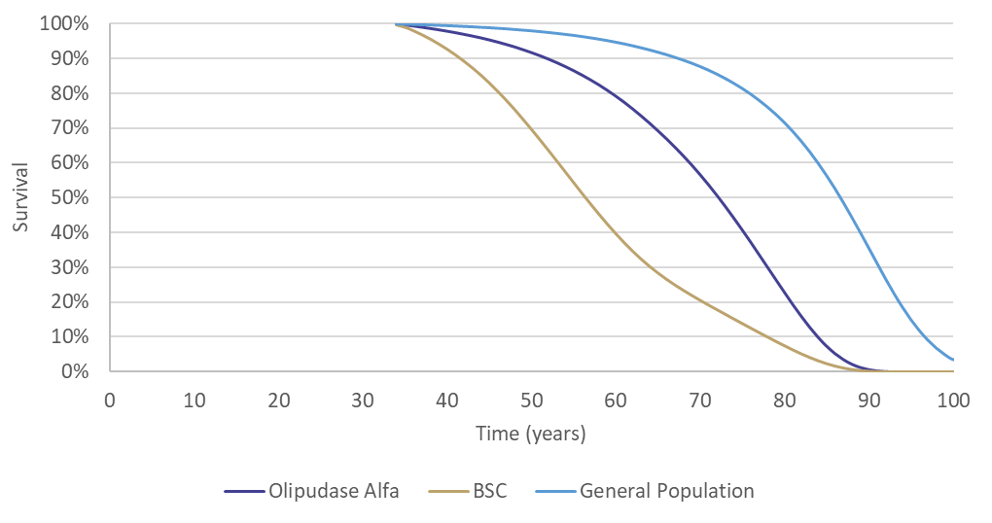
Source: ‘Base Case Result’ worksheet in ‘Olipudase_ASMD CEA’
BSC = best supportive care
X axis represents the age of patient entering the model.
Figure 11: Kaplan Meier for modelled overall survival for paediatric patients
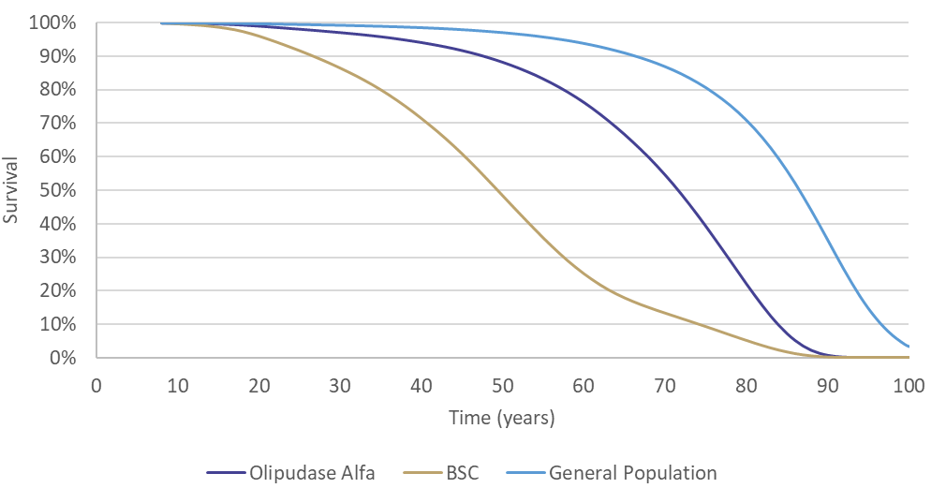
Source: ‘Base Case Result’ worksheet in ‘Olipudase_ASMD CEA’
BSC = best supportive care
X axis represents the age of patient entering the model.
  - The modelled OS appears to be overestimated for both adult and paediatric patients with approximately 22% patients alive in the olipudase alfa arm at the age of 80 years. As stated in paragraph 4.6, median age at death was 15.5 years (range: 1, 72) for patients with ASMD type B (McGovern et al. 2013). According to Cassiman et al. (2017), median age at death was 23.5 years for ASMD type B and 8.5 years for ASMD type A/B. The ESC considered modelled survival estimates to be clinically implausible and recommended these be validated against best available evidence.

Utilities
  - A time trade off (TTO) study with a 10-year time horizon was undertaken by the submission to estimate utilities for patients with ASMD. The TTO was conducted amongst 200 members of the general public of the United Kingdom. The economic model estimated the utilities for all patients who remain alive by multiplying the relevant health state utility values by the proportion of patients in each health state in the cycle. Table 15 and Table 16 summarises the utility values used for adult and paediatric patients in the economic evaluation.
Table 15: Utility values used in the economic evaluation for adult population
DLco | Spleen volume (MN)
 | <6 MN | 6–15 MN | >15 MN
100–80 | 0.918 | 0.837 | 0.636
80 40 | 0.847 | 0.770 | 0.532
<40 | 0.622 | 0.527 | 0.333
Source: Table 2.2.11, p129 of the submission
DLco = diffusion capacity of the lung for carbon dioxide, MN = multiple of normal.
Table 16: Utility values used in the economic evaluation for paediatric population
DLco | Spleen volume (MN)
 | <6 MN | 6–15 MN | >15 MN
100–80 | 0.939 | 0.867 | 0.685
80 40 | 0.882 | 0.809 | 0.594
<40 | 0.741 | 0.654 | 0.450
Source: Table 2.2.45, p174 of the submission
DLco = diffusion capacity of the lung for carbon dioxide, MN = multiple of normal.
  - The estimation of the utility values was uncertain because:
- The submission did not use HRQoL from the ASCEND trial to estimate utilities in the economic model.
- In the ASCEND trial, changes from baseline in HRQoL were not different between the arms as measured by the EuroQol five-dimension scale questionnaire (EQ-5D-5L) and the Short-Form Six-Dimension (SF-6D).
- TTO utility values did not account for treatment-related AEs, which ESC considered was not reasonable and favoured olipudase alfa given its inferior safety profile.
- TTO utility values were not based on the experience of people with ASMD and their carers and may not reflect accurate utility values. It was unclear how accurately members of the general population of the UK were able to imagine a health state of a rare disease and its impact on various aspects of HRQoL.

Key drivers of the model and stepped economic evaluation
  - A summary of the key drivers of the model are presented in Table 17.
Table 17: Key drivers of the model
Description | Method/Value | Impact  Base case (adult population):  $||||¹/QALY gained
Overall survival | Survival was derived from SPHINGO-100 data (12.5, 95% CI: 4.3, 20.7) and US life tables for the year 2017. The overall SMR calculated from SPHINGO-100 was expressed as a weighted average of two SMRs; SMR1 (43.1) for patients with severe splenomegaly (≥15 MN) and SMR2 (4.3) for patients without severe splenomegaly (<15 MN) at baseline. | High, favours olipudase.  Assuming an overall SMR of 12.5 irrespective of severity of splenomegaly, increased the ICER by 44.49% to $||||¹/QALY gained.
Time horizon | The time horizon in the base case (lifetime) was longer than the maximum follow-up period of the ASCEND trial (5 years; primary analysis and extended treatment period), | High, favours olipudase.  Assuming a time horizon of 20 years increased the ICER by 21.28% to $||||¹/QALY gained.
Treatment benefit | Olipudase alfa patients can remain in the same health state from nine years onwards | Moderate, favours olipudase  Assuming, olipudase alfa patients can remain in their current health state or transition to a worse health state from nine years onwards increased the ICER by 5.81% to $||||¹/QALY gained.
Description | Method/Value | Impact  Base case (paediatric population):  $||||¹/QALY gained
Overall survival | Survival was derived from SPHINGO-100 data (12.5, 95% CI: 4.3, 20.7) and US life tables for the year 2017. The overall SMR calculated from SPHINGO-100 was expressed as a weighted average of two SMRs; SMR1 (4.3) for patients with severe splenomegaly (≥15 MN) and SMR2 (43.1) for patients without severe splenomegaly (<15 MN) at baseline. | High, favours olipudase.  Assuming an overall SMR of 12.5 irrespective of severity of splenomegaly, increased the ICER by 18.92% to $||||¹/QALY gained.
Treatment benefit | Olipudase alfa patients can remain in the same health state from nine years onwards | High, favours olipudase  Assuming olipudase alfa patients can remain in their current health state or transition to a worse health state from nine years onwards increased the ICER by 12.11% to $||||¹/QALY gained.
Source: Olipudase_ASMD CEA worksheet
ICER = incremental cost-effectiveness ratio, MN = multiple of normal, QALY = quality-adjusted life-years, SMR = standardised mortality rate.
Corrected during evaluation to reflect only 20 mg vial of olipudase alfa. Recalculated by changing 62 vials to 63 vials of 20 mg and 3 vials to 0 vials of 4 mg in cell G46 and 236 vials to 237 vials of 20 mg and 2 vials to 0 vials of 4 mg in cell G50 of ‘treatment cost’ worksheet in ‘Olipudase_ASMD CEA’ workbook.
The redacted values correspond to the following ranges:
¹ > $1,055,000
  - Table 18 and Table 19 present the results of the stepped economic evaluation for the adult and paediatric populations, respectively.

Table 18: Results of the stepped economic evaluation for the adult population
Step and component | Olipudase alfa | BSC | Increment
Step 1: modelled trial-based costs and outcomes (two years) ª
Costs ($) | | | $0.00 | |
LYG | 1.89 | 1.88 | 0.01
Incremental cost/extra LYG gained |  |  | |¹
Step 2: time horizon extended to lifetime
Costs ($) | | | $0.00 | |
LYG | 16.13 | 12.88 | 3.25
Incremental cost/extra LYG gained |  |  | |¹
Step 3: incorporation of medical resource costs
Costs ($) | | | $32,935 | |
LYG | 16.13 | 12.88 | 3.25
Incremental cost/extra LYG gained |  |  | |¹
Step 4: utility weights applied
Costs ($) | | | $32,935 | |
QALYs | 11.62 | 7.51 | 4.11
Incremental cost/extra QALY gained (base case) |  |  | |¹
Source: Table 2.2.33, p154 of the submission.
BSC = best supportive care, LYG = life-years gained, QALY = quality-adjusted life years.
ª Overall survival over a time horizon of 2 years was modelled by applying an ASMD specific SMR to the Australian general population mortality with the results reported in LYG.
Corrected during evaluation to reflect only 20 mg vial of olipudase alfa. Recalculated by changing 236 vials to 237 vials of 20 mg and 2 vials to 0 vials of 4 mg in cell G50 of ‘treatment cost’ worksheet in ‘Olipudase_ASMD CEA’ workbook.
The redacted values correspond to the following ranges:
¹ > $1,055,000
Table 19: Results of the stepped economic evaluation for the paediatric population (discounted)
Step and component | Olipudase alfa | BSC | Increment
Step 1: modelled trial-based costs and outcomes (two years) ª
Costs ($) | | | $0.00 | |
LYG | 1.899 | 1.897 | 0.002
Incremental cost/extra LYG gained |  |  | |¹
Step 2: time horizon extended to lifetime (discounted)
Costs ($) | | | $0 | |
LYG | 18.95 | 16.76 | 2.19
Incremental cost/extra LYG gained |  |  | |¹
Step 3: incorporation of medical resource costs (discounted)
Costs ($) | | | $41,328 | |
LYG | 18.95 | 16.76 | 2.19
Incremental cost/extra LYG gained |  |  | |¹
Step 4: utility weights applied (discounted)
Costs ($) | | | $41,328 | |
QALYs | 14.35 | 9.26 | 5.09
Incremental cost/extra QALY gained (base case) |  |  | |¹
Source: Table 2.2.33, p154 of the submission.
BSC = best supportive care, LYG = life-years gained, QALY = quality-adjusted life years
ª Overall survival over a time horizon of 2 years was modelled by applying an ASMD specific SMR to the Australian general population mortality with the results reported in LYG.
Values in this table were corrected during evaluation to reflect the availability of the 20 mg vial only of olipudase alfa. Recalculated by changing 62 vials to 63 vials of 20 mg and 3 vials to 0 vials of 4 mg in cell G46 and 236 vials to 237 vials of 20 mg and 2 vials to 0 vials of 4 mg in cell G50 of ‘treatment cost’ worksheet in ‘Olipudase_ASMD CEA’ workbook.
The redacted values correspond to the following ranges:
¹ > $1,055,000
  - The ESC noted that the model may have overestimated olipudase alfa survival benefit with 11.78 life-years gained (LYG; undiscounted) and 11.23 quality-adjusted life-years (QALY; undiscounted) gained compared with only 0.01 LYG (undiscounted) observed in the trial-based time horizon for the adult population. A similar trend was observed for the paediatric population.
  - As described in paragraph 2.3, the 4 mg vial strength has not been submitted to the TGA for approval. Assuming the availability of only 20 mg vial results in an annual cost of treatment of $| | instead of $| | (as estimated by the submission) in subsequent years for the adult population. Similarly for paediatric patients, the annual cost of treatment was calculated to be $| | instead of $| | (as estimated by the submission) in Year 1. The drug and administration costs for olipudase alfa, accounted for 99.98% of the modelled incremental cost.
  - Based on the availability of only 20 mg vials, treatment with olipudase alfa was associated with an incremental cost per QALY gained of > $1,055,000 for adult the population and > $1,055,000 for the paediatric population. Overall, the ICER was extremely high in all steps of the economic evaluation.
  - The results of key sensitivity analyses for adult and paediatric population are summarised in Table 20 and Table 21.
Table 20: Univariate sensitivity analyses for the adult population
Analyses | Incremental cost ($) | Incremental QALY | ICER | % change to ICER
Base case | | | 4.11 | |¹
Time horizon (base case: lifetime)
20 years | | | 2.57 | |¹ | 21%
25 years | | | 3.08 | |¹ | 13%
30 years | | | 3.48 | |¹ | 7%
Discount rate (base case: 5%)
0% | | | 11.23 | |¹ | -18%
3.5% | | | 5.34 | |¹ | -6%
Olipudase alfa treatment benefit (base case: patients in the olipudase arm remain in the same health state from Year 9 onwards with no further transitions to new health states for the remainder of the lifetime time horizon)
Olipudase alfa patients can remain in their current health state or transition to a worse health state from nine years onwards | | | 3.88 | |¹ | 6%
SMR (base case: 4.3 for patients without and 43.1 for patients with severe splenomegaly) ^{b}
Assuming an overall SMR of 12.5 irrespective of severity of splenomegaly | | | 2.38 | |¹ | 44%
Source: Table 2.2.36, p157 of the submission.
ICER = incremental cost-effectiveness ratio, QALY = quality-adjusted life-years, SMR = standardised mortality rate.
Values in this table were corrected during evaluation to reflect the availability of the 20 mg vial only of olipudase alfa. Recalculated by changing 236 vials to 237 vials of 20 mg and 2 vials to 0 vials of 4 mg in cell G50 of ‘treatment cost’ worksheet in ‘Olipudase_ASMD CEA’ workbook.
The redacted values correspond to the following ranges:
¹ > $1,055,000
Table 21: Univariate sensitivity analyses for the paediatric population
Analyses | Incremental cost ($) | Incremental QALY | ICER | % change to ICER
Base case | | | 5.09 | | ¹ | -
Time horizon (base case: lifetime)
50 years | | | 4.71 | | ¹ | 3%
60 years | | | 4.96 | |¹ | 1%
70 years | | | 5.07 | |¹ | 0%
Discount rate (base case: 5%)
0% | | | 22.00 | |¹ | -12%
3.5% | | | 7.24 | |¹ | -3%
Olipudase alfa treatment benefit (base case: patients in the olipudase arm remain in the same health state from Year 9 onwards with no further transitions to new health states for the remainder of the lifetime time horizon)
Adult transition probabilities from 18 years ª | | | 4.54 | |¹ | 12%
Child transition probabilities ª | | | 3.84 | |¹ | 32%
SMR (base case: 4.3 for patients without and 43.1 for patients with severe splenomegaly) ^{b}
Assuming an overall SMR of 12.5 irrespective of severity of splenomegaly | | | 3.92 | |¹ | 19%
Source: Table 2.2.72, p202 of the submission.
ICER = incremental cost-effectiveness ratio, QALY = quality-adjusted life-years, SMR = standardised mortality rate.
ª In olipudase alfa and best supportive care arm
Values in this table were corrected during evaluation to reflect the availability of the 20 mg vial only of olipudase alfa. Values were recalculated by changing 62 vials to 63 vials of 20 mg and 3 vials to 0 vials of 4 mg in cell G46 and 236 vials to 237 vials of 20 mg and 2 vials to 0 vials of 4 mg in cell G50 of ‘treatment cost’ worksheet in ‘Olipudase_ASMD CEA’ workbook.
The redacted values correspond to the following ranges:
¹ > $1,055,000
  - The ESC noted that changes in assumptions around transition probabilities between health states were not tested in sensitivity analyses. The feasibility of conducting more comprehensive sensitivity analysis was limited by the complexity of the model with more than 1,000 individual transition probabilities included.
  - For both adult and paediatric patients, the results of the cost-effectiveness analysis were most sensitive to the SMR rate applied in the economic model. Assuming a SMR rate of 12.5 for all patients irrespective of severity of splenomegaly increased the ICER by 45% and 19% for the adult and paediatric populations, respectively.
  - The ESC advised the revisions required to address the following issues would require re-evaluation:
- The current 9-state Markov model is too complex given very small patient numbers and insufficient evidence to accurately populate transition probabilities and utilities. The ESC recommends that a simplified structure is adopted (paragraph 6.65).
- The model appears overly optimistic and does not present clinically plausible estimates of OS (paragraph 6.75).
- At a minimum, survival estimates need to be validated to ensure they reflect best available evidence (paragraph 6.75).

Drug cost/patient/course
  - Table 22 presents the calculations of cost per patient per course for adult patients.
Table 22: Drug cost per patient for olipudase alfa for adult patients
 | Olipudase alfa  Model | Olipudase alfa  Financial estimates
Annual average dose (Year 1) | 3,578 mg ^{b} | 3,739 mg
Annual average dose (subsequent years) | 4,727 mg ª | 4,727 mg
Number of vials required (Year 1) | 179 vials ^{c} | 208 vials ^{d}
Number of vials required (subsequent years) | 237 vials ^{c} | 260 vials ^{d}
Cost per vial | $| based on effective AEMP
Compliance | 95.3% in Year 1  89.8% in subsequent years | 100%
Annual cost per treatment course per patient (Year 1) ^{e} | $| | $| ^{f}
Annual cost per treatment course per patient (subsequent years) ^{e} | $| | $| ^{g}
Source: ‘Olipudase_ASMD CEA’ workbook and ‘Olipudase UCM-Australian patients’ – Prevalent workbook.
ª Annual dose for Year 1 was adjusted for highest tolerated dose (HTD) but annual dose for Year 2 onwards was not adjusted for HTD.
^{b} Annual dose was calculated based on an average body weight of 60.4 kg for adult patients and the recommended dosing regimen.
^{c} Annual dose required divided by 20 mg.
^{d} Back calculated using the annual cost per treatment course/price of a vial.
^{e} Number of vials required * cost per vial.
^{f} Annual cost per patient in Year 1 was calculated as annual cost for initiating patients/number of initiating patients. Financial estimate in was $0 to < $10 million for < 500 initiating patients and $0 to < $10 million for grandfather patients in Year 1.
^{g} Annual cost per patient in subsequent years was calculated as annual cost for continuing patients/number of continuing patients. Financial estimate was $0 to < $10 million in the subsequent years for six continuing patients.
  - Treatment with olipudase alfa is expected to continue as long as the patient is clinically benefiting. The differences between the economic and financial estimates were driven by the number of 20 mg vials required and the compliance rate used by the submission to calculate the annual cost for olipudase alfa. The economic estimates calculated the number of vials based on the annual average dose, whereas the financial estimates calculated the number of vials required according to the dosing regimen accounting for wastage.
  - Table 23 presents the calculations of cost per patient per course for paediatric patients.
Table 23: Drug cost per patient for olipudase alfa for paediatric patients
 | Olipudase alfa  Model ^{b} | Olipudase alfa  Financial estimates ^{c}
Annual average dose (Year 1) | 1,250 mg | 3,203 mg
Annual average dose (subsequent years) | 1,660 mg | Year 2: 4,494 mg  Year 3: 4,685 mg  Year 4 onwards:4,829 mg
Number of vials required (Year 1) | 63 vials ^{d} | 179 vials
Number of vials required (subsequent years) | 83 vials ^{d} | Year 2: 234 vials ^{e}  Year 3: 260 vials ^{e}  Year 4 onwards: 260 vials ^{e}
Cost per vial | $| based on effective AEMP
Compliance | 99.2% in Year 1  96.8% in subsequent years | 100%
Annual cost per treatment course per patient (Year 1) ^{e} | $| | $|
Annual cost per treatment course per patient (subsequent years) ^{e} | $| | Year 2: $|  Year 3: $|  Year 4 onwards: $|
Source: ‘Olipudase_ASMD CEA’ workbook and ‘Olipudase UCM-Australian patients’ – Prevalent workbook.
ª Annual dose for Year 1 was adjusted for highest tolerated dose (HTD) but annual dose for Year 2 onwards was not adjusted for HTD.
^{b} Annual dose was calculated based on an average body weight of 21.20 kg in Year 1 for paediatric patients.
^{c} Annual dose was calculated based on an average body weight of 54.4 kg in Year 1 increasing to 61.9 kg in Year 6 for paediatric patients.
^{d} Number of vials required * cost per vial.
^{e} Back calculated using the annual cost per treatment course/price of a vial.
  - The differences between the economic and financial estimates were driven by the age and weight of paediatric patients. In the economic evaluation, average age and body weight was informed by ASCEND-Peds (approximately 8 years and 21.20 kg) in the first year. The weight of paediatric patients was modelled up to the age of 17 years after which time patients were assumed to switch to adult weight and this remained constant for the remainder of the model. In the financial estimates, the submission assumed that paediatric patients (incident patients) will be diagnosed at an average age of 15 years based on the clinician survey. Furthermore, average body weight was informed by Australian general population, increasing each year until the age of 18 years. The ESC considered that the assumptions used in the financial estimates should match those used for the economic model.

Estimated PBS usage & financial implications
  - This submission was considered by DUSC.
  - The submission used an epidemiological approach to estimate the utilisation and financial impacts of listing olipudase alfa for the treatment of patients with ASMD type A/B or type B.
  - Table 24 presents the key inputs and data sources used to estimate financial impact.
Table 24: Key inputs for financial estimates
Parameter | Value applied and source | Comment
Prevalent population | ||||¹ patients including ||||¹ grandfathered patient; based on the Australian clinician survey. | The estimates of the prevalent population were likely to be the best available.
Incident population | ||||¹ new patient every other year; based on sponsor assumption. | This was highly uncertain; the number of new patients could be higher or lower. Furthermore, the submission assumed that the incident patient will be a paediatric patient (15 years old).
Body weight prevalent patients | 60.4 kg; based on average body weight of ASMD patients in Australia as determined by the Australian clinician survey. | There was uncertainty in the body weight estimates due to large variation in the patient population.
Body weight incident patients | 54.4 kg in Year 1 increasing to 61.9 kg in Year 6; based on average body weight of Australian general population. | This was consistent with the weight used for paediatric patients aged 15 years in the economic model
Uptake rate | 100%; based on the Australian clinician survey. | This was reasonable given the severity of the condition and the absence of other treatment options.
Dose prevalent adult patients | Olipudase alfa IV Q2W; starting dose of 0.1 mg/kg and maintenance dose of 3 mg/kg | This was reasonable and consistent with the draft PI and ASCEND trial.
Dose incident paediatric patients | Olipudase alfa IV Q2W; starting dose of 0.03 mg/kg and maintenance dose of 3 mg/kg | This was reasonable and consistent with the draft PI and ASCEND-peds trial.
Source: Source: Table 4.1.1, pp204-205.
AE = adverse event, ASMD = acid sphingomyelinase deficiency, IV = intravenous, PI = Product Information, Q2W = every two weeks.
The redacted values correspond to the following ranges:
¹ < 500
  - The estimated net cost to the PBS of listing olipudase alfa is presented in Table 25.
Table 25: Estimated use and financial implications
 | Year 1 | Year 2 | Year 3 | Year 4 | Year 5 | Year 6
Estimated extent of use
Prevalent patients | | ¹ | | ¹ | | ¹ | | ¹ | | ¹ | | ¹
Grandfathered patients | | ¹ | | ¹ | | ¹ | | ¹ | | ¹ | | ¹
Incident patients | | ¹ | | ¹ | | ¹ | | ¹ | | ¹ | | ¹
Total patients | | ¹ | | ¹ | | ¹ | | ¹ | | ¹ | | ¹
Number of scripts dispensed prevalent patients (including one grandfathered patient) ª | | ¹ | | ¹ | | ¹ | | ¹ | | ¹ | | ¹
Number of scripts dispensed incident patients ª | | ¹ | | ¹ | | ¹ | | ¹ | | ¹ | | ¹
Total scripts | | ¹ | | ¹ | | ¹ | | ¹ | | ¹ | | ¹
Estimated financial implications of olipudase alfa
Cost to PBS less co-payments | | ² | | ² | | ² | | ² | | ² | | ²
Net financial implications
Net cost to PBS | | ² | | ² | | ² | | ² | | ² | | ²
Net cost to MBS | | ² | | ² | | ² | | ² | | ² | | ²
Net cost to Government | | ² | | ² | | ² | | ² | | ² | | ²
Source: Table 4.2.1, p214, Table 4.2.2, p214, Table 4.4.1, p218, and Table 4.5.2, p218 of the submission.
MBS = Medicare Benefits Schedule, PBS = Pharmaceutical Benefits Schedule
ª Assuming 13 scripts for 20 mg olipudase alfa in initial treatment (26 weeks) and 26 scripts per year for 20 mg olipudase alfa in the maintenance phase.
Values in this table were corrected during evaluation to reflect the availability of the 20 mg vial only.
The redacted values correspond to the following ranges:
¹ < 500
² $0 to < $10 million
  - The submission estimated that < 500 prevalent, < 500 grandfathered patient and < 500 incident patients (< 500 every two years) would be treated with olipudase alfa over the first six years of listing. The net cost to the PBS/RPBS of listing olipudase alfa was estimated to be $0 to < $10 million in Year 1, and a total of $30 million to < $40 million in the first 6 years of listing (reflects the availability of the 20 mg vial only).
  - The main sources of uncertainty relating to the estimated use of olipudase alfa were:
- The absence of the 4 mg vial will increase wastage in the dose escalation phase, especially in paediatric patients.
- The assumption that < 500 new patient will be diagnosed and commence treatment with olipudase alfa every other year was uncertain given that the number of new patients added could be higher or lower.
- The drug cost per patient varies greatly based on body weight and age. Based on the 2023 Australian clinician survey, the body weight of the < 500 identified patients ranged from 48 kg to 72 kg and the age at diagnosis ranged from 3 years to 43 years.
  - The DUSC considered the estimates in the submission to be reasonable in the overall context of the data available. However, it considered that the following issues should be noted:
- The incident patient population estimates are highly uncertain;
- The body weight estimates are uncertain due to the large variation in the age of the patient population and the use of the average body weight for the Australian population may not be representative of the patient population;
- There was limited evidence of treatment effectiveness in ASMD type A/B;
- The current TGA regulatory status of the 4 mg dosage form impacts the financial estimates.
- While is unlikely that olipudase alfa would currently be used outside the requested restriction, previously undiagnosed patients with mild or moderate disease may be treated if new and more sensitive screening tests for ASMD become available.
  - DUSC advised that minor changes to the methods used to derive the utilisation and financial estimates and structure of the estimates model should be considered including inputs and/or assumptions to estimate the eligible and treated populations, availability of the 4 mg dosage form, and cost associated with outpatient treatment.
For more detail on PBAC’s view, see section 7 PBAC outcome.

- PBAC Outcome
  - The PBAC did not recommend the Section 100 (Highly Specialised Drugs Program) listing of olipudase alfa for the treatment of acid sphingomyelinase (ASMD) type A/B or type B. The PBAC considered olipudase alfa was an effective treatment for ASMD type A/B or type B; however, the incremental cost effectiveness ratio (ICER) for olipudase alfa compared to best supportive care was extremely high and uncertain.
  - The PBAC considered the primary reason for this outcome was due to the economic evaluation provided.
  - The PBAC noted the high clinical need for olipudase alfa, in that there is currently no other treatment that modifies the natural course or alters the progression of ASMD, and that splenectomy, liver transplantation, and allogenic stem cell transplantation are avoided in most cases due to the unfavourable risk/benefit profile. The PBAC acknowledged the unmet clinical need described in the Consumer Comments from health care professionals and individuals.
  - In the absence of a lack of other treatment options for ASMD being available, the PBAC considered that the submission’s nomination of BSC as the main comparator was appropriate.
  - In contrast to the requested written authority, the PBAC noted that a telephone/online listing would provide immediate approval to the medicine and avoid the need to digitally transform an ‘in-writing only’ Authority Required listing in the future. The PBAC also commented on other elements of the proposed restriction: (i) it supported combining the adult and paediatric restrictions; (ii) it supported noting specific conditions of similar presentation for exclusion in the restriction; and (iii) it supported specifying that patients must be treated by or in conjunction with a specialist physician with expertise in the management of inherited metabolic disorders. The PBAC noted the recommendation from the Secretariat regarding combining initial and continuing treatment criteria into one treatment phase and considered this may be reasonable given the lack of a defined continuation rule. The PBAC noted the sponsor’s suggested changes proposed in the PSCR (see paragraph 3.6) but considered they had not been adequately justified.
  - While the PBAC considered that the claim of superior comparative effectiveness of olipudase alfa compared to BSC was reasonable in terms of the change in spleen volume and DLco, it noted the uncertainty associated with extending this finding to a survival benefit. The PBAC noted the reduced life expectancy associated with ASMD (the median age at death was 23.5 years for ASMD type B and 8.5 years for ASMD type A/B according to Cassiman et al. 2017). The PBAC noted that comparative survival curves are challenging to construct due to heterogeneity of patients and limited available data, but considered it likely that treatment with olipudase alfa would extend life if it is accepted that reducing spleen size improves survival. The PBAC acknowledged the difficulty of providing data for an ultra-rare condition like ASMD.
  - The PBAC did not consider that the claim of non-inferior safety was supported, noting that randomised trial data in adults showed a greater proportion of olipudase alfa patients experienced TEAEs potentially related to study drug and infusion related reactions, compared to BSC.
  - The PBAC noted that the randomised ASCEND trial only included patients diagnosed with ASMD type B. The PBAC considered the applicability of the trial data to Australian patients with type A/B disease to be uncertain but noted: (i) that there is high clinical need; (ii) that type A/B has features of type B disease, and (iii) that the TGA approved olipudase alfa for ASMD ‘type B and intermediate form [i.e. type A/B]’. While the PBAC accepted that olipudase alfa may be effective in ASMD type A/B, it considered the clinical benefit in type A/B patients to be less certain compared with type B, given the lack of clinical evidence and the lower expected untreated patient survival.
  - The PBAC noted the base case ICER was over > $1,055,000 per QALY for the adult and paediatric population. The PBAC agreed with the ESC and the evaluation that the economic model structure with multiple health states defined by mild/moderate/severe splenomegaly and lung function (9 health states in total) was overly complex and not well justified, given the very small patient numbers and insufficient evidence to populate transition probabilities and utilities. The PBAC noted that the model appears overly optimistic for olipudase alfa and does not generate clinically plausible estimates of survival. The PBAC considered the ICER to be extremely high and uncertain.
  - The PBAC agreed with the DUSC that while the utilisation estimates presented in the submission were reasonable in the context of the data available, there were several uncertainties regarding the incident patient population, body weight estimates, and regulatory status of the 4 mg vial. The PBAC also noted DUSC’s view that with the availability of new and more sensitive screening tests in the future, olipudase alfa may be utilised beyond the currently identified population.
  - The PBAC noted that this submission is eligible for an Independent Review.
Outcome:
Not recommended
- Context for Decision
The PBAC helps decide whether and, if so, how medicines should be subsidised through the Pharmaceutical Benefits Scheme (PBS) in Australia. It considers applications regarding the listing of medicines on the PBS and provides advice about other matters relating to the operation of the PBS in this context. A PBAC decision in relation to PBS listings does not necessarily represent a final PBAC view about the merits of the medicine or the circumstances in which it should be made available through the PBS. The PBAC welcomes applications containing new information at any time.
- Sponsor’s Comment
The sponsor had no comment.

Delegate’s Overview Xenpozyme (olipudase alfa) Version 1.1, 28 February 2023.
Chin S. and Fuller M., (2021), ‘Prevalence of lysosomal storage disorders in Australia from 2009 to 2020’, Lancet Regional Health Western Pacific, 19.
Cassiman D. et al. (2016), ‘Cause of death in patients with chronic visceral and chronic neurovisceral acid sphingomyelinase deficiency (Niemann-Pick disease type B and B variant): Literature review and report of new cases’, Molecular Genetics and Metabolism, 206–213.
McGovern et al. (2013), ‘Morbidity and mortality in type B Niemann–Pick disease’, Genetics in Medicine, 15(8):618–623.
Kapetanakis V. et al. (2021), ‘Analysis of Overall Survival (OS) in Patients with Acid Sphingomyelinase Deficiency Type B Using the Standardized Mortality Ratio Method’, 14TH INTERNATIONAL CONGRESS OF INBORN ERRORS OF METABOLISM, Sydney, Australia.
European Medicines Agency (EMA), (2022), ‘Assessment report – Xenpozyme’, https://www.ema.europa.eu/en/documents/assessment-report/xenpozyme-epar-public-assessment-report_en.pdf
Geberhiwot et al. (2023), ‘Consensus clinical management guidelines for acid sphingomyelinase deficiency (Niemann–Pick disease types A, B and A/B)’, Orphanet Journal of Rare Diseases, 18:85
Jones et al. (2020), ‘Clinical relevance of endpoints in clinical trials for acid sphingomyelinase deficiency enzyme replacement therapy’, Molecular Genetics and Metabolism, 131:116–123.
Mengel et al. (2022), ‘Clinical relevance of diffusing capacity of the lungs for carbon monoxide (DLco) in patients with chronic acid sphingomyelinase deficiency (ASMD)’, SSIEM Annual Symposium 2022 Abstract no.: SSIEM22-2622.
McGovern et al. (2017), ‘Disease manifestations and burden of illness in patients with acid sphingomyelinase deficiency (ASMD)’, Orphanet Journal of Rare Diseases, 12:41.

