5.11 SELPERCATINIB,
Capsule 40 mg,
Capsule 80 mg,
Retevmo®,
ELI LILLY AUSTRALIA PTY LTD.
- Purpose of submission
  - The Category 1 submission requested a General Schedule Authority Required (STREAMLINED) listing for the treatment of REarranged during Transfection (RET) fusion-positive, locally advanced or metastatic non-small cell lung cancer (NSCLC), irrespective of line of therapy.
  - Listing was requested on the basis of a cost-effectiveness analysis versus i) pembrolizumab in combination with pemetrexed + platinum-based chemotherapy (pembrolizumab + PC) as the main comparator in the first-line treatment setting, and ii) docetaxel as a supplementary comparator in the pre-treated setting. The key components of the clinical issue addressed by the submission are summarised in Table 1.
Table 1: Key components of the clinical issue addressed by the submission
Component | Description
Population | Adults with histologically and cytologically confirmed locally advanced or metastatic rearranged during transfection (RET) fusion-positive non-small cell lung cancer (NSCLC)
Intervention | Selpercatinib orally administered until disease progression or unacceptable toxicity. The recommended dose in patients with bodyweight ≥50kg is 160 mg twice daily and that in patients with bodyweight <50kg is 120 mg twice daily
Comparator | Main comparator: Pembrolizumab in combination with platinum doublet chemotherapy (treatment naïve).  Supplementary comparator: Docetaxel (pre-treated)
Outcomes | Safety and tolerability, objective response rate, progression-free survival; overall survival; and health-related quality of life
Clinical claim | In treatment-naïve patients with RET fusion-positive locally advanced or metastatic NSCLC, selpercatinib is superior to pembrolizumab in combination with platinum doublet chemotherapy in terms of efficacy and has a different but manageable safety profile.  In previously treated patients with RET fusion-positive locally advanced or metastatic NSCLC, selpercatinib is superior to docetaxel in terms of efficacy and has a different but manageable safety profile
Source: Table 1-1, p15 of the submission
  - The sponsor submitted the application as a co-dependent submission prior to being advised that the Medical Services Advisory Committee (MSAC) Application 1721 (Small gene panel testing for NSCLC) had been recommended. With MSAC having already supported RET gene fusion testing as part of its consideration of application 1721, an assessment of RET fusion testing in NSCLC was no longer required.
- Background

Registration status
  - TGA status at time of PBAC consideration: The submission was made under the TGA/PBAC parallel process. Selpercatinib was TGA registered on 3 July 2023 for the following indication:
RETEVMO has provisional approval for the treatment of adult patients with locally advanced or metastatic RET fusion-positive NSCLC. The decision to approve this indication has been made on the basis of objective response rate (ORR) and duration of response (DOR) from a single arm study. Continued approval of this indication depends on verification and description of benefit in a confirmatory trial.
  - A TGA clinical evaluation report (Round 1) and the Delegate’s overview for selpercatinib were available during the evaluation. The TGA clinical evaluation report noted that the efficacy of selpercatinib in patients with advanced RET fusion-positive NSCLC will be further evaluated through a confirmatory Phase III randomised controlled trial (LIBRETTO-431) comparing selpercatinib to platinum-based and pemetrexed therapy with or without pembrolizumab as initial treatment of advanced RET fusion-positive non-squamous NSCLC.
For more detail on PBAC’s view, see section 7 PBAC outcome.
- Requested listing
  - Suggestions and additions proposed by the Secretariat are added in italics and suggested deletions are crossed out with strikethrough.
Category / Program: GENERAL – General Schedule (Code GE)

MEDICINAL PRODUCT  medicinal product pack |  | Dispensed Price for Max. Qty | PBS item code | Max. qty packs | Max. qty units | №.of  Rpts | Available brands
SELPERCATINIB
selpercatinib 80 mg modified release capsule, 112 |  | $ | | NEW 1  _{MP} | 1 | 112 | 5 | Retevmo
selpercatinib 40 mg modified release capsule, 56 |  | $ | ª | NEW 2  _{MP} | 1 | 56 | 5 | Retevmo
Safety Net rule penalty applies? Yes
Authority Required (STREAMLINED)

 | Indication: Locally advanced or metastatic non-small cell lung cancer Stage IIIB (locally advanced) or Stage IV (metastatic) non-small cell lung cancer (NSCLC)
 | Treatment phase: Initial treatment
 | Clinical criteria:
 | The condition must have evidence of rearranged during transfection (RET) gene fusion in tumour material – this evidence has been obtained prior to commencing this drug Patient must have evidence a rearranged during transfection (RET) gene fusion in tumour material
 | AND
 | Clinical criteria:
 | Patient must have a World Health Organisation (WHO) Eastern Cooperative Oncology Group (ECOG) performance status score of no higher than 2 at treatment initiation WHO performance status of 2 or less.
 | AND
 | Clinical criteria:
 | The treatment must be the sole PBS-subsidised systemic anti-cancer therapy for this PBS indication.
 | Treatment criteria:
 | Patient must be undergoing initial treatment with this drug; or
 | Patient must be undergoing continuing treatment with this drug, with an absence of further disease progression since the last prescription
 | Administrative Advice: No increase in the maximum quantity or number of units may be authorised.
 | Administrative Advice: No increase in the maximum number of repeats may be authorised
ª The dispensed price for selpercatinib 40 mg x 56 capsules used in the economic analysis and financial analysis was $|| || per pack
Category / Program: GENERAL – General Schedule (Code GE)

MEDICINAL PRODUCT  medicinal product pack |  | Dispensed Price for Max. Qty | PBS item code | Max. qty packs | Max. qty units | №.of  Rpts | Available brands
SELPERCATINIB
selpercatinib 80 mg modified release capsule, 56 |  | $ | | NEW 3  _{MP} | 1 | 56 | 5 | Retevmo
Safety Net rule penalty applies? Yes
Authority Required (STREAMLINED)

 | Indication: Locally advanced or metastatic non-small cell lung cancer
 | Treatment phase: For dosing where the daily dose does not exceed 120 mg per day
 | Clinical criteria:
 | The condition must have evidence of rearranged during transfection (RET) gene fusion in tumour material – this evidence has been obtained prior to commencing this drug
 | AND
 | Clinical criteria:
 | Patient must have a World Health Organisation (WHO) Eastern Cooperative Oncology Group (ECOG) performance status score of no higher than 2 at treatment initiation
 | AND
 | Clinical criteria:
 | The treatment must be the sole PBS-subsidised systemic anti-cancer therapy for this PBS indication.
 | Treatment criteria:
 | Patient must be undergoing initial treatment with this drug; or
 | Patient must be undergoing continuing treatment with this drug with an absence of further disease progression since the last prescription
 | Administrative Advice: No increase in the maximum quantity or number of units may be authorised.
 | Administrative Advice: No increase in the maximum number of repeats may be authorised

Category / Program: GENERAL – General Schedule (Code GE)
Prescriber type: Medical Practitioners
Restriction Type – assessment time by Services Australia – Method of obtaining authority approval (if Authority Required)
Authority Required – Streamlined [NEW]
Condition: Non-small cell lung cancer (NSCLC)
Indication: Stage IIIB (locally advanced) or Stage IV (metastatic) non-small cell lung cancer (NSCLC)
Treatment phase: Continuing
Clinical criteria:
Patient must have previously received PBS-subsidised treatment with this drug for this condition
AND
Clinical criteria:
The treatment must be the sole PBS-subsidised therapy for this condition
AND
Clinical criteria:
Patient must not develop disease progression while receiving PBS-subsidised treatment with this drug for this condition

Category / Program: GENERAL – General Schedule (Code GE)
Prescriber type: Medical Practitioners
Restriction Type – assessment time by Services Australia – Method of obtaining authority approval (if Authority Required)
Authority Required – Streamlined [NEW]
Condition: Non-small cell lung cancer (NSCLC)
Indication: Stage IIIB (locally advanced) or Stage IV (metastatic) non-small cell lung cancer (NSCLC)
Treatment phase: Grandfathered
Clinical criteria:
Patient must have previously received non-PBS subsidised treatment with this drug for this condition prior to [date of PBS listing]
AND
Clinical criteria:
Patient must have a WHO performance status of 2 or less prior to initiation on non-PBS subsidised treatment with this drug for this condition
AND
Clinical criteria:
Patient must have evidence of a rearranged during transfection (RET) gene fusion in tumour material

  - The submission noted that as pembrolizumab has a special pricing arrangement (SPA) in place, the sponsor may request a SPA during discussions with the Department of Health, should selpercatinib be recommended for PBS listing. The pre-PBAC response offered a 1.5% reduction on the price of selpercatinib (i.e. published AEMP of $| | for the 80mg x 112 pack size, $| | for the 80 mg x 56 pack size and $| | for the 40 mg x 56 pack size).
  - The recommended dose of selpercatinib is based on body weight (≥ 50 kg, 160 mg twice daily (BID); < 50 kg, 120 mg BID). The proposed treatment coverage for both doses is 28 days per prescription with 5 repeats (i.e. 24 weeks of treatment coverage per Authority); the 112 unit pack size of the 80 mg capsule provides 28 days treatment for the 160 mg BID dose, and the combination of the 56 unit pack size of the 80 mg capsule and the 56 unit pack size of the 40 mg capsule provides 28 days treatment for the 120 mg BID dose.
  - The requested restriction for selpercatinib is treatment line-agnostic. The submission noted that the sponsor is willing to collaborate to ensure that the restriction best supports the appropriate selection of patients for treatment with selpercatinib. Selpercatinib is recommended for use as the initial targeted therapy for RET fusion-positive advanced NSCLC in international guidelines. The evidence supporting the efficacy of selpercatinib as first-line drug therapy is the focus of the current evaluation. The ESC considered that based on current clinical practice, if approved, selpercatinib would be used as first-line and/or second line therapy and therefore a line-agnostic listing was appropriate.
  - The requested restriction was not limited to a specific NSCLC histology. Only one patient in the key LIBRETTO-001 study had NSCLC of squamous cell histology noting that RET fusions are very rare in lung cancer of squamous histology. In the November 2022 MSAC consideration of small gene panel testing for NSCLC, the recommended MBS item descriptors do not specify histology subtype (p5, Application No. 1721 Small gene panel testing for NSCLC Public Summary Document (PSD), November 2022 MSAC meeting). The ESC considered it was reasonable that the restriction was not limited to a specific NSCLC histology. The ESC noted that among currently listed targeted therapies for advanced or metastatic NSCLC the restrictions for brigatinib and entrectinib include reference to histology whereas the restrictions for tepotinib and osimertinib do not.
  - Currently, the PBS restrictions for pembrolizumab require that patients must not have previously been treated for their NSCLC in the metastatic setting, or that they have progressed after treatment with tepotinib. The submission proposed flow on changes to the listing of pembrolizumab to also permit its use in patients who have progressed after initial treatment with selpercatinib. The ESC considered that the proposed flow-on changes were reasonable.
  - The proposed PBS restrictions require that treatment must cease upon disease recurrence/progression (or if unacceptable toxicity occurs). This is consistent with the draft product information (PI) for selpercatinib. However, of the 69 patients in the treatment-naïve cohort of LIBRETTO-001, 22 patients (31.9%) continued treatment with selpercatinib, post-progression. Robust data showing that use of selpercatinib beyond progression is effective and cost-effective are lacking in the submission.
For more detail on PBAC’s view, see section 7 PBAC outcome.
- Population and disease
  - Lung cancer is the fifth most common cancer in Australia, however, it causes more deaths than any other cancer. Lung cancer generally affects older Australians, with a median age at diagnosis of 72 years. The prognosis of advanced lung cancer is poor with 5-year relative survival rates of 17.1% and 3.2% for patients presenting with Stage III and Stage IV lung cancer, respectively.
  - RET fusions have emerged as clinically actionable driver alterations and are present in approximately 1-2% of NSCLC patients. Approximately 20% to 50% of these patients have central nervous system (CNS) metastases. At least 45 RET gene fusion partners have been identified in lung cancers, the most common being KIF5B-RET (70%-90% of RET fusions). The clinical implications of specific gene fusion partners are currently not well defined.
  - The submission indicated that RET fusion-positive NSCLC patients are in general younger, more likely to be non-smokers, and have a better performance status (PS), when compared to RET fusion-negative NSCLC patients, and that these factors positively correlate with survival.
  - Despite this, the submission stated that RET fusion status is not an independent prognostic biomarker. An analysis by Hess et al (2021) was cited that showed no statistically significant differences in either progression-free survival (PFS) (p=0.25) or overall survival (OS) (p=0.08) between RET fusion-positive and RET fusion-negative NSCLC patients, after adjustment for age, sex, race, smoking status, disease stage, and PS.
  - The analysis by Hess et al (2021) was based on the US Flatiron Health database. The authors noted the need for caution in the interpretation of their findings due to the following limitations: limited reliability in the recording of the presence of metastatic sites, lack of information on other important prognostic variables which may potentially impact clinical outcomes such as tumour grade, histologic subtypes, comorbidities and other unmeasured confounders, and the small sample size of some of the datasets. The authors concluded that their study was not designed to evaluate the prognostic effect of the presence of a RET fusion in NSCLC.
  - The submission requested a line-agnostic listing for selpercatinib, but predicted that selpercatinib would be predominantly used as a first-line treatment. The ESC agreed with the evaluation that this was reasonable. The National Comprehensive Cancer Network (NCCN) guidelines now recommends selpercatinib and pralsetinib (another highly selective RET inhibitor) as the preferred first-line therapies for patients with metastatic RET fusion-positive NSCLC.
For more detail on PBAC’s view, see section 7 PBAC outcome.
- Comparator
  - The submission nominated pembrolizumab + PC as the main comparator for the first-line treatment setting. Patients eligible for treatment with pembrolizumab are increasingly likely to be treated with it in combination with chemotherapy. Pembrolizumab + PC is the appropriate comparator for a high proportion of patients. The submission nominated docetaxel as a supplementary comparator for the refractory (pre-treated setting) as the predominant use of selpercatinib is anticipated to be in the first-line setting. The ESC considered that the comparators were appropriate.
For more detail on PBAC’s view, see section 7 PBAC outcome.
- Consideration of the evidence

Sponsor hearing
  - There was no hearing for this item.

Consumer Comments
  - The PBAC noted and welcomed the input from an individual (1), a health care professional (1) and organisations (3) via the Consumer Comments facility on the PBS website. The comments from an individual who would like to access the medicine to treat their own health condition described a range of benefits of treatment with selpercatinib including the potential for reduced adverse effects compared to chemotherapy given intravenously (IV). The comments also described the potential for improvements in quality of life with the oral administration of selpercatinib compared to the appointment burden associated with IV therapies and radiation, especially for those with young families. The comments from a health care professional described the potential for improved outcomes for individuals undergoing selpercatinib treatment.
  - Input from Lung Foundation Australia stated that selpercatinib is an oral targeted therapy that may allow patients to live a better and healthier life with their condition. In addition, Lung Foundation Australia described its understanding that most common adverse events associated with selpercatinib are mild.
  - Rare Cancers Australia highlighted that patients with NSCLC with rare mutations are often faced with an extremely poor prognosis and stated that such patients need treatment options that provide significant improvements in survival. The input noted that selpercatinib is taken orally which may make administration easier and improve quality of life for patients with NSCLC.
  - The Medical Oncology Group of Australia (MOGA) also expressed its strong support for the selpercatinib submission, categorising it as one of the therapies of “highest priority for PBS listing”. The PBAC noted that the MOGA presented a European Society for Medical Oncology Magnitude of Clinical Benefit Scale (ESMO-MCBS) for selpercatinib, which was limited to 3 (out of a maximum of 5, where 5 and 4 represent the grades with substantial improvement).

Clinical studies
  - For determining comparative effectiveness in the first-line setting, the submission provided an indirect comparison of selpercatinib with pembrolizumab + PC via three studies:
- LIBRETTO-001: A phase II single-arm study of selpercatinib in patients with RET fusion-positive advanced (locally advanced or metastatic) non-squamous NSCLC.
- KN-189: A double-blind, randomised, controlled, phase III trial comparing pembrolizumab + PC versus PC in treatment-naïve patients with metastatic non-squamous NSCLC without sensitising EGFR or ALK mutations. This trial was considered by PBAC in July 2019 when making the recommendation for pembrolizumab + chemotherapy in metastatic NSCLC.
- KN-021 (Cohort G): An open-label, randomised, controlled, phase II trial comparing pembrolizumab + PC versus PC in treatment-naïve patients with metastatic non-squamous NSCLC without sensitising EGFR or ALK mutations.
  - For determining comparative safety in the first-line setting, the submission presented a descriptive comparison between LIBRETTO-001 and the pembrolizumab + PC arm of KN-189.
  - The ESC noted that a head-to-head randomised Phase III trial comparing selpercatinib to PC with or without pembrolizumab, as initial treatment of locally advanced or metastatic RET fusion-positive NSCLC, is currently ongoing (LIBRETTO-431, NCT04194944). The anticipated primary completion date is December 2023. It is anticipated that this study would address much of the uncertainty that is inherent in the indirect approach used to inform estimates of comparative effectiveness in this submission.
  - LIBRETTO-001 (Phase II NSCLC component) enrolled both treatment-naïve and pre-treated patients with RET fusion-positive advanced NSCLC. Data provided in the submission were for the most recent data cut-off, 15 June 2021.
- Treatment-naïve cohort (first-line setting, N=69): The median age was 63 years. 62.3% of patients were female, and 69.6% were Caucasian. 36.2% and 58.0% of patients had a baseline Eastern Cooperative Oncology Group (ECOG) PS of 0 and 1, respectively, and 69.6% had never smoked. 98.6% had metastases at baseline. 23.2% of patients had CNS metastases at baseline.
- Platinum-pre-treated cohort (second-line setting, N=247): The median age was 61 years, 56.7% were female, and 43.7% were Caucasian. 36.4% and 60.7% of patients had a baseline ECOG PS score of 0 and 1, respectively, and 66.8% had never smoked. All patients had received prior platinum chemotherapy and 58.3% of patients had received prior programmed cell death Ligand-1 (PD-1 (L)1) inhibitor therapy. The ESC noted that the proportion of patients pre-treated with platinum + anti-PD-1 (L1) therapy could not be identified from the submission.
- For the second-line setting, the submission was based on an indirect comparison between selpercatinib (LIBRETTO-001 study) and a single docetaxel arm from the REVEL study. REVEL was a randomised controlled trial comparing ramucirumab + docetaxel with docetaxel in squamous and non-squamous (72%), Stage IV NSCLC patients who had progressed during or after a first-line, single platinum-based chemotherapy regimen, with or without bevacizumab.
- The REVEL study was the only included study from 40 identified studies of docetaxel. The justification provided in the submission for excluding 39 studies was that individual patient data (IPD) were available for REVEL given that the study was conducted by the sponsor. This was problematic. The median OS reported for docetaxel in REVEL was 9.1 months. Median OS varied widely from 5.03 months to 15.7 months across the original identified set of 40 studies. Furthermore, patients in the REVEL study were not pre-treated with PD-1 (L1) inhibitors as these therapies were not approved during the conduct of the trial which was initiated in 2010. The ESC agreed with the evaluation that exclusion of 39 studies of docetaxel introduces a high risk of selection bias the impact of which was not thoroughly assessed.
- It is anticipated that the predominant use of selpercatinib is as initial targeted therapy for RET fusion-positive advanced NSCLC. The indirect comparison with docetaxel was considered largely uninformative and was not assessed further in the evaluation. The ESC agreed with the evaluation that the indirect comparison with docetaxel was largely uninformative due to the high risk of selection bias.
  - Details of the studies presented in the submission are provided in the Table 2.
Table 2: Trials and associated reports presented in the submission
Trial ID | Protocol title/ Publication title | Publication citation
Selpercatinib (key single arm study)
LIBRETTO-001  NCT03157128 | Interim Clinical Study Report (Protocol LOXO-RET-17001): A Study of Selpercatinib (LOXO-292) in Participants With Advanced Solid Tumours, RET Fusion-Positive Solid Tumours, and Medullary Thyroid Cancer: | 15 June 2021
 | Oxnard, G et al. Clinical Activity of LOXO-292, a Highly Selective RET Inhibitor, in Patients with RET Fusion+ Non-Small Cell Lung Cancer. | J Thorac Oncol, 2018; 13, S349-S350.
 | Drilon, A et al. Efficacy of Selpercatinib in RET Fusion-Positive Non-Small-Cell Lung Cancer. | N Engl J Med, 2020; 383, 813-824.
 | Nishio, M et al. Efficacy and Safety Analysis of Selpercatinib in Patients with RET Fusion-Positive Non-Small Cell Lung Cancer-Results from the Japanese Subset of a Global Phase 1/2 Study. | Gan To Kagaku Ryoho, 2022; 49, 669-675.
 | Drilon, A et al. Selpercatinib in Patients With RET Fusion-Positive Non-Small-Cell Lung Cancer: Updated Safety and Efficacy From the Registrational LIBRETTO-001 Phase I/II Trial. | J Clin Oncol, 2023; 41, 385-394.
Main comparator: pembrolizumab + pemetrexed + platinum chemotherapy
KN-189 | Study of Pemetrexed+Platinum Chemotherapy With or Without Pembrolizumab (MK-3475) in Participants With First Line Metastatic Nonsquamous Non-small Cell Lung Cancer (MK-3475-189/KEYNOTE-189)-Japan Extension Study. NCT03950674 | Not reported
 | Study of Pemetrexed+Platinum Chemotherapy With or Without Pembrolizumab (MK-3475) in Participants With First-Line Metastatic Nonsquamous Non-small Cell Lung Cancer (MK-3475-189/KEYNOTE-189). NCT02578680 | Not reported
 | Gandhi L et al. Pembrolizumab plus Chemotherapy in Metastatic Non–Small-Cell Lung Cancer. | N Engl J Med, 2018; 378, 2078-2092
 | Horinouchi, H et al. Safety and tolerability of pembrolizumab or placebo plus pemetrexed and platinum as first-line therapy in Japanese patients (PTS) with metastatic non-squamous non-small cell lung cancer (NSCLC) enrolled in the phase III KEYNOTE-189 study. | Annals of Oncology, 2019; 30, ii56-ii57
 | Horinouchi, H et al. Pembrolizumab plus pemetrexed-platinum for metastatic nonsquamous non-small-cell lung cancer: KEYNOTE-189 | Japan Study. Cancer Sci, 2021; 112, 3255-3265
 | Rodríguez-Abreu, D et al. Pemetrexed plus platinum with or without pembrolizumab in patients with previously untreated metastatic nonsquamous NSCLC: protocol-specified final analysis from KEYNOTE-189. | Ann Oncol, 2021; 32, 881-895
KN021  NCT02039674 | A Study of Pembrolizumab (MK-3475) in Combination With Chemotherapy in Participants With Non-small Cell Lung Cancer (MK-3475-021/KEYNOTE-021). | Not reported
 | Langer, C et al. Randomized, phase 2 study of carboplatin and pemetrexed with or without pembrolizumab as first-line therapy for advanced NSCLC: KEYNOTE-021 cohort G. | Annals of Oncology, 2016(a); 27, vi582
 | Langer, C et al. Carboplatin and pemetrexed with or without pembrolizumab for advanced, non-squamous non-small-cell lung cancer: a randomised, phase 2 cohort of the open-label KEYNOTE-021 study. | Lancet Oncol, 2016(b); 17, 1497-1508
 | Awad, M et al. Long-Term Overall Survival From KEYNOTE-021 Cohort G: Pemetrexed and Carboplatin With or Without Pembrolizumab as First-Line Therapy for Advanced Nonsquamous NSCLC. | J Thorac Oncol, 2021; 16, 162-168
Source: Modified from Table 2-52, pp171-173 of the submission
  - The key features of the included evidence are summarised in Table 3.
Table 3: Key features of the included evidence for the first-line setting – indirect comparison
Study | N | Design/ duration of follow-up for OS | Patient population | Risk of bias  Indirect comparison | Outcome(s) | Use in modelled evaluation
Selpercatinib
LIBRETTO-001 | Total: 316  Treatment naïve: 69 | Single arm, OL  Median 25.2 months | Stage IIIB or Stage IV patients with RET fusion-positive advanced NSCLC | High | ORR, PFS, OS | PFS and OS used.
Pembrolizumab + PC vs common reference of PC
KN189 | 616 | R, DB  Median 31.0 months | Untreated NSQ Stage IV NSCLC, EGFR and ALK negative |  | ORR, PFS, OS | PFS and OS used.
KN-021 (Cohort G) | 123 | R, OL  Median 49.4 months | Untreated NSQ Stage IV NSCLC, EGFR and ALK negative |  | ORR, PFS, OS | PFS and OS used.
Source: Sections 2D.4-2D.6, pp186-263 of the submission and the key publications for KN-189 (Rodriguez 2021) and KN-021 (Awad et al (2021)
ALK=anaplastic lymphoma kinase; DB=double blind; ECOG=Eastern Cooperative Oncology Group; EGFR=epidermal growth factor receptor (not reported for LIBRETTO-001); NSQ=non-squamous; NSCLC=non-small cell lung cancer; OL=open label; ORR=overall/objective response rate; OS=overall survival; PC=pemetrexed plus platinum (cisplatin or carboplatin) chemotherapy; PFS=progression-free survival; R=randomised; RET=rearranged during transfection.
  - The indirect comparisons are associated with a high risk of bias arising from transitivity issues, differences in some prognostic factors that were not controlled for, the unmeasured impact of unknown confounders, and the limited reliability of some of the indirect analyses.

Comparative effectiveness
LIBRETTO-001
  - As at the 15 June 2021 data cut-off, all 69 patients in the treatment-naïve cohort and all 247 patients in the pre-treated cohort had been followed for at least 6 months from the first dose of selpercatinib. Table 4 summarises results for the primary outcome of ORR.
Table 4: LIBRETTO-001 – Summary of ORRª
 | Treatment-naïve cohort  (N=69) |  | Previously treated with platinum-based chemotherapy cohort (N=247)
 | IRC | Investigator Assessment | IRC | Investigator Assessment
ORR
n (%) | 58 (84.1) | 59 (85.5) | 151 (61.1) | 159 (64.4)
95% CI | (73.3, 91.8) | (75.0, 92.8) | (54.7, 67.2) | (58.1, 70.3)
BOR, n (%)
CR | 4 (5.8) | 1 (1.4) | 18 (7.3) | 9 (3.6)
PR | 54 (78.3) | 58 (84.1) | 133 (53.8) | 150 (60.7)
SD | 6 (8.7) | 5 (7.2) | 81 (32.8) | 74 (30.0)
SD-16≥ weeks^{c} | 6 (8.7) | 4 (5.8) | 60 (24.3) | 55 (22.3)
PD | 3 (4.3) | 3 (4.3) | 7 (2.8) | 5 (2.0)
Not evaluable | 2 (2.9) | 2 (2.9) | 8 (3.2) | 9 (3.6)
Source: Table 2-79, p217 of the submission
BOR=best overall response; CI=confidence interval; CR=complete response; IRC=Independent Review Committee; ORR=objective response rate; PD=progressive disease; PR=partial response; SD=stable disease
ª ORR is defined as the proportion of patients with best overall response of confirmed CR or PR. Response was confirmed by a repeat assessment ≥ 28 days.
^{b} 95% CI was calculated using Clopper-Pearson method.
^{c} Indicates SD lasting ≥ 16 weeks following initiation of selpercatinib until the criteria for disease progression was first met.
  - The ORR in treatment-naïve patients was 84.1% (95% CI: 73.3, 91.8) as assessed by an independent review Committee (IRC) and 85.5% (95%CI: 75.0, 92.8) by investigator’s assessment. 4 patients (5.8%) had a complete response (CR). 8.7% of patients had stable disease (SD) while the majority of patients (78.3%) had a partial response (PR). The ORR in the pre-treated cohort was 61.1% (95% CI: 54.7, 67.2). 32.8% of patients had SD and 53.8% of patients had a PR.
  - The median DOR by IRC in treatment-naïve patients was 20.2 months (95% CI: 13.0, not reached) with 39.7% of patients continuing treatment or being free of progressive disease at a median follow-up of 20.3 months. The median DOR by IRC in the pre-treated cohort was 28.6 months (95% CI: 20.4, not reached).
  - The median PFS by IRC in treatment-naïve patients was 22.0 months (95% CI: 13.8, Not reached). The Kaplan-Meier (KM) estimates of the rate of PFS at ≥12 months was 70.6% (95% CI: 57.8, 80.2), and at ≥36 months was 38.4% (95% CI: 23.8, 52.9). The median PFS by IRC in the pre-treated cohort was 24.9 months (95% CI: 19.3, Not reached). The KM estimates of the rate of PFS at ≥12 months was 70.5% (95% CI: 64.1, 76.0), and at ≥36 months was 42.6% (95% CI: 33.4, 51.6).
  - The Pre-Sub-Committee Response (PSCR) provided updated data from the January 2023 data cut of LIBRETTO-001 which showed a median PFS by IRC of | | months (95% CI: | |¹²) in treatment-naïve NSCLC patients treated with selpercatinib after a median follow-up of | |¹² months. The median PFS by IRC in the pre-treated cohort was | |¹²(95% CI: | |¹²) after a median follow-up of | |¹² months.
  - The overall survival results are summarised in Table 5.
Table 5: Overall survival in treatment-naïve patients in LIBRETTO-001
Status | Treatment-Naïve Patients (N=69) | Patients previously treated with platinum-based chemotherapy (N=247)
Survival Status n (%)
Dead | 20 (29.0) | 78 (31.6)
Censored | 49 (71.0) | 169 (68.4)
Reason censored, n (%)
Lost to follow-up | 0 (0.0) | 1 (0.4)
OS follow-up ongoing | 44 (63.8) | 143 (57.9)
Withdrawal of consent | 5 (7.2) | 25 (10.1)
Median duration of overall Survival, months, (95% CI) ^{a,b} | NE (27.9, NE) | NE (33.5, NE)
Median duration of Follow-up (months) ª | 25.2 | 26.4
Rate (%) of Overall Survival^{a,b}
≥12 months (95% CI) | 92.7 (83.3, 96.9) | 87.9 (83.0, 91.4)
≥24 months (95% CI) | 69.3 (55.2, 79.7) | 68.9 (62.2, 74.7)
≥36 months (95% CI) | 57.1 (35.9, 73.6) | 58.5 (49.7, 66.3)
Source: Table 2-82, p228 of the submission
CI=confidence interval; NE=not estimable (not reached)
Data cutoff 15 June 2021.
ª Estimate based on Kaplan-Meier method.
^{b} 95% CI was calculated using Greenwood’s formula
  - The OS data were immature at data cutoff. The median duration of OS in both the treatment-naïve and pre-treated cohorts was not reached. In the treatment-naïve cohort, 71.0% patients were alive at a median follow-up of 25.2 months. The KM rate for OS at ≥12 months was 92.7%, and at ≥36 months was 57.1%. In the pre-treated cohort, 68.4% patients were alive at a median follow-up of 26.4 months. The rate of OS at ≥12 months was 87.9%, and at ≥36 months was 58.5%.
  - The PSCR provided updated data from the January 2023 data cut of LIBRETTO-001 which showed that | | in the treatment-naïve cohort (95% CI: | |¹³), with | |%¹³ patients alive at a median follow up of | |¹³ months. The ESC considered that while the OS data for the treatment-naïve cohort of LIBRETTO-001 were promising, they remained immature.
Indirect comparisons
  - The indirect comparisons presented in the submission included a network meta-analysis (NMA), an anchored indirect comparison (termed the Bucher method in the submission), and an unanchored matching adjusted indirect comparison (MAIC).
  - The approach taken by the submission involved:
- Generation of a pseudo-control PC arm for selpercatinib to conduct the NMA and anchored indirect comparisons. This synthetic pseudo-control PC arm was constructed by matching (using propensity score matching (PSM)) the PC arm of KN-189 to the IPD in LIBRETTO-001. The submission noted that IPD were available for the PC control arm of KN-189 but not for the pembrolizumab + PC intervention arm. The PSCR clarified that the analysis comparing IPD data from the pembrolizumab+ PC arm with IPD for selpercatinib from LIBRETTO-001 trial was not within the scope of the contract between Lilly and Merck & Co., Inc, who conducted the KEYNOTE-189 study, and therefore the analysis using the pembrolizumab + PC arm could not be performed.
- Connecting the LIBRETTO-001 study to a NMA of first-line NSCLC treatments using the pseudo-PC arm (generated from PSM). The submission noted that PC was the most common comparator among the identified studies in the NMA. However, the submission stated that given the NMA included several comparators not relevant to the current submission, and that “PBAC’s preference” is the presentation of less complex methods, an anchored indirect comparison (Bucher method) was conducted between LIBRETTO-001 (selpercatinib versus the synthetic PC arm) and the KN-189/KN-021 studies (published data for pembrolizumab + PC versus PC) via PC as the “common reference” or anchor arm. Summary statistics from KN-189 and KN-021 were meta-analysed for the comparison with LIBRETTO-001.
- An additional unanchored matching adjusted indirect comparison (MAIC) between selpercatinib and pembrolizumab + PC was conducted by matching IPD for selpercatinib from LIBRETTO-001 to published summary data for the pembrolizumab + PC arm of KN-189. Therefore, the synthetic PC control arm was not used in this indirect comparison.
  - Table 6 summarises the approach taken in the submission for the indirect comparisons.
Table 6: Summary of indirect comparisons in the treatment-naïve setting
Setting | Analysis | Summary of methods
Treatment-naïve | PSM NMA | Step 1: Generation of a pseudo-control arm to selpercatinib through PSM between the treatment-naïve NSCLC cohort of LIBRETTO-001 and the PC arm of the KN-189 RCT
 |  | Step 2: Adjoining of selpercatinib to an NMA of first-line NSCLC treatments via the pseudo-control PC arm
 | PSM Bucher ITC | An anchored indirect comparison between LIBRETTO-001 (with the pseudo-control arm derived from the PSM in Step 1 above) and published results for the KN-189 and KN-021 Cohort G trials using PC as the “common reference” arm. The KN-189 and KN-021 results were meta-analysed before the anchored indirect comparison.
 | MAIC | An unanchored MAIC using IPD from the treatment-naïve NSCLC cohort of LIBRETTO-001 matched to published data for the pembrolizumab + PC arm of KN-189.
Source: Modified from Table 2-104, p264 of the submission.
ITC=indirect treatment comparison; MAIC=matched-adjusted indirect comparison; NMA=network meta-analysis; NSCLC=non-small cell lung cancer; PC= pemetrexed plus platinum chemotherapy; PSM=propensity score matching; RCT=randomised controlled trial
  - The LIBRETTO-001 study enrolled patients with RET fusion-positive NSCLC whereas in the KN-189 and KN-021 studies, patients were not tested for RET status. Based on a RET fusion-positive prevalence of 1-2%, 98-99% of the comparator study populations would be expected to be RET fusion negative, meaning that the true treatment effect variation of RET fusion-positivity on the effectiveness of selpercatinib could not be distinguished from any prognostic effect of the biomarker.
  - The PSCR continued the submission argument that RET fusion status was not an independent prognostic characteristic for PFS or OS after adjustment for age and smoking status (see paragraphs 4.4 and 4.5). The PSCR noted that in a retrospective analysis by Bhandari et al (2021) the median OS were comparable between RET fusion-positive NSCLC patients who received pembrolizumab+PC and those who were treated with any immune checkpoint inhibitor regimen as first-line therapy (pembrolizumab + PC mOS: 19.0 months (95% CI: 6.9-NR); any ICI containing regimen mPFS: 19.1 months (95% CI: 6.9-NR). The PSCR argued that the comparability of these estimates to the median OS reported in the pembrolizumab + PC arm of KN-189 could be used to support a claim that this arm of KN-189 would be representative of outcomes for RET fusion-positive NSCLC patients treated with pembrolizumab + PC. The ESC considered a naïve comparison in outcomes between retrospective registry data and a prospective KN-189 trial was essentially exploratory. The ESC considered that this highlights the value of a direct trial in RET fusion-positive NSCLC patients (such as the ongoing LIBRETTO-431 trial) as any prognostic confounding by RET fusion positivity is nullified between the randomised selpercatinib and pembrolizumab + PC treatment arms. The pre-PBAC response provided a post-hoc analyses of the LIBRETTO-001 trial data (June 2021 data cut) comparing treatment outcomes for patients treated with selpercatinib as first-line treatment to outcomes of patients in the pre-treated cohort of LIBRETTO-001 who received a chemoimmunotherapy regimen as first-line treatment. The pre-PBAC response stated that the analysis demonstrated patients treated with selpercatinib as first-line treatment had a significantly improved time to progression compared to those treated with chemoimmunotherapy as first-line treatment. In addition, the pre-PBAC response argued that a retrospective multicentre study of RET fusion-positive NSCLC patients (N=218) provided additional evidence of improved efficacy of RET inhibitors (including selpercatinib) compared to current standard of care medicines.
  - Generation of the pseudo-control PC arm for selpercatinib involved matching using PSM for age, ECOG status, sex, smoking status, race and disease stage. To allow for matching, five patients from the LIBRETTO-001 dataset were excluded from the analysis (four patients with an ECOG PS of 2 and one patient with missing information on disease stage). 64 patients from the LIBRETTO-001 dataset were included in the PSM analysis.
  - Table 7 summarises baseline characteristics of the PC arm before and after matching.
Table 7: Baseline characteristics of LIBRETTO-001 (treatment-naïve) and KEYNOTE-189 (before and after PSM)
Characteristic | Baseline characteristics
 | LIBRETTO-001  (selpercatinib)  (N = 64) | KN-189 (PC arm)  (N =206) | KN-189 (PC arm)  (N = 64)
 |  | Before PSM | After PSMª  (Pseudo-control PC arm for selpercatinib)
Age (mean, years) | 60.64 | 62.84 | 61.19
ECOG PS=1 | 60.9% | 60.8% | 68.8%
Female | 60.9% | 47.1% | 59.4%
Never smoked | 68.8% | 12.3% | 39.1%
Race: Asian | 18.8% | 3.9% | 12.5%
Race: Other^{b} | 10.9% | 1.5% | 4.7%
Stage III | 3.1% | 0.5% | 1.6%
Stage IV | 93.8% | 99.5% | 98.4%
Source: Table 2-105, p266 of the submission
ECOG= Eastern Cooperative Oncology Group; PC= pemetrexed + platinum chemotherapy; PSM=propensity score matching
ª The analysis followed a greedy matching algorithm and therefore imbalances are not reconsidered or re-adjusted after matching.
^{b} Race: other includes non-white, non-Asian and unknown
  - Matching resulted in a better balance for gender. However, for the selpercatinib arm compared with the pseudo-control PC arm, there were residual imbalances after matching in never-smokers (68.8% versus 39.1%), ECOG PS=1 (60.9% versus 68.8%), and Stage IV disease (93.8% versus 98.4%). These differences are likely to favour selpercatinib over PC, and consequently favour selpercatinib over pembrolizumab + PC. Notably, before matching, ECOG status appeared similar between the selpercatinib arm and PC arm of KN-189, with any small difference likely a result of random variation and unlikely to have any prognostic relevance.
  - Matching substantially decreased the original sample size of the KN-189 PC arm (N=206) by approximately two-thirds (n=64) indicating the lack of overlap in characteristics between the populations.
  - The relative treatment effects in terms of ORR, for selpercatinib versus the synthetic PC arm, are summarised in Table 8. The relative treatment effects in terms of PFS and OS are summarised in Table 9. The corresponding Kaplan-Meier curves are presented in Figure 1 and Figure 2.
Table 8: Estimated ORR treatment effects (RD, OR and RR) for selpercatinib versus PC arm of KN-189 using propensity score matching (pseudo-control PC arm)
Endpoint | Number of events n/N (%) |  | Risk difference vs. PC  (95% CI) | Odds ratio vs. PC  (95% CI) | Relative risk vs. PC  (95% CI)
 | Selpercatinib | Pseudo-control PC
ORR, n/N, (%) | 53/64 (82.8) | 12/64 (18.8) | 0.64  (0.51, 0.77) | 20.9  (8.5, 51.5) | 4.4  (2.6, 7.4)
Source: Table 2-106, p267 of the submission
OR=odds ratio; ORR=objective response rate; PC=pemetrexed + platinum chemotherapy; RD=risk difference; RR=risk ratio
Table 9: Estimated PFS and OS treatment effects for selpercatinib versus PC arm of KN-189 (unadjusted and adjusted using propensity score matching)
Model | LIBRETTO-001 (selpercatinib)  N=64  Median survival time, months (95% CI) | KN-189 (pseudo-control PC)  N=64  Median survival time, months (95% CI) | HR  Selpercatinib vs. PC (95% CI)
PFS
Unadjusted | 22.0 (17.1, NR) | 4.9 (4.7, 5.5) | 0.18 (0.11, 0.29)
Adjusted (matched) | 22.0 (17.1, NR) | 4.9 (4.7, 6.7) | 0.20 (0.12, 0.35)
OS
Unadjusted | NR (27.9, NR) | 10.8 (8.7, 15.1) | 0.23 (0.13, 0.40)
Adjusted (matched) | NR (27.9, NR) | 12.4 (7.6, NR) | 0.21 (0.11, 0.40)
Source: Table 2-107, p267 of the submission
CI=confidence interval; HR=hazard ratio; NR=not reached OS=overall survival; PC=platinum chemotherapy; PFS=progression-free survival
Figure 1: Kaplan-Meier Curves for progression-free survival for selpercatinib and PC using propensity score matching
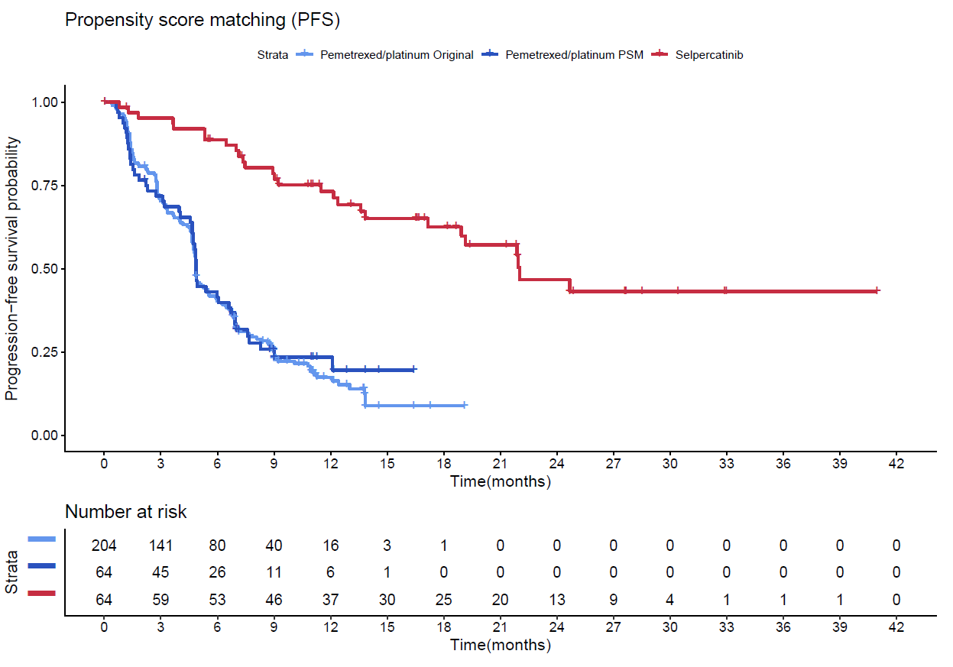
Source: Figure 2-50, p268 of the submission
ECOG PS=Eastern Cooperative Oncology Group performance status; PFS=progression-free survival; PC=pemetrexed + platinum chemotherapy
Control arm was matched by age, the proportion of female patients, the proportion of patients who never smoked, ECOG PS, race, and stage at diagnosis.
Figure 2: Kaplan-Meier Curves for overall survival for selpercatinib and PC using propensity score matching
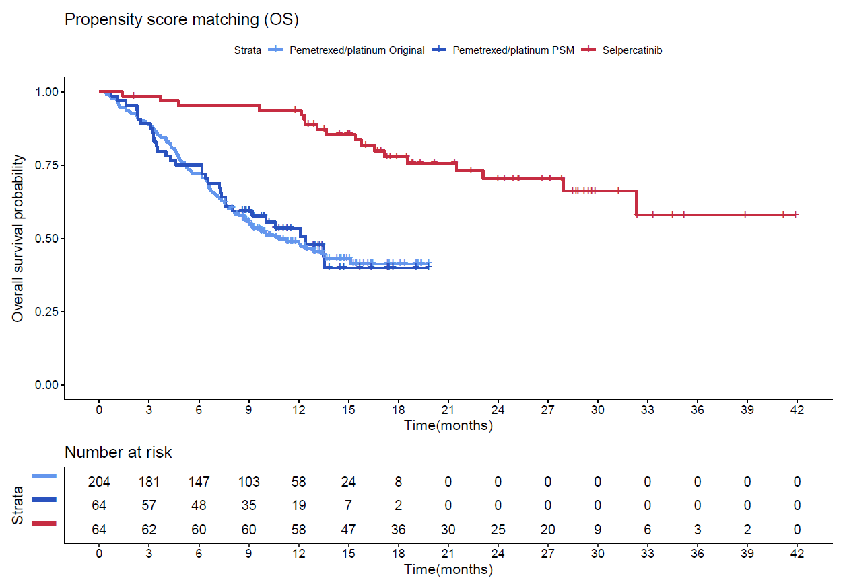
Source: Figure 2-50, p268 of the submission
ECOG PS= Eastern Cooperative Oncology Group performance status; OS=overall survival; PC=pemetrexed + platinum chemotherapy
Control arm was matched by prognostic factors: age, the proportion of female patients, the proportion of patients who never smoked, ECOG PS, race, and stage at diagnosis
  - Results of the indirect comparisons based on the NMA are summarised in Table 10, and Table 11 for PFS, and OS, respectively.
Table 10: Relative treatment effect estimates of PFS expressed as HRs, network meta-analysis, random effects model
Treatment comparison | Median HR (95% CrI) versus pemetrexed + platinum chemotherapy
Selpercatinib versus PC (pseudo-control) | 0.20 (0.11, 0.37)
Pembrolizumab + PC versus PC | 0.52 (0.40, 0.68)
Selpercatinib vs. Pembrolizumab + PC | 0.39 (0.20, 0.76)
Source: Tables 2-108 and 2-109, p272 of the submission
CrI=credible interval; HR=hazard ratio (rounded to 2 decimal places); PC=pemetrexed + platinum chemotherapy; PFS=progression-free survival
Table 11: Relative treatment effect estimates of OS expressed as HRs, network meta-analysis, random effects model
Treatment comparison | Median HR (95% CrI) versus PC
Selpercatinib versus PC (pseudo-control) | 0.21 (0.10, 0.41)
Pembrolizumab + PC versus PC | 0.61 (0.49, 0.76)
Selpercatinib vs. Pembrolizumab + PC | 0.34 (0.17, 0.69)
Source: Tables 2-112 and 2-113, p275 of the submission
CrI=credible interval; HR=hazard ratio (rounded to 2 decimal places); OS=overall survival; PC=pemetrexed + platinum chemotherapy
  - The NMA-based indirect comparisons indicated that:
        - selpercatinib was associated with a 61% reduction in the hazard of progression or death compared to pembrolizumab + PC (HR=0.39; 95% CI: 0.20, 0.76); and
        - selpercatinib was associated with a 66% reduction in the hazard of death compared to pembrolizumab + PC (HR=0.34; 95% CI: 0.17, 0.69).
  - There is a high degree of uncertainty associated with the indirect estimates of relative treatment effect. There is the potential for residual confounding due to i) imbalances, despite matching for some covariates, that may have favoured selpercatinib (most notably ‘never smoking’), and ii) other unknown confounders that may impact the indirect estimates in either direction.
  - The NMA was conducted by synthesising HRs for time-to-event endpoints (such as OS and PFS) assuming constant relative hazards between treatment arms (proportional hazards (PH) assumption). However, where the PH assumption does not hold, the NMA could lead to biased indirect estimates of the HR. The PH assumption did not hold for both PFS and OS in the KN-189 trial.
  - Results for the anchored indirect comparison, via a generated common reference arm, of PFS and OS are summarised in Table 12.
Table 12: Anchored indirect comparison of PFS and OS between selpercatinib and pembrolizumab plus PC
Outcome | Trial | Hazard ratio (95% CI), p-value
PFS | Selpercatinib vs generated pseudo-control PC
 | LIBRETTO PSM | 0.2 (0.1, 0.3), p<0.001
 | Pembrolizumab + PC vs PC
 | KEYNOTE-189 | 0.5 (0.4, 0.6), p<0.001
 | KEYNOTE-021 Cohort G | 0.5 (0.3, 0.8), p=0.010
 | Pooled result from random effects model | 0.51 (0.43, 0.60), p<0.001
 | Q (df), p-value: 0.1 (1) p=0.747
 | I², %, (95% CI): 0 (NR, NR)
 | Indirect comparison selpercatinib vs pembrolizumab + PC | 0.40 (0.23, 0.71), p=0.002
OS | Selpercatinib vs generated pseudo-control PC
 | LIBRETTO PSM | 0.2 (0.1, 0.4), p<0.001
 | Pembrolizumab + PC vs PC
 | KEYNOTE-189 | 0.6 (0.5, 0.7), p<0.001
 | KEYNOTE-021 Cohort G | 0.7 (0.5, 1.1), p=0.140
 | Pooled result from random effects model | 0.61 (0.52, 0.73), p<0.001
 | Q (df), p-value: 0.45 (1), p=0.502
 | I² , %, (95% CI): 0 (NR, NR)
 | Indirect comparison selpercatinib vs pembrolizumab + PC | 0.33 (0.17, 0.66), p=0.002
Source: Table 2-115, p277 of the submission and the published results for KN-189 (Rodríguez et al 2021) and KN-021 (Awad et al 2021).
CI=confidence interval; df=degrees of freedom; NR=not reported; OS=overall survival; PC=pemetrexed + platinum chemotherapy; PFS=progression-free survival; PSM=propensity score matching.
Median durations of follow-up varied across the studies: LIBRETTO-001: 25.2 months; KN-189: 31.0 months; KN-021: 49.4 months
I²=The I² index measures the extent of heterogeneity by dividing the result of Cochran's Q test and its degrees of freedom by the Q-value itself.
A DerSimonian-Laird random effects model was used to pool the efficacy results across the KN-189 and KN-021 studies
  - The anchored indirect comparison indicated that selpercatinib was associated with a 60% reduction in the hazard of progression or death compared to pembrolizumab + PC which was statistically significant (PFS HR: 0.40; 95% CI: 0.23, 0.71, p=0.002). Treatment with selpercatinib was also associated with a 67% reduction in hazard of death compared to pembrolizumab + PC which was statistically significant (OS HR: 0.33; 95% CI: 0.17, 0.66, p=0.002).
  - Essentially, the anchored indirect comparison between selpercatinib and pembrolizumab + PC used the synthetic HR for selpercatinib (relative to the pseudo-control PC arm created from PSM) and the published summary HR for pembrolizumab + PC (relative to the original randomised PC arm of the KN-189 trial). Thus, the “common reference” of PC varies substantially between the data sets being compared in terms of baseline prognostic factors and sample size due to the direct impact of matching. This raises a fundamental transitivity issue associated with this indirect comparison.
  - The anchored indirect comparison of HRs shares several of the limitations associated with the NMA including, amongst others, the unknown impact of the prognostic effect of RET fusion status, other unmeasured confounding, and not meeting the underlying assumption of constant proportional hazards.
  - Other concerns with the indirect comparisons include:
        - differences in median follow-up durations across the studies (LIBRETTO-001: 25.2 months (Clinical Study Report June 20210; KN-189: 31.0 months; KN-021: 49.4 months); and
        - the unknown impact of treatment switching in the KN-189 and KN-021 studies. 41% and 70% of patients switched from the PC arm to the pembrolizumab + PC arm in Studies KN-189 and KN-021, respectively. This treatment switching would tend to disfavour the pembrolizumab + PC arm relative to PC in KN-189. However, the overall impact on the indirect estimates of effect between selpercatinib and pembrolizumab + PC remains unknown.
  - The MAIC approach implemented in the submission was to match IPD from the treatment-naïve NSCLC cohort of LIBRETTO-001 to baseline characteristics (using published data) of the pembrolizumab + PC arm of KN-189.
  - The covariates considered for matching/weighting were age, smoking status, sex, ECOG PS, and the presence of brain metastases. The submission noted that due to the large imbalance in smoking status between the LIBRETTO-001 and KN-189 studies, and the resulting impact on the effective sample size (ESS) when used for matching, two models were considered:
- Model 1: matching for prespecified covariates except for smoking status; and
- Model 2: matching for all the prespecified covariates including smoking status.
  - The baseline characteristics, before and after adjustment, varying across the arms being compared are presented in Table 13.
Table 13: Baseline characteristics in LIBRETTO-001 (treatment-naïve) and KN-189 before and after adjustment - Model 1 (no adjustment for smoking status)
Characteristics | Category | LIBRETTO-001 (RET fusion-positive) |  | Keynote - 189  Pembrolizumab + Platinum chemotherapy N=410  Regardless of RET status
 |  | Before adjustment N=69 | After adjustment ESS=46.5^{b}
Mean age, years | Mean (SD) | 61.5 (13.0) | 65.0 (7.4) | 65.0 (8.3)ª
Sex | Female | 43 (62.3%) | 21 (38.1%) | 156 (38.0%)
Smoking history | Never smoked | 48 (69.6%) | 34 (63.4%) | 48 (11.7%)
ECOG PS | 0 | 25 (36.2%) | 24 (45.1%) | 185 (45.1%)
 | 1 | 40 (58.0%) | 28 (52.1%) | 221 (53.9%)
 | 2 | 4 (5.8%) | 1 (2.7%) | 1 (0.2%)
Brain metastases | at baseline | 16 (23.2%) | 10 (17.8%) | 73 (17.8%)
Source: Table 2-117, p281 of the submission.
ECOG= Eastern Cooperative Oncology Group; ESS=effective sample size; PS=performance status; RET=Rearranged during Transfection; SD=standard deviation
ª Mean age for KN-189 was assumed to be equal to median age. SD was calculated as range divided by 6.
^{b} Percentages for patient characteristics after adjustment were not based on the ESS or the original sample size of 69. The denominators used could not be identified from the submission or the technical report (Attachment A3.4) accompanying the submission.
Percentages rounded to one decimal place.
Table 14: Baseline characteristics in LIBRETTO-001 (treatment-naïve) and KN-189 before and after weighting - Model 2 (adjusted for smoking status)
Characteristics | Category | LIBRETTO-001 RET fusion-positive |  | Keynote - 189  Pembrolizumab + Platinum chemotherapy N=410  Regardless of RET fusion status
 |  | Before adjustment N=69 | After adjustment ESS=21.83^{b}
Mean age, years | Mean (SD) | 61.5 (13.0) | 65.0 (5.4) | 65.0 (8.3)ª
Sex | Female | 43 (62.3%) | 11 (38.1%) | 156 (38.0%)
Smoking history | Never smoked | 48 (69.6%) | 3 (11.7%) | 48 (11.7%)
ECOG PS | 0 | 25 (36.2%) | 13 (45.1%) | 185 (45.1%)
 | 1 | 40 (58.0%) | 15 (51.4%) | 221 (53.9%)
 | 2 | 4 (5.8%) | 1 (3.5%) | 1 (0.2%)
Brain metastases | at baseline | 16 (23.2%) | 5 (17.8%) | 73 (17.8%)
Source: Table 2-118, p282 of the submission.
ECOG= Eastern Cooperative Oncology Group; ESS=effective sample size; PS=performance status; RET=Rearranged during Transfection SD=standard deviation
ª Mean age for KN-189 was assumed to be equal to median age. SD was calculated as range divided by 6
^{b} Percentages for patient characteristics after adjustment were not based on the ESS or the original sample size of 69. The denominators used could not be identified from the submission or the technical report (Attachment A3.4) accompanying the submission.
Percentages rounded to one decimal place.
  - Matching resulted in a reduced sample size of the treatment-naïve cohort LIBRETTO-001 study which originally was only comprised of 69 patients. This impacts the reliability of the results and indicates the lack of overlap between the LIBRETTO-001 and KN-189 studies. Where there is poor overlap between the populations being compared, unanchored MAICs cannot adjust for several factors while maintaining a sufficiently large ESS:
- For Model 1, baseline characteristics were well balanced after matching except for ‘Never smokers’ which was not adjusted for. The sample size of the selpercatinib arm in LIBRETTO-001 (n=69) was reduced to an effective sample size (ESS) of 46.5 due to matching. Approximately 67% of the original sample size was retained.
- For Model 2, baseline characteristics were well balanced after matching for all the covariates including smoking. However, the sample size of the selpercatinib arm in LIBRETTO-001 (n=69) was substantially reduced due to matching to an ESS of 21.83. Approximately only 32% of the original sample size was retained.
  - Results of the unanchored MAICs for PFS and OS using Models 1 and 2 are summarised in Table 15. Unadjusted results are included for comparison. The PFS and OS KM curves for Model 1 are presented in Figure 3 and Figure 4, respectively. The PFS and OS KM curves for Model 2 are presented in Figure 5 and Figure 6, respectively.
Table 15: Indirect comparison of PFS and OS - unadjusted analysis and MAIC Models 1 and 2
Model | KN-189  Pembrolizumab + PC  Regardless of RET fusion status  Median (95% CI) | LIBRETTO-001  Selpercatinib  RET fusion-positive  Median (95% CI) | Selpercatinib vs Pembrolizumab + PC  HR (95% CI) [p-value]
PFS
Unadjusted (non-matching) | 9.0 months (8.2, 10.5) | 21.9 months (13.8, NR) | 0.46 (0.32, 0.66) [p<0.001]
Adjusted Model 1 | 9.0 months (8.2, 10.5) | 21.9 months (11.5, NR) | 0.44 (0.29, 0.67) [p<0.001]
Adjusted Model 2 | 9.0 months (8.2, 10.5) | 21.9 months (NR, NR) | 0.48 (0.27, 0.84) [p=0.01]
OS
Unadjusted (non-matching) | 22.2 months (19.7, 24.7) | NR (27.9, NR) | 0.43 (0.27, 0.67) [p<0.001]
Adjusted Model 1 | 22.2 months (19.7, 24.7) | NR (27.9, NR) | 0.38 (0.23, 0.65) [p<0.001]
Adjusted Model 2 | 22.2 months (19.7, 24.7) | NR (16.6, NR) | 0.43 (0.21, 0.89) [p=0.023]
Source: Table 2-120, p283 of the submission
CI=confidence interval; ESS=effective sample size; HR=hazard ratio; MAIC= Matching adjusted indirect comparison; N=original sample size; NR=not reached; OS=overall survival; PFS=progression-free survival; RET=rearranged during transfection
Model 1=no adjustment for smoking status; Model 2=Adjustment for smoking status.
Figure 3: Kaplan-Meier plot of PFS from unadjusted analysis and MAIC Model 1
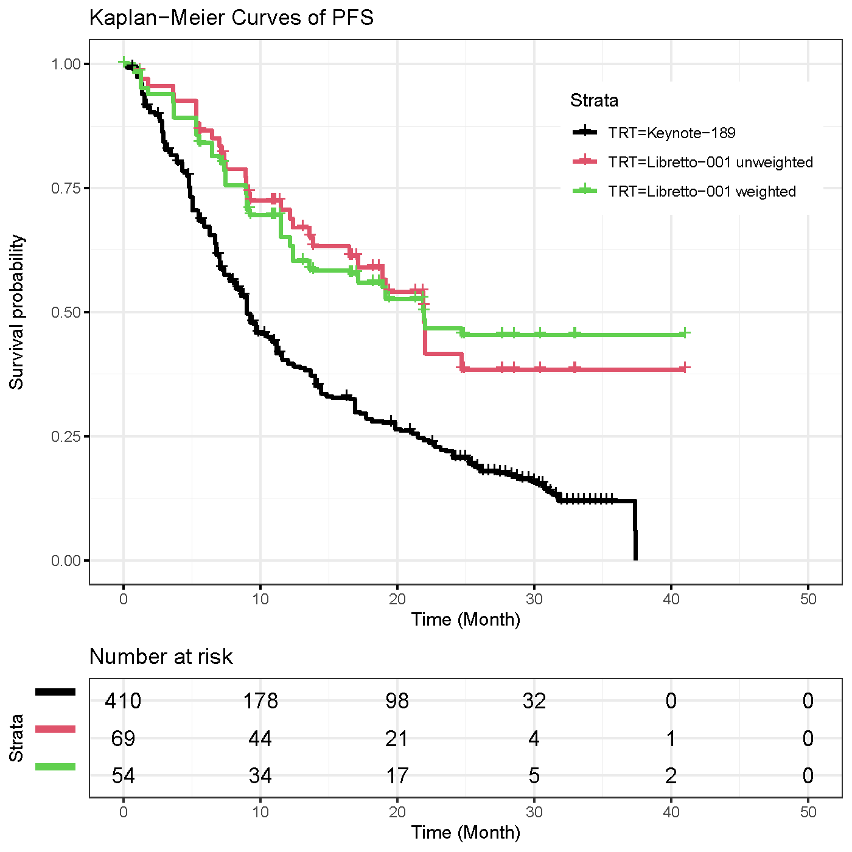
Source: Figure 2-57, p 284 of the submission
MAIC= Matching adjusted indirect comparison; PFS=progression-free survival

Figure 4: Kaplan-Meier plot of OS from unadjusted analysis and MAIC Model 1
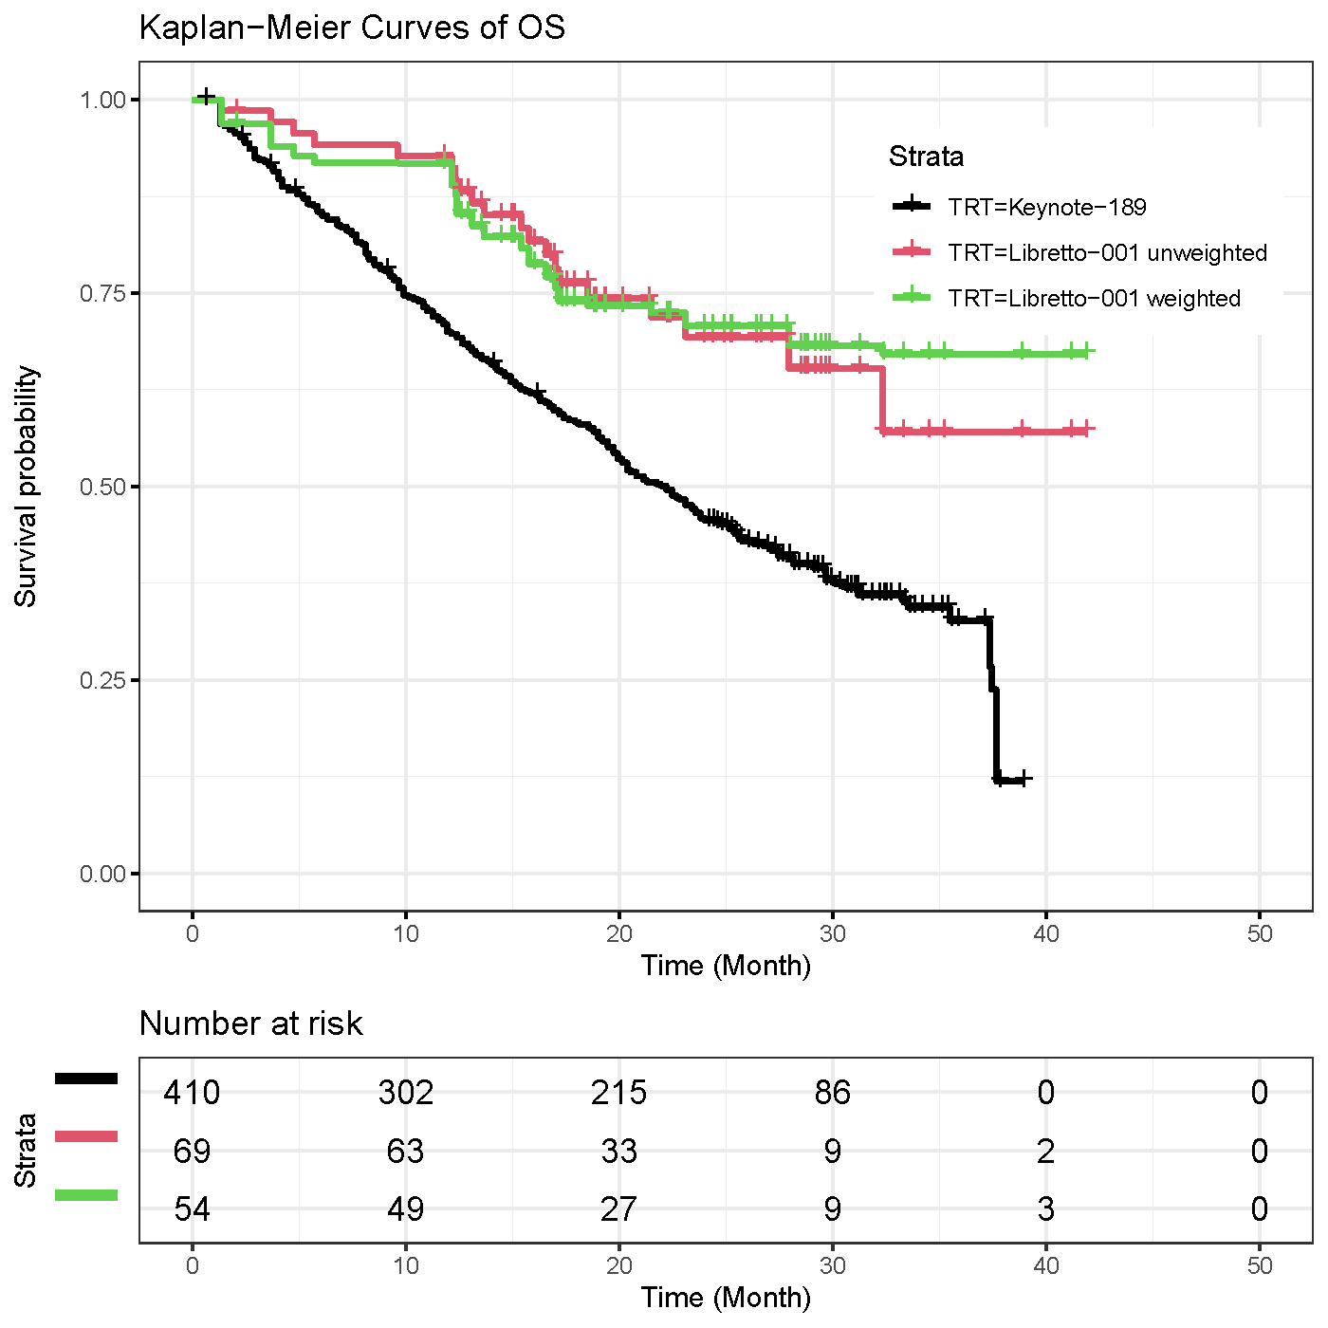
Source: Figure 2-58, p 285 of the submission
MAIC= Matching adjusted indirect comparison; OS=overall survival

Figure 5: Kaplan-Meier plot of PFS in unadjusted analysis and MAIC Model 2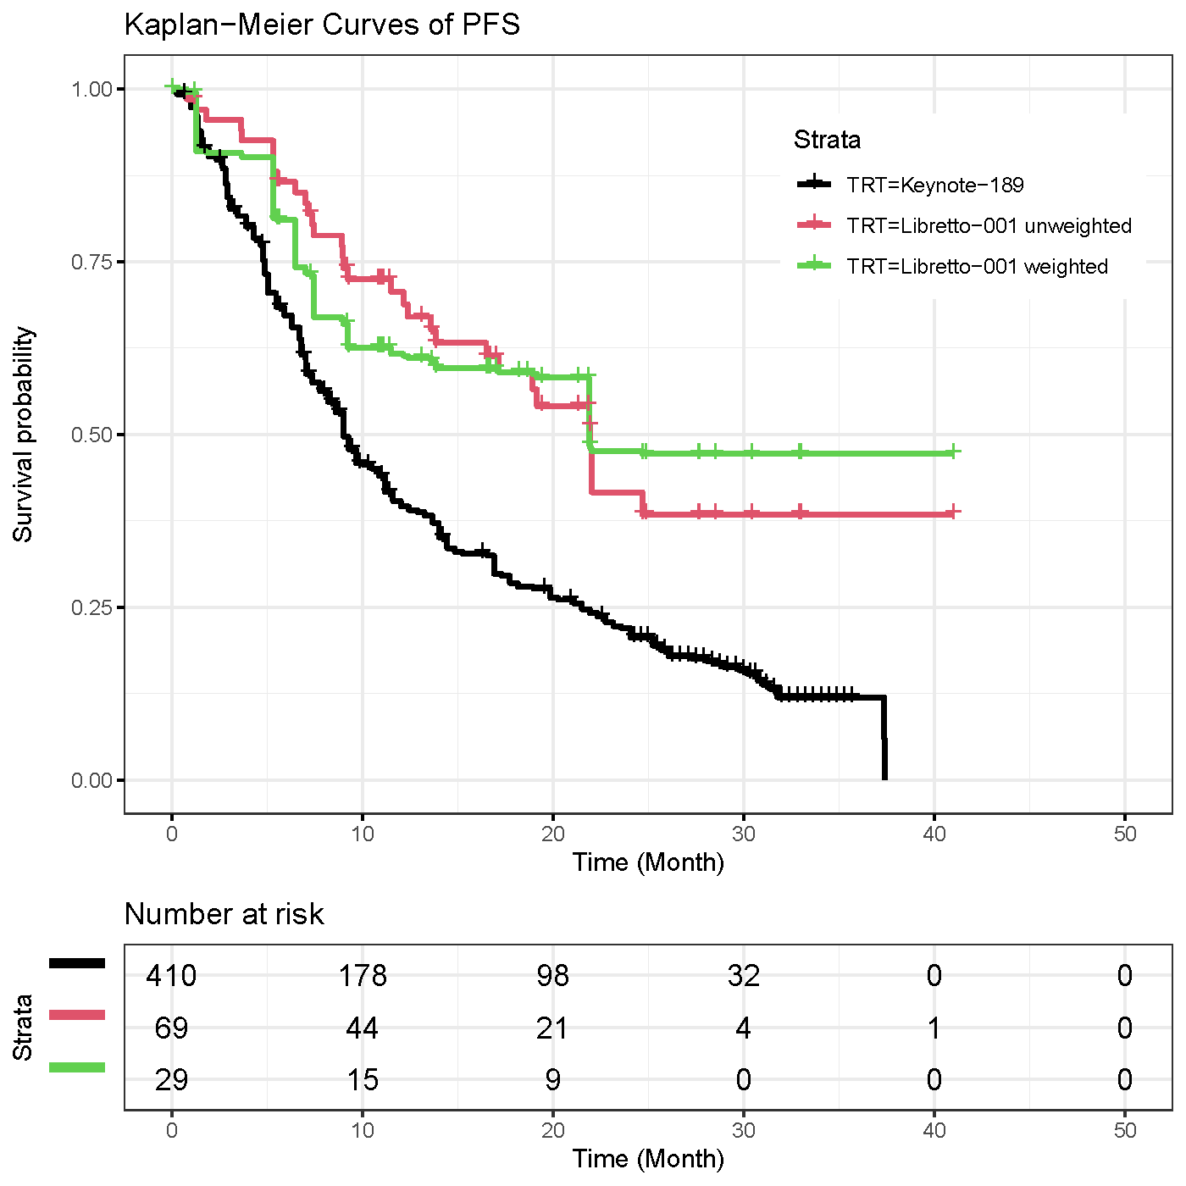
Source: Figure 2-58, p 285 of the submission
MAIC= Matching adjusted indirect comparison; PFS=progression-free survival

Figure 6: Kaplan-Meier plot of OS from unadjusted analysis and MAIC Model 2
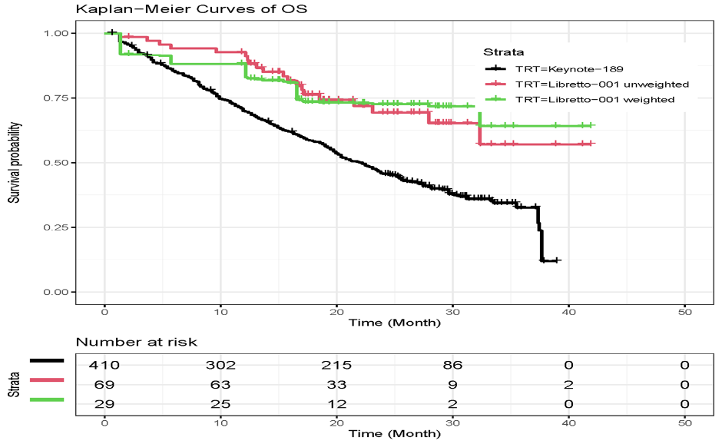
Source: Figure 2-58, p 285 of the submission
MAIC= Matching adjusted indirect comparison; OS=overall survival

  - There was no clear trend in the magnitude of the HRs across the unadjusted and adjusted models with largely overlapping 95% CIs. Across the unadjusted and adjusted models, the HRs for PFS and OS were statistically significant favouring selpercatinib over pembrolizumab + PC. Furthermore, due to the interdependence of variables, and different weights applied to each patient, matching of specific characteristics is likely to affect the distribution of other characteristics. Conducting an unanchored MAIC across all confounders does not appear possible in this circumstance given the extent of data available for matching and the small sample size of the selpercatinib cohort. As for the other indirect comparisons, the residual bias due to covariates that were unadjusted for, and the extent of this bias, remains unknown.
  - The PSCR highlighted that the submission had provided a NMA, an anchored indirect comparison and an unanchored MAIC and argued that the estimates of comparative effectiveness in terms of PFS, OS and ORR were consistent across all these methods of analysis. The ESC acknowledged the submission provided sufficient information regarding the methodological approach to each of the analyses undertaken. The ESC considered that the NMA and anchored ITCs share similar limitations as they are dependent on the synthetic pseudo-control PC arm with residual imbalances evident post propensity score matching (see paragraph 6.28). In addition, the ESC noted that matching also substantially decreased the original sample size of the PC arm from KN-189 (N=206) by approximately two-thirds (n=64) (see paragraph 6.29) and agreed with the evaluation that this indicated a lack of overlap in characteristics between the populations. The ESC noted the small EES for the unanchored MAIC and considered this limited the reliability and applicability of the indirect comparison results.

Comparative harms
LIBRETTO-001
  - Given LIBRETTO-001 is a single arm study, comparative safety data were not available. Safety data were presented for the NSCLC safety population which included both treatment-naïve and pre-treated patients.
  - Table 16 summarises treatment emergent adverse events (TEAEs) in LIBRETTO-001. Table 17 summarises TEAEs related to selpercatinib by preferred term in LIBRETTO-001.
Table 16: Summary of TEAEs in the NSCLC Safety Population in LIBRETTO-001
 | NSCLC Safety Population (N=356)
Any TEAE, n (%)
Regardless of cause | 356 (100.0)
Related to selpercatinib | 341 (95.8)
Grade ≥3 TEAE, n (%)
Regardless of cause | 263 (73.9)
Related to selpercatinib | 143 (40.2)
TEAE leading to permanent treatment discontinuation, n (%)
Regardless of cause | 34 (9.6)
Related to selpercatinib | 11 (3.1)
TE-SAE, n (%)
Regardless of cause | 173 (48.6)
Related to selpercatinib | 52 (14.6)
Fatal TEAE, n (%)
Regardless of cause | 24 (6.7)
Related to selpercatinib | 0
Source: Table 2-91, p248 of the submission:
Data cutoff 15 June 2021
Severity grade assignment based on CTCAE (v4.03).
CTCAE=common terminology criteria for adverse events; N=number of patients; n= number of patients in specific category; NSCLC=non-small cell lung cancer; TEAE=treatment-emergent adverse event; TE-SAE=treatment-emergent serious adverse event.
Table 17: TEAEs Related to Selpercatinib as Assessed by the Investigator (Occurring ≥15% of Patients) in LIBRETTO-001
Preferred or Composite Term | NSCLC Safety Population (N=356)
 | Any Grade  Related n (%) | Grade ≥3  Related n (%)
Patients with TEAEs related to Selpercatinib | 341 (95.8) | 143 (40.2)
Dry mouth | 151 (42.4) | 0 (0.0)
Oedema | 124 (34.8) | 2 (0.6)
AST increased | 122 (34.3) | 24 (6.7)
ALT increased | 120 (33.7) | 41 (11.5)
Hypertension | 95 (26.7) | 49 (13.8)
Fatigue | 78 (21.9) | 3 (0.8)
Diarrhea | 114 (32.0) | 8 (2.2)
Rash | 83 (23.3) | 4 (1.1)
Electrocardiogram QT prolonged | 57 (16.0) | 14 (3.9)
Source: Table 2-94, p251 of the submission
AESI=adverse event of special interest; ALT= Alanine aminotransferase; AST= Aspartate aminotransferase; ECG=echocardiogram; NSCLC=non-small cell lung cancer; TEAEs=Treatment-Emergent Adverse Events
  - The percentage of patients in the NSCLC Safety Population with at least one selpercatinib-related TEAE was 95.8%. The percentage of patients with TEAEs of ≥ Grade 3 related to selpercatinib (40.2%) appeared high. The incidence of selpercatinib-related TEAEs leading to permanent treatment discontinuation was 3.1%. These included alanine aminotransferase (ALT) increased, aspartate aminotransferase (AST) increased, fatigue and drug sensitivity (occurring in 2 patients each (0.6%).
  - Commonly reported selpercatinib-related serious adverse events (SAEs) were hypersensitivity (3.9%), ALT increased (1.7%), and AST increased (1.7%). The most frequently reported selpercatinib-related TEAEs were dry mouth (42.4%), oedema (34.8%), AST increased (34.3%), and ALT increased (33.7%). By severity grade, the incidence of selpercatinib-related TEAE of Grade ≥ 3 severity was 40.2% with the most commonly being hypertension (13.8%), ALT increased (11.5%), and AST increased (6.7%). The ESC noted the percentage of patients with Grade ≥ 3 AEs appeared largely driven by abnormal LFT results and hypertension and considered that such AEs do not necessarily require hospitalisation and may be asymptomatic.
  - The incidence of TEAEs of QT prolongation related to selpercatinib was 16.0%. The majority of these events were of Grades 1 or 2 in severity. There were no deaths due to a selpercatinib-related TEAE. There were 78 deaths (21.9%) occurring more than 28 days from the last dose of selpercatinib. The most common cause of these deaths was disease progression (16.3%; 58/356).
  - The TGA Clinical Evaluation Report noted that although the incidence of interstitial lung disease (ILD) or pneumonitis was low in the overall (1.5%) and NSCLC (0.8%) safety populations, ILD/pneumonitis has been reported with pralsetinib (another selective RET inhibitor) and other multikinase inhibitors, and that a potential class effect is possible, but more data are required to support this conclusion.
  - Overall, selpercatinib appears to be associated with substantial toxicity as indicated by the incidence of Grade ≥3 TEAEs (40.2%) and treatment emergent SAEs (14.6%) related to the drug. The TGA clinical evaluation report and European assessment report (p115, Assessment report EMA/9037/2021) for selpercatinib noted that the safety profile of selpercatinib is nevertheless consistent with that seen for other TKIs, and has been considered generally manageable in both reports.
Indirect comparisons
  - No formal indirect statistical analyses were conducted for assessing comparative safety. The submission presented comparisons of AEs between single arms using the safety populations of the LIBRETTO-001, KN-189 (pembrolizumab + PC arm), and KN-021 Cohort G (pembrolizumab + PC arm) studies. These are summarised in Table 18.
Table 18: Overall TEAEs across LIBRETTO-001, KN-189, and KN-021 Cohort G
Event | LIBRETTO-001 | KN-189 | KN-021 Cohort G
 | NSCLC Safety Population (N=356) | Pembro + PC  (N=405) | Pembro + PC  (N=59)
TEAE, n (%) | 356 (100.0) | 404 (99.8) | NR
Grade 3–5 | 263 (73.9) | 292 (72.1) | NR
Led to death | 24 (6.7) | 29 (7.2) | NR
Led to treatment discontinuation | 34 (9.6) | 146 (36.0) | NR
TEAE related to treatment, n (%) | 341 (95.8) | 376 (92.8) | 55 (93.0)
Grade 3–5 | 143 (40.2) | 212 (52.3) | 23 (39.0)
Led to death | 0 (0.0) | 8 (2.0) | 1 (2.0)
Led to treatment discontinuation | 11 (3.1) | 110 (27.2) | 10 (17.0)
Source: Table 2-125, p295 of the submission.
NR=not reported; PC=pemetrexed + platinum chemotherapy; Pembro=pembrolizumab; TEAE=treatment-emergent adverse event
  - Comparing the safety profiles of selpercatinib and pembrolizumab + PC is difficult due to the differences in mechanism of action and the trial populations. Safety data varied even among the pembrolizumab + PC arms across the KN-189 and KN-021 trials. For example, there was a higher proportion of patients in KN-189 compared to KN-021 with treatment-related Grade 3-5 TEAEs (52.3% vs. 39.0%) and TEAEs leading to treatment discontinuation (27.2% vs. 17.0%).
  - The majority of patients experienced a treatment–related TEAE across the LIBRETTO-001 (95.8%), KN-189 (92.8%), and KN-021 (93.0%) studies. The proportion of patients experiencing treatment-related TEAEs of Grade 3-5 appeared similar between the LIBRETTO-001 and KN-021 studies (40.2% vs. 39.0%) but higher in the KN-189 study (52.3%).
  - A lower proportion of patients experienced a TEAE that led to a permanent treatment discontinuation in LIBRETTO-001 (3.1%) compared to KN-189 (27.2%) and KN-021 (17.0%). The submission stated that this lower rate of treatment discontinuation with selpercatinib due to TEAEs demonstrate a safety advantage over pembrolizumab + PC.
  - The submission presented a comparison of specific treatment-related TEAEs across LIBRETTO-001 and KN-189 (pembrolizumab + PC arm) which included adverse events of special interest (AESIs) related to selpercatinib and chemotherapy. The submission concluded that there was a lower proportion of patients experiencing any grade and severe haematologic toxicities including neutropenia and anaemia with selpercatinib compared to pembrolizumab + PC.
  - AESIs differ between selpercatinib (such as ALT/AST increased, echocardiogram (ECG) QT prolongation and hypertension), pembrolizumab (immune-mediated AEs), and chemotherapy (haematologic AEs). A meaningful interpretation of the safety data, in terms of comparative safety, is therefore problematic. Overall, a more reasonable interpretation of the safety data is that selpercatinib, pembrolizumab, and PC have different safety profiles.

Benefits/harms
  - Given the uncertainty associated with the indirect comparisons between selpercatinib and pembrolizumab + PC, and the naïve nature of the comparisons for safety data, a benefits/harms table has not been presented.

Clinical claim
  - For the first-line setting, the submission described selpercatinib as superior to pembrolizumab + PC in terms of effectiveness. The submission described selpercatinib as having a different, but manageable, safety profile compared to pembrolizumab + PC.
  - Although the data from the individual studies indicated selpercatinib may be superior to pembrolizumab + PC in terms of ORR, PFS, and OS, the indirect comparisons were associated with several uncertainties. Transitivity was questionable given the differences in patient and disease characteristics across the studies. The evaluation considered the evidence was inadequate to support a conclusive claim on comparative effectiveness.
  - The results of the indirect comparisons based on the NMA, anchored approach, and unanchored MAICs, were associated with a high risk of bias whereby the true effect of this bias is unknown. Aside from residual confounding after matching, which was likely to favour selpercatinib, matching or weighting for numerous covariates (at the expense of precision) and for unknown confounders is not feasible. The PSCR argued that PFS, OS and ORR outcomes were consistent across the different methods of analyses employed and therefore a claim of superior comparative effectiveness of selpercatinib to pembrolizumab + PC was supported. The ESC agreed with the evaluation that the indirect comparisons were associated with a high degree of uncertainty with several transitivity, applicability and reliability issues. In particular, the ESC was concerned regarding the differences in RET status between the LIBRETTO-001 and KN-189 and KN-021 studies (see paragraphs 6.24 and 6.25) and the residual imbalances evident post propensity score matching (see paragraph 6.28) along with the significant reduction in the sample size after matching (see paragraph 6.46). Overall, the ESC considered that the true extent of confounding and the magnitude of the comparative treatment effect of selpercatinib compared with pembrolizumab + PC remains unknown. As such, the ESC agreed with the evaluation that the evidence was inadequate to support a conclusive claim on comparative effectiveness.
  - Recognising that the submission provided a descriptive unanchored comparison of AEs between single arms, the ESC agreed with the evaluation that the claim that selpercatinib has a different, but manageable, safety profile compared to pembrolizumab + PC better describes the data and appeared reasonable.
  - The ESC noted that the anticipated primary completion date of the Phase III randomised controlled trial (LIBRETTO-431) comparing selpercatinib to platinum-based and pemetrexed therapy with or without pembrolizumab as initial treatment of advanced RET fusion-positive non-squamous NSCLC is December 2023. The ESC considered that given the current clinical (and subsequent economic) uncertainties associated with the use of the LIBRETTO-001 study, it may be appropriate to wait for the results of the LIBRETTO-431 study prior to making a decision on selpercatinib for RET fusion-positive NSCLC. The pre-PBAC response continued to argue that the evidence presented within the submission and supplemented through the PSCR and pre-PBAC responses adequately substantiated the claim of superior effectiveness of selpercatinib versus pembrolizumab + PC.
  - The PBAC considered that the claim of superior comparative effectiveness was not adequately supported by the data.
  - The PBAC considered the claim that selpercatinib has a different, but manageable, safety profile compared to pembrolizumab + PC was reasonable.

Economic analysis
  - The submission presented a stepped economic evaluation of selpercatinib compared with pembrolizumab + PC as first-line therapy for treatment of RET fusion-positive, locally advanced or metastatic NSCLC, on the basis of the ITC of the treatment-naïve cohort of the LIBRETTO-001 study and the pembrolizumab trials KN-189 and KN-021.
  - The key components of the economic evaluation are summarised in Table 19, with major economic issues discussed in the following paragraphs.
Table 19: Summary of model structure, key inputs and rationale
Component | Summary
Treatments | Selpercatinib vs. pembrolizumab + PC in patients with RET fusion-positive NSCLC (treatment-naïve setting)
Time horizon | 20 years compared with a median follow-up of 25.2 months for OS in the treatment-naïve cohort of LIBRETTO-001.
Outcomes | LYs gained and QALYs gained
Methods used to generate results | Partitioned survival model (i.e. area under the curve)
Health states | Three health states: PFS, PD and death
Cycle length | 1 week
Allocation to health states and extrapolation method | Health state allocation over time in the selpercatinib arm was determined by the PFS and OS data from the treatment-naïve cohort of the selpercatinib trial LIBRETTO-001 up to median follow-up (21.9 months for PFS and 25.2 months for OS).  To estimate the survival in patients receiving pembrolizumab + PC, a pseudo-control arm (i.e. PC alone) was first constructed by matching the PC arm of KN-189 to the IPD of the selpercatinib arm in LIBRETTO-001, using PSM.  The PFS and OS estimates for selpercatinib after the trial data truncation time point and the PFS and OS for the pseudo-control arm were generated through the application of parametric survival functions, which were determined based on goodness of fit statistics, visual inspection, clinician opinion and external data. The PFS and OS functions for pembrolizumab + PC were constructed by applying the hazard ratio generated through the NMA to the pseudo-control arm.  Approximately 86% of undiscounted incremental LYs and 84% of undiscounted incremental costs were accrued over the extrapolated period (between 25.2 months and 20 years).
Health related quality of life | Health state utility values were derived from the EQ-5D results from the KN-189 trial using Australian-based valuations, which were used for the pembrolizumab + PC arm in the previous pembrolizumab economic model (considered at the July 2019 PBAC meeting). Utility decrements associated with adverse events were applied as a one-off in the first cycle.  Health state utilities:  PFS: 0.776 in both treatment arms; PD: 0.714 in both treatment arms
Source: Table 3-1, p320 of the submission.
EQ-5D = EuroQol-5 Dimensions; IPD = individual patient data; LYs = life years; NMA = network meta-analysis; NSCLC = non-small cell lung cancer; OS = overall survival; PC = pemetrexed + platinum chemotherapy; PD = progressed disease; PFS = progression-free survival; PSM = propensity score matching; QALYs = quality-adjusted life years; RET = rearranged during transfection
  - The economic model used a 20-year time horizon. The submission argued that this extended time horizon was chosen given the relatively younger age of NSCLC patients with RET fusions. The median age of the treatment-naïve cohort in LIBRETTO-001 (n=69) was 63.0 years, which was similar to the median patient age in the overall NSCLC population in Trials KN-189 (63.5-65.0 years) and KN-021 (62.5-63.2 years). There is no conclusive evidence that the presence of RET fusion is a good or poor independent prognostic factor for NSCLC patients. More importantly, the short follow-up period of the LIBRETTO-001 trial and the concern surrounding the ITC approaches did not provide a reliable basis for the long-term extrapolation which appeared overly optimistic (discussed in Paragraph 6.81). The PBAC has previously accepted a 7.5-year time horizon for first-line advanced NSCLC when particular specifications around costing and extrapolations were applied (Pembrolizumab PSD, November 2017 PBAC meeting). This time horizon was adopted by the first-line pembrolizumab + PC economic models previously reviewed by the PBAC at the November 2018 and July 2019 PBAC meetings. The PSCR noted that approximately 16% of patients treated with selpercatinib in the treatment-naïve cohort were estimated to still be alive at 10 years within the economic model and | |% of patients in the treatment-naïve cohort of LIBRETTO-001 remained alive at median follow-up of approximately | |²¹ years at the January 2023 datacut. As such, the PSCR argued that a time horizon of 20 years was appropriate. The ESC considered a 20-year time horizon remained highly uncertain given the immature data available and advised that a shorter time horizon would be appropriate with the duration likely best informed by the results of the LIBRETTO-431 trial.
  - In the base case, the PFS and OS curves for pembrolizumab + PC were estimated by two steps. A pseudo-control arm was simulated by matching the PC arm of KN-189 to the IPD of the selpercatinib arm in LIBRETTO-001, using PSM. Then the PFS and OS HRs comparing pembrolizumab + PC versus PC, as generated through the NMA, were applied to the hazards predicted by the parametric functions for PFS and OS relating to the pseudo-control arm. Alternative ITC methods (Bucher ITC, MAIC 1 and MAIC 2) were considered as sensitivity analyses. The limitations of the PSM NMA and other ITC approaches are summarised in the “Comparative effectiveness” section. Overall, the indirect estimates of the comparative treatment effect of selpercatinib versus pembrolizumab + PC were multi-stepped and associated with a high degree of uncertainty, the adjustments made cannot adequately address the transitivity issues that may occur due to differences in oncogenes (i.e. RET fusions) or other characteristics with effects on prognosis. The ESC agreed with the evaluation that the uncertainty in the magnitude of the comparative PFS and OS benefits of selpercatinib relative to pembrolizumab + PC is the key economic concern that cannot be solved using the evidence base presented in the submission.
  - In the model, the submission used observed KM data for PFS and OS from the treatment-naïve patients in LIBRETTO-001 until median follow-up. The parametric functions to extrapolate the trial data for selpercatinib and to model PFS and OS for the pseudo-control arm in the base case, i.e. Gompertz for PFS and spline (knot = 1) model for OS, were determined on the basis of goodness of fit statistics, visual inspection, clinicians’ landmark estimates for PFS and OS, and external data from other studies of NSCLC therapies. All parametric functions appeared to provide a similar fit to trial-based KM data. There was no information on how the clinical experts were selected; neither did the submission provide the landmark estimates from individual clinicians or the basis for their estimates. The representativeness and validity of the clinician estimates, against which various parametric functions were compared, cannot be assessed. The external data used to validate the PFS and OS parametric extrapolations either investigated therapies targeting different oncogenic variants for treatment patients who may have different prognosis (e.g. alectinib and brigatinib for treatment of ALK-positive NSCLC in ALTA-1L and ALEX trials) or had patient/disease characteristics incomparable with those of LIBRETTO-001, in terms of age, disease stage, and/or RET fusion status (KN-189 and Tan et al 2020). Overall, the selection of the parametric distributions used in the base case was not well justified in the submission. Sensitivity analyses showed that the model was sensitive to the change in the extrapolation function for OS. The PSCR (pp3-4) maintained that all parametric extrapolation methods resulted in similar fits to the observed KM data and the spline knot 1 model was selected based on expert feedback and argued the approach taken provided a conservative estimate of the longer-term OS. The ESC considered that it was largely unclear how the clinicians’ landmark estimates were derived, and noted the model was highly sensitive to types of parametric extrapolations used (see Table 20).
  - Figure 7 and Figure 8 compare the trial-based KM data and the modelled survival curves for PFS and OS, respectively.
Figure 7: Trial-based versus modelled PFS
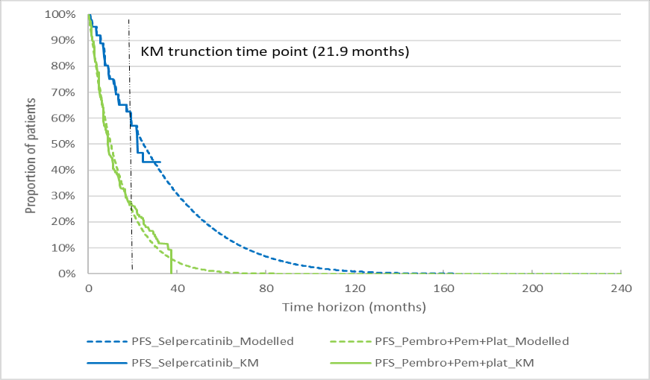
Source: Figure constructed during the evaluation from “A5.1_Selpercatinib Section 3 Workbook”.
KM = Kaplan-Meier; Pembro + Pem + Plat = pembrolizumab + pemetrexed + platinum; PFS = progression-free survival
Note: PFS KM curve for Pembro + Pem + Plat from Trial KN-189 was digitised from Rodríguez-Abreu et al 2021 (Figure 2A)
Figure 8: Trial-based versus modelled OS
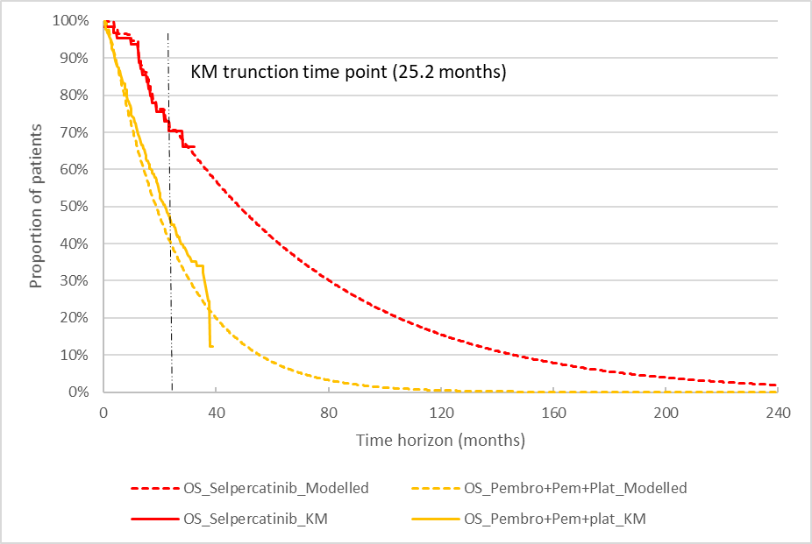
Source: Figure constructed during the evaluation from “A5.1_Selpercatinib Section 3 Workbook”.
KM = Kaplan-Meier; OS = overall survival; Pembro + Pem + Plat = pembrolizumab + pemetrexed + platinum
Note: OS KM curve for Pembro + Pem + Plat from Trial KN-189 was digitised from Rodríguez-Abreu et al 2021 (Figure 1A)
  - The OS estimates as observed in patients receiving pembrolizumab + PC in KN-189 were greater than the modelled OS for most of the trial period (orange solid line vs. orange dashed line, Figure 8). That is, the use of PSM NMA methodology for ITC resulted in a larger treatment benefit of selpercatinib in comparison with pembrolizumab + PC, in favour of selpercatinib. Throughout the time horizon of 20 years, higher proportions of patients treated with first-line selpercatinib remained alive than those in the comparator pembrolizumab + PC arm. Approximately 86% of undiscounted incremental life years (LYs) were accrued over the extrapolated period (between 25.2 months and 20 years).
  - Relative dose intensity (RDI), which was derived from the LIBRETTO-001 study in patients who had their treatment dose adjusted due to AEs, has been considered for costing selpercatinib and pembrolizumab + PC. The inclusion of dose reductions for pembrolizumab in the economic model was not reasonable, as no dose reductions are recommended by the pembrolizumab PI. Therefore, the re-specified base case included no dose reductions for pembrolizumab. It was also noted that the submission’s calculation of the drug costs for pembrolizumab and chemotherapy agents was not in line with the Efficient Funding of Chemotherapy (EFC) Program – the pharmacy mark-up (1.4%) was multiplied by other EFC fees, not by ex-manufacturer drug price, and the EFC mark-up/fees were applied per vial, not per infusion.
  - The distribution of subsequent treatments in the progressed disease (PD) health state was estimated based on the National Comprehensive Cancer Network (NCCN) guidelines for NSCLC. It was assumed that 90% of patients in the selpercatinib arm would subsequently receive pembrolizumab + PC upon disease progression, and the remaining 10% would receive second-line platinum doublet. For patients who experienced disease progression in the comparator pembrolizumab + PC arm, 100% would receive single-agent docetaxel in the second-line treatment setting. The current PBS restriction for pembrolizumab specifies that patients are eligible for pembrolizumab if they have not previously been treated for NSCLC in the metastatic setting, except for tepotinib. The base case economic model was built on the basis that the PBAC will accept the submission’ proposal of flow on changes to the listing of pembrolizumab to allow for its use after selpercatinib in metastatic NSCLC.
  - The submission did not provide the data source for the treatment duration of each subsequent therapy. The submission assumed shorter mean time to treatment discontinuation (TTD) for second-line pembrolizumab compared with that of second-line docetaxel (3.9 months vs. 4.1 months). This was not appropriate, considering the longer mean time in the PD health state for patients in the selpercatinib arm (receiving second-line pembrolizumab) than in the pembrolizumab + PC arm (receiving second-line docetaxel) in the economic model (undiscounted: 2.75 years vs. 0.96 years). This favoured selpercatinib. Given the extended duration of survival in PD that has been modelled, the base case analysis was re-specified during the evaluation by doubling the submission’s estimate of treatment duration of second-line pembrolizumab, along with other revisions. However, the appropriate duration to model use of second-line pembrolizumab remained an area of uncertainty. The PSCR stated that in the absence of alternative data sources, the economic analysis derived estimates of treatment duration of subsequent therapies from previously published National Institute for Health and Care Excellence (NICE) appraisal guidance documents for Pembrolizumab for treating PD-L1-positive NSCLC after chemotherapy, atezolizumab in combination for treating advanced non-squamous NSCLC and Pembrolizumab for untreated PD-L1-positive metastatic NSCLC (NICE TA428, NICE TA584, NICE TA531 respectively). The ESC considered the treatment duration of subsequent therapy should be consistent with the duration of the progressed disease health state, which was not the case for the selpercatinib arm of the economic model.
  - The economic model included the cost of RET fusion testing as proposed in the submission, i.e. $397.35. Assuming a prevalence of RET fusions in Australian NSCLC patients of 1.5%, a total of 66.67 patients needs to be tested, at a cost of $26,490, to identify one patient with RET fusions and, thus, eligible for selpercatinib. MSAC Application 1721 (small gene panel testing for NSCLC) has been recommended; and the MSAC supported RET gene fusion testing as part of its consideration of Application 1721. Therefore, patients diagnosed with NSCLC would undergo a multi-gene panel test, regardless the availability of selpercatinib. The inclusion of the testing cost for RET fusions in the economic evaluation was not reasonable.
  - A summary of the key drivers of the model is presented in Table 20.
Table 20: Key drivers of the model
Description | Method/Value | Impact  Base case: $|¹/QALY gained
Comparative treatment benefits of selpercatinib vs. pembrolizumab + PC | Estimated using the PSM NMA approach | High, likely favoured selpercatinib.  If the OS HR for pembrolizumab + PC vs. pseudo-control (i.e. PC) generated through NMA was reduced by 20%ª, the ICER increased to $||||². If the PFS and OS HRs from the NMA reduced further, the ICER could increase to above $||||³/QALY gained.
Extrapolation parametric function for OS | Spline knot 1 | High, direction cannot be determined.  Use of a stratified Gompertz distribution to extrapolate OS for both selpercatinib and the pseudo-control arm increased the ICER to $||||⁴/QALY gained.  Use of a generalised gamma distribution to extrapolate OS for selpercatinib decreased the ICER to $||||¹/QALY gained.
Time horizon | 20 years | Moderate, favoured selpercatinib.  Use of a 7.5-year time horizon increased the ICER to $||||²/QALY gained.
RET fusion testing cost | $26,490 per patient treated with selpercatinib | Moderate, favoured pembrolizumab + PC.  Exclusion of the testing cost reduced the ICER to $||||¹/QALY gained.
Treatment duration of pembrolizumab in the second-line setting | 5.7 3-weekly cycles, i.e. 3.9 months | Moderate, favoured selpercatinib  Doubling the treatment duration for pembrolizumab in the second-line setting increased the ICER to $||||²/QALY gained^{b}.
Source: Compiled during the evaluation, based on Section 3.9 of the submission and the sensitivity analyses performed during the evaluation.
HR = hazard ratio; ICER = incremental cost-effectiveness ratio; NMA = network meta-analysis; OS = overall survival; PC = pemetrexed + platinum chemotherapy; PFS = progression-free survival; PSM = propensity score matching; QALY = quality- adjusted life year; RET = rearranged during transfection
ª From 0.609 to 0.487 (Cell DS20, ‘1L NSCLC S(t)’, “A5.1_Selpercatinib Section 3 Workbook”).
^{b} From 16.96 weeks to 33.92 weeks (Cell H1403, ‘Country-Specific Data 1L NSCLC’, “A5.1_Selpercatinib Section 3 Workbook”)
The redacted values correspond to the following ranges:
¹ $55,000 to < $75,000
² $75,000 to < $95,000
³ $95,000 to < $115,000
⁴ $135,000 to < $155,000
  - The results of the stepped economic evaluation presented in the submission are summarised in Table 21. The PBAC noted the economic evaluation presented was based on the published price of pembrolizumab.
Table 21: Results of the stepped economic evaluation
Step and component | Selpercatinib | Pembrolizumab + PC | Increment
Step 0: Quasi-trial-based analysis with a time horizon of 42 monthsª, health outcomes for pembrolizumab + PC estimated using the PSM NMA approach
Costs | $| | $169,828 | $|
LYs | 2.718 | 1.767 | 0.951
Incremental cost/LY gained |  |  | $|¹
Step 1: Time horizon extrapolated to 20 years
Costs | $| | $177,374 | $|
LYs | 5.428 | 2.101 | 3.327
Incremental cost/LY gained |  |  | $|²
Step 2: Application of 5% per annum discounting rate
Costs | $| | $169,401 | $|
LYs | 4.401 | 1.923 | 2.478
Incremental cost/LY gained |  |  | $|²
Step 3: Incorporation of utility values
Costs | $| | $169,401 | $|
QALYs | 3.289 | 1.437 | 1.852
Incremental cost/QALY gained |  |  | $|³
Source: Table 3-35, p372 of the submission.
LYs = life years; PC = pemetrexed + platinum chemotherapy; PSM = propensity score matching; NMA = network meta-analysis; QALYs = quality-adjusted life years
ª 42 months was the latest follow-up in the selpercatinib trial LIBRETTO-001
The redacted values correspond to the following ranges:
¹ $75,000 to < $95,000
² $45,000 to < $55,000
³ $55,000 to < $75,000
  - The disaggregated base case results for LYs by health state are presented in Table 22. The incremental LYs accumulated in both the PFS and PD health states. The undiscounted LYs gained of 3.33 years modelled for selpercatinib versus pembrolizumab + PC appeared overly optimistic, considering the advanced disease stage of NSCLC in the proposed target population. The modelled mean time in the PD health state for patients receiving second-line pembrolizumab + PC (90%) or chemotherapy alone (10%) in the selpercatinib arm was 2.75 years (undiscounted), much greater than the median OS reported by the trials of PD-(L)1 inhibitors for the treatment of patients with locally advanced or metastatic NSLCLC that had progressed during or after platinum-based chemotherapy – median OS of 12.2-13.8 months in patients receiving second-line (majority of patients) or third-line nivolumab or atezolizumab for NSCLC with non-squamous histology predominantly (Trials CheckMate-057, OAK and POLAR). This supports the concern on the selection of extrapolation functions for OS in the base case analysis. The PSCR argued that the updated OS data from the January 2023 data cut of LIBRETTO-001 (see paragraph 6.20) supported the undiscounted LYs gained of 3.33 years modelled. In addition, the PSCR highlighted the limitations relating to the comparison of the modelled mean time in the progressed disease health state for selpercatinib with the median OS reported in the trials of PD-(L)1 inhibitors as later-line therapy for NSCLC. The ESC noted that more than half of the total incremental gain in undiscounted LYs was in the progressed state. The ESC considered this may not be reasonable given that patients are required to cease treatment on progression and the limited duration of subsequent therapy.
Table 22: Mean time in the economic model by health state
Outcome | Selpercatinib | Pembrolizumab + PC | Incremental outcome | % of total incremental outcome
Undiscounted (years)
Progression-free | 2.677 | 1.138 | 1.538 | 46%
Progressed disease | 2.751 | 0.963 | 1.789 | 54%
Total LYs | 5.428 | 2.101 | 3.327 | 100%
Discounted (years)
Progression-free | 2.406 | 1.083 | 1.323 | 53%
Progressed disease | 1.995 | 0.840 | 1.156 | 47%
Total LYs | 4.401 | 1.923 | 2.478 | 100%
Source: Table 3-37, p373 of the submission; “A5.1_Selpercatinib Section 3 Workbook”.
LYs = life years; PC = pemetrexed + platinum chemotherapy
  - As stated previously, the submission made a number of unreasonable or unjustified assumptions and errors in the base case analysis. The base case economic evaluation was re-specified as follows:
- A 7.5-year time horizon (see Paragraph 6.70);
- Removing the cost of RET fusion testing (see Paragraph 6.78);
- No dose reduction for pembrolizumab (see Paragraph 6.75);
- Doubling the TTD for later-line pembrolizumab therapy, from 5.65 3-weekly treatment cycles to 11.31 3-weekly cycles (see Paragraph 6.77); and
- Re-calculation of the drug acquisition costs for pembrolizumab, pemetrexed, carboplatin and docetaxel, according to the EFC Program (see Paragraph 6.75).
  - The ICER of the revised base case was estimated to be $75,000 to < $95,000/QALY gained, 8.7% higher than the submission’s base case estimate ($55,000 to < $75,000 /QALY gained). However the fundamental uncertainty associated with the indirect comparison between poorly transitive studies that formed the basis of the model cannot be resolved by re-specification; therefore the ICER remained highly uncertain.
Table 23: Results of the revised economic evaluation
 | Selpercatinib | Pembrolizumab + PC | Increment
Costs | $| | $185,634 | $|
QALYs | 2.804 | 1.421 | 1.382
Incremental cost/QALY gained |  |  | $|¹
Source: Analysis performed during the evaluation.
QALYs = quality-adjusted life years; PC = pemetrexed + platinum chemotherapy
The redacted values correspond to the following ranges:
¹ $75,000 to < $95,000

  - The results of key sensitivity analyses using the re-specified base case are summarised in Table 24.
Table 24: Key sensitivity analyses based on the re-specified base case
Description | Incremental cost ($) | Incremental QALYs | ICER (cost per QALY gained) | % change from base case ICER
Base case | | | 1.382 | | ¹ | –
Time horizon (base case: 7.5 years)
5 years | | | 0.992 | | ¹ | 5%
20 years | | | 1.852 | | ² | -13%
Discounting rate (base case: 5% for both costs and health outcomes)
0% for both costs and health outcomes | | | 1.663 | | ¹ | 3%
3.5% for both costs and health outcomes | | | 1.459 | | ¹ | 1%
Parametric function for OS (base case: spline knot 1 for both selpercatinib and pseudo-control (i.e. PC alone))
Use generalised gamma (2nd best fit) for selpercatinib arm only | | | 1.412 | | ¹ | -3%
Use gamma (3rd best fit) for selpercatinib arm only | | | 1.251 | | ¹ | 13%
Exponential for both arms | | | 1.305 | | ¹ | 6%
Weibull for both arms | | | 1.370 | | ¹ | 2%
Gompertz for both arms | | | 1.168 | | ³ | 24%
Spline knot 2 for both arms | | | 1.284 | | ¹ | 11%
Spline knot 3 for both arms | | | 1.377 | | ¹ | 1%
Stratified Weibull for both arms | | | 1.175 | | ¹ | 22%
Stratified Gompertz for both arms | | | 0.863 | | ⁴ | 67%
Relative efficacy (base case: PSM NMA)
PSM NMA, but OS HR for pembrolizumab + PC vs. pseudo-control (i.e. PC) generated through NMA reduced by 20%ª | | | 1.135 | | ³ | 23%
PSM NMA, but PFS and OS HRs for pembrolizumab + PC vs. pseudo-control (i.e. PC) generated through NMA reduced by 50%^{b} | | | 0.504 | | ⁴ | 55%
Bucher ITC | | | 1.343 | | ² | -4%
MAIC Model 1 (not adjusted for smoking status) | | | 1.198 | | ¹ | 1%
MAIC Model 2 (adjusted for smoking status) | | | 1.061 | | ¹ | 6%
Treatment duration of pembrolizumab therapy in the second-line setting (base case: 11.3 treatment cycles)
Increasing by 50% (i.e.17.0 cycles) | | | 1.382 | | ³ | 32%
Inclusion of terminal care cost (base case: yes)
No^{c} | | | 1.382 | | ¹ | 9%
Source: Sensitivity analyses performed during the evaluation.
ICER = incremental cost-effectiveness ratio; ITC = indirect treatment comparison; MAIC = matching-adjusted indirect comparison; OS = overall survival; PC = pemetrexed + platinum chemotherapy; PFS = progression-free survival; QALY = quality-adjusted life year
ª From 0.609 to 0.487 (Cell DS20, ‘1L NSCLC S(t)’, “A5.1_Selpercatinib Section 3 Workbook”).
^{b} From 0.518 to 0.259 for PFS and from 0.609 to 0.305 for OS (Cells DR20:DS20, ‘1L NSCLC S(t)’, “A5.1_Selpercatinib Section 3 Workbook”).
^{c} Change the cost of terminal care from $39,489.83 to $0 (F1377, ‘Country-Specific Data 1L NSCLC’, “A5.1_Selpercatinib Section 3 Workbook”)
The redacted values correspond to the following ranges:
¹ $75,000 to < $95,000
² $55,000 to < $75,000
³ $95,000 to < $115,000
⁴ $115,000 to < $135,000
  - The magnitude of the comparative treatment benefits of selpercatinib compared with pembrolizumab + PC affected the ICER greatly. As stated in Paragraph 6.74, the PSM NMA approach resulted in lower modelled OS estimates for pembrolizumab + PC than the OS data reported in KN-189 (red dotted line vs. blue solid line, Figure 9), which favoured selpercatinib. A 20% reduction of OS HR generated through NMA for pembrolizumab + PC versus pseudo-control (i.e. PC) (from 0.609 to 0.487) provided an OS curve more comparable with the trial-based KM (green dashed line vs. blue solid line, Figure 9). This would increase the ICER by 23% to $95,000 to < $115,000 /QALY. If the PFS and OS HRs from the NMA between pembrolizumab + PC and PC reduced further, the ICER could increase to above $95,000 to < $115,000/QALY gained.
Figure 9: OS for pembrolizumab + PC in the base case, in the sensitivity analysis and from the trial
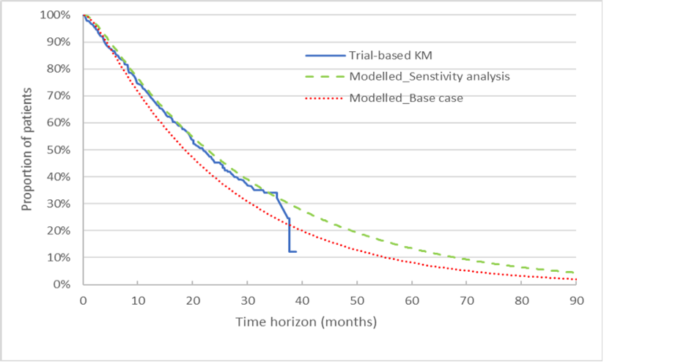Source: Figure constructed during the evaluation from “A5.1_Selpercatinib Section 3 Workbook”.
HR = hazard ratio; KM = Kaplan-Meier; OS = overall survival; PC = pemetrexed + platinum chemotherapy
Note: OS KM curve for pembrolizumab + PC from Trial KN-189 was digitised from Rodríguez-Abreu et al 2021 (Figure 1A). The OS HR for pembrolizumab + PC vs. PC generated from the NMA, as used in the base case analysis, was 0.609. This HR value was reduced by 20% (to 0.487) in the sensitivity analysis.
  - The model was sensitive the extrapolation parametric function for OS. Using different parametric functions to extrapolate OS, the ICER could increase by up to 67%.
  - The other economic parameters which had a relatively larger impact on the result were the duration of pembrolizumab therapy in a later-line treatment setting following first-line selpercatinib and the time horizon of the model.
  - The pre-PBAC response proposed a re-specified base case for the economic model with the following changes:
- Application of the selpercatinib treatment effect derived from the MAIC Model 2
- A 10-year time horizon
- Removal of the cost of RET fusion testing
- No dose reduction for pembrolizumab
- Doubling the time to treatment discontinuation (TTD) for later-line pembrolizumab therapy, from 5.65 3-weekly treatment cycles to 11.31 3-weekly cycles; and
- Re-calculation of the drug acquisition costs for pembrolizumab, pemetrexed, carboplatin and docetaxel, according to the EFC Program.
Incorporating the 1.5% price reduction for selpercatinib proposed in the pre-PBAC response (see paragraph 3.2) the resulting ICER was $55,000 to < $75,000/QALY gained.

Drug cost/patient/course
Table 25: Drug cost per patient for selpercatinib and for pembrolizumab + pemetrexed + platinum chemotherapy
 | Selpercatinib |  |  | Pembrolizumab + pemetrexed + carboplatin
 | Trial dose and duration | Model | Financial estimates | Trial dose and duration | Model | Financial estimates
Mean dose | 28-day Cycle 1: 293.3 mg/day  28-day Cycles 2+: 251.1 mg/dayª | 28-day Cycle 1: 293.3 mg/day  28-day Cycles 2+: 251.1 mg/day | 252.19mg/day^{b} | NR | As per dose regimen recommended in eviQ guidelines^{e}, including an RDI of 83.4% from treatment Cycles 2 | NA
Mean duration | 19.9 28-day cycles^{c} | 37.5 28-day cycles | 37.7 28-day cycles | NR | 23.4 21-day cycles | NA
Cost/patient  /cycle | 28-day Cycle 1: $|^{d}  28-day Cycles 2+: $|9^{d} | 28-day Cycle 1: $|^{d}  28-day Cycles 2+: $|^{d} | $|| per 28-day cycle^{d} | – | 21-day Cycle 1: $8,453  21-day Cycles 2-4: $7,059  21-day Cycles 5+: $6,873^{f} | –
Cost/patient  /course | $| | $| | $| | – | $120,011^{g} | –
Source: Table compiled during the evaluation, based on Table 2-70, p199 and Table 3-21, p359 of the submission, “A5.1_Selpercatinib Section 3 Workbook” and “A6.1_ Selpercatinib Cost and utilisation model”
NA = not applicable; NR = not reported; RDI = relative dose intensity
ª Daily dose in Trial LBRETTO-001 was calculated based on the proportion of patients on each dose as presented in Table 3-21, p359 of the submission
^{b} The daily dose used in the financial analysis was the weighted mean of 293.3 mg/day for the first 28-day treatment cycle and 251.1 mg/day for the remaining 36.7 cycles.
^{c} Derived from Table 2-70, p199 of the submission. The mean time on treatment was 18.27 months, equal to 19.9 28-day cycles.
^{d} Cost/patient/cycle was calculated by weighing the utilisation of selpercatinib across pack size combinations.
^{e} https://www.eviq.org.au/medical-oncology/respiratory/non-small-cell-lung-cancer. The recommended dosing regimen per infusion (every 3 weeks) is 200 mg for pembrolizumab, 500mg/m² for pemetrexed and 5 area under curve (AUC) for carboplatin. Based on a mean body surface area of 1.81m² and a mean glomerular filtration rate of 73 mL/min, the per infusion dose for pemetrexed and carboplatin was estimated to be 905 mg and 490 mg, respectively. The submission assumed that, from treatment Cycles 2 onward, the per infusion dose would reduce by 17.6% for pembrolizumab, pemetrexed and carboplatin.
^{f} Carboplatin discontinues from treatment Cycle 5.
^{g} The submission’s calculation of the dispensed costs for pembrolizumab and chemotherapy agents was not in line with the Efficient Funding of Chemotherapy (EFC) Program. In addition, the incorporation of an RDI to pembrolizumab therapy from treatment Cycles 2+ was not consistent with the pembrolizumab product information which does not recommend dose reductions. After fixing these errors, the revised cost per patient per course of pembrolizumab + pembrolizumab + carboplatin would be $138,111.
  - The pre-PBAC response offered a 1.5% reduction on the price of selpercatinib (i.e. published AEMP of $| |for the 80mg x 112 pack size, $| |for the 80 mg x 56 pack size and $| |for the 40 mg x 56 pack size).

Estimated PBS usage & financial implications
  - This submission was considered by DUSC. The submission used an epidemiological approach to determine the number of eligible patients in the first 6 years of listing. The key inputs used to determine the number of eligible patients and financial estimations are summarised in Table 26.
Table 26: Key inputs for utilisation and financial estimates
Data | Value | Source | Comment
Eligible population
Incident patients | Yr 1: 14,561  Yr 2: 14,840  Yr 3: 15,133  Yr 4: 15,414  Yr 5: 15,686  Yr 6: 15,943 | Australian Institute of Health and Welfare, Cancer in Australia 2021 | These numbers were based on the AIHW projections of lung cancer. DUSC agreed with the evaluation that this was reasonable.
Prevalent patients | Yr 1: 28,250  Yr 2-6: Not used | Australian Institute of Health and Welfare, Cancer in Australia 2021 | This was estimated by totalling the incidence of lung cancer for Years 2022 (13,978) and 2023 (14,272) based on the Cancer in Australia, 2021 AIHW report. Given that patients diagnosed at Stage IIIB/IV have an OS of 2 years, it may not be reasonable to include incident patients from 2022.  DUSC commented that it was reasonable to include a prevalent population but considered the submission underestimated mortality and that a proportion of the incident patients from the prior two years were likely to be deceased. DUSC considered the number of prevalent patients was overestimated.
Additional parameters utilised to estimate the number of eligible patients
% NSCLC | 86.6% | Mitchell et al 2013 | DUSC agreed with the evaluation that this was reasonable.
% NSQ/NOS | 74.2% | Paragraph 6.46, nivolumab PSD March 2016 PBAC meeting | The limitation to NSQ/NOS histology type is not consistent with the proposed PBS restriction. However, given that the occurrence of RET fusions is rare in squamous NSCLC, this is not expected to impact the estimates.  DUSC noted that the basis for including this proportion in the submission was that the proposed MBS item for RET fusion testing was to require patients to have NSQ/NOS NSCLC to be eligible for MBS funding. However, DUSC agreed that RET driver mutation positive was unlikely in SqCC histology and considered this was reasonable.
% ECOG PS: 0-2 | 96.8% | Hess et al. (2021) | Since RET fusion positive patients are generally younger, this assumption was reasonable but uncertain.  DUSC considered this was reasonable for incident patients, but likely overestimated in 2L+ patients.
Proportion of patients who are RET fusion positive | 1.5% | Kohno et al. (2012), Ferrara et al., (2018) | Literature suggests that 0.5% to 2% of the population are RET fusion positive. The 1.5% incidence utilised in the financial estimations was uncertain but reasonable and the range tested in the sensitivity analyses was plausible.  DUSC noted that this proportion was uncertain and impacted the estimates significantly but agreed the estimate of 1.5% was likely reasonable and noted the sensitivity analyses to support the uncertainty.
Eligible patients
Eligible patients, electing treatment and diagnosed at Stage IIIB/IV | Yr 1: ||||¹  Yr 2: ||||¹  Yr 3: ||||¹  Yr 4: ||||¹  Yr 5: ||||¹  Yr 6: ||||¹ | Based on 65.5% of patients diagnosed at Stage IIIB/IV as presented in Mitchell et al 2013 and the Erlotinib and Gefitinib DUSC report. | DUSC agreed with the evaluation that this was reasonable
Eligible patients, diagnosed at Stage I-IIIA who progress to Stage IIIB/IV within a year | Yr 1-2: ||||¹  Yr 3-6: ||||¹ | Based on 34.5% of patients diagnosed at Stage I-IIIA, of which 30% progress within a year as presented in Mitchell et al 2013. | DUSC agreed with the evaluation that this was reasonable but noted there may be limited benefit of adjuvant or consolidation immunotherapy in driver mutation positive NSCLC.
Eligible, pre-treated Stage IIIB/IV patients | Yr 1: ||||¹  Yr 2-6: ||||¹ | Based on 75.85% of prevalent patients at Stage IIIB/IV (at the time of listing) and inclusion of ||||¹ grandfathered patients who were enrolled into an Early Familiarisation Program. | The same estimates for proportions of NSCLC (86.6%), NSQ/NOS histology (74.2%), PS of 0-2 (98.6%) and RET fusion prevalence of 1.5% were utilised to estimate the number of previously treated eligible patients. These estimates may not be applicable as prevalent patients at Stage IIIB/IV are unlikely to have a PS of 0-2. Further, as discussed above, the approach assumes that all incident cases in the two years prior to listing would be eligible for treatment which is not consistent with the OS of 2 years for Stage IIIB/IV NSCLC patients.  DUSC considered that a proportion of these patients were likely to be deceased or no longer fit for treatment and that this was overestimated. DUSC considered the proportion of prevalent patients estimated from the incident patients for the prior two years who would be eligible for treatment may be between 70 - 80%.
Treatment utilisation
Uptake rate | Yr 1-6: 100% | Assumption | Selpercatinib is an oral form of therapy and thus, has a more convenient mode of administration when compared to pembrolizumab, which is administered intravenously. Further, since selpercatinib is a targeted therapy, clinicians may be more likely to prescribe it over immunotherapy. This was reasonable.  DUSC noted the submission estimated high uptake of 100% in eligible patients but agreed that uptake will likely be close to 100% and that this was reasonable.
Number treated | Yr 1: ||||¹  Yr 2: ||||¹  Yr 3: ||||¹  Yr 4: ||||¹  Yr 5: ||||¹  Yr 6: ||||¹ | Based on a treatment duration of 34.71 months for all eligible patients and calculated as a sum of prevalent and incident patients for each year. | The treatment duration was calculated by applying a range of standard parametric distributions to extrapolate the TTD data from the LIBRETTO-001 trial. The treatment duration was assumed to be the same for treatment-naïve and previously treated patients as both cohorts had similar PFS in the trial. The evaluation considered this was reasonable.  DUSC noted that the proposed PBS restriction states that patients must not develop disease progression while receiving PBS-subsidised treatment with this drug for this condition, however in the trial 31.9% of treatment naïve patients were treated beyond progression on the basis of continuous clinical benefit per the investigator with sponsor approval. DUSC commented that it may be more appropriate to apply the modelled PFS from the trial, of 32.1 months, but that more mature data from the trial may prove this to be overestimated.  DUSC also considered that prevalent patients, particularly grandfathered patients, should have a shorter duration of treatment applied.
Scripts dispensed | Yr 1: ||||²  Yr 2: ||||³  Yr 3: ||||³  Yr 4: ||||²  Yr 5: ||||²  Yr 6: ||||² | Based on 13.04 prescriptions per patient per year and patient population splits of 53%, 43% and 19% for the following dose/size packs: 80 mg (112 capsules pack), 80 mg (56 capsules pack) and 40 mg (56 capsules pack) | DUSC noted this was extrapolated from dose reductions in the clinical trial population and agreed with the evaluation that this was reasonable.
Costs
Selpercatinib  80 mg x 112 pack size  80 mg x 56 pack size  40 mg x 56 pack size | $||||  $||||  $|||| | Requested price | DUSC agreed with the evaluation that this was reasonable.
Patient co-payment | PBS: $14.61  RPBS: $6.93 | Services Australia PBS item statistics  PBS item numbers: 11492W, 11494Y, 12119W, 12121Y | DUSC agreed with the evaluation that this was reasonable
PBS/RPBS Split | PBS: 97.01%  RPBS: 2.99% | Services Australia PBS item statistics  PBS item numbers: 11492W, 11494Y, 12119W, 12121Y | DUSC agreed with the evaluation that this was reasonable
MBS costs
RET fusion testing | $317.88 per service | Proposed MBS item fee for RET Fusion testing, 80% rebate | As RET fusion testing has been supported by the MSAC as part of MSAC Application 1721, it may only be necessary to apply testing costs to 34% of prevalent patients (assuming the proposed fee from the MSAC Application 1721 for fusion testing i.e. item CCCC)  In its PSCR (p4) the sponsor agreed that it is not necessary to include the cost of RET fusion testing in the estimates of the financial impact of listing selpercatinib due to the recent MSAC recommendation for listing of a small gene panel in NSCLC which would include testing for RET fusions.
ECG | $20.50 per service | MBS item 11714, 80% rebate | While the source of unit cost per ECG service was reasonable, the extent of use applied (2.4 services per patient per year) was not, as patients would only require ECG in the first year of treatment.  DUSC noted that in the trial patients received two ECGs in the first cycle of treatment and then monthly ECGs and agreed with the suggestion in the evaluation that it would be more appropriate to cost for seven ECG services per patient in their first year of treatment.
Source: tabulated during evaluation from Tables 4-1, 4-3 of the submission.
ECOG=eastern cooperative oncology group; MBS=Medicare Benefits Schedule; NSCLC=non-small cell lung cancer; NSQ/NOS=non-squamous/not otherwise specified; PS=performance status; PBS=Pharmaceuticals Benefits Scheme; RET=rearranged during transfection; RPBS=Repatriation Pharmaceuticals Benefits Scheme
The redacted values correspond to the following ranges:
¹ < 500
² 500 to < 5,000
³ 5,000 to < 10,000
  - Incident patients were estimated based on AIHW lung cancer incidence projections from 2024-2029. The submission assumed that of incident cases, 86.6% would have NSCLC, based on Mitchell et al (2013), of which 74.2% were of non-squamous or NOS histology. While this latter estimate has previously been presented to the PBAC (paragraph 6.46, Nivolumab PSD, March 2016 PBAC meeting), the proposed restriction for selpercatinib does not restrict by histology (noting that the prevalence of RET fusions in squamous histology is low). The eligible population was further limited to those estimated to have a performance status of 0−2 (96.8%), those with RET fusions (1.5%) and those with Stage IIIB/IV disease (assuming 65.5% Stage IIIB/IV at diagnosis and 30% of the remaining 34.5% progress to Stage IIIB/IV disease within the same year, based on Mitchell et al 2013). The evaluation considered this was reasonable, noting that estimates of performance status and proportion with advanced disease were consistent with previous submissions presented to the PBAC (paragraph 6.81, Sotorasib PSD, March 2022 PBAC meeting). The prevalence of RET fusions in this population was based on literature and the evaluation considered this is a reasonable approach to determine the number of eligible patients, however, the estimate is highly uncertain. The submission additionally presented a sensitivity analysis to analyse the net cost to the PBS/RPBS for a RET fusion prevalence of 1% and 3.2%. Given the low absolute percentage estimate, even a small increase (1-2%) in the estimated prevalence of RET fusions leads to a very large increase in the net cost to the PBS/RPBS.
  - The submission assumed that some prevalent cases would receive selpercatinib in the later-line setting. The total number of prevalent patients in Year 1 was estimated to be 28,250 based on the number of incident lung cancer cases, projected by the AIHW, in the two years prior to listing. The submission then applied the same estimates detailed for incident patients to derive the number of prevalent patients who would be eligible for treatment. The evaluation considered this was not likely to be a reasonable approach to estimate the size of the prevalent population as the submission effectively assumed that all incident non-squamous or NOS NSCLC cases diagnosed at or who progress to Stage IIIB/IV disease who have RET fusions in the two years prior to listing would be able to tolerate selpercatinib treatment. Previous submissions to the PBAC had estimated that only 50% of those able to tolerate first-line therapy could receive subsequent treatment (paragraph 6.81, Sotorasib PSD March 2022 PBAC meeting). Furthermore, given that patients diagnosed at Stage IIIB/IV currently treated with first-line pembrolizumab + PC would progress on average after approximately 13.7 months (Table 22), it may be optimistic to assume any incident cases diagnosed two years prior to the listing of selpercatinib would be able to tolerate treatment.
  - All patients estimated to be eligible for selpercatinib were assumed to uptake treatment. Given the oral formulation and the targeted nature of the treatment, the evaluation considered this may be reasonable. Each patient was assumed to receive selpercatinib for 34.71 months (equivalent to 37.73 28-day cycles), based on TTD data extrapolated from the LIBRETTO-001 trial, and was applied irrespective of whether treatment was received in the first- or later-line. The same number of prescriptions was also applied per grandfathered patient. No information was provided in the submission regarding how long these patients would be treated for prior to the PBS listing of selpercatinib.
  - The cost of selpercatinib applied per 28-day cycle was estimated to be $||| |||for the 80 mg x 112 pack; $| |for the 80 mg x 56 pack and $| |for the 40 mg x 56 pack. This was based on the distribution of doses, as used in the LIBRETTO-001 trial, following dose modifications, considering the number and cost of packs required for each dose (as two packs are required to fill the 120 mg dose).
  - The total cost to the PBS/RPBS of listing selpercatinib increased from $20 million to < $30 million in Year 1 to $30 million to < $40 million in Year 3, before reducing to $20 million to < $30 million in Year 6 (Table 27). The total cost was estimated to be $100 million to < $200 million over the first 6 years of listing. No cost offsets were assumed as the submission considered that selpercatinib would displace rather than replace current use of pembrolizumab + PC. The evaluation considered this assumption was reasonable.
Table 27: Estimated use and financial implications
 | Year 1 | Year 2 | Year 3 | Year 4 | Year 5 | Year 6
Estimated extent of use
Number of incident patients eligible for treatment | | ¹ | | ¹ | | ¹ | | ¹ | | ¹ | | ¹
Number of prevalent patients eligible for treatment | | ¹
Number of grandfathered patients | | ¹
Number of eligible patients (100% uptake) | | ¹ | | ¹ | | ¹ | | ¹ | | ¹ | | ¹
Number of patients treatedª | | ¹ | | ¹ | | ¹ | | ¹ | | ¹ | | ¹
Number of scripts dispensed  80 mg x 112 pack | | ² | | ² | | ² | | ² | | ² | | ²
Number of scripts dispensed  80 mg x 56 pack | | ² | | ² | | ² | | ² | | ² | | ²
Number of scripts dispensed  40 mg x 56 pack | | ² | | ² | | ² | | ² | | ² | | ²
Number of scripts dispensed ^{b} | | ² | | ³ | | ³ | | ² | | ² | | ²
Net financial implications
Net cost to PBS/RPBS ^{c} | | ⁴ | | ⁵ | | ⁵ | | ⁴ | | ⁴ | | ⁴
Net cost to MBS | | ⁶ | | ⁶ | | ⁶ | | ⁶ | | ⁶ | | ⁶
Net cost to MBS  Revised ^{d} | | ⁶ | | ⁶ | | ⁶ | | ⁶ | | ⁶ | | ⁶
Net cost to PBS/RPBS/MBS | | ⁴ | | ⁵ | | ⁵ | | ⁴ | | ⁴ | | ⁴
Net cost to PBS/RPBS/MBS  Revised | | ⁴ | | ⁵ | | ⁵ | | ⁴ | | ⁴ | | ⁴
Source: tabulated during evaluation from Sheets “2d. Patients – DTG”, “3a. Scripts – proposed”, “5. Impact – net” and “6. Net changes – MBS” from the “A6.1_ Selpercatinib Cost and utilisation model” workbook included in the submission.
ª Assuming a treatment duration of 34.71 months; that patients in their third year of treatment receive treatment for only 89.25% of the year (10.71 months)
^{b} Assuming 13.04 prescriptions per year per patient as estimated by the submission; population splits of 53%, 43% and 19% for the 80 mg x 112 packs, 80 mg x 56 packs and 40 mg x 56 packs and assuming that one prescription provides a treatment coverage of 28 days.
^{c} Cost per prescription: $| |per 80 mg x 112 pack, $| |per 80 mg x 56 pack and $| |per 40 mg x 56 pack.
^{d} Revised to include RET fusion testing costs for only 34% of NSCLC, NSQ/NOS, PS of 0-2, RET fusion positive, prevalent patients, assuming a fee of $545.88 per test (based on item CCCC in MSAC Application 1721) and 7 ECG services costs for patients in their first year of treatment
The redacted values correspond to the following ranges:
¹ < 500
² 500 to < 5,000
³ 5,000 to < 10,000
⁴ $20 million to < $30 million
⁵ $30 million to < $40 million
⁶ $0 to < $10 million
  - Changes in the use and cost of MBS services were included in the submission. RET fusion testing costs (at a proposed fee based on MBS item 73337: $397.35, assuming an 80% rebate) were included for 34% of NSCLC, NSQ/NOS patients with a PS of 0-2. Following the positive MSAC recommendation for the inclusion of RET fusion testing in the small gene panel (MSAC Application 1721), patients diagnosed with NSCLC would undergo a multi-gene panel test regardless of the availability of selpercatinib. Therefore, the estimated change in use and cost of testing for RET fusions in incident patients was not reasonable. The estimated use of testing (under the supported item for fusion testing, i.e. item CCCC in MSAC Application 1721) in prevalent patients may be reasonable.
  - Changes in the use and cost to the MBS of ECG services were also included. Each patient treated with selpercatinib was assumed to receive 2.4 ECG services while on treatment. The evaluation considered this was not reasonable as the draft selpercatinib PI suggests that ECGs be conducted in the first week following treatment initiation with selpercatinib and then monthly for the first 6 months. Thus, it is more appropriate to cost for 7 ECG services per patient in their first year of treatment.
  - The sponsor noted that pembrolizumab currently has a Special Pricing Arrangement (SPA) in place and advised that they may seek an SPA during discussions with the Department of Health if selpercatinib is listed on the PBS. Thus, the submission noted that the financial estimations included in the submission would likely be an overestimation as it is based on the published price.
  - DUSC considered the utilisation estimates presented in the submission to be overestimated. The main issues were:
- In estimating the number of previously treated patients eligible for treatment with selpercatinib, the submission assumed that all previously treated patients will be considered for treatment with selpercatinib. This was not a reasonable assumption as a proportion of these patients will be deceased or unable to tolerate further treatment. DUSC considered the proportion of prevalent patients who would be eligible for treatment may be between 70% and 80%.
- The proposed PBS restriction states that patients must not develop disease progression while receiving PBS-subsidised treatment with this drug for this condition. The duration of treatment is estimated based on the trial, in which 31.9% of patients were treated beyond progression. DUSC commented that it may be more appropriate to apply a duration based on the modelled PFS from the trial, of 32.1 months, but that more mature data from the trial may prove this to be overestimated.
- Eligible prevalent patients were likely to be treated with a shorter treatment duration than incident patients.

Financial Management – Risk Sharing Arrangements
  - No Risk Sharing Arrangement was proposed in the submission.

Quality Use of Medicines
  - The sponsor noted that selpercatinib is the first targeted therapy for RET fusion positive, locally advanced or metastatic NSCLC. The sponsor’s risk management plan summarised the pharmacovigilance and risk minimisation activities following the listing of selpercatinib. Safety concerns will be addressed in the PI for selpercatinib which will be available via the TGA website. The evaluation considered this was reasonable and no other issues were identified.
For more detail on PBAC’s view, see section 7 PBAC outcome.
- PBAC outcome
  - The PBAC did not recommend the listing of selpercatinib for the treatment of REarranged during Transfection (RET) fusion-positive, locally advanced or metastatic non-small cell lung cancer (NSCLC), irrespective of line of therapy. The PBAC acknowledged the clinical need for effective treatments for patients with this condition. The Committee considered the results of the single arm LIBRETTO-001 trial demonstrated clinical activity for selpercatinib. However, the PBAC advised that indirect comparisons with pembrolizumab in combination with pemetrexed + platinum-based chemotherapy (pembrolizumab + PC) were associated with a high degree of uncertainty and were unable to support a claim of superior comparative effectiveness. Given the limitations of the comparative clinical data, the PBAC considered the estimated incremental cost-effectiveness ratio (ICER) was highly uncertain.
  - The PBAC considered the primary reason for this outcome was due to the comparative clinical evidence provided.
  - The PBAC noted the input from an individual, a health care professional, Lung Foundation Australia and Rare Cancers Australia supported the clinical need for effective treatment options for this population given there are currently no listed targeted therapies for RET fusion-positive NSCLC. In addition, the PBAC noted the Medical Oncology Group of Australia’s support for the submission. The PBAC acknowledged the clinical need for effective treatments for patients with this condition.
  - The PBAC noted the requested listing was line-agnostic and agreed with the ESC that this was appropriate (see paragraph 3.4).
  - The PBAC considered the nomination of pembrolizumab + PC (for the first-line treatment setting) as the main comparator and docetaxel (for the refractory setting) as a secondary comparator was appropriate. The PBAC considered that selpercatinib was most likely to be used as first-line therapy in keeping with international guidelines (see paragraph 3.4).
  - The pivotal selpercatinib trial (LIBRETTO-001) was a phase II single-arm study of patients with both treatment-naïve (N=69) and pre-treated patients (N=247) with RET fusion-positive advanced NSCLC. The PBAC noted the overall response rate (ORR), as assessed by an independent review Committee (IRC), in treatment-naïve patients was 84.1% and in pre-treated patients was 61.1%. The PBAC noted that, based on updated data from the January 2023 data cut of LIBRETTO-001, the median progression-free survival (PFS) by IRC was | | months (95% CI: | |²⁷) in treatment-naïve NSCLC patients after a median follow-up of | |²⁷months and | |²⁷ months (95% CI: | |²⁷) in the pre-treated cohort after a median follow-up of | |²⁷months. The PBAC noted the January 2023 data cut of LIBRETTO-001 showed that | |²⁷ in the treatment-naïve cohort, with | |%²⁷ patients alive at a median follow up of | |²⁷months. Overall, the PBAC considered the ORR and PFS results of the LIBRETTO-001 trial demonstrated clinical activity for selpercatinib and indicated it was a promising treatment option for patients with RET fusion-positive NSCLC.
  - The claim that selpercatinib had superior effectiveness relative to pembrolizumab + PC was based on indirect comparisons which included a network meta-analysis (NMA), an anchored indirect comparison, and an unanchored matching adjusted indirect comparison (MAIC). The PBAC noted the indirect comparisons were not conducted exclusively in the RET fusion-positive NSCLC population because the comparator studies did not assess patients for RET fusion status. The PBAC noted the submission argument that RET fusion status was not an independent prognostic characteristic for PFS or OS after adjustment for age and smoking status but considered this issue remained a source of significant uncertainty.
  - The NMA and anchored indirect comparisons were based on the generation of a synthetic (pseudo-control) PC arm for LIBRETTO-001 using propensity score matching (PSM). The PBAC noted that PSM was applied to the individual patient data (IPD) of the PC arm of the KN-189 trial which compared pembrolizumab + PC versus PC as IPD were not available for the pembrolizumab + PC arm. The common reference PC arm was used to link LIBRETTO-001 to the KN-189 and KN-021 comparator studies. The PBAC considered a limitation of use of the pseudo-PC arm was that there were residual imbalances, despite the matching, which may favour selpercatinib. In addition, the PBAC noted that as a consequence of the matching, the original sample size of the KN-189 PC arm was reduced from 206 patients to an effective sample size (ESS) of 64 patients. The PBAC considered this limited the reliability and applicability of the indirect comparison results.
  - In the unanchored MAIC, individual patient data from LIBRETTO-001 were re-weighted to match published summary data of the pembrolizumab + PC arm in KN-189. The PBAC noted that re-weighting reduced the LIBRETTO-001 selpercatinib cohort sample size from 69 patients to an ESS of 46.5 in Model 1 (not adjusted for ‘never smokers’) and to an ESS of 21.8 in Model 2 (adjusted for ‘never smokers’). The PBAC considered the small ESS limited the reliability and applicability of the indirect comparison results.
  - Overall, the PBAC considered the indirect comparisons were associated with a high degree of uncertainty with several transitivity, applicability and reliability issues. The PBAC advised that the true extent of confounding and the magnitude of the comparative treatment effect of selpercatinib compared with pembrolizumab + PC remained unknown. As such, the PBAC considered that the claim of superior comparative effectiveness was not adequately supported by the data provided.
  - The PBAC noted the treatment emergent adverse events (TEAEs) in LIBRETTO-001, in particular the incidence of QT prolongation (16%) of any grade. The PBAC agreed with the evaluation that comparing the safety profiles of selpercatinib and pembrolizumab + PC was difficult due to differences in the mechanism of action and trial populations. However, the PBAC considered that the toxicity of selpercatinib would be likely manageable in clinical practice, with some advantages as an oral therapy.
  - The PBAC considered the economic model was unreliable due to the uncertainties in the clinical data from the indirect comparison with pembrolizumab + PC. In addition, the PBAC agreed with the evaluation that the submission made a number of unreasonable or unjustified assumptions and errors in the base case analysis and noted that a re-specified base case was proposed during the evaluation (see paragraph 6.82). The pre-PBAC response provided a re-specified base case that differed from that provided during the evaluation in three ways: application of the selpercatinib treatment effect derived from the MAIC Model 2; use of a 10 year rather than a 7.5 year time horizon (submission base case time horizon was 20 years); and incorporation of a 1.5% price reduction for selpercatinib (see paragraph 6.88). The PBAC noted the re-specified base case and the price reduction proposed in the pre-PBAC response. However, the PBAC considered the fundamental uncertainty associated with the indirect comparison between poorly transitive studies that formed the basis of the model cannot be resolved by re-specification. As such, the PBAC considered the ICER remained highly uncertain.
  - The PBAC agreed with the DUSC that the overall financial estimates presented were overestimated. The PBAC considered that the prevalent population was overestimated as a proportion of previously treated patients would be deceased or unable to tolerate further treatment by the time they became eligible for selpercatinib. The PBAC agreed with DUSC that the proportion of prevalent patients eligible for treatment would be between 70% and 80%. The PBAC also noted that in the LIBRETTO-001 trial, 31.9% of patients were treated beyond disease progression, while the proposed restriction stated that patients must not develop disease progression while receiving selpercatinib. The PBAC agreed with DUSC that it may be more appropriate to apply a duration based on the modelled PFS from the trial (32.1 months) (see paragraph 6.99). The PBAC noted the submission estimated high uptake of 100% in eligible patients but agreed with the DUSC that uptake will likely be close to 100% due to selpercatinib being a targeted therapy in an oral dose form.
  - The PBAC noted that the efficacy of selpercatinib was being further evaluated through a confirmatory Phase III randomised controlled trial (LIBRETTO-431) comparing selpercatinib to platinum-based and pemetrexed therapy with or without pembrolizumab as initial treatment of advanced RET fusion-positive non-squamous NSCLC. The PBAC noted the estimated primary completion date of LIBRETTO-431 was December 2023. The PBAC anticipated that the results of LIBRETTO-431 may address much of the uncertainty associated with the indirect comparison used to inform estimates of comparative effectiveness in this submission.
  - The PBAC considered a resubmission for selpercatinib should address the following issues:
- The indirect comparisons presented in the submission were associated with a high degree of uncertainty (see paragraphs 7.7 to 7.10). Inclusion of the results from the LIBRETTO-431 trial may address much of the uncertainty that resulted in the PBAC advising that the claim of superior comparative effectiveness was not adequately supported by the data provided in the submission.
- Provide an economic model that incorporates revised data pertaining to the magnitude of comparative treatment effectiveness (as outlined in the point above) and which addresses the issues raised in paragraph 7.12.
- Provide revised financial estimates that address the issues outlined in paragraph 7.13.
  - The PBAC noted that this submission is eligible for an Independent Review.
Outcome:
Not recommended.
- Context for Decision
The PBAC helps decide whether and, if so, how medicines should be subsidised through the Pharmaceutical Benefits Scheme (PBS) in Australia. It considers applications regarding the listing of medicines on the PBS and provides advice about other matters relating to the operation of the PBS in this context. A PBAC decision in relation to PBS listings does not necessarily represent a final PBAC view about the merits of the medicine or the circumstances in which it should be made available through the PBS. The PBAC welcomes applications containing new information at any time.
- Sponsor’s Comment
The sponsor had no comment.

NCCN Guidelines Version 2.2023, Non-Small Cell Lung Cancer. Accessed 16 March 2023
https://www.aihw.gov.au/reports/cancer/cancer-data-in-australia/contents/cancer-summary-data-visualisation
https://www.cancercouncil.com.au/lung-cancer
Cancer Australia. 2019. Relative survival by stage of diagnosis (lung cancer) [Online]. https://ncci.canceraustralia.gov.au/outcomes/relative-survival-rate/relative-survival-stage-diagnosis-lung-cancer.
Ferrara R, Auger N, Auclin E, Besse B. Clinical and translational implications of RET rearrangements in non–small cell lung cancer. Journal of Thoracic Oncology. 2018;13(1):27-45.
Novello S, Califano R, Reinmuth N, Tamma A, Puri T. RET Fusion-Positive Non-small Cell Lung Cancer: The Evolving Treatment Landscape. The Oncologist. 2023:oyac264.
Hess LM, Han Y, Zhu YE, Bhandari NR, Sireci A. Characteristics and outcomes of patients with RET-fusion positive non-small lung cancer in real-world practice in the United States. BMC Cancer. 2021 Jan 5;21(1):28.
NCCN Guidelines Version 2.2023, Non-Small Cell Lung Cancer. https://www.nccn.org/guidelines. Accessed 16 March 2023).
Cherny NI, et al: ESMO-Magnitude of Clinical Benefit Scale version 1.1. Annals of Oncology 28:2340-2366, 2017
https://clinicaltrials.gov/ct2/history/NCT04194944?V_2=View
https://www.clinicaltrials.gov/ct2/show/NCT01168973
Data cut off January 2023: manuscript in preparation. To be submitted in 2024.
Data cut off January 2023: manuscript in preparation. To be submitted in 2024.
The NMA included 35 studies identified during a systematic literature review which provided outcomes of interest for the NMA. The NMA was conducted to support the health technology assessment (HTA) processes of multiple countries for multiple comparators
Bhandari, N. R., Hess, L. M., Han, Y., Zhu, Y. E., & Sireci, A. N. (2021). Efficacy of immune checkpoint inhibitor therapy in patients with RET fusion-positive non-small-cell lung cancer. Immunotherapy, 13(11), 893–904.
Tan, D., De Braud, F., Han, Y., Kiiskinen, U., Jen, M-H., Barker, S. S., Szymczak, S., & Gilligan, A. (2023) P2.10-11 Comparative Effectiveness Analysis of Selpercatinib versus Standard Therapy in Patients with Non-small Cell Lung Cancer [Poster Presentation] WCLC 2023 Singapore, Singapore.
Aldea, M., et al. (2023). RET-MAP: An international multicentre study on Clinicobiologic features and treatment response in patients with lung cancer harbouring a RET Fusion. Journal of Thoracic Oncology, 18(5), 576–586.
Rodríguez-Abreu D et al. Pemetrexed plus platinum with or without pembrolizumab in patients with previously untreated metastatic nonsquamous NSCLC: protocol-specified final analysis from KEYNOTE-189. Annals of Oncology. 2021;32(7):881-95
Awad MM et al. Long-term overall survival from KEYNOTE-021 cohort G: pemetrexed and carboplatin with or without pembrolizumab as first-line therapy for advanced nonsquamous NSCLC. Journal of Thoracic Oncology. 2021;16(1):162-8.
Gandhi L, Rodríguez-Abreu D, et al. Pembrolizumab plus Chemotherapy in metastatic non-small-cell lung cancer. N Engl J Med. 2018;378(22):2078-92. Langer CJ, Gadgeel SM, et al. Carboplatin and pemetrexed with or without pembrolizumab for advanced, non-squamous non-small-cell lung cancer: a randomised, phase 2 cohort of the open-label KEYNOTE-021 study. Lancet Oncol. 2016;17(11):1497-508.
Data cut off January 2023: manuscript in preparation. To be submitted in 2024.
Tan AC, Seet AOL, et al. Molecular characterization and clinical outcomes in RET-rearranged NSCLC. J Thorac Oncol. 2020;15(12):1928-34.
National Comprehensive Cancer Network (NCCN). NCCN Clinical Practice Guidelines in Oncology (NCCN Guidelines®). Non-Small Cell Lung Cancer. Version 1.2023. 2023.
Borghaei H, Paz-Ares L, et al. Nivolumab versus docetaxel in advanced nonsquamous non-small-cell lung cancer. N Engl J Med. 2015;373(17):1627-39. Rittmeyer A, Barlesi F, et al. Atezolizumab versus docetaxel in patients with previously treated non-small-cell lung cancer (OAK): a phase 3, open-label, multicentre randomised controlled trial. Lancet. 2017;389(10066):255-65. Fehrenbacher L, Spira A, et al. Atezolizumab versus docetaxel for patients with previously treated non-small-cell lung cancer (POPLAR): a multicentre, open-label, phase 2 randomised controlled trial. Lancet. 2016;387(10030):1837-46.
Mitchell PL, Thursfield VJ, Ball DL, Richardson GE, Irving LB, Torn-Broers Y, et al. Lung cancer in Victoria: are we making progress? Med J Aust. 2013;199(10):674-9
Hess LM, Han Y, Zhu YE, Bhandari NR, Sireci A. Characteristics and outcomes of patients with RET-fusion positive non-small lung cancer in real-world practice in the United States. BMC Cancer. 2021;21(1):28
Data cut off January 2023: manuscript in preparation. To be submitted in 2024.

