11.03 SONIDEGIB,

Capsule 200 mg,
Odomzo®,
Sun Pharma ANZ Pty Ltd
- Purpose of Submission
  - The Category 3 submission proposes new Deed arrangements for the supply of sonidegib (Odomzo®) and vismodegib (Erivedge®) for the treatment of metastatic or locally advanced basal cell carcinoma (BCC).
  - The submission requested the PBAC to consider and advise on the appropriate approach to establish a new Risk Sharing Arrangement (RSA) or pricing arrangement for the supply of sonidegib and vismodegib for BCC. The submission presented the following options:
- A 30% reduction in the effective approved ex-manufacturer price (AEMP) and removal of ongoing subsidisation caps.
- New subsidisation caps (Year 1 $| |M to Year 5 $| |M, see Table 1 for the yearly cap amounts).
- Requested listing
  - The submission proposed no changes to the existing listing.
- Background

Previous PBAC consideration
  - In its recommendation of the March 2016 submission for vismodegib the PBAC noted that the number of eligible patients was uncertain due to the limited information about the incidence and prevalence of BCC. The PBAC further noted that there was a potential for vismodegib to be used outside the restriction to treat patients with milder disease (paragraph 6.32, vismodegib, Public Summary Document (PSD), March 2016 PBAC). As such, an RSA with financial caps was recommended by the PBAC for the listing of vismodegib.
  - Sonidegib was first considered and recommended for listing at the November 2017 PBAC meeting, for the treatment of patients with metastatic or locally advanced BCC, who are inappropriate for surgery and curative radiotherapy due to the type, size, location, depth of penetration of the lesions and extent of the disease.
  - The PBAC’s recommendation for listing was based on, among other matters, its assessment, that the cost-effectiveness of sonidegib would be acceptable if it were cost-minimised against vismodegib and if it were to join the current RSA for vismodegib in the same indication (paragraph 7.1, Sonidegib PSD, November 2017 PBAC).
  - At its March 2021 meeting PBAC considered the utilisation of sonidegib and vismodegib for BCC as part of the review of PBS Authority Required (Written) restriction levels. The PBAC noted that the current BCC market was small but not yet stable, with patient numbers increasing over the four financial years 2016/17 to 2019/20. The PBAC did not recommend an amendment to the authority requirements for vismodegib and sonidegib given the risk of use outside the current PBS restricted population, the comparatively high cost of these medicines and the financial implications to government (Tranche 2, Review of PBS Authority Required (Written) Listings, March 2021 PBAC Meeting Outcomes).

Current RSA and expenditure
  - The Deed of Agreement between the sponsor and the Commonwealth for the supply of sonidegib for the treatment of metastatic or locally advanced BCC encompasses a shared subsidisation cap arrangement with vismodegib. The nominal term of the Deed ended on 31 March 2022.
  - As a new term has not been agreed, the Deed continues to operate on the existing terms applying the Subsidisation Cap for the final year (until such time as a new Deed is entered into, or the Deed is terminated).
3.7 The sponsor previously submitted a list management application for negotiation of a new Deed. On 7 June 2022, the sponsor put forth a proposal including caps of over $| | million that were significantly higher than their existing RSA caps of between $| | million and $| | million. The Department noted the consistent breach (between 125% and 170%) of the existing caps, indicating significant financial risk beyond the currently agreed caps, and was not in a position to agree with the proposed significantly increased new caps.
3.8 The Department advised the sponsor that a price reduction in the effective AEMP for sonidegib in the vicinity of 35% would be required for removal of the RSA. The sponsor proposed a 30% reduction in the effective AEMP and removing the RSA in its entirety. The Department considered that this reduction was not sufficient (i.e. a larger price reduction would be required to be equivalent to the reimbursements payable under the RSA) and presented a counterproposal of progressing with the 30% reduction in the effective AEMP with the addition of new caps between $| | million and $| | million (see Table 2) and maintaining the | |% above caps reimbursement RSA framework. The Department’s proposed caps were based on applying the same year-on-year increase in expenditure ($| |) as was in the initial term of the Deed. The sponsor did not agree to the counterproposal and there has been no further negotiation with the Department.
3.9 The RSA cap data for metastatic or locally advanced BCC for vismodegib and sonidegib is presented in Table 1.
Table 1: Sonidegib and vismodegib BCC subsidisation caps
Cap Year | Cap Threshold  (Cap 1) | Total Commonwealth Payment | Total % of Cap Reached  (Cap 1)
Year 2  (Apr-18 - Mar-19) | |||| | |||| | 122.70%
Year 3  (Apr-19 - Mar-20) | |||| | |||| | 129.16%
Year 4  (Apr-20 - Mar-21) | |||| | |||| | 167.54%
Year 5  (Apr-21 - Mar-22) | |||| | |||| | 168.28%
Year 6  (Apr-22 - Mar-23) | |||| | |||| | 170.60%
Year 7  (Apr-23 - Mar-24)* | |||| | |||| | 14.43%
Note: * part-year data for two months into cap year 7.

Proposed risk sharing arrangement
3.10 The sponsor notes its previously proposed 30% reduction in the effective AEMP in response to the Department’s initial suggestion as an alternative to continuing to subsidisation caps.
3.11 The submission presents subsidisation caps should the PBAC consider this is necessary to manage any potential financial risk to the Commonwealth (Table 2). The sponsor notes that its proposed caps were previously considered by the Department, as described above.
Table 2: Comparison of the Department’s most recent proposal vs. Sun Pharma ANZ’s subsidisation caps proposal
Year (1 April to 31 March) | Department latest proposed subsidisation caps | SUN Pharma ANZ proposed subsidisation caps
2022 – 2023 | | | |
2023 – 2024 | | | |
2024 – 2025 | | | |
2025 – 2026 | | | |
2026 - 2027 | | | |
Source: Table 2-2, page 6 of the submission.

Consideration of the evidence

Sponsor hearing
  - There was no hearing for this item.

Consumer comments
  - The PBAC noted that no consumer comments were received for this item.

Estimated PBS utilisation and financial implications
  - The submission presented the number of services processed by Services Australia over the period April 2017 to January 2023 which shows a typical uptake of a new medicine before stabilising towards the end of 2018. Since 2018, the utilisation of sonidegib and vismodegib have steadily increased until the present (Figure 1).
Figure 1: Total services processed for sonidegib & vismodegib (PBS items 11304Y & 11070P) from April 2017 to January 2023
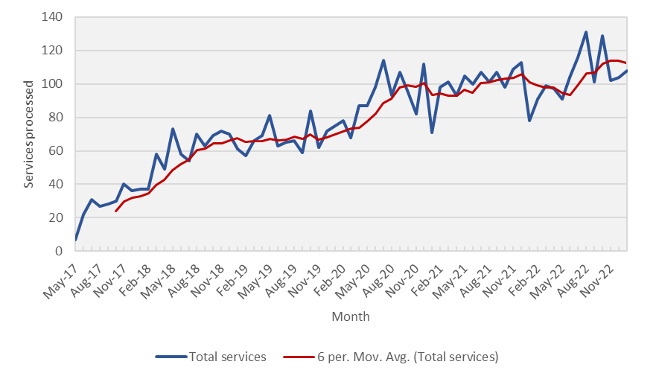Source: Services Australia - Sonidegib and vismodegib.xlsx (Appendix 1)

  - The submission considered it is unlikely that sonidegib and vismodegib would be used in patients outside the PBS indication. The submission argued that patients are required to satisfy multiple measures of disease activity to qualify for initial treatment with sonidegib and vismodegib as per the Authority Required listing and the submission claimed that the risk of use outside the reimbursed restriction is therefore low.
  - Under either new Deed proposal by the sponsor the Commonwealth would likely have increased expenditure on sonidegib and vismodegib above the current levels. .

PBAC Outcome
  - The PBAC advised that a continued Risk Sharing Arrangement (RSA) was required for sonidegib (Odomzo®) and vismodegib (Erivedge®) for the treatment of metastatic or locally advanced BCC.
  - In providing this advice, the PBAC noted that the current BCC market was small but not yet stable and reiterated its previous concerns from its consideration of Tranche 2 of the Review of Authority Required listings, regarding the risk of use outside the current PBS restricted population, the comparatively high cost of these medicines, and the financial implications to government.
  - The PBAC noted that the submission proposed a price reduction of 30% if the RSA is removed. The PBAC considered that a price reduction of at least this magnitude would be required, noting the significant expenditure above the caps in the initial estimates, and considered that a continued RSA was necessary to manage total expenditure to the Commonwealth. The PBAC did not accept that the proposed increase to current caps, representing an approximate 67% increase to current arrangements, was adequately justified. However, acknowledging that the original estimates used as the basis for the RSA may have been underestimated, some of the additional use above the cap is likely consistent with the intended PBS population, the PBAC advised that a one-off increase of 10% (applied to the most recent Deed Year cap) would be reasonable.
  - The PBAC noted that if the authority requirements for vismodegib and sonidegib remain unchanged the risk of use outside the current PBS restricted population will be low.
Outcome:
Advice provided

Context for Decision
The PBAC helps decide whether and, if so, how medicines should be subsidised through the Pharmaceutical Benefits Scheme (PBS) in Australia. It considers applications regarding the listing of medicines on the PBS and provides advice about other matters relating to the operation of the PBS in this context. A PBAC decision in relation to PBS listings does not necessarily represent a final PBAC view about the merits of the medicine or the circumstances in which it should be made available through the PBS. The PBAC welcomes applications containing new information at any time.

Sponsor’s Comment
The sponsor had no comment.

