5.13 TAGRAXOFUSP,
Solution concentrate for I.V. infusion 1 mg in 1 mL,
Elzonris®,
A. Menarini Australia Pty Limited.
- Purpose of submission
  - The Category 1 submission requested a Section 100 (Efficient Funding of Chemotherapy Program) Authority Required (Telephone/Online) listing for tagraxofusp for the first line treatment of blastic plasmacytoid dendritic cell neoplasm (BPDCN).
  - Listing was requested on the basis of a cost-effectiveness analysis versus Treatment of Physician’s Choice (TPC), consisting of acute myeloid leukaemia (AML)-type, acute lymphoblastic leukaemia (ALL)-type, and lymphoma-type chemotherapy regimens.
Table 1: Key components of the clinical issue addressed by the submission (as stated in the submission)
Component | Description
Population | Patients with blastic plasmacytoid dendritic cell neoplasm (BPDCN) who have not received prior treatment.
Intervention | Tagraxofusp 12 microgram/kg once daily, on days 1-5 of a 21-day cycle, until disease progression or unacceptable toxicity.
Comparator | Treatment of Physicians Choice (TPC), consisting of acute myeloid leukaemia (AML)-type, acute lymphoblastic leukaemia (ALL)-type, and lymphoma-type chemotherapy regimens.
Outcomes | Complete response (CR), % bridge to haematopoietic stem cell transplant (HSCT), overall survival (OS), progression free survival (PFS), bone marrow complete response rate, objective response rate (ORR), safety outcomes.
Clinical claim | In patients with BPDCN who have not received prior treatment, tagraxofusp is more effective than TPC at improving bridge to HSCT rate, OS and PFS.
Source: Table 1-1, p18 of the submission.
ALL=acute lymphoblastic leukaemia; AML=acute myeloid leukaemia; BPCDN=blastic plasmacytoid dendritic cell neoplasm; CR=complete remission; HSCT=haematopoietic stem cell transplant; ORR=objective response rate; OS=overall survival; PFS=progression free survival; TPC=Treatment of Physicians Choice.
- Background

Registration status
  - The TGA delegate overview and ACM outcomes were received during the evaluation. | | | | | | | | | | | | | | | | | | | | | | | | | | | | | | | | | | | | | | | | | | | | | | | | | | | | | | | | | | | | | |
  - ||| ||| ||| ||| ||| ||| ||| ||| ||| ||| ||| ||| ||| ||| ||| ||| ||| ||| ||| ||| ||| ||| ||| ||| ||| ||| ||| ||| ||| ||| ||| ||| | | | | | | | | | | | | | | | | | | | | | | | | | | | | | | | | | | | | | | | | | | | | | | | | | | | | | | | | | | | | | | | | | | | | | | | | | | | | | | | | | | | | | | | | | | | | | | | | | | | | | | | | | | | | | | | | | | | | | | | | | | | | | | | | | | | | | | | | | | | | | | | | | | | | | | | | | | | | | | | |.
  - ||| ||| ||| ||| ||| ||| ||| ||| ||| ||| ||| ||| ||| ||| ||| ||| ||| ||| ||| ||| ||| ||| ||| ||| ||| ||| ||| ||| ||| ||| ||| ||| | | | | | | | | | | | | | | | | | | | | | | | | | | | | | | | | | | | | | | | | | | | | | | | | | | | | | | | | | | | | | | | | | | | | | | | | | | | | | | | | | | | | | | | | | | | | | | | | | | | | | | | | | | | |.
For more detail on PBAC’s view, see section 7 PBAC outcome.
- Requested listing
Table 2: Essential elements of the requested listing
MEDICINAL PRODUCT  Form | Dispensed Price Max Amt | Max. Amount | №.of Rpts
TAGRAXOFUSP 1 mg/mL  Concentrate for Solution for Infusion, 1 mL | $| effective price (Public)  $ | published price (Public)  $| effective price (Private)  $ | published price (Private) | 1.7 mg | Induction: 9  Consolidation: 14  Grandfathering: 14
Available brands
Elzonris
(tagraxofusp 1 mg/mL Concentrate for Solution for Infusion, 1 mL vial)
Category / Program: Section 100 – Efficient Funding of Chemotherapy
Prescriber type: Dental Medical Practitioners Nurse practitioners Optometrists
Restriction type: Authority Required (telephone/online PBS Authorities system)
Administrative Advice: Special Pricing Arrangements Apply.
Condition: Blastic Plasmacytoid Dendritic Cell Neoplasm
Indication: Blastic Plasmacytoid Dendritic Cell Neoplasm
Treatment Phase: Induction
Clinical criteria:
Patient must not have received a prior systemic therapy for this condition,
AND
The treatment must be the sole PBS-subsidised therapy for this condition,
AND
Patient must have an Eastern Cooperative Oncology Group (ECOG) performance status (PS) of 2 or less.
Treatment criteria:
Must be treated by physician experienced in the treatment of haematological malignancies.
Prescribing Instructions: According to the TGA-approved Product Information, the first cycle should be administered in the in-patient setting.
Tagraxofusp is not PBS-subsidised if it is administered to an inpatient in a public hospital setting.
Caution: Before initiating therapy, ensure that the patient has adequate cardiac function and serum albumin. Monitor patient for capillary leak syndrome.
Treatment Phase: Consolidation
Clinical criteria:
Consolidation: Patient must have previously received PBS-subsidised treatment with this drug for this condition,
Grandfathering: Patient must have previously received non-PBS-subsidised treatment with this drug for this condition prior to [Date of PBS listing]
AND
Patient must not have developed disease progression while being treated with this drug for this condition,
AND
The treatment must be the sole PBS-subsidised therapy for this PBS indication.
Source: Table1-9, p41 of the submission.
  - The submission proposed a special pricing arrangement with an effective ex-manufacturer price (EMP) of $| | per vial for tagraxofusp and a published EMP of $| |.
  - The requested maximum amount of 1.7 mg was sufficient for a single infusion for a patient weighing up to 136 kg (the maximum patient weight in Study 0114) based on the dosage recommendations in the draft Product Information (12 mcg/kg tagraxofusp, once daily, on days 1-5 of a 21-day cycle). It was noted that each vial contains 1 mg of tagraxofusp. Section 100 EFC listings aim to provide a maximum amount sufficient to treat a patient up to 120 kg where dosing is by weight, or, sufficient to treat a patient with body surface area of up to 2.2 m². As the draft product information specifies dosing by weight, 1,440 micrograms would be the listed maximum amount.
  - The ESC noted that the proposed restriction allowed treatment until progression, whereas the economic model included a stopping rule for tagraxofusp after 26 weeks of treatment.
For more detail on PBAC’s view, see section 7 PBAC outcome.
- Population and disease
  - BPDCN is a life-threatening, aggressive, rare and difficult-to-treat haematologic malignancy characterised by rapid progression and lack of consensus regarding standard of care (Pemmaraju 2023). There are no other TGA-approved or specifically PBS-reimbursed treatments for BPDCN. The disease has had many nomenclature and classification changes over several decades (Pemmaraju 2023). BPDCN has previously been described as agranular CD4+ natural killer cell leukemia, blastic natural killer-cell leukemia/lymphoma and CD4+/CD56+ hematodermic neoplasm. The World Health Organization (WHO) established the term blastic plasmacytoid dendritic cell neoplasm in 2008, and in 2016 BPDCN was classified as a distinct entity within the myeloid neoplasm and acute leukemia classification (Leukemia & Lymphoma Society 2019). Establishing the diagnosis and the staging of BPDCN requires a multidisciplinary approach, including clinical analyses, laboratory assessments and imaging examinations. Markers useful for confirming or excluding a diagnosis of BPDCN as well as distinguishing it from other haematologic malignancies have been recently characterised. The NCCN guidelines state that a BPDCN diagnosis requires the presence of at least four out of the six antigens (i.e., CD4, CD56, CD123, TCL-1, CD2AP, CD303/BDCA-2) (NCCN 2022). Particularly, CD4, CD56, and CD123 complete a key signature marker triad that can be used to identify BPDCN and distinguish it from other haematologic malignancies (Konopleva 2018; Leukemia & Lymphoma Society 2019). The recognition of CD123 overexpression in BPDCN was a breakthrough in the field, adding specificity to the diagnosis and helping to distinguish BPDCN from similar diseases (Konopleva 2018).
  - Patients diagnosed with BPDCN generally have a poor prognosis. Median overall survival (OS) was estimated to be approximately 8 to 12 months when patients are treated with chemotherapy (NCCN 2022). BPDCN affects predominantly males with a male-to-female ratio of 3:1. The disease usually occurs in patients between 60 and 70 years, although it can occur at any age, including childhood with a less aggressive clinical course (Pagano 2016; Leukemia & Lymphoma Society 2019). BPDCN arises from the malignant transformation of precursor plasmacytoid dendritic cells and is characterised by a high frequency of cutaneous, bone marrow and central nervous system involvement, with an aggressive clinical course (Wilson 2021; Pagano 2016). The aetiology of BPDCN is unknown and there are no documented geographical, racial, environmental, or hereditary genetic factors predisposing to the development of BPDCN (Pagano 2016). The clinical presentation of BPDCN can be heterogeneous. Skin lesions are usually present at diagnosis or upon disease progression in around 80-90% of BPDCN patients, while bone marrow and peripheral blood involvement are observed in 60% to 90% of BPDCN cases (Herling 2007; Deconinck 2020; Leukemia & Lymphoma Society 2019). More rarely, around 10% of patients demonstrate features of an acute leukaemia with systemic involvement from the beginning, without skin manifestations; however, initial fulminant leukaemia is rare (Herling 2007; Sullivan 2016). BPDCN can occur as an isolated disease or in the context of other haematological neoplasms. Approximately 10% to 20% of patients have a previous history of haematological malignancies (Pagano 2016).
  - There is limited literature available on the epidemiology of BPDCN (Pagano 2016) and reported estimates vary widely. One report indicated that BPDCN is rare, accounting for 0.44% of all haematologic malignancies (Pemmaraju 2023 referencing Bueno 2004). In 2022, it was estimated that there were 19,403 incident cases of all blood cancers in Australia, equivalent to a rate of 74.8 per 100,000 persons (AIHW 2022). The Bueno 2004 estimate was higher than that calculated from analysis of US Surveillance, Epidemiology, and End Results Program (SEER) data and the National Cancer Database in the US which estimated the incidence of BPDCN to be 0.45/1,000,000 (age-adjusted to the 2000 US standard population) (Alsidawi 2016). There are no published estimates of the incidence of BPDCN in Australia. If the estimate of 0.44% is applied to the overall estimate of the incidence of blood cancer in 2022, approximately 85/19,403 incident cases of blood cancer could have been BPDCN. If the estimate from the SEER data is applied to the 2022 Australian population, approximately 12 cases of BPDCN may have presented that year. The submission based its estimate of incident BPDCN cases on the 0.44% figure originally reported by Bueno 2004, and a regression model of increasing overall incidence of blood cancer using actual (2013-2018) and projected (2019-2022) Australian data (AIHW 2022).
  - Tagraxofusp (ATC L01XX67), also known as SL-401, is a first-in-class CD123-directed cytotoxin composed of recombinant human interleukin-3 (IL-3) and truncated diphtheria toxin (DT) fusion protein that targets CD123 expressing cells. Tagraxofusp irreversibly inhibits protein synthesis of target cells by inactivating elongation factor 2 (EF2), resulting in apoptosis (cell death) (Draft Product Information, 2023).
  - Tagraxofusp was proposed as the preferred option for the first-line treatment of patients with BPDCN considered to be fit for intensive chemotherapy. This was consistent with recently published guidelines (NCCN 2022; Pemmaraju 2023). Consolidation treatment with haematopoietic stem cell transplant (HSCT) offers the best chance of long-term disease-free survival and is the goal in transplant eligible patients. HSCT should be considered in patients who achieve complete response (CR, defined as either CR or clinical complete response (CRc), which describes a complete response with residual skin abnormality not indicative of active disease). Should a patient achieve CR but not be bridged to HSCT, tagraxofusp was proposed for use until disease progression. Given the claimed improved safety for tagraxofusp versus chemotherapy, patients currently choosing palliative care may also wish to be treated with tagraxofusp if available.
  - The sponsor convened an advisory board (N=9) consisting of experts in the Australian clinical setting, representing public and private practice across clinical haematology, dermatology, and pathology specialties. The advisory board was consulted to validate the comparator selection, develop, and validate the clinical management algorithm, explore the applicability of Study 0114 in the local context, and inform health resource utilisation assumptions applied in the economic model and financial impact estimates.
Figure 1: Proposed algorithm for treatment of BPDCN
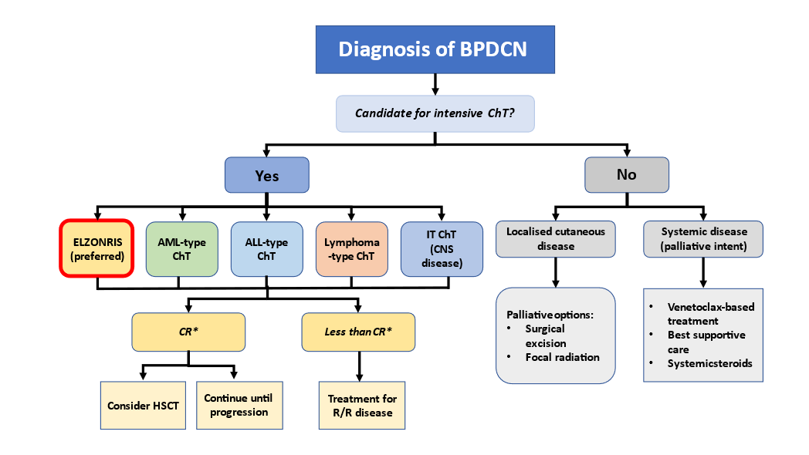Source: Figure 1-7, p37 of the submission
ALL=acute lymphocytic leukaemia; AML=acute myeloid leukaemia; BPDCN=blastic plasmacytoid dendritic cell neoplasm; ChT=chemotherapy; CNS=central nervous system; CR=complete response; ELZONRIS=tagraxofusp; HSCT=haematopoietic stem cell transplantation; IT=intrathecal therapy; R/R=relapsed/refractory.
* CR is defined as CR+CRc (clinical complete response with residual skin abnormality not indicative of active disease) as per Study 0114

For more detail on PBAC’s view, see section 7 PBAC outcome.
- Comparator
  - The submission nominated Treatment of Physician’s Choice (TPC), consisting of a mix of AML-, ALL- and lymphoma-type chemotherapy regimens, as the main comparator. The treatments that were nominated in the submission based the sponsor convened advisory board (see paragraph 4.6), are shown in Table 3.
Table 3: Treatments of Physician’s Choice that were nominated in the submission based on a sponsor convened advisory board.
TPC regimen | Expected useª | Cost per cycle^{b} | PBS restrictions for restricted medicines
HyperCVAD  Cyclophosphamide*  Vincristine*  Doxorubicin*  Dexamethasone*  Cytarabine*  Methotrexate*  Filgrastim | 27.5% | Cycle A  $590  Cycle B $2,910 | Filgrastim: chemo induced neutropenia
Cytarabine* Idarubicin (7+3) | 27.5% | $740 | Idarubicin: AML
Venetoclax + azacitidine | 25% | $14,950 | Venetoclax: CLL and SLL  Azacitidine: CML
FLAG-IDA  Fludarabine*  Cytarabine*  Idarubicin  Filgrastim | 7.5% | $3,550 | Idarubicin: AML  Filgrastim: chemo induced neutropenia
CHOP  Cyclophosphamide*  Doxorubicin*  Vincristine*  Prednisolone* | 2.5% | $330 | -
None | 10% | - | -
Source: reconstructed from Table 1-4, p31 of the submission.
AML=acute myeloid leukaemia, chemo=chemotherapy; CLL=chronic lymphocytic leukaemia, CML= chronic myelomonocytic leukaemia, SLL=small lymphocytic lymphoma
* Unrestricted PBS listing
ª Proportions suggested by the advisory board convened by the sponsor.
^{b} Estimated approximate costs derived from https://www.eviq.org.au/
  - The submission argued while these treatments are not TGA-approved or specifically PBS-listed for the treatment of BPDCN, they are accessed via the PBS for use in the target population and that they are the most likely regimens to be replaced by tagraxofusp in clinical practice. The ESC considered that the nomination of the comparators was generally appropriate; however, noted that the expected use nominated in Table 3 was not reflected in any subsequent sections of the submission which made different assumptions about utilisation. For example, the submission assumed the proportional use of venetoclax + azacitidine was 25% above, 75% in the economic model, and 14.3% in the financial estimates (see Table 17). A number of the nominated treatments are also restricted medicines on the PBS and thus, not able to be accessed by patients with BPDCN (including venetoclax, azacitidine and idarubicin). This was a concern given these treatments (typically with a higher cost) were used as cost offsets in the modelled economic evaluation and financial estimates. Due to the lack of consensus on treatments for BPDCN, other regimens for AML, ALL and lymphoma (such as HiDAC [high-dose cytarabine] and ICE [ifosfamide, carboplatin and etoposide] (Pemmaraju 2023)) may also be potential comparators, although their use are likely to be less frequent. The ESC considered that reasonable comparators may be two to four cycles of HyperCVAD for patients who are transplant eligible and six cycles of CHOP for patients who are ineligible for transplant.
For more detail on PBAC’s view, see section 7 PBAC outcome.
- Consideration of the evidence

Sponsor hearing
  - The sponsor requested a hearing for this item. The clinician described BPDCN as a rare disease with a poor prognosis and discussed the natural history of the disease. The clinician highlighted the lack of specific treatments available for this disease and noted that currently used chemotherapies resulted in long hospital stays and high rates of adverse events. The clinician described tagraxofusp as being an effective, tolerable alternative that resulted in more durable remissions and would allow more patients to bridge to HSCT compared to chemotherapy. The clinician also discussed the incidence of capillary leak syndrome, which is associated with tagraxofusp treatment, and stated that it was a known and manageable adverse event. The PBAC considered that the hearing was informative as it provided a clinical perspective on treating this uncommon disease.

Consumer comments
  - The PBAC noted the advice received via the Consumer Comments facility on the PBS website from Rare Cancers Australia supporting the tagraxofusp submission. The advice provided a patient perspective which described the benefits of tagraxofusp including the possibility of outpatient treatment, reduced side effects and the potential of bridging to HSCT. The PBAC noted that this advice was supportive of the evidence provided in the submission.

Clinical studies
  - The submission was based on:
- One multi-centre, open label, prospective, single arm, Phase 1/2 study of tagraxofusp in BPDCN (Study 0114), and
- One multi-national, multi-centre, retrospective observational study comparing outcomes from 398 patient records of adults diagnosed with BPDCN, grouped by therapy type and HSCT status (Laribi 2020).
  - Details of the studies presented in the submission are provided in Table 4.
Table 4: Studies and associated reports presented in the submission
Study | Protocol title/ Publication title | Publication citation
Tagraxofusp
Study 0114  NCT02113982 | SL-401 in Patients with Blastic Plasmacytoid Dendritic Cell Neoplasm or Acute Myeloid Leukemia. Clinical Study Report STML-401-0114. | October 2021
 | Pemmaraju N, Lane AA, Sweet KL, Stein AS, Vasu S, Blum W, Rizzieri DA, Wang ES, Duvic M, Sloan JM, Spence S, Shemesh S, Brooks CL, Balser J, Bergstein I, Lancet JE, Kantarjian HM, Konopleva M.  Tagraxofusp in Blastic Plasmacytoid Dendritic-Cell Neoplasm. | N Engl J Med. 2019 Apr 25;380(17):1628-1637.
 | N. S. Pemmaraju, Kendra L. Stein, Anthony S. Wang, Eunice S. Rizzieri, David A. Vasu, Sumithira Rosenblat, Todd L. Brooks, Christopher L. Habboubi, Nassir Mughal, Tariq I. Kantarjian, Hagop Konopleva, Marina Lane, Andrew A.  Long-Term Benefits of Tagraxofusp for Patients With Blastic Plasmacytoid Dendritic Cell Neoplasm. | Journal of Clinical Oncology. 2022;40:26:3032-3036
TPC
Laribi 2020 | Laribi K, Baugier de Materre A, Sobh M, Cerroni L, Valentini CG, Aoki T, Suzuki R, Takeuchi K, Frankel AE, Cota C, Ghez D, Calloch RL, Pagano L, Petrella T. Blastic plasmacytoid dendritic cell neoplasms: results of an international survey on 398 adult patients. | Blood Adv. 2020;4(19):4838-48.
Source: Tables 2-5, p53 and 2-32, p96 of the submission.
TPC=treatment of Physician’s choice
  - Laribi 2020, was selected from a possible 15 retrospective observational studies. Other potentially relevant comparator studies were excluded on the basis of either small sample size, limited reporting of outcomes or baseline patient characteristics, inclusion of tagraxofusp treated patients and years since publication. The pre-PBAC response stated that Laribi 2020 was representative of Australian practice, was a large study (N = 398) and reported all the baseline characteristics and endpoints of interest.
  - A claim of superiority for tagraxofusp versus TPC was made on the outcomes of OS, progression free survival (PFS) and HSCT on the basis of an unanchored matching adjusted indirect comparison (MAIC) between Study 0114 and Laribi 2020.
  - The limited presentation of Laribi 2020 for TPC in the submission was inappropriate, even if studies were not selected for the MAIC, given the limited available clinical evidence for treatments in BPDCN, other identified retrospective studies in the requested population may be relevant. It was noted that the presentation slides for the MAIC accompanying the submission indicated that the submission had conducted MAICs between Study 0114 and 9 other studies (aside from Laribi 2020) for the outcomes of OS, PFS and HSCT usage, indicating the submission had at least considered other studies to be potentially relevant. However, given the significant nomenclature change in 2008, cases identified prior to 2008 from medical history were likely to be less consistent with present day definitions of BPDCN.
  - It was noted that the submission had excluded two studies, Yun 2020 and Pemmaraju 2022 from further consideration. Unlike Laribi 2020, that reported outcomes for chemotherapy as a group, Yun 2020 and Pemmaraju 2022 had reported outcomes for individual regimens including those considered by the submission to be most likely replaced by tagraxofusp in practice (i.e., HyperCVAD and CHOP). Both studies were also relatively recent, with the majority of patients identified post 2008 in Yun 2020 (proportion not reported for Pemmaraju 2022). Given paucity of data in BPDCN, data from Yun 2020 and Pemmaraju 2022 were extracted during the evaluation for comparison.
  - It was noted that Yun 2020 and Pemmaraju 2022 also reported data for patients treated with tagraxofusp, including results versus chemotherapy regimens. While the comparative data was of low quality (retrospective and non-randomised), it possibly had higher internal consistency versus other retrospective studies, given all treatments were administered at the same centres. These studies appear to include patients treated with tagraxofusp in Study 0114. Yun 2020 indicated that at least some of the tagraxofusp treated patients in the study were part of Study 0114, while not discussed in Pemmaraju 2022, given Study 0114 was conducted over a similar time period, it was possible that patients in Pemmaraju 2022 had also received tagraxofusp as part of Study 0114. Of note, Laribi 2020 also included six patients treated with tagraxofusp.
  - The key features of the included studies are summarised in Table 5.
Table 5: Key features of the included studies
Study | N | Design/duration | Risk of bias | Patient population | Outcomes | Use in modelled evaluation
Tagraxofusp
Study 0114 | 86 BPDCN treated with 12 mcg/kg/day of tagraxofusp  66 Treatment naïve (65 with dataª)  20 R/R  (19 with dataª) | P1/2, single arm, OL, MC  Enrolled from October 2014;  Last patient exposure December 2019 | High | Adult patients with BPDCN, including 66 patients who were treatment naïve. | CRc, CR, PFS, OS, Bridge to HSCT, BMCR, ORR | Yes  (CR, PFS, OS, Bridge to HSCT)
TPC
Laribi 2020 | 398 | Retrospective, observational, MC  (75 centres, 5 countries),  2001-2017 | High | Treatment naïve | CR, PFS, OS, HSCT | Yes  (CR, PFS, OS, HSCT)
Yun 2020 | 49 | Retrospective, observational, single centre^{b},  2001 to 2019  (69% Dx 2010-2019) | High | Patients ≥18 years with BPDCN (WHO 2016 criteria)* | CR, PFS, OS, HSCT, remission duration probability after 1st line therapy | No
Pemmaraju 2022 | 100 | Retrospective observational, single centre^{c},  1999 to 2020. | High | Patients with BPDCN treated with 1L systemic therapy (HyperCVAD vs non HyperCVAD regimens) | CR, OS after 1st line systemic therapy | No
Source: complied during the evaluation based on information from the CSR synopsis, page 1; Laribi 2020, Yun 2020 and Pemmaraju 2022.
1L=first line; BMCR=bone marrow complete response; BPDCN=blastic plasmacytoid dendritic cell neoplasm; CR=complete response; CRc=clinical complete response with minimal residual skin involvement; Dx=diagnosed; HyperCVAD= hyperfractionated cyclophosphamide, vincristine, doxorubicin, dexamethasone alternating with high dose cytarabine and methotrexate; HSCT=haematopoietic stem cell transplant; MC=multi-centre; OL=open label; ORR=objective response rate; OS=overall survival; PFS=progression-free survival; R/R=relapsed and/or refractory; TPC=treatment of Physician’s choice; WHO = World Health Organisation
* Same as WHO 2008 definition.
ª 1 patient from each cohort withdrew consent prior to the first response assessment (p62 of the submission and p97 of the CSR).
^{b} H. Lee Moffitt Cancer Center and Research Institute, Tampa Florida, USA.
^{c} The University of Texas MD Anderson Cancer Center.
  - Study 0114 consisted of 4 stages. The numbers of treatment-naïve BPDCN patients who received the proposed dose of 12 mcg/kg/day (total with data N=65) in each of the stages were: Stage 1 (dose escalation) n=3, Stage 2 (expansion) n=13, Stage 3 (confirmatory) n=13 and Stage 4 (continued-access) n=37. Compared to those enrolled in Stages 1-3, a higher proportion of patients in Stage 4 had disease sites in the lymph node and in the peripheral blood (likely associated with poorer prognosis) but fewer patients with skin involvement (potentially hampering the speed of diagnosis and treatment, and important for outcomes).
  - In Stages 1-3 of the study a liquid formulation of tagraxofusp (as proposed for TGA registration and PBS listing) was utilised, however, a lyophilised formulation of tagraxofusp was evaluated in Stage 4. Due to this differentiation, the submission based its clinical claim on the subgroup of patients in Stages 1-3 (n=29). The results for this cohort were also utilised in the base case modelled economic evaluation. This was not appropriate. Data from all treatment naïve BPDCN patients in Study 0114 (i.e., Stages 1-4, N=65 with data) would be relevant to this submission. In relation to the two formulations, | | | | | | | | | | | | | | | | | | | | | | | | | | | | | | | | | | | | | | | | | | | | | | | | | | | | | | | | | | | | | | | | | | | | | | | | | | | | | | | | | | | | | | | | | | | | | | | | | | | | | | | | | | | | | | | | | | | | | | | | | | | | | | | | | | | | | | | | | | . Results are presented for both Stages 1-3 (n=29) and Stages 1-4 (n=65) of Study 0114. The Pre-Sub-Committee Response (PSCR) reiterated that, as the liquid formulation of tagraxofusp was proposed for PBS listing, the results from Stages 1-3 were the most relevant. The ESC considered that the inclusion of Stage 4 results was appropriate.
  - Overall, due to the study designs, all included studies were considered to have a high risk of bias. Selection bias was particularly high for the observational studies, and advancements in diagnosis of BPDCN meant retrospective identifications of BPCDN patients were likely to be associated with bias. The temporal differences between the included studies were also important, Study 0114 included patients diagnosed and treated between 2014 and 2019 whereas Laribi 2020, Yun 2020 and Pemmaraju 2022 included patients diagnosed and treated over a much wider period, between 2001 and 2017, 2001 and 2019 and 1999 and 2022 respectively (i.e., over at least 16 years). Over this time, there were likely differences in the availability and accuracy of testing to confirm diagnosis, treatment regimens and other clinical factors potentially impacting patient outcomes.
  - Participants enrolled in Study 0114 may have been healthier than those enrolled in the comparator studies. Given Laribi 2020, Yun 2020 and Pemmaraju 2022 were retrospective observational studies, outside of identifying patients with BPDCN, there were no specific exclusion criteria in these studies, conversely, as Study 0114 was a prospective study, it had excluded patients with central nervous system disease and other comorbidities, including active cardiovascular disease, uncontrolled pulmonary disease or those with recent or concurrent malignancies. There were other notable differences in reported patient characteristics across the studies including differences in patient age (younger in Study 0114), baseline functioning (better in Study 0114), disease sites (e.g., less skin disease in Stage 4 of Study 0114) that potentially favoured tagraxofusp. Clinical and/or molecular features associated with prognosis in BPDCN are poorly defined in the literature; however, limited evidence suggests younger age, skin disease only and less mature tumour cells to be predictive of better outcomes (Feuillard 2002, Tsagarakis 2010; Hashikawa 2012 and Jaye 2006).
  - All studies reported on the relevant outcomes of OS, PFS and intermediate outcomes of CR and bridging to HSCT. In Study 0114, CR rate was defined as CR/CRc, which was the proportion of patient that achieved either CR or CR with minimal residual skin abnormality (CRc). The outcome of CRc was first introduced in Study 0114. Patients in the retrospective studies with skin involvement at diagnosis who achieved clinical CR without 100% clearance of skin lesions would have been classified as achieving partial response (PR). The PSCR acknowledged that there was no clear CR definition, meaning that there was high uncertainty in terms of the comparability of this endpoint across studies.

Comparative effectiveness

Overall survival
  - Table 6, Figure 2 and Figure 3 summarise main OS outcomes from the included non-comparative studies.
Table 6: Overall survival outcomes from the included studies
Study | Tagraxofusp |  | TPC |  | Within study HR  (95% CI)  p-value
 | n/N (%)  [95% CI] | Median OS, months (95% CI) | n/N (%)  [95% CI]  at 36 months* | Median OS, months (95% CI)
Study 0114
Overall (Stage 1-4) | 41/65 (63.1%) | 15.8 (9.7, 25.8) | - | - | -
12 months survival | 54.9% [41.7, 66.3] | - | - | - | -
18 months survival | 49.7% [36.7, 61.4] | - | - | - | -
24 months survival | 39.7% [27.0, 52.0] | - | - | - | -
Stage 1-3 (modelled) | 18/29 (62.1%) | 25.8 (11.9, 53.9) | - | - | -
12 months survival | 62.1% [42.1, 76.9] | - | - | - | -
18 months survival | 58.6% [38.8, 74.0] | - | - | - | -
24 months survival | 51.7% [32.5, 67.9] | - | - | - | -
Laribi 2020
Overall | - | - | NR | 18 (15, 22) | -
24 months survival | - | - | 39% [34.1, 45] | - | -
36 months survival | - | - | 27.5% [22.5, 33.5] | - | -
60 months survival |  |  | 16.8% [12.0, 23.5]
Allo-HSCT combined | - | - | 72.4% [59, 88] | NR (39, NR) | 0.21 (0.12, 0.39)^{d,e}
Auto-HSCT combined | - | - | NR | 65 (48, NR) | 0.24 (0.10, 0.59)^{d,e}
AL-type combined | - | - | 30.7% [21, 45] | 18 (13, 25) | 0.88 (0.59, 1.32)^{d,e}
NHL-type | - | - | 11.1% [6.1, 20] | 14 (12, 18) | Reference
Palliative | - | - | 10% [4.1, 24.5] | 4 (3, 7) | 2.23 (1.48, 3.34)^{d,e}
Yun 2020
Overall | - | - | - | - | -
Tagraxofusp vs chemotherapy, deaths at last follow-up^{f} | 5/12 (41.7%) | NR | 4/21 (19.0%) | NR | 1.60 (0.46, 5.55)
HSCT vs no HSCT | - | - | NR | NR | 0.23 (0.07, 0.74)
HSCT vs no HSCT (adjusted for age, 1L therapy, sex, transplant) | - | - | NR | NR | 0.14 (0.02, 0.96)
Allo-HSCT vs no HSCT | - | - | NR | NR | 0.16 (0.05, 0.56)
(CHOP or HyperCVAD) + allo-HSCT vs tagraxofusp + allo-HSCT | NR | NR | NR | NR | 0.20 (0.05, 8.20)
Pemmaraju 2022
HyperCVAD-like | - | - | NR | 28.3 | -
HyperCVAD | - | - | NR | 31.4 | -
Tagraxofusp | NR | NR | - | 13.7 | -
Others | - | - | NR | 22.8 | -
HyperCVAD vs other treatment | - | - | NR | NR | p=0.434
HyperCVAD vs tagraxofusp | NR | NR | NR | NR | p=0.329
Tagraxofusp vs other treatments | NR | NR | NR | NR | p=0.797
Bold indicates statistically significant results.
Source: Compiled during the evaluation from Table 2-10, p91, Table 2-17, p74, 2-18, p 79 and 2-30, p101 of the submission, Tables 11-12, p127, 14.2.17.1, p459 and 14.2.18.1, p469 of the CSR, Laribi 2020, Yun, 2020, Pemmaraju 2022.
1L=first line; AL=acute leukemia; ALL=acute lymphoblastic leukemia; Allo=allogenic; AML=acute myeloid leukemia; auto=autologous; CHOP=cyclophosphamide, doxorubicin, vincristine, prednisone; CI=confidence interval; HR = hazard ratio; HSCT=haematopoietic stem cell transplant; HyperCVAD=hyper-fractionated cyclophosphamide, vincristine, doxorubicin, dexamethasone alternating with high dose cytarabine and methotrexate; NHL=non-Hodgkin lymphoma; NR=not reached; OS=overall survival; PFS=progression free survival; TPC = treatment of physician’s choice
* Unless otherwise specified.
ª ALL-like regimens included Aspa-MTX (30%), HyperCVAD (23%) and other unspecified ALL regimens (47%)
^{b} AML-like regimens included standard dose cytarabine by continuous infusion for 7 days + daunorubicin or idarubicin for 3-5 days (100%)
^{c} NHL-like regimens included CHOP or CHOP-like regimens (70%) and other NHL regimens including ifosfamide/etoposide/platinum-based regimens ESHAP, DEVIC, ICE, DHAP (30%)
^{d} Reference=NHL-type treatment without consolidation
^{e} Multivariate analysis
^{f} Median follow-up for Yun 2020 was 18.9 (1.4-182.1) months for chemotherapy treated patients,12.1 (4.1-48.8) months for tagraxofusp treated patients, and 10.5 (0.1-182.1) all patients (including patients who were not treated).

Figure 2 : Overall survival
A: Study 0114 Overall population (Stages 1-4, N=65) | B: Study 0114 OS by Stage
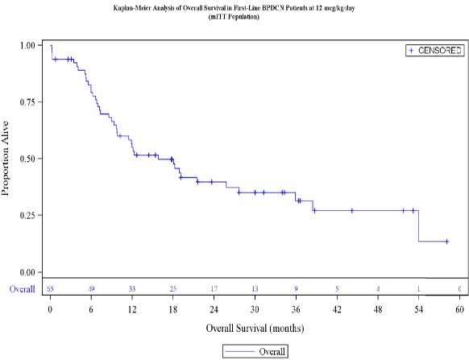 | 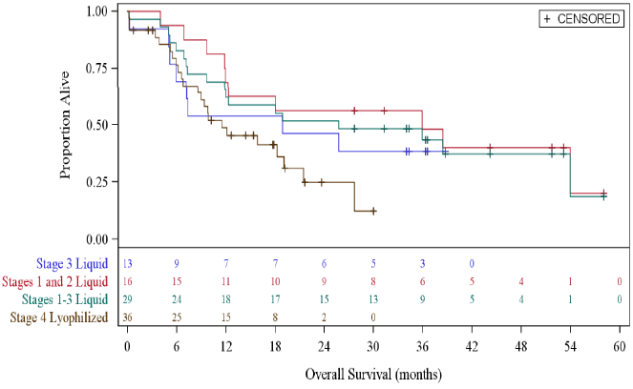
C: Yun 2020 | D: Pemmaraju 2022
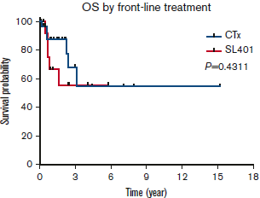 | 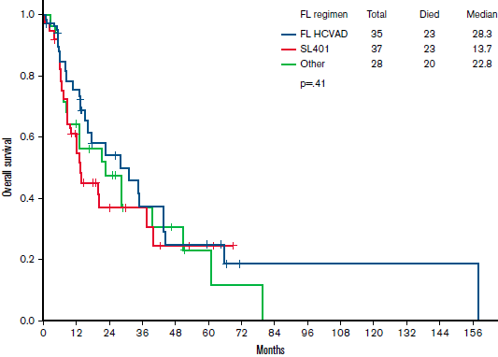
Source: A Figure 14.2.6.2, p573 of the CSR; B Figure 14.2.6.2, p572 of the CSR C Figure 2A, Yun 2020; D Figure 1, Pemmaraju 2022
CTx=chemotherapy; HCVAD=hyper-fractionated cyclophosphamide, vincristine, doxorubicin, dexamethasone alternating with high dose cytarabine and methotrexate; OS = overall survival; SL-401=tagraxofusp
Figure 3: OS by HSCT status
A: Study 0114: Stages 1-4 | B: Study 0114: CR/CRc responders +/− Bridged to HSCT
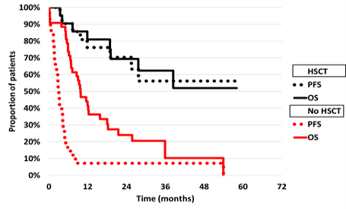 | 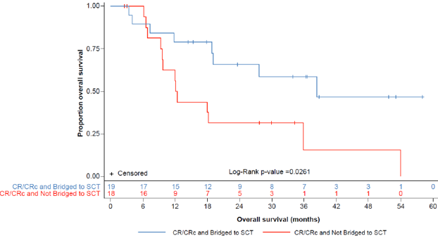
C: Laribi 2020 (by treatment type including +/−HSCT) | D: Yun 2020:
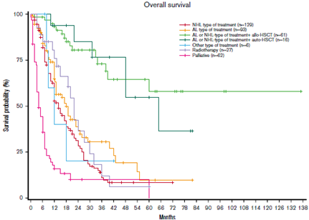 | 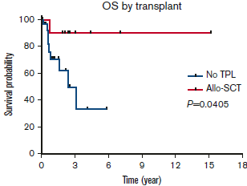
E: Yun 2020
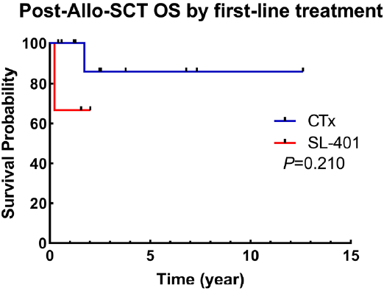
Source: Compiled during the evaluation from A: constructed using KM data presented in the modelled economic evaluation Sheet ‘Engine’ Excel workbook ‘Elzonris BPDCN Cost Effectiveness Model March 2023.xlsm’; B: Figure 2-9 of the submission; C: Figure 1, Laribi 2020; D: Figure S2A, Yun 2020; E: Figure S3, Yun 2020
Allo=allogenic; CR/CRc=complete response or complete response with minimal residual skin abnormality; CTx=chemotherapy; HSCT=haematopoietic stem cell transplant; OS=overall survival; PFS=progression free survival; SCT=HSCT; SL-401=tagraxofusp; TPL=transplant
OS by first-line therapies
  - Among the 65 first line BPDCN patients in the modified intention to treat (mITT) population treated with tagraxofusp at 12 mcg/kg/day (Stages 1-4), median OS was 15.8 months (95% CI: 9.7, 25.8) after a median follow up of 44 months. At the time of the analysis, 41/65 (63%) patients had died with 24/65 (37%) patients censored. The estimated probability of survival for Stages 1-4 patients at 12 and 24 months were 54.9% and 39.7% respectively. Laribi 2020 reported a similar median OS of 18 months (95% CI: 15, 22), with a similar 24 month survival probability for all included patients of 39.0% (95% CI: 34.1, 45.0). Yun 2020 and Pemmaraju 2022 found no difference in OS across included first-line treatments (p=0.43 and p=0.41, respectively), despite numerical differences in median OS in Pemmaraju 2022 varying between 13.7 months (for tagraxofusp) and 31.4 months (for HyperCVAD). Yun 2020 also found no significant difference in survival between those treated by tagraxofusp versus chemotherapy (HR = 1.597; 95% CI: 0.460, 5.548), although the result needs to be interpreted with caution as it was based on non-randomised data.
  - The median OS reported for tagraxofusp in Study 0114 fluctuated depending on the subgroup considered, with higher OS reported for Stages 1-3 (median OS: 25.8 months versus 15.8 months for Stages 1-4). The differences in outcomes were likely due to poorer prognosis of patients in Stage 4 of the study. These differences were more pronounced if further subgrouping patients by HSCT status.
OS by HSCT status
  - Study 0114, Laribi 2020 and Yun 2020 demonstrated a significant OS advantage with HSCT consolidation (p=0.026, p<0.001 and p=0.041, respectively). Laribi 2020 reported chemotherapy + allo- or auto-HSCT significantly improved OS compared to NHL-type treatment without consolidation (adjusted HR = 0.21; 95% CI: 90.12, 0.39 and HR = 0.24;95% CI: 0.10, 0.59, respectively). Yun 2020 reported significantly better OS for patients who underwent HSCT compared to those who did not (unadjusted HR = 0.225; 95% CI: 0.069, 0.735) including when adjusted for age, sex, first-line therapy and transplant (HR = 0.137; 95% CI: 0.020, 0.959). The type of first-line therapy did not significantly impact on post-HSCT survival (HR = 0.204; 95% CI: 0.005, 8.203, Yun 2020).
CR and OS
  - Figure 3, panel B illustrates survival data for those who achieved CR/CRc in Study 0114 grouped by those who bridged and did not bridge to HSCT. Those who bridged to HSCT gained a survival advantage over those who also achieved CR/CRc but did not bridge to HSCT (p=0.0261), indicating the important role of HSCT in achieving longer term OS.

Progression free survival
  - Table 7 and Figure 4 summarise main PFS outcomes from the included studies.
Table 7: Summary of progression-free survival outcomes in the included studies*
Study | Tagraxofusp |  | TPC |  | HR (95% CI)
 | n/N (%) | Median PFS, months (95% CI) | n/N (%)  at 36 months | Median PFS, months (95% CI)
Study 0114
Overall (Stage 1-4) | 48/65 (73.8%) | 4.4 (3.2, 7.3) | - | - | -
Stage 1-3 (used in model) | 20/29 (69.0%) | 7.3 (4.3, 53.9) | - | - | -
Stages 1-2 | 11/16 (68.8%) | 9.5 (4.3, NE) | - | - | -
Stage 3 | 9/13 (69.2%) | 7.3 (2.8, NE) | - | - | -
Stage 4 | 28/36 (77.8%) | 3.1 (1.8, 4.8) | - |  | -
Laribi 2020
Overall | - | - | NR | 10 (8.7, 11) | -
Chemo+allo-HSCT | - | - | 70.6% | NE (44, NE) | -
Chemo+auto-HSCT | - | - | 71.3% | 65 (48, NE) | -
ALL- or AML-like^{a,b} | - | - | 9.6% | 9 (6, 12) | -
NHL-like^{c} | - | - | 2.2% | 8 (8.7, 11) | -
Palliative | - | - | 0% | 4 (3, 6) | -
Yun 2020
Overall | - | - | NR | 9.9 | -
HyperCVAD vs CHOP | - | - | NR | NR | 0.217 (0.050, 0.933)
HyperCVAD vs tagraxofusp | NR | NR | NR | NR | 0.385 (0.126,1.179)
Tagraxofusp vs CHOP | NR | NR | NR | NR | 0.931 (0.321, 2.70)
Pemmaraju 2022
HyperCVAD | - | NR | NR | 38.6 ^{d} | -
Tagraxofusp | NR | - | NR | NR | -
Other | - | NR | NR | 10.2 ^{d} | -
Bold indicates statistically significant results.
Source: Compiled during the evaluation from Tables 2-17, p74 and 2-30, p101 of the submission, Tables 11-12, p127, 14.2.17.1, p459 and 14.2.18.1, p469 of the CSR, Laribi 2020, Yun 2020, Pemmaraju 2022.
ALL=acute lymphoblastic leukemia; allo=allogenic; AML=acute myeloid leukemia; auto=autologous; chemo=chemotherapy; CHOP=cyclophosphamide, doxorubicin, vincristine, prednisone; CI=confidence interval; HR=hazard ratio; HSCT=haematopoietic stem cell transplant; HyperCVAD=hyper-fractionated cyclophosphamide, vincristine, doxorubicin, dexamethasone alternating with high dose cytarabine and methotrexate; NE=not estimable; NHL=non-Hodgkin lymphoma; NR=not reported; PFS=progression free survival; TPC=treatment of physician’s choice
ª ALL-like regimens included Aspa-MTX (30%), HyperCVAD (23%) and other unspecified ALL regimens (47%)
^{b} AML-like regimens included standard dose cytarabine by continuous infusion for 7 days + daunorubicin or idarubicin for 3-5 days (100%)
^{c} NHL-like regimens included CHOP or CHOP-like regimens (70%) and other NHL regimens including ifosfamide/etoposide/platinum-based regimens ESHAP, DEVIC, ICE, DHAP (30%)
^{d} Duration of remission
* Note that the results presented in Table 7 are derived from ad-hoc analyses conducted by the applicant specifically for the purposes of informing the PBAC consideration. Interpretation of the results and their application should therefore be limited to seeking to understand the basis for the PBAC outcome and should not be used for any other purpose.

Figure 4: PFS from the included studies
A: Study 0114 PFS by Stage* | B: Laribi 2020 (by treatment type including +/−HSCT)
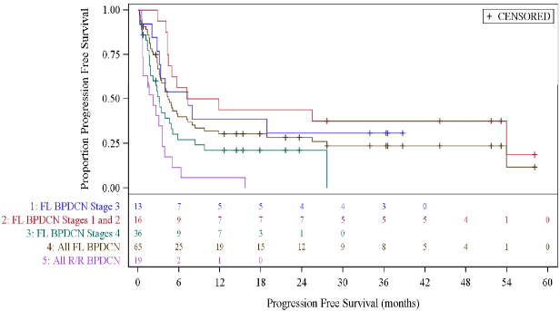 | 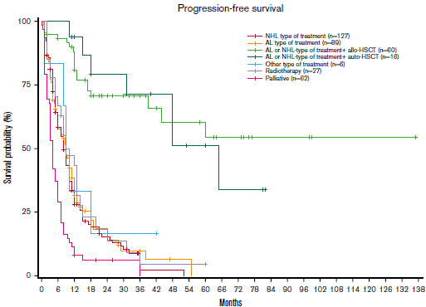
C: Yun 2020 | D: Pemmaraju 2022 (Remission duration)
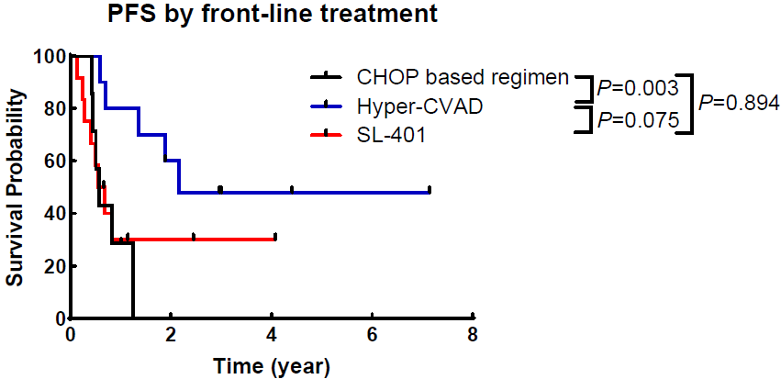 | 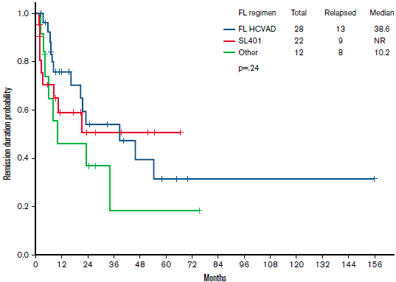
Source: A Figure 14.2.6.3, p574 of the CSR; B Figure 2, Laribi 2020; C Figure S2A, Yun 2020; D: Figure 2, Pemmaraju 2022.
CHOP=cyclophosphamide, doxorubicin, vincristine, prednisone; FL=first/front-line; HCVAD/Hyper-CVAD=hyper-fractionated cyclophosphamide, vincristine, doxorubicin, dexamethasone alternating with high dose cytarabine and methotrexate; HSCT=hematopoietic stem cell transplant; PFS=progression free survival; SL-401=tagraxofusp
* Note that the results presented in Figure 4 are derived from ad-hoc analyses conducted by the applicant specifically for the purposes of informing the PBAC consideration. Interpretation of the results and their application should therefore be limited to seeking to understand the basis for the PBAC outcome and should not be used for any other purpose.
  - PFS: Tagraxofusp did not demonstrate improvement in PFS over existing therapies. Median PFS for Stages 1-4 of Study 0114 was 4.4 months versus 10 months in Laribi 2020 and 9.9 months in Yun 2020 for TPC. Pemmaraju 2022 also reported similar remission duration probability (median not reached for tagraxofusp versus 38.6 and 10.2 months for HyperCVAD and other treatment groups respectively, p=0.24). Similarly, Yun 2020 found no significant difference between tagraxofusp and HyperCVAD or CHOP regimens in terms of PFS (p=0.075 and 0.894, respectively), although the point estimate was in favour of HyperCVAD (HR = 0.385; 95% CI: 0.126, 1.179).
  - PFS by HSCT status: Laribi 2020 reported PFS by treatment groups, including chemotherapy ± HSCT, and found significant differences. Median PFS was not estimable (NE) (95% CI: 44, NE) in patients who received chemotherapy followed by allo-HSCT and 65 months (95% CI: 48, NE) for patients who received chemotherapy followed by auto-HSCT, compared to 9 months (95% CI: 6, 12) for those who received ALL- or AML-type treatment without consolidation with HSCT, 8 months (95% CI: 8.7, 11) for those receiving NHL-type treatment without consolidation, and 4 months (95% CI: 3, 6) for those who received palliative treatment (Laribi 2020).

Response rates
  - Table 8 summarises results for complete response outcomes across the included studies.
Table 8: Summary of complete response outcomes across the included studies
Study | Treatment Group | CR  n/N (%) | CRc  n/N (%) | CR rate^{e}  n/N (%)  [95% CI] | Relapse^{e}  n/N (%) | Median duration of CR^{e},  months  (95% CI) | Median time to CR^{e},  days (IQR)
Tagraxofusp
Study 0114 | Stages 1-2 | 11/16  (68.8) | 3/16  (18.8) | 14/16 (87.5)  [61.7, 98.4] | 7/14  (50) | 24.9 (1.5, NE) | 41 (24, 49)
 | Stage 3^{f} | 3/13  (23.1) | 4/13  (30.8) | 7/13 (53.8)  [25.1, 80.8] | 2/7  (28.6) | NE (7.3, NE) | 57 (22, 81)
 | Stage 4^{g} | 7/36  (19.4) | 9/36  (25.0) | 16/36 (44.4)  [27.9, 61.9] | 9/16  (39.1) | 4.4 (2.3, NE) | 23.5 (21.5, 46)
 | Pooled Stage 1-3^{f} | 14/29  (48.3) | 7/29  (24.1) | 21/29 (79.3)  [52.8, 87.3] | 9/21  (33.3) | NE (5.9, NE) | 43 (NR, NR)
 | Pooled Stage 1-4^{h} | 21/65  (32.3) | 16/65  (24.6) | 37/65 (56.9)  [44.0, 69.2] | 18/37 (48.6)  PR: 9ª/12 (75.0) | 24.9 (3.8, NE) | 39 (22, 49)
TPC
Laribi (2020) | Chemotherapy with no consolidation | 153/222 (68.9) | NR | - | 131/168  (78.0) | - | -
 | Chemotherapy + allo-HSCT | 57/61  (93.4) | NR | - | 16/60  (26.7) | - | -
 | Chemotherapy + auto-HSCT | 16/16  (100) | NR | - | 5/16  (31.3) | - | -
Yun (2020) | Tagraxofusp | 6/12  (50) | 0/12 | - | NR | - | -
 | CHOP-based^{b} | 5/10  (50.0) | 0/10 | - | NR | - | -
 | HyperCVAD | 10/11  (90.9) | 0/11 | - | NR | - | -
 | Other (including palliative)^{c} | 2/9  (22.2) | 0/9 | - | NR | - | -
Pemmaraju (2022) | Tagraxofusp | 22/37  (59.5) | NR | - | 9/22  (40.9) | 10.7 | -
 | HyperCVAD | 28/35  (80.0) | NR | - | 13/28  (46.4) | 38.6 | -
 | Other^{d} | 12/28  (42.9) | NR | - | 8/12  (66.7) | 21.4 | -
Bold indicates statistically significant results.
Source: Compiled during the evaluation from Tables 2-17, p73 and 2-30, p101 of the submission, Tables 11-8, p113, 11-11, p124, 14.2.22.1, p542 of the CSR, p118 of the CSR, Laribi 2020, Table 2, Yun 2020, Pemmaraju 2022.
ALL=acute lymphoblastic leukemia; allo=allogenic; AML=acute myeloid leukemia; auto=autologous; CHOP=cyclophosphamide, doxorubicin, vincristine, prednisone; CI = confidence interval; CR=complete response; CRc=clinical CR with minimal residual skin involvement; HSCT=haematopoietic stem cell transplant; HyperCVAD=hyper-fractionated cyclophosphamide, vincristine, doxorubicin, dexamethasone alternating with high dose cytarabine and methotrexate; IQR=interquartile range; NE=not estimated, NHL=non-Hodgkin lymphoma; NR=not reported; PR=partial response; TPC=treatment of physician’s choice.
ª Relapsed or died,
^{b} CHOP-based regimens include CHOP (cyclophosphamide, doxorubicin, vincristine, prednisone), CNOP (cyclophosphamide, mitoxantrone, vincristine, prednisone), EPOCH (etoposide, prednisone, vincristine, cyclophosphamide, doxorubicin)
^{c} Other regimens include CLAG (cladribine, cytarabine, granulocyte colony stimulating factor), methotrexate/pralatrexate, radiation
^{d} Other regimens include CHOP (29%), AML-based (21%), Bortezomib (7%), Hypomethylator-based (14%), other (29%),
^{e} Study 0114 reported combined CR (CR+CRc); Pemmaraju 2022 reported duration of CR1
^{f} 1 person not evaluable
^{g} 3 patients not evaluable
^{h} 4 patients not evaluable
  - Complete response: The primary efficacy endpoint in Study 0114 was CR rate. The outcome was considered to have been met in the confirmatory Stage 3 cohort of first line BPDCN patients (N=13) if the lower bound of the 95% confidence interval surrounding the proportion of patients achieving CR/CRc was ≥10%. Seven of the 13 patients achieved CR or CRc, resulting in a combined CR/CRc of 54% (95% CI: 25, 81) and thus, meeting the MCID. Median time to CR was 39 days (IQR: 22, 49 days) with median duration of CR of 24.9 months (95% CI: 3.8, NE). Notably, the CR rates achieved in Study 0114 were highest in the dose escalation and expansion stages (Stages 1 and 2), and were lowest in Stage 4, the continued access stage. This may reflect potential selection bias of healthier patients in the early stages of the study. The overall CR rate for Stages 1-4 was similar to Stage 3 at 56.9% (95% CI: 44.0, 69.2). As discussed, CR reported in the TPC studies lacked comparability to Study 0114 given they did not include patients who achieved CRc and the PSCR acknowledged that as there was no clear CR definition, there was high uncertainty in terms of the comparability of this endpoint across studies. CR was considerably lower than CR/CRc in Study 0114 (i.e., 32.2% versus 56.9% for Stages 1-4 and 48.3% versus 79.3% in Stages 1-3). Yun (2020) and Pemmaraju (2022) utilised patient records from centres that participated in Study 0114, hence the CR rates reported for tagraxofusp were similar (50.0% and 59.5%, respectively). Of the chemotherapy regimens, HyperCVAD had the highest proportion of patients achieving CR (80.0 to 90.9%), exceeding proportions reported for tagraxofusp in Study 0114. HyperCVAD regimens also achieved the longest median duration of CR (38.6 months compared to 10.7 for tagraxofusp, Pemmaraju 2022); however, the difference was not statistically significant. CHOP-based regimens produced similar CR to tagraxofusp (50.0% achieving CR, Yun 2020). Laribi 2020 reported 69% of patients treated with any chemotherapy regimen without consolidation achieved CR.
  - Relapse: Relapse rates were similar between tagraxofusp and HyperCVAD (48.5% from Study 0114 vs 46.4% of HyperCVAD patients from Pemmaraju 2022). Laribi 2020 reported relapse rates stratified by HSCT status, with 78% of patients who received chemotherapy without consolidation experiencing relapse, compared to 27% and 31% who received chemotherapy with allo- and auto-HSCT, respectively. The proportions of patients achieving HSCT are presented in Table 9 and survival outcomes stratified by HSCT status are presented in Table 6, Table 7 and Figure 3.

HSCT rates
  - Table 9 summarise the proportions of patients achieving HSCT across the studies.
Table 9: Proportions of patients achieving HSCT across the studies
Study | Treatment Group | Bridged to HSCT | Any HSCT | Allo-HSCT | Auto-HSCT | No HSCT
Tagraxofusp
Study 0114 | Stage 1-3 | 13/29 (44.8%) | 18/29 (62.1%) | 10/13 (76.9%) | 3/13 (23.1%) | 11/29 (37.9%)
 | Stage 1-4 | 21/65 (32.3%) | 32/65 (49.2%) | 14/21 (66.7%) | 7/21 (33.3%) | 33/65 (50.8%)
TPC
Laribi 2020 | Overall | NR | 77/394 (19.5%) | 61/77 (79.2%) | 16/77 (20.8%) | 317/394 (80.5%)
 | ALL-likeª | NR | 39/96 (40.6%) | 33/39 (84.6%) | 6/39 (15.4%) | 57/96 (59.4%)
 | AML-like^{b} | NR | 17/53 (32.1%) | 16/17 (94.1%) | 1/17 (5.9%) | 36/53 (67.9%)
 | NHL-like^{c} | NR | 21/150 (14%) | 12/21 (57.1%) | 9/21 (42.9%) | 129/150 (86.0%)
Yun 2020 | Overall | 11/49 (22.4%) | 14/49 (28.6%) | 10/49 (20.4%) | 4/49 (8.2%) | 35/49 (71.4%)
 | Tagraxofusp | NR | 3/12 (25.0%) | 3/3 (100%) | 0/3 | 9/12 (75.0%)
 | Chemotherapy^{d} | NR | 11/21 (52.4%) | 7/11 (63.6%) | 4/11 (36.4%) | 10/21 (47.6%)
 | Other^{e} | NR | 0/16 | - | - | 16/16 (100%)
Pemmaraju 2022 | Overall | 32/100 (32%) | 45/100 (45.0%) | NR | NR | 55/100 (55.0%)
 | Tagraxofusp | 13/22 (59.1%) | 17/37 (45.9%) | NR | NR | 20/37 (54.1%)
 | HyperCVAD | 15/28 (53.6%) | 18/35 (51.4%) | NR | NR | 17/35 (48.6%)
 | Other | 4/12 (33.3%) | 10/28 (35.7%) | NR | NR | 18/28 (64.3%)
Source: Compiled during the evaluation from Tables 2-17, p75 and 2-19, p82 of the submission, CSR, p126, Table 14.2.18.1.1, p471 of the CSR, Tables 1 and 3, Laribi 2020, Table 1 and p3438, Yun 2020, Table 2, Pemmaraju 2022.
ALL=acute lymphoblastic leukemia; allo=allogenic; AML=acute myeloid leukemia; auto=autologous; CHOP=cyclophosphamide, doxorubicin, vincristine, prednisone; CI=confidence interval; HSCT=haematopoietic stem cell transplant; HyperCVAD=hyper-fractionated cyclophosphamide, vincristine, doxorubicin, dexamethasone alternating with high dose cytarabine and methotrexate; NHL=non-Hodgkin lymphoma; NR=not reported; TPC=treatment of physician’s choice;
ª ALL-like regimens included Aspa-MTX (30%), HyperCVAD (23%) and other unspecified ALL regimens (47%)
^{b} AML-like regimens included standard dose cytarabine by continuous infusion for 7 days + daunorubicin or idarubicin for 3-5 days (100%)
^{c} NHL-like regimens included CHOP or CHOP-like regimens (70%) and other NHL regimens including ifosfamide/etoposide/platinum-based regimens ESHAP, DEVIC, ICE, DHAP (30%)
^{d} Chemotherapy=CHOP-based (48%) and HyperCVAD (52%) regimens
  - A total of 21/65 (32%) first line BPDCN patients treated with tagraxofusp were bridged to HSCT, with a further five patients achieving HSCT after subsequent therapies. 19/21 (90%) of the patients bridged to HSCT had achieved CR while the remaining 10% (2/21) experienced PR before being bridged to HSCT. Seven of the 21 patients bridged to HSCT had bone marrow disease at baseline; all seven achieved BMCR. The pre-PBAC response stated that for the 32% of patients who were bridged to HSCT, the survival probability at 24 months for transplanted patients was 69%
  - Study 0114 and Pemmaraju 2022 reported higher proportions of patients achieving HSCT after first line therapy (32.3% and 32.0%, respectively) than Yun 2020 (22.4%). Laribi 2020 reported 19.5% of patients receiving HSCT without specifying if bridging to HSCT was achieved after the first or subsequent lines of therapy. Proportions of patients achieving HSCT were similar for the tagraxofusp and HyperCVAD patients in Pemmaraju 2022 (45.9-59.1% vs 51.4-53.6%, respectively); however, Yun 2020 reported only 25% of patients treated with tagraxofusp achieved HSCT compared to 52.4% of patients treated with chemotherapy.

Matching adjusted indirect comparison (MAIC) tagraxofusp versus TPC
  - A logistic propensity score model was constructed, matching Study 0114 to Laribi 2020 on mean patient age, male (%), bone marrow disease (%), peripheral blood disease (%), lymph node disease (%) and skin disease (%). The importance of these factors to outcomes was not described in the submission, and the submission stated that variables were excluded “to maintain an effective sample size (ESS) and accurate matched population characteristics”.
Table 10: Covariate matching for tagraxofusp (Study 0114) to TPC (Laribi 2020)
Scenario | Mean age | Male | LND | BMD | PBD | SD | ESS
Overall population
Laribi 2020 overall | 67ª | 74% | 39% | 62% | 15% | 89% | 398
Study 0114 Stages 1-3
Unweighted | 62.2 | 79% | 45% | 48% | 24% | 97% | 29
Weighted | 67 | 74% | 39% | 62% | 15% | 89% | 17.5
Study 0114 Stages 1-4
Unweighted | 63.2 | 80% | 51% | 49% | 26% | 92% | 65
Weighted | 67 | 74% | 39% | 62% | 15% | 89% | 46.7
HSCT^
Laribi 2020 any HSCT | 52.7^{c} | NE^{b} | NE^{b} | NE^{b} | NE^{b} | NE^{b} | 77
Study 0114 Stages 1-3
Unweighted | 55.1 | 69% | 54% | 38% | 31% | 100% | 13
Weighted | 52.7 | 74% | 70%^{d} | 62% | 15% | 100%^{d} | 5.2
Study 0114 Stages 1-4
Unweighted | 55.3 | 71% | 52% | 33% | 24% | 100% | 21
Weighted | 67 | 74% | 39% | 62% | 15% | 100%^{d} | 5.1
Not bridged to HSCT
Laribi 2020 no HSCT | 70.5e | NE^{b} | NE^{b} | NE^{b} | NE^{b} | NE^{b} | 317
Study 0114 Stages 1-3
Unweighted | 67.9 | 88% | 38% | 56% | 19% | 94% | 16
Weighted | 70.5 | 74% | 39% | 62% | 15% | 89% | 7.5
Study 0114 Stages 1-4
Unweighted | 67 | 84% | 50% | 57% | 27% | 89% | 44
Weighted | 70.5 | 74% | 39% | 62% | 15% | 89% | 30.7
Source: ‘3335f_Update to MAICs for the stage 1 to 3 patient subgroup results_v2_16Feb2023.pptx’, Laribi K et al. Blastic plasmacytoid dendritic cell neoplasms: results of an international survey on 398 adult patients. Blood Adv. 2020 Oct 13;4(19):4838-4848.
BMD=bone marrow disease, ESS=effective study sample, HSCT=hematopoietic stemc cell transplant; LND=lymph node disease, NE=not estimated, PBD=peripheral blood disease, SD=skin disease; TPC=treatment of physician’s choice
^HSCT in Laribi 2020 was not restricted to HSCT after first-line treatment (i.e. not just ‘bridged to HSCT’). Study 0114 estimates were restricted to ‘bridged to HSCT’.
ª Median assumed to be mean
^{b} Baseline characteristics for Laribi 2020 were not reported by HSCT status and therefore MAIC assumed they were equal to overall population
^{c} Not reported by study. Appears to be estimated as weighted averaged median age for patients receiving allo-HSCT (50 years) and auto-HSCT (63 years)
^{d} Not matched
^{e} Not reported by study. Appears to be estimated as weighted averaged median age excluding patients who received allo-HSCT (50 years) and auto-HSCT (63 years)
  - The base case modelled economic evaluation used data from Stages 1-3 of Study 0114. The ESS for this population was 17.5 compared to a total population of 29. If using Stages 1-4 from Study 0114, the ESS was 46.7 compared to a total population of 65.
  - MAICs of OS, PFS and HSCT were performed using weighted individual patient data from Study 0114 and extracted KM curves from Laribi 2020. KM curves reported in Laribi 2020 were disaggregated by first line systemic treatments and HSCT status. Given the numbers of patients at risk at each time point were not provided, it was unclear how the submission obtained the aggregated KM curves for the overall population OS and PFS (or OS and PFS by HSCT status) required for the MAIC. The reconstructed KM curves from Laribi 2020 which the MAIC relied on were not presented in the submission. The submission also did not provide the weighted and unweighted KM curves from Study 0114 for verification.
  - The submission presented MAICs comparing tagraxofusp to TPC for OS, PFS and HSCT for Stages 1-3 and Stage 4 without stratification by HSCT. For completeness, the results for Stages 1-3 and Stages 1-4, both for the overall population and stratified by HSCT status, are presented below.
Table 11: MAIC of OS HR, PFS HR, HSCT OR for tagraxofusp (Study 0114) vs TPC (Laribi 2020)*
Tagraxofusp source | OS HR (95% CI) |  | PFS HR (95% CI) |  | HSCT OR (95% CI)
Overall population | Unweighted | Weighted | Unweighted | Weighted | Unweighted | Weighted
Study 0114 Stages 1-3 | 0.74  (0.46, 1.19) | 0.84  (0.52, 1.38) | 0.74  (0.47, 1.17) | 0.80  (0.48, 1.34) | 3.39  (1.56, 7.34) | 2.44  (0.81, 7.35)
Study 0114 Stages 1-4 | 1.17  (0.860, 1.58) | 1.24  (0.85, 1.82) | 1.17  (0.86, 1.58) | 1.42  (0.97, 2.07) | 1.99  (1.12, 3.54) | 1.58  (0.79, 3.17)
HSCT
Study 0114 Stages 1-3 | 1.35  (0.52, 3.53) | 1.01  (0.26, 3.98) | 1.15  (0.44, 2.99) | 0.88  (0.23,3.33) | NA | NA
Study 0114 Stages 1-4 | 1.31  (0.59, 2.88) | 1.53  (0.29, 8.00) | 1.31  (0.59, 2.88) | 1.06  (0.21, 5.23) | NA | NA
Not bridged to HSCT
Study 0114 Stages 1-3 | 0.93  (0.53, 1.62) | 1.09  (0.52, 2.27) | 1.33  (0.79, 2.24) | 1.04  (0.40, 2.71) | NA | NA
Study 0114 Stages 1-4 | 2.17  (1.55, 3.04) | 1.41  (0.89, 2.22) | 2.17  (1.55, 3.04) | 2.27  (1.32, 3.91) | NA | NA
Source: ‘3335f_Update to MAICs for the stage 1 to 3 patient subgroup results_v2_16Feb2023.pptx’
CI=confidence interval, HR= hazard ratio, HSCT=haematopoietic stem cell transplant, NA=not applicable, OR=odds ratio, OS=overall survival, PFS=progression free survival,
HR < 1 or > 1 favours tagraxofusp.
HSCT in Laribi 2020 was not restricted to HSCT after first-line treatment (i.e. not just ‘bridged to HSCT’). Study 0114 estimates were restricted to ‘bridged to HSCT’. Baseline characteristics, excluding age, in Laribi 2020 were not reported by HSCT status and therefore MAIC assumed they were equal to overall population
* Note that the results presented in Table 11 are derived from post-hoc analyses conducted by the applicant specifically for the purposes of informing the PBAC consideration. These analyses were not part of the pre-specified statistical plan for Study 0114. Interpretation of the results and their application should therefore be limited to seeking to understand the basis for the PBAC outcome and should not be used for any other purpose.
  - Based on the MAIC results, the submission claimed a benefit for tagraxofusp versus TPC for OS, PFS and HSCT. The ESC considered that this was not appropriate. While the MAIC point estimates for Stages 1-3 generally favoured tagraxofusp, the confidence intervals were wide with none reaching statistical significance, likely due to low patient numbers in Study 0114. Additionally, an important concern was the change in direction of effect for PFS and OS when data from Stages 1-4 of Study 0114 were used, indicating worse OS and PFS for tagraxofusp versus TPC (HRs >1). The PSCR stated that bridging to HSCT is a highly patient-relevant outcome that is potentially curative and highlighted that the odds ratios for HSCT status consistently favoured tagraxofusp (Stages 1-3: OR = 2.44; 95% CI: 0.81, 7.35 and Stages 1-4: OR = 1.58; 95% CI: 0.79, 3.17). The ESC noted that neither comparison demonstrated statistically significant results. The PSCR also stated that is understood that in clinical practice, very few patients with TPC are able to bridge to transplant, as CR is usually short-lived and chemotoxicity complicates transplant eligibility. As more patients were able to bridge to transplant with tagraxofusp versus TPC, the PSCR stated that it was feasible that more patients achieved and sustained CR. The ESC agreed that bridging to HSCT was important; however, noted that it was the HSCT that conferred that majority of the survival advantage. The ESC further noted that there was not a significant difference in the percentage of patients being bridged to transplant between the Stages 1-4 tagraxofusp patients (32.3%) and patients achieving HSCT after first line therapy in Pemmaraju 2022 (32%) and Yun 2020 (22.4%)
  - The estimated hazard ratios and odds ratios by HSCT status (Table 11) must also be interpreted with caution, given the very small sample size for these comparisons (ESS < 10 for Stages 1-3), and the likely lack of adjustment of baseline characteristics by HSCT status given baseline demographics were not stratified by HSCT in Laribi 2020. At a high level, these results suggested that tagraxofusp was unlikely to have survival benefit over TPC once HSCT rate was taken into account.
  - The ESC noted that the results were also unlikely to be robust due to important limitations of the MAIC including:
- The submission presented an unanchored MAIC which required the acceptance of the strong assumption that absolute outcomes can be predicted from the covariates; that is, it assumed that all effect modifiers and prognostic factors were accounted for. This was unlikely to have been met.
- Due to limited sample size in Study 0114 (Stages 1-3: N=29, Stages 1-4: N=65), and the MAIC matching on 7 baseline characteristics (age, gender, lymph node disease, bone marrow disease, peripheral blood disease and skin disease) to reported aggregate data from Laribi 2020, not all observed across study differences were adjusted for, such as:
- median length of follow-up (44 months for Stages 1-3, 34 months for Stages 1-4 for tagraxofusp, 12 months for TCP),
- ECOG status (tagraxofusp 96% 0-1 in Stages 1-4 vs TPC 65%) was a prognostic factor for OS in Laribi 2020 and may be prognostic for HSCT.
Overall, these across-study differences were likely to favour tagraxofusp. The pre-PBAC response stated that due to the lack of reporting in the Laribi 2020 study and the lack of overlap, it was not possible to adjust for all factors and acknowledged that this was a major limitation of the analysis.
- By matching tagraxofusp individual patient data to TPC aggregate data, another implicit assumption was that the target population was closer to that represented in the TPC study than in Study 0114, which may not be true. While Laribi 2020 presented a large study sample, it included a historical cohort (patients diagnosed between 2001 and 2017) with patients receiving treatments not recommended in current practice (e.g. radiotherapy) and patients receiving palliative care, who are unlikely to be eligible for tagraxofusp. As such Laribi 2020 may not be entirely representative of the subset of BPDCN patients in Australia likely to be treated with tagraxofusp.

European Expanded Access Program
  - The PSCR proposed that data from an ongoing European Expanded Access Program (EAP) provided further evidence of the benefit-to-risk ratio for tagraxofusp. The first report of patients treated with tagraxofusp in the European EAP was described in the commentary (Herling 2022 poster, 12 first-line patients had data available for analysis). An additional analysis that included 22 first-line patients was presented at the annual meeting of the American Society of Hematology (ASH) in December 2022, and was provided with the PSCR (Deconinck 2022 poster). The PSCR stated that strong clinical efficacy with high CR rates were reported in the EAP; noting that the objective response rate (ORR) was 88% in first-line patients, with a CR rate of 71% and 45% of patients bridged to HSCT. The PSCR stated that the majority of capillary leak syndrome (CLS) events were mild/moderate (Grade 2/3) and no Grade 5 events were reported. These data have not been independently evaluated.

Comparative harms
  - The submission presented data for the safety population of Study 0114 including all patients who received at least one dose of tagraxofusp (i.e., even the 3 patients who received a lower dose of 7 mcg/kg/day). Given the paucity of data for tagraxofusp, appropriately, the submission also presented safety data for patients with relapsed and/or refractory BPDCN.
  - Treatment emerging adverse events (TEAEs) and serious adverse event (SAEs) are summarised in Table 12. The pre-PBAC response stated that tagraxofusp has a predictable and manageable safety profile, that TEAEs are typically mild to moderate, primarily occur in Cycle 1 and result in a low discontinuation rate. Further, the pre-PBAC response stated that TEAEs are not cumulative and do not result in long term myelosuppression.
Table 12: Adverse event overview for BPDCN patients, by line of therapy (safety population)
Patient with ≥ 1 adverse event | Treatment-naïve  N=69  n (%) | R/R BPDCN  N=20  n (%) | All BPDCN  N=89  n (%)
TEAE | 69 (100) | 20 (100) | 89 (100)
TEAE related to drug | 64 (92.8) | 16 (80.0) | 80 (89.9)
Grade ≥3 TEAE | 57 (82.6) | 18 (90.0) | 75 (84.3)
Grade ≥3 TEAE related to drugª | 44 (63.8) | 13 (65.0) | 57 (64.0)
SAE | 33 (47.8) | 14 (70.0) | 47 (52.8)
SAE related to drugª | 17 (24.6) | 7 (35.0) | 24 (27.0)
TEAE leading to drug discontinuation | 6 (8.7) | 0 | 6 (6.7)
Drug-related TEAE leading to discontinuationª | 5 (7.2) | 0 | 5 (5.6)
Drug related TEAE leading to dose reduction/interruption | 45 (65.2) | 12 (60.0) | 57 (64.0)
TEAE leading to dose reduction | 2 (2.9) | 0 | 2 (2.2)
TEAE leading to dose interruption | 48 (69.6) | 13 (65.0) | 61 (68.5)
TEAE leading to death (Grade 5 TEAE) | 6 (8.7) | 3 (15.0) | 9 (10.1)
Source: Table 2-21, p83 of the submission, Study 0114 CSR, Table 12-4.
BPDCN=blastic plasmacytoid dendritic cell neoplasm; R/R = relapsed and/or refractory; SAE = serious adverse event; TEAE = treatment-emergent adverse event.
ª Investigators assessed if TEAEs were drug-related (CSR, p185)
  - In the treatment naïve population, TEAEs were reported in 100% of patients who took at least one dose of tagraxofusp, with 82.6% Grade ≥3. 47.8% of the adverse events were considered serious and 7.2% led to discontinuation. Dose interruption due to TEAE was common (69.6%), with 8.7% of TEAEs causing death.
  - Figure 5 summarises adverse events for the treatment naïve and relapsed and/or refractory BPDCN safety population (N=89) by cycle. SAEs occurred in 33/69 (48%) of treatment naïve BPDCN patients who received tagraxofusp. The most common SAE was CLS (7/69, 10%), followed by pyrexia (3/69, 4%). No notable difference in the incidence of SAEs was observed between the two tagraxofusp formulations (56% liquid drug product and 53% lyophilized drug product).
Figure 5: Adverse events for the treatment naïve and R/R BPDCN safety population (N=89) by cycle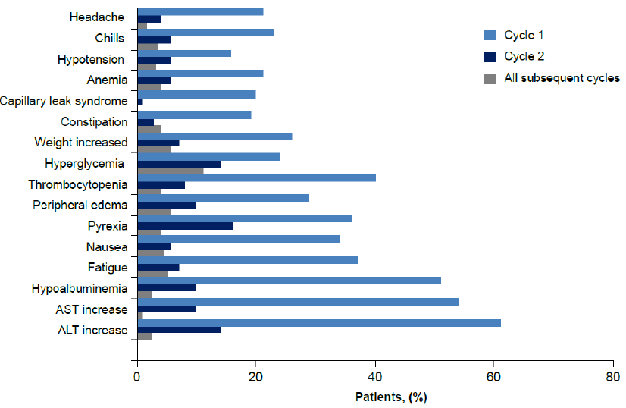
Source: Figure 2-10, p 86 of the submission (originally from Pemmaraju 2022a, Figure S5)
ALT=alanine aminotransferase; AST=aspartate aminotransferase; BPDCN=blastic plasmacytoid dendritic cell neoplasm; R/R=relapsed and/or refractory

Capillary Leak Syndrome
  - After the occurrence of a case of Grade 5 CLS during the dose-escalation phase in a patient in the 7 mcg/kg/day cohort, the protocol for Study 0114 was amended to provide risk mitigation strategies for CLS. Most (94%) patients were enrolled in the study after implementation of this amendment.
  - CLS occurred in 13/69 (19%) treatment naïve BPDCN patients, including 3 fatal cases. Most CLS events occurred during the first cycle of treatment, with the median time to onset of 6 days (range 3, 12) and a median time to resolution of 5 days.

Safety of chemotherapy regimens
  - The submission did not present any safety data for TPC in BPDCN. Laribi 2020 and Yun 2020 did not report any safety outcomes, while Pemmaraju 2022 (p3028) reported limited information regarding ‘early deaths’ of one patient in the HyperCVAD group who developed renal failure and one patient in the tagraxofusp group who developed CLS, no other details or safety information were reported.
  - The submission claimed that chemotherapy regimens adopted in BPDCN clinical practice are associated with high toxicity. The sponsor’s advisory board estimated that current AML- and ALL-type induction regimens have a mortality rate of approximately 5-10%. This figure is broadly consistent with the mortality rates from published studies.

Hospitalisation during treatment cycles
  - The first cycle of tagraxofusp must be given in the inpatient setting (patients are given tagraxofusp daily on Days 1 - 5, and up to Day 10 if dose withholding is necessary), where patients are closely monitored for adverse events including CLS. Subsequent cycles may be given in the outpatient setting if the centre has the facilities to manage the required patient monitoring. In contrast, all cycles of TPC chemotherapy regimens are given in the inpatient setting, with the possible exception of some reduced intensity CHOP-like regimens. Patients on CHOP, FLAG-IDA, 7+3, HyperCVAD Cycle A, HyperCVAD Cycle B and venetoclax + azacitidine regimens may be discharged after 1-4, 5, 7, 11-14, 4 and 28 days, respectively (https://www.eviq.org.au).

Benefits/harms
  - The unanchored indirect comparison presented in the submission did not allow for a quantitative comparison of the benefits and harms of tagraxofusp and TPC. Accordingly, a benefits/harms table has not been presented.

Clinical claim
  - The submission described tagraxofusp as superior in terms of effectiveness, and superior in terms of safety compared to TPC. The ESC considered that these claims were poorly supported by the data presented in the submission.
  - The superior efficacy claim relied on an unanchored MAIC based on data from Study 0114 (a non-randomised study) for tagraxofusp and Laribi 2020 (a retrospective observational study) for TPC. There were no statistically significant differences for any of the outcomes compared in the MAIC. For OS and PFS, while the point estimates favoured tagraxofusp when basing on data from Stages 1-3 of Study 0114, the opposite was true when more complete data from Stages 1-4 of Study 0114 were used. Results for bridge to HSCT favoured tagraxofusp consistently but, given data for TPC were extracted retrospectively in Laribi 2020 including historical data from 2001 (i.e., over 20 years ago), there was a high risk of bias in the comparisons. Other potentially important effect modifiers and prognostic factors were also likely unaccounted for in the MAIC. There was also no evidence of superiority based on CR rates reported for tagraxofusp and TPC in the included studies.
  - The submission did not present any comparative safety data, and no safety outcomes were reported for TPC. Instead, the safety claim appeared to be based on assertions of the sponsor’s advisory board that current AML- and ALL-type induction regimens have a mortality rate of approximately 5-10%. The summary of advice from the Advisory Board was that tagraxofusp was considered to have a superior safety profile compared to comparator chemotherapy, particularly with regard to cytopenias, especially neutropenia, and time spent in hospital is expected to be less with tagraxofusp, compared to intensive induction chemotherapy regimens, due to less toxicities. Data from Study 0114, suggest tagraxofusp was associated with high rates of TEAEs (100% of patients) including Grade ≥3 (82.6%) and TEAE leading to death (8.7%). Although the economic model assumed that patients treated with tagraxofusp required less hospitalisations than patients treated with TPC (primarily in relation to treatment administration), the submission did not present any data to substantiate the assumed benefit of less hospitalisations.
  - The PBAC considered that the claims of superior comparative effectiveness and safety compared to TPC were not adequately supported by the data.

Economic analysis
  - The submission presented a stepped economic evaluation of tagraxofusp compared to TPC in patients newly diagnosed with BPDCN based on data from treatment naïve patients receiving 12 mcg/kg tagraxofusp in Stages 1-3 of Study 0114 (henceforth referred to as Stages 1-3), and a matched indirect comparison with Laribi 2020. TPC treatments in the economic model comprised of FLAG-IDA, HyperCVAD, cytarabine + idarubicin (7+3) and CHOP for patients receiving HSCT, and venetoclax + azacitidine, the most expensive comparator, for patients who were not bridged to HSCT. The pre-PBAC response stated that 50% of patients who were not bridged to HSCT received venetoclax + azacitidine (with 15% receiving cytarabine + idarubicin (7+3), 15% receiving HyperCVAD and 20% not receiving treatment). In the model, all patients who did not bridge to HSCT were assigned the cost of treatment associated with venetoclax + azacitidine, which did not match the proportions described in the submission or displayed on the ‘Controls’ sheet of the model.
  - The type of economic evaluation presented was a cost-utility analysis. Key components of the economic evaluation are presented in the table below.
Table 13: Summary of model structure, key inputs and rationale
Component | Summary
Type of analysis | Cost-utility analysis.
Comparator | Treatment of the physician’s choice (TPC):  In terms of costs:  - ‘no HSCT’ subgroup: assumed to be: 100% venetoclax + azacitidine.  - ‘HSCT’ subgroup: assumed to be a mixture of: FLAG-IDA (15%), HyperCVAD (40%) cytarabine + idarubicin (7+3) (40%), CHOP (5%).  The submission did not provide justification for the above proportions. The ESC noted that these were also different to proportions stated in the ‘Comparator’ and ‘Estimated PBS usage and financial implication’ sections.  Effectiveness estimates were based on the MAIC comparing results of Study 0114 to Laribi 2020.  <1.5% of patients in Laribi 2020 received venetoclax or azacitidine (relatively new drugs) and 15.7% received no active treatment; therefore, Laribi 2020 may not be the most appropriate source of comparator effectiveness for patients not undergoing HSCT. The ESC noted that venetoclax is also not PBS listed for use in BPDCN. The submission did not discuss why venetoclax + azacitidine was selected as the comparator for patients not bridged to HSCT but noted that it was the most expensive comparator. The ESC considered that it might be most appropriate to assume patients who are transplant eligible would receive two to four cycles of HyperCVAD, whereas patients who were ineligible for transplant would receive six cycles of CHOP. The pre-PBAC response stated that the application of just two chemotherapy regimens was not evidence based.
Outcomes | Life years, quality-adjusted life years.
Time horizon | 20 years in the model base case vs. median follow up 44 months (Stage 1-3) in Study 0114, and 12 months in Laribi 2020.  The ESC considered that the time horizon was long compared to available data. Survival for non HSCT patients expected to be median 24 months. The pre-PBAC response stated truncating the time horizon would diminish the gains of tagraxofusp in bridging additional patients to transplant.
Methods used to generate results | Partitioned survival model with extrapolation from Time 0.
Health states | 5 health states:  Two for patients receiving HSCT:  - Progression free (PF) (with substates: on treatment, off treatment, cured)  - Progressed  Two for patients without HSCT:  - PF (with substates: on treatment, off treatment)  - Progressed  And Dead  This was reasonable, although there was limited data to inform transitions between these stratified health states.
Cycle length | 1 week. Reasonable, although costs of HSCT and AEs were all applied in Week 0 as upfront costs.
Transition probabilities | Probability of receiving HSCT  - Tagraxofusp arm: % bridged to HSCT in Stage 1-3 of Study 0114 (44.8%)  - TPC arm: tagraxofusp arm with 2.44 OR applied (25.0%) - from the MAIC.  The ESC noted that the bridging HSCT estimates in both arms were higher than the 11-18% rates identified in retrospective studies by the submission. However, recent studies, such as Pemmaraju 2022 have presented bridged HSCT rates of >50% for patients receiving HyperCVAD.
TTD | Tagraxofusp arm: KM data by HSCT status from Stage 1-3 in Study 0114 with stopping rule at Week 26.  TPC arm: same as tagraxofusp arm with maximum time ranging from 8 to 104 weeks depending on treatment regimen  The ESC noted that the assumed stopping rule in the tagraxofusp arm was inconsistent with the trial evidence and the requested restrictions.
PFS | Tagraxofusp arm: Extrapolations from Time 0 (no HSCT: log-log, HSCT: exponential) were based on KM data by HSCT status from Stage 1-3 in Study 0114.  TPC arm: tagraxofusp arm with HR of 0.802 from MAIC applied.  Limited to not exceed OS curve.
OS | Tagraxofusp arm: Exponential extrapolations from Time 0 based on KM data by HSCT status from Stage 1-3 in Study 0114.  TPC arm: Tagraxofusp arm with HR of 0.802 from MAIC applied.  HSCT patients alive and progression free at 156 weeks were assumed to have general population mortality.
All transition probabilities in the comparator arm were dependent upon results of the MAIC, which was highly uncertain.
The ESC noted that the PFS and OS hazard ratio was applied regardless of HSCT status. As such, PFS and OS benefit that may be attributed to HSCT is attributed to tagraxofusp.
The pre-PBAC response presented a revised base case in which the hazard ratios for OS and PFS were equal to 1 and the odds ratio for bridge to transplant was 1.58.
Health state utilities | Sourced from NICE TA545 (AML)  - PF on treatment (including HSCT) and off treatment without CR 0.6574  - PF off treatment CR: 0.74  - HSCT recovery and after: 0.849  - PF on treatment disutility comparator -0.0826 (PF CR, PF no CR), tagraxofusp -0.01652 (0.2 x disutility for comparator)  - PD: 0.568  - All age adjusted each cycle.  Treatment disutility appears to be applied twice, once for being in the health state and once depending upon treatment. The utility estimates in TA545 were not stratified by HSCT status.
Costs | Treatment and administration costs, treatment-based hospitalisation costs, HSCT cost, GP, haematologist, blood tests, bone marrow biopsies, AE costs.  - For patients receiving HSCT, comparator treatment costs based on weighted average treatment costs per cycle.  - For patients not receiving HSCT, comparator treatment costs based on venetoclax + azacitidine (up to 104 weeks).  Patients did not receive subsequent treatment in the model and thus were not able to bridge to HSCT after subsequent treatment nor were they treated for relapsed disease; however, this was likely to favour the TPC arm.  No costs were assumed for EoL (little difference to results) and no costs in were assumed in post HSCT recovery (assuming all patients were cured after 3 years).
Software package | Excel 2010.
Source: compiled during the evaluation
AE=adverse event, AML=acute myeloid leukaemia, BPDCN=blastic plasmacytoid dendritic cell neoplasm, CR=complete response, EoL=end of life, GP=general practitioner, HSCT=haematopoietic stem cell transplant, HR=hazard ratio, KM= Kaplan Meier, MAIC=matching adjusted indirect comparison, NICE=The National Institute for Health and Care Excellence, OR=odds ratio, OS=overall survival, PD=progressed disease, PF=progression free, PFS=progression free survival, QALY=quality adjusted life years, TPC=treatment of physician’s choice, TTD=time to treatment discontinuation.
  - The structure of the economic model is presented below.
Figure 6: Cost-effectiveness model structure
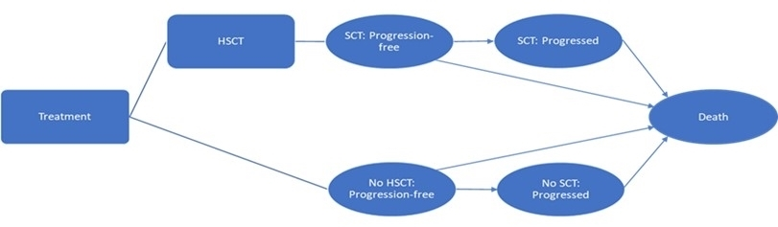
Source: Figure 3-1 of the submission
HSCT= hematopoietic stem cell transplant; SCT= stem cell transplant.
  - The model consisted of a decision tree (to first identify patients who would bridge to HSCT) followed by a partitioned survival model to predict longer term outcomes based on Kaplan Meier data from Study 0114 and hazard ratios estimated from the MAIC. All patients entered the model progression free and were first sorted into either the HSCT or no HSCT cohorts. Patients who received HSCT and were alive and progression free at 3 years, were assumed to remain progression free until death, with probability of death each cycle based on general population mortality. Time on treatment was modelled independently of the health states. The ESC noted that it was difficult to distinguish the effect of tagraxofusp and TPC from HSCT, and that the transition probabilities were uncertain.
  - The ESC considered that the base case model time horizon of 20 years was long compared to a median follow up of 44 months (Stages 1-3) and 34 months (Stages 1-4) in Study 0114, and 12 months in Laribi 2020 and the natural progression of the disease. The incremental cost effectiveness ratio (ICER) was sensitive to time horizon, increasing from $255,000 to < $355,000 per quality adjusted life year (QALY) to $355,000 to < $455,000 per QALY gained if a 10-year time horizon was applied. The pre-PBAC response stated that truncating the time horizon diminished the gains of tagraxofusp in bridging additional patients to transplant.
  - The population in the model was the subgroup of patients in Stages 1-3 of Study 0114 who received 12 mcg/kg tagraxofusp as first line treatment. The submission excluded Stage 4 patients from the base case without justification, elsewhere, the submission differentiated Stage 4 patients on the basis they received tagraxofusp in a different formulation. The ESC considered that the exclusion of Stage 4 patients from the model was not appropriate since these patients would also be eligible for tagraxofusp treatment based on the requested restrictions. The pre-PBAC response presented a revised base case which included Stage 4 patients and applied an odds ratio of 1.58 for bridge to transplant (see Table 11), but also applied hazard ratios equal to 1 for OS and PFS instead of the HRs derived from the MAIC which exceeded 1 (see Table 11).
  - A summary of the Kaplan Meier data from Study 0114 used in the model is presented in the figure below, stratified by ‘bridged to HSCT’ status. Patients in Stages 1-3 generally had better PFS and OS and longer time on treatment compared to Stages 1-4.
Figure 7: KM data from Study 0114 by enrolment stage and bridged to HSCT status
Stages 1-3 (N=29) | Stages 1-4 (N=65)
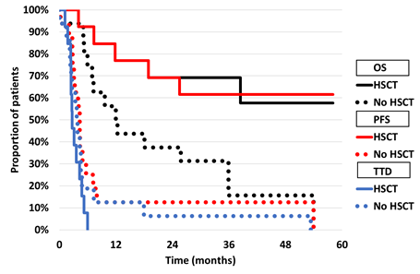 | 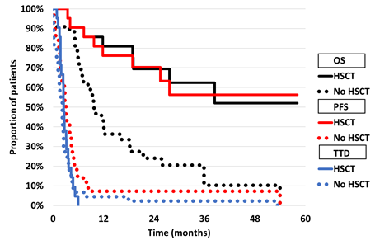
Source: compiled during the evaluation Excel workbook ‘Elzonris BPDCN Cost Effectiveness Model March 2023.xlsm
HSCT=haematopoietic stem cell transplant, KM=Kaplan Meier, OS=overall survival, PFS=progression free survival, TTD=time to treatment discontinuation
  - Probability of HSCT was based on the likelihood of bridging to HSCT from Study 0114 (Stages 1-3), comparator arm results were estimated by applying the odds ratio for HSCT from the MAIC against Laribi 2020. It was noted that despite favouring tagraxofusp, the results were not statistically significant for Stages 1-3 (OR = 2.44, 95% CI: 0.81, 7.44) or Stages 1-4 (OR = 1.58, 95% CI: 0.79, 3.17), while this was likely due to the small sample size of the MAIC (N= 17.5 in Stages 1-3 and N= 46.7 in Stages 1-4), this added considerable uncertainty to the results. The pre-PBAC response presented a revised base case in which the odds ratio for bridging to HSCT was 1.584.
  - The estimated rates of HSCT in the model base case were potentially high: 25% in the TPC arm and 45% in the tagraxofusp arm. Laribi 2020 reported HSCT rates of approximately 19% (not restricted to HSCT after one line of treatment) for TPC. The submission noted that published estimates of HSCT rates in BPDCN were 11-18%. If HSCT rates were reduced to 15% in the TPC arm (30% in the tagraxofusp arm), the ICER increased to $355,000 to < $455,000 per QALY gained compared to $255,000 to < $355,000 in the base case. Given the difference in HSCT rates applied from the MAIC were not statistically significant, the possibility of no difference in HSCT rates was tested in sensitivity analyses. The ESC noted that this increased the ICER to $855,000 to < $955,000 per QALY gained. If data from Stages 1-4 were applied, tagraxofusp was dominated.
  - PFS and OS extrapolations were chosen based on visual and statistical fit (measured by AIC and BIC) and clinical plausibility. The hazard ratios estimated from the MAIC were applied to the tagraxofusp curves to estimate the TPC arm. The ESC noted that the hazard ratios were not dependent on ‘bridged to HSCT’ status, and therefore likely overestimated the effect for patients who received HSCT.
Figure 8: Extrapolation of progression free survival
Stages 1-3 | Stages 1-4
Bridged to HSCT
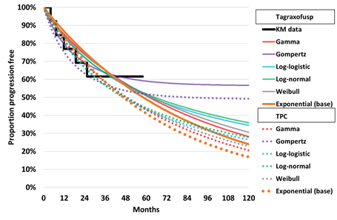 | 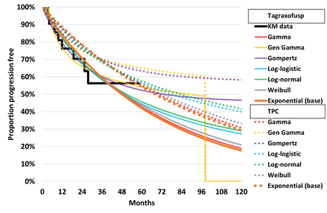
Not bridged to HSCT
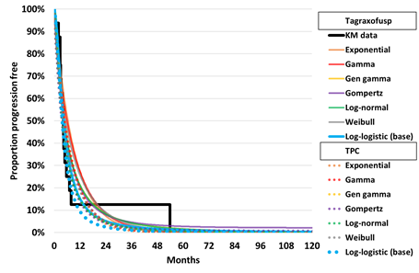 | 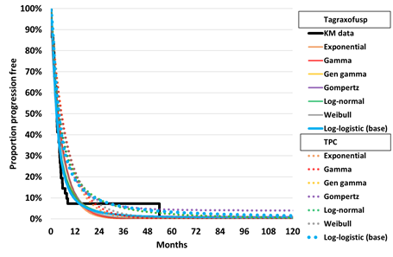
Source: compiled during the evaluation from Sheet PFS Excel workbook ‘Elzonris BPDCN Cost Effectiveness Model March 2023.xlsm’
HSCT = haematopoietic stem cell transplant, KM=Kaplan Meier, TPC=treatment of physician’s choice
Figure 9: Extrapolation of overall survival
Stages 1-3 | Stages 1-4
Bridged to HSCT
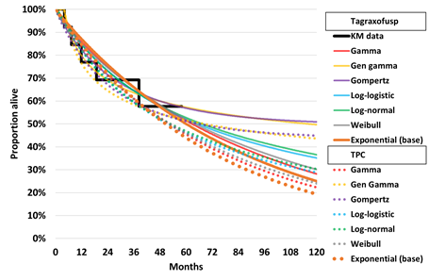 | 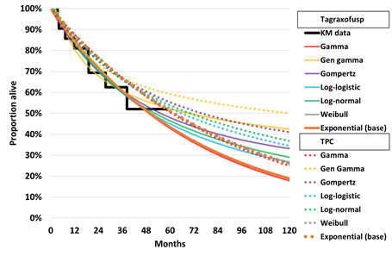
Not bridged to HSCT
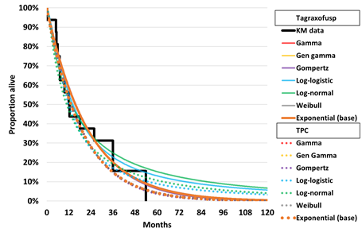 | 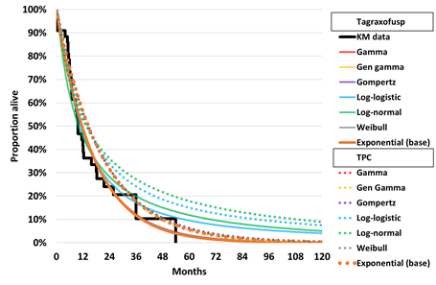
Source: compiled during the evaluation from Sheet OS Excel workbook ‘Elzonris BPDCN Cost Effectiveness Model March 2023.xlsm’
HSCT=haematopoietic stem cell transplant KM=Kaplan Meier, TPC=treatment of the physician’s choice
  - For PFS, exponential distribution was chosen for patients bridged to HSCT, which visually tended to overestimate PFS for the duration of the KM data. Log-logistic was the chosen extrapolation for PFS for the patients ‘not bridged to HSCT’. For OS, exponential distributions were chosen based on both visual goodness of fit and having the lowest AIC and BIC values. Two conflicting pictures were apparent when considering PFS and OS extrapolations for Stages 1-3 and Stages 1-4, where the Stages 1-3 extrapolations indicated better PFS and OS for tagraxofusp versus TPC whereas the Stages 1-4 extrapolations predicted the opposite (i.e., better PFS and OS with TPC). The ESC considered that this was a direct reflection of the conflicting results from the submission’s MAIC for the two cohorts. Also, the ESC noted that as the MAIC was not matched based on HSCT status, the estimated PFS and OS hazard ratios already included the survival benefits associated with HSCT. Therefore, the application of these ratios in the model inappropriately attributed the benefits of HSCT to tagraxofusp. Furthermore, no clinical reasons were presented in the submission to explain why PFS and OS for patients who bridged to HSCT after receiving tagraxofusp would be any different to those who bridged to HSCT from TPC. A sensitivity analysis assuming PFS and OS hazard ratios equal to 1 for patients bridged to HSCT was conducted during the evaluation, which increased the ICER to $255,000 to < $355,000 per QALY gained from a submitted base case of $255,000 to < $355,000.
Figure 10: Extrapolation of TTD for patients not bridged to HSCT
Stages 1-3 | Stages 1-4
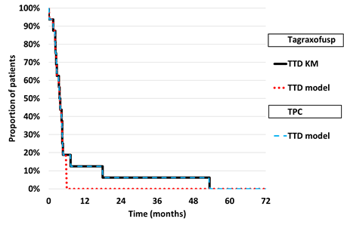 | 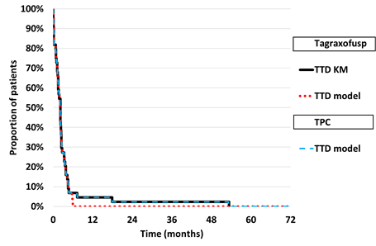
Source: compiled during the evaluation from Sheet TTD Excel workbook ‘Elzonris BPDCN Cost Effectiveness Model March 2023.xlsm’
HSCT=haematopoietic stem cell transplant, KM=Kaplan Meier, TPC=treatment of physician’s choice, TTD=time to treatment discontinuation
TPC treatment costs were capped at 104 weeks, but treatment related disutility continued to the end of the KM curve.
  - TTD data for all patients were based on data from Study 0114. For patients bridged to HSCT, TTD was assumed to follow KM data for tagraxofusp. For the TPC arm, costs were adjusted for treatment durations reported in the EviQ (8 weeks for FLAG-IDA and CHOP, 24 weeks for HyperCVAD and cytarabine + idarubicin 7+3). Patients not bridged to HSCT were also assumed to follow the TTD Kaplan Meier curve for tagraxofusp, except patients in the tagraxofusp arm of the model discontinued treatment at 26 weeks (affecting both costs and utilities), and patients in the TPC arm continued treatment to the end of the Kaplan Meier data for utilities and to 104 weeks for costs (maximum treatment duration for venetoclax + azacitidine). Given the requested restrictions did not cap tagraxofusp treatment to 26 weeks, it may be more appropriate to model tagraxofusp as per utilisations in Study 0114, which was up to a maximum of 4.4 years, this increased the ICER to $455,000 to < $555,000 per QALY.
  - A summary of the model extrapolations to 20 years (base case time horizon) is presented below. As discussed above, the assumption that patients are ‘cured’ by Year 3 (i.e., have general population mortality) leads to PFS and OS being overestimated compared to the Kaplan Meier data in patients bridged to HSCT. TTD was modelled independently of PFS and therefore patients in the TPC arm continued treatment into progressed disease.
Figure 11: Modelled PFS, OS and TTD by treatment arm and HSCT status
Stages 1-3 | Stages 1-4
Bridged to HSCT
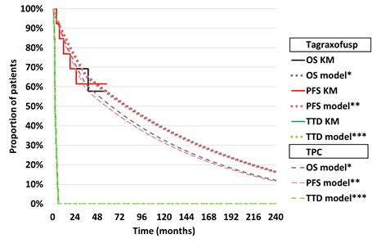 | 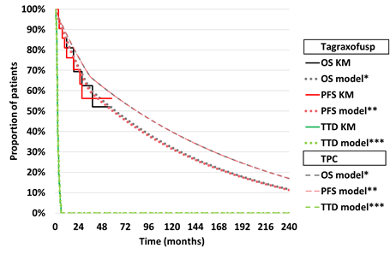
Not bridged to HSCT
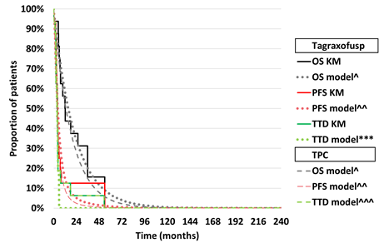 | 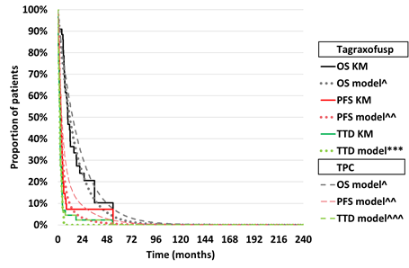
Source: compiled during the evaluation from Excel workbook ‘Elzonris BPDCN Cost Effectiveness Model March 2023.xlsm’
HSCT=haematopoietic stem cell transplant, KM=Kaplan Meier, OS=overall survival; PFS=progression free survival, TPC=treatment of physician’s choice, TTD=time to treatment discontinuation
* Exponential extrapolations, cannot exceed general population survival and is equal to general population mortality from Year 3
** Exponential extrapolations, cannot exceed overall survival and is equal to general population mortality from Year 3
*** Maximum duration equal to TTD KM data from Study 0114, ‘not bridged to HSCT’ subgroup capped at 26 weeks
^ Exponential extrapolations, cannot exceed general population survival
^^ Log-logistic extrapolations, cannot exceed overall survival
^^^ Maximum duration equal to TTD KM data from Study 0114, capped at 104 weeks for costs
  - Probability of adverse events (AEs) were based on Stages 1-4 patients in Study 0114 for tagraxofusp (grade 3 or higher with prevalence of at least 2%) and the RATIFY trial (cytarabine + daunorubicin + midostaurin + dexamethasone acetate arm) for the TPC arm (SAEs which affected more than 5% of patients). The RATIFY trial included AML patients and may not reflect the experience of patients receiving the treatments identified in the submission. Duration of AEs were based on durations in Study 0114 or estimated as the average of AE duration when duration was not available. While incidence and duration of AEs were uncertain, they had little effect on the ICER.
  - No published utilities were identified for BPDCN patients, nor for those receiving tagraxofusp or any of the proposed comparator treatments. Instead, utilities were based on estimates for AML for patients treated with daunorubicin plus cytarabine. The original source of the estimates (NICE TA399) did not provide utility estimates for HSCT patients, instead the submission assumed the utilities would apply regardless of HSCT status in line with NICE TA545. The submission further adjusted the health state utilities to match mean age of population in model (62 years) from an assumed baseline of 74.8 years in the utility studies (although no source was given for this age) using the method reported by Ara and Brazier 2010 for age and gender related general population utility.
  - The model appeared to double count the disutility associated with receiving treatment. The difference in utility (-0.0826) between ‘PFS on treatment’ and ‘PFS off treatment (in CR or CRc)’ was applied twice to patients on treatment in the TPC arm and 1.2 times to patients in the tagraxofusp arm. If the difference in utility (-0.0826) between ‘PFS on treatment’ and ‘PFS off treatment (in CR or CRc)’ was applied once to patients on treatment, regardless of treatment received, the ICER increased to $255,000 to < $355,000 per QALY gained $255,000 to < $355,000 in the submitted base case.
  - The cost of tagraxofusp was estimated based on the recommended dose (12 microgram/kg) multiplied by the mean population weight (81.2 kg based on Australian general population, not Study 0114) for five administrations (1 per day for 5 days) at a dose intensity of 93.8% for Stages 1-3 and 89.7% for Stages 1-4. Other premedications were also included in the model (i.e., paracetamol, ranitidine and diphenhydramine); however, these had little effect on the total incremental costs.
  - Patients in the TPC arm received a mixture of chemotherapy regimens FLAG-IDA (3.7% Stages 1-3, 3.5% Stages 1-4), HyperCVAD (10.0% Stages 1-3, 9.3% Stages 1-4), cytarabine + idarubicin (7+3) (10.0% Stages 1-3, 9.3% Stages 1-4), CHOP (1.2% Stages 1-3, 1.2% Stages 1-4) or venetoclax + azacitidine (75.0% Stages 1-3, 76.8% Stages 1-4). The only treatment assumed for patients not bridged to HSCT was venetoclax + azacitidine, whereas the other regimens were assumed to be accessed by patients bridged to HSCT. The ESC considered that it might be more appropriate to assume patients who are transplant eligible would receive two to four cycles of HyperCVAD and patients who were ineligible for transplant would receive six cycles of CHOP.
  - The ESC noted that venetoclax + azacitidine was the highest cost TPC treatment (estimated to be $13,078.31 per treatment cycle) with the longest treatment duration (assumed to match the TTD curve for tagraxofusp to 104 weeks) and was allocated to at least 75% of patients in the model. If prevalence of TPC treatments was not dependent on ‘bridged to HSCT status’, such that the proportions were based on the advisory board estimates, but venetoclax + azacitidine was excluded from the model (proportion received CHOP instead) and the prevalence of remaining TPC treatments unaffected by ‘bridged to HSCT status’, then the ICER increased to $255,000 to < $355,000 per QALY gained compared to the submitted base case of $255,000 to < $355,000.
  - Administration, hospitalisation, HSCT, health state and AE costs were not significant drivers of the incremental costs. Although the model assumed significantly higher hospital costs for TPC compared with tagraxofusp, this was not a driver because total incremental costs were driven nearly entirely by the cost of tagraxofusp (104% of total incremental costs for the submitted base case). The submission did not include costs for subsequent treatment, HSCT after subsequent treatment, HSCT complications, or end of life treatments.
  - Health state allocation figures compiled during the evaluation are presented below, for the ‘bridged to HSCT’ and ‘not bridged to HSCT’ subgroups and for the overall population.
Figure 12: Health state occupancy
Stages 1-3 | Stages 1-4
Bridged to HSCT
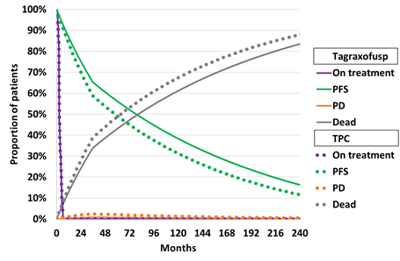 | 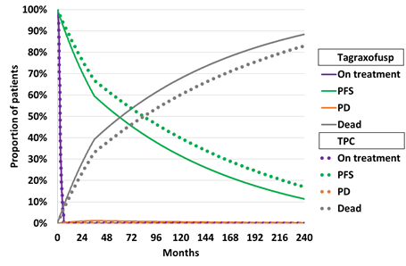
Not bridged to HSCT
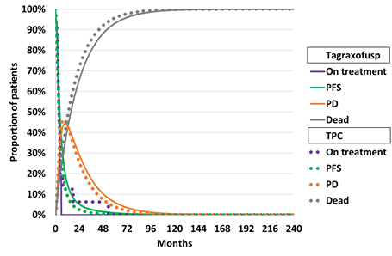 | 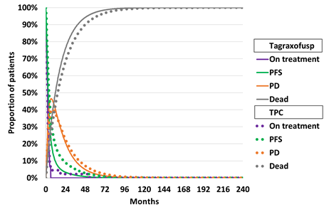
Overall
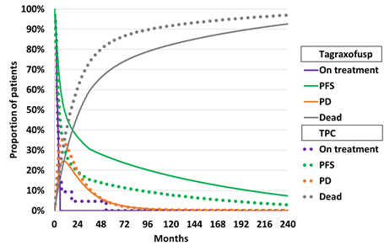 | 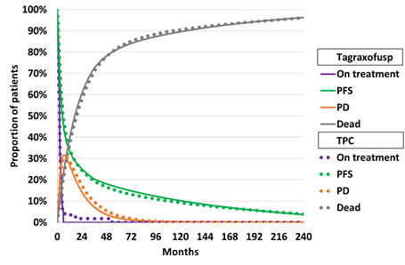
Source: compiled during the evaluation from Excel workbook ‘Elzonris BPDCN Cost Effectiveness Model March 2023.xlsm’
HSCT= haematopoietic stem cell transplant, PD=progressed disease, PFS=progression free survival, TPC=treatment of physician’s choice
  - Based on data for Stages 1-3 for tagraxofusp, 2-8% of patients in the tagraxofusp arm were predicted to be alive at 20 years. The survival benefit for tagraxofusp over TPC appeared to be primarily driven by an increase in the proportion of patients bridged to HSCT, which the ESC noted was not supported by the data, and the assumed survival benefit for tagraxofusp versus TPC post HSCT. When data from Stages 1-4 was applied, patients in the tagraxofusp arm experienced worse OS and PFS compared to those in the TPC arm. This was particularly apparent in the bridged to HSCT subgroup. In both the Stages 1-3 and Stages 1-4 populations, survival was much higher in the bridged to HSCT subgroup versus those not bridged to HSCT.
  - The submission did not present external validation of the survival estimates. Modelled survival for both TPC and tagraxofusp arms were not significantly different to published Kaplan Meier data for TPC treatments, further demonstrating the limited evidence of a survival benefit for tagraxofusp over TPC.
  - Key drivers of the model are presented in the following table.
Table 14: Key drivers of the model
Description | Method/Value | Impact  Base case ICER = $||||¹ per QALY gained.
Time horizon | 20 years versus 44 months follow up in Stages 1-3, 34 months in Stages 1-4 | High, favoured tagraxofusp. If time horizon reduced to 10 years, the ICER increased to $||||² per QALY.
Subgroup of Study 0114 | Data from Stages 1-3 of Study 0114 (N=29) were used to informed comparative PFS, OS and TTD and HSCT rate. The submission inappropriately excluded data from Stage 4 of Study 0114. | High favoured tagraxofusp. If the model were based on more complete data from Stages 1-4 of Study 0114 (N=65), the ICER increased to $||||³ per QALY.
OS HR | OS benefit for tagraxofusp versus TPC (HR=0.843 from the MAIC) was assumed in the model and used to estimated extrapolated TPC OS from KM for tagraxofusp for those bridged to HSCT and not bridged to HSCT. | High favoured tagraxofusp. If OS HRs were assumed to equal to 1 (assuming survival benefits for tagraxofusp were driven by increases in HSCT only), the ICER increased to $||||¹ per QALY.
TTD tagraxofusp | For patients bridged to HSCT, TTD followed the TTD KM from Study 0114. For patients not bridged to HSCT, treatment duration was capped at 26 weeks. | High favoured tagraxofusp. If the stopping rule was removed, the ICER increased to $||||⁴ per QALY.
HSCT rate | HSCT rate for tagraxofusp (44.8%) was based on data from Stages 1-3 Study 0114. TPC arm HSCT rate (25%) was calculated by applying the OR from the MAIC (2.44 tagraxofusp versus TPC). | High favoured tagraxofusp given HSCT improved both OS and QoL. If TPC HSCT rate was assumed to be 15% (i.e., lower) and tagraxofusp rate estimated to be 30%, the ICER increased to $||||² per QALY.
Patient age | 62.2 years based on mean age in Stages 1-3 of Study 0114. | Moderate favoured tagraxofusp, given those alive 3 years post HSCT were assumed to follow general population survival. If age was increased to 75 years, the ICER increased to $||||¹ per QALY.
TPC treatment | TPC treatments differed by HSCT status and included treatments that were not listed on the PBS for BPDCN.  Overall TPC treatment split in the model was: 3.7% FLAG-IDA, 10.0% HyperCVAD, 10.0% cytarabine + idarubicin (7+3), 1.2% CHOP, 75.0% venetoclax + azacitidine. | Moderate, favoured tagraxofusp. If TPC regimens were restricted to PBS-listed options (62.5% HyperCVAD, 27.5% CHOP, 10% no treatment) and assumed similar split irrespective of HSCT status, then the ICER increased to $||||¹ per QALY.
Utility gains associated with HSCT/CR | Utility post-HSCT recovery was assumed to be equal to 0.82 (for age 62.2 years) and patients PF who achieved CR were assumed to accrue a utility gain of 0.0826. CR was based on unweighted estimates of Study 0114 and Laribi 2020, stratified by HSCT status. | Moderate, favoured tagraxofusp. If CR effect excluded from the model, the ICER increased to $||||¹ per QALY.
Source: compiled during the evaluation
BPDCN=blastic plasmacytoid dendritic cell neoplasm, CR=complete response, HR=hazard ratio, HSCT= haematopoietic stem cell transplant, ICER=incremental cost-effectiveness ratio, KM=Kaplan Meier, MAIC=matching adjusted indirect comparison, OR=odd ratio, OS=overall survival, PF = progression fee, PFS=progression free survival, QALY=quality adjusted life year, QoL=quality of life, TPC=treatment of physician’s choice, TTD=time to treatment discontinuation
The redacted values correspond to the following ranges:
¹ $255,000 to < $355,000
² $355,000 to < $455,000
³ > $1,055,000
⁴ $455,000 to < $555,000
  - A summary of the stepped economic evaluation is presented in Table 15. All steps included discounting of costs and effects. Results utilising data from Study 0114 Stages 1-3 (the submission’s base case) and Stages 1-4 (conducted during the evaluation representing more complete data) are presented. The results for the revised base case presented in the pre-PBAC response which utilised data from Stages 1-4 of Study 0114 and applied hazard ratios for OS and PFS of 1 and an odds ratio for bridge to HSCT of 1.584 are also presented.
Table 15: Results of the stepped economic evaluation*
Model | Stages 1-3 |  |  | Stages 1-4
Step and component | Tagraxofusp | TPC | Increment | Tagraxofusp | TPC | Increment
Step 1: Drug cost per additional HSCT
Costs ($) | | | ||| | | | | | ||| | |
HSCT | 0.448 | 0.250 | 0.198 | 0.323 | 0.232 | 0.16
Incremental cost/HSCT gained |  |  | $ | ¹ | Incremental cost/HSCT gained |  | $ | ¹
Step 2: Drug cost per LYG to 3 years
Costs ($) | | | ||| | | | | | ||| | |
LYG | 1.861 | 1.553 | 0.308 | 1.554 | 1.621 | -0.066
Incremental cost/LY gained |  |  | $ | ¹ | Incremental cost/LY gained |  | Dominated
Step 3: Drug cost per QALY to 3 years
Costs ($) | | | ||| | | | | | ||| | |
QALYs | 1.542 | 1.159 | 0.383 | 1.235 | 1.233 | 0.001
Incremental cost/QALY gained |  |  | $ | ¹ | Incremental cost/QALY gained |  | $ | ¹
Step 4: All costs per QALY to 3 years
Costs ($) | | | |||| | | | | | |||| | |
QALYs | 1.542 | 1.159 | 0.383 | 1.235 | 1.233 | 0.002
Incremental cost/QALY gained |  |  | $ | ² | Incremental cost/QALY gained |  | $ | ¹
Step 5: All costs per QALY to 10 years
Costs ($) | | | |||| | | | | | |||| | |
QALYs | 2.790 | 1.802 | 0.987 | 2.011 | 1.956 | 0.056
Incremental cost/QALY gained |  |  | $ | ³ | Incremental cost/ QALY gained |  | $ | ¹
Step 6: All costs per QALY to 20 years
Costs ($) | | | |||| | | | | | |||| | |
LYG | 3.864 | 2.574 | 1.290 | 2.765 | 2.782 | -0.017
Incremental cost/LY gained |  |  | $ | ⁴ |  |  | Dominated
QALYs | 3.334 | 2.041 | 1.293 | 2.312 | 2.244 | 0.068
Incremental cost/QALY gained (base case) |  |  | $ | ⁴ | Incremental cost/ QALY gained |  | $ | ¹
Pre-PBAC revised base case
Costs ($) |  |  |  | | | |||| | |
QALYs |  |  |  | 2.312 | 1.889 | 0.423
Incremental cost/QALY gained (revised base case) |  |  |  |  |  | $ | ^{5a}
Source: Table 3-19 of the submission and compiled during the evaluation.
HSCT=haematopoietic stem cell transplant, LY=life year, LYG=life year gained, QALY=quality adjust life year, TPC=treatment of physician’s choice
ª OR bridge to HSCT = 1.584 (corrected by evaluator from 1.58), OS and PFS hazard ratios set to 1.
The redacted values correspond to the following ranges:
¹ > $1,055,000
² $955,000 to < $1,055,000
³ $355,000 to < $455,000
⁴ $255,000 to < $355,000
⁵ $555,000 to < $655,000
*Note that the results presented in Table 15 are derived from post-hoc analyses conducted by the applicant specifically for the purposes of informing the PBAC consideration. These analyses were not part of the pre-specified statistical plan for Study 0114. Interpretation of the results and their application should therefore be limited to seeking to understand the basis for the PBAC outcome and should not be used for any other purpose.
  - Cost per life year gained (LYG) and cost per QALY gained were similar for Stages 1-3 ($255,000 to < $355,000 and $255,000 to < $355,000 respectively), but for Stages 1-4 the TPC arm resulted in more LYG than tagraxofusp and with lower cost but had fewer QALYs (reflecting the expected reduction in quality of life associated with currently available treatments).
  - Drug cost per additional HSCT was a potentially important outcome given the paucity of data for the long-term extrapolation for OS and the uncertainty in the modelled estimates. The cost per additional HSCT ranged from > $1,055,000 to > $1,055,000 for Stages 1-3 and Stages 1-4 respectively.
  - The results of key sensitivity analyses including additional univariate and multivariate analysis conducted during the evaluation are summarised in Table 16. The ICER was most sensitive to time horizon, OS hazard ratio, tagraxofusp dose and duration, HSCT rate, TPC treatment choice, utility post HSCT and following CR, and age of patients. If tagraxofusp extrapolations and HSCT OR were based on Stages 1-4 data, with PFS and OS hazard ratios equal to 1 and the tagraxofusp stopping rule was removed, the ICER was estimated to be $855,000 to < $955,000 per QALY gained.
Table 16: Sensitivity analyses, based on submitted base case*
Analyses | Incremental cost ($) | Incremental QALY | ICER ($) | % change
Submitted base case (Stages 1-3) | | | 1.293 | | ¹ | -
Discount rate (base case 5% costs and outcomes)  - 0% costs and outcomes  - 3.5% costs and outcomes | |  | | 1.791  1.414 | | ²  | ¹ | -28%  -9%
Time horizon (base case 20 years)
- 5 years | | | 0.611 | | ³ | 111%
- 10 years | | | 0.987 | | ⁴ | 31%
- 15 years | | | 1.188 | | ¹ | 9%
Assume PFS and OS HR =1 for HSCT patients | | | 1.129 | | ¹ | 14%
OS HR=1 all ptsª | | | 1.074 | | ¹ | 20%
All PFS and OS HRs=1ª | | | 0.994 | | ⁴ | 30%
No stopping rule (base 26 weeks for tagraxofusp) | | | 1.290 | | ⁵ | 63%
Age 75 years (base 62.2) | | | 1.083 | | ¹ | 19%
HSCT OR (base=2.44)
- 0.81 | | | 0.196 | | ⁶ | 560%
- 7.346ª | | | 1.949 | | ² | -34%
1.65 vials tagraxofusp per patient (estimated based on weight in trial) | | | 1.293 | | ¹ | 12%
Single vial tagraxofusp per patient | | | 1.293 | | ² | -40%
Two vials tagraxofusp per patient | | | 1.293 | | ⁴ | 40%
TPC HSCT rate 15% (Tagraxofusp HSCT rate 30%) | | | 1.021 | | ⁴ | 26%
TPC treatments not differed by HSCT outcome | | | 1.293 | | ¹ | 11%
TPC treatment excluding non-PBS listed and not differed by HSCT outcome (i.e. HyperCVAD and CHOP only) | | | 1.293 | | ¹ | 15%
Turn off CR by subgroup and treatment | | | 1.169 | | ¹ | 11%
Multivariate analyses
MA1: Assume all PFS and OS HRs=1 and no stopping rule for tagraxofusp | | | 0.992 | | ³ | 111%
MA2: MA1 and TPC mix same regardless of HSCT status | | | 0.992 | | ⁷ | 126%
MA3: MA2 excluding non-PBS listed treatments | | | 0.992 | | ⁷ | 132%
MA4: Assume all PFS and OS HRs=1 and using Stages 1-4 data for extrapolations and HSCT OR | | | 0.423 | | ³ | 115%
MA5: MA4 without stopping rule for tagraxofusp | | | 0.422 | | ⁸ | 197%
MA6: MA5 plus TPC mix same regardless of HSCT status | | | 0.422 | | ⁸ | 216%
MA7: MA6 excluding non-PBS listed treatments | | | 0.422 | | ⁸ | 225%
Additional analyses performed by ESC
Base case (Stages 1-3, HSCT OR=2.44, PFS HR=0.80, OS HR=0.84, tagraxofusp stopping rule at 26 weeks) | | | 1.293 | | ¹ | -
- HSCT OR=1 | | | 0.426 | | ⁸ | 204%
- HSCT OR=1, no stopping rule for tagraxofusp | | | 0.423 | | ⁶ | 397%
Stages 1-4, HSCT OR=1.58, PFS HR=1.42, OS HR=1.24, tagraxofusp stopping rule at 26 weeks | | | 0.068 | | ⁶ | 1,222%
- HSCT OR=1 | | | -0.386 | Dominated | -
- HSCT OR=1, no stopping rule for tagraxofusp | | | -0.387 | Dominated | -
Source: Table 3-26 of the submission and compiled during the evaluation.
CR=complete response (includes CRc for tagraxofusp), HR=hazard ratio, HSCT=haematopoietic stem cell transplant, ICER=incremental cost effectiveness ratio, OR=odds ratio, OS=overall survival, PFS=progression free survival, QALY=quality adjusted life year, TPC=treatment of physician’s choice
ª Sensitivity analysis incorrect in Table 3-26 of the submission, corrected here
The redacted values correspond to the following ranges:
¹ $255,000 to < $355,000
² $155,000 to < $255,000
³ $555,000 to < $655,000
⁴ $355,000 to < $455,000
⁵ $455,000 to < $555,000
⁶ > $1,055,000
⁷ $655,000 to < $755,000
⁸ $855,000 to < $955,000
*Note that the results presented in Table 16 are derived from post-hoc analyses conducted by the applicant specifically for the purposes of informing the PBAC consideration. These analyses were not part of the pre-specified statistical plan for Study 0114. Interpretation of the results and their application should therefore be limited to seeking to understand the basis for the PBAC outcome and should not be used for any other purpose.
  - The ESC noted that in the submission base case (Stages 1-3 of the clinical trial), patients experienced better survival in the tagraxofusp arm, regardless of HSCT status, which was not supported by the evidence. If the HSCT odds ratio was set equal to 1 (i.e. if it was assumed that there was no benefit in the proportion of patients bridged to HSCT) and the PFS and OS hazard ratios were kept as per the base case, the discounted QALY gain for patients in the tagraxofusp arm was reduced to 0.462, resulting in an ICER of $855,000 to < $955,000 per QALY gained (assuming a stopping rule for tagraxofusp at 26 weeks). Without a stopping rule for tagraxofusp, the ICER increased to > $1,055,000 per QALY gained. The ESC noted that the incremental QALYs reduced when the stopping rule was removed, as patients were on treatment longer and had lower utility than those who were progression-free and off-treatment.
  - If Stages 1-4 of the clinical trial were used, the HSCT odds ratio was set to equal 1 (i.e. if it was assumed that there was no benefit in the proportion of patients bridged to HSCT) and PFS and OS hazard ratios were estimated from the MAIC, tagraxofusp was dominated by the TPC arm (higher costs and fewer QALYs).
  - Overall, the ESC considered that, given the high level of clinical uncertainty, the base case ICER was highly uncertain. The ESC considered that a more reasonable base case would (i) reduce the time horizon to 5-10 years, (ii) include the relevant data for treatment naïve patients from Study 0114 Stages 1-4, (iii) provide better justification of the transition probabilities associated with bridging to HSCT, and (iv) use two to four cycles of HyperCVAD as the comparator for patients who are transplant eligible and six cycles of CHOP for patients who are ineligible for transplant. Further the ESC considered that the submission should be consistent with the application of the stopping rule, and if it was relied upon to demonstrate cost-effectiveness over TPC, then it should be incorporated into the restriction. Alternatively, given that the submission did not demonstrate a clinical advantage for tagraxofusp over TPC, the ESC considered that a cost minimisation approach between tagraxofusp and two to four cycles of HyperCVAD for patients who were transplant eligible and six cycles of CHOP for patients who were ineligible for transplant may be reasonable.

Tagraxofusp cost/patient: $|||| ||||
Table 17: Drug cost per patient for proposed and comparator drugs
 | Tagraxofusp |  |  | TPC
 | Study 0114  dose and duration | Model  (Stages 1-3) | Financial estimates  (All TN pts) | Laribi 2020 dose and duration | Model | Financial estimates
Mean dose | 12 mcg/kg/day | 12 mcg/kg/day Assumed 50% of patients required 2x1mg vials and dose intensity of 93.8% = 1,407.3 mcg/day | 12 mcg/kg/day Assumed 50% of patients require 2x1mg vials and dose intensity of 90.2% = 1,352.7 mcg/day | NRª | NE^{b} | NE^{c}
Mean duration | Stages 1-4:  Mean 3.4 months  Median 2.3 months  Stages 1-3: NR | 3.5 months^{d,e} | 3.5 months^{f} | Mean NR  Median 9 months | 6.5 months^{g,h} | 9.0 months  (2 weeks for idarubicin)
Cost/patient/ month | - | $|  (including concomitant therapies) | $|  (excluding concomitant therapies) | - | $10,171^{i} | $1,144^{i}
Cost/patient/ course | - | $| | $| | - | $65,785 | $10,258
Source: compiled during the evaluation from ‘Elzonris BPDCN Cost Effectiveness Model March 2023.xlsm’, ‘UCM-Release-3-Workbook-v1081 Menarini Elzonris final for submission.xlsx’ and Laribi 2020.
NE=not estimable, NR=not reported, TN=treatment naïve; TPC=treatment of physician’s choice
ª Patient split was 5.5% HyperCVAD, 13.3% cytarabine + idarubicin/ daunorubicin, 26.4% CHOP/CHOP-like, 11.3% unspecified NHL treatment, 18.6% other ALL/ALL-like treatments, 6.8% radiotherapy, 1.5% new drugs (tagraxofusp, bortezomib, venetoclax), 15.6% palliative, 1.0% unknown
^{b} Patient split was 3.7% FLAG-IDA, 10.0% HyperCVAD, 10.0% cytarabine + idarubicin (7+3), 1.2% CHOP, 75.0% venetoclax + azacitidine.
^{c} Patient split was 14.3% cyclophosphamide, 14.3% cytarabine, 14.3% doxorubicin, 14.3% fludarabine, 14.3% idarubicin, 14.3% vincristine, 14.3% venetoclax + azacitidine.
^{d} 3.7 months not bridged to HSCT, 2.7 months bridged to HSCT
^{e} Includes 26 week stopping rule
^{f} No stopping rule and not stratified by HSCT status
^{g} 7.5 not bridged to HSCT, 1.12 bridged to HSCT
^{h} Estimate does not account for stopping rules ranging from 8-104 weeks
^{i} Total cost/mean duration- does not account for stopping rules
  - The proportional split of comparator chemotherapy regimens was inconsistent across the sections of the submission and inconsistent to the proportions initially nominated by the sponsor’s advisory board.

Estimated PBS usage & financial implications
  - This submission was considered by DUSC.
  - The submission reasonably used an epidemiological approach to estimate the financial impact of tagraxofusp listing for treatment naïve patients with BPDCN. The financial estimates, like the economic evaluation, included only adult patients; however, differed to the economic analysis in many ways, including the following key aspects:
- Tagraxofusp treatment duration (3.5 months) and dose intensity (90.2%) were based on data for all 69 treatment naïve patients from Study 0114, including those who received low dose tagraxofusp (7 mcg/kg) in Stage 1 and those who withdrew consent before treatment. The submitted cost-effectiveness analysis was based on the 29 patients in Stages 1-3 who received 12 mcg/kg tagraxofusp, with a 26-week stopping rule introduced in the model. Patients in Stages 1-3 of the economic analysis with stopping rule were predicted to have a mean treatment duration of 3.5 months (5.7 months without the stopping rule) and dose intensity 93.8%.
- TPC treatments (7 in total) included cyclophosphamide, cytarabine, doxorubicin, fludarabine, idarubicin, vincristine, azacitidine and venetoclax, but did not include other costlier components of FLAG-IDA, HCVAD such as filgrastim or methotrexate.
- Furthermore, the proportion of patients receiving each of the comparator treatments in the financial estimates appeared to be split equally across the seven alternatives. This was not justified in the submission, and was inconsistent with the economic analysis, where 100% of patients not bridged to HSCT received venetoclax + azacitidine (75% of overall population in the submitted base case), and the 25% patients bridged to HSCT received 3.7% FLAG-IDA, 10.0% HCVAD, 10.0% cytarabine + idarubicin (7+3) and 1.2% CHOP. As idarubicin is PBS listed only for AML, venetoclax for AML, CLL and SLL, and azacitidine for AML and myelodysplastic syndrome, it may not be appropriate to include these as PBS cost offsets.
  - Key epidemiological inputs for the financial estimates are presented in Table 18.
Table 18: Key epidemiological inputs for the financial estimates
Data | Value | Source | Comment
Eligible population
Incident blood cancer patients | Yr 1: 21,329  Yr 2: 22,083  Yr 3: 22,845  Yr 4: 23,612  Yr 5: 24,390  Yr 6: 25,178 | AIHW Blood cancers 2024:2029 | -
BPDCN proportion of blood cancers | Yrs1-6: 0.44% | Bueno 2004 (5/1131 AML and NHL patients with dendritic cell malignancy)  (Submission refers to Pagano 2016, Valentini 2021 and Economides 2019, but these references are quoting Bueno 2004) | This proportion is widely quoted in the literature. However, it was restricted to AML and NHL at one Spanish institution and therefore may not be representative of the wider population. Laribi 2020, the largest study of BPDCN patients identified 398 patients across 5 countries in a time span of 17 years (~36 patients a year).  A recent retrospective analysis of SEER and National Cancer Database in the US estimated an incidence rate of 0.45/1,000,000 age-adjusted US population (Alsidawi 2016). DUSC considered that this rate would be more appropriate.
% BPDCN correctly diagnosed in Australia | Yr 1: ||||%  Yr 2: ||||%  Yr 3: ||||%  Yr 4: ||||%  Yr 5: ||||%  Yr 6: ||||% | Sponsor assumption from Advisory board | The submission assumed that not all BPDCN cases are diagnosed correctly/prior to treatment and those who are diagnosed may not be fit enough to receive tagraxofusp, though there is currently no published evidence to support the values presented in the submission.
Treatment naïve for BPDCN | Yr 1: ||||%  Yr 2: ||||%  Yr 3: ||||%  Yr 4: ||||%  Yr 5: ||||%  Yr 6: ||||% | Sponsor assumption from Advisory board
Clinically appropriate (fit to receive tagraxofusp) | Yr 1-6: ||||% | Sponsor assumption from Advisory board
Total eligible incident BPDCN patients (1L) | Yr 1: ||||¹  Yr 2: ||||¹  Yr 3: ||||¹  Yr 4: ||||¹  Yr 5: ||||¹  Yr 6: ||||¹ | Incident cancers multiplied by % BPDCN, %diagnosed, % treatment naïve, % clinically appropriate | Arithmetically correct.
Grandfathered patients (GF) | Yr 1: ||||¹ | Assumption. | The submission stated that ||||¹-||||¹ patients will receive tagraxofusp through an early access program, though how this range was estimated was not described.
Total patients | Yr 1: ||||¹  Yr 2: ||||¹  Yr 3: ||||¹  Yr 4: ||||¹  Yr 5: ||||¹  Yr 6: ||||¹ | Total eligible incident BPDCN patients + grandfathered patients. | Arithmetically correct.
Treatment utilisation
Uptake rate (incident patients) | Yr 1: ||||%  Yr 2: ||||%  Yr 3: ||||%  Yr 4: ||||%  Yr 5: ||||%  Yr 6: ||||% | Sponsor assumption from Advisory board | With few other treatment options and reduced hospitalisation, tagraxofusp is likely to be a preferred option. DUSC considered the treatment uptake rate of tagraxofusp would be dependent on the whether the submission’s claim of superior effectiveness was accepted in clinical practice.
Uptake rate (grandfathered patients) | Yr 1: ||||%  Yr 2-6: NA | Assumption | Does not account for the grandfathered patients who will have ceased treatment (received HSCT, disease progression/death, unacceptable toxicity).
Number treated | Yr 1: ||||¹  Yr 2: ||||¹  Yr 3: ||||¹  Yr 4: ||||¹  Yr 5: ||||¹  Yr 6: ||||¹ | Uptake rate x number of patients | Arithmetically correct.
Scripts dispensed | Yr 1: ||||²  Yr 2: ||||²  Yr 3: ||||²  Yr 4: ||||²  Yr 5: ||||²  Yr 6: ||||² | 1L: 1.5x1 mg vials (1 mg/kg based on weight 83 kg) over 5 days for 5.1x3-week cycles with 90.18% dose intensity= 34.5 vials per patient, 2x1 mg vial per script=17.25 scripts per patient x no. 1L patient  Grand fathered: 1.5x1 mg vials (1 mg/kg based on weight 83 kg) over 5 days for 3.1x3-week cycles with 90.18% dose intensity= 21.0 vials per patient, 2x1 mg vial per script=10.5 scripts per patient x no. GF patient | Arithmetically correct. Number of cycles remaining for grandfathered patients was not justified. Dose intensity and treatment duration were based on all 1L TN patients in Study 0114, including 3 who received low dose tagraxofusp (7 mcg/kg) and 1 who received no treatment. This differed from the economic model which restricted to patients in Stages 1-3 with 12 mcg/kg dose.  Patient weight was based on average of Australian population, not Study 0114, who were heavier.  DUSC considered the treatment duration may have been underestimated. DUSC noted the mean treatment duration used in the financial estimates was 3.5 months. DUSC noted some patients in Study 0114 received treatment for 53 months and the mean treatment duration in the absence of a stopping rule for patients in Stages 1-3 was 5.7 months.
Source: Section 4.1-4.3 of the submission, Alsidawi S, Westin GF, Al-Kali A, Go RS; Blastic Plasmacytoid Dendritic Cell Neoplasm. a Population-Based Analysis from the SEER and NCDB Databases. Blood 2016; 128 (22): 4789,and compiled during the evaluation
AML=acute myeloid leukaemia, SLL=small lymphocytic leukaemia, CLL=chronic lymphocytic leukaemia, HSCT = bridged to haematopoietic stem cell transplantation, BPDCN= blastic plasmacytoid dendritic cell neoplasm, MBS=Medicare benefits schedule, PBS=pharmaceutical benefits scheme, 1L=first line, GP=general practitioner, Yr=year
The redacted values correspond to the following ranges:
¹ <500
² 500 to < 5,000
  - Estimated use and financial implications are presented in Table 19. The submission assumed that some of the first treatment cycle costs for tagraxofusp would be borne by the public hospital, though net costs were presented without this adjustment. As this was likely to be the same for comparator treatments, the public hospital cost offset was likely overestimated. In addition, the PBAC noted that costs of HSCT were not considered in the calculation of cost offsets by hospitals which was not consistent with the submission’s claim of improved bridge to HSCT rate with tagraxofusp compared with TPC. Exclusion of these costs further overestimated the savings for hospitals. The PBAC considered the estimated cost offset by hospitals were inaccurate.
Table 19: Estimated use and financial implications
 | 2024 | 2025 | 2026 | 2027 | 2028 | 2029
Estimation of number of treated patients
Initiating BPDCN treatment
Incident BPDCN | | ¹ | | ¹ | | ¹ | | ¹ | | ¹ | | ¹
Patients correctly diagnosed | | ¹ | | ¹ | | ¹ | | ¹ | | ¹ | | ¹
Patients treatment naïve | | ¹ | | ¹ | | ¹ | | ¹ | | ¹ | | ¹
Patients clinically eligible | | ¹ | | ¹ | | ¹ | | ¹ | | ¹ | | ¹
Patients electing treatment | | ¹ | | ¹ | | ¹ | | ¹ | | ¹ | | ¹
Patients grandfathered | | ¹ | - | - | - | - | -
Total initial patients for tagraxofusp | | ¹ | | ¹ | | ¹ | | ¹ | | ¹ | | ¹
Total tagraxofusp scripts | | ² | | ² | | ² | | ² | | ² | | ²
Net cost of tagraxofusp to PBS/RPBS ($) | ||³ | ||³ | ||⁶ | ||⁶ | ||⁶ | ||⁶
Estimation changes in use and financial impact of currently listed treatments
Patients on comparators displaced by PBS listing of tagraxofusp | | ¹ | | ¹ | | ¹ | | ¹ | | ¹ | | ¹
Reduction in cyclophosphamide scripts | -||¹ | - | ¹ | - | ¹ | - | ¹ | - | ¹ | - | ¹
Reduction in cytarabine scripts | -||¹ | - | ¹ | - | ¹ | - | ¹ | - | ¹ | - | ¹
Reduction in doxorubicin scripts | -||¹ | - | ¹ | - | ¹ | - | ¹ | - | ¹ | - | ¹
Reduction in fludarabine scripts | -||¹ | - | ¹ | - | ¹ | - | ¹ | - | ¹ | - | ¹
Reduction in idarubicin scripts | -||¹ | - | ¹ | - | ¹ | - | ¹ | - | ¹ | - | ¹
Reduction in vincristine scripts | -||¹ | - | ¹ | - | ¹ | - | ¹ | - | ¹ | - | ¹
Reduction in azacitidine scripts | -||¹ | - | ¹ | - | ¹ | - | ¹ | - | ¹ | - | ¹
Reduction in venetoclax scripts | -||¹ | - | ¹ | - | ¹ | - | ¹ | - | ¹ | - | ¹
Total cost offset to PBS/RPBS | | ⁴ | | ⁴ | | ⁴ | | ⁴ | | ⁴ | | ⁴
Net cost PBS/RPBS (net cost offsets) | ||³ | ||³ | ||⁶ | ||⁶ | ||⁶ | ||⁶
MBS 23 GP | | ¹ | | ¹ | | ¹ | | ¹ | | ¹ | | ¹
MBS 105 haematologist | | ¹ | | ¹ | | ¹ | | ¹ | | ¹ | | ¹
MBS 66512 serum/plasma/urine test | | ¹ | | ¹ | | ¹ | | ¹ | | ¹ | | ¹
MBS 65070 full blood count | | ¹ | | ¹ | | ¹ | | ¹ | | ¹ | | ¹
MBS 30087 bone marrow biopsy | | ¹ | | ¹ | | ¹ | | ¹ | | ¹ | | ¹
Net cost to MBS | ||⁵ | ||⁵ | ||⁵ | ||⁵ | ||⁵ | ||⁵
Net change to government budget | ||³ | ||³ | ||⁶ | ||⁶ | ||⁶ | ||⁶
Estimated cost offset by hospitals* | | ⁴ | | ⁴ | | ⁴ | | ⁴ | | ⁴ | | ⁴
Net change to government budget with hospital cost offset | ||³ | ||³ | ||³ | ||⁶ | ||⁶ | ||⁶
Source: Table 4-6, 4-9, 4-10, 4-13, 4-14, 4-15, 4-17, 4-24 of the submission and compiled during the evaluation
* tagraxofusp first treatment cycle cost assumed to be borne by hospitals, however same is likely true for comparators, which is not presented here. Therefore, interpret this number with caution.
The redacted values correspond to the following ranges:
¹ <500
² 500 <5,000
³ $10 million to <$20 million
⁴ net cost saving
⁵ $0 to <$10 million
⁶ $20 million to <$30 million
  - The submission estimated total net cost to government of listing tagraxofusp on the PBS/RPBS over the first 6 years to be $100 million to < $200 million ($100 million to < $200 million net cost to PBS/RBS, $0 to < $10 million net cost to MBS). If costs incurred in public hospitals were included as offsets, the net cost to government was estimated to be $100 million to < $200 million.
  - The financial estimates were uncertain. They may have been overestimated primarily due to the overestimation of BPDCN incidence. The financial estimates rely on published incidence from 2004, based on one institution in Spain (0.44% of blood cancers). As such the submission estimated that < 500 patients would receive tagraxofusp in the first 6 years of listing (including < 500 in the first year who were grandfathered). A more recent analysis of SEER and National Cancer Database in the US estimated incidence to be 0.45 per 1,000,000 people in the general population (equal to < 500 patients diagnosed with BPDCN in Year 1, < 500 receiving tagraxofusp, and a total < 500 patients receiving tagraxofusp over the first 6 years of listing. Alternatively, the estimated grandfathered population (< 500 patients) could be representative of the total annual incidence (equal to < 500 patients receiving tagraxofusp over the first 6 years of listing). The PSCR acknowledged, “the range of epidemiological estimates in the published literature; however, stated that regardless of the source used, BPDCN remains an ultra-rare disease with a very small patient population, as acknowledged by the TGA in granting orphan designation. The approach taken in the submission is consistent with the values used in the TGA dossier...”. The DUSC considered that there was substantial uncertainty in the epidemiology of BPDCN. The DUSC considered the SEER derived estimate (with < 500 patients treated with tagraxofusp over the first 6 years of listing) to be a more appropriate estimate of BPDCN incidence.
  - The utilisation estimated per patient may have been underestimated as the mean duration (3.5 months) and dose intensity (90.2%) may be underestimated. Some patients in Study 0114 received treatment for 53 months, and mean treatment duration in the absence of a stopping rule for patients in Stages 1-3 was 5.7 months (although Stages 1-4 had an average treatment duration of 3.5 months).
  - The submission did not present sensitivity analyses for the financial estimates, but stated that the incidence and diagnosis of BPDCN, duration of treatments and dose were sources of uncertainty. Sensitivity analyses conducted during the evaluation explored different incidence rates and treatment duration/dose intensities. The net cost to government was sensitive to BPDCN incidence and treatment duration. In particular:
- If BPDCN incidence was similar to incidence rate estimated by Alsidawi 2016 (0.45 per 1,000,000 persons in the general population), based on US data from SEER and National Cancer Database, the number of patients estimated to be treated over the first 6 years of listing was significantly lower (< 500 patients versus < 500 in the submission), resulting in a total net cost to government (not adjusting for hospital offsets) of $20 million to < $30 million versus $100 million to < $200 million in the base case.
- Treatment duration of tagraxofusp will differ by whether patients were bridged to HSCT. For Stages 1-4 patients in the economic analysis who were bridged to HSCT the mean treatment duration was 6.1 weeks, whereas for patients not bridged to HSCT the treatment duration was 16.2 weeks. Under base case conditions the net cost to government over the first 6 years therefore ranged from $50 million to < $60 million if 100% patients received HSCT, to $100 million to < $200 million if no patients received HSCT. If BPDCN incidence was reduced to the Alsidawi 2016 estimates, the net cost to government ranged from $0 to < $10 million if 100% patients received HSCT to $20 million to < $30 million if no patients received HSCT.
  - The PBAC considered there was a potential risk of usage beyond the requested restriction to other CD123 positive cancers (AML) or for use in combination with other medicines, noting that trials with venetoclax + azacitidine; venetoclax + hyperCVAD are underway currently.

Quality Use of Medicines
  - The submission indicated that as part of the Risk Management Plan (RMP) for TGA, | | | | | | | | | | | | | | | | | | | | | | | | | | | | | | | | | | | | | | | | | | | | | | | | | | | | | | | | | | | | | | | | | | | | | | | | | | | | | | | | | | | | | | | | | | | | | | | | | | | | | | | | | | | | | | | | | | | | | | | | | | . The DUSC noted the educational program proposed by the sponsor. DUSC considered that the submission’s claims of safety were not well supported and noted data from Study 0114 suggested that tagraxofusp was associated with high rates of TEAEs and the most common SAE was CLS (occurring in 10% of patients). The DUSC considered that prescriber education would be required given the high rates of TEAEs observed (see Table 12).

Financial Management – Risk Sharing Arrangements
  - No risk sharing arrangement was specified, but the sponsor indicated a willingness to negotiate one.
For more detail on PBAC’s view, see section 7 PBAC outcome.
- PBAC Outcome
  - The PBAC did not recommend tagraxofusp for the first line treatment of blastic plasmacytoid dendritic cell neoplasm (BPDCN). The PBAC noted that BPDCN was a very rare disease with a poor prognosis, but considered that, based on the data presented, tagraxofusp did not demonstrate superiority over standard chemotherapy. The PBAC considered that the revised incremental cost effectiveness ratio (ICER) presented in the pre-PBAC response was very high and highly uncertain. The PBAC considered that the estimated utilisation and financial impact estimates were uncertain.
  - The primary reason for this outcome was due to the comparative clinical evidence presented.
  - The PBAC acknowledged the advice received from Rare Cancers Australia which supported the submission.
  - The PBAC considered that the proposed treatment algorithm, which placed tagraxofusp as a first line therapy for BPDCN, was appropriate. The PBAC considered that the nominated comparator of Treatment of Physician’s Choice (TPC), which consisted of a mix of chemotherapy regimens, was reasonable, however noted that a consistent definition was not applied throughout the submission which was not appropriate.
  - The PBAC noted that the submission was based on unanchored matching adjusted indirect comparisons (MAICs) of clinical evidence from (i) Study 0114, an open-label, single arm study of tagraxofusp; and (ii) Laribi 2020, a retrospective observational study of TPC, with the evaluation presenting additional TPC data from Yun 2020 and Pemmaraju 2022. The PBAC noted that although Study 0114 consisted of 4 stages, only data from Stages 1-3 were presented in the submission. The PBAC agreed with the evaluation and considered that, despite a different formulation of tagraxofusp being used in Stage 4 of the study compared to Stages 1-3, data from Stages 1-4 were relevant to the submission.
  - The PBAC noted that MAICs were presented comparing tagraxofusp to TPC for overall survival (OS), progression free survival (PFS) and bridging to haemopoietic stem cell transplant (HSCT). The PBAC noted that no outcome reached statistical significance and that the 95% confidence intervals were wide. Further, the PBAC noted that when data from Stages 1-3 were applied, the point estimates for PFS and OS favoured tagraxofusp; however, when data from Stages 1-4 were used, the point estimates for PFS and OS favoured TPC. The PBAC noted that the point estimates for patients able to bridge to HSCT all favoured tagraxofusp. Overall, the PBAC considered that the results of the MAIC were unlikely to be robust as (i) the sample sizes were small, (ii) there was a high risk of bias in both studies, (iii) the lack of adjustment of baseline characteristics by HSCT status, and (iv) the assumption that all effect modifiers and prognostic factors had been accounted for had not been met.
  - The PBAC considered that the submission’s claim that tagraxofusp was superior to TPC in terms of effectiveness was not supported by the data presented.
  - The PBAC noted that data from Study 0114 indicated that, in treatment naïve patients, 64% had a Grade ≥ 3 treatment emergent adverse event (TEAE) related to tagraxofusp, 48% had a serious adverse event and 70% had a TEAE that resulted in dose interruption (Table 12). Further, the PBAC noted that 19% of treatment naïve BPDCN patients experienced capillary leak syndrome (paragraph 6.43).
  - As the submission did not present any comparative safety data, the PBAC considered the claim that tagraxofusp had a superior safety profile compared to TPC was not supported.
  - The PBAC noted that the base case ICER presented in the submission of $255,000 to < $355,000 per quality adjusted life year (QALY) was based on data from Stages 1-3 of Study 0114; however, when data from Stages 1-4 were used, the ICER increased to over > $1,055,000 per QALY. The PBAC noted that the pre-PBAC response presented a revised base case in which data from Stages 1-4 were used, in addition to revisions to the PFS and OS hazard ratios and the bridge to HSCT odds ratio (see paragraph 6.76), resulting in a base case ICER of $555,000 to < $655,000 per QALY. The PBAC noted that the issues raised concerning comparator costs, time horizon and stopping rule were not addressed by this revised analysis.
  - The PBAC considered that the revised base case ICER was very high, highly uncertain and likely underestimated as:
  - The applied time horizon of 20 years was long, particularly compared to the available study data and the survival of patients with BPDCN. The PBAC considered a time horizon of 5 to 10 years would be more reasonable.
  - The application of the comparator chemotherapies differed from the proportions proposed by the advisory board in Table 3 and favoured TPC, particularly for patients who did not bridge to HSCT. The submission had inappropriately included costs for venetoclax which is not PBS listed for this disease.
  - Treatment duration with tagraxofusp was capped at 26 weeks, which did not align with the proposed restriction.
  - The PBAC considered that the estimated utilisation and financial impact estimates were overestimated. The PBAC considered that the incidence of BPDCN was overestimated in the submission and that age adjusted incident data from the SEER and National Cancer Database in the US was more appropriate than the estimate from Bueno 2004. Further, the PBAC noted that the proportion of patients receiving each of the comparator therapies was inconsistent with the economic analysis and the proportions proposed by the advisory board in Table 3 and that cost offsets were inappropriately assumed for treatments that would likely be given as a public hospital inpatient. The PBAC considered the uncertainty regarding the financial estimates could potentially be addressed in a resubmission with a risk sharing arrangement.
  - In terms of the proposed PBS listing, the PBAC considered that the maximum amount should be 1,440 micrograms, an Authority Required – telephone/online application would be suitable given the highly specialised diagnosis, the restriction should specify that the first cycle be given as an inpatient (but PBS-subsidy is not available for public hospital inpatient use), and a caution regarding the incidence of CLS should be included.
  - The PBAC considered a resubmission for tagraxofusp should provide more robust comparative efficacy and safety data and a revised economic model should be presented based on the updated comparison. The PBAC considered a resubmission should present revised financial estimates addressing the issues noted in paragraph 7.12. The resubmission may be lodged at any future standard due date for PBAC submissions using the standard re-entry pathway.
  - The PBAC noted that this submission is eligible for an Independent Review.
Outcome:
Not recommended
- Context for Decision
The PBAC helps decide whether and, if so, how medicines should be subsidised through the Pharmaceutical Benefits Scheme (PBS) in Australia. It considers applications regarding the listing of medicines on the PBS and provides advice about other matters relating to the operation of the PBS in this context. A PBAC decision in relation to PBS listings does not necessarily represent a final PBAC view about the merits of the medicine or the circumstances in which it should be made available through the PBS. The PBAC welcomes applications containing new information at any time.
- Sponsor’s Comment
Menarini is disappointed with the PBAC outcome and commits to working with the PBAC and the Department of Health and Aged Care to make Elzonris® available for patients with BPDCN which is a very rare, hard to treat and aggressive malignancy with poor prognosis.
Further, Menarini acknowledges the inherent limitations of the MAIC approach. Given the rarity of the condition the MAIC utilised the best data available at the time, while not definitive, it adds to the evidence base for Elzonris®.

Information will be unredacted in full when the TGA Australian Public Assessment Report (AusPAR) is available.
Information will be unredacted in full when the TGA AusPAR is available.
Information will be unredacted in full when the TGA AusPAR is available.
Pemmaraju, N., Kantarjian, H., Sweet, K., Wang, E., Senapati, J., & et al. (2023). North American Blastic Plasmacytoid Dendritic Cell Neoplasm Consortium: position on standards of care and areas of need. Blood, 141(6):567-578.
Leukemia & Lymphoma Society. (2019). Facts About Blastic Plasmacytoid Dendritic Cell Neoplasm (BPDCN). FSHP2 BPDCN Facts.
NCCN. (2022). NCCN Clinical Practice Guidelines in Oncology - Acute Myeloid Leukemia. National Comprehensive Cancer Network® Guidelines.
Konopleva, M., & Pemmaraju, N. (2018). Treating Blastic Plasmacytoid Dendritic Cell Neoplasm. The Hematologist [Internet], 15(5).
Pagano, L., Valentini, C. G., Grammatico, S., & Pulsoni, A. (2016). Blastic plasmacytoid dendritic cell neoplasm: diagnostic criteria and therapeutical approaches. Br J Haematol, 174(2):188–202.
Wilson NR, Konopleva M, Khoury JD, Pemmaraju N. Novel Therapeutic Approaches in Blastic Plasmacytoid Dendritic Cell Neoplasm (BPDCN): Era of Targeted Therapy. Clin Lymphoma Myeloma Leuk. 2021;21(11):734-740.
Herling, M., & Jones, D. (2007). CD4+/CD56+ Hematodermic Tumor: The Features of an Evolving Entity and Its Relationship to Dendritic Cells. Am J Clin Pathol, 127(5):687–700.
Deconinck, E., Petrella, T., & Garnache Ottou, F. (2020). Blastic Plasmacytoid Dendritic Cell Neoplasm. Hematology/Oncology Clinics of North America, 34(3):491–500.
Sullivan, J. M., & Rizzieri, D. A. (2016). Treatment of blastic plasmacytoid dendritic cell neoplasm. Hematology, 2016(1):16–23.
Bueno C, Almeida J, Lucio P, Marco J, Garcia R, de Pablos JM, Parreira A, Ramos F, Ruiz-Cabello F, Suarez-Vilela D, San Miguel JF, Orfao A. Incidence and characteristics of CD4(+)/HLA DRhi dendritic cell malignancies. Haematologica. 2004 Jan;89(1):58-69.
AIHW. (2022). 2022 Cancer Data in Australia. Canberra: AIHW. Retrieved Feb 12, 2023, from AIHW: https://www.aihw.gov.au/reports/cancer/cancer-data-in-australia/
Alsidawi, S., Westin, G. F., Al-Kali, A., & Go, R. S. (2016). Blastic Plasmacytoid Dendritic Cell Neoplasm. a Population-Based Analysis from the SEER and NCDB Databases. Blood, 128(22): 4789.
Laribi K, Baugier de Materre A, Sobh M, et al. Blastic plasmacytoid dendritic cell neoplasms: results of an international survey on 398 adult patients. Blood Adv. 2020;4(19):4838-48.
File name: 3335f_Update to MAICs for the stage 1 to 3 patient subgroup results_v2_16Feb2023.pptx, page 4.
Yun S, Chan O, Kerr D, et al. Survival outcomes in blastic plasmacytoid dendritic cell neoplasm by first-line treatment and stem cell transplant. Blood Adv. 2020;4(14):3435-42
Pemmaraju N, Wilson NR, Garcia-Manero G, et al. Characteristics and outcomes of patients with blastic plasmacytoid dendritic cell neoplasm treated with frontline HCVAD. Blood Advances. 2022; 6(10):3027-35.
Information will be unredacted in full when the TGA AusPAR is available
Feuillard J, Jacob MC, Valensi F, et al. Clinical and biologic features of CD4(+)CD56(+) malignancies. Blood. 2002 Mar 1;99(5):1556-63.
Tsagarakis NJ, Kentrou NA, Papadimitriou KA, et al; Hellenic Dendritic Cell Leukemia Study Group. Acute lymphoplasmacytoid dendritic cell (DC2) leukemia: results from the Hellenic Dendritic Cell Leukemia Study Group. Leuk Res. 2010 Apr;34(4):438-46.
Hashikawa K, Niino D, Yasumoto S, et al. Clinicopathological features and prognostic significance of CXCL12 in blastic plasmacytoid dendritic cell neoplasm. J Am Acad Dermatol. 2012 Feb;66(2):278-91.
Jaye DL, Geigerman CM, Herling M et al. Expression of the plasmacytoid dendritic cell marker BDCA-2 supports a spectrum of maturation among CD4+ CD56+ hematodermic neoplasms. Mod Pathol. 2006 Dec;19(12):1555-62.
Note that the PFS results are derived from ad-hoc analyses conducted by the applicant specifically for the purposes of informing the PBAC consideration. Interpretation of the results and their application should therefore be limited to seeking to understand the basis for the PBAC outcome and should not be used for any other purpose.
Herling, M. D. (2022). An observational, multicentre, retrospective analysis of patients with blastic plasmacytoid dendritic cell neoplasm treated with tagraxofusp in the European expanded access program. Poster. Vienna: European Hematology Association.
Deconinck, E. (2022). Preliminary Results from an Observational Multicenter Study of Patients with Blastic Plasmacytoid Dendritic Cell Neoplasm Treated with Tagraxofusp in the European Expanded Access Program. Poster. New Orleans: American Society of Hematology.
Pemmaraju N, Sweet KL, Stein AS, et al. Long-Term Benefits of Tagraxofusp for Patients With Blastic Plasmacytoid Dendritic Cell Neoplasm. J Clin Oncol. 2022;40(26):3032-3036. doi:10.1200/JCO.22.00034
Estimated by the submission based on DMPQ of $7,395.09 for 120x100 mg venetoclax (400 mg daily for 28 days equating to 1x30-day pack) plus $5,683.22 for 7 days of 2x100 mg azacitidine (200 mg per day for 7 days based on 75 mg/m² got BSA 1.8m² with full wastage) with 95% dose intensity
Information will be unredacted in full when the TGA AusPAR is available.

