6.03 CABOZANTINIB,
Tablet 20 mg, Tablet 40 mg, Tablet 60 mg,
Cabometyx®
Ipsen Pty Ltd.
- Purpose of submission
  - The Category 2 submission requested a General Schedule Authority Required (STREAMLINED) listing for cabozantinib as monotherapy for the treatment of adult and paediatric patients aged 12 years and older with locally advanced or metastatic differentiated thyroid carcinoma (DTC) who are radioactive iodine (RAI) refractory or ineligible, who have progressed following treatment with a tyrosine kinase inhibitor (TKI) or have developed intolerance to prior vascular endothelial growth factor (VEGF)-targeted therapy.
  - Listing was requested on the basis of a cost-utility analysis versus best supportive care (BSC). Table 1 presents the key components of the clinical issue addressed by the submission.
Table 1: Key components of the clinical issue addressed by the submission (as stated in the submission)
Component | Description
Population | Patients with DTC refractory or not eligible to RAI who have progressed during or after prior VEGF-targeted therapy and have a WHO performance status of 2 or less. ª
Intervention | Cabozantinib, 60 mg orally once daily (QD) until disease progression or unacceptable toxicity.
Comparator | Best supportive care (placebo)
Outcomes | Progression-free survival (PFS)  Objective response rate (ORR)  Safety
Clinical claim | In patients with DTC refractory or not eligible to RAI who have progressed after prior systemic therapyª, and a WHO performance status of 2 or less, cabozantinib provides:  - Significantly superior PFS and ORR compared to standard of care, and  - An inferior but manageable safety profile
Source: Table 1.1, p16 of the submission.
DTC = differentiated thyroid carcinoma; ORR = objective response rate; PFS = progression-free survival; RAI = radioactive iodine; VEGF = vascular endothelial growth factor; WHO = World Health Organisation.
a This was inaccurate. The proposed restriction was for patients that have progressed following treatment with a tyrosine kinase inhibitor or have developed intolerance to prior VEGF-targeted therapy.
- Background

Registration status
  - Cabozantinib was TGA-registered on 9 December 2022 for ‘the treatment of adult and paediatric patients aged 12 years and older with locally advanced or metastatic differentiated thyroid carcinoma (DTC) that has progressed during or after prior VEGF-targeted therapy and who are radioactive iodine (RAI) refractory or ineligible’.

Previous PBAC consideration
  - The PBAC has not previously considered cabozantinib for this indication.
  - The PBAC previously recommended PBS listing of cabozantinib for patients with Stage IV (unresectable) clear cell variant renal clear carcinoma (RCC) whose disease is progressive following first-line treatment with a TKI (i.e., second-line), on a cost-minimisation basis against nivolumab (paragraph 7.1, cabozantinib Public Summary Document (PSD), December 2017 PBAC meeting).
  - The PBAC previously did not recommend PBS listing of cabozantinib for the treatment of patients with Barcelona-Clinic Liver Cancer (BCLC) B or C advanced hepatocellular carcinoma (HCC), World Health Organisation/Eastern Cooperative Oncology Group (WHO/ECOG) performance status ≤1 and Child Pugh A disease previously treated with sorafenib. The PBAC considered that the clinical benefits of cabozantinib were modest with considerable toxicity, the incremental cost-effectiveness ratio (ICER) was unacceptably high and the financial impact of listing cabozantinib was uncertain (paragraph 7.1, cabozantinib PSD, July 2019 PBAC meeting).
  - The PBAC previously recommended PBS listing of lenvatinib for the treatment of locally advanced or metastatic, RAI refractory DTC on the basis of acceptable cost effectiveness over BSC (paragraph 5.1, lenvatinib PSD, July 2016 PBAC meeting).
  - The PBAC previously deferred PBS listing of sorafenib for the treatment of locally advanced or metastatic, RAI refractory DTC as the re-submission had not provided a reliable estimate of the cost-effectiveness of sorafenib in this setting, and wished to see the results of its preferred re-specifications for the base case of the economic model (paragraph 7.1, sorafenib PSD, November 2015 PBAC meeting). No further action has been taken by the sponsor.
For more detail on PBAC’s view, see section 7 PBAC outcome.
- Requested listing
  - Suggested additions proposed by the Secretariat are in italics, suggested deletions in strikethrough.
MEDICINAL PRODUCT  medicinal product pack | Dispensed Price for Max. Qty | Max. qty packs | Max. qty units | №.of  Rpts | Available brands
CABOZANTINIB
Cabozantinib  20 mg tablet, 30 | $9,961.22ª published price  $ | effective price | 1 | 30 | 2 | Cabometyx,  Ipsen Pty Ltd
Cabozantinib  40 mg tablet, 30 | $9,961.22ª published price  $ | effective price | 1 | 30 | 2 | Cabometyx,  Ipsen Pty Ltd
Cabozantinib  60 mg tablet, 30 | $9,961.22ª published price  $ | effective price | 1 | 30 | 2 | Cabometyx,  Ipsen Pty Ltd
Source: Table 1-4, p28 of the submission.
a Elsewhere in the submission (e.g., Table 3-7, p137 of the submission) and the economic and financial models all used $9,961.28. It was likely that $9,961.22 reported in Table 1-4, p28 of the submission was a typo. Also, the current published DPMQ for cabozantinib 20 mg, 40 mg, 60 mg is $9,962.13 (PBS online, July 2023) due to an increase of Tier One Administration, Handling, and Infrastructure fee from $4.32 to $4.62 and Ready-prepared dispensing fee from $7.82 to $8.32 from 1 July 2023.
Category / Program: Section 85 (General Schedule)
Prescriber type: Medical Practitioners
Restriction Level / Method: Streamlined
Severity: Locally advanced or metastatic
Condition: Differentiated thyroid carcinoma
PBS Indication: DTC refractory or not eligible to radioactive iodine (RAI) who have progressed after prior systemic therapy Locally advanced or metastatic differentiated thyroid carcinoma
Treatment phase: Initial treatment
Clinical criteria:
The condition must be refractory to radioactive iodine; or
Patient must be deemed ineligible for treatment with radioactive iodine,
AND
Clinical criteria:
Patient must have progressive disease according to Response Evaluation Criteria in Solid Tumours (RECIST) whilst on treatment with a vascular endothelial growth factor (VEGF)-targeted tyrosine kinase inhibitor (TKI) for this indication;
OR
Patient must have developed intolerance of a severity necessitating permanent treatment withdrawal, in the absence of disease progression, to prior VEGF-targeted TKI therapy
AND
Clinical criteria:
Patient must have a WHO performance status of not greater than 2 or less,
AND
Clinical criteria:
The treatment must be the sole PBS-subsidised therapy for this condition.
AND
Clinical criteria:
Patient must have thyroid stimulating hormone adequately repressed
Population criteria:
Patient must be aged 12 years or older
Prescribing instructions:
Radioactive iodine refractory is defined as:
- a lesion without iodine uptake on a radioactive iodine (RAI) scan; or
- having received a cumulative RAI dose of greater than or equal to 600 mCi; or
- progression within 12 months of a single RAI treatment; or
- progression after two RAI treatments administered within 12 months of each other
Administrative Advice: No increase in the maximum quantity or number of units may be authorised
Administrative Advice: No increase in the maximum number of repeats may be authorised
Administrative Advice: Special Pricing Arrangements apply
Note:
Response Evaluation Criteria In Solid Tumours (RESIST) is defined as follows:
Complete response (CR) is disappearance of all targeted lesions.
Partial response (PR) is a 30% decrease in the sum of the longest diameter of target lesions.
Progressive disease (PD) is a 20% increase in the sum of the longest diameter of target lesions.
Stable disease (SD) is small changes that do not meet above criteria.
Note:
Vascular endothelial growth factor (VEGF)-targeted tyrosine kinase inhibitor’s (TKI) include: lenvatinib

MEDICINAL PRODUCT  medicinal product pack | Dispensed Price for Max. Qty | Max. qty packs | Max. qty units | №.of  Rpts | Available brands
CABOZANTINIB
Cabozantinib  20 mg tablet, 30 | $9,961.22 published price  $ | effective price | 1 | 30 | 5 | Cabometyx,  Ipsen Pty Ltd
Cabozantinib  40 mg tablet, 30 | $9,961.22 published price  $ | effective price | 1 | 30 | 5 | Cabometyx,  Ipsen Pty Ltd
Cabozantinib  60 mg tablet, 30 | $9,961.22 published price  $ | effective price | 1 | 30 | 5 | Cabometyx,  Ipsen Pty Ltd
Category / Program: Section 85 (General Schedule)
Prescriber type: Medical Practitioners
Restriction Level / Method: Streamlined
Severity: Locally advanced or metastatic
Condition: Differentiated thyroid carcinoma (DTC)
PBS Indication: DTC refractory or not eligible to radioactive iodine (RAI) who have progressed after prior systemic therapy Locally advanced or metastatic differentiated thyroid carcinoma
Treatment phase: Continuing treatment
Clinical criteria:
The condition must be refractory to radioactive iodine; or
Patient must be deemed ineligible for treatment with radioactive iodine,
AND
Clinical criteria:
Patient must have previously received non-PBS subsidised treatment with this drug for this condition prior to (PBS listing date);
OR
Patient must have previously received an initial authority prescription for PBS-subsidised treatment with this drug for this condition,
AND
Clinical criteria:
Treatment must be the sole PBS-subsidised therapy for this condition.
AND
Clinical criteria:
Patient must have stable or responding disease according to the Response Evaluation Criteria In Solid Tumours (RECIST).
Administrative Advice: No increase in the maximum number of repeats may be authorised
Administrative Advice: Special Pricing Arrangements apply
Administrative Advice: No increase in the maximum quantity or number of units may be authorised
Note:
Response Evaluation Criteria In Solid Tumours (RESIST) is defined as follows:
Complete response (CR) is disappearance of all targeted lesions.
Partial response (PR) is a 30% decrease in the sum of the longest diameter of target lesions.
Progressive disease (PD) is a 20% increase in the sum of the longest diameter of target lesions.
Stable disease (SD) is small changes that do not meet above criteria.
Note:
Vascular endothelial growth factor (VEGF)-targeted tyrosine kinase inhibitor’s (TKI) include: lenvatinib

MEDICINAL PRODUCT  medicinal product pack | Dispensed Price for Max. Qty | Max. qty packs | Max. qty units | №.of  Rpts | Available brands
CABOZANTINIB
Cabozantinib  20 mg tablet, 30 | $9,961.22 published price  $ | effective price | 1 | 30 | 2 | Cabometyx,  Ipsen Pty Ltd
Cabozantinib  40 mg tablet, 30 | $9,961.22 published price  $ | effective price | 1 | 30 | 2 | Cabometyx,  Ipsen Pty Ltd
Cabozantinib  60 mg tablet, 30 | $9,961.22 published price  $ | effective price | 1 | 30 | 2 | Cabometyx,  Ipsen Pty Ltd
Category / Program: Section 85 (General Schedule)
Prescriber type: Medical Practitioners
Restriction Level / Method: Streamlined
Severity: Locally advanced or metastatic
Condition: Differentiated thyroid carcinoma (DTC)
PBS Indication: Locally advanced or metastatic differentiated thyroid carcinoma
Treatment phase: Grandfather supply
Clinical criteria:
Patient must have previously received non-PBS subsidised treatment with this drug for this condition prior to [PBS listing date];
AND
Clinical criteria:
The condition must be refractory to radioactive iodine; or
Patient must be deemed ineligible for treatment with radioactive iodine,
AND
Clinical criteria:
Patient must have had progressive disease according to Response Evaluation Criteria in Solid Tumours (RECIST) whilst on treatment with a vascular endothelial growth factor (VEGF)-targeted tyrosine kinase inhibitor (TKI) prior to receiving this drug for this indication;
OR
Patient must have developed intolerance of a severity necessitating permanent treatment withdrawal, in the absence of disease progression, to prior VEGF-targeted TKI therapy prior to receiving this drug for this indication
AND
Clinical criteria:
Patient must have a WHO performance status of not greater than 2 prior to receiving this drug for this indication
AND
Clinical criteria:
The treatment must be the sole PBS-subsidised therapy for this condition.
AND
Clinical criteria:
Patient must have thyroid stimulating hormone adequately repressed
Population criteria:
Patient must be aged 12 years or older.
Prescribing instructions:
Radioactive iodine refractory is defined as:
- a lesion without iodine uptake on a radioactive iodine (RAI) scan; or
- having received a cumulative RAI dose of greater than or equal to 600 mCi; or
- progression within 12 months of a single RAI treatment; or
- progression after two RAI treatments administered within 12 months of each other
Administrative Advice: No increase in the maximum quantity or number of units may be authorised
Administrative Advice: No increase in the maximum number of repeats may be authorised
Administrative Advice: Special Pricing Arrangements apply
Note:
Response Evaluation Criteria In Solid Tumours (RESIST) is defined as follows:
Complete response (CR) is disappearance of all targeted lesions.
Partial response (PR) is a 30% decrease in the sum of the longest diameter of target lesions.
Progressive disease (PD) is a 20% increase in the sum of the longest diameter of target lesions.
Stable disease (SD) is small changes that do not meet above criteria.
Note:
Vascular endothelial growth factor (VEGF)-targeted tyrosine kinase inhibitor’s (TKI) include: lenvatinib

  - The requested effective DPMQ ($||| |||) was the same as the current effective price for RCC.
  - The recommended dose for adults is 60 mg once daily until the patient is no longer clinically benefiting from therapy or until unacceptable toxicity occurs. The recommended dose in paediatric patients aged 12 years and older is based on body weight: ≥ 40 kg: 60 mg once daily, and < 40 kg: 40 mg once daily. The dosing regimen for paediatric patients with DTC was based on pharmacokinetic simulation. The toxicity profile of cabozantinib can be managed through dose reductions.
  - The requested PBS restriction differed to the TGA-approved indication. The TGA indication required patients to have progressed during or after prior VEGF-targeted therapy; whereas the proposed PBS restriction required patients to have progressed after receiving a TKI or to have developed an intolerance, in the absence of disease progression, to a VEGF-targeted therapy. As patients in Australia would receive lenvatinib on the PBS, which is a VEGF-targeted TKI, it is suggested that the proposed restriction could be amended as follows:
Patient must have progressed according to Response Evaluation Criteria in Solid Tumours (RECIST) or developed intolerance whist receiving or following treatment with a vascular endothelial growth factor (VEGF)-targeted tyrosine kinase inhibitor (TKI) for this indication.
The proposed change was supported in the Pre-Sub-Committee Response (PSCR) and by ESC.
  - The proposed restriction was not entirely consistent with the key clinical trial, COSMIC-311, or the population presented in the clinical evaluation and modelled in economic evaluation. Patients were included in the COSMIC-311 trial if they were aged 16 years or older (PBS restriction was for ≥ 12 years, which aligns with the approved Product Information) or had a WHO/ECOG performance status of zero or one (PBS restriction was WHO/ECOG performance status of ≤ 2). This reduced the applicability of the COSMIC-311 trial to the Australian setting.
  - The submission included grandfathered patients in the financial estimates. The submission reported there were 15 patients enrolled in the Ipsen patient access program.
For more detail on PBAC’s view, see section 7 PBAC outcome.
- Population and disease
  - Thyroid cancer results from abnormal cell growth in thyroid gland tissue. In Australia in 2020, there were approximately 3,906 new cases and 152 thyroid cancer deaths. DTC is the most common type of thyroid cancer, accounting for 90-95% of cases, . Distant metastases are rare in DTC and occur in fewer than 10% of patients,. About 33% of DTC patients with distant metastases are successfully treated with RAI therapy and the remainder (~66%) will become refractory to RAI therapy,. The prognosis of metastatic cases of follicular origin is favourable if there is a response to radioiodine.
  - The 10-year life expectancy of patients with DTC is 80-95%, however, this drops to three to five years for patients with RAI refractory or not eligible DTC.
  - The standard of care for patients with RAI-refractory DTC is systemic treatment with TKIs (lenvatinib, which is PBS listed, and sorafenib, which is not PBS listed). However, patients may develop resistance to current therapy due to mutations in their cancer that overcome the targeted disruption of pathways with known oncogenic potential in DTC.
  - Cabozantinib is a multiple receptor TKI that targets multiple receptor kinases involved in angiogenesis, tumour growth and metastasis (mesenchymal-epithelial transition, MET, anexelekto, AXL and VEGF receptors). The mechanism of action targets multiple key pathways in DTC, which also reduces the risk of drug-resistance.
  - The submission proposed cabozantinib to be used in patients who progress following treatment with a TKI or have developed intolerance to prior VEGF-targeted therapy.
  - The US National Comprehensive Cancer Network (NCCN) recommended cabozantinib for patients with disease progression after lenvatinib and/or sorafenib. The European Society for Medical Oncology (ESMO) 2022 recommended cabozantinib for patients that have progressed following treatment with a TKI.
  - Overall, the population eligible for treatment with cabozantinib is small (approximately 70 patients per year).
For more detail on PBAC’s view, see section 7 PBAC outcome.
- Comparator
  - The submission nominated BSC as the main comparator, comprising any intervention including medications, medical procedures, psychotherapy, growth factors, palliative surgery or any other symptomatic therapy, except for anti-tumour agents, anti-neoplastic chemotherapy, hormonal or immunotherapy.
  - The ESC considered that the nominated comparator was appropriate.
For more detail on PBAC’s view, see section 7 PBAC outcome.
- Consideration of the evidence

Sponsor hearing
  - The sponsor requested a hearing for this item. The clinician discussed the trial design, noting that the OS data were uncertain, and stated that due to ethical considerations placebo patients had to be allowed to cross over to receive active treatment. The clinician further discussed the progression of disease, noting that once patients cease treatment with lenvatinib they decline very quickly. The clinician advised that approximately 50-60% of patients who progress following lenvatinib will receive cabozantinib. The PBAC considered that the hearing was informative.

Consumer comments
  - The PBAC noted and welcomed the input from health care professionals (2) and organisations (1) via the Consumer Comments facility on the PBS website. The comments described a range of benefits of treatment with cabozantinib including the prolonged progression free survival in patients with differentiated thyroid cancer that has progressed on first-line treatment. The comments also acknowledged that adverse events associated with treatment but advised that they were manageable.
  - The PBAC noted the advice received from the Australian Thyroid Foundation describing the prolonged progression free survival and improved quality of life associated with cabozantinib. The Foundation also noted that listing cabozantinib on the PBS would improve equity. The PBAC noted that this advice was supportive of the evidence provided in the submission.

Clinical trial
  - The submission was based on one head-to-head trial comparing cabozantinib to placebo: COSMIC-311 (N=258).
  - Details of the trial presented in the submission are provided in Table 2.
Table 2: Trials and associated reports presented in the submission
Trial ID | Protocol title/ Publication title | Publication citation
COSMIC-311  (NCT03690388) | Clinical study report: XL184-311  A Phase 3, Randomized, Double-Blind, Placebo-Controlled Study of Cabozantinib (XL184) in Subjects with Radioiodine-Refractory Differentiated Thyroid Cancer Who Have Progressed after Prior VEGFR-Targeted Therapy. | May 2021
 | Clinical study report: XL184-311 ADDENDUM 1 | May 2021
 | Clinical Study report: XL184-311 ADDENDUM 2 | August 2021
 | Brose M, Robinson B, Sherman S et al. Cabozantinib for previously treated radioiodine-refractory differentiated thyroid cancer: updated results from the phase 3 COSMIC-311 trial. | Cancer 2022; 128(24):4203‐4212
 | Erratum to “Cabozantinib for previously treated radioiodine-refractory differentiated thyroid cancer: updated results from the phase 3 COSMIC-311 trial” | Cancer 2022; 128(24):4203‐4212
 | Brose M, Robinson B, Sherman S et al. Cabozantinib for radioiodine-refractory differentiated thyroid cancer (COSMIC-311): a randomised, double-blind, placebo-controlled, phase 3 trial | The Lancet Oncology 2021; 22(8):1126-1138
 | Brose M, Krajewska J, Vaisman F et al. Cabozantinib versus placebo in patients with radioiodine-refractory differentiated thyroid cancer (RAIR-DTC) who progressed after prior VEGFR-targeted therapy: outcomes by duration of prior lenvatinib treatment. | Thyroid 2022 32: A97
 | Brose M, Krajewska J, Vaisman A et al. 1653P Cabozantinib © vs placebo (P) in patients (pts) with radioiodine-refractory (RAIR) differentiated thyroid cancer (DTC) who progressed after prior VEGFR-targeted therapy: Outcomes by duration of prior lenvatinib (L) treatment. | Annals of Oncology 2022; 33: S1297-S1298
 | Capdevila J, Robinson B, Sherman S et al. Cabozantinib versus placebo in patients (pts) with radioiodine-refractory (RAIR) differentiated thyroid cancer (DTC) who progressed after prior VEGFR-targeted therapy: Outcomes in prespecified subgroups based on histology subtypes. | Journal of Clinical Oncology 2022; 40(16)
 | Robinson B, Sherman S, Krajewska J et al. Effect of age on efficacy and safety of cabozantinib versus placebo in patients with radioiodine (rai)-refractory differentiated thyroid cancer (DTC) with progression after VEGFR-targeted therapy: Subgroup analysis from the phase 3 cosmic 311 study | Thyroid 2021; 31: A129-A130
 | Jarzab B, Krajewska J, Brose M et al. A phase 3 (COSMIC-311), randomized double-blind, placebo-controlled study of cabozantinib in patients with radioiodine (RAI)-refractory differentiated thyroid cancer (DTC) who have progressed after prior VEGFR-targeted therapy: trial in progress | European Thyroid Journal 2019; 8:102
 | Capdevila J, Robinson B, Sherman S et al. LBA67 Cabozantinib versus placebo in patients with radioiodine-refractory differentiated thyroid cancer who have progressed after prior VEGFR-targeted therapy: Updated results from the phase III COSMIC-311 trial and prespecified subgroup analyses by prior therapy | Annals of Oncology 2021; 32(5): S1343
 | Brose M, Robinson B, Sherman S et al. Cabozantinib versus placebo in patients with radioiodine-refractory differentiated thyroid cancer (DTC) who have progressed after prior VEGFR-targeted therapy: Updated results from the phase 3 cosmic-311 trial and prespecified subgroup analyses based on prior VEGFR-targeted therapy | Thyroid 2021; 31:A125-A126
 | Brose M, Robinson B, Sherman S et al. Cabozantinib versus placebo in patients with radioiodine (RAI)-refractory differentiated thyroid cancer (DTC) who have progressed after prior VEGFR-targeted therapy: results from the Phase 3 COSMIC-311 trial | European Thyroid Journal 2021; 10:12-13
 | Brose M, Robinson B, Sherman S et al. Cabozantinib versus placebo in patients with radio iodine refractory differentiated thyroid cancer who have progressed after prior VEGFR-targeted therapy: Results from the phase 3 COSMIC311 trial | Journal of Clinical Oncology 2021; 39:15
 | Clinical study report erratum: XL184-311 | May 2021
 | Ly N, Li J et al. Population Pharmacokinetics and Exposure-Response Analysis for the Phase 3 COSMIC-311 Trial of Cabozantinib for Radioiodine-Refractory Differentiated Thyroid Cancer. | Clin Pharmacokinet 2023; 62(4):587-598.
Source: Source: Table 2-2, p37; Cabozantinib Literature Search Strategy and Annotated Results.xlsx; Attachment 5 – Updated Annotated screening FINAL.xlsx of the submission
  - The key features of the direct randomised trial are summarised in Table 3.
Table 3: Key features of the included evidence
Trial | N | Design/duration | Risk of bias | Patient population | Outcomes | Use in modelled evaluation
cabozantinib vs. best supportive care
COSMIC-311 | OITT = 100ª  ITT = 187^{b}  Full ITT= 258^{c} | R, DB, MC  Median duration of follow up:  6^{d} and 10.1 mths^{e} | High ^{f} | ≥16 years of age; WHO/ECOG performance status of 0 or 1; DTC; RAI-refractory or ineligible; previous treatment with lenvatinib or sorafenib | 1°: ORR, PFS  2°: OS, duration of tumour response, HRQoL (EQ-5D-5L), safety | PFS, TTD, OS (sub-group previously treated with lenvatinib, OS adjusted using RPSFT)  Median duration of follow-up = 10.1 months, beyond which parametric survival functions were used to extrapolate the survival outcomes.
Source: Table 2-6, p46; p59; p89 of the submission and risk of bias as assessed during the evaluation.
DB = double blind; DTC = differential thyroid cancer; ECOG = Eastern Cooperative Oncology Group; HRQoL = Health-related quality of life; ITT: Intent-to-treat; MC = multi-centre; OITT: Overall response rate intent-to-treat; ORR = objective response rate; OS = overall survival; PFS = progression-free survival; R = randomised; RAI = radioactive iodine; RECIST = Response Evaluation Criteria in Solid Tumours; TTD = time to treatment discontinuation; VEGF = vascular endothelial growth factor; WHO = World Health Organisation.
a OITT: The first 100 subjects randomized to receive study treatment.
b ITT population (also referred to as the Primary Analysis subset by the submission): Patients randomised to receive study treatment as of the first clinical cut-off (CCO1) on 19 August 2020.
c Full ITT population: Patients randomised to receive study treatment as of the second clinical cut-off (CCO2) on 2 February 2021.
d The data cut-off for the prespecified primary endpoint analysis of ORR on the OITT population occurred 6 months after the last patient enrolled in the OITT population
e Median time of follow-up was 10.1 months in the Full ITT population.
f Risk of bias in COSMIC-311 were assessed using the Cochrane risk-of-bias tool for randomised trials
  - The COSMIC-311 trial was a phase 3, randomised, double-blind, multi-centre, placebo-controlled trial of cabozantinib in patients with RAI-refractory DTC who have progressed after prior VEGF-targeted therapy. Patients were stratified by previous lenvatinib treatment (yes/no) and age (≤65 years versus >65 years).
  - Following progression (as determined by the investigator per Response Evaluation Criteria in Solid Tumours (RECIST) 1.1 and confirmed by the blinded independent radiology committee (BIRC)):
- Patients randomised to the cabozantinib arm were permitted to continue to receive open-label cabozantinib if the investigator believed the patient was still deriving clinical benefit.
- Patients randomised to the placebo arm were permitted to crossover to receive open-label cabozantinib whilst the investigator believed the patient was still deriving clinical benefit.
  - The COSMIC-311 trial had several analysis populations, of which the key ones were:
- Overall response rate intent-to-treat (OITT): The first 100 subjects randomised to receive trial treatment (N=100).
- Intent-to-treat (ITT) population (also referred to as the Primary Analysis subset by the submission): Patients randomised to receive trial treatment as of the first clinical cut-off (CCO1) on 19 August 2020 (N=187).
- Full ITT population: Patients randomised to receive trial treatment as of the second clinical cut-off (CCO2) on 2 February 2021 (N=258).
  - The submission claimed that the COSMIC-311 trial had a low risk of bias. The ESC considered that the trial had a high risk of bias as overall survival in the placebo arm was confounded by trial participants crossing-over to treatment with open-label cabozantinib following progression. Furthermore, a large proportion of patients were missing objective response outcomes or had censored PFS or overall survival outcomes. In the OITT population, 7.5% of patients were missing objective response rates (ORR) with cabozantinib versus 0% of patients with placebo. Finally, patients and investigators may have been unblinded to treatment due to the high level of toxicity associated with cabozantinib.
  - The TGA Delegates Overview accepted that many patients would be reluctant to enrol in a placebo-controlled anti-cancer trial and hence, the trial allowed patients in the placebo arm to cross-over to open-label cabozantinib. Therefore, statistically robust estimates of overall survival were limited due to the design of the trial (TGA Delegates Overview) due to crossover of patients in the placebo arm to cabozantinib after confirmed disease progression (TGA Delegates Overview).
  - Overall, baseline demographics and disease characteristics were balanced between the treatment arms and were similar across the OITT, ITT and full ITT populations. However, the submission did not provide the baseline characteristics of the pre-specified sub-groups (i.e. those previously treated with lenvatinib and sorafenib or with lenvatinib only; the latter was the population used in the base case analysis in the economic model). The PSCR provided baseline characteristics for the subgroup of patients treated with lenvatinib only. Overall, the characteristics were well balanced between the treatment arms; however, more patients in the cabozantinib arm had bone metastases (34%) compared to the placebo arm (12%).
  - Several differences between the trial population and the Australian setting reduced the applicability of COSMIC-311 to the Australian context:
  - The allowed duration of treatment in the COSMIC-311 trial, in which patients were able to continue to receive open-label cabozantinib after progression, was inconsistent with the proposed PBS restriction, which required patients discontinue treatment upon progression.
  - In the COSMIC-311 trial 63% of patients had received prior treatment with lenvatinib, 60% had received prior treatment with sorafenib, and 24% had received prior treatment with both. In contrast, only lenvatinib is currently PBS subsidised for treatment of DTC. Pre-specified subgroup analyses suggested minimal differences in PFS by whether the patient had previously received lenvatinib +/- sorafenib.
  - In the COSMIC-311 trial patients with known brain metastases were excluded unless adequately treated with radiotherapy and/or surgery (including radiosurgery), stable for at least four weeks before randomisation, neurologically asymptomatic and without corticosteroid treatment at the time of randomisation. The clinical effectiveness of cabozantinib in patients with known brain metastases remains uncertain.

Comparative effectiveness
  - A summary of the main clinical effectiveness results is presented in Table 4 and Table 5.
  - The economic model used the following outcomes from the COSMIC-311 trial: PFS (in those who previously received lenvatinib only); overall survival (in those who previously received lenvatinib only, and adjusted and unadjusted for cross-over); time to treatment discontinuation (in those who previously received lenvatinib only); and the proportion of patients receiving different type of treatments post-progression.
Table 4: Results of the objective response rate per BICR in the COSMIC-311 trial
Trial ID | Cabozantinib  n/N (%) | Placebo  n/N (%) | Risk difference  p-value
COSMIC-311, OITT ª | 10/67 ( 15%) | 0/33 (0%) | 15% (99% CI: 3.7%, 26.1%)  Stratified CMH p-value = 0.0220  Unstratified Fisher exact test p-value = 0.0281
COSMIC-311, ITT ^{b} | 19/125 (15%) | 0/62 (0%) | 15% (95% CI: 8.9%, 21.5%)  Stratified CMH p-value = 0.0010  Unstratified Fisher exact test p-value = 0.0005
COSMIC-311, Full ITT ^{c} | 19/170 (11%) | 0/88 (0%) | 11% (95% CI: 6.4%, 15.9%)  Stratified CMH p-value = 0.0009  Unstratified Fisher exact test p-value = 0.0003
Source: Table 2-16, p65 of the submission and Table 28 of COSMIC-311 CSR & Protocol.pdf.
BICR = blinded independent radiology committee; CI = confidence interval; CMH = Cochran Mantel-Haenszel; ITT = Intent-to-treat; OITT = Overall response rate intent-to-treat.
a OITT: The first 100 subjects randomized to receive study treatment.
b ITT population (also referred to as the Primary Analysis subset by the submission): Patients randomised to receive study treatment as of the first clinical cut-off (CCO1) on 19 August 2020.
c Full ITT population: Patients randomised to receive study treatment as of the second clinical cut-off (CCO2) on 2 February 2021.
Bold indicates statistically significant results.
  - At CCO1 a numerical improvement in ORR (multiple primary endpoint) was demonstrated for cabozantinib versus placebo in the OITT population; 15% (99% confidence interval, CI: 5.8, 29.3) versus 0% (99% CI: 0.0, 14.8), unstratified p-value=0.0281. The trial failed to reject the null hypothesis of ORR at the prespecified alpha of 1%. The small sample size may have contributed to the non-statistically significant result. Subsequent estimates of ORR in the ITT and full ITT were statistically significant.
  - The improvement in the ORR was modest (11% to 15%) relative to lenvatinib for the treatment of RAI-refractory DTC, albeit for first-line treatment (the SELECT trial comparing lenvatinib to placebo, 64.8% vs 1.5%, p<0.001) but similar to sorafenib (the DECISION trial comparing sorafenib to placebo, 12.2% vs 0·5%, p<0.0001).
Table 5: Summary of survival outcomes in the COSMIC-311 trial
 | Cabozantinib  n/N (%) | Placebo  n/N (%) | Absolute difference | HR (95% CI)  p-value
Full ITT population at CCO2ª
Progression-free survival per BIRC
Events, n (%) | 62/170 (36) | 69/88 (78) | - | 0.22  (96% CI: 0.15, 0.32)^{b}  p-value<0.0001
Median PFS, months (96% CI)^{c} | 11.0 (7.4, 13.8) | 1.9 (1.9, 3.7) | 9.1ª | -
K-M landmark estimates (% of patients event-free) at 12 months | 45.6 | 1.8 | 43.8ª | -
Overall survival
Deaths, n/N (%) | 37/170 (22) | 21/88 (24) | - | 0.76  (95% CI: 0.45, 1.31)^{b}  p=0.3260
Median months OS (95% CI) | 19.4 (15.9, NE) | NE (NE, NE) | - | -
K-M landmark estimates (% of patients alive) at 12 months | 71.7 | 67.7 | 4.0ª | -
ITT population at CCO2ª
Progression-free survival per BIRC
Events, n (%) | 56/125 (45) | 58/62 (94) | - | 0.22  (96% CI: 0.14, 0.33)^{b}  p-value<0.0001
Median PFS, months (96% CI) ^{c} | 11.1 | 1.9 | 9.2ª | -
K-M landmark estimates (% of patients event-free) at 12 months | 46.3 | 1.9 | 44.4ª | -
Overall survival
Deaths, n/N (%) | 34/125 (27) | 20/62 (32) | - | -
Median months OS (95% CI) | 19.4 (15.9, NE) | NE (NE, NE) | - | 0.74  (95% CI: 0.42, 1.28)^{b}  p=0.2774
K-M landmark estimates (% of patients alive) at 12 months | 72.0 | 65.3 | 6.7ª | -
Source: Table 2-15, p62; Table 2-17, p70; p105 of the submission; CSR Table 28, p123 and calculated during the evaluation.
BIRC = blinded independent radiology committee; CI = confidence interval; CCO2 = clinical cut-off 2; HR = hazard rate ratio; ITT = Intent-to-treat; K-M = Kaplan-Meier; NE = not estimable; PFS = progression-free survival; OS = overall survival.
Bold indicates statistically significant results.
a Calculated during the evaluation
b ITT population (also referred to as the Primary Analysis subset by the submission): Patients randomised to receive study treatment as of the first clinical cut-off (CCO1) on 19 August 2020. Full ITT population: Patients randomised to receive study treatment as of the second clinical cut-off (CCO2) on 2 February 2021.
c Stratification factors (per IxRS) comprise receipt of prior lenvatinib (yes vs no) and age at informed consent (≤ 65 years vs 65 years); Estimated using the Cox proportional-hazard model (adjusted for stratification factors if applicable). HR < 1 indicated in favour of cabozantinib.
d The primary end point of PFS used the 96% CI for inferential purposes because the 1% α was spent in the analysis of ORR and could not be reallocated to PFS. All extended follow-up analyses were descriptive (Brose et al. Cabozantinib for previously treated radioiodine-refractory differentiated thyroid cancer: Updated results from the phase 3 COSMIC-311 trial. Cancer. 2022 Dec 15;128(24):4203-4212.)
  - Figure 1 and Figure 2 present Kaplan-Meier plots of PFS per BIRC and overall survival through 08 February 2021 (full ITT at CCO2), respectively.
Figure 1: Kaplan-Meier Plot of PFS per BIRC (Full ITT Population; N = 258)
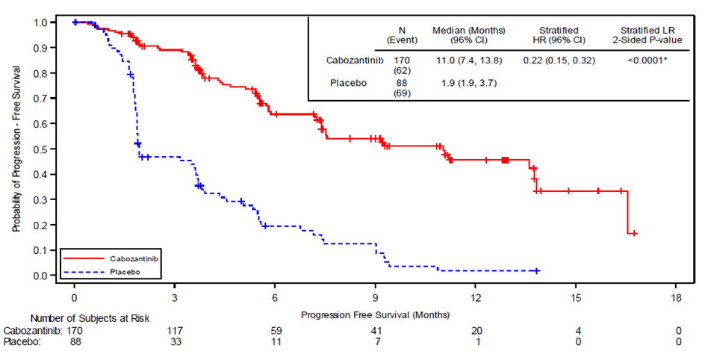
Source: Figure 2-2, p63 of the submission
BIRC = blinded independent radiology committee; CI = confidence interval; HR = hazard ratio; ITT = intent-to-treat; IxRS = interactive voice/web response system; LR = log-rank test; PFS = progression free survival.
Figure 2: Kaplan-Meier Plot of Overall Survival through 08 February 2021 (Full ITT Population, N = 258)
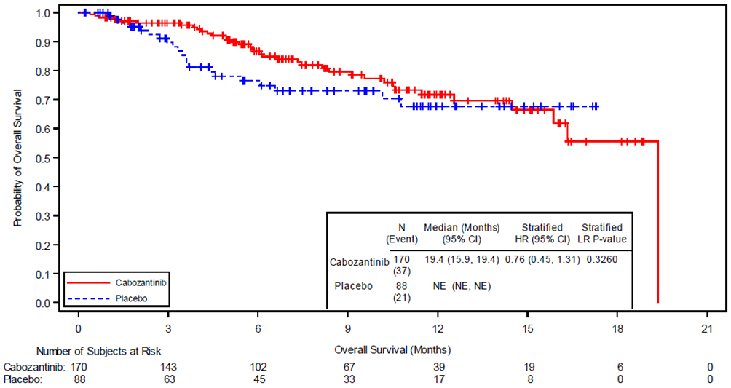
Source: Figure 2-5, p69 of the submission
CI = confidence interval; HR = hazard ratio; ITT = intent-to-treat; IxRS = interactive voice/web response system; LR = log-rank test; NE = not estimable; OS = overall survival.
+ Indicates censored observation
Stratification factors (per IxRS) comprise receipt of prior lenvatinib (yes vs no) and age at informed consent (≤ 65 years vs > 65 years).
The upper limit of the 95% CI for median OS should be interpreted as NE.
The last remaining patient in the cabozantinib arm had an event leading the survival probability to 0% as no patient remained at risk anymore.
  - In the full ITT population (CCO2), the Kaplan-Meier estimates for median duration of PFS were 11.0 months in the cabozantinib arm versus 1.9 months in the placebo arm (hazard rate ratio (HR) = 0.22 (95% CI: 0.15, 0.32), stratified p-value<0.0001). The proportion of patients who were event-free at 12 months was 45.6% in the cabozantinib arm compared with 1.8% in the placebo arm. A higher proportion of observations were censored in the cabozantinib arm compared to the placebo arm (64% versus 22%). This was largely driven by no event being recorded, which reflected the short median duration of follow-up (10.1 months).
  - In the full ITT population (CCO2), HR for overall survival was 0.76 (95% CI: 0.45, 1.31; stratified p-value = 0.3260). The median overall survival was not reached in the placebo arm. A total of 58 deaths (37 cabozantinib, 21 placebo) were reported at CCO2. A similar proportion of observations were censored in the cabozantinib arm compared to the placebo arm (78% versus 76%). Censoring was largely due to no event being recorded, which reflected the short median duration of follow-up (10.1 months).
  - In the placebo arm, 40 of 88 (45%) patients crossed over to receive open label cabozantinib. For the ITT analyses, overall survival in the placebo arm was confounded by trial participants in the placebo arm crossing-over to treatment with open-label cabozantinib following progression.
Health related quality of life
  - Table 6 presents the EQ-5D-5L results for the ITT population CCO1.
Table 6: EQ-VAS and EQ-Index Scores: Change from Baseline until 8 weeks after radiographic progression or discontinuation, Repeated-Measures Analysis (ITT Population, Countries in Which Index Is Validated [Index]; ITT Population [VAS])
 | Cabozantinib  n/N,  LSMeans (SE) | Placebo  n/N,  LSMeans (SE) | Difference in mean changeª | Pooled SD | p-valueª | Effect size^{b}
EQ-Index | 106/125  -0.0479 (0.0180) | 53/62  -0.0387 (0.0229) | -0.0092 | 0.1580 | 0.6797 | -0.0581
EQ-VAS | 108/125  -3.0415 (1.6746) | 53/62  -2.6727 (2.1078) | -0.3689 | 15.3759 | 0.8510 | -0.0240
Source: Table 2-19, p75 of the submission
EQ-VAS = EuroQol-visual analogue scale; ITT = intent-to-treat; LSMean = least squares means; SD = standard deviation; SE = standard error. A higher score indicates better health-related quality of life.
a Derived from the prespecified repeated-measures mixed-effects model analysis of covariance. Predictors (fixed effects) were baseline scores, treatment, visit, and randomization strata. Individual patient nested within the planned treatment arm was the random effect. No adjustment was made for multiple comparisons.
b Effect size = (mean of change in score)/ (pooled SD for both arms s for baseline values). Effect size differences ≥ 0.3 were regarded as likely to be clinically relevant (Sloan et al 2005, Yost and Eton 2005).
  - The differences in the EQ-5D-5L index and the EuroQol visual analogue scale (EQ-VAS) scores from baseline until eight weeks after radiographic progression or discontinuation were not statistically significant.
Subgroup analyses
  - The submission presented pre-specified subgroup analyses of PFS and overall survival at CCO2 (full ITT population) for patients who had previously received treatment with lenvatinib +/- sorafenib as the proposed restriction was for patients who have received prior anticancer therapy with a TKI, although only lenvatinib is listed on the PBS.
  - Table 7 and Table 8 present the prespecified subgroup analyses for PFS and OS (full ITT population) respectively.
Table 7: Subgroup analyses for PFS (Full ITT Population)
Cabozantinib |  |  | Placebo |  |  | Unstratified HR  (95% CI)ª
n | Events (%) | Median (95% CI) | n | Events (%) | Median (95% CI)
Overall population
170 | 62 (36) | 11.04 (7.39, 13.83) | 88 | 69 (78) | 1.94 (1.87, 3.68) | 0.23 (0.16, 0.33)
Receipt of prior lenvatinib per CRF - Yes^{b}
108 | 51 (47) | 5.82 (5.42, 9.26) | 55 | 45 (82) | 1.94 (1.77, 3.65) | 0.27 (0.18, 0.42)
Complement (receipt of prior lenvatinib per CRF – No)^{c}
62 | 11 (18) | 16.56 (11.04, NE) | 33 | 24 (73) | 3.15 (1.87, 5.52) | 0.12 (0.05, 0.25)
Receipt of prior sorafenib per CRF - Yes^{d}
101 | 31 (31) | 13.83 (7.56, NE) | 54 | 41 (76) | 1.94 (1.87, 4.57) | 0.19 (0.12, 0.30)
Complement (receipt of prior sorafenib per CRF – No)^{e}. This subgroup was previously treated with lenvatinib only and is the base case population in the economic model
69 | 31 (45) | 5.82 (5.13, 9.26) | 34 | 28 (82) | 1.87 (1.71, 3.68) | 0.28 (0.16, 0.48)
Source: Table 2-32, p89 of the submission; Table 12, p36 COSMIC-311 Clinical Study Report Addendum 1.
CRF = case form report; CI= confidence interval; HR= hazard ratio; ITT = intent to treat; PFS = progression free survival.
a HR and 95% CI were estimated from the Cox proportional-hazard unstratified model. HR < 1 indicates PFS in favour of cabozantinib.
b Patients could have received prior lenvatinib or lenvatinib and sorafenib
c Patients could have received prior sorafenib only
d Patients could have received prior sorafenib or lenvatinib and sorafenib
e Patients could have received prior lenvatinib only
Table 8: Subgroup analyses for OS (Full ITT Population)
Cabozantinib |  |  | Placebo |  |  | Unstratified HR  (95% CI)ª
n | Events (%) | Median (95% CI) | n | Events (%) | Median (95% CI)
Overall population
170 | 37 (22) | 19.4 (15.9, NE) | 88 | 21 (24) | NE | 0.76 (0.45, 1.31)
Receipt of prior lenvatinib per CRF - Yes^{b}
108 | 30 | 15.87 | 55 | 14 | NE | 0.95 (0.50, 1.80)
Complement (receipt of prior lenvatinib per CRF – No)^{c}
62 | 7 | NE | 33 | 7 | NE | 0.43 (0.15, 1.22)
Receipt of prior sorafenib per CRF - Yes^{d}
101 | 20 | 19.35 | 54 | 13 | NE | 0.59 (0.29, 1.19)
Complement (receipt of prior sorafenib per CRF – No)^{e}. This subgroup was previously treated with lenvatinib only and is the base case population in the economic model
69 | 17 | 14.49 | 34 | 8 | NE | 1.06 ¹(0.45, 2.47)
Source: XL184-311 CSR Addendum 1. Figure 9, p44.
CRF = case form report; CI= confidence interval; HR= hazard ratio; ITT = intent to treat; OS = overall survival.
a HR and 95% CI were estimated from the Cox proportional-hazard unstratified model. HR < 1 indicates OS in favour of cabozantinib.
b Patients could have received prior lenvatinib or lenvatinib and sorafenib
c Patients could have received prior sorafenib only
d Patients could have received prior sorafenib or lenvatinib and sorafenib
e Patients could have received prior lenvatinib only
  - The PFS HR for the subgroup of patients who had received prior lenvatinib only (i.e. the base case population in the economic model) was 0.28 (95% CI: 0.16, 0.48).
  - The overall survival HR for the subgroup of patients who had received prior lenvatinib only (i.e. the base case population in the economic model) was 1.06 (95% CI: 0.45, 2.47).
Adjustment for treatment switching
  - The submission used the Rank-Preserving Structural Failure Time (RPSFT) method to adjust the overall survival results for patients in the placebo arm crossing over to treatment with open-label cabozantinib following progression.
  - The submission argued that the choice of the RPSFT approach was supported by a National Institute for Health and Care Excellence (NICE) technology appraisal guidance (2018) and the potential for bias when the proportion of placebo arm patients who switched was high.
  - The submission also provided the results of applying the two-stage method and the inverse probability of censoring weights (IPCW) method.
  - Table 9 presents the estimated overall survival for the full ITT population in the COSMIC-311 trial and results adjusted for cross-over.
Table 9: Overall survival in the COSMIC-311 trial and adjusted for cross-over
 | Cabozantinib  n/N (%) | Placebo  n/N (%) | Mean difference (months) | HR (95% CI)  p-value
Full ITT population at CCO2ª
Deaths, n/N (%) | 37/170 (22) | 21/88 (24) | - | 0.76 (0.45, 1.31) ^{b}  p=0.3260
Median months OS (95% CI) | 19.4 (15.9, NE) | NE (NE, NE) | - | -
Mean months OS (95% CI)^{e} | 37.58  (27.08, 50.74) | 30.45  (20.89, 45.71) | 7.13  (-10.01,24.27) | -
Full ITT population at CCO2, adjusted using RPSFT^{c}
Deaths, n/N (%) | 37/170 (22) | 21/88 (24) | - | 0.65 (0.38, 1.13) ^{b}
Median months OS (95% CI) | 19.4 (15.9, NE) | NE (NE, NE) | - | -
Mean months OS (95% CI) ^{e} | 37.58  (27.08, 50.74) | 27.39  (18.38, 41.15) | 10.19  (-6.95, 27.33) | -
Full ITT population at CCO2, adjusted using two-stage method^{d}
Deaths, n/N (%) | 37/170 (22) | 21/88 (24) | - | 0.70 (0.41, 1.22) ^{b}
Median months OS (95% CI) | 19.4 ¹ (15.9, NE) | NE (NE, NE) | - | -
Mean months OS (95% CI) ^{e} | 37.58  (27.08, 50.74) | 29.25  (18.83, 43.47) | 8.33  (-8.81, 25.47) | -
Full ITT population at CCO2, adjusted using IPCW
Deaths, n/N (%) | 37/170 (22) | 21/88 (24) | - | 0.68 (0.37, 1.27) ^{b}
Median months OS (95% CI) | 19.4 (15.9, NE) | NE (NE, NE) | - | -
Mean months OS (95% CI) ^{e} | 37.58  (27.08, 50.74) | 31.76  (19.5, 51.59) | 5.82  (-11.7, 23.34) | -
Source: pp93-95, p98 of the submission and p15, 36 Attachment 7.
BIRC = blinded independent radiology committee; CI = confidence interval; CCO2 = clinical cut-off 2; HR = hazard rate ratio; IPCW = Inverse Probability of Censoring Weights ITT = Intent-to-treat; NE = not estimable; OS = overall survival; RPSFT = Rank-Preserving Structural Failure Time.
Bold indicates statistically significant results.
a Full ITT population: Patients randomised to receive study treatment as of the second clinical cut-off (CCO2) on 2 February 2021.
b Stratification factors (per IxRS) comprise receipt of prior lenvatinib (yes vs no) and age at informed consent (≤ 65 years vs 65 years); Estimated using the Cox proportional-hazard model (adjusted for stratification factors if applicable). HR < 1 indicated in favour of cabozantinib.
c. The treatment effect of cabozantinib over placebo was estimated at 1.42 when assuming the common treatment effect (k=1)
d The corresponding treatment effect in placebo switchers compared to non-switchers was 1.093 (i.e. shrunk by 9%)
e Estimated after extrapolating overall survival using an exponential function to 200 months.
  - Figure 3 presents the Kaplan-Meier curves for overall survival in the cabozantinib and placebo arms as of CCO2, and in the placebo-RPSFT adjusted treatment arms.
Figure 3: KM curves for OS in cabozantinib, placebo, and placebo-RPSFT adjusted
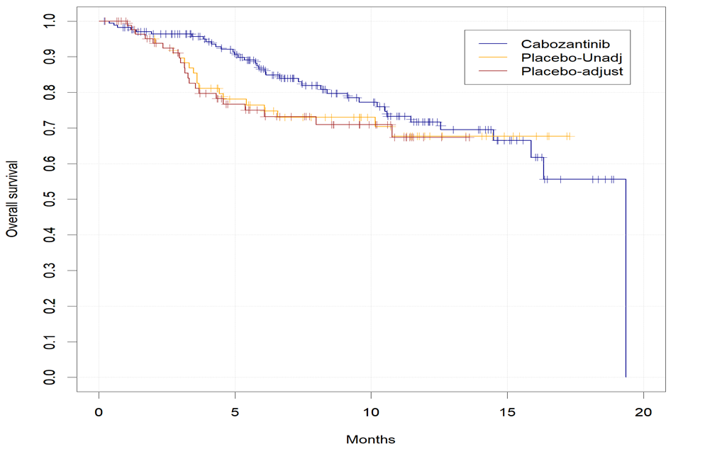
Source: Figure 2-9, p94 of the submission.
  - After adjusting the placebo arm for treatment crossover using the RPSFT method, the HR was estimated as 0.65 (95% CI: 0.28, 1.53) for cabozantinib versus placebo (compared to 0.76 (95% CI: 0.45, 1.31) in the ITT). The improvement in overall survival increased in terms of the point estimate but remained not statistically significant due to the widening of the confidence interval. The results were not sensitive to changing the common treatment effect.
  - The Guidelines for preparing submissions to PBAC state that methods for adjusting the treatment effect for treatment switching may rely on assumptions that are difficult to validate. Consequently, it is preferable to use a number of different statistical methods to adjust for switching. Similar results will reduce uncertainty and increase confidence in the treatment effect used in the economic model. In this case, three statistical methods were used (RPSFT, two-stage and IPCW). The estimated HRs and 95% CIs were similar across the statistical methods used to adjust for cross-over. Although the estimated differences in mean survival (estimated following extrapolation) were materially different across the methods (range: 5.82 to 10.19 months), the confidence intervals were wide and overlapping indicating that there was no statistical difference in the results.
  - The PSCR presented the results for the subgroup of patients who had received prior lenvatinib only. The HR was estimated to be 1.06 (95% CI: 0.45, 2.47) and, when adjusted using the RPSFT method, the HR was 0.98 (95% CI: 0.24, 3.91).

Comparative harms
  - Table 10 presents a summary of adverse events in the COSMIC-311 trial.
Table 10: Summary of key adverse events in COSMIC-311 (CCO2)ª
Trial ID | Cabozantinib  n/N (%) | Placebo  n/N (%) | RD (95% CI)
Any AE | 166/170 (98) | 75/88 (85) | 0.12 (0.05, 0.20)
Treatment-related AE | 159 (94) | 41 (47) | 0.47 (0.36, 0.58)
Grade 3/4 AE | 106 (62) | 25 (28) | 0.34 (0.22, 0.46)
Treatment-related Grade 3/4 AE | 88 (52) | 7 (8.0) | 0.44 (0.34, 0.53)
Grade 5 AE ≤ 30 days after last dose | 14 (8.2) | 7 (8.0) | 0.00 (-0.07, 0.07)
Treatment-related Grade 5 AE ≤ 30 days after last dose | 0 | 0 | 0.00 (-0.02, 0.02)
Treatment-related Grade 5 AE at any time | 0 | 0 | 0.00 (-0.02, 0.02)
Serious AE | 66 (39) | 24 (27) | 0.12 (0.00, 0.23)
Treatment-related serious AE | 25 (15) | 1 (1.1) | 0.14 (0.08, 0.19)
AE leading to dose modification (reduction or interruption) | 139 (82) | 24 (27) | 0.54 (0.44, 0.65)
AE leading to dose reduction | 114 (67) | 4 (4.5) | 0.63 (0.54, 0.71)
AE leading to dose interruption | 121 (71) | 23 (26) | 0.45 (0.34, 0.56)
AE leading to treatment discontinuation (not causally related to disease under study) | 15 (8.8) | 0 | 0.09 (0.04, 0.13)
Related to study treatment^{b} | 10 (5.9) | 0 | 0.06 (0.02, 0.10)
Source: Table 2-21, p77 of the submission.
AE = adverse event; CI = confidence interval; RD = risk difference.
a Full ITT population: Patients randomised to receive study treatment as of the second clinical cut-off (CCO2) on 2 February 2021. Median time is 10.1 months
b Leading to study discontinuation.
  - Nearly all patients treated with cabozantinib (98%, versus 85% for placebo) in the full ITT experienced an adverse event. Patients treated with cabozantinib versus placebo were more likely to experience treatment-related adverse events (94% versus 47%), grade 3/4 adverse events (62% versus 28%), treatment-related grade 3/4 adverse events (52% versus 8%), serious adverse events (39% versus 27%), and adverse events leading to dose modification (82% versus 27%) or treatment discontinuation (8.8% versus 0%).
  - The most frequent treatment-related adverse events (≥ 20% incidence) reported for patients in the cabozantinib arm in descending order of incidence were diarrhoea, palmar-plantar erythrodysaesthesia syndrome, hypertension, increased alanine aminotransferase (ALT), increased aspartate aminotransferase (AST), decreased appetite, fatigue, and nausea.
  - The most frequent grade 3/4 adverse events (≥ 5% incidence) reported for patients in the cabozantinib arm in descending order of incidence were hypertension, palmar-plantar erythrodysaesthesia syndrome, fatigue, diarrhoea, and hypocalcaemia. There were no grade 3/4 adverse events with a ≥ 5% incidence reported in the placebo arm.

Benefits/harms
  - A summary of the comparative benefits and harms for cabozantinib versus placebo in the full ITT population (not the subgroup who received lenvatinib only, which was used in the economic model) is presented in Table 11.
Table 11: Summary of comparative benefits and harms for cabozantinib and placebo
Benefits
Overall response rate (OITT)
Trial | Cabozantinib, n/N | Placebo,  n/N | RR (95% CI) | Event rate/100 patients* |  | RD (99% CI)
 |  |  |  | Cabozantinib | Placebo
COSMIC-311 | 10/67 (15) | 0/33(0) | 10.50  (0.63, 173.88) | 15 | 0 | 0.15  (0.037, 0.261)
Progression-free survival (median duration of follow up 10.1 months) Full ITT population
Event | Cabozantinib | Placebo | Absolute Difference | HR (95% CI)
Progressed, n (%) | 62/170 (36) | 69/88 (78) | - | 0.22 (0.15, 0.32) ^{b}
Median PFS, months (96% CI^{)d} | 11.0 (7.4, 13.8) | 1.9 (1.9, 3.7) | 9.1ª
K-M landmark estimates (% of patients event-free) at 12 months | 45.6 | 1.8 | 43.8ª
Overall survival (median duration of follow up 10.1 months) Full ITT population
Progressed, n (%) | 37/170 (22) | 21/88 (24) | - | 0.76 (0.45, 1.31)  p=0.3260^{b}
Median OS, months (95% CI) | 19.4 (15.9, NE) | NE (NE, NE) | NEª
K-M landmark estimates (% of patients alive) at 12 months | 71.7 | 67.7 | 4ª
Harms
Full ITT | Cabozantinib,  n/N | Placebo,  n/N | RR (95% CI) | Event rate/100 patients* |  | RD (95% CI)
 |  |  |  | Cabozantinib | Placebo
At least one SAE
COSMIC-311 | 166/170 (98) | 75/88 (85) | 1.15 (1.05, 1.25) | 97.65 | 85.23 | 0.12 (0.05, 0.20)
Hypertension, Grade 3 or 4
COSMIC-311 | 20/170 (12) | 2/88 (2.3) | 5.18 (1.24, 21.64) | 11.75 | 2.28 | 0.09 (0.04, 0.15)
Hand-foot skin reaction^{c,} Grade 3 or 4
COSMIC-311 | 17/170(10) | 0/88 | 18.22  (1.11, 299.39) | 10 | 0 | 0.10 (0.05, 0.15)
Fatigue, Grade 3 or 4
COSMIC-311 | 15/170 (8.8) | 0/88 | 16.13  (0.98, 266.52) | 8.82 | 0 | 0.09 (0.04, 0.13)
Diarrhoea, Grade 3 or 4
COSMIC-311 | 13/170 (7.6) | 0/88 | 14.05  (0.85, 233.65) | 7.65 | 0 | 0.08 (0.03, 0.12)
Source: Table 2-15, p62; Table 2-17, p70; Table 2-22, p79; p105 of the submission; CSR Table 28, p123.
BSC = Best supportive care; CI = confidence interval; HR = hazard ratio; PBO = placebo; RD = risk difference; RR = risk ratio; K-M = Kaplan-Meier; NE = not estimable; OS = overall survival;
*Median duration of follow-up: OITT = 6 months; Full ITT= 10.1 months
Bold indicates statistically significant results.
a Calculated during evaluation
b Stratification factors based on IxRS were receipt of prior lenvatinib (yes vs no) and age at informed consent (≤ 65 years vs ≥ 65 years); Estimated using the Cox proportional-hazard model (adjusted for stratification factors if applicable). HR < 1 indicated OS in favour of cabozantinib
c Palmar-plantar erythrodysesthesia syndrome also known as hand-foot skin reaction
d The primary end point of PFS used the 96% CI for inferential purposes because the 1% α was spent in the analysis of ORR and could not be reallocated to PFS. Because the primary end point of PFS was met at the interim analysis, this was also the final α‐controlled analysis of PFS. For the extended follow‐up analysis, efficacy end points were assessed in all randomized patients (the ITT population) per the data cut-off of February 8, 2021. All extended analyses were descriptive and supportive to show that significance was maintained at the same α level per the interim analysis. All p values were retained to support the overarching quality of the results from this extended analysis and their consistency with the primary analysis; p values were estimated by a stratified log‐rank test for PFS and by an unstratified Fisher exact test for ORR.
  - On the basis of direct evidence presented by the submission, for every 100 patients treated with cabozantinib in comparison with placebo over a median duration of 6 months:
- Approximately 15 additional patients would experience an overall response.
  - On the basis of direct evidence presented in the submission, for every 100 patients treated with cabozantinib in comparison with placebo at 12 months:
- Approximately 44 additional patients would be progression-free; and
- There would be no difference in the number of patients alive.
  - On the basis of direct evidence presented by the submission, for every 100 patients treated with cabozantinib in comparison with placebo over a median duration of 10.1 months:
- Approximately 9 additional patients would experience grade 3/4 hypertension (high blood pressure).
- Approximately 9 additional patients would experience grade 3/4 fatigue.
- Approximately 10 additional patients would experience grade 3/4 palmar-plantar erythrodysesthesia syndrome (hand-foot skin reaction).
- Approximately 8 additional patients would experience grade 3/4 diarrhoea.

Clinical claim
  - The submission described cabozantinib as superior in terms of PFS and ORR and inferior in terms of safety compared to placebo.
  - The therapeutic conclusion regarding improved PFS was supported by ESC. However, whether cabozantinib was more effective than placebo in terms of overall survival was unknown as:
- Overall survival in the placebo arm was confounded by patients (40/88, 45%) crossing-over to treatment with open-label cabozantinib following progression. The TGA Delegates Overview stated that the relatively short follow-up and the crossover design of the trial would have contributed to the smaller difference in overall survival than was seen with PFS. A recent published meeting abstract (2023 ASCO Annual meeting) of a systematic review and meta-analysis in RAI-refractory DTC found there was no significant correlation between ORR and PFS or overall survival, or between PFS and overall survival (N= 24 studies, 6 RCTs and 18 observational). However, a sub-analysis of the six RCTs found a significantly strong positive correlation between ORR and PFS (r_{s} = 0.92, p = 0.003). Similarly, significant improvements in PFS did not lead to significant improvements in overall survival in trials for the treatment of RAI-refractory DTC that have previously been considered by the PBAC (the SELECT trial comparing lenvatinib to placebo and the DECISION trial comparing sorafenib to placebo); however, these were also confounded by cross-over. Consequently, there is no external evidence that suggests that PFS is a good surrogate for overall survival.
  - No difference in quality of life with cabozantinib compared with placebo was found, using the EQ-5D-5L instrument.
  - Overall, the PBAC considered that the claim that cabozantinib was superior compared to placebo was reasonable in terms of ORR and PFS but was unknown in terms of OS.
  - The PBAC agreed with ESC and considered that the therapeutic conclusion that cabozantinib was inferior compared to placebo in terms of safety was adequately supported by the evidence presented.

Economic analysis
  - A cost-effectiveness analysis and a cost-utility analysis were presented.
  - Table 12 presents the key components of the model.
Table 12: Summary of model structure, key inputs and rationale
Component | Summary
Type of analysis | Cost-effectiveness analysis, cost-utility analysis.
Population | Base case population: pre-specified subgroup previously treated with lenvatinib only (did not receive sorafenib) in the pivotal COSMIC-311 trial, consistent with the proposed PBS population of “adult patients with RAI-R DTC…with progressive disease…or have developed intolerance necessitating permanent treatment withdrawal, after first-line treatment with lenvatinib”. The use of the subgroup decreased the sample size (the subgroup consisted of 102/258 = 40% of the Full ITT population), increasing the uncertainty in the results.  Additional population: overall patient population in the COSMIC-311 trial, to “provide further confidence around the conservative nature of the assumptions applied”. The ICER was sensitive to the population used to estimate efficacy.
Treatments | Cabozantinib as an adjunct to BSC versus BSC alone (matched placebo). This was consistent with the proposed listing.
Time horizon | Five years in the model base case versus 10.1 months of median follow-up in the pivotal COSMIC-311 trial. The submission considered the 5-year time horizon reasonable as the median survival of patients with RAI-refractory DTC was 2.5 to 3.5 years. The time horizon in the model was long compared to the follow-up duration (median 10.1 months) in the COSMIC-311 trial. However, sensitivity analyses demonstrated that the ICER stabilised after three years as most patients had died by this time.
Outcomes | Cost per LY gained, cost per QALY gained.
Methods used to generate results | Partitioned survival analysis.
Health states | Three health states:  - Pre-progression (also referred to as stable disease or progression-free),  - Post-progression (also referred to as progressive or progressed disease),  - Death.
Cycle length | Four weeks (28 days) (with half-cycle correction). Using a 28-day model cycle rather than a 30-day cycle (30 tablets per script, a 30-day supply per script) increased the number of cycles per year and slightly overestimated the monitoring costs for cabozantinib treatment as these were incurred every cycle for those on treatment.
Allocation to health states | Kaplan-Meier curves for PFS, TTD, and OS (adjusted using RPSFT) for the sub-group previously treated with lenvatinib only from the COSMIC-311 trial and applied up to 10.1ª months, the median follow-up of the COSMIC-311 trial). The submission did not present the RPSFT analysis for the subgroup of patients who were previously treated with lenvatinib only, therefore the effect of the adjustment on overall survival could not be assessed. The results were presented in the PSCR (see paragraph 6.35).  Beyond 10.1 months, parametric survival functions were used for extrapolation. Sensitivity analyses applying extrapolation from 9 and 12 months resulted in broadly similar ICERs compared to the base case.
Extrapolation method | Outcomes beyond 10.1 months were extrapolated using different parametric survival functions for the cabozantinib (+BSC) and BSC arms (Table 13). The parametric survival functions were selected based on consideration of both the AIC and BIC. Other factors considered included the plausibility of the extrapolated curves (i.e., avoiding combinations of PFS and OS curves whereby the PFS extrapolation crosses the OS extrapolation), clinical plausibility and visual fit. The submission did not provide log-cumulative hazard plots to justify the rejection of the proportional hazard assumption. These were presented in the PSCR and it appeared that the proportional hazards assumption was violated, thus it may have been appropriate to use different parametric survival functions for the comparison arms. However, the ICER was insensitive to the choice of parametric functions for PFS and TTD in the placebo arm, as most patients had progressed at the point of extrapolation, and the choice of parametric functions for OS were conservative. The ICER was most sensitive to the choice of parametric function for TTD in the cabozantinib arm.
Health-related quality of life | Base case (literature-based utilities): Pre-progression = 0.870, Post-progression = 0.520 (Fordham 2015), Death = 0  Sensitivity analysis (trial-based): Pre-progression = 0.692, Post-progression = 0.674 (from the COSMIC-311 trial)  Disutility for Grade 3/4 adverse event (referred to as “SAE” in the submission) = 0.04 (the METEOR trial)
Treatment interruptions | Cabozantinib (+BSC) arm: 14.63% (from the COSMIC-311 trial, based on the difference in the mean duration of exposure including (7.04 months) and excluding (6.01 months) dose holds in the cabozantinib arm (N=170, Safety Population).  BSC arm: 6.62% (from the COSMIC-311 trial, based on the difference in the mean duration of exposure including (4.23 months) and excluding (3.95 months) dose holds in the placebo arm (N=88, Safety Population).  The Safety Population included patients treated with both sorafenib and lenvatinib (any sequence) (23% in the cabozantinib + BSC treatment arm) and were likely to be sicker than those previously treated with lenvatinib only. Treatment interruptions in the subgroup previously treated with lenvatinib only was therefore uncertain.
Costs of management of Grade 3/4 adverse events | National Hospital Cost Data Collection, Australian Refined Diagnosis-Related Group (AR-DRG) cost weight tables v6.0x, Round 17 (FY 2012-13) were applied to of the incidence of Grade 3/4 adverse events (referred to as “SAEs” in the submission).
Post-progression costs | Subsequent therapies based on therapies reported in the COSMIC-311 trial.
Source: Table 3-2, p110 of the submission; Excel workbook titled ‘Attachment 10 – DTC economic evaluation – Section 3 – FINAL’ of the submission.AIC = Akaike Information Criterion; BIC = Bayesian Information Criterion; BSC = best supportive care; DTC = differentiated thyroid cancer; FY = financial year; ICER = incremental cost-effectiveness ratio; IPD = individual patient data; LY = life year; NICE = National Institute for Health and Care Excellence; OS = overall survival; PBS = Pharmaceutical Benefits Scheme; PFS = progression-free survival; QALY = quality-adjusted life year; RAI-R = radioactive iodine refractory; SAE = serious adverse event; TTD = time to treatment discontinuation.
ª The submission reported that the economic model utilised the Kaplan Meier curves up to the point of median follow-up of 10.2 months (p123 of the submission). However, the median follow-up for PFS and OS in the COSMIC-311 trial (Full ITT Population) was 10.1 months (Table 6, p19 of CSR Addendum 1). The economic model used the K-M model when the time in model was <10.2 months. The impact on the ICER was likely minimal.
  - The submission presented a modelled economic evaluation of cabozantinib as an adjunct to BSC versus BSC alone in patients with DTC who had progressed on previous treatment with a TKI over a time horizon of 5 years. Base case results were based on inputs from a pre-specified sub-group of the pivotal COSMIC-311 trial (subgroup previously treated with lenvatinib only), using RPSFT-adjusted OS. Although this was consistent with the proposed PBS population, the use of the subgroup was not adequately supported with clinical evidence, in terms of the pharmacological, biological or clinical rationale for a variation of in the treatment effect or tests for interaction. The use of a subgroup also decreased the sample size (the subgroup consisted of 102/258 = 40% of the Full ITT population), increasing uncertainty in the results. The same subgroup was used to inform the base-case analysis of a cabozantinib submission considered by the NICE for the same indication. An additional analysis was also presented based on inputs from the whole COSMIC-311 ITT population, which resulted in a lower ICER.
  - All patients, having previously been treated with lenvatinib, entered the model in the progression-free health state and remained there until progression or death. Allocation to the health states was informed by Kaplan-Meier curves for PFS and overall survival, estimated based on individual patient data (IPD) from the COSMIC-311 trial and applied up to 10.1 months, the median follow-up of the COSMIC-311 trial. Outcomes beyond 10.1 months were extrapolated using parametric survival functions, based on the consideration of both the AIC and the BIC. Similarly, time on treatment, used to calculate drug costs in the pre-progression state, was estimated based on time to treatment discontinuation (TTD) IPD data from the COSMIC-311 trial and extrapolation beyond 10.1 months. Table 13 provides the parametric models the submission selected for extrapolation of the survival outcomes. Figure 4, Figure 5 and Figure 6 provide the Kaplan-Meier curves and extrapolations for PFS, overall survival and TTD in the base case, respectively.
  - The submission did not test the proportional hazard assumption and used different parametric functions for the cabozantinib (+BSC) and BSC treatment arms. The PSCR presented the log-cumulative hazard plots, and it appeared that the assumption of proportional hazards had been violated, meaning that the use of different parametric functions was reasonable.
Table 13: Parametric models selected for extrapolation of PFS, OS and TTD outcomes beyond 10.2 months in the submission
 | Base case  Sub-group previously treated with lenvatinib only |  | Additional analysis  Full COSMIC-311 population
 | Cabozantinib (+ BSC) | BSC | Cabozantinib (+ BSC) | BSC
PFS | Weibull | Gompertz | Log-Logistic | Log-Normal
TTD | Gompertz | Gompertz | Exponential | Log-Normal
OS | Gompertz | Exponentialª | Weibull | Generalised Gammaª
Source: pp132 and 134 of the submission; Tab titled ‘3A. Control Panel’ in Excel workbook titled ‘Attachment 10 – DTC economic evaluation – Section 3 – FINAL’ of the submission.
BSC = best supportive care; OS = overall survival; PFS = progression-free survival; TTD = time to treatment discontinuation.
ª This is incorrect. The submission later assumed that overall survival with best supportive care is extrapolated “modelling the same probability of transitioning using the cabozantinib curve" (p147 of the submission).
  - In general, the choice of parametric functions applied to the cabozantinib (+BSC) arm to extrapolate PFS, TTD and overall survival were conservative in the base case (subgroup previously treated with lenvatinib), but less conservative for the full COSMIC-311 population. There was minimal extrapolation of PFS with placebo. Modelling and extrapolating TTD (rather than assuming TTD equals PFS) may slightly underestimate costs. The PBAC noted the parametric models selected for extrapolation differed depending on if the subgroup or ITT population was used; however, there was no clinical rationale for why a different functional form would be appropriate.
Figure 4: Kaplan Meier and extrapolations, PFS (base case)
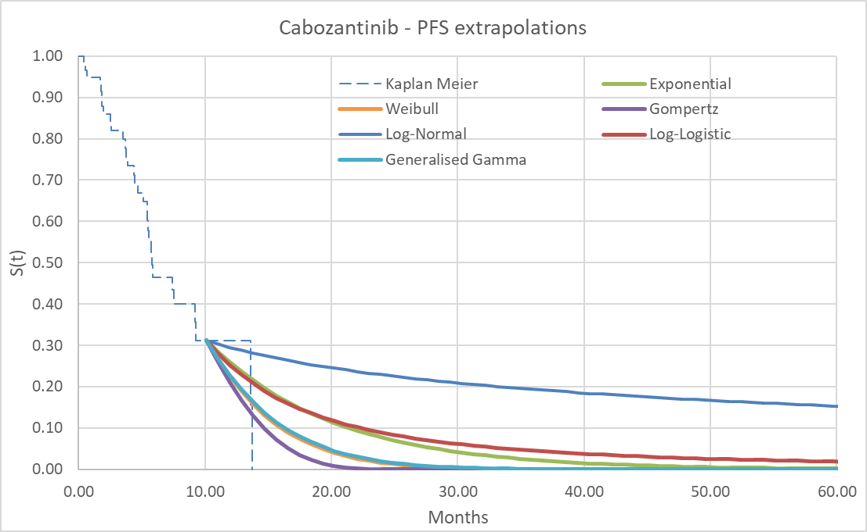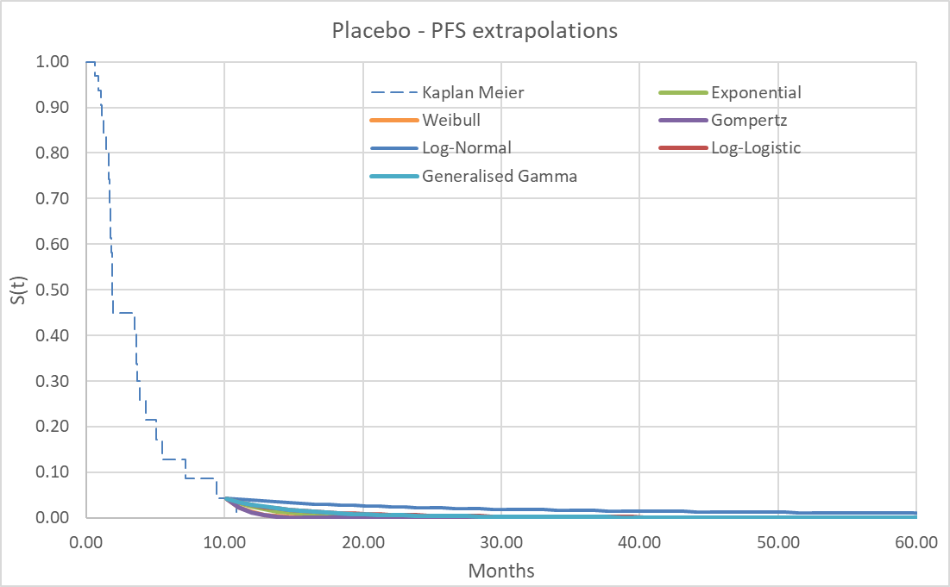
Source: Tab titled ‘3A. Control Panel’ in the Excel workbook titled ‘Attachment 10 – DTC economic evaluation – Section 3 – FINAL’ of the submission
PFS = progression-free survival.
Figure 5: Kaplan-Meier and extrapolations, OS (base case)
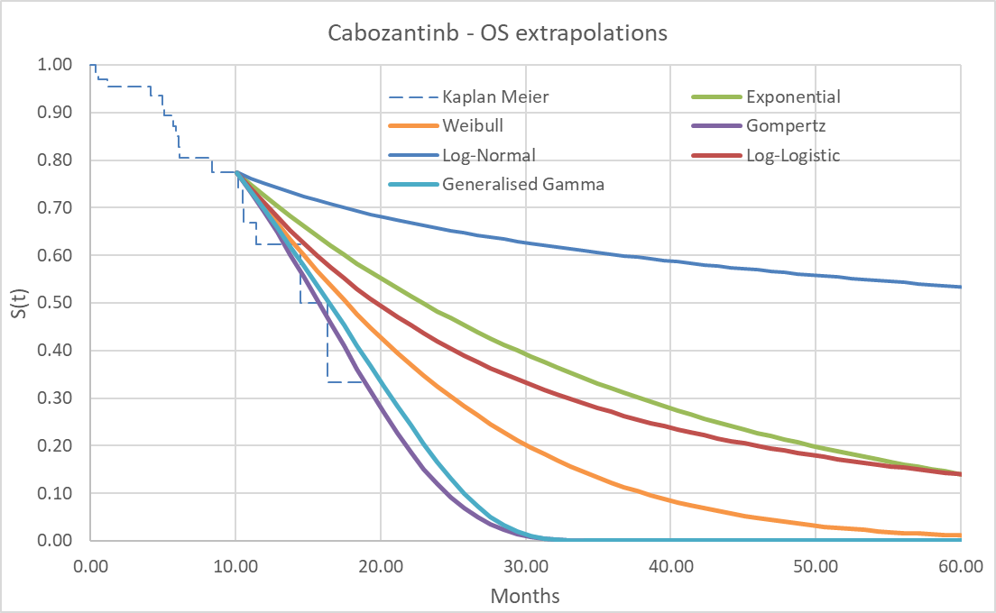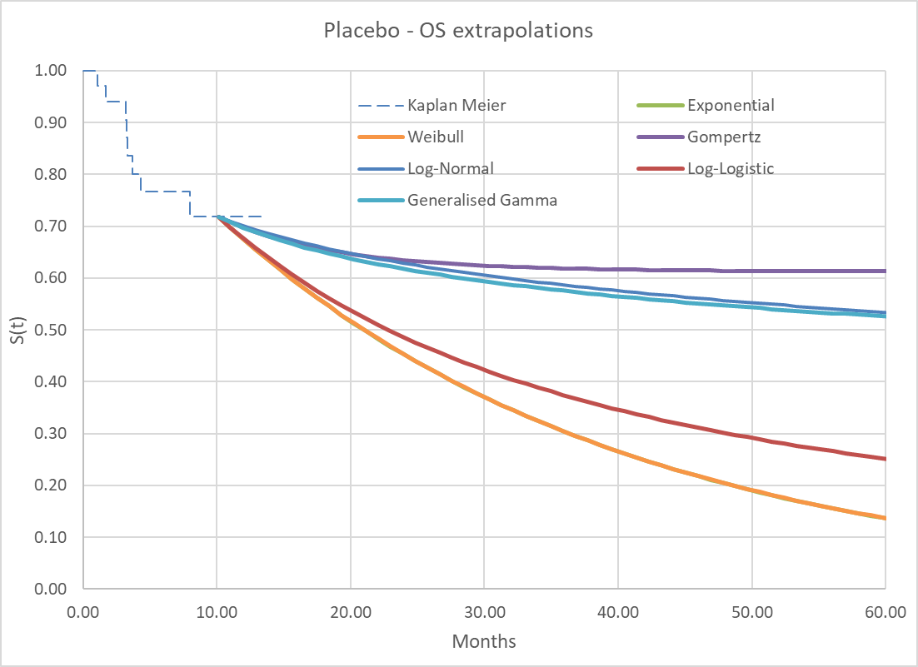
Source: Tab titled ‘3A. Control Panel’ in the Excel workbook titled ‘Attachment 10 – DTC economic evaluation – Section 3 – FINAL’ of the submission
OS = overall survival.
Note: The Exponential curve for placebo – OS was hardly visible as it overlapped with the Weibull curve (different values from third decimal place).
Figure 6: Kaplan-Meier and extrapolations, TTD (base case)
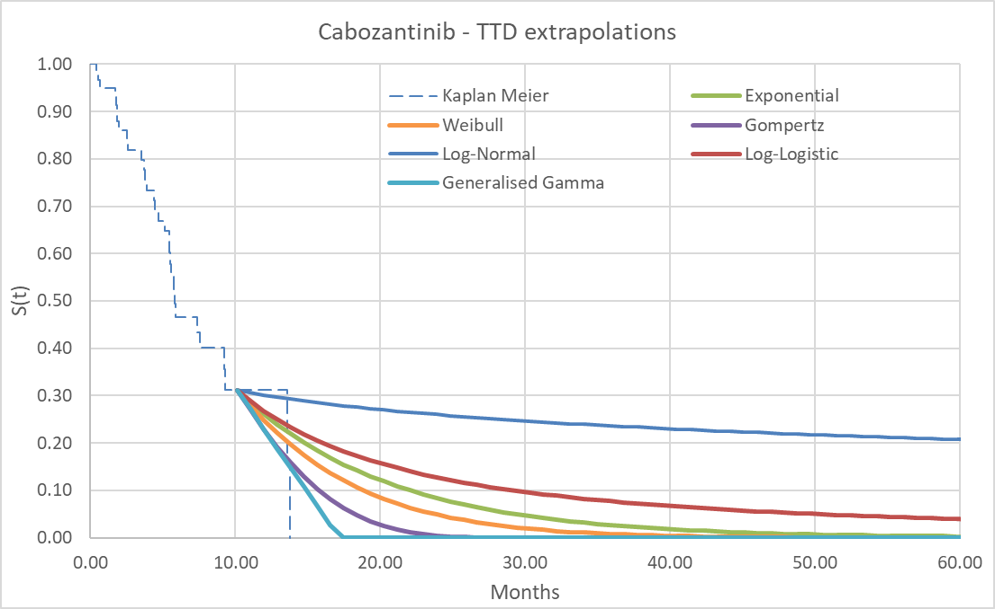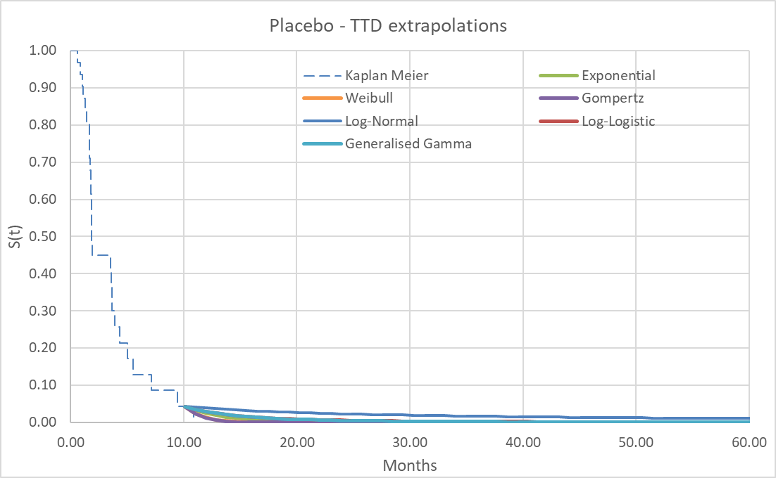
Source: Tab titled ‘3A. Control Panel’ in the Excel workbook titled ‘Attachment 10 – DTC economic evaluation – Section 3 – FINAL’ of the submission
TTD = time to treatment discontinuation.
  - Table 14 presents the utilities the submission used in the base case.
Table 14: Utility values used in the base case of the submission and alternative values in scenario analysis
 | Base case | Scenario analysis
Health state | Fordham 2015 | Trial based | TA535* (based on DECISION trial: sorafenib (+ BSC) vs. BSC, 1L setting
Pre-progression | 0.870 ª | 0.692 | 0.720
Post-progression | 0.520 | 0.674 | 0.640
Difference | −0.350 ^{b} | −0.018 | −0.080
Source: Table 3-6, p135 of the submission.
1L = first line; BSC = best supportive care.
* Lenvatinib and sorafenib for treating differentiated thyroid cancer after radioactive iodine. Technology appraisal guidance, TA535, NICE, 8 August 2018
ª Mean observed time trade-off (TTO) health state utility, base state (stable/no response), adjusted for educational level and EQ-5D-3L (usual activities and anxiety/depression) ratings using UK norms.
^{b} Disutility associated with progressive disease [adjusted for educational qualification level and EQ-5D-3L (usual activities and anxiety/depression) ratings using UK norms].
  - The submission applied literature-based utilities (Fordham 2015) of 0.87 and 0.52 to the pre-progression and post-progression health states, respectively. Fordham 2015 was a vignette study in 100 members of the UK public to elicit utilities for RAI-R DTC health states and evaluated the impact of treatment response and toxicities on quality of life. While the COSMIC-311 trial collected EQ-5D-5L data until radiographic disease progression as confirmed by the BIRC, the submission did not use the trial-based utilities for any model health state. This was not appropriate. The PBAC Guidelines stated that “if available, use quality-of-life or utility data reported in the trial to estimate [quality adjusted life years, QALYs] in the model”.
  - An Australian study that estimated health-related quality of life normative values for the EQ-5D-5L preference-based measure in a large, random, community sample (2,908 adults) reported a mean utility score of 0.87 for those aged 65-74 years. The ESC considered that it was unlikely that the Australian general population and patients with locally advanced or metastatic DTC, RAI-refractory and progression-free after a first-line treatment would have a similar utility (0.87, from Fordham 2015).
  - The submission argued that (a) the limited reduction of utilities (0.018) after progression observed in the trial-based utilities was inconsistent with the difference observed in other models and NICE appraisals (e.g., TA535, NICE 2018) in advanced thyroid cancer, and (b) this inconsistency was validated by UK clinicians in a recent advisory board; however, TA535 related to a first-line treatment whereas the COSMIC-311 trial related to a second-line treatment.
  - The submission also argued that the limited impact of progression in the COSMIC-311 data was likely a result of little follow-up post-progression and missing data, as the available data suggested that utility decreased over time post-progression. The ESC considered that this was plausible.
  - The NICE Technology appraisal committee considered a submission for cabozantinib as second-line treatment in a similar target population to the proposed PBS population. In general, NICE prefer using trial-based utilities provided they are robust, free of bias and clinically plausible. However, given the limitations of the trial-based data to inform progressed disease utility values (quality of life data stopped shortly after progression, NICE used (a) the trial-based utility for the progression-free state (0.692), as the COSMIC-311 trial included the population under appraisal and was the same source as for the model’s clinical efficacy inputs, and (b) the unadjusted post-progression utility value (0.520) from Fordham 2015.
  - The PSCR accepted that the trial-based utility value should have been used for the pre-progression health state and proposed that it would provide a relevant anchor for the post-progression utility value. Instead of using the unadjusted Fordham (2015) post-progression utility value which was derived from a general population sample, the PSCR suggested applying the relative and absolute utility decrements from Fordham (2015) to the pre-progression anchor. Table 15 provides a comparison of the various proposed pre- and post-progression utility values. The ESC considered that application of the relative utility decrement was more appropriate as, although not the case in this situation, application of absolute decrements can potentially result in negative utility values. The pre-PBAC response provided a revised base case which applied the trial-based utility for the pre-progression state (0.692) and Fordham (2015), adjusted using a relative decrement, for the post-progression state (0.414).
Table 15: Comparison of proposed utility values for the pre- and post-progression health states
 | Pre-progression | Change | Post-progression
Base case: Fordham (2015) for both pre-and post-progression health states | 0.87ª | −0.35^{b} | 0.52
COSMIC-311 trial | 0.692 | −0.018 | 0.674
Pre-progression: COSMIC 311; Post-progression: Fordham, 2015 | 0.692 | −0.172 | 0.52
Application of relative utility decrement from Fordham (2015) to COSMIC 311 anchor health state | 0.692 | −0.278 | 0.414
Application of absolute utility decrement from Fordham (2015) to COSMIC 311 anchor health state | 0.692 | −0.350 | 0.342
Source: modified from Tables 1 and 2, PSCR.
ª Mean observed time trade-off (TTO) health state utility, base state (stable/no response), adjusted for educational level and EQ-5D-3L (usual activities and anxiety/depression) ratings using UK norms.
^{b} Disutility associated with progressive disease (95% CI −0.41, −0.29) [adjusted for educational qualification level and EQ-5D-3L (usual activities and anxiety/depression) ratings using UK norms] (source: Table 2, Fordham 2015).
  - The source of the disutility for Grade 3/4 adverse events (0.04) was the METEOR trial comparing cabozantinib versus everolimus in patients with advanced RCC. The applicability to DTC was uncertain.
  - To estimate the cost of subsequent therapies in the post-progression state, the submission used the published prices for various drugs (including cabozantinib and lenvatinib) of which none were PBS-listed for use after second-line treatment in advanced DTC. The submission argued that due to the lack of reimbursed products for later lines of therapy, costs were assumed to be either borne by the patient (i.e., dispensed privately for off-label use) or provided through an access program. The applicability of the cost of non-PBS-listed post-progression therapies used in the COSMIC-311 trial to Australian clinical practice was uncertain, given many therapies may not be used by Australian patients due to high out of pocket costs. The PSCR stated that the use of active treatment post-progression contributes to the lack of observed difference in overall survival. Further, the PSCR stated that if the costs were removed, then the outcomes post-progression should also be adjusted for the survival benefits derived from these treatments. The ESC considered that it was inappropriate to include non-PBS drug costs in the post-progression setting and did not agree with the PSCR response that outcomes should also be adjusted in this case given the uncertainty this would introduce. The pre-PBAC response provided a revised base case in which the subsequent costs of lenvatinib, radiotherapy and surgery were included, stating that it was plausible that in the absence of any further treatment option, patients experiencing disease progression may continue lenvatinib.
  - Table 16 presents the key drivers of the model.
Table 16: Key drivers of the model
 |  | Impact
Description | Method/Value | Base case (subgroup previously treated with lenvatinib only):  ICER = $| ¹ per QALY gained
Utilities | The base case analysis applied literature-based utilities (Fordham 2015) (pre-progression 0.87, post-progression 0.52) rather than trial-based utilities (pre-progression 0.692, post-progression 0.674). | High, favoured cabozantinib.  Using the trial-based utility for pre-progression (0.692) and Fordham 2015 () for post-progression increased the ICER to $|||| ² per QALY gained.
Cost of subsequent therapies | The submission used the published DPMQs of various drugs (including cabozantinib and lenvatinib) to calculate weighted average unit costs of post-progression therapies for both the cabozantinib (+ BSC) and BSC treatment arms. However, none of the drugs were PBS-listed for use as subsequent line therapy following progression in the target PBS population. | High, favoured cabozantinib.  The exclusion of the costs of subsequent therapies increased the ICER to $|||| ³ per QALY gained.
TTD for cabozantinib | The submission used the Gompertz parametric function to extrapolate TTD for cabozantinib (+BSC). | Low to moderate, favoured cabozantinib.  Using the log-logistic function to extrapolate TTD for cabozantinib increased the ICER to $|||| ⁴ per QALY gained.
Source: p113 of the submission.
BSC = best supportive care; DPMQ = Dispensed Price for Maximum Quality; ICER = incremental cost-effectiveness ratio; QALY = quality-adjusted life year; SA = sensitivity analysis; TTD = time to treatment discontinuation
The redacted values correspond to the following ranges:
¹ $55,000 to < $75,000
² $115,000 to < $135,000
³ $155,000 to < $255,000
⁴ $75,000 to < $95,000
  - Figure 7 presents the traces for the health states in the cabozantinib (+BSC) and BSC arms.
Figure 7: Trace of health states (base case)
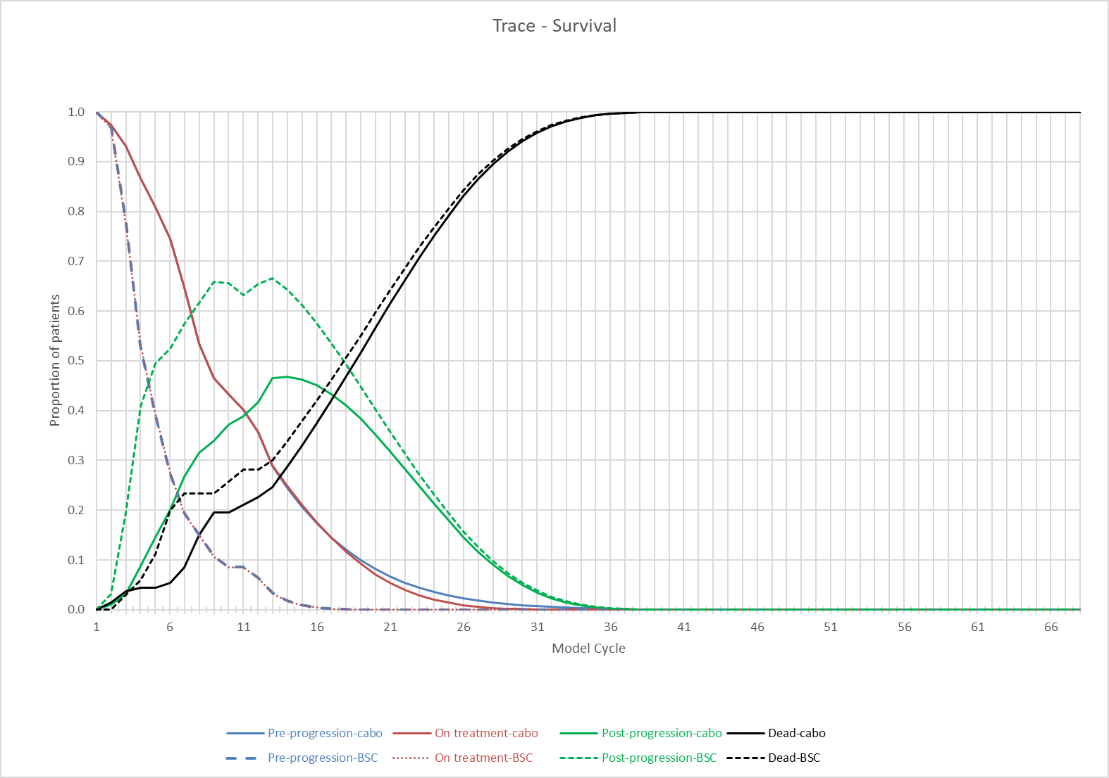
Source: Figure reconstructed during the evaluation based on data contained in the tabs titled ‘Markov – Cabozantinib’ and ‘Markov – PBO’ in Excel workbook titled ‘Attachment 10 – DTC economic evaluation – Section 3 – FINAL’ of the submission.
  - Table 17 presents the results of the economic evaluation in the base case (subgroup previously treated with lenvatinib only) and additional analysis (full COSMIC-311 population). The revised base case presented in the pre-PBAC response which incorporated adjusted utility values and adjusted subsequent treatment costs is also presented. The revised base case maintained the RPSFT cross over adjustment for overall survival; however, added subsequent treatment costs for patients who were randomised to placebo and then crossed over to receive cabozantinib (no subsequent treatment costs were included for these patients in the base case in the submission).
Table 17: Results of the economic evaluation
Component | Cabozantinib + BSC | BSC | Increment
Base case: subgroup previously treated with lenvatinib only
Costs ($) | | | $34,902 | |
LY (undiscounted) | 1.35 | 1.26 | 0.09
QALY | 0.93 | 0.76 | 0.18
Incremental cost/extra LY gained |  |  | | ¹
Incremental cost/extra QALY gained |  |  | $| ²
Pre-PBAC revised base case (pre-progression utility = 0.692, post-progression utility = 0.414; subsequent treatment costs included lenvatinib, radiotherapy and surgery; and addition of post progression costs for patients who had crossed over from placebo to cabozantinib)
Costs ($) | | | $25,759 | |
LY (undiscounted) | 1.35 | 1.26 | 0.09
QALY | 0.74 | 0.60 | 0.14
Incremental cost/extra LY gained |  |  | | ³
Incremental cost/extra QALY gained |  |  | | ²
Additional analysis: full COSMIC-311 population
Costs ($) | | | $52,538 | |
LY (undiscounted) | 2.05 | 1.88 | 0.17
QALY | 1.45 | 1.07 | 0.38
Incremental cost/extra LY gained |  |  | | ⁴
Incremental cost/extra QALY gained |  |  | | ⁵
Source: Tables 3-22 and 3-23, p150 of the submission.
BSC = best supportive care; LY = life year; QALY = quality-adjusted life year.
The redacted values correspond to the following ranges:
1 $135,000 to < $155,000
² $55,000 to < $75,000
³ $115,000 to < $135,000
⁴ $95,000 to < $115,000
⁵ $45,000 to < $55,000
  - In the base case (subgroup previously treated with lenvatinib only), the ICER was estimated to be $55,000 to < $75,000 per QALY gained, using the proposed effective price for cabozantinib. The ICER was driven by the improvement in quality of life (QALYs). The model did include a gain in overall survival (life years), which was not demonstrated in the trial. The revised ICER in the pre-PBAC response was $55,000 to < $75,000 per QALY.
  - Table 18 presents the list of health states and a summary of cost impacts included in the economic evaluation.
Table 18: List of health states and summary of cost impacts included in the economic evaluation
Health state | Resource use by health state | Cabozantinib (+ BSC) cost | BSC cost | Incremental cost | % of the incremental cost of the health state
Base case: Subgroup previously treated with lenvatinib only
Pre-progression | Drug | $| | $0 | $| | |%
 | Administration | $0 | $0 | $0 | |%
 | Monitoring | $1,113 | $0 | $1,113 | |%
 | Adverse events | $1,543 | $570 | $973 | |%
 | Total | $| | $570 | $| | 100%
Post-progression | Drug | $| | $33,797 | −$| | |%
 | Administration | $31 | $0 | $31 | |%
 | Monitoring | $314 | $535 | −$222 | |%
 | Adverse events | −$24 | $0 | −$24 | |%
 | Total | $| | $34,332 | −$| | 100%
Total |  | $| | $34,902 | $| | −
Source: Table 3-19, p148 of the submission.
BSC = best supportive care.
  - The cost estimates were based on the proposed effective DPMQ of cabozantinib in the pre-progression health state and the published DPMQs of subsequent therapies, including cabozantinib and lenvatinib, in the post-progression health state. In the base case, drug costs contributed 93% of the cost in the pre-progression state and 99% of the cost savings in the post-progression state. The inclusion of post-progression therapies resulted in cost-savings of $| | with cabozantinib (+ BSC) treatment versus BSC and reduced the total incremental cost to $| |.
  - The PBAC noted the pre-PBAC revised ICER was very sensitive to the addition of subsequent treatment costs (lenvatinib, radiotherapy and surgery) for patients in the placebo arm who crossed over to cabozantinib. In the revised scenario the cost of cabozantinib was $| | and there was a cost offset of $17,370 for subsequent therapies. Removing the cost for subsequent therapies in patients who crossed over to cabozantinib increased the ICER to from $55,000 to < $75,000 per QALY to $155,000 to < $255,000 per QALY.
  - Table 19 presents the average time in the health states by treatment arm.
Table 19: Mean time in health states
 | Economic model  Mean years |  |  | COSMIC-311 trial  Median months
 | Cabozantinib (+ BSC) | BSC | Increment
Base case (subgroup previously treated with lenvatinib only)
Pre-progression | 0.68 | 0.28 | 0.40 | 5.82 – 1.94 = 3.88 months
Time on treatment | 0.67 | 0.28 | 0.38 | NR
Post-progression | 0.60 | 0.90 | -0.31 | NR
Dead | 3.71 | 3.79 | -0.09 | -
Overall | 5.0 | 5.0 | 0.0 | -
Life years (undiscounted) | 1.35 | 1.26 | 0.09ª | 15.9 months – NE = NE
Quality-adjusted life-years | 0.93 | 0.76 | 0.18 | -
Additional analysis (full COSMIC-311 population)
Pre-progression | 1.32 | 0.39 | 0.93 | 11.0 – 1.9 = 9.1 months
Time on treatment | 1.26 | 0.39 | 0.87 | 6.03 – 2.64 = 3.39 months
Post-progression | 0.65 | 1.41 | -0.76 | NR
Dead | 3.01 | 3.18 | -0.17 | -
Overall | 5.0 | 5.0 | 0.0 | -
Life years (undiscounted) | 2.05 | 1.88 | 0.17ª | 19.4 months – NE = NE
Quality-adjusted life-years | 1.45 | 1.07 | 0.38 | -
Source: Tab titled ‘3A. Control Panel’ in the Excel workbook titled ‘Attachment 10 – DTC economic evaluation – Section 3 – FINAL’ of the submission.
BSC = best supportive care; NR = not reported; NE = not evaluable.
ª The incremental life year (undiscounted) gained matched the estimated life years gained in the model. However, the modelled means of time in pre-progression and time in post-progression do not sum to the life years experienced, and this may be due to the taking of averages across two time periods.
  - The absolute difference in the time in the pre-progression health state (0.40 and 0.93) and the total life-years gained (0.09 and 0.17) between the subgroup of patients previously treated with lenvatinib only and the full COSMIC-311 population reflected the less conservative choice of parametric function used for extrapolation for the full COSMIC-311 population.
  - Consequently, there was less of a difference between the modelled results and trial results for the subgroup previously treated with lenvatinib only:
  - For the subgroup, the modelled PFS was expected to increase by 0.4 years (or 4.8 months). In the COSMIC-311 trial, the median PFS was estimated to increase by 3.88 months. It was not possible to compare the estimated improvement in TTD as these were not reported for the subgroup.
  - Whereas, for the full ITT population, the modelled PFS was expected to increase by 0.93 years (or 11.2 months) and the modelled time on treatment was expected to increase by 0.87 years (or 10.4 months). In the COSMIC-311 trial, the median PFS was estimated to increase by 9.1 months and median TTD was estimated to increase by 3.4 months.
  - Table 20 presents the results of sensitivity analyses conducted during the evaluation for the base case (subgroup previously treated with lenvatinib only).
Table 20: Sensitivity analyses (base case: subgroup previously treated with lenvatinib only)
Analyses | Incremental cost ($) | Incremental QALY | ICER | % change to ICER
Base case | | | 0.18 | | ¹ | −
Univariate sensitivity analyses
Utilities (base case: literature-based using Fordham 2015: pre-progression = 0.87, post-progression = 0.520)
Trial-based (pre = 0.692, post = 0.674) [A] | | | 0.063 | | ² | |
NICE TA535 (pre = 0.720, post = 0.640) | | | 0.084 | | ³ | |
Pre = 0.692 (trial-based), post = 0.520 (Fordham 2015) [B]  Pre = 0.692 (trial-based), post = 0.414 (relative Fordham 2015 decrement) [C]  Pre = 0.692 (trial-based), post = 0.342 (absolute Fordham 2015 decrement) [D] | |  | | 0.11  0.14  0.16 | ||⁴  ^{| 5}  | ⁵ | |
Time horizon (base case: 5 years)
1 year | | | 0.13 | | ⁶ | |
2 years | | | 0.17 | | ¹ | |
Discount rate (base case: 5% costs and outcomes)
0% costs and outcomes | | | 0.18 | | ¹ | - |
3.5% costs and outcomes | | | 0.18 | | ¹ | - |
Unadjusted OS (base case: RPSFT- adjusted OS) | | | 0.16 | | ¹ | - |
Costs of post-progression (subsequent line) therapies (base case: included administration, monitoring and treatment of drugs PBS-listed for other conditions/indications)
Remove all post-progression treatment costs [E] | | | 0.18 | | ² | |
Parametric function, PFS (base case: cabozantinib = Weibull)
Log-Normal | | | 0.24 | | ⁷ | - |
Parametric function, OS (base case: cabozantinib = Gompertz)
Log-Normal | | | 0.24 | | ⁸ | - |
Parametric function, TTD (base case: cabozantinib = Gompertz)
Log-Logistic | | | 0.18 | | ⁵ | |
Generalised Gamma | | | 0.18 | | ¹ | - |
Parametric function, PFS (base case: BSC = Gompertz)
Log-Normal | | | 0.16 | | ⁵ | |
Parametric function, TTD (base case: BSC = Gompertz)
Log-Normal | | | 0.18 | | ⁵ | |
Treatment interruptions for cabozantinib (base case: 14.63%)
Minimal interruptions 2.56% | | | 0.18 | | ⁶ | |
Maximal interruptions 24.56% | | | 0.18 | | ¹ | - |
Treatment interruptions (base case: cabozantinib = 14.63%, BSC = 6.62%)
0% for both cabozantinib and BSC | | | 0.18 | | ⁶ | |
Multivariate sensitivity analysis
[B] Utilities: pre = 0.692 (trial-based), post = 0.52 (Fordham 2015) and [E] remove all post-progression treatment costs | | | 0.11 | | ⁹ | |
[A] Utilities: pre = 0.692 (trial-based), post = 0.674 (trial based) and [E] remove all post-progression treatment costs | | | 0.06 | | ¹⁰ | |
[C[ Utilities: pre = 0.692 (trial-based), post = 0.414 (relative Fordham 2015 decrement) and [E] remove all post-progression treatment costs | | | 0.14 | | ² | |
[D] Utilities: pre = 0.692 (trial-based), post = 0.342 (absolute Fordham 2015 decrement) and [E] remove all post-progression treatment costs | | | 0.16 | | ² | |
Source: Results presented in Table 3-25, p152 of the submission could not be reproduced during the evaluation. The results presented in italics were from sensitivity analyses conducted during the preparation of the ESC Advice, based on the Excel workbook titled ‘Attachment 10 – DTC economic evaluation – Section 3 – FINAL’ of the submission.
AR-DRG = Australian Refined Diagnosis Related Group; BC = base case; BSC = best supportive care; ICER = incremental cost-effectiveness ratio; OS = overall survival; PBS = Pharmaceutical Benefits Scheme; PD = progressive/progressed disease; PBS = Pharmaceutical Benefits Scheme; PFS = progression-free survival; QALY = quality-adjusted life year; RPSFT = rank-preserving structural failure time; SAE = serious adverse event; TTD = time to treatment discontinuation.
The redacted values correspond to the following ranges:
¹ $55,000 to < $75,000
² $155,000 to < $255,000
³ $135,000 to < $155,000
⁴ $115,000 to < $135,000
⁵ $75,000 to < $95,000
⁶ $95,000 to < $115,000
⁷ $45,000 to < $55,000
⁸ $25,000 to < $35,000
⁹ $255,000 to < $355,000
¹⁰$455,000 to < $555,000
  - The model was most sensitive to:
- The choice of utility values in the pre- and post-progression health states.
- The application of treatment costs (including cabozantinib and lenvatinib) in the post-progression health state. Removing all post-progression treatment costs increased the ICER from $55,000 to < $75,000 to $155,000 to < $255,000 per QALY gained in the base case.
  - The ESC noted the multivariate sensitivity analyses in which pre-progression utility was trial based, the post-progression utility value was based on the relative utility decrement from Fordham (2015) and which removed all treatment costs from the post-progression health state. The ESC noted that these changes resulted in an ICER of $155,000 to < $255,000 per QALY.

Drug cost/patient
  - Table 21 presents the drug cost per patient.
Table 21: Drug cost per patient for cabozantinib (+ BSC)*
 | Cabozantinib (+ BSC)
 | COSMIC-311 trial | Model | Financial estimates
Mean daily dose (range), mg/day | 40.09ª  (9.5, 60.0) | Not specified, assumed one tablet (any dose strength) per day | 60 mg (33%), 40 mg (34%), 20 mg (33%)
Duration of exposure (including dose holds),^{b} months | 7.04 (range 0.2, 18.8) [A] | − | −
Duration of exposure (excluding dose holds),^{c} months | 6.01 (range 0.0, 17.8) [B] | − | −
Mean duration, months | 7.04 [=C] | Modelled time on treatment 8 months [D] | 8 months [D]
Treatment interruption | − | 14.63% [E = (A-B)/A] | Not considered
Cabozantinib 60 mg, 40 mg, 20 mg, proposed DPMQ for 30 tablets | − | Effective DPMQ $| [F]
Cost per day | − | $| [G=F/30]
Scripts/course | − | − | 8 [H]
Cost/model cycle | − | $ | [I=G x 28] | −
Cost/course | − | Per course: $ |  [K = G x 365.25 x D/12] | Per course: $||^{d}  [= D x F]
Cost/course (less interruptions) | − | Per course: $ |  [=K x (1-E)] | Not considered
Source: Table 3-17, p147 of the submission; Table 3, p10 of CSR Addendum 2; Tabs titled ‘Tx & Monitoring costs’ in Excel workbook titled ‘Attachment 10 – DTC economic evaluation – Section 3 – FINAL’ of the submission; Excel workbook titled ‘Cabometyx DTC Section 4 FINAL’ of the submission).
BSC = best supportive care; DPMQ = Dispensed Price for Maximum Quantity.
* Drug cost for BSC = $0
ª Table 3, p10 of 41, CSR Addendum 2.
^{b} Duration of exposure = (date of decision to discontinue study treatment – date of first dose + 1)/30.4375. For subjects still on study, the data cut-off date was used to calculate the exposure (Table 3, p10/41 of CSR Addendum 2)
^{c} Duration of exposure (excluding dose holds) = (date of decision to discontinue study treatment – date of first dose – total duration of dose interruptions + 1)/30.4375 (Table 3, p10 of CSR Addendum 2).
^{d} This is what the cost (at the effective price) to the patient for a standard course of treatment would be if the medicine is not subsidised on the PBS (Source: Tab ‘1.0 Overview’, cell K17, in Excel workbook titled ‘Cabometyx DTC Section 4 FINAL’ of the submission). The slight decrease in drug cost of $| | per patient in the financial model was owing to the assumption of the use of eight 28-day scripts per patient per course.
  - The drug cost per patient for cabozantinib was $||| |||, calculated based on the proposed effective DPMQ of $| | (maximum quantity 30), the utilisation of one unit (any dose strength, 60 mg or 40 mg or 20 mg tablet) per day, for a modelled average of eight months on treatment [$| | = $| |/30 x 365.25 x 8/12]. When treatment interruptions were incorporated, as in the economic model, the drug cost per patient decreased to $| |. This was lower than the cost per patient in the financial estimates of $| |. The cost of BSC was $0 in the economic model and financial estimates.

Estimated PBS usage & financial implications
  - This submission was not considered by DUSC. The submission took at epidemiological approach. Table 22 outlines the key inputs and sources relied on in the financial estimates.
Table 22: Key inputs for financial estimates
Parameter | Value applied and source | Comment
Incidence of thyroid cancer | Incidence of thyroid cancer 13.9/100,000 based on AIHW cancer data, assumed constant throughout Years 1-6. | Likely underestimated as the incidence rate of thyroid cancer has been increasing at a rate of 2.7% per year.
Incident patients | - 94% of thyroid cancer patients had DTC;  - 27.5% of DTC patients had advanced/metastatic disease;  - 33.3% of patients with advanced/metastatic disease were refractory to RAI;  - 37.5% of patients with RAI-R DTC were treated with 1L TKI;  - 53.1% of 1L-treated patients with progressed disease  - 100% patient share in 2L (assumption of 100% uptake) | Uncertain. The ESC noted that the DUSC Secretariat provided a count of patients who had received lenvatinib in the first line setting (Table 24) which indicated that incident patient numbers may have been overestimated.
Prevalent patients | 30 in Year 1, none in other years. | Uncertain. Based on the estimated number of incident patients in Year 1.
Grandfathered patients | ||||¹ in Year 1, none in other years. Currently ||||¹patients were enrolled in the Ipsen Patient Access Program and on active treatment; assumed 100% meeting the proposed PBS restrictions and 100% electing continuing cabozantinib treatment. | It is unclear how many patients will be on the access program at the time of a listing.
Treatment duration | Incident patients: eight months per course per patient, based on the extrapolated average time (0.67 year) on treatment from the economic model. | -
 | Prevalent patients: 12 months | Over-estimated, should be the same, or possibly less than, for incident patients (i.e., eight months).
 | Grandfathered patients: 4 months | -
MBS 66512 | $17.70 Liver function testsª | -
MBS 65070 | $16.95 Complete blood countª | -
MBS 66509 | $17.70 Serum electrolytes/urea/creatine^{b} | -
MBS 66719 | $34.80 Thyroid function test^{b} | -
MBS 55145 | $496 ($513.85^{c}) Pharmacological stress ECG | MBS item 55145 cannot be co-claimed with MBS item 11729
MBS 11729 | $160.90 ($166.60^{c}) Multi-channel ECG | Inappropriate if MBS item 55145 was claimed already.
Source: Tables 4-1 and 4-2, pp155 and 164 of the submission; Excel workbook titled ‘Cabometyx DTC Section 4 FINAL’ of the submission.
1L = first-line; DTC = differentiated thyroid cancer; ECG = electrocardiogram; MBS = Medicare Benefits Schedule; RAI-R = radioactive iodine-refractory; RR-DTC = radioiodine-refractory DTC; TKI = tyrosine kinase inhibitor.
ª Evaluated at the time of each new script, i.e., at the time a new Authority prescription is issued (p159 of the submission).
^{b} Once for each patient, at the commencement of treatment with cabozantinib.
^{c} MBS online (accessed 25 July 2023 during the evaluation).
The redacted values correspond to the following ranges:
¹ < 500
  - Table 23 presents the estimated use and financial implications.
Table 23: Estimated use and financial implications (at proposed effective price of cabozantinib)
 | Year 1 | Year 2 | Year 3 | Year 4 | Year 5 | Year 6
 | 2024 | 2025 | 2026 | 2027 | 2028 | 2029
Estimated extent of use
Number of patients treated | ||^{a1} | | ¹ | | ¹ | | ¹ | | ¹ | | ¹
Number of scripts dispensed^{b} | | ² | | ¹ | | ¹ | | ¹ | | ¹ | | ¹
Estimated financial implications of cabozantinib
Cost to PBS/RPBS less copayments | | ³ | | ³ | | ³ | | ³ | | ³ | | ³
Estimated financial implications for other medicines
Cost to PBS/RPBS less copayments | | ³ | | ³ | | ³ | | ³ | | ³ | | ³
Net financial implications
Net cost to PBS/RPBS | | ³ | | ³ | | ³ | | ³ | | ³ | | ³
Net cost to MBS | | ³ | | ³ | | ³ | | ³ | | ³ | | ³
Net cost to PBS/RPBS/MBS | | ³ | | ³ | | ³ | | ³ | | ³ | | ³
Source: Excel workbook titled ‘Cabometyx DTC Section 4 FINAL’ of the submission.
ª < 500 patients = <500 incident patients + <500 prevalent patients + <500 grandfathered patients
^{b} Assuming 8 months treatment per course per patient, based on the extrapolated average time (0.67 year) on treatment from the economic model.
The redacted values correspond to the following ranges:
¹ < 500
² 500 to < 5,000
³ $0 to < $10 million
  - The total cost to the PBS/RPBS of listing cabozantinib was estimated to be $0 to < $10 million in Year 1, $0 to < $10 million in Year 6, and total $0 to < $10 million over the first 6 years of listing, based on the effective price.
  - The submission used the mean time on treatment (0.67 year or eight months) from the economic model to inform the treatment duration of cabozantinib in the financial estimates.
  - The submission used a distribution of 33%/34%/33% for the utilisation of cabozantinib 60 mg/40 mg/20 mg in the financial estimates, based on usage in the COSMIC-311 trial. However, dose modifications and interruptions for adverse events were common in the COSMIC-311 trial. Switching to a lower dose mid-script requires obtaining another script (40 mg or 20 mg); resulting in potential wastage. Consequently, the financial impact may be underestimated. PBS utilisation data for cabozantinib for renal cell carcinoma showed that patients initiated and continued with different dose strengths. The PBAC had previously noted that patients may receive prescriptions of varying strengths to assist with dose titration, and this may impact the overall cost of cabozantinib to the PBS (paragraph 7.12, cabozantinib PSD, December 2017 PBAC Meeting). In addition, the PBAC amended the listing of lenvatinib for DTC to allow for of one pack of 10 mg and two packs of 4 mg capsules (paragraph 5.1, lenvatinib PSD, July 2018 PBAC Meeting).
  - The ESC noted the data provided by the DUSC Secretariat (see Table 24) of counts of patients receiving first and prevalent supply of lenvatinib for the treatment of RAI-refractory DTC. Based on the count of incident lenvatinib patients the ESC considered that the estimates of cabozantinib patients were potentially overestimated.
Table 24: Count of patients receiving lenvatinib on the PBS/RPBS
 | FY 2017-18 | FY 2018-19 | FY 2019-20 | FY 2020-21 | FY 2021-22 | FY 2022-23
Count of incident patients receiving first supply of lenvatinib (10 mg: PBS item 10965D; 4 mg PBS item 10952K)* | | ¹ | | ¹ | | ¹ | | ¹ | | ¹ | | ¹
Count of patients receiving prevalent supply of lenvatinib (10 mg: PBS item 10965D; 4 mg PBS item 10952K) by financial year* | | ¹ | | ¹ | | ¹ | | ¹ | | ¹ | | ¹
Source: DUSC Secretariat
DTC = differentiated thyroid carcinoma; FY = financial year
* Actual patient numbers on lenvatinib for DTC could not be estimated based on the number of PBS/RPBS services available as the recommended dose for lenvatinib is 24 mg per day (TGA Product Information, Lenvatinib, p2), as dose reductions were recommended for adverse events and as in July 2018 the PBAC amended the listing of lenvatinib to allow for 1 pack of 10 mg and 2 packs of 4 mg capsules³⁸
The redacted values correspond to the following ranges:
¹ <500
For more detail on PBAC’s view, see section 7 PBAC outcome.
- PBAC Outcome
  - The PBAC did not recommend cabozantinib for the treatment of patients with locally advanced or metastatic differentiated thyroid carcinoma (DTC) who are radioactive iodine (RAI) refractory or ineligible and who have progressed following treatment with a tyrosine kinase inhibitor (TKI) or have developed intolerance to prior vascular endothelial growth factor (VEGF)-targeted therapy. The PBAC noted the clinical need for effective treatments in this setting but considered that the economic model was uncertain and that the incremental cost effectiveness ratio (ICER) was likely underestimated.
  - The primary reason for this decision was the economic evaluation.
  - The PBAC acknowledged the advice received via the consumer comments facility which noted the need for alternate DTC treatments, and which were supportive of the submission.
  - The PBAC considered that the proposed place in therapy for cabozantinib for use in patients who have progressed or developed intolerance whilst receiving or following treatment with a VEGF-targeted TKI was appropriate.
  - The PBAC considered that the appropriate comparator for cabozantinib plus best supportive care (BSC) was BSC alone.
  - The PBAC noted that the submission was based on one randomised controlled trial, COSMIC-311, that compared cabozantinib to placebo. The PBAC noted that patients were stratified by previous lenvatinib treatment (yes/no) and age (≤65 years versus >65 years). Results for the subgroup of patients who had received prior treatment with lenvatinib only were presented as it aligned with the proposed place in therapy.
  - The PBAC noted that cabozantinib was associated with a modest improvement in overall response rate (ORR) in the full intention to treat (ITT) population (risk difference = 11%; 95% CI: 6.4%, 15.9%).
  - The PBAC noted that cabozantinib demonstrated a statistically significant improvement in progression free survival (PFS) in both the full ITT population (HR = 0.22; 95% CI: 0.15, 0.32) and the subgroup who had received prior treatment with lenvatinib only (HR = 0.28; 95% CI: 0.16, 0.48).
  - The PBAC noted that the results for overall survival were not statistically significant in either the full ITT population (HR = 0.76; 95% CI: 0.45, 1.31) or the subgroup who had received prior treatment with lenvatinib only (HR = 1.06; 95% CI: 0.45, 2.47). The PBAC noted that the overall survival results were confounded by 45% of patients in the placebo arm crossing over to receive treatment with open label cabozantinib following disease progression. The PBAC noted that the submission applied the Rank-Preserving Structural Failure Time (RPSFT) method to adjust for the crossover, but that this did not result in a statistical difference in the results (full ITT population: HR = 0.65; 95% CI: 0.28, 1.53; prior lenvatinib only subgroup: HR = 0.98; 95% CI: 0.24, 3.91). Additionally, the PBAC noted that a high proportion of observations were censored in both the cabozantinib (78%) and placebo (76%) arms which was driven by the relatively short median follow up (10.1 months). The PBAC considered that these issues increased the uncertainty in the OS results.
  - The PBAC considered that the submission’s claim that cabozantinib was superior compared to placebo in terms of ORR and PFS was supported. However, the PBAC considered that the superiority of cabozantinib in terms of OS was uncertain due to patients randomised to placebo receiving cabozantinib, the relatively short follow up and the high number of observations that were censored.
  - The PBAC noted that patients in the cabozantinib arm of COSMIC-311 reported a higher incidence of Grade 3/4 adverse events (62% versus 28% for patients in the placebo arm) and had a higher incidence of hypertension, diarrhoea, palmar-plantar erythrodysaesthesia syndrome and fatigue. The PBAC considered that the claim that cabozantinib was inferior in terms of safety compared to placebo was reasonable.
  - The PBAC noted that the economic evaluation presented in the submission was based on the subgroup of patients who had received prior treatment with lenvatinib only. The PBAC noted use of a subgroup increased the extent of uncertainty with the results given the relatively small number of patients informing the analysis. However, the PBAC considered this was reasonable in the context of it potentially being more conservative versus use of the results for the ITT population. The PBAC considered that the 5-year model time horizon was reasonable, noting similar results with a three-year horizon reflecting that few patients were modelled to be alive after this time point.
  - The PBAC noted that the submission applied literature-based utilities (from Fordham, 2015) for the pre-progression (0.87) and post-progression (0.52) health states rather than the trial-based utilities (0.692 and 0.674 respectively). Noting the concerns with the trial-based post-progression value (see paragraph 6.58), the PBAC agreed with the ESC and advised that the trial-based utility should be applied for the pre-progression health state (0.692) and that the relative utility decrement (-0.278) from Fordham 2015 should be applied to determine the post-progression utility (0.414).
  - The PBAC noted that the submission inappropriately applied the costs of post-progression therapies that were not PBS listed for the indication, and that this resulted in a cost offset for post-progression therapies of $14,912. The PBAC noted that the pre-PBAC response provided a revised base case in which the costs of post-progression surgery, radiotherapy and lenvatinib were included, stating that it was plausible that in the absence of any further treatment option, patients experiencing disease progression may continue lenvatinib. The PBAC noted for the revised base case a larger proportion of patients were eligible for post progression treatment (37.0% in the submissions base case versus 74.6% in the pre-PBAC response) and this increased the cost offset to $17,370. The PBAC considered if lenvatinib is being used post-progression, then it would be appropriate to consider it as a comparator treatment rather than subsequent treatment, especially if used in the majority of patients as modelled. Overall, the PBAC considered that the post progression costs as presented in the submissions and the pre-PBAC response were unreliable and should be excluded from the base case analysis.
  - The PBAC considered that a more appropriate base case would be based on the subgroup of patients who had received prior lenvatinib only, apply the utility values as per paragraph 7.13 and remove all treatment costs from the post-progression health state. The PBAC noted the ICER for this scenario was $155,000 to < $255,000 per QALY (Table 20) and considered a price reduction would be required for cabozantinib to be considered cost-effective. Noting the rare nature of RAI refractory or ineligible DTC, the poor prognosis following progression, the potentially conservative model assumptions with respect to use of the subgroup data and removal of all post progression costs and the small budget impact, the PBAC considered that an ICER of less than $100,000 per QALY would be cost effective in this setting.
  - The PBAC noted that the utilisation and financial impact estimates were overly complex and advised that a modified market share approach based on the utilisation data for lenvatinib would be more reliable. The PBAC advised that if this approach was adopted, then an average of incident lenvatinib patients from 2020 to 2023 could be used as a base. The PBAC considered that approximately 60% of patients who received lenvatinib would be eligible to receive second line cabozantinib (based on the clinician hearing).
  - In terms of the proposed restriction, the PBAC considered that the addition that patients must have thyroid stimulating hormone adequately repressed was appropriate; however, the PBAC did not support treatment beyond progression. The PBAC also considered that the other revisions outlined in Section 3 and supported in the pre-Sub-Committee response should also be included in a revised restriction.
  - The PBAC considered the outstanding issues could be easily resolved in a simple resubmission for cabozantinib using the early re-entry pathway. If the sponsor accepts this pathway, the following changes may address these outstanding issues without requiring further re-evaluation:
  - Present a revised economic model as per the recommendations in paragraph 7.15;
  - Present revised financial estimates as outlined in paragraph 7.16; and
  - Present a revised restriction as outlined in paragraph 7.17.
The early re-entry resubmission must be lodged by week 7 of the current PBAC cycle or the next cycle. If the issues cannot be addressed by the sponsor in a simple resubmission and the early re-entry timing is not acceptable, a standard re-entry pathway is available.
  - The PBAC noted that this submission is eligible for an Independent Review.
Outcome:
Not recommended
- Context for Decision
The PBAC helps decide whether and, if so, how medicines should be subsidised through the Pharmaceutical Benefits Scheme (PBS) in Australia. It considers applications regarding the listing of medicines on the PBS and provides advice about other matters relating to the operation of the PBS in this context. A PBAC decision in relation to PBS listings does not necessarily represent a final PBAC view about the merits of the medicine or the circumstances in which it should be made available through the PBS. The PBAC welcomes applications containing new information at any time.
- Sponsor’s Comment
The sponsor had no comment.

World Health Organisation (WHO). International Agency for Research on Cancer. The Global Cancer Observatory. March 2021. Australia.
Kent WD, Hall SF, Isotalo PA, Houlden RL, George RL, Groome PA. Increased incidence of differentiated thyroid carcinoma and detection of subclinical disease. CMAJ. 2007;177(11):1357-61
Lirov R, Worden FP, Cohen MS. The Treatment of Advanced Thyroid Cancer in the Age of Novel Targeted Therapies. Drugs. 2017;77(7):733-745.
Kreissl MC, Janssen MJR, Nagarajah J. Current Treatment Strategies in Metastasized Differentiated Thyroid Cancer. J Nucl Med. 2019 Jan;60(1):9-15.
Distant metastases occurring in fewer than 10% of patients was inconsistent with the financial estimates which estimated the ‘proportion of DTC patients with advanced/metastatic disease’ to be 27.50%.
This was inconsistent with the financial estimates which estimated the 'proportion of RAI-refractory patients among advanced/metastatic DTC (%)’ to be 33.30%.
Fugazzola L, Elisei R, Fuhrer D, Jarzab B, Leboulleux S, Newbold K, Smit J. 2019 European Thyroid Association Guidelines for the Treatment and Follow-Up of Advanced Radioiodine-Refractory Thyroid Cancer. Eur Thyroid J. 2019. ;8(5):227-245.
Fugazzola 2019
Links TP, van Tol KM, Jager PL, Plukker JT, Piers DA, Boezen HM, Dullaart RP, de Vries EG, Sluiter WJ. Life expectancy in differentiated thyroid cancer: a novel approach to survival analysis. Endocr Relat Cancer. 2005(2):273-80.
Fugazzola et al 2019.
National Comprehensive Cancer Network (NCCN) Guidelines for Thyroid Carcinoma. Interim on V.3.2021 -10/15/2021/ National Comprehensive Cancer Network. Thyroid Cancer. Guidelines for Patients. 2022:28
Filetti S, Durante C, Hartl DM, Leboulleux S, Locati LD, Newbold K, Papotti MG, Berruti A; ESMO Guidelines Committee. ESMO Clinical Practice Guideline update on the use of systemic therapy in advanced thyroid cancer. Ann Oncol. 2022 Jul;33(7):674-684.
Schlumberger M, Tahara M, Wirth LJ, Robinson B, Brose MS, Elisei R, Habra MA, Newbold K, Shah MH, Hoff AO, Gianoukakis AG, Kiyota N, Taylor MH, Kim SB, Krzyzanowska MK, Dutcus CE, de las Heras B, Zhu J, Sherman SI. Lenvatinib versus placebo in radioiodine-refractory thyroid cancer. N Engl J Med. 2015 Feb 12;372(7):621-30.
Brose MS, Nutting CM, Jarzab B, Elisei R, Siena S, Bastholt L, de la Fouchardiere C, Pacini F, Paschke R, Shong YK, Sherman SI, Smit JW, Chung J, Kappeler C, Peña C, Molnár I, Schlumberger MJ; DECISION investigators. Sorafenib in radioactive iodine-refractory, locally advanced or metastatic differentiated thyroid cancer: a randomised, double-blind, phase 3 trial. Lancet. 2014 Jul 26;384(9940):319-28.
Inverse Probability of Censoring Weights (IPCW) allows patients to be artificially censored at the time of switch, remaining observations are weighted based upon covariate values and model the probability of being censored (Latimer N et al. The Challenge of Early Crossover in Oncology Trials. ScHARR, University of Sheffield, 2014).
Rank preserving structural failure time (RPSFT) uses counterfactual survival times to those that would have been observed if no treatment had been given (Latimer N et al. The Challenge of Early Crossover in Oncology Trials. ScHARR, University of Sheffield, 2014).
The ‘two-stage ‘method estimates the effect of switching to treatment post-progression, by contrasting post progression survival times in the control arm patients who switch post progression with those who do not (Latimer N et al. The Challenge of Early Crossover in Oncology Trials. ScHARR, University of Sheffield, 2014).
Brose MS, Robinson BG, Sherman SI, Jarzab B, Lin CC, Vaisman F, Hoff AO, Hitre E, Bowles DW, Sen S, Oliver JW, Banerjee K, Keam B, Capdevila J. Cabozantinib for previously treated radioiodine-refractory differentiated thyroid cancer: Updated results from the phase 3 COSMIC-311 trial. Cancer. 2022 Dec 15;128(24):4203-4212.
Ilerhunmwuwa, NP. Et al. (2023) Correlations between overall response rate, progression-free survival and overall survival with kinase inhibitors in radioiodine-refractory differentiated thyroid cancers: A systematic review and meta-analysis. Journal of Clinical Oncology 2023 41:16_suppl, e18087-e18087
Schlumberger M, Tahara M, Wirth LJ, Robinson B, Brose MS, Elisei R, Habra MA, Newbold K, Shah MH, Hoff AO, Gianoukakis AG, Kiyota N, Taylor MH, Kim SB, Krzyzanowska MK, Dutcus CE, de las Heras B, Zhu J, Sherman SI. Lenvatinib versus placebo in radioiodine-refractory thyroid cancer. N Engl J Med. 2015 Feb 12;372(7):621-30.
Brose MS, Nutting CM, Jarzab B, Elisei R, Siena S, Bastholt L, de la Fouchardiere C, Pacini F, Paschke R, Shong YK, Sherman SI, Smit JW, Chung J, Kappeler C, Peña C, Molnár I, Schlumberger MJ; DECISION investigators. Sorafenib in radioactive iodine-refractory, locally advanced or metastatic differentiated thyroid cancer: a randomised, double-blind, phase 3 trial. Lancet. 2014 Jul 26;384(9940):319-28.
N = 68 in cabozantinib + BSC treatment arm versus N = 34 in BSC control arm (source: Table 14.1.8.1.1, Prior Non-Radiation Anti-Cancer Therapy Population: ITT, p27 in COSMIC-311 csr add 14.1 demography and baseline characteristics (CCO2).
Using unadjusted overall survival resulted in a slight decrease in the ICER (Table 20).
Paragraph 3.6, Final draft guidance – Cabozantinib for previously treated advanced differentiated thyroid cancer unsuitable for or refractory to radioactive iodine, NICE, June 2023 [available: https://www.nice.org.uk/guidance/gid-ta10932/documents/674; accessed 28 July 2023].
The submission stated: "The economic model utilises the Kaplan Meier curves up to the point of median follow-up (10.2 months), and then applies an extrapolation beyond that point" (p123 of the submission). The median follow-up for PFS and OS was 10.1 months for cabozantinib (+BSC) treatment arm in the COSMIC-311 trial (Full ITT Population, clinical cutoff 8 February 2021) (Table 6, p19, CSR Addendum 1).
PBAC (2016) Guidelines for preparing a submission to the Pharmaceutical Benefits Advisory Committee, version 5.0, September 2016, Australian Government Department of Health. Page 76, Section 3A.5.1,
McCaffrey N, Kaambwa B, Currow DC, Ratcliffe J. Health-related quality of life measured using the EQ-5D-5L: South Australian population norms. Health Qual Life Outcomes. 2016 Sep 20;14(1):133. doi: 10.1186/s12955-016-0537-0. PMID: 27644755; PMCID: PMC5028927.
The UK general population utility was 0.82 and both the sponsor and the assessment arm for the appraisal agreed that an age-adjusted general population utility cap should be applied in the model (paragraph 3.9, Cabozantinib for previously treated advanced differentiated thyroid cancer unsuitable for or refractory to radioactive iodine, Final draft guidance, NICE, June 2023).
Lenvatinib and sorafenib for treating differentiated thyroid cancer after radioactive iodine. Technology appraisal guidance, TA535, NICE, 8 August 2018.
Paragraph 3.9, Cabozantinib for previously treated advanced differentiated thyroid cancer unsuitable for or refractory to radioactive iodine, Final draft guidance, NICE, June 2023. The unadjusted mean utility in Fordham 2015 was derived from reduced parameter model (health states only).
14.63% [(7.04-6.01)/7.04], calculated based on the difference in mean duration of exposure for including (7.04 months) and excluding (6.01 months) dose holds in the cabozantinib (+BSC) treatment arm (Safety Population, N=170) (source: Table 3, p10 of CSR Addendum 2).
95% CI lower and upper confidence intervals (CI) of the mean duration of exposure were calculated based on the means and standard deviations provided in the CSR (and assuming normal distribution). Minimal interruption (2.56%) was calculated using the lower 95% CI (6.35%) of the mean duration of exposure (including holds) and the upper 95% CI (6.19 months) of the mean duration of exposure (excluding holds), using the same method as in the submission (i.e., 2.56% = [(6.35-6.19/6.35].
Maximal interruption (24.56%) was calculated using the upper 95% CI (7.73%) of the mean duration of exposure (including holds) and the lower 95% CI (5.83 months) of the mean duration of exposure (excluding holds), using the same method as in the submission (i.e., 24.56% = [(7.73-5.83/7.73].
Average annual growth rate of thyroid cancer incidence 2020-2022, calculated during the evaluation based on data from Table S1a.1: Cancer incidence counts, age-specific rates, age-standardised rates (2001 Australian Standard, WHO and Segi populations), by sex, age group, actual data from 1982 to 2018 and projections to 2022, Data tables: CDIA 2022: Book 1a – Cancer incidence (age-standardised rates and 5-year age groups), Cancer data in Australia, web report, last updated 4 October 2022 [available: https://www.aihw.gov.au/reports/cancer/cancer-data-in-australia/data; accessed 2 August 2023].
Lowest dose level received 60 mg/40 mg/20 mg/Missing = 32%/34%/33%/1% (excluding dose interruptions in which 0 mg was given), Table 4 Dose reductions due to an adverse event (Safety Population), p12 of CSR Addendum 2. The submission used 33% for cabozantinib 60 mg rather than 32% reported in the CSR. It appeared that the 33% for 60 mg included the missing 1%.
At the July 2018 Meeting, the PBAC considered a minor submission requesting an amendment to the current PBS listing of lenvatinib to allow for the prescribing of one pack of 10 mg and two packs of 4 mg capsules. The rationale behind the proposed amendment was to allow “easier prescribing of doses that differed from the recommended starting dose of 24 mg per day” and citing benefits of cost-savings from reduced wastage (paragraphs 3.25 and 4.4, Lenvatinib for DTC PSD, July 2018 PBAC Meeting).

