5.05 EDARAVONE,
Solution concentrate for injection 30 mg in 20 mL,
Radicava®,
Teva Pharma Australia Pty Ltd.
- Purpose of submission
  - The Category 1 submission requested Section 100 Highly Specialised Drugs Authority Required (telephone/electronic) listing of edaravone solution for intravenous (IV) infusion as adjunct treatment to current standard of care (SOC) with or without riluzole in patients with amyotrophic lateral sclerosis (ALS).
  - The basis of the requested listing was a cost-utility analysis versus placebo (i.e. SOC with or without riluzole), with consideration given to the ‘Rule of Rescue’. Table 1 summarises the components of the overall clinical claim addressed by the submission. Under the rule of rescue criteria, ALS is a severe condition expected to lead to premature death (criteria 2) and affects a small number of patients (criteria 3), but it was unclear whether there are strictly no alternative pharmacological/non-pharmacological treatments for patients with ALS (criteria 1) or whether edaravone provides ‘a worthwhile clinical improvement sufficient to qualify as a rescue’ (criteria 4).
Table 1: Key components of the clinical issue addressed by the submission
Component | Description
Population | Patients with amyotrophic lateral sclerosis (ALS).
Intervention | Edaravone (Radicava®) as 30 mg/20 mL concentrated solution for injection to be diluted before use as an intravenous (IV) infusion.
Comparator | Current standard of care with or without riluzole
Outcomes | ALS functional rating scale (ALSFRS-R) after 6 cycles (6 months).
Clinical claim | Edaravone plus current standard of care with or without riluzole is superior in terms of effectiveness and has similar (non-inferior) safety compared to standard of care with or without riluzole.
Source: Table 1-1, p3 of the submission.
ALS=amyotrophic lateral sclerosis; ALSFRS-R=ALS Functional Rating Scale – Revised;
- Background

Registration status
  - Edaravone was granted orphan designation by the TGA on 17 August 2021, and registered by the TGA on 15 February 2023 for the following indication:
‘RADICAVA is indicated in adults with a diagnosis of amyotrophic lateral sclerosis who are independent in activities of daily living with normal respiratory function and where treatment is initiated within two years of disease onset. Efficacy has not been demonstrated in patients outside of this defined population.’

Previous PBAC consideration
  - The Pharmaceutical Benefits Advisory Committee (PBAC) has not previously considered edaravone for the treatment of ALS. Currently the only PBS-listed treatment for ALS is riluzole, which has been available to Australian patients since July 2003.
  - In 2019 the Canadian Agency for Drugs and Technologies in Health (CADTH) recommended edaravone IV for treatment of ALS (on conditions that included a price reduction) in a narrow ALS subpopulation enrolled in Study 19, which was the only trial to show a benefit in the primary efficacy outcome (ALSFRS-R score) for edaravone. In 2023, CADTH also recommended edaravone oral suspension formulation for the treatment of ALS.
For more detail on PBAC’s view, see section 7 PBAC outcome.
- Requested listing
  - The submission’s proposed restrictions are shown below. PBAC’s suggested additions are in italics and deletions are in strikethrough.
MEDICINAL PRODUCT  medicinal product pack | Dispensed Price for Max. Qty | Max. qty packs | Max. qty units | №.of  Rpts | Available brands
Edaravone
Initial treatment  30 mg/20 mL concentrated solution for injection, 10 ampoules | $ | (public)  $ | (private)# | 3^ | 2830 | 0 | Radicava, TEVA Pharma
Restriction Summary [new 1] / ToC: [new 2]
Category / Program: Section 100 – Highly Specialised Drugs Program (Public Hospital, Private Hospital and Community Access)
Prescriber type: Medical Practitioners
Restriction type: Authority Required (telephone/online PBS Authorities system)
Administrative Advice: No increase in the maximum quantity or number of units may be authorised.
Administrative Advice: No increase in the maximum number of repeats may be authorised.
Administrative Advice: Special Pricing Arrangements apply.
Administrative Advice
Continuing Therapy Only:
For prescribing by nurse practitioners as continuing therapy only, where the treatment of, and prescribing of medicine for, a patient has been initiated by a medical practitioner. Further information can be found in the Explanatory Notes for Nurse Practitioners.
Administrative Advice: Applications for authorisation under this restriction may be made in real time using the Online PBS Authorities system (see www.servicesaustralia.gov.au/HPOS) or by telephone by contacting Services Australia on 1800 888 333.
Indication: Amyotrophic lateral sclerosis (ALS)
Treatment Phase: Initial treatment
Clinical criteria:
The condition must be/have been diagnosed by a neurologist
AND
Clinical criteria:
Patient must not have had the disease symptoms for more than 2 years prior to commencing therapy with this drug
AND
Clinical criteria:
Patient must have at least 80 percent of predicted forced vital capacity (FVC) or slow vital capacity (SVC) within the 2 months before prior to commencing therapy with this drug
AND
Clinical criteria:
Patient must be ambulatory; or
Patient must not be ambulatory, and must be able to either use upper limbs or to swallow
Patient must not require assistance for eating or ambulation
AND
Clinical criteria:
Patient must have at least two points on each individual item of the ALS Functional Rating Scale – Revised (ALSFRS-R) score prior to commencing therapy with this drug
AND
Clinical criteria:
Patient must not have undergone a tracheostomy
AND
Clinical criteria:
Patient must not have experienced respiratory failure
Population criteria:
Patient must be at least 18 years of age.
Adult patients.
Administrative Advice: Prescribing Instructions:
The date of diagnosis, and the date and results of spirometry (in terms of percent of predicted forced vital capacity or slow vital capacity) must be supplied with the initial authority application.

Continuing treatment  30 mg/20 mL concentrated solution for injection, 10 ampoules | $ | (public)  $ | (private)# | 2 | 20 | 2 | Radicava, TEVA Pharma
Restriction Summary [new 3] / ToC: [new 4]
Category / Program: Section 100 – Highly Specialised Drugs Program (Public Hospital, Private Hospital and Community Access)
Prescriber type: Medical Practitioners
Restriction type: Authority Required (telephone/online PBS Authorities system)
Administrative Advice: No increase in the maximum quantity or number of units may be authorised.
Administrative Advice: No increase in the maximum number of repeats may be authorised.
Administrative Advice: Special Pricing Arrangements apply.
Administrative Advice
Continuing Therapy Only:
For prescribing by nurse practitioners as continuing therapy only, where the treatment of, and prescribing of medicine for, a patient has been initiated by a medical practitioner. Further information can be found in the Explanatory Notes for Nurse Practitioners.
Administrative Advice: Applications for authorisation under this restriction may be made in real time using the Online PBS Authorities system (see www.servicesaustralia.gov.au/HPOS) or by telephone by contacting Services Australia on 1800 888 333.
Indication: Amyotrophic lateral sclerosis (ALS)
Treatment Phase: Continuing treatment
Clinical criteria:
Patient must have previously received PBS-subsidised treatment with this drug for this condition
AND
Clinical criteria:
Patient must be ambulatory; or
Patient must not be ambulatory, and must be able to either use upper limbs or to swallow
AND
Clinical criteria:
Patient must not have undergone a tracheostomy
AND
Clinical criteria:
Patient must not have experienced respiratory failure
Source: Table 1-5, p25 of the submission and Submission Summary (HPP005945).
^ Dispensed price for initial treatment was calculated based on 2.8 max. qty packs.
# Using the July 2023 mark ups and dispensing fee, the private DPMQ for initial treatment is $| | and continuing treatment $| |.
  - Each dispensed pack containing 10 ampoules of 30 mg concentrated solution would provide for 5 infusions. The recommended dose of edaravone is 60 mg administered as IV infusion over a 60-minute period, according to an on/off regimen over 28-day cycles. The initial treatment cycle consists of edaravone daily for 14 days followed by a 14-day drug-free period, and subsequent treatment cycles consist of ‘daily dosing for 10 days out of 14-day periods, followed by 14-day drug-free periods’. The requested maximum quantity for initial treatment - three packs consisting of two full packs and one broken pack to make 28 ampoules (i.e. 2.8 packs x 10 ampoules) - would provide 14 days of initial treatment. The requested maximum quantity for continuing treatment – two full packs to make 20 ampoules plus two repeats - allows for 3 cycles (30 treatment days) of continuing treatment. In the key trial evidence presented in the submission (Study 19), the median treatment days for edaravone in cycle 1 was 14 days and in subsequent cycles (cycle 2-6) was 11-12 days.
  - The submission’s requested DPMQs were calculated based on the approved ex-manufacturer price (AEMP) for edaravone per ampoule, which will overestimate the DPMQ compared to calculating based on AEMP per pack (Table 2). The pre-PBAC response noted that the sponsor is working towards registering a new pack size to avoid potential wastage.
Table 2: DPMQs using the AEMP for edaravone per ampoule ($|| ||) and per pack of 10 ampoules ($|| ||).
 | DPMQ by ampoules | DPMQ by packs
 | Per ampoule (30mg/20mL) | Per pack 10 ampoules (30mg/20mL)
AEMP ($) | | | |
Initial treatment
Dispensed quantity | 28 ampoules | 3 packs
Max. quantity | 28 ampoules | 30 ampoules
DPMQ (public) ($) | | | |
DPMQ (private) ($) | | | |
Continuing treatment
Dispensed quantity | 20 ampoules | 2 packs
Max. quantity | 20 ampoules | 20 ampoules
DPMQ (public) ($) | | | |
DPMQ (private) ($) | | | |
Source: Constructed during the evaluation.
^ Using the July 2023 Pricing calculator (v43), the private DPMQ for initial treatment with 2.8 packs and 28 max quantity is $| |.
AEMP=approved ex-manufacturer price; DPMQ=Dispensed price for maximum quantity;
  - The requested clinical criteria restricts edaravone to patients with earlier/less progressed disease compared to the current restriction for riluzole. The pre-PBAC response noted that the clinical trial evidence shows that edaravone is effective where ALS patients are recently diagnosed and their functioning has not yet deteriorated. The PBAC considered that targeting treatment to the population most likely to benefit was important, especially given the high treatment burden associated with frequent IV infusion of edaravone. Key differences between the proposed restriction criteria for edaravone and current restriction criteria for riluzole include the following:
- Onset of disease: ≤ 2 years for edaravone; ≤ 5 years for riluzole.
- % forced vital capacity (FVC): ≥ 80% for edaravone; ≥ 60% for riluzole.
- % slow vital capacity (SVC): ≥ 80% for edaravone; not stated for riluzole. The submission stated that, for patients with bulbar involvement, FVC cannot always be measured but SVC would be similar.
- Function: if a patient is not ambulatory, they must be able to ‘use upper limbs’ for edaravone or ‘either use upper limbs or can swallow’ for riluzole.
  - The PBAC noted that Study 19 enrolled patients with symptoms for 2 years or less. The PBAC noted that the proposed restriction was for patients who have had the disease (ALS) for less than 2 years and the PBAC considered that the wording of the restriction should be aligned with the Study 19 criteria, noting also that there can be a substantial delay between symptomatic onset and diagnosis of ALS.
  - The proposed PBS population is likely broader than the key edaravone trial population owing to the proposed criteria permitting use in patients who are non-ambulatory and able to use upper limbs. In the trial evidence, the population was restricted to patients with Grade 1 (‘able to work or perform housework’) or Grade 2 (‘independent living but unable to work’) on the Japanese ALS severity classification scale. The pre-PBAC response suggested that the Japanese ALS severity classification scale could be used as an alternative to the submission’s proposed criteria. The PBAC considered that the clinical criterion “Patient must not require assistance for eating or ambulation” would appropriately reflect the trial criteria.
  - In addition, the PBAC noted that the key trial population were required to have an Amyotrophic Lateral Sclerosis Functional Rating Scale-Revised (ALSFRS-R) score ≥ 2 on all individual items (i.e. on the walking item this means normal walking to walk with assistance). Expert advice presented in the submission and the sponsor hearing indicated that ALSFRS-R is routinely used in practice to assess the effect of treatment on the patient’s function. The pre-PBAC response suggested that the criterion “Patient must have at least 2 points on each item of the ALSFRS-R” could be added to the restriction. The PBAC considered this was appropriate, to align with the population in Study 19, where a clinical benefit for edaravone was demonstrated.
  - The requested restriction does not specify the diagnostic criteria of ALS. Use of the more recent Gold Coast diagnostic criteria in practice would likely include patients with ‘probable laboratory supported’ and ‘possible’ ALS under the older El Escorial revised diagnostic criteria, who were excluded from the clinical trials. The Pre-Sub-Committee Response (PSCR) provided expert clinical opinion stating that patients across the various diagnostic criteria are not clinically different and the intention of the revised criteria is to make the diagnosis more certain, with the hope that patients can access treatment earlier. The clinical expert suggested that it was not appropriate to continue to use historically outdated terms and approaches as a means to restrict diagnosis of ALS and access to treatment. The Economic Sub-Committee (ESC) noted that the Gold Coast criteria is very different to previous diagnostic criteria. While it has improved sensitivity to diagnose patients earlier in disease, it also has reduced specificity, which may result in diagnosis of patients who would not have been diagnosed under the older criteria. The ESC considered that while it may not be appropriate for the restrictions to refer to outdated diagnostic criteria, the efficacy of edaravone in patients with ‘probable laboratory supported’ and ‘possible’ ALS under the older El Escorial revised diagnostic criteria is unknown. The pre-PBAC response argued that the vast majority (97.8%) of patients with ‘probable laboratory supported’ and ‘possible’ ALS under the revised El Escorial criteria would have been categorised as ‘definite/probable’ with an additional 12 months clinical follow up as in Pugdahl (2021). Therefore the pre-PBAC response argued that the trial data remains applicable to these patients. The PBAC noted that there appeared to be some variation in the specificity reported in different studies. The PBAC also noted that in Study 16 changes in the ALSFRS-R score in patients with a diagnosis of ‘probable-laboratory-supported’ were smaller than those of patients with a diagnosis of ‘definite’ or ‘probable’. The PBAC considered that neurologists are likely to use the Gold Coast criteria, and therefore a broader patient population would be included, largely from patients who are earlier in their disease than those included in the trials.
  - The current wording of the requested restriction included relatively few stopping criteria, and patients would remain eligible for continuing treatment with edaravone provided they remain ambulatory or not ambulatory but able to use upper limbs, and have not undergone tracheostomy or experienced respiratory failure. However, in the key trial evidence (Study 19), the discontinuation criteria also included other functional decline including respiratory support required all day, %FVC≤ 50% and/or PaCO2 (blood gas) ≥ 45 mmHg, adverse events (AEs) and worsening of disease (investigator determined). In Study 19, events associated with worsening disease were defined as: disability of independent ambulation, loss of upper limb function, tracheostomy, use of respirator, use of tube feeding, or loss of useful speech, occurring during the 6 cycles of treatment. The modelled economic evaluation also assumed patients with gastrostomy would become ineligible for treatment (i.e. King’s stage 4a onwards). Based on similar evidence, the CADTH recommended that edaravone be discontinued in patients who become non-ambulatory (defined by ALSFRS-R score ≤1 for item 8) and unable to cut food and feed themselves without assistance, irrespective of whether a gastrostomy is in place (ALSFRS-R score < 1 for item 5a or 5b); or in patients who require permanent non-invasive or invasive ventilation. The pre-PBAC response proposed replacing the submission’s proposed continuation criteria with “ALSFRS-R score > 1” and “ALSFRS-R score ≥ 1 for item 5a or 5b”. In addition, the pre-PBAC response proposed the addition of continuation criteria requiring patients to have at least 50% FVC or SVC. The PBAC considered that given the high treatment burden, patients are likely to be regularly assessed by clinicians and treatment ceased if not clinically appropriate to continue. As such, discontinuation criteria regarding tracheostomy and respiratory failure were considered sufficient.
  - The PSCR noted that the sponsor considered it would be appropriate to include restrictions that would allow access for patients currently importing edaravone. The PBAC noted that if the restrictions are changed as proposed above, they would allow patients accessing edaravone privately to transition to PBS-subsidised treatment.
  - The submission stated that infusions of edaravone would be delivered through commercial arrangements with existing infusion providers and where appropriate through home delivery, with the costs to be borne by the sponsor. In the trial evidence, patients received treatment at an inpatient or outpatient clinic with infusions administered by healthcare workers. The PSCR and pre-PBAC response also noted that delivering edaravone in patients' homes requires considerable financial investment by the sponsor (~$| | per infusion) and stated this is partly reflected in the proposed price of edaravone, to allow the sponsor to provide such a high level of care.
  - An oral formulation of edaravone is available overseas, but is not currently approved for use in Australia and PBS listing was not sought for the oral formulation.
For more detail on PBAC’s view, see section 7 PBAC outcome.
- Population and disease
  - ALS (also known as Lou Gehrig’s disease in the US) is the most common phenotype of motor neuron disease (MND), which affects both upper motor neurons (UMN) and lower motor neurons (LMN) of the brain. ALS is characterised by progressive muscular paralysis reflecting degeneration of motor neurons in the primary motor cortex, corticospinal tracts, brain stem and spinal cord. ALS has heterogeneous clinical presentation and rate of progression. The disease usually begins in the extremities (spinal onset), although 20% of patients have a bulbar onset, which has a worse prognosis. Patients with spinal onset present with symptoms related to focal muscle weakness, which may start distally or proximally in the upper limbs and lower limbs. Common bulbar (UMN) symptoms are dysarthria (slow speech) and dysphagia (swallowing difficulties) along with emotional lability. ALS is asymmetrical with respect to onset and spread of UMN and LMN dysfunction. Depending on the area of the body where muscles are affected first, symptoms and signs can include muscle wasting, weakness, stiffness, cramps and rippling of the muscles (fasciculations). As the disease progresses, patients gradually lose voluntary muscle control, and eventually lose the ability to speak, eat and move. Most people with ALS die from respiratory failure associated with the disease. Survival rate depends on the region of disease onset: 24 months for ALS bulbar (UMN) onset and 33-40 months for cervical and lumbar (LMN) onset. Prognostic factors associated with better survival without respiratory failure include younger age at symptom onset and delay from symptom onset to diagnosis (suggesting slower progression), as well as higher ALS functional score, FVC at presentation and limb rather than bulbar symptom onset.
Diagnosis
  - Diagnosis of ALS is primarily based on clinical signs, symptoms and process of elimination of other causes of progressive UMN and LMN dysfunction. The average time from ALS symptom onset to diagnosis is approximately 6 to 12 months. The delay in diagnosis is due to a number of factors such as variability in the type of symptoms, speed of symptoms progression and clinical presentation that can overlap with other neurological disorders. Diagnostic criteria for ALS have evolved over time.
  - The El Escorial revised Arlie House diagnostic criteria (2000) was previously the clinical standard, which categorised patients into four levels of disease: ‘definite ALS’, ‘probable ALS’, ‘probable ALS laboratory supported’, or ‘possible ALS’. This categorisation (and subsequent Awaji criteria 2008) is complex with several notable limitations including low inter-rater reliability and patients with possible ALS may progress to death without ever satisfying the criteria for probable or definite disease (Johnsen 2019, Traynor 2000). Another limitation was that the four categories describe patients whose disease is ALS to a high degree of diagnostic certainty, but patients may be excluded from clinical trials that required definite or probable ALS diagnosis.
  - Currently, the Gold Coast criteria is being integrated into clinical practice to facilitate earlier diagnosis of ALS and show better inter-rater agreement while maintaining specificity compared to previous diagnostic criteria. The Gold Coast criteria classifies patients as either having ALS or not. An advantage of the Gold Coast criteria is simplification of the diagnostic process without the likelihood of excluding patients with the disease. In a retrospective Australian study, Hannaford 2021 reported the diagnostic sensitivity of the Gold Coast criteria was similar to revised El Escorial for definite, probable, or possible ALS (92% vs 90%), but more sensitive for definite or probable ALS.
Disease staging
  - There are multiple clinical staging systems to help identify an objective measure of disease progression and guide treatment decisions and prognostication, including King’s staging and others (e.g. Milano Torino Staging and Fine till 9 staging). The modelled economic evaluation presented in the submission defined health states according to the King’s staging, which classifies disease progression based on the number of body regions involved (bulbar, upper limb and lower limb) as well as the need for swallowing or respiratory support. Expert advice presented in the submission indicated that clinicians are familiar with King’s staging but it is not usually assessed in clinical practice.
  - ALSFRS-R is a disease-specific severity score to assess motor impairment and functional deterioration in ALS, but does not provide information about the stage of the disease nor the expected speed of progression (Genge and Chio 2023). It is a multidimensional scale made up of 12 items, each graded from 4 (normal) to 0 (none), exploring the bulbar domain, upper limb and lower limb motility, and the respiratory domain. The scores range from 48 to 0, with higher score indicating more function is retained. The modelled economic evaluation presented in the submission used a mapping algorithm developed by Balendra 2014 to define progression through the different King’s stage using ALSFRS-R scores reported in the key edaravone trial evidence. While it is widely used and validated, ALSFRS-R also has a number of limitations: it is a subjective measure, the total score lacks unidimensionality meaning that the same total ALSFRS-R score in two patients with ALS may not reflect comparable clinical conditions (i.e. each one-point change on the scale represents a different quantity of functional change, and certain one-point changes on the scale represent a change in a domain other than functional status), lack of correlation between score and prognosis, and it has a floor-effect meaning that patients systematically die before reaching a score of 0 (Corcia 2019).
Treatment
  - Treatment of ALS is coordinated multidisciplinary care involving pharmacological and/or non-pharmacological approaches to manage symptoms (Dharmadasa 2017, Hogden 2017 and Lau 2018). Given the disease impacts all bodily functions, multidisciplinary care may include attendance of general practitioners, neurologists, gastroenterologists, rehabilitation and/or palliative care physicians, nurses, physiotherapists, psychologists, speech pathologists and occupational therapists. Symptomatic management of ALS includes management of respiratory symptoms, nutrition, dysarthria, dysphagia, functional decline and psychosocial issues. Depending on the symptoms, a mix of non-pharmacological and pharmacological management may be provided. Non-pharmacological therapies of ALS include physiotherapy, orthotics, ventilatory support (e.g. non-invasive ventilation), counselling, and nutritional support (e.g. gastrostomy feeding tube or percutaneous endoscopic gastrostomy). Pharmacological treatments include disease-modifying medication (riluzole), and medications to manage symptoms such as spasticity (baclofen; clonazepam, botulinum toxin injections), respiratory dysfunction (benzodiazepines, morphine), pain (e.g. analgesics, opioids and anti-inflammatory drugs) and mood disorder (anxiolytics and antidepressants).
  - Edaravone is a free radical scavenger and is expected to act as an antioxidant, a molecule that can prevent damage to nerve cells caused by oxygen-containing molecules and block clumping together of superoxide dismutase (SOD1) in the nerves and thereby reduces inflammation. The mechanism by which edaravone exerts its therapeutic effect in patients with ALS is unknown. The submission proposed edaravone as an adjunct (add-on) treatment to current treatments including riluzole, for patients who meet the proposed eligibility criteria.
For more detail on PBAC’s view, see section 7 PBAC outcome.
- Comparator
  - The submission nominated placebo plus SOC with or without riluzole, as the main comparator. The evaluation considered this was appropriate. The submission stated the proposed listing of edaravone as adjunct treatment was not expected to displace any non-pharmacological or pharmacological treatments (including riluzole), in-line with the clinical evidence presented in the submission. Riluzole is currently the only drug specifically listed on the PBS for ALS. The Australian MND registry (AMNDR) reported 78-85% uptake of riluzole across all ALS phenotypes with treatment initiated soon after diagnosis (median delay of 10-12 months from symptom onset) (Talman 2016).
  - In the past 20-30 years, there have been numerous drugs in development for ALS which have failed in clinical trials. However, the clinical and treatment landscape for ALS is evolving with emerging disease modifying drugs for ALS that include add-on treatments with sodium phenylbutyrate-taurursodiol (PB-TURSO) and tofersen. PB-TURSO was approved by the FDA in September 2022and tofersen for SOD1-associated ALS was approved by the FDA in April 2023. The ESC also noted that an oral form of edaravone is in development.
For more detail on PBAC’s view, see section 7 PBAC outcome.
- Consideration of the evidence

Sponsor hearing
  - The sponsor requested a hearing for this item. The clinician discussed the Gold Coast Diagnostic Criteria, noting that these new criteria diagnose ALS with greater sensitivity whilst maintaining specificity. While these criteria would be more inclusive, the clinician considered that they would identify patients earlier, where they are likely to benefit more from treatment. The clinician noted that diagnosis of ALS is not taken lightly given the major impact on patients and their families of a diagnosis of ALS. The clinician also discussed the use of the ALSFRS-R scale, which can be used by nurses or other health practitioners. The clinician noted that a change of 1 or 2 points on this scale can be very clinically meaningful for patients as it can reflect the ability to climb stairs, to speak, or the ability to sleep lying down. The clinician also discussed the real-world evidence for edaravone from Brooks 2022, and considered this would likely be representative of effectiveness in the proposed PBS population, though there were differences in the proportion of patients treated with riluzole (65% vs 85-95% in Australia).

Consumer comments
  - The PBAC noted and welcomed the input from individuals (15) and organisations (1) via the Consumer Comments facility on the PBS website. The comments from individuals who would like to access edaravone highlighted the anticipated clinical benefit on patients’ quality of life and life expectancy, with potential additive effects when taken in addition to existing treatments. The comments noted that side effects are expected to be minimal and manageable. The comments stated that slowed progression would result in preserved dignity, the ability to contribute to family life and social activities. In addition, preservation of mobility and use of hands would improve well-being for patients. Patients noted that edaravone is available in other countries and that the delay in access for Australian patients means that they cannot currently access treatment. Consumers caring for individuals with ALS considered that the possibility of extending life is highly valued and may allow time for a cure to be found. Other interested individuals added that edaravone would provide a choice of treatment and stated their support for patients with ALS.
  - The PBAC noted the advice received from Motor Neurone Disease Australia regarding ALS and available treatments. The PBAC specifically noted the advice that the prevalence of MND is anticipated to increase globally, with a 69% increase forecast in the next 25 years. The comments noted that clinical trials showed that riluzole slowed disease progression by 2-3 months, however real-world data indicated that survival benefit is greater, with a 6-19 months survival benefit. The comments noted that patients in Australian have accessed edaravone through special access schemes and edaravone has been demonstrated to have clinical benefit with minimal safety concerns.

Clinical trials
  - The submission was based on three randomised controlled trials (RCTs) comparing edaravone plus SOC with or without riluzole versus placebo plus SOC with or without riluzole (Study 16, Study 17 and Study 19) and one RCT comparing edaravone plus riluzole versus riluzole alone (Samadhiya 2022) in ALS patients. Details of the trials presented in the submission are provided in Table 3.
Table 3: Trials and associated reports presented in the submission
Trial ID | Protocol title/ Publication title | Publication citation
EDA ± RLZ vs PBO ± RLZ (main evidence)
Study 16  (MC186-16)  NCT00330681 | Mitsubishi Tanabe Pharma Corporation. MCI-186-16: A Double-Blind, parallel-group, placebo-controlled, phase III confirmatory study of MCI-186 (Edaravone) for the treatment of amyotrophic lateral sclerosis, Mitsubishi Tanabe Pharma Corporation. | 2016
 | Abe, K, Itoyama, Y, et al. Confirmatory double-blind, parallel-group, placebo-controlled study of efficacy and safety of edaravone (MCI-186) in amyotrophic lateral sclerosis patients. | Amyotroph Lateral Scler Frontotemporal Degener 2014; 15(7-8): 610-617
 | Edaravone (MCI-186) ALS 16 study Group. A post-hoc subgroup analysis of outcomes in the first phase III clinical study of edaravone (MCI-186) in amyotrophic lateral sclerosis. | Amyotroph Lateral Scler Frontotemporal Degener 2017; 18(sup1): 11-19
Study 17  (MCI186-17)  extension to MCI186-16  NCT00424463 | Mitsubishi Tanabe Pharma Corporation. MCI-186-17: A Double-Blind, parallel-group, placebo-controlled, phase III confirmatory study of MCI-186 (Edaravone) for the treatment of amyotrophic lateral sclerosis (extension study), Mitsubishi Tanabe Pharma Corporation. | 2016
 | The Writing Group. Exploratory double-blind, parallel-group, placebo-controlled extension study of edaravone (MCI-186) in amyotrophic lateral sclerosis. | Amyotroph Lateral Scler Frontotemporal Degener 2017; 18(sup1): 20-31
Study 19  (MCI186-19)  NCT01492686 | Mitsubishi Tanabe Pharma Corporation. MCI-186-19: A phase III, double-blind, parallel-group study of Edaravone (MCI-186) for treatment of amyotrophic lateral sclerosis (second confirmatory study), Mitsubishi Tanabe Pharma Corporation | 2016
 | The Writing Group. Safety and efficacy of edaravone in well defined patients with amyotrophic lateral sclerosis: a randomised, double-blind, placebo-controlled trial. | Lancet Neurol 2017; 16(7): 505-512
Studies MCI186-16, 17 and 19 | Takahashi, F, Kano, O, et al. Associations between the ALSFRS-R score and urate levels during 12 months of edaravone treatment for amyotrophic lateral sclerosis: Post hoc analysis of ALSFRS-R scores in clinical studies MCI186-16, MCI186-17, and MCI186-19. | Muscle and Nerve 2022; 66(5): 593-602.
EDA + RLZ vs RLZ (supplementary evidence)
Samadhiya 2022 | Samadhiya, S, Sardana, V, et al. Assessment of Therapeutic Response of Edaravone and Riluzole Combination Therapy in Amyotrophic Lateral Sclerosis Patients. | Ann Indian Acad Neurol 2022; 25(4): 692-697
Source: Table 2-5, pp32-34 of the submission.
EDA=edaravone; PBO=placebo; RLZ=riluzole;
  - The key features of the trials are summarised in Table 4.
Table 4: Key features of the included evidence
Trial | N | Design/ duration | Bias | Treatment arms | Population | Outcome(s) | S3
EDA ± RLZ vs PBO ± RLZ
Study 16 | 206 (72ª) | MC, R, DB, PC,  24w (+12w pre-study) | Low | EDA IV 60 mg D^{c}  PBO^{c} | Definite, probable or probable-laboratory supported ALS^, Grades 1 and 2# severity; FVC ≥70%; disease ≤3y | 1°: ALSFRS-R  2°: %FVC, MNS, death or state of disease progression | -
Study 17 (Study 16 extension) | 181 | MC, R, DB, PB,  24w^{b} +12w OL | Low | EDA IV 60 mg D^{c}  PBO^{c} | From Study 16 | 1°: ALSFRS-R  2°: %FVC, MNS, death or state of disease progression | -
Study 19 | 137 | MC, R, DB, PB,  24w (+12w pre-study) + 24w OL | Low | EDA IV 60 mg D^{c}  PBO^{c} | Definite or probable ALS^, Grades 1 and 2 severity#, FVC ≥80%, disease ≤2y, ALSFRS ≥2 all items | 1°: ALSFRS-R  2°: %FVC, MNS, death or state of disease progression
EDA + RLZ vs RLZ
Samadhiya 2022 | 30 | R, parallel, OL,  24w | High | RLZ 50 mg BID + EDA 60 mg D  RLZ 50 mg BID | Definite or probable ALS^, FVC ≥80%, disease ≤2y | ALSFRS-R, serum creatinine | -
Source: Sections 32.3.1.1-2.3.1.2, pp38-41 of the submission.
ALS=amyotrophic lateral sclerosis; ALSFRS-R=ALS Functional Rating Scale - Revised; DB=double blind; EDA=edaravone; FVC=forced vital capacity; MC=multi-centre; MND-NET=Motor Neuron Disease Network; MNS=Modified Norris Scale; OL=open label; OS=overall survival; PBO=placebo; PC=placebo controlled; PRO-ACT=Pooled Resource Open-Access ALS Clinical Trials database; R=randomised; RLZ=riluzole; SC=single centre; VHA=Veterans Health Administration database; w=week; y=year; S3=Section 3 of the submission;
^ El Escorial revised Arlie House diagnostic criteria.
# Japanese ALS severity classification.
ª The submission presented a post hoc analysis in a subgroup (N=72) meeting the dpEESP2y criteria (i.e. definite or probable ALS, efficacy expected subpopulation, within 2 years of ALS onset), ALSFRS ≥2 all items and FVC ≥80%; as supportive evidence for the proposed PBS population.
^{b} All patients who completed Study 16 without meeting discontinuation criteria were eligible to enter Study 17. In Study 17, patients in PBO group from Study 16 were allocated to EDA, and patients in EDA group from Study 16 were randomised on a 1:1 basis to continue EDA or to PBO. Following six cycles of treatment in the extension study (cycles 7-12), all patients were allocated to receive open label EDA for a further three cycles (cycles 13-15).
^{c} Patients may or may not have received treatment with riluzole.
  - Study 16, Study 17 and Study 19 were all multicentre, randomised double-blind, placebo-controlled trials, conducted in Japan. Study 16 and Study 19 randomised eligible patients to edaravone or placebo as add-on treatment to SOC with or without riluzole for 24 weeks (or 6 four-week cycles). Study 17 was an extension trial of Study 16, and re-randomised patients treated with edaravone in Study 16 to either edaravone (EDA-EDA) or placebo (EDA-PBO) for another 24-week double-blind period (cycles 7-12). Patients treated with placebo in Study 16 all switched to edaravone (PBO-EDA) in Study 17. Study 19 also included an extension phase following the double-blind period in which all patients received open-label edaravone for 24 weeks. Concomitant riluzole was permitted in Study 16, Study 17 and Study 19 if initiated prior to the pre-study observation period and dosage remained unchanged. Samadhiya 2022 was a small single centre, randomised open-label trial conducted in India, where patients were randomised to receive either combination therapy of edaravone plus riluzole or riluzole alone for 6 months. All patients in both groups then received open-label riluzole for another 6 months. The dose regimens across the randomised trials were consistent with the PI. However, it was noted that across all trials the median number of days on treatment per subsequent cycle (12-14 days) was longer than the recommended 10 days, and was also inconsistent with and longer than the number of treatment days in the modelled economic evaluation. The pre-PBAC response clarified that days on treatment was measured from the first day of infusion to the last and does not reflect the number of infusions over the 14 day cycle.
  - The submission described Study 19 as the pivotal trial in the proposed PBS population, which recruited ‘dpEESP2y’ patients:
- ‘dp’ - definite or probable ALS on El Escorial revised Airlie House criteria.
- ‘EESP’ - ‘efficacy expected subpopulation’ (FVC ≥80%, ALSFRS ≥2 all items).
- ‘2y’ - within 2 years of ALS symptom onset.
The dpEESP2y population enrolled in Study 19 was defined from a post-hoc subgroup analysis of Study 16 to identify the ‘greater efficacy expected population’. The submission described the dpEESP2y subgroup in Study 16, the corresponding dpEESP2y subgroup in Study 17 (a randomised extension of Study 16) and Samadhiya 2022 (a small open-label trial in dpEESP2y patients) as supportive evidence.
  - The submission did not provide a scientific justification or rationale for increased efficacy of edaravone in the dpEESP2y subpopulation. By definition, this subpopulation excludes patients with ‘probable ALS laboratory supported’ or ‘possible ALS’ according to the El Escorial revised diagnostic criteria. This is relevant because clinical practice is currently moving away from the El Escorial revised diagnostic criteria towards the Gold Coast diagnostic criteria, which would likely classify these excluded patients as having ALS. As discussed in paragraph 3.6, the requested restriction of edaravone does not specify the diagnostic criteria of ALS, and hence the precise alignment with the dpEESP2y subpopulation in practice may not be feasible. The submission did not present any evidence for edaravone in patients with ‘probable ALS laboratory supported’ or ‘possible ALS’ according to the El Escorial revised diagnostic criteria, who would also likely receive edaravone on the PBS.
  - In addition to other selection criteria, patients enrolled in Study 16, Study 17 and Study 19 also had to have grade 1 (‘able to work or perform housework’) and grade 2 (‘independent living but unable to work’) disease at baseline, according to the Japanese ALS severity classification system. The submission excluded Study 18 (NCT00415519), which enrolled patients with grade 3 disease (‘requiring assistance for eating, excretion or ambulation’) and slightly broader other criteria compared to Study 16, on the basis of ‘inappropriate indication or patient population’. It is unknown how the Japanese ALS severity classification system correlates with other severity scales / staging systems (e.g. King’s staging).
  - The decision to exclude Study 18 from the submission may not be appropriate, given the requested restriction would likely include some patients with Stage 3 disease on the Japanese ALS severity classification system. As discussed in paragraph 3.5, the requested restriction of edaravone permits use in non-ambulatory patients who can use their upper limbs, based on similar wording in the restriction of riluzole. The requested restriction makes no reference to the Japanese ALS severity system or minimum ALSFRS item scores. The results in the intention to treat (ITT) population of Study 18 showed no difference between edaravone and placebo on the primary and key secondary outcomes at 24 weeks, although results in the dpEESP2y subpopulation of Study 18 were not available.
  - For the ITT population, the risk of bias in Study 16, Study 17 and Study 19 was considered low, whereas the risk of bias in Samadhiya 2022 was considered high owing to the small unblinded comparison groups. The risk of bias in Study 16 (and Study 17) for the post-hoc dpEESP2y subgroup was also considered high due to the exploratory nature of the analysis. There were differences in baseline characteristics across the comparison groups in the dpEESP2y subgroup of Study 16 in terms of the proportion of patients diagnosed with definite ALS (45.0% vs 28.1%) and probable ALS (55.0% vs 71.9%), initial ALS symptoms were bulbar (12.5% vs 21.9%) as opposed to limb (87.5% vs 78.1%), disease duration (1.21 vs 1.03 years), concomitant therapy (62.5% vs 78.1%) and concomitant riluzole (92.5% vs 78.1%). The submission did not directly address the implications of these differences on the results, but noted an underpowered subgroup analysis in Study 19 showing results of the primary outcome (change in ALSFRS-R) were robust across prognostic factors related to survival (e.g. age, disease duration, bulbar vs limb onset, severity grade 1 vs 2).

Comparative effectiveness
  - Given that the primary goal of ALS treatment is the prevention or delay of disease progression, thus improving survival, the objectives of clinical trials include demonstrating efficacy on increased survival, delay of disease progression and improvement of symptoms (e.g. muscle strength and related function). Guidelines by the EMA 2016 and FDA 2019 on clinical trials for ALS treatment generally recommend survival or ALSFRS-R functional scale as either primary or secondary outcome. Survival data may be confounded by ventilation use, and a composite outcome using time to event (death, tracheostomy or permanent ventilator dependence) may be used. The ESC noted that use of invasive ventilatory support differs substantially by country and impacts on survival. ALSFRS-R is widely used in clinical trials, and is validated for ALS. Other measures of function included Modified Norris scale, muscle strength and respiratory function (i.e. FVC). Patient-reported outcomes such as generic quality of life index or disease specific scales (e.g. ALS assessment questionnaire – 40 items (ALSAQ-40)) are also generally recommended alongside effectiveness outcomes.

Trial results
  - Table 5 presents the results of the primary and key secondary outcomes from baseline to cycle 6 in Study 16 and Study 19; Table 6 presents the results from treatment extension to cycle 12 in Study 16/17 and Study 19. Results for Samadhiya 2022 were presented separately, as the study did not present the mean change from baseline in the ALSFRS-R score to cycle 6, instead the mean response on the individual ALSFRS-R items was presented at baseline, 6 months and 12 months.
Table 5: Change from baseline in ALSFRS-R, time to death and disease progression, FVC, Modified Norris Scale, ALSAQ-40 at cycle 6.
Outcome | Study 16  (ITT) |  | Study 16 dpEESP2y  (post hoc) |  | Study 19 dpEESP2y  (ITT)
 | EDA  N=100 | PBO  N=99 | EDA  N=39 | PBO  N=29 | EDA  N=68 | PBO  N=66
ALSRFS-R score: change from baseline in cycle 1 to end of cycle 6ª
End cycle 6, LS mean (SE) | -5.7 (0.85) | -6.35 (0.84) | -4.58 (1.55) | -7.59 (1.34) | -5.01 (0.64) | -7.50 (0.66)
Difference (95%CI) v PBO | 0.65 (-0.90, 2.19) |  | 3.01 (0.35, 5.67) |  | 2.49 (0.99, 3.98)
Meta-analysis (post hoc) | - |  | 2.62 (1.32, 3.91)
Time to death or state of disease progression from baseline in cycle 1 to end of cycle 6
No. patients^{d} | 32 | 27 | 7 | 9 | 2 | 6
No. events to cycle 6, n | 38 | 37 | 7 | 11 | 2 | 6
- Death | 2 | 2 | 0 | 0 | 0 | 0
- Disability of independent ambulation | 28 | 23 | 7 | 8 | 0 | 2
- Loss of upper limbs function | 2 | 4 | 0 | 2 | 0 | 0
- Tracheostomy | 0 | 2 | 0 | 0 | 1 | 0
- Use of respirator | 1 | 3 | 0 | 0 | 0 | 0
- Use of tube feeding | 5 | 3 | 0 | 1 | 0 | 1
- Loss of useful speech | -^{b} | -^{b} | -^{b} | -^{b} | 1 | 3
Between-group comparison | p=0.93^ |  | p=0.07^ |  | p=0.128 (log-rank test), p=0.142 (generalized Wilcoxon test)^{e}
%FVC: changes from baseline in cycle 1 to end of cycle 6^{c}
End cycle 6, LS mean (SE) | -14.57 (2.41) | -17.49 (2.39) | -13.40 (3.61) | -19.69 (3.12) | -15.61 (2.41) | -20.40 (2.48)
Difference (95%CI) v PBO | 2.92 (-1.49, 7.33) |  | 6.30 (0.09, 12.50) |  | 4·78 (-0·83, 10·40)
Meta-analysis (post hoc) | - |  | 5.47 (1.37, 9.58)
Modified Norris Scale score: changes from baseline in cycle 1 to end of cycle 6^{c}
End cycle 6, LS mean (SE) | -14.12 (2.05) | -16.15 (2.00) | -10.07 (4.22) | -18.01 (3.64) | -15.91 (1.97) | -20.80 (2.06)
Difference (95%CI) v PBO | 2.03 (-1.69, 5.75) |  | 7.95 (0.68, 15.21) |  | 4.89 (0·24, 9·54)
Meta-analysis (post hoc) | - |  | 5.79 (1.93, 9.66)
ALSAQ-40: changes from baseline in cycle 1 to end of cycle 6^{c}
End cycle 6, LS mean (SE) | 19.60 (3.82) | 19.13 (3.79) | 25.86 (7.85) | 28.99 (6.78) | 17.25 (3.39) | 26.04 (3.53)
Difference (95%CI) v PBO | 0.48 (-6.44, 7.39) |  | -3.14 (-16.65, 10.38) |  | -8.79 (-16.76, -0.82)
Meta-analysis (post hoc) | - |  | -7.31 (-14.09, -0.52)
Source: Table 2-33, p99, Table 2-38, p109, Table 2-40, p113, Table 2-41, p115, Table 2-42, p117, Table 2-48, p138 of the submission.
Bold text indicates statistical significance.
ALS=amyotrophic lateral sclerosis; ALSAQ-40=ALS Assessment Questionnaire; ALSFRS-R=ALS functional rating scale – revised; ANCOVA=analysis of covariance (using factors in randomisation dynamic allocation in that study as covariates); ANOVA=analysis of variance; CI=confidence interval; dpEESP2y=definite probably efficacy expected sub-population with ALS onset <2 years; EDA=edaravone; FVC=forced vital capacity; ITT=intention to treat; LOCF=last observation carried forward; LS=least squares; PBO=placebo;
Note: dpEESP2y defined as patients with a diagnosis of ‘definite’ or ‘probable’ ALS and within two years of initial ALS symptom onset in efficacy expected subpopulation (FVC ≥80% and ALSFRS-R ≥2 on all individual items).
^ Analysis during the evaluation used RevMan v5.4.1.
a ANCOVA LOCF analysis for patients who completed Cycle 3.
b ‘Loss of useful speech’ was not included as an event in Study 16.
c Adjusted mean value and p value from an ANOVA model with factors used in the randomisation dynamic allocation in each study as fixed effects. LOCF analysis was applied patients who completed Cycle 3.
d Patients with multiple events occurred are counted only once under the event that first occurred.
e Analysis of time to death or specified state of disease progression included Kaplan-Meier plot, log-rank test and generalised Wilcoxon test. The censoring date was the day when last observation was performed. For patients who completed double-blind period, this was end of cycle 6. For patients who discontinued treatment, it was 2 weeks after last dose. For patients with multiple events, the day of onset of first event was considered the event onset day.
Table 6: Change from baseline in ALSFRS-R, time to death and disease progression, FVC, Modified Norris Scale, ALSAQ-40 at cycle 12.
Outcome | Study 16/17  (ITT) |  |  | Study 16/17 dpEESP2y  (post hoc) |  |  | Study 19 dpEESP2y  (ITT)
 | EDA-EDA  N=48 | PBO-EDA  N=88 | EDA-PBO  N=44 | EDA-EDA  N=22 | PBO-EDA  N=29 | EDA-PBO  N=16 | EDA-EDA  N=69 | PBO-EDA  N=68
ALSRFS-R score: change from baseline in cycle 1 to end of cycle 12ª
End cycle 12, LS mean (SE) | -8.27 (1.54)# | -10.50 (1.37)# | NR | -8.92 (2.66) | -13.76 (2.15) | NR | -10.11 (1.02) | -13.09 (1.07)
Difference (95%CI) v PBO | 2.24 (-0.47, 4.95) |  | - | 4.84 (0.19, 9.49) |  | - | 2.99 (0.53, 5.45)
ALSRFS-R score: change from baseline in cycle 7 to end of cycle 12
End cycle 12, LS mean (SE) | -4.42 (0.69)^{d} | NR | -5.58 (0.74)^{d} | -4.22 (1.04)^{d} | NR | -7.02 (1.39)^{d} | NR |  | NR
Difference (95%CI) v PBO | 1.16 (-0.70, 3.01)^{d} |  |  | 2.79 (-0.26, 5.85)^{d} |  |  | -
Time to death or state of disease progression from baseline in cycle 1 to end of cycle 12
Outcome
No. patients^{e} | 27 | 46 | NR | 8 | 19 | NR | 10 | 19
No. events to cycle 6, n | 36 | 70 | NR | 9 | 30 | NR | 15 | 20
- Death | 1 | 1 | NR | 0 | 0 | NR | 1 | 2
- Disability of independent ambulation | 23 | 39 | NR | 8 | 18 | NR | 3 | 2
- Loss of upper limbs function | 6 | 10 | NR | 1 | 4 | NR | 4 | 6
- Tracheostomy | 1 | 5 | NR | 0 | 1 | NR | 1 | 0
- Use of respirator | 1 | 4 | NR | 0 | 0 | NR | 0 | 0
- Use of tube feeding | 4 | 11 | NR | 0 | 7 | NR | 2 | 5
- Loss of useful speech | -^{b} | -^{b} | -^{b} | -^{b} | -^{b} | -^{b} | 4 | 5
Between-group comparison | p=0.556 (log-rank test),  p=0.482 (generalized Wilcoxon test)f |  | - | p=0.024 (log-rank test),  p=0.024 (generalized Wilcoxon test)^{f} |  | - | p=0.019 (log-rank test),  p=0.035 (generalized Wilcoxon test)^{g}
%FVC: changes from baseline in cycle 1 (Study 19) or cycle 7 (Study 17) to end of cycle 12
End cycle 12, LS mean (SE) | -13.33 (2.29)^{d} | NR | -10.15 (2.44)^{d} | -11.85 (3.36)^{d} | NR | -9.94 (4.50)^{d} | -18.68 (18.96)^{c} | -28.21 (22.55)^{c}
Difference (95%CI) v PBO | -3.17 (-9.32, 2.97)^{d} |  |  | -1.91 (-11.83, 8.00)^{d} |  |  | 9.53 (2.55, 16.51)^
Modified Norris Scale score: changes from baseline in cycle 1 (Study 19) or cycle 7 (Study 17) to end of cycle 12
End cycle 12, LS mean (SE) | -10.84 (1.68)^{d} | NR | -14.02 (1.76)^{d} | -11.19 (2.45)^{d} | NR | -19.20 (3.22)^{d} | -20.4 (15.5)^{c} | -30.0 (21.6)^{c}
Difference (95%CI) v PBO | 3.19 (-1.32, 7.69)^{d} |  |  | 8.01 (0.73, 15.29)^{d} |  |  | 9.60 (3.30, 15.90)^
ALSAQ-40: changes from baseline in cycle 1 (Study 19) or cycle 7 (Study 17) to end of cycle 12
End cycle 12, LS mean (SE) | 13.54 (2.89)^{d} | NR | 18.99 (3.03)^{d} | 14.80 (4.63)^{d} | NR | 17.64 (6.08)^{d} | 29.9 (22.2)^{c} | 39.5 (21.6)^{c}
Difference (95%CI) v PBO | -5.45 (-13.19, 2.29)^{d} |  |  | -2.84 (-16.61, 10.93)^{d} |  |  | -9.60 (-16.93, -2.27)^
Source: Table 2-39, p110, Table 2-45, p124, of the submission, Table 11.4.1.2-8, p166, Table 11.4.1.2-11, p172, Table 11.4.1.2-12, p174 of Mitsubishi 2016 – Study 19 CSR, Table 3, The Writing Group (Study 17) 2017, Table 4, Takahashi 2017.
Bold text indicates statistical significance.
ALS=amyotrophic lateral sclerosis; ALSAQ-40=ALS Assessment Questionnaire; ALSFRS-R=ALS functional rating scale – revised; ANCOVA=analysis of covariance (using factors in randomisation dynamic allocation as covariates); ANOVA=analysis of variance; CI=confidence interval; dpEESP2y=definite probably efficacy expected sub-population with ALS onset <2 years; EDA=edaravone; FVC=forced vital capacity; ITT=intention to treat; LOCF=last observation carried forward; LS=least squares; PBO=placebo;
Note: dpEESP2y defined as patients with a diagnosis of ‘definite’ or ‘probable’ ALS and within two years of initial ALS symptom onset in efficacy expected subpopulation (FVC ≥80% and ALSFRS-R ≥2 on all individual items).
^ Evaluated during the evaluation using RevMan v5.4.1.
# post hoc analysis.
a ANCOVA LOCF analysis for patients who completed Cycle 9. Factors used in the dynamic randomisation for each study were used as fixed effects in the ANCOVA.
b ‘Loss of useful speech’ was not included as an event in Study 16.
c Reported as summary statistics for mean (SD) change from baseline in cycle 1 at end of cycle 12.
d Reported as change from baseline in cycle 7 to the end of cycle 12 (or discontinuation, LOCF). LOCF used for patients who completed cycle 9 (patients who reached 249 day from baseline in cycle 1). Inter-group difference in LS mean change reported only for EDA-EDA vs EDA-PBO group.
e Patients with multiple events occurred are counted only once under the event that first occurred.
f Analysis of time to death or specified state of disease progression used the stratified log-rank test and stratified generalised Wilcoxon test with change in ALSFRS-R score during the pre-observation period as stratification factor (other discontinuations were censored).
g Analysis of time to death or specified state of disease progression included Kaplan-Meier plot, log-rank test and generalised Wilcoxon test. The censoring date was date of the end of observation for patients without an event (for patients who did not participate in extension period, it was end of cycle 6; for patients who completed extension period, it was end of cycle 12; and for patients who discontinued, at 2 weeks after the last dose). The analysis was performed for events that occurred during cycles 1-12.
  - ALSFRS-R score: For dpEESP2y patients in Study 16/17 (post hoc subgroup) and Study 19 (ITT population), there was a smaller decline from baseline in ALSFRS-R score for patients randomised to edaravone compared to placebo at cycle 6 and maintained to cycle 12. The submission described the rate of decline in the ALSFRS-R score at cycle 6 of 40% in post hoc Study 16 and 33% in Study 19 as clinically meaningful based on MCID of >20% reduced rate of decline on ALSFRS-R score. The ESC noted that for the change in ALSFRS-R score, the difference between patients treated with edaravone and placebo was small (2.49 in Study 19). Based on the minimally important difference reported in a clinical cohort study of 3.24 points (Fournier 2023), the ESC considered that the difference may not be clinically significant. The pre-PBAC response argued that the cohort in Fournier (2023) was very different from the trial population and therefore the MCID was not applicable to Study 19. In the extension Study 17, the slopes of time-dependent change in ALSFRS-R (per cycle) between cycles 7-12 showed a separation between EDA-EDA and EDA-PBO indicating that the rate of decline in ALSFRS-R was maintained with ongoing treatment of edaravone. Patients who switched to PBO-EDA also showed a small improvement in the rate of decline in ALSFRS-R score from cycle 7 to cycle 12, indicating that earlier initiation of edaravone resulted in greater improvement (smaller decline) in ALSFRS-R. In the broader ITT population of Study 16/17, there was no difference between edaravone and placebo in the change in ALSFRS-R score from baseline to cycle 6 or cycle 12.
  - Time to death or certain disease progression: Across the trials, there was no survival benefit demonstrated for edaravone compared to placebo at any time point and the number of deaths were zero or low. For the outcome time to death or specified state of disease progression, the results only favoured edaravone in dpEESP2y patients in Study 16/17 (post hoc subgroup) and Study 19 (ITT population) at the end of cycle 12, with ‘disability of independent ambulation’ being the most frequent event. This result should be interpreted with caution, however, given Study 19 extension period was open-label and the post hoc analysis of Study 16 included small patient numbers. Further, the time to death and specified state of disease progression included tracheostomy use as an event of interest, however, invasive ventilation (tracheostomy) is not commonly used (<0.1%) in Australia. The PSCR noted that it was not feasible to demonstrate a treatment difference in survival in the 24-week RCT period as patients enrolled in the trial were recently diagnosed, with a high level of function.
  - Other outcomes: For dpEESP2y patients enrolled in Study 16/17 and Study 19, the results also generally favoured edaravone compared to placebo across other outcomes (%FVC, Modified Norris Scale score and patient reported quality of life on ALSAQ-40). In the broader ITT population of Study 16, there was no difference between edaravone and placebo for these outcomes. There was no adjustment for multiplicity applied to the secondary outcomes.
  - Additional results from Samadhiya 2022 in patients (with definite and probable ALS, FVC≥80%, disease duration ≤2 years, average Japanese ALS severity score 1.8), consistent with the definition for dpEESP2y, showed that there was no difference between combination therapy with edaravone plus riluzole compared to riluzole only in ALSFRS-R domain scores, except for salivation item in the bulbar domain (p=0.018) for the first 6 months. In the later part of the study between 6 and 12 months when both groups received riluzole, there was no difference in ALSFRS-R decline between groups. In Study 19, patients treated with edaravone showed statistically significant change in ALSFRS-R score by domain for the bulbar and limb components, but not for the respiratory component, compared to placebo at the end of cycle 6. Samadhiya 2022 also showed no difference between groups in the modified Rankin scale (functional disability) and average Japanese ALS severity score at 6 months and 12 months. Further, there was no difference in progressive decline in serum creatine levels over 12 months, which was used as surrogate biomarker for disease progression and functional disability. However, patients treated with combination therapy of edaravone plus riluzole had less decline in serum creatinine levels in the first 6 months of therapy of 0.08 (range 0.77-0.69) than in the later 6 months when patients were on riluzole 0.13 (0.69 to 0.56), compared to consistent decline in the riluzole only group (0.09 in the first 6 months and 0.08 in the later 6 months).

King’s stage progression mapped from ALSFRS-R data in Study 19
  - For the modelled economic evaluation, the submission relied on a post hoc analysis of Study 19 data by Al Chalabi 2021. The authors used a mapping algorithm developed by Balendra 2014 to derive King’s stage from ALSFRS-R scores at available time points, and compared time to King’s stage progression across the comparison groups. The authors concluded that patients in the placebo group experienced a shorter time to progression in King’s stage compared to the edaravone group, however, the difference between groups was not statistically significant (log-rank test, p=0.103). The same analysis by King’s stage (Figure 1) appeared to show the most pronounced effect in slowing the transition from stage 1 to stage 2, and there may also have been an effect in slowing the transition from stage 2 to stage 3 but this was less well pronounced. As time zero in the analysis represented the time patients entered the health state, the estimated treatment effects for stage 1 reflected treatment naïve patients, whereas stage 2 onwards included both treatment naïve and treatment experienced patients (i.e. patients who had already progressed from an earlier stage). The ESC noted there was a small number of patients informing the KM curves for some of these analyses.
Figure 1: Kaplan-Meier for patients remaining in King’s Stage 1-4 in Study 19 (24-week double-blind treatment period).
[A] King’s Stage 1 | [B] King’s Stage 2
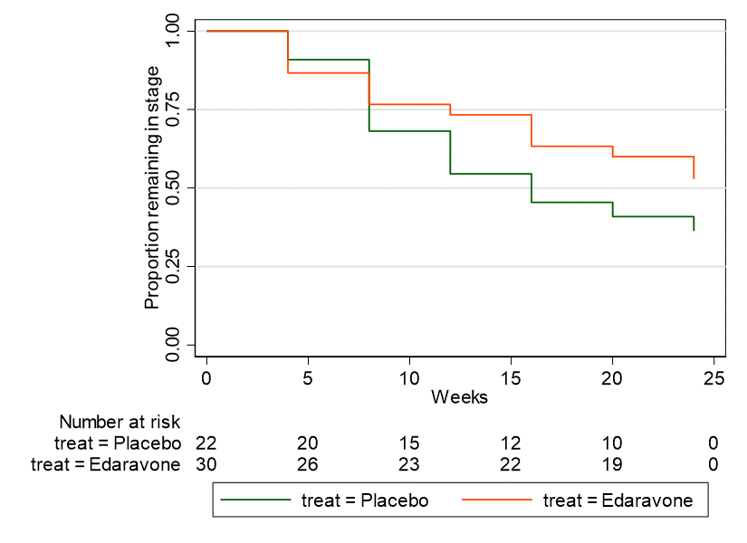 | 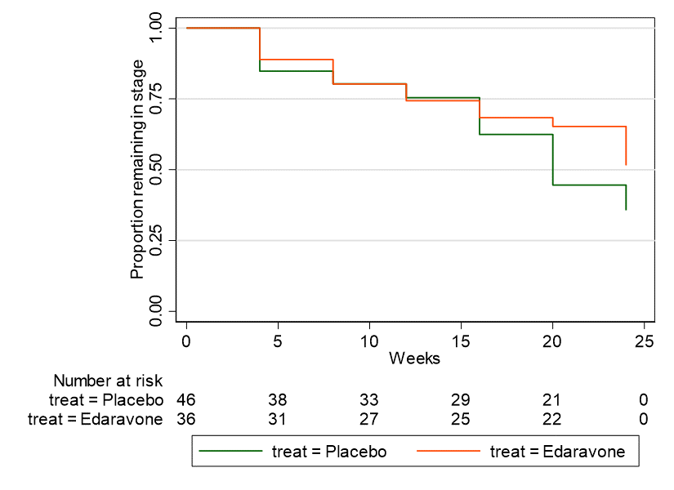
[C] King’s Stage 3 | [D] King’s Stage 4
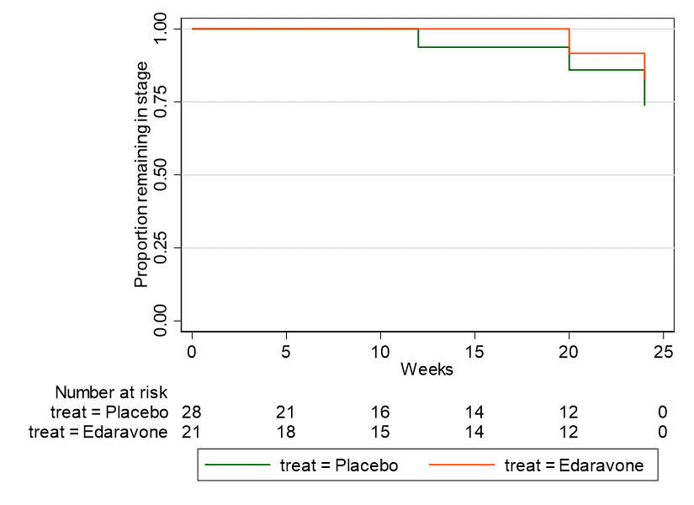 | 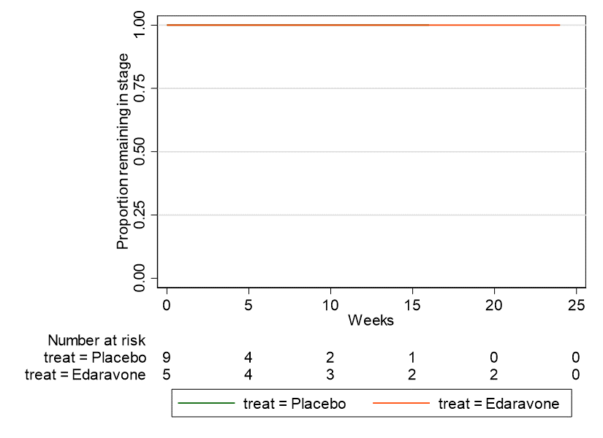
Source: constructed during the evaluation using data provided by the sponsor in Excel workbook ‘Al-Chalabi 2021 pseudo IPD.xlsx’ and Stata code reported in Stata log file ‘Al Chalabi 2021 analysis.pdf’.
HR=hazard ratio; NA=not applicable;
Notes:
i) All analyses are for time points during the 24-week double-blind treatment period. The number of patients at risk is listed under the graph at each time point for each treatment group.
ii) HR calculated during the evaluation using data from Al Chalabi 2021. HR<1 favoured edaravone.
iii) Horizontal axis corresponds to time when patients enter the King’s clinical stage. For example, Week 0 could correspond to baseline for patients who start in stages 1 and some patients in stages 2 to 3 but not for patients in stage 4, as none of the patients enrolled in Study 19 were mapped to stage 4 at baseline.
  - The mapping algorithm developed by Balendra 2014 appears to be widely used in the literature for ALS, but there are limitations which should be acknowledged. The authors compared the algorithm to the actual King’s stage based on the clinical history of 52 patients with 103 total observations, with 4 observations recorded in stage 4a and 7 in stage 4b. Although Balendra 2014 reported acceptable statistical results on the intraclass correlation, Bland-Altman and Spearman’s rank correlation coefficient tests, there was a high proportion of discrepancies reported from the algorithm in stages 1-3 (9.1-45.2% depending on stage). In general, while the algorithm appeared to identify patients in stages 4a and 4b well, it was likely to underestimate the number of patients in stage 2. Further validation of the algorithm has not occurred since the original Balendra 2014 publication.

Real-world evidence on survival
  - To calibrate survival in the modelled economic evaluation, the submission used the results of a real-world study by Brooks 2022. This study conducted a retrospective ‘exploratory’ analysis of a US administrative claims database (Optum’s Clinformatics Data Mart), comparing survival of ALS patients treated with edaravone (N=318) to propensity score matched (one to one) contemporaneous untreated patients (N=318). The study defined time-zero as the date of first edaravone for treated patients (between 8 August 2017 to 31 March 2020) and the date edaravone became ‘available’ for untreated controls (8 August 2017). To identify the untreated control patients, the study matched treated and untreated controls at time zero using available baseline characteristics - age, race, region, sex, insurance, history of cardiovascular disease, history of riluzole use and five pre-index surrogate markers for disease severity (gastrostomy tube placement, artificial nutrition, non-invasive ventilation, all-cause hospitalisation and disease duration). The results found median overall survival time was 29.5 months with edaravone versus 23.5 months without (HR = 0.73, 95%CI: 0.59-0.91), presented in Figure 2.
Figure 2: Overall survival analysis reported in Brooks 2022.
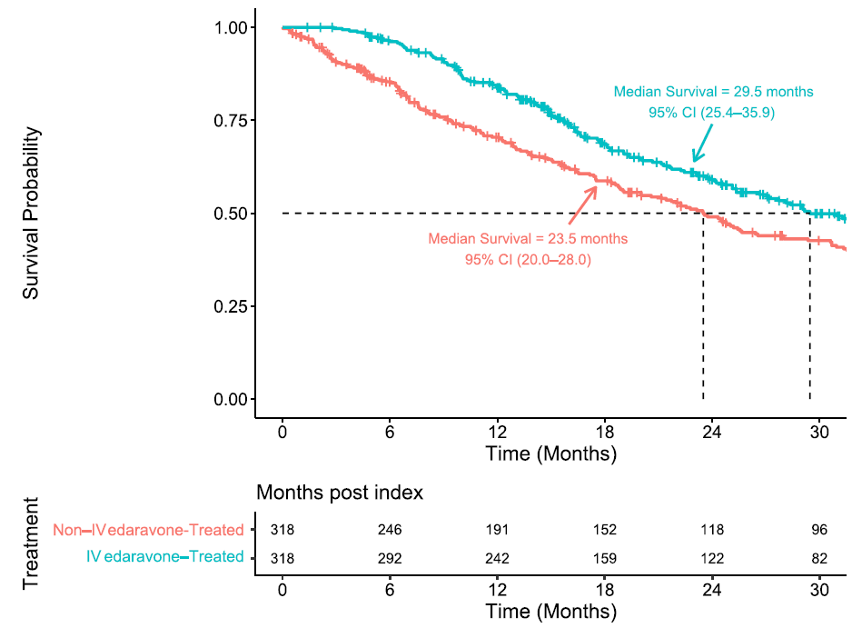
Source: Figure 4, Brooks 2022.
  - Overall, the evaluation considered the analysis presented in Brooks 2022 had a high risk of bias, and the design of the study (i.e. how control patients were identified) likely overestimated any survival benefit with edaravone. The first issue is that the administrative database did not include disease severity (i.e. ALSFRS-R score) and the broadly defined (binary) surrogates for severity used for matching were considered weak particularly for early disease. The second issue is that unobserved variables in the dataset likely explain why contemporaneous controls did not receive treatment compared to treated patients (e.g. patients with more severe disease less likely to be treated), and could potentially explain the difference in survival (e.g. patients with more severe disease more likely to die sooner). The third issue is that the assumed single date time-zero for identifying control patients (as opposed to using a date range for treatment patients), corresponding to the date edaravone became available on the market, would likely identify more ‘prevalent’ untreated patients closer to death, than ‘incident’ untreated patients that for some random-like reason did not receive treatment. Together, these design factors would likely lead to treatment selection bias favouring edaravone. For example, in the Kaplan-Meier plot (Figure 2), there were very few deaths in the treated arm at 6 months compared to ~20% of patients dying in the control arm. As the RCT evidence showed very few deaths in both the treated and control arms at 6 months, there is a lack of face validity that the control arm in Brooks 2022 can act as a reasonable counterfactual for treated patients.
  - The PSCR stated that matching was appropriately used to account for the different start definitions used (disease duration) and differences in disease/symptom severity and that given that disease severity was matched in the analysis this is not an unexplained variable impacting whether patients used edaravone (or not), and therefore survival.
  - The submission did not provide any justification for selecting the real-world analysis by Brooks 2022, and appeared to ignore the results of several other real-world studies (with the exception of Okada 2018). An independent search conducted during the evaluation identified a recent systematic review and meta-analysis by Nourelden 2023 that included survival outcomes of edaravone based on data from four RCTs and six real-world studies (including Brooks 2022, Okada 2018, Lunetta 2020, Vu 2020, Houzen 2021, Witzel 2022). This meta-analysis did find some survival benefit for edaravone versus SOC from 18 months, but the authors did not appear to control for population characteristics or methodology of the studies. Only three of the studies included in the meta-analysis reported a survival benefit with edaravone (Brooks 2022, Okada 2018, Houzen 2021). Across the real-world studies, the evaluation considered the analysis by Witzel 2022 likely used the least biased approach and found no difference in survival. The PSCR disagreed with the evaluation, noting that this study was smaller, had limited follow-up, did not include contemporaneous controls, and the matching process accounted for fewer potential confounders. In addition, patients were not identified as being ambulatory and not all patients had preserved respiratory function, maximum disease duration of 2 years and the minority of patients had ≥2 points for each item of the ALSFRS-R.
  - The ESC considered that the use of Brooks 2022 was selective, particularly as there was limited information about ALS disease staging and as its findings were inconsistent with the primary clinical trial evidence.

Comparative harms
  - Table 7 summarises the key safety outcomes from Study 16 and Study 19 to cycle 6.
Table 7: Summary of key adverse events in the double-blind period of Study 16 and Study 19
Trial ID | Edaravone  n/N (%) | Placebo  n/N (%) | RR (95% CI) | RD (95% CI)
Study 16 (ITT) to cycle 6
≥1 AEs | 91/102 (89.2) | 92/104 (88.5) | 1.01 (0.92, 1.11) | 0.01 (-0.08, 0.09)
AE leading to discontinuation | 3/102 (2.9) | 8/104 (7.7)ª | 0.38 (0.10, 1.40) | -0.05 (-0.11, 0.01)
≥1 SAE | 18/102 (17.6) | 24/104 (23.1) | 0.76 (0.44, 1.32) | -0.05 (-0.16, 0.06)
Deaths | 3/102 (2.9)^{b} | 2/104 (1.9) | 1.53 (0.26, 8.96) | 0.01 (-0.03, 0.05)
Adverse drug reactions | 14/102 (13.7) | 20/104 (19.2) | 0.71 (0.38, 1.33) | -0.06 (-0.16, 0.05)
Infusion site reaction | 1/102 (1.0) | 0 | 3.06 (0.13, 74.21) | 0.01 (-0.02, 0.04)
Study 16 dpEESP2y (post hoc) to cycle 6
≥1 AEs | 36/40 (90.0) | 30/32 (93.8) | 0.96 (0.84, 1.10] | -0.04 (-0.16, 0.09)
AE leading to discontinuation | NR | NR | - | -
≥1 SAE | 1/40 (2.5) | 8/32 (25.0) | 0.10 (0.01, 0.76] | -0.23 (-0.38, -0.07)
Deaths | 0 | 0 | NE | NE
Adverse drug reactions | 4/40 (10.0) | 9/32 (28.1) | 0.36 (0.12, 1.05] | -0.18 (-0.36, 0.00)
Study 19 dpEESP2y (ITT) to cycle 6
≥1 AEs | 58/69 (84.1) | 57/68 (83.8) | 1.00 (0.87, 1.16] | 0.00 (-0.12, 0.13)
AE leading to discontinuation | 1/69 (1.4) | 4/68 (5.9) | 0.25 (0.03, 2.15] | -0.04 (-0.11, 0.02)
≥1 SAE | 11/69 (15.9) | 16/68 (23.5) | 0.68 (0.34, 1.35] | -0.08 (-0.21, 0.06)
Deaths | 0 | 0 | NE | NE
Adverse drug reactions | 2/69 (2.9) | 5/68 (7.4) | 0.39 (0.08, 1.96) | -0.04 (-0.12, 0.03)
Injection site reaction^{c} | 3/68 (4.4) | 0 | 6.90 (0.36, 131.10) | 0.04 (-0.01, 0.10)
Infusion site reaction^{d} | 6/69 (8.7) | 7/68 (10.3) | 0.84 (0.30, 2.38) | -0.02 (-0.11, 0.08)
Source: Tables 2-46 and 2-47, p132 of the submission.
Bold text indicates statistical significance.
AE=adverse event; CI=confidence interval; ITT=intention to treat; n=number of participants reporting data; N=total participants in group; NE=not estimable; RD=risk difference; RR=relative risk;
a Study 16 CSR reported for the safety population 8/104 patients had AEs that required treatment discontinuation in placebo group. The submission reported 6/104 patients with treatment discontinuation in placebo described as ‘experienced an AE and it was difficult to continue the study’ in the efficacy full analysis set (FAS).
b Study 16 CSR and publication (Abe 2014) reported for the safety population there were 3/102 deaths in the edaravone group (2 cases of respiratory disorder and 1 respiratory failure). The submission reported 2 deaths in the edaravone group (N=101) based on events of death or specified state of disease progression in the secondary outcome for the efficacy analysis set, which excluded 1 patient who was diagnosed with a different disease.
c Included injection site rash and injection site reaction.
d Included injection site erythema, injection site pain, injection site swelling and injection site phlebitis.
  - The incidence of AEs, drug-related AEs and serious AEs were similar between edaravone and placebo groups to the end of cycle 6 in Study 16 and Study 19. The most frequently reported AEs included constipation, contusion, dysphagia, gait disturbance, nasopharyngitis. The majority of AEs were of mild severity. There were fewer discontinuations due to AEs and adverse drug reactions in the edaravone group compared to placebo. In the total patient population of Study 16, there were 3 deaths due to AEs in the edaravone group (2 respiratory disorder and 1 respiratory failure) and 2 deaths in the placebo group (respiratory failure). However, in the dpEESP2y population from post hoc Study 16 and Study 19 no deaths were reported.
  - Safety outcomes in the extension of Study 19 (open-label) and Study 17 from cycles 7-12 were generally consistent with the double-blind period to cycle 6. In Study 17, there were significantly more serious AEs in EDA-EDA group compared to EDA-PBO (p=0.034; 52.1% (25/48) vs 28.9% (13/45)). The majority of serious AEs were considered attributable to ALS progression. Patients receiving edaravone in the extension studies (EDA-EDA and PBO-EDA) also reported more adverse drug reactions than EDA-PBO. Both extension studies reported AEs leading to death. In Study 19 there were 6 patients who experienced AEs leading to death to cycle 12: 2 deaths in EDA-EDA (respiratory disorder and respiratory failure), 4 deaths in PBO-EDA (respiratory disorder, pneumonia aspiration, respiratory failure and stress cardiomyopathy). Safety data for the dpEESP2y subgroup in Study 17 was not reported.
  - While the safety data showed similar infusion/injection site reactions between groups, these safety results reflected trial conditions where patients were administered sham infusions in the placebo arm. In clinical practice however, additional infusion reactions are to be expected for edaravone versus SOC only.

Benefits/harms
  - The comparative benefits and harms for edaravone versus placebo in patients with ALS can be drawn from Table 5 and Table 7 above. On the basis of direct evidence in Study 19, the comparison of edaravone and placebo resulted in:
- Approximately a 33% reduction in the rate of decline (i.e. a slower decline) of the ALSFRS-R score (reflecting motor impairment and functional deterioration in ALS) over a 24-week period (an absolute difference in the ALSFRS-R score of 2.49 points). An improvement in the rate of decline of the ALSFRS-R score >20% was considered clinically meaningful.
- Approximately a 34% reduction in the rate of decline (i.e. a slower decline) of the ALSAQ-40 score (reflecting patient-reported health status) over a 24-week period (an absolute difference in the ALSAQ-40 score of -8.79). The submission did not indicate what difference in ALSAQ-40 score was considered to be clinically meaningful.
- Approximately a 24% reduction in the rate of decline (i.e. a slower decline) in Modified Norris Scale score (reflecting extremity and bulbar function) over a 24-week period (an absolute difference in the Modified Norris Scale score of 4.89). The submission did not indicate what difference in Modified Norris Scale score was considered to be clinically meaningful.
- Approximately 9 of every 100 patients treated with edaravone experienced an infusion site reaction over a 24-week period.

Clinical claim
  - The submission described edaravone as superior in terms of effectiveness and non-inferior in terms of safety compared to placebo in patients with Grades 1 and 2 ALS diagnosed as definite or probable ALS, within 2 years of initial ALS symptom onset, FVC ≥80%, ALSFRS ≥2 all items (i.e. dpEESP2y subgroup in the trials).
  - The clinical evidence for the effectiveness of edaravone was uncertain and requires consideration due to:
- Uncertain clinical benefit: In dpEESP2y patients enrolled in Study 16 and Study 19, there was statistically significant improvement from baseline in ALSFRS-R score and some secondary outcomes favouring edaravone after 24 weeks of treatment, but there was no difference in overall survival or time to death or certain disease progression. Though based on very small patient numbers, the results for similar patients enrolled in Samadhiya 2022 also showed no difference in ALSFRS-R item scores with the exception of one item (salivation). There were no reliable long-term data presented in the submission.
- Uncertain patient subgroup: The estimated treatment benefit with edaravone in the trial evidence was based on dpEESP2y patients in Japan, whereas the proposed PBS eligibility criteria would likely provide access to a broader population with more severe disease. The clinical evidence presented in the submission showed that any benefit with edaravone was likely specific to the dpEESP2y population, and there was no evidence presented to inform the clinical benefit in all patients potentially eligible for treatment on the PBS, or any difference in treatment effect between Japanese and non-Japanese ALS patients.
  - The incidence of AEs was generally similar between edaravone and placebo to end of cycle 6, however in Study 19 extension 6 patients (2 in EDA-EDA and 4 in PBO-EDA) experienced AEs leading to death to cycle 12. While the safety data showed similar infusion/injection site reactions between groups, these safety results reflected trial conditions where patients were administered sham infusions in the placebo arm. In clinical practice however, additional infusion reactions are to be expected for edaravone versus placebo. The ESC considered it would be more appropriate to claim inferior but manageable safety.
  - The PBAC considered that the claim of superior comparative effectiveness was reasonable, for the population that reflects patients enrolled in Study 19 (Grades 1 and 2 ALS diagnosed as definite or probable ALS, within 2 years of initial ALS symptom onset, FVC ≥80%, ALSFRS ≥2 all items). The PBAC considered that comparative effectiveness in a broader population had not been demonstrated and the clinical evidence indicated that there may be no treatment benefit in patients with more advanced disease.
  - The PBAC considered that the claim of non-inferior comparative safety was not adequately supported by the data and a claim of inferior safety would be reasonable.

Economic analysis
  - The submission presented a modelled cost-utility analysis comparing edaravone plus SOC (edaravone arm) to SOC alone (SOC arm), where SOC could be used with or without riluzole. The modelled SOC arm was based on published transition probabilities from combined trial and observational data in the PRO-ACT registry (Thakore 2018). The effectiveness of the edaravone arm was based on a post hoc analysis of Study 19 data (Al-Chalabi 2021) and a real-world analysis of US claims data (Brooks 2022).
  - Key components of the model are summarised in the following table.
Table 8: Summary of model structure, key inputs and rationale
Component | Summary
Treatments | Edaravone plus SOC with/without riluzole vs SOC with/without riluzole
Time horizon | 10 years in the model base case vs. 24 weeks in Study 19, 3 years in Brooks 2022 and 2 years in Thakore 2018. While average survival for ALS is expected to be 3-5 years, a proportion of patients are expected to have longer survival and live to 10 years. However, all the studies informing the model are based on data of a maximum of 3 years. Furthermore, the mean survival benefit for edaravone estimated by extrapolating Brooks 2022 was estimated from a 20-year time horizon, inconsistent with the modelled time horizon.
Outcomes | Life years gained, quality-adjusted life years.
Methods used to generate results | Markov cohort model. The model assumed constant transition probabilities across the patient’s lifetime, based on data up to a maximum of 3 years, which may not be appropriate.
Health states | The health states in the model were:  King’s stage 1, King’s stage 2, King’s stage 3, King’s stage 4a, King’s stage 4b, Death.  King’s staging was not included in the proposed restriction and patients in Study 19 were not enrolled based on King’s staging. Instead, in a post hoc analysis by Al Chalabi 2021, ALSFRS-R scores in Study 19 were mapped to King’s staging, using the algorithm presented in Balendra 2014.
Cycle length | 3 months
Transition probabilities | Transition between King’s stage:  SOC: published transition probabilities from Thakore 2018, based on the PRO-ACT database. The transition probabilities from Thakore 2018 were not well validated against the PRO-ACT data which informed them, overestimating time in each King’s stage.  Edaravone: HRs applied to SOC arm annual rates based on Cox models for each King’s stage estimated from KM data reported in Al-Chalabi 2021. These annual rates were converted back to transition probabilities by adjusting for mortality at each stage. The HR for transition between King’s stage was based on Study 19, but the HRs were highly uncertain (all included 1 in their 95% CI), and did not appear to meet proportional hazards criteria. Further, time 0 in Al-Chalabi 2021 was the time at which patients entered each stage. As patients in Study 19 at baseline could be in any of stages 1-3, and some transitioned during the trial, the time to progression for stages 2 and 3 estimated in Al-Chalabi 2021 were based on both treatment naïve and previously treated patients. In comparison, the model assumed all patients in stages 2 and 3 were previously treated with edaravone, as all patients entered the model in stage 1. Therefore, the cohort of previously treated patients in the model was assumed to accrue the same benefit as the mix of treatment naive and previously treated patients in Study 19, and therefore the effect for edaravone in stages 2 and 3 may be overestimated.  HR stage 1: 0.654  HR stage 2: 0.696  HR stage 3: 0.584  HR stage 4a: 1.000
OS
SOC: published transition probabilities from Thakore 2018 for each King’s stage, based on the PRO-ACT database. The transition probabilities from Thakore 2018 were not well validated against the PRO-ACT data which informed them, overestimating survival.

Edaravone: a mortality calibration adjustment was applied to the SOC arm based on expected mean survival difference estimated from Brooks 2022, extrapolated with independent generalised gamma curves to 20 years applied to a 10-year time horizon. Studies 16, 18 and 19 demonstrated no survival benefit for edaravone over SOC, and there were methodological concerns with Brooks 2022. Other observational data and matched studies showed mixed evidence of survival benefit for edaravone over SOC.
TTD
85% patients assumed to receive riluzole in stages 1-3 in both SOC and edaravone arms. Riluzole use was higher in Study 19 (91%).

Patients in the edaravone arm also received edaravone in stages 1-3, but were assumed to have a discontinuation rate of 30% each model cycle (based on median duration of 9 months from Brooks 2022). Treatment discontinuation in Study 19 was low, and in observational studies, average time on edaravone ranged from 8-27 months, suggesting the duration in Brooks 2022 could be an underestimate.
Health related quality of life | Age based general population utility for Australia (McCaffrey 2016) minus the following disutilities in each health state (based on ALS health state utilities in Thakore 2020 subtracted from US population utility in Janssen 2018). At the end of the modelled time horizon (patients aged 70.3 years) the estimated utilities in each stage were: stage 1 - 0.841, stage 2 - 0.768, stage 3 - 0.667, stage 4a - 0.681, stage 4b - 0.606.  Disutilities included in the model  King’s stage Disutility based on  Thakore 2020 (base case) Moore 2019 Jones 2014  1 0.029 0.028 0.14  2 0.102 0.188 0.26  3 0.203 0.258 0.38  4a 0.189 0.288 0.52  4b 0.264 0.288 0.52  No adverse events were included in the model  The submission did not adjust survival for age, and therefore the utility and survival estimates are inconsistent. EQ-5D data from Thakore 2020 was collected from patients in the waiting rooms of their medical appointments, and therefore may not represent patients in worse health. Patients in King’s Stage 4a had better utility than stage 3, which was counter to the assumption that each stage represented a disease progression. Moore 2019 resulted in similar disutilities to Thakore 2020, but data were collected by postal survey, again unlikely to represent patients in worse health. Jones 2014 collected data during an ALS trial (LiCALS), but had reduced statistical power. All utility sources mapped ALSFRS-R to King’s stage.
Resource use | Cost of edaravone was based on the per vial AEMP ($||||) dispensing mark-ups based on 100% private patients. In the model, the cost per dose (for all treatment cycles, initiating and continuing) was based on $|||| (DPMQ for 20 ampoules) divided by 10 to give $|||| per dose of 2 ampoules. The cost of edaravone was uncertain because of the increased preparation fee; the difference between DPMQ based on ampoule AEMP or pack AEMP; and the public/private split. The ICER was not sensitive to any of these uncertainties.  Riluzole costs were $174.30 for 56x50mg tablets and $244.52 for 300ml of 50mg/10ml liquid, slightly less than the current DPMQ for PBS items 8664B and 11662T ($175.15 and $245.37 respectively). 85% of patients in stage 1-3 were assumed to receive riluzole at a dose of 100mg per day, with 80% patients assumed to receive tablet form and 5% liquid form of riluzole, amounting to a total of $|||| per month for patients in stage 1-3 in both arms. Riluzole costs did not have a significant effect on the ICER.  Infusion costs were borne by the sponsor and equalled $0 in the base case. If infusions were costed (administration via a portacath, MBS item 14221, $57.50 per infusion), the ICER increased to $95,000 to < $115,000 per QALY gained versus $75,000 to < $95,000 in the base case. These costs are likely to be underestimated given the high discontinuation rate applied in the model base case.  Total health state costs were equal to $1,133 in stage 1, $2,420 in stage 2, $3,012 in stage 3, $5,941 in stage 4a, and $7,298 in stage 4b. These were based on UK postal survey of health state resource use (Moore 2019), the Australian costing study Deloittes 2015; and unit costs included MBS item, ambulance Victoria, and AR-DRG codes. Overall, the model estimated that the annual cost in the SOC arm was $27,152 compared to estimates >$30,000 based on Deloittes 2015. As such health state costs may be slightly underestimated compared to costs in practice.
Source: compiled during the evaluation
OS=overall survival, QALY=quality-adjusted life year, TTD=time to treatment discontinuation, HR= hazard ratio, SOC=standard of care, PRO-ACT= Pooled Resource Open-Access ALS Clinical Trials database, ALSFRS-R=Revised Amyotrophic Lateral Sclerosis Functional Rating Scale.
  - Patients entered the model in King’s stage 1 and each cycle could remain in stage 1 or progress to any of stages 2, 3, 4a or 4b. Progression did not have to be to an adjacent health state (e.g. patients could move from stage 1 to stage 3 without being in stage 2), but patients could not improve (i.e. move from a more advanced disease stage to a less advanced disease stage). The model did not include separate health states for patients on or off treatment. Aside from restricting use to stages 1-3, time on edaravone was modelled independently to the health states. It is unlikely that in practice all patients will be diagnosed in stage 1, as there is often a significant delay between onset of symptoms and diagnosis. Overall, the ESC considered that this approach was poorly justified by clinical data, and would overestimate the effects of edaravone, as outlined in the following paragraphs.
  - The submission contended that the modelled population was the proposed PBS population, however the modelled population was patients diagnosed in stage 1 with prognosis dependent upon input sources that did not match the proposed PBS population. The populations differed across the input sources, particularly with regards to riluzole use (65.4% in Brooks 2022 to 91% in Study 19), stage at baseline (e.g. for stage 4a and b: 0% Study 19, 25.8% Thakore 2018, 16-23% in Brooks 2022), and disease duration prior to study (0.57 years in Brooks 2022 to 1.42 years in Thakore 2018). In Study 19, patients in stages 2 onwards were a mix of treatment naïve and treatment experienced patients, whereas all patients in the model from stage 2 onwards were assumed to be treatment experienced. The input source populations also differed to the Australian population (Talman 2016), with reported bulbar onset rates of 20-23% in Study 19 and Thakore 2018, compared to 34% in the Australian populations. These differences were likely to affect stage progression, mortality and treatment discontinuation rates and meant the model likely did not well represent the population in Study 19 nor the Australian population.
  - King’s stage progression and mortality in the SOC arm were taken from Thakore 2018 based on the PRO-ACT database. At the time of Thakore 2018 publication, the PRO-ACT database contained US data on 3,199 patients (29,947 observations) from 23 trials in ALS. The median duration between first and last observations in Thakore 2018 was 12 months, and Thakore 2018 further noted that their model did not predict King’s stage progression or survival well beyond the first year. The transition probabilities in Thakore 2018 also resulted in the most life years being accrued in stage 4b: 1.30 years compared 0.41, 0.40, 0.76 and 0.40 in stages 1, 2, 3 and 4a respectively in the SOC arm. In comparison, Balendra 2015 (UK and Europe trial data), reported that median duration was longest in stage 1 (18.1 months, IQR 12.8–25.6 months) and shortest in stage 4b (3.2 months, IQR 1.6–5.8 months).
  - King’s stage progression in the edaravone arm was derived from the post hoc analysis of Study 19 by Al-Chalabi 2021. Although the analysis found no significant difference between edaravone and placebo in terms of King’s stage progression, the submission estimated individual patient data based on Kaplan-Meier curves presented in the paper and used these to estimate cox-proportional hazard ratios for progression from stages 1, 2 and 3. The Kaplan-Meier data from Al-Chalabi 2021, along with predicted survival based on the Cox proportional hazards for Al-Chalabi 2021 and the log-log survival plots are presented in Figure 3.
Figure 3: State progression based on post-hoc analysis of Al-Chalabi 2021
Stage | Observed KM data vs predicted Cox model | Log-log survival plots by treatment arm
1  HR=0.65  95%CI  0.31,1.38 | 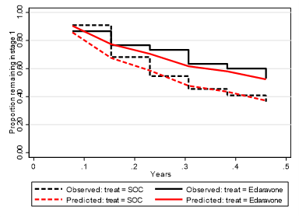 | 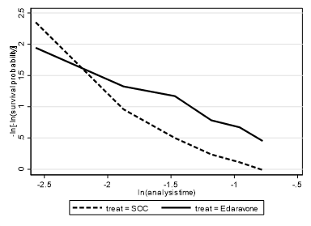
2  HR=0.70  95%CI  0.37,1.31 | 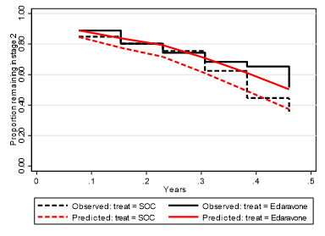 | 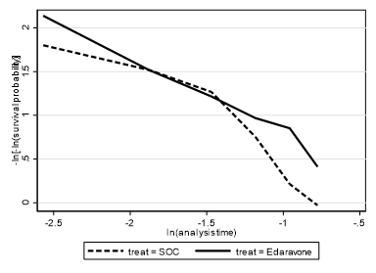
3  HR=0.58  95%CI  0.10,3.52 | 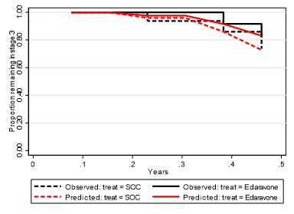 | 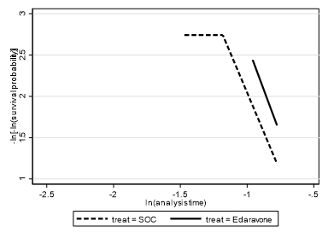
Source: compiled during the evaluation from data provided by the sponsor in Excel workbook ‘Al-Chalabi 2021 pseudo IPD.xlsx’
Black lines represent observed KM data. Red lines represent survival predicted by the Cox-proportional hazards model. Confidence limits for the Cox-proportional hazards model not included, but confidence limits overlap for all stages. Time 0 represents the time patients entered the stage, not time at baseline. Patients in stage 2 and 3 who had progressed from earlier stages had maximum <24 weeks follow up compared to patients who were stage 2 and 3 at baseline in Study 19 who had maximum 24 weeks of follow up. HR<1 favoured edaravone.
  - Although the clinical evidence presented in the submission showed a smaller rate of decline in ALSFRS-R score with edaravone compared to placebo, the decision to translate this benefit in the model using Al-Chalabi 2021 was poorly justified. The proportional hazards assumption for King’s stage progression did not appear to hold for any stage, though statistically the assumption was not violated, likely due to the high uncertainty in the estimates. Mean hazard ratios generally resulted in inaccurate estimates of the benefit of edaravone compared to SOC for stage progression compared to the observed Kaplan-Meier data. For all stages, the confidence limits for the hazard ratios included 1 and therefore there was no statistically significant difference in stage progression at any stage. In particular, despite the substantial hazard ratio for stage 3 (0.584), the difference in survival between edaravone and SOC was small both in the observed and predicted curves, and the hazard ratio had very wide confidence limits (95%CI 0.097 to 3.519). Overall, there was high uncertainty in the hazard ratios applied to King’s stage progression, particularly from stage 2 onwards. The PSCR noted that although Study 19 was not designed to detect statistical differences in staging analyses Kings staging was considered the best source to inform the edaravone treatment effect in the model. Nonetheless, the ESC considered although there was some evidence of reduced progression from King’s Stage 1, there was little evidence for the transitions between other King’s Stages, resulting in a high level of uncertainty in the modelled outcomes.
  - The submission calibrated the model assuming an average of 1.37 years of additional survival with edaravone, based on independent generalised gamma functions fit to the Brooks 2022 Kaplan-Meier data and extrapolated over 20 years. The independent generalised gamma function was chosen as it had the best fit for the edaravone arm and resulted in curves that did not cross (Figure 4). From this analysis, the submission applied a mortality hazard ratio of 0.665 to every King’s stage, which reduced the likelihood of transitioning out of the current King’s stage each cycle in the edaravone arm in addition to the effect estimated from the stage progression hazard ratios.
Figure 4: OS extrapolation of Brooks 2022 over 10-year time horizon
Independent | Joint fit
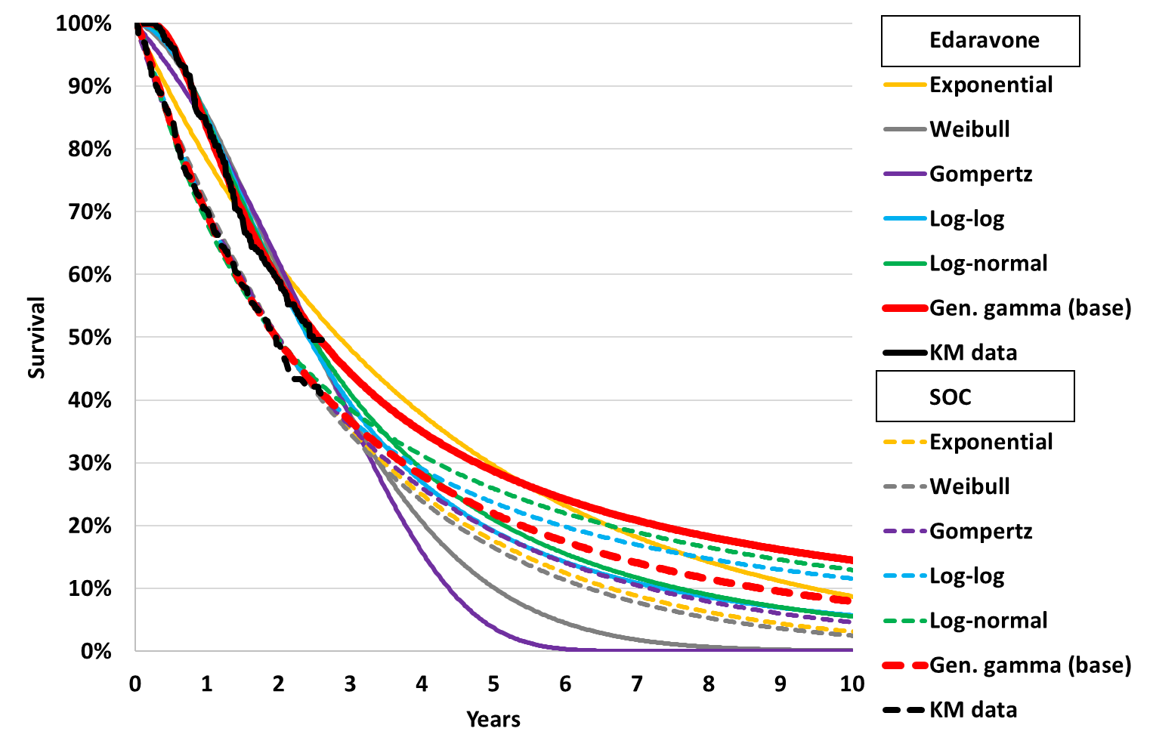 | 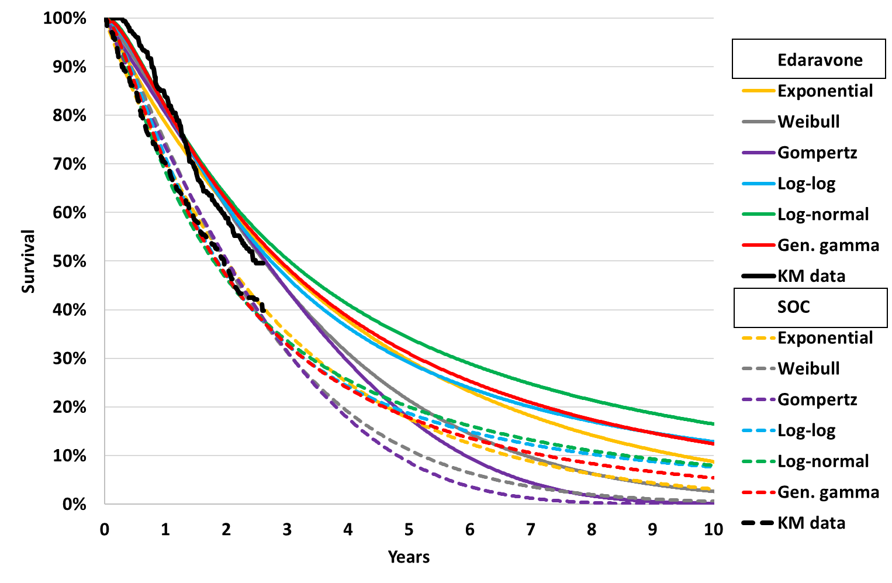
Source: compiled during the evaluation from data presented in ‘Brooks 2022 pseudo IPD.xlsx’ and Stata log file ‘Brooks 2022 analysis.pdf’
  - Application of this survival calibration factor was not supported by the evidence presented in the submission. As noted above (paragraph 6.21), the empirical strategy used in Brooks 2022 was considered highly biased in favour of edaravone. The key trial evidence presented in the submission showed no difference in survival at 48 weeks, and other real-world studies using less biased approaches found also no difference in survival. The PSCR and pre-PBAC response noted that as Study 19 was in early-stage ALS patients, where mortality is typically low, the RCT was not long enough to provide meaningful data on longer-term survival outcomes and real-world data is the only means by which survival can be estimated. In addition, the evaluation considered the submission’s justification for selecting the preferred parametric function was flawed (favouring edaravone) and the decision to apply the survival from a 20-year extrapolation to a 10-year model was inappropriate (favouring edaravone). Without this calibration, the model still estimated 0.52 years of additional survival with edaravone (0.42 life years undiscounted) associated with the estimated slower rate of King’s stage progression. No other economic evaluations of edaravone for ALS included the mortality calibration. CADTH 2019 estimated an additional 0.39 discounted life years for stage 1 patients receiving edaravone and ICER 2022 an additional 0.06 discounted life years for a mixed cohort. The PSCR argued that the CADTH 2019 analysis now lacks face validity given the more recent published real-world evidence showing greater survival benefit.
  - For time on treatment, the submission assumed a discontinuation rate for edaravone of 30% per 3-month model cycle in King’s stage 1 to 3 (100% discontinuation afterwards), corresponding to a mean (median) time on treatment of 7.2 (9.0) months (with half cycle correction). The discontinuation rate for edaravone was chosen based on the median time on treatment of 8.6 months in Brooks 2022. For riluzole, the submission assumed 85% of patients in both arms received riluzole and remained on treatment indefinitely (no discontinuation).
  - The evaluation considered that it was likely that time on edaravone in the model (mean 7.2 months) was considerably underestimated given there was a low rate of discontinuation observed in Study 19 and the proposed PBS restriction specifies few stopping criteria. In other real-world studies the average treatment duration with edaravone was up to 27 months, which is similar to the estimate from the model assuming patients only discontinue upon progression to King stage 4a/4b. In addition, the model assigned no edaravone cost to 16.4% of patients in the edaravone arm owing to the high discontinuation rate. The pre-PBAC response stated that time on treatment was calibrated to the 8.6 months median treatment duration for edaravone observed in Brooks 2022, to maintain consistency with the source of estimates for overall survival. The pre-PBAC response further noted that the median estimate of treatment duration from five real-world studies (Brooks 2022, Houzen 2021, Okada 2018, Witzel 2022, Vu 2020) is 8.8 months, with a weighted (by study size) average of 9.2 months and four out of the 5 studies producing an estimate of less than 13 months.
  - Figure 5 presents a comparison between modelled survival and time to treatment discontinuation with edaravone compared to input data sources. The figure highlights that the modelled survival benefit (i.e. the area between curves) was considerably larger than Brooks at 10 years (owing to estimated survival benefit over 20 years being attributed to the 10-year model time horizon), and patients were assumed to discontinue edaravone in the model much quicker than observed in Study 19.
  - The ESC noted that the survival benefit in Brooks 2022 did not appear to align with the survival benefit in the trials and further, the model appeared to overestimate the survival benefit compared with Brooks 2022. The ESC considered that application of this adjustment for survival in the model was not appropriate and likely to have substantially overestimated the survival benefit for edaravone. The ESC also noted that the modelled time on treatment appeared substantially underestimated compared with Study 19 and other real-world studies. In Study 19, over 11 months, 24% of patients discontinued treatment and ESC considered that the assumed discontinuation rate of 30% per 3-month model cycle was not appropriate.
Figure 5: Comparison of model to input data sources (Brooks 2022 and Study 19).
a) OS model vs Brooks 2022 (and extrapolation) | b) TTD model vs Study 19
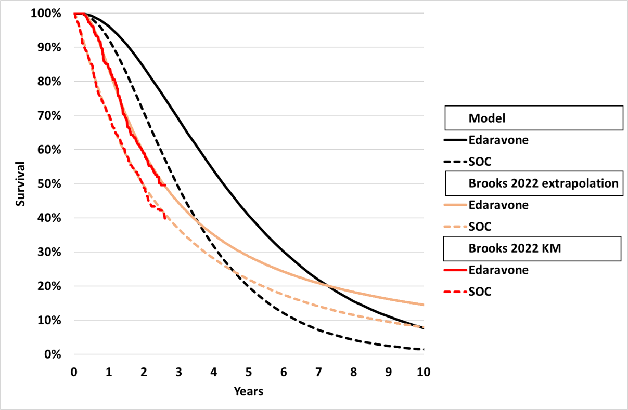 | 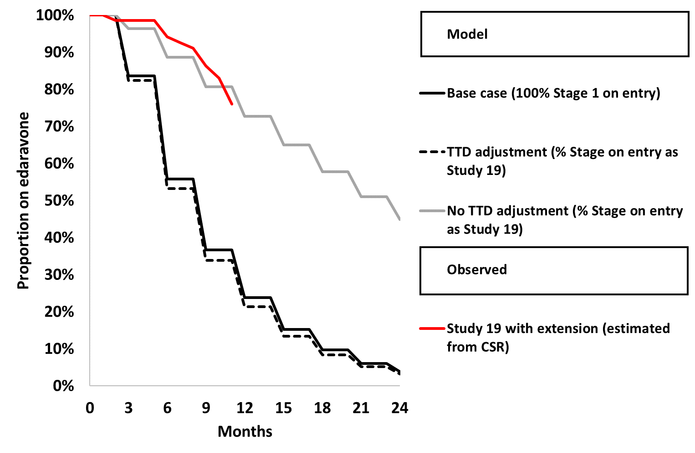
Source: compiled during the evaluation from Excel Workbook ‘Edaravone TEVA Section 3 Economic Model Nov 2023.xlsm’ and a) ‘Brooks pseudo IPD.xlsx’ and Stata code from ‘Brooks 2022 analysis.pdf’; b) patient numbers in Tables 11.3.1-2 and 11.3.2-2 of the Study 19 CSR (Mitsubishi 2016 – Study 19 study-body.pdf’ assuming patient numbers commencing in each cycle received treatment in prior cycle. Does not account for dose adjustments.
  - The submission implemented health state utilities by estimating disutility by King’s stage and applying the disutility to Australian general population utility by age and proportion male (McCaffrey 2016). Disutilities were estimated by subtracting health state utilities for ALS from Thakore 2020 (EQ-5D-3L data in the PRO-ACT database) from US general population utility from Janssen 2018.
  - The ESC considered that there was a high level of uncertainty associated with the utility values in the model because:
- Utility varied with age across the model time horizon, but survival did not, which was inconsistent and gave improbable model results. For example, if baseline age was increased in the model, patients accrued the same number of life years as the base case, but fewer QALYs.
- The utility estimates in Thakore 2020 were collected from patients in the waiting rooms of their medical appointments, and therefore may not represent patients with worse health. In particular, Thakore 2020 utilities did not demonstrate a significant reduction in utility for later King’s stages, with stage 4a having higher utility than stage 3.
- The corresponding modelled utilities were higher than reported in other literature. At the end of the modelled time horizon (patients aged 70.3 years) the estimated utilities in each stage were: stage 1 0.841, stage 2 0.768, stage 3 0.667, stage 4a 0.681, stage 4b 0.606.
  - The pre-PBAC response noted that all utility values derived from patient surveys have the potential for response bias and argued that all values from Thakore (2020) were plausible. The ICER was sensitive to utility source. If higher disutility estimates were incorporated (based on Jones 2014), the ICER increased to $115,000 to < $135,000 per QALY gained, compared to $75,000 to < $95,000 in the base case.
  - The model presented health state allocation plots for the edaravone and SOC arms. These have been reproduced during the evaluation with consistent shading in the following figure.
Figure 6: Health state allocation
Edaravone | SOC
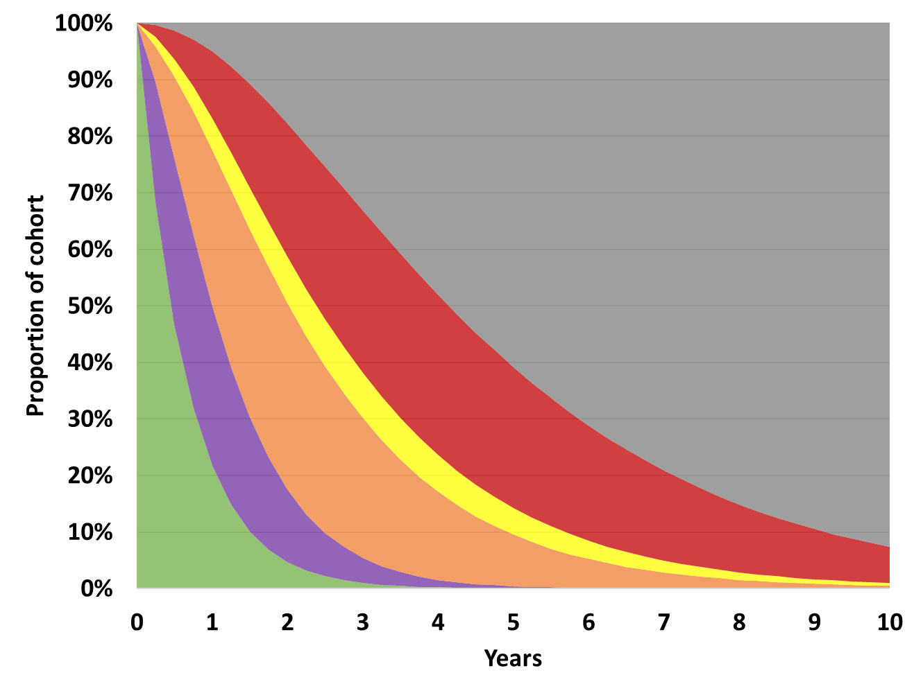 | 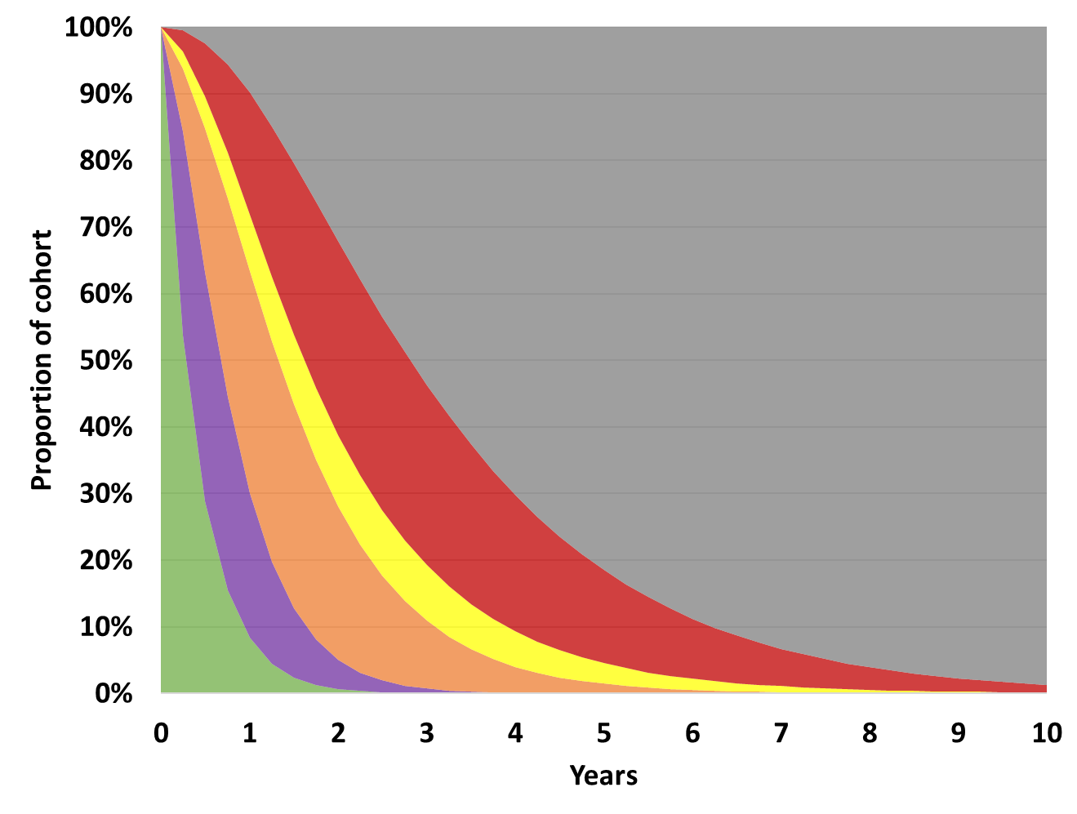
Incremental health state allocation over time, edaravone vs SOC
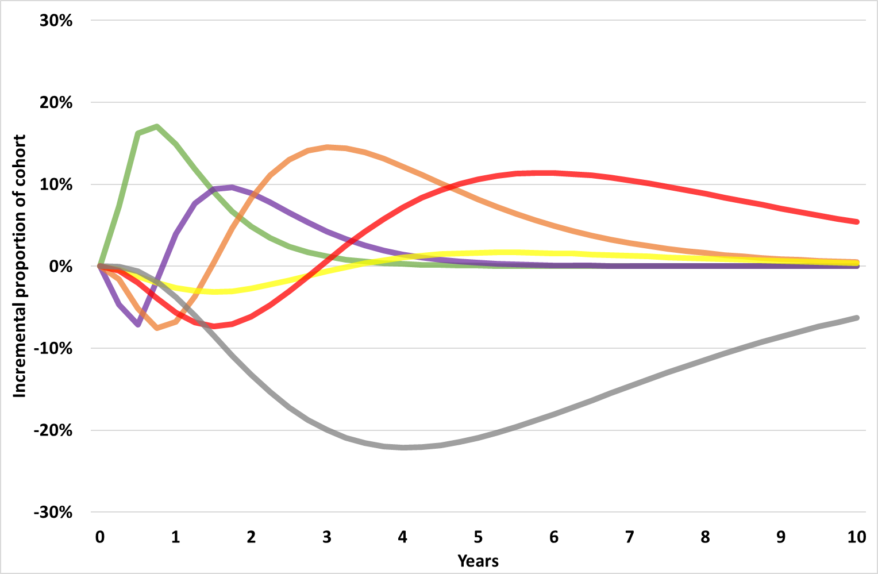
Source: adapted from Figure 3-7, 3-8, 3-9, pp191-192 of the submission.
  - In both arms, patients spent the most time in stage 4b, followed by stage 3 and stage 1. Edaravone patients spent more time in all stages overall, as a result of the increased survival and reduction in transition out of each state. While there was an initial delay out of stage 1, the largest incremental gain on proportion of patients appeared to be in stages 3 and 4b. This was poorly justified by the clinical trial evidence. By the end of the time horizon 7.7% of patients in the edaravone arm were alive compared to 1.4% in the SOC arm. The ESC considered that there was a high level of uncertainty associated with the translation of ALS-FRS-R scores to King’s Stage, particularly beyond transitions from Stage 1.
  - The model was not externally validated against other literature. Summary OS Kaplan-Meier data for SOC and edaravone were identified from the literature during the evaluation and are presented below. The Kaplan-Meier data identified is not exhaustive and survival by region of onset data from Australia is discussed separately.
Figure 7: Overall survival in ALS
Edaravone KM | SOC KM
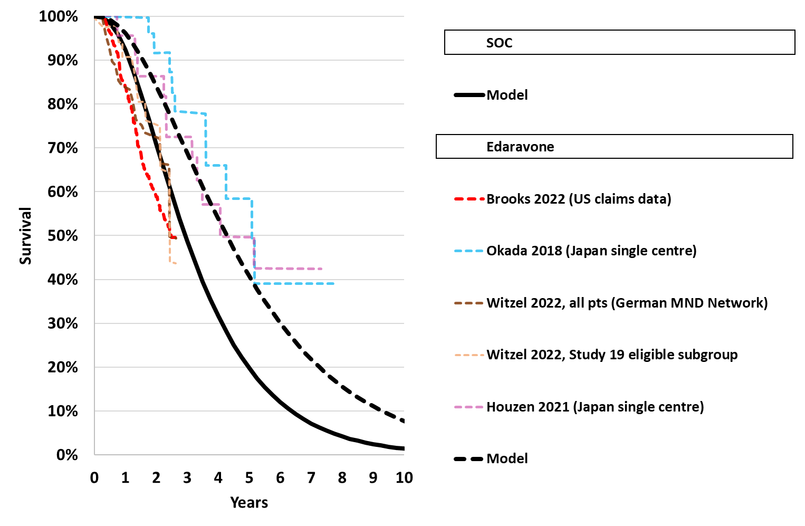 | 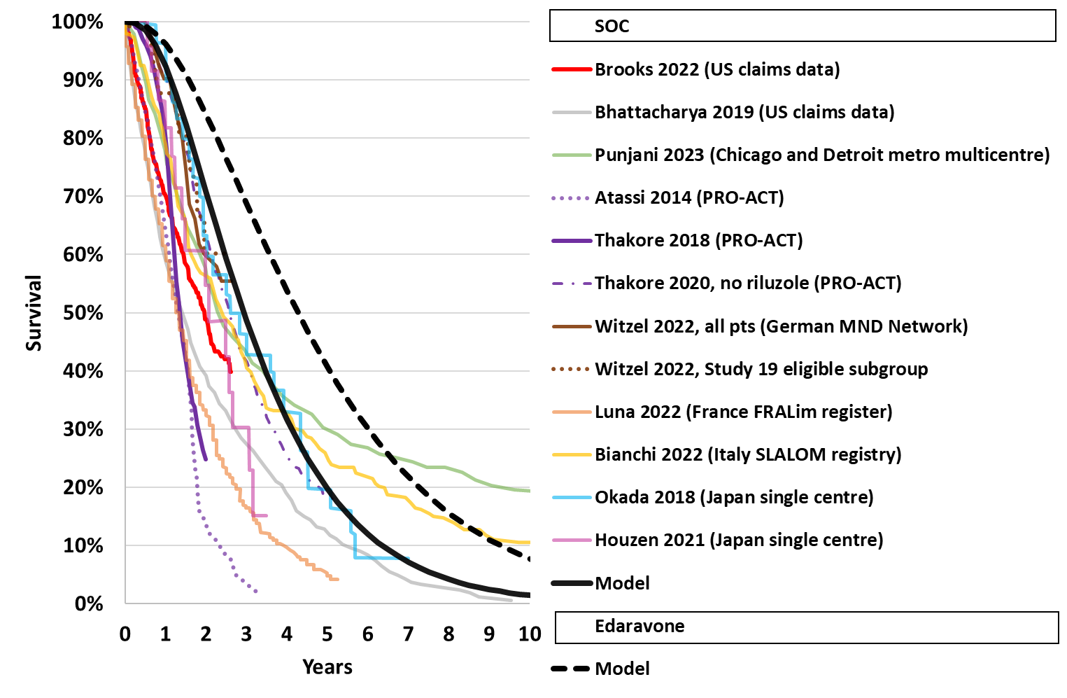
Source: compiled during the evaluation from Excel workbooks ‘Edaravone TEVA Section 3 Economic Model Nov 2023.xlsm’, ‘Brooks 2022 pseudo IPD.xlsx’ and extracted using PlotDigitizer, 3.1.5, 2023, https://plotdigitizer.com
Bhattacharya R, Harvey RA, Abraham K, Rosen J, Mehta P. Amyotrophic lateral sclerosis among patients with a Medicare Advantage prescription drug plan; prevalence, survival and patient characteristics. Amyotroph Lateral Scler Frontotemporal Degener. 2019 May;20(3-4):251-259.
Bianchi E, Pupillo E, De Feudis A, Enia G, Vitelli E, Beghi E. Trends in survival of ALS from a population-based registry. Amyotroph Lateral Scler Frontotemporal Degener. 2022 Aug;23(5-6):344-352. doi: 10.1080/21678421.2021.2004167. Epub 2021 Nov 24. PMID: 34818115.
Punjani R, Larson TC, Wagner L, Davis B, Horton DK, Kaye W. Survival and epidemiology of amyotrophic lateral sclerosis (ALS) cases in the Chicago and Detroit metropolitan cohort: incident cases 2009-2011 and survival through 2018. Amyotroph Lateral Scler Frontotemporal Degener. 2023 May;24(3-4):203-211.
Atassi N, Berry J, Shui A, Zach N, Sherman A, Sinani E, Walker J, Katsovskiy I, Schoenfeld D, Cudkowicz M, Leitner M. The PRO-ACT database: design, initial analyses, and predictive features. Neurology. 2014 Nov 4;83(19):1719-25.
Thakore NJ, Lapin BR, Kinzy TG, Pioro EP. Deconstructing progression of amyotrophic lateral sclerosis in stages: a Markov modeling approach. Amyotroph Lateral Scler Frontotemporal Degener. 2018 Nov;19(7-8):483-494.
Thakore NJ, Pioro EP, Udeh BL, Lapin BR, Katzan IL. A Cost-Effectiveness Framework for Amyotrophic Lateral Sclerosis, Applied to Riluzole. Value Health. 2020 Dec;23(12):1543-1551. doi: 10.1016/j.jval.2020.06.012. Epub 2020 Oct 9. PMID: 33248509.
Witzel S, Maier A, Steinbach R, Grosskreutz J, Koch JC, Sarikidi A, Petri S, Günther R, Wolf J, Hermann A, Prudlo J, Cordts I, Lingor P, Löscher WN, Kohl Z, Hagenacker T, Ruckes C, Koch B, Spittel S, Günther K, Michels S, Dorst J, Meyer T, Ludolph AC; German Motor Neuron Disease Network (MND-NET). Safety and Effectiveness of Long-term Intravenous Administration of Edaravone for Treatment of Patients With Amyotrophic Lateral Sclerosis. JAMA Neurol. 2022 Feb 1;79(2):121-130.
Luna J, Defressigne O, Erazo D, Lautrette G, Raymondeau-Moustafa M, Preux PM, Boumediene F, Couratier P. Epidemiological time-trend of amyotrophic lateral sclerosis (ALS) over two decades: The French population-based register of ALS in Limousin (FRALim register). Rev Neurol (Paris). 2022 Nov;178(9):914-923.
Okada M, Yamashita S, Ueyama H, Ishizaki M, Maeda Y, Ando Y. Long-term effects of edaravone on survival of patients with amyotrophic lateral sclerosis. eNeurologicalSci. 2018 May 17;11:11-14. doi: 10.1016/j.ensci.2018.05.001. PMID: 29928711; PMCID: PMC6006910.
Houzen H, Kano T, Horiuchi K, Wakita M, Nagai A, Yabe I. Improved Long-Term Survival with Edaravone Therapy in Patients with Amyotrophic Lateral Sclerosis: A Retrospective Single-Center Study in Japan. Pharmaceuticals (Basel). 2021 Jul 21;14(8):705.
  - In general, the modelled SOC arm appeared to have better survival than reported in the literature (including exceeding the edaravone arms of Witzel 2022 and Brooks 2022), though the long-term survival differed greatly across studies. As the literature combined patients of all stages and riluzole use, the model, which assumed all patients started in stage 1 and 85% riluzole use, may reasonably assume better survival for the modelled cohort. In particular, the model estimated slightly better survival than the no riluzole OS Kaplan-Meier data from Thakore 2020, which would be expected. However, the Australian MND registry estimated median survival as 24 months from symptom onset in the bulbar region and 33 months from symptom onset in flail or lumbar regions (Talman 2016). Median survival from diagnosis in the model was ~36 months, which was therefore likely to be an overestimate compared to survival in the Australian population.
  - Survival in the edaravone arm appeared similar to the single centre Japanese studies, but was significantly improved compared to the multicentre study (Witzel 2022) and Brooks 2022, which informed the model. The ESC noted that differences in survival may be due to the use of invasive ventilation in Japan, which is not commonly used in Australian clinical practice. Overall, the evaluation considered the model was likely to be overestimating survival in the edaravone arm.
  - The key drivers of the model are presented in Table 9.
Table 9: Key drivers of the model
Description | Method/Value | Impact  Base case: $||||¹/QALY gained
Time horizon | 10 years in the model base case vs. 24 weeks in Study 19, 3 years in Brooks 2022 and 2 years in Thakore 2018 | Moderate, favoured edaravone. With a 5 year time horizon, the ICER increased to $||||²/QALY. With a lifetime time horizon the ICER decreased to $||||¹/QALY
Stage at baseline | 100% stage 1. None of the input data sources were based on a cohort of exclusively stage 1 patients followed over time. Further, time between symptom onset and diagnosis can be 6-12 months, during which time patients may have progressed. | Moderate favoured edaravone. If all patients were Stage 2, the ICER increased to $||||²/QALY
SOC transition probabilities | Taken from Thakore 2018, restricted for stage improvements. Resulted in the majority of LYs accrued in stages 3 and 4b. | High, favoured edaravone. If Thakore 2020 used as alternate source, the ICER increased to $||||²/QALY
Edaravone stage progression HRs | All HR 95%CIs included 1. Further, the HRs in stage 2 and 3 were estimated from both patients who had transitioned from stage 1 and those who were in stage 2 and 3 at baseline. As such HRs were likely overestimated. | High, favoured edaravone. If no effect on stage progression assumed (i.e. stage 2 and stage 3 HRs=1), the ICER increased to $||||³/QALY
Edaravone mortality HR | HR=0.665  This was estimated based on the assumption that an extrapolation of Brooks to 20 years represented the LYG (1.37 years undiscounted) that should be observed in the model. There were concerns with the Brooks 2022 methodology, the choice of extrapolation, and the implementation of the extrapolation. It may therefore be more appropriate to remove the mortality adjustment. | High, favoured edaravone. If the mortality adjustment was removed (i.e. HR=1), the ICER increased to $||||⁴/QALY
Time on edaravone | 30% discontinuation rate applied each model cycle to patients in stage 1-3, based on median TTD in Brooks 2022 of 8.6 months. This was a much higher rate of discontinuation than observed in Study 19, and observation studies found average time on edaravone ranged between 8-27 months. | High, favoured edaravone. If patients discontinued edaravone only upon progression to stage 4a/b (i.e. no TTD adjustment), the ICER increased to $||||⁵/QALY
Utilities | Utilities were estimated as age based general population utilities (McCaffrey 2016) minus disutility in each King’s stage. Disutilities were estimated by subtracting utilities in Thakore 2020 from US general population utility (Janssen 2019), adjusted for mean age and %male in Thakore 2020. No other model inputs were adjusted for age, and base utilities were likely high due to selection bias. High utilities increased the benefit of edaravone, resulting in more incremental QALYs gained. | High, favoured edaravone. If Jones 2014 was used as the disutility source (where disutility was increased compared to base case), the ICER increased to $||||³/QALY
Source: compiled during the evaluation
The redacted values correspond to the following ranges:
¹ $75,000 to < $95,000
² $95,000 to < $115,000
³ $115,000 to < $135,000
⁴ $135,000 to < $155,000
⁵ $255,000 to < $355,000
  - The summary cost effectiveness results are presented in Table 10. No trial-based analysis was presented. The base case ICER was $75,000 to < $95,000 per QALY gained, which is likely to be an underestimate.
Table 10: Results of the economic evaluation, 10-year time horizon (discounted)
Component | Edaravone | SOC | Increment
Costs ($) | | | $76,939 | |
LYs | 3.99 | 2.92 | 1.07
QALYs | 2.81 | 2.05 | 0.76
Incremental cost/LY gained ($) |  |  | |¹
Incremental cost/QALY gained ($) |  |  | |²
Source: Table 3-26, 3-27 p194 of the submission
LY=life year, QALY= quality adjusted life year, SOC=standard of care
The redacted values correspond to the following ranges:
¹ $55,000 to < $75,000
² $75,000 to < $95,000
  - The largest contributor to the incremental costs was the cost of edaravone, equating to 69.5% of the overall incremental cost. Stage 4b costs were also a significant driver of the incremental costs (18.2%), resulting from stage 4b being the costliest health state, with a largest incremental life years for edaravone versus SOC (0.48 years). The edaravone arm was associated with an increase in life years and quality adjusted life years in all health states of the model. The largest incremental gain in undiscounted life years was seen in stages 4b and 3, with approximately 6 months of additional life years gained in each. This resulted in 0.32 incremental undiscounted QALYs in stage 3 (33.3% total incremental QALYs) and 0.29 incremental QALYs in stage 4b (30.4% total incremental QALYs).
  - The results of key sensitivity analyses are summarised in Table 11.
Table 11: Sensitivity analyses
Analyses | Incremental cost ($) | Incremental QALY | ICER | %∆
Base case | | | 0.76 | |||¹ | -
Discount rate (base case 5% costs and outcomes)
- 0% costs and outcomes | | | 0.96 | ||¹ | - ||
- 3.5% costs and outcomes | | | 0.81 | ||¹ | - ||
Time horizon 5 years (base case 10 years) | | | 0.47 | ||² | |
King’s stage at baseline (base case all stage 1)
- Study 19 (stage 1 38%, stage 2 47%, stage 3 15%) | | | 0.69 | ||¹ | |
- All stage 2 | | | 0.66 | ||² | |
- All stage 3 | | | 0.61 | ||² | |
Transition probabilities in SOC from Thakore 2020ª (base case Thakore 2018) | | | 0.78 | ||² | |
Progression out of stage HR^{b} (base case stage 1=0.654, stage 2=0.696, stage 3=0.584, stage 4a=1)
- No effect after stage 1 (i.e. stage 1=0.654, stage 2,3,4a=1) | | | 0.58 | ||³ | |
- All HRs=1 | | | 0.41 | ||⁴ | |
Mortality HR (base case 0.665, based on 1.37 undiscounted LYG from 20-year extrapolation of Brooks 2022)
- No mortality adjustment | | | 0.34 | ||⁵ | |
TTD edaravone (30% discontinuation each cycle for patients remaining in stages 1-3)
- No TTD adjustment | | | 0.76 | ||⁶ | |
Health state disutility source (base case Thakore 2020, stage 1=0.029, stage 2= 0.102, stage 3=0.203, stage 4a=0.189, stage 4b=0.264)
- Moore 2019 (stage 1=0.028, stage 2=0.188, stage 3=0.258, stage 4a/4b=0.288 | | | 0.72 | ||¹ | |
- Jones 2014 (stage 1=0.14, stage 2=0.26, stage 3=0.38, stage 4a/4b=0.52) | | | 0.56 | ||³ | |
Care giver disutility included (base case excluded) | | | 0.84 | ||¹ | - ||
Edaravone 100% public DPMQ $|||| per ampoule (base 100% private DPMQ $|||| per ampoule) | | | 0.76 | ||¹ | - ||
Infusion costs included (base case not included) | | | 0.76 | ||² | |
Health state costs excluded (base case included) | | | 0.76 | ||⁷ | - ||
Multivariate analyses
MA1: no mortality or TTD adjustment | | | 0.34 | ||⁸ | |
MA2: MA1 & no transition effect after stage 1 | | | 0.17 | ||⁹ | |
MA3: MA1 & stage at baseline from Study 19 | | | 0.26 | ||¹⁰ | |
MA4: MA1 & infusion costs | | | 0.34 | ||¹⁰ | |
MA5: MA1 & Jones 2014 utilities | | | 0.31 | ||¹⁰ | |
Source: Table 3-31, p201 of the submission and compiled during the evaluation
HR=hazard ratio, TTD=time to treatment discontinuation, LYG=life year gained, QALY=quality adjusted life year, ICER=incremental cost-effectiveness ratio
a Based on Thakore 2020 riluzole arm. The model was updated for 1 month cycle length, including health state costs, edaravone treatment discontinuation and mortality adjustment.
b the mortality adjustment HR=0.665 that gave 1.37 undiscounted LYG in the base case was not readjusted for these sensitivity analyses, which was inconsistent with the model assumption
The redacted values correspond to the following ranges:
¹ $75,000 to < $95,000
² $95,000 to < $115,000
³ $115,000 to < $135,000
⁴ $155,000 to < $255,000
⁵ $135,000 to < $155,000
⁶ $255,000 to < $355,000
⁷ $55,000 to < $75,000
⁸ $455,000 to < $555,000
⁹ $855,000 to < $955,000
¹⁰ $555,000 to < $655,000
  - The ICER was most sensitive to TTD adjustment, mortality calibration adjustment, health state progression HR, health state utility source, health state cost inclusion, SOC transition probabilities. In multivariate analyses, where the mortality and TTD adjustments were removed, the ICER ranged from $455,000 to < $555,000 to $855,000 to < $955,000 per QALY gained, compared to $75,000 to < $95,000 per QALY gained in the submitted base case. The ESC considered that the TTD adjustment, mortality calibration adjustment, and treatment effect for transitions after stage 1 were not supported by the available evidence. Therefore, the ESC considered that MA2, resulting in an ICER of $855,000 to < $955,000/QALY (see Table 11) may provide a closer estimate of cost-effectiveness within the current model structure.

Cost/patient/course (7.2 months): $|||| ||||
  - Costs for edaravone are presented in Table 12. SOC costs are not reported as edaravone is to be used in addition to SOC. The base case time on treatment in both the model and financial estimates were likely to be underestimated.
Table 12: Drug cost per patient for edaravone
 | Edaravone  Trial dose and duration | Edaravone  Model | Edaravone  Financial estimates
Mean dose | 60mg/dayª | 60mg/day^{c} | 60mg/day^{c}
Mean duration | 10.2 treatment cycles^{b}  (76% of patients received 12/12 cycles during the 48 week trial period) | 7.2 months (7.8 treatment cycles) | 7.8 months^{f} (7.8 treatment cycles)
Cost/patient/month ($) | - | | | |^{g}
Cost/patient/course ($) | - | |^{d,e} | |^{e,g}
Source: compiled during the evaluation from
a Planned dose. Actual mean dose in trial not reported. Observed mean 14.0 treatment days in initial cycle (planned: 14), 12.0-12.5 treatment days in subsequent cycle (maximum 18 treatment days in a treatment cycle, planned: 10 days each treatment cycle)
b estimated from area under the curve of Figure 6b. Maximum duration was 12 cycles in Study 19 (6 cycles in the main trial, plus 6 cycles in the extension). 76% patients commenced all 12 cycles
c 14 treatment days in initial treatment cycle, 10 treatment days in subsequent cycles. Treatment cycle length was 28 days.
d If the treatment discontinuation and mortality adjustments were removed from the model, the cost of edaravone treatment increased to $| | across 27.6 months of treatment ($| | per month).
e riluzole costs excluded from estimates.
f 85% patients received 9 cycles of treatment, 15% received 1 cycle of treatment. 1 treatment cycle assumed to equal 1 month.
g Cost per month underestimated as 28 day treatment cycle was assumed to equal 1 month in the financial analysis. If costs every 28 days, 85% patients received 9.8 cycles of treatment, 15% received 1 cycle of treatment, the cost per patient increased to $| | for 7.8 months of treatment ($| | per month). If time on treatment was based on time in stage 1-3 in the model, the cost per edaravone treatment increased to $| | per patient across 27.5 months of treatment ($| | per month).
  - Actual mean dose and time on treatment in Study 19 was not reported. Patients received treatment for 12.0-12.5 days (maximum 18 treatment days) in each subsequent cycle of Study 19 (including days off treatment, e.g. weekends).

Estimated PBS usage & financial implications
  - This submission was considered by the Drug Utilisation Sub-Committee (DUSC). The submission adopted an epidemiological approach to estimate the financial implications of the proposed edaravone listing. Table 13 summarises the parameters and data sources applied in the financial analysis. The submission assumed edaravone would be used as adjunctive therapy with best supportive care which was assumed for most patients to be riluzole. As edaravone was expected to increase survival by 1.37 years, it was assumed there would be a resultant increase in riluzole with an additional 1.37 years of treatment with riluzole for 85% of patients based on survival in the economic analysis base case. As in the economic analysis, the edaravone cost was based on the per ampoule AEMP ($| |) dispensing mark-ups based on 100% private patients rather than the per pack AEMP ($| | for 10 ampoules). Based on the per ampoule AEMP, this gave $| | for 28 ampoules for initiating patients and $| | for 20 ampoules for continuing patients. The edaravone cost based on per pack AEMP ($| | for 10 ampoules), rather than per ampoule AEMP, was $| | for initiating patients (3 packs of 10 ampoules, assuming 2 ampoules are wasted) and $| | for continuing patients (2 packs of 10 ampoules).
  - The financial analysis differed from the economic analysis in several ways. The most significant difference was that the financial analysis assumed a treatment cycle to be 1 month and the economic model assumed a treatment cycle to be 28 days. If treatment cycles were corrected to 28 days in the financial estimates the net cost over first 6 years of listing increased 7.8% (see Table 15).
Table 13: Key inputs for financial estimates
Data | Value | Source | Comment | DUSC comments
Eligible population
Eligible incident patients | Yr 1: ||||¹  Yr 2: ||||²  Yr 3: ||||²  Yr 4: ||||²  Yr 5: ||||²  Yr 6: ||||² | ALS incidence 2.9 per 100,000 population based on Vucic 2020, applied to ABS population data for 2024-2029.  80% assumed to meet PBS criteria for breathing capacity based on expert opinion. | The incidence rate was derived from AIHW data from 2007 to 2016 and may not reflect a contemporary estimate based on the more recent Gold Coast criteria. The submission presented a sensitivity analysis assuming an incidence rate of 3.4 per 100,000. | DUSC agreed with the evaluation regarding the age of the data and the broader Gold Coast criteria noting that the incidence rate is potentially underestimated.  DUSC considered that the incident patients were underestimated across the 6 years.
Eligible prevalent patients | Yr 1: ||||²  Yrs 2-6: ||||¹ | ALS prevalence 10.8 per 100,000 population, calculated by multiplying number of MND cases reported in Park 2022 (2,806 in 2019) by proportion ALS in Talman 2016 (76%) and dividing this by the 100,000 adult population of Australia in 2019.  67% assumed to not be diagnosed or ineligible for edaravone. | The submission estimated a prevalent pool of 2,309 patients in Year 1, and assumed a third of prevalent patients would meet the eligibility criteria (i.e. diagnosed within the past two years). However, it may be more appropriate to estimate number of prevalent patients in Year 1 from the estimated number of incident patients in the previous two years adjusted for survival.  PBS data provided by the DUSC Secretariat showed a stable market with approximately 1,200 to 1,400 patients receiving riluzole each year from 2012-2022 which the evaluation considered was a more accurate estimate of eligible patients. | DUSC noted that the PSCR stated that “the low prevalent eligibility of 33% (in year 1) is because patients must have had ALS for less than 2 years, at initiation. 20% of eligible prevalent patients are expected to use edaravone in 2024 (||||¹ patients) and 30% (rising to 80% over 6 years) of eligible incident patients are expected to use edaravone”.  DUSC agreed with the evaluation that based on the epidemiological approach it would be more appropriate to estimate the number of incident patients in the previous two years adjusted for survival as this would avoid double counting incident patients.  DUSC and the PBAC noted that the riluzole patient numbers provided by the DUSC Secretariat reflect the actual number of patients treated with riluzole in Australia in each year from 2012-2022 (based on the full PBS dataset) and were therefore a more reliable source of data.
Total patients eligible to initiate treatment | Yr 1: ||||²  Yr 2: ||||²  Yr 3: ||||²  Yr 4: ||||²  Yr 5: ||||²  Yr 6: ||||² | Sum of incident and prevalent patients. | Calculations were arithmetically correct. | The PBAC considered that the total number of patients appears to be overestimated due to double counting of incident patients.
Treatment utilisation
Uptake rate (incident) | Yr 1: ||||%  Yr 2: ||||%  Yr 3: ||||%  Yr 4: ||||%  Yr 5: ||||%  Yr 6: ||||% | Uptake rate based on expert opinion. | In the absence of other treatments, uptake rate may be higher than presented. However, if emerging treatments were to be listed in the future (and not be available for combination use with edaravone), the uptake could reduce. | DUSC agreed with the evaluation and suggested that the uptake rates are potentially underestimated.
Uptake rate (prevalent) | Yr 1: ||||% | Uptake rate based on expert opinion.
Number initiating treatment | Yr 1: ||||¹  Yr 2: ||||¹  Yr 3: ||||¹  Yr 4: ||||¹  Yr 5: ||||¹  Yr 6: ||||¹ | Number of eligible patients multiplied by uptake rate. | Calculations were arithmetically correct.
Continuation rate after first treatment cycle | Yrs 1-6: 85% | Assumed. | Continuation in Study 19 was high, with 99% patients commencing 6 cycles of treatment, and therefore this continuation rate may be an underestimate. The submission presented a sensitivity where 100% patients continue treatment. | DUSC considered that given the treatment burden, a continuation rate of 100% after the first cycle of treatment was an overestimate.
Number continuing treatment | Yr 1: ||||¹  Yr 2: ||||¹  Yr 3: ||||¹  Yr 4: ||||¹  Yr 5: ||||¹  Yr 6: ||||¹ | Number initiating treatment multiplied by continuation rate. | Calculations were arithmetically correct. However, the workbook did not allow for continuations beyond the year patients were initially treated.
Time on edaravone | 9 months | Median time to treatment discontinuation in Brooks 2022 (8.6 months). | With 15% discontinuation after the first cycle, mean time on treatment in the financial estimates was 7.8 months, similar to the economic analysis base case (7.2 months). As discussed in Section 3, this is likely to be a considerable underestimate of time on treatment. | DUSC considered that it was reasonable to assume that most patients will continue therapy after the first cycle.  DUSC commented that the time on treatment might be longer due to:  - the broadened Gold Coast diagnostic criteria, which diagnoses patients earlier than other diagnostic criteria.  - Slower progression of disease.
Scripts dispensed  edaravone | Yr 1: ||||²  Yr 2: ||||²  Yr 3: ||||²  Yr 4: ||||²  Yr 5: ||||²  Yr 6: ||||² | 1x initial script for 100% patients, 8x subsequent scripts for 85% patients who continue. | Calculations were arithmetically correct. | DUSC noted that the incident and prevalent patients were summed to obtain the total number of eligible patients. As the number of prevalent patients already captured incident patients, there was likely double counting of incident patients. As such, the number of prescriptions dispensed in Year 1 may need to be adjusted if the prevalent pool already includes incident patients..
Scripts dispensed riluzole | Yr 1: ||||²  Yr 2: ||||²  Yr 3: ||||²  Yr 4: ||||³  Yr 5: ||||³  Yr 6: ||||³ | 85% of patients receiving edaravone were assumed to also receive riluzole (78.71% tablet form, 6.29% oral liquid). Based on the economic analysis an additional 1.37 years of riluzole use was estimated per patient and accrued in the financial analysis during the year they initiated treatment with edaravone. Edaravone was not expected to displace current riluzole use. | Calculations were arithmetically correct. The 1.37 years was based on expected total survival gain in the economic analysis (not additional time on riluzole), and was likely an overestimate. Inclusion of additional riluzole costs was not a key driver of the financial estimates.
Costs
Edaravone (initial) | $|||| | Proposed DPMQ (private) for 28 x 30mg/20ml ampoules.  Based on AEMP $|||| per ampoule. | With July 2023 mark-ups cost was $||||.  DPMQ (private) based on per pack AEMP ($||||) for 3x10 ampoule pack is $||||
Edaravone (continuing) | $|||| | Proposed DPMQ (private) for 20 x 30mg/20ml ampoules.  Based on AEMP $|||| per ampoule. | With July 2023 mark-ups cost was $||||  DPMQ (private) based on per pack AEMP ($||||) for 2x10 ampoule pack is $||||.
Riluzole | $174.30 56x50mg tablets  $244.52 2x300ml (50mg/10ml) | PBS item 8664B, 11662T.  Proportion of tablet/oral liquid form was based on PBS/RPBS use for 2022. | Current DPMQ for PBS items 8664B and 11662T are $175.15 and $245.37 respectively, slightly more than in the financial estimates.
PBS/RPBS split | 98.25%/1.75% | PBS/RPBS riluzole scripts for 2022. | Appropriate.
Public/ private split | 100% private | Assumed. | This made little difference to the financial estimates.
Patient co-payment | PBS $14.69 RPBS $5.76 | Based on co-payment for riluzole. | Appropriate.
MBS costs | Insertion of portacath $288.00 + removal of portacath $215.90 for each initiating patients | MBS items 34528, 34530. 80% rebate applied to costs in the estimates. | Current MBS costs $298.35 (item 34528) and $223.65 (item 34530). The sponsor intends to cover the cost of infusion.
Source: Section 4.2-4.4, pp209-216 of the submission
DPMQ=dispensed price for maximum quantity, TTD=time to treatment discontinuation, yr=year
The redacted values correspond to the following ranges:
¹ < 500
² 500 to < 5,000
³ 5,000 to < 10,000
  - The evaluation considered that data on riluzole use provided during the evaluation by the DUSC Secretariat may provide a more accurate estimate of eligible patients. The data showed a stable market with approximately 1,200 to 1,400 patients receiving riluzole each year from 2012-2022. Given patients remained on treatment for approximately 12 months (median 9.4 months), this would suggest a total population of close to 1,200 to 1,400 patients, of whom, some would also be eligible for treatment with edaravone. DUSC agreed with the proposed commentary figures of 1,200 to 1,400 for incident patients, but also noted that incident patients are likely to have been captured in the prevalence estimates. DUSC noted that the PSCR suggested that the riluzole patient count should be around 500 to < 5,000 instead of 1,200, based on riluzole script numbers and assuming that patients receive the recommended dose. The pre-PBAC response also argued the submission’s estimate of 500 to < 5,000 prevalent patients was likely to be accurate, arguing that this was consistent with around 620 prevalent ALS patients based on an incidence rate of 2.9/100,000 (Park 2022, Vucic 2020) over 2 years adjusted for a 50% survival at 2 years, or around 930 prevalent patients after adjusting for a 75% survival at 2 years (based on Talman, Duong et al. (2016) - the Australian MND registry for ALS patients).
  - The PBAC noted that there was a high level of uncertainty in the incidence rate, which may also be underestimated due to changes in diagnosis criteria. There was also a high level of uncertainty regarding the prevalence rate, the proportion of prevalent patients who would be eligible for treatment, and the potential for double counting of these patients. The PBAC noted that the riluzole patient numbers provided by the DUSC Secretariat reflect the actual number of patients treated with riluzole in Australia in each year from 2012-2022 (based on the full PBS dataset) and were therefore a more reliable source of data.
  - The PBAC noted that around 35% of patients enrolled in Study 16 fit the dpEESP2y criteria. The PBAC considered that the proportion of patients meeting the PBS eligibility criteria (revised as outlined in paragraphs 3.5-3.7) is likely to be no more than 35% of incident patients (< 500 patients in year 1 based on the incidence in Vucic 2020 or < 500 patients based on riluzole patient numbers). Therefore, the submission’s estimated number of eligible patients appears too high. DUSC also suggested that using the Pooled Resource Open-Access ALS Clinical Trials (PRO-ACT) database data might assist with deriving better estimates of eligibility rate.
  - The PBAC considered that there is likely to be very few prevalent ALS patients who meet the narrower revised PBS restriction criteria reflecting the trial criteria, particularly the requirement for patient to have had symptoms for less than 2 years, given that there is often a substantial delay (10-12 months) between symptom onset and diagnosis. The PBAC considered that it would be reasonable to include a small number of additional prevalent patients in year 1, the PBAC considered this would be no more than 17.5% of patients treated with riluzole from the year prior to listing (approximately < 500 patients).
  - Table 14 summarises the estimated net financial implications to the PBS for the proposed listing of edaravone for ALS over the first six years (assumed 2024-2029) of listing, based on assumptions and data sources listed in Table 13. Note no patients were expected to receive edaravone beyond their initiating year.
Table 14: Estimation of use and financial impact of the proposed medicine
 | 2024 | 2025 | 2026 | 2027 | 2028 | 2029
Estimation of number of treated patients
Incident population
Incident ALS population | | ¹ | | ¹ | | ¹ | | ¹ | | ¹ | | ¹
Total incident patients eligible | | ² | | ¹ | | ¹ | | ¹ | | ¹ | | ¹
Total incident patients initiate edaravone | | ² | | ² | | ² | | ² | | ² | | ²
Total incident patients continue edaravone | | ² | | ² | | ² | | ² | | ² | | ²
Prevalent population
Prevalent ALS population | | ¹ | | ¹ | | ¹ | | ¹ | | ¹ | | ¹
Total prevalent patients eligible | | ¹ | | ² | | ² | | ² | | ² | | ²
Total prevalent patients initiate with edaravone | | ² | | ² | | ² | | ² | | ² | | ²
Total prevalent patients continue with edaravone | | ² | | ² | | ² | | ² | | ² | | ²
Total patients initiate edaravone | | ² | | ² | | ² | | ² | | ² | | ²
Total patients continue edaravone | | ² | | ² | | ² | | ² | | ² | | ²
Estimated number of edaravone scripts (PBS/RPBS)
Incident | | ¹ | | ¹ | | ¹ | | ¹ | | ¹ | | ¹
Prevalent | | ¹ | | ² | | ² | | ² | | ² | | ²
Total edaravone | | ¹ | | ¹ | | ¹ | | ¹ | | ¹ | | ¹
Estimated effective cost of edaravone to PBS/RPBS
Net cost edaravone ($) | | ³ | | ³ | | ³ | | ³ | | ⁴ | | ⁴
Estimation changes in use and financial impact of currently listed treatments
Total number of increased RILUZOLE scripts | | ¹ | | ¹ | | ¹ | | ⁵ | | ⁵ | | ⁵
Total additional cost to PBS/RPBS ($) | | ⁶ | | ⁶ | | ⁶ | | ⁶ | | ⁶ | | ⁶
Estimated financial implications for the PBS/RPBS and the health budget
Net change in scripts | | ⁵ | | ⁵ | | ⁵ | | ⁵ | | ⁵ | | ⁵
Net cost PBS/RPBS, proposed listing (net cost offsets) ($) | | ³ | | ³ | | ³ | | ⁴ | | ⁴ | | ⁴
Number of MBS services
Item 34528 | | ² | | ² | | ² | | ² | | ² | | ²
Item 34530 | | ² | | ² | | ² | | ² | | ² | | ²
Net cost to MBS ($) | | ⁶ | | ⁶ | | ⁶ | | ⁶ | | ⁶ | | ⁶
Net change to government budget ($) | | ³ | | ³ | | ³ | | ⁴ | | ⁴ | | ⁴
Source: Table 4-4 p211, Table 4-5 p212, Table 4-7 p214, Table 4-8 p215, Table 4-10 p216, Table 4-11 p216 and compiled during the evaluation from Sheet ‘6. Net changes – SA’ of Excel workbook ‘Edaravone – TEVA – Section – Base Case – Nov 2023 (Final).xlsx’
The redacted values correspond to the following ranges:
¹ 500 to < 5000
² < 500
³ $10 million to < $20 million
⁴ $20 million to < $30 million
⁵ 5,000 to < 10,000
⁶ $0 to < $10 million
  - The net cost to PBS/RPBS was estimated to be approximately $100 million to < $200 million over the first six years of listing. Although the additional riluzole use was likely overestimated, the evaluation considered the estimated total net cost of listing edaravone was likely a considerable underestimate due to:
- The incidence rate was a potential underestimate, and PBS utilisation data on riluzole suggested that the ALS population may be larger than assumed. The PBAC noted that with narrower restrictions than proposed by the sponsor, the eligible population is likely to be smaller than estimated by the submission.
- Time on treatment was likely to be an underestimate. Time on edaravone was assumed 7.8 months, based on Brooks 2022 (median time on treatment 8.6 months) with a 15% discontinuation rate after the first treatment cycle, however discontinuation rates in Study 19 were lower. DUSC considered that treatment continuation rates were uncertain due to the impact of the high treatment burden but treatment duration could also potentially be extended due to longer time on treatment for patients diagnosed earlier under the Gold Coast diagnostic criteria.
- Uptake of edaravone was assumed to be low in the first few years (| |- | |% in Years 1-3). DUSC considered that uptake rates for eligible patients may be underestimated given the lack of other new alternative therapies. As edaravone can be used in combination with existing treatments (i.e. patients do not have to choose between riluzole and edaravone), uptake may be higher.
  - Table 15 presents the results of the sensitivity analyses on the net cost to the government health budgets using the requested effective prices. The financial estimates were most sensitive to incidence, uptake, continuation, eligibility and time on treatment.
Table 15: Sensitivity analyses on net cost to the government
 | Year 1 | Year 2 | Year 3 | Year 4 | Year 5 | Year 6 | Total (Δ %)^
Base case | | ¹ | | ¹ | | ¹ | | ² | | ² | | ² | -
S1: Incidence rate per 100,000 Australian population (base 2.9)
3.4 | | ¹ | | ¹ | | ² | | ² | | ² | | ² | | ³ (16%)
S2: Increase eligibility (base 80% incident, 33% prevalent populations)
100% incident, 50% prevalent | | ² | | ¹ | | ² | | ² | | ² | | ⁴ | | ³ (27%)
S3: Uptake of edaravone (base incident Yr1 30%, Y2 50%, Yr3 60%, Yr4 70%, Yr5 80%, Yr6 85%; prevalent 20%)
Increaseª | | ⁴ | | ¹ | | ² | | ² | | ² | | ² | | ³ (38%)
S4: Continuation of edaravone after initial treatment cycle (base 85%)
100% | | ¹ | | ¹ | | ¹ | | ² | | ² | | ² | | ³ (14%)
S5: Time on edaravone (base 7.8 months: 85% 9 months, 15% 1 month)
a) 10.4 mths^{b} | | ² | | ¹ | | ² | | ² | | ⁴ | | ⁴ | | ³ (30%)
b) 27.5 mths^{c} | | ⁵ | | ⁶ | | ⁵ | | ⁷ | | ⁸ | | ⁸ | | ⁹ (258%)
S9: Treatment cycle length (base 1 month)
28 days | | ¹ | | ¹ | | ¹ | | ² | | ² | | ² | | ³ (8%)
Multivariate analyses
MA1: S3&S4 | | ⁴ | | ² | | ² | | ² | | ⁴ | | ⁴ | | ³ (57%)
MA2: MA1&S1 | | ¹⁰ | | ² | | ⁴ | | ⁴ | | ⁴ | | ⁴ | | ¹¹ (81%)
MA3: MA2&S9 | | ¹⁰ | | ² | | ⁴ | | ⁴ | | ¹⁰ | | ¹⁰ | | ¹¹ (95%)
MA4: MA3&S5b | | ³ | | ⁸ | | ¹² | | ³ | | ³ | | ³ | | ¹³ (469%)
Source: Table 4-17 p220 of the submission and compiled during the evaluation using Excel workbook ‘Edaravone – TEVA – Section – Base Case – Nov 2023 (Final).xlsx’
DPMQ=dispensed price for maximum quantity, TTD=time to treatment discontinuation, yr=year, init.=initial, cont.=continuing, mths=months
a incident Yr1 50%, Y2 70%, Yr3 80%, Yr4 90%, Yr5 95%, Yr6 95%; prevalent 50%
b 10.4 months: 85% 12 months,15% 1 month
c based on time in stages 1-3 in the economic model. The financial workbook did not allow for patients to continue treatment over multiple years and therefore this is an overestimate for the first 6 years of listing (representing total lifetime cost of edaravone for patients who commence treatment in first 6 years of listing). Assumed 28-day treatment cycle to match model.
d $57.50 per edaravone script based on MBS item 14221
The redacted values correspond to the following ranges:
¹ $10 million to < $20 million
² $20 million to < $30 million
³ $100 million to < $200 million
⁴ $30 million to < $40 million
⁵ $60 million to < $70 million
⁶ $50 million to < $60 million
⁷ $70 million to < $80 million
⁸ $80 million to < $90 million
⁹ $400 million to < $500 million
¹⁰ $40 million to < $50 million
¹¹ $200 million to < $300 million
¹² $90 million to < $100 million
¹³ $600 million to < $700 million

Quality Use of Medicines
  - DUSC noted that the submission did not mention any quality use of medicine (QUM) issues. DUSC considered that there could be wastage if a smaller pack size is not listed.
  - As noted above, the submission stated that infusions of edaravone would be delivered through commercial arrangements with existing infusion providers and where appropriate through home delivery. The PBAC noted that there may also be QUM issues associated with these arrangements that should be addressed by the sponsor.
- PBAC Outcome
  - The PBAC did not recommend edaravone for treatment of amyotrophic lateral sclerosis (ALS). The PBAC considered that edaravone was superior to placebo in slowing the rate of decline in terms of motor impairment and functional deterioration, however the level of long-term benefit and effect on survival is uncertain. The PBAC considered that edaravone was not cost-effective at the price proposed in the submission, noting that the economic model included a number of optimistic assumptions that were likely to underestimate the incremental cost-effectiveness ratio (ICER).
  - The PBAC considered that the key reason for this outcome was due to the economic evaluation provided.
  - The PBAC acknowledged the high clinical need for effective treatments for ALS, the most common phenotype of motor neuron disease (MND). The PBAC noted that consumers were supportive of making edaravone accessible to patients in Australia. The PBAC noted that the submission requested listing of edaravone with consideration given to the ‘rule of rescue’. However, the PBAC considered that edaravone did not meet the rule of rescue criteria, specifically criteria 1 “no nonpharmacological or pharmacological interventions for these patients”, as riluzole is an available pharmacological treatment for patients with ALS.
  - The PBAC noted that the PBS population under the proposed restrictions was broader and would include patients with less function than patients included in the key trial (Study 19) population. The PBAC considered that defining the population most likely to benefit was important because the clinical trial evidence from Study 16 showed that edaravone is substantially more effective in ALS patients recently diagnosed where their functioning has not yet deteriorated. The PBAC considered that this was also important in the context of the high treatment burden associated with frequent IV infusion of edaravone. The PBAC considered the inclusion of following criteria in the restriction, in addition to the proposed FVC/SVC requirements, would better align the PBS population with the key trial population:
- patients must have had symptoms of ALS for less than 2 years
- patients must not require assistance for eating or ambulation
- patients must have at least two points on each item of the ALSFRS-R.
  - The PBAC noted that use of the Gold Coast diagnostic criteria in practice would also capture patients with ‘probable laboratory supported’ and ‘possible’ ALS under the older El Escorial revised diagnostic criteria, and these patients were excluded from the key clinical trial (Study 19). The PBAC noted that in Study 16 changes in the ALSFRS-R score in patients with a diagnosis of ‘probable-laboratory-supported’ were smaller than those of patients with a diagnosis of ‘definite’ or ‘probable’. The PBAC considered that use of the Gold Coast criteria for diagnosis of ALS was reasonable but noted that a broader patient population would be captured, largely due to the inclusion of patients who are earlier in their disease course compared with those included in the trials, but there may also be some patients who would not have been diagnosed using the older criteria. The PBAC noted that the impact of this difference on the efficacy of edaravone in the PBS population compared with the trial population was uncertain.
  - The PBAC noted that the requested restriction included relatively few stopping criteria, whereas in Study 19 the discontinuation criteria included other functional decline measures including: respiratory support required all day, %FVC≤50% and/or PaCO2 (blood gas) ≥45 mmHg, adverse events (AEs), and worsening of disease. The PBAC considered that given the high treatment burden, patients are likely to be regularly assessed by clinicians and treatment ceased if not clinically appropriate to continue. As such, discontinuation criteria regarding tracheostomy and respiratory failure were considered sufficient.
  - The proposed clinical place for edaravone was in addition to riluzole. The PBAC considered this was appropriate and consistent with the clinical evidence. The PBAC considered the nomination of placebo plus SOC with or without riluzole as the main comparator was reasonable.
  - The submission was based on three randomised controlled trials (RCTs) comparing edaravone plus SOC with or without riluzole versus placebo plus SOC with or without riluzole (Study 16, Study 17 and Study 19) and one RCT comparing edaravone plus riluzole versus riluzole alone (Samadhiya 2022) in ALS patients. The PBAC noted that the population in Study 16 was broader than Study 19 and the submission presented a post hoc analysis of Study 16 in a subgroup (n=72) consistent with the Study 19 population, i.e. for patients who met the dpEESP2y criteria (definite or probable ALS, efficacy expected subpopulation, within 2 years of ALS onset), ALSFRS ≥2 all items and FVC ≥80%. This was provided as supportive evidence for the proposed PBS population. The PBAC noted that in Study 19 there was a statistically significant 33% reduction in the rate of decline of the ALSFRS-R score (reflecting motor impairment and functional deterioration in ALS) over a 24-week period (an absolute difference in the ALSFRS-R score of 2.49 points). The PBAC considered that this was likely to be a clinically significant reduction in functional decline. The PBAC noted however that the trials were not designed to demonstrate a difference in overall survival.
  - The PBAC noted that the submission also presented the results of a real-world study by Brooks 2022, a retrospective analysis of a US administrative claims database comparing survival of ALS patients treated with edaravone (N=318) to matched contemporaneous untreated patients (N=318). The median overall survival time was 29.5 months for patients treated with edaravone versus 23.5 months for patients not receiving edaravone (HR = 0.73, 95%CI: 0.59-0.91). The PBAC noted this result was used to inform the survival gain in the modelled economic evaluation. The PBAC considered that the analysis presented in Brooks 2022 had a high risk of bias, and the design of the study likely overestimated any survival benefit with edaravone.
  - Overall, the PBAC considered that edaravone was superior to placebo in slowing the rate of decline in terms of motor impairment and functional deterioration, however the level of long-term benefit and effect on survival is uncertain. The PBAC considered that the claim of superior efficacy was reasonable for the population that reflects patients enrolled in Study 19 (Grades 1 and 2 ALS diagnosed as definite or probable ALS, within 2 years of initial ALS symptom onset, FVC ≥80%, ALSFRS ≥2 all items). The PBAC considered that comparative effectiveness in a broader population had not been demonstrated and the clinical evidence indicated that there may be no treatment benefit in patients with more advanced disease.
  - The PBAC noted that the incidence of adverse events (AEs), drug-related AEs and serious AEs were similar between the edaravone and placebo groups to the end of cycle 6 in Study 16 and Study 19. The PBAC noted these safety results reflected trial conditions where patients were administered sham infusions in the placebo arm. In clinical practice however, additional infusion reactions are expected for edaravone versus no treatment. The PBAC therefore considered that the claim of non-inferior comparative safety was not adequately supported by the data and a claim of inferior safety would be more reasonable.
  - The PBAC noted the submission presented a modelled cost-utility analysis comparing edaravone plus SOC to SOC alone, where SOC could be used with or without riluzole. The modelled SOC arm was based on published transition probabilities from combined trial and observational data in the PRO-ACT registry (Thakore 2018). The effectiveness of the edaravone arm was based on hazard ratios from a post hoc analysis of Study 19 data (Al-Chalabi 2021) and a real-world analysis of US claims data (Brooks 2022). The PBAC noted that King’s stage progression hazard ratios were estimated from a post hoc Study 19 analysis of ALSFRS-R score data mapped to King’s stage, but these were highly uncertain and based on few patients, particularly beyond Stage 1, resulting in a high level of uncertainty in the modelled outcomes. The PBAC acknowledged that due to the limitations of the data, alternative approaches for converting the trial outcomes (ALSFRS-R score) to health states are unlikely to provide additional confidence in the modelled outcomes.
  - The PBAC noted that an additional mortality benefit was included for the edaravone arm, increasing the survival gain to align with the real-world analysis by Brooks 2022. This increased the survival gain from 0.52 years (based on King’s stage progression alone) to 1.37 years of additional survival with edaravone. There was no evidence of a survival benefit from Study 19 and limited evidence from other observational studies. Further, the model appeared to overestimate the survival benefit compared with Brooks 2022. The PBAC agreed with the ESC that application of this adjustment for survival in the model was not appropriate and was likely to have substantially overestimated the survival benefit for edaravone.
  - The PBAC considered that the modelled time on edaravone was likely to be substantially underestimated, resulting in the cost of treatment for edaravone, and hence the ICER, being underestimated. The model assumed a 30% discontinuation rate every 3 months in addition to ceasing treatment on disease progression, and this resulted in a similar treatment duration to that reported in the real-world analysis by Brooks 2022 (8.6 months). However, discontinuation of edaravone in Study 19 was much lower, with 76% of patients commencing all 12 cycles of treatment. Further, in other real-world evidence, the average treatment duration was reported to be up to 27 months. The PBAC considered that application of a 15% discontinuation rate every 3 months, resulting in a median treatment duration of 12 months, would be more reasonable.
  - The PBAC noted that when the mortality adjustment was removed from the model and the discontinuation rate reduced to 15%, the ICER increased from $75,000 to < $95,000 to $155,000 to < $255,000 per QALY gained. The PBAC considered that, based on this revised analysis, edaravone was not cost-effective at the requested price. The PBAC considered that in the context of the high clinical need an ICER of up to $100,000 per QALY gained would be considered acceptable. The PBAC noted that this would require a substantial reduction in the price for edaravone.
  - The PBAC noted that the submission used an epidemiological approach to estimate the number of patients with ALS eligible for treatment with edaravone. The PBAC considered that there was a high level of uncertainty regarding the estimates of incidence and prevalence and potential double-counting of patients in the year 1 estimates. The PBAC noted that the riluzole patient numbers provided by the DUSC Secretariat reflect the actual number of patients treated with riluzole in Australia (1,200-1,400 per year) and considered this was a more reliable estimate of ALS patient numbers than the submission’s estimates. The PBAC noted that around 35% of patients enrolled in Study 16 fit the dpEESP2y criteria. The PBAC considered that the proportion of patients meeting the revised PBS eligibility criteria is likely to be no more than 35% of incident patients (< 500 of < 500 patients in year 1 based on the incidence in Vucic 2020 (Table 13) or up to < 500 patients based on riluzole patient numbers). The PBAC considered that with the narrower restriction criteria, there is likely to be few eligible prevalent patients. The PBAC noted DUSC considered that the uptake rates applied in the submission are likely to have been underestimated, given the level of patient and clinician awareness of edaravone and the lack of new alternative treatments.
  - The PBAC also considered that a Risk Sharing Arrangement with 100% rebate over the caps would likely be required to address uncertainty regarding the overall expenditure and cost-effectiveness, especially where there is use in a broader population than that included in Study 19.
  - The PBAC considered the outstanding issues could be easily resolved in a simple resubmission for edaravone using the early re-entry pathway. If the sponsor accepts this pathway, the following changes may address these outstanding issues without requiring further re-evaluation:
- Revision of the restrictions to align the PBS population with patients included in the Study 19 as described in paragraphs 7.4-7.6.
- Revision of the economic model to remove the mortality adjustment (see paragraph 7.12) and reduce the discontinuation rate to 15% (see paragraph 7.13).
- Reduce the price for edaravone to result in an ICER of less than $100,000 per QALY gained.
- Reduction of the patient numbers as outlined in paragraph 7.16. The PBAC noted that estimated patient numbers as outlined in paragraph 7.16 remain uncertain and may require further consideration.
- Proposal of an RSA
  - The early re-entry resubmission must be lodged by week 7 of the current PBAC cycle or the next cycle. If the issues cannot be addressed by the sponsor in a simple resubmission and the early re-entry timing is not acceptable, a standard re-entry pathway is available.
  - The PBAC noted that this submission is eligible for an Independent Review.
Outcome:
Not recommended
- Context for Decision
The PBAC helps decide whether and, if so, how medicines should be subsidised through the Pharmaceutical Benefits Scheme (PBS) in Australia. It considers applications regarding the listing of medicines on the PBS and provides advice about other matters relating to the operation of the PBS in this context. A PBAC decision in relation to PBS listings does not necessarily represent a final PBAC view about the merits of the medicine or the circumstances in which it should be made available through the PBS. The PBAC welcomes applications containing new information at any time.
- Sponsor’s Comment
Teva Pharma appreciates the opportunity to resubmit via the early re-entry pathway and is committed to working with the PBAC to bring Radicava to Australian patients with ALS in a timely manner.

CADTH. Drug Reimbursement Recommendation. Edaravone (RADICAVA). March 2019. Available from: https://www.cadth.ca/sites/default/files/cdr/complete/sr0573-radicava-cdec-rec-march-29-2019.pdf. Accessed on 21/07/2023.
CADTH. Reimbursement Recommendation. Edaravone Oral Suspension (Radicava). January 2023. Vol 3, issue 1. Available from: https://www.cadth.ca/sites/default/files/DRR/2023/SR0727%20Radicava%20-%20CADTH%20Final%20Recommendation_for%20posting.pdf. Accessed on 21/07/2023.
Pugdahl, K., Camdessanché, J.P., Cengiz, B., et al. (2021). "Gold Coast diagnostic criteria increase sensitivity in amyotrophic lateral sclerosis." Clin Neurophysiol 132(12): 3183-3189.
Traynor BJ, Codd MB, Corr B, Forde C, Frost E, Hardiman OM. Clinical features of amyotrophic lateral sclerosis according to the El Escorial and Airlie House diagnostic criteria: A population-based study. Archives of Neurology. 2000. 57(8):1171-6.
Hannaford A, Pavey N, van den Bos M, Geevasinga N, Menon P, Shefner JM, Kiernan MC, Vucic S. Diagnostic Utility of Gold Coast Criteria in Amyotrophic Lateral Sclerosis. Annals of Neurology. 2021. 89(5):979-986.
Genge A, Chio A. The future of ALS diagnosis and staging: where do we go from here? Amyotrophic Lateral Sclerosis Frontotemporal Degeneration. 2023. 24(3-4):165-174.
Dharmadasa T, Henderson RD, Talman PS, Macdonell RA, Mathers S, Schultz DW, Needham M, Zoing M, Vucic S, Kiernan MC. Motor neurone disease: progress and challenges. Medical Journal of Australia. 2017. 206(8):357-362.
Hogden A, Foley G, Henderson RD, James N, Aoun SM. Amyotrophic lateral sclerosis: improving care with a multidisciplinary approach. Journal of Multidisciplinary Healthcare. 2017.;10:205-215.
Lau FS, Brennan FP, Gardiner MD. Multidisciplinary management of motor neurone disease. Australian Journal of General Practice. 2018. 47(9):593-597.
Food and Drug Administration (FDA). Relyvrio (sodium phenylbutyrate/taurursodiol). FDA-Approved Drugs. 29/09/2022. Available from: https://www.accessdata.fda.gov/scripts/cder/daf/index.cfm?event=overview.process&varApplNo=216660. Accessed on: 21/07/2023.
Food and Drug Administration (FDA). Qalsody (tofersen). FDA-Approved Drugs. 25/04/2023. Available from: https://www.accessdata.fda.gov/scripts/cder/daf/index.cfm?event=BasicSearch.process. Accessed on: 21/07/2023.
Andrews JA, Jackson CE, Heiman-Patterson TD, Bettica P, Brooks BR, Pioro EP. Real-world evidence of riluzole effectiveness in treating amyotrophic lateral sclerosis. Amyotroph Lateral Scler Frontotemporal Degener. 2020 Nov;21(7-8):509-518. doi: 10.1080/21678421.2020.1771734. Epub 2020 Jun 23. PMID: 32573277.
WRITING GROUP ON BEHALF OF THE EDARAVONE (MCI-186) ALS 18 STUDY GROUP. Exploratory double-blind, parallel-group, placebo-controlled study of edaravone (MCI-186) in amyotrophic lateral sclerosis (Japan ALS severity classification: Grade 3, requiring assistance for eating, excretion or ambulation). Amyotrophic Lateral Sclerosis Frontotemporal Degeneration. 2017. 18(sup1):40-48.
EMA. Guideline on clinical investigation of medicinal products for the treatment of amyotrophic lateral sclerosis (ALS). November 2016. Available from: https://www.ema.europa.eu/en/clinical-investigation-medicinal-products-treatment-amyotrophic-lateral-sclerosis-scientific. Accessed 10/08/2023.
FDA. Amyotrophic Lateral Sclerosis: Developing Drugs for Treatment Guidance for Industry. September 2019. Available from: https://www.fda.gov/regulatory-information/search-fda-guidance-documents/amyotrophic-lateral-sclerosis-developing-drugs-treatment-guidance-industry. Accessed 10/08/2023.
Fournier CN, James V, Glass JD. Clinically meaningful change: evaluation of the Rasch-built Overall Amyotrophic Lateral Sclerosis Disability Scale (ROADS) and the ALSFRS-R. Amyotroph Lateral Scler Frontotemporal Degener. 2023 May;24(3-4):311-316. doi: 10.1080/21678421.2022.2153607. Epub 2022 Dec 7. PMID: 36476010.
McCaffrey N, Kaambwa B, Currow DC, Ratcliffe J. Health-related quality of life measured using the EQ-5D-5L: South Australian population norms. Health Qual Life Outcomes. 2016 Sep 20;14(1):133. doi: 10.1186/s12955-016-0537-0. PMID: 27644755; PMCID: PMC5028927.
Janssen, M.F., Szende, A., Cabases, J. et al. Population norms for the EQ-5D-3L: a cross-country analysis of population surveys for 20 countries. Eur J Health Econ 20, 205–216 (2019). https://doi.org/10.1007/s10198-018-0955-5

