5.17 TRASTUZUMAB DERUXTECAN,
Powder for I.V. infusion 100 mg,
Enhertu®,
ASTRAZENECA PTY LTD.
- Purpose of submission
  - This Category 1 submission requested Section 100 (Efficient Funding of Chemotherapy) listing for trastuzumab deruxtecan (T-DXd) for the treatment of patients with human epidermal growth factor receptor 2 (HER2) low (immunohistochemical [IHC] 1+ or IHC 2+ and in situ hybridisation [ISH] negative) unresectable breast cancer (uBC) and/or metastatic breast cancer (mBC). These patients must have received prior chemotherapy in the metastatic setting or developed disease recurrence during or within 6 months of completing adjuvant chemotherapy. The target population includes patients with hormone receptor (HR) positive /HER2 low disease who have received or are ineligible for endocrine therapy (ET), and patients with HR negative /HER2 low disease.
  - Listing was requested on the basis of a cost-effectiveness analysis versus treatment of physician’s choice (TPC) consisting of capecitabine, gemcitabine, eribulin, paclitaxel, and nab-paclitaxel. The submission also presented a cost-minimisation of T-DXd versus sacituzumab govitecan (SG) for the HR negative/HER2 low population based on a claim of non-inferior clinical effectiveness and safety against SG’s published price.
Table 1: Key components of the clinical issue addressed by the submission
Component | Description
Population | Patients with HER2 low (IHC 1+ or IHC 2+/ISH-negative) unresectable and/or metastatic BC who have received a prior chemotherapy in the metastatic setting or developed disease recurrence during or within 6 months of completing adjuvant chemotherapy. This includes patients with HR positive/HER2 low BC who have received or are ineligible for endocrine therapy and patients with HR negative/HER2 low BC.
Intervention | Trastuzumab deruxtecan (T-DXd)
Comparator | HR positive/HER2 low: Physician’s choice of chemotherapy (TPC), consisting of capecitabine, eribulin, gemcitabine, paclitaxel and nab-paclitaxel.  HR negative/HER2 low: Sacituzumab govitecan (SG)
Outcomes | - Overall survival  - Progression-free survival  - Objective response rate  - Duration of response  - Time to progression  - Quality of life  - Safety
Clinical claim | In patients with HR positive/HER2 low unresectable or metastatic BC, T-DXd has superior efficacy and a different but non-inferior safety profile, compared to TPC.  In patients with HR negative/HER2 low unresectable or metastatic BC, T-DXd has non-inferior efficacy and a different but non-inferior safety profile, compared to SG.
Source: Table 1-1, p47 of the submission.
BC = breast cancer; HER2 = human epidermal growth factor receptor 2; HR = hormone receptor; IHC = immunohistochemical; ISH = in situ hybridisation
- Background

Registration status
  - T-DXd was approved by the TGA in January 2023 for the following indication: treatment of adult patients with unresectable or metastatic HER2 low (IHC 1+ or IHC 2+/ISH negative) breast cancer who have received prior chemotherapy in the metastatic setting or developed disease recurrence during or within 6 months of completing adjuvant chemotherapy. Patients with hormone receptor positive breast cancer should additionally have received and no longer be considered eligible for endocrine therapy.
  - The TGA evaluation noted that a validated diagnostic test is key for the accurate diagnosis of HER2 low breast cancer. The TGA Delegate sought opinions on testing of HER2 low in Australia and the expert opinions were that the current testing practices in Australia should be sufficient. The TGA Delegate overview also includes a Sponsor’s response indicating | | | | | | | | | | | | | | | | | | | | | | | | | | | | | | | | | |.
  - T-DXd is also currently TGA approved for the treatment of unresectable or metastatic HER2 positive breast cancer in patients who have previously received trastuzumab and a taxane for metastatic disease, or one prior anti HER2 based regimen, and developed recurrence during or within six months of completing neo-adjuvant or adjuvant therapy.

Previous PBAC consideration
  - T-DXd has not previously been considered by the PBAC for use in the HER2 low population. T-DXd was recommended for PBS listing at the March 2023 PBAC meeting for the treatment HER2 positive breast cancer for patients who have progressed following up to two prior lines of HER2 directed therapy for metastatic disease, or relapsed during or within 6 months of receiving HER2 directed adjuvant therapy.
- Requested listing
  - Suggestions and additions proposed by the Secretariat are added in italics and suggested deletions are crossed out with strikethrough.
MEDICINAL PRODUCT  Form | Dispensed Price Max Amt | Max. Amount | №.of Rpts
TRASTUZUMAB DERUXTECAN  Solution for infusion | Published price.  $17,540.04 (public)  $17,827.65 (private)  Effective price.  $ | (public)  $ | (private) | 675 mg | 0 (initial)  8 (continuing)
Available brands
Enhertu®
Trastuzumab deruxtecan, solution for infusion, 100mg/vial

Category / Program: Section 100 – Efficient Funding of Chemotherapy Public/Private hospitals
Prescriber type: Medical Practitioners
Restriction type:
Authority Required (telephone/online PBS Authorities system
Administrative Advice: Special pricing arrangements apply
Severity: Unresectable and/or metastatic
Condition: HER2-low breast cancer
Indication: Unresectable and/or metastatic HER2-low breast cancer
Treatment Phase: Initial
Clinical criteria:
Patient must have evidence of human epidermal growth factor receptor 2 (HER2)-low disease as demonstrated by in situ hybridisation (ISH) either in the primary tumour or /a metastatic lesion – establish this finding once only with the first PBS prescription
AND
Clinical criteria:
Patient must have received prior chemotherapy in the metastatic setting,
OR
Patient must have developed disease recurrence during or within 6 months of completing adjuvant chemotherapy
AND
Clinical criteria:
Patients with hormone receptor positive disease must have received or be ineligible for endocrine therapy,
AND
Clinical criteria:
Patient must have at the time of initiating treatment with this drug, a WHO performance status a World Health Organisation (WHO) Eastern Cooperative Oncology Group (ECOG) no higher than 1 at treatment initiation
AND
Clinical criteria:
The treatment must be the sole PBS-subsidised systemic anti-cancer therapy for this PBS indication.
AND
Population Clinical criteria:
The treatment must not be used in a patient with a left ventricular ejection fraction (LVEF) of less than 45% and/or with symptomatic heart failure.
The treatment must not be prescribed where any of the following is present: (i) left ventricular ejection fraction of less than 50%, (ii) symptomatic heart failure; confirm cardiac function testing for the first PBS-prescription only
Treatment criteria:
Patient must be undergoing initial treatment with this drug – the following are true: (i) this is the first prescription for this drug, (ii) this prescription seeks no more than 3 repeat prescriptions; or
Patient must be undergoing continuing treatment with drug – the following are true: (i) there has been an absence of further disease progression whilst on active treatment with this drug, (ii) this prescription does not seek to re-treat after disease progression, (iii) this prescription seeks no more than 8 repeat prescriptions
Prescribing Instructions: HER2-low is defined as an immunohistochemical [IHC] score of 1+ or an IHC score of 2+ and a negative result on in situ hybridization [ISH]).
Prescribing Instructions:
Confirm that the following information is documented/retained in the patient’s medical records once only with the first PBS prescription:
1) Evidence of HER2-low status
2) Details of prior drug regimens prescribed for the patient
3) Cardiac function test results
Administrative Advice: Increased maximum amounts can be requested where a patient's weight is greater than 125 kg.
Administrative Advice: No increase in the maximum number of repeats may be authorised.
Administrative Advice: Applications for authorisation under this restriction may be made in real time using the Online PBS Authorities system (see www.servicesaustralia.gov.au/HPOS) or by telephone by contacting Services Australia on 1800 700 270 (hours of operation 8 a.m. to 5 p.m. Monday to Friday).
  - The submission requested a special pricing arrangement. The published approved ex-manufacturer price (AEMP) per vial is $2,493.06 with a requested effective AEMP per vial of $| |.
  - The requested PBS restriction is mostly consistent with the TGA indication for HER2 low breast cancer apart from a difference in the wording for the use of ET in HR positive patients. The PBS restriction states that patients with HR positive disease must have received or be ineligible for endocrine therapy while the TGA restriction states that patients with HR positive breast cancer should additionally have received and no longer be considered eligible for endocrine therapy. The ESC noted the difference in wording but did not think it would make a substantial difference to the use of T-DXd. The PBAC considered that it would be unlikely for a patient to receive T-DXd prior to endocrine therapy, as it is an effective and less toxic treatment option compared to T-DXd in the HR positive metastatic breast cancer (mBC) BC setting.
  - The current wording of the proposed PBS listing is consistent with the inclusion criteria of the key trial presented in the submission (DB-04). However, patients who have experienced disease progression during or within 6 months of completing adjuvant chemotherapy would be able to receive T-DXd in the first line metastatic setting. Although this is consistent with the trial inclusion criteria, all patients in the DB-04 trial received at least one line of prior systemic therapy for metastatic disease and all, but two, patients received at least one line of prior chemotherapy.
  - The submission proposed separate initial, continuing and grandfather treatment phases. There was no clear justification for separate phases and the Secretariat considered a single restriction may be preferred, consistent with the recommended listing for T-DXd for HER2 positive breast cancer and with current restrictions for trastuzumab emtansine.
  - Patients with left ventricular ejection fraction (LVEF) of less than 50% within 28 days prior to randomisation were excluded from the DB-04 trial, however the proposed restriction excludes patients with LVEF less than 45%. The criteria regarding heart failure have been amended in the restriction above to be consistent with the DB-04 trial and the recommended listing for T-DXd in HER2 positive breast cancer.
  - The submission requested a grandfathering restriction for approximately < 500 patients who will be enrolled in an early access (‘| | | |’) program. The criteria have been amended above such that a separate restriction for these patients is not required.
  - The PBS listing for SG and the proposed listing for T-DXd do not exclude the possibility of sequential usage of the two drugs, although there is little evidence to support the sequential use of T-DXd and SG in either order. There is also some evidence of development of cross-resistance between the two drugs due to the similar mechanism of action. The PBAC considered that there was insufficient evidence to determine whether or not sequential use is likely to be effective.
For more detail on PBAC’s view, see section 7 PBAC outcome.
- Population and disease
  - Breast cancer is the second most diagnosed cancer in Australia with an estimated 20,640 new cases in 2022. It is also the second leading cause of mortality among women in Australia, with 3,214 deaths in 2022. Metastatic breast cancer is considered non-curable and the purpose of treatment in this setting is to extend survival and maintain quality of life.
  - HER2 is a receptor tyrosine kinase protein that is over-expressed in 15%-30% of breast cancers. The over-expression promotes cell proliferation and prevents apoptosis and is strongly associated with an increased risk of disease recurrence and poor prognosis. However, the presence of HER2 on cancer cells also provides a target for targeted therapies. HER2 low breast cancer is a newly defined subset of breast cancer that has a HER2 IHC score of 1+ or 2+/a negative ISH phenotype. Cancers with these IHC/ISH scores would traditionally be defined as HER2 negative and treated as such. HER2 low breast cancer is still not well characterised clinically and pathologically, however recent evidence suggests this level of expression of HER2 is still a viable target for pharmacological therapy⁷. It should be noted that the American Society of Clinical Oncology-College of American Pathologists (ASCO-CAP) does not currently recognise HER2 low as a separate category. The 2023 ASCO-CAP HER2 testing guidelines acknowledge the new category of HER2 low, and stated that it is clinically relevant, but decided that it was premature to create a new results category for HER2 expression due to the limited available evidence.
  - HR positive breast cancer cells express either estrogen receptors (ER), progesterone receptors (PR), or both. The hormone receptors provide a target for pharmacological intervention and endocrine therapy such as tamoxifen can vastly reduce breast cancer mortality in ER+ cancers.
  - In the treatment algorithm for HR positive/HER2 low uBC or mBC, T-DXd would be placed in the third line setting, after ET ± CDK4/6 inhibitors ± targeted therapies (everolimus) and at least one line of chemotherapy. It could also potentially be used as a second line treatment in HR positive/HER2 low patients who are not eligible for ET or as a first line treatment (in the unresectable/metastatic setting) for patients who have experienced disease progression during or within 6 months of receiving adjuvant chemotherapy.
  - In patients with HR negative/HER2 low uBC or mBC, T-DXd can be used as a second or third line treatment after one or two lines of chemotherapy or one line of chemotherapy and SG in the second line (see also paragraph 3.8 regarding sequential use of SG and T-DXd). Pembrolizumab was recommended at the March 2023 PBAC meeting for first line use in metastatic TNBC with PD-L1 expression (para 7.1, pembrolizumab Public Summary Document (PSD), March 2023 PBAC meeting) and is not included in the presented clinical management algorithms. As pembrolizumab is restricted to the first line metastatic setting in combination with chemotherapy, it would not be replaced by use of T-DXd, which would be used in a later line. The SG and T-DXd listings do not exclude prior use of pembrolizumab, however few patients (2-4%) in the key trial for T-DXd (DB-04) were treated with pembrolizumab.
  - The pre-PBAC response stated that the 2023 ESMO expert consensus statement on the management of HER2 low breast cancer suggests that when available, both SG and T-DXd may be used sequentially, with a recommendation that T-DXd be sequenced ahead of SG in HR positive disease, and SG ahead of T-DXd in HR negative disease. The PBAC noted that the consensus statement recommends that if both SG and T-DXd are available options, T-DXd should be prioritised for the HR positive population as it was studied in a less pre-treated population. In HR negative patients SG should be considered first as the evidence in this population is more robust.
  - Trastuzumab deruxtecan is a HER2 targeted antibody-drug conjugate. Trastuzumab, an anti-HER2 antibody, is linked to the topoisomerase I inhibitor, deruxtecan (DXd). Topoisomerase I is an enzyme that plays a role in changing the topological state of DNA during replication. By inhibiting this enzyme, DXd can prevent cellular replication. By combining these two molecules, T-DXd can be delivered to cells expressing HER2. In cancers that express HER2, this allows efficient delivery of the cytotoxic payload with the aim of minimising systemic exposure and toxicity.
- Comparator
  - The submission nominated TPC (comprising capecitabine, gemcitabine, eribulin, nab-paclitaxel, or paclitaxel) as the main comparator for HR positive/HER2 low patients and SG as the main comparator for HR negative/HER2 low patients. The main argument provided in support of the nomination in the HR positive/HER2 low population was that chemotherapy is the standard treatment option for HR positive patients with HER2 low uBC and/or mBC who have received a prior line of chemotherapy in the metastatic setting, including rapid progressors who have received chemotherapy in the adjuvant setting. TPC is the therapy most likely to be replaced by T-DXd in HR positive/HER2 low uBC and/or mBC, and the ESC considered it is the appropriate comparator for the target population in the Australian clinical setting.
  - The submission nominated SG as the main comparator for the HR negative/HER2 low population as this is the treatment most likely to be replaced by T-DXd in clinical practice. SG is currently listed for HR negative/HER2 negative (also referred to as triple negative) patients with metastatic breast cancer who have received two or more prior systemic therapies, at least one of them in the locally advanced or metastatic setting. The HR negative/HER2 negative (IHC 0, IHC 1+, IHC 2+/ISH-) patients eligible to receive SG would also include HR negative/HER2 low (IHC 1+ or IHC 2+/ISH-) patients as HER2 low is a subset of patients that would have previously been identified, and treated, as HER2 negative. The PBAC did not consider T-DXd would replace SG in this population as SG was likely to be used preferentially as the evidence for SG in this population is more robust. The PBAC considered that as SG is not likely to be replaced by T-DXd, TPC was an appropriate comparator for the HER2 low population, including the HR negative population.
For more detail on PBAC’s view, see section 7 PBAC outcome.
- Consideration of the evidence

Sponsor hearing
  - There was no hearing for this item.

Consumer comments
  - The PBAC noted and welcomed the input from individuals (2) and organisations (5) via the Consumer Comments facility on the PBS website. The comments described the effectiveness of T-DXd in those with HER2 low breast cancer in slowing disease progression, the improvement in quality of life and the manageable side effect profile. Input described the negative impact having to pay privately for a high cost treatment has on mental well-being.
  - The PBAC acknowledged the input from the Breast Cancer Network Australia (BCNA), Breast Cancer Special Interest Group, Rare Cancers Australia and Pink Hope who all expressed their support for listing T-DXd on the PBS for those with HER2 low breast cancer.
  - The BCNA noted the importance of additional treatment options and how valuable metastatic breast cancer patients consider any additional months of progression-free or overall survival. The BCNA noted T-DXd is associated with some side effects (including interstitial lung disease) but further noted patients with metastatic breast cancer routinely navigate balancing the efficacy and safety of their treatments with their oncologist. The BCNA stated that without listing T-DXd on the PBS, the private cost represented a significant financial barrier that will prevent many Australian women and men from accessing this treatment.
  - Pink Hope noted the importance patients place on any improved survival and of having an additional funded treatment available for patients with HER low metastatic breast cancer.
  - Rare Cancers Australia supported making T-DXd available for patients with HER2 low breast cancer and noted the high emotional and financial burden associated with this condition.
  - The Breast Cancer Special Interest Group of the Medical Oncology Group of Australia (MOGA) noted the OS benefit provided by T-DXd and, in terms of its safety, stated clinicians have gained experienced with using T-DXd in the HER2 positive population. The Group noted it is unclear how many patients may have HER low metastatic breast cancer and a key challenge will be to identify the size of the population. The Group noted T-DXd is unaffordable to many patients on the private market.
  - The MOGA also expressed its strong support for the T-DXd submission, categorising it as one of the therapies of “highest priority for PBS listing”. The PBAC noted that the MOGA presented a European Society for Medical Oncology Magnitude of Clinical Benefit Scale (ESMO-MCBS) for T-DXd, which was limited to 4 (out of a maximum of 5, where 5 and 4 represent the grades with substantial improvement).

Clinical trials
  - The submission was based on a single head-to-head randomised controlled trial (RCT) comparing T-DXd to TPC, known as DB-04. A supporting post hoc subgroup analysis from the ASCENT trial was also used to indirectly compare T-DXd with SG (although a formal indirect comparison was not performed due to transitivity concerns).
  - Details of the trials presented in the submission are provided in Table 2.
Table 2: Trials and associated reports presented in the submission.
Trial ID | Protocol title/ Publication title | Publication citation
DB-04 | Modi S., Jacot W., Yamashita T., Sohn J., Vidal M., Tokunaga E., Tsurutani J., Ueno N.T., Prat A., Chae Y.S., Lee K.S., Niikura N., Park Y.H., Xu B., Wang X., Gil-Gil M., Li W., Pierga J.-Y., Im S.-A., Moore H.C.F., Rugo H.S., Yerushalmi R., Zagouri F., Gombos A., Kim S.-B., Liu Q., Luo T., Saura C., Schmid P., Sun T., Gambhire D., Yung L., Wang Y., Singh J., Vitazka P., Meinhardt G., Harbeck N., Cameron D.A Trastuzumab Deruxtecan in Previously Treated HER2-Low Advanced Breast Cancer | New England Journal of Medicine 2022; 387(1): 9-20.
 | Ueno N.T., Jacot W., Yamashita T., Sohn J., Tokunaga E., Prat A., Tsurutani J., Park Y.H., Rugo H.S., Xu B., Cardoso F., Mitri Z., Mahtani R., Dunton K., Wang Y., Gambhire D., Cottone F., Harbeck N., Cameron D.A., Modi S. Patient-reported outcomes (PROs) from DESTINY-Breast04, a randomized phase III study of trastuzumab deruxtecan (T-DXd) vs treatment of physician's choice (TPC) in patients (pts) with HER2-low metastatic breast cancer (MBC) | Annals of Oncology 2022; 33(Supplement 7): S632-S633.
 | Modi S., Jacot W., Yamashita T., Sohn J., Vidal M., Tokunaga E., Tsurutani J., Ueno N.T., Chae Y.S., Lee K.S., Niikura N., Park Y.H., Wang X., Xu B., Gambhire D., Yung L., Meinhardt G., Wang Y., Harbeck N., Cameron D.A. Trastuzumab deruxtecan (T-DXd) versus treatment of physician's choice (TPC) in patients (pts) with HER2-low unresectable and/or metastatic breast cancer (mBC): Results of DESTINY-Breast04, a randomized, phase 3 study | Journal of Clinical Oncology 2022; 40(17): Supplement.
 | Zaman K., Modi S., Ohtan S., Lee C., Wang Y., Saxena K., Cameron D.A. A phase 3, multicenter, randomized, open-label trial of trastuzumab deruxtecan (T-DXd; DS-8201) vs investigator's choice in HER2-low breast cancer (DESTINY-Breast04) | Swiss Medical Weekly 2020; 150(SUPPL 247): 28S-29S.
 | Clinical Study Report A Phase 3, Multicenter, Randomized, Open-label, Active controlled Trial of Trastuzumab Deruxtecan (T-DXd), an Anti-HER2-antibody Drug Conjugate (ADC), versus Treatment of Physician' s Choice for HER2-low, Unresectable and/or Metastatic Breast Cancer Subjects. | Version 1.0, 03 May 2022
ASCENT | Hurvitz S.A., Bardia A., Punie K., Kalinsky K., Cortes J., O'Shaughnessy J., Carey L.A., Rugo H.S., Yoon O.K., Pan Y., Delaney R.J., Hofsess S., Hodgkins P., Phan S-C., Dieras V Sacituzumab govitecan (SG) efficacy in patients with metastatic triple-negative breast cancer (mTNBC) by HER2 immunohistochemistry (IHC) status: findings from the phase III ASCENT study | Annals of Oncology 2022; 33: S200‐S201
Source: Table 2-3, pp90-9- and Table 2-6, p98 of the submission.
DB-04 = DESTINY-Breast04; HER2 = human epidermal growth factor receptor 2; SG = sacituzumab govitecan; T-DXd = trastuzumab deruxtecan; TPC = treatment of physician's choice.
Note: The DB-04 trial compared T-DXd with TPC while the ASCENT trial compared SG with TPC.
  - The key features of the included trials are summarised in Table 3.
Table 3: Key features of the included evidence
Trial | N | Design/ duration | Risk of bias | Patient population | Outcomes | Use in modelled evaluation
T-DXd vs. TPC (FAS)
DB-04 FAS | 557 | R, OL, MC  32 months | Low | HER2 low uBC/mBC patients who have received a prior chemotherapy in the metastatic setting or developed disease recurrence during or within 6 months of completing adjuvant chemotherapy | OS  PFS  ORR  DOR  TTP  QoL  Safety | Not used
DB-04 HR positive cohort | 494 | R, OL, MC  32 months | Low | HR positive/HER2 low uBC/mBC patients who have received a prior chemotherapy in the metastatic setting or developed disease recurrence during or within 6 months of completing adjuvant chemotherapy | OS  PFS  ORR  DOR  TTP  QoL  Safety | Used in the cost-effectiveness analysis
T-DXd vs. SG
DB-04 HR negative cohort (T-DXd) | 63 | R, OL, MC  32 months | Low | HR negative/ HER2 low uBC/mBC patients who have received a prior chemotherapy in the metastatic setting or developed disease recurrence during or within 6 months of completing adjuvant chemotherapy | PFS  OS  ORR  Safety | Used
ASCENT, HER2 low cohort  (SG) | 123 | R, OL, MC  17.7 months | Low | HR negative HER2 low mBC patients previously treated with at least two prior chemotherapies in the locally advanced or metastatic BC setting. | PFS  OS  ORR  Safety | Used
Source: Table 1-1, p47, Table 2-8, pp102-103, Table 2-15, pp114-115, Table 2-20, pp124-125 of the submission.
DB-04 = DESTINY-Breast04; DOR = duration of response; FAS = full analysis set; HER2 = human epidermal growth factor receptor 2; mBC = metastatic breast cancer; MC = multi-centre; OL = open label; ORR = overall response rate; OS = overall survival; PFS = progression-free survival; QoL = quality of life; R = randomised; SG = sacituzumab govitecan; T-DXd = trastuzumab deruxtecan; TPC = treatment of physician’s choice; TTP = time to progression; uBC = unresectable breast cancer.

Comparative effectiveness
T-DXd vs TPC in HR positive or HR negative/HER2 low breast cancer
  - Two data cut-offs (DCO) were presented in the submission for DB-04. The primary DCO was 11 January 2022, and at this DCO progression free survival (PFS) by blinded independent central reading (BICR) in the full analysis set (FAS) population had a median pooled follow-up of 15.3 months and overall survival (OS) in the FAS had a median pooled follow-up of 18.4 months.
  - The second, and final, DCO was 1 March 2023. Only PFS by investigator assessment and OS were updated at this DCO. The median duration of follow-up for OS in the FAS was 32 months.
  - In the FAS population, at the 11 January 2022 DCO, 65.1% of patients in the T-DXd arm and 69.0% of patients in the TPC arm experienced disease progression as per BICR or death. T-DXd was associated with a statistically significant improvement in PFS compared with TPC. Patients in the T-DXd group had a median PFS of 9.9 months and those in the TPC group had a median PFS of 5.1 months, with a hazard ratio of 0.50 (95% confidence interval [CI]: 0.40, 0.63) (Table 4). The Kaplan-Meier (KM) curve for PFS by BICR in the FAS is shown in Figure 1. Early and sustained separation in the KM curves was observed. The percentage of patients without disease progression was higher in the T-DXd arm than in the TPC arm at 6 months (68.1% vs. 43.9%), 12 months (41.9% vs. 21.8%) and at 18 months (29.7% vs. 10.9%). The PFS KM estimate for TPC remained unchanged beyond 18 months primarily due to the small number of patients remaining at risk of an event.
  - The results of PFS by BICR in the HR positive cohort were similar to those reported in the FAS population (Table 4). This is expected as most of the FAS population (88.7%) were HR positive patients. In the HR positive cohort, patients receiving T-DXd had a median PFS of 10.1 months, compared with a median PFS of 5.4 months for TPC. The difference was statistically significant between the two treatment arms (hazard ratio: 0.51; 95% CI: 0.40, 0.64). The KM curves for the HR positive cohort of DB-04 are shown in Figure 2. Like the FAS, early and sustained separation of the curves was seen and persisted until the number of patients at risk became too small for reliable data.
  - The HR negative cohort of DB-04 was 63 patients (reduced to 58 patients in the Pre-Sub-Committee Response (PSCR) – see paragraph 6.26), representing 11.3% of the FAS population. In this cohort, patients receiving T-DXd had a median PFS of 6.6 months, compared with a median PFS of 2.9 months for TPC (Table 4), noting that HR negative patients have a worse prognosis. The difference was statistically significant between the two treatment arms (hazard ratio: 0.45; 95% CI: 0.23, 0.87). The KM curves for the HR negative cohort of the DB-04 trial are shown in Figure 3. The small number of patients in the HR negative TPC arm resulted in the number of patients at risk dropping quickly, making the KM results unreliable.
Table 4: Summary of PFS by BICR in DB-04 (DCO 1 January 2022, 15.3 months median follow-up).
PFS by BICR FAS | T-DXd (N=373) | TPC (N=184) | Absolute difference | Hazard ratio  (95% CI)
Patients with event (%) | 234 (65.1) | 127 (69.0) | - | -
Disease progression (%) | 208 (55.8) | 117 (63.6) | - | -
Death (%) | 35 (9.4) | 10 (5.4) | - | -
Median PFS months (95% CI) | 9.9 (9.0, 11.3) | 5.1 (4.2, 6.8) | 4.8 | 0.50 (0.40, 0.63)
Proportion of patients alive and progression-free over time
At 6 months (95% CI) | 68.1 (63.0, 72.6) | 43.9 (35.9, 51.6) | 24.2 | -
At 12 months (95% CI) | 41.9 (36.6, 47.2) | 21.8 (15.3, 29.2) | 20.1 | -
At 18 months (95% CI) | 29.7 (24.4, 35.2) | 10.9 (5.7, 18.1) | 18.8 | -
At 24 months (95% CI) | 18.1 (11.9, 25.4) | 8.2 (3.2, 16.3) | 9.9 | -
PFS by BICR HR positive cohort | T-DXd (N=331) | TPC (N=163) | Absolute difference | Hazard ratio  (95% CI)
Patients with event (%) | 211 (63.7) | 110 (67.5) | - | -
Disease progression (%) | 180 (54.4) | 101 (62.0) | - | -
Death (%) | 31 (9.4) | 9 (5.5) | - | -
Median PFS months (95% CI) | 10.1 (9.5, 11.5) | 5.4 (4.4, 7.1) | 4.7 | 0.51 (0.40, 0.64)
Proportion of patients alive and progression-free over time
At 6 months (95% CI) | 70.2 (64.8, 74.9) | 47.1 (38.5, 55.3) | 23.1 | -
At 12 months (95% CI) | 43.2 (37.4, 48.7) | 22.9 (15.8, 30.9) | 20.3 | -
At 18 months (95% CI) | 30.7 (24.9, 36.6) | 11.3 (5.6, 19.3) | 19.4 | -
At 24 months (95% CI) | 20.7 (14.0, 28.3) | 7.5 (2.2, 17.4) | 13.2 | -
PFS by BICR HR negative cohort | T-DXd (N=42) | TPC (N=21) | Absolute difference | Hazard ratio  (95% CI)
Patients with event (%) | 32 (76.2) | 17 (81.0) | - | -
Disease progression (%) | 28 (66.7) | 16 (76.2) | - | -
Death (%) | 4 (9.5) | 1 (4.8) | - | -
Median PFS months (95% CI) | 6.6 (4.1, 11.7) | 2.9 (1.4, 4.0) | 3.7 | 0.45 (0.23, 0.87)
Proportion of patients alive and progression-free over time
At 6 months (95% CI) | 51.8 (35.7, 65.7) | 21.1 (6.0, 42.2) | 30.7 | -
At 12 months (95% CI) | 32.7 (18.6, 47.5) | 14.1 (2.6, 34.8) | 18.6 | -
At 18 months (95% CI) | 22.9 (10.7, 37.8) | 7.0 (0.5, 26.6) | 15.9 | -
At 24 months (95% CI) | 7.6 (0.7, 26.7) | NE (NE, NE) | - | -
Source: Table 14.2.1.1.2, pp264-265, Table 14.2.1.1.1, pp262-263, and Table 14.2.1.1.3, pp266-267 of the DB-04 CSR tables and figures, Attachment 2.8 of the submission.
BICR = blinded independent central review; CI = confidence interval; DB-04 = DESTINY-Breast04; DCO = data cut-off; FAS = full analysis set; N = total participants in group; NE = not estimable; OS = overall survival; PFS = progression-free survival; T-DXd = trastuzumab deruxtecan; TPC = treatment of physician’s choice.
Bold = statistically significant.
Figure 1: KM plot of PFS by BICR in the FAS of DB-04 (DCO 11 January 2022)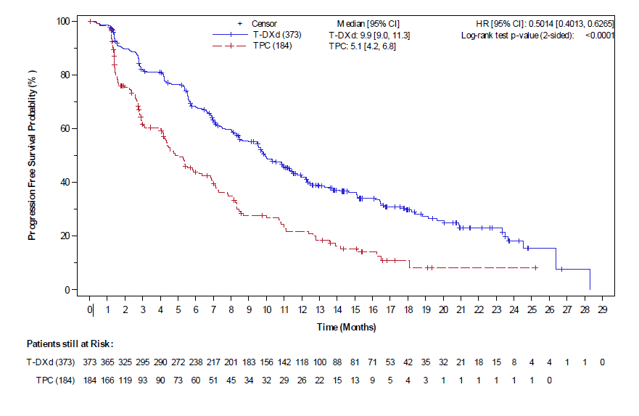
Source: Figure 14.2.1.1.2, p2248 of the DB-04 CSR tables and figures, Attachment 2.8 of the submission.
BICR = blinded independent central review; CI = confidence interval; DB-04 = DESTINY-Breast04; DCO = data cut-off; FAS = full analysis set; HR = hazard ratio; KM = Kaplan-Meier; PFS = progression-free survival; T-DXd = trastuzumab deruxtecan; TPC treatment of physician’s choice
Figure 2: KM plot of PFS by BICR in the hormone receptor positive cohort of DB-04 (DCO 11 January 2022)
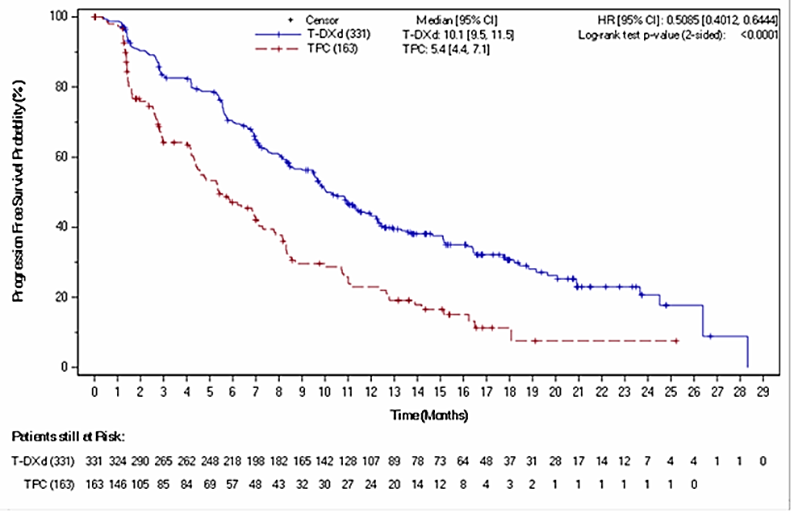
Source: Figure 2-7, p143 of the submission.
BICR = blinded independent central review; CI = confidence interval; DB-04 = DESTINY-Breast04; DCO = data cut-off; HR = hazard ratio; KM = Kaplan-Meier; PFS = progression-free survival; T-DXd = trastuzumab deruxtecan; TPC treatment of physician’s choice.
Figure 3: KM plot of PFS by BICR in the hormone receptor negative cohort of DB-04 (DCO 11 January 2022)
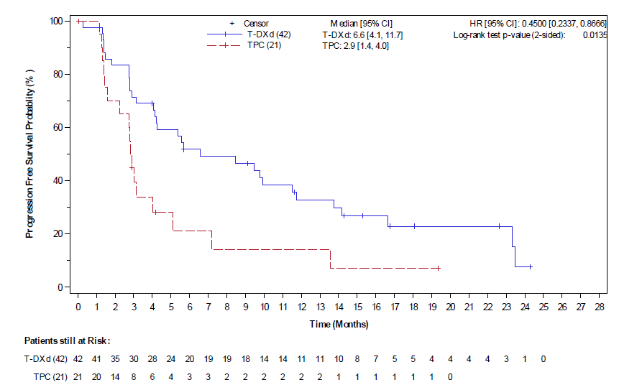
Source: 14.2.1.1.3, p2249 of the DB-04 CSR tables and figures, Attachment 2.8 of the submission.
BICR = blinded independent central review; CI = confidence interval; DB-04 = DESTINY-Breast04; DCO = data cut-off; HR = hazard ratio; KM = Kaplan-Meier; PFS = progression-free survival; T-DXd = trastuzumab deruxtecan; TPC treatment of physician’s choice.
Table 5: Summary of OS in the DB-04 trial (DCO 1 March 2023, 32 months median follow-up)
OS, FAS | T-DXd (N=373) | TPC (N=184) | Absolute difference | Hazard ratio  (95% CI)
Patients with event (%) | 242 (64.9) | 128 (69.6) | - | -
Median OS, months (95% CI) | 22.9 (21.5, 24.5) | 16.8 (14.1, 19.5) | 6.1 | 0.69 (0.55, 0.86)
Proportion of patients alive over time
At 12 months (95% CI) | 78.5 (74.0, 82.4) | 66.3 (58.5, 73.0) | 12.2 | -
At 18 months (95% CI) | 63.0 (57.8, 67.8) | 46.7 (38.8, 54.2) | 16.3 | -
At 24 months (95% CI) | 47.3 (41.9, 52.4) | 32.0 (24.8, 39.3) | 15.3 | -
At 36 months (95% CI) | 26.2 (20.8, 31.9) | 16.3 (10.3, 23.6) | 9.9 | -
At 42 months (95% CI) | 21.7, (15.2, 28.9) | NE (NE, NE) | - | -
OS, HR positive cohort | T-DXd (N=331) | TPC (N=163) | Absolute difference | Hazard ratio  (95% CI)
Patients with event (%) | 211 (63.7) | 110 (67.5) | - | -
Median OS, months (95% CI) | 23.9 (21.7, 25.2) | 17.6 (15.1, 20.2) | 6.3 | 0.69 (0.55, 0.87)
Proportion of patients alive over time*
At 12 months (95% CI) | 87.4 (75.6, 84.3) | 69.3 (61.1, 76.2) | 18.1 | -
At 36 months (95% CI) | 26.5 (20.7, 32.7) | 16.9 (10.2, 25.0) | 9.6 | -
At 42 months (95% CI) | 21.0 (12.7, 30.7) | NE (NE, NE) | -
OS, HR negative cohort** | T-DXd (N=42) | TPC (N=21) | Absolute difference | Hazard ratio  (95% CI)
Patients with event (%) | 31 (73.8) | 18 (85.7) | - | -
Median OS, months (95% CI) | 16.6 (11.3, 22.7) | 10.3 (6.1, 15.2) | 6.3 | 0.66 (0.36, 1.23)
Figure 2-11, pp150-151, and Table 2-43, pp174-175 of the submission.
CI = confidence interval; DB-04 = DESTINY-Breast04; DCO = data cut-off; FAS = full analysis set; HR = hormone receptor; OS = overall survival; T-DXd = trastuzumab deruxtecan; TPC = treatment of physician’s choice.
*The proportion of the HR positive cohort alive at 18 months and 24 months does not appear to be correct in the submission and is not presented here.
** the ‘proportion of patients alive over time’ for the HR negative cohort was not provided for the 1 March DCO.
  - At a median follow of up of 32 months across both arms, 64.9% of patients in the T-DXd arm had died compared with 69.6% in the TPC arm in the FAS. Patients treated with T-DXd had a median OS of 22.9 months compared with the median OS of 16.8 months for TPC, with a statistically significant hazard ratio of 0.69 (95% CI: 0.55, 0.86) (Table 5). A separation of the KM curves was observed from Month 6 and was sustained until 36 months. Thereafter, the number of patients at risk was low and the KM estimates for OS became unreliable (Figure 4).
  - The results of OS in the HR positive cohort are similar to the FAS with 63.7% of patients in the T-DXd arm having died compared with 67.5% of patients in the TPC arm. The median OS in the T-DXd arm was 23.9 months compared to 17.6 months in the TPC arm. The KM curves for the HR positive cohort are displayed in Figure 5. Like the FAS, a separation of the KM curves was observed at 6 months and persisted until 36 months at which point the number of patients at risk became too low for the KM estimates to be reliable.
  - At a median follow up of 32 months, the proportion of patients who had died in the HR negative cohort was 73.8% in the T-DXd arm and 85.7% in the TPC arm, which is higher than in the FAS and HR positive cohort. The KM curves for the HR negative cohort is shown in Figure 6. The small number of patients in the HR negative cohort makes the results and the KM curves unreliable.
Figure 4: OS for the FAS population in the DB-04 trial (1 March 2023 DCO)
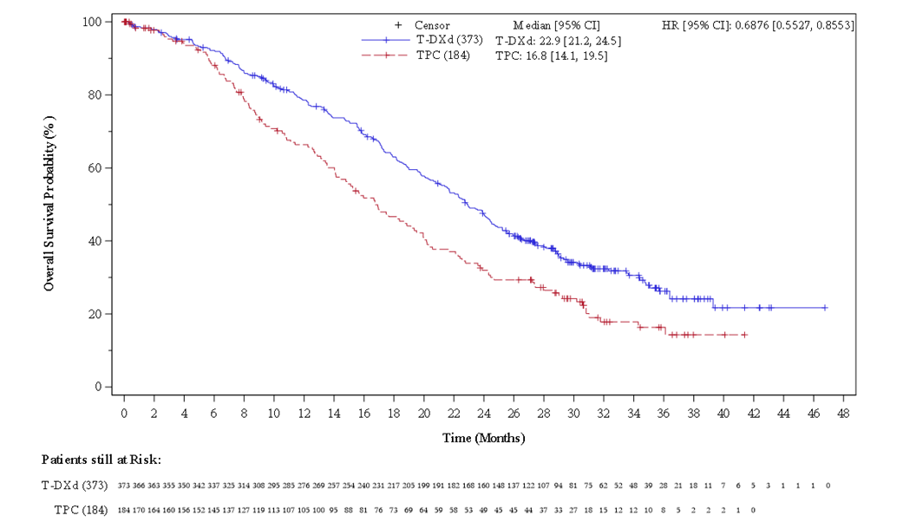
Source: Figure 2-11, pp150-151 of the submission.
CI = confidence interval; DCO = data cut-off; FAS = full analysis set; N = number of patients; NE = not estimable; OS = overall survival; T-DXd = trastuzumab deruxtecan; TPC = treatment of physician’s choice.
Figure 5: KM plot of OS in the hormone receptor positive cohort in the DB-04 trial (DCO 1 March 2023)
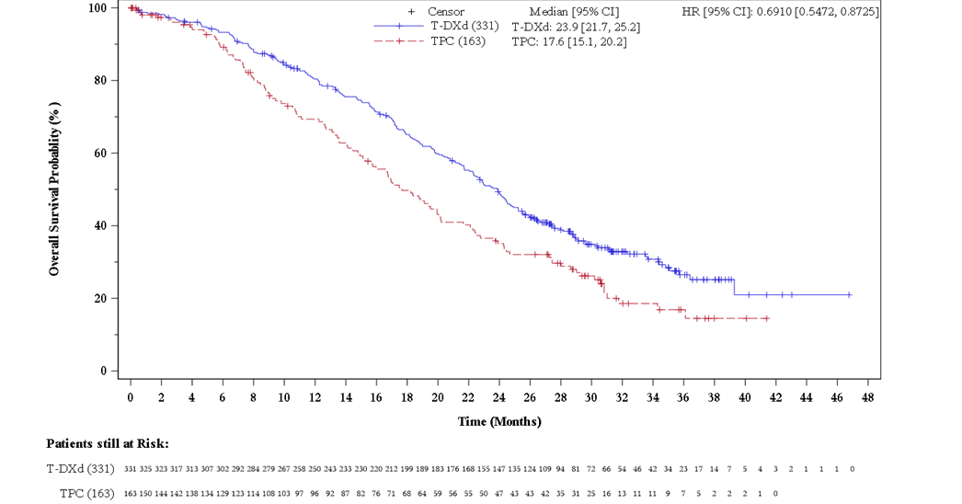
Source: Figure 2-10, p150 of the submission.
CI = confidence interval; DB-04 = DESTINY-Breast04; DCO = data cut-off; HR= hazard ratio; KM = Kaplan-Meier; OS = overall survival; T-DXd = trastuzumab deruxtecan; TPC = treatment of physician’s choice
Figure 6: KM plot of OS in the hormone receptor negative cohort in the DB-04 trial (DCO 1 March 2023)
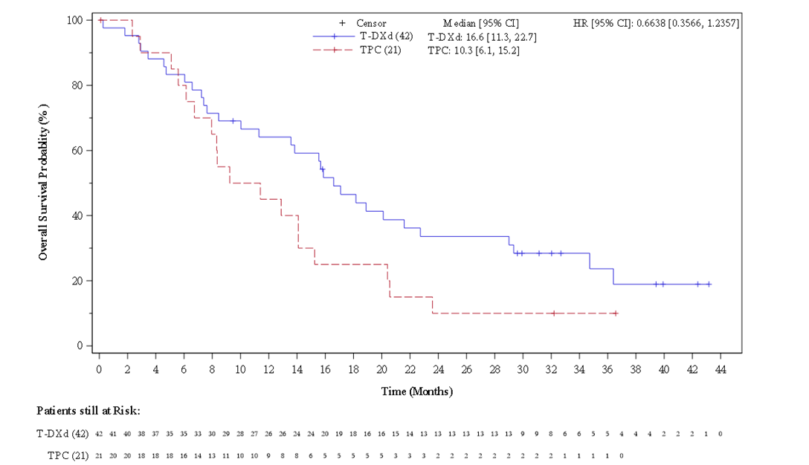
Source: Figure 2-20, p171 of the submission
CI = confidence interval; DB-04 = DESTINY-Breast04; DCO = data cut-off; HR= hazard ratio; KM = Kaplan-Meier; OS = overall survival; T-DXd = trastuzumab deruxtecan; TPC = treatment of physician’s choice
  - The PSCR stated the sponsor had been informed that a difference in the HR status of five subjects recorded in the interactive web/voice response system (IXRS) versus electronic data capture (EDC) was identified where these five subjects had been mis-stratified to the HR negative/HER2 low cohort when they were HR positive/HER2 low. The PSCR noted this reduced the size of this subgroup from 63 (IXRS) to 58 (EDC). The PSCR noted reanalysis using EDC patient numbers resulted in a median PFS of 8.5 months for T-DXd vs. 2.9 months for TPC [HR 0.46 (95%CI: 0.24, 0.89)] and median OS of 18.2 months for T-DXd vs. 8.3 months for TPC [HR 0.48 (95%CI: 0.24, 0.95)]. The PSCR stated these results are consistent with the results presented in the Product Information.
  - The confirmed objective response rate (ORR) based on BICR was 52.3% (95% CI: 47.1, 57.4) in the T-DXd arm and 16.3% (95% CI: 11.3, 22.5) in the TPC arm. In the two treatment arms, most of the confirmed objective response involved a partial response, with only a few patients having a complete response (13 [3.5%] for T-DXd and 2 [1.1%] for TPC).
  - The duration of response (DoR) for confirmed responses based on BICR was longer in the T-DXd arm than in the TPC arm (median: 10.7 months [95% CI: 8.5, 13.7] vs. 6.8 months [95% CI: 6.0, 9.9]).
  - HRQoL outcomes were assessed using three patient-reported outcome (PRO) questionnaires: the Quality of Life of Cancer Patients questionnaire (QLQ-C30), Quality of Life Breast Cancer Questionnaire (QLQ-BR45) and EuroQol 5-dimension 5-level (of severity) assessment (EQ-5D-5L). All HRQoL assessments were conducted during the treatment period, at the end of treatment (EOT), and during the 40-day and long-term/survival follow-up visits. In DB-04, HRQoL data were only assessed in the HR positive cohort, it was not explained why this was the case. Given the open-label design of the trial, there is the potential for bias in assessment of PROs.
  - Across the three questionnaires, the HRQoL data showed a delay in time to definitive deterioration (TTDD) for patients receiving T-DXd when compared to patients receiving TPC. In the QLQ-C30 patients had a noticeable delay in TTDD by at least 10 points in the T-DXd arm compared to TPC in the global health scale (7.6 months vs. 5.1 months, hazard ratio: 0.71, 95% CI: 0.56, 0.92), pain scale (9.7 months vs. 4.4 months hazard ratio: 0.51, 95% CI: 0.39, 0.65), physical functioning (9.2 months vs. 4.9 months, hazard ratio: 0.54, 95% CI: 0.42, 0.70), emotional functioning (11.3 months vs. 6.3 months, hazard ratio: 0.64, 95% CI: 0.48, 0.85) and social functioning (7.7 months vs. 4.4 months, hazard ratio: 0.67, 95% CI: 0.53, 0.86).
  - In the QLQ-BR23 questionnaire, patients experienced a notable delay in TTDD by at least 10 points in the arm symptoms subscale (9.8 months vs. 5.4 months, hazard ratio: 0.67, 95% CI: 0.50, 0.88). And in theEQ-5D-5L patients had a noticeable delay in TTDD in the visual analogue scale (8.8 months vs. 4.7 months, hazard ratio: 0.70, 95% CI: 0.54, 0.91).
T-DXd vs SG in HR negative/HER2 low breast cancer
  - In addition to the results of T-DXd vs. TPC from the DB-04 trial, the submission presented a descriptive indirect single arm comparison of T-DXd vs. SG. This comparison used the HR negative cohort of the DB-04 trial and the HER2 low cohort of the ASCENT trial. The data for the HER2 low cohort of the ASCENT trial were derived from a post hoc analysis of patients with recorded HER2 scores of IHC 1+ or IHC2+/ISH-.
  - Although the median PFS by BICR and the median OS appeared comparable between the two cohorts, the PBAC noted the ESC considered this comparison was unreliable due to the small numbers of patients, differences in the composition of TPC in each trial, missing baseline characteristics (such as age at diagnosis and the location of metastases), differences in median duration of follow-up, and differences in the number of prior lines of chemotherapy. Additionally, the PBAC considered the comparison was not relevant as SG was not the main comparator in the HR negative population (see paragraph 5.2).

Comparative harms
  - A summary of the safety results in the DB-04 safety analysis set (SAS) is presented in Table 6. Adverse events (AEs) of special interest, namely interstitial lung disease (ILD) and left ventricular dysfunction (LVD), are included. Both AEs of special interest have previously been documented with the use of T-DXd and are mentioned in the product information (PI).
Table 6: Summary of adverse events in the DB-04 SASª population (DCO 1 March 2023)
 | T-DXd | TPC | RD (95% CI)* | RR (95% CI)*
TEAEs (%) | 369/371 (99.5) | 169/172 (98.3) | 0.01 (-0.01, 0.03) | 1.01 (0.99, 1.03)
TEAEs of CTCAE grade ≥3 (%) | 202/371 (54.4) | 116/172 (67.4) | -0.13 (-0.22, -0.04) | 0.81 (0.70, 0.93)
Serious TEAEs (%) | 108/371 (29.1) | 44/172 (25.6) | 0.04 (-0.04, 0.12) | 1.14 (0.84, 1.54)
TEAEs associated with an outcome of death (%) | 15/371 (4.0) | 5/172 (2.9) | 0.01 (-0.02, 0.04) | 1.39 (0.51, 3.76)
TEAE associated with study drug discontinuation (%) | 62/371 (16.7) | 14/172 (8.1) | 0.09 (0.03, 0.14) | 2.05 (1.18, 3.56)
AEs of special interest
ILD (%) | 45/371 (12.1) | 1/172 (0.6) | 0.12 (0.08, 0.15) | 20.86 (2.90, 150.10)
LVD (%)^{b} | 60/335 (17.9) | 11/142 (7.7) | 0.10 (0.04, 0.16) | 2.31 (1.25, 4.26)
Source: Table 2-46, p182, and Table 2-55, p194 of the submission, Table 10.26, pp176-178 of the DB-04 CSR.
AEs = adverse events; CTCAE = Common Terminology Criteria for Adverse Events; DB-04 = DESTINY-Breast04; DCO = data cut-off; ILD = interstitial lung disease; LVD = left ventricular dysfunction; SAS = safety analysis set; T-DXd = trastuzumab deruxtecan; TEAE = treatment emergent adverse event; TPC = treatment of physician’s choice.
ª The safety analysis set included all patients who received at least one dose of study drug (N=543)
^{b} The denominator for LVD was patients who had non-missing data at both baseline and post-baseline for measurements of left ventricular ejection fraction.
Bold = Statistically significant
* Calculated using Stata MP 17.0
ILD is a group of respiratory diseases that affect the tissue and space around the air sacs of the lungs. It can cause scarring, inflammation, and difficulty breathing.
LVD is a condition that affects the function of the left side of the heart and can result in heart failure.
  - In the DB-04 trial, almost all patients in both arms experienced treatment emergent adverse events (TEAEs) (99.5% in T-DXd and 98.3% in TPC). The incidence of Grade ≥ 3 TEAEs was higher in the TPC arm than in the T-DXd arm, whereas patients receiving T-DXd had a greater risk of experiencing TEAEs leading to treatment discontinuation. The differences between the two treatment arms in terms of these TEAEs were statistically significant.
  - TEAEs associated with an outcome of death were reported in 15 (4.0%) patients in the T-DXd arm and five (2.9%) patients in the TPC arm. Of these, seven (1.9%) patients in the T-DXd arm and no subjects in the TPC arm had fatal TEAEs which were considered by the investigator to be related to study drug. The treatment related TEAEs leading to death in the T-DXd arm were listed as pneumonitis in two cases, and one instance each of: ischemic colitis, dyspnoea, sepsis, disseminated intravascular coagulation, and febrile neutropenia.
  - Drug-related ILD occurred in 45 (12.1%) patients in the T-DXd arm compared to one (0.6%) in the TPC arm. Likewise, 60 (17.9%) patients in the T-DXd arm experienced LVD and 11 (7.7%) in the TPC arm. As ILD can result in scarring of lung tissue making it difficult to breathe and LVD can lead to heart failure, the differences in these AEs were clinically relevant as well as statistically significant.
  - The most common TEAEs experienced varied by treatment arm. Nausea was the most common TEAE for T-DXd (76.0%) while neutrophil count decrease was the most common TEAE in patients receiving TPC (36.0%). The TEAEs that had a notably higher (≥10% difference) incidence in the T-DXd arm than in the TPC arm included nausea (76.0% vs. 30.2%), vomiting (40.7% vs. 13.4%), anaemia (38.5% vs. 26.7%), constipation (34.5% vs. 22.1%), decreased appetite (31.8% vs. 19.2%), platelet count decrease (20.8% vs. 7.0%) and ILD (12.1% vs. 0.6%). The TEAEs that had a notably higher (≥10% difference) incidence in the TPC arm than in the T-DXd arm were neutrophil count decrease (22.1% vs. 36.0%) and palmar-plantar erythrodysaesthesia syndrome (1.3% vs. 14.0%). The most common TEAEs reported in the two treatment arms were in line with the known safety profile of T-DXd and chemotherapy. The PSCR noted that prescribers of T-DXd for the requested HER2-low population will be the same prescribers of T-DXd for HER2+ disease and have considerable experience with managing the adverse events profile of T-DXd.
  - The total patient years of exposure in the T-DXd arm was 283.55 compared to 63.59 in the TPC arm. Due to the greater total patient years of exposure, the exposure adjusted incidence rate (EAIR) of TEAEs favoured T-DXd in all TEAEs measured in this way, including: any TEAE (1.30 vs. 2.66), TEAEs of ≥ grade 3 (0.69 vs. 1.82), and treatment emergent SAEs (0.36 vs. 0.68). However, as patients in the clinical setting would be expected to receive T-DXd for a greater duration of time than chemotherapy, the ESC agreed with the evaluation that the unadjusted TEAE incidence rate is more informative for the AEs that a patient may experience over the course of treatment.

Benefits/harms
  - A summary of the comparative benefits and harms for T-DXd versus TPC in DB-04 is presented in Table 7.
Table 7: Summary of comparative benefits and harms for T-DXd and TPC based on DB-04 trial data.
Progression free survival (DCO 11 January 2022)ª
Event | T-DXd | TPC | Absolute Difference | Hazard ratio (95% CI)
Disease progression or deaths, n/N (%) | 234/373 (65.1) | 127/184 (69.0) | – | 0.50 (0.40, 0.63)
Median PFS, months (95% CI) | 9.9 (9.0, 11.3) | 5.1 (4.2, 6.8) | 4.8
% alive and progression-free at 6 months (95% CI) | 68.1 (63.0, 72.6) | 43.9 (35.9, 51.6) | 24.2
% alive and progression-free at 12 months (95% CI) | 41.9 (36.6, 47.2) | 21.8 (15.3, 29.2) | 20.1
% alive and progression-free at 18 months (95% CI) | 29.7 (24.4, 35.2) | 10.9 (5.7, 18.1) | 18.8
Overall survival (DCO 1 March 2023, Median duration of follow up, 32 months)
Deaths, n/N (%) | 242/373 (64.9) | 128/184 (69.6) | - | 0.69 (0.55, 0.86)
Median OS, months (95% CI) | 22.9 (21.5, 24.5) | 16.8 (14.1, 19.5) | 6.1
% Alive at 12 months (95% CI) | 78.5 (74.0, 82.4) | 66.3 (58.5, 73.0) | 12.2
% Alive at 36 months (95% CI) | 26.2 (20.8, 31.9) | 16.3 (10.3, 23.6) | 9.9
Harms
 | T-DXd  n/N | TPC  n/N | RR^{b}  (95% CI) | Event rate/100 patients |  | RD^{b}  (95% CI)
 |  |  |  | T-DXd | TPC
Any TEAE | 369/371 | 169/172 | 1.01 (0.99, 1.03) | 99.5 | 98.3 | 0.01 (-0.01, 0.03)
Serious TEAEs | 108/371 | 44/172 | 1.14  (0.84, 1.54) | 29.1 | 25.6 | 0.04  (-0.04, 0.12)
TEAEs associated with study drug discontinuation | 62/371 | 14/172 | 2.05 (1.18, 3.56) | 16.7 | 8.1 | 0.09 (0.03, 0.14)
ILD | 45/371 | 1/172 | 20.86  (2.90, 150.10) | 12.1 | 0.6 | 0.12 (0.08, 0.15)
LVD^{c} | 60/335 | 11/142 | 2.31 (1.25, 4.26) | 17.9 | 7.7 | 0.10 (0.04, 0.16)
Source: Table 2-31, p158, Figure 2-11, pp150-151, and Table 2-46, p182 of the submission.
CI = confidence interval; CTCAE = Common Terminology Criteria for Adverse Events; FAS = full analysis set; HR = hormone receptor; ILD = interstitial lung disease; LVD = left ventricular dysfunction; OS = overall survival; PFS = progression-free survival; RD = risk difference; RR = risk ratio; SAS = safety analysis set; T-DXd = trastuzumab deruxtecan; TEAE = treatment emergent adverse event; TPC = treatment of physician’s choice.
Bold = statistically significant
ª At 11 January 2022 data cut-off, the median duration of follow-up was 16.1 months in the T-DXd arm and 13.5 months in the TPC arm.
^{b} Calculated using Stata/MP 17
^{c} The denominator for LVD was patients who had non-missing data at both baseline and post-baseline for measurements of left ventricular ejection fraction.
  - On the basis of direct evidence from the DB-04 trial presented in the submission, for every 100 patients treated with T-DXd in comparison with TPC:
- Approximately 19 additional patients would remain alive and progression-free at 18 months.
- Approximately 10 additional patients would remain alive at 3 years.
- Approximately 9 additional patients would discontinue treatment due to an adverse event.
- Approximately 12 additional patients would experience ILD, which affects the tissue and space around the air sacs of the lungs and can cause scarring, inflammation, and difficulty breathing.
- Approximately 10 additional patients would experience LVD, which affects the ability of the heart to pump blood and can lead to heart failure.

Clinical claim
  - The submission described T-DXd as superior in terms of effectiveness compared to TPC in patients with HR positive/HER2 low uBC/mBC patients who have been previously treated with chemotherapy. The submission made the claim that T-DXd had a different but non-inferior safety profile compared to TPC.
  - The ESC considered the claim of superior effectiveness of T-DXd over TPC in patients with HR positive/HER2 low uBC/mBC was supported by the PFS by BICR, OS, and ORR results by BICR, which showed that T-DXd was associated with a statistically and clinically significant improvement in these outcomes when compared with TPC.
  - The claim of a different but non-inferior safety profile of T-DXd vs. TPC was not supported by the evidence from the DB-04 trial. Although the safety results reported in DB-04 were consistent with the established safety profile of T-DXd in patients with HER2+ mBC across two other trials, and aligned with the existing PI, the difference in AEs compared to TPC suggest an inferior safety profile. The ESC noted there was less Grade ≥ 3 treatment-emergent AEs for T-DXd compared to chemotherapy but noted the toxicity associated with chemotherapy is usually manageable and reversible and the toxicity observed with T-DXd is not likely to be reversible and/ or requires treatment discontinuation. The ESC considered a claim of inferior safety was more reasonable.
  - The submission described T-DXd as non-inferior in terms of effectiveness and safety compared to SG in the HR negative/HER2 low population. The PBAC noted this claim was not relevant to its consideration as SG was not the main comparator for this population.
  - The PBAC considered that the claim of superior comparative effectiveness was reasonable for the HER2 low population.
  - The PBAC considered that the claim of non-inferior comparative safety was not adequately supported by the data and a claim of inferior safety was more reasonable.

Economic analysis
  - The submission presented cost-effectiveness and cost-utility analyses for the HR positive cohort of DB-04 measuring outcomes in terms of life-years (LYs) gained and quality-adjusted life years (QALYs) gained. The key components of the cost-utility analysis are presented in Table 8. A cost-minimisation analysis against SG was also presented for the HR negative cohort of DB-04; however, the PBAC noted this was not informative as it did not consider SG was the main comparator for this population.
Table 8: Summary of model structure, key inputs and rationale
Component | Summary
Treatments | T-DXd versus TPC (consisting of capecitabine, gemcitabine, eribulin, nab-paclitaxel, paclitaxel).
Time horizon | 12 years in the model base case vs median OS follow up of 18.4 months (at the January 2022 data-cut). This was only slightly shorter than the 15-year time horizon the PBAC had previously accepted for T-DXd in HER2 positive breast cancer (para 6.22, Trastuzumab deruxtecan PSD, March 2022 PBAC Meeting) despite the median OS of the current submission’s patient population being substantially shorter than for HER2 positive patients.ª
Outcomes | Life years gained; quality-adjusted life years gained.
Methods used to generate results | Partitioned survival analysis.
Health states | Progression-free, progressed disease and dead.
Cycle length | 21 days.
Health state allocation | PFS and OS data from the HR positive cohort of DB-04, represented and extrapolated through parametric functions. Consequently, no KM data was included in the model. This was not appropriate and in contrast to the PBAC guidelines which stipulates that observed time-to-event data should be used until it becomes unreliable.
Extrapolation method | The submission considered the PH assumption holds true for both PFS and OS based on log-cumulative hazard and Schoenfeld residuals plots. The use of dependent parametric functions has not been adequately justified as diagnostic plots presented in the submission were inconclusive regarding whether the PH assumption holds true for both PFS and OS. Additionally, as no treatment waning effect was applied, this resulted in an ongoing treatment benefit associated with T-DXd over TPC until the end of the time horizon.  Standard dependent parametric distributions were fitted to PFS and OS KM data in both arms. Log-normal and log-logistic distributions were chosen to model PFS and OS, respectively, in both arms based on AIC/BIC and visual fit. No treatment waning was applied to any curves. Whilst the PFS data were mature and not sensitive to changes in the parametric functions, there was substantial variation between the modelled OS curves. The submission’s rationale for choosing the log-logistic curve was poorly justified, given that this distribution was not the best fitting curve by AIC/BIC and had poor visual fit compared to the other statistically best fitting curves.  In the base case model 41% of LYs gained occurred after the maximum trial observation period.
Health related quality of life | Treatment specific health state utilities were derived from EQ-5D-5L data from the HR positive cohort of DB-04.  PF: 0.883 for T-DXd and 0.873 for TPC.  PD: 0.875 for T-DXd and 0.821 for TPC.  The application of a higher utility value for T-DXd patients was not plausible given the considerably higher risk of treatment discontinuation with T-DXd due to TEAEs, which may impact quality of life. Additionally, PF utility values in both arms are implausibly high given the background utility of the Australian population^{b} and other advanced breast cancer submissions to the PBAC.^{c} The small utility decrement from the PF to the PD health state in both arms is unlikely to reflect the utility decrement associated with deteriorating disease over time until death. This is possibly due to the lack of collection of EQ-5D-5L data for this health state.^{d}
Source: Constructed during the evaluation.
AIC = Akaike information criterion; BIC = Bayesian information criterion; DB-03 = Destiny Breast-03; DB-04 = Destiny Breast-04; HER2 = human epidermal growth factor receptor 2; HR = hormone receptor; KM = Kaplan Meier; LY = life year; OS = overall survival; PBAC = Pharmaceutical Benefits Advisory Committee; PD = progressed disease; PF = progression-free; PFS = progression-free survival; PH = proportional hazards; PSD = public summary document; T-DXd = trastuzumab deruxtecan; TEAE = treatment emergent adverse event; TPC = treatment of physician’s choice.
ª Lower bound of the 95% CI of the median OS in DB-03 (HER2 positive trial) for HR positive T-DXd patients reported as 40.5 months vs median OS of 23.9 months in DB-04 for T-DXd HR positive patients.
^{b} The background utility of the Australian population for the corresponding age group has been reported as 0.85.
^{c} The previous T-DXd submission (for HER2 positive advanced breast cancer) reported a pooled PF utility value of 0.812, PF utilities of 0.736 and 0.712 were applied for palbociclib + letrozole and letrozole alone, respectively (Table 9, Palbociclib PSD, November 2017 PBAC Meeting) and PF utility values of 0.746 and 0.662 were applied for SG and TPC, respectively (para 6.48, Sacituzumab govetican PSD, March 2022 PBAC Meeting).
^{d} EQ-5D-5L data was only collected at 2 time points (40 days and 3 months post treatment discontinuation) for patients in the PD health state in DB-04.
  - The submission nominated a time horizon of 12 years in the base case analysis as the extrapolated OS curves indicated that most patients had died by this time point. The choice of the extrapolation method for the OS curves was not well-justified and favoured the T-DXd arm (discussed below) and, hence, nominating the time horizon based on these curves may not be reasonable. The ESC noted this population had received at least one prior line of therapy and was likely to have aggressive disease. The ESC considered that a 10 year time horizon would be more appropriate for this patient population but noted the ICER was not sensitive to changing the time horizon from 12 to 10 years (see Table 11).
  - The observed TTD, PFS and OS curves were modelled over the entire time horizon using parametric functions and consequently no KM data was explicitly included in the model. The ESC considered this was not appropriate and in contrast to the PBAC guidelines which state a preference for observed time-to-event data until it becomes unreliable. The ESC noted including KM data in the model for TTD, PFS and OS increased the ICER by 13% (from $75,000 to < $95,000 to $95,000 to < $115,000 per QALY, see Table 12 footnotes for methodology).
  - The submission concluded that the proportional hazards (PH) assumption holds true based on log-cumulative hazard plots and Schoenfeld residuals. Dependently fitted parametric functions were therefore applied to the trial-based KM PFS and OS data from the HR positive cohort. The interpretation of the diagnostic plots is not as straightforward as suggested by the submission. The log-log survival curves were not parallel in the first few months and the Schoenfeld residuals plot showed a non-zero slope over time. The graphical analyses suggest that the PH assumption, at the very least, is uncertain. Additionally, as no treatment waning effect was applied to the extrapolated curves, the submission has assumed an ongoing treatment benefit associated with T-DXd over TPC until the end of the time horizon (i.e. 12 years), despite treatment with T-DXd lasting, on average, 13 months. The submission did not provide any evidence to support an ongoing treatment effect beyond the trial observation period. Whilst the model was not sensitive to changes in the modelling of PFS due to the maturity of data, a substantial amount of extrapolation was required for OS (approximately 8 years) and hence it is not reasonable to assume that a treatment benefit associated with T-DXd is maintained throughout this time period. The ESC considered it was appropriate for the OS curve to converge and noted that the independent Weibull function resulted in convergence at approximately 6.5 years.
  - The submission did not nominate the statistically best fitting dependent parametric function (Weibull) to model OS. Instead, the dependent log-logistic parametric function was chosen in both arms on the basis of visual fit and similar resulting median OS to what was reported in the DB-04 trial for the HR positive cohort. Most parametric functions fit the OS KM data well at earlier time points and hence all report similar median OS to the HR positive cohort of DB-04. However, this argument does not address the shape of the tail end of the curves, which is substantially uncertain given the amount of extrapolation required. Figure 7 compares the visual fitness of the submission’s base case curves (log logistic) against the statistically best fitting independent curves (Weibull) in both arms. Nominating an independent Weibull curve to model OS in both arms increased the ICER by 31% (from $75,000 to < $95,000 per QALY gained to $115,000 to < $135,000 per QALY gained) whereas nominating the dependent Weibull curve, which had a similar visual fit, increased the ICER by 27% (from $75,000 to < $95,000 per QALY gained to $95,000 to < $115,000 per QALY gained). The PSCR stated that when overlaying the PFS and OS curves of the top five distributions, the log-logistic curve was the only distribution where the PFS curve did not converge with the OS curve. The ESC considered that using a dependent log-logistic extrapolation assumed that a treatment benefit associated with T-DXd is maintained until the end of the time horizon (12 years) which overestimated the tail of the T-DXd OS curves. The ESC preferred an independent Weibull extrapolation because it resulted in convergence that was more aligned with what is known about current treatments for metastatic HER2-low breast cancer i.e., they extend OS, but do not provide a cure. The PSCR stated that in the longer-term, clinical experts indicated that some patients would still be expected to be alive at 10 years in the T-DXd arm and therefore considered the Weibull curve to be too pessimistic.
Figure 7: Comparison of OS parametric functions
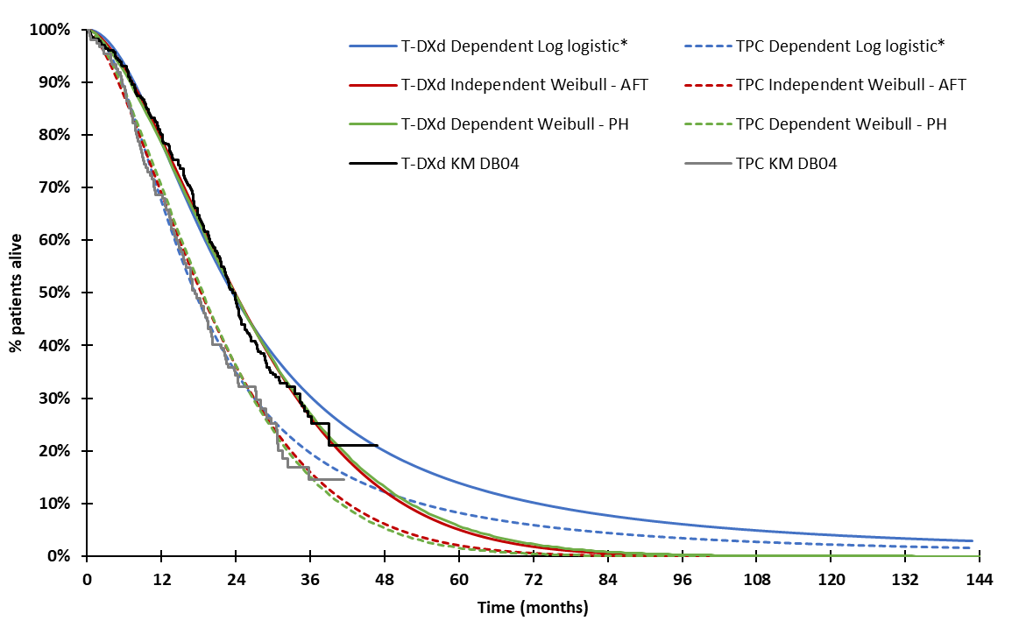
Source: Constructed during the evaluation, based on the “T-DXd_HER2-low 2L 3L mBC July 2023 CUA” Excel workbook included with the submission.
AFT = accelerated failure time; DB04 = Destiny Breast-04; KM = Kaplan Meier; OS = overall survival; PH = proportional hazards; TPC = treatment physician choice.
* Denotes the submission’s base case
  - The base case analysis applied treatment-specific health state utility values which were derived from EQ-5D-5L data reported in the DB-04 trial and transformed to utility values using Australian weights with no decrements due to AEs. This resulted in higher utility values for T-DXd patients. This does not reflect the substantial risk of inferior safety associated with T-DXd treatment (as discussed above) including the risk of ILD which is not curable and has continuing decrements to quality of life. The application of treatment-specific utility values was also not reasonable as EQ-5D-5L data were not statistically different across the two treatment arms and no justification was provided to support a difference in quality of life. Pooled health state utilities of 0.881 for the progression-free (PF) and 0.863 for the progressed disease (PD) health states were provided during evaluation. However, the evaluation considered the following issues remain:
- Whilst a pooled PF health state utility is more reasonable to include in the base case analysis, the evaluation considered this was implausibly high as it was higher than the background utility of the general Australian population for the corresponding age group which has been reported as 0.85. This utility was also substantially higher than other advanced breast cancer submissions to the PBAC. This may be due to the collection of EQ-5D data on day 1, every second cycle before infusion and hence decrements in quality of life due to T-DXd or TPC treatment are unlikely to be captured. This was problematic given the considerably higher risk of treatment discontinuation with T-DXd due to TEAEs, presumably also impacting on quality of life.
- Only a small decrement between the PF and PD health state utility values (-0.018 in both treatment arms) was reported. This was not plausible considering that disease progression has a large impact on quality of life for advanced breast cancer patients, and this health state continues from progression to death. This is most likely due to the early collection of EQ-5D data after progression (which may be radiological) rather than as symptoms progress toward the end of the health state. The ESC have previously considered the Lloyd et al.20 algorithm (i.e. a PD utility decrement of -0.272) to be reasonable to derive a non-treatment-specific PD health state utility when considering T-DXd for HER2 positive breast cancer (para 6.32, Trastuzumab deruxtecan PSD, July 2022 PBAC Meeting). This may be preferable to apply in the base case analysis for the PD health state.
The ICER was sensitive to cumulative changes in health state utility values (see Table 12).
  - The recommended dosing of T-DXd, outlined in the Australian PI, is 5.4 mg/kg administered intravenously, once every 3 weeks. However, the submission applied a relative dose intensity (RDI) of 90% to the recommended dose based on previous PBAC advice where it considered that the RDI reported in the SG ASCENT trial did not account for AE-related dose reductions and treatment interruptions (para 7.15, Sacituzumab govitecan PSD, March 2022 PBAC Meeting). As the submission indicated it was unsure whether the reported mean T-DXd RDI (99.8%) in the DB-04 clinical study report (CSR) accounted for AE-related dose reductions and interruptions, the applied RDI (90%) was not well justified. The mean actual dose intensity, which is based on the actual amount of T-DXd consumed (and hence likely to include dose reductions) was 5.1 mg/kg. Hence it is more reasonable to assume an RDI based on the actual dose intensity, relative to the recommended dose (94.4%). The applied RDIs for the TPC drugs were sourced directly from the DB-04 trial. However, the reported RDIs measured compliance to the planned dose intensity in DB-04 which was considerably lower than the recommended Australian dosing regimens. Hence, similar to T-DXd, the evaluation explored the effect of applying an RDI which was based on the average actual dose intensity, relative to the recommended dose in both arms. This increased the ICER by 8% (from $75,000 to < $95,000 per QALY gained to $95,000 to < $115,000 per QALY gained).
  - The submission assumed vial sharing would occur in the economic evaluation. This was not reasonable and is not consistent with the PBAC guidelines and the T-DXd PI which clearly stipulates that the “product is for single use in one patient only” and to “discard any residue” and the previous T-DXd submission for HER2 positive breast cancer. The PSCR stated the assumption of vial sharing was included in the cost-utility analysis firstly to be consistent with the approach accepted for SG for TNBC in March 2022 and because the practice of vial sharing to minimise wastage is more efficient than would otherwise occur if drug was supplied and claimed on a whole-vial basis and reflects the commercial reality of the PBS supply chain. Although the economic model allowed wastage to be incorporated (which was based on a normal distribution of body weight (for T-DXd) and body surface area (BSA) (for TPC)), this was applied incorrectly. It was 1) assumed that efficient funding of chemotherapies (EFC) dispensing fees were proportional to the cost of the medicine (whereas these are fixed, and so apply regardless of the amount dispensed) and 2) the RDI was applied after the required number of vials was estimated, which is not reasonable given the RDI relates to dosing and hence should be applied to the dose required. Additionally, for certain TPC drugs, incorrect vial sizes and inefficient use of vials were included. Assuming no vial sharing and correcting the EFC fees resulted in a 17% increase in the ICER (from $75,000 to < $95,000 per QALY gained to $95,000 to < $115,000 per QALY gained). The pre-PBAC response accepted removing assumptions regarding vial sharing.
  - Time on treatment for T-DXd and TPC was modelled through independent parametric functions, informed by time to treatment discontinuation (TTD) data from the HR positive cohort of DB-04. While the model was not sensitive to the nominated parametric function in the TPC arm, the submission had chosen an independent gamma function (third best statistical fit) to model T-DXd TTD data, however this was observed to underestimate TTD KM data. The generalized gamma function (second best statistical fit) appeared to have the best visual fit among all parametric functions. Using this function increased the time on treatment from 11.0 months (15.9 administrations) to 11.4 months (16.6 administrations) which increased the ICER by 4% (from $75,000 to < $95,000 per QALY gained to $75,000 to < $95,000 per QALY gained). The PSCR stated there was a marginally better statistical fit using AIC for generalised gamma, but there was a better statistical fit using BIC for the gamma function. The ESC considered applying the gamma function to model TTD for T-DXd was reasonable.
  - The economic analysis included costs associated with a subsequent line of therapy for a certain proportion of patients until death. The submission selected the most common and relevant subsequent therapies reported in DB-04 and distributed the patients in the progressed disease health state to each subsequent therapy as per the proportions reported in the DB-04 CSR for the HR positive cohort. This was not appropriate as these proportions included patients who had not yet progressed at the data cutoff and hence the applied proportions did not represent the distribution of use of each subsequent therapy among progressed patients. This was recalculated during the evaluation based on the clinical data to ensure the distribution reflected subsequent therapy use among progressed patients who received subsequent therapy. This approach was previously accepted by the Sponsor and the PBAC in the HER2 positive submission (para 7.9, Trastuzumab deruxtecan PSD, July 2022 PBAC Meeting). The evaluation also noted several issues with the submission’s approach to calculating the cost of subsequent therapies as vial sharing was assumed and incorrect vial sizes, dosing regimens and administration costs were applied for certain subsequent therapies. Once these issues were addressed, the ICER increased by 7% (from $75,000 to < $95,000 per QALY gained to $75,000 to < $95,000 per QALY gained).
  - Key model drivers are presented in Table 9.
Table 9: Key drivers of the model
Description | Method/Value | Impact  Base case: ||¹/QALY gained
OS Extrapolation | Dependent log-logistic distribution in both arms based on statistical and visual fit. As there was no application of treatment waning to the parametric functions, the modelled curves represented an ongoing treatment effect of T-DXd, in terms of overall survival, until the end of the time horizon, which was not justified.  The independent Weibull curve had better visual and statistical fit than the submission’s base case and estimated convergence of the OS curves at approximately 6.5 years, indicating a diminishing treatment effect. | High, favours T-DXd. Use of independent Weibull OS curves in both arms increased the ICER to ||||²/QALY gained.
Use of KM data | The observed TTD, PFS and OS curves were modelled over the entire time horizon using parametric functions and consequently no KM data was explicitly included in the model. | High, favours T-DXd. Use of KM data for TTD, PFS and OS in the model increased the ICER to ||||³/ QALY gained.
Vial sharing and EFC fees | 100% vial sharing assumed in the base case with proportional EFC fees. Vial sharing is not appropriate and contrasts the PBAC guidelines and the PI documents for T-DXd and TPC drugs which stipulate that wastage should be incorporated and unused portions left in vials should be discarded. EFC fees are fixed, and not proportional to the amount of drug dispensed. | High, favours T-DXd. Assuming no vial sharing, and fixed EFC fees in both arms increased the ICER to ||||³/QALY gained.
Utilities | The submission applied treatment-specific health state utilities for both the PF and PD health states with no decrements due to adverse events. This was not justified, given that the EQ-5D-5L utility scores were not significantly different between the two treatment arms, AEs were higher in the T-DXd arm, the EQ-5D-5L measures were not timed to capture disutility while on treatment, and that there is potential for bias for assessment of quality-of-life outcomes due to the open-label design of the clinical trial.  The PF utilities (both pooled and treatment-specific) appear unreasonably high. The small decrement between the PF and PD health state utility values does not seem plausible. | High, favours T-DXd. Use of a pooled PF utility of 0.881 and assuming a PD decrement of -0.272 (as suggested by Lloyd et al20) in both arms, increased the ICER to ||||³/QALY gained.
RDI | The submission assumed an RDI of 90% for T-DXd based on previous PBAC advice that the RDI reported for SG did not account for AE-related dose reductions and treatment interruptions (para 7.15, Sacituzumab govitecan PSD, March 2022 PBAC Meeting). As the submission stated it was “unclear” whether the reported T-DXd RDI in the DB-04 CSR accounted for AE-related dose reductions and interruptions, the RDI applied was not well justified. Applying an RDI based on the mean actual dose intensity (which is the actual amount of drug consumed) relative to the recommended Australian dosing regimen may be more reasonable for T-DXd and TPC drugs. | Moderate, favours T-DXd. Applying RDIs based on the mean actual dose intensity relative to the recommended dose intensity increased the ICER to ||||³/QALY gained.
Source: Constructed during the evaluation.
AE = adverse events; CSR = clinical study report; DB-04 = Destiny Breast-04; EFC = Efficient Funding of Chemotherapies; ICER = incremental cost effectiveness ratio; OS = overall survival; PBAC = Pharmaceutical Benefits Advisory Committee; PD = progressed disease; PF = progression-free; PI = Product Information; PSD = public summary document; QALY = quality-adjusted life year; RDI = relative dose intensity; T-DXd = trastuzumab deruxtecan; TPC = treatment of physician’s choice.
The redacted values correspond to the following ranges:
¹ $75,000 to < $95,000
² $115,000 to < $135,000
³ $95,000 to < $115,000
  - The submission’s stepped evaluation was not considered informative for decision making as no trial-based evaluation was included and hence the effect of extrapolation could not be clearly observed. A revised version has been presented below which allows the effects of extrapolation and the transformation of LYs to QALYS to be clearly observed. The re-arranged stepped evaluation is presented in Table 10.
Table 10: Results of the re-arranged stepped economic evaluation
Step | Description | T-DXd | TPC | Increment
1 | Trial based (DB-04) economic evaluation. Based on the PFS and OS data from the HR positive cohort of DB-04 represented with parametric functions. Time horizon of 3.83 years (OS follow-up time in DB-04).  Costs: Drug acquisition, drug administration and AE management.  Outcomes: LYs gained
 | Costs ($) | | | $8,422 | |
 | Outcomes | 2.13 | 1.75 | 0.38
 | Incremental cost per LY gained |  |  | | ¹
2 | Modelled economic evaluation. PFS and OS data extrapolated with parametric functions until 12 years. 5% discounting of costs and outcomes.  Costs: as in Step 1 + disease management and monitoring, subsequent therapy and terminal care  Outcomes: LYs gained over the modelled time horizon
 | Costs ($) | | | $53,892 | |
 | Outcomes | 2.47 | 1.94 | 0.53
 | Incremental cost per LY gained |  |  | $ | ²
3 | Cost per QALY gained. Transformation of LYs to QALYs.  Costs: As in Step 2  Outcomes: QALYs over the modelled time horizon
 | Costs ($) | | | $53,892 | |
 | Outcomes | 2.17 | 1.63 | 0.54
 | Incremental cost per QALY gained (base case) |  |  | $ | ²
Source: Constructed during the evaluation, based on the “T-DXd_HER2-low 2L 3L mBC July 2023 CUA” Excel workbook included with the submission.
AE = adverse event; DB-04 = Destiny Breast-04; HR = hormone receptor; LY = life year; OS = overall survival; PFS = progression-free survival; QALY = quality-adjusted life year; T-DXd = trastuzumab deruxtecan; TPC = treatment of physician’s choice.
The redacted values correspond to the following ranges:
¹ $115,000 to < $135,000
² $75,000 to < $95,000
  - Figure 8 depicts life years gained over the time horizon. It is noted that 41% of the incremental life years in the base case occurred after the maximum trial observation period and may be overly optimistic due to the approach used to extrapolate OS. The modelled mean undiscounted increase in PFS was 8.2 months and the mean undiscounted gain in OS was 7.7 months.
Figure 8: LYs gained over the time horizon, undiscounted
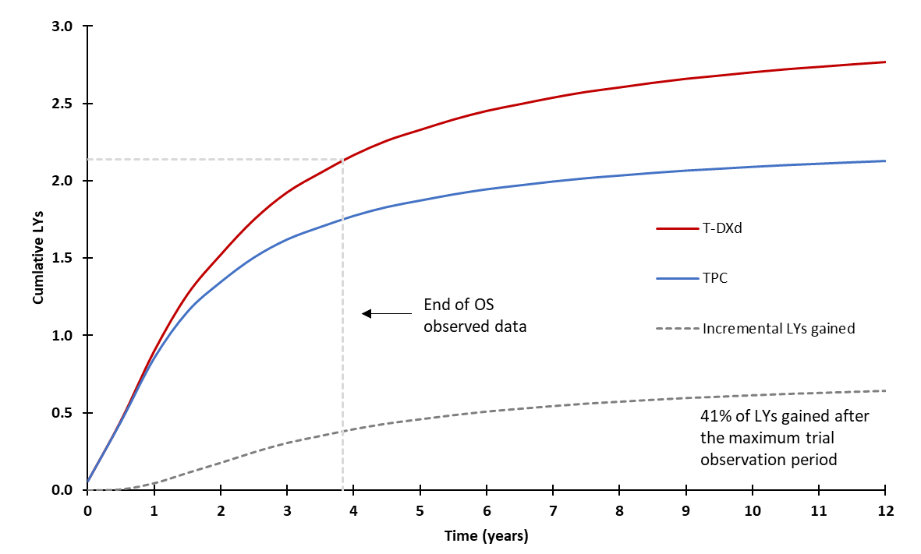
Source: Constructed during the evaluation, based on the “T-DXd_HER2-low 2L 3L mBC July 2023 CUA” Excel workbook included with the submission.
LYs = life years; T-DXd = trastuzumab deruxtecan; TPC = treatment of physician’s choice.
  - The disaggregated summary for costs and health outcomes are presented in Table 11. The drug acquisition of T-DXd comprises almost all of the incremental costs between the intervention and comparator arms. More PF health state disease management and monitoring costs are associated with T-DXd as patients remain in this health state for a longer period of time.
Table 11: Summary of cost and QALY impacts included in the base case economic evaluation, discounted
Resource cost | T-DXd | TPC | Incremental | % of total incremental value
Cost
Drug acquisition cost ($) | | | $7,199 | | | | %
Drug administration cost | $1,773 | $1,348 | $426 | | %
PF Disease management and monitoring | $5,657 | $3,084 | $2,573 | | %
AE management | $36 | $43 | -$6 | - | %
Subsequent treatment | $5,129 | $8,827 | -$3,698 | - | %
PD Disease management and monitoring | $4,034 | $4,295 | -$261 | - | %
Terminal care | $27,930 | $29,097 | -$1,166 | - | %
Total ($) | || | $62,665 | | | 100.0%
QALYs
PF | 1.20 | 0.66 | 0.54 | 100.1%
PD | 0.97 | 0.97 | -0.00 | -0.1%
AE disutilityª | 0.00 | 0.00 | 0.00 | 0.0%
Total | 2.39 | 1.71 | 0.68 | 100.0%
Source: Constructed during the evaluation, based on the “T-DXd_HER2-low 2L 3L mBC July 2023 CUA” Excel workbook included with the submission.
AE = adverse event; PD = progressed disease; PF = progression-free; QALY = quality-adjusted life year; T-DXd = trastuzumab deruxtecan; TPC = treatment of physician’s choice.
ª Health state utility values were assumed to include decrements due to AEs
  - Key sensitivity analyses are presented in Table 12. The model was most sensitive to the nominated OS parametric model and vial sharing assumption, which, as raised above, were not reasonable. The model was also moderately sensitive to health state utility values (including the extent and difference in the PD utility decrement across the arms) and curve convergence assumptions.
Table 12: Key sensitivity analyses
Analyses | Incremental cost ($) | Incremental QALY | ICER | % Change
Base case | | | 0.541 | ||¹ | 0%
Discount rate (base case 5% to costs and outcomes)
• 0% costs and outcomes | | | 0.645 | | ¹ | - ||
• 3.5% costs and outcomes | | | 0.569 | | ¹ | - ||
Time horizon (base case 12 years)
• 10 years #7 | | | 0.526 | | ¹ | |||
OS parametric extrapolation (base case dependent log-logistic in both arms)
• Dependent Weibull (PH) in both arms | | | 0.429 | | ² | |||
• Independent Weibull - AFT in both arms #6 | | | 0.415 | | ³ | |||
- Maintaining base case extrapolation function with convergence between 4 and 12 years | | | 0.493 | | ² | |||
KM data (base case not included)
- Included for OS, PFS and TTDª #5 | | | 0.504 | | ² | |||
Health state utility (base case PF 0.883 for T-DXd and 0.873 for TPC, PD 0.875 for T-DXd and 0.821 for TPC)
• 0.881 for PF and 0.863 for PD in both arms (DB-04 derived pooled utilities) | | | 0.534 | | ² | |||
• 0.881 for PF (DB-04 derived pooled PF utility) and 0.609 for PD in both arms (derived from Lloyd et al.'s algorithm)^{b} #4 | | | 0.534 | | ² | |||
RDI of T-DXd (base case: 90%)
• 99.8% (mean RDI reported in DB-04)^{c} | | | 0.541 | | ² | |||
• 94% (RDI based on Australian dosing regimen)^{c} #1 | | | 0.541 | | ¹ | |||
Vial sharing/wastage for T-DXd (base case vial sharing)
• No vial sharing, evaluation's approach^{d} #3 | | | 0.541 | | ² | |||
T-DXd TTD parametric extrapolation (base case independent gamma)
• Independent generalised gamma | | | 0.541 | | ¹ | |||
RDI of TPC (base case: 114% capecitabine; 99% eribulin; 100% gemcitabine; 100% nab-paclitaxel; 101% paclitaxel)
• 77% capecitabine; 82% eribulin; 81% gemcitabine; 90% nab-paclitaxel; 105% paclitaxel^{b} #1 | | | 0.534 | | ¹ | |||
Vial sharing/wastage for TPC (base case: vial sharing)
• No vial sharing, evaluation’s approach^{d} #3 | | | 0.541 | | ¹ | - ||
Subsequent treatments (base case: $265 per cycle following T-DXd and $428 following TPC, assumes 63% and 76% of T-DXd and TPC patients receive subsequent therapy, respectively until death and vial sharing).^{d,e}
• $611 per cycle following T-DXd and $602 following TPC (all patients receive subsequent therapy upon progression, distribution of patients receiving each subsequent therapy based on the number of patients receiving subsequent therapy and inclusion of wastage and fixed EFC fees)^{e,d,f} #2 | | | 0.534 | | ¹ | |||
Multivariate Analyses
#1, #2, #3 | | | 0.541 | | ³ | |||
#1, #2, #3, #4 | | | 0.489 | | ³ | |||
#1, #2, #3, #4, #5 | | | 0.465 | | ⁴ | |||
#1, #2, #3, #4, #5, #6 | | | 0.411 | | ⁵ | |||
#1, #2, #3, #4, #5, #6, #7 | | | 0.411 | | ⁵ | |||
Source: Constructed during the evaluation, based on the “T-DXd_HER2-low 2L 3L mBC July 2023 CUA” Excel workbook included with the submission.
AE = adverse events; AFT = accelerated failure time; DB-04 = Destiny Breast-04; EFC = Efficient Funding of Chemotherapies; ICER = incremental cost effectiveness ratio; ILD = interstitial lung disease; OS = overall survival; PD = progressed disease; PF = progression-free; PFS = progression-free survival; PH = proportional hazards; PI = Product Information; QALY = quality-adjusted life year; RDI = relative dose intensity; T-DXd = trastuzumab deruxtecan; TPC = treatment of physician’s choice; TTD = time to treatment discontinuation; UK = United Kingdom.
ª KM data truncated (and followed by bae case parametric extrapolation) when it is no longer reliable (due to low numbers at risk). OS KM data truncated at 34 months for T-DXd and 30 months for TPC. PFS KM data truncated at 20 months for T-DXd and 16 months for TPC. TTD KM data truncated at 28 months for T-DXd and 18 months for TPC.
^{b} Lloyd et al. suggests a utility decrement of -0.272 from the PF to the PD health state.
^{c} RDI reported in the DB-04 CSR was based on compliance to the planned dose intensity which differed from the dosing regimen outlined in the Australian PIs. An RDI based on the planned dose intensity (which had almost 100% compliance) to the recommended dose in the Australian PI was calculated during the evaluation.
^{d} The submission assumed EFC fees were proportional to the amount of drug dispensed. The evaluation’s approach applies fixed EFC fees (for EFC drugs), regardless of the amount of drug dispensed.
^{e} Changes in subsequent therapy costs also impact terminal care costs as 6 months’ worth of subsequent therapy costs are removed from terminal care costs.
^{f} This was the accepted approach by the PBAC and the sponsor in the previous T-DXd submission for HER2 positive breast cancer (para 7.9, Trastuzumab deruxtecan PSD, July 2022 PBAC Meeting).
The redacted values correspond to the following ranges:
¹ $75,000 to < $95,000
² $95,000 to < $115,000
³ $115,000 to < $135,000
⁴ $135,000 to < $155,000
⁵ $155,000 to < $255,000
  - Even after the stepped multivariate analysis, the evaluation noted there was still substantial uncertainty as the PF utility values are implausibly high (as discussed in paragraph 6.47). The PSCR stated the proposed method used in the multivariate analysis ignores the QoL results from the large pivotal DB-04 trial and is not consistent with HTA principles and recent recommendations by the PBAC. The ESC noted the proposed method includes health state utility values derived from DB-04 QoL data for the PF health state, however has derived PD health state utilities through external studies as there was insufficient QoL data collection for PD patients in the DB-04 trial, and utility values appeared implausibly high. The ESC noted the uncertainties regarding utilities but considered that, on balance, it was reasonable to assume a pooled DB-04 trial utility of 0.881 for the PF health state and 0.609 (i.e., 0.881 – 0.272) for the PD health state.
  - The ESC advised that a respecified base case would be informative for decision making, incorporating (i) adjusted RDIs for T-DXd and TPC to reflect actual dosing regimens; (ii) adjustments to subsequent treatment costs as specified in the evaluation; (iii) removal of vial sharing; (iv) application of DB-4 pooled utility estimates for PF and the Lloyd et al utility decrement for PD (v) the use of DB-04 KM data in modelling PFS, OS and TTD (vi) use of independent Weibull parametric functions to extrapolate OS (which results in convergence of curves by approximately 6.5 years); and (vii) a 10 year time horizon. The ESC noted this resulted in an ICER of $155,000 to < $255,000 per QALY.

Drug cost/patient/course
  - Table 13 presents the cost per patient per course for the HR positive population. The PBAC noted the cost per patient per course for the HR negative population would be less as the treatment duration is shorter (7.65 months compared to 10.96 months).
Table 13: Drug costs per patient per course for T-DXd and TPC (for HR positive/HER2 low patients)
 | T-DXd |  |  | TPC
 | DB-04 | Economic Model | Financial Estimates | DB-04 | Economic Model | Financial Estimates
Mean dose per administration (mg) | 323ª  (3.23 vials) (assuming vial sharing) | 331^{b}  (3.31 vials) (assuming vial sharing) | 368^{d}  (4 vials) (assuming no vial sharing) | E: 2^{i}  G: 1690^{i}  P: 306^{i}  N: 391^{i}  C: 1613^{i} | E: 2^{i}  G: 2099^{i}  P: 295^{i}  N: 438^{i}  C: 2390^{i} | E: 3^{f}  G: 3,000^{f}  P: 450^{f}  N: 580^{f}  C: 500^{f}
Mean duration (months) | 9.2^{c} | 11.0 | 9.9e | 4.4^{c} | 5.9 | E: 4.3^{c}  G: 2.6^{c}  P: 4.3^{c}  N: 3.9^{c}  C: 5.8^{c}
Cost/patient/month ($) | | | | | | | $1,049 | $1,249 | Varied across regimens
Cost/patient/course ($) | | | | | | | $4,616 | $7,399 | $9,313  Revised: $5,484^{g}
Source: Constructed during the evaluation, based on the “T-DXd_HER2-low 2L 3L mBC July 2023 CUA” Excel workbook and Table 14.1.5.1.1 of “Attachment 2.8 DB04 tables and figures” Attachment provided with the submission.
C = capecitabine; DB04 = Destiny Breast-04; E = eribulin; G = gemcitabine; HER = human epidermal growth factor receptor; HR = hormone receptor; N = nab-paclitaxel; P = paclitaxel; T-DXd = trastuzumab deruxtecan; TPC = treatment of physician’s choice.
ª Actual dose intensity reported in CSR × 63.5 kg (mean weight of DB04 patients) for T-DXd or 1.7 m² (mean BSA of DB04 patients) for TPC drugs, assuming vial sharing.
^{b} 5.4 mg/kg × 68.2 kg (mean weight of Australian women) × 90% RDI, assuming vial sharing.
^{c} Treatment duration of T-DXd in the all treated population in the DB-04 trial.
^{d} Assuming no vial sharing
^{e} T-DXd treatment duration is 10.96 months for HR positive/HER2 low population. Treatment compliance of 90% was applied to the treatment duration.
^{f} The mean dose for each TPC agent as used in the submission was not consistent with the dose regimen recommended in respective product information. The dose frequency as estimated in the financial analysis was twice per 21-cycle for eribulin and gemcitabine, per week for paclitaxel and nab-paclitaxel, and twice daily for 2 weeks followed by 1-week rest period for capecitabine.
^{g} The revised TPC cost was calculated after revising the number of scripts and dispensed cost per administration for each TPC agent based on the recommended dose regimen, the distribution of body surface and the relative dose intensity observed in DB-04.

Estimated PBS usage & financial implications
  - This submission was considered by DUSC. The submission utilised an epidemiological approach to estimate the extent of use of T-DXd and the financial impact of listing on the PBS. The key inputs for the financial analysis are summarised in Table 14.
Table 14: Key inputs for utilisation and financial estimates
Data | Value | Source | Comment
Eligible population
Incident patients | 22,189 in Year 1, increasing to 25,085 in Year 6. | AIHW all age-specific incidence rate data with growth based on linear regression, applied to the ABS population. | DUSC considered that epidemiologically it would be more appropriate to use the number of incident breast cancer cases per year. apply a linear projection to the number of incident cases. The PBAC noted this resulted in a small reduction in the number of incident cases (i.e., 22,189 vs 21,638 in Year 1)
Population 1a: HR positive/HER2 low patients
Proportion of BC with HR positive/HER2 negative | 68% | SEER data. https://seer.cancer.gov/statfacts/html/breast-subtypes.html (accessed May 2023) | This was largely consistent with previous submissions to the PBAC (abemaciclib PSD, March 2022 PBAC meeting; sacituzumab govitecan PSD, November 2021 PBAC meeting).
Proportion of HR positive/HER2 negative BC with HER2 low | 80.27% | Shang et al 2023 | DUSC considered this to be overestimated. DUSC noted that the differences in proportions in these studies are likely reflective of the heterogeneity of the populations and the unassessed influence of prior treatment on HER2 expression. DUSC noted the recently published study by Viale et al (2023) captures the Australian population and the value of 63.6% in the HR positive population and other estimates from Shettini et al (2021) at 65.4% and TROPiCs-02 at 56.6%. DUSC noted Shang et al (2023) may be an outlier and considered 61% would be a more appropriate assumption.
Proportion with uBC/mBC | 34% | IPSOS Sept 2022 (Commissioned data) | DUSC agreed with the evaluation that there is considerable uncertainty in this input as it is unclear how this number has been calculated and more information is required to judge its suitability given that there is no currently available literature discussing the number of HER2 low patients with metastatic disease. The PBAC considered this was too high.
Proportion of patients for whom T-DXd is clinically appropriate | 80% | Estimate based on expert opinion | DUSC considered that this is a reasonable estimate that is consistent with the proportion of patients who failed screening in the DB-04 trial (156 of 713 patients, 22%).
Population 1b: HR negative/HER2 low patients
Proportion of BC with HR negative/HER2 negative | 15% | Sacituzumab govitecan PSD, November 2021 PBAC meeting | This is reasonable.
Proportion with uBC/mBC | 54.80% | Sacituzumab govitecan PSD, November 2021 PBAC meeting | DUSC agreed with the evaluation that this is likely an overestimate. However, DUSC noted that this employs similar rationale to other submissions (atezolizumab March 2020 and SG for triple negative breast cancer). Prior TNBC submissions for atezolizumab March 2020 and pembrolizumab March 2023 have also taken into account the mortality rate (44% for all stages of breast cancer from Lin et al. 2012e) into the estimates.
Proportion of HR negative/HER2 negative BC with HER2 low | 60% | Shang et al 2023 | DUSC considered this to be an overestimate. Shang et al (2023) is a single institution study from an Asian country and is not necessarily applicable to an Australian population. This study seems to be an outlier when compared to other studies.  DUSC considered the percentage from Schettini et al. (2021) at 36.6% which used larger patient numbers and is more in line with other literature of smaller studies should be considered as an appropriate alternative.
Proportion of patients for whom T-DXd is clinically appropriate | 65% | Estimate based on expert opinion | DUSC considered this input to be uncertain. DUSC noted it would be reasonable to use 50% from the SG submission but noted that in general, TNBC was considered more aggressive than other breast cancer phenotypes but it is unknown if the HER2-low population of the TNBC subset are more likely to be ”fitter” for further lines of therapy than the overall TNBC population.  However, the additional side effects of interstitial lung disease in this population will also deter some patients who have poor pulmonary function
Treatment utilisation
Uptake rate | ||||% | Assumption | DUSC agreed with the evaluation and considered it would be more appropriate to start with a lower uptake in the first year and increase to 100% by the final year as oncologists become more experienced with the treatment.
Treatment duration | 10.96 months for population 1a and 7.65 months for population 1b | Modelled TTD, based on DB-04 | This is reasonable.
RDI | 90% | Assumption | The evaluation considered 94% is a more reasonable estimate. The submission’s approach to application of treatment compliance to treatment duration, not to dose per administration, is not appropriate and results in an underestimate of the number of scripts dispensed. DUSC agreed with the evaluation and noted the sponsors willingness to apply RDI to the dose per administration in the Pre-Sub-Committee Response (PSCR, p4).
MBS costs
Chemotherapy administration | $114.20 | MBS item 13950 | These are reasonable. However, most of the MBS fees have been updated since preparation of the submission. Further, the financial analysis did not include the costs for additional CT scans for patients with potential ILD events and the costs for monitoring of LVEF via echocardiogram.
Specialist consultation | $91.80 (initial)  $46.15 (subsequent) | MBS item 104  MBS item 105
GP visit | $39.75 | MBS item 23
Full blood count | $7.85 | MBS item 65060
Liver & renal function test | $11.65 | MBS item 66503
CT scan | $582.70 | MBS item 56807
ECG | $33.05 | MBS item 11704
Source: Table 4-1, pp 276-277 of the submission.
ABS = Australian Bureau of Statistics; AIHW = Australian institute of health and welfare; BC = breast cancer; DUSC = Drug Utilisation Sub Committee; GP = general practitioner; HER2 = human epidermal growth factor receptor 2; HR = hormone receptor; ILD = interstitial lung disease; LVEF = left ventricular ejection fraction; mBC = metastatic breast cancer; MBS = Medicare benefits scheme; PBAC = Pharmaceutical Benefits Advisory Committee; PBS = Pharmaceutical Benefits Scheme; RPBS = Repatriation Pharmaceutical Benefits Scheme; PSD = Public Summary Document; SEER = Surveillance, Epidemiology, and End Results (SEER) Program; T-DXd = trastuzumab deruxtecan; TNBC = triple negative breast cancer; TPC = treatment of physician’s choice; TTD = time to treatment discontinuation; uBC = unresectable breast cancer
  - The estimated use and financial implication of listing T-DXd is summarised in Table 18.
Table 15: Estimated financial implications of listing T-DXd
 | Year 1 | Year 2 | Year 3 | Year 4 | Year 5 | Year 6
Estimated extent of use
Number of patients treated | | ¹ | | ¹ | | ¹ | | ¹ | | ¹ | | ¹
HR positive/HER2 low | | ¹ | | ¹ | | ¹ | | ¹ | | ¹ | | ¹
HR negative/HER2 low | | ¹ | | ¹ | | ¹ | | ¹ | | ¹ | | ¹
Number of scripts dispensedª | | ² | | ² | | ² | | ² | | ² | | ³
HR positive/HER2 low | | ⁴ | | ⁴ | | ⁴ | | ² | | ² | | ²
HR negative/HER2 low | | ⁵ | | ⁵ | | ⁵ | | ⁵ | | ⁵ | | ⁵
Estimated financial implications of T-DXd
Cost to PBS/RPBS less co-payments | |⁶ | |⁶ | |⁶ | |⁶ | |⁶ | |⁶
Estimated financial implications for TPC
Cost to PBS/RPBS less co-payments ^{b} | |⁷ | |⁷ | |⁷ | |⁷ | |⁷ | |⁷
Net financial implications
Net cost to PBS/RPBS^{b} | |⁶ | |⁶ | |⁶ | |⁶ | |⁶ | |⁶
Net cost to MBS^{c} | |⁸ | |⁸ | |⁸ | |⁸ | |⁸ | |⁸
Net cost to PBS/RPBS/MBS ^{b,c} | |⁶ | |⁶ | |⁶ | |⁶ | |⁶ | |⁶
Source: Table 4-9, p284, Table 4-10, p284, Table 4-12, p285, Table 4-15, pp287-288, Table 4-22, p292, Table 4-23, p292, Table 4-26, p294 and Table 4-27, p295 of the submission
CT = computed tomography; ECG = electrocardiography; HER2 = human epidermal growth factor receptor 2; HR = hormone receptor; IV = intravenous; T-DXd = trastuzumab deruxtecan; TPC = treatment of physician’s choice
ª Assuming 12.30 scripts per HR positive/HER2 low patient (treatment duration of 10.96 months, 3-week cycle, 90% compliance). Assuming 9.98 scripts per HR negative/HER2 low patient (treatment duration of 7.65 months, 3-week cycle, 90% compliance)
^{b} Revised by: 1) correcting the number of patients receiving TPC; and 2) revising the number of scripts and dispensed cost per administration for each TPC agent, based on the recommended dose regimen, the distribution of body surface and the relative dose intensity observed in DB-04. The weighted cost per dose and dose frequency for TPC agents administered via IV infusion are as follows: eribulin: $664.40, twice per 21-day cycle; paclitaxel: $162.47 once per 21-day cycle; nab-paclitaxel: $1,644.09, once per 21-day cycle; and gemcitabine: $158.97, twice per 21-cycle cycle. The mean dose for capecitabine is estimated to be 1,613 mg twice daily for 2 weeks followed by 1-week rest period.
^{c} Revised by: 1) correcting the number treated patients receiving MBS services; 2) correcting the reference error in estimating the number of patients receiving ECG; 3) removing IV administration cost relating to capecitabine (orally) therapy; and 4) updating the associated MBS fees.
The redacted values correspond to the following ranges:
¹ 500 to < 5,000
² 50,000 to < 60,000
³ 60,000 to < 70,000
⁴ 40,000 to < 50,000
⁵ 5,000 to < 10,000
⁶ $200 million to < $300 million
⁷ Net cost saving
⁸ $0 to < $10 million
  - The total net cost to the PBS/RPBS of listing T-DXd was estimated to be $200 million to < $300 million in Year 1 increasing to $200 million to < $300 million in Year 6, with a total net cost across the first 6 years of listing of > $1 billion.
  - The number of T-DXd vials required per administration was estimated based on the recommended dose of 5.4 mg/kg and an average patient weight of 68.2 kg, accounting for wastage. The treatment duration of T-DXd was derived from the modelled TTD based on the DB-04 trial (10.96 months for HR positive/HER2 low and 7.65 months for HR negative/HER2 low), then applying an RDI of 90%. This approach was inconsistent with the cost-utility analysis, where the RDI was applied to the mean dose per administration, not to the treatment duration. The PSCR accepted the application of the RDI to the mean dose per administration, rather than the treatment duration, for consistency with the economic model.
  - Drug utilisation data provided by the DUSC Secretariat indicated that 500 to < 5,000 patients were initiated on CDK4/6 inhibitors (palbociclib, ribociclib and abemaciclib) in the most recent 12 months of data (July 2022 to June 2023). This suggests the number of patients with HR positive/ HER2 low (500 to < 5,000 in Year 1) is overestimated.
  - The DUSC considered the estimated use and financial implications of T-DXd to be overestimated primarily due to the uncertainty surrounding the proportion of patients who may be HER2 low. DUSC noted that the differences in proportions in the available literature are likely reflective of the heterogeneity of the populations and the unassessed influence of prior treatment on HER2 expression. DUSC noted that there are more robust studies suggesting that the proportion of HER2 low patients within the HR positive subgroup lies within 56-66% and considered Shang et al (2023) to be an outlier at 80.27%. DUSC considered that this is also the case within the HR negative population where 36.6% should be used from Schettini et al. (2021) instead of 60% from Shang et al. (2023). Additionally, the PBAC considered the assumption that 34% of incident patients with HR positive/HER2 low breast cancer would have unresectable or metastatic disease was not supported and was likely to be an overestimate.
  - The DUSC considered that one approach to reduce uncertainty in the population of HR positive / HER2 low patients would be to use the current CDK4/6 inhibitor market. This method uses the number of initiating patients on CDK4/6 inhibitors extracted by the DUSC Secretariat and assumes 2% growth per year. The model also includes a prevalent pool of patients who may be on third line (3L) or later stages in their therapy and was calculated using a 5-year exponential curve survival rate of 34%. This results in an estimated 2-year survival rate of 65%. DUSC noted that this method when combined with the HR negative /HER2 low estimates calculated in Table 3 resulted in a five year cost of $500 million to < $600 million which is a 45% reduction from the revised epidemiological estimates presented in Table 16. The Pre-PBAC response considered this methodology underestimates the budget impact and argued that the growth rate of 2% per year was inconsistent with the growth rate in services between August 2022 and August 2023 (which it stated was 10.4%). The Pre-PBAC response also argued that the number of rapid progressors on adjuvant therapy (< 500 per year in the DUSC estimates) was unlikely and this should increase to < 500 in year 6.
Table 16: DUSC revised estimated use and financial implications using CDK4/6 inhibitor data for the HR positive/ HER2 low population
 |  | Year 1 | Year 2 | Year 3 | Year 4 | Year 5 | Year 6
Initiating patient count of CDK4/6 inhibitor patients |  | | ¹ | | ¹ | | ¹ | | ¹ | | ¹ | | ¹
Proportion of HER2 low in HR pos patients | 61% | | ¹ | | ¹ | | ¹ | | ¹ | | ¹ | | ¹
Proportion suitable for TXDd | 80% | | ¹ | | ¹ | | ¹ | | ¹ | | ¹ | | ¹
Possible prevalent pool at 3L+ |  | | ¹ | | ¹ | | ² | | ² | | ² | | ²
Rapid progressors on adjuvant therapy |  | | ² | | ² | || ² | | ² | | ² | | ²
Uptake |  | | % | | % | ||% | | % | | % | | %
Total HR pos/HER2 low patients |  | | ¹ | | ¹ | ||¹ | | ¹ | | ¹ | | ¹
Incident population based on linear projection of AIHW incidence |  | | ³ | | ³ | | ³ | | ³ | | ³ | | ³
Triple negative breast cancer In Australia | 15% | | ¹ | | ¹ | | ¹ | | ¹ | | ¹ | | ¹
Proportion with uBC/mBC | 54.8% | | ¹ | | ¹ | | ¹ | | ¹ | | ¹ | | ¹
% HER2 low (to remove IHC zero patients from TNBC estimates used by SG) | 36.6% | | ¹ | | ¹ | | ¹ | | ¹ | | ¹ | | ¹
Proportion of patients for whom T-DXd is clinically appropriate | 50% | | ² | | ² | | ² | | ² | | ² | | ²
Uptake |  | | % | | % | ||% | | % | | % | | %
Total HR neg/HER2 low patients |  | | ² | | ² | ||² | | ² | | ² | | ²
Total all patients |  | | ¹ | | ¹ | ||¹ | | ¹ | | ¹ | | ¹
Net cost PBS/RPBS* |  | $ ||⁴ | $ ||⁴ | $ |||⁵ | $ ||⁵ | $ ||⁵ | $ ||⁵
HER2 = human epidermal growth factor receptor 2; HR = hormone receptor; IHC = immunohistochemistry, mBC = metastatic breast cancer; SG = sacituzumab govitecan; T-DXd = trastuzumab deruxtecan; TPC = treatment of physician’s choice; uBC = unresectable breast cancer;
* Applying RDI of 90% as per submission.
The redacted values correspond to the following ranges:
¹ 500 to < 5,000
² < 500
³ 20,000 to < 30,000
⁴ $100 million to < $200 million
⁵ $70 million to < $80 million

Quality Use of Medicines
  - The sponsor has developed a bespoke quality use of medicine (QUM) strategy for T-DXd, using current Australian medicines policies, contemporary international evidence on QUM, industry documents, clinical guidelines along with insights shared from multiple stakeholder interviews.

Financial Management – Risk Sharing Arrangements
  - The submission indicated that the sponsor is willing to work with the PBAC and the Department to determine appropriate terms for listing that share the risk of uncertainty in utilisation and budget impact between the company and the Commonwealth, if required.
- PBAC Outcome
  - The PBAC did not recommended the listing of trastuzumab deruxtecan (T-DXd) for the treatment of patients with HER2 low unresectable or metastatic breast cancer. The PBAC considered there was a moderate clinical need for additional treatments in this therapeutic area. The PBAC considered T-DXd was superior to chemotherapy based on progression free survival (PFS) and overall survival (OS). However, the PBAC considered T-DXd was not cost-effective at the price proposed in the submission given optimistic assumptions included in the economic model. The PBAC considered the financial estimates provided in the submission were substantially overestimated.
  - The PBAC considered the primary reason for this outcome was due to the economic evaluation.
  - The PBAC noted the input received from individuals and organisations expressing their support for listing T-DXd and emphasising the need for additional treatment options for this condition. The PBAC noted the value to patients of any additional progression-free survival and overall survival and the significant financial barriers of funding treatment privately. In addition, the PBAC noted the Medical Oncology Group of Australia’s support for the submission.
  - The PBAC noted there were a number of lines of therapy available to patients with HER2 low breast cancer (particularly for patients with HR positive disease) but considered there was a moderate clinical need for additional treatments for patients with HER2 low breast cancer. The PBAC noted sacituzumab govitecan (SG) was also considered at the November 2023 PBAC meeting for the treatment of adult patients with unresectable locally advanced or metastatic HR positive/ HER2 negative breast cancer, who have previously received at least two prior chemotherapeutic regimens.
  - The PBAC considered the proposed restriction, including the suggestions and additions proposed by the Secretariat, as outlined in paragraph 3.1, was reasonable.
  - The PBAC noted the submission nominated TPC as the comparator for the HR positive population and SG as the comparator for the HR negative population. However, the PBAC considered SG was likely to be the preferred treatment in the HR negative population given the available clinical evidence for SG was more robust. The PBAC therefore considered the appropriate comparator was TPC for the entire HER2 low population.
  - The PBAC noted the submission was based on the DESTINY-Breast04 (DB-04) study, an open-label, randomised, controlled trial comparing T-DXd (n=373) and treatment of physician’s choice (TPC) (n=184) in patients with HER2 low unresectable or metastatic breast cancer who had previously received prior chemotherapy in the metastatic setting or developed disease recurrence during or within 6 months of completing adjuvant chemotherapy. The PBAC noted the median progression free survival in the T-DXd arm was 9.9 months compared to 5.1 months in the TPC arm [hazard ratio (HR) 0.50 (95% CI: 0.40, 0.63)] (date cut off (DCO) January 2022 with a median follow up of 15.3 months). The PBAC noted the median overall survival in the T-DXd arm was 22.9 months compared to 16.8 months in the TPC arm (HR 0.69 (95% CI: 0.55, 0.86) (DCO March 2023 with a median follow up of 32 months). The PBAC noted, consistent with the submission’s nominated comparators, results were presented separately for the HR positive and HR negative populations. However, noting TPC is the appropriate comparator for all patients, the PBAC considered the intention to treat (ITT) results were the most relevant. The PBAC considered that the claim of superior comparative effectiveness, in terms of PFS and OS, was reasonable for the HER2 low population.
  - The PBAC noted the incidence of Grade ≥ 3 treatment emergent adverse events (TEAEs) was higher in the TPC arm (67.4%) than in the T-DXd arm (54.4%), whereas patients receiving T-DXd had a greater risk of experiencing TEAEs leading to treatment discontinuation (16.7% vs 8.1%). The PBAC noted drug-related interstitial lung disease occurred in 12.1% patients in the T-DXd arm compared to 0.6% in the TPC arm and left ventricular dysfunction was reported in 17.9% patients in the T-DXd compared to 7.7% in the TPC arm. The PBAC did not accept the submission’s claim of non-inferior safety and considered that, overall, T-DXd was of inferior safety compared with TPC, however considered the side effects associated with T-DXd were manageable.
  - The PBAC noted that the submission presented a cost-utility analysis based on the outcomes of the DB-04 trial with outcomes extrapolated to 12 years in the base case. The PBAC noted the ESC identified a number of key drivers of the model that all highly favoured T-DXd (as outlined in Table 9). The PBAC noted the respecified base case economic model, with more conservative assumptions for the key drivers (as outlined in paragraph 6.58), increased the ICER from $75,000 to < $95,000 per QALY to $$155,000 to < $255,000 per QALY.
  - The PBAC considered that a base case ICER of $45,000 to $50,000 per QALY would be appropriate in the HER2 low population, based on previous considerations in similar patient populations (i.e., eribulin, CDK4/6 inhibitors) and the moderate clinical need. The PBAC recalled it had recommended pembrolizumab and SG for triple negative breast cancer (TNBC) with higher ICERs but noted TNBC was an aggressive condition, with poorer survival and fewer treatment options. The PBAC also recalled it had recommended T-DXd for HER2 positive breast cancer with a higher ICER but noted this was also an aggressive condition and the relative benefit of treatment was substantially higher.
  - The PBAC noted the economic model was based on the HR positive cohort of the DB-04 study rather than the ITT population. However, the PBAC considered that, for the purposes of an early re-entry submission (see paragraph 7.15), this was acceptable because the HR positive cohort represented 90% of the ITT population.
  - The PBAC noted that the submission utilised an epidemiological approach to estimate the extent of use of T-DXd and the financial impact of listing on the PBS. However, the PBAC considered that there was a high level of uncertainty with a number of the assumptions driving the estimated patient numbers. The PBAC noted that the submission estimated a total net cost to the PBS/RPBS of > $1 billion over the first six years of listing. The PBAC considered the estimated number of treated patients was overestimated and agreed with changes proposed by DUSC in Table 14. In addition to the changes proposed by DUSC, the PBAC considered the assumption that 34% of incident patients with HR positive/ HER2 low breast cancer would have unresectable or metastatic disease was not supported and was likely to be an overestimate.
  - The PBAC noted the alternative approach to estimating the number of patients with HR positive/HER2 low unresectable or metastatic breast cancer, proposed by DUSC, based on CDK4/6 inhibitor data (see Table 16) and the PBAC considered this was a reasonable approach to estimate the likely number of eligible patients. The PBAC noted the financial estimates need to be updated to apply (i) the modelled treatment duration based on the respecified economic model and (ii) an RDI of 94% (consistent with the respecified economic model) and addressing the issues raised in paragraph 6.63.
  - The PBAC noted the significant cost of listing T-DXd for this population and considered a risk share arrangement (RSA) with expenditure caps would be required to address the uncertainty in the patient numbers.
  - The PBAC considered the outstanding issues could be easily resolved in a simple resubmission for T-DXd using the early re-entry pathway. If the sponsor accepts this pathway, the following changes may address these outstanding issues without requiring further re-evaluation:
- Propose a price reduction to achieve an ICER of $45,000 to $50,000 per QALY, using the respecified base case model referred to in paragraph 7.9.
- Revision of the financial estimates as described in paragraph 7.13.
- Propose an RSA with expenditure caps and a rebate above the caps (as discussed in paragraph 7.14).
The early re-entry resubmission must be lodged by week 7 of the current PBAC cycle or the next cycle. If the issues cannot be addressed by the sponsor in a simple resubmission and the early re-entry timing is not acceptable, a standard re-entry pathway is available.
  - The PBAC noted that this submission is eligible for an Independent Review.
Outcome:
Not recommended
- Context for Decision
The PBAC helps decide whether and, if so, how medicines should be subsidised through the Pharmaceutical Benefits Scheme (PBS) in Australia. It considers applications regarding the listing of medicines on the PBS and provides advice about other matters relating to the operation of the PBS in this context. A PBAC decision in relation to PBS listings does not necessarily represent a final PBAC view about the merits of the medicine or the circumstances in which it should be made available through the PBS. The PBAC welcomes applications containing new information at any time.
- Sponsor’s Comment
The sponsor had no comment.

Cancer Australia. Breast cancer in Australia statistics. Retrieved Jan 4, 2023, from Cancer Australia: https://wwwcanceraustraliagovau/cancer-types/breast-cancer/statistics. 2023.
AIHW. BreastScreen Australia monitoring report. Canberra: AIHW Retrieved Dec 14, 2022, from https://wwwaihwgovau/getmedia/54b2ae42-b1a6-43aa-a751-b23bf7ba9fea/aihw-can-150pdfaspx?inline=true. 2022.
Iqbal N, Iqbal N. Human Epidermal Growth Factor Receptor 2 (HER2) in Cancers: Overexpression and Therapeutic Implications. Mol Biol Int. 2014;2014:852748.
Morey AL, Brown B, Farshid G, Fox SB, Francis GD, McCue G, et al. Determining HER2 (ERBB2) amplification status in women with breast cancer: final results from the Australian in situ hybridisation program. Pathology. 2016 Oct;48(6):535-42.
Wang J, Xu B. Targeted therapeutic options and future perspectives for HER2-positive breast cancer. Signal Transduction and Targeted Therapy. 2019 2019/09/13;4(1):34.
Zhang H, Katerji H, Turner BM, Hicks DG. HER2-Low Breast Cancers. Am J Clin Pathol. 2022 Mar 3;157(3):328-36.
Wolff AC, Somerfield MR, Dowsett M, Hammond MEH, Hayes DF, McShane LM, et al. Human Epidermal Growth Factor Receptor 2 Testing in Breast Cancer: American Society of Clinical Oncology–College of American Pathologists Guideline Update. Archives of Pathology & Laboratory Medicine. 2023.
Reinert T, Barrios CH. Optimal management of hormone receptor positive metastatic breast cancer in 2016. Ther Adv Med Oncol. 2015 Nov;7(6):304-20.
Tarantino P, et al. ESMO expert consensus statements (ECS) on the definition, diagnosis, and management of HER2-low breast cancer. Ann Oncol. 2023 Aug;34(8):645-659. doi: 10.1016/j.annonc.2023.05.008. Epub 2023 Jun 1. PMID: 37269905.
Cortés J, Kim SB, Chung WP, Im SA, Park YH, Hegg R, et al. Trastuzumab Deruxtecan versus Trastuzumab Emtansine for Breast Cancer. N Engl J Med. 2022 Mar 24;386(12):1143-54.
Ogino M, Fujii T, Nakazawa Y, Higuchi T, Koibuchi Y, Oyama T, et al. Implications of Topoisomerase (TOP1 and TOP2α) Expression in Patients With Breast Cancer. In Vivo. 2020 Nov-Dec;34(6):3483-7.
Cherny NI, Dafni U, Bogaerts J, et al: ESMO-Magnitude of Clinical Benefit Scale version 1.1. Annals of Oncology 28:2340-2366, 2017
Safety analysis set included all patients who received at least one dose of study drug (N=543).
Hurvitz SA, Hegg R, Chung W-P, Im S-A, Jacot W, Ganju V, et al. Trastuzumab deruxtecan versus trastuzumab emtansine in patients with HER2-positive metastatic breast cancer: updated results from DESTINY-Breast03, a randomised, open-label, phase 3 trial. The Lancet. 2023;401(10371):105-17.
Clemens S, Begum N, Harper C, Whitty JA, Scuffham PA. A comparison of EQ-5D-3L population norms in Queensland, Australia, estimated using utility value sets from Australia, the UK and USA. Quality of Life Research. 2014;23:2375-81.
Norman R, Mulhern B, Lancsar E, Lorgelly P, Ratcliffe J, Street D, et al. The Use of a Discrete Choice Experiment Including Both Duration and Dead for the Development of an EQ-5D-5L Value Set for Australia. PharmacoEconomics. 2023 Apr;41(4):427-38.
Powell CA, Modi S, Iwata H, Takahashi S, Smit EF, Siena S, et al. Pooled analysis of drug-related interstitial lung disease and/or pneumonitis in nine trastuzumab deruxtecan monotherapy studies. ESMO Open. 2022;7(4).
Clemens S, Begum N, Harper C, Whitty JA, Scuffham PA. A comparison of EQ-5D-3L population norms in Queensland, Australia, estimated using utility value sets from Australia, the UK and USA. Quality of Life Research. 2014;23:2375-81.
The previous T-DXd submission (for HER2 positive advanced breast cancer) reported a pooled PF utility value of 0.812, PF utilities of 0.736 and 0.712 were applied for palbociclib + letrozole and letrozole alone, respectively (Table 9, Palbociclib PSD, November 2017 PBAC Meeting) and PF utility values of 0.746 and 0.662 were applied for SG and TPC, respectively (para 6.48, Sacituzumab govetican PSD, March 2022 PBAC Meeting).
Lloyd A, Nafees B, Narewska J, Dewilde S, Watkins J. Health state utilities for metastatic breast cancer. British Journal of Cancer. 2006 2006/09/01;95(6):683-90.
5.1 / 5.4
Denominator of the proportion of patients receiving subsequent therapy was the number of patients who had progressed at the latest data cut as per BICR in each arm. The result was >100% in both arms, hence it was assumed all patients received subsequent therapy upon progression. Denominator of the proportion of patients receiving each subsequent therapy was the number of patients receiving subsequent therapy in each arms.

