7.01 UPADACITINIB,  
Tablet 15 mg,   
Rinvoq®,   
AbbVie Pty Ltd

1. Purpose of Submission
   1. The submission requested amendment to the Authority Required (Written) listing for continuing treatment of PBS-listed upadacitinib 15 mg modified release tablet (Rinvoq®) for the treatment of severe active rheumatoid arthritis (RA) as follows:

* Authority Required (Written) for first continuing treatment.
* Authority Required (STREAMLINED) for subsequent continuing treatment.

1. Background
   1. In 2019, upadacitinib was listed on the PBS as an Authority Required (Written) listing for initial and continuing treatment of RA.
   2. At its March 2022 PBAC meeting, the PBAC considered the findings of the Drug Utilisation Sub-Committee (DUSC) Tranche 6 Review of the Authority Required (Written) listings. The DUSC review included the following RA medicines: abatacept, adalimumab, baricitinib, certolizumab, etanercept, golimumab, infliximab, rituximab, tocilizumab and tofacitinib. The PBAC recommended the amendment of the authority levels to (i) Authority Required (Written) for first continuing treatment and (ii) Authority Required (STREAMLINED) for subsequent continuing treatment (Tranche 6, Review of PBS Authority Required (Written) listings, March 2022 PBAC Outcomes).
   3. At its March 2022 PBAC meeting, the PBAC noted the market for upadacitinib for the treatment of RA was immature, and that upadacitinib had the potential for market disruption. The PBAC noted that Special Pricing Arrangements were in place for golimumab, tofacitinib and upadacitinib. The PBAC considered that upadacitinib was likely driving growth in the RA market and upadacitinib was consequently not included in the consideration (Tranche 6, Review of PBS Authority Required (Written) listings, March 2022 PBAC Outcomes).
   4. At its March 2022 PBAC meeting, the PBAC noted the administrative burden for prescribers associated with the high volume of written authority applications for RA medicines. The PBAC considered that reducing the authority administrative burden for prescribers and patients may result in a preference for prescribing the older medicines where appropriate, and a stabilisation of PBS expenditure (Tranche 6, Review of PBS Authority Required (Written) listings, March 2022 PBAC Outcomes).
   5. At its November 2022 PBAC meeting, the PBAC considered a further submission from the sponsor requesting the authority amendment for subsequent continuing treatment of upadacitinib for RA. The PBAC did not recommend changes to the Authority Required level for upadacitinib at that time. The PBAC noted it was unable to determine whether the requested change would have a financial impact on the PBS based on the data provided in the submission (adalimumab + upadacitinib Public Summary Document, Nov 2022 PBAC meeting).
   6. On 1 November 2023, the authority requirements for RA medicines (abatacept, adalimumab, baricitinib, certolizumab, etanercept, golimumab, infliximab, tocilizumab, tofacitinib) excluding upadacitinib were amended on the PBS as (i) Authority Required (Written) for first continuing treatment and (ii) Authority Required (STREAMLINED) for subsequent continuing treatment.
2. Requested listing
   1. The submission requested the following changes to the existing continuing restriction. Suggested additions are in italics.

|  |  |  |  |  |  |
| --- | --- | --- | --- | --- | --- |
| **MEDICINAL PRODUCT**  **medicinal product pack** | **PBS item code** | **Max. qty packs** | **Max. qty units** | **№.of**  **Rpts** | **Available brands** |
| UPADACITINIB | | | | | |
| upadacitinib 15 mg modified release tablet, 28 | 11979L | 1 | 28 | 5 | Rinvoq |
|  | | | | | |
| **Restriction Summary** | | | | | |
| **Category / Program:** GENERAL – General Schedule (Code GE) | | | | | |
| **Prescriber type:** Medical Practitioners | | | | | |
| **Restriction type:** Authority Required (in writing only via post/HPOS upload) | | | | | |
| **Administrative Advice:**  PBS AUTHORITY APPLICATIONS FOR SEVERE ACTIVE RHEUMATOID ARTHRITIS  The following information applies to Pharmaceutical Benefits Scheme (PBS) subsidy of the biological medicines for adults with severe active rheumatoid arthritis. Where the term biological medicine appears in the following notes and restrictions it refers to all PBS benefits with the specific PBS indication of: 'severe active rheumatoid arthritis'.  Some benefits are not biological medicines, but are small molecules. However, for practical purposes, these benefits are included within the term 'biological medicine'.  Only one biological medicine is to be PBS-subsidised at any one time for rheumatoid arthritis.  Upon 5 inadequate responses to biological medicines with the specific PBS indication of 'severe active rheumatoid arthritis', further subsidy is to cease. Where a particular biological medicine has provided an inadequate response, it must not be subsidised again.  A serious adverse reaction of a severity resulting in the necessity for permanent withdrawal of treatment, including serious infusion or injection related reactions, Stevens Johnson Syndrome, development of a demyelinating lesion, progressive multifocal leukoencephalopathy and malignancy related to treatment with the biological medicine, is not considered a treatment failure.  (1) Selecting the correct 'Treatment phase' listing to apply under  Initiating subsidy:  (i) Apply through 'Initial 1 treatment' where a patient has received no prior PBS-subsidised biological medicine treatment; or  (ii) Apply through 'Initial 2 treatment' where one of the following occurs: (a) PBS-subsidised treatment has at least been initiated through any Initial 1 listing, but the prescribed biological medicine is changing, (b) there has been a break in biological medicine of less than 24 months, but resumption of treatment is with the same biological medicine last prescribed, (c) there has been a break in biological medicine of less than 24 months and resumption of treatment is with a different biological medicine to that last prescribed, (d) treatment with rituximab has occurred within the past 24 months and is the most recent therapy prescribed leading up to this authority application, irrespective of the length in time elapsed between the 2 non-rituximab bDMARDs administered before and after rituximab.  Initial 2 does not require markers of inflammation/joint count to be re-established - those recorded in the first Initial 1 application can remain as baseline measures. Prerequisite DMARD treatments need not be re-proven to be inadequate.  The prescribed biological medicine may be changed at any time, regardless of whether the current prescribed biological medicine has been obtained through Initial treatment or Continuing treatment. However, the change in biological medicine cannot be back to the same biological medicine where that medicine has provided an inadequate response.  (iii) Apply through 'Initial 3 treatment' where treatment is recommencing following a break in PBS-subsidised therapy of at least 24 months. Initial 3 requires current markers of inflammation/joint count to be re-established. Prerequisite DMARD treatments need not be re-proven to be inadequate. PBS-subsidised therapy in this instance can include rituximab where prescribed as the most recent treatment - the 24 month break in therapy is from the second dose of the prior rituximab course.  Response assessment to any course of PBS-subsidised biological therapy must follow a minimum of 12 weeks of therapy. Applications made on the same day for Initial treatment and Continuing treatment clearly do reflect this requirement.  Where a response assessment is not conducted with a 'Continuing treatment' application, the biological medicine will be assumed to have failed, unless the patient has experienced a serious adverse reaction of a severity resulting in the necessity for permanent withdrawal of treatment. Authority applications for patients who experienced adverse reaction necessitating permanent treatment withdrawal should be submitted through 'Initial 2 treatment' or 'Initial 3 treatment'. Indicate where the adverse reaction has occurred in the authority application.  Continuing subsidy:  Apply under a 'Continuing treatment' phase listing only where treatment has initiated through an 'Initial treatment' listing and measures of disease control (i.e. ESR/CRP/joint count) demonstrate response following at least 12 weeks of treatment. Continuing treatment should never precede Initial treatment where the same biological medicine is being prescribed.  The description of 'Continuing treatment' means 'Continuing treatment of severe rheumatoid arthritis with the same biological medicine'. Where treatment of severe rheumatoid arthritis is continuing with a different biological medicine, 'Continuing treatment' is not to be interpreted as meaning 'Continuing treatment of severe rheumatoid arthritis with a different biological medicine' - see 'Initial 2 treatment' where continuing treatment is with a different biological medicine.  'Continuing treatment' is to be accessed repeatedly until the prescribed biological medicine is either changed, stops providing an adequate response, or the patient takes a break in treatment.  Where continuing treatment is divided into 'First continuing' and 'Subsequent continuing', the next authority application following immediately after any 'Initial treatment' authority application is to be through 'First continuing'. Following this, the next authority application is to occur under the 'Subsequent continuing' treatment phase. Assuming the drug continues to provide an adequate response, 'Subsequent continuing' is to be accessed repeatedly until the prescribed biological medicine is either changed, stops providing an adequate response, or the patient takes a break in treatment.  Balance of Supply listings:  Maximum quantities and the number of repeats stated in a PBS-listing are values that prescribers may seek up to, but are not obligated to prescribe. From time to time, there may be particular reasons why a prescriber may elect not to request the full maximum quantity listed, or, the full number of repeat prescriptions. Where this occurs, the intent of Balance of Supply treatment phase listings is to circumvent the need for another written-only authority application to be completed, as a written-only authority application may not be practical in terms of providing timely access to continued treatment.  Apply under a 'Balance of Supply' treatment phase (where available) when either the full maximum quantity or repeat prescriptions available under a particular treatment phase, was not requested and where the biological medicine has had insufficient time to demonstrate an adequate response. Where the preceding supply has been adequate to provide at least 12 weeks of treatment and has resulted in an adequate response, it may be more practical to access further treatment under 'Continuing treatment'.  (2) Baseline measurements to determine response.  Determination of response to treatment must be based on baseline measurements of the joint count, ESR and/or CRP provided with the first authority application for a biological medicine. However, prescribers may provide new baseline measurements demonstrating elevation of both joint count and markers of inflammation any time that an initial treatment authority application is provided and the eligibility for continuing treatment must be assessed according to these revised baseline measurements.  To ensure consistency in determining response, the same indices of disease severity used to establish baseline must be used for all subsequent continuing treatment applications. Therefore, where an ESR or CRP level is provided at baseline, an ESR or CRP level respectively must be used to determine response. Similarly, where the baseline active joint count is based on total active joints (i.e. more than 20 active joints), response must be determined according to the reduction in the total number of active joints. Where the baseline is determined on total number of major joints, the response must be determined on the total number of major joints.  Applications under the Initial 1 treatment restriction for a new patient must include a joint count and ESR and/or CRP measured at the completion of the 6 month intensive DMARD trial, but prior to ceasing DMARD therapy. The results must be no more than 4 weeks old at the time of application.  Applications under the Initial 3 treatment restriction for recommencement of treatment after a break in biological medicine of more than 24 months must include a joint count and ESR and/or CRP measurement that is no more than 4 weeks old at the time of application. | | | | | |
| **Administrative Advice:**  No increase in the maximum quantity or number of units may be authorised. | | | | | |
| **Administrative Advice:**  No increase in the maximum number of repeats may be authorised. | | | | | |
| **Administrative Advice:**  Special Pricing Arrangements apply. | | | | | |
|  | | | | | |
| **Indication:** Severe active rheumatoid arthritis | | | | | |
| **Treatment Phase:** *First* Continuing Treatment | | | | | |
| **Treatment criteria:** | | | | | |
| Must be treated by a rheumatologist; or | | | | | |
| Must be treated by a clinical immunologist with expertise in the management of rheumatoid arthritis | | | | | |
| **Clinical criteria:** | | | | | |
| Patient must have received this drug as their most recent course of PBS-subsidised biological medicine treatment for this condition | | | | | |
| **AND** | | | | | |
| **Clinical criteria:** | | | | | |
| Patient must have demonstrated an adequate response to treatment with this drug | | | | | |
| **AND** | | | | | |
| **Clinical criteria:** | | | | | |
| ~~Patient must not receive more than 24 weeks of treatment per continuing treatment course authorised under this restriction~~ | | | | | |
| *Patient must not receive more than 24 weeks of treatment under this restriction.* | | | | | |
| **Population criteria:** | | | | | |
| Patient must be at least 18 years of age | | | | | |
| **Prescribing Instructions:**  An adequate response to treatment is defined as:  an ESR no greater than 25 mm per hour or a CRP level no greater than 15 mg per L or either marker reduced by at least 20% from baseline;  AND either of the following:  (a) a reduction in the total active (swollen and tender) joint count by at least 50% from baseline, where baseline is at least 20 active joints; or  (b) a reduction in the number of the following active joints, from at least 4, by at least 50%:  (i) elbow, wrist, knee and/or ankle (assessed as swollen and tender); and/or  (ii) shoulder and/or hip (assessed as pain in passive movement and restriction of passive movement, where pain and limitation of movement are due to active disease and not irreversible damage such as joint destruction or bony overgrowth). | | | | | |
| **Prescribing Instructions:**  Where the baseline active joint count is based on total active joints (i.e. more than 20 active joints), response must be determined according to the reduction in the total number of active joints. Where the baseline is determined on total number of major joints, the response must be determined on the total number of major joints. If only an ESR or CRP level is provided with the initial application, the same marker must be used to determine response. | | | | | |
| **Prescribing Instructions:**  The authority application must be made in writing and must include:  (1) a completed authority prescription form; and  (2) a completed authority application form relevant to the indication and treatment phase (the latest version is located on the website specified in the Administrative Advice) | | | | | |
| **Prescribing Instructions:**  An application for the continuing treatment must be accompanied with the assessment of response conducted following a minimum of 12 weeks of therapy and no later than 4 weeks from cessation of the most recent course of treatment. This will enable ongoing treatment for those who meet the continuing restriction for PBS-subsidised treatment. | | | | | |
| **Prescribing Instructions:**  Where a response assessment is not conducted within the required timeframe, the patient will be deemed to have failed to respond to treatment with this drug, unless the patient has experienced a serious adverse reaction of a severity resulting in the necessity for permanent withdrawal of treatment. | | | | | |
| **Prescribing Instructions:**  If a patient has either failed or ceased to respond to a PBS-subsidised biological medicine for this condition 5 times, they will not be eligible to receive further PBS-subsidised treatment with a biological medicine for this condition. | | | | | |
| **Prescribing Instructions:**  If a patient fails to demonstrate a response to treatment with this drug under this restriction they will not be eligible to receive further PBS-subsidised treatment with this drug for this condition. | | | | | |
| **Administrative Advice:**  Any queries concerning the arrangements to prescribe may be directed to Services Australia on 1800 700 270 (hours of operation 8 a.m. to 5 p.m. Monday to Friday).  Prescribing information (including Authority Application forms and other relevant documentation as applicable) is available on the Services Australia website at www.servicesaustralia.gov.au  Applications for authority to prescribe should be submitted online using the form upload facility in Health Professional Online Services (HPOS) at www.servicesaustralia.gov.au/hpos  Or mailed to:  Services Australia  Complex Drugs  Reply Paid 9826  HOBART TAS 7001 | | | | | |
|  | | | | | |
| **Restriction Summary** | | | | | |
| **Category / Program:** GENERAL – General Schedule (Code GE) | | | | | |
| **Prescriber type:** Medical Practitioners | | | | | |
| **Restriction type:** Authority Required (in writing only via post/HPOS upload) | | | | | |
| **Indication:** Severe active rheumatoid arthritis | | | | | |
| **Treatment Phase:** *First* Continuing Treatment – balance of supply | | | | | |
| **Treatment Criteria:** | | | | | |
| Must be treated by a rheumatologist; or | | | | | |
| Must be treated by a clinical immunologist with expertise in the management of rheumatoid arthritis | | | | | |
| **Clinical criteria:** | | | | | |
| Patient must have received insufficient therapy with this drug for this condition under the *first* continuing treatment restriction to complete 24 weeks of treatment | | | | | |
| **AND** | | | | | |
| **Clinical criteria:** | | | | | |
| The treatment must provide no more than the balance of up to 24 weeks treatment | | | | | |
| **Administrative Advice:**  Applications for authorisation under this restriction may be made in real time using the Online PBS Authorities system (see www.servicesaustralia.gov.au/HPOS) or by telephone by contacting Services Australia on 1800 700 270 (hours of operation 8 a.m. to 5 p.m. Monday to Friday). | | | | | |

|  |  |  |  |  |  |
| --- | --- | --- | --- | --- | --- |
| **MEDICINAL PRODUCT**  **medicinal product pack** | **PBS item code** | **Max. qty packs** | **Max. qty units** | **№.of**  **Rpts** | **Available brands** |
| UPADACITINIB | | | | | |
| upadacitinib 15 mg modified release tablet, 28 | *NEW* | *1* | *28* | *5* | *Rinvoq* |
|  | | | | | |
| ***Restriction Summary*** | | | | | |
| ***Category / Program:*** *GENERAL – General Schedule (Code GE)* | | | | | |
| ***Prescriber type:*** *Medical Practitioners* | | | | | |
| ***Restriction type:*** *Authority Required (Streamlined)* | | | | | |
| ***Administrative Advice:***  *PBS AUTHORITY APPLICATIONS FOR SEVERE ACTIVE RHEUMATOID ARTHRITIS*  *The following information applies to Pharmaceutical Benefits Scheme (PBS) subsidy of the biological medicines for adults with severe active rheumatoid arthritis. Where the term biological medicine appears in the following notes and restrictions it refers to all PBS benefits with the specific PBS indication of: 'severe active rheumatoid arthritis'.*  *Some benefits are not biological medicines, but are small molecules. However, for practical purposes, these benefits are included within the term 'biological medicine'.*  *Only one biological medicine is to be PBS-subsidised at any one time for rheumatoid arthritis.*  *Upon 5 inadequate responses to biological medicines with the specific PBS indication of 'severe active rheumatoid arthritis', further subsidy is to cease. Where a particular biological medicine has provided an inadequate response, it must not be subsidised again.*  *A serious adverse reaction of a severity resulting in the necessity for permanent withdrawal of treatment, including serious infusion or injection related reactions, Stevens Johnson Syndrome, development of a demyelinating lesion, progressive multifocal leukoencephalopathy and malignancy related to treatment with the biological medicine, is not considered a treatment failure.*  *(1) Selecting the correct 'Treatment phase' listing to apply under*  *Initiating subsidy:*  *(i) Apply through 'Initial 1 treatment' where a patient has received no prior PBS-subsidised biological medicine treatment; or*  *(ii) Apply through 'Initial 2 treatment' where one of the following occurs: (a) PBS-subsidised treatment has at least been initiated through any Initial 1 listing, but the prescribed biological medicine is changing, (b) there has been a break in biological medicine of less than 24 months, but resumption of treatment is with the same biological medicine last prescribed, (c) there has been a break in biological medicine of less than 24 months and resumption of treatment is with a different biological medicine to that last prescribed, (d) treatment with rituximab has occurred within the past 24 months and is the most recent therapy prescribed leading up to this authority application, irrespective of the length in time elapsed between the 2 non-rituximab bDMARDs administered before and after rituximab.*  *Initial 2 does not require markers of inflammation/joint count to be re-established - those recorded in the first Initial 1 application can remain as baseline measures. Prerequisite DMARD treatments need not be re-proven to be inadequate.*  *The prescribed biological medicine may be changed at any time, regardless of whether the current prescribed biological medicine has been obtained through Initial treatment or Continuing treatment. However, the change in biological medicine cannot be back to the same biological medicine where that medicine has provided an inadequate response.*  *(iii) Apply through 'Initial 3 treatment' where treatment is recommencing following a break in PBS-subsidised therapy of at least 24 months. Initial 3 requires current markers of inflammation/joint count to be re-established. Prerequisite DMARD treatments need not be re-proven to be inadequate. PBS-subsidised therapy in this instance can include rituximab where prescribed as the most recent treatment - the 24 month break in therapy is from the second dose of the prior rituximab course.*  *Response assessment to any course of PBS-subsidised biological therapy must follow a minimum of 12 weeks of therapy. Applications made on the same day for Initial treatment and Continuing treatment clearly do reflect this requirement.*  *Where a response assessment is not conducted with a 'Continuing treatment' application, the biological medicine will be assumed to have failed, unless the patient has experienced a serious adverse reaction of a severity resulting in the necessity for permanent withdrawal of treatment. Authority applications for patients who experienced adverse reaction necessitating permanent treatment withdrawal should be submitted through 'Initial 2 treatment' or 'Initial 3 treatment'. Indicate where the adverse reaction has occurred in the authority application.*  *Continuing subsidy:*  *Apply under a 'Continuing treatment' phase listing only where treatment has initiated through an 'Initial treatment' listing and measures of disease control (i.e. ESR/CRP/joint count) demonstrate response following at least 12 weeks of treatment. Continuing treatment should never precede Initial treatment where the same biological medicine is being prescribed.*  *The description of 'Continuing treatment' means 'Continuing treatment of severe rheumatoid arthritis with the same biological medicine'. Where treatment of severe rheumatoid arthritis is continuing with a different biological medicine, 'Continuing treatment' is not to be interpreted as meaning 'Continuing treatment of severe rheumatoid arthritis with a different biological medicine' - see 'Initial 2 treatment' where continuing treatment is with a different biological medicine.*  *'Continuing treatment' is to be accessed repeatedly until the prescribed biological medicine is either changed, stops providing an adequate response, or the patient takes a break in treatment.*  *Where continuing treatment is divided into 'First continuing' and 'Subsequent continuing', the next authority application following immediately after any 'Initial treatment' authority application is to be through 'First continuing'. Following this, the next authority application is to occur under the 'Subsequent continuing' treatment phase. Assuming the drug continues to provide an adequate response, 'Subsequent continuing' is to be accessed repeatedly until the prescribed biological medicine is either changed, stops providing an adequate response, or the patient takes a break in treatment.*  *Balance of Supply listings:*  *Maximum quantities and the number of repeats stated in a PBS-listing are values that prescribers may seek up to, but are not obligated to prescribe. From time to time, there may be particular reasons why a prescriber may elect not to request the full maximum quantity listed, or, the full number of repeat prescriptions. Where this occurs, the intent of Balance of Supply treatment phase listings is to circumvent the need for another written-only authority application to be completed, as a written-only authority application may not be practical in terms of providing timely access to continued treatment.*  *Apply under a 'Balance of Supply' treatment phase (where available) when either the full maximum quantity or repeat prescriptions available under a particular treatment phase, was not requested and where the biological medicine has had insufficient time to demonstrate an adequate response. Where the preceding supply has been adequate to provide at least 12 weeks of treatment and has resulted in an adequate response, it may be more practical to access further treatment under 'Continuing treatment'.*  *(2) Baseline measurements to determine response.*  *Determination of response to treatment must be based on baseline measurements of the joint count, ESR and/or CRP provided with the first authority application for a biological medicine. However, prescribers may provide new baseline measurements demonstrating elevation of both joint count and markers of inflammation any time that an initial treatment authority application is provided and the eligibility for continuing treatment must be assessed according to these revised baseline measurements.*  *To ensure consistency in determining response, the same indices of disease severity used to establish baseline must be used for all subsequent continuing treatment applications. Therefore, where an ESR or CRP level is provided at baseline, an ESR or CRP level respectively must be used to determine response. Similarly, where the baseline active joint count is based on total active joints (i.e. more than 20 active joints), response must be determined according to the reduction in the total number of active joints. Where the baseline is determined on total number of major joints, the response must be determined on the total number of major joints.*  *Applications under the Initial 1 treatment restriction for a new patient must include a joint count and ESR and/or CRP measured at the completion of the 6 month intensive DMARD trial, but prior to ceasing DMARD therapy. The results must be no more than 4 weeks old at the time of application.*  *Applications under the Initial 3 treatment restriction for recommencement of treatment after a break in biological medicine of more than 24 months must include a joint count and ESR and/or CRP measurement that is no more than 4 weeks old at the time of application.* | | | | | |
| ***Administrative Advice:***  *Any queries concerning the arrangements to prescribe may be directed to Services Australia on 1800 700 270 (hours of operation 8 a.m. to 5 p.m. Monday to Friday).* | | | | | |
| ***Administrative Advice:***  *No increase in the maximum quantity or number of units may be authorised.* | | | | | |
| ***Administrative Advice:***  *No increase in the maximum number of repeats may be authorised.* | | | | | |
| ***Administrative Advice:***  *Special Pricing Arrangements apply.* | | | | | |
|  | | | | | |
| ***Indication:*** *Severe active rheumatoid arthritis* | | | | | |
| ***Treatment Phase:*** *Subsequent Continuing Treatment* | | | | | |
| ***Treatment criteria:*** | | | | | |
| *Must be treated by a rheumatologist; or* | | | | | |
| *Must be treated by a clinical immunologist with expertise in the management of rheumatoid arthritis* | | | | | |
| ***Clinical criteria:*** | | | | | |
| *Patient must have received this drug as their most recent course of PBS-subsidised biological medicine treatment for this condition under the First continuing treatment restriction; OR* | | | | | |
| *Patient must have received this drug under this treatment phase as their most recent course of PBS-subsidised biological medicine* | | | | | |
| ***AND*** | | | | | |
| ***Clinical criteria:*** | | | | | |
| *Patient must have demonstrated an adequate response to treatment with this drug* | | | | | |
| ***AND*** | | | | | |
| ***Clinical criteria:*** | | | | | |
| *Patient must not receive more than 24 weeks of treatment under this restriction* | | | | | |
| ***Population criteria:*** | | | | | |
| *Patient must be at least 18 years of age* | | | | | |
| ***Prescribing Instructions:***  *An adequate response to treatment is defined as:*  *an ESR no greater than 25 mm per hour or a CRP level no greater than 15 mg per L or either marker reduced by at least 20% from baseline;*  *AND either of the following:*  *(a) a reduction in the total active (swollen and tender) joint count by at least 50% from baseline, where baseline is at least 20 active joints; or*  *(b) a reduction in the number of the following active joints, from at least 4, by at least 50%:*  *(i) elbow, wrist, knee and/or ankle (assessed as swollen and tender); and/or*  *(ii) shoulder and/or hip (assessed as pain in passive movement and restriction of passive movement, where pain and limitation of movement are due to active disease and not irreversible damage such as joint destruction or bony overgrowth).* | | | | | |
| ***Prescribing Instructions:***  *The assessment of response to treatment must be documented in the patient’s medical records and must be no more than 4 weeks old at the time of the authority application.* | | | | | |
| ***Prescribing Instructions:***  *Where the baseline active joint count is based on total active joints (i.e. more than 20 active joints), response must be determined according to the reduction in the total number of active joints. Where the baseline is determined on total number of major joints, the response must be determined on the total number of major joints. If only an ESR or CRP level is provided with the initial application, the same marker must be used to determine response.* | | | | | |
| ***Prescribing Instructions:***  *If a patient has either failed or ceased to respond to a PBS-subsidised biological medicine for this condition 5 times, they will not be eligible to receive further PBS-subsidised treatment with a biological medicine for this condition.* | | | | | |
| ***Prescribing Instructions:***  *If a patient fails to demonstrate a response to treatment with this drug under this restriction they will not be eligible to receive further PBS-subsidised treatment with this drug for this condition.* | | | | | |

# Consideration of the evidence

Sponsor hearing

* 1. There was no hearing for this item.

Submission Estimated PBS Utilisation

* 1. The submission presented 40 months (May 2020 to August 2023, Table 1 below) of PBS/RPBS services data for all PBS listed RA medicines (except rituximab and infliximab due to their small PBS services/market share, i.e., <1%).

The submission considered that:

* the market of upadacitinib is mature. There is a steady decrease in patient initiations in the last 12 months and initiation growth is now being driven by tocilizumab and abatacept (Figure 1);
* the decrease in upadacitinib initiations will stabilise the overall upadacitinib share.
* upadacitinib will not drive growth in the RA market and will likely contribute to a reduced share of future growth;
* maintaining the current Authority Required (Written) for continuing treatment for upadacitinib will likely create practical challenges and confusion for clinicians and patients, and more barriers for upadacitinib patients to access continuing treatment compared to other RA patients and
* the proposed changes to continuing treatment restriction level for upadacitinib will reduce the administrative burden on prescribers and dispensers of PBS listed medicines.

**Table 1:** **Rheumatoid arthritis market (all scripts, 2020-2023)**

| **Month** | **Upa** | **Aba** | **Ada** | **Bar** | **Cer** | **Eta** | **Gol** | **Toc** | **Tof** | **Total** |
| --- | --- | --- | --- | --- | --- | --- | --- | --- | --- | --- |
| May-2020 | 25 | 2445 | 6039 | 2775 | 1324 | 4263 | 1998 | 4139 | 4366 | 27374 |
| Jun-2020 | 194 | 2558 | 5988 | 2670 | 1356 | 4421 | 1956 | 4323 | 4295 | 27761 |
| Jul-2020 | 598 | 2868 | 7033 | 3195 | 1604 | 5086 | 2408 | 4948 | 4924 | 32664 |
| Aug-2020 | 938 | 2790 | 6955 | 2869 | 1483 | 4856 | 2209 | 4624 | 4739 | 31463 |
| Sep-2020 | 1226 | 2639 | 6460 | 2796 | 1399 | 4568 | 2098 | 4488 | 4386 | 30060 |
| Oct-2020 | 1621 | 2834 | 6990 | 2913 | 1576 | 4930 | 2276 | 4592 | 4919 | 32651 |
| Nov-2020 | 1680 | 2506 | 6207 | 2664 | 1397 | 4467 | 2144 | 4461 | 4290 | 29816 |
| Dec-2020 | 2195 | 2882 | 7011 | 2996 | 1581 | 4985 | 2246 | 4783 | 4685 | 33364 |
| Jan-2021 | 2490 | 2854 | 6894 | 2820 | 1528 | 4790 | 2331 | 4899 | 4644 | 33250 |
| Feb-2021 | 2596 | 2557 | 6488 | 2742 | 1446 | 4479 | 2109 | 4291 | 4168 | 30876 |
| Mar-2021 | 2594 | 2393 | 6094 | 2404 | 1386 | 4343 | 2051 | 4103 | 3822 | 29190 |
| Apr-2021 | 3147 | 2670 | 6824 | 2655 | 1523 | 4579 | 2233 | 4718 | 4177 | 32526 |
| May-2021 | 3227 | 2750 | 6392 | 2610 | 1477 | 4573 | 2069 | 4566 | 4066 | 31730 |
| Jun-2021 | 3373 | 2540 | 6166 | 2557 | 1581 | 4554 | 2093 | 4323 | 3989 | 31176 |
| Jul-2021 | 3809 | 2861 | 6704 | 2803 | 1678 | 5012 | 2238 | 5025 | 4306 | 34436 |
| Aug-2021 | 3873 | 2581 | 6009 | 2543 | 1606 | 4687 | 2111 | 4817 | 3812 | 32039 |
| Sep-2021 | 4057 | 2721 | 6177 | 2597 | 1614 | 4727 | 2153 | 4297 | 3849 | 32192 |
| Oct-2021 | 4479 | 2818 | 6407 | 2556 | 1574 | 4682 | 2132 | 3272 | 3800 | 31720 |
| Nov-2021 | 4553 | 2678 | 6162 | 2522 | 1575 | 4478 | 2007 | 2739 | 3606 | 30320 |
| Dec-2021 | 5326 | 3138 | 7028 | 2836 | 1790 | 5169 | 2321 | 2925 | 3891 | 34424 |
| Jan-2022 | 5517 | 3024 | 7036 | 2679 | 1727 | 5061 | 2243 | 2973 | 3747 | 34007 |
| Feb-2022 | 4754 | 2144 | 6061 | 2313 | 1547 | 4230 | 1930 | 2571 | 3127 | 28677 |
| Mar-2022 | 5786 | 2065 | 7408 | 2725 | 1845 | 5250 | 2327 | 3329 | 3706 | 34441 |
| Apr-2022 | 5550 | 2093 | 7589 | 2526 | 1800 | 5462 | 2274 | 5356 | 3799 | 36449 |
| May-2022 | 5460 | 1981 | 7282 | 2556 | 1724 | 4912 | 2337 | 3640 | 3560 | 33452 |
| Jun-2022 | 6042 | 2144 | 7882 | 2757 | 1848 | 5287 | 2340 | 3984 | 3682 | 35966 |
| Jul-2022 | 6238 | 2214 | 7794 | 2647 | 1807 | 5137 | 2339 | 3882 | 3483 | 35541 |
| Aug-2022 | 5710 | 2088 | 7322 | 2484 | 1732 | 4784 | 2160 | 3759 | 3189 | 33228 |
| Sep-2022 | 6174 | 2302 | 7728 | 2517 | 1802 | 5078 | 2298 | 4140 | 3363 | 35402 |
| Oct-2022 | 6262 | 2519 | 8087 | 2613 | 1910 | 5221 | 2353 | 4411 | 3360 | 36736 |
| Nov-2022 | 6297 | 2442 | 7861 | 2550 | 1873 | 5026 | 2364 | 4350 | 3291 | 36054 |
| Dec-2022 | 6706 | 2631 | 8338 | 2693 | 1933 | 5225 | 2311 | 4615 | 3356 | 37808 |
| Jan-2023 | 6562 | 2687 | 8414 | 2614 | 1875 | 5181 | 2438 | 4572 | 3321 | 37664 |
| Feb-2023 | 5971 | 2389 | 7571 | 2339 | 1762 | 4535 | 2144 | 4187 | 2761 | 33659 |
| Mar-2023 | 6353 | 2475 | 8239 | 2457 | 1850 | 5045 | 2192 | 4300 | 2810 | 35721 |
| Apr-2023 | 6688 | 2600 | 8557 | 2429 | 1859 | 5129 | 2272 | 4594 | 3016 | 37144 |
| May-2023 | 6355 | 2498 | 7587 | 2385 | 1844 | 4689 | 2123 | 4401 | 2872 | 34754 |
| Jun-2023 | 6506 | 2643 | 8215 | 2402 | 1878 | 5014 | 2198 | 4635 | 2719 | 36210 |
| Jul-2023 | 6793 | 2886 | 8753 | 2451 | 1939 | 5254 | 2398 | 5084 | 2943 | 38501 |
| Aug-2023 | 6304 | 2828 | 8512 | 2373 | 1912 | 5237 | 2246 | 4965 | 2680 | 37057 |

Source of data: submission document attachment, aba=abatacept, ada= adalimumab, bar= Baricitinib, cer=certolizumab, eta=etanercept, gol=golimumab, toc=tocilizumab, tof=tofacitinib, upa= Upadacitinib,

**Figure 1: PBS initiation scripts for rheumatoid arthritis (Jan 2021 – August 2023)**

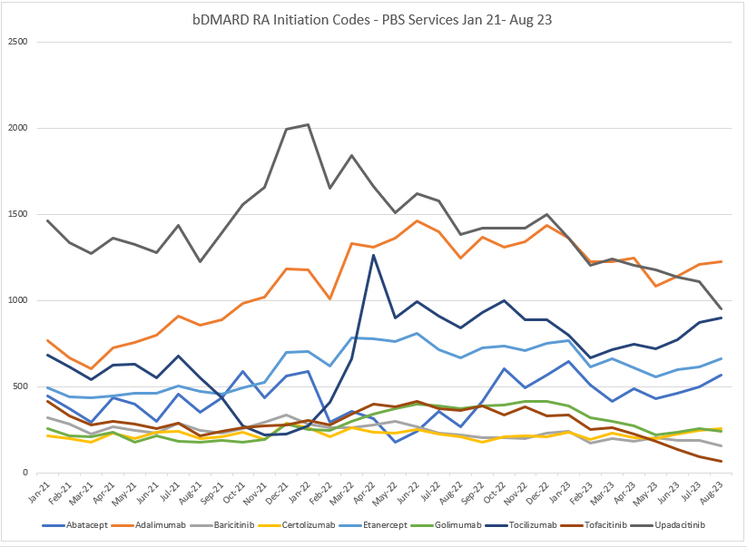

Source: Figure 1 of the submission

**Figure 2: Rheumatoid arthritis market (all scripts, 2018-2023)**

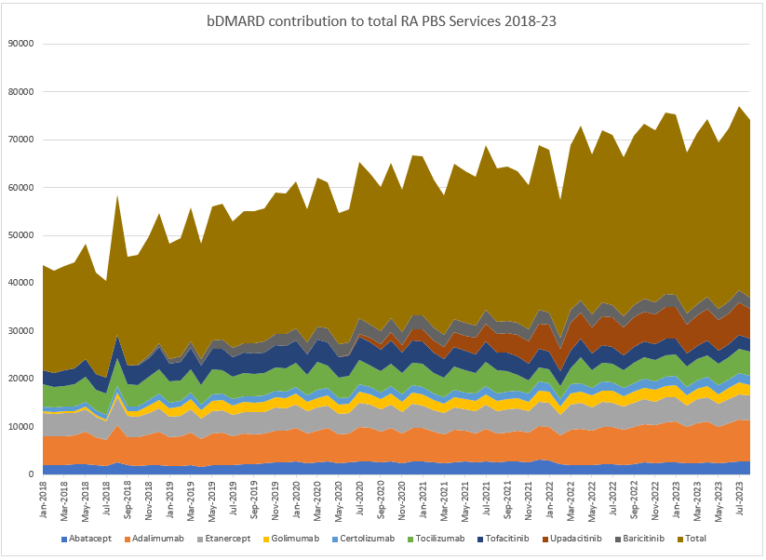

Source: Figure 2 of the submission

* 1. The submission also requested that a process be developed to ensure an equitable approach to the application of changes to products not included in post-market reviews or similar due to timing of listing. The submission noted the PBAC considered the other RA products two months before upadacitinib’s two-year anniversary, and as a result the sponsor has made two Category 3 submissions at a cost of ~$80,000 in order to request the RA changes recommended by the PBAC in March 2022 be applied to upadacitinib. The submission noted that upadacitinib patients therefore have a longer wait for easier access to treatment that other RA patients.

DUSC Secretariat Estimated PBS Utilisation (November 2023)

* 1. DUSC Secretariat presented analyses of the PBS services from 1 January 2018, the first listing of a biologic medicine, and between 1 May 2003 (first listing of infliximab for rheumatoid arthritis) and 30 September 2023 for all listings of abatacept, adalimumab, baricitinib, certolizumab pegol, etanercept, golimumab, infliximab, rituximab, tocilizumab, tofacitinib and upadacitinib for RA.
  2. The number of incident (new patients) for the RA biologics market grew after the listing of upadacitinib in May 2020 (Figure 3) and the overall market continued to grow when PBAC last considered the listing of upadacitinib at its November 2022 meeting.
  3. DUSC Secretariat also considered upadacitinib has had a consistent market share averaging 17.8 per cent per month (range 17.0 to 19.0 per cent) during 2023 to September (Figure 3).

**Figure 3: Number of incident patients supplied a biologic medicine for severe active rheumatoid arthritis by month**

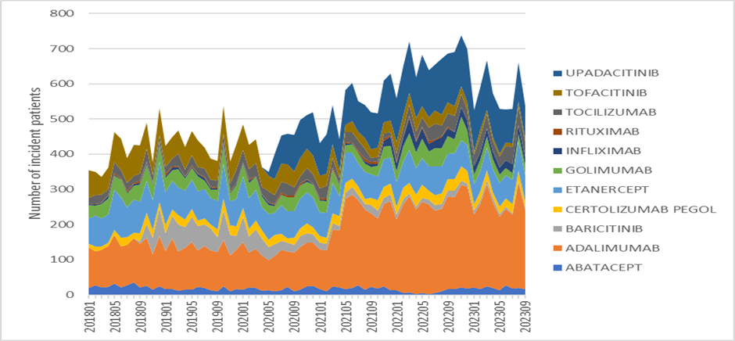

Source: DUSC analysis (November 2023) Figure 1

TGA notification, Shortages of abatacept (Orencia) medicines. Accessed at: <https://www.tga.gov.au/safety/shortages/medicine-shortage-alerts/shortage-abatacept-orencia-medicines>

TGA and ARA notification, Tocilizumab (Actemra) shortage: Patient management. Accessed at: <https://www.tga.gov.au/sites/default/files/tocilizumab-actemra-shortage-patient-management.pdf>

* 1. From January to September 2023, the total number of incident patients per month has remained steady, averaging 570 patients per month (range 526 to 667) with a negative month-on-month average growth of -1.7 per cent.
  2. The number of initiations was impacted by shortages for abatacept notified in January 2022[1] and tocilizumab notified in September 2021[2].
  3. The number of incident patients supplied upadacitinib per month has reduced between January 2023 and September 2023, with a negative month-on-month growth rate of -4.1 per cent. Of the 536 incident patients supplied a biologic in September 2023, upadacitinib represented 17 per cent of the market (n=93) with the greatest number of incident patients supplied adalimumab (n=225, 42 per cent). In its pre-PBAC response, the sponsor noted the DUSC Secretariat analysis corroborating that upadacitinib rate of initiation growth is declining.
  4. The number of prevalent (all treated) patients (Figure 4) and number of prescriptions supplied (Figure 5) appears to have stabilised since the PBAC consideration of the biologics RA market in November 2022, reflecting the reduction in new initiations.

**Figure 4: Number of prevalent patients supplied a biologic medicine for severe active rheumatoid arthritis by quarter**

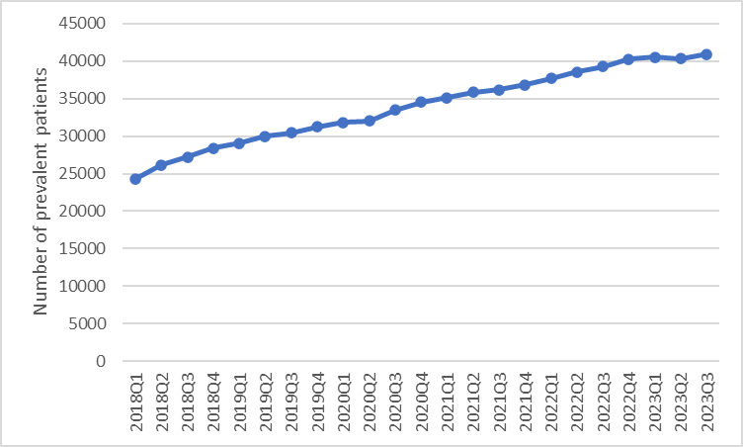

Source: DUSC analysis (November 2023) Figure 1

**Figure 5: Number of prescriptions supplied for biologic medicine for severe active rheumatoid arthritis by month**

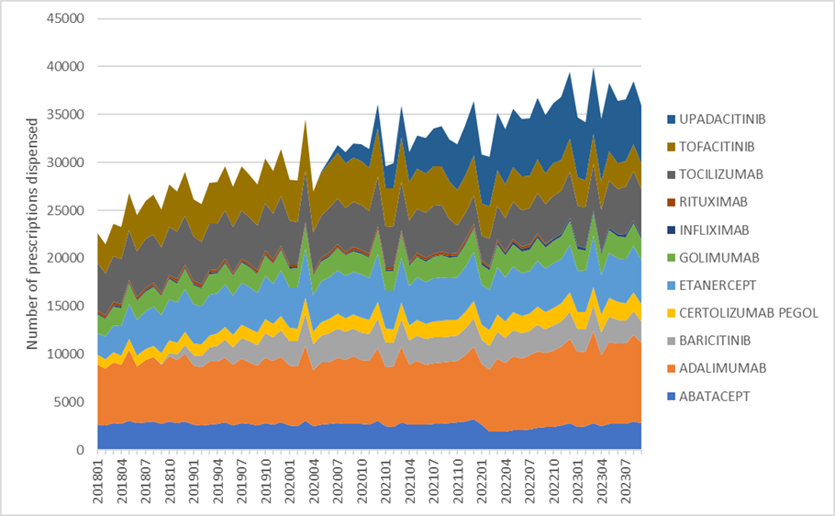

Source: DUSC analysis (November 2023) Figure 3

* 1. In 2022, the quarterly growth rate for prevalent patients averaged 2.2 per cent per quarter. In 2023 to Quarter 3, the quarterly growth rate for prevalent patients is lower compared to 2022 averaging 0.5 per cent per quarter.
  2. In comparing the number of prescriptions for the RA market in Figure 2 (presented in the submission) and Figure 5 (presented by DUSC Secretariat), DUSC Secretariat noted the following:
* The submission’s prescription figures are based on the date of processing compared to the DUSC Secretariat’s analysis which is based on the date of supply. The monthly totals are slightly higher in the submission from being based on the date of processing (e.g., July 2023 38,501 vs. 36,578).
* The submission excludes rituximab and infliximab due to their low volumes of utilisation.

# PBAC Outcome

* 1. The PBAC recommended an amendment to the Authority Required (Written) listing for continuing treatment of PBS-listed upadacitinib 15 mg modified release tablet (Rinvoq) for the treatment of severe active rheumatoid arthritis (RA) to:
* Authority Required (Written) for first continuing treatment.
* Authority Required (STREAMLINED) for subsequent continuing treatment.
  1. The PBAC considered the DUSC analyses of the PBS services from 1 January 2018 to 30 September 2023 of all listings of biologic medicine for RA and noted:
* the market of upadacitinib was mature, upadacitinib initiations had stabilised, and upadacitinib represented 17 per cent of the market with the greatest number of incident patients supplied adalimumab (42 per cent). The PBAC considered upadacitinib would not drive growth in the RA market.
* the number of prevalent (all treated) patients and number of prescriptions supplied appears to have stabilised since the PBAC consideration of the biologics RA market in November 2022, reflecting the reduction in new initiations.
  1. The PBAC noted the specialist clinician letter provided by the sponsor as part of its pre-PBAC response. The letter noted confusion among specialists as to why upadacitinib was not included in the 1 November 2023 amendments and stated that upadacitinib has been a very valuable addition to the RA treatment armamentarium – affirming that it is now a well-established, effective, and well tolerated agent commonly prescribed for patients with RA.
  2. The PBAC considered it was appropriate to align the restriction level of upadacitinib with its March 2022 PBAC meeting recommendation for RA medicines: abatacept, adalimumab, baricitinib, certolizumab, etanercept, golimumab, infliximab, tocilizumab and tofacitinib.
  3. The PBAC noted the submission also requested that a process be developed to ensure an equitable approach to the application of changes to products not included in post-market reviews or similar due to timing of listing. The PBAC recalled that, at its June 2020 meeting, the DUSC advised that the routine 24-month review assessment program was an efficient means of regularly reviewing the authorisation level of current written authority PBS medicines. The PBAC noted that the sponsor was notified following the March 2022 PBAC consideration that upadacitinib was not considered as part of the Written Authority review due to the immaturity of its listing compared to other listings for rheumatoid arthritis, and that it would be considered as part of routine 24-month DUSC reviews.
  4. The PBAC noted that because upadacitinib is not expected to address a high and urgent unmet clinical need given the presence of an alternative therapy, the criteria prescribed by the National Health (Pharmaceuticals and Vaccines – Cost Recovery) Regulations 2022 for Pricing Pathway A were not met.
  5. The PBAC noted that this submission is not eligible for an Independent Review as it received a positive recommendation.

**Outcome:**

Recommended

# Recommended listing

* 1. Amend existing listing as follows:

|  |  |  |  |  |  |
| --- | --- | --- | --- | --- | --- |
| **MEDICINAL PRODUCT**  **medicinal product pack** | **PBS item code** | **Max. qty packs** | **Max. qty units** | **№.of**  **Rpts** | **Available brands** |
| UPADACITINIB | | | | | |
| upadacitinib 15 mg modified release tablet, 28 | 11979L | 1 | 28 | 5 | Rinvoq |
|  | | | | | |
| **Restriction Summary** | | | | | |
| **Category / Program:** GENERAL – General Schedule (Code GE) | | | | | |
| **Prescriber type:** Medical Practitioners | | | | | |
| **Restriction type:** Authority Required (in writing only via post/HPOS upload) | | | | | |
| **Administrative Advice:**  PBS AUTHORITY APPLICATIONS FOR SEVERE ACTIVE RHEUMATOID ARTHRITIS  The following information applies to Pharmaceutical Benefits Scheme (PBS) subsidy of the biological medicines for adults with severe active rheumatoid arthritis. Where the term biological medicine appears in the following notes and restrictions it refers to all PBS benefits with the specific PBS indication of: 'severe active rheumatoid arthritis'.  Some benefits are not biological medicines, but are small molecules. However, for practical purposes, these benefits are included within the term 'biological medicine'.  Only one biological medicine is to be PBS-subsidised at any one time for rheumatoid arthritis.  Upon 5 inadequate responses to biological medicines with the specific PBS indication of 'severe active rheumatoid arthritis', further subsidy is to cease. Where a particular biological medicine has provided an inadequate response, it must not be subsidised again.  A serious adverse reaction of a severity resulting in the necessity for permanent withdrawal of treatment, including serious infusion or injection related reactions, Stevens Johnson Syndrome, development of a demyelinating lesion, progressive multifocal leukoencephalopathy and malignancy related to treatment with the biological medicine, is not considered a treatment failure.  (1) Selecting the correct 'Treatment phase' listing to apply under  Initiating subsidy:  (i) Apply through 'Initial 1 treatment' where a patient has received no prior PBS-subsidised biological medicine treatment; or  (ii) Apply through 'Initial 2 treatment' where one of the following occurs: (a) PBS-subsidised treatment has at least been initiated through any Initial 1 listing, but the prescribed biological medicine is changing, (b) there has been a break in biological medicine of less than 24 months, but resumption of treatment is with the same biological medicine last prescribed, (c) there has been a break in biological medicine of less than 24 months and resumption of treatment is with a different biological medicine to that last prescribed, (d) treatment with rituximab has occurred within the past 24 months and is the most recent therapy prescribed leading up to this authority application, irrespective of the length in time elapsed between the 2 non-rituximab bDMARDs administered before and after rituximab.  Initial 2 does not require markers of inflammation/joint count to be re-established - those recorded in the first Initial 1 application can remain as baseline measures. Prerequisite DMARD treatments need not be re-proven to be inadequate.  The prescribed biological medicine may be changed at any time, regardless of whether the current prescribed biological medicine has been obtained through Initial treatment or Continuing treatment. However, the change in biological medicine cannot be back to the same biological medicine where that medicine has provided an inadequate response.  (iii) Apply through 'Initial 3 treatment' where treatment is recommencing following a break in PBS-subsidised therapy of at least 24 months. Initial 3 requires current markers of inflammation/joint count to be re-established. Prerequisite DMARD treatments need not be re-proven to be inadequate. PBS-subsidised therapy in this instance can include rituximab where prescribed as the most recent treatment - the 24 month break in therapy is from the second dose of the prior rituximab course.  Response assessment to any course of PBS-subsidised biological therapy must follow a minimum of 12 weeks of therapy. Applications made on the same day for Initial treatment and Continuing treatment clearly do reflect this requirement.  Where a response assessment is not conducted with a 'Continuing treatment' application, the biological medicine will be assumed to have failed, unless the patient has experienced a serious adverse reaction of a severity resulting in the necessity for permanent withdrawal of treatment. Authority applications for patients who experienced adverse reaction necessitating permanent treatment withdrawal should be submitted through 'Initial 2 treatment' or 'Initial 3 treatment'. Indicate where the adverse reaction has occurred in the authority application.  Continuing subsidy:  Apply under a 'Continuing treatment' phase listing only where treatment has initiated through an 'Initial treatment' listing and measures of disease control (i.e. ESR/CRP/joint count) demonstrate response following at least 12 weeks of treatment. Continuing treatment should never precede Initial treatment where the same biological medicine is being prescribed.  The description of 'Continuing treatment' means 'Continuing treatment of severe rheumatoid arthritis with the same biological medicine'. Where treatment of severe rheumatoid arthritis is continuing with a different biological medicine, 'Continuing treatment' is not to be interpreted as meaning 'Continuing treatment of severe rheumatoid arthritis with a different biological medicine' - see 'Initial 2 treatment' where continuing treatment is with a different biological medicine.  'Continuing treatment' is to be accessed repeatedly until the prescribed biological medicine is either changed, stops providing an adequate response, or the patient takes a break in treatment.  Where continuing treatment is divided into 'First continuing' and 'Subsequent continuing', the next authority application following immediately after any 'Initial treatment' authority application is to be through 'First continuing'. Following this, the next authority application is to occur under the 'Subsequent continuing' treatment phase. Assuming the drug continues to provide an adequate response, 'Subsequent continuing' is to be accessed repeatedly until the prescribed biological medicine is either changed, stops providing an adequate response, or the patient takes a break in treatment.  Balance of Supply listings:  Maximum quantities and the number of repeats stated in a PBS-listing are values that prescribers may seek up to, but are not obligated to prescribe. From time to time, there may be particular reasons why a prescriber may elect not to request the full maximum quantity listed, or, the full number of repeat prescriptions. Where this occurs, the intent of Balance of Supply treatment phase listings is to circumvent the need for another written-only authority application to be completed, as a written-only authority application may not be practical in terms of providing timely access to continued treatment.  Apply under a 'Balance of Supply' treatment phase (where available) when either the full maximum quantity or repeat prescriptions available under a particular treatment phase, was not requested and where the biological medicine has had insufficient time to demonstrate an adequate response. Where the preceding supply has been adequate to provide at least 12 weeks of treatment and has resulted in an adequate response, it may be more practical to access further treatment under 'Continuing treatment'.  (2) Baseline measurements to determine response.  Determination of response to treatment must be based on baseline measurements of the joint count, ESR and/or CRP provided with the first authority application for a biological medicine. However, prescribers may provide new baseline measurements demonstrating elevation of both joint count and markers of inflammation any time that an initial treatment authority application is provided and the eligibility for continuing treatment must be assessed according to these revised baseline measurements.  To ensure consistency in determining response, the same indices of disease severity used to establish baseline must be used for all subsequent continuing treatment applications. Therefore, where an ESR or CRP level is provided at baseline, an ESR or CRP level respectively must be used to determine response. Similarly, where the baseline active joint count is based on total active joints (i.e. more than 20 active joints), response must be determined according to the reduction in the total number of active joints. Where the baseline is determined on total number of major joints, the response must be determined on the total number of major joints.  Applications under the Initial 1 treatment restriction for a new patient must include a joint count and ESR and/or CRP measured at the completion of the 6 month intensive DMARD trial, but prior to ceasing DMARD therapy. The results must be no more than 4 weeks old at the time of application.  Applications under the Initial 3 treatment restriction for recommencement of treatment after a break in biological medicine of more than 24 months must include a joint count and ESR and/or CRP measurement that is no more than 4 weeks old at the time of application. | | | | | |
| **Administrative Advice:**  No increase in the maximum quantity or number of units may be authorised. | | | | | |
| **Administrative Advice:**  No increase in the maximum number of repeats may be authorised. | | | | | |
| **Administrative Advice:**  Special Pricing Arrangements apply. | | | | | |
|  | | | | | |
| **Indication:** Severe active rheumatoid arthritis | | | | | |
| **Treatment Phase:** *First* Continuing Treatment | | | | | |
| **Treatment criteria:** | | | | | |
| Must be treated by a rheumatologist; or | | | | | |
| Must be treated by a clinical immunologist with expertise in the management of rheumatoid arthritis | | | | | |
| **Clinical criteria:** | | | | | |
| Patient must have received this drug as their most recent course of PBS-subsidised biological medicine treatment for this condition | | | | | |
| **AND** | | | | | |
| **Clinical criteria:** | | | | | |
| Patient must have demonstrated an adequate response to treatment with this drug | | | | | |
| **AND** | | | | | |
| **Clinical criteria:** | | | | | |
| ~~Patient must not receive more than 24 weeks of treatment per continuing treatment course authorised under this restriction~~ | | | | | |
| *Patient must not receive more than 24 weeks of treatment under this restriction.* | | | | | |
| **Population criteria:** | | | | | |
| Patient must be at least 18 years of age | | | | | |
| **Prescribing Instructions:**  An adequate response to treatment is defined as:  an ESR no greater than 25 mm per hour or a CRP level no greater than 15 mg per L or either marker reduced by at least 20% from baseline;  AND either of the following:  (a) a reduction in the total active (swollen and tender) joint count by at least 50% from baseline, where baseline is at least 20 active joints; or  (b) a reduction in the number of the following active joints, from at least 4, by at least 50%:  (i) elbow, wrist, knee and/or ankle (assessed as swollen and tender); and/or  (ii) shoulder and/or hip (assessed as pain in passive movement and restriction of passive movement, where pain and limitation of movement are due to active disease and not irreversible damage such as joint destruction or bony overgrowth). | | | | | |
| **Prescribing Instructions:**  Where the baseline active joint count is based on total active joints (i.e. more than 20 active joints), response must be determined according to the reduction in the total number of active joints. Where the baseline is determined on total number of major joints, the response must be determined on the total number of major joints. If only an ESR or CRP level is provided with the initial application, the same marker must be used to determine response. | | | | | |
| **Prescribing Instructions:**  The authority application must be made in writing and must include:  (1) a completed authority prescription form; and  (2) a completed authority application form relevant to the indication and treatment phase (the latest version is located on the website specified in the Administrative Advice) | | | | | |
| **Prescribing Instructions:**  An application for the continuing treatment must be accompanied with the assessment of response conducted following a minimum of 12 weeks of therapy and no later than 4 weeks from cessation of the most recent course of treatment. This will enable ongoing treatment for those who meet the continuing restriction for PBS-subsidised treatment. | | | | | |
| **Prescribing Instructions:**  Where a response assessment is not conducted within the required timeframe, the patient will be deemed to have failed to respond to treatment with this drug, unless the patient has experienced a serious adverse reaction of a severity resulting in the necessity for permanent withdrawal of treatment. | | | | | |
| **Prescribing Instructions:**  If a patient has either failed or ceased to respond to a PBS-subsidised biological medicine for this condition 5 times, they will not be eligible to receive further PBS-subsidised treatment with a biological medicine for this condition. | | | | | |
| **Prescribing Instructions:**  If a patient fails to demonstrate a response to treatment with this drug under this restriction they will not be eligible to receive further PBS-subsidised treatment with this drug for this condition. | | | | | |
| **Administrative Advice:**  Any queries concerning the arrangements to prescribe may be directed to Services Australia on 1800 700 270 (hours of operation 8 a.m. to 5 p.m. Monday to Friday).  Prescribing information (including Authority Application forms and other relevant documentation as applicable) is available on the Services Australia website at www.servicesaustralia.gov.au  Applications for authority to prescribe should be submitted online using the form upload facility in Health Professional Online Services (HPOS) at www.servicesaustralia.gov.au/hpos  Or mailed to:  Services Australia  Complex Drugs  Reply Paid 9826  HOBART TAS 7001 | | | | | |
|  | | | | | |
| **Restriction Summary** | | | | | |
| **Category / Program:** GENERAL – General Schedule (Code GE) | | | | | | |
| **Prescriber type:** Medical Practitioners | | | | | | |
| **Restriction type:** Authority Required (telephone/online PBS authorities system) | | | | | | |
| **Indication:** Severe active rheumatoid arthritis | | | | | | |
| **Treatment Phase:** *First* Continuing Treatment – balance of supply | | | | | | |
| **Treatment Criteria:** | | | | | | |
| Must be treated by a rheumatologist; or | | | | | | |
| Must be treated by a clinical immunologist with expertise in the management of rheumatoid arthritis | | | | | | |
| **Clinical criteria:** | | | | | | |
| Patient must have received insufficient therapy with this drug for this condition under the *first* continuing treatment restriction to complete 24 weeks of treatment | | | | | | |
| **AND** | | | | | | |
| **Clinical criteria:** | | | | | | |
| The treatment must provide no more than the balance of up to 24 weeks treatment | | | | | | |
| **Administrative Advice:**  Applications for authorisation under this restriction may be made in real time using the Online PBS Authorities system (see www.servicesaustralia.gov.au/HPOS) or by telephone by contacting Services Australia on 1800 700 270 (hours of operation 8 a.m. to 5 p.m. Monday to Friday). | | | | | | |

|  |  |  |  |  |  |
| --- | --- | --- | --- | --- | --- |
| **MEDICINAL PRODUCT**  **medicinal product pack** | **PBS item code** | **Max. qty packs** | **Max. qty units** | **№.of**  **Rpts** | **Available brands** |
| UPADACITINIB | | | | | |
| upadacitinib 15 mg modified release tablet, 28 | *NEW* | *1* | *28* | *5* | *Rinvoq* |
|  | | | | | |
| ***Restriction Summary*** | | | | | |
| ***Category / Program:*** *GENERAL – General Schedule (Code GE)* | | | | | |
| ***Prescriber type:*** *Medical Practitioners* | | | | | |
| ***Restriction type:*** *Authority Required (Streamlined)* | | | | | |
| ***Administrative Advice:***  *PBS AUTHORITY APPLICATIONS FOR SEVERE ACTIVE RHEUMATOID ARTHRITIS*  *The following information applies to Pharmaceutical Benefits Scheme (PBS) subsidy of the biological medicines for adults with severe active rheumatoid arthritis. Where the term biological medicine appears in the following notes and restrictions it refers to all PBS benefits with the specific PBS indication of: 'severe active rheumatoid arthritis'.*  *Some benefits are not biological medicines, but are small molecules. However, for practical purposes, these benefits are included within the term 'biological medicine'.*  *Only one biological medicine is to be PBS-subsidised at any one time for rheumatoid arthritis.*  *Upon 5 inadequate responses to biological medicines with the specific PBS indication of 'severe active rheumatoid arthritis', further subsidy is to cease. Where a particular biological medicine has provided an inadequate response, it must not be subsidised again.*  *A serious adverse reaction of a severity resulting in the necessity for permanent withdrawal of treatment, including serious infusion or injection related reactions, Stevens Johnson Syndrome, development of a demyelinating lesion, progressive multifocal leukoencephalopathy and malignancy related to treatment with the biological medicine, is not considered a treatment failure.*  *(1) Selecting the correct 'Treatment phase' listing to apply under*  *Initiating subsidy:*  *(i) Apply through 'Initial 1 treatment' where a patient has received no prior PBS-subsidised biological medicine treatment; or*  *(ii) Apply through 'Initial 2 treatment' where one of the following occurs: (a) PBS-subsidised treatment has at least been initiated through any Initial 1 listing, but the prescribed biological medicine is changing, (b) there has been a break in biological medicine of less than 24 months, but resumption of treatment is with the same biological medicine last prescribed, (c) there has been a break in biological medicine of less than 24 months and resumption of treatment is with a different biological medicine to that last prescribed, (d) treatment with rituximab has occurred within the past 24 months and is the most recent therapy prescribed leading up to this authority application, irrespective of the length in time elapsed between the 2 non-rituximab bDMARDs administered before and after rituximab.*  *Initial 2 does not require markers of inflammation/joint count to be re-established - those recorded in the first Initial 1 application can remain as baseline measures. Prerequisite DMARD treatments need not be re-proven to be inadequate.*  *The prescribed biological medicine may be changed at any time, regardless of whether the current prescribed biological medicine has been obtained through Initial treatment or Continuing treatment. However, the change in biological medicine cannot be back to the same biological medicine where that medicine has provided an inadequate response.*  *(iii) Apply through 'Initial 3 treatment' where treatment is recommencing following a break in PBS-subsidised therapy of at least 24 months. Initial 3 requires current markers of inflammation/joint count to be re-established. Prerequisite DMARD treatments need not be re-proven to be inadequate. PBS-subsidised therapy in this instance can include rituximab where prescribed as the most recent treatment - the 24 month break in therapy is from the second dose of the prior rituximab course.*  *Response assessment to any course of PBS-subsidised biological therapy must follow a minimum of 12 weeks of therapy. Applications made on the same day for Initial treatment and Continuing treatment clearly do reflect this requirement.*  *Where a response assessment is not conducted with a 'Continuing treatment' application, the biological medicine will be assumed to have failed, unless the patient has experienced a serious adverse reaction of a severity resulting in the necessity for permanent withdrawal of treatment. Authority applications for patients who experienced adverse reaction necessitating permanent treatment withdrawal should be submitted through 'Initial 2 treatment' or 'Initial 3 treatment'. Indicate where the adverse reaction has occurred in the authority application.*  *Continuing subsidy:*  *Apply under a 'Continuing treatment' phase listing only where treatment has initiated through an 'Initial treatment' listing and measures of disease control (i.e. ESR/CRP/joint count) demonstrate response following at least 12 weeks of treatment. Continuing treatment should never precede Initial treatment where the same biological medicine is being prescribed.*  *The description of 'Continuing treatment' means 'Continuing treatment of severe rheumatoid arthritis with the same biological medicine'. Where treatment of severe rheumatoid arthritis is continuing with a different biological medicine, 'Continuing treatment' is not to be interpreted as meaning 'Continuing treatment of severe rheumatoid arthritis with a different biological medicine' - see 'Initial 2 treatment' where continuing treatment is with a different biological medicine.*  *'Continuing treatment' is to be accessed repeatedly until the prescribed biological medicine is either changed, stops providing an adequate response, or the patient takes a break in treatment.*  *Where continuing treatment is divided into 'First continuing' and 'Subsequent continuing', the next authority application following immediately after any 'Initial treatment' authority application is to be through 'First continuing'. Following this, the next authority application is to occur under the 'Subsequent continuing' treatment phase. Assuming the drug continues to provide an adequate response, 'Subsequent continuing' is to be accessed repeatedly until the prescribed biological medicine is either changed, stops providing an adequate response, or the patient takes a break in treatment.*  *Balance of Supply listings:*  *Maximum quantities and the number of repeats stated in a PBS-listing are values that prescribers may seek up to, but are not obligated to prescribe. From time to time, there may be particular reasons why a prescriber may elect not to request the full maximum quantity listed, or, the full number of repeat prescriptions. Where this occurs, the intent of Balance of Supply treatment phase listings is to circumvent the need for another written-only authority application to be completed, as a written-only authority application may not be practical in terms of providing timely access to continued treatment.*  *Apply under a 'Balance of Supply' treatment phase (where available) when either the full maximum quantity or repeat prescriptions available under a particular treatment phase, was not requested and where the biological medicine has had insufficient time to demonstrate an adequate response. Where the preceding supply has been adequate to provide at least 12 weeks of treatment and has resulted in an adequate response, it may be more practical to access further treatment under 'Continuing treatment'.*  *(2) Baseline measurements to determine response.*  *Determination of response to treatment must be based on baseline measurements of the joint count, ESR and/or CRP provided with the first authority application for a biological medicine. However, prescribers may provide new baseline measurements demonstrating elevation of both joint count and markers of inflammation any time that an initial treatment authority application is provided and the eligibility for continuing treatment must be assessed according to these revised baseline measurements.*  *To ensure consistency in determining response, the same indices of disease severity used to establish baseline must be used for all subsequent continuing treatment applications. Therefore, where an ESR or CRP level is provided at baseline, an ESR or CRP level respectively must be used to determine response. Similarly, where the baseline active joint count is based on total active joints (i.e. more than 20 active joints), response must be determined according to the reduction in the total number of active joints. Where the baseline is determined on total number of major joints, the response must be determined on the total number of major joints.*  *Applications under the Initial 1 treatment restriction for a new patient must include a joint count and ESR and/or CRP measured at the completion of the 6 month intensive DMARD trial, but prior to ceasing DMARD therapy. The results must be no more than 4 weeks old at the time of application.*  *Applications under the Initial 3 treatment restriction for recommencement of treatment after a break in biological medicine of more than 24 months must include a joint count and ESR and/or CRP measurement that is no more than 4 weeks old at the time of application.* | | | | | |
| ***Administrative Advice:***  *Any queries concerning the arrangements to prescribe may be directed to Services Australia on 1800 700 270 (hours of operation 8 a.m. to 5 p.m. Monday to Friday).* | | | | | |
| ***Administrative Advice:***  *No increase in the maximum quantity or number of units may be authorised.* | | | | | |
| ***Administrative Advice:***  *No increase in the maximum number of repeats may be authorised.* | | | | | |
| ***Administrative Advice:***  *Special Pricing Arrangements apply.* | | | | | |
|  | | | | | |
| ***Indication:*** *Severe active rheumatoid arthritis* | | | | | |
| ***Treatment Phase:*** *Subsequent Continuing Treatment* | | | | | |
| ***Treatment criteria:*** | | | | | |
| *Must be treated by a rheumatologist; or* | | | | | |
| *Must be treated by a clinical immunologist with expertise in the management of rheumatoid arthritis* | | | | | |
| ***Clinical criteria:*** | | | | | |
| *Patient must have received this drug as their most recent course of PBS-subsidised biological medicine treatment for this condition under the First continuing treatment restriction; OR* | | | | | |
| *Patient must have received this drug under this treatment phase as their most recent course of PBS-subsidised biological medicine* | | | | | |
| ***AND*** | | | | | |
| ***Clinical criteria:*** | | | | | |
| *Patient must have demonstrated an adequate response to treatment with this drug* | | | | | |
| ***AND*** | | | | | |
| ***Clinical criteria:*** | | | | | |
| *Patient must not receive more than 24 weeks of treatment under this restriction* | | | | | |
| ***Population criteria:*** | | | | | |
| *Patient must be at least 18 years of age* | | | | | |
| ***Prescribing Instructions:***  *An adequate response to treatment is defined as:*  *an ESR no greater than 25 mm per hour or a CRP level no greater than 15 mg per L or either marker reduced by at least 20% from baseline;*  *AND either of the following:*  *(a) a reduction in the total active (swollen and tender) joint count by at least 50% from baseline, where baseline is at least 20 active joints; or*  *(b) a reduction in the number of the following active joints, from at least 4, by at least 50%:*  *(i) elbow, wrist, knee and/or ankle (assessed as swollen and tender); and/or*  *(ii) shoulder and/or hip (assessed as pain in passive movement and restriction of passive movement, where pain and limitation of movement are due to active disease and not irreversible damage such as joint destruction or bony overgrowth).* | | | | | |
| ***Prescribing Instructions:***  *The assessment of response to treatment must be documented in the patient’s medical records and must be no more than 4 weeks old at the time of the authority application.* | | | | | |
| ***Prescribing Instructions:***  *Where the baseline active joint count is based on total active joints (i.e. more than 20 active joints), response must be determined according to the reduction in the total number of active joints. Where the baseline is determined on total number of major joints, the response must be determined on the total number of major joints. If only an ESR or CRP level is provided with the initial application, the same marker must be used to determine response.* | | | | | |
| ***Prescribing Instructions:***  *If a patient has either failed or ceased to respond to a PBS-subsidised biological medicine for this condition 5 times, they will not be eligible to receive further PBS-subsidised treatment with a biological medicine for this condition.* | | | | | |
| ***Prescribing Instructions:***  *If a patient fails to demonstrate a response to treatment with this drug under this restriction they will not be eligible to receive further PBS-subsidised treatment with this drug for this condition.* | | | | | |

***These restrictions may be subject to further review. Should there be any changes made to the restriction the sponsor will be informed.***

# Context for Decision

The PBAC helps decide whether and, if so, how medicines should be subsidised through the Pharmaceutical Benefits Scheme (PBS) in Australia. It considers applications regarding the listing of medicines on the PBS and provides advice about other matters relating to the operation of the PBS in this context. A PBAC decision in relation to PBS listings does not necessarily represent a final PBAC view about the merits of the medicine or the circumstances in which it should be made available through the PBS. The PBAC welcomes applications containing new information at any time.

# Sponsor’s Comment

AbbVie welcomes the PBAC recommendation to align Rinvoq authority levels with other advanced therapies in severe rheumatoid arthritis. We consider that there should be an appropriate process developed to ensure an equitable approach to the application of changes to products not included in post-market reviews or similar due to timing of PBS listing.

1. TGA notification, Shortages of abatacept (Orencia) medicines. Accessed at: <https://www.tga.gov.au/safety/shortages/medicine-shortage-alerts/shortage-abatacept-orencia-medicines>
2. TGA and ARA notification, Tocilizumab (Actemra) shortage: Patient management. Accessed at: <https://www.tga.gov.au/sites/default/files/tocilizumab-actemra-shortage-patient-management.pdf>