5.08 IVOSIDENIB  
Tablet 250 mg,

**Tibsovo®,**

**Servier Laboratories Aust. Pty. Ltd.**

1. Purpose of submission
   * + - 1. An integrated codependent submission requesting: 1) the MBS listing of isocitrate dehydrogenase 1 *(IDH1)* testing for tier I *IDH1* p.R132X variants in patients with cholangiocarcinoma (CCA) to determine access to an IDH1inhibitor under the PBS, and 2) the PBS listing of ivosidenib for the treatment of locally advanced or metastatic CCA in patients who have evidence of an *IDH1* variant and whose disease has progressed on at least one prior line of systemic therapy.
         2. Listing was requested based on a cost-utility analysis which assessed the incremental costs and quality-adjusted life years (QALYs) associated with ivosidenib compared to palliative/best supportive care (BSC) for patients with locally advanced or metastatic CCA who have disease progression following at least one line of systemic therapy.

Table 1: Key components of the clinical issue addressed by the submission

|  |  |
| --- | --- |
| Component | Description |
| Population | **Test:** Adult patients with cholangiocarcinoma (CCA)  **Treatment**: Patients with locally advanced or metastatic CCA who have disease progression following at least one line of chemotherapy and a confirmed isocitrate dehydrogenase 1 (*IDH1*) mutation |
| Intervention | **Test:** Tumour tissue testing for *IDH1* tier I variant status  **Treatment:** Ivosidenib as second or third-line treatment for locally advanced or metastatic CCAs in those with *IDH1* p.R132X tier I variants |
| Comparator | **Test:** No testing  **Treatment:**   * Primary comparator: palliative care * Secondary comparator: chemotherapy with 5-fluorouracil (5-FU) plus oxaliplatin (FOLFOX) or 5-FU plus irinotecan (FOLFIRI) |
| Outcomes | **Test-related outcomes:**  **Clinical utility of the test:**   * Treatment effect modification for ivosidenib based on IDH1 p.R132X tier I variant status (predictive validity)   **Other test-related considerations:**   * Number estimated to be tested * Number needed to test (to identify one eligible case for ivosidenib) * Test turnaround time * Rate of re-biopsy (including test failure and inadequate sample rate) * Safety of re-biopsy   **Treatment-related outcomes:**   * Critical outcomes (GRADE):   + Progression free survival   + Overall survival   + Objective response rate * Important outcomes (GRADE)   + Time from randomisation to discontinuation or death   + Health-related quality of life * Safety and tolerability:   + Treatment-emergent adverse events   + Physical examination and laboratory findings |
| Clinical claim | Testing deoxyribonucleic acid (DNA) from tumour tissue to detect *IDH1* p.R132X tier I variant, followed by targeted therapy with ivosidenib results in superior health outcomes compared to no testing and untargeted treatment/palliative care in patients with locally advanced or metastatic CCA. |

Source: Table 1-2, of the submission

1. Background

Registration status

* + - * 1. Ivosidenib was included on the ARTG on 6th April 2023 for the following indication:

“For the treatment of adult patients with locally advanced or metastatic cholangiocarcinoma with an isocitrate dehydrogenase-1 (IDH1) R132 mutation after at least one prior line of systemic therapy.”

Previous PBAC consideration

* + - * 1. The PBAC has not previously considered ivosidenib for this proposed indication.

1. Requested listing
   * + - 1. The requested restriction, with Secretariat proposed changes in italics, is shown below.

|  |  |  |  |  |  |
| --- | --- | --- | --- | --- | --- |
| **Name, restriction, manner of administration, form** | **Maximum quantity (packs)** | **Maximum quantity (units)** | **No. of repeats** | **Dispensed price for maximum quantity** | **Proprietary name and manufacturer** |
| Ivosidenib, oral tablet, 250 mg | 1 | 60 | 2 (initial)  5 (continuing)  5 (grandfathering) | Published: $25,062.13  Effective: $|||| | TIBSOVO  Servier Laboratories (Aust.) Pty. Ltd. |

|  |  |  |  |  |  |  |  |  |  |
| --- | --- | --- | --- | --- | --- | --- | --- | --- | --- |
| **Restriction Summary [new 1] / Treatment of Concept: [new 1]** | | | | | | | | | |
|  | | | **Category / Program:** GENERAL – General Schedule (Code GE) | | | | | | |
| **Prescriber type:** Medical Practitioners | | | | | | |
| **Restriction type**: Authority Required (Streamlined) [new/existing code] | | | | | | |
| *Prescribing rule level* | |  | ***Administrative Advice:*** *No increase in the maximum quantity or number of units may be authorised.* | | | | | | |
|  | ***Administrative Advice:*** *No increase in the maximum number of repeats may be authorised.* | | | | | | |
|  | ***Administrative Advice:*** *Special Pricing Arrangements apply.* | | | | | | |
|  | | | **Episodicity:** [blank] | | | | | | |
| **Severity:** Locally advanced or metastatic | | | | | | |
| **Condition:** Cholangiocarcinoma | | | | | | |
|  | | | **Indication:** locally advanced or metastatic cholangiocarcinoma | | | | | | |
|  | | | **Treatment Phase:** Initial treatment | | | | | | |
|  | | | **Clinical criteria:** | | | | | | |
|  | | | The ~~patient~~ *condition* must ~~have~~ *be associated* with a confirmed *Isocitrate dehydrogenase 1* (IDH1) *tier I* variant | | | | | | |
|  | | | **AND** | | | | | | |
|  | | | **Clinical criteria:** | | | | | | |
|  | | | The patient must have ~~prior~~ *had* systemic therapy *for this condition prior to initiating treatment with this drug for this condition.* | | | | | | |
|  | | | **AND** | | | | | | |
|  | | | **Clinical criteria:** | | | | | | |
|  | | | Patient must have/*have had* a WHO performance status of 2 or less at treatment initiation with this drug | | | | | | |
|  | | | **AND** | | | | | | |
|  | | | **Clinical criteria:** | | | | | | |
|  | | | The treatment must be the sole PBS-subsidised therapy for this condition | | | | | | |
|  | | | **AND** | | | | | | |
|  | | | **~~Clinical criteria:~~** | | | | | | |
|  | | | ~~Patient must not~~ *~~have~~* ~~develop~~*~~ed~~* ~~disease progression while receiving PBS-subsidised treatment with this drug for this condition~~ | | | | | | |
|  | | | **Treatment criteria:** | | | | | | |
|  | | | Patient must be undergoing treatment with this drug class for the first time | | | | | | |
|  | | | **Caution:** Ivosidenib can cause dose-dependent prolongation of the heart rate-corrected QT (QTc) interval. *At treatment initiation patients should undergo an electrocardiogram (ECG) to assess the heart rate-corrected QT (QTc) interval.* Dose interruptions are recommended until QTc returns to ≤480 msec. Monitor ECGs at least weekly for two weeks following return of QTc. Permanently discontinue ivosidenib if QTc poses life threatening ventricular arrhythmia (Grade 4) | | | | | | |
|  | | | | | | | | | |
| **MEDICINAL PRODUCT**  **medicinal product pack** | | | | | **PBS item code** | **Max. qty packs** | **Max. qty units** | **№.of**  **Rpts** | **Available brands** |
| IVOSIDENIB | | | | | | | | | |
| Ivosidenib 250 mg tablet, 60 | | | | | NEW | 1 | 60 | 5 | Tibsovo |
|  | | | | | | | | | |
| **Restriction Summary [new 2] / Treatment of Concept: [new 2]** | | | | | | | | | |
|  | | | **Category / Program:** GENERAL – General Schedule (Code GE) | | | | | | |
| **Prescriber type:** Medical Practitioners | | | | | | |
| **Restriction type:** Authority Required (STREAMLINED) [new/existing code] | | | | | | |
|  | | | **Indication:** Locally advanced or metastatic cholangiocarcinoma | | | | | | |
|  | | | **Treatment Phase:** Continuing treatment | | | | | | |
|  | | | | **Clinical criteria:** | | | | | |
|  | | | | Patient must have previously received PBS-subsidised treatment with this drug for this condition | | | | | |
|  | | | | **AND** | | | | | |
|  | | | | **Clinical criteria:** | | | | | |
|  | | | | The treatment must be the sole PBS-subsidised therapy for this condition | | | | | |
|  | | | | **AND** | | | | | |
|  | | | | **Clinical criteria:** | | | | | |
|  | | | | Patient must not *have* develop*ed* disease progression while receiving PBS-subsidised treatment with this drug for this condition | | | | | |
|  | | | | **Caution:** Ivosidenib can cause dose-dependent prolongation of the heart rate-corrected QT (QTc) interval. *At treatment initiation patients should undergo an electrocardiogram (ECG) to assess the heart rate-corrected QT (QTc) interval.* Dose interruptions are recommended until QTc returns to ≤480 msec. Monitor ECGs at least weekly for two weeks following return of QTc. Permanently discontinue ivosidenib if QTc poses life threatening ventricular arrhythmia (Grade 4) | | | | | |
|  | | | | | | | | | |
| **Restriction Summary [new 1] / Treatment of Concept: [new 1]** | | | | | | | | | |
|  | | | **Category / Program:** GENERAL – General Schedule (Code GE) | | | | | | |
| **Prescriber type:** Medical Practitioners | | | | | | |
| **Restriction type:** Authority Required (Streamlined) [new/existing code] | | | | | | |
| Prescribing rule level |  | | **Administrative Advice:** *No increase in the maximum quantity or number of units may be authorised.* | | | | | | |
|  | | **Administrative Advice:** *No increase in the maximum number of repeats may be authorised.* | | | | | | |
|  | | **Administrative Advice:** *Special Pricing Arrangements apply.* | | | | | | |
|  | | | **Episodicity:** [blank] | | | | | | |
| **Severity:** Locally advanced or metastatic | | | | | | |
| **Condition:** Cholangiocarcinoma | | | | | | |
|  | | | **Indication:** Locally advanced or metastatic cholangiocarcinoma | | | | | | |
|  | | | **Treatment Phase:**  ~~Initial~~  *Transitioning from non-PBS to PBS-subsidised supply - Grandfather arrangements* | | | | | | |
|  | | | **Clinical criteria:** | | | | | | |
|  | | | The ~~patient~~ *condition* must ~~have~~ *be associated* with a confirmed *Isocitrate dehydrogenase 1* IDH1 *tier I* variant | | | | | | |
|  | | | **AND** | | | | | | |
|  | | | **Clinical criteria:** | | | | | | |
|  | | | The patient must have ~~prior~~ *had* systemic therapy *for this condition prior to initiating non-PBS-subsidised treatment with this drug for this condition.* | | | | | | |
|  | | | **AND** | | | | | | |
|  | | | **Clinical criteria:** | | | | | | |
|  | | | Patient must have/*have had* a WHO performance status of 2 or less at treatment initiation with this drug | | | | | | |
|  | | | **AND** | | | | | | |
|  | | | Patient must have previously received non-PBS-subsidised treatment with this drug for this condition *prior to [Date]* | | | | | | |
|  | | | **AND** | | | | | | |
|  | | | **Clinical criteria:** | | | | | | |
|  | | | The treatment must be the sole PBS-subsidised therapy for this condition | | | | | | |
|  | | | **AND** | | | | | | |
|  | | | **Clinical criteria:** | | | | | | |
|  | | | Patient must not have developed disease progression while receiving PBS-subsidised treatment with this drug for this condition | | | | | | |
|  | | | ***Prescribing Instructions:***  *A patient may qualify for PBS-subsidised treatment under this restriction once only.* | | | | | | |
|  | | | ***Prescribing Instructions:***  *For continuing PBS-subsidised treatment, a Grandfathered patient must qualify under the Continuing treatment criteria.* | | | | | | |
|  | | | **Caution:** Ivosidenib can cause dose-dependent prolongation of the heart rate-corrected QT (QTc) interval. *At treatment initiation patients should undergo an electrocardiogram (ECG) to assess the heart rate-corrected QT (QTc) interval.* Dose interruptions are recommended until QTc returns to ≤480 msec. Monitor ECGs at least weekly for two weeks following return of QTc. Permanently discontinue ivosidenib if QTc poses life threatening ventricular arrhythmia (Grade 4) | | | | | | |

Source: Table 1-12, of the submission

IDH1 = isocitrate dehydrogenase 1

Note: In Table 1-12, of the submission, for clinical criteria, it said “Patient must not develop disease progression while receiving PBS-subsidised treatment with this drug for this condition”. This is incorrect.

* + - * 1. The submission proposed a Special Pricing Arrangement (SPA). The requested effective ex-manufacturer price (EMP) was $| |.
        2. The proposed two repeats for initial scripts and five repeats for continuing scripts cover 12 weeks and 24 weeks of treatment, respectively.
        3. The PBAC considered a Streamlined Authority listing (as proposed) was appropriate as there is a low risk of use outside the intended population.
        4. Ivosidenib can cause dose-dependent prolongation of the heart rate-corrected QT (QTc) interval. The approved PI recommends performing “an electrocardiogram (ECG) at baseline, at least weekly during the first three weeks of therapy and at least monthly thereafter. Monitor electrolytes at baseline and throughout treatment as clinically indicated. Patients at higher risk of QTc interval prolongation, including due to concomitant medications, may require more frequent monitoring.” However, the requested PBS restriction did not include routine monitoring for QTc prolongation, but only specified the requirement for dose modifications and ECG monitoring after QT prolongation has occurred. The PBAC agreed with the Economic Sub-Committee (ESC) that the restrictions need not stipulate the requirement for routine ECG monitoring for QT prolongation.
        5. The submission proposed ivosidenib is used for the treatment of locally advanced or metastatic CCA in patients who have a World Health Organization (WHO) performance status (PS) of 2 or less and who have previously received treatment with systemic therapy. This was generally consistent with the TGA indication and the eligibility criteria in the ClarIDHy trial, except that patients with a WHO performance status of 2 or more were excluded from the clinical trial. The PBAC considered it was reasonable for the listing to allow inclusion of patients with a WHO PS of 2 to enable clinicians to determine whether a patient is suitable for treatment. However the PBAC noted this may result in a less fit population compared with the pivotal trial and therefore the level of benefit shown in the trial may not be realised in the PBS population.
        6. The sponsor requested the MBS listing of *IDH1* testing for tier I *IDH1* p.R132X gene variants in patients with CCA to determine access to an IDH1inhibitor under the PBS. The PBAC noted that this was for consideration by the MSAC. The ESCs noted that *IDH1* genetic variants encoding gain of function IDH1 proteins other than those specified in the ClarIDHy trial (p.R132C, p.R132G, p.R132H, p.R132L, p.R132S) are extremely rare, and considered it would not be appropriate to deny treatment to the very small number of patients with other gain of function IDH1 variants. The PBAC considered the appropriate restriction wording for specifying the target population would be: “The patient must have a test of tumour tissue confirming the presence of an *IDH1* R132 variant”.

*For more detail on PBAC’s view, see section 7 PBAC outcome*.

1. Population and disease
   * + - 1. CCA is a rare cancer that arises from the epithelium of the bile ducts and accounts for approximately 3% of all gastrointestinal cancers. It has an incidence of 0.3-6 per 100,000 people per year globally. It was estimated that, by 2025, there would be 1,613 newly diagnosed cases of CCA in Australia[1]. This would include 956 new cases of intrahepatic CCA (iCCA), 443 cases of extrahepatic CCA (eCCA) and 214 cases of overlapping or not otherwise specified bile duct cancer[2]. There has been an upward trend in the incidence of CCA in the past decades owing to an increasing population with conditions that cause chronic liver inflammation[3]. Signs and symptoms of CCA depend upon the location of the tumour. Jaundice is a common presentation in patients with eCCA due to the obstruction of the bile outflow. Symptoms associated with CCA can also include abdominal pain, fatigue, fever, nausea/vomiting, or weight loss. However, early CCA is often asymptomatic and only around 35% of patients with CCA are detected in early stages[4]. Surgical tumour resection is the only potentially curative approach for patients with localised, resectable CCA. However, cancer relapse occurs in 42% to 70% of patients who have had the tumour surgically removed[5]. Recurrence is also frequently found at a distant site[6],[7]. The American Cancer Society reported the 5-year survival rates for locally advanced eCCA and metastatic eCCA as 18% and 2%, respectively[8]. Five-year survival rates for patients with locally advanced and metastatic iCCA were reported as 9% and 2%, respectively[9].
         2. The current first-line treatment for patients diagnosed with locally advanced or metastatic biliary tract cancer including CCA who have a good performance status is chemotherapy with cisplatin plus gemcitabine, with the addition of durvalumab which is currently listed on PBS for this indication, as recommended by the latest version of National Comprehensive Cancer Network (NCCN) and European Society for Medical Oncology (ESMO) guidelines and endorsed by eviQ since June 2023.[10] For patients whose disease does not respond to, or relapses after, first-line therapy, FOLFOX (fluorouracil, leucovorin and oxaliplatin) is the recommended active treatment in the second-line and beyond setting, according to the latest NCCN and ESMO guidelines, as well as eviQ recommendation.[11].
         3. Ivosidenib is an inhibitor of *IDH1* p.R132X variant proteins and specifically targets the prevalent *IDH1* p.R132H and p.R132C variants. The drug intervenes in the *IDH1* metabolic pathway to prevent accumulation of 2-hydroxyglutarate (2-HG), an oncometabolite that promotes oncogenic transformation of cells, cell proliferation and metastasis. Ivosidenib is proposed to be used as a second- or third-line treatment for patients with locally advanced or metastatic CCA whose cancer tissue tests positive for *IDH1* p.R132X tier I variant and whose disease does not respond to, or relapses, after at least one line of systemic therapy. The PBAC noted that there are a number of ongoing trials of IDH inhibitors and treatments targeting other gene variants common in CCA.

*For more detail on PBAC’s view, see section 7 PBAC outcome.*

1. Comparator
   * + - 1. The nominated comparator for the proposed *IDH1* variant testing was no testing. Palliative care/BSC was nominated as the primary comparator for ivosidenib; and chemotherapy with FOLFOX or FOLFIRI (fluorouracil, leucovorin, and irinotecan) was nominated as the secondary comparator. The submission stated there is an absence of PBS-listed medicines for locally advanced or metastatic CCA harbouring an *IDH1* variant and the treatment options for previously treated patients include palliative care, mono-chemotherapy, combination chemotherapy, or clinical trial participation. The submission also noted that clinical studies reported that between 57% and 82% of patients with locally advanced or metastatic CCA who receive first-line chemotherapy do not receive second-line chemotherapy as their cancer progresses[12]. However, most of the studies cited were published before 2015. The ESCs noted that long term follow up data from the TOPAZ-1 trial[13] (durvalumab or placebo plus gemcitabine + cisplatin) indicated that 51-54% of patients received subsequent anti‑cancer therapy. The ESCs considered that this study suggests that a higher proportion of patients would receive second-line chemotherapy than was assumed in the submission.
         2. Data from the ABC-06 trial (published in May 2021), which compared FOLFOX with active symptom control alone in previously treated locally advanced or metastatic biliary tract cancer between 2014 and 2018, led to the recommendation that FOLFOX is to be used as second-line treatment for advanced CCA by the NCCN and ESMO guidelines, as well as the eviQ guidelines. The ESCs noted that the use of FOLFOX is limited by its unfavourable safety profile in frail patients, who are unlikely to tolerate it. However, the ESCs also noted that patients with poor performance status may also be unsuitable for treatment with ivosidenib.
         3. Overall, the submission’s nomination of palliative care/BSC as the primary comparator and FOLFOX as the secondary comparator appeared reasonable. The PBAC agreed with the ESCs that FOLFOX and FOLFIRI were important relevant comparators for a substantial proportion of patients. Although the submission provided clinical evidence for the comparison of ivosidenib and FOLFOX, it was not included in the base case economic evaluation, and was only considered in a sensitivity analysis.

For more detail on PBAC’s view, see section 7 PBAC outcome.

1. Consideration of the evidence

Sponsor hearing

* + - * 1. There was no hearing for this item.

Consumer comments

* + - * 1. The PBAC noted and welcomed the input from health care professionals (5) and organisations (4) via the Consumer Comments facility on the PBS website. The comments from health care professionals described ivosidenib as an effective and tolerable treatment option for the small subset of patients with CCA with IDH mutations, noting there is sufficient evidence for its use. The comments also noted the value of molecular profiling in patients with cholangiocarcinoma as a range of key driver mutations have been identified as potential targets for new therapies with evidence for clinical benefit. Comments indicated that ivosidenib is considered less toxic than chemotherapy in the second line (2L) setting. Input also described the small number of PBS-subsidised treatment options for patients with CCA, which has a very poor prognosis.
        2. The PBAC noted the advice received from Pancare Foundation, Liver Foundation and Rare Cancers Australia in support of the ivosidenib submission. Pancare Foundation also provided an in-depth report regarding the impact of upper GI cancers and the challenges of treatment. Input from both Liver Foundation and Pancare noted that patients diagnosed with cholangiocarcinoma are often diagnosed late, when chances of survival are reduced and treatment results in serious physical side effects, major impact on quality of life and high financial burden. Comments noted the progression free survival (PFS) gain and the overall survival (OS) gain (adjusted for cross over) for patients treated with ivosidenib was considered meaningful to patients, given the limited survival rate for CCA. Comments from Rare Cancers Australia noted that ivosidenib is expected to improve the daily functioning of people with cholangiocarcinoma, with PBS listing expected to remove the financial burden of self-funding treatment. Comments from the three consumer groups also noted that the oral administration for ivosidenib has substantial benefits for patients compared with chemotherapy.
        3. The Medical Oncology Group of Australia (MOGA) also expressed its support for the ivosidenib submission as an “other supported application”. The PBAC noted that the MOGA presented a European Society for Medical Oncology Magnitude of Clinical Benefit Scale (ESMO-MCBS) for ivosidenib, which was limited to 2 (out of a maximum of 5, where 5 and 4 represent the grades with substantial improvement)[14], based on a comparison with placebo.

Overview of the evidence base

* + - * 1. The approach taken in the submission was to present evidence showing that ivosidenib is superior to placebo in patients with *IDH1* variant positive CCA, combined with a biological rationale for restricting the use of ivosidenib to those patients with a tumour with the biomarker. No predictive evidence, or evidence on the use of ivosidenib in biomarker-negative CCA, was identified.

Table 2: Summary of the linked evidence approach

|  |  |  |
| --- | --- | --- |
|  | **Type of evidence supplied** | **Extent of evidence supplied** |
| Accuracy and performance of the test (cross-sectional accuracy) | Concordance with clinical utility standard | ☒ k=1 n=383 |
| Prognostic evidence (longitudinal accuracy) | Comparison of health outcomes in patients receiving usual care, conditioned on the presence or absence of biomarker-positive status | ☒ k=6 n=1153 |
| Change in patient management | No evidence supplied | ☐ k=0 n=0 |
| Health outcomes (clinical utility) | As per treatment effect evidence (enriched) | ☒ k=1 n=187 |
| Predictive effect (treatment effect variation) | No evidence supplied (only biological rationale) | ☐ k=0 n=0 |
| Treatment effect (enriched) | Single randomised controlled trial of ivosidenib vs placebo/BSC in locally advanced or metastatic CCA with positive *IDH1* variant status | ☒ k=1 n= 187 |

Source: developed during the commentary

BSC = best supportive care; *IDH* = isocitrate dehydrogenase; k=number of studies, n=number of patients.

a reference standard available

* + - * 1. The submission included a single key trial (ClarIDHy) of ivosidenib *versus* placebo in the proposed indication (second-line or third-line treatment for locally advanced or metastatic CCA with *IDH1* variants).

Table 3: Data availability to inform comparisons

|  |  |  |
| --- | --- | --- |
|  | Ivosidenib | Comparator drug |
| Biomarker test positive | ClarIDHy trial | ClarIDHy trial  Prognostic studies |
| Biomarker test negative | No evidence presented | Prognostic studies |

Source: Developed during the commentary

* + - * 1. The risk of bias in the treatment effect trial, i.e. ClarIDHy, was considered generally low due to its double-blind and placebo-controlled study design. However, 70.5% of patients in the placebo arm crossed over to receive open-label ivosidenib and, as this may have introduced bias in the assessment of subjective outcomes such as health-related quality of life (HRQoL), the analysis of HRQoL is undertaken prior to cross-over.

Claim of codependence

* + - * 1. The commentary considered the claim of codependence was not explicitly justified in the submission as no evidence was provided to demonstrate treatment effect variation in those with/without IDH1 variants. However, ivosidenib is an IDH1 enzyme inhibitor, and there is a reasonable biological rationale and pre-clinical evidence that it can selectively and reversibly inhibit the IDH1 variant proteins in cholangiocarcinoma. IDH1 p.R132X variants alter the behaviour of the *IDH1* gene, resulting in overexpression of IDH1 enzymes, which causes an excessive accumulation of the oncometabolite D-2-hydroxyglutarate (2-HG). Ivosidenib has been shown to bind to the altered IDH1 enzyme, reducing 2-HG levels (which interfere with cellular metabolism and epigenetic regulation, contributing to oncogenesis). The PBAC considered it therefore appears likely that there is a codependency between test and drug and there is a reasonable rationale for restricting the use of ivosidenib to patients with tumours with *IDH1* gene variants.

Clinical trial on the effectiveness and safety of ivosidenib

* + - * 1. The submission was based on a Phase 3, multicentre, randomised, double-blind, placebo-controlled trial comparing ivosidenib with placebo in patients diagnosed with locally advanced or metastatic CCA who had their tumour tissue confirmed to harbour the *IDH1* p.R132X tier I variant and had disease progression following at least one line of gemcitabine-based or fluorouracil-based chemotherapy. All enrolled participants continued to receive BSC throughout the duration of the study.
        2. Details of the trial presented in the submission are provided in Table 4.

Table 4: Trials and associated reports presented in the submission

|  |  |  |
| --- | --- | --- |
| Trial ID | Protocol title/Publication title | Publication citation |
| ClarIDHy  NCT02989857 | A phase 3, multicenter, randomized, double-blind, placebo-controlled study of AG-120 in previously treated subjects with nonresectable or metastatic cholangiocarcinoma with an *IDH1* mutation. DCO1 CSR (data cutoff 31 January 2019) | February 2020 |
| A phase 3, multicenter, randomized, double-blind, placebo-controlled study of AG-120 in previously treated subjects with nonresectable or metastatic cholangiocarcinoma with an *IDH1* mutation. DCO2 CSR (data cutoff 31 May 2020) | February 2021 |
| Abou-Alfa GK, Macarulla Mercade T, *et al*. LBA10_PR - ClarIDHy: A global, phase III, randomized, double-blind study of ivosidenib (IVO) *vs* placebo in patients with advanced cholangiocarcinoma (CC) with an isocitrate dehydrogenase 1 (*IDH1*) mutation. | *Annals of Oncology*. 2019;30: v872-v3. |
| Abou-Alfa GK, Valle JW, *et al*. ClarIDHy: A phase 3 multicenter randomized double-blind study of AG-120 versus placebo in patients with non-resectable or metastatic cholangiocarcinoma with an *IDH1* mutation. | *Journal of Clinical Oncology*. 2018;36(4_suppl): TPS545-TPS. |
| Abou-Alfa GK, Macarulla T, *et al*. Ivosidenib in *IDH1*-mutant, chemotherapy-refractory cholangiocarcinoma (ClarIDHy): a multicentre, randomised, double-blind, placebo-controlled, phase 3 study. | *The Lancet Oncology*. 2020;21(6):796-807. |
| Lowery MA, Abou-Alfa GK, *et al*. ClarIDHy: a phase 3, multicenter, randomized, double-blind study of AG-120 vs placebo in patients with an advanced cholangiocarcinoma with an *IDH1* mutation. | *Journal of clinical oncology*. 2017;35(15). |
| Valle J, Abou-Alfa G, *et al*. SO-2 Quantitative risk-benefit assessment of ivosidenib compared to placebo in patients with *IDH1*-mutated intrahepatic cholangiocarcinoma: Phase 3 ClarIDHy trial. | *Annals of Oncology*. 2023;34: S162. |
| Zhu AX, Macarulla T, *et al*. Final overall survival efficacy results of ivosidenib for patients with advanced cholangiocarcinoma with *IDH1* mutation: the Phase 3 randomized clinical ClarIDHy trial. | *JAMA Oncology*. 2021;7(11):1669-77. |
| Zhu AX, Macarulla T, *et al*. Final results from ClarIDHy, a global, phase III, randomized, double-blind study of ivosidenib (IVO) versus placebo (PBO) in patients (pts) with previously treated cholangiocarcinoma (CCA) and an isocitrate dehydrogenase 1 (*IDH1*) mutation. | *Journal of Clinical Oncology*. 2021;39(3_suppl):266 |

Source: Table 2-19, of the submission

CSR = clinical study report; DCO = data cutoff

* + - * 1. The key features of the included evidence are summarised in Table 5.

Table 5: Key features of the included evidence

|  |  |  |  |  |  |
| --- | --- | --- | --- | --- | --- |
| **Trial** | **N** | **Design/ duration** | **Patient population** | **Outcome(s)** | **Use in modelled commentary** |
| **Ivosidenib vs. placebo/BSC** | | | | | |
| ClarIDHy | 187 (ITT) | R, MC, DB  20.5-24.4mthsa | Locally advanced or metastatic CCA with confirmed *IDH1* variants and disease progression following ≥ 1 prior line chemotherapy | PFS, OS, ORR, HRQoL, TEAEs | PFS and OS (RPSFT-adjusted) |

Source: Section 2C in the submission

CCA = cholangiocarcinoma, DB = double-blind; ITT = Intention-to-Treat; HRQoL = health-related quality of life; MC = multi-centre; ORR = objective response rate; OS = overall survival; PFS = progression-free survival; R = randomised; RPSFT = rank-preserving structural failure time; TEAE = treatment-emergent adverse event

a At the May 2020 data cutoff, the median follow-up duration was 24.4 months for the ivosidenib arm and 20.5 months for the placebo arm

* + - * 1. Prior line of chemotherapy (one *vs.* two) was the stratification factor for randomisation. In the trial, 93% of the intention-to-treat (ITT) population had metastatic disease and 47% had received two prior lines of treatment. Durvalumab, in combination with cisplatin and gemcitabine, is the recommended first-line treatment for patients with locally advanced or metastatic CCA in current clinical practice. This was not reflected in the trial population as the previous line of therapy. There was no clinical evidence presented in the submission regarding the efficacy and safety of ivosidenib in patients who have previously received durvalumab, however the ESCs considered that, given the different mechanism of action of ivosidenib, efficacy and safety outcomes are unlikely to be affected by prior durvalumab.
        2. In the ClarIDHy trial, progression-free survival (PFS), assessed by the central independent review committee (IRC), was the primary endpoint. Overall survival (OS) was the key secondary endpoint. Results from the ClarIDHy trial were based on two data cutoffs (DCO). DCO1 on 31st January 2019 was for PFS and objective response rate (ORR); whereas DCO2 on 31st May 2020 was for OS, safety and HRQoL outcomes.
        3. In the trial, patients randomised to the placebo arm were permitted to crossover to receive open-label ivosidenib treatment following confirmed radiographic disease progression. At DCO2 (31st May 2020), 43 patients (70.5%) in the placebo arm crossed over to ivosidenib treatment. The rank-preserving structural failure time (RPSFT) model, as prespecified in the study protocol, was applied for adjustment for treatment switching.
        4. No head-to-head trial comparing ivosidenib to the secondary comparator, FOLFOX, in the proposed target population was identified. Indirect treatment comparisons (ITCs) of ivosidenib *versus* FOLFOX, based on the ClarIDHy trial and the FOLFOX trial (ABC-06), were presented in the submission.

Comparative effectiveness

Head-to-head comparison of ivosidenib versus palliative care/BSC

* + - * 1. The PFS and OS observed from the ClarIDHy trial are presented in Table 6.

Table 6: Summary of survival outcomes from the ClarIDHy trial (ITT population)

|  | **Ivosidenib**  **n/N (%)** | **Placebo**  **n/N (%)** | **HR**  **(95% CI)** |
| --- | --- | --- | --- |
| **PFSa** | | | |
| Progressed, n/N (%) | 76/124 (61.3%) | 50/61 (82.0%) | - |
| Median PFS, months (95% CI) | 2.7 (1.6, 4.2) | 1.4 (1.4, 1.6) | 0.37 (0.25, 0.54)c |
| % not progressed at 3 months | 44.8 | 12.5 | - |
| % not progressed at 6 months | 32.0 | NE | - |
| % not progressed at 12 months | 21.9 | NE | - |
| **OSb** | | | |
| Deaths, n/N (%) | 100/126 (79.4%) | 50/61 (82.0%) | - |
| Median months OS (unadjusted)  (95% CI) | 10.3 (7.8, 12.4) | 7.5 (4.8, 11.1) | 0.79 (0.56, 1.12)d |
| % alive at 12 months | 42.9 | 35.8 | - |
| % alive at 24 months | 20.7 | 15.0 | - |

Source: Table 2-31,; Table 2-34 and Table 2-35 of the submission

CI = confidence interval; HR = hazard ratio; ITT = intention-to-treat; NE = not estimable; OS = overall survival; PFS = progression-free survival

a Data cutoff date: 31st January 2019

b Data cutoff date: 31st May 2020

c one-sided p-value < 0.001

d one-sided p-value = 0.093

* + - * 1. At DCO1, the median duration of follow-up for PFS in the ITT population was 6.9 months. By DCO1, 61.3% (76 patients) in the ivosidenib arm and 82.0% (50 patients) in the placebo arm had disease progression, assessed by IRC, or had died. The median PFS was 1.3 months longer in the ivosidenib arm than in the placebo arm (2.7 months *vs.* 1.4 months). Ivosidenib was associated with a statistically significant 63% reduction in the hazard of a PFS event (hazard ratio [HR]: 0.37; 95% [CI]: 0.25, 0.54; one-side p<0.001). The Kaplan-Meier (KM) plots of PFS are presented in Figure 1. Results of the primary analysis of PFS by IRC assessment were supported by results of PFS by investigator assessment and the exploratory analysis of PFS per IRC excluding early progressors, defined as patients who have had a PFS event within the first 47 days from randomisation which corresponded to the first-post-baseline imaging timepoint at 6 weeks.

Figure 1: Kaplan-Meier plot of PFS per IRC in the ClarIDHy trial (ITT population)

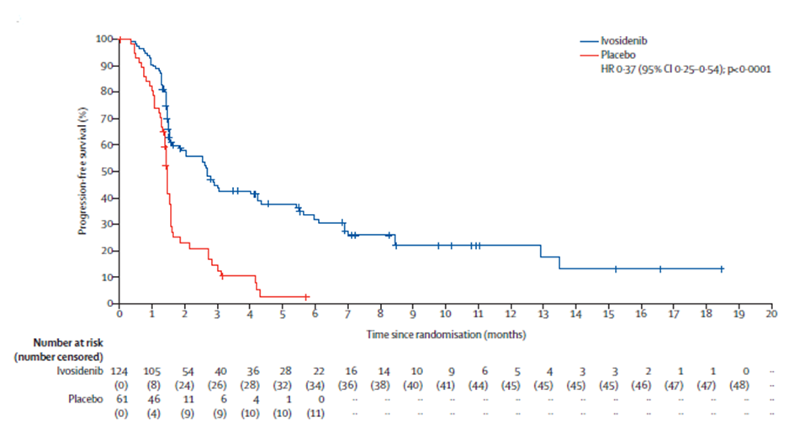

Source: Figure 2-11, of the submission

HR = hazard ratio; ITT = Intention-to-Treat; IRC = independent review committee; PFS = progression-free survival

Note: Data cutoff date: 31st January 2019.

* + - * 1. At DCO2 for the final OS analysis (31st May 2020), the median follow-up duration for OS was 24.4 months for ivosidenib and 20.5 months for placebo. At this DCO, death was observed in 100 (79.4%) patients in the ivosidenib arm and 50 (82.0%) patients in the placebo arm. The median OS in the ivosidenib arm was 10.3 months, compared with 7.5 months in the placebo arm, with overlapping confidence intervals, and a corresponding non-significant HR of 0.79 (95% CI: 0.56, 1.12; one-sided p = 0.093).
        2. At DCO2, 43 (70.5%) patients crossed over from placebo to ivosidenib. To adjust for treatment switching, the submission presented OS estimates from the RPSFT-adjusted analysis, using different approaches. The HRs for ivosidenib over placebo and the 95% CIs were calculated based on the Cox proportional hazards model (stratified by prior lines of treatment) and bootstrapped to take into account the uncertainty in the estimation of the acceleration factor. The results summarised in Table 7 and Figure 2 compare the unadjusted OS KM curves with the prespecified RPSFT-adjusted OS curves as used in the economic evaluation.

Table 7: Summary of crossover adjustment results

|  |  |  |
| --- | --- | --- |
| **Adjustment method** | **Median OS in placebo arm (months)** | **HR (95% CI) for ivosidenib *vs* placebo** |
| ITT (unadjusted) | 7.5 | 0.79 (0.56, 1.12) |
| Prespecified RPSFT | 5.1 | 0.49 (0.34, 0.70) |
| RPSFT, “treatment group”a (with re-censoring) | 4.9 | 0.46 (0.32, 0.67) |
| RPSFT, “treatment group”a (without re-censoring) | 5.2 | 0.52 (0.37,0.75) |
| RPSFT, “on treatment”b (with re-censoring) | NR | 0.49 (0.28, 0.87) |
| RPSFT, “on treatment”b (without re-censoring) | 5.5 | 0.52 (0.36, 0.74) |
| IPCW | NA | 0.74 (0.31, 1.56) |
| TSEc | NA | NA |

Source: Table 2-47, of the submission

IPCW = inverse probability of censoring weights; NA = not applicable; NR = not reached; RPSFT = rank-preserving structure failure time; TSE = two-stage estimation

a RPSFT “treatment group” approach, where the switch treatment effect duration is assumed to last from the first dose of the intervention until death/censoring. An analysis under this assumption ignores treatment discontinuation times.

b RPSFT “on-treatment” approach, where the switch treatment effect duration is assumed to last from the first dose of intervention until treatment discontinuation.

c Two-stage estimation was deemed not available for the ClarIDHy data given the small number of patients who did not switch

Figure 2: Kaplan-Meier plot of OS in the ClarIDHy trial (ITT population)

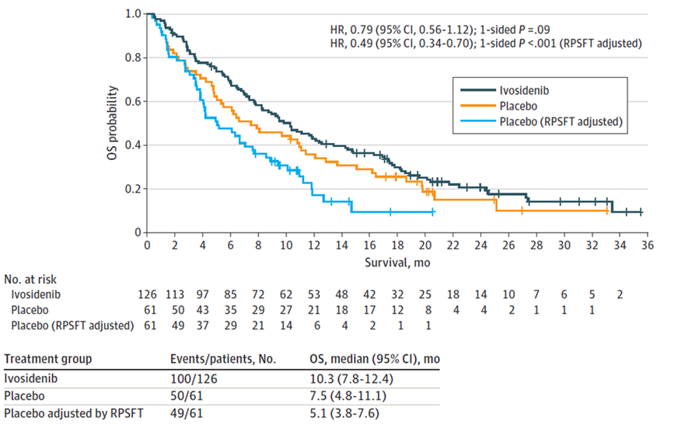

Source: Figure 2-14, of the submission

CI = confidence intervals; HR = hazard ratio; ITT = Intention-to-Treat; mo = month; OS = overall survival; RPSFT = rank-preserving structural failure time

Note: Data cutoff date: 31st May 2020.

* + - * 1. The RPSFT method produced consistent HRs for ivosidenib *versus* placebo under a range of assumptions and model structures. When using the RPSFT model, the HR for OS ranged between 0.46 and 0.52. In the prespecified RPSFT analysis, the HR for OS was 0.49 (95% CI: 0.34, 0.70), which was the primary analysis that has previously been reported by Zhu *et al* 2021[15].
        2. Overall, the adjustment for treatment switching in the placebo arm of the ClarIDHy using the RPSFT method, no matter which approach was taken, has an effect of increasing the difference in OS between the two treatment arms and the adjusted result favours ivosidenib in terms of OS outcome. However, the RPSFT approach was associated with high uncertainty as the approach assumes that the effect of ivosidenib was the same, regardless of the time point and stage of disease when the drug was received (common treatment effect). In the ClarIDHy trial, placebo patients were only allowed to receive ivosidenib treatment after their cancer was determined as progressive by investigator. The capacity for a patient to benefit from ivosidenib at this timepoint may be different compared to their pre-progression stage. Although acknowledging the uncertainty associated with any method for adjusting for treatment switching, the ESCs considered that RPSFT (on treatment, with re-censoring), was a reasonable approach for adjusting for treatment switching as it accounts for the duration of treatment received. The ESCs considered this was the most conservative statistical choice and noted the point estimate was similar to the pre-specified analysis. Although this approach resulted in wider confidence intervals, the confidence intervals did not cross 1, suggesting that the conclusion of a survival advantage for ivosidenib was reasonable.
        3. Adjusted analyses using other methods were presented in Table 7 for comparison with the RPSFT-adjusted results, given the uncertainty surrounding the key assumptions of the RPSFT method.The inverse probability of censoring weights (IPCW)-adjusted HR for OS was 0.74 (95% CI: 0.35, 1.56), lying between the RPSFT-adjusted HRs of 0.46-0.52 and the unadjusted HR of 0.79. Of note, in the ClarIDHy trial, the IPCW method may be less suitable for crossover adjustment due to the extensive nature of the crossover. Only a small number of patients chose not to switch when they were eligible to do so, and this greatly affected the validity of the IPCW approach. The two-stage estimation method was considered by the sponsor but was deemed unviable to implement and unfeasible to produce robust and reliable estimates.
        4. At DCO1, the ORR assessed by the IRC was 2.4% in the ivosidenib arm (all partial responses), compared to an ORR of 0% in the placebo arm. Before crossover, 63 of the 124 patients (50.8%) in the ivosidenib arm had stable disease compared to 17 of the 61 patients (27.9%) in the placebo arm. Before crossover, confirmed progressive disease occurred in one-third (33.1%) of the patients in the ivosidenib arm, compared to more than half (57.4%) of the patients in the placebo arm.
        5. In the ClarIDHy trial, HRQoL was assessed using the European Organisation for Research and Treatment of Cancer Quality of Life Questionnaire Core 30 (EORTC QLQ-C30), the cholangiocarcinoma and gallbladder cancer module (EORTC QLQ-BIL21), Patient Global Impression (PGI) questions adapted from the National Institute of Mental Health PGI of Change (PGI-C) and Severity (PGI-S), and the 5-level EuroQoL 5-Dimension (EQ-5D-5L) (used in the economic model). The analyses were based on the period before placebo patients crossed over to open-label ivosidenib. The HRQoL results focus on Cycle 2 Day 1 (C2D1) and Cycle 3 Day 1 (C3D1)[16] due to availability of data.
        6. Based on the data from DCO2, at C2D1, patients in the ivosidenib arm had preserved scores on the QLQ-C30 physical functioning subscales which persisted to C3D1, compared with patients in the placebo arm who experienced clinically meaningful[17] declines (indicating worsening) on the physical functioning subscale at C2D1. At C2D1, patient reported outcomes favoured ivosidenib for other QLQ-C30 subscales including emotional functioning, cognitive functioning, pain, and dyspnoea, as well as QLQ-BIL21 subscales including anxiety and tiredness. No differences in any QLQ-C30 symptom subscale or QLQ-BIL21 subscale were shown between the two treatment arms at C3D1.
        7. At C3D1, ivosidenib patients had better self-perceived health status. Mean (standard deviation [SD]) score change from baseline in EQ-5D-5L Visual Analogue Scale (VAS) for ivosidenib patients was 4.6 (14.4) compared to -2.8 (8.3) for placebo patients, with a higher score indicating a better health status. Results of descriptive responses in EQ-5D-5L aligned with the results from the EORTC questionnaires in terms of physical and emotional functioning. In the mobility dimension, the proportion of patients with no problems or slight problems at baseline was similar between arms (ivosidenib *vs* placebo: 79.4% *vs.* 84.3%), but by C3D1, a higher proportion of patients in the ivosidenib arm had no/slight problems than in the placebo arm (81.0% *vs.* 60.0%). Similarly, for the anxiety/depression dimension, the proportion of patients reporting not anxious/depressed or slightly anxious/depressed at baseline was comparable between arms (83.2% *vs.* 78.5%). However, by C3D1, more ivosidenib patients reported not or slightly anxious/depressed, compared to placebo patients (93.9% *vs.* 60.0%).
        8. The HRQoL findings appear inconsistent with the adverse event (AE) profile of ivosidenib relative to placebo. One possible reason is that AEs were well managed by treating clinicians and therefore did not affect quality of life. Alternatively, the HRQoL measures may not be sensitive enough to capture AEs that are associated with ivosidenib treatment. In addition, limited data were available for HRQoL outcome analyses. The assessment of change in EQ-5D-5L VAS from baseline to C3D1 to end of treatment was based on 38 (35.5%) and 8 (15.7%) patients in the ivosidenib and placebo arms, respectively. At C3D1, data from 9 placebo patients and 50 ivosidenib patients was available for QLQ-C30; data from 9 placebo patients and 48 ivosidenib patients was available for QLQ‑BIL21. Therefore, the results of HRQoL measurement in the trial should be interpreted with caution.

Indirect comparison of ivosidenib versus FOLFOX

* + - * 1. ITCs of ivosidenib *versus* FOLFOX were performed based on the ClarIDHy trial (ivosidenib + BSC *vs*. placebo + BSC) and the ABC-06 trial (FOLFOX + active symptom control (ASC) vs. ASC alone). There are key differences in patient characteristics between the two trial populations in terms of:
* *IDH1* variant status: all positive in the ClarIDHy trial versus all unknown status in the ABC-06 trial;
* CCA tumour site: 91% iCCA and 1% eCCA in the ClarIDHy trial versus 44% iCCA and 28% eCCA in the ABC-06 trial;
* Metastatic disease: 93% in the ClarIDHy trial versus 82% in the ABC-06 trial; and
* Prior line of treatment: 54% one prior line and 46% two prior lines in the ClarIDHy trial versus 100% one prior line in the ABC-06 trial.

The ClarIDHy and ABC-06 trial were also not comparable in terms of:

* Trial design: double-blinded design for the ClarIDHy trial versus open-label design for the ABC-06 trial;
* Frequency of radiologic tumour commentary: every 6 weeks for the first 48 weeks and every 8 weeks thereafter in the ClarIDHy trial versus 12 weeks after the start of FOLFOX, at the end of the treatment, and every 3 months thereafter until documentation of disease progression in the ABC-06 trial; and
* Median follow-up: 6.9 months at DCO 1 (January 2019) for PFS and 20.5-24.4 months at DCO 2 (May 2020) for OS in the ClarIDHy trial versus 21.7 months in the ABC-06 trial.
  + - * 1. The submission performed a matching-adjusted indirect treatment comparison (MAIC) for ivosidenib *versus* FOLFOX, using statistical weights to balance patient characteristics from ClarIDHy with those from ABC-06. An anchored MAIC was used for OS, via BSC as the common reference. Due to the lack of PFS data in the ASC only arm in the ABC-06 trial, an unanchored MAIC was used for PFS. The MAIC base case analysis included patient’s age, gender, performance status, previous line of treatment and extent of disease at screening as covariates for the matching. The Bucher method (unmatched anchored ITC) and unmatched unanchored ITC were also used for OS and PFS, respectively. The ITC results are summarised in Table 8.

Table 8: Key results of ITCs for ivosidenib vs. FOLFOX

|  |  |  |  |
| --- | --- | --- | --- |
| **OS** | **Intervention**  **Median, months (95% CI)** | **BSC (common reference)**  **Median, months (95% CI)** | **HR (95%CI)** |
| Ivosidenib *vs.* BSC (crossover-adjusted) (N=187) | 10.3 (7.8, 12.4) | 5.1 (3.8, 7.6) | 0.49 (0.34, 0.70) |
| FOLFOX *vs.* BSC (N=162) | 6.2 (5.4, 7.6) | 5.3 (4.1, 5.8) | 0.69 (0.50, 0.97) |
| iCCA (n=72) eCCA (n=45) | 5.7 (4.1, 7.4)  6.2 (5.4, 7.9) | 5.2 (3.7, 5.8)  5.4 (3.9, 6.3) | 0.64 (0.38, 1.06) 0.84 (0.45, 1.57) |
| **ITC (ivosidenib *vs.* FOLFOX)a** | **Ivosidenib**  **Median, months (95% CI)** | **FOLFOX**  **Median, months (95% CI)** | **HR (95%CI)** |
| Bucher | – | – | 0.58 (0.31, 1.09) |
| Anchored MAIC (base case) | 11.9 (9.2, 18.2) | 6.2 (5.4, 7.9) | 0.62 (0.33, 1.18) |
| **PFS** | **Intervention**  **Median, months (95% CI)** | **BSC (common reference)**  **Median, months (95% CI)** | **HR (95%CI)** |
| Ivosidenib *vs.* BSC (N=187) | 2.7 (1.6, 4.2) | 1.4 (1.4, 1.6) | 0.37 (0.25, 0.54) |
| FOLFOX *vs.* BSC (N=162) | 4.0 (3.2, 5.0) | NR | NR |
| iCCA (n=72) eCCA (n=45) | 3.3 (2.5, 5.2)  4.0 (2.9, 5.9) | NR NR | NR  NR |
| **ITC (ivosidenib *vs.* FOLFOX)a** | **Ivosidenib**  **Median, months (95% CI)** | **FOLFOX**  **Median, months (95% CI)** | **HR (95%CI)** |
| Unanchored unmatched | 3.1 (2.5, 8.4) | 4.1 (3.3, 5.4) | 0.92 (0.61, 1.39) |
| Unanchored MAIC (base case) | 3.1 (1.61, N/A) | 4.1 (3.3, 5.4) | NR |

Source: Table 1-10, of Appendix A in the submission; Lamarca *et al* 2021

BSC = best supportive care; CI = confidence interval; eCCA = extrahepatic cholangiocarcinoma; HR = hazard ratio; iCCA = intrahepatic cholangiocarcinoma; MAIC = matching-adjusted indirect comparison; OS= overall survival; PFS = progression-free survival

a ITC analysis only included patients with one previous line of therapy for both the ClarIDHy trial and the ABC-06 trial.

* + - * 1. After adjustment, the effective sample size (ESS) of the ClarIDHy trial was 75 for OS and 46 for PFS. The inclusion of CCA subtype (iCCA vs. eCCA) in the scenario analysis substantially reduced the ESS to 14 for OS and 8 for PFS, which introduced significant uncertainty into the analysis.
        2. After matching, the median OS for ivosidenib almost doubled the median OS for FOLFOX (11.9 months *vs*. 6.2 months). The OS HR from the anchored MAIC was 0.62 (95% CI: 0.33, 1.19), similar to the HR estimated using the Bucher method (HR: 0.58 [95% CI: 0.31, 1.09]). The 95% CIs of indirect HRs were wide, suggesting the analyses were not sufficiently powered. In addition, the indirect HR for OS should be interpreted with caution as it is unknown whether the proportional hazards assumption held. There are major uncertainties relating to the ITCs for OS between ivosidenib and FOLFOX which include: 1) transitivity issues remained after matching adjustment due to residual differences in patient characteristics, such as *IDH1* status and CCA tumour site; and 2) the ITCs used the RPSFT-adjusted OS from the ClarIDHy trial. The use of the RPSFT method for treatment switching adjustment may have overestimated the survival benefit of ivosidenib over placebo and, thus, biased the ITC results in favour of ivosidenib.
        3. Before matching and after matching, the median PFS was 3.1 months for ivosidenib, compared with a median PFS of 4.1 months for FOLFOX. The indirect PFS HR was not interpretable, given the crossover of the PFS curves for ivosidenib and FOLFOX, which suggests that the proportional hazard assumption was not met. Key uncertainties relating to the ITCs for PFS between ivosidenib and FOLFOX include: 1) radiologic tumour commentary occurred more frequent in the ClarIDHy trial than in the ABC-06 trial; and 2) differences in disease characteristics (e.g. IDH1 status and CCA tumour site), trial design and duration of follow-up between the ivosidenib and FOLFOX trials, which cannot be adjusted for.
        4. The Pre-Sub-Committee Response (PSCR) noted that subgroup results from the ABC-06 trial found that in patients with iCCA (comprising the vast majority of patients expected to be treated with ivosidenib), FOLFOX was associated with an improvement in median OS of only 0.5 months compared to BSC (5.7 vs 5.2 months). The PSCR argued that given this small incremental gain for FOLFOX compared to the over 5 months gain in OS observed in ivosidenib treated patients, it is reasonable to consider that ivosidenib would be superior to FOLFOX in IDH1m patients. The ESC noted, given the small number of patients with iCCA in the ABC-06 trial, the comparative result of median OS between the two treatment arms in this subgroup should be interpreted with caution.
        5. Overall, the ESCs noted that the ITC suggested ivosidenib was likely to be superior to FOLFOX in terms of OS, but was associated with a high level of uncertainty and did not reach statistical significance. The ESCs considered that the trials included were not sufficiently comparable to justify the conduct of ITCs, noting that transitivity issues remained after matching adjustment due to important residual differences in patient characteristics (including IDH1 status and CCA tumour site). In addition, the MAIC was confounded by the small numbers included in the analysis and use of RPSFT-adjusted OS for the placebo arm of the ClarIDHy trial.

Comparative harms

Head-to-head comparison of ivosidenib versus palliative/BSC

* + - * 1. The submission provided safety data on: 1) patients in the ivosidenib arm (N=123); 2) patients in the placebo arm, before crossover to open-label ivosidenib (N=59); 3) patients switching from placebo to open-label ivosidenib, after crossover (N=43); and 4) all patients receiving ivosidenib, including those from the ivosidenib arm and those switching from placebo to open-label ivosidenib (N=166). Table 9 summarises the overall treatment-emergent adverse events (TEAEs) in the ClarIDHy trial.
        2. At DCO2 of the ClarIDHy trial, the treatment duration for patients randomised to the ivosidenib arm (n=123) was much longer than the treatment duration for placebo patients before crossover (n=59): mean: 6.3 months *versus* 2.2 month; median: 2.8 months *versus* 1.6 months. Acknowledging this, the incidence of Grade ≥ 3 TEAEs, serious TEAEs and fatal TEAEs was notably higher in the ivosidenib arm than in the placebo arm.
        3. The overall ivosidenib patient population included the additional 43 patients who crossed over from placebo to open-label ivosidenib. The mean duration of ivosidenib therapy in this population was slightly shorter than that in the ivosidenib arm only population (6.0 months *vs.* 6.3 months). The incidence of TEAEs of any category, especially treatment related TEAEs, in the overall ivosidenib population was either lower than or similar to the ivosidenib arm only population.

Table 9: Overall summary of the treatment-emergent adverse events in the ClarIDHy trial (SAS)

|  |  |  |  |  |
| --- | --- | --- | --- | --- |
| AE category | Ivosidenib  N=123 (%) | Placebo  N=59 (%) | After crossover  N=43 (%) | Total ivosidenib  N=166 (%) |
| Number of TEAE | 1,542 | 446 | 386 | 1,928 |
| Number of Grade ≥3 TEAE | 226 | 57 | 73 | 299 |
| Subjects with any TEAE | 120 (97.6) | 57 (96.6) | 41 (95.3) | 161 (97.0) |
| Subjects with any Grade ≥3 TEAE | 62 (50.4) | 22 (37.3) | 26 (60.5) | 88 (53.0) |
| Subjects with related TEAE | 81 (65.9) | 23 (39.0) | 23 (53.5) | 104 (62.7) |
| Subjects with Grade ≥3 related TEAE | 8 (6.5) | 0 | 3 (7.0) | 11 (6.6) |
| Subjects with serious TEAE | 42 (34.1) | 14 (23.7) | 12 (27.9) | 54 (32.5) |
| Subjects with related serious TEAE | 3 (2.4) | 0 | 0 | 3 (1.8) |
| Subjects with TEAE leading to study drug discontinuation | 9 (7.3) | 5 (8.5) | 2 (4.7) | 11 (6.6) |
| Subjects with related TEAE leading to study drug discontinuation | 2 (1.6) | 0 | 0 | 2 (1.2) |
| Subjects with TEAE leading to death | 6 (4.9) | 0 | 2 (4.7) | 8 (4.8) |
| Subjects with related TEAE leading to death | 0 | 0 | 0 | 0 |

Source: Table 2-38, of the submission

AE = adverse event; SAS = safety analysis set; TE = treatment-emergent; TEAE = treatment-emergent adverse event

Note: Data cutoff date: 31st May 2020

* + - * 1. Approximately half (50.4%) of the patients in the ivosidenib arm (not including crossover patients) experienced ≥ Grade 3 TEAEs. Grade 3 or higher grade TEAEs that were most frequently reported (≥ 5%) in patients receiving ivosidenib included: ascites (7.4%), anaemia (6.5%), increased serum bilirubin (5.7%) and hyponatraemia (5.7%). Serious adverse events (SAEs) occurred in 34.1% of patients in the ivosidenib arm. The most common SAEs included pneumonia (3.3%), sepsis (3.3%), ascites (2.4%) and cholangitis (2.4%). Other SAEs that occurred in 2 or more ivosidenib patients but not in placebo patients included hip fracture, vomiting, hyperbilirubinemia, jaundice cholestasis, intestinal obstruction and pleural effusion. Drug-related TEAEs led to study drug discontinuation in 1.6% (2 patients) of patients in the ivosidenib arm. Generalised oedema and hyperbilirubinaemia were the causes of study drug discontinuation in these two patients, respectively.
        2. Six (4.9%) patients randomised to the ivosidenib arm experienced TEAEs leading to death, including sepsis (2 patients), pneumonia, intestinal obstruction, hepatic encephalopathy, and pulmonary embolism (1 patient each). Two additional fatal TEAEs occurred in crossover patients, including intestinal pseudo-obstruction and hepatic cirrhosis (1 patient each). None of the fatal TEAEs were considered associated with ivosidenib treatment by the investigator. The ESCs noted that the TEAEs leading to death were most likely to be related to disease progression and the number of events reported would be impacted by the substantially longer duration or treatment for patients treated with ivosidenib.
        3. Adverse events of special interest (AESI) in the submission were defined as prolongation of corrected QT (QTc) interval of any grade. In the ivosidenib arm (n=123), 12 patients (9.8%) experienced QTc prolongation events of any grade, two patients (1.6%) had Grade 3 events, and 8 patients (6.5%) had treatment related QTc prolongation of any grade. One crossover patient (2.3%) reported a Grade 3 AE of syncope. Durvalumab, in combination with cisplatin and gemcitabine, has been PBS-listed as first-line treatment for locally advanced or metastatic biliary tract cancer which includes CCA. According to the product information (PI), durvalumab can cause myocarditis of different severity. Although myocarditis is a relatively rare AE compared with other immune-checkpoint inhibitor (ICI) related AEs, it is associated with the highest mortality rate among all ICI-related AEs[18]. Ventricular arrhythmias, as well as heart failure, can be in the spectrum of clinical presentation of ICI-related myocarditis[19]. The safety of ivosidenib in patients previously treated with durvalumab-containing first-line therapy is unknown, however as noted above, the ESCs considered that safety outcomes are unlikely to be affected by prior durvalumab.

Indirect comparison of ivosidenib versus FOLFOX

* + - * 1. The submission did not present a formal ITC for safety between ivosidenib and FOLFOX. The limited safety data from the FOLFOX trial, especially for the ASC alone arm, hindered the comparison of safety between ivosidenib and FOLFOX. In addition, the dissimilar incidence of Grade ≥ 3 TEAEs in the placebo + BSC arm of the ClarIDHy trial and in the ASC alone arm of the ABC-006 trial (37.3% vs. 51.9%) suggests the lack of transitivity between the two trials. Essentially, ivosidenib and FOLFOX have different mechanisms of action and dissimilar safety profiles.

Benefits/harms

* + - * 1. A summary of the comparative benefits and harms for ivosidenib *versus* palliative/BSC is presented in the table below.

Table 10: Summary of comparative benefits and harms for ivosidenib and palliative care/BSC in the ClarIDHy trial

|  |  |  |  |  |
| --- | --- | --- | --- | --- |
| **Event** | **Ivosidenib** | **Palliative care/BSC** | **Absolute Difference** | **HR (95% CI)** |
| **Benefits** | | | | |
| **PFS (median follow-up of 6.9 months)** | | | | |
| Progressed, n/N (%) | 76/124 (61.3%) | 50/61 (82.0%) | – | 0.37 (0.25, 0.54) |
| Median PFS, months (95% CI) | 2.7 (1.6, 4.2) | 1.4 (1.4, 1.6) | 1.3 |  |
| % not progressed at 3 months | 44.8 | 12.5 | 32.3 |  |
| % not progressed at 12 months | 21.9 | NE |  |  |
| **Overall survival (median follow-up of 24.4 months for ivosidenib and 20.5 for palliative care)** | | | | |
| Deaths, n/N (%) | 100/126 (79.4%) | 50/61 (82.0%) | – | 0.79 (0.56, 1.12) |
| Median months OS (unadjusted)  (95% CI) | 10.3 (7.8, 12.4) | 7.5 (4.8, 11.1) | 2.8 |  |
| % alive at 12 months (95% CI) | 42.9 | 35.8 | 7.1 |  |
| % alive at 24 months (95% CI) | 20.7 | 15.0 | 5.7 |  |
| Median months OS (RPSFT-adjusted) (95% CI) | 10.3 (7.8, 12.4) | 5.1 (3.8, 7.6) | 5.2 | 0.49 (0.34, 0.70) |
| % alive at 12 months (95% CI) | 42.9 | 17.1 | 25.8 |  |

|  |  |  |  |  |  |  |
| --- | --- | --- | --- | --- | --- | --- |
| Harms | | | | | | |
|  | Ivosideniba  n/N | Palliative care/ BSCb  n/N | RR | Event rate/100 patients | | RD |
| Ivosidenib | Palliative care/BSC |
| All Grade 3 TEAEs | 62/123 | 22/59 | 1.35 | 50.4 | 37.3 | 13.1 |
| All serious TEAEs | 42/123 | 14/59 | 1.44 | 34.1 | 23.7 | 10.4 |
| Prolongation of QT | 12/123 | 2/59 | 2.88 | 9.8 | 3.4 | 6.4 |
| TEAEs leading to death | 6/123 | 0 | – | 4.9 | 0 | 4.9 |

Source: Table 2-31; Table 2-34 and Table 2-35 of the submission

CI = confidence interval; HR = hazard ratio; NE = not estimable; OS = overall survival; PFS = progression-free survival; RD = risk difference; RPSFT = rank-preserving structural failure time; RR = risk ratio; TEAE = treatment-emergent adverse event

a Including patients randomised to the ivosidenib arm (no crossover patients included). Duration of exposure to ivosidenib: mean 6.3 months; median 2.8 months

b Including patients in the placebo arm before crossover. Duration of exposure to placebo: mean 2.2 months; median 1.6 months

* + - * 1. Based on the head-to-head ClarIDHy trial presented in the submission, for every 100 patients treated with ivosidenib in comparison to palliative care/ BSC:
* Approximately 32 additional patients would remain progression-free at 3 months and up to 22 additional patients would remain progression-free at 12 months.
* Approximately 7 and 26 additional patients would remain alive at 12 months, when the survival in palliative care patients was unadjusted and adjusted, respectively, for treatment switching using the RPSFT model.
* For a mean treatment duration of 6.3 months for ivosidenib:
  + Approximately 13 additional patients would experience ≥ Grade 3 AEs.
  + Approximately 10 additional patients would experience serious AEs.
  + Approximately 6 additional patients would experience QT prolongation.
  + Approximately 5 additional patients would experience AEs leading to death.
    - * 1. The benefits/harms table for ivosidenib compared with FOLFOX is not presented due to the major issues associated with ITCs, and because the magnitude of the incremental benefit and harm of ivosidenib versus FOLFOX could not be reliably quantified.

Clinical claim

* + - * 1. The submission described ivosidenib as being superior in terms of efficacy compared to palliative care/BSC in patients with locally advanced or metastatic CCA who have received previous chemotherapy and have a confirmed a *IDH1* variant. The commentary considered this was supported by the trial data in terms of delaying progression for a median 1.3 months in ivosidenib-treated patients, but not in terms of OS, where there was a survival gain of a median of 2.8 months, but the result was not statistically significant. Adjustment for cross-over from the placebo arm, using an RPSFT model improved the survival gain with ivosidenib to a median of 5.2 months but this may have been an overestimate due to the violation of assumptions supporting use of the RPSFT. The ESCs considered that the clinical claim of superior efficacy for ivosidenib compared with BSC was reasonable for outcomes of PFS and OS, however the gains were very modest and outcomes remained poor.
        2. The submission described ivosidenib as inferior in terms of safety compared to palliative care/BSC, but with manageable AEs. The conclusion of an inferior safety profile of ivosidenib was supported by the safety data from the trial, showing that ivosidenib-treated patients experienced more AEs across all AE categories. The ESCs considered that the clinical claim of inferior safety for ivosidenib was reasonable.
        3. With regard to ivosidenib versus FOLFOX, the submission argued that ivosidenib was associated with an improvement in OS. The clinical evidence presented did not strongly support this conclusion as there were important residual differences in patient characteristics resulting in transitivity issues remaining after matching adjustment and the comparison was potentially confounded by the small number of patients included in the comparison and use of the RPSFT-adjusted OS results from the ClarIDHy trial. The submission and pre-PBAC response also argued that ivosidenib was likely associated with a favourable safety profile compared to FOLFOX. The pre-PBAC response stated that Australian clinicians have found that ivosidenib is well tolerated with a manageable safety profile. The commentary considered the claim of superior safety was not well supported by the clinical evidence as there were limited safety data available and a comparison with FOLFOX was not possible.
        4. The PBAC considered that the clinical claim of superior comparative effectiveness for ivosidenib compared with BSC was reasonable, with a small PFS benefit and moderate OS benefit shown after adjustment for cross-over. However, the PBAC considered that the OS benefit was associated with uncertainty given the adjustment for cross-over and because the patient population in the ClarIDHy trial is likely to be fitter than the Australian population that is likely to be treated with ivosidenib.
        5. The PBAC considered the clinical claim of inferior comparative safety for ivosidenib compared with BSC was reasonable.
        6. The PBAC considered that the clinical claim of superior comparative effectiveness for ivosidenib compared with FOLFOX is likely to be reasonable, however there is a high level of uncertainty due to the limitations of the ITC.
        7. The PBAC considered the clinical claim of superior comparative safety for ivosidenib compared with FOLFOX was uncertain as no formal safety comparison was possible, but noted that FOLFOX is associated with substantial toxicity.

Economic analysis

* + - * 1. The submission presented a stepped economic evaluation (cost-utility analysis), based on the ClarIDHy trial which compared ivosidenib with placebo in locally advanced or metastatic CCA with *IDH1* variants who had disease progression following at least one line of chemotherapy. The economic analysis compared testing plus ivosidenib with no testing plus palliative care/BSC in the proposed target population.The submission also allowed for the inclusion of FOLFOX as an additional comparator in the economic model.

Table 11: Summary of model structure, key inputs, and rationale

|  |  |
| --- | --- |
| Component | Summary |
| Comparison modelled | *IDH1* variant testing + ivosidenib *versus* no testing + palliative care/BSC |
| Time horizon | 10 years in the model base case (*vs.* a median follow-up for OS of 20.5-24.4 months from the ClarIDHy trial). |
| Outcomes | LYs; QALYs. |
| Methods used to generate results | Partitioned survival model. |
| Health states | PF, PD and death. |
| Cycle length | 1 week. |
| Test parameters | 100% test sensitivity and specificity with a *IDH1* variants prevalence of 9.15%.  The prevalence of *IDH1* variants was weighted based on prevalence of *IDH1* variants in intrahepatic CCA and extrahepatic CCA. The accuracy of the test was not of concern in line with previous MSAC advice (Section 14, PSD, MSAC application 1585). Thus, the testing parameters used in the economic model were reasonable*.* |
| Implications of false positive and false negative results | None, as 100% test sensitivity and specificity assumed. |
| Allocation to health states | Base case: derived from the PFS and OS KM curves from the ClarIDHy trial. Due to the high crossover rate (70.5%) from placebo to open-label ivosidenib in the trial, RPSFT-adjusted OS for placebo was used in the model.  Sensitivity analyses: for alternative scenarios (e.g. different approaches to treatment switching, inclusion of FOLFOX as comparator), survival is estimated for the comparator arm by applying a HR to the survival curve for ivosidenib (assuming proportional hazards). |
| Extrapolation method | KM data was used until median PFS and median OS. For ivosidenib, KM data for OS was used until 10.3 months and KM data for PFS was used until 2.7 months. For BSC, KM OS data was used until 5.1 months and KM PFS data was used until 1.4 months. Parametric models were fitted to each treatment arm based on goodness of fit (visual and AIC/BIC) (log-normal models for ivosidenib and BSC OS; generalised gamma and log-logistic models for ivosidenib and BSC PFS, respectively). |
| Health related quality of life | Utility values were derived from the ClarIDHy trial (PF= 0.8524; PD = 0.8043). |
| Costs | Direct treatment costs, costs for disease management (PF and PD), costs for AEs management and terminal care costs were applied.  The inclusion of the terminal care costs has not been well justified. The modelled patients had advanced disease and almost all patients have died within the modelled time horizon. However, exclusion of terminal care costs had a minimal impact on the result based on a time horizon of 10 years in the economic model, but may have a larger impact if a shorter time horizon is assumed. |

Source: Table 3-1, of the submission and the “3.1_Ivosidenib cost-effectiveness model” workbook provided in the submission.

AEs = adverse events; AIC = Akaike information criteria; BIC = Bayesian information criteria; BSC = best supportive care; CCA = cholangiocarcinoma; *IDH1* = isocitrate dehydrogenase 1; KM = Kaplan-Meier; LYs = life-years; OS = overall survival; PD = progressed disease; PFS = progression-free

* + - * 1. The submission employed a partitioned survival model and modelled three health states: progression-free (PF), progressed disease (PD) and death. Allocation to the three health states was based on the OS and PFS curves for the ivosidenib and placebo arms of the ClarIDHy trial. Patients entered the model at the point of testing in the PF health state. The submission presented results of the economic evaluation for the testing population. As a result, the costs and benefits associated with ivosidenib treatment were diluted due to the presence of a large number of biomarker negative patients in the model. For ease of interpretation, the submission’s co-dependent economic model has been simplified to a trial (treated) population, (as false positives and false positives were assumed to be zero in the model with no downstream effects), which does not include *IDH1* negative patients, but considers the incremental testing costs between the current and proposed scenarios per trial/treated patient. Of note, the incremental cost-effectiveness ratio (ICER) from this simplified model was the same as that from the submission’s co-dependent model.
        2. The submission nominated a time horizon of 10 years based on the median follow-up duration for OS of 20.5-24.4 months in the clinical trial. The ESC has previously advised that a time horizon of 7.5 years was appropriate for first-line treatment of advanced biliary tract cancer (Durvalumab public summary document [PSD], July 2023 PBAC meeting) and hepatocellular carcinoma (Atezolizumab and bevacizumab PSD, July 2020 PBAC meeting). Given the patients in the proposed targeted population have more advanced disease and that there are uncertainties regarding OS extrapolation, a shorter time horizon may be more appropriate. The ESCs considered a 5-year time horizon was appropriate as CCA has a poor prognosis, with very few second-line patients expected to survive to 5 years, with or without ivosidenib treatment. The pre-PBAC argued that a time horizon of 10 years is reasonable for ivosidenib because, as a targeted treatment, the OS benefit for ivosidenib would be greater than the previously considered non-targeted therapies. However, the pre-PBAC accepted use of a 7.5 year time horizon in the pre-PBAC response respecified base case. The PBAC noted that, in ClarIDHy, 78% of patients in the ivosidenib arm had progressed at 12 months and considered that a 5 year time horizon is likely to capture the benefit of ivosidenib treatment.
        3. Health state membership was determined based on the PFS and OS curves from the ClarIDHy trial data.Due to the high crossover rate (70.5%) from placebo to open-label ivosidenib treatment in the trial, OS data for BSC as used in the economic model were adjusted for treatment switching using the RPSFT method. As per paragraph 6.21, the common treatment effect assumption underlying the RPSFT model is uncertain. Given the limitations regarding the RPSFT method and other methods of adjustment for treatment switching, the health outcomes relating to the comparator BSC arm and, thus, the incremental survival from ivosidenib versus BSC cannot be reliably modelled. The modelled OS curves for the BSC arm, using different treatment adjustment methods are presented in Figure 3. The PSCR argued that the use of adjusted OS analysis in the economic model was reasonable as use of the unadjusted results would have significantly biased the cost-effectiveness analyses against ivosidenib. The ESCs considered that the RPSFT method was reasonable in this context and noted that modelled OS curves using variations on the RPSFT method were reasonably consistent.

Figure 3: Modelled OS curves using different adjusting methods for treatment switching (BSC)

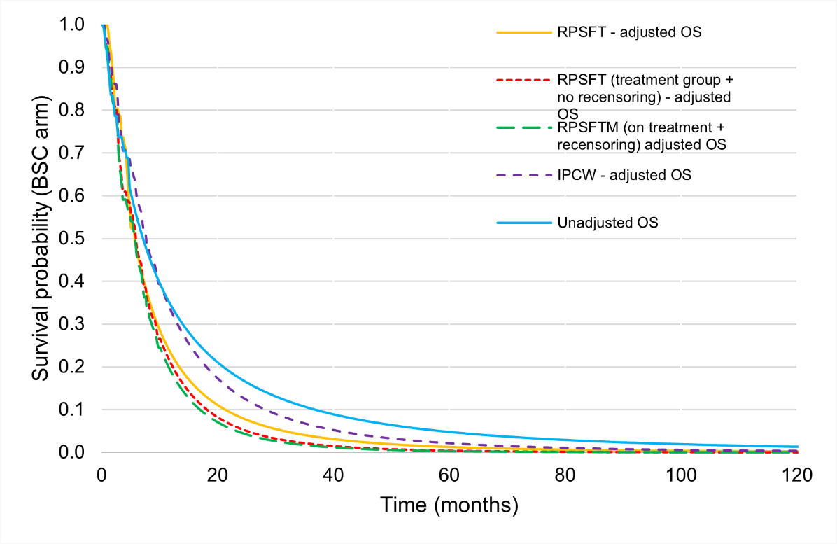

Source: constructed during the commentary from the “3.1_Ivosidenib cost-effectiveness model” Workbook provided in the submission.

BSC = best supportive care; OS = overall survival

Note: The base case (RPSFT – adjusted OS) uses the trial-based survival curves for both treatment arms (with extrapolations). However alternative analyses for treatment switching approaches estimate the survival for the comparator by applying a HR to the survival curve for ivosidenib (assuming proportional hazards). This results in a less favourable OS curve for BSC, even where the HR is the same as for the base case (RPSFT on treatment + re-censoring) and where the HR for IVO vs BSC is higher (treatment group + no re-censoring).

* + - * 1. As the clinical evidence was incomplete, extrapolation of the PFS and OS curves over the modelled time horizon was necessary. The extrapolation time point was selected based on the median OS (10.3 months for ivosidenib and 5.1 months for BSC) and median PFS (2.7 months for ivosidenib and 1.4 months for BSC).The PBAC guidelines recommend that trial-based data should be utilised until the data becomes unreliable due to a small number of patients remaining event free. In line with this, more observed data could have been used as there was still a reasonable number of patients remaining at risk in later time points. The impact of using different time points for truncation of KM data has been explored in sensitivity analyses. The ESCs agreed with the commentary that more observed data could have been used, but considered that the impact on the ICER was small.
        2. Parametric functions were selected based on goodness of fit to the trial data (log-normal for OS in both treatment arms; generalised gamma and log-logistic for ivosidenib PFS and BSC PFS, respectively). For the ivosidenib arm, additional parametric models (such as log-logistic and exponential) also provided a good visual fit to the trial data, with goodness of fit statistics, Akaike information criteria (AIC) and the Bayesian information criteria (BIC), similar to the log-normal distribution. While the log-logistic model had a minimal impact on the ICER, the use of the exponential distribution increased the ICER by 51%. The PSCR noted that in the NICE commentary of ivosidenib, the committee considered both the log-normal and generalised-gamma curves were plausible. The ESCs noted that most of the functions resulted in extrapolated curves that appeared similarly reasonable based on visual fit and differences in statistical measures of goodness of fit were small. The ESCs noted that the base case functional form resulted in ~5% of patients in the BSC arm and ~6% of patients in the ivosidenib arm alive at 5 years and considered this was overly optimistic in terms of survival and not clinically plausible. The ESCs considered that a common functional form, with a less optimistic survival trajectory, should form part of a respecified base case. The ESCs considered the extrapolations based on the exponential function were reasonable for both treatment arms. The pre-PBAC response argued that it was not necessary for a common functional form to apply as an active treatment is being compared to palliative care and the curves could plausibly differ. The pre-PBAC response also argued the exponential function underestimated the observed data from the ivosidenib arm and would therefore bias results against ivosidenib (see Figure 6). The PBAC noted that the extrapolation function had less of an impact when the time horizon was reduced to 5 years.

Figure 4: Parametric extrapolations for OS (ivosidenib)

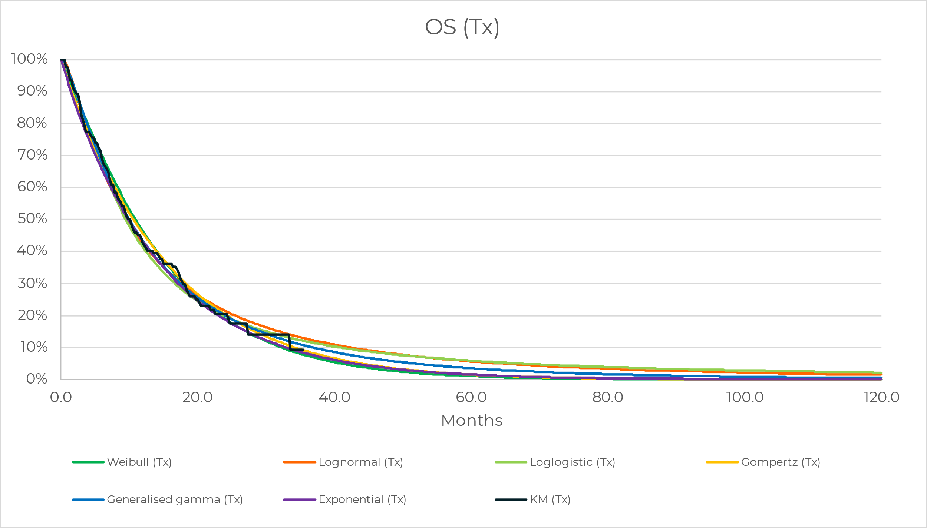Source: Figure 3-3 of the submission

BSC = best supportive care; Cx = comparator arm; KM = Kaplan-Meier; OS = overall survival

Figure 5: Parametric extrapolations for OS (BSC)

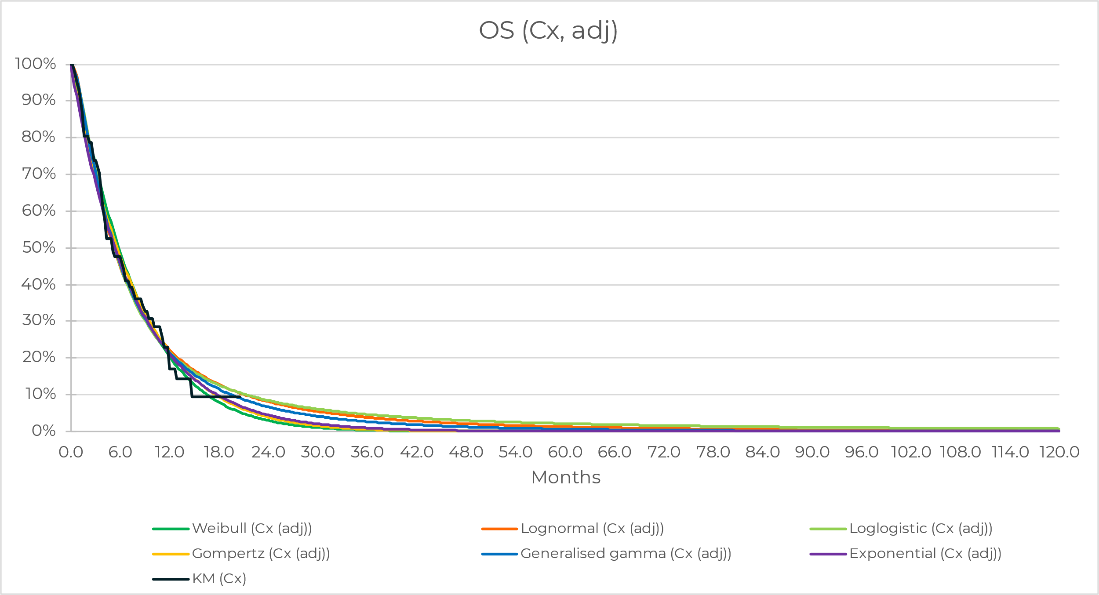

Source: Figure 3-4 of the submission

BSC = best supportive care; Cx = comparator arm; KM = Kaplan-Meier; OS = overall survival

Figure 6: Overall survival using exponential extrapolations

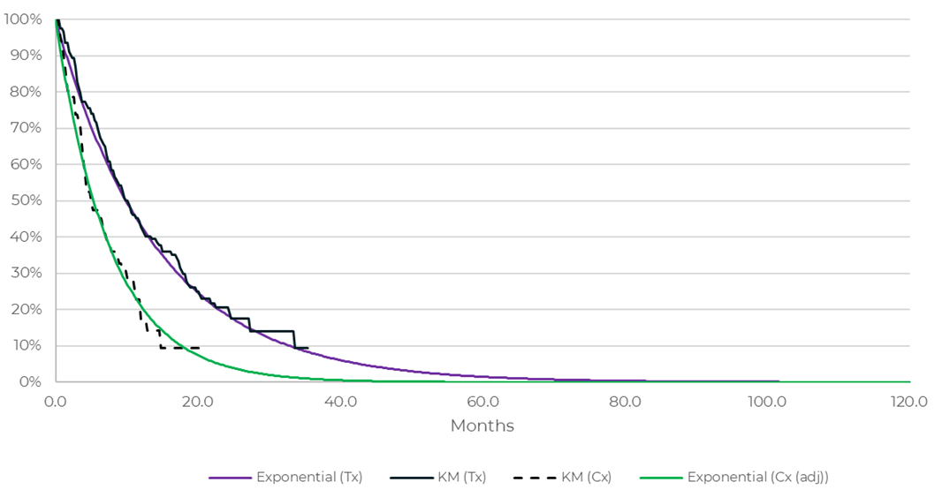

Source: pre-PBAC response

Cx = comparator arm; KM = Kaplan-Meier; Tx = treatment arm

* + - * 1. Patients were allowed to continue treatment with ivosidenib on disease progression in the ClarIDHy trial and the resulting mean duration of treatment was 6.3 months. The trial-based time-on-treatment (ToT) curve has been adjusted in the economic evaluation, *i.e.,* capped by the PFS curve. This adjustment was in line with the requested listing which specified that patients would discontinue treatment with ivosidenib upon disease progression. However, no adjustment for health outcomes associated with ivosidenib treatment was made in the economic model. This assumes that ongoing treatment with ivosidenib beyond disease progression provides no survival benefit. No evidence was presented to support this assumption and the submission’s approach may have favoured ivosidenib, as it reduced the treatment cost but used trial-based health outcomeswhich included ongoing therapy beyond progression. The ESCs considered that it would be appropriate to either include the trial-based time on treatment in the model (without capping at the PFS curve), or adjust the model outcomes to account for the reduced treatment duration. However, the ESCs noted that the model was not structured to allow forced equal hazards beyond progression to account for the reduced treatment benefit. The pre-PBAC response argued that treatment beyond progression would not occur in Australian practice and it is therefore not reasonable to model the cost of ivosidenib treatment using trial-based time on treatment. The pre-PBAC did not address adjustment of the outcomes to account for any benefit from use beyond progression. In the absence of any adjustment in outcomes, the PBAC considered it was reasonable for the ToT to be based on the trial data without being capped by the PFS curve.
        2. Comparisons of the observed Kaplan-Meier PFS and OS data to the modelled curves for both arms are presented in Figure 7 for the ivosidenib arm and Figure 8 for the BSC arm.

Figure 7: KM and modelled PFS and OS curves (ivosidenib)

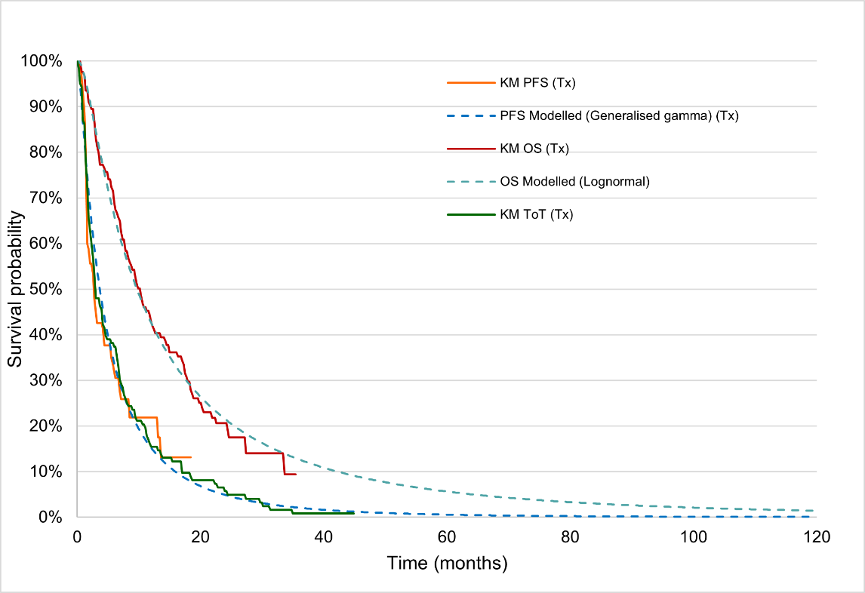

Source: Constructed during commentary*,* based on the ‘Extrapolations’, ‘Model_Tx (TP)’ and ‘Model_Cx (TN, FN, SOC)’ spreadsheets in the “3.1_Ivosidenib cost-effectiveness model” Workbook provided in the submission.

KM = Kaplan-Meier; OS = overall survival; PFS = progression-free survival; ToT = time-on-treatment; Tx = treatment arm

Figure 8: KM and modelled PFS and OS curves (best supportive care)

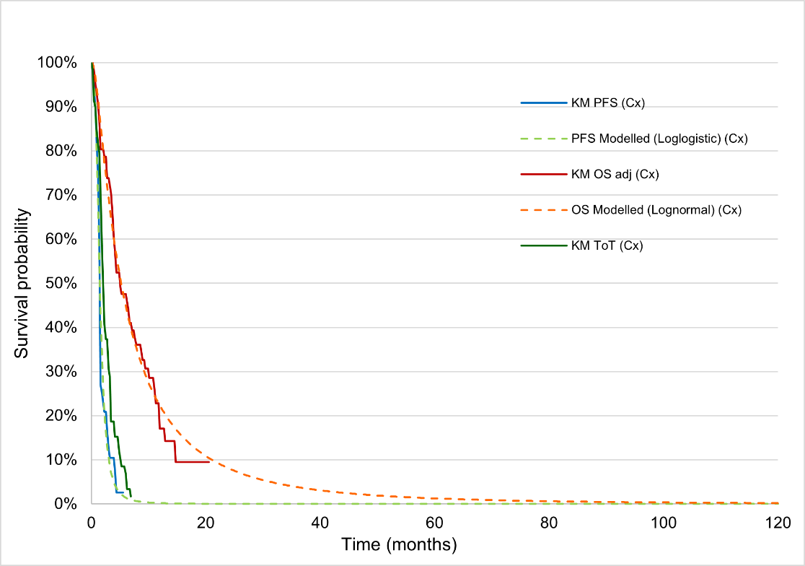

Source: Constructed during commentary*,* based on the ‘Extrapolations’, ‘Model_Tx (TP)’ and ‘Model_Cx (TN, FN, SOC)’ spreadsheets in the “3.1_Ivosidenib cost-effectiveness model” Workbook provided in the submission.

Cx = comparator; KM = Kaplan-Meier; OS = overall survival; PFS = progression-free survival; ToT = time-on-treatment

* + - * 1. The submission applied utility weights of 0.85 to patients in the PF health state and 0.80 in the PD state, which were derived from the HRQoL assessments of the ClarIDHy trial using the EQ-5D-5L (and mapped using the Australian value set). The utility weights applied appeared to be clinically implausible, especially for the PD health state, and were higher than the utility weights that have been previously considered by the PBAC in first-line treatment of advanced bile tract cancer (PF=0.857, PD=0.766; Table 14, durvalumab PSD, March 2023 PBAC meeting) and advanced hepatocellular carcinoma (PF=0.769, PD=0.627; Table 12, atezolizumab and bevacizumab PSD, July 2020 PBAC meeting). The ICER was highly sensitive to the utility weights applied, especially for the PD state, as patients treated with ivosidenib spend a longer time in the PD health state compared to patients in the BSC arm of the trial. Further, more LYs are gained in the PD state compared to the PF state. The PSCR and pre-PBAC response noted that trial-based HRQoL data from the pivotal trial were used, as per PBAC preference, ensuring that the model is internally consistent. The PSCR and pre-PBAC response also noted that at baseline, most participants in both arms of the trial noted ‘no problems’ or only ‘slight problems’ across all domains of the EQ-5D, which is consistent with the relatively high utility weights applied to the PFS health state. The ESCs agreed with the commentary that the reported weights did not have face validity, noting that the values are close to, or at, population norms, even for the PD state. The ESCs noted that utility values in the PD state may be impacted by the point at which QoL was measured in the ClarIDy trial (prior to cross-over) and the small number of patients with data to inform the values (as discussed in paragraph 6.27). The ESCs advised that the alternative weights considered in previous PBAC considerations would be appropriate to use in a respecified base case, given the lack of face validity for the values from the ClarIDy trial. The PBAC considered the values used in the durvalumab submission (PF=0.857, PD=0.766, Table 14, durvalumab PSD, March 2023 PBAC meeting) would be most reasonable.
        2. The life years (LYs) (discounted) gained over the model time horizon for the ivosidenib and BSC arms are presented in Figure 9. 49% and 46% of the LYs (discounted) were gained in the extrapolated period for the ivosidenib arm and placebo arm, respectively.

Figure 9: LYs (discounted) gained over the modelled time horizon, by treatment arm

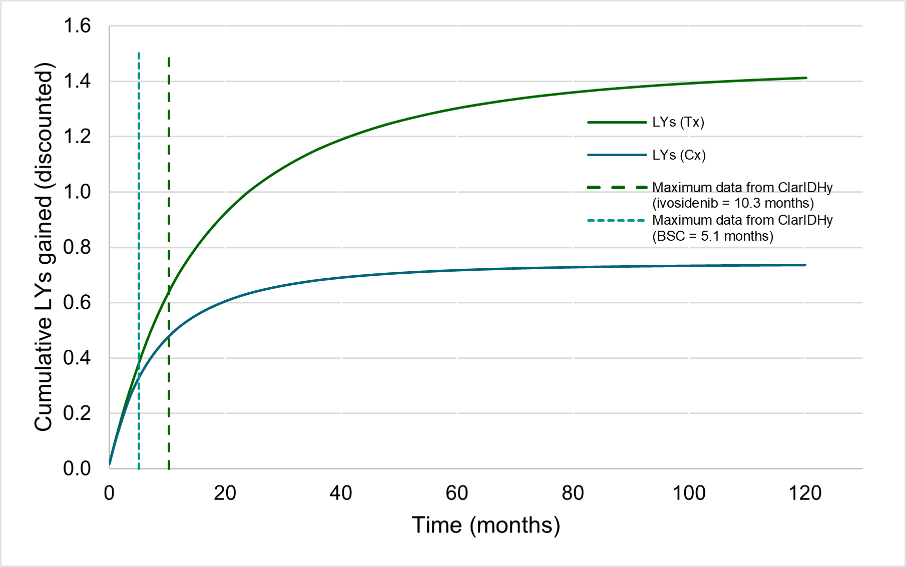

Source: Constructed during commentary*,* based on the ‘Model_Tx (TP)’ and ‘Model_Cx (TN, FN, SOC)’ spreadsheets in the “3.1_Ivosidenib cost-effectiveness model” Workbook provided in the submission.

Cx = comparator arm; LYs = life years; Tx = treatment arm

* + - * 1. The key drivers of the economic model are summarised in Table 12.

Table 12: Key drivers of the model

| Description | Method/Value | Impact  (base case ICER: $||||1/QALY gained) |
| --- | --- | --- |
| Extrapolation of OS for the ivosidenib arm | The log-normal model was fitted to the trial KM OS data in the base case analysis. | High – favours ivosidenib. When the exponential model is fitted to the trial data, the ICER increased to $||||2/QALY gained. |
| Utilities | The utility values for model health states were derived from the ClarIDHy trial. | High - favours ivosidenib. Applying lower utility weights, especially in the PD state, significantly increased the ICER. |
| Time horizon | 10 years. | High – favours ivosidenib. Decreasing the time horizon to 5 years increased the ICER to $||||. 1 |

Source: Tabulated during the commentary.

ICER = incremental cost-effectiveness ratio; KM = Kaplan-Meier; OS = overall survival; PD = progressed disease; RPSFT = rank-preserving structural failure time

*The redacted values correspond to the following ranges:*

*1 $95,000 to < $115,000*

*2 $135,000 to < $155,000*

* + - * 1. The results of the stepped economic evaluation for the trial population are presented Table 13.

Table 13: Results of the stepped economic evaluation

| Step and component | Ivosidenib | BSC | Increment |
| --- | --- | --- | --- |
| **Step 1: trial-based costs and outcomes (36 monthsa)** | | | |
| Costs | $| | $24,309 | $| |
| LYs gained | 1.154 | 0.682 | 0.473 |
| Incremental cost/extra LY gained | | | |1 |
| Step 2: extrapolated to 10 years | | | |
| Costs | $| | $25,024 | $| |
| LYs gained | 1.413 | 0.737 | 0.676 |
| Incremental cost/extra LY gained | | | |2 |
| Step 3: transformation into QALYs | | | |
| Costs | $| | $25,024 | $| |
| QALYs | 1.159 | 0.599 | 0.560 |
| **Incremental cost/extra QALY gained (base case)** | | | **|**1 |

Source: Tabulated during the commentary, based on the ‘Setting and Results’ and ‘Model_Tx (TP)’ spreadsheets in the “3.1_Ivosidenib cost-effectiveness model” Workbook provided in the submission.

BSC = best supportive care; LY = life-years; QALYs = quality-adjusted life years

Note: the number may not be exact due to rounding in the “3.1_Ivosidenib cost-effectiveness model” Workbook provided in the submission.

a 36 months was the latest follow-up for overall survival in the ivosidenib arm of the ClarIDHy trial

*The redacted values correspond to the following ranges:*

*1 $95,000 to < $115,000*

*2 $75,000 to < $95,000*

* + - * 1. For the trial population (*i.e.*, patients who test positive for *IDH1* variants and are treated with ivosidenib or BSC), ivosidenib, compared with BSC, was associated with 0.56 quality-adjusted life years (QALY) gained, at an additional cost of | |, resulting in an ICER of $95,000 to < $115,000/QALY gained. The ICER for the trial population was identical to the ICER for the testing population as presented in the submission.Themain driver of the costs was the cost of ivosidenib treatment, with the cost of testing, disease management, management of AEs and terminal care costs minor contributors.
        2. The Markov traces of the PF, PD, and death health states, for the ivosidenib and BSC treatment arms, over the modelled time horizon are presented in Figure 10.

Figure 10: Modelled traces over the time horizon

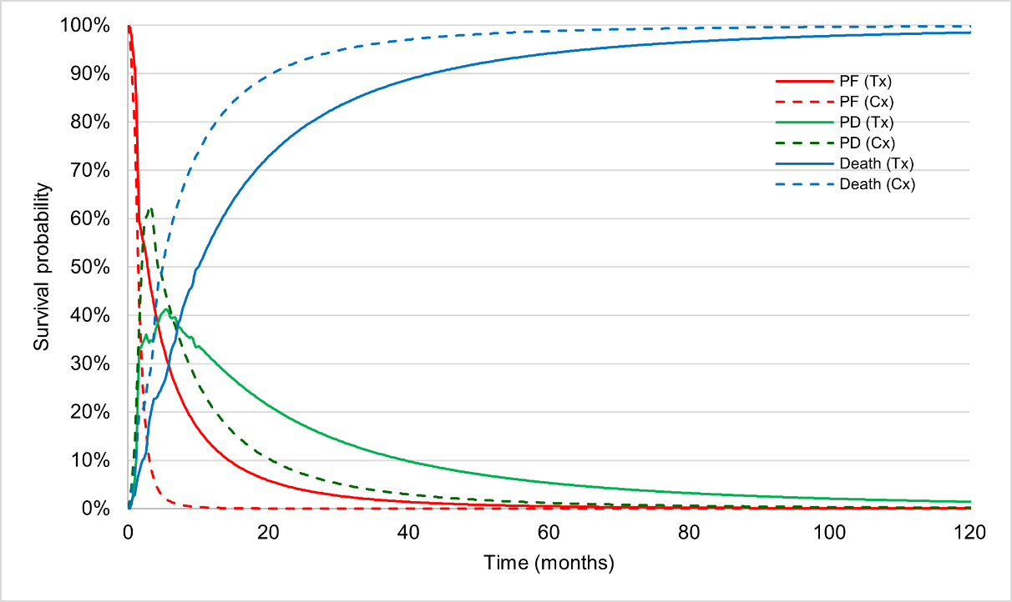

Source*:* Constructed during commentary*,* based on the ‘Markov trace’ spreadsheet in the “3.1_Ivosidenib cost-effectiveness model” Workbook provided in the submission.

Cx = comparator; PD = progressive disease; PF = progression-free; Tx = treatment arm

* + - * 1. From the modelled traces, it is evident that patients who did not receive treatment with ivosidenib progressed faster than those receiving ivosidenib treatment, especially in the first few months. Further, patients in the ivosidenib arm spent more time in the PD state (compared to the BSC arm). Both of the above contributed to the OS benefits accrued by patients receiving ivosidenib treatment.
        2. The results of key sensitivity analyses are summarised in Table 14.

Table 14: Results of the key univariate and multivariate **sensitivity analyses**

| **Analyses** | **Incremental cost** | **Incremental QALY** | **ICER** | **% change from baseline** |
| --- | --- | --- | --- | --- |
| **Base case** | **$||** | **0.560** | **|1** | **–** |
| **Time horizon (base case: 10 years)** | | | | |
| 5 years #1 | $　| | 0.486 | |**1** | |% |
| **Discount rate (base case: 5%)** | | | | |
| 0% | $　| | 0.620 | |2 | -　|　% |
| 3.5% | $　| | 0.576 | |**1** | -　|　% |
| **Utility weights (PF=0.85; PD=0.80)** | | | | |
| PF=0.769; PD=0.627  (Table 12, Atezolizumab and bevacizumab PSD, July 2020 PBAC meeting) | $　| | 0.473 | |3 | |% |
| PF=0.857; PD=0.766  (Table 14, durvalumab PSD, March 2023 PBAC meeting) *#3* | $　| | 0.549 | |**1** | |% |
| PF=0.76; PD=0.68[20] | $　| | 0.487 | |3 | |% |
| **Ivosidenib KM truncation time point (base case: OS=10.3 months; PFS=2.7 months)** | | | | |
| 12 months for OS | $　| | 0.540 | |**1** | |% |
| 18 months for OS | $　| | 0.548 | |**1** | |% |
| 3 months for PFS | $　| | 0.559 | |**1** | -　|　% |
| 6 months for PFS | $　| | 0.561 | |**1** | |% |
| **SOC KM truncation time point (base case: OS=5.1 months; PFS=1.4 months)** | | | | |
| 6 months for OS | $　| | 0.529 | |**1** | |% |
| **Adjustment for treatment switching (base case: RPSFT method)** | | | | |
| Unadjusted OS a | $　| | 0.211 | |4 | |% |
| IPCW-adjusted OS | $　| | 0.341 | |5 | |% |
| RPSFT (treatment group + no re-censoring) b | $　| | 0.599 | |2 | -　|　% |
| RPSFT (on treatment + re-censoring) b | $　| | 0.632 | |2 | -　|　% |
| **Parametric model extrapolation for OS (log-normal)** | | | | |
| OS: exponential (ivosidenib arm only) | $　| | 0.373 | |6 | |% |
| OS: exponential (both arms) #2 | $　| | 0.460 | |3 | |% |
| **Comparator (base case: only palliative care) c** | | | | |
| Include FOLFOX (15%) | $　| | 0.609 | |2 | -　|　% |
| Include FOLFOX (45%) *#5* | $　| | 0.563 | |2 | -　|　% |
| Include FOLFOX (100%) | $　| | 0.469 | |**1** | |% |
| **Costs** | | | | |
| Exclusion of terminal care costs | $　| | 0.560 | |**1** | |% |
| Using ToT curve (not limited by PFS curve) to model treatment cost for ivosidenib treatment #4 | $　| | 0.560 | |**1** | |% |
| **ESC specified multivariate analyses** |  |  |  |  |
| #1, #2 | $　| | 0.449 | |3 | |% |
| #1, #2, #3 | $　| | 0.443 | |3 | |% |
| #1, #2, #3, #4 | $　| | 0.443 | |6 | |% |
| #1, #2, #3, #4, #5 | $　| | 0.396 | |6 | |% |

Source: tabulated during the commentary and for ESC advice from table 3-27, of the submission and the “3.1_Ivosidenib cost-effectiveness model” Workbook provided in the submission.

BSC = best supportive care; ICER = incremental cost-effectiveness ratio; IPCW = inverse probability of censoring weights; KM = Kaplan-Meier; OS = overall survival; PD = progressed disease; PF = progression-free; QALY = quality-adjusted life year; RPSFT = rank-preserving structural failure time; ToT = time on treatment.

a Trial-based OS for BSC was used; but cost associated with ivosidenib treatment after crossover was not included in the analysis. The result, therefore, is difficult to interpret.

b While the base case uses the trial-based survival curves for both treatment arms (with extrapolations) these analyses estimate the survival for the comparator by applying a HR to the survival curve for ivosidenib (assuming proportional hazards). Use of the RPSFT (treatment group + no re-censoring) would be expected to increase the ICER slightly because the HR for IVO vs PBO is higher. Use of the RPSFT (on treatment + re-censoring) would not be expected impact the ICER because the HR for IVO vs PBO is the same as in the base case.

c The commentary corrected FOLFOX costs from $||per week to $|| per week. While the base case uses the trial-based survival curves for both treatment arms (with extrapolations) analyses including FOLFOX estimate the survival for the comparator by applying a HR (weighted by use of BSC vs FOLFOX) to the survival curve for ivosidenib (assuming proportional hazards).

d Value corrected from ESC advice

*The redacted values correspond to the following ranges:*

*1 $95,000 to < $115,000*

*2 $75,000 to < $95,000*

*3 $115,000 to < $135,000*

*4 $255,000 to < $355,000*

*5 $155,000 to < $255,000*

*6 $135,000 to < $155,000*

* + - * 1. From the results of the sensitivity analyses, it is evident that the utility weights, time horizon, choice of parametric model for ivosidenib OS extrapolation and method of adjustment for treatment switching for OS of the placebo arm are the key drivers of the model. The ICER increased to $95,000 to < $115,000/QALY (| |% increase) when durvalumab utilities were applied, $95,000 to < $115,000/QALY (| |% increase) when the time horizon was reduced to 5 years and $115,000 to < $135,000/QALY (| |% increase) when the extrapolation function for OS for both treatment arms are changed to exponential.
        2. The ESCs considered a respecified base case should be considered with the following changes to inputs:
* Time horizon revised to 5 years (see paragraph 6.54)
* OS extrapolation revised to exponential function in both arms (see paragraph 6.57)
* Utility weights revised to values from durvalumab trial (see paragraph 6.60)
* Time on treatment curve based on trial data, not limited to PFS (see paragraph 6.58)

The ESCs noted that this resulted in an ICER of $135,000 to < $155,000 per QALY, a |% increase compared with the submission’s base case ICER.

* + - * 1. The economic model allowed the inclusion of FOLFOX as a comparator in addition to BSC. The health outcomes for FOLFOX were modelled from an unanchored MAIC for PFS and from an anchored MAIC for OS, using data from the ClarIDHy trial (ivosidenib *vs*. placebo) and the ABC-06 trial (FOLFOX + ASC *vs*. ASC alone). The HRs for ivosidenib *versus* BSC and HRs for ivosidenib *versus* FOLFOX were weighted according to their relative use in the comparator arm and then applied to the ivosidenib reference curves to model PFS and OS in the comparator arm. Although the inclusion of FOLFOX in the comparator arm was reasonable, the ITCs were based on trials with major transitivity issues. In addition, the ESCs noted the base case economic evaluation used the trial-based survival curves for both treatment arms with extrapolation beyond the data truncation time point, whereas the analyses including the use of FOLFOX in the comparator arm estimated the survival for the comparator by applying the HR (weighted by use of palliative care vs. FOLFOX) to the survival for ivosidenib, which requires assuming proportional hazards. Assuming proportional hazards, and applying the HR from ClarIDHy to the ivosidenib survival curve without any adjustment for patients receiving FOLFOX reduced the ICER by | |%. The sensitivity analysis including adjustment of the HR for | |% of patients treated with FOLFOX decreased the ICER by | |%. The commentary noted the proportional hazards assumption did not hold for PFS and may not hold for OS, which invalidates the use of HRs in the modelling. Thus, the results of the sensitivity analyses are likely to be misleading and uncertain.
        2. The ESCs considered that a mixed comparator with at least 45% of patients receiving FOLFOX would better reflect clinical practice. The PSCR argued that the absolute magnitude of benefit of FOLFOX compared with BSC was relatively small, and therefore the cost-effectiveness of ivosidenib vs FOLFOX would be similar to that compared to BSC. The ESCs noted that, when applied to the base case, the assumption that 45% of patients receive FOLFOX decreased the ICER by | |% (due to the method of applying the HR to the ivosidenib curve). However, when applied to the respecified base case this increased the ICER from $135,000 to < $155,000 to $135,000 to <  $155,000 per QALY. The pre-PBAC response argued that the submission base case approach, which did not include FOLFOX, was considered reasonable to reduce the uncertainty in the model, given the identified limitations in the data (as described in paragraph 6.70). However the PBAC noted that excluding FOLFOX as a comparator was not necessarily conservative and is likely to overestimate the modelled benefit for ivosidenib in Australian clinical practice.

Drug cost/patient/course

Table 15: **Drug cost per patient for ivosidenib**

|  | Trial dose and duration | Model | Financial estimates |
| --- | --- | --- | --- |
| Mean dose per day | 478.9 mg | 479.4mg a | 479.4mg a |
| Mean duration (months) | 6.3 | 5.8 | 5.8 |
| Cost/patient/month | $| | $| | $| |
| Cost/patient//course | $| | $| | $| |

Source: Table 2-37, of the submission and Sheet “Index Tx costs” of the “3.1_Ivosidenib cost-effectiveness model’ workbook

a Assuming dose intensity of 95.9%

* + - * 1. The mean duration of ivosidenib treatment was longer in the trial when compared to the economic model as patients in the ClarIDHy trial were allowed to continue their ivosidenib therapy beyond treatment progression. However, the requested PBS restriction specifies that patients are no longer eligible for ivosidenib treatment after disease progression. The submission stated the mean duration of treatment utilised in the economic model and financial analyses, after adjustment for PFS, is more likely to reflect clinical practice. In the ESC respecified base case (with ToT based on extrapolated ClarIDHy data without capping at PFS) the mean duration of treatment increased to 6.4 months.

Estimated PBS & financial implications

* + - * 1. This submission was considered by DUSC. An epidemiological approach was used to estimate the use and costs of *IDH1* testing and ivosidenib treatment.
        2. The key inputs in the financial analysis are summarised in Table 16.

Table 16: **Key inputs for financial estimates**

| Data | Value applied | Source | Comments |
| --- | --- | --- | --- |
| Eligible population | | | |
| eCCA incidence | ||||1 in Year 1 of listing (2025), increasing to ||||2 in Year 6 (2030) | Calculated based on sponsor-commissioned incidence data from AIHW in 2015-2019. Assuming a linear projection from 2019 to 2030 for each CCA subtype, except for the overlapping CCA. | The commentary noted it remained uncertain whether patients with a diagnosis of biliary tract (NOS) cancer would be deemed eligible for ivosidenib in clinical practice.  DUSC considered this to be reasonable and noted patients with CCA would likely be prescribed ivosidenib in practice if there was an *IDH1* mutation. |
| iCCA incidence | |||| 2 in Year 1, increasing to |||| 2 in Year 6 |
| Biliary tract (NOS) CCA incidence | ||||1 in Year 1, increasing to ||||1 in Year 6 |
| Overlapping CCA incidence | ||||1 from Year 1 to Year 6 |
| *IDH1* test uptake rate | |% | Sponsor assumption based on clinician feedback and current rates of testing | DUSC considered the input could be increased to 95-100% as it will likely become routine for clinicians to test all patients diagnosed with CCA |
| Prevalence of *IDH1* variants by cancer subtype | iCCA: 13.1%  eCCA: 0.80%  Weighted: 9.15% | Boscoe *et al*. 2019 | DUSC considered this was a reasonable data source. |
| Proportion with locally advanced, or metastatic CCA | 80% | Table 16, Durvalumab PSD, March 2023 PBAC meeting | DUSC considered this to be reasonable and noted studies in which 70-90% of patients diagnosed with CCA present with either locally advanced or metastatic disease.[21] |
| Proportion progressing to 2L treatment | ||% | Sponsor assumption | DUSC considered this to be greatly overestimated. DUSC noted prior studies where patients experience a rapid decline in performance status following progression on 1L therapy and only 15-25% receive 2L therapy. DUSC noted a lower proportion of patients in the TOPAZ-1 trial received second-line treatment.  DUSC noted the PSCR proposed to change this to ||%. DUSC noted that 2L treatment with ivosidenib would be higher than 2L use of chemotherapy (as in real-world studies)[22], however, considered ||% would be a more appropriate estimate of patients progressing to 2L treatment, although may still be an overestimate. |
| Proportion electing to receive treatment with ivosidenib | Year 1: ||||%  Year 2: ||||%  Years 3-6: ||||% | Sponsor assumption based on clinician feedback and superior efficacy | DUSC considered this input was inappropriate. DUSC considered that the previous step (patients progressing to 2L treatment) incorporates these patients who elect treatment and applying both inputs unnecessarily decreases the population. DUSC considered it would be more appropriate to remove this step and use a lower input in the previous step which reflects real world evidence. |
| **Treatment utilisation** | | | |
| Duration of ivosidenib treatment | 25.11 weeks | Mean duration of treatment modelled in the economic evaluation | DUSC considered this was appropriate*.* |
| Compliance | 95.9% | ClarIDHy trial | DUSC considered this was reasonable. |
| Proportion receiving FOLFOX in the comparator arm | 0% in the base case | Ratified PICO. Palliative care was nominated as the primary comparator. | DUSC agreed with the commentary that this was not reasonable and noted that FOLFOX has been demonstrated to provide a small benefit to patients with metastatic cholangiocarcinoma in the second-line setting. With regard to the economic evaluation the ESC considered that a mixed comparator with at least 45% of patients receiving FOLFOX would better reflect Australian clinical practice. |
| **Costs** | | | |
| Cost of ivosidenib | $|||| per 250 mg x 60 tablets | Proposed effective price |  |
| Patient copayment | $18.75 for PBS (98.25%)  $6.70 for RPBS (1.75%) | PBS statistics on PBS items relating to cisplatin and gemcitabine | DUSC considered this was reasonable. |
| MBS services |  |  |  |
| *IDH1* testing | $340.00 | Proposed MBS item fee, assuming 80% benefit | For out of hospital services, the benefit is 85% of the Schedule fee. |
| ECG | $34.40 | MBS item 11704, assuming 80% benefit | The inclusion of cost for ECG monitoring was consistent with the ivosidenib PI and was reasonable. Results were revised during the commentary assuming 85% benefit. |

Source: Table 4-2, , Table 4-4, , Table 4-13, , Section 4.2.3, , and Section 4.5.2, of the submission

AIHW = Australian Institute of Health and Welfare; CCA = cholangiocarcinoma; eCCA = extrahepatic cholangiocarcinoma; ECG = electrocardiogram; iCCA = intrahepatic cholangiocarcinoma; *IDH*1 = isocitrate dehydrogenase 1; NOS = not otherwise specified; PI = product information; PSD = public summary document

*The redacted values correspond to the following ranges:*

*1 < 500*

*2 500 to < 5,000*

* + - * 1. The submission’s estimates for the number of patients likely to be treated with ivosidenib in the first 6 years of listing are presented in Table 17.

Table 17: Estimation of number of treated patients

|  |  |  |  |  |  |  |  |
| --- | --- | --- | --- | --- | --- | --- | --- |
|  |  | 2024 | 2025 | 2026 | 2027 | 2028 | 2029 |
| A | No. incident eCCA (AIHW incidence) | ||1 | ||1 | ||1 | ||1 | ||2 | |||2 |
| B | No. incident iCCA (AIHW incidence) | ||2 | ||2 | ||2 | ||2 | ||2 | |||2 |
| C | No. incident biliary tract NOS (AIHW incidence) | ||1 | ||1 | ||1 | ||1 | ||1 | |||1 |
| D | No. incident overlapping (AIHW incidence) | ||1 | ||1 | ||1 | ||1 | ||1 | |||1 |
| E | Total CCA incidence (A + B + C + D) | ||2 | ||2 | ||2 | ||2 | ||2 | |||2 |
| F | No. receiving *IDH1* testing (E x 90%) | ||2 | ||2 | ||2 | ||2 | ||2 | |||2 |
| G | No. tested positive for *IDH1* variants (F x 9.15%) | ||1 | ||1 | ||1 | ||1 | ||1 | |||1 |
| H | No. with locally advanced or metastatic CCA (G x 80%) | ||1 | ||1 | ||1 | ||1 | ||1 | |||1 |
| I | No. progressing to 2nd-line treatment (H x 100%) | ||1 | ||1 | ||1 | ||1 | ||1 | |||1 |
| J | Uptake of ivosidenib (assumption) | ||% | ||% | ||% | ||% | ||% | ||% |
| K | No. patients electing to receive ivosidenib (I x J) | ||1 | ||1 | ||1 | ||1 | ||1 | |||1 |
| L | Grandfathered patients (assumption) | ||1 | ||1 | ||1 | ||1 | ||1 | |||1 |
| **M** | **Total treated with ivosidenib (K + L)** | ||1 | ||1 | ||1 | ||1 | ||1 | |||1 |

Source: Table 4-4 to Table 4-7, , and Section 4.2.1.4, of the submission.

AIHW = Australian Institute of Health and Welfare; CCA = cholangiocarcinoma; eCCA = extrahepatic cholangiocarcinoma; iCCA = intrahepatic cholangiocarcinoma; *IDH*1 = isocitrate dehydrogenase 1; NOS = not otherwise specified

*The redacted values correspond to the following ranges:*

*1 < 500*

*2 500 to < 5,000*

* + - * 1. The financial implications associated with the proposed listing of ivosidenib are presented in Table 18.

Table 18: Estimated use and financial implications, base case analysis

|  | **Year 1** | **Year 2** | **Year 3** | **Year 4** | **Year 5** | **Year 6** |
| --- | --- | --- | --- | --- | --- | --- |
| **Estimated extent of use of ivosidenib** | | | | | | |
| No. patients likely to be treated with ivosidenib | ||||1 | |1 | |1 | |1 | |1 | |1 |
| No. scripts dispenseda | ||||1 | |2 | |2 | |2 | |2 | |2 |
| **Estimated financial implications of ivosidenib to the PBS/RPBS** | | | | | | |
| Cost to PBS/RPBS less copayments | ||3 | |3 | |3 | |3 | |3 | |3 |
| **Estimated financial implications for other drugs** | | | | | | |
| Cost to PBS/RPBS less copayments | ||||3 | |3 | |3 | |3 | |3 | |3 |
| **Net financial implications** | | | | | | |
| **Net cost to PBS/RPBS** | **||||**3 | **|**3 | **|**3 | **|**3 | **|**3 | **|**3 |
| Net cost to MBS | ||||3 | |3 | |3 | |3 | |3 | |3 |
| Net cost to PBS/RPBS/MBS | ||||3 | |3 | |3 | |3 | |3 | |3 |

Source: Table 4-9, Table 4-14, , and Table 4-22 of the submission.

a Assuming 5.62 scripts per incident patients treated with ivosidenib. The number of scripts was estimated based on a treatment duration of 25.11 weeks and a compliance rate of 95.9%. The number of scripts per grandfathered patients was estimated to be 2.81 (=5.62/2).

bThe net financial implication to the MBS has been revised by assuming 85% benefit as for out of hospital services

*The redacted values correspond to the following ranges:*

*1 < 500*

*2 500 to < 5,000*

*3 $0 to < $10 million*

* + - * 1. The submission estimated that the total cost to the PBS/RPBS of listing ivosidenib would be $0 to < $10 million in Year 6, and a total of $30 million to < $40 million in the first 6 years of listing.
        2. These estimates did not take into account the use of FOLFOX in current clinical practice. The PBAC considered it would be appropriate for the financial estimates to include offsets for 45% of patients who would otherwise receive FOLFOX.
        3. The commentary considered the number of patients eligible for ivosidenib treatment has been overestimated, as the submission assumed that ||% of patients with locally advanced or metastatic CCA would progress to receive second-line therapy and that | |%-| |% of these patients would be treated with ivosidenib. This was not reasonable as patients with locally advanced or metastatic CCA are often frail, and their condition deteriorates as the disease progresses. The PSCR revised the proportion of eligible patients to ||%. DUSC agreed with the commentary and considered the proportion of patients progressing to 2L treatment (||% in PSCR) to be overestimated. The PBAC noted that long term follow up data from the TOPAZ-1 trial[23] (durvalumab or placebo plus gemcitabine + cisplatin) indicated that 51-54% of patients received subsequent anti‑cancer therapy. The PBAC considered that there may be more patients who receive 2L therapy with ivosidenib compared with 2L chemotherapy, and agreed with DUSC that 70% would be a more appropriate estimate of patients progressing to 2L ivosidenib treatment. The PBAC considered that this would also account for patients electing to receive ivosidenib and therefore no additional uptake step should be included.
        4. The PBAC agreed with DUSC that the IDH1 test uptake should be increased to ||% as it is likely to become routine for clinicians to test all patients diagnosed with CCA.
        5. Given the poor prognosis of the proposed PBS population, the submission noted the untreated prevalent population is expected to be small and will be captured by the sponsor’s patient access program. The commentary considered this was reasonable. The submission estimated that, at the time of listing, < 500 patients would receive treatment through the patient access program and 100% of them would meet the restriction for access to ivosidenib through the grandfathering restriction.
        6. Revised financial estimates reducing the number of patients receiving 2L treatment to ||%, removing additional uptake estimates, including offsets from FOLFOX (45% of patients) and increasing *IDH1* testing to ||% are shown in Table 19. The PBAC considered these changes were reasonable and noted that the net costs for *IDH1* testing plus ivosidenib were reduced by 17% compared with the submission.

Table 19: DUSC estimated use and financial implications

|  |  |  |  |  |  |  |
| --- | --- | --- | --- | --- | --- | --- |
|  | **Year 1** | **Year 2** | **Year 3** | **Year 4** | **Year 5** | **Year 6** |
| No. patients likely to be treated with ivosidenib | |　1 | |　1 | |　1 | |　1 | |　1 | |　1 |
| No. scripts dispensed | |　1 | |　1 | |　2 | |　2 | |　2 | |　2 |
| Cost to PBS/RPBS less copayments | |　3 | |　3 | |　3 | |　3 | |　3 | |　3 |
| Estimated offset from FOLFOX (45% use) | |　3 | |　3 | |　3 | |　3 | |　3 | |　3 |
| **Net cost to PBS/RPBS** | **|**3 | **|**3 | **|**3 | **|**3 | **|**3 | **|**3 |
| Net cost to PBS/RPBS/MBS | |　3 | |　3 | |　3 | |　3 | |　3 | |　3 |

Source: Calculated from ivosidenib 4.1_Budget impact model worksheet, with corrected MBS rebate.

*The redacted values correspond to the following ranges:*

*1 < 500*

*2 500 to < 5,000*

*3 $0 to < $10 million*

Quality use of medicines

* + - * 1. The submission stated that the sponsor will work collaboratively with health care providers to ensure that ivosidenib is used appropriately and in line with the available clinical evidence and TGA restrictions. No quality use of medicines activities were specified in the submission.

*For more detail on PBAC’s view, see section 7 PBAC outcome*.

1. **PBAC Outcome**
   * + - 1. The PBAC did not recommend ivosidenib for treatment of patients with locally advanced or metastatic cholangiocarcinoma with an IDH1 mutation, who have previously progressed on chemotherapy. The PBAC considered that there was a high clinical need for treatments for patients with locally advanced or metastatic cholangiocarcinoma, who have a very poor prognosis. The PBAC considered the clinical evidence indicated that ivosidenib had a small progression free survival and moderate overall survival advantage compared with standard treatment, for the small subset of patients with IDH1 mutations. The PBAC considered that the incremental cost-effectiveness ratio (ICER) was high at the proposed price and likely to be underestimated in the submission base case due to optimistic assumptions in the economic model. The PBAC considered these issues could be addressed in an early re-entry submission.
         2. The PBAC noted that survival outcomes for patients with cholangiocarcinoma are very poor, with a 2% 5-year survival rate for patients with metastatic disease. The PBAC considered there is a high clinical need for more effective therapies for cholangiocarcinoma and noted that ivosidenib is a novel medicine, targeted to the small subset of patients whose tumours have a IDH1 gene variant. The PBAC noted comments from health care providers noted a range of key driver mutations have been identified as potential targets for new therapies for cholangiocarcinoma.
         3. The PBAC noted the integrated codependent submission requested: 1) the MBS listing of *IDH1* testing for tier I *IDH1* p.R132X variants in patients with CCA to determine access to an IDH1inhibitor under the PBS, and 2) the PBS listing of ivosidenib for the treatment of locally advanced or metastatic CCA in patients who have evidence of an *IDH1* variant and whose disease has progressed on at least one prior line of systemic therapy. The PBAC considered it is likely that there is a codependency between ivosidenib and *IDH1* testing based on the biological rationale as described in paragraph 6.8 and there is therefore a reasonable rationale for restricting the use of ivosidenib to patients with tumours with *IDH1* gene variants. The PBAC noted that consideration of the proposed MBS item for *IDH1* testing for patients with CCA, to determine access to IDH1 inhibitors (including ivosidenib) was a matter for MSAC consideration. The PBAC considered the appropriate restriction wording for specifying the target population would be: “The patient must have a test of tumour tissue confirming the presence of an *IDH1* R132 variant”.
         4. The PBAC considered a Streamlined Authority listing (as proposed) was appropriate as there is a low risk of use outside the intended population. The PBAC considered it was reasonable for the listing to allow inclusion of patients with a WHO PS of 0-2 to enable clinicians to determine whether a patient is suitable for treatment. However the PBAC noted this may result in a less fit population compared with the pivotal trial and therefore the level of benefit shown in the trial may not be realised in the PBS population. The PBAC agreed with the ESCs that the restrictions need not stipulate the requirement for routine ECG monitoring for QT prolongation.
         5. The submission nominated BSC as the primary comparator and FOLFOX as the secondary comparator. The submission argued that the majority of patients do not receive a second line treatment, however the ESCs noted that long term follow up data from the TOPAZ-1 trial[24] (durvalumab or placebo plus gemcitabine + cisplatin) indicated that 51-54% of patients received subsequent anti‑cancer therapy. The PBAC considered that FOLFOX was an important relevant comparator for a substantial proportion of patients. The PBAC also noted that there are a number of ongoing trials of IDH inhibitors and treatments targeting other gene variants common in CCA, including FGFR inhibitors, however they are not currently PBS-listed in this indication.
         6. The submission was based on a Phase 3, multicentre, randomised, double-blind, placebo-controlled trial comparing ivosidenib with placebo in patients diagnosed with locally advanced or metastatic CCA with confirmed a *IDH1* p.R132X tier I variant and disease progression following at least one line of gemcitabine-based or fluorouracil-based chemotherapy (ClarIDHy). The PBAC considered the trial had a low risk of bias in PFS outcomes, however a high rate of cross-over from the placebo arm at progression (70.5%) is likely to have biased overall survival outcomes and also HRQoL. The PBAC noted that appropriate methods for adjustment for treatment switching were applied, and the ESC’s preferred method led to a similar point estimate to the trial pre-specified RPFST method. However, the PBAC considered that there is uncertainty associated with any method for adjusting for treatment switching. The PBAC noted that baseline characteristics, including the proportions with metastatic disease (93%), two prior lines of treatment (47%), and ECOG PS 0 (31-40%) suggest that the population included in ClarIDHy were fitter than would be expected in the Australian population for the PBS listing. Therefore the level of benefit shown in the trial may not be realised in the PBS population.
         7. The PBAC noted that at the first data cut off (median follow up of 6.9 months) there was a small improvement in PFS, with median PFS 1.3 months longer in the ivosidenib arm than in the placebo arm (2.7 months *vs.* 1.4 months) and a statistically significant HR (0.37 (95% CI: 0.25 – 0.54), p<0.0001). At 12 months PFS was 22% in the ivosidenib arm and <5% in the placebo arm. At the second data cut off (median follow up of 20-24 months) there was a OS benefit for ivosidenib compared with placebo (median OS 10.3 vs. 7.5 months). After adjustment for cross-over the median OS for placebo was reduced to 5.1 months and the HR was statistically significant (HR 0.49 (95% CI: 0.34 – 0.70), p<0.001). The PBAC noted that the trial also demonstrated improvements in partial response rate (2.4% vs 0%) and stable disease (50.8% vs 27.9%), with a reduction in progressive disease (33.1% vs. 57.4%). The PBAC considered that the clinical claim of superiority for ivosidenib compared with BSC was reasonable, with a small PFS benefit and moderate OS benefit shown after adjustment for cross-over.
         8. The PBAC noted the incidence of Grade ≥ 3 TEAEs, serious TEAEs and fatal TEAEs was higher in the ivosidenib arm than in the placebo arm, however the number of events reported would be impacted by the substantially longer duration of treatment for patients treated with ivosidenib. The PBAC agreed with the ESC that the TEAEs leading to death were most likely to be related to disease progression. The PBAC considered the clinical claim of inferior safety for ivosidenib compared with BSC was reasonable.
         9. The PBAC noted that the submission also presented an indirect treatment comparison of ivosidenib and FOLFOX based on the ClarIDHy trial and the ABC-06 trial (FOLFOX versus no active treatment). The PBAC noted that there were substantial uncertainties with this comparison as the trials were not sufficiently comparable to justify the conduct of ITCs, even after the matching adjustment, including differences in frequency of radiological commentary, disease characteristics (including prior treatments and IDH1 status), trial design, and follow-up duration. The OS HR from the anchored MAIC was 0.62 (95% CI: 0.33, 1.19), however the result was not statistically significant and the PBAC noted that even after matching the median PFS for FOLFOX was longer than for ivosidenib and the PFS HR was not interpretable as the PFS curves crossed. Overall, based on the OS HR from the anchored MAIC, the PBAC considered it is likely that ivosidenib is superior to FOLFOX, however there is a high level of uncertainty due to the limitations of the ITC. The submission did not present a formal ITC for safety between ivosidenib and FOLFOX due to limited safety data from the FOLFOX trial.
         10. The submission presented a cost-utility analysis, based on the ClarIDHy trial which compared ivosidenib with placebo in locally advanced or metastatic CCA with *IDH1* variants who had disease progression following at least one line of chemotherapy. The economic analysis compared testing plus ivosidenib with no testing plus BSC in the proposed target population.
         11. The PBAC considered that the time horizon in the base case (10 years), and the pre-PBAC response (7.5 years) was not justified given the patients in the proposed targeted population have advanced disease and a poor prognosis. The PBAC considered a 5-year time horizon would appropriately capture the benefits of ivosidenib, as very few second-line patients expected to survive to 5 years, with or without ivosidenib treatment and a high proportion in the ivosidenib arm had progressed as early as 12 months. Further, the PBAC considered the reduced time horizon was appropriate in the context of uncertain magnitude of clinical benefit (given the inherent uncertainty in the adjustment for cross-over and a potentially fitter population than expected in clinical practice).
         12. The PBAC noted that there was uncertainty associated with the extrapolated benefit in the base case as the chosen functional forms appeared optimistic in terms of survival and were not clinically plausible. In addition, extrapolations of the BSC arm relied on outcomes adjusted for cross-over, which are associated with inherent uncertainty. The PBAC noted that most of the functions resulted in extrapolated curves that appeared similarly reasonable based on visual fit and differences in statistical measures of goodness of fit were small. Although the pre-PBAC response argued that the exponential function underestimated the observed data from the ivosidenib arm, the PBAC agreed with the ESCs that the extrapolations based on the exponential function were reasonable for both treatment arms. In addition, the PBAC considered extrapolations based on the exponential function were clinically plausible and appropriately conservative in the context of the uncertainties in the clinical data applied in the model.
         13. The PBAC noted the utility weights used in the submission, derived from the HRQoL assessments in the ClarIDHy trial, were high (at or close to population norms) and appeared clinically implausible, especially in the PD health state. The applied utility weights were higher than those previously considered by the PBAC for the first-line treatment of advanced biliary tract cancer and hepatocellular carcinoma. The PBAC noted that application of the trial-based values favoured ivosidenib. The PBAC noted that utility values in the PD state may be impacted by the point at which HRQoL was measured in the ClarIDy trial (prior to cross-over) and the small number of patients with data to inform the values. Although utility weights based on trial outcomes are generally preferred, the PBAC considered that, given the lack of face validity and likely impact of limited trial QoL data, in this case the values used in the durvalumab submission (PF=0.857, PD=0.766) would be more reasonable.
         14. The PBAC noted that in ClarIDHy patients were allowed to continue treatment with ivosidenib on disease progression, whereas this would not be allowed through the PBS based on the proposed restrictions. The trial-based ToT curve was adjusted in the economic evaluation to reflect the restrictions, however, no adjustment for health outcomes associated with ivosidenib treatment was made in the economic model which would favour ivosidenib. In the absence of any adjustment in outcomes, the PBAC considered it was reasonable for the ToT to be based on the trial data without being capped by the PFS curve.
         15. The economic model allowed inclusion of FOLFOX as an additional comparator. However, the PBAC noted that there was a high level of uncertainty in the OS outcomes from the ITC that were applied in the sensitivity analyses including model and limitations with the economic model structure that meant that application of FOLFOX in the modelled commentary potentially introduced additional uncertainty in the modelled outcomes. The pre-PBAC response argued that the submission base case approach, which did not include FOLFOX, was reasonable to reduce the uncertainty in the model, given the identified limitations in the data. However, the PBAC noted that excluding FOLFOX as a comparator was not necessarily conservative and is likely to overestimate the modelled benefit for ivosidenib in Australian practice.
         16. Overall, the PBAC considered that the structure of the base case economic model for ivosidenib versus placebo was reasonable, but that the base case presented in the submission included a number of optimistic assumptions that favoured ivosidenib and the ICER was therefore likely to be underestimated. The PBAC noted that the base case ICER of $95,000 to < $115,000/QALY increased to $135,000 to < $155,000/QALY when the time horizon was reduced to 5 years, the extrapolation function for OS for both treatment arms was changed to exponential, durvalumab utilities were applied, and ToT was not limited to PFS. The PBAC noted that inclusion of FOLFOX as a comparator had little impact on the ICER after adjusting these assumptions in the model. The PBAC considered the ICER was high at the proposed price and likely to be underestimated in the submission base case due to optimistic assumptions in the economic model. The PBAC considered that ivosidenib would be acceptably cost-effective with an ICER no more than $55,000 to < $75,000/QALY, which would reflect the clinical need in this indication but also the level of uncertainty in the clinical benefit.
         17. The PBAC noted an epidemiological approach was used to estimate the use and costs of *IDH1* testing and ivosidenib treatment. The PBAC considered the number of patients eligible for ivosidenib treatment was overestimated, as the submission assumed that ||% of patients with locally advanced or metastatic CCA would progress to receive second-line therapy and that | |%-| |% of these patients would be treated with ivosidenib. The PBAC noted that long term follow up data from the TOPAZ-1 trial indicated that 51-54% of patients received subsequent anti‑cancer therapy, however considered that there may be more patients who receive 2L therapy with ivosidenib compared with 2L chemotherapy. The PBAC considered that ||% would be a more appropriate estimate of patients progressing to 2L ivosidenib treatment. The PBAC considered that this would also account for patients electing to receive ivosidenib so no additional adjustment for ivosidenib uptake is required. The PBAC agreed with DUSC that the *IDH1* test uptake should be increased from ||% to ||% as it is likely to become routine for clinicians to test all patients diagnosed with CCA. The PBAC considered that with these revisions the financial estimates are likely reasonable. The PBAC noted that the submission assumed that the untreated prevalent population is expected to be small and will be captured by the sponsor’s patient access program and considered this was reasonable.
         18. The PBAC considered the outstanding issues could be easily resolved in a simple resubmission for ivosidenib using the early re-entry pathway. If the sponsor accepts this pathway, the following changes may address these outstanding issues without requiring further re-commentary:

* Revision of the economic model as per paragraphs 7.11 to 7.14, without inclusion of FOLFOX as a comparator.
* Reduced price to give an ICER of no more than $55,000 to < $75,000/QALY using the revised model.
* Revision of the financial estimates as per paragraph 7.17.
  + - * 1. The PBAC noted that if MSAC is not of a mind to recommend the proposed testing component, an integrated resubmission would be required, which would not be suitable for the early re-entry pathway. The early re-entry resubmission must be lodged by week 7 of the current PBAC cycle or the next cycle. If the issues cannot be addressed by the sponsor in a simple resubmission and the early re-entry timing is not acceptable, a standard re-entry pathway is available.
        2. The PBAC noted that this submission is eligible for an Independent Review.

**Outcome:**

Not recommended

1. **Context for Decision**

The PBAC helps decide whether and, if so, how medicines should be subsidised through the Pharmaceutical Benefits Scheme (PBS) in Australia. It considers applications regarding the listing of medicines on the PBS and provides advice about other matters relating to the operation of the PBS in this context. A PBAC decision in relation to PBS listings does not necessarily represent a final PBAC view about the merits of the medicine or the circumstances in which it should be made available through the PBS. The PBAC welcomes applications containing new information at any time.

1. **Sponsor’s Comment**

The sponsor had no comment.

1. Banales JM et al. Expert consensus documents: Cholangiocarcinoma: current knowledge and future perspectives consensus statement from the European Network for the Study of Cholangiocarcinoma (ENS-CCA). Nature Reviews Gastroenterology & Hepatology. 2016; 13(5): 261-280.
2. Australian Institute of Health and Welfare. Cancer data in Australia. Canberra: AIHW; 2022.
3. Forner A et al. Clinical presentation, diagnosis and staging of cholangiocarcinoma. Liver International. 2019; 39(S1): 98-107.
4. Li Y, Song Y & Liu S. The new insight of treatment in cholangiocarcinoma. Journal of Cancer. 2022; 13(2): 450-464.
5. Neoptolemos JP et al. Effect of adjuvant chemotherapy with fluorouracil plus folinic acid or gemcitabine vs observation on survival in patients with resected periampullary adenocarcinoma: the ESPAC-3 periampullary cancer randomized trial. JAMA. 2012; 308(2): 147-156.

   Primrose JN et al. Capecitabine compared with observation in resected biliary tract cancer (BILCAP): a randomised, controlled, multicentre, phase 3 study. Lancet Oncology. 2019; 20(5): 663-673.
6. Groot Koerkamp B et al. Recurrence rate and pattern of perihilar cholangiocarcinoma after curative intent resection. Journal of the American College of Surgeons. 2015; 221(6): 1041-1049.
7. Horgan AM et al. Adjuvant therapy in the treatment of biliary tract cancer: a systemic review and meta-analysis. Journal of Clinical Oncology. 30(16): 1934-1940.
8. American Cancer Society: Survival Rates for Bile Duct Cancer. Available from URL: https://www.cancer.org/cancer/types/bile-duct-cancer/detection-diagnosis-staging/survival-by-stage.html [Accessed 5 March 2024]
9. American Cancer Society: Survival Rates for Bile Duct Cancer. Available from URL: https://www.cancer.org/cancer/types/bile-duct-cancer/detection-diagnosis-staging/survival-by-stage.html [Accessed 5 March 2024].
10. National Comprehensive Cancer Network. Biliary Tract Cancers (Version 2.2023). https://www.nccn.org/professionals/physician_gls/pdf//btc.pdf. Accessed 17 April 2024.

    Vogel A et al. Biliary tract cancer: ESMO clinical practice guideline for diagnosis, treatment and follow-up. Annals of Oncology. 2023; 34(2): 127-140.

    Cancer Institute NSW, eviQ, Biliary and gallbladder advanced cisplatin and gemcitabine. Available from URL: https://www.eviq.org.au/medical-oncology/upper-gastrointestinal/pancreas-and-biliary/4301-biliary-and-gallbladder-advanced-cisplatin-g [Accessed 7 April 2024]
11. Cancer Institute NSW, eviQ, Biliary and gallbladder advanced FOLFOX6 (modified)(fluorouracil leucovorin oxaliplatin). Available from URL: https://www.eviq.org.au/medical-oncology/upper-gastrointestinal/pancreas-and-biliary/3875-biliary-and-gallbladder-advanced-folfox6-mod
12. Valle J et al. Cisplatin plus Gemcitabine versus Gemcitabine for Biliary Tract Cancer. The New England Journal of Medicine. 2010; 362(14): 1273-1281.

    Cassier PA. Outcome of patients receiving chemotherapy for advanced biliary tract or gallbladder carcinoma. European Journal of Gastroenterology & Hepatology. 2010; 22(9): 1111-1117.

    Walter T et al. Feasibility and benefits of second-line chemotherapy in advanced biliary tract cancer: A large retrospective study. European Journal of Cancer. 2013; 49(2): 329-335.

    Malka D et al. Gemcitabine and oxaliplatin with or without cetuximab in advanced biliary-tract cancer (BINGO): a randomised, open-label, non-comparative phase 2 trial. Lancet Oncology. 2014; 15: 819-828.

    Möhring C et al. First Line and Second Line Chemotherapy in Advanced Cholangiocarcinoma and Impact of Dose Reduction of Chemotherapy: A Retrospective Analysis. Frontiers in Oncology. 2021; 11: 717397.

    Oh et al. Durvalumab plus gemcitabine and cisplatin and advanced biliary tract cancer. The New England Journal of Medicine. 2022; 1(8): EVIDoa2200015.
13. Bouattour, M. et al Characterisation of long-term survivors in the TOPAZ-1 study of durvalumab or placebo plus gemcitabine and cisplatin in advanced biliary tract cancer. *American Society of Clinical Oncology 2023*. https://ascopubs.org/doi/pdfdirect/10.1200/JCO.2023.41.4_suppl.531
14. Cherny NI, Dafni U, Bogaerts J, et al: ESMO-Magnitude of Clinical Benefit Scale version 1.1. Annals of Oncology 28:2340-2366, 2017]
15. Zhu et al. Final overall survival efficacy results of ivosidenib for patients with advanced cholangiocarcinoma with IDH1 mutation: The Phase 3 randomized clinical ClarIDHy trial. JAMA Oncology. 2021; 7(11): 1669-1677.
16. In the ClarIDHy trial, the length of cycle was 28 days (± 2 days).
17. Defined as a 10- point difference from baseline
18. Wang DY et al. Fatal toxic effects associated with immune checkpoint inhibitors: A systemic review and meta-analysis. JAMA Oncology. 2018; 4(12): 1721-1728.
19. Inno A et al. Cardiovascular effects of immune checkpoint inhibitors: More than just myocarditis. Current Oncology Reports. 2023; 25(7): 743-751.
20. Zheng Z, Fang L, Cai H. (2023). Cost-effectiveness analysis of pembrolizumab in combination with chemotherapy compared with chemotherapy alone as first-line treatment for patients with advanced biliary tract cancer in China. BMC Cancer. 2023;23(1):823.
21. Valle JW, et al. 2016, Rizvi S, Gores GJ. 2013, Razumilava N, Gores GJ et al 2014.
22. RWE studies – references (percent receiving second-line therapy): Cassier et al 2010 72/410 (17.6%), Walter et al 2013 31/76 (40.8%), Malka et al 2014 96/378 (25.4%), Möhring et al 2021 60/150 (40%), Oh et al 2022 21/58 (36.2%)
23. Bouattour, M. et al Characterisation of long-term survivors in the TOPAZ-1 study of durvalumab or placebo plus gemcitabine and cisplatin in advanced biliary tract cancer. *American Society of Clinical Oncology 2023*. https://ascopubs.org/doi/pdfdirect/10.1200/JCO.2023.41.4_suppl.531
24. Bouattour, M. et al Characterisation of long-term survivors in the TOPAZ-1 study of durvalumab or placebo plus gemcitabine and cisplatin in advanced biliary tract cancer. *American Society of Clinical Oncology 2023*. https://ascopubs.org/doi/pdfdirect/10.1200/JCO.2023.41.4_suppl.531