**5.05 Elacestrant**

**Tablet 86 mg (as dihydrochloride)**

**Tablet 345 mg (as dihydrochloride)**

**Orserdu®**

**A. MENARINI AUSTRALIA PTY LTD**

1. Purpose of submission
   * + - 1. The Category 1 integrated codependent submission requested Medicare Benefits Schedule (MBS) listing of next generation sequencing (NGS) testing for activating estrogen receptor 1 (*ESR1*) variants in circulating tumour deoxyribonucleic acid (ctDNA) extracted from blood plasma (liquid biopsy) and Pharmaceutical Benefits Scheme (PBS) listing of elacestrant for the targeted treatment of estrogen receptor-positive, human epidermal growth factor receptor 2-negative (ER+/HER2-), locally advanced or metastatic breast cancer (mBC), with an activating *ESR1* variant, in patients who have disease progression following at least one line of endocrine therapy (ET), including a cyclin-dependent kinase 4/6 inhibitor (CDK4/6i).
         2. Listing was requested on the basis of a cost-effectiveness analysis versus standard of care (SOC) (consisting of fulvestrant or an aromatase inhibitor [AI]).

**Table 1: Key components of the clinical issue addressed by the submission**

|  |  |
| --- | --- |
| **Component** | Description |
| Population | Test: Men and postmenopausal women with ER+/HER2- mBC, who have disease progression following at least one line of ET, including a CDK4/6i.  Drug: Men and postmenopausal women with ER+/HER2- mBC, who have disease progression following at least one line of ET, including a CDK4/6i and test positive for an *ESR1* variant. |
| Intervention | Test: Testing for *ESR1* variants in ctDNA extracted from blood (liquid biopsy) through NGS  Drug: Elacestrant 345mg po daily until disease progression or unacceptable toxicity |
| Comparator | Test: No testing  Drug: SOC, defined as conventional ET (monotherapy):  Fulvestrant 500 mg IM days 1 and 15 (cycle 1), then day 1 in subsequent cycles (frequency: 28 days),  Anastrozole 1 mg po daily,  Letrozole 2.5 mg po daily, or  Exemestane 25 mg po daily  until disease progression or unacceptable toxicity. |
| Outcomes | Test: Diagnostic accuracy (Sensitivity, Specificity, PPV, NPV), test-retest reliability.  Predictive validity of the test (distinguished from *ESR1* as a prognostic biomarker)  Comparative performance of *ESR1* variant testing methods  Incremental benefits and risks of ctDNA testing compared to tumour testing for *ESR1* variants  Concordance between *ESR1* variant testing assays:  NGS vs ddPCR  NGS vs qPCR  Change in clinical management from testing  Percentage of patients changing treatment plan  Impact of discordance between test methods on treatment selection and effect.  Testing Safety outcomes  AEs related to testing  Drug: OS, PFS, ORR, CBR, CR, PR, SD, HRQoL, treatment-emergent and treatment-related AEs |
| Clinical claim | In men and postmenopausal women with ER+/HER2- mBC, who have disease progression following at least one line of ET, including a CDK4/6i, with *ESR1* variants identified by NGS testing of ctDNA extracted from blood (liquid biopsy), elacestrant is superior to SOC in terms of effectiveness with a different and manageable safety profile. |

Source: Table 1.1, p21 of the submission

AEs = adverse events; CDK4/6i = cyclin dependent kinase 4/6 inhibitors; CBR = clinical benefit rate; CR = complete response; ctDNA = circulating tumour DNA; ddPCR = digital droplet polymerase chain reaction; ER+/HER2- = estrogen receptor positive, human epidermal growth factor 2 negative; *ESR1* = estrogen receptor 1; ET = endocrine therapy; HRQoL = health-related quality of life; IM = intramuscular; mBC = metastatic breast cancer; mg = milligram; NGS = next generation sequencing; ORR = overall response rate; NPV = negative predictive value; po = per oral; PPV = positive predictive value; PR = partial response; qPCR = quantitative polymerase chain reaction; OS = overall survival; PFS = progression-free survival; SD = stable disease; SOC = standard of care.

1. Background

Registration status

* + - * 1. The submission was made under the Therapeutic Goods Administration (TGA)/Pharmaceutical Benefits Advisory Committee (PBAC) Parallel Process.
        2. Elacestrant was ||||||||||||||||||||||||||||||||||||||||||||||||||||| ||||||||||||||||||||||||||||||||||||||||||||||||||||| |||||||||||||||||||||||||||||||||||||||||||||||||||||||||||||| |||||||||||||||||||||||||||||||||||||||||||||||||||||||||||||| ||||||||||||||||||||||||||||||||||||||||||||||||||||||||||||| ||||||||||||||||||||||||||||||||||||||||||||||||||||||||||||| ||||||||||||||||||||||||||||||||||||||||||||||||||||||||||||| ||||||||||||||||||||||||||||||||||||||||||||||||||||||||||||| | | | | | | | | ||||||||||||||||||||||||||||||||||||||||||||||||||||||||||||| ||||||||||||||||||||||||||||||||||||||||||||||||||||||||||||| ||||||||||||||||||||||||||||||||||||||||||||||||||||||||||||| ||||||||||||||||||||||||||||||||||||||||||||||||||||||||||||| | | | | || ||[1] | | | | | |. targeted treatment of estrogen receptor-positive, human epidermal growth factor receptor 2-negative (ER+/HER2-), locally advanced or metastatic breast cancer (mBC), with an activating ESR1 variant, in patients who have disease progression following at least one line of endocrine therapy (ET), including a cyclin-dependent kinase 4/6 inhibitor (CDK4/6i).
        3. The |||||||||||||||||||||||||||||||||||||||||||||||||||||||||||||||| |||||||||||||||||||||||||||||||||||||||||||||||||||||||||||||||| ||||||||||||||||||||||||||||||||||||||||||||||||||||||||||||| ||||||||||||||||||||||||||||||||||||||||||||||||||||||||||||| |||||||||||||||||||||||||||||||||||||||||||||||||||||||||||||||||||| |||||||||||||||||||||||||||||||||||||||||||||||||||||||||||||||||||| ||||||||||||||||||||||||||||||||||||||||||||||||||||||||||||| ||||||||||||||||||||||||||||||||||||||||||||||||||||||||||||| | | ||||||||||||||||||||||||||||||||||||||||||||||||||||||||||||| ||||||||||||||||||||||||||||||||||||||||||||||||||||||||||||| ||| |||1

*For more detail on PBAC’s view, see section 7 PBAC outcome.*

1. Requested listing
   * + - 1. The requested restriction is shown below, with Secretariat additions in italics and deletions in strikethrough.

|  |  |  |  |  |  |
| --- | --- | --- | --- | --- | --- |
| MEDICINAL PRODUCT  medicinal product pack | Dispensed Price for Max. Qty | Max. qty packs | Max. qty units | №.of  Rpts | Available brands |
| ELACESTRANT | | | | | |
| ELACESTRANT 345 mg tablets, 28 | $　|　 published price  $　|　 effective price | 1 | 28 | 5 | ORSERDU |
| ELACESTRANT 86 mg tablets, 28 | $　|　 published price  $　|　 effective price | 2 | 56 | 5 |
| ELACESTRANT 86 mg tablets, 28 | $　|　 published price  $　|　 effective price | 3 | 84 | 5 |

|  |
| --- |
| Restriction Summary [new] / Treatment of Concept: [new] |
| Category / Program:  GENERAL - General Schedule (Code GE) |
| Prescriber type: Medical Practitioners |
| Restriction type: Authority Required (telephone/online) |
| Administrative Advice: No increase in the maximum *quantity* ~~amount~~ or number of units may be authorised. |
| Administrative Advice: No increase in the maximum number of repeats may be authorised. |
| Administrative Advice: Special Pricing Arrangements apply. |
| *Administrative Advice:*  *Cyclin-dependent kinase 4 and 6 (CDK4/6) inhibitors for the purposes of this restriction are abemaciclib, palbociclib and ribociclib.* |
| *Administrative Advice: Applications for authorisation under this restriction may be made in real time using the Online PBS Authorities system (see www.servicesaustralia.gov.au/HPOS) or by telephone by contacting Services Australia on 1800 888 333.* |
| Indication: Locally advanced or metastatic breast cancer |
| Treatment Phase: ~~Initial and Continuing Treatment and Grandfather arrangements~~ |
| Clinical criteria: |
| The condition must be hormone receptor positive |
| AND |
| Clinical criteria: |
| The condition must be human epidermal growth factor receptor 2 (HER2) negative |
| AND |
| Clinical criteria: |
| Patient must have evidence of an *activating* estrogen receptor 1 (ESR1) variant |
| AND |
| Clinical criteria: |
| Patient must have received at least one prior line of endocrine therapy including a CDK4/6 inhibitor *prior to initiation of treatment with this drug for this condition* |
| AND |
| Clinical criteria: |
| Patient must have/*have had* ~~an~~ *a World Health Organisation (WHO) Eastern Cooperative Oncology Group* *(*ECOG*)* performance status score of no *higher* ~~greater~~ than 1 at treatment initiation with this drug |
| *AND* |
| *Clinical criteria:* |
| *The condition must be inoperable* |
| AND |
| Clinical criteria: |
| The treatment must be the sole PBS-subsidised therapy for this ~~indication~~ *condition* |
| AND |
| Clinical criteria: |
| Patient must not have developed disease progression while being treated with this drug for this condition |
| ~~Treatment criteria:~~ |
| ~~Must be treated by a physician experienced in the use of anticancer therapies~~ |
| Population criteria: |
| Patient must not be premenopausal. |
| *Prescribing Instructions:*  *Confirm that the following information is documented/retained in the patient's medical records once only with the first PBS prescription (evidence obtained in relation to past PBS treatment is acceptable):*  *1) Evidence of HER2 gene amplification*  *2) Evidence of HR status*  *3) Evidence of an activating ESR1 variant* |

* + - * 1. The recommended dose of elacestrant is 345 mg once daily. Dose modifications are recommended to manage adverse reactions (dose reduction to 258 mg [three 86 mg tablets] once daily) and use with CYP3A4 inhibitors (86 mg or 172 mg [one or two 86 mg tablets] once daily). The maximum quantity proposed is sufficient for 28 days of treatment at the maximum recommended dose of each tablet strength; and the number of repeats proposed is sufficient for 6 months of treatment at the maximum recommended dose of each tablet strength.
        2. The proposed price for elacestrant was $||| ||| (AEMP) for the 345 mg dose. The proposed DPMQ for the 258 mg dose was the same as the 345 mg dose, resulting in a higher price per mg than the 345 mg dose. The proposed DPMQ for the 172 mg dose was lower than the 345 mg dose but still resulted in a higher price per mg.
        3. The requested restriction is largely consistent with the draft TGA indication and the eligibility criteria for the key clinical trial, EMERALD. However, they both specified that patients must have ‘estrogen receptor positive’ (ER+) breast cancer, not the broader ‘hormone receptor positive’ term used in the proposed restriction. The term ‘hormone receptor positive’ would encompass both estrogen ER+ and progesterone receptor positive (PR+) breast cancers. While the two terms are often used interchangeably, the ESCs agreed with the evaluation that it would be more appropriate that the clinical criteria in the PBS restriction for elacestrant is specified as ‘estrogen receptor positive’, given the mechanism of action for elacestrant.
        4. The ESCs considered the requirement for the *ESR1* variant to be an activating variant should be added to the criterion regarding *ESR1* status.
        5. The ESCs agreed that removal of the treatment criterion “must be treated by a physician experienced in the use of anticancer therapies” would be appropriate, as proposed in the Secretariat comments on the restriction.

*For more detail on PBAC’s view, see section 7 PBAC outcome.*

1. Population and disease

Disease

* + - * 1. Breast cancer is a common, molecularly heterogenous malignancy that causes high levels of disability and mortality and predominantly occurs in postmenopausal women aged ≥50 years. In Australia it is the second most diagnosed cancer and the fifth most common cause of cancer death, with an estimated 20,640 new cases diagnosed and 3,214 deaths in 2022[2].
        2. In the early stages of breast cancer, where the cancer is confined to the breast or axillary lymph nodes, the disease can be potentially cured using surgery, usually with neoadjuvant or adjuvant systemic therapy. However, some patients (5-10%) present with mBC at diagnosis (de novo metastatic disease), and many with early breast cancer eventually progress to mBC (20% to 30%) (recurrent metastatic disease)[3].
        3. While incurable, mBC is treatable, with the main goals of therapy to delay disease progression and prolong survival, while minimising treatment toxicity and preserving health related quality of life (HRQoL). Treatment choice depends on the histological and molecular characteristics of the tumour which drives carcinogenesis2. These characteristics have informed the classification of breast cancer into five subtypes, largely based on the expression of ER and HER2:
* Luminal A-like (ER+/HER2-): 40%-50% of invasive breast cancer
* Luminal B-like: ~20%-30% of invasive breast cancer
  + HER2- (ER+/HER2-; but ER expression lower than luminal A-like)
  + HER2+ (ER+/HER2+; but ER expression lower than luminal A-like)
* HER2-enriched (non-luminal; ER-/HER2+): 15%-20% of invasive breast cancer
* Triple negative (ER-/HER2-): ~10%-20% of invasive breast cancer

ER+/HER2- tumours comprise luminal A-like and luminal B-like HER2- tumours, which account for approximately 70% of mBC cases[4].

* + - * 1. Except for patients with visceral crisis (imminent organ failure) in whom chemotherapy is recommended, ET, with either aromatase inhibitors AIs or fulvestrant, plus a CDK4/6i is the recommended SOC first-line treatment for patients with ER+/HER2- mBC[5].
        2. However, approximately 20% of mBC patients progress rapidly on initial ET (i.e., have de novo or primary resistance, with disease progression within the first 6 months of 1L treatment with ET+ CDK4/6i), while the remaining acquire resistance over time (secondary resistance, with disease progression at least 6 months after initiating ET for mBC)3. Several molecular mechanisms have been identified which underlie acquired endocrine resistance, including acquired variants in specific genes (e.g., *ESR1*, the gene which encodes for estrogen receptor alpha [ERα]).

Biomarker

* + - * 1. *ESR1* variants are a key mechanism of acquired resistance to ET. *ESR1* variants are somatic variants that alter the ligand-binding domain (LBD) of estrogen receptors, resulting in a ligand-independent, constitutively active conformation that enhances cancer growth, metastasis, and resistance. This decreases the affinity of estrogen receptors for estrogen (thereby making AIs, which reduce estrogen production, ineffective), selective estrogen receptor modulators (SERMs- e.g. tamoxifen) and selective estrogen receptor degraders (SERDs – e.g. fulvestrant).

Figure 1: Mechanisms of resistance in ER+/HER2- mBC

Figure 1: Diagram showing mechanisms of resistance in ER+/HER2- mBC

Source: Figure 1.3, p26 of the submission.

AI = aromatase inhibitor; CCND1 = cyclin D1; CDK4/6 = cyclin-dependent kinase 4 and 6; ER+/ HR2-mBC = estrogen receptor positive, human epidermal growth factor receptor 2 metastatic breast cancer; *ESR1-WT* = estrogen receptor 1 wild type; *ESR1-*mut = estrogen receptor 1 variant; E2 = estradiol; mTORC = mammalian target of rapamycin complex; PI3K = phosphoinositol three kinase; TFs = transcription factors;

Note: In the *ESR1*-WT situation, AI depletion of estrogen inhibits *ESR1* activity, SERMs such as tamoxifen alter *ESR1* binding partners and transactivation ability, and SERDs such as fulvestrant inhibit *ESR1* activity and proteolytic stability. In the *ESR1*-mut situation, AI is ineffective since *ESR1*-mut does not require estrogen, and tamoxifen and fulvestrant bind less strongly to *ESR1*-mut. CDK4/6i is effective in both *ESR1*-wt and *ESR1*-mut BC.

* + - * 1. *ESR1* variants are rarely detected in treatment-naive primary tumours[6], occurring more frequently with longer exposure to conventional ET (AIs, fulvestrant) for mBC[7]. The duration of exposure to ET in first line (1L) treatment has increased due to combination with CDK4/6i, with median progression free survival (PFS) ranging from 9.5 months to 28.1 months[8]. As such, *ESR1* variants predominantly emerge during first line treatment, although they may develop during any subsequent line of therapy; therefore, testing for *ESR1* variants is relevant at each episode of disease progression. It is estimated that up to 40-50% of patients with ER+/HER2- mBC will develop *ESR1* variants during their treatment course.
        2. Patients harbouring *ESR1* variants have a poorer prognosis, with inferior PFS and overall survival (OS) outcomes[9], as currently available second line plus (2L+) treatments are less effective (tamoxifen, fulvestrant) or not effective (in the case of AIs) (see Figure 1). Chemotherapy is an alternative treatment option for these patients but is associated with toxicities.

Elacestrant treatment

* + - * 1. Elacestrant is a potent, selective and orally active ERα antagonist and SERD. Elacestrant inhibits the estrogen-dependent and independent growth of ERα-positive breast cancer cells, including those harbouring *ESR1* gene variants, thus providing a 2L+ treatment option for patients with ER+/HER2-mBC and *ESR1* variants. The submission stated that as it is administered orally, elacestrant reduces healthcare resource utilisation costs associated with the toxicities and administration of other treatments (fulvestrant [monthly IM (intramuscular) injections] and chemotherapy) and minimises disruptions to patients’ lives while maintaining their HRQoL.
        2. Australian clinical practice is informed by international guidelines, including European Society for Medical Oncology (ESMO) and National Comprehensive Cancer Network (NCCN). Both of these clinical guidelines have recently been updated and have added elacestrant as a treatment option for postmenopausal females and adult males with ER+/HER2- mBC who test positive for *ESR1* variants after disease progression following at least one line of ET including a CDK4/6i[10],[11].

*For more detail on PBAC’s view, see section 7 PBAC outcome.*

1. Comparator
   * + - 1. The submission nominated endocrine monotherapy as the main comparator for the proposed drug. This consisted of fulvestrant (500 mg [IM] days 1 and 15 [cycle 1], then day 1 in subsequent cycles [frequency: 28 days]), or an AI (anastrozole 1 mg oral daily, letrozole 2.5 mg oral daily, or exemestane 25 mg oral daily) until disease progression or unacceptable toxicity. The main arguments provided in support of this nomination were:

* In the 2L+ treatment setting, clinical guidelines recommend sequential endocrine monotherapy (unless there is imminent organ failure, where chemotherapy is recommended), until all ET options have been exhausted or where there is evidence of endocrine resistance. However, clinical guidelines also state that selection of second-line therapy (chemotherapy vs further endocrine-based therapy) should be based on disease aggressiveness, extent and organ function, and consider the associated toxicity profile.
* In the comparator arm of EMERALD, 73% of patients received fulvestrant and 27% of patients received an AI (either anastrozole, letrozole or exemestane). This split was considered relevant to Australian clinical practice, particularly given AIs are the preferred 1L endocrine therapy option for postmenopausal women[12],[13].
* Fulvestrant and AIs are listed on the PBS (fulvestrant is restricted to the treatment of inoperable HR+/HER2- mBC, and anastrozole, letrozole or exemestane are restricted to the treatment of HR+ BC).
  + - * 1. However, for the financial estimates, the submission conducted analysis of the PBS 10% sample dataset from 2023 which identified a range of 2L+ therapies for patients with ER+/HER2- mBC and disease progression following 1L therapy (ET + CDK4/6i). This included fulvestrant and AI monotherapies, which comprised approximately 51% of treatments given in the 2L (with an additional 8% of patients receiving exemestane in combination with everolimus or goserelin). Large proportions of patients also received chemotherapy in the 2L setting (17%) or discontinued treatment (21%). Only a small proportion of patients received tamoxifen (1%). Based on the 10% sample dataset from 2023, after disease progression following 2L therapy, most patients discontinue treatment (70%) although some will elect for chemotherapy (17%).
        2. As noted in paragraph 4.6, patients who develop *ESR1* variants will no longer respond to AI monotherapy and experience a reduced response to SERMs (e.g. tamoxifen) and SERDs (e.g. fulvestrant*).* However, the ESCs noted that *ESR1* testing is not widely available and *ESR1* status is not likely to be known without the proposed MBS item for testing. Clinical guidelines recommend that patients with tumours that are endocrine resistant should be considered for chemotherapy. The ESCs noted that a significant proportion of patients in the EMERALD trial had two prior lines of ET (38.9% of patients in the *ESR1* subgroup SOC arm). The ESCs considered that for patients who have received 2 prior lines of ET, single agent ET would be unlikely to provide a significant benefit and would not be the preferred treatment.
        3. The ESCs noted the choice of comparator is complex, and there are subgroups of patients for whom a different therapy could be the appropriate comparator depending on the previous treatments or other biomarkers, as well as the line of treatment for elacestrant. There are a range of different treatment options in the 2L setting and no clear SOC. While the nominated comparator of ET monotherapy is a relevant 2L therapy, the ESCs considered that ET monotherapy was not representative SOC in the 2L+ setting as other viable options may be preferred due to improved efficacy compared with FULV monotherapy[14]:
* In patients with BRCA positive tumours olaparib may be used.
* In patients with HER2 low tumours (a subset of HER2-), trastuzumab deruxtecan may be used.
* Everolimus+exemestane/FULV/tamoxifen are PBS-listed and are also recommended combination 2L options.
* Chemotherapy may be preferred in some patients as it is likely to provide longer PFS compared with FULV alone.
* In addition, potential near market comparators (capivasertib, alpelisib, inavolisib and pembrolizumab) suggest an evolving clinical landscape in which the use of 2L FULV monotherapy may be diminished.
  + - * 1. Therefore, the nominated comparator of fulvestrant or AI monotherapy does not reflect current 2L+ SOC therapies received by Australian patients. The pre-PBAC response argued that everolimus is rarely used in Australian due to toxicity, and that chemotherapy is reserved for visceral crisis.
        2. The nominated comparator of AI monotherapy was consistent with that used in the economic model, however the submission considered substitution of the broader list of all 2L+ treatments (relative to their use as analysed by the PBS 10% dataset) in the utilisation and financial estimates.

*For more detail on PBAC’s view, see section 7 PBAC outcome.*

1. Consideration of the evidence

Sponsor hearing

* + - * 1. The sponsor requested a hearing for this item. The clinician responded to questions from the committee and discussed how elacestrant would be used in practice. The clinician noted that fulvestrant has only a modest benefit (2-3 months additional PFS) and noted that patients may benefit more from an oral treatment. The clinician noted that elacestrant was well-tolerated in practice and few patients discontinued treatment. The clinician noted that elacestrant could be used 1L (after CDK4/6i in the early (eBC) setting), however it is expected that relatively few patients would progress following a CDK4/6i for eBC. The clinician noted that there may be some patients previously treated with chemotherapy who would wish to try elacestrant and may benefit from it.

Consumer comments

* + - * 1. The PBAC noted and welcomed the input from individuals (1), health care professionals (2) and organisations (3) via the Consumer Comments facility on the PBS website. The comments from individuals, healthcare professionals and consumer groups (Rare Cancers Australia and Breast Cancer Network Australia) described the advantages of an oral treatment, noting that monthly fulvestrant injections are extremely painful, distressing and debilitating and less accessible for people living in rural and remote areas. Healthcare professionals and consumer groups described the PFS benefit of elacestrant as being clinically meaningful and potentially prolonging the time before chemotherapy is required.
        2. The Medical Oncology Group of Australia (MOGA) also expressed its strong support for the elacestrant submission, categorising it as one of the therapies of “highest priority for PBS listing” on the basis of the EMERALD 3 trial. The PBAC noted that the MOGA presented a European Society for Medical Oncology Magnitude of Clinical Benefit Scale (ESMO-MCBS) for elacestrant, which was limited to 3 (out of a maximum of 5, where 5 and 4 represent the grades with substantial improvement)[15].

Overview of the evidence base

* + - * 1. The approach taken in the submission was to present direct evidence of the effect of targeting *ESR1* variants with elacestrant. This was based on a single, randomised, Phase 3 clinical trial of elacestrant versus SOC (which included only AI or fulvestrant monotherapy) in patients with ER+/HER2- mBC who had disease progression following 1L or 2L treatment with a CDK4/6 inhibitor and ET: EMERALD. Comparative efficacy between treatment arms was analysed in the whole trial population and in patients with a detectable *ESR1* variant (47.7% of patients). The evaluation considered the overall risk of bias in the EMERALD trial was low.
        2. The PBAC noted that the EMERALD trial included a comparator arm described as representing SOC, consisting of investigators choice of: fulvestrant, anastrozole, letrozole or exemestane. In the SOC arm 70% of patients received fulvestrant and 30% received an AI. In the *ESR1* variant subgroup 38% of patients had 2 prior lines of ET, 25% had prior chemotherapy and 73% had visceral metastases. The PBAC noted that 60% of the AI control arm had already received a prior AI (strongly predicting resistance). The PBAC considered that retreatment with an AI following progression is not clinically appropriate and would be expected to be ineffective. Further, for patients with 2 lines of prior ET or patients with visceral metastases, endocrine monotherapy would be expected to be ineffective and equivalent to placebo rather than SOC[16]. As such, the PBAC considered that the EMERALD trial is likely to overestimate the benefit for elacestrant compared to SOC as the comparator arm was inappropriate and expected to be ineffective for a substantial proportion of patients.

**Table 2: Direct evidence provided in the submission to support the use of the codependent technology**

|  |  |  |
| --- | --- | --- |
| **Study design** | **Extent of evidence supplied** | **Overall risk of bias in clinical trials** |
| Prospective biomarker stratified randomised controlled trial of druga | ☒ k=1 n=478 | Low |

Source: compiled during the evaluation from section 2B.3.1. Study design, pp171-173.

a population with and without the biomarker randomised to drug or usual care

k=number of studies; n=overall number of patients

* + - * 1. Details of the EMERALD trial are provided in Table 3 and Table 4.

**Table 3: Trials and associated reports presented in the submission**

|  |  |  |
| --- | --- | --- |
| Trial ID | Protocol title/ Publication title | Publication citation |
| EMERALD | **Clinical study reports:**  Elacestrant Monotherapy vs Standard of Care for the Treatment of Patients with ER+/HER2- Advanced Breast Cancer Following CDK4/6 Inhibitor Therapy: A Phase 3 Randomised, Open-Label, Active-Controlled, Multicenter Trial. | RAD1901-308 |
|  | Elacestrant Monotherapy Vs. Standard Of Care For The Treatment Of Patients With ER+/HER2- Advanced Breast Cancer Following CDK4/6 Inhibitor Therapy: A Phase 3 Randomised, Open-Label, Active-Controlled, Multicenter Trial (EMERALD).  Overall Survival Addendum As Of 02 September 2022 | RAD1901-308 |
|  | Phase 3 Trial of Elacestrant vs. Standard of Care for the Treatment of Patients With ER+/HER2- Advanced Breast Cancer <https://clinicaltrials.gov/study/NCT03778931> | NCT03778931 |
|  | **Key study publications:**  Bidard, FC. et al. Elacestrant (oral selective estrogen receptor degrader) Versus Standard Endocrine Therapy for Estrogen Receptor-Positive, Human Epidermal Growth Factor Receptor 2-Negative Advanced Breast Cancer: Results From the Randomized Phase III EMERALD Trial | J Clin Oncol. 2022 Oct 1;40(28):3246-3256. |
|  | **Additional publications:**  Anonymous, Erratum: Elacestrant (oral selective estrogen receptor degrader) Versus Standard Endocrine Therapy for Estrogen Receptor-Positive, Human Epidermal Growth Factor Receptor 2-Negative Advanced Breast Cancer: Results From the Randomized Phase III EMERALD Trial | J Clin Oncol. 2023 Aug 10;41(23):3962 |
|  | Bardia, A. et al. Elacestrant in ER+, HER2− Metastatic Breast Cancer with ESR1-Mutated Tumours: Subgroup Analyses from the Phase III EMERALD Trial by Prior Duration of Endocrine Therapy plus CDK4/6 Inhibitor and in Clinical Subgroups | Clin Cancer Res 2024 OF1–OF11 |

Source: Table 2.55, pp168-169 of the submission

CDK4/6 = cyclin-dependent kinase 4/6; ER+/HER2- = oestrogen receptor positive, human epidermal growth factor receptor 2 negative

**Table 4: Key features of the included evidence**

|  |  |  |  |  |  |
| --- | --- | --- | --- | --- | --- |
| **Trial** | **N** | **Design/ duration** | **Patient population** | **Outcome(s)** | **Use in modelled evaluation** |
| Elacestrant vs SOC (in both with and without *ESR1* variant patients) | | | | | |
| Bidard 2022 | 478 | R, DB, MC  median duration follow-up 15.9 months for PFS (26.0 months for OS) | ER+/HER2- mBC with disease progression following at least one line of ET, including a CDK4/6i | PFS, OS, ORR, DoR, CBR | PFS, OS, TTD, TCD |

Source: Compiled during the evaluation using information from Section 2B.4 of the submission.

CBR = clinical benefit rate; CDK4/6i = cyclin-dependent kinase 4/6 inhibitor; DB=double blind; DoR = duration of response; ER+/HER2-mBC = oestrogen receptor positive/ human epidermal growth factor receptor 2 negative metastatic breast cancer; *ESR1* = estrogen receptor 1; ET = endocrine therapy; MC=multi-centre; OS = overall survival; ORR = objective response rate; PFS=progression-free survival; R=randomised; SOC = standard of care; TCD = time to chemotherapy or death; TTD = time to treatment discontinuation

Comparative effectiveness

* + - * 1. A summary of the PFS and OS results from EMERALD comparing the whole trial population and those with and without the *ESR1* variant is presented in Table 5.

Table 5: Results of PFS and OS in EMERALD comparing whole of trial population and those with and without ESR1 variant subgroup populations (BIRC, ITT)

| **Population** | **Elacestrant** | | **SOC c** | | **HR (95% CI); p-value** |
| --- | --- | --- | --- | --- | --- |
| **Event n/N (%)** | **Median, months (95%CI)** | **Event n/N (%)** | **Median, months (95%CI)** |
| **PFSa** | | | | | |
| Whole trial population | 144/239 (60.3) | 2.79  (1.94, 3.78) | 156/239 (65.3) | 1.91  (1.87, 2.10) | **0.70 (0.55, 0.88);**  **0.0018** |
| *ESR1*-mut | 62/115 (53.9) | 3.78  (2.17, 7.26) | 78/113 (69.0) | 1.87  (1.87, 2.14) | **0.55 (0.39, 0.77); 0.0005** |
| *ESR1*-mut-nd | 82/124 (66.1) | 1.94  (1.87, 3.55) | 78/126 (61.9) | 1.97  (1.87, 2.20) | 0.86 (0.63, 1.19);  0.31 |
| Test for interaction | | | | | 0.053 |
| **OSb** | | | | | |
| Whole trial population | 124/239 (51.9) | 24.61  (20.67, 29.47) | 121/239 (50.6) | 22.57  (18.14, 28.88) | 0.91 (0.71, 1.18);  0.48 |
| *ESR1*-mut | 61/115 (53.0) | 24.18  (20.53, 28.71) | 60/113 (53.1) | 23.49  (15.64, 29.90) | 0.90 (0.623, 1.30); 0.58 |
| *ESR1*-mut-nd | 63/124 (50.8) | 26.12  (18.83- NC) | 61/126 (48.4) | 22.57  (18.37, 30.98) | 0.92 (0.65, 1.31);  0.65 |
| Test for interaction d | | | | | 0.93 |

Source: Table 2.5: Number of patients with reference to *ESR1*-mut status (ITT), p75 of the submission, Bidard 2022   
CI = confidence interval; *ESR1* = estrogen receptor 1; *ESR1*-mut = *ESR1* mutated; *ESR1*-mut-nd = *ESR1* mutation not detected; HR = hazard ratio; ITT = intent to treat analysis population; NC = not calculable; OS = overall survival; PFS = progression-free survival; SOC = standard of care.

**a** September 2021 data cut off

**b** September 2022 data cut off

c SOC in the EMERALD trial comprises of choice of aromatase inhibitor (AI) or fulvestrant monotherapy which may not reflect the true extent of current therapies received by Australian patients.

d Test for interaction conducted during the evaluation   
Note: p-values using stratified log-rank test.

**Bold** text indicates a statistically significant p-value

* + - * 1. Both primary endpoints of the study (PFS in all subjects (whole trial population) and in *ESR1* variant subjects) were met by the September 2021 data cutoff date (median follow up 16 months).
        2. In the whole trial population, elacestrant demonstrated statistically significant improvements in PFS, reducing the risk of disease progression or death by 30% compared to SOC (hazard ratio [HR] 0.697 [95% CI: 0.552 to 0.880]. The median PFS was 2.79 months for the elacestrant group and 1.91 months for the SOC group.
        3. In patients with *ESR1* variant tumours, elacestrant was associated with significant improvements in PFS, reducing the risk of disease progression or death by 45% compared to SOC (HR 0.546 [95% CI: 0.387 to 0.768]. The median PFS was 3.78 months for the elacestrant group compared to 1.87 months in the SOC group.
        4. In the non-*ESR1* variant (complement) subgroup, there was no significant improvement in PFS (HR 0.86 [95% CI: 0.63 to 1.19]). The test for interaction between the *ESR1* and non-*ESR1* variant subgroup did not unequivocally confirm the presence of an *ESR1* variant is a significant treatment effect modifier (p=0.053).
        5. The K-M estimates for PFS in the whole trial population, the *ESR1* variant subgroup and its complement are shown below.

**Figure 2: PFS Kaplan Meier plot in whole of trial population (BIRC, ITT)** 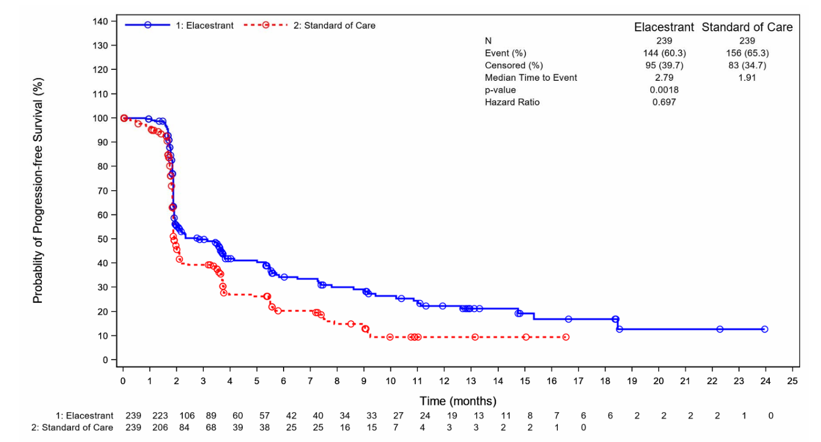

Source: Figure 2.32, p204 of the submission

BIRC = blind independent central review; CI = confidence interval; ITT = intention to treat; N = total number of subjects in group; PFS = progression free survival

**Figure 3: PFS Kaplan Meier plot in *ESR1* variant subgroup (BIRC, ITT)** 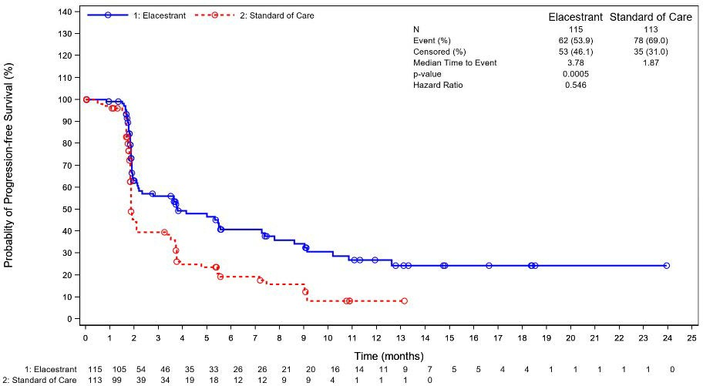

Source: Figure2.33, p206 of the submission

BIRC = blind independent central review; CI = confidence interval; HR = hazard ratio; ITT = intention to treat; N = total number of subjects in group; PFS = progression free survival

**Figure 4: PFS Kaplan Meier plot in non-*ESR1* variant subgroup (BIRC, ITT)**

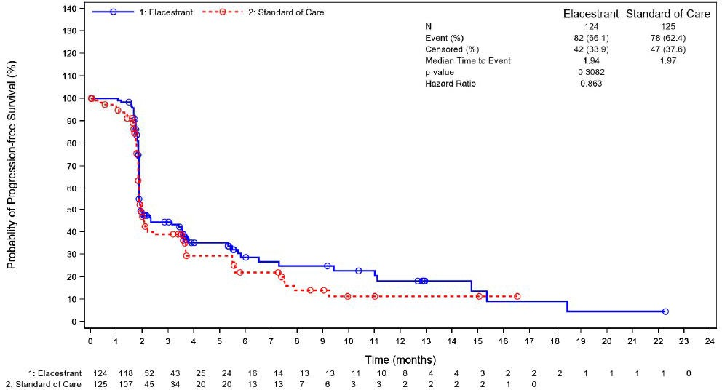

Source: Figure 2.35, p207 of the submission

BIRC = blind independent central review; *ESR1*-mut-nd = no estrogen receptor mutation detected; ITT = intention to treat; N = total number of subjects in group

* + - * 1. The pre-PBAC response stated that the initial rapid drop of the PFS KM curve in both arms is due to the inclusion of heavily pre-treated patients, including those with prior exposure to chemotherapy, fulvestrant, and CDK4/6i, who have primary endocrine resistance and are expected to progress rapidly. As such, at the median point (50% progression) the curves have only just begun to diverge. The pre-PBAC response noted that pre-specified landmark PFS analyses provide an additional characterisation of the long-term benefits of elacestrant in patients with *ESR1* variant; 6-month PFS: 40.8% (elacestrant) vs 19.1% (SOC), 12-month PFS: 26.8% (elacestrant) vs 8.2% (SOC).
        2. An updated analysis for the key secondary outcome of OS was performed with a cut-off date of 02 September 2022, by which time 50% of events had occurred (median follow-up 26 months) for both the overall population as well the *ESR1* variant population (intention to treat [ITT]). The difference in OS between the elacestrant and SOC treatment arms was not statistically significant in either the whole trial population or the *ESR1* variant population. The Pre-Sub-Committee Response (PSCR) noted that the EMERALD trial was not powered to demonstrate an OS benefit and that this was consistent with other trials in this patient population. The PSCR also noted that no ET based regimens, including fulvestrant monotherapy, have demonstrated OS benefit after 1L ET + CDK4/6i.
        3. In the whole of trial population, the 6- and 12-month OS rates were 93.01% and 78.97%, respectively, in the elacestrant arm as compared to 84.87% and 73.84% in the SOC arm. At month 24, the OS rates across both arms were similar (51.00% vs 48.84%) as observed in the converging of curves in Figure 5.
        4. In the *ESR1* variant patients, the 6- and 12-month OS rates were 92.79% and 83.11%, respectively, in the elacestrant arm as compared to 84.36% and 74.38% in the SOC arm. At month 24, the OS rates across both arms were similar (50.71% vs 49.02%) as observed in the converging of curves in Figure 6.

Figure 5: **OS Kaplan Meier plot in whole of trial population (ITT, final analysis)**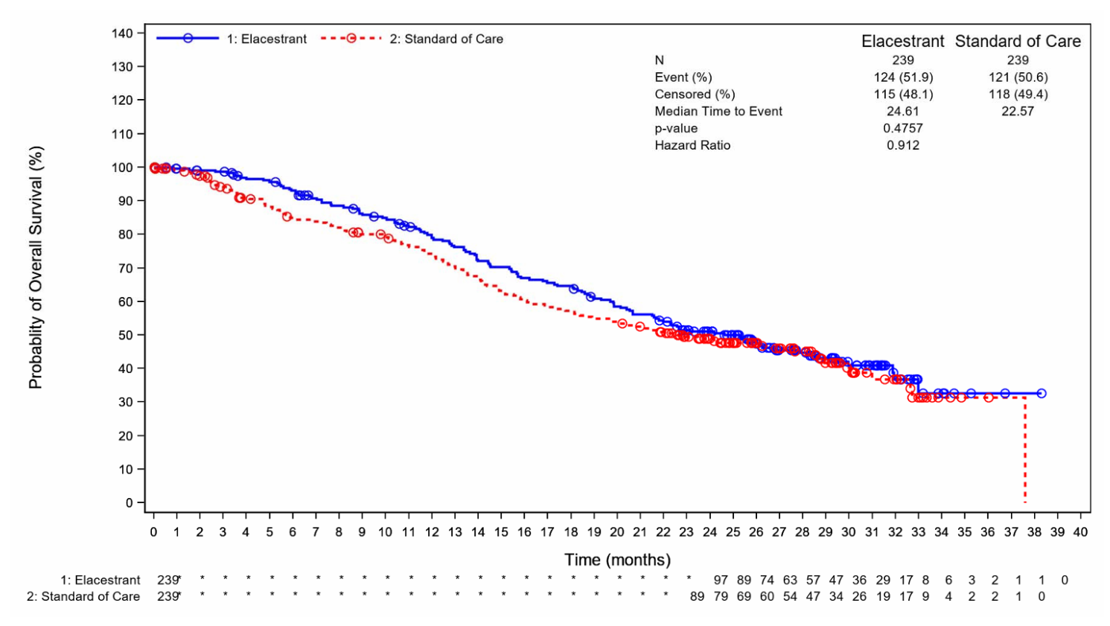

Source: Figure 2.42, p218 of the submission

ITT = intention to treat; N = total number of subjects in group; OS = overall survival

Figure 6: OS Kaplan Meier plot in the ESR1 variant subgroup (ITT, final analysis)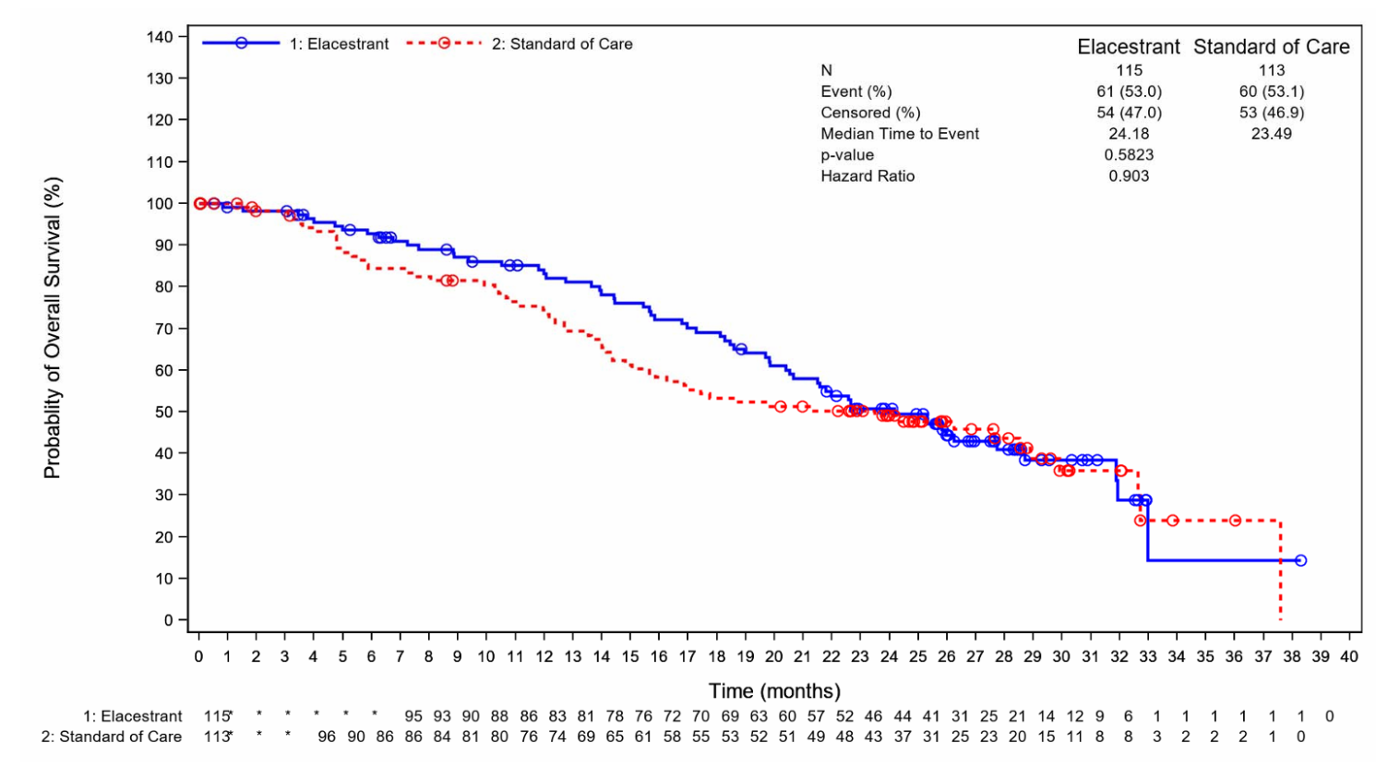

Source: Figure 2.44, p219 of the submission

*ESR1*-mut = estrogen receptor 1 variant; ITT = intention to treat; N = total number of subjects in group; OS = overall survival

Figure 7: OS Kaplan Meier plot in the non-ESR1 variant subgroup (ITT, final analysis)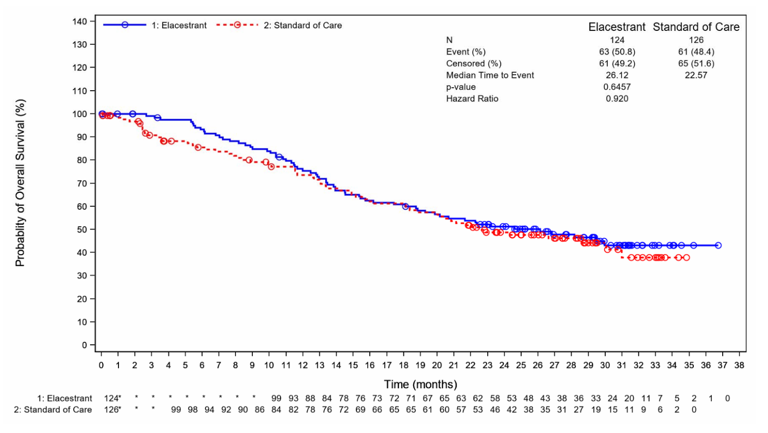 Source: Figure 2.46, p220 of the submission

*ESR1*-mut-nd = *ESR1* mutation not detected;; ITT = intention to treat; N = total number of subjects in group; OS = overall survival

* + - * 1. For other secondary outcomes, including ORR and HRQoL, there were no statistically significant differences between treatment arms, in either the whole trial population or the *ESR1* variant population. The submission stated that the median duration of response (DoR) could not be calculated in the elacestrant arm because all patients with response were censored without progression or death as of the cut-off date. However, for the secondary outcome clinical benefit rate (CBR- the percentage of patients who achieved a partial response or stable disease sustained for at least 24 weeks), there was a significant difference between patients treated with elacestrant and those treated with SOC in the *ESR1* variant population (24.1% vs 11.5%, p=0.024).

Comparative harms

* + - * 1. All patients who received at least one dose of study drug were included in the safety assessment.
        2. The mean duration on treatment was longer for patients in the elacestrant arm (144.1 days) than in the SOC arm (fulvestrant 122.6 days and AIs 96.8 days).
        3. Patients in the elacestrant arm had a greater risk of experiencing treatment emergent adverse events (TEAEs) related to trial therapy (63.3% vs 43.5%), Grade ≥3 TEAEs (27.0% vs 20.9%) and TEAEs leading to interruption (15.2% vs 5.2%) as shown in Table 6. There were three patients with serious TEAEs related to treatment with elacestrant (2 patients had nausea, and 1 had vomiting, cholecystitis acute, decreased appetite, dehydration, and pulmonary embolism).
        4. The most common Grade ≥3 TEAEs observed in the elacestrant arm were gastrointestinal (nausea) and musculoskeletal and connective tissue (back and bone pain) disorders (Table 6).
        5. There were no deaths reported that were study drug related.

Table 6: **Summary of key adverse events in EMERALD**

| TEAE type | Elacestrant (N=237)  n with event (%) | SOC (N=230) b  n with event (%) | RR (95% CI) |
| --- | --- | --- | --- |
| Any TEAE | 218 (92.0) | 198 (86.1) | **1.07 (1.00, 1.14), p=0.043** |
| * Gastrointestinal disorders   + Nausea   + Vomiting | 155 (65.4)  83 (35.0)  45 (19.0) | 79 (34.3)  44 (19.1)  20 (8.7) | **1.90 (1.56, 2.33), p<0.0001**  **1.83 (1.33, 2.51), p=0.0013**  **2.18 (1.33, 3.58), p=0.0013** |
| Related | 150 (63.3) | 100 (43.5) | **1.46 (1.22, 1.74), p<0.0001** |
| Grade ≥ 3 AEs | 64 (27.0) | 48 (20.9) | 1.29 (0.93, 1.80), p=0.12 |
| * Gastrointestinal disorders   + Nausea | 12 (5.1)  6 (2.5) | 7 (3.0)  2 (0.9) | 1.66 (0.67, 4.15), p=0.28  2.91 (0.59, 14.28), p=0.17 |
| * Musculoskeletal and connective tissue disorders | 17 (7.2) | 3 (1.3) | **5.50 (1.63, 18.51), p=0.006** |
| * Investigationsa | 24 (10.1) | 23 (10.0) | 1.01 (0.59, 1.74), p=0.96 |
| * Blood and lymphatic system disorders | 9 (3.8) | 12 (5.2) | 0.73 (0.31, 1.69),p=0.46 |
| * Neoplasms benign, malignant (incl cysts and polyps) | 0 (0.0) | 2 (0.9) | 0.19 (0.0094, 4.02), p=0.29 |
| Related Grade ≥ 3 | 17 (7.2) | 7 (3.0) | **2.36 (0.99, 5.57), p=0.05** |
| Fatal | 4 (1.7) | 6 (2.6) | 0.65 (0.19, 2.26), p=0.50 |
| Serious | 29 (12.2) | 25 (10.9) | 1.13 (0.68, 1.86), p=0.64 |
| Related and serious | 3 (1.3) | - | 6.79 (0.35, 130.81), p=0.20 |
| Leading to interruption | 36 (15.2) | 12 (5.2) | **2.91 (1.55, 5.45), p=0.0008** |
| Related and leading to interruption | 15 (6.3) | 4 (1.7) | **3.64 (1.23, 10.80), p=0.02** |
| Leading to dose reduction | 7 (3.0) | - | 14.56 (0.84, 253.47), p=0.066 |
| Related and leading to dose reduction | 6 (2.5) | - | 12.62 (0.71, 222.71), p=0.08 |
| Leading to discontinuation of study drug | 15 (6.3) | 10 (4.3) | 1.46 (0.67, 3.17), p=0.35 |
| Related leading to discontinuation of study drug | 8 (3.4) | 2 (0.9) | 3.88 (0.83, 18.09), p=0.08 |

Source: Table 2.82, p227 and Table 2.84, p229 of the submission

AEs = adverse events; CI = confidence interval; n = number of participants reporting data; N = total participants in group; RR = relative risk; SOC =standard of care; TEAE = treatment emergent adverse event

a Relates to investigations required due to several factors, including Alanine aminotransferase increased, Blood pressure increased and Gamma-glutamyltransferase increased

b SOC in the EMERALD trial comprises of choice of aromatase inhibitor (AI) or fulvestrant monotherapy which may not reflect the true extent of current therapies received by Australian patients.

**Bold** text indicates a p-value <0.05

Benefits/ harms

* + - * 1. A summary of the comparative benefits and harms for elacestrant versus SOC is presented in Table 7.

Table 7: Summary of comparative benefits and harms for elacestrant and SOC from EMERALD trial a

|  |  |  |  |  |
| --- | --- | --- | --- | --- |
| **Progression free survival (median duration of follow up 15.9 months) b** | | | | |
| Event | Elacestrant (N=115) | SOC (N=113) g | Absolute Difference | HR (95% CI) |
| Progressed, n (%) | 62 (54) | 78 (69) |  | **0.55**  **(0.39, 0.77)**  **P=0.0005** |
| Median PFS, months (95% CI) | 3.78  (2.17, 7.26) | 1.87  (1.87, 2.14) | 1.91 |
| % not progressed at 3 months (95% CI) | 55.93  (45.80, 66.05) | 39.55  (29.44, 49.65) | 16.38% |
| % not progressed at 6 months (95% CI) | 40.76  (30.10, 51.43) | 19.14  (10.52, 27.76) | 21.62% |
| Overall survival (median duration of follow up 26 months) d | | | | |
| Deaths, n (%) e | 28 (24) | 40 (38) |  | 0.903  (0.63, 1.30)  P=0.58 |
| Median OS, months (95% CI) | 24.18  (20.53, 28.71) | 23.49  (15.64, 29.90) | 0.69 |
| % Alive at 6 months (95% CI) | 92.79  (87.97, 97.60) | 84.36  (77.32, 91.40) | 8.43% |
| % Alive at 12 months (95% CI) | 83.11  (75.98, 90.25) | 74.38  (65.88, 82.89) | 8.73% |
| % Alive at 18 months (95% CI) | 69.09  (60.15, 78.04) | 53.27  (43.50, 63.04) | 15.82% |
| % Alive at 24 months (95% CI) | 50.71  (40.91, 60.52) | 49.02  (39.18, 58.87) | 1.69% |

|  |  |  |  |  |  |  |  |  |
| --- | --- | --- | --- | --- | --- | --- | --- | --- |
| Harmsf | | | | | | | | |
| TEAE type | Elacestrant (N=237)  n (%) | | SOC g  (N=230)  n (%) | | RR  (95% CI) | Event rate/100 patients | | RD  (95% CI) |
| elacestrant | SOCg |
| Related | | 150 (63.3) | | 100 (43.5) | **1.46 (1.22, 1.74), p<0.0001** | 63 | 44 | 19.81  (10.79, 28.39) |
| Nausea | | 83 (35.0) | | 44 (19.1) | **1.83 (1.33, 2.51),**  **p<0.0001** | 35 | 19 | 15.89  (7.97, 23.81) |
| Vomiting | | 45 (19.0) | | 20 (8.7) | **2.18 (1.33, 3.58)**  **p=0.0013** | 19 | 9 | 10.29  (4.11, 16.47) |
| Related Grade ≥ 3 | | 17 (7.2) | | 7 (3.0) | **2.36 (0.99, 5.57), p=0.05** | 7 | 3 | 4.13  (0.05, 8.44) |
| Related and leading to interruption | 15 (6.3) | | | 4 (1.7) | **3.64 (1.23, 10.80), p=0.02** | 6 | 2 | 4.59  (1.00, 8.58) |

Source: Table 2.76, 2.78, p215, 218 of the submission, Table 17, p94 and Table 14.3.1.5.1, p2302 of the CSR and Table 1, p9 of EMERALD CSR OS addendum

CI = confidence interval; HR = hazard ratio; OS = overall survival; PFS = progression free survival; RD = risk difference; RR = risk ratio; SOC = standard of care; TEAE = treatment emergent adverse event.

a Results reported for *ESR1* variant subgroup only from EMERALD trial

b Data from September 2021 data cut off

c All patients in the SOC arm were either censored or had an experience event before 18 months

d Data from September 2022 data cut off

e Deaths only reported for *ESR1* variant subgroup from September 2021 data cut off (safety population – 7 patients from SOC excluded as did not receive study drug) – 18 month follow up

f Results reported from safety population from EMERALD trial (includes *ESR1* variant [positive and negative patients)

g SOC in the EMERALD trial comprises of choice of aromatase inhibitor (AI) or fulvestrant monotherapy which may not reflect the true extent of current therapies received by Australian patients.

**Bold** text indicates a statistically significant p-value

* + - * 1. On the basis of direct evidence presented by the submission, for every 100 patients treated with elacestrant in comparison with SOC for a median follow up of 15.9 months:
* Approximately 22 additional patients would remain progression free at 6 months.
* Approximately 20 additional patients would have a treatment-related TEAE.
* Approximately 16 additional patients would have treatment-related nausea.
* Approximately 10 additional patients would have treatment-related vomiting.

Clinical claim

* + - * 1. The submission described NGS testing for *ESR1* variants in ctDNA from liquid biopsy and treatment with elacestrant as superior in terms of effectiveness having a different and manageable safety profile compared to no testing and SOC (fulvestrant or AI monotherapy).
        2. The claim for superior effectiveness of elacestrant over fulvestrant or AI monotherapy is supported based on PFS and CBR results reported from the EMERALD trial. However, fulvestrant and AI are not fully representative of SOC therapies received by Australian patients, thus the applicability of the treatment effect observed in the EMERALD trial in Australian clinical practice is uncertain and the level of benefit may be overestimated due to likely improved SOC 2L+ treatment outcomes in Australian practice compared to the EMERALD trial. Additionally, there were no statistically significant differences between treatment arms for other secondary outcomes, including OS, ORR, DoR or HRQoL.
        3. In the EMERALD trial, patients in the elacestrant arm had a greater risk of experiencing TEAEs (63.3% vs 43.5%), Grade ≥3 events (27.0% vs 20.9%) and those leading to treatment interruption (15.2% vs 5.2%). The evaluation considered an inferior safety claim would be more appropriate, although noting that the adverse events are likely manageable (the most common Grade ≥3 TEAEs observed in the elacestrant arm were gastrointestinal (nausea) and musculoskeletal and connective tissue (back and bone pain) disorders). The PSCR maintained that elacestrant is best described as having similar safety to SOC, arguing that the duration of treatment was longer in the elacestrant arm and there was a low incidence of grade ≥3 AEs considered related to trial therapy. The ESCs agreed with the evaluation that an inferior safety claim would be appropriate and noted that Grade ≥3 AEs such as nausea and musculoskeletal disorders require hospitalisation, and considered it was not appropriate to describe these events as manageable.The pre-PBAC response maintained that the claim of non-inferior safety was appropriate, arguing that patients were treated with elacestrant for roughly twice as long as SOC so where AE rates are comparable between the treatment arms in EMERALD AE incidence is actually lower for elacestrant. The PBAC noted that the longer duration of treatment with elacestrant was needed for patients to receive the benefit from treatment and therefore the relevant comparison includes the difference in treatment duration.
        4. The PBAC considered that the claim of superior comparative effectiveness was reasonable based on a modest improvement in PFS compared with endocrine monotherapy. However, the PBAC considered the benefit for elacestrant compared with SOC was likely to be overestimated due to the inappropriate and suboptimal comparator in the EMERALD trial.
        5. The PBAC considered that a claim of inferior comparative safety would be appropriate based on the evidence provided.

Claim of codependence

* + - * 1. The submission claimed that, based on results from the EMERALD trial, using *ESR1* variant status as a predictive biomarker for treatment with elacestrant optimises treatment outcomes and informs physicians about the likelihood of clinical benefit in patients with ER+/HER2- mBC who have disease progression following at least one line of ET, including a CDK4/6 inhibitor.
        2. In the analysis of non-*ESR1* variant patients in EMERALD, there was no statistically significant difference in PFS between elacestrant and SOC (HR 0.863 [95% CI: 0.628 – 1.186)], p-value = 0.3082), thus suggesting that ER+/HER2- mBC patients without *ESR1* variants may be unlikely to achieve additional benefits from treatment with elacestrant compared to current SOC 2L+ therapies. However, the test for interaction for the PFS from Bidard 2022, which utilised patient level data, gave a p-value for interaction of 0.053. The PSCR argued that the EMERALD trial results clearly demonstrate a difference in PFS response between the *ESR1* variant and non-variant subgroups and noted that the primary endpoint of PFS was statistically significant for both the ITT and *ESR1* variant populations.
        3. The ESCs noted that the test for interaction did not reach statistical significance but noted that there appeared to be minimal benefit in the non-*ESR1* subgroup and the clinical rationale and mechanism of action for elacestrant supported the claim that *ESR1* is likely to be a predictive biomarker for treatment with elacestrant. The ESCs considered the claim of codependence to be reasonable overall, but the extent of treatment effect variation to be uncertain. The ESCs also noted that the draft TGA indication as approved by the delegate is specific to patients with an activating *ESR1* mutation. The PBAC noted that the indication in the approved PI was specific to mBC with an activating *ESR1* mutation.

Economic analysis

* + - * 1. The submission presented a modelled economic evaluation, based on the direct randomised trial, EMERALD, comparing elacestrant to SOC (fulvestrant or an AI monotherapy) in a population of patients with ER+/HER2- mBC who have disease progression following at least one line of ET, including a CDK4/6i, and who test positive for an *ESR1*-variant (termed by the submission as the ‘label population’). This is not consistent with PBAC guidelines v5 which state that, for a co-dependent technology, the model structure should capture patients at the point of testing such that the incremental benefits and costs are included for those who are both positive and negative for the test. The modelling approach was also not consistent with advice from PASC, which considered that cost modelling for both NGS and digital droplet polymerase chain reaction (ddPCR) methodology in the detection of *ESR1* variants should be included in the assessment (p16, 1782 Ratified PICO Confirmation, August 2024 PASC meeting).
        2. The type of economic evaluation presented was a cost-utility analysis. This was appropriate given the clinical claim that elacestrant is superior in terms of effectiveness.
        3. Table 8 presents a summary of the economic model components.

Table 8: Summary of model structure, key inputs and rationale

|  |  |
| --- | --- |
| **Component** | **Summary** |
| Comparison modelled | NGS testing for *ESR1* variants available and treatment with elacestrant for patients with *ESR1* variants vs Testing not available and SOC for patients with *ESR1* variants. |
| Time horizon | 10 years in the model base case vs 26 months follow up (median OS) in the EMERALD trial |
| Outcomes | LYG and QALYs |
| Methods used to generate results | Partitioned survival analysis |
| Health states | Progression-free, progressed disease (divided into those receiving chemotherapy and those not receiving chemotherapy) and dead.  TTD included to account for time on treatment. |
| Cycle length | 28 days |
| Test parameters | Prevalence: 100% (implied as population only consists of patients with *ESR1* variants)*.*  Test accuracy/performance estimates (implied)  Sensitivity = 100%  Specificity = 100%  Test failure rate = 0%  Test uptake rate = 100%  *No allowance for re-testing was included in the model* |
| Implications of false positive and false negative results | Not described |
| Allocation to health states | Derived from PFS, OS, TTD and TCD K-M data from the *ESR1*-variant cohort in EMERALD (excluding 6 patients who received CDK4/6i in the adjuvant setting), then extrapolated using parametric survival analysis for remaining time horizon.  Truncation point for all model outcomes was the mean OS follow up from the 2022 data cut (18 months [claimed by the submission; this could not be verified]). |
| Extrapolation method | Independent parametric models were fitted to each treatment arm with Log-logistic (OS), Generalised Gamma (PFS), Log-normal (TCD) and Generalised Gamma (TTD) selected in base case for elacestrant and Gompertz (OS), Generalised Gamma (PFS), Log-normal (TCD) and Generalised Gamma (TTD) selected in base case for SOC, based on goodness of fit/visual inspection/assessment of the clinical plausibility of the extrapolation.  Convergence was not assumed to occur within the modelled time horizon. |
| Health related quality of life | A linear mixed-effects regression model was fitted to EQ-5D-5L data from the EMERALD trial with Australian tariffs applied. A baseline utility value, accounting for mean age of the population and proportion of patients receiving 2+ prior LOT was used for the PF state (excludes time-varying age and G3/4 AE decrements).  The utility value for PD health state was derived from a PD multiplier (sourced from the Lloyd 2006) that was applied to the PF health state value from EMERALD.  Utility decrements related to IM administration (from fulvestrant treatment as part of SOC) and subsequent chemotherapy treatment were derived from the literature  Utility values used in model:  PF=0.876  PD=0.543  Age decrement= -0.0014  Grade 3/4 AE decrement= -0.0830  IM administration = -0.0040  Chemotherapy treatment = -0.113 |

Source: Table 2.78, p218 and Table 3.1, p254 of the submission

AE= adverse event; EQ-5D-5L = EuroQol 5 dimension 5 level; *ESR1* = estrogen receptor 1; ICER = incremental cost-effectiveness ratio; IM = intramuscular injection; K-M = Kaplan-Meier; LOT= lines of therapy; LYs = life years; LYG = life years gained; OS = overall survival; PBAC= Pharmaceutical Benefits Advisory Committee; PD = progressed disease; PF = progression free; PFS = progression-free survival; QALY = quality-adjusted life year; SOC = standard of care; TCD = time to chemotherapy or death; TTD = time to treatment discontinuation

* + - * 1. The submission applied test costs to the elacestrant arm only ($3,144.74, based on an expected test cost of $1500 and a prevalence rate of ESR1 variants of 47.7% i.e. 2.1 patients must be tested to identify one *ESR1* variant positive patient). The submission argued that since the prevalence of *ESR1* variants in the EMERALD trial reflects patients who were 2nd and 3rd line post CDK4/6i treatment, this reflects the rate of *ESR1* variants across multiple lines of ET. Therefore, the submission argued that the economic model implicitly evaluates multiple rounds of testing, and it is not necessary to evaluate subsequent rounds of testing separately. The methods used by the submission to determine testing costs reflect a scenario where eligible patients are only tested once following disease progression after 1 or 2 prior lines of therapy. This was not consistent with the proposed MBS restriction, which allows testing at each episode of disease progression following first line treatment. As such, the ESCs considered that costs of testing applied in the model were underestimated (see also paragraph 6.52). The pre-PBAC response acknowledged that the proposed MBS item number allows testing at each episode of progression, but noted that while *ESR1* mutations emerge over time, the majority of *ESR1* variant patients are identified early, and the occurrence of new cases is expected to decrease in later treatment lines as patients transition away from ET-based therapies.
        2. No test scenarios were included in the economic model. This implies that testing in clinical practice incurs no false negative or false positive results compared with testing in the EMERALD trial, test uptake is 100%, and test failure rate is 0%. This was not appropriate; based on the data provided in the submission, there were differences between the assay proposed for use in Australia and the assay used in the EMERALD trial; Guardant360® CDx (used in EMERALD) could be interpreted as reporting 14% false positives (based on 86% PPV) and 3% false negatives (based on 97% NPV) and one patient was reported to have failed the test and had to be re-tested (and subsequently not included in the analysis). It is likely that the assumptions made regarding 100% test accuracy would likely underestimate the ICER, however given the structure of the model, sensitivity analyses could not be conducted during the evaluation to test the impact of these assumptions.
        3. The economic model used Kaplan Meier (KM) data from the *ESR1* variant positive subgroup of patients from the EMERALD trial (September 2022 data cut) for the key outcomes (OS, PFS, time to chemotherapy of death [TCD] and time-to-treatment discontinuation [TTD]) until the mean OS follow-up across both treatment arms (=17.95 months)[17]. Following this, fitted parametric distributions were applied to extrapolate model outcomes. The evaluation considered the choice of a single truncation point for all outcomes was not appropriate as it excludes data from many patients in both treatment arms (approximately 67% of patients in the elacestrant arm and 54% of patients in the SOC arm remain at risk for the OS outcome, while 18% of patients in the elacestrant arm remain at risk for the PFS outcome)17. The chosen truncation point is when the OS curves are most separated, resulting in an increasing OS benefit in the elacestrant arm over the time horizon, despite clear convergence of the OS curves from the trial data (see Figure 6). The evaluation presented sensitivity analysis using more appropriate truncation points for each model outcome individually, using methods from Gebski 2018. The PSCR and pre-PBAC response argued that upon disease progression patients were allowed to receive other treatments and therefore the 18-month cutoff helps mitigate bias in OS outcomes caused by the impact of post-progression therapies. The ESCs considered the treatments received after progression are likely to reflect clinical practice and considered that the observed time-to-event data should be used up to the time point at which the observed data become unreliable as a result of small numbers of patients remaining event-free.
        4. Based on Akaike information criterion (AIC) and Bayesian information criterion (BIC) goodness-of-fit statistics and visual interpretation of the hazard plots, the Generalised Gamma parametric curve was selected in the base case to extrapolate PFS outcomes for elacestrant. Using the Generalised Gamma distribution for PFS for elacestrant resulted in a predicted median PFS of 5.44 months, compared to the observed median PFS of 3.78 months in the EMERALD trial. Although the model also overestimated median PFS for SOC (3.26 months vs 1.87 months observed in EMERALD), the difference in median PFS between elacestrant and SOC in the model was greater than that observed in EMERALD (2.18 vs 1.91 months). It is also estimated that 6.71% of patients treated with elacestrant will be alive and progression free at 5-years. The choice of parametric curve for PFS for elacestrant was a key driver of the ICER, the base case favouring elacestrant. Selection of the Log-normal distribution (ranked second based on AIC and BIC goodness-of-fit statistics) results in an estimated 0.77% of patients alive and PF at 5-years; this may be a more plausible choice.

Figure **8: Predicted survival from independent parametric models compared to the observed data – elacestrant – PFS – label population**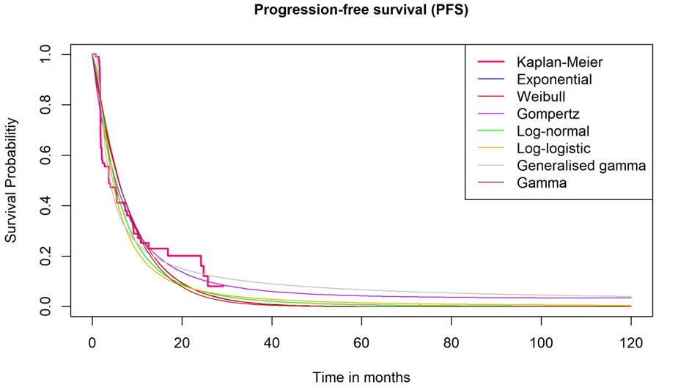

Source: Figure 3.8, p302 of the submission.

PFS = progression free survival.

*Note that the results presented in Figure 8 are derived from ad-hoc analyses conducted by the applicant specifically for the purposes of informing the PBAC consideration. Interpretation of the results and their application should therefore be limited to seeking to understand the basis for the PBAC outcome and should not be used for any other purpose.*

* + - * 1. Despite ranking 5/7 based on AIC and BIC goodness-of-fit statistics, the submission chose the log-logistic parametric curve to extrapolate OS outcomes for elacestrant, arguing that visual interpretation of the hazard plots and clinical feedback indicates that the log-logistic curve most closely aligns with the elacestrant data and statistical expectations for OS. Using the log-logistic distribution for elacestrant likely overestimates the survival of this patient population; it was estimated that 13.52% of patients will be alive at 5-years and 3.59% of patients will be alive at 10-years. The choice of parametric curve for OS for elacestrant was a key driver of the ICER, the base case favouring elacestrant. Using the Gamma distribution resulted in 5-year survival estimates of 7.17% and a 10-year survival estimate of 0.17%; this may be a more plausible estimate.

Figure 9: Predicted survival from independent parametric models compared to the observed data Elacestrant – OS – label population

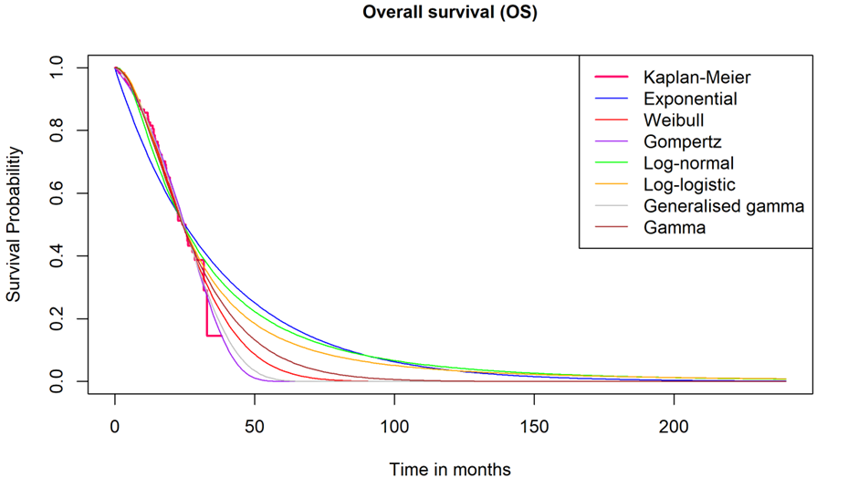

Source: Figure 3.14, p308 of the submission

OS = overall survival

*Note that the results presented in Figure 9 are derived from ad-hoc analyses conducted by the applicant specifically for the purposes of informing the PBAC consideration. Interpretation of the results and their application should therefore be limited to seeking to understand the basis for the PBAC outcome and should not be used for any other purpose.*

* + - * 1. Despite ranking 6/7 based on AIC and BIC goodness-of-fit statistics, the submission chose the Gompertz parametric curve to extrapolate OS outcomes for SOC. No justification was provided for this choice. Using the Gompertz curve likely underestimates OS for SOC; it is estimated that only 2.73% of patients will be alive at 5-years, with no patients alive by 6 years. The choice of parametric curve for OS for SOC is a key driver of the ICER, the base case favouring elacestrant. Based on AIC and BIC goodness-of-fit statistics and visual interpretation of the hazard plots, the gamma distribution may be a more plausible choice; using this curve it is estimated that 8% of patients in the SOC arm will be alive at 5 years, with all patients dead by 9.5 years.
        2. The ESCs considered that given the lack of demonstrated statistically significant difference in OS in EMERALD, the choice of a comparator which may overestimate the benefit for elacestrant, and the potential impact of newly available subsequent therapies, it may not be reasonable for the model to include any OS difference, given the presented evidence. The pre-PBAC response stated that demonstrating significant improvement in OS is made substantially more difficult by confounding factors, and that no ET based regimens, including FULV monotherapy, have demonstrated OS benefit after 1L CDK4/6i + ET.

Figure 10: Predicted survival from independent parametric models compared to the observed data – SOC – OS – label population

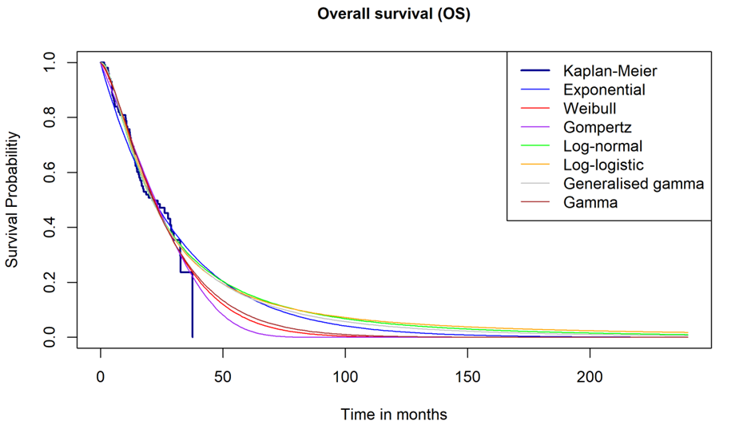

Source: Figure 3.15, p308 of the submission

OS = overall survival; SOC = standard of care

*Note that the results presented in Figure 10 are derived from ad-hoc analyses conducted by the applicant specifically for the purposes of informing the PBAC consideration. Interpretation of the results and their application should therefore be limited to seeking to understand the basis for the PBAC outcome and should not be used for any other purpose.*

* + - * 1. The base case PFS and OS curves are presented in Figure 11.

Figure 11: Base case PFS and OS curves applied in economic model

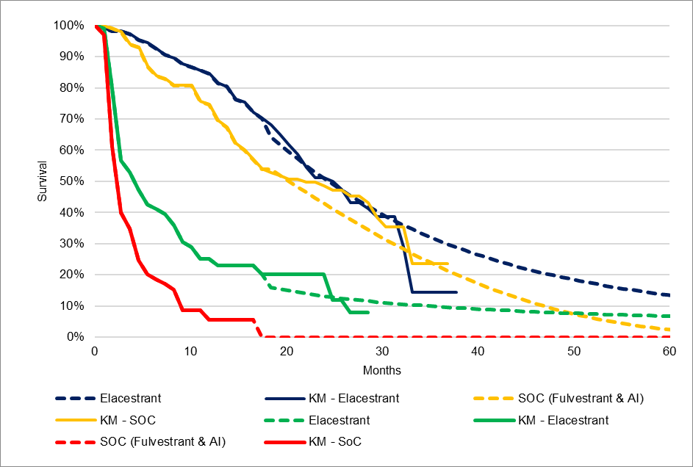

Source: Constructed in the evaluation using data from the economic workbook

KM = Kaplan-Meier; OS= overall survival; PFS = progression-free survival; SOC =standard of care

Note: OS curves are navy blue/gold, PFS curves are green/red

*Note that the results presented in Figure 11 are derived from ad-hoc analyses conducted by the applicant specifically for the purposes of informing the PBAC consideration. Interpretation of the results and their application should therefore be limited to seeking to understand the basis for the PBAC outcome and should not be used for any other purpose.*

* + - * 1. The ESCs noted that the TTD KM curves were mature and their extrapolation in the economic model appears to overestimate the time on treatment (mean 8.38 cycles, compared with 5.73 mean treatment duration from EMERALD).
        2. The time horizon in the base case analysis was 10 years. The time horizon is a key driver of the ICER because of the extrapolation functions chosen, favouring elacestrant. The PBAC has previously indicated that a 7-year time horizon was appropriate for the second-line HR+ advanced breast cancer setting (section 10, everolimus Public Summary Document (PSD), March 2013 PBAC Meeting), although the PBAC recently accepted a 10 year time horizon in the mBC setting with disease progression (paragraph 1.2, trastuzumab deruxtecan PSD, March 2024 PBAC meeting). The ESCs considered a time horizon of 10 years may be reasonable, consistent with the PBAC’s consideration of T‑­­Dxd.
        3. The utility value applied for progression free [PF] (=0.88, derived from EQ-5D-5L data from the EMERALD trial using the Australian value set) is comparable to that applied for a population of adult patients with HER2 low (Immunohistochemistry [IHC] 1+ or IHC 2+/ISH] negative) unresectable or mBC who have received prior chemotherapy in the metastatic setting or developed disease recurrence during or within 6 months of completing adjuvant chemotherapy (=0.88), which was recommended by the PBAC as part of a respecified base case (trastuzumab deruxtecan PSD, March 2024 PBAC meeting).
        4. For the progressed disease [PD] utility value, the submission applied a multiplier derived from Lloyd et al 2006[18]. Lloyd et al 2006 reported a progression-free utility value of 0.715, with a decrement of -0.272 for the PD state, which results in a multiplier of 0.620 ((0.715-0.272)/0.715). This PD multiplier was then applied to the utility value for the PF health state from EMERALD (=0.876). The resulting PD utility value was 0.543 (0.876 x 0.620), a utility decrement from the transition to the PD state of -0.333. Use of the values from Lloyd 2006 to determine the PD utility value is consistent with previous PBAC advice for similar patient populations (paragraph 4.10, Trastuzumab Deruxtecan PSD, March 2024 PBAC meeting). However, the methodology used in the submission differs from that previously advised by the PBAC, which was to apply the utility decrement from Lloyd et al 2006 (= -0.272) to determine the PD utility value (paragraph 4.10, Trastuzumab Deruxtecan PSD, March 2024 PBAC meeting). Using the utility decrement from Lloyd et al 2006 results in a utility value of 0.604 for the PD health state. The utility value for the PD health state from the EMERALD trial was considerably higher (=0.84); the submission stated that collection of HRQoL data declined throughout the trial and as such the PD utility value from EMERALD likely reflects healthier patients. The ESC considered the utility decrement associated with progression was likely overestimated, and is a key driver of the ICER, favouring elacestrant. The pre-PBAC response argued that the multiplicative approach to applying the decrement for progressed disease is commonly preferred, captures heterogeneity by scaling the decrement to baseline utility, and aligns with how patients subjectively experience worsening QoL.
        5. A summary of the key drivers of the model which were subjected to sensitivity analysis is presented in Table 9. Sensitivity analyses were not conducted either relying on PFS gains only or using the overall EMERALD population rather than the requested subgroup population.

Table 9: Key drivers of the model

| **Description** | **Method/Value** | **Impact**  **Base case: ||||1/QALY gained** |
| --- | --- | --- |
| Extrapolation | Choice of parametric curve for extrapolation of OS for elacestrant (base case= log-logistic) | High, favours elacestrant  Use of Gamma curve increased the ICER to ||||2/QALY gained (+||||%). |
| Extrapolation | Choice of parametric curve for extrapolation of OS for SOC (base case= Gompertz) | High, favours elacestrant  Use of Gamma curve increased the ICER to ||||3/QALY gained (+||||%). |
| Extrapolation | Choice of parametric curve for extrapolation of PFS for elacestrant (base case= Generalised Gamma) | High, favours elacestrant  Use of log-normal curve increased the ICER to ||||3/QALY gained (+||||%). |
| Truncation point | Truncation point for PFS, OS, TCD and TTD outcomes (base case = mean OS follow up [18 months]) | Low, favours elacestrant  Use of separate truncation points for each outcome derived using methods from Gebski 2018 increased the ICER to ||||**1**/QALY gained (+||||%). |
| Utilities | High value for PF health state (=0.876) and low value for the PD health state (=0.543) in the base case, resulting in a higher utility decrement for progression to PD (=-0.333) than that seen in the literature and in previous PBAC submissions involving similar patient populations | High, favours elacestrant  Use of utilities from Lloyd 2006 (PF=0.715, PD=0.587, utility decrement=-0.272) increased the ICER to ||||3/QALY gained (+||||%). |
| Time horizon | 10 years in the base case | High, favours elacestrant  Use of a 7-year time horizon increased the ICER to ||||3/QALY gained (+||||%) |

Source: Compiled during the evaluation using data from Table 3.39, of the submission.

ICER = incremental cost-effectiveness ratio; OS = overall survival; PBAC = Pharmaceutical Benefits Advisory Committee; PD = progressed disease; PF = progression free; PFS = progression-free survival; QALY = quality-adjusted life year; SOC = standard of care; TCD = time to chemotherapy or death; TTD = time to treatment discontinuation

*The redacted values correspond to the following ranges:*

*1 $55,000 to < $75,000*

*2 $95,000 to < $115,000*

*3 $75,000 to < $95,000*

* + - * 1. The results of the stepped economic evaluation are presented in Table 10.

Table 10: Results of the stepped economic evaluation

| **Step and component** | **Elacestrant** | **Comparator** | **Increment** |
| --- | --- | --- | --- |
| **Step 1: Trial based evaluation - Drug costs per LYG over mean follow-up (18 months)** | | | |
| Costs | $| | $1,424 | $| |
| LYG | 1.28 | 1.17 | 0.11 |
| Incremental cost/extra LYG gained | | | $|1 |
| **Step 2: Incorporate cost subsequent treatments** | | | |
| Costs | $| | $2,987 | $| |
| LYG | 1.28 | 1.17 | 0.11 |
| Incremental cost/extra LYG gained | | | $|1 |
| **Step 3: utility weights applied** | | | |
| Costs | $| | $2,987 | $| |
| QALYs | 0.84 | 0.68 | 0.16 |
| Incremental cost/extra QALY gained | | | $|2 |
| **Step 4: Extend time horizon to 10 years, extrapolate OS, PFS, apply discounting of 5%** | | | |
| Costs | $| | $4,297 | $| |
| QALYs | 1.61 | 1.02 | 0.59 |
| Incremental cost/extra QALY gained | | | $|3 |
| **Step 5: Add disease management and AE costs, remove G3/4 AE, Age-related, chemotherapy disutilities** | | | |
| Costs | $| | $|||| | $| |
| QALYs | 1.74 | 1.13 | 0.60 |
| **Incremental cost/extra QALY gained (base case)** | | | **$|**3 |

Source: Table 3.33, p342 of the submission.

AE= adverse events; LYG = life years gained; OS = overall survival; PFS = progression-free survival; QALYs = quality adjusted life years

*Note that the results presented in Table 10 are derived from ad-hoc analyses conducted by the applicant specifically for the purposes of informing the PBAC consideration. Interpretation of the results and their application should therefore be limited to seeking to understand the basis for the PBAC outcome and should not be used for any other purpose.*

*The redacted values correspond to the following ranges:*

*1 $255,000 to < $355,000*

*2 $155,000 to < $255,000*

*3 $55,000 to < $75,000*

* + - * 1. The health state traces of the elacestrant and SOC treatment arms over the model time horizon is presented in Figure 12.

Figure 12: Health state traces of elacestrant and SOC treatment arms over model time horizon

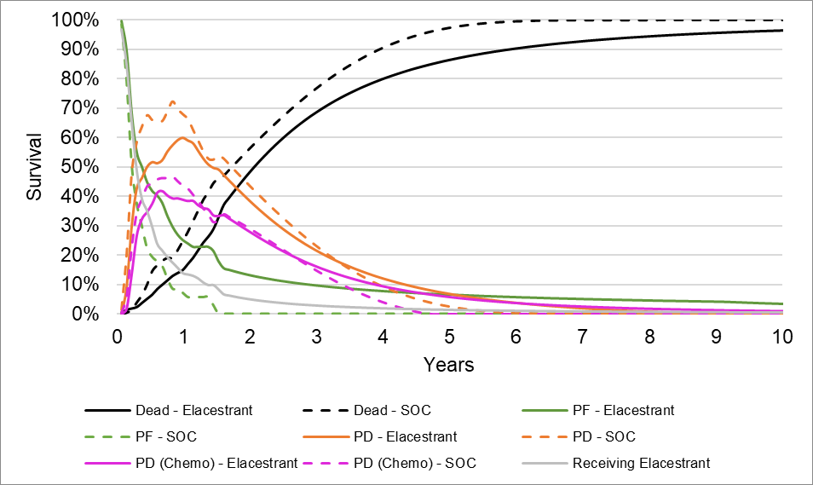

Source: Developed during the evaluation using data from the economic workbook

PD = progressed disease; PF = progression free; SOC = standard of care.

*Note that the results presented in Figure 12 are derived from ad-hoc analyses conducted by the during the evaluation process based on data included in the economic workbook. Interpretation of the results and their application should therefore be limited to seeking to understand the basis for the PBAC outcome and should not be used for any other purpose.*

* + - * 1. The results of key univariate and multivariate sensitivity analyses (MVSA) are summarised below. The ESCs revised the MVSA to remove the step shortening the time horizon to 7 years as a 10-year time horizon as considered reasonable but noted that increasing the time horizon from 7 to 10 years for the MVSA increased the ICER to $155,000 to < $255,000 per QALY. This was because, with revised OS extrapolations, most patients in both arms had died by 7 years and the extrapolation for the SOC was slightly more favourable than elacestrant for years 7-10 (resulting in 0.0076 fewer LY gained for elacestrant with the longer time horizon). The pre-PBAC response argued that alternative inputs applied in the MVSA were not more plausible than the submission base case.
        2. The ESCs also requested an additional sensitivity analysis to show the impact of accounting for additional testing costs for patients who undergo re-testing following progression. The ESCs noted that there was uncertainty regarding the proportion of patients likely to test positive at the point of first progression and for each subsequent progression as the EMERALD trial included patients who had received multiple prior lines of treatments but *ESR1* testing results were only reported at study entry. The ESCs considered it was likely that there would be a diminishing number of additional patients who test positive at each subsequent progression, and this should be accounted for in the estimated cost of testing. The ESCs considered that the data from the PALOMA-3 trial (fulvestrant plus palbociclib vs fulvestrant alone) may be informative as rates of *ESR1* variants were reported at baseline (25.1%) and end of treatment (31.3%, which would most closely match patients entering the EMERALD trial)[19]. The ESCs noted results of this sensitivity analysis showed that the ICER increased by | |%, to $75,000 to < $95,000 per QALY.

Table 11: **Sensitivity analyses**

| Analyses | Incremental cost ($) | Incremental QALY | ICER | % change from base case |
| --- | --- | --- | --- | --- |
| **Base case** | **|** | **0.60** | **||1** | **-** |
| **Discount rate (base case 5% cost and outcomes)** | | | | |
| 0% costs and outcomes | | | 0.72 | |　**1** | -|% |
| 3.5% costs and outcomes | | | 0.64 | |　**1** | -|% |
| **Time horizon (base case 10 years)** | | | |  |
| 5 years | | | 0.41 | |　2 | +　|　% |
| 7 years | | | 0.52 | |　3 | +　|　% |
| **Truncation point for model outcomes (base case =17.95 months for PFS, OS, TCD and TTD)** | | | | |
| Truncation points derived using methods from Gebski 2018 | | | | |
| PFS (elacestrant = 25.79 months, SOC = 11.17 months) | | | 0.61 | |　**1** | -|% |
| OS (elacestrant = 31.93 months, SOC = 32.72 months) | | | 0.57 | |　3 | +　|　% |
| Truncation points for PFS, OS, TCD and TTD (combined) | | | 0.57 | |　**1** | +　|　% |
| **OS extrapolation elacestrant (base case log-logistic)** | | | | |
| Gamma | | | 0.42 | |　2 | +　|　% |
| **OS extrapolation SOC (base case Gompertz)** | | | | |
| Gamma | | | 0.52 | |　3 | +　|　% |
| **PFS extrapolation Elacestrant (base case Generalised Gamma)** | | | | |
| Log-normal | | | 0.48 | |　3 | +　|　% |
| ***Extrapolation of TTD (base case Gen Gamma)*** | | | | |
| No extrapolation of TTD (based on KM data only) for both arms | | | 0.60 | |　**1** | -|% |
| **Health state utility values (base case PF=0.876, PD=0.543, PD utility decrement = -0.333)** | | | | |
| Utilities from Lloyd 2006 (PF=0.715, PD=0.443a, utility decrement=-0.272) | | | 0.48 | |　3 | +　|　% |
| PD utility decrement from Lloyd 2006 (PF=0.876, PD=0.604, utility decrement= -0.272) | | | 0.60 | |　**1** | +　|　% |
| PD utility value from EMERALD trial (=0.834) | | | 0.57 | |　3 | +　|　% |
| **Testing costs (base case $1500 per test, $3,144.74 per patient identified, 47.7% test positive rate)** | | | | |
| 1st test - 31.3% test positive  2nd test (for 68.7% of remaining patients) -additional 12.8% test positive  40.1% total yield | | | 0.60 | |　3 | +　|　% |
| $647.05/ test, $1,356.53 per patient identified | | | 0.60 | |　**1** | -|% |
| $1,766.75/ test, $3,703.98 per patient identified | | | 0.60 | |　**1** | +　|　% |
| **Stepped multi-variate analyses** | | | | |
| 1. Truncation point for PFS, OS, TCD and TTD outcomes derived using methods from Gebski 2018 (base case = mean OS follow up [18 months]) | | | 0.57 | |　**1** | +　|　% |
| 1. OS extrapolation elacestrant = Gamma (base case = Log-logistic) | | | 0.39 | |　2 | +　|　% |
| 1. OS extrapolation SOC = Gamma (base case = Gompertz) | | | 0.30 | |　4 | +　|　% |
| 1. PFS extrapolation elacestrant = log-normal (base case = generalised gamma) | | | 0.23 | |　5 | +　|　% |
| 1. PD utility decrement from Lloyd 2006 (PF=0.876, PD=0.604, utility decrement= -0.272 [base case = ‑ 0.333]) | | | 0.21 | |　5 | +　|　% |
| 1. Time horizon = 7 years (base case =10 years) | | | 0.21 | |　5 | +　|　% |

Source: Table 3.39, of the submission and developed during the evaluation.

ICER = incremental cost effectiveness ratio; OS = overall survival; PD = progressed disease; PF = progression-free; PFS = progression-free survival; QALY = quality adjusted life year; SOC = standard of care; TCD = time to chemotherapy or death; TTD = time to treatment discontinuation

*a* Value corrected during the evaluation

*Note that the results presented in Table 11 are derived from ad-hoc analyses conducted by the applicant specifically for the purposes of informing the PBAC consideration. Interpretation of the results and their application should therefore be limited to seeking to understand the basis for the PBAC outcome and should not be used for any other purpose.*

*The redacted values correspond to the following ranges:*

*1 $55,000 to < $75,000*

*2 $95,000 to < $115,000*

*3 $75,000 to < $95,000*

*4 $135,000 to < $155,000*

*5 $155,000 to < $255,000*

***Drug cost/patient/course***

* + - * 1. The drug cost/patient/course for elacestrant and SOC is presented in Table 12.

Table 12: **Drug cost per patient for proposed and comparator drugs**

|  | Elacestrant  Trial dose and duration | Elacestrant  Model | Elacestrant Financial estimates | SOC  Trial dose and duration | SOC  Model | SOC  Financial estimates |
| --- | --- | --- | --- | --- | --- | --- |
| Mean dose (proportion of cohort) | 345mg/day (95%)  258mg/day (2.5%)  172mg/day (2.5%) | | | Fulvestrant (cycle 1) 500mg x2/cycle (73%)  Fulvestrant (cycle 2+) 500mg x1/cycle (73%)  Anastrozole: 1mg/day (3%)  Letrozole: 2.5mg/day (3%)  Exemestane: 25mg/day (21%) | | 2L therapies as analysed by PBS10% sample in 2023  with treatment dosages and regimens informed by EviQ guidelinesa |
| Mean duration (days) | 160.30 | *224.94 b* | 160.30 | 117.26 | 121.24 b | 160.30 |
| Mean number of cycles | 5.73 c | 8.38 d | 5.73 c | 4.19 c | 4.33 d | 5.73 c |
| Cost/patient/cycle | $| | | | | Cycle 1: $343.93  Cycle 2+: $180.36 | | Cycle 1: $169.46  Cycle 2+: $138.13 |
| Cost/patient/course | $　|　e | $　| | $　|　 e | $919 e | $945 | $823e |

Source: Developed during the evaluation using data from the economic workbook

2L = second line; mg = milligram; PBS = Pharmaceutical Benefits Scheme; SOC = standard of care

a Treatments included fulvestrant 500mg x2/first cycle then x 1/cycle (14%), Everolimus 10mg/day (3%), , Goserelin 3.6mg/cycle (6%), AIs (Anastrozole 1mg/day 10%, Letrozole 2.5mg/day 26%, Exemestane 25mg/day 9%), Tamoxifen 20mg/day (1%) and Chemotherapy (Paclitaxel 300mg/50 ml injection [3% Public/6% Private], Doxorubicin 135 mg injection/intravesical [2% Public/3% Private], Capecitabine 500mg tablet [4%])

b Calculated by multiplying the mean number of cycles by 28

c Calculated by dividing mean duration (days) by 28

d Calculated by dividing the mean undiscounted cost/patient/course from the economic model by the cost/patient/cycle

e Calculated by multiplying the cost/patient/cycle by the mean number of cycles

Notes: 1 cycle is equivalent to 28 days. Numbers in italics indicate calculations undertaken during the evaluation

*Note that the results presented in Table 12 are derived from ad-hoc analyses conducted by the applicant specifically for the purposes of informing the PBAC consideration. Interpretation of the results and their application should therefore be limited to seeking to understand the basis for the PBAC outcome and should not be used for any other purpose.*

* + - * 1. The treatment duration (and associated drug costs) for both elacestrant and SOC was greater in the economic model than the trial and financial estimates. This is likely related to the time-to-discontinuation extrapolation method applied in the economic model which overestimated the predicted outcomes when compared to that observed in the trial. The ESCs noted that the TTD KM curves were mature and their extrapolation in the economic model appears to overestimate the time on treatment.

Estimated PBS usage & financial implications

* + - * 1. This submission was considered by DUSC. The submission used an epidemiological approach to estimating the use and financial impact of the proposed codependent technologies. To estimate the size of the eligible population of patients for elacestrant, an analysis was conducted using the 10% PBS sample. Firstly, the number of patients with ER+/HER2- mBC treated with a CDK4/6i in combination with fulvestrant or an AI was identified. Secondly, the analysis determined the number of these patients that progressed onto another treatment in the most recent full year of data (2023) or patients that stopped CDK4/6i treatment in 2023 and did not seek further PBS-listed treatment. DUSC considered that to capture the prevalent population more appropriately, the approach should identify when the incident population progresses to the next line of therapy.
        2. A summary of the key inputs for the financial estimates is presented in Table 13.

Table 13: **Key inputs for financial estimates**

| Parameter | Value applied and source | Evaluation and DUSC comments |
| --- | --- | --- |
| Eligible test population: Patients with ER+/HER2- mBC progressing from a CDK4/6i | Sourced from analysis of annual number of patients with ER+/HER2- mBC progressing from a CDK4/6i between 2018 and 2023 (from the PBS10%), indexed against the general population growth in Australia (1.4%) for future years (sourced from ABS data).  In the first year of the proposed listing, it is expected that there will be a pool of prevalent patients who progressed from a CDK4/6i in previous years and would be eligible for elacestrant under the proposed listing (‘warehoused’ patients). The submission doubled the number of eligible patients in the test population in Year 1 to account for these patients. | The evaluation and DUSC considered that the number of ‘warehoused’ patients included in year 1 was uncertain.  DUSC identified populations potentially not accounted for (although they may have been included in the assumed “warehoused” patients):   1. 2L/3L population already on ET or chemotherapy 2. Adjuvant population on abemaciclib who progress (5-6% in first year and up to 10-15% in the second year of therapy)​   In addition, patient numbers may be underestimated as it was unclear why there were fewer CDK4/6 inhibitor 1L progressors for 2023 compared with 2022. |
| Prevalence of biomarker (*ESR1* variants*)* | 70.2%  Based on calculations using the prevalence of *ESR1* variant positive patients from the EMERALD trial (47.7%) and assumptions that 100% of patients will opt for a test post 1L progression and 90% of remaining patients will opt for a further test post 2L progression (in the same year). | The proportion of *ESR1* variant positive patients in the EMERALD trial (47.7%) was based on a single test and included those who had disease progression following 1L or 2L therapy. As such, the estimated prevalence of *ESR1* variants applied in the financial estimates is likely overestimated.  DUSC agreed the overall prevalence should be 47.7% but acknowledged that given the *ESR1* variant is emergent and dynamic, the exact numbers are somewhat uncertain. |
| Uptake rate | ||||% in Year 1 increasing to ||||% in Year 4 onwards. Based on an estimate from the submission | The evaluation and DUSC considered the estimates appear reasonable given the demonstrated superior effectiveness and likely inferior but manageable safety profile. |
| Compliance rate | 95%  Based on an assumption from the submission | The evaluation and DUSC considered this were reasonable – compliance in the EMERALD trial was high (99%) with low incidence rates for treatment emergent AEs. However, DUSC considered that compliance may be lower in clinical practice. |
| Mean duration of treatment | 160.3 days  EMERALD trial (*ESR1* positive subgroup) | The evaluation and DUSC considered this were appropriate.  The duration of treatment applied in the economic model was substantially longer. |
| Offsets for comparator | Substitution of SOC 2L+ therapies including Fulvestrant (14%), AIs (Anastrozole [10%],Exemestane [9%], Letrozole [26%]), chemotherapy (Paclitaxel [3% Public/6% Private], Doxorubicin [2% Public/3% Private], capecitabine [4%]) Everolimus (3%), Goserelin (6%), Tamoxifen (1%)  Based on analysis of 2L treatments in PBS 10% sample in 2023  Dosages and treatment regimens determined by EviQ recommendations  Mean duration 160.3 days (as per elacestrant treatment arm in EMERALD trial) | This is inconsistent with Section 1 and 3, where SOC consisted of fulvestrant (73%) or AI (Anastrozole, exemestane, letrozole [27%]) monotherapy only.  The proportions assigned to each treatment sum to 87%; this is greater than the 79% as analysed by the PBS10% sample (which included 21% of patients who had no further treatment following disease progression after 1L therapy). Further, the mean treatment duration of elacestrant was greater than the mean treatment duration of SOC in EMERALD (117.3 days). As such, the extent of substitution of current PBS listed drugs may be overestimated.  DUSC also noted that the submission had not accounted for some patients that would have palliative care (no treatment) nor displacement of these therapies to a later line. |
| MBS items | *ESR1* variant test cost = $1500  Estimate based on costs of similar MBS items  Given the expected substitution of fulvestrant, paclitaxel and doxorubicin by PBS listing of elacestrant, the need for parenteral administrations of these drugs is expected to be reduced  Parenteral administration =$123.05  MBS item 13950 | Cost offsets related to parenteral administration was appropriate.  The submission incorrectly applied an 80% benefit to MBS costs- this was corrected by the evaluation (85% benefit assuming all items out of hospital and greatest permissible gap (=$102.40) applied to test costs). |

Source: Table 4.3,pp349-350, Table 4.5, pp350-351, Tables 4.6 & 4.8 p351 of the submission.

1L = first line; 2L = second line; AI = aromatase inhibitor; ABS = Australian Bureau of Statistics; AEs = adverse events; CDK4/6i = cyclin dependent kinase 4/6 inhibitor; ER+/HER2-mBC = estrogen receptor 1, human epidermal growth factor 2 negative metastatic breast cancer; *ESR1* =estrogen receptor 1; MBS = Medicare Benefits Schedule; PBS = Pharmaceutical Benefits Scheme; SOC = standard of care.

*Note that the results presented in Table 13 are derived from ad-hoc analyses conducted by the applicant specifically for the purposes of informing the PBAC consideration. Interpretation of the results and their application should therefore be limited to seeking to understand the basis for the PBAC outcome and should not be used for any other purpose.*

* + - * 1. The estimated use and financial implications of the proposed MBS and PBS/RPBS listings of the co-dependent technologies is presented in Table 14. In estimating the number of tests for *ESR1* variants, the submission multiplied the patient years of treatment by the number of tests required to identify one *ESR1* variant patient (=2.1, based on an *ESR1* variant prevalence rate of 47.7% from the EMERALD trial). This was inconsistent with methods used by the submission to estimate the number of patients likely to be treated with elacestrant, underestimating the number of tests that would be required (and subsequent costs to the MBS). This was corrected during the evaluation.
        2. The ESCs considered that prevalence of *ERS1* variants is unlikely to exceed 50%, even after several lines of treatment and progression, and considered that the prevalence from EMERALD was the most appropriate value for use in estimating the cost to Government for listing of elacestrant.

Table 14: Estimated use and financial implications

|  | **Year 1** | **Year 2** | **Year 3** | **Year 4** | **Year 5** | **Year 6** |
| --- | --- | --- | --- | --- | --- | --- |
| **Estimated extent of use of genetic testing for ESR1 variants** | | | | | | |
| Number of patients tested | |　1a | |　1 | |　1 | |　1 | |　1 | |　1 |
| Predicted number of patients testing positive for an *ESR1* variant and eligible for treatment with elacestrant | |　1 | |　1 | |　1 | |　1 | |　1 | |　1 |
| **Estimated extent of use of elacestrant** | | | | | | |
| Number of patients likely to be treated with proposed drug | |　1 | |　1 | |　1 | |　1 | |　1 | |　1 |
| Number of scripts dispensedb | |　2 | |　1 | |　1 | |　2 | |　2 | |　2 |
| **Estimated financial implications of the genetic testing for ESR1 variants to the MBS** | | | | | | |
| Cost to the MBSc | |　3 | |　3 | |　3 | |　3 | |　3 | |　3 |
| **Estimated financial implications of elacestrant to the PBS/RPBS** | | | | | | |
| Cost to PBS/RPBS less copaymentse | |　4 | |　5 | |　5 | |　5 | |　5 | |　5 |
| **Estimated financial implications from change in use of other MBS services** | | | | | | |
| Cost to MBSd | |　6 | |　6 | |　6 | |　6 | |　6 | |　6 |
| **Estimated financial implications from change in use of other PBS items** | | | | | | |
| Cost to PBS/RPBS less copayments | |　66 | |　6 | |　6 | |　6 | |　6 | |　6 |
| **Net financial implications** | | | | | | |
| Net cost to PBS/RPBS | |　4 | |　7 | |　5 | |　5 | |　5 | |　5 |
| Net cost to MBS | |　3 | |　3 | |　3 | |　3 | |　3 | |　3 |
| Net cost to PBS/RPBS/MBS | |　4 | |　5 | |　5 | |　5 | |　4 | |　4 |

Source: Table 4.5, Table 4.6 & 4.8, Table 4.9, Table 4.14, Table 4.15, Table 4.20 & 4.21, of the submission

*ESR1* = estrogen receptor 1; MBS = Medicare Benefits Schedule; PBS = Pharmaceutical Benefits Scheme; RPBS = Reparation Pharmaceutical Benefits Scheme.

a Projected eligible test population (n=500 to < 5,000) multiplied by 2 due to expected ‘warehoused’ patients from previous years

b Based on 5.44 scripts/patient/year (calculated by mean duration of treatment [=160.3 days] ÷ max quantity per prescription [=28 days] x treatment compliance [=95%])

c 85% benefit and greatest permissible gap (=$102.40) applied to proposed test cost for *ESR1* variants (all out of hospital services)

d 85% benefit applied to MBS item 13950 (all out of hospital services)

e The price for the 258 mg dose was entered incorrectly as $|| ||, however the discrepancy made only a small impact on overall costs and has not been corrected.

*The redacted values correspond to the following ranges:*

*1 500 to < 5,000*

*2 5,000 to < 10,000*

*3 $0 to < $10 million*

*4 $30 million to < $40 million*

*5 $20 million to < $30 million*

*6 net cost saving*

*7 $10 million to < $20 million*

* + - * 1. The total cost to the PBS/RPBS of listing elacestrant was estimated to be $20 million to < $30 million in Year 6, and a total of $100 million to < $200 million in the first 6 years of listing. The net financial impact to the PBS/RPBS of listing elacestrant was estimated to be $100 million to < $200 million over 6 years. The net financial impact to the Australian Government (PBS/RPBS/MBS) of listing elacestrant was estimated to be $100 million to < $200 million over 6 years.
        2. The evaluation considered the overestimation of the number of ‘warehoused patients’ in year 1 (achieved by doubling the number of patients eligible for testing), the prevalence of *ESR1* variants (70%) and the extent of substitution of current PBS listed drugs has likely resulted in the financial implications being overestimated.

1. PBAC Outcome
   * + - 1. The PBAC did not recommend the listing of elacestrant for the treatment of patients with ER+ HER2­­­‑ locally advanced or metastatic breast cancer in patients whose tumours have evidence of activating *ESR1* variants. The PBAC considered that in the heavily pre-treated population included in the clinical trial for elacestrant, the control arm of fulvestrant was inappropriate for many patients and was not representative of standard of care. The PBAC considered the outcomes from the pivotal trial are likely to overestimate the clinical benefit for elacestrant due to the inappropriate comparison. The PBAC considered that in some patients elacestrant may be useful as an oral alternative to intramuscular fulvestrant due to its different mode of administration. However, the PBAC considered that, due to the patient population included in the trial, no clear PFS or OS benefit compared with fulvestrant was supported by the evidence and therefore at the proposed substantially higher cost, elacestrant was not considered cost‑effective.
         2. The PBAC considered there is a moderate clinical need for additional effective therapies in HR+/HER2 metastatic breast cancer, particularly noting that fulvestrant has very limited efficacy and its method of administration is painful and distressing for many patients, as outlined in the consumer comments.
         3. The PBAC considered that the clinical criteria in the PBS restriction for elacestrant should specify ‘estrogen receptor positive’ breast cancer, consistent with the mechanism of action of elacestrant (ER degrader), the TGA indication, and the clinical trial population included in EMERALD. The PBAC also agreed with the ESCs that the requirement for the *ESR1* variant to be an ‘activating’ variant should be added to the criterion regarding *ESR1* status. The PBAC considered that it would be reasonable to exclude the criteria relating to ECOG status to allow clinical judgement regarding patient performance. The PBAC considered it would be reasonable for the restrictions to allow treatment of patients who had received ET+CDK4/6i in the adjuvant setting, as this is consistent with the population in the EMERALD trial and is likely to become increasingly common.
         4. The PBAC noted that as an integrated codependent submission, the proposed MBS item for *ESR1* testing would be considered at the April 2025 MSAC meeting. The PBAC considered that there appeared to be minimal benefit in the non-*ESR1* subgroup and the clinical rationale and mechanism of action for elacestrant supported the claim that *ESR1* is likely to be a predictive biomarker for treatment with elacestrant. The PBAC noted that there is evidence that AIs are ineffective in patients with activating *ESR1* variants, and that fulvestrant and tamoxifen are less effective in these patients. The PBAC noted that further input from MSAC was required regarding the suitability of the proposed MBS item for *ESR1* testing.
         5. The PBAC considered that there may be a clinical place for elacestrant as an oral alternative to fulvestrant for patients naïve to fulvestrant, both drugs being SERDs. However, the PBAC considered that there was no clinical evidence presented to support use of elacestrant in place of chemotherapy or alternative targeted treatments. The PBAC considered that elacestrant was unlikely to be the best treatment choice for patients with more than one line of prior endocrine therapy or with visceral metastases.
         6. The PBAC considered that the treatment algorithm in the 2L setting was complex as there is a range of different treatment options and no clear SOC. There are subgroups of patients for whom a different therapy could be the appropriate comparator depending on the previous treatments or other biomarkers, as well as the line of treatment for elacestrant. The PBAC considered that if the clinical place for elacestrant is in patients naïve to fulvestrant (likely to be endocrine sensitive), and with no visceral crisis, the nominated comparator of ET monotherapy is appropriate. However, for the proposed population, and for patients included in the pivotal trial (EMERALD) ET monotherapy was not representative of SOC as other viable options would be preferred for many patients due to improved efficacy compared with ET monotherapy.
         7. The PBAC noted that the submission was based on the EMERALD trial, a randomised, Phase 3 clinical trial of elacestrant versus ET monotherapy in patients with ER+/HER2- mBC who had disease progression following 1L or 2L treatment with a CDK4/6 inhibitor and ET. Comparative efficacy between treatment arms was analysed in the whole trial (ITT) population and in patients with a detectable *ESR1* variant. The PBAC noted that the EMERALD trial included a comparator arm described as representing SOC, consisting of investigators choice of: fulvestrant, anastrozole, letrozole or exemestane. In the SOC arm 70% of patients received fulvestrant and 30% received an AI. In the *ESR1* variant subgroup 38% of patients had 2 prior lines of ET, 25% had prior chemotherapy, and 73% had visceral metastases. The PBAC noted that 60% of the AI control arm had already received a prior AI (strongly predicting resistance). The PBAC considered that retreatment with an AI following progression is not clinically appropriate and would be expected to be ineffective. Further, for patients with 2 lines of prior ET or patients with visceral metastases, endocrine monotherapy would be expected to be ineffective and equivalent to placebo rather than SOC. The PBAC considered that the EMERALD trial is likely to overestimate the benefit for elacestrant compared to SOC as the comparator arm was suboptimal and expected to be ineffective for a substantial proportion of patients.
         8. In the EMERALD trial, in patients with *ESR1* variant tumours, elacestrant was associated with a statistically significant improvement in PFS, reducing the risk of disease progression or death by 45% compared to ET monotherapy (HR 0.546 [95% CI: 0.387 to 0.768]. The median PFS was 3.8 months for the elacestrant group compared to 1.9 months in the ET monotherapy group. The pre-PBAC response stated that the initial rapid drop of the PFS KM curve in both arms is due to the inclusion of heavily pre-treated patients, including those with prior exposure to chemotherapy, fulvestrant, and patients who have primary endocrine resistance and are expected to progress rapidly. As such, at the median point (50% progression) the curves have only just begun to diverge. The PBAC considered that the inclusion of heavily pre-treated patients made it difficult to interpret the PFS benefit for elacestrant and the applicability of the trial data to Australian clinical practice was uncertain. The PBAC considered that the PFS improvement compared to endocrine monotherapy was modest. The PBAC noted that there were no statistically significant differences in secondary endpoints (OS, ORR, duration of response, or HRQoL), though the trial was not powered to detect differences in OS.
         9. The PBAC noted the submission described treatment with elacestrant as having a different and manageable safety profile compared to SOC (ET monotherapy). The PBAC noted that patients in the elacestrant arm of EMERALD had a greater risk of experiencing Grade ≥3 TEAEs (27.0% vs 20.9%), the most common being gastrointestinal (primarily nausea) and musculoskeletal and connective tissue (back and bone pain) disorders. The PBAC considered that gastrointestinal AEs are likely to have a substantial impact on patients and a claim of inferior comparative safety would be appropriate based on the evidence provided.
         10. The PBAC noted the submission presented a modelled economic evaluation, based on the direct randomised trial, EMERALD, comparing elacestrant to SOC (defined as fulvestrant or an AI monotherapy) in patients with ER+/HER2- mBC who test positive for an *ESR1* variant. The model structure did not capture patients at the point of testing as recommended in the PBAC Guidelines (Version 5.0). Although testing costs were included in the model for a single test, costs were underestimated as the proposed restriction allows testing at each episode of disease progression and no test scenarios were included in the economic model structure. The PBAC noted that the submission applied independent parametric extrapolations for OS, PFS, TCD and TTD outcomes. The PBAC considered that the parametric functions for OS and PFS were poorly justified and inappropriately favoured elacestrant. The PBAC noted that the choice of truncation point was not justified as it excluded a large amount of trial data in both treatment arms and favoured elacestrant as the point chosen was where OS curves were most separated. The PBAC noted that the utility value for the PD state was inconsistent with prior submissions and the larger difference between the progression-free and progressed state utility values favoured elacestrant. Overall, the PBAC considered that the modelled outcomes were optimistic and thus the ICER for elacestrant was underestimated. The PBAC noted that this was in addition to the overestimated treatment effect from the EMERALD trial (see also paragraph 7.7). The PBAC noted that the requested price for elacestrant resulted in treatment costs that are substantially higher than for fulvestrant. The PBAC considered that this was inappropriate given that its mechanism of action is the same as fulvestrant, and its main advantage over fulvestrant is the mode of administration (despite the association of gastrointestinal AEs with oral administration).
         11. The submission used an epidemiological approach to estimating the use and financial impact of *ESR1* testing and elacestrant. The number of incident patients was calculated based on the PBS 10% sample. The PBAC considered that this approach may be reasonable, however the estimated number of prevalent patients was highly uncertain and poorly justified. The PBAC noted that the submission overestimated the *ESR1* positive test rate and the PBAC agreed with the ESCs and DUSC that the rate should be no more than 47.7% across multiple lines of treatment, consistent with the EMERALD trial. The PBAC considered that uptake is likely to be overestimated as clinicians would be expected to choose more effective therapies, particularly in more heavily pre-treated patients.
         12. The PBAC considered a resubmission for elacestrant should provide more clarity with regard to the clinical place for elacestrant, and evidence that supports the efficacy over a comparator that reflects standard of care in that patient population. In addition, the PBAC considered that for fulvestrant naïve patients elacestrant is unlikely to be considered cost-effective at a price substantially higher than fulvestrant. The resubmission may be lodged at any future standard due date for PBAC submissions using the standard re-entry pathway.
         13. The PBAC noted that this submission is eligible for an Independent Review.

**Outcome:**

Not recommended

1. Context for Decision

The PBAC helps decide whether and, if so, how medicines should be subsidised through the Pharmaceutical Benefits Scheme (PBS) in Australia. It considers applications regarding the listing of medicines on the PBS and provides advice about other matters relating to the operation of the PBS in this context. A PBAC decision in relation to PBS listings does not necessarily represent a final PBAC view about the merits of the medicine or the circumstances in which it should be made available through the PBS. The PBAC welcomes applications containing new information at any time.

1. Sponsor’s Comment

The sponsor had no comment.

1. Information will be unredacted in full when the product has been approved by the Therapeutic Goods Administration (TGA) and listed on the Australian Register of Therapeutic Goods (ARTG)
2. Cancer Australia. (2023). *Breast cancer in Australia statistics*. https://www.canceraustralia.gov.au/cancer-types/breast-cancer/statistics
3. Harbeck, N., Penault-Llorca, F., Cortes, J., et al. (2019). Breast cancer. *Nature Reviews Disease Primers*, *5*(1), 1–31. https://doi.org/10.1038/s41572-019-0111-2
4. Howlader, N., Altekruse, S. F., Li, C. I., Chen, V. W., Clarke, C. A., & et al. (2014). US incidence of breast cancer subtypes defined by joint hormone receptor and HER2 status. *J Natl Cancer Inst*, 106(5):dju055
5. Gennari, A., André, F., Barrios, C. H., et al. (2021). ESMO Clinical Practice Guideline for the diagnosis, staging and treatment of patients with metastatic breast cancer. *Annals of Oncology*, *32*(12), 1475–1495. <https://doi.org/10.1016/j.annonc.2021.09.019>.
6. Hartkopf, A. D., Grischke, E., & Brucker, S. Y. (2020). Endocrine-Resistant Breast Cancer: Mechanisms and Treatment. *Breast Care (Basel)*, 15(4):347-354.
7. Brett, J. O., Spring, L. M., Bardia, A., & Wander, S. A. (2021). *ESR1* mutation as an emerging clinical biomarker in metastatic hormone receptor-positive breast cancer. *Breast Cancer Res*, 23(1):85.
8. Piezzo, M. C. (2020). Progression-Free Survival and Overall Survival of CDK 4/6 Inhibitors Plus Endocrine Therapy in Metastatic Breast Cancer: A Systematic Review and Meta-Analysis. . *International Journal of Molecular Science*, 21(17) 6400.
9. Turner, N. C., Swift, C., Kilburn, L., Fribbens, C., Beaney, M., & et al. (2020). *ESR1* Mutations and Overall Survival on Fulvestrant versus Exemestane in Advanced Hormone Receptor-Positive Breast Cancer: A Combined Analysis of the Phase III SoFEA and EFECT Trials. Clin Cancer Res, 26(19):5172-5177.
10. ESMO. (2024). *ESMO Guidelines Breast Cancer Version 4. 2024.* ESMO. Retrieved Sep 08, 2024, from <https://www.esmo.org/living-guidelines/esmo-metastatic-breast-cancer-living-guideline/er-positive-her2-negative-breast-cancer>.
11. NCCN. (2024). *NCCN Guidelines Breast Cancer Version 4. 2024.* NCCN. Retrieved Sep 08, 2024, from <https://www.nccn.org/professionals/physician_gls/pdf/breast.pdf>.
12. Cancer Australia. (2023). *Breast cancer in Australia statistics*. https://www.canceraustralia.gov.au/cancer-types/breast-cancer/statistics
13. Harbeck, N., Penault-Llorca, F., Cortes, J., et al. (2019). Breast cancer. *Nature Reviews Disease Primers*, *5*(1), 1–31. https://doi.org/10.1038/s41572-019-0111-2
14. Ashai N, Swain SM. Post-CDK 4/6 Inhibitor Therapy: Current Agents and Novel Targets. Cancers (Basel). 2023 Mar 20;15(6):1855. doi: 10.3390/cancers15061855.
15. Cherny NI, Dafni U, Bogaerts J, et al: ESMO-Magnitude of Clinical Benefit Scale version 1.1. Annals of Oncology 28:2340-2366, 2017
16. Olivier and Prasad (2022) Elacestrant in metastatic breast cancer: Is the “standard of care” meeting standard requirements?” *Translational Oncology 15 (2022) 101273*. https://doi.org/10.1016/j.tranon.2021.101273
17. *Note that the results presented in Paragraph 6.38 are derived from ad-hoc analyses conducted by the applicant specifically for the purposes of informing the PBAC consideration. These analyses were not part of the pre-specified statistical plan for EMERALD Study. Interpretation of the results and their application should therefore be limited to seeking to understand the basis for the PBAC outcome and should not be used for any other purpose.*
18. Lloyd A, Nafees B, Narewska J, Dewilde S, Watkins J. Health state utilities for metastatic breast cancer. Br J Cancer. 2006 Sep 18;95(6):683-90. doi: 10.1038/sj.bjc.6603326. 
19. O’Leary et al (2018) The Genetic Landscape and Clonal Evolution of Breast Cancer Resistance to Palbociclib plus Fulvestrant in the PALOMA-3 Trial *Cancer Discov* (2018) 8 (11): 1390–1403. <https://doi.org/10.1158/2159-8290.CD-18-0264>