6.04 PEMBROLIZUMAB,
Solution concentrate for I.V. infusion 100 mg in 4 mL,
Keytruda®,
Merck Sharp & Dohme (Australia) Pty Ltd
- Purpose of submission
  - This Category 2 submission requested a Section 100 (Efficient Funding of Chemotherapy Program) Authority Required (STREAMLINED) listing for the treatment of high-risk, locally advanced cervical cancer (LACC).
  - Listing was requested on the basis of a cost-effectiveness analysis versus standard of care which involves concurrent chemoradiotherapy (CCRT) alone. The key components of the clinical issue are summarised in Table 1.
Table 1: Key components of the clinical issue addressed by the submission (as stated in the submission)
Component | Description
Population | High-risk, locally advanced cervical cancer
Intervention | 5 cycles of pembrolizumab (200 mg) IV Q3W plus CCRT: cisplatin 40 mg/m² weekly for 5 cycles ª + EBRT followed by brachytherapy), followed by 15 cycles of pembrolizumab IV (400 mg) Q6W.
Comparator | CCRT
Outcomes | Primary outcomes: PFS per investigator review, OS  Secondary outcomes: HRQoL, PFS and OS by BICR, AEs
Clinical claim | In high-risk locally advanced cervical cancer, pembrolizumab with CCRT is superior with respect to PFS and OS and has an inferior but manageable safety profile when compared to CCRT alone
Source: Table 1.1-1, p3 of the submission.
AEs=adverse events; BICR=blinded independent central review; CCRT=concurrent chemoradiotherapy; EBRT=external beam radiotherapy; HRQoL=Health-related quality of life; IV=intravenous; OS=overall survival; PFS=progression-free survival; Q3W=every 3 weeks; Q6W=every 6 weeks.
ª6th cycle was allowed per investigator discretion.
- Background

Registration status
  - Pembrolizumab was approved by the Therapeutic Goods Administration on 26 February 2025 as follows: “KEYTRUDA® (pembrolizumab), in combination with chemoradiotherapy (CRT), is indicated for the treatment of patients with high-risk, locally advanced cervical cancer (FIGO 2014 Stage IB2-IIB and node-positive, or Stage III-IVA)”.

Previous PBAC consideration
  - The PBAC has not previously considered pembrolizumab for the treatment of high-risk LACC. However, in the November 2022 PBAC meeting, the PBAC recommended the listing of pembrolizumab for the treatment of patients with persistent, recurrent, or metastatic (Stage IVB) cervical cancer).
For more detail on PBAC’s view, see section 7 PBAC outcome.
- Requested listing
Essential elements of the requested listing
MEDICINAL PRODUCT  Form | Dispensed Price Max Amt | Max. Amount | №.of Rpts
PEMBROLIZUMAB  Solution concentration for I.V. infusion | Published prices:  $7,889.37 (private)  $7,737.63 (public)  Effective prices:  $|| || (private)  $|| || (public) | 200 mg | Initial: 4  Continuing: 7
PEMBROLIZUMAB  Solution concentration for I.V. infusion | Published prices:  $15,643.92 (private)  $15,385.13 (public)  Effective prices:  $|| || (private)  $|| || (public) | 400 mg | Initial: 2  Continuing: 3
Available brands
Keytruda® (MSD Australia Pty Ltd)
(pembrolizumab 100 mg in 4mL solution concentration for I.V. infusion, 1 vial)

Requested restriction (initial and continuing treatment)
Category / Program: Section 100 – Efficient Funding of Chemotherapy Public/Private hospitals
Prescriber type: Medical Practitioners
Restriction type: Authority Required (STREAMLINED)
Severity: High risk locally advanced
Condition: Carcinoma of the cervix of the following types: (i) squamous cell carcinoma, (ii) adenosquamous carcinoma, (iii) adenocarcinoma
Indication: High risk locally advanced carcinoma of the cervix of the following types: (i) squamous cell carcinoma, (ii) adenosquamous carcinoma, (iii) adenocarcinoma
Administrative Advice:
No increase in the maximum quantity or number of units may be authorised.
No increase in the maximum number of repeats may be authorised.
Special Pricing Arrangements apply
Administrative Advice Applications for authorisation under this restriction may be made in real-time using the Online PBS Authorities system (see www.servicesaustralia.gov.au/HPOS) or by telephone by contacting Services Australia on 1800 888 333
Treatment Phase: Initial treatment
Clinical criteria:
Patient must have high-risk, locally advanced cervical cancer
AND
The treatment must be commenced in combination with concurrent chemoradiotherapy
AND
Patient must have a WHO performance status of 1 or less
Treatment criteria
Patient must be undergoing treatment with this drug administered once every 3 weeks at 200 mg - prescribe up to 4 repeat prescriptions.
Patient must be undergoing treatment with this drug administered once every 6 weeks - prescribe up to 2 repeat prescriptions.
Treatment Phase: Continuing treatment
Clinical Criteria
Patient must have previously received PBS-subsidised treatment with this drug for this condition
AND
Patient must not have experienced disease recurrence while being treated with this drug for this condition
AND
The treatment must be the sole PBS-subsidised therapy for this condition.
Treatment Criteria:
Patient must be undergoing treatment with this drug administered once every 3 weeks - prescribe up to 7 repeat prescriptions; OR
Patient must be undergoing treatment with this drug administered once every 6 weeks - prescribe up to 3 repeat prescriptions
Source: Table 1.4-1, p16 of the submission, and p18 of the submission

  - In the approved Product Information (PI), the recommended dose regimen of pembrolizumab in combination with CCRT for the treatment of high-risk LACC is 200 mg IV Q3W or 400 mg IV Q6W, administered for up to 2 years or until disease recurrence or unacceptable toxicity. It is recommended that patients continue pembrolizumab treatment until disease recurrence or unacceptable toxicity for a maximum of 35 cycles at the 200 mg Q3W dosing OR 17 cycles at the 400 mg Q6W dosing. These maximum cycles equate to approximately 24 months of treatment, consistent with the design of the KN-A18 trial and the dosing regimen in the approved PI.
  - The proposed maximum amounts for pembrolizumab (200 mg and 400 mg) are in line with the recommended dosing regimens in the approved PI. The number of repeats will be determined by the dose selected, i.e., if 200 mg is selected as a Q3W dose regimen, then the number of repeats will be four for the initial and seven for continuing. If the 400 mg dose Q6W dose regimen is selected, then the number of repeats will be two for initial and three for continuing.
  - The submission ‘acknowledged’ that the Q6W initial scripts are misaligned with the 15-week length of initial treatment (2+1 = 18 weeks) and stated that feedback is welcome from the Department. After confirmation of no disease recurrence or toxicity, a patient would be eligible to receive the remaining 6-month supply via a continuing treatment script (plus repeats) to complete their treatment course.
  - In the recurrent or metastatic carcinoma of the cervix setting, for the Q3W dosing, up to 6 repeat prescriptions can be prescribed, and for the Q6W dosing, up to 3 repeat prescriptions can be prescribed.
  - The submission requested a special pricing arrangement (SPA). The ESC noted that the requested ex-manufacturer price (EMP) of $||| ||| per 100 mg vial for patients with high-risk LACC is ||| ||| than the approved EMP (AEMP) for the current pembrolizumab listing for patients with advanced carcinoma of the cervix (persistent, recurrent or metastatic cervical cancer that is unsuitable for curative treatment with surgical resection or radiation) ($||| ||| per 100 mg vial). The pre-PBAC response presented a revised pricing proposal with a price of $||| ||| per 100 mg vial.
  - The submission proposed an Authority (STREAMLINED) restriction given the extensive experience medical oncologists have with immunotherapy in the early stage and metastatic cancer settings.
  - The initial PBS restriction permits Grandfathered patients who have received non-PBS subsidised pembrolizumab on cost-share programs, paying privately or on patient familiarisation programs to access PBS therapy when they fulfill the criteria “The treatment must be commenced in combination with concurrent chemoradiotherapy therapy (CCRT)”.
  - The PBAC was asked to consider whether the proposed restriction has sufficient clarity regarding the definition of “high-risk” to reflect the relevant inclusion criteria in the KN-A18 trial.
  - The submission noted that high-risk LACC patients are identified based on multidisciplinary team (MDT) consideration of a number of factors including the extent of disease and nodal positivity, which increase the likelihood of recurrence. The submission noted these patients fall within the FIGO 2018 Stage III-IVA patient group and that “high-risk” LACC reflects a higher risk of recurrence (i.e. failure of local control) and lower survival rates. The submission stated that amongst the factors that correlate with higher risk are larger primary tumours (>5 cm), node-positive disease regardless of stage, younger age at diagnosis (≤40 years), non-squamous histology, and higher stage (which incorporates primary tumour size and node status).
  - The requested restriction was silent on disease stage. The pre-PBAC response (p1) stated that “keeping the PBS restriction agnostic to specific guidelines will allow multidisciplinary teams to apply their clinical judgement so that appropriate high-risk patients receive treatment. This approach is consistent with other PBS restrictions for pembrolizumab (e.g. TNBC), which are agnostic on specific guidelines”.
  - The proposed clinical criteria in the restriction do not exclude prior definitive surgery although this was an exclusion criterion in KN-A18. The submission argued that according to clinician feedback, there are a small number of patients in clinical practice who would undergo surgery and who would then be found to have nodal involvement, necessitating CCRT to follow surgery. In these cases, the MDT may consider adding pembrolizumab due to incorrect initial staging, where surgery alone is no longer curative. The submission stated that it is inequitable to exclude these patients from the best chance of a cure, given the aggressive nature of this disease. An estimate of the proportion of these patients in clinical practice is unclear from the submission. If this proportion is significant, the evaluation stated that the cost-effectiveness in this patient population would need to be estimated as there is no evidence from the KN-A18 trial to support the benefit risk profile of pembrolizumab + CCRT in this population.
For more detail on PBAC’s view, see section 7 PBAC outcome.
- Population and disease
  - Cervical cancer remains a major global health problem for women, with an estimated 604,000 new cases and 342,000 deaths worldwide in 2020. In Australia, the incidence of cervical cancer has significantly decreased since the National Cervical Screening Program began in 1991 and a national Human Papilloma Virus (HPV) vaccine program was introduced in 2007. In 2022, it was estimated that in Australia, 942 new cases of cervical cancer were diagnosed, and 222 patients died from cervical cancer.
  - The vast majority (99%) of cervical cancer cases are caused by persistent infection with HPV2, which can affect the skin, genital area and throat. Although most HPV infections clear up naturally, some types, especially high-risk HPV types 16 and 18, are less likely to clear up on their own. HPV 16 and 18 are the most common subtypes identified in cervical cancer, accounting for 70% of cervical cancers worldwide.
  - The ESC noted that women with cervical cancer are overrepresented in First Nations people, rural and remote communities, and in other socioeconomically vulnerable populations.
  - The extent of disease at the time of diagnosis is a significant prognostic factor in cervical cancer. Recurrence rates worsen by increasing disease stage; and the benefits of standard of care treatment are greater in patients diagnosed with earlier stages of disease. Patients with locally advanced disease have a 5-year disease-free survival of 68% and a 5-year overall survival (OS) of 74%.
  - The target population is women with high-risk LACC. The submission noted that the definition of high-risk LACC is based on MDT consideration of several factors which increase the likelihood of recurrence including extent of disease and nodal positivity.
  - The patient population enrolled in KN-A18 were classified based on the FIGO 2014 classification system as having Stage IB2-IIB node positive and Stage III-IVA cervical cancer. The submission noted that all but one patient from the KN-A18 trial would fall under the revised FIGO 2018 Stage III-IVA staging categories and that this simplifies implementation using the 2018 staging system.
  - In KN-A18, all patients with FIGO 2014 Stage IB2-IIB disease were required to have node-positive disease to enrol, per the inclusion criteria. Based on the FIGO 2018 staging system for cervical cancer, all participants in the subgroup of KN-A18 with FIGO 2014 Stage IB2-IIB lymph node positive disease would have been classified as having FIGO 2018 Stage IIIC disease, based on the positive lymph node status (p29, Delegate’s Overview of pembrolizumab, MSD PM-2023-04787-1-4).
  - Pembrolizumab is a high affinity antibody against PD-1, which is an immune-checkpoint receptor that limits the activity of T lymphocytes in peripheral tissues. For high-risk LACC, the recommended dose of pembrolizumab in the draft PI is 200 mg Q3W (5 cycles) in combination with CCRT followed by pembrolizumab 400 mg Q6W (15 cycles) as monotherapy administered as an intravenous (IV) infusion over 30 minutes. The draft PI also recommends that pembrolizumab should be administered until disease progression, unacceptable toxicity, or for up to 24 months. The submission proposed that in high-risk LACC patients, pembrolizumab would be restricted to “once in a lifetime” access to PBS-funded pembrolizumab.
For more detail on PBAC’s view, see section 7 PBAC outcome.
- Comparator
  - The evaluation and the ESC considered the submission appropriately nominated standard of care (SOC), which is CCRT alone, as the main comparator to pembrolizumab + CCRT. The placebo + CCRT comparator arm in the KN-A18 trial is a proxy for CCRT alone. CCRT is widely considered to include external beam radiation therapy (EBRT) with concurrent chemotherapy followed by brachytherapy. IV cisplatin at a dose of 40 mg/m² is administered for 5-6 cycles in conjunction with EBRT, with either concurrent or sequential brachytherapy.
For more detail on PBAC’s view, see section 7 PBAC outcome.
- Consideration of the evidence

Sponsor hearing
  - There was no hearing for this item.

Consumer comments
  - The PBAC noted and welcomed the input from health care professionals (18) and organisations (3) [Rare Cancers Australia, the Medical Oncology Group of Australia (MOGA), and National Aboriginal Community Controlled Health Organisation (NACCHO)] via the Consumer Comments facility on the PBS website. Health care professionals highlighted that the addition of pembrolizumab to CCRT represents the first major change in the management of cervical cancer of the last two decades, increasing the likelihood that patients undergoing therapy will be cured of their disease. Health care professionals also noted the higher prevalence of cervical cancer among Aboriginal and Torres Strait Islanders as well as the culturally and linguistically diverse population who are typically socially disadvantaged. In addition to the higher prevalence of cervical cancer among Aboriginal and Torres Strait Islanders, NACCHO highlighted that mortality rates are estimated to be four times higher, with late diagnosis being a key challenge. The PBAC also noted that one health care professional believed it was premature to fund pembrolizumab for this indication given that it is available at the time of relapse.
  - MOGA expressed its strong support for the pembrolizumab submission, categorising it as one of the therapies of “highest priority for PBS listing” on the basis of the Keynote-A18 trial. The PBAC noted that the MOGA presented a European Society for Medical Oncology Magnitude of Clinical Benefit Scale (ESMO-MCBS) for pembrolizumab of A (where A is the highest grade in the curative setting), based on a comparison with CCRT.

Clinical trials
  - The submission was based on one head-to-head, double blind, Phase III randomised trial (KN-A18) comparing pembrolizumab or placebo with CCRT followed by pembrolizumab or placebo for patients with newly diagnosed, high-risk LACC (FIGO 2014 Stage IB2-IIB [node-positive disease] or Stage III-IVA [either node-positive or node-negative disease]).
  - Details of the KN-A18 trial presented in the submission are provided in Table 2.
Table 2: Trial and associated reports presented in the submission
Trial ID | Protocol title/ Publication title | Publication citation
KEYNOTE-A18 (KN-A18) | A Randomized, Phase 3, Double-Blind Study of Chemoradiotherapy With or Without Pembrolizumab for the Treatment of High-risk, Locally Advanced Cervical Cancer (KEYNOTE-A18/ENGOT-cx11/GOG-3047) (KN-A18 Clinical Study Report Interim analysis 2 [IA2]). | June 2024
 | Lorusso D, Xiang Y, et al. Pembrolizumab or placebo with chemoradiotherapy followed by pembrolizumab or placebo for newly diagnosed, high-risk, locally advanced cervical cancer (ENGOT-cx11/GOG-3047/KEYNOTE-A18): a randomised, double-blind, phase 3 clinical trial. | Lancet 2024; 403(10434):1341-1350-
 | Lorusso D, Xiang Y, et al. Pembrolizumab plus chemoradiotherapy for high-risk locally advanced cervical cancer: A randomized, double-blind, phase III ENGOT-cx11/GOG-3047/KEYNOTE-A18 study. | Annals of Oncology 2023; 34 (supplement 2):S1279-S1280
 | Xiang Y, Hasegawa H, et al. A randomized, phase III, double-blind study of chemoradiotherapy with or without pembrolizumab in patients with high-risk, locally advanced, cervical cancer (KEYNOTE-A18/ENGOT-cx11/GOG-3047): Results for patients enrolled in Asia (Abstract). | ESMO Open 2024; 29(2):142-150
Source: Table 2.2-1, p23 of the submission
  - The key features of the direct randomised trial are summarised in Table 3.
Table 3: Key features of the included evidence
Trial | N | Design/ duration | Risk of bias | Patient population | Outcome(s) | Use in modelled evaluation
Pembrolizumab + CCRT vs. placebo + CCRT
KN-A18 | 1,060 | Rª, DB, MC/  PEM (200 mg Q3W, 5 infusions) + CCRT (cisplatin, 5 infusions; and external beam radiotherapy [EBRT]) followed by maintenance with PEM 400 mg Q6W monotherapy (15 infusions) or placebo + CCRT followed by placebo Q6W (15 infusions).  Median follow-up  IA1 (DCO Jan 2023): 17 months  IA2 (DCO Jan 2024: 28 months | Low | Females with high-risk LACC  (FIGO 2014 Stage IB2-IIB node positive and Stage III-IVA) | OS, PFS, health -related quality of life | PFS and health -related quality of life
Source: Table 2.3-2 and associated text, p25-26 of the submission, Table 14.2-3 KN-826 CSR.
CCRT=concurrent chemoradiotherapy as a proxy for standard of care; DB=double blind; DCO=data cutoff; ERBT=external beam radiotherapy; FIGO= International Federation of Gynaecology and Obstetrics; IA1=interim analysis 1; IA2=interim analysis 2; LACC=locally advanced cervical cancer; MC=multi-centre; OL=open label; OS=overall survival; PEM=pembrolizumab; PFS=progression-free survival; QoL=quality of life; Q3W=every three weeks; Q6W=every six weeks; R=randomised.
ªStratification factors at randomisation were i) planned type of EBR) (intensity modulated radiotherapy [IMRT] or volumetric modulated arc therapy [VMAT] vs. non-IMRT and non-VMAT), ii) cervical cancer stage at screening (FIGO 2014 Stage IB2-IIB vs. FIGO 2014 Stage III-IVA), and iii) planned total radiotherapy dose, defined as EBRT + brachytherapy dose (<70 Gy vs. ≥70 Gy).
  - The ESC noted that KN-A18 was conducted in multiple countries, including Australia, and that the treatment groups were well balanced for FIGO 2014 staging and histology subtypes.
  - The Co-primary 1 objective in KN-A18 was to compare pembrolizumab + CCRT with placebo + CCRT in prolonging progression-free survival (PFS) per Response Evaluation Criteria in Solid Tumour, version 1.1 (RECIST), as assessed by the investigator based on radiography and/or histopathology. The Co-primary 2 objective was to compare pembrolizumab + CCRT with placebo + CCRT in prolonging overall survival (OS), which was defined as time from randomisation to death due to any cause.
  - The two Co-primary endpoints were analysed in a hierarchical approach—first PFS, and only if PFS was positive, all the alpha (α) was reallocated to the analysis of OS.
  - At IA1, the median duration of follow-up was 17 months in either treatment arm. At IA2, the median duration of follow-up was 28 months in the pembrolizumab + CCRT arm and 27 months in the placebo + CCRT arm.
  - For the intention to treat (ITT) population, the median duration on therapy was similar between the pembrolizumab + CCRT (18.96 months) and the placebo + CCRT (18.14 months) arms. The submission noted that for the FIGO 2014 Stage III-IVA subgroup, the median duration of therapy was longer in the pembrolizumab + CCRT arm (20.4 months) compared to the placebo + CCRT arm (15.97 months). This could reflect a better efficacy profile of pembrolizumab + CCRT over placebo + CCRT in terms of PFS in the FIGO 2014 Stage III-IVA subgroup compared to the FIGO 2014 Stage IB2-IIB subgroup.
  - Formal crossover between treatment arms was not permitted in KN-A18. However, subsequent global regulatory approvals for pembrolizumab as a first-line therapy for advanced persistent, recurrent, or metastatic cervical cancer, occurred approximately two years after KN-A18 commenced, and access to pembrolizumab on progression/recurrence, which varied across countries depending on availability, was subsequently permitted at the discretion of the investigator.
  - Of patients who progressed in KN-A18, the use of a 1st subsequent therapy with pembrolizumab was 10.9% in the pembrolizumab + CCRT arm and 20.9% in the placebo + CCRT arm.
  - The extent of treatment switching from the placebo + CCRT to pembrolizumab appeared low relative to current Australian clinical practice. In Australia, based on the results of the Keynote-826 [KN-826] trial, pembrolizumab in combination with chemotherapy +/- bevacizumab has been reimbursed on the PBS since October 2023, and has become the current standard of care for persistent/recurrent/metastatic cervical cancer. Consequently, the clinical benefits of the placebo + CCRT arm of KN-A18 may underperform compared with what would occur in Australian clinical practice, and thus the comparative survival gain in KN-A18 may not be realised in the Australian setting.
  - The submission attempted to address this applicability issue by incorporating results from the pembrolizumab and chemotherapy +/- bevacizumab arm of KN-826 into the comparator arm of the economic model in the post-progression state.

Comparative effectiveness
  - At IA1 (January 2023 data cutoff), the median duration of follow-up was 17 months in both the pembrolizumab + CCRT and placebo + CCRT arms. At IA2 (January 2024 data cutoff), the median duration of follow-up was 27.8 months in the pembrolizumab + CCRT arm and 26.9 months in the placebo + CCRT arm. Where available, results corresponding to IA2 are presented.
  - The PFS results at IA2, as assessed by investigator, are summarised below.
Table 4: KN-A18 PFS (investigator) results at Interim Analysis 2 (ITT population)
Treatment | Number of events (%) | Median PFS (Months)  (95% CI) | PFS rates at 24 months in %  (95% CI) | PFS rates at 36 months in % (95% CI) | Hazard Ratioª  (95% CI) | p-value
PEM + CCRT  N=529 | 155 (29.3) | NR (NR, NR) | 70.6  (66.3, 74.5) | 62.7  (56.4, 68.4) | 0.68 (0.56,0.84) | 0.0002
Placebo + CCRT  N=531 | 210 (39.3) | NR  (32.0, NR) | 58.6  (54.0, 62.9) | 54.5  (49.3, 59.3)
Source: Table 2.5-2, p41 of the submission.
BICR=blinded independent central review; CCRT=concurrent chemoradiotherapy; EBRT=external beam radiotherapy; ITT=intention to treat; NR=not reached; PEM=pembrolizumab; PFS=progression-free survival; Gy=grays. EQ2D=equivalent dose in 2 Gy fractions FIGO=International Federation of Gynaecology and Obstetrics; Gy=grays; IMRT=intensity-modulated radiotherapy; VMAT=volumetric modulated arc therapy.
ªBased on Cox regression model with Efron’s method of tie handling with treatment as a covariate stratified by planned type of EBRT (IMRT or VMAT vs non-IMRT and non-VMAT), Stage at screening (FIGO [2014] IB2-IIB vs III-IVA), and Planned total radiotherapy dose (<70 Gy vs >=70 Gy) with small strata collapsed as pre-specified in the statistical analysis plan.

Figure 1: KN-A18 - Kaplan-Meier Estimates of Progression-Free Survival (Primary Censoring Rule) Based on Investigator Assessment at Interim Analysis 2 (ITT Population)
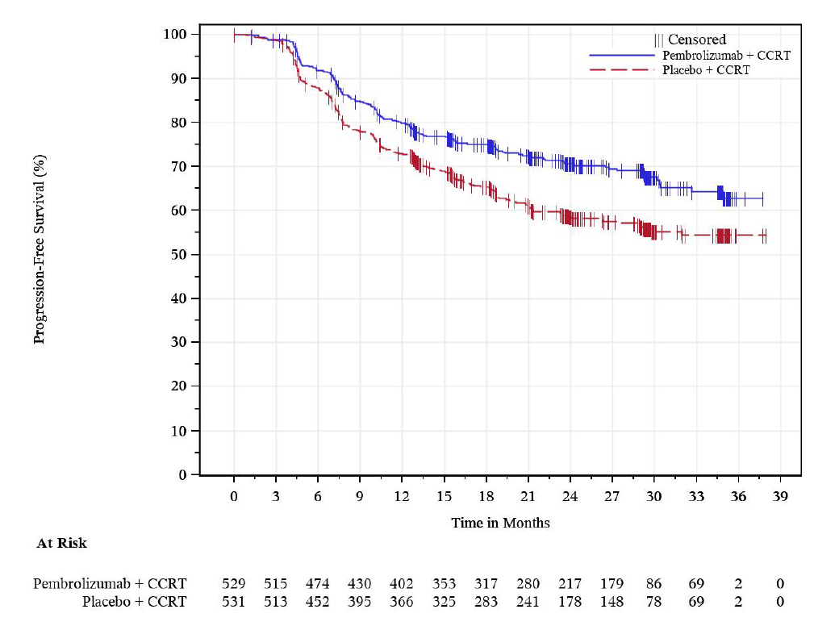
Source: Figure 2.5-3, p44 of the submission.
CCRT=concurrent chemoradiotherapy; ITT=intention to treat
  - The ESC noted that at 36 months median PFS duration had not yet been reached for both treatment arms. A statistically significant 32% reduction in the hazard of a PFS event, as assessed by the investigator, was observed in the pembrolizumab + CCRT arm compared with the placebo + CCRT arm (HR: 0.68; 95% CI: 0.56, 0.84). The PFS rates were higher in the pembrolizumab + CCRT arm compared with the placebo + CCRT at 24 months (70.6% vs. 58.6%) and at 36 months (62.7% vs. 54.5%). The ESC noted that the KM curves for PFS separated early at approximately 3 months and remained separated over time in favour of pembrolizumab + CCRT.
  - The PFS results at IA2 for the pembrolizumab + CCRT arm compared with the placebo + CCRT arm were similar to those observed at IA1 (HR: 0.70; 95% CI: 0.55, 0.89; p=0.002). Similarly to IA1, the KM curves for PFS separated at approximately 3 months and remained separated over time in favour of pembrolizumab + CCRT.
  - Results for the analysis of PFS as assessed by blinded, independent, central review (BICR) were generally consistent with those based on investigator review.
  - The OS results at IA2 are summarised below.
Table 5: KN-A18 Analysis of overall survival at Interim analysis 2 (ITT Population)
Treatment | N | Number of events (%) | Median OS (Months) (95% CI) | Person-months (Event rate/ 100 person-months) | OS rates at 36 months in % (95% CI) | Hazard Ratioª (95% CI) | p-value^{b}
Pembrolizumab + CCRT | 529 | 75 (14.2) | NR (NR, NR) | 13763.6 (0.5) | 82.6  (78.4, 86.1) | 0.67  (0.50, 0.90) | 0.004
Placebo + CCRT | 531 | 109 (20.5) | NR (32.0, NR) | 13483.8 (0.8) | 74.8  (70.1, 78.8)
Source: Table 2.5-1, p37 of the submission.
CCRT=concurrent chemoradiotherapy; EBRT=external beam radiotherapy; FIGO=International Federation of Gynaecology and Obstetrics; Gy=grays; IMRT=intensity-modulated radiotherapy; ITT=intention to treat; NR = Not reached; SAP=statistical analysis plan; VMAT=volumetric modulated arc therapy.
ªBased on Cox regression model with Efron’s method of tie handling with treatment as a covariate stratified by planned type of EBRT ([IMRT or VMAT vs non-IMRT and non-VMAT]), Stage at screening (FIGO [2014] IB2-IIB vs III-IVA), and Planned total radiotherapy dose (<70 Gy vs >=70 Gy) with small strata collapsed as pre-specified in the statistical analysis plan
^{b}One-sided p-value based on log-rank test stratified by planned type of EBRT (IMRT or VMAT vs non-IMRT and non-VMAT), Stage at screening (FIGO [2014] IB2-IIB vs III-IVA), and Planned total radiotherapy dose (<70 Gy vs >=70 Gy) with small strata collapsed as pre-specified in the sSAP.
Database Cutoff Date: 08JAN2024

Figure 2: KN-A18 Kaplan-Meier Estimates of Overall Survival at Interim analysis 2 (ITT Population)
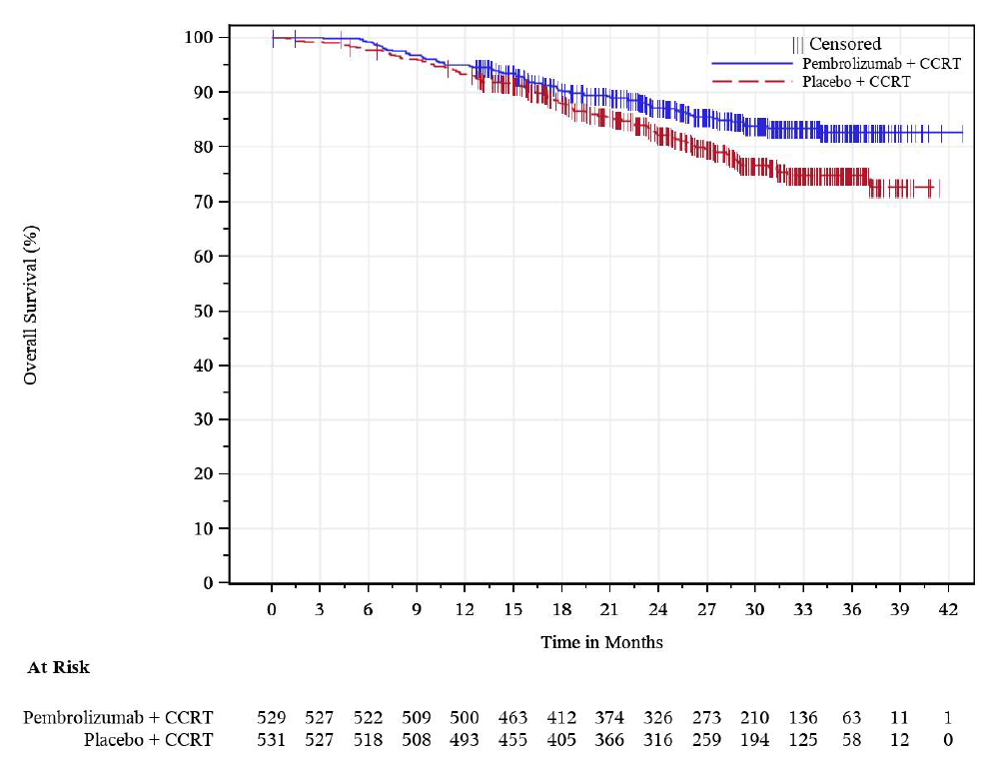
Source: Figure 2.5-1, p39 of the submission.
CCRT=concurrent chemoradiotherapy; ITT=intention to treat.
  - A total of 184 OS events out of 240 planned events (deaths) were observed at IA2, suggesting a 77% information fraction. The submission stated that the data can be considered reasonably mature for OS.
  - The ESC noted that the OS curves separated at 10.5 months, remaining separated, and that at 36 months median OS had not been reached in either treatment arm. The OS data remain immature for a reliable estimation of the magnitude of the survival benefit given the low death rates in the ITT population (pembrolizumab + CCRT [14.2%]; placebo + CCRT [20.5%]).
  - The OS results at IA2 indicate there was a statistically significant 33% reduction in the hazard of death associated with pembrolizumab + CCRT compared with placebo + CCRT (HR: 0.67; 95% CI: 0.50, 0.90, p=0.004). The ESC noted that the OS rate at 3 years was higher in the pembrolizumab + CCRT arm (82.6%) versus the placebo + CCRT arm (74.8%).
  - By comparison, at IA1, there was a non-statistically significant 27% reduction in the hazard of death associated with pembrolizumab + CCRT (HR: 0.73; 95% CI: 0.49, 1.07). However, only 103 of the 240 deaths expected occurred at IA1 (42·9% information fraction).
  - Subgroup analyses of PFS (investigator assessment) and OS are summarised below.
  - By disease stage: Subgroup analyses by the stratification factor disease stage were prespecified. The analyses indicated there was a differential magnitude of treatment effects with the possibility that a treatment effect with pembrolizumab may be either lacking in patients with FIGO 2014 Stage IB2-IIB disease or that a detrimental effect associated with pembrolizumab could not be ruled out in these patients. There is a similar concern with the OS results. Results at both IA1 and IA2 have been presented for comparison purposes.
- At IA1, the PFS HR (95% CI) for patients with FIGO 2014 Stage III-IVA disease was 0.58 (0.42, 0.80) and for patients with FIGO 2014 Stage IB2-IIB disease was 0.91 (0.63, 1.31).
- At IA2, the PFS HR (95% CI) for patients with FIGO 2014 Stage III-IVA disease was 0.57 (0.43, 0.76) and for patients with FIGO 2014 Stage IB2-IIB disease was 0.85 (0.62, 1.16).
- At IA1, the OS HR (95% CI) for patients with FIGO 2014 Stage III-IVA disease was 0.51 (0.31, 0.83) and for patients with FIGO 2014 Stage IB2-IIB disease was 1.62 (0.79, 3.34).
- At IA2, the OS HR (95% CI) for patients with FIGO 2014 Stage III-IVA disease was 0.57 (0.39, 0.83) and for patients with FIGO 2014 Stage IB2-IIB disease was 0.89 (0.55, 1.44).
  - By PD-L1 expression (Predictive value of PD-L1 expression): These data were not presented in the submission but have been reproduced from the TGA Delegate’s Overview (p28, Delegate’s Overview pembrolizumab, MSD PM-2023-04787-1-4). PD-L1 expression was not a stratification factor at randomisation and so subgroup analyses by PD-L1 status are essentially exploratory.
- At IA2: for the CPS ≥1 subgroup, there was a 34% reduction in the hazard for death (OS HR: 0.66 [95% CI: 0.49, 0.89]). For the CPS <1 subgroup, the OS HR was 1.06 (95% CI: 0.26, 4.29).
- At IA2: for the CPS ≥ 1 subgroup, there was a 31% reduction in the hazard of a PFS event (PFS HR: 0.69 [95% CI: 0.56, 0.85]). For the CPS < 1 subgroup, the PFS HR was 0.57 (95% CI: 0.19, 1.71). Given the small numbers in this subgroup, the 95% CI has low precision.
  - Patients with PD-L1 CPS ≥1 tumours accounted for 94.3% of the KN-A18 ITT population. The Delegate’s Overview further noted that additional baseline demographic and disease data provided by the sponsor were reasonably balanced between the two treatment arms in the CPS ≥ 1 subgroup. In contrast, in the smaller subgroup of patients with CPS < 1 tumour (N=50), patients in the pembrolizumab + CCRT arm and those in the placebo +CCRT arm were not matched in terms of several factors including ECOG PS (1: 59.1% vs. 35.7%), FIGO 2014 stage (IB2-IIB: 36.4% vs. 28.6%), presence of lymph node positivity (yes: 81.8% vs. 75.0%), and planned type of EBRT (IMRT or VMAT: 81.8% vs. 92.9%). Considering the subgroup size and imbalances in known predictive baseline factors, it was not possible to draw robust conclusions from the KN-A18 subgroup data about efficacy of pembrolizumab for patients with high-risk LACC with CPS <1.
  - Analysis of PFS2 (secondary endpoint) indicated there was a 40% reduction in the hazard of a PFS2 event associated with pembrolizumab + CCRT compared with placebo + CCRT (HR: 0.60; 95% CI: 0.46, 0.80). The median duration of PFS2 was not reached in either of the trial arms.
  - The difference in response rates between the treatment arms appeared modest. Complete response (CR) rates (secondary endpoint) as assessed by investigator (RECIST 1.1) at 12 weeks were 36.9% in the pembrolizumab + CCRT arm compared with 33.5% in the placebo + CCRT arm. The corresponding point estimates of objective response rate (ORR) were 87.5% in the pembrolizumab + CCRT arm compared with 83.7% in the placebo + CCRT arm.
  - Change from baseline in the analysis of patient reported outcomes (PRO) were based on a prespecified 36-week time point and the results are summarised below.
  - For EuroQol 5-Dimension 5-Level (EQ5D5L), there were no clinically meaningful differences between patients treated with pembrolizumab + CCRT versus placebo + CCRT (Least squares [LS] mean change at Week 36 from baseline: 6.63 [95% CI: 4.61, 8.24] vs. 7.01 [95% CI: 5.20, 8.82]; difference in LS means: -0.59 [95% CI: -2.81, 1.64]).
  - For EORTC QLQ-C30 global health status/quality of life (QoL) and physical functioning, the results showed no clinically meaningful differences between patients in the pembrolizumab + CCRT arm versus the placebo + CCRT arm at Week 36 (difference in LS means for global health status: 0.07 [95% CI: -2.66, 2.80]; difference in LS means for physical functioning: 0.68 [95% CI: -1.36, 2.71]).

Comparative harms
  - Safety analyses were based on the All Patients as Treated (APaT) population (patients who received at least one dose of study treatment). The APaT dataset included 1,058 patients (pembrolizumab + CCRT arm: N=528; placebo + CCRT arm: N=530). A summary of overall AEs in KN-A18 is presented below.
Table 6: KN-A18 – Overall adverse event summary (APaT Population)
Participants in population | Pembrolizumab + CCRT (N=528) |  | Placebo + CCRT (N=530)
 | n | (%) | n | (%)
With one or more AEs | 528 | (100.0) | 526 | (99.2)
With drug-related AEs | 512 | (97.0) | 513 | (96.8)
With toxicity Grade 3-5 AEs | 413 | (78.2) | 371 | (70.0)
With toxicity Grade 3-5 drug related AEs | 365 | (69.1) | 325 | (61.3)
With serious AEs | 172 | (32.6) | 151 | (28.5)
With serious drug-related AEs | 102 | (19.3) | 71 | (13.4)
Who died | 5 | (0.9) | 7 | (1.3)
Who died due to a drug-related AEs | 2 | (0.4) | 2 | (0.4)
Discontinued drug due to an AE | 109 | (20.6) | 79 | (14.9)
Discontinued drug due to a drug-related AE | 99 | (18.8) | 69 | (13.0)
Discontinued drug due to a serious AE | 35 | (6.6) | 23 | (4.3)
Discontinued drug due to a serious drug-related AE | 29 | (5.5) | 14 | (2.6)
Source: Table 2.5-10, p50 of the submission
AE=adverse event; APaT=All patients as treated; CCRT = concurrent chemoradiotherapy
  - Most patients in the pembrolizumab + CCRT and placebo + CCRT arms of KN-A18 experienced one or more AEs (100.0% vs 99.2%, respectively). The proportion of patients with Grade 3-5 drug-related AEs (69.1% vs 61.3%), serious drug-related AEs (19.3% vs 13.4%), and who discontinued any drug due to a treatment-related AE (18.8% vs 13.0%) was numerically higher in the pembrolizumab + CCRT arm compared to the placebo + CCRT arm. The discontinuation rate due to a serious drug-related AE in the pembrolizumab + CCRT arm was low but approximately twice that in the placebo + CCRT arm (5.5% vs 2.6%).
  - Drug-related AEs that occurred at a higher incidence in the pembrolizumab + CCRT arm compared with the placebo + CCRT arm were hypothyroidism (21.2% vs 5.7%) and hyperthyroidism (10.6% vs 2.8%). These are well-established immune-related AEs (irAEs) associated with pembrolizumab.
  - The overall incidence of drug-related Grade ≥3 AEs was higher in the pembrolizumab + CCRT arm compared with the placebo + CCRT arm (69.1% vs 61.3%). The overall incidence of drug-related SAEs was also higher in the pembrolizumab + CCRT group compared with the placebo + CCRT group (19.3% vs 13.4%).
  - The incidence of deaths due to a drug-related AE was similar between the treatment arms (0.4%).
  - The overall incidence of adverse events of special interest (AEOSI) observed was higher in the pembrolizumab +CCRT arm compared with the placebo plus CCRT arm (40.2% vs 18.3%). This was driven primarily by Grade 1-2 events within the hypothyroidism and hyperthyroidism AEOSI categories. The most frequently reported AEOSI (≥5% in either arm) were hypothyroidism (22.3% vs. 6.8%) and hyperthyroidism (11.9% vs 2.8%). The submission noted that at the January 2024 data cutoff, the majority of AEOSI in the pembrolizumab + CCRT arm were resolved (42.0%) or in the process of resolving (20.8%).
  - Overall, the frequency of AEs was higher in the pembrolizumab + CCRT arm compared to the placebo + CCRT arm. There were no new safety signals apparent from the available data. However, additional safety data by treatment phase would have been informative. That is, AEs for the concurrent pembrolizumab plus CCRT phase versus AEs for the pembrolizumab monotherapy maintenance treatment phase. Safety data from the monotherapy maintenance phase would be expected to be generally specific to pembrolizumab.

Benefits/harms
  - A summary of the comparative benefits and harms for pembrolizumab + CCRT versus placebo + CCRT is presented in Table 7.

Table 7: KN-A18 - Summary of the comparative benefits and harms for pembrolizumab + CCRT versus placebo + CCRT (proxy for standard of care) – Interim analysis 2 (IA2)
Benefits
 |  | PEM + CCRT  N=529 | Placebo + CCRT  N=531 | Absolute difference | HR  (95% CI)
PFS (ITT population)
Number of events, n (%) |  | 155 (29.3) | 210 (39.3) | – | 0.68 (0.56, 0.84)  p=0.0002
Median PFS, months (95% CI) |  | NR | NR | –
PFS rate at Month 36, % (95% CI) |  | 62.7 (56.4, 68.4) | 54.5 (49.3, 59.3) | 8.2
PFS (FIGO 2014 Stage III-IVA subgroup) |  |  |  |  | 0.57 (0.43, 0.76)
PFS (FIGO 2014 Stage IB2-IIB subgroup) |  |  |  |  | 0.85 (0.62, 1.16)
OS (ITT population)
Death, n (%) |  | 75 (14.2) | 109 (20.5) | – | 0.67 (0.50, 0.90)  p=0.0040
Median OS, months (95% CI) |  | NR | NR | –
Alive at Month 36, % (95% CI) |  | 82.6 (78.4, 86.1) | 74.8 (70.1, 78.8) | 7.8
Harms (all participants as treated population)
Event | Pembrolizumab  n/N | Placebo  n/N | Event rate/100 patients |  | Absolute difference
 |  |  | Pembrolizumab | Placebo
Grade 3-5 drug related AEs | 365/528 | 325/530 | 69.1 | 61.3 | 7.8
AEOSI | 212/528 | 97/530 | 40.2 | 18.3 | 21.9
Source: Sections 2.5 and 2.6 of the submission
AEs = adverse events; AEOSIs = adverse events of special interests; CCRT=concurrent radiochemotherapy; CI = confidence interval; PFS = progression-free survival; HR = hazard ratio; ITT = intention-to-treat; NR = not reached; OS = overall survival; PEM=pembrolizumab.
Notes: Data cutoff date: January 2024. Median duration of follow-up: 27.8 months in the pembrolizumab + CCRT arm and 26.9 months in the placebo + CCRT arm.
HR for PFS and OS were for pembrolizumab versus placebo. HR <1 favours pembrolizumab over placebo.
  - On the basis of the direct evidence presented by the submission, for every 100 high risk LACC patients treated with pembrolizumab + CCRT in comparison with placebo + CCRT (median follow-up: 27.8 months for pembrolizumab arm and 26.9 months for placebo arm):
- Approximately 8 additional patients will remain free of disease progression or death at 3 years.
- Approximately 8 additional patients will remain alive at 3 years.
- Approximately 22 additional patients will experience an AEOSI.
- Approximately 8 additional patients will experience a Grade ≥3 drug-related AE.

Clinical claim
  - The submission described pembrolizumab + CCRT as superior in terms of effectiveness and inferior but manageable safety compared to CCRT alone. The ESC considered the therapeutic conclusion presented in the submission was supported by the evidence presented in the submission noting the following concerns:
- Prespecified subgroup analyses by FIGO 2014 disease stage (a stratification factor in the trial) indicated the observed benefit in the KN-A18 ITT population was probably driven by the treatment effect in patients with a more advanced disease stage, i.e., FIGO 2014 Stage III-IVA. At IA2:
- the PFS Hazard Ratio (HR) (95% CI) for patients with FIGO 2014 Stage III-IVA disease was 0.57 (0.43, 0.76) and for patients with FIGO 2014 Stage IB2-IIB disease was 0.85 (0.62, 1.16).
- the OS HR (95% CI) for patients with FIGO 2014 Stage III-IVA disease was 0.57 (0.39, 0.83) and for patients with FIGO 2014 Stage IB2-IIB disease was 0.89 (0.55, 1.44).
- Patients with FIGO 2014 Stage IB2-IIB disease have a more favourable prognosis compared to patients with FIGO 2014 Stage III-IVA disease, and it may be challenging for additional therapy to show benefit for this group of patients. It is plausible that patients with higher stage disease (and at highest risk of recurrence) are those who are deriving the most benefit from additional pembrolizumab therapy.
  - Australian clinical practice includes the use of pembrolizumab in patients with advanced (persistent, recurrent, or metastatic) cervical cancer. In KN-A18, the proportion of patients in the placebo + CCRT arm who progressed and subsequently switched to pembrolizumab appeared lower than that expected in Australian clinical practice. Whilst recognising that the later stage indication for pembrolizumab may not have been available or widely funded during the conduct of the trial, and as a result the low extent of switching, the concern remains that the placebo arm of KN-A18 may underperform when compared to current Australian standard of care, and so the magnitude of comparative survival gain observed in the trial may not be realised. Noteworthy is that the submission attempted to adjust for this low switching in the economic model.
  - There is limited data available for patients whose tumours did not express PD-L1 (CPS <1). This concern was raised given the mechanism of action of pembrolizumab (a PD-1 inhibitor) and the biological rationale for differential efficacy by PD-L1 status in some cancer settings. Patients with PD-L1 CPS ≥1 tumours accounted for 94.3% of the KN-A18 ITT population. At IA2, for the CPS ≥1 subgroup, there was a 34% reduction in the hazard for death (OS HR: 0.66 [95% CI: 0.49, 0.89]). For the CPS <1 subgroup, the OS HR was 1.06 (95% CI: 0.26, 4.29). The 95% CI has low precision in this subgroup. Considering the small subgroup size and the potential for imbalances in baseline prognostic factors, it was not possible to draw any meaningful conclusions about the efficacy of pembrolizumab for patients with high-risk LACC with CPS <1.
  - The PBAC considered that the clinical evidence supported a claim of superiority with respect to OS and PFS for pembrolizumab + CCRT vs CCRT alone, though the magnitude of clinical benefit that would be observed in the Australian treatment setting remained uncertain due to the immaturity of the clinical data as well as the relatively low proportion of patients in the placebo + CCRT arm who switched to pembrolizumab compared with that expected in Australian clinical practice.
  - The PBAC considered that the claim of inferior but manageable comparative safety was reasonable.

Economic analysis
  - The submission presented a stepped economic evaluation for the use of pembrolizumab plus CCRT for the treatment of LACC based on the direct, randomised KN-A18 trial for the comparison of treatment with pembrolizumab + CCRT vs CCRT alone.
  - The key components of the economic evaluation are summarised in
  - Table 8.

Table 8: Summary of model structure, key inputs and rationale
Component | Summary
Treatments | Pembrolizumab + CCRT versus CCRT only
Time horizon | 30 years in the model base case vs 27.5 months of follow-up in the KN-A18 trial. Sensitivity analyses consider time horizons of 25 and 35 years. The ESC considered that a time horizon of 30 years may be too long, noting that the ICER is sensitive to reduced time horizons.
Outcomes | LYs and QALYs gained
Methods used to generate results | Markov cohort model
Health states | Four health states: PF, PD1, PD2 and Dead.
Cycle length | 1 week, with half cycle correction for outcomes, subsequent treatment and AEs costs
Transition probabilities and extrapolation | A multi-state parametric modelling approach was used to derive the transition probabilities using patient level data from the KN-A18 trial, January 2024 data cut (for transitions from the PF health state) and from the KN-826 trial (for transitions from the PD1 and PD2 health states). Separate parametric models were fitted to the observed PFS, TTP and post-progression survival (PPS) curves from the KN-A18 trial based on statistical fit, visual inspection and clinical plausibility. Dependent models were fitted to the observed PFS, TTP and PPS data from the KN-826 trial, based on the proportional hazards assumption. The log-normal model was fitted to the KN-A18 PFS and TTP curves across both treatment arms and exponential functions were fitted to the KN-826 TTP, PFS and PPS curves across both treatment arms.  Observed KM data were not directly used in the economic model. In line with PBAC Guidelines, use of observed time-to-event data is preferred over the use of modelled data only, until the time point at which the observed data becomes unreliable as a result of small patient numbers remaining event-free. It is unclear why the submission did not make use of observed data for the PFS and TTP curves of the KN-A18 trial in the base case. Further the ICER was sensitive to the choice of parametric model, and alternative functions also provided a good fit to the observed data (and substantially increased the ICER).  99.7% of the incremental LYs (undiscounted) were gained in the extrapolated period.
Health related quality of life | Utility values for the PF and PD1 health state were derived using EQ-5D-5L data from the KN-A18 trial. Health state utility values were not assumed to vary by treatment arm: PF = 0.953 (without toxicity); 0.920 (with toxicity); PD1 = 0.857; PD21 = 0.792. To avoid double counting (as disutility due to AEs was included in the base case), the utility value for the PF health state was based on HRQoL data of patients who were progression-free and not experiencing an AE. The utility values applied in the submission were higher than the utility values of the age-equivalent general Australian population and appear to be implausible at face value. Further, the PF and PD1 health state utility values were based on EQ-5D-5L observations for a small proportion of the study patients and therefore there was significant potential for non-response bias. Thus, the within-trial utility weights cannot be assumed to reliably represent the whole of the proposed Australian population in clinical practice. The utility decrement between the PF and PD health states from the KN-826 trial was applied to the utility value of the PD1 health state to derive the utility value for the PD2 health state.
Subsequent treatment costs | Costs for subsequent treatment were included in both arms. The submission assumed that 100% and 50% of patients who progress to the PD1 and PD2 health states, respectively, would receive subsequent treatment. The ESC considered it may not be reasonable to assume that 100% of patients would be treated with pembrolizumab in the CCRT alone arm, and that a figure of ||||% would be more appropriate. The ICER increases when the proportion of patients treated with pembrolizumab in the CCRT alone arm of the model is reduced.
Source: Table 3.1-1, p73 of the submission and the “Attachment 5 (UCA)” workbook provided in the submission.
AEs = Adverse Events; CCRT = Concurrent chemoradiotherapy; HRQoL = Health related quality of life; ICER = Incremental cost-effectiveness ratio; KM = Kaplan-Meier; LY = Life-year; LYs = Life-years; PD1 = Progressed disease 1; PD2 = Progressed disease 2; PF = Progression-free; PFS = Progression-free survival; PPS = Post-progression-survival; QALY = Quality-adjusted life year ; QALYs = Quality-adjusted life years; TTP = Time-to-progression
  - The submission constructed a Markov model that included four health states: progression-free (PF), first progression (PD1), second progression (PD2) and Dead. All patients entered the model in the PF health state and received treatment, i.e., pembrolizumab in combination with CCRT in the intervention arm and CCRT only in the comparator arm.
  - A time horizon of 30 years was nominated in the base case based on a median follow-up for OS of 27.5 months at the time of the interim analysis 2 (January 2024 data cut). The submission noted that this was consistent with submissions to the PBAC for treatment of early cancers such as breast cancer. The ESC considered that this may be too long and that a time horizon of 25 years would be more appropriate. The ESC noted that the ICER is sensitive to shorter time horizons, increasing by | |% for a time horizon of 25 years. The pre-PBAC response stated that a 30-year time horizon is reasonable given the “younger Australian patient age and in the context of a treatment with curative intent”, highlighting that a time horizon of 30 years has been accepted for triple negative early breast cancer (paragraphs 4.9 and 5.5, pembrolizumab Public Summary Document (PSD), July 2023 PBAC Meeting) where women are of a similar age.
  - The transition probabilities used in the economic model were based on extrapolation of the time-to-event curves from the KN-A18 trial for transitions from the PF health state and the time-to-event curves from the KN-826 trial, for the PD1 and PD2 health states, with adjustment for background mortality where applicable. The model assumed that the effect of pembrolizumab treatment (given for a maximum of 2 years) would persist throughout the model time horizon, which the ESC considered was implausible. No data were provided to support persistence of the effect beyond that observed in the KN-A18 and KN-826 trials. A review of NICE appraisals noted that a 3–5-year treatment effect has been considered plausible for immunotherapies. The Pre-Sub-Committee Response (PSCR ) maintained that no treatment waning is an appropriate assumption for the base case economic evaluation, citing a conference poster on the review that stated “when assessing the smoothed HRs from the more mature data [for 2 appraisals for pembrolizumab in lung cancer and 1 in bladder cancer, and 1 for durvalumab in lung cancer], it is evident that the HR for majority of the follow-up period is below 1, indicating maintained treatment effect over time”. The ESC noted however, the conference poster also stated, “uncertainties around the long-term treatment effects remain despite the availability of longer follow-up data”. Given the data is immature, and that treatment with pembrolizumab is allowed for a maximum of 2 years, the ESC considered it may be reasonable to apply treatment waning from year 3. The ICER increased by | |% when treatment waning was applied to each of the PFS, TTP and PPS curves for the KN-A18 trial and to the PFS and TTP curves of the KN-826 trial (gradually reducing from 100% to 0%) during years 3-5 (and remaining at 0% after year 5 i.e., with the same event rate for both treatment arms), from $35,000 to < $45,000/QALY to $55,000 to < $75,000 /QALY (see
  - Table 13). Independent parametric survival models were fitted to the time-to-event curves of the KN-A18 trial, while dependent parametric models were fitted to the time-to-event curves of the KN-826 trial, based on clinical plausibility, statistical fit (using the Akaike information criteria [AIC] and Bayesian information criteria [BIC]) and visual inspection. The impact of applying treatment waning on the modelled PFS and OS curves in KN-A18 is shown in Figures 3 and 4. The pre-PBAC response acknowledged that while relative treatment effect may not continue indefinitely that treatment waning assumptions in economic appraisals have not reflected the increasing evidence base for immunotherapies that show a consistent survival plateau. The pre-PBAC response proposed a respecified base case model with treatment waning applied in years 7 to 10.

Figure 3: Impact of treatment waning on modelled progression-free survival curves in KN-A18
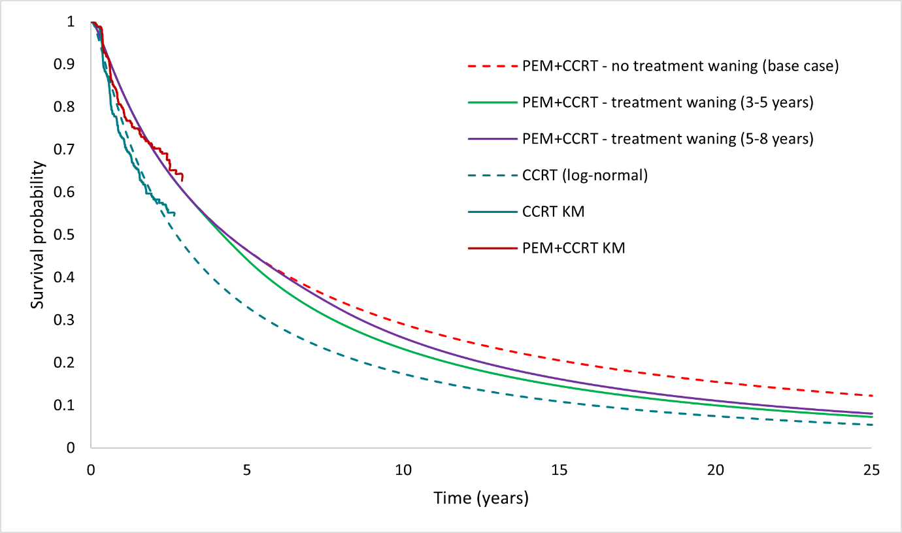
Source: constructed during the preparation of the ESC Advice, from the “Attachment 5 (CUA)” workbook provided in the submission.
CCRT = Chemoradiotherapy; PEM = Pembrolizumab; KM = Kaplan-Meier.

Figure 4: Impact of treatment waning on modelled overall survival curves in KN-A18
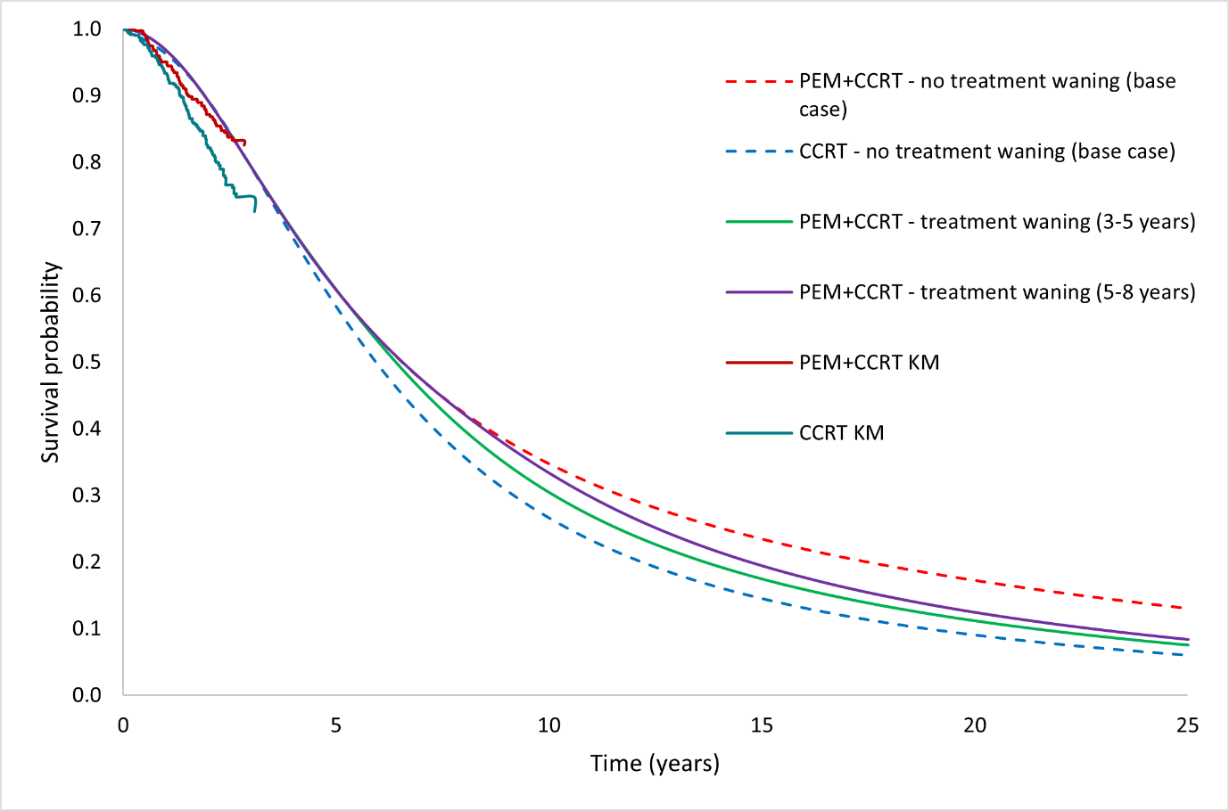
Source: constructed during the preparation of the ESC Advice, from the “Attachment 5 (CUA)” workbook provided in the submission.
CCRT = Chemoradiotherapy; PEM = Pembrolizumab; KM = Kaplan-Meier.

  - To inform the transitions from the PF health state to the PD1 and Dead health states, extrapolation of the TTP and PFS curves of the KN-A18 trial was undertaken. Log-normal models were fitted to the observed data to both curves, across both treatment arms, in the base case. The log-logistic model also provided a good fit to the observed KM data on visual inspection for both, the PFS and TTP curves. When the log-logistic model was chosen for PFS and TTP extrapolation in the pembrolizumab + CCRT arm, the ICER increased by | |% to $45,000 to < $55,000/QALY (compared to the base case ICER of $35,000 to < $45,000/QALY).
  - Pembrolizumab was listed on the PBS for the treatment of advanced (recurrent, persistent or metastatic) cervical cancer in October 2023. However, in the KN-A18 trial, only 20.9% of patients in the CCRT arm received pembrolizumab as a second line (2L) treatment. To adjust for the expected use of pembrolizumab in the Australian setting (assumed to be 100% in the submission), transition probabilities from the PD1 and PD2 health states were derived using data from the KN-826 trial. This was reasonable. However, the ESC considered it was not reasonable to assume that 100% of patients who progress after CCRT will go on to receive pembrolizumab in the later line setting: the ESC considered ||| |||% to be a more reasonable estimate, noting that the PBAC considered ||| |||% to be a likely overestimate of the uptake rate for pembrolizumab for advanced carcinoma of the cervix (para 6.44, Table 13 and para 7.12, pembrolizumab PSD, November 2022 PBAC Meeting). The pre-PBAC response proposed a respecified base case that assumed ||| |||% of patients would use pembrolizumab post progression after CCRT. In the KN-A18 trial, 10.9% of patients received a subsequent line of therapy containing pembrolizumab on progression with pembrolizumab + CCRT. This did not align with Australian clinical practice in which retreatment with PD-L1 inhibitors is not allowed. The submission did not adjust for this continued use and the impact on the ICER remains uncertain.
  - Transition probabilities from the PD1 to the PD2 and Dead health states were based on the TTP and PFS curves of the KN-826 trial. Exponential distributions were fitted to the observed data in the base case. All parametric models appeared to fit the observed data considerably well on visual inspection, with the ICER moderately sensitive to the choice of extrapolation (increasing by ||| |||% and ||| |||% when the Weibull and log-logistic models were fitted to the TTP and PFS curves, respectively). The transition probability from the PD2 health state to the Dead health state was based on the extrapolation of the PPS curve from the KN-826 trial. The exponential function was fitted to the observed data in the base case. The choice of parametric extrapolation had a minimal impact on the ICER.
  - To validate the operation of the model, the submission presented a comparison of observed PFS and OS data from the KN-A18 trial to the modelled curves used in the base case analysis, extrapolated over the time horizon (Figures 5 and 6). The modelled PFS curve overestimates and underestimates the observed data at various time points for both treatment arms. Further, the modelled curves did not make use of any observed data. The ESC noted this was inappropriate and not in line with the approach outlined in the PBAC Guidelines that suggests use of observed data up to the time point at which the data becomes unreliable due to a small number of patients remaining event-free. To validate the economic model, the KM OS curves for the two arms of the trial were plotted against the modelled OS curves, as predicted by the economic model, during the evaluation. From the graph, it is evident that the OS curves generated by the economic model overestimate the KM OS data at all times for the CCRT arm. The evaluation and the ESC considered this to be reasonable as the economic model adjusted for an increased use of 2L pembrolizumab, which results in an increase in the benefits accrued by patients in the CCRT arm. For the PEM+CCRT arm, the modelled OS curves slightly overestimate the observed OS in the first 2 years.
Figure 5: Comparison of Kaplan-Meier and modelled curves for PFS
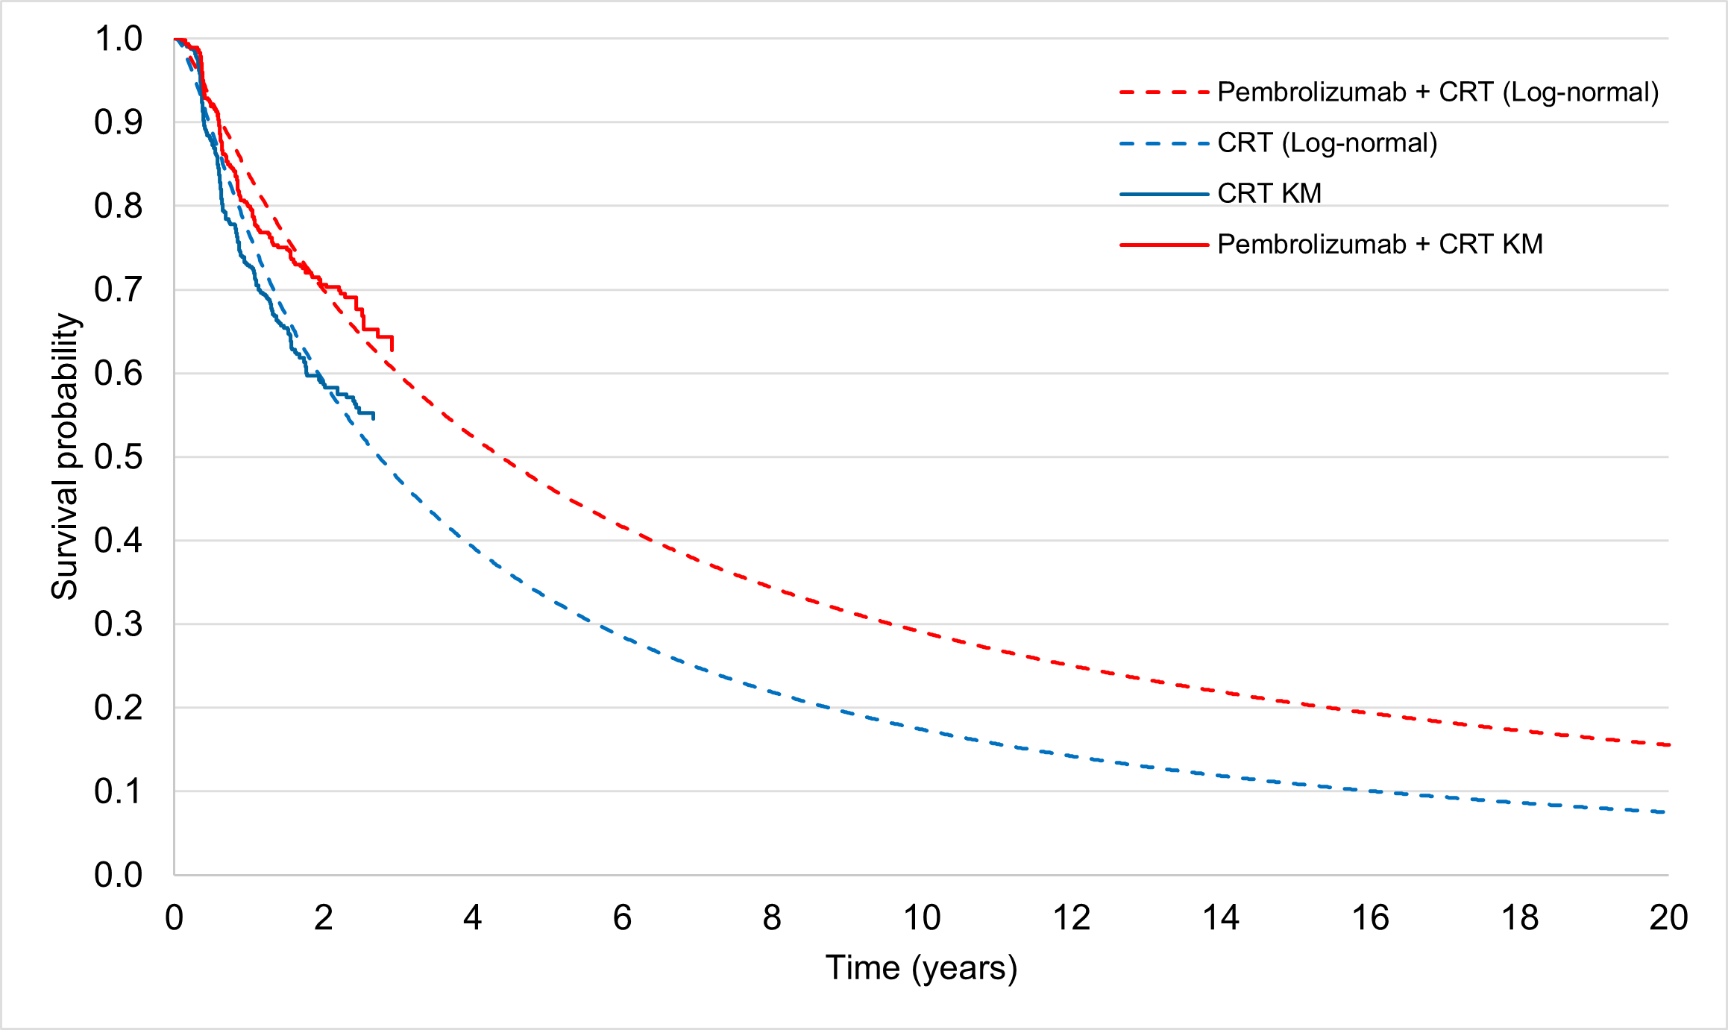
Source: constructed during the evaluation, from the “Attachment 5 (UCA)” workbook provided in the submission.
CRT = chemoradiotherapy; KM = Kaplan-Meier; PFS = Progression-free survival.

Figure 6: Comparison of Kaplan-Meier and modelled curves for OS
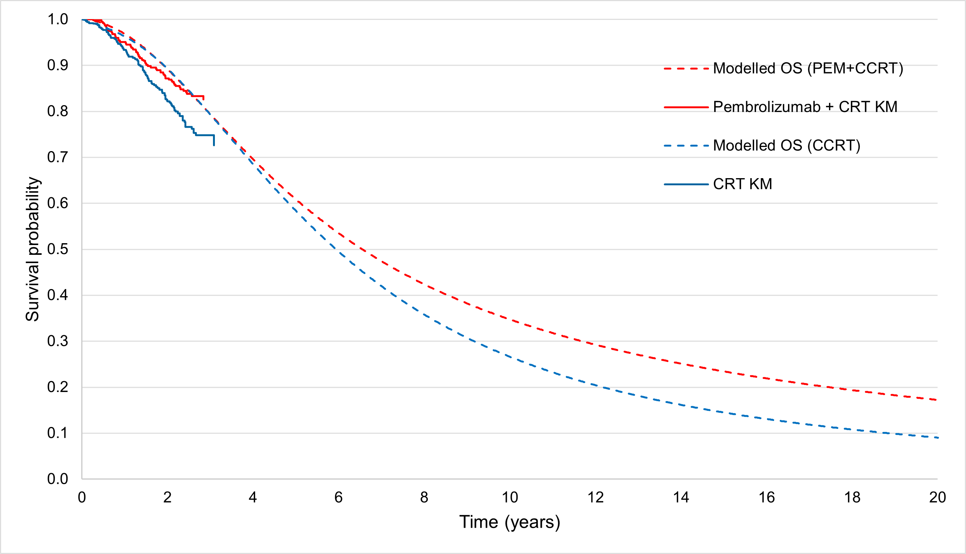
Source: constructed during the evaluation, from the “Attachment 5 (UCA)” workbook provided in the submission.
CRT = chemoradiotherapy; KM = Kaplan-Meier; OS = Overall survival.
  - The submission applied utility weights of 0.953, 0.857 and 0.792 in the PF, PD1 and PD2 health states, respectively, which were derived from the Health-related quality of life (HRQoL) assessments of the KN-A18 trial, using the EQ-5D-5L and mapped using the Australian value set. The ESC considered that the utility weights applied appeared to be clinically implausible and lacked face validity, given that a recent study in a representative sample of the general Australian population (n = 9,958) reported an average utility of 0.85 for women aged between 45 and 54 years of age using the EQ-5D-5L. Further, the utility weights applied in the PF and PD1 health states were based on HRQoL data for a small proportion of patients (379 and 261 patients, respectively, across both treatment arms) and therefore, cannot be used to reliably estimate the utility weights associated with the PF and PD1 health states. The ICER was sensitive to the utility weights applied, increasing by ||| |||% to $35,000 to < $45,000/QALY when alternative values (PF = 0.85, PD1 = 0.754, PD2 = 0.689), based on the utility value of a general Australian woman aged between 45-54 years of age (0.85) and utility decrements derived from the KN-A18 and KN-826 trials, were applied in the economic model. The pre-PBAC response proposed a respecified base case that used the alternative utility values.
  - The treatment costs were estimated based on the recommended dose of 200 mg Q3W while on initial treatment (15 weeks or 5 cycles) followed by 400 mg Q6W for a maximum of 90 weeks for pembrolizumab (15 cycles). CCRT was administered for a maximum of 6 cycles during initial treatment (5-6 cycles of cisplatin, a maximum of 40 days of EBRT followed by 10 days of brachytherapy). The duration of pembrolizumab + CCRT treatment applied in the model was based on extrapolation of the time-to-discontinuation (TTD) curves from the KN-A18 trial. The Gompertz model was fitted to the TTD curve for pembrolizumab while log-logistic models were fitted to the TTD curves for cisplatin and EBRT. It was unclear why TTD data from the trial was not directly used in the economic model and what the basis for extrapolation of the TTD curves for cisplatin and EBRT was as no KM data was provided in the economic model. The ICER was sensitive to the choice of extrapolation of TTD for pembrolizumab, reducing by ||| |||% and ||| |||% when the generalised gamma and Weibull models were fitted to the observed data.
  - The mean time-on-treatment (TOT) was estimated to be 73.79 weeks, 5.07 and 5.97 weeks for pembrolizumab, cisplatin and EBRT, respectively. For simplicity, the model assumed that treatment with brachytherapy would last 1 week. This was reasonable.
  - The submission applied a one-off cost for subsequent treatment for patients entering the PD1 and PD2 health states for 100% of patients who progress to the PD1 health state and 50% of patients who progress to the PD2 health state. No justification for these assumptions was provided in the submission. The ESC agreed with the evaluation that it may not be reasonable to assume that all patients who progress to the PD1 health state will receive further treatment. The distribution of and treatment durations for subsequent treatments were derived from the KN-826 trial, with the exception of gemcitabine, and the doses were based on eviQ Guidelines for management of persistent/recurrent/metastatic cervical cancer. However, the ICER was particularly sensitive to the proportion of patients that receive 2L pembrolizumab in the CCRT arm. The ICER increases when the use of 2L pembrolizumab is reduced. The usage, treatment durations and doses of the subsequent therapies are summarised in Table 9.
Table 9: Subsequent treatments for patients in the PD1 and PD2 health states
Subsequent treatment | Dose  (Q3W) | Treatment duration (months) | Weighted DPMAs | Cost per treatment cycle | Usage (PD1) |  | Usage (PD2)
 |  |  |  |  | PEM+CCRT  (%) | CCRT  (%) | PEM+CCRT  (%) | CCRT  (%)
Pembrolizumab | 200 mg | 14.4ª | $|||| | $||||$|||| | - | 100% | - | -
Paclitaxel | 175 mg/m² | 3.9 | $174.6  $193.0 | $115.43  $155.80 | 100% | 100% | - | -
Carboplatin | 750 mg | 3.7 | $172.6 | $143.81  $172.40 | 70.31% | 76.47% | 19.40% | 13.7%
Cisplatin | 50 mg/m² | 3.8 | $161.7  $168.1 | $62.49  $138.20 | 29.69% | 23.53% | 8.20% | 10.4%
Bevacizumab | 15 mg/kg | 13.6 | $1,759.0 | $951.49  $1,030.0 | 63% | 63% | 6.5% | 13.7%
Gemcitabine | 1700 mg, days 1 and 8 | 4.1 | $192.3 | $200.0  $315.60 | - | - | 4% | 12.2%
Costs for subsequent treatments |  |  |  |  | $|||| | $|||| | $|||| | $||||
Revised |  |  |  |  | $|||| | $|||| | $|||| | $||||
Source: tabulated during the evaluation, from Tables 3.5-7, 3.5-8, 3.5-9, 3.5-10, pp112-113 and the “Attachment 5 (CUA)” workbook provided in the submission.
CCRT = Concurrent chemoradiotherapy; DPMA = Dispensed price for maximum amount; DPMAs = Dispensed price for maximum amounts; PD1 = Progressed disease 1; PD2 = Progressed disease 2; PEM = Pembrolizumab ; Q3W = Every 3 weeks
ª A mean treatment duration of 11.8 months was previously used in the economic model that was accepted for pembrolizumab for metastatic cervical cancer (Table 12, pembrolizumab PSD, November 2022 PBAC meeting)
Note: Revised estimates were based on the dispensed price for the average dose in line with eviQ Guidelines.
  - Costs for routine monitoring, management of AEs, disease management and terminal care were also included in the base case. It may have been reasonable to exclude terminal care costs as all patients will transition to the death health state. Exclusion of terminal care costs had a minimal impact on the ICER (increased by | |%).
  - The key drivers of the economic model are summarised in Table 10.
Table 10: Key drivers of the model
Description | Method/Value | Impact  Base case: ||||/QALY gained
Treatment waning | No treatment waning was assumed in the base case, on the basis that these treatments offer the potential for durable response and long-term survival, particularly in the early stage setting with curative intent. No data were provided to support persistence of the effect beyond that observed in the KN-A18 and KN-826 trials. | High, favours PEM+CCRT  Applying treatment waning between years 5 and 8 increases the ICER to $||||/QALY; waning from 3-5 years increases the ICER to $||||/QALY
Extrapolation of the KN-A18 PFS and TTP curves | The log-normal model was fitted to the observed KM data in the base case. | High, favours PEM+CCRT  If the log-logistic models are fitted to the observed KM data in the PEM+CCRT arm, the ICER increases to $||||³/QALY.
Extrapolation of the TTD curve (pembrolizumab) | The Gompertz model was fitted to the TTD curve in the base case. | High, favours CCRT.  Alternate parametric models for extrapolation of the TTD curve reduced the ICER.
Utilities | The utility values for model health states were derived from the KN-A18 trial. | High, favours PEM+CCRT  Applying lower utility values increased the ICER to $||||¹/QALY.
Time horizon | 30 years in the base case, based on a follow-up for OS of 27.5 months at the interim analysis 2 (January 2024 data cut). | High, favours PEM+CCRT  Decreases in the time horizon led to substantial increases in the ICER ($||||¹/QALY for a time horizon of 25 years).
Use of 2L PEM in the CCRT arm | 100% use in the CCRT arm of progression to the PD1 health state. Average treatment duration of 14.4 months. | Moderate, favours PEM+CCRT  The ESC noted that reducing the use of pembrolizumab 2L to ||||% increased the ICER to $||||¹/QALY.  Reducing the use of 2L pembrolizumab to ||||% and the treatment duration to 11.8 months (consistent with that previously accepted by the PBAC for the pembrolizumab submission for metastatic disease) increased the ICER to $||||³/QALY.
Source: tabulated during the evaluation.
2L = Second-line; CCRT = Concurrent chemoradiotherapy; ICER = Incremental cost-effectiveness ratio; KM = Kaplan-Meier; OS = Overall survival; PD1 = Progressed disease 1; PEM = Pembrolizumab; PF = Progression-free; PFS = Progression-free survival; QALY = Quality-adjusted life year; TTD = Time to discontinuation; TTP = Time-to-progression
The redacted values correspond to the following ranges:
¹ $35,000 to < $45,000
² $55,000 to < $75,000
³ $45,000 to < $55,000
  - The results of the stepped economic evaluation are presented in Table 11.
Table 11: Results of the stepped economic evaluation
Step and component | Proposed medicine | Comparator | Increment
Step 1: Costs and outcomes over a 3-year time horizon
Costs | $|||| | $47,492 | $||||
LYG | 2.59 | 2.58 | 0.01
Incremental cost/extra LYG gained |  |  | $||||¹
Step 2: time horizon extended to 30 years and subsequent treatment costs applied
Costs | $|||| | $86,428 | $||||
LYG | 6.96 | 6.11 | 0.86
Incremental cost/extra LYG gained |  |  | $||||²
Step 3: utility weights applied
Costs | $|||| | $86,428 | $||||
QALYs | 6.42 | 5.54 | 0.89
Incremental cost/extra QALY gained (base case) |  |  | $||||²
Source: Table 3.7-2, p120 of the submission.
LYG = Life-year gained; QALYs = Quality-adjusted life years.
The redacted values correspond to the following ranges:
¹ > $1,055,000
² $35,000 to < $45,000
  - The ESC noted that in Step 1, the costs and outcomes were based on the modelled PFS and OS curves, and that a trial-based ICER using the KM data had not been presented. The disaggregated costs and outcomes for the economic analysis are presented in Table 12.
Table 12: Disaggregated summary of costs and health outcomes (discounted)
Resource item | PEM+CCRT cost ($) | CCRT cost | Incremental cost | % of total incremental cost
Costs
Drug costs | $|||| | $11,750 | $|||| | ||||%
Subsequent treatments | $|||| | $58,485 | -$|||| | -||||%
Disease management | $6,435 | $5,538 | $897 | 2.82%
Management of AEs | $6,806 | $5,911 | $895 | 2.81%
Terminal care | $4,368 | $4,744 | -$376 | -1.18%
Total cost | $|||| | $86,428 | $|||| | 100%
Outcomes
PF LYs | 5.76 | 4.18 | 1.58 | 185.54%
PD1 LYs | 0.69 | 1.33 | -0.64 | -74.21%
PD2 LYs | 0.52 | 0.61 | -0.09 | -10.33%
Total LYs | 6.96 | 6.11 | 0.86 | 100%
PF QALYs | 5.42 | 3.92 | 1.50 | 169.38%
PD1 QALYs | 0.59 | 1.14 | -0.54 | -61.47%
PD2 QALYs | 0.41 | 0.48 | -0.07 | -7.91%
Total QALYs | 6.42 | 5.54 | 0.89 | 100%
Source: tabulated during the evaluation, from Tables 3.7-3 and 3.7-4, p121 of the submission.
AEs = Adverse Events; CCRT = Concurrent chemoradiotherapy; LYs = Life-years; PD1 = Progressed disease 1; PD2 = Progressed disease 2; PEM = Pembrolizumab; PF = Progression-free; QALYs = Quality-adjusted life years
  - Pembrolizumab + CCRT, compared with CCRT only, was associated with 0.89 quality-adjusted life years (QALYs) gained, at an additional cost of $25,000 to < $35,000, resulting in an incremental cost-effectiveness ratio (ICER) of $35,000 to < $45,000/QALY gained. The main driver of the costs was the cost of pembrolizumab + CCRT treatment, with monitoring costs, disease management, management of AEs and terminal care costs being small contributors. The majority of costs were offset by the cost of subsequent treatments in the CCRT arm, which the ESC considered were overestimated (para 6.61). Patients in the pembrolizumab + CCRT arm accrued more LYs in the PF health state compared to those in the CCRT arm, while patients in the CCRT arm of the model accrued more LYs in the PD1 and PD2 health states.
Figure 7: Incremental LYs (undiscounted) gained over the modelled time horizon by treatment arm
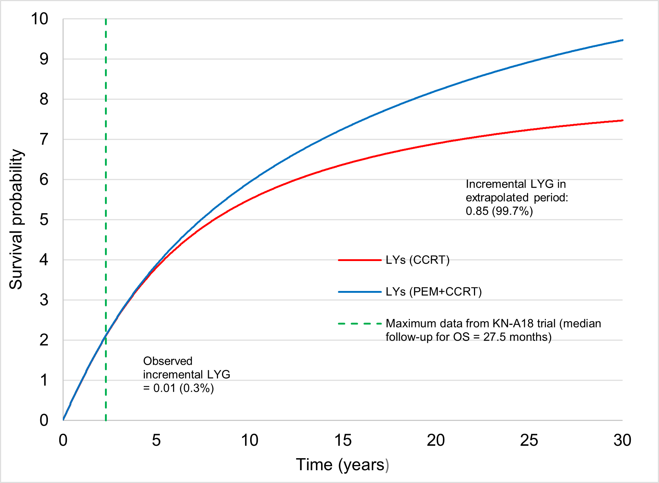
Source: constructed during evaluation, from the “Attachment 5 (CUA)” workbook provided in the submission.
CCRT = Chemoradiotherapy; LYG = Life-years gained; OS = Overall survival; PEM = Pembrolizumab.
  - The results of key sensitivity analyses are summarised in
  - Table 13. The analyses were sensitive to changes in choice of extrapolation of the TTP and PFS curves of the KN-A18 trial, extrapolation of the pembrolizumab TTD curve, model time horizon, utility weights, extent and duration of subsequent use of pembrolizumab in the CCRT arm and the assumption of treatment waning.
  - A sensitivity analysis assuming a treatment duration of 11.8 months for 2L pembrolizumab (rather 14.4 months), was undertaken during preparation of the ESC Advice. The ESC noted that the listing for pembrolizumab for patients with advanced cancer of the cervix (persistent, recurrent or metastatic) had been accepted based on an economic model that used a treatment duration for pembrolizumab of 11.8 months (Table 12, pembrolizumab PSD, November 2022 PBAC Meeting). The ESC considered that the treatment duration for high-risk LACC patients receiving subsequent treatment with pembrolizumab in the CCRT arm of the current model should be consistent with this. The ESC noted that with a treatment duration of 11.8 months and a ||| |||% uptake rate for 2L pembrolizumab, the base case ICER increased by 28% to $45,000 to < $55,000/QALY gained. The pre-PBAC response argued that a treatment duration for subsequent pembrolizumab use of 14.4 months was appropriate as this aligned with the treatment duration based on the Final Analysis of KN-826 (October 2022 data cutoff). The pre-PBAC response also noted that should the treatment duration be reduced to 11.8 months in line with the earlier May 2021 data cutoff, that applying the HR for PFS at the same data cutoff, which was 0.65 rather than the 0.61, reduces the ICER.
Table 13: Results of key sensitivity analyses
Analyses | Incremental QALY | Incremental Cost ($) | ICER | % change from baseline
Base case | 0.89 | |||| | ||||¹ | -
Discount rate (base case ||||%)
0% | 1.89 | |||| | ||||² | -||||%
3.5% | 1.09 | |||| | ||||³ | -||||%
Time horizon (base case 30 years)
25 years (#1) | 0.81 | |||| | ||||¹ | ||||%
35 years | 0.93 | |||| | ||||³ | -||||%
20 years | 0.68 | |||| | ||||⁴ | ||||%
40 years | 0.96 | |||| | ||||³ | -||||%
Utilities (base case: PF=0.953, PD1=0.857, PD2=0.792; disutility due to AEs based on Canadian values)
PF=0.85, PD1=0.754, PD2=0.689 (#2) | 0.80 | |||| | ||||¹ | ||||%
Disutility due to AEs based on Australian values (#3) | 0.89 | |||| | ||||¹ | -||||%
Extrapolation of PFS and TTP curves KN-A18 trial (base case: log-normal)
Log-logistic (PEM+CCRT arm) | 0.65 | |||| | ||||⁴ | ||||%
Generalized gamma (both arms) | 1.38 | |||| | ||||³ | -||||%
TTD extrapolation KN-A18 trial (pembrolizumab base case: Gompertz)
Weibull | 0.89 | |||| | ||||³ | -||||%
Generalised gamma | 0.89 | |||| | ||||³ | -||||%
Extrapolation of KN-826 TTP and PFS curves (base case: modelled data only)
KM+PSM approach (truncated at 37 weeks) | 0.78 | |||| | ||||¹ | ||||%
KM+PSM approach using Gebski criterion 2 (truncated at 150 weeks) | 1.04 | |||| | ||||³ | -||||%
Transition probability of PD1 to PD2 health states (base case: informed by TTP and PFS curves of the KN-826 trial)
Using KN-A18 data to inform transition | 1.43 | |||| | ||||⁵ | -||||%
Treatment waning (base case: no treatment waning)
Applied between years 5 and 8 (#4) | 0.59 | |||| | ||||⁶ | ||||%
Applied between years 3 and 8 | 0.53 | |||| | ||||⁶ | ||||%
Applied between years 3 and 5 (#5) | 0.44 | |||| | ||||⁶ | ||||%
Costs
Reducing use of subsequent PEM in the CCRT arm from ||||% to ||||% (#6) | 0.95 | |||| | ||||¹ | ||||%
Treatment duration of 11.8 months for PEM in the CCRT arm (#7) | 0.89 | |||| | ||||⁴ | ||||%
Excluding terminal care costs | 0.89 | |||| | ||||¹ | ||||%
Multivariate analyses
#1, #2, #3 | 0.73 | |||| | ||||¹ | ||||%
#1-3 AND #4 | 0.51 | |||| | ||||⁶ | ||||%
#1-3 AND #5 | 0.38 | |||| | ||||⁷ | ||||%
#6 AND #7 | 0.95 | |||| | ||||⁴ | ||||%
#1-3 AND #4,6,7 | 0.56 | |||| | ||||⁷ | ||||%
#1-3 AND #5,6,7 | 0.42 | |||| | ||||⁸ | ||||%
Pre-PBAC scenario
- Treatment waning applied between years 7 and 10  - #2 and #3  - #6  - Reduced price (EMP $|||| per vial) | Not reported | Not reported | ||||¹ | ||||%
Sensitivity analysis on pre-PBAC scenario
(i) Treatment waning applied between years 7 and 10  (ii) #2 and #3  (iii) #6 and #7  (iv) Reduced price (EMP $|| || per vial) | 0.66 | |||| | ||||⁴ | ||||%
Source: tabulated during the evaluation and preparation of the ESC Advice, from the “Attachment 5 (CUA)” workbook provided in the submission.
AEs = Adverse Events; CCRT = Concurrent chemoradiotherapy; ICER = Incremental cost-effectiveness ratio; PD1 = Progressed disease 1; PD2 = Progressed disease 2; PEM = Pembrolizumab; PF = Progression-free; PFS = Progression-free survival; QALY = Quality-adjusted life year; TTD = Time to discontinuation; TTP = Time-to-progression; KM = Kaplan Meier; PSM = partitioned survival models
The redacted values correspond to the following ranges:
¹ $35,000 to < $45,000
² $5,000 to < $15,000
³ $25,000 to < $35,000
⁴ $45,000 to < $55,000
⁵ $15,000 to < $25,000
⁶ $55,000 to < $75,000
⁷ $75,000 to < $95,000
⁸ $95,000 to < $115,000
  - The submission did not present any multivariate sensitivity analyses. Thus, multivariate sensitivity analyses were conducted around areas of key concern identified during the evaluation and preparation of the ESC Advice such as incorporating a waning of treatment effect between years 5-8 and years 3-5; a reduced time horizon of 25 years; plausible utility weights; alternate parametric models for extrapolation of the TTP and PFS curves in the pembrolizumab + CCRT arm and for extrapolation of the pembrolizumab TTD curve; a combination of KM and parametric models for extrapolation of the KN-826 TTP and PFS curves and a reduction in the treatment duration and the expected use of 2L pembrolizumab in the CCRT arm of the model following progression on first-line treatment of LACC.
  - The pre-PBAC response presented a model scenario applying treatment waning in years 7 to 10, application of alternate utility values and disutility due to adverse events based on Australian values, an assumption that ||| |||% of patients on CCRT receive subsequent pembrolizumab and utilising the reduced EMP for pembrolizumab of $||| ||| per 100 mg vial, which resulted in an ICER of $35,000 to < $45,000 per QALY gained.

Drug cost/patient/course
  - The total drug cost per patient per course for pembrolizumab + CCRT and CCRT, as estimated in the economic analysis and financial estimates, is presented in Table 14. The total treatment cost for pembrolizumab + CCRT differed in the financial and economic analyses as the financial estimates assumed that all patients would be treated with the Q6W dose (400 mg) while on continuing treatment. However, this was not in line with the draft PI for pembrolizumab for the treatment of high-risk LACC. Further, when the correct costs for pembrolizumab and cisplatin were applied in the economic model, the total treatment costs increased across both arms. As discussed in paragraph 3.5, the pre-PBAC response presented a revised pricing proposal with an EMP of $||| ||| per 100 mg vial.
Table 14: Drug cost per patient for PEM+CCRT and CCRT (based on pembrolizumab price proposed in submission)
 | PEM+CCRT |  |  | CCRT
 | Trial dose and duration | Model | Financial estimates | Trial dose and duration | Model | Financial estimates*
Mean dose
Pembrolizumab |  |  |  | - | - | -
Initial | 200 mg | 200 mg | 200 mg
Continuing | 400 mg | 400 mg | 200 mg**
Cisplatin | 68 mg | 68 mg | - | 68 mg | 68 mg | -
EBRT | 80+ Gy | 80+ Gy | - | 80+ Gy | 80+ Gy | -
Brachytherapy | 1.8 – 2 Gy | 1.8 – 2 Gy | - | 1.8 – 2 Gy | 1.8 – 2 Gy | -
Mean treatment duration
Pembrolizumab | 73.79 weeks | 73.79 weeks | 73.79 weeks | - | - | -
Cisplatin | 5.07 weeks | 5.07 weeks | - | 5.07 weeks | 5.07 weeks | -
EBRT | 5.97 weeks | 5.97 weeks | - | 5.97 weeks | 5.97 weeks | -
Brachytherapy | 10 days | 1 week | - | 10 days | 1 week | -
Cost/patient/course | PEM: $||||  CCRT: $11,182 | PEM: $||||  CCRT: $11,182 | PEM: ||||  CCRT: - | $11,182 | $11,182 | -
Revised | PEM: $||||  CCRT: $11,453 | PEM: $||||  CCRT: $11,453 |  | - | - | -
Note: Revised estimates were based on the correct dispensed price for the average doses of pembrolizumab Q3W and cisplatin.
* The financial estimates do not include any costs associated with CCRT.
** The financial estimates assumed that all patients will be treated with Q3W in both the initial and continuing phases of treatment.
Source: tabulated during the evaluation, from the “Attachment 5 (CUA)” and the “KNA18 UCM” workbooks provided in the submission.
CCRT = Concurrent chemoradiotherapy; EBRT = External beam radiation therapy; Gy = Gray; PEM = Pembrolizumab

Estimated PBS usage & financial implications
  - This submission was not considered by DUSC. The submission used an epidemiological approach to derive the potential patient population based on Australian Institute of Health and Welfare incident population projections.
Table 15: Key inputs for financial estimates
Parameter | Value applied and source | Comment
Incident population | AIHW 2023, Cancer Data in Australia 2023: Book 1e – Long-term cancer incidence projections. | The AIHW data source was appropriate to identify the incident population. The PSCR updated the financial estimates based on Cancer Data in Australia Book 1e, which resulted in a small increase in the incident population, which has not been incorporated in the estimated presented in Table 16.
% who meet other PBS criteria | FIGO 2018 Stage III-IVA 27%  Lai et al, 2023  ECOG 0-1 97%  Mileshkin et al, 2023  Uptake rate ||||%  Sponsor clinical advice | The submission provided two figures for FIGO Stage III-IVA – 24% and 27%. The PSCR stated that 27% was the recalculated figure following removal of 11% of pre-cancerous patients from the population (24%/0.89 = 27%).
Grandfathered patients | ||||¹ patients diagnosed in prior years and ||||¹ in the first year of listing. | The ||||¹ patients diagnosed in the first year of listing were removed from the calculation of the incident patient population to avoid double counting.
Dose/duration | Q3W for 24.60 cycles results in 17.33 scripts per patient year of treatment (52 / 3 = 17.33 scripts). Grandfathered patients only receive 50% of the scripts per patient per year of incident patients. | The 50% reduction in scripts for grandfathered patients was appropriate but should have been applied from the start of treatment so that the split between initial and continuing patients was correct.
Offsets for comparator | Concurrent chemoradiotherapy (CCRT) | CCRT was proposed as the main comparator to pembrolizumab. It was not included in the financial model as pembrolizumab is added to the existing CCRT. Offsets for CCRT apply to both the proposed and affected sides of the model and they net to zero impact. This was appropriate as the subsequent pembrolizumab line of therapy was offset.
Offsets for subsequent therapies | Pembrolizumab for metastatic disease | The once in a lifetime restriction on pembrolizumab means that patients treated in the LACC setting will not be eligible to receive pembrolizumab in the metastatic setting. The rate of recurrence applied was the cumulative recurrence rate achieved in the economic model. This was applied to the treated incident patients (including grandfathered patients). No additional costs were applied for patients who progress after pembrolizumab and are subsequently treated with other agents.
MBS item | MBS Item 13950 | This was the appropriate MBS item for the delivery of infusions of chemotherapy medicines. While the model included an offset for later line pembrolizumab use forgone with the listing for LACC, there was no corresponding decrease in the infusions for the administration of the medicine. The PSCR provided an updated financial estimates model with this included, noting that this had minimal impact on the net cost to Government. Updated estimates have not been included herein given the small differences.
Source: Table 4.2-1 – Table 4.3-3, pp129-132 of the submission.
AIHW = Australian Institute of Health and Welfare; CCRT = Concurrent chemoradiotherapy; LACC = Locally advanced cervical cancer; MBS = Medicare benefits schedule; PBS = Pharmaceutical benefits scheme; Q3W = Every 3 weeks; PSCR = Pre-Sub-Committee Response The redacted values correspond to the following ranges:
¹ <500

Table 16: Estimated use and financial implications (based on price proposed in submission)
 | Year 1 | Year 2 | Year 3 | Year 4 | Year 5 | Year 6
Estimated extent of use
Number of patients treated | ||||¹ | ||||¹ | ||||¹ | ||||¹ | ||||¹ | ||||¹
Number of scripts dispensedª | |||| | ||||³ | ||||³ | ||||³ | ||||³ | ||||³
Estimated financial implications of pembrolizumab
Cost to PBS/RPBS less copayments | ||||⁴ | ||||⁴ | ||||⁴ | ||||⁴ | ||||⁴ | ||||⁴
Q3W for initial Q6W for continuing treatment* | ||||⁴ | ||||⁴ | ||||⁴ | ||||⁴ | ||||⁴ | ||||⁴
Estimated financial implications for pembrolizumab (metastatic setting)
Cost to PBS/RPBS less copayments | ||||⁵ | ||||⁵ | ||||⁵ | ||||⁵ | ||||⁵ | ||||⁵
Net financial implications
Net cost to PBS/RPBS | ||||⁵ | ||||⁴ | ||||⁴ | ||||⁴ | ||||⁵ | ||||⁵
Net cost to the PBS/RPBS* | ||||⁵ | ||||⁴ | ||||⁴ | ||||⁵ | ||||⁵ | ||||⁵
Net cost to MBS | ||||⁵ | ||||⁵ | ||||⁵ | ||||⁵ | ||||⁵ | ||||⁵
Net cost to MBS* | ||||⁵ | ||||⁵ | ||||⁵ | ||||⁵ | ||||⁵ | ||||⁵
Net cost to PBS/RPBS/MBS | ||||⁴ | ||||⁴ | ||||⁴ | ||||⁴ | ||||⁵ | ||||⁵
Net cost to PBS/RPBS/MBS* | ||||⁵ | ||||⁴ | ||||⁴ | ||||⁴ | ||||⁵ | ||||⁵
Source: Submission workbook, worksheet 6 and 7.
MBS = Medicare benefits schedule; PBS = Pharmaceutical benefits scheme; Q3W = Every 3 weeks; Q6W = Every 6 weeks; RPBS = Repatriation pharmaceutical benefits scheme
* The PBS/RPBS costs were recalculated using the Q3W regimen for initial treatment and Q6W in line with the economic model.
ª Assuming 17.33 scripts per patient year of treatment as estimated by the submission.
The redacted values correspond to the following ranges:
¹ < 500
² 500 to < 5,000
³ 5,000 to < 10,000
⁴ $10 million to < $20 million
⁵ $0 to < $10 million
  - The total cost to the PBS/RPBS of listing pembrolizumab was estimated to be $0 to < $10 million in Year 6, and a total of $60 million to < $70 million in the first 6 years of listing. The PSCR provided an update to the financial estimates based on a small increase in the number of incident patients, as detailed in Table 15. This resulted in a correspondingly small increase in the net cost to the PBS/RPBS/MBS compared to the figures presented in Table 16.
  - The PSCR noted that the evaluation recalculated the PBS/RPBS costs using the Q3W regimen for initial treatment and Q6W in line with the economic model and stated that this may underestimate the financial impact as it is likely that not all patients will transition to Q6W.

Quality Use of Medicines
  - The submission proposed the development of a range of education materials for medical professionals. These materials will be supplemented with fora for case discussions and face to face workshops.
  - The sponsor stated that they will also provide telephone-based medical information services to patients and medical professionals for pembrolizumab for LACC.

Financial Management – Risk Sharing Arrangements
  - The submission noted that the existing RSA for pembrolizumab with chemotherapy for advanced carcinoma of the cervix (persistent, recurrent or metastatic disease) would need to be renegotiated if the proposed restriction for pembrolizumab with CCRT for patients with high-risk LACC was listed on the PBS.
  - The submission noted that the sponsor was happy to engage with the Department in the development of an appropriate RSA but provided no details on any proposed structure.
  - The ESC noted that the existing RSA had been in place since October 2023, which may be too early to determine whether the caps would be reached. The ESC considered that a combined cap across both listings would be appropriate so that the reduced use of pembrolizumab in the advanced setting as a result of use in the locally advanced setting could be accounted for.
For more detail on PBAC’s view, see section 7 PBAC outcome.
- PBAC Outcome
  - The PBAC recommended pembrolizumab for the treatment of high-risk, locally advanced cervical cancer (LACC). The PBAC considered that pembrolizumab commenced in combination with chemoradiotherapy (CCRT) improved progression-free survival (PFS) and overall survival (OS) compared to CCRT alone. The PBAC noted the magnitude of the benefit over CCRT was likely overestimated in the clinical trial given the underutilisation of subsequent pembrolizumab in patients who progressed following treatment with CCRT alone. The PBAC considered that revisions to the economic model were required and that pembrolizumab would be cost-effective with a price reduction. The PBAC considered that pembrolizumab should join the existing risk sharing arrangement (RSA) for pembrolizumab for advanced carcinoma of the cervix (persistent, recurrent or metastatic disease) on the basis that the cost-effectiveness of pembrolizumab for LACC will depend on the realisation of cost savings from reduced use of pembrolizumab in the advanced/metastatic setting.
  - The PBAC noted the consumer comments from health care professionals, the National Aboriginal Community Controlled Health Organisation, Rare Cancers Australia, and the Medical Oncology Group of Australia were generally supportive of the proposed listing. The PBAC noted that high-risk LACC is overrepresented in low socioeconomic populations, and that this reflects reduced rates of screening and HPV vaccination for these populations. The PBAC considered there was a clinical need for treatment for patients with high-risk LACC, however noted this is a preventable cancer and the goal should be prevention rather than treatment.
  - In relation to the restriction, the PBAC considered that further definition of the phrase high-risk would not be required and that it would be appropriate for the indication to remain agnostic to FIGO staging, noting the comments made in the sponsor’s pre-PBAC response (see paragraphs 3.6 to 3.8).
  - While the key trial KN-A18 had excluded patients with prior definitive surgery, the PBAC considered the restriction should not exclude these patients, noting that in the case of incorrect initial staging that a multidisciplinary team may consider adding pembrolizumab, where surgery alone is no longer curative.
  - The PBAC noted that the submission had proposed separate initial and continuing listings and considered this was reasonable.
  - The PBAC noted that the proposed maximum amount of 400 mg with 7 repeats would allow for patients to be prescribed 200 mg with 7 repeats for patients on Q3W dosing or 400 mg with 3 repeats for patients on Q6W dosing. The PBAC noted that these maximum amounts would provide for 24 weeks of treatment per script, which it considered was appropriate and in line with the dosing regimen in the approved Product Information.
  - In line with the approved dosing regimen and the KN-A18 trial, the PBAC considered it would be appropriate to specify a maximum treatment duration of 24 months, noting that this would equate to 35 doses for patients treated with pembrolizumab 200 mg Q3W and 17 doses for patients treated with pembrolizumab 400 mg Q6W.
  - Regarding a once-in-a-lifetime restriction for PD-(L)1 inhibitors, the PBAC considered it would be appropriate to revise the following criterion to the current initial treatment for advanced cervical cancer listing for pembrolizumab + chemotherapy +/- bevacizumab to: "Patient must not have received prior treatment with a programmed cell death-1 (PD-1) inhibitor or a programmed cell death ligand-1 (PD-L1) inhibitor for carcinoma of the cervix".
  - The PBAC noted the submission nominated standard of care, which is CCRT alone, as the comparator and considered this to be reasonable.
  - The PBAC noted the submission was based on one head-to-head, double blind randomised Phase III trial (KN-A18) comparing pembrolizumab (200 mg every 3 weeks [Q3W]) + CCRT followed by pembrolizumab (400 mg every 6 weeks [Q6W]) (N=529) with placebo + CCRT (N=531) in patients with with newly diagnosed, high-risk LACC (FIGO 2014 Stage IB2-IIB [node-positive disease] or Stage III-IVA [either node-positive or node-negative disease]).
  - The PBAC noted the primary outcomes for KN-A18 were PFS per investigator review and OS, and that the results from the second interim analysis (IA2) of the trial results were used to inform the economic model. The PBAC considered that while the clinical data was immature, noting that median PFS and median OS had not been reached at 36 months in either treatment arm, the results indicated that pembrolizumab was improving PFS and OS. At IA2, the PBAC noted that there was a statistically significant 32% reduction in the hazard of a PFS event in the pembrolizumab + CCRT arm compared with the placebo + CCRT arm (HR: 0.68; 95% CI: 0.56, 0.84). With respect to OS the PBAC noted that the hazard of death was reduced by 33% (HR: 0.67; 95% CI: 0.50, 0.90).
  - The PBAC noted that prespecified subgroup analyses by FIGO disease stage indicated that the difference in PFS and OS appeared to have been driven by the treatment effect in patients with later stage disease, with a greater reduction in the hazard of a PFS event or death in patients with later stage disease (FIGO 2014 Stage III or IVA) compared to earlier stage disease (FIGO 2014 Stage IB2-IIB) (paragraph 6.27). The PBAC also noted that there was limited data available for patients whose tumours didn’t express PD-L1 (CPS<1). The PBAC considered it would be reasonable for patients with high-risk LACC to be able to be treated with pembrolizumab regardless of FIGO disease stage or CPS.
  - The PBAC considered the claim of superior comparative effectiveness was supported by the evidence presented.
  - The PBAC noted that the proportion of patients in KN-A18 who subsequently received pembrolizumab after progression was 10.9% arm in the pembrolizumab + CCRT arm and 20.9% in the CCRT alone arm. The PBAC noted that patients in the Australian treatment setting would not be able to receive pembrolizumab again post progression given that treatment in Australia will be limited to once-in-a-lifetime for carcinoma of the cervix (see paragraph 7.8) and that the use of pembrolizumab in the CCRT alone arm was lower than would be expected given pembrolizumab in combination with chemotherapy +/- bevacizumab has become the standard of care for patients with advanced/metastatic disease. The PBAC considered that this resulted in the trial overestimating the magnitude of clinical benefit that would be observed in the Australian treatment setting.
  - The PBAC noted pembrolizumab was associated with more Grade 3 – 5 adverse events (AEs) than CCRT alone (78.2% vs 70.0%) and a higher rate of discontinuation due to AEs (20.6% vs 14.9%). The PBAC considered the claim of inferior but manageable comparative safety was reasonable.
  - The submission presented a cost-utility analysis to support the cost-effectiveness of pembrolizumab in the locally advanced setting, with the economic model reporting an ICER of $35,000 to < $45,000 per QALY gained. The PBAC noted that the ESC considered that the results of the economic evaluation were associated with a number of uncertainties, as discussed in paragraphs 6.52 to 6.68 and that the model was particularly sensitive to incorporation of treatment waning, the assumptions used to model OS over the 30-year time horizon, and changes to the assumptions regarding treatment with pembrolizumab for patients who progress.
  - The PBAC noted that the economic model was based on a time horizon of 30 years and considered this to be reasonable given the average age of patients at the start of the model was 49.8 years. The PBAC recalled that it had considered a time horizon of 30 years to be reasonable for triple negative early breast cancer, where the patient age was similar (paragraphs 4.9 and 5.5, pembrolizumab PSD, July 2023 PBAC Meeting; and paragraphs 6.50-6.51 March 2023 PBAC Meeting).
  - The PBAC noted that the submission had not incorporated treatment waning, that the ESC had considered that treatment waning in either years 3 to 5 or in years 5 to 8 should be examined, and that the pre-PBAC response had presented a revised economic model that incorporated treatment waning in years 7 to 10. The PBAC considered an assumption of no treatment waning to be implausible. Given the adjustments in the model to account for pembrolizumab use in the metastatic setting, the PBAC noted that the modelled OS curves do not separate until after 5 years (Figure 4) and in that context considered that it would be reasonable to apply treatment waning in years 7 to 10.
  - The PBAC noted that standard of care in Australia includes the use of pembrolizumab in patients with advanced cervical cancer and that the submission had attempted to adjust for the low proportion of patients in the placebo arm who switched to pembrolizumab upon progression by incorporating results from the pembrolizumab +/- bevacizumab arm of the KN-826 trial into the comparator arm of the economic model in the first post-progression state (PD1).
  - The PBAC noted the ICER was sensitive to the assumed cost for subsequent use of pembrolizumab in the CCRT alone arm of the model (see Table 13) and that this cost was dependent on i) the assumed duration of subsequent treatment and ii) the proportion of patients who would receive subsequent pembrolizumab.
  - With respect to i) the PBAC noted that the pre-PBAC response maintained that it was reasonable to apply a mean treatment duration for pembrolizumab used post progression of 14.4 months, as this was mean duration of treatment in KN-826 based on the Final Analysis data cutoff of October 2022. The PBAC noted that the ESC considered the treatment duration should be 11.8 months, given that the listing for pembrolizumab for advanced cervical cancer was recommended based on an economic model that used this treatment duration (Table 12, pembrolizumab PSD, November 2022 PBAC Meeting). The PBAC agreed with the ESC that the treatment duration for subsequent pembrolizumab use should be 11. 8 months, noting that the price at which pembrolizumab for advanced disease was considered cost-effective was derived from this economic model. The PBAC further noted that the pre-PBAC response stated that the model had applied the Final Analysis PFS HR from KN-826 of 0.61, and that if the earlier May 2021 PFS HR of 0.65 had been applied (which correlated to the mean treatment duration of 11.8 months), the ICER decreased. As it was recommending a treatment duration of 11.8 months, the PBAC considered that it would also be reasonable for the economic model to apply a PFS HR of 0.65.
  - With respect to ii) the PBAC noted that the pre-PBAC response had reduced the proportion of patients that would receive subsequent pembrolizumab from 100% to ||| |||% in line with the ESC Advice. The PBAC considered this was appropriate.
  - In line with the ESC Advice, the PBAC noted that in their pre-PBAC response the sponsor had applied alternate utility weights for a general Australian woman aged 45 to 54 years (along with decrements from KN-A18 and KN-826 trials), which it considered to be reasonable.
  - The PBAC noted the ICER based on the revised model as presented in the pre-PBAC response, which incorporated the changes outlined in paragraphs 7.18 (waning from 7-10 years), 7.22 (subsequent pembrolizumab in ||| |||% of patients) and 7.23 (alternate utility values), was $35,000 to < $45,000 per QALY gained (based on a vial price of $||| ||| per 100 mg vial as proposed in the pre-PBAC response).
  - The PBAC noted revising the pre-PBAC model such that the parameters for subsequent pembrolizumab therapy are consistent with those previously accepted (paragraph 7.21) increased the ICER to $45,000 to < $55,000 per QALY gained. The PBAC considered that pembrolizumab would be cost-effective based on this revised model with a price reduction to achieve an ICER of $25,000 to < $35,000.
  - The PBAC noted that the submission used an epidemiological approach to estimate the utilisation and financial implications of listing pembrolizumab for the treatment of high-risk LACC. The PBAC noted that the submission’s estimates assumed that all patients would be treated with pembrolizumab Q3W and that this was inconsistent with the economic model where continuing patients were assumed to be treated Q6W. The PBAC noted that the sponsor acknowledged in their Pre-Sub-Committee Response (PSCR) that a proportion of patients would be treated Q6W and considered that the financial estimates should be aligned with the assumptions regarding dosing in the economic model.
  - The PBAC noted that the financial estimates were based on an uptake rate for pembrolizumab of ||| |||% from Year 1 which was the same as previously assumed for pembrolizumab for advanced/metastatic cervical cancer. Noting that the use in metastatic cervical cancer has been less than estimated, the PBAC considered the uptake rate of ||| |||% to be uncertain and possibly overestimated.
  - The PBAC noted the PSCR provided revised estimates that included an MBS cost offset for reduced administration for pembrolizumab post progression and a small change to the proportion of incident patients (see Table 15). The PBAC considered both changes to be reasonable.
  - The PBAC noted that the financial estimates would need to be revised to include the cost-effective price of pembrolizumab (as per paragraph 7.25), changes to pembrolizumab use post progression as outlined in paragraphs 7.20 and 7.21, and the changes outlined in paragraphs 7.26 and 7.28.
  - The PBAC considered it would be appropriate for pembrolizumab to be included in the existing RSA in place for pembrolizumab in advanced carcinoma of the cervix (persistent, recurrent or metastatic disease) with expenditure caps adjusted to account for the net cost of listing pembrolizumab for high-risk LACC (accounting for cost offsets in the advanced/metastatic treatment setting).
  - The PBAC found that the criteria prescribed by the National Health (Pharmaceuticals and Vaccines – Cost Recovery) Regulations 2022 for Pricing Pathway A were not met. Specifically, the PBAC found that in the circumstances of its recommendation for pembrolizumab:
    - The expected magnitude of improvement in efficacy over CCRT alone is unclear given the low use of pembrolizumab in the trial for patients who progressed;
    - The treatment is not expected to address a high and urgent unmet clinical need as there are currently PD-(L)1 inhibitors listed on the PBS for cervical cancer; and
    - It was not necessary to make a finding in relation to whether it would be in the public interest for the subsequent pricing application to be progressed under Pricing Pathway A because one or more of the preceding tests had failed.
  - The PBAC noted that this submission is not eligible for an Independent Review as it received a positive recommendation.
Outcome:
Recommended
- Recommended listing
  - Add new listing as follows:
MEDICINAL PRODUCT  Form |  |  | PBS item code | Max. Amount | №.of Rpts
PEMBROLIZUMAB  Injection |  |  | NEW (Public)  NEW (Private) | 400 mg | 7
Available brands
Keytruda®
(pembrolizumab 100 mg/4 ml injection, 4 ml vial)
Concept ID (for internal Dept. use) |  | Category / Program: Section 100 – Efficient Funding of Chemotherapy Public/Private hospitals
 |  | Prescriber type: Medical Practitioners
 |  | Restriction type: Authority Required (STREAMLINED) [new]
Prescribing rule level |  | Administrative Advice:  Patient should be treated with the recommended dose of pembrolizumab according to the TGA-approved Product Information.
 |  | Administrative Advice: No increase in the maximum amount or number of units may be authorised.
 |  | Administrative Advice: No increase in the maximum number of repeats may be authorised
 |  | Administrative Advice: Special Pricing Arrangements apply
Restriction Summary [new1] / Treatment of Concept: [new1A]
 |  | Severity: High risk locally advanced
 |  | Condition: Carcinoma of the cervix
 |  | Indication: High risk locally advanced carcinoma of the cervix
 |  | Treatment Phase: Initial treatment
 |  | Clinical criteria:
 |  | Patient must have high-risk, locally advanced cervical cancer of one of the following types: (i) squamous cell carcinoma, (ii) adenosquamous carcinoma, (iii) adenocarcinoma
 |  | AND
 |  | Clinical criteria
 |  | The treatment must be/have been commenced in combination with concurrent chemoradiotherapy
 |  | AND
 |  | Clinical criteria
 |  | Patient must have a WHO performance status of 1 or less
 |  | AND
 |  | Clinical criteria
 |  | Patient must not have received prior PBS subsidised treatment with a programmed cell death-1 (PD-1) inhibitor or a programmed cell death ligand-1 (PD-L1) inhibitor for carcinoma of the cervix
 |  | AND
 |  | Clinical criteria
 |  | The treatment must not exceed a total of (i) 24 months, (ii) 35 doses (based on a 3-weekly dose regimen), (iii) 17 doses (based on a 6-weekly dose regimen) whichever comes first from the first dose of this drug regardless if it was PBS/non-PBS subsidised
 |  | AND
 |  | Treatment Criteria
 |  | Patient must be undergoing treatment with this drug administered once every 3 weeks - prescribe up to 7 repeat prescriptions; OR
 |  | Patient must be undergoing treatment with this drug administered once every 6 weeks - prescribe up to 3 repeat prescriptions
Restriction Summary [new2] / Treatment of Concept: [new2A]
 |  | Severity: High risk locally advanced
 |  | Condition: Carcinoma of the cervix
 |  | Indication: High risk locally advanced carcinoma of the cervix
 |  | Treatment Phase: Continuing treatment
 |  | Clinical Criteria
 |  | Patient must have previously received PBS-subsidised treatment with this drug for this indication
 |  | AND
 |  | Clinical criteria
 |  | Patient must not have experienced disease recurrence while being treated with this drug for this indication
 |  | AND
 |  | Clinical criteria
 |  | The treatment must be the sole PBS-subsidised anti-cancer therapy for this condition
 |  | AND
 |  | The treatment must not exceed a total of (i) 24 months, (ii) 35 doses (based on a 3-weekly dose regimen), (iii) 17 doses (based on a 6-weekly dose regimen) whichever comes first from the first dose of this drug regardless if it was PBS/non-PBS subsidised
 |  | AND
 |  | Treatment criteria
 |  | Patient must be undergoing treatment with this drug administered once every 3 weeks - prescribe up to 7 repeat prescriptions; OR
 |  | Patient must be undergoing treatment with this drug administered once every 6 weeks - prescribe up to 3 repeat prescriptions
  - Flow on changes: amend existing pembrolizumab ‘advanced carcinoma of the cervix’ listing as follows.
Suggested additions are in italics and deletions are in strikethrough.
MEDICINAL PRODUCT  Form |  |  | PBS item code | Max. Amount | №.of Rpts
PEMBROLIZUMAB  Injection |  |  | 13635P (Public)  13645E (Private) | 400 mg | 6
Available brands
Keytruda®
(pembrolizumab 100 mg/4 ml injection, 4 ml vial)
Concept ID (for internal Dept. use) |  | Category / Program: Section 100 – Efficient Funding of Chemotherapy Public/Private hospitals
 |  | Prescriber type: Medical Practitioners
 |  | Restriction type: Authority Required (STREAMLINED)
Prescribing rule level |  | Administrative Advice:  Patient should be treated with the recommended dose of pembrolizumab according to the TGA-approved Product Information.
 |  | Administrative Advice: No increase in the maximum amount or number of units may be authorised.
 |  | Administrative Advice: No increase in the maximum number of repeats may be authorised
 |  | Administrative Advice: Special Pricing Arrangements apply
Restriction Summary [14418] / Treatment of Concept: [14403]
 |  | Indication: Advanced carcinoma of the cervix
 |  | Treatment Phase: Initial treatment
 |  | Clinical criteria:
 |  | The condition must be at least one of (i) persistent carcinoma, (ii) recurrent carcinoma, (iii) metastatic carcinoma of the cervix
 |  | AND
 |  | Clinical criteria
 |  | The condition must be unsuitable for curative treatment with either of (i) surgical resection, (ii) radiation
 |  | AND
 |  | Clinical criteria
 |  | Patient must have WHO performance status no higher than 1
 |  | AND
 |  | Clinical criteria
 |  | Patient must not have received prior PBS subsidised treatment with a programmed cell death-1 (PD-1) inhibitor or a programmed cell death ligand-1 (PD-L1) inhibitor in any earlier line of carcinoma of the cervix for this PBS indication
 |  | Treatment Criteria
 |  | Patient must be undergoing concomitant treatment with chemotherapy, containing a minimum of: (i) a platinum-based chemotherapy agent, plus (ii) paclitaxel
 |  | AND
 |  | Treatment Criteria
 |  | Patient must be undergoing treatment with this drug administered once every 3 weeks - prescribe up to 6 repeat prescriptions; OR
 |  | Patient must be undergoing treatment with this drug administered once every 6 weeks - prescribe up to 3 repeat prescriptions
Restriction Summary [14385] / Treatment of Concept: [14404]
 |  | Indication: Advanced carcinoma of the cervix
 |  | Treatment Phase: Continuing treatment
 |  | Clinical Criteria
 |  | Patient must have previously received PBS-subsidised treatment with this drug for this condition indication
 |  | AND
 |  | Clinical criteria
 |  | The condition must not have progressed while receiving PBS-subsidised treatment with this drug for this condition indication
 |  | AND
 |  | Clinical criteria
 |  | The treatment must not exceed a total of (i) 24 months, (ii) 35 doses (based on a 3-weekly dose regimen), (iii) 17 doses (based on a 6-weekly dose regimen) whichever comes first from the first dose of this drug regardless if it was PBS/non-PBS subsidised
 |  | AND
 |  | Treatment criteria
 |  | Patient must be undergoing treatment with this drug administered once every 3 weeks - prescribe up to 6 repeat prescriptions; OR
 |  | Patient must be undergoing treatment with this drug administered once every 6 weeks - prescribe up to 3 repeat prescriptions

These restrictions may be subject to further review. Should there be any changes made to the restriction the sponsor will be informed.
- Context for Decision
The PBAC helps decide whether and, if so, how medicines should be subsidised through the Pharmaceutical Benefits Scheme (PBS) in Australia. It considers applications regarding the listing of medicines on the PBS and provides advice about other matters relating to the operation of the PBS in this context. A PBAC decision in relation to PBS listings does not necessarily represent a final PBAC view about the merits of the medicine or the circumstances in which it should be made available through the PBS. The PBAC welcomes applications containing new information at any time.
- Sponsor’s Comment
The sponsor had no comment.

Cho O, Chun M. Management for locally advanced cervical cancer: new trends and controversial issues. Radiation oncology journal. 2018;36(4):254.
Cancer Australia. Cervical cancer in Australia statistics. 2024; Available from: https://www.canceraustralia.gov.au/cancer-types/cervical-cancer/statistics. [Accessed 15 November 2024]
de Sanjose et al. Human papillomavirus genotype attribution in invasive cervical cancer: a retrospective cross-sectional worldwide study. The Lancet Oncology 2010; (11), pp1048-1056.
Cherny NI, Dafni U, Bogaerts J, et al: ESMO-Magnitude of Clinical Benefit Scale version 1.1. Annals of Oncology 28:2340-2366, 2017.
Lorusso et al. Pembrolizumab or placebo with chemoradiotherapy followed by pembrolizumab or placebo for newly diagnosed, high-risk, locally advanced cervical cancer (ENGOT-cx11/GOG-3047/KEYNOTE-A18): a randomised, double-blind, phase 3 clinical trial. The Lancet 2024: 403, (Issue 10434), pp1341-1350.
The time from randomization to subsequent disease progression after initiation of new anticancer therapy, or death from any cause, whichever occurs first. If progression after next line therapy cannot be measured, a PFS2 event is defined as end or discontinuation of next line treatment or death from any cause, whichever occurs first.
Kamgar F, Ho S, Hawe E, Brodtkorb TH. EE228 A Review of Treatment Effect Waning Methods for Immuno-Oncology Therapies in National Institute for Health and Care Excellence Technology Appraisals. Value in Health. 2022;25(12):S98.
https://www.ispor.org/docs/default-source/euro2022/6367isporkamgarposter21oct2022-pdf.pdf?sfvrsn=f86dde27_0
Norman R, Mulhern B, Lancsar E, Lorgelly P, Ratcliffe J, Street D, Viney R. The Use of a Discrete Choice Experiment Including Both Duration and Dead for the Development of an EQ-5D-5L Value Set for Australia. Pharmacoeconomics. 2023 Apr;41(4):427-38.
Redwood L, Currow D, Kochovska S, Thomas SJ. Australian population norms for health-related quality of life measured using the EQ-5D-5L, and relationships with sociodemographic characteristics. Qual Life Res. 2024 Mar;33(3):721-33.

