7.08 POLATUZUMAB VEDOTIN,
Powder for I.V. infusion 30 mg,
Powder for I.V. infusion 140 mg,
Polivy®,
Roche Products Pty Ltd.
- Purpose of submission
  - The standard re-entry resubmission requested Section 100 (Efficient Funding of Chemotherapy) Authority Required (Telephone/Online) listing for polatuzumab vedotin in combination with rituximab plus cyclophosphamide, doxorubicin and prednisone (Pola+R-CHP) for the treatment of diffuse large B cell lymphoma (DLBCL) in previously untreated patients with an international prognostic index (IPI) score of 3-5. The PBAC considered listing polatuzumab vedotin as part of Pola+R-CHP for the same indication at the November 2022 PBAC meeting.
  - Listing was requested on the basis of a cost-effectiveness analysis versus rituximab in combination with cyclophosphamide, doxorubicin, vincristine, and prednisolone (R-CHOP) administered over a 21-day cycle for 6 cycles followed by 2 cycles of rituximab as monotherapy, as the main comparator. The basis of the listing was unchanged from the November 2022 submission.
Table 1: Key components of the clinical issue addressed by the submission (as stated in the submission)
Component | Description
Population | Patients with previously untreated DLBCL and an IPI score of 3–5
Intervention | Polatuzumab vedotin in combination with rituximab plus cyclophosphamide, doxorubicin and prednisone (Pola+R-CHP)
Comparator | Rituximab plus cyclophosphamide, doxorubicin, vincristine, and prednisone (R-CHOP)
Outcomes | Primary endpoint: Progression-free survival (PFS)  Secondary/exploratory endpoints:  • Event-free survival-efficacy (EFSeff)  • Complete response (CR)  • Overall survival (OS)  • Adverse events (AEs)
Clinical claim | Pola + R-CHP in patients with previously untreated DLBCL and an IPI score of 3–5 is associated with superior comparative efficacy and non-inferior comparative safety to R-CHOP.
Blue shading indicates data previously seen by the PBAC.
Source: Table 1.2, p7 of the resubmission.
AEs = adverse events; DLBCL = diffuse large B-cell lymphoma; CR = complete response; EFSeff = event-free survival-efficacy; IPI = international prognostic Index score; OS = overall survival; PFS = progression-free survival; Pola+R-CHP=polatuzumab vedotin plus rituximab, cyclophosphamide, doxorubicin and prednisone; R-CHOP=Rituximab plus cyclophosphamide, doxorubicin, vincristine and prednisone
- Background

Registration status
  - Polatuzumab vedotin was approved by the TGA in February 2023 for the following indication: “Polivy in combination with rituximab, cyclophosphamide, doxorubicin, and prednisone (R-CHP) is indicated for the treatment of adult patients with previously untreated diffuse large B-cell lymphoma (DLBCL).” Polatuzumab vedotin was also approved by the TGA in October 2019, for use in combination with bendamustine and rituximab in previously treated adult patients with DLBCL who are not candidates for haematopoietic stem cell transplant (SCT).

Previous PBAC consideration
  - At the November 2022 PBAC meeting, the PBAC did not recommend listing of polatuzumab vedotin (in combination with chemotherapy as part of Pola+R-CHP) for the treatment of DLBCL in previously untreated patients with an international prognostic index (IPI) score of 3-5. The PBAC considered that Pola+R-CHP resulted in no more than a modest benefit in progression free survival (PFS) compared to R-CHOP, and did not provide a benefit in terms of overall survival. In addition, the PBAC considered that the estimated incremental cost effectiveness ratio (ICER) was optimistic and the financial impact of listing polatuzumab vedotin was high (paragraphs 7.1 and 7.5, polatuzumab vedotin Public Summary Document, November 2022 PBAC meeting).
  - Since the November 2022 submission, polatuzumab vedotin has received widespread regulatory approval (more than 80 countries) and public funding (more than 20 countries). Recently updated international guidelines now recommend Pola+R-CHP as first-line treatment for patients with previously untreated DLBCL. In addition, five-year follow-up data from the POLARIX trial has become available (compared to a median of 28 months follow-up considered in the November 2022 submission). The resubmission stated it was important to address the inequality of access to polatuzumab vedotin in Australia for the treatment of an aggressive cancer with poor prognosis and high unmet need.
  - Table 2 presents a summary of key matters of concern raised by the PBAC at the November 2022 PBAC Meeting and how the matters were addressed in the resubmission.
Table 2: Summary of key matters of concern
Component | Matter of concern | How the resubmission addresses it
Restriction | Aside from the IPI score, the requested restriction criteria were relatively broad and permitted use in a broader range of patients than the trial evidence (paragraph 3.6, polatuzumab vedotin, PSD, November 2022 PBAC meeting). | Partially addressed. The PBS restriction in the resubmission was revised:  - Addition of a new criterion, requiring eligible patients to have an ECOG score ≤2.  - Increased authority level from Authority Required (streamlined) to Authority Required (Telephone/Online).  - Treatment phase changed from ‘initial and continuing treatment’ to ‘one treatment course of 6 cycles per lifetime’  The grandfather restriction was also revised, incorporating the changes above, as well as a clarification that the patient must have met the eligibility criteria at the time non-PBS supply was initiated, and advised that the restriction will cease to operate 12 months after the listing date.
The Secretariat proposed a number of changes to the restriction for consideration, including:
- Justification for IPI or another prognostic index
- Restrict use to WHO ECOG ≤2
- Increase DPMA to 210mg (120kg patients)
- Increase restriction level to written or telephone/online authority
- Change treatment phase to ‘one treatment course of 6 cycles per lifetime’
- Align criteria for the grandfather restriction, including advice when it would cease to operate
Clinical effectiveness | Based on POLARIX (28 Jun 21 cut-off), the PBAC considered that POLA+R-CHP resulted in no more than a modest benefit compared to R-CHOP in patients with an IPI score of 3-5 in terms of PFS and considered the claim of superior effectiveness was potentially reasonable for this outcome only. Although Pola+R-CHP increased the duration of response, based on the evidence available, Pola+R-CHP resulted in no benefit in OS or the proportion of patients with a complete and/or partial response (paragraph 7.5, polatuzumab vedotin, PSD, November 2022 PBAC meeting). | Partially addressed. The resubmission presented five-year follow-up data from POLARIX (5 Jul 24 cut-off), which showed a slight separation of the Kaplan-Meier curves after 48 months, favouring Pola+R-CHP (stratified HR 0.82 95%CI: 0.58, 1.16, IPI 3-5 subgroup). The five-year data also showed a 9.9% reduction in subsequent treatment favouring Pola+R-CHP.
Clinical safety | Overall, the PBAC considered that the claim that Pola+R-CHP was non-inferior to R-CHOP in terms of safety may not be reasonable given the increased incidence of febrile neutropenia with Pola+R-CHP, although noted that the AEs appeared manageable in the context of a clinical trial (paragraph 7.7, polatuzumab vedotin, PSD, November 2022 PBAC meeting). | Not adequately addressed. The resubmission presented five-year follow-up data from POLARIX (5 Jul 24 cut-off) for safety outcomes, but results were nearly identical to the earlier data cut due to the limited reporting requirements after the main reporting period of the trial. The Advisory Committee on Medicines (ACM) described Pola+R-CHP as having marginally higher toxicity compared to R-CHOP.
Cost-effectiveness | The PBAC considered the model was optimistic as: the mixture-cure model predicted a large survival benefit for Pola+R-CHP when no OS benefit was observed in POLARIX, the extrapolated functions did not fit the trial data (which appeared too immature to estimate a reliable model), the incremental difference in modelled cure rates at 2 years exceeded the POLARIX data, and the model did not adjust for patients cured from subsequent therapies (paragraphs 6.32, 7.1, 7.9, 7.10 polatuzumab vedotin, PSD, November 2022 PBAC meeting). | Partially addressed. The resubmission presented a new modelling approach, utilising standard parametric modelling with reduced OS benefit, a later data cut for the trial data, and extrapolations with better visual fit to the trial data. However, PFS extrapolations were chosen primarily according to clinical expectation (plateauing PFS over time, and therefore effectively modelling some patients as cured), rather than best visual and statistical fit. The resubmission did not explicitly address the curative effect of subsequent therapies. Further, the relationship between PFS and OS remained similar. For every PF life year gained for patients in the Pola+R-CHP arm versus the R-CHOP arm, patients would gain 0.61 years of OS, compared with 0.58 in the November 2022 submission. Time horizon was reduced from 25 years to 20 years and the same proportion of subsequent therapies were applied across both treatment arms, but these assumptions were unchanged from the November 2022 pre-PBAC response.
 | It was recommended that a future model should reflect the modest benefit in PFS, consider an OS effect of small magnitude, reduce the time horizon and apply the same proportions of subsequent therapies across both treatment arms (previous proportions based on POLARIX by arm) (paragraph 6.43 polatuzumab vedotin, PSD, November 2022 PBAC meeting).
Financial estimates | The PBAC noted the high financial impact of listing polatuzumab vedotin (particularly when considered in the context of the modest PFS benefit and lack of benefit in terms of OS) with “considerable financial risk” of use in the broader DLBCL population (i.e., IPI scores less than 3) (paragraph 7.11, polatuzumab vedotin, PSD, November 2022 PBAC meeting). | Partially addressed. The financial impact of listing polatuzumab vedotin remained high in the resubmission (net cost ||||¹ million to PBS/RPBS, $||||² million to government across the first 6 years of listing [$||||¹ million excluding the cost of CAR-T and hospital costs for SCT]). The resubmission proposed a risk share agreement of ||||% rebate above proposed utilisation estimates, which assumed a 19% increase in utilisation compared to the November 2022 pre-PBAC response.
Blue shading indicates data previously seen by the PBAC. Italics indicate data extracted/corrected or comments made during the evaluation.
AE = adverse event, IPI = international prognostic index, OS = overall survival, PFS = progression free survival, Pola+R-CHP = polatuzumab vedotin in combination with cyclophosphamide, doxorubicin and prednisone, PSD=public summary document, R-CHOP = rituximab in combination with cyclophosphamide, doxorubicin, vincristine and prednisone
Source: compiled during the evaluation.
The redacted values correspond to the following ranges:
¹$200 million to < $300 million
² $100 million to < $200 million
  - At the November 2019 PBAC meeting, the PBAC also considered and did not recommend listing polatuzumab vedotin (in combination with bendamustine and rituximab) for the treatment of relapsed/refractory DLBCL (Paragraphs 7.1 and 7.4, Polatuzumab vedotin Public Summary Document, November 2019 PBAC meeting).
  - The PBAC noted that at its September 2002 meeting rituximab was recommended for DLBCL (rituximab, Recommendations made by the PBAC – September 2002, September 2002 PBAC meeting), with its use extended to the treatment of patients aged less than 60 years with DLBCL in November 2004 (rituximab, Recommendations made by the PBAC – November 2004, November 2004 PBAC meeting). The PBAC noted that, in the LNH 98.5 trial conducted by the Groupe d’Etudes des Lymphomes de I’Adulte (GELA), the event-free survival (EFS) for R-CHOP was 57% (95% CI 50-64) at 2 years, while it was 38% (95% CI 32, 45) for cyclophosphamide, doxorubicin, vincristine, and prednisolone (CHOP). At 5 years the EFS was 47% (95% CI 39.9, 54.1) for R-CHOP compared to 29% (95% CI 23.1, 35.8). The PBAC noted that PFS was unreported at 2 years but was 54% at 5 years (95% CI 46.8, 61.6) for R-CHOP compared to 30% (95% CI 24.4%, 37.3) for CHOP. The PBAC noted that overall survival (OS) at 2 years was 70% (95% CI 63, 77) for R-CHOP versus 57% (95% CI 50, 64) (risk ratio 0.53, 95% CI 0.37, 0.77). At 5 years, OS for R-CHOP was 58% (95% CI 50.8, 64.5) compared to 45% for CHOP (95% CI 39.1, 53.3). At 10 years, OS for R-CHOP was 43.5% (95% CI 36.4%, 50.4%) and 27.6% (95% CI 21.4%, 34.3%) for CHOP. The PBAC noted the benefit of the addition of rituximab to CHOP in terms of OS was 15.9% at 10 years.
For more detail on PBAC’s view, see section 7 PBAC outcome.
- Requested listing
MEDICINAL PRODUCT  Form | Dispensed Price Max Amt | Max. Amount | №.of Rpts
POLATUZUMAB VEDOTIN | Publishedª:  Public: $18,592.40  Private: $18,896.10  Effective^{b}:  Public: $|  Private: $ | | 200 mg | 5
Available brands
POLIVY, polatuzumab vedotin, 140 mg powder for injection, 1 vial
POLIVY, polatuzumab vedotin, 30 mg powder for injection, 1 vial
Category / Program: Section 100 – Efficient Funding of Chemotherapy
Prescriber type: Dental Medical Practitioners Nurse practitioners Optometrists
Severity: Previously untreated
Condition: Diffuse large B-cell lymphoma
Indication: Previously untreated diffuse large B-cell lymphoma
Treatment Phase: One treatment course of 6 cycles per lifetime
Restriction type: Authority Required (telephone/online PBS Authorities system)
Clinical criteria:
Patient must have an International Prognostic Index (IPI) score of 3–5
AND
The condition must be previously untreated
AND
Patient must have a World Health Organisation (WHO) Eastern Cooperative Oncology Group (ECOG) performance status score of no higher than 2 prior to treatment initiation,
AND
The treatment must be in combination with rituximab
AND
The treatment must be in combination with cyclophosphamide
AND
The treatment must be in combination with doxorubicin
AND
The treatment must be in combination with prednisone
AND
Patient must not receive more than 6 cycles of treatment under this restriction
Prescribing Instructions:
Treatment must be discontinued in patients who experience disease progression while on treatment
A patient may qualify for PBS-subsidised treatment under this restriction once only
Administrative Advice:
No increase in the maximum number of repeats may be authorised
Special pricing arrangements apply
Treatment Phase: Transitioning from non-PBS to PBS-subsidised supply – Grandfather arrangements
Restriction type: Authority Required (telephone/online PBS Authorities system)
Clinical criteria:
Patient must have an International Prognostic Index (IPI) score of 3–5 at the time non-PBS supply was initiated
AND
The condition must be previously untreated at the time non-PBS supply was initiated
AND
Patient must have a World Health Organisation (WHO) Eastern Cooperative Oncology Group (ECOG) performance status score of no higher than 2 prior to treatment initiation,
AND
Patient must have received non-PBS-subsidised treatment with this drug for this PBS indication prior to [listing date]
AND
The treatment must be in combination with rituximab
AND
The treatment must be in combination with cyclophosphamide
AND
The treatment must be in combination with doxorubicin
AND
The treatment must be in combination with prednisone
AND
Patient must not receive more than 6 cycles of treatment under this restriction
Prescribing Instructions:
Treatment must be discontinued in patients who experience disease progression while on treatment
A patient may qualify for PBS-subsidised treatment under this restriction once only
Administrative Advice:
No increase in the maximum number of repeats may be authorised
Special pricing arrangements apply
This grandfather restriction will cease to operate from 12 months after the date specified in the clinical criteria
Blue shading indicates data previously seen by the PBAC.
Source: Tables 1.7, 1.8 and 1.9, p21-23 of the resubmission.
a Published EMP $12,951.59 for 140 mg vial and $2,775.34 for 30 mg vial
b Effective EMP $| | for 140 mg vial and $| | for 30 mg vial
  - The resubmission requested a Section 100 (Efficient Funding of Chemotherapy) listing of polatuzumab vedotin 140 mg and 30 mg vials with a maximum amount of 200 mg and 5 repeats, consistent with the November 2022 submission.
  - The resubmission proposed a Special Pricing Arrangement (SPA) with the same published ex-manufacturer price (EMP) and effective EMP as the pre-PBAC response to the November 2022 submission. The requested effective EMP was $| | for the 140 mg vial and $| | for the 30 mg vial. At the current fees / mark-ups, the corresponding effective DPMA for 200 mg was $| | for public hospitals and $| | for private hospitals. The pre-PBAC response offered a revised effective EMP of $| | for the 140 mg vial and $| | for the 30 mg vial.
  - The resubmission proposed similar restriction criteria, with minor changes in line with the Secretariat’s comments to the November 2022 submission. These changes included: (i) a new clinical criterion that limits use to patients with an ECOG score ≤2; (ii) an increased authority level to Authority Required (Telephone/Online); and (iii) an updated treatment phase description to one treatment course of 6 cycles per lifetime. Similarly, the resubmission proposed the same eligibility criteria for grandfathered patients with minor changes based on the Secretariat’s comments. The changes to the grandfather restriction included: (i) additional wording indicating that patients must have had previously untreated disease and an IPI score 3-5 at the time the non-PBS supply was initiated; and (ii) administrative advice stating that the grandfather restriction will cease to operate 12 months after the listing date. The Secretariat proposed merging the initial and grandfather restrictions into one general listing, and amending the requested wording accordingly to allow for this.
  - The requested population was unchanged from the November 2022 submission, with treatment restricted to patients with an IPI score of 3-5. This population was nominated based on an exploratory subgroup of the POLARIX trial (the ITT population included patients with an IPI score of 2-5). In November 2022, the PBAC ultimately accepted the proposed population on the basis that the highest clinical need was in patients with an IPI score of 3-5 (paragraph 7.2, polatuzumab vedotin Public Summary Document, November 2022 PBAC meeting). At that time, expert advice indicated patients with an IPI score of 2 would be less likely to be treated with Pola+R-CHP due to a range of clinical factors such as lower clinical need, age and toxicity (paragraph 3.5, polatuzumab vedotin Public Summary Document, November 2022 PBAC meeting). In addition, the IPI was also described as the most reliable method to identify patients with high-risk disease (i.e. IPI 3-5) who would most likely benefit from treatment with Pola+R-CHP in the November 2022 sponsor hearing (paragraph 6.1, polatuzumab vedotin Public Summary Document, November 2022 PBAC meeting).
For more detail on PBAC’s view, see section 7 PBAC outcome.
- Population and disease
  - DLBCL is an aggressive type of non-Hodgkin lymphoma (NHL) that develops from the B-cells in the lymphatic system. The incidence of NHL in Australia is approximately 20 cases per 100,000 person-year, with DLBLC accounting for up to one-third of cases. The incidence of DLBCL increases with age and is most commonly diagnosed in patients aged 65–74 years. Patients with DLBCL typically present with a rapidly enlarging symptomatic mass, mostly with nodal enlargement in the neck or abdomen. The disease symptoms (e.g., fever, recurrent night sweats, weight loss and/or local effects of lymph node enlargement), as well as those of bone marrow failure, along with treatment-related side effects, often lead to impairments in health-related quality of life (HRQoL), including physical functioning and fatigue. Without treatment, the median survival for DLBCL is approximately 6 months.
  - There are several prognostic indices commonly used for non-Hodgkin lymphoma based on clinical characteristics prior to treatment, where higher scores are associated with a greater risk of relapse and worse survival. The IPI and the age-adjusted IPI (aa-IPI) date back prior to the development of rituximab, whereas the revised-IPI and the NCCN-IPI were created in the post-rituximab era. The IPI, aa-IPI and revised-IPI are all based on similar risk factors (e.g. age, LDH above normal, ECOG, extranodal disease). In contrast, the NCCN-IPI incorporates additional risk factors such as evidence of tumour spread to specific extranodal sites like the bone marrow. The Australasian guidelines considered the NCCN-IPI score to provide the best discrimination between the prognostic groups (along with other independent risk factors such as tumour bulk). However, a study by Chorão 2022 found that outside of a clinical trial, differences between the NCCN-IPI and the IPI may not be sufficient to result in better treatment decisions.
  - The clinical algorithm presented in the resubmission was unchanged from that presented in November 2022, which positioned Pola+R-CHP as an alternative first-line treatment to R-CHOP or other rituximab-based regimens for patients with an IPI score of 3-5 (intermediate-high or high risk). The Australasian guidelines 2022 recommend R-CHOP (administered over a 21-day cycle) as the preferred treatment option for most patients, with other rituximab-based regimens or fewer cycles considered as alternatives in some circumstances. The ESC agreed with the resubmission that several international guidelines updated since the November 2022 submission - including the British Society for Haematology guideline 2024, the National Comprehensive Cancer Network guideline 2024, and the American Cancer Society guideline 2024 - recommend Pola+R-CHP as an alternative first-line treatment for patients with an IPI score of 2-5 (with or without other criteria).
  - Polatuzumab vedotin is a CD79b-targeted antibody-drug conjugate that preferentially delivers a potent anti-mitotic agent (monomethyl auristatin E, MMAE) to B-cells, which results in the killing of malignant B cells. For previously untreated patients, the recommended dose is 1.8 mg/kg given as an intravenous infusion (IV) every 21 days for 6 cycles in combination with rituximab, cyclophosphamide, doxorubicin and prednisone (i.e. the Pola+R-CHP regimen), followed by 2 cycles of rituximab as monotherapy.
For more detail on PBAC’s view, see section 7 PBAC outcome.
- Comparator
  - The resubmission nominated R-CHOP (rituximab in combination with cyclophosphamide, doxorubicin, vincristine, and prednisolone, administered over a 21-day cycle) for 6 cycles followed by 2 cycles of rituximab as monotherapy, as the main comparator. In November 2022, the PBAC considered R-CHOP was the appropriate comparator (paragraph 7.3, polatuzumab vedotin Public Summary Document, November 2022 PBAC meeting). However, it was unclear whether patients in Australia would receive 2 cycles of rituximab monotherapy post 6 cycles of R-CHOP. The additional cycles of rituximab monotherapy (administered in both arms of the POLARIX trial) appeared to be based on the European Society for Medical Oncology (ESMO) clinical practice guidelines (2015) and would be permitted on PBS, but more recent evidence from PETAL suggest no benefit in survival outcomes in CD20 positive lymphoma patients who achieved a negative interim PET scan by cycle 2 (paragraph 5.2, polatuzumab vedotin Public Summary Document, November 2022 PBAC meeting). The Pre-Sub-Committee Response (PSCR) acknowledged the uncertainty in the number of rituximab cycles used in R-CHOP, and stated that the same number used in the R-CHOP regimen (6 or 8) would be carried through to Pola+R-CHP according to clinician preference.
For more detail on PBAC’s view, see section 7 PBAC outcome.
- Consideration of the evidence

Sponsor hearing
  - There was no hearing for this item.

Consumer comments
  - The PBAC noted and welcomed the input from health care professionals (5) and organisations (4) via the Consumer Comments facility on the PBS website. The comments from health care professionals described Pola+R-CHP as one of the only novel treatment combinations to show a clinically meaningful improvement over R-CHOP and that use of polatuzumab vedotin would bring Australia in line with almost all Western Europe, North America, and much of Asia. The comments from health care professionals also proposed that use of Pola+R-CHP would result in fewer patients requiring subsequent therapy such as transplant or CAR-T. The comments stated that the toxicity profile of polatuzumab vedotin is largely the same as vincristine (which it replaces). The health care professional comments noted that polatuzumab vedotin was associated with a small increase in rates of febrile neutropenia, but stated that this can mostly be ameliorated with consistent granulocyte colony stimulating factor use. Input received from the Australasian Leukaemia & Lymphoma Group (ALLG) and Rare Cancers Australia highlighted the high supportive care requirements associated with therapies for relapsed or refractory DLBCL and the impact of such treatments on patients and caregivers QoL. As such, ALLG stated that achieving cure with first treatment and preventing relapse, is an issue not only of improved survival but also reducing the burdens of treatment. Input received from Leukaemia Foundation and Lymphoma Australia described how Pola+R-CHP has evidence of improved PFS with Lymphoma Australia highlighting that Pola+R-CHP is recommended in over 18 practice guidelines. The PBAC noted that this advice was supportive of the evidence provided in the submission.

Clinical trials
  - The resubmission was based on updated clinical evidence from POLARIX, a phase III randomised controlled trial comparing Pola+R-CHP versus R-CHOP in previously untreated patients with an IPI score of 2-5. The November 2022 submission was based on results at the clinical cut-off date of 28 June 2021 (approx. 28 months median follow-up), whereas the resubmission presented five-year follow-up data reported at the clinical cut-off date of 5 July 2024.
  - Details of the POLARIX trial presented in the resubmission are provided in Table 3.
Table 3: Trials and associated reports presented in the submission
Trial ID | Protocol title/ Publication title | Publication citation
GO39942 (POLARIX)  NCT03274492 | Study GO39942 (POLARIX) – A Phase III, Multicenter, Randomized, Double-Blind, Placebo-Controlled Trial Comparing the Efficacy and Safety of Polatuzumab Vedotin in Combination with Rituximab and CHP (R-CHP) versus Rituximab and CHOP (R-CHOP) in Previously Untreated Patients with Diffuse Large B-Cell Lymphoma. Data cut-off 28 June 2021 | CSR October 2021
 | Tilly, Morschhauser, Sehn et al. Polatuzumab vedotin in previously untreated diffuse large B-cell lymphoma | New England Journal of Medicine 2022; 386(4): 351-363.
 | POLARIX five-year survival and adverse event data (5 July 2024 CCOD), supplement ITT and subgroup data. | Access Evidence Dossier 2024
Blue shading indicates data previously seen by the PBAC.
Source: Table 2.6, p 39 of the resubmission
  - The key features of the POLARIX trial are summarised in Table 4. The resubmission was based on the clinical evidence for the subgroup of patients with IPI 3-5 in line with the November 2022 submission.
Table 4: Key features of the included evidence
Trial | N | Design / duration | Risk of bias | Patient population | Outcome(s) | Use in modelled evaluation
ITT (IPI 2-5) | 875 | MC, R, DB | Low | Previously untreated DLBCL, IPI of 2-5 and ECOG PS≤2 | PFS, OS, EFS, AEs | Not used
 |  | CCOD 28 Jun ’21: 28 months
 |  | CCOD 5 Jul ’24: ‘five years’
IPI 3-5 (Subgroup) | 545 | MC, R, DB | High | Previously untreated DLBCL, IPI of 3-5 and ECOG PS ≤2 | PFS, OS, EFS, AEs | Used
 |  | CCOD 28 Jun ’21: 28 months
 |  | CCOD 5 Jul ’24: ‘five years’
IPI 2 (Complement) | 330 | MC, R, DB  CCOD 28 Jun ’21: 28 months | High | Previously untreated DLBCL, IPI of 2 and ECOG PS ≤2 | PFS | Not used
Blue shading indicates data previously seen by the PBAC.
Source: Constructed during the evaluation
AE = adverse event; CCOD = clinical cut-off date; DB = double blind; MC = multi-centre; DLBCL=diffuse large B-cell lymphoma; ECOG PS Eastern Cooperative Oncology Group Performance Score; EFS = event free survival; IPI = International Prognostic Index; OS = overall survival; PFS = progression-free survival; R = randomised., Pola = polatuzumab vedotin; R-CHP = rituximab, cyclophosphamide, hydroxydaunorubicin hydrochloride (doxorubicin hydrochloride), and prednisone; R-CHOP = rituximab, cyclophosphamide, hydroxydaunorubicin hydrochloride (doxorubicin hydrochloride), vincristine (Oncovin) and prednisone
  - Patients were randomised 1:1 to Pola+R-CHP (administered over a 21-day cycle for 6 cycles, followed by 2 cycles of rituximab monotherapy) or R-CHOP (administered over a 21-day cycle for 6 cycles, followed by 2 cycles of rituximab monotherapy). To balance potential prognostic factors, patients were stratified during randomisation by IPI score (IPI 2 versus IPI 3-5), bulky disease (present versus absent) and geographical region (Western Europe, United States, Canada & Australia versus Asia versus other countries). The primary outcome was PFS and key secondary endpoints included in the hierarchical testing procedure were investigator-assessed EFS, complete response at the end of treatment and OS. Although IPI was a stratification factor (IPI 2 vs IPI 3-5), the trial was not designed or powered to show statistically significant differences between subgroups, the subgroups were not part of the testing hierarchy, and there were no methods of statistical adjustment to account for multiple subgroup analyses.
  - The resubmission presented updated baseline characteristics by IPI subgroup. Based on limited data, most characteristics appeared reasonably balanced across the treatment arms in patients with an IPI score of 3-5 (the PBS population) and an IPI score of 2 (the non-PBS complement), with a few exceptions. For example, the IPI 3-5 subgroup had a higher proportion of males in the R-CHOP arm whereas the IPI 2 complement had a higher proportion of females in the R-CHOP arm. There were also small differences in the distribution of IPI scores across arms in the IPI 3-5 subgroup (not reported in IPI 2) and smaller differences in the distribution of Ann Arbor stage across arms in the IPI 2 complement.

Comparative effectiveness
  - Table 5 and Figure 1 present PFS and OS in POLARIX at the 28 June 2021 data cut-off and updated results at the 5 July 2024 data cut-off. The resubmission did not present any updated results for patients with an IPI score of 2, aside from the number of PFS events at the 28 June 2021 data cut-off. The PBAC noted that at the 28 June 21 data cut-off the % of patients with an IPI score of 3-5 surviving without progression was 75.2% in the Pola+R-CHP arm and 65.1% in the R-CHOP arm. At the 5 July 2024 data cut-off the % of patients with an IPI score of 3-5 surviving without progression was 63.2% in the Pola+R-CHP arm and 53.5% in the R-CHOP arm.
Table 5: Progression free survival (INV assessed) and overall survival in POLARIX - ITT population, IPI 3-5 subgroup (PBS population)
 |  |  | Pola+R-CHP | R-CHOP | Stratified HR (95% CI)
Progression-free survival
ITT | CCOD: 28 Jun 21 | Patients with event n/N (%) | 107/440 (24.3) | 134/439 (30.5) | 0.73 (0.57, 0.95)
 |  | Median PFS months (95% CI) | 33 (33.3, NE) | NE
 | CCOD: 5 Jul 24 | Patients with event n/N (%) | NR | NR | 0.77 (0.62, 0.97)
 |  | Median PFS months (95% CI) | 70.1 (66.7, NE) | 70.5 (NE, NE)
IPI 3-5 | CCOD: 28 Jun 21 | Patients with event n/N (%) | 70/273 (25.6) | 97/272 (35.7) | 0.65 (0.47, 0.88)
 |  | Median PFS months (95% CI) | NR | NR
 | CCOD: 5 Jul 24 | Patients with event n/N (%) | NR | NR | 0.71 (0.54, 0.93)
 |  | Median PFS months (95% CI) | 66.7 (54.8, NE) | 70.5 (NE, NE)
IPI 2 | CCOD: 28 Jun 21 | Patients with event n/N (%) | 37/167 (22.2) | 37/167 (22.2) | Unstratified:  0.99 (0.63, 1.56)
 |  | Median PFS months (95% CI) | NR | NR
Overall survival
ITT | CCOD: 28 Jun 21 | Patients with event | 53/440 (12.1) | 57/439 (13.0) | 0.94 (0.65, 1.37)
 |  | Median months OS (95% CI) | NE | NE
 | CCOD: 5 Jul 24 | Patients with event | 91/439 (20.7) | 79/440 (18.0) | 0.85 (0.63, 1.15)
 |  | Median months OS (95% CI) | NE | NE
IPI 3-5 | CCOD: 28 Jun 21 | Patients with event | 40/273 (14.7) | 43/272 (15.8) | 0.93 (0.60, 1.43)
 |  | Median months OS (95% CI) | NE | NE
 | CCOD: 5 Jul 24 | Patients with event | 69/272 (25.4) | 58/273 (21.2) | 0.82 (0.58, 1.16)
 |  | Median months OS (95% CI) | NE | NE
Blue shading indicates data previously seen by the PBAC.
Source: Tables 2.17, 2.21, 2.26, 2.35, 2.36, 2.39 and Figure 2.11, pp 57, 61, 65, 66, 82, 83, 88 of the resubmission
CCOD=clinical cut-off date; ITT=intention-to-treat; progression free survival; IPI=international prognostic index; Pola+R-CHP=polatuzumab vedotin in combination with rituximab plus cyclophosphamide, doxorubicin and prednisone; R-CHOP=rituximab plus cyclophosphamide, doxorubicin, vincristine and prednisone;
Figure 1: Kaplan-Meier curves for progression-free survival (INV- assessed) and overall survival in POLARIX - ITT population, IPI 3-5 subgroup (PBS population)
 | CCOD: 28 Jun 21 | CCOD: 5 Jul 24
Progression-free survival
ITT | 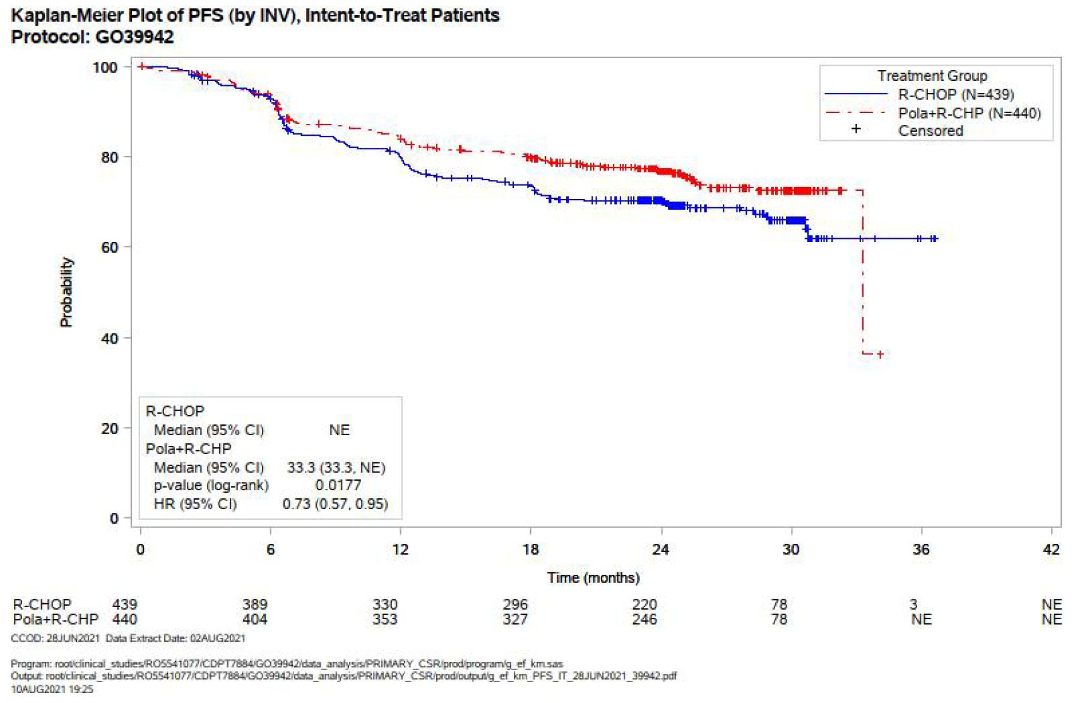 | 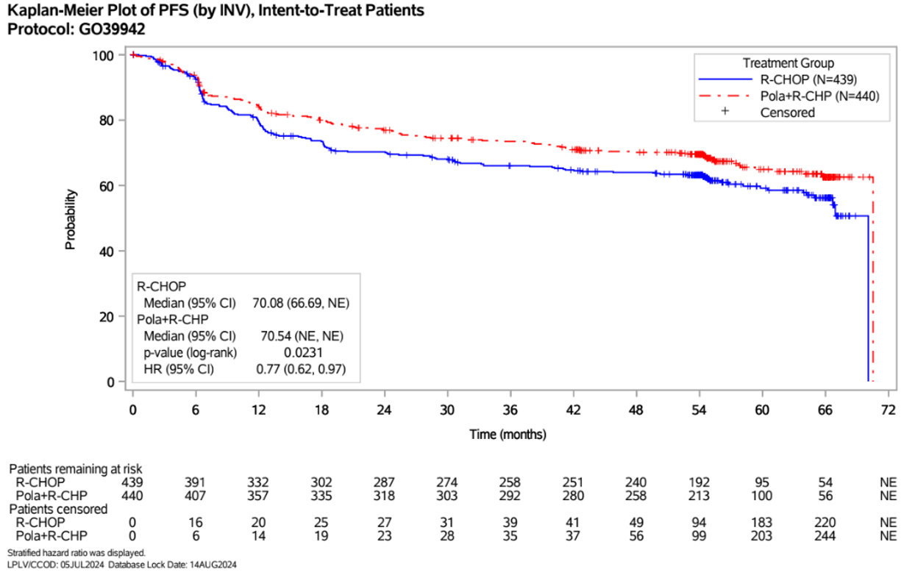
IPI 3-5 | 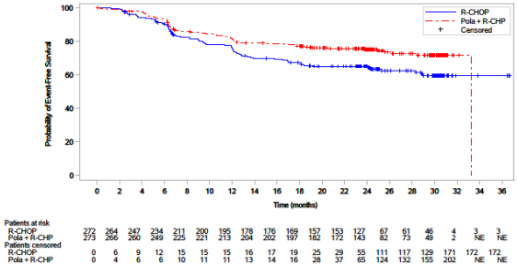 | 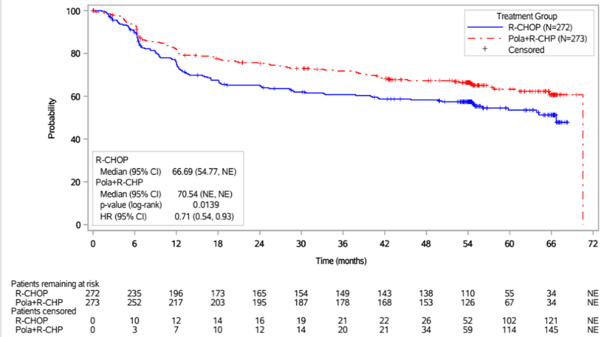
Overall survival
ITT | 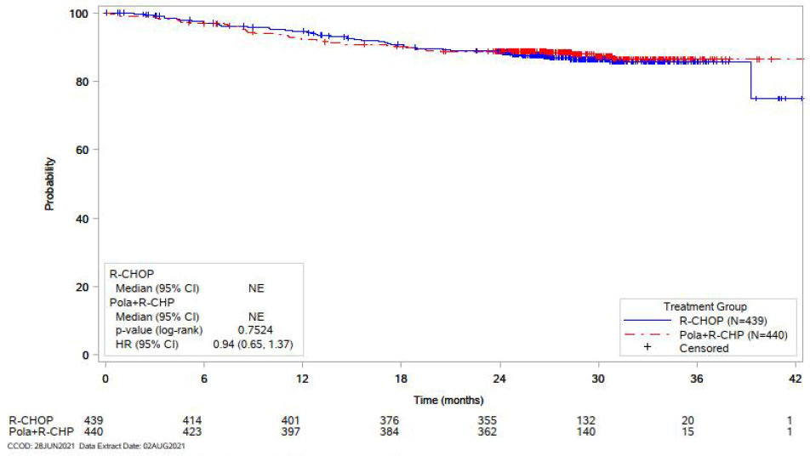 | 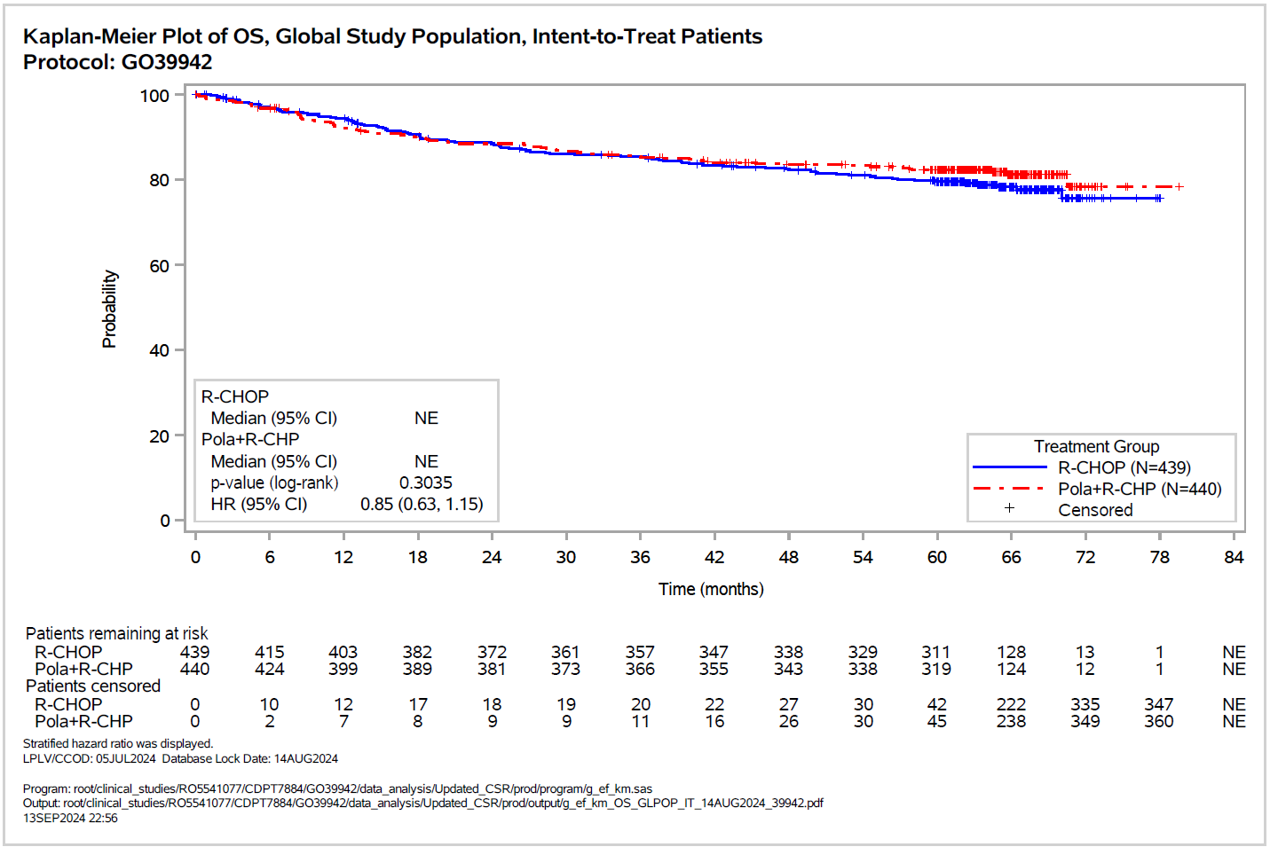
IPI 3-5 | 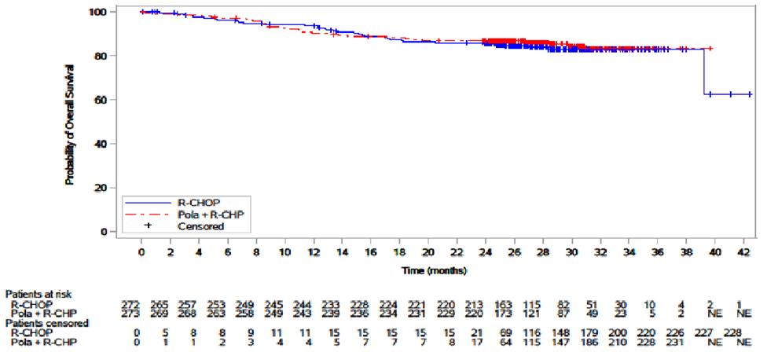 | 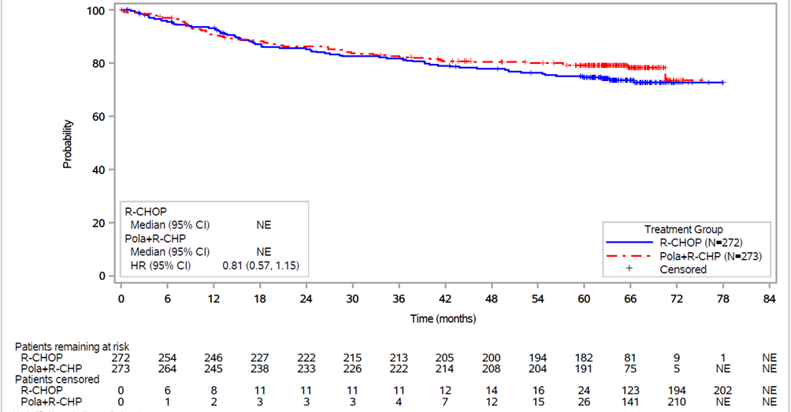
Blue shading indicates data previously seen by the PBAC. The red line corresponds to the Pola+R-CHP arm; the blue line corresponds to the R-CHOP arm.
Source: Figures 2.8, 2.9, 2.11, 2.12, 2.14, 2.18, 2.22, 2.23, pp 60, 61, 65, 82, 85, 90, 91 of the resubmission
CCOD=clinical cut-off date; ITT=intention-to-treat; progression free survival; IPI=international prognostic index; Pola+R-CHP=polatuzumab vedotin in combination with rituximab plus cyclophosphamide, doxorubicin and prednisone; R-CHOP=rituximab plus cyclophosphamide, doxorubicin, vincristine and prednisone;
  - The results at the 5 July 2024 data cut-off were similar to the results at the 28 July 2021 data cut-off, with the improvement in PFS maintained in both the ITT population (HR=0.77, 95%CI: 0.62, 0.97) and IPI subgroup (HR=0.71, 95%CI: 0.54, 0.93), as well as no difference in OS. Despite the lack of statistical significance, the resubmission argued that the updated Kaplan-Meier curves for both populations showed a positive trend in OS favouring Pola+R-CHP and suggested that the peak difference in OS was yet to be reached. The PSCR argued that it was to be expected that the peak difference in OS was not yet reached. The PSCR noted that a pooled analysis of 7,507 patients from 13 randomised controlled trials concluded that median OS in first-line DLBCL patients will likely take more than eight years to achieve (Shi 2018).
  - The resubmission also presented updated clinical evidence on the proportion of patients who received at least one new anti-lymphoma treatment (NALT) after completing the study treatment, summarised in Table 6.
Table 6: New Anti-Lymphoma Treatments (NALTs) during the follow-up period in POLARIX (ITT population)
 | CCOD: 28 Jun 21 |  | CCOD: 5 Jul 24
 | Pola + R-CHP  (N=440) | R-CHOP  (N=439) | Pola + R-CHP  (N=440) | R-CHOP  (N=439)
Patients with at least one NALT | 99 (22.5%) | 133 (30.3%) | 112 (25.5%) | 155 (35.3%)
Patients with at least one NALT before PFS event | 7 (1.6%) | 16 (3.6%) | 14 (3.2%) | 19 (4.3%)
Patients with at least one NALT after PFS event | 64 (14.5%) | 93 (21.2%) | 79 (18.0%) | 114 (26.0%)
Patients with at least one NALT without PFS event | 29 (6.6%) | 31 (7.1%) | 23 (5.2%) | 29 (6.6%)
Total number of NALTs | 179 | 290 | 209 | 336
Radiotherapy
Patients with at least one treatment | 41 (9.3%) | 57 (13.0%) | 42 (9.5%) | 62 (14.1%)
Patients with pre-planned treatment | 11 (2.5%) | 18 (4.1%) | 11 (2.5%) | 18 (4.1%)
Patients with unplanned treatment | 30 (6.8%) | 39 (8.9%) | 31 (7.0%) | 44 (10.0%)
Total number of treatments | 42 | 73 | 45 | 78
Systemic therapy
Patients with at least one treatment | 75 (17.0%) | 103 (23.5%) | 88 (20.0%) | 124 (28.2%)
Patients received stem cell transplants | 17 (3.9%) | 31 (7.1%) | 22 (5.0%) | 37 (8.4%)
Patients received CAR-T | 9 (2.0%) | 16 (3.6%) | 10 (2.3%) | 18 (4.1%)
Patients received other systemic treatment | 49 (11.1%) | 56 (12.8%) | 56 (12.7%) | 69 (15.7%)
Total number of treatments | 137 | 217 | 164 | 258
Blue shading indicates data previously seen by the PBAC.
Source: Table 2.25 and 2.27, p64 and p67 of the resubmission; Table 17, p 96 of the POLARIX CSR
CART = Chimeric antigen receptor T cells; ITT = intention-to-treat; NALT = new anti-lymphoma treatments; Pola = polatuzumab vedotin; R-CHOP = rituximab plus cyclophosphamide, doxorubicin, vincristine and prednisone; R-CHP = rituximab plus cyclophosphamide, doxorubicin and prednisone
  - Approximately 26% of patients in the Pola+R-CHP arm and 35% of patients in the R-CHOP arm had received at least one NALT after five years of follow-up, slightly more than at the earlier data cut-off presented in the November 2022 submission. The resubmission stated that the results demonstrated Pola+R-CHP was associated with an absolute reduction in the subsequent use of radiotherapy by 4.6%, stem cell transplant by 3.4%, CAR-T by 1.8% and other systemic treatments by 3.0%. The use of subsequent CAR-T may be higher in practice given it was recently funded for second line relapsed or refractory large B-cell lymphoma (axicabtagene ciloleucel, Medical Services Advisory Committee Public Summary Document, April 2024). Previously it was available only after relapsed SCT, or two prior systemic therapies (Axicabtagene ciloleucel for CD19-positive lymphoma, Medical Services Advisory Committee Public Summary Document, January 2020 and Tisagenlecleucel for DLBCL, Medical Services Advisory Committee Public Summary Document, August 2019).
  - The resubmission did not present updated results for other secondary endpoints measured in POLARIX. The results at the 28 June 2021 data cut-off, presented in the November 2022 submission, showed a statistically significant improvement in event-free survival, duration of response and disease-free survival (in patients with a best overall response of complete or partial response) for patients randomised to Pola+R-CHP compared to R-CHOP, but no difference in the objective response rate or best overall response.

Comparative harms
  - Table 7 presents adverse events (AEs) reported in POLARIX at the 28 June 2021 data cut-off and results at the 5 July 2024 data cut-off. There were minimal differences in safety outcomes across the data cuts given the limited reporting requirements after the main reporting period of the trial (i.e., 90 days after the last dose of any study drug or prior to NALT, whichever is earlier). The resubmission did not present updated results for the most frequently reported adverse events (any Grade). The PSCR presented an analysis of AE for the extended safety population (including the China cohort) which consisted of 993 patients (Safety-evaluable; Pola+R-CHP: n = 495, R-CHOP: n = 498) for the 5 July 2024 data cut. The PSCR argued that the data showed that safety profiles remained comparable between the Pola+R-CHP and R-CHOP arms with no new safety signals detected.
Table 7: Adverse events reported in POLARIX (safety population)
 | CCOD: 28 Jun 21 |  | CCOD: 5 Jul 24 resubmission |  | CCOD: 5 Jul 24 PSCR
 | Pola+R-CHP  N =435 | R-CHOP  N = 438 | Pola+R-CHP  N =435 | R-CHOP  N = 438 | Pola+R-CHP  N =495 | R-CHOP  N = 498
Any AE | 426 (97.9) | 431 (98.4) | 426 (97.9) | 431 (98.4) | NR (98.0) | NR (98.6)
Any Grade 3-5 AE | 264 (60.7) | 262 (59.8) | 264 (60.7) | 264 (60.3) | NR (62.6) | NR (60.8)
Any Grade 5 AE | 13 (3.0) | 10 (2.3) | 13 (3.0) | 10 (2.3) | NR (2.8) | NR (2.0)
Any SAE | 148 (34.0) | 134 (30.6) | 148 (34.0) | 134 (30.6) | NR (34.3) | NR (31.1)
Any AE resulting in death | 13 (3.0) | 11 (2.5) | 14 (3.2) | 12 (2.7) | NR (NR) | NR (NR)
AE leading to trial discontinuation | 13 (3.0) | 10 (2.3) | 13 (3.0) | 10 (2.3) | NR (NR) | NR (NR)
AE leading to dose interruption
Any drug | 103 (23.7) | 111 (25.3) | 121 (27.8) | 120 (27.4) | NR (28.1) | NR (28.5)
Polatuzumab vedotin/ vincristine | 61 (14.0) | 62 (14.2) | 78 (17.9) | 67 (15.3) | NR (NR) | NR (NR)
AE leading to dose reduction
Any drug | 40 (9.2) | 57 (13.0) | 40 (9.2) | 57 (13.0) | NR (9.1) | NR (12.7)
Polatuzumab vedotin/ vincristine | 24 (5.5) | 45 (10.3) | 24 (5.5) | 45 (10.3) | NR (NR) | NR (NR)
Most common Grade 3-5 AEs with an incidence rate of ≥2% in any arm (MedDRA Preferred Term)
Blood and lymphatic system disorders
Neutropenia | 123 (28.3) | 135 (30.8) | 123 (28.3) | 135 (30.8) | 216 (43.6) | 228 (45.8)
Febrile neutropenia | 60 (13.8) | 35 (8.0) | 60 (13.8) | 35 (8.0) | NR (NR) | NR (NR)
Anaemia | 52 (12.0) | 37 (8.4) | 52 (12.0) | 38 (8.7) | 56 (11.3) | 49 (9.8)
Leukopenia | 25 (5.7) | 30 (6.8) | 25 (5.7) | 31 (7.1) | NR (NR) | NR (NR)
Thrombocytopenia | 14 (3.2) | 19 (4.3) | 14 (3.2) | 18 (4.1) | 32 (6.5) | 31 (6.2)
Lymphopenia | 7 (1.6) | 10 (2.3) | 7 (1.6) | 2.3% | NR (NR) | NR (NR)
Investigations
Neutrophil count decreased | 30 (6.9) | 28 (6.4) | 30 (6.9) | 29 (6.6) | NR (NR) | NR (NR)
White blood cell count decreased | 18 (4.1) | 14 (3.2) | 18 (4.1) | 14 (3.2) | NR (NR) | NR (NR)
Lymphocyte count decreased | 13 (3.0) | 15 (3.4) | 13 (3.0) | 15 (3.4) | NR (NR) | NR (NR)
Platelet count decreased | 9 (2.1) | 3 (0.7) | 9 (2.1) | 3 (0.7) | NR (NR) | NR (NR)
Infections and infestations |  |  |  |  | 75 (15.2) | 66 (13.3)
Pneumonia | 18 (4.1) | 20 (4.6) | 18 (4.1) | 20 (4.6) | NR (NR) | NR (NR)
Gastrointestinal disorders
Diarrhoea | 17 (3.9) | 8 (1.8) | 16 (3.7%) | 8 (1.8) | NR (NR) | NR (NR)
Metabolism and nutrition disorders
Hyponatraemia | 6 (1.4) | 9 (2.1) | 6 (1.4) | 9 (2.1) | NR (NR) | NR (NR)
General disorders, administration site conditions
Fatigue | 4 (0.9) | 11 (2.5) | 4 (0.9) | 11 (2.5) | NR (NR) | NR (NR)
Nervous system disorders
Syncope | 8 (1.8) | 9 (2.1) | 8 (1.8) | 9 (2.1) | NR (NR) | NR (NR)
Vascular disorders
Hypertension | 6 (1.4) | 10 (2.3) | 6 (1.4) | 10 (2.3) | NR (NR) | NR (NR)
Blue shading indicates data previously seen by the PBAC.
Source: Tables 2.28 and 2.31, p69 and 74 of the resubmission; p621-630 of the CSR; Figure 2 and Table 1 of the PSCR; Salles 2024 abstract
AE = adverse events, Pola = polatuzumab vedotin; R-CHOP = rituximab plus cyclophosphamide, doxorubicin, vincristine and prednisone; R-CHP = rituximab plus cyclophosphamide, doxorubicin and prednisone; SAE = serious adverse events;
  - In November 2022, the PBAC noted that Pola+R-CHP was associated with a higher rate of febrile neutropenia compared to R-CHOP, but a similar incidence of any AEs, Grade 3-5 AEs, serious AEs, AEs leading to treatment discontinuation and AEs leading to dose interruption (paragraph 7.6, polatuzumab vedotin Public Summary Document, November 2022 PBAC meeting).
  - Since November 2022, the Advisory Committee on Medicines (ACM) discussed the safety profile of polatuzumab and noted the increase in (any Grade of) diarrhoea, febrile neutropenia and anaemia. The ACM advised that, while there appears to be a marginally higher toxicity profile compared to the standard of care, polatuzumab in combination would be prescribed by specialists familiar with managing toxicity; therefore, it concluded that polatuzumab has an overall positive benefit-risk profile. In addition, the sixth Periodic Benefit Risk Evaluation Report (to 9 June 2023) did not identify any new safety concerns, with the conclusion that the safety profile observed in the post-marketing setting is consistent with the safety profile seen in clinical trials.

Benefits/harms
  - A benefits and harms table is not presented because the resubmission only presented summary results from the five-year follow-up data, and the findings are largely unchanged from the November 2022 submission. Based on updated Kaplan-Meier data used in the economic evaluation, for every 100 patients with an IPI score 3-5 treated with Pola+R-CHP, approximately 10 additional patients will remain in progression-free survival at 60 months follow-up. The safety data remained unchanged from the November 2022 submission, which indicated 5 fewer patients will experience an adverse event requiring a dose reduction of the microtubule inhibitor (i.e. polatuzumab vedotin / vincristine) but 7 additional patients will experience infection and 6 additional patients will experience febrile neutropenia (paragraph 6.17, polatuzumab vedotin Public Summary Document, November 2022).

Clinical claim
  - The resubmission described Pola+R-CHP as superior in terms of effectiveness and non-inferior in terms of safety compared to R-CHOP in previously untreated DLBCL patients with an IPI score of 3-5, which was unchanged from the November 2022 submission.
  - In November 2022, the PBAC considered that POLA+R-CHP resulted in no more than a modest benefit compared to R-CHOP in patients with an IPI score of 3-5 in terms of PFS and considered the claim of superior comparative effectiveness for these patients was potentially reasonable for this outcome only. The PBAC considered that although Pola+R-CHP increased the duration of response, based on the evidence provided in POLARIX, Pola+R-CHP resulted in no benefit in terms of OS or the proportion of patients who achieved a complete and/or partial response. The PBAC considered that the claim that Pola+R-CHP was non-inferior compared to R-CHOP in terms of safety may not be reasonable given the increased incidence of febrile neutropenia with Pola+R-CHP, although noted that the AEs appeared manageable in the context of a clinical trial (paragraphs 7.5 and 7.6, polatuzumab vedotin Public Summary Document, November 2022 PBAC meeting).
  - The ESC agreed with the evaluation that overall, the clinical claim of superior effectiveness was adequately supported by the evidence presented in the resubmission for PFS. The latest data cut from the POLARIX trial indicated that the improvement in PFS was maintained over the five-year follow-up and this may translate into a small OS benefit over time. Despite not reaching statistical significance, the Kaplan-Meier curves show a small separation in OS favouring Pola+R-CHP after approximately 48 months. The ESC also noted that treatment with Pola+R-CHP was associated with a reduction in the proportion of patients who received at least one NALT compared to R-CHOP.
  - The evaluation considered the clinical claim of non-inferior safety remained poorly justified. The evaluation considered that although no new safety concerns were identified and the risks were considered manageable, there were noteworthy differences in toxicity favouring R-CHOP in terms of diarrhoea, anaemia and febrile neutropenia. The ESC noted that no new safety concerns were identified with the extended AE data. The ESC acknowledged the differences in toxicity highlighted by the evaluation but agreed with the ACM that polatuzumab would be prescribed specialists familiar with managing toxicity. Overall, the ESC considered that claim of non-inferior safety was uncertain but likely reasonable.
  - The PBAC considered that the claim of superior comparative effectiveness was reasonable for PFS.
  - The PBAC agreed with the ESC that the claim of non-inferior comparative safety was uncertain but likely reasonable.

Economic analysis
  - The resubmission presented an updated economic evaluation compared to those previously considered at the November 2022 PBAC meeting. In summary, the changes included:
- Employed a standard parametric survival model rather than a mixture-cure model, refitting survival curves to the new data.
- Updated inputs from POLARIX for the 5 July 2024 data cut-off (versus the 28 June 2021 data cut-off in the November 2022 submission), including PFS and OS Kaplan-Meier data, utilities, subsequent treatments and adverse events.
- Updated cost inputs to 2024 costs, including unit costs, mark-ups and public/private split.
  - All other model assumptions and inputs were the same as presented in the pre-PBAC response, including the time horizon, the proportion of subsequent therapies set as equal across arms, time on treatment, and an effective EMP of polatuzumab vedotin equal to $| | for 140mg vial, $| | for 30mg vial.
  - For clarity, the stepped changes from the original November 2022 submission to the March 2025 resubmission and the effect of these changes on the base case ICER are summarised in Table 8. Compared to the November 2022 pre-PBAC response, the changes to the economic evaluation presented in the resubmission increased the ICER by | |%.
Table 8: Model changes (versus November 2022) and the stepped effect of each amendment on the ICER
Model change | Incremental cost ($) | Incremental QALY | ICER ($/QALY) | % ∆ versus November 2022 base case
November 2022 base case | | | 0.70 | |||¹ | -
Step 1: correct cost vincristine | | | 0.70 | ||¹ | |%
Step 2: Step 1 + limit PFS curve to not exceed OS, rather than not exceed per cycle survival | | | 0.69 | ||¹ | |%
Step 3 PSCR revised base case: Step 2 + remove half cycle correction 1L treatment costs | | | 0.69 | ||¹ | |%
Step 4: Step 2 + remove half cycle correction for all costs and benefits | | | 0.69 | ||¹ | |%
Step 5: Step 4 + subsequent therapy split equal across arms | | | 0.69 | ||¹ | |%
Step 6: Step 5 + time horizon 20 years | | | 0.61 | ||² | |%
Step 7 Pre-PBAC response revised base caseª: Step 6 + polatuzumab vedotin effective price reduction^{b} | | | 0.61 | ||³ | - | %
Step 8: Step 7 + updated POLARIX data (PFS and OS KM, utilities, AE incidence, subsequent treatment incidence) and new parametric extrapolations | | | 0.54 | ||⁴ | - | %
Step 9 March 2025 base case: Step 8 + updated cost inputs (e.g., unit costs, mark-ups and public/private split) | | | 0.54 | |||⁴ | - | %
Blue shading indicates data previously seen by the PBAC
Source: compiled during the evaluation based on information in Table 3.1 of the resubmission; Table 11 and paragraph 6.44, polatuzumab vedotin PBAC minutes November 2022 and conducting independent analysis during the evaluation.
ICER=incremental cost-effectiveness ratio, QALY=quality-adjusted life-year, PFS=progression free survival, OS=overall survival, 1L=first- line
ª Paragraph 6.44, polatuzumab vedotin PBAC minutes November 2022 stated that the effective price reduction of | |% resulted in an ICER of 3 $35,000 to < $45,000 per QALY gained, but the reduction applied was | |%, the same as presented in the current resubmission.
^{b} Effective EMP $| | for the 140 mg vial, $| | for the 30 mg vial. Previously $| | for the 140 mg vial and $| | for the 30mg vial in the November 2022 submission.
The redacted values correspond to the following ranges:
¹ $55,000 to < $75,000
² $75,000 to < $95,000
³ $35,000 to < $45,000
⁴ $45,000 to < $55,000
  - A summary of the key components of economic evaluation is presented in Table 9.
Table 9: Summary of model structure, key inputs and rationale
Component | Summary
Treatments | Pola+R-CHP vs R-CHOP.
Population | DLBCL patients with IPI score 3-5. The November 2022 submission included a separate analysis for the ITT population of POLARIX (IPI score 2-5).
Type of analysis | Cost-utility analysis. Unchanged, appropriate
Time horizon | 20 years in the model base case vs 5- year follow up in POLARIX . Unchanged from pre-PBAC response. A large proportion of benefit still occurs in the extrapolated period
Outcomes | LYs, QALYs. Unchanged, appropriate
Methods used to generate results | Standard parametric survival model. Reasonable. The November 2022 submission utilised a mixture-cure model where patients in progression-free at 2 years were considered “cured”.
Health states | PFS, Progressed Disease (PD), Dead. Unchanged. Patients receiving subsequent curative treatment assumed to remain in PD, which may not be appropriate.
Cycle length | 1 week, no half cycle correction. Unchanged from pre-PBAC response. The short cycle length may be too granular compared to the uncertain future events.
Allocation to health states | POLARIX IPI 3-5 PFS and OS KM data
Extrapolation method | PFS and OS IPI 3-5 subgroup KM data from POLARIX to 65 months and 68 months respectively followed by independent extrapolations (Gompertz for PFS, log-normal for OS) for all patients. PFS could not exceed OS, OS was restricted to not exceed general population survival. Time on treatment modelled separately with KM data from POLARIX.  91% of LYs gained (88% QALYs gained) occurred in the extrapolated period along with cost savings (i.e., 151% of incremental costs occurred in the trial period, and therefore -51% of the incremental costs accrued in the extrapolated period).
Health related quality of life | PFS 0-2 years 0.801 (POLARIX ITT data 5 July 2024 data cut-off); PFS >2 years: age dependent population utility, 0.80 (age 75-90) to 0.85 (age 55); PD 0.736 (POLARIX ITT data 5 July 2024 data cut-off). The approach to estimating utilities was unchanged from the November 2022 submission.  PFS 0-2 years and PD utilities were based on ITT data. Patients with IPI 3-5 may have worse utility than those with IPI 2 as IPI score increases with worse health/prognosis factors. It was unclear if the PFS 0-2 years were based only on utilities collected up to 2 years from drug commencement.  The model also did not include a disutility for adverse events.
Costs | The models included costs for Pola+R-CHP, R-CHOP, management of AEs, medical service use, subsequent treatment post progression and end of life costs. Costs were generally reasonable, except: it was unclear whether the trial data would reflect current use of treatments in Australia, the cost of CAR-T did not have a verifiable source, and subsequent therapy costs were applied in the first cycle patients entered PD, therefore not subject to discounting over time. Also, while costs of subsequent therapies were included, benefits were not.  Effective EMP of polatuzumab vedotin equal to $|||| for 140mg vial, $|||| for 30mg vial, unchanged from the November 2022 pre-PBAC response.
Blue shading indicates data previously seen by the PBAC
Source: complied during the evaluation
AE = adverse event, CAR-T = chimeric antigen receptor T cell therapy, EMP = ex-manufacturer price, IPI = international prognostic index, ITT = intention to treat, KM = Kaplan-Meier, OS = overall survival, PD = progressed disease, PFS = progression free survival, Pola+R-CHP = polatuzumab vedotin in combination with cyclophosphamide, doxorubicin and prednisone, R-CHOP = rituximab in combination with cyclophosphamide, doxorubicin, vincristine and prednisone
  - A summary of the extrapolations used in the economic evaluation (base case) is presented in Table 10.
Table 10:Summary of extrapolations used in the economic model by treatment arm and survival curve
Model | Arm (source) | PFS | OS | TTD
Nov 2022 IPI 3-5 | Pola+R-CHP  (POLARIX IPI 3-5) | PFS KM data to median follow up (28.2 mths) then independent lognormal extrapolations to 2 yrs then general population thereafter, restricted to not exceed mortality from OS extrapolation each cycle. | OS KM data to median follow up (28.2 mths) then independent lognormal extrapolations for patients with PFS <2 yrs, general population otherwise. Restricted to not exceed general population survival | TTD KM data
R-CHOP
(POLARIX IPI 3-5)
Mar 2025 IPI 3-5 | Pola+R-CHP  (POLARIX IPI 3-5) | PFS KM data to 65 mths then independent Gompertz extrapolations thereafter, restricted to not exceed OS each cycle. | OS KM data to 68 mths then independent lognormal extrapolations thereafter, restricted to not exceed general population survival | TTD KM data
R-CHOP
(POLARIX IPI 3-5)
Blue shading indicates data previously seen by the PBAC
Source: Section 3.4 of the resubmission and compiled during the evaluation from Excel files ‘Economic Evaluation_IPI 3-5 2024.xlsx’ and ‘Economic Evaluation_IPI 3-5.xlsx’
ITT = intention to treat, IPI = International Prognostic Index, KM = Kaplan-Meier, mths= months, OS = overall survival, PFS = progression free survival, Pola+R-CHP = polatuzumab vedotin in combination with cyclophosphamide, doxorubicin and prednisone, R-CHOP = rituximab in combination with cyclophosphamide, doxorubicin, vincristine and prednisone, TTD = time to treatment discontinuation, yrs=years
  - The November 2022 submission presented a mixture-cure model, where PFS and OS were estimated as the weighted average of ‘cured’ patients (patients who were progression free at 2 years and assumed to have general population mortality from 2 years) and ‘not cured’ patients whose PFS and OS were estimated using standard parametric survival functions. At that time, the PBAC considered this approach optimistic, predicting a large survival benefit for Pola+R-CHP (no OS benefit was observed in POLARIX at 28.2 months), the extrapolated functions did not fit the trial data, and the incremental difference in modelled cure rates at 2 years exceeded the POLARIX data (paragraph 7.9, polatuzumab vedotin, Public Summary Document, November 2022 PBAC meeting). The resubmission, therefore, presented a new approach for extrapolating PFS and OS, by removing the explicit cure assumption and utilising standard parametric modelling fit to the five-year trial follow-up data. The resubmission presented results of the estimated extrapolations using exponential, Weibull, Gompertz, Gamma, log-logistic and log-normal functions to extrapolate PFS and OS.
  - Figure 2 presents standard extrapolation functions estimated in the resubmission compared to the weighted mixture-cure extrapolations assumed in the November 2022 submission, as well as a comparison of the modelled PFS and OS. As the mixture-cure approach weighted the ‘cured’ and ‘not cured’ patients, the extrapolations utilised in the November 2022 submission were highly influenced by the general population, which was applied at a later step in the resubmission.
Figure 2: Extrapolations for POLARIX IPI 3-5 KM data
PFS
November 2022 submission  Mixture-cure extrapolations with per cycle mortality cap | March 2025 (current) resubmission  Standard parametric survival extrapolation
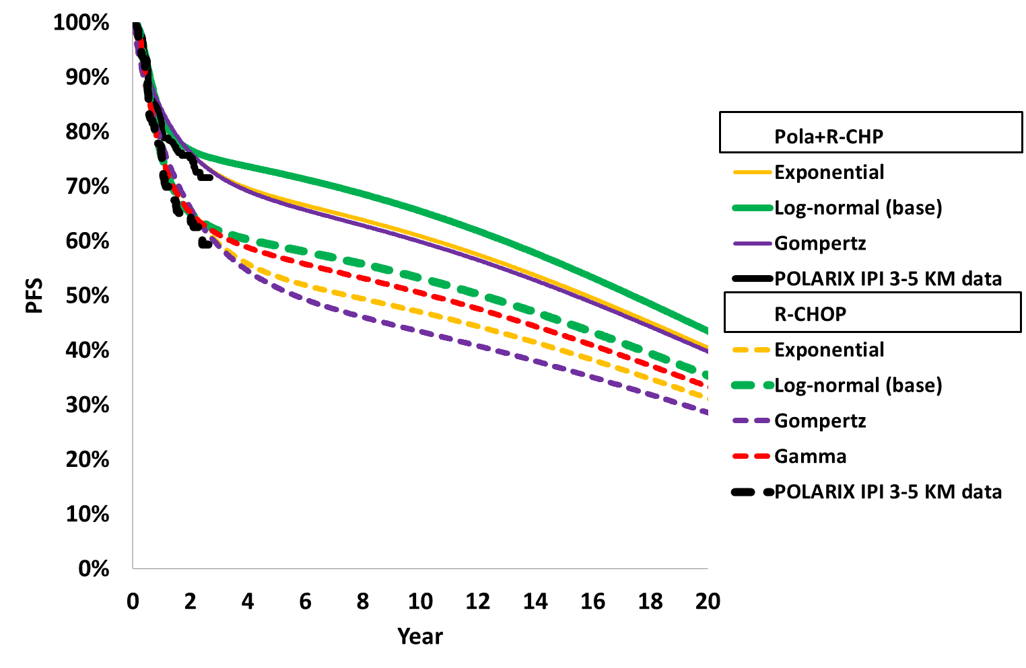 | 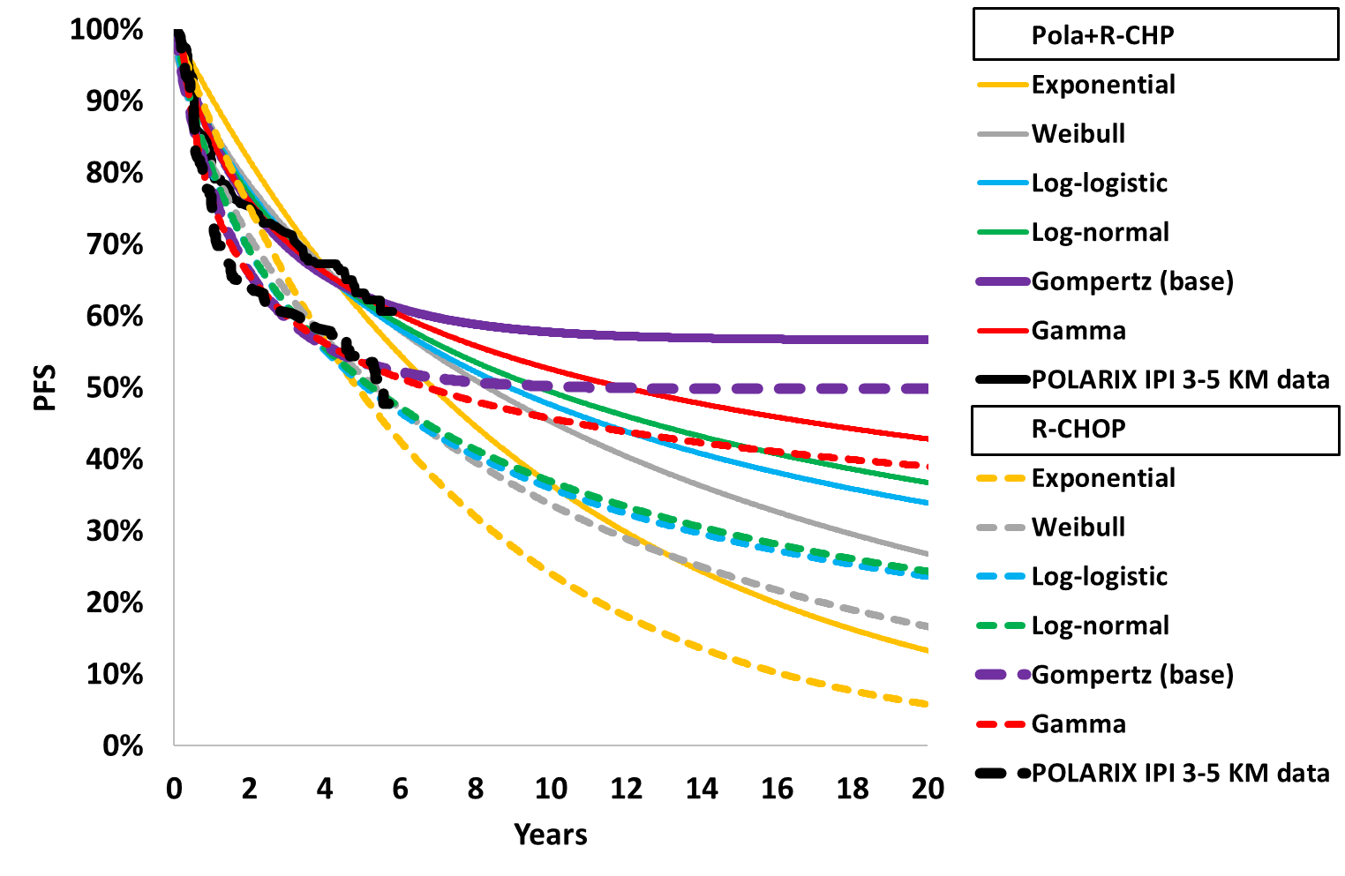
OS
November 2022 submission  Mixture-cure extrapolations | March 2025 (current) resubmission  Standard parametric survival extrapolation
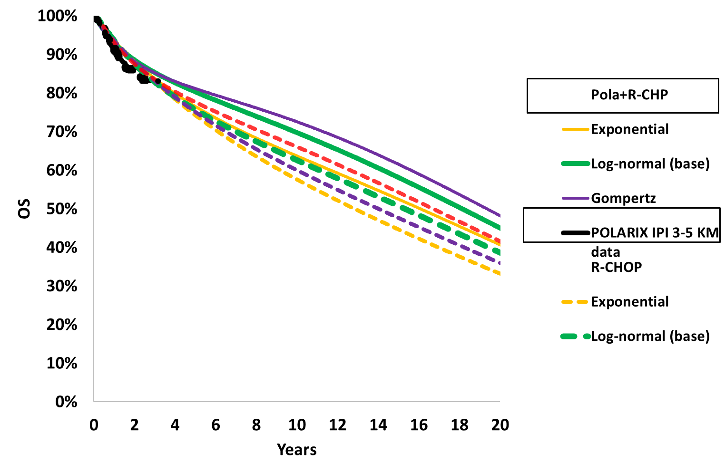 | 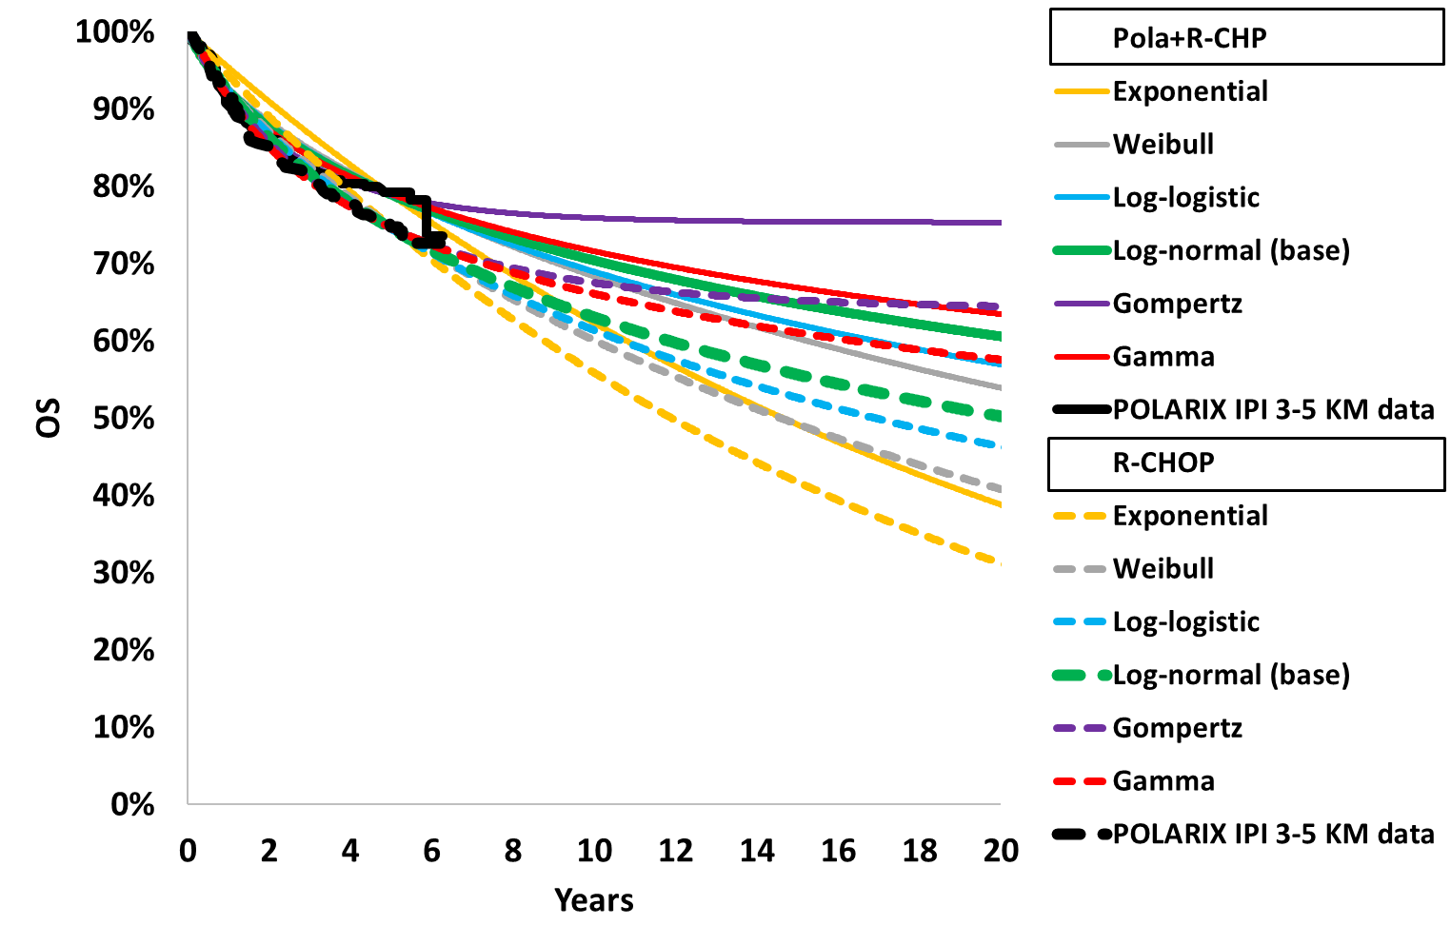
Modelled PFS and OS, resubmission versus November 2022 submission
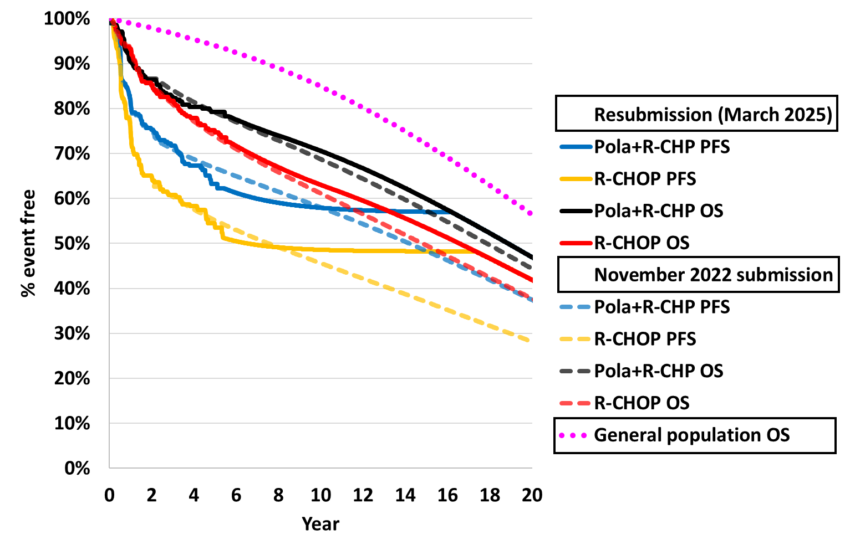
Blue shading indicates data previously seen by the PBAC
Source: compiled during the evaluation from Excel files ‘Economic Evaluation_IPI 3-5 2024.xlsx’ and ‘Economic Evaluation_IPI 3-5.xlsx’’
ITT = intention to treat; IPI = International Prognostic Index, KM = Kaplan-Meier, OS = overall survival, PFS = progression free survival; Pola+R-CHP = polatuzumab vedotin in combination with rituximab, cyclophosphamide, doxorubicin and prednisone; R-CHOP = rituximab in combination with cyclophosphamide, doxorubicin, vincristine and prednisone
  - PFS extrapolations were fitted to data up to 65 months and OS extrapolations were fitted to data up to 68 months. Based on visual and statistical fit, and clinical plausibility, the resubmission chose the Gompertz extrapolations for PFS and log-normal for OS in both arms of the model. The long tails of the Gompertz PFS extrapolations acted similarly to a cure assumption at the PFS Kaplan-Meier data cut-off of 65 months, with very few patients transitioning out of PFS beyond this time point. The chosen log-normal extrapolation slightly overestimated OS for most of the OS Kaplan-Meier data in both arms. Compared to the November 2022 submission, the resubmission estimated a slight increase in OS in both arms (Figure 2). Per cycle mortality in both arms was modelled equal to age-based general population mortality for much of the time horizon, particularly advantaging the Pola+R-CHP arm. The ESC considered that the PFS extrapolations chosen were appropriate, noting that the resulting curves plateaued across time and effectively modelled some patients as cured. However, in terms of OS the ESC considered that, given the risk of relapse at 5 years was low, mortality should be equal across both arms from 68 months in the model. The ESC noted that doing so increased the ICER from $45,000 to < $55,000 to $55,000 to < $75,000 per QALY gained (see Table 13).
  - The resubmission estimated updated utility weights based on the POLARIX EQ-5D-5L ITT data at the 5 July 2024 data cut-off and valued using published Australian weights, using the same approach as the November 2022 submission. The pooled utility estimate for PFS 0-2 years increased from 0.795 to 0.801, whereas the progressed disease (PD) estimate decreased from 0.749 to 0.736. Patients who remained in PFS beyond 2 years would return to age and gender-related general population utility as per the November 2022 submission. It was unclear if the POLARIX PFS utilities had been collected beyond 2 years, which may overestimate utility in the first 2 years, however the ICER was not very sensitive to changes in the utility.
  - The approach to costs was unchanged from the November 2022 pre-PBAC response, with updated unit costs. The per cycle cost of polatuzumab vedotin was based on the EMP of $| | per 140mg vial (30mg vial price $| |) (unchanged from the pre-PBAC response), resulting in an average cost per cycle of equal to $| |, which was applied for a maximum 6x3-week cycles (mean 5.7 cycles in the model compared to 5.8 in POLARIX). The ICER was not sensitive to the slight difference in mean length of treatment in the model compared to POLARIX. The difference was due to the model estimating costs for patients alive at the end of Cycle 1 rather than at the beginning.
  - Costs for subsequent therapies were updated based on the occurrence of subsequent treatment in POLARIX at the 5 July 2024 data cut-off (ITT population). Proportions of treatments were equal across treatment arms, consistent with the pre-PBAC response. However, there was a difference in the number of subsequent therapies observed between arms in POLARIX (Pola+R-CHP 1.87, R-CHOP 2.17), which contributed to the increased subsequent treatment costs in the R-CHOP arm of the model versus Pola+R-CHP. The model was not constructed to explore uncertainties in downstream benefits associated with subsequent treatments. The PSCR stated that late relapse (after five years) is uncommon in DLBCL. The PSCR therefore argued that the additional POLARIX five-year follow-up data provided greater certainty that these costs and benefits associated with subsequent treatments are being captured. The PSCR also argued that the reduction in NALTs reported in POLARIX is likely to be replicated in clinical practice.
  - The evaluation considered there were also uncertainties with regards to the cost and use of treatments such as CAR-T in Australia compared to POLARIX. The ESC noted the economic model was sensitive to the cost of CAR-T (see Table 13).
  - Cohort traces are presented in Figure 3. For the majority of the time horizon, patients were either in the PFS or dead states, with a low percentage of patients who entered the PD health state, consistent with the choice of PFS extrapolation and the implicit assumption that patients who achieve long-term PFS are unlikely to experience disease progression. Time in PFS was increased in the resubmission compared to the November 2022 submission, by Year 20, 42-47% of patients remained alive and progression-free, compared with 28-38% in the November 2022 submission (the November 2022 submission adopted a 25 year time horizon and 20-30% patients were alive at Year 25). All patients with progressed disease in the resubmission were expected to die by Years 16-17, but 4-7% of progressed patients in the November 2022 submission remained alive by Year 25.
Figure 3: Cohort traces for base case economic model
November 2022 submission | March 2025 resubmission
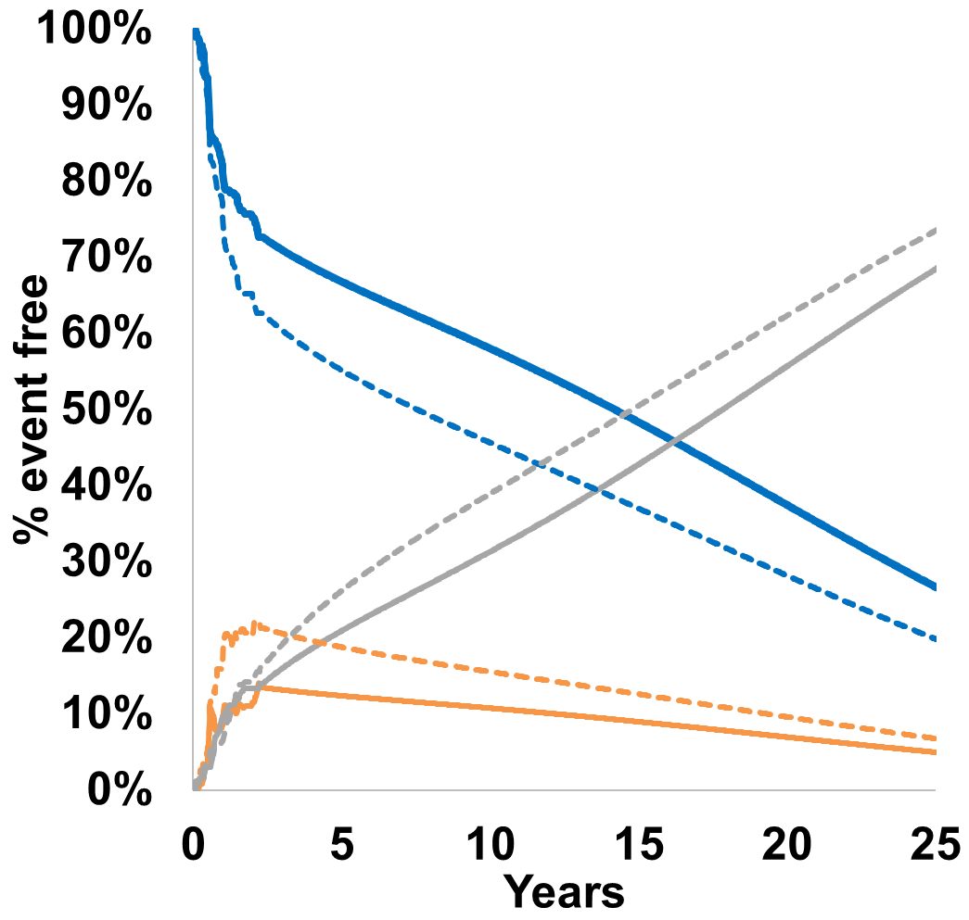 | 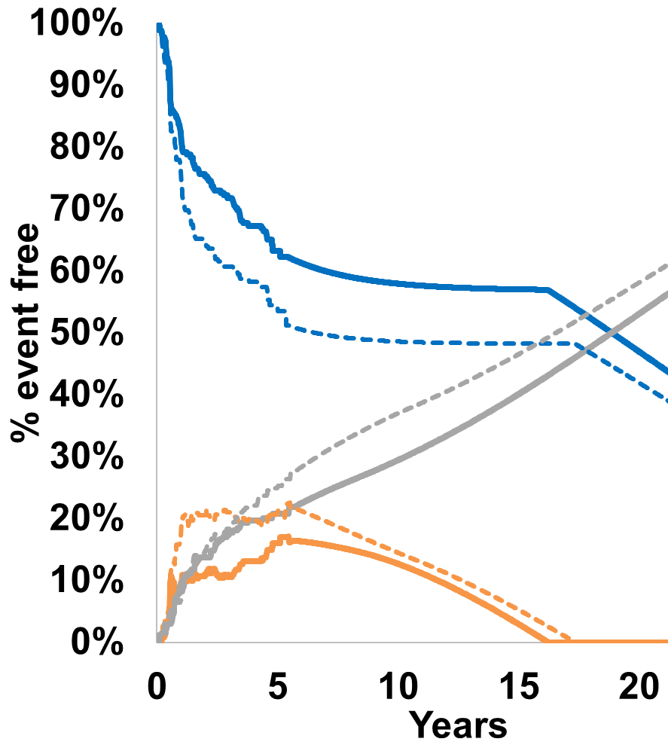
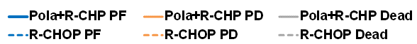
Blue shading indicates data previously seen by the PBAC
Source: compiled during the evaluation from Excel files ‘Economic Evaluation_IPI 3-5 2024.xlsx’ and ‘Economic Evaluation_IPI 3-5.xlsx’
IPI = International Prognostic Index, ITT = intention to treat, PD = progressed disease, PF = progression free, Pola+R-CHP = polatuzumab vedotin in combination with cyclophosphamide, doxorubicin and prednisone, R-CHOP = rituximab in combination with cyclophosphamide, doxorubicin, vincristine and prednisone
  - The resubmission did not present any formal external validation of the model outputs, but briefly noted that modelled survival in the R-CHOP arm exceeded those reported in Wright 2018, which was identified as a long-term study of Australian patients with DLBCL. External validation conclusions remained unchanged from the previous evaluation: there is limited PFS and OS data to validate a time horizon beyond 5 years; patient and clinical characteristics are likely to have a significant effect on survival rates. 5-year OS for the R-CHOP arm of POLARIX was 75%, compared to 5-year OS of 68.3% for all NHL in Australia, and 64% for Queensland DLBCL patients diagnosed between 2008 and 2012 (Wright 2018). The tolerance and effectiveness of polatuzumab vedotin in a population with poorer prognosis than POLARIX remains uncertain, and may also affect their accessibility to costly subsequent treatments such as CAR-T.
  - A summary of the key drivers of the model is presented in Table 11.
Table 11: Key drivers of the model
Description | Method/Value | Impact  Base case: |¹/QALY gained.
Extrapolation | Treatment effect continued beyond 5-year trial period for up to 20 years.  In comparison, no explicit treatment effect for downstream treatments was modeled and may not yet be observable in the POLARIX data. | High, favoured Pola+R-CHP.  If the OS curves converged between the KM data cut-off and Year 10 (with both arms having equal survival from Year 10), the ICER increased to ||||² per QALY gained.
Time horizon | 20 years. Unchanged from the pre-PBAC response. The ESC considered a 15 year time horizon more reasonable. | Moderate-High, favoured Pola+R-CHP.  If the time horizon was shortened to 15 years (in line with other published models), the ICERs increased to ||||³ per QALY gained
Cost of CAR-T | $500,000 value could not be verified. | Moderate-High, uncertain impact.  As the true cost of CAR-T may vary, a sensitivity analysis exploring the range $|||| to $|||| was equivalent +/-||||% change in the ICER ||||⁴ to ||||¹ per QALY gained).
Number of subsequent therapies | Base case Pola+R-CHP 1.87, R-CHOP 2.17. POLARIX may not capture all downstream treatments | Moderate-High, favoured Pola+R-CHP.  If the Pola+R-CHP arm was equal to the R-CHOP arm (the most conservative estimate), the ICER increased to ||||³ per QALY gained.
Source: compiled during the evaluation
IPI = International Prognostic Index, ITT = intention to treat, PD = progressed disease, PF = progression free, Pola+R-CHP = polatuzumab vedotin in combination with cyclophosphamide, doxorubicin and prednisone, R-CHOP = rituximab in combination with cyclophosphamide, doxorubicin, vincristine and prednisone, CAR-T = chimeric antigen receptor T cell therapy, KM = Kaplan-Meier
The redacted values correspond to the following ranges:
¹ $45,000 to < $55,000
² $115,000 to < $135,000
³ $55,000 to < $75,000
⁴ $35,000 to < $45,000
  - A summary of the stepped economic analyses is presented in Table 12. The majority of the incremental costs were accrued in the first 65 months of the model, and the majority of benefits were accrued in the extrapolated time horizon. The base case ICER for the IPI 3-5 population was $45,000 to < $55,000 per QALY gained versus $55,000 to < $75,000 in the November 2022 submission, $55,000 to < $75,000 in the November 2022 submission PSCR revised base case and $35,000 to < $45,000 in the November 2022 submission pre-PBAC response revised base case. Incremental costs were similar to the pre-PBAC response, where the current EMP was first introduced, with fewer incremental life year and QALY gains in the current resubmission.
Table 12: Results of the stepped economic evaluation
Step and component | November 2022 submission (IPI 3-5) |  |  | March 2025 (current) resubmission
 | Pola+R-CHP | R-CHOP | Increment | Pola+R-CHP | R-CHOP | Increment
Step 1: Time horizon, trial based (Nov 2022 submission 28.2 mths, resubmission 65 mths), treatment costs only
Costs | $|||| | $7,542 | $|||| | $|||| | $6,465 | $||||
Lys | 2.08 | 2.08 | 0.00 | 4.18 | 4.10 | 0.08
QALYs | 1.65 | 1.64 | 0.01 | 3.35 | 3.26 | 0.09
Incremental cost/extra LY gained |  |  | ||||¹ |  |  | ||||
Incremental cost/extra QALY gained |  |  | ||||¹ |  |  | ||||³
Step 2: Time horizon Nov 2022 submission 25 yrs, resubmission 20 yrs, treatment costs only
Costs | $|||| | $7,542 | $|||| | $|||| | $6,465 | ||||
Lys | 10.14 | 9.33 | 0.81 | 9.62 | 9.00 | 0.62
QALYs | 8.11 | 7.41 | 0.70 | 7.70 | 7.15 | 0.54
Incremental cost/extra LY gained |  |  | ||||⁴ |  |  | ||||⁵
Incremental cost/extra QALY gained |  |  | ||||⁴ |  |  | ||||⁵
Step 3: Time horizon Nov 2022 submission 25 yrs, resubmission 20 yrs, treatment and MRU costs
Costs | $|||| | $10,118 | $|||| | $|||| | $9,244 | ||||
Lys | 10.14 | 9.33 | 0.81 | 9.62 | 9.00 | 0.62
QALYs | 8.11 | 7.41 | 0.70 | 7.70 | 7.15 | 0.54
Incremental cost/extra LY gained |  |  | ||||⁵ |  |  | ||||⁵
Incremental cost/extra QALY gained |  |  | ||||⁴ |  |  | ||||⁵
Step 4: Time horizon Nov 2022 submission 25 yrs, resubmission 20 yrs, treatment, MRU, AE costs
Costs | $|||| | $12,170 | $|||| | $|||| | $11,277 | $||||
Lys | 10.14 | 9.33 | 0.81 | 9.62 | 9.00 | 0.62
QALYs | 8.11 | 7.41 | 0.70 | 7.70 | 7.15 | 0.54
Incremental cost/extra LY gained |  |  | ||||⁵ |  |  | ||||⁵
Incremental cost/extra QALY gained |  |  | ||||⁴ |  |  | ||||⁵
Step 5: Time horizon Nov 2022 submission 25 yrs, resubmission 20 yrs, MRU, AE, subsequent therapy costs
Costs | $|||| | $47,115 | $|||| | $|||| | $51,769 | $||||
Lys | 10.14 | 9.33 | 0.81 | 9.62 | 9.00 | 0.62
QALYs | 8.11 | 7.41 | 0.70 | 7.70 | 7.15 | 0.54
Incremental cost/extra LY gained |  |  | ||||⁶ |  |  | ||||⁷
Incremental cost/extra QALY gained |  |  | ||||⁵ |  |  | ||||⁶
Step 6: Time horizon Nov 2022 submission 25 yrs, resubmission 20 yrs, all costs
Costs | $|||| | $48,156 | $|||| | $|||| | $52,783 | $||||
Lys | 10.14 | 9.33 | 0.81 | 9.62 | 9.00 | 0.62
QALYs | 8.11 | 7.41 | 0.70 | 7.70 | 7.15 | 0.54
Incremental cost/extra LY gained |  | Submission | ||||⁶ |  |  | ||||⁷
Incremental cost/extra QALY gained |  | Submission | ||||⁵ |  |  | ||||⁶
 |  | PSCR  Pre-PBAC | ||||⁵||||⁷
Blue shading indicates data previously seen by the PBAC
Source: Tables 3.23- 3.29 pp 137-14 of the resubmission; Table 11 and paragraph 6.44, polatuzumab vedotin PBAC minutes November 2022, and compiled during the evaluation from Sheet ‘Results’ of Excel files ‘Economic Evaluation_IPI 3-5 2024.xlsx’ and ‘Economic Evaluation_IPI 3-5.xlsx’
AE= adverse event, IPI = International Prognostic Index, ITT = intention to treat, LY = life year, MRU = medical resource use, Pola+R-CHP = polatuzumab vedotin in combination with cyclophosphamide, doxorubicin and prednisone, QALY = quality adjusted life year R-CHOP = rituximab in combination with cyclophosphamide, doxorubicin, vincristine and prednisone
Costs for Pola+R-CHP arm in Step 1 and 2 were misreported as $| | in the November 2022 submission.
The LYs, QALYs and ICER in Step 1 of the resubmission and November 2022 submission were based on rounding the time horizon down to the nearest week for the benefits (Steps 2-6 rounded up), but this had little impact upon the ICER.
The redacted values correspond to the following ranges:
¹ $1,055,000
² $455,000 to < $555,000
³ $355,000 to < $455,000
⁴ $75,000 to < $95,000
⁵ $55,000 to < $75,000
⁶ $45,000 to < $55,000
⁷ $35,000 to < $45,000
  - The cost of polatuzumab vedotin remained the largest contributor to incremental undiscounted cost ($| |, | |% of the incremental cost in the resubmission compared to $| |, | |% of the incremental cost in the November 2022 submission), and cost of subsequent therapy the largest cost offset (-$| |, -52.1% of the incremental cost in the resubmission compared to -$| |, -52.1% of the incremental cost in the November 2022 submission). The total incremental undiscounted cost ($| |) however was similar to that presented in the November 2022 pre-PBAC response revised base case, which was $| | (with undiscounted cost of polatuzumab vedotin equal to $| |).
  - As with the previous versions of the model, most life years and QALYs were accrued in the PFS health state for both treatment arms with this health state the largest contributor to the incremental QALYs for Pola+R-CHP (1.39 QALYs equal to 154.8% of the undiscounted incremental QALYs, compared with 2.08 QALYs equal to 164.8% of the undiscounted incremental QALYs in the November 2022 submission). Similarly, the R-CHOP arm accrued more QALYs in progressed disease than the Pola+R-CHP arm in all versions of the model, though this was reduced from an additional 0.82 undiscounted QALYs in the November 2022 submission to 0.49 additional undiscounted QALYs in the current resubmission. As with the incremental costs, incremental QALYs in the resubmission were similar to those presented in the November 2022 pre-PBAC response: 0.90 and 1.01 undiscounted incremental QALYs in the current resubmission and November 2022 pre-PBAC response respectively.
  - Furthermore, the relationship between incremental PFS and OS was broadly similar between the resubmission and the November 2022 submission, with every progression free life year gained for patients in the Pola+R-CHP arm versus the R-CHOP arm resulting in a gain of 0.61 life years in the resubmission (0.58 years in the November 2022 submission). The PSCR argued that the slight separation in the Kaplan Meier curves after 48 months suggested that maximum OS benefits may still be forthcoming and hence it is reasonable to model a sustained survival benefit. The PSCR stated that while the ratio of progression free life years to overall life years remained relatively constant between the November 2022 submission and the resubmission, the incremental estimates for PFS and OS were significantly more conservative in the resubmission. The ESC disagreed with the PSCR noting that the incremental QALY reduction evident between the November 2022 pre-PBAC response revised base case and the resubmission was small (0.61 – 0.54 = 0.07). The ESC considered the sustained survival benefit modelled for Pola+R-CHP remained optimistic in the resubmission.
  - The results of key sensitivity analyses are summarised in Table 13. The ICER was most sensitive to inputs relating to the extrapolations, time horizon, cost of CAR-T and number of subsequent therapies. The ICER was not sensitive to utility source as utility values were generally similar across published sources.
Table 13: Sensitivity analyses
Analyses | Incr. cost ($) | Incr. QALY | ICER $/QALY | % change
Base case | | | 0.54 | | ¹ | -
Discounting (base ||||%)
||||% | | | 0.90 | | ² | - | %
||||% | | | 0.77 | | ² | - | %
||||% | | | 0.63 | | ³ | - | %
Time horizon (base 20 years)
10 years | | | 0.28 | | ⁴ | | %
15 years | | | 0.44 | | ⁵ | | %
25 years | | | 0.60 | | ³ | - | %
Extrapolations (base PFS Gompertz, OS log-normal)
PFS best stat fit (Pola+R-CHP log-normal, R-CHOP gamma) | | | 0.52 | | ¹ | | %
OS both arms Gompertz | | | 0.47 | | ⁵ | | %
OS both arms gamma | | | 0.47 | | ⁵ | | %
OS convergence (base case OS benefit across time horizon)
Mortality equal after KM (68 months) ª | | | 0.42 | | ⁵ | | %
OS curves linearly converge after KM data (68 months), Pola+R-CHP equal to R-CHOP OS from
Year 10 | | | 0.22 | | ⁶ | | %
Year 15 | | | 0.29 | | ⁴ | | %
Number subsequent therapies (base Pola+R-CHP 1.87, R-CHOP 2.17)
Equal number (2.17) across treatment arms | | | 0.54 | | ⁵ | | %
Cost of CAR-T (base $500,000)
$300,000 | | | 0.54 | | ¹ | | %
$700,000 | | | 0.54 | | ³ | - | %
Multivariate sensitivity analyses
MA1: Time horizon 15 yrs, mortality equal after KM (68 months) ª | | | 0.35 | | ⁵ | | %
MA2: MA1 & CAR-T=$300,000 | | | 0.35 | | ⁴ | | %
Source: Table 3.31, p142 of the resubmission and compiled during the evaluation from Excel files ‘Economic Evaluation_IPI 3-5 2024.xlsx’ and ‘Economic Evaluation_IPI 3-5.xlsx’
ICER = incremental cost effectiveness ratio, IPI = International Prognostic Index, ITT = intention to treat, OS= overall survival, PFS = progression free survival, Pola+R-CHP = polatuzumab vedotin in combination with cyclophosphamide, doxorubicin and prednisone, QALY = quality adjusted life year R-CHOP = rituximab in combination with cyclophosphamide, doxorubicin, vincristine and prednisone
ª per cycle mortality in the Pola+R-CHP arm was set equal to the R-CHOP arm from Month 68
The redacted values correspond to the following ranges:
¹ $45,000 to < $55,000
² $25,000 to < $35,000
³ $35,000 to < $45,000
⁴ $75,000 to < $95,000
⁵ $55,000 to < $75,000
⁶ $115,000 to < $135,000

  - Overall, the ESC considered that the economic analysis presented in the resubmission continued to model a sustained survival benefit for Pola+R-CHP despite the limited clinical evidence to support such a benefit. The ESC also noted the sensitivity of the economic model to alternative extrapolation functions for OS and PFS and the cost of CAR-T. In addition, the ESC noted that it was not possible to fully explore the sensitivity of the ICER to subsequent treatments, as the downstream benefits could not be adjusted in the model. The ESC advised that a reduced time horizon would assist in addressing some of the uncertainty in the model and noted that six of the ten published models identified by the submission used a time horizon of 15 years or less. The ESC considered that a revised base case should model mortality as equal across both arms from 68 months and reduce the time horizon to 15 years. The ESC noted that the revised base case increased the ICER from $45,000 to < $55,000 per QALY gained to $55,000 to < $75,000 per QALY gained. The ESC advised that if the actual cost of CAR-T was lower than $500,000, as proposed in multivariate sensitivity analyses 2 in Table 13, then the ICER of Pola+R-CHP would increase further to $75,000 to < $95,000 per QALY gained. The pre-PBAC response stated that the cost of CAR-T is uncertain with limited data available in the public domain.
  - The pre-PBAC response accepted the ESC revised base case that modelled mortality as equal across both arms from 68 months and reduced the time horizon to 15 years. The pre-PBAC response noted that with the price reduction offered in the response (see paragraph 3.2) incorporated in the ESC revised base case the ICER returned was $45,000 to < $55,000 per QALY gained. The mean discounted incremental life years gained and QALYs were 0.38 and 0.35 respectively. The mean undiscounted incremental life years gained and QALYs were 0.56 and 0.52 respectively.

Polatuzumab vedotin $|||| ||||/patient/course
Table 14: Drug cost per patient for polatuzumab vedotin
 | Trial dose and duration |  | Model |  | Financial estimates
 | Nov 2022 | Resub | Nov 2022 | Resub | Nov 2022 | Resub
Mean dose | 137mgª | 137mgª | 140mg^{b} | 140mg^{b} | 140mg^{b} | 140mg^{b}
Mean duration (cycles) | 5.8 | 5.8 | Submission: 5.3  PSCR: 5.7  Pre-PBAC response: 5.7 | 5.7 | 5.8 | 5.8
Cost/patient/cycle | - | - | Submission: $ |  PSCR: $|  Pre-PBAC: $ | | $|| | Submission: $||  PSCR: $|  Pre-PBAC: $ | | $|
Cost/patient/course | - | - | Submission: $ |  PSCR: $|  Pre-PBAC: $ | | $|| | Submission: $||  PSCR: $|  Pre-PBAC: $ | | $|
Blue shading indicates data previously seen by the PBAC.
Source: compiled during the evaluation
Resub=resubmission
ª 137mg 1.8mg/m² for 1.86m²
^{b} 137mg rounded to nearest vial (no vial sharing assumed)
  - The estimated undiscounted average cost per patient per course of polatuzumab vedotin was $| | over 5.69 treatment cycles (3.92 months) which was increased from 5.32 cycles (3.68 months) in the November 2022 IPI 3-5 subgroup model. This was still fewer cycles than the mean 5.8 cycles seen in POLARIX ITT data (utilised in the financial estimates), but did not greatly affect the overall cost.
  - The pre-PBAC response offered a revised effective EMP of $||| ||| for the 140 mg vial and $| | for the 30 mg vial.

Estimated PBS usage & financial implications
  - This resubmission was not considered by DUSC. The resubmission presented updated financial estimates for the proposed listing of polatuzumab vedotin based on the same epidemiological approach as the November 2022 submission. Changes to the financial estimates built upon those presented in the November 2022 PSCR and pre-PBAC response revised base cases. In summary, the main changes from the November 2022 pre-PBAC response included:
- Updated NHL population numbers to years 2025-2030 and cost inputs to 2024,
- Increased uptake rate of | |%-| |%, and
- Increased cost-offsets in the form of subsequent treatments avoided (an additional hospitalisation cost for SCT and including a cost for CAR-T) with incremental change based on the POLARIX 5 July 2024 data cut-off.
  - A summary of the changes and effect upon the net costs to government are presented in Table 15. Compared to the November 2022 pre-PBAC response, the changes to the financial estimates presented in the resubmission increased the net cost to the PBS/RPBS by 20.4% but decreased the net cost to the government health budget by 5.1% due to the increase in cost-offsets. The ESC noted that the cost-offsets inappropriately included CAR-T and hospitalisation costs for SCT (see paragraph 6.52).
Table 15: Financial estimate changes (versus November 2022) and the stepped effect on net costs
Financial estimates change | Net cost to (over 6 years) ($) |  | % ∆ versus November 2022 base case
 | PBS/RPBS | Government | PBS/RPBS | Government
November 2022 base case (IPI 3-5 subgroup) | | ¹ | | ¹ | - | -
Step 1: 35% NLH pts with DLBCL (Nov 22: 36%) | | ¹ | | ¹ | -2.8% | -2.8%
Step 2: Step 1 + 82% fit for treatment (Nov 22: 88%) | | ¹ | | ¹ | -9.4% | -9.4%
Step 3 PSCR revised base case: Step 2 + 51% IPI score 3-5 (Nov 22: 30%) | | ² | | ² | 53.7% | 53.7%
Step 4 Pre-PBAC response revised base case ª: Step 3 + polatuzumab vedotin effective price reduction^{b} | | ¹ | | ¹ | -7.3% | -7.3%
Step 5: Step 4 + number of NHL patients 2025-2030 (Nov 2022: 2023-2028) | | ¹ | | ¹ | -4.3% | -4.4%
Step 6: Step 5 + uptake increased to ||||-||||% (Nov 22: ||||-||||%) | | ² | | ² | 10.5% | 10.5%
Step 7: Step 6 + update cost inputs (e.g., unit costs, mark-ups and public/private split) | | ² | | ² | 11.7% | 11.6%
Step 8 March 2025 base case: Step 7 + updated subsequent treatment (CAR-T and hospitalisation costs for SCT added, proportion updated for POLARIX 5 July 2024 data cut-off) | | ² | | ² | 11.7% | -12.0%
Source: compiled during the evaluation based on information in Table 4.22 of the resubmission; Table 14 and paragraph 6.51, polatuzumab vedotin PBAC minutes November 2022 and conducting independent analysis during the evaluation.
NHL=non-Hodgkin lymphoma, DLBCL=diffuse large B cell lymphoma, Nov=November, pts=patients, CAR-T = Chimeric antigen receptor T-cells therapy, SCT = stem cell therapy
ª Paragraph 6.44, polatuzumab vedotin PBAC minutes November 2022 stated that the effective price reduction was | |%, but the reduction applied was | |%, the same as presented in the current resubmission.
^{b} EMP $| | for the 140 mg vial, $| | for the 30 mg vial. Previously, $| | was used for the 140 mg vial, and $| | was used for the 30mg vial in the November 2022 submission.
The redacted values correspond to the following ranges:
¹ $100 million to < $200 million
² $200 million to < $300 million
  - At the November 2022 meeting, the PBAC noted that the financial impact of listing polatuzumab vedotin was high particularly when considered in the context of the modest PFS benefit and lack of benefit in terms of OS (paragraph 7.11, polatuzumab vedotin, Public Summary Document, November 2022 PBAC meeting). The financial impact of listing polatuzumab vedotin remained high in the resubmission (net cost $200 million to < $300 million to PBS/RPBS,$100 million to < $200 million to government across the first 6 years of listing).
  - Table 16 outlines the key inputs relied on in the financial estimates.
Table 16: Key inputs for financial estimates
Data | Value |  |  |  | Source and comments
 | Nov 2022 submission | Nov 2022 PSCR | Nov 2022 Pre-PBAC | Mar 2025 resubmission
Eligible population
Number of NLH patients | Yr 1: ||||¹  Yr 2: ||||¹  Yr 3: ||||¹  Yr 4: ||||¹  Yr 5: ||||¹  Yr 6: ||||¹ | Yr 1: ||||¹  Yr 2: ||||¹  Yr 3: ||||¹  Yr 4: ||||¹  Yr 5: ||||¹  Yr 6: ||||¹ | Yr 1: ||||¹  Yr 2: ||||¹  Yr 3: ||||¹  Yr 4: ||||¹  Yr 5: ||||¹  Yr 6: ||||¹ | Yr 1: ||||¹  Yr 2: ||||¹  Yr 3: ||||  Yr 4: ||||¹  Yr 5: ||||¹  Yr 6: ||||¹ | 2021 Australian Cancer Incidence and Mortality (ACIM) book for non-Hodgkin lymphoma, (AIHW), updated to 2025-2030 population. The numbers were hardcoded in the Excel workbook and therefore could not be verified. AIHW estimates for 2025-2030 appear to be less than those proposed in the resubmission ª. The PBAC considered that the updated data from the AIHW identified by the evaluation should be used to inform the estimates.
% of NLH patients with DLBCL | 36% | 35% | 35% | 35% | Upper limit of DUSC estimates. DUSC previously proposed a range of 25%-35% 5.09 DUSC advice for polatuzumab vedotin).
% of DLBCL patients fit enough for treatment | 88% | 82% | 82% | 82% | METIS Healthcare research 2021 with R-mini-CHOP excluded. Unchanged from the PSCR analysis.
% of DLBCL patients with IPI 3-5 | 30% | 51% | 51% | 51% | The Lymphoma and Related Diseases Registry (LaRDR) 2022. Unchanged from PSCR analysis.
Treatment utilisation
Uptake rate | Yr 1: ||||%  Yr 2: ||||%  Yr 3: ||||%  Yr 4: ||||%  Yr 5: ||||%  Yr 6: ||||% | Yr 1: ||||%  Yr 2: ||||%  Yr 3: ||||%  Yr 4: ||||%  Yr 5: ||||%  Yr 6: ||||% | Yr 1: ||||%  Yr 2: ||||%  Yr 3: ||||%  Yr 4: ||||%  Yr 5: ||||%  Yr 6: ||||% | Yr 1: ||||%  Yr 2: ||||%  Yr 3: ||||%  Yr 4: ||||%  Yr 5: ||||%  Yr 6: ||||% | Assumed based on global polatuzumab vedotin use. Reasonable, given the claim of superior efficacy compared to R-CHOP.
Number of scripts per person (dose) | 5.8 (140mg every 3 weeks) | 5.8 (140mg every 3 weeks) | 5.8 (140mg every 3 weeks) | 5.8 (140mg every 3 weeks) | Mean number of doses from POLARIX ITT. Reasonable. Mean number of doses in the model was 5.7.
Costs
Polatuzumab vedotin | 140mg: $||||  30mg: $|||| | 140mg: $||||  30mg: $|||| | 140mg: $||||  30mg: $|||| | 140mg: $||||  30mg: $|||| | DPMA based requested effective EMP weight by public/private split
Vincristine | 2x1mg: $202.00 | 2x1mg: $202.00 | 2x1mg: $202.00 | 2x1mg: $138.15 | PBS items 4619D 7262F. Reasonable. Cost of vincristine corrected from Nov 2022 submission.
PBS/RPBS split | PBS: 98.1%  RPBS: 1.9% | PBS: 98.1%  RPBS: 1.9% | PBS: 98.1%  RPBS: 1.9% | PBS: 98.2%  RPBS: 1.8% | Based on rituximab split of PBS items 13102N, 13090Y. Reasonably updated from November 2022 submission items 4614W, 7257Y which were no longer listed.
Public/Private split | Public: 37.3%  Private: 62.7% | Public: 37.3%  Private: 62.7% | Public: 37.3%  Private: 62.7% | Public: 32.8%  Private: 67.2%
Patient copayment | PBS: $21.21  RPBS: $6.02 | PBS: $21.21  RPBS: $6.02 | PBS: $21.21  RPBS: $6.02 | PBS: $17.84  RPBS: $6.93
SCT | $718 applied to 4.0% of patients based on POLARIX ITT data | $718 applied to 4.0% of patients based on POLARIX ITT data | $718 applied to 4.0% of patients based on POLARIX ITT data | $83.14 MBS item 71146 (||||% rebate) | Total cost of $32,315 was applied to 3.4% of patients based on POLARIX ITT data. The ||||% rebate was inappropriately applied to all costs. Proportion of subsequent treatments could differ by arms, whereas proportions were assumed equal across arms in the economic evaluation. Overall cost of SCT in the financial estimates increased from Nov 2022 but these costs had been considered in a previous sensitivity analysis, which was not commented on in the polatuzumab vedotin PSD, November 2022. Hospital costs should not be included in the financial estimates.
 |  |  |  | $695.04 MBS item 13760 (||||% rebate)
 |  |  |  | $31,536.83 AR-DRG R06A, R06B, R06C (||||% rebate)
CAR-T | Not included in base case | Not included in base case | Not included in base case | $500,000 applied to 1.8% of patients based on POLARIX ITT data | Lymphoma Australia with ||||% rebate, which did not have a calculation for the estimate. This cost was included as sensitivity analysis in the Nov 2022 submission and was not commented on in the polatuzumab vedotin PSD, November 2022. CAR-T costs should not be included in the financial estimates as they do not accrue a PBS or MBS cost.
Source: Tables 4.1, 4.3, 4.4, 4.5, 4.6, 4.7, 4.11, 4.16, 4.21 of the resubmission and compiled from Excel workbooks ‘POLIVY_DLBCL_Section 4 Workbook.xlsx’, ‘POLIVY_DLBCL_Section 4 Workbook_PrePBAC.xlsx’, ‘POLIVY_DLBCL_Section 4 Workbook_PSCR.xlsx’ submitted prior to the November 2022 PBAC meeting.
AR-DRG = Australian Refined Diagnosis Related Groups, CAR-T = Chimeric antigen receptor T-cells therapy, MBS = Medicare Benefits Scheme, PBS = Pharmaceutical Benefits Scheme, Pola+R-CHP = polatuzumab vedotin in combination with cyclophosphamide, doxorubicin and prednisone, R-CHOP = rituximab in combination with cyclophosphamide, doxorubicin, vincristine and prednisone, SCT = stem cell therapy, PSD=Public Summary Document
ª 2025: 6,967; 2026: 7,156; 2027: 7,351; 2028: 7,546; 2029: 7,719; 2030: 7,893 Australian Institute of Health and Welfare (AIHW) 2024 Cancer Data in Australia; Canberra: AIHW. https://www.aihw.gov.au/reports/cancer/cancer-data-in-australia/ .
The redacted values correspond to the following ranges:
¹ 5,000 to < 10,000
  - Table 17 summarises the estimated changes in script volume and total cost to the government budget as presented in the resubmission and the November 2022 submission (blue shaded).

Table 17: Estimated use and financial implications
 | Year 1 | Year 2 | Year 3 | Year 4 | Year 5 | Year 6 | Total
Incident patients with NHL¹
November 2022 Pre-PBAC | ||¹ | | ¹ | ||¹ | ||¹ | |¹ | |¹ | |²
Resubmission | ||¹ | | ¹ | ||¹ | ||¹ | | | |¹ | |²
Patients receiving polatuzumab vedotin (%DLBCL x % fit enough for treatment x % with IPI 3-5 x uptake rate)
November 2022 Pre-PBAC | ||³ | | ³ | ||³ | ||³ | |³ | |³ | |³
Resubmission | ||³ | | ³ | ||³ | ||³ | |³ | |³ | |¹
No. polatuzumab vedotin scripts
November 2022 Pre-PBAC | ||³ | | ³ | ||³ | ||³ | |³ | |¹ | |⁴
Resubmission | | | | | ||¹ | ||¹ | |¹ | |¹ | |⁵
No. vincristine scripts
November 2022 Pre-PBAC | -||³ | - | ³ | -|| | -||||³ | - | ³ | -|¹ | -|⁴
Resubmission | -||³ | - | ³ | -||||¹ | -||||¹ | - | ¹ | -|¹ | -|⁵
Cost of polatuzumab vedotin to PBS/RPBS (less copayments)
November 2022 Pre-PBAC | ||⁶ | | ⁶ | ||⁶ | ||⁷ | |⁷ | |⁷ | |⁸
Resubmission | ||⁶ | | ⁷ | ||⁷ | ||⁷ | |⁷ | |⁹ | |¹⁰
Cost of vincristine to PBS/RPBS (less copayments)
November 2022 Pre-PBAC | ||¹¹ | | ¹¹ | ||||¹¹ | ||||¹¹ | | ¹¹ | |¹¹ | |¹¹
Resubmission | ||¹¹ | | ¹¹ | ||||¹¹ | ||||¹¹ | | ¹¹ | |¹¹ | |¹¹
Net cost to PBS/RPBS (less copayments)
November 2022 Pre-PBAC | ||⁶ | | ⁶ | ||⁶ | ||⁷ | |⁷ | |⁷ | |⁸
Resubmission | ||⁶ | | ⁷ | ||⁷ | ||⁷ | |⁷ | |⁹ | |¹⁰
Pre-PBAC | ||⁶ | | ⁶ | ||⁶ | ||⁶ | |⁷ | |⁷ | |⁸
MBS costs (items 71146, 13760)
November 2022 Pre-PBAC | ||¹¹ | | ¹¹ | ||||¹¹ | ||||¹¹ | | ¹¹ | |¹¹ | |¹¹
Resubmission | ||¹¹ | | ¹¹ | ||||¹¹ | ||||¹¹ | | ¹¹ | |¹¹ | |¹¹
Other costs (SCT hospitalisation, CAR-T)
Resubmission ª | ||¹¹ | | ¹¹ | ||||¹¹ | ||||¹¹ | | ¹¹ | |¹¹ | |¹¹
Net cost to government
November 2022 Pre-PBAC | ||⁶ | | ⁶ | ||||⁶ | ||||⁷ | |⁷ | |⁷ | |⁸
Resubmission | ||⁶ | | ⁶ | ||||⁶ | ||||⁶ | |⁷ | |⁷ | |⁸
Resubmission without SCT hospital costs or CAR-T | ||⁶ | | ⁷ | ||||⁷ | ||||⁷ | |⁷ | |⁹ | |¹⁰
Pre-PBAC without SCT hospital costs or CAR-T | ||⁶ | | ⁶ | ||||⁶ | ||||⁶ | |⁷ | |⁷ | |⁸
Blue shading indicates data previously seen by the PBAC.
Source: compiled from Tables 4.4, 4.5, 4.6, 4.7, 4.11, 4.12, 4.14 4.16, 4.17, 4.18, 4.21, 4.22 of the resubmission and Excel workbooks ‘POLIVY_DLBCL_Section 4 Workbook.xlsx’, ‘POLIVY_DLBCL_Section 4 Workbook_PrePBAC.xlsx’, ‘POLIVY_DLBCL_Section 4 Workbook_PSCR.xlsx’ submitted prior to the November 2022 PBAC meeting.
CAR-T = Chimeric antigen receptor T-cells therapy, DLBCL = diffuse large B cell lymphoma, MBS = Medicare Benefits Scheme, NHL = non-Hodgkin lymphoma, PBS = Pharmaceutical Benefits Scheme, SCT = stem cell therapy
a not included in November 2022 submission, PSCR or pre-PBAC response base cases
The redacted values correspond to the following ranges:
¹ 5,000 to < 10,000
² 40,000 to < 50,000
³ 500 to < 5,000
⁴ 20,000 to < 30,000
⁵ 30,000 to < 40,000
⁶ $20 million to < $30 million
⁷ $30 million to < $40 million
⁸ $100 million to < $200 million
⁹ $40 million to < $50 million
¹⁰ $200 million to < $300 million
¹¹ net cost saving
  - The total net cost to PBS/RPBS over the first six years of use was increased from $100 million to < $200 million in the pre-PBAC response of the November 2022 submission to $200 million to < $300 million in the resubmission. Similarly, the total net cost to government over the first six years of use was increased from the estimated $100 million to < $200 million in the pre-PBAC response of the November 2022 submission to $200 million to < $300 million in the resubmission when excluding the cost offsets for CAR-T and SCT hospitalisation that were inappropriately included in the resubmission (no PBS or MBS items were applicable for these costs). The PSCR acknowledged that CAR-T therapies do not accrue a PBS or MBS cost but argued that they are in part funded by the Federal Health Budget. The ESC considered that the cost offsets for CAR-T and SCT hospitalisations should be excluded when considering the financial impact to the PBS and MBS.
  - The financial impact was uncertain for the following reasons:
- Proportion of NHL patients with DLBCL. DUSC considered that the proportion of NHL patients with DLBCL may be between 25% - 35% ( 5.09 DUSC advice for polatuzumab vedotin).
- Subsequent treatment. The most significant change in the resubmission base case compared to the November 2022 pre-PBAC response revised base case was the inclusion of CAR-T and hospitalisation for SCT cost-offsets, resulting in cost offset of -$| | per person in the financial estimates (-$| | with | |% rebate applied to all subsequent treatment costs, which may not be appropriate). This was a much larger offset than considered in the pre-PBAC response from November 2022 (-$| | per person with | |% rebate), but a smaller offset than estimated in the economic evaluation, where incremental cost of subsequent treatment was -$| | per person including all subsequent treatments, or -$| | per person when costing only for CAR-T and SCT. Downstream costs following cessation of Pola+R-CHP or R-CHOP remain uncertain as POLARIX may not capture all subsequent treatments, and it remains unclear whether POLARIX reflected treatments or patient population in Australia.
  - Key sensitivity analyses conducted by the submission and the evaluation, demonstrated that the financial estimates were most sensitive to the estimated number of patients with DLBCL, once SCT hospitalisation and CAR-T costs were removed from the resubmission base case. The ESC noted that if the proportion of NHL patients diagnosed with DLBCL decreased from 35% to 25% the total net cost to government over the first 6 years of listing decreased to $100 million to < $200 million compared to $200 million to < $300 million in the base case. The pre-PBAC response provided data from the Australian Institute of Health and Welfare (AIHW) that reported from 2011-2020 DLBCL accounted for 35% of all NHL cases.
  - The pre-PBAC response provided revised financial estimates incorporating the price reduction offered in the response (see Table 17).

Quality Use of Medicines
  - The resubmission did not present any factors for quality use of medicines.

Financial Management – Risk Sharing Arrangements
  - The PBAC previously considered that there was considerable financial risk should polatuzumab vedotin be used in the broader DLBCL population (paragraph 7.11, polatuzumab vedotin, Public Summary Document, November 2022 PBAC meeting). The Sponsor proposed a Risk Sharing Arrangement (RSA) to mitigate the financial risks to government for use of polatuzumab vedotin in patients that do not meet the proposed IPI 3-5 criterion. The resubmission argued that use in the broader population was unlikely but proposed a | |% rebate for usage above the proposed utilisation estimates. A summary of the thresholds is presented in the following table. The resubmission assumed a 19% increase in utilisation compared to the November 2022 pre-PBAC response.
Table 18: Risk Share agreement thresholds (cost to PBS/RPBS)
 | 2023 | 2024 | 2025 | 2026 | 2027 | 2028
November 2022 submission
Threshold 1 (IPI 3-5 base case) | | | | | | | | | | | |
Threshold 2 (IPI 2-5 sensitivity)ª ($) | | | | | | | | | | | |
Pre-PBAC threshold (IPI 3-5) ($) | | | | | | | | | | | |
March 2025 utilisation estimates^{b} ($) | | | | | | | | | | | |
Source: Table 4.24, p135 of the November 2022 submission and compiled from Excel workbooks ‘POLIVY_DLBCL_Section 4 Workbook.xlsx’, ‘POLIVY_DLBCL_Section 4 Workbook_PrePBAC.xlsx’ submitted prior to the November 2022 PBAC meeting.
RSA = Risk Share Agreement
ª The submission assumed 67% of patients meet the IPI 2-5 criteria (from 30% in the base case) and uptake in patients with IPI 2-5 would be | |-| |% (from | |-| |% in the base case)
^{b} The resubmission did not state the proposed thresholds, so the utilisation estimates are presented, i.e., the cost to PBS/RPBS (less copayments)

For more detail on PBAC’s view, see section 7 PBAC outcome.
- PBAC Outcome
  - The PBAC recommended the Section 100 (Efficient Funding of Chemotherapy) Authority Required (Telephone/Online) listing of polatuzumab vedotin in combination with rituximab plus cyclophosphamide, doxorubicin and prednisone (Pola+R-CHP) for the treatment of diffuse large B cell lymphoma (DLBCL) in previously untreated patients with an international prognostic index (IPI) score of 3-5. The PBAC was satisfied that Pola+R-CHP provides, for some patients, a modest improvement in progression-free survival (PFS) over rituximab in combination with cyclophosphamide, doxorubicin, vincristine, and prednisolone (R-CHOP). However, the PBAC noted that no statistically significant difference in overall survival (OS) was reported. The PBAC considered the incremental cost effectiveness ratio (ICER) proposed in the pre-PBAC response was unacceptably high, noting it was based on a subgroup of the trial data and incorporated a relatively large OS benefit which was not supported by trial data. The PBAC advised that an ICER range in the order of $15,000 to < $25,000 to $25,000 to < $35,000 per QALY gained (based on the ESC revised base case and with variations in the cost of CAR-T as outlined in paragraph 7.127.11) would be appropriate. As such, the PBAC noted that a price reduction would be required to achieve cost-effectiveness for polatuzumab vedotin. The PBAC considered a risk-sharing arrangement (RSA), based on amended financial estimates, appropriate to mitigate the risk of use of polatuzumab vedotin in the broader DLBCL population.
  - The PBAC noted the input from health care professionals and organisations that highlighted that Pola+R-CHP is recommended for the first-line treatment of DLBCL in a number of international guidelines. The PBAC also noted input describing the toxicity profile of polatuzumab vedotin as largely the same as vincristine (which it replaces) with the increased rates of febrile neutropenia reported primarily managed with consistent granulocyte colony stimulating factor use.
  - With regard to the requested listing and restriction, the PBAC advised that:
- A Section 100 (Efficient Funding of Chemotherapy) Authority Required (Telephone/Online) listing was appropriate.
- It was appropriate for the initial and grandfather restrictions to be merged into one general listing, with the wording of the restriction adjusted accordingly to allow for this.
- A maximum amount of 200 mg was appropriate. As was the stipulation of 5 repeats and a treatment phase that specifies once treatment course of 6 cycles per lifetime.
- The prescribing instruction stating ‘Treatment must be discontinued in patients who experience disease progression while on treatment’ should be amended to ‘Patient must not develop disease progression while receiving treatment with this drug for this condition’. In addition, the clinical criteria on the total number of cycles of therapy should be amended to ‘The treatment must not exceed a total of 6 cycles of PBS and non-PBS subsidised treatment.’
  - The PBAC considered R-CHOP was appropriate as the main comparator.
  - The PBAC recalled that, in November 2022, the Committee had considered that Pola+R-CHP resulted in no more than a modest benefit in PFS compared to R-CHOP in the trial subgroup of patients with an IPI score of 3-5, and that it did not provide a benefit in terms of OS (see paragraph 6.18). The PBAC noted that the resubmission presented five year follow-up data from the pivotal trial (POLARIX). The PBAC noted that the results at the 5 July 2024 data cut-off were similar to those reported in the November 2022 submission, with the improvement in PFS maintained in the trial subgroup of patients with an IPI score of 3-5 (HR=0.71, 95% CI: 0.54,0.93). The PBAC noted that, consistent with the November 2022 submission, the benefit of polatuzumab vedotin replacing vincristine was a 10% improvement in PFS (see paragraph 6.8). The PBAC noted that no statistically significant difference in OS was reported at 5 years (HR=0.82, 95% CI: 0.58,1.16).
  - The PBAC recalled that the last major approval in the first-line treatment of DLBCL was R-CHOP. The PBAC noted the results from the LNH 98.5 trial which compared R-CHOP with cyclophosphamide, doxorubicin, vincristine, and prednisolone (CHOP) and reported a 24% improvement in PFS for R-CHOP over CHOP (see paragraph 2.6). Specifically, the PBAC noted that a significant difference in OS at 2 years (risk ratio 0.53, 95% CI 0.37, 0.77) was reported with the benefit of the addition of rituximab to CHOP at 10 years noted to be 15.9%. In contrast, the PBAC noted that a 10% improvement in PFS was reported for Pola+R-CHP compared to R-CHOP and that no statistically significant difference in OS was observed at 5 years in the POLARIX trial. The PBAC noted the resubmission argument that the improvement in PFS was maintained over the five-year follow-up and that this may translate into a small OS benefit over time. The PBAC considered the OS benefits of Pola+R-CHP remained a source of uncertainty.
  - The PBAC noted that treatment with Pola+R-CHP was associated with a reduction in the proportion of patients who received at least one new anti-lymphoma treatment (NALT). The PBAC considered that NALT use in the R-CHOP arm may mean that, unlike observed in the LNH 98.5 trial, a difference in OS may not be observed with further data collection for Pola+R-CHP. Overall, the PBAC considered that the clinical claim of superior effectiveness was adequately supported by the evidence presented in the resubmission for PFS, but advised that the benefit in terms of PFS remained modest.
  - The PBAC recalled that in November 2022, the Committee had noted that Pola+R-CHP was associated with a higher rate of febrile neutropenia compared to R-CHOP, but a similar incidence of any adverse events (AEs), Grade 3-5 AEs, serious AEs, AEs leading to treatment discontinuation and AEs leading to dose interruption (see paragraph 6.14). The PBAC noted the advice from the Advisory Committee on Medicines (ACM) that while the frequency of (any Grade of) diarrhoea, febrile neutropenia and anaemia was increased with Pola+R-CHP, it would be prescribed specialists familiar with managing toxicity (see paragraph 6.15). Overall, the PBAC considered that claim of non-inferior safety was uncertain but likely reasonable.
  - The PBAC noted the resubmission presented an updated economic evaluation compared to that previously considered at the November 2022 PBAC meeting. Despite the limited clinical evidence to support a survival benefit for Pola+R-CHP, the PBAC noted the resubmission model still implemented a sustained survival benefit for the Pola+R-CHP arm over the length of the 20-year time horizon. Further, the PBAC noted that the relationship between incremental progression free life years (PFLYs) and overall life years (LYs) modelled was similar to the November 2022 submission (1PFLY:0.61LYs in the resubmission compared to 1PFLY:0.58LYs in the November 2022 submission). The PBAC also noted ESC advice that the incremental QALY reduction evident between the November 2022 pre-PBAC response revised base case and the resubmission was small (see paragraph 6.41). The PBAC agreed with the ESC that the sustained survival benefit modelled for Pola+R-CHP remained optimistic in the resubmission base case.
  - The PBAC noted that the ESC proposed a revised base case that modelled mortality as equal across both arms from 68 months and reduced the time horizon to 15 years to address some of the uncertainty in the model. The ESC revised base case was accepted by the pre-PBAC response. The PBAC noted that incorporating the pre-PBAC response price reduction (see paragraph 3.2) in the ESC revised base case returned an ICER of $45,000 to < $55,000 per QALY gained compared to the resubmission base case ICER of $45,000 to < $55,000 per QALY gained.
  - Despite the amendments to the model made in the ESC revised base case and accepted by the pre-PBAC response, the PBAC considered the pre-PBAC response ICER to be unacceptably high due to the uncertainty remaining the model. Uncertainty remained given the key trial inputs were based on a subgroup of patients (those with an IPI score of 3-5) from the POLARIX trial. Furthermore, the PBAC considered that uncertainty remained regarding the extent of OS benefits modelled noting that a difference was not observed in the trial and may not be observed given the use of NALT in the R-CHOP arm (see paragraph 7.7). The PBAC noted that for the trial based analysis the differences in life years and QALYs were 0.08 and 0.09 respectively (see Table 12). The PBAC noted that for the ESC revised base case this was extrapolated to an incremental difference in life years and QALYs of 0.38 and 0.35 respectively when discounting was used or 0.56 and 0.52 respectively without discounting. The PBAC considered that this modelled benefit was highly uncertain. The PBAC also noted the ESC revised base case continued to be sensitive to the cost of CAR-T, with the ICER increasing if the actual cost was less than $| |.
  - The PBAC advised that, given the extent of uncertainty in the model as outlined above, an ICER range in the order of $15,000 to < $25,000 per QALY gained (if the cost of CAR-T in the ESC revised base case was $| |) to $25,000 to < $35,000 per QALY gained (if the cost of CAR-T in the ESC revised base case was $| |) would be appropriate. As such, the PBAC noted that a price reduction would be required to achieve cost-effectiveness for polatuzumab vedotin.
  - The resubmission provided revised financial estimates that updated the non-Hodgkin lymphoma (NHL) population numbers to years 2025-2030, increased uptake rates (| |-| |%) and increased cost-offsets by including an additional hospitalisation cost for stem cell therapy and including a cost for CAR-T. The PBAC noted that more recent data from the Australian Institute of Health and Welfare (AIHW) were available to inform the estimates for NHL population numbers to years 2025-2030 and advised that these should be used. The PBAC considered the revised uptake rates were reasonable as use of Pola+R-CHP would likely be high. The PBAC noted that the cost offsets for CAR-T and SCT hospitalisations should be excluded when considering the financial impact to the PBS and MBS. In addition, the PBAC noted the pre-PBAC response provided data from the AIHW to address concerns raised by the ESC regarding the use of the upper limit of the DUSC estimates (35%) as an input for the proportion of NHL patients with DLBCL. The PBAC considered the data provided addressed the concerns raised and advised that the use of 35% as an input was appropriate. The PBAC advised that once updated to account for recent AIHW data on NHL population numbers and for the outcome of the price reduction outlined in paragraph 7.12 it would be reasonable to accept the financial estimates as the basis of a RSA.
  - The PBAC reiterated its November 2022 advice that there was considerable financial risk of polatuzumab vedotin being used in the broader DLBCL population (see paragraph 6.57) and advised that a RSA remained appropriate to mitigate this risk. The PBAC considered the resubmission proposal for a | |% rebate for usage above the financial estimates was appropriate. The PBAC advised that the use of the financial estimates accepted by the Committee in paragraph 7.13 was appropriate.
  - The PBAC recommended that polatuzumab vedotin should not be treated as interchangeable with any other drugs.
  - The PBAC advised that polatuzumab vedotin is not suitable for prescribing by nurse practitioners.
  - The PBAC recommended that the Early Supply Rule should not apply.
  - The PBAC found that the criteria prescribed by the National Health (Pharmaceuticals and Vaccines – Cost Recovery) Regulations 2022 for Pricing Pathway A were not met. Specifically the PBAC found that in the circumstances of its recommendation for polatuzumab vedotin:
  - The treatment is not expected to provide a substantial and clinically relevant improvement in efficacy over SoC, as while clinically relevant the benefit in terms of PFS was considered modest.
  - The treatment is not expected to address a high and urgent unmet clinical need because there are alternative treatment options for DLBCL.
  - It was not necessary to make a finding in relation to whether it would be in the public interest for the subsequent pricing application to be progressed under Pricing Pathway A because one or more of the preceding tests had failed.
  - The PBAC advised that this submission would not meet the criteria for an Independent Review as it received a positive PBAC recommendation.
Outcome:
Recommended
- Recommended listing
  - Add new item:

MEDICINAL PRODUCT  Form |  |  | PBS item code | Max. Amount | №.of Rpts
POLATUZUMAB VEDOTIN  Injection |  |  | NEW (Public)  NEW (Private) | 200mg | 5
Available brands
Polivy
Polatuzumab vedotin 140 mg injection, 1 vial
Polivy
Polatuzumab vedotin 30 mg injection, 1 vial
Restriction Summary [new1]/ Treatment of Concept: [new1A]
Concept ID (for internal Dept. use) |  | Category / Program: Section 100 – Efficient Funding of Chemotherapy Public/Private hospitals
 |  | Prescriber type: Medical Practitioners
Restriction type:
Authority Required (telephone/online PBS Authorities system)
Prescribing rule level |  | Administrative Advice:  No increase in the maximum number of repeats may be authorised.
Administrative Advice:
Special Pricing Arrangements apply.
 |  | Severity: Previously untreated
 |  | Condition: Diffuse Large B-cell Lymphoma
 |  | Indication: Previously untreated Diffuse Large B-Cell Lymphoma
 |  | Treatment Phase: One treatment course of 6 cycles per lifetime
 |  | Clinical criteria:
 |  | The condition must be previously untreated prior to initiating treatment with this drug for this condition
 |  | AND
 |  | Clinical criteria:
 |  | Patient must have an International Prognostic Index (IPI) score of 3–5 prior to initiating treatment with this drug for this condition
 |  | AND
 |  | Clinical criteria:
 |  | Patient must have a World Health Organisation (WHO) performance status score of 2 or less prior to initiating treatment with this drug for this condition;
 |  | AND
 |  | Clinical criteria:
 |  | The treatment must be in combination with rituximab;
 |  | AND
 |  | Clinical criteria:
 |  | The treatment must be in combination with cyclophosphamide;
 |  | AND
 |  | Clinical criteria:
 |  | The treatment must be in combination with doxorubicin;
 |  | AND
 |  | Clinical criteria:
 |  | The treatment must be in combination with prednisone;
 |  | AND
 |  | Clinical criteria:
 |  | The treatment must not exceed a total of 6 cycles of PBS and non-PBS-subsidised treatment.
 |  | AND
 |  | Clinical criteria:
 |  | Patient must not develop disease progression while receiving treatment with this drug for this condition.
 |  | Prescribing Instructions: A patient may qualify for PBS-subsidised treatment under this restriction once only.
Administrative Advice:
Applications for authorisation under this restriction may be made in real time using the Online PBS Authorities system (see www.servicesaustralia.gov.au/HPOS) or by telephone by contacting Services Australia on 1800 888 333.

These restrictions may be subject to further review. Should there be any changes made to the restriction the sponsor will be informed.
- Context for Decision
The PBAC helps decide whether and, if so, how medicines should be subsidised through the Pharmaceutical Benefits Scheme (PBS) in Australia. It considers applications regarding the listing of medicines on the PBS and provides advice about other matters relating to the operation of the PBS in this context. A PBAC decision in relation to PBS listings does not necessarily represent a final PBAC view about the merits of the medicine or the circumstances in which it should be made available through the PBS. The PBAC welcomes applications containing new information at any time.
- Sponsor’s Comment
Roche wishes to express our sincere gratitude to the patient groups, healthcare professionals and other individuals who made comments in support of the resubmission. Whilst acknowledging the positive recommendation made by the PBAC for polatuzumab vedotin, Roche is extremely disappointed by the exceptionally low incremental cost effectiveness ratio (ICER) threshold of $15,000 to < $25,000/ QALY imposed by the PBAC as part of this recommendation and disagrees with the PBAC assessment that the clinical evidence remains uncertain. These conditions make this positive recommendation effectively unimplementable at this time. Roche would welcome further engagement with the PBAC and the Department of Health, Disability and Ageing regarding this matter.

Putri, S., Setiawan, E., Saldi, S.R.F. et al. 2022. “Adding rituximab to chemotherapy for diffuse large B-cell lymphoma patients in Indonesia: a cost utility and budget impact analysis.” BMC Health Serv Res 22, 553. https://doi.org/10.1186/s12913-022-07956-w
Duhrsen, U., S. Muller, B. Hertenstein, et al. 2018. "Positron Emission Tomography-Guided Therapy of Aggressive Non-Hodgkin Lymphomas (PETAL): A Multicenter, Randomized Phase III Trial." J Clin Oncol 36(20):2024-2034.
Tilly, H., Morschhauser, F., Sehn, L.H., et al. 2022. “Polatuzumab Vedotin in Previously Untreated Diffuse Large B-Cell Lymphoma.” N Engl J Med 386(4):351-363
Salles, G., Morschhauser, F., Sehn, L.H., et al. 2024. “Five-year analysis of the POLARIX study: Prolonged follow-up confirms positive impact of polatuzumab vedotin plus rituximab, cyclophosphamide, doxorubicin, and prednisolone (Pola-R-CHP) on outcomes. 66th Ash Annual Meeting. December 7-10, 2024
Wright F, Hapgood G, Loganathan A, Dunn N, Philpot S, Moore J, Mollee P. Relative survival of patients with lymphoma in Queensland according to histological subtype. Med J Aust. 2018 Aug 20;209(4):166-172. doi: 10.5694/mja17.00937. Epub 2018 Aug 13. PMID: 30092750.
https://www.aihw.gov.au/reports/cancer/cancer-data-in-australia/contents/cancer-survival-by-age-visualisation
Australian Institute of Health and Welfare (2024). https://www.aihw.gov.au/reports/cancer/cancer-data-in-australia/contents/blood-cancer-incidence-and-survival-by-histology-e

