6.03 DURVALUMAB,
Solution concentrate for I.V. infusion, 120 mg in 2.4 mL, 500 mg in 10 mL
Imfinzi®,
AstraZeneca Pty Ltd.
- Purpose of submission
  - The Category 2 submission requested Section 100 (Efficient Funding of Chemotherapy Program), Authority Required (Streamlined) listing for durvalumab for the treatment of limited-stage small cell lung cancer (LS-SCLC) in patients whose disease has not progressed during or following chemoradiation therapy (CRT).
  - Listing was requested on the basis of a cost-effectiveness analysis versus ‘watch and wait’.
Table 1: Key components of the clinical issue addressed by the submission (as stated in the submission)
Component | Description
Population | Patients with LS-SCLC who have not progressed following CRT.
Intervention | Durvalumab 1,500 mg via an IV infusion every 4 weeks after CRT for up to 24 months or until disease progression.
Comparator | Watch and wait monitoring plus BSC (represented in the ADRIATIC trial by matched placebo infusion every 4 weeks for up to 24 months or until disease progression).
Outcomes | Primary: OS and PFS by BICR according to RECIST v1.1  Secondary: PFS at 18 and 24 months, PFS2, OS at 24 and 36 months, ORR, TTDM, DoR, safety, HRQoL.
Clinical claim | Durvalumab demonstrates superior efficacy, similar quality of life and manageable safety compared with watch and wait monitoring of patients with LS-SCLC whose disease has not progressed following CRT.
Source: Table 1.1.1, p2 of the submission.
BICR = Blinded independent central review; BSC = best supportive care; CRT = chemoradiation therapy; DoR = duration of response; HRQoL = health-related quality of life; IV = intravenous; LS-SCLC = limited-stage small cell lung cancer; ORR = objective response rate; OS = overall survival; PFS = progression-free survival; PFS2 = time to second progression; RECIST = Response Evaluation Criteria in Solid Tumours; TTDM = time to distant metastasis
- Background

Registration status
  - Durvalumab was registered by the TGA (Therapeutic Goods Administration) on 27 February 2025 for treatment of adult patients with limited-stage small-cell lung cancer (LS-SCLC) whose disease has not progressed following platinum-based CRT.
  - Durvalumab is also TGA-approved for other indications such as non-small cell lung cancer (NSCLC), extensive-stage small cell lung cancer (ES-SCLC), biliary tract cancer and hepatocellular carcinoma.
- Requested listing
  - Suggestions and additions proposed by the Secretariat are added in italics and suggested deletions are crossed out with strikethrough.
Medicinal product | DPMA, published (effective) |  | Max. Amount | №. of Rpts
Medicinal product | Public hospital | Private hospital | Max. Amount | №. of Rpts
Durvalumab 500 mg/10 mL; 10 mL vial | $10,852.45 ($||||) | $11,047.79 ($||||) | 1,500 mg | 5
Durvalumab 120 mg/2.4 mL; 10 mL vial | $10,852.45 ($||||) | $11,047.79 ($||||) | 1,500 mg | 5
Available brands
IMFINZI®, durvalumab 500 mg/10 mL, 10 mL vial for IV infusion/durvalumab 120 mg/2.4 mL, 10 mL vial for IV infusion
Source: Tables 1.4.1 and 1.4.2, pp14-15 of the submission.
DPMA = dispensed price for maximum amount; IV = intravenous; rpts = repeats; SPA = Special Pricing Arrangement

Category / Program: Section 100 – Efficient Funding of Chemotherapy Public/Private hospitals
Prescriber type: Dental Medical Practitioners Nurse practitioners Optometrists Midwives
Restriction type: Authority Required (STREAMLINED)
Severity: Limited-stage
Condition: Small cell lung cancer
Indication: Limited-stage small cell lung cancer
Treatment phase: Initiation
Clinical criteria:
Patient must have received platinum based chemoradiation therapy
AND
Clinical criteria:
The condition must not have progressed following platinum based chemoradiation therapy
AND
Clinical criteria:
Patient must have a WHO performance status of 0 or 1
Patient must have/have had a WHO performance status of no greater than 1 at treatment initiation with this drug for this condition
AND
Clinical criteria:
Treatment must be as monotherapy
AND
Clinical criteria:
Treatment must be sole PBS-subsidised systemic anti-cancer therapy for this indication
AND
Clinical criteria:
Treatment must not exceed 24 months in total for this condition, measured from the initial dose, or must not extend beyond disease progression, whichever comes first
Administrative advice:
No increase in the maximum quantity or number of units may be authorised
No increase in the maximum number of repeats will be authorised
Special pricing arrangements apply
Source: Table 1.4.2, pp15-16 of the submission.
WHO = World Health Organization

Category / Program: Section 100 – Efficient Funding of Chemotherapy Public/Private Hospitals
Prescriber type: Dental Medical Practitioners Nurse practitioners Optometrists Midwives
Restriction type: Authority Required (STREAMLINED)
Severity: Limited-stage
Condition: Small cell lung cancer
Indication: Limited-stage small cell lung cancer
Treatment phase: Continuation
Clinical criteria:
Patient must have previously received PBS-subsidised treatment with this drug for this condition
AND
Clinical criteria:
Patient must not have developed disease progression while being treated with this drug for this condition
AND
Clinical criteria:
Treatment must be the sole PBS-subsidised systemic anti-cancer therapy for this indication
AND
Clinical criteria:
Treatment must not exceed 24 months in total for this condition under the initial and continuing restriction combined.
Administrative advice:
No increase in the maximum quantity or number of units may be authorised
No increase in the maximum number of repeats will be authorised
Special pricing arrangements apply
Source: Table 1.4.3, pp 15-16 of the submission.
PBS = Pharmaceutical Benefit Scheme; WHO = World Health Organization

Category / Program: Section 100 – Efficient funding of Chemotherapy Public/Private Hospitals
Prescriber type: Dental Medical Practitioners Nurse practitioners Optometrists Midwives
Restriction type: Authority Required (STREAMLINED)
Severity: Limited-stage
Condition: Small cell lung cancer
PBS indication: Limited-stage small cell lung cancer
Treatment phase: Grandfathering
Clinical criteria:
The patient must have received treatment with this drug for this condition prior to [DATE]
AND
Clinical criteria:
The treatment must be the sole PBS-subsidised treatment for this condition
AND
Clinical criteria:
Patient must have stable or responding disease
Administrative advice
No increase in the maximum quantity or number of units may be authorised
No increase in the maximum number of repeats will be authorised
Special pricing arrangements apply
Source: Table 1.4.5, p20 of the submission.
PBS = Pharmaceutical Benefits Scheme

  - The requested published dispensed price for maximum amount (DPMA) and approved ex-manufacturer price (AEMP) for durvalumab are consistent with current PBS-listed conditions. The sponsor requested a special pricing arrangement. The requested effective ex-manufacturer price (EMP) is $||| ||| for 500 mg vial and $||| ||| for 120 mg vial.
  - The proposed restrictions were aligned with the clinical evidence presented in the submission with the following exceptions:
- patients in the trial had to receive the first durvalumab dose 1–42 days after CRT, while the proposed restriction has no time limit on commencing durvalumab. The ESC considered it was appropriate to not specify the timing of commencing durvalumab to allow for unforeseen circumstances.
- patients in the trial had to receive 4 cycles of platinum-based chemotherapy with 4 to 6 cycles of concurrent radiotherapy (RT), while the proposed restriction does not specify the duration of chemotherapy or RT. The ESC considered the proposed restriction was reasonable.
- sequential CRT was an exclusion criterion in the clinical trials; however, it is not excluded in the proposed restriction. The submission stated approximately 90% of LS-SCLC patients in Australia will receive concurrent CRT (cCRT). The ESC considered reference to chemoradiation therapy without specifying sequential or concurrent was adequate.
- patients in the clinical with stage I or II disease must have been medically inoperable, while the proposed criteria does not specify this. The ESC considered the reference to CRT implies inoperable.
  - The Secretariat has proposed combining all three requested treatment phases into a single restriction.
  - A grandfathering restriction is requested for approximately < 500 patients accessing the drug through an early access program upon its listing on the PBS.
For more detail on PBAC’s view, see section 7 PBAC outcome.
- Population and disease
  - SCLC is a highly aggressive malignancy accounting for 10–13% of all lung cancer diagnoses in Australia, with 30% of SCLC being LS-SCLC. Despite the curative intent of CRT, most patients progress or relapse within 2 years and 5-year survival rates remain low (20–30%). LS-SCLC occurs most often in older patients (≥60 years) with a history of smoking and is more common in men. It typically presents with rapidly progressing respiratory symptoms including cough, dyspnoea, chest pain and haemoptysis. Chronic obstructive pulmonary disease is a frequent comorbidity and an independent risk factor.
  - The evaluation noted introduction of the National Lung Cancer Screening Program in July 2025 is expected to increase the diagnosis of LS-SCLC through earlier detection, potentially expanding the eligible treatment population and impacting treatment uptake over time. The ESC considered that while the screening program is likely to detect more cases of early non-small cell lung cancer, it was unlikely many additional LS-SCLC cancers would be detected via biannual screening of asymptomatic high-risk individuals as it a rapidly growing cancer. This is consistent with the NCCN guidelines that note screening programs are unlikely to be useful for detecting SCLC.
  - The current standard of care for LS-SCLC is CRT, platinum-based chemotherapy delivered concurrently with thoracic radiotherapy. Radiotherapy is initiated as early as possible, ideally within the first or second cycle of chemotherapy. For patients unable to tolerate concurrent CRT due to poor performance status, comorbidities, or high disease burden, sequential CRT (delayed initiation of radiotherapy following chemotherapy) or single modality treatment may be considered as an alternative.
  - While initial CRT response results in improvements in overall survival (OS), disease progression and response rates, most patients experience disease progression or death before 2 years and <5% of patients are suitable for surgical resection with curative intent post-CRT². Following CRT, followed in some circumstances by prophylactic cranial irradiation, patients with LS-SCLC who show no evidence of disease progression (i.e. complete response, partial response or stable disease) would receive durvalumab instead of a watch and wait approach. Durvalumab is proposed as an adjunct to existing therapies in this population.
  - Durvalumab is an immune checkpoint inhibitor (ICI) belonging to the anti- programmed cell death ligand 1 (PD-L1) monoclonal antibody class. It prevents PD-L1 from interacting with programmed cell death protein 1 (PD-1) receptors thereby reducing the immunosuppressive effects of PD-L1, which allows cancer cells to remain undetected by the immune system, in turn enhancing the effect of anti-tumour T cells.
- Comparator
  - The submission nominated ‘watch and wait’ monitoring as the main comparator (represented in the ADRIATIC trial as placebo) alongside best supportive care (BSC) post-CRT treatment.

- Consideration of the evidence

Sponsor hearing
  - There was no hearing for this item.

Consumer comments
  - The PBAC noted and welcomed the input from health care professionals (2) and organisations (4) via the Consumer Comments facility on the PBS website. The health care professionals described SCLC as a rapidly growing aggressive cancer with very low cure rate and high risk of relapse and outlined the current unmet need for effective treatment options. The inequitable burden of disease among socially disadvantaged individuals was highlighted. The survival benefit was thought to be clinically worthwhile, albeit a disadvantage of durvalumab is patients require more prolonged IV treatment. Rare Cancers Australia noted patients experience significant cancer-related respiratory symptoms including coughing, shortness of breath, fatigue, dizziness and chest pains that have a significant impact on quality of life. The Thoracic Oncology Group of Australasia (TOGA) was supportive of listing durvalumab for LS-SCLC and noted clinicians are experienced with using durvalumab as it used widely for Stage III NSCLC. TOGA also noted there have been no new medicines for LS-SCLC since CRT. Lung Foundation Australia (LFA) provided comments on behalf of people living with SCLC or caring for someone with SCLC. LFA noted the most important clinical need to address for SCLC is improving cure rates and prolonging overall survival.
  - The Medical Oncology Group of Australia (MOGA) also expressed its strong support for the durvalumab submission, categorising it as one of the therapies of “highest priority for PBS listing” on the basis of the ADRIATIC trial. The PBAC noted that the MOGA presented a European Society for Medical Oncology Magnitude of Clinical Benefit Scale (ESMO-MCBS) for durvalumab, which was limited to 4 (out of a maximum of 5, where 5 and 4 represent the grades with substantial improvement, based on a comparison with no treatment.

Clinical trials
  - The submission was based on one head-to-head randomised controlled trial (RCT) comparing durvalumab to watch and wait (placebo) (ADRIATIC).
  - Details of the trial presented in the submission are provided in Table 2.
Table 2: Trials and associated reports presented in the submission
Trial ID | Protocol title/ Publication title | Publication citation
ADRIATIC  NCT03703297 | Cheng Y, Spigel DR, Cho BC, Laktionov KK, Fang J, Chen Y, et al. Durvalumab after Chemoradiotherapy in Limited-Stage Small-Cell Lung Cancer. | Full publication; New England Journal of Medicine, 39(140), 1313-27. DOI: 10.1056/NEJMoa2404873
ADRIATIC  NCT03703297 | A Phase III, Randomized, Double-blind, Placebo-controlled, Multi-center, International Study of Durvalumab or Durvalumab and Tremelimumab as Consolidation Treatment for Patients with Limited Stage Small-Cell Lung Cancer Who Have Not Progressed Following Concurrent Chemoradiation Therapy (ADRIATIC). | ADRIATIC Interim Clinical Study Report (CSR); 2024.
ADRIATIC  NCT03703297 | A Phase III, Randomized, Double-blind, Placebo-controlled, Multi-center, International Study of Durvalumab or Durvalumab and Tremelimumab as Consolidation Treatment for Patients with Limited Stage Small-Cell Lung Cancer Who Have Not Progressed Following Concurrent Chemoradiation Therapy (ADRIATIC). | ADRIATIC clinical study protocol (CSP); 2023.
Source: Table 2.21, pp26-27 of the submission.
CRT = chemoradiotherapy; CSP = clinical study protocol

  - The key features of the trial are summarised in Table 3.
Table 3: Key features of the included evidence
Trial | N | Design; duration | Risk of bias | Patient population | Outcome(s) | Use in modelled evaluation
durvalumab vs watch and wait + BSC
ADRIATIC | 530 | RCT, DB, MC;  Median FU for OS:  28.63–30.75 months | Low | Patients with LS-SCLC who have not progressed following CRT | Primary: OS, PFS  Secondary: PFS (18 and 14 months), PFS2, OS (24 and 36 months) ORR, TTDM, DoR, safety and HRQoL | Time to treatment discontinuation; PFS and OS, HRQoL, AEs (Grade 3-4)
Source: Table 1.1.1, p2 of the submission.
AE = adverse event; BSC = best supportive care; CRT = chemoradiotherapy; DB = double blind; DoR = duration of response; FU= follow-up; KM = Kaplan Meier; LS-SCLC = limited-stage small cell lung cancer; MC = multicentre; NR = not reported; ORR = objective response rate; OS = overall survival; PFS = progression-free survival; PFS2 = time to second progression; RCT = randomised controlled trial; TTDM = time to distant metastasis

  - The evaluation considered most domains were of low risk of bias; the only outcome of concern was health-related quality of life (HRQoL), with the reported results having a high degree of missing participant data across timepoints.
  - At the time of the analysis, a total of 95 patients (36.0%) in the durvalumab group and 127 (47.7%) in the placebo group in the intention-to-treat population had received subsequent anticancer therapy, with 82 (31.1%) and 114 (42.9%), respectively, having received cytotoxic chemotherapy and 17 (6.4%) and 31 (11.7%), respectively, having received immunotherapy as components of their first subsequent therapy. The proposed PBS listing would not allow retreatment with immunotherapy and hence the use of immunotherapy as a subsequent treatment in the durvalumab arm potentially overestimates the OS benefit in this arm compared with that expected in the PBS population. The use of immunotherapy as a subsequent therapy in the placebo arm (11.7% of all patients; 18.3% of progressed patients) is likely low compared with that expected for the PBS population. This potentially underestimates the OS benefit in the placebo arm compared with that expected in the PBS population. Overall, the ESC considered the extent of use of immunotherapy as a subsequent therapy in ADRIATIC is not consistent with that expected in the PBS population and has likely resulted in the incremental OS benefit being overestimated.
  - Although the ADRIATIC trial population and Australian Victorian Lung Cancer Registry (VLCR) population were considered comparable, survival rates at 1, 2, and 3 years were notably higher in the ADRIATIC ‘watch and wait’ group (81.8%, 58.5%, 47.6%) than in the VLCR Stage I–III SCLC cohort (71.3%, 45%, 35.6%). The evaluation noted this potentially reflected stricter patient selection in the trial setting and greater variability in the real-world population. The ESC acknowledged the trial population may not fully match the PBS population and noted this is not uncommon with clinical trials generally including a highly selected patient population with less comorbidities.

Comparative effectiveness
  - The ADRIATIC trial included 530 patients (durvalumab n=264, placebo n=266) in the full analysis set (FAS). Table 4 and Table 5 summarise the key results for the primary and secondary effectiveness outcomes.
  - A minimal clinically important difference (MCID) for OS was nominated. The submission stated that MCIDs for progression-free survival (PFS) and OS in the LS-SCLC population have not been published; however, MCIDs for other lung cancers (i.e. non-squamous and squamous cell carcinoma) have been previously defined by the American Society of Clinical Oncology (ASCO). ASCO identified a clinically meaningful difference in OS for non-squamous cell carcinoma as either an increase of 3.25–4 months or a hazard ratio (HR) of 0.76–0.80. Despite the absence of published MCIDs for LS-SCLC, it is reasonable to interpret the meaningfulness of OS results in LS-SCLC patients based on the published MCID for OS in patients with non-small cell carcinoma of the lung.

Table 4: Summary of survival outcomes in the ADRIATIC trial
Outcome | Durvalumab  (n=264) | Placebo  (n=266) | Absolute difference | HR (95% CI), p-value
Primary outcome: OS
Number of events, n (%) | 115 (43.6) | 146 (54.9) | - | -
Median OS (95% CI) | 55.9 months  (37.3, NR) | 33.4 months  (25.5, 39.9) | 22.5 months | 0.73 (0.57, 0.93), p=0.01042
Secondary outcome: OS at 24 and 36 months
Survival rate at 24 months (95% CI) | 68.0% (61.9, 73.3) | 58.5% (52.3, 64.3) | 9.5% | NA
Survival rate at 36 months (95% CI) | 56.5% (50.0, 62.5) | 47.6% (41.3, 53.7) | 8.9% | NA
Primary outcome: PFS
Number of events, n (%) | 139 (52.7) | 169 (63.5) | - | -
Median PFS (95% CI) | 16.6 months  (10.2, 28.2) | 9.2 months  (7.4, 12.9) | 7.4 months | 0.76 (0.61, 0.95), p=0.02
Secondary outcome: PFS at 18 and 24 months
PFS rate at 18 months (95% CI) | 48.8% (42.2, 55.0) | 36.1% (29.9, 42.2) | 12.7% | NA
PFS rate at 24 months (95% CI) | 46.2% (39.6, 52.5) | 34.2% (28.2, 40.3) | 12.0% | NA
Secondary outcome: PFS2
Number of events, n (%) | 82 (31.1) | 108 (40.6) | - | -
Median PFS2 (95% CI) | NR (NR, NR) | 37.6 months  (25.3, NR) | NE | 0.66 (0.495, 0.880), p=0.0045
Source: Table 2.5.1, p48 and Table 2.5.5, p53 of the submission. CSR, Table 13 and Table 14.
CI = confidence interval; HR = hazard ratio; n = number of participants reporting data; N = total participants in group; NA, not applicable; NE= not estimable; NR = not reached; OS = overall survival; PFS = progression-free survival; PFS2 = time to second progression

Figure 1: Kaplan-Meier curve showing overall survival in the ADRIATIC trial (FAS by BICR according to RECIST 1.1)
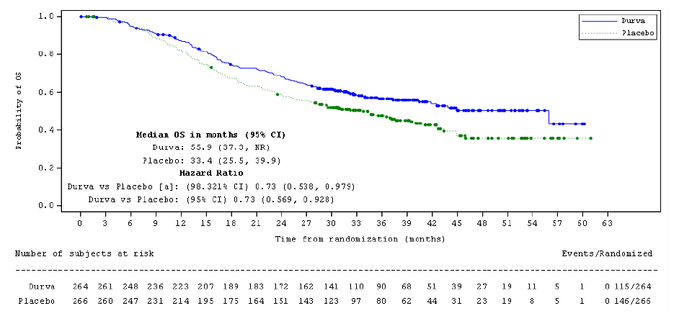
Source: Figure 2.5.1, p49 of the submission. CSR, Figure 5.
BICR = Blinded Independent Central Review; CI = confidence interval; FAS = full analysis set; NR = not reached; OS = overall survival; RECIST = Response Evaluation Criteria in Solid Tumours
ª Based on a Lan-DeMets alpha spending function with O’Brien Fleming type boundary with the actual number of events observed, the boundary for declaring statistical significance is 1.679% for a 4.5% overall alpha for OS. The Lan-DeMets spending function that approximates the O’Brien Fleming approach was used to derive the adjusted alpha level.
Circle indicates a censored observation.

Figure 2: Kaplan-Meier plot of progression-free survival in the ADRIATIC trial (FAS by BICR according to RECIST 1.1)
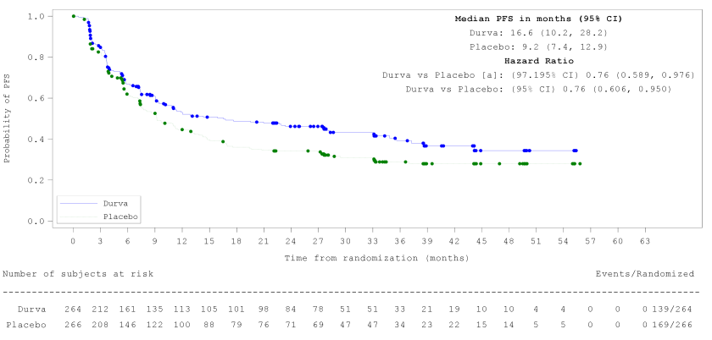
Source: Table 2.5.4, p54 of the submission. CSR, Figure 7
BICR = Blinded Independent Central Review; CI = confidence interval; FAS = full analysis set; KM = Kaplan-Meier; PFS = progression-free survival
ª Based on a Lan-DeMets alpha spending function with O’Brien Fleming type boundary with the actual number of events observed, the boundary for declaring statistical significance is 2.805% for a 5% overall alpha for PFS. The Lan-DeMets spending function that approximates the O’Brien Fleming approach was used to derive the adjusted alpha level.
Circle indicates a censored observation.
  - The results from the ADRIATIC trial indicate that durvalumab resulted in a statistically significant improvement in OS compared to placebo (HR 0.73, 95% CI: 0.569, 0.928, p=0.001).
  - The median OS for durvalumab was 55.9 months compared with median OS 33.4 months in the placebo arm, an estimated improvement in median OS of 22.5 months for patients on durvalumab compared to placebo (Figure 1). As defined by the MCID, the improvement in OS is clinically meaningful. However, the relatively large difference in the median OS reflects the flattening of the KM plot just above 50% for durvalumab and just below 50% for placebo. Further the estimated median OS for durvalumab is imprecise as it is based on the end of the KM curve where approximately 10 patients remained at risk. The ESC considered the difference in the proportion of patients alive at 24 and 36 months (approximately 9%) is more informative in this context.
  - Treatment with durvalumab resulted in a statistically significant improvement in PFS compared to placebo (HR 0.76, 95% CI: 0.606, 0.950, p=0.016) (Table 4).
  - The median PFS for durvalumab was 16.6 months and 9.2 months in the placebo arm, which translates to an estimated improvement in median PFS of 7.4 months for durvalumab-treated patients compared to placebo (Figure 2). Although no MCID for PFS was nominated in the submission, an improvement in PFS of 4 months is likely to be considered clinically meaningful. As for OS, the difference in PFS at 24 and 36 months (approximately 12-13%) is informative.
  - KM plots of time to censoring for PFS showed that patients in the durvalumab group were potentially censored for PFS earlier and more frequently than those in the placebo group. There were 22.0% and 14.3% of patients prematurely censored in the durvalumab and placebo groups, respectively, and 22.3% and 14.3% were censored more than 24 weeks before the data cut-off, respectively. While the ADRIATIC CSR reported balanced characteristics between the two censored groups, and between the two censored groups and the whole trial population, the higher and earlier censoring in the durvalumab group introduces uncertainty in the reported result, with the PFS benefit potentially overestimated.

Table 5: Results of response outcomes across the ADRIATIC trial
Outcome | Unconfirmed response¹ |  |  | Confirmed response¹
Outcome | Durvalumab  (n=175) | Placebo  (n=169) | RR  (95% CI) | Durvalumab  (n=175) | Placebo  (n=169) | RR (95% CI)
Secondary outcome: ORR
ORR, n (%); (95% CI) | 53 (30.3);  (23.6, 37.7) | 54 (32.0);  (25.0, 39.6) | 0.95  (0.69, 1.30) | 45 (25.7);  (19.4, 32.9) | 44 (26.0);  (19.6, 33.3) | 0.99  (0.69, 1.41)
Secondary outcome: Best objective response
CR, n (%) | 5 (2.9) | 4 (2.4) | 1.21  (0.33, 4.42) | 5 (2.9) | 3 (1.8) | 1.61  (0.39, 6.63)
PR, n (%) | 48 (27.4) | 50 (29.6) | 0.93  (0.66, 1.30) | 40 (22.9) | 41 (24.3) | 0.94  (0.64, 1.38)
SD ≥7 wk, n (%) | 94 (53.7) | 76 (45.0) | 1.19  (0.96, 1.48) | 94 (53.7) | 76 (45.0) | 1.19  (0.96, 1.48)
PD, n (%) | 24 (13.7) | 33 (19.5) | 0.70  (0.43, 1.14) | 24 (13.7) | 33 (19.5) | 0.70  (0.43, 1.14)
Not evaluated, n (%) | 4 (2.3) | 6 (3.6) | 0.64  (0.19, 2.24) | 0 (0) | 0 (0) | NA
Secondary outcome: DoR
 | Durvalumab  (n=53)² | Placebo  (n=54)² | Relative risk (95% CI) | Durvalumab  (n=45)² | Placebo  (n=44)² | RR (95% CI)
Disease progression or death, n (%) | 22 (42) | 23 (43) | 0.98  (0.63, 1.52) | 16 (36) | 19 (43) | 0.82  (0.49, 1.38)
Median DoR (95% CI) | 33.0 months  (22.4, NR) | 27.7 months  (9.6, NR) | NA³ | 38.8 months (25.9, NR) | 27.8 months (9.9, NR) | NA³
Ongoing response at 6 months (95% CI) | 80% (NR) | 70% (NR) | NA³ | 91% (NR) | 76% (NR) | NA³
Ongoing response at 12 months (95% CI) | 74% (59, 84) | 60% (44, 73) | NA³ | 84% (NR) | 66% (NR) | NA³
Ongoing response at 18 months (95% CI) | 71% (57, 82) | 55% (39,68) | NA³ | 81% (NR) | 60% (NR) | NA³
Secondary outcome: Time to treatment or distant metastasis
 | Durvalumab  (n=264) | Placebo  (n=266) | HR (95% CI), p-value | Durvalumab  (n=264) | Placebo  (n=266) | HR (95% CI), p-value
Median TTDM (95% CI) | NR (37.3, NR) | 37 months (16.9, NR) | 0.76  (0.57, 1.01), p=0.058 | 37.3 months (23.0, NR) | 17.6 months (12.9, NR) | 0.79  (0.61, 1.03), p=081
Secondary outcome: Time from randomisation to first subsequent therapy or death
Median TFST (95% CI) | 25.4 months (18.1, 37.3) | 15.1 months (12.0, 18.1) | 0.72  (0.58, 0.90), p=0.0032 | NR | NR | NR
Secondary outcome: Time from randomisation to second subsequent therapy or death
Median TTST (95% CI) | 37.2 months (26.9, NR) | 24.9 months (19.3, 29.4) | 0.74  (0.59, 0.94), p=0.0122 | NR | NR | NR
Source: Tables 2.5.9-14, pp59-64 of the submission.
CI = confidence interval; CR = complete response; DoR = duration of response; HR = hazard ratio; n = number of participants with event; N = total participants in group; NR = not reported; ORR = objective response rate; PD = progressed disease; PR = partial response; RR = relative risk; SD = standard deviation; TFST = time from randomisation to first subsequent therapy or death; TTDM = time to distant metastasis; TTST = time from randomisation to second subsequent therapy or death
¹ ORR based on the programmatically derived RECIST 1.1 using BICR assessments for unconfirmed (no requirement for confirmation) and confirmed (required confirmation of response no sooner than 4 weeks after the initial CR/PR was conducted) responses.
2. Number of patients with unconfirmed/confirmed ORR (CR+PD).
3. Duration of response and ongoing response outcomes have been measured in the ADRIATIC trial via KM technique, therefore a conversion of these percentages has not been undertaken during the evaluation to determine the number of patients the percentage would correspond to. Thus, without this figure the RR (95% CI) cannot be produced.

  - For objective response rate (ORR), in patients with unconfirmed response (i.e. confirmation of response not required) ORR in durvalumab was 30.3% and 32.0% in placebo per blinded independent central review (BICR) (difference in proportion -1.2%, 95% CI: -11.0, 8.5). Five patients (2.9%) experienced CR and 48 patients (27.4%) PR in the durvalumab arm, and 4 (2.4%) had CR and 50 (29.6%) PR in the placebo arm. In patients with confirmed response (i.e. confirmation of response required no sooner than 4 weeks after the initial CR/PR conducted) per BICR, ORR in durvalumab was 25.7% and 26.0% in placebo per BICR (difference in proportion: 0.0%, 95% CI: −9.3, 9.1). Five patients (2.9%) experienced CR and 40 patients (22.9%) PR in the durvalumab arm, and 3 (1.8%) CR and 41 (24.2%) PR in the placebo group. All patients received cCRT prior to their assigned trial intervention, therefore it may be plausible that this prior anti-cancer treatment could result in the comparable ORR between treatment groups. Longer-term follow-up is needed to assess the durability of response.
  - For duration of response (DoR), in patients with unconfirmed response per BICR, median DoR was 33.0 months (95% CI: 22.4, not reached [NR]) in the durvalumab arm and 27.7 months (95% CI: 9.6, NR) in the placebo arm per BICR. In patients with confirmed response per BICR, median DoR was 38.8 months (95% CI: 25.9, NR) in the durvalumab arm and 27.8 months (95% CI: 9.9, NR) in the placebo arm per BICR.
  - For DoR based on KM estimates for unconfirmed response, 71.5% (95% CI: 56.6, 82.0) of durvalumab patients and 55.2% (95% CI: 39.4, 68.5) of placebo patients remained in response at 18 months after initial onset of response. In patients with confirmed response, the KM estimates for patients who remained in response at 18 months after initial onset of response are higher in both treatment arms (durvalumab: 81.1% vs placebo: 60.2% [95% CI not reported for either arm]).
  - The submission reported several HRQoL outcomes including the European Organisation for Research and Treatment of Cancer (EORTC) 30-item Core Quality of Life Questionnaire (QLQ-C30), the EORTC Quality of Life Questionnaire Lung Cancer module (QLQ-LC13), the European Quality of Life 5-dimension 5-level questionnaire (EQ-5D-5L), the Patient-Reported Outcomes version of the Common Terminology Criteria for Adverse Events assessment (PRO-CTCAE) and the Patient’s Global Impression of Severity (PGIS) tests.
  - For EORTC QLQ-C30 and EORTC QLQ-LC13 several function and symptom scales were reported. However, no statistically or clinically important differences were identified across most domains, including the EORTC QLQ-C30 global health score (difference −1.1, 95% CI −3.725, 1.496; p=0.4019). According to the ADRIATIC protocol, a clinically relevant change is defined as a change from baseline of ≥10 points for scales or items from the QLQ-C30 and QLQ-LC13. The protocol further states that changes in symptoms or functioning will be categorised as improvement, no change, or deterioration based on this threshold. Based on this definition, the only statistically significant difference (appetite loss) did not meet the ≥10-point threshold and would therefore not be considered clinically meaningful.

Comparative harms
  - A summary of safety outcomes is presented in Table 6.
  - The overall number of AEs was high in both the durvalumab and placebo groups, with 94.3% and 88.3% of patients reporting any AEs, respectively. The ESC considered the high AE event rate in the placebo group likely reflected the poor general health of this patient population.
  - Treatment-related AEs were more prevalent in the durvalumab group (67.2%) than in the placebo group (48.7%).
  - Grade 3 or 4 AEs were similar in both the durvalumab and placebo groups (26.3% vs 25.7%). The only Grade 3 or 4 AE with a prevalence >2% was pneumonia, which was similar between groups (2.7% durvalumab vs 3.4% placebo).
  - The prevalence of patients reporting serious AEs (SAEs) was higher in the durvalumab group (29.8%) compared to the placebo group (24.2%). Similarly, treatment-related SAEs were higher in the durvalumab group (12.2%) compared to placebo (6.4%).
  - Overall deaths and treatment-related deaths were higher for durvalumab (2.7% and 0.8%, respectively) compared to placebo (1.9% and 0.0%, respectively). However, the number of patients who died as the result of an AE was very small in both groups (durvalumab n=7; placebo n=5).
Table 6: Summary of adverse events in the ADRIATIC trial
AE, n (%)¹ | Durvalumab  n=262 | Placebo  n=265
Overview of AEs in ADRIATIC trial
Any AE | 247 (94.3) | 234 (88.3)
Any AE possibly related to treatment² | 176 (67.2) | 129 (48.7)
Any AE of any CTCAE Grade 3 or 4 | 69 (26.3) | 68 (25.7)
Pneumonia | 7 (2.7) | 9 (3.4)
Any AE of any CTCAE Grade 3 or 4, possibly related to treatment | 25 (9.5) | 16 (6.0)
Any AE with a maximum CTCAE Grade 3 or 4 | 64 (24.4) | 64 (24.2)
Any AE possibly related to treatment, with a maximum CTCAE Grade 3/4^{2, 3} | 23 (8.8) | 16 (6.0)
Any SAE (incl. events with outcome of death) | 78 (29.8) | 64 (24.2)
Any SAE (incl. events with outcome of death), possibly related to treatment² | 32 (12.2) | 17 (6.4)
Any AE leading to discontinuation of treatment | 43 (16.4) | 28 (10.6)
Any AE leading to discontinuation of treatment, possibly related to treatment² | 30 (11.5) | 15 (5.7)
Any AE leading to dose interruption¶ | 91 (34.7) | 76 (28.7)
imAEs⁴ | 84 (32.1) | 27 (10.2)
Infusion reaction AEs⁵ | 6 (2.3) | 0 (0.0)
Any AE with outcome of death | 7 (2.7) | 5 (1.9)
Any AE with outcome of death possibly related to treatment² | 2 (0.8) | 0 (0.0)
Source: Table 2.5.17 p69-70 of the submission. CSR, Tables 29.
AE = adverse event; AEPI = adverse event of potential interest; AESI = adverse event of special interest; CI = confidence interval; CTCAE = common terminology criteria for adverse events; eCRF = electronic case report form; imAE = immune-mediated adverse event; NR = not reported; RD = risk difference; RR = relative risk; SAE = serious adverse event; SAS = Safety Analysis Set
¹ Per Safety Analysis Set (SAS)
² As assessed by the investigator. AEs are counted as related if related to any treatment (durvalumab, durvalumab placebo, or tremelimumab placebo) or missing response for any component.
³ Possibly related to treatment and further identified as maximum CTCAE Grade 3 or 4.
⁴ imAEs are identified from AESIs and AEPIs using a programmatic approach. Excludes AESI group of infusion or hypersensitivity reaction.
⁵ As assessed by the investigator.
Note: Risk ratio/risk difference not reported
  - The ESC noted there were higher rates of pneumonitis or radiation pneumonitis in the durvalumab arm than in the placebo arm (38.2% vs 30.2% respectively), with a higher rate of Grade ≥ 3 events (3.1% vs 2.6%, respectively). The ESC considered durvalumab may synergistically increase the rates of pneumonitis after RT and considered this is clinically relevant as this could significantly affect quality of life.

Benefits/harms
  - A summary of the comparative benefits and harms for durvalumab versus placebo is presented in Table 7.
Table 7: Summary of comparative benefits and harms for durvalumab and placebo
Benefits
PFS (median duration follow-up 7.39–9.07 months)
Event | Durvalumab | Placebo | Absolute difference | HR (95% CI)
Number of events, n (%) | 139/264 (52.7) | 169/266 (63.5) | - | 0.76 (0.61, 0.95), p=0.02
Median PFS, months (95% CI) | 16.6 (10.2, 28.2) | 9.2 (7.4, 12.9) | 7.4 months
PFS rate at 18 months (95% CI) | 48.8% (42.2, 55.0) | 36.1% (29.9, 42.2) | 12.7% | -
PFS rate at 24 months (95% CI) | 46.2% (39.6, 52.5) | 34.2% (28.2, 40.3) | 12.0% | -
OS (median duration follow-up 28.63–30.75 months)
Number of events, n (%) | 115/264 (43.6) | 146/266 (54.9) | - | 0.730 (0.57, 0.93), p=0.01042
Median OS, months (95% CI) | 55.9 (37.3, NR) | 33.4 (25.5, 39.9) | 22.5 months
Survival rate at 24 months (95% CI) | 68.0% (61.9, 73.3) | 58.5% (52.3, 64.3) | 9.5% | -
Survival rate at 36 months (95% CI) | 56.5% (50.0, 62.5) | 47.6% (41.3, 53.7) | 8.9% | -
Harms (from first dose through to 90 days after the last dose; data cut-off 15 January 2024)
 | Durvalumab  n/N | Placebo  n/N | RR*  (95% CI) | Event rate/100 patients |  | RD*  (95% CI)
 |  |  |  | Durvalumab | Placebo | RD*  (95% CI)
Any AE of any CTCAE Grade 3 or 4 | 69/262 | 68/265 | 1.0263  (0.77, 1.37) | 26.3 | 25.7 | 0.006  (-0.07, 0.08)
Any serious adverse events (SAEs) | 78/262 | 64/265 | 1.2327  (0.93, 1.64) | 29.8 | 24.2 | 0.056  (-0.02, 0.13)
Immune-mediated AEs | 84/262 | 27/265 | 3.147  (2.11, 4.69) | 32.1 | 10.2 | 0.219  (0.15, 0.29)
Source: Tables 2.5.1-5-9-15 and 17, p48, 53, 59 64, and 70 of the submission.
CI = confidence interval; CTCAE = common terminology criteria for adverse events; HR = hazard ratio; NE = not estimable; NR = not reached; OS = overall survival; PFS = progression-free survival; RD = risk difference; RR = risk ratio.
Text in bold indicates statistically significant results.
* Values calculated during evaluation
  - On the basis of direct evidence presented in the submission, for every 100 patients treated with durvalumab in comparison to placebo:
- approximately 12 additional patients will remain progression-free at 24 months
- approximately 9 additional patients will remain alive at 36 months.
  - On the basis of direct evidence presented in the submission, for every 100 patients treated with durvalumab in comparison to placebo from first dose through to 90 days after the last dose (data cut-off 15 January 2024):
- approximately 22 additional patients will experience immune-mediated AEs.

Clinical claim
  - The submission described durvalumab as superior in terms of efficacy compared to placebo (watch and wait). The ESC considered this claim was adequately supported. The key issues were: (1) the incremental OS benefit in the trial being overestimated in the ADRIATIC trial compared with that expected in the PBS population due to the use of subsequent immunotherapy in the durvalumab arm and low use of subsequent immunotherapy in the placebo arm and (2) the applicability of the ADRIATIC trial results to the PBS population as discussed in paragraph 1.24.
  - The submission described durvalumab as inferior in terms of safety compared to placebo (watch and wait). The ESC considered this claim was adequately supported.
  - The PBAC considered that the claim of superior comparative effectiveness and inferior comparative safety was reasonable.

Economic analysis
  - The submission presented a stepped economic evaluation of durvalumab compared with watch and wait for patients with LS-SCLC who have not progressed following CRT, over a 15-year time horizon. The modelled evaluation was a cost-utility approach, consistent with the clinical claims that durvalumab is superior to watch and wait in terms of both OS and PFS. A partitioned survival model (PSM) was utilised to estimate the incremental cost per QALY gained.
  - The submission stated that the cost of durvalumab as the index treatment was based on a proposed effective AEMP of $||| ||| per 500 mg vial. The costs of durvalumab and atezolizumab as subsequent therapies (for ES-SCLC) were both estimated as $||| ||| per patient, based on the effective AEMP of durvalumab for ES-SCLC. The costs of other subsequent therapies were based on their published AEMPs.
  - Table 8 outlines the key components of the economic evaluation.
Table 8: Summary of model structure and key inputs of economic evaluation
Component | Summary
Treatment | Durvalumab vs watch and wait
Time horizon | 15 years in the model base case vs median follow-up of 28.63–30.75 months for OS (placebo and durvalumab, respectively) in the ADRIATIC trial
Outcomes | Cost per QALY and cost per LYG
Methods used to generate results | Partitioned survival model
Health states | 3 health states: PF, PD and death
Cycle length | 4 weeks
Allocation to health states | Derived from PFS and OS data from the ADRIATIC trial
Extrapolation method | 1-spline odds selected for OS; 1-spline normal for PFS  Parametric model fitted independently to the durvalumab and watch and wait arms, based on goodness of fit, visual fit, hazard trends assessment, and external validation  Applied beyond the points at which ~10% of patients remained at risk in each treatment arm. For durvalumab, the truncation points were 39 months for PFS and 48 months for OS; for the watch and wait arm, truncation occurred at 39 months for PFS and 45 months for OS
Health related quality of life | ADRIATIC trial-based  PF = 0.858; PD = 0.821
Source: Table 3.1.1, pp85-86 of the submission.
LYG = life year gained; OS = overall survival; PD = progressed disease; PF = progression-free; PFS = progression-free survival; QALY = quality-adjusted life-year

  - The key drivers of the model are summarised in Table 9. During the evaluation, a calculation error was identified, where the public hospital DPMA was incorrectly multiplied by the private utilisation proportion, and vice versa. This was corrected during the evaluation. The correction increased the base case ICER by ||| |||%, from $55,000 to < $75,000 to $55,000 to < $75,000 /QALY.
  - Based on the sensitivity analyses conducted in the submission and during the evaluation, key model drivers included time horizon, discount rate and OS extrapolation approach. Cohort starting age, terminal care cost and source of utility values were also moderate drivers.
Table 9: Key drivers of the model
Description | Method/Value | Impact  Base case: $||||¹/QALY gained
Time horizon | A 15-year time horizon was used in the base case and alternate time horizons tested in the sensitivity analysis.  Median duration of follow-up for OS in the ADRIATIC trial was 28.63–30.75 months (for placebo and durvalumab, respectively). As of the data-cutoff date 54.9% and 43.6% of patients had died across the placebo and durvalumab arms, indicating immaturity of the durvalumab OS data. While a 15-year horizon might be reasonable to capture long-term effects associated with durvalumab (treatments in this setting are used with curative intent), there is uncertainty associated with extrapolating to 15 years. A 10-year time horizon could be an alternative. | High, potential to favour durvalumab.  Use of a 10-year time horizon increased the ICER to $||||²/QALY gained.
Extrapolation of OS | KM curves were used until the point at which ~10% of patients remained at risk. Truncation points were 48 months for durvalumab OS and 45 months for watch and wait. Extrapolations beyond these truncation points were made using 1-knot spline odds models in the base case. Alternate extrapolation approaches—1-knot spline hazard; log normal and generalised gamma distributions—were tested in the sensitivity analysis.  The treatment arms were modelled independently (proportional hazards assumed to not hold). | High, direction of impact unclear. The modelled LYs gained were 1.07 over a 15 year time horizon compared with 0.09 over 2 years and 0.17 over 3 years in the trial based analyses.  Use of ‘best fitting’ standard parametric distribution (generalised gamma) increased the ICER to $||||¹/QALY gained. The impact of assuming proportional hazards was not tested.
Terminal care cost | The terminal care cost estimated as $55,976 based on Goldsbury et al. (2018) | Moderate, favours durvalumab. The modelled difference in OS at the end of the 15 year time horizon resulted in a cost offset for terminal care costs. Removing this cost offset increased the ICER to $||||¹/QALY gained.
Health state utilities | Health state utility values based on ADRIATIC trial data mapped to UK preference-weighted values. Model specification ensures health state utilities can never exceed population norm utilities, which were defined based on expected EQ-5D-3L values reported by the NICE Decision Support Unit.  Sensitivity analysis explored use of alternate utility value sets (ADRIATIC trial data mapped to Australian preference-weights; published ‘real-world’ utility values weighted using Canadian value set).  Based on the submission’s sensitivity analyses, the ICER is highest when using the Canadian values—seemingly explained by the lower absolute values leading to a reduced weight being placed on improvements in OS. Use of UK population norms as the ceiling values may underestimate utilities in the target PBS population, considering higher population norms in Australia relative to the UK. | Low to moderate, direction of impact unclear.  Use of ‘real world’ Canadian-weighted values increased the ICER to $||||¹/QALY gained; however, these are based on a cohort including both ES-SCLC and LS-SCLC so may underestimate utilities in the target PBS population.
Start age | Start age set at the mean age of ADRIATIC trial population of 62 years.  This may reflect a younger cohort than the target PBS population, considering the median age of patients in the VLCR was 69 years. Nevertheless, applicability of the VLCR data to the target population is uncertain (the VLCR cohort included patients with LS-SCLC and ES-SCLC). Furthermore, the eligible patient population must be fit enough to receive CRT, which may exclude some older, more frail patients from the target PBS population. A sensitivity analysis setting the start age to 69 years was undertaken during the evaluation. | Low to moderate; may potentially favour durvalumab if target PBS population is expected to be, on average, older than the ADRIATIC trial cohort.  Increasing the start age to 69 years increased the ICER to $||||¹/QALY gained.
Source: Constructed during the evaluation based on the information provided in the submission.
CRT = chemoradiotherapy; cCRT = concurrent chemoradiotherapy; EQ-5D-3L = the European Quality of Life 5-dimension 3-level; ICER = incremental cost-effectiveness ratio; ES-SCLC = extensive-stage small cell lung cancer; LS-SCLC = limited-stage small cell lung cancer; LYG = life year gained; NICE = National Institute for Health and Care Excellence; OS = overall survival; PBS = Pharmaceutical Benefits Scheme; QALY = quality-adjusted life-year; UK = United Kingdom; VLCR = Victorian Lung Cancer Registry
The redacted values correspond to the following ranges:
¹ $55,000 to < $75,000
² $75,000 to < $95,000
  - A 15-year time horizon (180 months) was used in the submission base case to capture long-term economic impacts of durvalumab. In the submission’s stepped analysis, the results were presented using a time horizon extrapolated from 2 years to 15 years (Table 11). The LYs gained increased from 0.09 over 2 years to 1.07 discounted (1.50 years undiscounted) over 15 years. Sensitivity analyses tested alternative time horizons from 5 years to 30 years. A 10-year time horizon may offer a more balanced approach, capturing most of the long-term treatment benefits while minimising uncertainties associated with extended extrapolations.
  - The KM curves versus tested extrapolated curves for OS and PFS for durvalumab and the comparator are presented in Figure 3 to || |Figure 6. The treatment arms were modelled independently. The 1 spline odds function was selected for extrapolating OS for the base case analysis. This function resulted in the highest estimates of long term survival for both treatment arms. The 1 spline normal function was selected for extrapolating PFS. Figure 7 compares the trial data with the selected extrapolations over the 15-year (180-month) base-case time horizon. From approximately 120 months the PFS curves converge with OS curves. A difference in OS is maintained throughout the model time horizon. The ESC considered the use of a 1 spline odds function as the extrapolation function was inadequately supported in the submission.

Figure 3: Durvalumab KM and extrapolation curves for OS
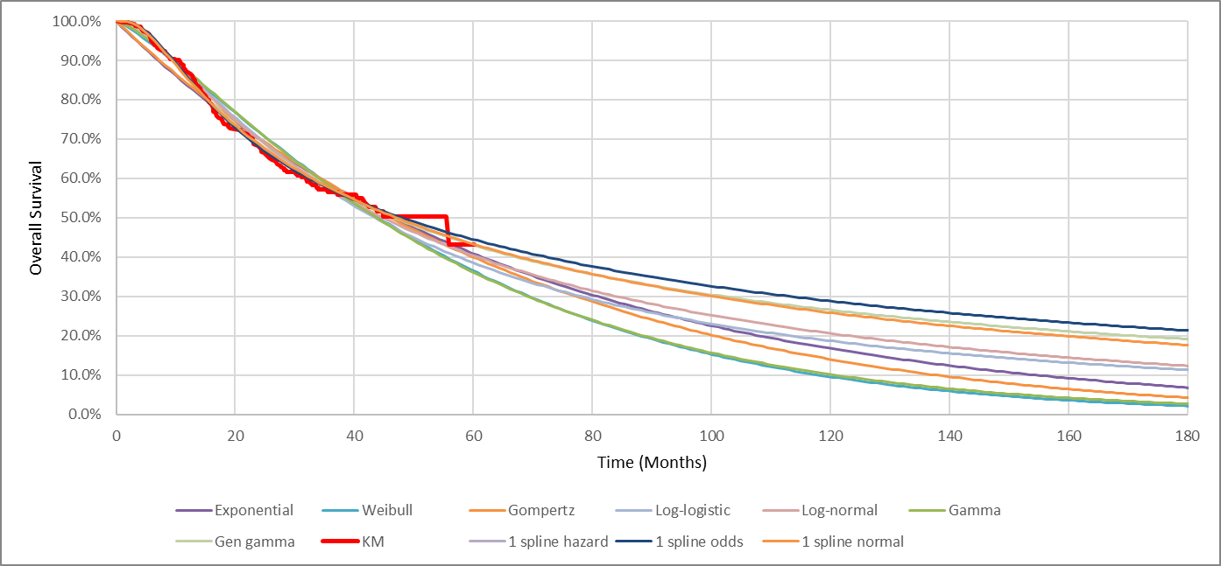
Source: Figure 3.4.2, p95 of the submission.
KM = Kaplan-Meier; OS = overall survival

Figure 4: Watch and wait KM and extrapolation curves for OS
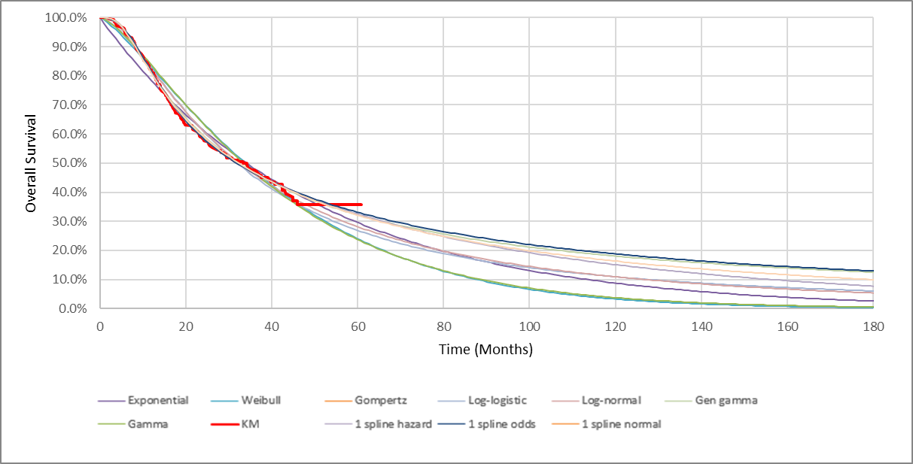
Source: Figure 3.4.6, p100 of the submission.
KM = Kaplan-Meier; OS = overall survival

Figure 5: Durvalumab KM and extrapolation curves for PFS
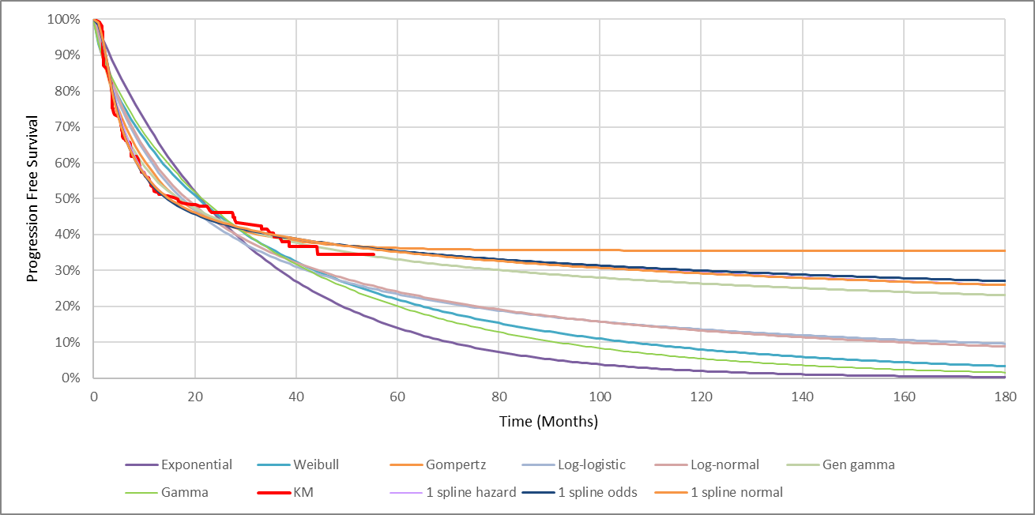||Source: Figure 3.4.8, p106 of the submission.
KM = Kaplan-Meier; PFS = progression-free survival
|| |Figure 6: Watch and wait KM and extrapolation curves for PFS
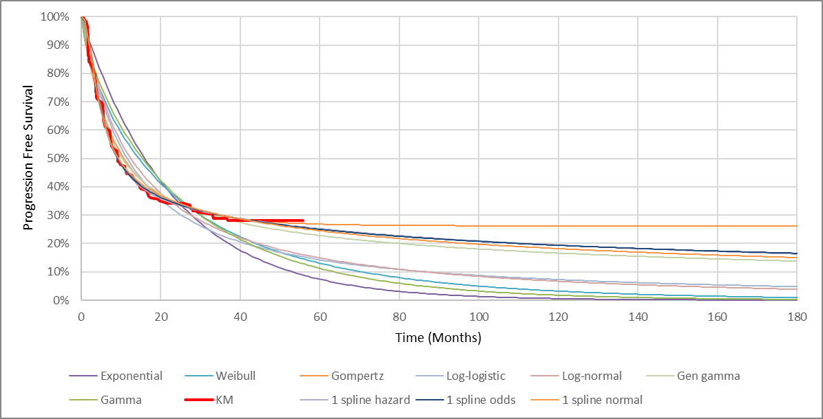||Source: Figure 3.4.12, p110 of the submission.
KM = Kaplan-Meier; PFS = progression-free survival

Figure 7: Comparison of KM curves and base case extrapolations
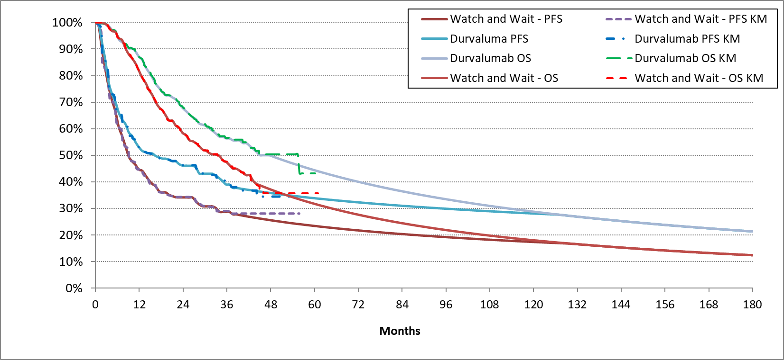
Source: ADRIATIC_CEM Excel model.
KM = Kaplan-Meier; OS = overall survival; PFS = progression-free survival
  - The submission provided a rationale for the selection of extrapolation approaches, and the need for spline models was justified through a multidimensional assessment including goodness of fit measures, visual check, evaluation of hazard trends and external validation. The submission noted the potential violations of the proportional hazard assumption by visual inspections of the log–log plot. For both OS and PFS, log–log plots demonstrated some non-parallel features such as of converging-diverging trends as well as crossing over. The ESC noted the submission did not provide statistical tests and considered the assumption that proportional hazards did not hold was inadequately supported. The ESC noted sensitivity analyses using extrapolations assuming proportional hazard were not presented. In multivariate analyses selecting from the most appropriate of standard parametric models for both PFS (generalised gamma) and OS (generalised gamma or log normal) simultaneously, increased the ICER by ||| |||% (for generalised gamma, both arms).
  - After the extrapolation, the submission applied a cure assumption—starting at 60 months, 90% of patients in the PFS state were assumed to follow the general population mortality risk and would not transition to the progressed disease (PD) state for the remainder of the model. The ESC noted the cure model was applied to the extrapolated data, rather than before conducting the extrapolation and considered this approach to be inappropriate. However, the ESC noted the model was not sensitive to the inclusion of the cure assumption. This was likely to due to the mortality rate for patients in the PFS state from 60 months before application of the cure assumption being the same or lower than for the general population.
  - The health state utility values in the economic model base case were based on EQ-5D-5L data from the ADRIATIC trial, mapped to UK preference-weighted values. While it is acknowledged that the trial utility values were higher than the population norm and the submission model had adjusted the values using UK population norms as the ceiling, there were significant uncertainties.
- Although the submission indicated that utility values were sourced from the ADRIATIC trial, it provided no references or any details of the mapping functions used the approach was unable to be validated.
- The submission stated that EQ-5D-5L data from the trial were first mapped to EQ-5D-3L to apply to the UK value set and then mapped back to the -5L data using the Australian value set. The necessity of the 2-step mapping process is unclear, considering the availability of the EQ-5D-5L Australian value set.
  - The submission model used a starting age of 62 years, based on the mean age of participants in the ADRIATIC trial, which was younger than the average age of 69 years in the VLCR cohort in Australia. A sensitivity analysis conducted during the evaluation tested the start age of 69 years and found it had a moderate impact on the economic results (||| |||%). The VLCR cohort included both LS-SCLC and ES-SCLC patients, with ES-SCLC potentially skewing towards an older group. Additionally, some older patients may be excluded from the target population due to not being fit enough to receive CRT or not being PF following CRT. The ESC considered it would be reasonable to assume an older starting age in the model.
  - The disaggregated costs for healthcare resource use items are summarised in Table 10.

Table 10: Healthcare resource items: disaggregated summary of cost impacts
Resource item | Durvalumab cost | watch and wait cost | Incremental cost | % of total incremental cost
Pharmaceutical products
Drug acquisition | $|||| | $0.00 | $|||| | ||||%
Drug administration | $1,586.59 | $0.00 | $1,586.59 | ||||%
Total index treatment | $|||| | $0.00 | $||||
Subsequent treatment | $3,389.23 | $5,3551.11 | −$1,965.88 | −||||%
Management of adverse events
Pneumonia | $222.41 | $283.80 | −$61.39 | −||||%
Disease management | $7,431.03 | $5,344.99 | $2,086.04 | ||||%
Terminal care | $37,237.54 | $42,469.31 | −$5,231.77 | −||||%
Total | $|||| | $53,453.22 | $|||| | ||||%
Source: Table 3.8.3, p127 of the submission.

  - The terminal care cost, based on Goldsbury et al. (2018), was estimated as $55,000 to < $75,000. The modelled difference in OS at the end of the 15 year time horizon resulted in a substantial cost offset for terminal care costs. Removing this cost offset increased the ICER by ||| |||%.
  - The subsequent treatments, and specifically the subsequent use of immunotherapy, does not reflect that expected for the PBS population (see paragraph 1.23). Increasing the extent of subsequent immunotherapy in the watch and wait arm would reduce both the incremental OS benefit and the incremental cost. The cost of subsequent immunotherapy (estimated to be $21,707) was applied as a one-time cost at the point of entry into the PD state. The applied cost did not appear to account for the cost-effective price of atezolizumab (and subsequently durvalumab) being achieved through RSA rebates (Paragraph 7.1, atezolizumab PSD, November 2019 meeting).
  - The results of the stepped economic evaluation are summarised in Table 11.
Table 11: Results of the stepped economic evaluation
Step and component | Durvalumab | Watch and wait | Increment
Step 1: trial-based analysis over 2-year time horizon (cost per LYG)
Treatment acquisition, administration and subsequent treatment costs only
Costs | $|||| | $4,250.62 | $||||
LYs | 1.69 | 1.60 | 0.09
ICER (cost/extra LY gained) |  |  | $||||¹
Additional step 1ª: trial-based analysis over 3-year time horizon (cost per LYG)
Treatment acquisition, administration and subsequent treatment costs only
Costs | $|||| | $4,602.94 | $||||
LYs | 2.23 | 2.06 | 0.17
ICER (cost/extra LY gained) |  |  | $||||²
Step 2: Time horizon extended to 15 years (cost per LYG)
Treatment acquisition, administration and subsequent treatment costs only
Costs | $|||| | $5,355.11 | $||||
LYs | 5.04 | 3.97 | 1.07
ICER (cost/extra LY gained) |  |  | $||||³
Step 3: Add disease management, AE and terminal care costs (cost per LYG)
Costs | $|||| | $53,453.22 | $||||
LYs | 5.04 | 3.97 | 1.07
ICER (cost/extra LY gained) |  |  | $||||⁴
Step 4: Transform LYGs into QALYs over 15-year time horizon (cost per QALY)
Costs | $|||| | $53,453.22 | $||||
QALYs | 4.12 | 3.25 | 0.87
ICER (cost/extra QALY gained) (base case) |  |  | $||||³
Source: Table 3.8.2, p126 of the submission.
AE = Adverse event; ICER = incremental cost-effectiveness ratio; LYG = life year gained; QALY = quality-adjusted life year
Italics denote updates made during the evaluation.
ª additional step added during the evaluation.
The redacted values correspond to the following ranges:
¹ $655,000 to < $755,000
² $355,000 to < $455,000
³ $55,000 to < $75,000
⁴ $45,000 to < $55,000

  - The results of key univariate and multivariate sensitivity analyses are summarised in Table 12.
Table 12: Sensitivity analyses
Analysis |  | Incremental cost |  | Incremental QALY |  | ICER | % change to ICER
Base case |  | $|||| |  | 0.87 |  | $||||¹ | -
Base case (updated) |  | $|||| |  | 0.87 |  | $||||¹ | -
Time horizon (base case 15 years)
5 years |  | $|||| |  | 0.306 |  | $||||² | ||||%
10 years #1 |  | $|||| |  | 0.65 |  | $||||³ | ||||%
20 years |  | $|||| |  | 1.01 |  | $||||⁴ | −||||%
Discount rate (base case 5%)
0% |  | $|||| |  | 1.21 |  | $||||⁴ | −||||%
3.5% |  | $|||| |  | 0.96 |  | $||||¹ | −||||%
Utilities (base case based on ADRIATIC trial data mapped to UK values; UK population norms as ceiling values, PF=0.858, PD=0.821)
ADRIATIC trial data mapped to Australian values (PF=0.930, PD=0.900) |  | $|||| |  | 0.87 |  | $||||¹ | ||||%
Utilities from Kuehne 2022 (PF=0.775, PD=0.640) |  | $|||| |  | 0.83 |  | $||||¹ | ||||%
ADRIATIC trial data mapped to Australian values; Australian norms as ceiling values (PF=0.930, PD=0.900) |  | $|||| |  | 0.93 |  | $||||¹ | −||||%
Start age (base case 62 years)
69 years based on VLCR registry data |  | $|||| |  | 0.83 |  | $||||¹ | ||||%
Terminal care costs (base case included)
Remove terminal care costs for all patients #2 |  | $|||| |  | 0.87 |  | $||||¹ | ||||%
Extrapolation of PFS (base case 1 spline normal in both arms)
PFS curves gen gamma in both arms |  | $|||| |  | 0.87 |  | $||||¹ | ||||%
Extrapolation of OS (base case 1 spline odds in both arms)
OS curves log normal in both arms |  | $|||| |  | 0.87 |  | $||||¹ | ||||%
OS curves gen gamma in both arms |  | $|||| |  | 0.81 |  | $||||¹ | ||||%
KM data cut-off method (base case 10% at risk in each treatment arm)
Method outlined in Gebski et al. (2018) | $|||| |  | 0.85 |  | $||||¹ |  | ||||%
Multivariate analyses
PFS and OS curves gen gamma in both arms |  | $|||| |  | 0.81 |  | $||||¹ | ||||%
PFS gen gamma, OS log normal both arms |  | $|||| |  | 0.87 |  | $||||¹ | ||||%
PFS and OS curves gen gamma in both arms + 10-year time horizon |  | $|||| |  | 0.62 |  | $||||³ | ||||%
PFS gen gamma both arms, OS log normal both arms +10-year time horizon |  | $|||| |  | 0.67 |  | $||||³ | ||||%
PBAC multivariate analysis
#1 and #2 |  | $|||| |  | 0.65 |  | $||||⁵ | ||||%
Source: Table 3.9.1, p129 of the submission.
ICER = incremental cost-effectiveness ratio; OS = overall survival; PFS = progression-free survival; QALY = quality adjusted life year; VLCR = Victorian Lung Cancer registry
The redacted values correspond to the following ranges:
¹ $55,000 to < $75,000
² $155,000 to < $255,000
³ $75,000 to < $95,000
⁴ $45,000 to < $55,000
⁵ $95,000 to < $115,000

Drug cost/patient/year
  - A comparison of durvalumab use between the trial setting, the economic model and the financial estimates model is presented in Table 13.
  - The mean modelled total duration of treatment was 53.3 weeks. The financial model used a treatment duration of 52.1 weeks (13.025 cycles).
Table 13: Drug cost per patient per course for durvalumab
 | ADRIATIC trial  Trial dose and duration | Economic model | Financial estimates
Dose | 1,500 mg Q4W
Mean duration | 54.5 weeks | 53.3 weeks | 52.1 weeks
Requested effective EMP | - | $|||| per 500 mg | $|||| per 500 mg
Cost per cycle (28 days) | - | $|||| ª | $|||| ^{b}
No. cycles per course | 12.9 | 13.33 | 13.025
Cost/patient/course | - | $|||| ^{d} | $||||
Source: produced during the evaluation.
EMP = ex-manufacturer’s price; Q4W = every 4 weeks; SD = standard deviation
ª Corrected for an error in public and private utilisation rates. Based on public and private hospital markups effective from 1 July 2024, the effective DPMA is $|| in public hospitals and $|| in private hospitals per 1,500 mg. Public hospital DPMA was incorrectly multiplied by the private utilisation proportion.
^{b} Based on public and private hospital markups effective from 1 July 2024, and a utilisation split of 46% public hospital use vs. 54% private hospital use.
^{d} Cost per patient per course was calculated based on cost per 28-day cycle and number of cycles per year.

Estimated PBS usage and financial implications
  - The submission was not considered by the Drug Utilisation Sub-Committee (DUSC).
  - The submission took an epidemiological approach and assumed ||| |||% market uptake among eligible LS-SCLC patients. The annual number of treated patients was estimated based on incident patient numbers, plus grandfathered patients in year 1. Key inputs relied on in the financial analyses are presented in Table 14.

Table 14: Key inputs for financial estimates
Parameter | Value applied and source | Comment
Incident lung cancer population | Incidence from AIHW 2024 data, projected using annual growth rates of 4.6% for females and 2.0% for males. | Annual growth rate was based on 4-year average (2021–2024) data, which is considerably higher than the 3-year (2.53%) and 5-year averages (2.50%). The 5-year average of 2.5% (2020–2024) is a better assumption. The pre-PBAC response decreased the growth from 3.322% to 2.713%. The pre-PBAC response requested this growth rate also be applied to the current ES-SCLC expenditure caps.
Proportion with SCLC | 11.75%  Atezolizumab PSD 2019; Durvalumab PSD 2020 | The atezolizumab 2019 PSD referred to AIHW 2011 as the original data source and stated the percentage is likely to decrease over time. New data has since become available: Huang 2023 reported a value of 10.5%, which is a better assumption. The pre-PBAC response decreased the proportion to 11.19%.
Proportion with LS-SCLC | 28.70%  Atezolizumab PSD 2019; Durvalumab PSD 2020, Inverse of proportion with ES-SCLC
CRT uptake | 70%  Durvalumab PSD 2019 | Huang 2023 reported 71%. The pre-PBAC response amended to 71%.
Proportion of LS-SCLC cohort with WHO PS of 0 or 1 | 78%  Huang 2023 | The correct percentage is 86.5% based on Huang 2023. The pre-PBAC response amended to 86.5%.
Proportion that has not progressed after CRT | 99%  Takada 2002 | Inappropriately derived: used smaller Asian study despite better alternatives and applied an inverse method which did not account for patients who discontinue. A better assumption is 95% based on a pooled analysis in more current year (Salama 2013). The pre-PBAC response amended to 95%.
Grandfathered patients | ||||¹  Current number of EAP patients
Uptake rate | ||||% each year  Assumption | Potentially overestimated. The PBAC considered ||||% would be a more reasonable estimate.
Scripts per patient per course | 13.025  Mean treatment duration from the ADTRIATIC trial (52.1 weeks) divided by frequency of cycles (i.e. 4-weekly)
Scripts per grandfathered patient | 6.5  Grandfathered patients were considered to have finished half the treatment course
Dose/duration | 1,500 mg per script  ADRIATIC trial
Offsets for comparator/ subsequent therapies | $0  Based on comparator being watch and wait | Did not consider reduced use of durvalumab and atezolizumab in ES-SCLC. The current utilisation of durvalumab and atezolizumab in ES-SCLC is provided in Table 17. The pre-PBAC response provided revised financial estimates that included offsets.
MBS item | $123.05  MBS item 13950 for parenteral administration of chemotherapy
Source: Table 4.1.1, p132 of the submission.
AEs = Adverse events; AIHW = Australian Institute of Health and Welfare; CRT = chemoradiotherapy; CSR = clinical study report; EAP = early access program; ES-SCLC = extensive-stage small cell lung cancer; LS = limited stage; LS-SCLC = limited-stage small cell lung cancer; MBS = Medicare Benefits Schedule; NLCSP = National Lung Cancer Screening Program; PSD = public summary document; Q4W, every 4 weeks; SD = standard deviation; WHO PS = World Health Organization Performance Status
The redacted values correspond to the following ranges:
¹ < 500

  - The estimated use and financial implications to the PBS/RPBS presented in the submission are provided in Table 15.
Table 15: Estimated use and financial implications (based on proposed effective price)
 | Year 1 | Year 2 | Year 3 | Year 4 | Year 5 | Year 6
Estimated extent of use
Number of patients treated | ||||¹ | ||||¹ | ||||¹ | ||||¹ | ||||¹ | ||||¹
Number of scripts dispensed | ||||² | ||||² | ||||² | ||||² | ||||² | ||||²
Estimated financial implications of durvalumab
Cost to PBS/RPBS less copayments | $||||⁴ | $||||⁴ | $||||⁴ | $||||⁴ | $||||⁵ | $||||⁵
Net financial implications
Net cost to PBS/RPBS | $||||⁴ | $||||⁴ | $||||⁴ | $||||⁴ | $||||⁵ | $||||⁵
Net cost to MBS | $||||³ | $||||³ | $||||³ | $||||³ | $||||³ | $||||³
Net cost to health budget | $||||⁵ | $||||⁴ | $||||⁴ | $||||⁵ | $||||⁵ | $||||⁵
Source: Table 4.2.1, 4.2.3, pp141-144 of the submission.
MBS = Medicare Benefits Schedule; PBS = Pharmaceutical Benefits Scheme; RPBS = repatriation pharmaceutical benefits scheme
The redacted values correspond to the following ranges:
¹ < 500
² 500 to < 5,000
³ $0 to < $10 million
⁴ $10 million to < $20 million
⁵ $20 million to < $30 million

  - The total net cost to the PBS/RPBS of listing durvalumab was estimated to be $20 million to < $30 million in year 6, a total of $100 million to $200 million in the first 6 years of listing. The net PBS/RPBS cost presented in the submission did not account for reduced use of durvalumab and atezolizumab in the ES SCLC setting (this was provided in the pre-PBAC response, see paragraph 1.73).
  - Several concerns were identified during the evaluation, including potential overestimations in the annual population growth rate, the proportion with SCLC, the proportion not progressing after CRT and the number of scripts per patients. There was a potential underestimation in the proportion of patients with Eastern Cooperative Oncology Group (ECOG) 0–1.
  - The pre-PBAC response provided revised financial estimates that included cost-offsets for reduced use of immunotherapy in ES-SCLC. In addition to the amendments to parameters outlined in Table 14, the pre-PBAC response assumed that, cumulatively, 78% of patients progress over the 6 years of the forward estimates (based on standard of care PFS curve in the economic model); 25% would not have been appropriate for IO in the ES-SCLC setting and 17.5% would have been early progressors.
Table 16: Estimated use and financial implications, pre-PBAC response
 | Year 1 | Year 2 | Year 3 | Year 4 | Year 5 | Year 6
Estimated extent of use
Number of patients treated | ||||¹ | ||||¹ | ||||¹ | ||||¹ | ||||¹ | ||||¹
Number of scripts dispensed | ||||² | ||||² | ||||² | ||||² | ||||² | ||||²
Estimated financial implications of durvalumab
Cost to PBS/RPBS less copayments | $||||⁴ | $||||⁴ | $||||⁴ | $||||⁴ | $||||⁵ | $||||⁵
Reduced use in ES-SCLC
Number of patients with reduced IO use | - | ||||¹ | ||||¹ | ||||¹ | ||||¹ | ||||¹
Reduced scripts | - | -||||² | -||||² | -||||² | -||||² | -||||²
Cost to PBS/RPBS less copayments | - | -$||||³ | -$||||³ | -$||||³ | -$||||³ | -$||||³
Net financial implications
Net cost to PBS/RPBS | $||||⁴ | $||||⁴ | $||||⁴ | $||||⁴ | $||||⁴ | $||||⁴
Net cost to MBS | $||||³ | $||||³ | $||||³ | $||||³ | $||||³ | $||||³
Net cost to health budget | $||||⁵ | $||||⁴ | $||||⁴ | $||||⁴ | $||||⁴ | $||||⁴
Source: revised Section 4 model provided with pre-PBAC response
MBS = Medicare Benefits Schedule; PBS = Pharmaceutical Benefits Scheme; RPBS = repatriation pharmaceutical benefits scheme
The redacted values correspond to the following ranges:
¹ < 500
² 500 to < 5,000
³ $0 to < $10 million⁴ $10 million to < $20 million⁵ $20 million to < $30 million
  - The PBS utilisation of atezolizumab and durvalumab in ES-SCLC from 2021 to 2025 (January to March) is presented in Table 17 .
Table 17: Utilisation of immune checkpoint inhibitors in ES-SCLC
Year | 2021 | 2022 | 2023 | 2024 | 2025*
Atezolizumab
Incident patients | ||||² | ||||² | ||||² | ||||² | ||||¹
Prevalent patients | ||||² | ||||² | ||||² | ||||² | ||||²
Scripts | ||||³ | ||||³ | ||||³ | ||||³ | ||||²
Durvalumab
Incident patients | - | - | <||||¹ | ||||¹ | ||||¹
Prevalent patients | - |  | <||||¹ | ||||¹ | ||||¹
Scripts | - | - | <||||¹ | ||||² | ||||¹
*January to March 2025
The redacted values correspond to the following ranges:
¹ < 500
² 500 to < 5,000
³ 5,000 to < 10,000

Financial Management – Risk Sharing Arrangements
  - The sponsor expressed a willingness to enter into a risk sharing arrangement (RSA), proposing an agreement under which the sponsor would rebate ||| |||% of any expenditure above the net cost to PBS/RPBS estimates.
  - There is an RSA in place for durvalumab and atezolizumab for ES-SCLC (with ||| |||% rebate over the cap). The PBAC noted the cost effectiveness of immunotherapy in ES-SCLC was achieved via the RSA (paragraph 6.9, atezolizumab PSD, November 2019 PBAC meeting).
  - The evaluation considered it may be appropriate for the net cost of listing durvalumab for LS-SCLC to be added to the existing RSA given its listing should result in a reduction in use of durvalumab and atezolizumab for ES-SCLC. The pre-PBAC response proposed that if durvalumab in LS-SCLC is added to the existing RSA for durvalumab and atezolizumab in ES-SCLC, the financial estimates for LS-SCLC should account for an increase in LS-SCLC diagnoses from the lung cancer screening program, rather than just the 2.7% applied due to population growth. Additionally, the pre-PBAC response noted that the current RSA in place for ES-SCLC is in its sixth year, with no increases to account for natural lung cancer population growth since March 2025. To address this, the pre-PBAC response proposed a population growth percentage of 2.7% should also apply to the ES-SCLC portion of the RSA.
- PBAC Outcome
  - The PBAC recommended durvalumab for the treatment of limited-stage small cell lung cancer (LS-SCLC) in patients whose disease has not progressed during or following chemoradiation therapy (CRT). The PBAC noted outcomes were poor with the current standard of care for LS-SCLC and there was a high clinical need for effective treatments. The PBAC noted that treatment with durvalumab provided a moderate overall survival benefit but was associated with immune-mediated adverse events. The PBAC considered there was some uncertainty regarding whether the OS benefit observed in the clinical trial would be realised in clinical practice. The PBAC considered that revisions to the economic model were required and that durvalumab would be cost effective with an incremental cost effectiveness ratio (ICER) of less than $45,000 to < $55,000 per quality adjusted life year (QALY). The PBAC considered the revised utilisation estimates provided in the pre-PBAC response, which accounted for reduced use of immunotherapy in extensive stage SCLC, would be reasonable with a decrease in durvalumab uptake applied. The PBAC considered that durvalumab should join the existing risk sharing arrangement in place for extensive stage small cell lung cancer with an increase in expenditure caps.
  - The PBAC noted the consumer comments were supportive of the proposed listing. The PBAC noted outcomes were poor with the current standard of care for LS-SCLC and there was a high clinical need for effective treatments.
  - In relation to the restriction criteria, the PBAC advised:
- it was not necessary to include ‘platinum based’ when describing chemoradiation therapy;
- The clinical criterion “The treatment must be as monotherapy” could be deleted;
- A single restriction criteria incorporating initiation, continuation and grandfathering was appropriate; and
- flow on changes would be required to the current durvalumab and atezolizumab listings for extensive stage SCLC to ensure once per lifetime access to immunotherapy.
  - The PBAC noted durvalumab will be used in patients whose disease has not progressed during or following CRT and considered the nominated comparator of ‘watch and wait’ monitoring was reasonable.
  - The PBAC noted the submission was based on one head-to-head randomised controlled trial (ADRIATIC) comparing durvalumab to placebo (representing ‘watch and wait’) (n=530). The PBAC noted that, based on a median follow up of approximately 30 months, the results indicated treatment with durvalumab resulted in a statistically significant improvement in overall survival (OS) compared to placebo (hazard ratio 0.73, 95%CI: 0.57, 0.93). The PBAC noted 68% of patients were alive at 24 months in the durvalumab arm compared to 58.5% in the placebo arm.
  - The PBAC noted that of the patients in the placebo arm that received subsequent anticancer therapy in the ADRIATIC trial, 11.7% received immunotherapy. The PBAC considered that the use of immunotherapy in the placebo arm was lower than would be expected and that this resulted in the trial overestimating the magnitude of clinical benefit that would be observed in the Australian treatment setting. Additionally, the PBAC noted patients in the ADRIATIC trial may not reflect patients likely to be treated in Australia as survival in the ‘watch and wait’ group appeared to be higher in the ADRIATIC trial compared to clinical practice (as discussed in paragraph 1.24) which may further limit the applicability of the trial results.
  - The PBAC considered the claim of superior comparative effectiveness was supported by the evidence presented.
  - The PBAC noted durvalumab was associated with higher rates of pneumonitis or radiation pneumonitis (38.2% vs 30.2%) and immune-mediated adverse events (32.1% vs 10.2%) than placebo. The PBAC considered the claim of inferior comparative safety was reasonable, however did not consider the claim of a “manageable” safety profile was informative. The PBAC also noted that the inconvenience of prolonged intravenous therapy may limit uptake and compliance particularly for some rural and regional patients.
  - The PBAC noted the submission presented a cost-utility analysis to support the cost-effectiveness of durvalumab compared to watch and wait monitoring with the economic model reporting a base case ICER of $55,000 to < $75,000 per QALY gained. The PBAC noted the key model drivers included time horizon, approach to overall survival extrapolation and terminal care cost. The PBAC noted the model estimated an additional 1.50 life years gained (undiscounted) over the 15 year time horizon and considered this was likely overestimated. The PBAC considered reducing the time horizon to 10 years would mitigate the uncertainty related to the OS benefit. The PBAC noted the impact of terminal care costs was driven by the difference in the surviving proportions at the end of the model time horizon and was artificial as ultimately it should be applied to all patients. The PBAC noted using a time horizon of 10 years and removing terminal care costs resulted in an ICER of $95,000 to < $115,000 per QALY. The PBAC considered durvalumab would be cost effective with an ICER less than $45,000 to < $55,000 per QALY consistent with other early stage lung cancer indications.
  - The PBAC noted the utilisation estimates presented in the submission were based on an epidemiological approach with assumptions revised in the pre-PBAC response. The PBAC noted the pre-PBAC response provided estimates for cost offsets related to the reduced use of immunotherapy in the ES-SCLC treatment setting. The PBAC considered it was unlikely uptake of durvalumab in LS-SCLC would be ||| |||% given the inconvenience of ongoing intravenous therapy, and considered ||| |||% would be a more reasonable estimate. The PBAC considered that, with the amended uptake rate, the revised utilisation estimates provided in the pre-PBAC response were reasonable.
  - The PBAC considered it would be appropriate for durvalumab to be included in the existing RSA in place for ES-SCLC as cost effectiveness in LS-SCLC relies on achieving the offsets in ES-SCLC. The PBAC advised expenditure caps should be adjusted to account for the net cost of listing durvalumab for LS-SCLC (accounting for cost offsets in the ES-SCLC treatment setting). The PBAC recalled that the ES-SCLC RSA caps were expected to be exceeded to achieve cost-effectiveness (refer paragraph 1.76). While the PBAC considered the pre-PBAC response proposal for an increase in the ES-SCLC caps to account for population growth was reasonable in principle, the PBAC advised it would also be appropriate to take into account the performance of the RSA to ensure cost-effectiveness in ES-SCLC consistent with what was intended.
  - The PBAC found that the criteria prescribed by the National Health (Pharmaceuticals and Vaccines – Cost Recovery) Regulations 2022 for Pricing Pathway A were not met. Specifically, the PBAC found that in the circumstances of its recommendation for durvalumab:
    - The treatment is not expected to provide a substantial and clinically relevant improvement in efficacy, over watch and wait monitoring, noting the expected magnitude of improvement in efficacy in the clinical trials was modest and may not be realised in the PBS population;
    - The treatment is not expected to address a high and urgent unmet clinical need as there are other therapies available in the later line treatment setting; and
    - It was not necessary to make a finding in relation to whether it would be in the public interest for the subsequent pricing application to be progressed under Pricing Pathway A because one or more of the preceding tests had failed.
  - The PBAC noted that this submission is not eligible for an Independent Review as it received a positive recommendation.

Outcome:
Recommended

- Recommended listing
  - Add new item:

MEDICINAL PRODUCT  Form |  |  | PBS item code | Max. Amount | №.of Rpts
DURVALUMAB  Injection |  |  | NEW (Public)  NEW (Private) | 1500mg | 5
Available brands
Imfinzi
durvalumab 500mg/10 mL injection, 10 mL vial
Imfinzi
durvalumab 120mg/2.4 mL injection, 10 mL vial
Restriction Summary [New 1] / Treatment of Concept: [New 1A]
Concept ID  (for internal Dept. use) |  | Category / Program: Section 100 – Efficient Funding of Chemotherapy Public/Private hospitals
 |  | Prescriber type: Medical Practitioners
 |  | Restriction type: Authority Required: Streamlined
Prescribing rule |  | Administrative Advice: No increase in the maximum amount or number of units may be authorised
Prescribing rule |  | Administrative Advice: No increase in the maximum number of repeats may be authorised
Prescribing rule |  | Administrative Advice: Special Pricing Arrangements apply
 |  | Severity: Limited-stage
 |  | Condition: Small cell lung cancer
 |  | PBS Indication: Limited-stage small cell lung cancer
 |  | Clinical criteria:
 |  | Patient must have received chemoradiation therapy (CRT)
 |  | AND
 |  | Clinical criteria:
 |  | The condition must not have progressed following CRT
 |  | AND
 |  | Clinical criteria:
 |  | Patient must have had a WHO performance status of no greater than 1 at treatment initiation with this drug for this condition
 |  | AND
 |  | Clinical criteria:
 |  | The treatment must be the sole PBS-subsidised systemic anti-cancer therapy for this PBS indication
 |  | AND
 |  | Clinical criteria:
 |  | Treatment must not exceed 24 months in total for this condition, measured from the initial dose, or must not extend beyond disease progression, whichever comes first

  - Amend the following restriction criteria:
MEDICINAL PRODUCT  medicinal product pack |  | PBS item code | Max. qty packs | Max. qty units | №.of  Rpts | Available brands
ATEZOLIZUMAB
atezolizumab 1.875 g/15 mL injection, 15 mL vial |  | 14248X | 1 | 1 | 3 | Tecentriq SC
atezolizumab 1.875 g/15 mL injection, 15 mL vial |  | 14289C | 1 | 1 | 3 | Tecentriq SC
 | Category / Program: GENERAL - General Schedule (Code GE)
 | Prescriber type: Medical Practitioners
 | Benefit type: Authority Required (STREAMLINED – 10206)

MEDICINAL PRODUCT |  | PBS item code | Max. Amount | №.of Rpts
ATEZOLIZUMAB |  | 11926Q HB  11927R HS | 1200mg | 3
Available brands
Tecentriq
(Atezolizumab - Solution concentrate for I.V. infusion 1200 mg in 20 mL – Injection)
 | Category / Program: Section 100 – Efficient Funding of Chemotherapy – Public (HB)/ Private (HS)
 | Prescriber type: Medical Practitioners
 | Benefit type: Authority Required (STREAMLINED – 10206)

MEDICINAL PRODUCT |  |  | PBS item code | Max. Amount | №.of Rpts
DURVALUMAB |  |  | 13775B HB  13779F HS | 1,500 mg | 3
Available brands
Imfinzi
(durvalumab 120 mg/2.4 mL injection, 2.4 mL vial)
Imfinzi
(durvalumab 500 mg/10 mL injection, 10 mL vial)
Concept ID |  | Category / Program: Section 100 – Efficient Funding of Chemotherapy – Public (HB)/ Private (HS)
 |  | Prescriber type: Medical Practitioners
 |  | Benefit type: Authority Required (STREAMLINED – 10206)
Prescribing rule |  | Administrative Advice: No increase in the maximum amount or number of units may be authorised
Prescribing rule |  | Administrative Advice: No increase in the maximum number of repeats may be authorised
Prescribing rule |  | Administrative Advice: Special Pricing Arrangements apply
Restriction Summary modified 10205 / Treatment of Concept: modified 10206
 |  | Severity: Extensive-stage
 |  | Condition: small cell lung cancer
 |  | Indication: Extensive-stage small cell lung cancer
 |  | Treatment Phase: Initial treatment
 |  | Clinical criteria:
 |  | The condition must be previously untreated
 |  | AND
 |  | Clinical criteria:
 |  | Patient must have a WHO performance status of 0 or 1
 |  | AND
 |  | Clinical criteria:
 |  | The treatment must be in combination with etoposide and a platinum-based antineoplastic drug
 |  | AND
 |  | Clinical criteria:
 |  | Patient must not have previously received programmed cell death-1/ligand 1 (PD-1/PD-L1) inhibitor therapy for any stage of small cell lung cancer
These restrictions may be subject to further review. Should there be any changes made to the restriction the sponsor will be informed.
- Context for Decision
The PBAC helps decide whether and, if so, how medicines should be subsidised through the Pharmaceutical Benefits Scheme (PBS) in Australia. It considers applications regarding the listing of medicines on the PBS and provides advice about other matters relating to the operation of the PBS in this context. A PBAC decision in relation to PBS listings does not necessarily represent a final PBAC view about the merits of the medicine or the circumstances in which it should be made available through the PBS. The PBAC welcomes applications containing new information at any time.

10 Sponsor’s Comment
The sponsor had no comment.

https://www.health.gov.au/our-work/nlcsp
National Comprehensive Cancer Network 2025. NCCN Clinical Practice Guidelines in Oncology Small Cell Lung Cancer version 4.2025. Available at: https://www.nccn.org/professionals/physician_gls/pdf/sclc.pdf
Cherny NI, Dafni U, Bogaerts J, et al: ESMO-Magnitude of Clinical Benefit Scale version 1.1. Annals of Oncology 28:2340-2366, 2017
Ellis LM, Bernstein DS, Voest EE, Berlin JD, Sargent D, Cortazar P, Garrett-Mayer E, Herbst RS, Lilenbaum RC, Sima C, Venook AP, Gonen M, Schilsky RL, Meropol NJ, Schnipper LE. American Society of Clinical Oncology perspective: Raising the bar for clinical trials by defining clinically meaningful outcomes. J Clin Oncol. 2014 Apr 20;32(12):1277-80. doi: 10.1200/JCO.2013.53.8009. Epub 2014 Mar 17. PMID: 24638016.
Osoba D, Rodrigues G, Myles J, Zee B, Pater J. Interpreting the significance of changes in health-related quality-of-life scores. J Clin Oncol 1998;16(1):139-44.
Includes pneumonitis, immune-mediated lung disease, interstitial lung disease, radiation pneumonitis and lung radiation fibrosis. Source: durvalumab Product Information
Hernández Alava, M, Pudney, S & Wailoo, A 2022, 'Estimating EQ-5D by age and sex for the UK', viewed 23 April 2025, https://www.sheffield.ac.uk/nice-dsu/methods-development/estimating-eq-5d
Salama, J. K., Hodgson, L., Pang, H., Urbanic, J. J., Blackstock, A. W., Schild, S. E., Crawford, J., Bogart, J. A., Vokes, E. E., & Cancer and Leukemia Group B (2013). A pooled analysis of limited-stage small-cell lung cancer patients treated with induction chemotherapy followed by concurrent platinum-based chemotherapy and 70 Gy daily radiotherapy: CALGB 30904. Journal of thoracic oncology: official publication of the International Association for the Study of Lung Cancer, 8(8), 1043–1049. https://doi.org/10.1097/JTO.0b013e318293d8a4

