6.07 OSIMERTINIB,
Tablet 40 mg,
Tablet 80 mg,
Tagrisso®,
ASTRAZENECA PTY LTD
- Purpose of submission
  - The Category 2 submission requested an Authority Required listing for osimertinib as monotherapy for the treatment of patients with unresectable locally advanced (Stage III) epidermal growth factor receptor (EGFR) pathogenic variant positive non-small cell lung cancer (NSCLC) whose disease has not progressed during or following platinum-based chemoradiation therapy (CRT).
  - While the submission did not specify the type of EGFR pathogenic variant in the wording of the request, only patients with tumours harbouring the two common EGFR variants (exon 19 deletions or exon 21 L858R substitution, either alone or in combination with other EGFR pathogenic variants) were included in the pivotal trial.
  - Listing was requested on the basis of a cost-effectiveness analysis versus placebo (standard of care [SoC]), based on the results of the LAURA trial (Table 1).
Table 1: Key components of the clinical issue addressed by the submission (as stated in the submission)
Component | Description
Population | Unresectable locally advanced (Stage III) EGFR pathogenic variant positive NSCLC patients whose disease has not progressed during or following platinum-based chemoradiation therapy (CRT)
Intervention | Osimertinib 80 mg once daily
Comparator | Placebo
Outcomes | PFS (primary outcome), OS, ORR, DoR, depth of response, DCR, post-progression outcomes, HRQoL and safety
Clinical claim | In patients with unresectable locally advanced (Stage III) EGFR pathogenic variant NSCLC who have not progressed during or following platinum-based chemoradiation therapy, osimertinib compared to placebo is:  - Superior in terms of effectiveness compared to placebo (added to standard of care) and  - Has an inferior but manageable safety profile.
Source: Table 1-1, p14 of the submission.
CRT=Chemoradiation therapy; DCR=disease control rate; DoR=duration of response; EGFR=Epidermal growth factor receptor; HRQoL= health-related quality of life; NSCLC=non-small cell lung cancer; PFS=Progression-free survival; ORR=objective response rate; OS=overall survival
- Background

Registration status
  - Osimertinib monotherapy was registered with the Therapeutic Goods Administration (TGA) on November 28, 2024, for ‘the treatment of patients with locally advanced, unresectable (stage III) NSCLC whose tumours have activating EGFR mutations and whose disease has not progressed during or following platinum-based chemoradiation therapy.’

Previous PBAC consideration
  - This was the first submission for osimertinib for the treatment of patients with unresectable locally advanced (Stage III) NSCLC with an EGFR pathogenic variant whose disease has not progressed during or following platinum-based CRT. Osimertinib is currently listed on the PBS as adjuvant therapy in EGFR pathogenic variant positive patients with resected Stage IB to IIIA NSCLC and for the first- and second-line treatment of advanced stage (IIIB to IV) EGFR pathogenic variant positive NSCLC. EGFR variant testing is required to determine osimertinib eligibility (osimertinib PI]). EGFR variant testing in NSCLC is available under the MBS (item numbers 73437 and 73438) irrespective of the stage of NSCLC.
  - Osimertinib for the first line treatment of Stage IIIB (locally advanced) or Stage IV (metastatic) EGFR pathogenic variant positive NSCLC in combination with pemetrexed and platinum-based chemotherapy was also considered at the May 2025 PBAC meeting. The PBAC did not recommend osimertinib for this listing but considered that the outstanding issues in the submission could be addressed in an early re-entry submission.
For more detail on PBAC’s view, see section 7 PBAC outcome.
- Requested listing
  - The requested listing is presented below.
MEDICINAL PRODUCT  medicinal product pack | Dispensed Price for Max. Qty | Max. qty packs | Max. qty units | №.of  Rpts | Available brands
OSIMERTINIB
Osimertinib 80 mg tablet, 30 | $7582.10 published price  $|||| effective price | 1 | 30 | 5 | Tagrisso
Osimertinib 40 mg tablet, 30 | $7582.10 published price  $|||| effective price | 1 | 30 | 5 | Tagrisso
Category / Program: General Schedule
Prescriber type: Medical Practitioners
Restriction type: Authority Required (telephone/online PBS Authorities system)
Severity: Unresectable Stage III
Condition: Non-small cell lung cancer (NSCLC)
Indication: Unresectable locally advanced (Stage III) non-small cell lung cancer (NSCLC)
Treatment Phase: Initial treatment
Clinical criteria:
Patient must have received platinum-based chemoradiation therapy (CRT)
AND
The condition must not have progressed during or following platinum-based CRT
AND
Patient must have a WHO performance status of 2 or less,
AND
Patient must not have previously received PBS-subsidised treatment with this drug for this condition,
AND
The treatment must be the sole PBS-subsidised systemic anti-cancer therapy for this condition.
Population criteria:
Patient must have evidence in tumour material of an activating epidermal growth factor receptor (EGFR) gene mutation known to confer sensitivity to treatment with EGFR tyrosine kinase inhibitors.
PBS-subsidised treatment with this drug is restricted to one line of therapy at any disease staging for NSCLC (i.e. if therapy has been prescribed for early disease, subsidy under locally advanced or metastatic disease is no longer available).
Administrative Advice:
No increase in the maximum quantity or number of units may be authorised
No increase in the maximum number of repeats may be authorised
Special Pricing Arrangements apply

Category / Program: General Schedule
Prescriber type: Medical Practitioners
Restriction type: Authority Required (telephone/online PBS Authorities system)
Severity: Unresectable Stage III
Condition: Non-small cell lung cancer (NSCLC)
Indication: Unresectable locally advanced (Stage III) non-small cell lung cancer (NSCLC)
Treatment Phase: Continuing treatment
Clinical criteria:
Patient must have previously received PBS-subsidised treatment with this drug for this condition,
AND
Patient must not have developed disease progression while being treated with this drug for this condition,
AND
The treatment must be the sole PBS-subsidised systemic anti-cancer therapy for this condition.
Population criteria:
PBS-subsidised treatment with this drug is restricted to one line of therapy at any disease staging for NSCLC (i.e. if therapy has been prescribed for early disease, subsidy under locally advanced or metastatic disease is no longer available).
Administrative Advice:
No increase in the maximum quantity or number of units may be authorised
No increase in the maximum number of repeats may be authorised
Special Pricing Arrangements apply
Source: Table 1-5 to 1-7, pp27-30 of the submission.
  - The submission proposed a special pricing arrangement (SPA) for this indication and requested the same price for both the 40 mg and 80 mg tablet strengths.
  - The requested restriction was silent on the timeframe between completing CRT and initiation of osimertinib. Conversely, the LAURA trial included patients who initiated osimertinib within 6 weeks of completing CRT and excluded patients with symptomatic radiation pneumonitis, which is common after CRT. The evaluation considered that application of a 6-week time limit, as per the LAURA trial, may unfairly exclude patients who have not progressed after CRT but have not yet sufficiently recovered from CRT to initiate osimertinib (i.e. a 6-week time limit may be too short). However, the lack of a defined time window between CRT completion and osimertinib initiation in the restriction would allow for any prevalent patient who remains progression-free following CRT to initiate osimertinib (i.e. no time limit may inappropriately allow osimertinib treatment too soon or too long after completing CRT). It was also noted by the evaluation that only incident and prevalent patients who completed CRT within 6 weeks prior to the listing date were included in the financial estimates. The PBAC considered that a timeframe between CRT and initiation of osimertinib would not be necessary or appropriate, as it should be determined on an individual patient basis.
  - The criteria proposed for continuing treatment with osimertinib, ‘Patient must not have developed disease progression while being treated with this drug for this condition’ was not consistent with the treatment practice in the LAURA trial, but consistent with the PI, which states that osimertinib should be administered until progression or unacceptable toxicity. The Economic Sub-Committee (ESC) noted that all patients in the LAURA trial were offered open-label osimertinib following disease progression and 15/63 patients in the osimertinib arm (23.8% of those who discontinued study treatment) continued to receive osimertinib post-blinded independent central review (BICR)-confirmed progression. The potential applicability issue associated with this difference between the proposed listing and the trial evidence with regard to treatment beyond progression is discussed in paragraph 6.12. The Pre Sub-Committee Response (PSCR) acknowledged that the clinical benefit of osimertinib use beyond progression is uncertain and any associated financial risk could be addressed through a Risk Sharing Arrangement (RSA). The PBAC agreed with the criterion proposed in the submission, that patients should cease treatment after disease progression.
  - The submission did not place a restriction on the duration of continuing treatment in patients who do not develop disease progression; however, the evaluation noted that the efficacy and safety of long-term use of osimertinib remain uncertain. The evaluation considered that it may not be reasonable for osimertinib patients to continue indefinitely if they do not have disease progression. There is no confirmed OS data to inform the optimal duration of treatment for osimertinib, and there is a risk of extended use of osimertinib in this setting. The median extent of exposure to osimertinib in LAURA was 24 months (range 0−63 months, with trial follow up continuing). The modelled economic evaluation assumed a mean treatment duration of 38.5 months (with a maximum duration of 67 months of treatment in the model), which the submission indicated will need to be captured in the expenditure caps for osimertinib. Emerging clinical opinion noted a decline in PFS between 36 and 48 months, suggesting treatment may need to be continued for at least 4 years (Nozaki 2024). The PBAC did not consider that a maximum treatment duration should be specified in the restriction and noted that this aligned with the osimertinib product information (PI).
  - The submission proposed a World Health Organization (WHO) performance status (PS) score of 2 or less as an initiation eligibility criterion. However, the inclusion criteria for the key LAURA trial applied a WHO PS status of 0 to 1. While consistent with other PBS listed osimertinib and EGFR positive NSCLC treatment listings for metastatic disease, the durvalumab listing for the same condition and the osimertinib listing for the adjuvant therapy for Stage IB, II, or IIIA NSCLC includes patients who have WHO performance status of 0 or 1. The PBAC considered that it would be appropriate for the WHO performance status to be 2 or less for this osimertinib indication to be consistent with other osimertinib listings.
  - The proposed population criterion for osimertinib (‘Patient must have evidence in tumour material of an activating epidermal growth factor receptor (EGFR) gene mutation known to confer sensitivity to treatment with EGFR tyrosine kinase inhibitors’) is broader than the inclusion criteria of the pivotal trial (LAURA), which specified exon 19 deletions or exon 21 L858R substitution (paragraph 1.2). An EGFR/TKI stakeholder meeting in October 2012 advised that a PBS restriction should not specify the specific EGFR activating mutations, noting that the strongest evidence is limited to the EGFR ex19del and L858R mutations, which are estimated to account for about 70% of detected EGFR mutations (paragraph 3.3, osimertinib Public Summary Document [PSD], November 2023). The population criterion as proposed by the submission (i.e. without the particular EGFR pathogenic variant specified) has previously been recommended by the PBAC for the PBS-listing of osimertinib for the first line treatment of NSCLC in the locally advance/metastatic setting and for adjuvant osimertinib in early stage resected NSCLC.
For more detail on PBAC’s view, see section 7 PBAC outcome.
- Population and disease
  - Lung cancer is the fifth most commonly diagnosed cancer in Australia and the most common cause of cancer death (Australian Institute of Health and Welfare [AIHW] 2024). Approximately 85% of cases are NSCLC and approximately 25% of NSCLC patients have Stage III disease at diagnosis. Over 80% of patients diagnosed with Stage III NSCLC have unresectable disease (Seung 2018). Approximately 33% of patients have an EGFR pathogenic variant (Casal-Mourino 2020). EGFR pathogenic variants are commonly detected in adenocarcinoma, with higher rates amongst Asian populations (30−64%) than amongst Western populations (5–18%), in women, and people with no history of smoking (Rybarczyk-Kasiuchnicz 2021, Yoon 2020, Tan 2018). The most frequent EGFR pathogenic variants are exon 19 deletions (Ex19del) (40–50%) and the L858R leucine to arginine substitution pathogenic variant of exon 21 (L858R) (30–40%) (Yoon 2020, Tan 2018).
  - Treatment for unresectable Stage III NSCLC without metastatic disease is definitive concurrent chemoradiation (cCRT) consisting of platinum-based chemotherapy with concurrent radiation therapy (NCCN 2024). Consolidation after cCRT with durvalumab is currently available for all patients in Australia with WHO PS ≤1, however, the benefit of durvalumab consolidation is uncertain in those with EGFR pathogenic variants given the small number of patients with confirmed EGFR pathogenic variants included in the PACIFIC trial, and the minimal benefits seen in real world studies (Antonia 2017, Passaro 2022, Nassar 2024).
  - In patients with unresectable EGFR pathogenic variant positive NSCLC who have not progressed after CRT, osimertinib 80 mg is recommended to be taken orally once daily until disease progression or unacceptable toxicity (osimertinib PI). Lung cancers with an EGFR pathogenic variant depend on EGFR signalling for growth and survival, which confers sensitivity to treatment with EGFR tyrosine kinase inhibitors (TKIs) (Tan 2018). Osimertinib is an orally administered TKI. It is a selective and irreversible inhibitor of EGFRs harbouring single (L858R or del746-750) or double (L858R/T790M or
del746-750/T790M) pathogenic variants common in NSCLC (osimertinib PI). Inhibitory activity at uncommon pathogenic variant forms of EGFR in NSCLC (G719A/C/S, L747S, S768I, L861Q [single or double]) has also been shown (osimertinib PI).
  - After FDA approval of osimertinib for this indication in 2024, National Comprehensive Cancer Network (NCCN) and American Society of Clinical Oncology (ASCO) guidelines were updated to recommend osimertinib after definitive cCRT for patients with EGFR exon 19 deletion or exon 21 L858R pathogenic variants, based on the results of the LAURA trial (NCCN 2024, Daly 2024).
For more detail on PBAC’s view, see section 7 PBAC outcome.
- Comparator
  - The submission nominated placebo, or standard of care (consisting of active surveillance), as the main comparator. The main justifications provided by the submission in support of this nomination were: (i) there is no targeted treatment currently available for patients with unresectable locally advanced (Stage III) EGFR pathogenic variant positive NSCLC whose disease has not progressed during or following platinum-based CRT, and (ii) evidence from the pivotal trial LAURA presents a direct comparison of osimertinib compared to placebo in this patient population. The evaluation noted that the latter point does not contribute to nominating the appropriate comparator, as the control arm of a trial may not be the therapy that is most likely to be replaced in Australia. Notwithstanding, the evaluation agreed with the submission that the appropriate comparator is placebo, based on point (i).
  - Durvalumab was not considered a relevant comparator, as the efficacy in patients with EGFR pathogenic variants is uncertain (Naidoo 2023, Spigel 2022). The evaluation considered that this was appropriate, however some EGFR-positive patients in Australia may receive durvalumab, and it is possible that if listed, osimertinib may replace some durvalumab use. Additionally, given that osimertinib is currently available in locally advanced/metastatic EGFR-positive NSCLC, listing osimertinib for maintenance therapy in unresectable locally advanced (Stage III) disease may replace osimertinib use in the locally advanced/metastatic setting.
For more detail on PBAC’s view, see section 7 PBAC outcome.
- Consideration of the evidence

Sponsor hearing
  - There was no hearing for this item.

Consumer comments
  - The PBAC noted and welcomed the input from 4 organisations and an individual via the Consumer Comments facility on the PBS website.
  - An individual with experience of taking osimertinib in a later stage of disease noted the side effects were minor and their quality of life on the drug enabled them to live a more normal life.
  - Two medical organisations (the Thoracic Oncology Group of Australasia [TOGA] and the Medical Oncology Group Australia [MOGA]) indicated their support for the PBS listing of osimertinib to be extended to unresectable Stage III NSCLC patients with an EGFR mutation. TOGA emphasised the positive benefit of osimertinib to extend PFS as observed in the LAURA trial and commented on the benefit observed with respect to reducing both local progression and distant metastases, compared with placebo. TOGA also noted that osimertinib demonstrated a protective effect against central nervous system (CNS) progression reducing the incidence of new brain metastases compared to placebo, which it considered to be of particular concern for patients with EGFR positive NSCLC. The MOGA also expressed its strong support for the osimertinib submission, categorising it as one of the therapies of ‘highest priority for PBS listing’ on the basis of the LAURA trial. The PBAC noted that the MOGA presented a European Society for Medical Oncology Magnitude of Clinical Benefit Scale (ESMO-MCBS) for osimertinib, which was scored 4 (out of a maximum of 5, where 5 and 4 represent the grades with substantial improvement), based on a comparison with placebo.
  - Similarly, two consumer groups (Lung Foundation Australia and Rare Cancers Australia) expressed their support for the PBS listing of osimertinib for the treatment of unresectable Stage III EGFR positive NSCLC. Rare Cancers Australia emphasised the strong clinical results observed for osimertinib in the LAURA trial reflected by a marked increase in PFS. Lung Foundation Australia also considered that osimertinib would likely provide longer PFS for this cohort of patients who currently have low survival rates and no targeted treatments available on the PBS. Both consumer groups emphasised the significant financial burden experienced by NSCLC patients, highlighting the high and ongoing costs associated with medical care and treatment and a reduced ability to work leading to a decreased income. Rare Cancers Australia noted that the current cost of targeted therapies, such as osimertinib, was a significant barrier to treatment. Lung Foundation Australia noted that osimertinib is a monotherapy that can be taken orally, which it considered would likely lead to a reduction in the time and cost associated with clinical appointments and travel and that a PBS listing would ensure equity of access.

Clinical trial
  - The submission was based on one randomised controlled trial (RCT), LAURA, comparing the efficacy and safety of osimertinib to placebo (N=216).
  - Details of the trial presented in the submission are provided in Table 2.
Table 2: Trials/studies and associated reports presented in the submission
Trial ID | Protocol title/ Publication title | Publication citation
LAURA  (NCT03521154) | A Phase III, Randomised, Double-Blind, Placebo-Controlled, Multicentre, International Study of Osimertinib as Maintenance Therapy in Patients with Locally Advanced, Unresectable EGFR Mutation-Positive Non-Small Cell Lung Cancer (Stage III) Whose Disease Has Not Progressed Following Definitive Platinum-Based Chemoradiation Therapy (LAURA) | Clinical Study Report  Version 1.0, 28 March 2024
 | A Phase III, randomized, double-blind, placebo-controlled, multicenter, international study of osimertinib as maintenance therapy in patients with locally advanced, unresectable EGFR mutation-positive Non-Small Cell Lung Cancer (Stage III) whose disease has not progressed following definitive platinum-based chemoradiation therapy (LAURA) | Clinical Study Protocol  Version 1.0, 23 March 2018
 | Updated Overall Survival (DCO: 29Nov24) | PowerPoint slide  No citation
 | Lu S, Kato T, Dong X, Ahn MJ, Quang LV, et al; LAURA Trial Investigators. (2024) Osimertinib after Chemoradiotherapy in Stage III EGFR-Mutated NSCLC. | N Engl J Med. 2024 Aug 15;391(7):585-597.
 | Dong X, Jian H, Huang M, et al (2024). 1248P Osimertinib (osi) after definitive chemoradiotherapy (CRT) in unresectable stage III epidermal growth factor receptor-mutated (EGFRm) NSCLC: LAURA China cohort analysis. | Ann Oncology 35: S799.
 | Kato, T, X. Dong, T. Takahashi, N. et al. (2024). Osimertinib After Definitive CRT in Unresectable Stage III EGFR-mutated NSCLC: safety Outcomes from the Phase 3 LAURA Study. | J Thorac Oncol. 2024 19(10): S36
 | Lu S, Ahn M-J, Baisamut T R, et al. 1241MO Osimertinib (osi) after definitive chemoradiotherapy (CRT) in unresectable (UR) stg III EGFRm NSCLC: analyses of CNS and distant progression from the phase III LAURA study. | Ann Oncol. 2024. 35: S794‐S795
 | Lu S, Ahn M -J, Reungwetwattana T, et al (2024). Osimertinib after definitive chemoradiotherapy in unresectable stage III epidermal growth factor receptor-mutated non-small-cell lung cancer: analyses of central nervous system efficacy and distant progression from the phase III LAURA study. | Ann Oncol. 2024 Dec;35(12):1116-1125
 | Lu, S. and S. S. Ramalingam (2024). Osimertinib after Chemoradiotherapy in Stage III EGFR-Mutated NSCLC. Reply. | N Engl J Med. 2024 391(16): 1555-1556.
 | Ozguroglu, M., M. J. Ahn, X. Dong, et al. Osimertinib after definitive chemoradiotherapy (CRT) in patients (pts) with unresectable (UR) stage III epidermal growth factor receptor-mutated (EGFRm) non-small cell lung cancer (NSCLC): Post-progression outcomes from the phase III LAURA study. | Ann Oncol. 2024 35: S1626
Source: Table 2-3, pp36-37 of the submission.

  - The key features of the direct randomised trial are summarised in Table 3.
Table 3: Key features of the included evidence
Trial | N | Design/ duration | Risk of bias | Patient population | Outcome(s) | Use in modelled evaluation
Osimertinib vs placebo
LAURA  (NCT03521154) | 216 (randomised 2:1) | P3, R, DB, MC / median follow-upª: osimertinib: 29.5mth  placebo: 28.1mth | Low | Unresectable Stage III EGFR positive^{b} NSCLC without progression after CRT | PFS, OS, CNS PFS, ORR, DoR, HRQoL, safety | PFS, OS
Source: Section 2.3, p38 and Table 18, p102 of the submission.
CNS = central nervous system; CRT = chemoradiation therapy; DB = double blind; DoR = duration of response; EGFR = epidermal growth factor receptor pathogenic variant; HRQoL=health related quality of life, MC = multi-centre; mth = months; NSCLC = non-small cell lung cancer; ORR = objective response rate; OS = overall survival; P3 = phase 3; PFS = progression-free survival; R = randomised.
ª median follow-up for overall survival.
^{b} Ex19del or L858R alone or with other EGFR pathogenic variants.
  - LAURA was a Phase 3, international multi-centre, placebo-controlled, randomised, double-blind clinical trial that aimed to assess the safety and efficacy of osimertinib as a maintenance therapy in people with unresectable locally advanced (Stage III) NSCLC, with centrally confirmed EGFR pathogenic variants Ex19del or L858R, whose disease had not progressed during or following definitive concurrent or sequential platinum-based CRT. The proposed restriction is inclusive of all EGFR pathogenic variants (paragraph 3.7).
  - Patients were enrolled between July 2018 and July 2022 at 74 sites across
16 countries. Over 80% of participants were from Asian countries (China 18.5%, Thailand 15.7%, Japan 13.9%, South Korea 11.1%, Taiwan 10.6%, Vietnam 10.6%), reflecting the higher incidence of EGFR pathogenic variants in Asian populations. Patients were randomised 2:1 to receive osimertinib 80 mg orally daily (n=143) or placebo (n=73) until disease progression or another discontinuation criterion was met. Randomisation was stratified by (i) administration of CRT (concurrent vs sequential), (ii) disease stage prior to CRT (IIIA vs IIIB/C) and (iii) China cohort. A cohort of at least 40 patients from mainland China was necessary to satisfy China Regulatory Authority requirements for stand-alone efficacy and safety analyses of patients from China.
  - The primary endpoint for the LAURA trial was progression-free survival (PFS). Key secondary endpoints were overall survival (OS), CNS PFS, duration of response, objective response rate, health-related quality of life (HRQoL) and safety.
  - Overall, the LAURA trial was of a low risk of bias, due to the study design, including the use of BICR for the assessment of outcomes according to standard criteria (Response Evaluation Criteria in Solid Tumours [RECIST] version 1.1). However, other aspects of the trial may introduce bias:
  - Setting and prior treatment - The trial was conducted in 16 countries, only 6 of which are classified by the World Bank as high-income countries, accounting for 43.5% of participants (Japan 13.9%, South Korea 11.1%, Taiwan 10.6%, Spain 4.6%, Russia 2.8%, USA 0.5%). Trial participants received CRT according to local protocols prior to enrolment in LAURA. It is possible that the technology providing the radiation therapy to patients in low-middle income countries (China 18.5%, Thailand 15.7%, Vietnam 10.6%, Turkey 3.7%, Brazil 2.8%, Argentina 1.4%, India 1.4%, Peru 1.4%, Malaysia 0.5%, Mexico 0.5%) may not have been equivalent to the standard of equipment used in the high-income countries, and thus the comparative effectiveness of the CRT between participating countries is unknown.
  - Staging -
    - Patients were staged locally according to the standard staging protocol: Version 8 of the IASLC Staging Manual in Thoracic Oncology. Baseline positron emission tomography (PET) staging was recommended but not required for inclusion in LAURA. PET imaging is more accurate than conventional computed tomography (CT) in detecting metastases, and is standard practice in Australia (Volpi 2018, Cancer Council Victoria 2021). Approximately half of the patients included in LAURA did not receive a PET scan (45% of patients in the osimertinib arm and 55% of patients in the placebo arm). The evaluation considered that it is possible that some of these patients may have had undetected metastatic disease and been misclassified as Stage III and included in the trial, especially since in the study protocol, staging by PET scan was encouraged but not mandatory, whereas in Australia staging by PET scan is standard practice due to its greater accuracy in detecting metastatic disease compared to CT scans.
    - The PFS results stratified by pre-CRT PET scan were reported, and hazard ratios (HRs) estimated for both groups were similar (with PET scan
PFS HR 0.24 [95% confidence interval (CI) 0.14, 0.40]; without PET scan
PFS HR 0.23 [95%CI 0.13, 0.38]), however the Kaplan-Meier (KM) PFS curves show a clear separation between Month 9 and Month 24 of follow-up for the placebo arms with and without the pre-CRT PET scan. At 12- and 18-months the group who were staged with a PET scan had approximately 16% and 12% better PFS, respectively, than those who were staged without a PET scan (see Figure 2 below) (Lu 2024a).
The PSCR stated that staging was rigorously conducted according to Version 8 of the IASLC Staging Manual in Thoracic Oncology, irrespective of the participating country. The PSCR noted the similarity of the PFS HRs with and without PET scans (0.24 and 0.23, respectively).
  - Post-study treatments – EGFR-TKIs were the most commonly used treatments after disease progression in both arms, being used by 22/63 (34.9%) patients in the osimertinib arm and 56/66 (84.8%) patients in the placebo arm. At Data Cut-off (DCO) on the 5 January 2024, 15 patients in the treatment arm had received osimertinib after disease progression for a median 16.2 months (range 0.8, 31.4). In the placebo arm, 51 patients had initiated osimertinib after disease progression with a median duration of treatment of 18.17 months (range 1.7, 41.5). Radiotherapy and chemotherapy were the next most commonly used first subsequent therapies in the osimertinib arm, being received by 17/63 (27.0%) and 16/63 (25.4%) patients, respectively. This was inconsistent with the proposed clinical management algorithm, which lists platinum-based chemotherapy and ABCP (atezolizumab, bevacizumab and carboplatin with paclitaxel or pemetrexed) regimens as later line therapies after progression on osimertinib in the target population. Thus, the trial results for time to second subsequent treatment (TSST) and second PFS may not be generalisable to the Australian population due to the differences between the subsequent treatments received by those in the trial and those likely to be received in Australia. The evaluation considered that while PBS restrictions prohibit the use of osimertinib after disease progression, some patients may continue to use it. The optimal treatment duration for osimertinib in this setting is unknown (Nozaki 2024).
  - There was no adjustment made for treatment switching. Of the 57 patients in the placebo arm who received a first subsequent anticancer therapy, 50 patients (87.7%) received osimertinib. The evaluation noted that this was appropriate, as osimertinib is the recommended treatment for locally advanced and metastatic disease and thus placebo arm patients receiving osimertinib on disease progression reflects current clinical practice (NCCN 2024). The ESC noted that the high rate of TKIs used as subsequent treatment in the placebo arm (85% [56/66] of patients who discontinued due to disease progression) likely affected the OS results of the LAURA trial, but that this would be reflective of SoC treatment practices in Australia (patients would receive their first EGFR-TKI in the locally advanced/metastatic setting).
  - The use of subsequent therapies in LAURA is shown in Table 4.
Table 4: Proportions using subsequent treatment in the LAURA trial
Drug type (LAURA) | Drug costed (model) | Osimertinib^{a,b}  N=143 | Placebo^{a,b}  N=73
Number of patients who discontinued randomised study treatment |  | 63 | 66
 |  | % N (% discontinued) | % N (% discontinued)
PD1/PDL1 | Nivolumab | 3.5% (7.9%) | 1.4% (1.5%)
Non-platinum chemotherapy | Pemetrexed | 19.6% (44.4%) | 17.8% (19.7%)
Platinum-based chemotherapy | Gemcitabine + carboplatin | 13.3% (30.2%) | 9.6% (10.6%)
VEGF inhibitor – monoclonal antibody | ABCP | 5.6% (12.7%) | 6.8% (7.6%)
EGFR-TKI | Osimertinib | 19.6% (44.4%) | 78.1% (86.4%)
Source: Tables 3-23 to 3-24; pp.149-151 of the submission; Table 14 of CSR, pp. 86-87
ABCP = atezolizumab, bevacizumab, carboplatin, paclitaxel; EGFR = epidermal growth factor receptor; FAS = Full Analysis Set; PD1 = Programmed Cell Death Protein 1; PD-L1, Programmed Death-Ligand 1; TKI = tyrosine kinase inhibitor; VEGF = vascular endothelial growth factor.
ª Numbers used in base case analysis: derived from proportion of patients in the FAS who used subsequent treatments
^{b} Numbers in parentheses were used in additional sensitivity analyses during the evaluation: derived from the proportions of patients who discontinued randomised study treatment in LAURA and who used subsequent treatments.

Comparative effectiveness
  - Table 5 and Figure 1 present the results for PFS and OS for the LAURA trial. DCO for the primary analysis was 5 January 2024, after a median PFS follow-up of 21.98 months (range 0.03 to 60.55) in the osimertinib arm and 5.55 months (range 0.03 to 49.71) in the placebo arm.
Table 5: PFS and OS in the LAURA trial
 | Osimertinib N=143 | Placebo N=73 | Absolute difference | HR (95% CI)
Progression-free survivalª
Patients with event, n (%) | 57/143 (39.9) | 63//73 (86.3) | - | -
Disease progression | 53 (37.1) | 62 (84.9)
Target lesions^{b} | 23 (16.1) | 16 (21.9)
Non-target lesions^{b} | 6 (4.2) | 5 (6.8)
New lesions^{b} | 29 (20.3) | 45 (61.6)
Death in the absence of progression | 4 (2.8) | 1 (1.4)
Median PFS, months (95% CI) | 39.13 (31.51, NC) | 5.55 (3.71, 7.43) | 33.58 | 0.16 (0.10, 0.24)  p<0.001
Median (range) duration of follow-up, months | 21.98 (0.03, 60.55) | 5.55 (0.03, 49.71)
PFS rate, % (95%CI) at
6 months | 84.0 (76.7, 89.2) | 45.1 (33.3, 56.1) | 38.9
12 months | 73.7 (65.4, 80.3) | 21.8 (13.0, 32.1) | 51.9
18 months | 69.1 (60.5, 76.1) | 15.0 (7.8, 24.4) | 54.1
24 months | 65.1 (56.4, 72.6) | 12.5 (5.9, 21.6) | 52.6
36 months | 58.4 (48.6, 66.9) | 10.0 (4.0, 19.2) | 48.4
Overall survival
DCO1 5 January 2024
Patients with event, n/N (%) | 28/143 (19.6) | 15/73 (20.5) | - | -
Median OS, months (95%CI) | 53.95 (46.49, NC) | NC (42.05, NC) | - | 0.81 (0.42, 1.56)  p=0.530
OS rate, % (95%CI)
12 months | 95.0 (89.8, 97.6) | 98.6 (90.3, 99.8) | -3.6
24 months | 90.3 (83.8, 94.2) | 90.8 (80.5, 95.8) | -0.5
36 months | 83.7 (75.3, 89.4) | 73.7 (56.7, 84.9) | 10.0
48 months | 65.1 (47.9, 77.8) | 52.4 (26.6, 72.9) | 12.7
Median (range) duration of follow-up, months | 29.50 (1.87 to 62.88) | 28.09 (4.93 to 61.24)
DCO2 29 Nov 2024
Patients with event, n/N (%) | 40/143 (28.0) | 26/73 (35.6) | - | -
Median OS, months (95% CI) | 58.81 (54.08. NC) | 53.98 (42.05, NC) | 4.83 | 0.67 (0.40, 1.14)  p=0.140
Median duration of follow-up, months in censored patients^{c} | 42.61 | 37.53
Source: Table 2-18, p 72, Table 2-20, p 77 and Figure 2-8, p79 of the submission.
CI = confidence interval; DCO = data cut-off; HR = hazard ratio; NC = not calculable; PFS = progression free survival; OS = overall survival.
Statistically significant results are shown in bold text.
ª DCO 5th January 2024
^{b} Target lesions, non-target lesions and new lesions are not necessarily mutually exclusive categories.
^{c} Median follow-up in all patients was not reported for OS
Figure 1: Survival outcomes in the LAURA trial
A. PFS by BICR (DCO 5 January 2024)
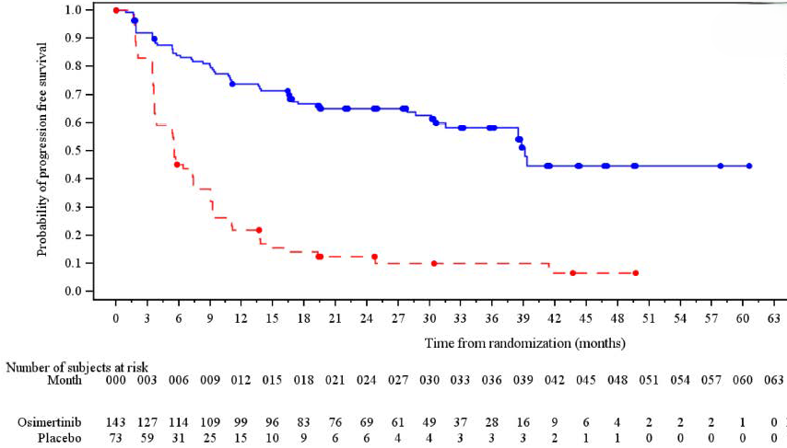
B. OS (DCO 29 November 2024)
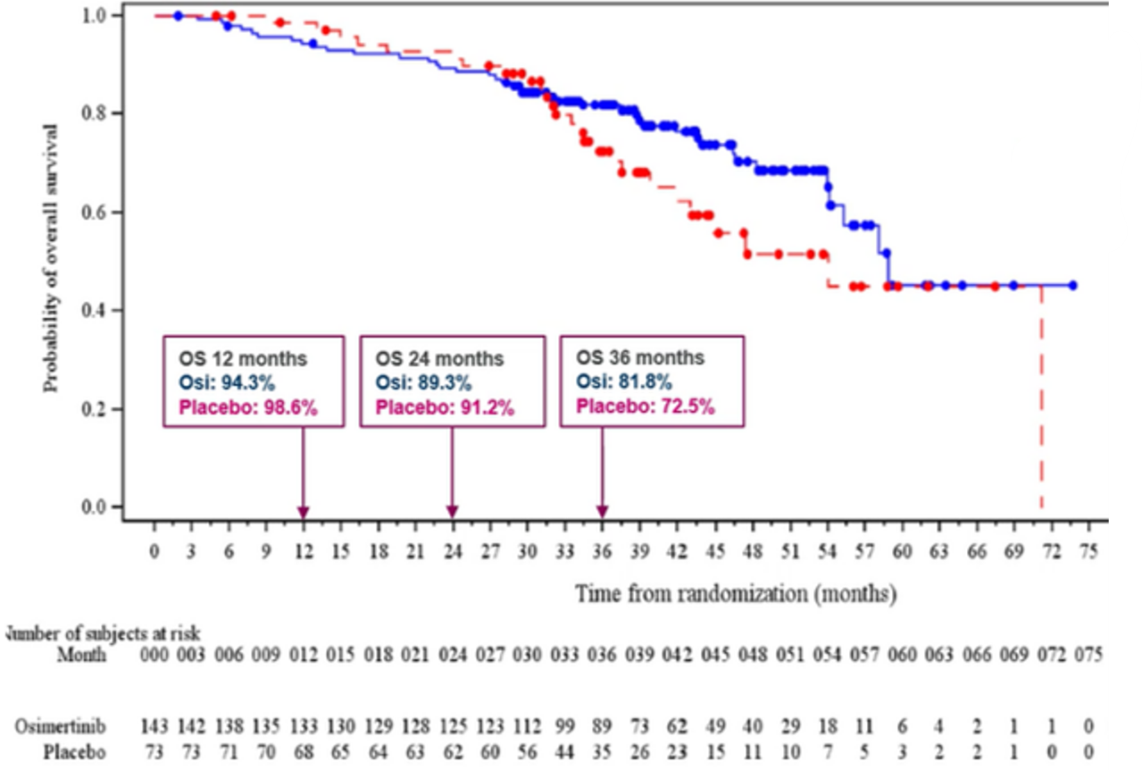
Source: Figures 2-4, p73 and 2-8, p79 of the submission.
BICR = blinded independent central review; DCO = data cut-off; OS = overall survival
  - Osimertinib was associated with significant benefit compared to placebo for PFS, with a significant reduction in disease progression (18-month PFS rate 69% vs 15%, HR 0.16 [95%CI 0.10, 0.24]). It was noted during the evaluation that the proportional hazards assumption for PFS appeared to be violated, given residual plots indicated time trends (paragraph 6.45). The hazard ratio should be interpreted with caution. The evaluation also considered that disease progression in the placebo arm appeared poorer than might be expected in clinical practice in Australia.
  - To aid interpretation of the LAURA trial results, PFS data from the control arms of PACIFIC, ADAURA, and FLAURA were extracted during the evaluation and presented alongside LAURA in an unadjusted, unanchored visual comparison (Figure 2). While none are a perfect match, these trials offer a reference for interpreting the findings. Specifically:
- LAURA subgroups: patients with and without a pre-CRT PET scan.
- PACIFIC trial: evaluated durvalumab versus placebo in patients with Stage III NSCLC. The control arm received placebo, 6.0% of participants had confirmed EGFR pathogenic variant NSCLC (26.6% had unknown EGFR status). The PSCR stated that the placebo arm of the PACIFIC trial would not be expected to have a comparable PFS risk as that for the LAURA trial due to different EGFR status.
- FLAURA trial: Compared osimertinib with first- or second-generation EGFR TKIs in first line treatment of patients with metastatic Stage IIIB-IV EGFR pathogenic variant NSCLC. The PSCR stated that the control arm of the FLAURA trial was active EGFR-TKI and therefore not appropriate for comparison to placebo.
- ADAURA trial: Assessed adjuvant osimertinib versus placebo in patients with resectable Stage IB-IIIA EGFR pathogenic variant NSCLC. The control arm depicted in Figure 2 includes only the Stage IIIA subgroup. The PSCR stated that the ADAURA trial was conducted in the adjuvant setting after tumour removal and therefore PFS in the placebo arm is likely to be better than in the LAURA trial.
Figure 2: Comparison of PFS for osimertinib arm in LAURA and comparator arms of LAURA, PACIFIC, ADAURA and FLAURA trials
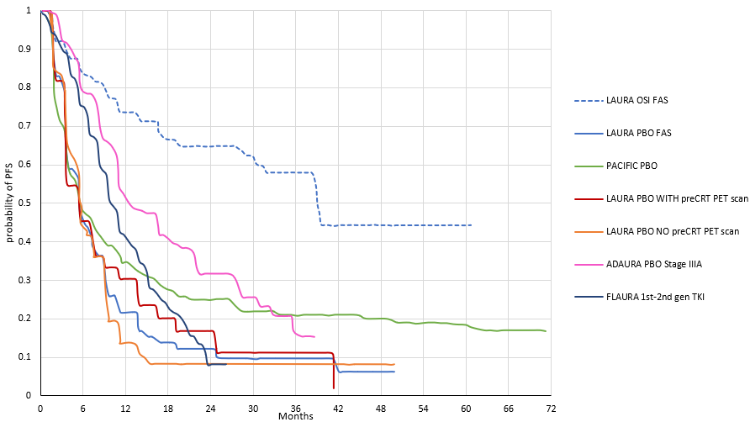

Source: Complied during the evaluation using WebPlotDigitizer 5.2ª, from Figure 1, Lu 2024^{b}, Figure S3C, Wu 2020^{c^}, Figure 2B, Spigel 2022^{d}, Figure 1A, Soria 2017e, and Figure 1, Lu 2024a^{f}
CRT = chemoradiation therapy; EGFR = epidermal growth factor receptor; FAS = full analysis set; Gen = generation; OSI = osimertinib; PET = positron emission tomography; PBO = placebo; PFS = progression-free survival; TKI = tyrosine kinase inhibitor.
ª Automeris LLC, California, USA (available at https://automeris.io)
^{b} Lu S, Kato T, Dong X, et al. Osimertinib after Chemoradiotherapy in Stage III EGFR-Mutated NSCLC. N Engl J Med. 2024;391(7):585-597. doi:10.1056/NEJMoa2402614
^{c} Wu Y-L, Tsuboi M, He J, et al. Osimertinib in resected EGFR-mutated non–small-cell lung cancer. N Engl J Med 2020;383:1711-23. DOI: 10.1056/NEJMoa2027071
^{d} Spigel DR, Faivre-Finn C, Gray JE, et al. Five-Year Survival Outcomes From the PACIFIC Trial: Durvalumab After Chemoradiotherapy in Stage III Non-Small-Cell Lung Cancer [published correction appears in J Clin Oncol. 2022 Jun 10;40(17):1965. doi: 10.1200/JCO.22.01023.]. J Clin Oncol. 2022;40(12):1301-1311. doi:10.1200/JCO.21.01308
^{e} Soria, J.-C., et al. (2018). Osimertinib in Untreated EGFR -Mutated Advanced Non–Small-Cell Lung Cancer. The New England Journal of Medicine., 378(2), 113–125. https://doi.org/10.1056/NEJMoa1713137
^{f} Lu, S. et al. Osimertinib after definitive chemoradiotherapy in unresectable stage III epidermal growth factor receptor-mutated non-small-cell lung cancer: analyses of central nervous system efficacy and distant progression from the phase III LAURA study.
Annals of Oncology, Volume 35, Issue 12, 1116 - 1125
^ The ADAURA trial reported disease-free survival (DFS) after surgical resection with or without chemotherapy consolidation followed by adjuvant osimertinib for up to 3 years. Placebo results for the Stage IIIA subgroup shown.
  - The evaluation noted that the control arms of the PACIFIC, ADAURA, and FLAURA trials all demonstrated more favourable PFS than the placebo patients in the LAURA trial. The evaluation considered that the comparison suggests that placebo patients in Australia may have better PFS than those in LAURA, and therefore, the magnitude of the benefit from osimertinib post-CRT may be smaller in the Australian setting than reported in LAURA. While the ESC acknowledged that placebo arms in the PACIFIC and ADAURA trials may have performed better than the placebo arm in the LAURA trial, it considered that the differences in EGFR status and treatment setting between the trials made the clinical importance of the comparison uncertain.
  - There was no significant difference between osimertinib and placebo in OS at either DCO, however the HR point estimates were in favour of osimertinib, and the confidence interval narrowed between the January 2024 and November 2024 data cuts. The ESC noted that the OS data remained immature, with 66 of the 216 randomised patients having died (31%). The KM curve for the placebo group sits slightly higher than the curve for the treatment group for the first 31 months after randomisation (Figure 3). The evaluation noted that the reason for this was unclear. There was 1 fatal adverse event considered related to osimertinib (pneumonitis), and most deaths (osimertinib arm: 78.6%; placebo arm: 73.3%) were considered to be related to the disease. The ESC noted that the crossing of KM curves suggests a violation of the proportional hazards assumption. Therefore, the HR should be interpreted cautiously, as it may not reflect time-varying effects.
  - Pre-specified subgroup analyses for PFS are presented in Figure 3. All subgroup analyses conducted statistically significantly favoured osimertinib except one, and there were variations in the magnitude of benefit. In the non-Asian trial population, the PFS HR was not statistically significant, however this subgroup was small
(27 patients in the osimertinib arm and 11 patients in the placebo arm), which may have contributed to the wide confidence interval.
Figure 3: Subgroup analysis of PFS
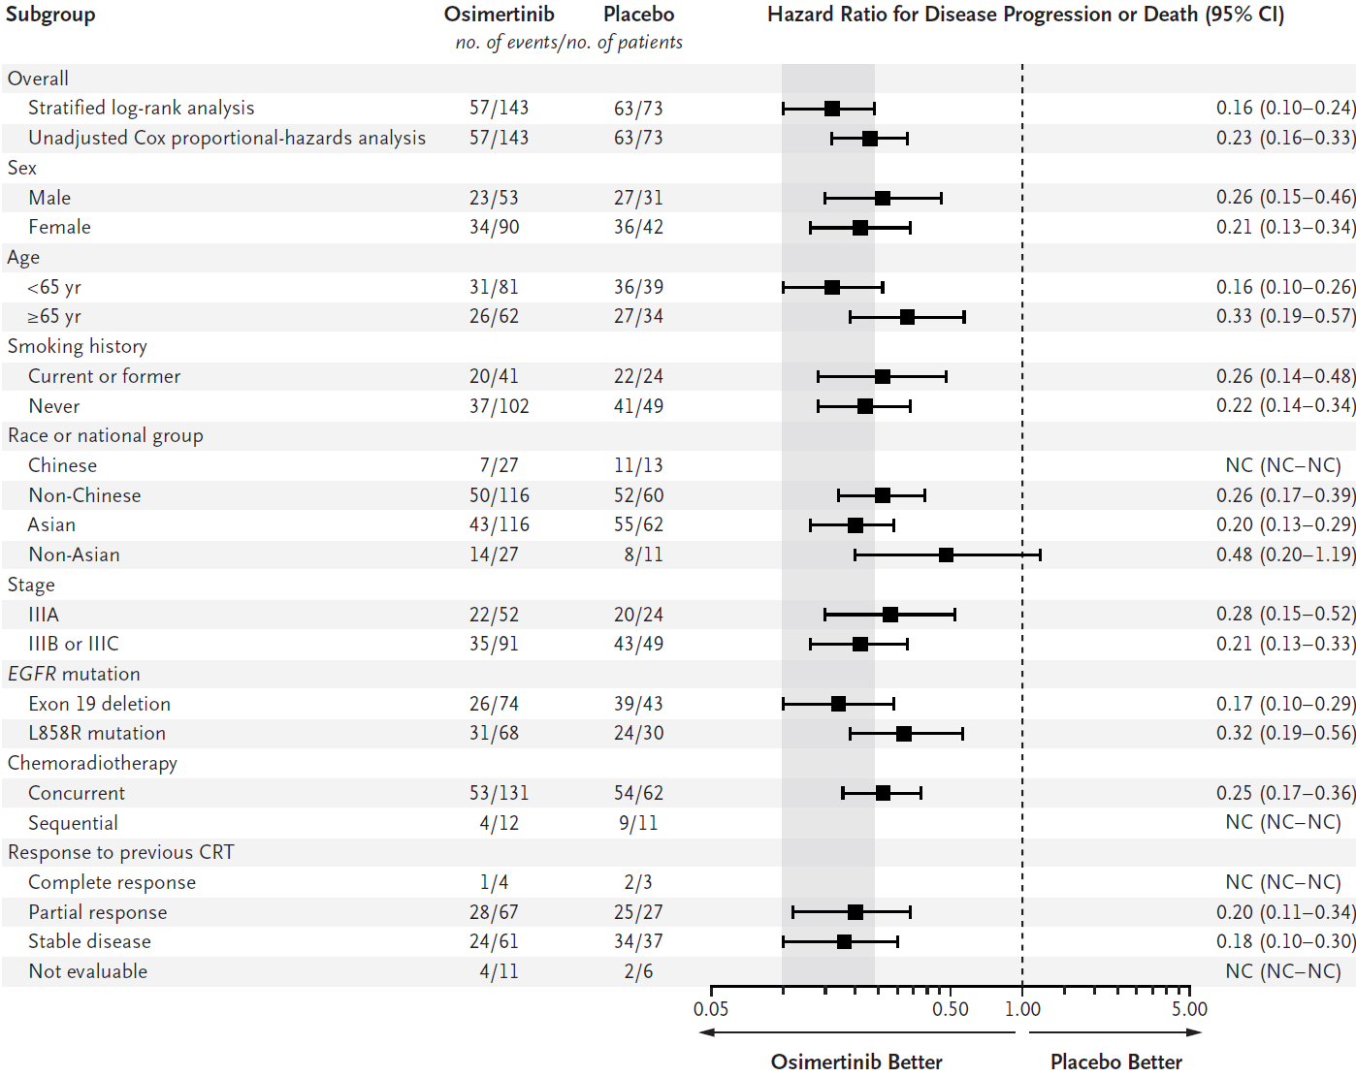
Source: Figure 2, Lu 2024
CI = confidence interval; CRT = chemoradiation therapy; EGFR = epidermal growth factor receptor; NC = not calculable; yr = years
  - Table 6 summarises the response outcomes for the LAURA trial.
Table 6: Response outcomes from the LAURA trial
 | Osimertinib  N=143 | Placebo  N=73 | OR  (95% CI)
Best objective response
Response, n (%) [95% CI] | 82 (57.3) [48.8, 65.6] | 24 (32.9) [22.3, 44.9] | 2.77 (1.54, 5.08)
Complete response | 3 (2.1) | 1 (1.4) | p<0.001
Partial response | 79 (55.2) | 23 (31.5)
Stable disease (≥8 weeks) | 45 (31.5) | 34 (46.6)
Disease progression | 11 (7.7) | 12 (16.4)
Not evaluable | 5 (3.5) | 3 (4.1)
BOR in confirmed responsesª, n (%) [95%CI] | 77 (53.80) [45.3, 62.2] | 19 (26.0) [16.5, 37.6] | 3.33 (1.82, 6.31)  p<0.001
Duration of response
Responders who subsequently progressed or died, n/n (%) | 28/82 (34.1) | 21/24 (87.5) | NR
Time to onset, weeks, mean (SD); median [range] | 25.9 (28.51); 16.00 [6.9, 180.3] | 17.23 (10.203); 15.79 [7.6, 40.0]
Median DoR, months (95%CI) | 36.9 (30.1, NC) | 6.5 (3.6, 8.3)
Depth of Response |  |  | Difference in LS means  -16.6 (-25.85, -7.41) p<0.001
Patients with at least 1 post-baseline scan | 133 | 70 | Difference in LS means  -16.6 (-25.85, -7.41) p<0.001
Best change in tumour size, unadjusted, %, mean (SD); median [range] | -41.5 (33.94);  -43.3 [-100, 144] | -23.5 (27.18);  21.9 [-100, 23] | Difference in LS means  -16.6 (-25.85, -7.41) p<0.001
Source: Table 2-22, p82 2-23, p 83, 2-24, p 84 of the submission and Table 14.2.7.4, p273 of Attachment 2.2 to the submission.
BOR = best objective response; CI = confidence interval; DoR = duration of response; LS = least squares; NC = not calculable; NR = not reported; OR = odds ratio; SD = standard deviation;
Statistically significant results are shown in bold text.
a Response confirmed after 4 weeks
  - Response outcomes were based on BICR assessments. There were a higher proportion of responders in the osimertinib arm than in the placebo arm (57.3% vs 32.9%), and responders in the osimertinib arm had a longer duration of response than responders in the placebo arm (median 36.9 months vs 6.5 months). Patients in the osimertinib arm also had a more favourable depth of response, with a 16.6% greater reduction in tumour size from baseline compared to placebo.
  - Table 7 summarises the other reported time-to-event outcomes: CNS PFS, time to death or distant metastases (TTDM), time to study treatment discontinuation or death (TTD) , time to first- and second subsequent treatments (TFST and TSST, respectively), and second PFS (defined as time from randomisation to death or the progression event following the first objective disease progression, subsequent to the first subsequent therapy). Figure 4 presents the cumulative incidence plot for the TTDM competing risk analysis.
Table 7: Secondary time-to-event outcomes
 | Osimertinib N=143 | Placebo N=73 | Absolute difference | HR (95% CI)
CNS PFSª
Number (%) with event | 29 (20.3) | 30 (41.1)
CNS RECIST progression | 18 (12.6) | 26 (35.6)
CNS Target lesions^{b,c} | 0 | 0
CNS Non-target lesions^{b,c} | 1 (0.7) | 0
CNS New lesions^{b} | 17 (11.9) | 26 (35.6)
Death in the absence of progression | 11 (7.7) | 4 (5.5)
Censored | 114 (79.7) | 43 (58.9)
Median, months [95%CI] | NC (NC, NC) | 14.88 (7.36, NC) | NC | 0.17 (0.09, 0.32)
CNS PFS rate, % (95%CI) |  |  |  | p<0.001
12 months | 86.7 (79.4, 91.5) | 53.0 (38.3, 65.6) | 33.7
24 months | 82.7 (74.7, 88.5) | 43.3 (28.0, 57.7) | 39.4
TTDM
Number (%) with event | 33 (23.1) | 31 (42.5) |  | 0.21 (0.11, 0.38)
Median, months [95%CI] | NC [39.29, NC] | 13.04 [9.03, NC] | NC | p<0.001
TTDM competing risks analysis
Number (%) with event | 57 (39.9) | 63 (86.3)
Distant metastases | 23 (16.1) | 27 (37.0)
Local progression | 30 (21.0) | 35 (47.9)
Death in the absence of distant metastasis or progression | 4 92.8) | 1 91.4) |  | -
Censored | 86 (60.1) | 10 (13.7)
Cumulative incidence rate (95%CI)
12 months | 0.11 (0.06, 0.17) | 0.37 (0.26, 0.48) | 0.26
24 months | 0.14 (0.09, 0.21) | 0.39 (0.27, 0.50) | 0.25
TTD
Number (%) with event | 63 (44.1) | 66 (90.4) |  | 0.21 (0.14, 0.32)
Median, months [95%CI] | 40.28 [32.72, NC] | 8.31 [6.14, 11.10] | 31.97 | p<0.001
TFST
Number (%) with event | 53 (37.1) | 61 (83.6) |  | 0.13 (0.08, 0.21)
Median, months [95%CI] | 43.83 [38.87, NC] | 9.46 [6.60, 11.53] | 34.37 | p<0.001
TSST
Number (%) with event | 32 (22.4) | 24 (32.9) |  | 0.51 (0.28, 0.91)
Median, months [95%CI] | NC [44.42, NC] | 47.38 [34.14, NC] | NC | p<0.001
Second PFS
Number (%) with event | 34 (23.8) | 24 (32.9) |  | 0.62 (0.35, 1.08)
Median, months [95%CI] | 48.20 [44.42, NC] | 47.38 [28.22, NC] | 0.82 | p=0.088
Source: Table 2-21, p81 of the submission, Table 14.2.8.1, p277, 14.2.8.2, p278, 14.2.9.2.1, p283, 14.2.9.1.1, p281 of Attachment 2.2 ‘csr-section-14-tables-figures’ of the submission.
BICR = Blinded Independent Central Review; CI = confidence interval; CNS = central nervous system; HR = hazard ratio; NC = not calculable; PFS = progression-free survival; TFST = time to first subsequent treatment; TSST = time to second subsequent treatment; TTD = time to study treatment discontinuation or death; TTDM = time to death or distant metastases.
Statistically significant results are shown in bold text.
ª CNS PFS events that did not occur within 2 scheduled visits (plus visit window) of the last non-missing assessment (or randomisation) are censored.
^{b} Target lesions, non-target lesions and new lesions are not mutually exclusive categories.
^{c} It is noted that whilst patients were free of CNS disease at baseline according to the Investigator, the neuroradiologist BICR reader could independently assign target and non-target lesions during CNS BICR assessment.
Figure 4: Cumulative incidence plot of TTDM, competing risk analysis
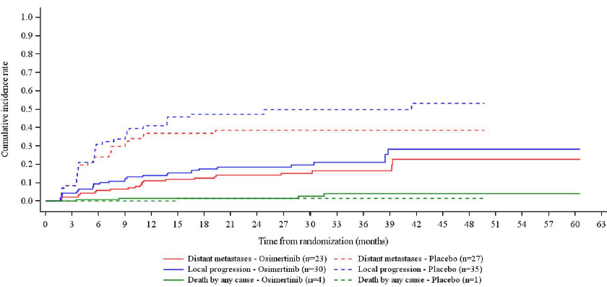

Source: Figure 14.2.8.4, p280 of Attachment 2.2 ‘csr-section-14-tables-figures’ of the submission.
TTDM = time to death or distant metastases.
  - The efficacy of osimertinib in the CNS has been demonstrated in the ADAURA (early stage, adjuvant setting) and FLAURA (late stage, first-line setting) trials (osimertinib PI). In the LAURA trial, new CNS lesions accounted for the majority of CNS PFS events in both arms (17/29 events in the osimertinib arm and 26/30 events in the placebo arm). At DCO 5 January 2024, after a median 24.64 months follow-up, the median CNS PFS had not yet been reached in the osimertinib arm and was 14.88 months
(95%CI 7.36, NC) in the placebo arm, after a median 5.72 months follow-up.
  - Patients in the osimertinib arm had significantly longer TTDM, TTD, TFST, and TSST than those in the placebo arm. However, while the HR for second PFS favoured osimertinib, it was not statistically significant (HR 0.62: 95%CI 0.35, 1.08), though second PFS data were immature (26.9%). The evaluation noted that the results for TSST and second PFS may not be generalisable to the Australian population due to the differences between the subsequent treatments received by those in the trial in the osimertinib arm and those likely to be received in Australia.
  - Table 8 summarises the patient reported outcomes from the LAURA trial.
Table 8: Patient reported outcomes
PRO scale | Treatment arm | N | Number (%) of patients with events | Patients without deterioration, % (95%CI) |  | HR (95% CI)
 |  |  |  | At 6 months | At 12 months | HR (95% CI)
QLQ-C30ª
GHS/QoL | Osimertinib | 131 | 65 (49.6) | 68.0 (59.1, 75.3) | 59.7 (50.5, 67.6) | 1.14 (0.74, 1.78)
GHS/QoL | Placebo | 68 | 28 (41.2) | 68.1 (55.3, 77.9) | 58.6 (45.1, 69.8) | 1.14 (0.74, 1.78)
Physical function | Osimertinib | 130 | 56 (43.1) | 68.9 (60.0, 76.3) | 64.8 (55.7, 72.5) | 1.06 (0.65, 1.71)
Physical function | Placebo | 68 | 24 (35.3) | 74.1 (61.7, 83.1) | 70.3 (57.3, 80.0) | 1.06 (0.65, 1.71)
Fatigue | Osimertinib | 130 | 84 (64.6) | 46.9 (38.0, 55.3) | 42.6 (33.8, 51.1) | 1.23 (0.85, 1.80)
Fatigue | Placebo | 68 | 37 (54.4) | 66.7 (53.8, 76.7) | 51.3 (37.9, 63.2) | 1.23 (0.85, 1.80)
Appetite loss | Osimertinib | 130 | 58 (44.6) | 69.8 (60.9, 77.0) | 64.7 (55.6, 72.4) | 1.00 (0.63, 1.58)
Appetite loss | Placebo | 68 | 28 (41.2) | 84.7 (73.5, 91.5) | 61.7 (47.4, 73.1) | 1.00 (0.63, 1.58)
QLQ-LC13^{b}
Dyspnoea | Osimertinib | 131 | 96 (73.3) | 33.2 (25.1, 41.4) | 26.9 (19.4, 35.0) | 1.30 (0.91, 1.86)
Dyspnoea | Placebo | 68 | 40 (58.8) | 49.8 (37.4, 61.0) | 45.2 (32.6, 57.0) | 1.30 (0.91, 1.86)
Coughing | Osimertinib | 130 | 86 (66.2) | 43.4 (34.7, 51.8) | 38.2 (29.8, 46.6) | 1.17 (0.81, 1.71)
Coughing | Placebo | 67 | 37 (55.2) | 48.2 (35.7, 59.6) | 46.4 (33.9, 57.9) | 1.17 (0.81, 1.71)
Pain in chest | Osimertinib | 131 | 76 (58.0) | 54.2 (45.2, 62.3) | 48.2 (39.3, 56.6) | 1.46 (0.95, 2.23)
Pain in chest | Placebo | 68 | 25 (36.8) | 70.0 (57.4, 79.5) | 66.1 (53.0, 76.3) | 1.46 (0.95, 2.23)
Source: Table 2-25, p88 of the submission and Table 25, p126 of the CSR.
CI = confidence interval; GHS = global health scale; HR = hazard ratio; PRO = patient reported outcome; QLQ = Quality of Life Questionnaire; QoL = quality of life.
ª QLQ-C30 = European Organization for Research and Treatment of Cancer (EORTC) Quality of Life Questionnaire (QLQ) EORTC QLQ-C30
^{b} QLQ-LC13 = lung-cancer specific companion module to QLQ-C30
  - Completion rates for both questionnaires were > 90% at baseline and were > 70% until after week 32, however, compliance rates in the placebo arm declined after week 32 as the number of expected completions in the placebo arm dropped below 50% of the cohort. There were no significant differences in time to deterioration between the osimertinib and placebo arms in the domains captured by the EORTC QLQ-C30 and QLQ-LC3 instruments, though the point estimates showed higher rates of fatigue, dyspnoea, coughing and pain in chest for osimertinib compared to placebo.

Comparative harms
  - Table 9 presents the key safety data from the LAURA trial.
Table 9: Summary of key adverse events in the LAURA trial
AE Category | Osimertinib N=143  n with eventª (%) | Placebo N=73  n with eventª (%) | RR (95%CI)ª | RD (95%CI)ª
Any AE | 140 (97.9) | 64 (87.7) | 1.12 (1.02, 1.22) | 0.10 (0.02, 0.18)
Treatment related AE^{b} | 115 (80.4) | 30 (41.1) | 1.96 (1.47, 2.61) | 0.39 (0.26, 0.52)
Grade ≥3 | 50 (35.0) | 9 (12.3) | 2.83 (1.48, 5.44) | 0.23 (0.12, 0.33)
Grade ≥3 and treatment related^{b} | 19 (13.3) | 2 (2.7) | 4.85 (1.16, 20.25) | 0.11 (0.04, 0.17)
AE with outcome of death | 3 (2.1) | 2 (2.7) | 0.76 (0.13, 4.45) | -0.01 (-0.05, 0.04)
AE with outcome of death, possibly treatment related^{b} | 1 (0.7) | 0 | NC | 0.01 (-0.01, 0.02)
Commonly reported AEs
Radiation pneumonitis | 68 (47.6) | 28 (38.4) | 1.24 (0.88, 1.74) | 0.09 (-0.05, 0.23)
Diarrhoea | 51 (35.7) | 10 (13.7) | 2.60 (1.41, 4.82) | 0.22 (0.11, 0.33)
Rash | 34 (23.8) | 10 (13.7) | 1.74 (0.91, 3.31) | 0.10 (-0.004, 0.21)
Paronychia | 24 (16.8) | 1 (1.4) | 12.25 (1.69, 88.77) | 0.15 (0.09, 0.22)
Cough | 23 (16.1) | 7 (9.6) | 1.68 (0.76. 3.72) | 0.06 (-0.26, 0.16)
Decreased appetite | 21 (14.7) | 4 (5.5) | 2.68 (0.96, 7.52) | 0.09 (0.01, 0.17)
Dry skin | 18 (12.6) | 4 (5.5) | 2.30 (0.81, 6.54) | 0.07 (-0.004, 0.15)
Pruritus | 18 (12.6) | 5 (6.8) | 1.84 (0.71, 4.75) | 0.06 (-0.22, 0.14)
Stomatitis | 17 (11.9) | 2 (2.7) | 4.34 (1.03, 18.27) | 0.09 (0.03, 0.16)
White blood cell count decreased | 17 (11.9) | 2 (2.7) | 4.34 (1.03, 18.27) | 0.09 (0.03, 0.16)
Any SAE | 55 (38.5) | 11 (15.1) | 2.55 (1.43, 4.57) | 0.23 (0.12, 0.35)
Treatment related SAE | 12 (8.4) | 1 (1.4) | 6.13 (0.81, 46.20) | 0.07 (0.18, 0.12)
Any AE leading to discontinuation of treatment | 18 (12.6) | 4 (5.5) | 2.30 (0.81, 6.54) | 0.07 (-0.004, 0.15)
Any AE leading to discontinuation of treatment possibly related to treatment^{b} | 9 (6.3) | 0 | NC | 0.06 (0.02, 0.10)
Any AE leading to dose modification | 80 (55.9) | 18 (24.7) | 2.27 (1.48, 3.48) | 0.31 (0.18, 0.44)
Any AE leading to dose reduction | 12 (8.4) | 1 (1.4) | 6.12 (0.81, 46.20) | 0.07 (0.02, 0.12)
Any AE leading to dose interruption | 80 (55.9) | 18 (24.7) | 2.27 (1.48, 3.48) | 0.31 (0.18, 0.44)
ª Estimated during the evaluation.
Source: Table 2-30, p93 of the submission.
AE = adverse event; CI = confidence interval; n = number of participants reporting data; N = total participants in group; NC = not calculable; RD = risk difference; RR = risk ratio; SAE = serious adverse event.
ª Patients with multiple events in the same category are counted only once in that category. Patients with events in more than one category are counted once in each of those categories.
^{b} Investigator assessed.
  - Adverse events (AEs) were reported by most patients in the trial. A higher proportion of patients in the osimertinib arm reported a serious AE (38.5% vs 15.1%), with 12.6% experiencing an AE leading to discontinuation of the study drug, compared to 5.5% in the placebo arm. More patients in the osimertinib arm had an AE leading to dose modifications including dose interruptions (55.9% vs 24.7%) and dose reductions (8.4% vs 1.4%). One patient in the osimertinib arm had an AE of pneumonitis leading to death. The investigator considered the Grade 5 event of pneumonitis to be related to osimertinib and rivaroxaban (concomitant medication), and also considered the patient’s death to be related to their underlying cancer.
  - Patients with Grade ≤2 toxicities from prior CRT were allowed to enrol in the study. The most frequently reported (> 10%) AEs in the osimertinib arm were radiation pneumonitis, diarrhoea, rash, paronychia, cough, dry skin, pruritus, stomatitis, decreased white blood cell count and pneumonia. Radiation pneumonitis, diarrhoea, rash and musculoskeletal chest pain were the most common AEs reported in the placebo arm. Radiation pneumonitis is common after CRT, and patients with symptomatic radiation pneumonitis at screening were excluded from the trial. The evaluation considered that the AE profile for osimertinib in LAURA was consistent with AEs identified in previous clinical trials of osimertinib.
  - Interstitial lung disease (ILD), pneumonitis and pulmonary fibrosis were considered to be AEs of special interest for osimertinib. Reporting of these AEs in LAURA was low, but higher in the osimertinib arm. Table 10 summarises the AEs of special interest.
Table 10: AEs of special interest from the LAURA trial
Grouped Term | Treatment arm | Number of patients (%)
Grouped Term | Treatment arm | Any AE | CTCAE  Grade ≥ 3 | SAE | DAE | Related to IP
ILD and Pneumonitis | Osimertinib | 11 (7.7) | 3 (2.1) | 3 (2.1) | 3 (2.1) | 9 (6.3)
ILD and Pneumonitis | Placebo | 1 (1.4) | 0 | 0 | 0 | 1 (1.4)
Interstitial lung disease | Osimertinib | 1 (0.7) | 1 (0.7) | 1 (0.7) | 1 (0.7) | 1 (0.7)
Interstitial lung disease | Placebo | 0 | NA | NA | NA | NA
Pneumonitis | Osimertinib | 8 (5.6) | 2 (1.4) | 2 (1.4) | 2 (1.4) | 8 (5.6)
 | Placebo | 1 (1.4) | 0 | 0 | 0 | 1 (1.4)
Pulmonary Fibrosis | Osimertinib | 3 (2.1) | 0 | 0 | 0 | 1 (0.7)
 | Placebo | 0 | NA | NA | NA | NA
Source: Table 2-36, p100 of the submission.
AE = adverse event; CTCAE = Common Terminology Criteria for Adverse Events; DAE =adverse event leasing to discontinuation; ILD = interstitial lung disease; IP = investigational product; NA = not applicable; SAE = serious adverse event.

Benefits/harms
  - A summary of the comparative benefits and harms for osimertinib versus placebo (standard of care) is presented in Table 11.
Table 11: Summary of comparative benefits and harms for osimertinib and placebo from LAURA
Progression free survival (DCO1 January 5, 2024)
Event | Osimertinib | Placebo | Absolute Difference | HR (95% CI)
Disease progression or death, n/N (%) | 57/143 (39.9%) | 63/73 (86.3%) | - | 0.16 (0.10, 0.24)  p<0.001
Median PFS, months (95% CI) | 39.13 (31.51, NC) | 5.55 (3.71, 7.43)) | 33.58 | 0.16 (0.10, 0.24)  p<0.001
PFS rate at 12 months, % (95% CI) | 73.7 (65.4, 80.3) | 21.8 (13.0, 32.1) | 51.9% | 0.16 (0.10, 0.24)  p<0.001
PFS rate at 24 months, % (95% CI) | 65.1 (56.4, 72.6) | 12.5 (5.9, 21.6)) | 52.6% | 0.16 (0.10, 0.24)  p<0.001
PFS rate at 36 months, % (95% CI) | 58.4 (48.6, 66.9) | 10.0 (4.0, 19.2) | 48.4% | 0.16 (0.10, 0.24)  p<0.001
Median (range) duration of follow-up, months | 21.98 (0.03, 60.55) | 5.55 (0.03, 49.71) | - | 0.16 (0.10, 0.24)  p<0.001
Overall survival (DCO2 November 29, 2024)
Deaths, n/N (%) | 40/143 (28.0) | 26/73 (35.6) | - | 0.67 (0.40, 1.14) p=0.140
Median OS, months (95% CI) | 58.81 (54.0, NC) | 53.98 (42.05, NC) | 4.83 | 0.67 (0.40, 1.14) p=0.140
% Alive at 12 months | 94.3 | 98.6 | 4.3% | 0.67 (0.40, 1.14) p=0.140
% Alive at 24 months | 89.3 | 91.2 | 1.9% | 0.67 (0.40, 1.14) p=0.140
% Alive at 36 months | 81.8 | 72.5 | 9.3% | 0.67 (0.40, 1.14) p=0.140
Median follow-up (censored patients only) | 42.61 | 37.52 | 5.1 | 0.67 (0.40, 1.14) p=0.140
Harms
AE Category | Osimertinib  n/N | Placebo  n/N | RR (95% CI)ª | RD (95% CI)ª | Event rate/100 patients^{b}
 |  |  |  |  | Osimertinib | Placebo
Any AE | 140/143 | 64/73 | 1.12 (1.02, 1.22) | 0.10 (0.02, 0.18) | 97.9 | 87.7
Diarrhoea | 51/143 | 10/73 | 2.60 (1.41, 4.82) | 0.22 (0.11, 0.33) | 35.7 | 13.7
Paronychia | 24/143 | 1/73 | 12.25 (1.69, 88.77) | 0.15 (0.09, 0.22) | 16.8 | 1.4
Stomatitis | 17/143 | 2/73 | 4.34 (1.03, 18.27) | 0.09 (0.03, 0.16) | 11.9 | 2.7
White blood cell count decreased | 17/143 | 2/73 | 4.34 (1.03, 18.27) | 0.09 (0.03, 0.16) | 11.9 | 2.7
Grade ≥3 AEs
Any Grade ≥3 | 50/143 | 9/73 | 2.84 (1.48, 5.44) | 0.23 (0.12, 0.33) | 35.0 | 12.3
Source: Table 2-18, p72, 2-34, p97, 2-31, p94 of the submission}.
AE = adverse event; CI = confidence interval; DCO = data cut-off; HR = hazard ratio; OS = overall survival; PFS = progression free survival; PBO = placebo; RD = risk difference; RR = risk ratio.
Statistically significant results are shown in bold text.
ª Estimated during the evaluation.
^{b} Includes AEs with onset date on or after the date of first dose and up to and including the earlier of 28 days following the date of last dose of study medication and the day before the start of subsequent anti-cancer therapy.
  - On the basis of direct evidence presented by the submission, for every 100 patients treated with osimertinib in comparison with placebo (standard of care):
- Approximately 48 additional patients will remain progression-free after 3 years, however, there would be no difference in overall survival after 4 years;
- Approximately 23 more patients would experience a grade ≥3 adverse event.

Clinical claim
  - The submission described osimertinib as superior in terms of effectiveness compared with placebo/SoC and with inferior but manageable safety. The evaluation considered that the conclusions were reasonable with respect to efficacy and safety based on data from the LAURA trial. The ESC noted that osimertinib effectively prolongs PFS, according to the separation of osimertinib and placebo KM curves with an associated HR of 0.16 (95% CI 0.10, 0.24, p < 0.001).
  - However, important limitations were noted by the evaluation and the ESC with respect to OS results from the LAURA trial:
- OS data from LAURA remained immature at the latest follow up (DCO2:
29 Nov 2024) with OS yet to reach statistical significance (HR 0.67, 95%CI 0.40, 1.14, p=0.140). The data reflected only 31% maturity (66 of the 216 randomised patients had died). The PSCR stated that the substantial improvement in PFS is expected to lead to a statistically significant OS result. At DCO1, with OS data at 20% maturity, the HR was 0.81 (95% CI 0.42, 1.56, p=0.530). By DCO2, with maturity at 31%, the trend towards an OS benefit continued, reaching a HR of 0.67. While the ESC noted a trend over time suggestive of an OS benefit, it considered that it may be necessary for mature OS data to become available to confirm the benefit of osimertinib in the unresectable locally advanced setting and distinguish between curative treatment versus suppression of established metastatic disease. The PSCR stated that mature OS data would be available in late 2026.
- The KM data from the LAURA trial indicates that patients receiving osimertinib experienced a higher rate of death than placebo patients prior to Month 31. The crossing of KM curves after Month 31 suggests a violation of the proportional hazards assumption. Therefore, the HR should be interpreted cautiously, as it may not reflect time-varying effects. The PSCR stated that there was no evidence to suggest that the deaths in the osimertinib arm were due to AEs since the numbers of AEs leading to death was low and comparable between the arms (2/28 [7%] in the osimertinib arm and 1/15 [7%] in the placebo arm). Notwithstanding, the ESC considered that while the toxicity of osimertinib is well known, it has inferior safety to placebo and may have contributed to the violation of the proportional hazards for OS.
  - Furthermore, the evaluation and the ESC noted that the results from the trial population may not be generalisable to the Australian population:
  - PFS for the LAURA placebo arm was poorer than those reported in control arms of other trials (PACIFIC, FLAURA and ADAURA trials) with Stage III EGFR pathogenic variant NSCLC (Figure 2). The PSCR noted that the other trials had different EGFR status, control arms (active EGFR-TKI), or treatment settings (adjuvant therapy after surgical resection) to the LAURA trial, respectively, and therefore the PFS risk of these control arms could not be compared with LAURA (paragraph 6.17).
  - Over 80% of participants in the LAURA trial were from Asia, with the majority from low- to middle- income countries, where limited access to PET scans and variable CRT quality may have contributed to poorer outcomes. The standard of equipment and treatments available may have impacted the trial results (paragraph 6.12). The PSCR stated that multi-national clinical trials in EGFR mutant NSCLC are located in Asian countries because they generally have a higher incidence of patients with these mutations, noting that Asian patients are over-represented among Australian EGFRm NSCLC patients. Further, the large urban centres of these Asian countries have a high standard of medical care, and they were selected with consideration of access to medical technologies and ability to comply with the study protocol.
  - The trial population had a better performance status (WHO PS 0 or 1) than the proposed PBS population (≤2) (paragraph 3.6).
  - The subsequent therapies received on progression, including the continued use of osimertinib and initiation of other TKIs, were not consistent with Australian practice. The PSCR noted that post-progression use of osimertinib is not permitted by the proposed restriction. However, the ESC considered that the post-progression use of osimertinib and other EGFR-TKIs in the osimertinib arm (35% [22/63] of osimertinib patients who progressed) remains an applicability issue between the trial data and the likely circumstances of use in Australia.
  - The ESC agreed with the evaluation that the expected benefit in the Australian population for osimertinib versus placebo may be of a smaller magnitude than that observed in LAURA based on PFS in the placebo arm potentially being better in Australia, better access to PET scans in Australia, and potentially better WHO PS of Australian patients.
  - The ESC and the PBAC noted the high rate of post-progression EGFR-TKIs (including osimertinib) used as subsequent treatment in the placebo arm (85% [56/66] of patients who discontinued due to disease progression). The ESC considered that the post-progression treatments in the placebo arm likely affected the OS results in the LAURA trial but that this would be reflective of SoC treatment practices in Australia (patients would receive their first EGFR-TKI in the locally advanced/metastatic setting).
  - While the PBAC acknowledged the comments from the evaluation and the ESC regarding the limitations of the immature OS data and the potential applicability issues to the Australian population, it considered that the claim of superior comparative effectiveness was reasonable based on the strong PFS outcome result for the Stage III population.
  - The PBAC considered that osimertinib has inferior safety to placebo based on data from the LAURA trial. The PBAC noted that there was no additional safety signals observed for osimertinib compared to the other settings/populations already covered for treatment with osimertinib on the PBS.

Economic analysis
  - The submission presented a stepped economic evaluation comparing osimertinib versus placebo based on the LAURA trial. The modelling was a cost-utility analysis using a three-state partitioned survival model with the health states: PFS, progressive disease (PD) and death. Table 12 summarises the key aspects of the model presented in the submission.
Table 12: Summary of model structure, key inputs and rationale
Component | Summary
Treatments | Osimertinib versus placebo
Time horizon | 10 years in the model base case versus 49 monthsª in the LAURA trial.  The evaluation considered this was likely reasonable. The submission’s justification was that the proposed time horizon for Stage III NSCLC sits between the 15- and 7.5-year time horizons that PBAC had previously accepted in the adjuvant NSCLC and first-line metastatic NSCLC settings, respectively.
Outcomes | LYG and QALYs.
Methods used to generate results | Partitioned survival model.
Health states | PFS, PD and Dead
Cycle length | One month
Allocation to health states | Based on PFS and OS KM curves from the LAURA trial (the OS KM data for osimertinib was adjusted [discussed below]), up to the truncation time points (PFS: 36 and 13 months for osimertinib and placebo, respectively; OS: 50 and 46 months for osimertinib and placebo, respectively). The evaluation considered that the point of truncation was reasonably set at the point at which approximately 20% of patients remain in the risk set (Pocock 2002). The Pocock publication stated that it would often be reasonable to curtail the plot when only 10−20% are still in follow-up.  An adjustment was applied to the first 30 months of the model which assumed that the survival modelled for the osimertinib arm could not be worse than the survival observed in the placebo arm. Therefore, for the first 30 months of the model, the OS of the osimertinib arm was assumed to equal the OS of the placebo arm. This assumption favoured osimertinib.  After truncation points, PFS (both arms) and OS (placebo arm only in base case analysis) was extrapolated. The OS for the osimertinib arm was estimated by applying a HR (0.67).
Extrapolation method | PFS: Parametric model fitted to KM estimates from each treatment arm, selection of parametric function was based on goodness of fit (AIC/BIC) in the placebo arm, and the most conservative extrapolation of PFS in the osimertinib arm.  OS: Base case: Parametric models were fitted to the placebo arm KM data, selection of parametric function based on goodness of fit (AIC/BIC). A HR approach was applied beyond the truncation time point to estimate modelled osimertinib OS. Time-varying HR from Year 3 to Year 10 was applied to represent the effect of treatment waning.  The evaluation noted that there were no significant differences in OS between osimertinib and placebo based on the results of LAURA, which was at 31% maturity in the latest follow-up data.  OS: Sensitivity analysis: Parametric model fitted to each treatment arm.  n/a = not applicable  21−29% of outcomes (and 16-24% of costs) occur in the extrapolated period.
   | Osimertinib | Placebo
  PFS | exponential | generalised gamma
  OS | Weibull (sensitivity analysis) | gamma
  TTD | exponential | n/a
Health related quality of life | Progression-free survival (PFS) = 0.871 (pooled across treatment arms); mapped from EQ-5D-5L data from LAURA using an Australian algorithm (Viney 2011).  Progressive disease (PD) = 0.731; based on applying disutility of PD versus PFS (0.14) from the durvalumab November 2018 PBAC model. The submission stated that it was inappropriate to use HRQoL data from the LAURA trial for patients with progressive disease. The ICER was sensitive to the assumed disutility of PD versus PFS.  Disutility of AEs (first line) = 0.0735 and 0.047 for grade ≥3 pneumonia/radiation pneumonitis and diarrhoea, respectively. The ICER was insensitive to the disutility of AEs.
Costs of osimertinib (proposed listing) | The submission assumed that TTD would follow a similar relationship to PFS, based on the PBS restriction that patients should cease osimertinib treatment upon disease progression. Mean duration of treatment was assumed to be |||| months in the base case, based on a median PFS of 39.1 months from LAURA. In order to achieve a mean of |||| months in the model, the maximum duration of osimertinib treatment was set to 67 months. The median TTD was |||| months from the LAURA trial, as trial patients were allowed to remain on treatment post-progression. The evaluation noted that OS data is immature and there is a lack of guidance on the optimal duration of treatment for osimertinib, hence there is a risk of extended use of osimertinib in this setting.
Costs of subsequent treatment | EGFR-TKIs are restricted to once in a lifetime use on PBS. Hence, the model assumed 0% of patients in the osimertinib arm would receive subsequent osimertinib. This was reasonable. However, subsequent treatments with immunotherapy were excluded in the osimertinib arm of the model, which the evaluation considered was inappropriate given effective subsequent options such as ABCP (atezolizumab, bevacizumab in combination with platinum doublet chemotherapy).  Duration of treatment of osimertinib (in the metastatic setting) was assumed to be |||| months, based on details in the 2021 deed for osimertinib based on FLAURA.  The model assumed a 50% rebate for the published prices of atezolizumab and nivolumab.
Disease monitoring costs | One hospitalisation per year for PFS patients and two hospitalisations per year for PD patients, based on assumptions. The submission stated that AIHW data found two hospitalisations per year for patients with NSCLC, which could not be verified during the evaluation. The model applied a hospitalisation cost of $9,203 based on AR-DRG E71A-B.  The submission also assumed that all patients would require regular follow-up visits as well as pathology and diagnostic tests as part of routine disease monitoring, but the model assumed no difference in utilisation of all other healthcare costs, aside from hospitalisation costs, between PFS and PD patients.
End of life costs | The model applied a one-off cost ($17,904) upon transition to the dead health state. The cost of an episode of hospitalisation was removed to avoid double-counting. This was based on the cost of palliation from Reeve 2018 (estimating total healthcare cost in the last 6 months of life in cancer cohort in elderly Australian patients), however the quoted value of $27,107 could not verified during the evaluation, the 2009/2010 cost quoted in Reeve 2018 was $28,091.
Source: Table 3-1, p114 of the submission.
AE = adverse event; AIC/BIC= Akaike/Bayesian information criterion; EGFR = epidermal growth factor receptor; HR = hazard ratio; KM = Kaplan-Meier; LYG=life years gained, NSCLC = non-small-cell lung cancer; OS = overall survival; PD = progressive disease; PFS = progression free survival; TTD = time to treatment discontinuation; QALYs=quality adjusted life years, TKI = tyrosine kinase inhibitor.
ª The total follow-up duration for the LAURA trial was not reported. 49 months is the duration for which PFS data from DCO1 is available for both treatment arms (p116 of submission). Median follow-up for OS was 29.5 months and 28.1 months for osimertinib and placebo, respectively.
  - The economic model assumed a 10-year time horizon. The selection of this time horizon was based on the time horizons of 15 years in the adjuvant NSCLC setting (paragraph 6.28, osimertinib PSD, November 2023 and paragraph 6.37, atezolizumab PSD, July 2022) and 7.5 years in the first-line metastatic NSCLC setting (Table 9, osimertinib PSD, July 2020). The evaluation considered that this was likely reasonable. The PBAC previously considered that a 10-year time horizon was reasonable for durvalumab for the treatment of Stage III unresectable NSCLC in patients who have not progressed after platinum-based CRT (paragraphs 6.42 and 7.7, durvalumab PSD, July 2019). The incremental cost effectiveness ratio (ICER) was sensitive to time horizon.
  - Health state allocation for treatment arms in the model was determined by PFS and OS curves from the LAURA trial.
  - The model fitted independent parametric survival models to observed KM data from each arm of the LAURA trial for PFS curves, beyond truncation points (36 and 13 months for osimertinib and placebo, respectively). The point of truncation was set at the point at which approximately 20% of patients remain in the risk set (Pocock 2002); the evaluation considered that this was reasonable.
  - The submission chose the generalised gamma function for the placebo arm based on goodness of fit statistics. The submission chose the exponential function for the osimertinib arm in the base case, to represent the most conservative extrapolation of PFS; the evaluation considered that this was reasonable. The ICER was fairly insensitive to the parametric function chosen to extrapolate PFS for the osimertinib arm. The submission did not discuss testing the proportional hazards assumption, but it appeared that the proportional hazards assumption was violated, given the Schoenfield residual plots indicated time trends. Parametric functions for PFS are presented in Figure 5.
Figure 5: Parametric functions for PFS
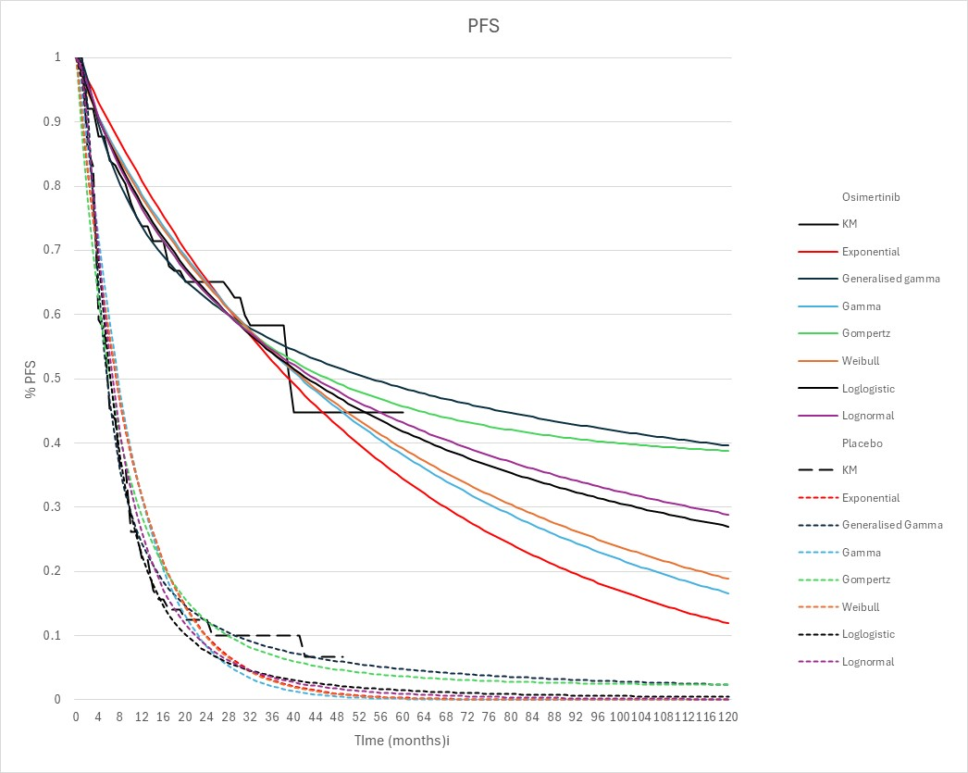
Source: independently constructed during the evaluation from ‘Osi extrap’ and ‘Placebo extrap’ worksheets of LAURA economic evaluation file. Figure 3-2, p128 of the submission appears to be inaccurate and mislabelled generalised gamma and gamma functions.
KM = Kaplan-Meier; PFS = progression-free survival.
  - The evaluation considered that placebo patients in Australia may have better PFS than those in the LAURA trial, and therefore, the magnitude of the benefit from osimertinib post-CRT may be smaller in the Australian setting than reported in the LAURA trial (paragraphs 6.36−6.37). LAURA subgroup data showed that patients who had a
pre-CRT PET scan had better PFS outcomes than those who did not (paragraph 6.12). An additional sensitivity analysis performed during the evaluation, replacing the PFS curves for this subgroup in the model (instead of those for the FAS population), found that the ICER increased to $55,000 to < $75,000/quality adjusted life year (QALY) from a base case of $55,000 to < $75,000/QALY gained. Figure 6 shows the PFS curves from the LAURA trial for the FAS population and the subgroup with pre-CRT PET scan.
Figure 6: PFS curves from the LAURA trial: FAS and subgroup with preCRT PET scan
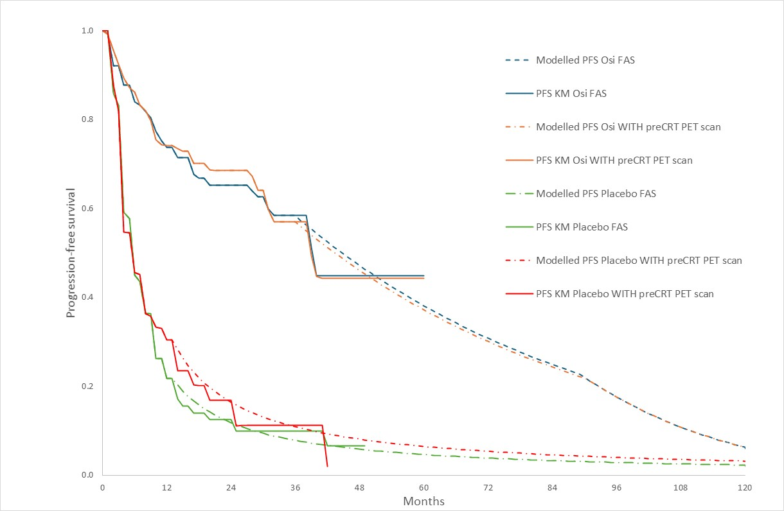
Source: independently constructed during the evaluation. Data for preCRT PET scan were digitised from Figure 1A, Lu 2024aª
CRT = chemoradiation therapy; FAS = Full Analysis Set; KM = Kaplan-Meier; Osi = osimertinib; PET = positron emission tomography; PFS = progression-free survival.
ª Lu, S. et al. Osimertinib after definitive chemoradiotherapy in unresectable stage III epidermal growth factor receptor-mutated non-small-cell lung cancer: analyses of central nervous system efficacy and distant progression from the phase III LAURA study, Annals of Oncology, Volume 35, Issue 12, 1116 - 1125
  - Overall survival was based on the observed KM data from the LAURA trial up to truncation points for OS curves (50 and 46 months for osimertinib and placebo, respectively), and subsequently applied a HR approach to the extrapolated OS curve for the placebo arm to generate the OS curve for the osimertinib arm. An adjustment was applied to the first 30 months of the model that assumed that the survival modelled for the osimertinib arm could not be worse than the survival in the placebo arm. Therefore, for the first 30 months of the model, the OS of the osimertinib arm was assumed to equal the OS of the placebo arm. Removing this adjustment increased the ICER from $55,000 to < $75,000 per quality adjusted life year (QALY) gained to $55,00 to < $75,000 QALY gained.
  - The OS for the osimertinib arm was extrapolated by applying a HR of 0.67 to the OS curve of the placebo arm. The model assumed that the HR for OS increased linearly each cycle up to a maximum of 1.0 between Year 3, and Year 10 to represent the effect of treatment waning. The OS HR for osimertinib versus placebo from LAURA was not statistically significant: DCO2 HR=0.67 (95%CI 0.40, 1.14, p=0.140). The submission stated that a HR approach had been previously accepted by the PBAC in the olaparib consideration for metastatic breast cancer (paragraph 7.12, olaparib PSD, July 2024), despite no statistically significant improvement in OS. The PSCR also noted that this methodology was used to adjust for the subsequent TKI use in 19.6% of the osimertinib arm of the LAURA trial.
  - It was noted by the evaluation that long-term extrapolations were likely to be uncertain. Overall survival data from the LAURA trial were immature (31% maturity at DCO2) and the crossing of KM curves suggests a violation of the proportional hazards assumption. Therefore, the HR should be interpreted cautiously, as it may not reflect time-varying effects. In sensitivity analysis, the model extrapolated OS data using parametric functions for both arms of the model. In this scenario, the ICER decreased to $45,000 to < $55,000/QALY from a base case of $55,000 to < $75,000/QALY gained. However, the evaluation noted that the LAURA trial showed no statistically significant improvement in OS. The ESC noted that assuming a HR of 1 for OS increased the ICER to $55,000 to < $75,000/QALY from a base case of $55,000 to < $75,000/QALY gained. The PSCR stated that the submission’s approach was balanced between a favourable extrapolation of OS and the conservative suggestion of assuming a HR of 1. The PSCR argued that using a HR of 1 was not reasonable as it assumes there is no continued OS benefit after trial follow-up, even though 45% of the osimertinib arm remain free from disease progression at the end of trial follow-up (compared to only 7% in the placebo arm).
  - For the PFS health state in the base case, the model applied EQ-5D-5L data from the LAURA trial, using the published Australian algorithm from Viney 2011, which resulted in a utility of 0.871. The difference in utility associated with PD versus PFS was derived from the November 2018 PBAC model for durvalumab. The utility for the PD health state was estimated to be 0.731. Although it is generally more appropriate to use PFS and PD utilities from the same source, the submission stated that it was inappropriate to use HRQoL data from the LAURA trial for the following reasons:
- Patients in the LAURA trial received subsequent anti-cancer treatments (TKIs, platinum chemotherapy, monoclonal antibodies and PD-1/PD-L1 inhibitors), many of which were not consistent with Australian practice.
- High loss of follow-up for post-progression utilities from the LAURA trial skewed the post-progression utility score to be higher than would be observed in clinical practice (0.798 pooled across treatment arms; using the algorithm from Viney 2011).
  - The submission presented alternate utility values from the published literature − mostly all based on published durvalumab models, with smaller differences in PD and PFS health state utilities, ranging between -0.03 (NICE durvalumab model) and -0.16. The osimertinib PBAC model for Stage IIIB/IV metastatic NSCLC assumed utility values of 0.804 and 0.784 for PFS (osimertinib) and PFS (standard care), respectively, and 0.704 for PD (≥180 days to death). The ICER was sensitive to the utility assumed for PD and PFS. When both PFS and PD utilities were derived from the LAURA trial (PD utility of 0.798 using Viney 2011 algorithm), the ICER increased to $55,000 to < $75,000/QALY, from a base case of $55,000 to < $75,000/QALY gained. Additional sensitivity analysis showed that the ICER increased to $75,000 to < $95,000/QALY when the utility of PD was assumed to be 0.03 lower than the utility of PFS (NICE durvalumab model).
  - The PSCR maintained that it would not be appropriate to use EQ-5D data collected in the LAURA trial to inform the post-progression utility value due to the low number and timing of observations recorded post-progression. In total, 2,624 EQ-5D observations were available from 213 patients. Of these, 2,189 observations were recorded pre-progression and 435 were recorded at or soon after treatment discontinuation/progression. Out of the 232 EQ-5D observations recorded at or after progression, 196 were conducted at or within 16 weeks of progression and only 36 observations were conducted later than 16 weeks after progression. The PSCR argued that the PD health state should capture the entire period of time between first progression and death. Given that post-progression EQ-5D assessments in the trial were performed shortly after progression when patients are receiving effective subsequent therapies, the resulting trial-based post-progression utility score does not represent the poorer quality of life observed in later line / terminal patients.
  - The submission assumed that TTD would follow a similar relationship to PFS, based on the PBS restriction that patients should cease osimertinib treatment upon disease progression. The base case analysis assumed a mean duration of treatment for osimertinib of ||| ||| months, based on the observed median PFS of 39.1 months from LAURA (in order to achieve this in the model, the maximum duration of treatment was set to 67 months). The median time to TTD was slightly longer in the LAURA trial (||| ||| months), as patients were allowed to remain on treatment post-progression. However, the evaluation noted that in the proposed restriction, the only stopping rules for osimertinib treatment are disease progression or unacceptable toxicity. There is no confirmed OS data to inform the optimal duration of treatment for osimertinib, and there is a risk of extended use of osimertinib in this setting. The LAURA trial suggested a decline in PFS between 36 and 48 months, implying treatment may need to be continued for at least 4 years (Nozaki 2024). The ESC noted that the ICER was sensitive to the duration of osimertinib treatment. If assuming the mean duration of treatment to be ||| ||| months (||| ||| years), derived by setting the maximum duration of osimertinib treatment to be the entire model time horizon of 10 years, the ICER increased to $75,000 to < $95,000/QALY from a base case of $55,000 to < $75,000/QALY gained. The PSCR stated that duration of treatment (||| ||| months) should be limited by PFS because (i) the proposed restriction does not allow treatment beyond disease progression; (ii) median TTD in the LAURA trial was only slightly longer (||| ||| months) than median PFS (39.1 months), despite osimertinib patients in LAURA being able to remain on treatment after progression, with the median values being close once treatment interruptions are considered; (iii) a RSA will cover the financial risk if the duration of treatment is longer than the proposed ||| |||months.
  - Fixed one-off costs for subsequent treatments were applied to the proportion of patients transitioning to PD each cycle. The use of subsequent treatments in each arm of the model was based on subsequent anti-cancer therapies used in the LAURA trial. The model assumed 0% of patients in the osimertinib arm would use subsequent EGFR-TKI / osimertinib post-progression, based on current PBS restrictions. However, the model did not consider that the proportion of patients in the osimertinib arm who went on to subsequent EGFR-TKI in the trial (28/143 (19.6%) of patients in the FAS or 28/63 (44.4%) of patients who discontinued) would in practice, likely receive other effective therapies such as atezolizumab, bevacizumab in combination with platinum doublet chemotherapy (ABCP) (Table 4). Instead, these patients were assumed to receive no other treatment. Only those who received a subsequent VEGF inhibitor in the LAURA trial (8/143 [5.6%] patients in the FAS or 8/63 [12.7%] of patients who discontinued treatment) were assumed to receive ABCP in the base case. If those who received subsequent EGFR-TKI in LAURA were assumed to instead receive ABCP, as that would be most likely in Australian clinical practice, this percentage would increase to 57.1% of those who discontinued treatment (i.e., 28 + 8 = 36/63). In the placebo arm, the evaluation considered that it was reasonable to assume that patients who progressed on placebo would initiate osimertinib (86.4%). Assuming all osimertinib patients who used subsequent EGFR-TKI in the LAURA trial used subsequent ABCP post-progression and applying proportions who discontinued and who used subsequent treatments, increased the ICER to $75,000 to < $95,000/QALY, from a base case of $50,000 to < $75,000/QALY gained. The PSCR presented an alternative sensitivity analysis that appeared to assume subsequent treatment use was estimated as a proportion of the FAS for both arms of the model rather than as a proportion of those who discontinued treatment. This may not be appropriate, since subsequent treatment costs in the model were applied to newly progressed patients each cycle. The PSCR also stated that the use of treatment waning HR (assuming loss of treatment effect for osimertinib over time) negates the need to include ABCP costs for the 19.6% of patients in the LAURA trial who used osimertinib post-progression.
  - The ESC considered there was uncertainty related to whether the trial accurately represented the Australian population in terms of placebo. The ESC considered that the percentage of patients who would receive subsequent ABCP post progression would likely be less than 57.1% and considered an assumption of approximately 30−35% may be more appropriate (resulting ICER = $55,000 to < $75,000/QALY).
  - The Pre-PBAC response argued that the increased use of ABCP further reduces the likelihood of patients continuing osimertinib after disease progression and should not be included without considering the likely additional efficacy. The Response stated that the application of a treatment waning hazard ratio (as included in the submission base case) would no longer be suitable when projecting the likely impact of increased subsequent ABCP therapy. The pre-PBAC response argued that the ICER of $55,000 to < $75,000 (when assuming 30% subsequent ABCP use) reduces to $55,000 to < $75,000 when a constant HR is applied to represent the increased efficacy of additional subsequent ABCP in the osimertinib arm. The Response also proposed an alternative scenario with an osimertinib mean treatment duration extended to ||| ||| months and 30% post-progression ABCP use (as suggested by ESC), but with independent OS extrapolations and the inclusion of third-line treatment costs, which resulted in an ICER of $55,000 to < $75,000 per QALY gained.
  - The cost of subsequent therapies, including subsequent osimertinib in the placebo arm, as well as costs related to disease monitoring, managing AEs, CNS metastases and palliative care were also included in the model. The model assumed a 50% rebate for the published prices of atezolizumab and nivolumab. The duration of treatment of post-progression osimertinib use (metastatic setting) in the placebo arm was limited to ||| ||| months to be consistent with details in the 2021 deed for osimertinib based on data from the FLAURA trial. The ICER was sensitive to the assumed duration of treatment of osimertinib post-progression.
  - Table 13 presents the disaggregated summary of costs from the economic evaluation.
Table 13: Health care resource items: disaggregated summary of costs (discounted)
Resource use | Osimertinib | Placebo | Incremental cost | % of total incremental cost
Drug costs (osimertinib) | $||||⁶ | $0 | $||||⁶ | ||||%
Monitoring costs (osimertinib) | $||||¹ | $0 | $||||¹ | ||||%
Adverse events  (intervention and comparator) | $||||¹ | $11 | $||||¹ | ||||%
Costs of subsequent treatmentsª | $|||| | $58,916 | -$||||⁴ | -||||%
Costs of second-line adverse events | $||||¹ | $93 | -$||||¹ | -||||%
Disease monitoring costs ^{b} | $||||⁵ | $73,860 | -$||||² | -||||%
Costs of CNS metastases | $||||² | $16,587 | -$||||² | -||||%
Costs of palliative care | $||||² | $14,338 | -$||||¹ | -||||%
Total Costs | $||||⁷ | $163,806 | $||||⁴ | ||||%
Source: Table 3-30, p157 of the submission.
ABCP = atezolizumab, bevacizumab in combination with platinum doublet chemotherapy; CNS = central nervous system.
ª Costs of osimertinib, ABCP, PD1/PDL1, non-platinum chemotherapy, and platinum-based chemotherapy.
^{b} Monitoring comprise of doctor visits, pathology, radiography, CT scans and hospitalisations.
The redacted values correspond to the following ranges:
¹ $0 to < $5,000
² $5,000 to < $15,000
³ $15,000 to < $25,000
⁴ $45,000 to < $55,000
⁵ $55,000 to < $75,000
⁶ $115,000 to < $135,000
⁷ $155,000 to < $255,000

  - Osimertinib costs were the largest contributor to the incremental costs. The largest cost offsets were subsequent treatment costs, resulting from the high costs of osimertinib for patients in the placebo arm who progressed. The next largest cost offsets were disease monitoring costs, which were driven by assumptions about the frequency of hospitalisations.
  - Model Markov traces are presented in Figure 7. The model traces illustrate a large benefit for osimertinib versus placebo with respect to PFS. The evaluation considered that placebo patients in Australia may have better PFS than those in LAURA, and therefore, the magnitude of the benefit from osimertinib post-CRT may be smaller in the Australian setting than reported in the LAURA trial. They also show a large benefit with respect to OS given OS data from the LAURA trial was immature. A large proportion of patients are in the progressive disease health state in the placebo arm compared to the osimertinib arm, especially in the first 50 months. As noted previously, the OS curve for the osimertinib arm was adjusted and assumed to be the same as the placebo arm for the first 30 months of the model. The KM data from the LAURA trial indicates that patients receiving osimertinib experienced a higher rate of death than placebo patients prior to Month 30.
Figure 7: Markov traces
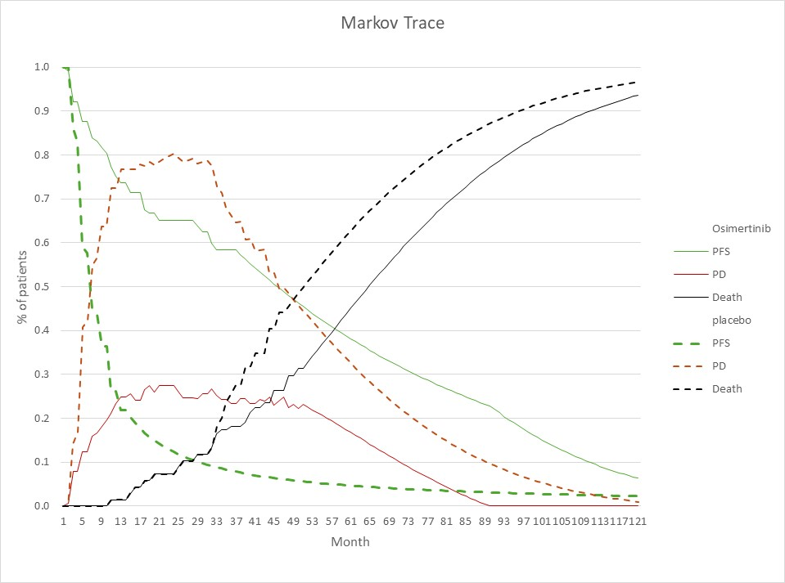
Source: Independently constructed during the evaluation from ‘Trace-OSI’ and ‘Trace-Placebo’ worksheets in ‘LAURA economic evaluation’ file.
PD= progressive disease; PFS = progression-free survival.

  - Table 14 presents a summary of the key drivers of the model.
Table 14: Key drivers of the model
Description | Method/Value | Impact  Base case: $||||¹/QALY gained
Osimertinib (proposed listing) treatment duration and costs | Mean duration of treatment for osimertinib was assumed to be |||| months (based on the median PFS of 39.1 months from LAURA). The submission assumed that TTD would follow a similar relationship to PFS. There is no confirmed OS data to inform the optimal duration of treatment for osimertinib, and there is the risk of extended use of osimertinib in this setting. | High, favoured osimertinib  Assuming the maximum duration of osimertinib treatment to be the model time horizon of 10 years (mean duration of |||| months), increased the ICER to $||||²/QALY gained.
Costs of ABCP post-progression for patients in the osimertinib arm | The model assumed 0% of patients in the osimertinib arm would use subsequent EGFR-TKI / osimertinib post-progression. However, the model did not consider that the proportion of patients in the osimertinib arm in LAURA who went on to subsequent EGFR-TKI in the trial would in practice, likely receive other effective therapies such as atezolizumab, bevacizumab in combination with platinum doublet chemotherapy (ABCP). | High, favoured osimertinib  A sensitivity analysis conducted during the evaluation, assuming 57.1% of patients who progressed in the osimertinib arm receive ABCPª, increased the ICER to $||||²/QALY gained.
Hospitalisation costs | Assumed one hospitalisation per year for PFS patients and two hospitalisations per year for PD patients. | High, favoured placebo.  Assuming no hospitalisations for PFS patients, decreased the ICER to $|| ||³/QALY gained.
Disutility of progressive disease (PD versus PFS) | PFS utility based on the LAURA trial and applied a difference in utility for PD versus PFS from the PBAC model for durvalumab (November 2018) of -0.14. The submission argued that it was inappropriate to use HRQoL data from the LAURA trial. | High, favoured osimertinib  Assuming trial-based utilities for PD and PFS^{b}, increased the ICER to $||||¹/QALY gained.
Approach to estimating osimertinib OS curve | The base case analysis applied a HR approach beyond truncation points to generate the osimertinib OS curve. The OS HR for osimertinib versus placebo from LAURA (DCO2) was not statistically significant: 0.67 (0.40, 1.14). It was noted that long-term extrapolations were likely to be uncertain. Overall survival data from LAURA were immature (31% maturity at DCO2). The crossing of KM curves suggests a violation of the proportional hazards assumption. Therefore, the HR should be interpreted cautiously, as it may not reflect time-varying effects. | Moderate, favoured osimertinib  Assuming HR for OS of 1 increased the ICER to $||||¹/QALY gained.
PFS | The model fitted independent parametric survival models to observed KM data from each arm of LAURA for PFS curves, beyond truncation points (36 and 13 months for osimertinib and placebo respectively). | The expected PFS benefit is likely smaller in the context, but this was not able to be explored due to the model structure.
Source: Compiled during the evaluation and Table 3-37, p162 of the submission.
ABCP = atezolizumab, bevacizumab in combination with platinum doublet chemotherapy; DCO = data cut-off; EGFR = epidermal growth factor receptor; HR = hazard ratio; KM = Kaplan-Meier; OS = overall survival; PD = progressive disease; PFS = progression-free survival; TKI = tyrosine kinase inhibitor; TTD = time to treatment discontinuation.
ª Based on patients discontinuing treatment who used subsequent treatment in LAURA. 57.1% was calculated as 12.7% using VEGF inhibitor – monoclonal antibody + 44.4% using EGFR-TKI. The proportion of patients in the osimertinib arm who went on to subsequent EGFR-TKI was 44.4% (28/63) of patients who discontinued; 8/63 (12.7%) of patients who discontinued received a subsequent VEGF inhibitor.
^{b} Viney 2011 Australian preference weights.
The redacted values correspond to the following ranges:
¹ $55,000 to < $75,000
² $75,000 to < $95,000
³ $25,000 to < $35,000

  - Table 15 presents the results of the stepped economic evaluation presented in the submission.
Table 15: Results of the stepped economic evaluation
Step and component | Osimertinib | Placebo | Increment
Step 1: trial-based costs and outcomes: time horizon of 49 months. Including costs of osimertinib and treatment of adverse events.
Costs (undiscounted)ª | $|||| | $11 | $||||
Progression-free years (undiscounted)^{b} | 2.70 | 0.89 | 1.81
Incremental cost/extra progression-free year |  |  | $||||¹
Step 2: time horizon extended to 10 years and discounting included.
Included costs of monitoring for patients on osimertinib treatment, costs of disease monitoring, subsequent treatment, CNS metastases and palliative care.
Costs (discounted) | $|||| | $163,806 | $||||
LYG (discounted) | |||| | 4.131 | ||||
Incremental cost/extra LYG gained |  |  | $||||²
Step 3: utility weights applied.
Costs (discounted) | $|||| | $163,806 | $||||
QALYs (discounted) | |||| | 3.159 | ||||
Incremental cost/extra QALY gained (base case) |  |  | $||||¹
Source: Table 3-29 to 3-35, pp.157-159 of the submission.
CNS = central nervous system; LYG = life years gained; QALY = quality adjusted life year.
ª Estimated based on patients on-treatment calculated using an Area Under the Curve approach from LAURA TTD curve.
^{b} Progression-free years were calculated using an Area Under the Curve approach from LAURA PFS curves.
The redacted values correspond to the following ranges:
¹ $55,000 to < $75,000
² $75,000 to < $95,000

  - The results of key sensitivity analyses are summarised in
  - Table 16.
Table 16: Sensitivity analyses
Analyses | Incremental cost | Incremental QALY | ICER | % change to ICER
Base case | $|||| | 0.847 | $||||¹ | -
Time horizon (base case 10 years)
5 years | $|||| | 0.485 | $||||² | +||||%
12 years | $|||| | 0.869 | $||||¹ | -||||%
Discount rate (base case: ||||%)
||||% | $|||| | 1.044 | $||||¹ | +||||%
||||% | $|||| | 0.899 | $||||¹ | +||||%
Osimertinib OS curve
Independent extrapolation of trial-based KM data for OS (base case HR approach used) | $|||| | 1.190 | $||||³ | -||||%
Assuming HR for OS of 1ª (base case HR for OS of 0.67) (#4) | $|||| | 0.704 | $||||¹ | +||||%
Utility value for PD health state (base case 0.731)
Trial-based from LAURA & Viney 2011 weights: 0.798 (#3) | $|||| | 0.714 | $||||¹ | +||||%
0.841^{b}: based on a smaller difference between PD and PFS of 0.03 (Criss 2018 and NICE durvalumab model) | $|||| | 0.628 | $||||² | +||||%
Costs
Treatment duration of osimertinib (base case: mean of 38.5 months; maximum 67 months)
Stopping rule removed: Mean osimertinib treatment duration of |||| months in the economic model* (#1) | $|||| | 0.847 | $||||² | +||||%
Proportion of patients in the placebo arm receiving osimertinib post-progression (base case 78.1%)
0%^{d} | $|||| | 0.847 | $||||⁴ | +||||%
100%^{d} | $|||| | 0.847 | $||||³ | -||||%
Proportion of patients in the osimertinib arm receiving ABCP post-progression (base case 5.6%)
25.2%^{e} | $|||| | 0.847 | $||||¹ | +||||%
57.1% (#2)^{g} | $|||| | 0.847 | $||||² | +||||%
Number of hospitalisations for PFS health state (base case one per year)
No hospitalisations for PFS^{f} | $|||| | 0.847 | $||||⁵ | -||||%
Multivariate sensitivity analysis
#1 and #2 | $|||| | 0.847 | $||||⁶ | +||||%
#1 and #2 and #3 | $|||| | 0.714 | $||||⁴ | +||||%
#1 and #2 and #3 and #4 | $|||| | 0.564 | $||||⁷ | +||||%
Source: Constructed during the evaluation; Table 3-37, p162 of the submission.
ABCP = atezolizumab, bevacizumab in combination with platinum doublet chemotherapy; EGFR = epidermal growth factor receptor; FAS = full analysis set; HR = hazard ratio; KM = Kaplan-Meier; OS = overall survival; PD = progressive disease; PFS = progression-free survival; QALY = quality adjusted life year; TKI = tyrosine kinase inhibitor.
* unlimited osimertinib treatment for model duration of 10 years.
ª Cell B3 in ‘OS using HR’ worksheet.
^{b} Cell B5 in ‘Utilities’ worksheet.
^{c} Cell B18 in ‘Subs. Tx’ worksheet.
^{d} Cell D18 in ‘Subs. Tx’ worksheet.
^{e} Cell C17 in ‘Subs. Tx’ worksheet.
f Cell B12 in ‘DM costs’ worksheet.
^{g} This sensitivity analysis assumed (i) all patients in the osimertinib arm receiving EGFR-TKI in the trial used ABCP in the model; (ii) applied patients discontinuing treatment who used subsequent treatment i.e. by changing cells C14:D18 of ‘Subs. Tx’ worksheet. FAS patients who used subsequent treatment were used in the base case analysis. 57.1% was calculated as 12.7% using VEGF inhibitor – monoclonal antibody + 44.4% using EGFR-TKI from LAURA.
The redacted values correspond to the following ranges:
¹ $55,000 to < $75,000
² $75,000 to < $95,000
³ $45,000 to < $55,000
⁴ $115,000 to < $135,000
⁵ $25,000 to < $35,000
⁶ $95,000 to < $115,000
⁷ $155,000 to < $255,000

  - The ICER was most sensitive to the treatment duration of osimertinib in the proposed listing, costs of subsequent osimertinib treatment for placebo patients who progressed, proportion of patients using subsequent ABCP, hospitalisations, disutility of PD versus PFS and time horizon. Multivariate sensitivity analyses show an even higher effect to ICER when key model drivers were varied jointly, with ICERs ranging from $95,000 to < $115,000 to $155,000 to < $255,000/QALY gained.

Drug cost/patient/course
  - A comparison of the drug cost estimated in the economic evaluation and in the financial analysis is presented in Table 17. The average cost per patient per course on osimertinib was $||| |||, based on an assumed mean treatment duration of 38.5 months (course of treatment).
Table 17: Drug cost per patient for osimertinib
 | LAURA trial dose and duration | Model | Financial estimates
Mean dose | 80 mg/day | 80 mg/day | 80 mg/day
Mean duration | |||| monthsª | |||| months | |||| months
Cost/patient/month | $|||| | $|||| | $||||
Cost/patient/course | $|||| | $|||| | $||||
Source: Compiled during the evaluation from economic and financial model assumptions.
ª median time to treatment discontinuation (TTD) in the LAURA trial

^{b} based on the median PFS of 39.1 months in the LAURA trial. When the maximum duration of treatment in the model was set to 67 months, the mean duration of osimertinib treatment in the model was |||| |||| months. Estimated PBS usage & financial implications
  - This submission was not considered by DUSC.
  - The financial analysis used an epidemiological approach to estimate the financial impacts of the proposed listing of osimertinib. The key inputs in the financial analysis are summarised in Table 18.
Table 18: Key inputs for financial estimates
Parameter | Value applied and source | Evaluation comment
Incident cases of lung cancer | 16,138 in Yr 1 (2026) to 19,039 in Yr 6 (2031).  AIHW Cancer Data in Australia 2024 web report and supplementary data tables. | Appropriate.
Proportion NSCLC | 87.81% - Victorian Cancer Registry 2024. | Appropriate.
Proportion of NSCLC with Stage III disease | 27.2% - Wainer 2018 | Likely over-estimated based on a fairly small sample size of 555 patients. The VLCR 2023 annual report, with 19,757 patients recruited to the VLCR registry (Figure 5), found that 15% of NSCLC was Stage III at diagnosis. The PSCR and the pre-PBAC response maintained that the estimate of 27.2% was substantiated by the broader literature.
Proportion of Stage III NSCLC classified as unresectable | 79.10% -Data from VLCR for 2018-2021 on 1,044 Stage III patients; Sponsor-commissioned. | Unclear whether the data was restricted to NSCLC patients, as the cited data did not have sufficient details. Data from the VLCR annual report (Figure 9) showed 50% of NSCLC Stage III patients had systemic anticancer therapy and 29% radiotherapy, which is close to the estimate of 79%.
Proportion of patients EGFRm positive | 17.9%  DUSC review of TKIs for NSCLC (2017). | Uncertain. The DUSC review did not have an estimate restricted to unresectable Stage III patients who are EGFRm positive and receive platinum-based CRT and also stated that the prevalence of patients with activating EGFR mutation was uncertain.
Proportion of patients receiving platinum-based CRT | 70%  paragraph 7.13; durvalumab NSCLC PSD July 2019. | Likely over-estimated. Although the 70% was derived from the durvalumab PSD, this was applicable to a population without EGFR pathogenic variant disease. An estimate for proportion on CRT was 33% from Figure 9 of the VLCR 2023 annual report (29% with radiotherapy out of 88% with no resection, i.e., 29/88). A Canadian retrospective cohort study of patients with unresectable stage III NSCLC (Agulnik 2020) found that 59% received combined (sequential or concurrent) CRT. The PSCR and the pre-PBAC response maintained that 70% was a reasonable estimate because the proportion of patients eligible for Pt-based CRT is unlikely to vary based on mutation status.
Proportion of patients without progressive disease following CRT | 95%  IQVIA chart audit; sponsor-commissioned data based on 65 medical records | Likely over-estimated from data on 65 medical records. A systematic review of 1352 patients from 10 studies that compared concurrent radiotherapy and chemotherapy with sequential arm in advanced NSCLC patients (Liang 2010) found 64.0% objective response rate to concurrent radiotherapy and chemotherapy. The PSCR presented three new sources to justify that 95% of patients would not have progressive disease following CRT; while the sources are supportive, none of the publications explicitly reported the disease control rate. The pre-PBAC response maintained the proportion of 95% reflects the substantially improved disease control rate observed in modern trials.  The PSCR noted that the estimate of patients who would take osimertinib following CRT was based on a prevalent pool of patients who would initiate therapy within 6 weeks of completing CRT. The PSCR stated that if the PBAC did not specify a 6-week time limit for the restriction (paragraph 3.3), a small amendment to the prevalent pool would be required for the financial estimates. The requested restriction was silent on the timeframe between CRT and initiation of osimertinib. The PBAC considered that a 6-week time limit would not be appropriate.
Proportion of patients with no previous osimertinib treatment | 99% in model  ADAURA model; assumptions. | Reasonable but could not be verified accurately.
Treatment utilisation
Uptake rate of osimertinib | ||||% in each of Years 1 to 6.  Assumption, based on uptake of osimertinib in the metastatic setting and unmet clinical need in the proposed population. | Area of uncertainty. The submission stated that osimertinib uptake in Y1 and Y2 of listing in the first line metastatic setting was ||||% and ||||%, but this could not be verified.
Osimertinib scripts dispensed per patient | Yr 1: 12  Yr 2: 12  Yr 3: 12  Yr 4: 3  Economic model’s mean treatment duration (based on median PFS in LAURA) | There is no confirmed OS to inform the optimal duration of treatment for osimertinib, and there is the risk of extended use of osimertinib. Sensitivity analysis assuming a mean treatment duration of 48 months or 4 years, was performed on the financial estimates.
Osimertinib (metastatic setting) scripts dispensed per patient | First year of treatment: 12.18  Second year of treatment: 8.82  FLAURA (|||| months treatment duration reimbursed through a RSA). | Reasonable.
Osimertinib (metastatic setting) uptake rate | ||||%  Worksheet ‘14a’ of the financial model cited FLAURA as the source of this estimate, whilst p174 of the submission cited LAURA.  The proportion of disease progression in the placebo arm in each year was applied to the eligible initiating patient population (80.60%). | Uncertain, the cited sources could not be verified. The model appeared to have applied an additional 95% uptake rate to the reduction in number of patients on osimertinib (metastatic), which were already adjusted for uptake of ||||%. Hence, the reduction in number of patients may have been under-estimated. The pre-PBAC response stated that in the first-line metastatic setting, 80% of patients with EGFR TKI mutation are assumed to receive systemic anticancer therapy; of these, ||||% are assumed to receive osimertinib, which is broadly aligned with the market share of osimertinib in the first-line metastatic setting.
Drug cost
Osimertinib effective DPMQ | $||||  Proposed effective DPMQ | Reasonable, but noted that treatment interruptions modelled in the economic analysis were not applied in the financial estimates.
Substituted PBS costs | Osimertinib (metastatic setting)  Assumption. | The financial model did not include additional costs of other effective post-progression therapies such as ABCP for a proportion of patients who progress on osimertinib in the proposed listing. Additional sensitivity analysis performed during the evaluation included additional costs of ABCP for 57.1%ª of patients who progress on osimertinib in the proposed listing.
Osimertinib (metastatic setting) effective DPMQ | $|||| | Inappropriate and inconsistent with the economic model. The submission appropriately applied an effective DPMQ of $|||| in the economic model for osimertinib in the metastatic setting.
Source: Table 4-1, p165 of the submission.
ABCP = atezolizumab, bevacizumab in combination with platinum doublet chemotherapy; AIHW = Australian Institute of Health and Welfare; CRT = chemoradiation therapy; DPMQ=dispensed price for maximum quantity, EGFR = epidermal growth factor receptor; FAS = full analysis set; KM = Kaplan-Meier; LRR = loco-regional recurrence; MBS = Medicare Benefits Schedule; NSCLC = non-small cell lung cancer; OS = overall survival; PBS = Pharmaceutical Benefits Scheme; PD = progressive disease; PFS = progression-free survival; RPBS = Repatriation Pharmaceutical Benefits Scheme; RSA = risk-share arrangement; TKI = tyrosine kinase inhibitor; TTD = time to treatment discontinuation; VLCR = Victorian Lung Cancer Registry; Yr=year.
ª This was derived in the economic analysis as follows: from the osimertinib arm of LAURA, 28 patients used subsequent EGFR-TKI, and 8 patients used subsequent VEGF-inhibitor – monoclonal antibody. 36 out of 63 patients who discontinued randomised study treatment is 57.1%.
  - The predicted use of osimertinib and financial implications associated with the proposed listing are summarised in Table 19. The model assumed a 50% rebate for the published prices of atezolizumab and nivolumab.
Table 19: Estimated use and financial implications
 | Year 1 | Year 2 | Year 3 | Year 4 | Year 5 | Year 6
Estimated extent of use
Number of patients treated | ||||^{b1} | ||||¹ | ||||¹ | ||||¹ | ||||¹ | ||||¹
Number of scripts dispensedª | ||||² | ||||³ | ||||⁴ | ||||⁴ | ||||⁴ | ||||⁴
Estimated financial implications of osimertinib
Cost to PBS/RPBS less copayments | $||||⁶ | $||||⁷ | $||||⁹ | $||||⁹ | $||||⁹ | $||||¹⁰
Estimated financial implications for osimertinib (metastatic setting)
Change in patients^{c} | -||||¹ | -||||¹ | -||||¹ | -||||¹ | -||||¹ | -||||¹
Cost to PBS/RPBS less copayments^{d} | -$||||⁵ | -$||||⁶ | -$||||⁶ | -$||||⁶ | -$||||⁶ | -$||||⁷
Net financial implications
Net cost to PBS/RPBS | $||||⁵ | $||||⁶ | $||||⁷ | $||||⁷ | $||||⁷ | $||||⁸
Net cost to PBS/RPBS^{e} in pre-PBAC response | $||||⁵ | $||||⁷ | $||||⁷ | $||||⁷ | $||||⁸ | $||||⁸
Source: Tables 4-2 to 4-22, pp.166-178 of the submission.
ª Assuming | | scripts per patient (| | in the first year, | | in the second year, | | in the third year, and | | in the fourth year) as estimated by the submission.
^{b} Assuming | | incident patients, and | | prevalent patients.
^{c} Assumed proportion of patients transitioning out of PFS health state in the placebo arm of the economic model.
^{d} Assumed | | months treatment duration for osimertinib (metastatic setting).
^{e} Alternative financial estimates were provided in the pre-PBAC response that include subsequent use of the ABCP regimen after progression on osimertinib, applying a | |% uptake rate in line with ESC sensitivity analysis and a 50% discount to the published ABCP price in lieu of effective prices. Incorporating these assumptions projects an increase of around | | additional patients receiving immune oncology over six years (see paragraph 6.70 below, third dot point).
The redacted values correspond to the following ranges:
¹ < 500
² 500 to < 5,000
³ 5,000 to < 10,000
⁴ 10,000 to < 20,000
⁵ $0 to < $10 million
⁶ $10 million to < $20 million
⁷ $20 million to < $30 million
⁸ $30 million to < $40 million
⁹ $40 million to < $50 million
¹⁰ $50 million to < $60 million

  - The total cost to the PBS/RPBS of listing osimertinib was estimated to be $30 million to < $40 million in Year 6, and a total of $100 million to < $200 million in the first 6 years of listing. The main uncertainties were:
  - the proportion of NSCLC patients having Stage III disease, the proportion of unresectable stage III NSCLC EGFRm positive patients receiving platinum-based CRT, and the proportion of those patients who do not have progressive disease following CRT. If lower proportions are used for these inputs, the PBS costs would be lower. The comments in the PSCR and pre-PBAC response regarding specific inputs for the financial model are shown in Table 18. The ESC noted the uncertainty associated with these inputs to the financial model.
  - the cost for osimertinib due to uncertainties in the uptake of osimertinib and the risk of extended use of osimertinib beyond progression. If the uptake of osimertinib is assumed to be less than ||| |||% from Year 1, the PBS costs would be lower; if there is use of osimertinib post disease progression, which may occur despite the requested restriction stopping treatment at disease progression, the PBS costs would be higher. The ESC noted that this could be addressed through a RSA.
  - the exclusion of costs for additional targeted therapies such as ABCP (atezolizumab, bevacizumab in combination with platinum doublet chemotherapy) post progression for a proportion of patients on osimertinib is expected to underestimate the budget impact of the proposed listing. The PSCR stated that although ABCP is available on the PBS as first subsequent therapy after osimertinib, the uptake is reasonably low; however, the PSCR did not provide the stated 10% sample PBS data to support this claim, and the ESC noted it is relevant to include the cost of ABCP in the financial estimates because it is an effective post-progression therapy used in Australia. The pre-PBAC response provided alternative financial estimates that included costs for the subsequent use of the ABCP regimen after progression on osimertinib, applying a ||| |||% uptake rate in line with the alternative economic base case (paragraph 6.56). This added a financial cost of approximately $0 to < $10 million over the first six years of listing.
  - Table 20 shows sensitivity analyses performed during the evaluation for the financial impact of osimertinib in the unresectable locally advanced (Stage III) setting.
Table 20: Financial impacts to the PBS/RPBS for sensitivity analyses – effective prices
Sensitivity analysis assumptions | Year 1  2026 | Year 2  2027 | Year 3  2028 | Year 4  2029 | Year 5  2030 | Year 6  2031 | First 6 years | % change
Base case | $||||  ¹ | $||||² | $||||³ | $||||³ | $||||³ | $||||⁴ | $||||⁸ | -
1. Proportion of NSCLC with Stage III 15% (base case 27.2%) | $||  ¹ | $||  ¹ | $||² | $||² | $||² | $||² | $||  ⁶ | -44.9%
2. Proportion receiving platinum-based CRT 59% (base case 70%) | $||  ¹ | $||² | $||³ | $||³ | $||³ | $||³ | $||⁸ | -15.7%
3. 64% without progressive disease following CRT (base case 95%) | $||¹ | $||¹ | $||² | $||² | $||³ | $||³ | $||⁷ | -32.6%
4. 60-80% osimertinib (proposed listing) uptake rates (base case ||||%): assumed ||||% Y1, ||||% Y2, ||||% Y3, ||||% Y4, ||||% Y5, ||||% Y6 | $||  ¹ | $||  ¹ | $||² | $||³ | $||³ | $||³ | $||⁸ | -26.3%
5. Assuming mean treatment duration of |||| months for osimertinib under the proposed listingª (base case |||| months) | $||  ¹ | $||² | $||³ | $||⁵ | $||⁵ | $||⁵ | $||⁸ | +24.6%
6. Including additional costs of ABCP^{b} for 57.1% of patients who progress on osimertinib under the proposed listing | $||  ¹ | $||² | $||⁴ | $||⁴ | $||⁴ | $||⁴ | $||⁸ | +20.9%
Source: constructed during the evaluation.
ABCP = atezolizumab, bevacizumab in combination with platinum doublet chemotherapy; CRT = chemoradiation therapy; NSCLC = non-small cell lung cancer.
ª In the financial model the following changes have to be made to change the treatment duration for osimertinib in the proposed listing: (i) cell N32 and cell N54 of ‘2d. Patients – DTG’ worksheet have to be changed to treatment duration minus 6 months. (ii) the wording in cells Q117:120 of ‘3a. Scripts – proposed’ worksheet have to be changed to reflect variation in treatment duration.
^{b} Assumed ABCP cost of $7,212.92 per month (50% rebate assumed); and duration of ABCP of 8 months, derived from the Section 3 economic model. Applied estimated osimertinib patients who progressed from ‘14c.Recurrence_osimertinib’ worksheet of financial model based on osimertinib arm of Section 3 economic model (26.3% progress in first year post progression, an additional 8.5% progress in second year post progression, additional 7%, 11%, 9% and 7% progress in 3rd, 4th, 5th and 6th year post progression, respectively).
The redacted values correspond to the following ranges:
¹ $0 to < $10 million
² $10 million to < $20 million
³ $20 million to < $30 million
⁴ $30 million to < $40 million
⁵ $40 million to < $50 million
⁶ $70 million to < $80 million
⁷ $90 million to < $100 million
⁸ $100 million to < $200 million

Financial Management – Risk Sharing Arrangements
  - No specific RSA was proposed by the submission, although it was noted that the Sponsor was willing to share the risk of uncertainty in utilisation and budget impact (noting that use beyond progression could be addressed through a RSA [paragraph 3.4]). The ESC noted that the uncertainty regarding the treatment duration would not be managed if the use in the unresectable locally advanced (Stage III) setting was overestimated or the offsets for use in the metastatic setting were underestimated. In this context, the ESC considered the identified risk would not be adequately managed based on sensitivity analyses 1−4 in Table 20 (which individually suggested that the use of osimertinib in Stage III disease was substantially overestimated), as well as the financial estimates not accounting for treatment interruptions and the uptake for the offsets for osimertinib in the metastatic setting being potentially underestimated.
  - The submission stated that if recommended by the PBAC, the Sponsor will request to increase the expenditure caps in the Deed to account for the new patients being treated and the longer duration of osimertinib treatment i.e., ||| ||| packs.
For more detail on PBAC’s view, see section 7 PBAC outcome.
- PBAC Outcome
  - The PBAC recommended the General Schedule Authority Required (Telephone/Online PBS Authorities System) listing of osimertinib for the treatment of unresectable locally advanced (Stage III) epidermal growth factor receptor (EGFR) pathogenic variant positive non-small cell lung cancer (NSCLC) patients whose disease has not progressed during or following platinum-based chemoradiation therapy (CRT). The PBAC considered the evidence presented in the submission demonstrated a meaningful difference in progression free survival (PFS) over the comparator (placebo [standard of care]) but noted that a benefit in terms of overall survival (OS) had not been demonstrated in the clinical trial and therefore remained uncertain. The PBAC considered the structure of the economic model to be a reliable basis for decision making, however considered that the incremental cost-effectiveness ratio (ICER) had been underestimated due to the inclusion of a number of optimistic assumptions. The PBAC considered that amendment to these inputs and a price reduction would be required to achieve a more reliable and cost-effective ICER. The PBAC considered that the financial estimates were uncertain, and likely overestimated, and advised that the inputs used to calculate the eligible patient population required further revision. The PBAC recommended the listing should join the existing combined osimertinib risk sharing arrangement (RSA).
  - The PBAC considered that an unmet clinical need remains for additional treatments in the Stage III unresectable setting, noting that there is no targeted treatment currently available for EGFR positive patients and the benefit of consolidation treatment with immunotherapy following CRT is uncertain. The PBAC also noted that the use of osimertinib after definitive concurrent CRT would be consistent with current clinical practice guidelines (NCCN 2024, Daly 2024).
  - The PBAC noted the consumer comments received for this submission from one individual and medical organisations and consumer groups (Thoracic Oncology Group of Australasia, the Medical Oncology Group Australia, Lung Foundation Australia, and Rare Cancers Australia), all of which supported the proposed listing for osimertinib in this population. The PBAC noted the consumer comments outlining the clinical benefits associated with osimertinib, based on the results of the LAURA trial. The PBAC also noted comments emphasised the significant financial burden experienced by NSCLC patients and that the cost of osimertinib remained a barrier to treatment and that a PBS listing would ensure equity of access.
  - The PBAC noted the following points regarding the restriction for osimertinib in unresectable Stage III disease. The reasoning behind each point is discussed in paragraphs 3.3 to 3.6.
- That it would not be necessary or appropriate to require a specific timeframe between CRT and initiation of osimertinib
- That the criterion proposed in the submission, that patients should cease treatment after disease progression, was appropriate
- That a limit on the duration of continuing treatment in patients who do not develop disease progression would not be required
- That it would be appropriate for the WHO performance status to be 2 or less for this osimertinib indication.
The PBAC noted that it would be preferable to have a combined broad restriction for osimertinib covering all the EGFR positive NSCLC patient populations: (1) adjuvant early stage resected; (2) unresectable locally advanced (Stage III); and (3) first- or second line locally advanced or metastatic. The PBAC noted this would require a single weighted price across all indications. The PBAC considered it would be appropriate to consider a combined broad restriction as part of its reconsideration of osimertinib for the first line treatment of Stage IIIB (locally advanced) or Stage IV (metastatic) EGFR positive NSCLC in combination with pemetrexed and platinum-based chemotherapy.
  - The PBAC accepted the nominated comparator for osimertinib as being standard of care (SoC), which is active surveillance. The PBAC noted that the use of CRT would remain unchanged and that osimertinib would not replace any medicine other than the use of osimertinib in the locally advanced/metastatic setting.
  - The PBAC noted that the clinical evidence presented in the submission was based on the LAURA randomised control trial (RCT), comparing the effectiveness and safety of osimertinib to placebo. The PBAC noted the prolongation of PFS with osimertinib, as shown by the separation of the Kaplan-Meier (KM) curves with an associated hazard ratio (HR) of 0.16 (95% confidence interval [CI] 0.10, 0.24, p < 0.001). The PBAC noted that the OS data remained immature at the latest follow up and had not reached statistical significance (HR 0.67, 95%CI 0.40, 1.14, p=0.140), and that crossing of KM curves after Month 31 suggests a violation of the proportional hazards assumption. The PBAC also noted the potential applicability issues involving the trial results not being generalisable to the Australian population and that the comparator arm may have performed more poorly than expected, noting the high proportion of patients from Asia and low- to middle- income countries. However, the PBAC noted that the high rate of post-progression EGFR-tyrosine kinase inhibitors (TKIs) (85%, including osimertinib) used as subsequent treatment in the placebo arm was consistent with SoC in Australia. The PBAC considered that this would likely have contributed to an improvement in the OS results, generally comparable to the Australian setting, and noted the trend of improving OS over time with each data cut off. Overall, the PBAC considered that the claim of superior effectiveness was supported, primarily based on the strong PFS outcome.
  - The PBAC considered that osimertinib has inferior safety to placebo with no additional safety signals compared to the other settings/populations already listed for treatment with osimertinib on the PBS.
  - The PBAC considered the structure of the economic model to be a reasonable basis for decision-making, noting an acceptable 10-year time horizon, with health state allocation based on PFS and OS data from the LAURA trial, and generally appropriate extrapolation techniques. While the structure of the model was appropriate, the PBAC considered that the ICER had been underestimated due to the inclusion of a number of optimistic assumptions. The PBAC noted that the model did not consider that the proportion of patients in the osimertinib arm of the LAURA trial who went on to subsequent EGFR-TKI in the trial would in practice, likely receive other effective therapies such as platinum doublet chemotherapy with or without atezolizumab and/or bevacizumab (ABCP). Instead, these patients were assumed to receive no other treatment. Only those who received a subsequent VEGF inhibitor in the LAURA trial (8/143 [5.6%] patients in the osimertinib arm of the full analysis set [FAS] or 8/63 [12.7%] of patients who discontinued treatment) were assumed to receive ABCP in the base case. The PBAC agreed with the ESC that the percentage of patients who would likely receive subsequent ABCP post progression would be approximately 30−35%, which it noted increased the base case ICER from $55,000 to < $75,000 to $55,000 to < $75,000 per quality adjusted life year (QALY) gained.
  - The PBAC also noted that the base case analysis applied a HR approach (with waning between 3 to 10 years) beyond truncation points to generate the osimertinib OS curve. However, the OS HR for osimertinib versus placebo from the LAURA trial (data cut off [DCO] 2) was not statistically significant: 0.67 (95% CI: 0.40, 1.14) and the OS data from the trial were immature (31% maturity at DCO2). For these reasons, the PBAC considered the long-term OS projections were highly uncertain. The PBAC also noted that the crossing of KM curves suggested a violation of the proportional hazards assumption and that OS in the osimertinib arm was assumed to equal the OS of placebo arm until month 30 of the model, despite there being more deaths in the osimertinib arm. Overall, the PBAC considered that given the strength of the PFS results in the LAURA trial, it was likely reasonable to assume some degree of OS benefit; however, considered the magnitude to be less than assumed in the submission base case. The PBAC considered applying a hazard ratio of 0.84 (midpoint between a HR of 0.67 and 1) beyond truncation points, with waning applied between years 3−10, was likely reasonable.
  - The PBAC also noted the uncertainty raised by the evaluation and ESC related to the mean duration of osimertinib treatment assumed in the model (||| ||| months, based on PFS). However, the PBAC noted the inclusion of the restriction criterion requiring patients to cease treatment after disease progression and considered that expenditure caps would be a reasonable mechanism to limit the financial risk associated with use post-progression. For this reason, the PBAC considered that the duration of osimertinib treatment assumed in the submission base case was likely reasonable.
  - Overall, while noting the uncertainties raised above, the PBAC considered that the listing would be cost-effective with the following changes to the economic model, and noted that a price reduction would be required to achieve this scenario:
- an ICER of $45,000 to < $55,000 per QALY gained, consistent with previously accepted ICERs for similar populations
- use of post-progression ABCP in 30% of osimertinib patients
- an OS HR = 0.84, with waning from 3–10 years.
  - The PBAC considered that the financial estimates were uncertain because of the overestimate of several inputs and considered alternative inputs would be more appropriate:
- The proportion of NSCLC patients with Stage III disease (submission percentage of 27.2% was sourced from Wainer 2018 compared to the Victorian Lung Cancer Registry percentage of 15%).
- The proportion of EGFR positive Stage III NSCLC patients receiving platinum-based CRT (submission percentage of 70% was based on patients without EGFR pathogenic variant disease from the durvalumab public summary document [PSD] compared to the Victorian Lung Cancer Registry percentage of 33%); while the PBAC agreed with the PSCR and pre-PBAC response that the proportion of patients eligible for platinum based CRT is unlikely to vary based on mutation status, it also noted the lower estimate.
- The proportion of patients who do not have progressive disease following CRT (submission percentage of 95% from a chart audit compared to 64% from a systematic review [Laing 2010]).
The PBAC also considered that the financial estimates should account for the use of post-progression ABCP in 30% of osimertinib patients, the mean duration of treatment of ||| ||| months consistent with the economic model, and the revised price as per paragraph 7.11.
  - The PBAC advised that osimertinib for unresectable locally advanced (Stage III) should join the existing combined osimertinib NSCLC RSA to help address uncertainties in the financial model. The PBAC considered it would be appropriate to increase the existing caps consistent with the incremental cost to the PBS per the agreed financial estimates.
  - The PBAC found that the criteria prescribed by the National Health (Pharmaceuticals and Vaccines – Cost Recovery) Regulations 2022 for Pricing Pathway A were not met. Specifically, the PBAC found that in the circumstances of its recommendation for osimertinib:
  - The treatment is not expected to provide a substantial and clinically relevant improvement in efficacy over standard of care (active surveillance), as while clinically relevant improvements in PFS were evident there was no statistically significant difference in overall survival
  - The treatment is not expected to address a high and urgent unmet clinical need
  - It was not necessary to make a finding in relation to whether it would be in the public interest for the subsequent pricing application to be progressed under Pricing Pathway A because one or more of the preceding tests had failed.
  - The PBAC noted that this submission is not eligible for an Independent Review as it received a positive recommendation.
Outcome:
Recommended

- Recommended listing
8.1 Add new listing as follows:

MEDICINAL PRODUCT  medicinal product pack | PBS item code | Max. qty packs | Max. qty units | №.of  Rpts | Available brands
OSIMERTINIB
osimertinib 80 mg tablet, 30 | NEW | 1 | 30 | 5 | Tagrisso
Category / Program: GENERAL - General Schedule (Code GE)
Prescriber type: Medical Practitioners
Benefit type: Authority Required (Telephone/Online PBS Authorities System)
Prescribing rule level:
Administrative advice:
No increase in the maximum quantity or number of units may be authorised.
Administrative advice:
No increase in the maximum number of repeats may be authorised.
Administrative advice:
Special Pricing Arrangements apply.
Administrative advice:
Applications for authorisation under this restriction may be made in real time using the Online PBS Authorities system (see www.servicesaustralia.gov.au/HPOS) or by telephone by contacting Services Australia on 1800 888 333.
Restriction Summary [new1] / Treatment of Concept: [new1A]
Indication: Unresectable Stage III non-small cell lung cancer
Treatment phase: Initial treatment
Clinical criteria:
Patient must have received platinum based chemoradiation therapy
AND
Clinical criteria:
The condition must not have progressed during or following platinum based chemoradiation therapy
AND
Clinical criteria:
Patient must have a WHO performance status of 2 or less
AND
Clinical criteria:
Patient must not have previously received PBS-subsidised treatment with this drug for this condition,
AND
Clinical criteria:
The treatment must be the sole PBS-subsidised systemic anti-cancer therapy for this condition.
Population criteria:
Patient must have evidence in tumour material of an activating epidermal growth factor receptor (EGFR) gene mutation known to confer sensitivity to treatment with EGFR tyrosine kinase inhibitors.
Prescribing Instruction:
PBS-subsidised treatment with this drug is restricted to one line of therapy at any disease staging for NSCLC (i.e. if therapy has been prescribed for early disease, subsidy under locally advanced or metastatic disease is no longer available).

MEDICINAL PRODUCT  medicinal product pack | PBS item code | Max. qty packs | Max. qty units | №.of  Rpts | Available brands
OSIMERTINIB
osimertinib 80 mg tablet, 30 | NEW | 1 | 30 | 5 | Tagrisso
osimertinib 40 mg tablet, 30 | NEW | 1 | 30 | 5 | Tagrisso
Category / Program: GENERAL - General Schedule (Code GE)
Prescriber type: Medical Practitioners
Benefit type: Authority Required (Telephone/Online PBS Authorities System)
Prescribing rule level:
Administrative advice:
No increase in the maximum quantity or number of units may be authorised.
Administrative advice:
No increase in the maximum number of repeats may be authorised.
Administrative advice:
Special Pricing Arrangements apply.
Administrative advice:
Applications for authorisation under this restriction may be made in real time using the Online PBS Authorities system (see www.servicesaustralia.gov.au/HPOS) or by telephone by contacting Services Australia on 1800 888 333.
Restriction Summary [new2] / Treatment of Concept: [new2A]
Indication: Unresectable Stage III non-small cell lung cancer
Treatment phase: Continuing treatment
Clinical criteria:
Patient must have previously received PBS-subsidised treatment with this drug for this condition,
AND
Clinical criteria:
Patient must not have developed disease progression while receiving treatment with this drug for this condition,
AND
Clinical criteria:
The treatment must be the sole PBS-subsidised systemic anti-cancer therapy for this condition.
Population criteria:
Patient must have evidence in tumour material of an activating epidermal growth factor receptor (EGFR) gene mutation known to confer sensitivity to treatment with EGFR tyrosine kinase inhibitors.
Prescribing Instruction:
PBS-subsidised treatment with this drug is restricted to one line of therapy at any disease staging for NSCLC (i.e. if therapy has been prescribed for early disease, subsidy under locally advanced or metastatic disease is no longer available).

These restrictions may be subject to further review. Should there be any changes made to the restriction the sponsor will be informed.

9 Context for Decision
The PBAC helps decide whether and, if so, how medicines should be subsidised through the Pharmaceutical Benefits Scheme (PBS) in Australia. It considers applications regarding the listing of medicines on the PBS and provides advice about other matters relating to the operation of the PBS in this context. A PBAC decision in relation to PBS listings does not necessarily represent a final PBAC view about the merits of the medicine or the circumstances in which it should be made available through the PBS. The PBAC welcomes applications containing new information at any time.

10 Sponsor’s Comment
The sponsor had no comment.

https://www.pbs.gov.au/industry/listing/elements/pbac-meetings/pbac-outcomes/2025-05/pbac-web-outcomes-05-2025.pdf
Nozaki K, Watanabe S, and Kikuchi T. Review on LAURA: Is it a game changer for unresectable stage III EGFR-mutated non-small-cell lung cancer? AME Clin Trials Rev 2024; 2: 94.
AIHW 2024. Lung cancer in Australia statistics. Available at: https://www.canceraustralia.gov.au/cancer-types/lung-cancer/lung-cancer-australia-statistics
Seung SJ, et al. Cost-of-illness study for non-small-cell lung cancer using real-world data. Curr Oncol. 2019 Apr;26(2):102-107. doi: 10.3747/co.26.4555.
Casal-Mouriño A, et al. Epidemiology of stage III lung cancer: frequency, diagnostic characteristics, and survival. Transl Lung Cancer Res. 2021 Jan;10(1):506-518. doi: 10.21037/tlcr.2020.03.40.
Rybarczyk-Kasiuchnicz A. (2021). Treatment of Brain Metastases of Non-Small Cell Lung Carcinoma. Int J Mol Sci 2021;22.
Yoon HY, et al. Clinical significance of EGFR mutation types in lung adenocarcinoma: A multi-centre Korean study. PLoS One. 2020 Feb 13;15(2):e0228925. doi: 10.1371/journal.pone.0228925.
Tan L. (2018). Survival difference according to mutation status in a prospective cohort study of Australian patients with metastatic non-small-cell lung carcinoma. Intern Med J. 2018 Jan;48(1):37-44.
NCCN clinical practice guidelines in Oncology. Non-small cell lung cancer. Version 6.2024.
Antonia SJ, Villegas A, Daniel D, et al; PACIFIC Investigators. Durvalumab after Chemoradiotherapy in Stage III Non-Small-Cell Lung Cancer. N Engl J Med. 2017 Nov 16;377(20):1919-1929. doi: 10.1056/NEJMoa1709937.
Passaro, A. et al. ESMO expert consensus statements on the management of EGFR mutant non-small-cell lung cancer. Annals of Oncology, Volume 33, Issue 5, 466 - 487
Nassar, Amin H. et al. Consolidation Osimertinib Versus Durvalumab Versus Observation After Concurrent Chemoradiation in Unresectable EGFR-Mutant NSCLC: A Multicenter Retrospective Cohort Study J Thorac Oncol, Volume 19, Issue 6, 928 - 940
Daly, M. et al. Management of Stage III Non–Small-Cell Lung Cancer: ASCO Guideline. JCO 40, 1356-1384(2022). DOI:10.1200/JCO.21.02528
Naidoo, Jarushka et al. 2023. Brief Report: Durvalumab After Chemoradiotherapy in Unresectable Stage III EGFR-Mutant NSCLC: A Post Hoc Subgroup Analysis From PACIFIC. Journal of Thoracic Oncology, Volume 18, Issue 5, 657 - 663
Spigel DR, Faivre-Finn C, Gray JE, et al. Five-Year Survival Outcomes From the PACIFIC Trial: Durvalumab After Chemoradiotherapy in Stage III Non-Small-Cell Lung Cancer [published correction appears in J Clin Oncol. 2022 Jun 10;40(17):1965.
Cherny NI, Dafni U, Bogaerts J, et al: ESMO-Magnitude of Clinical Benefit Scale version 1.1. Annals of Oncology 28:2340-2366, 2017
Lu S, et al. Osimertinib after definitive chemoradiotherapy in unresectable stage III epidermal growth factor receptor-mutated non-small-cell lung cancer: analyses of central nervous system efficacy and distant progression from the phase III LAURA study. Ann Oncol. 2024 Dec;35(12):1116-1125. doi: 10.1016/j.annonc.2024.08.2243.
Nozaki, K., Watanabe, S., & Kikuchi, T. (2024). Review on LAURA: is it a game changer for unresectable stage III EGFR-mutated non-small-cell lung cancer? AME Clin Trials Rev 2024; 2: 94.
Nozaki K, Watanabe S, and Kikuchi T. Review on LAURA: Is it a game changer for unresectable stage III EGFR-mutated non-small-cell lung cancer? AME Clin Trials Rev 2024; 2: 94.
https://vlcr.org.au/wp-content/uploads/2018/05/VLCR-Annual-Report-2023.pdf
Agulnik J, Kasymjanova G, Pepe C et al. Understanding clinical practice and survival outcomes in patients with unresectable stage III NSCLC in a single centre in Quebec. Curr Oncol 2020; 27(5): e459-466.
Liang H-Y, Zhou H, Li X-L et al. Chemo-radiotherapy for advanced non-small cell lung cancer: concurrent or sequential? It’s no longer the question: a systematic review. Int J Cancer 2010; 127: 718-728.
NCCN clinical practice guidelines in Oncology. Non-small cell lung cancer. Version 6.2024.
Daly ME, Singh N, Ismaila N. Management of Stage III Non-Small Cell Lung Cancer: ASCO Guideline Rapid Recommendation Update. J Clin Oncol. 2024; 42(25) https://doi.org/10.1200/JCO-24-01324

