Dutasteride and dutasteride with tamsulosin: analysis of actual versus predicted utilisation

Drug utilisation sub-committee (DUSC)

June 2015

Abstract

Purpose
To investigate the utilisation of dutasteride, and dutasteride with tamsulosin fixed dose combination (FDC) product since they were listed on the Pharmaceutical Benefits Scheme (PBS) in February 2011 and August 2011 respectively. The analysis compares the extent of use predicted at the time of listing to actual use.

Date of listing on PBS
- Dutasteride was listed on the PBS on 1 February 2011.
- Dutasteride with tamsulosin FDC was listed on the PBS on 1 August 2011.
Current PBS listing details are available from PBS website.

Data Source / methodology
The analysis examined de-identified prescription and Government expenditure data for dutasteride and dutasteride/tamsulosin FDC.
The extracted data included the number of prescriptions, the patient beneficiary category and Government expenditure based on the price published in the PBS schedule. All data were based on date of supply to the patient.

Key Findings
- The R/PBS utilisation of dutasteride for benign prostatic hyperplasia (including both the single agent listed 1 February 2011, and dutasteride with tamsulosin FDC listed 1 August 2011) has been substantially less than expected.
- Use of single agent dutasteride continues to be low and stable.
- Growth in the usage of dutasteride with tamsulosin FDC has been slower than expected.
- Overall utilisation of dutasteride with tamsulosin FDC seems unlikely to reach predicted levels by year 5 of listing.
- In 2014, 63,127 people received at least one prescription for dutasteride with tamsulosin FDC.

Purpose of analysis
Dutasteride and dutasteride with tamsulosin are both PBS listed for treatment of lower urinary tract symptoms (LUTS) due to benign prostatic hyperplasia (BPH). This analysis compares actual with predicted use since listing.
In June 2013, the DUSC compared the predicted and actual utilisation of dutasteride and dutasteride with tamsulosin FDC. The analysis considered actual utilisation of dutasteride for the first two years of listing and the FDC for the first 18 months of listing. At the time of consideration, the DUSC noted the lower than predicted initial uptake of these products, but expected this would be overcome and utilisation would eventually reach its predicted level. The DUSC requested further analysis to assess whether this eventuated.

Background

Pharmacology
Dutasteride inhibits the conversion of testosterone to 5α-dihydrotestosterone (DHT), the androgen primarily responsible for the initial development and subsequent enlargement of the prostate gland. Tamsulosin inhibits α1a-adrenergic receptors in the stromal prostatic smooth muscle and bladder neck, resulting in relaxation of prostate smooth muscle and improved urodynamics.

Therapeutic Goods Administration (TGA) approved indications
Dutasteride was registered with the Therapeutic Goods Administration (TGA) on 14 November 2002. Dutasteride is indicated for use as monotherapy for the management of symptomatic BPH, or as combination therapy with an alpha blocker which is approved for use in BPH and has been dose titrated in accordance with the relevant product recommendations.
Dutasteride with tamsulosin was registered with the TGA on 28 October 2010. It is indicated for the management of moderate to severe symptomatic BPH.
Current Product Information (PI) and Consumer Medicine information (CMI) are available from the TGA website.

Dosage and administration
Dutasteride
In adult males, including the elderly, the recommended dose is one 500 mcg capsule daily. The capsules should be swallowed whole and not chewed or opened.
Treatment for at least 6 months is generally necessary to assess whether a beneficial response in symptom relief has been achieved.
Dutasteride with tamsulosin
The recommended dose of dutasteride with tamsulosin is one capsule (500 mcg dutasteride/400 mcg tamsulosin) taken orally approximately 30 minutes after the same meal each day. The capsules should be swallowed whole and not chewed or opened.
Current Product Information (PI) and Consumer Medicine information (CMI) are available from the TGA website.

PBS listing details (as at April 2015)

Table 1: PBS listing of dutasteride, and dutasteride with tamsulosin
Item | Name, form & strength, pack size | Max. quant. | Repeats | DPMQ | Brand name and manufacturer
5468T | Dutasteride 500 microgram, 30 capsules | 30 | 5 | $30.77 | Avodart®,  GlaxoSmithKline Australia Pty Ltd
10095Hª  RPBS | Dutasteride 500 microgram, 30 capsules | 30 | 5 | $30.77 | Avodart®,  GlaxoSmithKline Australia Pty Ltd
5490Y | Dutasteride 500 microgram with tamsulosin hydrochloride 400 microgram, 30 modified release capsules | 30 | 5 | $35.63 | Duodart®,  GlaxoSmithKline  Australia Pty Ltd
10102Qª  RPBS | Dutasteride 500 microgram with tamsulosin hydrochloride 400 microgram, 30 modified release capsules | 30 | 5 | $35.63 | Duodart®,  GlaxoSmithKline  Australia Pty Ltd
Source: March 2015 PBS Schedule
ª Listed 1 June 2014

Restriction
Dutasteride: Authority Required (STREAMLINED)
3667: Treatment, in combination with an alpha-antagonist, of lower urinary tract symptoms due to benign prostatic hyperplasia where treatment was initiated by n urologist.
Dutasteride: Authority Required
Benign prostatic hyperplasia
Clinical criteria:
- Patient must be one in whom surgery is inappropriate; OR
- Patient must have failed to respond to other drug treatment or other drug treatment must be contraindicated.
Dutasteride with tamsulosin: Authority Required (STREAMLINED)
3687: Treatment of lower urinary tract symptoms due to benign prostatic hyperplasia where treatment was initiated by a urologist.

Date of listing on PBS
Dutasteride was listed on the PBS on 1 February 2011.
Dutasteride with tamsulosin FDC was listed on the PBS on 1 August 2011.
Current PBS listing details are available from the PBS website

Relevant aspects of PBAC consideration
Dutasteride
The PBAC (November 2009) recommended the PBS listing of dutasteride in combination with an alpha-antagonist, on the basis of acceptable cost-effectiveness compared to an alpha-antagonist alone.
The PBAC considered uncertainty remained with the utilisation estimates and recommended that a RSA be put in place with expenditure capped at the financial estimates provided in the resubmission.
For further details refer to the Public Summary Document from the November 2009 PBAC meeting.

Dutasteride with tamsulosin
The PBAC (November 2010) recommended the listing of dutasteride with tamsulosin on a cost-minimisation basis compared with dutasteride and prazosin.
For further details refer to the Public Summary Document from the November 2010 PBAC meeting.

Approach taken to estimate utilisation
The submission took an epidemiological approach to estimate the eligible population for both products.
The dutasteride submission assumed that prazosin use would increase and that finasteride use on the Repatriation Pharmaceutical Benefits Scheme (RPBS) would decrease after listing. The submission also assumed that medical treatment for acute urinary retention and BPH surgery would decrease.
The submission for dutasteride with tamsulosin assumed that the FDC would substitute within the existing eligible population for dutasteride, with patients previously taking dutasteride and prazosin as individual components switching to the FDC.
The PBAC considered uncertainty remained with the utilisation estimates. The main areas of uncertainty identified were:
- numbers of diagnosed BPH patients
- numbers of patients electing to receive drug treatment
- whether medical therapy is required post-surgery
- applicability of overseas data (where access to dutasteride was greater) to Australian population
- assumed uptake rates
- applicability of RPBS population for finasteride – older patients than in clinical studies may have progressed beyond medical treatment of BPH
- rate of switching from individual agents (dutasteride and prazosin) to the combination product

Previous reviews by the DUSC
The DUSC reviewed the utilisation of dutasteride and dutasteride with tamsulosin FDC at the June 2013 meeting.
The initial uptake of both the single agent and FDC was lower than expected. The following factors were thought to have contributed:
- initial overestimates of the eligible population and/or those presenting for treatment
- overestimated uptake with prescribers choosing not to use dutasteride until the combination with tamsulosin was available on the PBS
- lower than expected adherence or persistence to therapy
- delayed access to a urologist, which is required to initiate treatment
- the potential for urologists to prefer surgical treatment over medical management
- the unforeseen private market for both single agent and combination dutasteride
Some prescribing of dutasteride and dutasteride with tamsulosin on private prescription was evident. As these drugs are below the general patient co-payment, some patients may have preferred private prescription if it allowed them to have a larger quantity dispensed at a lower cost.
The onset of effect for dutasteride is 4–6 months, and patients may have been unwilling to persist with treatment for the duration.
Prazosin usage seemed to be unaffected by use of either single agent or FDC dutasteride. An analysis of prazosin and dutasteride co-administration was suggested to ascertain the extent of use for BPH. However, given the very low use of dutasteride it was considered that this analysis may not be very informative.
Given the large potential population for these products and based on the utilisation in Year 2, the DUSC believed that the factors slowing initial uptake would be overcome, and utilisation would eventually reach its predicted level.

Methods
De-identified pharmacy claim data for prescriptions of dutasteride and dutasteride with tamsulosin were extracted from the DUSC database for the period February 2011 to October 2014 inclusive. The DUSC database combines data for PBS prescriptions submitted to the Department of Human Services (DHS) for payment of a PBS/RPBS subsidy by the Government, with an estimate of under general co-payment and private prescriptions based on dispensing data from a sample of pharmacies until March 2012. Actual under co-payment data became available from 1 April 2012 and the estimate was discontinued.
Private estimates were included for the first two years of listing as per the prior report, but were unavailable for the third and fourth years of listing.
The actual data presented for year four is a part year, as complete data was only available for the first nine months (February 2013 to October 2014).
The extracted data included the number of prescriptions, the patient beneficiary category and Government expenditure based on the price published in the PBS schedule. All data were based on date of supply to the patient.
The estimates of use presented in this report are those agreed between the Sponsor and the then Department of Health and Ageing (DoHA) post PBAC recommendation to list.
Length of treatment analysis was performed using DHS supplied prescription data using the methodology described in Appendix B. Length of treatment analyses used prescription data from February 2011 to December 2014 inclusive.

Results

Analysis of drug utilisation

Overall utilisation
Table 2 presents prescription volume data for the first three years, and the first nine months of the fourth year, from 1 February 2011 (the date of PBS listing of dutasteride). The same time periods are used for assessing dutasteride with tamsulosin FDC product utilisation (listed from 1 August 2011) because it allows predicted versus actual comparison of the total dutasteride market, consistent with the epidemiological basis of the estimates. Utilisation of the FDC product specifically for the first year of its listing is provided as a footnote to the table. Actual prescription volume data categorised by prescription type is provided in Appendix A.
Table 2: number of R/PBS prescriptions for dutasteride (5468T) and dutasteride with tamsulosin FDC (5490Y) supplied
 | Year 1 |  | Year 2 |  | Year 3 |  | Year 4^{d}
 | Predicted | Actual (%^{c}) | Predicted | Actual (%^{c}) | Predicted | Actual (%^{c}) | Predicted | Actual (%^{c})
Dutasterideª | 205,633 | 30,794  (15%) | 396,216 | 33,220  (8%) | 397,007 | 35,686  (9%) | 373,037 | 28,301  (8%)
Dutasteride + tamsulosin^{b} | 139,443 | 38,660  (28%^{e}) | 333,172 | 214,307  (64%) | 508,701 | 360,922  (71%) | 711,419 | 353,789  (50%)
Total |  | 90,018 |  | 262,882 |  | 396,608 |  | 382,090
Source: Predicted - estimates agreed between the Sponsor and DoHA post PBAC recommendation to list. Actual - DUSC database accessed March 2015, based on date of prescription supply.
ªlisted 1 February 2011
^{b}listed 1 August 2011
^{c}percent of predicted use
^{d}actual data presented for year 4 is a part year, as complete data was only available for February 2013 to October 2014
^{e}between Aug 11 and Jul 12 there were 124,456 R/PBS prescriptions for dutasteride with tamsulosin FDC
Table 3 presents data on the number of patients who received at least one R/PBS prescription for dutasteride or dutasteride with tamsulosin FDC in years 2012, 2013 and 2014.

Table 3: number of patients who received at least 1 R/PBS prescription for dutasteride (5468T) and dutasteride with tamsulosin FDC (5490Y)
 | 2012 |  | 2013 |  | 2014 ^{d}
 | Predicted | Actual (%^{c}) | Predicted | Actual (%^{c}) | Predicted | Actual (%^{c})
Dutasteride | 88,483 | 4,723 (5%) | 120,045 | 4,638 (4%) | 129,638 | 4,872 (4%)
Dutasteride + tamsulosin^{b} | 44,604 | 31,716  (71%) | 72,518 | 49,830  (69%) | 91,277 | 63,127  (69%)
Total |  | 36,439 |  | 54,468 |  | 67,999
Source: Predicted - estimates agreed between the Sponsor and DoHA post PBAC recommendation to list. Actual - DUSC database accessed March 2015, based on date of prescription supply.
ªlisted 1 February 2011
^{b}listed 1 August 2011
^{c}percent of predicted use
^{d}actual data presented for 2014 is a part year, as complete data was only available up until October 2014
Figure 1 shows the length of treatment for first treatment episode and all treatment episodes, the latter with and without accounting for breaks in treatment.
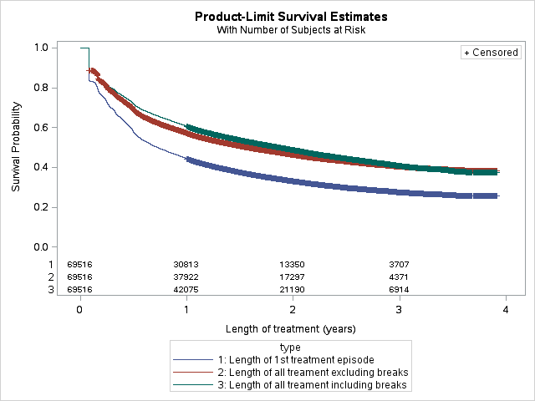Figure 1: length of treatment on dutasteride and dutasteride with tamsulosin FDC
Source: DHS PBS supplied prescription database for prescription s supplied from February 2011 to December 2014 inclusive.
Around 40% of patients remained on treatment over four years. Accounting for interruptions in therapy had a minor early impact on the duration of treatment but did not influence the persistence on treatment in the longer term. For patients on their first episode of treatment, around one-third remained on their first episode of treatment for four years.
The Kaplan Meier (KM) analysis used to produce Figure 1 was also used to estimate the median and mean lengths of treatment with dutasteride or dutasteride with tamsulosin FDC for the three different measures (Table 4).

Table 4: median and mean time spent on treatment with either dutasteride or dutasteride with tamsulosin FDC in months.
 | Median | Mean
First episode of treatment | 8.7 months | 17.9 months
All treatment excluding breaks | 18.8 months | 23.2 months
All treatment including breaks | 22.4 months | 24.0 months
Source: DHS PBS supplied prescription database for prescriptions supplied from February 2011 to December 2014 inclusive.
Figure 2 presents the number of R/PBS and under co-payment prescriptions supplied each month since dutasteride was listed on the PBS.

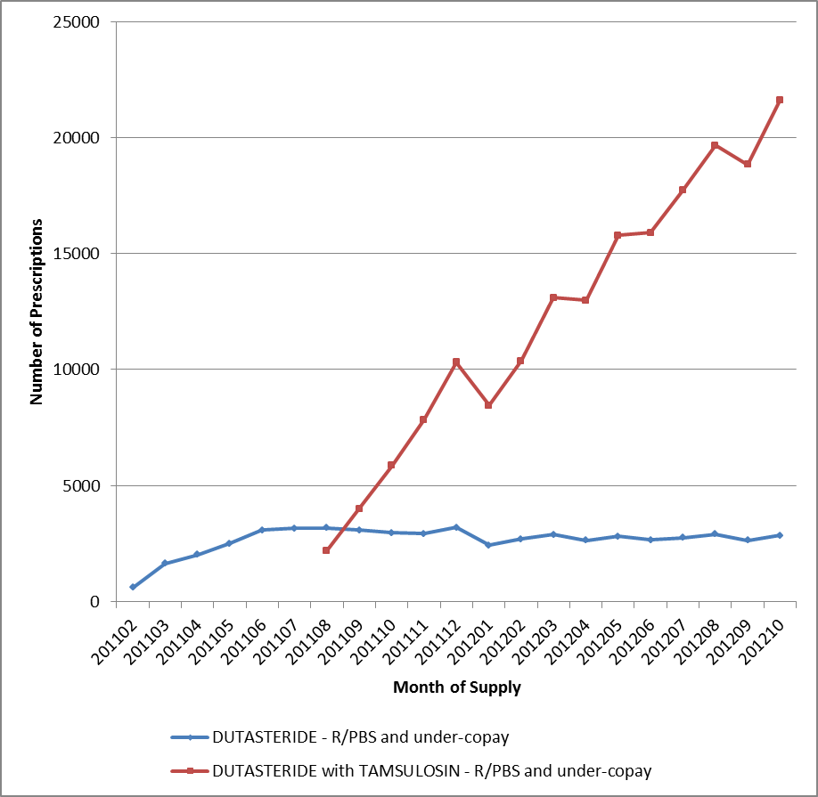Figure 2: dutasteride and dutasteride with tamsulosin FDC R/PBS prescriptions (including under co-payment) by month of supply.
Source: DUSC database accessed March 2015

Changes in the use of other drugs
The dutasteride submission assumed that the use of prazosin would increase with the PBS listing of single agent dutasteride due to the need to co-administer the drug with an alpha-antagonist. Initial analysis failed to demonstrate a clear increase in use of prazosin following the listing of dutasteride. Further analysis of prazosin and dutasteride co-administration was not thought to be necessary due to the continued low utilisation of single agent dutasteride.
The dutasteride submission also assumed that RPBS usage of finasteride would decrease. However, usage has continued to be low and stable. The number of finasteride prescriptions in the most recent complete year (year 3 after listing of single agent dutasteride, January 2013-February 2014), was 35,686.

Use of single agent tamsulosin has been steady at approximately 50, 000 prescriptions per year, since the last report.

Analysis of expenditure

Table 5: total R/PBS cost to the government for dutasteride (5468T) from 1 February 2011 (date of listing) to 31 January 2012 (Year 1) and 31 October 2015 (month 9 of Year 4)
 | Year 1 | Year 2 | Year 3 | Year 4^{b}
Predicted | $''''''''''''''''''' | $ ''''''''''''''''''''' | $ '''''''''''''''''' | $ ''''''''''''''''''''
Actual (%ª) | $653,069 (''''''''''''''''''''%) | $707,006 ('''''''''''''''''''''%) | $771,199  (''''''''''''''''''%) | $600,840 ('''''''''''''''''''''%)
Source: Predicted - estimates agreed between the Sponsor and DoHA post PBAC recommendation to list. Actual - DUSC database accessed March 2015, based on date of prescription supply.
ªpercent of predicted use
^{b}actual data presented for year 4 is a part year, as complete data was only available for February 2013 to October 2014

Table 6: total R/PBS cost to the government for dutasteride + tamsulosin (5490Y)^{c} from 1 February 2011 to 31 January 2012 (Year 1) and 31 October 2015 (month 9 of Year 4)
 | Year 1 | Year 2 | Year 3 | Year 4^{b}
Predicted | $ '''''''''''''''''''' | $ ''''''''''''''''''' | $ ''''''''''''''''''' | $ ''''''''''''''''''''
Actual (%ª) | $988,099 (''''''''''''''''''%) | $988,099 ('''''''''''''''''''''%) | $988,099 ('''''''''''''''''''''%) | $988,099 ('''''''''''''''''''''%)
Source: Predicted - estimates agreed between the Sponsor and DoHA post PBAC recommendation to list. Actual - DUSC database accessed March 2015, based on date of prescription supply.
ªpercent of predicted use
^{b}actual data presented for year 4 is a part year, as complete data was only available for February 2013 to October 2014
^{c}listed 1 August 2011

Table 7: total R/PBS cost to the government for dutasteride (5468T) and dutasteride + tamsulosin (5490Y)^{c} from 1 February 2011 to 31 January 2012 (Year 1) and 31 October 2015 (month 9 of Year 4)
 | Year 1 | Year 2 | Year 3 | Year 4^{b}
Predicted | $ ''''''''''''''''''''' | $ ''''''''''''''''''' | $ '''''''''''''''''''''' | $ '''''''''''''''''''''
Actual (%ª) | $1,641,167 ('''''''''''''''''''''%) | $1,641,167 (''''''''''''''''''''''%) | $1,641,167 ('''''''''''''''''''''%) | $1,641,167 ('''''''''''''''''''%)
Source: Predicted - estimates agreed between the Sponsor and DoHA post PBAC recommendation to list. Actual - DUSC database accessed March 2015, based on date of prescription supply.
ªpercent of predicted use
^{b}actual data presented for year 4 is a part year, as complete data was only available for February 2013 to October 2014
^{c}listed 1 August 2011

Analysis of actual versus predicted utilisation
The number of prescriptions for single agent dutasteride has been low and stable over the first four years of listing. Actual use, in terms of prescription numbers and expenditure, is substantially lower than predicted. The estimates assumed that utilisation of the single agent would continue to increase for the first five years after listing. This does not appear to be the case, with utilisation at its peak in the first year of listing.
Uptake of the dutasteride with tamsulosin FDC following PBS listing on 1 August 2011 was rapid; however, the extent of use was lower than predicted. While the number of patients on this therapy has steadily increased in 2014, the proportion of actual patients compared to predicted levels has remained stable between 60% and 80% of estimates. The number of prescriptions increased steadily over years 2-3, but has remained between 60% and 80% of estimates. The DUSC noted that given the trend for nine months of data in year 4, the number of prescriptions for dutasteride with tamsulosin in the whole of year 4 will be likely to at least match year 3 levels.
The submission assumed that 23.5% of PBS prescriptions would be for general beneficiary patients. Approximately 17-18% of PBS prescriptions supplied in the first three years of listing were for general beneficiary patients. The DUSC noted that the difference between predicted and actual percentages for costs compared to prescriptions is due to the proportion of general and concessional patients differing from the estimates.
Overall, the total utilisation for both dutasteride and dutasteride with tamsulosin is significantly lower than predicted. The rate of growth of the FDC product is slower than expected, although it has not yet plateaued. Use in year 3 was closer to predicted levels than year 2; however utilisation remains lower than estimated.

Discussion
Overall, the total utilisation for both dutasteride and dutasteride with tamsulosin since listing continues to be much lower than predicted. Usage of the dutasteride and tamsulosin FDC are increasing at a much slower rate than expected.
The DUSC considered that the lower than expected use of dutasteride and dutasteride with tamsulosin may be due to a number of reasons:
- The number of eligible patients may have been overestimated;
- The uptake of the therapies may have been overestimated;
- Private prescriptions may form a large part of the market - about 30%;
- The duration of treatment may have been overestimated;
- The restriction requires initiation and review by a urologist, which may be limiting the number of patients commencing therapy; and
- In the case of the dutasteride monotherapy, the requirement for a concomitant alpha antagonist therapy may have contributed to the low uptake. The combination therapy offers patients convenience and fewer co-payments than concomitant agents.
The DUSC considered that the similar outcomes in predicted versus actual patient and prescription numbers indicates that low adherence to therapy is unlikely to be contributing to the lower than expected utilisation.
Dutasteride treatment can take at least three to twelve months to have maximum impact on symptoms. The rate of drop out from treatment is highest during the first year (56% of patients stop treatment), and there are a number of patients who cease treatment before this time. These patients may not have felt the full effects of treatment, and this could indicate that an unwillingness to persist with therapy is contributing to the lower than expected utilisation.
The median treatment time was 22 months, with a mean of 24 months. 30% of patients are thought to remain on the therapy after four years. 17% of patients stop after their first prescription. 56% of patients ceased treatment within the first year. The DUSC noted that there are no data to indicate the reason patients stop after their first prescription. The DUSC considered this may indicate some patients are ceasing therapy due to adverse effects. The DUSC noted that the long time period for onset of effect (3-12 months) may lead patients to believe therapy is not working.
Due to the chronic nature of BPH, patients may have been expected to be on long-term treatment. However, there is no standard treatment length recommended in the clinical guidelines for the treatment of LUTS due to BPH. This makes it difficult to assess if the actual time patients are spending on treatment is appropriate or not. The data does not provide information on the reasons that patients ceased treatment and therefore it is difficult to assess the impact of persistence on overall utilisation.
The sponsor response suggested that the lower than expected utilisation may be due to the requirement for a urologist to initiate treatment. The DUSC considered the current requirement for initiation of treatment by a urologist, and noted that the market is now mature and the products are well understood. The DUSC suggested that the PBAC consider whether there is an ongoing need for these therapies to be initiated by a urologist.

Actions undertaken by the DUSC Secretariat
A copy of the report and a letter was sent to the Urological Society of Australia and New Zealand requesting consideration of the report and comment on the issues surrounding lower than expected utilisation, particularly whether access to a urologist and/or poor persistence to therapy is affecting utilisation.

DUSC actions
The DUSC requested that the report be provided to the PBAC.

The DUSC requested that the PBAC consider amending the restrictions for dutasteride and dutasteride with tamsulosin to remove the requirement for treatment to be initiated by a urologist. The DUSC suggested that the PBAC consider the management of any expansion of the accessibility of dutasteride and dutasteride with tamsulosin with respect to existing risk sharing arrangements.

The DUSC requested that the Secretariat seek advice from the Urological Society of Australia and New Zealand (USANZ) regarding the impact of removing the requirement for urologist initiation.

Context for analysis
The DUSC is a Sub Committee of the Pharmaceutical Benefits Advisory Committee (PBAC). The DUSC assesses estimates on projected usage and financial cost of medicines.
The DUSC also analyses data on actual use of medicines, including the utilisation of PBS listed medicines, and provides advice to the PBAC on these matters. This may include outlining how the current utilisation of PBS medicines compares with the use as recommended by the PBAC.
The DUSC operates in accordance with the quality use of medicines objective of the National Medicines Policy and considers that the DUSC utilisation analyses will assist consumers and health professionals to better understand the costs, benefits and risks of medicines.
The utilisation analysis report was provided to the pharmaceutical sponsors of each drug and comments on the report were provided to DUSC prior to its consideration of the analysis.

Sponsors’ comments
GlaxoSmithKline Pty Ltd Comments:
GSK Australia welcomes the publication of this report. This is the second DUSC review since the PBS listing of Avodart® and Duodart® to identify significant under utilisation, with current actual usage ≤50% of predicted expenditure. It is noted that the likely factors limiting utilisation identified in the DUSC 2013 report have again been identified in this review. The relatively high proportion of private scripts supports a conclusion that the current PBS restriction may be a barrier to treatment and equitable access. Consistent with this, GSK Australia supports the DUSC recommendation that the PBAC consider amending the restrictions for dutasteride (Avodart) and dutasteride with tamsulosin (Duodart) to remove the requirement for treatment to be initiated by a urologist given that the that the market is now mature and the products are well understood.

Appendices

Appendix A

Table 8: Number of R/PBS prescriptions for dutasteride (5468T) and dutasteride with tamsulosin FDC (5490Y) supplied.
 | Year 1  Feb 2011-Jan 2012 | Year 2  Feb 2012-Jan 2013 | Year 3  Feb 2013-Jan 2014 | Year 4  Feb 2014-Oct 2014
 | Actual (%^{e}) | Actual (%) | Actual (%) | Actual (%)
Dutasteride^{b}
General PBS/under-copayª | 5,791 | 6,059 | 6,242 | 5,141
Concessional PBS | 23,169 | 25,056 | 27,097 | 21,369
RPBS | 1,834 | 2,105 | 1,791 | 1,791
Private ^{d} | 13,739 | 3,971 | - | -
Total R/PBS | 30,794 (15%) | 33,220 (8%) | 35,686 (9%) | 28,301 (8%)
Total dutasteride | 44,533 | 37,191 | 35,686 | 28,301
Dutasteride + tamsulosin FDC^{c}
General PBS/under-copayª | 7,365 | 37,999 | 6,134 | 58,441
Concessional PBS | 29,350 | 165,799 | 283,074 | 280,086
RPBS | 1,945 | 10,509 | 16,507 | 15,262
Private^{d} | 6,412^{f} | 11,384 | - | -
Total R/PBS | 38,660(28%^{g}) | 214,307 (64%) | 360,922 (71%) | 353,789 (50%)
Total dutasteride + tamsulosin FDC | 45,485 | 224,467 | 360,922 | 353,789
Total dutasteride (single agent and FDC) | 90,018 | 262,882 | 396,608 | 382,090
Source: DUSC database accessed March 2015, based on date of prescription supply.
ª under co-payment prescriptions estimated from Guild Survey to April 2012, then actual prescription data collected by DHS (Medicare)
^{b}listed 1 February 2011
^{c}listed 1 August 2011
^{d} estimate of private prescriptions only available up to August 2012
^{e} percent of predicted use
^{f} from 1 August 2011. Private prescription utilisation prior to PBS listing is presented in Figure 7.1.1.
^{g} Between Aug 11 and Jul 12 there were 124,456 R/PBS prescriptions for dutasteride with tamsulosin FDC

Appendix B

Detailed methodology for Kaplan Meier length of treatment analyses
A break in treatment is defined as a gap of 2 x Standard Coverage Days (SCD) in drug coverage which is equivalent to 3 x SCDs between prescription supply. An episode is defined as the time from the first prescription to the last prescription before a break plus one SCD (i.e. the coverage of the last prescription). The prescription after a break in treatment is defined as the first prescription of the next episode. The SCDs are equal to the median time to re-supply of prescriptions calculated at the drug level. The table below shows the SCDs used in this analysis.
Drug | Median time to re-supply by any item of the specified drug = SCD (days)
dutasteride | 30
dutasteride with tamsulosin | 30

The data period used in the length of treatment analysis was from February 2011 (the listing of dutasteride) December 2014 inclusive (based on date of supply). A patient was deemed to be continuing treatment (i.e. censored for the purposes of the KM analysis) at the end of the data period if the supply of their last prescription was within 3 x SCDs (which is equivalent to the item coverage end date being within 2 x SCDs) of the end of the data period (i.e. 31 December 2014). Patients initiating in 2014 are excluded as they have minimal follow-up time. Three lengths of treatment were calculated, i.e. the length of;
- the first episode of treatment (i.e. up to the first break in treatment);
- all treatment excluding breaks (i.e. the sum of all episodes); and
- all treatment including breaks (i.e. the time from the first prescription of the first episode to the last prescription of the last episode plus one SCD (i.e. the coverage of the last prescription).
When two different strengths (i.e. PBS items) of the same drug were supplied on the same day it was assumed that these strengths were taken concurrently (i.e. were necessary to achieve the prescribed dose). This is not considered stockpiling.

Stockpiling
In previous KM analyses performed by DUSC the issues of both same-day and non-same-day stockpiling of supplies has been addressed. Non-same-day stockpiling is when a patient gets the next supply of a drug earlier than expected (i.e. before the median time to re-supply). This most commonly occurs late in the calendar year when a patient is on the PBS Safety Net. The risk of not allowing for this is that a break in treatment may be imputed for a patient early in the calendar year, where in fact the patient is simply consuming the stockpiled drug. The trade-off risk of allowing for non-same-day stockpiling is that a patient may consistently have a less than median time to re-supply (e.g. because they have a high prescribed dose) and so the imputed coverage end date gets to be significant further than the real coverage end date. This means a break in treatment may be missed. In this KM analysis non-same-day stockpiling was not allowed for because the risk of stockpiling of these drugs was considered low.
Same-day stockpiling is deemed to have occurred when there are multiple supplies of the same PBS item on the same day. Supplies of different strengths on the same day is deemed to be necessary for the supply of the prescribed dose and so not considered to be stockpiling. Multiple supplies of the same strength on the same day are most likely due to stockpiling (i.e. if such a quantity were required for the prescribed dose then the prescriber should have requested an increased maximum quantity). Thus same-day stockpiling is taken into account in this analysis.

Disclaimer
The information provided in this report does not constitute medical advice and is not intended to take the place of professional medical advice or care. It is not intended to define what constitutes reasonable, appropriate or best care for any individual for any given health issue. The information should not be used as a substitute for the judgement and skill of a medical practitioner.
The Department of Health (DoH) has made all reasonable efforts to ensure that information provided in this report is accurate. The information provided in this report was up-to-date when it was considered by the Drug Utilisation Sub-committee of the Pharmaceutical Benefits Advisory Committee. The context for that information may have changed since publication.
To the extent provided by law, DoH makes no warranties or representations as to accuracy or completeness of information contained in this report.
To the fullest extent permitted by law, neither the DoH nor any DoH employee is liable for any liability, loss, claim, damage, expense, injury or personal injury (including death), whether direct or indirect (including consequential loss and loss of profits) and however incurred (including in tort), caused or contributed to by any person’s use or misuse of the information available from this report or contained on any third party website referred to in this report.

Dutasteride (Avodart) Product Information. Available from https://www.ebs.tga.gov.au, Accessed 2 Mar 2015
Dutasteride and tamsulosin (Duodart) Product Information. Available from https://www.ebs.tga.gov.au, Accessed 2 Mar 2015
Dutasteride (Avodart) Consumer Medicine Information. Available from https://www.ebs.tga.gov.au, Accessed 2 Mar 2015
Dutasteride with tamsulosin (Duodart) Consumer Medicine Information. Available from https://www.ebs.tga.gov.au, Accessed 2 Mar 2015
AMH Aged Care Companion 2014, Australian Medicines Handbook Pty Ltd; Adelaide.

