Alprazolam: Review of PBS utilisation following rescheduling to Schedule 8

Drug utilisation sub-committee (DUSC)

October 2015

Abstract

Purpose
To assess the utilisation of alprazolam supplied through the Pharmaceutical Benefits Scheme (PBS) following its rescheduling from Schedule 4 (S4) to Schedule 8 (S8) in the Standard for the Uniform Scheduling of Medicines and Poisons (SUSMP) on
1 February 2014.

Pharmaceutical Benefits Scheme (PBS) Listing
Alprazolam was first listed on the PBS on 1 December 1993.
Alprazolam has an Authority Required PBS listing for the treatment of panic disorder where other treatments have failed or are inappropriate.

Data Source
Four data sources were used:
- DUSC database;
- Department of Human Services (DHS) pharmacy claim database;
- DHS Authority approvals database; and
- data on supply of all brands of items listed on the PBS, provided to the Pharmaceutical Benefits Division of the Australian Department of Health to administer the price disclosure policy.

Key Findings
The utilisation of alprazolam supplied through the PBS declined by about one third immediately after rescheduling to S8 and has continued to decline since.
Changes in alprazolam use in the first 12 months after rescheduling compared with the previous 12 month period include:
- a 35% reduction in the number of prescriptions dispensed;
- a 30 % reduction in the total number of patients dispensed at least one prescription; and
- a 35 % reduction in the number of new patients starting alprazolam.
These trends were unique to alprazolam and not observed in other benzodiazepines.
No significant change in the amount of alprazolam dispensed per prescription was observed.
In the months surrounding the rescheduling of alprazolam, about double the number of patients switched from alprazolam to diazepam or oxazepam compared to usual levels.
Private prescriptions comprise about a quarter of the total community prescriptions of alprazolam. Based on limited data, the private prescription market appears to have declined to a similar extent as the PBS market, however further sources of data would be required to confirm this trend.

Purpose of analysis
To assess the utilisation of alprazolam supplied through the PBS following its rescheduling from Schedule 4 (S4) to Schedule 8 (S8) in the Standard for the Uniform Scheduling of Medicines and Poisons (SUSMP) on 1 February 2014.

Background
In June 2013, following consideration by the Advisory Committee on Medicines Scheduling (ACMS) and public consultation, the TGA medicines scheduling delegate decided that alprazolam should be rescheduled from S4 to S8. The reasons for the decision were as follows:
- Alprazolam has increased morbidity and mortality in overdose with possible increased toxicity. It does not appear to have any additional therapeutic benefits compared with any other substance in the class.
- There has also been a rapid increase in the use of alprazolam compared with other benzodiazepines and evidence of widespread misuse.
- There were concerns of possible increased toxicity with alprazolam.
- There were concerns that current alprazolam pack size is inappropriate for indications.
- There is evidence of abuse of alprazolam and misuse with opioids with it being more subject to diversion from licit to illicit use.
- Listing in S8 of alprazolam does not restrict its short-term use for the approved indication.
The scheduling change occurred on 1 February 2014.

Relevant aspects of consideration by the Pharmaceutical Benefits Advisory Committee (PBAC)
At its March 2014 meeting, the PBAC considered a request to delist alprazolam from the PBS on the basis of the potential for harm associated with the use of alprazolam outweighing the potential benefit. The PBAC noted that the TGA had rescheduled alprazolam from S4 to S8 on 1 February 2014, and decided to revisit the request after more time had elapsed so as to better evaluate the effect of rescheduling.
At the November 2014 meeting, the PBAC considered the request again, and noted the submission of a sponsor and a specialist clinician supporting the retention of alprazolam on the PBS. The PBAC agreed that the rescheduling to S8 had appeared to reduce alprazolam’s usage and so considered it appropriate to take no further actions with respect to alprazolam’s current PBS listing. To further confirm the effect of rescheduling, the PBAC requested the DUSC review alprazolam’s usage in 12 months’ time.

Therapeutic Goods Administration (TGA) approved indications
The current indications are as follows:
Anxiety: the short-term symptomatic treatment of anxiety including treatment of anxious patients with some symptoms of depression.
Panic Disorder: the treatment of panic disorder with or without some phobic avoidance, and for blocking or attenuation of panic attacks and phobias in patients who have agoraphobia with panic attacks.
Note that alprazolam is not PBS subsidised for anxiety and is only PBS subsidised for panic disorder where other treatments have failed or are inappropriate.

Clinical situation
Panic disorder is characterised by recurrent panic attacks, in which the onset of the attack is not associated with a situational trigger. It should be differentiated from other conditions such as isolated panic attacks, generalised anxiety disorder, and symptoms due to substance abuse.²
The Therapeutic Guidelines (TG)² recommend cognitive behavioural therapy (CBT) as first line treatment for panic disorder. When CBT is not available or not effective, pharmacotherapy may be required. Selective serotonin reuptake inhibitors (SSRIs) and venlafaxine are regarded as first line pharmacotherapies. On initiation of antidepressants there may be a transient increase in anxiety, therefore lower initial doses, or short term co-administration of a benzodiazepine can be considered.
Tricyclic antidepressants such as clomipramine or imipramine may be used after unsuccessful trials of at least one first line drug. Irreversible nonselective monoamine oxidase inhibitors (MAOIs) such as phenelzine are a further option and should generally be restricted to specialist psychiatric practice.
The Therapeutic Guidelines² consider that the role of benzodiazepines in treating panic disorder has been replaced by the antidepressants. Infrequently they may be used in patients who have not responded or who cannot tolerate antidepressants. Specialist review and advice is recommended before prescribing benzodiazepines.

Guidelines for the prescribing of alprazolam endorsed by The Royal Australian and New Zealand College of Psychiatrists (RANZCP) and The Royal Australian College of General Practitioners (RACGP), published in 2007, concur with the TG that first line therapies should include cognitive behavioural therapy (CBT) and/or SSRIs. The guidelines previously recommended benzodiazepines and other antidepressants as second-line therapies; however the most recent advice from the RANZCP on the treatment of panic disorder no longer recommends benzodiazepines, due to their addictive nature and the presence of new treatments. Recently released RACGP guidelines note that alprazolam is the most commonly prescribed benzodiazepine for panic disorder; however, these guidelines also note that meta-analyses have not shown superior efficacy compared to other benzodiazepines, but have shown a greater risk of dependence, problematic use and withdrawal.,
In addition to panic disorder, alprazolam is registered for short term symptomatic treatment of anxiety. The current Therapeutic Guidelines recognise that benzodiazepines have been widely used for anxiety but are no longer recommended for the treatment of anxiety disorders other than in exceptional circumstances.² Similarly, new guidelines for the prescribing of benzodiazepines from the RACGP state they are not indicated for use in mild anxiety, however there may be a clinical place for 'patients with very distressing or impairing symptoms whom rapid symptom control is critical'. The guidelines state that trials for clonazepam, diazepam and lorazepam have demonstrated efficacy for the treatment of panic disorder and other anxiety disorders.

State and Territory Regulations
Prescribing of controlled drugs is regulated by the states and territories. There is some variation between the states and territories on prescribing requirements for S8 drugs. These differences include information requirements, manner of preparation of prescriptions and reporting requirements to authorised delegates of state or territory health departments. However, there are two consistencies in the regulations for all states and territories. Each prescription for a controlled drug must be reported to the associated health department and approval must be sought for the use of controlled drugs in drug dependent patients. For a more detailed summary of the current requirements for each state and territory, please refer to tables 1 and 2 in Hua et al, 2015.

Dosage and administration
Alprazolam is available in 0.25mg, 0.5mg, 1mg and 2mg tablets. The dose of alprazolam is individualised. See the full product information for details.
Table 2 below provides usual dosages for treating panic disorder.

Table 2: Alprazolam usual starting dosage and dosage ranges
Indication | Usual Starting Dosage | Usual Dosage Range
Panic disorder | 0.5 to 1.0mg given at bed time, increasing at a rate of 0.25 to 1mg every 3 days until symptoms are controlled. | The dose should be adjusted to patient response. Dosage adjustment should be in increments no greater than 1mg every three to four days.  Additional doses can be added until a three times daily or four times daily schedule achieved.  The mean dose in a large multi-clinic study was 5.7 ± 2.27mg, with rare patients requiring a maximum of 10mg daily.
Source: Australian Medicines Handbook and Product Information (multiple), Accessed June 24 2015
The current Product Information (PI) and Consumer Medicine Information (CMI) are available from the TGA (Product Information) and the TGA (Consumer Medicines Information).

PBS listing details (as at 7 July 2015)

Table 3: PBS listing of alprazolam
Name | Item Code | Forms and strengths | Qty and Rpts | DPMQ | Brand name and manufacturers
ALPRAZOLAM | 2130D | 250mcg tablet, 50 | Max Qty: 1  Repeats: 2 | $14.96 | Alprax® (250mcg, 0.5mg, 1mg, 2mg)  Aspen Pharma Pty Ltd  Kalma® (250mcg, 0.5mg, 1mg, 2mg)  Alphapharm Pty Ltd  Chemmart Alprazolam (1mg, 2mg)  Apotex Pty Ltd  GenRx® Alprazolam (1mg, 2mg)  Apotex Pty Ltd  Terry White Chemists Alprazolam (1mg, 2mg)  Apotex Pty Ltd
 | 2131E | 0.5mg tablet, 50 | Max Qty: 1  Repeats: 2 | $15.97
 | 2132F | 1mg tablet, 50 | Max Qty: 1  Repeats: 0 | $17.92
 | 8118G | 2mg tablet, 50 | Max Qty: 1  Repeats: 0 | $20.45
Source: the PBS website.

Restriction
Alprazolam is listed as Authority Required with the following restriction:
Panic disorder where other treatments have failed or are inappropriate.
For details of the current PBS listing refer to the PBS website.

Date of listing on PBS
Alprazolam was first listed on 1 December 1993 for the 1mg dosage strength. Other strengths were added between 1994 and 1997.

Changes to listing
Since listing on the PBS, alprazolam has been an Authority Required item. The initial restriction stated:
‘Treatment of panic disorder or agoraphobia with panic attacks where other treatments have failed or are inappropriate’.
At the July 2004 PBAC meeting, the committee recommended the restriction be changed to remove the reference to agoraphobia with panic attacks, to harmonise the indications of alprazolam with listing changes made to SSRIs.
The originator brand name, Xanax®, was delisted from the PBS on 31 January 2014. As of 1 July 2015 Xanax® remains registered in the ARTG.

Methods
Data sources
This analysis used four sources of data: DUSC database, DHS (Medicare) pharmacy claims database, DHS authority approvals database, and data on supply of PBS items from price disclosure data. The latter was used to estimate the proportion of PBS listed alprazolam items supplied on private prescription, by subtracting the PBS prescription supply data from the price disclosure supply data. All data are de-identified.
All strengths of alprazolam are currently priced below the general patient copayment. Prior to April 2012, the DHS pharmacy claim database only included data for PBS prescriptions where a subsidy was paid. From April 2012, all PBS prescriptions are captured, including those priced below the general patient co-payment where a subsidy was not paid. The DUSC database includes an estimate of under co-payment prescriptions until April 2012 and an estimate of private prescriptions until August 2012.
The DHS Authority approvals database includes approval data for both under-copayment and PBS subsidised prescriptions and therefore provides a more complete picture of PBS utilisation over time.
Analyses
Analyses undertaken with prescription dispensing data included prescription volume, defined daily doses (DDDs) per 1000 population per day, and the number of patients treated and commencing treatment. The authority approval data was used to examine the number of patients on treatment over a longer time period.

Prescription dispensing data was also used to undertake a simple analysis comparing rates of switching from alprazolam to other benzodiazepines. Potential switchers were identified by determining the monthly number of patients ceasing treatment with alprazolam and commencing treatment with another benzodiazepine they had not used recently.

Various groups of drugs have been used in the treatment of panic disorder including selective serotonin reuptake inhibitors, serotonin and noradrenaline reuptake inhibitors (SNRIs), tricyclic antidepressants, monoamine oxidase inhibitors and benzodiazepines. Although not all of the individual medicines in these groups are TGA indicated, PBS listed or recommended in guidelines for panic disorder, PBS data for all benzodiazepines and SSRIs were extracted and then further filtered as needed.

Data analysis was undertaken using SAS.
The size of the private market was also estimated and presented separately. Data on supply of all brands of items listed on the PBS, provided to the Pharmaceutical Benefits Division of the Australian Department of Health to administer the price disclosure policy, was used. Data from the period 1 October 2011 to 31 March 2015 were obtained. The data provided did not include any dispensing from public hospitals. As price disclosure data is presented in the number of packs supplied, PBS prescription data was converted to packs by calculating the total number of alprazolam tablets supplied and dividing by the standard pack size (50) to calculate the number of packs. An estimate of private supply of alprazolam was calculated by subtracting the calculated PBS-supplied pack data from the number of packs in the price disclosure data.

Results

Analysis of drug utilisation

Overall utilisation
Figure 1 presents the number of alprazolam prescriptions dispensed through the PBS each month over the last 5 years.
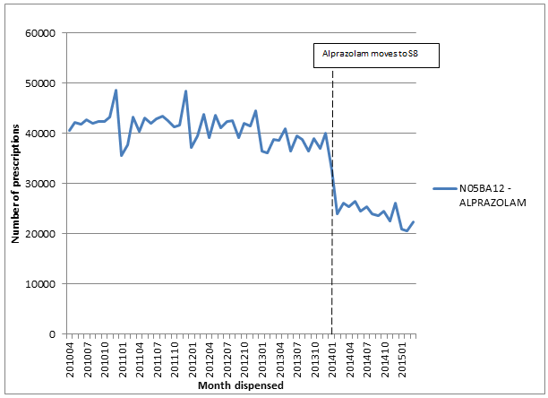

Figure 1 – PBS prescriptions of alprazolam, April 2010 – March 2015
Source: DUSC database, extracted July 2015

There was a 35% decrease in PBS alprazolam prescriptions immediately upon rescheduling to S8 and use has continued to decline.
Figure 2 shows the alprazolam prescription data in the context of other PBS listed oral benzodiazepines.
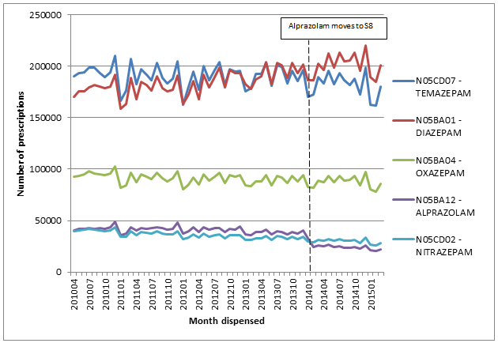

Figure 2 – PBS prescriptions dispensed for alprazolam and tablet formulations* of other benzodiazepines April 2010 – March 2015
Source: DUSC database, extracted July 2015
*Note that all prescriptions for the tablet formulations are included regardless of the indication for which they are prescribed. Clonazepam is not included as it is an authority required medicine for epilepsy only.

The step-down in use of alprazolam in 2014 is not observed with other benzodiazepines. The prescription volumes of other oral benzodiazepines are mostly stable or increasing over the time period. The rate of growth of diazepam appears to be higher in the 12 months following the rescheduling of alprazolam. An analysis presented later in this report examines whether some of this increase can be attributed to switching between alprazolam and diazepam.
Figure 3 presents the number of DDDs per 1000 population per day for alprazolam. The DDD for alprazolam assigned by the World Health Organization of 1mg is the assumed average maintenance dose per day of alprazolam when used for anxiety and may underrepresent the daily dose of alprazolam used for panic disorder.

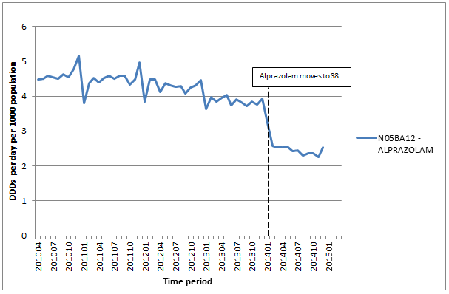

Figure 3 – DDDs per 1000 population per day for PBS dispensed alprazolam
Source: DUSC database, extracted July 2015

Similar to the change with prescription volume, there was an approximate one third decrease in PBS alprazolam use as measured by DDD/1000 population/day immediately upon rescheduling to S8. The similar magnitude decline in prescription volume and DDD/1000/population/day suggests that the quantity of alprazolam dispensed per prescription has not altered substantially since rescheduling to S8. This is supported by data presented in Table 4, showing the mean and median quantity per prescription for the 12 months before and 12 months after the rescheduling of alprazolam.

Table 4: Quantity (mg) of alprazolam supplied per prescription in the 12 months before and after rescheduling
 | Feb 13 – Jan 14 | Feb 14 – Jan 15
Mean | 70.87 mg | 70.55 mg
Median | 70.75 mg | 70.46 mg
Source: DHS supplied prescription database

The quantity of alprazolam supplied per prescription has not altered significantly following rescheduling.

Patient Numbers
The number of patients dispensed at least one PBS prescription of alprazolam in the year prior and year following rescheduling is shown in Table 5:

Table 5: Number of prevalent and new patients prescribed PBS subsidised alprazolam in the 12 months prior and following rescheduling
 | Feb 13-Jan 14 | Feb 14-Jan 15
All patients | 79,639 | 56,359
New patients* | 30,024 | 19,169
Source: DHS supplied prescription database
*New patients were defined by no prior alprazolam with a look back period of 10 months at the patient level, to an earliest possible date of 1 April 2012, to coincide with availability of under co-payment prescription data.

The number of patients dispensed at least one prescription of alprazolam in the 12 months after rescheduling decreased by about 30% compared to the 12 months before. Additionally, the number of new alprazolam patients (defined as those with no prior alprazolam in the previous 10 months) decreased by about 35% over the same period. As prescriptions and repeats for alprazolam written prior to 1 February 2014 remained valid, it is reasonable to expect that the number of new patients may have decreased at a quicker rate than prevalent patients.
Because under co-payment prescriptions for general patients were not captured in the PBS dataset prior to April 2012 the look back period is limited. An alternate data source, the DHS Authority approvals database, includes approval data for both under co-payment and PBS subsidised prescriptions and therefore provides a more complete picture of PBS utilisation over time.
The number of patients receiving alprazolam, as estimated from PBS authority approval data, is presented in Figure 4. Prevalent patients are classified as those with at least one authority approval within a six month interval. In this instance, initiating patients were identified as those with no prior authority approval since 1 January 2002.

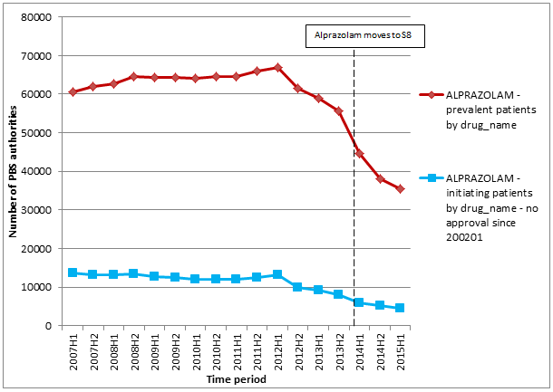

Figure 4 – Number of patients and new patients# approved for a PBS supply of alprazolam 2007-2015
Source: Medicare Authority Approvals database, extracted July 2015
# New patients are defined as those with no prior PBS authority approval since January 2002.

The red line in Figure 4 shows an upward trend in the total number of people receiving an authority approval between the first half 2007 and second half of 2008, stabilising between first half of 2009 and second half of 2012, before beginning a marked decline that became further pronounced in late 2013 and continued until the end of 2014. The sharpest decrease is in the months before and after the rescheduling of alprazolam. The number of new patients was fairly stable until the first half of 2012, and has declined since, showing no evidence of stabilising.
Changes in use of other medicines used for the treatment of panic disorder
PBS prescription data for other medicines used to treat panic disorder, including SSRIs, SNRIs, TCAs and monoamine oxidase inhibitors, are provided in Appendix A. These markets would not have been expected to change markedly following the rescheduling of alprazolam to S8 given that the PBS restriction for alprazolam requires other treatments to have failed or be inappropriate. Further, because these markets are much larger than alprazolam and are growing, and because the predominant use is for depression and the indication is not available in the PBS dataset, prescription volume data is not informative for considering whether the rescheduling of alprazolam resulted in more patients being treated with these medicines.
Patient level analysis
Alprazolam does not appear to have any additional therapeutic benefits compared with any other substance in the class., Therefore it would be reasonable to expect that some patients with an ongoing need for a benzodiazepine may be switched to other drugs in this class. Figure 2 is suggestive of switching to diazepam because growth in the number of prescriptions for diazepam appears to have increased at a higher rate following the rescheduling of alprazolam. Diazepam and oxazepam are indicated for anxiety and have unrestricted PBS listings for standard quantities. Nitrazepam and temazepam, although indicated for insomnia, also have unrestricted PBS listings and are included for completeness. Clonazepam is considered unlikely to substitute for alprazolam because it is an authority required PBS medicine and only indicated for epilepsy.
Figure 5 presents the number of patients who initiated diazepam, oxazepam, nitrazepam or temazepam between January 2013 and March 2015 whose previous prescription for a benzodiazepine was alprazolam.
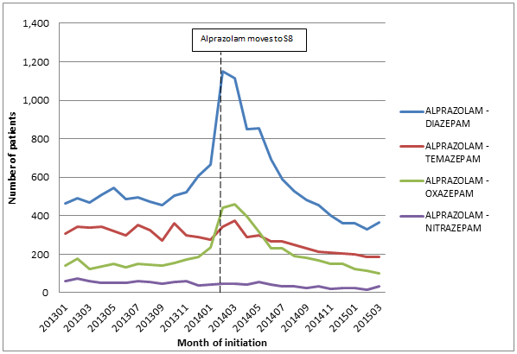

Figure 5: Initiations to diazepam, oxazepam, temazepam or nitrazepam where the prior drug supplied was alprazolam, January 2013 – March 2015
Source: Medicare dispensing database, extracted July 2015
Figure 5 shows a substantial increase in the number of patients switching to diazepam or oxazepam coinciding with the rescheduling of alprazolam. A similar trend is not apparent with nitrazepam or temazepam.
A comprehensive analysis to assess switching from alprazolam to other medicines was not undertaken due to complexities of distinguishing cessation, switch or add-on therapy with the available data. Such an analysis would be particularly complex because of the wide range of alprazolam regimens used in practice (individualised dosing, periods of dose titration, intermittent/short term/longer term use, patterns of misuse or abuse). In addition, co-morbidity of panic disorder and other conditions is common and the indication for use is not available in the PBS dataset.

Size of the Private Market
Prior to August 2012 an estimate of the private prescription market, based on community pharmacy survey data, was available from the DUSC database. In the period 1 April 2010 to 31 August 2012 this source estimated that the size of the alprazolam private market was between 25% and 28% of total community use.
Using price disclosure data collected between October 2011 and March 2015, analyses revealed that sales of alprazolam decreased approximately 25% in the April 2014 to September 2014 quarter compared with the October 2013 to March 2014 quarter. The reduction in the estimated size of the private market (i.e. Total packs sold minus R/PBS packs) was also 25% for the same period.
This estimate of the private prescription market for alprazolam does not include use in the public hospital setting. The impact of this is likely to be small in the context of the total market. In addition, price disclosure data does not contain sales for non-PBS listed brands, including the originator Xanax® after its delisting from the PBS on 1 January 2014.

Discussion and DUSC consideration
The DUSC noted the noticeable decline in the utilisation of PBS prescriptions of alprazolam following rescheduling to S8. This included an immediate drop of approximately 30%, with utilisation continuing to decline. This was observed from multiple measures of utilisation including the number of prescriptions dispensed, the DDD/1000 population/day and the number of patients. The DUSC observed that the change in use from February 2014 onward was unique to alprazolam. The DUSC considered that the rescheduling has helped to curb the use of alprazolam and that this is evident in both the PBS and non-PBS prescription market. The DUSC noted that rescheduling a medicine from S4 to S8 restricts access to this medicine across the entire market, not just the PBS.
The private market accounts for approximately 25-30% of alprazolam use. Estimated private prescription use (i.e. total packs sold minus R/PBS packs) for PBS listed alprazolam brands to pharmacies decreased 25% between the periods 1 October 2013 to 31 March 2014 and 1 April to 30 September 2014 (with rescheduling occurring in the middle of this period) indicating that the rescheduling of alprazolam also had an impact on the size of the private market. However, there are several limitations with using this data source as data on supply collected through price disclosure may not align with consumption and data may be incomplete. Further data sources would be necessary to confirm whether the decline of alprazolam use through the PBS is mirrored in the private prescription market. The DUSC noted that the PBS authority requirement and the low price of alprazolam are likely to be contributing to the size of the private market. Furthermore, the DUSC noted that alprazolam is indicated for use in anxiety disorders, but is not listed on the PBS for that use, and considered it likely that some use is for the treatment of anxiety. The DUSC discussed the use of alprazolam potentially declining in the future particularly with the roll out of real-time controlled drugs monitoring.
The DUSC noted that the rate of switching from alprazolam to diazepam and oxazepam doubled around the time alprazolam was rescheduled. The analysis presented indicated that some alprazolam patients were switched to alternative longer-acting benzodiazepines. The number of patients ceasing alprazolam, switching to other medicines or adding further medicines was not quantified because of the complexities of differentiating these patterns of use in the context of varying dosage regimens, pack sizes, and multiple indications in a group of patients where comorbidity is common.
The DUSC was concerned that, although alprazolam is associated with increased morbidity and mortality in overdose with possible increased toxicity compared with other benzodiazepines,¹² misuse and dependency are concerns with all benzodiazepines; dose reduction and cessation should be the goal. Therefore, while the reduction in alprazolam use is encouraging, it is important to consider this in the context of the total benzodiazepine market. The DUSC was also concerned that there could be a shift to other potentially inappropriate medicines such as antipsychotics.

The DUSC considered correspondence from a concerned group of General Practitioners who recommend that alprazolam is withdrawn completely from the PBS on the basis that there is no evidence to suggest that anyone will come to harm if this medicine is withdrawn. Alternative recommendations were also suggested to assist in limiting harm if alprazolam remains on the PBS including removing the 1mg and 2mg doses, reducing the pack size and having nil repeats, tightening the restriction to specify treatments that must have failed or are inappropriate, limiting prescribing to psychiatrists or specifically trained GPs, encouraging education and support for prescribing according to guidelines, and reducing and withdrawing benzodiazepine use. The DUSC referred the correspondence to the PBAC for consideration. The DUSC discussed that should any further restrictions be applied to the PBS listings, it may result in a further shift to the alprazolam private prescription market.

DUSC noted that comment had been sought from the Royal Australian College of General Practitioners (RACGP) and the Royal Australian and New Zealand College of Psychiatrists (RANZCP). These responses were unable to be provided in time for the DUSC but were provided to the PBAC alongside with the report, DUSC minutes and responses from other stakeholders.

DUSC actions
The DUSC requested that the report, stakeholder responses and DUSC minutes be provided to the PBAC.

The DUSC requested that the PBAC consider whether any further restriction on the prescribing of alprazolam is required. Such changes could include reducing the maximum quantity and repeats available through the PBS or limiting prescribing to psychiatrists or specially-trained GPs.

Context for analysis

The DUSC is a Sub Committee of the Pharmaceutical Benefits Advisory Committee (PBAC). The DUSC assesses estimates on projected usage and financial cost of medicines.

The DUSC also analyses data on actual use of medicines, including the utilisation of PBS listed medicines, and provides advice to the PBAC on these matters. This may include outlining how the current utilisation of PBS medicines compares with the use as recommended by the PBAC.

The DUSC operates in accordance with the quality use of medicines objective of the National Medicines Policy and considers that the DUSC utilisation analyses will assist consumers and health professionals to better understand the costs, benefits and risks of medicines.

The utilisation analysis report was provided to the pharmaceutical sponsors of each drug and comments on the report were provided to DUSC prior to its consideration of the analysis.

Sponsors’ comments
Aspen Pharma Pty Ltd, Alphapharm Pty Ltd and Apotex Pty Ltd:

No comment received.

Appendix A: Utilisation of antidepressant medicines

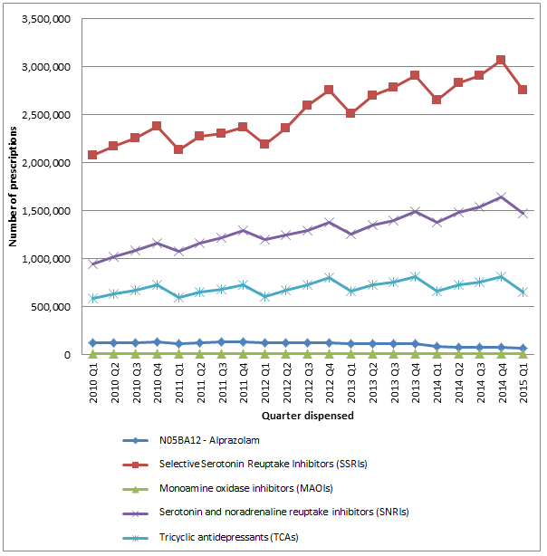

Figure A – PBS Prescriptions dispensed for alprazolam and selected antidepressants
Source: DUSC database, extracted July 2015
Included medicines are from classes referred to in treatment guidelines for use panic disorder:
Benzodiazepines: alprazolam
SSRIs: fluoxetine, citalopram, paroxetine, sertraline, fluvoxamine, escitalopram
SNRIs: venlafaxine, duloxetine, desvenlafaxine
Tricyclic antidepressants: Imipramine, clomipramine, trimipramine, amitriptyline, nortriptyline, doxepin, dothiepin
MAOIs: phenelzine, tranylcypromine

Disclaimer
The information provided in this report does not constitute medical advice and is not intended to take the place of professional medical advice or care. It is not intended to define what constitutes reasonable, appropriate or best care for any individual for any given health issue. The information should not be used as a substitute for the judgement and skill of a medical practitioner.
The Department of Health (DoH) has made all reasonable efforts to ensure that information provided in this report is accurate. The information provided in this report was up-to-date when it was considered by the Drug Utilisation Sub-committee of the Pharmaceutical Benefits Advisory Committee. The context for that information may have changed since publication.
To the extent provided by law, DoH makes no warranties or representations as to accuracy or completeness of information contained in this report.
To the fullest extent permitted by law, neither the DoH nor any DoH employee is liable for any liability, loss, claim, damage, expense, injury or personal injury (including death), whether direct or indirect (including consequential loss and loss of profits) and however incurred (including in tort), caused or contributed to by any person’s use or misuse of the information available from this report or contained on any third party website referred to in this report.

Therapeutic Goods Administration. Reasons for scheduling delegates’ final decisions, June 2013 – benzodiazepines. Canberra: Therapeutic Goods Administration; 2013. Available from https://www.tga.gov.au/book/part-scheduling-proposals-referred-march-2013-meeting-acms#benzo
Panic disorder [revised 2014 June]. In: eTG complete [Internet]. Melbourne: Therapeutic Guidelines Limited; 2015; accessed 19 August 2015.
Royal Australian and New Zealand College of Psychiatrists, Royal Australian College of General Practitioners, Tasmania Department of Health and Human Services (2007). Alprazolam Prescribing Guidelines. Available at: http://www.dhhs.tas.gov.au/__data/assets/pdf_file/0020/46514/Alprazolam_prescribing_guidelines.pdf Accessed June 24 2015.
Royal Australian and New Zealand College of Psychiatrists. Panic disorder and agoraphobia guidelines. Melbourne: RANZCP; 2009. Available at https://www.ranzcp.org/Files/Resources/Publications/CPG/Australian_Versions/AUS_Panic_disorder-pdf.aspx
Moylan S, Staples J, Alison Ward S, Rogerson J, Stein D and Berk M. The efficacy and safety of alprazolam versus other benzodiazepines in the treatment of panic disorder. Journal of Clinical Psychopharmacology 2011; 31:647-652
Royal Australian College of General Practitioners. Prescribing drugs of dependence in general practice, Part B. Melbourne: RACGP; 2015. Available at http://www.racgp.org.au/your-practice/guidelines/drugs-of-dependence-b .
Royal Australian College of General Practitioners. Prescribing drugs of dependence in general practice, Part B. Melbourne: RACGP; 2015. Available at http://www.racgp.org.au/your-practice/guidelines/drugs-of-dependence-b .
Hua A, Shen F, Ge X. State-based legal requirements for Schedule 8 prescriptions: why so complicated? Sydney: Medical Journal of Australia; 2015: 203 (2).
Australian Medicines Handbook, 2015 edition. Medicine Information: Alprazolam. Adelaide: Australian Medicines Handbook Pty Ltd; 2015.
Moylan S, Staples J, Alison Ward S, Rogerson J, Stein D and Berk M. The efficacy and safety of alprazolam versus other benzodiazepines in the treatment of panic disorder. Journal of Clinical Psychopharmacology 2011; 31:647-652
Therapeutic Goods Administration. Reasons for scheduling delegates’ final decisions, June 2013 – benzodiazepines. Canberra: Therapeutic Goods Administration; 2013. Available from https://www.tga.gov.au/book/part-scheduling-proposals-referred-march-2013-meeting-acms#benzo

