Antipsychotic medicines: 24 month review of quetiapine 25 mg

Drug utilisation sub-committee (DUSC)
September 2016

Abstract

Purpose
To review the utilisation of PBS listed antipsychotic medicines, including changes in use of 25 mg quetiapine in the 24 months after the restriction was altered to remove repeats from PBS prescriptions.

Listing on the Pharmaceutical Benefits Scheme (PBS)
Quetiapine was listed on 1 November 2000 for schizophrenia, with extensions to the listing to include bipolar disorder from December 2007 and August 2009.
From 1 January 2014, the number of repeats for the listing of 25 mg strength of quetiapine was reduced from five to zero. The clinical criteria for the listing were also changed to include ‘The treatment must be for dose titration purposes’. The PBAC recommended this change because there was evidence of off-label and non-subsidised use of the 25mg strength of quetiapine. A reduction in repeats from five to zero was considered to be sufficient for dose titration in bipolar disease and schizophrenia, and would encourage regular prescriber review for patients treated for non-subsidised indications.
Refer to Appendix 3 for the listing dates of other antipsychotics examined in this review.

Data Source / methodology
Patient counts and patient level analysis data were extracted from the Department of Human Services (DHS) prescription database for prescriptions supplied from the January 2004 to May 2016. Aggregated prescription data were extracted from the DUSC database (which contains estimates of private and under co-payment prescriptions) for prescriptions supplied from January 2004 to March 2016.

Key Findings
- Growth in the use of typical and atypical antipsychotics had declined. In 2015 there were 438,292 prevalent patients compared to 428,130 in 2014, a year-on-year growth rate of 2.4%. This compared with a year-on-year growth of 4.6% between 2013 and 2014. The slowing in the growth of the prevalent population was mainly attributed to negative growth in the incident population. There were 85,678 patients initiated on an antipsychotic during 2015, which was 1% less than the number of incident patients presenting in 2014 (n=86,552).
- The intervention to change the listing of the 25 mg strength of quetiapine to allow no repeats from 1 January 2014 had been effective in supporting its intended use as a titrating dose for PBS-listed indications.
- Expenditure on all antipsychotics in 2015 was $293.6 million. This was significantly less compared to prior years, largely arising from price reductions which were applied from October 2014.

Purpose of analysis
To review the utilisation of PBS listed antipsychotic medicines, including changes in use of 25 mg quetiapine in the 24 months after the restriction was altered to remove repeats from PBS prescriptions.
The PBAC (August 2013) requested that DUSC undertake this review.

Background
At its August 2013 meeting the PBAC considered the 2013 DUSC review of the use of antipsychotics. The PBAC noted there was off-label and non-subsidised use of antipsychotics which was most evident with the use of the 25 mg strength of quetiapine. The PBAC considered that quetiapine 25 mg was not a therapeutic dose for any of its PBS listed indications and that the role for the 25 mg strength of quetiapine, within the PBS restrictions, should be for dose titration in older people with bipolar disease or schizophrenia. As such, the PBAC requested that the number of repeats of 25 mg quetiapine be reduced from five to zero. The PBAC considered that this listing would be sufficient for dose titration in bipolar disease and schizophrenia, and would encourage regular prescriber review for patients treated for non-subsidised indications.
For further details refer to the Public Summary Document for the August 2013 PBAC meeting.

Pharmacology
Antipsychotic medications are used to treat a range of conditions, including schizophrenia and bipolar disorder (or manic depression). They act on chemicals which are used by cells in the brain to communicate with each other, called neurotransmitters. The main neurotransmitter affected by antipsychotics is dopamine which is involved in how we feel and also the control of muscle movements. If the dopamine system becomes overactive this may cause thought disorders, hallucinations and delusions (Tost et al., 2010).
Antipsychotics are referred to as ‘typical’ or ‘atypical’. A typical drug is an older generation drug while newer drugs are called ‘atypical’. The actions of these drug classes are similar.

Therapeutic Goods Administration (TGA) approved indications
The approved indications vary for each antipsychotic medicine. Details can be found in the Product Information available on the TGA website.

Quetiapine 25 mg is registered for the following indications:
- In adults, maintenance treatment of bipolar I disorder as monotherapy or in combination with lithium or sodium valproate for the prevention of relapse/recurrence of manic, depressive or mixed episodes.
- Treatment of depressive episodes associated with bipolar disorder.
- Treatment of acute mania associated with bipolar I disorder as monotherapy or in combination with lithium or sodium valproate.
- In children and adolescents aged 10 to 17 years as monotherapy for the treatment of acute mania.
- Treatment of schizophrenia.

Dosage and administration
Atypical and typical antipsychotic medicines were included in this class review. The dosing and administration of the atypical medicines are summarised in Appendix 1. The atypical drugs considered in this review include amisulpride, aripiprazole, asenapine, clozapine, lurasidone, olanzapine, paliperidone, quetiapine, risperidone and ziprasidone. The dosing and administration of the typical medicines are described in Appendix 2. The typical medicines included chlorpromazine, flupenthixol, fluphenazine, haloperidol, periciazine, trifluoperazine, zuclopenthixol and thioridazine.
The current Product Information (PI) and Consumer Medicine Information (CMI) for these drugs are available from the TGA (Product Information) and the TGA (Consumer Medicines Information).

Clinical situation
Several antipsychotic medicines listed on the PBS are subsidised to treat the symptoms of schizophrenia, bipolar I disorder and the behavioural symptoms associated with dementia. Risperidone is also indicated for behavioural disturbances in autism. Further details are provided in Appendix 3.
Schizophrenia is an illness which affects how a person feels, acts and thinks. Bipolar I disorder is a condition involving changes between elevated and depressed moods. When in an elevated mood, or mania state, patients may by overly elated or irritable and may become overactive. During states of depression patients may lack energy, feel guilty and be in a down mood, experience difficulty with sleeping and may lose their appetite.
In addition to their subsidised indications, antipsychotics may be used to treat non-psychotic conditions including anxiety, depression and insomnia. Utilisation reviews undertaken by DUSC in 2013 raised concerns that antipsychotics were being used outside their PBS listed indications, in particular the newer generation atypical antipsychotics., The main findings were:
- a rapid increase in the utilisation of atypical antipsychotics in people aged 20 to 59 years beyond the prevalence of the listed indications; and
- a high level of the supply of quetiapine at doses below the minimum dose recommended for its listed indications, schizophrenia and bipolar disease.

Quetiapine 25 mg tablets are listed on the PBS as Authority Required (STREAMLINED) items. The intention of its listing is for use during the titration phase of quetiapine therapy for the treatment of schizophrenia, acute mania and bipolar I disorder. As such, the 25 mg strength listing was changed from January 2014 to allow no repeats.

PBS listing details (as at July 2016)
The listing details for the atypical and typical drugs included in this review are provided at Appendix 3.
The registered indications and PBS restricted indications for each medicine are summarised below.
Generic name | Not restricted | Schizophrenia | Maintenance treatment of bipolar I disorder | Acute mania associated with bipolar I disorder | Behavioural disturbances dementia and autism
Chlorpromazine | Y
Fluphenazine | Y
Flupenthixol | Y
Haloperidol | Y
Pericyazine | Y
Thioridazine¹ | Y
Trifluoperazine | Y
Zuclopenthixol | Y
Amisulpride |  | Y
Aripiprazole |  | Y
Asenapine |  | Y | Y | Y
Clozapine |  | Y
Lurasidone |  | Y
Olanzapine |  | Y | Y
Paliperidone |  | Y
Quetiapine |  | Y | Y | Y
Risperidone |  | Y | Y | Y | Y
Ziprasidone |  | Y |  | Y
Source: Registered indications were sourced from the Australian Register of Therapeutic Goods as of August 2016.
Note: Shaded cells indicate the medicine is registered for a given indication. PBS restricted indications are indicated by ‘Y’.
¹ Thioridazine is no longer listed on the PBS schedule.

Restriction (Abridged)
Quetiapine 25 mg is supplied through the PBS as an Authority Required (STREAMLINED) listing for the treatment of schizophrenia, acute mania and bipolar I disorder. The medicine is provided as a pack of 60 tablets with no repeats.
Full wording of the restrictions, including notes, can be found at the PBS website.

Date of listing on PBS
The 25 mg strength of quetiapine was first listed on 1 November 2000.

Changes to listing
From 1 January 2014, the number of repeats for the listing of 25 mg strength of quetiapine was reduced from five to zero. The clinical criteria for the listing were also changed to include ‘The treatment must be for dose titration purposes’.
Current PBS listing details are available from the PBS website.

Previous reviews by the DUSC
Separate utilisation reviews on the use of antipsychotics in children and adolescents and in the middle aged were considered by DUSC in 2013 at its February and June meetings. For children and adolescents, while of low prevalence, concerns were raised about the use of risperidone in very young patients. DUSC was also concerned about the high use of low dose quetiapine which may have been used off-label for sedation or as an agent to treat anxiety. A higher than expected use of low dose quetiapine was also found for middle aged patients, which was thought to reflect its use as a sedative or as an anxiolytic. Additional use of quetiapine 25 mg as an adjunct treatment to manage depression and to manage the side effects of antidepressants was also noted.
For details of the DUSC consideration of antipsychotics refer to the Public Release Documents for the children and adolescents and middle aged reports from the February 2013 and June 2013 DUSC meetings are available on the PBS website.

Methods

Drugs included in the analysis
The following typical and atypical antipsychotic drugs were included in the analyses:
Typical antipsychotics: chlorpromazine; flupenthixol; fluphenazine; haloperidol; pericyazine; trifluoperazine; zuclopenthixol; and thioridazine.
Atypical antipsychotics: amisulpride; aripiprazole; asenapine; clozapine; lurasidone; olanzapine; paliperidone; quetiapine; risperidone; and ziprasidone.

Number of PBS/RPBS prescriptions supplied and benefits paid
The number of PBS/RPBS prescriptions supplied for atypical and typical antipsychotic medicines was sourced from the DUSC database. The DUSC database combines data on prescriptions submitted to the Department of Human Services (DHS) for payment of a PBS/RPBS subsidy by the Government with an estimate of under patient co-payment prescriptions based on dispensing data from a sample of pharmacies to the end of August 2012. This was replaced by actual under patient co-payment prescription data from 1 April 2012.

From 1 July 2013 there was complete prescription data capture for Highly Specialised Drugs (HSD) prescriptions for clozapine dispensed by public and private hospital pharmacies. Prior to 1 July 2013, prescriptions for clozapine supplied through public hospitals were processed through the DHS Offline processing system, for which only aggregated data was available; i.e. the number of packs supplied and the cost per quarter. Prior to 1 July 2013 expenditure data for clozapine was sourced from the DUSC Highly Specialised Drugs database, which combines public hospital offline with public and private Hospital online processed prescription data.
The analyses in this report are based on date of supply prescription data. As such, there may be small differences compared with publicly available DHS date of processing data.

Patient-level analyses
For the patient level analyses and counts of patients supplied with an atypical or typical antipsychotic medicine, PBS and RPBS prescription data were extracted from the DHS Prescriptions database. The number of prevalent patients was determined by counting the number of people supplied at least one PBS prescription using person specific numbers (non-identifying) in the data for the specified time periods. Patient initiation was defined as the date of supply of the first PBS or RPBS prescription.
The number of patients initiating on an atypical antipsychotic by their age at initiation was derived for the 2013 and 2015 calendar years. These calendar years were selected to examine the impact pre- and post- the change in the restriction for quetiapine 25 mg from 1 January 2014 to allow no repeats. The age at initiation was determined as the patient’s age when they were first supplied any atypical antipsychotic medicine. A look-back period of two years was used to identify first-time initiators to antipsychotic therapy for each calendar year cohort. Patients were grouped into five-year age categories up to 84 years and 85 years and over. The initiation rates were age standardised using the Direct Method and were based on the Australian age distribution of the Australian Bureau of Statistics (ABS) estimated resident population in the reference year 2011.

From 1 January 2014, the number of repeats allowed for quetiapine 25 mg was reduced from five to zero. The impact of this listing change was examined by comparing the number of scripts received by patients who commenced this treatment before and after the introduction of the new listing. The number of scripts was derived for the following initiating cohorts where quetiapine 25 mg was the first episode of PBS/RPBS antipsychotic treatment:
- over six months between July to December 2012 (the pre listing change cohort); and
- over six months between December 2014 and May 2015 (the post listing change cohort).
For each initiating cohort, the number of prescriptions supplied per patient was derived over 12 months from the date of initiation. The pre-initiating cohort included patients up to December 2012 to allow at least 12 months of follow-up prior to the change in the restriction from 1 January 2014. The post-initiating cohort included patients up to May 2015 to allow up to 12 months follow-up to the most complete month of PBS data at the time of this report (i.e. May 2016). The number of scripts received per patient was also compared between the pre- and post- cohorts based on the patient’s age at initiation.
The frequency of refilling was also investigated in the pre-listing change and post-listing change cohorts whose first initiation to PBS therapy was quetiapine 25 mg. Supplies received by these cohorts were analysed over a 12-month period from the date they first initiated on quetiapine 25 mg.
The use of low dose quetiapine (25 mg) with an antidepressant was examined. Due to the large number of supply records, a 10% sample of antidepressant claims data was obtained from 1 January 2013 to December 2015. A separate dataset of quetiapine supply records was extracted from 1 January 2013. Patient identifiers in the antidepressant and quetiapine datasets were matched to identify patients supplied an antipsychotic who were also supplied quetiapine 25 mg. An analysis dataset was then created by stacking the full quetiapine 25 mg dataset to the set of antidepressant records including patients who were identified as having also received quetiapine. Initiators between July to December 2014 were identified as having no prior supply of quetiapine 25 mg or an antidepressant in the period 1 January 2013 to 30 June 2014. The supply of quetiapine 25 mg and antidepressants for these initiators was then analysed over a 12-month period from the date of initiation on either quetiapine or an antidepressant. The sequence of therapy was assessed for the supply of quetiapine and an antidepressant on the same day or co-supplied within 35 days (i.e. the median number of days of re-supply between quetiapine prescriptions). The results are presented in Appendix 4.

Results

Analysis of drug utilisation

Overall utilisation
A summary of the market for PBS/RPBS listed atypical and typical antipsychotic drugs is presented in Table 1 and Figure 1. Atypicals had the majority of the market share.
Table 1. Utilisation of PBS/RPBS listed atypical and typical antipsychotics
 | 2011 | 2012 | 2013 | 2014 | 2015
Typical and atypical listings
Incident patients | 78,463 | 83,624 | 87,294 | 86,552 | 85,678
Year-on-year growth in incident patients | 5.2% | 6.6% | 4.4% | -0.9% | -1.0%
Prevalent patients | 357,451 | 384,918 | 409,238 | 428,130 | 438,292
Year-on-year growth in prevalent patients | 6.3% | 7.7% | 6.3% | 4.6% | 2.4%
Total number of prescriptions | 3,958,416 | 4,211,732 | 4,484,592 | 4,746,344 | 4,745,384
Prescriptions - PBS | 3,554,250 | 3,760,738 | 3,987,178 | 4,136,940 | 4,065,939
Prescriptions - RPBS | 133,614 | 126,091 | 119,959 | 113,565 | 106,377
Prescriptions - Under co-payment | 270,552 | 324,903 | 377,455 | 495,839 | 573,068
Atypical listings only
Incident patients | 73,185 | 74,901 | 79,407 | 78,674 | 78,089
Year-on-year growth in incident patients | 6.49% | 2.34% | 6.02% | -0.92% | -0.74%
Prevalent patients | 322,971 | 344,891 | 368,515 | 387,182 | 397,716
Year-on-year growth in prevalent patients | 7.8% | 6.8% | 6.8% | 5.1% | 2.7%
Total number of prescriptions | 2,733,423 | 2,946,396 | 3,190,439 | 3,458,808 | 3,473,651
Prescriptions - PBS | 2,635,201 | 2,848,755 | 3,080,462 | 3,235,956 | 3,181,770
Prescriptions - RPBS | 82,900 | 79,684 | 78,163 | 74,849 | 71,454
Prescriptions - Under co-payment | 15,322 | 17,957 | 31,814 | 148,003 | 220,427
Quetiapine 25 mg
Incident patients | 16,787 | 18,404 | 21,223 | 18,954 | 20,456
Year-on-year growth in incident patients | 18.33% | 9.63% | 15.32% | -10.69% | 7.92%
Prevalent patients | 55,903 | 64,350 | 74,335 | 73,499 | 67,380
Year-on-year growth in prevalent patients | 19.67% | 15.11% | 15.52% | -1.12% | -8.33%
Total number of prescriptions | 253,369 | 294,292 | 342,675 | 247,944 | 206,175
Proportion of overall atypical prescriptions | 9.30% | 10.00% | 10.70% | 7.20% | 5.90%
Prescriptions - PBS | 242,179 | 281,556 | 328,463 | 183,618 | 153,592
Prescriptions - RPBS | 11,017 | 11,860 | 12,871 | 11,151 | 10,280
Prescriptions - Under co-payment | 173 | 876 | 1,341 | 53,175 | 42,303
Source: PBS/RPBS prescriptions data was obtained from the DUSC Database. Incident and prevalent patient counts were derived from the DHS Prescriptions Database. Both sources were accessed on 7 July 2016.
Note: Undercopayment data for the 2011 and 2012 calendar years was estimated as this data is only available from the DHS Prescriptions database from August 2012. As such, patients receiving only an undercopayment medicine or clozapine will be underrepresented in the 2011 and 2012 calendar years.

There was a decline in the number of incident patients for quetiapine 25 mg in 2014 followed by a growth in incident patients in 2015 (Table 1). The change in the restriction criteria for the 25 mg strength of quetiapine from January 2014, to promote its use as a titrating dose by not allowing repeats, contributed to a small negative growth in the overall antipsychotics PBS/RPBS market (Table 1, Figure 1).

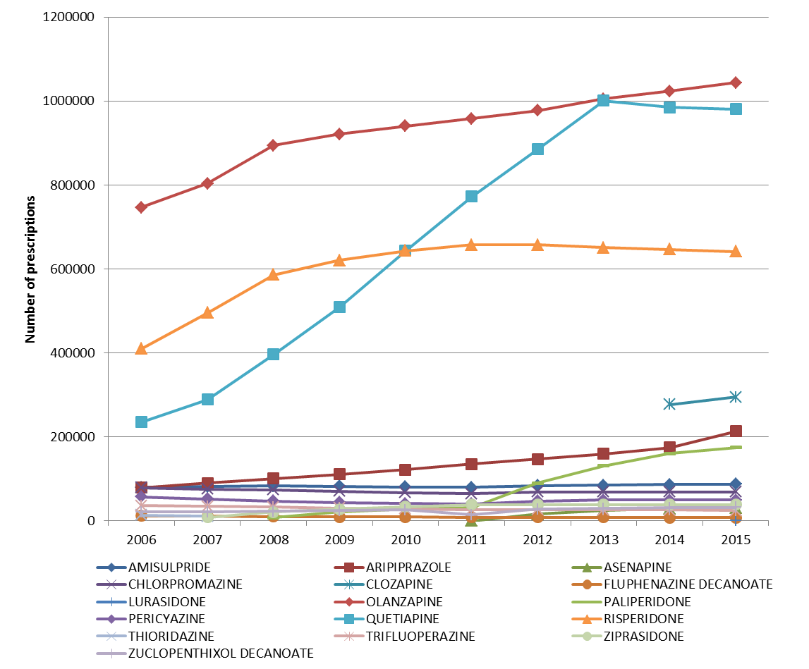
Figure 1. PBS/RPBS prescriptions dispensed for antipsychotics by drug
Source: DUSC Database. Accessed on 7 July 2016.
Note:
Utilisation data for clozapine was underrepresented in the PBS prescriptions data until July 2013. As such, only data from 2014 for this drug is presented here.
Undercopayment data prior to the 2013 calendar year was estimated as this data is only available from the DHS Prescriptions database from April 2012. Patients receiving only an undercopayment medicine will be underrepresented prior to the 2013 calendar year.

A reduction in the number of quetiapine prescriptions from the 2014 calendar year coincides with the change in its restriction from 1 January 2014 to reduce the number of repeats for the 25 mg strength from five to zero (Figure 1).

Continuing growth was demonstrated for olanzapine, paliperidone, risperidone, clozapine and aripiprazole (Figure 1). The year-on-year growth in the number of scripts for aripiprazole occurring between the 2014 and 2015 calendar years was mainly from the listing of the powder for injection forms from March 2015 (Figure 1).

Patient level analyses of the utilisation of all antipsychotics
The number of patients treated with typical antipsychotics has remained relatively stable since 2006 (Figure 2). Growth in the population treated with atypical antipsychotics has slowed since 2014 (Figure 2).
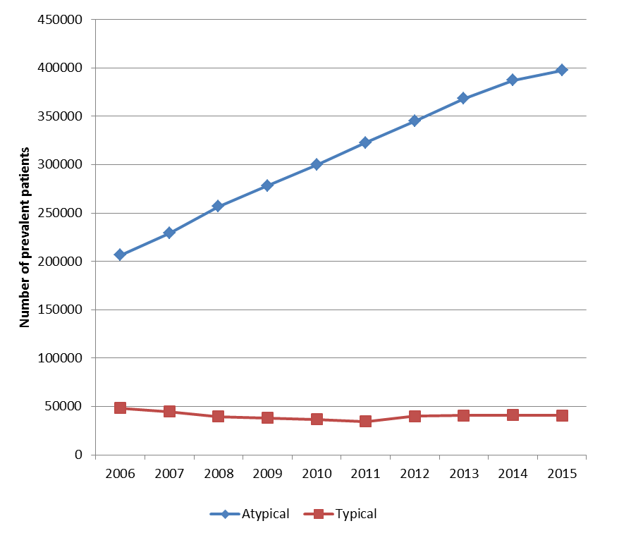
Figure 2. Number of prevalent patients supplied an atypical or typical antipsychotic
Source: DHS Prescriptions database.
Note: Full capture of undercopayment data is only available in the DHS Prescriptions database from April 2012. As such, the number of prevalent patients who only received an undercopayment medicine is underrepresented prior to the 2013 calendar year.

The growth in the atypical prevalent population (Figure 2) was largely driven by the utilisation of quetiapine (Figure 3). The growth in the prevalent populations for other antipsychotic listings was relatively modest (Figure 3).
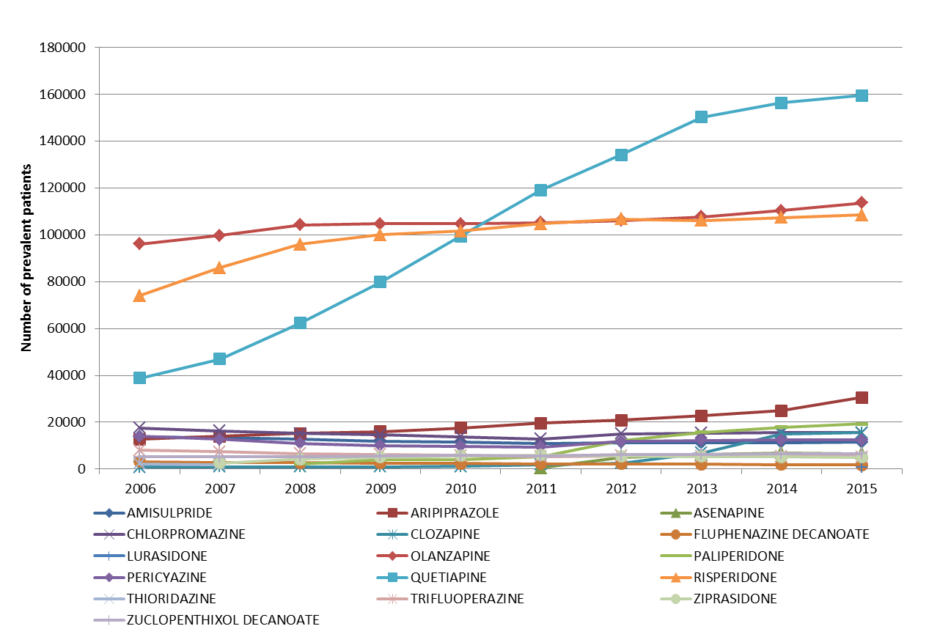

Figure 3. Number of prevalent patients supplied an atypical or typical antipsychotic by drug
Source: DHS Prescriptions database. Accessed on 14 July 2016.
Note:
Utilisation data for clozapine was underrepresented in the PBS prescriptions data until July 2013. As such, only data from 2014 is presented here.
Full capture of under co-payment data is only available in the DHS Prescriptions database from April 2012. As such, the number of prevalent patients who only received an under co-payment medicine are underrepresented prior to the 2013 calendar year.
The incident population for atypical and typical antipsychotics plateaued between 2013 and 2015 (Figure 4).
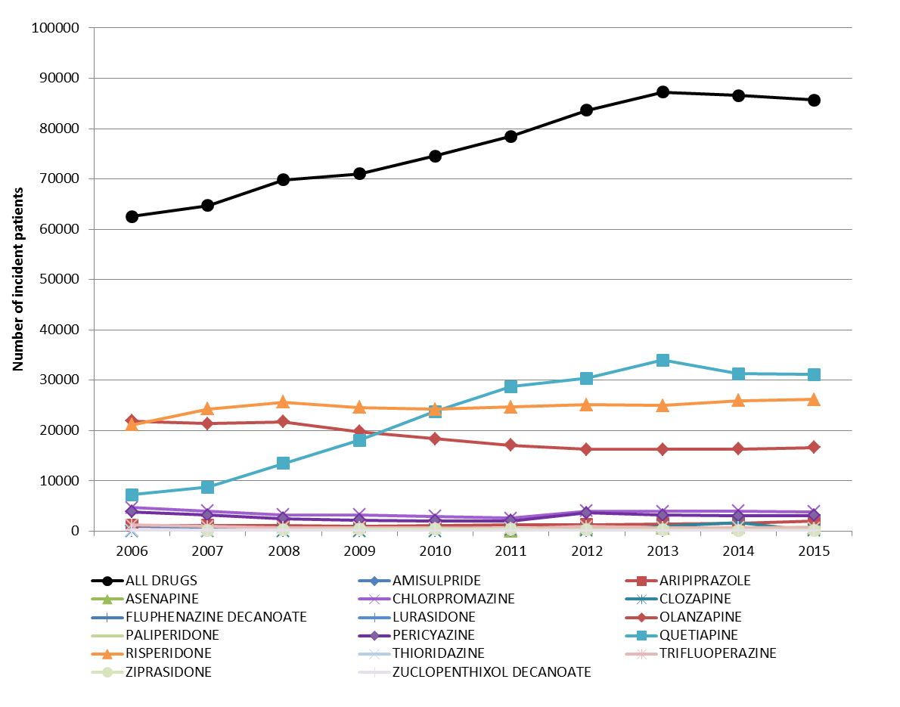

Figure 4. Number of incident patients by first drug supplied
Source: DHS Prescriptions database. Accessed on 14 July 2016.
Note:
Utilisation data for clozapine was underrepresented in the PBS prescriptions data until July 2013. As such, only data from 2014 is presented here.
Full capture of under co-payment data is only available in the DHS Prescriptions database from April 2012. As such, the number of prevalent patients who only received an under co-payment medicine is underrepresented prior to the 2013 calendar year.

Patients incident to antipsychotic treatment over time by age at initiation

Rates of initiation to either an atypical or typical antipsychotic are shown in Figures 5 and 6 which are standardised by age. For persons aged between 20 to 59 years, the highest rate of initiation was in the 20-24 age group (Figure 5). The rate of initiation of antipsychotics in patients aged 20-59 years was lower in the 2015 compared with the 2013 calendar year. For the older population, the rates of initiation were similar between the 2013 and 2015 calendar years (Figure 6).

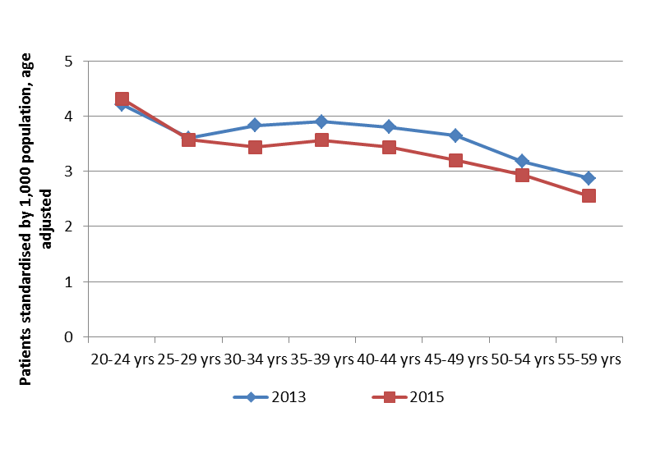
Figure 5. Number of patients per 1,000 population aged 20 to 59 years first initiating to a PBS antipsychotic, standardised by age.
Note: The age adjusted rates use the Direct Method and are based on the Australian age distribution of the ABS Estimated Residential Population in the reference year 2011.

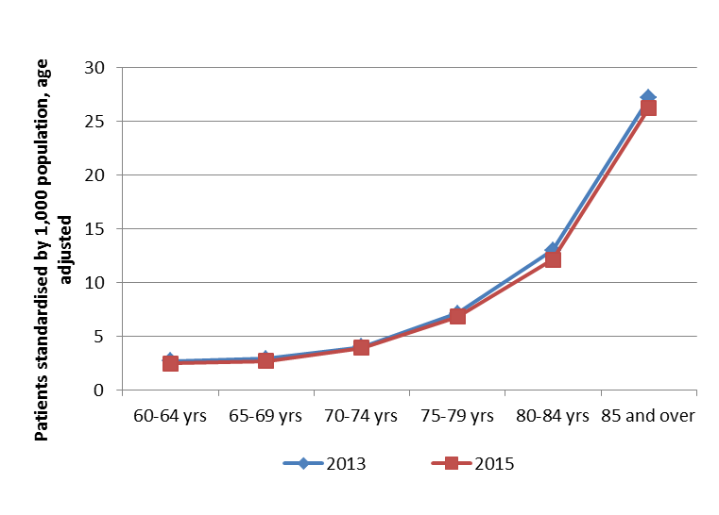
Figure 6. Number of patients per 1,000 population aged 60 years and over first initiating to a PBS antipsychotic, standardised by age.
Note: The age adjusted rates use the Direct Method and are based on the Australian age distribution of the ABS Estimated Residential Population in the reference year 2011.

The extent of use of risperidone for the treatment of behavioural symptoms of dementia (BPSD) was investigated. Risperidone is the only PBS listing for this indication. Patients aged 80 years and over initiating on risperidone between July to December 2014 were assessed to examine their treated indications. Initiators were followed up over 12 months from the date of their initiation. Around 70% of patients were supplied risperidone for BPSD.

Utilisation of quetiapine 25 mg before and after its restriction change from January 2014

First-time initiators to quetiapine mainly commenced treatment on the 25 mg strength (Figure 7).

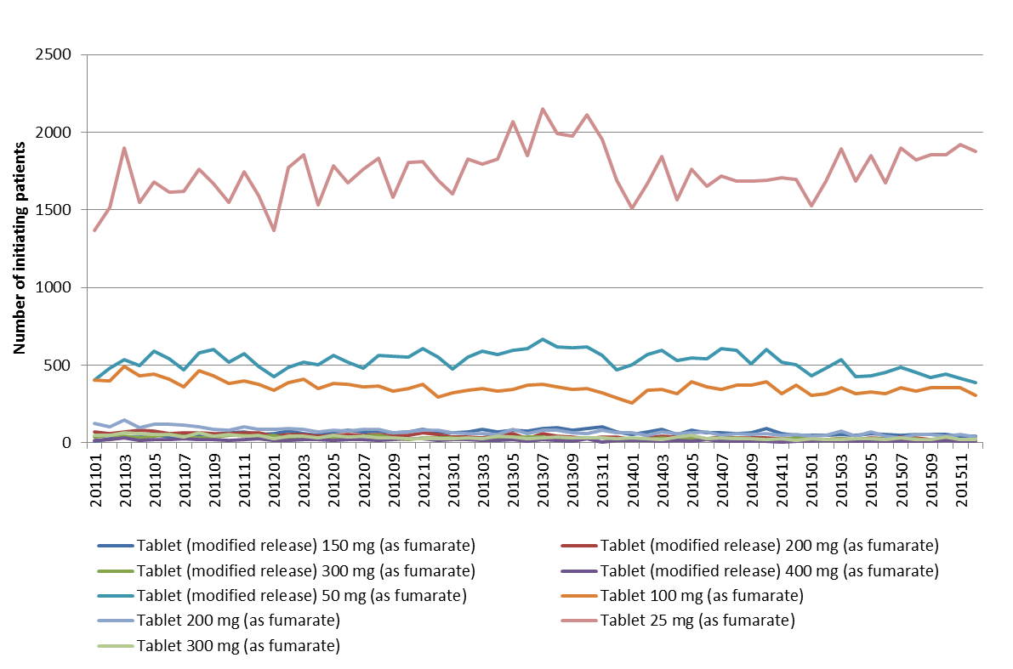
Figure 7. Number of first-time initiators to quetiapine by strength and by month of supply

The supply of antipsychotics to patients initiating on quetiapine 25 mg as their first PBS antipsychotic before and after its restriction change from 1 January 2014 was examined. The pre-restriction change cohort included patients who first initiated on quetiapine 25 mg between July to December 2012. The post-restriction change cohort comprised of patients initiating between December 2014 to May 2015. These analysis periods were selected to allow at least 12 months of follow-up before the restriction change and over the most recent 12 months after the restriction change. The number of initiators in the pre- and post- cohorts was similar (n=10,527 vs. n=10,359, respectively). All patients were followed up for 12 months from the date of their first initiation. To identify potential off-label use, the pre- and post- cohorts were categorised into the following groups:
- Patients who only ever received one supply of quetiapine 25 mg through the PBS;
- Patients who received multiple supplies of the 25 mg strength without receiving a supply of a higher strength of quetiapine or the supply of another antipsychotic;
- Patients who received a supply of a higher strength of quetiapine after an initial supply of the 25 mg strength; and
- Patients who received a supply of another antipsychotic after receiving an initial supply of the 25 mg strength.
Patients who received only one supply of quetiapine 25 mg, who did not uptitrate to a higher strength of quetiapine or who did not transition to a different antipsychotic may have been using the 25 mg strength outside its listed indications. The results are shown in Table 2.

Table 2. Utilisation of quetiapine 25 mg before and after its restriction change from January 2014
 | Pre-cohort  (n=10,527) |  | Post-cohort  (n=10,359)
 | n | Proportion | n | Proportion
Group 1: One supply of quetiapine 25 mg | 3,091 | 29.4% | 3,888 | 37.5%
Group 2: More than one supply of quetiapine 25 mg | 4,394 | 41.7% | 3,150 | 30.4%
Group 3: Received a higher strength of quetiapine | 2,254 | 21.4% | 2,513 | 24.3%
Group 4: Quetiapine 25 mg to another antipsychotic | 788 | 7.5% | 808 | 7.8%

Compared to the pre-cohort, a higher number of patients in the post-cohort may have commenced therapy on the 25 mg strength for an off-label indication, inferred from the receipt of only a single supply (3,888 vs. 3,091 patients, Table 2). Of the 37.5% of patients in the post-cohort who received only one supply of quetiapine (Table 2), the majority (68.8%) of these patients were aged between 20 to 59 years, with 14.6% aged between 60 to 79 years and 7.8% aged 80 years or more. The representation of patients aged less than 20 years within this group was 8.7%. There were fewer patients in the post-cohort who received multiple scripts for the 25 mg strength due to the restriction change of zero repeats (Table 2). However, nearly one-third (30.4%) of the post-cohort patients still received a multiple supply of the 25 mg strength despite the restriction change.
For the 3,150 patients in the post-cohort group who received multiple supplies of quetiapine 25 mg, the number of supplies and time on therapy by age is summarised in Table 3. Older persons tended to have a higher number of supplies and longer time on therapy with quetiapine 25 mg compared to younger age groups (Table 3).
Table 3. Comparison of multiple use of quetiapine 25 mg by age
Age category | N | Number of supplies |  | Time on therapy (days)
 |  | Mean | Median | Mean | Median
Less than 20 years | 271 | 3.6 | 3 | 179.4 | 163
20 to 59 years | 1,741 | 4.2 | 3 | 196.1 | 196
60 to 79 years | 587 | 5.1 | 4 | 233.6 | 280
80 years and over | 518 | 5.6 | 5 | 228.3 | 273
Note: Excludes 33 patients who did not have information to determine their age at initiation.
The use of quetiapine as an adjunctive treatment in depression was investigated. The methods and results are provided in Appendix 4. A 10% sample was obtained for patients initiating on either quetiapine 25 mg or an antidepressant between July to December 2014. Patients were followed-up over 12 months from the date of their initiation. A relatively large number of patients (n=4,430, scaled to 100% from the 10% sample) were estimated to have used quetiapine 25 mg with an antidepressant.

Time to refill quetiapine 25 mg
The use of quetiapine 25 mg as a once daily dose (i.e. with around 60 days between refills) or as required (prn) was investigated for the cohorts presented in Table 2 who only received multiple supplies of quetiapine (‘quetiapine only’ group) or who received a higher strength of quetiapine or another antipsychotic after quetiapine 25 mg (‘all use’ group). Once daily or prn use would indicate that the 25 mg strength, usually given twice daily, is being used for reasons other than as titration for the treatment of schizophrenia or bipolar I disorder. Patients initiating pre- and post- the restriction change for quetiapine 25 mg from January 2014 were compared.
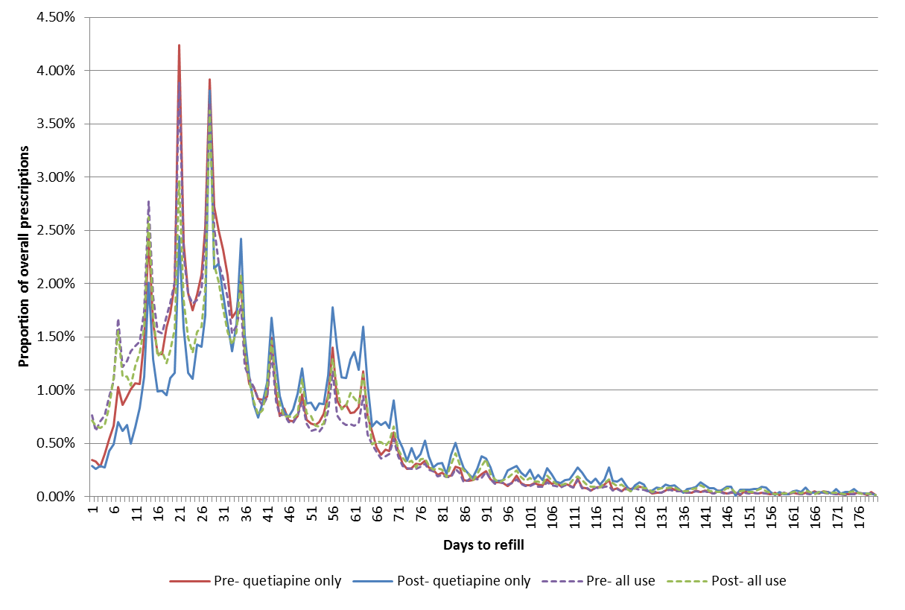
Figure 8. Quetiapine 25 mg scripts supplied pre- and post- the listing change from January 2014 with 6 months follow-up

For all pre- and post- cohorts, a second peak refilling from 55 to 65 days was evident (Figure 8). Nearly one-fifth (18%) of patients in the post- quetiapine only group received a refill between 55 to 65 days from the last supply (Figure 8). This suggests that quetiapine 25 mg was potentially being used off-label as a once daily or prn dose in a relatively large number of patients.

Analysis of expenditure
Expenditure on all antipsychotics in the 2015 calendar year was $293.6 million. Since 2012 there were significant reductions in the expenditure on antipsychotics resulting from statutory price reductions and price disclosure reductions, as shown in Figure 9.
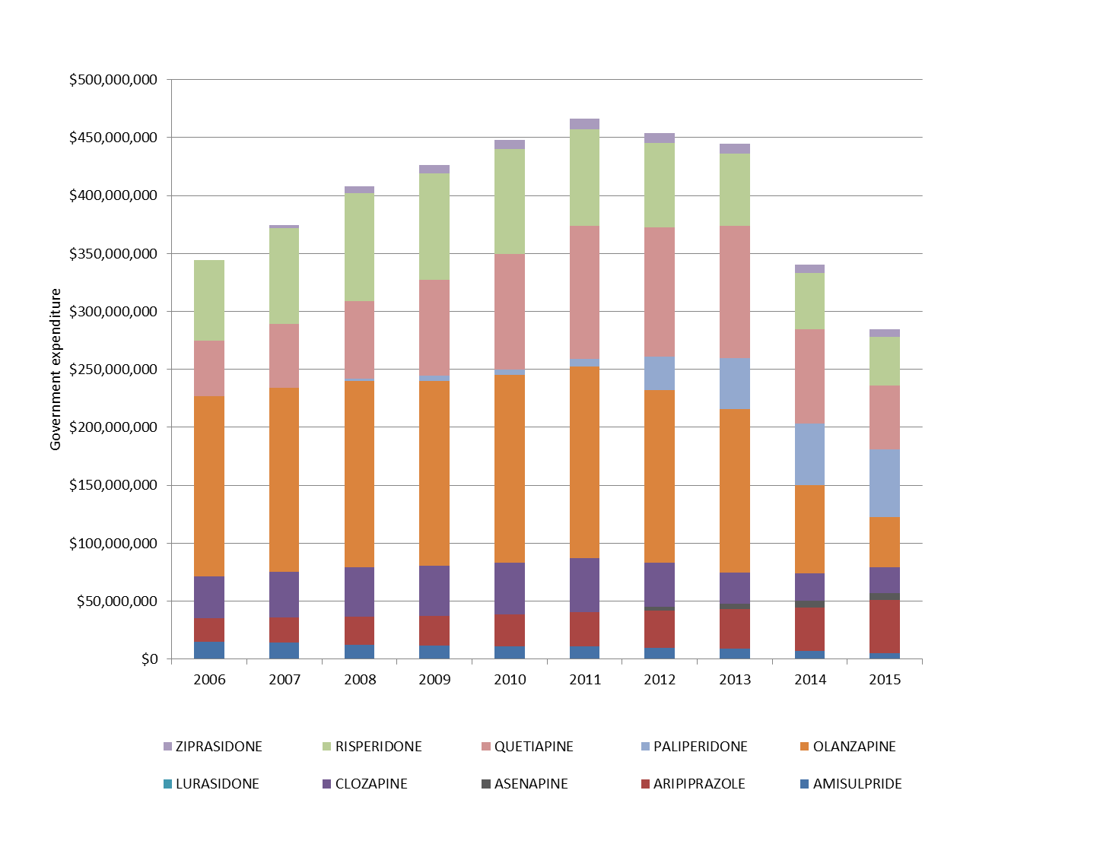
Figure 9. Government expenditure on atypical antipsychotics
A summary of the relevant price reductions is shown in Table 5.

Table 5. Summary of price reductions to antipsychotic medicines
Effective date | Drug | Outcome
August 2007ª | Amisulpride | 16% statutory price reduction.
December 2008 ª | Risperidone | 16% statutory price reduction.
April 2012 ª | Quetiapine | 16% statutory price reduction.
December 2013 ª | Ziprasidone | 16% statutory price reduction.
October 2014 ^{b} | Following reductions refer to the October 2014 relative to the April 2014 listing prices:
 | Amisulpride | 12.1%
 | Clozapine | 13.9%
 | Olanzapine | 35.3%
 | Quetiapine | 24.2%
 | Risperidone | 14.4%
Source:
ª PBS website. Accessed on 1 August 2016 at: http://www.pbs.gov.au/info/industry/pricing/pbs-items/price-reductions
^{b} PBS website. Accessed on 1 August 2016 at: http://www.pbs.gov.au/info/industry/pricing/price-disclosure-spd/price-disclosure-reductions-for-2014-october-cycle

Discussion
The off-label use of low dose quetiapine is common, particularly for the treatment of sleep disturbances (Hartung et al., 2014; Marston et al., 2014; Kamphuis et al., 2015; Iaboni et al., 2016). Registered medications to treat sleep disorders, such as benzodiazepines, have well-documented side effects (Lancel and Kamphuis, 2014; Iaboni et al., 2016). Quetiapine acts on histamine and alpha receptors which promote sleep and its affinity for these receptors is maintained at low doses; i.e. 25 mg per day or less (Blaszczyk et al., 2015). The off-label prescribing of low dose quetiapine has also been reported for the treatment of behavioural and psychological symptoms of dementia (BPSD), generalised anxiety disorder and depression (DUSC 2013; Shin 2013; NPS Medicinewise 2014).
The PBAC (August 2013) recommended that the listing of quetiapine 25 mg be amended to allow no repeats. The intent of this restriction change, which was implemented on
1 January 2014, was to promote the use of the 25 mg strength as a titrating dose for the treatment of schizophrenia and bipolar disorder. The number of scripts for quetiapine 25 mg fell from 2014 to 2015 and a decline in the number of incident patients on this strength was observed in 2014 (Table 1). However, the number of incident patients for quetiapine 25 mg increased from 2014 to 2015; further data will be needed to confirm if this increase is sustained.
Although the number of scripts for quetiapine 25 mg has declined, the results indicate that there is continuing off-label use of quetiapine 25 mg since the restriction change. A higher proportion of patients initiating on quetiapine 25 mg after the restriction change received only one supply compared to initiators prior to the restriction change (37.5% vs. 29.4%, Table 2). Further, 18% of initiators after the restriction change appeared to be using quetiapine 25 mg as a single daily or prn dose. This was inferred from a refilling time between scripts of between 55 to 65 days (Figure 8). The adjunctive use of quetiapine 25 mg outside its restrictions with an antidepressant was also estimated to have continued to occur in a large number of patients since the restriction change (Appendix 4). Such adjunctive therapy to treat depressive disorders is associated with adverse effects, including extrapyramidal symptoms, hyperglycaemia and weight gain (Wang and Tianmei, 2013; Marston et al., 2014).
In terms of overall utilisation there was declining growth in the utilisation of antipsychotics during the 2014 and 2015 calendar years (Table 1). This was attributed to negative growth in the incident population since 2014. The decline in growth may reflect the impact of several initiatives which have been implemented to promote the quality use of antipsychotic medicines, including:
- projects administered by NPS MedicineWise, such as:
- a collaboration with Webstercare to encourage the review of antipsychotic medicine use in residential aged care facilities. This involves the provision of individualised reports from pharmacies to specific residential aged care facilities to monitor medication usage against evidence-based guidelines;
- the provision of information to prescribers on the appropriate use of antipsychotics and education on harms; and
- the promotion of antipsychotic monitoring tools to facilitate the prompt management of adverse drug reactions; and
- the ‘Reducing use of Sedatives’ (RedUSe) project. This is a national intervention project funded by the Australian Government which aims to promote the quality use of antipsychotic and benzodiazepine medication use in residential aged care. It provides education on sedative use to general practitioners, aged care staff, residents and their relatives.

Several price reduction measures were applied to antipsychotics which are summarised in Table 5. These measures, particularly the price disclosure reductions which were implemented in October 2014, led to a substantial decrease in expenditure on antipsychotics from the 2014 calendar year (Figure 9).
For people aged less than 60 years, the rate of initiation to an antipsychotic was highest in those aged between 20 to 24 years (Figure 5). Rates of initiation were similar between the ages of 25 to 49 years, with a decline in the rate until aged 64 years (Figures 5 and 6). From age 70 years there was a strong rise in initiations to antipsychotics (Figure 6). These higher rates may relate to a greater proportion of patients being treated in residential aged care settings (Atlas of Healthcare Variation 2015). A study of antipsychotic use in the elderly undertaken in Ontario, Canada identified that the rates of prescribing for both typical and atypical antipsychotics were significantly higher in the long-term care (LTC) setting versus the community setting (ODPRH 2015). For atypical drugs, comparing the LTC and community settings the rates were 328 versus 22 per 1,000 eligible users, respectively (ODPRH 2015).

DUSC consideration
DUSC recalled that in its prior review of antipsychotics undertaken in 2013 that the utilisation of quetiapine 25 mg was higher than expected, which suggested some of its use was for off-label indications. Compared to 2013 there was a 10% reduction in the growth of incident patients supplied quetiapine 25 mg in 2014 and there was a reduction in the number of prescriptions for this listing from 342,000 in 2013 to 206,000 in 2015. The total number of patients treated with quetiapine was beginning to plateau by 2015. DUSC considered that the intervention to change the listing of the 25 mg strength to allow no repeats from 1 January 2014 had been effective in supporting its intended use as a titrating dose for PBS-listed indications and reducing inappropriate use. DUSC considered that the difference is most likely due to a reduction in use in patients aged 20-59 years noting that fewer patients in this age range initiated antipsychotics in 2015 compared with 2013 (Figure 5).
Age-adjusted rates of antipsychotic prescribing increased with age, particularly in people aged 80 years and over. DUSC observed that most of the use in this age cohort was for risperidone to treat the behavioural symptoms of dementia. DUSC considered that this report did not demonstrate a clear change in use between 2013 and 2015 in older people. This is despite positive outcomes for several initiatives targeted at reducing the use of antipsychotics in residential aged care, such as the ‘Reducing Use of Sedatives’ (RedUSe) project and NPS MedicineWise programs. DUSC considered that widespread use of antipsychotics in the elderly remained an issue. DUSC noted that there was an Australian Government action to be implemented from 1 October 2016 to support a national Dementia Behaviour Management Advisory Service and Dementia Training Program. These initiatives aimed to improve dementia support through promoting more consistency in the provision of clinical support services, advice and support to carers and workforce training through a national level provider.
While the use of quetiapine 25 mg had decreased, DUSC was concerned that following the restriction change there was still a relatively large number of patients receiving multiple supplies of the 25 mg strength or who were not up-titrated to a higher dose of quetiapine. As such, DUSC considered that vigilance was still needed to promote the appropriate use of the 25 mg strength to prevent the harms associated with the longer term use of quetiapine.
DUSC considered whether the restriction change had diverted patients using quetiapine for the treatment of non-psychotic conditions towards the private use of quetiapine or shifted patients to other medicines. Based on MedicineInsight data, the private use of quetiapine did not appear to substantially change following the amendment to the restriction. The rate of prescribing of original plus repeat prescriptions for private quetiapine 25 mg remained at similar levels from quarter 1 2014 to quarter 2 2016. DUSC further noted that there were only a small number of private original plus repeat scripts of around 1.1 per 1,000 GP encounters per quarter. DUSC considered that there may also be a shift towards use of other sedating medicines as an alternative to low dose quetiapine, such as sedating antidepressants. As one example, DUSC discussed the possible use of agomelatine to treat sleep disorders in younger people. However, DUSC noted there was a lack of evidence to support this use. DUSC noted the findings of the ‘Reducing Use of Sedatives’ (RedUSe) project which indicated that the use of mirtazapine was increasing.
DUSC considered that quality use of medicines initiatives for the appropriate use of antipsychotics were mainly targeted towards the elderly and needed to also consider use in younger people. Limited data are available to weigh up the benefits and harms of off-label prescribing of antipsychotics particularly noting that patients initiating at younger ages may use these medicines for long periods of time.

DUSC actions
The DUSC requested that the report be provided to the PBAC noting that the change of quetiapine 25mg listing to allow no repeats had resulted in a large decline in the number of quetiapine prescriptions dispensed through the PBS.

Context for analysis
The DUSC is a Sub Committee of the Pharmaceutical Benefits Advisory Committee (PBAC). The DUSC assesses estimates on projected usage and financial cost of medicines.
The DUSC also analyses data on actual use of medicines, including the utilisation of PBS listed medicines, and provides advice to the PBAC on these matters. This may include outlining how the current utilisation of PBS medicines compares with the use as recommended by the PBAC.
The DUSC operates in accordance with the quality use of medicines objective of the National Medicines Policy and considers that the DUSC utilisation analyses will assist consumers and health professionals to better understand the costs, benefits and risks of medicines.
The utilisation analysis report was provided to the pharmaceutical sponsors of each drug and comments on the report were provided to DUSC prior to its consideration of the analysis.
Sponsors’ comments
The sponsors had no comment.
Disclaimer
The information provided in this report does not constitute medical advice and is not intended to take the place of professional medical advice or care. It is not intended to define what constitutes reasonable, appropriate or best care for any individual for any given health issue. The information should not be used as a substitute for the judgement and skill of a medical practitioner.
The Department of Health (DoH) has made all reasonable efforts to ensure that information provided in this report is accurate. The information provided in this report was up-to-date when it was considered by the Drug Utilisation Sub-committee of the Pharmaceutical Benefits Advisory Committee. The context for that information may have changed since publication.
To the extent provided by law, DoH makes no warranties or representations as to accuracy or completeness of information contained in this report.
To the fullest extent permitted by law, neither the DoH nor any DoH employee is liable for any liability, loss, claim, damage, expense, injury or personal injury (including death), whether direct or indirect (including consequential loss and loss of profits) and however incurred (including in tort), caused or contributed to by any person’s use or misuse of the information available from this report or contained on any third party website referred to in this report.

References
Atlas of Healthcare Variation. Antipsychotic medicines dispensing 65 years and over 2015; Section 4.9: 241-248.
Blaszczyk A.T., McGinnis K.A., Michaels H.N., Nguyen T.N. Is it time to call it quits on low-dose quetiapine? Consultant Pharmacist 2015; 30 (5): 287-290.
Drug Utilisation Sub-Committee Report. Use of antipsychotics in children and adolescents, February 2013 & June 2013; accessed on 9 August 2016 at: http://www.pbs.gov.au/info/industry/listing/participants/public-release-docs/antipsychotics-children-adolescents-2013
Drug Utilisation Sub-Committee Report. Use of antipsychotics in the middle aged 2013; accessed on 9 August 2016 at: http://www.pbs.gov.au/info/industry/listing/participants/public-release-docs/antipsychotics-middle-aged-2013
Hartung D.M., Zerzan J., Yamashita T., Tong S., Morden N.E., Libby A.M. Characteristics and trends of low-dose quetiapine use in two western state Medicaid programs. Pharmacoepidemiology and Drug Safety 2014;. 23 (1): 87-94.
Iaboni A., Bronskill S.E., Reynolds K.B., Wang X., Rochon P.A., Herrmann N., Flint A. Changing Pattern of Sedative Use in Older Adults: A Population-Based Cohort Study. Drugs & Aging 2016; 1179-1969.
Kamphuis J., Taxis K., Schuiling-Veninga C.C.M., Bruggeman R., Lancel M. Off-Label Prescriptions of Low-Dose Quetiapine and Mirtazapine for Insomnia in the Netherlands. Journal of Clinical Psychopharmacology 2015;. 35 (4):468-470.
Lancel M., Kamphuis J. Off-label use of low-dose quetiapine and mirtazapine for insomnia is growing. Journal of Sleep Research. Conference: 22nd Congress of the European Sleep Research Society Tallinn Estonia 2014; 23: 84.
Marston L, Nazareth I, Petersen I, et al. Prescribing of antipsychotics in UK primary care: a cohort study 2014;. BMJ 4: e006135. doi:10.1136/bmjopen-2014-006135
NPS MedicineWise. Low-dose quetiapine: place in therapy? Health News and Evidence 2014; Accessed on 9 August 2016 at: http://www.nps.org.au/publications/health-professional/health-news-evidence/2014/low-dose-quetiapine.
NPS MedicineWise. Medicines for psychotic conditions. Accessed on 9 August 2016 at: http://www.nps.org.au/medicines/brain-and-nervous-system/medicines-for-psychotic-conditions.
NPS MedicineWise. New reporting mechanism for antipsychotic use in aged care 2013; Media release accessed on 9 August 2016 at: http://www.nps.org.au/media-centre/media-releases/repository/New-reporting-mechanism-for-antipsychotic-use-in-aged-care.
Ontario Drug Policy Research Network (ODPRN). Antipsychotic Use in the Elderly 2015; Final Consolidated Report. Accessed on 10 August 2016 at: http://brainxchange.ca/getattachment/Public/Topics-A-to-Z/Drugs/ODPRN_Antipsychotics_Consolidated-Final-Report_June-3-2015-1.pdf.aspx
Shin C.-S. A randomized placebo-controlled trial of quetiapine for the treatment of behavioral and psychological symptom of dementia in Alzheimer's disease patients. Journal of the Neurological Sciences. Conference: 21st World Congress of Neurology Vienna Austria 2013; 333:294-295.
Tost, H., Alam, T. and Meyer-Lindenberg, A. Dopamine and Psychosis: Theory, Pathomechanisms and Intermediate Phenotypes. Neurosci Biobehav Rev. 2010; 34(5): 689–700.
Wang, P. and Tianmei, S.I. Use of antipsychotics in the treatment of depressive disorders. Shanghai Archives of Psychiatry 2013; 25(3): 134-140.

Appendix 1: Dosage and administration of atypical antipsychotic drugs considered in this review
Product | Brand name and sponsor | Dose and frequency of administration
Amisulpride | Amipride 400 (Arrow Pharma Pty Ltd)  Amisulpride 100 Winthrop (sanofi-aventis Australia Pty Ltd)  Amisulpride 200 Winthrop (sanofi-aventis Australia Pty Ltd)  Amisulpride 400 Winthrop (sanofi-aventis Australia Pty Ltd)  Amisulpride Sandoz (Sandoz Pty Ltd)  APO-Amisulpride (Apotex Pty Ltd)  Solian 100 (sanofi-aventis Australia Pty Ltd)  Solian 200 (sanofi-aventis Australia Pty Ltd)  Solian 400 (sanofi-aventis Australia Pty Ltd)  Solian Solution (sanofi-aventis Australia Pty Ltd)  Sulprix (Alphapharm Pty Ltd) | For acute psychotic episodes, oral doses between 400 and 800 mg/day are recommended. In individual cases, the daily dose may be increased up to 1,200 mg/day.  Amisulpride should be administered bid (twice daily) for doses above 400 mg.  No specific titration is required when initiating the treatment with amisulpride.  For patients characterised by predominant negative symptoms, oral doses between 50 mg/d and 300 mg/d are recommended.
Aripiprazole | Abilify (Otsuka Australia Pharmaceutical Pty Ltd)  Abilify Maintena (Lundbeck Australia Pty Ltd) | Schizophrenia:  Daily dosage may be adjusted on the basis of individual clinical status within the range of 10-30 mg daily.  The maintenance dose is 15 mg/day.  No dosage adjustment is required for patients ≥65 years of age.  Bipolar I disorder:  The dose can be increased to 30mg/day based on clinical response.  Patients responding to aripiprazole for an acute or mixed episode may be continued on monotherapy aripiprazole at 15 mg or 30 mg daily
Asenapine | Saphris (Lundbeck Australia Pty Ltd) | Schizophrenia:  The recommended dose range is 5 mg to 10 mg twice daily. An increase in dose to 10 mg twice daily is recommended only after clinical assessment.  Bipolar I disorder:  The recommended starting dose is 10 mg twice daily. The dose can be reduced to 5 mg twice daily, according to clinical assessment.
Clozapine | Clopine 200 (Hospira Pty Limited)  Clopine 25 (Hospira Pty Limited)  Clopine 50 (Hospira Pty Limited)  Clopine 100 (Hospira Pty Limited)  Clopine 200 (Hospira Pty Limited)  Clopine Suspension (Hospira Pty Limited)  Clozaril 25 (Novartis Pharmaceuticals Australia Pty Limited)  Clozaril 100 (Novartis Pharmaceuticals Australia Pty Limited) | Starting therapy of 12.5 mg once or twice daily on the first day, followed by one or two 25 mg tablets on the second day. If well-tolerated, the daily dose may then be increased slowly in increments of 25 to 50 mg in order to achieve a dose level of up to 300 mg/day within 2 to 3 weeks. Thereafter, if required, the daily dose may be further increased in increments of 50 to 100 mg at half-weekly or, preferably, weekly intervals.  After achieving maximum therapeutic benefit, a lower maintenance dose of 150 - 300 mg/day given in divided doses is recommended for some patients.
Lurasidone | Latuda (Servier Laboratories (Aust.) Pty Ltd | The recommended starting dose is 40 mg once daily. Initial dose titration is not required. The maximum recommended dose is 160 mg/day.
Olanzapine | APO-Olanzapine ODT (Apotex Pty Ltd)  Chem mart Olanzapine (Apotex Pty Ltd)  Chem mart Olanzapine ODT (Apotex Pty Ltd)  Lanzek (Eli Lilly Australia Pty Ltd)  Lanzek Zydis (Eli Lilly Australia Pty Ltd)  Olanzacor (Pharmacor Pty Limited)  Olanzapine ODT-DRLA (Dr Reddy’s Laboratories (Aust.) Pty Ltd)  Olanzapine AN (Amneal Pharmaceuticals Pty Ltd)  Olanzapine AN ODT (Amneal Pharmaceuticals Pty Ltd)  Olanzapine-GA ODT (Amneal Pharmaceuticals Pty Ltd)  Olanzapine generichealth (Generic Health Pty Ltd)  Olanzapine RBX (Ranbaxy Australia Pty Limited)  Olanzapine RBX ODT (Ranbaxy Australia Pty Limited)  Olanzapine Sandoz ODT (Sandoz Pty Ltd)  Ozin (Aurobindo Pharma (Australia) Pty Limited)  Ozin ODT (Aurobindo Pharma (Australia) Pty Limited)  Terry White Chemists Olanzapine (Apotex Pty Ltd)  Terry White Chemists Olanzapine ODT (Apotex Pty Ltd)  Zypine (Alphapharm Pty Ltd)  Zypine ODT (Alphapharm Pty Ltd)  Zyprexa (Eli Lilly Australia Pty Ltd)  Zyprexa Relprevv (Eli Lilly Australia Pty Ltd)  Zyprexa Zydis (Eli Lilly Australia Pty Ltd) | Schizophrenia and related disorders: The recommended starting dose is 5 to 10 mg/day, administered as a single daily dose.  A routine therapeutic dose of 10 mg/day is recommended. The highest recommended daily dose is 20 mg.  Acute Mania Associated with Bipolar Disorder: The recommended starting dose 10 or 15 mg administered once a day as monotherapy or 10 mg administered once daily in combination therapy with lithium or valproate. Antimanic efficacy was demonstrated in a dose range of 5 to 20 mg/day in clinical trials.  Preventing Recurrence in Bipolar Disorder: Recommended starting dose is 10 mg once a day. Subsequent daily dosage in the range of 5 mg to 20 mg per day.
Paliperidone | Invega (Janssen-Cilag Pty Ltd)  Invega Sustenna (Janssen-Cilag Pty Ltd) | Invega  Recommended dose for schizophrenia and schizoaffective disorder is 6 mg once daily. The maximum recommended dose is 12 mg once daily.  Invega Sustenna  Recommended initiation of INVEGA SUSTENNA® is with an injection of a dose of 150 mg on treatment day 1 and 100 mg one week later (day 8). The recommended monthly maintenance dose is 75 mg. Highest recommended dose is 150 mg.
Quetiapine | APO-Quetiapine (Apotex Pty Ltd)  Chem mart Quetiapine (Apotex Pty Ltd)  Delucon (Aurobindo Pharma (Australia) Pty Limited  Kaptan (Eris Pharmaceuticals (Australia) Pty Ltd  Pharmacor Quetiapine (Pharmacor Pty Limited)  Quetia (Arrow Pharma Pty Ltd)  Quetiaccord (Amneal Pharmaceuticals Pty Ltd)  Quetiapine Actavis (Amneal Pharmaceuticals Pty Ltd)  Quetiapine AN (Amneal Pharmaceuticals Pty Ltd)  Quetiapine-AS XR (Arrow Pharma Pty Ltd)  Quetiapine-DRLA (Dr Reddy’s Laboratories (Australia) Pty Ltd  Quetiapine GH (Generic Health Pty Ltd)  Quetiapine RBX (Ranbaxy Australia Pty Limited)  Quetiapine Sandoz (Sandoz Pty Ltd)  Seronia (Arrow Pharma Pty Ltd)  Seroquel (AstraZeneca Pty Ltd)  Seroquel XR (AstraZeneca Pty Ltd)  Syquet (Alphapharm Pty Ltd)  Terry White Chemists Quetiapine (Apotex Pty Ltd) | Bipolar disorder - acute mania  Administered twice daily (conventional tablet). The total daily dose for the first four days of therapy is 100 mg (Day 1), 200 mg (Day 2), 300 mg (Day 3) and 400 mg (Day 4), alone or in combination with a mood stabiliser.  Administered once daily (controlled release tablet). 300 mg (Day 1), 600 mg (Day 2) then 800 mg (from Day 3).  Further dosage adjustments up to 800 mg/day by Day 6 should be in increments of no greater than 200 mg/day. The usual effective dose is in the range of 400 to 800 mg/day.  Bipolar disorder - depression  Administered once daily at bedtime (conventional and controlled release tablet). Quetiapine should be titrated as follows: 50 mg (Day 1), 100 mg (Day 2), 200 mg (Day 3) and 300 mg (Day 4). The dose may be adjusted up to 600 mg/day in increments of 100 mg/day.  Schizophrenia  Administered once daily (controlled release tablet). 300 mg (Day 1), 600 mg (Day 2) and up to 800 mg (Day 3 onwards). The dose should be adjusted within the usual effective dose range of 400-800 mg/day.  Administered twice daily (conventional tablet). The total daily dose for the first four days of therapy is 50 mg (Day 1), 100 mg (Day 2), 200 mg (Day 3) and 300 mg (Day 4). the dose may be adjusted within the range 150 to 750 mg/day.  Dose adjustments for the elderly  The rate of dose titration may need to be slower, and the daily therapeutic dose lower, than that used in younger patients.
Risperidone | APO-Risperidone (Apotex Pty Ltd)  Ozidal (Ranbaxy Australia Pty Limited)  Rispa (Arrow Pharma Pty Ltd)  Risperdal (Janssen-Cilag Pty Ltd)  Risperdal Consta (Janssen-Cilag Pty Ltd)  Rispericor (Pharmacor Pty Ltd)  Risperidone Actavis (Amneal Pharmaceuticals Pty Ltd)  Risperidone AMNEAL (Amneal Pharmaceuticals Pty Ltd)  Risperidone AN (Amneal Pharmaceuticals Pty Ltd)  Risperidone generichealth (Generic Health Pty Ltd)  Risperidone Sandoz (Sandoz Pty Ltd)  Rispernia (Eris Pharmaceuticals (Australia) Pty Ltd)  Rixadone (Alphapharm Pty Ltd) | Schizophrenia  Starting dose of 1 mg twice a day. The dosage may be increased on the second day to 2 mg twice a day. In stable patients, risperidone may be given once daily or twice daily, with a recommended daily dose between 4 and 6 mg.  Bipolar Mania  Administered on a once daily basis, starting with 2 mg.  A dosing range of between 2–6 mg/day is recommended.
Ziprasidone | APO-Ziprasidone (Apotex Pty Ltd)  Zeldox (Pfizer Australia Pty Ltd) | For schizophrenia and bipolar mania the recommended dose is 40 mg twice daily. The maximum recommended dose of 80 mg twice daily.
Source: Product Information

Appendix 2: Dosage and administration of current typical antipsychotic drugs

Product | Brand name and sponsor | Dose and frequency of administration
Chlorpromazine | Largactil (Sanofi-Aventis Australia Pty Ltd) | Oral or intramuscular injection.  Generally maintenance doses range from 25 to 100 mg three times daily.
Flupenthixol | Fluanxol Concentrated Depot (Lundbeck Australia Pty Ltd)  Fluanxol Depot (Lundbeck Australia Pty Ltd) | Intramuscular injection.  Initial dose ranging 5 mg to 40 mg depending on treatment experience with long-acting depot neuroleptics.  Most patients are adequately controlled by 20 to 40 mg of Fluanxol every 2 to 4 weeks.
Fluphenazine | Modecate (Bristol-Myers Squibb Australia Pty Ltd) | Intramuscular injection.  Initial dose of 12.5 to 25mg (0.5 to 1mL).  When administered as maintenance therapy, a single injection may control schizophrenic symptoms up to 4 weeks or longer.
Haloperidol | Haldol Decanoate (Janssen-Cilag Pty Ltd)  Serenace (Aspen Pharma Pty Ltd) | Haldol Decanoate  Intramuscular injection generally administered at monthly intervals.  Maximum initial dose of 100 mg. Limited clinical experience with a dose exceeding 300 mg.  Serenace  Oral, up to 100 mg daily.
Pericyazine | Neulactil (Sanofi-Aventis Australia Pty Ltd) | Oral.  Initial daily dosage is 10 to 75 mg depending on the severity of the symptoms.  Dosage is increased until the most effective level is reached to maintain control of symptoms.
Trifluoperazine | Stelazine (Amdipharm Mercury (Australia) Pty Limited) | Oral.  Starting dose of 1 to 5 mg twice daily depending on severity.  After a week, this may be increased to 15 mg a day in divided doses. Further increases of 5 mg may be made if needed at 3 day intervals.
Zuclopenthixol | Clopixol Depot (Lundbeck Australia Pty Ltd) | Intramuscular injection.  The usual maintenance dose is 200 - 400 mg (1 - 2 mL) every second to fourth week.
Source: Product Information

Appendix 3: PBS listing details for the atypical and typical antipsychotic drugs included in this review, as at July 2016
Item | Date first listed | Pack size | Maximum quantity | Number of repeats | DPMQ | Drug, form and strength | Brand (manufacturer)
08736T | 01May2004 | 1 | 2 | 5 | $148.74 | Amisulpride, Oral solution 100 mg per mL, 60 mL | Solian Solution (SANOFI-AVENTIS AUSTRALIA PTY LTD)
08594H | 01Aug2002 | 30 | 30 | 5 | $23.27 | Amisulpride, Tablet 100 mg | Amisulpride Sandoz (SANDOZ PTY LTD)
08595J | 01Aug2002 | 60 | 60 | 5 | $114.44 | Amisulpride, Tablet 200 mg | Amisulpride Sandoz (SANDOZ PTY LTD)
08596K | 01Aug2002 | 60 | 60 | 5 | $226.90 | Amisulpride, Tablet 400 mg | Amisulpride Sandoz (SANDOZ PTY LTD)
10224D | 01Mar2015 | 1 | 1 | 5 | $314.78 | Aripiprazole, Powder for injection 300 mg (as monohydrate) with diluent | Abilify Maintena (LUNDBECK AUSTRALIA PTY LTD)
10219W | 01Mar2015 | 1 | 1 | 5 | $392.44 | Aripiprazole, Powder for injection 400 mg (as monohydrate) with diluent | Abilify Maintena (LUNDBECK AUSTRALIA PTY LTD)
08717T | 01May2004 | 30 | 30 | 5 | $142.99 | Aripiprazole, Tablet 10 mg | Abilify (OTSUKA AUSTRALIA PHARMACEUTICAL PTY LTD)
08718W | 01May2004 | 30 | 30 | 5 | $198.84 | Aripiprazole, Tablet 15 mg | Abilify (OTSUKA AUSTRALIA PHARMACEUTICAL PTY LTD)
08719X | 01May2004 | 30 | 30 | 5 | $241.15 | Aripiprazole, Tablet 20 mg | Abilify (OTSUKA AUSTRALIA PHARMACEUTICAL PTY LTD)
08720Y | 01May2004 | 30 | 30 | 5 | $278.65 | Aripiprazole, Tablet 30 mg | Abilify (OTSUKA AUSTRALIA PHARMACEUTICAL PTY LTD)
05141N | 01Dec2011 | 60 | 60 | 5 | $252.82 | Asenapine, Sublingual wafer 10 mg (as maleate) | Saphris (LUNDBECK AUSTRALIA PTY LTD)
05140M | 01Dec2011 | 60 | 60 | 5 | $157.17 | Asenapine, Sublingual wafer 5 mg (as maleate) | Saphris (LUNDBECK AUSTRALIA PTY LTD)
01195X | 01May1964 | 10 | 10 | 0 | $12.53 | Chlorpromazine hydrochloride, Injection 50 mg in 2 mL ampoule | Largactil (SANOFI-AVENTIS AUSTRALIA PTY LTD)
03455W | 01Dec1990 | 10 | 10 | 0 | $13.40 | Chlorpromazine hydrochloride, Injection 50 mg in 2 mL ampoule | Largactil (SANOFI-AVENTIS AUSTRALIA PTY LTD)
01201F | 01May1964 | 1 | 1 | 4 | $7.46 | Chlorpromazine hydrochloride, Oral solution 25 mg per 5 mL, 100 mL | Largactil (SANOFI-AVENTIS AUSTRALIA PTY LTD)
01196Y | 01May1964 | 100 | 100 | 1 | $6.81 | Chlorpromazine hydrochloride, Tablet 10 mg | Largactil (SANOFI-AVENTIS AUSTRALIA PTY LTD)
01199D | 01May1964 | 100 | 100 | 5 | $12.73 | Chlorpromazine hydrochloride, Tablet 100 mg | Largactil (SANOFI-AVENTIS AUSTRALIA PTY LTD)
01197B | 01May1964 | 100 | 100 | 5 | $8.68 | Chlorpromazine hydrochloride, Tablet 25 mg | Largactil (SANOFI-AVENTIS AUSTRALIA PTY LTD)
05630H | 01Jul2010 | 1 | 1 | 0 | $135.00 | Clozapine, Oral liquid 50 mg per mL, 100 mL | Clopine Suspension (HOSPIRA PTY LIMITED)
09632Y | 01Oct2008 | 1 | 1 | 0 | $146.92 | Clozapine, Oral liquid 50 mg per mL, 100 mL | Clopine Suspension (HOSPIRA PTY LIMITED)
10341G | 01Jul2015 | 1 | 1 | 0 | $147.42 | Clozapine, Oral liquid 50 mg per mL, 100 mL | Clopine Suspension (HOSPIRA PTY LIMITED)
05629G | 01Jul2010 | 100 | 200 | 0 | $242.38 | Clozapine, Tablet 100 mg | Clopine 100 (HOSPIRA PTY LIMITED)
06102E | 01Sep1993 | 100 | 100 | 0 | $276.10 | Clozapine, Tablet 100 mg | Clopine 100 (HOSPIRA PTY LIMITED)
06463E | 01Aug2005 | 28 | 28 | 0 | $75.60 | Clozapine, Tablet 100 mg | Clozaril 100 (NOVARTIS PHARMACEUTICALS AUSTRALIA PTY LIMITED)
10358E | 01Jul2015 | 100 | 200 | 0 | $259.01 | Clozapine, Tablet 100 mg | Clopine 100 (HOSPIRA PTY LIMITED)
05627E | 01Jul2010 | 100 | 100 | 0 | $518.62 | Clozapine, Tablet 200 mg | Clopine 200 (HOSPIRA PTY LIMITED)
06418T | 01Feb2004 | 100 | 200 | 0 | $702.21 | Clozapine, Tablet 200 mg | Clopine 200 (HOSPIRA PTY LIMITED)
10288L | 01Jul2015 | 100 | 200 | 0 | $511.09 | Clozapine, Tablet 200 mg | Clopine 200 (HOSPIRA PTY LIMITED)
05628F | 01Jul2010 | 100 | 200 | 0 | $64.64 | Clozapine, Tablet 25 mg | Clopine 25 (HOSPIRA PTY LIMITED)
06101D | 01Sep1993 | 100 | 200 | 0 | $85.88 | Clozapine, Tablet 25 mg | Clopine 25 (HOSPIRA PTY LIMITED)
06462D | 01Aug2005 | 28 | 28 | 0 | $20.16 | Clozapine, Tablet 25 mg | Clozaril 25 (NOVARTIS PHARMACEUTICALS AUSTRALIA PTY LIMITED)
10289M | 01Jul2015 | 100 | 200 | 0 | $75.57 | Clozapine, Tablet 25 mg | Clopine 25 (HOSPIRA PTY LIMITED)
05626D | 01Jul2010 | 100 | 200 | 0 | $129.28 | Clozapine, Tablet 50 mg | Clopine 50 (HOSPIRA PTY LIMITED)
06417R | 01Feb2004 | 100 | 200 | 0 | $141.22 | Clozapine, Tablet 50 mg | Clopine 50 (HOSPIRA PTY LIMITED)
10302F | 01Jul2015 | 100 | 200 | 0 | $141.48 | Clozapine, Tablet 50 mg | Clopine 50 (HOSPIRA PTY LIMITED)
02257T | 01Aug1994 | 5 | 5 | 0 | $43.28 | Flupenthixol decanoate, Oily I.M. injection 100 mg in 1 mL ampoule | Fluanxol Concentrated Depot (LUNBECK AUSTRALIA PTY LTD)
02255Q | 01Aug1994 | 5 | 5 | 0 | $17.33 | Flupenthixol decanoate, Oily I.M. injection 20 mg in 1 mL ampoule | Fluanxol Depot (LUNBECK AUSTRALIA PTY LTD)
02256R | 01Aug1994 | 5 | 5 | 0 | $24.41 | Flupenthixol decanoate, Oily I.M. injection 40 mg in 2 mL ampoule | Fluanxol Depot (LUNBECK AUSTRALIA PTY LTD)
01046C | 01Apr1973 | 5 | 5 | 0 | $16.08 | Fluphenazine decanoate, Injection 12.5 mg in 0.5 mL ampoule | Modecate (BRISTOL-MYERS SQUIBB AUSTRALIA PTY LTD)
03098C | 01Apr1972 | 5 | 5 | 0 | $23.16 | Fluphenazine decanoate, Injection 25 mg in 1 mL ampoule | Modecate (BRISTOL-MYERS SQUIBB AUSTRALIA PTY LTD)
01001Q | 01Apr1973 | 5 | 5 | 0 | $34.31 | Fluphenazine decanoate, Injection 50 mg in 2 mL ampoule | Modecate (BRISTOL-MYERS SQUIBB AUSTRALIA PTY LTD)
02659Y | 01Sep1967 | 100 | 100 | 1 | $6.82 | Fluphenazine hydrochloride, Tablet 1 mg | Anatensol (BRISTOL-MYERS SQUIBB AUSTRALIA PTY LTD)
02660B | 01Sep1967 | 100 | 100 | 1 | $8.26 | Fluphenazine hydrochloride, Tablet 2.5 mg | Anatensol (BRISTOL-MYERS SQUIBB AUSTRALIA PTY LTD)
02661C | 01Sep1967 | 100 | 100 | 1 | $10.56 | Fluphenazine hydrochloride, Tablet 5 mg | Anatensol (BRISTOL-MYERS SQUIBB AUSTRALIA PTY LTD)
02766N | 01Aug1990 | 5 | 5 | 0 | $42.89 | Haloperidol decanoate, I.M. injection equivalent to 150 mg haloperidol in 3 mL ampoule | Haldol Decanoate (JANSSEN-CILAG PTY LTD)
02765M | 01Aug1990 | 5 | 5 | 0 | $24.19 | Haloperidol decanoate, I.M. injection equivalent to 50 mg haloperidol in 1 mL ampoule | Haldol Decanoate (JANSSEN-CILAG PTY LTD)
02768Q | 01Aug1968 | 10 | 10 | 0 | $22.28 | Haloperidol, Injection 5 mg in 1 mL | Serenace (ASPEN PHARMA PTY LTD)
03456X | 01Dec1990 | 10 | 10 | 0 | $14.31 | Haloperidol, Injection 5 mg in 1 mL ampoule | Serenace (ASPEN PHARMA PTY LTD)
02763K | 01Apr1988 | 1 | 1 | 5 | $14.22 | Haloperidol, Oral solution 2 mg per mL, 100 mL | Serenace (ASPEN PHARMA PTY LTD)
02762J | 01Apr1988 | 1 | 1 | 5 | $9.40 | Haloperidol, Oral solution 2 mg per mL, 15 mL | Serenace (ASPEN PHARMA PTY LTD)
02767P | 01Aug1968 | 100 | 100 | 5 | $8.76 | Haloperidol, Tablet 1.5 mg | Serenace (ASPEN PHARMA PTY LTD)
02770T | 01Dec1977 | 50 | 50 | 5 | $8.75 | Haloperidol, Tablet 5 mg | Serenace (ASPEN PHARMA PTY LTD)
02761H | 01Oct1992 | 100 | 100 | 5 | $8.13 | Haloperidol, Tablet 500 micrograms | Serenace (ASPEN PHARMA PTY LTD)
04251R | 01Aug1985 | 100 | 100 | 1 | $6.07 | Haloperidol, Tablet 500 micrograms | Serenace (ASPEN PHARMA PTY LTD)
03059B | 01Dec1971 | 100 | 200 | 2 | $10.17 | Lithium carbonate, Tablet 250 mg | Lithicarb (CP PROTEA)
03060C | 01Aug1981 | 100 | 200 | 1 | $18.99 | Lithium carbonate, Tablet 400 mg (delayed release) | Priadel (CP PROTEA)
10526B | 01Nov2015 | 30 | 30 | 5 | $77.05 | Lurasidone, Tablet containing lurasidone hydrochloride 40 mg | Latuda (SERVIER LABORATORIES (AUST)PTY LTD)
10529E | 01Nov2015 | 30 | 30 | 5 | $143.68 | Lurasidone, Tablet containing lurasidone hydrochloride 80 mg | Latuda (SERVIER LABORATORIES (AUST)PTY LTD)
09294E | 01Dec2009 | 1 | 2 | 5 | $499.88 | Olanzapine, Powder for injection 210 mg (as pamoate monohydrate) with diluent | Zyprexa Relprevv (ELI LILLY AUSTRALIA PTY LTD)
09295F | 01Dec2009 | 1 | 2 | 5 | $809.26 | Olanzapine, Powder for injection 300 mg (as pamoate monohydrate) with diluent | Zyprexa Relprevv (ELI LILLY AUSTRALIA PTY LTD)
09303P | 01Mar2010 | 1 | 1 | 5 | $499.99 | Olanzapine, Powder for injection 405 mg (as pamoate monohydrate) with diluent | Zyprexa Relprevv (ELI LILLY AUSTRALIA PTY LTD)
08187X | 01Aug1997 | 30 | 30 | 5 | $221.94 | Olanzapine, Tablet 10 mg | Zyprexa (ELI LILLY AUSTRALIA PTY LTD)
01042W | 01Apr2012 | 28 | 28 | 5 | $93.78 | Olanzapine, Tablet 10 mg (as benzoate) | Olanzapine generichealth 10 (GENERIC HEALTH PTY LTD)
03382B | 01Apr2012 | 28 | 28 | 5 | $93.91 | Olanzapine, Tablet 10 mg (orally disintegrating) | Olanzapine ODT generichealth 10 (GENERIC HEALTH PTY LTD)
03384D | 01Apr2012 | 28 | 28 | 5 | $51.07 | Olanzapine, Tablet 15 mg (orally disintegrating) | Olanzapine AN ODT (AMNEAL PHARMACEUTICALS PTY LTD)
08170B | 01Aug1998 | 28 | 28 | 5 | $53.12 | Olanzapine, Tablet 2.5 mg | Zyprexa (ELI LILLY AUSTRALIA PTY LTD)
01024X | 01Apr2012 | 28 | 28 | 5 | $15.57 | Olanzapine, Tablet 2.5 mg (as benzoate) | Olanzapine generichealth 2.5 (GENERIC HEALTH PTY LTD)
03385E | 01Apr2012 | 28 | 28 | 5 | $119.54 | Olanzapine, Tablet 20 mg (orally disintegrating) | Olanzapine AN ODT (AMNEAL PHARMACEUTICALS PTY LTD)
08185T | 01Aug1997 | 30 | 30 | 5 | $113.06 | Olanzapine, Tablet 5 mg | Zyprexa (ELI LILLY AUSTRALIA PTY LTD)
01037N | 01Apr2012 | 28 | 28 | 5 | $23.84 | Olanzapine, Tablet 5 mg (as benzoate) | Olanzapine generichealth 5 (GENERIC HEALTH PTY LTD)
03381Y | 01Apr2012 | 28 | 28 | 5 | $35.94 | Olanzapine, Tablet 5 mg (orally disintegrating) | Olanzapine ODT generichealth 5 (GENERIC HEALTH PTY LTD)
08186W | 01Aug1997 | 28 | 28 | 5 | $147.11 | Olanzapine, Tablet 7.5 mg | Zyprexa (ELI LILLY AUSTRALIA PTY LTD)
01041T | 01Apr2012 | 28 | 28 | 5 | $72.00 | Olanzapine, Tablet 7.5 mg (as benzoate) | Olanzapine generichealth 7.5 (GENERIC HEALTH PTY LTD)
08434X | 01Aug2000 | 28 | 28 | 5 | $208.65 | Olanzapine, Wafer 10 mg | Zyprexa Zydis (ELI LILLY AUSTRALIA PTY LTD)
08952E | 01Apr2011 | 28 | 28 | 5 | $239.39 | Olanzapine, Wafer 15 mg | Zyprexa Zydis (ELI LILLY AUSTRALIA PTY LTD)
08953F | 01Apr2011 | 28 | 28 | 5 | $311.11 | Olanzapine, Wafer 20 mg | Zyprexa Zydis (ELI LILLY AUSTRALIA PTY LTD)
08433W | 01Aug2000 | 28 | 28 | 5 | $99.27 | Olanzapine, Wafer 5 mg | Zyprexa Zydis (ELI LILLY AUSTRALIA PTY LTD)
05107T | 01Dec2011 | 1 | 1 | 5 | $440.69 | Paliperidone, I.M. injection (modified release) 100 mg (as palmitate) in pre-filled syringe | Invega Sustenna (JANSSEN-CILAG PTY LTD)
05109X | 01Dec2011 | 1 | 1 | 5 | $440.79 | Paliperidone, I.M. injection (modified release) 150 mg (as palmitate) in pre-filled syringe | Invega Sustenna (JANSSEN-CILAG PTY LTD)
05100K | 01Dec2011 | 1 | 1 | 5 | $140.61 | Paliperidone, I.M. injection (modified release) 25 mg (as palmitate) in pre-filled syringe | Invega Sustenna (JANSSEN-CILAG PTY LTD)
05102M | 01Dec2011 | 1 | 1 | 5 | $284.80 | Paliperidone, I.M. injection (modified release) 50 mg (as palmitate) in pre-filled syringe | Invega Sustenna (JANSSEN-CILAG PTY LTD)
05103N | 01Dec2011 | 1 | 1 | 5 | $363.48 | Paliperidone, I.M. injection (modified release) 75 mg (as palmitate) in pre-filled syringe | Invega Sustenna (JANSSEN-CILAG PTY LTD)
09194X | 01Oct2008 | 28 | 28 | 5 | $248.48 | Paliperidone, Tablet 12 mg (prolonged release) | Invega (JANSSEN-CILAG PTY LTD)
09140C | 01Apr2008 | 28 | 28 | 5 | $161.07 | Paliperidone, Tablet 3 mg (prolonged release) | Invega (JANSSEN-CILAG PTY LTD)
09141D | 01Apr2008 | 28 | 28 | 5 | $138.10 | Paliperidone, Tablet 6 mg (prolonged release) | Invega (JANSSEN-CILAG PTY LTD)
09142E | 01Apr2008 | 28 | 28 | 5 | $212.77 | Paliperidone, Tablet 9 mg (prolonged release) | Invega (JANSSEN-CILAG PTY LTD)
03053Q | 01Aug1971 | 100 | 100 | 5 | $12.21 | Pericyazine, Tablet 10 mg | Neulactil (SANOFI-AVENTIS AUSTRALIA PTY LTD)
03052P | 01Aug1971 | 100 | 100 | 5 | $8.03 | Pericyazine, Tablet 2.5 mg | Neulactil (SANOFI-AVENTIS AUSTRALIA PTY LTD)
05458G | 01Jan2011 | 60 | 60 | 5 | $47.89 | Quetiapine, Tablet (modified release) 150 mg (as fumarate) | Seroquel XR (ASTRAZENECA PTY LTD)
09203J | 01Nov2008 | 60 | 60 | 5 | $187.70 | Quetiapine, Tablet (modified release) 200 mg (as fumarate) | Seroquel XR (ASTRAZENECA PTY LTD)
09204K | 01Nov2008 | 60 | 60 | 5 | $266.23 | Quetiapine, Tablet (modified release) 300 mg (as fumarate) | Seroquel XR (ASTRAZENECA PTY LTD)
09205L | 01Nov2008 | 60 | 60 | 5 | $112.53 | Quetiapine, Tablet (modified release) 400 mg (as fumarate) | Seroquel XR (ASTRAZENECA PTY LTD)
09202H | 01Nov2008 | 60 | 60 | 5 | $44.62 | Quetiapine, Tablet (modified release) 50 mg (as fumarate) | Seroquel XR (ASTRAZENECA PTY LTD)
08457D | 01Nov2000 | 90 | 90 | 5 | $86.91 | Quetiapine, Tablet 100 mg (as fumarate) | Sequase (PHARMACEUTICAL MANUFACTURING COMPANY PTY LIMITED)
08458E | 01Nov2000 | 60 | 60 | 5 | $116.03 | Quetiapine, Tablet 200 mg (as fumarate) | Sequase (PHARMACEUTICAL MANUFACTURING COMPANY PTY LIMITED)
08456C | 01Nov2000 | 60 | 60 | 5 | $46.82 | Quetiapine, Tablet 25 mg (as fumarate) | Sequase (PHARMACEUTICAL MANUFACTURING COMPANY PTY LIMITED)
08580N | 01May2002 | 60 | 60 | 5 | $167.14 | Quetiapine, Tablet 300 mg (as fumarate) | Sequase (PHARMACEUTICAL MANUFACTURING COMPANY PTY LIMITED)
08780D | 01Feb2005 | 1 | 2 | 5 | $303.68 | Risperidone, I.M. injection (modified release), set containing 1 vial powder for injection 25 mg and 1 pre-filled syringe diluent 2 mL | Risperdal Consta (JANSSEN-CILAG PTY LTD)
08781E | 01Feb2005 | 1 | 2 | 5 | $387.70 | Risperidone, I.M. injection (modified release), set containing 1 vial powder for injection 37.5 mg and 1 pre-filled syringe diluent 2 mL | Risperdal Consta (JANSSEN-CILAG PTY LTD)
08782F | 01Feb2005 | 1 | 2 | 5 | $499.76 | Risperidone, I.M. injection (modified release), set containing 1 vial powder for injection 50 mg and 1 pre-filled syringe diluent 2 mL | Risperdal Consta (JANSSEN-CILAG PTY LTD)
08100H | 01Nov1996 | 1 | 1 | 5 | $119.82 | Risperidone, Oral solution 1 mg per mL, 100 mL | Risperdal (JANSSEN-CILAG PTY LTD)
09293D | 01Dec2008 | 1 | 1 | 2 | $111.88 | Risperidone, Oral solution 1 mg per mL, 100 mL | Risperdal (JANSSEN-CILAG PTY LTD)
08791Q | 01Apr2005 | 1 | 1 | 2 | $39.29 | Risperidone, Oral solution 1 mg per mL, 30 mL | Risperdal (JANSSEN-CILAG PTY LTD)
04587K | 01Feb2004 | 1 | 2 | 5 | $329.32 | Risperidone, Powder for I.M. injection 25 mg (modified release) with 2 mL diluent in pre-filled syringe | Risperdal Consta (JANSSEN-CILAG PTY LTD)
04588L | 01Feb2004 | 1 | 2 | 5 | $692.94 | Risperidone, Powder for I.M. injection 37.5 mg with 2 mL diluent in pre-filled syringe | Risperdal Consta (JANSSEN-CILAG PTY LTD)
04589M | 01Feb2004 | 1 | 2 | 5 | $514.50 | Risperidone, Powder for I.M. injection 50 mg (modified release) with 2 mL diluent in pre-filled syringe | Risperdal Consta (JANSSEN-CILAG PTY LTD)
01842Y | 01Aug2012 | 20 | 60 | 2 | $15.48 | Risperidone, Tablet 0.5 mg | APO-Risperidone (APOTEX PTY LTD)
01846E | 01Aug2012 | 20 | 60 | 5 | $26.71 | Risperidone, Tablet 0.5 mg | APO-Risperidone (APOTEX PTY LTD)
08787L | 01Apr2005 | 60 | 60 | 2 | $26.69 | Risperidone, Tablet 0.5 mg | Risperidone GH (GENERIC HEALTH PTY LTD)
08869T | 01Dec2005 | 60 | 60 | 5 | $13.63 | Risperidone, Tablet 0.5 mg | Risperidone GH (GENERIC HEALTH PTY LTD)
08788M | 01Apr2005 | 28 | 56 | 2 | $36.25 | Risperidone, Tablet 0.5 mg (orally disintegrating) | Risperdal Quicklet (JANSSEN-CILAG PTY LTD)
08870W | 01Dec2005 | 28 | 56 | 5 | $36.42 | Risperidone, Tablet 0.5 mg (orally disintegrating) | Risperdal Quicklet (JANSSEN-CILAG PTY LTD)
03169T | 01Feb1995 | 60 | 60 | 5 | $20.18 | Risperidone, Tablet 1 mg | Risperidone generichealth (GENERIC HEALTH PTY LTD)
08789N | 01Apr2005 | 60 | 60 | 2 | $51.89 | Risperidone, Tablet 1 mg | Risperidone generichealth (GENERIC HEALTH PTY LTD)
08790P | 01Apr2005 | 28 | 56 | 2 | $59.78 | Risperidone, Tablet 1 mg (orally disintegrating) | Risperdal Quicklet (JANSSEN-CILAG PTY LTD)
08792R | 01Apr2005 | 28 | 56 | 5 | $50.30 | Risperidone, Tablet 1 mg (orally disintegrating) | Risperdal Quicklet (JANSSEN-CILAG PTY LTD)
03170W | 01Feb1995 | 60 | 60 | 5 | $32.75 | Risperidone, Tablet 2 mg | Risperidone generichealth (GENERIC HEALTH PTY LTD)
09079W | 01Apr2007 | 60 | 60 | 2 | $91.57 | Risperidone, Tablet 2 mg | Risperidone generichealth (GENERIC HEALTH PTY LTD)
08794W | 01Apr2005 | 28 | 56 | 5 | $115.78 | Risperidone, Tablet 2 mg (orally disintegrating) | Risperdal Quicklet (JANSSEN-CILAG PTY LTD)
09080X | 01Apr2007 | 28 | 56 | 2 | $46.25 | Risperidone, Tablet 2 mg (orally disintegrating) | Risperdal Quicklet (JANSSEN-CILAG PTY LTD)
03171X | 01Feb1995 | 60 | 60 | 5 | $137.84 | Risperidone, Tablet 3 mg | Risperidone generichealth (GENERIC HEALTH PTY LTD)
09075P | 01Mar2007 | 28 | 56 | 5 | $162.54 | Risperidone, Tablet 3 mg (orally disintegrating) | Risperdal Quicklet (JANSSEN-CILAG PTY LTD)
03172Y | 01Feb1995 | 60 | 60 | 5 | $183.79 | Risperidone, Tablet 4 mg | Risperidone generichealth (GENERIC HEALTH PTY LTD)
09076Q | 01Mar2007 | 28 | 56 | 5 | $83.24 | Risperidone, Tablet 4 mg (orally disintegrating) | Risperdal Quicklet (JANSSEN-CILAG PTY LTD)
02402K | 01Nov1964 | 1 | 1 | 5 | $10.84 | Thioridazine, Oral solution 30 mg per mL, 30 mL | Melleril (SANDOZ PTY LTD)
08095C | 01Nov1996 | 1 | 1 | 5 | $11.63 | Thioridazine, Oral suspension 10 mg per mL, 100 mL | Melleril Suspension 1% (SANDOZ PTY LTD)
08096D | 01Nov1996 | 1 | 1 | 5 | $26.89 | Thioridazine, Oral suspension 10 mg per mL, 500 mL | Melleril Suspension 1% (SANDOZ PTY LTD)
02163W | 01May1964 | 100 | 100 | 1 | $6.81 | Thioridazine, Tablet 10 mg | Melleril (SANDOZ PTY LTD)
02165Y | 01May1964 | 100 | 100 | 1 | $12.37 | Thioridazine, Tablet 100 mg | Melleril (SANDOZ PTY LTD)
02359E | 01Aug1964 | 100 | 100 | 1 | $8.19 | Thioridazine, Tablet 25 mg | Melleril (SANDOZ PTY LTD)
02164X | 01May1964 | 100 | 100 | 1 | $8.56 | Thioridazine, Tablet 50 mg | Melleril (SANDOZ PTY LTD)
02835F | 01Apr1969 | 10 | 10 | 0 | $10.03 | Trifluoperazine hydrochloride, Injection equivalent to 1 mg trifluoperazine in 1 mL ampoule | Stelazine (AMDIPHARM MERCURY(AUSTRALIA)PTY LIMITED)
02185B | 01May1964 | 100 | 100 | 5 | $8.41 | Trifluoperazine hydrochloride, Tablet equivalent to 1 mg trifluoperazine | Stelazine (AMDIPHARM MERCURY(AUSTRALIA)PTY LIMITED
02386N | 01Sep1964 | 100 | 100 | 5 | $23.48 | Trifluoperazine, Tablet 2 mg (as hydrochloride) | Stelazine (AMDIPHARM MERCURY(AUSTRALIA)PTY LIMITED
02186C | 01May1964 | 100 | 100 | 5 | $13.96 | Trifluoperazine, Tablet 5 mg (as hydrochloride) | Stelazine (AMDIPHARM MERCURY(AUSTRALIA)PTY LIMITED
09070J | 01Apr2007 | 60 | 60 | 5 | $77.49 | Ziprasidone, Capsule 20 mg (as hydrochloride) | APO-Ziprasidone (APOTEX PTY LTD)
09071K | 01Apr2007 | 60 | 60 | 5 | $118.54 | Ziprasidone, Capsule 40 mg (as hydrochloride) | APO-Ziprasidone (APOTEX PTY LTD)
09072L | 01Apr2007 | 60 | 60 | 5 | $217.17 | Ziprasidone, Capsule 60 mg (as hydrochloride) | APO-Ziprasidone (APOTEX PTY LTD)
09073M | 01Apr2007 | 60 | 60 | 5 | $281.68 | Ziprasidone, Capsule 80 mg (as hydrochloride) | APO-Ziprasidone (APOTEX PTY LTD)
08097E | 01Nov1996 | 5 | 5 | 0 | $23.09 | Zuclopenthixol decanoate, Oily I.M. injection 200 mg in 1 mL ampoule | Clopixol Depot (LUNDBECK AUSTRALIA PTY LTD)
Source: the PBS website.

Appendix 4: Utilisation of quetiapine 25 mg with an anti-depressant
The 2013 DUSC report on the use of antipsychotics in the middle aged identified off-label use of quetiapine as an adjunctive treatment in depression and to treat the side effects of antidepressants. The extent of this off-label use was examined in patients initiating on either quetiapine 25 mg or an antidepressant between July to December 2014 (after the restriction change on 1 January 2014). Due to the large number records for the supply of antidepressants, an 18 month look back period was used and a 10% sample was obtained. There were 443 initiators who were supplied both quetiapine and an antidepressant. The supply history for these patients was analysed over 12 months from the date of their initiation. Potential off-label use of quetiapine 25 mg was identified as:
- Patients receiving the supply of quetiapine 25 mg and an antidepressant on the same day; and
- The supply of quetiapine 25 mg and an antidepressant within 35 days (i.e. the median refill time for patients who received a supply of both agents within 12 months from initiation).

The results are presented in Table A4.1.

Table A4.1. Use of quetiapine 25 mg with antidepressant therapy

 | Number of prescriptions in the 10% sample
Co-supply of quetiapine 25 mg with an antidepressant | 728
Same day - Quetiapine and antidepressant | 308
Total | 1036

Compared to the 18,107 patients (based on a full sample) who initiated on quetiapine 25 mg between July to December 2014, a relatively large number of patients (n=4,430, scaled to 100% from the 10% sample) were estimated to have used quetiapine 25 mg with an antidepressant to treat an off-label indication.

NPS Medicinewise (2014) ‘Low dose quetiapine: Place in therapy?’ Accessed on 11 July 2016 at: http://www.nps.org.au/publications/health-professional/health-news-evidence/2014/low-dose-quetiapine
DUSC report 2013
PBS statistics. Australian Government Department of Human Services Medicare. Canberra. Available from the Medicare Australia website.
Principles on the use of direct age-standardisation in administrative data collections, September 2011, AIHW. Available from the AIHW website.
Principles on the use of direct age-standardisation in administrative data collections, September 2011, AIHW
Principles on the use of direct age-standardisation in administrative data collections, September 2011, AIHW

