5-Aminosalicylic Acids

Drug utilisation sub-committee (DUSC)

September 2017

Abstract

Purpose
At its June 2017 meeting, DUSC considered an analysis of utilisation of medicines to treat ulcerative colitis (UC). DUSC requested further analyses to determine if the increasing use of 5-aminosalicylic acids (5-ASAs) is due to more patients being treated or patients using higher doses.

Listing on the Pharmaceutical Benefits Scheme (PBS)
5-aminosalicylates (sulfasalazine, mesalazine, balsalazide and olsalazine) are listed on the PBS in a range of oral and rectal formulations.
Restrictions apply to some of these medicines. See pbs.gov.au for details.

Data Source
The medicines included in the analysis were sulfasalazine, mesalazine, balsalazide and olsalazine. The analyses used data from the Department of Human Services (DHS) supplied prescriptions database for dates of supply between 1 January 2002 and 31 March 2017 inclusive. DHS Authorities data was used to examine prescriptions with an approved Authority for an increase in quantity or the number of repeats.

Utilisation was expressed as prescription volumes, DDD/1000 population/day and patient counts. The average daily amount (mass) of oral mesalazine dispensed per person was also calculated for 2007 and 2016.

Key Findings
- The increasing utilisation of 5-ASAs is driven by growth in both the number of people on treatment and the amount of medicine dispensed per person.
- Comparing 2007 with 2016 there was:
  - no change in the number of patients initiating a 5-ASA for the first time
  - a 27% increase in the number of patients on 5-ASAs (prevalent patients)
  - a 38% increase in prescription volume
  - a 42% increase in DDDs/1000 population/day
- The most commonly used 5-ASA is mesalazine. The average amount of mesalazine dispensed per patient per day increased by over 50% between 2007 and 2016.
- The PBS dataset does not contain information on the prescribed dose or indication. Inference from the available data is difficult because of the individualisation of treatment, wide ranges of recommended doses, and different doses for induction and maintenance treatment. The use of higher doses is likely be a key factor contributing to the overall increase in use. Another factor could be improved adherence.

Methods
PBS/RPBS prescription claim data were extracted from January 2002 to March 2017. These data include all PBS/RPBS prescriptions of 5-ASAs as all are priced above general patient co-payment. As this analysis uses date of supply data, there may be small differences compared with publicly available Department of Human Services (DHS) Medicare date of processing data.
DHS Authorities data was used to examine prescriptions with an approved Authority for an increase in quantity or the number of repeats.
To determine whether more patients are using 5-ASAs, distinct de-identified patient IDs were counted from the prescription data. Patients new to 5-ASA therapy (incident patients) were identified using a two year look back period.
Defined daily doses standardised by the Australian population (DDDs/1000/day) were calculated using the following formula:
$$\frac{N ×M ×Q ×1000}{DDD ×P ×D}$$
Where N = the number of prescriptions dispensed in the month
M = the drug mass in each unit
Q = the dispensed quantity
P = the midyear Australian population for the year of data collection
D = the number of days in the month

Prescriptions supplied in 2017 were standardised by the mid-year Australian population from 2016.
The average daily mass amount of mesalazine oral preparations dispensed was derived for patients supplied mesalazine in 2007 versus 2016. For each cohort, the total amount of mesalazine supplied (calculated as the sum of the mass amount and quantity for all scripts supplied to the patient in a given calendar year) was divided by the total time in days from when the patient started treatment to the end date of the relevant year (i.e. 31 December in either 2007 or 2016).
Analyses were undertaken in SAS Enterprise Guide version 7.12.

Results

Number of patients
Figure 1 shows the number of patients dispensed a prescription for any form of 5-ASA each month (prevalent treated patients). The number of patients commencing a 5-ASA for the first time (incident patients) is also shown.
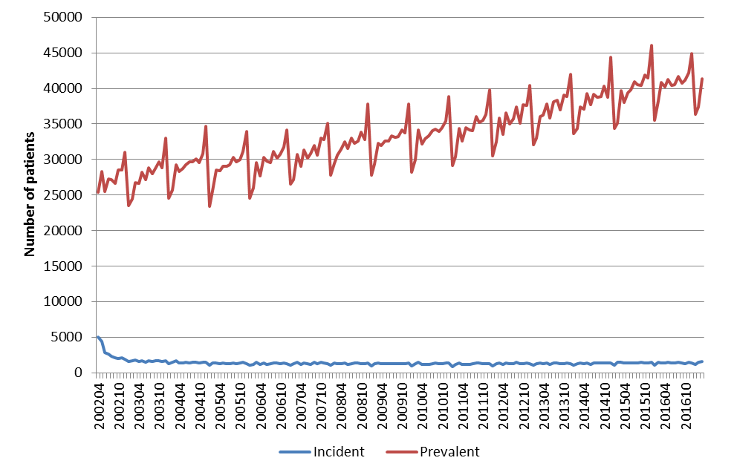

Figure 1: Number of incident and prevalent treated patients for all 5-ASAs by month

Note: Data prior to mid-2002 is incomplete, resulting in an overestimate of the number of incident patients.

Figure 1 shows the number of incident patients to 5-ASA treatment has been stable at approximately 1,500 to 1,600 per year. In 2016, 38.5% of incident patients commenced on mesalazine, balsalazide or olsalazine and can be assumed to have an inflammatory bowel disease. The remaining 61.5% of initiators in 2016 started on sulfasalazine which may be used for inflammatory bowel disease or rheumatoid arthritis (data not shown).

The number of prevalent patients has increased gradually over time. Comparing 2007 with 2016, the growth in prevalent patients was 27%.

Prescriptions
Prescription volumes indicate an overall increase in the utilisation of all forms of 5-ASAs (Figure 2). The total volume of prescriptions grew by 38% between 2007 and 2016.
Figure 2: Total prescription volume for 5-ASAs and for each drug (all forms).
Most of the growth in the total 5-ASA market was due to the oral forms which have a much greater market share than the rectal forms (see Appendix 1 Figures A1.1 versus A1.3, respectively). The use of oral sulfasalazine to treat rheumatoid arthritis as well as inflammatory bowel disease may have contributed to the trend in growth for 5-ASA listings.
The trends for 5-ASA prescriptions over time are influenced by the introduction of new strengths and changes to the maximum quantity per PBS prescription. As an example, the change in the restriction for the 1.2 g modified release tablet from April 2016 to increase the maximum quantity from 60 to 120 tablets likely explains the reduction in the number of prescriptions for the 1.2 g strength from this time (see Appendix 1 Figure A1.3). Prescribers may also make a request to the Department of Human Services for increased maximum quantities for an Authority approval.
The listing of additional strengths and changes in the maximum quantities recommended by the PBAC are outlined in Appendix 2. The number of coverage days per prescription varies and depends on whether the medicines is used for induction or maintenance treatment, the strength and quantity per prescription, and the dose prescribed. A dose range is recommended for most 5-ASA medicines as outlined in the product information and clinical guidelines. For example the recommended dose ranges for oral mesalazine for acute and maintenance treatment of UC is 2 - 4.8g and 1 - 3 g daily, respectively.

Analysis of Authorities for 5-ASAs with increased quantities
For the orally listed forms of 5-ASAs, 6% of prescriptions in 2016 had an approved Authority for an increased quantity or increased repeat (Table 1). A low proportion (0.6%) of prescriptions for the rectal forms had an approved Authority for an increased quantity or increased repeats (Table 1).
Table 1: Proportion of 5-ASA prescriptions in 2016 with an Authority for an increased quantity or increased repeats
Form | Total prescriptions | Number of prescriptions with an Authority for an increased quantity or increased repeats | Proportion of scripts with approved Authority with an increased quantity or increased repeats
Oral | 521,274 | 30,043 | 6%
Rectal | 36,958 | 220 | 0.6%
Source: DHS Authorities database and DHS Prescriptions database. Accessed on 5 September 2017.
Note:
Oral form listings included in the analysis: 1611T, 1728Y, 2093E, 2096H, 2214M, 2234N, 2287J, 3413P, 8086N, 8598M, 8599N, 8731M, 8845M, 9206M,9208P, 9209Q, 9353G, 10254Q, 10257W.
Rectal form listings included in the analysis: 5461K, 8616L, 8617M, 8752P, 8753Q, 8768L.

Committee-in-confidence
In July 2017, the PBAC considered a minor submission for balsalazide seeking an addition of a 280-capsule pack size in addition to the currently listed 180-capsule pack size for the
750 mg capsule. A survey of prescribing behaviour for balsalazide for mild to moderate UC, involving six specialists, presented in the July 2017 submission indicated that the respondents frequently requested an increase in the maximum quantity for the 180-capsule pack listing.
Of the 11,968 prescriptions for balsalazide in 2016, 15% had an Authority for an increased quantity or repeat.
End committee-in-confidence

DDD/1000 population/day
Examining the utilisation by DDD/1000 population/day allows for comparison of drug utilisation independent of differences in the formulations and quantity per prescription.
The World Health Organization (WHO) DDDs are based on treatment of ulcerative colitis (UC) and Crohn disease (CD). The DDDs for the oral and rectal forms of mesalazine (1.5g) and sulfasalazine (2g) are the same. Olsalazine and balsalazide are only available as oral formulations and the assigned DDDs are 1g and 6.75g respectively.
Figure 3 presents the DDD/1000 population/day for all of their listed forms of 5-ASAs. DDDs/1000 population/day for 5-ASAs has increased progressively over time. The growth in the average of the monthly DDDs for 2007 (2.6 DDDs) versus 2016 (3.6 DDDs) was 42%.

Figure 3: DDD/1000 population/day by drug (oral and rectal aggregated)

Comparing the orally listed forms by drug, the DDD/1000 population/day for mesalazine has increased steadily over time from around 0.5 DDDs to 2.2 DDDs as at March 2017 (Figure 4).
Figure 4: DDD/1000 population/day by drug (oral)
The DDDs/1000 population/day for the rectal form of mesalazine are low overall but had a marked rise in 2011 (Figure 5). This coincides with the listings for mesalazine suppositories for use in the treatment of an acute episode of mild to moderate ulcerative proctitis, and mesalazine enemas and rectal foam for use in the treatment of an acute episode of mild to moderate ulcerative colitis being amended to allow for the supply of one repeat on the same prescription. This recommendation was based on a request from the Gastroenterological Society of Australia for the small number of patients with active ulcerative colitis who require a longer duration of therapy than one month.
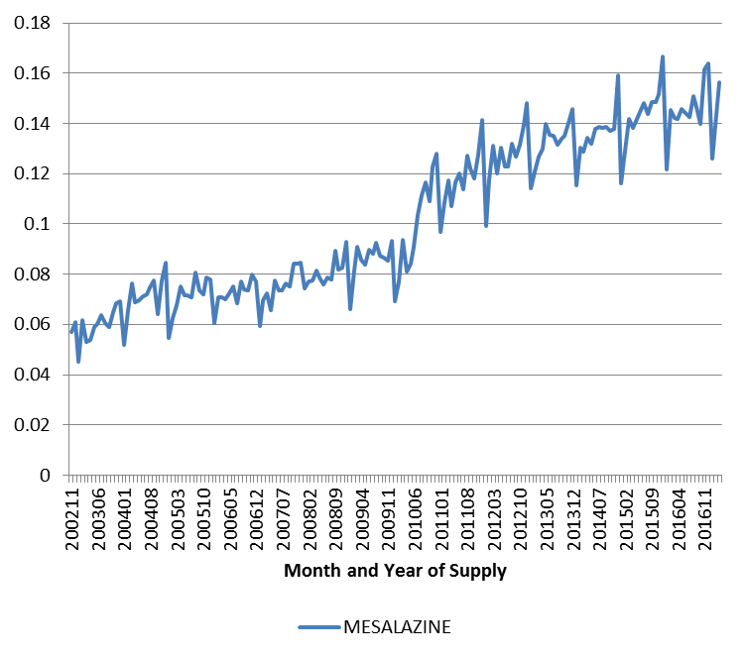
Figure 5: DDD/1000 population/day by drug (rectal)

Average daily quantity of oral mesalazine dispensed per patient
The average daily mass amount of mesalazine oral preparations dispensed was compared in patients supplied mesalazine in 2007 versus 2016. For each cohort, the total amount of mesalazine supplied (calculated as the sum of the mass amount and quantity for all scripts supplied to the patient in a given calendar year) was divided by the total time in days from when the patient started treatment to the end date of the relevant year (i.e. 31 December in either 2007 or 2016).
Table 2 shows that the mean daily mass amount for the mesalazine oral preparations increased from a mean of 2.5 g in 2007 to 3.8 g in 2016.
Table 2: Mean and median daily mass amounts for mesalazine oral preparations in 2007 versus 2016
Patient cohort | Mean mass amount per day (g) | Median mass amount per day (g)
2007 | 2.5 | 2.1
2016 | 3.8 | 2.9

The distributions of the average daily mass amounts of mezalazine show that there was a tendency toward higher mass amounts in 2016 compared with 2007 (Figure 6).
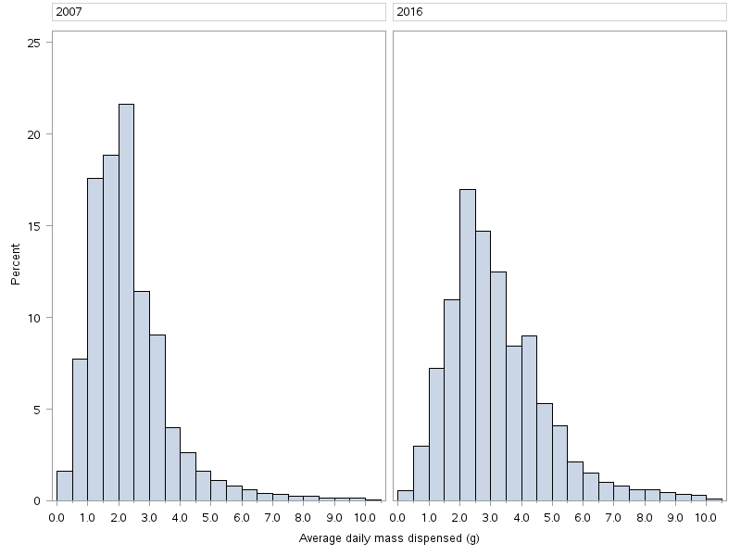
Figure 6: Average daily mass of oral mesalazine dispensed, 2007 compared with 2016
Based on the upper end of the dose range for oral mesalazine (4.8 g/day for acute and
3 g/day for maintenance), and assuming 60 days of acute therapy and 305 days of maintenance therapy per year (see the Therapeutic Relativity Sheet on the PBS website) and full compliance, the daily amount of mesalazine would be 3.3 g. Using the same assumptions and the lower end of the dose range (2 g/day acute and 1 g/day maintenance), the daily amount would be 1.2 g.
Figure 6 indicates that in 2016, 38% of patients received an average daily mass amount of mesalazine of more than 3.3 g per day. This compared with 14% of patients in 2007.
In 2016, a lower proportion of patients (6%) had an average daily mass amount of less than 1.2 g per day compared to 2007 (15% of patients).
The PBS dataset does not contain information on the prescribed dose or indication. Inference from the available data is difficult because of the individualisation of treatment, wide ranges of recommended doses, and different doses for induction and maintenance treatment. The use of higher doses is likely be a key factor contributing to the overall increase in use. Another factor could be improved adherence.

DUSC (June 2017) had considered an analysis of prescribed doses from MedicinesInsight data may be useful. However DUSC noted that gastroenterologists are the most common prescribers for ulcerative colitis patients, and these specialist prescribers are not captured in the MedicinesInsight data.

DUSC consideration
DUSC noted the method used to derive the average daily mass amount of oral mesalazine summed the mass amount and quantity for all scripts supplied to the patient in a given calendar year and divided by the number of days from the start of treatment to 31 December of the relevant year. DUSC commented this method underestimates the average daily mass amount, as some patients are likely to have ceased treatment earlier in the year. DUSC considered the method was designed to compare 2007 to 2016 and for this purpose the method was reasonable.
DUSC noted the 50% increase of the average dose of mesalazine and the rising number of treated patients and considered the drivers for this were uncertain. DUSC considered better tolerability and safety over alternative treatment options, possible improved focus on adherence to 5-ASA therapy to minimise exposure to steroids, and greater awareness of available treatments could be factors affecting the changing utilisation patterns. DUSC suggested there may have been an unmet need for treatment in earlier years.
DUSC noted the analysis of incident patients showed that in 2016, 38.5% of patients initiated on mesalazine, balsalazide or olsalazine. The remaining 61.5% of initiators in 2016 started on sulfasalazine, although some of these patients may have been treated for rheumatoid arthritis. DUSC questioned whether the high proportion of patients who did not trial sulfasalazine prior to being supplied mesalazine indicates a need to reconsider the cost-effectiveness of mesalazine in this population. DUSC requested that data be provided to the PBAC on the proportion of patients commencing oral mesalazine that have received prior sulfasalazine.
DUSC recalled the comments in the response from the Gastroenterological Society of Australia (GESA) to the ulcerative colitis report at the previous meeting. The response noted:
- The European Crohn’s and Colitis third evidence based consensus on the management of ulcerative colitis and the Cochrane Library review of oral 5-aminosalicylic acid state that mesalazine is no more effective than sulfasalazine (RR for failure to achieve remission 0.90, 95% CI 0.77–1.04) but is better tolerated [RR for an adverse event 0.48, 95% CI 0.36–0.63]. 29% of sulfasalazine patients experienced an adverse event compared to 15% of mesalazine patients (RR 0.48, 95% CI 0.37 to 0.63) (Wang, Parker, Bhanji, Feagan, & Macdonald, 2016). It is the tolerance and safety issues for sulfasalazine that are likely driving the greater use of mesalazine.
- Prior sulphur drug reactions are a contraindication to the use of sulfasalazine and many patients are unaware of their prior exposure to sulphur containing agents, but have a recollection of prior adverse reactions to antibiotics as a child.
- The requirement for more intense monitoring of potential adverse events to sulfasalazine also needs to be taken into consideration when assessing the total cost to the Australian community of these agents. The cost of consultation to facilitate this testing also needs to be taken into account.
- The common large reduction in sperm count and reversible azospermia is also a significant consideration in the prescription of sulfasalazine. The peak age of onset for inflammatory bowel diseases is between the ages of 15 and 40 years of age, the peak reproductive years. Many males wish to avoid the potential effect of sulfasalazine to decrease their fertility.
- While equivalent efficacy in the clinical trial environment has been demonstrated, the large pill burden associated with sulfasalazine is an issue for many patients.
- The increased cost to the PBS is clearly apparent from this low rate of sulfasalazine prescription but the adverse events, risk of serious life threatening toxicity, decreased fertility, cost of monitoring; and a high pill burden (with likely lower adherence from treatment with sulfasalazine) should also be taken into account.

DUSC noted the response from one of the sponsors of mesalazine (Shire), which considered there are multiple factors that may have contributed to an increasing use of 5-ASAs since 2002. Guidelines promote a reduced reliance on steroids which leads to a higher reliance on 5-ASAs. The guidelines include specific recommendations for dose escalation of oral 5-ASA up to 4.8g/day for the induction of remission in relapsing patients. In addition, newer high strength tablet formulations that minimise tablet burden may have improved patient adherence and contributed to the increase in prevalent patient numbers since 2007.
DUSC noted the response from the sponsor of balsalazide (Fresenius Kabi), which considered the key findings of the analysis consistent with the minor submission seeking to list a 280 pack size of balsalazide.
DUSC noted the Secretariat made a request to MedicinesInsight for data related to prescribed doses. MedicinesInsight returned data of 38,000 original prescriptions from 2012 to 2016 inclusive. In approximately 75% of these prescription data the prescribing instructions field was blank. The prescribing instruction fields that were not blank were not standardised and would be difficult to categorise or analyse. DUSC considered the data in this instance was not informative as it lacked sufficient detail to give context of the prescribed dose.
DUSC concluded the increasing use of 5-ASAs is due to more patients being treated and patients using higher doses.
DUSC commented rising prevalence is generally not predicted in utilisation estimates and this result should be considered when assessing future estimates.

DUSC actions
- DUSC requested that the report be provided to the PBAC.

Context for analysis
The DUSC is a Sub Committee of the Pharmaceutical Benefits Advisory Committee (PBAC). The DUSC assesses estimates on projected usage and financial cost of medicines.
The DUSC also analyses data on actual use of medicines, including the utilisation of PBS listed medicines, and provides advice to the PBAC on these matters. This may include outlining how the current utilisation of PBS medicines compares with the use as recommended by the PBAC.
The DUSC operates in accordance with the quality use of medicines objective of the National Medicines Policy and considers that the DUSC utilisation analyses will assist consumers and health professionals to better understand the costs, benefits and risks of medicines.
The utilisation analysis report was provided to the pharmaceutical sponsors of each drug and comments on the report were provided to DUSC prior to its consideration of the analysis.

Sponsors’ comments
Aspen Pharmacare Australia Pty Limited: The sponsor has no comment.
Clinect Pty Ltd: The sponsor has no comment.
Emerge Health Pty Ltd: The sponsor has no comment.
Ferring Pharmaceuticals Pty Limited: Ferring is supportive of drug utilisation reviews as long as they are in consultation with local HCP societies (e.g., GESA) and reflective of current local and international guidelines and the associated treatment algorithms. Ferring is re-assured to see from this review that the median daily mass amount for acute and maintenance patients on 5-ASA of 2.9 g remains within the calculated acute and maintenance dose range of 1.2-3.3 g (as per the Therapeutic Relativity Sheet) which is also aligned to the latest Australian (i.e., GESA and eTG), and international (i.e., ECCO) guidelines.
Fresenius Kabi Australia Pty Limited: The sponsor has no comment.
Orphan Australia Pty Ltd: The sponsor has no comment.
Pfizer Australia Pty Ltd: The sponsor has no comment.
Shire Australia Pty Limited: The sponsor has no comment.

Disclaimer
The information provided in this report does not constitute medical advice and is not intended to take the place of professional medical advice or care. It is not intended to define what constitutes reasonable, appropriate or best care for any individual for any given health issue. The information should not be used as a substitute for the judgement and skill of a medical practitioner.
The Department of Health (DoH) has made all reasonable efforts to ensure that information provided in this report is accurate. The information provided in this report was up-to-date when it was considered by the Drug Utilisation Sub-committee of the Pharmaceutical Benefits Advisory Committee. The context for that information may have changed since publication.
To the extent provided by law, DoH makes no warranties or representations as to accuracy or completeness of information contained in this report.
To the fullest extent permitted by law, neither the DoH nor any DoH employee is liable for any liability, loss, claim, damage, expense, injury or personal injury (including death), whether direct or indirect (including consequential loss and loss of profits) and however incurred (including in tort), caused or contributed to by any person’s use or misuse of the information available from this report or contained on any third party website referred to in this report.

Appendix 1

Prescription volumes for the oral and rectal 5-ASA forms
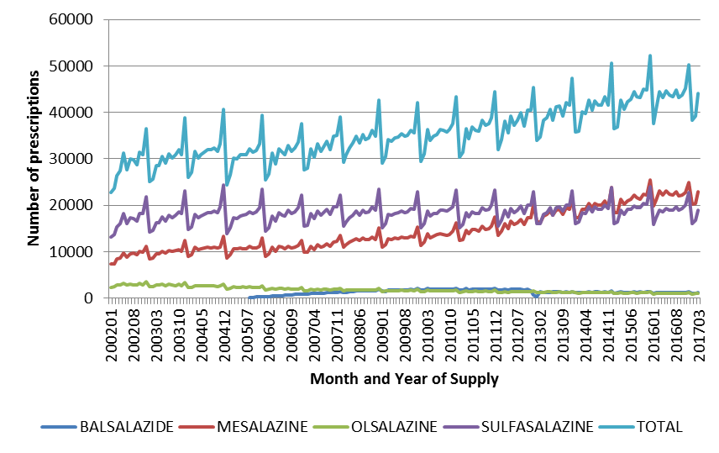
Figure A1.1: Total prescription volume for oral forms for each drug

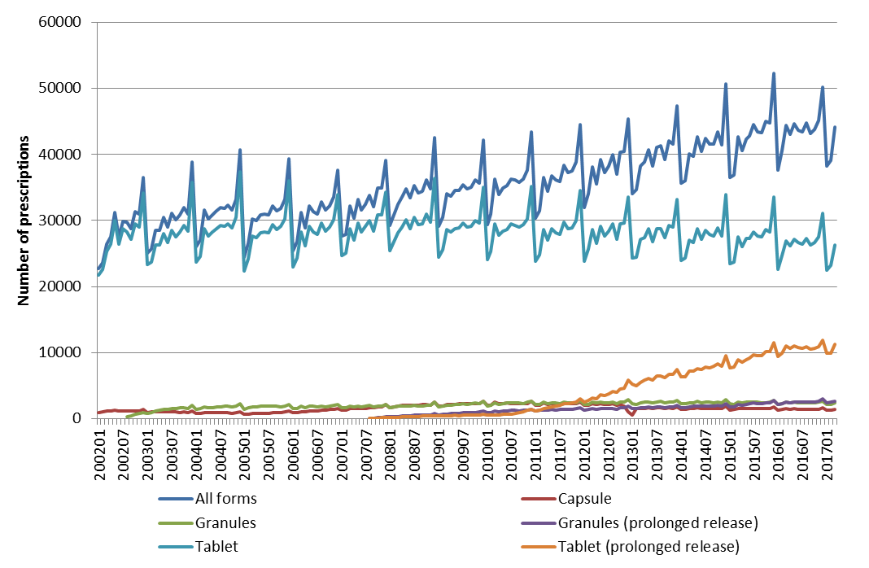
Figure A1.2: Utilisation of oral listings by form

Figure A1.3: Number of prescriptions for oral listings by strength

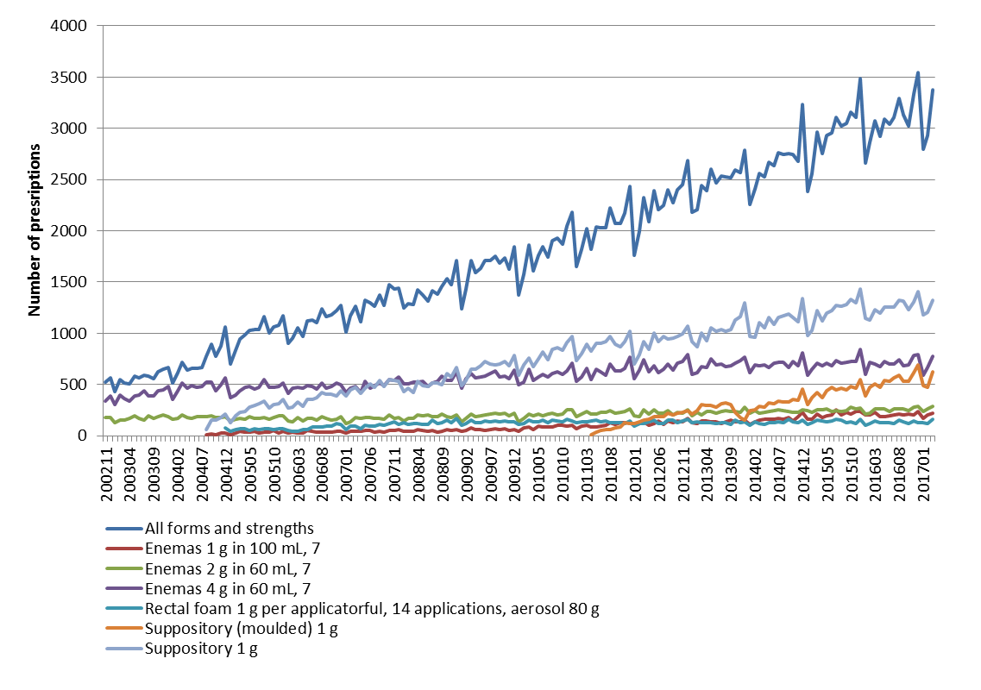
Figure A1.4: Total prescription volume for rectal forms for mesalazine

Appendix 2

Table A2.1: 5-ASA listings and main restriction changes
Date of PBAC recommendation | Drug and form | Recommendation | Date of first listing
- | Sulfasalazine tablet | Listing of a 500 mg tablet | 1 May 1964
- | Olsalazine capsule | Listing of a 250 mg capsule | 1 August 1988
- | Mesalazine tablets | 250 mg tablet for Inflammatory bowel disease involving the colon in patients with proven hypersensitivity to sulphonamides or sustained intolerance to sulphasalazine. | 1 December 1989
- | Olsalazine tablet | Listing of a 500 mg tablet | 1 November 1996
March 2002 | Mesalazine granules | Listing of new forms and strengths of mesalazine, granules, 500mg & 1g sachets | 1 August 2002
June 2002 | Mesalazine enemas | Listing of new enema form with strengths 2g/60 mL and 4g/60 mL | 1 November 2002
December 2003 | Mesalazine enema and suppositories | Listing of enemas 1 g in 100 mL and suppositories 1 g. | 1 August 2004
December 2003 | Mesalazine rectal foam | Listing of 1 g rectal foam | 1 December 2004
March 2005 | Balsalazide capsule | Listing of 750 mg capsule | 1 August 2005
November 2006 | Mesalazine modified release tablets and granules | Listing of modified release 500 mg tablet and modified release 1 g and 2 g granules | 1 August 2007
November 2009 | Mesalazine prolonged release tablet | 1.2 g prolonged release tablets | 1 June 2010
July 2011 | Mesalazine suppositories | Change to the pack size of mesalazine suppositories from 28 to 30 | 1 September 2011
November 2014 | Mesalazine granules | Listing of mesalazine 3 g and 4 g granules for ulcerative colitis | 1 April 2015 (4 g) and 1 May 2015 (3 g)
November 2015 | Mesalazine modified release tablets | Increase in maximum quantity to 2 packs of 60 tablets for mesalazine 1.2 g modified released tablets (Mezavant) for the treatment of ulcerative colitis (UC). | 1 April 2016
March 2017 | Mesalazine tablet | Listing of a 800 mg mesalazine enteric coated tablet | Not listed at the time of reporting

PBS statistics. Australian Government Department of Human Services Medicare. Canberra. Available from <http://www.medicareaustralia.gov.au/provider/pbs/stats.jsp>.
eTG Therapeutic Guidelines. Accessed at: https://tgldcdp.tg.org.au/etgcomplete

