Bevacizumab for epithelial ovarian, fallopian tube, or primary peritoneal cancer: 24 month predicted versus actual analysis

Drug utilisation sub-committee (DUSC)

September 2018

Abstract

Purpose
To compare the predicted and actual utilisation of bevacizumab since PBS listing on 1 August 2014.
Listing on the Pharmaceutical Benefits Scheme (abridged)
Bevacizumab is subsidised through the PBS for previously untreated advanced FIGO Stage IIIB, IIIC or Stage IV epithelial ovarian, fallopian tube or primary peritoneal cancer where:
- the condition is suboptimally debulked (if the patient presents with Stage IIIB or Stage IIIC disease); and
- the patient has a WHO performance status of 2 or less; and
- the treatment is commenced in combination with platinum-based chemotherapy.
The maximum PBS subsidised dose is 7.5 mg per kg every 3 weeks for not more than 18 cycles.
Data Source / methodology
Data for bevacizumab was extracted from the Department of Human Services (DHS) prescription databases from the date of listing on the PBS Schedule on 1 August 2014 to 31 July 2018. Fact of death data were obtained from DHS for patients who initiated bevacizumab between 1 August 2014 and 31 May 2018.
Key Findings
- Since listing, 17,550 prescriptions of bevacizumab were supplied to 1,765 patients under the PBS item codes for epithelial ovarian, fallopian tube, or primary peritoneal cancer.
- The number of prescriptions and treated patients have been stable since the beginning of 2016.
- The predicted versus actual analysis showed that the number of treated patients was close to the number predicted, but the number of prescriptions supplied was lower than predicted. The difference was likely due to some patients receiving less than the maximum allowed 18 cycles of bevacizumab.
- PBS data show 14% of bevacizumab prescriptions supplied under the PBS item codes for epithelial ovarian, fallopian tube, or primary peritoneal cancer were for men. This could indicate incorrect code selection by prescribers (for example for colorectal cancer) or use outside of the PBS subsidised criteria for other indications.

Purpose of analysis
To compare the predicted and actual utilisation of bevacizumab since PBS listing on 1 August 2014.

Background

Clinical situation
Epithelial ovarian cancer is the most common type of ovarian cancer, accounting for about 90% of ovarian cancer cases. Epithelial ovarian, fallopian tube and primary peritoneal cancers all develop in the same type of tissue and are treated the same way.
In its early stages, ovarian cancer usually has no symptoms. When signs and symptoms do appear, the cancer is often advanced.1
Ovarian cancer is surgically staged, based on the extent of the disease. The staging system commonly used is the International Federation of Gynecology and Obstetrics (FIGO) system, which divides ovarian cancer into four stages. Stages I-II indicates early ovarian cancer. Stages III-IV indicates the cancer is advanced.1
Primary peritoneal cancer forms in the tissue that lines the abdominal wall and covers organs in the abdomen. The disease occurs almost exclusively in women; though rare cases have been reported in men. Current medical literature indicates there have been four case reports of primary peritoneal cancer in men.

Pharmacology
Bevacizumab is a recombinant humanised monoclonal antibody that selectively binds to and neutralises the biologic activity of human vascular endothelial growth factor (VEGF).
Tumours produce high levels of VEGF, which stimulates blood vessels to grow, thereby providing the tumour with nutrients and oxygen. When bevacizumab blocks VEGF it disrupts the blood supply to the tumour, stopping or slowing down its growth.

Therapeutic Goods Administration (TGA) approved indications
Bevacizumab (Avastin®) is PBS listed for advanced (FIGO Stage IIIB, IIIC or Stage IV) epithelial ovarian, fallopian tube or primary peritoneal cancer.
Bevacizumab is also TGA registered for the treatment of:
- metastatic colorectal cancer,
- advanced carcinoma of cervix,
- locally recurrent or metastatic breast cancer,
- advanced, metastatic or recurrent, non-squamous, non-small cell lung cancer,
- advanced or metastatic renal cell cancer, and
- grade IV glioma.
Bevacizumab is available as a 100 mg/4 mL vial and 400 mg/16 mL vial for intravenous infusion.

Dosage and administration
The Product Information recommends that for advanced epithelial ovarian, fallopian tube, or primary peritoneal cancer bevacizumab can be administered as a three weekly infusion with a dose of 15 mg per kg given in combination with carboplatin and paclitaxel for up to 6 cycles of treatment, followed by continued use of bevacizumab as single agent.5
The eviQ website recommends bevacizumab be administered as a three weekly infusion with a dose of 7.5 mg per kg given in combination with paclitaxel and carboplatin for six cycles, followed by 12 cycles of single agent bevacizumab (unless disease progression or unacceptable toxicity).
The PBS restriction specifies that the subsidised dose of bevacizumab must not exceed 7.5 mg per kg every three weeks. The number of prescribed repeats is five for initial treatment (in combination with platinum-based chemotherapy) and 11 for continuing treatment. The PBS restriction states treatment must not exceed a lifetime total of 18 cycles of bevacizumab for epithelial ovarian, fallopian tube or primary peritoneal cancer. See the ‘Relevant Aspects of PBAC Consideration’ section for further information about the subsidised dose of bevacizumab.

PBS listing details (as at 1 August 2018)
Bevacizumab is PBS listed as an Authority Required (STREAMLINED) listing for advanced (FIGO Stage IIIB, IIIC or Stage IV) epithelial ovarian, fallopian tube or primary peritoneal cancer, under the item codes in Table 1.

Table 1: PBS listing of bevacizumab
Item | Name, form & strength, pack size | Max. amount | Rpts | DPMQ* | Brand name and manufacturer
s100 Authority Required (STREAMLINED) Private
10120P  Initial treatment | bevacizumab 400 mg/16 mL injection, 1 x 16 mL vial  bevacizumab 100 mg/4 mL injection, 1 x 4 mL vial | 900 mg | 5 | $3,851.64 | Avastin®  Roche Products Pty Limited
10114H  Continuing treatment | bevacizumab 400 mg/16 mL injection, 1 x 16 mL vial  bevacizumab 100 mg/4 mL injection, 1 x 4 mL vial |  | 11
s100 Authority Required (STREAMLINED) Public
10115J  Initial treatment | bevacizumab 400 mg/16 mL injection, 1 x 16 mL vial  bevacizumab 100 mg/4 mL injection, 1 x 4 mL vial | 900 mg | 5 | $3,760.94 | Avastin®  Roche Products Pty Limited
10121Q  Continuing treatment | bevacizumab 400 mg/16 mL injection, 1 x 16 mL vial  bevacizumab 100 mg/4 mL injection, 1 x 4 mL vial |  | 11
Source: PBS website. *Special Pricing Arrangements apply.

Restriction
Authority Required (STREAMLINED)
Advanced FIGO Stage IIIB, IIIC or Stage IV epithelial ovarian, fallopian tube or primary peritoneal cancer.
The clinical criteria for initial treatment states:
- The condition must be suboptimally debulked (maximum diameter of any gross residual disease greater than 1cm) only if the patient presents with Stage IIIB or Stage IIIC disease, AND
- Patient must have a WHO performance status of 2 or less, AND
- The condition must be previously untreated, AND
- The treatment must be commenced in combination with platinum-based chemotherapy, AND
- The treatment must not exceed a dose of 7.5 mg per kg every 3 weeks, AND
- The treatment must not exceed a lifetime total of 18 cycle of bevacizumab for epithelial ovarian, fallopian tube or primary peritoneal cancer.
For details of the current PBS listing refer to the PBS website.
Date of listing on PBS
Bevacizumab was listed on the PBS for Stage IIIB, IIIC or IV epithelial ovarian, fallopian tube, or primary peritoneal cancer on 1 August 2014.

Changes to listing
On 1 February 2015 the PBS items for private hospital use were changed from Authority Required to Authority Required (STREAMLINED), making it consistent with the public hospital listings.
On 1 March 2015 the PBS restriction was changed to specify that an initiating patient must be suboptimally debulked only if the patient presents with Stage IIIB or Stage IIIC disease.
Current PBS listing details are available from the PBS website.

Relevant aspects of consideration by the Pharmaceutical Benefits Advisory Committee (PBAC)
The PBAC recommended bevacizumab for PBS listing at its November 2013 meeting. The submission requested a Section 100 (Efficient Funding of Chemotherapy) Authority Required listing for first line treatment of previously untreated advanced epithelial ovarian, fallopian tube or primary peritoneal cancer who is at risk of disease recurrence.
The submission nominated carboplatin plus paclitaxel as the main comparator, proposing that bevacizumab would be used in addition to carboplatin and paclitaxel.
The PBAC agreed that doublet chemotherapy alone is the main comparator. The PBAC noted however that, while carboplatin plus paclitaxel is the most commonly used doublet chemotherapy regimen, in clinical practice docetaxel may be substituted for paclitaxel and cisplatin may be used instead of carboplatin. The PBAC also noted that monotherapy with carboplatin was often used in elderly patients or individuals who were unable to tolerate taxanes. The PBAC considered that it would be inappropriate to mandate paclitaxel with carboplatin as the only chemotherapy regimen to be used with bevacizumab, and recommended that the initial restriction specify only that it should be used in combination with chemotherapy.
The PBAC noted that the submission presented two trials, GOG-0218 (which was considered as evidence in the Australian Public Assessment Report for Bevacizumab) and ICON-7, neither of which demonstrated an incremental overall survival benefit in their intention to treat population. Bevacizumab 15mg/kg was delivered for up to 22 cycles in the GOG-0218 trial compared with 7.5mg/kg delivered for up to 18 cycles in the ICON-7 trial. The PBAC noted several issues in relation to GOG-0218, which reduced the Committee’s confidence in relying on its results.
The PBAC considered that, as there was no convincing evidence of any additional clinical benefit from using a dose of 15 mg/kg for 22 cycles (a duration of about 15 months as in GOG-0218) compared with a dose of 7.5 mg/kg for 18 cycles (a duration of about 12 months as in ICON-7), the use of the higher dose and the longer duration, with the associated increased risk of adverse events, was not justified.
The PBAC therefore recommended that PBS subsidy be limited to a dose of 7.5 mg/kg every three weeks for a maximum of 18 cycles. The PBAC considered this to be consistent with the evidence and with prudent prescribing in using the lowest effective dose for the shortest duration.
For further details refer to the Public Summary Document from the November 2013 PBAC meeting.
A minor resubmission was submitted for the March 2014 PBAC meeting with re-modelling proposed by the applicant. The PBAC rejected the ICERs generated by these modelling approaches, as unacceptably high. The PBAC therefore reiterated its November 2013 recommendation in relation to the appropriate base case of the economic model and the consequence for the pricing of bevacizumab for the proposed restriction.
For further details refer to the Public Summary Document from the March 2014 PBAC meeting.

Approach taken to estimate utilisation
The submission used an epidemiological approach to estimate the number of epithelial ovarian, fallopian tube, or primary peritoneal cancer patients eligible for bevacizumab. The submission assumed that a proportion of patients would switch from doublet chemotherapy to a triplet regimen of bevacizumab plus doublet chemotherapy.
AIHW ovarian cancer incidence projections in Australia, 1982-2009, were used and extrapolated to estimate the incidence rates of ovarian cancer over the following ten years (2010-2019).
The submission used a published population-based study and two surveys to estimate the staging of ovarian cancer. The Jordan study was used to estimate 56.8% of ovarian cancer patients as having Stage III disease, and 15% as having Stage IV disease. A physician survey (2013) was used to estimate that 81.4% of patients with Stage III disease undergo surgical staging and debulking. An additional survey, Brand, was used to estimate 32% of patients that are suboptimally debulked.
DUSC reviewed the November 2013 submission and advised the eligible population was underestimated. The submission did not account for patients diagnosed with earlier stage disease who progress and become eligible to use bevacizumab, or existing prevalent patients diagnosed in previous years who meet the criteria. The March 2014 resubmission addressed DUSC’s concern regarding the existing group of prevalent patients who would be eligible for bevacizumab. DUSC also advised bevacizumab may be used to treat patients outside of the PBS restriction, for example patients with stage IIIB or IIIC disease who are optimally debulked.
The submission assumed that there would be a ‘’’’’’’’’ uptake rate of bevacizumab for patients that have Stage IIIB and IIIC disease who are suboptimally debulked, and a ‘’’’’’’ uptake rate of bevacizumab for patients with Stage IV disease.
The submission assumed treated patients would receive a dose per administration of 15 mg/kg every three weeks for 22 cycles. Following PBAC recommendation the financial estimates model was revised to incorporate the recommended bevacizumab dose of 7.5 mg/kg every 3 weeks, and the number of cycles revised from 22 to 18. The estimates model assumed all treated patients would receive the maximum number of 18 cycles of bevacizumab, however in the ICON-7 trial 39% of patients who entered the bevacizumab arm of the trial did not complete all 18 treatments.

Methods

Prescriptions and patients
PBS prescription data were extracted for the PBS items listed for bevacizumab for epithelial ovarian, fallopian tube or primary peritoneal cancer from 1 August 2014 to 31 July 2018.
The data extractions were based on the date of supply. The date of processing of PBS prescriptions may differ from the date of supply. As such, there may be differences in the data reported by date of supply or processing (such as that available publicly available from the DHS Medicare website).
These data were used to determine the number of infusions supplied, to count the number of unique incident and treated patients by month, and to analyse the gender of patients treated.

Length of treatment
The duration of treatment and the number of treatments were analysed for patients who:
- received a supply of bevacizumab under a PBS item code for epithelial ovarian, fallopian tube or primary peritoneal cancer; and
- were validated as being treated for epithelial ovarian, fallopian tube or primary peritoneal cancer using supplied chemotherapy medicines, mean bevacizumab dose and gender; and
- had sufficient follow up in the data (initiated prior to 2017 for the number of treatments analysis).
Refer to Appendix A for details on the method used to validate epithelial ovarian, fallopian tube or primary peritoneal cancer patients.
Date of death data were used to determine discontinuation due to death for patients who initiated between August 2014 and May 2018.
The length of treatment was estimated using the Kaplan Meier method with and without accounting for breaks. The without accounting for breaks method used the time between each patient’s initiation, until the median time of refill (21 days) after their last prescription as the patient’s length of treatment. If a patient died less than 21 days after their last supply of bevacizumab, the date of their death was used as the end date.
To account for breaks, a period of three times the median time of refill (3 × 21 = 63 days) between supplies of bevacizumab was determined to be a break. The length of the first episode was determined to be 21 days after the last supply of bevacizumab before the break. The total length of treatment was calculated as the sum of the length of episodes.
Patients were censored in Kaplan Meier analyses when the last supplied prescription was supplied less than 63 days prior to the end of extracted PBS data.

Results

Analysis of drug utilisation

Overall utilisation
Bevacizumab is PBS listed for epithelial ovarian, fallopian tube or primary peritoneal cancer under four Authority Required (STREAMLINED) PBS item codes. Two codes are indicated for initial treatment with five repeats (one for public hospital use and one for private hospital use), and two are indicated for continuing treatment (with eleven repeats).
Figure 1 shows the number of patients initiating bevacizumab under any of the four item codes, and treated with bevacizumab under any of the four items codes, by month since listing. The total number of prescriptions dispensed is also shown in Figure 1.

Figure 1: Initiating and prevalent treated patients and prescriptions of bevacizumab for epithelial ovarian, fallopian tube, or primary peritoneal cancer, by month of supply
Source: DHS prescription database, extracted August 2018

Figure 1 shows that the number of initiating patients remained steady since listing in August 2014. The total number of treated patients has been fairly stable since the beginning of 2016.
The number of dispensed prescriptions grew fairly quickly during the first 12 months of listing, but has since become fairly stable. The number of prescriptions per month was higher than the number of treated patients. Given the three weekly dosing regimen it is reasonable that the number of prescriptions dispensed per month is higher than the number of patients treated per month, as some patients will have more than one prescription supplied in a month. In 2017, 5,053 prescriptions were dispensed.

Figure 2: Gender of initiating patients by quarter of supply
Note: Data from August 2014 to June 2018 inclusive
Source: DHS prescription database, extracted August 2018

Since listing in August 2014, 86% of prescriptions were for females and 14% were for males. The number of males treated was inconsistent with use for ovarian and fallopian tube cancer, and primary peritoneal cancer which occurs almost exclusively in women. Bevacizumab is also PBS listed for metastatic colorectal cancer. It is likely that a proportion of the prescriptions supplied to males are a result of prescriber or dispenser coding error. Noting this, the results presented in Figure 1 above, and the predicted versus actual analysis in Table 2 below, should be interpreted with caution. Use of bevacizumab for non-subsidised indications could be another factor contributing to the unexpected gender distribution in Figure 2.

Analysis of actual versus predicted utilisation
Table 2: Analysis of actual versus predicted utilisation of bevacizumab for advanced (FIGO Stages IIIB, IIIC or IV) epithelial ovarian, fallopian tube, or primary peritoneal cancer.
 |  | Listing year
 |  | Year 1  (Aug 14 – Jul 15) | Year 2  (Aug 15 – Jul 16) | Year 3  (Aug 16 – Jul 17) | Year 4  (Aug 17 – Jul 18)
Patients | Predicted | ‘’’’’’ | ‘’’’’’ | ‘’’’’’ | ‘’’’’’
 | Actual | 456 | 414 | 465 | 430
 | % Difference (A-P)/P | ‘’’’’’’’ | ‘’’’’’ | ‘’’’’’’ | ‘’’’’’
Prescriptions | Predicted | ‘’’’’’’’’ | ‘’’’’’’’’ | ‘’’’’’’’’ | ‘’’’’’’’’
 | Actual | 2,872 | 4,690 | 5,091 | 4,897
 | % Difference (A-P)/P | ‘’’’’’’’ | ‘’’’’’’’ | ‘’’’’’’’ | ‘’’’’’’’
Source: Predicted: Final agreed estimates, (Listing years estimated from July to June, without recalculation based on the PBS listing effective from 1 August 2014)
Actual: DHS prescriptions database, extracted August 2018 for PBS item codes 10120P, 10114H, 10115J, 10121Q.
The comparison of predicted and actual number of patients and prescriptions is shown for listing years. In the first year of listing the number of patients treated was lower than predicted, likely indicating that the inclusion of prevalent pool of patients in the year 1 estimates as suggested by DUSC was overestimated. Since the second year of listing, the number of treated patients per calendar year was close to the number predicted.
The number of prescriptions supplied for ovarian cancer was lower than predicted. This may be because patients are not being treated as often or for as long as predicted. This is investigated in the ‘Analysis of Duration’ section below.
The results in Table 2 should be interpreted with caution due to potential misattribution of PBS item codes between the various subsidised indications for bevacizumab.

Analysis of duration
Following are analyses of the number of treatments and length of treatment for the cohort of 1,249 patients ascertained to be using bevacizumab for ovarian, fallopian or primary peritoneal cancer, as described in the methods section and Appendix A.

Number of treatments
Table 3 shows the mean and median number of treatments supplied to patients who initiated in 2014, 2015, or 2016 (867 patients). Although the most common number of treatments patients received was 18 in all groups, the mean and median were both lower for patients who are deceased. This may be because a higher number of patients in this group experienced disease progression and were unable to complete 18 treatments of bevacizumab.

Table 3: Number of treatments
Number of treatments | Number | Mean | Median | Mode
Alive | 497 | 14.55 | 17 | 18
Deceased | 379 | 10.80 | 10 | 18
Overall | 876 | 12.93 | 15 | 18

Figure 3 shows the distribution of the number of treatments supplied to patients who initiated in 2014, 2015, or 2016 (867 patients). Patients most often received 18 treatments of bevacizumab. The number of patients receiving less than 18 treatments was lower in alive patients than deceased patients.

Figure 3: Number of treatments of bevacizumab for patients who initiated prior to 2017
Note: The number of patients is not shown disaggregated by group for more than 19 treatments due to small numbers in separate groups

Length of treatment
Table 4 summarises the number of episodes as a percentage of the 1,249 patients. It shows 82% of patients in the cohort did not have any treatment breaks.

Table 4: Number of episodes as percentage of patients
Episodes | Overall
1 | 82%
2 | 17%
3-4 | 1%
Note: of the cohort of 1,249 patients used to examine length of treatment
The mean and median length of treatment is shown in Table 5, with and without regard for breaks. The median time between treatments was 21 days.

Table 5: Length of treatment estimated from Kaplan Meier
 |  | Without breaks |  | With breaks
Number | Censored | Mean | Median | Mean | Median
1249 | 241 | 296.79 | 329 | 273.18 | 305

The length of treatment analysis shows that the median length of treatment is approximately 10 months without accounting for breaks, and approximately nine months accounting for breaks.
Figures 4 and 5 below show the Kaplan Meier curves of the length of treatment without accounting for breaks and with accounting for breaks.

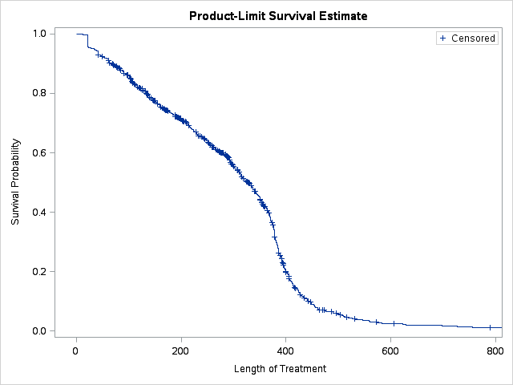

Figure 4: Kaplan Meier estimate of length of treatment without accounting for breaks
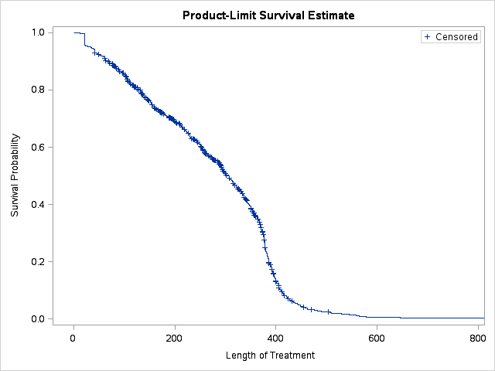

Figure 5: Kaplan Meier estimate of length of treatment, accounting for breaks

Discussion
There was likely some misattribution of PBS item codes, which is apparent from the proportion of males appearing in the data for ovarian cancer and the mixture of chemotherapy medicines supplied to these patients.
The PBS restriction for bevacizumab stated that treatment must not exceed a lifetime total of 18 cycles of bevacizumab for epithelial ovarian, fallopian tube or primary peritoneal cancer. Although the most common number of treatments patients received was 18, the mean and median number of treatments supplied was less than 18. This may have been due to progressive disease preventing some patients from completing 18 treatments. The analysis also shows that only a few patients were receiving more than the recommended 18 treatments of bevacizumab. The limit of the number of treatments patients may receive was likely contributing to the number of prevalent treated patients appearing to have stabilised.
Although the number of patients treated was close to the number predicted, the number of prescriptions dispensed was overestimated. The final agreed estimates incorporated the recommendation of the PBAC, and assumed each treated patient would receive 18 cycles of bevacizumab, over approximately one year. The estimates did not account for the 39% of patients who entered the bevacizumab arm of the ICON-7 trial who did not complete the maximum number of 18 treatments. The discordance between estimated patients and estimated prescriptions may be explained by the mean and median number of treatments being less than 18, likely due to discontinuation of patients prior to 18 treatments.

DUSC consideration
DUSC noted the number of initiating patients was steady, and commented the number of dispensed prescriptions appeared to have stabilised after the first 12 months of listing.
DUSC noted the report found 14% of patients who initiated to bevacizumab under the item codes for ovarian cancer were identified as male. DUSC noted the predicted versus actual analysis was based on all patients supplied bevacizumab under ovarian cancer item codes, including male patients.
DUSC noted the predicted versus actual table was updated in the errors document. DUSC commented that the number of patients was overestimated in year 1, but was close to the predicted number in other years. DUSC considered this suggested all or most women who were eligible for treatment were able to access bevacizumab. DUSC noted the submission estimates were for listing years. As such, the overestimate in year 1 was because a half cycle correction had not been applied to account for the listing occurring part way through the initial year. DUSC noted the prescriptions were grossly overestimated in year 1, and overestimated in all out years.
DUSC noted prior and concurrent chemotherapy medicines were used to determine which patients were likely treated for ovarian cancer. DUSC noted there may have been ovarian cancer patients treated under metastatic colorectal cancer item codes which would not have been included in this analysis.
DUSC noted the report presented a Kaplan Meier analysis to estimate duration in treatment, with and without breaks. DUSC commented that the vast majority (82%) of patients received one treatment episode.
DUSC noted the analysis of the number of treatments that patients received. DUSC noted that half of the patients in the analysis had 15 treatments or less, which suggested some patients were not completing the full course of bevacizumab. DUSC noted this aligned with the overestimate of prescriptions seen in the predicted versus actual analysis. DUSC noted that 10% of patients received more than 18 treatments. DUSC considered the number receiving more than 18 treatments may increase in the future.
DUSC noted the comments regarding the report from the consumer organisation Ovarian Cancer Australia.

DUSC actions
- DUSC requested that the report be provided to the PBAC.

Context for analysis
The DUSC is a Sub Committee of the Pharmaceutical Benefits Advisory Committee (PBAC). The DUSC assesses estimates on projected usage and financial cost of medicines.
The DUSC also analyses data on actual use of medicines, including the utilisation of PBS listed medicines, and provides advice to the PBAC on these matters. This may include outlining how the current utilisation of PBS medicines compares with the use as recommended by the PBAC.
The DUSC operates in accordance with the quality use of medicines objective of the National Medicines Policy and considers that the DUSC utilisation analyses will assist consumers and health professionals to better understand the costs, benefits and risks of medicines.
The utilisation analysis report was provided to the pharmaceutical sponsors of each drug and comments on the report were provided to DUSC prior to its consideration of the analysis.

Sponsors’ comments
Roche Products Pty Limited: The sponsor has no comment.

Disclaimer
The information provided in this report does not constitute medical advice and is not intended to take the place of professional medical advice or care. It is not intended to define what constitutes reasonable, appropriate or best care for any individual for any given health issue. The information should not be used as a substitute for the judgement and skill of a medical practitioner.
The Department of Health (DoH) has made all reasonable efforts to ensure that information provided in this report is accurate. The information provided in this report was up-to-date when it was considered by the Drug Utilisation Sub-committee of the Pharmaceutical Benefits Advisory Committee. The context for that information may have changed since publication.
To the extent provided by law, DoH makes no warranties or representations as to accuracy or completeness of information contained in this report.
To the fullest extent permitted by law, neither the DoH nor any DoH employee is liable for any liability, loss, claim, damage, expense, injury or personal injury (including death), whether direct or indirect (including consequential loss and loss of profits) and however incurred (including in tort), caused or contributed to by any person’s use or misuse of the information available from this report or contained on any third party website referred to in this report.

Appendix A
The analysis of bevacizumab use by item code and gender indicates that there may have been incorrect PBS item code selection. To assess the number and duration of bevacizumab treatments without confounding from this miscoding, a cohort of patients was identified where the indication for use was validated. This included patients who had received a supply of bevacizumab under a PBS item code for epithelial ovarian, fallopian tube or primary peritoneal cancer; and were supplied chemotherapy used to treat epithelial ovarian, fallopian tube or primary peritoneal cancer; and were supplied a mean bevacizumab dose consistent with use for these indications. All patients in the resulting cohort had gender recorded as female.
Chemotherapy medicines commonly prescribed for colorectal cancer, cervical cancer and ovarian, fallopian tube or primary peritoneal cancer were identified through clinical guidelines and PBAC consideration of chemotherapy used in clinical practice.
For ovarian, fallopian tube and primary peritoneal cancer the PBAC had noted that while carboplatin plus paclitaxel is the most commonly used doublet chemotherapy regimen, in clinical practice docetaxel may be substituted for paclitaxel and cisplatin may be used instead of carboplatin. The PBAC also noted that monotherapy with carboplatin was often used in elderly patients or individuals who were unable to tolerate taxanes.
The treatment regimens listed on eviQ for metastatic colorectal cancer and advanced carcinoma of cervix that include bevacizumab are summarised below.⁶
In advanced carcinoma of the cervix bevacizumab (15 mg per kg) is used:
- in combination with paclitaxel and carboplatin, and
- in combination with paclitaxel and cisplatin.
In metastatic colorectal cancer bevacizumab (5 mg per kg or 7.5 mg per kg) is used:
- in combination with capecitabine;
- in combination with irinotecan and capecitabine;
- in combination with oxaliplatin and capecitabine;
- in combination with irinotecan, calcium folinate (leucovorin), and fluorouracil;
- in combination with oxaliplatin, calcium folinate (leucovorin), and fluorouracil;
- in combination with irinotecan, oxaliplatin, calcium folinate (leucovorin), and fluorouracil; and
- in combination with calcium folinate (leucovorin), and fluorouracil.
For details on eviQ recommended treatment regimens refer to eviQ.
Based on the common chemotherapy drug regimens above, PBS prescription data were extracted for carboplatin, paclitaxel, cisplatin, docetaxel, irinotecan, capecitabine, oxaliplatin, fluorouracil and folinic acid from 1 August 2014 to 31 July 2018. The number of supplies of each chemotherapy medicine was counted for these patients, and the mean dose of bevacizumab was calculated for each patient. Then, each patient was assigned a likely indication based on the rules in Table A.1. For more information see Figure A.1.
The length of treatment and the number of treatments patients were supplied were analysed for the 1,249 patients likely to have ovarian cancer.

Table A.1: Validation of disease using chemotherapy prescriptions
Number of supplies of carboplatin, paclitaxel, cisplatin and docetaxel | Number of supplies of irinotecan, capecitabine, oxaliplatin, fluorouracil and folinic acid | Mean dose of bevacizumab | Assigned indication | Number of patients
≥ 1 | 0 | ≤ 900 mg | Ovarian cancer | 1,249
 |  | > 900 mg | Cervical cancer | 18
0 | ≥ 1 |  | Metastatic colorectal cancer | 358
0 | 0 |  | Nil determined | 25
≥ 1 | ≥ 1 |  | Split results | 23
Total |  |  |  | 1,673

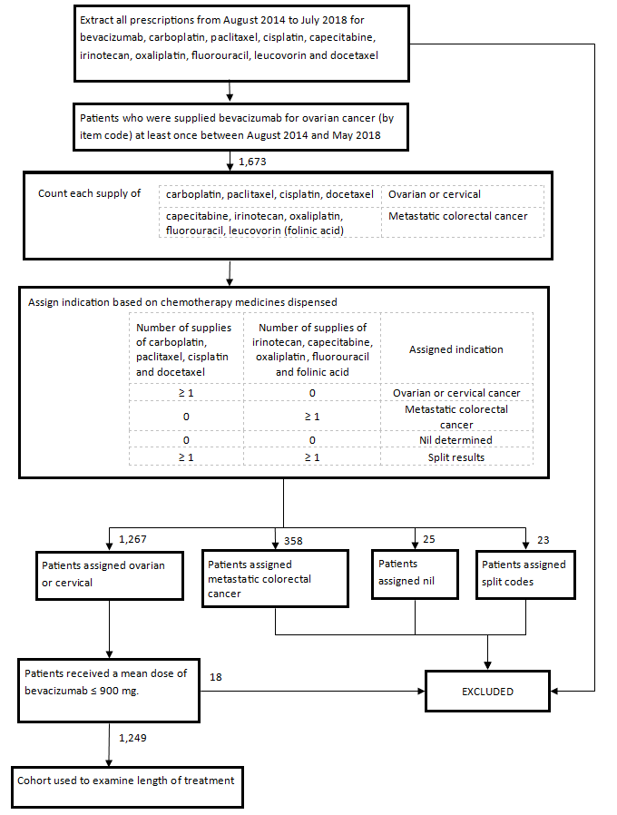

Figure A.1: Flowchart describing the validation of patients with epithelial ovarian, fallopian tube or primary peritoneal cancer

Cancer Council Australia. Understanding Ovarian Cancer. April 2018. Available from <http://www.cancervic.org.au/>. Accessed 06 August 2018
National Breast and Ovarian Cancer Centre. Epithelial Ovarian Cancer. June 2008. Available from <https://canceraustralia.gov.au/ >. Accessed 06 August 2018
National Cancer Institute. National Institutes of Health. Available from <https://www.cancer.gov/>. Accessed 15 August 2018
Xu J, Weisman P, Loeffler A. Primary peritoneal low-grade serous carcinoma in a man: A case report and review of literature. Human Pathology: Case Reports. 2017;9:1-4. DOI: https://doi.org/10.1016/j.ehpc.2016.12.003
Avastin®, (Bevacizumab), Product Information, 24 November 2017. Available from <https://www.tga.gov.au/>. Accessed 25 June 2018
eviQ. Ovarian advanced carboplatin, paclitaxel and bevacizumab. 3 November 2017. Available from <https://www.eviq.org.au/>. Accessed 20 August 2018
The Pharmaceutical Benefits Scheme, (Bevacizumab), Department of Health. Available from <http://www.pbs.gov.au/>. Accessed 20 August 2018
Australian Public Assessment Report for Bevacizumab, Published 6 August 2012, Accessed 27 August 2018 https://www.tga.gov.au/sites/default/files/auspar-bevacizumab-120806.pdf
Jordan S, Steer C, DeFazio A, Quinn M, Obermair A, Friedlander M et al. Patterns of chemotherapy treatment for women with invasive epithelial ovarian cancer—a population-based study. 2013; 129(2):310-7. DOI: 10.1016/j.ygyno.2013.02.007
Brand A. Ovarian Cancer Debulking Surgery: A survey of Practice in Australia and New Zealand. 2011 – Volume 21 – Issue 2 – p 230-235. DOI: 10.1097/IGC.0b013e318205fb4f
ICON-7 Clinical Study Report p79

