Direct acting antiviral medicines for the treatment of chronic hepatitis C

Drug utilisation sub-committee (DUSC)

September 2018

Abstract

Purpose
To review the utilisation of new generation direct acting antiviral (DAA) medicines listed on the PBS for the treatment of chronic hepatitis C.

Date of listing on the Pharmaceutical Benefits Scheme (PBS)
Drug name | Listing date
Daclatasvir | 1 March 2016
Ledipasvir with sofosbuvir | 1 March 2016
Ribavirin | 1 March 2016
Sofosbuvir | 1 March 2016
Paritaprevir with ritonavir with ombitasvir and dasabuvir | 1 May 2016
Paritaprevir with ritonavir with ombitasvir and dasabuvir and ribavirin | 1 May 2016
Grazoprevir with elbasvir | 1 January 2017
Sofosbuvir with velpatasvir | 1 August 2017
Glecaprevir with pibrentasvir | 1 August 2018

Data Sources
Data to assess the utilisation of direct acting antiviral therapy was obtained from three sources:
- Prescription dispensing data from the Department of Human Services (DHS) prescription database.
- DHS Authorities data, including information on hepatitis C virus genotype and the cirrhotic status of the patient.
- Aboriginal Health Services data.

Key Findings
- Over the first two years of listing (1 March 2016 to 28 February 2018), a total of 56,356 patients were supplied a DAA medicine. As at 30 April 2018, 58,941 patients had received a DAA medicine. The number of patients treated was more than anticipated at the time when the DAA medicines were first listed.
- There was a high initial uptake averaging 4,400 incident patients per month during the first four months of listing. By December 2017, the number of initiators to DAA therapy had stabilised to an average of around 1,280 patients per month.
- The majority of patients were dispensed the full number of original and repeat prescriptions for their allocated DAA regimen that the prescriber had applied for when seeking an Authority approval. Based on a six-month cohort of patients issued with an approved Authority between 1 January to 30 June 2017, 94.3 percent were dispensed a full course of their approved DAA regimen. While the majority of patients were supplied their full course of treatment, it cannot be determined from the PBS data whether the patient was fully compliant in taking all their prescribed medicine.
- Initially the most commonly prescribed DAA regimen was daclatasvir with sofosbuvir. As at April 2018, sofosbuvir with velpatasvir was the most commonly prescribed regimen.
- During the initial year of listing (March 2016 to February 2017), the DAA regimens were mostly prescribed by specialists (67.7 percent). Over time, the number of general practitioners prescribing DAA regimens had increased. During the first quarter of 2018, the highest proportion of prescribing was by general practitioners (57.0 percent).

Purpose of analysis
To review the utilisation of direct acting antiviral (DAA) medicines listed on the PBS for the treatment of chronic hepatitis C.

Background

Clinical situation
Hepatitis C is a type of liver inflammation caused by a virus. Chronic infection with the virus may lead to severe health complications, including irreversible scarring on the liver (cirrhosis) and cancer of the liver (Khoo, A. and Tse, E., 2016). At the beginning of 2016 it was estimated that around 230,000 Australians were living with hepatitis C (The Kirby Institute, 2016). As at August 2018 it has been estimated that there are around 170,000 people who are still living with chronic hepatitis C.
The aim of drug treatment is to achieve a virological response where the hepatitis C virus is not detected in the blood. When the virus remains undetectable for at least 12 weeks after completing drug treatment, it is considered that a sustained virologic response (SVR) has been achieved.
The availability of DAA medicines has had important implications for the treatment of hepatitis C. DAA therapy has a high efficacy in achieving SVRs with improved safety when compared to earlier therapy options. The first drug regimen listed on the PBS to treat the hepatitis C virus (HCV) was pegylated interferon plus ribavirin. This regimen is associated with suboptimal SVR rates in genotype 1 patients (around 30 percent, (Herzer, K. and Gerken, G., 2016) and modest SVR rates for other genotypes 2 to 6, ranging from around 50 percent to 78 percent (Public Summary Document, sofosbuvir, March, 2015). The addition of the first generation DAA medicines, telaprevir and boceprevir, improved the effectiveness of pegylated interferon plus ribavirin therapy in treating genotype 1 patients with SVR rates between 55 to 75 percent (Public Summary Document, sofosbuvir, March, 2015). However, these regimens were restricted to only treating genotype 1 patients and the high incidence of adverse events from the interferon component remained. The new generation of DAA therapy is reported to achieve high real world SVR rates at 12 weeks (over 90 percent) across all genotypes and in individuals with cirrhosis and for people who had previously been treated (The Kirby Institute, 2017c).

Therapeutic Goods Administration (TGA) approved indications
The registered indications for the DAA medicines are summarised in Table 1.
Table 1: Summary of registered indications, mechanism of actions and eligibility criteria for PBS listed DAA regimens as at August 2018
 | Sofosbuvir  with  RBV | Sofosbuvir with PEG  with  RBV | Ledipasvir with sofosbuvir | Daclatasvir  with  sofosbuvir | Paritaprevir with ritonavir with ombitasvir and dasbuvir±RBV | Ribavirin | Grazoprevir with elbasvir±RBV | Sofosbuvir  with  velpatasvir | Glecaprevir  with  pibrentasvir
ARTG start date¹ | 30/06/2014 | 30/06/2014 | 13/05/2015 | 25/06/2015 | 10/07/2015 | 15/03/2016 | 29/08/2016 | 19/12/2016 | 02/01/2018
Registered indication¹ | Treatment of adults with chronic hepatitis C (CHC) infection as a component of a combination antiviral treatment regimen. | Treatment of adults with chronic hepatitis C (CHC) infection as a component of a combination antiviral treatment regimen. | Treatment of chronic hepatitis C (CHC) infection in adults. | Use in combination with other medicinal products for the treatment of chronic hepatitis C virus (HCV) infection in adults. | Treatment of genotype 1 chronic hepatitis C infection, including patients with compensated cirrhosis. | Use in combination with other oral agents for the treatment of chronic hepatitis C (CHC) in adults. | Treatment of Chronic Hepatitis C genotype 1 or 4 infection in adults. | Treatment of chronic hepatitis C virus (HCV) infection (genotype 1, 2, 3, 4, 5 or 6) in adults. | Treatment of adult patients with chronic hepatitis C virus (HCV) genotype 1, 2, 3, 4, 5, or 6 infection with or without compensated cirrhosis. This includes patients with HCV genotype 1 infection who were previously treated with either a regimen of an NS5A inhibitor or with an NS3/4A protease inhibitor but not both classes of inhibitors
Mechanism of action² | NS5B RNA polymerase inhibitor + nucleoside analogue | NS5B RNA polymerase inhibitor + nucleoside analogue | NS5B RNA polymerase inhibitor + NS5A inhibitor | NS5B replication complex inhibitor + NS5A inhibitor | NS3-4A protease inhibitor + NS5A inhibitor + non-nucleoside inhibitor of NS5B RNA polymerase | Nucleoside analogue | NS5A inhibitor + NS3/4A protease inhibitor | NS5B RNA polymerase inhibitor+ NS5A inhibitor | NS5A inhibitor + NS3/4A protease inhibitor
Drug regimen subsidy by HCV genotype³:
Genotype 1 | No | Yes | Yes | Yes | Yes | Yes | Yes | Yes | Yes
Genotype 2 | Yes | No | No | No | No | Yes | No | Yes | Yes
Genotype 3 | Yes | Yes | No | Yes | No | Yes | No | Yes | Yes
Genotype 4 | No | Yes | No | No | No | Yes | Yes | Yes | Yes
Genotype 5 | No | Yes | No | No | No | Yes | No | Yes | Yes
Genotype 6 | No | Yes | No | No | No | Yes | No | Yes | Yes
Cirrhotic patients³ | Yes | Yes | Yes | Yes | Yes | Yes | Yes | Yes | Yes
Use in pregnancy^{2,4} | Category B1 or  Category X when used with RBV | Category B1 or  Category X when used with RBV | Category B1 | Category B3 | Category B3 or  Category X when used with RBV | Category X | Category B1 or Category X when used with RBV | Category B1 | Category B1

Note:
ARTG, Australian Register of Therapeutic Goods; NS, Nonstructural protein; RBV, ribavirin.
¹ Australian Register of Therapeutic Goods, accessed in July 2018.
² The current Product Information (PI) available from the TGA (Product Information).

³ General Statement for Drugs for the Treatment of Hepatitis C, accessed in August 2018.
⁴ The following definitions are based on the Australian categorisation system for prescribing medicines in pregnancy:
Category B1 = Drugs which have been taken by only a limited number of pregnant women and women of childbearing age, without an increase in the frequency of malformation or other direct or indirect harmful effects on the human fetus having been observed. Studies in animals have not shown evidence of an increased occurrence of fetal damage.
Category B3 = As per Category B1 in terms of human studies but studies in animals have shown evidence of an increased occurrence of fetal damage, the significance of which is considered uncertain in humans.
Category X = Drugs which have a high risk of causing permanent damage to the fetus which should not be used in pregnancy or when there is a possibility of pregnancy.

Dosage and administration
The dose and frequency of administration of direct acting antiviral therapy listed on the PBS is summarised in Appendix 1.
Direct acting antiviral therapy is administered orally.
The duration of each drug regimen depending on a patient’s HCV genotype, cirrhotic status and prior therapy received is set out in the General Statement for Drugs for the Treatment of Hepatitis C. The duration of subsidised therapy is consistent with the recommended treatment time for the medicines in their respective Product Information.

PBS listing details (as at July 2018)
A summary of the PBS listings is provided at Appendix 2.

Restriction and medicine supply arrangements
The General Statement for Drugs for the Treatment of Hepatitis C (the ‘Statement’) sets out the criteria to determine patient eligibility for subsidisation under the PBS for the treatment of chronic hepatitis C (CHC) infection. The Statement includes matrices to identify patient eligibility for the available drug regimens based on the HCV genotype, and the patient’s cirrhotic status and treatment history. Patients must be aged 18 years or older. A copy of the Statement as at August 2018 is provided at Appendix 3. Previous and any subsequent versions can be accessed from the PBS website.
The medicines for CHC are available as Authority Required listings through both the PBS General Schedule (‘S85’) and the Section 100 (‘S100’) Highly Specialised Drugs (HSD) Program. This does not include the HSD Community Access arrangements. Further details about the listing arrangements for the DAA medicines are available in the hepatitis C factsheet for community-based prescribers and hospital prescribers.
Patient eligibility is the same for both the S85 and S100 listings. People in custodial settings are able to access DAA medicines for the treatment of CHC under the HSD program. It is a matter for the state and territory justice and health departments to establish arrangements for the supply of these medicines to prisoners.
If more than one medicine is prescribed as part of a course of treatment, a separate authority prescription must be authorised for each medicine for PBS subsidy. An original prescription can be written for a full course of treatment. Prescribers can apply for the appropriate number of repeats to cover the duration of the relevant treatment course. If a prescription is issued under the S85 General Schedule, the medicine can be dispensed by approved pharmacists in the community. Prescriptions written under S100 HSD arrangements in a public hospital must be dispensed by a section 94 approved hospital authority.
At the time of an Authority application, information about the patient’s hepatitis C virus genotype and cirrhotic status (either cirrhotic or non-cirrhotic) must be provided.
Peginterferon alfa-2a and ribavirin are listed on the PBS for use as part of a DAA regimen for the treatment of chronic hepatitis C. Peginterferon alfa-2a is available as an Authority Required Section 100 Highly Specialised Drug listing with treatment limited to a maximum duration of 12 weeks. Ribavirin has Authority Required S100 and General Schedule listings and is limited to a maximum treatment duration of 24 weeks.
All medical practitioners, including general practitioners, who are experienced in the treatment of CHC infection, can prescribe the hepatitis C medicines. All other medical practitioners may prescribe under the PBS in consultation with a gastroenterologist, hepatologist, or infectious disease physician experienced in the treatment of CHC infection. From 1 June 2017 authorised nurse practitioners experienced in treating CHC infection have been able to prescribe the hepatitis C medicines under the General Schedule. All other nurse practitioners may prescribe under the PBS General Schedule in consultation with a gastroenterologist, hepatologist, or infectious disease physician if in accordance with state and territory requirements. For further information about eligible prescribers, refer to the Hepatitis C Medicines – Fact Sheet for Community Based Prescribers.

Date of listing on PBS
Drug name | Listing date
Daclatasvir | 1 March 2016
Ledipasvir with sofosbuvir | 1 March 2016
Ribavirin | 1 March 2016
Sofosbuvir | 1 March 2016
Paritaprevir with ritonavir with ombitasvir and dasabuvir | 1 May 2016
Paritaprevir with ritonavir with ombitasvir and dasabuvir and ribavirin | 1 May 2016
Grazoprevir with elbasvir | 1 January 2017
Sofosbuvir with velpatasvir | 1 August 2017
Glecaprevir with pibrentasvir | 1 August 2018

Changes to listing
In November 2016 the PBAC recommended amending the Statement to remove the criteria for treatment experienced patients requiring them to have failed prior treatment with peginterferon containing regimens before accessing interferon-free drug regimens. The amendments to the Statement were effective from 1 February 2017.
From 1 June 2017 the treatment criteria were changed to allow nurse practitioners to prescribe DAA medicines under the General Schedule only.
Current PBS listing details are available from the PBS website.

Relevant aspects of consideration by the Pharmaceutical Benefits Advisory Committee (PBAC)

February 2014 stakeholder meeting
The PBAC held a stakeholder meeting on 25 February 2014 to inform the Committee about the following aspects of the treatment of the hepatitis C virus: new therapy options and their implications on the models of care; the number of affected patients and priority treatment populations; considerations for data collection; and diagnostic testing requirements.
The difficulty in estimating the number of patients who were likely to be treated with the new generation of DAA therapy was discussed. On the one hand, greater prescribing was expected compared to the available interferon-based therapies as the DAAs involved shorter treatment durations, had better tolerability, achieved greater gains in SVR rates and could be prescribed by general practitioners. However, there were also potential constraints on use of DAA therapy. Participants noted that the registered indications of the DAAs would limit their use to certain genotypes. The need to assess disease severity in order to prescribe appropriate DAA therapy, including cirrhotic status and genotype, was considered to be likely rate-limiting. Clinicians stated that it would take time for the current S100 listing model of care involved for prescribing interferon-based therapy to transition to a wider, community based access model enabled by the newer DAA therapies. Social barriers to the uptake of treatment, including the stigmatisation of some patients such as injecting drug users, were also discussed. Overall, it was estimated that between 10,000 to 15,000 patients could be treated with DAA therapy within the next 3 to 4 years if it were listed on the PBS. It was noted that around 4,000 patients per year were treated with interferon-based drug regimens at the time. It was also noted that some genotype 1 patients were delaying interferon-based therapy in anticipation of future interferon-free drug regimens.
Clinicians considered that the rate of re-infections was likely to be low; estimated to be 2 to 3 percent annually.
For further details, refer to the record of the meeting on the PBS website.
March 2015 recommendations for sofosbuvir and sofosbuvir plus ledipasvir

Sofosbuvir and sofosbuvir plus ledipasvir were recommended by the PBAC in March 2015 for the following Authority Required listings:
- 12 week regimen of sofosbuvir in combination with peg-interferon and ribavirin for genotype 1 on the basis of cost-effectiveness of the treatment over no treatment and non-inferior efficacy with sofosbuvir plus ledipasvir.
- 12 week regimen of sofosbuvir in combination with ribavirin for genotype 2 on the basis of cost-effectiveness of the treatment over no treatment.
- 24 week regimen of sofosbuvir in combination with ribavirin for genotype 3 on the basis of cost-effectiveness of the treatment over no treatment.
- 12 week regimen of sofosbuvir in combination with peg-interferon and ribavirin for genotypes 3, 4, 5 and 6 on the basis of cost-effectiveness of the treatment over no treatment.
- 8 week (non-hepatic cirrhosis) and 12 week (with hepatic cirrhosis) regimens of sofosbuvir with ledipasvir for genotype 1 on the basis of cost-effectiveness of the treatment over no treatment.
PBAC recommended the listing of these medicines on the General Schedule to facilitate the role of primary care in prescribing. PBAC considered that some patients will still need to be clinically managed through the hospital system. PBAC also considered that prescribing would continue to be delivered through specialist clinics in the short-term until prescribers in other settings became familiar with the DAA medicines. PBAC was of the view that nurse practitioner prescribing would be appropriate in a shared care model.
PBAC noted DUSC’s estimate of 61,500 patients treated over the first five years of listing based on treatment targets in the Fourth National Hepatitis C Strategy 2014-2017, advice from the Australian Liver Association and the February 2014 Stakeholder meeting. PBAC noted advice from the Australian Liver Association which estimated there were around 233,000 people living with HCV, of whom 193,000 were diagnosed. PBAC considered it was uncertain how many people living with CHC would seek therapy. PBAC noted there would be a significant opportunity cost to the government as the uptake of DAA medicines would be higher than the existing interferon-based drug regimens.
PBAC considered that the existing listings to treat CHC, including ribavirin and peginterferon alone and in combination with telaprevir, boceprevir or simeprevir, were no longer cost-effective, particularly because of their higher rate of adverse effects. The PBAC recommended that the Minister may wish to review the listing of these drugs. Boceprevir and telaprevir were subsequently delisted from the PBS from 1 May 2017 and 1 September 2015, respectively. Simeprevir was recommended by PBAC in November 2015 for use in combination with sofosbuvir for genotype 1 CHC, but did not proceed to PBS listing.
For further details refer to the Public Summary Documents for sofosbuvir and sofosbuvir plus ledipasvir from the March 2015 PBAC meeting.
March and November 2015 recommendations for daclatasvir
At its March 2015 meeting, the PBAC recommended an Authority Required listing for daclatasvir in combination with sofosbuvir for genotype 1 treatment naïve non-cirrhotic patients and genotype 3 CHC patients. The listings were recommended on the basis of acceptable cost effectiveness over no treatment, with the price of a course of treatment to be the same as the price of a course of treatment with ledipasvir with sofosbuvir.
In November 2015, the PBAC recommended to expand the Authority Required listing of daclatasvir in combination with sofosbuvir for the treatment of all patients with genotype 1 and genotype 3 CHC. The PBAC considered that there was no basis on which to make a cost effectiveness recommendation for daclatasvir in combination with sofosbuvir over ledipasvir/sofosbuvir (genotype 1) or sofosbuvir in combination with ribavirin (genotype 3). The expanded listings for daclatasvir in combination with sofosbuvir were expected to substitute directly for other CHC treatment regimens and were not anticipated to have an additional financial impact.
For further details refer to the Public Summary Documents for daclatasvir from the March 2015 and November 2015 PBAC meetings.
November 2015 recommendation for simeprevir with sofosbuvir
At its November 2015 meeting the Authority Required listing of simeprevir in combination with sofosbuvir for the treatment of patients with genotype 1 CHC infection. It was recommended that the price of a course of treatment with this drug regimen should be the same as the price of a course of treatment with ledipasvir plus sofosbuvir.
For further details refer to the Public Summary Document for simeprevir with sofosbuvir from the November 2015 PBAC meeting.
July 2016 recommendations for ribavirin
At its July 2016 meeting, the PBAC recommended the listing of ribavirin in combination with daclatasvir and sofosbuvir as a 12 week treatment course for the treatment of genotype 3 CHC in treatment naïve and treatment experienced cirrhotic patients. The PBAC also recommended the use of ribavirin as part of a daclatasvir plus sofosbuvir 24 week regimen in genotype 3 patients when clinically appropriate, such as in patients with decompensated liver disease.
The PBAC considered that the changes to the listing of ribavirin would not have an impact on the cost to Government. The PBAC noted there would be a small number of patients with genotype 3 disease who would have ribavirin added to their treatment regimen. The PBAC considered there would also be a small number of patients who would now be treated with a 12-week treatment course of ribavirin with daclatasvir plus sofosbuvir in place of the currently subsidised 24 week treatment course of daclatasvir plus sofosbuvir.
For further details refer to the Public Summary Documents for ribavirin for the 400 mg and 600 mg strengths and 200 mg strength.

July 2015 recommendation for paritaprevir with ritonavir, ombitasvir and dasabuvir
At its July 2015 meeting, the PBAC recommended the Authority Required listing of paritaprevir and ritonavir and ombitasvir plus dasabuvir (Viekira PAK) and paritaprevir and ritonavir and ombitasvir plus dasabuvir with ribavirin (Viekira PAK-RBV) for the treatment of patients with genotype 1 CHC. The listings were recommended on the basis of non-inferior efficacy and safety with ledipasvir plus sofosbuvir.
It was recommended that the price of a course of treatment for Viekira PAK / Viekira PAK-RBV should be the same as the price of a course of treatment with ledipasvir plus sofosbuvir for treatment naïve, non-cirrhotic genotype 1 patients.
For further details refer to the Public Summary Document from the July 2015 PBAC meeting.
July 2016 recommendation for grazoprevir plus elbasvir
At its July 2016 meeting, the PBAC recommended the listing of grazoprevir plus elbasvir with or without ribavirin for the treatment of treatment-naïve and treatment experienced CHC patients with genotypes 1, 4 and 6 on a cost minimisation basis with ledipasvir with sofosbuvir for genotype 1 disease and on a cost-minimisation basis with sofosbuvir plus peginterferon plus ribavirin for genotype 4 and 6 disease.
The PBAC rejected the requested listing of grazoprevir plus elbasvir and sofosbuvir for treatment-naïve genotype 3 CHC as it considered there was insufficient data to support recommending listing for this patient group.
For further details refer to the Public Summary Document from the July 2016 PBAC meeting.
November 2016 recommendation for paritaprevir with ritonavir and ombitasvir, in combination with ribavirin
The PBAC (November 2016) recommended the Authority Required General Schedule and Section 100 listing of paritaprevir with ritonavir and ombitasvir, in combination with ribavirin for treatment naïve and treatment experienced genotype 4 CHC infection on a cost-minimisation basis with grazoprevir with elbasvir with or without RBV.
At the time of writing (August 2018) this regimen has not proceeded to a listing on the PBS.
For further details refer to the Public Summary Document from the November 2016 PBAC meeting.
November 2016 recommendation for sofosbuvir with velpatasvir
At its November 2016 meeting, the PBAC recommended Authority Required General Schedule and Section 100 listings of sofosbuvir with velpatasvir for the treatment of CHC infection for patients with:
- Genotypes 1-6 and no cirrhosis; and
- For use with or without ribavirin for patients with genotypes 1-6 and cirrhosis.

It was anticipated that there may be a prescriber preference for sofosbuvir with velpatasvir as it could act against all genotypes.

For further details refer to the Public Summary Document from the November 2016 PBAC meeting.
November 2017 recommendation for glecaprevir with pibrentasvir
At its November 2017 meeting, the PBAC recommended the Authority Required General Schedule and Section 100 listing of glecaprevir with pibrentasvir for the treatment of CHC infection for treatment naïve and treatment experienced patients (including those with prior non-structural protein 5A (NS5A) treatment) with genotypes 1-6, with or without cirrhosis. The PBAC considered is was reasonable to add a footnote in the General Statement that glecaprevir with pibrentasvir was appropriate for NS5A treatment experienced patients requiring treatment for 16 weeks.
The PBAC considered that the listing of glecaprevir with pibrentasvir would not increase the cost to the Government.
For further details refer to the Public Summary Document from the November 2017 PBAC meeting.

Approach taken to estimate utilisation
In its recommendation of sofosbuvir in March 2015, the PBAC considered that the DUSC estimate of approximately 60,000 treated patients over 5 years was reasonable based on the available evidence at the time. When considering the DUSC advice, the PBAC noted the modelling work of Sievert et al. 2014 which projected up to 13,500 people (including all fibrosis stages) could be treated annually by 2018.² The PBAC considered it was not clear how many people living with CHC would seek treatment and this would partly depend on the level of management of patients through specialist liver clinics versus community care settings.²
At its February 2015 meeting, DUSC developed the following estimates for the number of patients treated with DAA medicines. These estimates took into account: advice from the February 2014 stakeholder meeting that within the health system’s capacity at the time, a maximum of up to 15,000 might be treated per year; advice from the Australian Liver Association that immediate treatment with the newer generation DAA medicines would likely be prioritised to patients with advanced fibrosis, who are at a greater risk of developing liver-related complications, before being prescribed to the broader CHC population; estimates of the number of patients warehoused from existing therapy in anticipation of the availability of the newer generation DAA medicines; and treatment targets set in the Fourth National Hepatitis C Strategy 2014-2017.
Committee-in-confidence
'''''''' ''''''''''''''' '''''''''''''''''''' ''''''''' '''''''''''''''''''''' ''''''''''' '''''' ''''''' ''''''''''' ''''''''''''''''' '''' '''''''''''' ''''''''''''''' ''''''''' ''''''' '''''''' ''''''' '''''''''' '''' '''''''''''' ''''' ''''''''''' '''''' ''''''' ''''''''''''''''''''' ''' ''''''' ''''''''''''''' ''''' ''''''''''''''' '''''''' ''''''''''' '''''''''''''' ''''''''''''''' '''''' ''''''''' ''''''''''''''''''''' ''''''' '''''''''''''' '''' ''''''''''''''''''' ''''''''''''''''' '''''''' '''''''''''''''''''' '''' '''''''''' ''''''''''''''''' ''''''''''''''''''' '''''''''''''''' '''' ''''''' ''''''''''' ''''''''''' ''''''''''''''''' '''''' '''''''''''' ''''''''''' '''''''''''' '''''''' ''''''''''''''' ''''''''''''''' '''''''''''''''''' ''''''''''''
'''''''' '''''''''''''' '''''''''''' '''''''''''''''''' ''''''''''
'''''''''' ''' | ''''''''' ''' | ''''''''' ''' | ''''''''' ''' | ''''''''' '''
''''''''''''''''' | '''''''''''''''' | ''''''''''''''''' | '''''''''''''''''' | '''''''''''''''''
''''''''''''''' '''''''''''''''' '''''''''''''''' '''''''''''''''''' ''''''''''''' ''''''''''''' ''''''''''
''''''''''' ''''' '''''' '''''''''''' '''' ''''''' '''''''''''''''''' '''''''' '''''''''''''''''''''' ''' '''''''' ''''''''''''''' ''''''' ''''''''''''''' ''''''''' ''''''''''' '''''''''''' '''''''''''''' ''''''''''''' ''''' ''''''''''''''''''''' '''''' ''''''''''''''''''' '''''''''''' ''''''' ''''''''''' ''''''''' ''''' '''''''''''' ''''''' '''''''''''''''''''''' '''''' '''''' ''''''''''''' '''' ''''''' '''''''''''''''''''''' ''''' ''''''''''''''' ''''''''' '''''''''''''''' ''''' ''''''' ''''''''' ''''''''' '''''' '''''''''''''''' ''''''''''''''''''' ''''''''''' ''''''''' '''' ''''''''''''''
''''''''''''''''''''' '''''' ''''''' ''''''''''''''''''''' '''' ''''''''''''''' '''''''' ''''''''''''''' '''' '''''''' ''''''' '''''''''
''''''''' ''' | '''''''''' ''' | ''''''''' ''' | '''''''''' ''' | '''''''''' '''
''''''''''' | ''''''''''''''''' | ''''''''''' | ''''''''''''' | ''''''''''''

'''''''' ''''''''''''''''' '''''''''''''''''''' '''' ''''''' ''''''''''''''''' ''''''' ''''''''''' '''''' ''''''''''''''''''''''' ''''' '''' '''''''''''''' ''''''''''''''''''' '''' ''''''''''' '''''''''''''''''' '''' '''''''''' '''''''''''''''''' '''' ''''''''''''' ''''''' ''''''''''''''''''''' '''''''' ''''''''''' ''''''' ''''''''''''''''' '''''''' '''''''''''''''''' '''' '''''''''''' '''''''''''''''''' '''''''' '''''' ''''''''''''''' ''''''''''''''''' '''''''''''''
''''' '''''''''''''''' ''''''' '''''''''''''''' '''' '''''''''''''''''''''''''''' ''''''''''''''' ''''''''''' '''''''''''''''' '''' '''''''' '''''''''' ''''''''''''''' '''''''''''''''''''' ''''' '''''''''' ''''''''''''''' ''''''' ''''''''''''''''' '''''''''''''
End committee-in-confidence

Previous reviews by the DUSC
The utilisation of peginterferon and ribavirin for the treatment of hepatitis C was considered by DUSC in June 2012. The drugs included in the review were part of the Section 100 HSD Program. At the time of the review, data on scripts supplied through public hospitals was in aggregated form, as such the information available was very limited. It was estimated that as at May 2012 there were around 3,450 patients initiating treatment per year.

Methods

Data extraction and analyses were undertaken using SAS Enterprise Guide version 7.13. ArcGIS Desktop version 10.5.1 was used for the geospatial analyses.

Data sources
Data were sourced from the Department of Human Services (DHS), including de-identified records of:
- Authority approvals for the period from the first date of listing of a new generation DAA regimen (1 March 2016) to 30 April 2018. The Authorities data provided information on the cirrhotic status and HCV genotype of patients, up to 30 March 2018. The approvals data was also used to identify patients with an Authority approval who did not receive a supply of the approved medicine(s).
- Prescriptions supplied under the Pharmaceutical Benefits Scheme (PBS) and Repatriation Pharmaceutical Benefits Scheme (RPBS). Data was first extracted for DAA drug regimens listed from 1 March 2016 based on the date of supply. To identify treatment experienced patients, a list of unique identifiers for patients (PINs) supplied DAA therapy was obtained. All prescription records for earlier listings for hepatitis C, including peginterferon with ribavirin, boceprevir, telaprevir and simeprevir were extracted based on the date of supply. Data matching was undertaken to identify all supplies of hepatitis C medicines for patients who had a supply of DAA therapy.
The prescriptions records for DAA therapy were matched to the Authorities data using de-identified PINs to obtain the patient’s HCV genotype and cirrhotic status and to quantify the proportion of approved prescriptions subsequently dispensed.
The final data analysis set contained all prescription records for DAA drug regimens supplied since 1 March 2016 and the patient’s HCV genotype and cirrhotic status when the DAA regimen was approved, and any previous supplies for patients supplied a DAA drug regimen of peginterferon with ribavirin, boceprevir, telaprevir or simeprevir. The data period was from 1 July 2013 to 30 April 2018 (most complete month of data at the time of the analysis based on the date of supply).
Data were obtained on the supply of DAA medicines through Aboriginal Health Services from 1 March 2016 to 30 April 2018. This dataset includes the number of packs supplied and the location (State or Territory) where the medicine was dispensed.
Derivation of patient counts and prescriber counts
Patient counts were based on de-identified unique patient identification numbers (PINs) from the prescription data. Patient initiation was defined as the date of supply of the first PBS or RPBS prescription. From 1 July 2013 there was complete prescription data capture for HSD prescriptions dispensed by public and private hospital pharmacies. Prior to 1 July 2013, most HSD prescriptions supplied through public hospitals were processed through the DHS Offline processing system, for which only aggregated data was available, i.e. the number of packs supplied and the cost per quarter. Therefore, a patient level analysis has not been performed prior to 1 July 2013 as the data are likely to be incomplete. As such, the proportion of patients treated with DAA therapy that had prior treatment may be underestimated.
A patient was identified as treatment experienced if they were dispensed the following regimens only intended for experienced patients: daclatasvir plus sofosbuvir for 24 weeks; grazoprevir plus elbasvir plus ribavirin for 16 weeks; ledipasvir with sofosbuvir for 24 weeks; daclatasvir plus sofosbuvir plus ribavirin; and paritaprevir with ritonavir with ombitasvir and dasabuvir and ribavirin. A patient was also classified as treatment experienced if they were supplied a new generation DAA after 1 March 2016 and received a prior supply of either boceprevir, telaprevir, simeprevir, interferon, peginterferon or ribavirin with interferon or peginterferon in the period between 1 July 2013 to 28 February 2016.
The number of prescribers was based on a unique count of de-identified prescriber identification numbers. Prescribers were classified into major specialties. Further information about the classifications is provided at Appendix 4.

Co-administration analysis
Most of the DAA listings are given as part of a drug regimen with other medicines. The Statement was used to identify the possible combinations of DAA regimens (see Appendix 3). The median number of days to re-supply for the DAAs was 22 days for over 95 percent of prescriptions dispensed between 1 March 2016 to 30 April 2018. To allow for potential treatment breaks, it was assumed that the period of a potential treatment break was twice the median days between supplies (i.e. 44 days) and this was assumed to be the standard number of coverage days for a prescription for a DAA medicine.
DAA medicines were assumed to be co-administered if there was an overlap in the coverage days from the date each drug was dispensed. The overlap period included a lookback period of 44 days and look forward period of 44 days.
Analysis of Authority approved versus dispensed DAA regimens
A patient’s approved Authority records were matched to any associated supply of the medicine by linking the patient’s unique identifier and Authority approval identifier. The mean time between Authority approvals for individual patients was 29 days. The approved regimen was determined by identifying all agents as part of the regimen if there was an overlap in the Authority approval period from the date each drug was approved. The overlap period included a lookback period of 29 days and a look forward period of 29 days.
The planned time on therapy was assumed to be the number of repeats ordered by the prescriber in the approved Authority. The number of prescriptions against a given Authority approval (i.e. scripts supplied under a certain Authority ID) was derived. A six-month cohort issued an Authority between 1 January to 30 June 2017 was selected to allow at least 10 months of follow-up to 30 April 2018 to monitor any subsequent supply of medicines. A patient was deemed to have received the full course of therapy if the total number of prescriptions matched the original and number of ordered repeats on the Authority.
For patients who had an Authority approval in 2017 (January to December), their approved DAA regimen was compared to the DAA regimen that they were dispensed against the relevant Authority.
Number of annual prescriptions per prescriber
The number of prescription records was counted for each prescriber from the date of their first prescription of a DAA medicine with a follow-up of 365 days from the date of the first prescription. Prescribers who had a first initiation date after 1 May 2017 were excluded as there was an insufficient follow-up period to the data cut-off date (30 April 2018).
Prescribers were categorised as either being a ‘specialist’ or a ‘GP’. Refer to Appendix 4 for further information about the prescriber classifications.
Geospatial analysis
The geospatial analysis is presented for Statistical Area Level 2 (SA2). SA2 regions are medium-sized areas that have an average of 10,000 persons and represent communities that interact socially (ABS, 2016). As such, this regional level was considered appropriate to investigate whether there were regional differences in the rates of DAA treatment across Australia.
The estimated resident populations in each SA2 region have different age and gender structures which may confound comparisons of treatment rates between regions. To account for this, the treatment rates were adjusted using direct standardisation for age and gender. The standardisation was done according to the Australian Bureau of Statistics (ABS) principles on the use of direct standardisation in administrative data collections (Australian Bureau of Statistics, 2012). As recommended by the ABS and Australian Institute of Health and Welfare (AIHW), the estimated resident population for each SA2 region in 30 June 2001 was used as the standard population. The treatment rate was calculated per 1,000 population based on the number of patients treated in 2017. The age and gender adjusted specific treatment rates were compared to the crude treatment rates in each SA2 region. The median difference between the adjusted and unadjusted crude rates across all SA2 regions was 3.6 per 1,000 population.
Mapping was generated for all prescribers and separately for prescribers identified as specialists or general practitioners.

Results and Discussion

Analysis of drug utilisation

Number of incident patients
At the start of 2016 it was estimated that there were 227,310 Australians living with hepatitis C (The Kirby Institute., 2016). At that time around 4,000 patients per year were accessing the existing PBS interferon-containing drug regimens. It was noted at the February 2014 stakeholder meeting held by PBAC that patients would delay starting interferon-based therapy in anticipation of the new oral DAA regimens. As such, it was expected that there would be a relatively high uptake during the initial months when the DAAs first listed.
In the first month of listing (March 2016), 4,975 patients were first initiated on DAA therapy (Figure 1). The number of first initiations per month remained relatively high during the first four months of listing, averaging 4,400 incident patients per month (Figure 1). In the first year of listing (1 March 2016 to 28 February 2017), 36,118 patients were supplied a DAA medicine. The number of initiators in the second year of listing was lower (n=20,238).
Over the first two years of listing (1 March 2016 to 28 February 2018), a total of 56,356 patients were supplied a DAA medicine. As at 30 April 2018, 58,941 patients had received a DAA medicine.

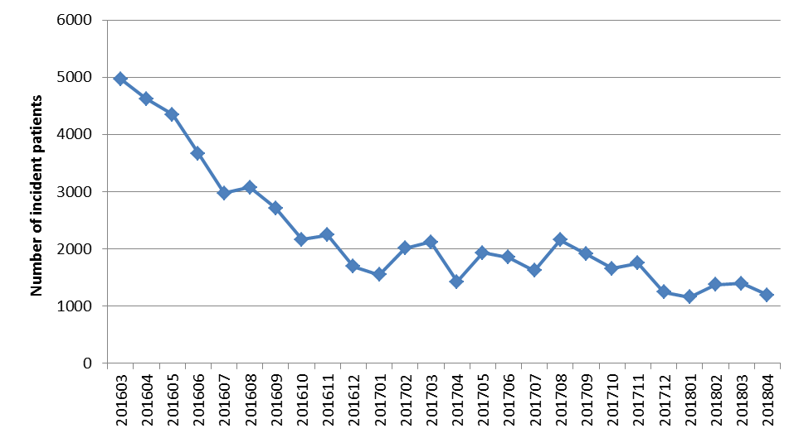

Figure 1: Number of incident patients by month

Drug therapy
The DAA market evolved over time in response to changing patient characteristics and the entry of newer therapies, particularly pan-genotypic drug regimens. During the first months of listing, a larger proportion of patients had cirrhosis (Figure 4). Consequently, there was a greater representation of drug regimens available at the time to treat cirrhotic patients, including the 24-week regimens of daclatasvir with sofosbuvir and ledipasvir with sofosbuvir (Figure 2). As the proportion of patients with cirrhosis decreased over time (Figure 4), the uptake of the 24-week drug regimens subsequently declined (Figure 2).
Sofosbuvir with velpatasvir was the first pan-genotypic drug regimen to be listed on the PBS from 1 August 2017. By late 2017, the majority of patients were first initiated on sofosbuvir with velpatasvir and in April 2018, 70.6 percent of patients were dispensed this drug regimen. The other main drug regimens that patients were first initiated on in April 2018 were grazoprevir with elbasvir (10.2 percent) and the ledipasvir with sofosbuvir 12-week drug regimen (8.0 percent), (Figure 2).
In its July 2016 recommendation for ribavirin the PBAC noted that the addition of this drug to DAA regimens would likely be used in a small number of patients mainly with genotype 3. By April 2018 there was limited use of drug regimens containing ribavirin (Figure 2).

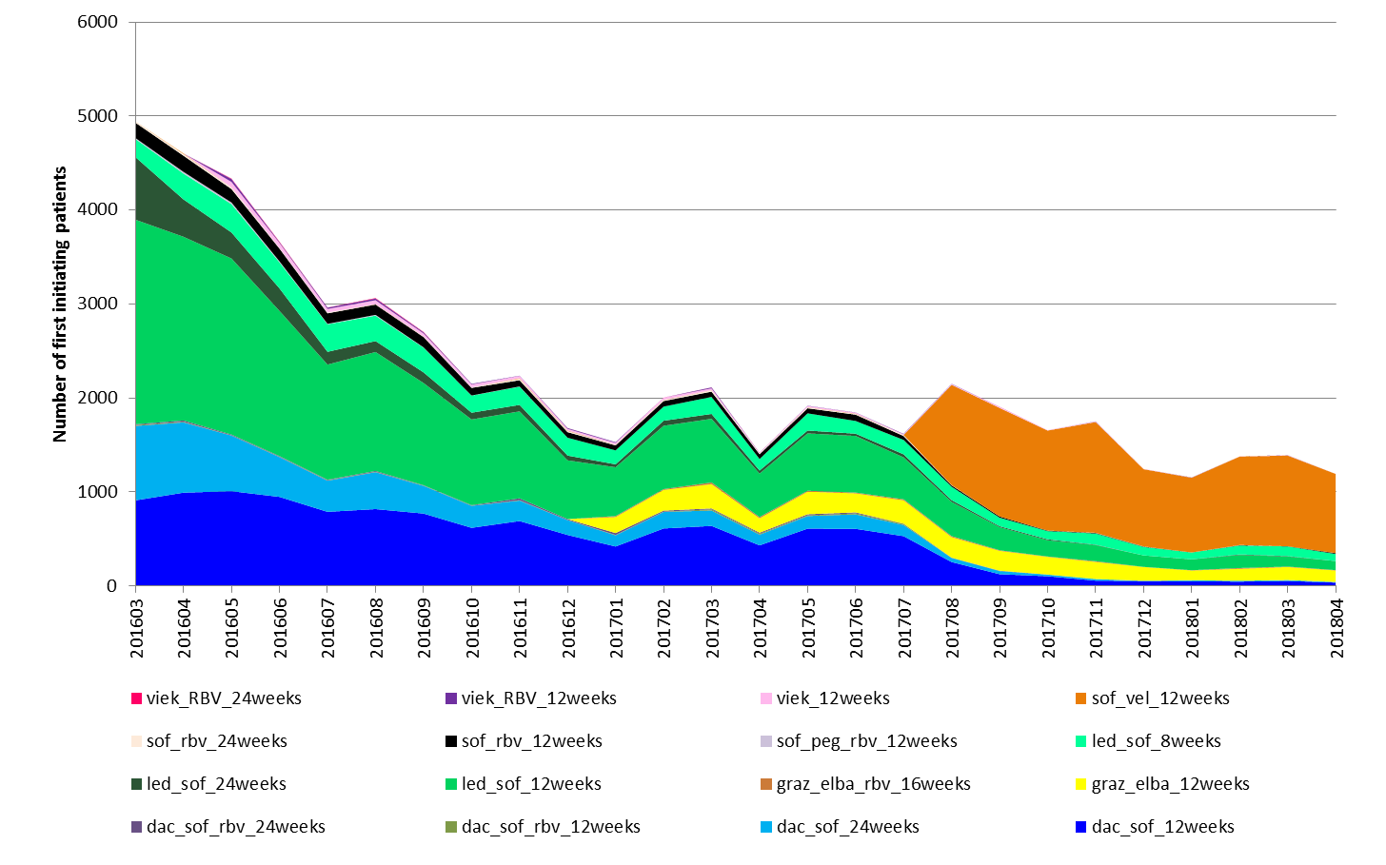

Figure 2: Number of first initiating patients by drug regimen by month

Authorised versus actual medicine supply
An analysis of patients issued with an approved Authority who did not receive a subsequent supply of a DAA regimen was undertaken. A cohort of patients issued an approved Authority between 1 January to 30 June 2017 was selected. Any supply of a DAA regimen for the patient up to 30 April 2018 was examined. This allowed a follow up period of at least 10 months from the date an Authority was approved.
Of the 10,995 patients in the cohort with an approved Authority, 2.5 percent did not have a record of a subsequent supply of a PBS DAA regimen.
For the cohort who had an approval and medicine supply (n=10,716), the median time from an approved Authority to supply was 2 days, and the mean was 10.8 days.
An approved Authority can cover a full course of DAA therapy and the number of repeats that the prescriber applied for is recorded in the Authorities data. For the six-month initiating cohort between 1 January to 30 June 2017, a small proportion of patients (5.7 percent n=607) were not supplied their full course of therapy as requested on their approved Authority.

Patient demographics - 2017 snapshot
Patient demographics for 2017 are shown in Table 2. For patients first initiating on DAA therapy in 2017, 67 percent were male. The age at initiation for men and women was similar (47 vs. 48 years, respectively). Around one-fifth (18 percent) of patients were identified as having cirrhosis at the time of their application to access PBS therapy. Ninety-one percent of patients were either HCV genotype 1 (51 percent) or genotype 3 (40 percent). Only a small proportion of patients were either genotype 2, 4, 5 or 6.

Table 2: PBS client demographics, first initiators in 2017
 | All PBS clients (n=21,262)
Gender | Male: n=14,339, 67.4%.  Female: n=6,920, 32.5%.
Age | All patients: n=21,262, mean 47.6 (SD 11.8) years.  Male: n=14,339, mean 47.3 (SD 11.6) years.  Female: n=6,920, mean 48.3 (SD 12.0) years.
Cirrhotic status | Cirrhotic (n=3,952, 18.6%)  Non-cirrhotic (n=17,053, 80.2%)  Not specified (n=257, 1.2%)
HCV Genotype | Genotype 1 (n=10,884, 51.2%)  Genotype 2 (n=869, 4.1%)  Genotype 3 (n=8,495, 40.0%)  Genotype 4 (n=371, 1.7%)  Genotypes 5 or 6 (n=384, 1.8%)  Not specified (n=259, 1.2%)
Note: SD, standard deviation.
Referring to Figure 3, most of the treated population (50.6 percent) were between 30 and 50 years of age. A relatively small number (n=248) of patients were 75 years of age or older (Figure 3). Patients aged 24 years or less were a small fraction (n=339, 1.6 percent) of the overall initiating cohort in 2017 (Figure 3).
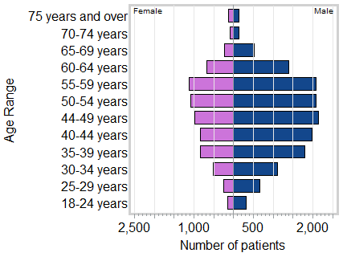
Figure 3: Pyramid chart of patient age and gender for first initiators on DAA therapy in 2017 (n=21,262)

Cirrhosis status
Figure 4 shows that the proportional representation of patients with cirrhosis decreased from 40.4 percent in the first month of listing (March 2016) to 16.3 percent after two years of listing (February 2018).
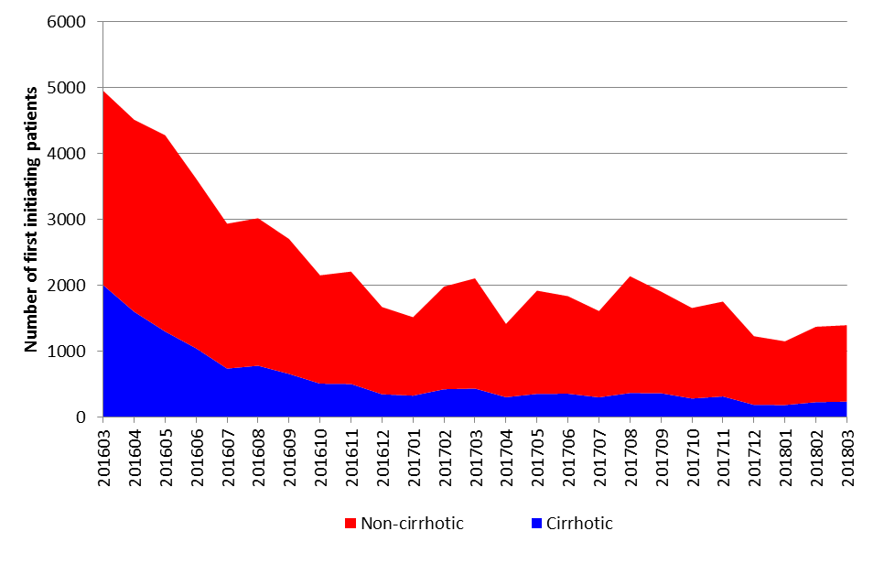

Figure 4: Number of first initiating patients by cirrhotic status by month

Genotype
Before the listing of grazoprevir with elbasvir on 1 January 2017, a very small proportion (an average of 0.1 percent per month) of patients supplied DAA therapy were HCV genotype 4 (Figure 5). In the first month of grazoprevir with elbasvir’s listing, the proportion of genotype 4 patients who were dispensed DAA therapy rose to 3.7 percent (Figure 5). From 1 January to 31 March 2018, around 1 percent of patients treated per month were genotype 4. The subsequent listing of sofosbuvir with velpatasvir from 1 August 2017 did not have a substantive impact on the number of genotype 4 patients treated.
Prior to the listing of sofosbuvir with velpatasvir from 1 August 2017, the representation of patients with genotypes 5 or 6 was very low (around 0.2 percent per month). The listing of sofosbuvir with velpatasvir increased the proportion of genotype 5 or 6 patients treated to 5.5 percent in its first month of listing with an average of around 3 percent per month between August 2017 to March 2018 (Figure 5).
The proportion of patients with genotype 2 supplied DAA therapy also increased following the listing of sofosbuvir with velpatasvir. Before August 2017, an average of around 3.5 percent of patients per month was identified as having genotype 2. Between August 2017 to March 2018 the monthly average of genotype 2 patients treated increased to 5.1% (Figure 5).
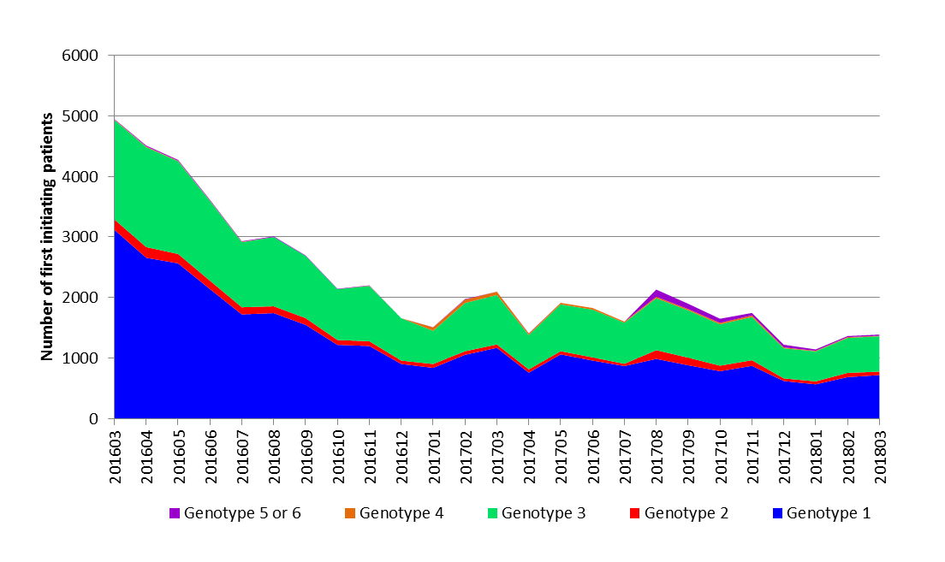

Figure 5: Number of first initiating patients by genotype by month

Treatment experienced patients
Of the 58,941 patients supplied a DAA between 1 March 2016 and 30 April 2018, n=10,772 (22.4 percent) were identified as having a DAA regimen specifically for treatment experienced patients and/or prior therapy with peginterferon plus ribavirin alone or in combination with boceprevir, telaprevir or simeprevir.

Supply of multiple DAA regimens
3.5 percent (n=2,050 patients) of the 58,941 initiators between 1 March 2016 and 30 April 2018 were supplied two or more different DAA regimens. Of patients who were supplied a different drug regimen, around one-quarter (26 percent) were switched to sofosbuvir with velpatasvir. Table 3 presents the most common sequences of multiple drug regimens involving different medicines.

Table 3: 10 most common sequences of multiple drug regimens
Sequence of drug regimens | Patients | Rank
dac_sof_12weeks -> sof_vel_12weeks | 179 | 1
dac_sof_rbv_24weeks -> dac_sof_24weeks | 112 | 2
led_sof_12weeks -> sof_vel_12weeks | 94 | 3
dac_sof_12weeks -> dac_sof_24weeks | 86 | 4
led_sof_8weeks -> led_sof_12weeks | 77 | 5
dac_sof_24weeks -> dac_sof_rbv_24weeks | 75 | 6
dac_sof_24weeks -> sof_vel_12weeks | 69 | 7
led_sof_12weeks -> led_sof_8weeks | 69 | 8
led_sof_12weeks -> led_sof_24weeks | 61 | 9
sof_rbv_12weeks -> sof_vel_12weeks | 61 | 10
Note: For n=58,941 initiators between 1 March 2016 to 30 April 2018 (n=2,050 patients supplied a different drug regimen)

The reasons for re-treatment cannot be ascertained from the PBS data. However, some inferences could be made to identify a change in therapy due to adverse events or further treatment following re-infection. For example, a patient transitioning to another DAA regimen without completing a full course of their initial DAA regimen could indicate the experience of an adverse event or failure to respond to the initial regimen. If a patient completes a full initial course and then receives a further DAA regimen after a period of time this might represent therapy after re-infection.

Priority populations
The transmission of hepatitis C mainly occurs through unsafe practices when injecting drugs (Fourth National Hepatitis C Strategy 2014-2017). Populations who have been identified as having a priority for DAA therapy include: people who inject drugs, in particular young injectors and people from an Aboriginal and Torres Strait Islander background; and individuals in custodial settings (Fourth National Hepatitis C Strategy 2014-2017).
Aboriginal and Torres Strait Islanders account for around 8 percent of newly diagnosed cases of hepatitis C (Graham et al., 2016). Under the Closing the Gap PBS Co-payment Program (‘CTG’), introduced on 1 July 2010, Aboriginal and Torres Strait Islander people living with chronic diseases, such as chronic hepatitis C, can access PBS medicines at a reduced cost. Claims as part of the Closing the Gap measure identify medicine supplied to a person of Aboriginal and Torres Strait Islander descent, but not all PBS prescriptions for Aboriginal and Torres Strait Islanders are supplied through the CTG measure.
Between 1 March 2016 to 30 April 2018, 1,873 patients were identified as being supplied a DAA medicine under the CTG measure. The number of patients first initiating on a DAA in 2017 supplied through CTG was 857, representing 4 percent of the overall PBS population. Further, there was a very small supply of DAA medicines through Aboriginal Health Services. Since March 2016 a total of 32 packs were supplied. The supply was through four health services, including two health in Queensland and two in Western Australia.
Eligible prisoners can access DAA medicines under the Section 100 HSD Program. However, the supply of DAAs to this population cannot be discerned from the overall supply of medicines in the hospital outpatient setting. As at 30 June 2017 there were 41,202 prisoners in Australian prisons (ABS, 2017) and the prevalence of HCV infection among prisoners was estimated to be approximately 30 percent (Bretaria et al., 2015). As such, prisoners could represent a relatively large proportion of the overall subsidised population. At the time of writing, prisoners in NSW correctional centres were able to access DAA therapy (sofosbuvir with velpatasvir) separately through the ‘Surveillance and Treatment of Prisoners with Hepatitis C (SToP-C)’ trial conducted by The Kirby Institute. The SToP-C trial is expected to be completed by December 2019 with an estimated enrolment of 2,500 participants.

Utilisation by prescriber type
Over the first two years of listing (1 March 2016 to 28 February 2018), the total number of unique prescribers of DAA medicines identified as a GP or specialist were 4,651 and 819, respectively. Only a small number of nurse practitioners (n=10) were identified as prescribing a DAA medicine during this period. It is not possible to determine from the PBS data when prescribing by a GP or nurse practitioner is done in consultation with a gastroenterologist, hepatologist or infectious diseases physician.
Table 4 presents the unique counts of DAA medicine prescribers by specialty for the first two years of listing. Table 5 shows the number of prescriptions supplied by speciality. In the first year of listing, there were more prescriptions attributed to specialists compared to GPs (Table 5). This reflects the nature of the PBS population at this time who had more severe disease, such as a greater proportion of patients who had cirrhosis (Figure 4). The drug regimens utilised during the initial months of listing involved longer treatment durations with associated higher prescription volumes from more repeats. By the second year of listing, there were more GPs involved in prescribing with a similar number of gastroenterologists, hepatologists and infectious diseases physicians (Table 4).
Specialist prescribing accounted for 68 percent of DAA prescriptions supplied and 65 percent of patients treated with a DAA in Year 1 of listing; and 51 percent of DAA prescriptions supplied and 47 percent of patients treated with a DAA in Year 2 of listing.
GP prescribing accounted for 31 percent of DAA prescriptions supplied and 34 percent of patients treated with a DAA in Year 1 of listing; and 48 percent of DAA prescriptions supplied and 51 percent of patients treated with a DAA in Year 2 of listing.

Table 4: Comparison of the number of prescribers by specialty during the first two years of listing
Prescriber Group | Year 1  (1 Mar 2016-28 Feb 2017) | Year 2  (1 Mar 2017-28 Feb 2018)
Addiction Medicine | 18 | 29
Gastroenterology and Hepatology | 404 | 400
GP¹ | 2,488 | 3,493
Infectious Diseases | 99 | 93
Internal Medicine | 101 | 97
Nurse Practitioner | NA | 10
Public Health Medicine | 12 | 9
Sexual Health Medicine | 25 | 28
Other | 73 | 259
Total | 3,220 | 4,418
¹ Includes vocationally registered GPs, non-vocationally registered GPs, GP trainees and GP unclassified.

Table 5: Number of prescriptions by prescriber type
Prescriber Group | Year 1  (1 Mar 2016-28 Feb 2017) | Year 2  (1 Mar 2017-28 Feb 2018)
Addiction Medicine | 432 | 1,079
Gastroenterology and Hepatology | 85,175 | 31,284
GP¹ | 54,841 | 44,727
Infectious Diseases | 11,385 | 5,310
Internal Medicine | 17,326 | 6,482
Nurse Practitioner | NA | 213
Public Health Medicine | 2,341 | 1,122
Sexual Health Medicine | 1,549 | 904
Other | 1544 | 968
Total | 174,593 | 92,089
¹ Includes vocationally registered GPs, non-vocationally registered GPs, GP trainees and GP unclassified.
Figure 6 shows that over time there was a progressive increase in the proportion of prescriptions supplied which were prescribed by a general practitioner.

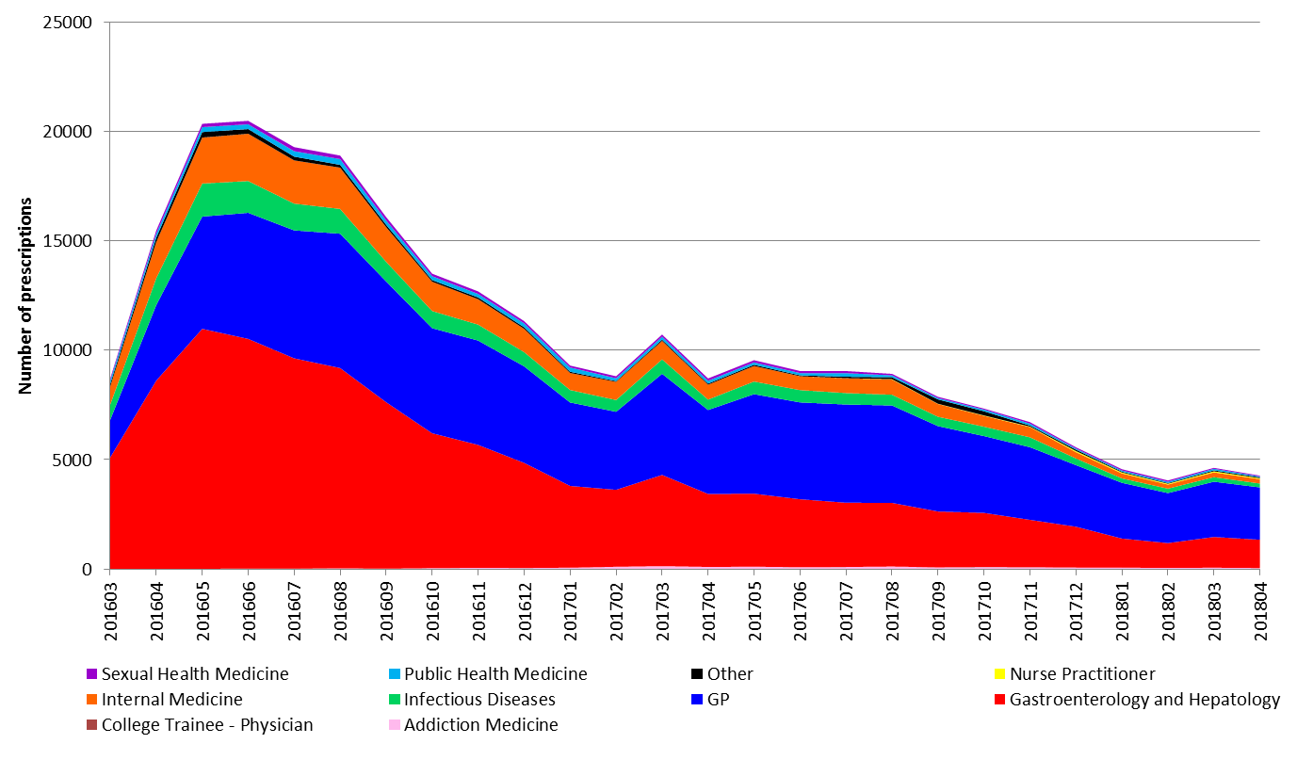

Figure 6: Number of prescriptions supplied by prescriber type by month

The number of patients per prescriber and the number of prescriptions per prescriber over a one-year period was examined for specialists and GPs. Refer to the ‘Methods’ section for the selection of the prescriber cohorts for this analysis.
There were more prescriptions supplied per specialist compared to general practitioners (Table 6). This likely indicates the involvement of specialists in treating more severe patients requiring DAA regimens with longer treatment durations.

Table 6: Number of patients and number of prescriptions supplied per prescriber
Group | Mean | Standard deviation | Maximum
Patients per prescriber
GP | 5.7 | 21.89 | 657
Specialist | 43.3 | 70.05 | 695
Prescriptions per prescriber
GP | 20.0 | 56.92 | 1,972
Specialist | 50.9 | 87.70 | 815
Note: Total number of prescribers was n=2,819.
Compared to specialists, GPs tended to treat fewer patients and supplied less prescriptions at the individual prescriber level (Figures 7 to 10).
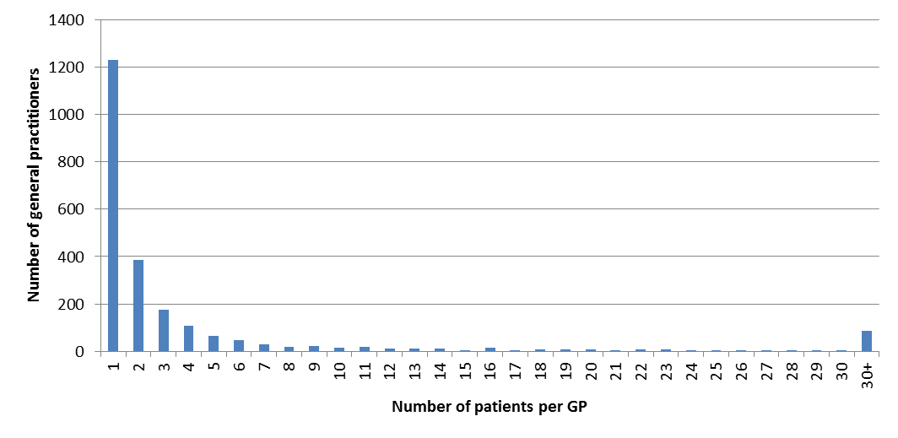

Figure 7: Frequency distribution of the number of patients per GP over a one-year period (n=2,329)

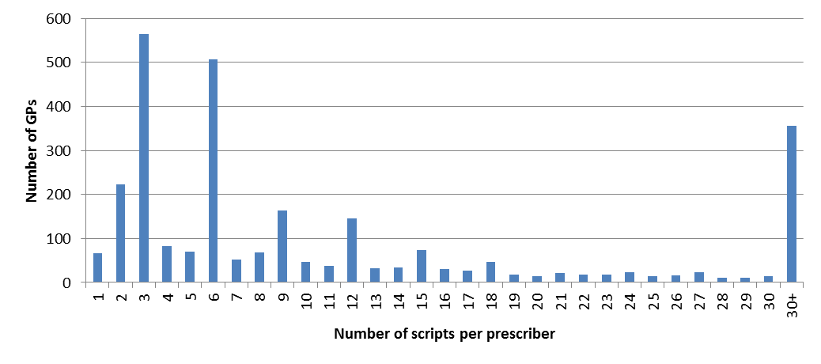
Figure 8: Frequency distribution of the number of prescriptions per GP over a one-year period (n=2,329)

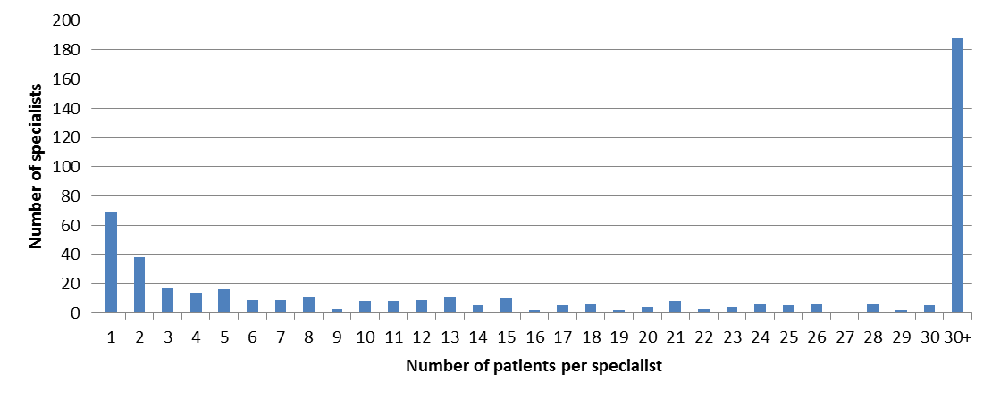
Figure 9: Frequency distribution of the number of patients per specialist over a one-year period (n=490)

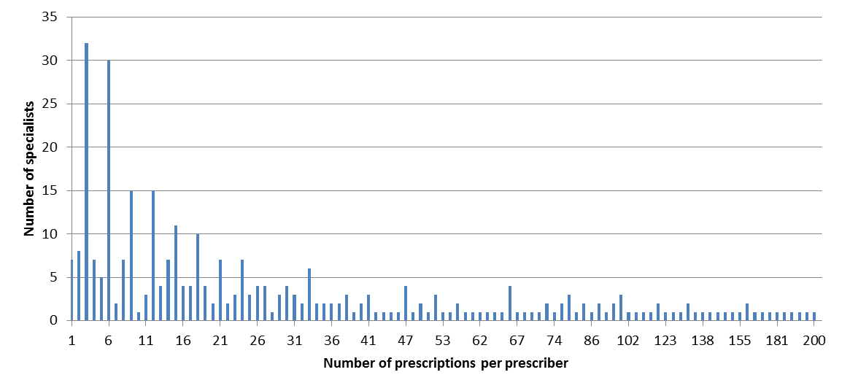
Figure 10: Frequency distribution of the number of prescriptions per specialist over a one-year period (n=490)

Since 1 June 2017, nurse practitioners have been able to prescribe DAA medicines provided they are authorised or in consultation with a gastroenterologist, hepatologist or infectious diseases physician. The level of prescribing by nurse practitioners was low. Between 1 June 2017 to 30 April 2018, 308 prescriptions dispensed were identified as being prescribed by a nurse practitioner. The number of prescriptions dispensed per month prescribed by nurse practitioners has remained at a similar level from December 2017 to April 2018, averaging 47 prescriptions per month (Figure 11).
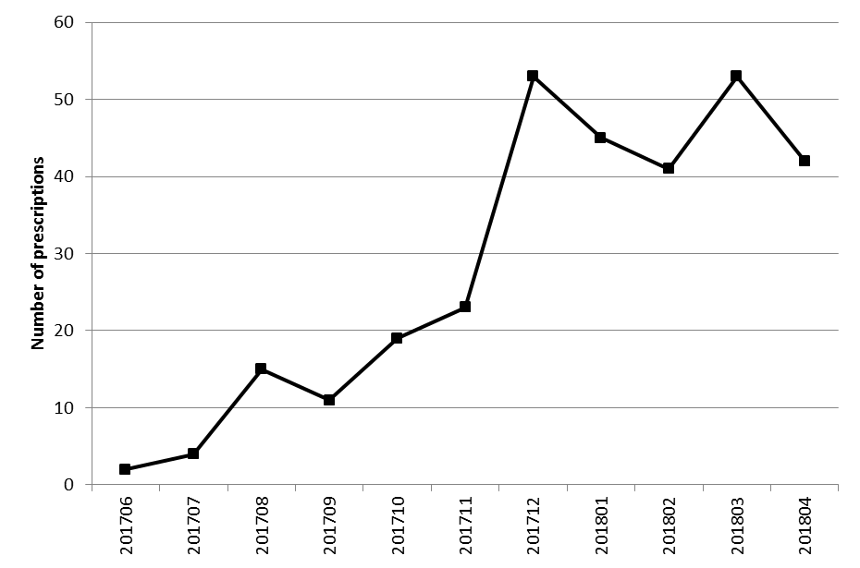

Figure 11: Number of prescriptions supplied that were prescribed by nurse practitioners by month

Regional differences in treatment rates
A hepatitis C mapping project was undertaken by the World Health Organization (WHO) Collaborating Centre for Viral Hepatitis. The 2016 project report provided data on the prevalence and treatment of chronic hepatitis C by SA3 region for 2016 (ASHM, 2016). In 2016, the estimated prevalence of chronic hepatitis C was 0.94 percent (ASHM, 2016). The report highlighted the diversity in prevalence and treatment rates across Australia. Prevalence tended to be higher in rural and remote locations and lower in metropolitan areas. The highest prevalence rates were found in the Northern Territory, the North Coast of NSW and Western NSW. Treatment rates were highest in Adelaide, the North Coast of NSW and the South Eastern and Eastern parts of Melbourne. The lowest treatment rates were reported for the Northern Territory and Western Queensland.
A mapping analysis was done of DAA treatment rates in the general population for 2017. The treatment rates were standardised for age and gender and are presented per 1,000 population by SA2 region. Figure 12 shows the treatment rates for all prescribers. Figures 13 and 14 present treatment rates separately for specialists and general practitioners, respectively.
The mean treatment rate for 2017 across all SA2 regions of 9.3 per 1,000 (i.e. 0.93 percent) was consistent with the national prevalence estimate of 0.94 percent. The median treatment rate across all SA2 regions was 5.7 per 1,000.
The patterns of regional variation in treatment uptake for 2017 (Figure 12) was similar to those reported from the hepatitis C mapping project for 2016. Table 7 presents SA2 regions with treatment rates significantly higher than the base treatment rate across all SA2 areas. The estimated resident populations for these regions were substantially lower than the typical population size for an SA2 region which averages around 10,000 persons. As such, the rates for these regions should be interpreted with caution. Most of the SA2 regions in Table 7 were represented in the corresponding SA3 regions with the highest ranking treatment rates identified from the hepatitis C mapping project; in particular, the ACT regions, North Western Melbourne and Adelaide.

Table 7: SA2 regions with highest treatment rates, 2017
SA2 code | Patients | ERP | Adjusted treatment rate per 1,000 population | SA2 name (SA3, State)
206041118 | 63 | 154 | 409.3 | Docklands (North Western Melbourne, Victoria)
213011329 | 106 | 366 | 289.4 | Cairnlea (North Western Melbourne, Victoria)
402041042 | 14 | 72 | 194.4 | Parafield (Adelaide, South Australia)
303051074 | 187 | 1,023 | 183.0 | Pallara – Willawong (Brisbane South, Queensland)
801021027 | 76 | 481 | 157.7 | ACT - South West
204011061 | 26 | 173 | 150.3 | Upper Yarra Valley (Murray, Victoria)
507031168 | 137 | 1,117 | 122.9 | Anketell – Wandi (Perth South, Western Australia)
801031030 | 108 | 1,021 | 105.8 | ACT - East
213041359 | 109 | 1,760 | 62.1 | Rockbank - Mount Cottrell (North Western Melbourne, Victoria)
309071254 | 150 | 2,508 | 59.8 | Jacobs Well – Alberton (Gold Coast, Queensland)
319041516 | 146 | 2,699 | 53.9 | Booral - River Heads (Central Queensland)
Note: ERP = estimated resident population for a given SA2 region.
Prescribing by GPs was represented in more regions compared to prescribing by specialists (see Figure 13 versus Figure 14). An exception was the Northern Territory where only prescribing by specialists was identified within the Roper Gulf and Barkley regions (Figure 13).

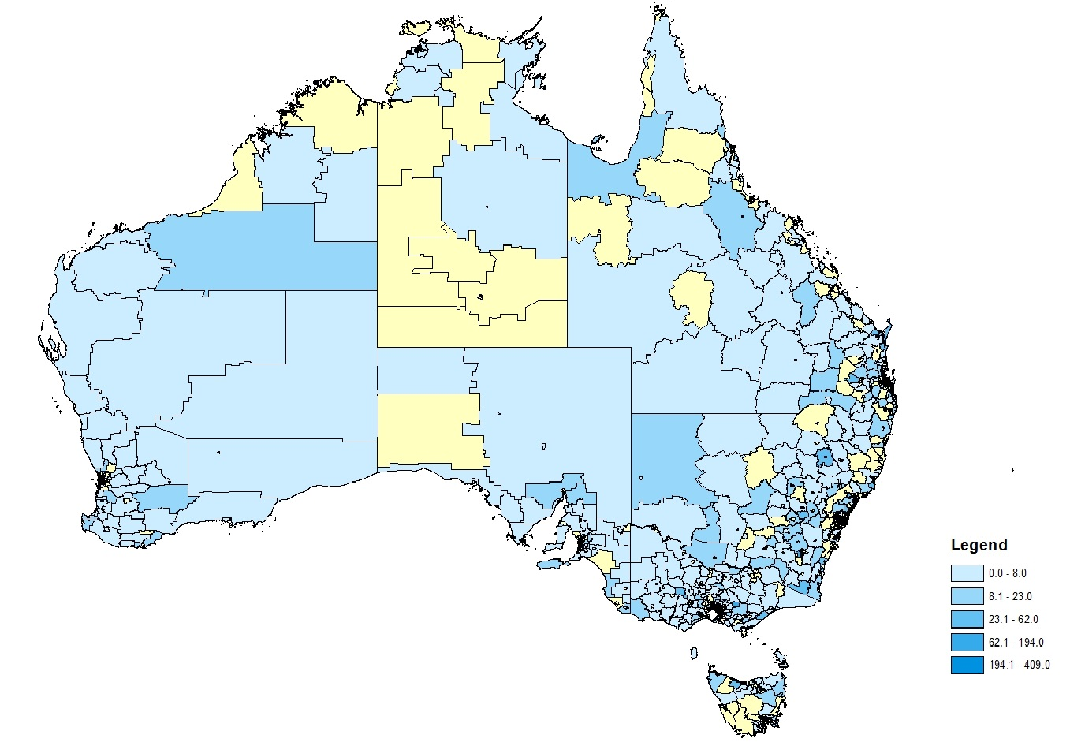
Figure 12: Treatment rates per 1,000 population standardised by age and gender for all prescribers (n=4,201), 2017
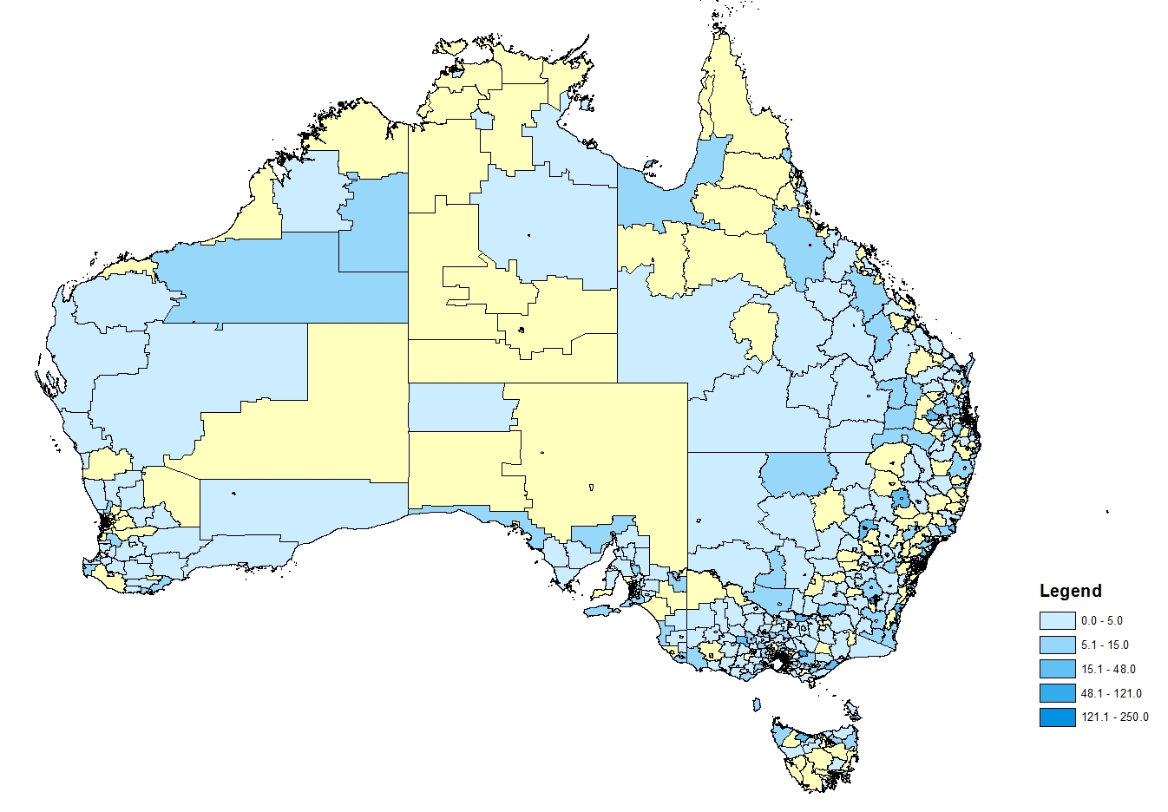
Figure 13: Treatment rates per 1,000 population standardised by age and gender for prescriptions attributed to specialists (n=714), 2017
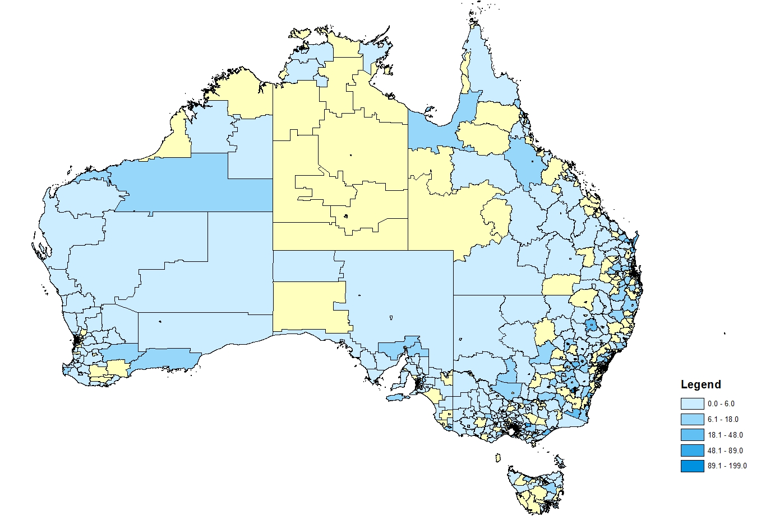
Figure 14: Treatment rates per 1,000 population standardised by age and gender for prescriptions attributed to general practitioners (n=3,478), 2017

Analysis of actual versus predicted utilisation
Table 8 presents a comparison of the estimated versus actual utilisation of the DAA medicines over the first two years of listing.
''''''' '''''''''''''''''' '''''''''''' ''''''''' ''''''''''''''' '''''''''' '''''' ''''''''''''''''' ''''''''''''''''''' '''''''''''' ''''''''''''''''''''''''''''''''''''''''''''''''' ''''''''''''''''''''' '''''''''' ''''''''''''''' ''''' ''''''' '''''''''''''''' '''' ''''''''' ''''''' '''''''''''' '''''''' '''''' ''''''''''''' ''''''''' '''' '''''''''' ''''' ''''''''''''''' '''''''''' '''''''' ''''''' '''''''''''' '''''''''''''''''''' '''''''''''
Table 8: Predicted versus actual number of treated patients, number of prescriptions and comparison of hepatitis C virus genotype and cirrhotic status profiles
 | Year 1  (1 Mar 2016 – 28 Feb 2017) | Year 2  (1 Mar 2017 – 28 Feb 2018)
Number of treated patients
Predicted | ''''''''''''''''' | '''''''''''''''''
Actual | 36,118 | 24,834
Actual vs. Predicted (%) | '''''''''''''''''' | ''''''''''''''''
Proportion of patients classified as cirrhotic
Predicted | '''''''''''''''' | ''''''''''''''''
Actual | 28.2% | 21.3%
Actual vs. Predicted (%) | '''''''''''''''''' | '''''''''''''''''
Hepatitis C virus genotype
Proportion of patients classified as genotype 1
Predicted | '''''''''''''''' | '''''''''''''''
Actual | 57.4% | 49.4%
Actual vs. Predicted (%) | '''''''''''''' | '''''''''''''''
Proportion of patients classified as genotype 2
Predicted | '''''''''''' | ''''''''''''
Actual | 3.7% | 4.2%
Actual vs. Predicted (%) | '''''''''''''''' | ''''''''''''''''
Proportion of patients classified as genotype 3
Predicted | ''''''''''''''' | ''''''''''''''''
Actual | 36.5% | 41.9%
Actual vs. Predicted (%) | ''''''''''''' | ''''''''''''''''
Genotype 4, 5 or 6:
Predicted | '''''''''''' | ''''''''''''''
Actual | 0.5% | 1.5%
Actual vs. Predicted (%) | '''''''''''''''''' | '''''''''''''''''
Number of prescriptions
Predicted | '''''''''''''''' | ''''''''''''''''
Actual | 174,120 | 90,884
Actual vs. Predicted (%) | '''''''''''''''''' | ''''''''''''''''

''''''' '''''''''''''''''''' ''''' '''''' ''''''''' ''''''''''''''''' ''''''' ''''''''''''''''''''''''''''''''' '''''''''''' '''''''''' ''''' ''''''''''''''''''''''''''' '''' ''''''' '''''''''''''''' ''''' '''''''''''''' ''''''''''''''''' ''''''''''''''''''' ''''''''''''''''' '''''''''''''' '''''''''''''''''''' ''''''''''''''''' ''''''''' ''''''''''' ''''''''' '''''' '''''''''''''' ''''''''''''''''' '''''''''''' ''''''''''''' ''''''' '''''''''''''''' ''''''''''''''''''' ''''' '''''' ''''''''' ''''''''''''''''' '''''''''''' ''''''''''''''' ''''' ''''''''''''''' ''''' ''''''''''' ''''''' '''''''''''''''''''''''' '''''' ''''''' '''''''''''''''''''' ''''''''''''''''' '''''''' '''''''''''''''''' '''''''''''''''' '''' ''''''''''''''''''''''' ''''''' '''''''''''''' '''''''''' ''''''''''''''''''''''''' ''''''''''''''' ''''' ''''''' '''''''''' '''''''''''''''''''' ''''''''' ''''''''' '''''''''''''''' ''' ''''''' ''''''''''''' ''''''''' ''''''''''''''''

DUSC consideration

At the start of 2016 it was estimated that there were 227,310 Australians living with hepatitis C. At that time around 4,000 patients per year were accessing the existing PBS interferon-containing drug regimens. DUSC commented that the utilisation of interferon-based treatment was low because the response to this therapy was poor and there were significant drug-related side effects. DUSC noted that the availability of boceprevir, telaprevir and simeprevir had improved the response to interferon therapy but only in patients who were HCV genotype 1.

DUSC commented that the high initial uptake of DAA medicines was mainly from patients who delayed interferon-based treatment, which, compared to the DAAs, had less clinical efficacy and was not as well tolerated. DUSC noted that during the first two years of listing the utilisation of the DAA medicines was substantially greater than anticipated. DUSC considered that the uptake of DAA therapy was difficult to predict at the time of first listing as it was unknown what the rates of diagnosis and access to treatment would be.

DUSC noted that the number of patients initiating DAA therapy had stabilised to around 1,200 patients per month compared with around 4,400 initiators per month at the time of listing. DUSC considered that this indicated that the remaining untreated population included hard-to-reach groups, such as people who inject drugs. DUSC further noted from the geospatial analysis of DAA utilisation that there was regional variation in accessing these medicines. DUSC considered that may reflect socioeconomic differences between the regions. Patient access to screening, diagnosis, staging (by fibroscan) and access to specialist services may also account for variation in regional prescribing.

Populations who have been identified as having a priority for DAA therapy include: people who inject drugs, in particular young injectors and people from an Aboriginal and Torres Strait Islander background; and individuals in custodial settings. DUSC noted that around 8 percent of people with newly diagnosed HCV are of Aboriginal or Torres Strait Islander descent. DUSC noted that in 2017, 857 people were supplied a DAA medicine under the Closing the Gap PBS Co-payment Program (‘CTG’) measure, representing around 4 percent of the total PBS population. DUSC further noted that there was only a small supply of DAA medicines through Aboriginal Health Services. DUSC considered that compared to the diagnosed population, the supply of DAA medicines to the Aboriginal and Torres Strait Islander population was relatively low. However, DUSC noted that the CTG measure does not capture all prescribing to this population. DUSC noted that the prevalence of HCV among prisoners was relatively high, which was estimated to be around 30 percent. DUSC noted that while PBS subsidised DAA therapy could be accessed by eligible prisoners under the Section 100 HSD Program, the supply of DAAs to this population could not be identified from the overall supply of these medicines in the hospital outpatient setting. DUSC further noted that some prisoners were also able to access non-PBS-subsidised DAA therapy, such as through the ‘Surveillance and Treatment of Prisoners with Hepatitis C (SToP-C)’ trial where around 2,500 prisoners within NSW correctional centres were expected to be supplied sofosbuvir with velpatasvir.
DUSC noted that only a small proportion of patients (5.7 percent) were not supplied the full course of treatment that was authorised. DUSC further noted that for most patients, the time between an Authority to when the regimen was dispensed was short (median of 2 days).

Of the 58,941 patients supplied a DAA between 1 March 2016 and 30 April 2018, 22.4 percent (n=10,772) were identified as having a DAA regimen specifically for treatment-experienced patients and/or prior therapy with peginterferon plus ribavirin alone or in combination with boceprevir, telaprevir or simeprevir. DUSC noted that complete prescriptions data for HSDs was only available from July 2013, and as such, the analysis included a lookback period to this time. However, the number of treatment-experienced patients was likely to have been underestimated by using this limited data period.

3.5 percent (n=2,050 patients) of the 58,941 initiators between 1 March 2016 and 30 April 2018 were supplied two or more different DAA regimens. DUSC commented that patients may be switching therapy due to re-infection, and also due to drug intolerance or poor adherence. DUSC considered that including re-treatment with the same DAA regimen in the analysis may also be informative about rates of non-completion of courses of treatment. DUSC noted that this would require assumptions about time between treatments to classify patients who were potentially having a treatment break versus those who may be recommencing therapy due to re-infection.

DUSC noted that there has been a change over the first two years of listing with a greater extent of prescribing of DAA medicines by general practitioners in the latter time and less by specialists. DUSC considered that this indicated that general practitioners had become more confident with using the DAA medicines. DUSC also noted that the availability of pan-genotypic regimens had simplified prescribing and that these were the most commonly dispensed DAA regimens. DUSC noted there was a small but growing number of nurse practitioners involved in prescribing.

When compared to specialists, DUSC noted that general practitioners tended to treat fewer patients and there were fewer prescriptions per prescriber. DUSC noted that Figure 7 indicated that a large number of general practitioners prescribed DAA therapy for only one patient over a one-year period. DUSC discussed undertaking a geospatial analysis of general practitioners with low prescribing rates to identify particular regions to target resources to assist these prescribers. However, DUSC noted that the availability of simpler pan-genotypic regimens may result in improved prescribing rate among general practitioners.

DUSC Actions
DUSC requested that the report be provided to the PBAC.

Context for analysis
The DUSC is a Sub Committee of the Pharmaceutical Benefits Advisory Committee (PBAC). The DUSC assesses estimates on projected usage and financial cost of medicines.
The DUSC also analyses data on actual use of medicines, including the utilisation of PBS listed medicines, and provides advice to the PBAC on these matters. This may include outlining how the current utilisation of PBS medicines compares with the use as recommended by the PBAC.
The DUSC operates in accordance with the quality use of medicines objective of the National Medicines Policy and considers that the DUSC utilisation analyses will assist consumers and health professionals to better understand the costs, benefits and risks of medicines.
The utilisation analysis report was provided to the pharmaceutical sponsors of each drug and comments on the report were provided to DUSC prior to its consideration of the analysis.

Sponsors’ comments
Merck Sharp & Dohme (Australia) Pty Ltd:
The availability of pan-genotypic agents has not universally simplified prescribing due to genotype-specific adjustments to regimens and has not arrested the significant decline in DAA treatment uptake, despite making inroads to the hard-to-reach populations. Genotyping informs the appropriate DAA regimen to likely achieve SVR12 and allows the consideration of all appropriate DAAs to maximise tolerability and avoid clinically significant drug to drug interactions.

Disclaimer
The information provided in this report does not constitute medical advice and is not intended to take the place of professional medical advice or care. It is not intended to define what constitutes reasonable, appropriate or best care for any individual for any given health issue. The information should not be used as a substitute for the judgement and skill of a medical practitioner.
The Department of Health (DoH) has made all reasonable efforts to ensure that information provided in this report is accurate. The information provided in this report was up-to-date when it was considered by the Drug Utilisation Sub-committee of the Pharmaceutical Benefits Advisory Committee. The context for that information may have changed since publication.
To the extent provided by law, DoH makes no warranties or representations as to accuracy or completeness of information contained in this report.
To the fullest extent permitted by law, neither the DoH nor any DoH employee is liable for any liability, loss, claim, damage, expense, injury or personal injury (including death), whether direct or indirect (including consequential loss and loss of profits) and however incurred (including in tort), caused or contributed to by any person’s use or misuse of the information available from this report or contained on any third party website referred to in this report.

References
ABS (2016). 1270.0.55.001 - Australian Statistical Geography Standard (ASGS): Volume 1 - Main Structure and Greater Capital City Statistical Areas, July 2016. Australian Bureau of Statistics.
ABS (2016). Census of Population and Housing. Accessed on 26 July 2018 at: http://www.abs.gov.au/ausstats/abs@.nsf/MediaRealesesByCatalogue/02D50FAA9987D6B7CA25814800087E03?OpenDocument.
ABS (2017). 4517.0 - Prisoners in Australia, 2017.
ASHM (2016). Hepatitis C Mapping Project: Estimates of geographic diversity in chronic hepatitis C prevalence, diagnosis, monitoring and treatment - National Report 2016.
Australian Bureau of Statistics. (2012). Principles on the use of direct age standardisation in administrative data collections. Retrieved 2018, from abs.gov.au: http://www.abs.gov.au/ausstats/abs@.nsf/Lookup/3302.0Appendix12010
Bretaria et al. (2015). Transmission of hepatitis C virus among prisoners, Australia, 2005-2012. Emerg Infect Dis 21(5):, 765–774.
Bruggmann et al. (2014). Historical epidemiology of hepatitis C virus (HCV) in selected countries. Journal of Viral Hepatitis 21 (Suppl.1), 5-33.
Fourth National Hepatitis C Strategy 2014-2017. Commonwealth of Australia.
Graham et al. (2016). Prevalence of hepatitis C among Australian Aboriginal and Torres Strait Islander people: A systematic review and met- analysis. Hepat Mo. 16(7):, e38640.
Herzer, K. and Gerken, G. (2016). When and how to treat HCV infection withthe new antivirals before or after liver transplantation. Visc Med 32(4), 258-262.
Khoo, A. and Tse, E. (2016). A practical overview of the treatment of chronic hepatitis C virus infection. AFP 45(10), 718-720.
Public Summary Document, sofosbuvir, March. (2015).
The Kirby Institute. (2016). Hepatitis B and C in Australia Annual Surveillance Report Supplement.
The Kirby Institute. (2017a). HIV, viral hepatitis and sexually transmissible infections in Australia: annual surveillance report. The Kirby Institute UNSW Sydney NSW 2052.
The Kirby Institute. (2017b). Monitoring hepatitis C treatment uptake in Australia. The Kirby Institute, UNSW.
The Kirby Institute. (2017c). Real world efficacy of antiviral therapy in chronic hepatitis C in Australia. UNSW.

Appendix 1: Dosage and frequency of administration for DAA regimens

Generic name, brand name and sponsor | Recommended dose and frequency of administration
Daclatasvir (Daklinza), Bristol-Myers Squibb Australia Pty Ltd | The recommended dose for daclatasvir is 60 mg once daily. Dose modifications may be required for patients co-infected with human immunodeficiency virus (HIV). When co-administered with strong inhibitors of cytochrome P450 enzyme 3A4 (CYP3A4), it is recommended that the dose of daclatasvir is reduced to 30 mg once daily. An increase in the dose of daclatasvir to 90 mg once daily is recommended when it is co-administered with moderate CYP3A4 inducers.
Glecaprevir with pibrentasvir (Maviret), AbbVie Pty Ltd | Glecaprevir with pibrentasvir is a fixed-dose combination product containing glecaprevir 100 mg and pibrentasvir 40 mg in each tablet. The recommended dosage is three tablets with a total daily dose of glecaprevir 300 mg and pibrentasvir 120 mg.
Grazoprevir with elbasvir (Zepatier), Merck Sharp & Dohme (Australia) Pty Ltd | Grazoprevir with elbasvir is a fixed-dose combination product containing 50 mg of elbasvir and 100 mg of grazoprevir in a single tablet. The recommended frequency is once daily.  When used in combination with ribavirin, the recommended dose of ribavirin depends on the patient's body weight (1000 mg for less than 75 kg and 1200 mg when 75 kg or more).
Ledipasvir with sofosbuvir (Harvoni), Gilead Sciences Pty Limited | Ledipasvir with sofosbuvir is available as a fixed-dose combination tablet. Each tablet contains 90 mg ledipasvir and 400 mg sofosbuvir. It is recommended that the produce is taken once daily.
Paritaprevir with ritonavir with ombitasvir and dasabuvir (Viekira Pak), AbbVie Pty Ltd | The recommended dose of Viekira Pak is two paritaprevir/ritonavir/ombitasvir 75/50/12.5 mg tablets once daily and one dasabuvir 250 mg tablet twice daily.
Paritaprevir with ritonavir with ombitasvir and dasabuvir and ribavirin(Viekira Pak-RBV), AbbVie Pty Ltd | The recommended dose of Viekira Pak-RBV is two paritaprevir/ritonavir/ombitasvir 75/50/12.5 mg tablets once daily and one dasabuvir 250 mg tablet twice daily. The recommended dose of ribavirin depends on the patient's body weight (1000 mg for less than 75 kg and 1200 mg when 75 kg or more).
Ribavirin (Ibavyr), Clinect Pty Ltd | Ribavirin monotherapy is not effective and IBAVYR must only be used in combination with other oral agents for the treatment of CHC. In terms of PBS listed regimens, this includes sofosbuvir, Viekira Pak and grazoprevir with elbasvir.  Ribavirin is administered orally in two daily divided doses.  The dose must be individualised to the patient depending on their disease characteristics and the drugs it is co-administered with. Refer to the summaries of sofosbuvir, Viekira Pak and grazoprevir with elbasvir in this table for more information.
Sofosbuvir (Sovaldi), Gilead Sciences Pty Limited | It is recommended that sofosbuvir is used in combination with other agents. Other relevant agents listed on the PBS that can be administered with sofosbuvir include daclatasvir, ledipasvir, peginterferon alfa-2a, ribavirin and velpatasvir.  The recommended dose for sofosbuvir is 400 mg once daily.  When used in combination with ribavirin, the recommended dose of ribavirin depends on the patient's body weight (1000 mg for less than 75 kg and 1200 mg when 75 kg or more).  The recommended dose of peginterferon alfa-2a is 180 micrograms when used in combination with ribavirin by subcutaneous administration.
Sofosbuvir with velpatasvir (Epclusa), Gilead Sciences Pty Limited | Sofosbuvir with velpatasvir is available as a fixed-dose combination tablet taken once daily. Each tablet contains 100 mg velpatasvir and 400 mg sofosbuvir.
Source: The current Product Information (PI) available from the TGA (Product Information).

Appendix 2: Summary of PBS listings as at July 2018
Item | Max. quant. | Rpts | DPMQ  Published prices¹ | Name, form & strength, pack size | Brand name and manufacturer
10623D | 28 | 2 | $152.75 | Ribavirin, Tablet 400 mg | Ibavyr, Clinect Pty Ltd
10624E | 28 | 2 | $19,447.27 | Sofosbuvir, Tablet 400 mg | Sovaldi, Gilead Sciences Pty Limited
10625F | 28 | 2 | $19,297.75 | Sofosbuvir, Tablet 400 mg | Sovaldi, Gilead Sciences Pty Limited
10628J | 28 | 2 | $22,216.19 | Ledipasvir with sofosbuvir, Tablet containing 90 mg ledipasvir with 400 mg sofosbuvir | Harvoni, Gilead Sciences Pty Limited
10629K | 28 | 5 | $7,666.67 | Daclatasvir, Tablet 30 mg | Daklinza, Bristol-Myers Squibb Australia Pty Ltd
10630L | 28 | 5 | $7,713.82 | Daclatasvir, Tablet 30 mg | Daklinza, Bristol-Myers Squibb Australia Pty Ltd
10631M | 28 | 5 | $7,713.82 | Daclatasvir, Tablet 60 mg | Daklinza, Bristol-Myers Squibb Australia Pty Ltd
10635R | 28 | 5 | $152.75 | Ribavirin, Tablet 400 mg | Ibavyr, Clinect Pty Ltd
10637W | 28 | 5 | $225.55 | Ribavirin, Tablet 600 mg | Ibavyr, Clinect Pty Ltd
10638X | 28 | 5 | $210.00 | Ribavirin, Tablet 600 mg | Ibavyr, Clinect Pty Ltd
10641C | 28 | 5 | $7,666.67 | Daclatasvir, Tablet 60 mg | Daklinza, Bristol-Myers Squibb Australia Pty Ltd
10642D | 28 | 2 | $7,816.19 | Daclatasvir, Tablet 60 mg | Daklinza, Bristol-Myers Squibb Australia Pty Ltd
10643E | 28 | 2 | $7,713.82 | Daclatasvir, Tablet 30 mg | Daklinza, Bristol-Myers Squibb Australia Pty Ltd
10644F | 28 | 2 | $7,713.82 | Daclatasvir, Tablet 60 mg | Daklinza, Bristol-Myers Squibb Australia Pty Ltd
10645G | 28 | 2 | $7,816.19 | Daclatasvir, Tablet 30 mg | Daklinza, Bristol-Myers Squibb Australia Pty Ltd
10646H | 28 | 5 | $140.00 | Ribavirin, Tablet 400 mg | Ibavyr, Clinect Pty Ltd
10647J | 28 | 2 | $161.62 | Ribavirin, Tablet 400 mg | Ibavyr, Clinect Pty Ltd
10648K | 28 | 5 | $19,297.75 | Sofosbuvir, Tablet 400 mg | Sovaldi, Gilead Sciences Pty Limited
10651N | 28 | 2 | $7,666.67 | Daclatasvir, Tablet 30 mg | Daklinza, Bristol-Myers Squibb Australia Pty Ltd
10653Q | 28 | 1 | $22,113.82 | Ledipasvir with sofosbuvir, Tablet containing 90 mg ledipasvir with 400 mg sofosbuvir | Harvoni, Gilead Sciences Pty Limited
10654R | 28 | 2 | $19,344.90 | Sofosbuvir, Tablet 400 mg | Sovaldi, Gilead Sciences Pty Limited
10657X | 28 | 5 | $19,447.27 | Sofosbuvir, Tablet 400 mg | Sovaldi, Gilead Sciences Pty Limited
10659B | 28 | 5 | $7,816.19 | Daclatasvir, Tablet 60 mg | Daklinza, Bristol-Myers Squibb Australia Pty Ltd
10660C | 28 | 2 | $7,666.67 | Daclatasvir, Tablet 60 mg | Daklinza, Bristol-Myers Squibb Australia Pty Ltd
10661D | 28 | 2 | $22,066.67 | Ledipasvir with sofosbuvir, Tablet containing 90 mg ledipasvir with 400 mg sofosbuvir | Harvoni, Gilead Sciences Pty Limited
10663F | 28 | 2 | $210.00 | Ribavirin, Tablet 600 mg | Ibavyr, Clinect Pty Ltd
10665H | 28 | 2 | $238.48 | Ribavirin, Tablet 600 mg | Ibavyr, Clinect Pty Ltd
10666J | 28 | 5 | $238.48 | Ribavirin, Tablet 600 mg | Ibavyr, Clinect Pty Ltd
10667K | 28 | 1 | $22,066.67 | Ledipasvir with sofosbuvir, Tablet containing 90 mg ledipasvir with 400 mg sofosbuvir | Harvoni, Gilead Sciences Pty Limited
10668L | 28 | 1 | $22,216.19 | Ledipasvir with sofosbuvir, Tablet containing 90 mg ledipasvir with 400 mg sofosbuvir | Harvoni, Gilead Sciences Pty Limited
10669M | 28 | 5 | $22,066.67 | Ledipasvir with sofosbuvir, Tablet containing 90 mg ledipasvir with 400 mg sofosbuvir | Harvoni, Gilead Sciences Pty Limited
10670N | 28 | 5 | $22,216.19 | Ledipasvir with sofosbuvir, Tablet containing 90 mg ledipasvir with 400 mg sofosbuvir | Harvoni, Gilead Sciences Pty Limited
10671P | 28 | 5 | $7,816.19 | Daclatasvir, Tablet 30 mg | Daklinza, Bristol-Myers Squibb Australia Pty Ltd
10672Q | 28 | 2 | $22,113.82 | Ledipasvir with sofosbuvir, Tablet containing 90 mg ledipasvir with 400 mg sofosbuvir | Harvoni, Gilead Sciences Pty Limited
10673R | 28 | 5 | $161.62 | Ribavirin, Tablet 400 mg | Ibavyr, Clinect Pty Ltd
10675W | 28 | 2 | $225.55 | Ribavirin, Tablet 600 mg | Ibavyr, Clinect Pty Ltd
10676X | 28 | 5 | $19,344.90 | Sofosbuvir, Tablet 400 mg | Sovaldi, Gilead Sciences Pty Limited
10678B | 28 | 2 | $140.00 | Ribavirin, Tablet 400 mg | Ibavyr, Clinect Pty Ltd
10679C | 28 | 5 | $22,113.82 | Ledipasvir with sofosbuvir, Tablet containing 90 mg ledipasvir with 400 mg sofosbuvir | Harvoni, Gilead Sciences Pty Limited
10747P | 1 | 5 | $13,997.39 | Paritaprevir with ritonavir with ombitasvir and dasabuvir and ribavirin, Pack containing 56 tablets | Viekira Pak-RBV, AbbVie Pty Ltd
10749R | 1 | 2 | $13,895.02 | Paritaprevir with ritonavir with ombitasvir and dasabuvir, Pack containing 56 tablets paritaprevir 7 | Viekira Pak, AbbVie Pty Ltd
10750T | 1 | 2 | $13,895.02 | Paritaprevir with ritonavir with ombitasvir and dasabuvir and ribavirin, Pack containing 56 tablets | Viekira Pak-RBV, AbbVie Pty Ltd
10751W | 1 | 2 | $13,847.87 | Paritaprevir with ritonavir with ombitasvir and dasabuvir, Pack containing 56 tablets paritaprevir 7 | Viekira Pak, AbbVie Pty Ltd
10752X | 1 | 5 | $13,847.87 | Paritaprevir with ritonavir with ombitasvir and dasabuvir and ribavirin, Pack containing 56 tablets | Viekira Pak-RBV, AbbVie Pty Ltd
10753Y | 1 | 2 | $13,895.02 | Paritaprevir with ritonavir with ombitasvir and dasabuvir and ribavirin, Pack containing 56 tablets | Viekira Pak-RBV, AbbVie Pty Ltd
10754B | 1 | 2 | $13,847.87 | Paritaprevir with ritonavir with ombitasvir and dasabuvir and ribavirin, Pack containing 56 tablets | Viekira Pak-RBV, AbbVie Pty Ltd
10761J | 1 | 5 | $13,895.02 | Paritaprevir with ritonavir with ombitasvir and dasabuvir and ribavirin, Pack containing 56 tablets | Viekira Pak-RBV, AbbVie Pty Ltd
10765N | 1 | 2 | $13,847.87 | Paritaprevir with ritonavir with ombitasvir and dasabuvir and ribavirin, Pack containing 56 tablets | Viekira Pak-RBV, AbbVie Pty Ltd
10766P | 1 | 2 | $13,997.39 | Paritaprevir with ritonavir with ombitasvir and dasabuvir, Pack containing 56 tablets paritaprevir 7 | Viekira Pak, AbbVie Pty Ltd
10768R | 1 | 5 | $13,847.87 | Paritaprevir with ritonavir with ombitasvir and dasabuvir and ribavirin, Pack containing 56 tablets | Viekira Pak-RBV, AbbVie Pty Ltd
10769T | 1 | 2 | $13,997.39 | Paritaprevir with ritonavir with ombitasvir and dasabuvir and ribavirin, Pack containing 56 tablets | Viekira Pak-RBV, AbbVie Pty Ltd
10771X | 1 | 5 | $13,997.39 | Paritaprevir with ritonavir with ombitasvir and dasabuvir and ribavirin, Pack containing 56 tablets | Viekira Pak-RBV, AbbVie Pty Ltd
10772Y | 1 | 2 | $13,997.39 | Paritaprevir with ritonavir with ombitasvir and dasabuvir and ribavirin, Pack containing 56 tablets | Viekira Pak-RBV, AbbVie Pty Ltd
10773B | 1 | 5 | $13,895.02 | Paritaprevir with ritonavir with ombitasvir and dasabuvir and ribavirin, Pack containing 56 tablets | Viekira Pak-RBV, AbbVie Pty Ltd
10914K | 28 | 5 | $70.00 | Ribavirin, Tablet 200 mg | Ibavyr, Clinect Pty Ltd
10923X | 28 | 2 | $81.15 | Ribavirin, Tablet 200 mg | Ibavyr, Clinect Pty Ltd
10928E | 28 | 5 | $86.35 | Ribavirin, Tablet 200 mg | Ibavyr, Clinect Pty Ltd
10929F | 28 | 2 | $70.00 | Ribavirin, Tablet 200 mg | Ibavyr, Clinect Pty Ltd
10937P | 28 | 2 | $86.35 | Ribavirin, Tablet 200 mg | Ibavyr, Clinect Pty Ltd
10938Q | 28 | 5 | $81.15 | Ribavirin, Tablet 200 mg | Ibavyr, Clinect Pty Ltd
10978T | 28 | 2 | $21,000.00 | Grazoprevir with elbasvir, Tablet containing grazoprevir 100 mg with elbasvir 50 mg | Zepatier, Merck Sharp & Dohme (Australia) Pty Ltd
10979W | 28 | 2 | $21,047.15 | Grazoprevir with elbasvir, Tablet containing grazoprevir 100 mg with elbasvir 50 mg | Zepatier, Merck Sharp & Dohme (Australia) Pty Ltd
10986F | 28 | 3 | $21,000.00 | Grazoprevir with elbasvir, Tablet containing grazoprevir 100 mg with elbasvir 50 mg | Zepatier, Merck Sharp & Dohme (Australia) Pty Ltd
10991L | 28 | 3 | $21,047.15 | Grazoprevir with elbasvir, Tablet containing grazoprevir 100 mg with elbasvir 50 mg | Zepatier, Merck Sharp & Dohme (Australia) Pty Ltd
11011M | 28 | 3 | $21,149.52 | Grazoprevir with elbasvir, Tablet containing grazoprevir 100 mg with elbasvir 50 mg | Zepatier, Merck Sharp & Dohme (Australia) Pty Ltd
11021C | 28 | 2 | $21,149.52 | Grazoprevir with elbasvir, Tablet containing grazoprevir 100 mg with elbasvir 50 mg | Zepatier, Merck Sharp & Dohme (Australia) Pty Ltd
11144M | 28 | 2 | $22,113.82 | Sofosbuvir with velpatasvir, Tablet containing 400 mg sofosbuvir with 100 mg velpatasvir | Epclusa, Gilead Sciences Pty Limited
11145N | 28 | 2 | $22,066.67 | Sofosbuvir with velpatasvir, Tablet containing 400 mg sofosbuvir with 100 mg velpatasvir | Epclusa, Gilead Sciences Pty Limited
11147Q | 28 | 2 | $22,216.19 | Sofosbuvir with velpatasvir, Tablet containing 400 mg sofosbuvir with 100 mg velpatasvir | Epclusa, Gilead Sciences Pty Limited
Source: the PBS website.
¹ Special Pricing Arrangements apply, the listed prices are presented in this table.

Appendix 3: General Statement for Drugs for the Treatment of Hepatitis C, August 2018
Use the following criteria to determine patient eligibility for subsidisation under the PBS for hepatitis C treating agents.
By writing a PBS prescription, the prescriber is certifying the patient satisfies the qualifying criteria set out below and the use in accordance with the registered indications which differ between agents in this class – refer to the current Product Information for details.
Population criteria:
Patient must be aged 18 years or older.
Treatment criteria:
Must be treated by a medical practitioner or an authorised nurse practitioner [1] experienced in the treatment of chronic hepatitis C infection; or in consultation with a gastroenterologist, hepatologist or infectious diseases physician experienced in the treatment of chronic hepatitis C infection.
The following information must be provided at the time of application:
- the hepatitis C virus genotype; and
- the patient’s cirrhotic status (non-cirrhotic or cirrhotic)
The following information must be documented in the patient’s medical records:
- evidence of chronic hepatitis C infection (repeatedly antibody to hepatitis C virus (anti-HCV) positive and hepatitis C virus ribonucleic acid (HCV RNA) positive); and
- evidence of the hepatitis C virus genotype
The following matrices identify the regimens which are available for PBS prescription for eligible patients, based on the hepatitis C virus genotype and treatment history.

Hepatitis C - Non-cirrhotic patients
 | Treatment naïve | Treatment experienced
Genotype 1 | LEDIPASVIR + SOFOSBUVIR  [8 or 12 weeks] [2]  OR  DACLATASVIR and SOFOSBUVIR  [12 weeks]  OR  SOFOSBUVIR and PEG-IFN and RBV  [12 weeks]  OR  PARITAPREVIR + RITONAVIR + OMBITASVIR (&) DASABUVIR  [12 weeks] [3]  OR  PARITAPREVIR + RITONAVIR + OMBITASVIR (&) DASABUVIR (&) RBV  [12 weeks] [4]  OR  GRAZOPREVIR + ELBASVIR  [12 weeks]  OR  SOFOSBUVIR + VELPATASVIR  [12 weeks]  OR  GLECAPREVIR + PIBRENTASVIR  [8 weeks] | LEDIPASVIR + SOFOSBUVIR  [12 weeks]  OR  DACLATASVIR and SOFOSBUVIR  [12 or 24 weeks]  OR  SOFOSBUVIR and PEG-IFN and RBV  [12 weeks]  OR  PARITAPREVIR + RITONAVIR + OMBITASVIR (&) DASABUVIR  [12 weeks] [3]  OR  PARITAPREVIR + RITONAVIR + OMBITASVIR (&) DASABUVIR (&) RBV  [12 weeks] [4]  OR  GRAZOPREVIR + ELBASVIR  [12 weeks]  OR  GRAZOPREVIR + ELBASVIR and RBV  [16 weeks] [5]  OR  SOFOSBUVIR + VELPATASVIR  [12 weeks]  OR  GLECAPREVIR + PIBRENTASVIR  [8 or 12 or 16 weeks] [6]
Genotype 2 | SOFOSBUVIR and RBV  [12 weeks]  OR  SOFOSBUVIR + VELPATASVIR  [12 weeks]  OR  GLECAPREVIR + PIBRENTASVIR  [8 weeks] | SOFOSBUVIR and RBV  [12 weeks]  OR  SOFOSBUVIR + VELPATASVIR  [12 weeks]  OR  GLECAPREVIR + PIBRENTASVIR  [8 weeks]
Genotype 3 | DACLATASVIR and SOFOSBUVIR  [12 weeks]  OR  SOFOSBUVIR and RBV  [24 weeks]  OR  SOFOSBUVIR and PEG-IFN and RBV  [12 weeks]  OR  SOFOSBUVIR + VELPATASVIR  [12 weeks]  OR  GLECAPREVIR + PIBRENTASVIR  [8 weeks] | DACLATASVIR and SOFOSBUVIR  [12 weeks]  OR  SOFOSBUVIR and RBV  [24 weeks]  OR  SOFOSBUVIR and PEG-IFN and RBV  [12 weeks]  OR  SOFOSBUVIR + VELPATASVIR  [12 weeks]  OR  GLECAPREVIR + PIBRENTASVIR  [16 weeks]
Genotype 4 | SOFOSBUVIR and PEG-IFN and RBV  [12 weeks]  OR  GRAZOPREVIR + ELBASVIR  [12 weeks]  OR  SOFOSBUVIR + VELPATASVIR  [12 weeks]  OR  GLECAPREVIR + PIBRENTASVIR  [8 weeks] | SOFOSBUVIR and PEG-IFN and RBV  [12 weeks]  OR  GRAZOPREVIR + ELBASVIR  [12 weeks]  OR  GRAZOPREVIR + ELBASVIR and RBV  [16 weeks] [5]  OR  SOFOSBUVIR + VELPATASVIR  [12 weeks]  OR  GLECAPREVIR + PIBRENTASVIR  [8 weeks]
Genotype 5 & 6 | SOFOSBUVIR and PEG-IFN and RBV  [12 weeks]  OR  SOFOSBUVIR + VELPATASVIR  [12 weeks]  OR  GLECAPREVIR + PIBRENTASVIR  [8 weeks] | SOFOSBUVIR and PEG-IFN and RBV  [12 weeks]  OR  SOFOSBUVIR + VELPATASVIR  [12 weeks]  OR  GLECAPREVIR + PIBRENTASVIR  [8 weeks]
KEY
- PEG-IFN - peginterferon alfa-2a
- RBV – ribavirin

Hepatitis C – Cirrhotic patients
 | Treatment naïve | Treatment experienced
Genotype 1 | LEDIPASVIR + SOFOSBUVIR  [12 weeks]  OR  DACLATASVIR and SOFOSBUVIR and RBV  [12 weeks]  OR  DACLATASVIR and SOFOSBUVIR  [24 weeks]  OR  SOFOSBUVIR and PEG-IFN and RBV  [12 weeks]  OR  PARITAPREVIR + RITONAVIR + OMBITASVIR (&) DASABUVIR (&) RBV  [12 weeks]  OR  GRAZOPREVIR + ELBASVIR  [12 weeks]  OR  SOFOSBUVIR + VELPATASVIR  [12 weeks] [7]  OR  GLECAPREVIR + PIBRENTASVIR  [12 weeks] | LEDIPASVIR + SOFOSBUVIR  [24 weeks]  OR  DACLATASVIR and SOFOSBUVIR  [24 weeks]  OR  DACLATASVIR and SOFOSBUVIR and RBV  [12 weeks]  OR  SOFOSBUVIR and PEG-IFN and RBV  [12 weeks]  OR  PARITAPREVIR + RITONAVIR + OMBITASVIR (&) DASABUVIR (&) RBV  [12 or 24 weeks] [8]  OR  GRAZOPREVIR + ELBASVIR  [12 weeks]  OR  GRAZOPREVIR + ELBASVIR and RBV  [16 weeks] [5]  OR  SOFOSBUVIR + VELPATASVIR  [12 weeks] [7]  OR  GLECAPREVIR + PIBRENTASVIR  [12 or 16 weeks]
Genotype 2 | SOFOSBUVIR and RBV  [12 weeks]  OR  SOFOSBUVIR + VELPATASVIR  [12 weeks] [7]  OR  GLECAPREVIR + PIBRENTASVIR  [12 weeks] | SOFOSBUVIR and RBV  [12 weeks]  OR  SOFOSBUVIR + VELPATASVIR  [12 weeks] [7]  OR  GLECAPREVIR + PIBRENTASVIR  [12 weeks]
Genotype 3 | SOFOSBUVIR and RBV  [24 weeks]  OR  DACLATASVIR and SOFOSBUVIR  [24 weeks]  OR  SOFOSBUVIR and PEG-IFN and RBV  [12 weeks]  OR  DACLATASVIR and SOFOSBUVIR and RBV  [12 or 24 weeks] [9]  OR  SOFOSBUVIR + VELPATASVIR  [12 weeks] [7], [10]  OR  GLECAPREVIR + PIBRENTASVIR  [12 weeks] | DACLATASVIR and SOFOSBUVIR  [24 weeks]  OR  SOFOSBUVIR and RBV  [24 weeks]  OR  SOFOSBUVIR and PEG-IFN and RBV  [12 weeks]  OR  DACLATASVIR and SOFOSBUVIR and RBV  [12 or 24 weeks] [9]  OR  SOFOSBUVIR + VELPATASVIR  [12 weeks] [7], [10]  OR  GLECAPREVIR + PIBRENTASVIR  [16 weeks]
Genotype 4 | SOFOSBUVIR and PEG-IFN and RBV  [12 weeks]  OR  GRAZOPREVIR + ELBASVIR  [12 weeks]  OR  SOFOSBUVIR + VELPATASVIR  [12 weeks] [7]  OR  GLECAPREVIR + PIBRENTASVIR  [12 weeks] | SOFOSBUVIR and PEG-IFN and RBV  [12 weeks]  OR  GRAZOPREVIR + ELBASVIR  [12 weeks]  OR  GRAZOPREVIR + ELBASVIR and RBV  [16 weeks] [5]  OR  SOFOSBUVIR + VELPATASVIR  [12 weeks] [7]  OR  GLECAPREVIR + PIBRENTASVIR  [12 weeks]
Genotype 5 & 6 | SOFOSBUVIR and PEG-IFN and RBV  [12 weeks]  OR  SOFOSBUVIR + VELPATASVIR  [12 weeks] [7]  OR  GLECAPREVIR + PIBRENTASVIR  [12 weeks] | SOFOSBUVIR and PEG-IFN and RBV  [12 weeks]  OR  SOFOSBUVIR + VELPATASVIR  [12 weeks] [7]  OR  GLECAPREVIR + PIBRENTASVIR  [12 weeks]
KEY
- PEG-IFN - peginterferon alfa-2a
- RBV – ribavirin
[1] Medicines for the treatment of hepatitis C are listed for prescribing by authorised nurse practitioners under the General Schedule only. Medicines for the treatment of hepatitis C are not listed for prescribing by authorised nurse practitioners under the S100 Highly Specialised Drugs Program.
[2] [LEDIPASVIR + SOFOSBUVIR] for treatment-naïve, non-cirrhotic patients:
- consider treatment for 8 weeks where pre-treatment HCV RNA is less than 6 million IU/mL;
- otherwise treatment for 12 weeks where pre-treatment HCV RNA is 6 million IU/mL or greater.
[3] [PARITAPREVIR + RITONAVIR + OMBITASVIR (&) DASABUVIR] for treatment-naïve and treatment experienced, non-cirrhotic patients, treatment for 12 weeks in patients with genotype 1b HCV.
[4] [PARITAPREVIR + RITONAVIR + OMBITASVIR (&) DASABUVIR (&) RBV] for treatment-naïve and treatment experienced, non-cirrhotic patients, treatment for 12 weeks in patients with genotype 1a HCV.
[5] [GRAZOPREVIR + ELBASVIR and RBV] for treatment-experienced, non-cirrhotic and cirrhotic patients, treatment for 16 weeks in patients with genotype 1a or 4 HCV who have experienced on-treatment virologic failure to prior treatment.
[6] [GLECAPREVIR + PIBRENTASVIR] - treatment for 8 weeks for treatment-experienced patients with genotype 1 who have failed regimens containing peginterferon, ribavirin, and/or sofosbuvir but no prior treatment experience with an HCV NS3/4A PI or NS5A inhibitor; treatment for 12 weeks for treatment-experienced patients with genotype 1 who have failed regimens containing an NS3/4A PI; treatment for 16 weeks for treatment-experienced patients with genotype 1 who have failed regimens containing an NS5A inhibitor.
[7] [SOFOSBUVIR + VELPATASVIR] for patients with decompensated cirrhosis:
- Use in combination with ribavirin.
[8] [PARITAPREVIR + RITONAVIR + OMBITASVIR (&) DASABUVIR (&) RBV] for treatment-experienced, cirrhotic patients:
- consider treatment for 12 weeks in patients with genotype 1a HCV (except prior null responders to PEG-IFN and RBV) and genotype 1b HCV; or
- consider treatment for 24 weeks in patients with genotype 1a HCV who have had a previous null response to PEG-IFN and RBV.
[9] [DACLATASVIR and SOFOSBUVIR and RBV] for cirrhotic patients consider a 24 week regimen of where clinically appropriate.
[10] [SOFOSBUVIR + VELPATASVIR] for patients with genotype 3 infection with compensated cirrhosis:
- Consider addition of ribavirin.

Appendix 4: Classification of prescribers into major specialities
Main prescriber group | Specialities
General practitioner | Vocationally registered GP, non-vocationally registered GP, GP trainee and GP unclassified.
Specialist | Addiction Medicine, Anaesthetics, Cardiology, College Trainee - Physician, Dermatology, Gastroenterology and Hepatology, Geriatric Medicine, Haematology, Endocrinology, ENT, Infectious Diseases, Intensive Care, Internal Medicine, Medical Oncology, Nephrology, Neurology, Nuclear Medicine, Obstetrics and Gynaecology, Ophthalmology, Oral and Maxillofacial Surgery, Paediatric Medicine, Palliative Medicine, Psychiatry, Public Health Medicine, Rehabilitation Medicine, Maternal-foetal Medicine, Reproductive Endocrinology and Infertility, Rheumatology, Respiratory and Sleep Medicine, Sexual Health Medicine, Specialist Unclassified, Surgery and Urogynaecology.
Nurse practitioner | Nurse practitioner

Hepatitis Australia. Accessed on 28 August 2018 at: https://www.hepatitisaustralia.com/newsarticles/
‘New Hepatitis C medicines – Factsheet for patients and consumers’. Accessed from the Department of Health website on 23 August 2018 at: https://www.health.gov.au/internet/ministers/publishing.nsf/Content/FAE2B65331456243CA257F20006D4C48/$File/Hepatitis%20C%20Factsheet%20for%20patients%20and%20consumers.pdf
Public Summary Document, sofosbuvir, March 2015.
Clinicaltrials.gov. Accessed on 27 August 2018 at: https://clinicaltrials.gov/ct2/show/NCT02064049.

