Sapropterin: predicted vs actual analysis

Drug utilisation sub-committee (DUSC)

June 2019

Abstract

Purpose
To compare the predicted and actual utilisation of sapropterin since PBS listing on
1 May 2014. In its recommendation, the Pharmaceutical Benefits Advisory Committee (PBAC) requested that the Department review the utilisation of sapropterin after five years of its first listing to examine the number of patients continuing on this therapy.

Date of listing on the Pharmaceutical Benefits Scheme (PBS)

Sapropterin was listed on the PBS on 1 May 2014.

Data Source / methodology

• PBS pharmacy claims data from the Department of Human Services (DHS) prescription database.

Key Findings
• Majority of patients (94%) who had initiated on sapropterin between Years 1 to 4 of listing were continuing to be supplied sapropterin, including all patients who initiated therapy in the first year of listing (1 May 2014 to 30 April 2015).
• The number of actual patients treated with PBS subsidised sapropterin in the first two years of listing was similar to predicted. However, the actual number of patients exceeded the number of patients predicted from Year 3 onwards. Actual patient numbers were xxxx%, xxxx% and xxxx% higher than predicted in Years 3, 4 and 5, respectively.
• The total number of prescriptions of sapropterin supplied was less than predicted in the first two years of listing. The number of prescriptions were xx% and xx% higher than predicted in Year 4 and 5 respectively.
• The greater than predicted number of patients and prescriptions in the later years did not translate to greater than predicted PBS & RPBS (R/PBS) expenditure because there was:
- a lower than expected number of prescriptions dispensed per patient per year; and
- a lower than expected number of dispensed pack quantity per patient per year.
The lower than expected number of prescriptions and dispensed pack quantity could be due to the following:
- A higher than expected proportion of prescriptions dispensed at less than the maximum quantity;
- A lower than expected dose supplied due to dose titration, particularly in older patients, to achieve individualised targets of blood phenylalanine level.

Purpose of analysis
To compare the predicted and actual utilisation of sapropterin since PBS listing on
1 May 2014. In its recommendation, the Pharmaceutical Benefits Advisory Committee (PBAC) requested that the Department review the utilisation of sapropterin after five years of its first listing to examine the number of patients continuing on this therapy.

Background
Tetrahydrobiopterin (BH4) deficiency is a rare inborn error of metabolism which leads to a chronic abnormal accumulation of phenylalanine in the blood called hyperphenylalaninaemia. Typically, symptoms of BH4 deficiency appear a few months after birth and include poor feeding from abnormal sucking, impaired muscle tone, microencephaly (or small headedness) and a range of extrapyramidal signs, such as muscle spasms. If left untreated, profound neurological impairment, delayed psychomotor development and death in early childhood can result. In Australia, BH4 deficiency is identified as part of the newborn screening program.

Pharmacology¹

Sapropterin is a synthetic version of the naturally occurring 6R-BH4, which is a cofactor of the hydroxylases for phenylalanine, tyrosine and tryptophan. The rationale for administration of sapropterin in patients with BH4 deficiency is to replace the deficient levels of BH4, thereby restoring the activity of the hydroxylase enzyme.

Therapeutic Goods Administration (TGA) approved indications¹

Sapropterin is indicated for the treatment of HPA in sapropterin-responsive adult and paediatric patients with phenylketonuria (PKU) or tetrahydrobiopterin (BH4) deficiency.

Dosage and administration
The starting dose of sapropterin in adult and paediatric patients with BH4 deficiency is 2 to 5 mg/kg body weight once daily. The dose is adjusted to achieve and maintain adequate blood phenylalanine levels as defined by the physician. The recommended daily dose is between 2 and 20 mg/kg/day. It may be necessary to divide the total daily dose into 2 or 3 administrations, distributed over the day, to optimise the therapeutic effect.
Sapropterin is a synthetic form of BH4, which is intended to reduce and normalise plasma phenylalanine levels independently of a low phenylalanine diet.

Clinical guidelines
Clinics differ on what is considered to be an acceptable level of phenylalanine. For children aged up to eight years old, the recommended level is between 100–350 micromoles per litre (μmol/L). For older children, teenagers and adults, most clinics recommend a maximum level of 450 μmol/L. However, some clinics accept levels up to 600 or 700 μmol/L and other clinics aim to keep their levels around 100–350 μmol/L for life. Pregnant women are generally recommended to have lower than usual acceptable levels to reduce the risk of heart abnormalities and other neurocognitive problems for the foetus. Although not deficient in endogenous BH4, some patients with phenylalanine hydroxylase deficiency or PKU, who have some residual enzyme activity respond to the administration of sapropterin with an increase in the metabolism of phenylalanine to tyrosine.

PBS listing details (as at February 2019)
Table 1: PBS listing of sapropterin
Item | Name, form & strength, pack size | Max. quant. | Rpts | DPMQ | Brand name and manufacturer
10086W, 10087X | SAPROPTERIN  sapropterin dihydrochloride 100 mg soluble tablet, 30 | 6 | 0 | $5311.05 | Kuvan®, BioMarin Pharmaceutical Australia Pty Ltd
Source: the PBS website.

Restriction
Authority required – written
- Initial supply for treatment of patients with hyperphenylalaninaemia (HPA) due to tetrahydrobiopterin (BH4) deficiency who have documented BH4 deficiency using tests for BH4 loading and/or urine pterin metabolites, blood spot dihydropteridine reductase (DHPR) and have cerebrospinal fluid neurotransmitter metabolites measured.
- Continuing supply for treatment of HPA in patients with HPA due to BH4 deficiency who have previously been issued with an Authority prescription for this drug or who have accessed non-PBS-subsidised treatment prior to 1 May 2014. Patient must have documented BH4 deficiency using tests for BH4 loading and/or urine pterin metabolites, blood spot dihydropteridine reductase (DHPR) and have cerebrospinal fluid neurotransmitter metabolites measured.
- In addition to the above , as sapropterin has a weight-based dosing regimen, the Authority application form also collects the following information to be recorded:
  - patient weight; and
  - dose (mg/kg).
- Patients are eligible for a maximum of one script as initial therapy to enable assessment of response to treatment with sapropterin.
For details of the current PBS listing refer to the PBS website.

Relevant aspects of consideration by the Pharmaceutical Benefits Advisory Committee
Sapropterin was first considered at the November 2011 meeting. The submission sought a Section 100 Authority Required listing for the initial and continuing treatment of patients with: 1) hyperphenylalaninaemia (HPA) due to phenylketonuria (PKU) in patients who are sapropterin responsive; 2) HPA due to PKU or tetrahydrobiopterin (BH4) deficiency in pregnant women who meet certain criteria and are sapropterin responsive; and 3) HPA due to BH4 deficiency in patients who are sapropterin responsive. The PBAC considered that the base case (uncontrolled diet) incremental cost per QALY in the range of $75,000 – $105,000 was high and uncertain. The PBAC rejected the submission because of uncertainty around the clinical place in therapy and high and uncertain cost effectiveness.
For further details refer to the Public Summary Document from the November 2011 PBAC meeting.
At the July 2012 meeting, a resubmission for a narrower Section 100 listing for treatment of HPA due to BH4 deficiency was considered by the PBAC. The PBAC noted that the base case cost/patient/year of sapropterin was between $45,000 and $75,000. The PBAC considered that the costs and utilisation of sapropterin presented in the submission were uncertain. Particularly as these factors would be predominantly influenced by paediatric requirements over the first 5 years of listing whereas the estimates in the submission assumed a uniform distribution of patients over all ages (0-81 years), and were therefore primarily influenced by adult requirements. The PBAC also requested that the sponsor provide information regarding the appropriateness of the 100 mg soluble tablet particularly for paediatric patients and clarify whether there was the possibility of wastage. The PBAC was also interested in stability data for the solution formed by dissolving the tablet, particularly as the patient could retain any remaining solution for the next dose. The PBAC therefore deferred the submission so that discussion could take place with the sponsor regarding price, noting that further information regarding dissolution stability data and wastage could inform this discussion.
For further details refer to the Public Summary Document from the July 2012 PBAC meeting.
At its November 2012 meeting, the sponsor provided additional information on the dissolution stability and wastage potential of sapropterin in response to the deferral. The PBAC noted that wastage had been taken into account in previous submissions when the price of sapropterin was originally proposed. The sponsor also reduced the price of sapropterin making it comparable to other international prices including the price in Canada and the United Kingdom. The PBAC noted the difficulty of precisely calculating the cost effectiveness of sapropterin in BH4 deficiency. With the price reduction offered in the current submission, the PBAC noted that the incremental cost effectiveness ratio for sapropterin would remain within the range of between $45,000 and $75,000 cost per life year gained. The PBAC considered that sapropterin provided a significant clinical benefit and improvement to patients, commensurate with a rescue in these specific circumstances, and recommended listing the sapropterin 100 mg soluble tablet on the PBS as a Section 85 Authority Required listing for BH4 deficiency under the Rule of Rescue. The PBAC considered that the risk of leakage into patients with PKU was considerable, and recommended that Authority applications should be in writing to the DHS.
For further details refer to the Public Summary Document from the November 2012 PBAC meeting.
At its November 2018 meeting, the PBAC recommended extending the listing of sapropterin to include treatment of HPA caused by PKU as a Section 85 Authority Required listing. The PBAC considered that the greatest clinical benefits would be achieved in children and adolescents and thus reiterated its previous consideration in March 2018 that sapropterin should only be commenced in patients who are younger than 18 years of age. The submission proposed a continuation criteria where response is defined by a ≥ 30% reduction in blood phenylalanine levels from baseline. The PBAC considered that a ≥ 30% reduction in blood phenylalanine levels was consistent with the guidelines and clinical data presented in the previous submission, and represented a reasonable balance between sensitivity and specificity. The PBAC considered that any continuation requirements based on phenylalanine levels would potentially be confounded by intra-patient variability. Thus, the PBAC considered that the risk of use in patients not continuing to respond would be better managed through a risk sharing arrangement, rather than the PBS restriction.
The broader listing for sapropterin commenced on 1 May 2019.
For further details refer to the Public Summary Document from the November 2018 PBAC meeting.

Approach taken to estimate utilisation
An epidemiological approach was used to estimate the utilisation and financial implications associated with the requested PBS listing of sapropterin for the treatment of HPA.
The submission applied the incidence rates of BH4 deficiency in the general population, assumed to be one to two every 1,000,000 newborns. The incidence rates were based on recent literature reviews of BH4 deficiency particularly: Shintaku (2002), Longo (2009), and Bramwell (2011).
The submission assumed xxx% compliance of all eligible patients with treatment from infancy to end of life at 81 years of age.5 This uptake is based on clinician survey that xxx patients with BH4 deficiency would be treated with sapropterin on an ongoing basis, and that xxx patients would respond to treatment.

Methods
PBS & RPBS (R/PBS) prescription data for sapropterin were extracted from the DHS Prescription database for the period from May 2014 to February 2019 inclusive, based on the date that the prescription was supplied.

The number of prevalent patients was determined by counting the number of individuals supplied at least one PBS prescription of sapropterin using person specific numbers (non-identifying) in the data for the specified time periods.

The number of incident patients was determined by counting the number of new patients based on the date of supply of the first prescription for PBS subsidised sapropterin. This group contained patients who were naïve to sapropterin and ‘grandfathered’ patients (i.e. patients who obtained sapropterin through other means prior to listing on the PBS and then commenced PBS-subsidised treatment).

The number of dispensed packs was determined by the number of units supplied per dispensing divided by the number of units per pack (i.e. 30 tablets is the listed pack size of sapropterin).

Length of treatment was determined by the number of days between the initial supply and the last supply of an initiating patient in a one year period. Kaplan-Meier analysis of time on therapy with sapropterin (including treatment breaks) was performed for patients initiating in the first year of listing with follow-up to 28 February 2019. Patients were considered to be on continuing treatment if their last supply date was within 90 days of the data period (Note: 90 days is three times the median length of refills between supplies). Continuing patients were censored from the Kaplan-Meier estimate.

The number of prescriptions supplied per patient was counted over a 12 month period from when the patient first initiated on sapropterin. Patients initiating on sapropterin up to 28 February 2018 were included to allow a follow-up period of at least 12 months from the end date of the analysis period (28 February 2019). The mean and median number of prescriptions supplied per patient was calculated.
To identify co-administration of sapropterin with a PKU nutritional product, all PBS supplies of PKU nutritional products were obtained for patients who had been also been supplied sapropterin. The prescription records for sapropterin and the PKU nutritional products were combined and the records for each patient were sorted by the date of supply to obtain the temporal sequence of the medicines. For each prescription record, the time between a given medicine relative to the last and next medicine was obtained. The co-administration of sapropterin with a nutritional product was assumed if their supplies occurred within 60 days before or within 60 days after each other.
Data analysis was undertaken using SAS Enterprise Guide version 7.13.

Results

Analysis of drug utilisation
Number of patients
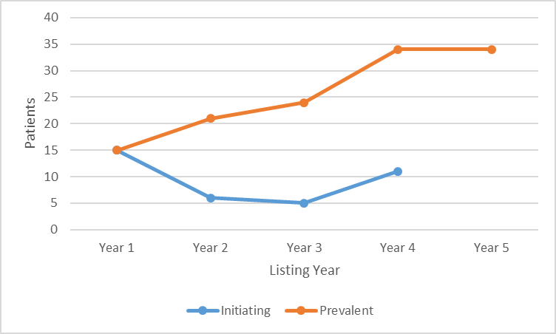
Figure 1: Patients on initiating and continuing treatment of sapropterin.
Note: Listing Year covers the period from 1 May – 30 April except for Year 5 as data cut off is 28 February 2019. Where the patient or prescription count is between 1 and 5 (inclusive), a figure data point is set to 5 to protect patient confidentiality.

The number of prevalent patients has been increasing since listing until Year 5 (noting Year 5 only contains part year data to February 2019). From Year 3 onwards, the number of prevalent patients have exceeded predicted levels. The number of incident patients has been higher than predicted. No incident patients were recorded for Year 5. This is plausible as the expected incidence rate was estimated to be one patient every two to three years.

Number of prescriptions
Figure 2 shows the number of prescriptions of sapropterin supplied per month since first listing on the PBS from 1 May 2014. Refer to Table 6 for the number of prescriptions supplied per year. The PBS listing allows for up to a maximum quantity of 180 tablets or 6 packs of 30 tablets per dispensing. Increased maximum quantities and repeats may be authorised by the DHS if required.

Figure 2: Sapropterin prescriptions (Item code 10086W & 10087X) by month of supply
Note: Where the patient or prescription count is between 1 and 5 (inclusive), a figure data point is set to 5 to protect patient confidentiality.
The modest uptake in the first few months of listing may be due to some patients having residual supply through the sponsor’s access program or lag due to the requirement for a written Authority. The number of prescriptions dispensed increased steadily from October 2014 to December 2017. There was a slowing in the growth of the number of prescriptions dispensed in 2018, consistent with the plateau in prevalent patients from Years 4 to 5 of listing (Figure 1).
Patient age
Table 2: Patient age at initiation of treatment
Patient age | Count
0 to 6 years | 8
7 to 12 years | 14
13 to 18 years | 14
Note: Includes all patients (n=36) who had initiated on sapropterin since it was first listed on the PBS.

The median age at initiation was 9 years old. The minimum and maximum age at initiation was 1 and 18 years, respectively.

Figure 3: Mean PBS dispensed quantity versus mean age by year
Note: Listing Year covers the period from 1 May – 30 April except for Year 5 as data cut off is 28 February 2019.
There is a positive correlation between mean age and mean dispensed quantity. This is plausible as sapropterin has a weight-based dosing regimen. For male patients, the mean age has slightly reduced from 15.4 in Year 1 to 13.9 in Year 5. The mean dispensed quantity had stabilised to around 180 tablets (the listed maximum quantity) from Year 3 onwards. For female patients, the mean age and mean dispensed quantity has gradually increased since Year 1. Similarly, the mean dispensed quantity of female patients has stabilised to around 180 tablets from Year 3 onwards.
Length of treatment
The time on sapropterin was examined for 15 patients who initiated on this therapy in the first year of listing (1 May 2014 to 30 April 2015). As at 28 February 2019, all patients from this initiating cohort were continuing to be supplied sapropterin (Figure 4).
For all (n=36) patients who had initiated on sapropterin between Years 1 to 4 of listing (there were no initiators in Year 5), two patients discontinued PBS treatment (an initiator in Year 2 and an initiator in Year 3) as at February 2019.
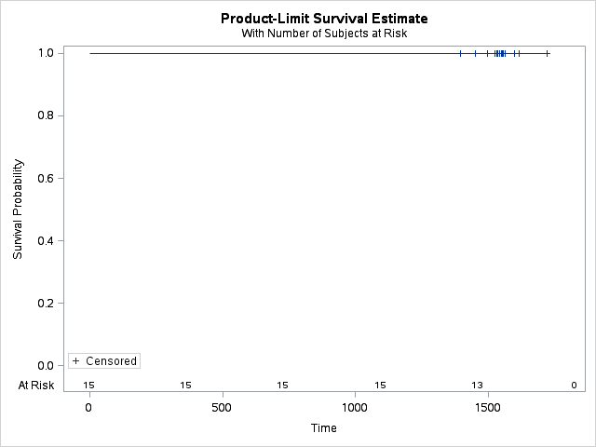
Figure 4: Kaplan-Meier analysis of time on therapy with sapropterin (including treatment breaks) for patients initiating in the first year of listing with follow-up to 28 February 2019
Note: Patients were considered to be on continuing treatment if their last supply date was within 90 days of the end date for the data period (Note: 90 days is three times the median length of refills between supplies). Continuing patients were censored from the Kaplan-Meier estimate.
Number of prescriptions per patient

Figure 5: Number of prescriptions supplied per patient over a 12 month period from first initiation
Note: Where the patient or prescription count is between 1 and 5 (inclusive), a figure data point is set to 5 protect patient confidentiality.
Both the median and mean number of prescriptions supplied per patient was 9 prescriptions per year. The median time between prescription refills was 30 days.
Prescriber type
Table 3: Sapropterin prescriptions by prescriber type
Specialty Type | Percentage
Paediatric Medicine | 58.7%
GP | 18.7%
Pathology | 9.8%
Clinical Genetics | 8.6%
Other specialties | 4.2%
Note: Other specialties include aggregated percentages of intensive care, gastroenterology and hepatology, internal medicine, and obstetrics and gynaecology.
The most common prescriber type was Paediatric Medicine, followed by GP and Pathology.

Analysis of expenditure
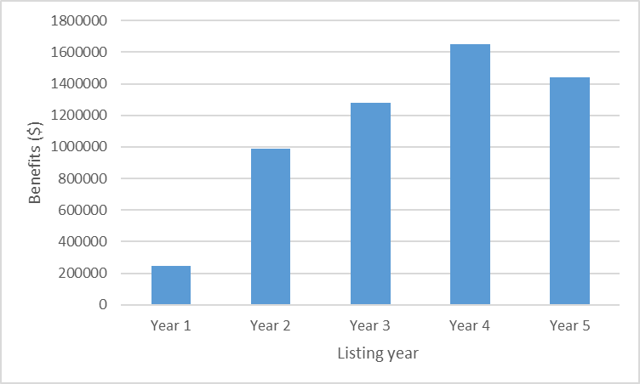
Figure 6: Sapropterin actual expenditure by Listing Year.
Note: Year covers the period from 1 May – 30 April except for Year 5 as data cut off was 28 February 2019.

Analysis of actual versus predicted utilisation
Predicted vs Actual utilisation
Table 4: Predicted versus actual utilisation for patients, prescriptions, packs and expenditure
 |  | Year 1 | Year 2 | Year 3 | Year 4 | Year 5
Patients | xxxxxxxxx xxx | xx | xx | xx | xx | xx
 | Actual (A) | 15 | 21 | 24 | 34 | 34
 | xxxxxxxxxx xxxxx | xx | x | x | xx | xx
 | x xxxxxxxxxx xxxxxxx | xxxx | xx | xxxxx | xxxxx | xxxxx
Prescriptions | xxxxxxxxx xxx | xxx | xxx | xxx | xxx | xxx
 | Actual (A) | 81 | 197 | 241 | 310 | 298
 | xxxxxxxxxx xxxxx | xxxx | xxx | xxx | xx | xx
 | x xxxxxxxxxx xxxxxxx | xxxxxx | xxxxxx | xxxxx | xxxxx | xxxxx
Packs | xxxxxxxxx xxx | xxxx | xxxx | xxxx | xxxx | xxxx
 | Actual (A) | 276 | 1110 | 1442 | 1823 | 1727
 | xxxxxxxxxx xxxxx | xxxxx | xxxx | xxxx | xxxx | xxxx
 | x xxxxxxxxxx xxxxxxx | xxxxxx | xxxxxx | xxxxxx | xxxxxx | xxxxxx
Prescriptions per patient | xxxxxxxxx xxx | xx | xx | xx | xx | xx
 | Actual (A) | 5 | 9 | 10 | 9 | 9
 | xxxxxxxxxx xxxxx | xx | xx | xx | xx | xx
 | x xxxxxxxxxx xxxxxxx | xxxxxx | xxxx | xxxxxx | xxxx | xxxx
Packs per patient | xxxxxxxxx xxx | xxxx | xxxx | xxxxx | xxxxx | xxxxx
 | Actual (A) | 18.4 | 52.9 | 60.0 | 53.6 | 50.8
 | xxxxxxxxxx xxxxx | xxxxx | xxxxx | xxxxx | xxxxx | xxxxx
 | x xxxxxxxxxx xxxxxxx | xxxxxx | xxxxxx | xxxxxx | xxxxxx | xxxxxx
Expenditure | xxxxxxxxx xxx | xxxxxxxxxx | xxxxxxxxxx | xxxxxxxxxx | xxxxxxxxxx | xxxxxxxxxx
 | Actual (A) | $246,173 | $986,940 | $1,281,076 | $1,648,050 | $1,559,783
 | xxxxxxxxxx xxxxx | xxxxxxxxxxx | xxxxxxxxxxx | xxxxxxxxx | xxxxxxxxx | xxxxxxxxx
 | x xxxxxxxxxx xxxxxxx | xxxxxx | xxxxxx | xxxxxx | xxxxxx | xxxxxx
Note: Year covers the period from 1 May – 30 April except for 2018-19 as data cut off was 28 February 2019.

The total amount of drug dispensed (milligrams) was lower than predicted (Figure 7). The total amount of drug dispensed increased steadily, as shown by the declining gap between the predicted and actual amount dispensed, of xxxx%, xxxx% and xxxx% in Years 2, 3 and 4 respectively.
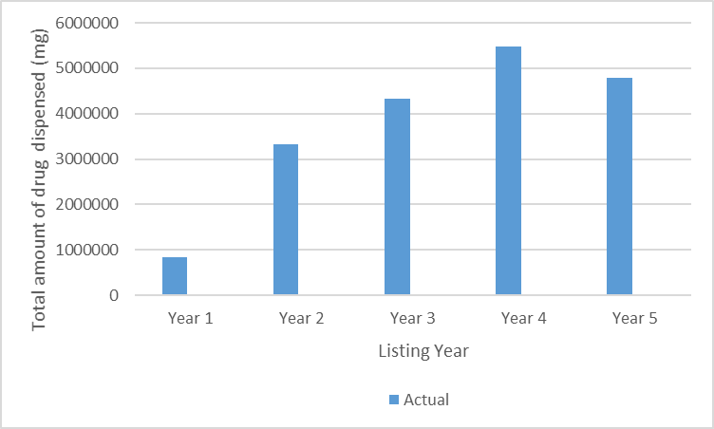
Figure 7: Total amount of drug dispensed (milligrams) by year
Note: Year covers the period from 1 May – 30 April except for Year 5 as data cut off is 28 February 2019.

A considerable proportion of prescriptions were dispensed at less than the maximum quantity of 180 tablets, 57.9% in Year 1 decreasing to 37.7% in Year 5. Where the dispensed quantity was less than the maximum quantity, 30.2% were for quantities of 90 tablets or less. Prescriptions dispensed at the increased maximum quantity were 18.6% in Year 1 increasing to 37.3% in Year 5. Prescriptions dispensed at the maximum quantity were 23.5% in Year 1 and 24.5% in Year 5. Based on the results in Table 5, there was a trend towards an increase in the dispensed quantity over the first five years of listing.

Table 5: Analysis of dispensed quantities relative to the maximum quantity
 | Less than max qty |  | Equal to max qty |  | More than max qty
 | Actual | Predicted | Actual | Predicted | Actual | Predicted
Year 1 | 57.9% | xxxxx | 23.5% | xxxx | 18.6% | xxxxx
Year 2 | 48.9% | xxxxx | 24.7% | xxxx | 26.5% | xxxxx
Year 3 | 43.4% | xxxxx | 23.4% | xxxx | 33.2% | xxxxx
Year 4 | 39.6% | xxxxx | 22.0% | xxxx | 38.4% | xxxxx
Year 5 | 37.7% | xxxxx | 24.5% | xxxx | 37.7% | xxxxx
Note: Year covers the period from 1 May – 30 April except for Year 5 as data cut off was 28 February 2019.

Patient dose was further analysed based on the sequence of the dispensed pack size (Table 6). If the original dispensed pack size is different to the next, then a dose adjustment was assumed. The dose adjustment was then further categorised to whether it was an increase or decrease from the initial dose, or if the sequence of dispensed pack quantity was variable. Patients were grouped into the following age categories:
- 0 – 6 years;
- 7 – 12 years; and
- 13 & above years.
Table 6: Sequence of dispensed pack quantity by age
Sequence of dispensed pack quantity | Age category
 | 0-6 years | 7-12  Years | 13 and above  Years
 | (Percent) | (Percent) | (Percent)
Increase in pack size | N/A | 27.8% | 22.2%
Decrease in pack size | 10.0% | 16.7% | 27.8%
Variable | 10.0% | N/A | 16.7%

The highest percentage of dose adjustment was observed in the ‘13 & above’ age group, at 66.7%, where half of which were for dose increases and the other half were for dose decreases. For the ‘7 – 12’ age group, 28% of the dose was increased, while 17% was decreased. The ‘0 – 6’ age group had the lowest dose adjustment of 20%, where half of which were for dose increases and the other half were for dose decreases.
The influence of co-administration of sapropterin with nutritional products for PKU on patient dose was examined. Nutritional products were considered to be used for PKU if the restriction text contained the terms “phenylketonuria” and the drug name contained the text “without phenylalanine”. Patients were considered to be co-administering if the supply date of a PKU nutritional product was within 60 days before or after the supply date of sapropterin. Out of all 36 patients who have been supplied sapropterin through the PBS, 18 patients were identified as potentially having sapropterin co-administered with PKU products. Of these 18 patients, 12 patients either had their sapropterin dispensed pack quantity increased, decreased or varied during the co-administration period.

Discussion
There are few published guidelines for using BH4 or sapropterin therapy to manage hyperphenylalaninaemia. The current PBS restriction for sapropterin requires confirmation of BH4 deficiency using tests for BH4 loading and/or urine pterin metabolites, blood spot dihydropteridine reductase and have cerebrospinal fluid neurotransmitter metabolites measured. In most cases, BH4 deficiency is determined through a loading test using 20 mg/kg BH4 with monitoring over 24 hours to assess responsiveness. A clinically significant response to BH4 therapy is defined as a ≥30% reduction in blood phenylalanine levels following treatment. Around 20%-50% of all patients with PKU respond to a BH4 loading dose with lower blood phenylalanine levels allowing a less restrictive diet in these patients.
It is well established that BH4, particularly in patients with higher residual activity of phenylalanine hydroxylase, may improve blood phenylalanine control and allow some relaxation of the dietary phenylalanine restriction in PKU patients. Additionally, there is a general consensus amongst Australasian PKU experts that patients with moderate PKU (i.e. phenylalanine levels between >600-1200μmol/L) at diagnosis should be offered a trial of BH4 therapy.9 It is possible that some of the patients who have initiated on PBS listed sapropterin are patients with moderate to severe PKU who have responded positively to a BH4 loading test, and have since been maintained as continuing patients. This could explain some of the increase in patient numbers in Year 3 (Figure 1) and the higher than predicted patient numbers which was observed from Year 3 onwards.
Further analysis on the incident patients in Year 3 showed that 91% of the dispensings were attributed to Victoria. The Australasian Society for Inborn Errors of Metabolism Clinical Guideline document states that a small number of PKU patients, mainly in Victoria, are currently treated with BH4. ⁸ Although sapropterin is a synthetic form of BH4, and the term BH4 also includes other formulations, the clinical trial (PKU-007) cited in the July 2012 submission was a study consisting of nine patients switching from a non-registered formulation of BH4 to sapropterin. The submission also assumed that sapropterin is equally efficacious as the synthetic BH4 described in other published citations. The higher than expected patient numbers observed for sapropterin may be due to treatment of patients with HPA other than caused by BH4 deficiency, including BH4-responsive PKU patients.
The most widely recommended target of blood phenylalanine levels for children less than 12 years of age is 120-360μmol/L. In patients over 12 years of age, phenylalanine levels above 360μmol/L may be appropriate, however there is a lack of consensus of the target phenylalanine levels for adolescence and adults., , It is recommended for women with PKU who wish to become pregnant to maintain phenylalanine levels between 70 – 250 μmol/L for 3 months prior to conception to achieve best infant outcomes. In addition to the broad target range, fluctuations in phenylalanine levels due to other causes such as changes in diet or intercurrent illness can also occur. There was variation in the dispensed pack quantity of individual patients. The intra-patient variability and the broad range of target blood phenylalanine levels may explain the variation in the dispensed pack quantity observed in the data (Table 6). As per Clinical Guidelines, sapropterin has a range of recommended weight-based dose.2,10,11,12 It is likely that the variation in the dispensed pack quantity is related to patient dose as this could be titrated up or down according to patient response or tolerability to sapropterin. The financial estimates model assumed that patient dose would steadily increase as patients get older and heavier each year until an upper limit weight of xxxx kg is reached where a dose of xxxx mg is then maintained for any subsequent years.
The actual median number of prescriptions per patient was 9 (Figure 5). Given the wide range of the recommended daily dose to achieve and maintain adequate blood phenylalanine levels (between 2 and 20 mg/kg/day)⁴, less than full compliance to sapropterin in practice is not unexpected.
The predicted versus actual analysis showed that there has been a lower than expected number of prescriptions per patient, at xx% in Years 4 and 5. A similar percentage of shortfall in expenditure is observed in the same period, at xx and xx% in Year 4 and 5 respectively. As the higher than expected patient numbers did not translate to higher expenditure, the lower than expected prescription per patient could explain the lower than expected expenditure.
Another possible contributor to the lower costs is that the dispensed quantity per prescription has been less than anticipated. Compared to the predicted levels, there was a higher proportion of prescriptions dispensed at less than the maximum quantity, and a lower proportion of prescriptions dispensed at more than the maximum quantity (Table 5). The lower dispensed quantity could be due to lower than predicted patient weights as initiators were younger and lighter than predicted (Table 2), individual variation in quantity dispensed over time (Table 6), and potential dose adjustments during intercurrent illness or when sapropterin is used with nutritional products for PKU.

DUSC consideration
DUSC noted that the majority of patients (over 90%) who had first initiated on sapropterin within its first four years of listing were continuing to be supplied sapropterin, including all patients who initiated therapy in the first year of listing. The number of patients who were supplied sapropterin was similar to predicted in the first two years of listing, and exceeded predicted levels thereafter. However the higher than predicted number of patients did not translate to a greater expenditure on sapropterin than anticipated. This was mainly because of a lower than predicted number of prescriptions dispensed per patient per year. DUSC considered that this could be due to dose variability resulting from the weight-based dosing regimen of sapropterin, and the use of different target phenylalanine levels by prescribers for adolescents and adults.

DUSC actions
DUSC requested that the report be provided to the PBAC.

Context for analysis
The DUSC is a Sub Committee of the Pharmaceutical Benefits Advisory Committee (PBAC).
The DUSC assesses estimates on projected usage and financial cost of medicines.

The DUSC also analyses data on actual use of medicines, including the utilisation of PBS listed medicines, and provides advice to the PBAC on these matters. This may include outlining how the current utilisation of PBS medicines compares with the use as recommended by the PBAC.

The DUSC operates in accordance with the quality use of medicines objective of the
National Medicines Policy and considers that the DUSC utilisation analyses will assist consumers and health professionals to better understand the costs, benefits and risks of medicines.

The utilisation analysis report was provided to the pharmaceutical sponsors of each drug and comments on the report were provided to DUSC prior to its consideration of the analysis.

Sponsor’s comment
The sponsor has no comment.

References
¹ Sapropterin (Kuvan) Product Information. Available from https://www.ebs.tga.gov.au.
² The PKU Handbook: Australasian Society for Inborn Errors of Metabolism. Available from https://www.mdda.org.au/wp-content/uploads/2016/02/ASIEM-Phenylketonuria-PKU-Handbook-.pdf
³ American College of Medical Genetics and Genomics (US). Phenylalanine hydroxylase deficiency: diagnosis and management guideline [Internet][cited 27 March 2019]. Available from: https://www.acmg.net//PDFLibrary/Phenylalanine-Hydroxylase-Deficiency-Diagnosis-Management.pdf
⁴ Sapropterin Public Summary Document – November 2012 PBAC Meeting. Available from http://www.pbs.gov.au/info/industry/listing/elements/pbac-meetings/psd/2012-11/sapropterin
⁵ Shintaku H. Disorders of tetrahydrobiopterin metabolism and their treatment. Current Drug Metabolism 2002 3:2 (123-131).
⁶ Longo N. Disorders of biopterin metabolism. Journal of Inherited Metabolic Disease 2009 32:3 (333-342) Sanford M. et al.
⁷ Bramwell B. Folinic acid, L-DOPA and 5-hydroxytryptophan in tetrahydrobiopterin deficiency: Treatment plan for a pediatric patient. International Journal of Pharmaceutical Compounding 2011 15:4 (316-319).
⁸ BH4 in the management of phenylketonuria. ASIEM Clinical Guideline Document. Available from https://www.mdda.org.au/wp-content/uploads/2017/10/Australasian-BH4-Guidelines-Document-ASIEM-Endorsed-06.09.2017.pdf.
⁹ Enns G M, Koch R, Brumm V, Blakely E, Suter R and Jurecki E. Suboptimal outcomes in patients with PKU treated early with diet alone: Revisiting the evidence. Molecular Genetics and Metabolics. 2010, 101: 99-109.
¹⁰ Ogier de Baulny H, Abadie V, Feillet F, De Parscau L. Management of Phenylketonuria and Hyperphenylalaninemia. The Journal of Nutrition. 2007; 137: 1561S-1563S.
¹¹ Vockley J, Andersson HC, Antshel KM, Braverman NE, Burton BK, Frazier DM, et al. Phenylalanine hydroxylase deficiency: diagnosis and management guideline. Genetics in medicine: official journal of the American College of Medical Genetics. 2014 Feb;16 (2):188-200. PubMed PMID: 24385074.
¹² Australasian consensus guidelines for the management of maternal phenylketonuria (PKU) Available from https://www.hgsa.org.au/documents/item/6357

Disclaimer
The information provided in this report does not constitute medical advice and is not intended to take the place of professional medical advice or care. It is not intended to define what constitutes reasonable, appropriate or best care for any individual for any given health issue. The information should not be used as a substitute for the judgement and skill of a medical practitioner.

The Department of Health (DoH) has made all reasonable efforts to ensure that information provided in this report is accurate. The information provided in this report was up-to-date when it was considered by the Drug Utilisation Sub-committee of the Pharmaceutical
Benefits Advisory Committee. The context for that information may have changed since publication.

To the extent provided by law, DoH makes no warranties or representations as to accuracy or completeness of information contained in this report.

To the fullest extent permitted by law, neither the DoH nor any DoH employee is liable for any liability, loss, claim, damage, expense, injury or personal injury (including death),
whether direct or indirect (including consequential loss and loss of profits) and however incurred (including in tort), caused or contributed to by any person’s use or misuse of the information available from this report or contained on any third party website referred to in this report.

Sapropterin (Kuvan) Product Information. Available from https://www.ebs.tga.gov.au.
The PKU Handbook: Australasian Society for Inborn Errors of Metabolism. Available from https://www.mdda.org.au/wp-content/uploads/2016/02/ASIEM-Phenylketonuria-PKU-Handbook-.pdf
American College of Medical Genetics and Genomics (US). Phenylalanine hydroxylase deficiency: diagnosis and management guideline [Internet][cited 27 March 2019]. Available from: https://www.acmg.net//PDFLibrary/Phenylalanine-Hydroxylase-Deficiency-Diagnosis-Management.pdf
Sapropterin Public Summary Document – November 2012 PBAC Meeting. Available from http://www.pbs.gov.au/info/industry/listing/elements/pbac-meetings/psd/2012-11/sapropterin
Shintaku H. Disorders of tetrahydrobiopterin metabolism and their treatment. Current Drug Metabolism 2002 3:2 (123-131).
Longo N. Disorders of biopterin metabolism. Journal of Inherited Metabolic Disease 2009 32:3 (333-342) Sanford M. et al.
Bramwell B. Folinic acid, L-DOPA and 5-hydroxytryptophan in tetrahydrobiopterin deficiency: Treatment plan for a pediatric patient. International Journal of Pharmaceutical Compounding 2011 15:4 (316-319).
BH4 in the management of phenylketonuria. ASIEM Clinical Guideline Document. Available from https://www.mdda.org.au/wp-content/uploads/2017/10/Australasian-BH4-Guidelines-Document-ASIEM-Endorsed-06.09.2017.pdf.
Enns G M, Koch R, Brumm V, Blakely E, Suter R and Jurecki E. Suboptimal outcomes in patients with PKU treated early with diet alone: Revisiting the evidence. Molecular Genetics and Metabolics. 2010, 101: 99-109.
Ogier de Baulny H, Abadie V, Feillet F, De Parscau L. Management of Phenylketonuria and Hyperphenylalaninemia. The Journal of Nutrition. 2007; 137: 1561S-1563S.
Vockley J, Andersson HC, Antshel KM, Braverman NE, Burton BK, Frazier DM, et al. Phenylalanine hydroxylase deficiency: diagnosis and management guideline. Genetics in medicine: official journal of the American College of Medical Genetics. 2014 Feb;16 (2):188-200. PubMed PMID: 24385074.
Australasian consensus guidelines for the management of maternal phenylketonuria (PKU) Available from https://www.hgsa.org.au/documents/item/6357.

