Adrenaline for acute allergic reaction with anaphylaxis

Drug utilisation sub-committee (DUSC)

October 2020

Abstract

Purpose
To analyse the utilisation of adrenaline PBS listed for the treatment of acute allergic reaction with anaphylaxis, as requested by DUSC at its June 2020 meeting.

Date of listing on the Pharmaceutical Benefits Scheme (PBS)
The first adrenaline autoinjector was PBS listed 1 November 2003.

Data Source / methodology
Data from 1 November 2003 to 30 June 2020 were extracted from the PBS data maintained by Department of Health, processed by Services Australia (SA) on or before 12 August 2020, for the current and historical PBS item codes for adrenaline autoinjectors.

Key Findings
- In 2019:
  - There were 260,593 adrenaline autoinjectors supplied to 122,271 patients.
  - The number of initiating patients was 23,534.
  - The mean number of adrenaline autoinjectors supplied per prescription was 1.87.
  - The mean number of prescriptions per patient was 1.14.
- Although the number of treated patients and prescriptions supplied per year have been steadily increasing, expenditure has remained fairly consistent since 2014, likely due to price decreases.
- Geospatial analysis suggests fewer patients were supplied adrenaline autoinjectors in some remote areas in central Australia, compared to populated areas

Purpose of analysis
To analyse the utilisation of adrenaline PBS listed for the treatment of acute allergic reaction with anaphylaxis, as requested by DUSC at its June 2020 meeting.

Background

Clinical situation
Adrenaline autoinjectors are used for the immediate emergency treatment of a severe allergic reaction (also known as anaphylaxis) caused by hypersensitivity to food, medicines insect bites, latex or other allergens. A severe allergic reaction is life threatening and affects the whole body, in particular the:
- heart and blood circulation.
- blood flow to the brain.
- smooth muscle of the air passages and lungs.
- stomach and bowels, and
- skin

Pharmacology
Adrenaline shrinks abnormally wide blood vessels and makes the heart beat strongly. This helps improve the very low blood pressure and poor circulation that occur in a severe allergic reaction. It also relaxes the lungs, which eases breathing and lessens wheezing, and helps stop swelling, skin rash and itching.¹

Therapeutic Goods Administration (TGA) approved indications
Adrenaline autoinjectors are TGA approved for the emergency treatment of anaphylaxis (acute severe allergic reactions) due to insect stings, or bites, foods, drugs or other allergens.

Dosage and administration
The appropriate dosage is determined by the patient’s body weight and should be based on careful assessment of the individual patient and recognition of the life-threatening nature of reactions for which adrenaline autoinjectors are prescribed.

Table 1: Dosage and administration of adrenaline autoinjectors
Brand name and sponsor | Product | Dose and frequency of administration
Adrenaline Jr Mylan,  EpiPen Jr.  Alphapharm Pty Ltd | adrenaline (epinephrine) 150 microgram/0.3 mL injection | Children (15 to 30 kg): Intramuscular injection of adrenaline autoinjector containing 0.15 mg adrenaline injection (0.15 mg/0.3 mL)
Adrenaline Mylan, EpiPen  Alphapharm Pty Ltd | adrenaline (epinephrine) 300 microgram/0.3 mL injection | Adults (≥ 30 kg): Intramuscular injection of adrenaline autoinjector containing 0.3 mg adrenaline injection (0.3 mg/0.3 mL)
Source: the Australian Approved Product Information²
The current Product Information (PI) and Consumer Medicine Information (CMI) are available from the TGA (Product Information) and the TGA (Consumer Medicines Information).

PBS listing details (as at 1 July 2020)

Table 2: PBS listing of adrenaline autoinjectors
Item | Name, form & strength, pack size | Max. quant. | Rpts | DPMQ | Brand name and manufacturer
8697R | adrenaline (epinephrine) 150 microgram/0.3 mL injection, 0.3 mL pen device | 1 | 0 | $84.26 | Adrenaline Jr Mylan,  EpiPen Jr.  Alphapharm Pty Ltd
8698T | adrenaline (epinephrine) 300 microgram/0.3 mL injection, 0.3 mL pen device | 1 | 0 | $84.26 | Adrenaline Mylan, EpiPen  Alphapharm Pty Ltd
Source: the PBS website.
The maximum quantity in the listings is one, however the restriction includes a note which states, “Authority approvals will be limited to a maximum quantity of two autoinjectors at any one time.”
On its website, the Australasian Society of Clinical Immunology and Allergy (ASCIA) notes that, “Two devices per prescription are routinely recommended. This allows one device to be with the patient (or for parental use at home for younger children), and one device to be available for use at the early childhood education/care centre or school. Additional devices (if desired) may be purchased privately without prescription in Australia, since more than two devices at a time are not PBS subsidised in Australia.
“In adults and older high school students, two devices are strongly recommended in those with:
- Previous hypotensive or near fatal anaphylaxis.
- Need for more than one adrenaline dose to treat previous anaphylaxis episodes.
- Limited access to medical care (e.g. travel or residence in remote areas, perhaps overseas travel in some circumstances.
- Patients with systemic mastocytosis.
- Where high body mass indicates that the routine 0.3mg adrenaline dose will provide an insufficient dose for adequate treatment.”

Restriction
Adrenaline autoinjectors are PBS listed for acute allergic reaction with anaphylaxis as sole PBS-subsidised supply for anticipated emergency treatment. Patients must have
- been assessed to be at significant risk of anaphylaxis by, or in consultation with a clinical immunologist, allergist, paediatrician or respiratory physician, or
- been discharged from hospital or an emergency department after treatment with adrenaline (epinephrine) for acute allergic reaction with anaphylaxis, or
- previously been issued with an authority prescription for this drug.
For details of the current PBS listing refer to the PBS website.

Date of listing on PBS
The first adrenaline autoinjector was PBS listed 1 November 2003.

Changes to listing

Table 3: Summary of adrenaline listings for acute allergic reaction with anaphylaxis
Date of first listing | Item code | Brand name | Form and strength | Max. Qty | Pack size | No. Rpts | Listing status
1 Nov 2003 | 08697R | EpiPen Jr. | I.M. injection 150 micrograms in 0.3 mL single dose syringe auto-injector, pen device | 1 | 1 | 0 | Current
1 Nov 2003 | 08698T | EpiPen | I.M. injection 300 micrograms in 0.3 mL single dose syringe auto-injector, pen device | 1 | 1 | 0 | Current
1 Jul 2010 | 03408J | Anapen Junior | I.M. injection 150 micrograms in 0.3 mL single dose syringe auto-injector | 1 | 1 | 0 | Delisted
1 Jul 2010 | 03409K | Anapen | I.M. injection 300 micrograms in 0.3 mL single dose syringe auto-injector | 1 | 1 | 0 | Delisted
1 Jun 2018 | 08697R | Adrenaline Jr Mylan | I.M. injection 150 micrograms in 0.3 mL single dose syringe auto-injector, pen device | 1 | 1 | 0 | Current
1 Jun 2018 | 08698T | Adrenaline Mylan | I.M. injection 300 micrograms in 0.3 mL single dose syringe auto-injector, pen device | 1 | 1 | 0 | Current
1 Jul 2018 | 11390L | Emerade | I.M. injection 150 micrograms in 0.15 mL single dose auto-injector | 1 | 1 | 0 | Delisted
1 Jul 2018 | 11398X | Emerade | I.M. injection 300 micrograms in 0.3 mL single dose auto-injector | 1 | 1 | 0 | Delisted

In August 2006 the restriction was altered to include that patients who had been discharged from hospital or an emergency department after treatment with adrenaline for acute allergic reaction with anaphylaxis were eligible for supply.
In July 2010 the note regarding the maximum quantity was altered. The original listing included a note which stated, “Authorities for increased maximum quantities, up to a maximum of 2, may be authorised for children aged less than 17 years where 2 autoinjectors are necessary to ensure 1 is on hand at all times. No increased maximum quantities will be authorised for patients aged 17 years or older. No repeats will be issued.” This was changed to, “Authority approvals will be limited to a maximum quantity of 2 autoinjectors at any one time.”
Current PBS listing details are available from the PBS website.

Relevant aspects of consideration by the Pharmaceutical Benefits Advisory Committee (PBAC)
Adrenaline autoinjectors were recommended for listing on the PBS by the PBAC at its June 2003 meeting.

Previous reviews by the DUSC
September 2005
The initial 12 month predicted versus actual review noted:
- Uptake of the drug was lower than predicted in the submission.
- While less patients than expected obtained prescriptions, the number of pens/patient dispensed was greater than calculated in the submission.
- There was a rapid uptake of both EpiPen jnr and EpiPen followed by a drop from March to August 2004 and an increase in September and October 2004. Possible explanations for this pattern included: early uptake with a low number of new patients per month, supply problems for EpiPen, cyclical pattern in utilisation resulting from the shelf-life limiting the time to obtain a new device and seasonal fluctuations.
June 2008
A subsequent analysis in June 2008 examined an extension of the PBS restriction for the adrenaline auto-injector (from 1 August 2006) to allow for patients who have received adrenaline for an anaphylactic reaction as inpatients or in emergency departments to be eligible without consultation by any specialists.
This review noted:
- Steady increase in utilisation but that it had not exceeded the predicted maximum volumes agreed between the sponsor and Department post PBAC.
- Available data did not indicate that widening access has resulted in an unexpected change in utilisation.
- The measures taken to address the uncertainties highlighted during consideration of the listing were successful.
- While the prevalence of anaphylaxis was increasing in Australia, there was no indication that there were eligible patients who were unable to access PBS supplies of adrenaline autoinjectors. The high level of uncertainty about the prevalence of ‘at risk’ patients was continuing.

Methods
PBS prescription data for adrenaline autoinjectors dispensed from 1 November 2003 to 30 June 2020 were extracted from the SA PBS prescription database on 12 August 2020. These data were used to determine the number of prescriptions and autoinjectors supplied, the number of incident and prevalent treated patients and to analyse patient demographics such as age and sex.
Geospatial analysis is presented by Australian Statistical Geography Standard (ASGS) Statistical Areas Level 2 (SA2). This regional level was considered appropriate to investigate whether there were regional differences in the rates of adrenaline supply across Australia. The number of treated patients and quantities supplied in 2019 were summarised by postcode, which was converted to ASGS 2016 SA2 using Australian Bureau of Statistics 2019 Pitney Bowes Postcodes to 2016 SA2 geographical correspondences, and standardised by the 2019 Population Estimates by SA2 divided by 1,000.
Data extraction and manipulation was undertaken using SAS. Geographical analyses were undertaken using ArcGIS mapping software.
As this analysis uses date of supply prescription data, there may be small differences compared with publicly available SA Medicare date of processing data.

Results

Analysis of drug utilisation

Figure 1: Patients, prescriptions and quantity dispensed since listing

Table 5: Annual amounts of patients, prescriptions and quantity dispensed since listing
Year | Initiating patients | Treated patients | Prescriptions dispensed | Quantity dispensed | Quantity per prescription | Prescriptions per patient
2003 | 3,160 | 3,160 | 3,251 | 4,677 | 1.44 | 1.03
2004 | 17,336 | 18,730 | 21,058 | 30,920 | 1.47 | 1.12
2005 | 14,595 | 27,981 | 35,598 | 55,575 | 1.56 | 1.27
2006 | 14,458 | 31,951 | 34,868 | 53,391 | 1.53 | 1.09
2007 | 15,542 | 41,760 | 46,247 | 71,253 | 1.54 | 1.11
2008 | 15,828 | 48,840 | 54,499 | 84,544 | 1.55 | 1.12
2009 | 15,085 | 50,661 | 55,885 | 87,184 | 1.56 | 1.10
2010 | 16,726 | 62,414 | 68,542 | 112,211 | 1.64 | 1.10
2011 | 17,629 | 64,580 | 69,852 | 123,681 | 1.77 | 1.08
2012 | 18,316 | 72,799 | 78,865 | 140,918 | 1.79 | 1.08
2013 | 19,310 | 79,919 | 87,269 | 157,849 | 1.81 | 1.09
2014 | 20,076 | 94,665 | 105,519 | 192,972 | 1.83 | 1.11
2015 | 20,910 | 95,667 | 105,558 | 193,574 | 1.83 | 1.10
2016 | 21,430 | 104,422 | 114,422 | 210,640 | 1.84 | 1.10
2017 | 22,037 | 116,220 | 130,128 | 241,486 | 1.86 | 1.12
2018 | 22,193 | 114,214 | 124,054 | 230,304 | 1.86 | 1.09
2019 | 23,534 | 122,271 | 139,427 | 260,593 | 1.87 | 1.14
2020* | 10,733 | 66,590 | 69,769 | 130,462 | 1.87 | 1.05
Note: *2020 is to June 2020

Table 6: Count of quantity dispensed by year
 | 1 | 2 | 3 | 4+
2003 | 1,821 (56%) | 1,425 (44%) | ≤5 (<0.001%) | -
2004 | 11,178 (53%) | 9,858 (47%) | 7 (<0.001%) | ≤5 (<0.001%)
2005 | 15,613 (44%) | 19,971 (56%) | ≤5 (<0.001%) | ≤5 (<0.001%)
2006 | 16,326 (47%) | 18,531 (53%) | ≤5 (<0.001%) | -
2007 | 21,219 (46%) | 25,011 (54%) | ≤5 (<0.001%) | -
2008 | 24,439 (45%) | 30,045 (55%) | ≤5 (<0.001%) | -
2009 | 24,571 (44%) | 31,302 (56%) | ≤5 (<0.001%) | -
2010 | 24,858 (36%) | 43,669 (64%) | ≤5 (<0.001%) | -
2011 | 15,999 (23%) | 53,836 (77%) | ≤5 (<0.001%) | ≤5 (<0.001%)
2012 | 16,773 (21%) | 62,071 (79%) | ≤5 (<0.001%) | -
2013 | 16,654 (19%) | 70,591 (81%) | ≤5 (<0.001%) | ≤5 (<0.001%)
2014 | 18,038 (17%) | 87,444 (83%) | 10 (<0.001%) | ≤5 (<0.001%)
2015 | 17,521 (17%) | 88,004 (83%) | 7 (<0.001%) | 6 (<0.001%)
2016 | 18,179 (16%) | 96,186 (84%) | 13 (<0.001%) | 8 (<0.001%)
2017 | 18,747 (14%) | 111,317 (86%) | 15 (<0.001%) | 11 (<0.001%)
2018 | 17,751 (14%) | 106,242 (86%) | 11 (<0.001%) | 9 (<0.001%)
2019 | 18,248 (13%) | 121,122 (87%) | 13 (<0.001%) | 11 (<0.001%)
2020 | 9,080 (13%) | 60,651 (87%) | 18 (<0.001%) | 6 (<0.001%)

In addition to quantities of four, five and six being dispensed, there are rare records of 20 and 22 autoinjectors being dispensed, which may be due to data entry errors. The number of dispensed quantities higher than two increases when same day supply is accounted for.

Table 7: Count of quantity dispensed by year accounting for same day supply
 | 1 | 2 | 3 | 4+
2003 | 1,796 (56%) | 1,433 (44%) | ≤5 (<0.001%) | -
2004 | 11,073 (53%) | 9,884 (47%) | 14 (<0.001%) | 9 (<0.001%)
2005 | 15,441 (44%) | 19,997 (56%) | 20 (<0.001%) | 20 (<0.001%)
2006 | 16,144 (46%) | 18,525 (53%) | 11 (<0.001%) | 40 (<0.001%)
2007 | 21,003 (46%) | 25,011 (54%) | 26 (<0.001%) | 36 (<0.001%)
2008 | 24,194 (45%) | 30,059 (55%) | 24 (<0.001%) | 40 (<0.001%)
2009 | 24,322 (44%) | 31,328 (56%) | 22 (<0.001%) | 35 (<0.001%)
2010 | 24,533 (36%) | 43,696 (64%) | 38 (<0.001%) | 43 (<0.001%)
2011 | 15,758 (23%) | 53,839 (77%) | 23 (<0.001%) | 43 (<0.001%)
2012 | 16,502 (21%) | 62,084 (79%) | 14 (<0.001%) | 51 (<0.001%)
2013 | 16,249 (19%) | 70,649 (81%) | 34 (<0.001%) | 50 (<0.001%)
2014 | 17,558 (17%) | 87,532 (83%) | 38 (<0.001%) | 59 (<0.001%)
2015 | 17,061 (16%) | 88,091 (84%) | 29 (<0.001%) | 60 (<0.001%)
2016 | 17,647 (15%) | 96,274 (84%) | 46 (<0.001%) | 72 (<0.001%)
2017 | 18,117 (14%) | 111,397 (86%) | 57 (<0.001%) | 97 (<0.001%)
2018 | 17,132 (14%) | 106,330 (86%) | 62 (<0.001%) | 81 (<0.001%)
2019 | 17,545 (13%) | 121,119 (87%) | 88 (<0.001%) | 132 (<0.001%)
2020 | 8,739 (13%) | 60,635 (87%) | 66 (<0.001%) | 63 (<0.001%)

Figure 2: Age and sex of patients at initiation

The age of patients initiating to adrenaline autoinjectors appears to include patients of all ages, although patients aged 0 to 4 years old represent 26% of all initiators, and patients aged 0 to 14 years old represent 47% of all initiators.

Figure 3: Age and sex of treated patients in 2019

For patients treated in 2019, patients aged 0 to 4 years old represent 13% of treated patients, and patients aged 0 to 14 years old represent 48% of treated patients.

Geospatial analysis
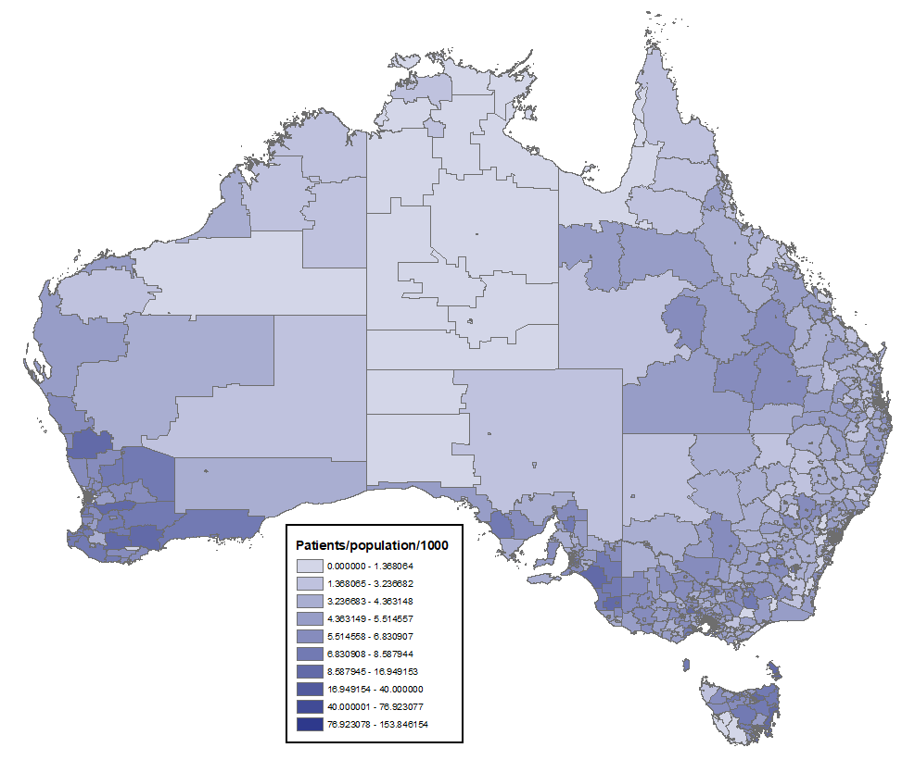

Figure 4: Treated patients in 2019 (standardised) by SA2 region

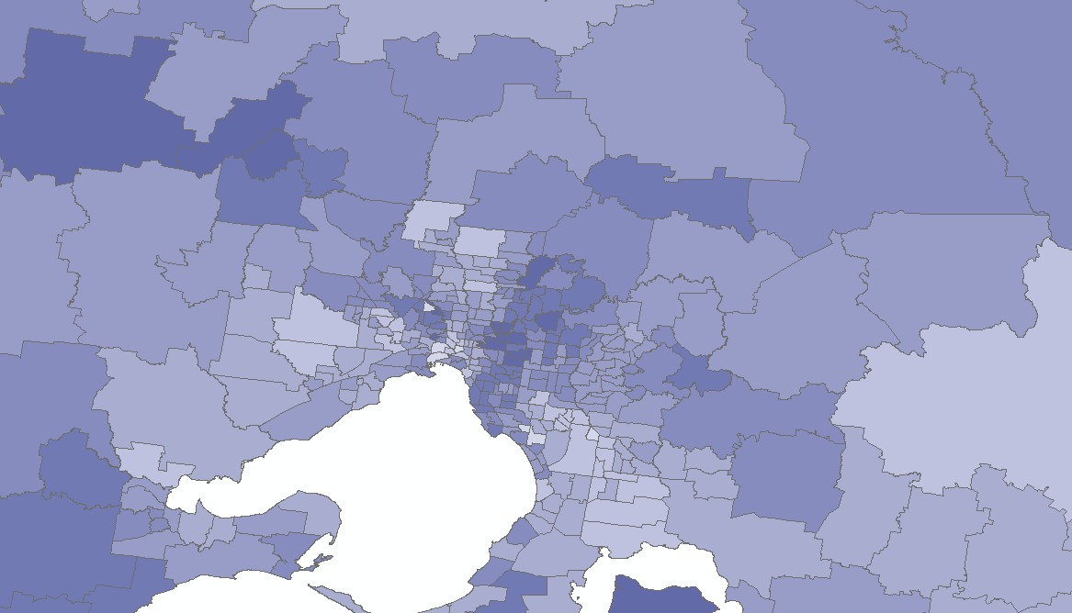

Figure 5: Treated patients in 2019 (standardised) by SA2 region Melbourne

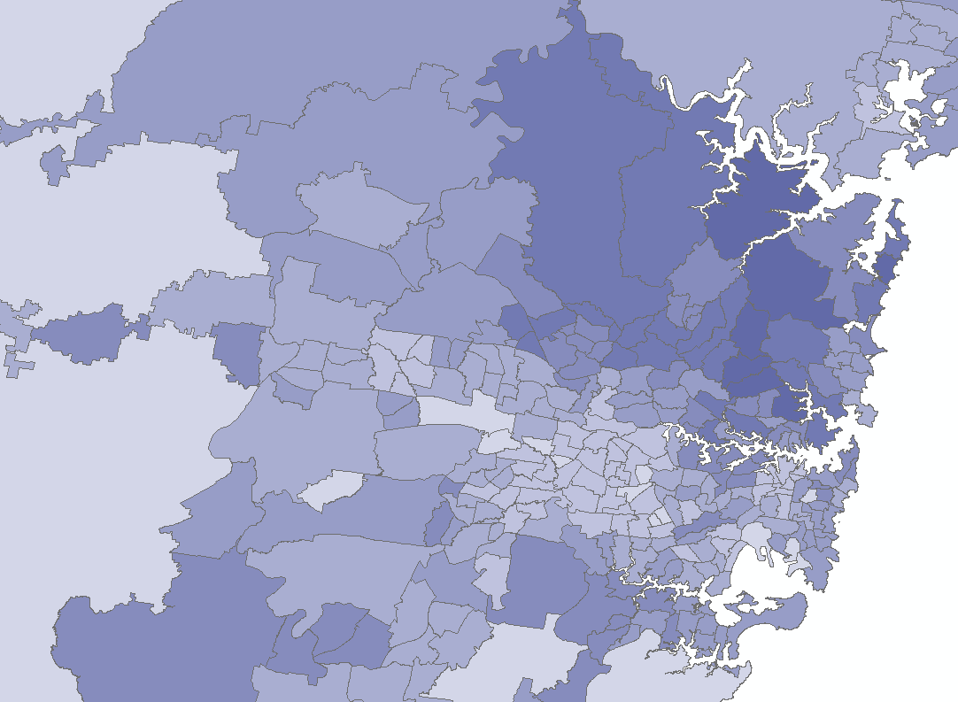

Figure 6: Treated patients in 2019 (standardised) by SA2 region Sydney

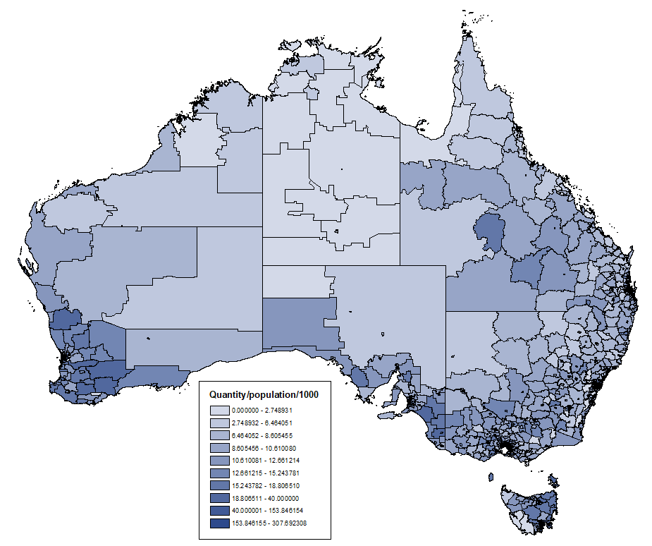

Figure 7: Total quantity dispensed in 2019 (standardised) by SA2 region

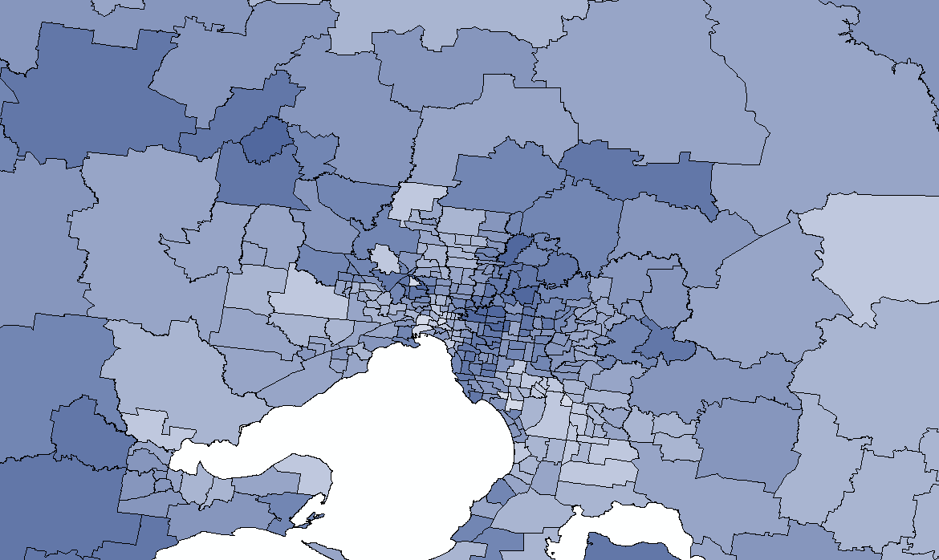

Figure 8: Total quantity dispensed in 2019 (standardised) by SA2 region Melbourne

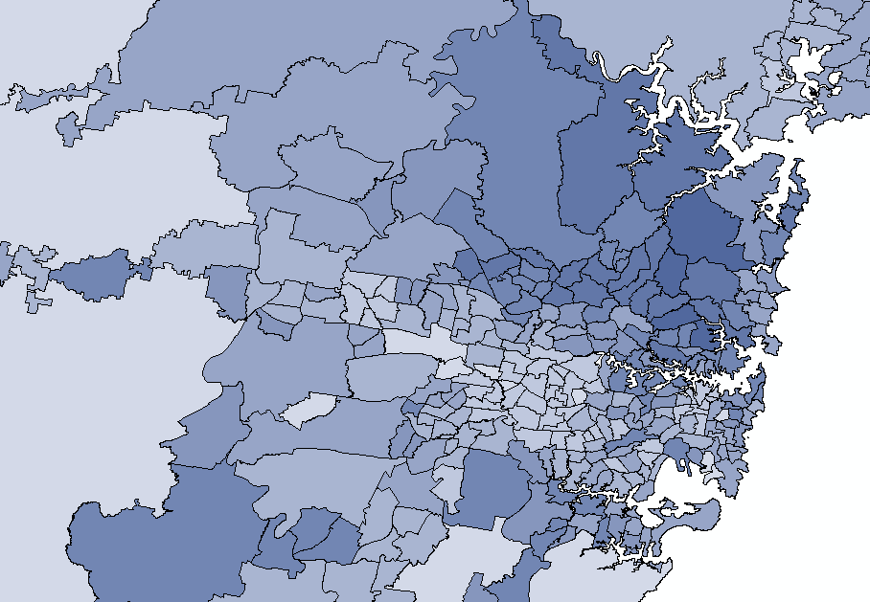

Figure 9: Total quantity dispensed in 2019 (standardised) by SA2 region Sydney

Analysis of expenditure

Table 8: Annual cost to Government for adrenaline autoinjectors since listing
Year | Cost to Government
2003 | $394,114
2004 | $2,573,911
2005 | $4,519,174
2006 | $4,229,288
2007 | $5,855,137
2008 | $7,446,195
2009 | $7,645,785
2010 | $9,882,237
2011 | $10,941,303
2012 | $12,418,154
2013 | $13,880,862
2014 | $16,947,193
2015 | $16,423,207
2016 | $16,605,736
2017 | $18,680,776
2018 | $15,982,109
2019 | $16,456,924
2020 (YTD to June) | $8,207,867
Total | $189,089,971

Table 8 shows that the annual cost to Government of adrenaline autoinjectors peaked in 2017. Table 9 below summarises the price decreases applied to adrenaline autoinjectors since listing.

Table 9: Price decreases applied to adrenaline autoinjectors
 | Price | New Price | Reason
July 2015 | $106.34 | $100.95 | New AHI fee structure according to the 6CPA
April 2016 | $100.95 | $96.43 | Five year 5% Anniversary Price Reduction
June 2018 | $97.10 | $83.33 | 16% Statutory Price Reduction with the listing of an additional bioequivalent brand

DUSC consideration
DUSC noted the number of treated patients and prescriptions have been growing since PBS listing in November 2003, despite intermittent medicine shortages affecting supply. DUSC noted the number of autoinjectors supplied per treated patient and the number of autoinjectors supplied per prescription have been fairly stable since the notable increase in the second half of 2010. DUSC agreed with the report that this increase was likely due to the alteration of the note regarding the maximum quantity in July 2010. DUSC noted a comment from a sponsor that the PBS-listing of the maximum quantity is unclear, stating that the maximum quantity on the PBS schedule is one and it is only when a separate Note is viewed that it is apparent two auto-injectors can be prescribed and dispensed at any one time.
DUSC noted that the analysis of use by SA2 showed fewer patients received supplies of adrenaline autoinjectors in some remote areas in central Australia compared to populated areas. DUSC noted the geographical analysis of Sydney appeared to show relatively higher use in north east Sydney and relatively lower use in western Sydney, and relatively higher use in the areas surrounding a known allergy centre. DUSC commented that people living in remote areas may have been expected to be prescribed higher amounts of adrenaline autoinjectors because of the time and distance to reach emergency services, however DUSC commented there is no evidence to demonstrate stockpiling in remote areas. DUSC considered the lower use in remote areas may be an issue of access to prescribers rather than access to medicines, as there may be a 12-24 month wait to see a specialist. DUSC considered that the closing the gap data could offer more insight into the use of adrenaline autoinjectors in remote areas.
DUSC Actions
DUSC requested that the report be provided to the PBAC for consideration.

Context for analysis
The DUSC is a Sub Committee of the Pharmaceutical Benefits Advisory Committee (PBAC). The DUSC assesses estimates on projected usage and financial cost of medicines.
The DUSC also analyses data on actual use of medicines, including the utilisation of PBS listed medicines, and provides advice to the PBAC on these matters. This may include outlining how the current utilisation of PBS medicines compares with the use as recommended by the PBAC.
The DUSC operates in accordance with the quality use of medicines objective of the National Medicines Policy and considers that the DUSC utilisation analyses will assist consumers and health professionals to better understand the costs, benefits and risks of medicines.
The utilisation analysis report was provided to the pharmaceutical sponsors of each drug and comments on the report were provided to DUSC prior to its consideration of the analysis.

Sponsors’ comments
Alphapharm Pty Ltd: The sponsor had no comment.

Disclaimer
The information provided in this report does not constitute medical advice and is not intended to take the place of professional medical advice or care. It is not intended to define what constitutes reasonable, appropriate or best care for any individual for any given health issue. The information should not be used as a substitute for the judgement and skill of a medical practitioner.
The Department of Health (DoH) has made all reasonable efforts to ensure that information provided in this report is accurate. The information provided in this report was up-to-date when it was considered by the Drug Utilisation Sub-committee of the Pharmaceutical Benefits Advisory Committee. The context for that information may have changed since publication.
To the extent provided by law, DoH makes no warranties or representations as to accuracy or completeness of information contained in this report.
To the fullest extent permitted by law, neither the DoH nor any DoH employee is liable for any liability, loss, claim, damage, expense, injury or personal injury (including death), whether direct or indirect (including consequential loss and loss of profits) and however incurred (including in tort), caused or contributed to by any person’s use or misuse of the information available from this report or contained on any third party website referred to in this report.

EpiPen (adrenaline). Australian Approved Consumer Medicine Information. Millers Point NSW: Alphapharm Pty Ltd. Approved January 1998 (this located at the end of the PI), updated 22 September 2017. Available from https://www.ebs.tga.gov.au/ebs/picmi/picmirepository.nsf/pdf?OpenAgent&id=CP-2010-CMI-06621-3
EpiPen (adrenaline). Australian Approved Product Information. Millers Point NSW: Alphapharm Pty Ltd. Approved 20 August 1993, updated 21 October 2019. Available from https://www.ebs.tga.gov.au/ebs/picmi/picmirepository.nsf/pdf?OpenAgent&id=CP-2010-PI-06620-3&d=202008171016933
Australasian Society of Clinical Immunology and Allergy (ASCIA) https://www.allergy.org.au/hp/anaphylaxis/adrenaline-autoinjector-prescription
Australian Bureau of Statistics, ASGS Correspondences (2016) - 2016 Population Weighted, https://data.gov.au/data/dataset/23fe168c-09a7-42d2-a2f9-fd08fbd0a4ce/resource/951e18c7-f187-4c86-a73f-fcabcd19af16/download/asgs2016_2016gridcorrespondences.zip, ‘CG_POSTCODE_2019_SA2_2016.xlsx’
Australian Bureau of Statistics, 3218.0 - Regional Population Growth, Australia, 2018-19, https://www.abs.gov.au/AUSSTATS/abs@.nsf/DetailsPage/3218.02018-19?OpenDocument, ‘Population Estimates by Statistical Area Level 2, 2018 to 2019’
PBS statistics. Australian Government Department of Human Services Medicare. Canberra. Available from <http://www.medicareaustralia.gov.au/provider/pbs/stats.jsp>.

