Teduglutide for Short Bowel Syndrome: 24 month predicted versus actual analysis

Drug utilisation sub-committee (DUSC)

June 2022

Abstract

Purpose
To compare the predicted and actual utilisation of teduglutide for Type III Short Bowel Syndrome with intestinal failure in the first 24 months of PBS listing.

Date of listing on the Pharmaceutical Benefits Scheme (PBS)
Teduglutide was listed on the PBS, for this indication, on 1 October 2019.

Data Source / methodology
Data extracted from the PBS, Authorities and Date of Death databases maintained by Department of Health and Aged Care, processed by Services Australia were used for analyses.

Key Findings
- There were 24 and 33 patients treated with teduglutide during the first and second year of its listing respectively, which was XXXX than estimated.
- There were 215 and 277 teduglutide prescriptions dispensed during the first and second year of its listing respectively, which was XXXX than estimated.
- The median age of patients initiating teduglutide treatment was 47 years old. There was a wider age distribution for males compared to females.
- The data were too immature to analyse the time of teduglutide treatment, the median treatment duration was not reached by 31 December 2021.

Purpose of analysis
To compare the predicted and actual utilisation of teduglutide for Type III Short bowel syndrome with intestinal failure in the first 24 months of PBS listing. Teduglutide was PBS listed for this indication on 1 October 2019.

Background

Clinical situation
Short Bowel Syndrome (SBS) is a rare disorder arising from an inability to absorb nutrients and fluid across the gastrointestinal tract (gut). It is often caused by surgical removal of all or part of the small intestine. The spectrum of SBS varies widely due to the differences in remnant bowel anatomy, comorbidities and clinical management requirements, and ranges from single micronutrient malabsorption to intestinal failure. ² Symptoms vary depending on the length and function of the remaining bowel, but may include diarrhoea, nutrient deficiencies, electrolyte disturbances, dehydration, malnutrition, and weight loss.
Intestinal failure (IF) in SBS occurs when intravenous supplementation is required to maintain health as gut function is impaired below the minimum necessary for absorption of macronutrients and/or water and electrolytes.
There are three types of intestinal failure:
- Type I: acute and short-term.
- Type II: prolonged acute condition, requiring complex multi-disciplinary care and intravenous supplementation over weeks or months.
- Type III: chronic condition, requiring intravenous supplementation over months or years. It may be reversible or irreversible.

Pharmacology
Teduglutide is an analogue of naturally occurring human glucagon-like peptide-2 (GLP-2), a peptide secreted by L-cells of the distal intestine. GLP-2 is known to increase intestinal and portal blood flow, decrease intestinal motility and inhibit gastric acid secretion. Teduglutide binds to the GLP-2 receptors located in intestinal subpopulations of enteroendocrine cells, subepithelial myofibroblasts and enteric neurons of the submucosal and myenteric plexus. Activation of these receptors results in the local release of multiple mediators including insulin-like growth factor (IGF)-1, nitric oxide and keratinocyte growth factor (KGF). Teduglutide has been shown to preserve mucosal integrity by promoting repair and normal growth of the intestine through an increase of villus height and crypt depth.

Therapeutic Goods Administration (TGA) approved indications
Teduglutide is only indicated for the treatment of adult and paediatric patients 2 years of age and above with SBS who need additional nutrition or fluids from intravenous feeding (parenteral support).

Dosage and administration
Paediatric (2 years of age and above)
Teduglutide should not be administered to children weighing less than 10 kg. Treatment should be evaluated after 6 months. If no overall improvement is achieved, the need for continued treatment should be re-assessed. There are no data available in paediatric patients after 6 months of continued treatment.
Adult
Treatment effect should be evaluated on an ongoing basis. Clinical assessment by the physician should consider individual treatment objectives and patient preferences. If no overall improvement is achieved after 12 months for adults, the need for continued treatment should be assessed. Continued treatment is recommended for patients who have weaned off parenteral nutrition.
The recommended dose of teduglutide for both adults and paediatric patients (aged 2 years and above) is 0.05 mg/kg body weight administered by subcutaneous injection once daily.
After reconstitution with the solvent (0.5 mL water for injections), the prepared solution from each vial contains 10 mg/mL of teduglutide.³
The current Product Information (PI) and Consumer Medicine Information (CMI) are available from the TGA (Product Information) and the TGA (Consumer Medicines Information).

PBS listing details (as at March 2022)

Table 1: PBS listing of teduglutide
Item | Name, form & strength, pack size | Max. quant. | Rpts | DPMQ | Brand name and manufacturer
11793Qª | teduglutide 5 mg injection [28 vials] (&) inert substance diluent [28 x 0.5 mL syringes] | 1 | 11 | $21,840.00 | Revestive®  Takeda Pharmaceuticals Australia Pty. Ltd.
11794R | teduglutide 5 mg injection [28 vials] (&) inert substance diluent [28 x 0.5 mL syringes] | 1 | 5 | $21,840.00 | Revestive®  Takeda Pharmaceuticals Australia Pty. Ltd.
11795Tª | teduglutide 5 mg injection [28 vials] (&) inert substance diluent [28 x 0.5 mL syringes] | 1 | 11 | $21,887.78 | Revestive®  Takeda Pharmaceuticals Australia Pty. Ltd.
11806J | teduglutide 5 mg injection [28 vials] (&) inert substance diluent [28 x 0.5 mL syringes] | 1 | 5 | $21,887.78 | Revestive®  Takeda Pharmaceuticals Australia Pty. Ltd.
11808L | teduglutide 5 mg injection [28 vials] (&) inert substance diluent [28 x 0.5 mL syringes] | 1 | 0 | $21,840.00 | Revestive®  Takeda Pharmaceuticals Australia Pty. Ltd.
11812Q | teduglutide 5 mg injection [28 vials] (&) inert substance diluent [28 x 0.5 mL syringes] | 1 | 0 | $21,887.78 | Revestive®  Takeda Pharmaceuticals Australia Pty. Ltd.
Source: the PBS website.
Notes:
- No increase in the maximum number of repeats may be authorised.
- Special Pricing Arrangements apply.
- ª A patient may only qualify for PBS-subsidised treatment under this restriction once a lifetime.

Restriction (Abridged)
Indication: Type III Short bowel syndrome with intestinal failure
Treatment criteria:
Must be treated by a gastroenterologist; OR
Must be treated by a specialist within a multidisciplinary intestinal rehabilitation unit.
Treatment phase | Clinical criteria
Initial treatment | - Patient must have short bowel syndrome with intestinal failure following major surgery, AND  - Patient must have a history of dependence on parenteral support for at least 12 months, AND  - Patient must have received a stable parenteral support regimen for at least 3 days per week in the previous 4 weeks, AND  - Patient must not have active gastrointestinal malignancy or history of gastrointestinal malignancy within the last 5 years, AND  - The treatment must not exceed 12 months under this restriction, AND  - Patient must not have previously received PBS-subsidised treatment with this drug for this condition.
First continuing treatment | - Patient must have previously received PBS-subsidised initial treatment with this drug for this condition; OR Patient must have received PBS-subsidised treatment with this drug for this condition as a grandfathered patient, AND  - Patient must have a reduction in parenteral support frequency of at least one day per week compared to the mean number of days per week at baseline; OR Patient must have, as a patient yet to turn 18 years of age, a reduction in the mean weekly parenteral support volume of at least 20% (mL per kg of body weight) relative to baseline.
Subsequent continuing treatment | - Patient must have received PBS-subsidised first-continuing treatment with this drug for this condition and achieved a treatment response in the preceding treatment period; OR Patient must have received PBS-subsidised recommencement of treatment following a trial cessation period and not have previously experienced a failure to respond to treatment with this drug for this condition.

Treatment phase | Clinical criteria
Recommencement of treatment | - Patient must have received PBS-subsidised treatment with this drug for this condition, AND  - Patient must have undertaken a trial cessation period due to experiencing a stable parenteral support regimen in the first continuing or subsequent continuing treatment phase, and not due to treatment failure; OR Patient must have undertaken a trial cessation period for any medical reason other than lack of treatment efficacy, AND  - Patient must have experienced deterioration during a trial cessation period.  Deterioration during the trial cessation period includes an increase in parenteral support use, as well as changes in renal function, urinary sodium levels and changes in body weight in the absence of an increase in parenteral support use. This is not an exhaustive list of the signs/symptoms of disease deterioration- the treating physician must be satisfied that in the absence of treatment with this drug, the patient’s condition has deteriorated.
Initial treatment – balance of supply | - Patient must have previously received PBS-subsidised initial treatment with this drug for this condition, AND  - Patient must have received insufficient therapy with this drug under the initial treatment restriction to complete the maximum duration of 12 months of initial treatment, AND  - The treatment must provide no more than balance of up to 12 months of treatment.
For details of the current PBS listing refer to the PBS website.

Date of listing on PBS
Teduglutide was listed on the PBS on 1 October 2019.

Changes to listing
August 2021: Removal of treatment criteria for grandfather patients.
September 2021: Extension of listing to paediatric patients.
Addition of administrative handling requirement details for paediatric patients who were under 18 years of age at the last authority application who had since turned 18.
In the first authority application for paediatric patients, the mean days of parenteral support or the mean volume of parenteral support per week for patients yet to turn 18 of years could be used.
These changes were recommended by the PBAC at its March 2021 Meeting.
Current PBS listing details are available from the PBS website.

Relevant aspects of consideration by the Pharmaceutical Benefits Advisory Committee (PBAC)
Teduglutide was considered by the PBAC and rejected at its November 2017 meeting and July 2018 meeting. It was recommended by the PBAC at its March 2019 meeting. A minor submission to amend the listing of teduglutide for the treatment of paediatric patients was recommended by the PBAC at its March 2021 meeting.
November 2017
The PBAC did not recommend the listing of teduglutide for the treatment of patients with Type III (chronic) intestinal failure associated with short bowel syndrome on the basis of an unclear clinical place in therapy and the very high and uncertain incremental cost-effectiveness ratio (ICER). The PBAC considered the use of teduglutide in clinical practice was unclear with regards to the appropriate time to commence and cease treatment, and identifying the appropriate patient population. The PBAC considered the economic model as presented in the submission to be optimistic and noted that the financial impact of listing teduglutide was uncertain due to issues with the PBS restriction.
The PBAC noted that the estimated net cost of teduglutide was approximately $60 -$100 million over six years. The PBAC noted that the financial estimates were particularly sensitive to a change in patient numbers and that given the high cost of teduglutide; any use outside of the PBS restriction (e.g. Type II intestinal failure, paediatric patients) may have a substantial impact on the budget impact estimates. The PBAC considered that given there are currently no PBS subsidised treatment options for patients dependent on parenteral nutrition, the risk of leakage outside of the proposed PBS restriction, to patients with less severe intestinal failure associated with short bowel syndrome, was high.
The PBAC considered that the PBS is the most appropriate mechanism for subsidising teduglutide for Type III (chronic) intestinal failure associated with short bowel syndrome, rather than other programs such as the Life Saving Drugs Program.
For further details refer to the Public Summary Document from the November 2017 PBAC meeting.
July 2018
The PBAC did not recommend the listing of teduglutide for the treatment of patients with Type III (chronic) intestinal failure associated with short bowel syndrome on the basis that the patient group most likely to achieve a clinically meaningful benefit was unclear, the treatment duration required to achieve these benefits was unclear and the ICER was uncertain and unacceptably high. The PBAC accepted the high clinical need and limited treatment options available for people with this condition. The PBAC recommended stakeholder consultation regarding the patient group most likely to benefit, criteria for stopping and continuing teduglutide and clarification of economic model parameters.
The PBAC noted that, under the proposed restriction, patients who achieve a clinical benefit whilst on teduglutide are indicated to continue treatment indefinitely. However, other factors such as endogenous intestinal adaptation and intestinal rehabilitation programs may contribute to clinical improvements. Thus, the PBAC considered that a stopping rule would be appropriate (i.e. where patients who have improved are required to cease teduglutide) to ensure that patients do not continue on treatment that may be unnecessary, and also given the high cost of treatment.
The PBAC considered that a separate continuation rule would also be required (i.e. where patients with an inadequate response are required to cease teduglutide). Overall, the PBAC considered it was more appropriate for the continuation criteria to be based on days reduction in parenteral support requirements (rather than volume reduction) as consumer comments indicated that this was the most patient-relevant outcome.
The PBAC considered that the economic model and financial estimates should be updated to incorporate the impact of the stopping rule and continuation criteria.
Further, the PBAC considered that the financial estimates should also be updated to reflect the requirement for patients to be on at least three days per week of parenteral support at baseline.
For further details refer to the Public Summary Document from the July 2018 PBAC meeting.
March 2019
The PBAC recommended the listing of teduglutide as a Section 100 (Highly Specialised Drug Program) benefit for the treatment of patients with Type III (chronic) intestinal failure associated with short bowel syndrome. The PBAC recognised the high clinical need in this small patient group, and considered that teduglutide may reduce the patient burden associated with the current therapy, parenteral support.
The PBAC recalled its previous advice that teduglutide treatment should be confined to those patients most likely to achieve a clinically meaningful benefit, with the treatment duration limited to that necessary to achieve meaningful benefits.
The PBAC recalled its previous advice that teduglutide treatment should be confined to those patients most likely to achieve a clinically meaningful benefit, with the treatment duration limited to that necessary to achieve meaningful benefits. The PBAC noted that the resubmission had significantly revised the restriction to address this, particularly by:
- revising the restrictions to be based on the key patient relevant outcome of days per week (rather than volume of parenteral support) to determine eligibility and treatment response.
- revising the initiation criteria to limit use of teduglutide to patients who have a history of dependence on parenteral support for at least 12 months, require ≥ 3 days per week of parenteral support, and have stable parenteral support requirements for at least four consecutive weeks prior to initiating teduglutide.
- including a continuation restriction that requires patients to demonstrate a reduction of ≥ 1 day per week in parenteral support requirements after the first 12 months of teduglutide therapy to be eligible for continuing use.
- including a stopping rule so that patients do not continue on treatment that may be unnecessary. A ‘trial of treatment cessation’ is required for patients who have a stable frequency of days per week of parenteral support in the preceding 6 months. The PBAC considered that patients who have completely weaned off parenteral support should be exempt from the requirement to undergo a trial of treatment cessation. Further, the PBAC considered that patients who are continuing to improve should not be required to undergo a trial of treatment cessation (i.e. patients who have a reduction in the number of days per week of parenteral support since the last assessment should be eligible for continuing access to teduglutide). The PBAC considered that patients whose parenteral support requirements increase (i.e. at least one day per week increase in parenteral support over a consecutive 4-week period) while on teduglutide under the continuing restriction should be required to cease teduglutide therapy permanently.
- including a recommencement restriction wherein patients can recommence teduglutide if their condition deteriorates during the trial cessation period. The PBAC considered that recommencement of teduglutide should be based on clinician judgement as there are no simple objective measures for assessing deterioration. As such, justification of recommencement may include parameters such as an increase in parenteral support requirements by one or more days, changes in renal function or urinary sodium levels, or changes in body weight. The PBAC also considered that there should be no time limit on accessing the recommencement restriction.
The PBAC considered that the restriction should not specify any age criteria, noting that teduglutide had been studied in paediatric patients and was shown to be well tolerated.
The PBAC considered that the resubmission had addressed its previous concerns regarding the financial estimates by updating the growth and uptake rates, and by including the impact of treatment discontinuations consistent with the proposed PBS restriction.
For further details refer to the Public Summary Document from the March 2019 PBAC meeting.
March 2021
The PBAC recommended amending the Section 100 (Highly Specialised Drugs Program) Authority required listing of teduglutide for the treatment of paediatric patients with Type III (chronic) SBS with intestinal failure (SBSIF) to include specific response criteria for paediatric patients.
The PBAC recalled it and considered that the restriction should not specify any age criteria given teduglutide has been studied in paediatric patients and was shown to be well tolerated (paragraph 7.6, teduglutide Public Summary Document (PSD), March 2019).
The PBAC acknowledged that, as children’s nutritional requirements continue to increase with continued body growth, it may not always be possible to demonstrate a benefit in terms of reduced parental support (PS) days within the specified timeframes of the current restriction, even in circumstances when the child is benefiting from treatment with teduglutide. The PBAC noted that input from a paediatric advisory board formed the basis of, and justification for, the submission’s request to include a 20% reduction in weekly PS volume as a response criterion for paediatric patients.
For further details refer to the Public Summary Document from the March 2021 PBAC meeting.

Approach taken to estimate utilisation
An epidemiological approach was used to estimate the utilisation and financial implications associated with the PBS listing of teduglutide.
XXXXXXXXXXXXXXXXXXXXXXXXXXXXXXXXXXXXXXXXXXXXXXXXXXXXXXXXXXXXXXXXXXXXX
XXXXXXXXXXXXXXXXXXXXXXXXXXXXXXXXXXXXXXXXXXXXXXXXXXXXXXXXXXXXXXXXXXXXXXXXXXXXXXXXXXXXXXXXXXXXXXXXXXXXXXXXXXXXXXXXXXXXXXXXXXXXXXXXXXXXXXXXXXXXX
XXXXXXXXXXXXXXXXXXXXXXXXXXXXXXXXXXXXXXXXXXXXXXXXXXXXXXXXXXXXXXXXXX
XXXXXXXXXXXXXXXXXXXXXXXXXXXXXXXXXXXXXXXXXXXXXXXXXXXXXXXXXXXXXXXXXXXX
XXXXXXXXXXXXXXX

XXXXXXXXXXXXXXXXXXXXXXXXXXXXXXXXXXXXXXXXXXXXXXXXXXXXXXXXXXXXXXXXXXXXXXXXXXXXXXXXXXXXXXXXXXXXXXXXXXXXXXXXXXXXXXXXXXXXXXXXXXXXXXXXXXXXXXXXXXXXX
XXXXXXXXXXXXXXXXXXXXXXXXXXXXXXXXXXXXXXXXXXXXXXXXXXXXXXXXXXXXXXXXXXXXXXXXXXXXXXXXXXXXXXXXXXXXXXXXXXXX

The revised uptake rate was estimated to be 40% in Year 1 to 100% in Year 6.
XXXXXXXXXXXXXXXXXXXXXXXXXXXXXXXXXXXXXXXXXXXXXXXXXXXXXXXXXXXXXXXXXXX
XXXXXXXXXXXXXXXXXXXXXXXXXXXXXXXXXXXXXXXXXXXXXXXXXXXXXXXXXXXXXXXXXXXXXXX
XXXXXXXXXXXXXXXXXXXXXXXXXXXXXXXXXXXXXXXXXXXXXXXXXXXXXXXXXXXXXXXXXXXXXX
XXXXXXXXXXXXXXXXXXXXXXXXXXX

XXXXXXXXXXXXXXXXXXXXXXXXXXXXXXXXXXXXXX
XXXXXXXXXXXXXXXXXXXXXXXXXXXXXXXXXXXXXXXXXXXXXXXXXXXXXXXXXXXXXXXXXXXXX
XXXXXXXXXXXXXXXXXXXXXXXXXXXXXXXXXXXXXXXXXXXXXXXXXXXXXXXXXXXXXXXXXXXXXXX
XXXXXXXXXXXXXXXXXXXXXXXXXXXXXXXXXXXXXXXXXXXXXXXXXXXXXXX

Table 2: Total utilisation and cost to PBS of listing teduglutide (as presented in the March 2019 resubmission)
 | Year 1 | Year 2 | Year 3 | Year 4 | Year 5 | Year 6
Eligible population
Total HPN patients ( XXXX annual growth) | XXXX | XXXX | XXXX | XXXX | XXXX | XXXX
Total eligible patients ( XXXX of total HPN patients) | XXXX | XXXX | XXXX | XXXX | XXXX | XXXX
Initiating patients
Eligible patients | XXXX | XXXX | XXXX | XXXX | XXXX | XXXX
Uptake rate | XXXX | XXXX | XXXX | XXXX | XXXX | XXXX
New patient uptake of teduglutide | XXXX | XXXX | XXXX | XXXX | XXXX | XXXX
Patients who meet continuation criteria at 12 months ( XXXX) | XXXX | XXXX | XXXX | XXXX | XXXX | XXXX
Patients qualifying for permanent treatment ( XXXX)¹ | XXXX | XXXX | XXXX | XXXX | XXXX | XXXX
Total treated patients
Total treated patients²  - Non-permanent  - Permanent | XXXX | XXXX | XXXX | XXXX | XXXX | XXXX
Mortality ( XXXX) | XXXX | XXXX | XXXX | XXXX | XXXX | XXXX
Discontinuing patients ( XXXX) | XXXX | XXXX | XXXX | XXXX | XXXX | XXXX
Total treated patients | XXXX | XXXX | XXXX | XXXX | XXXX | XXXX
XXXX | XXXX | XXXX | XXXX | XXXX | XXXX | XXXX
Total packs dispensed ( XXXX) | XXXX | XXXX | XXXX | XXXX | XXXX | XXXX

XXXXXXXXXXXXXXXXXXXXXXXXXXXXXXXXXXXXXXXXXXXXXXXXXXXXXXXXXXXXXXXXXXXXXXXXXXXXXXXXXXXXXXXXXXXXXXXXXXXXXXXXXXXXXXXXXXXXXXXXXXXXXX
XXXXXXXXXXXXXXXXXXXXXXXXXXXXXXXXXXXXXXXXXXXXXXXXXXXXXXXXXXXXXXXXX
XXXXXXXXXXXXXXXXXXXXXXXXXXXXXXXX
XXXXXXXXXXXXXXXXXXXXXXXXXX
XXXXXXXXXXXXXXXXXXXXXXXXXXXXXXXX

Methods
Data extracted from the PBS claims database maintained by the Department of Health and Aged Care and processed by Services Australia were used for the analyses. Prescription data were extracted from when teduglutide was PBS listed on 1 October 2019 up to and including 31 December 2021. Data were extracted on 28 March 2022.
This data was used to determine the number of initiating and prevalent patients, number of prescriptions supplied, supply according to hospital type (based on item code) and to analyse patient demographics such as age and gender. Initiating and prevalent patients were counted by quarter of supply. An initiating patient was defined based on their first date of supply of teduglutide.
The Kaplan-Meier method was used to analyse treatment duration with teduglutide, censoring patients that were still continuing treatment at the analysis end date. Patients were followed until 31 December 2021. Patients were censored if they received a supply within three sets of standard treatment days before the analysis end date.
As this analysis uses date of supply prescription data, there may be small differences compared with publicly available Services Australia Medicare date of processing data. The publicly available Medicare data only includes subsidised R/PBS prescriptions with prescriptions under the patient co-payment not included. The Medicare data used in this report includes under co-payment prescriptions from 1 April 2012.
Additional data were extracted from the Authorities database maintained by Department of Health and processed by Services Australia. Teduglutide is an Authority Required (Written) listing where questions regarding the patient’s condition are answered by prescribing clinicians. Responses to these questions, such as the level of parenteral support, and the number of patients treated under each treatment phase were analysed.
Date of death data were linked to the PBS claims data based on the unique patient identifier. However, no deaths were identified in patients who were treated with teduglutide during the analysis period.
Data manipulation was undertaken using SAS.

Results

Analysis of drug utilisation

Overall utilisation
From Figure 1, the number of prescriptions remained relatively stable from since PBS listing up to the second quarter of 2021, with an average of approximately 60 prescriptions supplied per quarter. Following the extension of the restriction on September 2021 to allow use in paediatric patients, the number of prescriptions supplied increased to approximately 90 prescriptions supplied per quarter.

Figure 1: Number of teduglutide prescriptions supplied according to supply quarter

In Figure 2, the number of patients treated with teduglutide is increasing over time, with a steeper increase in the number of treated patients from 2021 onwards. Less than five patients initiated teduglutide treatment per supply quarter.

Figure 2: Number of prevalent teduglutide patients by supply quarter

Utilisation by relevant sub-populations/regions or patient level analysis
From Figure 3, the median and mean age of patients initiating teduglutide treatment was 47 years and 43 years, respectively. Patient age ranged from 2 to 78 years old. The 25th and 75th percentile of initiating patient age was 27 years and 61 years, respectively.
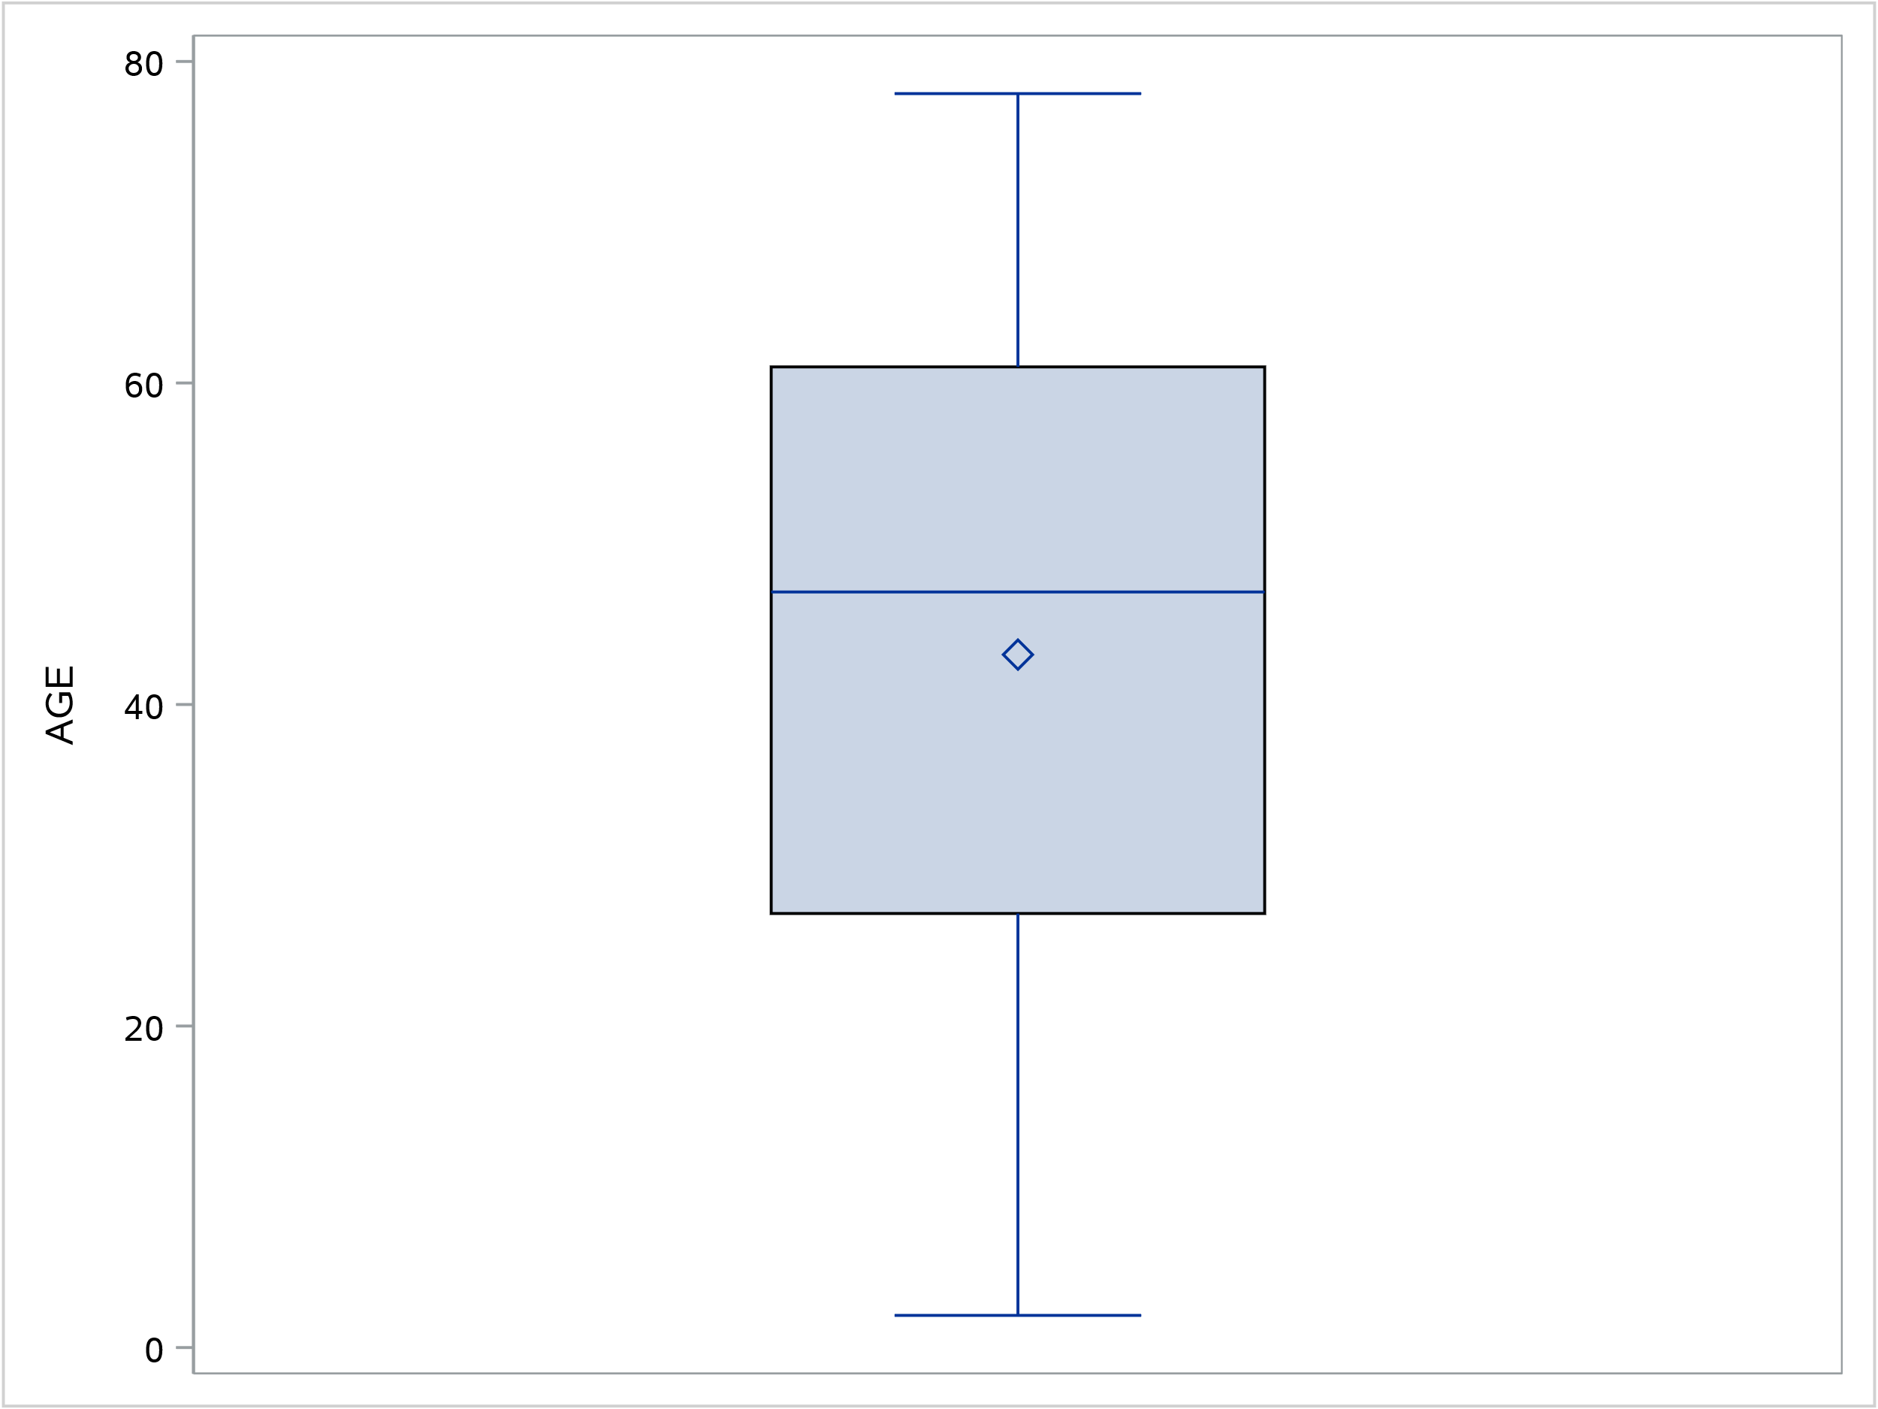

Figure 3: Age distribution of initiating patients since PBS listing October 2019

From Figure 4, the median age of initiating patients since PBS listing for females and males was 50 and 39 years, respectively. The mean age of females and males was 49 years and 37 years, respectively. There was wider age distribution for males compared to females, the age of male patients ranged from 2 to 78 years old, whereas for female patients this ranged from 9 to 73 years old. The 25th and 75th percentile for females was 40 and 62 years, whereas for males this was 7 and 60 years.
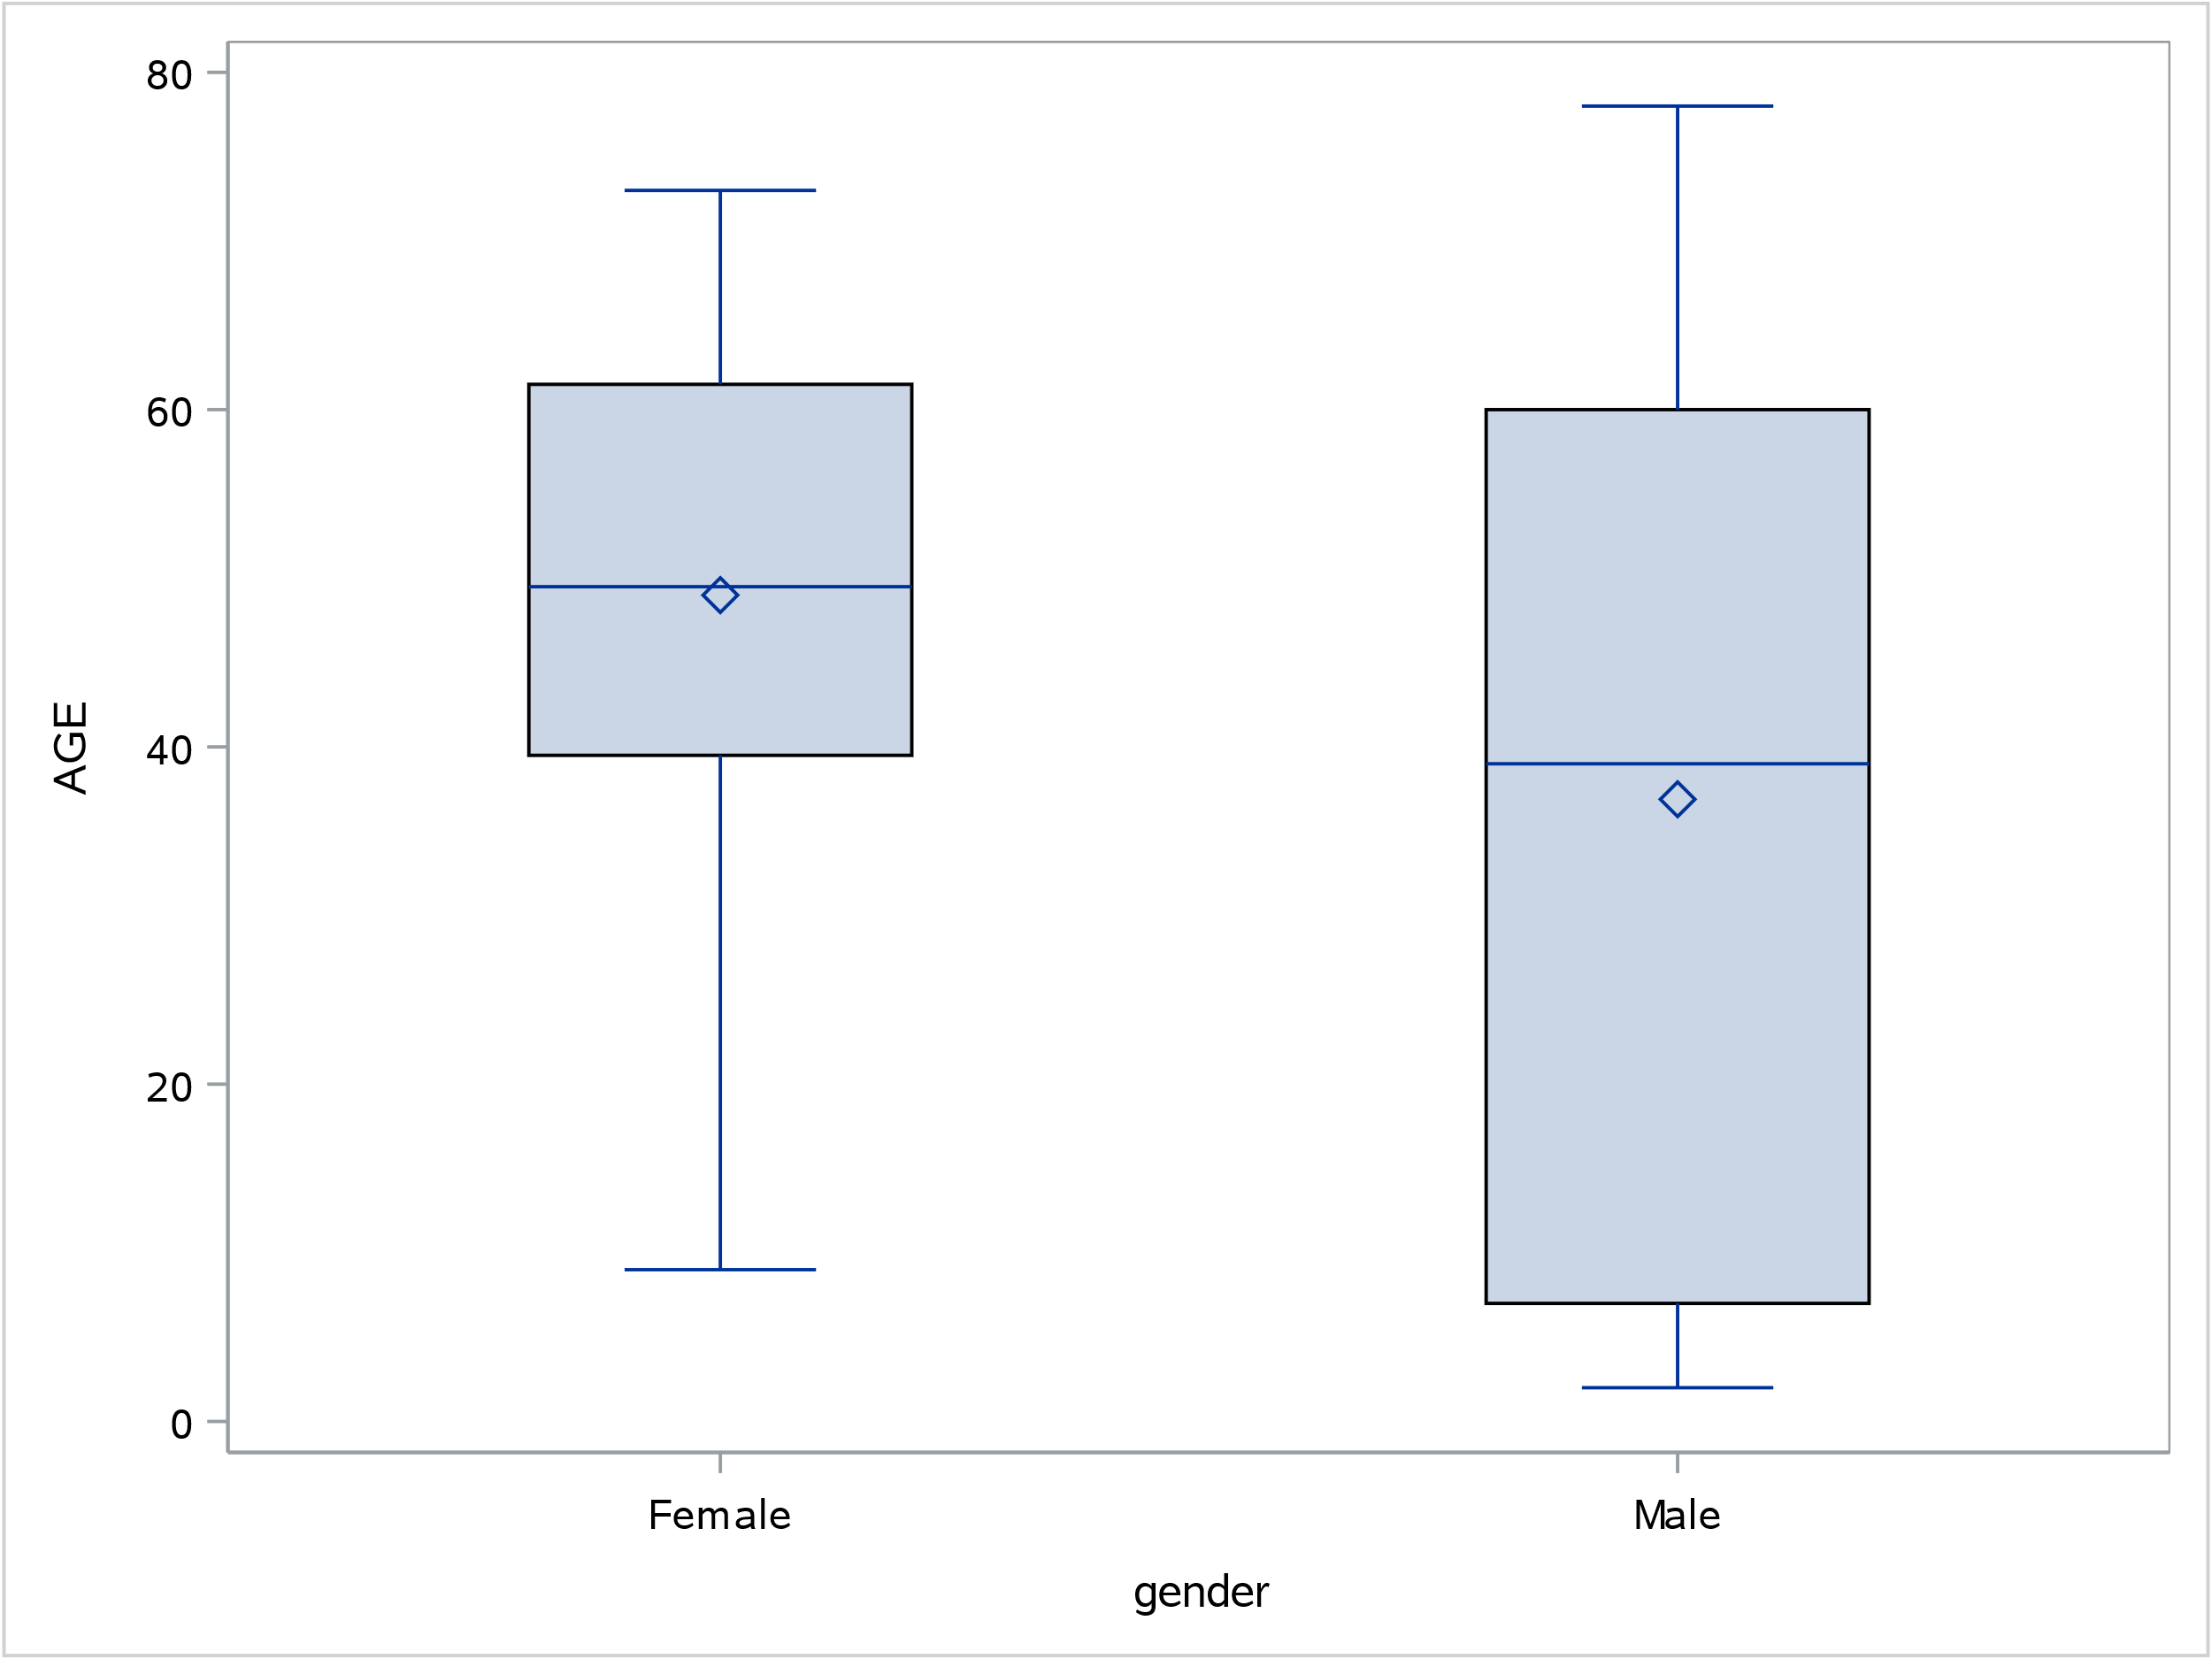

Figure 4: Age and gender distribution of initiating teduglutide patients since PBS listing (October 2019)

In Figure 5, there was an older and wider age distribution of patients before the restriction was extended to include paediatric patients.
The median age of initiating patients before and after the restriction was extended to include the paediatric population was 49 years old and 7 years old, respectively. The mean age of patients before and after the restriction was extended to include the paediatric population was 46 years and 21 years, respectively.
The age range of initiating patients before and after the restriction was extended to include the paediatric population was 4 to 78 years old and 2 to 47 years old, respectively. The 25th and 75th percentile for patients who initiated before the restriction extension was 34 and 61 years, respectively. The 25th and 75th percentile in patients who initiated after the restriction extension was 7 and 42 years, respectively.
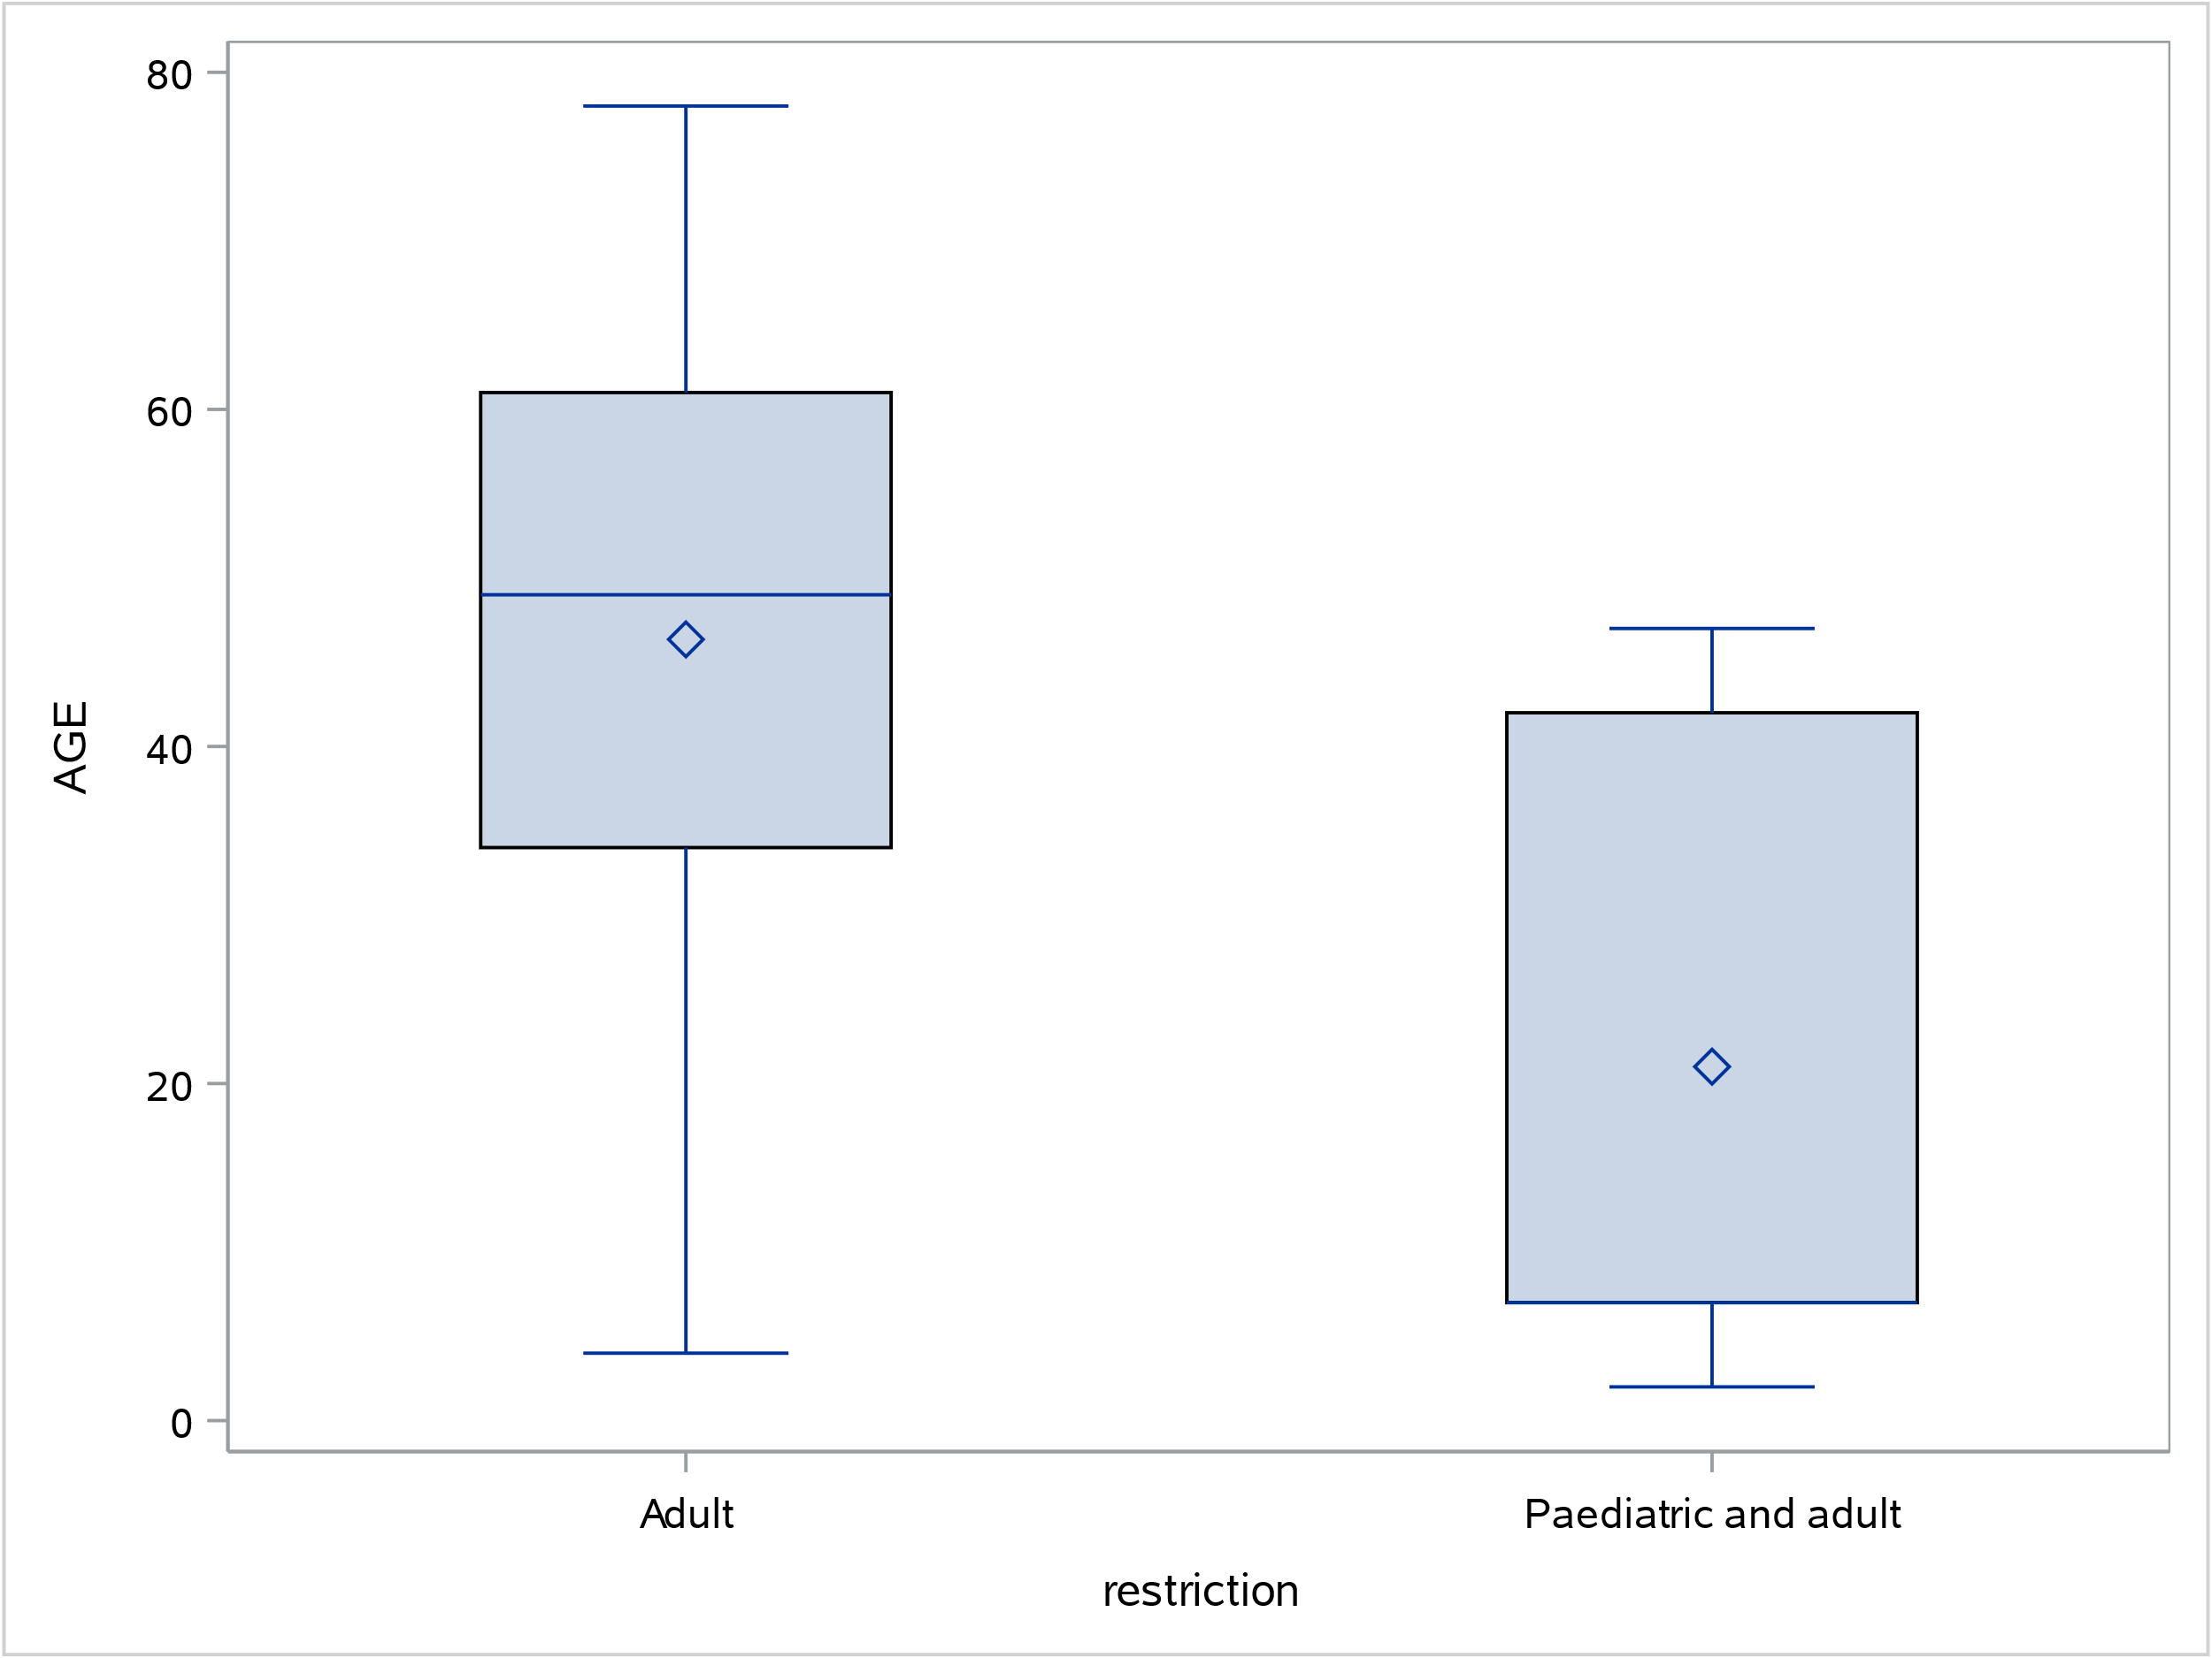

Figure 5: Comparison of the age distribution of initiating teduglutide patients before and after extending the restriction to paediatric patients on September 2021

The resubmission assumed 100% of patients would be treated in a public hospital. Treatment must be under the supervision and direction of a medical specialist with experience in the management of patients with SBS-IF. All SBS multidisciplinary teams are based in public hospitals in Australia.

Figure 6 shows the number of prescriptions supplied according to hospital setting and based on item code. Since PBS listing, the number of prescriptions supplied at public hospitals accounted for a greater proportion compared to private hospitals.

Figure 6: Number of teduglutide prescriptions according to hospital setting

From Figure 7, the most common time to resupply teduglutide was 28 days, which corresponds to the number of vials in a pack of teduglutide.

Figure 7: Time to refill teduglutide prescriptions

The data were too immature to fully analyse the time on teduglutide, with a median time on therapy not being reached within 27 months from first listing. Of the 38 patients who initiated teduglutide treatment between 1 October 2019 and 31 December 2021, 86.8% patients were censored at the analysis end date (Figure 8).
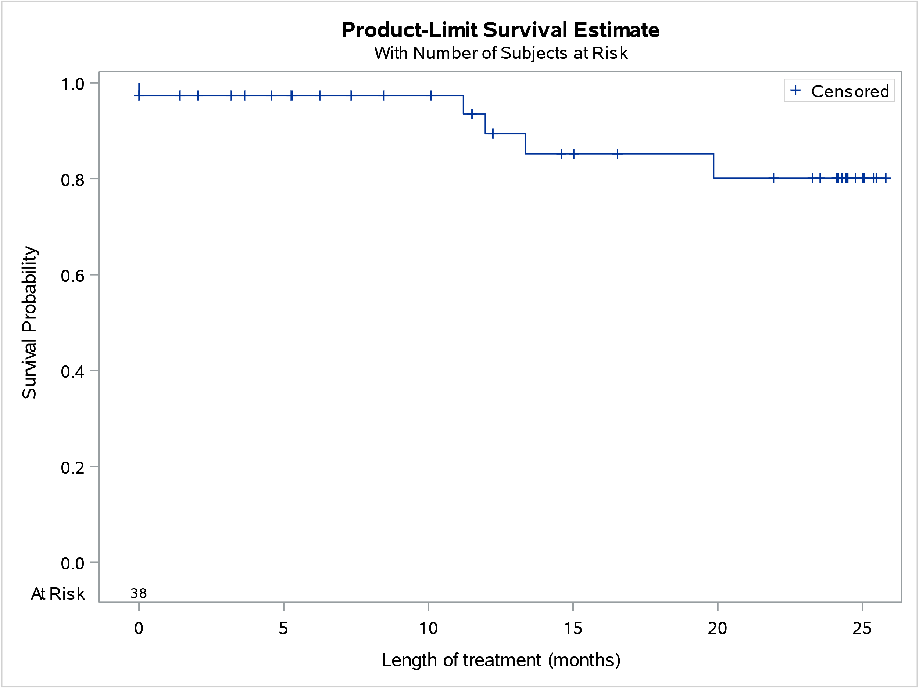

Figure 8: Kaplan-Meier curve of time of supply of teduglutide treatment in patients who were followed to 31 December 2021

At its March 2019 meeting, the PBAC noted the resubmission had significantly revised the restriction to restrict to patients most likely to achieve a clinically meaningful benefit. The initiation criteria were revised to limit use of teduglutide to patients who have a history of dependence on parenteral support for at least 12 months, require ≥ 3 days per week of parenteral support, and have stable parenteral support requirements for at least four consecutive weeks prior to initiating teduglutide.
Referring to Table 3 below, patients had an average of 72 months of dependence on parenteral support and received an average of 6 days per week for 4 consecutive weeks of parenteral support prior to teduglutide initiation.

Table 3: Mean days of parenteral support reported in approved initial teduglutide authority applications
 | Mean | Median | Range
The duration in months of prior dependence of parenteral support. | 72 months | 52 months | 12-384 months
The baseline mean number of days on parenteral support per week for 4 consecutive weeks immediately preceding this application. | 6 days | 7 days | 3-7 days

The continuation criteria requires patients to demonstrate a reduction of ≥ 1 day per week in parenteral support requirements after the first 12 months of teduglutide therapy to be eligible for continuing use. Based on Table 4 below, patients had an average of 1.4 days reduction of parenteral support prior to receiving continuing teduglutide therapy.

Table 4: Mean days of parenteral support reported in approved continuing teduglutide authority applications
 | Mean | Median | Range
The mean number of days reduction of parenteral support (parenteral nutrition I IV fluids) per week to meet caloric, fluid or electrolyte needs from baseline (if applicable). | 4.4 days | 4 days | 1-7 days
The mean number of days reduction of parenteral support (parenteral nutrition I IV fluids) per week to meet caloric, fluid or electrolyte needs over the proceeding treatment period. | 1.4 days | 1 day | 0-4 days
The current mean number of days per week or mean volume per week of any parenteral support (parenteral nutrition with or without IV fluids) over the preceding 4 week period. | 1.7 days | 1 day | 0-6 days

As shown in Figure 9, there were approximately 5 patients who recommenced treatment with teduglutide. These patients undertook a trial cessation period due to experiencing a stable parenteral support regimen in the first continuing or subsequent continuing treatment phase (and not due to treatment failure). The average trial cessation period of patients who recommenced treatment was approximately 126 days. This was estimated by determining the time between the supply date of the last script before the recommencing treatment and the first script under the recommencement of treatment phase, excluding 28 days to account for completion of the last script. Teduglutide treatment was recommenced due to reasons such as: dehydration, weight loss, poor appetite and diarrhoea.

Figure 9: Number of patients according to treatment phase in authority application since October 2019
Note: Where the patient count is between 1 and 4 (inclusive), a figure data point is set to 5 to protect patient confidentiality.

Analysis of actual versus predicted utilisation

Table 5: Teduglutide actual versus predicted utilisation
Teduglutide listing years |  | Year 1 | Year 2 | Year 3
 |  | October 2019- September 2020 | October 2020- September 2021 | October 2021- September 2022
Patients | Predicted | xxx | xxx | xxx
 | Actual | 24 | 33 | 34
 | Difference | xxx | xxx | xxx
Prescriptions | Predicted | xxx | xxx | xxx
 | Actual | 215 | 277 | 120
 | Difference | xxx | xxx | xxx
Expenditure | Predicted | $xxxxxxxxxxx | $ xxxxxxxxxxx | $ xxxxxxxxxxx
 | Actual | $4,507,217 | $6,030,613 | $2,645,023
 | Difference | xxx | xxx | xxx
Notes:
- Year 3 predicted numbers are for the full year, actual numbers are three months of data (October 2021 to December 2021 inclusive).
- Expenditure figures are based on published prices.

As shown in Table 5, actual patient and prescription figures were XXXX than estimated. The number of patients in the first and second year of teduglutide listing were lower by xxx% and xxx%, respectively.
The number of prescriptions in the first and second year of teduglutide listing were XXXX by xxx% and xxx%, respectively.
Expenditure based on published prices in the first and second year of teduglutide listing were XXXX by xxx% and xxx%, respectively.
Dosing
The average teduglutide dose supplied to patients was 28 vials.

Table 6: Teduglutide dosing actual versus predicted utilisation
Teduglutide listing years |  | Year 1 | Year 2 | Year 3
 |  | October 2019- September 2020 | October 2020- September 2021 | October 2021- September 2022
Packs per patient | Predicted ª | xxx | xxx | xxx
 | Actual | 8.60 | 8.36 | 3.56
 | Difference | xxx | xxx | xxx
Packs | Predicted ^{b} | xxx | xxx | xxx
 | Actual | 241 | 235 | 100
 | Difference | xxx | xxx | xxx
ª The number of packs per patient was calculated by the total number of days in a year with the number of vials in a pack (=365/28).
^{b} The predicted number of packs was calculated by multiplying the number of treated patients with the number of packs per patient per year.
Note: Year 3 predicted numbers are for the full year, actual numbers are three months of data (October 2021 to December 2021 inclusive).

Similar to Table 5, the actual number of teduglutide packs and the number of packs per patient per year were XXXX than estimated.

The number of packs per year during the first and second year of teduglutide listing were XXXX by xxx% and xxx%, respectively. The number of packs per patient per year during the first and second year of teduglutide listing were XXXX by xxx% and xxx%, respectively.

Based on the findings from the Table 5 and Table 7, there was a XXXX XXXX in the estimated number of prescriptions (xxx%, xxx%) and packs (xxx%, xxx%) compared to the number of patients (xxx%, xxx%), possibly indicating a XXXX proportion of patients discontinued teduglutide treatment than expected.

Discussion
Overall utilisation of teduglutide was XXXX than estimated. There has been a consistent trend of a low number of patients initiating teduglutide treatment per quarter. The majority of patients supplied teduglutide met the parenteral eligibility criteria for treatment (Tables 3 and 4).
The data were too immature to analyse the time of supply of teduglutide treatment, the median treatment duration was not reached by the analysis end date (31 December 2021). Under the restriction, a ‘trial of treatment cessation’ is required for patients who have a stable frequency of days per week of parenteral support in the preceding 6 months. In Figure 8, 13.2% of patients who initiated treatment since PBS listing (1 October 2019) were considered to have ceased treatment at the analysis end date. Based on the linkage of PBS claims data with date of death data, no deaths were identified in patients treated with teduglutide at the analysis end date. Approximately 5 patients who underwent a trial cessation period recommenced teduglutide treatment (Figure 9).

Although the resubmission assumed that supply of teduglutide was expected to occur through public hospitals where SBS multidisciplinary teams are located, some private hospital utilisation was identified (Figure 6).

The clinical and additional material requirements to commence and continue teduglutide treatment described in the Consumer Medicine Information (CMI) may have contributed to its lower than anticipated utilisation.¹ As outlined in the CMI for teduglutide, medical check-ups are required before and during treatment.
- In adults: “before you start treatment… your doctor will need to perform a colonoscopy to check for the presence of polyps and remove them…It is recommended that your doctor performs these examinations once a year during the first two years after starting treatment, and then at a minimum of five-year intervals. If polyps are found either before or during treatment with teduglutide, your doctor will decide whether you continue using this medicine.”

- In children: “before starting treatment…your child will have a test done to see if there is blood in the stool. Your child will also have a colonoscopy done if they have unexplained blood in their bowel movements. If polyps are found before treatment with teduglutide, the doctor will decide whether your child should use this medicine… The doctor will perform further colonoscopies if your child continues treatment.”
Furthermore, the CMI lists the materials required for teduglutide administration. Each teduglutide pack consists of 28 vials with 5 mg teduglutide as a powder and 28 pre-filled syringes with solvent. Additional materials required but are not part of the pack include:
- reconstitution needles (size 22G, length 1½" (0.7 x 40 mm))
- 1 mL injection syringes (with scale intervals of 0.02 mL or smaller). For children, up to a 1 mL (or smaller) injection syringe (with scale intervals of 0.01mL or smaller) may be used
- thin injection needles for subcutaneous injection (for example, size 26G, length 5/8" (0.45 x 16 mm), or smaller needles for children, as appropriate)
- alcohol wipes
- alcohol swabs
- a puncture-proof container for safe disposal of the used syringes and needles

DUSC consideration
DUSC noted teduglutide utilisation was XXXX than estimated. The Pre-Sub-Committee Response (PSCR) (p1) considered that the COVID-19 pandemic had affected teduglutide utilisation. The sponsor stated that due to the cancellation of non-elective procedures, adult patients could not initiate treatment as a colonoscopy was required for initiation. Furthermore, the PSCR stated that due to the cancellation of outpatient clinics, specialists were reluctant for patients to initiate treatment due to the complexity of the condition which required close monitoring. DUSC sought consumer input from Parenteral Nutrition Down Under (PNDU) who described factors affecting low teduglutide utilisation including:
- The impact of the COVID-19 pandemic had affected availability of clinical appointments.
- The lack of parenteral nutrition specialists in regional areas where patients must rely on a referral to a gastroenterologist in a major centre.
- Underlying medical conditions can prevent a potential teduglutide patient from initiating treatment.
DUSC noted an additional comment from PNDU who described that not all gastroenterologists, regional and feeder hospitals are familiar with teduglutide. PNDU commented on the need for increased awareness of this drug, and PNDU suggested that the sponsor consider reaching out to clinicians to provide them with further information about teduglutide.
DUSC noted approximately 5 patients recommenced treatment with teduglutide following a treatment break. Based on data from the sponsor’s patient support program (PSP), the PSCR (p1) stated adult patients treated with teduglutide gain days off and independence from parenteral support (PS). DUSC noted consumer input from PNDU who described patients who have accessed teduglutide have found it to be beneficial and improved their quality of life.
The PSCR (p2) requested a review of the definition of ‘treatment failure’ in the restriction criteria. The PSCR described the complex clinical situation for patients and commented that “increases in PS volume over the short term are sometimes required.” DUSC agreed with the sponsor and considered that the definition of treatment failure could be changed however DUSC noted that the current restriction was complex and any changes would require further investigation by the department.

DUSC actions
DUSC requested that the report be provided to the PBAC for consideration.

Context for analysis
The DUSC is a Sub Committee of the Pharmaceutical Benefits Advisory Committee (PBAC). The DUSC assesses estimates on projected usage and financial cost of medicines.
The DUSC also analyses data on actual use of medicines, including the utilisation of PBS listed medicines, and provides advice to the PBAC on these matters. This may include outlining how the current utilisation of PBS medicines compares with the use as recommended by the PBAC.
The DUSC operates in accordance with the quality use of medicines objective of the National Medicines Policy and considers that the DUSC utilisation analyses will assist consumers and health professionals to better understand the costs, benefits and risks of medicines.
The utilisation analysis report was provided to the pharmaceutical sponsors of each drug and comments on the report were provided to DUSC prior to its consideration of the analysis.

Sponsors’ comments
Takeda Pharmaceuticals Australia Pty. Ltd: The sponsor has no comment.

Disclaimer
The information provided in this report does not constitute medical advice and is not intended to take the place of professional medical advice or care. It is not intended to define what constitutes reasonable, appropriate or best care for any individual for any given health issue. The information should not be used as a substitute for the judgement and skill of a medical practitioner.
The Department of Health and Aged Care has made all reasonable efforts to ensure that information provided in this report is accurate. The information provided in this report was up-to-date when it was considered by the Drug Utilisation Sub-committee of the Pharmaceutical Benefits Advisory Committee. The context for that information may have changed since publication.
To the extent provided by law, the Department of Health and Aged Care makes no warranties or representations as to accuracy or completeness of information contained in this report.
To the fullest extent permitted by law, neither the Department of Health and Aged Care nor any Department of Health and Aged Care employee is liable for any liability, loss, claim, damage, expense, injury or personal injury (including death), whether direct or indirect (including consequential loss and loss of profits) and however incurred (including in tort), caused or contributed to by any person’s use or misuse of the information available from this report or contained on any third party website referred to in this report.

Revestive (teduglutide). Australian Approved Consumer Medicine Information. Sydney: Takeda Pharmaceuticals Australia Pty Ltd. Approved 24 March 2017, updated November 2020. Available from <https://www.tga.gov.au/consumer-medicines-information-cmi.>
Teduglutide, Public Summary Document March 2019 PBAC Meeting. Department of Heath. Available from <https://www.pbs.gov.au/pbs/industry/listing/elements/pbac-meetings/psd/2019-03/teduglutide-psd-march-2019>
Pironi L, Arends J, Bozzetti F, Cuerda C, Gillanders L, Jeppesen P.B et al. ESPEN guidelines on chronic intestinal failure in adults. Clinical Nutrition 2016; 35: 247-307
Revestive (teduglutide). Australian Approved Product Information. Sydney: Takeda Pharmaceuticals Australia Pty Ltd. Approved 19 May 2017, updated 3 November 2020. Available from < https://www.tga.gov.au/product-information-pi.>
PBS statistics. Services Australia Medicare. Canberra. Available from <http://www.medicareaustralia.gov.au/provider/pbs/stats.jsp>.

